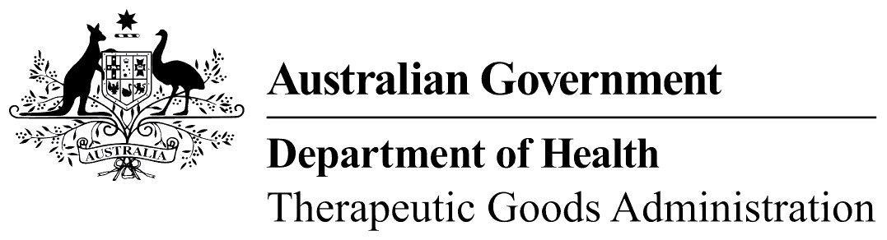
TGA use only

This form, when completed, will be classified as 'For official use only'.
For guidance on how your information will be treated by the TGA see: Treatment of information provided to the TGA at <https://www.tga.gov.au/treatment-information-provided-tga>.

Transfers of conformity assessment certificates
This form, along with sufficient documentary evidence for the relevant event, is to be provided as part of a change application in the TGA Business Services portal.
 | - Not all sections of the form will be relevant in all circumstances - please refer to the guidance for Transfers of conformity assessment certificates for information about what sections are required.  - If the manufacturer’s address has changed, a Substantial change application will be required.  - Do not submit a transfer application until the actual transfer, assignment, or name change has occurred.

Section 1 – Details
This transfer is because the former certificate holder has:
died, become bankrupt, or is wound up
disposed of the business or amalgamated with another manufacturer
changed its name
Name of former holder (disposer)
Client ID
Postal address

Name of new holder (acquirer)
Client ID (if any)
Postal address

Section 2 – Conformity assessment certificates to be transferred
If there are additional certificates, please add them as an attachment to the form.
Certificate number | Certificate number

Section 3 – Declaration of former holder
Please note: Under section 137.1 of the Criminal Code Act 1995, it is an offence to knowingly provide information to a Commonwealth entity that is false or misleading in a material particular, or to omit any information without which the information is misleading in a material particular.
Penalty: 12 months imprisonment
I declare I am:
the former certificate holder (disposer)
OR
authorised to make this declaration on behalf of the former certificate holder
I declare that I, , have:
disposed of / transferred / assigned the business in relation to the certificate(s) listed in section 1 above
OR
transferred / assigned my / its interest in the certificate(s) listed in section 1 above
To (name of new holder):
I declare that the information I have provided above is true and correct
Signature: |  | Date:
 |  | Full name:
Position:* |  | Email:
Phone: |  | Fax:
*e.g. managing director or regulatory affairs officer of former holder; agent of the former holder.
Please note: In exceptional circumstances, if the declaration of the former holder is not provided in this form, the new holder will need to provide us with other documentary evidence that is sufficient to establish the transfer event took place, including the date on which it occurred.

Section 4 – Declaration of new holder
Please note: Under section 137.1 of the Criminal Code Act 1995, it is an offence to knowingly provide information to a Commonwealth entity that is false or misleading in a material particular, or to omit any information without which the information is misleading in a material particular.
Penalty: 12 months imprisonment
I declare I am:
the new certificate holder (acquirer)
OR
authorised to make this declaration on behalf of the new certificate holder
I declare that (former holder) has:
disposed of / transferred / assigned the business in relation to the certificate(s) listed in section 1 above
OR
transferred / assigned its interest in the certificate(s) listed in section 1 above
To (name of new holder):
I declare that the information I have provided above is true and correct
Signature: |  | Date:
 |  | Full name:
Position:* |  | Email:
Phone: |  | Fax:
*e.g. managing director or regulatory affairs officer of former holder; agent of the former holder.

