Suspending, revoking and TGA initiated variation of conditions of a manufacturing licence
Version 1.2, December 2021

Copyright
© Commonwealth of Australia 2021
This work is copyright. You may reproduce the whole or part of this work in unaltered form for your own personal use or, if you are part of an organisation, for internal use within your organisation, but only if you or your organisation do not use the reproduction for any commercial purpose and retain this copyright notice and all disclaimer notices as part of that reproduction. Apart from rights to use as permitted by the Copyright Act 1968 or allowed by this copyright notice, all other rights are reserved and you are not allowed to reproduce the whole or any part of this work in any way (electronic or otherwise) without first being given specific written permission from the Commonwealth to do so. Requests and inquiries concerning reproduction and rights are to be sent to the TGA Copyright Officer, Therapeutic Goods Administration, PO Box 100, Woden ACT 2606 or emailed to <tga.copyright@tga.gov.au>.

Contents
Suspending and revoking manufacturing licences 4
Manufacturer requests to suspend or revoke a licence 4
How to make a request to suspend or revoke a licence 5
TGA-initiated suspension or revocation 8
Why we suspend or revoke licences 8
Imminent risk 8
Process 8
1: Notification of intent 8
2: Delegate’s decision 8
3: Publishing our decision 8
4: Your ongoing obligations 8
TGA initiated variations to your licensing conditions 9

Suspending and revoking manufacturing licences
This guidance will assist Australian manufacturers understand how TGA manufacturing licences can be suspended or revoked.
It is not intended for:
- overseas manufacturers
- medical device manufacturers
We provide separate guidance on Revoking manufacturing licences for not paying the annual charge on our website.
If you wish to request a variation to the details of your licence, see our guidance on Varying a manufacturing licence.
When we revoke or suspend a licence we will:
- notify you of our decision in writing
- publish our decision in the Gazette or on our website [in line with subsection 41(6) of the Therapeutic Goods Act 1989].
Our decision is considered an ‘initial decision’ and you can request it be reconsidered under subsection 60(1) of the Therapeutic Goods Act 1989.

Manufacturer requests to suspend or revoke a licence
If you wish to stop manufacturing therapeutic goods, you need to ask us to suspend or revoke your manufacturing licence [as per section 41(1)(d) of the Therapeutic Goods Act 1989]. You can make this request via TGA Business Services.
You will be required attach notification letter to your application addressed to the Assistant Secretary, Manufacturing Quality Branch. Your letter should address but not be limited to:
For suspending your licence:
- your request to suspend your licence including the site address and licence number
- the reason why you wish to suspend your licence; and
- the time period for the suspension including the date that you intend to resume manufacture.
This letter must be signed by the Licence Holder [as per section 38 of the Therapeutic Goods Act 1989).
For revoking your licence:
- your request to revoke your licence including the site address and licence number
- the reason why you wish to revoke your licence
- How you will maintain your GMP responsibilities for any product manufactured at the site including the management of:
  - Manufacturing documentation including batch documents
  - Management of any retention samples
  - Information including the contact person/company if a recall were required
- the date of the revocation.
Please note: all outstanding fees are required to be paid prior to the revocation of your licence.
This letter must be signed by the Licence Holder [as per section 38 of the Therapeutic Goods Act 1989).
To request any other changes to your manufacturing licence, apply to vary your licence.
When we suspend or revoke a licence at your request we will not issue you a notice of intent. However, we may withdraw the revocation if you ask us to in writing within 90 days of the revocation date (as per section 41AAAA Therapeutic Goods Act 1989).

How to make a request to suspend or revoke a licence
You can ask us to suspend or revoke your manufacturing licence by applying through TGA Business Services.
- Log in to TGA Business Services.
- Click on Your TGA to open the dropdown menu and select Manufacturer Information.
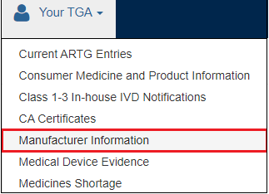
- Search for your licence. One way to do this is to filter by Identifier, or you may search for your licence using other fields or filters.
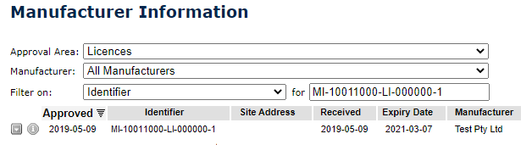
- When you locate your licence, double-click on it to open the licence.
- Click on the Vary Application button at the top of the screen.


- Click on the Save button at the top of the screen
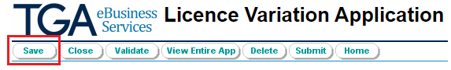
- Click on the Supporting Documents tab and attach a notification letter to your application addressed to the Assistant Secretary, Manufacturing Quality Branch.
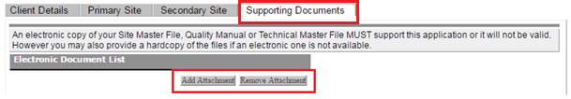
- Under Variation: Application Details, you will see to see two radio buttons; Change Details and Change Status.
- Select the Change Status radio button, then select the Status tab.
- On the Status tab you will see a Select new status field and three radio buttons.
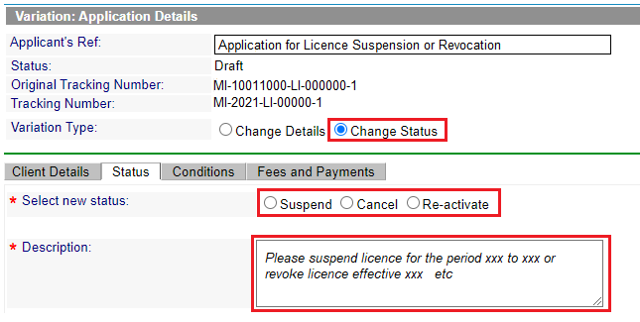
- Select the Suspend radio button if you wish to suspend your licence. Select the Cancel radio button if you wish to request us to revoke your licence.
You must provide details of the action to be taken in the Description text box.
- Click on the Validate button to validate your application. If validation fails, the system will advise you which areas you need to complete.

You will receive a pop-up message to advise you your application has been successfully validated.
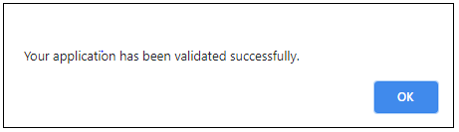
- Click on the Submit button to submit your validated application.

- When you click on Submit you will be shown the following screen to ensure that all the evidence required to support a suspension or cancellation application has been submitted and offers you the option to cancel your application or continue with your submission.
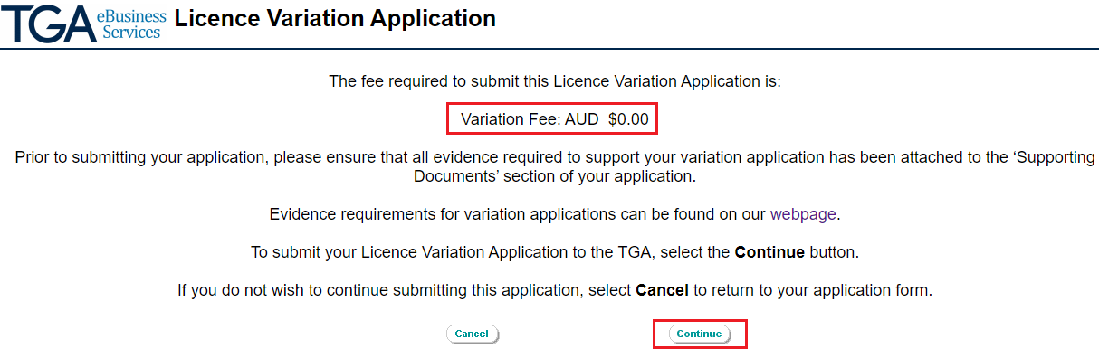
 | There is currently no fee for submitting a request to suspend or revoke a TGA manufacturing licence.
- Click on Continue to submit your application. You will receive the follow message confirming your application has been successfully submitted to the TGA.
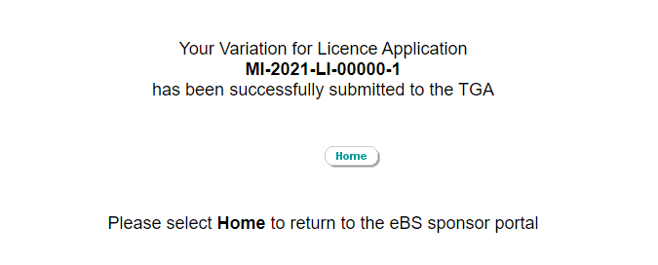

TGA-initiated suspension or revocation

Why we suspend or revoke licences
We may suspend or revoke a licence for any of the reasons listed in section 41(1) of the Therapeutic Goods Act 1989. Where we propose to revoke or suspend a licence, other than at the request of the licence holder, we would issue a notice of intent to revoke or suspend, unless we consider there is imminent risk.

Imminent risk
If we consider there is imminent risk of death, serious illness or serious injury, we may immediately suspend or revoke a manufacturing licence without notice of intent, as prescribed in section 41(2) of the Therapeutic Goods Act 1989.
We may also take other regulatory actions depending on the nature of the risk.

Process
This section describes the typical process for how TGA initiates and actions the suspension or revocation of a manufacturing licence.

1: Notification of intent
When we intend to suspend or revoke a manufacturing licence, we will usually advise you in writing of our intention to suspend or revoke the manufacturing licence.
We are not required to issue a notice of intent if we consider there is an imminent risk of death, serious illness or serious injury, as prescribed in section 41(2) of the Therapeutic Goods Act 1989.

2: Delegate’s decision
The Secretary’s delegate will decide whether to suspend or revoke your manufacturing licence under subsection 41(1) of the Therapeutic Goods Act 1989, and will take into account any information submitted in response to our notification of intent before making a decision.

3: Publishing our decision
When we decide to suspend or revoke your manufacturing licence, we will:
- notify you of our decision
- publish the decision in the Gazette or on our website [subsection 41(6) of the Therapeutic Goods Act 1989].

4: Your ongoing obligations
If your manufacturing licence has been suspended or revoked:
- it becomes an offence to manufacture, supply or export a therapeutic good from the manufacturing site, in accordance with section 35(4) of the Therapeutic Goods Act 1989.

TGA initiated variations to your licensing conditions
We may impose new conditions, or vary or remove existing conditions of your licence, in accordance with section 40(2) of the Therapeutic Goods Act 1989. We will notify you of any such decision in writing.
In accordance with section 40(3) of the Therapeutic Goods Act 1989, any changes to conditions (whether to vary or remove conditions or impose new conditions) take effect:
- on the day the notice is given if there is an imminent risk of death, serious illness or injury
- on the day specified in the notice in any other case. This must be at least 28 days after notice is given unless the person has agreed to an earlier day.

Version history
Version | Description of change | Author | Effective date
V1.0 | Original publication following consultation with industry in January 2017 | Manufacturing Quality Branch | August 2017
V1.1 | Minor editorial changes | Manufacturing Quality Branch | March 2019
V1.2 | Minor editorial changes | Manufacturing Quality Branch | December 2021

Therapeutic Goods Administration
PO Box 100 Woden ACT 2606 Australia
Email: info@tga.gov.au Phone: 1800 020 653 Fax: 02 6203 1605
https://www.tga.gov.au
Reference/Publication #

