Special Access Scheme (SAS) Applications - Quick Reference Guide
  - Medicinal cannabis
Version 1.1, June 2022

Copyright
© Commonwealth of Australia 2022
This work is copyright. You may reproduce the whole or part of this work in unaltered form for your own personal use or, if you are part of an organisation, for internal use within your organisation, but only if you or your organisation do not use the reproduction for any commercial purpose and retain this copyright notice and all disclaimer notices as part of that reproduction. Apart from rights to use as permitted by the Copyright Act 1968 or allowed by this copyright notice, all other rights are reserved and you are not allowed to reproduce the whole or any part of this work in any way (electronic or otherwise) without first being given specific written permission from the Commonwealth to do so. Requests and inquiries concerning reproduction and rights are to be sent to the TGA Copyright Officer, Therapeutic Goods Administration, PO Box 100, Woden ACT 2606 or emailed to <tga.copyright@tga.gov.au>.

Introduction
The Special Access Scheme (SAS) quick reference guide is a tool to assist health professionals in using the SAS and Authorised Prescriber (AP) online system to submit SAS B applications to access unapproved medicinal cannabis products for their patients.
This guide is to be read in conjunction with the Special Access Scheme (SAS) online system guidance document available on the TGA website.
From 22 November 2021, SAS applications for medicinal cannabis products are only accepted by active ingredient category rather than by trade names. For general information on access pathways available for medicinal cannabis, refer to ‘Accessing medicinal cannabis for a patient’ on the TGA website.
To support health professionals in prescribing and supplying medicinal cannabis products, TGA has published a list of available medicinal cannabis products by active ingredient. Sponsor details are also included to facilitate patient access.
Two pathways for accessing medicinal cannabis products

Special Access Scheme (SAS)
Application for an individual patient
Authorised Prescriber (AP) scheme
Application for a class of patients for a particular condition
Access the AP dashboard on the SAS & AP Online System and submit a new AP application.
Refer to the AP quick reference guide
Refer to SAS B Application flowchart on page 4 of this document
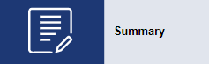

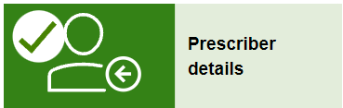
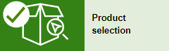
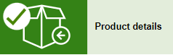
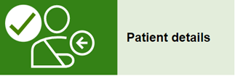
Log in to the SAS & AP online system, go to ‘SAS Dashboard’ and click on ‘+New SAS submission’
Therapeutic Good Type – Select Medicine
Active ingredient(s) – select from one of the five medicinal cannabis product categories
Dosage form – Select from the options available.
Indication – Select from the options available. If the required indication is not available, there is a free text option.
Do you need to notify or apply to a state or territory health department? If YES, choose the relevant state/territory.
Would you like to submit a category A notification? Select “No” for a SAS B application.
Dosage and Frequency – Prefilled with ‘As per prescription’. This field is editable if necessary.
Expected duration of treatment – SAS B approval for a medicinal cannabis product is valid for 24 months.
Intended date of supply – Enter as required.
Note: Trade name & Sponsor/supplier are non-mandatory fields.
Acknowledge that you have read and understood the privacy statement and consent and click on ‘submit’ to send the application to TGA for review.
The prescriber details will be pre-populated from the account if you are the prescriber.
Note: The contact details can be amended before continuing.
Enter Patient details, Diagnosis(es), Clinical justification and Intended monitoring details. There is also an option to attach any additional supporting information in this section.
Have you considered other ARTG Products? Select Yes or NO

Version history
Version | Description of change | Author | Effective date
V1.0 | Original publication | International Regulatory Branch | March 2022
V1.1 | Guidance updated based on system changes. | Special Access Section (SAS);  International Regulatory Branch (IRB) | June 2022

Therapeutic Goods Administration
PO Box 100 Woden ACT 2606 Australia
Email: info@tga.gov.au Phone: 1800 020 653 Fax: 02 6203 1605
https://www.tga.gov.au
Reference/Publication #

