Requesting variations to your manufacturing licence
  - A step-by-step guide
Version 1.2, December 2021

Copyright
© Commonwealth of Australia 2021 This work is copyright. You may reproduce the whole or part of this work in unaltered form for your own personal use or, if you are part of an organisation, for internal use within your organisation, but only if you or your organisation do not use the reproduction for any commercial purpose and retain this copyright notice and all disclaimer notices as part of that reproduction. Apart from rights to use as permitted by the Copyright Act 1968 or allowed by this copyright notice, all other rights are reserved and you are not allowed to reproduce the whole or any part of this work in any way (electronic or otherwise) without first being given specific written permission from the Commonwealth to do so. Requests and inquiries concerning reproduction and rights are to be sent to the TGA Copyright Officer, Therapeutic Goods Administration, PO Box 100, Woden ACT 2606 or emailed to <tga.copyright@tga.gov.au>.

Contents
Commencing a licence variation application 5
Variation application types 7
Requesting a change to the licence nominees (Persons in charge of Production and Quality Control) 7
Supporting documents 8
Requesting a change to manufacturing authorisations 9
Supporting documents 10
Changing the manufacturer name or address 11
Supporting documents 13
Adding / removing a secondary site 13
Supporting documents 15
Completing & submitting your licence variation
application 16
Reviewing your variation application 18

This is a step-by-step guide for Australian manufacturers of therapeutic goods (other than medical devices) applying through TGA Business Services to vary an in-force manufacturing licence for an Australian manufacturing site under section 40B of the Therapeutic Goods Act 1989. If you have any questions, contact the Manufacturing Quality Branch.
This process should not be used for requesting:
- licence transfers
- licence suspension or revocation
- a new licence
- a new licence when a primary manufacturing site has relocated
 | You cannot request a variation to your GMP certification for an overseas manufacturer via TGA Business Services. You should email these requests to Manufacturing Quality Branch.
You can request to vary details of the manufacturing licence such as the licence nominees (Persons in control of Quality Control and Production) and manufacturing authorisations (e.g. dosage forms and manufacturing steps et cetera). See Section 40B of the Therapeutic Goods Act 1989 for additional information.
Variations made to a manufacturing licence under Section 40B of the Therapeutic Goods Act 1989 may incur a licence variation fee.
The application fees for manufacturing licence variations are published in the Summary of fees and charges, under Manufacturing medicines and OTGs.

Commencing a licence variation application
- Log in to TGA Business Services.
- Click on Your TGA to open the dropdown menu and select Manufacturer Information.
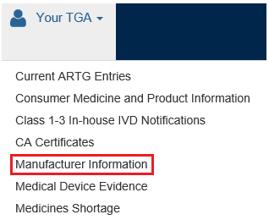
- Search for your licence. One way to do this is to select Licences in the drop down menu in ‘Approval Area’ field and ‘filter on’ by Identifier to search for your licence number. You may search for your licence using other fields or filters too.
sear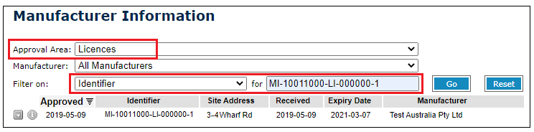
- When you locate your licence, double-click on it. This will open your application.
- Click on the Vary Application tab at the top of the screen.

- Under Variation: Application Details, you will see:
  - the original tracking number – the tracking number of the current approved licence
  - the tracking number – the new tracking number for the replacement application
  - two radio buttons – Change Details and Change Status.

- Select the Change Details radio button. (The Change Status button is used to request us to suspend or cancel the licence.)
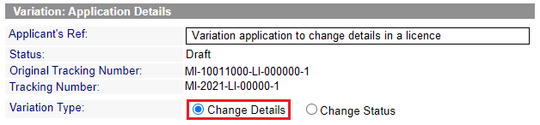

Variation application types
You can vary your application by editing a number of fields, including:
- the licence nominees (Persons in charge of Production and Quality Control)
- the manufacturing authorisations (Manufacturing Items table)
- the manufacturer name or address (Client Details tab)
- the secondary manufacturing site (Secondary Site tab)

Requesting a change to the licence nominees (Persons in charge of Production and Quality Control)
- On the Primary Site tab, you will see a field for Licence variation type. For a change in the Person in charge of Quality Control or Production, select Other.
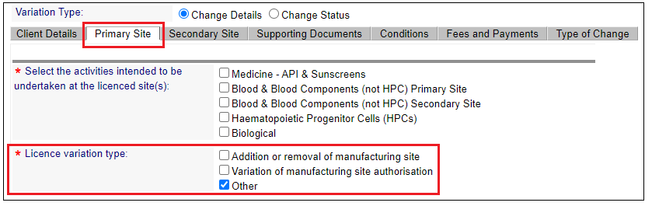
Please ensure that you have selected ‘Other’ to stop an invoice from generating, as this is an administrative change only.
If you do not select ‘Other’ and an invoice issues, the application cannot be process until the invoice is paid. Invoices may not be cancelled once generated.
- On the Primary site tab, you will see the name of the current Person in charge of Quality Control and an editable field where you can enter the name(s) of the new nominee(s) and attach their CV (resume) if this a new person is now doing this role.
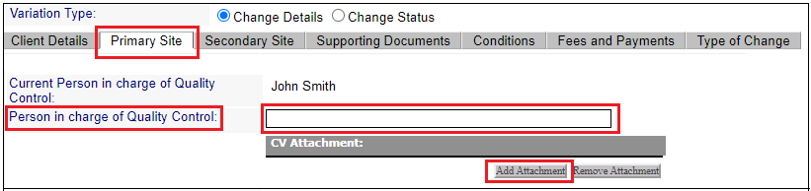

- You can also enter the name(s) of the new nominee(s) for Person in charge of Production and attach their CV(resume) if this has changed.
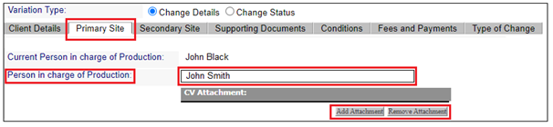
Under the Type of Change tab, please write a brief description of the requested change.
For example, ‘The person in charge of production needs to be changed from John Black to John Smith. Resume has been uploaded.’ This is a free text box. The more information you provide, will assist us in processing your application in a timely manner.
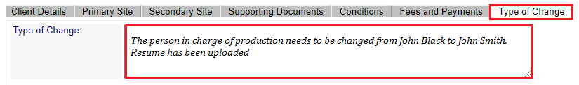

Supporting documents
- On the Supporting Documents tab you may attach a cover letter detailing the reason for the change and the date of its effect.
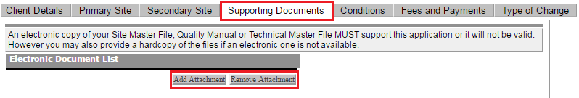

Under Regulation 21 of the Therapeutic Good Regulations 1990, the licence holder must inform the Secretary as soon as practicable when there is any change to those in charge of production and/or quality control and provide the name, qualifications and experience of the replacement person(s).
The licence remains in force and manufacturing operations can continue while we review your licence variation.

Requesting a change to manufacturing authorisations
- On the Primary Site tab, you will see a field for Licence variation type. For a change in the manufacturing authorisations, select Variation of manufacturing site authorisation.
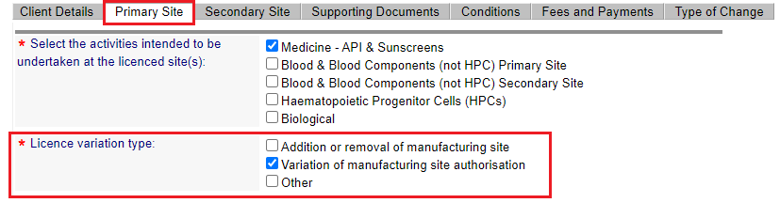
- On the Primary Site tab, you can edit the Manufacturing Items table (e.g. dosage forms, manufacturing steps, et cetera) to add, remove or edit existing items.
To add or remove an item, select the Add or Remove button at the bottom of the table.
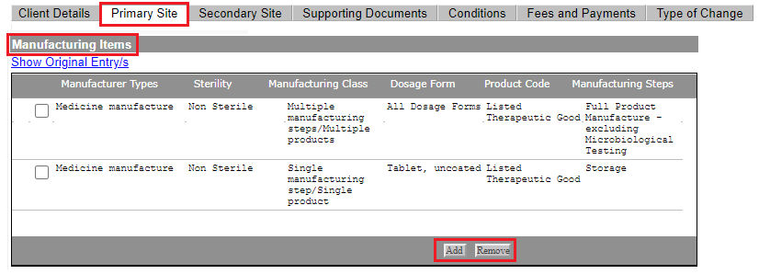

Radio buttons are only visible in window-based applications. They are not visible using mac products like iPads etc.
- When adding an item, a pop-up dialogue window will open. Make the appropriate selection from the dropdown menu for each field.
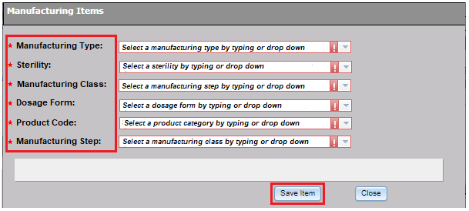
The dropdown menu is linked to TGA code tables for manufacturing type, sterility, manufacturing class, dosage form, product code and manufacturing steps.
A list of the current manufacturing steps and manufacturing steps groups can be found within the Code Tables heading under the ‘Public TGA Information’ tab in the TGA Business Services (TBS) page
- When you are finished, click on Save Item to add the new item.
- On the Type of Change tab, please write a brief description of the requested change.
For example, ‘New manufacturing steps added for non-sterile dosage form tables, uncoated’. This is a free text box. The more information you provide, will assist us in processing your application in a timely manner.
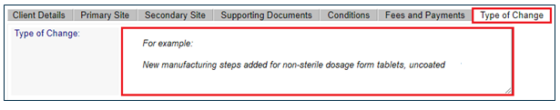

Supporting documents
- On the Supporting Documents tab, attach a current Site Master File (SMF). Please also attach a cover letter detailing the requested change(s) and the proposed date of the change.
Changes to the items you are authorised to manufacture may require prior approval and an onsite inspection before the licence can be varied.
- Do not commence additional manufacturing operations until an updated licence has been granted.

Changing the manufacturer name or address
You can change the manufacturer’s name on the Client Details tab.
- On the Primary Site tab, you will see a field for Licence variation type. For a change in the manufacturer name or address, select Other.
Please ensure that you have selected ‘Other’ to stop an invoice from generating, as this is an administrative change only.
If you do not select ‘Other’ and an invoice issues, the application cannot be process until the invoice is paid. Once an invoice has been generated it may not be cancelled.
- On the Client Details tab, under Manufacturer Details, type in the new proposed manufacturer name.
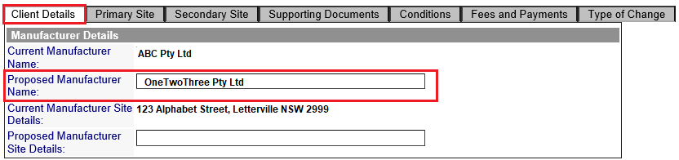
- On the Type of Change tab, please write a brief description of the requested change.
For example ‘ABC Pty Ltd will be change its name to OneTwoThree Pty Ltd effective XX/XX/XXX etc’. This is a free text box. The more information you provide, will assist us in processing your application in a timely manner.
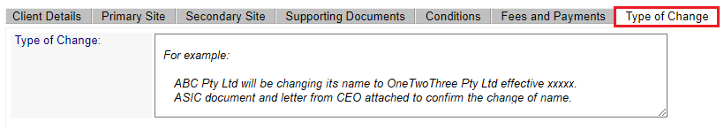
- If the primary manufacturing address has changed due to council renaming or rezoning, you can change the manufacturer’s site address on the Client Details tab.
On the Client Details tab, under Manufacturer Details, type in the new proposed Manufacturer Site Details.
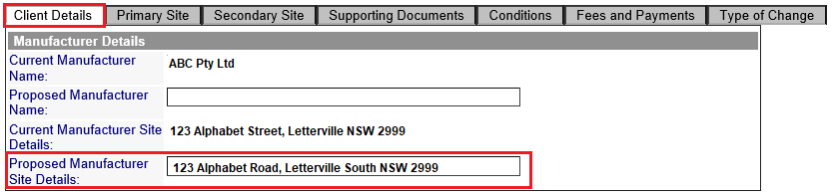
Changes to primary manufacturing site address is only if a council has changed a street name or suburb etc.
- Do not use this process for primary manufacturing site relocations.
- Do not use this process for licence transfer requests.
If there has been a change to an address because of a council change, the council notification advice must be provided.

- On the Type of Change tab, please write a brief description of the requested change.
For example ‘The council has made changes to our site address. It is now 123 Alphabet Road not Street and out suburb is now Letterville South. Council notification advice has been uploaded in supporting documents’.
This is a free text box. The more information you provide, will assist us in processing your application in a timely manner.
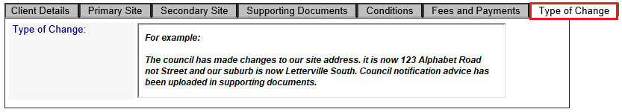

Supporting documents
- On the Supporting Documents tab, attach a current Site Master File (SMF).
For a change of name, please attach a copy of the ASIC document that supports the change of name as well as a letter from the Chief Executive Officer (CEO)/Managing Director (MD) confirming the change of name and the proposed date of the change.
For a change of address due to a council decision, please attach a copy of the council notification advice.

Adding / removing a secondary site
You can request to add a secondary manufacturing site to your licence.
You need prior approval to add a secondary site. The site must be inspected before we can grant an updated licence.
Secondary sites must meet the requirements outlined under section 38A of the Therapeutic Goods Act 1989 in the Therapeutic Goods (Multi-Site Manufacturing Licences) Guidelines of 2020.
- Do not commence additional manufacturing operations until an updated licence has been granted.

- On the Primary Site tab, you will see a field for Licence variation type. For the addition or removal of a secondary site, select Addition or removal of manufacturing site.
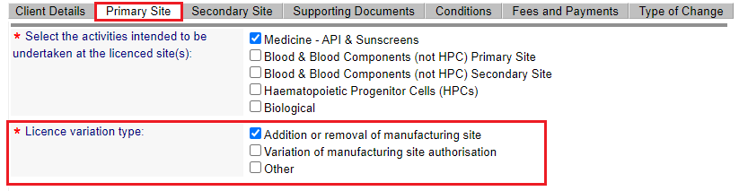

- On the Secondary Site tab, click on the Add Secondary Site button at the bottom of the window. To remove a secondary site, select the site address and click on the Remove button at the bottom of the window.
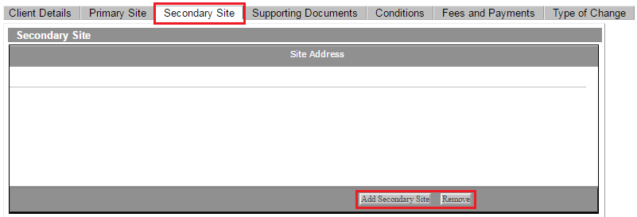
- Where adding a secondary site, a pop-up dialogue window will open. You will see two radio buttons for Existing Site and New Site.
  - If you are changing the details of an existing site, select the Existing Site radio button and fill in the site details fields.
  - If you are entering a new site, choose the New Site radio button and fill in the site details fields.
  - Information must be added in fields denoted with an *
- When you have entered all the necessary details, click on the Save Site button to save them.
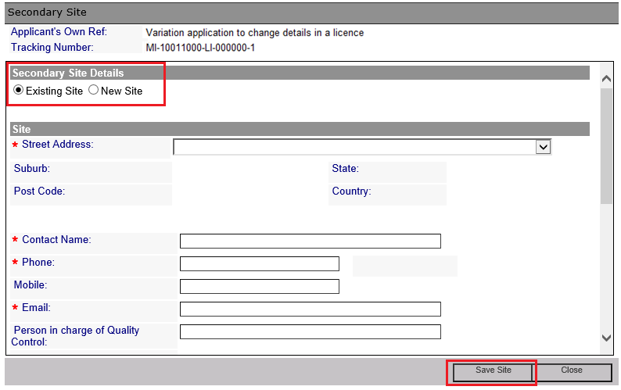
- A pop-up dialogue window will open. Make the appropriate selection from the dropdown menu for each field. When you have made all the selections, click Save Item.
- The Type of Change tab will appear after saving the application. On the Type of Change tab, please write a brief description of the requested change.
For example ‘Secondary site 123 Smith Road, Smithville added to carry out secondary packaging and release for supply for all dosage forms of listed therapeutic goods’ or ‘Secondary site 456 Jones Street Jonesville was removed’. This is a free text box, so the more information you provide, will assist us in processing the application in a timely manner.
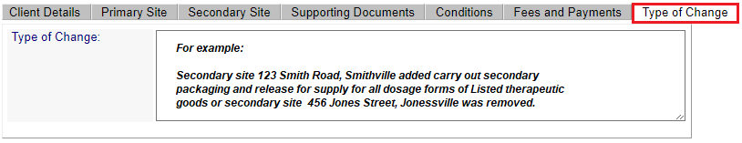

Supporting documents
- On the Supporting Documents tab, attach a current Site Master File (SMF). Please also attach a cover letter detailing the requested change and the proposed date of the change.

Completing & submitting your licence variation application
- When you have entered all the variations you wish to request, click on the Validate button to validate your application. If validation fails, the system will advise you which areas you need to complete.

- You will receive a pop-up message to advise you your application has been successfully validated.
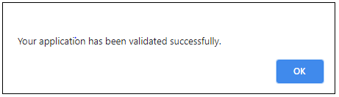
- Click on the Submit button to submit your validated application.

- When you click on Submit you will be shown the following screen, which advises you the associated cost for submitting the licence variation application and to ensure that all the evidence required to support a variation application has been submitted and offers you the option to Cancel your application or Continue with your submission.
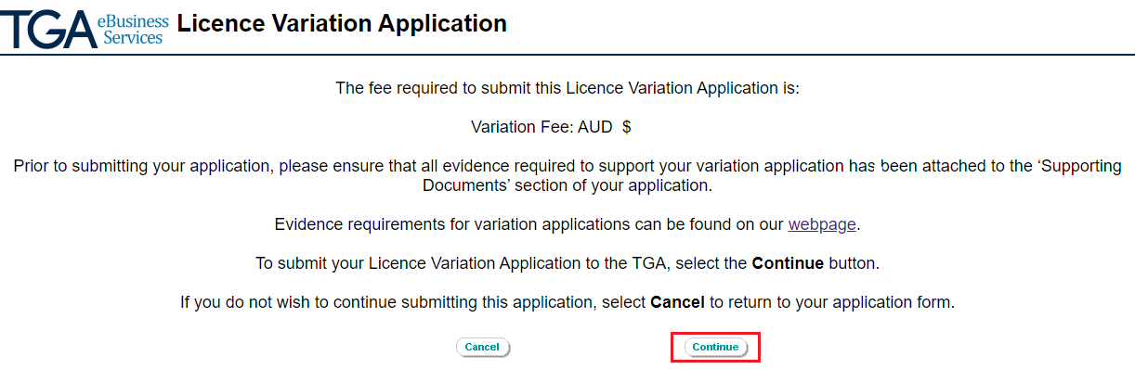

- Click on Continue to submit your application or Cancel to return to the application. If you choose Continue, you will receive the follow message confirming your application has been successfully submitted to the TGA.
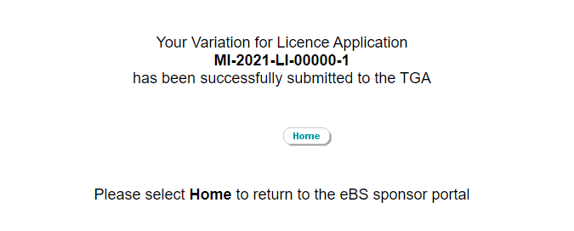

Reviewing your variation application
We will review your variation application to determine whether an inspection is required. We may ask you for additional information to assist with our review.
If inspection is not required, we will let you know whether the variation is approved.
If an inspection is required, we will determine whether:
- this should be conducted as part of the next routine inspection, or
- a special inspection covering the scope of the variation is required.
The TGA works towards timeframes. Our target scheduled timeframes can be found on the TGA website under Target timeframes for manufacturing inspections.

Version history
Version | Description of change | Author | Effective date
V1.0 | Original publication following consultation with industry in January 2017 | Manufacturing Quality Branch | June 2017
V1.1 | Added instructions for selecting manufacturer name and site details, and the manufacturing activities and variation type in the application form.  Minor editorial changes. | Manufacturing Quality Branch | March 2019
V1.2 | Minor editorial changes | Manufacturing Quality Branch | December 2021

Therapeutic Goods Administration
PO Box 100 Woden ACT 2606 Australia
Email: info@tga.gov.au Phone: 1800 020 653 Fax: 02 6203 1605
https://www.tga.gov.au
Reference/Publication #

