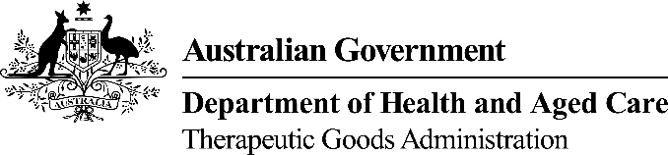 | TGA USE ONLY
This form, when completed, will be classified as 'For official use only'.
For guidance on how your information will be treated by the TGA see: Treatment of information provided to the TGA at <https://www.tga.gov.au/treatment-information-provided-tga>.

Request to reinstate an entry on the Australian Register of Therapeutic Goods (ARTG)
Requests to revoke the cancellation of an ARTG entry may be made in accordance with the legislated requirements specified within the Therapeutic Goods Act 1989 under sections 30A and 30AA in relation to medicines, sections 32GD and 32GDA in relation to biologicals and sections 41GLA and 41GLB in relation to devices.
 | • Requests to reinstate a cancelled entry must be received by the TGA within 90 days of the cancellation date.  • Making a request to reinstate a cancelled entry incurs a prescribed, non-refundable fee. The value of the prescribed fee is dependent upon the number of entries included in the request. Please refer to the TGA’s Summary of Fees and Charges.  • Where an entry was cancelled due to non-payment of annual charges, evidence of payment of the outstanding annual charges must accompany the request to reinstate a cancelled entry.  • Evidence of payment of the prescribed fee for making a request to reinstate a cancelled entry must accompany ALL requests to reinstate. Please refer to the TGA’s Payment Options.  • Requests that fail to meet the abovementioned legislated requirements, will be assessed as invalid. It is the responsibility of the person who is authorised to make the request, to ensure the requirements are met.  • Where the Secretary decides to reinstate a cancelled entry, the cancellation is taken to never have occurred and the public record of the cancellation will be withdrawn.

Submit the completed request accompanied by evidence of payment, by email to accountsrec@health.gov.au. The subject field of your email must quote your TGA Organisation Identification Number (e.g. TGA00xxxxx’) followed by ‘ARTG Reinstatement Request’.
For more information about cancelled entries, please refer to Important Dates published on the TGA website. If you require assistance, please contact 1800 020 653 or email accountsrec@health.gov.au.

Section 1 Organisation details
Identification number | Organisation name
TGA00

Section 2 ARTG entry details
Reinstatement is requested for the following ARTG entries:
ARTG number | ARTG description

Section 3 Fee details
Reinstatement is requested for the following ARTG entries:
Total number of ARTG entries | Total prescribed fee payable
 | $
NOTE: The prescribed fee is published in the TGA’s annual Summary of Fees and Charges (see ‘General fees, revoke an ARTG cancellation’) and is calculated based on the number of entries included in the request. To remit payment of the prescribed fee, please refer to the TGA’s Payment Options. Evidence of payment must accompany this request.

Section 4 Authorisation details
A request to reinstate a cancelled ARTG entry must be approved by a person who registered in the TGA Business Services (TBS) portal to act on behalf of / has been assigned a ‘submitter’ role for the organization.
Name
Title
Email/Phone
Signature |  | Date

