Registered complementary and OTC medicines application and submissions
  - TGA Business Services (TBS) user guidance

Version 1.0, May 2020

Copyright
© Commonwealth of Australia 2020
This work is copyright. You may reproduce the whole or part of this work in unaltered form for your own personal use or, if you are part of an organisation, for internal use within your organisation, but only if you or your organisation do not use the reproduction for any commercial purpose and retain this copyright notice and all disclaimer notices as part of that reproduction. Apart from rights to use as permitted by the Copyright Act 1968 or allowed by this copyright notice, all other rights are reserved and you are not allowed to reproduce the whole or any part of this work in any way (electronic or otherwise) without first being given specific written permission from the Commonwealth to do so. Requests and inquiries concerning reproduction and rights are to be sent to the TGA Copyright Officer, Therapeutic Goods Administration, PO Box 100, Woden ACT 2606 or emailed to <tga.copyright@tga.gov.au>.
Contents

Introduction 4
TGA business service portal (TBS) 4
How to login 4
Creating a new RCM or OTC application 6
Draft applications 6
Navigating through an application 7
Menu 7
Tabs 7
Required fields 8
Action toolbar 8
Saving a draft 8
Editing a draft Error! Bookmark not defined.
Validation 8
Validation errors 9
Printing, deleting, and copying 9
Submitting 11
The Declaration 11
View lodged applications 13
Withdraw a submission Error! Bookmark not defined.
Complete an online non-prescription application form 14
Application details tab 14
Registration details tab 18
Manufacturer details tab 19
Product details tab 20
Supporting information tab 25
Invoice and payment 25
Version history 34

Introduction
The TGA Business services (TBS) portal provides an electronic facility for an application to register a complementary medicine (RCM) or over the counter (OTC) medicine on the Australian Register of Therapeutic Goods (ARTG). In relation to the TBS portal, RCM and OTC medicines are known collectively as ‘Non-prescription medicines’.
Sponsors should have an understanding of the regulation of registered medicines in Australia and their legal obligations prior to preparing an application. For more information, refer to:
- Applications for registered complementary medicines
- Australian regulatory guidelines for OTC medicines (ARGOM)

TGA business service portal (TBS)
To apply for a TGA client ID and access to the TBS portal, please see TGA Business Services: getting started with the TGA. Information regarding the various ‘roles’ within TBS, can be found at TGA Business Services - how to use the site under Roles: what each user can do.
The TBS portal can be accessed through your web browser using either - Internet Explorer, Google Chrome, Firefox or Safari.

How to login
Once you have received your login details, log on to the TBS portal. You will be prompted to enter your login details on the right hand side of the screen.
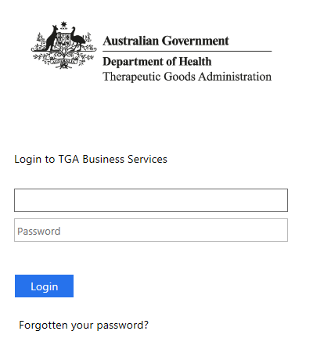
 | For information:  Note that the user name and password are case sensitive.
Once logged in, you will see a personalised work page or ‘dashboard’. What you can see and do on the dashboard will depend on your user role (access level).
At the top of the dashboard, the main menus: Application, Documents and Your TGA are displayed. If you also have financial access, the Financials menu will be displayed.
From this screen you can:
- Access the ‘My work’ menu to work on drafts or view submissions;
- Access the ‘$ My finances’ to view invoices;
- Access the ‘News Panel’ to view the latest TGA news;
- Access the ‘Work on drafts’ and ‘View submissions’ to view all draft and submitted applications;
- View the ‘Applications menu’ – the drop down will display all application types available;
- View the ‘Documents menu’ – the drop down will display manufacturers, Consumer Medicine information and Product information;
- Access the ‘View my organisation’ to edit user details;
- View the ‘Your TGA menu’ – the drop down will display your current ARTG entries and other useful information.

Creating a new RCM or OTC application
Select Applications from the top menu.
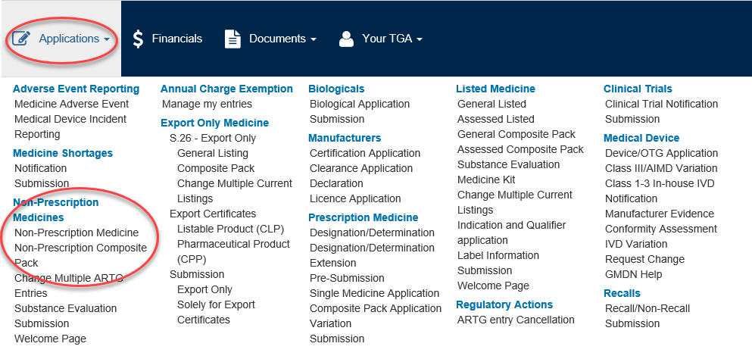
Under Non-Prescription Medicine subheading, select either Non-Prescription medicine for a single medicine RCM or OTC application or Non-Prescription Composite Pack for a composite pack RCM or OTC application.

Draft applications
Previously initiated draft applications, which have not been submitted, can be accessed by selecting ‘Work on drafts’ from the My Work menu:
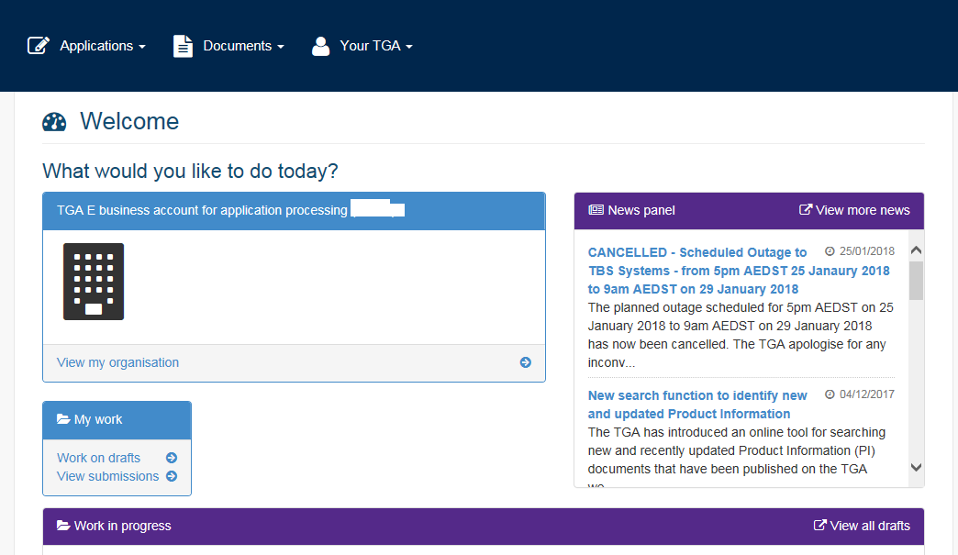
The drafts window will open displaying a list of current draft applications. Click on the draft application you wish to continue editing.
To access other functions such as ‘copy’, ‘delete’ or ‘print preview’, select the arrow to the left of the application.
For information:
Note that draft applications are automatically deleted from the Portal if they have not been updated in the last twelve months. Once deleted, records are not retrievable.

Navigating through an application
Once a new application type or draft has been selected, the application will open.

Menu
There are a two buttons above the Banner:
- Application: allows you to ‘save’ or ‘close’ an application. It also allows for validation once all necessary information has been entered;
- Help: provides definitions and information regarding each step of the application process.
The top right hand side in the Banner displays:
- Application ID: the unique application identification number for the application being displayed (generated when the form is first saved);
- Status: displays the current status of the application;
- Client Reference: a name that can be entered by the application in order to identify the current application and is not visible to TGA.
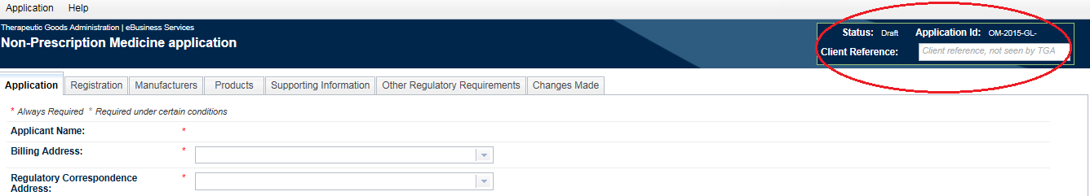

Tabs
There are a number of tabs below the Banner:
- Application: This tab contains general information relating to the application, including: applicant contact details and application type;
- Registration: This tab contains general product information such as: product name, product code;
- Manufacturers: This tab contains manufacturer details and nominated manufacturing steps;
- Products: This tab contains specific information relating to the product including: route of administration, dosage form, container specifications, ingredients, indications and warnings;
- Supporting Information: Supporting information can be uploaded;
- Other Regulatory Requirements: This tab displays regulatory information after validation;
- Changes made: This tab appears after validation when the application is to change an existing ARTG entry. All changes that are made to the application will be displayed on this tab and should be reviewed before submitting.

Required fields
A red asterisk next to a field indicates that it is mandatory.
A grey asterisk indicates a conditional mandatory field (the field must be completed if certain conditions are met).
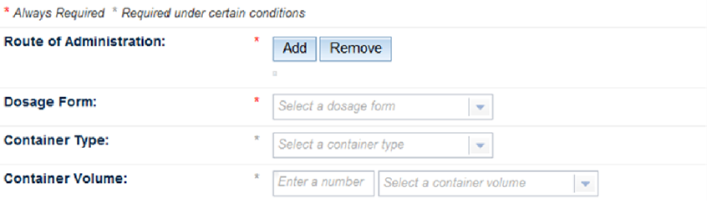

Action toolbar
The action toolbar is located at the bottom right of the form.
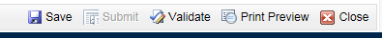

Saving a draft
You can save a draft at any time by selecting Save in the action toolbar. It is recommended you save the application at regular intervals, to ensure no ongoing work is lost.
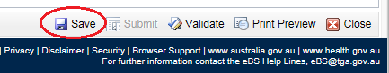

Validation
The application must pass validation before it can be submitted.
Select Validate, located at the bottom right hand side of the form.
The validation process checks that all compulsory fields are completed, and that information is entered in the correct format.
If there are no validation errors, the status of the form (top right of window) will change from Draft to Passed Validation.
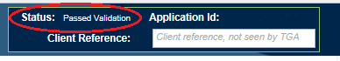

Validation errors
If the form does not validate, the status will remain as Draft. The top right hand corner under Failure Messages, will display the fields you need to amend. You can double click on the message and the system will take you to the field where updating is required.
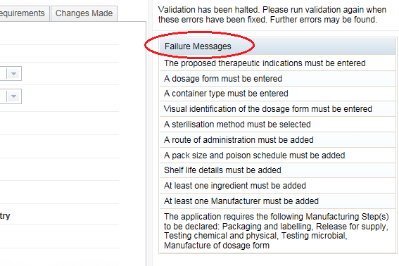
Once you have corrected these fields, save the form and validate. Please note further validation errors may be displayed.
If you have issues with your application, please contact Complementary medicines for assistance.

Printing, deleting, and copying

Printing
You can print the application form at any time before or after submitting.
Prior to submitting the application, a copy can be found in the Drafts list, select the drop-down arrow located on the left hand side of the draft and Print Preview.
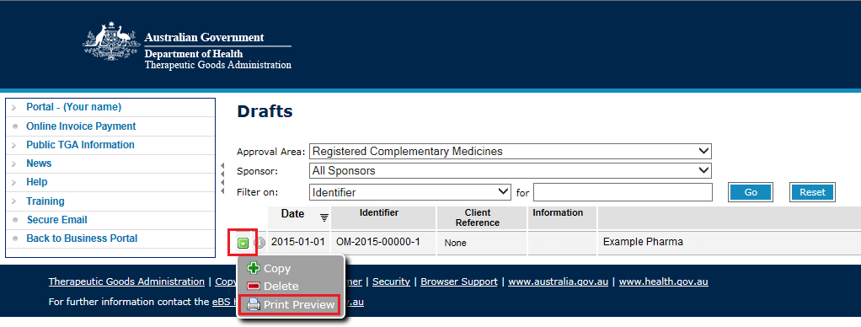
After submitting the application, a copy can be found in the View Lodged Submissions list, select the drop-down arrow and Print Preview.
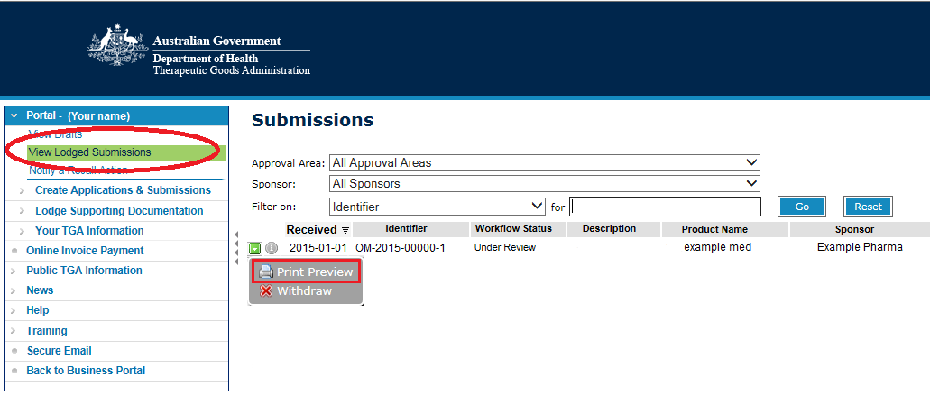

Deleting
You can delete a draft application up until it has been submitted.
Select View Drafts in the navigation panel.
Select the drop-down arrow next to the draft application and Delete.
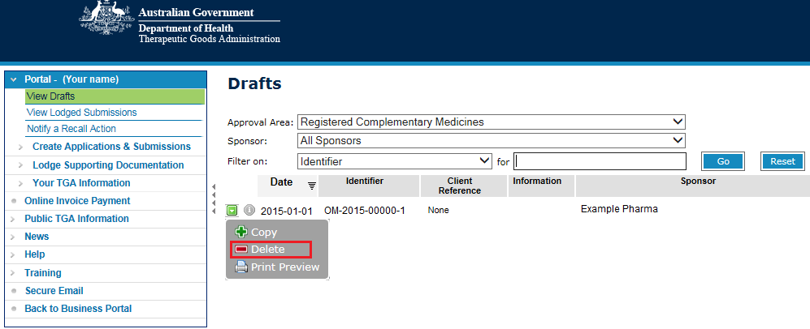
You will need to confirm that you want to delete the draft.
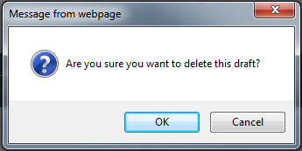
Select OK if you wish to proceed, or Cancel to go back to the Drafts list.

Copying
You can copy any draft application to create an additional draft, which will retain all details previously entered.
Select View Drafts in the navigation panel.
Select the drop down arrow next to the draft application and Copy.
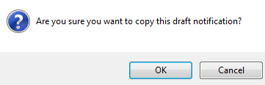
Select OK and a new draft application will be created. Selecting Cancel will take you back to the Drafts list.

Submitting
For information:
It may be useful to make a copy of your application before submitting it.
This is for cases where you need to temporarily withdraw an application, as doing so removes all the originally submitted information.
Once validation has been successful, the Submit button will become available and can be accessed in the action toolbar.
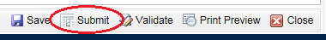

The Declaration
After selecting the Submit button, the Declaration page will be displayed. Read the declaration and either select the ‘Agree’ or ‘Disagree’ button.
Note: by selecting ‘Agree’, you declare that the information given in the application is correct.

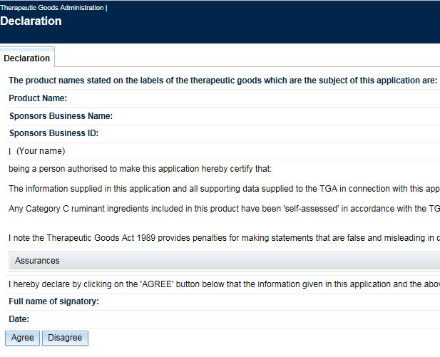

Finalise the submission
Selecting Agree takes you to the submission step, which allows you to:
- confirm submission details;
- add comments in relation to other related submissions and special instructions;
- see the total fee (application + evaluation fee).
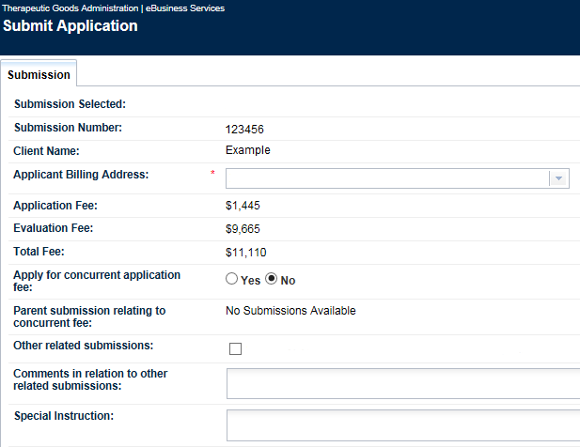
Once completed, select Submit (bottom right-hand corner of the form). The Checklist will be displayed for you to review.
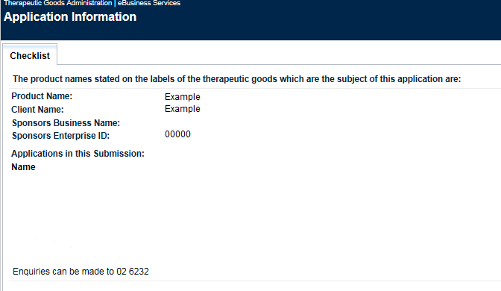
If the information is correct, select Submit at the bottom right-hand corner.
A notification page will be displayed which:
- confirms a successful submission;
- provides your submission number;
- gives instructions for accessing your invoice.

View lodged applications
From the TBS dashboard, there are two ways to access your submissions list:
- Select View submissions from the My work menu
- Select the Submissions tab in the Work in progress list, then select View all submissions
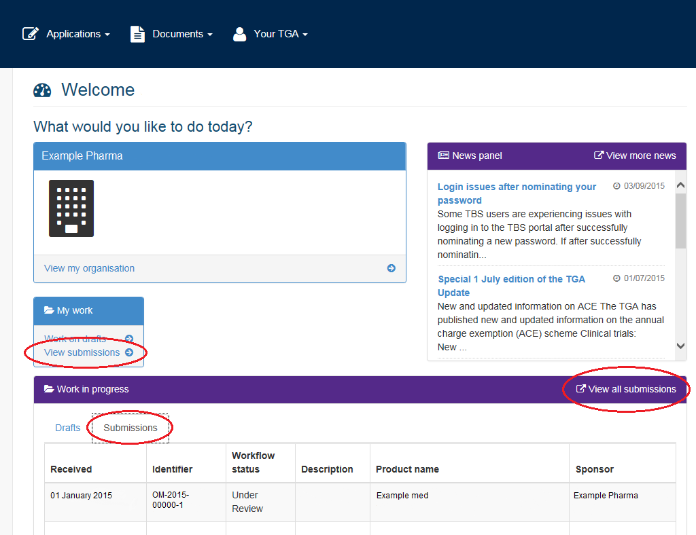
From the navigation panel, select View Lodged Submissions:
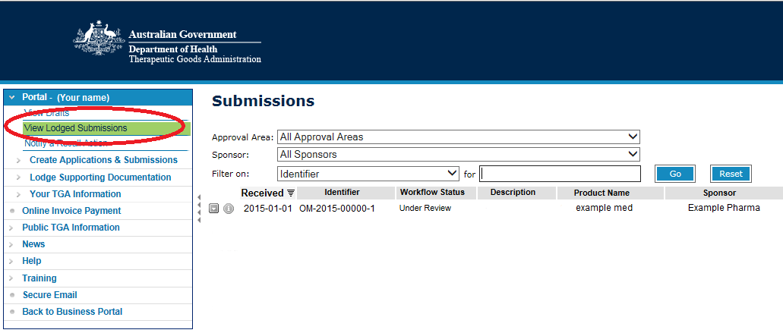
You can view submitted application by selecting the drop-down arrow located on the left hand side of the application and select Print Preview.

Complete an online non-prescription application form
The information below will assist you in providing the required information for completing (and submitting) an online application for an RCM or OTC medicine. The same application is used for both a new ARTG entry or changing an existing ARTG entry).
For information:
This guide is set up to walk you through this application in sequence.
Ensure you complete ALL fields, indicating ‘nil’ or ‘not applicable’ if required.

Application details tab

Applicant name
Pre-populated based on the TBS logon ID used.

Sponsor Name
If your organisation is authorised as an agent for other organisations in TBS, you will be able complete an application on behalf of a sponsor.

Billing address
Select the address for the sponsor from a drop-down list.

Regulatory correspondence address
Select the address for the sponsor from a drop-down list.

Contact person
Enter the contact person for this application.

This application is to:
This field defaults to ‘Create a new ARTG entry’. You will need to select change a current ARTG entry if you wish to update an existing ARTG entry. Selecting this will display additional fields that will need to be completed.

Select application type: new non-prescription medicine
Application types:
- Registered complementary medicine application types will be prefaced with ‘RCM’. For example, RCM1 or RCM5.
- OTC medicine applications will be prefaced with ‘N’. For example, N1 or N5.
Non-prescription medicine applications are categorised according to risk. For information on the levels for non-prescription medicine applications and examples, see:

RCM1 and N1 Category type
If you select the application type RCM1 or N1, an additional field (Parent) will appear requiring you to select the AUST R number of the fully evaluated parent medicine.
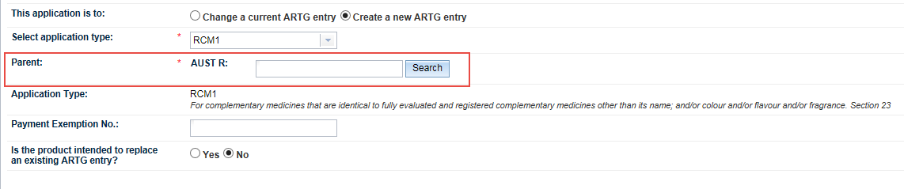

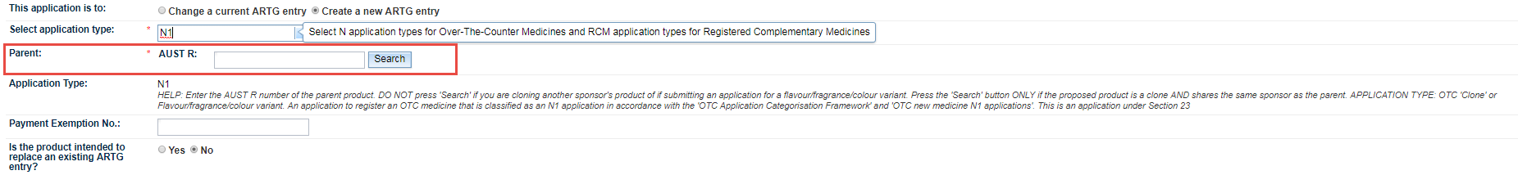
For information:
The Parent AUST R number needs to be entered for all RCM1 or N1 applications. By selecting the Search button for the Parent the application will be auto populated.
Please note that the search button can only be used if the Parent is owned by the applicant. If not, you will need to manually enter the individual fields of the application.

Changes to registered complementary medicine
Applications to change an ARTG entry for a complementary medicine are categorised into five levels (CN to C4 for OTC medicines and RCM-CN to RCM-C4 for RCM) based on increasing risk. The application levels determine approval, data and assurance requirements as well as applicable fees.
For information on determining the change types for your medicine, refer to:
- Changing a registered complementary medicine: Application levels and change tables
- Changes tables for OTC medicines
After you select Change a current ARTG entry, enter the ARTG number of the entry you want to change in the Licence to Change field and select Search.
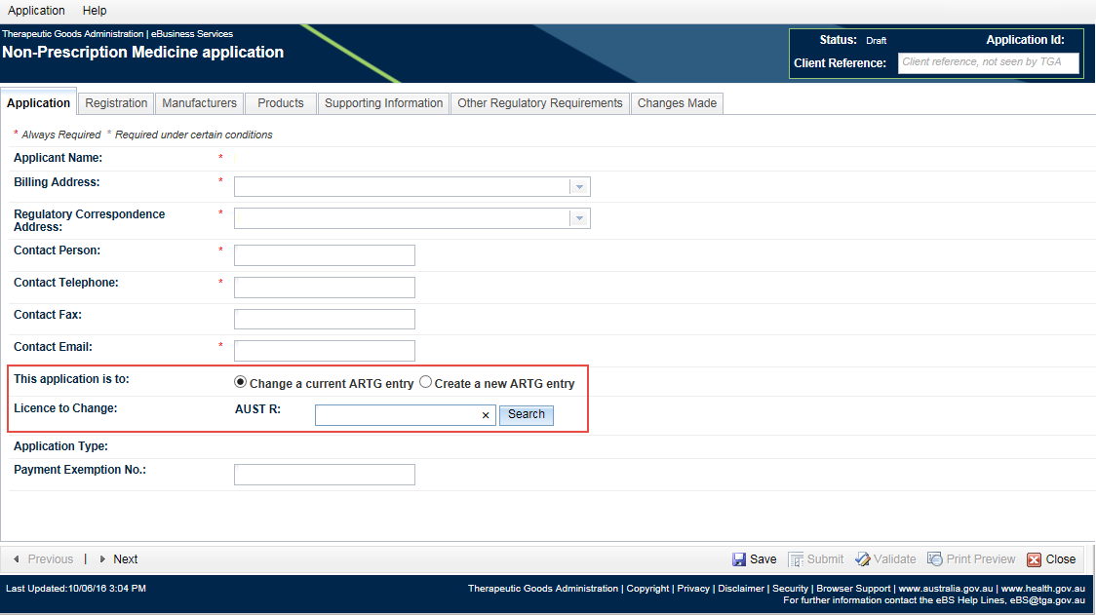
The Changes box will be displayed.
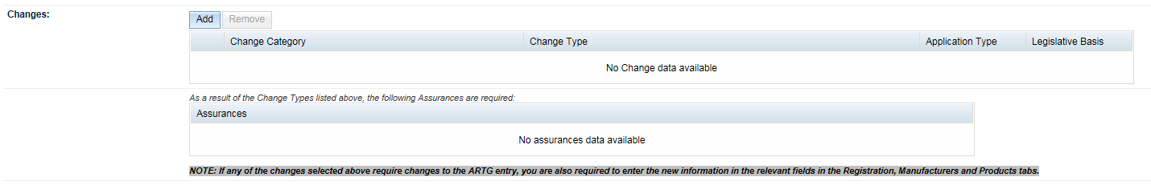
Select Add and the Change Detail window will open.
Select the relevant Change Category from the drop-down list.
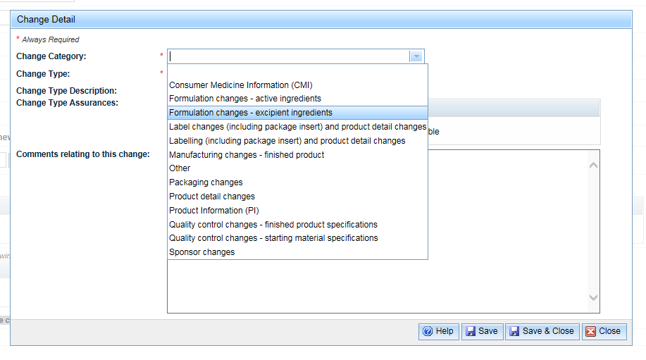
Select the Change Type from the drop-down list.
Note: This list will only contain the change types relevant to the change category you have selected.

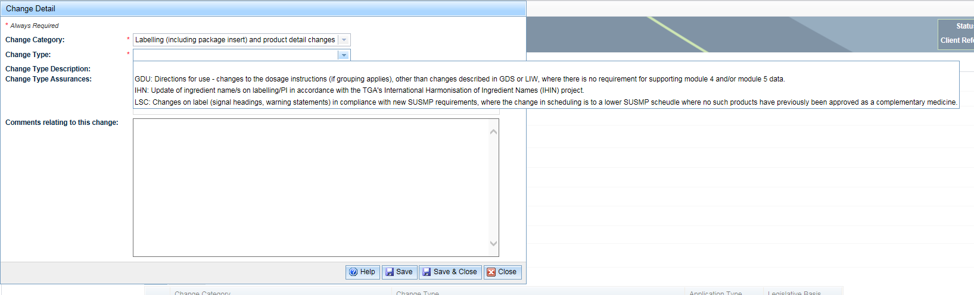
Once the relevant Change Type have been select, the Description and Assurances fields will be pre-populated with the relevant information. You will be able to add comments.
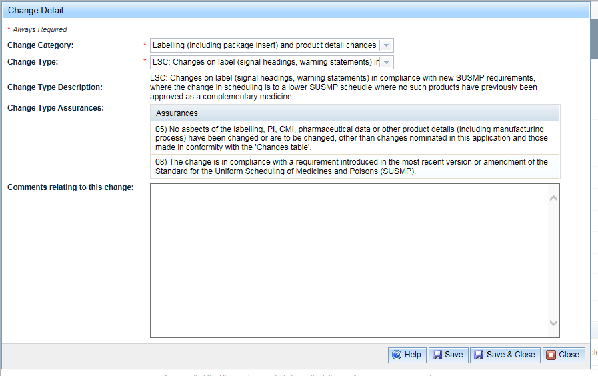
Select Save and Close.
Multiple change types can be added.
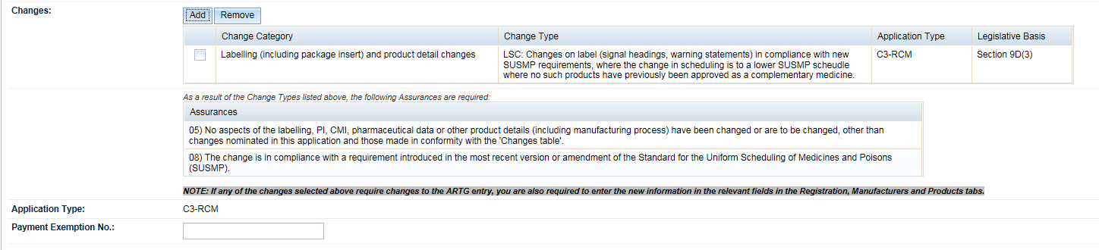
For information
After entering the changes codes you need to ensure that you make the actual change in your application.

Payment exemption number
Exemption from payment is allowed in exceptional circumstance and only available upon written authorisation for TGA.

Registration details tab

Product name
For a new registration application, enter the product name as it is to appear on the ARTG, as follows:
For medicines with single active ingredients:
LABEL NAME + generic name of active + strength of active + dosage form + container type
For products with multiple active ingredients:
LABEL NAME + dosage form + container type
For a change application, only amend this field if proposing a change to the proprietary name.

Export names
To add export names, select Add. A free text box is displayed and the export name(s) can be entered. Multiple export names can be entered.
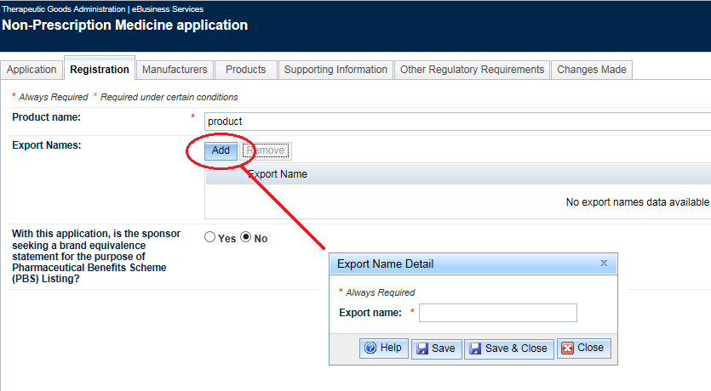

Manufacturer details tab
For change applications, this tab will be pre-populated with the details of the existing ARTG entry.

Manufacturers
To add manufacturers, select Add. The manufacturer details box will be displayed.
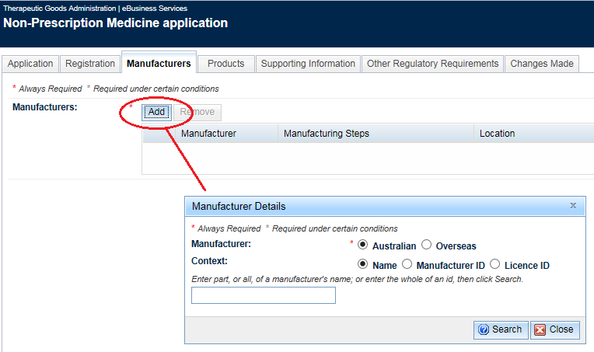
Enter part, or all of a manufacturer’s names or ID and select Search.
Details of the manufacturer will be displayed.
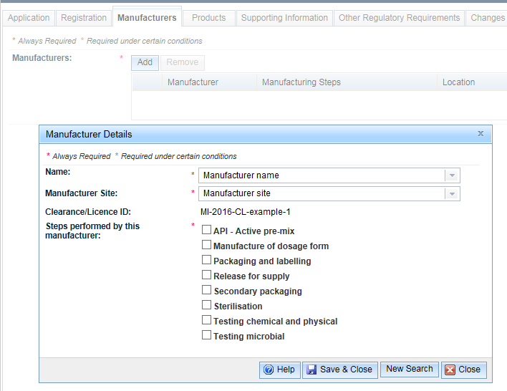
Select the ‘Steps performed by this manufacturer’ and Save & Close.
To remove manufacturers, select the check box next to the entry you wish to delete, and Remove.

Product details tab
For change applications, the fields in this tab will be pre-populated with the information from the existing ARTG entry.

Proposed therapeutic indications
Enter the proposed indications for the medicine.

Additional appliance
Include details if your product contains an additional appliance, e.g. a measuring device.

Dosage form
A dosage form can be selected from the drop-down list or begin entering your proposed dosage form, which will then display a filtered list of possible options from the available list.
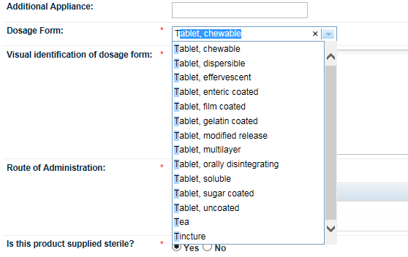

Visual identification of dosage form
Enter the medicine’s visual appearance (visual ID), as specified in the medicine’s Finished Product Specifications document, for example:
- white, circular, biconvex tablets.

Route of administration
A route of administration can be added by selecting Add.
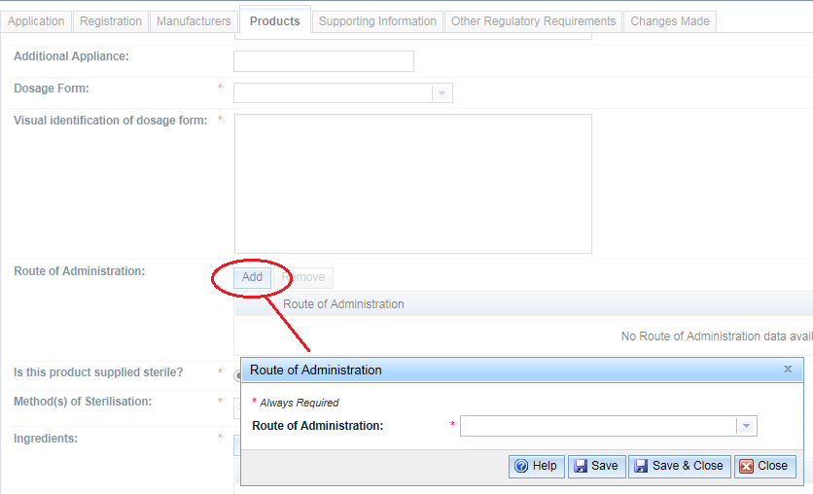
You can either select a route from the drop-down list or begin entering your proposed route, which will then display a filtered list of possible options from the available list. Multiple routes of administration can be selected.
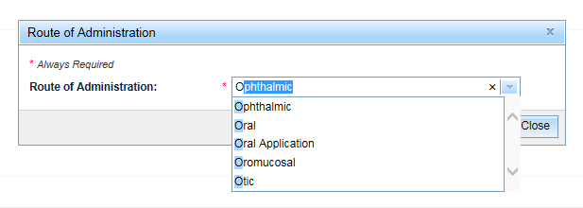

Is the product supplied sterile?
For ‘is the product supplied sterile?’, select Yes or No.
If Yes, select the relevant ‘method(s) of sterilisation’ from the drop down list. You can also begin entering the sterilisation method, which will then display a filtered list of possible options.
If you have selected No, the ‘method(s) of sterilisation’ will be hidden.
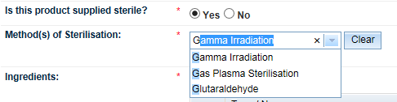

Ingredients
To add ingredients, select Add to open the Ingredient search box.
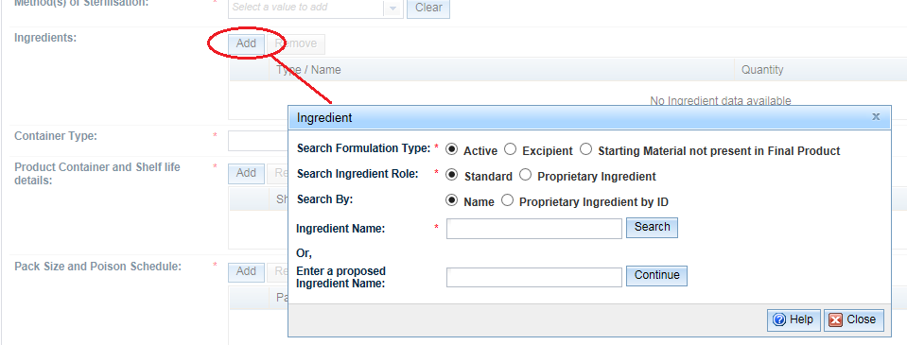
In the Ingredient search box, select the appropriate Formulation Type and Ingredient Role.
- Select search by name or proprietary ingredient by ID
- Enter either:
  - Ingredient Name
  - proposed ingredient name
- If you are searching for an ingredient name, enter your search term and select Search. This will open the Ingredient details box, and enter required fields.
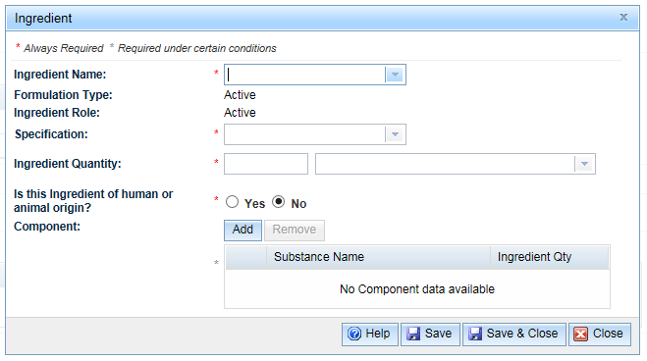
If a component needs to be added, select Add in the Component section. This will open the Add Equivalent search box to either search for a component, or enter a proposed component name.
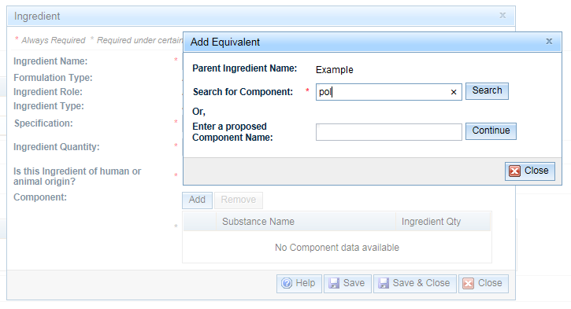
When searching for a component (for example, pollen), you can enter either a full or partial term to search.
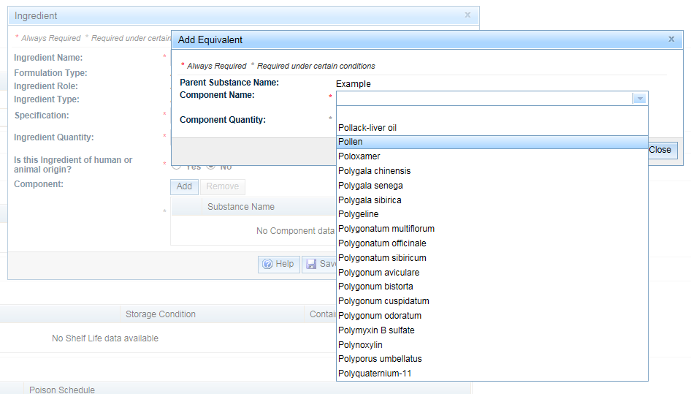
Once your component name is selected, enter the quantity of the component and Save.
Additional components can be entered. When completed Save & Close.

Container type
Container types can be selected from the drop-down list.

Product container and shelf life details
Select Add to open the Product Container and Shelf life details box.
The following details can be added:
- Container material
- Container closure
- Container condition
- Product shelf life
- Product storage conditions
- Additional shelf life information
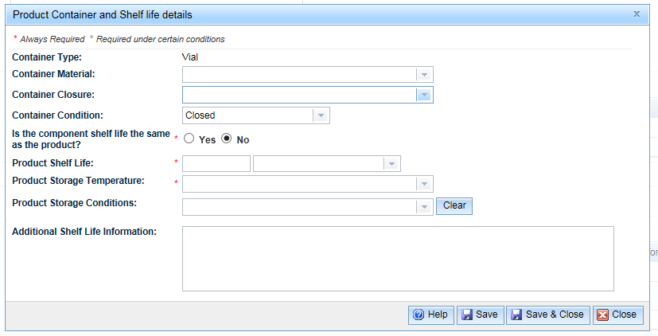
When completed select Save & Close.

Pack size and poison schedule
Select Add to open the Pack Size and Poison Schedule details box.
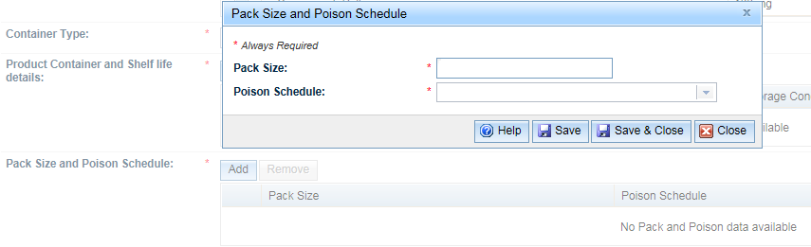
Pack size: Select the Help button for information on pack sizes.
Poison schedule: Select from the drop-down list.
When completed select Save& Close.

Supporting information tab
Supporting information should be attached as a single zipped file or sent separately. The size of an attached file is limited to 100 megabytes.
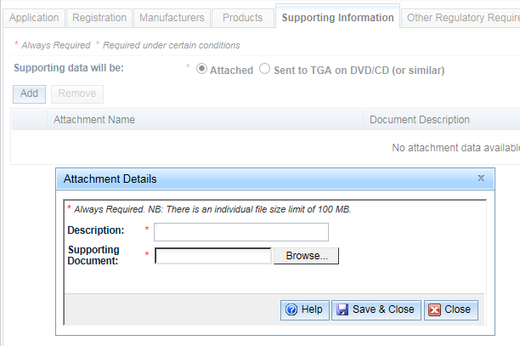

Description
Title of the document is entered.

Supporting document
Selecting the Browse button will open a window that will allow you to search and select the relevant file to upload.
Select Save & Close to attach the file to your application.

Invoice and payment
Once you have submitted your application, an invoice will be created that comprises of:
- an application fee (non-refundable)
- a pre-determined base evaluation fee (refer to Summary of fees and charges).
Important:
Your application will not proceed until both the application fee and base evaluation fees have been paid and the supporting information has been received.
Options on how to make your payment, refer to Payment options.

Preparing to make an application
Useful information for preparing your application can be found in the TBS portal under ‘Public TGA information’. These include:
- Code Tables
- Ingredients
- Ingredients – Proprietary

Code tables
The code tables provide terminology for use in product applications. Data in certain drop-down lists in a RCM or OTC medicine application is populated from Code Tables. Sponsors can view this information prior to creating an application by selecting the ‘Code Tables’ in the TBS navigation panel.
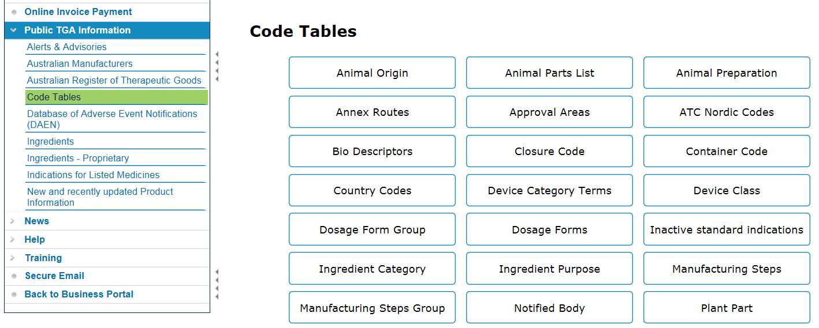
Codes Tables that are most useful for preparing a registered non-prescription medicine application are:
- Dosage Forms
- Dosage Form Group
- Manufacturing Steps
- Manufacturing Steps Group
For information
Note the Code Tables display information for all type of applications e.g. Listed medicines, Non-Prescription Medicines and Prescription Medicines. Therefore, some of the information found in the Code Tables is not applicable to a RCM or OTC medicine application.

Manufacturers
RCM and OTC medicines must be manufactured in accordance with Good Manufacturing Practice (GMP) (unless they are exempt from manufacturing requirements).
You must ensure that your manufacturer has a licence or clearance for the steps of manufacture required for your type of medicine and dosage form.

Manufacturing steps
There are eight manufacturing steps that can be included in a registered non-prescription medicine application. Five of these steps are mandatory in all applications. The other steps must be included in the medicine application in certain situations. Each step can be undertaken by more than one manufacturer but all mandatory steps must be covered by a manufacturer.
Manufacturing step | Mandatory
Manufacture of dosage form | Yes
Packaging and labelling | Yes
Release for supply | Yes
Secondary packaging | No
Testing chemical and physical | Yes
Testing microbial | Yes
API – Active pre-mix | No (except when using an active premix)
Sterilisation | No (except when the product is sterile)
The system will not validate and consequently not allow the medicine to be registered if the manufacturer does not hold a valid licence/certificate with the exact manufacturing step match, unless they have been licenced for a manufacturing step group which contains the specific step.
Further information about what is covered by a particular manufacturing step group or dosage form group can be found in the relevant TBS Code Table.

Manufacturer’s GMP Licence or Clearance – Product Details
The product details of the manufacturer’s licence/clearance will specify the dosage form, product category and manufacturing step that the manufacturer is able to conduct.
For RCM and OTC medicines:
- The product category must be ‘Registered Therapeutic Good’.
- The manufacturing step must be one of the eight described in the above manufacturing step table or be a manufacturing step group that includes one of the seven described steps.
For example, the ‘Finished Product Manufacturer’ group includes the following individual manufacturing steps: ‘Release for supply’, ‘Secondary packaging’, ‘Manufacturer of dosage form’, ‘Testing chemical and physical’, ‘Testing microbial’ and ‘Packaging and labelling’.
‘Active material manufacture’ is not a manufacturing step group and it is an individual manufacturing step that does not work in non-prescription medicine application form.
- The Dosage Form in your GMP licence or clearance must be one of the Dosage forms described in the below Dosage forms table or in a dosage form group which includes the dosage form that you intend to use in your medicine application.

Dosage Forms
The dosage form is the pharmaceutical form in which a product is presented for therapeutic administration, e.g. tablet or cream. Select the dosage form that best suits the application being submitted from the drop down list. Descriptions of the dosage forms can be found in the Code Table for dosage forms.
In an application for a GMP licence or GMP clearance, single or group items can be selected. For example, the single dosage form ‘Liquids’ or the group dosage form ‘Liquids Group’.
Dosage forms that can be used in a registered non-prescription medicine application are:

Dosage form
Application
Bar, soap
Block
Capsule, enteric
Capsule, hard
Capsule, modified release
Capsule soft enteric
Capsule, soft
Cream
Collodion
Drug delivery system
Drug delivery system, ocular
Drug delivery system, transdermal
Diluent, not applicable
Dressing, medicated
Ear Drops
Ear Drops, emulsion
Ear Drops, powder for
Ear Drops, solution
Ear Drops, suspension
Enema
Essential Oil
Extract
Extract, concentrated
Extract, dry
Extract, liquid
Extract, soft
Eye Drops
Eye Drops, emulsion
Eye Drops, powder
Eye Drops, solution
Eye Drops, suspension
Eye Ointment
Eye and Ear Drops
Eye and Ear Ointment
Gel
Gel, eye
Gel, modified release
Granules, effervescent
Granules, enteric-coated
Granules, modified release
Granules
Gum, chewing
Herb, dried
Inhalation, conventional
Inhalation, powder for
Inhalation, pressurised
Inhalation
Insufflation
Liquid, multipurpose
Liquids, tinctures
Liniment
Lotion
Lozenge
Mouthwash
Nasal Drops
Nasal Drops, emulsion
Nasal Drops, powder for
Nasal Drops, solution
Nasal Drops, suspension
Ointment
Oral Liquid, powder for
Oral Liquid, solution
Oral Liquid, suspension
Oral Liquid
Oral Liquid, syrup
Pad, impregnated
Paint, concentrated
Paint, powder for
Paint
Paste
Pastille
Patch, dermal
Pessary, compressed
Pessary, modified release
Pessary, moulded
Pessary, shell
Pessary
Pill
Powder, dusting
Powder, dusting, sterile
Powder, oral
Powder
Solution, irrigation
Solution, powder for
Solution
Soluble Film
Spray, nasal
Spray, pressurised
Spray, solution
Spray, suspension
Spray
Stick, lip
Stick
Suppository, compressed
Suppository, moulded
Suppository, shell
Suppository
Suspension, powder for
Suspension
Tablet, chewable
Tablet, dispersible
Tablet, effervescent
Tablet, enteric coated
Tablet, film coated
Tablet, gelatin coated
Tablet, modified release
Tablet, multilayer
Tablet, orally disintegrating
Tablet, soluble
Tablet, sugar coated
Tablet, uncoated
Tea
Tincture
Wafer
Wipe, medicated

Ingredients of animal origin
All therapeutic goods containing products of animal origin must comply with the Ph. Eur general monograph 1483: Products with risk of transmitting agents of animal spongiform encephalopathies. The assessment for animal derived material must be against the principle and requirements detailed in the Ph. Eur monograph, and can be conducted:
- For low risk materials, by self-assessment; and
- For all other materials, by TGA evaluation.
Additional information can be found Transmissible Spongiform Encephalopathies (TSE): TGA approach to minimising the risk of exposure.
You may need a pre-clearance prior to starting your application.

Trouble shooting in the TBS portal
The TBS portal successfully processes a large number of applications each year; however, occasionally there are system errors that may occur from time to time.
If an application is not behaving in a manner you expect, please DO NOT submit the application. Instead, use this trouble shooting guide below to investigate the issues.
If you are unable to rectify the issue, contact Complementary medicines In your correspondence please include the following:
- application ID (located in the top right corner of your application)
- screen shot of the validation messages and relevant sections of the form
- details of the changes required (applicable to change applications only).

Common IT issues
Issue | Suggestion
When validating, there is an instant validation error. | Stop the validation process and re-validate.
The system is responding slowly or a jumbled screen has appeared. | Clear the cache in the web browser.  Internet Explorer: Press CTRL-SHIFT and click on the refresh button in the address bar at the same time.  Firefox: Press Shift and click on the refresh button in the address bar at the same time.
Your application fails validation. | Read Validation error message carefully and correct the application as per instructions in the Validation message.  Double click on the validation error to be directed to the field that is affected.  You may need to check the requirements if the error is unexpected.
The following system error message appears - “www.ebs.tga.gov.au says: An error occurred while updating some of the page...” | Try re-validating the application until the message disappears. If not contact the TGA via the above email.
When validating an application the following error message appears stating information is required in a particular field, even though the information has been added to the application. | Remove the information, save and validate the application. Re-add the information, save and validate the application.
The validation message appears – Manufacturer is not valid for dosage form. | Check the manufacturer’s GMP licence or clearance and compare with the dosage form in the medicine application.  The product dosage form must be an exact match with the Manufacturer’s licence or clearance or be covered by a dosage form group.  For example, tablet film-coated is covered by the dosage form group Solid Unit Dosage Forms – Tablets.
Your application has validated successfully but when you select ‘Submit’ – the application field is blank. | Ensure that the correct billing address and sponsor name has been selected on any filters.
Your application does not appear in the submission window. | After proceeding to Submission, if a window does not appear advising you of the cost and type of application, your application has not been submitted correctly. You should attempt to re-submit.
Your draft application has disappeared from the system. | Draft application will remain in the system for 365 days. If the application has not been edited in that time, the system will automatically delete it.  To prevent this, open the draft and select save.
Cannot find my medicine in the ‘Change Multiple ARTG entries’ form | Registered complementary medicines cannot be changed in the ‘Change Multiple ARTG entries’ form.  Check that all medicines being changed are OTC medicines.  There are limited changes that can be applied for through the ‘Change Multiple ARTG entries’ form:  - manufacturing details  - shelf life  - visual identifier  - labelling changes under section 9D (where there is no change to the fields in the application form).
One or more of the selected medicine did not pass validation in the ‘Change Multiple ARTG entries’ form | All medicines must be current and pass validation before using the ‘Change Multiple ARTG entries’ form.  You may need to submit separate applications for the medicines that did not pass and address the validation issues separately.

Version history
Version | Description of change | Author | Effective date
V1.0 | Information extracted from ARGCM pages 122-147 to create standalone user guide. The guidance has also been amended to include references to OTC medicine applications as these medicines use the same on line application portal as RCM applications.  Additional information provided on Code tables and common IT issues | Complementary and over the counter medicines branch | May 2020

Therapeutic Goods Administration
PO Box 100 Woden ACT 2606 Australia
Email: info@tga.gov.au Phone: 1800 020 653 Fax: 02 6203 1605
https://www.tga.gov.au
D18-10618784

Changes under section 23 of the Act (known as ‘grouping’ changes) cannot be made through the ‘Change Multiple ARTG entries’ form. For further information, see Changing an OTC medicine: using the Changes Tables.

