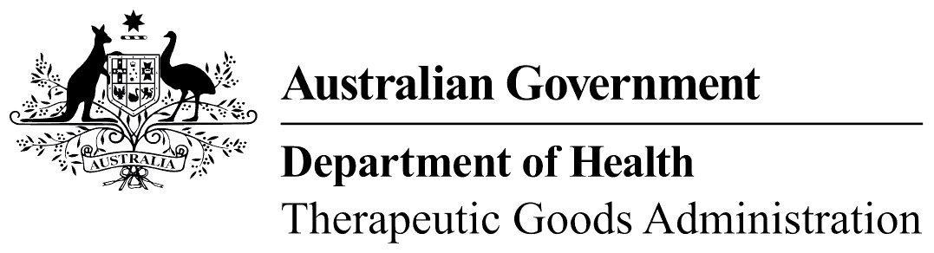
TGA use only

This form, when completed, will be classified as 'For official use only'.
For guidance on how your information will be treated by the TGA see: Treatment of information provided to the TGA at <https://www.tga.gov.au/treatment-information-provided-tga>.

Publication order form
We accept payment by cheque or credit card (MasterCard and Visa only), and credit card payments must be minimum of $10 to a maximum of $20,000.
Cheques should be made payable to: Therapeutic Goods Administration
Orders paid by cheque should be mailed to: TGA Office of Corporate Services, PO Box 100, Woden ACT 2606.
Orders paid by credit card should be emailed to accountsrec@health.gov.au or faxed to 02 6232 8222.

I authorise payment to the Therapeutic Goods Administration for the amount of:
$AUD | $
Being payment for:
Company name:
Company address:
Company phone:

Credit card authorisation
Credit card type: MasterCard: Visa:
Credit card number:
Expiry date:
Authorised signature:
Print name:

