Publication of notified medicine shortages: Updated protocol
  - User guide
Version 1.0, September 2020

Copyright
© Commonwealth of Australia 2020
This work is copyright. You may reproduce the whole or part of this work in unaltered form for your own personal use or, if you are part of an organisation, for internal use within your organisation, but only if you or your organisation do not use the reproduction for any commercial purpose and retain this copyright notice and all disclaimer notices as part of that reproduction. Apart from rights to use as permitted by the Copyright Act 1968 or allowed by this copyright notice, all other rights are reserved and you are not allowed to reproduce the whole or any part of this work in any way (electronic or otherwise) without first being given specific written permission from the Commonwealth to do so. Requests and inquiries concerning reproduction and rights are to be sent to the TGA Copyright Officer, Therapeutic Goods Administration, PO Box 100, Woden ACT 2606 or emailed to <tga.copyright@tga.gov.au>.

Contents
Introduction 4
Background 4
New publication protocol 5
Figure 1: Flowchart - New publication protocol 6
Completing the electronic notification form 7
Consent to publish 7
Proposed date of publication 7
Reasons to support delayed date of publication 7
How to submit reasons to delay publication 8
TBS notification form 8
Via email 9

Introduction
From 14 September 2020, the TGA will publish all medicine shortage notifications for reportable medicines on the Medicine Shortages Information Initiative (MSII) database on the TGA website. We will, however, consider requests to delay the publication of anticipated shortages and future discontinuations, and continue to consult with those sponsors on an appropriate publication date.
To support this change, we have developed a new protocol for the publication of shortages of reportable medicines. There have not yet been any changes to the Medicine Shortages Notification form in TGA eBusiness Services (TBS) to support this protocol. This user guide details an interim solution that allows sponsors to request delays in publication of anticipated shortages and future discontinuations using the current TBS form.
This guide is supplementary to a number of resources developed and published on the TGA website delivered under the Medicine Shortages Information Initiative (MSII) including:
- Management and communication of medicines shortages in Australia – Guidance for sponsors and other stakeholder bodies – November 2018
- Medicine Shortages – Electronic Notification Form: User Guide – December 2018

Background
The TGA publishes information about medicine shortages to ensure that timely and consistent communication is available to industry, health professionals and consumers. Since January 2019, sponsors have been required to notify us of all shortages of reportable medicines. However, to date, publishing has been mandatory only for medicine shortages and discontinuations that have a critical patient impact. Sponsors have been encouraged to agree to publishing of medium and low impact shortages and discontinuations.
Following consultation with industry, we are implementing a new protocol for the publication of notified shortages to improve the availability of information on the MSII database.

New publication protocol
Under the new publication protocol, we will immediately publish all current shortages, including those that do not have a critical patient impact. Anticipated shortages will also be published, but sponsors can still request delays and these will be considered. Discontinuations will also be published, but sponsors can continue to request a delayed publication date for those with a future supply impact date.
A flow-chart detailing the new process is provided below.
 | Key changes  - All current shortages will be published immediately.  - All anticipated shortages will be published. Requests for delays in publication can be made to the TGA.  - All discontinuations will be published. Requests for delays in publication for future discontinuations can be made to the TGA.

Figure 1: Flowchart - New publication protocol
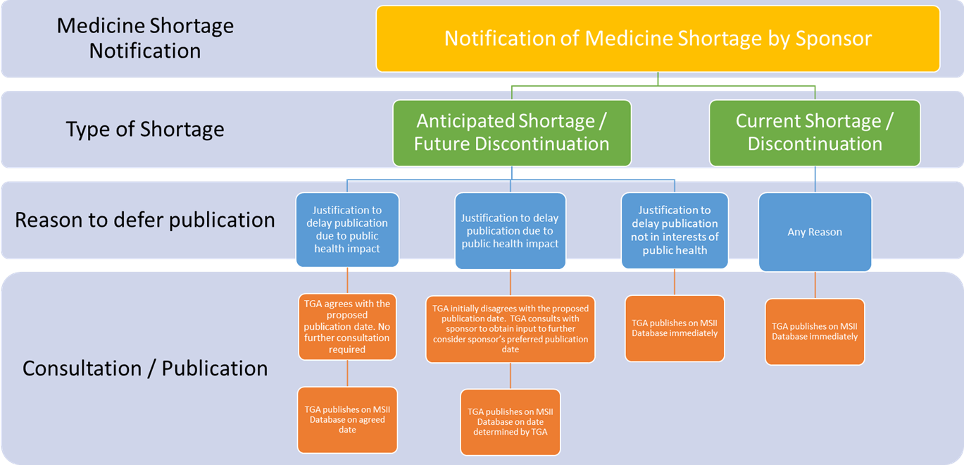

Completing the electronic notification form
Detailed instructions for completing the electronic notification form are in Medicine Shortages – Electronic Notification Form: User Guide – December 2018.
Additional instructions are provided below to take account of the new publication protocol, in the absence of updates to the form itself.

Consent to publish
Sponsors submitting a medicine shortage notification for a shortage or discontinuation with a critical patient impact will not be asked for consent to publish. There is no change to the current process.
Sponsors submitting a notification for a shortage or discontinuation with a medium or low patient impact, will continue to be asked for consent to publish (under the Details tab). However, irrespective of whether sponsors answer yes or no to this question, the TGA will publish all notified shortages and discontinuations in the interests of public health. Sponsors will be asked to acknowledge this when submitting the notification.
Sponsors will be able to request to delay the publication of anticipated shortages and future discontinuations.

Proposed date of publication
Sponsors will continue to be given the option to propose a date of publication for the shortage notification (under the Details tab).
For current shortages and discontinuations:
- We will publish all current shortages and discontinuations as soon as possible after receipt of the notification, irrespective of the proposed date.
For anticipated shortages and future discontinuations:
- We will consider requests to delay the publication of anticipated shortages and future discontinuations if there is a strong public health justification.
- We aim to publish anticipated medicine shortages and future discontinuations in a timeframe that allows sufficient time for healthcare professionals and consumers to prepare in advance of the expected shortage start date.

Reasons to support delayed date of publication
Sponsors must provide information to support any requests to delay the publication of anticipated shortages and future discontinuations.
We recognise that in some instances, sponsors provide compelling public health justifications to delay publication of a medicine shortage notification, for example:
- where an unexpected spike in demand may not result in an actual shortage, depending on the arrival of stock and future demand
- where publication of a shortage is likely to result in stockpiling or panic buying.
In limited circumstances, we will also consider requests to delay the publication of future discontinuations.
We will not consider requests to defer publication because of a medicine’s low market share, small patient population or the availability of exact alternatives.
If we agree with the justification and the proposed date:
We will publish on the agreed date without further correspondence.
If we don’t agree with the proposed date:
We will consult with the sponsor and may ask for further information. After consultation, we will publish the shortage notification unless the shortage is rectified before the planned publication date.
The final decision about the publication date will be at the TGA’s discretion.

How to submit reasons to delay publication
If sponsors wish to delay publication of an anticipated shortage or a future discontinuation, they must provide additional information to support their request.

TBS notification form
There are two ways to include additional information to support a request to delay the publication of anticipated shortages and future discontinuations within the TBS notification form.
- Under the ‘Shortage Action’ tab, include free text as ‘Further comments on communications’.
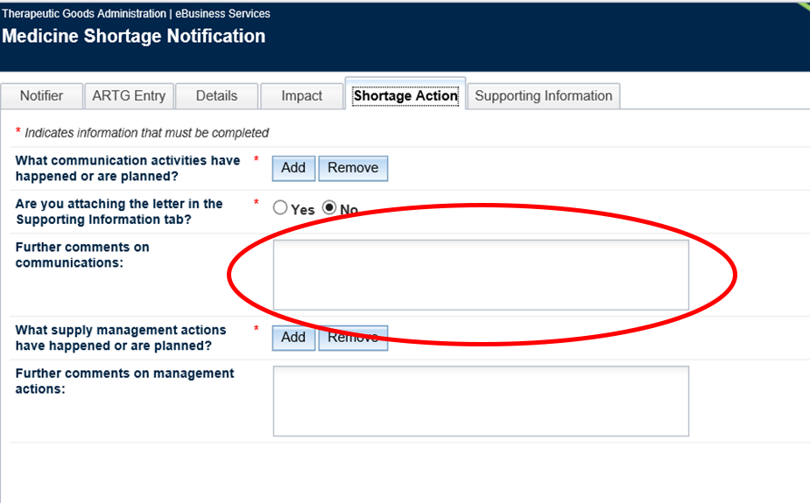
- Attach a separate document to the notification using the ‘Supporting Information’ tab.
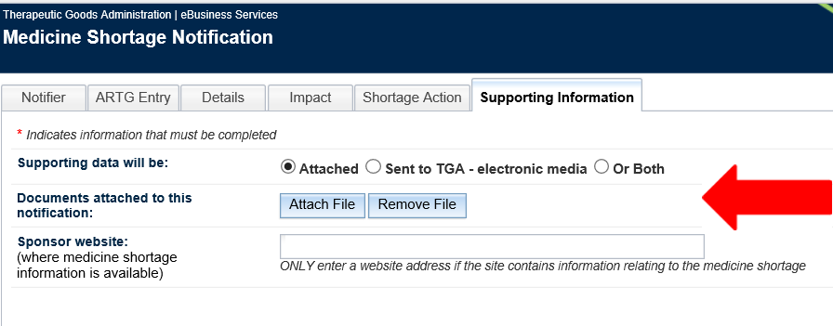

Via email
Additional information to support requests to delay the publication of anticipated shortages and future discontinuations can also be emailed to medicine.shortages@health.gov.au within two (2) working days of submitting the notification. Please include a reference to the notification application ID (as issued at the time of submitting the notification).
Additional information to support request to defer the publication of anticipated shortages and future discontinuations can be provided to the TGA:
- in a free text field in the electronic notification form
- uploaded as a separate document in the electronic notification form
- separately by email to the TGA within 2 working days.

Version history
Version | Description of change | Author | Effective date
V1.0 | Original publication | Medicine Shortages Taskforce | September 2020

Therapeutic Goods Administration
PO Box 100 Woden ACT 2606 Australia
Email: info@tga.gov.au Phone: 1800 020 653 Fax: 02 6203 1605
https://www.tga.gov.au
Reference/Publication #D20-3328683

Critical impact shortages are those that are likely to have a serious or life-threatening impact or for which there are no products registered in Australia that could be used as a substitute.

