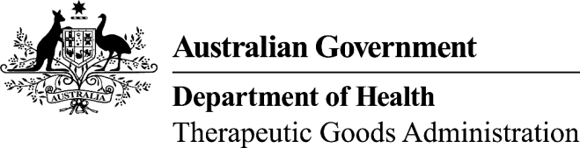
TGA use only
This form, when completed, will be classified as 'For official use only'.
For guidance on how your information will be treated by the TGA see: Treatment of information provided to the TGA at <http://www.tga.gov.au/about/tga-information-to.htm>.

Module 1.6.2 Applicant declaration
  - Drug master files, plasma master files, and EDQM certificates of suitability
Please note: This form is to be completed and included in module 1.6.2 for prescription medicine applications that make reference to one or more drug master files (DMF), plasma master files (PMF), and/or EDQM Certificates of Suitability (CEP).

Part A - Drug substances
The following drug substances are the subject of a DMF or PMF:
The following drug substances are the subject of an EDQM Certificate of Suitability:¹

Part B - Declaration
I confirm:
The drug substance(s) above is/are the subject of either a DMF, a PMF, or an EDQM CEP supplied with this application.
Each drug substance manufacturer has been requested to forward a letter of access to the TGA, authorising the TGA to refer to the DMF/PMF/CEP in the evaluation of the medicine.
The letters of access (Module 1.6.3) include assurances regarding subsequent changes to the manufacture or quality control of the drug substance as required by the TGA.
For submissions referencing an EDQM CEP, all relevant information in the TGA guideline Drug master files and certificates of suitability of a monograph of the European Pharmacopoeia for drug substances has been supplied in the submission dossier.
A formal agreement exists between the applicant of the medicine and each manufacturer of the drug substance(s) that ensures information will be communicated between the applicant and the manufacturer, and to the TGA before any significant change is made to:
- the site of manufacture
- manufacturing procedure
quality control specifications of the drug substance.
Except as permitted by the TGA’s guidelines on changes to medicines, such changes will not be made to the drug substance(s) to be used in the manufacture of medicines destined to be distributed in Australia before written approval is granted by the TGA.
The manufacturer and the applicant understand the consequence of failing to obtain approval for changes to manufacture where approval is necessary, may include deregistration and recall in Australia of batches of medicines containing this material.
Name of authorised officer
Applicant name
Signature |  | Date

If insufficient room, attach a separate page with the required details.

