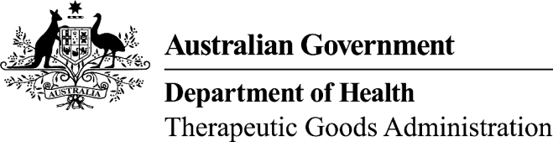
TGA use only
This form, when completed, will be classified as 'For official use only'.
For guidance on how your information will be treated by the TGA see: Treatment of information provided to the TGA at <http://www.tga.gov.au/about/tga-information-to.htm>.

Module 1.6.1 Drug master file, plasma master file and/or EDQM certificates of suitability
Details form
Please note: This form is to be completed and included in Module 1.6.1 for prescription medicine applications that make reference to one or more of the following:
- drug master files (DMF) – complete Part A
- plasma master files (PMF) – complete Part A
- EDQM Certificates of Suitability (CEP) – complete Part B

Part A - Drug master files and plasma master files

Drug substance 1
Name of substance:
Manufacturer’s business name:
Full street address of manufacturing site:
Manufacturer’s client ID (if known):
TGA DMF/PMF file number:
Manufacturer’s letter of access included in module 1.6.3: Yes No

Drug substance 2
Name of substance:
Manufacturer’s business name:
Full street address of manufacturing site:
Manufacturer’s client ID (if known):
TGA DMF/PMF file number:
Manufacturer’s letter of access included in module 1.6.3: Yes No
Note: for additional drug substances, attach a separate page with the required details as above.

Part B - EDQM certificates of suitability (CEP)

Drug substance 1
Name of substance:
Manufacturer’s business name:
Full street address of manufacturing site:
Manufacturer’s client ID (if known):
CEP number and version:
Manufacturer’s letter of access included in module 1.6.3: Yes No

Drug substance 2
Name of substance:
Manufacturer’s business name:
Full street address of manufacturing site:
Manufacturer’s client ID (if known):
CEP number and version:
Manufacturer’s letter of access included in module 1.6.3: Yes No
Note: for additional drug substances, attach a separate page with the required details as above.

Part C - Applicant information
Authorised officer’s name:
Applicant’s name:
Signature: |  | Date:

