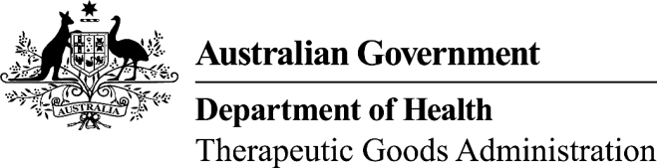
TGA use only
This form, when completed, will be classified as 'For official use only'.
For guidance on how your information will be treated by the TGA see: Treatment of information provided to the TGA at <http://www.tga.gov.au/about/tga-information-to.htm>.

Module 1.4: ‘Local’ (Australian) experts
Please note: Applicants are advised that a signed declaration is required for ‘local’ (Australian) experts, if used. The following is an example of suitable text for this declaration form (please revise as necessary):

Information about the expert
Select those that are appropriate:
Quality Nonclinical Clinical
I, the undersigned, declare that I have:
- the suitable technical or professional qualifications to act in this capacity (for more information, refer to the enclosed curriculum vitae).
- fully examined the data provided by the applicant and have provided references to the literature to support statements made that are not supported by the applicant’s original data. This report presents an objective assessment of the nature and extent of the data.
- provided a report based on my independent assessment of the data provided.
- based my recommendations, regarding suitability for registration, on the data provided herewith. I have considered the attached data and have recommended as to suitability for registration of the intended dose forms and presentations according to the proposed product information document.
I further declare that this expert report represents my own view.
Further, I declare the following to be the full extent of the professional relationship between myself and the applicant:

Select those that are appropriate:
Quality Nonclinical Clinical
Name of expert:
Signature |  | Date
Address:

Module 1.4: Overseas experts
Applicants should note that the TGA requires similar signed declarations from local and overseas experts, however, the following would also be acceptable (please revise as necessary):

Information about the expert
Quality/Nonclinical/Clinical (delete those not appropriate)
According to his/her respective qualifications the undersigned expert declares hereby to have performed the duties set out in the Article 12.2 and in accordance with Annex I, Part I 1.4 of Directive 2001/83/EC, as amended.
Select those that are appropriate:
Quality Nonclinical Clinical
Name of expert:
Signature |  | Date
Address:

