

1 September 2014
First Expression of Interest (EOI) to Participate in an Information Sharing Pilot for the Evaluation of Generic Drug Applications involving the Decentralised Procedure (DCP) of the European Union

The International Generic Drug Regulators Pilot (IGDRP) was launched in April 2012 in the face of mounting pressures that confront generic drug review programs worldwide and a willingness on the part of regulatory agencies to pursue collaboration and convergence in order to help mitigate these pressures. Broadly speaking, this would be realized through:
- increasing the efficiency of review procedures;
- strengthening the regulatory review process and human resource capacity;
- applying an appropriate level of global regulatory oversight through information exchange and coordination, while reducing unnecessary regulatory burden; and
- promoting the adoption of modern science and risk based approaches on the part of both industry and agencies.
Information sharing mechanisms and work-sharing models offer important means of achieving these objectives. One of the most significant developments in this regard involves the piloting of the European Union’s Decentralised Procedure (DCP) as a model for the sharing of information with IGDRP competent authorities external to the EU during the scientific assessment phases of the DCP.
A generic drug applicant wishing to market the same product in the EU through the DCP and in other jurisdictions that form part of IGDRP are invited to participate in this pilot provided that the criteria for eligibility listed below are met. This would include the requirement to file marketing applications in a synchronized manner in at least one of the IGDRP participating jurisdictions. A list of regulatory agencies that have expressed an interest to participate in the first round of the pilot is provided in Appendix 1. Additional agencies may choose to participate in subsequent stages of this pilot.
Under the arrangements established for the pilot, the assessment reports generated as part of the DCP would be shared in real time with collaborating IGDRP agencies outside the EU, as illustrated in the schematic in Appendix 2.
Participation in the pilot would offer applicants the potential to obtain market authorization in chosen markets as part of a coordinated process. Experience gained by industry and regulatory agencies would help to refine the process and inform other information and work sharing models currently under consideration by regulatory agencies. The objective of the pilot is to provide for a more efficient and consistent review process while at the same time reducing regulatory burden and facilitating the similar timing of market authorizations across jurisdictions.
The applicant is required to provide consent to share the DCP assessment reports (Preliminary, Draft and Final) with the non-EU agencies proposed in the EOI. In order to further promote the value and impact of the pilot, interested applicants are requested to provide consent for the sharing of DCP assessment reports ) with other regulatory agencies that form part of IGDRP or may be of interest from a marketing perspective (see EOI Request form, Appendix 3).
Expressions of Interest related to the pilot should be forwarded to the contact points for candidate agencies selected by the applicant (see Appendix 1) and the CMDh Secretariat (H-CMDhSecretariat@ema.europa.eu) at least 8 weeks prior to the intended submission of the application using the EOI form. Applicants should also inform the proposed Reference Member State (RMS) of the EU DCP and the CMDh-Member (http://www.hma.eu/352.html) of this member state about the intention.
Applications to this EOI should are requested by 10 October 2014.
Criteria for Eligibility for the Pilot
In order to qualify for consideration in the pilot, interested applicants must comply with the following criteria:
- Synchronized filing of generic drug applications for the same product in at least one of the IGDRP participating jurisdictions selected for the pilot. Synchronized filing means the applications are submitted at times defined by participating non-EU agencies in relation to the time of filing of the DCP application. The timing will be made available by the IGDRP participating jurisdictions and will be defined in a manner that best aligns the review processes and the flow of information. This may be simultaneous or sequential, depending on the agency.
- Minor differences in products from the product that is intended to be authorised in the EU may be considered acceptable provided these differences are not expected to impact on the safety, efficacy or quality of the product and ensure a similarity the products/dossiers under assessment (e.g., differences in container closure system formats). Non-EU regulatory agencies identified for collaboration in the pilot will confirm the acceptability of any such differences upon review of information submitted with the EOI, including the completed Summary of Quality Differences (see below).
- Complete applications, compliant with respective regulatory requirements, will be filed with the jurisdictions participating in the exercise.
- Original generic drug applications for the following pharmaceutical (dosage) forms:
  - immediate-release, solid oral
  - solutions (e.g., oral, injectable)
- When in-vitro or in-vivo comparative studies against a reference product are warranted, comparative studies should be against the reference product marketed in the jurisdiction of the non-EU regulatory agency participating in the pilot, or against another suitable reference product with the condition that the non-EU agency's requirements for the use of a foreign-sourced reference product are met.
- A completed Summary of Quality Differences form is submitted noting the differences, if any, between the products filed with the EU DCP and the non-EU agency (Appendix 4).
- Consent is provided granting permission for the sharing of DCP assessment reports with non-EU agencies involved in the pilot (Appendix 3).
- Practical knowledge on how to apply and run an EU-DCP is deemed as a prerequisite.
A verification assessment will be undertaken by non-EU agencies to determine whether the product being evaluated meets eligibility criteria.
Appendix 1 - List of Regulatory Agencies interested in participating in the first DCP Information Sharing Pilot
Jurisdiction | Regulatory Agency | Contact Information
Australia | Therapeutic Goods Administration (TGA) | PCSInbox@tga.gov.au
Canada | Health Canada | TPD-DPT.International@hc-sc.gc.ca
Chinese Taipei | Taiwan Food and Drug Administration (TFDA) | lin.bond@fda.gov.tw
Switzerland | Swissmedic – Swiss Agency for Therapeutic Products | Networking@swissmedic.ch  gabriela.zenhaeusern@swissmedic.ch

Appendix 2 – Schematic of how DCP Pilot would operate

The EU has offered to pilot the DCP as a model for the sharing of information with IGDRP regulatory agencies external to the EU during the scientific assessment phases of the DCP. This would involve a parallel review process, with non-EU agencies continuing to conduct separate but synchronized receipt, validation/screening, assessment and market authorization (or refusal) steps, using the outputs from the Step 1 and 2 DCP to inform their scientific assessments
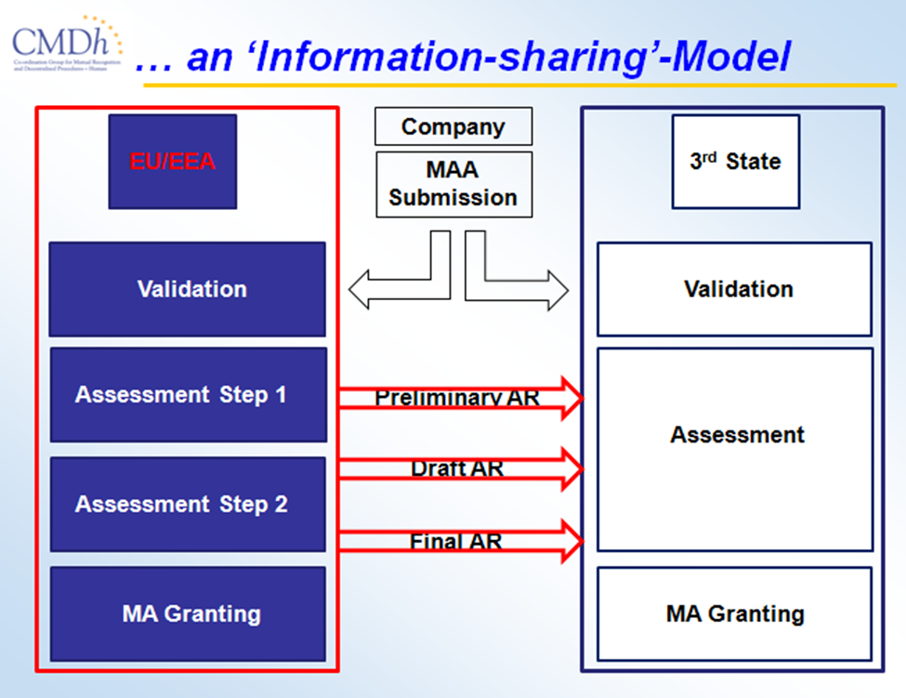

Appendix 3
Expression of Interest (EOI) Request to Participate in the First Information Sharing Pilot for the Evaluation of Generic Drug Applications involving the Decentralised Procedure of the European Union

Product Information
Product Name (should be same as on product label):
Active Pharmaceutical Ingredient:
Pharmaceutical Form | Route |  | Strength |  | Conditions of Use
Applicant Information
Name (Full legal name):
Address:
Contact Person:
Tel: |  | Fax: |  | Email:
Application/submission filing information
Intended filing date in EU Reference Member State:
Reference Member State (RMS):
DCP-Number (if already known):
Concerned Member States (CMS):
Non-EU agencies proposed for this pilot:
Australia (Therapeutic Goods Administration (TGA))
Canada (Health Canada)
Chinese Taipei (Taiwan Food and Drug Administration (TFDA))
Switzerland (Swissmedic, Swiss Agency for Therapeutic Products)

Confirmation of Meeting Eligibility Criteria for Pilot
This marketing application complies with all of the eligibility criteria listed in the Expression of Interest Notice including the following:

Original generic drug application for the following pharmaceutical (dosage) forms:
immediate-release, solid oral
solutions (e.g., oral, injectable)

When in-vitro or in-vivo comparative studies against a reference product are warranted, comparative studies comply with the requirements of the non-EU agencies proposed in this EOI request, as substantiated by evidence appended to the completed EOI Request.

A completed Summary of Quality Differences form is included as part of this EOI Request.

Consent to share regulatory information
The undersigned hereby acknowledges and gives consent to the sharing of DCP assessment reports with
the IGDRP agencies proposed in this EOI Request.

In addition, the undersigned hereby acknowledges and gives consent to the sharing of the same information :

with all IGDRP agencies*, or
with the following agencies:_____________________________________________________

Name of Authorized Signing Official: _________________________________________________

Title, Company: __________________________________________________________________

Signature: _______________________________________________________________________

Date: ____________

* Agencies from the following jurisdictions form part of IGDRP: Australia, Brazil, Canada, China, Chinese Taipei, the European Union, the Republic of Korea, Japan, Mexico, New Zealand, Russia, Singapore, South Africa, Switzerland and the United States as well as the World Health Organization.

Appendix 4 – Summary of Quality Differences
This form must be completed and submitted to each Non-EU agency proposed in the EOI Request
Summary of Quality Differences
Modules and numbering reflect the ICH Common Technical Document.
Modules where there are no differences between the products filed with the EU DCP and the non-EU agency should be reported as “No differences”. Where minor differences exist for a listed module, a brief summary of the details should be described.
Module | Details in application to be filed with the EU DCP | Details in application to be filed with the non-EU agency | Discussion of noted differences
3.2.S Drug Substance
3.2.S.1 General Information
3.2.S.2 Manufacture
3.2.S.3 Characterisation
3.2.S.4 Control of the Drug Substance
3.2.S.5 Reference Standard or Materials
3.2.S.6 Container Closure System
3.2.S.7 Stability
3.2.P Drug Product
3.2.P.1 Description and Composition of the Drug Product
3.2.P.2 Pharmaceutical Development
3.2.P.3 Manufacture
3.2.P.4 Control of Excipients
3.2.P.5 Control of Drug Product
3.2.P.6 Reference Standard or Materials
3.2.P.7 Container Closure System
3.2.P.8 Stability

World Health Organization (WHO) Drug Information Vol. 28 No. 1, 2014 (www.who.int/medicines/publications/druginformation/DI_28-1_Regulatory-Harmonization.pdf?ua=1)

