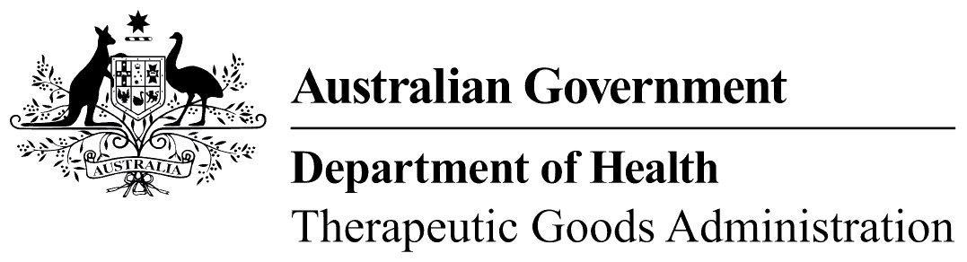
TGA use only

This form, when completed, will be classified as 'For official use only'.
For guidance on how your information will be treated by the TGA see: Treatment of information provided to the TGA at <http://www.tga.gov.au/about/tga-information-to.htm>.

Proposal form
  - Amendment of the Required Advisory Statements for Medicine Labels (RASML)
Applicants should note that ALL information submitted with this proposal will be made available to the public.
Applicants should:
- complete the relevant section(s) of the form as shown below. Note that more than one section may be completed if appropriate;
  - Proposed changes to section 1 (Medicines to which Advisory Statements Apply)
  - Proposed changes to section 2 (Advisory Statements)
  - Proposed changes to section 3 (Additional Requirements)
- complete the BACKGROUND, IMPLEMENTATION and APPLICANT DETAILS sections at the end of the form.
- forward the amendment proposal and supporting documentation as shown below (under CONTACT DETAILS).
If insufficient space has been provided applicants may copy section/s of the form and/or attach further information as required.

Contact details
Submissions may be sent by post, fax or e-mail. Note that where the submission (including its attachments) is more than 20 A4 pages long when printed, the applicant is to send two hard copies of the submission to the postal address shown below, regardless of whether the submission has also been made by e-mail or fax.
RASML Document Manager
Non-Prescription Medicines Branch Telephone: 02 6232 8652
Therapeutic Goods Administration Fax: 02 6232 8145
PO Box 100 E-mail: otc.medicines@health.gov.au
WODEN ACT 2606

Proposed changes to section 1

Proposed change type
I/We propose to amend Section 1 of the Required Advisory Statements for Medicine Labels by (more than one item may be selected):
applying new label advisory statement(s) to a substance or class of substances
removing the requirement for label advisory statement(s) in relation to a substance or a class of substances
adding an additional requirement (from Section 3) to an advisory statement that applies to a substance or class of substances
removing an additional requirement (from Section 3) to an advisory statement that applies to a substance or class of substances
other (specify)

Existing details
The substances currently included in Section 1 of the Required Advisory Statements for Medicine Labels that will be affected by the proposed change are:
None Details are shown in the following table
State the existing information in columns 1 and 2 of Section 1. More than one substance may be included (expand space provided as required)
Column 1  Medicines Containing … | Column 2  Which meet the following requirements

Details of proposed change
It is proposed to amend Section 1 by:
applying the statement(s) shown to the following substance(s) or class of substances under the conditions shown in the following table.
Statements to be applied are: New (see Section 2 below)
Existing (insert numbers): , ,
Copy/expand table as required if more items.
Substance | Conditions under which the statement(s) will apply  (include details dosage form, route(s) of administration, strength (upper and/or lower cut off), indications, pack size, Poisons schedule, other as required. If proposal applies under all circumstances, state “All”.)
AND/OR
removing the requirement that the existing statements (insert numbers) , , , apply to the following substances.
Copy/expand table as required if more items.
Substance | Conditions under which the statement(s) will NO LONGER apply  (include details dosage form, route(s) of administration, strength (upper and/or lower cut off), indications, pack size, Poisons schedule, other as required. If proposal applies under all circumstances, state “All”.)
AND/OR
applying the additional requirement(s) shown to the following statements in relation to the substance(s) or class of substances under the conditions shown in the following table.
Additional requirements: New (see Section 3 below)
Existing (insert letters) , ,
are to be applied to the following statement(s):
New (see Section 2 below)
Existing (insert numbers): , ,
in relation to the following substances under the conditions shown.
Copy/expand table as required if more items.
Substance | Conditions under which the statement(s) will apply  (include details dosage form, route(s) of administration, strength (upper and/or lower cut off), indications, pack size, Poisons schedule, other as required. If proposal applies under all circumstances, state “All”.)
AND/OR
removing the requirement that the existing additional requirements (insert letters): , , are applied to the existing statements (insert numbers) , , , in relation to the following substances under the conditions shown below.
Copy/expand table as required if more items.
Substance | Conditions under which the statement(s) will NO LONGER apply  (include details dosage form, route(s) of administration, strength (upper and/or lower cut off), indications, pack size, Poisons schedule, other as required. If proposal applies under all circumstances, state “All”.)

Proposed changes to section 2

Existing details
The label advisory statement/s currently included in Section 2 of the Required Advisory Statements for Medicine Labels that will be affected by the proposed change are:
None Details are shown in the following table.
State the existing information in Section 2. More than one statement may be included. (Expand space provided as required)
No | Existing Statement Text

Details of proposed change
It is proposed to amend Section 2 by:
adding the new statement(s) shown below
amending existing statement(s) (Insert numbers). , , as shown below
deleting statement number (insert number)
The text of the proposed new/amended statements is shown below (Expand space provided as required).

Proposed changes to section 3

Existing details
The additional requirements currently included in Section 3 of the Required Advisory Statements for Medicine Labels that are affected by the proposed change are:
None Details are included in the following table.
State the existing information in Section 3. More than additional requirement may be included. (expand space provided as required)
Requirement | Existing Text of Requirement

Details of proposed change
It is proposed to amend Section 3 by:
adding new additional requirement(s) as shown below.
amending the existing additional requirement(s) as shown below (insert letters) , ,
deleting additional requirement(s) (insert letters) , ,
The text of the proposed new/amended additional requirements is shown below (Expand space provided as required).

Background

Why is the proposal being made? (expand space provided as required)

How will the safety of the relevant medicines be affected by the proposed change?
The safety of the affected medicines will be:
increased
decreased
unaffected

The following evidence is provided in support of the proposed change:
(Expand space provided or attach relevant documents as required. Include safety data, risk analysis etc where appropriate)

Other options that have been considered are (Expand space provided or attach relevant documents as required):

The costs and benefits of the proposed change are (Expand space provided or attach relevant documents as required):

The costs and benefits of the other options are (Expand space provided or attach relevant documents as required):

Other relevant information is (Expand space provided or attach relevant documents as required):

Implementation
It is proposed that a transition period for the introduction of the changes to relevant labels of existing products will be:
12 months from the date of Gazettal
Other (specify, giving reasons for longer/shorter time proposed)

Applicant details
Organisation name:
TGA Client ID No (if any):
Contact person:
Address (postal):
Telephone: |  | Fax:
E-mail:

Consultation

TGA Use Only
Date commences |  | Date closes

