Introduction to the Permissible Ingredients Determination
Version 1.0, December 2020

Copyright
© Commonwealth of Australia 2020
This work is copyright. You may reproduce the whole or part of this work in unaltered form for your own personal use or, if you are part of an organisation, for internal use within your organisation, but only if you or your organisation do not use the reproduction for any commercial purpose and retain this copyright notice and all disclaimer notices as part of that reproduction. Apart from rights to use as permitted by the Copyright Act 1968 or allowed by this copyright notice, all other rights are reserved and you are not allowed to reproduce the whole or any part of this work in any way (electronic or otherwise) without first being given specific written permission from the Commonwealth to do so. Requests and inquiries concerning reproduction and rights are to be sent to the TGA Copyright Officer, Therapeutic Goods Administration, PO Box 100, Woden ACT 2606 or emailed to <tga.copyright@tga.gov.au>.

Contents
About this guidance 4
The Permissible Ingredients Determination 4
Limitations of the Determination 5
Responsibilities of the sponsor 5
Using the Permissible Ingredients Determination 6
Terminology 6
Volumes 6
Columns 7
Ingredients not found in the Permissible Ingredients Determination 8
Ingredients Table 8
Case study: George and his sting relief product 8
Acetic acid requirements from the Determination 10
Almond oil requirements from the Determination 10
Melaleuca oil requirements from the Determination 10
Summary 11

About this guidance
This guidance is to assist sponsors of listed and assessed listed medicines to understand ingredient requirements for market authorisation. This guidance will take you through how to access and use the Therapeutic Goods (Permissible Ingredients) Determination (‘Permissible Ingredients Determination’ or ‘the Determination’) for this purpose.
To supply a listed or assessed listed medicine in Australia, sponsors need to submit a market authorisation application to the Therapeutic Goods Administration (TGA) to include their medicine in the Australian Register of Therapeutic Goods (ARTG). One component of market authorisation is compliance with the requirements for each ingredient used in the formulation of your medicine.
The TGA is authorised to pursue sanctions and penalties against those who do not comply with market authorisation requirements and other applicable regulatory requirements for therapeutic goods.
 | If you are unsure if you have a therapeutic good or whether you have a listed, assessed listed or registered medicine, use our decision tool: Is my product a therapeutic good?  To understand the differences between different types of medicines, see How we regulate medicines.
For further information on market authorisation requirements for listed and assessed listed medicines, see Parts B and C of the Australian Regulatory Guidelines for Complementary Medicines (ARGCM).

The Permissible Ingredients Determination
The Permissible Ingredients Determination provides an alphabetical list of low-risk ingredients and their requirements that we consider suitable for use in listed and assessed listed medicines. Listed and assessed listed medicines may only use ingredients found in the Determination.
Other medicine types, such as registered complementary medicines, over the counter (OTC) medicines and prescription medicines, may use ingredients from the Permissible Ingredients Determination, but unlike listed and assessed listed medicines, they are not limited to ingredients specified in the Determination. Registered medicines may use ingredients found in Schedules 2, 3, 4 and 8 of the Poisons Standard (Standard for the Uniform Scheduling of Medicines and Poisons or SUSMP).
The Determination outlines specific requirements of use for individual ingredients. This includes (but is not limited to) how an ingredient can be used, if it requires a label advisory statement and any quantity restrictions that must be complied with.
‘26BB’ is a common term used by regulatory affairs agents to refer to the Permissible Ingredients Determination. This is because Section 26BB is where the Determination is referenced in the Therapeutic Goods Act 1989.
The Determination is located on the Federal Register of Legislation (FRL) and is updated regularly to incorporate new ingredients, remove ingredients (this may be due to safety issues or scheduling changes in the Poisons Standard) and amend existing requirements. Make sure you are looking at the version labelled ‘In force – latest version’.
Notice of updates to the Permissible Ingredients Determination can be found in Regulatory decisions & notices (complementary medicines). This also provides background information on reasons behind the changes.

Limitations of the Determination
The Determination will not tell you everything you need to have on your label or everything you must consider for the manufacture of your goods. The Determination works in conjunction with other relevant legislation such as the Advertising Code, Therapeutic Goods Order No. 92 – Standard for labels of non-prescription medicines (TGO 92) and the Poisons Standard (the SUSMP).
Full details of an ingredient, such as the Chemical Abstracts Service (CAS) number, ingredient category and naming reference can be found in the Ingredients Table through the TGA Business Services (TBS) portal, but these details won’t appear in the Determination.

Responsibilities of the sponsor
If you are a sponsor of a listed or assessed listed medicine, you must ensure that your medicine formulation complies with the Permissible Ingredients Determination. You can ask your manufacturer, or regulatory affairs agent to perform this step for you, or you can check the Determination yourself for individual ingredient requirements and restrictions.
You are responsible for ensuring all ingredients in your medicine, even those within a Proprietary Ingredient (PI) are compliant. In some circumstances, you may need to ask the supplier of your PI to check the PI’s contents on your behalf, as PI content may be hidden from you due to intellectual property rights.
TGA Business Services (TBS) is the online portal used to apply to have a medicine entered in the ARTG and is where you need to enter details of you ingredients. TBS will help you validate your ingredients as you enter them, but it will not be able to capture all checks required. Just because you have successfully listed your medicine through TBS, does not mean your medicine is compliant.
Consult the Determination prior to listing so you know the requirements of your ingredients and the impact these may have on your medicine.
It is your responsibility as the sponsor to ensure compliance of your medicine with all relevant legislation. The ARGCM and the Australian Regulatory Guidelines for Sunscreens (ARGS) contain further information regarding other regulatory requirements not mentioned here.

Using the Permissible Ingredients Determination
The first few pages of the Determination provide definitions and clarifies how to interpret the list of permissible ingredients.

Terminology
Search the Determination using Australian approved terminology. Approved names fall into the following categories:
- Australian Approved Name (AAN)
- Australian Biological Name (ABN)
- Australian Herbal Name (AHN)
- Australian Herbal Substance (AHS)
Within the Determination, it is important to note the following abbreviations:
- ’A’ means an active ingredient: the therapeutically active component in a medicine's final formulation that is responsible for its physiological or pharmacological action.
- ’E’ means an excipient ingredient: an inactive substance which does not contribute to the physiological action in a medicine’s final formulation.
- ’H’ means a homoeopathic ingredient: an ingredient that is a constituent of a homoeopathic preparation. These have specific requirements and may not be able to be used in non-homoeopathic medicines.

Volumes
The Permissible Ingredients Determination is separated into volumes, which are categorised alphabetically according to ingredient name:
- volume 1 – 1 to A
- volume 2 – B to E
- volume 3 – F to J
- volume 4 – K to O
- volume 5 – P to T
- volume 6 – U to Z
While in the Determination you can press ‘CTRL+F’ (PC) or ‘Command+F’ (Mac) to bring up the ‘find’ function. Type in your ingredient and any instances of that term will be highlighted in the document.
This function will not work between volumes. Make sure you have the correct volume open (e.g. volume 3, inclusive of the letter ‘F’) to search for ‘folate’, otherwise you will not be able to locate it.

Columns
The Determination is structured into columns of information:
- Column 1 numerically lists the ingredients
- Column 2 shows the Australian approved name of the ingredient
- Column 3 shows the purpose of the ingredient, as an active (A), excipient (E) or homoeopathic (H) ingredient
- Column 4 shows the requirements associated with the ingredient
Figure 1. A screenshot of the Determination showing the layout of information and different columns.
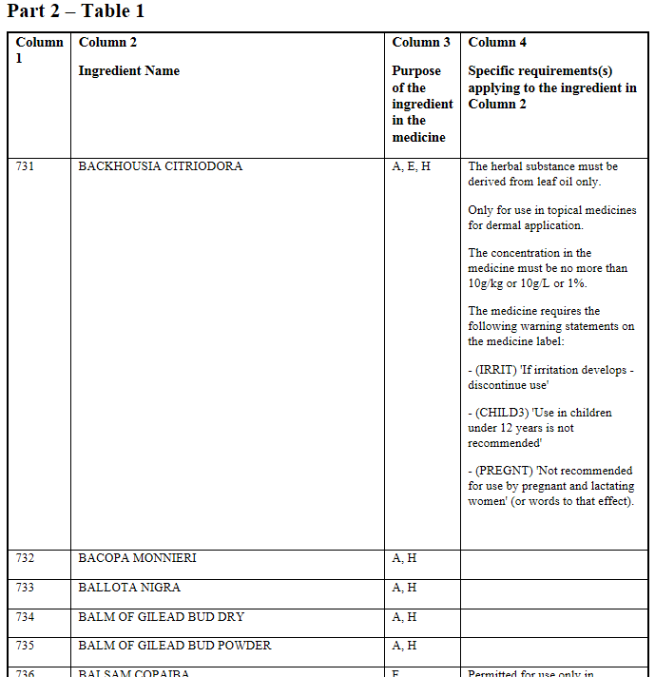

Ingredients not found in the Permissible Ingredients Determination
If the medicine you propose to submit for inclusion on to the ARTG contains an ingredient not included in the Permissible Ingredients Determination, the following options are available:
- Check the Poisons Standard to see if your ingredient is subject to a schedule. If your ingredient is scheduled, your proposed medicine may be a registered medicine (i.e. a prescription medicine, over-the-counter medicine or registered complementary medicine), which have different requirements from listed medicines.
- You may submit an application for a substance evaluation to include an ingredient in the Determination, provided that it is not subject to a schedule to the Poisons Standard. Our User guide: Evaluation of substances for use in listed medicines contains relevant information on how to submit an application to create a new entry or amend an existing one, such as adding an additional route of administration.

Ingredients Table
TGA Business Services (TBS) contains a user-friendly database called the Ingredients Table, which allows you to search for an ingredient by its approved name and synonyms. It contains other information about ingredients such as the CAS number and the name category (AAN, ABN etc.).
Restrictions found in the Ingredients Table are the same as those found in the Permissible Ingredients Determination. As the Permissible Ingredients Determination is a legal instrument presenting the most up to date and enforceable information, the Determination is the best source of information to reference.

Case study: George and his sting relief product
George wants to supply a sting relief product and using the ‘Is my product a therapeutic good?’ decision tool, has determined it is a listed medicine.
George’s product contains:
- melaleuca oil as an active ingredient
- acetic acid as an active ingredient
- almond oil as an excipient
George needs to make sure his medicine is compliant with the requirements of the ingredients in his formulation.
First, George checks the Permissible Ingredients Determination to make sure each of his ingredients is permitted for use in a listed medicine and to understand their individual requirements.
He searches:
- Volume 1 (1 to A) for acetic acid
- Volume 1 (1 to A) for almond oil
- Volume 4 (K to O) for melaleuca oil
These ingredients are included in the Determination, which confirms that he can use them in his listed medicine. He reviews the following information shown below to understand how he can use them:
Figure 2: acetic acid search result
Figure 3: almond oil search result
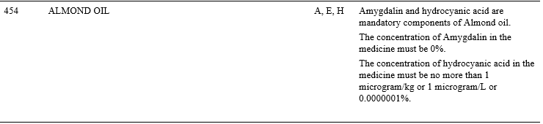
Figure 4: melaleuca oil search result
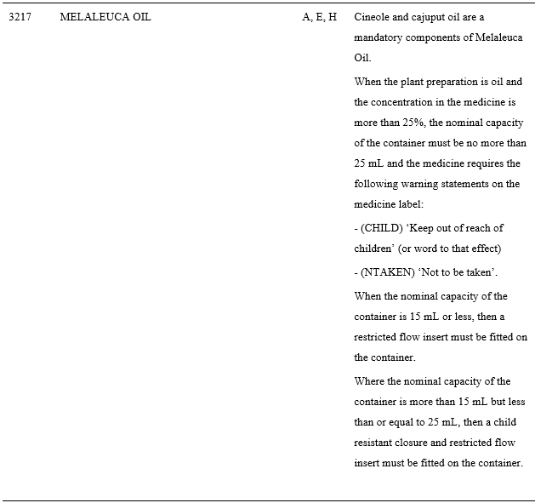
George notes the specific requirements that apply to the ingredients (seen in columns 3 and 4). Now he needs to understand the implications of all these requirements.

Acetic acid requirements from the Determination
- Has a permitted use of ‘E’ (as an excipient) and ‘H’ (as a homoeopathic ingredient)
- The concentration in the medicine must be no more than 80%

George’s considerations
George has spotted that acetic acid is only available as an ‘E’ and ‘H’. He could revise his formulation, pick an active to replace acetic acid, or consider using it as an excipient.
George thinks it could be safely used as an active. As his medicine must comply with the requirements, he decides to submit an application for acetic acid to be evaluated as an active. Depending on this outcome, he may or may not be able to use it as an active. George will not be able to supply his product until the outcome is known and it is listed on the ARTG.
George can contact his manufacturer to make sure his concentration of acetic acid is correct (less than 80%) if he is unsure.

Almond oil requirements from the Determination
- Has a permitted use of A, E, H
- Amygdalin and hydrocyanic acid are mandatory components of almond oil.
- The concentration of amygdalin in the medicine must be 0%
- The concentration of hydrocyanic acid in the medicine must be no more than 1 microgram/kg or 1 microgram/L or 0.0000001%

George’s considerations
George wants to use almond oil as an excipient and he can as this is permitted.
George must declare the concentrations of amygdalin and hydrocyanic acid as mandatory components of almond oil in his market authorisation application. Even if those concentrations are 0%, George must still declare this information.
George ensures that the concentration of amygdalin contained in his medicine is 0% and the concentration of hydrocyanic acid is no more than 1 microgram/kg or 1 microgram/L or 0.0000001% by assay through his manufacturer.

Melaleuca oil requirements from the Determination
- Has a permitted use of A, E, H
- Cineole and cajuput oil are mandatory components
- When the plant preparation is oil and the concentration in the medicine is more than 25%, the nominal capacity of the container must be no more than 25 mL and the medicine requires the following warning statements on the medicine label:
  - (CHILD) ‘Keep out of reach of children’ (or words to that effect)
  - (NTAKEN) ‘Not to be taken’
- When the nominal capacity of the container is 15 mL or less, then a restricted flow insert must be fitted on the container
- Where the nominal capacity of the container is more than 15 mL but less than or equal to 25 mL, then a child resistant closure and restricted flow insert must be fitted on the container

George’s considerations
George wants to use melaleuca oil as an active and he can as this is permitted.
George must declare the concentrations of cineole and cajuput oil as mandatory components of melaleuca oil in his market authorisation application. Even if those concentrations are 0%, George must still declare this information. George will speak to his manufacturer about ensuring cineole and cajuput oil are assayed to determine the amount present so he can declare them in his market authorisation application.
George knows that the melaleuca oil concentration in his medicine is at 26%. He has a 25mL container for his medicine, which is compliant. He understands that he cannot use a larger container while the concentration remains more than 25%. George also makes a note to include both warning statements on the label of his medicine.
George already has a 25 mL container, but realises that as his product contains melaleuca oil, he will need to get a child resistant closure and restricted flow insert for it.

Summary
If George did not consult the Determination before entering his product in the ARTG, he may not have realised he needed to:
- include specific warning statements on his label
- apply for acetic acid as an active ingredient before he can supply it
- declare certain ingredient components even if they exist in 0% concentrations
- ensure he had a child resistant closure and flow insert for his medicine.
Note that the ingredient details used in this case study are accurate at the time of publishing. Please refer to the current Permissible Ingredients Determination for the most recent information.

Version history
Version | Description of change | Author | Effective date
V1.0 | Original publication | Regulatory Engagement, Education & Planning Branch | December 2020

Therapeutic Goods Administration
PO Box 100 Woden ACT 2606 Australia
Email: info@tga.gov.au Phone: 1800 020 653 Fax: 02 6203 1605
https://www.tga.gov.au

