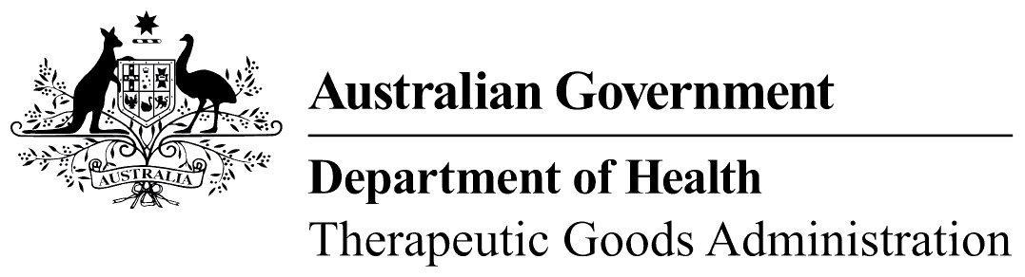
TGA use only
This form, when completed, will be classified as 'For official use only'.
For guidance on how your information will be treated by the TGA see: Treatment of information provided to the TGA at <https://www.tga.gov.au/treatment-information-provided-tga>.

Notice that a certificate under subsection 26B(1) of the Therapeutic Goods Act 1989 is not required
I,
[Name and where applicable, relationship to applicant]
[Applicant name]
[Applicant address]
hereby notify the Secretary of the Department of Health that, in relation to the application under section 23B and 23C of the Therapeutic Goods Act 1989 (the Act) for the registration under section 25AB (registered medicines), or listing under section 26 (export only medicines) or section 26AE (assessed listed medicines), of the following therapeutic goods (the goods):
[Product name*]
[Submission number]
a certificate under subsection 26B(1) of the Act is not required because either (1) or (2) below applies (strike out whichever of these is inapplicable):
- I, as the Applicant, am not required to submit evidence or information to establish the safety or efficacy of the goods as part of the process of applying for registration or listing.
OR
- I, as the Applicant, am required to submit evidence or information to establish the safety or efficacy of the goods as part of the process of applying for registration or listing but, in order to satisfy this requirement, I am not relying (in whole or in part) on evidence or information that another person submitted to the Secretary:
    - to establish the safety or efficacy of other therapeutic goods that have already been registered or listed; and
    - as part of the process of applying for the registration or listing of those other goods.
Signature |  | Date
* As it is to appear on the Registration or Listing Certificate – generally trade name, active ingredient name (if one only) and quantity, dosage form and container type, so as to distinguish the product from other products entered in the ARTG.

