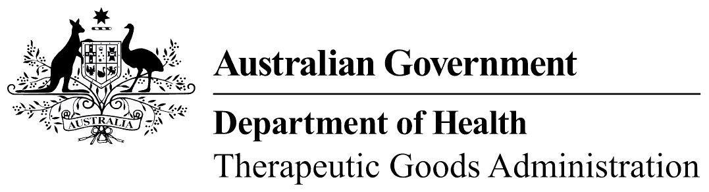
TGA use only
This form, when completed, will be classified as 'For official use only'.
For guidance on how your information will be treated by the TGA see: Treatment of information provided to the TGA at <https://www.tga.gov.au/treatment-information-provided-tga>.

Inspection feedback form – Routine
 | Please note  The terms ‘inspection’ and ‘inspector’ are synonymous with the terms ‘audit’ and ‘auditor’, which are used by the Medical Devices Branch.

Notice
This form is intended to provide general feedback on the planning, conduct and communication of routine inspections undertaken by the TGA. The information received will be used to review processes and for internal training.
Feedback received through this form will not be regarded as a complaint. If you wish to lodge a complaint, please follow the Inspections & inspectors complaint process

Privacy Information
The TGA collects your personal information in this form to provide context to your feedback. For information about how your personal information is protected under the Privacy Act 1988 please go to <https://www.tga.gov.au/privacy>.

Part 1: Manufacturer and inspector details
Manufacturer
Address of manufacturing premises
Date of inspector(s) |  | Inspector(s) names

Name |  | Position
Signature |  | Date

Part 2: Before the inspection
 | Yes | No
- Were you satisfied with the notice given for the dates of the inspection?
- Were you provided with an inspection plan at the opening meeting?
- Was the purpose of the inspection and the inspection process explained to you?

Comments: (add additional pages if required)

Part 3: Conducting the inspection
 | Yes | No
- Were you satisfied with the amount of time allocated for the inspection? |  | Not enough time
 |  | Too much time
- Was the inspection organised in a logical manner?
- Were you provided with explanations by the inspectors of their observations?
- Were you provided sufficient opportunity to comment on the inspectors’ observations?

Comments: (add additional pages if required)

Part 4: Completing the inspection
 | Yes | No
- Was a list of items for discussion provided to you at the closing meeting?
- Were you provided enough opportunity to clarify and comment on the inspection findings?
- Were you informed about how to respond to the inspection, how you can query the inspection observations and how you can provide TGA with feedback?

Comments: (add additional pages if required)

Part 5: The inspector(s)
 | Yes | No
- Were the inspector(s) courteous and professional?
- Do you consider that the inspector(s) demonstrated a sound understanding of the Manufacturing Principles, Code of GMP (or international standards), the Essential Principles and all applicable regulations?
- Did the inspectors demonstrate an understanding of the products and/or manufacturing processes undertaken at your manufacturing site?

Comments: (add additional pages if required)

Part 6: General comments

Comments: (add additional pages if required)
The TGA thanks you for your feedback.

