This medicinal product is subject to additional monitoring. This will allow quick identification of new safety information. Healthcare professionals are asked to report any suspected adverse events. See Section 4.8 for how to report adverse events.

AUSTRALIAN PI – AJOVY® (FREMANEZUMAB) SOLUTION FOR INJECTION

1. NAME OF THE MEDICINE
Fremanezumab

2. QUALITATIVE AND QUANTITATIVE COMPOSITION
One pre-filled syringe contains 225 mg fremanezumab in 1.5 mL (150 mg/mL).
Fremanezumab is a fully humanised monoclonal antibody produced in Chinese Hamster Ovary (CHO) cells by recombinant DNA technology.
For the full list of excipients, see Section 6.1 “List of excipients”.

3. PHARMACEUTICAL FORM
AJOVY is a sterile, preservative-free solution for injection in pre-filled syringe.
AJOVY is a clear to opalescent, colourless to slightly yellow solution with a pH of 5.5 and an osmolality of 300-450 mOsm/kg.

4. CLINICAL PARTICULARS

4.1 THERAPEUTIC INDICATIONS
AJOVY is indicated for the preventive treatment of migraine in adults.

4.2 DOSE AND METHOD OF ADMINISTRATION
Dosage
AJOVY should be initiated by a physician experienced in the diagnosis and treatment of migraine.
AJOVY should only be administered by subcutaneous injection.
Two dosing options are available:
225 mg once monthly (monthly dosing); or
675 mg every three months (quarterly dosing)
When switching dosing regimens, the first dose of the new regimen should be administered on the next scheduled dosing date of the prior regimen.
The treatment benefit should be assessed 8-12 weeks after initiation of treatment. Any further decision to continue treatment should be taken on an individual patient basis. Evaluation of the need to continue treatment is recommended regularly thereafter.
Missed dose
If an AJOVY injection is missed on the planned date, dosing should resume as soon as possible on the indicated dose and regimen. A double dose must not be administered to make up for a missed dose.
Method of administration
Subcutaneous use.
Instructions for use
AJOVY may be administered by healthcare professionals, patients, and/or caregivers. Provide proper training to patients and/or caregivers on the preparation and administration of AJOVY pre-filled syringe prior to use according to the Instructions For Use. Instruct patients and/or caregivers to read and follow the Instructions For Use each time they use AJOVY Pre-filled Syringe.
AJOVY is for single use in one patient only. Discard any residue. Follow clean injection technique every time AJOVY is administered.
Remove AJOVY from the refrigerator. Prior to use, allow AJOVY to reach room temperature for 30 minutes. Do NOT use AJOVY if it has been stored unrefrigerated for 14 days or longer, or at temperatures higher than 30°C.
The pre-filled syringe should not be shaken.
Visually inspect AJOVY for particles or discolouration prior to administration. AJOVY is a clear to opalescent, colourless to slightly yellow solution. Do not use if the solution is cloudy, discoloured, or contains particles. Do not use if AJOVY is frozen.
Administer AJOVY by subcutaneous injection into areas of the abdomen, thigh, or upper arm that are not tender, bruised, red, or indurated. For multiple injections, do not use the same injection site.
Do not co-administer AJOVY with other injectable drugs at the same injection site.
Dosage Adjustments
Renal or hepatic impairment
No dose adjustment is required in patients with renal or hepatic impairment.
Paediatric population
The safety and efficacy of AJOVY in children and adolescents below the age of 18 years have not yet been established. No data are available.
Elderly
There is limited data available on the use of AJOVY in patients ≥65 years of age. Based on the results of population pharmacokinetic analysis, no dose adjustment is required.

4.3 CONTRAINDICATIONS
Hypersensitivity to the active substance or to any of the excipients listed in Section 6.1.

4.4 SPECIAL WARNINGS AND PRECAUTIONS FOR USE
In order to improve traceability of biological medicinal products, the name and the batch number of the administered product should be clearly recorded.

Identified precautions
Hypersensitivity
Hypersensitivity reactions were reported with AJOVY in less than 1% of patients in clinical trials. If a hypersensitivity reaction occurs, discontinuation of AJOVY administration should be considered and appropriate therapy should be initiated.
Major cardiovascular diseases
Patients with certain major cardiovascular diseases were excluded from clinical studies (see section 5.1). No safety data are available in these patients.

Use in the elderly
No data available

Paediatric use
No data available

Effects on laboratory tests
No data available

4.5 INTERACTIONS WITH OTHER MEDICINES AND OTHER FORMS OF INTERACTION
No formal clinical drug interaction studies have been performed with AJOVY.
The safety and efficacy of AJOVY has been evaluated in patients concurrently taking acute migraine
treatments (specifically analgesics, ergots, and triptans) and preventive migraine medications. In
population pharmacokinetic analysis, concomitant use of these medications was not found to influence fremanezumab exposure.
CYP450 Substrates
Monoclonal antibodies are not metabolised by cytochrome P450 (CYP) enzymes. Fremanezumab is expected to be metabolised in the same manner as other endogenous proteins; degraded into small peptides and amino acids via catabolic pathways. Therefore, direct pharmacokinetic interactions via the CYP pathway are not expected between AJOVY and co-administered small molecular weight medicinal products.

4.6 FERTILITY, PREGNANCY AND LACTATION

Effects on Fertility
There are no fertility data in humans. Available non-clinical data do not suggest an effect on fertility. In a combined fertility/embryofetal development study in rats, fremanezumab had no effect on fertility at exposures corresponding to 22 (females) to 45 (males) times those achieved clinically at a 225 mg/month dose (based on AUC).

Use in Pregnancy - Pregnancy Category B1
There are limited data from the use of AJOVY in pregnant women. Animal studies do not indicate direct or indirect harmful effects with respect to reproductive toxicity. In embryo-fetal development (EFD) studies in NZW rabbits and SD rats fremanezumab was administered subcutaneously (achieving exposures approximately 20 times those achieved clinically at a 225 mg/month dose) during the organogenesis period of the pregnancy and was well tolerated and did not induce any maternal or embryo-fetal toxicity at any dose level in either animal species.
Data from an embryo-fetal development study in rabbits demonstrated that fremanezumab crossed the placenta. Concentrations of fremanezumab in newborns were about 9% to 23% exposure relative to the maternal exposure.
In a pre- and postnatal development study in rats (achieving fremanezumab exposures 20 times that achieved clinically at a 225 mg/month dose), no maternal effects were noted as well no effects on F₁ offspring following subcutaneous weekly dosing.
Fremanezumab has a long half-life (see Section 5.2 PHARMACOKINETIC PROPERTIES). This should be taken into consideration for women who are pregnant or intend to become pregnant while using AJOVY.
Monoclonal antibodies, such as AJOVY, are transported across the placenta in a linear fashion as pregnancy progresses. Therefore, exposure of the fetus is likely to be greater during the second and third trimester of pregnancy.

Use in Lactation
It is unknown whether fremanezumab is excreted in human milk. A risk to the breastfed child cannot be excluded. A decision must be made whether to discontinue breast-feeding or to discontinue/abstain from AJOVY therapy taking into account the benefit of breastfeeding for the child and the benefit of therapy for the woman.

4.7 EFFECTS ON ABILITY TO DRIVE AND USE MACHINES
AJOVY has no or negligible influence on the ability to drive and use machines.

4.8 ADVERSE EFFECTS (UNDESIRABLE EFFECTS)
Reporting suspected adverse effects
Reporting suspected adverse reactions after authorisation of the medicinal product is important. It allows continued monitoring of the benefit/risk balance of the medicinal product. Healthcare professionals are asked to report any suspected adverse reactions at www.tga.gov.au/reporting-problems.
Summary of the safety profile
The most frequently reported adverse events were local reactions at the injection site [pain (24%), induration (17%), erythema (16%) and pruritus (2%)].
Tabulated list of adverse events
Adverse events from clinical studies are presented according to the MedDRA system organ classification. Within each system organ class, events are ranked by frequency, most frequent events first. Within each frequency grouping, adverse events are presented in the order of decreasing seriousness. Frequency categories are based on the following convention: very common (≥1/10); common (≥1/100 to <1/10); uncommon (≥1/1,000 to <1/100); rare (≥1/10,000 to <1/1,000); very rare (<1/10,000).
The safety of AJOVY was evaluated in all completed and ongoing clinical studies for all indications. In the four placebo controlled trials and the single long-term study for migraine, a total of 2,512 patients received at least 1 dose of AJOVY with the mean (standard deviation [SD]) duration of exposure of 244.8 (121.24) days. A total of 2,289 patients (91%) received treatment with AJOVY for ≥3 months, 1,731 patients (69%) received treatment with AJOVY for ≥6 months, and 775 patients (31%) received treatment with AJOVY for ≥12 months.
The following Adverse events have been identified in the AJOVY clinical development programme. Table 1 depicts the relative frequencies of Adverse events in AJOVY and placebo treated patients.
Table 1: Adverse events occurring in clinical studiesª
System Organ Class |  | AJOVY N=1702 | Placebo N=861
 |  | n (%) | n (%)
General Disorders and Administration Site Conditions
Very Common | Injection Site Pain | 413 (24) | 189 (22)
Very Common | Injection Site Induration | 292 (17) | 113 (13)
Very Common | Injection Site Erythema | 273 (16) | 104 (12)
Common | Injection Site Pruritus | 30 (2) | 2 (<1)
Uncommon | Injection Site Rash | 13 (<1) | 0
ª Double-blind, placebo-controlled studies (phase II and phase III) in patients with episodic and chronic migraine exposed to AJOVY or placebo for up to 52 weeks of treatment duration.
Description of selected adverse events
Injection site reactions
The most frequently observed local reactions at the injection site were pain, induration and erythema. These reactions were predominantly mild to moderate in severity. Pain, induration and erythema were typically observed immediately after injection while pruritus and rash appeared within a median of 24 and 48 hours, respectively. All injection site reactions resolved, mostly within a few hours or days. Injection site reactions generally did not necessitate discontinuation of the medicinal product.
Immunogenicity
Clinical immunogenicity of AJOVY was monitored by analysing anti-drug antibodies (ADA) and
neutralising antibodies in drug-treated patients. In placebo-controlled studies, 0.4 % of patients (6 out of 1,701) treated with AJOVY developed anti-drug antibodies (ADA). The antibody responses were of low titer. One of these 6 patients developed neutralising antibodies. There was no detectable effect of ADA formation on the safety of fremanezumab. To date, for the ongoing long-term study [Study 3], ADA were detected in 2% of patients (38 out of 1,888)with 0.95% of the patients developing neutralising antibodies. There were no significant adverse events related to ADA development in patients with treatment-emergent ADA. The safety and efficacy of fremanezumab were not affected by ADA development.

4.9 OVERDOSE
Doses up to 2000 mg have been administered intravenously in clinical trials without dose-limiting toxicity. In case of overdose, it is recommended that the patient be monitored for any signs or symptoms of adverse effects and given appropriate symptomatic treatment if necessary.
For information on the management of overdose, contact the Poisons Information Centre on 13 11 26 (Australia).

5. PHARMACOLOGICAL PROPERTIES

5.1 PHARMACODYNAMIC PROPERTIES

Pharmacotherapeutic group: Analgesics, antimigraine preparations, ATC code: N02CD03.

Mechanism of action
Fremanezumab is a fully humanised IgG2Δa/kappa monoclonal antibody produced by recombinant DNA technology that is derived from a murine precursor. Fremanezumab potently and selectively binds the calcitonin gene-related peptide (CGRP) ligand and blocks both CGRP isoforms (α-and β-CGRP) from binding to the CGRP receptor preventing the activation of the trigeminal system. While the precise mechanism of action by which fremanezumab prevents migraine attacks is unknown, it is believed that prevention of migraine is obtained by its effect modulating the trigeminal system.
Fremanezumab is highly specific for CGRP and does not bind to closely related family members (e.g., amylin, calcitonin, intermedin and adrenomedullin).
Pharmacodynamic effects
Fremanezumab binds to the C-terminus of CGRP preventing interaction with the CGRP receptor and thereby inhibits physiological signalling of the CGRP receptor. The relationship between the pharmacodynamic activity and the mechanism(s) by which fremanezumab exerts its clinical effects is unknown.

Clinical trials
Patients with certain major cardiovascular diseases were excluded from clinical studies. No safety data are available in these patients.
Efficacy
The efficacy of AJOVY was assessed in two randomised, 12-week, double-blind, placebo-controlled phase III studies in adult patients with episodic (Study 1) and chronic migraine (Study 2).
Episodic Migraine
Study 1 included adults with a history of episodic migraine (patients with less than 15 headache days per month). All patients were randomised to one of three arms: 675 mg fremanezumab every three months (quarterly), 225 mg fremanezumab once a month (monthly), or monthly administration of placebo administered via subcutaneous injection. Patients were allowed to use acute headache treatments during the study. A sub-set of patients (21%) were also allowed to use one concomitant, preventive medication,consistent with patient treatment outside of controlled clinical settings.
In Study 1, a total of 875 patients (742 females, 133 males), ranging in age from 18 to 70 years, were randomised. A total of 791 patients completed the 12-week double-blind treatment period.
The primary efficacy endpoint was the mean change from baseline in the monthly average number of migraine days during the 12-week treatment period. Both monthly and quarterly dosing regimens of AJOVY demonstrated statistically significant and clinically meaningful improvement from baseline compared to placebo at all time points over the 12-week treatment period (see Figure 1).
Figure 1: Mean Change from Baseline in the Monthly Average Number of Migraine Days for Study 1
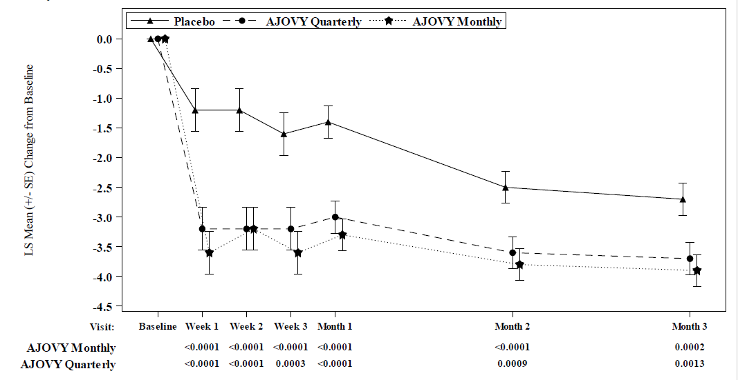
Mean at baseline (monthly average number of migraine days): Placebo: 9.1, AJOVY Quarterly: 9.2, AJOVY Monthly: 8.9.
AJOVY treatment demonstrated statistically significant and clinically meaningful improvements from baseline compared to placebo for all key efficacy variables (see Table 2).
Table 2: Key Efficacy Variables for Study 1
Study 1  Efficacy Endpoint | AJOVY  Monthly  (N=287) | AJOVY  Quarterly  (N=288) | Placebo  (N=290)
Change from baseline in monthly average number of migraine days*** | -3.7** | -3.4** | -2.2
Reduction of at least 50% in monthly average number of migraine days | 47.7%** | 44.4%** | 27.9%
Change from baseline in monthly average number of days of acute headache medication | -3.0** | -2.9** | -1.6
Change from baseline in monthly average number of migraine days at 4 weeks after 1st dose | -3.5** | -3.3** | -1.7
Change from baseline in the monthly average number of migraine days in patients without concomitant migraine preventive medication | -3.7** | -3.5** | -2.4
Change from baseline in disability scores (Migraine Disability Assessment) | -24.6* | -23.0* | -17.5
* Significantly different from placebo (p<0.0025)
** Significantly different from placebo (p<0.0001)
*** Primary efficacy endpoint
On average in a given month, more than 67% of episodic migraine patients treated with AJOVY achieved at least a 25% reduction in monthly migraine days (compared to 53% of placebo), while more than 25% of patients achieved at least a 75% reduction in monthly migraine days (compared to 15% of placebo), and more than 8% of patients achieved a 100% reduction in monthly migraine days (compared to 4% of placebo).
Chronic Migraine
Study 2 included adults with a history of chronic migraine (patients with 15 headache days or higher per month). All patients were randomised to one of three arms: 675 mg fremanezumab for the starting dose followed by 225 mg fremanezumab once a month (monthly), 675 mg fremanezumab every three months (quarterly), or monthly administration of placebo administered via subcutaneous injection. Patients were allowed to use acute headache treatments during the study. A sub-set of patients (21%) were also allowed to use one concomitant, preventive medication, consistent with patient treatment outside of controlled clinical settings.
In Study 2, a total of 1,130 patients (991 females, 139 males), ranging in age from 18 to 70 years, were randomised. A total of 1,034 patients completed the 12-week double-blind treatment period.
The primary efficacy endpoint was the mean change from baseline in the monthly average number of headache days of at least moderate severity during the 12-week treatment period (See Table 3). Both monthly and quarterly dosing regimens of AJOVY demonstrated statistically significant and clinically meaningful improvement from baseline compared to placebo at all time points over the 12-week treatment period (see Figure 2).
Figure 2: Mean Change from Baseline in the Monthly Average Number of Headache Days of At Least Moderate Severity for Study 2
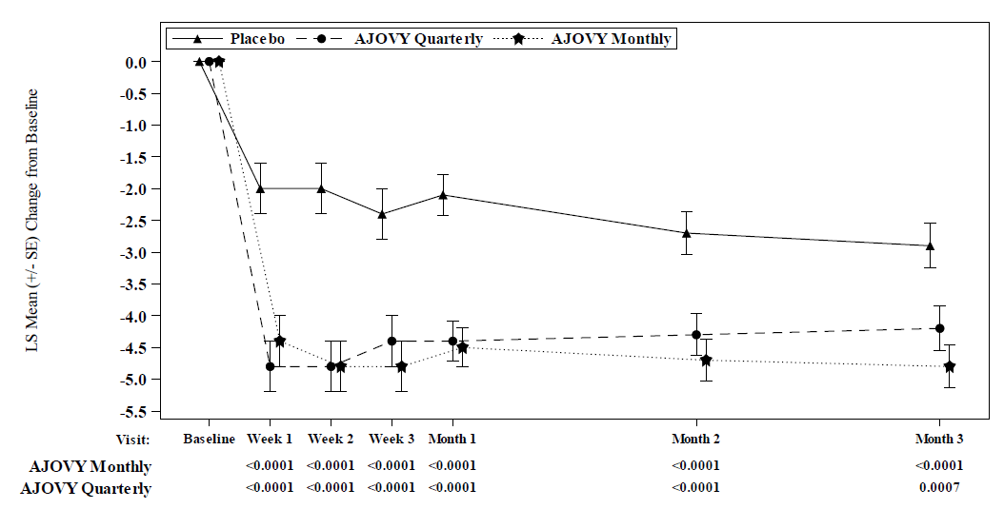
Mean at baseline (monthly average number of headache days of at least moderate severity): Placebo: 13.3, AJOVY Quarterly: 13.2, AJOVY Monthly: 12.8.
AJOVY treatment demonstrated statistically significant and clinically meaningful improvements from baseline compared to placebo for all key efficacy variables.
Table 3: Key Efficacy Variables for Study 2
Study 2  Efficacy Endpoint | AJOVY  Monthly  (N=375) | AJOVY  Quarterly  (N=375) | Placebo  (N=371)
Change from baseline in the monthly average number of headache days of at least moderate severity*** | -4.6** | -4.3** | -2.5
Change from baseline in the monthly average number of migraine days in patients | -5.0** | -4.9** | -3.2
Change from baseline in monthly average number of headache days of at least moderate severity at 4 weeks after 1st dose | -4.6** |  | -2.3
Reduction of at least 50% in monthly average number of headache days of at least moderate severity | 40.8%** | 37.6%** | 18.1%
Change from baseline in monthly average number of days of acute headache medication | -4.2** | -3.7** | -1.9
Change from baseline in the monthly average number of headache days of at least moderate severity in patients without concomitant migraine preventive medication | -4.8** | -4.6** | -2.6
Change from baseline in disability scores (6-Item Headache Impact Test) | -6.8** | -6.4* | -4.5
* Significantly different from placebo (p=0.0001)
** Significantly different from placebo (p<0.0001)
*** Primary efficacy endpoint
On average in a given month, more than 61% of chronic migraine patients treated with AJOVY achieved at least a 25% reduction in monthly headache days of at least moderate severity (compared to 46% of placebo), while more than 20% of patients achieved at least a 75% reduction in monthly headache days of at least moderate severity (compared to 10% of placebo), and more than 7% of patients achieved a 100% reduction in monthly headache days of at least moderate severity (compared to 4% of placebo).
Long-term open label study (study 3)
For all episodic and chronic migraine patients, efficacy was sustained for up to 12 additional months in the long-term open label study (Study 3), in which patients received 225 mg fremanezumab monthly or 675 mg quarterly. 79% of patients completed the 12-month treatment period of Study 3. Pooled across the two dosing regimens, a reduction of 6.6 monthly migraine days was observed after 15 months relative to Study 1 and Study 2 baseline. 61% of patients completing Study 3 achieved a 50% response in the last month of the study. No safety signal was observed during the 15-month combined treatment period.
Intrinsic and extrinsic factors
The efficacy and safety of AJOVY was demonstrated regardless of age, gender, race, use of concomitant preventive medications, use of topiramate for migraine in the past, and use of onabotulinumtoxin A for migraine in the past.

5.2 PHARMACOKINETIC PROPERTIES

Absorption
After single subcutaneous administrations of 225 mg, 675 mg, and 900 mg fremanezumab, median time to maximum concentrations (t_{max}) was 5 to 7 days. The absolute bioavailability of fremanezumab after subcutaneous administration was about 55% as determined by subcutaneous vs. intravenous administrations of 225 mg and 900 mg. Dose proportionality, based on population pharmacokinetics, was observed between 225 mg to 900 mg. Steady state was achieved by approximately 168 days (about 6 months) following 225 mg subcutaneous monthly and 675 mg subcutaneous quarterly dose regimens. Median accumulation ratio, based on once monthly and once quarterly dosing regimens, is approximately 2.3 and 1.2, respectively.

Distribution
Fremanezumab has an apparent volume of distribution of approximately 6 litres (for a patient at a weight of 71 kg), suggesting minimal distribution to the extravascular tissues.

Metabolism
Similar to other monoclonal antibodies, fremanezumab is expected to be degraded by enzymatic proteolysis into small peptides and amino acids (see Section 4.5 INTERACTIONS WITH OTHER MEDICINES AND OTHER FORMS OF INTERACTIONS).

Elimination
As fremanezumab binds to a soluble target, it is not expected to be eliminated through a target-mediated clearance. Fremanezumab has an apparent clearance of approximately 0.141 L/day (for a patient at a weight of 71 kg). Fremanezumab has an estimated half-life of 31 days.
Special populations
A population pharmacokinetic analysis looking at age, race, gender, and weight was conducted on data from 2,287 subjects. No dose adjustments are required for AJOVY.
Renal or hepatic impairment
Since monoclonal antibodies are not known to be eliminated via renal pathways or metabolised in the liver, renal and hepatic impairment are not expected to impact the pharmacokinetics of fremanezumab. No clinical studies were conducted to assess the effect of renal or hepatic impairment on the pharmacokinetics of fremanezumab.

5.3 PRECLINICAL SAFETY DATA
Non-clinical data reveal no special hazard for humans based on conventional studies of safety pharmacology, repeated dose toxicity or toxicity to reproduction and development in studies conducted in rats and monkeys.
Intravenous and subcutaneous repeated administrations to rats (up to 3 months) and monkeys (up to 6 months) did not induce toxic effect and no target organs were identified (including injection sites). In the pivotal 6-month chronic toxicity study in monkeys at the NOAEL (No Observed Adverse Effects Level) dose of 300 mg/kg/week (at least 158 times the exposure achieved at MRHD (Maximum Recorded Human Dose) on an AUC (Area Under the Curve) basis)) subcutaneous weekly dosing was well tolerated.
Safety pharmacology studies to assess cardiovascular (CV) effects in cynomolgus monkeys demonstrated no CV effects following single and repeated administrations. No effect on CNS
and respiratory function was noted following a single administration to SD (Sprague Dawley) rats

Genotoxicity
As fremanezumab is a monoclonal antibody, no genotoxicity studies have been conducted.

Carcinogenicity
As fremanezumab is a monoclonal antibody no carcinogenicity studies have been conducted.

6. PHARMACEUTICAL PARTICULARS

6.1 LIST OF EXCIPIENTS
Histidine
Histidine hydrochloride monohydrate
Sucrose
Disodium edetate
Polysorbate 80
Water for injections

6.2 INCOMPATIBILITIES
Not applicable.

6.3 SHELF LIFE
In Australia, information on the shelf life can be found on the public summary of the Australian Register of Therapeutic Goods (ARTG). The expiry date can be found on the packaging.

6.4 SPECIAL PRECAUTIONS FOR STORAGE
Store in a refrigerator (2°C to 8°C). Do not freeze.
Keep the pre-filled syringe(s) in the outer carton in order to protect from light.
AJOVY may be stored unrefrigerated for up to 14 days at a temperature up to 30°C. AJOVY must be discarded if not used within 14 days of removal from refrigeration.

6.5 NATURE AND CONTENTS OF CONTAINER
1.5 mL solution in a 2.25 mL Type I glass syringe with plunger stopper (bromobutyl rubber) and needle. The pre-filled syringe cap is not made with natural rubber latex.
Pack sizes of one 225mg/1.5mL or three 225mg/1.5mL pre-filled syringes. Not all pack sizes may be marketed.

6.6 SPECIAL PRECAUTIONS FOR DISPOSAL
Dispose of carefully in a sharps container. Do not throw away (dispose of) loose needles, syringes, or prefilled syringes in your household rubbish.
Do not recycle used sharps disposal container.

6.7 PHYSIOCHEMICAL PROPERTIES

Chemical Structure
C₆₄₇₀H₉₉₅₂N₁₇₁₆O₂₀₁₆S₄₆

CAS number
1655501-53-3

7. MEDICINE SCHEDULE (POISONS STANDARD)
Schedule 4 – Prescription Only

8. SPONSOR
Teva Pharma Australia Pty Ltd
37 Epping Rd
Macquarie Park, NSW, 2113
Ph: 1800 288 382
www.tevapharma.com.au

9. DATE OF FIRST APPROVAL
20th September 2019

10. DATE OF REVISION
Summary table of changes
Section Changed | Summary of new information

