December 2019

Australian Public Assessment Report for Fremanezumab
  - Proprietary Product Name: Ajovy
Sponsor: Teva Pharma Australia Pty Ltd

About the Therapeutic Goods Administration (TGA)
- The Therapeutic Goods Administration (TGA) is part of the Australian Government Department of Health and is responsible for regulating medicines and medical devices.
- The TGA administers the Therapeutic Goods Act 1989 (the Act), applying a risk management approach designed to ensure therapeutic goods supplied in Australia meet acceptable standards of quality, safety and efficacy (performance) when necessary.
- The work of the TGA is based on applying scientific and clinical expertise to decision-making, to ensure that the benefits to consumers outweigh any risks associated with the use of medicines and medical devices.
- The TGA relies on the public, healthcare professionals and industry to report problems with medicines or medical devices. TGA investigates reports received by it to determine any necessary regulatory action.
- To report a problem with a medicine or medical device, please see the information on the TGA website <https://www.tga.gov.au>.
About AusPARs
- An Australian Public Assessment Report (AusPAR) provides information about the evaluation of a prescription medicine and the considerations that led the TGA to approve or not approve a prescription medicine submission.
- AusPARs are prepared and published by the TGA.
- An AusPAR is prepared for submissions that relate to new chemical entities, generic medicines, major variations and extensions of indications.
- An AusPAR is a static document; it provides information that relates to a submission at a particular point in time.
- A new AusPAR will be developed to reflect changes to indications and/or major variations to a prescription medicine subject to evaluation by the TGA.
Copyright
© Commonwealth of Australia 2019
This work is copyright. You may reproduce the whole or part of this work in unaltered form for your own personal use or, if you are part of an organisation, for internal use within your organisation, but only if you or your organisation do not use the reproduction for any commercial purpose and retain this copyright notice and all disclaimer notices as part of that reproduction. Apart from rights to use as permitted by the Copyright Act 1968 or allowed by this copyright notice, all other rights are reserved and you are not allowed to reproduce the whole or any part of this work in any way (electronic or otherwise) without first being given specific written permission from the Commonwealth to do so. Requests and inquiries concerning reproduction and rights are to be sent to the TGA Copyright Officer, Therapeutic Goods Administration, PO Box 100, Woden ACT 2606 or emailed to <tga.copyright@tga.gov.au>.

Contents
Common abbreviations 4
I. Introduction to product submission 7
Submission details 7
Product background 7
Regulatory status 8
Product Information 9
II. Registration time line 9
III. Overall conclusion and risk/benefit assessment 10
Quality 10
Nonclinical 10
Clinical 11
Efficacy 11
Safety 20
Risk management plan 22
Risk-benefit analysis 23
Outcome 27
Attachment 1. Product Information 28

Common abbreviations
Abbreviation | Meaning
ACM | Advisory Committee on Medicines
ADA | Anti-drug antibodies
ADR | Adverse drug reaction
AE | Adverse event
AESI | Adverse event of special interest
AMPP | American Migraine Prevalence and Prevention
ANCOVA | Analysis of covariance
ANOVA | Analysis of variance
ASA | Australian specific annex
AUC_{inf} | Area under the curve (to infinity)
BMI | Body mass index
C-SSRS | Columbia-Suicide Severity Rating Scale
CaMEO | Chronic Migraine Epidemiology and Outcomes
CBER | Centers for Biologics Evaluation and Research (USA)
CDRH | Center for Devices and Radiological Health (USA)
CER | Clinical evaluation report
CGA… | Study identifier
CGRP | Calcitonin gene-related peptide
CHMP | Committee for Medicinal Products for Human Use (EU)
CHO | Chinese hamster ovary
CI | Confidence interval
CM | Chronic migraine
CMI | Consumer Medicines Information
CSR | Clinical study report
CV | Coefficient of variation
DCAE | Discontinuation due to adverse event(s)
ECG | Electrocardiogram / electrocardiographic
EMA | European Medicines Agency (EU)
EU | European Union
ePRO | Electronic patient-reported outcome
GCP | Good Clinical Practice
HDOMS | Headache Days of Moderate Severity
HIT-6 | 6-item Headache Impact Test
IBMS | International Burden of Migraine Study
ICH | International Conference on Harmonisation
IDR | Indirect response
IHS | International Headache Society
IIV | Inter-individual variation
ITT | Intent-to-treat
IVRS | Interactive voice response system
IWRS | Interactive web-response system
LDI | Laser Doppler imaging
LOCF | Last observation carried forward
mAb | Monoclonal antibody
MHD | Migraine headache day
MHDs-AMU | Migraine Headache Days with acute medication use
MIDAS | Migraine Disability Assessment
MMRM | Mixed-effect model repeat measurement
MRT-inf | Mean residence times (to infinity)
MSQ, MSQL | Migraine Specific Quality of Life
NAb | Neutralising antibodies
PD | Pharmacodynamic(s)
PFS | Prefilled syringe
PK | Pharmacokinetic(s)
PT | Preferred Term
QOL | Quality of life
RMP | Risk management plan
SAE | Serious adverse event
SC | Subcutaneous
SCE | Summary of Clinical Efficacy
SD | Standard deviation
SMQs | Standardised Medical Dictionary for Regulatory Activities Queries
TEAE | Treatment-emergent adverse event
TGA | Therapeutic Goods Administration
T_{max} | Time to maximum concentration
ULN | Upper limit of normal

I. Introduction to product submission

Submission details
Type of submission: | New biological entity
Decision: | Approved
Date of decision: | 17 September 2019
Date of entry onto ARTG: | 20 September 2019
ARTG number: | 308630
Black Triangle Scheme | Yes  This product will remain in the scheme for 5 years, starting on the date the product is first supplied in Australia.
Active ingredient: | Fremanezumab
Product name: | Ajovy
Sponsor’s name and address: | Teva Pharma Australia Pty Ltd  37 Epping Road, Macquarie Park, NSW 2113
Dose form: | Solution for injection
Strength: | 225 mg/1.5 mL
Container: | Prefilled syringe
Pack size: | 1 or 3
Approved therapeutic use: | Ajovy is indicated for the preventive treatment of migraine in adults.
Route of administration: | Subcutaneous (SC)
Dosage: | 225 mg once monthly (monthly dosing) or 675 mg every three months (quarterly dosing).  For further information, refer to the Product Information.

Product background
This AusPAR describes the application by the sponsor (Teva Pharma Australia Pty Ltd) to register the new biological entity fremanezumab (as Ajovy) 225 mg/1.5 mL prefilled syringe for the following indication:
Ajovy is indicated for the preventive treatment of migraine in adults.
The sponsor proposed two different doses:
- 225 mg subcutaneously (SC) once monthly (monthly dosing); or
- 675 mg SC every three months (quarterly dosing).
The 675 mg dose is achieved by administering the contents of three pre-filled syringes, each containing 225 mg of fremanezumab.
Fremanezumab is a new biological agent, consisting of a humanised immunoglobulin (Ig) G2Δa/kappa monoclonal antibody (mAb), derived from a murine precursor, produced in Chinese hamster ovary (CHO) cells by recombinant DNA technology). It binds both isoforms (α and β) of calcitonin gene-related peptide (CGRP) and prevents the biological activity of CGRP without blocking the CGRP receptor. It closely resembles galcanezumab in its mode of action, with both agents targeting CGRP ligand. It differs in its mode of action from the recently registered agent erenumab, which targets the CGRP receptor, but the clinical effects of fremanezumab, galcanezumab and erenumab appear similar.
While the precise mechanism of action by which fremanezumab prevents migraine attacks is unknown, it is believed that prevention of migraine is obtained by its effect modulating the trigeminal system.
Migraine is a common neurological condition, usually manifesting as severe headache, and often accompanied by visual changes, photophobia, phonophobia, nausea and lethargy. It is sometimes associated with focal neurological deficits such as weakness or numbness, speech disturbance or vertigo. Typically, migraines cause asymmetrical or unilateral throbbing headaches, with attacks lasting from hours to days. Many patients can identify food or environmental triggers for their migraines and, in some cases, migraines are associated with menstrual cycles, but in many other cases, the triggers for individual migraines are obscure. Many people suffer infrequent migraines, with only a few attacks per year, but some subjects experience multiple attacks per month. By convention, using definitions formalised by the International Headache Society (IHS), a rate of ≥ 15 headache days per month with ≥8 migraine days is used to identify subjects with ‘chronic’ migraine, in contrast to those with ‘episodic’ migraine who suffer <15 headache days per month. Migraines can have major impacts on quality of life and mood, especially if they occur frequently. Migraine is also a major cause of absenteeism from work.
There are several TGA approved drugs (beta-blockers, calcium channel blockers, some anticonvulsants and pizotifen) for the prophylaxis of migraine. All of them are associated with significant tolerability issues.
Two drugs in this class (mAbs) were approved during the past year for the preventive treatment of migraine: erenumab and galcanezumab. Fremanezumab and galcanezumab bind to the CGRP ligand, whereas erenumab binds to the CGRP receptor.

Guidance used
The following guidance were used in evaluating the clinical data:
- Guideline on Clinical Investigation of Medicinal Products for the Treatment of Migraine (CPMP/EWP/788/01 Rev. 1 2007)
- A concept paper proposing revision of this guideline to include guidance on the design of studies in Chronic Migraine (EMA/CHMP/179671/2016).

Regulatory status
This is a new biological entity for Australian regulatory purposes.
The medicine has been approved in the USA, in the European Union EU) in March 2019 and in Israel as summarised in Table 1 below.
Table 1: International regulatory status of Ajovy
Country | Approval date | Approved indication
USA | 14 September 2018 | Ajovy is indicated for the preventive treatment of migraine in adult patients
European Union | 28 March 2019 | Ajovy is indicated for prophylaxis of migraine in adults who have at least 4 migraine days per month
Israel | 29 October 2019 | Ajovy is indicated for prophylaxis of migraine in adults who have at least 4 migraine days per month.

Product Information
The Product Information (PI) approved with the submission, which is described in this AusPAR, can be found as Attachment 1. For the most recent PI, please refer to the TGA website at <https://www.tga.gov.au/product-information-pi>.

II. Registration time line
The following table captures the key steps and dates for this application and which are detailed and discussed in this AusPAR.
Table 2: Registration time line for Ajovy PM-2018-03494-1-1
Description | Date
Submission dossier accepted and first round evaluation commenced | 28 September 2018
First round evaluation completed | 3 April 2019
Sponsor provides responses on questions raised in first round evaluation | 5 June 2019
Second round evaluation completed | 26 June 2019
Delegate’s Overall benefit-risk assessment and request for Advisory Committee advice | 2 July 2019
Sponsor’s pre-Advisory Committee response | 12 July 2019
Advisory Committee meeting | 1-2 August 2019
Registration decision (Outcome) | 17 September 2019
Completion of administrative activities and registration on ARTG | 20 September 2019
Number of working days from submission dossier acceptance to registration decision* | 202
*Statutory timeframe for standard applications is 255 working days

III. Overall conclusion and risk/benefit assessment
The submission was summarised in the following Delegate’s overview and recommendations:

Quality
Fremanezumab is a fully humanised mAb produced CHO cells by recombinant DNA technology.
Ajovy is a sterile, preservative-free solution for injection in pre-filled syringe.
It is a clear to opalescent, colourless to slightly yellow solution with a pH of 5.5 and an osmolality of 300 to 450 mOsm/kg.
One pre-filled syringe contains 225 mg fremanezumab in 1.5 mL (150 mg/mL).
There are no objections on quality grounds to the approval of Ajovy (fremanezumab) provided the outstanding Good Manufacturing Practice clearance issue is resolved.

Nonclinical
The submitted nonclinical data were in general accordance with the International Council on Harmonisation (ICH) of Technical Requirements for Pharmaceuticals for Human Use guideline (ICH S6R1 2011) on the non-clinical evaluation of biotechnology-derived pharmaceuticals. All pivotal repeat dose toxicity and reproductive toxicity studies were Good Laboratory Practice (GLP) compliant.
Primary pharmacology studies provided sufficient evidence of fremanezumab affinity and selectivity for the human and monkey CGRP ligand. Treatment-related effects associated with weekly intravenous (IV) or SC administration were minimal and limited to injection site reactions and mild inflammatory reactions in various organs. Pregnancy Category B1 is considered appropriate.
Overall, there are no nonclinical objections to the registration of fremanezumab (Ajovy).
The draft PI is acceptable from a nonclinical viewpoint.

Clinical

Pharmacokinetics
Fremanezumab exhibits linear pharmacokinetics (PK), with approximately dose-proportional exposures in the range of 225 to 900 mg. After a single SC dose of 225 mg, 675 mg, and 900 mg of fremanezumab, the median time to maximum concentration (T_{max}) was 5 to 7 days. The exposure-response analyses showed shallow relationships between efficacy and fremanezumab concentrations, that is, the slopes of the relationships are close to 0. The mean terminal elimination half-life of fremanezumab is approximately 31 days. Steady state is expected to be achieved by approximately 6 months. No dose adjustment is necessary for patients based on intrinsic or extrinsic factors.
The effects of anti-drug antibodies (ADA) on PK appear to be minimal.
The effects of ADA on pharmacodynamics (PD) have not been assessed. The potential effects of ADA on efficacy could not be estimated from the Phase II and III studies, because of the very low incidence of ADA. No important differences in safety or tolerability were noted when comparing subjects with ADA (ADA+ subjects) with subjects with no ADA (ADA- subjects), in terms of adverse events (AE), but the incidence of ADA+ status was too low to allow robust comparisons.

Pharmacodynamics
The specific binding of fremanezumab to its target, CGRP, while not binding to similar peptides such as amylin, intermedin, calcitonin, or adrenomedullin has been characterised in in vitro systems.
Fremanezumab prevents in vitro cyclic adenosine monophosphate production induced by CGRP. No clinical relevant relationship between exposure metrics and safety endpoints.

Dose selection
The sponsor’s submission provides very little commentary justifying the doses assessed in the pivotal studies. The doses used in the pivotal Phase III studies appear to have been chosen based on two Phase II studies, and to a lesser extent based on tolerability in Phase I PK studies.

Efficacy
The sponsor submitted four efficacy studies and one long term safety (ongoing) study performed in subjects with migraine, as listed below in Table 3.
Table 3: Efficacy studies in patients with migraine
Study number / reference name | Study title
TV48125-CNS-30049 / Study 30049 | Multicenter, Randomized, Double-Blind, Placebo-Controlled, Parallel-Group Study Comparing the Efficacy and Safety of 2 Dose Regimens of Subcutaneous Administration of TEV-48125 Versus Placebo for the Preventive Treatment of Chronic Migraine
TV48125-CNS-30050 / Study 30050 | A Multicenter, Randomized, Double-Blind, Placebo-Controlled, Parallel-Group Study Comparing the Efficacy and Safety of 2 Dose Regimens of Subcutaneous Administration of Fremanezumab (TEV-48125) Versus Placebo for the Preventive Treatment of Episodic Migraine
TV48125-CNS-30051 / Study 30051a | A Multicenter, Randomized, Double-Blind, Parallel-Group Study Evaluating the Long-Term Safety, Tolerability, and Efficacy of Subcutaneous Administration of TEV 48125 for the Preventive Treatment of Migraine
LBR-101-021 / Study 021 | A Multicenter, Randomized, Double-Blind, Double-Dummy, Placebo-Controlled, Parallel-Group, Multi-Dose Study Comparing the Efficacy and Safety of Subcutaneous TEV-48125 with Placebo for the Preventive Treatment of Chronic Migraine
LBR-101-022 / Study 022 | A Multicenter, Randomized, Double-Blind, Placebo-Controlled, Parallel-Group Study Comparing the Efficacy and Safety of Two Doses of Subcutaneous TEV-48125 with Placebo for the Preventive Treatment of High Frequency Episodic Migraine

Pivotal efficacy studies

Chronic migraine

Study 30049
Study 30049 (n=1121 evaluable for efficacy; n=1130 evaluable for safety; 92% completed) was a Phase III pivotal study that used a randomised, double-blind, placebo controlled design to assess the efficacy of SC fremanezumab (675 mg quarterly or 225 mg monthly with a 675 mg loading dose) in comparison with placebo in the preventive treatment of chronic migraine (CM). The study assessed two different active doses, 675 mg SC quarterly (every three months), or 225 mg SC monthly with a 675 mg SC loading dose.
The study was conducted at 132 study centres in nine countries; USA, Canada, Czech Republic, Finland, Israel, Japan, Poland, Russian Federation and Spain.
Subjects eligible for enrolment were adults aged 18 to 70 years, inclusive, with migraine onset at ≤ 50 years of age; history of migraine ≥ 12 months prior to screening, demonstrated compliance with the electronic headache diary and fulfilled the criteria for CM in prospectively collected baseline information during the 28 day run-in period.
Figure 1: Treatment sequence for Studies 30049 and 30051 (long term safety study)
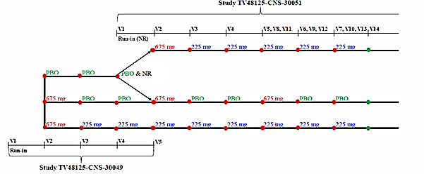
The treatment phase of Study 30049 lasted for 3 months, with injections provided at baseline and after each month (using a dummy approach for subjects on a quarterly regimen). The final efficacy assessment was performed 3 months after the first treatment.
The primary efficacy endpoint was the mean change from Baseline in the monthly average number of Headache Days of Moderate Severity (HDOMS) during the 12 weeks after the first dose of study drug and secondary efficacy variables included response rates, number of days satisfying other headache definitions and quality of life measures.
Eligible patients were randomised in a 1:1:1 ratio to receive a loading dose of fremanezumab at 675 mg followed by monthly fremanezumab at 225 mg, fremanezumab at 675 mg followed by monthly placebo, or monthly placebo. Randomisation was to be stratified by gender, country and baseline preventive medication use (yes, no). The mean age of the patients was 41.3 years (range 18 to 71 years). The majority of patients were White (79%) and women (88%).
The demographic characteristics of sex, age, race, and weight were generally similar across treatment groups. The average number of years since initial migraine diagnosis was similar across treatment groups (19 to 20 years) as was the proportion of patients using concomitant preventive migraine medication (20 to 22%). The majority (95%) of patients received acute medications for migraine prior to study entry. The mean number of migraine days per month was 16, doubling the cut-off for the CM study (≥8migraine days).
A statistically significant but clinically moderate difference from placebo was observed, in favour of fremanezumab, for both active treatment groups (p < 0.0001).
Table 4: Primary efficacy endpoint, Study 30049 in patients with chronic migraine
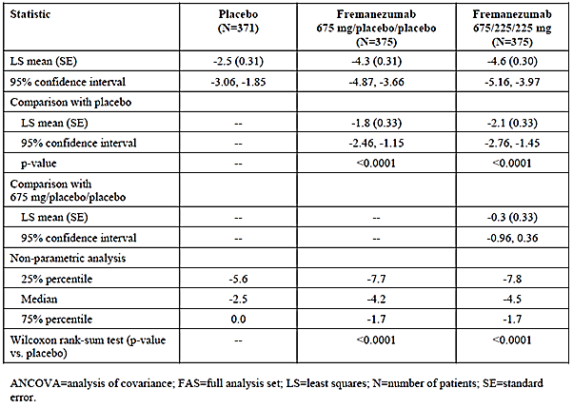
As shown in the figure below, benefit for the primary efficacy variable was observed early (by the end of the first week) and remained broadly consistent over the 3 month period.
Figure 2: Study 30049; Change in monthly HDOMS by treatment group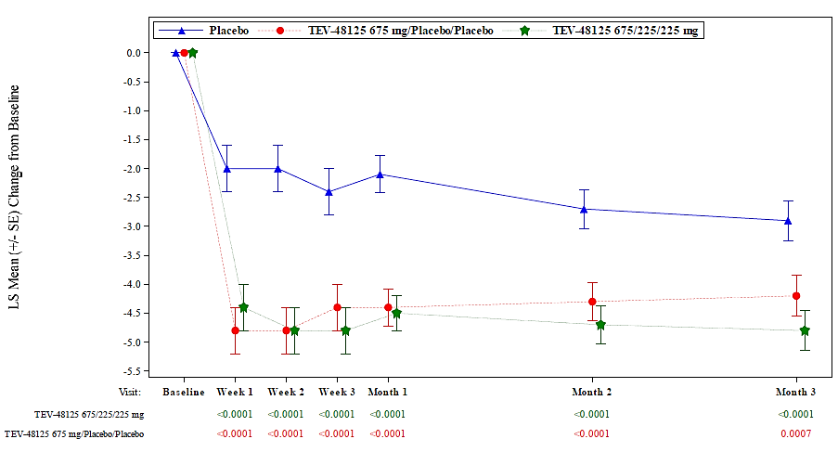
Table 5: Study 30049; Key efficacy endpoint in patients with chronic migraine
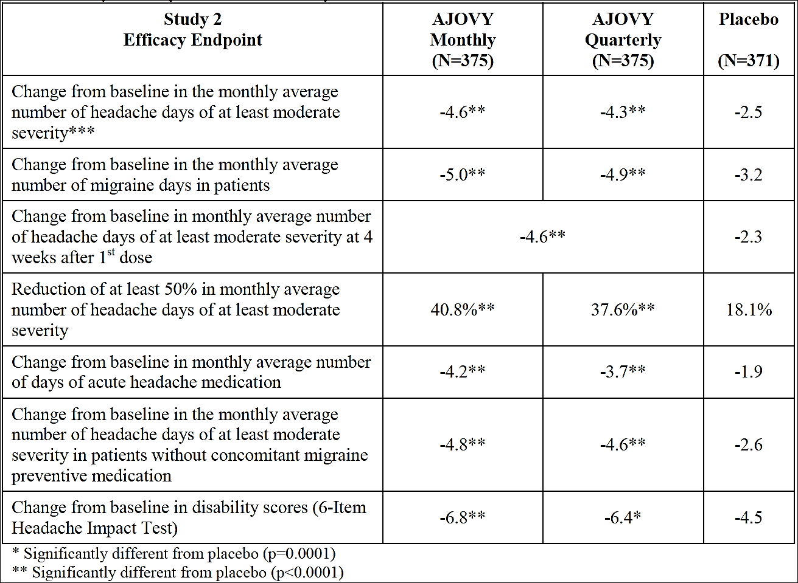
The proportion of patients who achieved ≥ 50% reduction in HDOMS was better with fremanezumab than with (p < 0.0001 for both dose regimens). By this definition, 141 patients (37.6%) in the 675 mg/placebo/placebo treatment group and 153 patients (40.8%) in the 675/225/225 mg treatment group were responders, compared with 67 patients (18.1%) in the placebo group. The attributable response rate (19.5% for the low dose group and 22.7% for the high dose group) suggests that about five subjects would need to be treated to obtain one attributable response.
Overall, this pivotal study showed a statistically robust but clinically modest treatment effect, similar to that observed with other agents in this class, with one treatment arm receiving one of the doses proposed for registration. The study did not show a significant dose effect.

Episodic migraine

Study 30050
Study 30050 (n=865 evaluable for efficacy; n=874 evaluable for safety; 90% completed) in patients with episodic migraine had identical trial design as Study 30049 described above, but the dosing regimens during the double-blind treatment period were either quarterly doses of 675 mg or monthly doses of 225 mg administered SC. The patients enrolled in the study had a history of migraine (for ≥ 12 months) prior to screening and experienced ≥ 6 and ≤ 14 headache days, with ≥ 4 migraine days with or without aura during the 28 day baseline (run-in) period.
The study was performed in the same nine countries as the other pivotal study, that is, USA, Canada, Czech Republic, Finland, Israel, Japan, Poland, Russian Federation and Spain.
Figure 3: Treatment sequence for Studies 30049 and 30051 (long term safety study)
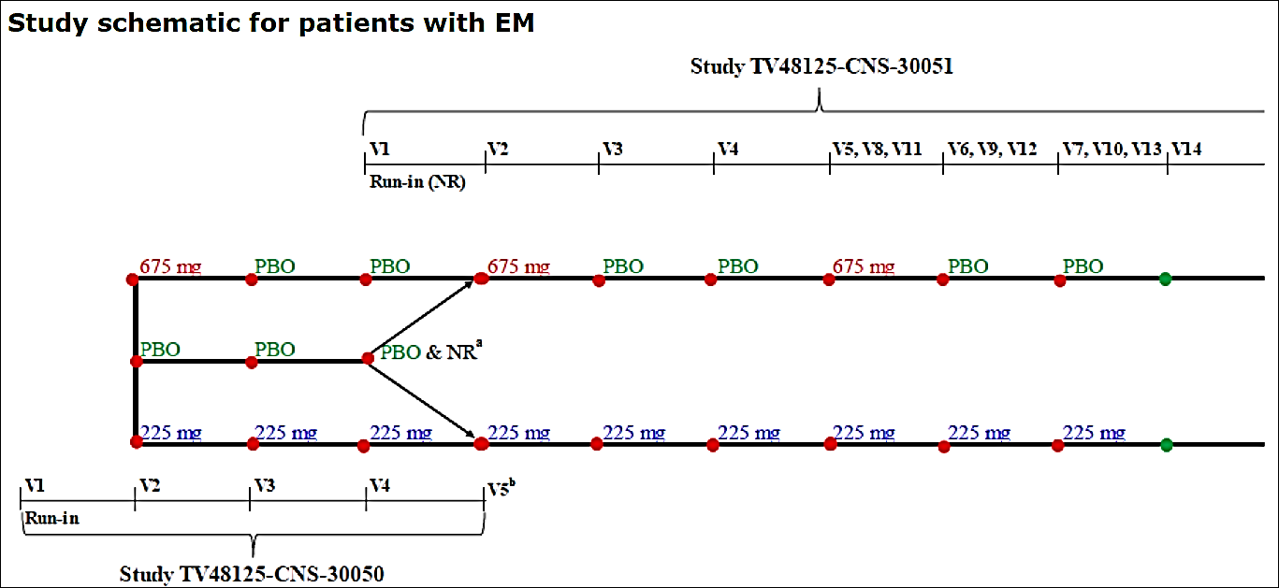
The primary efficacy variable was the change from Baseline in the monthly average number of migraine days during the 12 week period after the first dose of study drug. The primary efficacy endpoint was the mean change from Baseline (28 day run-in period) in the monthly average number of migraine days during the full 12 weeks after the first dose of study drug. Secondary efficacy variables included response rates, number of days satisfying other headache definitions, and quality of life measures.
Eligible patients were to be randomised in a 1:1:1 ratio to receive 1 of the 2 fremanezumab dose regimens or placebo with stratification based on gender, country, and baseline preventive medication use (yes, no).
Similar to the CM study, patients were predominantly female (85%), White (80%) with a mean age of 41.8 years. The demographic characteristics of sex, age, race, and weight were generally similar across treatment groups. The average number of years since initial migraine diagnosis was similar across treatment groups (19 to 20 years) as was the proportion of patients using concomitant preventive migraine medication (20% to 21%).
The primary endpoint was met and statistical significance for the mean change from baseline in the monthly average number of migraine days during the 12 week period after the first dose of study drug was demonstrated for both doses of fremanezumab compared to placebo.
The absolute difference over placebo treatment was only modest clinically with the mean reduction of 3.9 and 4.0 migraine days for the 675 mg/placebo/placebo and 225/225/225 mg treatment groups, respectively. In the placebo treatment group, a mean reduction of 2.6 migraine days was observed, which equates a least squares (LS) mean difference versus placebo of only -1.3 migraine days for 675 mg/placebo/placebo and -1.5 migraine days for 225/225/225 mg (analysis of co-variance (ANCOVA) results). Although this reflects an only modest superiority over placebo, the beneficial treatment effect was consistently shown across all patient subgroups.
Only modest superiority versus placebo was also found with regard to secondary efficacy analysis.
Table 6: Change from Baseline in the monthly average number of migraine days during the 12 weeks after the first dose of study drug ANCOVA and Wilcoxon Rank-Sum Test (Full analysis set) Study 30050
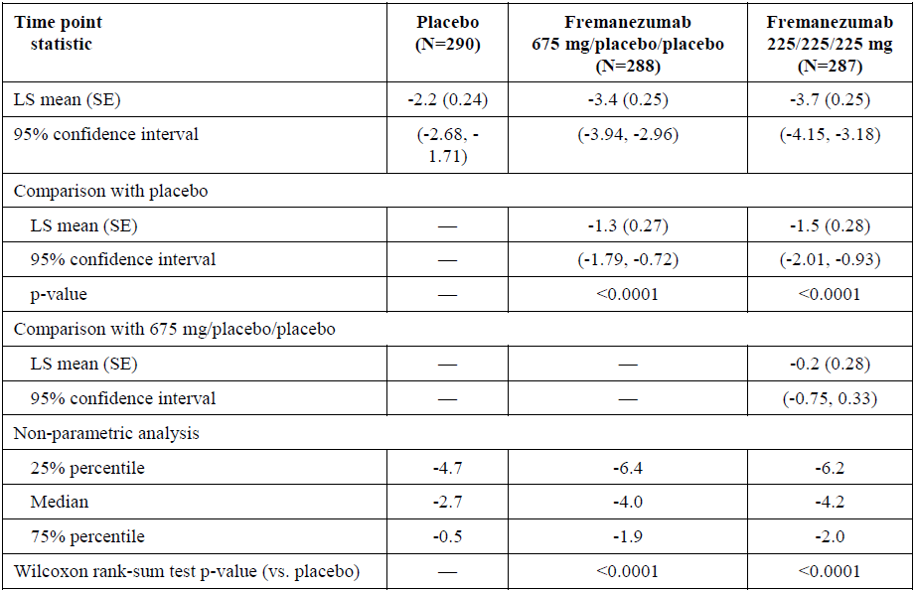
Figure 4: Change from Baseline in the monthly number of migraine days by treatment group using mixed-effect model repeat measurement (Full analysis set)
Table 7: Key efficacy endpoint, Study 30049 in patients with episodic migraine
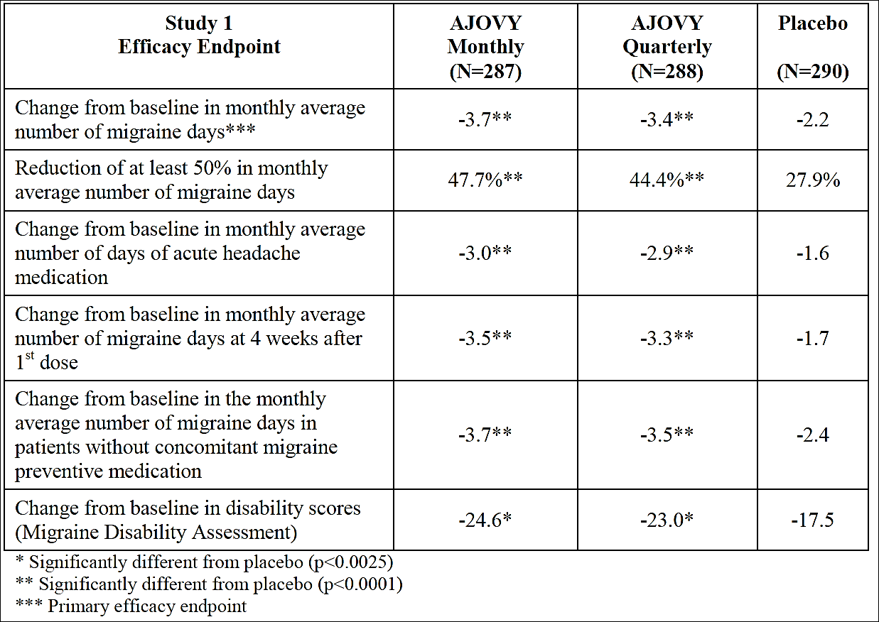

Supportive studies

Study 021 in chronic migraine
This Phase IIb placebo controlled study involved doses (900 mg SC monthly, or 675 mg followed by 225 mg monthly) above those of proposed for registration (evaluable for efficacy, n=261), so the results are only weakly supportive.
The primary endpoint was the change from baseline in monthly cumulative headache hours of any severity, assessed for Month 3 at Week 12. Analysis of this endpoint showed a significant treatment effect for both dose regimens (p=0.0057 and p=0.0386 for the 900 mg and 675/225/225 mg treatment groups, respectively, by mixed-effect model repeat measurement (MMRM). The LS mean differences for Month 3, in comparison to placebo, were -30.41 and -22.74 hours for the 900 mg and the 675/225/225 mg treatment groups, respectively. Secondary endpoints were broadly consistent with the primary endpoint.

Study 022 in episodic migraine
Study 022 had an unacceptable design, with different periods of recruitment that differed in their allocation of subjects to different treatment arms (fremanezumab 675 mg monthly or 225 mg monthly, or placebo). Only the low dose group corresponds to one of the proposed dose regimens. The results were nominally positive, but they can only be considered weakly supportive.
The LS mean differences from placebo at Month 3 were –2.64 and –2.81 days for the 675 mg and the 225 mg treatment groups, respectively. This is substantially better than the results obtained in the pivotal episodic migraine study. The study did not show any evidence of a dose trend, despite the fact that the high dose group received three times as much fremanezumab as the low dose group, but the two dose groups are not directly comparable as they were recruited at different times in the study, and could have been subject to different biases. Inclusion of the results of this study in the sponsor’s exposure-response model raises a number of difficulties of interpretation, because the estimate of the treatment effect was systematically higher in this study than in the pivotal study even for the 225 mg monthly group. Subjects receiving 675 mg monthly in this study had higher exposure than subjects in either dose group of the pivotal episodic migraine study, and they also appeared to achieve a greater treatment effect, but the apparent superiority could reflect between-study differences rather than between dose differences. Indeed, this seems likely, given the lack of a dose effect within either the episodic migraine studies.
Overall, the results of this study should be considered only weakly supportive of the submission.

Study 30051(ongoing not completed)
This was an open-label extension study (primarily designed to assess the long-term safety of fremanezumab) that offered active treatment to subjects from the two pivotal studies (Studies 30049/30050), with some additional patients added to increase the numbers. All subjects received active treatment with the same total fremanezumab dose of 675 mg SC every three months. Blinding was only maintained for the relatively minor detail of whether this dose was divided into three separate monthly doses of 225 mg or given as 675 mg quarterly. There was no primary or secondary efficacy measure in this study.
There are no statistical considerations for this sample size. A total of 1842 patients (867 patients from Study TV48125-CNS-30049, 675 patients from Study TV48125-30050, and approximately 300 patients who did not participate in the pivotal efficacy studies) were planned for enrolment, and a 30% drop-out rate was anticipated. The treatment effect observed during the first three treatment months was sustained over the whole study duration of > 12 months, which is reassuring. Final study results are still pending.
Figure 5: Mean change from Baseline in monthly average number of days of use of any acute headache medication (full analysis set) Study 30051
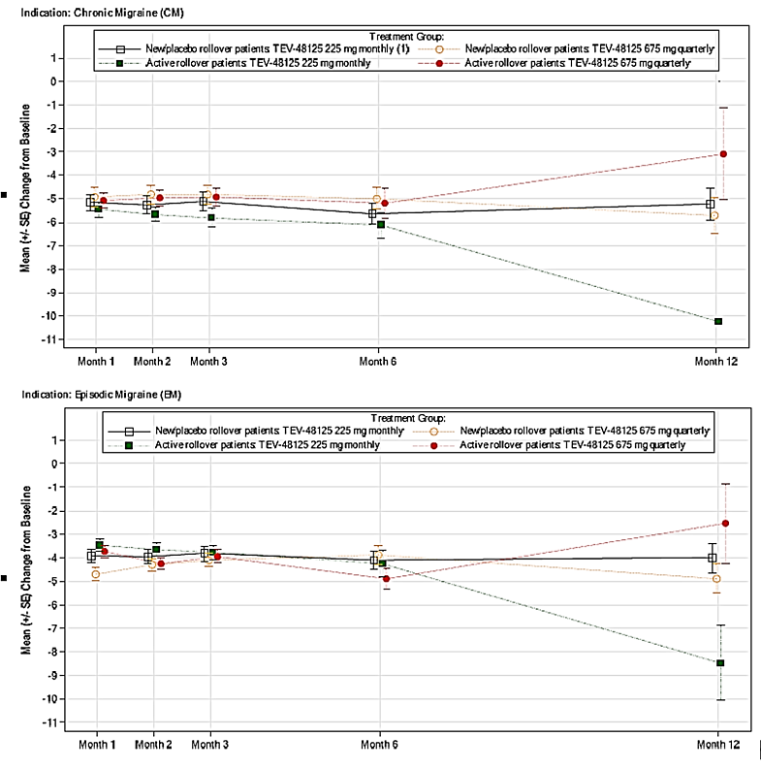

Safety
The overall exposure to fremanezumab exceeds the minimum numbers of patients recommended by the ICH E1 Guideline for chronically administered medications.
The sponsor’s Summary of Clinical Safety (SCS) considers data from seven overlapping cohorts, summarised in the table below.
Table 8: Number of patients included in each of the 7 integrated cohorts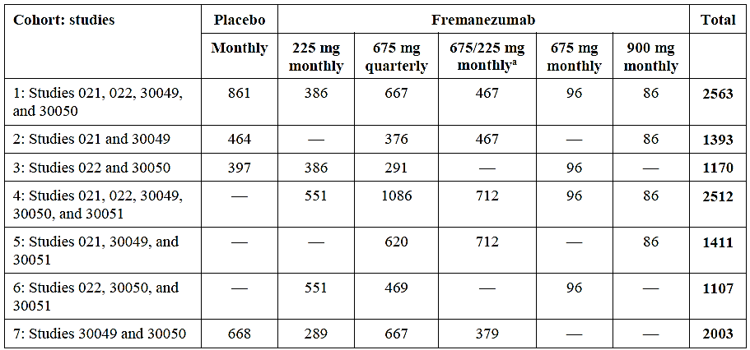
Only Cohort 1 (placebo controlled trials) and 4 (patients exposed to fremanezumab in Phase II and III trials) were evaluated in detail.
A total of 1702 subjects received fremanezumab in placebo controlled studies, and 861 subjects received placebo (see Table 9). Most subjects were followed for at least 3 months, and total fremanezumab exposure amounts to 390 patient-years.
Table 9: Treatment emergent adverse events for all patients in the placebo controlled studies; Cohort 1 (placebo controlled exposure)
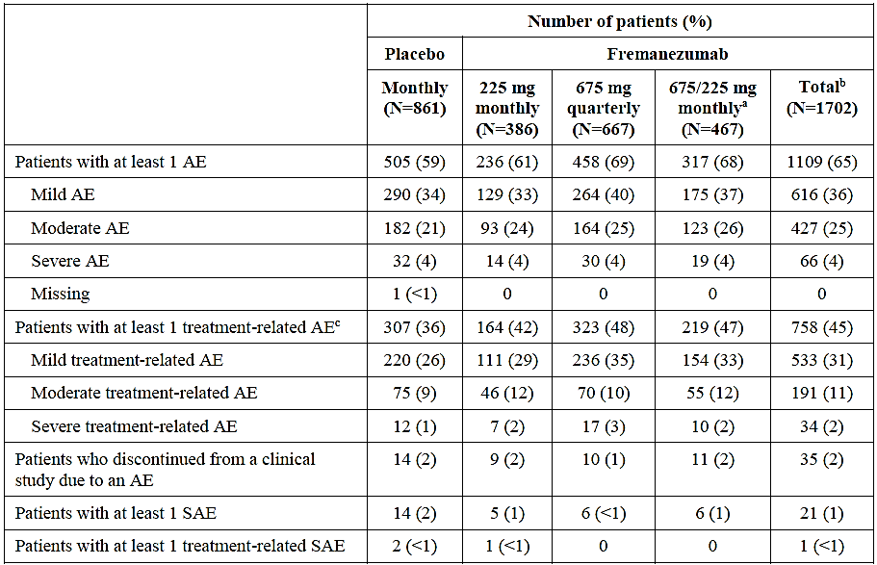
The most frequently occurring AEs up to 24 h post-dosing were injection site reactions. Most injection site reactions after administration of fremanezumab were of short duration and mild severity.
Serious adverse events (SAE) occurred in 21 fremanezumab recipients (1%) and 14 placebo recipients (2%) in the placebo controlled studies (Cohort 1). No event by Preferred Term (PT) occurred in ≥ 1% of patients.
Two deaths occurred in the clinical development program; one related to an exacerbation of pre-existing lung disease, and one related to suicide in the setting of pre-existing depression. On evaluating the available information, the clinical evaluator agrees that neither death appears to have been related to treatment.
AEs leading to discontinuation were infrequent, with a similar incidence (2%) in fremanezumab and placebo recipients.
Three main categories of events as adverse events of special interest (AESI) were pre-identified by the sponsor: ophthalmic AEs, hepatic AEs, and hypersensitivity reactions including anaphylaxis. None of them was evident to be excess with active treatment.
No significant safety issues arose from laboratory monitoring. No liver or renal toxicity were reported.
Cardiovascular risk has not been fully assessed due to exclusion of elderly patients and those with significant cardiovascular morbidity. Although there is no strong evidence of cardiovascular toxicity associated with active treatment, cardiovascular safety should remain the focus of ongoing risk management similar to other agents of same class such as erenumab and galcanezumab.
Overall, fremanezumab appears to be associated with a minimal risk of serious skin reactions. Fremanezumab has been assigned Pregnancy Category B1.¹ PI wording has been amended at the request of the clinical evaluator to include the following:
‘There are limited data from the use of Ajovy in pregnant women. Animal studies do not indicate direct or indirect harmful effects with respect to reproductive toxicity.’
The Delegate notes the clinical evaluator’s recommendation on lactation but to maintain consistency with other approved agents of similar class, the proposed PI has appropriate wording on lactation as well as the potential risks of hypersensitivity. There was no increased risk observed with ADAs. Safety of combination with other agents targeting CGRP pathway is unknown.

Risk management plan
The sponsor submitted EU risk management plan (RMP) version 1.0 (dated 5 January 2018; data lock point (DLP) 31 May 2017) and Australian Specific Annex (ASA) version 1.0 (dated 26 April 2018) in support of this application. In their response to TGA’s request for further information, the sponsor submitted EU RMP version 1.4 (dated 29 January 2019; DLP 29 January 2019) and ASA version 1.2 (dated 03 July 2019). EU RMP Version 1.4 is recognised as the first European Medicines Agency (EMA) approved version.
The following table summarises the ongoing safety concerns with Ajovy.
Table 10: Summary of ongoing safety concerns
Summary of safety concerns |  | Pharmacovigilance |  | Risk Minimisation
 |  | Routine  (R) | Additional  (A) | R | A
Important identified risks | None identified | – | – | – | –
Important potential risks | Severe hypersensitivity reactions | ¹ | ² |  | –
Important potential risks | Unfavourable cardiovascular outcomes in patients with pre-existing myocardial infarction, cerebrovascular accident, transient ischemic attack, angina unstable, and hypertension | ¹ | ³ |  | –
Missing information | Long-term safety |  | ² |  | –
Missing information | Use in pregnant women  (including those at risk of pre‐eclampsia) | ¹ | ³ |  | –
¹ Follow up questionnaire
² Post authorisation safety study TV48125-CNS-30051 (ongoing)
³ Post authorisation safety study (planned)
Ajovy is a new biological entity, and as such meets the inclusion criteria for the Black Triangle Scheme. The relevant warning symbol and statements are included in the supplied PI, Consumer Medicine Information (CMI) and Instructions for Use leaflet. All these risk minimisation materials will be included as a package insert in the primary carton.
Patients eligible for self-administration will be trained by their doctor or nurse as per the agreed PI. The CMI and ‘Instructions for Use’ guide warns patients of self-administration without training. Together with the pre-filled syringe, the outpatient is to have access to an injection training video.

Risk-benefit analysis

Delegate’s considerations
Overall, the pharmacokinetics of fremanezumab have been adequately characterised by the sponsor and closely resemble the PK of other IgG mAbs. ADA directed against fremanezumab appear to have a minor effect on the PK of fremanezumab (reducing exposure,) but the effect is unlikely to be clinically important.
Two pivotal studies were well designed, one performed in episodic migraine (< 15 headache days /month at Baseline) and one performed in ‘chronic’ migraine (≥ 15 headache day per month at Baseline). In the pivotal studies, dosing regimen and administration instructions was the same as that in the proposed PI and CMI with the exception of 675 mg loading dose used in the chronic migraine study. Both studies compared fremanezumab 225 mg/month and 675 quarterly with placebo, and both studies demonstrated a clinically modest reduction in migraine and/or headache days. The results were consistent across a range of secondary endpoints, including response rates and quality of life measures.
Injections sites in the clinical trials included the abdomen, arm and thigh. The sponsor did not test whether absorption from these sites was equivalent but the drug has a relatively flat dose response relationship within the proposed dose range and minor variations in absorption related to the site of administration are not expected to be clinically important.
As a new biological entity, fremanezumab is not known to be associated with any substantial safety issues so far, but its safety has not yet been fully characterised; notably in patients with cardiovascular risk factors and aged ≥ 65 years. Similarly, the long-term safety in subjects < 18 years or > 65 years, and in pregnancy and lactation has not been fully characterised as pivotal studies enrolled young, healthy, female patients, and excluded patients older than 70 years and those with significant cardiovascular disease.
The most frequent AE in controlled clinical trials was injection site reaction (about 45% in fremanezumab-treated patients vs. 38% on placebo). A few cases of hypersensitivity reactions, including rash, pruritus, drug hypersensitivity, urticaria, and angioedema, were reported in patients treated with fremanezumab. Most reactions were mild to moderate, but some led to discontinuation or required corticosteroid treatment.
There are theoretical concerns that interfering with CGRP could modify processes relevant to protection against ischaemia, increasing the risk of cardiovascular events. No evidence of this emerged in the submitted studies; nevertheless, subjects with a strong history of cardiovascular events were excluded.
The safety of fremanezumab in combination with other agents targeting the CGRP pathway is not characterised. There is also no data on combination of botulinum toxin A or B with fremanezumab.
The recently registered similar class drugs, erenumab and galcanezumab, have a safety profile that appears to be broadly acceptable, with no major safety warnings, although the safety of erenumab and galcanezumab (like fremanezumab) has not been assessed in the setting of pregnancy, lactation or advanced age.
Given the benefits from treatment are highly variable in a condition which also varies in severity over time without therapeutic intervention, it is reasonable that patients with chronic migraine should not continue with fremanezumab if they do not have a least a reduction of 2 days in their monthly migraine day frequency after a trial. Current Australian guidelines for treatment trials for migraine prophylaxis treatment recommend a trial of 8 to 12 weeks. This should also apply to fremanezumab. The Delegate also notes that only small number of patients has been re-exposed after fremanezumab treatment migraine studies. These were patients who finished Phase II studies and then entered the long term study. However, re-exposure has not been systematically evaluated. This is a potential safety issue, if a patient were to stop fremanezumab and then re-start treatment.

Deficiencies of the data
- No head to head comparison with other active comparators
- Long-term safety beyond 15 months treatment period
- Safety in subjects < 18 years or > 65 years
- Safety in pregnancy and lactation
- Only a small number of patients has been re-exposed after fremanezumab treatment (restarting fremanezumab treatment).

Summary of issues
The Delegate overall supports the clinical evaluator in recommending approval of fremanezumab for ‘preventive treatment of migraine in adults’

Key issues
- There are theoretical concerns that interfering with CGRP could modify processes relevant to protection against ischaemia, increasing the risk of cardiovascular events. No evidence of this emerged in the submitted studies; but it is to be noted subjects with a strong history of cardiovascular events were excluded.
- The absolute difference was around 1.8 to 2 days per month for chronic migraine and 1.3 to 1.4 days for episodic migraine. This extent of benefit is clinically modest for both episodic migraine as well as chronic migraine patients.
- The safety of fremanezumab in combination with other agents targeting the CGRP pathway is unknown.
- Given the benefits from treatment are highly variable in a condition which also varies in severity over time without therapeutic intervention, it is reasonable that patients with chronic migraine should not continue with fremanezumab if they do not have at least a reduction of 2 days in their monthly migraine day frequency after a trial. Current Australian guidelines for treatment trials for migraine prophylaxis treatment recommend a trial of 8 to 12 weeks. The Delegate also notes that only a small number of patient has been re-exposed to fremanezumab treatment in migraine studies. However, re-exposure has not been systematically evaluated. This is a potential safety issue, if a patient were to stop fremanezumab and re-starts the treatment.

Proposed action

Pre-advisory committee preliminary assessment
The Delegate had no reason to say, at this time, that the application for fremanezumab should not be approved for registration.
Any approval is subject to taking into account all issues arising from the ACM deliberations and finalising matters pertaining to the PI, to the satisfaction of the TGA.

Request for Advisory Committee on Medicines (ACM) advice
The committee is requested to provide advice on the following specific issue:
- What are ACM’s views on the efficacy and to what extent is there sufficient clinical trial evidence to support the proposed indication for fremanezumab?
- Does the ACM consider that the safety of fremanezumab in the proposed new indication is sufficiently well characterised and communicated in the PI?
    - Any specific measures to be taken to highlight possible cardiovascular risk knowing that trial population excluded elderly and patient with cardiovascular risk?
    - Does the ACM anticipate frequent re-exposure to fremanezumab in clinical settings as no relevant safety data exist in any migraine or non-migraine study?
    - Does the ACM foresee combination of fremanezumab and erenumab or galcanezumab used frequently?
- The committee is also requested to provide advice on any other issues that it thinks may be relevant to a decision on whether or not to approve this application.

Advisory committee considerations
The Advisory Committee on Medicines (ACM), having considered the evaluations and the Delegate’s overview, as well as the sponsor’s response to these documents, advised the following:
The ACM considered the referral for advice from the TGA Delegate in relation to the submission to register Ajovy pre-filled syringe, containing 225 mg fremanezumab in 1.5 mL (150 mg/mL).
The ACM considered this product to have an overall positive benefit-risk profile for the proposed indication:
‘Ajovy is indicated for the preventive treatment of migraine in adults.’

Specific advice
The ACM advised the following in response to the Delegate’s specific request for advice:
- What are ACM’s views on the efficacy and to what extent is there sufficient clinical trial evidence to support the proposed indication for fremanezumab?
The ACM was of the view that sufficient evidence had been provided to demonstrate efficacy and support the proposed indication.
- Does the ACM consider that the safety of fremanezumab in the proposed new indication is sufficiently well characterised and communicated in the PI?
The ACM agreed that the safety of fremanezumab in the proposed indication was well characterised and communicated in the PI.
- Any specific measures to be taken to highlight possible cardiovascular risk knowing that trial population excluded elderly and patient with cardiovascular risk?
The ACM was of the view that the possible cardiovascular risk associated with fremanezumab use is theoretical in nature. The ACM agreed that this risk had been adequately addressed in the RMP and ASA.
- Does the ACM anticipate frequent re-exposure to fremanezumab in clinical settings as no relevant safety data exist in any migraine or non-migraine study?
The ACM noted that migraines are usually a life-long condition and often follow a relapsing and remitting pattern and advised that it is highly likely that fremanezumab will be used on an intermittent basis. The ACM was of the view that, despite the paucity of data on this issue, the likelihood of developing anti-drug antibodies appears to be low and there is no evidence at present to suggest that if such antibodies did develop, the efficacy of the drug would not be significantly affected.
- Does the ACM foresee combination of fremanezumab and erenumab or galcanezumab used frequently?
The ACM noted that limited evidence is available exploring the outcomes of combination therapies of mAbs. However, the ACM was of the view that this would be an unlikely occurrence as it was unlikely to be helpful.
- The committee is also requested to provide advice on any other issues that it thinks may be relevant to a decision on whether or not to approve this application.
The ACM observed that the instructions on use in the video and CMI suggest that the injection can be given in the abdomen, thigh or the back of the arm. The ACM was of the view that the latter instruction re ‘back of the arm’ could be considered confusing and was not consistent with usual practice. This instruction should be further clarified, including through inclusion of a diagram in the CMI.

Outcome
Based on a review of quality, safety and efficacy, the TGA approved the registration of Ajovy (fremanezumab) for SC injection indicated for:
Ajovy is indicated for the preventive treatment of migraine in adults.

Specific conditions of registration applying to these goods
- Ajovy (fremanezumab) is to be included in the Black Triangle Scheme. The PI and CMI and any other agreed additional risk minimisation materials for Ajovy must include the black triangle symbol and mandatory accompanying text for five years, which starts from the date that the sponsor notifies the TGA of supply of the product.
- The Ajovy (Fremanezumab) EU-Risk Management Plan (RMP) (version 1.4, dated 29 January 2019, data lock point 29 January), with Australian Specific Annex (version 1.1, dated 16 April 2018), included with submission PM-2018-03494-1-1, and any subsequent revisions, as agreed with the TGA will be implemented in Australia.
An obligatory component of risk management plans is routine pharmacovigilance. Routine pharmacovigilance includes the submission of periodic safety update reports (PSURs).
Reports are to be provided in line with the current published list of EU reference dates and frequency of submission of PSURs until the period covered by such reports is not less than three years from the date of this approval letter.
The reports are to at least meet the requirements for PSURs as described in the European Medicines Agency’s Guideline on good pharmacovigilance practices (GVP) Module VII-periodic safety update report (Rev 1), Part VII.B Structures and processes. Note that submission of a PSUR does not constitute an application to vary the registration.
- Ajovy is a new biological entity, and as such meets the inclusion criteria for the Black Triangle Scheme. The relevant warning symbol and statements are included in the supplied PI, CMI and Instructions for Use leaflet. All these risk minimisation materials will be included as a package insert in the primary carton.
Patients eligible for self-administration will be trained by their doctor or nurse per the agreed PI. The CMI and ‘Instructions for Use’ guide warns patients of self-administration without training. Together with the pre-filled syringe, the outpatient is to have access to an injection training video.
PI, CMI and IFU must be included as package insert.
- It is a condition of registration that all batches of Ajovy (fremanezumab) imported into/manufactured in Australia must comply with the product details and specifications approved during evaluation and detailed in the Certified Product Details (CPD).
- It is a condition of registration that each batch of Ajovy (fremanezumab) imported into/manufactured in Australia is not released for sale until samples and/or the manufacturer’s release data have been assessed and endorsed for release by the TGA Laboratories Branch. Outcomes of laboratory testing are published biannually in the TGA Database of Laboratory Testing Results http://www.tga.gov.au/ws-labs-index.
The sponsor should be prepared to provide product samples, reference materials and documentary evidence as defined by the TGA Laboratories branch. The sponsor must contact Biochemistry.Testing@health.gov.au for specific material requirements related to the batch release testing/assessment of the product. More information on TGA testing of biological medicines is available at https://www.tga.gov.au/publication/testing-biological-medicines.
This batch release condition will be reviewed and may be modified on the basis of actual batch quality and consistency. This condition remains in place until you [the sponsor] are notified in writing of any variation.
- Certified Product Details
The Certified Product Details (CPD), as described in Guidance 7: Certified Product Details of the Australian Regulatory Guidelines for Prescription Medicines (ARGPM) [http://www.tga.gov.au/industry/pm-argpm-guidance-7.htm], in PDF format, for the above products should be provided upon registration of these therapeutic goods. In addition, an updated CPD should be provided when changes to finished product specifications and test methods are approved in a Category 3 application or notified through a self-assessable change.
- For all injectable products the Product Information must be included with the product as a package insert.

Attachment 1. Product Information
The PI for Ajovy approved with the submission which is described in this AusPAR is at Attachment 1. For the most recent PI, please refer to the TGA website at <https://www.tga.gov.au/product-information-pi>.
Therapeutic Goods Administration
PO Box 100 Woden ACT 2606 Australia
Email: info@tga.gov.au Phone: 1800 020 653 Fax: 02 6232 8605
https://www.tga.gov.au

Category B1: Drugs which have been taken by only a limited number of pregnant women and women of childbearing age, without an increase in the frequency of malformation or other direct or indirect harmful effects on the human fetus having been observed. Studies in animals have not shown evidence of an increased occurrence of fetal damage.
The ACM provides independent medical and scientific advice to the Minister for Health and the Therapeutic Goods Administration (TGA) on issues relating to the safety, quality and efficacy of medicines supplied in Australia including issues relating to pre-market and post-market functions for medicines. The Committee is established under Regulation 35 of the Therapeutic Goods Regulations 1990. Members are appointed by the Minister. The ACM was established in January 2017 replacing Advisory Committee on Prescription Medicines (ACPM) which was formed in January 2010. ACM encompass pre and post-market advice for medicines, following the consolidation of the previous functions of the Advisory Committee on Prescription Medicines (ACPM), the Advisory Committee on the Safety of Medicines (ACSOM) and the Advisory Committee on Non-Prescription Medicines (ACNM). Membership comprises of professionals with specific scientific, medical or clinical expertise, as well as appropriate consumer health issues relating to medicines.

