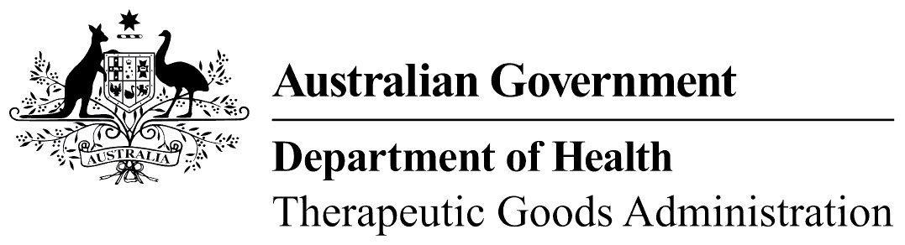
TGA use only

This form, when completed, will be classified as 'For official use only'.
For guidance on how your information will be treated by the TGA see: Treatment of information provided to the TGA at <https://www.tga.gov.au/treatment-information-provided-tga>.

Designation checklist: for sponsor seeking Orphan Drug designation
 | Please note: The check lists are intended to assist applicants to determine if they have provided all of the necessary information to allow the TGA to make an informed decision on the designation application.  It is your responsibility to download, complete and attach the checklist as part of the supporting documentation provided for a designation application. See TGA Business Services for more information.
- Is your intended application for only one medicine and one indication? Yes No
You need to submit separate applications for each medicine and indication
- Have you prepared a cover letter for your application? Yes No
- Have you included a description of the condition for which the medicine, including vaccines or in vivo diagnostic agents is intended?
  - Details of the condition Yes No
  - Proposed indication Yes No
  - Medical plausibility Yes No
    - the rationale for use of the medicine in the proposed orphan indication (the medicine will be effective in the treatment, prevention or diagnosis of the condition).
    - if the proposed orphan condition is a subset of a condition affecting a larger population, then the medicine would not be effective for the larger population.
- Have you included a justification of the life threatening or seriously debilitating* nature of the condition? Yes No
  - * A prominent feature of the orphan condition (i.e. affecting an important portion of the target population) is morbidity with a well-established, major impact on the functioning of the person based on objective and quantifiable medical or epidemiological information. Short lived and /or self-limiting morbidity is not considered seriously debilitating.
- Have you included the prevalence of the condition?
  - Prevalence of the proposed orphan condition in Australia Yes N/A
  - Prevalence and incidence of the overall condition in Australia Yes N/A
- Have you included a justification for the lack of financial viability?
  - Grants and tax incentives Yes N/A
  - Past and future Australian development costs Yes N/A
  - Australian production and/or marketing costs Yes N/A
  - Expected Australian revenues Yes N/A
  - Certification (qualified accountant) Yes N/A
- Have you included a comparison against registered therapeutic goods* for the prevention diagnosis or treatment of the proposed condition?
  - Details of registered therapeutic goods Yes N/A
  - Declaration that there are no registered therapeutic goods Yes N/A
  - Justification of significant benefit Yes N/A
*Note: for the purposes of this comparison, registered therapeutic goods do not include therapeutic goods in the part of the Register for provisionally registered goods.
- Have you included a description of the product development? | Yes No
- Have you included the current regulatory status in Australia and overseas? | Yes No
- Have you included a Bibliography containing all published references referred to in your application? | Yes No

