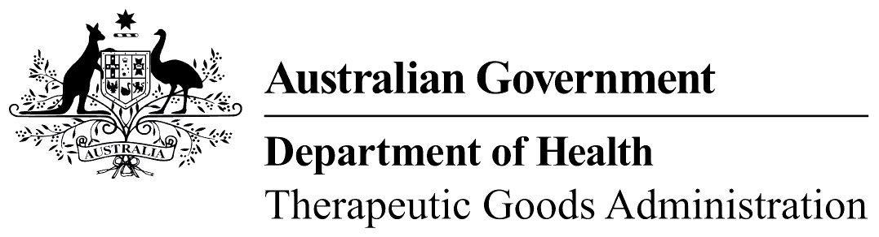
TGA use only

This form, when completed, will be classified as 'For official use only'.
For guidance on how your information will be treated by the TGA see: Treatment of information provided to the TGA at <https://www.tga.gov.au/treatment-information-provided-tga>.

Notification of selective non-disclosure of active herbal extract details form
- Please refer to the Guide to ensure that this form is correctly completed. Where a question number (e.g. 1) appears on the form, a corresponding note is given in the Guide.
- This form should be used to request the Therapeutic Goods Administration (TGA) to keep selective details (e.g. solvent type, concentration, extract ratio and extract excipient details) regarding an ‘Active Herbal Extract’ confidential from the sponsor.
- An Active Herbal Extract contains a single herbal active ingredient and may or may not contain excipient ingredients. All ingredients included in the formulations of Active Herbal Extracts must be permitted for use in listed medicines.
- Notifications for proprietary ingredients other than Active Herbal Extracts should use the ‘Notification of a new proprietary ingredient’ form.
- This notification will result in the standardised/non-standardised extract being allocated a specific name and reference number and entered into the eBusiness Services (eBS). The name and reference number will be used in listed medicine entries on the Australian Register of Therapeutic Goods (ARTG) entries.
- The allocation of a specific name and reference number to an Active Herbal Extract by the TGA is not related to any evaluation, approval or similar in relation to the extract. It is solely a mechanism to assist in having an efficient application process for new listed medicines. The TGA is aware that claims have been made that the allocation of this number constitutes an endorsement by the regulator, however this is not the purpose of the allocation.
 | Disclaimer: It is the responsibility of the sponsor of a medicine including an Active Herbal Extract in their formulation to ensure that the permitted herbal ingredient, after undergoing a specific manufacturing process, complies with the definition of a herbal substance (defined in Regulation 2 of the Therapeutic Goods Regulations 1990). Sponsors are reminded of the importance of ensuring the correctness of matters which they must certify under subsection 26A of the Therapeutic Goods Act 1989 in relation to their medicine containing an Active Herbal Extract. These include that the medicine is safe for the purpose for which it is to be used, that it conforms to all applicable standards and is eligible for listing.  It is the responsibility of the sponsor of a medicine to be aware of any restricted ingredients contained in the Active Herbal Extract by obtaining this information from the Active Herbal Extract supplier.
Regulation 11 of the Regulations state that:
A substance is a restricted ingredient if:
- it is an ingredient in a relevant medicine; and
- for that medicine to be, or to remain, eligible for listing, the permissible quantity or concentration of the substance in the medicine is restricted by operation of any of the following:
- Schedule 4;
- the Poisons Standard;
- a condition imposed under section 28 of the Act;
- a standard under section 10 of the Act;
- the Required Advisory Statements for Medicine Labels;
- any other provision in these Regulations or in the Act that deals with eligibility of medicines for listing.
The TGA will not assess notifications of Active Herbal Extracts for compliance with the legislated definition of a ‘herbal substance’. The TGA will use the information provided in the notification form to ensure that the nominated ingredients are permitted for use in listed medicines.
The completed form and any attachments should be sent to:
Active Herbal Extract coordinator, Complementary Medicines Branch, Therapeutic Goods Administration, PO Box 100, Woden ACT 2606, Australia.
For more information, telephone +61 2 6289 4627 or email complementary.medicines@tga.gov.au.

Part A – General details

Active Herbal Extract supplier's details
1. Business name:
2. Business address:
3. Client identification (ID) number:

Contact officer details
4. Name:
Postal address:
Phone: |  | Fax:
Email:
5. Have you attached a completed ‘Client details’ form for this information? Yes No

Active Herbal Extract manufacturer's details
6. Client identification (ID) number:
7. Name:
Site address:

Part B - Product/formulation details

Proposed Active Herbal Extract name
8. Proposed name:
Please supply the following information for the active ingredient:
9. Botanical name:
Plant part used:
Type of preparation:
Equivalent weight of herb (specify fresh or dry):
Standardised activity:
Equivalent amount of standard component (specify in mg/g):
Native plant / Extract ratio:
Final plant / Extract ratio:
Provide details of each extraction step used in the Active Herbal Extract.
Please note: this should only include solvents that are used to obtain the extract, not those solvents used in other roles in the manufacturing process - see the Guide for details.
Step Number | Preparation step | Solvents (including the % of each solvent)
Example:  1 | Extract dry concentrate | 45% ethanol: water
10. List all the excipient/s used in the formulation, including the quantity of each ingredient expressed as a percentage. Attach additional pages if required.
Name of excipient ingredient | Quantity (% w/w)
11. Total number of ingredients contained in the Active Herbal Extract formulation٭
*Active Herbal Extracts must contain only one herbal active ingredient and may or may not contain excipient ingredients. All ingredients (active and excipients) must use valid names consistent with the ‘TGA approved terminology for medicines’ (i.e. AAN or AHN). Quantitative data must also be provided for all ingredients. All ingredients must be approved for the proposed route of administration of the finished product (allowed in listed medicines).

TGA use only

