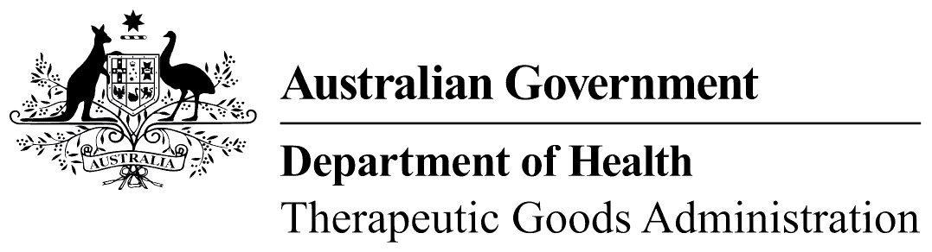
Office use only

Checklist 1: Evidence package cover page
Attach this completed document to the front of your evidence package.

1a: Identification of listed medicine and sponsor details
Medicine identification
Medicine name
AUST L
Sponsor name
Sponsor contact details (as recorded in eBs)

1b: Listed medicine details
Medicine details
Dosage form
Route of administration
Intended population
Recommended dose
Maximum recommended daily dose (MRDD)
Directions for use
Duration of use
Cautions and contraindications

1c: Listed medicine active ingredients
Active ingredient/s | Plant/animal part | Preparation | Equivalent dose | MRDD

1d: Listed medicine indication/s details
No. | Indication/s | Related ingredient/s | Traditional  (Yes) | Scientific  (Yes)

1e: Evidence package details
Does your evidence package include the following: | Yes | No
Completed evidence cover page (checklist 1)?
Evidence search strategy results (checklist 2)?
Evidence of traditional use filter (checklist 3)?
Scientific evidence filter (checklist 4)?
Evidence of traditional use summary (checklist 5)?
Evidence summary for scientific indications (checklist 6)?
An attached copy of all evidence items included in your evidence summary?
What is the total number of attachments (excluding checklists)?
What is the total number of pages in evidence package?

Include all ingredient details such as extraction, solvent, concentration, equivalent weight.

