Clinical decision support software
  - Scope and examples
Version 1.1, October 2021

Copyright
© Commonwealth of Australia 2021
This work is copyright. You may reproduce the whole or part of this work in unaltered form for your own personal use or, if you are part of an organisation, for internal use within your organisation, but only if you or your organisation do not use the reproduction for any commercial purpose and retain this copyright notice and all disclaimer notices as part of that reproduction. Apart from rights to use as permitted by the Copyright Act 1968 or allowed by this copyright notice, all other rights are reserved and you are not allowed to reproduce the whole or any part of this work in any way (electronic or otherwise) without first being given specific written permission from the Commonwealth to do so. Requests and inquiries concerning reproduction and rights are to be sent to the TGA Copyright Officer, Therapeutic Goods Administration, PO Box 100, Woden ACT 2606 or emailed to <tga.copyright@tga.gov.au>.
The purpose of this guidance is to help manufacturers and sponsors understand how the TGA interprets requirements, and thus indicate how manufacturers and sponsors can comply.
This is a guide only, and manufacturers and sponsors are encouraged to familiarise themselves with the legislative and regulatory requirements in Australia, and if necessary, to seek professional advice. It is the responsibility of each manufacturer or sponsor to understand and comply with these requirements.
This document will evolve over time and updates and clarifications will be included as required. Feedback on the guidance is always welcome, please send any comments to digital.devices@tga.gov.au.

Contents
About this guidance 4
Excluded or exempt software 4
Exemption for clinical decision support software 5
How to determine if your clinical decision support software is regulated by the TGA 6
Is it a medical device? 6
Examples of CDSS that is not a medical device 7
Is it excluded? 8
Is it exempt? 9
Examples of CDSS that is exempt 10
What to do if your clinical decision support software is exempt 13
Examples of CDSS that is not exempt 13
What to do if your clinical decision support software is regulated by the TGA 16

About this guidance
Changes to the way that software-based medical devices are regulated in Australia came into effect on 25 February 2021. Information about the changes can be found in Regulatory changes for software based medical devices.
Clinical decision support software (CDSS) that meets the definition of a medical device must be included in the Australian Register of Therapeutic Goods (ARTG) unless otherwise exempt. Under the changes, an exemption has been introduced for some CDSS that is a medical device. Note, CDSS that does not meet the definition of a medical device, or is excluded, is not subject to regulation by the TGA.
CDSS is software that can perform a broad range of functions that facilitate, support and enable clinical practice. Examples of clinical decision support software include:
- A web-based application that provides information about particular diseases or conditions based on a health practitioner’s input of their patient’s symptoms;
- Software intended to analyse an x-ray image to assist a radiologist in identifying anomalies; and
- Software that collects and records data from a closed-loop blood glucose monitor.
CDSS could be any kind of software, including but not limited to:
- mobile apps;
- software as a service (cloud based);
- websites and browser delivered products; and
- more traditional software platform architectures.
This guidance document provides information about when and how CDSS is regulated in Australia by the TGA.
This document includes examples of CDSS that is a medical device to help illustrate key considerations.

Excluded or exempt software
Recent reforms have been implemented to clarify the requirements for regulated software based medical devices, including introducing a number of exclusions and exemptions for specific types of software products.
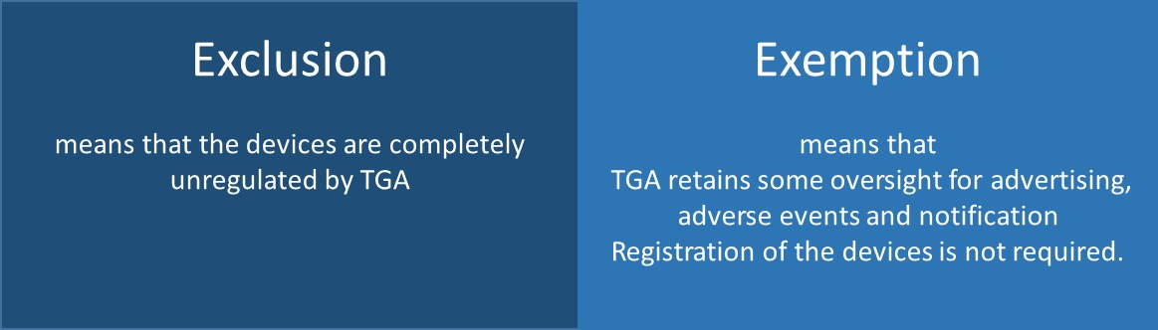
Certain clinical decision support systems have been exempted. Exempt software is a medical device but is not subject to all regulatory requirements.
Other software products have been excluded and are not subject to any TGA regulatory requirements. See the Therapeutic Goods (Excluded Goods) Determination 2018 for the full list of excluded software.
 | Note on Excluded Products  If a clinical decision support system meets the exclusion criteria described in Therapeutic Goods (Excluded Goods) Determination 2018, it is excluded from regulation, and organisations do not need to give further consideration to this guideline document and the examples included in it.  If a CDSS does not meet the exclusion criteria, then it is regulated, and this guidance document should be closely examined to see if the exemption rules may apply.  It is important to note that if the product is changed or enhanced, the intended purpose may change and organisations (manufacturers and/or sponsors) will need to re-examine the exclusion criteria to check that the product is still excluded.

Exemption for clinical decision support software
An exemption has been introduced for some clinical decision support software. Exempt software is a medical device but is not subject to all regulatory requirements. The exemption can be found in Part 2 of Schedule 4 of the Therapeutic Goods (Medical Devices) Regulations 2002.
- Please note, if you have already determined that your CDSS either does not meet the definition of a medical device or is excluded then you do not need to assess it against the exemption criteria, as it is not regulated by the TGA.
If the CDSS is exempt, it is not required to be registered in the ARTG. However, the following requirements still apply:
- Sponsors (suppliers) must notify the TGA of their exempt CDSS devices. You must notify the TGA using the Notification form: Clinical decision support software exemption within 30 working days of supply.
- Sponsors of exempt devices must ensure the devices meet the relevant essential principles for safety and performance of medical devices. The essential principles describe the fundamental design and manufacturing legislative requirements. More information on the essential principles can be found in the Australian regulatory guidelines for medical devices (ARGMD).
- The TGA can take regulatory action such as a recall or issuing a hazard alert if there is a problem with the device.
- Sponsors must report adverse events to the TGA.

How to determine if your clinical decision support software is regulated by the TGA
Generally speaking, a CDSS is regulated by the TGA if:
- It is manufactured or supplied in Australia; and
- It is a medical device; and
- It is not excluded from TGA regulation
The sections below set out the process you should follow in order to determine whether a particular CDSS is regulated by the TGA. The intended purpose of the CDSS, as stated by the manufacturer, is a key determinant of whether or not a CDSS is regulated by the TGA. Some software may have multiple functions, each with a distinct intended purpose. Some functions may be associated with a medical purpose, and some not. It is the responsibility of the manufacturer to review the intended purpose of each function and determine whether or not it meets the definition of a medical device and will be regulated by the TGA, see next section.

Is it a medical device?
CDSS is regulated by the TGA if it meets the definition of a medical device provided in Section 41BD of the Therapeutic Goods Act 1989 (the Act). The flow chart below can assist you to identify whether or not a particular CDSS is a medical device.
Figure 1. Is a particular CDSS a medical device?
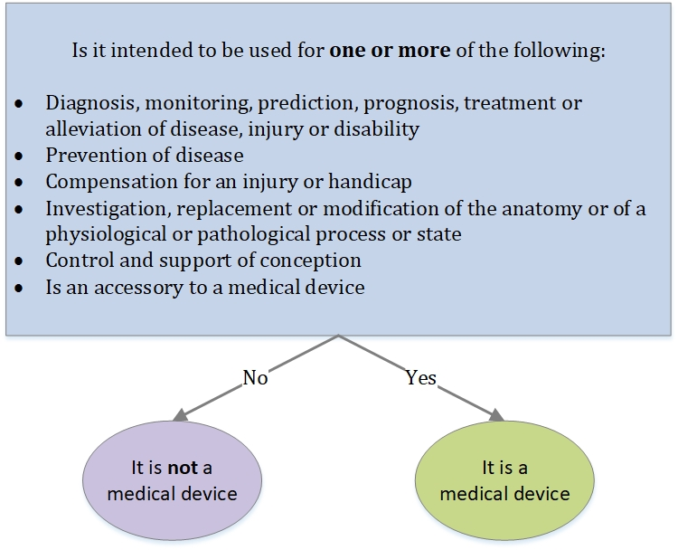

Monitoring
Monitoring in this instance refers specifically to the active, clinical patient monitoring of a disease, injury or disability. For example, this definition does not include software for indirect monitoring activities such as regularly reviewing an individual’s health records to determine if they meet the criteria to participate in a screening program for a particular disease, or they are due for a particular medical assessment.
Software functions intended for active patient monitoring include the following characteristics:
- The clinical context requires a timely response (e.g. in-hospital patient monitoring).
- The clinical condition (disease or diagnosis) requires a timely response (e.g., a monitor that is intended to detect life-threatening arrhythmias, such as ventricular fibrillation, or a device used to actively monitor diabetes for time-sensitive intervention).
An example of a medical device that provides active patient monitoring is a nurse telemetry station that receives and displays information from a bedside hospital monitor in an ICU.
The functionality of CDSS varies immensely. Some CDSS provide clinicians with decision support on individual patient care and provide information to help them diagnose and treat their patients; others collate relevant information to make it more easily accessible to clinicians. It is important to consider the intended purpose when determining if a CDSS is a medical device or not.

Examples of CDSS that is not a medical device
If CDSS does not perform any functions consistent with the definition of a medical device, it is not considered a medical device, and so not regulated by the TGA.
For example, CDSS that is intended only to display or print medical information about a patient or other medical information (such as demographic information, drug labelling, clinical guidelines, studies, or recommendations ) is not a medical device and is not regulated by the TGA.
These examples are not medical devices, as they are digitising what was previously a paper based resource through an interactive software interface. The health professional uses information about their patient to decide which path to proceed, and whether to use the resulting recommendation. The software itself is not directly performing any of the activities in the definition of a medical device (see Figure 1).
Example 1
A web-based application that provides reference information about particular diseases or conditions based on a health practitioner’s input of their patient’s symptoms. The app does not indicate probability of a match/ red flag or priorities.
Example 2
A website that provides referenced cancer treatment information categorised by cancer type. The information is intended as a resource for clinicians who have made a diagnosis to use when making treatment decisions. The information is collected in a particular way from a number of references; the treatment information presented would otherwise be available to the health professional.
Example 3
Software that digitises a clinical guideline decision tree for stroke management. The software guides the health professional user through the steps of the process and prompts when a decision needs to be made by the user (the software does not recommend a decision). The software then presents the recommended management plan to the health professional, based on the decision selections made by that user. The software clearly references the clinical guideline as the basis for the recommendation.
Example 4
Where a Clinical Information System, such as a GP CIS or other used by providers receives a signal from a medical device, and records that signal into the software, that does not convert the excluded GP CIS into a SAMD subject to regulation.
For clarity– the recording does not convert the CIS into a medical device, however analysing the signal may convert the CIS into a medical device.
If a “signal” originates from a medical device, then any clinical decision support software that processes or analyses that data will not be exempt. This applies even if the “signal“ is stored in an Electronic Medical Record (EMR) in between. Storing the “signal” would not make the EMR a medical device.
The medical device may be software or hardware.

Is it excluded?
Certain software products are excluded from regulation by the TGA.
Excluded products are low-risk products that may meet the definition of a medical device, but which have been declared not to be medical devices in law. Excluded products are not subject to any TGA regulatory requirements. Excluded products are described in excluded goods orders, determinations and specifications. Some software is excluded from regulation by the TGA when limited to performing only certain functions. The Therapeutic Goods (Excluded Goods) Determination 2018 is the legislative instrument that describes these exclusions. See Examples of regulated and unregulated software (excluded) software based medical devices for further guidance on these exclusions.
Example 1
Pharmacy dispensing systems and prescribing software used by GPs.
Example 2
Software module that provides alerts for adverse drug interactions based on established rules and guidelines.
Example 3
A clinical information system (CIS) that stores data received from a medical device for later review by a health professional (but does not display the data for the purposes of diagnosis or monitoring)
- If a CDSS is excluded it is not regulated by the TGA and you do not need to determine whether it is exempt or not.
- A CDSS may be exempt if:
- it meets the definition of a medical device and
- is not excluded from regulation by the TGA.
To determine if your CDSS is exempt you should review the criteria below.

Is it exempt?
Certain software products that meet the definition of a medical device and that are not otherwise excluded, may be exempt from regulation by the TGA.
Exempt products are medical devices but are not subject to all regulatory requirements. An exemption has been introduced for CDSS that meet certain criteria. The exemption can be found in Part 2 of Schedule 4 of the Therapeutic Goods (Medical Devices) Regulations 2002 (the Regulations).
Exempt CDSS are not required to be approved by the TGA prior to supply, and do not need to be included on the Australian Register of Therapeutic Goods (ARTG).
A clinical decision support system is exempt if it meets all 3 of the following criteria:
- does NOT directly process or analyse a medical image or a signal from another medical device (including an in vitro diagnostic device); and
- is solely used to provide or support a recommendation to a health professional about prevention, diagnosis, curing or alleviating a disease, ailment, defect or injury; and
- does NOT replace the clinical judgement of a health professional in relation to making a clinical diagnosis or decision about the treatment of patients.
If any of these criteria are not met, the CDSS is not exempt and requires inclusion in the ARTG.
The flow chart in Figure 2 can assist you to identify whether or not a particular CDSS is exempt from regulation by the TGA.
Figure 2. Is a particular CDSS exempt?
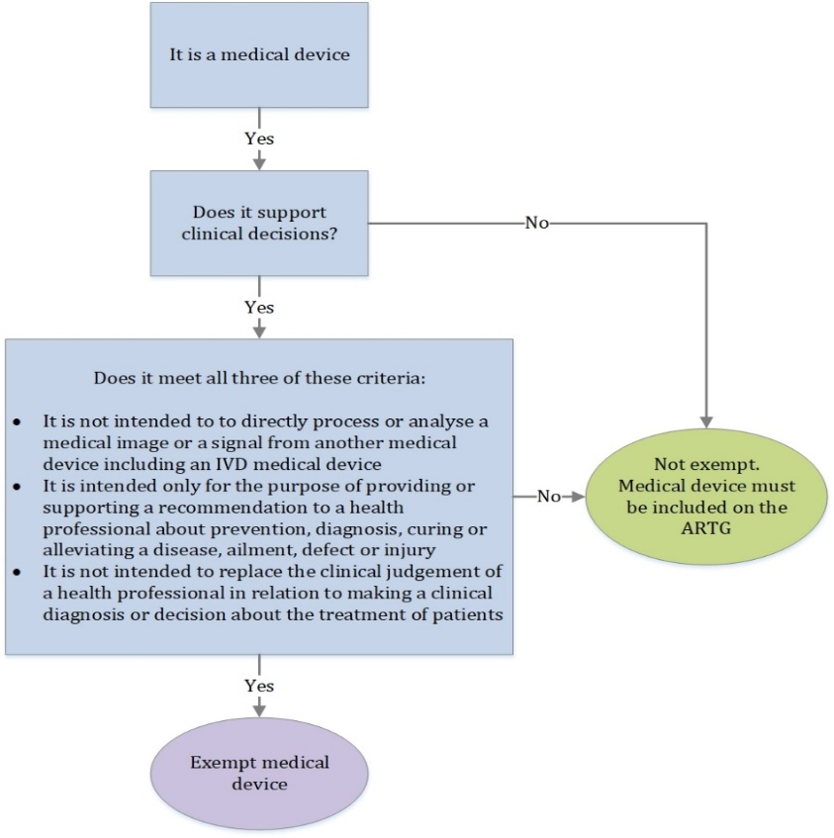
Exempted CDSS devices must clearly reference the basis of the recommendations, including the source(s) of information used (e.g. specific clinical guideline, hospital procedure) so that the information can be independently reviewed. The user may rely on their own judgement and reach a recommendation without primarily relying on the software function.
For guidance on the regulation of medical device software, see How the TGA regulates software based medical devices.

Examples of CDSS that are exempt
CDSS is exempt when it meets all three of the criteria outlined in Exemption criteria.
Some examples are provided to help illustrate how the exemption criteria are applied.

Example 1
Software intended to compare a particular patient’s symptoms and test results with available clinical practice guidelines to recommend, to a health practitioner, condition-specific diagnostic tests, investigations, or therapy. The practice guidelines are described as the basis for the recommendation and are provided for the health practitioner’s review.
You can check this example against the exemption criteria to confirm that it is exempt:
Does it meet the exemption criteria? | Yes/No
Does not directly process or analyse a medical image or a signal from another medical device (including an in vitro diagnostic device) | Yes; the software analyses test results, but does not take signals or images from a hardware medical device
Is solely used to provide or support a recommendation to a health professional about prevention, diagnosis, curing or alleviating a disease, ailment, defect or injury | Yes; the software provides recommendations to a health practitioner, who then decides the appropriate course of action
Does not replace the clinical judgement of a health professional in relation to making a clinical diagnosis or decision about the treatment of patients | Yes; the clinical practice guidelines are described as the basis for the recommendation and are provided for the health practitioner’s review.

Example 2
Surgical workflow software that describes the steps of a surgical procedure to a surgeon. The software is based on an accepted clinical guideline, and analyses an individual patient’s test results to determine which steps of the surgery are or are not required. The software recommends an action to the surgeon and the surgeon can choose to override the recommendations from the software.
This is a medical device, as the software has gone beyond digitising the paper-based resource by automatically taking patient information and using this to recommend actions to a health professional.
You can check this example against the exemption criteria to confirm that it is exempt:
Does it meet the exemption criteria? |  | Yes/No
Does not directly process or analyse a medical image or a signal from another medical device (including an in vitro diagnostic device) | Yes; the software analyses test results, but does not take signals or images from another medical device
Is solely used to provide or support a recommendation to a health professional about prevention, diagnosis, curing or alleviating a disease, ailment, defect or injury | Yes; the software provides recommendations to a health practitioner, who then decides the appropriate course of action
Does not replace the clinical judgement of a health professional in relation to making a clinical diagnosis or decision about the treatment of patients | Yes; the clinical practice guideline is referenced as the basis for the recommendation and the health practitioner is able to review the guideline if they choose.

Comparative example of CDSS that is not a medical device, and exempt CDSS
Not a medical device:
Software that digitises a clinical guideline decision tree for stroke management. The software guides the health professional user through the steps of the process and prompts when a decision needs to be made by the user (the software does not recommend a decision). The software then presents the recommended management plan to the health professional, based on the decision selections made by that user. The software clearly references the clinical guideline as the basis for the recommendation. and is not replacing the clinical judgement of the health professional.
This is not a medical device, as it is digitising what was previously a paper based resource through an interactive software interface. The health professional uses information about their patient to decide which path to proceed along the decision tree, and whether to use the resulting recommendation. The software does not allow the clinician to input individualised patient symptoms or test results, but rather provides yes/no prompts (e.g. ‘is the patient conscious?’).
Medical device (exempt):
Surgical workflow software that describes the steps of a surgical procedure to a surgeon. The software is based on an accepted clinical guideline, and analyses an individual patient’s test results to determine which steps of the surgery are or are not required. The software recommends an action to the surgeon and the surgeon can choose to override the recommendations from the software.
This is a medical device, as the software has gone beyond digitising the paper-based resource, as it automatically takes patient information and uses this to recommend actions to a health professional. The software is exempt, as it meets all three criteria:
- It does not take data directly from a medical device.
- It is intended only for the purpose of providing a recommendation to a health professional.
- It is not intended to replace the clinical judgement of a health professional, as it is based on information (the referenced clinical guideline) that can otherwise be verified.

What to do if your clinical decision support software is exempt
If the CDSS is exempt, it is not required to be approved by the TGA and included in the ARTG. However sponsors/suppliers must notify the TGA of their exempt CDSS devices. You must notify the TGA using the Notification form: Clinical decision support software exemption within 30 working days of supply.
Sponsors of exempt devices must also comply with the requirements outlined in Exemption for clinical decision support software.
Exempted CDSS devices must clearly reference the basis of the recommendations, including the source(s) of information used (e.g. specific clinical guideline, hospital procedure) so that the information can be independently reviewed by the user. The user may rely on their own judgement and reach a recommendation without primarily relying on the software function.

Examples of CDSS that is not exempt
These are examples of CDSS that (1) meet the definition of a medical device and (2) are not exempt. These CDSS would be required to be approved by the TGA and included in the ARTG.
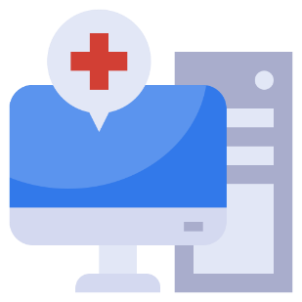
Example 1
Software intended to analyse an x-ray image to assist a radiologist in identifying anomalies. The software highlights detected irregularities for the purposes of a health professional making a diagnosis. The process used by the software is not published, and consequently the software provides a diagnostic output that a health professional would otherwise not have access to.
You can check this example against the exemption criteria to confirm that it is exempt:
Does it meet the exemption criteria? | Yes/No
Does not directly process or analyse a medical image or a signal from another medical device (including an in vitro diagnostic device) | Yes; although the software analyses a medical image, it is not taken directly from a hardware medical device, which means it is not converting a raw signal into an image
Is solely used to provide or support a recommendation to a health professional about prevention, diagnosis, curing or alleviating a disease, ailment, defect or injury | No; the software provides a diagnostic output that a health professional would otherwise not have access to
Does not replace the clinical judgement of a health professional in relation to making a clinical diagnosis or decision about the treatment of patients | No; the software does not reference how the recommendations are derived, and therefore cannot be verified by the health professional

Example 2
Software that collects and records data from a closed-loop blood glucose monitor. The software analyses this data to provide early diagnosis of a diabetic emergency. When a patient experiences a diabetic emergency, the software will alert the healthcare professional and use the analysed information to make treatment decisions based on the patient’s unique health profile.
This example software contains multiple functions. You can check this example against the exemption criteria to confirm that it is NOT exempt:
Does it meet the exemption criteria? | Yes/No
Does not directly process or analyse a medical image or a signal from another medical device (including an in vitro diagnostic device) | No, the software analyses a signal from a blood glucose monitor
Is used solely to provide or support a recommendation to a health professional about prevention, diagnosis, curing or alleviating a disease, ailment, defect or injury | No, the software provides early diagnosis itself (of a diabetic emergency) rather than simply supporting a diagnosis with information.
Does not replace the clinical judgement of a health professional in relation to making a clinical diagnosis or decision about the treatment of patients | No, the software makes patient care decisions without the intervention of a health professional

Example 3
Software that analyses mammography images to detect anomalies in an individual’s breast tissue and classify these anomalies as either breast cancer or benign. The process used by the software is not published, and consequently the software provides a diagnostic output that a health professional would otherwise not have access to.
You can check this example against the exemption criteria to confirm that it is NOT exempt:
Does it meet the exemption criteria? | Yes/No
Does not directly process or analyse a medical image or a signal from another medical device (including an in vitro diagnostic device) | Yes; although the software analyses a medical image, it is not taken directly from a hardware medical device, and so does not convert the raw signal into an image
Is solely used to provide or support a recommendation to a health professional about prevention, diagnosis, curing or alleviating a disease, ailment, defect or injury | No; the software generates a diagnostic output that a health professional would otherwise not have access to
Does not replace the clinical judgement of a health professional in relation to making a clinical diagnosis or decision about the treatment of patients | No; the software does not reference how the recommendations are derived, and therefore cannot be verified by the health professional

Example 4
Radiation treatment planning software that takes patient images, and allows a healthcare professional to identify tumours, healthy tissues, and critical organs. The software calculates a plan for the delivery of radiation therapy, and the plan serves as input for medical linear accelerators in the treatment of cancer.
The software stores the finalised plans and patient images in a separate database from the one used to calculate the treatment plans. This separate database is used only for storage and retrieval and not to manipulate or analyse the plans and images. Therefore, this data store is not a medical device or part of the CDSS in this instance.
You can check this example against the exemption criteria to confirm that it is NOT exempt:
Does it meet the exemption criteria? | Yes/No
Does not directly process or analyse a medical image or a signal from another medical device (including an in vitro diagnostic device) | Yes; the software uses patient images, and provides them to the health professional who identifies the tumours, health tissues and critical organs. In this case the software does not process or analyse the images; it only provides them to the health professional.
Is solely used to provide or support a recommendation to a health professional about prevention, diagnosis, curing or alleviating a disease, ailment, defect or injury | No; the software calculates a treatment plan and then programs the medical device delivering the treatment.
Does not replace the clinical judgement of a health professional in relation to making a clinical diagnosis or decision about the treatment of patients | No; the software calculates a treatment plan that is used by the linear accelerator. The detailed calculations are not available to be readily checked.

What to do if your clinical decision support software is regulated by the TGA
If your CDSS is regulated by the TGA it will need to be registered in the ARTG prior to importation or supply in Australia.
For further information on how software is regulated, see How the TGA regulates software based medical devices.
Information on the actual process for applying for inclusion of your device in the ARTG is available in the Medical device inclusion process guidance.

Version history
Version | Description of change | Author | Effective date
Draft V1.0 | Original publication | Devices Emerging Technology & Diagnostics Section | February 2021
V1.1 | Update – finalise draft | Devices Emerging Technology & Diagnostics Section | October 2021

Therapeutic Goods Administration
PO Box 100 Woden ACT 2606 Australia
Email: info@tga.gov.au Phone: 1800 020 653 Fax: 02 6203 1605
https://www.tga.gov.au
Reference/Publication #

