Brief overview: Feedback on consultation on Scope of Regulated Software based products
10 August 2020
The TGA released a public consultation paper in April 2020 seeking feedback on proposals to “carve-out” from regulatory oversight by the TGA, certain groups of software medical device products that would normally be regulated by the TGA under the Australian medical devices regulatory framework. This document is a brief overview of the feedback provided by respondents. Another more detailed document is also available on our website. Based on feedback, the TGA has commenced further discussions with respondents to clarify their comments or to seek further information prior to advice being provided to the Government.
Generally there are three main issues for consideration in a potential carve-out:
- What kinds of software-based products should be excluded from regulation by the TGA?
Feedback indicated there needed to be simple decision rules and clear rationale for exclusion, e.g.:
  - Low risk to safety and/or
  - intervention of a clinician (so software largely provides “information” rather than decision and/or
  - alternative oversight schemes or systems
- Are there products that warrant being exempted but not fully excluded? This is an intermediate category (between full regulation by TGA (inclusion) and no oversight by TGA (exclusion)
  - Some categories may be appropriate for exclusion, others exemption
- Which approaches from international jurisdictions, if any, should be used to inform the Australian regulatory requirements? The aim is to minimise unique Australian requirements, but at the same time provide
  - Clarity in regulatory requirements
  - A scheme that is affordable for industry and the TGA to manage
  - Enables evaluations by comparable regulators to be used to streamline TGA approvals

Summary of feedback

Software as a Medical Device (SaMD) is a subset of health software
Feedback to the consultation indicated that this differentiation needs to be made clear in any future TGA guidance material.
Health software is defined in the standard ISO/IEC 82304-1 (2016) “Health Software - General Requirements for product safety” as:
“software intended to be used specifically for managing, maintaining or improving health of individual persons or the delivery of care”
The scope of ‘health software’ in IEC 82304 is broader than medical device software. Most health software is not a medical device and is not regulated by the TGA.
The diagram below illustrates where SaMD sits in the broader category of the scope of health software:
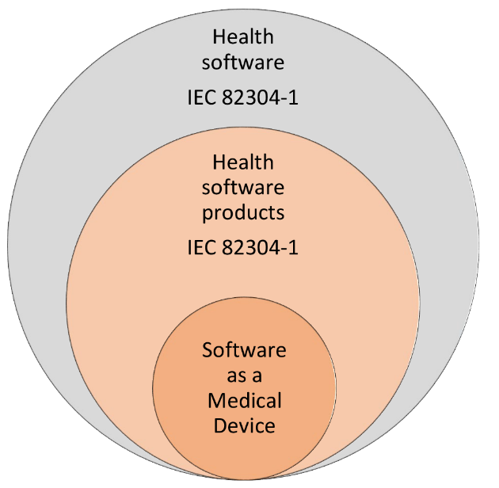

International alignment
Feedback indicated that the TGA needed to develop a brief statement on international regulatory alignment and use of Comparable Overseas Regulator reports to assist understanding of how to reduce regulatory burden and make clear where differences occurred – i.e.: transparency to assist market entry.
- Minimise unique Australian requirements (however some respondents did not recognise that the major jurisdictions are inconsistent in carve-outs)
- Enable regulatory submissions and evaluations from comparable regulators (where available) to be used
- Canadian guidance and approach seemed simplest and clearest
- Are there specific mechanisms used in international jurisdictions noting that
  - The EU regulations lack sufficient specificity on carve-outs
  - the US FDA “Pre- cert” approach while reducing regulatory burden on sponsors would be too resource intensive for TGA to implement at this stage)

Exclusion vs Exemption
Feedback indicated there needs to be clarity about both of these mechanisms and the rationale for proposing one over the other.
Excluded products are not subject to any TGA oversight.
Exempt products are not required to be included in the ARTG. These do not have pre-market evaluation by the TGA and:
- Sponsors must ensure that exempted products still meet the relevant essential principles for safety and performance
- TGA monitors on going safety of products and manufacturers/sponsors must report adverse events to the TGA
- TGA can issue recalls or issuing hazard alerts in the event of a problem
- Products are subject to the Therapeutic Goods Advertising Code

Products with clear agreement to carve out
Feedback indicated that the TGA should amend the list of principles and products in the consultation paper taking into consideration the views of respondents. From the feedback received, determine whether exemption versus exclusion should be proposed for particular subgroups of products (a proposed set of rules is below). The TGA will also need to document the requirements for suitable alternative systems of oversight.
Products where there may be other systems of oversight:
- Laboratory Information Management Systems (LIMS) and Laboratory Support software where there is laboratory accreditation in place (broadly supported). EXCLUDE
Alternative oversight: NATA (National Association of Testing Authorities)/RCPA (Royal College of Pathologists Australia) and/or based on NPAAC (National Pathology Accreditation Advisory Council) standards. Note that accreditation is of the laboratories themselves, and does not cover device design, performance or safety. It does not cover the manufacturers of software systems that these labs may use. A carve-out on this basis needs to consider these limitations.
- Clinical Decision Support Systems (CDSS) – for further consideration. We may need to better define the different CDSS and clarify what is carved out versus not carved out. EXEMPT
Broad support for clinical decision support systems being carved-out, but some felt that conditions should be applied to the carved-out.
- A total carve-out of CDSS is inconsistent with international regulators.
- Oversight by “qualified health professionals” was proposed as an alternative oversight mechanism. But it’s unlikely that health professional representative bodies would pass responsibility for their safety, efficacy and performance from the software developer/manufacturer to the medical practitioner user
- Concerns that medical practitioner users would have no way to validate that the software is functioning correctly
- Several respondents stated that clinical decision support systems should not be carved out is they were linked to other systems or used machine learning or artificial intelligence as the systems could become de facto decision makers.
Are there other systems of oversight that were not adequately described in the consultation submissions? Are there other systems recognised e.g. By Health Canada?
There was broad support to carve-out products that pose no potential for significant harm to an individual:
- Self-management of an existing specific disease or condition (without providing specific treatment or treatment suggestions) EXCLUDE
- Patient or consumer health and wellness products (may be a combination of hardware and software) EXEMPT
- Behavioural change or coaching software for patients that include strategies for improving general health parameters such as weight, exercise, hypertension, salt intake. (may need to further consider mental health ?) EXCLUDE
- Electronic Patient Records EXEMPT (except where functionality has a therapeutic purpose) REGULATE AS A DEVICE
- Software intended to administer or manage health processes or facilities, rather than patient clinical use cases. EXCLUDE
- PROMs – patient surveys and questionnaires except where they provide further analysis such as risk scoring EXCLUDE
- Software that enables telehealth consultations or supports remote diagnosis EXCLUDE
- Simple calculators e.g. dosage calculators that perform a simple look-up or that show the logic enabling the calculation to be readily verified by the user EXCLUDE
- Data analytics that are class or group based rather than individual patient based EXEMPT

Other products proposed for carve-out
A number of other products were mentioned in submissions; some can be grouped with the above listed products and for others, we will continue to analyse with a view to potential carve out. Some examples are:
- Apps that connect to MyHealth Record
- Systems that record and store patient images
- Software that is used by health professionals who can “exercise their own judgement”, pharmacy dispensing systems and information systems used by GP practices and individual GPs
- Software embedded in delivery of health services
- Middleware that does not recommend a diagnosis or treatment decision
- Consumer genomic interpretation tools – for data analytics versus diagnostic purposes
- IVD software that can be covered by an expanded role by NPAAC – i.e. in-house IVD software
- 3D printers that create anatomical or physiological models and custom make devices
- Individual consumer products – i.e. custom made that may have software components
- Patient surveys that form part of an electronic health record and patient recorded outcome measures

Other issues raised in submissions
- Some submissions mentioned particular products/ groups on the list that had been proposed in the TGA consultation paper for carve out which they believed had potential to impact patient safety. Several respondents asked that there be regulatory oversight for these products so patients and clinicians who use the software must be able to trust software performance.
- Some submissions requested greater oversight of consumer software including apps, given privacy concerns, vulnerable groups, low IT literacy, and the risk of poor outcomes and increased risk of mismanagement as a result of software devices.

Next steps
Finalise analysis and publish on the TGA website
Targeted discussions with respondents on specific areas to clarify comments or seek additional information to enable the determination of a potential carve-out
Provide advice to the Government and seek a Policy decision on proposed carve out
Commence drafting of legislative instrument/s
Develop guidance (with stakeholders)
Identify future work or consultations required on areas that are either not agreed by the Government to take forward or where there is insufficient clarity or agreement by key stakeholders on the proposals for change

