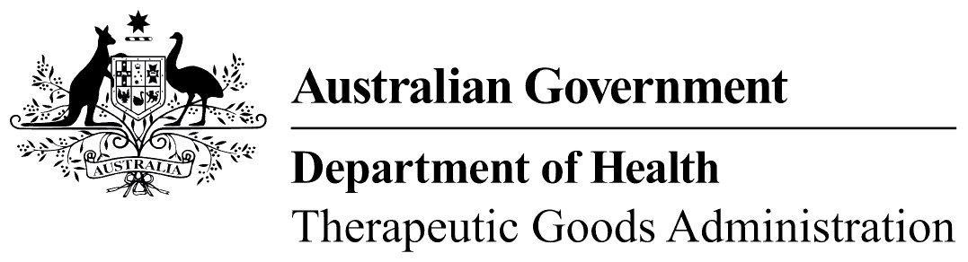
TGA use only

This form, when completed, will be classified as 'For official use only'.
For guidance on how your information will be treated by the TGA see: Treatment of information provided to the TGA at <https://www.tga.gov.au/treatment-information-provided-tga>.

Biologicals (including tissues), human blood and blood components report
Recall report form
- This form is used to report recalls of human blood and tissue products.
- Recalls must be reported as soon as possible to recalls@health.gov.au, and by telephone or facsimile to the Deputy Australian Recall Co-ordinator Telephone: 02 6232 8935, Mobile: 0412 205 568 (AH) Facsimile: 02 6232 1451
- Date of problem:
- Reporter (person reporting the problem):
Name:
Occupation/Position:
Institution:
Address:
Telephone: |  | Facsimile:
Email:
- Product name(s):
- Primary donation/tissue bank number:
- Secondary Identifier number (where applicable): |  |  | Expiry date:
- Donation type:
- Reason for recall:
- Source of failure (if known):
- Date: of donation |  |  | and of issue:
- Has the recipient hospital/pathologist/fractionator been contacted? Yes No
Details:

Signature: |  | Date:

