July 2013

AusPAR Attachment 2

Extract from the Clinical Evaluation Report for Zonisamide
  - Proprietary Product Name: Zonegran
  - Sponsor: SciGen (Australia)

About the Therapeutic Goods Administration (TGA)
- The Therapeutic Goods Administration (TGA) is part of the Australian Government Department of Health and Ageing, and is responsible for regulating medicines and medical devices.
- The TGA administers the Therapeutic Goods Act 1989 (the Act), applying a risk management approach designed to ensure therapeutic goods supplied in Australia meet acceptable standards of quality, safety and efficacy (performance), when necessary.
- The work of the TGA is based on applying scientific and clinical expertise to decision-making, to ensure that the benefits to consumers outweigh any risks associated with the use of medicines and medical devices.
- The TGA relies on the public, healthcare professionals and industry to report problems with medicines or medical devices. TGA investigates reports received by it to determine any necessary regulatory action.
- To report a problem with a medicine or medical device, please see the information on the TGA website <http://www.tga.gov.au>.
About the Extract from the Clinical Evaluation Report
- This document provides a more detailed evaluation of the clinical findings, extracted from the Clinical Evaluation Report (CER) prepared by the TGA. This extract does not include sections from the CER regarding product documentation or post market activities.
- The words [Information redacted], where they appear in this document, indicate that confidential information has been deleted.
- For the most recent Product Information (PI), please refer to the TGA website <http://www.tga.gov.au/hp/information-medicines-pi.htm>.
Copyright
© Commonwealth of Australia 2013
This work is copyright. You may reproduce the whole or part of this work in unaltered form for your own personal use or, if you are part of an organisation, for internal use within your organisation, but only if you or your organisation do not use the reproduction for any commercial purpose and retain this copyright notice and all disclaimer notices as part of that reproduction. Apart from rights to use as permitted by the Copyright Act 1968 or allowed by this copyright notice, all other rights are reserved and you are not allowed to reproduce the whole or any part of this work in any way (electronic or otherwise) without first being given specific written permission from the Commonwealth to do so. Requests and inquiries concerning reproduction and rights are to be sent to the TGA Copyright Officer, Therapeutic Goods Administration, PO Box 100, Woden ACT 2606 or emailed to <tga.copyright@tga.gov.au>.

Contents
List of abbreviations 4
1. Clinical rationale 5
2. Contents of the clinical dossier 5
2.1. Scope of the clinical dossier 5
2.2. Paediatric data 5
The submission did not include paediatric data. 5
2.3. Good clinical practice 5
3. Pharmacokinetics 6
3.1. Study ELN46046-108 6
3.2. Summary of pharmacokinetics 9
3.3. Evaluator’s overall conclusions on pharmacokinetics 10
4. Pharmacodynamics 10
5. Dosage selection for the pivotal studies 10
6. Clinical efficacy 11
6.1. Efficacy for the proposed indication 11
6.2. Evaluator’s conclusions on clinical efficacy 34
7. Clinical safety 36
7.1. Studies providing evaluable safety data 36
7.2. Patient exposure 37
7.3. Subject disposition 39
7.4. Adverse events 40
7.5. Laboratory tests 48
7.6. Postmarketing experience 48
7.7. Evaluator’s overall conclusions on clinical safety 48
8. First round benefit-risk assessment 49
8.1. First round assessment of benefits 49
8.2. First round assessment of risks 49
9. First round assessment of benefit-risk balance 49
10. First round recommendation regarding authorisation 49
11. Clinical questions 49
11.1. Efficacy 49
12. Second round evaluation of clinical data submitted in response to questions 50

List of abbreviations
Abbreviation | Meaning
AED | Anti-epileptic drug
ETV | Early Termination Visit
FV | Final Visit
Aldenkamp–Baker Neuro-psychological Assessment Scale | The ABNAS is a subject based questionnaire to measure subjective perceived drug-related cognitive impairments. The questionnaire measured seven critical domains of cognition (tiredness/fatigue, hyperexcitability, slowing (mental and motor), memory impairment, attention disorders, impairment of motor coordination, and language disorders.
Bond–Lader Scale | The Bond–Lader visual analogue scale is made up of 16 pairs of alternative descriptors of mood and attention at either end of a 10 cm line. Subjects were asked to rate their feelings at the time of assessment by indicating the point on the line which best represented their mood. Each item was scored by measuring the position relative to the left hand end of the line and levels of anxiety, sedation, and dysphoria were then calculated from the combined scores of selected items using a predefined weighting scheme.

Clinical rationale
Zonisamide is thought to exert its actions by blockade of the neuronal voltage-sensitive sodium and calcium channels, thereby disrupting synchronized neuronal firing, reducing the spread of seizure discharges and disturbing subsequent epileptic activities. In addition, it also has some effects on the synthesis, release, and degradation of a number of different neurotransmitters, including glutamate, GABA, dopamine, serotonin, and acetylcholine, which may lead to enhancement of synaptic inhibition.
Partial epilepsies (focal or localization-related) account for more than 60% of epilepsies, and they include most of the difficult-to-treat subjects. Partial epilepsies include simple partial seizures (without impairment of consciousness), complex partial seizures (with impairment of consciousness and often more disabling), and secondarily generalized tonic-clonic seizures.
The goals of treatment for adults with epilepsy are the best quality of life achievable, with no seizures, and the fewest possible adverse effects from treatment.
The majority of newly diagnosed subjects (50% – 70%) achieve seizure freedom on monotherapy. Monotherapy is more likely to facilitate subjects’ compliance with treatment, whereas the opposite is true for polytherapy regimens.

Contents of the clinical dossier

Scope of the clinical dossier
The submission included:
One clinical pharmacology study (ELN46046-108) that evaluated the effect of race on 100 mg single-dose PKs of zonisamide in healthy White, Black, and Asian subjects.
Two efficacy studies:
- Pivotal noninferiority study E2090-E044-310 that compared zonisamide used as a monotherapy to treat newly diagnosed partial epilepsy in adults versus carbamazepine.
- Study AN46046-304 evaluated the dose-response relationships of zonisamide monotherapy in adults with newly diagnosed epilepsy and complex partial seizures.
Safety data from two extension studies:
- StudyE2090-E044-314 from the ongoing double-blind extension of StudyE2090-E044-310, as of the data cut-off of 31 December 2010 (targeted to end in June 2011).
- Study ELN46046-355 from the open-label extension of Study ELN46046-304, completed in 2005 planned duration of treatment was up to 24 months. However, the study was terminated early, upon receipt of marketing approval in the EU.

Paediatric data
The submission did not include paediatric data.

Good clinical practice
The studies were carried out in accordance with Good Clinical Practice.

Pharmacokinetics

Study ELN46046-108
A US single-centre, open-label, parallel group study in three groups (Group 1: White; Group 2: Black; Group 3: Asian) of healthy subjects to examine the effect of race on the single 100 mg dose PKs of zonisamide in healthy subjects.
Thirty-six subjects were enrolled (and completed), with 12 subjects (6 males and 6 females) in each group. Subjects were screened within 21 days prior to dosing.
Measurement of serum zonisamide concentrations was made using a validated high performance liquid chromatographic (HPLC) method with ultraviolet (UV) detection.
There were no important protocol deviations.
Table 1. Demographic and Baseline Characteristics
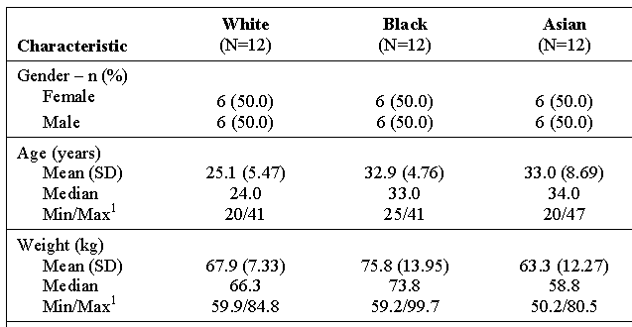

Figure 1. Mean Serum Zonisamide Concentration–Time Plots.
(Linear Scale)
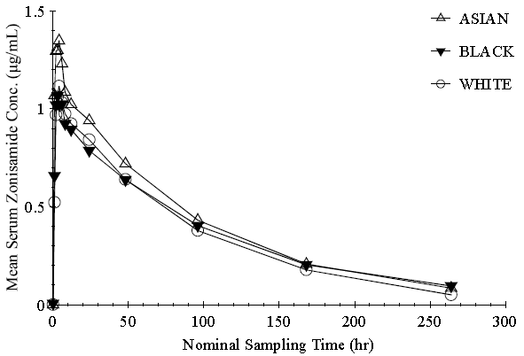
(Semi-Logarithmic Scale)
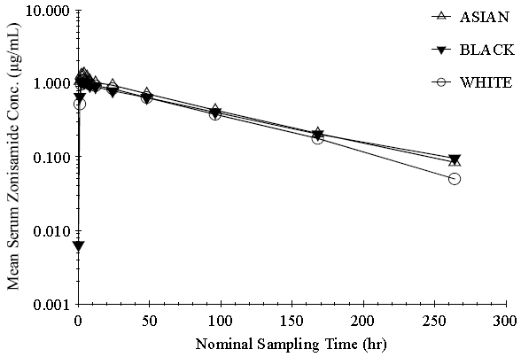
Table 2. Summary Statistics for Zonisamide Pharmacokinetic Parameters
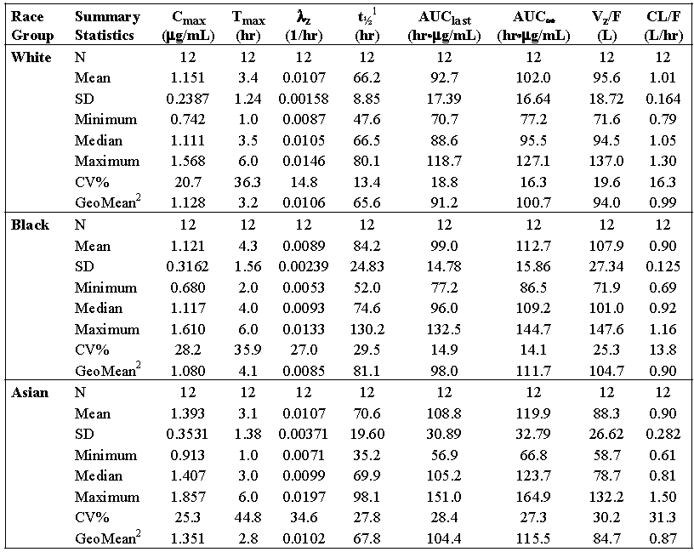
¹ The estimated harmonic mean ± pseudo SD (based on the jack knife variance) for t½ in the White, Black, and Asian groups were 65.0 ± 9.77 hr, 78.3 ± 21.18 hr, and 64.7 ± 23.42 hr, respectively. ² GeoMean = Geometric Mean
Table 3. Equivalence Analysis of Pharmacokinetic Exposure Parameters for Zonisamide between Races
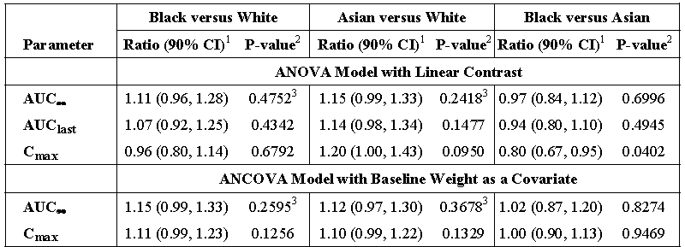
¹ Ratio of geometric means of two races (Black versus White, Asian versus White, or Black versus Asian) and the associated 90% CI. ² The natural logarithm of the ratio of the geometric means was analysed using linear contrasts with significance level of 5% for each contrast. ³ P-values for the co-primary comparisons have been adjusted using a Bonferroni correction with an overall significance level of 5%
The ANOVA model showed no statistically significant (p>0.05) comparisons between racial groups except of C_{max} (Black versus Asian; p=0.0402), λ_{z} (Black versus White; p=0.0491), and V_{z}/F (Black versus Asian; p=0.0460).
Because of the body weight differences between race groups, an ANCOVA model with baseline body weight as a covariate was used for further analysis. Results showed no statistically significant differences for AUC∞ or C_{max} when comparing between the race groups (p > 0.05)
Ratios across the racial groups of geometric means and 90% CIs for AUC_{last}, AUC∞, and C_{max} were calculated to assess whether any clinically relevant changes in zonisamide serum exposure were observed due to race. The ratios were all within the range of 0.80 - 1.25, however, in some instances the associated 90% CIs fell outside this range. The sponsor suggests this is likely due to the limited sample size of the study and the confounding baseline body weight differences between race groups

Summary of pharmacokinetics
The information in the following summary is derived from the PI.
Absorption
Zonisamide is almost completely absorbed after oral administration, generally reaching peak serum or plasma concentrations within 2 to 5 hours of dosing. First-pass metabolism is believed to be negligible. Absolute oral bioavailability is estimated to be approximately 100% and is not affected by food, although peak plasma and serum concentrations may be delayed.
Zonisamide plasma AUC and C_{max} values increased almost linearly after a single dose over the dose range of 100-800 mg and after multiple doses over the dose range of 100-400 mg once daily. The increase following a single dose and at steady state were slightly more than expected on the basis of dose, probably due to the saturable binding of zonisamide to erythrocytes. Steady state was achieved within 13 days of a change in dose. Concentrations of zonisamide at steady state are up to six-fold higher than following an equivalent single dose at the recommended dosing interval.
Distribution
Zonisamide is 40 - 50 % bound to human plasma proteins, with in vitro studies showing that this is unaffected by the presence of various antiepileptic medicinal products (that is, phenytoin, phenobarbitone, carbamazepine, and sodium valproate). The apparent volume of distribution is about 1.1 – 1.7L/kg in adults indicating that zonisamide is extensively distributed to tissues. Zonisamide binds saturably to erythrocytes, and erythrocyte/plasma C_{max} ratios are about 11 at low drug concentrations in plasma and about 3 at therapeutic concentrations.
Metabolism
Zonisamide is metabolised primarily through reductive cleavage of the benzisoxazole ring of the parent drug by CYP3A4 to form 2-sulphamoylacetylphenol (SMAP) and also by N-acetylation to form N-acetyl zonisamide. Parent drug and SMAP can additionally be glucuronidated. The metabolites, which could not be detected in plasma, are devoid of anticonvulsant activity. There is no evidence that zonisamide induces its own metabolism.
Elimination
Apparent clearance of zonisamide from plasma at steady-state after oral administration is about 0.70L/h and the terminal elimination half-life is about 60 hours in the absence of concomitant therapy with CYP3A4 inducers. However, the apparent clearance is increased by up to 2-fold in patients also receiving the antiepileptic drugs phenobarbitone, phenytoin, carbamazepine and/or sodium valproate, and elimination half-life is reduced by up to 50%. The elimination half-life is independent of dose and not affected by repeat administration. Fluctuation in serum or plasma zonisamide concentrations over a dosing interval is low (< 30 %). The rate of clearance from erythrocytes is approximately 0.3L/h at steady state. The main route of excretion of zonisamide metabolites and unchanged drug is via the urine. In healthy volunteers, 62% of the dose was recovered in urine and a further 3% in faeces over 10 days. Renal clearance of unchanged zonisamide is relatively low (approximately 3.5 mL/min); about 15 - 30 % of the dose is eliminated unchanged, with the remainder being excreted as metabolites.
Effect of zonisamide on cytochrome P450 enzymes
In vitro studies using human liver microsomes show no or little (< 25%) inhibition of cytochrome P450 isoenzymes 1A2, 2A6, 2C9, 2C19, 2D6, 2E1 or 3A4 at zonisamide concentrations approximately two-fold or greater than clinically relevant unbound serum concentrations. Clinical studies have demonstrated that zonisamide does not significantly affect the pharmacokinetics of carbamazepine, phenytoin, lamotrigine, sodium valproate, levonorgestrel, norethindrone, ethynylestradiol and desipramine in vivo. The potential effects of zonisamide on the pharmacokinetics of other compounds, including phenobarbitone, are unknown.
Special patient groups
In subjects with renal impairment, renal clearance of single doses of zonisamide was positively correlated with creatinine clearance. The plasma AUC of zonisamide was increased by 35% in subjects with creatinine clearance < 20mL/min.
Patients with an impaired liver function: The pharmacokinetics of zonisamide in patients with impaired liver function have not been adequately studied.
Elderly: No clinically significant differences were observed in the pharmacokinetics between young (aged 21-40 years) and elderly (65-75 years).
Adolescents (12-18 years): Limited data indicate that pharmacokinetics in adolescents dosed to steady state at 1, 7 or 12mg/kg daily, in divided doses, are similar to those observed in adults, after adjustment for bodyweight.
Other characteristics
No clear zonisamide dose-concentration-response relationship has been defined. When comparing the same dose level, subjects of higher total body weight appear to have lower steady-state serum concentrations, but this effect appears to be relatively modest. Age (≥ 12 years) and gender, after adjustment for body weight effects, have no apparent effect on zonisamide exposure in epileptic patients during steady-state dosing

Evaluator’s overall conclusions on pharmacokinetics
The ratios of the geometric means indicated that the Black and Asian race groups had 4% lower and 20% higher peak serum zonisamide exposure (that is, C_{max}), respectively, compared to the White race group. Meanwhile, serum zonisamide cumulative exposure (that is, AUC_{last} and AUC∞) was 7.11% and 14.15% higher in the Black and Asian race groups, respectively, compared to the White race group.
As race has no apparent clinically relevant effect on single-dose serum zonisamide PKs, modification of zonisamide dosing based on race should not be necessary.

Pharmacodynamics
No new information was submitted.

Dosage selection for the pivotal studies
Study AN46046-304 (monotherapy in the treatment of newly diagnosed epilepsy) dose-response results suggested a possible effect at a dose of 300 mg/day. In that the proportion of subjects who were seizure-free for at least 6 months was 60.0% in the 300 mg/day group and 30.8% and 33.3% in the 25 and 100 mg groups. There were no unexpected findings that would suggest a differential tolerability or safety profile from that demonstrated in the adjunctive setting. Higher doses led to slightly more withdrawals than the lower dose, and a higher percentage of subjects had SAEs in the 300 mg arm compared to the 100 and 25 mg arms.

Clinical efficacy
The relevant guideline is CHMP/EWP/566/98 Rev. 2/Corr. Guideline on Clinical Investigation of Medicinal Products in the Treatment of Epileptic Disorders. It contains the following quotations:
4.3 Assessment of efficacy
In monotherapy (adults and children)
a)in newly or recently diagnosed patients, the primary efficacy variable should be based on the proportion of patients remaining seizure free for at least six months (excluding the dose escalation period). The trial should have a minimum duration of one year in order to assess safety and maintenance of efficacy
4.4 Statistical analyses
The analysis of efficacy will usually be intended to demonstrate superiority based on the ITT principle as referred in ICHE9 and the period when patients are established on a fixed dose of either the study product or placebo/comparator i.e. the maintenance dose.
The primary analysis of efficacy should be unadjusted except for factors used to stratify randomisation. Factors known to influence outcome such as aetiology, seizure type, baseline seizure frequency, seizure severity and epilepsy syndrome should be taken into account in supportive analyses. The use of concomitant anti-epileptic products should be summarised and the potential impact on efficacy evaluated and discussed.

Efficacy for the proposed indication
For Monotherapy of Partial Seizures With or Without Secondary Generalization in Adults with Newly Diagnosed Epilepsy

Pivotal efficacy study

Study E2090-E044-310

Study design, objectives, locations and dates
This was a multi-centre, two-arm, randomized, double-blind, noninferiority study using a flexible dosing regimen to allow optimal zonisamide or carbamazepine therapy for individual subjects, to compare the efficacy and safety of zonisamide and carbamazepine as monotherapy, in newly diagnosed partial epilepsy.
The trial consisted of:
- A maximum 2-week Screening
- A 4-week Titration Period: The starting dose was 100 mg/day zonisamide or 200 mg/day carbamazapine once daily in the evening. The dose was up-titrated every 2 weeks; to 200 mg/day zonisamide given once daily plus a daily placebo or 400 mg/day carbamazapine given twice daily, and after 4 weeks to 300 mg/day zonisamide or 600 mg/day carbamazapine.
- A 26- to 78-week Flexible Dosing Period during which if subjects experienced a seizure, their dose could be up-titrated a maximum of twice (up to a maximum dose of 400 mg/day zonisamide or 800 mg/day carbamazepine initially, then to a maximum of 500 mg/day zonisamide or 1200 mg/day carbamazapine). Down titration for AEs etc. was possible.
- A 26-week Maintenance Period: Subjects seizure-free for 26 weeks entered the Maintenance Period and continued on a stable dose for a further 26 weeks.
- Subjects who completed the study (seizure-free for 26 weeks during the Maintenance Period) could continue zonisamide/carbamazepine treatment in extension study E2090-E044-314.
Otherwise:
- Up to 6 weeks Down-titration Period, at a rate of 100 mg/week zonisamide or 200 mg/week carbamazepine until a zero dose was reached.
Maximum 116 weeks.

Primary Objective
To assess the efficacy of zonisamide compared to carbamazepine when given as monotherapy to newly diagnosed subjects with partial seizures by assessment of 26-week seizure-free rate

Secondary Objectives
To further explore the efficacy of zonisamide compared to carbamazapine
To assess the safety and tolerability of zonisamide compared to carbamazapine
To assess the QoL of subjects taking zonisamide compared to carbamazapine
120 centres screened subjects in 22 countries:
Australia (6), Czech Republic (3), France (1), Germany (9), Greece (2), Hungary (9), India (11), Italy (9), Montenegro (1), Poland (15), Romania (4), Russia (14), Serbia (5), Slovakia (7), South Africa (3), South Korea (4), Spain (4), Sweden (2), Switzerland (1), Taiwan (2), Ukraine (4), UK (4). Study went from 13 Jul 2007 to 14 Jan 2011.

Inclusion and exclusion criteria
Inclusion Criteria:
- Male or female subjects, 18 to 75 years of age.
- Subjects had untreated, newly diagnosed epilepsy having at least two well documented, unprovoked, clinically evaluated and classified partial seizures (with or without secondary generalization) or generalized tonic-clonic seizures (without clear focal origin) within 12 months of the Screening Visit, of which at least one seizure occurred within 3 months of the Screening Visit (more than one seizure within a 24-hour period was counted as one seizure).
- Either no previous use of an AED, or treatment with one AED for a maximum duration of 2 weeks.
- A documented EEG within 12 months of the Screening Visit, compatible with localization-related epilepsy (to exclude primary generalized epilepsy).
- A documented computed axial tomography (CAT) scan or magnetic resonance imaging (MRI) scan confirming the absence of a progressive neurological lesion within 12 months of the Screening Visit.
Exclusion Criteria:
- A history of clinical investigations, including EEG data that were suggestive of idiopathic generalized epilepsy as defined by the ILAE5.
- A history of absence, myoclonic, clonic, tonic, or atonic seizures.
- A history of status epilepticus or non-epileptic seizures (e.g., metabolic, pseudo seizures).
- Progressive encephalopathy or findings consistent with progressive central nervous system disease or lesion (e.g., infection, demyelination, or tumour).
- A body weight of less than 40 kg.
- A history of psychiatric illness or mood disorder requiring electro-convulsive or drug therapy within the previous 6 months which is considered uncontrolled; a history of suicide attempt; alcohol or drug abuse; chronic treatment with benzodiazepines or barbiturates.
- Currently taking carbonic anhydrase inhibitors.
- In all countries except India, South Korea, and Taiwan: subjects with Asian ancestry, unless they were tested for the human leukocyte antigen (HLA) B1502 allele.
- Subjects who were tested for the HLA B1502 allele and tested positive for the HLA B1502 allele.

Study treatments
Figure 2. Study Diagram
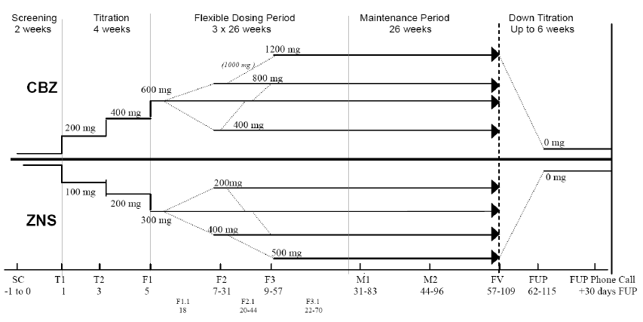
Titration to 300 mg/day zonisamide or 600 mg/day carbamazepine, subjects unable to achieve the target dose at end of titration period were either withdrawn from the study, or alternatively, subjects not tolerating their medication were permitted one down-titration step during the first 2 weeks after the titration period only, to 200 mg/day zonisamide or 400 mg/day carbamazapine. If subjects consequently experienced a seizure, their dose could be up-titrated.
Subjects who required a dose outside of the study dose ranges (less than 200 mg or more than 500 mg/day zonisamide; less than 400 mg or more than 1200 mg/day carbamazapine) were withdrawn from the study.
Comparator choice: carbamazepine is used specifically for the treatment of partial epilepsy, and is recommended as the first line monotherapy treatment in newly diagnosed individuals. The prolonged release formulation of Tegretol Retard is equally as efficacious as immediate release carbamazepine but has fewer dose-related side effects and more stable plasma concentrations.

Efficacy variables and outcomes
The primary efficacy variable was the proportion of subjects seizure-free for 26 weeks as assessed by the occurrence of seizures as documented in the seizure diary.
The secondary efficacy variables measured were:
- Proportion of subjects seizure-free for 52 weeks
- Time to withdrawal due to lack of efficacy
- Time to withdrawal due to an AE
- Time to the end of a 26-week and 52-week seizure-free period.

Randomisation and blinding methods
Eligible subjects were randomized in a 1:1 ratio to either the carbamazepine or zonisamide arm.
The comparator study drug, carbamazapine, is a liver enzyme inducer whereas zonisamide is not. It may therefore, have been possible for the investigator to know which treatment a subject was receiving by reviewing their laboratory results, that is, gamma glutamyl transferase (GGT) levels were likely to increase for subjects who were being treated with carbamazapine . It was therefore necessary for the GGT results to remain blinded. They were not included on the report sent to the investigators but were reviewed by an independent medical monitor, who had access to the randomization code. Only results of clinical significance were reported to the investigators.

Analysis populations
The All Subjects Population was defined as all subjects who were recruited to the study.
The Randomized Population was defined as all screened subjects who were randomized to treatment.
The Intent to treat (ITT)/Safety Population was defined as all randomized subjects who received at least one dose of study medication.
The Per Protocol (PP) Population was defined as a subset of the ITT Population who had no major protocol violations or deviations.

Sample size
The sample size was based on the primary efficacy endpoint of proportion of subjects seizure-free for at least 6 months. The noninferiority margin (delta) is a relative 20% difference (e.g., an absolute difference of 12% if proportion seizure-free is 60%) up to a maximum of an absolute 12% difference.
Assuming that the proportion seizure-free in the zonisamide and carbamazepine groups is 60%, 262 subjects per group were required to conclude that zonisamide is noninferior to carbamazepine if the lower limit of the 95% CI of the treatment difference (carbamazepine – zonisamide) is above –12% with 80% power and a 1-sided 0.025 alpha level. If the proportion of seizure-free subjects in both groups is 65% or 70%, then 262 subjects per group would provide 82% and 85% power, respectively.
Allowing for a 10% drop-out rate, a total of 582 subjects were to be randomized in a ratio of 1:1 between zonisamide: carbamazapine.

Statistical methods
The null hypothesis and alternative hypotheses were:
H₀: zonisamide is inferior to carbamazepine
H₀: pZ - pC ≤- delta
Where:
pZ = proportion with 6-month seizure freedom on zonisamide
pC = proportion with 6-month seizure freedom on carbamazapine
H_{a}: zonisamide not inferior to carbamazepine
H_{a}: pZ - pC > . delta
The noninferiority margin (delta) is a 20% relative difference (e.g., 12% if the proportion seizure-free is 60%, up to a maximum of 12%).
The primary analysis was performed using logistic regression, including as factors, treatment (zonisamide versus carbamazapine) and country.
The adjusted difference ( zonisamide – carbamazapine ) in proportions and 95% CI were calculated. A sensitivity analysis was conducted excluding country group as a factor. Similar analyses were performed in the ITT Population.
A further analysis considering additional factors/covariates such as epilepsy etiology (structural brain anomalies or head injuries versus others), number of pretreatment seizures (number of seizures in the 3 months/12 months before randomization) was performed.
A subgroup analysis based on seizure history was performed. For each subgroup the percentage seizure-free in each treatment group was presented, along with odds ratios, adjusted difference in proportions, and 95% CIs.
The key secondary efficacy parameter was the proportion of subjects seizure-free for at least a 12-month (52-week) period and was analysed similarly to the primary endpoint. A non inferiority margin was not set for this endpoint.

Changes to the Planned Analyses
The secondary endpoints of time to 6 months seizure freedom and 12 months seizure freedom were analysed using Cox’s proportional hazards model and not using logistic regression as specified in the protocol. For subjects who did not achieve seizure freedom, time to seizure freedom was censored at the date of their last treatment visit, and not the time of commencing the last dose, as specified in the protocol.

Participant flow
Pooling of centres and countries with low numbers occurred. When a group would have no responders that country was combined with others.
Figure 3. Subject Disposition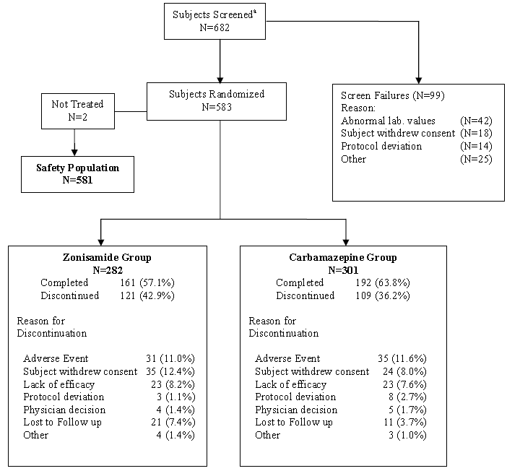
ª Subject who signed informed consent

Major protocol violations/deviations
Table 4. Major Violations/Deviations: Per Protocol Population
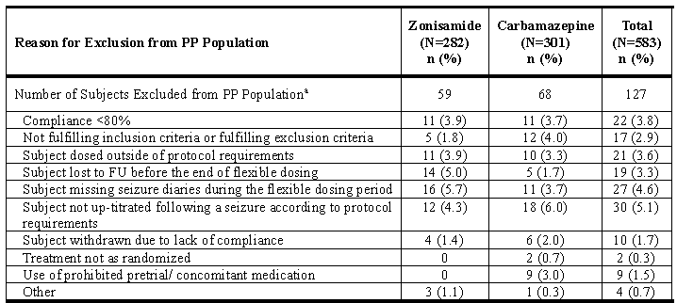
Note: Subject 21091001 took the incorrect treatment before randomization and therefore, has been classified 'Treated not as randomized'. The subject then followed the protocol as planned on the correct randomized treatment and is therefore summarized as randomized in all summaries. FU = Follow-up, ª A subject may appear in more than one category.

Baseline data
Table 5. Summary of Baseline Characteristics: Safety Population. Table continued across 2 pages.
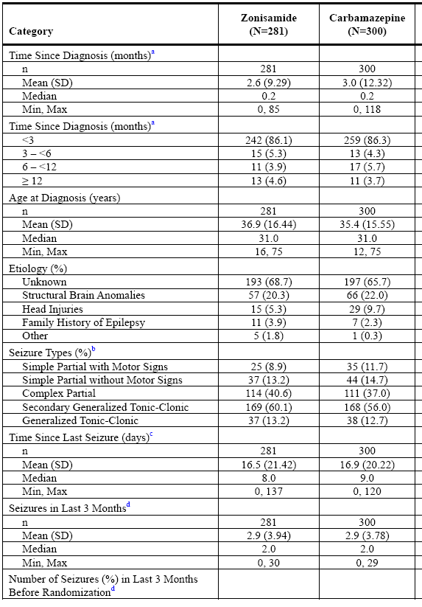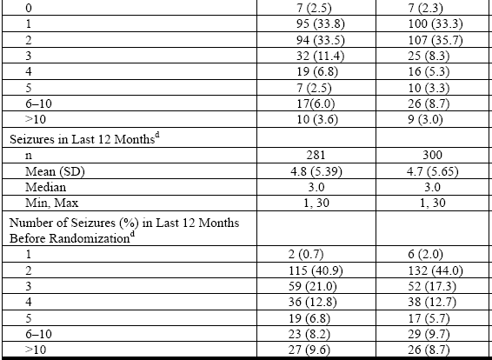
ª Time since diagnosis is calculated as ((date of informed consent minus date of diagnosis)/365.25)*12.^{b} Subjects may have had more than one type of seizure. ^{c} Time since last seizure is calculated as the (date of informed consent minus date of last seizure before informed consent date). ^{d} The maximum number of seizures recorded at baseline was cut off at 30.
Table 6. Summary of Demography, Baseline Height & Weight: Safety Population
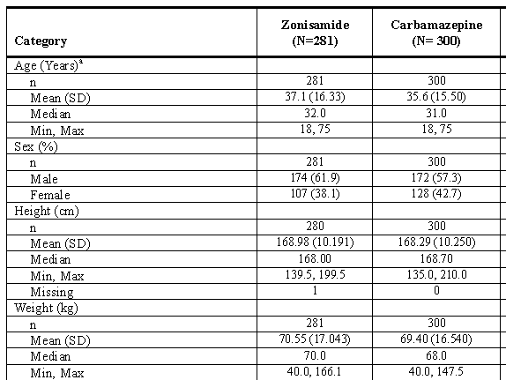
ª Age is age at informed consent.
Some subjects were taking other Anti epileptic drugs just before receiving their randomized study medication or during the period immediately after the Final Visit, any subjects on these drugs at other times during the study were excluded.
Twenty-two subjects (11 zonisamide; 11 carbamazepine) had < 80% compliance to treatment and were excluded from the PP Population.

Results for the primary efficacy outcome
Table 7. Six-Month Seizure Freedom:
Six-Month Seizure Freedom |  | Zonisamide  n (%) | Carbamazepine  n (%) | Adjusted difference^{b} (95% CI)^{c} | Odds Ratio(95% CI)ª
PP pop |  | (N=223) | (N=233)
PP pop | Modelled with factors for treatment and pooled country group. | 177 (79.4) | 195 (83.7) | –0.045  (–0.122, 0.031) | 0.748  (0.459, 1.219)
PP pop | Sensitivity Analysis Excluding Country modelled with a factor for treatment only. | 177 (79.4) | 195 (83.7) | -0.043  (-0.114, 0.028) | 0.750  ( 0.466, 1.206)
PP pop | Modelled with factors for treatment, pooled country and number of pre-treatment seizures in the 3 months prior to randomisation.^{d} | 177 (79.4) | 195 (83.7) | -0.042  (-0.118, 0.034) | 0.760  ( 0.465, 1.242)
ITT pop | Modelled with factors for treatment and pooled country group. | (N=281) 195 (69.4) | (N=300)  224 (74.7) | –0.061  (–0.136, 0.014) | 0.737  (0.507, 1.072)
ª Wald ^{b} Zonisamide – Carbamazepine ^{c} Derived ^{d} Exploratory Analysis
Having set the non inferiority margin to a maximum of an absolute 12% difference the primary efficacy endpoint of proportion of subjects seizure-free for at least 6 months, when this was not met, the sponsor modelled out any effect for country, which brought the lower CI within the lower bound.
The sponsor then argued that -0.122 the lower CI of the adjusted difference (with factors for treatment and pooled country group) was -14.7% of the carbamazapine response rate of 82.81% (adjusted for country group.) i.e. within 20% of that response rate. The sponsor then referred to published treatment guidelines to support this as a demonstration of efficacy.
For the ITT population it was likewise argued that -0.136 the lower CI of the adjusted difference (with factors for treatment and pooled country group) was -18.03% of the carbamazapine response rate of 75.30% (adjusted for country group.) i.e. within 20% of that response rate.
The minimum non inferiority margin of –12% was set as a relative 20% of the expected 60% CBZ response rate which was assumed in the sample size calculation. Higher rates for 6-month seizure freedom were observed for CBZ (83.7%) compared to the predefined, assumed rate of 60% seizure freedom.
In light of the high response rates observed in the study, the sponsor considers that the protocol predefined absolute margin value of –12% was set too conservatively.
Comment: The sponsor in the Study Report appears to argue that the non inferiority margin that was set was statistically but not clinically significant. The selection of the non inferiority margin was not directly discussed, but appears to have been based on a sole review article which stated:
“It has been suggested that early treatment may not only suppress seizures in the short term but also prevent the evolution of newly developing seizures to chronic epilepsy. This proposition is based on the temporal patterns of epilepsy- that chronic epilepsy is difficult to treat, with perhaps 80% of patients having continuing seizures, in pronounced contrast to newly diagnosed patients started on treatment in whom immediate seizure control is obtained in over 60%; that the chances of long remission are greatest in the early years of treatment; and that relapse after remission is uncommon. Some experimental data (e.g., Kindling) add circumstantial evidence to this proposition. However, another explanation of these clinical patterns of epilepsy is that the disorder, from its onset, is inherently mild or severe, and that the mild cases remit naturally early in their course. Whilst the clinical observations are undoubted, the exact role of early treatment has not been resolved.”
The Summary of Clinical Efficacy refers to multiple studies as the source of the non-inferiority margin:
The minimum noninferiority margin of −12% was set as a relative 20% of the expected 60% CBZ response rate, which was assumed in the sample size calculation based on review of a large number of clinical trials (Brodie MJ et al., 1995; Kalviainen R et al., 1995; Chadwick DW et al., 1998; Arroyo S et al., 2005; Rowan AJ et al., 2005).

Additional analyses
The sponsor was able by using an exploratory analysis that considered additional factors/covariates to show that adjusted for the number of seizures in the 3 months prior to randomization and country group, the treatment difference was –4.2% (95% CI: –11.8, 3.4); that is, the lower limit of the 95% CI for the absolute difference met the non inferiority margin.
In subgroup analysis based on seizure history (subjects with a history of simple partial seizures; complex partial seizures; all partial seizures; secondary generalized tonic clonic seizures; generalized tonic-clonic seizures; and all generalized tonic-clonic seizures), only the all generalized tonic-clonic seizures comparison met the non inferiority margin. The greatest difference was for Complex Partial Seizures where carbamazapine was considerably more effective.

Secondary Efficacy Results
Table 8. Secondary Efficacy Results
Variable  (Modelled with factors for treatment and pooled country group) |  | Zonisamide | Carbamazepine | Adjusted difference^{b} (95% CI)^{c} | Odds Ratio(95% CI)ª
PP pop | Twelve-Month Seizure Freedom n (%) | 146 (67.6) (N=216) | 171 (74.7) (N=229) | –0.079(–0.172, 0.015) | 0.697 (0.454, 1.070)
ITT pop | Twelve-Month Seizure Freedom n (%) | 157 (55.9)  (N=281) | 187 (62.3)  (N=300) | -0.077  (-0.161, 0.007) | 0.729  ( 0.517, 1.029)
PP pop | Median Time (days) to Drop Out Due to Lack of Efficacy | 722  19 (N=223) | NC  12 (N=233) |  | 1.63e  (0.78, 3.42)
ITT pop | Median Time (days) to Drop Out Due to Lack of Efficacy | 722^{f}  23 (N=281) | NC  23 (N=300) |  | 1.11  (0.62, 2.01)
PP pop | Median Time (days) to Drop Out Due to an AE | NC  21(N=223) | NC  24 (N=233) |  | 0.94 e  (0.52, 1.70)
ITT pop | Median Time (days) to Drop Out Due to an AE | NC  31 (N=281) | NC  35 (N=300) |  | 1.01 e  (0.62, 1.65)
PP pop | Median Time (Days)to 6-Months Seizure Freedom | 204  177 (N=223) | 204  195 (N=233) |  | 0.92e  (0.75, 1.14)
ITT pop | Median Time (Days)to 6-Months Seizure Freedom | 205  195 (N=281) | 204  224 (N=300) |  | 0.91e  (0.75, 1.11)
PP pop | Median Time (Days)to 12-Months Seizure Freedom | 381  146 (N=216) | 381  171 (N=229) |  | 0.88e  (0.70, 1.11)
ITT pop | Median Time (Days)to 12-Months Seizure Freedom | 382  157 (N=281) | 381  187 (N=300) |  | 0.83  (0.67, 1.04)
^{e} Hazard Ratio (Zonisamide: Carbamazepine) ^{f} The calculated median is not reliable due to the last observation being an event, with a small number of events in total. NC = Not calculable due to insufficient events.
The sponsor did not declare a non inferiority margin for secondary variables. The Odds and Hazard ratios CIs are wide although they include 1. The Twelve-Month Seizure Freedom (PP pop) is within the 12 % margin but it is exceeded in the ITT population.

Aldenkamp–Baker Neuropsychological Assessment Scale (see list of abbreviations)
There were no clinical or statistically significant differences in ABNAS scores between the groups for any of the parameters.

Bond–Lader Scale
For the ITT Population for OC and LOCF showed a statistically significant difference between the groups in favour of carbamazapine giving improvement for dysphoria with zonisamide having little effect.

Quality of Life in Epilepsy – Problems
There was no statistically significant difference between the groups for overall score.

Short Form 36 Health and Wellbeing questionnaire
There was no statistically significant difference between the groups for aggregate physical component score and aggregate mental component score, except for mental health at the FV/ETV (ZNS, 0.54 versus CBZ, 2.56; P = 0.0328).

European Quality of Life Group 5-Dimension Self-Report Questionnaire
There were no clinically significant differences in EQ-5D scores between the groups.
Table 9. Dose at Which 6-Month Seizure Freedom was Attained: Per Protocol Population
Zonisamide / Carbamazepine Dose Level | Zonisamide  (N=223) | Carbamazepine  (N=233)
Number Seizure-free | 177 | 195
200 mg / 400 mg | 3 (1.7) | 2 (1.0)
300 mg / 600 mg | 154 (87.0) | 173 (88.7)
400 mg / 800 mg | 15 (8.5) | 17 (8.7)
500 mg / 1200 mg | 5 (2.8) | 3 (1.5)
Percentages are calculated from the number of subjects in each treatment group who achieved 6-month seizure freedom.

Study AN46046-304

Study design, objectives, locations and dates
A double-blind, randomised multicenter study to evaluate 3 dose levels of zonisamide (25, 100, and 300 mg/day) as monotherapy in adult subjects with newly diagnosed epilepsy and complex partial seizures.
The study consisted of a screening visit (Day 1), a double-blind titration and treatment phase (up to 40 weeks), and a blinded conversion phase (2 weeks). Clinic visits occurred weekly for the first 5 weeks, and again at Weeks 8, 12, 24, 40, and 42.
The primary objective was to characterize the dose-response behaviour of zonisamide monotherapy efficacy in adult patients with newly diagnosed epilepsy with respect to the time to achieve a predefined efficacy exit criterion.
The secondary objectives included:
- To evaluate the proportion of patients who are seizure-free for at least 6 months
- To evaluate the proportion of patients in each treatment group remaining on treatment for the duration of the study.
From 20 February 2002 to 20 October 2004 the study was conducted in 25 US centres and 8 European (4 Ukraine, 2 Estonia, and 2 Latvia). Most centres had < 10 patients, except 1 US centre (11 patients) and 2 Ukraine centres (15 & 34).

Inclusion criteria
- Newly diagnosed epilepsy and complex partial seizures (with or without secondary generalization).
- Subject had during the year prior to screening:
  - ≥ 2 well-documented, unprovoked, clinically evaluated and classified complex partial seizures, or
  - 1 well-documented, unprovoked, clinically evaluated and classified complex partial seizure and an abnormal EEG consistent with the diagnosis of epilepsy.
- Subject received less than 2 weeks of AED therapy prior to screening, and that medication was discontinued at study entry.
- Subject’s EEG changes were consistent with the diagnosis of epilepsy:
  - For subjects with 2 well-documented, unprovoked complex partial seizures within 1 year prior to enrollment, the EEG results could be normal at the time of testing but, in the opinion of the investigator, the subject had epilepsy.
  - For subjects with 1 well-documented, unprovoked complex partial seizure within 1 year prior to enrollment, the EEG was abnormal at the time of testing consistent with the diagnosis of epilepsy.

Exclusion criteria
- A history of status epilepticus.
- Simple partial seizures only.
- A history of non-epileptic seizures (e.g., metabolic or pseudo seizures).
- Progressive encephalopathy or findings consistent with progressive central nervous system disease or lesions (e.g., infection, demyelination, tumour).
- A history of acute intermittent porphyria, glucose-6-phosphate dehydrogenase deficiency, or haemolytic anaemia.
- A psychiatric illness or mood disorder requiring treatment in the previous 6 months, or a history of suicide attempt or psychosis.
- Subject used benzodiazepines (however, intermittent use as a rescue AED or hypnotic was allowed during the study).

Study treatments
Titration began with 25 mg/day (for the 25-mg/day group) or 50 mg/day (for the 100- and 300-mg/day groups). The dose was increased weekly by 50 mg for subjects in the 100-mg/day and 300-mg/day treatment groups.
The once daily zonisamide doses selected were based on previous clinical experience, and were expected to produce measurable zonisamide levels and exposure at steady state.

Efficacy variables and outcomes
The primary endpoint (reaching the exit criteria) was defined as the time to the occurrence of either of these events after taking the first dose of the study drug:
- 2 complex partial seizures
- generalized tonic-clonic seizure.
The secondary study endpoints were:
- Proportion of patients seizure-free for at least 6 months
- Proportion of patients in each treatment group remaining on treatment for the duration of the study.

Randomisation and blinding methods
Subjects who met study entry criteria were randomized in a 1:1:1 ratio to one of: 25, 100, or 300 mg/day of zonisamide.
Subjects in all 3 treatment groups received the same number of capsules of each size (active or placebo) at each study week.
To maintain the study treatment blind, all subjects entered a 2-week blinded conversion phase at the end of the 40-week study period. This conversion phase allowed for the dose to be increased in the 25-mg/day treatment group to 100 mg/day, maintained in the 100-mg/day group, and decreased in the 300-mg/day group to 100 mg/day.

Analysis populations
Safety Population – All randomized subjects who received at least 1 dose of study medication during the 40-week treatment phase.
Evaluable Population – All subjects in the safety population who met all eligibility criteria for entry into the study (referred to in the Statistical Analysis Plan as Intent-to-Treat).

Sample size
The primary efficacy analysis was to test the significance of the linear component of the relationship between time to attain the predefined exit criterion and dosage. Under the assumption that the 3 groups were equally spaced, the 1-degree-of-freedom linear component of the 2-degree-of-freedom test of equality of the 3 dosages would compare the 300 and 25 mg/day dosages. Thus, the required sample size was estimated using the method of Freedman for comparing 2 time-to-event distributions using the log-rank test. Given that there were 3 treatment groups instead of 2, this approach is conservative. Based on a 2-sided log-rank test at the 5% level of significance and at 90% power, and assuming that the estimated proportions remaining in the study at 40 weeks were 20% (25 mg/day) and 60% (300 mg/day), and that there was a 40% dropout rate, the sample size required per group was 55 subjects (a total of 165 subjects).

Statistical methods
The hypothesis was that as the zonisamide dosage level is increased, the time to reach the exit criteria will also increase. The primary analysis tests the hypothesis that the one degree of freedom linear component is equal to zero.

Primary Efficacy Analysis
The time to reach 2 complex partial seizures or 1 generalized tonic-clonic seizure was compared among the 3 dose levels, and the dose-response relationship was defined. The significance of the linear component of the relationship between time to reaching the predefined exit criterion and dosage levels was tested by fitting a Cox proportional hazards regression model. The dependent variable was time to reaching the predefined exit criterion, and the independent variable was treatment group. The 2 degrees of freedom for the treatment group effect were parameterized as the linear and the quadratic component (under the assumption that the 3 dosage levels were equally spaced). The 1-degree-of-freedom test of the linear component was tested at the 5% level of significance using a 2-sided test. In addition, the significance of the nonlinear component of the relationship between the time to exit and dosage was tested.
A plot of the cumulative proportion of subjects reaching the predefined exit criterion was created using Kaplan-Meier estimates for each group.
A sensitivity analysis was conducted to censor observations at the time of the last dose of study medication during the treatment phase to evaluate whether the results of the primary efficacy analysis were affected by the method of censoring observations. If a subject withdrew or was lost to follow-up without meeting the exit criterion, the observation was censored at the date that the last dose of study medication was taken during the treatment phase. If the subject completed the study without meeting the exit criterion, that subject was censored on the date that the last dose of study medication was taken during the treatment phase.

Secondary Efficacy Analyses
The Proportion of Subjects Seizure-Free for at Least 6 Months (that is, through Day 184) was compared among groups using Pearson’s chi-square test. The Cochran-Mantel-Haentzel 1-degree-of-freedom chi-square test was used to assess the linear trend in these proportions across the 3 dose groups, under the assumption that the groups were equally spaced.
The Proportion of Subjects Remaining on Treatment for the Duration of the Study through the Week 40 visit was compared among groups using Pearson’s chi-square test. The Cochran-Mantel-Haentzel 1-degree-of-freedom chi-square test was used to assess the linear trend in these proportions across the 3 dose groups, under the assumption that the groups were equally spaced.

Participant flow
Figure 4. Subject Disposition (All Randomized Subjects)
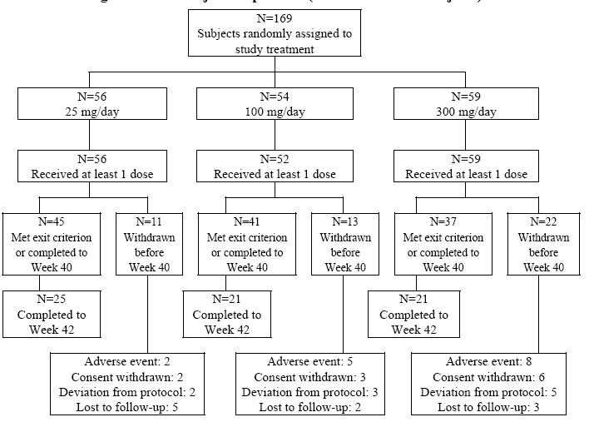
Table 10. Subject Disposition (All Randomized Subjects)
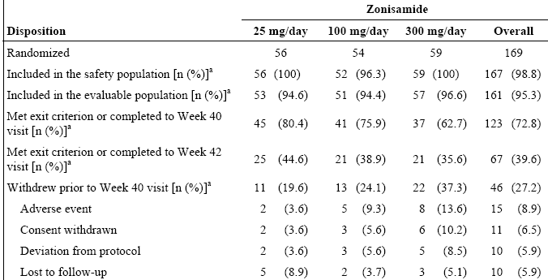
ª Denominators are based on the number of randomized subjects within each category.

Major protocol violations/deviations
Included failed eligibility criteria (7 subjects), subject not withdrawn when exit criterion was met (9 subjects), subject taking prohibited medications (31 subjects), and visit outside protocol windows (50 subjects).
A total of 10 subjects were withdrawn from the study due to protocol deviations: pregnancy (2); noncompliance (3); use of prohibited medication (2); reason not specified or unknown (3).
Seven subjects took a prohibited AED during treatment with zonisamide. Eleven subjects took a prohibited AED with the stop day recorded as Day 1 (first day of treatment with zonisamide).

Baseline data
Table 11. Subject Epilepsy Etiology and History (Safety Population)
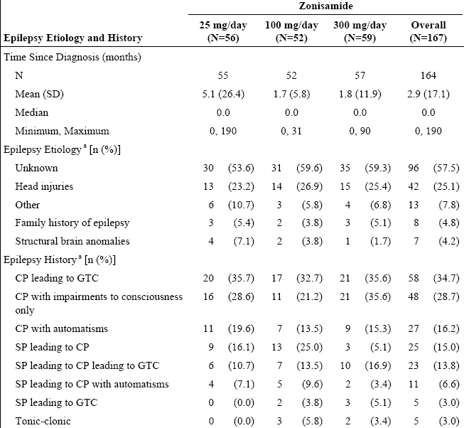
ª Subjects may be included in more than 1 category. CP = complex partial; GTC = generalized tonic-clonic; SD = standard deviation; SP = simple partial.
Among the concomitant medications taken: 2 (3.6%) of the 25 mg/day and 3 (5.1%) on 300 mg/day were also on Diazepam; 4 (7.1%) of the 25 mg/day group, 3 (5.8%) on 100 mg/day, and 2 (3.4%) on 300 mg/day were also taking Carbamazepine.
Table 12. Subject Demographic and Baseline Characteristics (Safety Population)
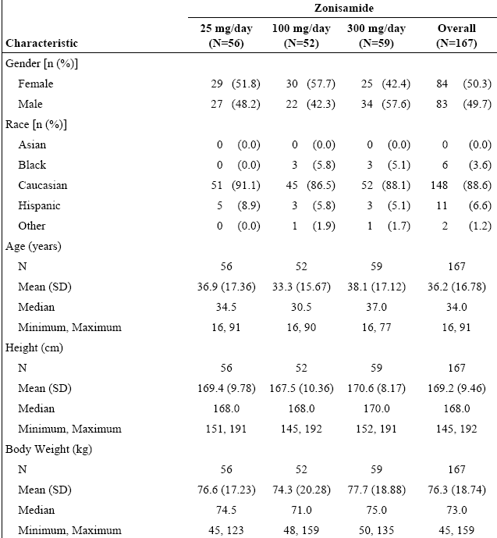

Results for the primary efficacy outcome
Table 13. Time to Predefined Exit Criterion (2 Complex Partial Seizures or 1 Generalized Tonic-Clonic Seizure) (Safety Population)
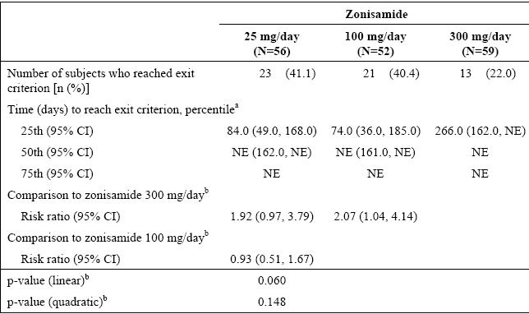
NE = not estimable. ª Results are based on the Kaplan-Meier method.
^{b} The risk ratio, 95% CI for risk ratio, and p-value are based on Cox proportional hazards regression model under the assumption that the dosing groups were equally spaced.
Table 14. Time to Predefined Exit Criterion (2 Complex Partial Seizures or 1 Generalized Tonic-Clonic Seizure) Evaluable Population
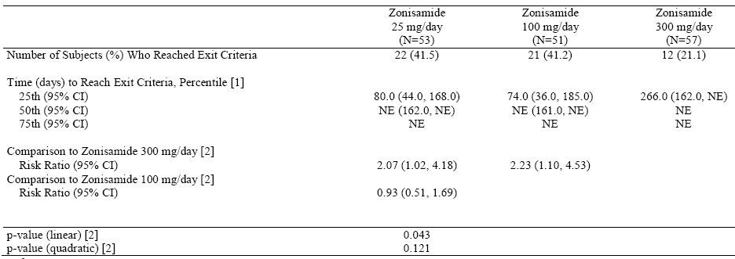
NE = Not Estimable. [1] Results are based on the Kaplan-Meier method. [2] The risk ratio, 95% CI for risk ratio, and p-value are based on Cox Proportional Hazards Regression Hazard Model under the assumption the dosing groups are equally spaced.

Figure 5. Analysis of Time to Predefined Exit Criterion (Safety Population) Survival Plot

Table 15. Secondary Variables: Proportion of Subjects Seizure-Free for ≥ 6 Months and Proportion of Subjects Remaining on Treatment for the Duration of the Study (Safety Population)
Variable | 25 mg/day  (N=56) |  |  |  | 100 mg/day  (N=52) |  |  | 300 mg/day  (N=59) |  | p-valueª
Variable | No.  n | %  (95%CI) | vs. 300 mg/day^{b} | vs. 100 mg/day^{b} | No.  n | %  (95%CI) | vs. 300 mg/day^{b} | No.  n | %  (95%CI) | p-valueª
Seizure-Free for ≥ 6 Months | 19 | 33.9 (21.81, 47.81) | 0.067 | 0.032 | 16 | 30.8 (18.72, 45.10) | 0.726 | 30 | 50.8 (37.5, 64.11) | 0.061
Remaining on Treatment | 23 | 41.1 (28.10, 55.02) | 0.966 | 0.975 | 21 | 40.4 (27.01, 54.90) | 0.942 | 24 | 40.7 (28.07, 54.25) | 0.967
ª The p-value for trend is based on the Cochran-Mantel-Haenszel statistic under the assumption that the dosing groups were equally spaced.
^{b} The p-value for treatment comparisons is based on the Pearson’s Chi square statistic

Other efficacy studies

Study ELN46046-355

Study design, objectives, locations and dates
This was an open-label, non-randomized extension of study AN46046-304 for up to an additional 24 months.
The primary objective of the study was to assess the long-term safety of zonisamide monotherapy in adult patients with newly diagnosed epilepsy, by examining the incidence and severity of treatment-emergent AEs.
The secondary objective was to measure efficacy according to treatment duration from baseline in AN46046-304 to study exit from ELN46046-355 due to one of the pre-defined exit criteria:
- 2 complex partial seizures
or
- 1 generalized tonic-clonic seizure.
The study database was locked on 25 August 2005.

Inclusion criteria
The patient had to have been correctly included in the AN46046-304 study and completed 42 weeks of study treatment.

Exclusion criteria
- Previous early withdrawal from trial AN46046-304
- Experience of a generalized seizure or more than one complex partial seizure during AN46046-304.

Study treatments
Patients commenced treatment with 100 mg zonisamide capsules. Patients who experienced a partial seizure during the Titration Period attended an additional visit to begin upward titration of their zonisamide dose to 300 mg. During the Maintenance Period no dose increases were permitted. Patients continued at their Visit 4 level dose until study withdrawal. Patients then fell into two dose groups, those with a daily dose of 100 mg from Visit 5 (Week 13) onward and those with a daily dosage of 300 mg from Visit 5 onward. During the Withdrawal Period patients on 100 mg continued to take zonisamide 100 mg capsules for one week. At the same time another AED could be introduced, as deemed appropriate by the Investigator. Patients on 300 mg took 200 mg zonisamide for one week, followed by 100 mg zonisamide for one week. At the same time another AED could be introduced, as deemed appropriate by the Investigator. The maximum dose for this study was 300 mg o.d. If more than 300 mg o.d. was prescribed, it was to be considered a protocol deviation.

Efficacy variables and outcomes
The primary efficacy variable was the time to study exit from the start of the AN46046-304.
Secondary Efficacy Variables included: The proportion of patients that remained seizure-free for at least six months, were seizure free for the duration of the AN-46046-355 study and were seizure free for the duration of treatment in both studies was also evaluated.

Analysis populations
Pre-Treatment Baseline: Day 1 of the AN46046-304 study was the screening visit for that study. Data collected at this time point represents the subject’s pre-treatment state before the receipt of any drug and serves as their baseline.
355 Baseline: The 42nd week clinic visit for the AN46046-304 study, the last visit, of that study, coincides with Visit 1 of the extension study ELN46046-355, the first visit or screening visit of that study. This time point was used as a point from which changes since the start of the ELN46046-355 study were measured.

Statistical methods
For time-to-event analyses, Kaplan-Meier estimates of the 25th, 50th (and 95%CIs), and 75th percentiles and plots of the cumulative proportions of patients with the event were used.

Participant flow
Table 16. Reasons for Withdrawal from the Study
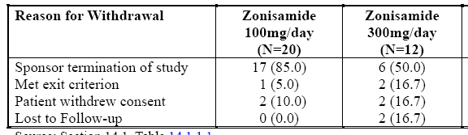
Table 17. Summary of Demographic Characteristics
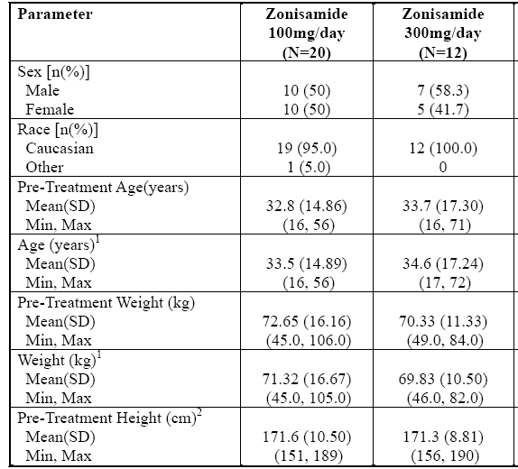
¹ Measurements taken at ELN46046-355 baseline (Visit 1). ² Height was not measured in ELN46046-355

Major protocol violations/deviations
None of the protocol deviations resulted in the patient being excluded from the evaluable (ITT) population.

Results for the efficacy outcomes
One 100 mg patient met the exit criteria for the study of two complex partial seizures. In the 300 mg group two patients met the exit criteria, one due to two complex partial seizures and one due to a generalized tonic-clonic seizure.
The number of patients that remained seizure-free for all three categories was higher in the group maintained at 100 mg compared to those on 300 mg; (patients were only titrated to the 300 mg dose if they experienced a seizure and so the sponsor suggests this group of patients may therefore be considered to be less likely to remain seizure-free for the duration of the study).
Table 18. Summary of the Proportion of Patients that Remained Seizure-Free for at Least Six Months and for the Duration of Study 355
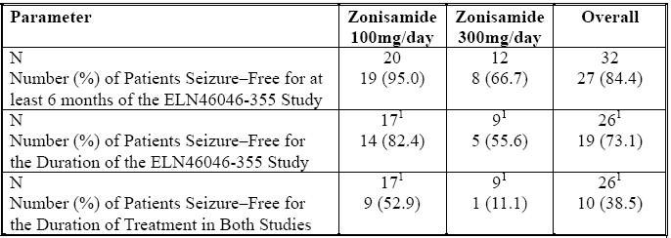
¹ Patients who were not on study drug for the duration of the study or until the exit criteria were met are removed from the denominators.

Evaluator’s conclusions on clinical efficacy

For Monotherapy of Partial Seizures With or Without Secondary Generalization in Adults with Newly Diagnosed Epilepsy
The pivotal Study 304 population was not restricted to the proposed Indication. The wording of Inclusion and Exclusion criteria regarding generalised epilepsy indicates that the EEG result together with other clinical investigations (not named) was used to exclude idiopathic (primary) generalised epilepsy, leaving a group that were considered compatible with being localization-related epilepsy, but not established as such.
It included within it patients with generalised tonic-clonic seizures (that were not clearly secondary); 37 (13.2%) in the zonisamide group and 38 (12.7%)on carbamazapine. This is in accordance with the protocol inclusion criterion.
2. Subjects with untreated, newly diagnosed epilepsy having at least two well documented, unprovoked, clinically evaluated and classified partial seizures (with or without secondary generalization) or generalized tonic-clonic seizures (without clear focal origin) within 12 months of the Screening Visit, of which at least one seizure occurred within three months of the Screening Visit (> one seizure within a 24 hour period will be counted as one seizure).
It should be noted, that carbamazepine can cause an exacerbation of epilepsy in subjects with primary generalised epilepsy, so possible inclusion of such subjects was inappropriate, and might have biased this study against the carbamazepine cohort.
A subgroup analysis was undertaken but All Partial and Secondary Generalised Tonic-Clonic were not combined. Thus the applied for Indication has a differing population from this study.
Table 19. 6-Month Seizure Freedom – sub group analysis by Seizure History (PP Population)
Seizure History | Zonisamide  (N=223) |  | Carbamazepine  (N=233) |  | Adjusted difference^{b}  (95% CI)^{c} | Odds Ratio  (95% CI)ª
Seizure History | N* | n (%) free | N* | n (%) free | Adjusted difference^{b}  (95% CI)^{c} | Odds Ratio  (95% CI)ª
Simple Partial | 47 | 34 (72.3) | 52 | 39 (75.0) | -0.027 (-0.200, 0.147) | 0.872 (0.356, 2.135)
Complex Partial | 91 | 70 (76.9) | 86 | 80 (93.0) | -0.161 (-0.263, -0.059) | 0.250 (0.095, 0.654)
All Partial | 123 | 94 (76.4) | 129 | 111 (86.0) | -0.096 (-0.192, -0.000) | 0.526 (0.275, 1.006)
Secondary Generalised  Tonic-Clonic | 137 | 106 (77.4) | 135 | 108 (80.0) | -0.026 (-0.124, 0.071) | 0.855 (0.478, 1.529)
Generalised Tonic-Clonic | 28 | 24 (85.7) | 25 | 23 (92.0) | -0.063 (-0.231, 0.105) | 0.522 (0.087, 3.129)
All Generalised Tonic-Clonic | 161 | 127 (78.9) | 158 | 129 (81.6) | -0.028(-0.115, 0.060) | 0.840 (0.483, 1.459)
ª Wald ^{b} Zonisamide – Carbamazepine, ^{c} Derived * Total of all Per-Protocol patients with the relevant Seizure History category. Seizure freedom is modelled with a factor for treatment only. Patients can appear in more than one category
None of the subgroups achieved the preset non-inferiority margin except the combined Generalised Tonic-Clonic subgroups. Viewed separately Complex Partial and Generalised Tonic-Clonic exceeded the modified non inferiority margin, which Simple Partial reached.
Comment: Note that the study was not powered to determine statistically significant differences among subgroups, nor is it clear whether multiplicity effects have been allowed for in the above statistical calculations.
The Clinical Overview claims Amendment 1 to the protocol modified the entry criteria so that primary generalized seizures were removed as one of the entry criteria in order to align further with the approved indication for ZNS, Such a modification by amendment could not be found in either the Protocol submitted nor any of the associated amendments nor was it referred to in the Clinical Study Report.
The pivotal Study 304 failed to meet the preset non inferiority margin and as such it has to be considered that efficacy was not shown.
The efficacy shown was greater than anticipated when setting up the study for both carbamazapine and zonisamide with such an event the relevant guideline EMEA/CPMP/EWP/2158/99 Guideline on the Choice of the Non-Inferiority Margin states If the performance of the reference product in a trial is very different from what was assumed when defining the non-inferiority margin then the chosen margin may no longer be appropriate. The sponsor has argued that this being the case the basis of the preset margin i.e. 20% should apply. If this is accepted then efficacy was shown in the population of the study.
Study AN46046-304 added little to the efficacy evaluation outcome.
With regard to once daily dosing which is currently approved for maintenance, but not titration the sponsor has argued:
ZNS has a long half-life, which allows for once-daily oral dosing. Convenience of use is expected to result in high patient compliance. Furthermore, because ZNS has a long half-life, plasma concentrations will be reasonably maintained even in the event that a daily dose is missed.
The evaluator agrees they are not unreasonable statements (terminal elimination half life is approximately 60h)

Clinical safety

Studies providing evaluable safety data
The following studies provided evaluable safety data:
- Study E2090-E044-310.
- StudyE2090-E044-314 from the ongoing double-blind extension of StudyE2090-E044-310, as of the data cut-off of 31 December 2010 (targeted to end in June 2011). No form of study outline was found.
- Study AN46046-304.
- Study ELN46046-355 from the open-label extension of Study ELN46046-304.
- Study ELN46046-108 was not included in the Safety Summary submitted, an evaluation was undertaken.
Monotherapy safety data were not pooled. The sponsor considered it unlikely that a pooling of these data would have resulted in a profile significantly different from the analyses produced from the individual studies.
Overall, a total of 448 subjects were exposed to ZNS in monotherapy studies.
Table 20. Safety Evaluations in Phase 3 Zonisamide Monotherapy Studies
Study | Description of Safety Assessments
310 | Safety was assessed by summary of AEs and SAEs; incidence of withdrawal for TEAEs; change from baseline in physical and neurological examinations; vital signs; routine clinical laboratory tests; weight; height; 12-lead ECGs.
314 | Safety was assessed by the incidence and severity of TEAEs and SAEs. Changes in clinical laboratory parameters, physical examination, neurological examination, concomitant medication(s) and vital signs were reviewed.
304 | Safety was assessed by the following measures: time to withdrawal due to an adverse event; the overall incidence and severity of TEAEs; results of clinical laboratory measurements, including zonisamide levels; physical examinations; neurological examinations; vital signs; and 12-lead ECGs.
355 | Safety was assessed by monitoring of seizures and other AEs, use of concomitant medication and changes to vital signs. Routine blood and urine samples were taken throughout the study, and a physical and neurological assessment was performed at baseline and at the end of the study

Patient exposure
Table 21. Study 310 Cumulative Extent of Exposure: Time on Trial and Duration of Exposure Safety Population
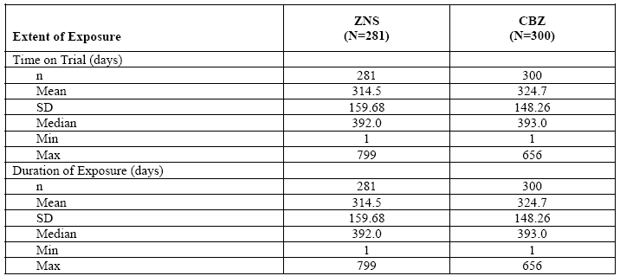
Time on trial = date of last dose before down-titration - date of first dose + 1. CBZ = carbamazepine; ZNS = zonisamide.
Duration of exposure = date of last dose before down-titration – date of first dose + 1 – any drug holidays or dose interruptions.
[information redacted] was randomized to CBZ but received ZNS for the first 2 weeks of study. He went on to receive CBZ as randomized and completed the study. He was summarized as randomized.
Table 22. Study 304 Subject Compliance Safety Population
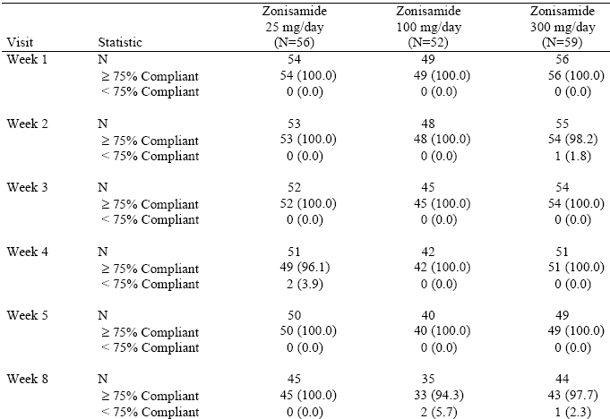
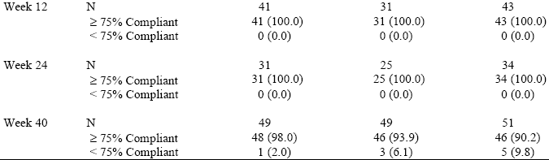
Note: Subjects compliance ( ≥ 75% or <75%) as recorded on the Drug Dispensing/Return form during clinic visits.
Per protocol, subjects took study medication or placebo from up to 4 bottles per week. Because unblinding data were provided at the subject level rather than at the bottle level, actual daily dose could not be calculated for this study.

Table 23. Study 355 Summary of Exposure to Study Drug (Days) Safety Population
[1] Exposure Days = Days on Zonisamide starting with first dose in AN46046-304.
[2] Study Days = Days on Zonisamide starting with first dose in AN46046-355 Study.
Note: The Safety Population and the Evaluable Population are identical in this study.
Per protocol, subjects took study medication or placebo from up to 4 bottles per week. Because unblinding data were provided at the subject level rather than at the bottle level, actual daily dose could not be calculated for this study.
All subjects in Study ELN46046-108 received a single 100 mg dose.

Subject disposition
Table 24. Subject Disposition in the Phase 3 Zonisamide Monotherapy Studies: Completion/Discontinuation from Study: Randomized Population
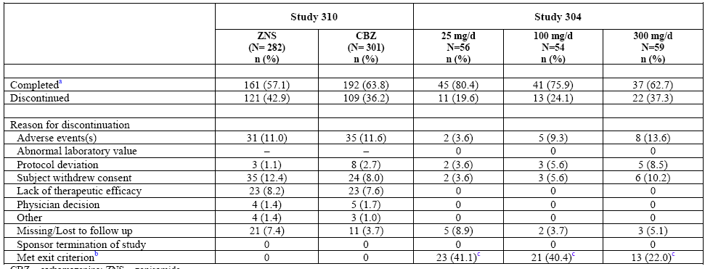
ª In the case of Study 304, numbers are subjects who completed Week 40 or met an exit criterion by Week 40.
^{b} In Study 304, meeting the predefined exit criterion was effectively, the same as lack of therapeutic efficacy because subjects had to have had either two complex partial seizures or one generalized tonic-clonic seizure.
^{c} Numbers represent the Safety Population, not randomized subjects, as this was an efficacy endpoint and the Safety Population was used for the efficacy analyses. CBZ = carbamazepine; ZNS = zonisamide.

Adverse events

All adverse events (irrespective of relationship to study treatment)
Events that are to be expected due to the trial indication (such as seizures in subjects with epilepsy) were not considered to be AEs or SAEs, unless the event represented a significant worsening of the symptom (e.g., new seizure type, clinically significant increase in seizure severity, status epilepticus or hospitalization, etc).
Table 25. Overview of Adverse Events, Treatment-related Adverse Events, Deaths, Nonfatal Serious Adverse Events, and Adverse Events Leading to Discontinuation of Therapy in the Phase 3 Zonisamide Monotherapy Studies(Safety Population)
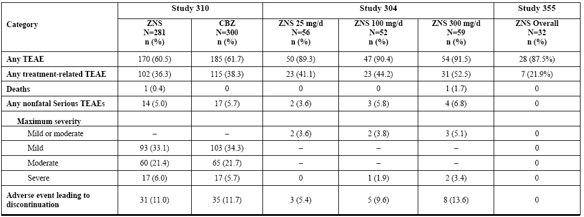
CBZ = carbamazepine; TEAE = treatment-emergent adverse event; ZNS = zonisamide.

Pivotal studies
Table 26. Study 310 Incidence of Common Treatment Emergent Adverse Events by MedDRA System Organ Class and Preferred Term (≥ 2% Subjects in either Treatment Group) Safety Population
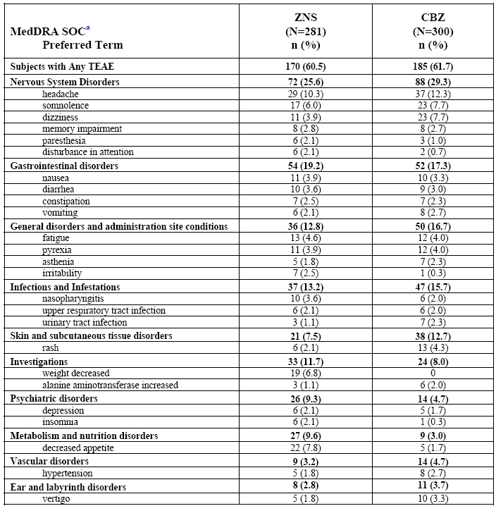
A TEAE is defined as an AE with a start date on or after Day 1 and within 15 days of last dose. If the start date is missing then the AE is considered to be a TEAE. For each row category, a subject with two or more AEs in that category is counted only once
ª SOC values are representative of all TEAEs in that particular SOC.

Other studies
Table 27. 304 Incidence of Common Treatment Emergent Adverse Events by Body System and Preferred Term by Treatment Group (≥ 2% Subjects in Any Treatment Group): Safety Population
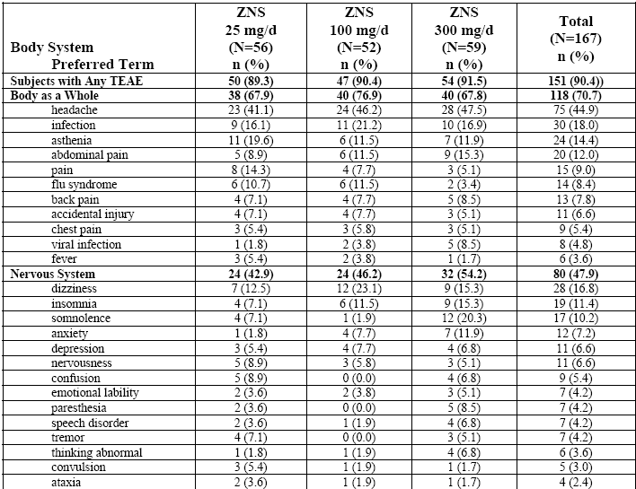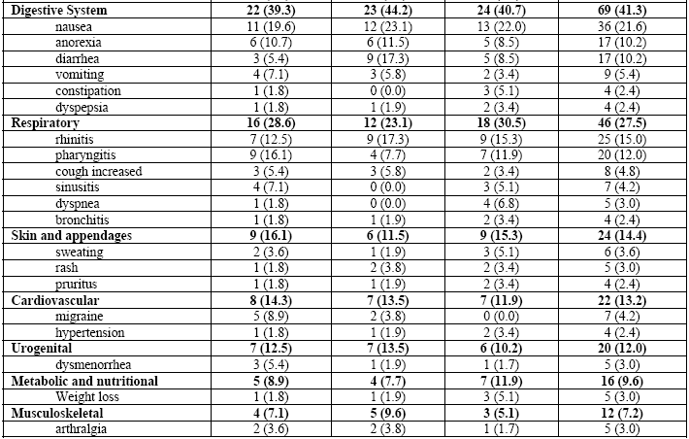
Table 28. Study 355 Incidence of Common Treatment Emergent Adverse Events by Body System and Preferred Term by Treatment Group (≥ 10% Overall) : Safety Population
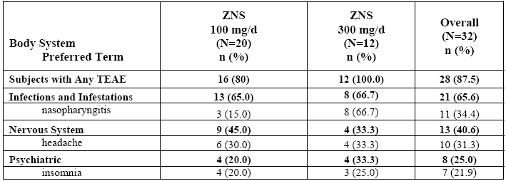
Table 29. Study 108 Overall Summary of Adverse Events
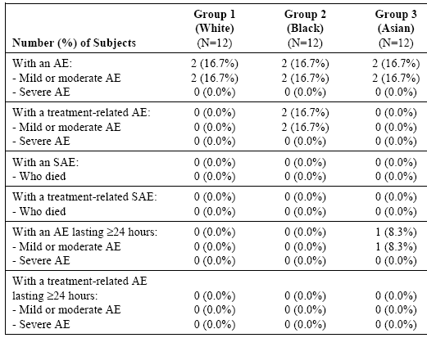
Table 30. Study 108 Number of Subjects with Adverse Events by Preferred Term
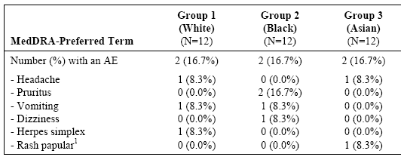
¹ Investigator verbatim term: lip papule

Treatment-related adverse events (adverse drug reactions)

Pivotal studies
Study 310 had no summary of Treatment related AEs, only a table (Table 14.3.1.3 Treatment-Emergent Adverse Events by System Organ Class and Preferred Term and Relationship to Study Treatment (Safety Population)) which was a 129 page listing of all AEs.

Other studies
Table 31. Study 304 Treatment-Related, Treatment-Emergent Adverse Events Reported in at Least 5% of Subjects in Any Treatment Group (Safety Population)
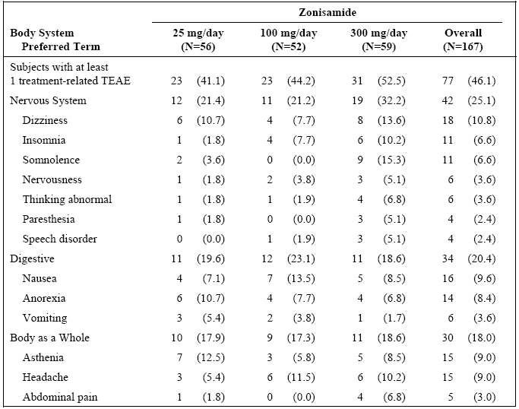
Table 32. 108 Number of Subjects with Treatment-Related Adverse Events by Preferred Term
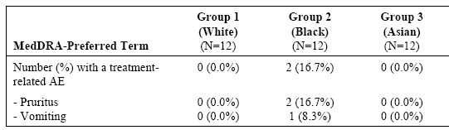

Treatment-related SAEs
Table 33. Study 310 Serious Adverse Events Related to Study Treatment: Safety Population
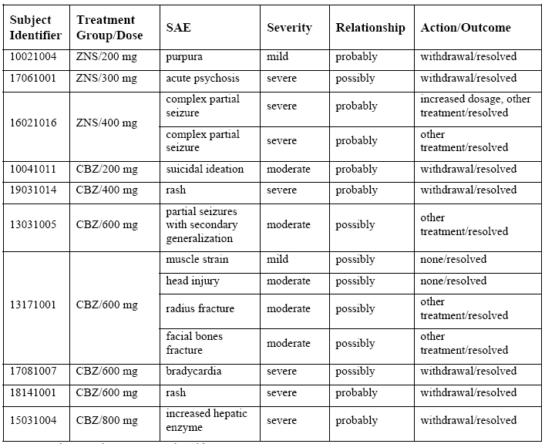
CBZ = carbamazepine; ZNS = zonisamide
There were no treatment related SAEs in studies 304 and 355 and only 1 in study 314.

Deaths and other serious adverse events

Pivotal studies
One death in Study 3 - unexplained cause.

Other studies
One death in Study 304 - due to RTA.
8 subjects reported 12 SAEs in study 314, only 1 SAE (Hyponatraemia) was Treatment-related.

Serious AEs
Table 34. Incidence of Nonfatal Serious Adverse Events and Medical Events of Interest in the Phase 3 Zonisamide Monotherapy Studies: Safety Population
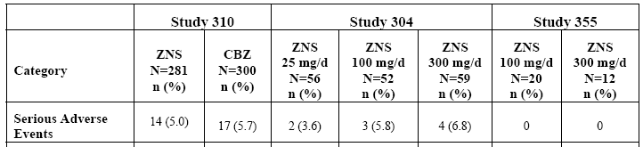
Note: Subjects are counted only once even though may have multiple categories.

Discontinuation due to adverse events

Pivotal studies
In Study 310, 42.9% of ZNS-treated subjects and 36.2% of CBZ-treated subjects discontinued from the study; the primary reasons for premature withdrawal were AEs (ZNS, 11.0%; CBZ, 11.6%) and withdrawal of consent (ZNS, 12.4%; CBZ, 8.0%).
Table 35. 310 Incidence of Treatment-Emergent Adverse Events that Resulted in Discontinuation of Therapy in > 1 Subject in Either Group Safety Population
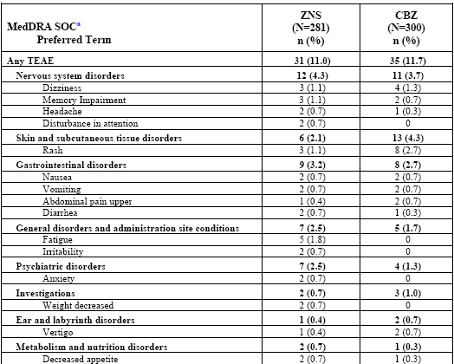
Subjects could have more than one category TEAE leading to withdrawal. For each row category, a subject with two or more adverse events in that category is counted only once. ª SOC values are representative of all TEAEs in that particular SOC.

Other studies
The proportion of subjects who withdrew due to an AE increased with higher dose level in Study 304: 3.6% in the 25mg/d treatment group, 9.3% in the 100 mg/d treatment group, and 13.6% in the 300 mg/d treatment group. Premature withdrawals due to withdrawn consent or protocol deviations were also more frequent at the higher dose levels in Study 304.
Table 36. Treatment-Emergent Adverse Events That Led to Withdrawal (Safety Population)
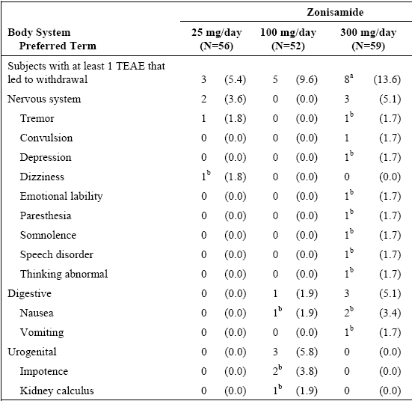
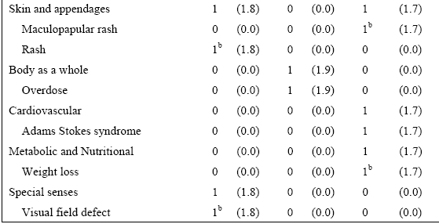
[Number (%) of Subjects]. ª This number does not include Subjects 501 or 6804, both of whom are included in the calculation of time to withdrawal due to AEs for the efficacy section (see Table 10). The study completion CRF for Subject 501 indicates withdrawal due to AE; however, none of the AEs reported for Subject 501 had an action of discontinued. Subject 6804 died due to an accidental injury; discontinuation was not recorded on the AE CRF for Subject 6804. ^{b} Treatment-related.
Based on preliminary, unaudited data in the Study 314 clinical database as of 31 Dec 2010, of 133 subjects in the zonisamide group, and 150 subjects in the carbamazapine group, 8.3% of zonisamide treated subjects and 11.3% of carbamazapine treated subjects discontinued from the study. The most common reason for discontinuation was withdrawal of consent (on zonisamide 1 withdrew due to depressed mood AE, 1 other AE NOS, 2 on carbamazapine withdrew doe to AEs).

Laboratory tests

Haematology
There were no findings inconsistent with normal laboratory patterns over time.

Other clinical chemistry
There were no findings inconsistent with normal laboratory patterns over time with the exception of bicarbonate. In Study 3 the decreases (mean −2.8 mmol/L at final visit were generally small to moderate, similar to what has been described in previous Trials. Decreases from Baseline of ≥ 3.5 mmol/L were seen in 121 subjects (51.1%) in the zonisamide group and 45 subjects (17.4%) in the carbamazapine group. Nine zonisamide treated subjects (3.8%) and 1 carbamazapine treated subject (0.4%) had a bicarbonate value of ≤ 16 mmol/L and a decrease from Baseline of ≥ 6 mmol/L.
In Study 304 subjects who had a baseline serum bicarbonate level ≥ 17 mEq/L, the incidence of subjects with post baseline levels < 17 mEq/L with a corresponding decrease from baseline > 5 mEq/L) at any visit was 3.8% in the 25-mg/d group, 4.2% in the 100-mg/d group, and 15.7% in the 300-mg/d group
Two subjects, both in the 300-mg/day group, had post baseline serum chloride levels over 115 mEq/L; both subjects had serum chloride levels within the normal range at Week 40.
In the extension study 355 clinically notable decreases in serum calcium were detected in 3 subjects on 100 mg of zonisamide . Five subjects on 100 mg had clinically notable elevations in serum alkaline phosphatase, remaining abnormal at the final visit in 3 cases.

Vital signs, Electrocardiograph, Physical signs
There were no unexpected findings.
In Study 3, 36 zonisamide subjects (13.2%) and 4 carbamazapine subjects (1.4%) had > 10% body weight loss at any post-Baseline visit, but only 6.8% (zonisamide only) of subjects reported as TEAEs. Two subjects, both on zonisamide treatment, had > 20% body weight loss.
In Study 304, 7 subjects lost 10 – 19% body weight.

Postmarketing experience
Not submitted. The only data was in the Clinical Overview:
In the 8th PSUR of 01 April 2010 to 31 March 2011, it is estimated that there have been over 52,970,000 patient-days of exposure to zonisamide (including over 100,000 patient-days of exposure in clinical trials), based on consumption data from the US, Japan, EU, and Korea.

Evaluator’s overall conclusions on clinical safety
While the submission does not raise any new concerns regarding safety. Any risks of the new once daily regime for titration were not reviewed in the submission.

First round benefit-risk assessment

First round assessment of benefits
The benefits of zonisamide in the proposed usage are:
- The provision of an alternative monotherapy antiepileptic drug, that appears to have a different mode of action. However this was subject to the acceptance of the amended non- inferiority margin in Study 3, and then only applied to the population of that study not that of the proposed Indication.
- The change to a once daily regime for titration.

First round assessment of risks
The risks of zonisamide in the proposed usage are:
- The tolerability of the new once daily regime for titration has not been clarified in that adverse reactions in that period have not been separately reviewed.
- The established risks in the current Indication.

First round assessment of benefit-risk balance
The benefit-risk balance of zonisamide, given the proposed usage, is unfavourable.

First round recommendation regarding authorisation
It is not recommended that authorisation be made without justification by the sponsor of:
- Efficacy in the population in the proposed Indication. The population in the pivotal efficacy study was not the same as the population in whom the monotherapy regimen is proposed. The sponsor should justify the inclusion of subjects with generalized tonic-clonic seizures (without clear focal origin) in the study population or this group should be specifically excluded in the indications for monotherapy Zonegran.
- The once daily regime for titration with regard to tolerability.

Clinical questions

Efficacy
- Please provide for Study E2090-E044-310 an analysis of the primary efficacy parameter (the proportion of subjects seizure-free for 26 weeks) that excludes subjects with generalised tonic-clonic seizures that had not been confirmed as local in origin(that is, as defined in the study: all partial seizures and secondary generalized tonic clonic seizures but not generalized tonic-clonic seizures). The analysis to include calculation of the 95% CI for the difference between treatments.

Second round evaluation of clinical data submitted in response to questions
Not applicable.

Subjects recruited in India, South Korea, and Taiwan, and subjects of Asian ancestry recruited in other countries, were tested for the HLA B1502 allele.
For the primary efficacy analysis, a subject was classified as having achieved a 26-week seizure-free period if they were free of all seizures, regardless of seizure type, for 26 weeks while receiving the same dose.
A subject was classified as having achieved a 52-week seizure-free period if they were free of all seizures, regardless of seizure type, for 52 weeks receiving the same dose.
Criteria for class I classification were a double-blind randomized controlled trial (RCT) design, ≥ 48-week treatment duration without forced exit criteria, information on ≥ 24-week seizure freedom data (efficacy) or ≥ 48-week retention data (effectiveness), demonstration of superiority or 80% power to detect a ≤ 20% relative difference in efficacy/effectiveness versus an adequate comparator, and appropriate statistical analysis. After “extensive discussion”, came from a 10-member subcommission of the Commission on Therapeutic Strategies of The International League Against Epilepsy (ILAE), including adult and paediatric epileptologists, clinical pharmacologists, clinical trialists, and a statistician who evaluated available evidence found through a structured literature review. ILAE Treatment Guidelines: Evidence-based Analysis of Antiepileptic Drug Efficacy and Effectiveness as Initial Monotherapy for Epileptic Seizures and Syndromes; Glauser et al; Epilepsia, Vol. 47, No. 7, 2006
Study Report Page 94
EMEA/CPMP/EWP/2158/99 Guideline on the Choice of the Non-Inferiority Margin contains these quotes: 2.GENERAL CONSIDERATIONS - Usually the primary focus of a non-inferiority trial is the relative efficacy of the test and reference products, not simply demonstration that the test product has an effect. In these cases an appropriate choice of margin will, in addition to proving that the product has an effect, also provide assurance that the test product is not substantially inferior to the reference, resulting in a tighter margin - The choice of non-inferiority margin should be justified in the study protocol, - It is not appropriate to define the non-inferiority margin as a proportion of the difference between active comparator and placebo. Such ideas were formulated with the aim of ensuring that the test product was superior to (a putative) placebo; however they may not achieve this purpose. If the reference product has a large advantage over placebo this does not mean that large differences are unimportant, it just means that the reference product is very efficacious. - If the performance of the reference product in a trial is very different from what was assumed when defining the non-inferiority margin then the chosen margin may no longer be appropriate. The implications of this should be considered at the planning stage. 3.2 Two arm trials: test and reference A systematic review should be conducted to identify studies relevant to the comparison of the reference treatment with placebo in the condition being considered. These can be used for estimating the difference between the reference and placebo in the intended patient population. If the performance of the active comparator in the trial is very different to what was anticipated a priori there may be difficulty in interpreting the meaning of the differences between test and reference and the pre-defined delta may no longer seem appropriate. In this situation it may not be possible to draw positive conclusions from the trial.
Shorvon SD. Epilepsy Octet: Epidemiology, classification, natural history and genetics of epilepsy. Lancet 1990; 336:93 - 96.
A new diagnosis of epilepsy included a subject for whom this was the first diagnosis of epilepsy or a subject who had a previous diagnosis of epilepsy but had not received AED therapy for that previous diagnosis for at least 2 years.
Note: patients who experienced 1 complex partial seizure during study AN46046-304 were only permitted to experience one further complex partial seizure during ELN46046-355 in order to meet the exit criteria. However, seizures occurring during the first four weeks of the extension study did not count towards the exit criteria.
4 weeks + < 14 days from 355 baseline.
Page 22.
Clinical Overview page 53.
PI.

