Date of first round CER: June 2013
Date of second round CER: October 2013

AusPAR Attachment 2

Extract from the Clinical Evaluation Report for vortioxetine hydrobromide
  - Proprietary Product Name: Brintellix
  - Sponsor: Lundbeck Australia Pty Ltd
About the Therapeutic Goods Administration (TGA)
- The Therapeutic Goods Administration (TGA) is part of the Australian Government Department of Health, and is responsible for regulating medicines and medical devices.
- The TGA administers the Therapeutic Goods Act 1989 (the Act), applying a risk management approach designed to ensure therapeutic goods supplied in Australia meet acceptable standards of quality, safety and efficacy (performance), when necessary.
- The work of the TGA is based on applying scientific and clinical expertise to decision-making, to ensure that the benefits to consumers outweigh any risks associated with the use of medicines and medical devices.
- The TGA relies on the public, healthcare professionals and industry to report problems with medicines or medical devices. TGA investigates reports received by it to determine any necessary regulatory action.
- To report a problem with a medicine or medical device, please see the information on the TGA website <http://www.tga.gov.au>.
About the Extract from the Clinical Evaluation Report
- This document provides a more detailed evaluation of the clinical findings, extracted from the Clinical Evaluation Report (CER) prepared by the TGA. This extract does not include CER sections regarding product documentation or post market activities.
- The words [Information redacted] indicate confidential information has been deleted.
- For the most recent Product Information (PI), please refer to the TGA website <http://www.tga.gov.au/hp/information-medicines-pi.htm>.
Copyright
© Commonwealth of Australia 2013
This work is copyright. You may reproduce the whole or part of this work in unaltered form for your own personal use or, if you are part of an organisation, for internal use within your organisation, but only if you or your organisation do not use the reproduction for any commercial purpose and retain this copyright notice and all disclaimer notices as part of that reproduction. Apart from rights to use as permitted by the Copyright Act 1968 or allowed by this copyright notice, all other rights are reserved and you are not allowed to reproduce the whole or any part of this work in any way (electronic or otherwise) without first being given specific written permission from the Commonwealth to do so. Requests and inquiries concerning reproduction and rights are to be sent to the TGA Copyright Officer, Therapeutic Goods Administration, PO Box 100, Woden ACT 2606 or emailed to <tga.copyright@tga.gov.au>.

Contents
List of abbreviations 5
1. Clinical rationale 10
2. Contents of the clinical dossier 10
2.1. Scope of the clinical dossier 10
2.2. Paediatric data 11
2.3. Good clinical practice 11
3. Pharmacokinetics 12
3.1. Studies providing pharmacokinetic data 12
3.2. Summary of Pharmacokinetics 16
3.3. Evaluator’s overall conclusions on PK 25
4. Pharmacodynamics 26
4.1. PK/PD population study 26
4.2. Risk of nausea 27
4.3. Summary of pharmacodynamics 27
5. Dosage selection for the pivotal studies 30
6. Clinical efficacy 31
6.1. Major depressive disorder (acute phase) 31
6.2. Major depressive disorder (relapse-prevention) 63
6.3. Other efficacy studies (maintenance phase) 70
7. Clinical safety 75
7.1. Studies providing evaluable safety data 76
7.2. Pivotal efficacy studies 78
7.3. Pivotal studies that assessed safety as a primary outcome 79
7.4. Patient exposure 81
7.5. Adverse events 82
7.6. Laboratory tests 100
7.7. Adverse events of special interest 103
7.8. Safety issues with the potential for major regulatory impact 109
7.9. Other safety issues 112
7.10. Post-marketing experience 116
7.11. Draft risk management plan 116
7.12. Evaluator’s conclusions on safety 117
8. First round benefit-risk assessment 118
9. First round recommendation regarding authorisation 118
10. Clinical questions 118
10.1. Pharmacokinetics 118
10.2. Pharmacodynamics 119
10.3. Efficacy 119
10.4. Safety 120
11. Second round evaluation 121
11.1. Pharmacology 121
11.2. Efficacy 121
11.3. Safety 132
12. Second round benefit-risk assessment 135
13. Second round recommendation regarding authorisation 136

List of abbreviations
Abbreviation | Meaning
ADR | Adverse Drug Reaction
AE | Adverse Event (or Effect)
ALT | ALanine aminoTransferase
ANOVA | ANalysis Of VAriance
ANCOVA | ANalysis of COVAriance
APRS | All-Patients-Randomised Set
APTS | All-Patients-Treated-Set
ASEX | Arizona Sexual Experiences Scale
AST | ASpartate aminoTransferase
AUC_{0-72h} | Area Under the plasma Concentration-time curve from zero to 72 hours post-dose
AUC_{0-inf} | Area Under the plasma Concentration-time curve from zero to infinity
AUC_{0-t} | Area Under the plasma Concentration-time curve from zero to time t (t = time of last quantifiable concentration)
AUC_{(0-tlqc)} | Area Under Curve to time of last quantifiable concentration
AUC_{(0-tlqc),u} | AUC for unbound fraction to time of last quantifiable concentration
BMI | Body Mass Index
C_{max} | maximum observed concentration
C-CASA | Columbia Classification Algorithm for Suicide Assessment
CER | Clinical Evaluation Report
CGI-I | Clinical Global Impression – Global Improvement
CGI-S | Clinical Global Impression – Severity of Illness
CI | Confidence Interval
CL/F | oral clearance
CMI | Consumer Medicines Information
CO | Clinical Overview
CPFQ | Cognitive and Physical Functioning Questionnaire
CRT | Choice Reaction Time
CSR | Clinical Study Report
C-SSRS | Columbia Suicide Severity Rating Scale
CV | Coefficient of Variation
DB | Double-Blind
DBP | DB Period
DESS | Discontinuation-Emergent Signs and Symptoms Scale
DSM-IV-TR | Diagnostic and Statistical Manual of Mental Disorders, Fourth Edition, Text Revision
DSST | Digit Symbol Substitution Test
DUL | DULoxetine
E_{max} | maximum analyte concentration from zero to 24 hours post-dose
EC₅₀ | plasma concentration which gives 50% of E_{max}
ECG | ElectroCardioGram
EM | Extensive Metaboliser
EMA | European Medicines Agency
ESRD | end-stage renal disease
EU | European Union
F | absolute bioavailability
FAS | Full Analysis Set
FDA | Food & Drugs Administration
GAD | Generalised Anxiety Disorder
GCP | Good Clinical Practice
GGT | Gamma-Glutamyl Transferase
GI | GastroIntestinal
HAM-A | Hamilton Anxiety Rating Scale
HAM-D | Hamilton Depression Rating Scale
HR | Hazards Ratio
HRQoL | Health Related Quality of Life
5-HT | 5-HydroxyTryptamine (serotonin)
5-HTT | 5-HydroxyTryptamine/serotonin Transporter
[I] | concentration of inhibitor
ICH | International Conference on Harmonisation
IM | Intermediate Metaboliser
IMP | Investigational Medicinal Product
IR | Immediate Release
IVRS | Interactive Voice Response System
K_{d} | the plasma concentration which gives 50% of the maximum effect
K_{i} | dissociation constant of inhibitor
LC-MS/MS | liquid chromatography - tandem mass spectrometry
LLOQ | Lower Limit Of Quantification
LOCF | Last Observation Carried Forward
LoE | Lack of Efficacy
LS | Least Squares
LTP | (MDD open-label) Long-Term Pool
Lu AA21004 | vortioxetine
Lu AA34443 | major metabolite, inactive
MAA | Marketing Authorisation Application
MADRS | Montgomery and Åsberg Depression Rating Scale
MDD | Major Depressive Disorder
MDE | Major Depressive Episode
MedDRA | Medical Dictionary for Regulatory Activities
MINI | Mini International Neuropsychiatric Interview
MMRM | Mixed Model Repeated Measures
ms | millisecond(s)
N (or n) | Number of subjects
NCE | New Chemical Entity
NONMEM | NONlinear Mixed-Effect Modelling
OC | Observed Case(s)
OL | Open-Label
OLP | OL Period
OR | Odds Ratio
PCS | Potentially Clinically Significant
PD | PharmacoDynamics
PDQ | Perceived Deficits Questionnaire
PI | Product Information
PK | PharmacoKinetics
PM | Poor Metaboliser
PMDA | Pharmaceuticals and Medical Devices Agency (Japan)
Pop-PK | Population PharmacoKinetics
PPS | Per-Protocol Set
PSG | PolySomnoGraphy
PT | Preferred Term
PYE | Patient Years of Exposure
RAVLT | Rey Auditory Verbal Learning Test
REM | Rapid Eye Movement
RMP | Risk Management Plan
ROL | REM Onset Latency
SAE | Serious Adverse Event
SAP | Statistical Analysis Plan
SCE | Summary of Clinical Efficacy
SCID | Structured Clinical Interview for DSM Disorders
SCP | Summary of Clinical Pharmacology
SCS | Summary of Clinical Safety
SD | Standard Deviation
SIADH | Syndrome of Inappropriate AntiDiuretic Hormone secretion
SmPC | Summary of Product Characteristics
SNRI | Selective Noradrenaline Reuptake Inhibitor
SOC | System Organ Class
SDS | Sheehan Disability Scale
SRT | Simple Reaction Time
SSRI | Selective Serotonin Reuptake Inhibitor
STP | (MDD) Short-Term Pool
STROOP | Stroop Colour Naming Test
t_{½} | apparent elimination half-life
t_{max} | time to maximum observed concentration
TEAE | Treatment-Emergent Adverse Event
TESD | Treatment-Emergent Sexual Dysfunction
TMT A/B | Trail Making Test A or B
UM | Ultra-Metaboliser
USPI | US Prescribing Information
V | vortioxetine
VLF | VenLaFaxine
Vz/F | apparent volume of distribution

Clinical rationale
Nonclinical studies indicate vortioxetine is a 5-HT₃, 5-HT₇ and 5-HT_{1D} receptor antagonist, a 5-HT_{1B} receptor partial agonist, a 5-HT_{1A} receptor agonist, and an inhibitor of the 5-HT transporter (5-HTT). These affinities are all considered to be of clinical relevance and involved in the mechanism of action of vortioxetine at therapeutic doses. Data from serotonergic receptor and transporter occupancy studies coupled with neuronal firing and microdialysis studies in rats suggest the targets interact in a complex fashion, leading to modulation of neurotransmission in several systems, including the serotonin, noradrenaline, dopamine, histamine and acetylcholine systems within the rat forebrain. These multimodal pharmacological actions are thought to be responsible for the antidepressant effects of vortioxetine. In addition, vortioxetine shows anxiolytic and cognitive enhancing properties and analgesic potential in animal models.
The Phase II/III clinical development program for vortioxetine was initiated in 2006 and was jointly conducted by H Lundbeck and Takeda Pharmaceutical Company Ltd.

Contents of the clinical dossier

Scope of the clinical dossier
The clinical dossier documented a full development program of clinical pharmacology, efficacy and safety studies. The electronic version of the dossier was comprehensive and well structured.
The submission contained the following clinical information:
- Completed clinical pharmacology studies
  - Single and multiple dose PK: 10272, 10467
  - Japanese single and multiple dose PK: CPH-001, CPH-002, CPH-003
  - Mass balance: 10477
  - Absolute and relative bioavailability: 10982, 123, 106, 13921A, 13138A, 13119A, 14520A
  - Intrinsic factor a: 111, 114, 112
  - Extrinsic factor b: 17, 115, 103, 11826A, 101, 102, 109, 113, 110, 116, 118
  - Pharmacodynamic (PD): 104, 12689A, 10985, 12260A, 124
  - Pop-PK of vortioxetine in healthy subjects and PK/PD.
- Ongoing clinical pharmacology studies (as of 29 February 2012)
  - Polysomnographic: 14029A*
  - Japanese food effect: CPH-004*
- Completed clinical studies in MDD
  - Short term, placebo controlled, fixed dose:
    - 11492A: 6 week, (5 or 10mg/day), active reference (venlafaxine 225 mg/day),
    - 11984A: 8 week, (2.5, 5 or 10mg/day), active reference (duloxetine 60mg/day),
    - 305: 8 week, (1, 5 or 10mg/day),
    - 13267A: 8 week, (15 or 20mg/day), active reference (duloxetine 60mg/day),
    - 315: 8 week, 15 or 20mg/day); active reference (duloxetine 60mg/day),
    - 316: 8 week, (10 or 20mg/day),
    - 303: 6 week, (5 mg/day),
    - 304: 8 week, (2.5 or 5 mg/day), active reference (duloxetine 60 mg/day).
  - Short term, placebo controlled, elderly:
    - 12541A: 8 week, (5mg/day), active reference (duloxetine 60 mg/day).
  - Long term, placebo controlled, relapse prevention:
    - 11985A: 12 week, open label (OL), flexible dose (5 or 10 mg/day), followed by 24 to 64 week, double blind (DB), placebo controlled, fixed dose (5 or 10 mg/day).
  - Long term, OL, safety: 11492C, 11984B, 301.
- Completed clinical studies in generalised anxiety disorder (GAD)
  - Short term, placebo controlled fixed dose: 308, 309, 310, 311.
  - Long term, placebo controlled, relapse prevention: 12473A.
- Ongoing clinical studies in MDD (as of 29 February 2012)
  - Short term, placebo controlled fixed dose: 317*, CCT-002*, CCT-003, 14122A*.
  - Short term, active comparator, flexible dose: 14178A*, 318.
  - Long term, OL, safety: 13267B*, 314*, OCT-001.
* represents studies completed and submitted for second round evaluation

Paediatric data
Vortioxetine is not indicated for children. The submission did not include paediatric data. The EMA approved the development of a paediatric investigation plan for vortioxetine aimed at treating MDD and GAD in 7 to 18 year olds.

Good clinical practice
Studies were designed and conducted in accordance with the principles of the Declaration of Helsinki and in compliance with the principles of GCP. However, Clinical Safety Report (CSR) 101 identified 11 noncompliant batches and CSR 102 Amendment identified one noncompliant batch. Integrated CSR 10985 states:
For the bioanalyical phase compliance with Good Clinical Practice (ICH GCP Guidance) and Good Laboratory Practice (GLP Guidance) could not be claimed.

Pharmacokinetics

Studies providing pharmacokinetic data
Submitted PK studies are shown in Table 1 and PK results excluded from consideration are shown in Table 2.
Table 1. Submitted PK studies.
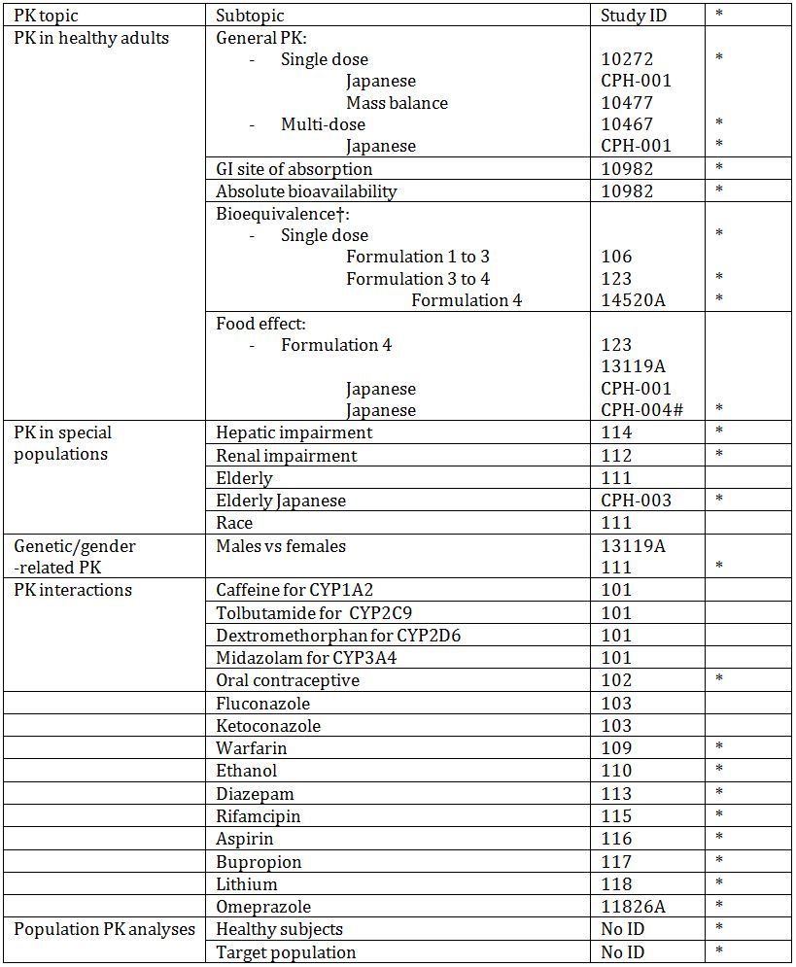
* Indicates primary study aim.
† Bioequivalence of different formulations.
# Studies completed and submitted for second round evaluation.
Table 2. PK results excluded from consideration.

Population pharmacokinetics

Population pharmacokinetics phase I studies (healthy subjects)
The sponsor submitted a PopPK study report in healthy subjects, based on most PK & PD studies. It was conducted by nonlinear mixed-effect modelling (NONMEM). The first order conditional estimation with interaction minimisation method was used. Plasma concentration data were log-transformed prior to analysis.
The objectives of the analysis were:
- To develop a Pop-PK model for vortioxetine in healthy subjects;
- To assess the relationships between the PK parameters of vortioxetine and subject specific covariates.
The doses of vortioxetine administered were 2.5 to 75 mg for single dosing and 2.5 to 60 mg per day for multiple dosing, with 21758 quantifiable plasma concentrations. Quality check and visual inspection of the data could not detect any outliers in plasma concentration or covariate data.
CYP2C9 genotype was not present for 84 subjects, which were imputed with “extensive metaboliser” (EM). For CYP2C19 and CYP2D6, 13 and 12 subjects had missing data, respectively, which were imputed as EM. For continuous covariates, the following were missing: alanine transferase (ALT; six subjects), aspartate transferase (AST; six subjects) and bilirubin (18 subjects). All missing continuous covariates were imputed with the median value.
Baseline characteristics: Mean age was 33.7y (18 to 78); mean body mass index (BMI) was 24.8kg/m² (15.1 to 35.5), mean creatinine clearance was 122mL/min (41.9 to 223), 74% Caucasian, 15% Asian and 11% Black; 71% male, 29% female.
Following exclusion of Aptuit-comprised bioanalytical data the final model demonstrated: Approximately 90% subjects had reached 90% of steady state after 12 days of dosing. The final model, consisted of CYP2D6 inferred metabolic status and age on CL/F and height on V2/F. It was a two-compartment model with first-order absorption and elimination that described the distribution and elimination phases very well, while the absorption phase was less well described based on the general goodness-of-fit and normalised prediction distribution error (NPDE) plots. CYP2D6 inferred metabolic status on CL/F was the most significant relationship, the mean group CL/F values for the four different categories of CYP2D6 metabolic status were 53L/h (UM), 34L/h (EM), 27L/h (IM) and 18L/h (PM). The EM/PM ratio in CL/F was approximately 1.9 (34.2/18.1). CL/F decreased with age, 0.28L/h for every year. V2/F increased with 17L/cm of height. The inter-individual variability for CL/F was 42% and V2/F 31% (Table 3).
Table 3. Population PK parameters of vortioxetine in healthy subjects obtained from the final model.
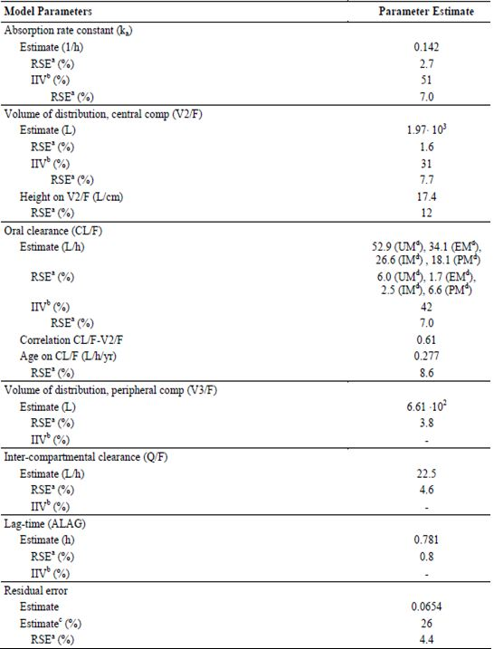
ª Relative standard error (RSE) was calculated as Standard Error / Estimate*100 from NONMEM results
^{b} Inter-individual variability
^{c} Percentage standard deviation (SD) calculated as 100*sq rt (Estimate)
^{d} CYP2D6 inferred metabolic status
With an absolute bioavailability of 75% (Study 10982) and with a population mean oral clearance of 33L, the average systemic clearance is around 25L/h. The sum of the population mean of the central and peripheral volumes of distribution after oral administration, i.e. V2/F+V3/F, is 2.60 x 10³ L, which gives a volume of distribution of 1.95 x 10³ L (assuming a bioavailability of 75%).
All body size measures, except BMI, were strongly related to the central volume of distribution, although only height remained in the final model.
The apparent age dependency of oral clearance may result from reduced kidney function with age. However, for vortioxetine the impact of age on CL/F is not considered of clinical relevance.
In the population studied, men had in general larger volume of distribution and higher oral clearance compared to women. Sex was a significant covariate for volume of distribution and oral clearance. Population mean values for men were 1.94.103L (V2/F) and 34L/h (CL/F), while for women the values were 1.81·103L and 30L/h. However, when height on V2/F was incorporated in the model, sex was no longer a significant covariate i.e. body size (in this case height) explained the difference between the sexes in V2/F and CL/F.
Race, ethnicity and region did not impact as covariates.
For the simulated Cmax and AUC0-24 values at steady-state, the variability (CV%) was over 50% for both parameters, which is comparable with 40% seen general in the phase I studies.
The eta (η) shrinkages for the final model were 22% (ka), 16% (V2/F) and 2% (CL/F). Epsilon (ε) shrinkage was 4 %. According to the criterion of 20%, shrinkage was only to a small degree present for ka.
For the visual predictive check plot, the observed values lay within the 95% CIs (CIs).

Population pharmacokinetics phase III studies (patients)
This report included patients from two short term GAD studies (308 & 311).
Two outliers on visual inspection of plasma concentrations were excluded from the analysis. All missing continuous covariates were imputed with the median value. All missing categorical covariates were imputed with the most frequent category (10% were missing: smoking status).
Baseline characteristics: mean age 46y (18 to 88); mean BMI 27kg/m² (16 to 60); creatinine clearance 111mL/min (26 to 322).
Based on the results of the covariate screening, height, ALT, CrCL, smoking status, race, region and Z3 (subjects taking vitamins versus not taking vitamins) for oral CL/F and weight, height for V2/F were identified as potentially significant covariates to be tested in the forward selection of the covariate analysis for vortioxetine. In addition to the above screened covariates age, sex, weight, Z4 (subjects taking 2D6 inhibitors versus not taking 2D6 inhibitors) for CL/F were also included to be tested.
The final PopPK model was a two compartment model with first order absorption and linear elimination where first-order absorption rate constant (KA), inter compartmental clearance (Q/F) and peripheral volume of distribution (V3/F) were fixed to the values estimated based upon the PopPK analysis performed using pooled data obtained in healthy subjects.
Creatinine clearance, region and height appear to have statistically significant effect on oral clearance of vortioxetine (Table 4).
Table 4. Population PK Parameters of vortioxetine patients obtained from the final model.
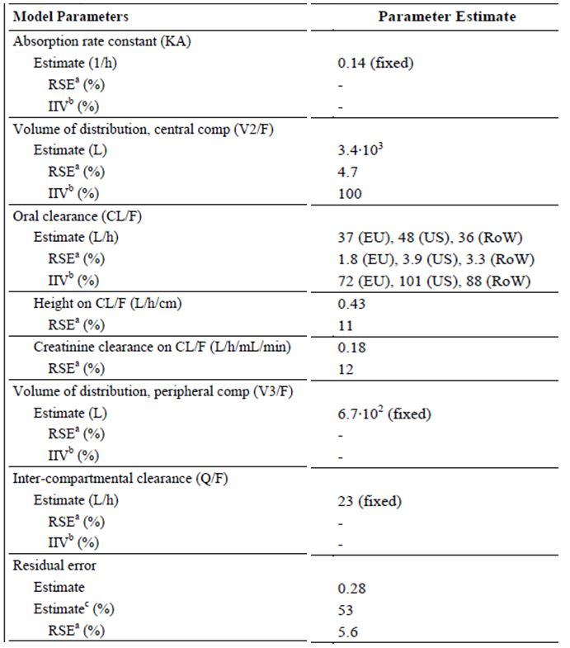
ª RSE was calculated as Standard Error / Estimate*100 from NONMEM results.
^{b} Inter-individual variability.
^{c} Percentage SD calculated as 100*sq rt (Estimate)
The parameter estimates from the final model were consistent with those estimated from the bootstrap evaluation and within the 95% CI of the median bootstrap estimate,
Eta (η)-shrinkages were 63% (V2/F), 38 % (CL/F EU), 52 % (CL/F US) and 55 % (CL/F RoW) which were above the non-shrinkage limit of 20% i.e. shrinkage was present due to the sparse PK sampling approach. Epsilon (ε) shrinkage was 16 %. Due to the very large shrinkage for V2/F, the secondary parameter, elimination half-life (t½) was not derived.
Bootstrap analysis for the final PK model was only performed with 200 replicates.

Summary of Pharmacokinetics
The information in the following summary is derived from conventional PK studies. Table 5 summarises single dose PK and Table 6 summarises multiple dose PK.
Table 5. Non-compartmental PK Parameters of Vortioxetine Following Single Oral Doses of vortioxetine (5, 10, 20 mg).
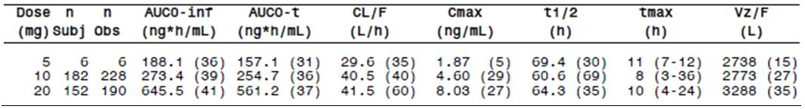
Studies included: 10272 103 10467 106 10982 110 111 112 114 115 123 13138A 13921A CPH-001 CPH-003
Mean and coefficient of variation (CV) are presented for all parameters, except Tmax, for which median and range are presented.
All single-dose data from healthy subjects have been included with the following qualifications:
Only doses between 5 and 20 mg, only administrations of vortioxetine with no co-administered drugs, only IR formulations, and only observations deemed evaluable in the included studies have been selected.
Table 6. Non-compartmental PK Parameters of Vortioxetine Following Multiple Oral Doses of Vortioxetine (5, 10, 20 mg).
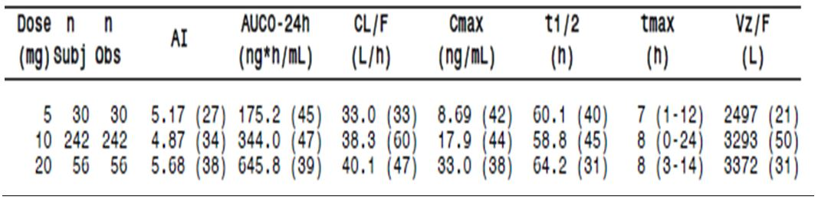
Studies included: 104 10467 10985 111 113 116 117 11826A 12260A 13119A CPH-001 CPH-002
Mean and CV are presented for all parameters, except T_{max}, for which median and range are presented.
All multiple-dose data from last day of dosing of healthy subjects have been included with the following qualifications:
Only doses between 5 and 20mg, only administrations of vortioxetine with no co-administered drugs, only IR formulations, and only observations deemed evaluable in the included studies have been selected.

Physicochemical characteristics of the active substance
Vortioxetine belongs to a new chemical class of psychotropics, the bis-aryl-sulfanyl amines, which is structurally different compared with currently known psychotropics. Vortioxetine has been developed as a hydrobromide (HBr) salt the relative molar mass of which is 379.36. The relative molar mass of the active substance (vortioxetine) is 298.45. The molecule is not chiral. The drug substance is a white to very slightly beige powder.

Pharmacokinetics in healthy subjects

Absorption
Vortioxetine is absorbed throughout the small intestine (Study 10982).

Bioavailability

Absolute bioavailability
The absolute bioavailability of vortioxetine tablets was approximately 75%. In Study 10982 the relative bioavailability (95% CI) of vortioxetine, based on AUC0-inf, following a single administration of 20mg to the proximal small intestine, compared with 20mg (IR tablets) was 1.02 (0.956, 1.10), while for the distal small intestine it was 0.970 (0.882, 1.07).

Bioavailability relative to an oral solution or micronised suspension
This formulation is not to be marketed (Study 13921A).

Bioequivalence of clinical trial and market formulations
In Study 123 for vortioxetine, the ratios (90% CIs) of Formulation 4 to Formulation 3 were: for Cmax, 94.86 ng/mL (89.41, 100.65) and AUC0-inf 101.42ng.hr/mL (96.62, 106.46) i.e. the 90% CIs fell within the bioequivalence limits of 80% to 125%.
Formulation 1 was used in the early clinical studies initiated prior to June 2007. Bioequivalence was shown with Formulation 3 in Study 106.

Bioequivalence of different dosage forms and strengths
Study 14520A was a randomised, OL, two-way crossover, single-dose study that compared 4x5mg (test) Formulation 4 with 1x20mg (reference) Formulation 4, in healthy young adults. The plasma concentration-time curves for these regimens are almost superimposable. The LS estimated mean ratios (test/reference) for AUC0-72h and Cmax were 102 (90% CI 98.0, 106) and 101 (90% CI 96.3, 106), respectively. These results are within the accepted range for bioequivalence (80 to 125%). Hence, bioequivalence was demonstrated between 4x5mg and 1x20mg vortioxetine tablets (Formulation 4) in Study14520A.

Influence of food
In Study 123 for Formulation 4 vortioxetine 20mg the 90% CIs for the ratios of fasted versus fed were AUC0-inf 106.48 (101.52, 111.68) and Cmax 102.67 (98.95, 106.53) i.e. within the limits of 80% to 125% and thus there was no food effect.
Study CPH-004 was a randomised, OL, two-way crossover, single-dose (10mg vortioxetine) study in young Japanese men. While total exposure (AUC) was 9% higher in the fed state and Cmax 13% higher in the fed state, these differences are not clinically significant. The plasma concentration-time curves followed a similar pattern. The 90% CIs for the LS ratios of AUC0-t and Cmax were within the accepted 80-125% limits. Presence of food did not significantly affect the PK of a single 10mg vortioxetine dose in Japanese men.

Dose proportionality
Data from Studies 10272 (10 to 75mg; Formulation 1) and CPH-001 (2.5 to 40mg; Formulation 3) were pooled. The 95% CIs for the slopes of the log-transformed AUC0-inf and dose contained unity and the slope was 1.09, suggesting dose proportionality. The 95% CIs for the slopes of the log-transformed Cmax and dose did not include 1. However, the Cmax graphical data suggest dose proportionality within the dose range of 2.5 to 75mg.
Data from Studies 104, 10467, 10985, and 12260A, following multiple doses (range 2.5 to 60mg/day), were pooled. The slopes of the log-transformed Cmax and AUC0-24h versus dose were close to 1 and the 95% CIs contained 1, indicating dose proportionality for vortioxetine following multiple doses of 2.5 to 60mg/day.

Bioavailability during multiple-dosing
In Study 10467 the accumulation index of vortioxetine and Lu AA34443 following repeated administration of vortioxetine ranged from 1.6 to 6.6 for all groups and tended to increase over time (vortioxetine consistently increased in all groups between Days 6 & 12 and Days 9 & 16).
Across studies the accumulation index for vortioxetine (based on AUC0-24h) was estimated to be five to six following multiple doses of 5 to 20mg/day.
In Study 10467 metabolite ratio as measured by AUC0-24h geometric mean (Lu AA34443/vortioxetine) ranged from approximately 0.7 to 2 and decreased when on the same dose from Day 1 through to Day 16 (except in the 2.5 mg dose).

Effect of administration timing
The CL/F was similar following single and multiple doses of vortioxetine (30 to 40L/h).
From the phase I PopPK analysis, no apparent time dependency or nonlinearity was observed. Based on the t½ in the phase I PopPK analysis ~ 90% of the subjects had reached 90% of steady-state exposure after 12 days of vortioxetine once a day (QD).
The accumulation index for vortioxetine (based on AUC0-24h) was five to six following multiple doses, consistent with a mean half-life of 60 to 70h and once daily administration.

Distribution

Volume of distribution
Following single and multiple doses of vortioxetine across studies, the estimated volume of distribution (Vz/F) is ~ 2500 to 3400L, while in the phase I PopPK analysis, the sum of the volumes of distribution in the central (V2/F) and peripheral (V3/F) compartments was approximately 2600L and ~ 4,000L in the phase III analysis.

Plasma protein binding
In Study 10477, there was evidence of significant amounts of non-specific binding to the membrane or dialysis cell components that indicated the dialysis method was not suitable for determination of the protein binding of 14C-vortioxetine.
This only left the in vitro assessment (Study 12287), which showed binding to both human serum albumin (mean range 85.1% to 95.7%) and to α1-acid glycoprotein (mean range 41.5% to 84.1%) the latter being more variable and significantly lower at the low target concentrations. In the ex vivo assessment, Study 124, the [14C]vortioxetine protein binding determined, using equilibrium dialysis in predose plasma samples, averaged 98.3% (range 97.9% to 98.0%) in the subjects who were randomised to receive vortioxetine. Mean Fraction of Unbound vortioxetine [CV%] was 1.68 [12%].
There was no apparent difference in the fractions of unbound vortioxetine between healthy subjects and subjects with hepatic (mild or moderate) or renal (mild, moderate, severe or end-stage renal disease [ESRD]) impairment.
The potential for displacement from protein binding was not considered.

Erythrocyte distribution
In Study 10477 after a single oral dose of 50mg 14C-labelled vortioxetine, negligible distribution of drug-related material (vortioxetine and metabolites) into red blood cells was observed.

Tissue distribution
The large volume of distribution suggests wide tissue distribution.
In Studies 10985 and 12260A (both ligand-based PET studies), the 5-HTT occupancy values observed seven hours after administration of single doses of vortioxetine suggest vortioxetine crosses the blood-brain barrier.

Metabolism

Sites of metabolism and mechanisms / enzyme systems involved
Vortioxetine is extensively metabolised in liver, primarily through oxidation and subsequent glucuronic acid conjugation with CYP2D6 the primary enzyme in the first step of the metabolism of vortioxetine to the major, pharmacologically inactive metabolite Lu AA34443. Several CYP isozymes (CYP2D6, CYP3A4/5, CYP2C19, CYP2C9, CYP2A6, CYP2C8, and CYP2B6) contribute to metabolism.

Non-renal clearance
Negligible amounts of vortioxetine were excreted unchanged (1.5% quantified material, in faeces only).

Metabolites identified in humans
Two metabolites of vortioxetine, Lu AA34443 and Lu AA39835, were measured in plasma in most of the clinical pharmacology studies. Lu AA34443 is a major, pharmacologically inactive metabolite and Lu AA39835 is a minor, active metabolite that does not cross the blood-brain barrier.
Four other metabolites of vortioxetine were quantified in plasma: the glucuronide of Lu AA34443 (M4(b)), the glucuronide of Lu AA39835 (M3), and two Lu AE22404 glucuronides (Lu AE87283 [M11] and M12) (Figure 1).
Figure 1. Biotransformation scheme showing the enzymes involved in the metabolism of vortioxetine in humans.
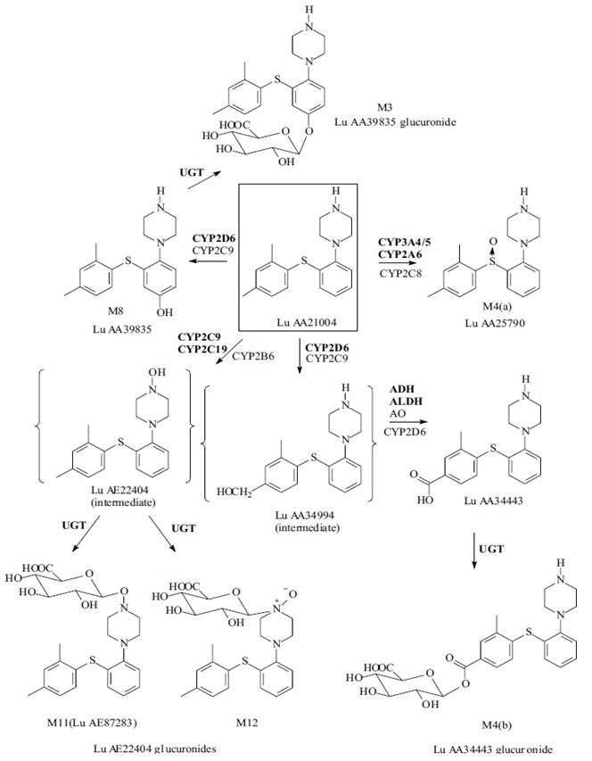
ADH = alcohol dehydrogenase; ALDH = aldehyde dehydrogenase; AO = aldehyde oxidase; UGT = UDP-glucuronosyl transferase
The enzymes in bold are considered the primary enzymes involved in the metabolism of vortioxetine. The intermediates (within brackets) were detected in vitro, but not in vivo (Study 10431).

Pharmacokinetics of metabolites
There were multiple studies with results for the PKs of Lu AA34443. For Lu AA39835 concentrations were frequently < LLQ. Table 7 summarises the results from Study 10467.
Table 7. Geometric Mean (%CV) PK Parameters for Lu AA34443 (Young Men on 20mg vortioxetine).
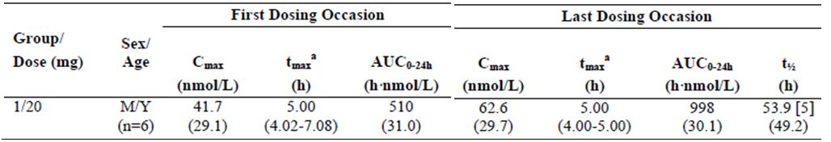
a = Median (Range); n as detailed unless otherwise stated [ ]; M = men, Y = young

Consequences of genetic polymorphism
In the PopPK study of phase III trials:
- CYP2D6 inferred metabolic status significantly affected CL/F, with CYP2D6 PMs having a 47% lower oral clearance than CYP2D6 (EMs);
- CYP2C19 inferred metabolic status affected CL/F, but to a lesser degree than CYP2D6, with a 31% lower oral clearance in CYP2C19 PMs than in EMs. The CL/F was 36L/h (EM), 29L/h (IM), and 25L/h (PM) for the 3 categories of CYP2C19 metabolic status. Although statistically significant as a covariate, CYP2C19 inferred metabolic status could not be included in the final model due to over-parameterisation;
- Race, ethnicity and region did not impact as covariates.
In the clinical pharmacology studies, vortioxetine plasma concentrations in CYP2D6 PMs were approximately two times higher than those in EMs. In patient studies, no significant effect of concomitant administration of CYP2D6 inhibitors on the PK of vortioxetine was observed. Lack of effect of CYP2D6 inhibitors might be due to limited numbers of subjects.

Excretion

Routes and mechanisms of excretion
After hepatic metabolism the metabolites of vortioxetine undergo urinary and faecal excretion.

Mass balance studies
In Study 10477, a single-dose mass balance study with 14C-vortioxetine, ~ 85% of the drug-related material was recovered in urine and faeces over 360 hours (59% urine and 26% faeces). Only 1.5% of the quantified drug-related material was excreted as parent compound and only in faeces. The major metabolite Lu AA34443 and its glucuronide conjugate M4(b) accounted for 80% and 17% of the quantified material, respectively, indicating a very small contribution from other metabolites.

Renal clearance
In Study 10272 the amount of dose excreted in the urine 48 hours after administration was 0.02 to 0.11% and the corresponding renal clearance ranged from 5.2 to 193.7mL/h. The renal clearance for Lu AA34443 was 5.9 to 16.4L/h.

Intra- and inter-individual variability of pharmacokinetics
The inter-subject variability in the single-dose, relative bioavailability studies of vortioxetine, the CV% for Cmax and AUC0-inf ranged from 24.5 to 26% and from 42.5 to 49%, respectively. The intra-subject variability was < 15% (CV%) for Cmax and AUC0-inf (Studies 106 and 123).
The inter-subject variability for CL/F and V2/F was estimated to 42% and 31%, respectively, and the residual (intra-individual) variability was 26% based on the phase I PopPK analysis.
In the PopPK studies height, as a measure of body size, was significantly related to CL/F in patients and to V2/F in healthy subjects. In the patient population, the vortioxetine exposure differed up to 17% in a short person (153cm) and a tall person (183cm) compared to the average patient with a height of 166cm. This variability in exposure was not considered clinically meaningful.

Pharmacokinetics in the target population
In the two PopPK analyses in healthy subjects and in patients with MDD or GAD, CL/F values for vortioxetine were 33L/h and 39L/h, respectively, while the inter-individual variability was larger in MDD/GAD patients (88% vs. 46%). The estimated V2/F was apparently larger and the associated inter-individual variability was higher in patients than in healthy subjects (3400L [98%] and 1900L [33%], respectively). Possible explanations for the differences between patients and healthy subjects include different sampling schemes, inclusion criteria and compliance on dose administration.

Pharmacokinetics in other special populations

Pharmacokinetics in subjects with impaired hepatic function
There were no apparent differences in the plasma protein binding of vortioxetine between subjects with hepatic impairment and their healthy controls.
For vortioxetine, AUC0-t was slightly lower (9% and 2%, respectively) in the subjects with mild or moderate hepatic impairment than in healthy controls. Cmax was up to 16% lower in subjects with hepatic impairment than in healthy controls. Only a few subjects had evaluable AUC0-inf values.
For Lu AA34443, the plasma exposure was lower in the subjects with moderate hepatic impairment than in the healthy controls (35% and 52% lower for AUC0-t and Cmax, respectively). Similarly, the plasma exposure to Lu AA39835 was lower in the subjects with moderate hepatic impairment than in the healthy controls (13% and 28% lower for AUC0-t and Cmax, respectively).

Pharmacokinetics in subjects with impaired renal function
The effect of CrCL on vortioxetine exposure in the patient population (up to 25% higher for a patient with a CrCL of 65mL/min than for the average patient with a CrCL of 106mL/min) is in line with the findings in the renal impairment study (PopPK phase II analysis).
In Study 112 there were no apparent differences in the plasma protein binding of vortioxetine between the subjects with renal impairment and their healthy controls. There was a statistically significant linear relationship between AUC0-t of vortioxetine and CrCL.
For vortioxetine, AUC0-t was 9, 16, and 11% higher in the subjects with mild, moderate, or severe renal impairment, respectively, than in their healthy controls. Slight differences (less than 11%) were observed for Cmax in the subjects with mild, moderate, or severe renal impairment compared to their healthy controls. Only a few subjects had evaluable AUC0-inf values.
Mean AUC(0-tlqc) values were 256, 294, and 320ng.hr/mL for subjects with mild, moderate, and severe renal impairment, respectively, compared with mean values in healthy matches of 233, 263, and 255ng.hr/mL, respectively. The predicted AUC(0-tlqc),u value from the regression model for a subject at about the midpoint CrCl for each renal impairment group differed from that of the normal renal function group by less than 32%.
In the subjects with ESRD, vortioxetine AUC0-t and Cmax were 13% and 27% lower than in the healthy controls. For the inactive metabolite Lu AA34443, AUC0-t and Cmax were up to 2.2-fold and 1.3-fold higher in the subjects with mild, moderate, severe, or ESRD than in their healthy controls. For Lu AA39835, AUC0-t and Cmax were 24% and 8% higher, respectively, in the subjects with mild, moderate, or severe renal impairment, and 13% and 27% lower, respectively, in the subjects with ESRD than in their healthy controls.
No relationship between vortioxetine Cmax values and CrCL was identified.

Pharmacokinetics according to age
In the phase I PopPK analysis, age was significantly related to the CL/F for vortioxetine, but not to CrCL, whereas the opposite was observed in patients. This could be due to the restrictive inclusion criteria on CrCL in the clinical pharmacology studies, which limits the range of CrCL values observed in this population. In Study 111 following single doses, a slightly higher AUC0-t (4%) and lower Cmax (11%) of vortioxetine were observed for elderly subjects than for young subjects. Only a few elderly subjects had evaluable AUC0-inf values. Following multiple doses, the AUC0-24h and Cmax of vortioxetine were 27% and 23% higher, respectively, in elderly subjects than in young subjects.

Pharmacokinetics related to genetic factors

Race
In Study 111 following single doses, the AUC0-t and Cmax of vortioxetine were slightly higher (8% and 6%, respectively) in Black subjects than in White subjects. Only a few subjects had evaluable AUC0-inf values. Following multiple doses, the AUC0-24h and Cmax of vortioxetine were 25% and 33% higher, respectively, in Black subjects than in White subjects. In Study 12260A following multiple vortioxetine doses, AUC0-24h and Cmax of vortioxetine were slightly higher (8% and 9%, respectively) in Japanese subjects than in Caucasian subjects. In the PopPK study race, ethnicity and region did not impact as covariates.

Gender
In Study 111, after a single dose of vortioxetine 10mg, between women and men increases in the values of AUC(0-tlqc), AUC(0-inf), and Cmax, for vortioxetine of 18%, 36%, and 16% respectively, were observed. Following multiple doses of vortioxetine (10 mg QD for 14 days), increases of approximately 30% for AUC(0-24) and Cmax values of vortioxetine were seen in women compared with men. However, in the PopPK study of phase I studies, while men had in general larger volume of distribution and higher oral clearance compared to women, body size (in this case height) explained the difference between the sexes in V2/F and CL/F.

Pharmacokinetic interactions

Pharmacokinetic interactions demonstrated in human studies
- When multiple doses of vortioxetine (10mg/day) were co-administered with bupropion (150mg, twice daily), the 90% CIs for AUC0-24h and Cmax were outside the limits of 80% to 125%, with 2.3-fold increases in AUC0-24h and 2.1-fold increases in Cmax for vortioxetine. CYP2D6 is involved in the metabolism of vortioxetine to Lu AA34443 and to Lu AA39835.
- When a single dose of 20mg vortioxetine was co-administered with 600mg/day rifampicin (a broad CYP inducer) at steady state, the 90% CIs for AUC0-t and Cmax were outside the limits of 80% to 125% and a 72% decrease in AUC0-t and a 51% decrease in Cmax were observed for vortioxetine.
- When a single dose of 10mg vortioxetine was co-administered with ketoconazole 400mg/day (a CYP3A4/5 and P-gp inhibitor) at steady state, the 90% CIs for AUC0-t and Cmax were outside the limits of 80% to 125% and a 30% increase in AUC0-t and a 26% increase in Cmax were observed for vortioxetine. For the metabolites Lu AA34443 and Lu AA39835, AUC0-t was 10% and 46% higher, respectively.
- When a single dose of 10mg vortioxetine was co-administered with fluconazole 200mg/day (a CYP2C19, CYP2C9, and CYP3A4/5 inhibitor) at steady state, the 90% CIs for AUC0-t were outside the limits of 80% to 125% and a 46% increase in AUC0-t was observed for vortioxetine. For the metabolites Lu AA34443 and Lu AA39835, AUC0-t was 10% and 86% higher, respectively.
- When a single dose of 40mg omeprazole was co-administered with multiple doses of 10mg/day vortioxetine, the AUC0-inf CI for omeprazole was within the limits of 80% to 125%; for Cmax, the upper limit of the 90% CI was 130%. For the metabolite 5’hydroxyomeprazole, the 90% CIs for AUC0-inf and Cmax were within the limits of 80% to 125%. When multiple doses of 10mg/day vortioxetine were co-administered with a single dose of 40mg omeprazole, the 90% CIs for AUC0-24h and Cmax for vortioxetine were within the limits of 80% to 125%.
In summary co-administration of multiple doses of vortioxetine with a CYP2C19 substrate and inhibitor (omeprazole) had minimal effect on the PKs of omeprazole, indicating vortioxetine is not an inhibitor or inducer of CYP2C19. In addition, no effect on the PKs of vortioxetine was observed following a single dose of the CYP2C19 inhibitor.
- The drug cocktail consisting of caffeine (CYP1A2 substrate; 200mg), tolbutamide (CYP2C9 substrate; 500mg), dextromethorphan (CYP2D6 substrate; 30mg), and midazolam (CYP3A4/5 substrate; 4mg) was given with vortioxetine at steady state. For caffeine and tolbutamide, as well as their metabolites, the 90% CIs for AUC0-inf and Cmax were within the limits of 80% to 125%. This was also seen for unchanged midazolam and the dextromethorphan metabolite, dextrorphan. For dextromethorphan, AUC0-inf and Cmax were 24% and 14% lower, respectively, following co-administration with vortioxetine and the lower limit of the 90% CI (58% for AUC0-inf and 68% for Cmax) was below the 80% limit. For the midazolam metabolite 1-hydroxymidazolam, a higher exposure (17% for AUC0-inf and 14% for Cmax) was observed following co-administration with vortioxetine and the upper limit of the 90% CI was above the 125% limit (128% for AUC0-inf and 130% for Cmax). In summary, vortioxetine is not a major inhibitor or inducer of CYP1A2, CYP2C9, CYP2D6, or CYP3A4/5.
- Ethinyl oestradiol and levonorgestrel are both CYP3A4/5 substrates, multiple doses of vortioxetine (10mg/day) did not have an effect on the steady state PKs. For both ethinyl oestradiol and levonorgestrel, the 90% CIs for AUC0-24h and Cmax were within the limits of 80% to 125%.
- R-warfarin is a CYP1A2 substrate and S-warfarin is a CYP2C9 Substrate. Co-administration of multiple doses of vortioxetine and warfarin had no effect on the steady-state PKs, indicating vortioxetine is not an inhibitor or inducer of CYP2C9 or CYP1A2. For both R- and S-warfarin, the 90% CIs for AUC0-24h, Cmax, and Cmin were within the limits of 80% to 125%. In addition, least squares (LS) mean point estimates close to one and the narrow 90% CIs further support the lack of effect for a narrow therapeutic index compound.
- Diazepam is a CYP2C19 substrate. Multiple doses of vortioxetine (10mg/day) did not have an effect on the PKs for both diazepam and its metabolite, N-desmethyldiazepam, after a single dose of 10mg diazepam the 90% CIs for AUC0-t and Cmax were within the limits of 80% to 125% i.e. vortioxetine is not an inhibitor or inducer of CYP2C19.
- For ethanol, the 90% CIs for AUC0-t and Cmax were within the limits of 80% to 125% when a single dose of 40mg vortioxetine was co-administered with a single dose of 0.6g/kg ethanol. For vortioxetine, the 90% CIs for AUC0-t and Cmax were also within the limits of 80% to 125%.
- For aspirin and its metabolite, salicylic acid, the 90% CIs for AUC0-24h and Cmax were within the limits of 80% to 125% following co-administration of aspirin and vortioxetine. For vortioxetine, the 90% CIs for AUC0-24h and Cmax were also within the limits of 80% to 125%.
- The 90% CIs for lithium AUC0-12h, Cmax, and Cmin were within the limits of 80% to 125% following co-administration of multiple doses of lithium (extended-release 450mg bd) and vortioxetine (10mg/day). In addition, LS mean point estimates close to one and the narrow 90% CIs further support the lack of effect for a narrow therapeutic index compound.

Clinical implications of in vitro findings
Vortioxetine and its metabolites showed no inhibitory potential towards CYP1A2, CYP2A6, CYP2D6, CYP2E1, or CYP3A4/5 (IC50 > 34μmol/L, corresponding to >10100ng/mL for vortioxetine). For the other CYP isozymes investigated, a few IC50 values <34μmol/L were observed. All estimated [I]/Ki ratios were much smaller than 0.1, which indicates a very low potential for clinically relevant CYP inhibition by vortioxetine or any of the tested metabolites.
Vortioxetine (< 2.54μM, corresponding to < 7600ng/mL) and Lu AA34443 (<20μM, corresponding to < 6600ng/mL) had little or no induction potential (defined as < 2-fold effect on activity or mRNA levels) of CYP1A2, CYP2A6, CYP2B6, CYP2C8, CYP2C9, CYP2C19, or CYP3A4/5. The relative effectiveness of vortioxetine as an inducer compared with the positive controls was negligible (<7%) at all concentrations examined.

Evaluator’s overall conclusions on PK
Across 10 mg vortioxetine studies, mean (CV) results for multi dose studies were AUC0-24h 344.0 (47) ng.h/mL; Cmax 17.9(44) ng/mL and Tmax 8 h. For 5 to 20 mg vortioxetine mean results in multi dose studies were AUC0-24h 175 to 646 ng.h/mL; Cmax 8.7 to 33.0ng/mL and Tmax 7 to 8h; and in single dose studies were AUC0-∞ 157 to 561 ng.h/mL; Cmax 1.87 to 8.03ng/mL and Tmax 8 to 11h.
Following single and multiple doses of vortioxetine across studies, the estimated volume of distribution (Vz/F) was ~2500 to 3400L, while in the phase I PopPK analysis, the sum of the volumes of distribution in the central (V2/F) and peripheral (V3/F) compartments was approximately 2600L and ~4,000L in the Phase III analysis.
The mean oral clearance (CL/F) was 33L/h in the Phase I Pop-PK study and 40 L/h in the Phase III. Across studies, for vortioxetine 5 to 20 mg (inclusive), this ranged from 30 to 42 L/h.
The mean elimination half life (t1/2) was 66 h in the Phase I Pop-PK study compared with 59 to 69 h across the vortioxetine therapeutic range.
For vortioxetine, AUC0-t was 9, 16, and 11% higher in the subjects with mild, moderate, or severe renal impairment, respectively, than in their healthy controls. The predicted AUC of the unbound fraction to last quantifiable concentration (AUC0-tlqc,u) value from the regression model for a subject at about the midpoint CrCL for each renal impairment group differed from those in the normal renal function group by less than 32%.
While Study 111 showed women had a 30% greater AUC, the Pop-PK study of Phase I studies, body size (height) explained the difference between the sexes.
While in Study 111 following multiple doses, the AUC0-24h and Cmax of vortioxetine were 25% and 33% higher, respectively, in Black subjects than in White subjects, in Study 12260A following multiple vortioxetine doses, AUC0-24h and Cmax of vortioxetine were slightly higher (8% and 9%, respectively) in Japanese subjects than in Caucasian subjects.
In the Pop-PK study, race, ethnicity or region did not impact as covariates.
Japanese Study CPH-004 demonstrated no food interaction with vortioxetine (10 mg). This confirmed the results of Study 123, in which a 20 mg vortioxetine dose was administered. Bioequivalence was demonstrated between 4 x 5 mg vortioxetine tablets Formulation 4 and 1 x 20 mg vortioxetine tablet Formulation 4, in Study 14520A. Hence, bioequivalence is expected for the intermediate dose strengths, that is, 10 mg and 15 mg tablets.

Pharmacodynamics
Table 8 summarises the PD studies in the first and second rounds.
Table 8. Submitted pharmacodynamic studies.
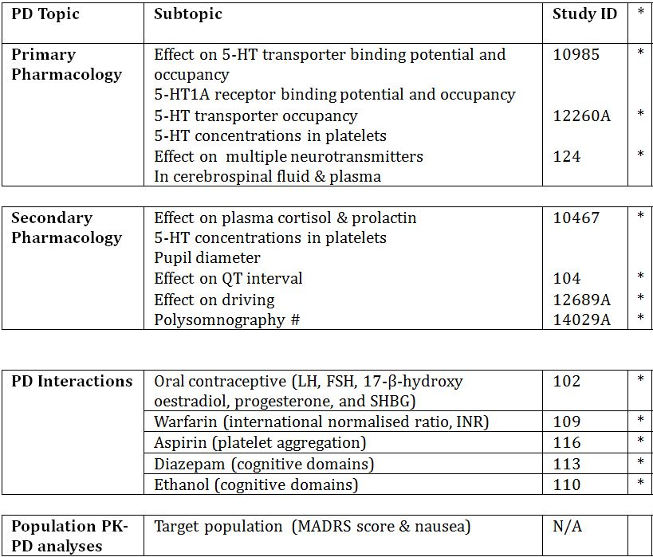
* Indicates the primary aim of the study.
# Study completed and submitted for second round evaluation.

PK/PD population study
A PK/PD model for vortioxetine in patients with MDD was developed by evaluating the relationship between exposure of vortioxetine and the clinical (MADRS score) and safety endpoints. Subject demographics are summarised in Table 9.
Table 9. Summary statistics of subject demographics.
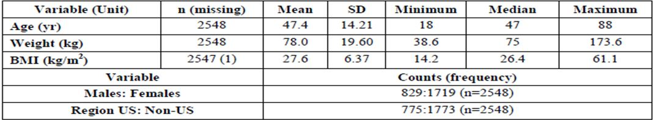
The covariates weight, age, region and BMI had statistically significant effect on the PD parameters (Emax or EC50) of vortioxetine; gender did not have statistically significant effect on either.
For age, a0 = 0.1 implies that as age increases, the magnitude of Emax decreases; b0 = -0.2 implies that as age increases, EC50 decreases. Based upon the observed data, the responder rates among different age groups were: 56.3% for < 30 years old, 52.4% for 30 ≤ 50 years old, and 51.5% for ≥ 50 years old. The observed responder rates decrease as age increases. The smaller response rates for older subjects were consistent with the smaller magnitude of Emax and smaller EC50 for older subjects described by the model.
For weight, a0 = 0.1 implies that as weight increases, the magnitude of Emax decreases and as weight increased, the magnitude of ΔMADRS decreased.
Similarly for BMI, a0 = 0.2 implies that as BMI increases, the magnitude of Emax decreases and ΔMADRS decreased.
For region a0 = 5.7, suggests the magnitude of Emax in the US population is smaller and the US population had smaller magnitude of ΔMADRS than the non-US population.

Risk of nausea
A logistic regression analysis evaluated the relationship between Cav or dose and risk of nausea (Table 10). 1925 subjects from short term MDD studies were included in the analysis. 480 had treatment-emergent nausea. The model with dose had a smaller Akaike’s information criteria (AIC) score. However, both Cav and dose are statistically significant factors that impact the risk of nausea.
Table 10. Evaluation of the relationship between Cav or dose versus risk of nausea.
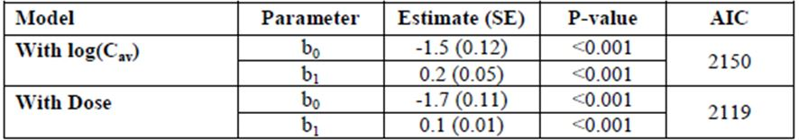

Summary of pharmacodynamics
The information in the following summary is derived from conventional PD studies in humans unless otherwise stated.

Mechanism of action
Human in vitro binding studies indicate vortioxetine is a 5-HT3, 5-HT7, and 5-HT1D receptor antagonist, 5-HT1B receptor partial agonist, 5-HT1A receptor agonist, and inhibitor of the 5-HT transporter. This multimodal activity of vortioxetine is thought to mediate the antidepressant effect.

Pharmacodynamic effects

Primary pharmacodynamic effects
In the two ligand-based PET Studies 10985 & 12260A, the frontal cortex, insular, hippocampus, and raphe nuclei were chosen as the regions of interest (ROIs) based on the 5-HT1A and 5-HTT receptor distribution demonstrated in non-clinical studies and, with the exception of raphe, because the regions are relatively large and homogenous giving reliable time activity data. In the SCP, EC50 values that were observed for the raphe nuclei were considered comparable across the studies (4.2 to 6.5ng/mL). The mean 5-HT transporter occupancy in the raphe nuclei was approximately 50% at 5mg/day, 65% at 10mg/day, and increased to above 80% at 20mg/day. No measurable occupancy at the 5-HT1A receptor was observed in Study 10985, since the ligand used is not appropriate for the investigation of 5-HT1A agonists. In cerebral spinal fluid (CSF), the PD parameter of 5-HT, AUEC0-24h, increased 41% and 176% from baseline following single and multiple doses of 20mg vortioxetine, respectively (Study 124). For the 5-HT metabolite, 5-HIAA, in CSF, a 19% decrease in AUEC0-24h from baseline was observed following multiple dosing of vortioxetine only.

Secondary pharmacodynamic effects

Cortisol

Study 10647
Changes from baseline AUCs were very variable. No statistically significant differences were seen between any dose of vortioxetine and placebo.

Study 10272
When compared to the effect of placebo the changes from baseline for cortisol secretion AUC0-8h were claimed statistically significant for all doses except 20 mg, (for 30 mg p=0.0627).

Prolactin (study 10647)
There was no clear dose response in change from baseline of AUCs for prolactin.

Pupil diameter (study 10647)
No statistically significant changes in pupillometry were seen.

Platelet serotonin (study 10647)
Concentrations decreased with increasing dose of vortioxetine, the decrease was maintained throughout the study period (maximum decrease between 10 to 14 days). Decreases in platelet serotonin concentrations were not observed in subject receiving placebo.

QT electrocardiograph (ECG) changes (study 104)
No notable treatment-related differences in the proportion of subjects with predefined outlier events for QTcNi (linear), QTcF, QTcB, QTcFm, or QTcNi (nonlinear) were observed. No clear treatment-related differences in the proportion of subjects with predefined outlier events for PR interval, QRS duration, or heart rate were noted. No positive U-waves were reported during the study. The percentage of subjects with T-wave morphology described as “inverted,” “biphasic,” and “flat” was small and equally distributed among treatment groups at Baseline and after 14 days.

Effect on driving (study 12689A)
The primary analysis based on the SD of lateral position concluded non-inferiority of vortioxetine compared to placebo on Days 2 and 16 with the upper 95% CI being less than the inferiority limit of 2.0 cm. The secondary analysis: Mirtazapine compared with placebo based on the SDLP showed inferiority on Day 2, but non-inferiority on Day 16 using the two-sided test with 90% CIs; Vortioxetine compared with mirtazapine based on the SDLP using the two-sided test, showed superiority of vortioxetine on Day 2, but non-inferiority on Day 16; No statistically significant difference for the SD of speed on Days 2 or 16 for 10mg vortioxetine or 30mg mirtazapine compared with placebo. Based on the exploratory cognitive and psychomotor tests, 10 mg Lu AA21004 administered in the evening yielded no residual effects, whereas mirtazapine yielded moderate residual effects in the acute phase (Day 2), but which decreased to more minor effects at steady-state.

Polysomnography
Study 14029A was a randomised, DB, four way crossover, placebo controlled, active comparator, single centre, multiple dose polysomnographic interventional study undertaken in 24 healthy young men. The study investigated the effect of vortioxetine 20mg and 40mg doses on mean sleep fragmentation, rapid eye movement (REM) suppression versus placebo and paroxetine 20mg. An increase in sleep fragmentation and REM sleep suppression was apparent after vortioxetine dosing for 3 days, with a dose-dependent trend. However, no adjustment for multiplicity was performed in PD analyses. While no statistically significant differences in sleep fragmentation were identified between 40mg vortioxetine and 20mg paroxetine, the study was not powered to make such comparisons and the 40mg vortioxetine regimen had numerically greater values than the paroxetine 20mg i.e. a tendency towards greater sleep fragmentation with the high vortioxetine dose (but not with 20mg). When compared to placebo the effect of 40 mg vortioxetine and 20mg paroxetine on sleep fragmentation was statistically significantly different whereas 20 mg vortioxetine did not differ statistically significantly from placebo. For REM sleep suppression the effect of 40 mg vortioxetine was similar to 20 mg paroxetine whereas 20 mg vortioxetine showed significantly less effect on REM suppression compared to 20 mg paroxetine. All three active treatments differed statistically significantly from placebo. Vortioxetine 20mg and 40mg (equivalent to Cav 10mg and 20mg, respectively) was reasonably well tolerated, albeit a 3-day study in healthy young males.

Pharmacodynamic interactions

Female sex hormones (oral contraceptives study 102)
Any statistically significant differences in concentration levels of LH, FSH, 17-β- hydroxyestradiol, progesterone, and SHBG from co-administration of vortioxetine 10mg + ethinylestradiol 30μg/levonorgestrel 150μg compared with placebo + ethinylestradiol 30μg/levonorgestrel 150μg were not considered clinically meaningful.

INR (warfarin study 109)
The mean INR profiles were similar between the two treatment groups at the end of the Warfarin Titration Period and after 14 days of co-administration of vortioxetine with warfarin and placebo with warfarin. Statistical analyses of INR derived parameters, INRMax and AUCINR, indicated no difference between the treatment groups. Post hoc statistical analysis of Prothrombin Time, PTmax and AUCPT, indicated no difference between the treatment groups.

Ethanol (study 110)
With most of the ‘Primary Outcome PD Variables’ there were no statistical differences.
There was a statistical difference (in the presence of alcohol) for vortioxetine versus placebo only for Postural Stability on 20 mg at 1 h, with no difference in subjective assessment (Self Rated Alertness). No statistical difference on postural stability was observed for 40mg vortioxetine (in the presence of alcohol) vs. placebo.
There was only statistical difference for the addition of alcohol versus placebo up to 4h in Digital Vigilance Speed on 20 mg plus alcohol and up to 2 h on 40 mg plus alcohol. However this only translated to subjective statistical significance at 1 h on 40 mg plus alcohol for Self Rated Alertness. No statistical difference in Digital Vigilance Speed was seen between alcohol with and without 20 or 40 mg vortioxetine.
Among the other major variables a statistically significant difference was seen between alcohol with and without 20mg vortioxetine only for Self-Rated Contentment at 2 h (p = 0.024) and with and without 40mg vortioxetine only for Self-Rated Calmness at 1 h (p = 0.003), for the Quality of Working Memory at 6 h (p = 0.025) and in Speed of Memory at 2 h (p = 0.003).

Diazepam (study 113)
There was no statistically significant difference between treatments (Treatment A on Day 15 was vortioxetine + diazepam; Treatment B on Day 15 was placebo + diazepam) at any time point for any of the composite scores measured on Day 15. There was no statistically significant difference between treatments (Treatment A on Day 14 was vortioxetine; Treatment B on Day 14 was placebo) at any time point for any of the composite scores measured on Day 14.
There was no apparent pattern with respect to time points or treatment group differences for the subtask scores on Days 14 or 15. The observed few numbers of significant treatment differences in subtask scores were expected due to random chance given the significance level, the number of subtasks, and times of assessment tested.

Aspirin (study 116)
The percent inhibition of arachidonic acid (AA)- (1.5mcM), ADP- (2.5μM and 5μM), and collagen-induced (2μM and 5μM) platelet aggregation on Day 14 (predose, 2 and 8 hours postdose) and predose on Day 15, were similar between the two treatments of multiple doses of vortioxetine 10mg and placebo, indicating vortioxetine did not have any effect on the inhibition of platelet aggregation. Vortioxetine did not have any synergetic affects due to aspirin on the percent inhibition of platelet aggregation at 2 and 8 hours postdose when vortioxetine 10mg was co-administered with aspirin 150 mg.

Dosage selection for the pivotal studies
Vortioxetine is efficacious at a lower 5-HTT occupancy level than currently available antidepressants. Studies have previously demonstrated that at therapeutic doses of SSRIs and SNRIs, the 5-HTT occupancies are ~80% or above. This suggests a high 5-HTT blockade is important for the therapeutic effects of SSRIs and SNRIs. In the clinical development program with vortioxetine, doses giving rise to approximately 50% 5-HTT occupancy (5 mg/day dose) demonstrated a clinically relevant effect. A possible explanation could be the multimodal mechanism of action of vortioxetine, where it acts both at 5-HT receptors and at the 5-HTT, contributes to enhanced serotonin neurotransmission and, through combined activities, mediates vortioxetine antidepressant activity. Nonclinical mechanistic studies suggest at low vortioxetine doses, where there is a high level of occupancy at 5-HT₃ receptors; a synergistic action with 5-HTT inhibition could be expected.
At 20 mg/day, 5-HTT occupancies >80% were observed in humans. Nonclinical occupancy data, in vitro human binding data and occupancy data in healthy subjects, predict greater involvement of the 5-HT receptors and of 5-HTT with increasing vortioxetine dose. The modulation of multiple neurotransmitter systems may contribute to the incremental overall antidepressant effect with increasing dose seen in patients. These modulations have been shown to be brain region specific, as determined by receptor localisations in nonclinical studies.
Vortioxetine acts broadly at several 5-HT receptors and at the 5-HTT, which could hypothetically be a concern with respect to safety and tolerability. However, vortioxetine is very well tolerated at the higher doses. This suggests the complex interaction of these targets includes a counterbalancing effect. Furthermore, the agonistic activity of vortioxetine at the 5-HT_{1A} receptor predicts a low level of sexual side effects, as might modulation of other 5-HT receptor subtypes (such as 5-HT_{1B} and 5-HT₇). In addition, the antagonistic activity of vortioxetine at the 5-HT₇ receptor may potentially contribute to a favourable sleep profile.
Vortioxetine was initially developed globally in MDD at doses up to 10mg/day, focusing on 5 and 10 mg/day. However, the efficacy of 5mg/day was not consistently confirmed, being negative in the studies conducted in the US. The results for 10mg/day were more consistent and 10 mg/day was more effective than 5 mg/day. Based on these results and the mechanism of action of vortioxetine (higher doses lead to higher occupancies at all targets and consequently a broader pharmacological profile), an extended Phase III program was initiated, which included doses up to 20 mg/day.
Randomised DB comparisons versus placebo were selected, as reliable evaluation of treatments intended for the management of psychiatric illness is not possible without the use of placebo, and to provide unambiguous evidence of efficacy. Comparison with placebo is also valuable for distinguishing disease manifestations from adverse reactions of the medicinal product and is in line with the guidelines in depression.
The placebo response has been shown to be as high as 40% in MDD trials. Although the use of placebo in conditions where effective treatment is known may be considered controversial, existing literature justifies its use in disorders characterised by a fluctuating course with only a slight chance of permanent harm associated with treatment delay or assignment to placebo. It is recommended to include an active reference to distinguish between a failed trial, where the reference also fails, and a negative study. The reference drugs (duloxetine, venlafaxine) were considered safe, effective and widely used in MDD treatment.

Clinical efficacy

Major depressive disorder (acute phase)

Pivotal efficacy studies (adults)
Eight pivotal phase III studies of 6 to 8 weeks duration investigated the efficacy, safety and tolerability of between 1 to 20mg/day vortioxetine, in adults with MDD (acute phase). These studies were randomised, DB, parallel-group, multi-centre, placebo-controlled and fixed-dosed. In six studies, an active reference (duloxetine or venlafaxine) was included for internal validation. In this CER, the eight pivotal studies were evaluated as a group, as they have many features in common, including their objectives, design and efficacy endpoints. Individual differences between studies are documented.
Comment: Studies 315, 316, 303 and 304 were conducted in the US whereas Studies 11492A, 11984A, 305 and 13267A were conducted in Asia, Australia, Canada, Europe or South Africa. The sponsor has emphasised efficacy results of ‘non-US’ trials over ‘US’ trials throughout this submission, the former appearing more favourable than results from US studies alone or combined US and non-US studies. The sponsor argues US study results are not generalisable to non-US subjects because of a larger placebo effect reported in US clinical trials compared with non-US trials. It is not appropriate in this CER, for a NCE, to separate US from non-US clinical trial results, without compelling argument. Ideally, an NCE should show a clinically significant effect in a diverse range of subjects from different ethnic and racial origins. While differences between non-US study efficacy results compared with overall (i.e. combined US and non-US) efficacy results will be noted where appropriate, overall conclusions and recommendations in this CER will be based on the combined US and non-US clinical trial data.

Short-term adult MDD studies

Study design, objectives, locations and dates
Lundbeck or Takeda assumed overall responsibility for all studies, including those delegated to contract research organisations. The common study design is presented in Figure 2.
Figure 2. Overall study design of short-term studies in MDD.
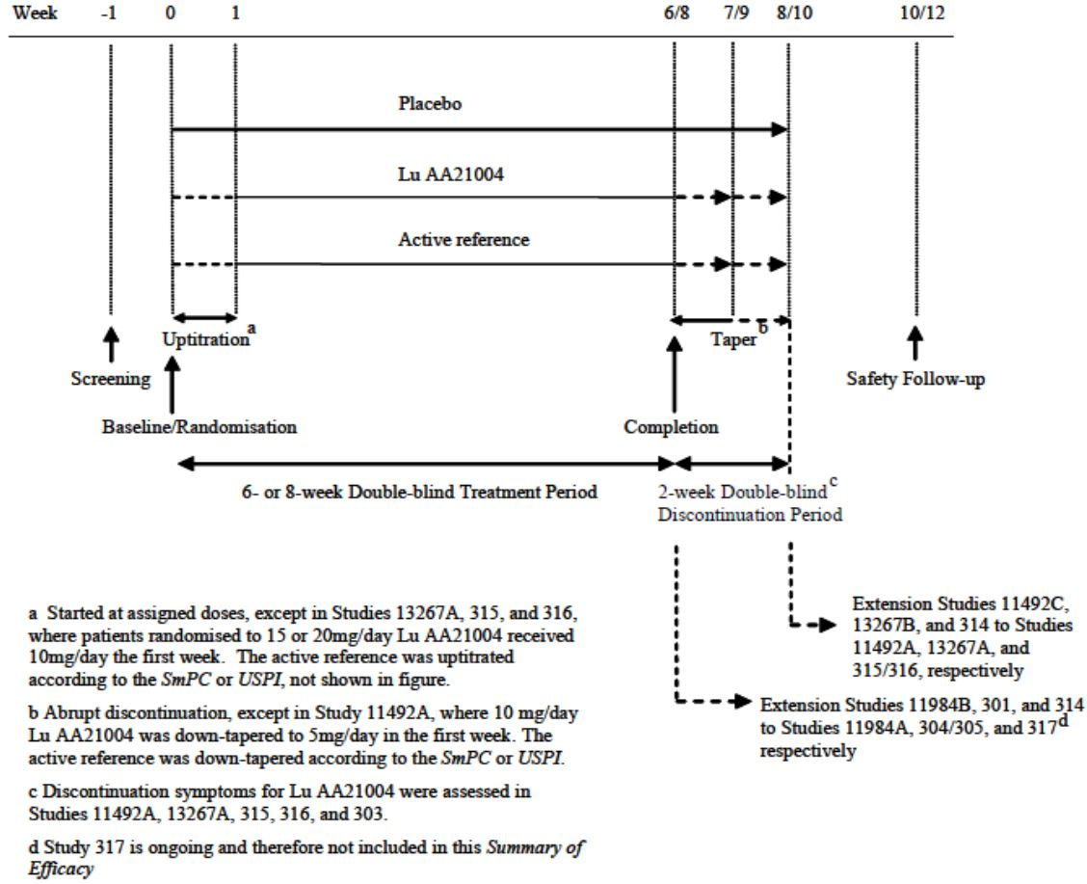
In 6-week studies, patients were seen every week for eight scheduled visits. In 8-week studies, patients were seen every week from screening to Week 2, and every second week thereafter for seven scheduled visits. Subjects could choose to enter an OL safety study on completion of DB treatment.
The primary study objective was to evaluate vortioxetine efficacy compared with placebo by change from baseline in MADRS or HAM-D24 total scores after 6 or 8 weeks of DB treatment in subjects with MDD.
In the second round, the sponsor provided three additional completed MDD studies to the MDD short-term pool: Studies 14122A, CCT-002 & 317. They were all 8 week studies with a similar design to the other short-term, placebo-controlled studies in MDD, with the following exceptions:
- In Study 14122A, the primary efficacy outcome measure was cognitive performance (composite z-score for Digit Symbol Substitution Test [DSST] and Rey Auditory Verbal Learning Test [RAVLT]) assessed using neuropsychological tests of executive function, processing speed, attention, and learning and memory. The secondary efficacy measures included assessments of depressive symptoms.
- In Study CCT-002, which was conducted as an integral part of a Japanese clinical development program there were small differences between protocols for this study and those for the global development program, including use of concomitant medications.
- In US Study 317, the primary efficacy outcome measure (MADRS total score) was assessed remotely via a video transmission by raters (central raters at MedAvante, a contract research organisation that specialises in central rating) who had no other interactions with the patients. This methodology represented a newer experimental design within MDD.
Study 14178A was a 12-week, active-comparator, flexible-dose study versus agomelatine. Study 14178A is the only completed active-comparator study and the only controlled flexible-dose study in the vortioxetine clinical development program and provides comparative data versus another antidepressant. Due to study design differences (e.g. longer study duration and lack of a placebo-control group), Study 14178A was reviewed separately.

Inclusion and exclusion criteria
Patients were included if they had a primary diagnosis of MDE within MDD according to the Diagnostic and Statistical Manual of Mental Disorders, Fourth Edition, Text Revision (DSM-IV-TR) criteria. MDD is characterised by one or more MDEs i.e. at least two weeks of depressed mood or loss of interest accompanied by at least four additional symptoms of depression. MDE diagnosis was confirmed using the Mini International Neuropsychiatric Interview (MINI) in Study 13267A and the Structured Clinical Interview for DSM Disorders (SCID) in Studies 315 and 316.
The short-term studies included men and women, aged ≥ 18 and ≤ 75 years (except Study 11492A: patients aged ≥ 18 and ≤ 65 years), with a primary diagnosis of MDE within MDD.
Patients were in- or outpatients from psychiatric settings. The inclusion criteria selected patients with mild to severe MDD (Montgomery and Åsberg Depression Rating Scale [MADRS] total score ≥ 22 [Study 304], ≥ 26 [Studies 11984A, 305, 13267A, 315 and 316], or ≥ 30 [Studies 11492A and 303]). In Studies 13267A, 315 and 316, there was an additional requirement for a Clinical Global Impression – Severity of Illness (CGI-S) score ≥ 4. The duration of the current MDE had to be ≥ 3 months (> 3 months in Study 13267A) and, in Study 11492A, the current MDE had to have lasted < 12 months. In Studies 13267A, 315 and 316, patients had to have had at least one MDE prior to the current episode.
Patients were excluded from study participation if they had:
- any current psychiatric disorder other than MDD (the MINI or the SCID assisted in the exclusion of disallowed Axis I disorders); a history of manic or hypomanic episode; schizophrenia or any other psychotic disorder; a mental disorder due to a general medical condition; or any significant Axis II disorder;
- was at significant risk of suicide as: Judged by the investigator OR a MADRS item 10 [suicidal thoughts] score ≥ 5 at the screening and baseline visits OR suicide attempt during the last six months (not used in Study 11492A);
- significant somatic co-morbidity;
- any substance-related disorder (except nicotine or caffeine) within six months (two years in Studies 13267A and 315) prior to the screening visit. No current diagnosis or history of substance abuse was allowed in Study 316;
- treatment-resistant depression (defined as resistant to two adequate antidepressant treatments of ≥ 6 week’s duration, judged by the investigator);
- was receiving formal cognitive or behavioural therapy or had received electroconvulsive therapy (or vagal nerve stimulation or repetitive transcranial magnetic stimulation [Studies 13267A, 315 and 316]) within six months prior to screening visit;
- history of lack of response to previous adequate treatment with duloxetine (Studies 11984A, 13267A, 315, 304 and 12541A) or venlafaxine (Study 11492A);
- one or more laboratory value outside the normal range (serum creatinine value > 1.5 times ULN, serum ALT or AST value > 2 x ULN
- a history of severe drug allergy or hypersensitivity, or known hypersensitivity to duloxetine (Studies 11984A, 13267A, 304 and 12541A) or venlafaxine (Study 11492A).
Comments: Only three of eight pivotal MDD studies (Studies 315, 316 and 13267A) used MINI or SCID to confirm the MDE diagnosis, which may potentially compromise the internal validity of the results. Furthermore, besides the three aforementioned studies, eligible patients did not have to have a prior episode of MDE at time of enrolment. Together, these factors may have introduced significant selection bias, thereby potentially favouring recruitment of subjects without MDD or a MDE.
Subjects with raised baseline hepatic enzymes were excluded from study participation, which may have implications for the generalisability of the findings

Study treatments
An interactive voice response system (IVRS) assigned the study medication. In each study, patients were randomised equally to treatment with a fixed dose of vortioxetine (1, 2.5, 5, 10, 15 or 20mg/day). Doses varied across studies (Table 11), placebo, or, in some studies, a fixed dose of active reference (venlafaxine 225mg/day or duloxetine 60mg/day).
Table 11. Summary of study treatments in the short-term MDD studies.
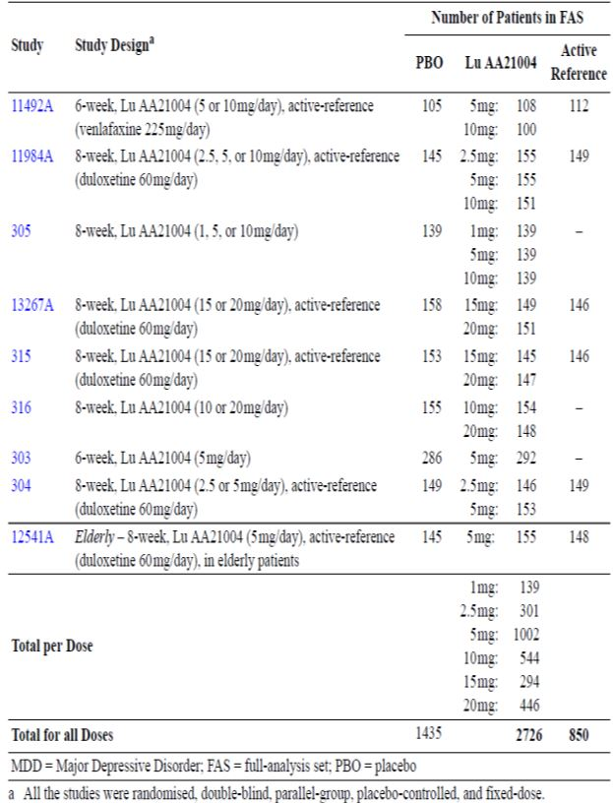
Patients randomised to 1, 2.5, 5 or 10mg/day vortioxetine started treatment on that dose, whereas patients randomised to 15 or 20mg/day vortioxetine were uptitrated from 10mg/day at the end of the first week of treatment. Patients randomised to venlafaxine were uptitrated stepwise during the first week of treatment, and patients randomised to duloxetine started on 60mg/day (Studies 11984A, 304 and 12541A) or were uptitrated during the first week of treatment (from 30mg/day; Studies 13267A and 315). Uptitration was conducted according to the Summary of Product Characteristics (SmPC) or US Prescribing Information (USPI) recommendations.
Vortioxetine was discontinued abruptly in every study except Study 11492A, when patients who had received 10mg/day then received 5mg/day during the first week after the 6-week treatment period. In studies with an active reference, venlafaxine or duloxetine was down-tapered after the 6- or 8-week treatment period in accordance with the SmPC or USPI recommendations.
Placebo capsules were made from the same material and were identical in appearance to vortioxetine and duloxetine capsules. The sponsor claims over-encapsulation did not alter drug bioavailability.
Comment: The sponsor seeks to register vortioxetine in the dose range 5 to 20mg/day (inclusive). Hence, reference to the 1mg and 2.5mg vortioxetine doses used in some pivotal short-term MDD trials will only be made to highlight a relevant efficacy and/or safety finding

Efficacy variables
The primary efficacy outcome was either MADRS or Hamilton Depression Rating Scale (HAM-D24) total scores (Table 12).
Table 12. Overview of primary (and key secondary) efficacy variables in the short-term MDD studies.
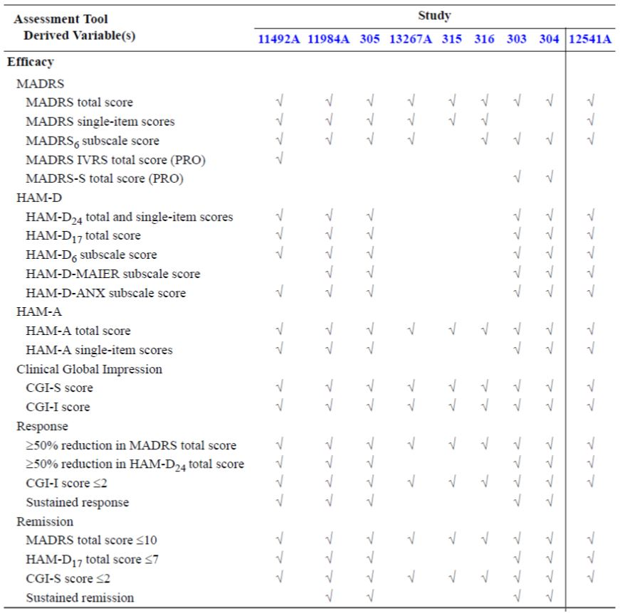
HAM-D24 measures the severity of depressive symptoms in patients with primary depressive illness. The rating is made on the basis of a specific statement, content, tone, facial expression and subject gestures during a clinical interview. The scores range for each item from 0 to 4 or 0 to 2, where 0 represents no symptoms. The rating is based on the past seven days prior to assessment. The most widely used HAM-D version consists of 21 original items from Hamilton, with specific anchor points for each score. Three additional items (helplessness, hopelessness and worthlessness) result in the 24-item version used in this application.
MADRS is a depression rating scale consisting of 10 items, each rated 0 to 6. The 10 items represent the core symptoms of depressive illness. Nine items are based upon subject report and one is based on subject observation. Decrease in the total score, or on individual items, indicates improvement.
Hamilton Anxiety Scale (HAM-A) is an anxiety rating scale consisting of 14 items that assess anxious mood, tension, fear, insomnia, intellectual (cognitive) symptoms, depressed mood, behaviour at interview, somatic (sensory), cardiovascular, respiratory, gastrointestinal (GI), genitourinary, and autonomic and somatic (muscular) symptoms. Each symptom is rated from 0 (absent) to 4 (maximum severity). Total scores range from 0 to 56.
Clinical Global Impression (CGI) Scales comprise two subscales: Severity of Illness (CGI-S) and Global Improvement (CGI-I). CGI-S assesses the clinician’s global impression of the subject’s current mental illness state on a 7-point scale and CGI-I will assess the subject’s global improvement (or worsening).
MADRS, HAM-D24 and CGI-S were assessed at all visits, HAM-A at all scheduled visits except the screening visit, and the CGI-I at all scheduled visits except the screening and baseline visits.
Comment: The primary efficacy and key secondary efficacy variables are acceptable. ‘Sustained remission’ in this application can only demonstrate an effect for a single episode of depression i.e. prevention of relapse not prevention of new episodes i.e. prevention of recurrence.
In the second round, the primary efficacy endpoint in Studies CCT-002 and 317 was the MADRS total score at week 8. Secondary efficacy endpoints included: proportions of responders and remitters, CGI-I score, severe MDD, high level of anxiety, SDS, HRQoL and EQ-5D. In Study 14122A, the primary efficacy outcome measure was cognitive performance. Depressive symptoms were a secondary efficacy measure.

Randomisation and blinding methods
Subjects were assigned in a 1:1 ratio to vortioxetine treatment(s), placebo and active comparator (if applicable) via the IVRS. Randomisation was stratified by subjects’ baseline sexual functioning status (normal or abnormal, decided by baseline ASEX scores). Within each stratum, subject randomisation across treatments was also balanced at the site level according to an on-demand allocated site-balanced randomisation list.
Study medication blind was maintained by use of encapsulation of vortioxetine tablets, duloxetine capsules and placebo capsules, to produce a solid-dose preparation identical in appearance. The IVRS also maintained the study medication blind.
Comment: The process of randomisation and the blinding methods used were consistent across the pivotal studies and are acceptable.

Analysis populations
Efficacy analyses were performed on the full-analysis set (FAS) in each study, defined as all randomised patients who took at least one dose of investigational medicinal product (IMP) and who had at least one valid post-baseline measurement of the primary efficacy variable. The ‘per protocol’ set (PPS) included all FAS subjects who had no major protocol violations. If more than 5% of total subjects in the FAS had major protocol violations, analyses based on the PPS were performed for the primary efficacy variable only.

Sample size
Assuming a minimum standard deviation (SD) of 9.0 for the change from baseline in MADRS/HAM-D24 total score, the total number of subjects per treatment group to achieve at least 80% power to detect a difference of at least 3.5 between a vortioxetine dose and placebo by a 2-sample t-test with a 0.025 2-sided significance level, were used.
Comment: The sample size calculations were consistent across the pivotal studies and are acceptable.

Statistical methods
The primary efficacy endpoint was the change from baseline to Week 6 or 8 in MADRS or HAM-D24 total score (Table 13), and the statistical analysis was either a mixed model repeated measures (MMRM) analysis using observed cases (OC) or an analysis of covariance (ANCOVA) using the last observation carried forward (LOCF). Missing values for post-baseline assessments were imputed by LOCF of the value immediately prior to the missing value.
The MMRM model had a completely unstructured covariance matrix and included terms for site, baseline score-by-visit interaction and treatment-by-visit interaction. The ANCOVA used the LOCF, with treatment and site as fixed factors and the baseline scale score as a covariate. Active reference data were kept in the models to improve estimate precision.
Table 13. Primary Efficacy Analyses in the Short-term Adult MDD Studies.
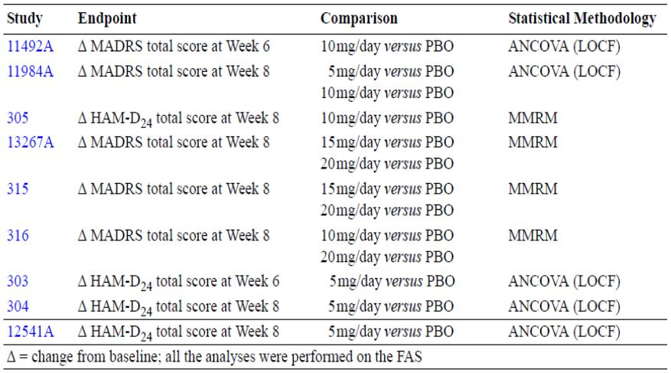
In each study, a hierarchically-ordered testing strategy was defined a priori in the statistical analysis plan (SAP) and comprised the primary efficacy and key secondary efficacy endpoints. The testing strategy comprised of one or two sequences, tested in parallel. Testing stopped within a sequence when a hierarchical hypothesis could not be rejected.
Hierarchical testing was used to control the 2-sided Type I error over the primary and key secondary endpoints. When the testing strategy comprised one sequence (Studies 11492A, 305, 304 and 12541A), each sequential step was tested separately versus placebo at a 0.05 significance level. When the testing strategy comprised two parallel sequences (Studies 11984A, 13267A, 315 and 316), each sequential step was tested separately versus placebo at a Bonferroni-corrected 0.025 significance level. In Study 303, the testing strategy comprised two steps: the first step comprised one sequence with a single endpoint that was tested versus placebo at a 0.05 significance level; the second step comprised two parallel sequences, and each step in each sequence was tested separately versus placebo at a Bonferroni-corrected 0.025 significance level.
All study endpoints in the testing strategy (except response and remission) were analysed using the same methodology used for the primary efficacy analysis. Response and remission were analysed based on logistic regression using LOCF, adjusted for baseline score and treatment, with p-values derived from odds ratios (OR). In Study 11492A, the logistic regression analysis for response and remission was also adjusted for site.
Active reference versus placebo comparison was performed outside the testing strategy, at a 0.05 significance level. For endpoints outside the testing strategy, or endpoints within the testing strategy that were not tested because the procedure had stopped, nominal p-values were reported. In tabulations of secondary efficacy results, p-values are designated as nominal regardless of the testing strategy results.
Comments: The SAP and statistical methods used in the pivotal efficacy studies were consistent and generally acceptable. Of note, four of the eight pivotal efficacy studies used MMRM as the primary efficacy analysis compared with the remaining four studies, which used the ANCOVA LOCF method. The latter makes cross-study comparisons more difficult to interpret. However, given the pivotal efficacy studies also conducted an MMRM or ANCOVA LOCF, as a sensitivity analysis of the primary efficacy variable, like for like comparisons are summarised in the results section.
In Study CCT-002, as agreed with the Japanese regulatory authority, PMDA, site was not included as a covariate in either the primary efficacy analysis (ANCOVA, LOCF) or the MMRM analysis. However, site was consistently included as a covariate in all the statistical models used for the other short-term, placebo-controlled studies in the vortioxetine clinical development program and is also advocated in the ICH guideline on Statistical Principles for Clinical Trials. Therefore, site was included as a covariate (as a fixed factor) in the analyses presented in the second round Addendum.
In Study 14122A, to evaluate the clinical relevance of the results on the neuropsychological tests, the standardised mean differences to placebo interpreted as Cohen’s d standardised effect size were used (using the standard 0.2 threshold). The proportion of the treatment effect on cognitive function that was a direct treatment effect (that is, not mediated through an improvement in depressive symptoms) was determined using a path analysis.

Participant flow
The proportion of subjects who completed vortioxetine (and reference) DB treatment was generally well distributed across treatment groups with similar inter-study completion rates:
- Study 11492A: 82.0% for 10mg vortioxetine and 90.7% for 5mg vortioxetine (placebo 82.9%)
- Study 11984A: 77.5% for 10mg vortioxetine and 77.7% for 5mg vortioxetine (placebo 83.1%)
- Study 305: 87.1% for 10mg vortioxetine and 92.1% for 5mg vortioxetine (placebo 90.7%)
- Study 13267A: 77.5% for 15mg vortioxetine and 82.8% for 20mg vortioxetine (placebo 84.2%)
- Study 315: 73.4% for 20mg vortioxetine and 76.9% for 15mg vortioxetine (placebo 80.1%)
- Study 316: 80.0% for 10mg vortioxetine and 81.3% for 20mg vortioxetine (placebo 88.5%)
- Study 303: 78.7% for placebo and 81.3% for 5mg vortioxetine
- Study 304: 78.4% for placebo and 79.7% for 5mg vortioxetine
Placebo subjects had proportionately higher DB completion rates compared with vortioxetine treatments in Studies 315, 316 and 11984A.
Generally, lower dose vortioxetine treatments (5mg & 10mg) had proportionately higher DB completion rates compared with higher dose vortioxetine treatments (15mg & 20mg).
Adverse events (AEs) accounted for most study withdrawals and were generally evenly distributed across treatment groups, with similar rates among the pivotal efficacy studies (range: 2.0% Total in Study 305 to 9.7% Total in Study 11984A).
Subjects who withdrew secondary to lack of efficacy (LoE) were generally evenly distributed across treatment groups, with similar rates among the efficacy studies (range: 0.8% Total in Study 304 to 4.0% Total in Study 11492A). Placebo treatment had proportionately greater rates of LoE compared with active treatment(s) in just three of eight pivotal efficacy studies (305, 315 & 11492A).
Comments: The general trend for lower dose vortioxetine treatments (5mg & 10mg) to complete DB treatment compared with higher dose vortioxetine treatments (15mg and 20mg) may reflect greater tolerability of the lower dosage regimens. The high DB completion rates for placebo subjects across the pivotal studies (often higher than active treatments) may suggest lack of efficacy for vortioxetine treatment across the proposed 5-20mg/day dosage range. The 2.5mg vortioxetine group in Study 304 had proportionately greater numbers of subjects compared with the other treatment groups who were lost to follow-up (12.4% versus 5.2-7.2%), who withdrew consent (7.8% versus 3.3-3.9%), had major protocol violations (4.6% versus 1.3-3.3%) and non-compliance (2.6% versus 0.0-2.0%). Hence the rates for AE and LoE reported here may be under-representative of the true rates.

Major protocol violations/deviations
The proportion of major protocol violations or deviations, were generally evenly distributed across treatment groups, with similar inter-study rates for the individual pivotal efficacy studies (PPS analyses). However, there were proportionately more protocol violations in Studies 11984A and 304 (19.3% and 18.5%, respectively).
Study 11984A was audited. Non-compliance with the protocol, GCP, applicable regulations, and applicable SOPs was identified at Centre FR002 after unblinding. Fifteen patients were randomised at the site and 13 of them completed the study. Following a blinded data review meeting, the primary efficacy analysis was repeated, excluding this site. This course of action was appropriate and acceptable to maintain Study 11984A as ‘pivotal’.
In Study 304, proportionately more protocol violations occurred in all treatment groups because treatment assignments for a total of 66 (10.8%) of all randomised subjects could potentially have been unblinded by the investigator. Some labels used on study medication bottles during the taper-down period had wording that could have led the investigator to discover the treatment the subject was receiving. These labels were discovered and replaced. To protect study integrity, data from all subjects who had seen a corrupt label were excluded from the PPS analysis. This action was reasonable and explains the high proportion of major study protocol violations.
An audit was also conducted at centre AT002 in Study 11492A, after the study was unblinded. The auditor found the quality of the medical records was inadequate. The efficacy analyses were repeated without the data from centre AT002 (data on file). In general, these results slightly favoured vortioxetine. The data from this centre, from which 28 patients had been randomised, were kept in all the analyses presented in this report. The HAM-A data from patients from centres FR001, FR002 and FR005 were excluded since the ratings were based on a non-valid version of the scale. The sponsor’s actions are reasonable.
Study 13267A was audited after unblinding. Non-compliance with the protocol, GCP, and applicable regulations was identified at Site FR004. One patient was randomised and completed the study.
Randomised study participants were found (after unblinding) to have taken part in more than one centre and were therefore excluded from the PPS (Study 315, five subjects; Study 316, four subjects, Study 303, 12 subjects [four dosed with vortioxetine and two dosed with placebo in Studies 303 & 304; two dosed with vortioxetine and four dosed with placebo simultaneously in Studies 303 & 308]; and Study 304, 11 subjects assigned as ‘overdoses’ [three subjects were enrolled in 304 & 309, a GAD study, two subjects were enrolled in 304 & 308, a GAD study and six subjects were enrolled in 304 & 303]).
Comment: Subjects who participated in multiple vortioxetine studies (n=32 subjects in total) were all based in the United States. Refer to comment in regards to subject selection into the pivotal MDD short-term trials.

Treatment compliance
Compliance was defined as [(number of capsules dispensed - number of capsules returned)/ (date of last dose - date of first dose + 1)] x 100%. There were three compliance categories: < 80%, 80% to 120% and > 120%. The sponsor did not provide an explanation why these categories were chosen. In particular the 80 to 120% range, when 80 to 100% is usually the accepted range. Mean and median study drug compliance was > 90% across treatment groups in each pivotal study, most often close to 100%.
Comment: The clinical study reports for the eight adult pivotal efficacy MDD studies do not report the numbers or proportions of subjects who took greater than 100% of study drug i.e. an ‘overdose’. This may have efficacy and safety implications.

Baseline data
In general, baseline demographic characteristics were evenly distributed across treatment groups, with similar rates among the pivotal efficacy studies. Mean age was around 45 years, with a greater proportion of females (approximately 2:1) and the study populations were predominantly Caucasian (> 70%) i.e. representative of an MDE population.
In general, baseline disease characteristics were evenly distributed across treatment groups, with similar rates among the pivotal efficacy studies in terms of past episodes of MDE, duration of current MDE and baseline depressive symptoms. Studies 11492A, 305 & 303 recruited subjects with a severe MDE (MADRS or HAM-D24 total score ≥ 30 at baseline), while the remaining studies recruited subjects with moderate to severe MDE (MADRS total score ≥ 26 at baseline). No studies were undertaken with subjects with mild symptoms of depression (although Study 304 was designed to assess this subgroup). Most subjects in all eight studies had a substantial level of anxiety symptoms (based on baseline HAM-A total scores).
The following differences were noted within treatment groups of the specified study:
- Study 305: The majority of subjects in each group were Caucasian/White, although the 1mg group had a greater percentage of White subjects (92.1%) than other treatment groups (p=0.032) and proportionately more current smokers (38.6%).
- Study 305: The vortioxetine 10mg group had slightly higher scores than the other groups. The p-values for mean baseline MADRS total score (p=0.009) and mean CGI-S (p=0.021) indicate higher baseline scores in the 10mg group.
- Study13267A: There was a slight imbalance between the treatment groups with respect to the proportions of women, ranging from 60% (vortioxetine 20mg) to 70% (placebo) and predominantly a white study population (98.2%).
- Study 304: There was one statistically significant difference among the treatment groups at baseline, for BMI (p=0.035), but this difference was not considered clinically relevant.
Comment: The four US studies (315, 316, 303 & 304) recruited subjects with greater BMI (approximately 30) than non-US studies (range 25 to 26) and proportionately more black subjects (range 22.1% in Study 315 to 27.9% in Study 316). These racial and weight differences are not expected to have a great effect on overall efficacy results (especially based on the clinical pharmacology results).

Results for the primary efficacy outcome
- Non-US subjects consistently demonstrated greater reductions in LS mean scores compared with US subjects across the dose range 1 to 15mg (results were comparable for the 20mg dosage regimen);
- Efficacy was only established for the 20mg dosage regimen in US studies (315 & 316);
- A dose-response trend appeared in overall non-US studies for the range 2.5mg to 20mg (inclusive);
- In non-US studies, two out of three studies demonstrated efficacy of the 5mg and 10mg dosage regimens (11492A and 305);
- Two of five studies demonstrated efficacy of the 5mg dosage regimen and two of four studies demonstrated efficacy of the 10mg regimen and 15mg regimens (one of two studies) and three of three studies demonstrated efficacy of the 20mg regimen;
- No active treatment demonstrated efficacy in Studies 11984A, 303 and 304;
- Of the five studies that employed an active reference group, one study (11984A) failed to reach statistical separation at p<0.05.

Sensitivity analyses for the primary efficacy variable
The sensitivity analyses (OC, LOCF; MMRM) were consistent for the primary efficacy and key secondary efficacy analyses in each pivotal study. MMRM analyses consistently demonstrated higher LS mean reductions versus placebo for most vortioxetine and active reference treatments compared with LOCF analyses of the primary efficacy variable.

ANCOVA LOCF versus MMRM analyses
Comparison of LOCF and MMRM analyses (Table 14) consistently demonstrated greater differences versus placebo in favour of MMRM results over LOCF results.
Table 14. Comparison of MMRM and ANCOVA LOCF efficacy results for the adult MDD studies.
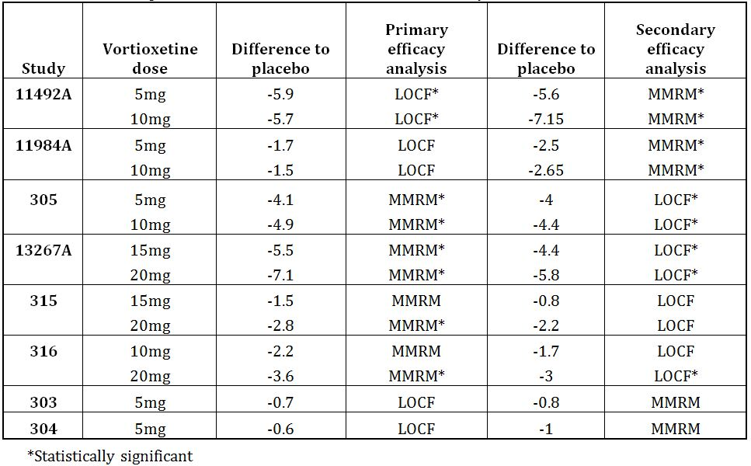
Comment: Use of MMRM instead of ANCOVA LOCF in Study 11984A changed the study results to statistical significance in favour of vortioxetine treatments (5mg and 10mg).

Per protocol analysis
The PP analyses of the primary efficacy variable compared with the FAS analyses were consistent for US studies except for a 0.50 greater reduction in LS mean difference compared with placebo in Study 316 for the 10mg vortioxetine strength leading to a statistically significant difference over placebo (-2.19, p=0.058 versus -2.69, p=0.024 for FAS and PPS analysis, respectively).
For non-US studies, the FAS and PPS analyses were consistent in Studies 13267A and 305. In Study 11492A there was a marked difference, favouring the vortioxetine 10mg strength compared with placebo (-5.7, p<0.001 for FAS versus -7.25, p<0.001 for PPS). This difference is most probably due to the greater loss of subjects in the 10mg vortioxetine group.
The FAS and PPS results differ considerably in Study 11984A, most probably reflecting the large proportion of major protocol violations at several participating centres. Unlike the FAS analysis that failed to demonstrate statistical separation for any treatment group (vortioxetine and active reference) in Study 11984A versus placebo, the PPS analysis, in contrast, demonstrated a statistically significant dose-response relationship versus placebo for the 5mg and 10mg vortioxetine treatments, as well as statistical superiority of duloxetine versus placebo.
Table 15 summarises the primary efficacy (and sensitivity) results for Studies CCT-002, 317 and 14122A, submitted in the second round evaluation.
Table 15. Comparison of MMRM and ANCOVA LOCF efficacy results for the supplementary adult MDD studies.
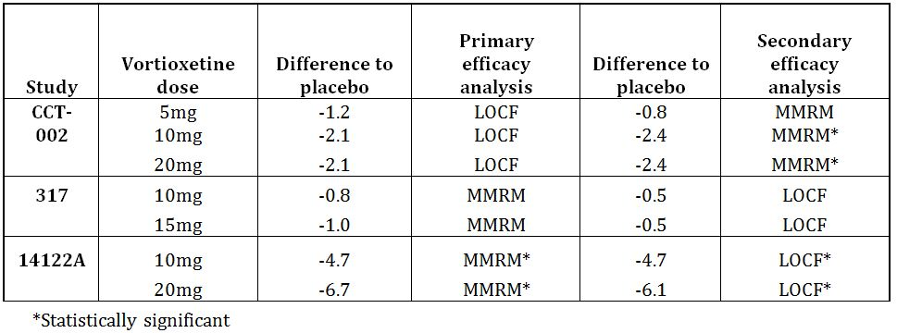
The primary efficacy results for Study 11492A: Composite z-score (MMRM analysis) for vortioxetine 10mg versus placebo was 0.36 (p<0.001) and, for 20mg vortioxetine, 0.33 (p<0.001). The sensitivity analysis (ANCOVA, LOCF) supported these positive findings (0.36 and 0.32 for the 10mg and 20mg regimens, respectively).
Comments: Study 317 produced a negative result, consistent with the other vortioxetine MDD studies conducted in the US. While the primary efficacy analysis in Study CCT-002 produced a negative result, the MMRM analysis produced a statistical separation versus placebo for the 10mg and 20mg vortioxetine doses. Hence, Study CCT-002 produced ‘supportive’ efficacy results for 10mg and 20mg vortioxetine regimens only. While the separation versus placebo in Study 14122A for MADRS total score was similar in size for the 10mg regimen in Studies 305 & 11492A and for the 20mg regimen in Study 13267A, respectively, MADRS total score was not the primary efficacy analysis in Study 14122A. Hence, the results for Study 14122A are regarded as supportive in terms of MADRS total score and positive in terms of cognitive performance. Generally, the primary efficacy and sensitivity analysis results were similar, supporting the internal validity of the results.
From Study 11984A, the greatest proportion of major violations that led to PPS analysis exclusion were from centres not monitored by [information redacted], a clinical trials contract organisation.
Comments: Comparison of the FAS and PPS analyses demonstrated reasonable internal validity across the pivotal studies. However, Study 11984A failed to demonstrate good internal validity, as evidenced by the major differences between the FAS and PPS analyses. This lack of validity was most probably due to the large number of GCP and major protocol violations identified at several centres for this study. The active reference reductions in LS mean were consistently greater than vortioxetine treatments.

Subgroup analyses of primary efficacy outcome
Subgroup analyses of the primary efficacy variable were undertaken: age (≤ 55, > 55); sex; race; baseline HAM-D24, MADRS & HAM-A (≤ 19, > 19). Generally, the results from these subgroup analyses support the results from the covariate analyses, where no statistically significant main effect or interactions were found except the following:
- In Study 11492A, for MADRS at Week 6 (LOCF), a statistically significant interaction between treatment and the following covariates was found: Centre (p=0.0502), baseline MADRS total score (p=0.0355) and baseline HAM-D item 8 (retardation) score (p=0.0345). Inspection of by-centre results showed no clear tendencies;
- In Study 11984A, there was a statistically significant effect of previous MDD episode on the mean change from baseline in MADRS total score at Week 8 (p=0.0185). There were statistically significant effects of COUNTRY (p=0.002) and MADRS total score at baseline (p<0.001) on the mean change from baseline in MADRS total score at Week 8. However, there were no statistically significant interactions at Week 8;
- In Study 13267A, there was a statistically significant interaction between treatment and country (p=0.025). A post-hoc analysis indicated this interaction was mainly driven by the 15mg vortioxetine group (data on file);
- In Study 315, female subjects had greater improvements in MADRS total score than male subjects with both vortioxetine doses. The improvements were similar between sexes with duloxetine. Improvements in MADRS total scores were greater in Blacks than in Caucasians with both vortioxetine doses and duloxetine;
- In Study 304, the nominal p-values were p>0.05 for the vortioxetine treatment groups versus placebo in the analysis of the change from baseline in HAM-D24 by age, sex and race. The nominal p-values were p<0.05 for duloxetine versus placebo in the analysis of the change from baseline in HAM-D24 total score by age > 55 years, sex (female subjects) and race (Caucasian subjects) at Week 8.

Results for secondary efficacy outcomes
Generally, the key secondary efficacy analyses were consistent with the primary efficacy analyses across treatment groups in each pivotal study, except:
- In Studies 11984A, 303 & 304 vortioxetine treatment(s) did not show statistical separation versus placebo;
- In Study 315, no key secondary efficacy variable for 15mg or 20mg vortioxetine demonstrated statistical separation versus placebo (compared with separation of the 20mg dosage regimen in the primary efficacy analysis);
- In Study 316, most key secondary efficacy variables for 10mg vortioxetine did not demonstrate statistical separation versus placebo, whereas most did for the 20mg regimen (albeit supportive data with nominal p<0.05 values).

Responder rate differences from placebo (≥ 50% HAM-D24 or ≥ 50% MADRS)
The 50% responder rates for the MDD pivotal studies are summarised in Figure 3. Generally, the responder rates versus placebo were consistent with the primary efficacy analyses across treatment groups for each pivotal study:
- In the four US studies (315, 316, 303, 304), the vortioxetine 20mg regimen was the only active treatment that demonstrated statistical separation versus placebo (10.8%, p=0.044; Study 316). In Study 303, the responder rate for 5mg vortioxetine was the same as placebo;
- The active reference groups used in five pivotal studies consistently demonstrated greater LS mean reductions than vortioxetine treatments, four of these (80%) demonstrated statistical separation versus placebo (range: 15.6% for duloxetine in Study 315 to 42% for duloxetine in Study 13267A; Study 11984A failed to demonstrate validity);
- In Study 13267A, the 20mg vortioxetine regimen appeared to demonstrate greater efficacy than the 15mg vortioxetine regimen.
Figure 3. MADRS 50% response at week 6/8 (FAS LOCF) MDD short-term studies.
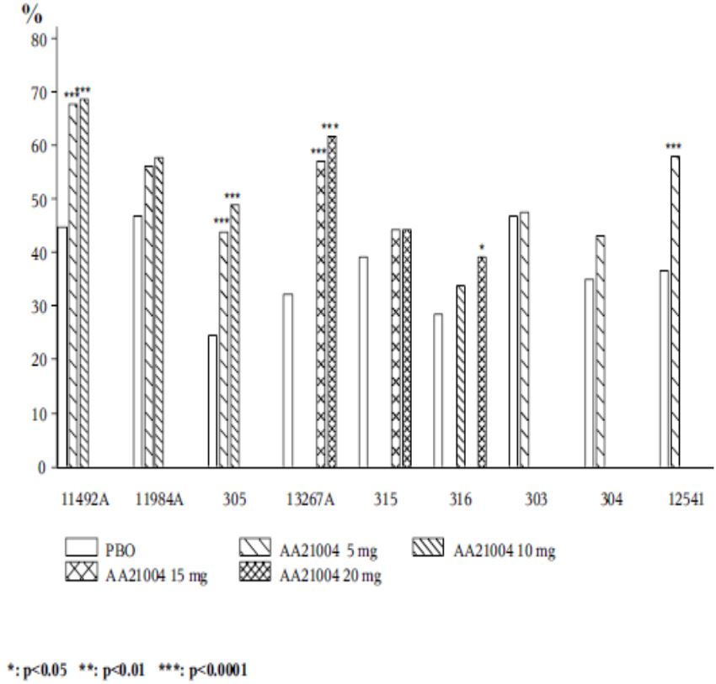
Table 16. Primary efficacy results in adult MDD short-term studies (FAS).
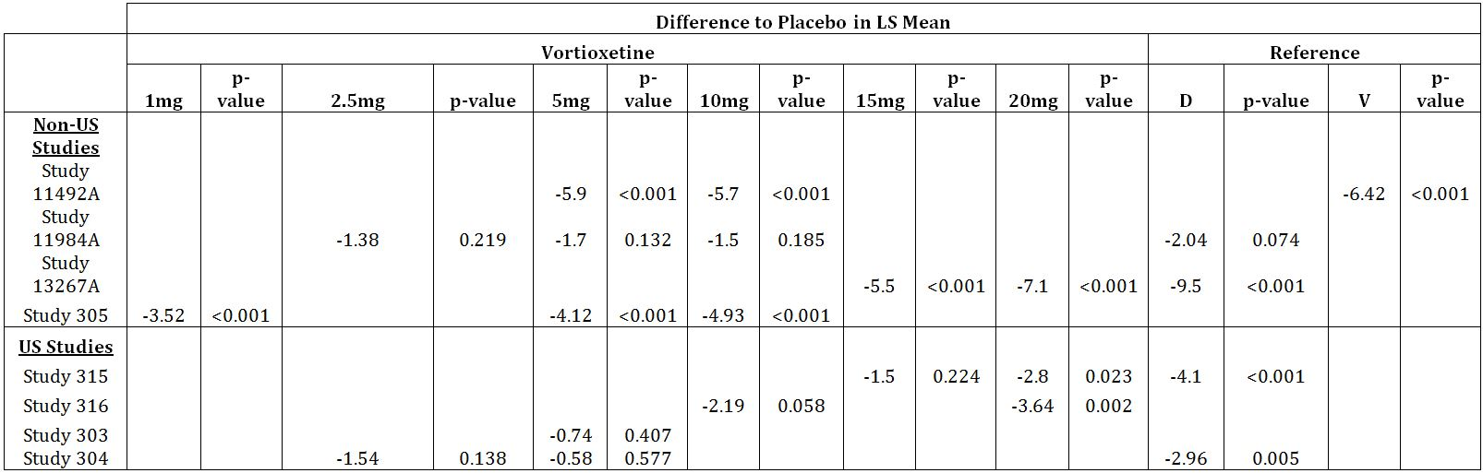
PEV=primary efficacy variable; D=duloxetine; V=venlafaxine
Table 17. Primary efficacy results in adult MDD short-term studies (PPS).
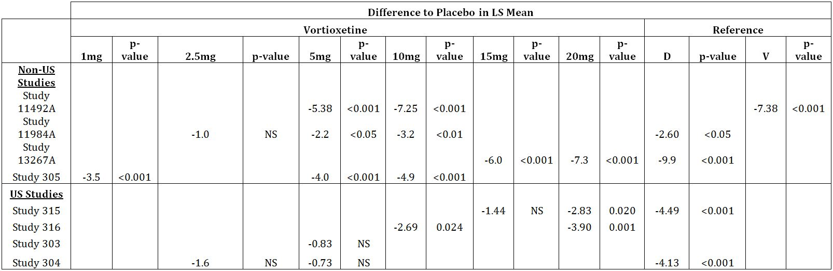
PEV=primary efficacy variable; D=duloxetine; V=venlafaxine; NS=not significant
Furthermore:
- In Studies 11492A and 305, responder rates were similar between 1mg vortioxetine and 10mg vortioxetine (all achieved statistical separation versus placebo);
- No meaningful differences in responder rates between 2.5mg vortioxetine and 10mg vortioxetine were demonstrated in Study 11984A (no treatment [active or reference] achieved statistical separation versus placebo);
- The responder rates for the 2.5mg vortioxetine regimen (in Studies 11984A and 304, 7% and 8.9%, respectively) failed to demonstrate statistical separation versus placebo;
Comment: Figure 3 shows the high placebo response rates across treatment groups and highlights the statistically significant differences. The sponsor provided pooled efficacy results for the 50% response rates of any vortioxetine dose.

Remission rate differences from placebo (MADRS ≤ 10)
The remission rates for the MDD pivotal studies are summarised in Figure 4. Generally, the remission rates versus placebo were consistent with the primary efficacy analyses across treatment groups for each pivotal study:
- Remission rates were generally lower than the corresponding responder rates for all treatments except for 10mg vortioxetine in Study 316 (responder rate 5.4% compared with remission rate 7.2%) and Study 11492A, in which responder rates and remission rates were almost identical;
- In only three (non-US) short-term adult studies did vortioxetine favourably separate from placebo in the LOCF remitter analysis (11492A, 305 & 13267A);
- In two US studies (303 and 304), the LS mean reductions in the placebo treatment groups were greater than those in the 5mg vortioxetine treatments groups (-3.1 in Study 303 and -0.7 in Study 304, respectively)
- No vortioxetine treatment in US studies demonstrated statistical separation versus placebo;
- The active reference group (duloxetine 60mg) in Study 315 failed to demonstrate statistical separation versus placebo (along with duloxetine 60mg in Study 11984A);
- No clear dose-response relationship was clearly demonstrated across the pivotal studies.
Comments: Generally, the key secondary efficacy analyses were consistent with the primary efficacy analyses across treatment groups in each pivotal study. No clear dose-response relationship was evident from the responder and remission rates or other efficacy analyses (besides PPS for Study 11984A).
Differences between US subjects and non-US subjects in all efficacy measures presented in this submission are noted. Besides the 20mg vortioxetine regimen, no other vortioxetine treatment in US subjects demonstrated statistical separation versus placebo. While the active reference used in the two US studies demonstrated validity (by showing statistical separation versus placebo in the primary efficacy analysis), the LS mean reductions for the active reference groups were consistently lower in most efficacy measures compared with non-US study subjects.
Figure 4. Remission (MADRS ≤ 10) at Week 6/8 (FAS LOCF) –MDD short-term studies.
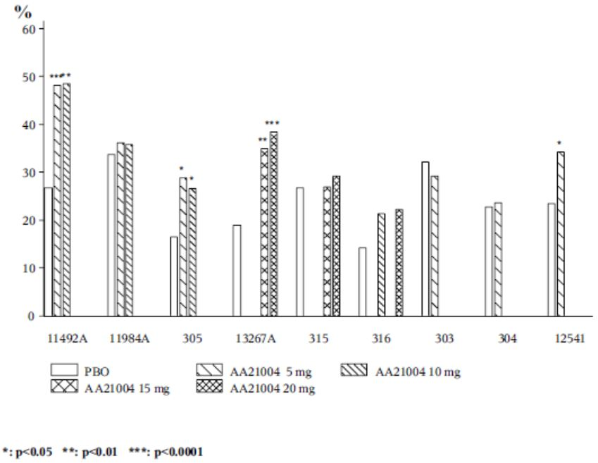

Analyses performed across trials (pooled analyses and meta-analyses)
The sponsor conducted pooled analyses and a meta-analysis of the eight adult pivotal studies in MDD. For comparisons across studies, a meta-analysis rather than a pooled analysis was considered the statistical methodology that would provide the most reliable estimates of treatment effect. Since not all doses of vortioxetine were included in all the studies, the comparison to an overall placebo group in a pooled analysis could be misleading. The meta-analysis is a transparent analysis as it is possible to determine which studies drive the observed effect. The key elements of the meta-analysis comprised:
- All MMRM and ANCOVA LOCF analyses were repeated, to provide consistent input for the meta-analyses. The results of the repeated analyses were the basis for the meta-analyses based on standard methodology, including tests for heterogeneity and estimation under random effects assumptions.
- In the MMRM and ANCOVA LOCF analyses, results at Week 6 from the 6-week studies (Studies 11492A and 303) were treated as Week 8 results. The model used considered the Week 3 assessment of a 6-week study to be Week 6 of an 8-week study, and the Week 5 assessment of a 6-week study to be Week 8 of an 8-week study.
- The MMRM was chosen as the main analysis in the SCE. The sponsor claims MMRM analyses provide less biased estimates and superior control over both type I (false positive) and type II (false negative) errors. However, ANCOVA LOCF analyses were also performed as sensitivity analyses.
- Meta-analyses were performed on the MADRS total and single-item scores, MADRS total score in patients with a baseline MADRS total score ≥ 30, MADRS total score in patients with a baseline HAM-A total score ≥ 20, CGI-I score, HAM-A total score and item five, difficulties in concentration and memory score, SF-36 Mental Component Summary (MCS) and Physical Component Summary (PCS) scores, SF-36 domain scores, and SDS total and single-item scores (The pooled analyses were only performed on the MADRS total score in subgroup analyses, where relevant).
- For the meta-analyses of results across studies, all the short-term MDD studies conducted in adults were included in the analysis, unless data were missing (for example, Studies 11492A and 303. were excluded from analyses of the subgroup of patients with a baseline MADRS total score < 30).
- The dedicated study in the elderly (Study 12541A) was excluded from all the meta-analyses and pooled analyses, as it only included patients aged ≥ 65 years.
Comment: Use of MMRM as the main analysis is acceptable, even though the treatment effects of vortioxetine versus placebo are expected to be marginally greater than use of the ANCOVA LOCF method.
In the second round, meta-analyses were updated for the MADRS scores (total score for the total population and for patients with severe MDD or a high level of anxiety and single-item scores for the total population), CGI-I score, and SDS total and single-item scores for all the short-term, placebo-controlled studies and for the subset of studies conducted outside the US (non-US studies). Pooled analyses (based on MADRS total score) were only performed for the elderly, since this subpopulation had too few patients in the individual studies for a meta-analysis.

Primary efficacy results
The results of the meta-analysis are provided in Figure 5. The primary efficacy result in the individual studies was supported by the meta-analysis (MMRM) of the mean change from baseline in MADRS total score at Week 6/8 in the short-term MDD studies in adults. Six of the short-term vortioxetine studies in adults separated from placebo. This compared with five of the studies using the LOCF analysis in which the 5 and 10mg/day doses did not separate from placebo in Study 11984A and the 20mg/day dose did not separate from placebo in Study 315. In the meta-analysis, the overall mean difference to placebo across the studies was statistically significant: -2.57 points (p=0.008), -4.11 points (p<0.001), and -4.53 points (p<0.001) for the 5, 10 and 20mg/day doses, respectively; the 15mg/day dose did not separate from placebo in the meta-analysis, but the mean difference to placebo was -3.54 points. Overall, a dose-response relationship was not demonstrated.
Figure 5. Change from baseline in MADRS total score at week 6/8 (FAS, MMRM) MDD short-term studies.
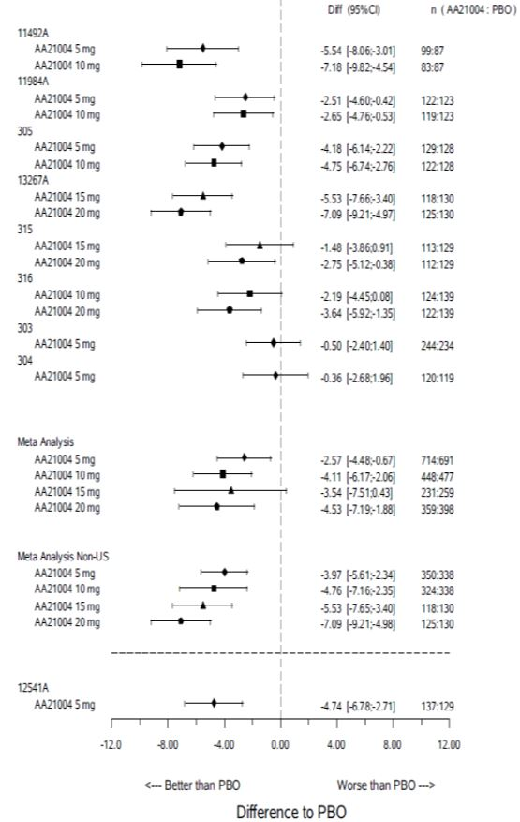
The ANCOVA LOCF analyses gave similar results to the MMRM analyses except the 5 and 10mg/day doses did not separate from placebo in Study 11984A and the 20mg/day dose did not separate from placebo in Study 315.
The addition of Studies CCT-002, 317 & 14122A to the updated efficacy meta-analysis resulted in a general lowering of the treatment difference versus placebo (Figure 6), especially for the 15mg vortioxetine strength (-3.54 in the original meta-analysis versus -2.60 in the updated meta-analysis). The 20mg strength effectively remained unchanged, despite inclusion of the secondary efficacy results for Study 14122A. The treatment differences versus placebo exceeded 2 points for each therapeutic vortioxetine regimen, which may be regarded as clinically significant. In the ANCOVA LOCF analysis, the 10 and 20mg/day doses did not separate from placebo in Study CCT-002 (although still > 2 points versus placebo).
Figure 6. Change from baseline in MADRS total score at week 6/8 (FAS, MMRM) MDD short-term studies – original plus studies 317, 14122A & CCT-002.
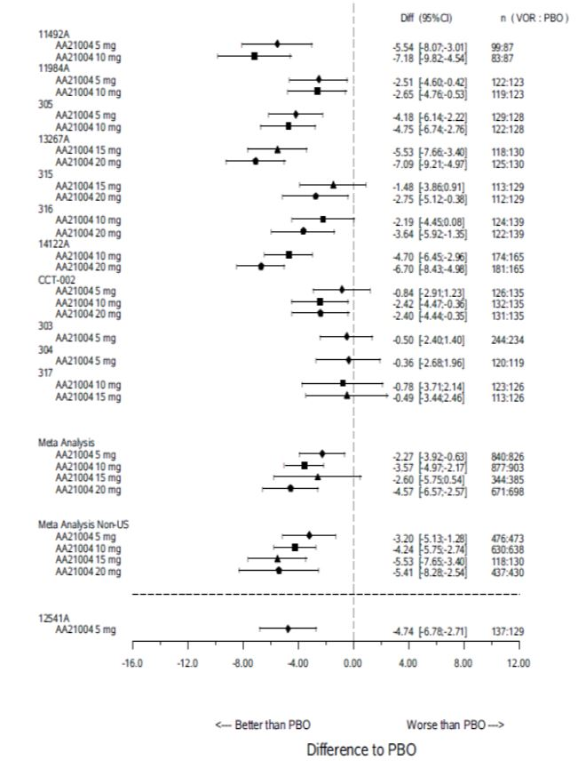
In the non-US updated meta-analysis there was a general lowering of the treatment difference versus placebo for the 5mg and 10mg vortioxetine strengths, no effective difference in the 15mg strength, but a considerable lowering of the treatment difference in the 20mg strength (-7.09 in the original meta-analysis versus -5.41 in the updated meta-analysis). Therefore the dose-response pattern observed in the original meta-analysis for non-US studies was lost in the updated analysis, and this was despite inclusion of the secondary efficacy results for Study 14122A, which gave a favourable finding towards 20mg vortioxetine treatment. The overall treatment differences versus placebo were greater in non-US subjects than those from the US, and each vortioxetine dose exceeded placebo treatment by 2 points, which may be regarded as clinically significant.

Subgroup analyses
Age, sex, race, BMI, baseline MADRS total score, duration of current MDE and number of previous MDEs was analysed for each vortioxetine dose group (5, 10, 15 or 20mg/day) and corresponding placebo group in the individual studies. All individual doses were then evaluated in a meta-analysis for that category, using the same MMRM methodology as for the total population.

Study withdrawals
Overall, the proportion of withdrawals for any reason was similar across the pivotal studies. The proportion ranged between 7 & 21%, 12 & 23%, 21 & 22%, and 17 & 23% in the 5, 10, 15 and 20mg/day groups, respectively, and 9 & 19.5% in the placebo groups. Within studies, and in the pooled analysis, the proportion of withdrawals for any reason was similar between the 5mg/day and placebo groups, and increased slightly for the three higher doses. The proportion of withdrawals due to LoE was generally low in the vortioxetine dose groups across studies. The proportions ranged between 1 & 7%, 2 & 6%, 0 & 8%, and 1 & 2% in the 5, 10, 15 and 20mg/day groups, respectively, and 1 & 10% in the placebo groups. Within studies, the proportion of withdrawals due to LoE varied slightly between treatment groups; when the studies were pooled. The proportion of withdrawals due to LoE was lowest in the 20mg/day group.

Gender
Females demonstrated a statistically significant dose-response relationship versus placebo in the MDD short-term studies (-2.17, p=0.030 for vortioxetine 5mg; -3.79, p<0.001 for vortioxetine 10mg; -4.32, p=0.013 for vortioxetine 15mg; -4.66, p<0.001 for vortioxetine 20mg). This result contrasts with males, who demonstrated statistical separation versus placebo for just the 5mg and 10mg vortioxetine doses (-2.83, p=0.006, for vortioxetine 5mg and -4.47, p<0.001 for vortioxetine 10mg).

US studies versus non-US studies
The meta-analysis of non-US studies was applied to the MADRS total and single-item scores, MADRS total score in patients with a baseline MADRS total score ≥ 30, MADRS total score in patients with a baseline HAM-A total score ≥ 20, CGI-I score, HAM-A total score, SF-36 MCS score, and the SDS total and single-item scores. A dose-response relationship was observed between 5mg to 20mg/day vortioxetine in non-US studies. No comparative data was provided for US studies. The ANCOVA, LOCF analyses based on individual studies also gave results similar to the MMRM analyses, except the 5 and 10mg/day doses did not separate from placebo in Study 11984A. In the LOCF analysis there appears to be a dose-response relationship in non-US subjects between 10mg and 20mg/day, with little difference noted between the 5mg and 10mg regimens.
Comments: While the meta-analysis results in non-US subjects appear to demonstrate a dose-response relationship in the range 5mg to 20mg/day vortioxetine, this trend is not apparent when the overall results are examined (especially lack of statistical separation in the 15mg/day vortioxetine dosage regimen). While the evaluator notes the lack of vortioxetine efficacy demonstrated in US subjects per se, this does not mean the US study results should be disregarded. A demonstration of reasonably consistent clinically significant efficacy is required to support registration.
The sponsor’s claim that lack of efficacy in US patients is explained by non-adherence to study treatment is unsubstantiated. More treatment compliance results are requested. Other factors may have impacted upon the efficacy results. Inclusion of patients with a first episode of depression for instance is likely to have resulted in inclusion of subjects who may not really have had a recurrent depressive disorder, though they met the diagnostic criteria for MDD. The evaluator notes the active comparators in US studies were more likely to separate from placebo than vortioxetine. This suggests it is not patient selection alone but rather the combination of less efficacy of vortioxetine compared with comparators, and US population factors too, have contributed to the statistical differences across the efficacy studies.

Patients with severe MDD
In each MDD short-term adult study in which efficacy was established, vortioxetine 5 to 20mg/day was also effective in patients with severe MDD (baseline MADRS total score ≥30) in the analysis (MMRM) of the mean change from baseline in MADRS total score at Week 6/8 (Figure 7). Approximately one-half to two-thirds of the patients in each of the studies had severe MDD, apart from studies that only recruited patients with severe MDD, i.e. Studies 11492A and 303. The effect sizes were similar to those in the total population.
Figure 7. Change from baseline in MADRS total score at week 6/8 (FAS, MMRM): Baseline MADRS ≥ 30 in MDD short-term studies.
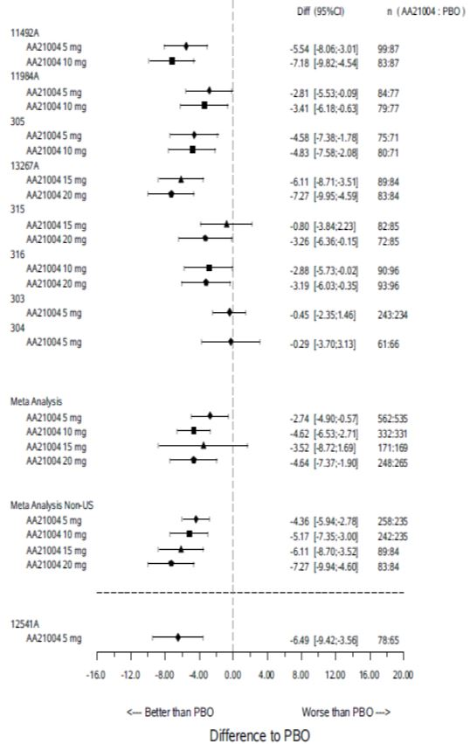
In the meta-analysis, the overall mean difference to placebo across the studies was statistically significant: -2.74 points (p=0.013), -4.62 points (p<0.001), and -4.64 points (p<0.001) for the 5, 10 and 20mg/day doses, respectively. The 15mg/day dose did not separate from placebo in the meta-analysis (-3.52 points, NS; Panel 80). The ANCOVA LOCF analyses gave results similar to those of the MMRM analyses, except the 5 and 10mg/day doses did not separate from placebo in Study 11984A, the 20mg/day dose did not separate from placebo in Study 315, and the 10mg/day dose did not separate from placebo in Study 316.
When the meta-analysis (MMRM) of the mean change from baseline in MADRS total score (≥ 30) at Week 6/8 in patients with severe MDD was repeated for the short-term MDD studies in adults conducted outside the US, the overall mean difference to placebo across the studies was statistically significant and a dose-response relationship demonstrated: -4.36 points (p<0.001), -5.17 points (p<0.001), -6.11 points (p<0.001), and -7.27 points (p<0.001) for the 5, 10, 15 and 20mg/day doses, respectively. The sponsor did not present the US data in this submission.
Comment: The sponsor does not appear to have provided a pooled analysis of mild cases of MDD [MADRS ≥ 22 and ≤ 26] or moderate cases [MADRS ≥ 26 and ≤ 30] for comparison. Table 133 in the SCE presented the baseline MADRS total score <30 i.e. mild and moderate MDD cases combined. Studies 305 & 13267A were positive, Studies 11984A & 304 were negative and Studies 315 & 316 had one dosage regimen that demonstrated statistical separation versus placebo (15mg and 20mg, respectively). In the meta-analysis all treatments exceeded 2 points versus placebo with a trend towards dose-response (-2.2, -2.5, -4.5 & -4.5 for 5mg, 10mg, 15mg & 20mg vortioxetine, respectively). The 10mg regimen had borderline statistical significance (p=0.070) whereas the other regimens separated versus placebo.
The updated meta-analysis of all the short-term, placebo-controlled studies in adults is summarised in Figure 8. Overall, the effect size on the MADRS total score across the studies were statistically significant and > 2 points versus placebo: -2.4 points (p = 0.011), -3.8 points (p <0.001), -3.0 points (p = 0.089), and -4.4 points (p <0.001) at Week 6/8 for the 5, 10, 15 and 20mg/day doses, respectively.
Figure 8. Change from baseline in MADRS total score at week 6/8 (FAS, MMRM): Baseline MADRS ≥ 30 in MDD short-term studies - original plus studies 317, 14122A & CCT-002.
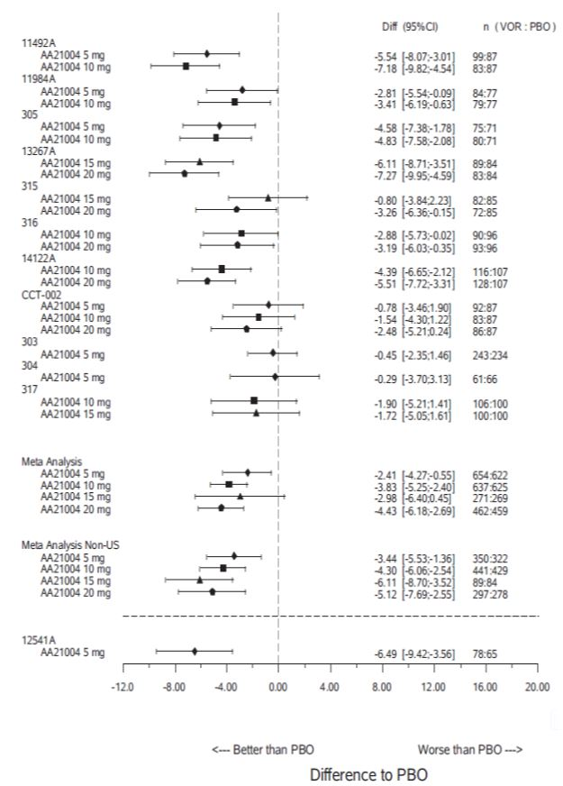
No vortioxetine dosage regimen in either Study CCT-002 or Study 317 achieved statistical separation versus placebo in subjects with severe MDD.
The addition of Studies CCT-002, 317 & 14122A to the updated meta-analysis resulted in a general lowering of the treatment difference versus placebo, especially for the 10mg & 15mg vortioxetine strengths (-4.62 in the original meta-analysis versus -3.83 in the updated meta-analysis and -3.52 versus -2.98, respectively). The treatment differences versus placebo exceeded 2 points for each therapeutic vortioxetine regimen, which may be regarded as clinically significant. The ANCOVA LOCF analysis results for the additional studies were consistent with the MMRM analysis results.
In the non-US updated meta-analysis there was a general lowering of the treatment difference versus placebo for the 5mg and 10mg vortioxetine strengths, no effective difference in the 15mg strength, but a considerable lowering of the treatment difference in the 20mg strength (-7.27 in the original meta-analysis versus -5.12 in the updated meta-analysis). Therefore the dose-response pattern observed in the original meta-analysis for non-US studies was lost in the updated analysis. The overall treatment differences versus placebo were greater in non-US subjects than those from the US, and each vortioxetine dose exceeded placebo treatment by 2 points, may be regarded as clinically significant.

Patients with a high level of anxiety
Four of the six short-term studies in adults demonstrated statistical separation versus placebo (using MMRM analysis compared with three of five studies using LOCF analysis in subjects with a high level of anxiety [baseline HAM-A total score ≥ 20] in the analysis [MMRM] of the mean change from baseline in MADRS total score at Week 6/8). The effect sizes were similar to those in the total population.
In the meta-analysis, the overall mean difference to placebo across the studies was statistically significant: -3.2 points (p<0.001), -4.2 points (p<0.001), and -5.1 points (p=0.005) for the 5, 10 and 20mg/day doses, respectively; the 15mg/day dose did not separate from placebo in the meta-analysis. The ANCOVA LOCF results were similar to those using MMRM except the 10mg/day dose did not separate from placebo in Study 316. A dose-response relationship was not clearly established in the overall meta-analysis (MMRM or LOCF).
When the meta-analysis (MMRM) of the mean change from baseline in MADRS total score at Week 6/8 in patients with a high level of anxiety was repeated for the short-term MDD studies in adults conducted outside the US, the overall mean difference to placebo across the studies was statistically significant with an apparent dose-response relationship (especially between 10mg and 20mg/day): -4.1 points (p=0.002), -4.2 points (p=0.001), -5.2 points (p<0.001), and -6.4 points (p<0.001) for the 5, 10, 15 and 20mg/day doses, respectively.
Comment: Like subjects with severe depressive symptoms, those with higher levels of anxiety appeared to derive more benefit from vortioxetine treatment than those subjects with lower levels of anxiety, even though an overall dose-response relationship was not clearly demonstrated.
No vortioxetine dosage regimen in either Study CCT-002 or Study 317 achieved statistical separation versus placebo in subject in MDD with high anxiety (HAM-A ≥ 20) in the MMRM or LOCF analysis. The addition of Studies CCT-002, 317 & 14122A to the updated meta-analysis resulted in a general lowering of the treatment difference versus placebo. The overall effect size on the MADRS total score were: -2.7 points (p = 0.005), -3.9 points (p <0.001), -1.1 points (p = 0.650), and -5.0 points (p <0.001) at Week 6/8 for the 5, 10, 15, and 20mg/day doses, respectively. This pattern is consistent with the original meta-analysis results. Note: the treatment difference versus placebo was only 1.11 i.e. < 2 points, which is a clinically significant negative result. In the non-US updated meta-analysis there was a general lowering of the treatment difference versus placebo for all vortioxetine strengths. The overall effect size on the MADRS total score demonstrated dose-response, treatment effects > 2 points versus placebo and each comparison was statistically significant versus placebo. This pattern is consistent with the original meta-analysis results. The overall effect size on the MADRS total score were: -3.1 points (p = 0.025), -3.8 points (p <0.001), -5.2 points (p <0.001), and -4.3 points (p = 0.051) for the 5, 10, 15 and 20mg/day doses, respectively.

Secondary efficacy analyses

MADRS single item scores
In the updated meta-analysis (MMRM and LOCF), vortioxetine in the range 5 to 20mg/day (inclusive) was statistically significantly (p < 0.05) superior to placebo at Week 6/8 in reducing the scores on all 10 items of the MADRS and, for all 10 items. Except for the 15mg vortioxetine regimen, the effects generally increased with increasing dose (especially for item 6 ‘concentration difficulties’ and item 10 ‘suicidal thoughts’ (Figure 9). As for the MADRS total score, the results and the increased effect with increasing dose were more pronounced in non-US studies. These results support the primary efficacy results and demonstrated some benefit with vortioxetine treatment (all therapeutic doses) across the spectrum of depressive symptoms.
Figure 9. Meta-analysis of change from baseline in MADRS single items at week 6/8 (FAS, MRM) MDD short-term studies - original adding Studies 317, 14122A and CCT-002.
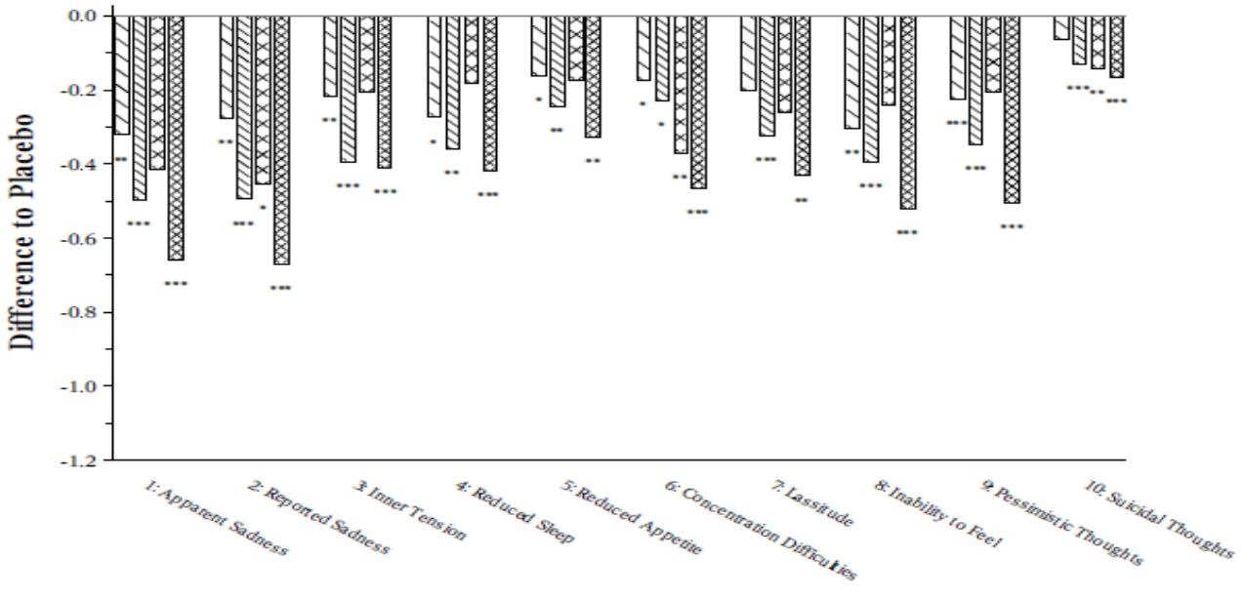

CGI-I Score
Four of the eight short-term studies in adults (11492A, 11984A, 305 & 13267A) vortioxetine separated from placebo (p < 0.05) in the MMRM analysis of the mean CGI-I score at Week 6/8. In a fifth study (316), vortioxetine separated from placebo for the 20mg/day regimen (but not the 10mg/day regimen). The overall meta-analysis results were consistent with the primary efficacy analysis results (especially failure for the 15mg/day vortioxetine regimen to separate from placebo at a statistically significant level and lack of efficacy in US studies). In the ANCOVA, LOCF analysis, only three short-term studies (11492A, 305 & 13267A) separated from placebo and the 20mg vortioxetine regimen in Study 316 failed to separate from placebo.
The reduction in CGI-I score ranged from -0.30 for the vortioxetine 5mg/day dose to -0.48 for the vortioxetine 20mg/day dose. These reductions are modest and therefore their clinical significance remains unclear.
No vortioxetine dosage regimen in Study 317 achieved statistical separation versus placebo in subject in MDD with CGI-S score in the MMRM or LOCF analysis. In Study CCT-002, the 5mg vortioxetine dose did not separate from placebo. The addition of Studies CCT-002, 317 & 14122A to the updated meta-analysis did not significantly alter the pattern of effects observed in the original meta-analysis of CGI-S scores. The overall updated meta-analysis results were consistent with the primary efficacy analysis results (especially failure for the 15mg/day vortioxetine regimen to separate from placebo at a statistically significant level and lack of efficacy in US studies), and the results were consistent with the original meta-analysis results. The non-US study results demonstrated a trend towards dose-response, as previously.

Responder analysis
In the responder analysis, vortioxetine separated from placebo (p <0.05) at Week 6/8 in 6 of the 11 short-term, placebo-controlled studies in adults. In 4 of these (all non-US studies), the difference was > 16 percentage points, which is regarded as sufficient to establish the clinical relevance of investigational treatments in studies submitted for licensing approval. Only 4 of 11 short-term MDD studies achieved a treatment difference versus placebo of > 16% in terms of ≥ 50% responder rate. No US-based short-term MDD study achieved the target treatment difference, which suggests there may be a generalisability problem.

Remitter analysis
Vortioxetine also separated from placebo (p < 0.05) at Week 6/8 in the remitter analysis in 4 of the 11 short-term, placebo-controlled studies in adults (all non-US studies). No US-based short-term MDD study achieved the target treatment difference for remitters, which suggests there may be a generalisability problem.

Health-related quality of life and overall functioning
The following patient-reported HRQoL and assessment tools were included in the evaluation of vortioxetine: SF-36 evaluated the effect on the patients’ HRQoL in four of eight short-term studies in adults; Q-LES-Q (SF) and EQ-5D were used in two separate short-term studies in adults, respectively; and the HSQ-12 was used in the dedicated study in elderly. In addition, SDS was included in seven of eight the short-term studies in adults to assess patients’ overall functioning.

SF-36 MCS score
Two the four short-term studies (11492A & 305) in adults separated from placebo (p<0.05) in the analysis (MMRM) of the mean change from baseline in MCS score at Week 6/8 and the 10mg regimen in Study 11984A (but not on the ANCOVA, LOCF analysis). The meta-analysis results were favourable for both vortioxetine 5mg & 10mg regimens.

SF-36 PCS score
In the analyses (MMRM and LOCF) of the mean change from baseline in PCS score at Week 6/8, vortioxetine did not separate from placebo in the individual studies or in the meta-analysis of the four short-term studies in adults.

SF-36 domain scores
In the meta-analysis (MMRM) of the mean changes from baseline in SF-36 domain scores at Week 6/8, vortioxetine 5mg/day was statistically significantly (p<0.05) superior than placebo in increasing the role-physical, vitality, social functioning, role-emotional, and mental health scores and vortioxetine 10mg/day was statistically significantly (p<0.05) superior than placebo in increasing each domain score, except for the physical functioning score.
Comment: SF-36 scores were not reported for vortioxetine 15mg & 20mg and, furthermore only one US study (303) was included and this failed to demonstrate statistical separation versus placebo in MCS score.

SDS total score
All vortioxetine doses separated from placebo (p<0.05) in the MMRM analysis in just one of seven short-term studies of the mean change from baseline in SDS total score at Week 6/8 in adults (Study 13267A). The vortioxetine 10mg/day dose in Study 11984A and the vortioxetine 20mg/day dose in Study 316 also separated from placebo treatment. Of note, the vortioxetine 5mg/day dose did not separate from placebo in any of the four studies where the dose was included and the 10mg/day dose only separated from placebo in one of three studies. The 20mg/day dose did separate from placebo in both studies. The vortioxetine 10mg & 20mg doses demonstrated statistical separation versus placebo in the meta-analysis, but the 5mg and 15mg doses did not separate from placebo.
No vortioxetine dosage regimen in Study 317 achieved statistical separation versus placebo in subjects in MDD with SDS total score in the MMRM analysis. In Study CCT-002, only the 10mg vortioxetine dose separated from placebo. The addition of Studies CCT-002, 317 & 14122A to the updated meta-analysis did not significantly alter the pattern of effects observed in the original meta-analysis of SDS total score scores. The overall updated meta-analysis results were consistent with the primary efficacy analysis results (especially failure for the 15mg/day vortioxetine regimen to separate from placebo at a statistically significant level and lack of efficacy in US studies), and the results were consistent with the original meta-analysis results. The vortioxetine 10mg and 20mg doses demonstrated statistical separation versus placebo in the meta-analysis, but the 5mg and 15mg doses did not separate from placebo.

SDS single-item scores
In the meta-analysis (MMRM) of the mean changes from baseline in SDS single-item scores at Week 6/8, vortioxetine 10mg/day was statistically significantly (p<0.05) superior than placebo in reducing the work, social life, and family life scores; vortioxetine 20mg/day was statistically significantly (p<0.05) superior than placebo in reducing the work and social life scores; the 5 and 15mg/day doses were not statistically significantly different from placebo on any of the single items.
Comment: While the secondary efficacy results (including quality of life indices) were consistent with the primary efficacy results, no clear dose-response relationships were demonstrated and, as such, the role of vortioxetine in MDD treatment remains unclear.
The results of the updated meta-analyses (MMRM) of the mean changes from baseline in SDS single-item scores at Week 6/8 were consistent with the original meta-analysis results. No clear dose-response relationships were observed.

Other efficacy endpoint: cognitive dysfunction
In Study 14122A, the primary objective was to evaluate the efficacy of vortioxetine in cognitive dysfunction in adults (aged 18 to 65 years) with MDD, to corroborate the efficacy in cognitive performance previously seen in the dedicated study in the elderly (Study 12541A). Cognitive function was assessed in cognitive domains known to be impaired in MDD using neuropsychological tests of executive function, processing speed, attention, and learning and memory (DSST, RAVLT, TMT A & TMT B, STROOP, SRT, and CRT) as well as using a patient-reported cognitive function outcome (Perceived Deficits Questionnaire [PDQ]). In Study 317, a patient-reported outcome that included cognitive function (Cognitive and Physical Functioning Questionnaire [CPFQ]) was used.
Rationale (from Clinical Overview Addendum): The cognitive enhancing properties of vortioxetine are supported by substantial nonclinical evidence and involve modulation of multiple neurotransmitter systems, including the monoaminergic, GABAergic, and glutamatergic systems. Nonclinical studies in models predictive of enhanced effect on cognitive function, including attention, learning and memory, and executive function, indicate that vortioxetine has a distinct profile and a potential to enhance cognitive function at doses equivalent to clinically relevant exposure (assessed by 5-HTT occupancy).
In the dedicated study in the elderly (Study 12541A), vortioxetine 5mg/day and the active reference duloxetine separated from placebo (p<0.05) in the RAVLT, while only vortioxetine separated from placebo (p<0.05) in the DSST. These data confirmed published findings with duloxetine and indicate vortioxetine has a positive effect on a broader range of cognitive domains.
In Study 14122A, the primary endpoint was a composite score of the DSST (executive function, speed of processing, and attention) and the RAVLT (learning and memory). Vortioxetine and 20mg/day were statistically significantly superior to placebo in the composite z-score (p<0.001). The patients who received vortioxetine improved consistently statistically significantly more than those who received placebo (p<0.05) on all the assessed measures of cognitive function (DSST, RAVLT, TMTA, TMT B, STROOP, SRT, and CRT). The clinical relevance of the significant effect of vortioxetine on the neuropsychological tests was supported by the magnitude of the standardised effect sizes (which ranged from 0.23 to 0.52 [Cohen’s d]).
The improvement in cognitive function includes an independent effect not captured by the MADRS. A pre-specified path analysis showed 50 to 90% of the effect of vortioxetine was a direct effect on cognitive performance rather than an indirect effect mediated through an effect on depressive symptoms. A significant and relevant effect on cognitive performance was shown after correcting for the alleviation of depressive symptoms. Furthermore, vortioxetine improved cognitive performance in patients who were non-responders or non-remitters (defined using criteria based on the MADRS), supporting an independent effect on cognitive dysfunction.
In Study 14122A, the pre-specified patient-reported outcome, the PDQ, was included to assess cognitive function from the patient’s perspective. Vortioxetine 10 and 20mg/day showed a consistently statistically significantly greater improvement relative to placebo (p < 0.05) in the PDQ total score and across all four subscale scores (attention/concentration, retrospective memory, prospective memory, and planning/organisation). These findings strengthen the results on the CPFQ, another patient-report outcome used to assess cognitive function. In Study 316, vortioxetine 10 and 20mg/day significantly improved patient-perceived cognitive function (the cognitive dimension of the CPFQ) compared to placebo (p < 0.05; post hoc analysis) in patients with clinically relevant self-reported cognitive symptoms at baseline (81% of the total population). In Study 317 (which was a failed/negative study), the vortioxetine groups did not separate from placebo on the CPFQ or in the primary or any of the other secondary efficacy analyses.
The positive effects of vortioxetine on cognitive dysfunction are further strengthened by the results of the cognition-related single item of the MADRS (item 6, concentration difficulties) as assessed by the clinician. The updated meta-analysis of MADRS item 6 supported the results of the individual short-term, placebo-controlled studies in adults, with a statistically significant (p < 0.05) difference to placebo at Week 6/8, in favour of vortioxetine, for all doses (5, 10, 15 and 20mg/day).
Overall, the results of Study 14122A strengthen the evidence that vortioxetine significantly improves cognitive dysfunction in patients with MDD as assessed using a range of objective neuropsychological tests and subjective patient-reported as well as clinician-rated outcomes. Furthermore, the results of Study 14122A support a significant and independent effect of vortioxetine on cognitive dysfunction associated with MDD not captured by the MADRS. The clinical relevance of the results is supported by the constructs of the neuropsychological tests that involve key cognitive domains relevant for MDD (executive function, processing speed, attention, and learning and memory), by the magnitude of the effect sizes, and by capturing the patient’s perception of his/her cognitive function.

Other efficacy study (acute treatment)

Elderly: study 12541A
In line with the TGA-adopted guidelines on clinical investigation of medicinal products in the treatment of depression, a separate evaluation in the elderly was warranted, since it is not clear a benefit to younger adults enrolled in clinical studies can be extrapolated directly to the elderly.
The study design was an 8-week multicentre, multinational, randomised, DB, parallel-group, placebo-controlled, duloxetine-referenced, fixed-dose study of vortioxetine in the acute treatment of major depressive disorder in elderly subjects. The study consisted of a screening period followed by 1:1:1 randomisation (according to a computer generated randomisation list by H. Lundbeck A/S) into an 8-week DB core treatment period (vortioxetine 5mg/day, duloxetine 60mg/day or placebo), followed by a 1-week DB taper period [randomised vortioxetine and placebo treatment groups received placebo while duloxetine received 30mg/day]. A safety follow-up period was undertaken during the 4-week period after study completion or withdrawal (Weeks 8-12, inclusive; Figure 10).
Figure 10. Study design (12541A).
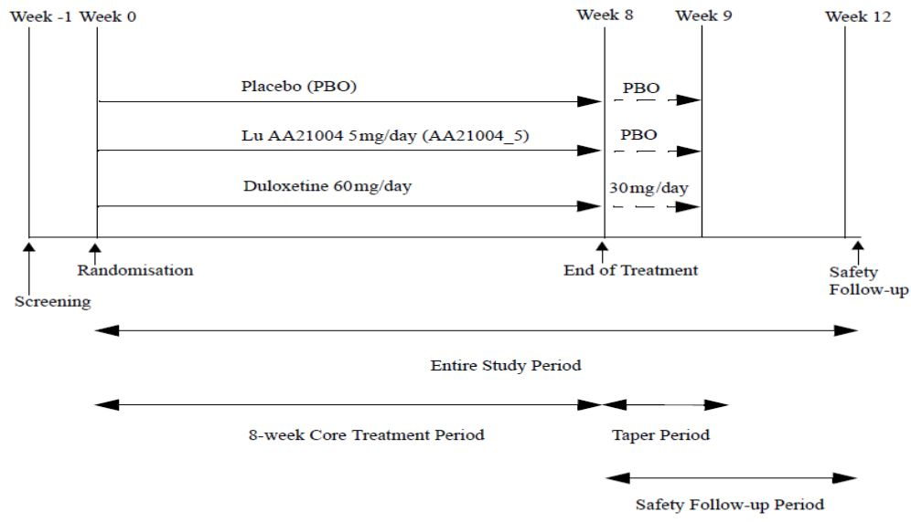
The primary study objective was to assess the efficacy of vortioxetine 5mg/day versus placebo in the acute treatment of depression by means of the change from baseline in the 24-item HAM-D24 total score after 8 weeks of DB treatment in elderly subjects.
The inclusion and exclusion criteria were similar to those employed for the pivotal efficacy studies. In brief, subjects were eligible to enter the study if they had a primary diagnosis of recurrent MDD according to DSM-IV-TR criteria and had:
- MADRS total score ≥ 26 at screening and at baseline;
- were women or men aged ≥ 65 years;
- had at least one previous MDE before the age of 60 years;
- had the current MDE for ≥ 4 weeks;
- Mini-Mental State Examination (MMSE) score ≥ 24 (to exclude dementia).
The primary efficacy variable was HAM-D24 total score. The key secondary variables were similar to those employed for the pivotal efficacy studies and included HAM-D24 single item scores, HAM-D17 total score, MADRS total score and single item scores, HAM-A and single item scores, CGI-S & CGI-I scores, Geriatric Depression Scale (GDS) total score and single item scores, RAVLT scores, DSST scores, proportion of responders [a ≥ 50% decrease from baseline in HAM-D24, MADRS, or HAM-D17 total score or a CGI-I score ≤ 2] and proportion of remitters (defined as a MADRS total score ≤ 10, a HAM-D17 total score ≤ 7 or a CGI-S score ≤ 2). RAVLT & DSST investigated cognitive dysfunction.
Baseline demographic and disease characteristics were generally similar across treatment groups. Approximately two-thirds of subjects in each group were women, with a mean (± SD) age of 71 ± 5 years and most were Caucasian (93% to 96%). At baseline, the mean MADRS total score (approximately 30) indicated subjects had moderate to severe MDD, the mean HAM-A total score (approximately 20) indicated subjects had substantial levels of anxiety symptoms and the mean CGI-S score (approximately 4.7) indicated subjects were moderately to markedly ill.
Block randomisation (in blocks of 6) ensured equal numbers of patients entered each treatment group. At each centre, the 4-digit randomisation number was assigned consecutively, starting with the lowest number available.
Sample size: Approximately 450 patients were planned for enrolment in the study. With 150 patients per treatment group and a SD of 8.0, the power to detect a true treatment effect of 2.64 in the change from baseline to Week 8 on the HAM-D24 would be at least 80%, using a 5% level of significance and a standard ANCOVA (t-distributed contrast). The treatment effect of 2.64 corresponded to a standardised effect size of 0.33.
Statistical methods: The primary efficacy analysis was an analysis of covariance (ANCOVA) of the change from baseline in HAM-D24 total score at Week 8 (FAS, LOCF), and, if applicable, at Weeks 6, 4, 2 and 1, with treatment and centre as factors and the baseline HAM-D24 total score as a covariate. A statistical testing strategy was defined a priori in the SAP. As soon as an endpoint was non-significant at the 0.05 level of significance, the testing procedure was stopped for all subsequent endpoints. The study was not designed or powered to show a treatment difference between vortioxetine and duloxetine.
Patient disposition revealed 86.7% (of 452 randomised) subjects completed DB treatment and the overall proportions of study withdrawal were similar among treatments. The greatest proportion of withdrawals was due to AEs (duloxetine 9.9%, vortioxetine 6.4% and placebo 4.1%). The majority of withdrawals from LoE occurred in the placebo group (4.8%) then vortioxetine (1.3%) and 0% in the duloxetine group. There were eight major protocol violations in total, evenly distributed across treatments.
Mean treatment compliance with IMP was reported as 99% in each treatment group (median: 100%).
In the primary efficacy analysis, vortioxetine 5mg/day was statistically significantly superior to placebo in reducing the HAM-D24 total score at Week 8 (p=0.001), with a mean difference to placebo of -3.32 points (compared with -5.48, p<0.001 for duloxetine 60mg). Vortioxetine 5mg/day demonstrated statistical separation versus placebo at Week 6 (HAM-D24 reduction -2.1 points, p=0.024) compared with duloxetine at Week 4.
The results from the sensitivity analyses (MMRM; OC and PPS) were consistent with the results from the primary efficacy analysis, which support the internal validity of the study. Furthermore, while the MMRM results were numerically higher than the corresponding LOCF results, unlike the adult MDD short-term studies, the differences were much smaller, again supporting the internal validity of the study.
Subgroup analysis: The treatment difference (change from baseline in MADRS total scores at Week 8) to placebo for vortioxetine was similar in women than in men (-4.48, p=0.015 for men and -4.77, p<0.001 for women), unlike the MDD short-term results in adults, and approximately two-fold greater in magnitude than the 5mg vortioxetine dosage regimen in adults.
The treatment difference to placebo for vortioxetine was higher in more depressed patients (baseline MADRS total score > 31 or baseline HAM-D24 total score > 26) than in the less depressed patients (baseline MADRS total score ≤ 31 or baseline HAM-D24 total score ≤ 26): Vortioxetine 5mg/day was also effective (p <0.001 versus placebo) in those with severe MDD, with an effect size on the MADRS total score of -6.49 points at Week 8.
The treatment difference to placebo for vortioxetine in the more anxious patients (baseline HAM-A total score ≥ 20) was more than those in less anxious patients (baseline HAM-A total score < 20): Vortioxetine 5mg/day was also effective (p < 0.05 versus placebo) in those with MDD and a high level of anxiety, with an effect size on the MADRS total score of -5.64 points at Week 8.
There was no statistically significant interaction between treatment and region (US versus outside US). Pre-defined subgroup analyses by region showed a lower effect (mean change from baseline in HAM-D24 total score) of vortioxetine and duloxetine in the US than outside the US (-0.89 [NS] and -2.76 [NS] in the US, respectively & -4.80 [p<0.001] and -6.70 [p<0.001] outside the US, respectively). In the placebo group, the mean change from baseline in HAM-D24 total score was similar in the two regions (-10.5 reduction from baseline score). The antidepressant-placebo differences in the mean changes from baseline in the MADRS and HAM-D24 (primary variable) total scores were approximately two points higher for non-US than US sites, both for vortioxetine and duloxetine in the MMRM and ANCOVA, LOCF analyses. For HAM-D24 at Week 8, there was a statistically significant interaction between treatment and country (p=0.0337). However, the number of patients varied between countries, as did the effects of vortioxetine and duloxetine, with no specific pattern.
Secondary efficacy analysis: The results of the key secondary efficacy analyses were consistent with the findings of the primary efficacy analyses and demonstrated statistically significant reductions for vortioxetine compared with placebo. Duloxetine also separated from placebo (p<0.05) in each of these analyses.
Proportion of Responders and Remitters at Week 8: Vortioxetine 5mg/day demonstrated proportionately higher rates (nominal statistical significance) compared with placebo for response and for remission (21.5% and 10.8% percentage points difference to placebo, respectively). The active control group (duloxetine 60mg) also demonstrated higher rates (nominal statistical significance) compared with placebo for response and for remission (28% and 26%, respectively). No breakdown by US or non-US status was provided in this submission.
In the dedicated study in the elderly, the clinical relevance of the effect on the MADRS was shown by the >16 percentage-point higher (p <0.05) proportion of responders, the higher (p <0.05) proportion of remitters, and the greater (p <0.05) improvement in the CGI-I score at Week 8 in the vortioxetine group than in the placebo group.
The mean CGI-I score (MMRM analysis) at Week 6/8 demonstrated statistical separation of vortioxetine 5mg/day treatment versus placebo treatment (-0.62, pp<0.05). This was approximately twice the reduction compared with the 5mg/day vortioxetine meta-analysis results in adults (-0.30).
In the MMRM analyses of the mean change from baseline in HSQ-12 domain scores at Week 8, vortioxetine 5mg/day separated from placebo (at least nominal p<0.05) on the domains health perception, mental health, and energy at Week 8, but not on physical functioning, role-physical, role-mental, social functioning and bodily pain.

Pooled analysis for elderly (acute phase)
At US sites (approximately one-third of the study population), vortioxetine 5mg/day separated from placebo (p<0.05) in the MMRM analysis, but not in the ANCOVA LOCF analysis. At non-US sites, vortioxetine 5mg/day separated from placebo (p<0.001) in the MMRM analysis of the change from baseline in MADRS total score at Week 8. Similar results were obtained using ANCOVA LOCF. The vortioxetine-placebo difference was approximately two points higher at the non-US sites than at the US sites, both in the MMRM and ANCOVA LOCF analyses. All separations from placebo favoured vortioxetine treatment.
In the second round, pooled analysis was performed in the subgroup of patients aged ≥ 65 years from the dedicated study in the elderly, 12541A, and from subjects in Studies 14122A and 317 (Study CCT-002 only included patients aged < 65 years). The effect size on the MADRS total score (MMRM) was: -3.3, -2.6, -0.11, and -4.2 points at Week 6/8 for vortioxetine 5, 10, 15, and 20mg/day, respectively. In contrast, in the dedicated elderly study (12541A), the 5mg/day vortioxetine regimen provided a clinically relevant effect size of -4.7 points at week 8 versus placebo. The 15mg vortioxetine regimen was not observed to be efficacious in the elderly. However, the numbers of elderly subjects taking 10 to 20mg/day vortioxetine are probably too small to draw meaningful conclusions.
In patients with high anxiety, vortioxetine 5mg/day separated from placebo (p<0.001) in the MMRM analysis of the change from baseline in MADRS total score at Week 8, with a mean change from baseline of -15.9 points and a mean difference to placebo of -5.6 points. Similar results were obtained using ANCOVA LOCF. All separations from placebo favoured vortioxetine treatment.
In patients with severe MDD, vortioxetine 5mg/day separated from placebo (p<0.001) in the MMRM analysis of the change from baseline in MADRS total score at Week 8, with a mean change from baseline of -17.6 points and a mean difference to placebo of -6.5 points. Similar results were obtained using ANCOVA LOCF.

Neuropsychological tests
In the ANCOVA LOCF analysis of the mean change from baseline in DSST (the task reliant on speed of processing, executive function and attention) at Week 8, vortioxetine 5mg/day separated from placebo (p<0.05) on correct number of symbols. In the ANCOVA LOCF analysis of the mean change from baseline in RAVLT (the task reliant on learning and memory) at Week 8, vortioxetine 5mg/day separated from placebo (p<0.05) on acquisition and delayed recall. All separations from placebo favoured vortioxetine treatment.
A path analysis assessed to what extent the effect on DSST and RAVLT was a direct treatment effect, rather than an indirect effect through improvement of depressive symptoms, as measured using the primary assessment tool (HAM-D24). The results showed vortioxetine 5mg/day had an 83% direct effect on DSST correct numbers (duloxetine 26%), a 71% direct effect on RAVLT acquisition (duloxetine 65%), and a 72% direct effect on RAVLT delayed recall (duloxetine 66%). Furthermore, positive effects on cognitive function of vortioxetine treatment compared with placebo treatment were observed in MADRS item 6 concentration difficulties and HAM-A item 5 difficulties in concentration and memory.
Comments: The magnitude of the reduction in MADRS score in this elderly population was much greater than the corresponding 5mg vortioxetine dose in the pooled MDD adult short-term study results (-4.74 versus -2.57, respectively; Panel 76 in the SCE). The secondary efficacy and sensitivity analyses support the primary efficacy results to a greater extent than the MDD adult studies. The demonstrated effect of the active control (duloxetine) supports internal validity of the study.
The magnitude of the responder rates (> 50%) versus placebo demonstrated in this study for vortioxetine 5mg/day (21.5%, NNT 5) appears greater than the corresponding 5mg regimen in (younger) adults (0.7% in Study 303 8.2% in Study 304, 9.2% in Study 11984A, 19.4% in Study 305 22.8% in Study 11492A). While duloxetine 60mg/day consistently demonstrated greater responder and remission rates than vortioxetine 5mg/day in Study 12541, the study was not designed or powered to compare these two agents.

Comparator in adults with MDD: study 14178A
Study 14178A was conducted in patients with MDE within MDD with inadequate response to SSRI/SNRI treatment. The study population comprised patients with depressive symptoms considered not or partially responsive to no more than one adequate course of SSRI/SNRI monotherapy. The remaining inclusion and exclusion criteria were essentially the same as those in the short-term, placebo-controlled studies in MDD (including MADRS total score ≥ 22 and patients could not have past or current treatment-resistant depression). The rationale for choosing agomelatine was its different mechanism of action from SSRIs/SNRIs, i.e. it is a noradrenaline dopamine disinhibitor. As with the short-term placebo-controlled MDD studies, the primary efficacy endpoint was the MADRS total score at Week 8. Secondary efficacy endpoints included: proportions of responders and remitters, CGI-I score, severe MDD, high level of anxiety, SDS, HRQoL and EQ-5D.
Non-inferiority of vortioxetine to agomelatine was established from an MMRM analysis, since the upper bound of the 95% CI for the vortioxetine and agomelatine comparison was -0.81 points on the MADRS i.e. below the non-inferiority margin of +2 points versus agomelatine on the MADRS. As the two-sided 95% CI for the difference between the means excluded zero and was in favour of vortioxetine, vortioxetine was also superior to agomelatine.
When the primary efficacy analysis (Week 8) was repeated for patients with severe MDD (baseline MADRS total score ≥ 30) or patients with MDD and a high level of anxiety (baseline HAM-A total score ≥ 20), the mean difference in the change from baseline in MADRS total score at Week 8 was -2.0 points (n = 101 [vortioxetine] and n = 71 [agomelatine]; p = 0.125) and -2.4 points (n = 138 [vortioxetine] and n = 116 [agomelatine]; p <0.001), respectively.
Vortioxetine was consistently statistically significantly superior to agomelatine at Weeks 8 & 12 based on analyses of the secondary efficacy endpoints used to establish clinical relevance (i.e. MADRS single items, the proportions of responders and remitters, the CGI-I, the effect in patients with a high level of anxiety [a subgroup analysis of the primary efficacy endpoint {at Week 8}], and the effect on HRQoL [EQ-5D] and overall functioning [SDS and single item scores]).
In the subgroup of patients aged ≥ 65 years, the difference to agomelatine was -4.6 points on the MADRS total score (MMRM), in favour of vortioxetine. Since there were few patients (16 patients in the vortioxetine group and 8 patients in the agomelatine group), the difference was clinically relevant, although not statistically significant.
Evaluator’s comment: Study 14178A supports the efficacy of vortioxetine in the acute phase of MDD.

Major depressive disorder (relapse-prevention)
The risk of relapse or recurrence, chronicity (measured by episode duration) and treatment resistance increases with each new depressive episode. Thus, treatment to full remission and continued treatment to prevent relapse and recurrence are major priorities for management of recurrent MDD. In a meta-analysis by Geddes and colleagues, patients who continued on active antidepressant therapy had approximately half the risk of relapse compared to patients who were switched to placebo in a DB fashion. Discontinuation of an apparently effective antidepressant can result in a significant risk of relapse, typically within six months after ceasing antidepressant treatment. Clinical practice guidelines, such as those provided by the American Psychiatric Association and the British Association for Psychopharmacology, recommend all patients who respond to acute-phase therapy with antidepressant medications receive at least six months of continuation therapy to prevent relapse.
Conduct of a relapse-prevention study is consistent with the TGA-adopted guideline on the treatment of depression i.e. responders to an initial OL treatment period are randomised to DB, placebo-controlled treatment to establish whether the acute effect of vortioxetine is maintained during long-term treatment.

Pivotal efficacy study: 11985A
The study design for 11985A was a DB, randomised, placebo-controlled, multi-centre, multi-national relapse-prevention study with two doses (5mg and 10mg) of vortioxetine in patients with MDD. The study was conducted in 66 centres in 17 countries in Asia, Australia, Canada, Europe and South Africa. According to the sponsor, this study was designed and conducted in accordance with the principles of the Declaration of Helsinki (1964, and its amendments in force at the initiation of the study).
In accordance with the TGA-adopted guideline for the treatment of depression, the study comprised a 12-week OL, flexible-dose period, followed by a randomised, DB, placebo-controlled, fixed-dose period of at least 24 weeks (Figure 11).
Figure 11. Study design (12541A).
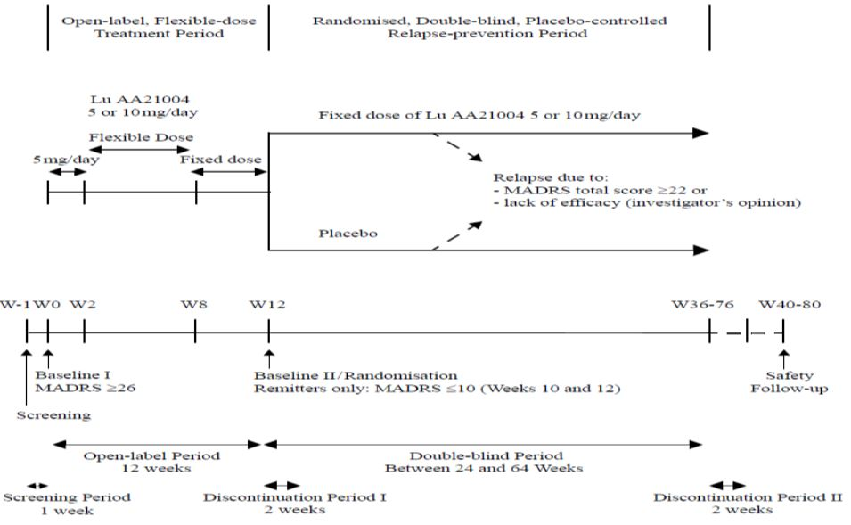
In the OL period, the dose of vortioxetine was fixed (5mg/day) during the first two weeks. From Week 3, the dose could be adjusted (increased to 10mg/day, and decreased again to 5mg/day, as judged by the investigator). During Weeks 8 to 12, the dose was fixed. Patients in remission (MADRS total score ≤ 10) at both Weeks 10 and 12 were randomised to the DB, placebo-controlled, fixed-dose treatment period (DB period). Non-remitters at Week 10 and/or Week 12 left the study and were treated at the investigator’s discretion. Patients who withdrew during the OL period were seen for a withdrawal visit and a safety follow-up visit 4 weeks after study withdrawal.
Remitters were randomised equally (1:1) to vortioxetine or placebo in the DB period. Patients randomised to vortioxetine continued on their final dose from the OL period (Table 18). Patients randomised to placebo were switched abruptly to placebo. The duration of the DB period was between 24 and 64 weeks, depending on when in the accrual period patients entered the study, as non-relapsing patients had to complete the DB period simultaneously.
Table 18. Treatment regimen in study 11985A.
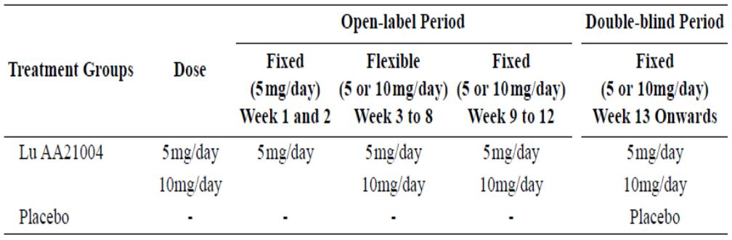
Efficacy and safety data were collected at 2-week intervals in the OL period and at Weeks 1, 2 and 4 and then at 4-week intervals in the DB period.
For patients who were randomised to the DB period, potential discontinuation symptoms were evaluated during the first 2-weeks of the DB period (Weeks 12 and 13; Discontinuation Period I). For patients who completed the DB period potential discontinuation symptoms were also evaluated during the 2-week period after discontinuation of DB treatment (Discontinuation Period II). This is in line with the recommendations in the TGA-adopted guideline.
A safety follow-up was scheduled for four weeks after completion of the DB period or withdrawal from the OL or DB period.
The primary objective was to evaluate the efficacy of vortioxetine (5 and 10 mg/day) in the prevention of relapse of MDE. The key secondary objective was to evaluate the efficacy of vortioxetine during continuation treatment of patients with MDD.
The Study Population included men and women, aged ≥ 18 and ≤ 75 years, with a primary diagnosis of MDE. The patients were in- or outpatients from psychiatric settings. To be included in the study, a patient had to have a baseline MADRS total score ≥ 26 (i.e. moderate to severe MDD to exclude patients with mild depression); the duration of the current MDE had to be ≥ 4 weeks and the patient had to have had at least one MDE prior to the current episode. The exclusion criteria were as in the short-term studies. Furthermore, to ensure patients were not at significant risk of suicide, those with a score ≥ 5 on item 10 of the MADRS (suicidal thoughts), or who were at a significant risk of suicide in the opinion of the investigator, were not allowed to participate in the study.
Study treatment: Vortioxetine 5 and 10 mg/day doses were chosen since this was expected to be the optimal dose range according to previous investigations in healthy subjects, as well as safe and well-tolerated in patients with MDD.
Sample size: The sample size and power calculations were based on the analysis of time to relapse in the DB period at a 5% level of significance, using a log-rank test. A sample size of 420 patients (210 patients per treatment group) provided 91% power to find a statistically significant difference between placebo and vortioxetine, when expecting cumulative relapse rates of 0.20 and 0.10, respectively. Approximately 65% of patients enrolled in the OL period were eligible for the DB period. Hence, at least 650 patients needed to be enrolled in the OL period.
The primary efficacy variable was the time to relapse of MDD (defined as a MADRS total score ≥ 22, or lack of efficacy, as judged by the investigator) within the first 24 weeks of the DB period. Key secondary efficacy variables included: HAM-D17 score, HAM-A total score, CGI-S score & CGI-I score.
Randomisation Criterion: The patient was in remission (MADRS total score ≤ 10) at both Weeks 10 and 12 (baseline II visit/randomisation) and were assigned to treatment with either vortioxetine (at their final dose in the OL period) or placebo, in accordance with a randomisation list computer generated by H. Lundbeck A/S. Patients were assigned to treatment with either vortioxetine or placebo in a 1:1 ratio. Block randomisation (in blocks of 4) ensured equal numbers of patients entered each treatment group. At each centre, the 4-digit randomisation number was assigned consecutively, starting with the lowest number available.
Relapse criterion (only applicable in DB period): The patient had a MADRS total score ≥ 22 or lack of efficacy, as judged by the investigator.
Statistical Analyses: The OC efficacy analyses in the DB period were performed on the FAS, defined as all randomised patients who took at least one dose of IMP in the DB period. The time to relapse was defined as: (date of relapse – date of randomisation to DB Period) + 1 day. Treatment groups were compared using a Cox model with an exact method to handle ties, supplemented by Kaplan-Meier plots. A secondary analysis of time to relapse considered all data in the DB period. Withdrawals (e.g. due to relapse) after Week 24 in the DB period were censored. Withdrawals before Week 24 in DB period due to reasons other than LoE (relapse) were considered non-relapses.
A sensitivity analysis, using the same methodology as for the primary efficacy analysis, was performed where patients with relapses that occurred within the first seven days of the DB period were excluded (these patients were considered to have rebound and discontinuation symptoms rather than a relapse) to distinguish between rebound and withdrawal phenomena in accordance with the recommendations in the TGA guideline on depression. Missing data used LOCF analysis.
Subgroup analyses of the primary efficacy variable were performed for: age (≤ 50, > 50 years); sex (women, men); race (Caucasian, Asian); baseline I MADRS total score (≤ the median of 32, > the median of 32); baseline I HAM-D17 total score (≤ the median of 23, > the median of 23); baseline I HAM-A total score (< 20, ≥ 20); stable responders (with ≥ 50% decrease from baseline I in MADRS total score at Week 2 in the OL period) and treatment at the end of OL period (vortioxetine 5 or 10 mg/day).
The following analysis sets were defined in the protocol or SAP:
- All-patients-treated set (APTS) – all patients who took ≥ 1 dose of IMP in the OL period;
- All-patients-randomised set (APRS) – all patients who completed the OL period and were randomised to DB treatment;
- Full-analysis set (FAS) – all patients in the APRS who took ≥ 1 dose of IMP in the DB period;
- Per-protocol set (PPS) – all patients in the FAS who did not have any major protocol violations.
Baseline demographics and disease characteristics: The mean age (± SD) at baseline I (start of OL period) was 45 ± 12 years and the ratio of men to women was approximately 1:2. Most patients were Caucasian (78%) or Asian (19%). The distribution of mean (± SD) MADRS total scores at baseline I (32.3 ± 4.1) indicated patients had severe MDD, and the distribution of mean (± SD) CGI-S scores at baseline (4.8 ± 0.7), moderate to marked illness. Furthermore, patients had a substantial level of anxiety symptoms [mean (± SD) HAM-A total scores at baseline (22.6 ± 6.6)]. The treatment response during the OL period is reflected in substantially lower efficacy scale scores at baseline II [mean(± SD) MADRS total scores, 4.8 ± 3.1; mean (± SD) CGI-S scores, 1.6 ± 0.69 and mean (± SD) HAM-A total scores, 4.9 ± 3.7]. There were no clinically relevant or statistically significant differences in demographic or baseline values between treatment groups at baseline I or II, or between the vortioxetine and placebo groups at baseline I or baseline II.
Comment: Unlike the short-term MDD studies (in adults and the elderly), the relapse-prevention study examined age in the primary efficacy analysis as two categories: age (years) ≤ 50; age (years) > 50 compared with ≤ 65 years and > 65 years. This makes generalisations between acute and maintenance treatments more difficult.
Subject disposition: A total of 639 patients were treated with OL vortioxetine and 400 entered the DB treatment phase (i.e. 62.6% entered this phase in remission). A total of 159 patients (25%) did not change dose during the OL period and remained on vortioxetine 5mg/day. The most frequent primary reason for withdrawal from vortioxetine treatment in the OL period was not fulfilling randomisation criteria (9.2%), followed by LoE (8.9%) and then AE (8.5%).
In the DB period, 60.7% of patients in the vortioxetine group completed the study, compared with 53.6% in the placebo group (i.e. treatment difference was 7.1%; NNT 14: Table 19). Although the most common reason for withdrawal in both treatment groups was LoE, this proportion was statistically significantly lower in the vortioxetine group than in the placebo group (χ² test; p<0.001). Withdrawal due to LoE included patients who reached the study endpoint by relapsing. Overall, there were no statistically significant differences between the treatment groups in the proportion of patients who withdrew for any reason during the DB period (χ² test; p=0.152). In the DB period, the proportion of patients who withdrew due to AEs was statistically significantly higher in the vortioxetine group (7.8%) than in the placebo group (2.6%: χ² test; p=0.020).
Table 19. Study 11985A patient disposition (DB, APRS).
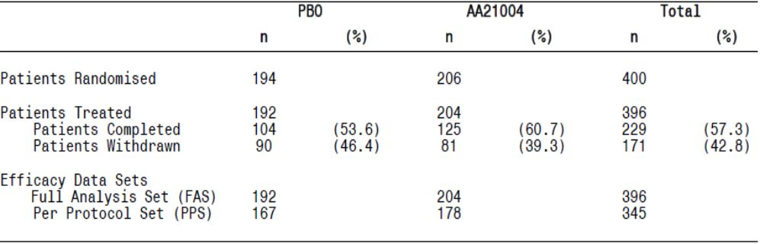
Analysis of time to withdrawal for any reason in the DB period showed an even distribution of withdrawals over time and no statistically significant differences between treatment groups. Analysis of time to withdrawal due to LoE showed a statistically significantly shorter time to withdrawal in the placebo group than in the vortioxetine group (Cox model, p=0.001). The Cox proportional hazard model gave a hazard ratio (HR) of 0.48 i.e. the risk of withdrawal due to LoE for the patients in the vortioxetine group was approximately half that for patients in the placebo group.
Analysis of time to withdrawal due to AEs showed an even distribution of withdrawals over time, but with a statistically significantly shorter time to withdrawal in the vortioxetine group than in the placebo group (Cox model, p=0.043). The Cox proportional hazard model gave a HR of 2.82 i.e. the risk of withdrawal due to AEs for the patients in the vortioxetine group was approximately three times higher than for the patients in the placebo group.
Protocol Deviations: Non-compliance with the protocol, GCP, the Declaration of Helsinki, and/or other applicable regulations was identified at Centres BE002, KR002 and IN005. The auditors found the quality of the medical records was inadequate and, at Centre BE002, there was serious non-compliance concerning patient’s rights and safety. Twelve patients were enrolled in the OL period and 10 were randomised to DB treatment. Following the Classification Meeting held before study unblinding, all patients from BE002 were excluded from the PPS. The primary efficacy analyses were repeated without the data from centre BE002 (data on file). At Centre KR002, 11 patients were enrolled in the OL period and three patients were randomised to DB treatment. At Centre IN005, 18 patients were enrolled in the OL period and 15 patients were randomised to DB treatment. The data from KR002 and IN005 were kept in all analyses presented in this report. Excluding Centres BE002, IN005, and KR002 from the primary efficacy analysis, due to the non-compliance, did not affect the overall study conclusions (data on file). The number of patients excluded from the PPS was comparable between the vortioxetine and placebo groups (26 in the vortioxetine group and 25 in the placebo group, respectively).
Primary efficacy results: The proportion of patients who relapsed over 24 weeks DB treatment was lower in the vortioxetine group (13.2%) than in the placebo group (26.0%). The Cox proportional hazard model gave a HR of 2.01 (p=0.0035) i.e. the risk of relapse for patients in the placebo group was twice that for patients in the vortioxetine group and the NNT to prevent one relapse event in 24 week’s treatment was 1/0.13 = 8.
Table 20. Study 11985A time to relapse within 24 weeks of DB period (FAS).
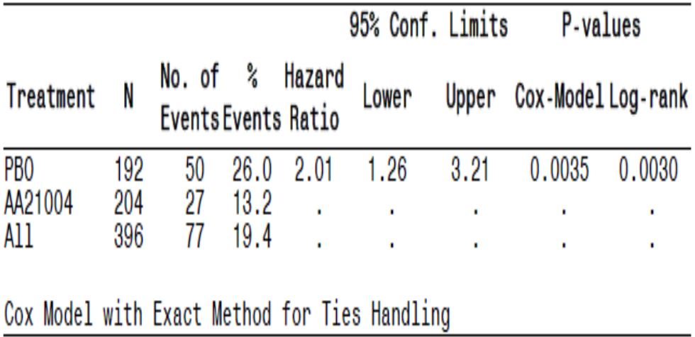
Comments: The sponsor did not distinguish between the 5mg and 10mg vortioxetine treatments but treated them as a combined group. The time to relapse in the FAS analysis for the 5mg vortioxetine regimen was not statistically significant (p=0.0852), whereas the 10mg vortioxetine regimen was (HR 1.94, p=0.0179). The sponsor provided LOCF analyses for each vortioxetine dosage regimen.
During the entire DBP, 20 patients (6 in the vortioxetine group and 14 in the placebo group) relapsed as judged by the investigator, but did not have a MADRS total score ≥ 22 points; 18 relapsed within the first 24 weeks of the DB period. The time to relapse within the first 24 weeks of the DBP was compared between the treatment groups using a Cox proportional hazard model.
Figure 12. Study 11985A patient disposition.
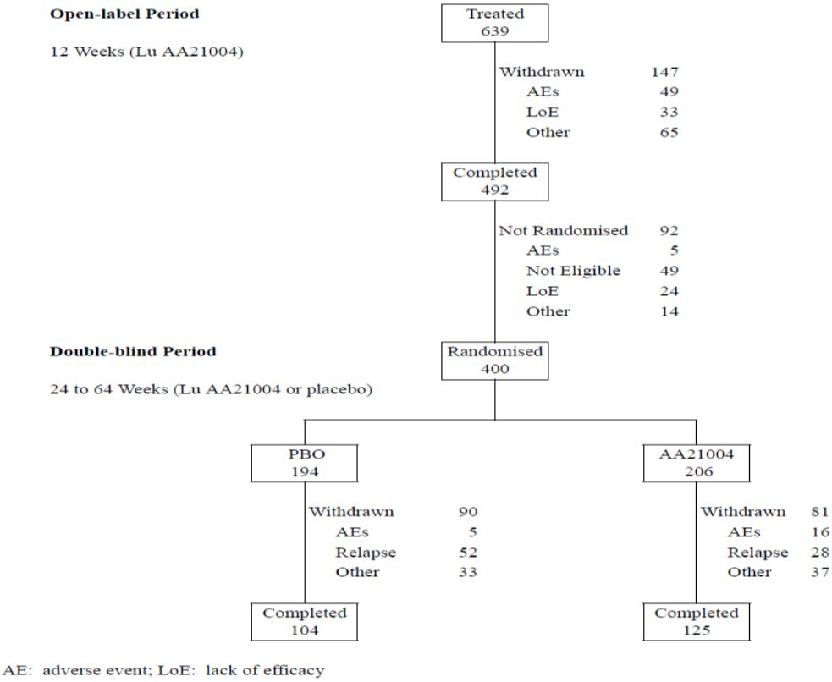
Subgroup analysis of the primary efficacy variable revealed statistically significant main effects on time to relapse (within the first 24 weeks of the DB period) of the following covariates: age [patients aged ≤50 years versus patients aged >50 years, HR 2.06, p=0.027]; MADRS total score at baseline I, p=0.010; HAM-D17 total score at baseline I, p=0.016; patients with HAM-D17 total score ≤22 versus >22, p=0.043; HAM-A total score at baseline I, p=0.0045; patients with HAM-A total score ≤22 versus >22, p=0.019; SDS total score at baseline I, p=0.007 and also at baseline II, p=0.044.
Comment: The subgroup analyses of the primary efficacy variables were only undertaken on the combined vortioxetine treatments (5mg & 10mg). This is addressed.
No statistically significant interaction was found between treatment and any of the investigated covariates at the 5% level of significance, except for race, where there was a statistically significant (p=0.016) interaction between treatment and the covariate ‘Asians’. A greater effect of treatment and a lower risk of relapse for Caucasian patients than for Asian patients (Cox model HR: 2.47 versus 0.42, respectively). However, the total number of Asian patients in the study was low (32 Asian patients [16%] in the vortioxetine group and 34 Asian patients [18%] in the placebo group).
The primary efficacy results were confirmed in the sensitivity analyses that excluded relapses that occurred during the first 7, 14 or 28 days of the DB period. Approximately twice as many patients in the placebo group relapsed within the first 24 weeks of the DB period compared with the vortioxetine group who (HR range 1.92 to 2.50).
Secondary Efficacy Analysis Results: Based on the OC results, vortioxetine was statistically significantly superior to placebo (p<0.05) in most key secondary efficacy analyses (except HAM-A total score). Size differences were small, which showed the effect of vortioxetine was consistent and stable over time. A consistent, slight deterioration in the MADRS total score in the placebo group was observed during the DB period.
During the DB period, a considerably larger proportion of patients in the placebo group than in the vortioxetine group withdrew from the study (mainly due to relapse), resulting in a larger difference to placebo in the ANCOVA analyses based on the LOCF than in those based on OC.
Responders and remitters: 492 subjects completed the 12 weeks OL treatment. Of these, 400 were randomised into placebo (n=194) and vortioxetine treatment (n=206), the dose of which was determined at the end of the OL period, and entered the DB treatment period 24 to 64 weeks i.e. these subjects were in remission at baseline II, the start of the DB period.
The OL period results are summarised in Table 21. Based on MADRS, 90% of observed cases responded to vortioxetine treatment and 85% remitted. No breakdown by vortioxetine dose is provided.
Comment: These OL responder and remitter rates are much greater than those observed in the DB treatment in the MDD pivotal studies. This discrepancy is addressed.
Table 21. Study 11985A OL responders and remitters (APTS, OC).
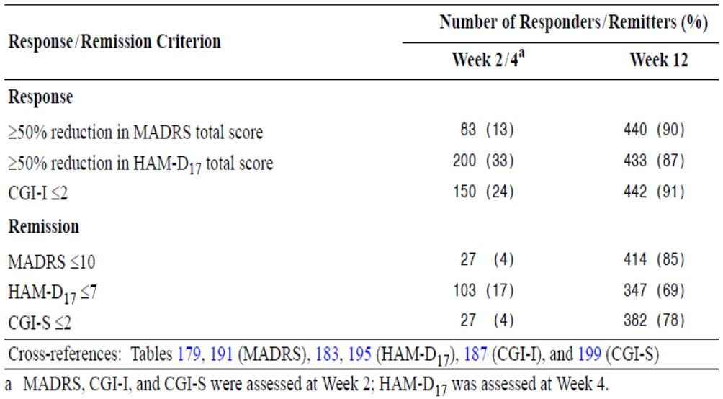
The DB responder and remitter OC results are summarised in Table 22. The rates for vortioxetine treatment appear stable over time compared with baseline II levels, with statistically significantly greater responder and remission rates, favouring vortioxetine treatment versus placebo, at Week 24 (p=0.025 and p=0.002, respectively). No breakdown by vortioxetine dose is provided.
Table 22. Study 11985A DB responders and remitters at baseline II and at week 24 (FAS, OC).
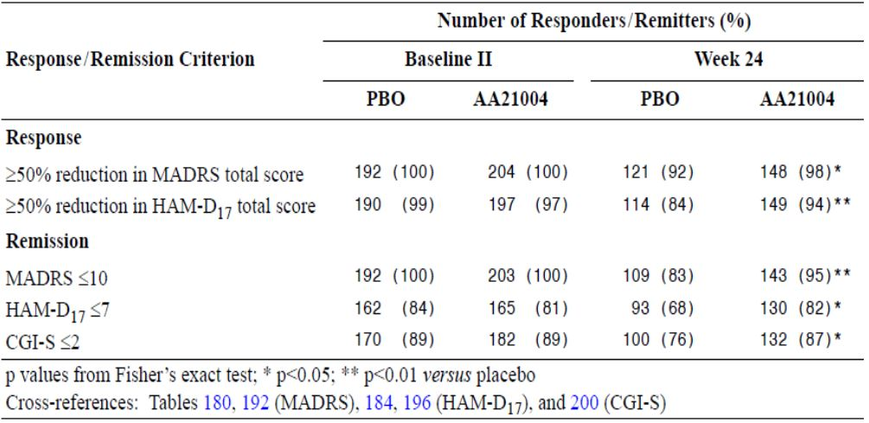
Comments: While vortioxetine demonstrated statistical superiority versus placebo in the OC analysis at Week 24 in the DB period for responder rates, Weeks 20 and 28 did not achieve statistical separation (p=0.393 and p=0.125, respectively). Similar results were found in the remission rates (Week 20, p=0.205 and Week 28, p=0.076).Therefore, vortioxetine treatments did not clearly separate from placebo over the entire study duration in both responder and remission rates. In contrast, the LOCF analyses demonstrated statistical separation favouring vortioxetine treatment compared with placebo from Week 4 in both responder rate and remission rate. The results were stable from Week 4 to Week 24 and beyond.
Proportions of subjects who had sustained remission from baseline II to Week 24 in either OC or LOCF analyses would provide useful information on the effectiveness of vortioxetine to prevent relapse. This is addressed.

Other efficacy studies (maintenance phase)

Completed extension studies
The secondary objectives of these OL extension studies were to evaluate the maintenance of the therapeutic effect of vortioxetine. In all three studies, patients were seen at Weeks 1, 2 and 4, then every four weeks to Week 28, and every eight weeks thereafter until the end of the study. The studies were conducted in Asia, Australia, Europe, North America (Canada and the US) and South Africa.
Subjects had to have completed the short-term, lead-in study immediately prior to inclusion in the long-term extension study. Furthermore, in Studies 11984B and 301, the investigator had to be of the opinion the patient needed 12 months of continued treatment with vortioxetine.
Patients at significant risk of suicide (that is, either in the investigator’s opinion, or who had a MADRS item 10 [suicidal thoughts] score ≥ 5) were excluded, as were patients who had been diagnosed with a psychiatric disorder other than MDD during the lead-in study. Patients were also excluded from the extension study if they had a clinically significant, moderate or severe ongoing AE, judged by the investigator to be related to IMP, in the lead-in study.
The key efficacy variables were based on the MADRS and the CGI-S. All the analyses were performed on all patients who took at least one dose of IMP in the extension study and who had at least one valid efficacy assessment in the extension study.

Study 11492C
This study investigated the maintenance of effect of vortioxetine, at flexible doses of 5 or 10mg/day, over 52 weeks in patients with MDD who had completed lead-in Study 11492A. Only 74 patients (21% of the patients who completed the lead-in study) continued into this extension study. Of these, 54 (73%) completed the study [7% withdrew from an AE and 5% from LoE]. The mean age (± SD) at baseline II (start of the extension study) was 44 ± 11 years, the ratio of men to women was approximately 2:3, and all patients were Caucasian. At baseline I (start of the lead-in study), the mean MADRS total score was 33.7 points in those patients who were enrolled in the extension study. At baseline II, the mean MADRS total score had decreased to 10.7 points. The mean number of days of exposure to vortioxetine in Study 11492C was 302 days (median: 355 days). Approximately 84% patients received vortioxetine for ≥180 days. The mean compliance with vortioxetine was reported as 97% (median: 99%).
The mean MADRS total score decreased from 10.7 points at baseline II to 5.3 points at Week 52, a reduction of approximately 5.4 points, which indicated maintained improvement in depressive symptoms during the extension study. The proportion of patients who had a response (≥50% reduction in mean MADRS total score from baseline I) increased from 76% at baseline II to 93% at Week 52 for the total population (OC). The proportion of patients in remission (MADRS total score ≤10) increased from 58% at baseline II to 82% at Week 52 for the total population (OC). Exploratory statistical analyses (MMRM) investigating the time course of efficacy showed that from baseline II to Week 4 of Study 11492C, the mean MADRS total score continuously decreased and patients showed improvement in depressive symptoms. From Week 4 onwards, the patients maintained their mean MADRS total scores and did not improve further.

Study 11984B
This study investigated the maintenance of effect of vortioxetine, at flexible doses of 2.5, 5 or 10mg/day, over 52 weeks in patients with MDD who had completed lead-in Study 11984A. Of 535 enrolled patients, 61% (n=328) completed this extension study, 8% withdrew from an AE and 7% from LoE. The mean age (± SD) at baseline II (start of the extension study) was 46 ± 12 years and the ratio of men to women was approximately 1:2. The majority of the patients were Caucasian (81%) or Asian (18%). At baseline I (start of the lead-in study), the mean MADRS total score was 31.9 points in those patients who were enrolled in the extension study. At baseline II, the mean MADRS total score had decreased to 13.5 points. The mean CGI-S score had decreased from 4.8 to 2.7 points. The mean number of days of exposure to vortioxetine was 268 days in the extension study (median: 359 days). Approximately 72% of the patients received vortioxetine for ≥ 180 days. The mean compliance with vortioxetine was reported as 98% (median: 100%).
The mean MADRS total score decreased from 13.5 points at baseline II to 5.5 points at Week 52, and the mean CGI-S score decreased from 2.7 points at baseline II to1.7 points at Week 52, which indicated maintained improvement in depressive symptoms and the global impression during the extension study. At baseline II, 63% of the patients in the total patient population had responded to the treatment they received in lead-in Study 11984A, based on the MADRS criterion (FAS, OC). The proportion of responders increased over time until Week 24 and remained stable until Week 52, at which time 94% of the patients in the total patient population had responded. Based on the HAM-D24 and HAM-D17 criteria, the proportion of responders was 60% at baseline II and increased over time until Week 52, at which time approximately 91% of the patients had responded. At baseline II, 42% of the patients in the total patient population were in remission, according to the MADRS criteria (FAS, OC). The proportion of remitters increased over time until Week 52, at which time 83% of the patients were in remission. Similar results were seen for CGI-S remission. At baseline II, 20% of the patients in the total patient population had a MADRS total score ≥ 22 (FAS, OC). This proportion decreased over time until Week 52, at which time 3% of the patients had a MADRS total score ≥ 22.

Study 301
This study investigated the maintenance of effect of vortioxetine, at flexible doses of 2.5, 5 or 10mg/day, over 52 weeks in patients with MDD who had completed lead-in Studies 304 (US) or 305 (non-US).
Of 834 enrolled patients, 63% (n=526) completed this extension study, 6% withdrew from an AE and 4% from LoE.
The mean age (± SD) at baseline II (start of the extension study) was 46 ± 13 years and the ratio of men to women was approximately 1:2. The majority of the patients were Caucasian (83%) or Black (10%) or Asian (7%). At baseline I (start of lead-in Study 304 or 305), the mean MADRS total score was 30.3 points and the mean CGI-S score was 4.7 points in those patients who were enrolled in the extension study. At baseline II, the mean MADRS total score and CGI-S score had decreased to 16.6 points and 3.2 points, respectively,
The mean number of days of exposure to vortioxetine was 276 days in the extension study (median: 363 days). Approximately 65% of the patients received vortioxetine for ≥309 days. The mean compliance with vortioxetine was reported as 100% (median: 100%).
Overall, the mean (± SD) HAM-D24 total score decreased throughout Study 301 for the total population, from 31.2 ± 5.46 at baseline I to 17.6 ±9.41 at baseline II, and to 9.7 ± 8.24 at the final visit. At the final visit, the mean change from baseline I was -21.5 ± 9.40, while the mean change from baseline II was -7.9 ± 9.66. The mean CGI-S score decreased from 3.2 to 2.2 points from baseline II to the final visit, which indicated maintained improvement in depressive symptoms and the global impression during the extension study.
Comment: The overall reductions in efficacy endpoints, irrespective of treatment group, were greater in subjects enrolled from Study 305 compared with Study 304 i.e. vortioxetine appeared less effective in US subjects. These findings are consistent with the original pivotal results.

Ongoing extension studies

Study 13267B
This study is investigating the maintenance of effect of vortioxetine, at flexible doses of 15 or 20mg/day, over 52 weeks in patients with MDD who have completed lead-in Study 13267A. Of 71 patients enrolled as of 29 February 2012, 21 had withdrawn. The mean MADRS total score decreased from 16.2 points at baseline II (n = 71) to 7.65 points at Week 36 (n = 20).
In the second round, Study 13267B was completed. The mean MADRS total score decreased from 16.2 points at Baseline II to 5.0 points at Week 52 i.e. subjects generally continued to improve in regards to their depressive symptoms. A similar result was found with a reduction in CGI-S scores over the study duration. In the total population, the mean SDS total score decreased (improved) from 13.2 points at Baseline II to 4.9 points at Week 52 (FAS, OC).

Study 314
This study is investigating the maintenance of effect of vortioxetine, at flexible doses of 15 or 20mg/day, over 52 weeks in patients with MDD who have completed lead-in Studies 315, 316 or 317. The results below include only those patients who originated from Study 315 or 316 (n=721 Total). Of 986 patients enrolled in Study 314 as of 29 February 2012, 112 had completed the study and 313 had withdrawn. The mean MADRS total score decreased from 19.7 points at baseline II (n = 721) to 8.8 points at Week 52 (n = 93).
Comment: The large number of subject withdrawals in this high dose US based population is a potential safety signal and is addressed.

Evaluator’s conclusions on clinical efficacy for MDD

Acute treatment of MDD in adults
Overall, three (11492A, 305 and 13267A) of ten MDD short-term adult studies were positive in the primary efficacy analysis i.e. vortioxetine demonstrated statistical separation versus placebo (at all doses). No US studies were positive. While Study 14122A was ‘positive’ according to the above criterion, analysis of depressive symptoms was a secondary efficacy endpoint. Hence, Study 14122A is supportive of vortioxetine in adult MDD. Two US studies (315 and 316) were supportive of vortioxetine efficacy in adult MDD i.e. at least one vortioxetine regimen demonstrated statistical superiority versus placebo in the primary efficacy analysis. Five short-term MDD studies (11984A, 303, 304, CCT-002 and 317) were negative studies i.e. vortioxetine failed to demonstrate statistical superiority versus placebo for any vortioxetine dose in the primary efficacy analysis. In summary, the short-term adult MDD studies provided three positive studies (none in the US), three supportive and five negative studies (three in the US). No clear dose-response relationships were demonstrated.
Studies 11984A and CCT-002 were negative studies in the primary efficacy analysis (LOCF) but became positive for 11984A and supportive for CCT-002 in the MMRM sensitivity analysis. In the meta-analysis of the MDD short-term studies MMRM was used (and justified). The addition of Studies CCT-002, 317 and 14122A to the updated meta-analysis generally lowered the treatment difference versus placebo, especially for the 15mg vortioxetine dose but did not greatly affect the overall pattern i.e. statistical separation versus placebo was statistically significant for the 5mg, 10mg and 20mg vortioxetine doses and not-significant for the 15mg dose. However, the vortioxetine therapeutic range achieved > 2 points treatment difference versus placebo, which is regarded as clinically significant. In the non-US study meta-analysis the dose-response relationship seen in the original meta-analysis was lost for the 20mg vortioxetine regimen in the updated meta-analysis. Again treatment differences across the therapeutic vortioxetine range exceeded 2 points versus placebo treatment. Hence, the sensitivity analysis in the individual studies and the meta-analyses of the short-term MDD studies in adults provide support for the primary efficacy findings. No meta-analysis for US-only studies was provided but these would be expected to show little or no benefit from vortioxetine treatment.
In general, the sensitivity, subgroup and secondary efficacy analyses supported the primary efficacy results in terms of MADRS single item scores, sustained remission, changes in CGI scores and SDS scores. In terms of ≥ 50% responder and remitter rates, in the updated meta-analyses (Question 4), the clinically relevant treatment difference the sponsor identified (>16% versus placebo) was not achieved at any vortioxetine dose in the overall responder analysis (but did so in the non-US results in a dose-response pattern).
Females demonstrated a dose-response relationship across the therapeutic dose range, a trend not evident with male participants. However, this may reflect the greater proportion of female participants (approximately 2:1 females:males).
Severe cases of depression (MADRS total score ≥ 30 at baseline) followed a similar trend to the meta-analysis results, in which 15mg/day vortioxetine failed to demonstrate statistical separation versus placebo, although the 5mg, 10mg and 20mg doses did. Mild and moderate cases of depression were analysed as one group and demonstrated statistical separation versus placebo consistent with the primary efficacy results. An analysis of ≥ 50% responder rate (Question 5) by severity of depression (severe or mild/moderate) demonstrated vortioxetine efficacy versus placebo in the severity groups tested, albeit the most severe subjects appeared to derive greatest benefit from the lower vortioxetine doses (5 and 10mg) than the mild/moderate group, who appeared to derive the greatest benefit from the higher vortioxetine doses (15 and 20mg).
While subjects who participated in non-US studies appeared to derive greater benefit from vortioxetine treatment in the dose-range 5 to 20mg/day than US participants, the reasons the sponsor provided to explain the differences (primarily non-adherence to study medication) are unsubstantiated and speculative. Thirty-two US subjects concurrently participated in more than one vortioxetine trial compared with no subject in non-US trials. Also, US subjects had proportionately more subjects who exceeded 100% and 120% of their allocated study medication (in Studies 303 and 304). While it was beyond the scope of this submission to examine the role of socio-economic factors and motivation of trial participants in subject recruitment into MDD clinical trials, there appear to be fundamental differences between subjects recruited from the US versus those recruited from outside the US that may warrant further examination in future studies.
While study design features and methodologies used in the eleven pivotal efficacy trials were consistent with the TGA-adopted guideline, a number of potential study design limitations are identified. In particular, internal validity may have been compromised by not using a reference group in five of the studies. Furthermore, only three studies used MINI or SCID to confirm the diagnosis of MDE. Hence, most subjects recruited into the adult MDD short-term program did not have their MDE diagnosis confirmed, potentially leading to significant selection bias (and investigator bias). Selection of subjects who had not had a prior episode of MDE, i.e. an established history of major depressive disorder, could result in the introduction of significant selection bias into the studies. An analysis of ≥ 50% responder rate by prior history of MDE (see Question 5) failed to demonstrate statistical separation versus placebo for subjects who had not had a prior MDE. Although this subgroup of subjects were restricted to 5mg and 10mg vortioxetine doses, this result lends support to a selection/diagnostic problem, especially in US subjects, that may have significantly contributed to the negative study results seen in this application. While those subjects who were treated with recurrent MDE demonstrated a similar pattern to the overall meta-analysis of the primary efficacy results, no vortioxetine dose achieved > 16% treatment difference versus placebo, the clinically relevant endpoint determined by the sponsor in its response document to clinical questions.
In the active-comparator study, 14178A, vortioxetine was non-inferior and even superior to agomelatine in the treatment of MDD patients with a previous inadequate response to SSRI/SNRI antidepressant monotherapy. However, this study had no placebo control and Total doses of vortioxetine and agomelatine were analysed rather than individual doses as per the relapse-prevention trial. It was beyond the scope of this submission to include comparator antidepressant data within the proposed PI.
In Study 14122A, vortioxetine demonstrated a significant and independent effect on cognitive dysfunction associated with MDD, which was not captured by the MADRS.

Acute treatment of MDD in the elderly
Vortioxetine 5mg/day was statistically significantly superior to placebo in reducing the HAM-D24 total score at Week 8 (p=0.001), with a mean difference to placebo of -3.32 points, and demonstrated statistical separation at Week 6 (compared with duloxetine at Week 4). In the pooled data, the magnitude of the reduction in MADRS total score in this elderly population was much greater (two-fold) than the corresponding 5mg vortioxetine dose in the pooled MDD adult short-term study results (-4.74 versus -2.57, respectively).
The results from the sensitivity analyses (MMRM, OC & PPS) were consistent with the results from the primary efficacy analysis, which also support internal validity of the study. Furthermore, while MMRM results were numerically higher than corresponding LOCF results, these differences were much smaller than observed in the adult MDD short-term studies. This further supports the internal validity of the study.
The treatment difference to placebo for vortioxetine and duloxetine was higher in more depressed patients, although these differences were not statistically significant. However, in the pooled analysis, with patients with severe MDD, vortioxetine 5mg/day separated from placebo (p<0.001) in the MMRM (and LOCF) analysis of the change from baseline in MADRS total score at Week 8, with a mean change from baseline of -17.6 points and a mean difference to placebo of -6.5 points.
The treatment difference to placebo for vortioxetine and duloxetine was higher in more anxious patients, although these differences were not statistically significant. However, in the pooled analysis with patients with high anxiety, vortioxetine 5mg/day separated favourably from placebo (p<0.001) in the MMRM (and LOCF) analysis of the change from baseline in MADRS total score at Week 8, with a mean change from baseline of -15.9 points and a mean difference to placebo of -5.6 points.
Overall, the results for the aged population for the 5mg/day vortioxetine dosage regimen in the acute treatment of MDD are more consistent than those ≤ 65 years of age. The key difference between the elderly and the adult populations was the elderly were required to have an established history of MDD, unlike several of the adult studies. While Study 12541A incorporated participants from within and outside the US, and US subjects had less favourable reductions in HAM-D24 & MADRS total scores than non-US subjects, the overall study results support vortioxetine use in this elderly population in the acute treatment of MDD.

Relapse-prevention
The proportion of patients who relapsed over 24 weeks DB treatment was lower in the vortioxetine group combined (13.2%) than in the placebo group (26.0%). The Cox proportional hazard model gave a HR of 2.01 (p=0.0035) i.e. the risk of relapse for the patients in the placebo group was twice that for patients in the vortioxetine group and the NNT to prevent one relapse event in 24 week’s treatment was 1/0.13 = 8. However, analysis by individual vortioxetine dose showed vortioxetine 5mg failed to separate from placebo (albeit borderline statistical significance) i.e. only the 10mg vortioxetine dose demonstrated statistical superiority versus placebo. The latter supports the proposed dosage regimen for relapse-prevention but only in adults ≤ 50 years of age.
Efficacy was not clearly demonstrated in subjects > 50 years of age and especially in those in the elderly (≥ 65 years of age). Hence, although the acute MDD trial in the elderly appears to support efficacy in this age group for up to 8 weeks treatment, long-term efficacy in this aged population has not been established.
Since the sponsor submitted the primary (and secondary) efficacy results for Study 11985A in terms of ‘Total vortioxetine’ administered during DB treatment i.e. combined 5mg & 10mg vortioxetine doses, it is difficult to draw meaningful conclusions from the study results. The clinician may have difficulty in determining the most appropriate maintenance dose for their patient. From the Total vortioxetine sub-group analyses, sensitivity analyses and secondary efficacy analyses, the overall results are generally consistent with the primary efficacy results (although there was a statistically significant difference noted between the vortioxetine 5mg and 10mg doses: see previous comment).

Clinical safety
In the Summary of Clinical Safety (SCS), the safety and tolerability of vortioxetine in the treatment of MDE within MDD was evaluated primarily on data from 13 completed phase II/III studies. Nine studies were 6- to 8-week, DB, placebo-controlled, with or without an active reference, and included 2755 patients exposed to vortioxetine, 1461 patients exposed to placebo, and 866 patients exposed to active reference. One long-term (24 to 64-week) relapse-prevention study included 639 patients exposed to vortioxetine 5 or 10mg/day. A total of 1443 patients included in the short-term studies continued in the three completed OL, long-term extension studies with flexible doses of vortioxetine 2.5 to 10mg/day. Of these, 908 patients completed the 1-year treatment periods. As of the safety data cut-off date of 29 February 2012, a further 1057 patients were included in the ongoing, OL, long-term extension studies with flexible doses of vortioxetine 15 and 20mg/day. Of these, 112 patients have completed the 1-year treatment periods.
The safety and tolerability of vortioxetine were further evaluated based on data from five completed phase III studies in GAD, which included 1755 patients as well as 31 completed clinical pharmacology studies, which included 1169 subjects.
Finally, safety data from two ongoing clinical pharmacology studies, six ongoing short-term phase III studies in MDD, and one ongoing OL long-term Japanese study in MDD are presented (including 44 subjects, 1359 patients, and 57 patients, respectively, as of 29 February 2012).
In the second round evaluation, the sponsor provided additional safety-related data from five completed clinical efficacy and/or safety studies, and three pharmacology studies. In the Addendum to the original SCS, safety data cut-off dates are further defined:
- 31 July 2013 provided a full update for the MDD short-term pool (“STP”);
- 26 October 2012 provided a 240-day update for the MDD OL long-term pool (“LTP”).
Unless otherwise indicated, the methodology used to summarise and tabulate data in this Addendum is identical to that used in the Summary of Clinical Safety.

Studies providing evaluable safety data
Evaluable safety data was provided as follows:
- A Clinical Pharmacology Integrated Safety Database was made that included exposure, disposition and AEs from 31 completed clinical pharmacology studies.
Table 23. Overview of clinical pharmacology studies completed between 29/2/2012 and 31/8/2013.
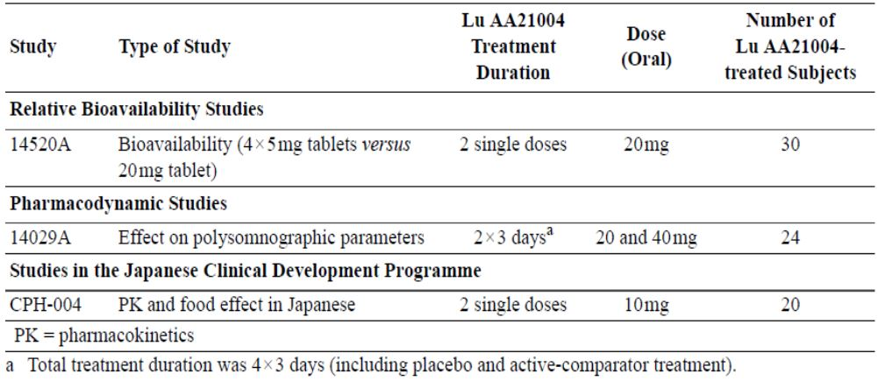
- An Integrated Safety Database was made that included data from the phase II/III studies with designs that allowed for pooling and safety data comparisons. Five pools were made:
  - Short-term:
    - STP (11492A, 11984A, 305, 13267A, 315, 316, 303, 304 & 12541A)
    - GAD Short-term Pool (308, 309, 310 & 311)
    - MDD & GAD Short-term Pool
Note: The primary pool for the evaluation of the short-term safety and tolerability of vortioxetine was the STP, supported by the MDD & GAD Short-term Pool. SAEs for the GAD Short-term Pool are presented separately. All other safety data from the GAD short-term studies are presented as part of the MDD & GAD Short-term Pool.
In the second round evaluation, the sponsor provided additional safety-related data from five completed clinical efficacy and/or safety studies. These studies are summarised in Table 24.
Table 24. Overview of studies in MDD completed between TGA submission and 31/8/2013.
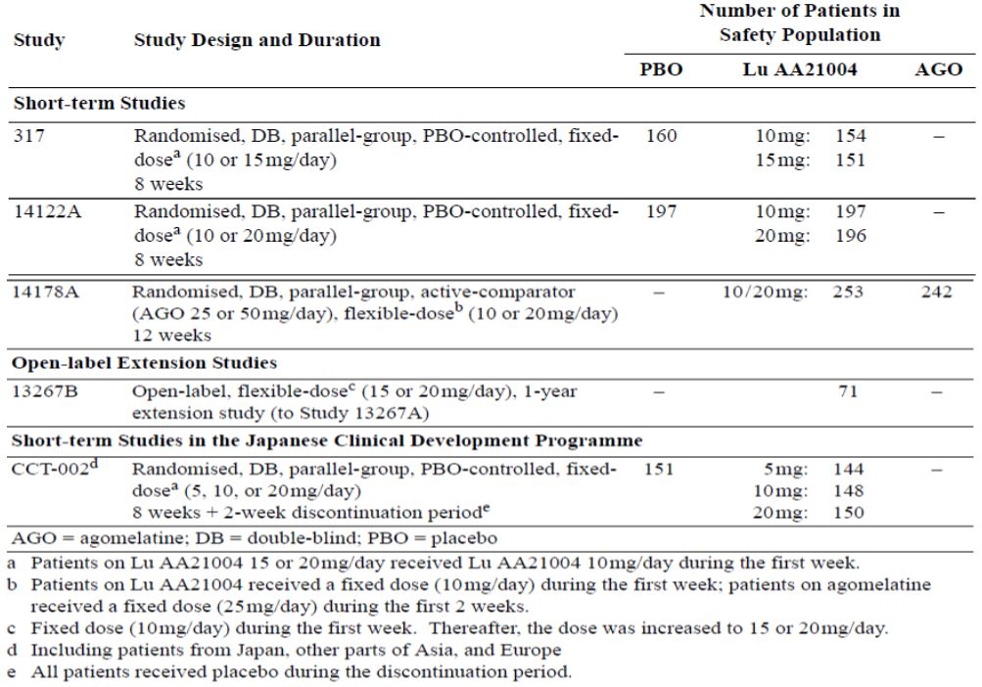
Safety and tolerability data from Studies 317, 14122A and CCT-002 are included in the updated STP. The LTP has been updated with final data from the OL, 1-year extension study (13267B) and updated data from the ongoing OL, 1-year extension study (314). In the LTP, 391 subjects had completed 52-week treatment as of 26 October 2012 compared with 112 subjects in the original cut-off date. The safety data for the active-comparator study, 14178A, is presented separately. The safety-related data package in the second round evaluation is comprehensive and acceptable.
- MDD Open-label Long-term:
  - LTP (completed studies with doses of 2.5 to 10mg vortioxetine: 11492C, 11984B & 301))
  - MDD Ongoing OL Long-term Pool (ongoing studies with doses of 15 and 20mg vortioxetine: 13267B & 314)). Data regarding SAEs, withdrawals due to AEs, and body weight are presented for this pool.
Data from the two long-term relapse-prevention studies, 11985A (MDD) and 12473A (GAD), are presented by individual study, as are data from the six ongoing short-term MDD studies (317, CCT-002, CCT-003, 14122A, 14178A & 318) and the one OL long-term MDD study conducted in Japan (Study OCT-001).
The design of the relapse-prevention studies in MDD and GAD made them unsuitable for pooling. Therefore, these studies are presented individually, primarily based on data from the CSRs. However, tabulations and listings of AEs of special interest, other safety considerations, and the C-SSRS (Study 12473A only) are presented based on the Integrated Safety Database.

Study periods and baseline definitions
For the pooled analyses, the following periods were defined:
- Core Treatment Period – from first dose of IMP to last dose of IMP in the DB Period (DBP)
- Entire Study Period – from first dose of IMP to last visit/contact (i.e, including the Discontinuation and Safety Follow-up Periods)
For studies with a Discontinuation Period, this was defined as the two weeks after the last dose of IMP (Week 1 and Week 2 of the Discontinuation Period).
For the relapse-prevention studies, the following periods were defined:
- OL Period (OLP) – from first dose to last dose of OL IMP
- DBP – from first dose to last dose of DB IMP
For pooled analyses and the relapse-prevention studies, the following baselines were defined:
- Baseline I:
  - short-term pools: the last observation collected before the first dose of DB IMP
  - OL, long-term pool: the last observation collected before the first dose of DB IMP in the lead-in study
  - relapse-prevention studies: the last observation collected before the first dose of OL IMP (designated Baseline I in the CSRs)
- Baseline II:
  - OL, long-term pool: the last observation collected before the first dose of OL IMP
  - relapse-prevention studies: the last observation collected before the first dose of DB IMP
In the SCS, the Vortioxetine Total group includes patients from all vortioxetine dose groups: 1, 2.5, 5, 10, 15, and 20mg/day. The therapeutic vortioxetine dose groups refer to the 5, 10, 15 and 20mg/day dose groups.

Pivotal efficacy studies
In the pivotal efficacy studies, the following safety data were collected:
- General treatment emergent adverse events (TEAEs), serious AEs (SAEs), severity of AE, SEs that lead to study drug withdrawal.
- AEs of particular interest were assessed by:
  - Sheehan Disability Scale (SDS) comprises self-rated items designed to measure the extent to which the subject’s life is impaired by panic, anxiety, phobic, or depressive symptoms. The subject rated the extent to which his or her (1) work, (2) social life or leisure activities, and (3) home life or family responsibilities, were impaired by his or her symptoms on 10-point visual analogue scales. In addition, the SDS addressed the number of days lost and the number of days underproductive due to the symptoms.
  - The Arizona Sexual Experiences Scale (ASEX) scale is a short, 5-item tool used to assess sexual function. The elements of sexual function were assessed by the level of sexual drive, arousal, the ability to reach orgasm and by sexual satisfaction. Separate versions were available for use with men or women with either a heterosexual or homosexual orientation.
  - Assessment of Suicidal Ideation and Behaviour (C-SSRS) is composed of three questions addressing suicidal behaviour and five questions addressing suicidal ideation, with sub-questions assessing the severity.
  - Assessment of Potential Discontinuation Symptoms (the DESS scale) assessed potential discontinuation symptoms. This is a clinician-rated checklist designed to evaluate possible discontinuation-emergent events seen when antidepressant treatment is missed (non-compliance) or stopped at the end of therapy (2-week discontinuation period). The DESS comprises 43 items (for example, agitation, insomnia, fatigue, dizziness). An event is considered discontinuation-emergent if it is reported for the first time or if a previously reported event has worsened
- Laboratory tests included clinical chemistry, haematology, urinalysis, body weight and vital signs.

Pivotal studies that assessed safety as a primary outcome

Analysis populations
For the pools, the analyses of safety and tolerability were based on the all-patients-treated set (APTS), which comprised all patients who took at least one dose of IMP.
For the relapse-prevention studies, safety analyses of the OLP and the DBP were based on the APTS and the APTS_DB, respectively:
- APTS – all patients who took at least one dose of IMP in the OL Period
- APTS_DB – all randomised patients who took at least one dose of IMP in the DBP (in Study 11985A, this was designated the FAS).
The all-patients-completed set (APCS) comprised all patients who completed the study. For Studies 11492A, 303, 13267A, 315, 316, 308, 11985A and 12473A, the evaluation of the Discontinuation Period was based on the patients in the APCS who entered the Discontinuation Period.

Participant disposition
Clinical pharmacology studies: The withdrawal rates were similar in the placebo (5.9%), Total vortioxetine (7.4%) and other IMP (4.3%) groups. The most common reason for withdrawal was ‘adverse event’: vortioxetine 3.5%, placebo 1.4% and other study drug 1.2%.
STP: The withdrawal rates in the vortioxetine dose groups were higher than in the placebo group for the 2.5mg, 10mg, 15mg and 20mg/day doses (24.7%, 18.3%, 22.8% and 20.9%, respectively versus 16.4% in the placebo group), whereas the 1mg vortioxetine dose group had the lowest withdrawal rate (9.3%) and the 5mg vortioxetine dose group had a similar withdrawal rate to placebo (16.0%). The withdrawal rate in the venlafaxine and duloxetine groups was 17.7% and 20.7%, respectively. The most common reason for withdrawal in all treatment groups was AEs, except in vortioxetine 1mg group in which the most common reason for withdrawal was LoE. Higher proportions of patients in the therapeutic vortioxetine dose groups than in the placebo group withdrew due to AEs (vortioxetine: 5.3% [5mg], 6.6% [10mg], 8.1% [15mg], and 8.4% [20mg]; placebo: 3.9%), with a slight dose-response relationship. The withdrawal rate due to AEs was lower in all vortioxetine dose groups than in the venlafaxine and duloxetine groups (14% and 9.2%, respectively).
MDD & GAD short-term pool: The withdrawal rates and proportion of patients who withdrew due to AEs in the MDD & GAD Short-term Pool were very similar to those in the STP.

MDD long-term relapse-prevention Study 11985A:
- OLP: The withdrawal rate in the Total vortioxetine group was 36.8%; 8.5% due to AEs. The most common reason for withdrawal was ‘administrative or other reason’ (13.3%) followed by ‘lack of efficacy’ (8.9%). Of the 400 patients who completed the OL Period, 92 patients did not qualify for randomisation to the DBP;
- DBP: The withdrawal rate in the Total vortioxetine group was lower than in the placebo group (38.7% versus 45.8%, respectively). The proportion of patients who withdrew due to AEs was higher in the vortioxetine group (7.8%) than in the placebo group (2.6%). The most common reason for withdrawal in both treatment groups was lack of efficacy (including relapses), the proportion of which was almost twice as high in the placebo group than in the Total vortioxetine group (271% versus 13.7%, respectively).

GAD long-term relapse-prevention Study 12473A:
- OLP: The withdrawal rate was 33.2%; 8.7% due to AEs, which was the most common reason for withdrawal. Of the 459 patients who completed the OL Period, 28 patients did not qualify for randomisation to the DB Period;
- DBP: The withdrawal rate was higher in the placebo group (47.4%) than in the Total vortioxetine group (31.4%). The proportion of patients who withdrew due to AEs was similar in both treatment groups (2.6% and 3.5%, respectively). The most common reason for withdrawal in both treatment groups was LoE, the proportion of which was almost three times higher in the placebo group than in the Total vortioxetine group (31.3% versus 10.9%, respectively).
LTP (2.5 to 10mg/day): The withdrawal rate was 37.1% and 6.8% were withdrawn due to AEs. The most common reason for withdrawal was withdrawal of consent (10.0%).
In the second round, patient disposition and withdrawals by primary reason are summarised for the updated STP and for the updated LTP (15mg & 20mg doses). The overall pattern of study drug withdrawal and primary reasons for withdrawal in the STP and LTP were consistent between the original and updated safety reports. Patient disposition and withdrawals by primary reason are summarised for Study 14178A in Table 25.
Table 25. Withdrawals from study 14178A by primary reason (APTS).
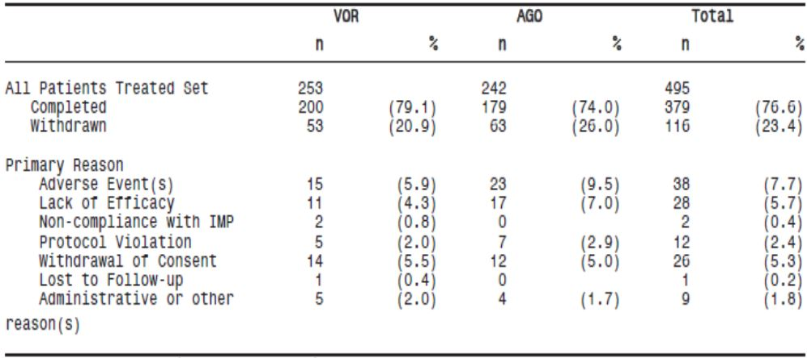
While the overall rate of withdrawal for Total vortioxetine in Study 14178A was approximately 4% higher than observed in the updated STP (20.9% versus 17.1%, respectively), this difference is not expected to be clinically meaningful when considered in context of the primary reasons for withdrawal. AE rates for Total vortioxetine in the updated STP and Study 14178A were both 5.9%, the most common reason for withdrawal. The overall withdrawal rate and incidence of withdrawal from AEs in the active comparator group, agomelatine, were comparable to the reference agents (venlafaxine and duloxetine) used in the updated STP.
MDD Ongoing OL Long-term Pool (15 or 20mg/day): The withdrawal rate from the MDD Ongoing OL Long-term Pool was 31.6%, with similar proportions of patients withdrawing from both of the studies in the pool (29.6% in Study 13267B and 31.7% in Study 314, respectively). The primary reason for study withdrawal was not specified in the SCS.

Patient exposure
Exposure to vortioxetine was calculated for all completed clinical (and pharmacology) studies in the development program. The duration of exposure was calculated for the Core Treatment Period from the first day of IMP to the last day of IMP. Down-taper IMP was not included in the exposure calculations. The overall exposure is tabulated by number of patients and patient years of exposure (PYE; Table 26). For the STP and the MDD & GAD Short-term Pool, exposure was also summarised by demographic variables (age, sex and race). Due to the flexible dosing in the OL, long-term studies, a summary of exposure (mean, SD, median and range [minimum and maximum]) was provided for the LTP.
Table 26. Exposure to vortioxetine (APTS) – completed studies.
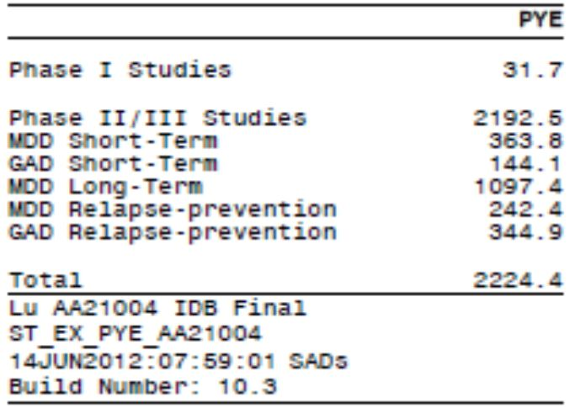
In the completed phase II/III studies, 5709 patients with MDD (3954 patients in 13 studies) or GAD (1755 patients in five studies) received vortioxetine at doses up to 20mg/day; 1479 of these patients received vortioxetine for 26 weeks or more and 981 received vortioxetine for 52 weeks or more (Table 27). In addition, 1169 subjects in 31 clinical pharmacology studies in healthy subjects, elderly subjects, and subjects with hepatic or renal impairment have been exposed to vortioxetine. Subjects received vortioxetine orally (as solution or tablets) as a single dose (up to 75mg) or repeated doses (up to 60mg/day).
Table 27. Number of subjects exposed to vortioxetine (APTS) –completed studies.
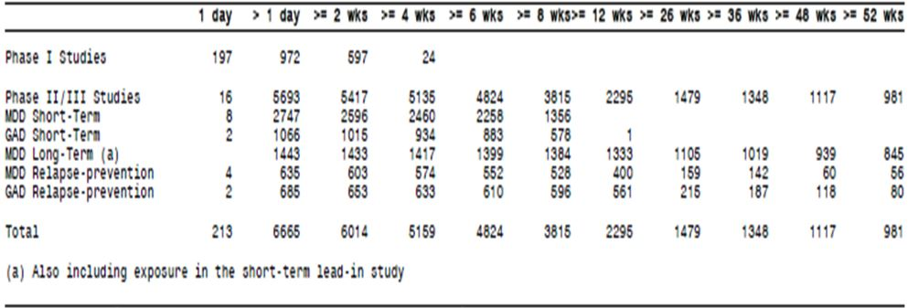
STP: For vortioxetine, 302 of the PYE (83%) were accrued for 5 to 20mg/day, 243 of the PYE (67%) were accrued in women, 325 of the PYE (89%) were accrued in patients aged <65 years and 294 of the PYE (81%) were accrued in Caucasians.
There were no clinically meaningful differences between the STP and the MDD & GAD Short-term Pool in respect to exposure based on the demographics sex, age and race.
Comment: Long-term exposure to vortioxetine is limited to the phase II/III clinical trials included in this application as vortioxetine is a NCE with non post-marketing exposure.

Adverse events

All adverse events (irrespective of relationship to study treatment)
TEAEs were defined as AEs with an onset on or after the day of first IMP intake. If information on intensity was missing, a worst case scenario was assumed, in which case an intensity missing during treatment was set to severe. Table 28 summarises the overall TEAE incidences and Table 29 summarises ≥ 1% incidence of TEAEs in the STP core treatment period.
Table 28. Overall safety profile: STP.
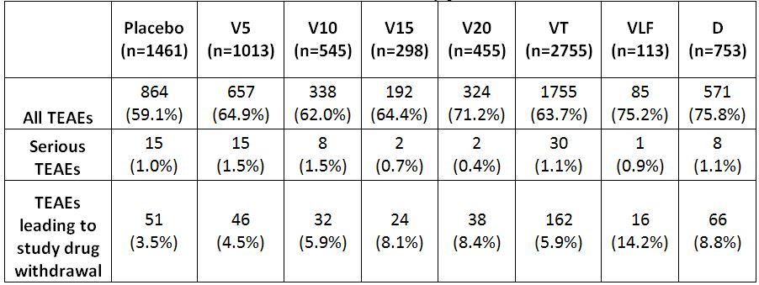
V=vortioxetine; VT=vortioxetine total; VLF=venlafaxine; D=duloxetine
TEAE=treatment-emergent adverse event
Table 29. TEAEs ≥ 1% core treatment period by dose (APTS) – STP.
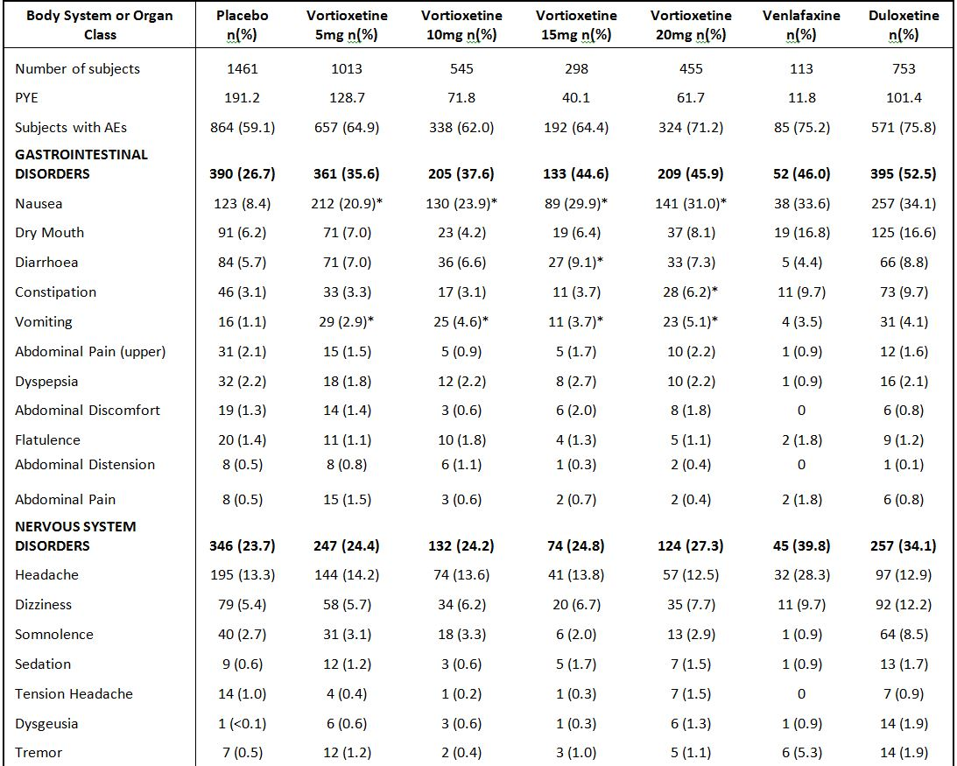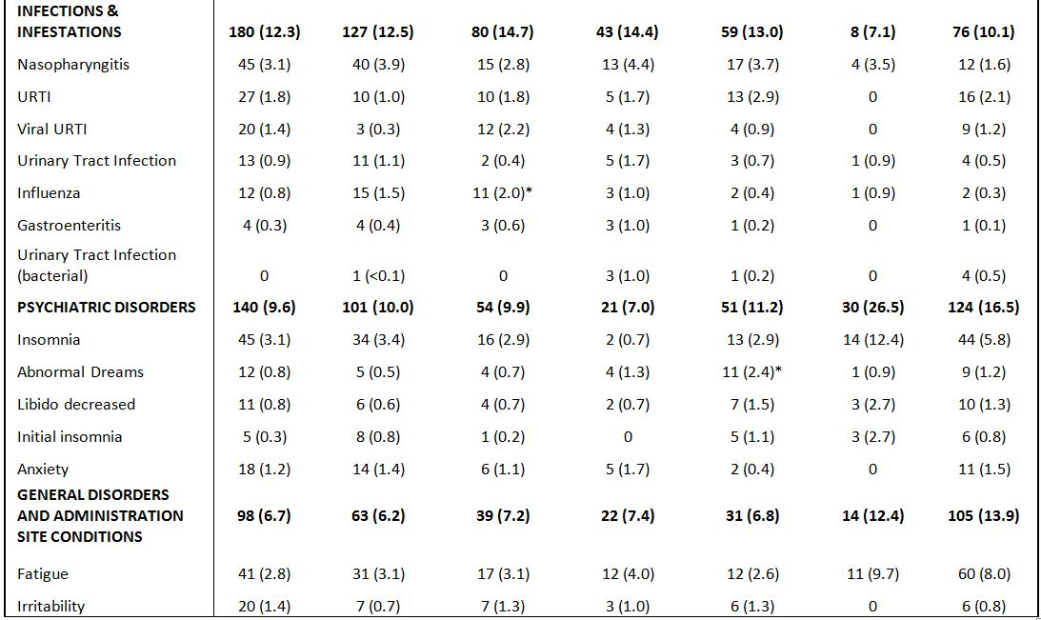
Table 29 (continued). TEAEs ≥ 1% core treatment period by dose (APTS) – STP.
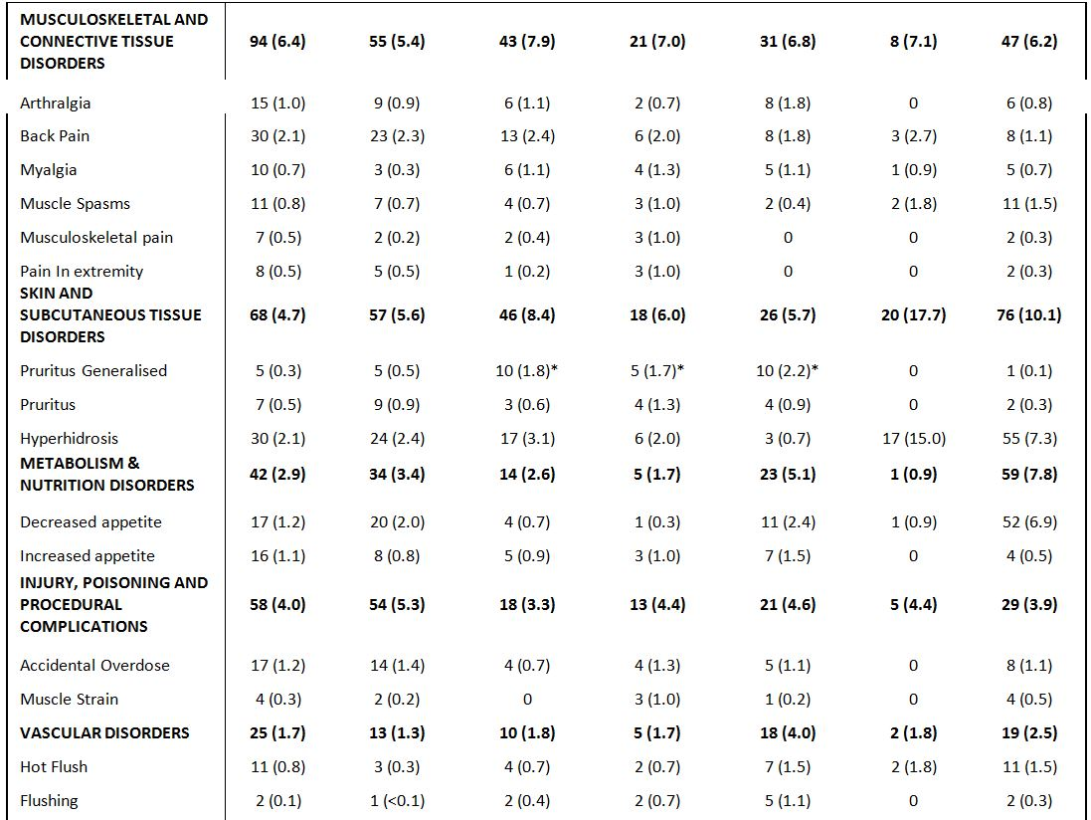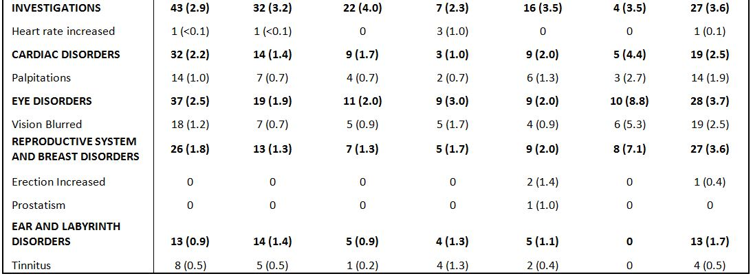
*Difference versus placebo is statistically significant (p<0.05)
From Table 29, there was ≥ 10% greater incidence in overall TEAEs for all vortioxetine treatments (5 to 20mg/day, inclusive) versus placebo for nausea, in a statistically significant dose-response manner. There was ≥ 2% greater incidence in overall TEAEs for all vortioxetine treatments (5 to 20mg/day, inclusive) versus placebo for vomiting. Some vortioxetine dose-groups achieved statistically significantly higher TEAE incidence rates than placebo: vortioxetine 20mg/day (constipation 6.2% versus 3.1%), vortioxetine 10mg/day (influenza 2.0% versus 0.8%); vortioxetine 15mg/day (diarrhoea 9.1% versus 5.7%) and vortioxetine 10mg, 15mg & 20mg for generalised pruritus (1.8%, 1.7% & 2.2%, respectively). Dizziness demonstrated a trend towards dose-response, albeit modest with no statistically significantly differences demonstrated versus placebo. Abnormal dreams also demonstrated a modest dose-response relationship with the 20mg vortioxetine dose demonstrating statistical separation versus placebo. Headache was the TEAE with the highest incidence in the placebo group (similar incidence rates to all vortioxetine treatments; approximately 13%).
Comments: The overall incidence rates of TEAEs in the STP were similar to placebo except a modestly higher rate for the vortioxetine 20mg/day group. The overall TEAE incidence rates for venlafaxine and duloxetine were comparable to each other and vortioxetine 20mg/day treatment. There appeared to be a dose-response relationship between 5 to 20mg/day vortioxetine and TEAEs that lead to study withdrawal. Overall, most TEAEs for vortioxetine treatments in the STP had similar rates to placebo except for nausea and dizziness (both demonstrated dose-response relationships). Active controls tended to have higher overall TEAE incidence rates than vortioxetine treatments for nausea, headache, dry mouth, dizziness, constipation, diarrhoea, insomnia, somnolence, fatigue, hyperhidrosis and adverse effects on sexual function e.g. delayed ejaculation, and a lower incidence than vortioxetine treatments for vomiting. However, the pivotal studies lacked the power to compare active controls versus vortioxetine treatments.

Other phase II/III studies
In the MDD & GAD Short-term Pool, the pattern of TEAEs, in regards to incidences and severities, was similar to the STP, with similar patterns exhibited in the Core Treatment and Entire Study Treatment Periods.
In the OLP of the MDD Long-term Relapse-prevention Study 11985A, the incidence of TEAEs was 70.6% (n=451). TEAEs with ≥ 5% incidence were: nausea (25.7%); headache (18.3%); nasopharyngitis (8.1%); dizziness (6.9%); dry mouth (6.4%); accidental overdose (5.8%); insomnia (5.6%) and fatigue (5.0%). In the DBP of the MDD Long-term Relapse-prevention study, 11985A, the incidence of TEAEs was similar in the placebo and vortioxetine groups (63.5% and 62.3%, respectively). The SOCs with an incidence ≥ 20% in either treatment group were infections and infestations, gastrointestinal disorders, and nervous system disorders. The TEAEs occurring in ≥ 5% of the patients occurred with similar incidences in the two treatment groups, except for headache and nasopharyngitis, which had higher incidences in the placebo group than in the vortioxetine group (13.0% versus 12.3% and 14.1% versus 10.8%, respectively), and nausea, which had a higher incidence in the vortioxetine group than in the placebo group (5.4% versus 3.1%, respectively). Higher incidence rates of influenza were demonstrated in the vortioxetine group versus placebo (6.9% versus 5.2%, respectively) and for gastroenteritis (5.4% versus 3.1%, respectively).
In the OLP of the GAD Long-term Relapse-prevention Study 12473A, the incidence of TEAEs was 76.9% (n=528). TEAEs with ≥ 5% incidence were: nausea (27.1%); headache (17.6%); influenza (7.6%); diarrhoea (7.4%); accidental overdose (6.4%) and dizziness (6.1%). In the DBP of the GAD Long-term Relapse-prevention Study 12473A, the incidence of TEAEs was similar in the placebo and vortioxetine groups (53.9% and 55.0%, respectively). In both treatment groups, the only SOC with an incidence ≥ 20% was infections and infestations. The only TEAE with an incidence ≥ 10% was influenza (12.2%) in the vortioxetine group (compared with 6.1% in the placebo group). TEAEs occurring in ≥ 5% of patients had higher incidences in the placebo group than in the vortioxetine group for headache (8.7% versus 6.1%, respectively) and insomnia (6.5% versus 2.6%) and higher rates in vortioxetine compared with placebo for accidental overdose (5.2% versus 1.3%, respectively) and nausea (5.2% versus 3.0%).
In the OLP of the LTP (2.5 to 10mg/day), TEAE incidence was 71.2%. TEAEs in the Core Treatment Period with incidence ≥ 5% were: nausea (17.5%); headache (13.2%); nasopharyngitis (10.5%); dizziness (6.4%); diarrhoea (6.4%) and weight increased (5.6%). During the first two weeks of OL treatment, the incidence of nausea was lower in patients who continued treatment with vortioxetine (6% to 9%) than those who switched from other treatments to vortioxetine (15% to 18%) when entering the extension study.

Active comparator study 14178A
TEAEs during the entire study period were 55.3% for Total vortioxetine treatment (10mg/20mg combined) and 52.9% for Total agomelatine (25mg/50mg combined). These values were similar to rates reported in the 12-week core treatment period: 54.2% versus 52.5%, respectively. Nausea had the highest AE incidence (16.2% vortioxetine group versus 9.1% agomelatine group, respectively). All other TEAEs with an incidence ≥ 5% had a higher incidence in the agomelatine group than in the vortioxetine group and comprised headache (13.2% versus 10.3%, respectively), dizziness (11.6% v7.1%) and somnolence (7.9% versus 4.0%).

Clinical pharmacology studies
There was ≥ 10% greater incidence in overall TEAEs for Total vortioxetine treatment versus placebo for nausea (19.9% versus 2.9%; respectively). There was ≥ 5% greater incidence in overall TEAEs for Total vortioxetine treatment versus placebo for diarrhoea (12.5% versus 3.6%) and headache (18.6% versus 10.6%). There was ≥ 2% greater incidence in overall TEAEs for Total vortioxetine treatment versus placebo for vomiting (5.9% versus 1.4%), abdominal pain (3.6% versus 0.9%), dizziness (6.7% versus 2.3%), pruritus generalised (3.7% versus 0.2%) and pruritus (3.3% versus 0.9%).
Comment: The pattern and overall frequency of TEAEs were consistent between the STP and pharmacology studies, particularly in relation to nausea. Unlike the STP results, the ‘other study drug’ TEAE rates were consistently less than the corresponding rates reported for Total vortioxetine treatments. The latter finding may reflect differences in subject selection into the pharmacology trials, as well as their relative lack of controlled conditions compared with the pivotal efficacy and safety trials.

System organ classification

Phase II/III studies
Vortioxetine treatment (5 to 20mg/day) revealed a dose-response relationship versus placebo for ‘gastrointestinal disorders’ for TEAEs that lead to study withdrawal and the same SOC for overall TEAE incidence rates. No dose-response relationship was observed for any serious TEAEs and SOC.

Pharmacology studies
Total vortioxetine treatment had proportionately more cases (≥ 1%) of TEAEs than placebo treatment in the following SOCs: GI disorders (35.6% versus 14.2%, respectively); nervous system disorders (26.2% versus 14.9%); skin and subcutaneous tissue disorders (17.4% versus 15.3%); respiratory, thoracic and mediastinal disorders (6.8% versus 4.3%); general disorders and administration site conditions (6.4% versus 3.8%); musculoskeletal and connective tissue disorders (6.0% versus 3.6%); infections and infestations (5.6% versus 4.5%); psychiatric disorders (4.4% versus 2.3%); reproductive system and breast disorders (2.9% versus 1.4%); eye disorders (2.6% versus 1.4%) and vascular disorders (2.1% versus 1.1%).

Treatment-related adverse events (adverse drug reactions)
The information contained in Tables 30 and 31 is presented as part of the second round evaluation.
Table 30. Overall ADRs: STP.
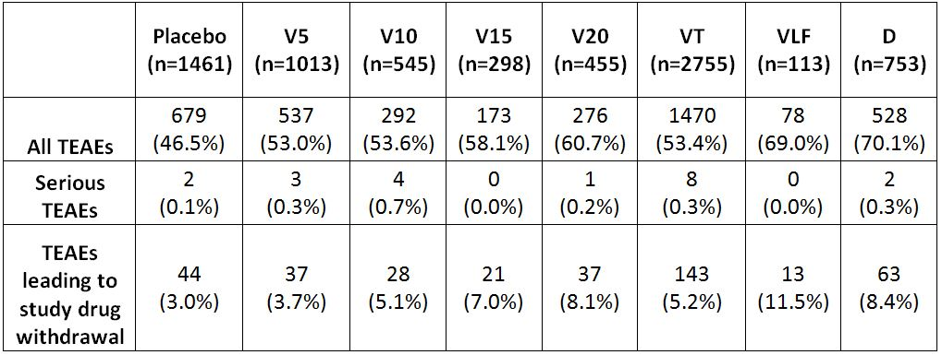
V=vortioxetine; VT=vortioxetine total; VLF=venlafaxine; D=duloxetine
TEAE=treatment-emergent adverse event
Table 31. Related TEAEs ≥1% compared with placebo (core treatment period by SOC and dose (APTS) – STP).
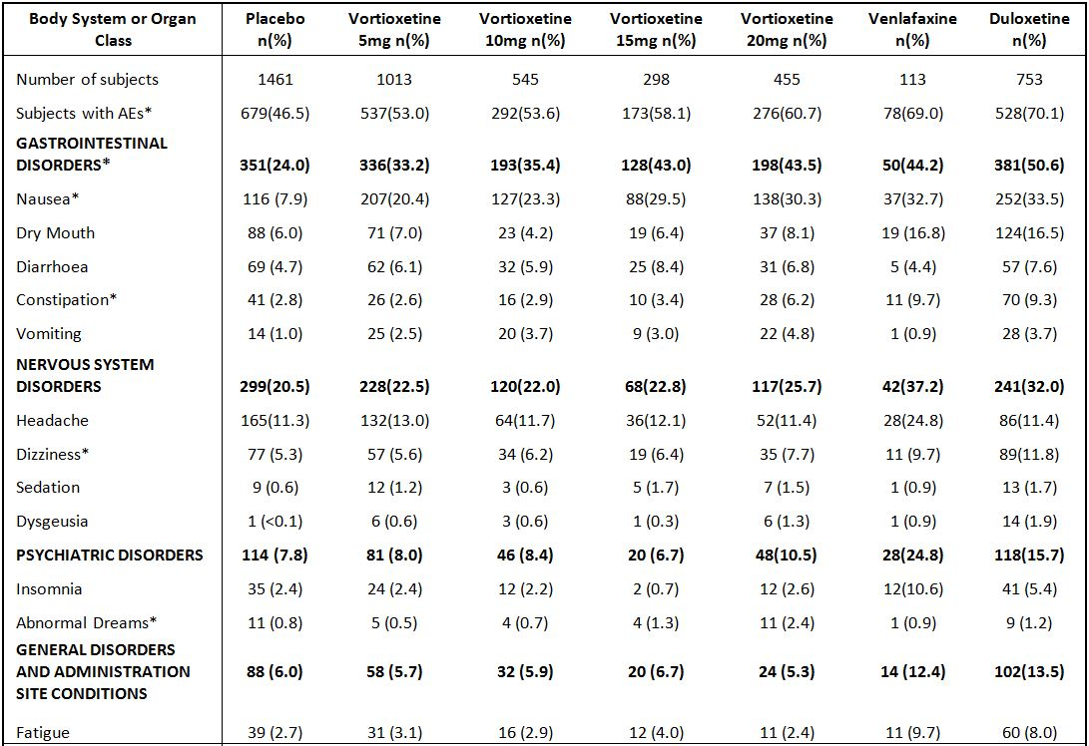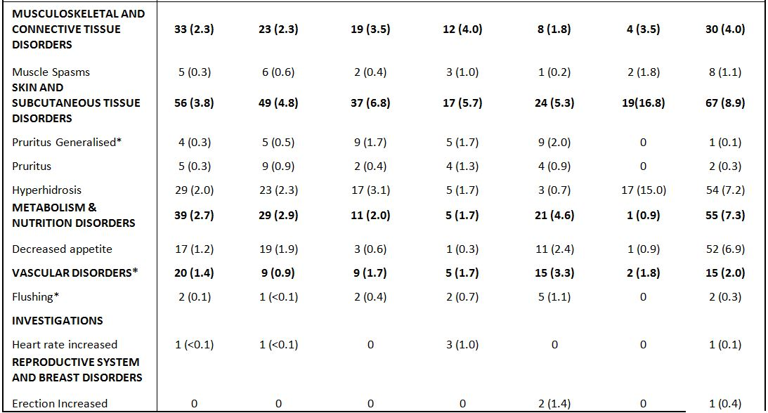
*dose response relationship
Comment: The patterns of ADRs in the STP (for overall TEAE incidence, SAE incidence and incidence of TEAEs leading to withdrawal) are similar to those seen for AEs irrespective of relationship to study drug. In particular, GI disorders and Nervous System disorders accounted for most ADRs and AEs, with nausea consistently the most common ADR or AE in a dose-response manner.

Deaths

Pivotal studies
As of 29 February 2012, six deaths (all subjects received vortioxetine treatment) were reported in the 27 phase II/III studies in MDD and GAD (completed and ongoing). Narratives for the patients who died are included in the individual CSRs. Short descriptions are presented below:
- Two subjects died of cancer:
  - Subject [information redacted] woman in MDD short-term Study 11984A, was diagnosed with gallbladder cancer approximately one month after starting treatment with vortioxetine 5mg/day and died from the disease one month after last dose of vortioxetine. The patient was withdrawn from the study after 19 days of treatment due to out-of-range bilirubin values and reported cholestatic jaundice as an AE 10 days after the Withdrawal Visit. The patient had a medical history of cholelithiasis.
  - Subject [information redacted] treated with OL vortioxetine (10mg/day) in MDD relapse-prevention Study 11985A, was diagnosed with pancreatic carcinoma approximately one month after starting treatment with vortioxetine and died from the disease eight months after last dose of vortioxetine. The patient had a medical history of type 2 diabetes.
- One subject died from suicide:
  - Subject [information redacted] treated with OL vortioxetine (5mg/day for 28 days) in GAD relapse-prevention Study 12473A, committed suicide two days after withdrawal from the study after having been treated with vortioxetine for approximately one month. The patient had been thrown out of the house by their spouse, according to whom the patient might be suicidal. No previous history of suicide attempts had been reported. On the MADRS and C-SSRS, no suicidal thoughts were present prior to the event. During the study, there was little improvement on the HAM-A.
- One subject died from morphine intoxication:
  - Subject [information redacted] treated with vortioxetine (5mg/day) in GAD short-term Study 310, died from morphine intoxication three days after the baseline visit. No information was available regarding IMP intake during the three days prior to the event but according to the autopsy and toxicology report, there was no IMP in the stomach or body fluids. No relevant medical history was reported for this patient prior to the event. However, needle marks from previous injections were noted at the autopsy, indicating previous intravenous intake of drugs.
- Two subjects died from accidents:
  - Subject [information redacted] treated with vortioxetine (2.5mg/day) in MDD short-term Study 11984A, died from multiple trauma following a fall from a fourth-floor balcony on Day 55) and was withdrawn from the study because of this. The patient was enrolled in Study 11984B but did not take any OL IMP in that study (all tablets were returned). According to the investigator, the patient was not at risk of suicide and there were no signs of a suicidal act. On the same day, the MADRS item 10 (suicidal thoughts) score was zero. The patient had no relevant medical history and had not previously attempted suicide.
  - Subject [information redacted] treated with vortioxetine 5mg/day (duloxetine in lead-in Study 11984A), died on Day 169 in the OL long-term extension Study 11984B due to road traffic accident. The accident was caused by another driver. The patient did not have any history of dizziness or other AEs that could adversely affect his driving skills, except for one event of “blurry vision” six months earlier.
The deaths were considered not related to IMP by the investigator.
Comment: While the temporal relationship between vortioxetine exposure and the two cases of deaths from cancer appear unrelated in this submission, the four deaths from accident, suicide or trauma should be viewed with a high index of suspicion. Suicidality associated with antidepressant intake is a recognised phenomenon (compounded by suicidality associated with depressive illness per se). Hence, an association, albeit weak at this stage of the vortioxetine development program, cannot and should not be ruled out

Clinical pharmacology studies
No deaths occurred in any of the five new clinical studies the sponsor submitted in the second round.

Other serious adverse events

Pivotal studies
The overall incidence of SAEs in the completed phase II/III studies is summarised in Table 32.
Table 32. Treatment-emergent SAEs, entre study period (APTS): overview.
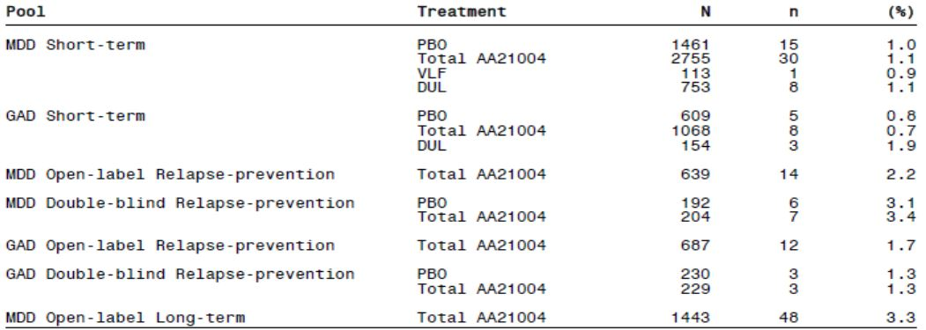
Comment: There were no apparent dose-response relationships for vortioxetine treatments and SAEs and the rates were similar to placebo and active controls.
In the second round evaluation, SAEs for the updated STP are summarised in Tables 21 and 22 in the clinical response document. The overall distribution and incidence of SAEs was consistent between the updated and original STPs. The serious TEAEs that occurred in ≥ 2 patients in any treatment group were:
- Convulsion: 2 patients (0.2%) in the vortioxetine 5mg group;
- Depression: 2 patients (0.1%) in the placebo group; 1 patient (< 0.1%) in the vortioxetine 5mg group; 3 patients (0.3%) in the vortioxetine 10mg group;
- Suicide attempt: 1 patient (< 0.1%) in the placebo group; 1 patient (< 0.1%) in the vortioxetine 5mg group; 2 patients (0.2%) in the vortioxetine 10mg group; 1 patient (0.1%) in the vortioxetine 20mg group.
SAEs for the updated LTP are summarised in the clinical response document. The overall distribution and incidence of SAEs was consistent between the updated and original LTPs. there were no apparent patterns in the SAEs with respect to distribution across the SOCs or preferred terms. The overall incidence of SAEs was 2.4%. Breast cancer female, cholelithiasis and suicide attempt were each reported in 2 patients: no other serious TEAE occurred in > 1 patient.

Clinical pharmacology studies
In the completed clinical pharmacology studies, four of the 1169 subjects exposed to vortioxetine had five SAEs; three of the subjects while exposed to 10mg vortioxetine and one subject while exposed to placebo:
- Abortion spontaneous – five weeks after discontinuation of treatment (gestational week 13) with multiple doses of vortioxetine 10mg and omeprazole (Study 11826A [omeprazole interaction study])
- Chest discomfort and dyspnoea – at discontinuation of treatment with multiple doses of vortioxetine 10mg (Study 102 [oral contraceptive interaction study])
- Traumatic fracture – one week after discontinuation of treatment with multiple doses of buproprion and vortioxetine 10mg (Study 117 [buproprion interaction study])
- Diverticulum intestinal hemorrhagic – one month after starting treatment (placebo). The subject completed the study (Study 111 [intrinsic factor study])

MDD ongoing OL pool

2.5 to 10mg/day
Forty-eight (48) subjects (3.3%) had SAEs during the entire study period. The SOC with the highest incidence of SAEs was psychiatric disorders (1% [14 patients]), mainly suicidal ideation and depression. There were no apparent trends or patterns in the other SAEs with respect to distribution across SOCs or preferred terms. The SAEs that occurred in ≥ 2 patients were: suicidal ideation (five patients; 0.3%); depression (four patients; 0.3%); appendicitis (two patients; 0.1%); influenza (two patients; 0.1%) and suicide attempt (two patients; 0.1%).

15 or 20mg/day
Twenty (20) patients (1.9%) had had 22 SAEs. The only SAEs that occurred in ≥ 2 patients were breast cancer female and cholelithiasis (two patients each). Approximately 27% of the SAEs belonged to the neoplasms SOC. There were no apparent trends or patterns with respect to distribution across SOCs or preferred terms.
Comment: In view of an increased incidence of hepatocellular adenomas and rectal polypoid adenomas reported in male and female rats and mice from the high dose groups in the 2-year carcinogenicity studies (non-clinical overview), more details on the neoplasms in the high-dose vortioxetine MDD ongoing OL pool was requested, as well as more current data.

Ongoing short-term phase II/III studies
No SAEs were reported in the two ongoing clinical pharmacology studies with vortioxetine (10 to 40mg/day). In the seven ongoing short-term phase II/III studies with vortioxetine (5 to 20mg/day), as of 29 February 2012, a total of 13 patients had reported 21 SAEs. No SAEs had been reported in Studies 318, 14122A, 14178A or OCT-001. The types of SAEs are claimed to be similar to those seen in the completed studies.

Active comparator study 14178A
The overall incidence for SAEs during the entire study period was 1.2% for the Total vortioxetine group (anxiety, depression, oedema peripheral, peptic ulcer perforation) versus 1.7% for the Total agomelatine group (breast cancer, GGT increased, metrorrhagia, hospitalisation for social reasons). No SAE occurred in > 1 patient in either treatment group.

Severe TEAEs
Most TEAEs were mild or moderate. The incidence of severe TEAEs was similar in the placebo and vortioxetine Total groups (5.0% and 6.2%, respectively). In the duloxetine group, the incidence was 8.2%. In the therapeutic vortioxetine dose groups, the incidence of severe TEAEs ranged from 3.4% in the 15mg group to 7.5% in the 5mg group. The severe TEAEs with an incidence ≥ 1% in any of the therapeutic vortioxetine dose groups were nausea and headache. The incidence of severe nausea was 0.1% (two patients) in the placebo group and 1.3% (six patients) in the vortioxetine 20mg group, which was the vortioxetine dose group with the highest incidence. In the duloxetine group, the incidence was 1.5%. The incidence of severe headache was 0.7% (10 patients) in the placebo group and 1.5% (15 patients) in the vortioxetine 5mg group, which was the vortioxetine group with the highest incidence. In the duloxetine group, the incidence was 0.5%.
In the MDD & GAD Short-term Pool, the pattern of TEAEs, with regards to incidences and severities, was similar to the STP. In the OLP of the MDD Long-term Relapse-prevention Study 11985A, the incidence of severe TEAEs was 13%. The severe TEAEs with the highest incidences (≥ 1%) were headache (1.6%), nausea (1.6%), and accidental overdose (1.3%). In the DBP, the incidence of severe TEAEs was approximately 10% in both treatment groups. The only severe TEAE that occurred in > 2 patients was accidental overdose, which was reported by three patients in each treatment group. All other severe TEAEs occurred in ≤ 2 patients.
In the OLP of the LTP (2.5 to 10mg/day), the incidence of severe TEAEs was 9%. The only severe AE with an incidence ≥ 1% was nausea (1.1%).
The sponsor provided collated intensity data from the individual study reports for the updated STP in its response document. The overall distribution of severe TEAEs for the updated STP was similar to the original STP. No dose-response trends were observed in the vortioxetine treatment groups. The incidence of related severe nausea was 0.1% in the placebo group, 1.0% in the vortioxetine 10mg/day group and 1.6% in the vortioxetine 15mg/day group. The incidence of related severe headache was 0.6% in the placebo group, 1.0% in the vortioxetine 10mg/day group and 1.4% in the vortioxetine 5mg/day group.
In the updated LTP (vortioxetine 15mg & 20mg/day), the incidence of severe TEAEs was 7.9%. The only severe AE with an incidence ≥ 1% was nausea (1.0%). These results are consistent with the original LTP results for the 2.5 to 10mg/day vortioxetine. In the active comparator study, 14178A, 4.3% of the patients in the Total vortioxetine group and 4.5% of the patients in the Total agomelatine group had severe TEAEs in the core treatment period (Table 268 CSR). The only severe TEAE with an incidence ≥ 1% in any of the treatment groups was insomnia (1.6% in the vortioxetine group) and headache in the agomelatine group (1.2%). Nausea was not reported as a severe TEAE for either comparator.

Discontinuation due to adverse events

Phase II/III studies
TEAEs leading to withdrawal were categorised as a) TEAEs with an onset in the Core Treatment Period or b) TEAEs with an onset after the Core Treatment Period.

MDD short-term pool
The TEAEs leading to withdrawal in ≥ 1% of patients with an onset in the Core Treatment Period are summarised for the therapeutic vortioxetine dose groups in Table 33. The incidence of TEAEs leading to withdrawal was lowest in the placebo group (3.5%) with a dose-response relationship in total AEs that lead to withdrawal in the vortioxetine dose range 5 to 20mg/day (4.5 to 8.4%). The incidence rate for the 15 to 20mg/day vortioxetine was similar to duloxetine (8.8%) and lower than venlafaxine (14.2%).
Table 33. TEAEs leading to withdrawal with an incidence ≥1% in the core treatment period (APTS), STP.
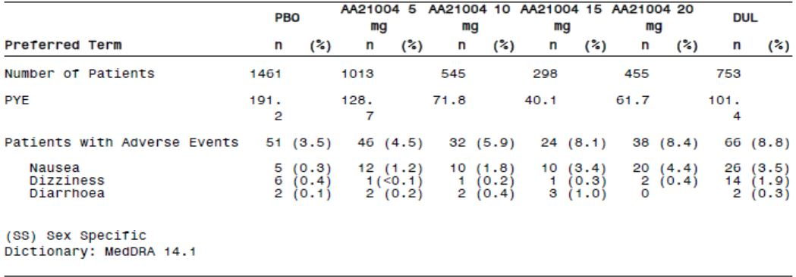
The SOC with the highest incidence of TEAEs leading to withdrawal was ‘gastrointestinal disorders’ for placebo (1.0%) and all treatment groups (range 1.4% for vortioxetine 1mg/day to 5.3% in the vortioxetine 20mg/day group). There was a trend towards a dose-response relationship between 1mg to 20mg/day vortioxetine.
The TEAE that most frequently contributed to withdrawal in each of the active treatment groups was nausea. The incidence of nausea leading to withdrawal was lowest in the placebo group (0.3%), with a trend towards a dose-response relationship in vortioxetine treatment across the range 1mg to 20mg/day (0.7 to 4.4%). Venlafaxine and duloxetine treatments had 3.5% incidence rates for nausea, similar to vortioxetine 15mg/day.
A Nelson-Aalen plot of time to withdrawal due to nausea is presented in Figure 12. Most patients who withdrew due to nausea did so early in the study. These withdrawals tended to occur earlier in the duloxetine group than in the therapeutic vortioxetine dose groups.
Figure 12. Nelson-Aalen plot of time to withdrawal due to nausea, core treatment period, by dose (APTS) - STP.
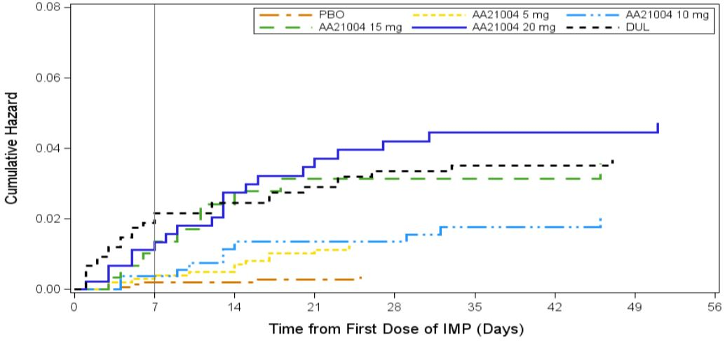
In the second round, the sponsor provided updated STP incidence rates for study withdrawals. The distribution and incidence rates for TEAEs that lead to study withdrawal in the updated STP report were generally consistent with the original STP results. Whereas in the original STP results dose-response trends were observed for overall TEAE withdrawals, and for nausea and dizziness, these trends were not so clear in the updated STP results. In particular, the incidence rates for the 20mg vortioxetine dose were lower than the 15mg regimen for overall incidence rate, nausea, headache and diarrhoea. The dose-response trend for dizziness leading to withdrawal remained. The apparent lowering of the incidence of TEAEs that lead to study withdrawal for the 20mg vortioxetine regimen between cut-off dates was unexpected. Proportionately, nausea still accounted for approximately 50% of TEAEs that lead to withdrawal in the original (52.3%; 4.4/8.4) and updated (48.5%; 3.3/6.8) reports for the 20mg dose. Given the small numbers of subjects with observed TEAEs that lead to study withdrawal, caution should be exercised in interpreting these results.

MDD & GAD short-term pool
Overall, the incidences and types of TEAEs leading to withdrawal in the MDD & GAD Short-term group reflected those in the STP. Any differences were small and not clinically relevant.

MDD long-term relapse-prevention study 11985A
During the OLP, the incidence of TEAEs leading to withdrawal was 8.6%. The TEAEs leading to withdrawal with the highest incidences were nausea (2.7%) and vomiting (1.3%). An additional four patients withdrew due to TEAEs with an onset in the Safety Follow-up Period following the OLP (nasopharyngitis, nausea and vomiting, and nausea [two patients]). During the DBP, the incidence of TEAEs leading to withdrawal was lower in the placebo group than in the vortioxetine group (1.0% versus 6.9%). The TEAEs leading to withdrawal with the highest incidences were: nausea (placebo: 0%; vortioxetine: 1.5% [three patients]) and nasopharyngitis (placebo: 0%; vortioxetine: 1.0% [two patients]).

GAD long-term relapse-prevention study 12473A
During the OLP, the incidence of TEAEs leading to withdrawal was 8.9%. Except for nausea, which had an incidence of 2.9%, none of the TEAEs leading to withdrawal had an incidence ≥%. An additional three patients withdrew due to TEAEs with an onset in the Safety Follow-up Period following the OL Period (blood pressure increased, migraine [SAE] and somnolence). During the DBP, the incidence of TEAEs leading to withdrawal was lower in the placebo group than in the vortioxetine group (1.3% versus 2.6%). There was no apparent pattern in the TEAEs leading to withdrawal between or within treatment groups; none of the TEAEs led to withdrawal in >1 patient in either treatment group. One patient in the vortioxetine group had a severe anaphylactic allergic reaction on Day 289. The patient was hospitalised and recovered. Two days later, the patient withdrew from the study due to the TEAE. An additional three patients (all in the placebo group) withdrew due to TEAEs with an onset in the Safety Follow-up Period following the DBP.

MDD OL long-term pool (2.5 to 10mg/day)
In the LTP, the incidence of TEAEs leading to withdrawal was 6.2%. The SOC with the highest incidence of TEAEs leading to withdrawal was ‘psychiatric disorders’ (2.2%). Except for nausea, which had an incidence of 1.0%, none of the TEAEs leading to withdrawal had an incidence ≥ 1%.

MDD ongoing OL long-term pool (15 or 20mg/day)
The incidence of TEAEs leading to withdrawal in the MDD Ongoing OL Long-term Pool was 8.3%. Except for nausea, which had an incidence of 2.4%, none of the TEAEs leading to withdrawal had an incidence ≥ 1%.
In the second round, the sponsor provided updated LTP incidence rates for study withdrawals. The distribution and incidence rates for TEAEs that lead to study withdrawal in the updated LTP report were generally consistent with the original LTP results. The overall incidence rate was 10.5%. Except for nausea, which had an incidence of 2.6% and vomiting (1.0%), no TEAE that lead to withdrawal had an incidence ≥ 1%.

Ongoing short-term phase II/III studies
Sixty-nine (69) patients (of the 1416 randomised) had withdrawn due to AEs in the ongoing phase II/III studies with vortioxetine (5 to 20mg/day).

Active comparator study 14178A
During the core treatment period, 5.5% of Total vortioxetine subjects had TEAEs that lead to study withdrawal compared with 8.3% in the Total agomelatine group. The only TEAE leading to withdrawal with an incidence ≥ 1% in the vortioxetine group was vomiting (1.2%) and in the agomelatine group it was dizziness (2.1%).

Clinical pharmacology studies
There were 3.2% (n=37) of 1169 subjects exposed to vortioxetine who withdrew during the entire study period compared with 1.4% for the placebo group and 1.0% for other study drugs. Vomiting accounted for the greatest proportion of withdrawals in the Total vortioxetine group (0.6%; n=7), followed by urticaria (n=4), increased blood pressure (n=3) and syncope (n=3).
Note: Four additional AEs were reported in Study 10467 but ‘due to the data collection procedure, the specific events leading to withdrawal’ could not be identified.

Ongoing clinical pharmacology studies
Two subjects had withdrawn due to AEs in the two ongoing clinical pharmacology studies with vortioxetine (10 to 40mg/day). One subject in the 10mg group withdrew from Study CPH-004 due to vomiting and one subject withdrew from Study 14029A due to concomitant medication taken following the AE pruritus.
In the second round, the sponsor provided completed clinical study reports for Studies CPH-004, 14029A and 14520A. Review of the data revealed one only AE in Study CPH-004 lead to withdrawal (vomiting). No AE lead to withdrawal in either Study 14029A or Study 14520A.

Adverse events of special interest

Nausea
During the first week of treatment, the incidence was 6% in the placebo group and ranged in the therapeutic vortioxetine dose groups from 16% in the 5mg group to 26% in the 15mg group (all patients in the 15 and 20mg groups received 10mg during the first week of treatment). In the duloxetine group, the incidence of nausea in the first week was 32%. During the third week of treatment, the incidence of new AE of nausea had decreased to 1% in the placebo group, approximately 2% in all the therapeutic vortioxetine dose groups, and 1% in the duloxetine group. After three weeks of treatment, the incidence of new AE of nausea remained low in all treatment groups.
In the fourth week of treatment, the prevalence of nausea was 3% in the placebo group and 8%, 10%, 10%, and 14% in the therapeutic vortioxetine dose groups, respectively. In the last week of treatment (Week 8), the prevalence of nausea was 2% in the placebo group and 6%, 9%, 5%, and 10% in the therapeutic vortioxetine dose groups, respectively. The prevalence of nausea in the duloxetine group was 9% after four weeks of treatment and 5% after eight weeks.
The median duration of nausea ranged in the therapeutic vortioxetine dose groups between nine days in the 5mg group and 16 days in the 20mg group. In the placebo and duloxetine groups, the median duration was seven days.
A population PK/PD analysis for nausea, based on short-term MDD study data, showed a statistically significant relationship between treatment-emergent nausea and vortioxetine dose, and the average plasma concentration at steady state.
Comment: Results across the clinical studies, especially the short-term MDD studies, consistently demonstrated nausea to be the most common AE and the incidence (and prevalence) data suggested a dose-response relationship across the proposed vortioxetine dose range. This trend is supported by the PK/PD data. While the prevalence of nausea appeared to decline over study duration, the rates were still at least 3% greater than placebo.

Suicidal ideation and behaviour
A dedicated scale (the Columbia-Suicide Severity Rating Scale [C-SSRS]) was used to investigate the potential relationship between vortioxetine and suicidal ideation and behaviour. The C-SSRS comprises three questions that address suicidal behaviour and five questions that address suicidal ideation, with sub-questions assessing the severity. This results in a score between 1 and 10 or no intention (no suicidal ideation or behaviour and any non-suicidal self injurious behaviour). The tool was administered via patient interview. The C-SSRS scores (1 to 10) were mapped into the Columbia Classification Algorithm for Suicide Assessment (C-CASA) categories: C-SSRS scores 1 to 5 were regarded as suicidal ideation and C-SSRS scores 6 to 10 as suicidal behaviour.
In the clinical studies, two versions of the scale were used, the Baseline Version that explored the patients’ suicidal ideation and behaviour prior to the study (lifetime assessment) and the Since last visit Version that explored the patients’ suicidal ideation and behaviour since the last visit (during study assessment).
The C-SSRS was used in the following studies:
- Clinical pharmacology studies 13921A, 123 and 124
- MDD short-term studies 303, 304, 305, 13267A, 315 and 316
- MDD short-term study 12541A in elderly patients
- MDD open-label long-term Study 301
- GAD short-term studies 308, 309, 310 and 311
- GAD relapse-prevention study 12473A

Completed suicides and suicide attempts

Phase II/III studies
In all the completed phase II/III studies, one patient committed suicide. Also two patients died unwitnessed, under circumstances that remain unknown. These cases were not evaluated as suicides, but are mentioned here as no definitive conclusion can be made.
In the STP, three patients attempted suicide, without sequelae (incidence 0.11% CI 0.02, 0.32); one received vortioxetine 5mg/day and two received 10mg/day (all withdrew due to the event). In the LTP and the OLPs of the relapse-prevention studies in MDD and GAD, an additional three patients attempted suicide, without sequelae. Two patients had received vortioxetine 5mg/day and one patient received 10mg/day. No patients attempted suicide during the DBPs of the relapse-prevention studies in MDD and GAD. In the ongoing studies, two patients attempted suicide in the STP, placebo-controlled studies (blinded) and one patient attempted suicide in the ongoing OL studies.

Clinical pharmacology studies
No suicide attempts or self-injurious behaviour were reported.

Suicidal ideation and behaviour based on TEAEs

Phase II/III studies
In the STP, the incidence of TEAEs for the vortioxetine Total group was 0.5% versus 0.3% for the placebo group. Most events occurred during the Core Treatment Period and there was no indication of a dose-response relationship in the incidence or pattern of Suicide/Self-injury events. In the vortioxetine Total group, five patients had an intentional overdose; of these, one patient in the vortioxetine 5mg group also had suicide attempt (Patient [information redacted]) and two patients in the vortioxetine 20mg group also had intentional self-injury reported on the same day (Patients [information redacted] in Study 13267A).
The incidence of TEAEs in the MDD & GAD Short-term Pool was similar to the STP. The incidence of TEAEs in the MDD relapse-prevention Study 11985A OL period was 0.8%; one patient had suicide attempt another had suicidal ideation. In the DBP, there were no TEAEs in the vortioxetine group versus 0.5% (one patient) in the placebo group. The incidence of TEAEs in the GAD relapse-prevention Study 12473A OL period was 1.2%; four subjects had suicidal ideation but no patient had suicide attempt. In the DBP, there were no TEAEs in the vortioxetine group versus 2.2% (five patients) in the placebo group. The incidence of TEAEs in the LTP was 0.9%. Two patients had suicide attempt during long-term treatment with vortioxetine and seven had suicidal ideation.
In the completed phase II/III studies, 15 patients who received vortioxetine had intentional overdose. For nine of these patients, the intentional overdose was one additional tablet/capsule on one or more occasions due to lack of efficacy (two patients), stress (one patient), anxiety (one patient), vomiting (one patient), or unknown (four patients). No event was reported as an SAE and no patient withdrew due to the event.

Clinical pharmacology studies
No subject in the 31 clinical pharmacology studies had TEAEs captured as Suicide or Self-injury.

Suicidal ideation and behaviour based on the C-SSRS

MDD short-term pool
In the short-term studies in MDD, the pre-treatment assessments of C-SSRS (All Prior History and Recent History) showed an even distribution in the treatment groups with respect to the proportions of patients in each of the suicidal ideation (C-SSRS Categories 1 to 5) and suicidal behaviour (C-SSRS Categories 6 to 9) categories. For the suicidal ideations, there were no clinically relevant differences between the treatment groups in the overall proportions of patients with severe suicidal ideations (C-SSRS Categories 4 and 5). Two patients had a Recent History of severe suicidal ideation: one in the placebo group and one in the vortioxetine 5mg group had active suicidal ideation with specific plan and intent. In addition, two patients had a Recent History of suicidal behaviour: one patient in the vortioxetine 5mg group and one patient in the vortioxetine 20mg group had not fatal suicide attempt.
In the short-term studies in MDD (303, 304, 305, 13267A, 315 and 316), the proportion of patients with suicidal ideation (C-SSRS Categories 1 to 5) in the post-baseline assessment was 16% in vortioxetine Total group versus 17% in the placebo group. In the vortioxetine dose groups, the incidence of suicidal ideation ranged from 7.1% to 21%, with no indication of a dose-response relationship. Also, there were no clinically relevant differences between the treatment groups in the overall proportions of patients with severe suicidal ideations (C-SSRS Categories 4 and 5).
In the STP, the shift in the C-SSRS scores comparing the All Prior History (derived from screening and baseline data) to the C-SSRS scores post-baseline and comparing Recent History (derived from baseline data only) to the C-SSRS scores post-baseline demonstrated:
- for patients with no history of suicidal ideation or behaviour, the proportion of patients with post-baseline suicidal ideation in the vortioxetine Total group was 2.3% versus 5.5% in the placebo group; two patients (both in the vortioxetine group) had suicidal behaviour
- for patients with a history of suicidal ideation, none had suicidal behaviour post-baseline. The proportion of patients with post-baseline suicidal ideation in the vortioxetine Total group was 38% versus 36% in the placebo group.
- for patients with a history of suicidal behaviour, the proportion of patients with post baseline suicidal ideation in the vortioxetine Total group was 35% versus 28.0% in the placebo group; one patient (in the vortioxetine Total group) had suicidal behaviour post-baseline.
In the second round, C-SSRS was included in Studies 317, 14122A and CCT-002. The post-baseline C-SSRS scores for the updated STP were summarised by C-CASA category, as in the first-round submission.
No patients committed suicide in the studies completed between the time the MAA was submitted to TGA and 31 August 2013, but two subjects attempted suicide (1 placebo group: preparatory action towards imminent suicidal behaviours [C-SSRS categories 6 to 8] and 1 total vortioxetine group: not fatal suicide attempt [C-SSRS category 9]). However, overall incidence rate of suicide attempts in the updated STP was virtually unchanged in the vortioxetine Total and placebo groups compared with the original STP. In the updated STP, the incidences and pattern of suicide or self-injury TEAEs were similar to those in the original STP.

MDD and GAD short-term pools
In the short-term studies in MDD and GAD, the pre-treatment assessments (All Prior History and Recent History) showed an even distribution in the treatment groups with respect to the proportions of patients in each of the suicidal ideation (C-SSRS Categories 1 to 5) and suicidal behaviour (C-SSRS Categories 6 to 9) categories. Furthermore, for the suicidal ideations, there were no clinically relevant differences between the treatment groups in the overall proportions of patients with severe suicidal ideations (C-SSRS Categories 4 and 5). Using the C-CASA categories, one patient in the vortioxetine 10mg group had a Recent History of preparatory action towards imminent suicidal behaviours and one patient in the vortioxetine 5mg group, one patient in the vortioxetine 20mg group, and one patient in the placebo group had a Recent History of not fatal suicide attempt.
The proportion of patients with suicidal ideation (C-SSRS Categories 1 to 5) was 11% in the vortioxetine Total group versus 12% in the placebo group. In the vortioxetine dose groups, the incidence of suicidal ideation ranged from 7.1% to 15%, with no indication of a dose-response relationship. Also, there were no clinically relevant differences between the treatment groups in the overall proportions of patients with severe suicidal ideations (C-SSRS Categories 4 and 5). The shift in the C-SSRS scores that compared the All Prior History to the C-SSRS scores post-baseline, and shift analyses that compared the Recent History to the C-SSRS scores post-baseline showed similar results.

MDD short-term study 12541A in the elderly
In MDD short-term Study 12541A in the elderly, the C-SSRS was added after study start (Amendment SA01) and some patients had already had the screening visit. For these patients, the Already enrolled Version of the scale was used for the first assessment after the implementation of the scale; it explored the patients’ suicidal ideation and behaviour prior to the study and since study start.
In Study 12541A, one C-SSRS assessment (at baseline) was made prior to first dose of IMP and the data from this assessment constitute the All Prior History. The proportions of patients with an All Prior History of suicidal ideation (C-SSRS Categories 1 to 5) and suicidal behaviour (C-SSRS Categories 6 to 9) were similar in the placebo group and the vortioxetine 5mg group. One patient (duloxetine group) had severe suicidal ideation (C-SSRS Categories 4 and 5). Using the C-CASA categories, two patients (both in the placebo group) had a history of preparatory action towards imminent suicidal behaviours and approximately 5% of the patients in each treatment group had a history of not fatal suicide attempt.
The proportion of patients with suicidal ideation was 12% in the vortioxetine 5mg group versus 9.6% in the placebo group. No patient had severe suicidal ideations (C-SSRS Categories 4 and 5) or preparatory action towards imminent suicidal behaviours, not fatal suicide attempt, or completed suicide during the study. The proportions of MDD patients with post-baseline suicidal ideation was 12% in the elderly versus 19% in adult patients with MDD (in the vortioxetine 5mg group in Studies 303, 304, 305, 13267A and 316). The shift in the C-SSRS scores that compared the All Prior History to the C-SSRS scores post-baseline showed no trends or differences between the treatment groups.

MDD OL long-term study 301
The proportion of patients with an All Prior History of suicidal ideation was 24%. A total of 7.1% and 1.8% of the patients had an All Prior History of not fatal suicide attempt or preparatory action towards imminent suicidal behaviours, respectively. A total of five patients had an All Prior History of severe suicidal ideations (C-SSRS Categories 4 and 5).
During OL long-term treatment with vortioxetine in Study 301, the proportion of patients with suicidal ideation was 9.6%, which was similar to the MDD short-term studies (16%) and in the MDD and GAD short-term studies (11%). Two patients had severe suicidal ideation (C-SSRS Categories 4 and 5); one patient had not fatal suicide attempt and two patients had preparatory action towards imminent suicidal behaviour.
The shift of the C-SSRS scores that compared the All Prior History to the C-SSRS scores post-baseline showed:
- for patients with no history of suicidal ideation or behaviour, the proportion of patients with post-baseline suicidal ideation was 2.2%; one patient had suicidal behaviour
- for patients with a history of suicidal ideation, the proportion of patients with post-baseline suicidal ideation was 25%; one patient had suicidal behaviour
- for patients with a history of suicidal behaviour, the proportion of patients with post baseline suicidal ideation was 23%; one patient had suicidal behaviour

GAD long-term relapse-prevention study 12473A
One C-SSRS assessment (at baseline) was made prior to first dose of IMP. The proportion of patients with an All Prior History of suicidal ideation was 6.0%, which was lower than that in the MDD and GAD short-term studies (21%). The proportion of patients with an All Prior History of not fatal suicide attempt was 1.8%. One patient had an All Prior History of severe suicidal ideations (C-SSRS Categories 4 and 5). At baseline II, most (> 99%) patients in both treatment groups had no suicidal ideation or behaviour.
During the OLP, the proportion of patients with suicidal ideation was 5.1%. Two patients had severe suicidal ideation (C-SSRS Categories 4 and 5). No patient had not fatal suicide attempt or completed suicide. A total of four patients had preparatory action towards imminent suicidal behaviours. During long-term treatment in the DBP, the proportion of patients with suicidal ideation in the vortioxetine group was 2.2% versus 3.5% in the placebo group. No patient had not fatal suicide attempt or completed suicide. One patient in the vortioxetine group and three patients in the placebo group had preparatory action towards imminent suicidal behaviours. No patient had severe suicidal ideation (C-SSRS Categories 4 and 5) during the long-term DBP.
The shift in the C-SSRS scores that compared the All Prior History and baseline II scores to the C-SSRS scores post-baseline in the OLP and DBP showed no trends or differences between the treatment groups.

Clinical pharmacology studies
In the clinical pharmacology studies (13921A, 123 and 124), none of the subjects who received vortioxetine reported any suicidal ideation or behaviour in the post-baseline C-SSRS interviews.
Comments: The C-SSRS evaluation in three clinical pharmacology studies and 13 phase II/III studies did not identify any events of suicide or suicide attempts (C-SSRS items 9 and 10) that had not already been captured as AEs. The results captured for spontaneous AEs were consistent with those identified using C-SSRS data, in which incidence of suicidal ideation was evenly distributed across treatments (including placebo), although the rates tended to be higher using C-SSRS data.
The incidence of suicidal ideation or behaviour appeared to be lower in the elderly compared with adults. This may provide a therapeutic benefit of vortioxetine in the elderly population, an ‘at risk group’ for suicidality (especially elderly males). No breakdown by gender has been provided for the elderly in this submission.

Laboratory tests

Clinical chemistry

Liver function

MDD short-term pool
Overall incidence of post-baseline PCS ALT or AST values (≥ 3 x ULN) was similar in the placebo group (0.7%) and the vortioxetine Total group (0.5%). In the vortioxetine groups, there was no indication of a dose-response relationship. Ten (10) of the 15 patients were in the vortioxetine 5mg group. For most patients in the vortioxetine groups with post-baseline PCS ALT or AST values, the elevated ALT or AST values were sporadic or transient, or the values decreased towards normal during continued treatment. No subject in the vortioxetine groups withdrew due to PCS ALT or AST values.
Among patients in the placebo group with PCS ALT and/or AST values: one patient had an ALT value ≥3 x ULN (178U/L) and an AST value ≥5 x ULN (353U/L) at the final visit (Day 44). At baseline, the values were normal and at Day 40, the ALT and AST values were 37 and 58U/L, respectively. The patient did not have any related AEs.
Among patients in the vortioxetine groups with PCS ALT and/or AST values: three patients in the 5mg group had AST or ALT values ≥5 x ULN. In all three patients, the values decreased during continued treatment with vortioxetine; two of the patients continued in the OL extension studies during which all liver values were normal or below the PCS limit. The values were reported as AEs. The third patient also had an AE of increased creatinine kinase and withdrew from the study due to the event and one patient in the 5mg group (Patient [information redacted] in MDD short-term Study 11984A) concurrently had a PCS AST value and a total bilirubin value >2 x ULN. The patient was withdrawn due to the out-of-range bilirubin value and reported cholestatic jaundice as an AE 10 days after withdrawal. The patient was later diagnosed with gall bladder cancer and died 30 days after last dose of IMP.
Comment: Patient number [information redacted] died 30 days after the last dose of IMP (vortioxetine 5mg/day). The laboratory values recorded are consistent with a Hy’s Law case but given the gallbladder carcinoma diagnosis during IMP treatment it is highly improbable vortioxetine accounted for the major component of the raised liver enzymes. However, a Hy’s Law case cannot be ruled out.

MDD & GAD short-term pool
Overall incidence of post-baseline PCS ALT or AST values in the placebo and vortioxetine Total groups were similar to those in the MDD Short term Pool (approximately 0.5%). No subject in the placebo group with PCS ALT and/or AST values in the GAD studies fulfilled any additional criteria.

MDD OL long-term pool (2.5 to 10mg/day)
Overall incidence of PCS ALT or AST values was 1.1% (n=16/1443). Two subjects (0.1%) had ALT or AST ≥ 5 x ULN, one subject (<0.1%) had ALT or AST ≥ 10 x ULN and three subjects (0.2%) had ALT and AST ≥ 3 x ULN. There were no Hy’s Law cases.

Other clinical chemistry
In the MDD short-term studies, the mean changes from baseline in clinical chemistry values were small and not clinically relevant and similar in the placebo and vortioxetine groups; no trends over time or between the vortioxetine dose groups were seen. In general, the incidences of post-baseline PCS lipid values were ≥ 3% in all treatment groups, including the placebo.
The mean changes from baseline in clinical chemistry values in the MDD & GAD short-term pool were small, not clinically relevant, and similar in the placebo and vortioxetine dose groups. No trends over time or between the vortioxetine dose groups were seen. One patient had a serum sodium level of 108mmol/L on Day 56 (completion visit).
In the MDD long-term relapse-prevention study, 11985A, mean changes from baseline in clinical chemistry values were small and not clinically relevant. The incidences of post-baseline PCS clinical chemistry values in the OLP were low and did not increase over time. The highest incidences of PCS values were for lipids. 10% patients with normal total cholesterol values at baseline and 8% with normal LDL cholesterol values at baseline had high values at last assessment. Mean changes from baseline II in clinical chemistry values during the DBP were small and similar between treatment groups. The clinical chemistry tests with an incidence of post-baseline PCS values ≥ 3% in either treatment group were: high triglycerides (placebo: 11%; vortioxetine: 10%); high LDL cholesterol (placebo: 1.1%: vortioxetine: 6.1%); low HDL cholesterol (placebo: 5.4%; vortioxetine: 5.6%) and high HDL cholesterol (placebo: 2.2%; vortioxetine: 4.1%). The incidences of post-baseline PCS lipid values were similar in placebo and vortioxetine groups, except for PCS high LDL and HDL cholesterol (vortioxetine incidence > placebo).
In the GAD long-term relapse-prevention Study 12473A, the clinical chemistry results were in line with those in MDD long-term relapse prevention Study 11985A. The mean changes were small and the incidences of PCS values were low, except for lipids.
In the LTP (2.5 to 10mg/day), the mean changes from baseline II in clinical chemistry values for vortioxetine were small and not clinically relevant. No trends over time were seen.
Comments: The elevated lipid fractions are consistent with an association with depressive illness and cardiovascular disease. However, baseline lipids were raised in many treatment groups across the studies. Many subjects (especially in the US) had raised BMI and were smokers, so the study results should be interpreted with caution. In view of the proposed biological effect on dopamine, prolactin levels are not reported in these trials.

Haematology
No clinically relevant mean changes in haematology parameter values were found in patients treated with vortioxetine in the phase II/III studies. The incidences of post-baseline PCS haematology parameter values were generally low, with similar values for placebo and vortioxetine treatments (in the short-term MDD and GAD studies, and the relapse-prevention studies and the MDD OL long-term pools). No clear dose-response relationship with any haematology parameter was noted with vortioxetine treatment.

Body weight
Body weight was evaluated at screening and/or baseline and, at least, at Week 4 and at completion/withdrawal, except in Study 11492A in which body weight was not assessed at Week 4. A PCS weight change was defined as a weight increase or decrease ≥7% relative to baseline or baseline II.
In the STP, the mean weight at baseline was comparable between treatment groups (range: 75 to 83kg). There were only small fluctuations in weight during the 8-week treatment period, similar between placebo and vortioxetine treatments. Overall, the weight changes (mean and PCS) in the MDD & GAD Short-term Pool reflected those in the STP.
During the OL phase of the MDD long-term relapse-prevention study, 11985A, the mean change from baseline to Week 12 was small (0.2kg) and the incidence of PCS weight changes low. Approximately 2% of patients had a PCS weight increase and approximately 2% of the patients had a PCS weight decrease. During the DBP, only small fluctuations in weight from baseline and baseline II were seen, with no trends over time or between treatment groups. At Week 36, the mean weight change from baseline II was 0.3kg in the placebo group and 0.6kg in the vortioxetine group. At last assessment, the mean change from baseline II was 0.1kg in the placebo group and 0.4kg in the vortioxetine group.
In GAD long-term relapse-prevention study 12473A, the mean weight and changes from baseline in the OLP were similar to those in MDD relapse-prevention study, 11985A. The mean change from baseline to Week 20 was small (0.2kg) and the incidence of PCS weight changes was low. Approximately 3% of patients had PCS weight increases and approximately 3% had PCS weight decreases. At Week 44, the mean weight change from baseline II was 0.4kg in the placebo group and 0.5kg in the vortioxetine group. At last assessment, the mean change from baseline II was 0.4kg in the placebo group and 0.6kg in the vortioxetine group. During the DBP, the incidence of PCS weight increases relative to baseline was lower in the placebo group than in the vortioxetine group (10 versus 14%).
In LTP (2.5 to 10mg/day), the mean baseline weight was 77kg. The mean weight change from baseline and baseline II (up to 52 weeks) was small (≤ 1kg), although a slight mean increase over time was seen. In the 15 or 20mg/day long-term pool, the mean baseline weight was 88kg. The mean weight change from baseline and baseline II (up to 52 weeks) was small (≤ 1kg).

Urinalysis
Urinalysis results did not show any clinically relevant changes in patients treated with vortioxetine or relevant differences between treatment groups in the short-term studies in MDD and GAD, the long-term relapse-prevention studies in MDD and GAD (OLP and DBP) and the MDD OL long-term studies.

Electrocardiograph (ECG)
A 12-lead ECG was recorded for each patient at screening or baseline and, at least, at Week 4 and at completion/withdrawal, except in Study 11492A in which ECGs were recorded at Week 2 and at completion/withdrawal. ECGs were evaluated by a cardiologist at a central laboratory.
No clinically relevant mean changes in ECG parameter values were found in patients treated with vortioxetine in the phase II/III or clinical pharmacology studies. The incidences of post-baseline PCS ECG parameter values were generally low, with similar values for placebo and vortioxetine treatments (in DB treatment in the short-term MDD and GAD studies, and the relapse-prevention study). No clear dose-response relationship with any ECG parameter was noted with vortioxetine treatment.

Vital signs
Vital signs (supine and standing blood pressure, pulse rate) were evaluated at screening and/or baseline and at all visits to completion/withdrawal, except in Studies 11985A and 12473A in which vital signs were evaluated every 12 weeks during the DBP and at completion/withdrawal, and in Study 303 in which evaluations were performed at all visits, including completion/withdrawal, except Weeks 3 and 5. Study 104 evaluated the potential of vortioxetine to cause QTc prolongation.
No clinically relevant mean changes in vital sign values were found in patients treated with vortioxetine in the phase II/III or clinical pharmacology studies. The incidences of post-baseline PCS vital sign parameter values were generally low, with similar values for placebo and vortioxetine treatments (in the short-term MDD and GAD studies, the relapse-prevention studies and LTP). No clear dose-response relationship with any vital sign parameter was noted with vortioxetine treatment.

Adverse events of special interest

Antidepressant adverse effects

Akathisia and dyskinesia
Akathisia (including movement disorder and dyskinesia) may be AEs of psychotropic treatment. Although vortioxetine predominantly interacts with the serotonergic system, it also elevates levels of additional neurotransmitters such as dopamine.

Akathisia
In the STP, the incidence of TEAEs was similar in the placebo group (0.7%) and the vortioxetine Total group (0.8%). The majority of the events were restlessness; one patient in each of the placebo, vortioxetine, and duloxetine groups had akathisia. All events in the vortioxetine group were non-serious. Three patients withdrew: two patients in the placebo group (due to akathisia and restlessness) and one patient in the vortioxetine 5mg group (due to restlessness). In the MDD & GAD Short-term Pool, the long-term relapse-prevention studies in MDD and GAD, and the LTP, the incidences and pattern of TEAEs were similar to those in the STP. One patient had akathisia (OL Long-term Pool). All events were non-serious and only few patients withdrew from the studies.

Dyskinesia
In the STP, the incidence of TEAEs was similar in the placebo group (0.3%) and the vortioxetine Total group (0.3%). No event was dyskinesia. All events were mild and non-serious, and none resulted in withdrawal from the study. In the MDD & GAD Short-term Pool, the long-term relapse-prevention studies in MDD and GAD, and the LTP, the incidences and pattern of TEAEs were similar to those in the STP. No event was dyskinesia.

Seizures
In the STP, two patients in the vortioxetine 5mg group had convulsion (SAEs):
- Patient [information redacted], had convulsion (an episode of generalised tonic clonic seizures) on Day 28 of Study 303 in which he received vortioxetine 5mg/day. The patient had a history of traumatic head injury and seizures that included recent activity of seizure a few weeks prior to study start. The patient was withdrawn due to the event.
- Patient [information redacted], was violently assaulted and had head injury (also an SAE) that resulted in convulsion on Day 8 of Study 304 in which she received vortioxetine 5mg/day. The patient was hospitalised for two days due to the head injury and was withdrawn from the study due to this event.
No additional events were reported in the other phase II/III or clinical pharmacology studies.

Serotonin syndrome
In the STP, two patients, one in the placebo group and one in the duloxetine group, had serotonin syndrome, both were SAEs and both occurred after one day of treatment with IMP. The patients were withdrawn from the study and recovered without sequelae. Patient [information redacted] in MDD long-term relapse-prevention study 11985A had serotonin syndrome. The event was an SAE and occurred after one day of treatment with vortioxetine 5mg/day in the OLP. The patient developed severe migraine, dyspnoea, tachycardia, anxiety, nausea, sweat, and insomnia. The patient’s temperature was not measured and the events were not associated with convulsion. The patient was withdrawn due to the event and recovered after five days. No additional patient had serotonin syndrome in the MDD & GAD Short-term Pool, the LTP and the GAD long-term relapse-prevention study.

Activation of mania or hypomania
Patients presenting with mania or hypomania may be agitated, hostile and aggressive. In the STP, the incidence of TEAEs for hostility and aggression was similar in the placebo group (2.9%) and the vortioxetine Total group (2.2%). The most frequent event in all treatment groups was irritability. In the vortioxetine dose groups, there was no clear dose-response relationship in the incidence of irritability. In the placebo group, the incidence of irritability was 1.6%. No patient in the vortioxetine group had mania; one patient in the vortioxetine 10mg group had hypomania and the patient was withdrawn due to the event. One patient in the duloxetine group had mania. All events were non-serious, except one event of injury in the vortioxetine 5mg group. Twelve (12) patients had events that lead to withdrawal: three in the placebo group, two in the vortioxetine 5mg group, two in the vortioxetine 10mg group, two in the vortioxetine 15mg group, two in the vortioxetine 20mg group, and one in the duloxetine group.
In the MDD & GAD Short-term Pool and the LTP, the incidences and pattern of TEAEs were similar to those in the STP and there were no additional events of mania or hypomania. All events were non-serious, except one event of injury (mentioned above) and one event of sexual abuse in the duloxetine group (MDD & GAD Short-term Pool) and, two patients had hypomania and four patients in the LTP were withdrawn due to irritability [two patients] and agitation [two patients]. In the long-term relapse-prevention studies in MDD and GAD, all TEAEs were non-serious and none of them led to withdrawal from the study. No event of mania or hypomania was captured in the OLP or DBP.

Hyponatraemia
Hyponatraemia has been reported during treatment with SSRIs and SNRIs. In many cases, hyponatraemia appears to be the result of the syndrome of inappropriate antidiuretic hormone secretion (SIADH).
In the completed phase II/III studies, patient [information redacted]who received vortioxetine 10mg/day in Study 11984A, had hyponatraemia (sodium value 126mmol/L, mild and non-serious in the Safety Follow-up Period, 3 days after last dose of IMP). The sodium value had decreased from 133mmol/L at screening. The event occurred while the patient was hospitalised due to worsening of depression (SAE) for which he was withdrawn. The patient received multiple disallowed (according to the protocol) medications in the period between the date of last dose of IMP and the date of the Withdrawal Visit. No other signs or symptoms were reported for the patient in the Safety Follow-up Period.
In the GAD short-term Study 311, patient [information redacted] who received vortioxetine 5mg/day had a serum sodium value of 108mmol/L (reference range: 134 to 146mmol/L) on Day 56 (Completion Visit). She also had serum calcium, chloride, creatinine, glucose, HDL cholesterol, potassium and protein values below the reference ranges; for calcium, the value was PCS (1.63mmol/L; reference range: 2.1 to 2.55mmol/L). No AEs were reported at the time of the Completion Visit or during the Safety Follow-up Period. At Screening and on Day 28, her serum chemistry values were within the reference ranges, except LDL cholesterol (2.85mmol/L), which was above the upper limit of the reference range (0 to 2.58mmol/L) at Screening.
In addition, one patient who received vortioxetine and two patients who received duloxetine had PCS low sodium values (≤ 125mmol/L but > 110mmol/L) during short-term treatment; during OL long-term treatment, two patients had PCS low sodium values. In MDD short-term Study 12541A in the elderly, the sodium test values showed no relevant changes over time in the vortioxetine group compared to the placebo group. No patients in the vortioxetine group had a PCS low post-baseline serum sodium value.

Abnormal bleeding
As platelet aggregation is inhibited by serotonin transporter inhibition, drugs that inhibit the serotonin transporter may result in increased bleeding tendencies. Mean platelet counts did not show any clinically relevant changes over time.
In Study 109, co-administration of multiple doses of vortioxetine 10mg/day with multiple doses of warfarin was well tolerated and had no apparent effect on the steady-state PK or on the PD of warfarin. No significant effects relative to placebo were observed in prothrombin or plasma R- or S-warfarin values or INR. No clinically relevant trends in the clinical safety laboratory test values were observed. In Study 116, multiple doses of vortioxetine 10mg did not lead to any statistically significant or clinically meaningful inhibitory effect on platelet aggregation and the co-administration of multiple doses of vortioxetine 10mg with multiple doses of aspirin had no synergetic effect on the ability of aspirin to inhibit platelet aggregation. No PK interaction was observed following co-administration of vortioxetine 10mg and aspirin. No clinical safety laboratory value was reported as an AE and no subject withdrew from the study because of an abnormal laboratory finding.
In the STP, the incidence of TEAEs was similar in the placebo group (1.1%) and the vortioxetine Total group (1.5%). All events in the vortioxetine dose groups were non-serious and none led to study withdrawal. One patient in the duloxetine group had an SAE (vaginal haemorrhage) after 17 days on IMP; the patient continued in the study. In the MDD & GAD Short-term Pool and the long-term relapse-prevention studies in MDD and GAD, the incidences and pattern of TEAEs were similar to those in the STP. All events were non-serious. Two patients withdrew from vortioxetine treatment. In the LTP, the incidence of TEAEs was 2.9%. The overall pattern of TEAEs was similar to the short-term pools. Three patients had SAEs: one had menorrhagia (the patient had uterine leiomyoma in the lead-in study during treatment with placebo); one patient had upper gastrointestinal haemorrhage and one patient had uterine haemorrhage. No TEAE led to withdrawal.

Bone fractures/osteoporosis
In the STP, the incidence of TEAEs was similar in the placebo group (< 0.1%) and vortioxetine Total group (0.1%). In MDD long-term relapse-prevention study, 11985A, one patient had osteoporosis in the OLP. In the DBP (up to 64 weeks), one patient in each treatment group had TEAEs. In the LTP (52 weeks), eight patients (0.6%) had TEAEs (all fractures).

Closed-angle glaucoma
In all short-term and long-term pools, and the relapse-prevention studies in MDD and GAD, no patient in the vortioxetine dose groups had glaucoma. In the STP, the incidence of TEAEs was similar in the placebo group (1.5%) and vortioxetine Total group (1.1%). Most events, in all vortioxetine dose groups, were vision blurred, and the incidences were comparable to placebo. No TEAE was a SAE. Five patients had vision blurred leading to withdrawal in the STP: two patients in the placebo group and one patient in each of the vortioxetine 5mg, venlafaxine and duloxetine groups. Six patients had TEAEs leading to withdrawal: four withdrew from the short-term studies in GAD (two patients in the placebo group [both vision blurred], one patient in the vortioxetine 5mg group [eye pain], and one patient in the duloxetine group [vision blurred]) and two patients withdrew from MDD relapse-prevention study, 11985A, (one patient during OL treatment with vortioxetine [photophobia and vision blurred] and one patient during DB treatment with placebo [vision blurred]).

Insomnia and somnolence

Insomnia
In the STP, the incidence of Insomnia TEAEs in the vortioxetine Total group was low (4.2%) and similar to placebo (4.6%). In the venlafaxine and duloxetine groups, the incidences were 16% and 8.1%, respectively. There was no indication of a dose-response relationship in the incidences and types of Insomnia TEAEs in the vortioxetine dose groups. Withdrawals due to Insomnia TEAEs were: one patient in the placebo group, six patients in the vortioxetine Total group, five patients in the venlafaxine group, and six patients in the duloxetine group. The incidences and pattern of Insomnia TEAEs in the MDD & GAD Short-term Pool, the long-term relapse-prevention studies in MDD and GAD, and the LTP were similar to those in the STP.

Somnolence
In the STP, the incidence of somnolence during treatment with vortioxetine was 2.8%, similar to placebo (2.7%). In the vortioxetine dose groups, the incidence ranged from 0.7% (vortioxetine 1mg group) to 3.3% (vortioxetine 10mg group), with no indication of a dose-response relationship. The incidences of somnolence in the venlafaxine and duloxetine groups were 0.9% and 8.5%, respectively. In the MDD & GAD Short-term Pool, the long-term relapse-prevention studies in MDD and GAD, and the LTP, the incidence of somnolence was similar to the STP.
In the MDD & GAD Short-term Pool, two patients withdrew from vortioxetine treatment due to somnolence, three patients withdrew from placebo due to somnolence, and eight patients withdrew from duloxetine due to somnolence. Five patients withdrew from the long term relapse-prevention studies in MDD and GAD (all from OL treatment) due to somnolence and five patients withdrew from vortioxetine treatment in the LTP due to somnolence.

Hypertension
The vital signs evaluations did not show any relevant changes over time. In the STP, the MDD & GAD Short-term Pool and the long-term relapse-prevention studies in MDD and GAD, the incidence (≤ 2 patients) and pattern of TEAEs was similar in the placebo group and the vortioxetine Total group. Most events were hypertension and blood pressure increased. In the completed phase II/III studies, one TEAE was an SAE: Patient [information redacted] who received vortioxetine 1mg/day in Study 305 had a hypertensive crisis on Day 9. The patient had a history of hypertension. She recovered and continued in the study. An additional six patients had hypertensive crisis:
- Placebo:
  - Patient [information redacted] who received placebo in Study 305 had a hypertensive crisis on Day 23. She recovered and continued in the study.
- Vortioxetine:
  - Patient [information redacted] who received vortioxetine 5mg/day in OL extension Study 11984B had a hypertensive crisis after 365 days. The patient had a history of hypertension. The patient recovered and continued in the study. The patient had received vortioxetine in the lead-in study;
  - Patient [information redacted] who received vortioxetine 5mg/day in OL extension Study 301 had a hypertensive crisis on Days 356 and 359. The patient recovered and continued in the study. The patient had received placebo in the lead-in study;
  - Patient [information redacted] who had received vortioxetine 5mg/day in GAD Study 311 had a hypertensive crisis on Day 3. The patient recovered and continued in the study;
  - Patient [information redacted] who had received vortioxetine 5mg/day in GAD long-term relapse-prevention Study 12473A had a hypertensive crisis on Days 17 and 36 of the OL Period. The patient recovered and continued in the study.
- Duloxetine:
  - Patient [information redacted] who received duloxetine in Study 12541A, had a hypertensive crisis on Day 5. The patient recovered and continued in the study.

General drug safety issues

Abuse liability
In the STP, the incidence of TEAEs was similar in the placebo group (4.2%) and the vortioxetine Total group (3.9%). In the therapeutic vortioxetine dose groups, the incidences were 3.0% (5mg), 4.4% (10mg), 5.4% (15mg) and 5.7% (20mg) i.e. a slight dose-response relationship was demonstrated. The most frequent events were irritability, sedation and agitation in all treatment groups. The most frequent reason for withdrawal due to an AE captured was irritability in the placebo and vortioxetine Total groups (two and four patients, respectively), while it was sedation in the duloxetine group (four patients). Events were non-serious in the placebo and vortioxetine dose groups while one patient in the duloxetine group had intentional overdose (SAE).
In the MDD & GAD Short-term Pool, the long-term relapse-prevention studies in MDD and GAD, and the LTP, the incidences and pattern of TEAEs were similar to those in the STP. Three patients receiving vortioxetine had SAEs; Patient 1009-008 died from morphine intoxication three days after the baseline visit in GAD short-term Study 310; Patient 3107 had intentional overdose (zopiclone) on Day 79 of OL treatment with vortioxetine in MDD OL extension Study 11984B (the patient received placebo in the lead-in study); Patient 0132-111 had confusional state on Day 114, one day after last dose of vortioxetine 5mg/day in MDD OL extension Study 301 (the patient received duloxetine in the lead-in study).

Severe skin reactions
In the phase II/III clinical studies no event in vortioxetine treatment groups was a severe skin disorder or a skin reaction with generalised symptoms. All events were non-serious and no subject in vortioxetine withdrew to the event, while two patients in the placebo group withdrew. The incidences and pattern of TEAEs in the MDD & GAD Short-term Pool, MDD long-term relapse-prevention study and the LTP and were similar to those in the STP. Two subjects who received vortioxetine withdrew to conjunctivitis but were not considered serious. No TEAEs were reported in the GAD long-term relapse-prevention Study.

QT prolongation
The ECG evaluation did not show any relevant changes over time.

Clinical pharmacology study
Study 104 evaluated the potential of vortioxetine to cause QTc prolongation. The administration of vortioxetine 10 or 40mg/day for 14 days to healthy men had no clinically significant effect on cardiac repolarisation using ICH E14 definitions. The upper bound of the two-sided 90% CI around the LS mean, time-matched, baseline-adjusted difference to placebo for QTcNi, QTcF, QTcB, and QTcFm was < 10ms for both doses of vortioxetine at all assessment time points. The pre-specified primary endpoint was the largest time-matched baseline-adjusted LS means difference for QTcNi (linear) to placebo at post-treatment ECG collection times. The maximum mean difference to placebo in QTcNi (linear) was 1.4ms (90% CI: -2.1; 4.9) for Vortioxetine 10mg/day and 4.4ms (90% CI: 0.9; 7.9) for vortioxetine 40mg/day. For the positive control moxifloxacin, the upper bound of the two-sided 90% CI around the LS mean, time-matched, baseline-adjusted difference to placebo for QTcNi (linear and non-linear), QTcF, QTcB, and QTcFm exceeded 10ms from 1 to 7 hours post-dose (inclusive), confirming the study had adequate sensitivity (Study 104). No correlations between the time-matched, baseline-adjusted QTc and the plasma concentrations of vortioxetine or its metabolites Lu AA34443 and Lu AA39835 were observed.

Phase II/III studies
The incidence of TEAEs was low in the vortioxetine dose groups in the STP with similar incidences in the placebo (0.1%) and vortioxetine Total groups (0.3%). Most events were electrocardiogram QT prolonged, non serious and not reported as arrhythmias or torsades de pointes. No events in the placebo or vortioxetine dose groups resulted in withdrawal from the study; one patient in the duloxetine group withdrew due to electrocardiogram QT prolonged. Three patients had syncope (moderate events): one patient in the placebo group, one patient in the vortioxetine 10mg group, and one patient in the duloxetine group. Additionally, one patient in the vortioxetine 2.5mg group had loss of consciousness (severe event; concurrent with an accident [kicked by a horse], soft tissue injury, arthralgia and swollen tongue).
In the MDD & GAD Short-term Pool, MDD long-term relapse-prevention study and the LTP, five patients had syncope: three patients who received vortioxetine 2.5mg/day in short-term studies in GAD and two patients during long-term treatment with vortioxetine; one event was mild, three events were moderate, and one event was severe; one patient withdrew due to syncope and nine other events. In addition, three patients withdrew from OL treatment with vortioxetine due to electrocardiogram qt prolonged, one of which also had Wolff-Parkinson-white syndrome.
In GAD long-term relapse-prevention Study 12473A, one patient had ventricular tachycardia on Day 5 of the OLP, withdrew from the study, and recovered. The patient had a history of obesity, ventricular extrasystoles, and hypertension and received beta blockers and angiotensin II antagonists. In addition, one patient had an SAE of electrocardiogram QT prolonged and electrocardiogram T wave inversion (non-serious) reported in the OLP. The patient completed the study. In the DBP, one patient in the vortioxetine group had electrocardiogram QT prolonged.

Nonclinical findings (target organ toxicity)
From the nonclinical overview: Target organ toxicity was restricted to kidneys (rats) and liver (mice and rats) and was mainly attributed to the crystalline material obstruction of the renal tubules and the bile ducts, respectively. These findings are considered only to pose a low risk to humans as crystal precipitation is considered not likely to occur at therapeutic dose levels. The findings are discussed in the RMP as an important potential risk.

Kidney toxicity
Clinical safety laboratory tests (including urinalysis) in the vortioxetine clinical development program showed no clinically relevant changes over time. No TEAE occurred in ≥ 2 patients in the vortioxetine dose groups in any pool or study. In the other treatment groups in the MDD & GAD Short-term Pool, the TEAEs in ≥ 2 patients were proteinuria (two patients in the placebo group), blood creatinine increased (three patients in the placebo group), and protein urine present (two patients in the duloxetine group). In MDD long-term relapse-prevention Study 11985A, no TEAEs were captured. In the STP, overall incidence of TEAEs for Acute Renal Failure was similar in the placebo group (0.1%) and vortioxetine Total group (0.1%). All events were non-serious and none resulted in withdrawal from the study.

Liver toxicity
Clinical safety laboratory tests in the vortioxetine clinical development program showed no clinically relevant changes over time. In the STP, overall incidences of TEAEs were similar in the placebo group (1.0%) and vortioxetine Total group (0.6%). In the vortioxetine dose groups, all TEAEs were non-serious, except for jaundice cholestatic (Patient [information redacted]). Four patients had TEAEs leading to withdrawal in the STP: two patients in the placebo group (one patient had ALT increased and AST increased; one patient had ALT increased), one patient in the vortioxetine group (5mg; blood alkaline phosphatase increased and γ-GT increased) and one patient in the duloxetine group (ALT increased and AST increased). In the MDD & GAD Short-term Pool, the long-term relapse-prevention studies in MDD and GAD, and the LTP, the incidences and pattern of TEAEs were similar to those in the STP. All events in the Core Treatment Periods were non-serious.
In the updated STP, the incidences and pattern of TEAEs captured for seizures, serotonin syndrome, hyponatraemia, bones fractures/osteoporosis, akathisia, dyskinesia, activation of mania/hypomania, abnormal bleeding, closed-angle glaucoma, insomnia/somnolence, hypertension, abuse liability, severe skin reactions, QT prolongation, kidney toxicity and liver toxicity were similar to those in the original STP.

Safety issues with the potential for major regulatory impact

Sexual dysfunction

Phase II/III studies
In the STP, the overall incidence of sexual dysfunction TEAEs during treatment with vortioxetine was low (1.7%) versus placebo (1.2%). Overall incidence of sexual dysfunction TEAEs during treatment with vortioxetine ranged from 0% to 5.0% in the individual studies (not in a dose-related manner) compared with placebo, duloxetine and venlafaxine groups. The incidence rates were 13, 9, 34, and 119 per 100 PYE in the total vortioxetine, placebo, duloxetine and venlafaxine groups, respectively. The most common sexual dysfunction TEAE during treatment with vortioxetine was libido decreased: overall incidence was 0.8%, which was similar to placebo (0.8%).
Addition of the GAD studies to the short-term pool did not change the overall pattern between the groups in incidences, incidence rates or types of sexual dysfunction TEAEs. During the OLP, MDD Long-term Relapse-prevention study, 11985A, 2.5% patients had a sexual dysfunction TEAE. The most common (> 2 patients) TEAEs were libido decreased (1.4%), erectile dysfunction (1.7%), and ejaculation delayed (1.2%). During the DBP, 2.0% patients in the vortioxetine group and 1.0% in the placebo group had a sexual dysfunction TEAE. No event was reported by >2 patients. The types and incidences of sexual dysfunction TEAEs in GAD long-term relapse-prevention study, 12473A, were similar to those in the MDD relapse-prevention study, 11985A, in OLP and DBP. During long-term treatment with vortioxetine, in the LTP, the incidence of sexual dysfunction TEAEs remained low (1.7%). The incidence rate was 2.2 per 100 PYE. The most common sexual dysfunction TEAEs during long-term treatment with vortioxetine were libido decreased (0.9%) and erectile dysfunction (1.0%).

Sexual dysfunction based on the Arizona Sexual Experience Scale (ASEX)
The ASEX is a 5-item, patient self-rated scale that evaluated a patient’s recent sexual experiences. Patients were asked to assess their own experiences over the last week (for example, "How strong is your sex drive?", "Are your orgasms satisfying?") and respond on a 6-point scale for each item. The ASEX was used to dichotomously divide patients into those with and those without sexual dysfunction (sexual dysfunction status). Based on the ASEX, sexual dysfunction was defined as at least one of the following: an ASEX total score ≥ 19; a score ≥ 5 on any ASEX item; a score ≥ 4 on ≥ 3 ASEX items. For patients who did not fulfil these criteria at baseline, but who did so during the Core Treatment Period, the sexual dysfunction was considered treatment-emergent (TESD).
In the phase II/III program, the ASEX was assessed in MDD short-term Studies 304 & 13267A, and GAD short-term Study 308 at all visits from screening to completion/withdrawal and in MDD short-term Studies 315 & 316 from baseline to completion/withdrawal. In MDD short-term Study 11984A, the ASEX was assessed at all visits (from screening to completion/withdrawal) after local approval of Amendment SA01. The assessment of TESD was based on the subset of patients without sexual dysfunction at baseline. As there is no confounding by indication, data from all these studies in MDD and GAD were pooled. A Mantel-Haenszel approach with ‘stratification by study’ estimated the pair-wise treatment differences between the placebo, vortioxetine Total and duloxetine groups with the associated two-sided 95% CI. Using a similar approach, a comparison between the placebo group and each vortioxetine dose group was performed. The ASEX total scores and individual item scores and changes from baseline therein were summarised by dose (Table 34).
Table 34. Incidence of TESD, Core Treatment Period, by Dose (APTS) in Studies 11984A, 304, 13267A, 315, 316 and 308.
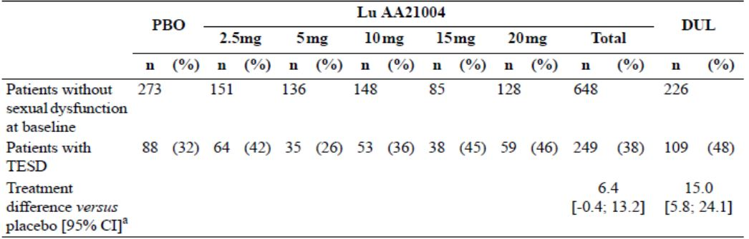
In the dose-range 5 to 20mg/day there appeared a modest dose-response relationship. Vortioxetine 15mg and 20mg/day demonstrated a similar rate of TESD as duloxetine (45% and 46% versus 48%, respectively). There was a tendency for the proportion of women with TESD to be slightly larger than the proportion of men with TESD for all doses and in all treatment groups: 42% of the women versus 35% of the men in the vortioxetine Total group, 37% of the women versus 28% of the men in the placebo group, and 50% of the women versus 46% of the men in the duloxetine group (similar incidences for the vortioxetine 15mg & 20mg doses).
In Studies 11984A, 304, 13267A, 315, 316 and 308, at baseline, the mean ASEX total score was approximately 20 in each treatment group (range: 18.6 to 20.4), which corresponded to a moderate level of sexual dysfunction, and the changes over time were small. Mean changes in the ASEX individual item scores reflected the mean changes in the ASEX total score, with very small changes in all treatment groups and no clear trends over time.
The incidences and pattern of TEAEs captured for sexual dysfunction in the updated and original STPs were similar. Incidence of TESD, based on the ASEX, in the updated STP (that included additional subjects from Study 317), tended to occur with vortioxetine in a dose-related pattern. A similar trend was observed in the original STP. Incidence of sexual dysfunction-related TEAEs was generally low (0.4% in the vortioxetine group and 0% in the agomelatine group) in Study 14178A.

Discontinuation symptoms
In accordance with the TGA-adopted guideline for depression, five short-term studies (11492A, 13267A, 315, 316 & 303) and one long term relapse-prevention study (11985A) were designed to investigate the occurrence of potential discontinuation symptoms following abrupt discontinuation of treatment with vortioxetine in patients with MDD.
Studies 13267A, 315 and 316 included a dedicated scale, the DESS checklist. This checklist evaluated possible effects of discontinuation of antidepressant therapy. It is a clinician-rated instrument that queries for signs and symptoms on a 43-item checklist (for example, agitation, insomnia, fatigue and dizziness) to assess whether the item (event) is discontinuation-emergent. An event is considered discontinuation-emergent if it is reported for the first time or if a previously reported event worsened. In either case, the event scores one point on the checklist and the DESS total score is the sum of all scores on the checklist. In addition, in GAD, one short-term study (308) and one relapse-prevention study (12473A) were prospectively designed to look for potential discontinuation symptoms. The DESS was assessed in Studies 13267A, 315 and 316 at Weeks 8, 9 and 10 for patients who completed the Core Treatment Period only (APCS). In Study 13267A, the DESS was added after study start (Amendment SA01).
Overall incidence of AEs in the vortioxetine dose groups tended to be lower in the second week than in the first week of the 2-week Discontinuation Period in Studies 11492A, 303, 13267A, 315, 316, 308, 11985A and 12473A. There was no clear dose response relationship in the incidences of AEs in the first or second week of the Discontinuation Period.
In the first week after discontinuation, overall incidence of AEs in the STP was similar in patients who abruptly discontinued vortioxetine 2.5 to 20mg/day (range: 5 to 21%), in patients who discontinued placebo (range: 5 to 15%), and in patients who down-tapered duloxetine from 60 to 30mg/day (range: 8 to 20%).
Compared with the first week, the incidence of AEs in the second week was similar to or decreased in the vortioxetine (range: 2 to 13%) and placebo (range: 4 to 10%) groups. In the duloxetine group, in which duloxetine was discontinued in the second week, the incidences of AEs was at the same level or increased (range: 8 to 22%) compared to those in the first week.
In the first week of the Discontinuation Period, the DESS total scores in the vortioxetine 10mg, 15mg and 20mg groups was 1.41, 1.58, and 1.58, respectively, which was similar to or slightly higher than that in the placebo (0.96) and duloxetine (1.33) groups. In the second week of the Discontinuation Period, the DESS total score in the vortioxetine 10mg, 15mg and 20mg groups (1.60, 1.60, and 1.56, respectively) was similar to the placebo group (1.19) and similar to the first week. In the duloxetine group, in which the patients received duloxetine 30mg/day in the first week of the Discontinuation Period, the DESS total score was twice as high in the second week (2.85) than in the first week (1.33).
The DESS single items with the highest incidences in the first and second weeks of the 2-week Discontinuation Period were consistent with the types of AEs reported in the same period. The DESS single items with an incidence ≥ 10% in any treatment group in the first week of the
Discontinuation Period were: irritability: vortioxetine 10mg (15%), 15mg (11%), and 20mg (13%); fatigue/tiredness: vortioxetine 10mg (11%) and 20mg (10%); trouble sleeping/insomnia: vortioxetine 20mg (10%); increased dreaming or nightmares: vortioxetine 20mg (11%) and duloxetine (14%).
For vortioxetine, the DESS total score and the nature of the events in the Discontinuation Period were similar to those in the treatment period. In the first and second weeks after abrupt discontinuation of treatment in Studies 13267A, 315 and 316, DESS total score in the vortioxetine groups was slightly higher than the placebo group. In the duloxetine group, in which patients were down-tapered, the DESS total score increased in the second week to twice that in the first week.
Comments: The DESS only evaluated short-term studies.
Potential discontinuation symptoms were not systematically evaluated in Studies 14122A & 317. Study CCT-002 included a 2-week Discontinuation Period that evaluated AE incidence following abrupt discontinuation of placebo or vortioxetine 5, 10 or 20mg/day. Potential discontinuation symptoms were assessed based on AE reporting and the Discontinuation-Emergent Signs and Symptoms (DESS) scale in patients who completed the 8-week Treatment Period. Overall reporting of TEAEs after the last dose in the treatment period was similar in the treatment groups following abrupt discontinuation: placebo (18%), vortioxetine 5mg (17%), 10mg (13.5%) and 20mg (19%). These results were similar to those in the first-round evaluation.

Other safety issues

Safety in special populations

Intrinsic factors

Sex
In the STP, overall incidence of TEAEs across the therapeutic vortioxetine dose groups and in the placebo group were lower in men than in women. There was no apparent dose-response relationship in the magnitude of the difference between men and women in the vortioxetine dose groups. However, there was a dose-response trend towards overall incidence of TEAEs in women.
In the STP, the incidence of TEAEs leading to withdrawal was similar between men and women in the vortioxetine 5mg group. In the vortioxetine 10mg, 15mg and 20mg groups, the incidences of TEAEs leading to withdrawal were higher for women (6.5%, 9.5%, and 9.3%, respectively) than for men (4.5%, 5.2%, and 6.3%, respectively). There appeared to be a general dose-response trend for TEAEs leading to withdrawal in both males and females.
In the STP, the incidences of TEAEs were similar between men and women, except for nausea, which was consistently lower in men than in women in the therapeutic vortioxetine dose groups, the active reference groups and the placebo group. The incidence of nausea increased in a dose-dependent manner in both men (from 17% in the 5mg group to 22% in the 20mg group) and women (from 23% in the 5mg group to 35% in the 20mg group).
Similar results were observed in the MDD-GAD Short-term Pool, while, no clinically relevant differences were observed during long-term treatment (LTP).

Age
In the MDD short-term study in the elderly (Study 12541A), the AE profile was similar to the overall MDD short-term study population. The incidence of TEAEs in the 8-week Core Treatment Period was 62% in the vortioxetine group, 61% in the placebo group and 78% in the duloxetine group. For TEAEs with an incidence ≥ 5%, the incidence of nausea was 22% in the vortioxetine group compared with 8.3% in the placebo group. All other TEAEs with an incidence ≥ 5% occurred in placebo, except for dizziness (9.3% versus 6.9% in the placebo group), fatigue (7.1% versus 3.4% in the placebo group), constipation (6.4% versus 4.1% in the placebo group) and dry mouth (6.4% versus 4.8% in the placebo group). No patient in the vortioxetine group had AEs related to sexual dysfunction. In the duloxetine group, the incidences of erectile dysfunction and ejaculation delayed were 5.9% each.
In the STP, including Study 12541A, 680 patients (13%) were aged ≥ 65 years: 290 patients (11%) in the vortioxetine groups, 204 patients (14%) in the placebo group, and 186 patients (25%) in the duloxetine group. The overall incidence of TEAEs in patients aged < 65 years and in those aged ≥ 65 years in the vortioxetine 5mg and 15mg groups was generally similar. In the vortioxetine 10mg group, the overall incidence of TEAEs was lower in patients aged ≥ 65 years than in patients aged < 65 years (36% and 63%, respectively). In the vortioxetine 20mg group, the overall incidences of TEAEs was higher in patients aged ≥ 65 years than in patients aged < 65 years (87% and 70%, respectively).
The incidence of TEAEs leading to withdrawal in the therapeutic vortioxetine dose groups was generally higher in patients aged ≥ 65 years than in patients aged < 65 years, even though the overall TEAE incidence in ≥ 65 years was approximately twice the rate of those < 65 years (implying less tolerated/more severe TEAEs in the elderly population, albeit subject numbers were small). Incidence of SAEs was 4.0% in the 10mg/day group compared with 0.5% in the 5mg/day group and 0.0% in placebo and other treatment regimens. No SAEs in ≥ 75 years).
Nausea accounted for most TEAEs in patients aged ≥ 65 years, which generally appeared at higher rates than patients < 65 years. The incidence rate in the 10mg elderly group was only 4.0% compared with 7.4% in placebo, 19.3% in 5mg/day, 33.3% in 15mg/day and 45.2% in 20mg/day. This is an erroneous finding, albeit based on small patient numbers. The 10mg/day group had proportionately higher incidences of dyspepsia (8.0% versus 2.5 to 4.8% for vortioxetine) and back pain (8.0% versus 0.0 to 2.0%).
In the MDD & GAD Short-term Pool, the incidence of TEAEs leading to withdrawal, the overall incidence of TEAEs, and the types of TEAEs with an incidence ≥ 5% in the vortioxetine groups in patients aged < 65 years and ≥ 65 years were similar to those observed in the STP.
During long-term treatment (LTP), the incidence of TEAEs leading to withdrawal, the overall incidence of TEAEs, and the types of TEAEs with an incidence ≥ 5% were similar between patients aged < 65 years and those aged ≥ 65 years. For TEAEs with an incidence ≥ 5%, the incidence of nausea was slightly higher in patients aged < 65 years than in patients aged ≥ 65 years (18% and 11%, respectively).
In the second round, the sponsor provided an update of safety in the elderly. In the STP, for those ≥ 65 years of age, only an additional 18 subjects received vortioxetine treatment (n=308 in total) and 10 received placebo treatment (n=214 in total). The updated findings are not unexpectedly very similar to the original safety report in terms of distribution of TEAEs and overall incidences of TEAEs, SAEs and TEAEs that lead to study drug withdrawal. In the updated LTP there were 39 subjects aged ≥ 65 years. Of these no subjects received a 10mg dose of vortioxetine. The overall findings of the updated safety report are consistent with the original safety report.

Race
In the vortioxetine groups, in the STP, approximately 81% of the patients were Caucasian, and approximately 11% were Black. From 10 to 20mg/day vortioxetine, Black subjects tended to have proportionately less overall TEAE incidences than Caucasians (and Asian) subjects. Those Asian subjects who received 15 or 20mg/day vortioxetine had 100% incidence of overall TEAEs. However, subject numbers were small (two and five, respectively).
In the STP, TEAE incidence leading to withdrawal, the overall incidence of TEAEs, and the types of TEAEs with an incidence ≥ 5% in the vortioxetine groups were generally similar among the different race categories. Similar results were observed in the MDD-GAD Short-term Pool. During long-term treatment (LTP), overall incidence of TEAEs in the vortioxetine group was higher in Blacks (81%) than in Caucasian (71%) or Asians (69%). The types of TEAEs with an incidence ≥ 5% were generally similar in the different race categories.

BMI
In the STP, TEAE incidence leading to withdrawal, overall incidence of TEAEs and the types of TEAEs with an incidence ≥ 5% in the vortioxetine groups was generally similar among different BMI categories. Similar results were observed in the MDD-GAD Short-term Pool and during long-term treatment (LTP).

Genetic polymorphisms in cytochrome P450 enzymes
Several cytochrome P450 (CYP) enzymes contribute to the metabolism of vortioxetine and CYP2D6 is the primary enzyme in the first step of the metabolism of vortioxetine to the major, pharmacologically inactive metabolite Lu AA34443.
Genotyping for CYP2D6, CYP2C9 and CYP2C19 alleles was performed in most clinical pharmacology studies. A phase I PopPK analysis included data from 887 subjects and indicated CYP2D6 EMs have an approximately 2-fold higher oral clearance than PMs. Therefore, an analysis of tolerability in CYP2D6 PMs versus CYP2D6 non-PMs from the clinical pharmacology studies was conducted. Only subjects who received vortioxetine monotherapy in the 31 clinical pharmacology studies were included in the analysis. Subjects who received the experimental enteric-coated formulation of vortioxetine were not included as the formulation could impact on the tolerability profile of vortioxetine, making it unsuitable for comparison with the oral IR formulation.
Forty-one (41) PMs and 879 non-PMs were identified. Of the PMs, 20, 15, and seven subjects received at least one dose of vortioxetine ≤ 10mg, 15 to 30mg and ≥4 0mg, respectively. Mean duration of exposure in these dose categories was 10.6, 7.4 and 6.5 days, respectively. Of the 879 non-PMs, 518, 242 and 162 subjects received at least one dose of vortioxetine ≤ 10mg, 15 to 30mg, and ≥ 40mg, respectively. Mean duration of exposure in these dose categories was 9.3, 5.3 and 8.5 days, respectively. No SAEs were reported in the PMs. TEAE incidences leading to withdrawal were 4.9% (two subjects) and 2.4% (21 subjects) in the PM group and the non-PM group, respectively. TEAEs leading to withdrawal in the PM group were vomiting and angioedema. In the non-PM group, the most common TEAE leading to withdrawal was vomiting (four subjects). All other TEAEs leading to withdrawal did not occur in > 2 subjects. The incidence of GI TEAEs was similar in the PM and non-PM groups (29% and 30%, respectively). TEAEs with an incidence ≥ 5% in both groups were: nausea, diarrhoea, headache, and dizziness. In the clinical pharmacology studies, vortioxetine was generally well tolerated and no clinically relevant differences were observed in the AE profile in CYP2D6 PM compared to non-PM.

Disease factors

Hepatic impairment
Study 114 was an OL, single-dose study that investigated the effect of hepatic impairment on the PK of vortioxetine and its metabolites Lu AA34443 and Lu AA39835 following a single dose of vortioxetine 10mg. Subjects with mild or moderate hepatic impairment (Child-Pugh Classification A and B, respectively) were stratified into groups and compared with healthy, matched control subjects. No SAEs were reported. The incidence of TEAEs was 38% (3 of 8 subjects) in the moderate hepatic impairment group and 44% (4 of 9 subjects) in the corresponding healthy matched control group. No TEAEs were reported in the mild hepatic impairment group or the healthy matched control group. All TEAEs were mild. There were no clinically relevant changes in clinical safety laboratory test values, vital signs or ECG values. Administration of a single oral dose of vortioxetine 10mg was generally well tolerated, regardless of the extent of hepatic dysfunction (mild or moderate hepatic impairment).

Renal impairment
Study 112 was an OL, single-dose study that investigated the effect of renal impairment on the PK of vortioxetine following a single dose of vortioxetine 10mg. Subjects with varying degrees of renal impairment and healthy, age- and sex-matched control subjects were stratified into groups based on renal function estimated using serum CLCr calculated using the Cockcroft-Gault formula: healthy controls (CLCr > 80mL/min), mild (CLCr 51-80mL/min), moderate (CLCr 30-50mL/min), severe (CLCr < 30mL/min), ESRD and patients in haemodialysis with no or negligible urine output). No SAEs were reported and no TEAE lead to withdrawal.
TEAE incidence was 50% (4 of 8 subjects) in the mild renal impairment group, 25% (2 of 8 subjects) in the healthy matched control group for mild renal impairment, 11% (1 of 9 subjects) in the severe renal impairment group, 33% (3 of 9 subjects) in the healthy matched control group for severe renal impairment, 13% (1 of 8 subjects) in the ESRD group, and 25% (2 of 8 subjects) in the healthy matched control group for ESRD. No TEAEs were reported in the moderate renal impairment group or in the healthy matched control group for moderate renal impairment. All TEAEs were mild. There were no clinically relevant changes in clinical safety laboratory test values, vital signs or ECG values. Administration of a single oral dose of vortioxetine 10mg was generally well tolerated, regardless of the degree of renal impairment (mild, moderate, severe or ESRD).

Safety related to drug-drug interactions and other interactions
Eleven clinical pharmacology studies have been conducted to investigate potential drug-drug interactions. With the exception of concomitant administration with bupropion (Study 117), treatment with vortioxetine was well tolerated, with a tolerability profile similar to studies where vortioxetine was administered alone.
In Study 117, the exposure (AUC) to vortioxetine increased 2.3-fold when vortioxetine 10mg was co-administered with bupropion (a strong CYP2D6 inhibitor) 150mg b.i.d. for 14 days in 44 healthy subjects. The co-administration resulted in a higher incidence of AEs when bupropion was added to vortioxetine (cohort I) than when vortioxetine was added to bupropion (cohort II). The incidence of AEs was approximately three times higher in cohort I, notably, with increased incidences in nausea, vomiting, insomnia and dizziness. Nine subjects (15%; three in cohort I and six in cohort II) withdrew due to a TEAE, considered mild or moderate. In cohort I, during vortioxetine monotherapy, one subject withdrew due to urticaria. During co-administration with bupropion, two subjects withdrew due to agitation and vomiting. In cohort II, during bupropion monotherapy, two subjects withdrew due to rash maculopapular and depression. During co-administration with vortioxetine, three subjects withdrew due to urticaria and one subject withdrew due to depression.
In the rifampicin (a CYP isozyme) interaction study (Study 115), co-administration of a single dose of vortioxetine 20mg following 10 days of rifampicin 600mg/day to 14 healthy subjects led to a 72% decrease in AUC of vortioxetine. There were no apparent differences in the tolerability of vortioxetine in subjects who had co-administered rifampicin.

Pregnancy and lactation

Pregnancy
Thirty-six (36) women who received vortioxetine became pregnant during or shortly after stopping treatment with vortioxetine. For most of these pregnancies, the mother had an elective abortion or gave birth to a healthy infant with no birth or developmental birth defects. Eleven (11) women had spontaneous or missed abortion; six received vortioxetine, three received placebo, and two received blinded IMP in ongoing studies. These abortions occurred between gestational weeks 2 and 12. One woman (subject [information redacted]) who received vortioxetine had an intra-uterine death:
For one woman (on placebo), the pregnancy was ectopic and her fallopian tube was removed. In addition to the 49 pregnancies in patients, five partner pregnancies were reported in the vortioxetine clinical development program. The partners of four men who received vortioxetine became pregnant: two healthy infants with no birth or developmental birth defects (one of the mothers was also a patient in the study and received placebo), one spontaneous abortion in gestational week 8, and one unknown. In addition, the partner of a man who received placebo became pregnant (outcome unknown).
In the short-term placebo-controlled studies, four women (all received placebo) became pregnant despite reported use of oral contraceptives. In the relapse-prevention and OL studies, three women became pregnant despite reported use of oral contraceptives while receiving vortioxetine.

Lactation
In lactating rats, vortioxetine-related material was distributed to the milk (Nonclinical overview). Vortioxetine is expected to be excreted into human milk.

Overdose
A number of clinical pharmacology studies investigated multiple doses of vortioxetine >20mg/day.
Across completed phase II/III studies, the highest doses of vortioxetine taken were:
- Patient [information redacted] took at least two vortioxetine 20mg tablets per day for 13 days during MDD short-term Study 315. No additional AEs were reported.
- Patient [information redacted] took four vortioxetine 10mg tablets per day for four days during MDD short-term Study 11984A. No additional AEs were reported. On two prior occasions, the patient had taken two vortioxetine 10mg tablets per day for two days. All events were reported as accidental overdose.

Effects on ability to drive or operate machinery or impairment of mental ability
In driving performance study, 12689A, single and multiple doses of vortioxetine 10mg/day did not impair driving performance compared with placebo assessed using SDLP and SDS during an on-the-road driving test. Based on a PD battery of psychomotor and cognitive testing vortioxetine 10mg/day (evening dose) yielded no residual effects, whereas mirtazapine yielded moderate residual effects in the acute phase, which decreased to more minor effects at steady-state. Furthermore, compared with placebo, vortioxetine (10mg multiple once daily doses [Studies 113 & 12689A]) was not associated with any clinically significant changes in cognitive domains or motor skills. The lack of effect of vortioxetine on driving performance, cognitive function, and motor skills is consistent with results obtained for vortioxetine in two drug-drug interaction studies (110 & 113, respectively). In these studies, vortioxetine had no additive effect on cognitive function or motor skills when co-administered with a single dose of ethanol 0.6g/kg or multiple doses of diazepam 10mg/day. In the STP, the incidences of insomnia, somnolence, fatigue and sedation in the vortioxetine Total group were similar to those in the placebo group. The incidence of dizziness in the vortioxetine groups increased slightly with increasing dose, from 5.7% and 6.2% in the 5mg and 10mg groups, respectively, to 6.7% and 7.7% in the 15mg and 20mg groups, respectively. The incidence in the placebo group was 5.4%.

Post-marketing experience
Vortioxetine hydrobromide is not currently approved for marketing in any country.

Draft risk management plan
Important potential risks and missing information is summarised in Table 35.
Table 35. Summary of risks and missing information.
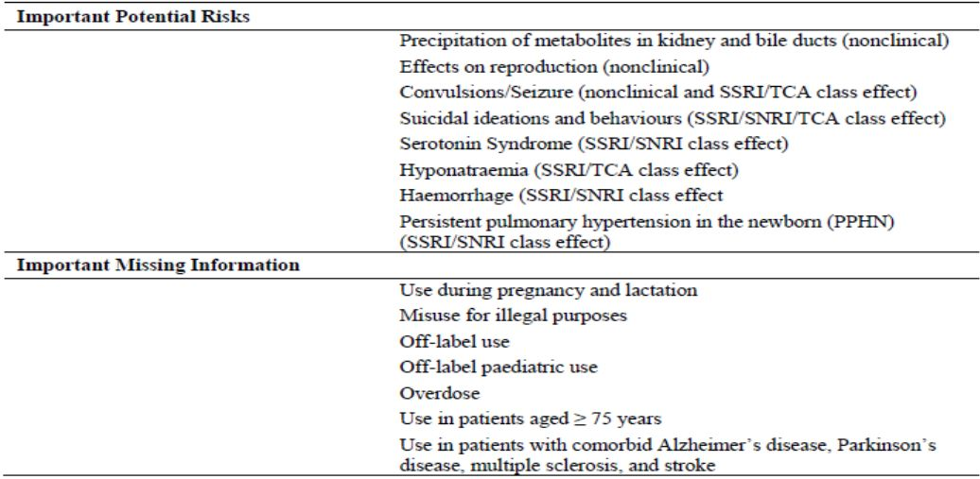
Comment: Potential risks of vortioxetine exposure in relation to dopamine-specific AEs, development of neoplasms (especially hepatic and renal) and cardiovascular risk also remains unclear.

Evaluator’s conclusions on safety
Overall, the safety data from the vortioxetine clinical development program appears consistent with SSRIs and SNRIs (and antidepressants as a therapeutic class of drugs). However, vortioxetine exposure was limited to subjects enrolled in the clinical development program and so, the safety profile of vortioxetine, especially in long term use, is not clearly established.
The most consistent TEAE identified in clinical trials was elevated incidence of nausea, in a dose dependent manner, although few subjects withdrew because of severe nausea and nausea was transient in many cases. Dizziness (but not insomnia and somnolence) was also demonstrated in a dose dependent manner, and vomiting to a lesser extent. The incidence of TEAEs that lead to study drug withdrawal had a modest dose response relationship too, but this was not found for serious or severe AEs.
While it was beyond the scope of the clinical trials in the MDD STP to compare vortioxetine against the active controls, duloxetine and venlafaxine, TEAE incidence rates were similar, especially for the vortioxetine 15 mg and 20 mg doses. In the MDD short term active comparator Study 14178A, which compared vortioxetine (10/20 mg combination) versus agomelatine (25/50 mg combination), overall incidence rates of TEAEs were similar.
The important potential risks and missing information are described in the draft Risk Management Plan (RMP). The effect of the nonclinical findings of crystallisation in the liver and kidney in rats and mice, as well as the potential of adenoma formation in these organs is not yet known. A high rate of neoplasms in the ongoing MDD OL LTP HD (15 mg and 20 mg vortioxetine) has been mentioned in this application but no further details are provided. Two of the six deaths as of 29 February 2012 cut off were from carcinoma (including a case of gallbladder carcinoma). Given the short exposure period of vortioxetine treatment before diagnosis of carcinoma and death, it is highly improbable the events are strongly associated. Post marketing surveillance will help to identify whether vortioxetine is associated with neoplastic disease. Similarly, while the spontaneous AEs and Columbia Suicide Severity Rating Scale (C-SSRS) analysis of suicide ideation and behaviour did not demonstrate a positive association with vortioxetine treatment, long term data will be required to ascertain if there is a causal link. One death was attributed to suicide and two deaths were unknown, so a causal link with vortioxetine treatment is possible even though depression per se has a positive association with suicidal behaviours.
Vortioxetine treatment did not demonstrate discontinuation symptoms in the short term MDD and GAD studies. While this may provide some reassurance for short term (6 to 8 week) exposure to vortioxetine treatment, lack of development of discontinuation symptoms after long term vortioxetine exposure has not been demonstrated.
Generally, vortioxetine did not demonstrate higher incidence than placebo (or active controls) in all the AEs of special interest except for TESD, which appeared to have a dose response relationship, with higher incidences reported in females. The significance of this finding is unclear.
In the elderly (those aged ≥ 65 years), the safety profile was consistent with those aged <65 years, except the 15 mg and 20 mg vortioxetine regimens appeared to give rise to proportionately higher rates of overall TEAEs, particularly nausea and constipation.
The updated safety reports the sponsor provided in the second round were generally consistent with the original submission. No new deaths or new safety signals were identified.

First round benefit-risk assessment
The benefits, risks and benefit-risk balance for vortioxetine in the proposed indication could not be undertaken until the sponsor had provided answers to specific clinical questions.

First round recommendation regarding authorisation
A recommendation for vortioxetine in the proposed indication could not be undertaken until sponsor had provided answers to specific clinical questions.

Clinical questions

Pharmacokinetics

Question 1
The report for Study 10477 was amended:
The pharmacokinetic parameters originally reported in the Integrated Clinical Study Report (ICSR) for Lundbeck Study 10477 were calculated using incorrect plasma and whole blood total radioactivity data. In the original report, the plasma concentration data were converted from units of ng/mL to nmol/L using incorrect molecular weights for Vortioxetine and Lu AA34443. The plasma and whole blood total radioactivity data were also incorrectly converted from units of ng equiv/g to nmol/L.
For the purposes of this amendment, the Vortioxetine and metabolite Lu AA34443 plasma concentration data were provided in units of nmol/L and were back corrected to units of ng/mL, using conversion factors supplied by H. Lundbeck A/S. The plasma and whole blood total radioactivity data were provided in the original units of ng equiv/g. The pharmacokinetic parameters for both plasma concentration and total radioactivity data were recalculated and the ICSR was updated accordingly with the revised data.
A modification was also made to the results of the protein binding, in order to clarify the information originally reported.
Please provide details of the conversion factors used and how derived. Please explain the modification to the results of the protein binding. It is recommended the responses to these questions be directed to the nonclinical evaluator.

Pharmacodynamics

Question 2
In the Summary of Clinical Pharmacology:
Comparable Vortioxetine EC₅₀ values were observed for the raphe nuclei (4.2 to 6.5 ng/mL; Studies 10985 and 12260A).
Study 10985 Panel 19 gives a mean Kd of 12.2nmol/L, using the conversion factor of 0.29845 gives 3.6 ng/mL.
Please explain the conversion of vortioxetine 12.2 nmol/L to 4.2 ng/mL.

Efficacy

Question 3
The inclusion criteria were chosen to select patients with mild to severe MDD (MADRS total score ≥22 [Study 304]). It is unclear from the submission whether subjects with mild depression were recruited into Study 304 or indeed any of the other seven pivotal efficacy short-term adult MDD studies.
Please clarify the proportion of subjects by randomised treatment group with mild depression (MADRS total score ≥22 and ≤26) who were recruited in the pivotal efficacy short term MDD studies, especially the designated trial, Study 304. If no (or few) mild cases were recruited into the designated trial, Study 304, what reasons do you have to explain the change in subject selection?
If mild cases of depression were recruited into the pivotal studies, please provide the meta analysis results by change in baseline in MADRS Total score at Week 6/8 (FAS, MMRM), baseline MADRS ≥22 to ≤26, for all the MDD short term studies.

Question 4
Why has the Sponsor categorised treatment compliance for the adult MDD pivotal efficacy short term studies (11492A, 11984A, 305, 13267A, 315, 316, 303 AND 304) in the range 80 to 120%, instead of 80 to 100%?
Please provide mean and median treatment compliance rates for the ranges 80 to 100% and >100%, by randomised treatment for each of the adult MDD pivotal efficacy studies.

Question 5
What are the pooled 50% response rates for vortioxetine 5 mg, 10 mg, 15 mg and 20 mg dosage regimens in the adult MDD short term pivotal efficacy studies (11492A, 11984A, 305, 13267A, 315, 316, 303 and 304)?

Question 6
In the primary efficacy analysis in Study 11985A, the time to relapse within 24 weeks of the double blind period (FAS), the Sponsor provided results for vortioxetine 5 mg and 10 mg dosages combined rather than by individual doses.
What is the rationale for combining the vortioxetine 5 mg and 10 mg dosage regimens in Study 11985A?
Please provide the primary efficacy results (OC analysis), by double blind randomised treatment, for (a) vortioxetine 5 mg/day and (b) vortioxetine 10 mg/day. Furthermore please provide the LOCF analysis for each dosage regiment too.

Question 7
The responder and remitter rates for the open label phase of Study 11985A are presented in the Summary of Clinical Efficacy. Based on MADRS, 90% of observed cases responded to vortioxetine treatment and 85% remitted. These results differ markedly from the responder and remitter rates observed in the MDD short term pivotal studies.
How does the sponsor reconcile the marked differences between responder and remitter rates in the open label phase of the relapse prevention study compared with the DB treatment phase of the MDD short term pivotal studies?

Question 8
In Study 11985A, what proportion of subjects had ‘sustained remission’ from Baseline II to Week 24 in (a) OC analysis and (b) LOCF analysis?

Safety

Question 9
In Study 314, an ongoing extension study of subjects who had completed lead in Studies 315, 316 or 317, a total of 986 patients had enrolled in Study 314 as of 29 February 2012. Of these 986, patients, 112 had completed the study and 313 had withdrawn. This seems an unusually high proportion of withdrawals (for subjects receiving vortioxetine 15 mg or 20 mg/day at flexible doses).
Does the sponsor have current information on the proportion of subjects who withdrew from Study 314 and the main reasons for study withdrawal?

Question 10
The sponsor has provided overall TEAE incidence rates, and rates for SAEs and TEAEs that lead to study drug withdrawal but has not provided an overall table that summarises the MDD STP in terms of overall drug related TEAEs, drug related SAEs, drug related serious TEAEs and drug related TEAEs that lead to study withdrawal, by vortioxetine dosage, that is, adverse drug reactions (ADRs) per se.
Where in this submission can the above information on ADRs be found?

Question 11
The integrated safety database for the phase II/III clinical trials had a cut off date of 29 February 2012.
Will the sponsor be prepared to provide a more current safety update to include the following treatment emergent information from its clinical development program?
- Deaths (by numbers, study treatment received and primary cause of death)
- Other serious TEAEs (by proportions, study treatment received, systems organ classification)
- Severe TEAEs (by proportions, study treatment received, systems organ classification)
- TEAEs leading to study drug withdrawal (by proportions, study treatment received, systems organ classification)

Question 12
The proportions of MDD patients with post baseline suicidal ideation was 12% in the elderly versus 19% in adult patients with MDD (in the vortioxetine 5 mg group in Studies 303, 304, 305, 13267A and 316).
Is the sponsor able to provide the proportions of males and females with post baseline suicidal ideation in the (a) elderly and (b) adult populations?

Second round evaluation

Pharmacology

Question 1
The first round evaluator requested clarification on (a) the conversion factors used in the calculations of pharmacokinetic parameters for plasma and whole blood radioactivity data for vortioxetine and one of its metabolites, LU AA34443 and (b) the protein binding results. The first round evaluator also requested Question 1 be directed to the nonclinical evaluator for comment.
Sponsor’s response: The sponsor acknowledged incorrect calculations were made for vortioxetine and LU AA34443 in plasma and whole blood radioactivity, as a consequence of incorrectly using molecular weights from the hydrobromide salt of vortioxetine rather than its free base. The sponsor provided a detailed explanation and example calculations to clarify the correct conversions (reported in the integrated clinical study report for Study 10477). Protein binding could not be determined due to the low radioactivity in the plasma samples.
Evaluator’s comment: The sponsor’s explanation is acceptable.

Question 2
The first round evaluator requested clarification of the conversion calculation of ‘nmol/L’ to ‘ng/mL’ for mean Kd of vortioxetine in the raphe nuclei in Study 10985, Panel 19.
Sponsor’s response: Mean Kd of 14.0 nmol/L in the Panel 19 amendment in the clinical study report replaced 12.2 nmol/L in the original Panel 19 data, thereby giving rise to 4.2 ng/mL as stated in the Summary of Clinical Pharmacology.
Evaluator’s comment: The sponsor’s explanation is acceptable.

Efficacy

Question 3
The first round clinical evaluator requested the sponsor to clarify the proportion of subjects in the pivotal efficacy adult MDD studies with mild depression symptoms (MADRS total score ≥ 22 to ≤ 26), as well as the efficacy results for those classified as ‘mild depression’, to ascertain whether there was any benefit in treating this group of subjects. This information was not readily identified in the first round submission documentation.
Sponsor’s response: Panel 1 in the clinical response document summarises the baseline MADRS severity (FAS) for Study 304, the only pivotal efficacy study in MDD that allowed inclusion of patients with mild to severe depression (a baseline MADRS total score ≥ 22). From Panel 1, subjects with mild depression symptoms were evenly distributed across treatment groups (range: 16.4% in the V2.5 group to 20.8% in the duloxetine group). The sponsor did not provide any efficacy results for those subjects with mild depression on the basis a meta analysis was not possible as the subjects with mild depression were limited to Study 304.
Evaluator’s comments: The sponsor has not provided any efficacy results for subjects categorised with ‘mild depression’ based on MADRS scores, and therefore its response to the first round clinical question is unsatisfactory. While it was beyond the scope of Study 304 to investigate vortioxetine treatment for mild depression, it remains unclear whether vortioxetine treatment provides any positive effect on efficacy in the acute phase of a MDE (for example, improved symptoms) or indeed provides a negative effect (for example, failure to prevent deterioration in symptoms or unacceptable adverse effect rates for little or no change in efficacy parameters), for this group of patients

Question 4
In the eight adult MDD pivotal efficacy studies (11492A, 11984A, 305, 303, 304, 13267A, 315 and 316) the sponsor considered a subject was treatment compliant if they received 80 to 120% (inclusive) of their randomised study drug treatment. Mean treatment compliance rates in the individual CSRs were often listed as >100%, which is not clinically useful. Hence, the first round clinical evaluator requested recalculation of mean and median compliance rates for the ranges: 80-100% and >100% (the latter to gauge the potential for ‘overdose’ as well as a possible indicator of lack of efficacy).
Sponsor’s response: Lundbeck was the sponsor of Studies 11492A, 11984A and 13267A, and Takeda for Studies 305, 315, 316, 303 and 304. Treatment compliance was categorised and calculated differently in the short term studies in MDD depending on the sponsor:
- Lundbeck: expressed in percentages
number of capsules dispensed – number of capsules returned) / (date of last dose –date of first dose + 1) × 100
- Takeda: < 80%, 80 to 120%, and > 120%:
calculated as the ratio between exposure and the number of doses the patient should have taken.
Due to the way compliance was calculated in Studies 11492A, 11984A & 13267A, it was not possible to achieve a compliance rate > 100%. Hence, mean and median treatment compliance was presented in the CSRs as ≤ 100%. The sponsor recalculated compliance rates (mean and median) for the ranges 80-100% and > 100% as requested (Panel 2 of its response document) for the Takeda studies, whereas Panel 3 in the response document summarised the ≤ 100% compliance rates (taken from the Lundbeck sponsored clinical study reports).
Evaluator’s comments: The results in Panel 2 of the clinical response document demonstrated consistency between all the treatment groups in the five Takeda sponsored clinical trials (Studies 305, 315, 316, 303 and 304). Mean and median compliance rates across all study treatments were greater than 97.9% and consistent with the Clinical Safety Reports for the individual studies. Few subjects in any study group had a <80% treatment compliance rate. While subjects in Studies 305, 315 & 316 had low (<1.5%) or very low treatment (<0.5%) compliance rates >120% (as per individual Clinical Safety Reports), subjects in Studies 303 and 304 had proportionately greater numbers of subjects (in all treatments) >120% [placebo range 4.0 to 6.4% and vortioxetine range 3.0 [V5] to 6.7% [v2.5]). Vortioxetine 15 mg and 20 mg treatments had low or very low treatment compliance >120%. Given the similar rates between placebo and vortioxetine treatments, these differences are not clinically meaningful. Treatment compliance >100% was approximately 20% across all treatments in the Takeda sponsored studies, that is, treatment compliance in the range 80 to 100% (inclusive) approximated 80% across all study treatments in these five studies.
While the overall mean and median treatment compliance rates for Studies 11492A, 11984A and 13267A (Panel 3) were consistently high (>92%) across studies, and within randomised treatment groups (including placebo) across the vortioxetine range 2.5 mg to 20 mg (inclusive), the sponsor did not provide the range of compliance values for each treatment. Examination of the individual Clinical Safety Reports (Table 26 of Study 13267A, Table 42 of Study 11984A and Table 39 of Study 1429A) revealed a very broad range of compliance percentages (13 to 100% for Study 1429A; 12.5 to 143.2% for Study 13267A, and 5 to 100% for Study 11984A). In all three studies some vortioxetine treatments had the lowest compliance rates (V10 in Study 11492A, V20 in Study 13267A and V10 in Study 11984A) compared with placebo treatments.
While the sponsor claimed in its response document compliance could not exceed 100%, in Study 13267A treatment compliance did exceed 100% in two of four treatment groups, that is, 143.2% in the duloxetine group and 101.7% in the vortioxetine 20 mg group. No explanation for these supra maximal percentages was provided.
In conclusion, the use of different methods to calculate treatment compliance rates makes cross study comparisons difficult. On balance, this clinical evaluator is satisfied the sponsor has demonstrated a reasonably high and consistent adherence to randomised study treatment across the eight pivotal adult MDD studies. The relatively higher rates of supra maximal compliance ( both >100% and >120%) observed in the US Studies 303 and 304 may reflect lack of efficacy for the 2.5 mg and 5 mg vortioxetine treatments and/or patient selection issues (for example, no prior history of MDE required for study participation).

Question 5
The sponsor was requested to provide further information in relation to pooled ≥ 50% response rates for therapeutic vortioxetine (5 to 20 mg, inclusive) in the short term adult MDD pivotal efficacy studies (11492A, 11984A, 305, 13267A, 315, 316, 303 and 304) in terms of (a) overall pooled response rates, (b) response rates sub grouped by history of MDE (no previous MDE or recurrent MDE) and (c) response rates sub grouped by severity of depression (mild/moderate or severe).

Overall pooled response rates:
Sponsor’s response: The four non US studies (11492A, 11984A, 305 and 13267A) were positive or supportive and a pooled analysis of these studies could be expected to show a relevant treatment difference. A treatment difference in responder rates >16 percentage points has been regarded as sufficient to establish the clinical relevance of investigational treatments in studies submitted for licensing approval. The US Studies 303 and 304 were failed/negative studies and so might be expected to influence any treatment effect in a pooled analysis, and Studies 315 and 316 were positive. The proportion of responders, based on a ≥ 50% reduction from baseline in MADRS total score, are summarised by individual studies, pooled MDD studies and pooled non US studies by LOCF analysis (Figure 13) and by OC analysis (Figure 14):
Figure 13. Response (greater than or equal to 50% decrease in MADRS) at Week 6/8 (FAS, LOCF); all short term studies.
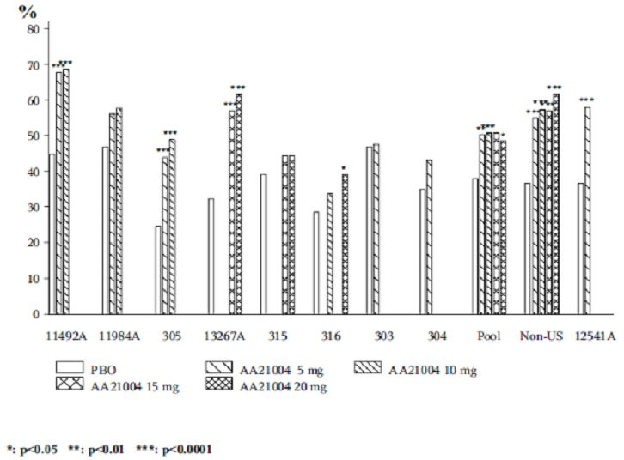
1. LOCF: Non US Studies 11492A, 305 and 13267A positively demonstrated statistical separation from placebo and treatment differences >16%;
2. LOCF: US Study 316, 20 mg dose demonstrated statistical separation from placebo but the treatment difference was < 16%;
3. LOCF: Pooled non US response rates positively demonstrated statistical separation from placebo across the therapeutic vortioxetine range with treatment differences >16% for all treatments but the % of responders were similar among all vortioxetine dose groups;
4. LOCF: MDD short term pool response rates positively demonstrated statistical separation from placebo for the 5 mg, 10 mg and 20 mg vortioxetine doses, but not for the 15 mg dose. All treatment differences were <16% and the % of responders were similar among all vortioxetine dose groups.
Figure 14. Response (greater than or equal to 50% decrease in MADRS) at Week 6/8 (FAS, OC); all short term studies.
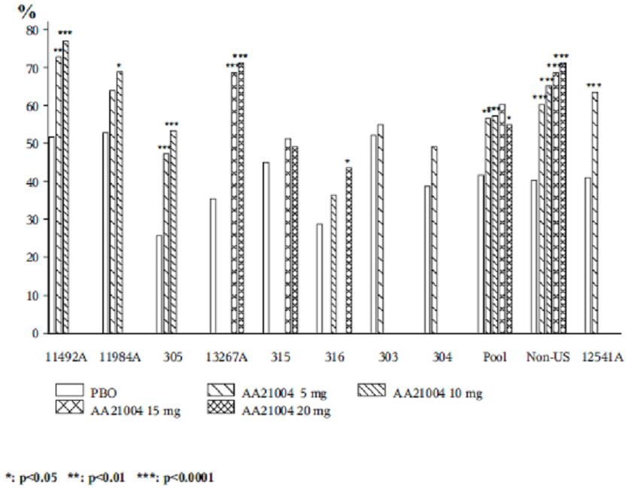
1. OC: Non US Studies 11492A, 305 and 13267A positively demonstrated statistical separation from placebo and treatment differences >16%. The 10 mg vortioxetine regimen in Study 11984A demonstrated statistical separation from placebo but the treatment difference was < 16%;
2. OC: US Study 316, 20 mg dose demonstrated statistical separation from placebo but the treatment difference was <16%;
3. OC: Pooled non US response rates positively demonstrated statistical separation from placebo across the therapeutic vortioxetine range with treatment differences >16% for all treatments in a dose response trend;
4. OC: MDD STP response rates positively demonstrated statistical separation from placebo for the 5 mg, 10 mg and 20 mg vortioxetine doses, but not for the 15 mg dose. All treatment differences were <16% except for the 15 mg dose. The % of responders was similar among all vortioxetine dose groups.
Evaluator’s comments: In terms of overall responder rates, no dose response patterns were identified in the overall MDD STP results in the LOCF and OC analyses. Furthermore, applying the sponsor’s definition of >16% as a clinically relevant treatment difference (versus placebo), the overall pooled results in the LOCF analysis failed to achieve >16% for any therapeutic vortioxetine dose, irrespective of achieving statistical separation versus placebo. Generally, the LOCF and OC analysis results were very similar. The evaluator notes the only vortioxetine treatment in the OC analysis that achieved a treatment difference >16% was the 15 mg regimen, but this dose group failed to demonstrate statistical separation versus placebo.
While a dose response trend was observed in the OC analysis of the non US pooled studies (but not LOCF), as well as statistically significant separation versus placebo at each vortioxetine dose, as well as treatment differences that exceeded >16% for all vortioxetine treatments in LOCF and OC analyses, this evaluator considers it improper to consider US studies and non US studies as separate groups. Given the lack of dose-response in the overall pooled data for the short term MDD studies, the similar response rates between therapeutic vortioxetine treatments and generally treatment differences <16%, vortioxetine in the proposed therapeutic range has failed to satisfactorily demonstrate superior efficacy versus placebo using ≥50% overall responder rates.

Response rates sub-grouped by history of MDE (no previous MDE or recurrent MDE):
Sponsor’s response: In the Vortioxetine clinical development program, Studies 11492A, 11984A, 305, 303 and 304 (Vortioxetine 5 and 10 mg/day) included patients with no previous MDE as well as patients with recurrent MDE. Studies 13267A, 315, and 316 (Vortioxetine 10, 15, and 20 mg/day) included only patients with recurrent MDE.
The proportion of responders, based on a ≥50% reduction from baseline in MADRS total score, with recurrent MDE are summarised in the clinical response document (LOCF and OC analyses, respectively).

Recurrent MDE

LOCF analysis
- Three of four non US studies demonstrated statistical separation versus placebo at all vortioxetine doses, in a dose response trend with a treatment difference >16% versus placebo. The 10 mg vortioxetine dose in Study 11984A also demonstrated statistical separation versus placebo, in a dose response trend but with a treatment difference <16% versus placebo;
- Only one of the four US studies demonstrated statistical separation versus placebo (Study 304), although with a treatment difference <16% versus placebo. The 20 mg regimen in Study 316 also demonstrated statistical separation versus placebo, but again with a treatment difference <16% versus placebo;
- Pooled non US response rates positively demonstrated statistical separation from placebo across the therapeutic vortioxetine range with treatment differences >16% for all treatments with a dose response tendency;
- MDD STP response rates positively demonstrated statistical separation from placebo for the 5 mg, 10 mg and 20 mg vortioxetine doses, but not for the 15mg dose. All treatment differences were <16%. The % of responders was similar among all vortioxetine dose groups.

OC analysis
- For non US studies, the OC results were very similar to the LOCF results except the 10mg vortioxetine dose in Study 11984A had a treatment difference >16% versus placebo;
- For US studies, the OC results were very similar to the LOCF results except the treatment difference in Study 304 became >16% versus placebo;
- For Pooled non US studies, the OC results were very similar to the LOCF results with a dose response trend observed;
- MDD STP response rates positively demonstrated statistical separation from placebo for the 5 mg, 10 mg and 20 mg vortioxetine doses, but not for the 15 mg dose. All treatment differences were <16% except for the 15 mg dose. The % of responders was similar among all vortioxetine dose groups.

Without MDE

LOCF analysis
- Only one dose (vortioxetine 10 mg in Study 305) in the three non US studies demonstrated statistical separation versus placebo, and this was with a treatment difference >16% versus placebo;
- No dose regimen demonstrated statistical separation versus placebo in the two US studies. Indeed, placebo response exceeded vortioxetine response in each study;
- Pooled non US study response rates did not demonstrate statistical separation versus placebo and treatment differences were <16% compared with placebo;
- MDD STP response rates did not demonstrate statistical separation versus placebo and treatment differences were <16% compared with placebo. There appeared to be a dose response trend.

OC analysis
- For non US studies, the OC results were very similar to the LOCF results;
- For US studies, the OC results were very similar to the LOCF results except in Study 303 the vortioxetine response rate was higher compared with placebo, albeit <16% treatment difference and not statistically significant;
- For pooled non US studies, the OC results were very similar to the LOCF results;
- MDD STP response rates for OC were very similar to the LOCF results.
Evaluator’s comments: In terms of overall responder rates for subjects with recurrent MDE, no dose response patterns were identified in the overall MDD STP results in the LOCF and OC analyses. Furthermore, applying the sponsor’s definition of >16% as a clinically relevant treatment difference (versus placebo), the overall pooled results for recurrent MDE in the LOCF analysis failed to achieve >16% for any therapeutic vortioxetine dose, irrespective of achieving statistical separation versus placebo. Generally the LOCF and OC analysis results were very similar for recurrent MDE as well as overall responder rates (see [a] above). The evaluator notes the only vortioxetine treatment in the OC analysis that achieved a treatment difference >16% was the 15 mg regimen, but this dose group failed to demonstrate statistical separation versus placebo.
While a dose response trend was observed in the OC analysis of the non US pooled studies (and tendency in the LOCF analysis), as well as statistically significant separation versus placebo at each vortioxetine dose, as well as treatment differences that exceeded >16% for all vortioxetine treatments in LOCF and OC analyses, this evaluator considers it improper to consider US studies and non US studies as separate groups. Given the lack of dose response in the overall pooled data for the short term MDD studies, the similar response rates between therapeutic vortioxetine treatments and generally treatment differences <16%, vortioxetine in the proposed therapeutic range has failed to satisfactorily demonstrate superior efficacy versus placebo using ≥50% responder rates in those subjects with an established history of recurrent MDE.
In subjects with no prior history of MDE, the LOCF and OC analysis results were very similar. Apart from one vortioxetine dose (10 mg) in Study 305, no other non US or US study, or pooled analysis, demonstrated statistical separation versus placebo. While adult subjects with no prior history of MDE were only exposed to lower doses of vortioxetine (5 mg and 10 mg doses) than those with recurrent MDE, the submitted data does not indicate any therapeutic benefit in vortioxetine treatment in this population, Indeed, in Studies 303 and 304, placebo treatment was superior to vortioxetine 5 mg treatment.

Response rates sub grouped by severity of depression (mild/moderate or severe):
Sponsor’s response: In the vortioxetine clinical development program, Studies 11984A, 305, 13267A, 315 and 316 (vortioxetine 5, 10, 15 and 20 mg/day) included patients with a baseline MADRS total score ≥ 26 (moderate) and Studies 11492A and 303 (vortioxetine 5 & 10 mg/day) included patients with a baseline MADRS total score ≥ 30 (severe). Study 304 included patients with a baseline MADRS total score ≥ 22 (mild).
The proportion of responders, based on a ≥50% reduction from baseline in MADRS total score, with severe MDD are summarised in Tables 7 and 8 of the clinical response document (LOCF and OC analyses, respectively).

Severe depression (baseline MADRS total score ≥ 30)

LOCF analysis
- Three of four non US studies demonstrated statistical separation versus placebo at all vortioxetine doses, in a dose response trend with a treatment difference >16% versus placebo;
- No US study demonstrated statistical separation versus placebo and all treatment differences were <16% versus placebo;
- Pooled non US response rates positively demonstrated statistical separation from placebo across the therapeutic vortioxetine range with treatment differences >16% for all treatments (no dose response trend);
- MDD short term pool response rates positively demonstrated statistical separation from placebo for the 5 mg and 10 mg vortioxetine doses, but not for the 15 mg and 20 mg doses. All treatment differences were < 16% versus placebo and no response trend was observed.

OC analysis
- For non US studies, the OC results were very similar to the LOCF results except the 10mg vortioxetine dose in Study 11984A demonstrated statistical separation from placebo (but with <16% treatment difference);
- For US studies, the OC results were very similar to the LOCF results;
- For Pooled non US studies, the OC results were very similar to the LOCF results with a small dose response trend observed;
- MDD STP response rates for OC were very similar to the LOCF results.

Mild/moderate depression (baseline MADRS total score < 30)

LOCF analysis
- Two of three non US studies demonstrated statistical separation versus placebo at all vortioxetine doses, in a dose response trend with a treatment difference >16% versus placebo;
- No US study demonstrated statistical separation versus placebo and all treatment differences were <16% versus placebo except the 20 mg vortioxetine regimen in Study 316;
- Pooled non US response rates positively demonstrated statistical separation from placebo for vortioxetine 5 mg, 15 mg and 20 mg with treatment differences >16% for 10 mg, 15 mg and 20 mg treatments;
- MDD STP response rates positively demonstrated statistical separation from placebo for the 5 mg, 15 mg and 20 mg vortioxetine doses, but not for the 10 mg dose. The 15 mg and 20 mg doses achieved treatment differences >16% versus placebo. No response trend was observed.

OC analysis
- For non US studies, the OC results were very similar to the LOCF results except the 10 mg vortioxetine dose in Study 11984A had a treatment difference >16% versus placebo;
- For US studies, the OC results were very similar to the LOCF results except the 20 mg vortioxetine dose in Study 316 demonstrated statistical separation from placebo and the 15 mg dose, while not demonstrating statistical superiority versus placebo did demonstrate a >16% treatment difference against placebo;
- For pooled non US studies, the OC results were very similar to the LOCF results except all vortioxetine treatments positively demonstrated statistical separation from placebo;
- MDD STP response rates for OC were very similar to the LOCF results.
Evaluator’s comments: The response rate profiles by severity are similar and consistent with the rates and distribution for the overall responder rates, and those with recurrent MDE (but not with subjects with any prior history of MDE). The OC analyses generally resulted in slightly more favourable outcomes for vortioxetine treatments. Of note, in the pooled analysis of MDD short term studies, those subjects with mild/moderate depression appeared to derive greater benefit from higher vortioxetine dosing (15 mg and 20 mg) compared with subjects with severe depression, which appeared to derive greatest benefit from the lower vortioxetine regimens (5 mg and 10 mg), although the latter did not achieve the >16% treatment difference the sponsor made reference to. The results of the breakdown in responder rates by severity of depression were unexpected and, as a result, it is difficult to identify which patient groups (if any) derive the greatest benefit from vortioxetine treatment. Breakdown in responder rates by dose, severity and history of MDE may provide more meaningful results. Alternatively, further breakdown of subjects who failed to respond to treatment may assist in identification of those subject groups most likely to benefit from vortioxetine treatment.

Question 6
The first round clinical evaluator asked the sponsor to explain why the primary efficacy analyses (and other important efficacy endpoints) were not presented by individual vortioxetine dose (5 mg or 10 mg), but the combined vortioxetine group instead, for Study 11985A, the relapse prevention trial. This information was requested for the OC and LOCF analyses.
Sponsor’s response: The study design is compliant with the TGA adopted guideline for depression. The sponsor did not randomise patients into the DB period by dose. Hence, the primary efficacy results for Study 11985A were presented for the combined (Total) vortioxetine dose (~75% received 10 mg and 25% the 5 mg regimen) versus placebo. Study 11985A was powered based on the analysis of time to relapse in the DB period for the combined doses. Analyses by individual doses are regarded as exploratory subgroup analyses. Table 36 summaries the time to relapse within the 24 week DB period of Study 11985A for the 5 mg and 10 mg vortioxetine doses.
Table 36. Time to relapse within the first 24 weeks of the DB period (FAS, Cox Model): Study 11985A.
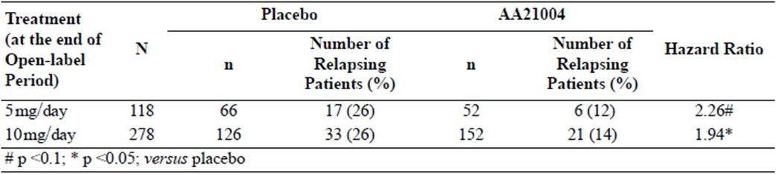
The sponsor provided tabulated results of the mean change from Baseline II in MADRS total score up to Week 24 of the DB period, using LOCF and OC. During the DB period, a considerably larger proportion of patients in the placebo group than in the vortioxetine group withdrew from the study (mainly due to relapse), resulting in a larger difference to placebo in the analysis of covariance (ANCOVA) based on LOCF than on OC. Hence, the OC data is more conservative.
The vortioxetine 5 mg dose regimen (OC analysis) did not statistically separate from placebo at any time point in the 24 week DB period. In contrast, the LOCF analysis demonstrated statistical separation from placebo from Weeks 4 to 16 (inclusive), but ‘borderline significance’ at Weeks 20 and 24 (inclusive). The vortioxetine 10 mg dose regimen (OC analysis) demonstrated statistical separation from placebo from Weeks 4 to 16 (inclusive) and at Week 24 but not at Week 20 (p = 0.1864). In contrast, the LOCF analysis demonstrated statistical separation from placebo from Weeks 4 to 24 (inclusive).
Evaluator’s comments: While the primary efficacy analysis for Total vortioxetine treatment resulted in a statistically significant HR (2.01, p = 0.0035), the result for the 5 mg regimen did not reach statistical significance, although there was a tendency towards statistical significance per se. The latter finding may be due to the smaller subject numbers in the 5 mg group. Not providing efficacy results by individual dose may comply with the TGA adopted guideline for depression but does not help to guide clinicians on the most appropriate maintenance dose for their patients.
In the analysis of time to relapse within the 24 week DB period, using the more conservative OC analysis for MADRS score (the secondary efficacy analyses in this study), the vortioxetine 5 mg regimen did not show superiority versus placebo at any time point, and while the 10 mg regimen did so at multiple points (including the 24 week endpoint), it did not separate from placebo at the 20 week time point. Furthermore, the upper 95% CIs for most 10 mg time points that attained statistical separation versus placebo were between -0.22 and -0.62, that is, close to zero (not statistically significant).
The less conservative LOCF analysis of the 5 mg vortioxetine regimen, while showing statistical separation versus placebo at several time points in the DB period, did not show an overall statistical significant result at the end of the DB period (24 weeks), thereby supporting the OC analysis results. Of those time points that reached statistical significance, the 95% upper CI ranged from -0.08 to -0.30, that is, close to zero (not statistically significant). The LOCF analysis of the 10 mg vortioxetine regimen gave a more favourable efficacy profile than the OC analysis.
In conclusion, combining the 5 mg and 10 mg vortioxetine regimens into a total combined vortioxetine group gives a more statistically significantly favourable outcome than vortioxetine regimens singly, but is not helpful to the clinician in establishing the most appropriate maintenance dose for their patient. While it was beyond the scope of the study to examine the efficacy results of individual doses, the submitted data, albeit on small subject numbers, does not support the 5 mg vortioxetine regimen in relapse prevention of a MDE. The use of a 10 mg vortioxetine regimen may provide a benefit in preventing relapse of a MDE, but the OC analysis results as a whole are inconsistent. Further study is needed to ascertain the optimal dose in maintenance treatment, especially the aged population (no breakdown by dose and age provided but subject numbers are expected to be too small to draw meaningful conclusions about optimal dosing in this subpopulation).

Question 7
The first round clinical evaluator asked the sponsor to reconcile the marked differences between responder and remitter rates in the open label phase of the relapse prevention Study 11985A compared with the DB treatment phase of the MDD short term pivotal studies.
Sponsor’s response: The differences between the response and remission rates in the OLP of Study 11985A and the MDD short term studies may be explained by differences in treatment duration (Study 11985A: 12 weeks; MDD short term studies: 6/8 weeks) and study design characteristics (Study 11985A: OL, flexible dose; MDD short term studies: DB, fixed dose, placebo controlled). The high response and remission rates observed at the end of the OLP may be explained by the anticipation of a better treatment effect by raters or patients when treated with active drugs as compared with a study where placebo is included as a treatment arm. The response and remission rates for Study 11985A and the MDD short term studies are summarised in Table 37.
Table 37. Response and remission rates.
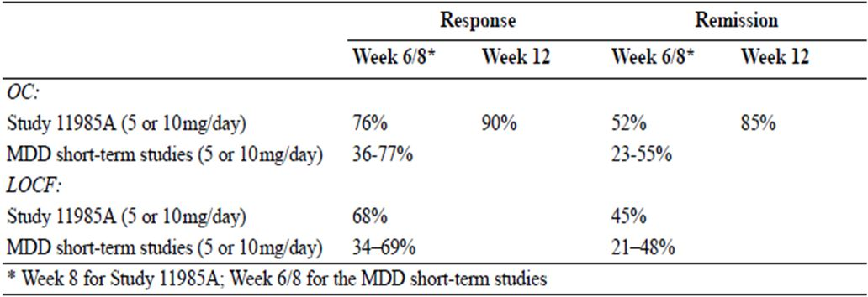
Evaluator’s comments: The short term adult MDD studies were limited to 6 or 8 weeks DB treatment so no comparison at 12 weeks can be made. The response and remission rates for the OC analysis during the first 6-8 weeks OL treatment were consistent with the MDD short term studies, on an equivalent dose basis (although the results of Study 11985A are presented as a total combined 5/10 mg vortioxetine group rather than as individual regimens). The high response rate and especially the high remission rate at 12 weeks of OL treatment may be explained by the OL design of Study 11985A.

Question 8
The first round clinical evaluator requested the proportions of subjects who had sustained remission (MADRS total score ≤ 10) from Baseline II up to Week 24 of the DP period in Study 11985A by OC and LOCF analyses.
Sponsor’s response: Since all observations for a patient are used to determine whether loss of remission has occurred, the results based on OC or LOCF data are identical. Table 38 summarises the requested information.
Table 38. MADRS sustained remission up to Week 24 (FAS): Study 11985A MADRS total score less than or equal to 10 throughout 24 weeks of DP period.
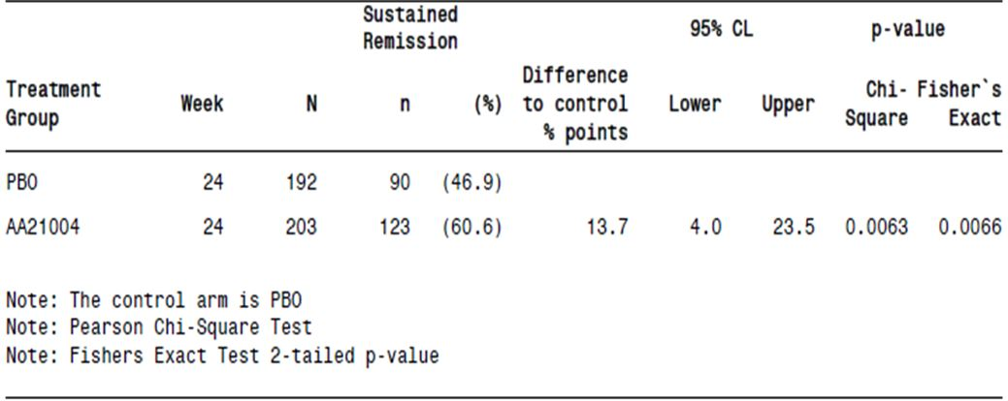
Evaluator’s comments: The sponsor’s response is generally acceptable, although vortioxetine treatments by dose groups have not been provided, which may provide information on the more optimal dose for maintaining patients in remission. The NNT for one vortioxetine treated subject to remain in remission over 24 weeks treatment was 1/0.137 = 7. The treatment difference between total vortioxetine and placebo for sustained remission, and the primary efficacy variable (proportion of patients who relapsed over 24 weeks DB treatment) was similar, as were the patients needing to be treated (7 cases and 8 cases, respectively).

Safety

Question 9
In the first round evaluation, the sponsor provided safety data for Study 314, to the 29 February 2012 cut off date. The evaluator requested further information on the proportions of subjects who withdrew from Study 314 (an ongoing extension study of subjects who had completed lead in Studies 315, 316 or 317 where subjects received flexible dosed 15 mg or 20 mg vortioxetine per day), as well as the main reasons for study withdrawal. The basis of this request was that of 986 subjects enrolled as of 29 February 2012, 112 had completed the study while 313 had withdrawn, that is, proportionately more subjects had withdrawn from the study than completed the study, which may indicate a new safety signal, especially at higher doses of vortioxetine. This first round evaluation data referred to withdrawals and completions by subjects originally recruited from US studies 315 and 316 not from 317.
Sponsor’s response: The sponsor provided tabulated data from Study 314 with a cut off date of 26 October 2012 (Table 39). From the table, the study withdrawal rate for the 26 October 2012 cut off date had reduced proportionately compared with subjects who had completed the study as of 29 February 2012. The primary reasons for withdrawal were ‘withdrawal of consent’ (11.9%), AEs (10.8%), and lost to follow up (8.8%).
Table 39. Patient disposition and withdrawals by primary reason (APTS): Study 314.
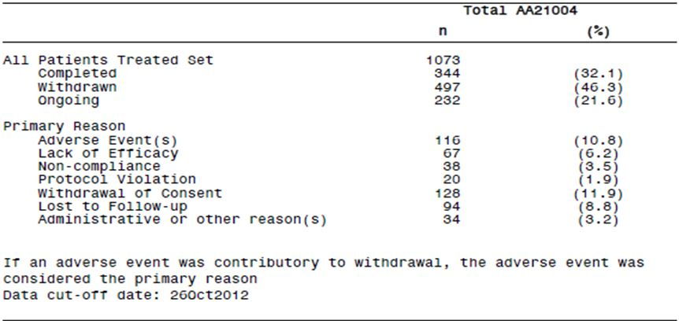
The sponsor also provided a list of references that suggested the extent of study drug withdrawals for vortioxetine 15/20 mg day is comparable with other antidepressant agents (range: 26 to 59%).
Evaluator’s comments: The sponsor did not provide detailed information on the reasons why subjects withdrew consent, so the information provided here is of limited usefulness. With 21.6% subjects still ongoing, proportionately an overall withdrawal rate of between 55 to 60% might be expected, or thereabouts. This compares with 35% withdrawals in Study 13267B using vortioxetine 15 mg and 20 mg doses. This evaluator still considers the withdrawal rate in Study 314 to be much higher than expected for this agent, but the reason/s for this unexpectedly higher rate cannot be determined given ~20% of the study population were either lost to follow up or did not provide further details on why consent was withdrawn

Question 10
The sponsor did not provide a summary table of incidences of ADRs for vortioxetine in the MDD STP in its original Summary of Clinical Safety document. These ADRs relate to those TEAEs deemed possibly or probably related to study drug treatment by the investigator. The first round clinical evaluator requested ADRs in relation to overall TEAE incidence, and incidence of SAEs, severe TEAEs, and TEAEs leading to withdrawal by vortioxetine dose for the STP.
Sponsor’s response: Related TEAEs are summarised for the Core Treatment Period (from first to last dose of IMP in the DB Period), except for related SAEs, which are summarised for the Entire Study Period (from first dose of the Investigational Medicinal Product to last visit/contact, including the Discontinuation and Safety Follow up Periods). The sponsor collated overall incidence of treatment related TEAEs by SOC from individual study reports.
- Overall ADR incidences of therapeutic vortioxetine doses occurred with a dose dependent trend. GI disorders and CNS disorders accounted for most ADRs, with nausea the most common, observed in a dose response manner.
- Eight vortioxetine cases (0.3% total group) had SAEs versus two cases (0.1%) with placebo treatment. No dose response trends were observed in the vortioxetine groups. The only related serious TEAE that occurred in ≥2 patients in any treatment group (including the vortioxetine total group) was depression: 1 patient (<0.1%) in the placebo group; 1 patient (<0.1%) in the vortioxetine 5 mg/day group; 2 patients (0.4%) in the vortioxetine 10mg/day group.
- No dose response trends were observed in the vortioxetine groups for severe TEAEs. There were no related severe TEAEs with an incidence ≥1% in the vortioxetine total group. The incidence of related severe nausea was 0.1% in the placebo group and 1.3% in the vortioxetine 20 mg/day group (highest incidence).
- There was an overall dose related trend for therapeutic vortioxetine doses versus placebo (3.7% for 5 mg, 5.1% for 10 mg, 7.0% for 15 mg and 8.1% for 20 mg versus 3.0%, respectively) in the withdrawal related data. There was a dose dependent trend for GI disorders. The only related TEAE leading to withdrawal in ≥1% of the patients in the vortioxetine total group was nausea (2.0%), with a trend towards a dose response relationship (1.2%, 1.8%, 3.4% and 4.4% in the 5, 10, 15 and 20 mg groups, respectively, versus 0.3% for placebo treatment).
Evaluator’s comments: The information provided by the sponsor is satisfactory. Overall, the pattern of ADRs in the MDD STP is consistent with those seen for AEs irrespective of relationship to study drug. While no new safely signals were identified from the submitted data, nausea is consistently the TEAE that gave rise to the highest overall incidence of TEAEs, with highest severity, highest incidence of SAEs and TEAEs that lead to study withdrawal. The (adverse) effect of nausea appears to be dose related across the proposed therapeutic vortioxetine range.
Summary tables of ADRs have been incorporated into the main text of this report.

Question 11
Since the integrated safety database for the Phase II/III clinical trials had a cut-off date of 29 February 2012, the first round clinical evaluator requested an updated safety report to include any new deaths, and further incidence data for treatment-emergent SAEs, severe TEAEs and TEAEs that lead to study withdrawal.
Sponsor’s response: The sponsor provided clinical study reports for an additional five clinical studies in MDD completed since the data package was originally submitted to TGA (four short term studies and one long term OL study):
- Study 317: 8 weeks, placebo controlled, fixed dose (10 or 15 mg/day);
- Study 14122A: 8 weeks, placebo controlled, fixed dose (10 or 20 mg/day);
- Study 14178A: 12 weeks, flexible dose (10 or 20 mg/day), active comparator (agomelatine 25 or 50 mg/day). Not placebo controlled;
- Study 13267B:1 year extension to Study 13267A, OL, flexible dose (15 or 20 mg/day);
- Study CCT-002: 8 weeks, placebo controlled, fixed dose (5, 10, or 15 mg/day).
Studies 317, 14122A and CCT-002 are included in the updated MDD STP. The design of Study 14178A made it unsuitable for pooling with other MDD studies. Study 13267B results are included in the updated MDD Ongoing Open label Long term Pool. All patients in the updated MDD Ongoing Open label Long term Pool received vortioxetine 15 or 20 mg/day.
Evaluator’s comments: The information the sponsor provided is acceptable. In addition to the information the first round clinical evaluator requested, the sponsor also provided an integrated safety update that encompassed adverse events of special interest. The updated safety data has been incorporated into the relevant sections of the main text of this report and identified. In summary, the additional data added to the body of clinical knowledge of the safety of vortioxetine in the proposed therapeutic dose range. The updated safety report is generally consistent with the original findings documented in individual study reports, the original Summary of Clinical Safety document and the RMP. No new safety signals have been identified in the updated safety report and no new deaths were recorded with vortioxetine treatment since the original 29 February 2012 cut off.

Question 12
The proportion of MDD patients with post baseline suicidal ideation was 12% in the elderly versus 19% in adult patients with MDD (in the vortioxetine 5 mg group in Studies 303, 304, 305, 13267A and 316). The first round clinical evaluator requested a breakdown in incidence rates for suicidal ideation by gender for the elderly and adult groups, respectively.
Sponsor’s response: The sponsor provided suicidal ideation and behaviour data (based on C-SSRS scores during the study by C-CASA) for the elderly (Study 12541A) in its response document. Male gender was associated with 5.9% rate of suicidal ideation compared with 14.0% in females. The sponsor provided suicidal ideation and behaviour data (based on C-SSRS scores during the study by C-CASA) for the adult population in Studies 303, 304, 305, 13267A, 315 and 316 in its response. Male gender was associated with 15.6% total rate of suicidal ideation and 19.6% incidence at a 5 mg vortioxetine dose. Female gender was associated with 15.9% total rate of suicidal ideation and 18.8% incidence at a 5 mg vortioxetine dose.
Evaluator’s comments: In the elderly, there appeared to be a higher incidence of suicidal ideation in females than males, but these results were based on small subject numbers and the differences versus placebo treatment were not clinically significant. On this basis, vortioxetine treatment was not clinically associated with suicidal ideation in the elderly in total and by gender at a vortioxetine dose of 5 mg/day. In adults, vortioxetine treatment did not demonstrate a dose response relationship with suicidal ideation in total or by gender breakdown for Studies 303, 304, 305, 13267A, 315 and 316. Although the incidence rates for adults for 5 mg vortioxetine treatment were relatively higher than those demonstrated in the elderly population, the treatment differences versus placebo were not clinically significant.
Of note, whereas no male adult subject reported a C-SSRS score higher than 5 (1-5 = suicidal ideation or behaviour), one female who received 5 mg vortioxetine had a C-SSRS score of 6-8, that is, preparatory action towards imminent suicidal behaviours and two female subjects who received 10 mg vortioxetine recorded C-SSRS scores of 9, that is, not fatal suicide attempt. The incidence rates are too small (0.3% and 1.0%, respectively) to draw meaningful conclusions of any possible association with vortioxetine treatment and suicidal ideation and behaviour, especially in female subjects. However, suicidal ideation and behaviour is well documented in the risk management plan and is a recognised adverse event of special interest for antidepressants as a class of drugs.

Second round benefit-risk assessment
The benefit-risk balance is favourable for registration of vortioxetine hydrobromide in MDD.
In general, the pattern and incidence of TEAEs (overall incidence, incidence of SAEs or AEs leading to withdrawal) were similar between placebo and vortioxetine across the proposed therapeutic range (5 to 20 mg once daily, inclusive). Nausea in particular, and dizziness to a lesser extent, gave rise to proportionately more AEs than any other preferred term in most studies submitted. There was some suggestion tolerance to the development of nausea occurred in some subjects. Development of nausea, while distressing to some subjects is the only detailed risk identified in the submission. While there was a dose response relationship for this AE in most analyses, the relatively minor trade off of having worse severity nausea over the potential therapeutic gain of improved MDD symptom control at a higher vortioxetine dose makes this risk more acceptable.
The potential risks for vortioxetine as an antidepressant agent are extensive (see RMP for further details) and this must be kept in perspective should vortioxetine be granted registration for MDD (and future indications such as GAD). For instance, subjects were selected with a relatively low risk of suicidal behaviour but in the post marketing clinical setting this is not likely to remain the case, particularly with patients with severe depressive symptoms, prior history of self-harming behaviour, co-morbidities and Axis II disorders. Any association between development of neoplasms and vortioxetine exposure will only become apparent after much longer exposure. The long term safety of vortioxetine in MDD (and other indications) has not been established. Comprehensive post marketing pharmacovigilance activities will need to be undertaken to more fully establish the safety profile of vortioxetine over time.
For vortioxetine to be registered in MDD, the clinical data submitted needed to demonstrate efficacy in a broad range of subjects from diverse racial and cultural origins. While this appeared to have been satisfactorily demonstrated in non US studies this was not the case with US based studies. Hence, the decision to approve or reject the application should be based primarily on the overall results, that is, US and non US studies combined.
Notwithstanding the more favourable non US study results in terms of the primary efficacy endpoint, when the MMRM sensitivity analyses of the primary efficacy endpoint were taken into consideration, this resulted in more positive studies, more supportive studies and less negative studies (3 of 10 in total compared with 5 of 10 before the sensitivity analyses were undertaken). The large number of short term adult studies in MDD is indicative of the number of failed or negative studies usually expected in a MDD submission of this type. There is a significant placebo effect in MDD and this was seen across all the MDD studies in this submission. Thirty per cent (30%) failed or negative study (after sensitivity analyses) provides reasonable demonstration of vortioxetine efficacy in the acute phase of adult MDD. The designated study in the elderly also produced a positive study result. Efficacy was further supported in the relapse prevention study and the active comparator (agomelatine) study, as well as the meta analyses of the primary efficacy endpoint.
The meta analysis of all the short term adult MDD studies did not demonstrate a clear dose response relationship (as compared with the non US studies meta analysis). In part, the poor response in US subjects may have been due to subject selection issues, such as misdiagnosis of MDE or MDD, or non recruitment of subjects without an established history of recurrent MDE/MDD, or perhaps suboptimal dosing in US subjects. However, given > 2 points treatment difference of vortioxetine versus placebo is regarded as clinically relevant, the point estimates did indeed reach clinical significance in favour of vortioxetine across the whole proposed therapeutic range (5 to 20 mg, inclusive). While the 15mg vortioxetine regimen did not reach statistical significance (in either meta analysis), the point estimate was still clinically relevant. The wide confidence intervals of the 15mg group did not allow for statistical separation versus placebo. The latter may, in part, have occurred because of a change in emphasis within the clinical development program for vortioxetine when doses up to and including 10 mg once daily were not found to produce optimal efficacy outcomes. The program was changed and doses up to 20 mg once daily were included in subsequent trials. Hence, the lack of statistical significance in the 15 mg vortioxetine regimen is, in part, due to lack of subject numbers who received this dose. The PK and PD results suggest there is dose proportionality across the vortioxetine therapeutic range and so a dose response relationship in patients with MDD would be expected, given sufficient participant numbers and studies are well conducted. Furthermore, analysis of individual short term adult MDD studies and pooled analyses in terms of subgroup, sensitivity and key secondary endpoints generally supported the primary efficacy results. On this basis, efficacy in acute phase MDD in adults has been satisfactorily demonstrated across the therapeutic range.
In the elderly (≥ 65 years), efficacy was clearly established at a 5 mg once daily regimen in the designated study. There were too few participants in the pooled analysis over the vortioxetine therapeutic range to make recommendations of alternative regimens. On this basis, elderly patients should commence on a starting dose of 5 mg once daily.
The relapse prevention study only examined subjects taking 5 mg or 10 mg vortioxetine. While the 10 mg regimen demonstrated statistical separation versus placebo, the 5 mg regimen did not, although the result was borderline significant. On this basis, adult (and maybe elderly) subjects maintained on doses of 10 mg once daily or less may provide a benefit in reducing a single episode of relapse (NNT 8). The submission did not provide relapse prevention data for doses >10 mg once daily and hence the maximum dose recommended should not exceed 10 mg once daily in maintenance treatment (for adults and especially the elderly, who are more likely to have comorbidities and concomitant medications that have the potential to change the benefit-risk balance away from vortioxetine treatment). Furthermore, the relapse prevention study was not designed to demonstrate prevention of remission of MDD. This aspect of MDD treatment requires further study.
In view of the results of responder rates > 50% by prior history of MDD (see ‘List of Questions’), in which subjects who did not have a previous history of MDE/MDD did not appear to derive benefit from vortioxetine treatment versus placebo, vortioxetine administration in this group of patients is not acceptable to this evaluator. While vortioxetine across the therapeutic range was well tolerated and nausea is the only currently identified risk, the benefit-risk balance for this group is not acceptable in view of the extensive list of known potential risks plus there may be yet unknown risks for a new chemical entity that may only become apparent over time. It is therefore recommended only subjects with an established history of recurrent MDD should receive vortioxetine. Hence, vortioxetine should not be administered as first line treatment in MDD, in adults at least.

Second round recommendation regarding authorisation
The evaluator recommends approval of the sponsor’s application to register Brintellix (vortioxetine hydrobromide) for major depressive disorder in adults (and the aged) provided the following conditions are met:
- Vortioxetine should only be administered to patients with an established history of MDE or MDD;
- Vortioxetine should be reserved for second line use in MDD, upon initial registration;
- The aged (≥ 65 years of age) should commence vortioxetine on a dose of 5 mg once daily;
- Maintenance treatment, that is, relapse prevention doses of vortioxetine for adults and the aged should be restricted to 10 mg once daily, upon initial registration;
The sponsor should provide detailed assurance it will be proactive in undertaking post marketing pharmacovigilance activities and in its reporting of any new safety signals or potential safety signals, until the safety profile of vortioxetine as a new class of chemicals for human administration, becomes well established.

CPH-003, CPH-002, CPH-001, 101, 103, 104, 106, 109, 110, 111, 112, 113, 114, 115, 116, 117, 123, 10272, 10467, 10477, 10982, 10985, 11826A, 12260A, 13119A, 13138A.
Bootstrap evaluation showed signs of instability which could indicate model over-parameterization. Therefore, the parameter Q/F, V3/F and KA values from the PopPK from phase I studies in healthy subjects with frequent blood sampling were used.
A measure of the relative goodness of fit.
Submitted but not evaluated by this evaluator.
Study 12260A gives a mean EC₅₀ for Caucasians of 6.52ng/mL; Study 10985 panel 19 gives a mean K_{d} of 12.2 nmol/L, using the conversion factor of 0.29845 gives 3.6ng/mL.
European Medicines Agency, “Committee for Proprietary Medicinal Products (CPMP): Note for Guidance on Clinical Investigation of Medicinal Products in the Treatment of Depression (CPMP/EWP/518/97 Rev. 1)”, 25 April 2002.
European Medicines Agency, “Committee for Proprietary Medicinal Products (CPMP): Note for Guidance on Clinical Investigation of Medicinal Products in the Treatment of Depression (CPMP/EWP/518/97 Rev. 1)”, 25 April 2002.

