October 2020

Australian Public Assessment Report for Vonicog alfa
  - Proprietary Product Name: Veyvondi
  - Sponsor: Shire Australia Pty Limited (now Takeda Pharmaceuticals Australia Pty Ltd)

About the Therapeutic Goods Administration (TGA)
- The Therapeutic Goods Administration (TGA) is part of the Australian Government Department of Health and is responsible for regulating medicines and medical devices.
- The TGA administers the Therapeutic Goods Act 1989 (the Act), applying a risk management approach designed to ensure therapeutic goods supplied in Australia meet acceptable standards of quality, safety and efficacy (performance) when necessary.
- The work of the TGA is based on applying scientific and clinical expertise to decision-making, to ensure that the benefits to consumers outweigh any risks associated with the use of medicines and medical devices.
- The TGA relies on the public, healthcare professionals and industry to report problems with medicines or medical devices. TGA investigates reports received by it to determine any necessary regulatory action.
- To report a problem with a medicine or medical device, please see the information on the TGA website <https://www.tga.gov.au>.

About AusPARs
- An Australian Public Assessment Report (AusPAR) provides information about the evaluation of a prescription medicine and the considerations that led the TGA to approve or not approve a prescription medicine submission.
- AusPARs are prepared and published by the TGA.
- An AusPAR is prepared for submissions that relate to new chemical entities, generic medicines, major variations and extensions of indications.
- An AusPAR is a static document; it provides information that relates to a submission at a particular point in time.
- A new AusPAR will be developed to reflect changes to indications and/or major variations to a prescription medicine subject to evaluation by the TGA.

Copyright
© Commonwealth of Australia 2020
This work is copyright. You may reproduce the whole or part of this work in unaltered form for your own personal use or, if you are part of an organisation, for internal use within your organisation, but only if you or your organisation do not use the reproduction for any commercial purpose and retain this copyright notice and all disclaimer notices as part of that reproduction. Apart from rights to use as permitted by the Copyright Act 1968 or allowed by this copyright notice, all other rights are reserved and you are not allowed to reproduce the whole or any part of this work in any way (electronic or otherwise) without first being given specific written permission from the Commonwealth to do so. Requests and inquiries concerning reproduction and rights are to be sent to the TGA Copyright Officer, Therapeutic Goods Administration, PO Box 100, Woden ACT 2606 or emailed to <tga.copyright@tga.gov.au>.

Contents
Common abbreviations 4
I. Introduction to product submission 6
Submission details 6
Product background 8
Regulatory status 9
Product Information 10
II. Registration timeline 10
III. Submission overview and risk/benefit assessment 11
Quality 11
Nonclinical 12
Clinical 13
Risk management plan 20
Risk-benefit analysis 21
Outcome 22
Attachment 1. Product Information 23

Common abbreviations
Abbreviation | Meaning
ACM | Advisory Committee on Medicines
ADAMTS13 | A disintegrin and metalloproteinase with a thrombospondin type 1 motif, member 13
ARGPM | Australian Regulatory Guidelines for Prescription Medicines
ARTG | Australian Register of Therapeutic Goods
ASA | Australian specific Annex
AUC | Area under the plasma concentration-time curve
AUC_{0-inf} | Area under the plasma concentration-time curve from time 0 (dosing) extrapolated to infinity
BE | Bleeding episode
CHO | Chinese hamster ovary
CI | Confidence interval
CK | Cysteine knot
CL | Clearance
C_{max} | Maximum plasma concentration
CMI | Consumer Medicines Information
COR-B | Comparable Overseas Regulator approach B
CPD | Certified Product Details
DDAVP | Tradename for desmopressin (D-amino D-arginine vasopressin)
DLP | Data lock point
DVT | Deep vein thrombosis
EMA | European Medicines Agency (European Union)
EU | European Union
FVIII | Factor VIII (factor 8)
FVIII:C | Factor VIII (factor 8) coagulant activity
GI | Gastrointestinal
GLP | Good Laboratory Practice
GVP | Good Pharmacovigilance Practice(s)
ICH | International Council for Harmonisation
IP | Investigational product
IR | Incremental recovery
IU | International unit
IV | Intravenous
pdVWF | Plasma derived von Willebrand factor
PI | Product Information
PK | Pharmacokinetic(s)
PSUR | Periodic safety update reports
RMP | Risk management plan
rFVIII | Recombinant Factor VIII (recombinant factor 8)
rVWF | Recombinant von Willebrand factor
SD | Standard deviation
T_{1/2} | Half life
US | United States
VWD | von Willebrand disease
VWF | von Willebrand factor
VWF:Ag | von Willebrand factor antigen
VWF:RCo | von Willebrand factor ristocetin cofactor

I. Introduction to product submission

Submission details
Type of submission: | New biological entity
Product name: | Veyvondi
Active ingredient: | Vonicog alfa
Decision: | Approved
Date of decision: | 15 April 2020
Date of entry onto ARTG: | 20 April 2020
ARTG numbers: | 316659, 316660
Black Triangle Scheme: | Yes. This product will remain in the scheme for 5 years, starting on the date the product is first supplied in Australia
Sponsor’s name and address: | Shire Australia Pty Limited (now Takeda Pharmaceuticals Australia Pty Ltd)  Level 39, 225 George Street, Sydney NSW 2000
Dose forms: | Powder and solvent for injection
Strengths: | 650 International units (IU), 1300 IU
Container: | Vial
Pack size: | One
Approved therapeutic use: | Veyvondi is indicated in adults (age 18 and older) with von Willebrand Disease (VWD), when desmopressin (DDAVP) treatment alone is ineffective or not indicated, for the  - treatment of haemorrhage and surgical bleeding  - prevention of surgical bleeding.  Veyvondi should not be used in the treatment of Haemophilia A.
Route of administration: | Intravenous infusion
Dosage: | Veyvondi is not bioequivalent to plasma-derived von Willebrand factor (VWF), and individual patient dosage must be calculated specifically for Veyvondi.  Treatment of von Willebrand disease (VWD) should be supervised by a physician experienced in the treatment of haemostatic disorders.  Dosage  Dosage and frequency of administration must be individualised according to clinical judgement and based on the patient’s weight, severity and type of bleeding episodes/surgical intervention, as well as both von Willebrand factor ristocetin cofactor (VWF:RCo) and factor VIII coagulant activity (FVIII:C) levels, and also based on monitoring of appropriate clinical and laboratory measures. Dose based on bodyweight may require adjustment in underweight or overweight patients.  Generally, 1 IU/kg Veyvondi raises the plasma VWF:RCo by 0.02 IU/mL (2%).  Haemostasis cannot be ensured until FVIII:C is at least 0.4 IU/mL (≥ 40% of normal activity). Depending on the patient’s baseline FVIII:C levels, a single infusion of recombinant von Willebrand factor (rVWF) will, in a majority of patients, lead to an increase above 40% in endogenous FVIII:C activity within 6 hours and will result in sustaining this level up to 72 hours post infusion. The dose and duration of the treatment depend on the clinical status of the patient, the severity and type of bleeding, and both VWF:RCo and FVIII:C levels. If the patient’s baseline plasma FVIII:C level is < 40% or is unknown and in all situations where a rapid correction of haemostasis should be achieved, such as treatment of an acute haemorrhage, severe trauma or emergency surgery, it is necessary to administer a recombinant coagulation factor VIII (rFVIII) product with the first infusion of Veyvondi, in order to achieve a haemostatic plasma level of FVIII:C.  However, if an immediate rise in FVIII:C is not necessary, or if the baseline FVIII:C level is sufficient to ensure haemostasis, the physician may decide to omit the co-administration of rFVIII at the first infusion with Veyvondi.  In case of major bleeding events or major surgeries requiring repeated, frequent infusions, monitoring of FVIII:C levels is recommended, to decide if rFVIII is required for subsequent infusions to avoid excessive rise of FVIII:C.  Patients should be monitored for the development of VWF or FVIII neutralising antibodies (inhibitors). If suspected VWF activity (VWF:RCo) plasma levels are not attained, or if bleeding is not controlled with an appropriate dose, an assay should be performed to determine if a VWF or FVIII inhibitor is present. See Product Information: Section 4.4 Special Warnings and Precautions for Use, Neutralising antibodies (inhibitors).  For further information regarding dosage, refer to the Product Information.
Pregnancy category: | B2  Drugs which have been taken by only a limited number of pregnant women and women of childbearing age, without an increase in the frequency of malformation or other direct or indirect harmful effects on the human fetus having been observed.  Studies in animals are inadequate or may be lacking, but available data show no evidence of an increased occurrence of fetal damage.  The use of any medicine during pregnancy requires careful consideration of both risks and benefits by the treating health professional. This must not be used as the sole basis of decision making in the use of medicines during pregnancy. The TGA does not provide advice on the use of medicines in pregnancy for specific cases. More information is available from obstetric drug information services in your State or Territory.

Product background
This AusPAR describes the application by Shire Australia Pty Ltd (the sponsor, now Takeda Pharmaceuticals Australia Pty Ltd) to register Veyvondi (vonicog alfa) 650 IU and 1300 IU powder for injection with solvent for the following proposed indication:
Veyvondi is indicated in adults (age 18 and older) with von Willebrand Disease (VWD), when desmopressin (DDAVP) treatment alone is ineffective or not indicated, for the
- treatment of haemorrhage and surgical bleeding
- prevention of surgical bleeding
Veyvondi should not be used in the treatment of Haemophilia A.
Von Willebrand disease (VWD) is one of the most common inherited bleeding disorders, potentially affecting 1% of the population, although in many cases remaining subclinical throughout life. It is characterised by the reduced levels, dysfunction or absence of von Willibrand factor (VWF). VWF is a large multimeric glycoprotein which is essential for the binding of platelets to sites of endothelial injury, forming the primary platelet plug at a site of bleeding. It also acts as a carrier for Factor VIII (FVIII; factor 8) and reduces its clearance five fold. There are six variants of von Willebrand Disease (VWD). All variants involve a deficiency of one or more aspects of VWF functional activity. This may be a quantitative and/or qualitative defect. Type 1 VWD involves a partial quantitative deficiency of VWF. Type 2 is divided into four subtypes (2A, 2B, 2M and 2N), which are all qualitative VWF defects. Type 3 is a complete deficiency of VWF.
VWD mostly becomes evident when a person with the diathesis suffers a bleeding challenge, such as surgery. In patients with a risk of bleeding, preventative therapy will be administered ahead of surgery. First line pharmacological treatment for treatment usually includes desmopressin (also known via the trade name, DDAVP); which results in a physiological release of stored VWF and temporarily boosts its availability for clotting. DDAVP may, however, not be sufficient to control major bleeding episodes.
VWF has historically been available from human plasma (plasma derived VWF, pdVWF). These are potentially costly and vary in their FVIII content depending on the donor source and post-donation processing. Proteolytic degradation of pdVWF also reduces the concentration of large multimers necessary to promote clotting. There remains a small but present risk of virological contamination in pooled donor sources of pdVWF. For these reasons there has been interest in recombinant VWF (rVWF).
Vonicog-alpha is a recombinant VWF combination expressed in Chinese hamster ovary (CHO) cell culture. At the time the submission was under consideration, there were no rVWF products in the Australian market. Vonicog-alpha had, however, been registered in comparable overseas jurisdictions for several years.
This application was submitted through the TGA’s Comparable Overseas Regulator approach B (COR-B) process; using evaluation reports from the European Medicines Agency (EMA). The full dossier was also submitted to the TGA.

Regulatory status
This product is considered a new biological entity for Australian regulatory purposes.
At the time the TGA considered this application, a similar application had been approved in the European Union (EU), United States (US), Canada and Switzerland for indications as described in the table below.
Table 1: International regulatory status of vonicog alfa (as of April 2020)
Region | Approval date | Approved indications
EU | 31 August 2018 | Veyvondi is indicated in adults (age 18 and older) with von Willebrand Disease (VWD), when desmopressin (DDAVP) treatment alone is ineffective or not indicated, for the  - treatment of haemorrhage and surgical bleeding  - prevention of surgical bleeding.  Veyvondi should not be used in the treatment of Haemophilia A.
US | Date of initial registration: 8 December 2015  The extension of indication in perioperative management was approved on 16 April 2018 | Vonvendi [von Willebrand factor (recombinant)] is a recombinant von Willebrand factor (rVWF) indicated for use in adults (age 18 and older) diagnosed with von Willebrand disease (VWD) for:  - On-demand treatment and control of bleeding episodes.  - Perioperative management of bleeding.
Canada | 10 January 2019 | Vonvendi (von Willebrand factor (Recombinant)) is indicated for:  - Treatment and Control of bleeding episodes in adults (age ≥ 18) diagnosed with von Willebrand Disease (VWD).  - Perioperative management of bleeding in adults (age ≥ 18) diagnosed with VWD.
Switzerland | 4 October 2018 | Treatment of haemorrhage or surgical bleeding in von Willebrand disease (VWD), when desmopressin (DDAVP) treatment alone is ineffective or contraindicated.  Veyvondi should not be used in the treatment of Haemophilia A.

Product Information
The Product Information (PI) approved with the submission which is described in this AusPAR can be found as Attachment 1. For the most recent PI, please refer to the TGA website at <https://www.tga.gov.au/product-information-pi>.

II. Registration timeline
The following table captures the key steps and dates for this application and which are detailed and discussed in this AusPAR.
Table 2: Timeline for Submission PM-2019-01555-1-6
Description | Date
Submission dossier accepted and first round evaluation commenced | 3 June 2019
First round evaluation completed | 30 September 2019
Sponsor provides responses on questions raised in first round evaluation | 28 November 2019
Second round evaluation completed | 2 January 2020
Delegate’s Overall benefit-risk assessment | 8 April 2020
Sponsor’s pre-Advisory Committee response | Not applicable
Advisory Committee meeting | Not applicable
Registration decision (Outcome) | 15 April 2020
Completion of administrative activities and registration on the ARTG | 20 April 2020
Number of working days from submission dossier acceptance to registration decision* | 173
* The COR-B process has a 175 working day evaluation and decision timeframe.

III. Submission overview and risk/benefit assessment
The submission was summarised in the following Delegate’s overview and recommendations.
This section is a TGA summary of wording used in TGA’s evaluation report, which discussed numerous aspects of overseas evaluation reports and included some information that was commercial-in-confidence.

Quality
Recombinant von Willebrand Factor (rVWF) is co-expressed with recombinant Factor VIII (rFVIII) in CHO cells as part of the manufacturing process. The rVWF protein is separated from the factor VIII and further purified.
Human VWF is synthesized as a 2813 amino acid pro-VWF molecule. The pro-VWF is composed of A, B, C and D repeats, which contain various functional domains that have been identified. The mature VWF monomer is a 2050 amino acid protein. Monomers of pro-VWF are subsequently N-glycosylated, arranged into dimers in the endoplasmic reticulum and into multimers by crosslinking of cysteine residues via disulfide bonds. The basic structure of a VWF is depicted in Figure 1.
Figure 1: Pictorial representation of von Willebrand Factor monomer/dimer
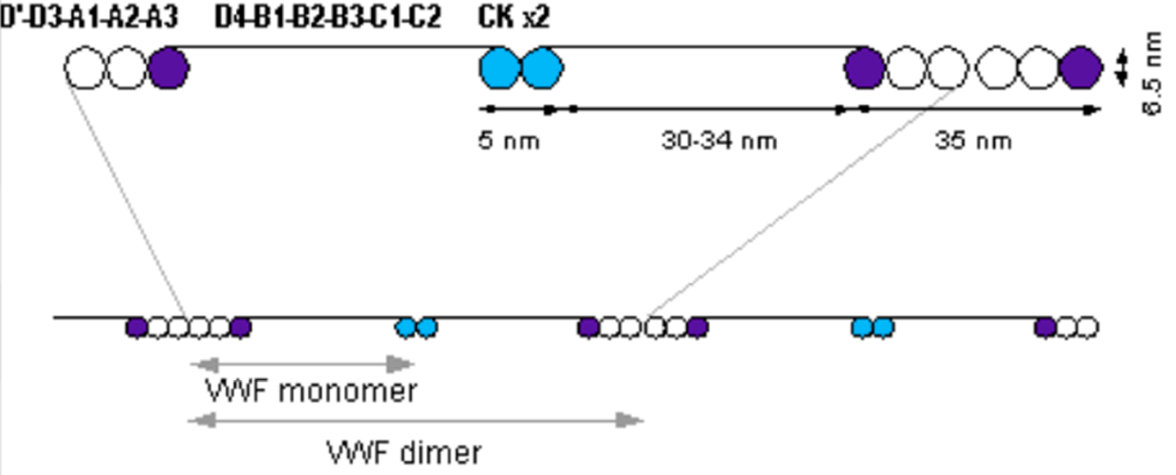
The D’/D3 domain binds to factor VIII; the A1 domain binds to platelet gp1b-receptor, heparin and collagen; the A3 domain binds to collagen; the C1 domain binds to activated platelet integrin αIIbβ3, the cysteine knot domain (CK) is at the C-terminal end of the protein.
The quality evaluator concluded that there are no objections on quality grounds to the approval of Veyvondi (vonicog alfa).

Nonclinical
The nonclinical evaluator has summarised the findings of the toxicology studies as follows:
- Nonclinical data contained an adequate set of studies investigating pharmacology, pharmacokinetics (PK) and toxicity, conducted in general accordance with relevant TGA adopted guidelines, including International Council for Harmonisation (ICH); S6 (R1). All pivotal safety-related studies were Good Laboratory Practice (GLP); compliant.
- In vitro, the presence of ultra-large multimers in vonicog alfa was shown to enhance platelet aggregation in comparison with other VWF preparations lacking these. In vivo, vonicog alfa was shown to promote thrombus formation and reduce blood loss and bleeding time in studies in VWF-deficient mice and dogs.
- No off-target pharmacological effects were apparent. Safety pharmacology studies identified no clinically relevant concerns.
- PK studies in laboratory animal species showed exposure to VWF after intravenous (IV) administration of vonicog alfa at least as high compared with plasma-derived VWF in most species, dose-proportional exposure, no effect of co-administered recombinant human FVIII on kinetics, stabilisation of endogenous FVIII, and limited extravascular distribution (as expected for a large protein molecule).
- Vonicog alfa showed a low order of acute toxicity by the IV route in laboratory animal species.
- Pivotal repeat-dose toxicity studies were performed in rats and cynomolgus monkeys. These involved once daily dosing by the clinical route (IV) for 2 weeks; study length was limited by the immunogenicity of the human protein. Treatment with vonicog alfa (100 IU/kg/day) was without adverse effect in monkeys. Regenerative anaemia, thrombocytopenia, and inflammatory lesions in the heart, liver and salivary gland, were observed in rats treated with vonicog alfa at 1400 IU/kg/day (17.5 times the maximum recommended clinical dose on a single occasion).
- Findings in the single and repeat dose toxicity program represent exaggerated pharmacological effects. The thrombogenicity of vonicog alfa is greater in rodents compared with other laboratory animal species and humans as their endogenous ADAMTS13; enzyme is not capable of cleaving ultra-large multimers of recombinant human VWF.
- Vonicog alfa was shown to be non-genotoxic. Carcinogenicity studies have not been performed, which is acceptable given the nature of the drug (consistent with ICH S6 (R1)).6
- Reproductive and developmental toxicity studies have not been conducted and are not required. Consistent with its large size, no placental transfer of vonicog alfa was observed in an ex vivo human perfusion model. Pregnancy Category B2, as the sponsor proposes, is supported.
- The approximate commercial formulation was shown to be well tolerated locally in rabbits.
There are no nonclinical objections to the registration of Veyvondi for the proposed indications. The draft PI should be amended as directed by the evaluator.

Clinical
The following studies were included in the clinical dossier (Table 3).
Table 3: Summary of clinical study reports submitted in the dossier
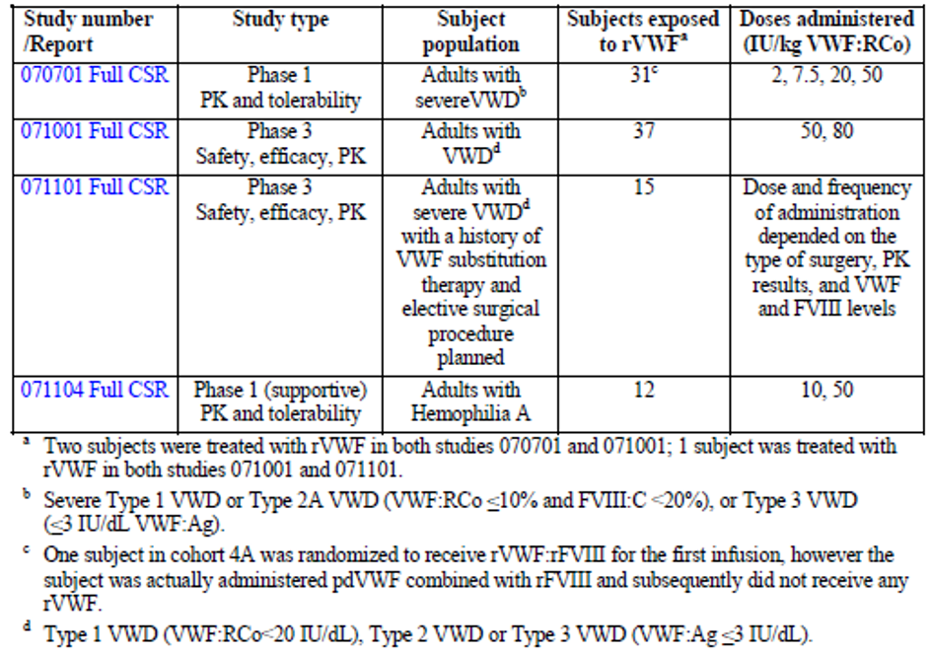
VWF:Ag = von Willebrand factor antigen.

Pharmacology
Vonicog alfa is administered IV. The clinical evaluator has summarised the pharmacological parameters as shown in Table 4.
Table 4: Summary of studies providing pharmacokinetic parameters for vonicog alfa
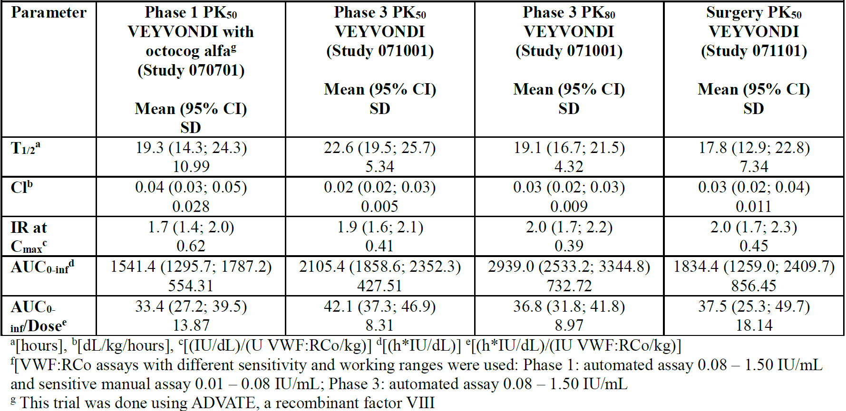
SD = standard deviation; CI = confidence interval; PK = pharmacokinetic; T_{1/2} = half life; CL = clearance; IR = incremental recovery; AUC_{0-inf} = Area under the plasma concentration-time curve from time 0 to infinity; C_{max} = maximum plasma concentration.
The evaluator has noted that vonicog alfa was not bioequivalent to pdVWF, having a 1.46 and 1.49 larger area under the plasma concentration-time curve (AUC) in Study 070701 (dose escalation study) and Study 071001 (bleeding events study), respectively. Non-equivalence was not considered relevant to the efficacy of vonicog alfa, but should be noted given the long historical experience with pdVWF.
There were no specific pharmacodynamics studies.

Efficacy
The efficacy of vonicog alfa was demonstrated in two Phase III studies in which control of bleeding events and bleeding during surgery were examined (Studies 071001 and 071101).

Study 071001
Study 071001; a bleeding events study, was a prospective, open label and non-comparative study which was run in two parts. Part A consisted of PK assessment that involved comparison with and without recombinant factor XIII (rFVIII) co-administration for up to six months. Part B consisted of prospective treatment for bleeding events on vonicog alfa. A total of 49 patients were randomised, of whom 32 completed both arms of treatment. The study design is depicted in Figure 2.
Figure 2: Study 071001 schema and study design
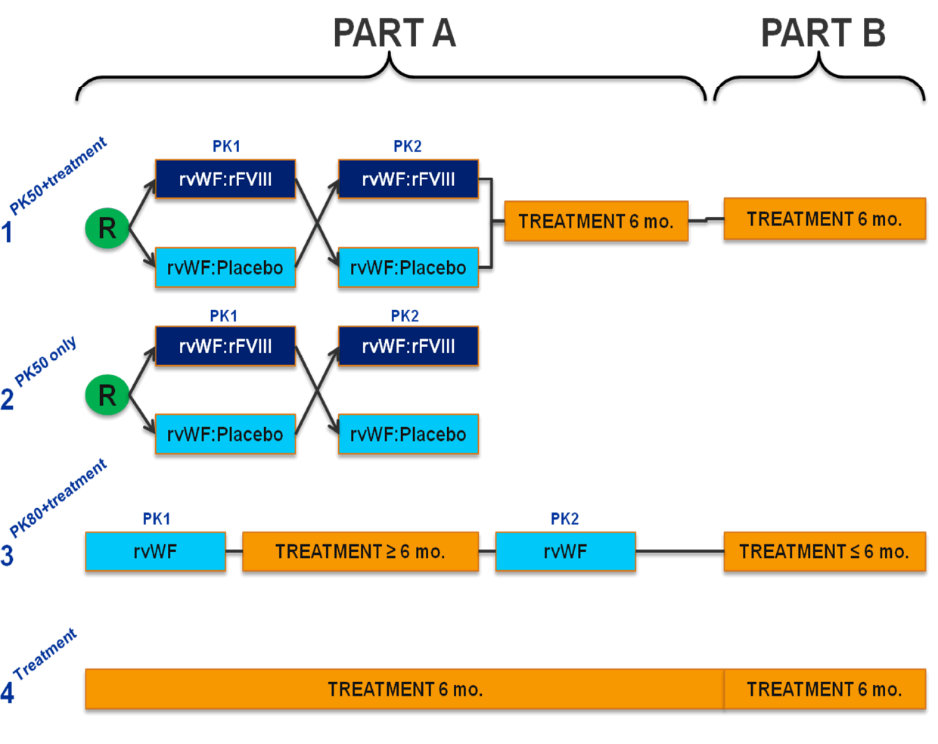
Included in the study were adult patients with all three types of VWD who had had a minimum of 1 bleeding episode (BE) requiring VWF replacement therapy during the preceding 12 months.
The primary endpoint was the number of patients with treatment success for BEs, meaning the mean extent of control was measured as < 2.5 on a 4 point scale as shown in Table 5.
Table 5: Study 071001 Efficacy rating criteria
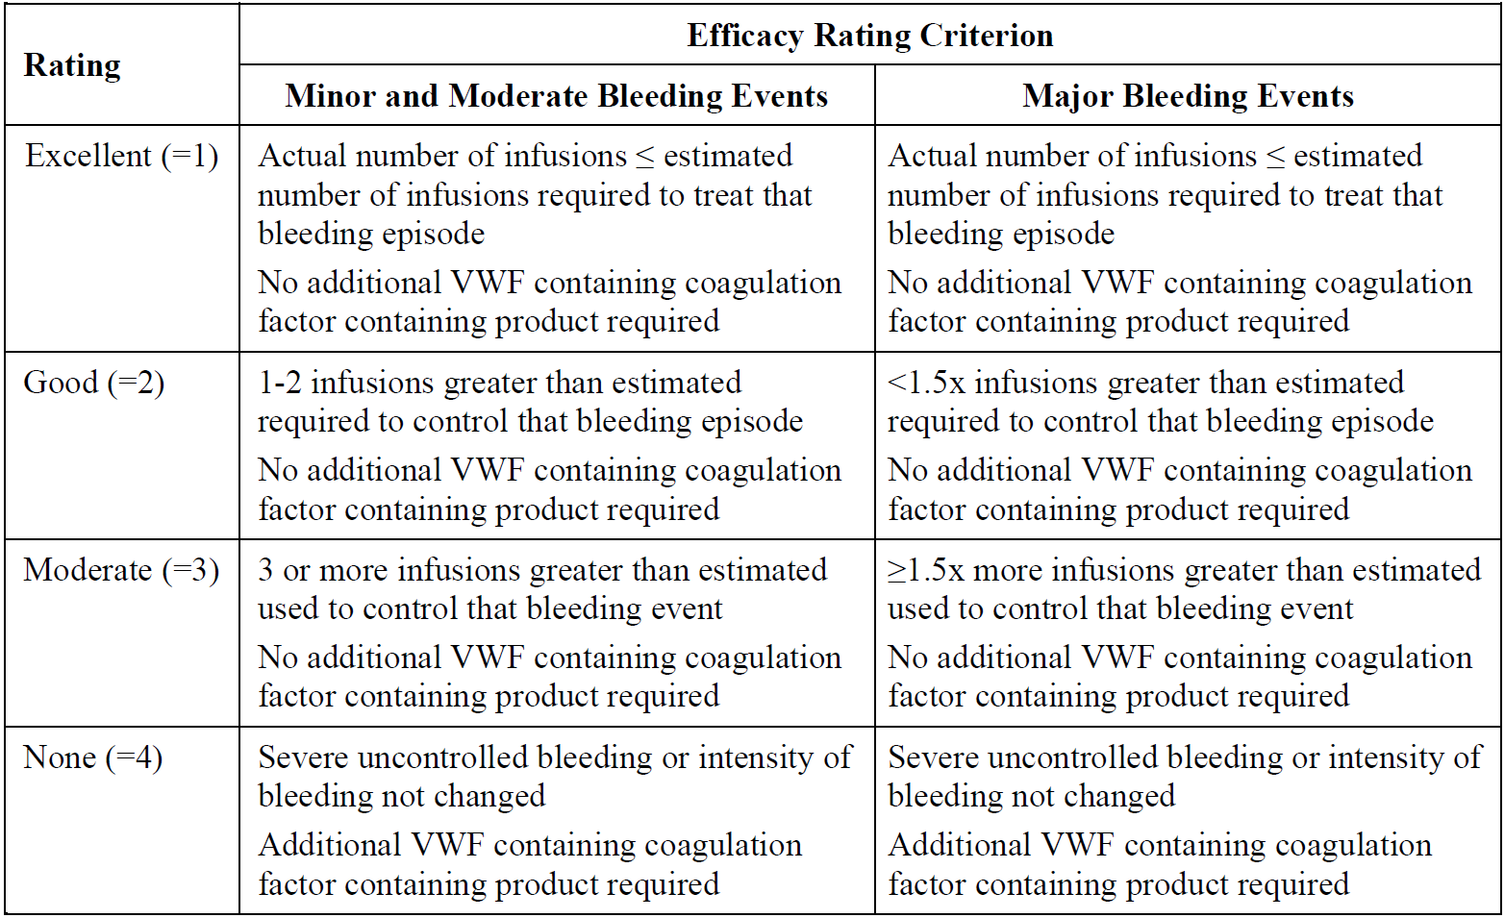
A total of 193 bleeding events occurred in 22 subjects. The majority (n = 107) were mucosal bleeds, followed by joint bleeds (n = 59). Of the 193 bleeding events, 85% (n = 166) were spontaneous, 13.5% (n = 26) were traumatic and 0.5% (n = 1) were of unknown cause. In 63.2% of cases (n = 122) the severity of bleeding was minor, in 32.1% (n = 62) it was moderate, and in 3.6% (n = 7) it was major.
Table 6: Study 071001 Characteristics of bleeding episodes treated with vonicog alfa with or without recombinant FVIII
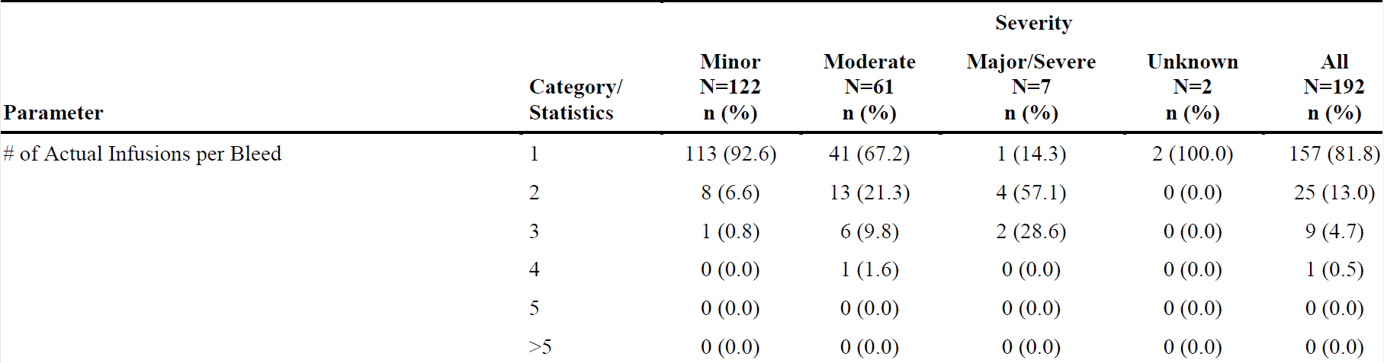
The rate of treatment success (defined as an efficacy rating < 2.5) was 100% (95% confidence interval (CI) 81.5 to 100) for bleeding events. This result remained stable when gastrointestinal (GI) bleeds were included or excluded, and did not change whether prospective or retrospective determination of bleeding severity by the investigator was included.
Table 7: Study 071001 Treatment success for bleeding events treated with vonicog alfa with or without recombinant FVIII
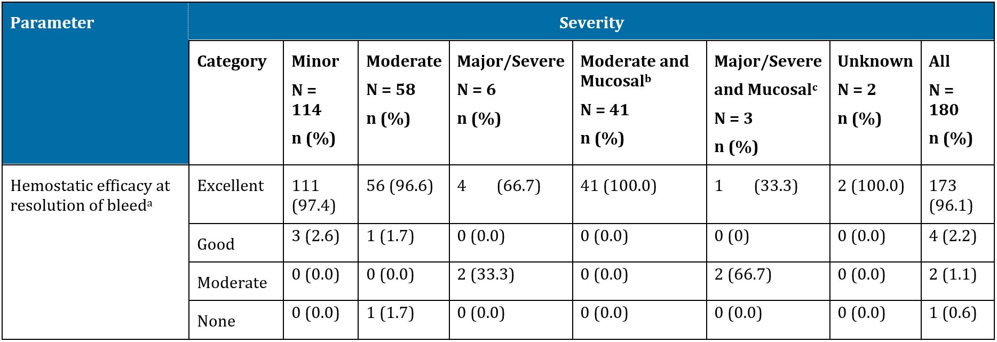
ª For the major BE13 of ‘first’ subject and the major BE2 of ‘second’ subject the estimated number of infusions was 1; using the number of infusions of 2 for both bleedings, the clinical efficacy rating is set to ‘Moderate’ in the table above. For the major BE11 of ‘third’ subject the estimated number of infusions was 2; using the number of infusions of 3, the clinical efficacy rating is set to ‘Moderate’ – however, since this bleeding was not treated with investigational product (IP) exclusively, it is not shown up in the table above. BE5 of a subject is set to ‘None’ in the table above since IP infusion had to be stopped due to AEs.
For 3 major mucosal BEs in the three subjects one additional IP infusion was administered as given for prophylactic purposes (including for the third subject, pre-surgery) and after the BE was reported to have stopped. The investigators assessed the overall efficacy ratings as follows: Subject 1/BE 13: ‘Good’, Subject 2/BE 11: ‘Excellent’ and Subject 3/BE 2: ‘Excellent’.
BE5 in Subject 4 was rated as ‘good’ for the overall clinical efficacy but the second IP infusion (of the 2 estimated) was discontinued after a few minutes due to adverse events. The bleeding stopped without administration of any additional haemostatic agent. The applicant is of the opinion that all documentation available on these four BEs support the ratings of overall clinical efficacy assessment provided by the investigators.
^{b} BE1, BE8, BE10, BE11, BE13, BE 14, BE16, BE18, BE23, BE25 and BE27 of a subject were originally assessed as ‘Bleeding within body cavity’ by the investigator since these moderate bleedings were ‘menorrhagia’, they are categorized under ‘Mucosal’.
^{C} BE11 of the third subject was originally assessed as ‘Bleeding within body cavity’ by the investigator since this major bleeding was a ‘menorrhagia’, it is categorised under ‘Mucosal’. However, BE11 of the subject was not treated with IP exclusively and is therefore not shown up in the table above. N = Number of bleeding episodes.
The clinical evaluator has noted that the study had numerous methodological issues. These included:
- a high risk of selection bias as the subjects were allowed to choose the study arm in which they participated;
- potential confounding by non-protocol-specified use of haemostatic agents such as tranexamic acid;
- a small number of patients (n = 37) from which a significant proportion (n = 15) were excluded from the analysis (n = 22).

Study 071101
Study 071101; a surgery study, was a prospective, open label, uncontrolled Phase III study designed to evaluate the efficacy and safety of rVWF with or without rFVIII as prophylaxis for bleeding in major and minor elective surgeries. Major surgeries were defined as those with a significant risk of large volume blood loss or bleeding into a confined anatomical space, including extraction of third molars. Minor surgeries included placement of intravenous access devices, removal of small skin lesions, arthroscopy, gastroscopy, conisation, and extraction of fewer than three (non-third molar) teeth.
A total of 24 subjects were enrolled, of whom 15 received vonicog alfa. Ten underwent major surgeries, 4 minor surgeries and 1 tooth extraction. An overview of the study design is shown in Figure 3.
Figure 3: Study 071101 Schema and study design
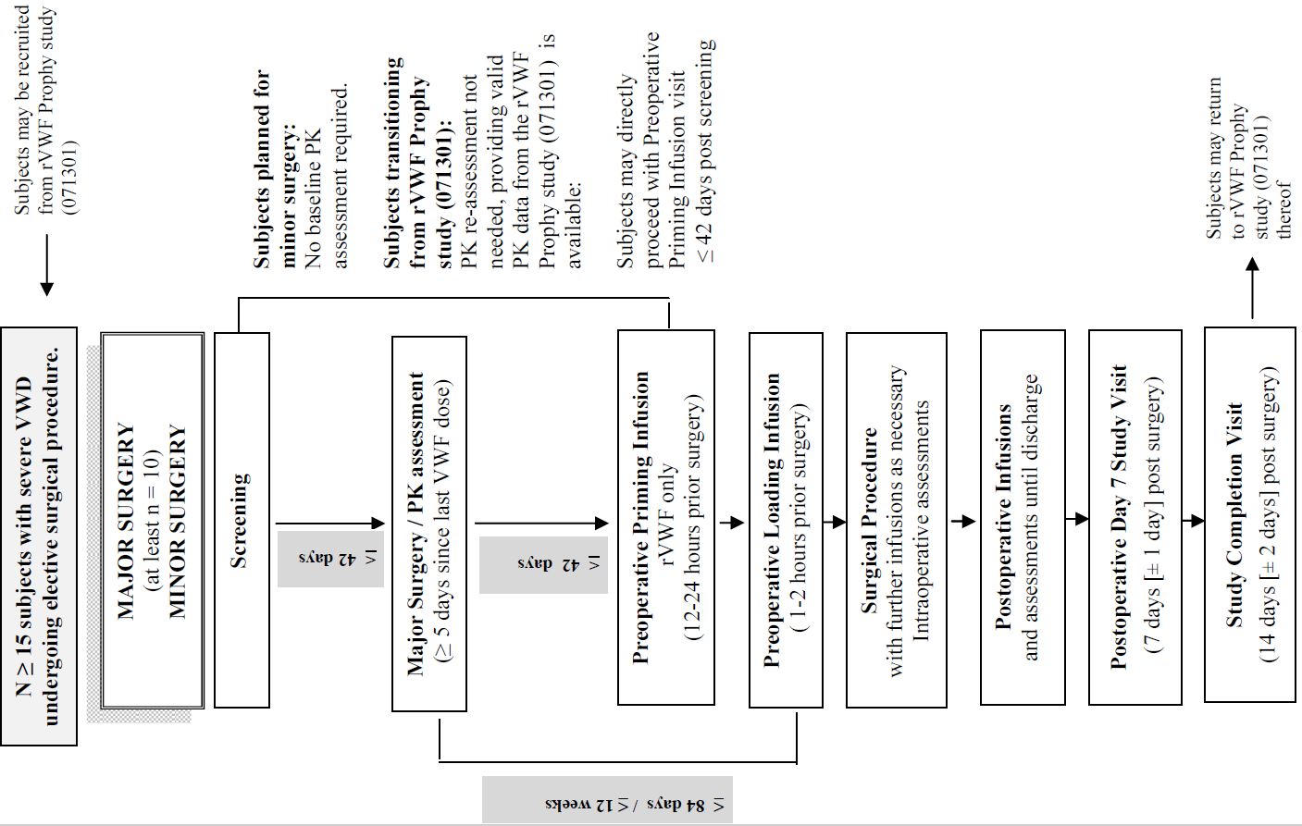
Included were adult patients had severe VWD with a history of substitution therapy with VWF to control bleeding.
The primary endpoint was the assessment of haemodynamic efficacy 24 hours after the last infusion or at the Day 14 visit, whichever was the earlier. The rating scale applied is shown in Table 8.
Table 8: Study 071101 Four point scale of haemodynamic effectiveness
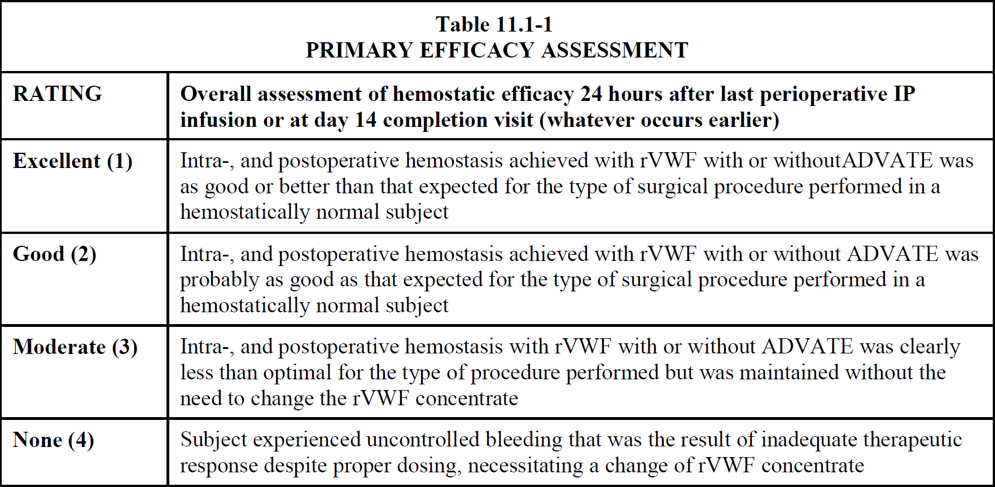
Advate (octocog alfa) = recombinant FVIII.
Haemodynamic control was rated as ‘Excellent’ in 11 out of 15 subjects, and ‘Good’ in 4 out of 15 subjects. In considering only major surgery, haemodynamic control was rated as excellent in 7 out of 10 subjects and good in 3 out of 10 subjects.
The clinical evaluator has noted that there are similar methodological concerns with this study as with the Study 071001 with respect to confounding. Three subjects were treated with tranexamic acid during the study and this concern was raised with the sponsor. The sponsor indicated that tranexamic acid is standard of care, which while true, does not address the potential confounding of the efficacy results.

Safety
A total of 92 patients were included in the safety analysis, of whom 80 suffered from VWF. Patients included in safety analysis are shown in the Figure 4.
Figure 4: Patients included in the safety analysis
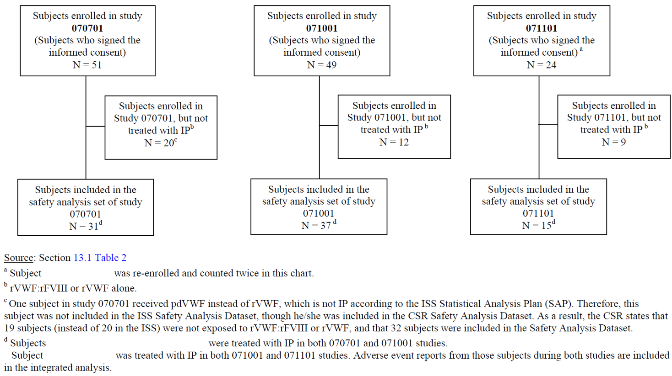
No deaths were reported during the trials or in post-marketing data. Most adverse events were mild to moderate. There was no evidence of hypersensitivity reactions suffered by patients in the safety data set.
One patient suffered two deep vein thrombosis (DVT) in the trials, and there was one reported in the post-market setting. This is consistent with VWF administration generally.

Risk management plan
The sponsor has submitted EMA approved EU-risk management plan (RMP) version 1.3 (date 31 May 2018; data lock point (DLP) 6 March 2018) and Australian specific Annex (ASA) version 1.0 (date 23 April 2019) in support of this application. In response to request for information, the sponsor has submitted EU RMP version 1.4 (date 18 September 2019; DLP 6 March 2018). ASA version 1.0 (date 23 April 2019) remains in support of this application. After the second round of evaluation, the sponsor supplied ASA version 1.1 (date 10 January 2020) as the agreed version associated with EU RMP version 1.4.
The summary of safety concerns and their associated risk monitoring and mitigation strategies are summarised in Table 9.
Table 9: Summary of safety concerns
Summary of safety concerns |  | Pharmacovigilance |  | Risk minimisation
 |  | Routine | Additional | Routine | Additional
Important identified risks | Hypersensitivity reactions |  | ¹ |  | –
Important identified risks | Thromboembolic events (particularly in patients with low ADAMTS13 levels as well as other risk factors, and concomitant overuse of FVIII) |  | ¹ |  | –
Important potential risks | Inhibitor formation |  | ¹ |  | –
Missing information | Insufficient clinical data on use in pregnancy and lactation |  | – |  | –
Missing information | Insufficient clinical data on use in geriatric patients |  | – |  | –
1: Post-authorisation safety study (PASS); (Study VON (BAX0111) VWF-500 COL).
The RMP evaluator has raised no objections to registration.

Risk-benefit analysis

Delegate’s considerations
VWD is by definition characterised by a reduction in VWF activity and there is long historical experience with treating bleeding episodes in VWD with VWF replacement. This, combined with the existing marketing experience with vonicog alfa, factors into the Delegate’s risk-benefit assessment of the data submitted to support the efficacy and safety of vonicog alfa.
The trials submitted are small and methodologically flawed. The main issue is a lack of statistically powered comparison in the efficacy or safety of vonicog alfa with a defined standard of care, including pdVWF. The Delegate notes that the clinical evaluator requested a comparison of the primary endpoint between vonicog alfa and Biostate; the currently registered plasma derived VWF. The sponsor has provided the following indirect comparison (Table 10).
Table 10: Indirect comparison of Veyvondi and Biostate, Investigator’s assessment of haemostatic efficacy
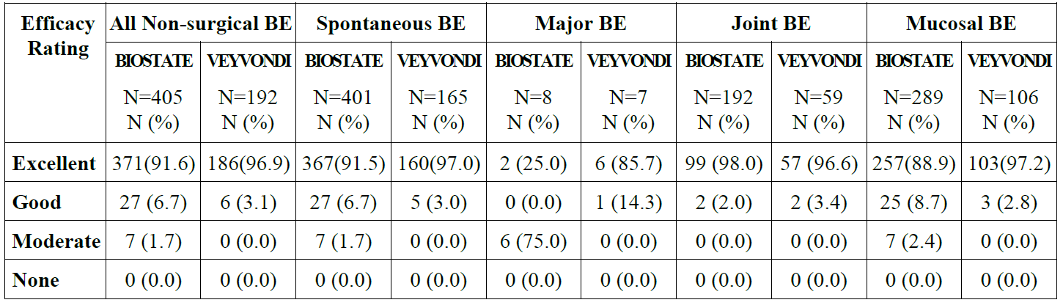
The clinical evaluator has noted the similarity in outcomes between the two treatments, acknowledging the limitations of an indirect comparison, and the Delegate concurs that this is reassuring with respect to vonicog alfa.
No unexpected safety issues have been detected for vonicog alfa since it was marketed and, while the trial data contains small numbers of patients and relatively short durations of therapy, the Delegate feels this mitigates the risk of unknown adverse events from vonicog alfa. The risks of hypersensitivity, neutralising antibodies and thrombosis are recognised for VWF replacement generally.
The Delegate notes, however, that the bioinequivalence between pdVWF and vonicog alfa is not well known and feels this must be prominently identified in the PI to avoid possible misdosing using existing clinical protocols for pdVWF.

Proposed action
The Delegate intends to register vonicog alpha for the indication:
Veyvondi is indicated in adults (age 18 and older) with von Willebrand Disease (VWD), when desmopressin (DDAVP) treatment alone is ineffective or not indicated, for the
- treatment of haemorrhage and surgical bleeding
- prevention of surgical bleeding.
Veyvondi should not be used in the treatment of Haemophilia A.
The Delegate has recommended further amendments to the PI [inclusion of these recommendations is beyond the scope of this AusPAR].

Advisory Committee considerations
The Delegate did not refer this application to the Advisory Committee on Medicines (ACM) for advice.

Outcome
Based on a review of quality, safety and efficacy, the TGA approved the registration of Veyvondi (vonicog alfa) 650 IU and 1300 IU powder for injection with solvent, indicated for:
Veyvondi is indicated in adults (age 18 and older) with von Willebrand Disease (VWD), when desmopressin (DDAVP) treatment alone is ineffective or not indicated, for the
- treatment of haemorrhage and surgical bleeding
- prevention of surgical bleeding.
Veyvondi should not be used in the treatment of Haemophilia A.

Specific conditions of registration applying to these goods
- Veyvondi (vonicog alfa) is to be included in the Black Triangle Scheme. The PI and Consumer Medicines Information (CMI) for Veyvondi must include the black triangle symbol and mandatory accompanying text for five years, which starts from the date that the sponsor notifies the TGA of supply of the product.
- The Veyvondi EU-RMP (version 1.4, date 18 September 2019; DLP 6 March 2018), with ASA (version 1.1, dated 10 January 2020), included with submission PM-2019-01555-1-6, and any subsequent revisions, as agreed with the TGA will be implemented in Australia.
An obligatory component of risk management plans is routine pharmacovigilance. Routine pharmacovigilance includes the submission of periodic safety update reports (PSURs).
Reports are to be provided in line with the current published list of EU reference dates and frequency of submission of PSURs until the period covered by such reports is not less than three years from the date of the approval letter.
The reports are to at least meet the requirements for PSURs as described in the European Medicines Agency’s Guideline on Good Pharmacovigilance Practices (GVP) Module VII-periodic safety update report (Rev 1), Part VII.B Structures and processes. Note that submission of a PSUR does not constitute an application to vary the registration.
- Batch release testing and compliance with Certified Product Details
  - It is a condition of registration that all batches of Veyvondi (vonicog alfa) 650 IU powder for injection with solvent vials and Veyvondi (vonicog alfa) 1300 IU powder for injection with solvent vials imported into/manufactured in Australia must comply with the product details and specifications approved during evaluation and detailed in the Certified Product Details (CPD).
  - It is a condition of registration that up to 5 initial batches of Veyvondi (vonicog alfa) 650 IU powder for injection with solvent vials and Veyvondi (vonicog alfa) 1300 IU powder for injection with solvent vials imported into/manufactured in Australia is not released for sale until samples and/or the manufacturer’s release data have been assessed and endorsed for release by the TGA Laboratories Branch. Outcomes of laboratory testing are published biannually in the TGA Database of Laboratory Testing Results http://www.tga.gov.au/ws-labs-index.
  - The sponsor should be prepared to provide product samples, reference materials and documentary evidence as defined by the TGA Laboratories branch. The sponsor must contact Biochemistry.Testing@health.gov.au for specific material requirements related to the batch release testing/assessment of the product. More information on TGA testing of biological medicines is available at https://www.tga.gov.au/publica tion/testing-biological-medicines
This batch release condition will be reviewed and may be modified on the basis of actual batch quality and consistency. This condition remains in place until you are notified in writing of any variation.
- Certified Product Details
The CPD, as described in Guidance 7: Certified Product Details of the Australian Regulatory Guidelines for Prescription Medicines (ARGPM) [http://www.tga.gov.au/industry/pm-argpm-guidance-7.htm], in PDF format, for the above products should be provided upon registration of these therapeutic goods. In addition, an updated CPD should be provided when changes to finished product specifications and test methods are approved in a Category 3 application or notified through a self-assessable change.
- For all injectable products the PI must be included with the product as a package insert.

Attachment 1. Product Information
The PI for Veyvondi approved with the submission which is described in this AusPAR is at Attachment 1. For the most recent PI, please refer to the TGA website at <https://www.tga.gov.au/product-information-pi>.

Therapeutic Goods Administration
PO Box 100 Woden ACT 2606 Australia
Email: info@tga.gov.au Phone: 1800 020 653 Fax: 02 6232 8605
https://www.tga.gov.au

The Black Triangle Scheme provides a simple means for practitioners and patients to identify certain types of new prescription medicines, including those being used in new ways and to encourage the reporting of adverse events associated with their use. The Black Triangle does not denote that there are known safety problems, just that the TGA is encouraging adverse event reporting to help us build up the full picture of a medicine's safety profile.
Hoffbrand, A.V. et al. Postgraduate Haematology. Seventh edition. 2016: John Riley & Sons, West Sussex.
Desmopressin (DDAVP) or D-amino D-arginine vasopressin a synthetic analogue of the endogenous pituitary hormone 8-arginine vasopressin (ADH), an antidiuretic peptide drug modified by deamination of 1-cysteine and substitution of 8-L-arginine by 8-D-arginine.
The TGA makes use of assessments from Comparable Overseas Regulators (CORs), where possible, in the evaluation of prescription medicines. Under the COR-B approach, the TGA regulatory decision will be mostly based on a critical review of the COR assessment reports. The COR-B process has a 175 working day evaluation and decision timeframe, allowing for TGA evaluation of certain data, in addition to the label, Product Information (PI) and Risk Management Plan (RMP). The amount and type of additional data requiring evaluation will determine whether the application is best processed under the COR-B approach or as a Category 1 application. Examples of additional data that may be considered under the COR-B process include updated stability data, validation data for an additional manufacturing site and updates to pivotal studies that support the proposed indication.
The International Council for Harmonisation of Technical Requirements for Pharmaceuticals for Human Use (ICH) is unique in bringing together the regulatory authorities and pharmaceutical industry to discuss scientific and technical aspects of pharmaceuticals and develop ICH guidelines. Since its inception in 1990, the ICH has gradually evolved, to respond to increasingly global developments in the pharmaceutical sector and these ICH guidelines are applied by a growing number of regulatory authorities. The ICH's mission is to achieve greater harmonisation worldwide to ensure that safe, effective and high quality medicines are developed, and registered and maintained in the most resource efficient manner whilst meeting high standards. Since its announcement of organisational changes in October 2015, ICH has grown as an organisation and now includes 17 Members and 32 Observers. Australia, via the TGA, has been an observer member since 2015.
European Medicines Agency (EMA) Committee for medicinal products for human use (CHMP), ICH guideline S6 (R1) – preclinical safety evaluation of biotechnology-derived pharmaceuticals, EMA/CHMP/ICH/731268/1998, June 2011.
Good Laboratory Practice (GLP) is an international quality system of management controls for the experimental (non-clinical) research arena, research laboratories and organisations to ensure the uniformity, consistency, reliability, reproducibility, quality, and integrity of products in development for human or animal health (including pharmaceuticals) through non-clinical safety tests; from physio-chemical properties through acute to chronic toxicity tests.
ADAMTS13, or a disintegrin and metalloproteinase with a thrombospondin type 1 motif, member 13; also known as von Willebrand factor-cleaving protease (VWFCP). This zinc-containing metalloprotease enzyme cleaves von Willebrand factor (VWF), a large protein involved in blood clotting. It is secreted into the blood and degrades large VWF multimers, decreasing their activity.
Australian Pregnancy Category B2: Drugs which have been taken by only a limited number of pregnant women and women of childbearing age, without an increase in the frequency of malformation or other direct or indirect harmful effects on the human fetus having been observed. Studies in animals are inadequate or may be lacking, but available data show no evidence of an increased occurrence of fetal damage.
Study 071001; title: . A Phase 3 Clinical Study to Determine the Pharmacokinetics, Safety and Efficacy of Recombinant Von Willebrand Factor : Recombinant Factor VIII (rVWF:rFVIII) and rVWF in the Treatment of Bleeding Episodes in Subjects Diagnosed With Von Willebrand Disease’. ClinicalTrials.gov Identifier: NCT01410227; EudraCT number: 2010-024108-84.
Study 071101; title: ‘A Phase 3, Prospective, Multicenter Study to Evaluate Efficacy and Safety of Recombinant Von Willebrand Factor (rVWF) With or Without ADVATE in Elective Surgical Procedures in Subjects With Severe Von Willebrand Disease‘. ClinicalTrials.gov Identifier: NCT02283268; EudraCT number: 2014-003575-38.
Routine risk minimisation activities may be limited to ensuring that suitable warnings are included in the product information or by careful use of labelling and packaging. Routine pharmacovigilance practices involve the following activities: - All suspected adverse reactions that are reported to the personnel of the company are collected and collated in an accessible manner; - Reporting to regulatory authorities; - Continuous monitoring of the safety profiles of approved products including signal detection and updating of labelling; - Submission of PSURs; - Meeting other local regulatory agency requirements.
A post-authorisation safety study (PASS) is a study that is carried out after a medicine has been authorised to obtain further information on a medicine's safety, or to measure the effectiveness of risk-management measures.
Biostate is a plasma derived VWF/FVIII complex product, registered on the ARTG as AUSTR 79993 and 73032, sponsored by CSL Behring Australia Pty Ltd.
The ACM provides independent medical and scientific advice to the Minister for Health and the Therapeutic Goods Administration (TGA) on issues relating to the safety, quality and efficacy of medicines supplied in Australia including issues relating to pre-market and post-market functions for medicines. The Committee is established under Regulation 35 of the Therapeutic Goods Regulations 1990. Members are appointed by the Minister. The ACM was established in January 2017 replacing Advisory Committee on Prescription Medicines (ACPM) which was formed in January 2010. ACM encompass pre and post-market advice for medicines, following the consolidation of the previous functions of the Advisory Committee on Prescription Medicines (ACPM), the Advisory Committee on the Safety of Medicines (ACSOM) and the Advisory Committee on Non-Prescription Medicines (ACNM). Membership comprises of professionals with specific scientific, medical or clinical expertise, as well as appropriate consumer health issues relating to medicines.

