September 2013

Australian Public Assessment Report for vismodegib
  - Proprietary Product Name: Erivedge
  - Sponsor: Roche Products Pty Limited

About the Therapeutic Goods Administration (TGA)
- The Therapeutic Goods Administration (TGA) is part of the Australian Government Department of Health and Ageing, and is responsible for regulating medicines and medical devices.
- The TGA administers the Therapeutic Goods Act 1989 (the Act), applying a risk management approach designed to ensure therapeutic goods supplied in Australia meet acceptable standards of quality, safety and efficacy (performance), when necessary.
- The work of the TGA is based on applying scientific and clinical expertise to decision-making, to ensure that the benefits to consumers outweigh any risks associated with the use of medicines and medical devices.
- The TGA relies on the public, healthcare professionals and industry to report problems with medicines or medical devices. TGA investigates reports received by it to determine any necessary regulatory action.
- To report a problem with a medicine or medical device, please see the information on the TGA website <http://www.tga.gov.au>.
About AusPARs
- An Australian Public Assessment Record (AusPAR) provides information about the evaluation of a prescription medicine and the considerations that led the TGA to approve or not approve a prescription medicine submission.
- AusPARs are prepared and published by the TGA.
- An AusPAR is prepared for submissions that relate to new chemical entities, generic medicines, major variations, and extensions of indications.
- An AusPAR is a static document, in that it will provide information that relates to a submission at a particular point in time.
- A new AusPAR will be developed to reflect changes to indications and/or major variations to a prescription medicine subject to evaluation by the TGA.
Copyright
© Commonwealth of Australia 2013
This work is copyright. You may reproduce the whole or part of this work in unaltered form for your own personal use or, if you are part of an organisation, for internal use within your organisation, but only if you or your organisation do not use the reproduction for any commercial purpose and retain this copyright notice and all disclaimer notices as part of that reproduction. Apart from rights to use as permitted by the Copyright Act 1968 or allowed by this copyright notice, all other rights are reserved and you are not allowed to reproduce the whole or any part of this work in any way (electronic or otherwise) without first being given specific written permission from the Commonwealth to do so. Requests and inquiries concerning reproduction and rights are to be sent to the TGA Copyright Officer, Therapeutic Goods Administration, PO Box 100, Woden ACT 2606 or emailed to <tga.copyright@tga.gov.au>.

Contents
I. Introduction to product submission 5
Submission details 5
Product background 5
Regulatory status 6
Product Information 6
II. Quality findings 6
Drug substance (active ingredient) 6
Drug product 6
Biopharmaceutics 7
Advisory committee considerations 8
Quality summary and conclusions 9
III. Nonclinical findings 9
Introduction 9
Secondary pharmacodynamics 10
Pharmacokinetics 11
Toxicity 12
Paediatric use 16
Comments on the safety specification of the risk management plan 16
Nonclinical summary and conclusions 16
IV. Clinical findings 18
Introduction 18
Clinical rationale 18
Pharmacokinetics 19
Pharmacodynamics 23
Efficacy 24
Safety 35
First round benefit-risk assessment 44
First round recommendation regarding authorisation 45
List of questions 45
Second round evaluation of clinical data submitted in response to questions 45
Second round benefit-risk assessment 50
Second round recommendation regarding authorisation 50
V. Pharmacovigilance findings 51
Risk management plan 51
VI. Overall conclusion and risk/benefit assessment 56
Introduction 56
Quality 57
Nonclinical 57
Clinical 57
Risk management plan 67
Risk-benefit analysis 67
Outcome 77
Attachment 1. Product Information 77

I. Introduction to product submission

Submission details
Type of Submission: | New Chemical Entity
Decision: | Approved
Date of Decision: | 6 May 2013

Active ingredient: | Vismodegib
Product Name: | Erivedge
Sponsor’s Name and Address: | Roche Products Pty Limited  4–10 Inman Road  Dee Why NSW 2099
Dose form: | Hard capsule
Strength: | 150 mg
Container: | Blister
Pack size: | 28
Approved Therapeutic use: | Erivedge is indicated for the treatment of adult patients with metastatic basal cell carcinoma, or with locally advanced basal cell carcinoma where surgery and/or radiation therapy are not appropriate.
Route of administration: | Oral
Dosage: | 150 mg daily
ARTG Number: | 196234

Product background
Vismodegib is a first in class, synthetic, small molecule (421 Dalton) inhibitor of the hedgehog (Hh) signalling pathway through the Smoothened (SMO) trans-membrane protein. Signal transduction through SMO leads to the activation and nuclear localisation of transcription factors and an induction of Hh target genes. Many of these genes are involved in cellular proliferation, survival and differentiation. Almost all basal cell carcinomas (BCC) are the result of alterations in the Hh signalling pathway resulting in aberrant activation of the pathway and uncontrolled proliferation of basal cells. By inhibiting SMO, it is expected that vismodegib will reduce transcription of Hh target genes, and angiogenesis, thereby reducing the development of BCC cells.
This AusPAR describes the application by Roche Products Pty Limited (the sponsor) to register vismodegib as oral capsules (Erivedge) for the proposed indication:
treatment of adult patients with advanced basal cell carcinoma for whom surgery is inappropriate.

Regulatory status
The product received initial registration in the Australian Register of Therapeutic Goods (ARTG) on 9 May 2013.
At the time TGA considered this application, a similar application had been approved in 4 counties including the USA was under evaluation in the European Union (EU), Canada and Switzerland.

Product Information
The approved Product Information (PI) current at the time this AusPAR was prepared can be found as Attachment 1.

II. Quality findings

Drug substance (active ingredient)
Vismodegib (International Non-proprietary Name (INN)) is chemically designated as 2-Chloro-N-(4-chloro-3-(pyridin-2-yl)phenyl)-4-(methylsulfonyl)benzamide (chemical name). The drug is synthetic and achiral. The chemical structure is shown in Figure 1.
Figure 1. Structure of vismodegib
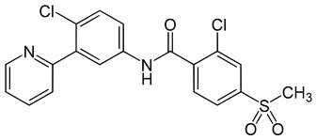
Vismodegib is a crystalline free base. The thermodynamically most stable polymorphic form observed to date (Form B) is used for drug substance. Solubility of vismodegib is pH dependent: it is markedly more soluble in acid than at neutral pH. Drug particle size was considered as a critical quality attribute and is controlled in the drug substance specification.

Drug product
Immediate release, hard gelatin, size 1 capsules containing a white to off-white powder are proposed for registration. The capsules have grey opaque caps printed ‘VISMO’ in black and ‘Flesh opaque’ bodies printed ‘150 mg’. The capsule fill is a powder formulated with conventional excipients.
Vismodegib was first formulated as 25 mg, 125 mg, and 270 mg dry blend capsules for Phase I trials. Then 150 mg capsules, manufactured by wet granulation, were developed for Phase II clinical trials. These 150 mg capsules have been used in almost all the clinical trials, with only minor changes to the manufacturing method. The formulation used in the pivotal Phase II trial is the capsule proposed for registration.
Batches of capsules are tested for in vitro dissolution.
The capsules show little change on storage and a 24 months shelf life, store below 30°C, is proposed.

Biopharmaceutics
Vismodegib is a compound with low solubility (relative to dose) and high permeability (that is, Biopharmaceutics Classification System ‘Class 2’).
The solubility of vismodegib is strongly pH dependent. Thus, it is possible that the drug is only usefully dissolved (and hence absorbed) if the stomach is acidic. Roche states that there are no direct data for achlorhydric or hypochlorhydric patients. There is a related potential for antacids etc to affect bioavailability.
Roche plans to “perform a clinical study to evaluate if gastric pH-elevating agents alter the bioavailability and impact the steady-state exposure of vismodegib. Planning for this study is currently ongoing as a result of a Post-Marketing Requirement (PMR) from the U.S. Food and Drug Administration, and the final study report will be available in 2015. The Sponsor commits to providing this report to TGA according to this timeframe.”
The single dose mean absolute bioavailability of vismodegib is about 32%. This seems relatively low for a permeable drug with slow metabolism; absorption is apparently saturable and limited solubility at physiologic pH may also affect bioavailability. The volume of distribution is low (16-27 L), with vismodegib bound to both human serum albumin (HSA) and alpha-1-acid glycoprotein (AAG). Vismodegib concentrations are strongly correlated with AAG levels.
Unchanged vismodegib is the dominant drug-related species in plasma. Vismodegib is slowly eliminated by a combination of biliary excretion and metabolism via several pathways. Excretion is mostly hepatic.
After single oral doses, vismodegib shows unusual pharmacokinetic (PK) profiles, with sustained high plasma levels reflecting an unusually long elimination half-life (about 12 days). There is relatively wide variation in plasma levels between subjects.
At steady state, the apparent vismodegib half-life is about 4 days which is shorter than the half life after a single dose. Thus there is clear accumulation on daily dosing, with steady state reached in about 7 days. The PKs are non-linear. The fraction of drug unbound to protein increases markedly on continuous daily dosing, with corresponding increases in clearance.
Three bioavailability studies were considered by the TGA Pharmaceutical Chemistry Section:

Study SHH4683g: Absolute bioavailability study
This was an open, absorption, distribution, metabolism and excretion (ADME) study in 6 healthy female volunteers. Single oral doses of 150 mg vismodegib (capsule; unlabelled drug) were followed by an intravenous (IV) dose after 2 hours (bolus 10 μg of ¹⁴C labelled drug in 2 mL solution). The IV dose was thus given at approximately the time to reach the maximum concentration (T_{max}) following the oral doses. Drug from the two dosing routes could be quantified separately.
The individual measurements of absolute bioavailability following oral vismodegib doses were fairly consistent (23%, 31%, 32%, 33%, 34%, 37%; mean 32%) notwithstanding significant intersubject variability in PK profiles (similar to that discussed above).

Study SHH4893s: Study of the effect of food
Study SHH4893s is an ongoing study of the effect of food on bioavailability. An interim analysis was reviewed.
There have been changes in the study design during the trial. Part I of the study was a parallel group study in which patients received a single 150 mg capsule dose either fasted (n=13), or with a low fat (n=3) or a high fat meal (n=13). Meals were given 30 minutes before vismodegib capsules were administered.
After a single dose there is a clear increase in mean exposure if capsules are taken with food, especially a high fat meal.
The second part of the study involved multiple doses. After 6 days without vismodegib, patients from different groups were reassigned to take 150 mg capsule doses daily either in a fasting state or 30 minutes after a ‘healthy breakfast’ (not-standardised; recommended menu provided to patients). Thus, this part did not determine the effect of high fat food on bioavailability, which might have shown larger differences. Steady state PK were then measured after two weeks. At steady state, there was a smaller effect of food (again increasing exposure). At this interim analysis the results are outside standard bioequivalence limits (Table 1):
Table 1. Vismodegib pharmacokinetics. Statistical analysis
Multidose Statistical Analysis
vismodegib |  | GMR | 90% CI
C_{max} | Fed/fasted | 107% | 81.9-139%
AUC_{0-24 h} | Fed/fasted | 105% | 80.0-137%
GMR = geometric mean ratio. CI = confidence interval. AUC_{0-24 h} = area under the concentration-time curve from time zero to 24 h
Roche argues that it is reasonable to direct that capsules may be taken with or without food.
In the pivotal clinical study (SHH4476g) patients were instructed to take vismodegib with or without food at the same time each day.

Study SHH3925g
This was a study with a complex design (including dose escalation) to assess single and multiple dose PK in patients. It included a comparison of the bioavailability of dry blend Phase I capsules (1x25 mg + 1x125 mg = 150 mg) and the proposed 150 mg capsule formulation (1x150 mg).
This single dose comparison (parallel group) suggested that the bioavailability of the Phase I capsules may be significantly lower. The data are insufficient for a reliable bioequivalence conclusion, but the Phase I capsules were anyway not used significantly in clinical studies.

Advisory committee considerations
The application was considered at the January 2013 meeting of the Pharmaceutical Subcommittee (PSC) of the TGA’s Advisory Committee on Prescription Medicines (ACPM).
The PSC endorsed all questions raised by the TGA in relation to the pharmaceutic and biopharmaceutic aspects of the submission. In particular, the PSC supported the TGA’s request that the sponsor should continue long term stability studies under relevant conditions and to provide the TGA with data when available.
The PSC also advised that the attention of the clinical delegate and the ACPM should be drawn to the impact of food on the bioavailability of vismodegib from this product.
Revisions to the draft PI were also recommended but details of these are beyond the scope of the AusPAR.

Quality summary and conclusions
There are some clarifications and assurances needed from Roche, but it is anticipated that these will be received by the time of the ACPM meeting. In that case registration would be recommended with respect to chemistry and biopharmaceutic aspects.

III. Nonclinical findings

Introduction

Overall quality of the nonclinical dossier
The nonclinical studies were reasonably well presented, although there was little analysis of the clinical significance of the results or the relative exposure compared to the clinical studies. The safety-related studies were all compliant with principles of good laboratory practice (GLP). The range of safety pharmacology studies was limited but consistent with ICH guidelines for anticancer drugs. The repeat dose studies were consistent with the European Medicines Agency (EMA)/ICH S9 guideline Nonclinical Evaluation for Anticancer Pharmaceuticals (EMEA/CHMP/ICH/646107/2008) for drugs to be used in patients with advanced cancer.

Primary pharmacology

Mechanism of action
Vismodegib acts as an inhibitor of the Hh signalling pathway, which has been implicated in the development of BCC and other cancers. Vismodegib is reported to bind to and inhibit SMO, a transmembrane protein, thus inhibiting the transmission of the Hh signal.

In vitro studies
In vitro studies in mouse and human cell lines (carrying a GLi-responsive promoter driving expression of luciferase) confirmed the ability of vismodegib to inhibit Hh signalling with 50% maximal inhibitory concentration (IC₅₀) values of 2.8 and 12.7nM, respectively. There was no activity of vismodegib in control assays (IC₅₀≥50µM).

In vivo studies
Vismodegib was tested for its ability to inhibit tumour growth in an allograft tumour model in mice as well as in patient-derived cancer xenografts in mice. Regression of a medulloblastoma allograph tumour in mice by day 14 was achieved by daily oral (PO) doses of ≥25 mg/kg vismodegib, with a 50% effective dose (ED₅₀) of 5.8 mg/kg. The anti-tumour activity of vismodegib in this allograft tumour correlated with inhibition of the Hh pathway (measured by expression of Gli1 in the tumour). Maximum repression of the Hh pathway was seen at total plasma concentrations >1µM (approximately 4% steady state total plasma concentration in clinical studies). Inhibition of the growth of a patient-derived colorectal cancer xenograft D5123 in mice correlated with inhibition of the Hh pathway (Gli1 suppression) in the tumour, with maximum inhibition at 69 mg/kg, equivalent to a total plasma concentration of 19µM (approximately 82% of steady state total plasma concentrations in clinical studies). Similarly, inhibition of the growth of a primary human pancreatic adenocarcinoma xenograph D5124 in mice correlated with inhibition of the Hh pathway (Gli1 messenger ribonucleic acid (mRNA) suppression) in the tumour with significant inhibition at a total plasma concentration of 69 mg/kg (equivalent to approximately 82% steady state total plasma concentrations in clinical studies).

Secondary pharmacodynamics
Secondary pharmacodynamic studies evaluated whether hair follicles and skin can be used as surrogate tissues for Hh pathway suppression. At 100 mg/kg vismodegib twice daily for 5 total doses, Hh suppression (measured as Gli1 mRNA) was greater in skin than in hair follicles regardless of the growth phase.

Safety pharmacology
In vitro binding of vismodegib was examined against a wide range of common pharmacological receptors. There was no significant binding (≥50% inhibition) at 10µM vismodegib (approximately 60 times the steady state unbound plasma concentration of 0.17µM in clinical studies).
Vismodegib inhibited human ether-a-go-go (hERG) potassium channel current in human embryonic kidney cells with a concentration causing 50% inhibition (IC₅₀) of 37.2µM, compared with the positive control terfenadine at an IC₅₀ of 60nM. Based on this result, there is no potential for cardiac arrhythmia from vismodegib at clinical levels (approximately 200 times the steady state unbound plasma concentration of 0.17µM in clinical studies).
In a dedicated safety pharmacology study in dogs, there were no treatment-related effects on cardiovascular parameters (including electrocardiogram (ECG), blood pressure (BP), heart rate and QTc interval) or on body temperature at single oral dose levels up to 2000 mg/kg (equivalent to 3.6 times the clinical exposure based on C_{max}). In the repeat dose study in dogs, there were no treatment-related effects on ECG, blood pressure or QTc intervals at dose levels up to 400 mg/kg/day (equivalent to 2 times the clinical exposure based on C_{max}).
Dedicated safety pharmacology studies to assess central nervous system (CNS) and respiratory functions were not performed, consistent with ICH S9 guidelines for anticancer drugs; however, CNS effects were evaluated in the repeat-dose rat studies and respiratory effects were evaluated in the repeat-dose dog studies. In rats, effects on the CNS (tremors, low posture and jerking) were noted at 100 mg/kg/day (equivalent to the clinical exposure based on AUC). In dogs, there were no effects on respiration at dose levels up to 400 mg/kg/day twice daily (equivalent to 2 times the clinical exposure based on C_{max}).

Pharmacodynamic drug interactions
Vismodegib is proposed as a monotherapy in advanced cancer patients and therefore pharmacodynamic (PD) drug interaction studies were not warranted.

Pharmacokinetics
Nonclinical PK studies were conducted in the mouse, rat, dog and monkey.
Absorption following single dose oral administration was rapid in the mouse and rat (T_{max} <1 h), but slower in monkey (2 h) and dog (9 h). Bioavailability varied with species between 13.4% in monkey to 52.9% in rat. The plasma half-life (t_{1/2}) was rapid in mouse, rat and monkey (0.5-1.5 h), but slow in dog (42 h). In repeat-dose studies in rat and dog, exposure (measured by both C_{max} and AUC) increased with dose, but was less than dose-proportional in both species. No sex-related differences were noted.
Tissue distribution of radiolabelled vismodegib was widespread following oral administration in rats, declined in all tissues over the 6 day study but remained in the uvea of the eye, aorta, liver, Harderian gland, kidney cortex and adrenal gland. There was no evidence of significant accumulation over time in rats or dogs in the repeat-dose studies.
In vitro plasma protein binding was very high (>95%) in the plasma of all species, including humans (>95%). Binding was high to both HAS and human AAG. With regard to blood-plasma partitioning, there was no evidence of differential distribution to red blood cells in any species, including humans.
The major pathways of metabolism of vismodegib involve oxidation of the 4-chloro-3-(pyridine-2-yl)-phenyl moiety followed by glucuronidation or sulfation. A minor metabolic pathway involves pyridine ring cleavage. Metabolism was examined in vitro in rat, dog and human liver microsomes. The two major metabolites in all species were mono-oxidation products of vismodegib. These were produced mainly by human cytochrome P450 (CYP) 3A4 and 3A5 (M1) and CYP2C9 and 3A4 (M3). In in vivo studies in rat and dog, the major component in plasma was unchanged vismodegib. The faeces was the major elimination pathway of vismodegib and its metabolites in both species, while urine was a minor elimination pathway. Bile cannulation in both rat and dog indicated that the bile was a significant route of elimination for vismodegib metabolites (36% and 21%, respectively), but not for vismodegib. Mass balance studies in rat and dog confirmed that faeces was the major excretion route. Based on total excretion in bile and urine, mean absorption was 42% in rats and 31% in dogs.
On the basis of the submitted data, the PK of vismodegib in rats and dogs is similar to the PK in humans, with moderate absorption, high plasma protein binding, slow metabolism involving oxidation and conjugation, followed by slow elimination via the bile and faeces.

Pharmacokinetic drug interactions
Vismodegib in vitro was a weak inhibitor of human liver CYP2C8 (affinity constant K_{i} 6.0µM) and CYP2C9 (K_{i} 5.4µM) (equivalent to approximately 30 times the steady state unbound plasma concentration). There was no evidence of induction of CYP1A2, 2B6 or 3A4/5 by vismodegib in human hepatocytes over 48 h at concentrations up to 100µM (equivalent to >500 times the steady state plasma concentration). Nor was there evidence of induction of enzymes regulated by the pregnane X receptor (PXR), given the weak binding of vismodegib to PXR (concentration causing 50% inhibition (IC₅₀) of 83.3µM, equivalent to >400 times the steady state unbound plasma concentration).
With regard to transporters, vismodegib did not inhibit P-glycoprotein in cultured kidney MDR1-MDCK cells, but it is a substrate for the P-glycoprotein transporter, with efflux ratios (B-A/A-B)of 8.6 and 1.0, respectively, in the absence or presence of the inhibitor, cyclosporin A. Vismodegib is not a substrate for breast cancer resistant protein (BCRP), but inhibited the BCRP transport of prazosin with an IC₅₀ of 2.4µM (approximately 14 times the steady state unbound plasma concentration). Given the high plasma protein binding of vismodegib, the unbound plasma concentration is unlikely to be high enough for the potential inhibition of the CYP450 enzymes or the potential inhibition of BCRP transport to have clinical relevance.

Toxicity

Acute toxicity
Vismodegib demonstrated low acute toxicity in studies conducted in rats and dogs. A treatment-related increase in serum cholesterol in dogs at doses ≥225 mg/kg was the only observed toxicity. The minimum nonlethal dose in rats and dogs was 2000 mg/kg by the oral route (>4 times the clinical dose, based on AUC or C_{max}). Vismodegib has a low order of acute toxicity by the clinical (oral) route.

Repeat-dose toxicity
Repeat-dose studies up to 26 weeks were conducted in rats and dogs. All studies were conducted by the oral route with dosing twice daily (6 h interval). The proposed clinical route is the oral route with once daily dosing, based on sustained plasma levels in humans and an estimated terminal half-life of 12 days.

Relative exposure
Exposure ratios have been calculated based on animal:human plasma AUC_{0–24 h} and C_{max}. The relative exposure in the longer term animal studies ranged from equivalent to approximately twice as high as the clinical exposure at steady state.
Table 2. Relative exposure in repeat-dose toxicity studies
Species | Study duration | Dose  mg/kg/day | AUC_{0–24 h}  (ng∙h/mL) | C_{max}  (ng/mL) | Exposure ratio based on AUC# | Exposure ratio based on C_{max}#
Rat  (SD) | 4 weeks | 50 | 116000 | 14500 | 0.5 | 1.5
Rat  (SD) | 4 weeks | 150 | 197000 | 18100 | 0.9 | 1.9
Rat  (SD) | 4 weeks | 500 | 404000 | 36600 | 1.8 | 3.8
Rat  (SD) | 13 weeks | 10 | 37550 | 3190 | 0.17 | 0.3
Rat  (SD) | 13 weeks | 50 | 166200 | 12400 | 0.7 | 1.3
Rat  (SD) | 13 weeks | 150 | 314000 | 19800 | 1.4 | 2.0
Rat  (SD) | 13 weeks | 500 | 294500 | 25450 | 1.3 | 2.6
Rat  (SD) | 26 weeks | 15 | 77600 | 6450 | 0.3 | 0.7
Rat  (SD) | 26 weeks | 50 | 125600 | 8350 | 0.6 | 0.9
Rat  (SD) | 26 weeks | 100 | 245000 | 21150 | 1.1 | 2.2
Dog (Beagle) | 4 weeks | 50 | 515000 | 8330 | 2.2 | 0.9
Dog (Beagle) | 4 weeks | 150 | 754500 | 17300 | 3.4 | 1.8
Dog (Beagle) | 4 weeks | 400 | 747500 | 19600 | 3.3 | 2.0
Dog (Beagle) | 13 weeks | 15 | 344500 | 15950 | 1.5 | 1.6
Dog (Beagle) | 13 weeks | 50 | 493000 | 23650 | 2.2 | 2.4
Dog (Beagle) | 13 weeks | 150 | 479500 | 24650 | 2.1 | 2.5
Dog (Beagle) | 26 weeks | 5 | 153000 | 7260 | 0.7 | 0.7
Dog (Beagle) | 26 weeks | 15 | 258000 | 11700 | 1.1 | 1.2
Dog (Beagle) | 26 weeks | 50 | 447000 | 21150 | 2.0 | 2.2
# = animal:human plasma AUC_{0–24 h} based on typical AUC_{0-24 h} of 225000ng.h/mL and C_{ss} of 23.1µM (9732 ng/mL) (Studies nos. SHH3925g; SHH4610g and SHH4476g).

Major toxicities
The nonclinical toxicity associated with vismodegib included evidence of general toxicity as well as toxicity associated with the pharmacological activity of vismodegib. In the short term rat studies (<4 weeks), general toxicity was seen only at the higher dose (>250 mg/kg/day). In the 4 week rat study, there was reduced bodyweight gain and signs of neurotoxicity (reduced grip strength) at ≥150 mg/kg/day. In the longer term rat studies (13 and 26 weeks), there were neurological signs (tremors, low posture, jerking), a reduced number of corpora lutea in females, and a general moribund condition in both sexes at 100 mg/kg/day (equivalent to 1-2 times the clinical exposure based on AUC or C_{max}). In the dog studies, reversible general toxicity (reduced bodyweight gain and increased cholesterol) was evident at ≥15 mg/kg/day. The increased incidence of degenerating sperm cells and hypospermia in the epididymides in the 4 week dog study at ≥50 mg/kg/day (equivalent to approximately twice the clinical exposure based on AUC or C_{max}) was not repeated in longer studies and may be related to the young age of the dogs in this study. In the 26 week dog study, there was equivocal evidence of an increase in abnormal sperm at 50 mg/kg/day (equivalent to twice the clinical exposure based on AUC or C_{max}).
Toxicity associated with the pharmacological activity of vismodegib included effects on growing teeth, skin and bones., , In rats, an increase in missing incisors in the 4 week study was evident during the recovery period at ≥50 mg/kg/day and was accompanied by microscopic degenerative changes in the incisor teeth. This effect was evident again in the 13 week study at 50 mg/kg/day and in the 26 week study at 15 mg/kg/day (equivalent to approximately half the clinical exposure based on AUC or C_{max}), and was accompanied by microscopic degenerative changes which continued through the recovery period. The overall no observed adverse effect level (NOAEL) in rats was 10 mg/kg/day (equivalent to a third of the clinical exposure based on AUC or C_{max}). The incidence of red skin and altered femoral epiphyseal plate was also increased in the 26 week rat study at ≥ 50mg/kg/day (equivalent to slightly less than the clinical exposure, based on AUC or C_{max}). A decrease in corpora lutea was also seen at 100 mg/kg/day which may indicate an effect on ovarian activity. Effects on the incisor teeth and femoral epiphyses are considered to be influenced by Hh inhibition. Rat incisors are considered more sensitive to Hh inhibition than dogs or humans, and no corresponding effect was seen in dogs. In the dog studies, effects of Hh inhibition on the hair follicle were more evident than in the rat studies, with increased alopecia, follicular hyperkeratosis and inflammation at 5 mg/kg/day (equivalent to slightly less than the clinical dose, based on AUC or C_{max}). These dose-limiting effects were considered secondary to the effects of vismodegib on the hair follicles, and no NOAEL could be established in dogs.

Genotoxicity
The genotoxic potential of vismodegib was examined in in vitro studies in bacteria and mammalian cells and in an in vivo study in rats. In Salmonella typhimurium strains TA98, TA100, TA1535 and TA1537, and in Escherichia coli WP2 uvrA, there was no evidence of an increased frequency of mutations at 5000µg/plate. In human lymphocytes, there was no evidence of an increase in the number of cells with chromosome aberrations at 600µg/ml. In the rat micronucleus test, there was no increase in the incidence of micronucleated polychromatic erythrocytes at 2000 mg/kg PO, which was > 5 times the clinical exposure, based on C_{max}. The overall conclusion is that vismodegib does not have genotoxicity potential in vitro or in vivo.

Carcinogenicity
Carcinogenicity studies were not conducted. This is in accordance with ICH S9 (EMEA/CHMP/ICH/646107/2008) guidelines as vismodegib is intended to treat advanced patients with advanced cancer. The US FDA has requested carcinogenicity studies as a post-marketing commitment.
In the 26 week rat study, a pilomatricoma (believed to originate within the hair follicle matrix) was found in the skin of 1 male and 1 female rat after the recovery period at 100 mg/kg/day (equivalent to 1-2 times the clinical exposure based on AUC or C_{max}). An increase in follicular cysts was also noted at this dose level and the pilomatricoma may be related to pharmacologically mediated disruption of the hair follicle morphogenesis. In humans, pilomatricomas are almost exclusively benign and readily excisable. While an increased incidence of pilomatricomas is possible following vismodegib treatment, it would be clinically manageable.

Reproductive toxicity
Very limited assessment of reproductive toxicity was performed with vismodegib. This is consistent with ICH S9 guidelines as vismodegib is intended to treat patients with advanced cancer. There was integration of aspects of reproductive toxicity into the repeat dose studies in rat and dog (see below). There were no studies on placental transfer or examination of excretion into milk. Fertility studies were not performed; however, there is some evidence of effects on fertility in repeat-dose studies in rats and dogs.
Based on the well characterised teratogenic potential of Hh pathway inhibitors, , a confirmatory study only on embryofetal development in rats was performed. No study in a second species was performed. Similarly, in accordance with ICH S9 guidelines, dedicated studies on pre- and post-natal development were not performed. However, evidence of effects on post-natal development of teeth and bones was seen in the repeat-dose studies in rats.

Relative exposure
Exposure ratios have been calculated based on animal:human plasma AUC_{0–24 h} and C_{max}. The relative exposure in the embryofetal toxicity study ranged from less than to approximately 5-8 times higher than the clinical exposure at steady state.
Table 3. Relative exposure in an embryofetal development study in rats
Species | Study | Dose  mg/kg/d | AUC_{0–24 h}  (ng∙h/mL) | C_{max}  (ng/mL) | Exposure ratio based on AUC# | Exposure ratio based on C_{max}#
Rat  (Wistar) | Embryofetal development  GD1 | 10 | 63600 | 6510 | 0.2 | 0.7
Rat  (Wistar) | Embryofetal development  GD1 | 60 | 250000 | 17400 | 1.1 | 1.8
Rat  (Wistar) | Embryofetal development  GD1 | 300 | 506000 | 36700 | 2.5 | 3.8
Rat  (Wistar) | Embryofetal development  GD10 | 10 | 50500 | 7220 | 0.2 | 0.7
Rat  (Wistar) | Embryofetal development  GD10 | 60 | 620000 | 50200 | 2.8 | 5.2
Rat  (Wistar) | Embryofetal development  GD10 | 300 | 1030000 | 75400 | 4.6 | 7.8
# = animal:human plasma AUC_{0–24 h} based on typical AUC_{0-24h} of 225000ng.h/mL and C_{ss} of 23.1µM (Study nos. SHH3925g; SHH4610g and SHH4476g). GD = gestation day.
In the embryofetal development study in rats, the results were consistent with the well characterised teratogenic potential of Hh pathway inhibitors. Reproductive toxicity was evident with early resorption of all fetuses at 60 mg/kg/day and above (approximately 3 times the clinical exposure based on AUC); however, some evidence of reproductive toxicity was also evident at 10 mg/kg/day (reduced implantation sites and fetuses). Skeletal malformations were increased at 10 mg/kg, particularly absent or fused digits of the hindlimbs. Other less common skeletal malformations in this species were also found (open perineum, craniofacial malformations). The study author considered all of these malformations to be treatment-related based on similar findings and mechanistic plausibility reported in published studies. There was also an increase in incomplete or non-ossified bones (including the centra of cervical vertebrae, sternum and phalanges). Visceral malformations in the kidney were also observed (including dilated renal pelvis and dilated ureter). A dose of 10 mg/kg is approximately 0.2-1 times the clinical exposure based on AUC or C_{max.}

Pregnancy classification
The nonclinical data indicates that treatment with vismodegib at the proposed levels of exposure leads to a high probability of embryotoxicity during early pregnancy and a high probability of malformations in surviving fetuses. Based on this data and teratogenic potential of Hh pathway inhibitors, there may be a case for placing vismodegib in Pregnancy Category X. However, in the absence of human data and considering the proposed indication (advanced cancer), Pregnancy Category D is considered appropriate. A clear warning in the PI on potential teratogenicity would be necessary.

Local tolerance
Not studies of local tolerance were performed, based on the intended oral route of administration.

Paediatric use
Vismodegib is not proposed for paediatric use and no specific studies in juvenile animals were submitted.

Comments on the safety specification of the risk management plan
Results and conclusions drawn from the nonclinical program for vismodegib detailed in the sponsor’s draft Risk Management Plan (RMP) are in general concordance with those of the nonclinical evaluator, except for the following:
In the section on carcinogenicity, the paragraph under the column “Relevance to Human Usage” could be expanded to include the statement: “In humans, pilomatricomas are almost exclusively benign and readily excisable.” The reference (Julian et al, 1998) could be included in the 3rd column.

Nonclinical summary and conclusions
- There was adequate data in Module 4 to analyse and assess the nonclinical pharmacological, PK and toxicological properties of vismodegib in relation to its proposed clinical use.
- The primary pharmacology studies confirm the activity of vismodegib as an inhibitor of the Hh signalling pathway, both in vitro and in vivo at exposures well below the clinical exposure. Its activity against tumours in vivo was demonstrated in an allograft tumour model in mice as well as in patient-derived cancer xenografts in mice at exposure levels equivalent to the clinical exposure.
- A secondary PD study in mice confirmed secondary effects of inhibition of the Hh pathway in the skin and hair follicles. The safety pharmacology studies directly assessed only potential cardiovascular effects (ECG, blood pressure and QTc prolongation) and body temperature, and no adverse effects were observed at 2-3 times the clinical exposure. The hERG potassium channel current was inhibited by vismodegib but only at exposure levels well in excess of the unbound plasma concentration. Central nervous system and respiratory parameters were examined in repeat dose studies. A potential for CNS effects (tremors, low posture and jerking) was noted in rats at a dose level equivalent to the clinical exposure. No CNS or respiratory effects were noted in dogs.
- The PK studies demonstrated mean absorption was 42% in rats and 31% in dogs. High in vitro plasma protein binding was observed in all species, including humans. Tissue distribution in rats was very wide. In in vitro studies, metabolism was similar in rats, dogs and humans, with two major mono-oxidation products, and no human-specific metabolites. Excretion was largely via the bile and faeces. Vismodegib was a weak inhibitor of CYP2C8 and CYP2C9, and an inhibitor of BCRP transport, but given the high plasma protein binding, the unbound concentration of vismodegib is unlikely to be high enough for these inhibitions to be of clinical relevance. There was no evidence of induction of CYP1A2, 2B6 or 3A/5 by vismodegib. Vismodegib is a weak binder to the pregnane X receptor.
- In the repeat dose studies, there was evidence of general toxicity as well as toxicity associated with the pharmacological activity of vismodegib. Moribund condition, reduced bodyweight and neurological signs were evident in rats at exposures similar to the clinical exposure. Toxicity associated with the pharmacological activity of vismodegib was evident in teeth, skin and bones. The effect on incisor teeth in rats was seen at exposure below the clinical exposure, although rat incisors are considered more sensitive to Hh inhibition than dogs or humans. The effect on the femoral epiphyseal plate in rats was at exposures below the clinical exposure. The effects on the hair follicle in dogs (alopecia and follicular hyperkeratosis and inflammation) were seen at exposures less than the clinical exposure.
- The genotoxicity data was adequate and produced negative results in in vitro and in vivo studies. No carcinogenicity studies were performed, consistent with the ICH guidelines for an anti-cancer drug. The presence of pilomatricoma in rats may be related to pharmacologically-mediated disruption of the hair follicle morphogenesis. Although this tumour occurs at exposures similar to the clinical exposure, pilomatricomas are almost exclusively benign and readily excisable.
- The limited reproductive toxicity studies (consistent with ICH guidelines for a drug for the treatment of advanced cancer) confirmed the teratogenic potential of Hh pathway inhibitors. Vismodegib displayed significant embryofetal toxicity and teratogenicity at exposures lower than the clinical exposure. Based on animal data and teratogenicity of other Hh pathway inhibitors, there may be a case for placing vismodegib in Pregnancy Category X. However, in the absence of human data and considering the proposed indication (advanced cancer), Pregnancy Category D is considered appropriate. A clear warning in the PI on potential teratogenicity would be necessary.

Conclusions
- There were no major deficiencies in the nonclinical data on vismodegib.
- The primary pharmacology data confirm the inhibition of the Hh signalling pathway by vismodegib as well as its ability to reduce tumour growth in animals at clinically relevant exposures.
- The safety pharmacology data did not demonstrate any potentially adverse cardiovascular effects in dogs at clinically relevant exposures.
- There was no evidence of potential PK drug interactions at clinically relevant exposures.
- The repeat dose studies in rats indicate a potential for CNS effects at clinically relevant exposures. The pharmacologically-mediated effect on incisor teeth in rats is clinically relevant for paediatric patients although these effects were not noted in dogs and may indicate that rats are more sensitive to this effect than other species. The pharmacologically-mediated effect on bone in rats is also considered clinically relevant for paediatric patients. In dogs, the pharmacologically-mediated effects on hair follicles leading to alopecia are considered clinically relevant.
- There is no evidence that vismodegib has genotoxic potential. The pilomatricomas observed in rats may be relevant to clinical exposure; however, their presence in humans would not present a significant additional risk and is clinically manageable.
- The reproductive toxicity studies indicate a significant risk of embryofetal toxicity and teratogenicity associated with the use of vismodegib. Pregnancy Category D is recommended and a clear warning on potential teratogenicity should be included in the PI.

Recommendations
Based on the nonclinical data provided for vismodegib and evaluated in this report, there are no nonclinical objections to the approval of vismodegib.
The sponsor should be requested to include an appropriate warning statement on potential teratogenicity in the PI.

IV. Clinical findings

Introduction
Vismodegib is a low molecular weight, orally available inhibitor of the Hh pathway signalling through the SMO trans-membrane protein. Signal transduction through SMO leads to the activation and nuclear localisation of transcription factors and an induction of Hh target genes. Many of these genes are involved in cell proliferation, survival and differentiation. Vismodegib binds to and inhibits SMO thereby preventing Hh signalling transduction. Almost all basal cell carcinomas (BCC) are the result of alterations in the Hh signalling pathway, resulting in aberrant activation of the pathway and uncontrolled proliferation of basal cells. As vismodegib targets the SMO protein, a key component of Hh signalling, it acts as an inhibitor of Hh signalling and subsequent inhibition of the basal cell carcinoma cells.
This application is for approval for marketing of vismodegib (VIS), an inhibitor of Hh signalling, for the proposed indication for the treatment of adult patients with advanced basal cell carcinoma for whom surgery is inappropriate.

Clinical rationale
Basal cell carcinoma is a common skin malignancy generally treated by various surgical methods, photodynamic therapy and other topical treatments. The development of locally advanced BCC and even more rarely metastatic BCC are unusual circumstances. Nevertheless when such situations arise treatment is limited and in the locally advanced situation when surgery is no longer either possible or indicated, treatment methods are generally considered to be inadequate. Similarly, when the disease becomes metastatic there are no published data to indicate treatments of clear cut efficacy. At the present time there are no established treatments of efficacy for either locally advanced or metastatic BCC. The development of vismodegib represents a new and potentially worthwhile approach to the management of this condition.
Molecular and genetic studies have shown that almost all sporadic human BCCs have alteration in the Hh signalling pathway, resulting in aberrant activation of the pathway and uncontrolled proliferation of basal cells. These data suggest that blocking of the Hh signalling pathway by targeting Hh dependent activity of the trans-membrane protein SMO can provide a therapeutic benefit for patients with BCC. Animal studies have shown that orally delivered vismodegib has anti-tumour activity in the variety of primary human tumour xenografts and tumour cell lines in xenograft models.

Scope of the clinical dossier
Module 1 contains the appropriate application form, draft Australian PI and Consumer Medicine Information (CMI), FDA approved product label and proposed European summary of product characteristics (EU SmPC).
Module 2 contains appropriate clinical overviews together with summaries of clinical efficacy and clinical safety and literature references.
Module 5 included:
- 10 pharmacokinetics/pharmacodynamics studies;
- 2 efficacy studies
- safety data from a total of nine company-sponsored clinical studies and 14 studies which were sponsored by the National Cancer Institute Cancer Therapy Evaluation Program (NCI CTEP) conducted in the United States and other institutions.
Also included are two pooled studies, one a population PK analysis of vismodegib and the second a pooled study involving an exposure-response analysis of vismodegib in cancer patients.
For all studies full clinical reports together with relevant summaries and tabular summaries were provided. The data were adequate for full evaluation.

Paediatric data
This submission did not include paediatric data.

Good clinical practice
All aspects of good clinical practice were observed.

Pharmacokinetics

Studies providing pharmacokinetics data
Module 5 contained a total of 10 clinical studies providing PK data, as summarised in table 4.
In addition, the dossier included an interim report of an ongoing, Phase Ib, open label, PK drug interaction study (Study SHH4593g) of vismodegib with rosiglitazone and oral combined contraceptives in patients with locally advanced or metastatic solid tumours that are refractory to standard therapy or for whom no standard therapy exists.
A population PK analysis was also conducted on combined PK data in 225 subjects from five clinical studies: Phase I studies SHH3925g (in cancer patients including BCC, n=68), SHH4610g (cancer patients, n=63), SHH4433g (in healthy subjects, n=3) and SHH4683 (healthy subjects, n=18), and the Phase II Study SHH4476g (BCC patients n=73).
Table 4. Overview of vismodegib studies providing PK data
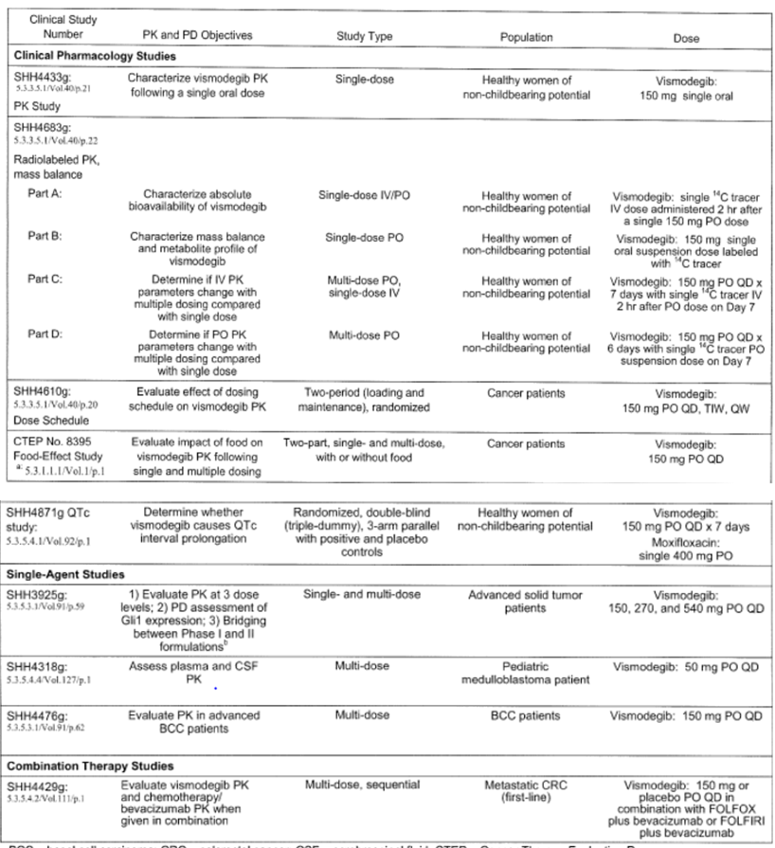
BCC = basal cell carcinoma; CRC = colorectal cancer; CSF = cerebrospinal fluid; CTEP = Cancer Therapy Evaluation Program; FOLFORI = irinotecan, leucovorin and infusional 5-fluorouracil (5-FU); FOLFOX = oxaliplatin, leucovorin and infusional 5-FU; QD = once daily; TIW = three times a week; QW = once a week; IV = intravenous; PO = by mouth.

Evaluator’s summary and conclusions on pharmacokinetics
The data from the studies (see Table 4 above) indicate that after a single oral dose vismodegib exhibits a unique PK profile with sustained plasma concentrations and a long terminal half-life. Parallel concentration-time profiles were observed in the terminal elimination phase following oral and IV dosing, indicative of elimination rate-limited PK. Non-linear PK of vismodegib were also evidenced by dose- and concentration-dependent changes in PK parameters with continuous daily dosing.
Vismodegib concentrations after a single oral dose increase with dose escalation from 150 mg to 270 mg, however at 540 mg the mean total of unbound plasma vismodegib concentrations were similar to that observed at 270 mg suggesting saturable absorption. The estimated terminal elimination half-life of vismodegib is 12 days after a single dose.
After continuous once daily dosing, similar steady state levels (total and unbound) of vismodegib were observed across all three dosing cohorts (150, 270 and 540 mg). The plasma concentration-time curve for vismodegib in cancer patients is shown in Figure 2.
Figure 2. Mean (± SD) plasma concentrations of vismodegib (Total [A] and Unbound [B] versus time after daily oral dosing. Study SHH3925g.
Following IV administration of vismodegib at oral steady state, vismodegib clearance (CL) and volume of distribution at steady state (Vss) both increased >50% compared with after a single dose. The increase in CL and Vss can be explained by the observed increase (approximately three-fold) in fraction of unbound vismodegib after daily dosing relative to a single dose. Under continuous dosing conditions the apparent half-life of vismodegib at steady state is shorter at 4 days than after a single dose (12 days) and steady state drug concentrations are obtained earlier and are lower than expected.
Total vismodegib concentrations and AAG levels were strongly correlated, showing parallel fluctuations of AAG and total drug over time with consistently low unbound drug levels (<1%) regardless of dose or concentration. Collectively these findings demonstrate that the PK profile of vismodegib can be explained by its saturable absorption, slow metabolic elimination properties and high, saturable binding to AAG.
A population PK analysis was conducted on combined PK data in 225 subjects from five clinical studies. Because of the non-linear PK of vismodegib and the importance of AAG binding both total and unbound plasma concentrations of vismodegib were analysed simultaneously where available.
The PK of vismodegib at the clinical dose range can be adequately described by a one-compartment model with first order absorption, first order elimination of unbound drug and saturable binding to AAG with fast equilibrium.
Alpha-1-acid glycoprotein concentrations were the most important factor influencing steady state plasma concentrations of total or unbound vismodegib. Alpha-1-acid glycoprotein was also the most influential factor for steady state concentration of unbound vismodegib. None of the other baseline co-variants evaluated showed clinically relevant impact on steady state concentrations of total or unbound vismodegib.
In the population PK analysis age and body weight were identified as statistically significant covariates for the vismodegib disposition parameters CL (unbound drug) and apparent volume of distribution of the central compartment (V_{c}), respectively, but sensitivity analysis suggested that neither of these effects had a clinically significant impact on vismodegib concentration at steady state.
Cancer patients showed slower drug absorption (lower first-order absorption rate constant [ka]) than did healthy volunteers, but with no significant impact on vismodegib exposure at steady state. The vismodegib CL (unbound drug), V_{c}, and dissociation constant for vismodegib-AAG binding (KD_{AAG}) did not differ among different subject populations (healthy versus patients, BCC versus non-BCC, locally advanced versus metastatic BCC). The slow absorption in patients may be due to multiple factors such as slower gastrointestinal transit, higher gastrointestinal pH and co-medications affecting gastrointestinal conditions which in turn may affect vismodegib solubility and absorption in vivo.
Estimation of population PK parameters suggested an apparent vismodegib half-life of 4 days at steady state in a typical patient (60 year old with bodyweight of 75 kg and AAG of 30 µM). Modelling and simulations suggested that a time to steady state is approximately seven days in a typical population with continuing daily dosing of 150 mg vismodegib. Moderate inter-subject variability was estimated for vismodegib disposition parameters in the population PK analysis (approximately 50% for CL (unbound drug) and V_{c}, 20% for KD_{AAG}).
Intra-subject variability estimates were 27% and 42% for total and unbound plasma concentrations of vismodegib respectively. The greater intra-subject variability of unbound concentration was consistent with the potential greater assay variability associated with separation of unbound drug prior to measurement. No difference in PK variability between cancer patients and healthy subjects was identified in the population PK analysis.
Overall, vismodegib exhibits non-linear PK as evidenced by dose and concentration dependent changes in PK parameters. Absorption is saturable and CL and V_{ss} increase after repeated daily dosing due to changes in the fraction unbound, which is dependent on the degree of AAG saturation. As a result of these PK properties, daily dosing of vismodegib does not result in excessive drug accumulation as predicted for a drug with a single dose half-life of 12 days.
An optimal dose of vismodegib (150 mg) was identified based on multiple factors including saturable absorption at daily doses >150 mg and non-linear protein binding with dosing schedules alternate to once daily. Because of the slow elimination of vismodegib via multiple elimination pathways, including metabolism by several CYPs and excretion of unchanged drug, interactions in which vismodegib is affected are unlikely.
The similar steady state vismodegib concentrations obtained in patients receiving CYP inhibitors and inducers support the lack of effect of such agents on vismodegib PK. Similarly data from studies presented indicates that the potential for vismodegib to affect the PK of other drugs is minimal.
Population PK analysis suggested that vismodegib PK is highly dependent on AAG concentration whereas no other intrinsic factors were shown to significantly impact vismodegib exposure.

Pharmacodynamics

Studies providing pharmacodynamic data
Several exposure-response relationship studies were conducted as follows:

Exposure-response relationship for biomarker response
Biomarker GLi1 expression from hair follicle cells from pulled hair and skin punch biopsies was determined prior to vismodegib dosing in the Stage II cohort with advanced BCC in Study SHH3925g.
No relationship between GLi1 biomarker expression and total plasma concentration of vismodegib was observed. A slight trend suggesting a decrease in GLi1 expression with increasing unbound plasma concentrations of vismodegib was observed, however this effect was deemed to be inconclusive and insignificant with linear regression (P value for slope = 0.081) because of the limited number of data points.

Exposure-response relationship for clinical efficacy
The exposure-response relationship for efficacy was explored from data from the Phase II Study SHH4476g in patients who were administered vismodegib 150 mg daily (n=77). No exposure-response relationship was observed for tumour response (complete response, partial response, stable disease, or progressive disease) or type of clinical responder (responder or non-responder) and steady-state total plasma concentration of vismodegib. Additionally no exposure-response relationship was observed for tumour response or type of clinical responder for the locally advanced or metastatic BCC patients. The lack of an exposure-response relationship for efficacy suggested that additional benefit would not be expected with higher exposure of vismodegib.

Exposure-response relationship for clinical safety
The most frequently observed adverse events (AEs) of weight loss, alopecia, dysgeusia, fatigue, muscle spasms and nausea were used to examine exposure-response relationships related to safety. Combined data from the Phase I Study SHH3925g (n=61) and the Phase II Study SHH4476g (n=78) were used.
No meaningful exposure-response relationship was observed for any of the AEs and total or unbound vismodegib plasma concentration. Vismodegib exposure was also not significantly different between the severity grades of these AEs. Additionally, results were similar between tumour type (locally advanced or metastatic BCC) and Study (SHH3925g or SHH4476g).
While a trend was observed for an increased probability of nausea with increasing total plasma vismodegib concentration and the relationship could be described by the sigmoidal E_{max} model with a large hill co-efficient, this observation was not considered to be clinically meaningful primarily because of the small sample size and the limited data within the low plasma concentration range. Vismodegib exposure was also not significantly different between the grades of nausea. No clear trend was observed between the probability of nausea and unbound vismodegib plasma concentration based on limited data from Study SHH3925g.
Most events were mild and occurred after weeks of vismodegib continuous dosing. There were no appreciable differences in time to onset when comparing first to worst reported AE.

Exposure-response relationship for QTc
The exposure-response relationship for QTc interval was assessed in two clinical studies SHH3925g, a Phase I study in cancer patients and SHH4871g, a dedicated QTc study in healthy volunteers.
Based on exploratory analysis from Study SHH3925g there appeared to be no trend between plasma concentrations of vismodegib and effect on the QTc interval within the concentration range observed in this study. Data from Study SHH4871g were used to explore the relationship between total vismodegib plasma concentrations and QTcF. These results, together with extensive graphical exploratory data analyses, suggest no evidence of an effect of vismodegib plasma concentration on QTcF interval.

Conclusions
No exposure-response relationship was observed for tumour response or type of clinical responder in BCC patients. No clinically relevant exposure response relationship was observed in the most common AEs. Furthermore there was no evidence of an effect of vismodegib plasma concentration on QTc interval prolongation.

Efficacy
Two studies were provided:
- The pivotal Study SHH4476g: A Phase II, international, multicentre, open-label, single-arm, two-cohort study of single agent vismodegib
- Supportive Study SHH3925g: A Phase I, multicentre, open-label, 3+3 design, two-stage study of single agent vismodegib

Study SHH4476g
Study SHH4476g was a pivotal, Phase II, single-arm, two-cohort, multicentre study evaluating the efficacy and safety of vismodegib in patients with metastatic and locally advanced BCC.

Study design
According to the sponsor, a single-arm trial design was chosen for the pivotal confirmatory study with overall response rate (ORR) as the primary endpoint because a standard of care comparator for advanced BCC is not available and responses to placebo in advanced BCC are unexpected. There were no data suggesting the possibility of spontaneous responses in advanced BCC in the literature, and a long BCC history was observed in patients enrolled in the supportive Study SHH3925g (described below). In addition a placebo control was considered inappropriate because it was likely there would be a high rate of study drop out prior to meeting progression criteria since efficacy was already observed in the proof of concept cohort of advanced BCC patients in the earlier Phase I Study SHH3925g. Therefore a single-arm study with an ORR as primary endpoint was considered an appropriate design for the pivotal study.

Comment
While the clinical evaluator had some doubts regarding the validity of the decision to conduct a single-arm study, it is recognised that there were some data on efficacy for vismodegib from the earlier Phase I study and there would have been difficulty in recruiting patients to a randomised study. Furthermore, as advanced stage BCC is very uncommon, the potential to conduct a worthwhile randomised trial would have had significant limitations. Accordingly, analysing the study on the basis of a Phase II approach appears to be reasonable.

Objectives
The primary objective of the study was to estimate the clinical benefit of vismodegib given as therapy for patients with metastatic or locally advanced BCC as measured by ORR assessed by an independent review facility (IRF).
The secondary efficacy objectives were to estimate the ORR per investigator assessment, duration of response and progression free survival (PFS) per IRF and investigator assessment, and overall survival (OS), as well as to assess patient reported outcomes using a short form 36 point (SF-36) health survey and to assess histopathological response (defined as all target lesions that were found to be absent of residual BCC post-baseline as assessed by the independent pathological review). Other secondary objectives were assessment of safety, tolerability and PK of vismodegib.

Treatment
All patients received oral vismodegib at 150 mg per day until evidence of progression, intolerable toxicities most probably attributable to vismodegib, or withdrawal from the study. No specific concomitant medications were prohibited but concomitant medications were used with care and the risk-benefit profile of each patient was taken into consideration. No dose modifications or reductions in study drug were allowed per protocol. However treatment interruption of up to four weeks was allowed for evaluation of intolerable toxicities or if the patient had trouble swallowing, or for up to eight weeks for planned surgical procedure.
Patients who discontinued from the study were followed for survival approximately every three months until death, loss to follow up, or study termination. Patients who discontinued from treatment for a reason other than disease progression or who did not withdraw from the study were to continue all study assessments.

Study population
The study population consisted of patients aged at least 18 years with a histologically confirmed diagnosis of metastatic or locally advanced BCC. Patients with an Eastern Cooperative Oncology Group performance status (ECOG PS) of 0, 1 or 2 were eligible.
Patients with metastatic BCC were required to have histological confirmation by a local pathologist of distant BCC metastasis and at least one target lesion measured radiographically by Response Evaluation Criteria in Solid Tumors (RECIST Version 1.0).
Patients with locally advanced BCC were required to have a histologically confirmed (by a local pathologist) lesion at least 10 mm in the longest diameter that was considered inoperable or had a medical contraindication to surgery.
For patients with locally advanced BCC, radiotherapy should have been previously administered for the locally advanced BCC unless radiotherapy was contraindicated or inappropriate. Acceptable contraindications to surgery included:
- Lesion that recurred in the same location after two or more surgical procedures and curative resection was deemed unlikely.
- Expectation of substantial morbidity and/or deformity from surgery (for example, removal of all or part of a facial structure such as nose, ear or eye; or requirement for limb amputation).
A total of 104 patients, 33 with metastatic BCC and 71 with locally advanced BCC, were enrolled from 31 international sites in Australia, Belgium, France, Germany, UK and the USA. All enrolled patients received at least one dose of vismodegib. Approximately half the patients had discontinued from study drug treatment as of the initial 26th November 2010 cut-off date.
Among the 33 efficacy-evaluable patients with metastatic BCC, the median age was 62.0 years (range: 38–92 years), 72.7% were male, and the median weight was 74.80 kg (range: 54.2–122.0 kg). The ECOG PS was mostly 0–1 (1 patient had an ECOG PS of 2). Most patients with metastatic BCC (97.0%) had received prior surgery, 57.6% had received prior radiotherapy, and 30.3% had received prior systemic therapy. The majority of patients with metastatic BCC (60.6%) had three or more target lesions. The most frequent sites of screening target lesions in patients with metastatic BCC were the lung (in 22 patients, 66.7%) and lymph nodes (7 patients, 21.2%).
Among enrolled patients with locally advanced disease, 63 of 71 were efficacy-evaluable having received at least one dose of vismodegib and showing the presence of a BCC in the baseline biopsy as confirmed by the independent pathologist. Eight patients were excluded from the efficacy-evaluable population since BCC was not confirmed on an independent review of their baseline biopsy. The median age for the 63 efficacy-evaluable patients with locally advanced BCC was 62 years and 55.6% were male. The ECOG PS was mostly 0-1 with two patients having ECOG PS of 2. Some 88.9% of patients had prior surgery, 27% prior radiotherapy and 11.1% prior systemic therapy. Patients with locally advanced BCC had fewer target lesions than those with systemic BCC: three or more target lesions were reported in only 17% of patients and the most frequent sites in the locally advanced BCC group were scalp in 18 patients and forehead in 15 patients.
Median time from diagnosis of any BCC to enrolment in the efficacy-evaluable population was approximately five years in the metastatic BCC cohort and 14 years in the locally advanced BCC cohort.

Response assessments
Response assessments were undertaken during treatment every eight weeks and at study completion or termination visit as appropriate. For both cohorts, patients assessed as having an objective response (defined as complete or partial response) underwent confirmatory tumour assessments at least four weeks after the initial documentation of the objective response.
For patients enrolled in the metastatic BCC cohort, response assessments were evaluated according to RECIST, version 1.0. Radiographic images were reviewed by an IRF.
There was no precedent for the objective measurement of efficacy in patients with locally advanced BCC. Therefore on the basis of key evidence of clinical benefit reported by patients and investigators in the Phase I Study SHH3925g and after consultation with the US FDA, a composite endpoint was developed for those patients in the pivotal trial to measure the clinical benefit. The response criteria developed are presented in Table 5.
Table 5. Response criteria for patients with locally advanced BCC in Study SHH4476g
The composite endpoint for the study incorporated external tumour dimensions, ulceration for those patients whose tumours were ulcerated at baseline, and RECIST for patients with radiographic measurable disease. The sponsor considered that in those locally advanced BCC patients with externally visible and disfiguring disease, tumour shrinkage measured by response rate and durable response are valid and direct measures of clinical benefit.
The histology of tumour biopsies obtained at baseline and at 24 weeks or at the investigator’s assessment of best clinical response if occurring prior to 24 weeks was also used to characterise response. For patients who experienced response by the composite endpoint and who underwent a post-baseline biopsy of their tumour site, the histology evaluation was used to differentiate partial response (residual BCC present on sampling biopsy) from complete response (no residual disease present on sampling biopsy). Patients who did not meet the criteria for response or progressive disease were considered to have stable disease.
Standardised digital photographs, tumour biopsies and radiographic images for patients with RECIST measurable disease were reviewed by three independent review committees.

Statistical methods
The primary analysis population for efficacy in the study was comprised of all treated patients for whom an independent pathologist’s interpretation of archival tissue or baseline assessment was consistent with BCC (the efficacy-evaluable population).
The primary efficacy endpoint of IRF-determined objective response was the proportion of responders whose response to findings were complete or partial response determined on two consecutive assessments at least four weeks apart. Patients without baseline or post-baseline tumour assessment were considered non-responders.
The magnitude of the objective response was formally tested in two parallel analyses using one-sided exact binominal tests in both the metastatic and the locally advanced BCC cohorts.
Response rates of >10% for metastatic disease and >20% for locally advanced disease represent clinically meaningful benefits for patients with advanced BCC as no therapeutic options exist for these patients and spontaneous response had not been reported in this disease.
Secondary efficacy endpoints included the assessment of duration of objective response and PFS per the IRF and investigator assessment, and ORR per investigator assessment. Overall survival, changes from Day one in patient reported symptoms, and the histological absence of residual BCC in patients with locally advanced BCC were also assessed.

Summary of results
In the pivotal study 49 patients or 47% had discontinued treatment as of the clinical cut-off date 26th November 2010. The most common reason for treatment discontinuation in the metastatic BCC cohort was disease progression in six patients. In contrast the most common reason for treatment discontinuation in the locally advanced BCC cohort was patient decision, accounting for 18/39 treatment discontinuations, followed by AEs reported in 11 patients (Table 6 below).
Table 6. Patient Disposition and Reasons for Treatment Discontinuation: Treated Patients with Advanced BCC in Studies SHH4476g and SHH3925g
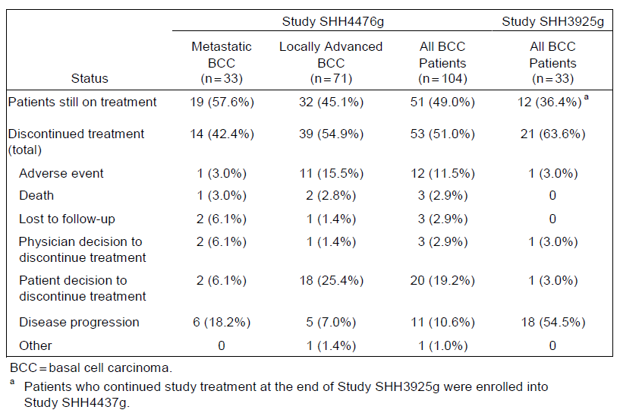
A summary of the key results is shown in Table 7.
Table 7. Primary and key secondary efficacy endpoint results in Study SHH4476g: Efficacy-evaluable population
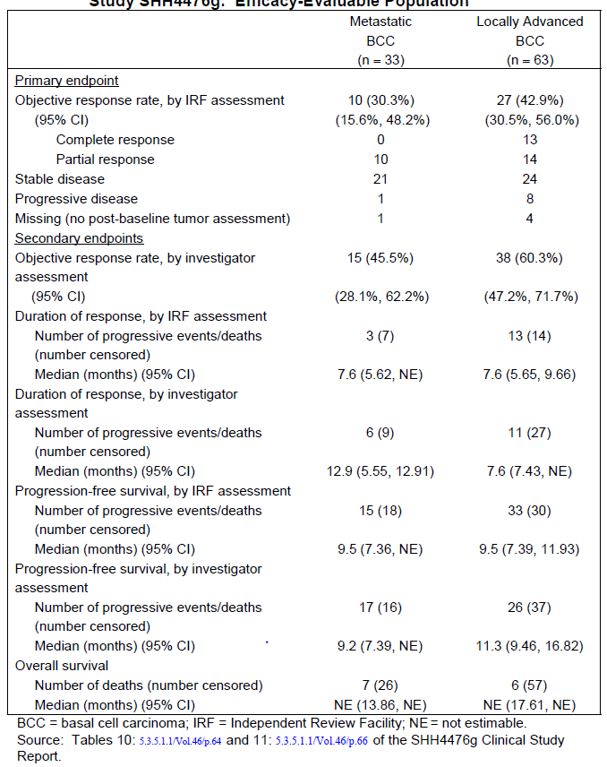
In relation to responses, the efficacy evaluable population included 96 patients, 33 with metastatic disease and 63 with locally advanced BCC.
Confirmation of single agent activity of vismodegib was demonstrated by the primary study endpoint of ORR as assessed by the IRF: 30.3% (95% confidence interval (CI) 15.6-48.2%) in patients with metastatic BCC and 42.9% (95% CI 30.5-56%) in patients with locally advanced BCC responded. These ORRs were significantly higher than the protocol specified minimal clinical benefit thresholds of 10% (p=0.0011) and 20% (p<0.0001) respectively, with p values based on a one-sided binominal test.
In the metastatic BCC cohort no patient had a complete response while 10 had partial responses. For the locally advanced cohort a total of 27 patients had a confirmed response, 13 of which were complete as confirmed by biopsy, and 14 had a partial response.
Overall responses as determined by the investigator were 45.5% for patients with metastatic BCC and 60.3% for patients with locally advanced BCC.
In relation to duration of response the median IRF-determined duration of response in each cohort was 7.6 months, while the median investigator-determined duration of response was 12.9 months in the metastatic BCC patients and 7.6 months in the locally advanced BCC cohort.
Progression free survival as assessed by the IRF revealed the same results for both metastatic and locally advanced BCC cohorts, with a median of 9.5 months. The investigator assessed median PFS was 9.2 months for the metastatic BCC cohort and 11.3 months for the locally advanced BCC cohort.
As of the cut-off date of the 26th November 2010, 13 efficacy-evaluable patients had died, 7 in the metastatic cohort and 6 in the locally advanced cohort. Overall survival data was immature, with a median OS not reached for either cohort. The one year survival rate was 75.5% for the metastatic cohort with survival times ranging from 0.9-16.4 months, while the one year survival rate for the locally advanced BCC cohort was 91.6% with survival times ranging from 2.4-19.7 months.
An updated analysis to the 26th May 2011 provided further data with regards to response rates and duration of response. Approximately two-thirds of the patients in both cohorts had discontinued from the study by the 26th May 2011. The results were as determined by the investigator assessment. Objective response rates remained essentially unchanged with ORR of 48.5% for metastatic BCC and 60.3% for locally advanced BCC. The median duration of objective response was also unchanged at 12.9 months for metastatic BCC and not estimable for locally advanced BCC. The overall median duration of response per investigator assessment for all patients had an increase to 9.6 months and the primary analysis to 14.8 months as of the update.
Median PFS was 9.3 months for patients with metastatic BCC and 12.9 months for locally advanced disease. The median duration of follow up among all patients was 14.8 months. As of the 26th May 2011 the OS data was still relatively immature with a median OS not reached in either cohort. For one year survival rates were 77.3% for the metastatic BCC cohort and 93.1% for the locally advanced BCC cohort, which was slightly higher than the rates reported for the primary analysis.

Overall tumour shrinkage
In an assessment of the overall extent of tumour shrinkage from the IRF reviews, a “waterfall plot” was determined for both the metastatic and locally advanced disease cohorts (Figure 3 and Figure 4, respectively). It is worth noting that these determinations of percent shrinkage of target lesions were according to photographic or radiographic assessments. For the locally advanced disease patients, complete responses were confirmed by biopsy.

Figure 3. Maximum percent tumor shrinkage in sum of longest dimensions from baseline by IRF Assessment: Metastatic BCC cohort
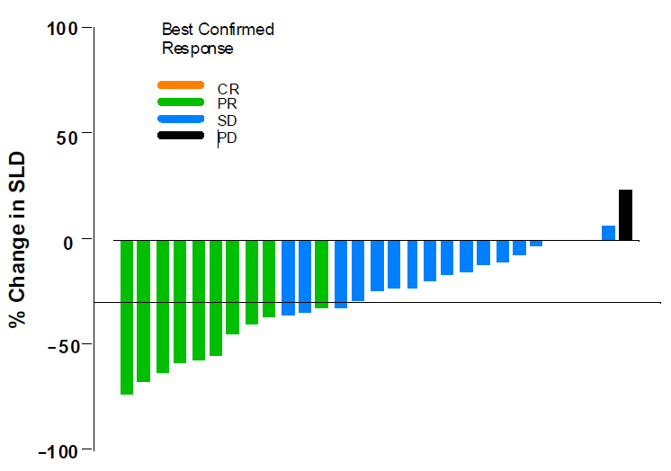
BCC = basal cell carcinoma; CR = complete response; PD = progressive disease; PR = partial response; SD = stable disease; SLD = sum of the longest dimension (of target lesion[s]). Note: Of the 33 patients in the metastatic BCC cohort, 3 patients had a best percent change in SLD of 0; these represent the gap in the figure. Three patients did not have measurements, and 1 patient was unevaluable for assessment of best confirmed response; these 4 patients were excluded from the analysis.
Figure 4. Maximum percent tumor shrinkage in sum of longest dimensions from baseline by IRF assessment: Locally Advanced BCC Cohort
BCC = basal cell carcinoma; IRF = independent review facility; PD = progressive disease; R = response; SD = stable disease; SLD = sum of the longest dimension (of target lesion[s]). Note: Four patients did not have lesion measurements and were not included in the plot.

Patients reported outcomes
In a patient reported outcomes analysis changes from baseline in the SF-36 results varied by subscale and component scores and were small. Mean changes from baseline in mental and physical components scores were approximately two points, indicating that patient quality of life on treatment was maintained through week 24.
In 7 of 8 patients who were excluded from the efficacy-evaluable population because of a lack of confirmed BCC on screening biopsy, archival tissues submitted from target lesions was interpreted by the independent pathologist as being consistent with BCC. A sensitivity analysis of the 70 patients in this tissue-confirmed population (these 7 patients plus the 63 with histologically confirmed BCC at baseline) yielded an IRF-assessed response rate of 44% or 31 of 70 patients (95% CI, 32.4%-56.7%).

Efficacy in patient sub-groups
Sub-group analyses of ORRs per IRF and per investigator among patients in the efficacy-evaluable population and in the all-treated population were performed according to a number of baseline and demographic characteristics. The results indicated that the benefits observed in the sub-groups were consistent with those in the overall efficacy-evaluable study population.
Hedgehog signalling results in the expression of the transmembrane proteins GLi1 and PTCH2. Analysis of ORR, duration of response and PFS based on relative expression of GLi1 and PTCH2 in efficacy-evaluable patients were summarised by tertiles. Responses were observed in all tertiles and no consistent pattern of response rate was noted when comparing investigator or IRF response rates across tertiles. Some of these sub-groups contained very small numbers of patients. There was no evidence to suggest an association between response rates, duration of response or PFS with GLi1 and PTCH2 levels regardless of whether the response assessments were determined by the IRF or by investigators.

Study SHH3925g

Study design and treatments
A single supportive study was provided in this submission (Study SHH3925g) which was an open-label, multicentre, Phase I study using a 3+3 design to evaluate the safety and tolerability of escalating doses of vismodegib administered orally on a once daily schedule for 28 days to patients with advanced solid malignancies that were refractory to standard therapy or for which no standard therapy existed.
The primary objectives of this study were evaluation of safety, the estimation of maximum tolerated dose, the characterisation of PK and the determination of a recommended dose. The secondary efficacy objective was to make a preliminary assessment of tumour response in patients with advanced solid tumours and advanced BCC receiving vismodegib as a single agent.
Enrolment into the study occurred in two stages. Stage 1 was a dose escalation stage with a goal of estimating the maximum tolerated dose. Patients received a single oral dose of vismodegib on Day 1 followed by daily administration of the same dose beginning on Day 8. Seven patients received 150 mg vismodegib daily, 9 received 270 mg daily and 4 received 540 mg daily. In Stage 1, if a patient did not experience a dose limiting toxicity and had no signs or symptoms of disease progression upon completion of the first 35 days after the initiation of study drug, the patient could continue treatment at his or her assigned dose level. Three patients with advanced BCC were enrolled in Stage 1: one received 150 mg vismodegib daily, another 270 mg daily and the third 540 mg daily.
Stage 2 of the study included an expansion cohort of 12 patients with solid tumours, none of whom had advanced BCC, who began continuous daily dosing at 150 mg vismodegib on Day 1 in order to assess the safety profile and PK and PD of vismodegib. After a protocol amendment two additional cohorts were added: 1: a cohort of 16 patients (including 10 with advanced BCC) to investigate the PK properties of a new vismodegib formulation at 150 mg daily; and 2: a cohort of 20 patients with advanced BCC treated at either 150 mg or 270 mg daily to evaluate the safety and efficacy based on encouraging responses observed in the 2 patients in Stage 1 with advanced BCC. Patients in Stage 2 were treated until disease progression, recurrence, intolerable side effects or study withdrawal. Patients with dose limiting toxicities, other intolerable side effects, disease progression, or who did not benefit from treatment as determined by the investigator were discontinued from treatment.
Patients in all cohorts received one daily oral dose of vismodegib at their assigned dose levels.

Study population
The study population consisted of patients aged at least 18 years with histologically documented, incurable, locally advanced or metastatic solid malignancy that had progressed after first and second line therapies. For inclusion in the Stage 2 BCC cohort histopathological documentation of BCC from metastatic or locally advanced lesions was required. Disease had to have been evaluable by examination or imaging for patients with advanced BCC. Patients with an ECOG PS of 0, 1 or 2 were eligible. Eligible patients could not have received chemotherapy, investigational agents, radiation therapy or major surgical procedure for at least three weeks prior to study entry and had to have recovered to pre-treatment baseline or stabilisation of all treatment related toxicities.
The remainder of the data presented in relation to this study are limited to enrolled patients with advanced BCC.

Response assessments
In the absence of clinically overt tumour progression, tumour response was objectively assessed upon the completion of eight weeks of dosing and nearly eight weeks thereafter. A complete or partial objective response was determined from two consecutive assessments at least four weeks apart. Patients with disease that was measurable by RECIST who did not experience intolerable side effects or who had a complete or partial response after eight weeks could proceed with dosing of vismodegib at their assigned dose level.
Patients with disease that was evaluable but not measurable by RECIST had to have had stabilisation or improvement of their evaluable lesions and/or symptoms in order to proceed beyond the first eight weeks of dosing. Vismodegib administration was discontinued for patients who at any time in the course of this study experienced a dose limiting toxicity or other intolerable side effects, disease progression, or who in their opinion or the opinion of the investigator were not benefiting from vismodegib.
All patients were monitored for safety and disease progression throughout the study. Patients were seen weekly for the first six weeks then every two weeks until week 26 then monthly while the patient was still receiving study treatment, and then weekly for four weeks up to the last of vismodegib dose.

Statistical methods
Efficacy-evaluable patients in the study comprised those with measurable disease at baseline who had received at least one dose of vismodegib and who either had a post-baseline tumour assessment or who had progressed after any tumour assessment. Anti-tumour activity of vismodegib was assessed to investigate or assess objective response, duration of objective response and PFS. Objective response was defined as a complete or partial response determined with two consecutive assessments at least four weeks apart.
Patients with advanced BCC in the Phase 1 Study SHH3925g were not prospectively categorised as having locally advanced or metastatic disease. Therefore, in a non-pre-planned analysis, patients with advanced BCC were retrospectively categorised as having metastatic or locally advanced BCC based on a medical review of enrolment documents, in order to facilitate comparison of these data with those from the pivotal Study SHH4476g. Overall response rates, duration of response and PFS for these two disease states are presented separately below.

Summary of results
A total of 68 patients from three study sites in the US were enrolled in the study, including 33 patients with advanced BCC. In the subset of patients with advanced BCC, 17 received 150 mg vismodegib daily, 15 received 270 mg daily and one received 540 mg daily. No dose limiting toxicity effects were observed and no maximum tolerated dose was established.
Of the 33 patients with advanced BCC, 18 were characterised as having metastatic BCC and 15 as locally advanced BCC. Of the 33 patients with advanced BCC, 24% were women, median age was 53 years, 42.4% had an ECOG PS of 0 and 57.6% had ECOG PS of 1. Some 97% had received prior surgery, 57.6% had prior radiotherapy and 45.5% had prior systemic therapy.
In relation to responses, safety was the primary endpoint for the study, and investigator assessment of response was the secondary endpoint.
The ORR (complete and partial responses) in the efficacy-evaluable patients with advanced BCC was 18/33 patients or 54.5%. The mean duration of objective response from these responders was 9.2 months. 11/33 patients with advanced BCC experienced stable disease as the best response in the study. The median PFS among all patients with advanced BCC was 11.4 months.
Review of the response data according to the post-hoc breakdown of patients into those with metastatic BCC and those with locally advanced BCC indicated that of the 18 patients with metastatic BCC, the objective response rate was 55.6% while for the 15 patients with locally advanced BCC the objective response rate was 53.3%. The median duration of response for patients with metastatic BCC was 9.2 months and not evaluable for the locally advanced patients, while PFS for the patients with metastatic BCC was 10.8 months and 15.1 months for patients with locally advanced BCC.

Evaluator’s overall conclusions on efficacy
The data from the pivotal Phase II study together with that from the supportive study clearly indicates a definite response rate for vismodegib in patients with advanced and metastatic BCC. The degree of responses observed in the pivotal study exceeds that anticipated from statistical pre-analysis. There is no meaningful alternative systemic treatment available for advanced stage BCC; therefore vismodegib represents a new agent with clinically meaningful potential to improve clinical outcomes.
Recognising the shortcomings of the studies being only Phase II in nature and without appropriate objective comparators, there is a definite requirement for very clear-cut evidence of responsiveness to be obtained. In the pivotal study a response rate of 30.3% for patients with metastatic BCC and 42.9% for those with locally advanced BCC is, in the reviewer’s opinion, supportive of that. The duration of response and duration of PFS are also supportive of a worthwhile clinical benefit.
In the absence of a randomised trial to confirm these data it would seem appropriate to consider the need for a further Phase II trial to consolidate the findings from the present studies.

Safety

Studies providing evaluable safety data
Safety data from a total of 9 company-sponsored clinical studies are submitted. These include studies involving advanced BCC patients from Studies SHH4476g, SHH3925g and SHH4610g which were pooled and analysed in an integrated manner. The remaining six studies provide supportive safety information.
A further 14 studies, which were NCI CTEP-sponsored studies conducted in the United States and other institutions, are also included in the safety analyses for supportive data.
An overview of the studies providing data is shown in Figure 5.
Figure 5. Vismodegib-treated patients in studies contributing to Summary of Clinical Safety
The safety data base for this evaluation involves all patients who received at least one dose of study drug. As of April 1st 2011 more than 750 patients were exposed to vismodegib, of who more than 450 were in the sponsor’s clinical studies and more than 300 were in NCI CTEP-sponsored studies. The patients on the 14 ongoing studies from the NCI are not included in this evaluation.
Overall, a total of 138 advanced BCC patients from the pivotal Study SHH4476g (n=104), supportive Study SHH3925g (n=33) and study SHH4610g (n=1) were pooled to provide a more complete characterisation of safety profile. This pooled safety data population was further pooled with 52 single agent vismodegib-treated patients with ovarian cancer from Study SHH4489.
Relevant studies contributing safety information, other than the pivotal Phase II and supportive Phase I studies discussed above include the following:
- Phase Ib study SHH4610g: a multicentre, two-stage, open label study designed to describe the PK of once daily, three times weekly and once weekly dosing of 150 mg vismodegib in 63 safety-evaluable patients with advanced solid tumours. Only one patient with advanced BCC was enrolled in this study.
- Extension Study SHH4437g: a multicentre, open label, extension study for patients who received vismodegib in a company sponsored Phase I or Phase II cancer study and who did not show evidence of disease progression at the completion of the parent study or at the time of the parent study closure. As of the 26th November 2010, 15 patients were enrolled, 13 of whom were advanced BCC patients previously enrolled in Phase I Study SHH3925g or in the Phase I dose continuing Study SHH4610g. Each patient continued to receive the same dose and the same schedule from the parent study, that is, 150 or 300 mg of vismodegib every day.
- Phase II Study SHH4489g: a randomised, placebo controlled, double-blind, multicentre trial of single agent vismodegib in patients with ovarian cancer in second or third complete remission. A total of 104 patients were enrolled into the study, of who 52 received single agent vismodegib 150 mg and the remaining 52 received placebo.
- Phase II Study SHH4429g: a company sponsored, randomised, double-blind, placebo control study of vismodegib with concurrent chemotherapy and bevacizumab as first line therapy for patients with metastatic colorectal cancer (CRC). The primary objective of the study was to make an assessment of whether adding vismodegib to the standard of care, (that is, FOLFOX plus bevacizumab or FOLFIRI plus bevacizumab) increased anti-tumor efficacy as measured by PFS when compared to standard of care chemotherapy alone in patients with previously untreated metastatic colorectal cancer. A total of 199 patients were enrolled, of who a total of 196 received at least one dose of vismodegib (n=98) or placebo (n=98) plus standard chemotherapy.
Safety assessments consisted of AEs, serious adverse events (SAEs), haematology and clinical chemistry variables, vital signs and other protocol specified tests. All AEs were graded according to NCI criteria.

Drug exposure
In the BCC pooled safety population the median duration of follow up across all studies was 10.4 months with a range of 0.9 to 35.8 months. The median cumulative dose of vismodegib received by patients in this population was 44 g.
With the expanded pool safety population the median duration of safety follow up for patients was 11.2 months and the median cumulative dose of vismodegib was 41.3 g.
For the pivotal study the median duration of exposure to vismodegib was approximately 10 months in both the metastatic and locally advanced BCC cohorts, with 53 patients discontinuing treatment. The reasons for discontinuation included patient decision in 20 patients or 19.2%, AEs in 11.5% and disease progression in 10.6%. The median cumulative dose of vismodegib was 43.2 g with a range of 2.9–84.6 g and median dose intensity was 98.4%. Demographic and disease baseline characteristics for all patients in the pooled safety population are shown in Table 8.
Table 8. Demographic and disease baseline characteristics: Enrolled patients in the Pooled Safety Population

Adverse events
An overview of treatment emergent adverse events (TEAEs) across studies is shown in Table 9.
Table 9. Treatment-Emergent Adverse Events across studies in vismodegib-treated patients
All but two patients experienced at least one AE. Patients who experience SAEs were reported in similar percentages in the pivotal Study SHH4476g and supportive Study SSH3925g and this is reflected in the percentage of patients reporting SAEs in the pooled safety population (26.1%). Similar proportions of at least Grade III AEs were reported in the pivotal study and supportive Study SHH3925g.
Treatment emergent AEs of any grade were reported in all of the 138 pooled BCC patients. Most patients (n=76, 55%) only experienced AEs of Grade I-II severity. The most common TEAEs, occurring in at least 30% of patients, were muscle spasms, alopecia, dysgeusia, decreased weight, fatigue and nausea. It is noteworthy that among women of childbearing potential (n=10) amenorrhea was observed in three patients.
The most common TEAEs of at least Grade III level were decreased weight (7.2%), fatigue (5.8%) and muscle spasms (3.5%).
The spectrum of TEAEs and the frequency were similar in the expanded pool safety population and the pooled safety population. The most common TEAEs of at least Grade III level were decreased weight (5.3%), fatigue (4.7%) and muscle spasms (4.2%) in the expanded safety population.
For treatment emergent AEs of any grade occurring in at least 10% of all treated patients in the pivotal Phase II Study, again the most frequently involved muscle spasms, alopecia, dysgeusia, decreased weight and fatigue. Dysgeusia, fatigue and cough were reported more frequently in metastatic BCC patients but the remainder of TEAEs are approximately equivalent for both the metastatic and advanced disease groups. Squamous cell carcinomas were reported in 12 patients with advanced BCC and among women of childbearing potential, amenorrhea was observed in two patients. More than half of the treated patients (57%) experienced TEAEs with the highest reported severity of Grade I or II. At least Grade III TEAEs were reported in 42% of all patients. The most common of these were decreased weight (4.8%), fatigue (3.8%), muscle spasms (3.8%), death of unknown cause (2.9%) and decreased appetite (2.9%).
Almost all patients (94%) reported having at least one TEAE that was assessed by the investigator as related to study drug. Study drug related events reported most frequently included muscle spasms (65%), alopecia (61%), dysgeusia (49%), decreased weight (38%) and fatigue (26%). Some 21% of patients had study drug related events of at least Grade III severity. Three of these were deaths of unknown cause, one in a patient with metastatic BCC and the other two in patients with locally advanced BCC.
Data from the supportive clinical studies were essentially similar to that seen from the pivotal trial. It is of note that in the supportive Study SHH3925g the most frequent Grade III AE was hyponatremia, effecting seven patients overall and three with BCC, followed by abdominal pain involving five patients overall but no patients with BCC.
In Study SHH4429g involving patients with metastatic colorectal carcinoma also receiving either FOLFOX or FOLFIRI and bevacizumab with or without vismodegib, patients on the vismodegib treatment arm experienced AEs which particularly emphasised the chemotherapy received. It was of note that four patients experienced Grade V AEs, three of which occurred in patients receiving FOLFOX and one FOLFIRI. None of these were attributed to vismodegib treatment.

Deaths
In the pooled safety population deaths from any cause that occurred within 30 days of the last dose of vismodegib in (n=7) and death that occurred >30 days post treatment (n=10) are summarised in Table 10. All were assessed by the investigators as not related to vismodegib. Preliminary safety analyses did not reveal a definite pattern of events. In all cases co-morbid conditions and pre-existing risk factors were present and the events did not suggest a relationship to vismodegib.
Table 10. On-study deaths and causes of deaths: pooled safety population
Eight patients died from AEs. These are not considered attributable to vismodegib.
In the pivotal Phase II study seven metastatic BCC patients (21%) had died with progressive disease by the time of the data cut-off date. In the locally advanced BCC cohort nine patients had died as of the data cut-off date, and again there was no definite pattern of events and all patients had significant pre-existing risk factors or co-morbidities at baseline. None of the deaths were assessed by the investigators as related to vismodegib.
In the supportive studies there was no deaths considered related to vismodegib.
It is of note that in Study SHH4429g in metastatic CRC, three deaths occurred in vismodegib-treated patients and were attributed to dehydration, pneumonia and sudden death but none were considered directly related to vismodegib.

Serious adverse events
In the pooled safety population a total of 36 patients or 26.1% experienced a SAE. Eleven patients or 8% experienced Grade IV SAEs. In the expanded, pooled safety population an additional six patients experienced eight SAEs.
In the pivotal study SAEs were reported in 26 patients (25%), with seven events in the metastatic BCC patients and 19 in the locally advanced BCC patients. Serious AEs considered by the investigator as related to vismodegib were reported in four patients, including cholestasis in one locally advanced BCC patient, two episodes of pulmonary embolism in one locally advanced BCC patient, syncope and dehydration in one metastatic BCC patient, and cardiac failure and pneumonia in one locally advanced BCC patient.
In the supportive clinical studies a variety of SAEs were reported, hyponatremia in two patients being among the more notable. Other notable SAEs included intestinal obstruction in three patients in Study SHH4610g, and elevation of hepatic enzymes considered related to study drug in one patient in the ovarian cancer Study SHH4489. In the study of CRC (Study SHH4429g), dehydration was the only SAE that was reported to have occurred at an incidence ≥ 5% higher in vismodegib-treated patients than in the placebo-treated patients (8.2% versus 2.0%).

Treatment emergent adverse events leading to discontinuation of study drug
In the pooled safety population a total of 15 patients (11%) discontinued vismodegib treatment as a result of a TEAE. Muscle spasms account for vismodegib discontinuation in two patients. No other single AE accounted for more than one study treatment discontinuation. Adverse events considered by the investigator to be related to vismodegib treatment occurred in 5 of the 15 patients, 3 of which were Grade V, 2 were Grade IV and 8 were Grade III events.
In the expanded pooled safety population, 21 patients (11.1%) discontinued vismodegib treatment as a result of TEAEs. Muscle spasms accounted for discontinuation in four and dysgeusia accounted for discontinuation in three patients.
In the pivotal study 13 patients or 12.5% had TEAEs leading to discontinuation of vismodegib, of which muscle spasms were reported in two patients.
In the ovarian cancer Study SHH4489g, six patients had AEs leading to study drug discontinuation, three of which were Grade III events of increased hepatic enzymes, mucosal inflammation and muscle spasms, while one patient discontinued for Grade II diarrhoea.
It is noted that in the metastatic CRC study (SHH4429g), a greater percentage of vismodegib patients (33.7%) than placebo patients (23.5%) discontinued non-investigational drug treatment (that is, chemotherapy, bevacizumab or both) because of an AE. The most commonly reported AEs that led to the discontinuation of non-investigational drug treatment were peripheral neuropathy (5% for placebo, 3.1% for vismodegib), fatigue (2% for placebo, 5.1% for vismodegib), neutropenia (0 for placebo, 5.1% for vismodegib) and diarrhoea (1% for placebo, 3.1% for vismodegib).

Adverse events by system organ class
In the pooled safety population the most common AEs (that is, AEs with >30% incidence) are summarised by MedDRA system organ class (Table 11, below) and preferred term. The most common AEs by MedDRA SOC were: nervous system disorders (79.7%, primarily dysgeusia at 55.1%), skin and subcutaneous disorders (79.0%, primarily alopecia at 63.8%; squamous cell carcinoma at 8.7%), musculoskeletal and connective tissue disorders (78.3%, primarily muscle spasms at 71.7%), gastrointestinal disorders (74.6%, primarily nausea at 30.4% and diarrhoea at 29.0%), general disorders and administration site conditions (57.2%, primarily fatigue at 39.9%), infections and infestations (56.5%, primarily upper respiratory tract infection at 10.1%), investigations (50.7%, primarily weight decreased at 44.9%), respiratory, thoracic, and mediastinal disorders (43.5%, primarily cough at 18.8%), and metabolism and nutrition disorders (36.2%, primarily decreased appetite at 25.4%).
Table 11. Treatment-Emergent Adverse Events by System Organ Class: Pooled Safety Population
The most common ≥ Grade III AEs were fatigue at 5.8%, decreased weight (7.2%), pneumonia (2.2%), hyponatremia (2.9%) and decreased appetite (2.2%), muscle spasm (3.6%), squamous carcinoma and pancreatic adenocarcinoma at 1.4% each, and gastrointestinal haemorrhage (1.4%). In the expanded pool safety population the spectrum of TEAEs were similar.

Clinical laboratory evaluations
In the pooled safety population available laboratory data were assessed by shifts in baseline to worst post-baseline grade for sodium, potassium and magnesium as well as alkaline phostaphase, aspartate transaminase (AST), alanine transaminase (ALT), bilirubin, blood urea nitrogen (BUN) and creatinine levels. The majority of laboratory abnormalities were Grade I. Laboratory abnormalities that changed to Grade II or higher were low sodium in 6 cases and potassium in 2, as well as high alkaline phosphatase in 5, AST in 4, ALT in 6, bilirubin in 2, BUN in 9 and creatinine in 5. Post-baseline changes in laboratory parameters of Grade III severity were uncommon, occurring in <5% of patients for each laboratory parameter evaluated. There were no Grade IV laboratory abnormalities.
In the expanded pooled safety population the incidence of patients with abnormalities in each individual laboratory parameter was similar to that observed in the pooled safety population. The only changes of Grade II or higher were for low sodium in 8, potassium in 2, magnesium in one as well as high alkaline phosphatase in 7, AST in 8, ALT in 11, bilirubin in 2, BUN in 16 and creatinine in 5. Similar to the pooled safety population, few patients had laboratory abnormalities of Grade III level.
In the individual studies there was no pattern of clinically significant changes for any of the specific haematological, chemistry or urinary analysis parameters separate from that already indicated above for the pooled safety and expanded pool safety populations.

Vital signs, typical findings, and other observations
In the pooled safety population and the expanded pooled safety population no salient vital sign abnormalities were reported and no major changes in ECOG PS were reported. The only significant observation was that of decreased weight occurring in 44.9% of patients.

Safety in relation to age
The majority (60.9%) of patients in these studies were <65 years old. Among the pooled safety population of patients there was a >10% higher incidence of muscle spasms, alopecia, diarrhoea, cough and muscular/skeletal chest pain in patients <65 years compared to those >65 years. There was, however, a >10% higher incidence of decreased appetite among patients aged >65 years compared to those <65 years. A larger percentage (51.9%) of patients aged >65 years experienced Grade III or greater AEs compared with patients aged <65 years (39.3%). Among the most frequent ≥ Grade III AEs were decreased weight (6% in patients <65 years, 9.3% in those >65 years) and fatigue (2.4% for those <65 years and 11.1% for those >65 years).

Safety in relation to sex
The majority (64.5%) of patients in these studies were male. In patients in the pooled safety population there was a higher incidence of nausea, diarrhoea, decreased appetite, vomiting and pain in extremity among females compared with males. There was a >10% higher incidence of constipation and flatulence among males compared with females. Amenorrhea was noted in 3 patients among women of childbearing potential (n=10). More female patients (49%) compared with male patients (41.6%) experienced at least Grade III AEs. Among the most frequent ≥ Grade III AEs were decreased weight, observed in 2 female patients and 8 male patients, and fatigue, observed in 3 female patients and 5 male patients.

Safety update
An update of safety for the pivotal Study SHH4476g with a clinical cut-off date of the 26th May 2011 is provided, thereby giving six months additional safety data.
As of the data cut-off date of 26th May 2011, of the 104 patients originally enrolled, 37 patients (35.6%) were still in the study period undergoing protocol specified assessments and 45 patients (43.3%) had entered survival follow up. An additional 8 patients had discontinued therapy because of disease progression and an additional 4 patients, one in the metastatic BCC cohort and 3 in the locally advanced cohort, discontinued study drug because of AEs. These AEs included weight decrease, muscle spasms, osteomyelitis and depression. An additional 2 patients decided to discontinue treatment, one in each cohort.
Other relevant results from the safety update included:
- The median vismodegib dosing intensity was similar between the two reporting periods (98.4% for the initial data cut-off and 98.6% for the update). The median time on study treatment increased from 9.8 months to 12.9 months.
- The AE profiles for the safety update were consistent between the two reporting periods, with most frequently reported AEs still being muscle spasms (70%), alopecia (64%), dysgeusia (53%), decreased weight (50%), fatigue (39%), nausea (33%) and amenorrhea (33%).
- The Grade III-V AE profile for the update was consistent, with 50 patients (48.1%) reporting Grade III-V AEs compared to 44 patients (42.3%) reporting these in the initial data cut-off. The most common Grade III-V AEs included decreased weight and muscle spasms (each 5.8%) and fatigue (4.8%). There were no additional Grade V AEs reported in the update. New Grade III-IV AEs occurring in two or more patients included weight decrease, muscle spasms and syncope.
- Five additional deaths had occurred, all due to disease progression and one due to melanoma. Nine patients experienced 15 new SAEs, six of which were considered related to vismodegib in four patients. These included one patient with asthenia, pneumonia and syncope, another with osteomyelitis, another with syncope and another with cerebral haemorrhage. The SAEs were generally consistent with the previous data cut-off.
- For the update, 4 new AEs had led to treatment discontinuation, including decreased weight, muscle spasms, depression and osteomyelitis. Three of these were in the locally advanced cohort and one in the metastatic cohort.
Overall the safety update did not provide any new safety signals.

Evaluator’s overall conclusions on safety
The data presented in this analysis generally indicates that vismodegib is well tolerated, with a dose intensity median of 98% indicating that patients did not require treatment interruption. Among the AEs experienced, 55% experienced only Grade I or II TEAEs, the most common being muscle spasms, alopecia, dysgeusia, weight loss, fatigue and nausea. It is noteworthy that in women of childbearing potential amenorrhea was observed in 30% of patients. All individual AEs of ≥ Grade III severity occurred in <10% of patients.
A total of 26.1% of patients in the pooled safety population experienced a treatment emergent SAE, including death in 3 patients, pneumonia in 3, cardiac failure in 2, gastrointestinal haemorrhage in 2, pulmonary embolism (PE) in 2, deep vein thrombosis (DVT) in 2 and haemorrhage in two. Among the total of 17 deaths which occurred, eight were attributed to TEAEs. The analysis of these deaths indicates that all the patients had significant co-morbidities and pre-existing risk factors.
It is appropriate therefore to conclude that vismodegib has an acceptable safety profile which can generally be managed by relevant preventive or interventional medication and occasional treatment interruption. It is worth noting that in the study in patients with metastatic colorectal cancer where vismodegib was administered in combination with chemotherapy, the incidence of neutropenia was somewhat higher than that observed in those on placebo. While there is no definite data to indicate drug interaction effects, it would be appropriate in the future to assess potential for vismodegib to influence chemotherapy induced myelosuppression.

First round benefit-risk assessment

First round assessment of benefits
Treatment options available for patients with advanced stage BCC, either locally advanced or metastatic, are limited. Once surgery and radiotherapy have either failed or are inappropriate, then available systemic therapies have not demonstrated worthwhile outcomes. Accordingly, the introduction of a new agent with significant potential for clinical benefit is welcome.
Vismodegib represents a first in-class, small molecule inhibitor of the Hh signalling pathway which binds to and inhibits the trans-membrane protein SMO. The data presented in this submission, in particular that related to the pivotal trial, clearly indicates that in terms of disease response for patients with advanced BCC the benefit is apparent. This is determined by a 30% response rate in patients with metastatic disease and a 43% response rate in patients with locally advanced disease. Perhaps most pertinent was that of the 27 patients who demonstrated response with locally advanced disease, 13 of these proved to be in complete remissions, as defined by biopsy confirmation of no evidence of residual tumour.
Durations of response are also encouraging being in excess of 9 months for both metastatic disease and locally advanced disease. It is also noteworthy that vismodegib can be administered orally at 150 mg per day and evidence does not support a benefit from higher doses.
It is recognised that the size of the pivotal trial, namely 104 patients, together with supporting data from a further 33 patients does not represent a large cohort for full determination of the potential benefit of vismodegib. Taking into account the relatively uncommon nature of the disease and the inherent difficulties of undertaking a randomised trial, as well as the demonstration of a clearly clinically meaningful response rate and in particular evidence of biopsy proven complete remissions, the clinical evaluator considers that there is adequate evidence to support worthwhile benefit for vismodegib in the treatment of advanced stage BCC in circumstance where no such benefits were previously available.

First round assessment of risks
As of May 2011 more than 450 patients and healthy volunteers have received vismodegib in sponsor’s clinical studies and more than 300 patients have been treated in NCI studies. The safety profile demonstrated from these data indicates that commonly occurring AEs include spasms, dysgeusia, nausea, weight loss, loss of appetite, fatigue, diarrhoea, constipation and alopecia. These AEs are mild to moderate in the majority of incidences and are generally managed well by either appropriate medication or temporary interruption of vismodegib. The occurrence of amenorrhea in women of childbearing potential is noteworthy and needs to be kept in mind.
More severe AEs were demonstrated in <30% of patients and generally affected those which had been outlined above. The proportion of patients requiring treatment interruption was generally relatively low. There were no deaths that could be clearly related to vismodegib as the principal determinant.
Accordingly, it would appear that the risk profile for vismodegib is acceptable and generally manageable given the circumstances of relatively long term administration.

First round assessment of benefit-risk balance
As discussed above the data from the pivotal study together with the supporting Phase I trial has indicated a level of response for patients with advanced stage BCC approaching 50%. Most pertinently the patients with locally advanced disease who achieved complete response have these proven on biopsy, indicative of a very major regression of disease in these instances. The available evidence in regards to duration of response is reasonable in the context of a response duration of >9 months. Further data with regards to the durability of response and potential for subsequent operation in patients with locally advanced disease who respond to a major extent but not complete remission would be worthwhile.
The risk profile for vismodegib as determined from the submitted studies is generally manageable and not commonly associated with severe AEs requiring treatment withdrawal. The majority of AEs encountered were managed by either temporary interruption of treatment or a relevant therapeutic intervention.
Taking these aspects into account and despite the limited extent of data available, the clinical evaluator considers that the benefit-risk profile favours the value of vismodegib as an agent of efficacy for the treatment of advanced stage BCCs which has not been available previously.

First round recommendation regarding authorisation
This clinical evaluator is cognisant of the general requirement for Phase III, randomised trials to act as pivotal determination of potential efficacy for new agents in the treatment of major diseases. Nevertheless in this instance, advance stage BCC is a relatively uncommon disease but still carries with it major morbidity and potential mortality. Previous systemic therapeutic interventions have generally been ineffective. The results from the studies provided in this submission regarding the role of vismodegib suggest it is an agent of efficacy not previously available.
Notwithstanding the need for further studies to act as confirmation of the level of benefit and particularly the potential for durable benefit and possible operative intervention in those with incomplete but major response, the evaluator considers it appropriate to recommend approval for vismodegib in the proposed indication for the treatment of adult patients with advanced BCC for whom surgery is inappropriate.

List of questions
- Please provide information about ongoing or planned studies for confirmation of benefits of vismodegib, in particular determination of durability of responses and possible influence on OS. This may require randomised trials. Data about potential for operation subsequent to major response to vismodegib in patients with locally advanced BCC are also of importance.
- Please provide data about the influence of hepatic and/or renal dysfunction on vismodegib administration.

Second round evaluation of clinical data submitted in response to questions
The sponsor’s response to the TGA request for further information includes updates for the pivotal Study SHH4476g. These included both investigator assessed and IRF assessed efficacy results for a further year of follow up to the 28th November 2011, including proportions of response, durations of response and also durations of PFS. Also included in the latter is a comparison of PFS and OS between responders and non-responders in the pivotal study.
Also provided is a comparison of survival in distant metastatic BCC patients from the literature compared with survival in patients with distant metastatic BCC from the vismodegib studies.

Pharmacokinetics
In response to a question about data on the influence of hepatic and/or renal dysfunction on vismodegib administration, the following have been provided by the sponsor.
The sponsor indicated that there is an ongoing study to specifically characterise the PK of vismodegib in patients with hepatic and renal impairment (Study GP27839). This study is being conducted in the USA and to date there have been 10 patients with data available on the influence of hepatic impairment on PK.
It is noted that vismodegib is mainly eliminated by the hepatic route and considering that vismodegib binds to plasma proteins synthesised by the liver, patients with severe hepatic impairment could have altered vismodegib exposure.
In Study GP27839 patients with varying degrees of impairment were treated with 150 mg of vismodegib per day for eight days. Initial steady state PK results on Day 8 are available from 10 patients, which include 3 patients with normal hepatic function, 5 patients with mild hepatic impairment, one patient with moderate hepatic impairment and one patient with severe hepatic impairment.
The concentration-time profiles suggest that the total and unbound plasma concentration of vismodegib in patients with varying degrees of hepatic function were similar. A summary of non-compartmental analysis preliminary results suggests that total and unbound vismodegib concentrations were similar regardless of hepatic function. In addition the total and unbound plasma concentrations of vismodegib in each of these patients were consistent with the predicted range of concentrations from the population PK analysis.
In relation to renal elimination, this appears to be a minor route for vismodegib as earlier studies have shown that only 4% of the administered dose was recovered in urine from subjects with normal renal function. At this stage therefore it is not expected that severe renal impairment would have clinically relevant impact on the exposure of vismodegib. In Study GP27839 to date no patients have been enrolled with severe renal impairment, defined as glomerular filtration rate of <20 mL/min.

Evaluator comment
The data provided in this limited preliminary evaluation suggest there is no influence of clinical significance of impaired hepatic function on vismodegib PK. Full results of this study will be awaited.

Clinical efficacy
Updated data on durability of responses and on PFS and OS from pivotal Study SHH4476g are provided in response to a TGA question on issues concerning ongoing or planning studies for confirmation of benefits of vismodegib, in particular the determination and durability of response and possible influence on OS.
The sponsor has acknowledged that the ORR is a novel composite endpoint. They have undertaken an independent review of clinical benefit by clinical experts which involve three European dermato-oncologists. Every locally advanced patient in the pivotal study is reviewed by this panel, both individually and together.
From this assessment, 71.4% or 45 of 63 of the efficacy-evaluable patients with locally advanced BCC from the pivotal study were judged to have severe disease at baseline, while 58.7% had very severe disease and 12.7% had moderately severe disease. It was noted that 76.2% (48 of 63 of the efficacy-evaluable patients) experienced clinical benefit: significant clinical benefits in 65.1%, and some clinical benefit in 11.1%.

Comment
This data is of interest in confirming evidence of efficacy of vismodegib by an independent review group. Problems still remain in terms of lack of definition of clinical benefit and in particular ‘significant clinical benefit’ versus ‘some clinical benefit’. Nevertheless the evaluator acknowledges the fact that this is confirmatory in relation to the initial presented response data from the pivotal vismodegib trial.
In an effort to provide longer follow up data a 12 month update beyond the original cut-off date of the 26th November 2010 is provided which assesses objective response rate, duration of response, PFS and OS as of the data cut-off date of 28th November 2011, thereby giving a total minimum potential follow up time of 21 months for all patients.
It is noted that as of 28th November 2011, 75 patients or 72.1% had discontinued from the study. The most common reason for discontinuation was disease progression for the metastatic BCC cohort (53.8%) while in the locally advanced BCC cohort patient decision was the most common reason for treatment discontinuation (in 40.8%). As of the 28th November 2011, 29 patients or 27.9% were still on vismodegib treatment. The median duration of exposure to vismodegib was 12.9 months for all patents, 13.3 months for patients with metastatic BCC and 12.7 months for patients in the locally advanced BCC cohort. Median dose intensities were 98.9% in the metastatic BCC cohort and 97.4% in the locally advanced BCC cohort.
Table 12 presents the investigator assessed response rates and duration of response to 28th November 2011 compared to 26th November 2010.
Table 12. Study SHH4476g. Summary of investigator assessed efficacy results and survival results as at 26th November 2010 and 28th November 2011 data cutoff dates (efficacy-evaluable patients).
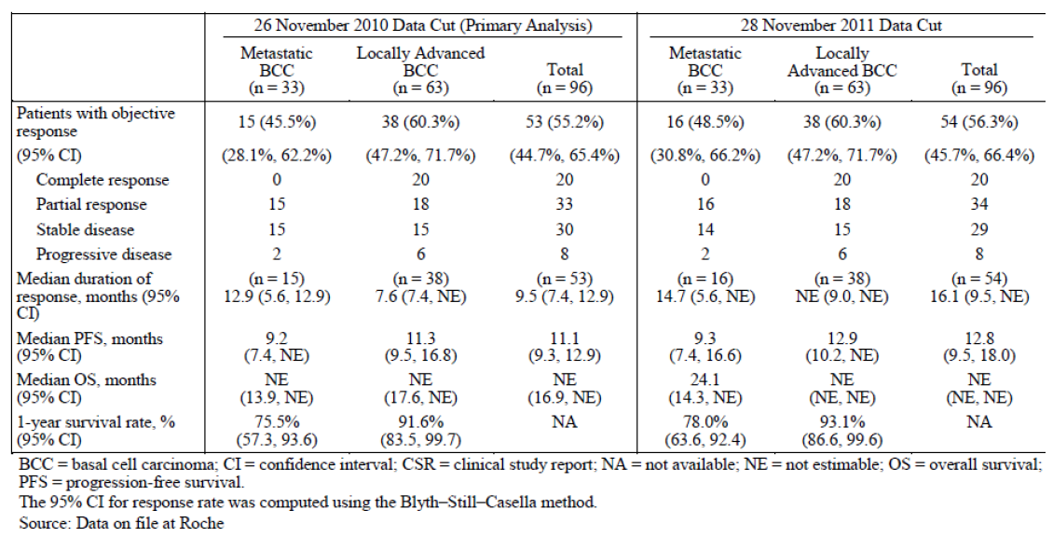
As indicated above, one further patient was classified as having partial response in the update from the metastatic BCC cohort and the median duration of response in the metastatic BCC cohort was 14.7 months and not evaluable in the locally advanced BCC cohort. For a total of 96 efficacy-evaluable patients, the median duration of response was 16.1 months compared to 9.5 months for the 2010 cut-off date.
In relation to PFS, for both the November 2010 data cut-off and the November 2011 data cut-off there are increments in PFS data for both the metastatic BCC cohort and the locally advanced BCC cohort. The median PFS for the total patients is 11.1 months for the 2010 data cut-off versus 12.8 months for 2011 data cut-off. Little worthwhile information is provided for the OS estimates. It is noted that one year survival rates also improved to some extent over the one year extra follow up.
In an effort to provide further evidence in relation to objective response rates, duration of response and PFS, the reviews by the IRF have been updated to the 28th November 2011. The results essentially support the data provided as per the investigator assessment.
In a further effort to provide some meaningful information in relation to PFS and OS from the pivotal study, an evaluation and comparison between these two endpoints for responders versus non-responders has been provided by the sponsor. These data are as per the IRF evaluation. As might be expected they clearly show a longer PFS and OS for responding patients versus non-responding patients. While the sponsors claim this is further evidence of therapeutic benefit in relation to vismodegib as acknowledged, other factors, including variations in baseline parameters, could influence this and in particular the natural biological behaviour of the malignancy has potential influence on this aspect of assessment.
Also undertaken by the sponsor was a comparison of survival in distant metastatic BCC patients for patients who had received vismodegib versus those from a literature review. It is noteworthy that the literature review effectively involves evaluation of multiple case reports which immediately brings into question the validity of this. Nevertheless, as indicated by the sponsor 50 patients were reported to have disease that had metastasised to a distant organ and 50 had disease confined to a local site or lymph node. Clearly there were marked differences in median one year OS between these two groups. Comparing this data is a population of vismodegib treated patients with metastatic BCC who were included in the pooled safety population from Studies SHH3925g, SHH4437g, SHH4610g and SHH4476g which involved 45 patients. Table 13 presents the baseline characteristics and survival data for patients with metastatic BCC that had metastasised to distant organs.
Table 13. Baseline characteristics and survival data for patients with distant metastatic BCC from the literature and from studies with vismodegib
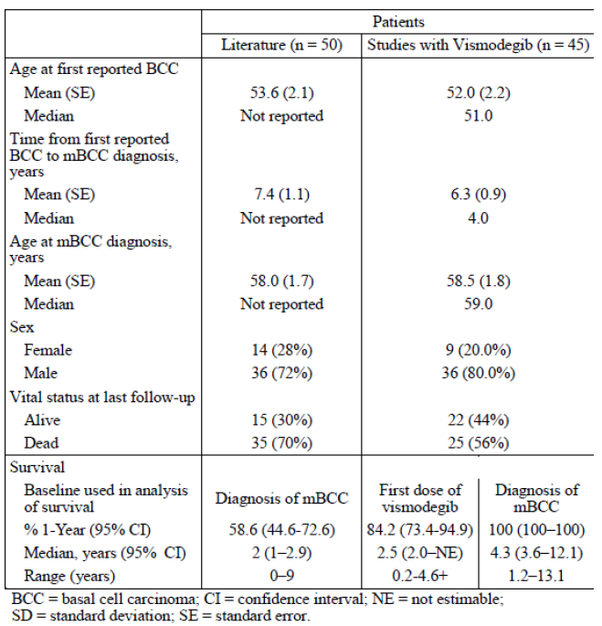
Differences in percentage one year survival illustrated indicate that for those patients on the studies with vismodegib, from the first dose of vismodegib, the one year survival was 84.2% whereas from diagnosis of metastatic BCC the one year survival was 100%. This compares to a survival rate from diagnosis of 58.6% for the literature review patients.
This data suffers from the difficulties associated with summating multiple case reports and probably has relatively little to offer in terms of further validating the evidence of efficacy for vismodegib in patients with metastatic BCC.
In relation to the proposal that a randomised trial would be optimal in ultimately determining the efficacy of vismodegib, the sponsor has replied with an indication that they consider there are considerable difficulties in potentially organising and running such a study. This revolves around difficulties with a double blind trial in circumstances where skin lesions are readily viewed by both patients and medical staff. Also the AEs associated with vismodegib would be very likely to clearly indicate those patients who are actually receiving vismodegib in a placebo controlled study.
Probably the most pertinent argument is the view that BCC in locally advanced disease is readily apparent and therefore specific changes in the tumours in terms of size, ulceration and such characteristics can be clearly indicative of response. This is appropriate in circumstances where all aspects of the disease are apparent on the skin, but this does not take into account the evaluation of circumstances with metastatic BCC where potentially lymph nodes and other organs such as lungs and liver may be affected. Nevertheless taking into account the concerns the sponsor has raised together with the fact that the updated information on the pivotal Study SHH4476g reinforce the indication of definite benefit, the evaluator feels it is reasonable not to press too strongly regarding the requirement for a randomised study.
In relation to the issue regarding evidence that vismodegib influences potential for greater surgical resection after major response, the sponsor acknowledge the importance of determining whether vismodegib may have clinical value as a pre-operative treatment and are in the process of undertaking a pilot Study SHH4812g evaluating the ability of vismodegib to produce complete histological clearance and safety in patients with newly diagnosed operable nodular BCC. It is understood the results from cohort 1 of this study are presently being assessed to determine the potential for further evaluation of vismodegib in a preoperative setting.

Evaluator comment
The data presented in this section essentially provides useful information regarding updated results of response rate and duration of response for the previously evaluated pivotal study. Also provided is new information regarding PFS, which is of some benefit. The attempt to further assess PFS and OS by evaluating comparisons between responders and non-responders in the pivotal study has relatively little to offer. The remaining aspects regarding a randomised study and preoperative assessment of vismodegib have been addressed and seem reasonable.

Second round benefit-risk assessment

Second round assessment of benefits
The data presented in response to the TGA request for further information provides a further 12 months of follow up in the pivotal Study SHH4476g, indicating ongoing durability of response and maintenance of levels of response. There is also data to support the duration of response evidence with PFS. Up to this time no useful information has been provided in reference to OS. Comparison between responders and non-responders in the pivotal study regarding PFS and OS are of limited value, as stated above. There is an effort to compare the results from vismodegib studies with literature reviews involving multiple case reports. This is of very limited benefit and does not really add to the indication of vismodegib’s efficacy.
Nevertheless, the data still provides sufficient support that vismodegib represents an advance in treatment for those patients with metastatic BCC or locally advanced BCC.

Second round assessment of risks:
There are no new data provided in relation to risks.

Second round assessment of benefit-risk balance
The balance remains favourable in terms of appropriate evidence of benefit in the context of manageable AEs, as provided from the data from the pivotal study and the earlier Phase I Study SHH3925g. Accordingly, the evaluator remains supportive of the appropriateness of vismodegib for the proposed indication for the treatment of adult patients with advanced BCC for whom surgery is inappropriate.

Second round recommendation regarding authorisation
This evaluator continues to support the application for vismodegib in the treatment of adult patients with advanced BCC for whom surgery is inappropriate. Evidence is still essentially in favour of the beneficial effects of vismodegib in the context of an unusual malignancy for which there is otherwise little in the way of worthwhile treatments available in the setting proposed.

V. Pharmacovigilance findings

Risk management plan
The sponsor submitted a Risk Management Plan (Version: 1.0, dated 31 January 2012, with Australia Specific Annex (ASA) Version: 1.0, dated April 2012) which was reviewed by the TGA’s Office of Product Review (OPR). A summary of the RMP is shown in Table 14.
Table 14. Summary of the RMP.
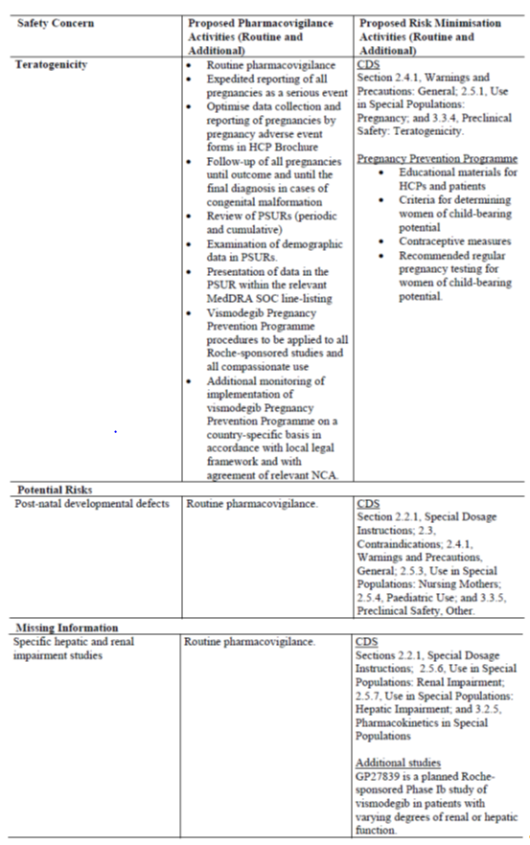

Safety specification
Subject to the evaluation of the nonclinical aspects of the Safety Specification (SS) by the Toxicology area of the Office of Scientific Evaluation (OSE) and the clinical aspects of the SS by the Office of Medicines Authorisation (OMA), the summary of the Ongoing Safety Concerns as specified by the sponsor is as follows:
Table 15. Summary of the Ongoing Safety Concerns

OPR reviewer comment:
Notwithstanding the evaluation of the nonclinical and clinical aspects of the SS, it is recommended that the sponsor include the important missing information: ‘Use in the Paediatric population’ as an ongoing safety concern. Consequently the Core RMP and ASA will need to be amended accordingly when these documents are next updated.

Pharmacovigilance plan
The sponsor states that routine pharmacovigilance activities, consistent with the activities outlined in 3.1.2 Routine pharmacovigilance practices, Note for Guidance on Planning Pharmacovigilance Activities (CPMP/ICH/5716/03), are proposed to monitor all the specified ongoing safety concerns.
An additional pharmacovigilance activity, in the form of a Pregnancy Pharmacovigilance Plan, is proposed to further monitor the important identified risk: ‘Teratogenicity’.
Furthermore, an additional study (Study GP27839) is ongoing to characterise the important missing information: ‘Specific studies in hepatic impairment and renal impairment’.
In addition, the ‘Overview of Study Protocols for the Pharmacovigilance Plan’ and ‘Outstanding Actions to be Completed, Including Milestones’ of the Core RMP refers to the ongoing international Study MO25616: A single arm, open-label, non-comparative, multicentre, phase II study of vismodegib in patients with locally advanced BCC or metastatic BCC who are otherwise without satisfactory treatment options.

Risk minimisation activities
The sponsor has provided justification and concluded that routine risk minimisation activities are required for all the specified ongoing safety concerns. Additional risk minimisation activities are also required for the important identified risk: ‘Teratogenicity’.

OPR reviewer comment:
Routine risk minimisation activities will comprise labelling, including PK information, contraindications, special warning and precaution statements and/or instructions for use for all the specified ongoing safety concerns. Furthermore additional risk minimisation activities are also proposed for the important identified risk: ‘Teratogenicity’ in the form of a ‘Communication Plan’.
There is no objection to the sponsor implementing routine risk minimisation activities for all the specified ongoing safety concerns and additional risk minimisation activities to mitigate the important identified risk: ‘Teratogenicity’. Nevertheless the non-clinical and clinical aspects of the SS remain subject to the evaluation by the Toxicology area of the OSE and by the OMA, respectively.

Summary of recommendations
The OPR provides these recommendations in the context that the submitted AU-RMP is supportive to the application; the implementation of a RMP satisfactory to the TGA is imposed as a condition of registration; the submitted Core RMP is applicable without modification in Australia unless so qualified; and the draft PI and CMI documents are not revised until the Delegates Overview has been received.
Safety considerations may be raised by the nonclinical and clinical evaluators during the evaluation phase. It is important to ensure that the information provided in response to these includes a consideration of the relevance for the RMP, and any specific information needed to address this issue in the RMP. For any safety considerations so raised, the sponsor should provide information that is relevant and necessary to address the issue in the RMP.
- Notwithstanding the evaluation of the nonclinical and clinical aspects of the SS, it is recommended that the sponsor include the important missing information: ‘Use in the Paediatric population’ as an ongoing safety concern. Consequently the Core RMP and ASA will need to be amended accordingly when these documents are next updated.
- In principle there is no objection to the sponsor implementing additional pharmacovigilance activities to further monitor the specified ongoing safety concerns. However, the ongoing studies are not considered to be part of the planned clinical studies in the pharmacovigilance plan. Therefore the related study protocols have not been reviewed. Nevertheless an update on the progress, results and analysis of this study, as outlined in the Core RMP, will be expected in future periodic safety update reports (PSURs).
- The sponsor should state if there are any material differences between the Pharmacovigilance Plan (PP) of the Core RMP, as adopted in Australia, compared to the PP of the updated EU-RMP submitted with the similar application in the EU. The sponsor should justify why any such material differences have not been adopted in Australia.
- When the US FDA approved a similar application on 30 January 2012, part of the Postmarketing Requirements was the commitment to conduct two rodent carcinogenicity studies, a drug-drug interaction clinical trial to evaluate if gastric pH elevating agents alter the bioavailability of vismodegib, and the submission of a final report for the ongoing drug interaction trial (protocol SHH4593g). The sponsor should provide an assurance that the results of these studies will be incorporated into the RMP when available.
- There is no objection to the sponsor implementing routine risk minimisation activities for all the specified ongoing safety concerns and additional risk minimisation activities to mitigate the important identified risk: ‘Teratogenicity’.
As agreed the sponsor should now provide copies of the Australian Health Care Professional (HCP) and Patient educational material. If available the sponsor should also provide corresponding results of user testing and final materials validation or advise when such information will be submitted to the TGA (presumably prior to launch).
In regard to the criteria to be used to verify the success of the Australian Communication Plan, the sponsor should definitively state whether Australian prescriber, pharmacy and patient survey data will also be submitted periodically to the TGA, as well as the primary indicator being the number of reported pregnancies in the PSUR. If not, compelling justification should be provided as the reporting of such pregnancies is unlikely to be sufficient in measuring the effectiveness of this proposed additional risk minimisation activity due to under-reporting, not to mention the information gained from such reporting may be incomplete.
- The sponsor should state if there are any material differences between the Risk Minimisation Plan of the Core RMP, as adopted in Australia, compared to the Risk Minimisation Plan of the updated EU-RMP submitted with the similar application in the EU. The sponsor should justify why any such material differences have not been adopted in Australia.
- In regard to the proposed routine risk minimisation activities, it is recommended to the Delegate that the draft PI document be revised as follows:
  - For the important identified risk: ‘Teratogenicity’, the currently approved US monograph contains a boxed warning. No such boxed warning is proposed for the Australian PI. The sponsor should provide justification for such an omission.
In response to the RMP evaluation report, the sponsor adequately addressed all OPR recommendations except for the risk minimisation activities in relation to the important identified risk: ‘Teratogenicity’, which was drawn to the attention of the Delegate as follows:
Additional risk minimisation activities are proposed for the important identified risk: ‘Teratogenicity’ in the form of a ‘Communication Plan’. The ASA states that following approval but prior to launch, Australian-specific educational materials for HCPs and patients will be mailed to the target prescribers (specialist dermatologists and medical oncologists) and pharmacists (pharmacists in teaching hospitals). Additional copies will be made available on request and at a Roche healthcare professional website. Patients should receive the patient educational material from their doctor or pharmacist. However, the TGA Advisory Committee on the Safety of Medicines (ACSOM) questioned the proposed distribution of this information, advising that if vismodegib prescribing is unrestricted, then it is not adequate to only send the letter to dermatologists and oncologists. Rather it should be sent to all prescribers. Alternatively the sponsor should consider restricting prescribing this medicine to only specialist dermatologists and medical oncologists.
The sponsor should address this matter to the TGA’s satisfaction preferably before this application is approved.
For the important identified risk: ‘Teratogenicity’, the currently approved US monograph contains a boxed warning. No such boxed warning is proposed for the Australian PI. The sponsor was requested to provide justification for such an omission. The clinical evaluator assessed the sponsor’s justification as follows: “[The sponsor’s] provided justification for not providing a boxed warning in relation to the identified risk of teratogenicity in that this is not a common practice for Australian PI and the current warnings within the “use in pregnancy” section of the PI is comprehensive and clearly indicates the risks. This evaluator considers the explanation reasonable but nevertheless does still feel that consideration for a box warning would be appropriate.”
In addition, the ACSOM advised that consideration should be given to revising the pregnancy category to Category X. At the doses used there are clearly demonstrated life limiting effects and embryofetal deaths and therefore it was the committee’s view that vismodegib should not be used during pregnancy or when there is a possibility of pregnancy. Related wording in the proposed Australian PI and CMI would need to be amended accordingly. Consequently it is recommended to the Delegate that consideration be given to contraindicating the use of this medicine in pregnancy or at least a boxed warning for the important identified risk: ‘Teratogenicity’ be applied as a routine risk minimisation activity.
In addition to the above, the RMP evaluator recommended to the Delegate that if this application is approved the following specific conditions of registration should be applied:
- The Core Risk Management Plan Version: 1.0, dated 31 January 2012, with an Australian Specific Annex (ASA) identified as Version: 1.0, dated April 2012, to be revised as specified in the sponsor’s correspondence dated 22 November 2012, must be implemented.

VI. Overall conclusion and risk/benefit assessment
The submission was summarised in the following Delegate’s Overview and recommendations:

Introduction

Targets and mechanism of action
Vismodegib is a synthetic, small molecule (421 Dalton) orally administered inhibitor of the Hh signalling pathway. It is a ‘first-in-class’ agent and its chemical structure does not closely resemble that of any registered medicine. It binds to and inhibits the trans-membrane protein Smoothened (SMO), which is a key component of the Hh signalling pathway. The expected result of this inhibition is reduced transcription of Hh target genes, which have been implicated in processes such as cell proliferation, anti-apoptosis and angiogenesis.

Basal cell carcinoma
Basal cell carcinomas are treated with surgery, photodynamic therapy and other topical treatments (such as 5-FU and imiquimod). Locally advanced or metastatic BCC are very rare and are seen in patients presenting late or in patients with recurrent, aggressive BCC.
Almost all sporadic BCCs are the result of enhancement of the Hh signalling pathway, with 90% having alterations in at least one allele of PTCH1 and 10% having activating mutations in SMO. These alterations result in constitutive activation of the pathway and lead to uncontrolled proliferation of basal cells.
Patients with the autosomal dominant Gorlin’s Syndrome (basal cell nevus syndrome; birth incidence of 1:19000) have many BCCs. These patients have inherited a defective copy of PTCH1 (there are many detected variants), resulting in constitutive activity of the Hh pathway as is seen with sporadic BCCs.
In other tumour settings (for example, colorectal cancer), aberrant expression by the tumour cell of Hh ligands may support tumour growth via paracrine signalling from stromal cells.

Application
The sponsor of the current application proposes to register vismodegib (Erivedge) 150 mg capsules for the following indication:
Treatment of adult patients with advanced basal cell carcinoma for whom surgery is inappropriate.
There are no agents currently approved for that use in Australia.
A pre-submission meeting between the TGA and the sponsor was conducted before this application was submitted. The sponsor’s minutes of the meeting note that “it is considered appropriate to file based on the Phase II data”. This can in no way be taken as an assurance that the Phase II data are sufficient to allow registration; this question is examined afresh in this Overview.

TGA guidelines of relevance
The TGA has adopted the EU Guideline on the Evaluation of Anticancer Medicinal Products in Man (EMEA/EWP/205/95 Rev 3 Corr) and appendices.

Quality
The Module 3 Summary for ACPM notes that no dosage adjustment is recommended in the PI (for example to take into account food), and such adjustment would be difficult given the single strength dosage form. It is also noted that solubility is strongly pH dependent (high solubility at low pH). There are no direct data about bioavailability in hypochlorhydric or achlorhydric patients. The sponsor mentions the possibility of a clinical study in this area. Food effect (Study SHH4893s) is discussed; at steady state the impact of food does not seem substantial. Also, in the pivotal study, vismodegib was taken with or without food.
There were no objections to registration on Module 3 (chemistry, biopharmaceutic) grounds.

Nonclinical
There were no objections to registration on non-clinical grounds.

Clinical
The following data were provided for evaluation:
- 10 clinical pharmacology studies, a population PK analysis (Study 11-2188) and an exposure–response analysis (Study 11-2187)
- Study SHH4476g, the pivotal study, is a Phase II, single-arm, open-label study in 104 patients with advanced BCC (locally advanced in 71; metastatic in 33). Analyses were presented based on three distinct clinical data cut-offs (an original then two updates).
- Study SHH3925g, a supportive study, is a Phase I, open-label study of 68 patients with locally advanced or metastatic solid tumours refractory to standard therapy, including 33 patients with advanced BCC.
- Nine studies contributed safety data. Six of these were in cancer patients (pivotal Study SHH4476g; supportive Study SHH3925g; Study SHH4610g that enrolled patients with solid tumours including one advanced BCC patient; Study SHH4489g in ovarian cancer; Study SHH4429g in metastatic colorectal cancer; and extension Study SHH4437g). Three studies were PK studies counted above. Notably, Studies SHH4489g (ovarian cancer) and SHH4429g (metastatic CRC) were randomised, placebo-controlled studies.
- A further 14 studies sponsored by the NCI CTPE contributed to the safety profiling, but were not prominent in the clinical evaluation.

Pharmacokinetics
- Vismodegib PK are non-linear.
- In single dose studies in healthy subjects (SHH4433; SHH4683g) absorption was slow, with peaks at 1-4 h then 24-48 h. In addition, there are sustained plasma levels after a single dose, with a long terminal half-life of approximately 12 days.
- In Study SHH4683g (healthy volunteers), absolute bioavailability was determined to be 31.8%, with low variability.
- In Study SHH4683g, steady state concentrations were seen within 7 days of starting daily 150 mg dosing (faster than expected given the single dose half-life). Time to steady state was 7-14 days in cancer patients.
- As noted above, terminal half-life is 12 days after a single dose, but the apparent half-life at steady state is shorter, at around 4 days for a typical patient.
- With multiple doses, clearance and steady state volume of distribution increased relative to results after a single dose, indicating concentration-dependent changes in PK. Plasma exposure was only approximately 3 fold higher at steady state than after a single dose.
- In cancer patients, similar steady state levels (for both total and unbound vismodegib) were seen across 150 mg, 270 mg and 540 mg arms, indicating non-linearity with regard to dose. The sponsor attributed this to saturable absorption.
- Vismodegib PK is influenced by systemic levels of AAG. There is a strong correlation between total vismodegib plasma concentration and AAG level (correlation coefficient r² = 0.73). There was no such correlation for unbound vismodegib levels and AAG. Binding to AAG is high affinity and is saturable at clinically relevant levels; the sponsor states that this explains the concentration-dependent changes in PK. Vismodegib also binds to albumin.
- Elimination is I metabolism and excretion of parent drug. Nonclinical studies found a role in metabolism of vismodegib for CYP3A4, CYP3A5 and CYP2C9. After oral administration of radiolabelled drug, 82% of the radiolabel was recovered in faeces and 4.4% in urine.
- Drug interactions were studied in SHH4429g and SHH4593g. Bevacizumab trough concentrations were higher in the presence of vismodegib. There was no indication of drug interactions mediated via the CYP450 enzyme system. The nonclinical evaluator also considered clinically relevant interactions with CYP450 and BRCP transport to be unlikely.
- Population PK analysis was based predominantly on the study of cancer patients. The most important factor influencing steady state plasma concentration was found to be AAG level. No other baseline co-variates had a clinically relevant impact on steady state total or unbound vismodegib levels.
There is an ongoing study to characterise PK in patients with hepatic or renal impairment. The one patient tested so far who had severe hepatic impairment had distinctly lower total vismodegib levels. It is noted that AAG is synthesised in the liver. In that patient, unbound vismodegib levels were essentially the same as in patients with no impairment. This suggests that hepatic impairment might lead to apparent changes in total levels but does not alter clearance of unbound vismodegib dramatically. Data from more patients are required. No patients tested so far have had severe renal impairment.
The formulation proposed for marketing is that used in the pivotal study. Earlier studies used other formulations.

Pharmacodynamics
There was a dedicated QT prolongation study, SHH4871g. No clear-cut relationship between exposure and QTc prolongation was uncovered.
The biomarker GLi1 (from a Hh pathway target gene) was assessed. Expression of GLi1 mRNA was examined pre- and post-dosing. Use of GLi1 as a biomarker of efficacy or safety endpoints was not validated.
The relationship between exposure and efficacy was examined; no relationship was found.
The relationships between exposure and various characteristic AEs were examined. No clear-cut relationship was uncovered.

Efficacy

Choice of Phase II dose
In Study SHH3925g, increasing daily dose from 150 mg to 270 mg to 540 mg did not result in higher steady state plasma levels. Also, no exposure-efficacy relationship was uncovered. The sponsor justified the absence of assessment of lower doses, noting there were no dose-limiting or other major toxicities at 150 mg daily. Simulation suggested that below 150 mg, unbound concentrations would fall disproportionately more, possibly to levels where pathway suppression might be reduced.

Study SHH4476g (pivotal)
This was a Phase II, single-arm, open-label study of vismodegib in adults with metastatic or locally advanced BCC.
Locally advanced could mean inoperable BCC or BCC in a subject with a contraindication to surgery. Patients with contraindications to surgery included the following:
- BCC patients who had a lesion that had recurred in the same location after two or more surgical procedures and for whom curative resection was deemed unlikely;
- BCC patients who would suffer substantial morbidity and/or deformity from surgery (for example, removal of all or part of a facial structure, such as nose, ear, eyelid, eye; or requirement for limb amputation).
Patients received 150 mg per day until disease progression, intolerable toxicity or study withdrawal.
Data based on three clinical cut-offs were presented. For the clinical evaluation, emphasis was given to the initial cut-off of 26th November 2010; there was also reference to a subsequent cut-off of 26th May 2011. There are also results using a cut-off of 28th November 2011.
Overall response rate determined on two consecutive assessments at least 4 weeks apart and assessed by an IRF was the primary endpoint.
- For patients with metastases, RECIST criteria were used.
- For patients with locally advanced disease, a novel composite endpoint was developed, apparently in or after consultation with the US FDA. The composite endpoint does not in itself distinguish complete from partial responses; for this, the histology evaluation was used.
Concordance between IRF and investigator-based results was modest, especially for those with locally advanced disease (60%), where a composite endpoint was used. Given the open-label design, IRF results are emphasised here.
Progression free survival was a secondary endpoint, as was OS.
104 patients were enrolled, including 33 with metastatic BCC and 71 with locally advanced BCC. All ‘metastatic’ patients and 63 of 71 ‘locally advanced’ patients were evaluable for efficacy; 8 locally advanced patients had no confirmed BCC on baseline biopsy assessment.
Median age was 62 years (range 21-101 years); 61.5% were male; and except in 3/104 cases, ECOG PS was 0-1. About half of subjects had 1 lesion. Median time from first BCC diagnosis to enrolment was 5 years for the metastatic cohort and 14 years for the locally advanced cohort. According to the published report of this study by Sekulic et al, among those with locally advanced disease and included in the efficacy analysis, 24/63 had BCC considered inoperable, while in 39/63 surgery was inappropriate (16 had multiple recurrences; 32 had the prospect of surgery-related morbidity or deformity; some fell into both camps). 22 patients in this study had Gorlin’s Syndrome.
For patients with locally advanced disease, radiotherapy should have been previously given unless this was contraindicated or otherwise inappropriate (in fact, only 13/63 patients had prior radiation). 11.1% of locally advanced patients had received prior systemic therapy (versus 30.3% of metastatic patients). Details of prior chemotherapy were not well presented, for example, in the metastatic cohort, 9/33 had received “non-anthracycline” chemotherapy. It would have been useful to know how many had received cisplatin or other platinum compounds, and time to progression on those compounds.
Using the cut-off of 26th November 2010, 51/104 patients remained on treatment but 53/104 had discontinued treatment. Discontinuation was commonly a decision of the patient (20/104; data were not collected concerning the underlying reason) but was due to AEs in 12/104, disease progression in 11/104, and death in 3 cases.
A summary of efficacy results is tabulated in Table 16 and described below.
Table 16. Efficacy results for Study SHH4476g
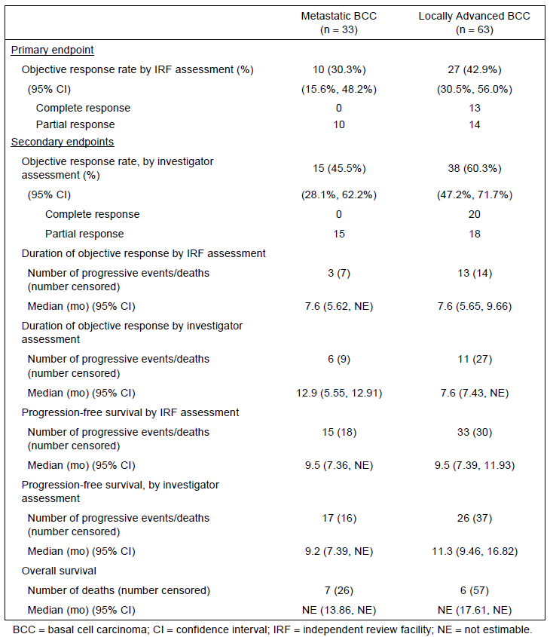
Objective response. In 10/33 metastatic patients (30.3%) and in 27/63 locally advanced patients (42.9%), there was an objective response. This response was partial for 10/10 metastatic patients and for 14/27 locally advanced patients. Disease was often ‘stable’ (but BCC may evolve slowly).
Subgroup analysis suggested a lower objective response rate in those ≥65 years (27% versus 48%); there was also regional variation (results were better in the US than elsewhere). Also, in metastatic patients, there were no objective responses in the 13 patients with 1-2 target lesions at baseline, while 10/20 with 3 or more target lesions at baseline responded.
Duration of objective response. In 10/33 metastatic patients with an objective response, 3 had disease progression or died and the median duration of response was 7.6 months. In the 27/63 locally advanced patients, 13 had disease progression or died and the median duration of response was again 7.6 months. These figures use independent (IRF) assessments.
Progression free survival. The median PFS was 9.5 months for both metastatic and locally advanced patients, as determined by the IRF.
Overall survival. Median OS was not calculable in either group, however 7/33 metastatic patients and 6/63 locally advanced patients had died by the clinical cut-off. One year survival was 75.5% for metastatic patients and 91.6% for locally advanced patients.
First efficacy update (26th May 2011). The sponsor provided results using a cut-off of 26th May 2011. These were investigator-determined and were not very different from investigator-determined results using the original cut-off. In locally advanced BCC, there was a modest rise in median PFS, to 12.9 months (from 11.3 months).
Second efficacy update (28th November 2011). These are the most up-to-date results. There was a minimum follow-up of 21 months for all patients. At this stage, 72.1% of patients had discontinued, while 27.9% were still being treated with vismodegib. Median duration of exposure was 12.9 months. Results for IRF-based responses were broadly unchanged. Investigator-assessed outcomes are more favourable than independent assessments, for example, median duration of response was 16.1 months based on investigator results.
Patient-reported outcomes. SF-36 is a questionnaire profiling functional health and well-being. Changes from baseline over 24 weeks were small. This is somewhat out of step with the finding that patient’s decision was a prominent reason for study drug discontinuation.

Study SHH3925g (supportive)
This was a Phase I, open-label study of daily vismodegib in patients with advanced solid malignancies refractory to standard therapy (or for whose tumours no standard therapies existed). Vismodegib was given as a 150, 270 or 540 mg daily dose. Primary objectives were related to safety and PK.
68 patients were enrolled; 33 of these had advanced BCC (median age 53 years; 24% were female). Of advanced BCC patients, 17/33 received 150 mg daily (including 7/17 given an early formulation, 10/17 given a new formulation). In the 33 BCC patients, median number of days on study was 314 (range 36-810).
Tumour assessment was every 8 weeks; anti-tumour activity was determined by investigators according to RECIST, although some radiology results were reviewed independently.
Overall response rate was 18/33 for BCC patients (55%), with a median duration in these 18 responders of 9.2 months (see Table 17 below). Median PFS for BCC patients was 11.4 months. These outcomes are similar to those in Study SHH4476g.
Table 17. Best overall response for patients with basal cell carcinoma
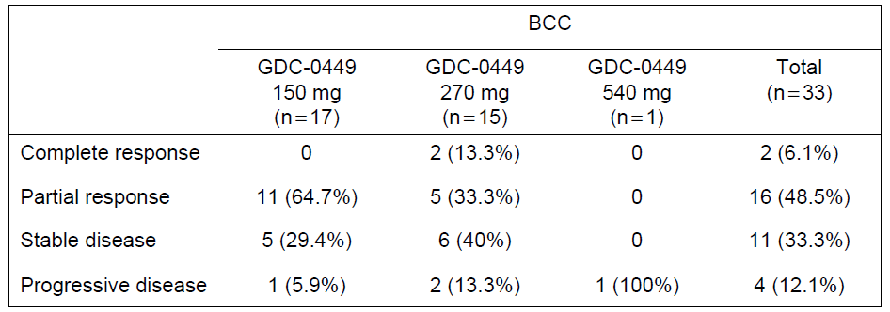

Study in basal cell nevus syndrome
Tang et al 2012 conducted a 2:1 randomised, double-blind, placebo-controlled study in 42 patients with Gorlin’s Syndrome. Vismodegib dose was 150 mg once daily. The primary endpoint was reduction in the incidence of new BCCs eligible for surgical resection after 3 months.
In 41 patients followed for a mean of 8 months (range 1-15 months), the mean per-patient rate of new, surgically eligible BCCs was 2 per year for vismodegib and 29 per year for placebo (p<0.0001). Existing BCCs regressed in those given vismodegib (percentage change from baseline in sum of longest diameters was -65% for vismodegib and -11% for placebo). Vismodegib patients had fewer surgeries for BCC removal. The study authors reported that “palmar and plantar pits, which are pathognomonic signs of the basal cell nevus syndrome, also disappeared during vismodegib therapy, often within the first month”. In patients who stopped vismodegib and had >3 months follow-up, some disease manifestations returned to baseline levels (most surgically eligible BCCs re-grew).

Comparison with historical results
The clinical evaluator comments on the sponsor’s comparison of survival in distant metastatic BCC patients for patients given vismodegib versus historical controls, noting “this data suffers from the difficulties associated with summating multiple case reports and really probably has relatively little to offer in terms of further validating the evidence of efficacy for Vismodegib in patients with metastatic BCC”. Patients with distant metastases do worse than those with metastatic disease restricted to a lymph node or local site. The sponsor stated that of 52 patients with metastatic BCC in the pooled safety population, 45 had distant metastases.

Efficacy in other populations
Vismodegib was apparently inefficacious in the randomised, placebo-controlled add-on Study SHH4429g in metastatic colorectal cancer (the Clinical Study Report stated a hazard ratio for PFS of 1.25 [90% CI 0.89-1.76] in favour of placebo).
In the randomised, placebo-controlled ‘maintenance’ Study SHH4489g in ovarian cancer patients in a second or third complete remission, vismodegib was again apparently not able to improve PFS (the clinical study report stated a hazard ratio for PFS of 0.79 [95% CI, 0.46-1.35] in favour of placebo).
These findings have no direct relevance to efficacy in the advanced BCC population, especially since the Hh pathway is likely to have a different role in these tumours, however it is worth reporting the findings given the randomised, double-blind study designs used.

Safety

Exposure
The clinical evaluator reports that as of 1st April 2011, >750 patients have been exposed to vismodegib. The sponsor has pooled safety data from various studies, including studies of patients with tumours other than advanced BCC. In the advanced BCC safety pool (n=138), median duration of follow-up was 10.4 months, range 0.9-35.8 months. The overall profile of AEs in relevant datasets is as follows:
Table 18. Vismodegib adverse events overall profile
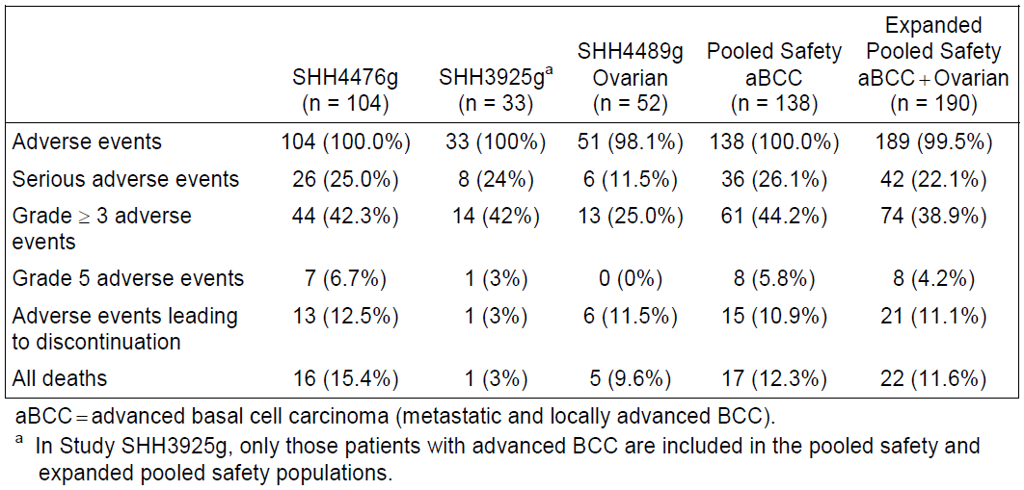
In the pooled advanced BCC safety population, commoner, severe AEs and their frequencies were: decreased weight (7.2%), fatigue (5.8%), muscle spasms (3.5%) and hyponatremia (2.9%). Selected other severe AEs included cardiac failure, keratitis and DVT (all n=2; 1.4%).

AEs in randomised, placebo-controlled studies
Although these studies were in less relevant patient populations, the randomisation process at least allows dissection of vismodegib’s contribution to AEs. Imbalance in exposure to other chemotherapy (in SHH4429g) may confound interpretation to a degree. Full study details are not evaluated here.
In SHH4429g (metastatic CRC; n=98 per arm), median duration of vismodegib treatment was 6 months. Notable disparities in AE frequency were seen for decreased weight (35.7% for vismodegib; 13.3% for placebo), decreased appetite (50% versus 24.5%), dehydration (24.5% versus 9.2%), muscle spasms (16.3% versus 2.0%) and dysgeusia (41.8% versus 9.2%).
In relation to severe AEs, mucosal inflammation was more common in the vismodegib arm (6.1% versus 1.0%), along with weight loss (10.2% versus 1.0%), decreased appetite (8.2% versus 1.0%), dehydration (12.2% versus 2.0%) and peripheral sensory neuropathy (8.2% versus 1.0%). Serious AEs were likewise often commoner (for example, dehydration, 9.2% versus 2.0%; pulmonary embolism 7.1% versus 4.1%; DVT 4.1% versus 1.0%). Also, discontinuations for fatigue were seen in 5.1% versus 2.0%; for neutropenia in 5.1% versus 0%; and diarrhoea in 3.1% versus 1.0%.
In SHH4489g (maintenance treatment in 2nd or 3rd remission from ovarian cancer; n=52 per arm), median duration of vismodegib treatment was approximately 5.5 months. There were stark differences in incidence of some AEs, for example, muscle spasms (67.3% for vismodegib; 1.9% in the placebo arm), dysgeusia (67.3% versus 17.3%; ageusia in 7.7% versus 1.9%) and alopecia (53.8% versus 7.7%). These differences carried across to severe AEs. Notable were multiple reports of severe abdominal pain, LFT elevation and muscle spasm. Serious AEs were commoner in the vismodegib arm, although no patterns emerged.
In the more relevant randomised study of Gorlin’s Syndrome by Tang et al, 2012 AEs were not as well characterised. Results from publication are shown in Table 19 and Table 20:
Table 19. AEs in the study of Gorlin’s Syndrome by Tang et al. 2012. Grade I-II
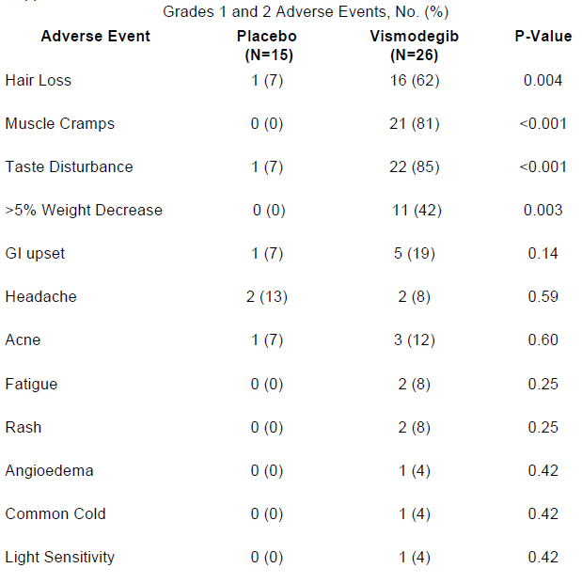
Table 20. AEs in the study of Gorlin’s Syndrome by Tang et al. 2012. Grade III-IV
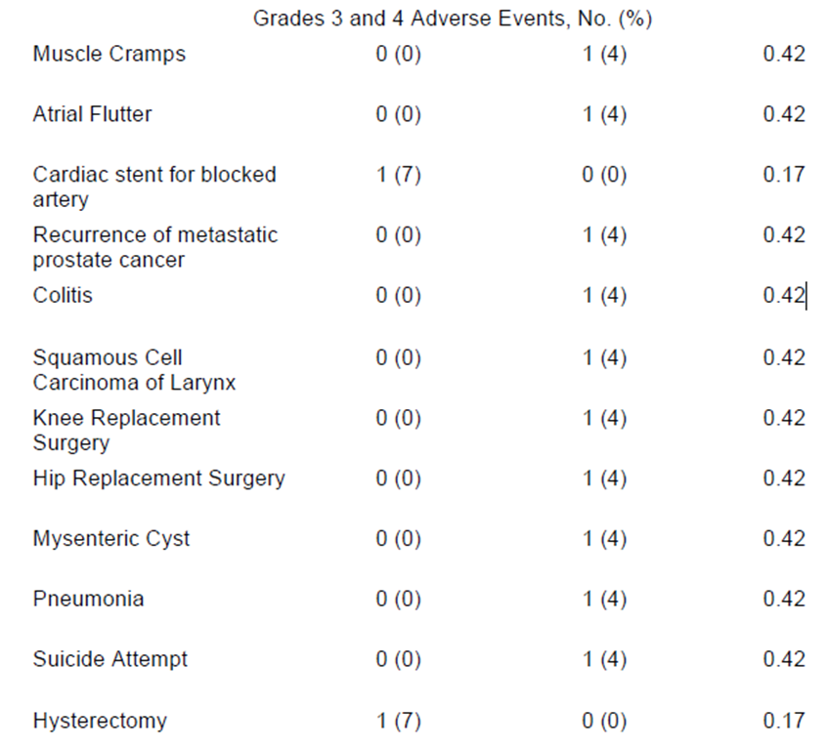
Overall, 14/26 vismodegib patients discontinued due to AEs (as of 31st January 2012). One of 5 eligible patients was able to continue vismodegib for 18 months. Tang et al. stated that when vismodegib was withdrawn, dysgeusia and muscle cramps ceased within 1 month, and scalp and body hair started to regrow within 3 months.

Deaths
In the advanced BCC cohort, 17/138 subjects died on-study (12.3%). Death was due to progressive disease in 7 subjects, and AEs in 8 subjects. None of these Grade V AEs was attributed to vismodegib. However, one fatal AE was hypovolaemic shock. Several other deaths had an unknown cause.

Serious AEs
Vismodegib-related serious AEs in the pivotal study were cholestasis, pulmonary embolism, syncope plus dehydration, and cardiac failure plus pneumonia. In a safety update (cut-off 26th May 2011), a further two subjects reported serious AEs involving syncope; osteomyelitis and cerebral haemorrhage were also reported. In supportive studies, prominent serious AEs included hyponatremia, intestinal obstruction and elevated hepatic enzymes.
One case of pancreatic cancer was thought to have developed de novo during vismodegib treatment and was thought drug-related by the investigator. A second case was considered to have been present at baseline, based on retrospective review of baseline scans.
Emergent cases of squamous cell carcinoma appear attributable to existing risk factors (such as sun exposure) in SHH4476g; no cases were observed in the ovarian cancer study.

Taste loss and dysgeusia
The Hh pathway is important in taste papillae. In rats, vismodegib exposure led to a decrease in taste bud numbers. In the pivotal clinical study, 53/104 patients were reported to have dysgeusia, 29 with a Grade I AE (altered taste) and 24 with Grade II (altered taste with diet change, or noxious / unpleasant taste, or loss of taste). Two patients had hypogeusia (decreased taste) followed by dysgeusia, another 9 had only hypogeusia and another 12 had only ageusia (loss of taste). This suggests that 74/104 reported some taste disturbance. One investigator considered that the appreciable impact of vismodegib on taste and enjoyment of eating contributed prominently to the marked weight loss seen in patients.

Muscle cramps and spasms
In pivotal advanced BCC Study SHH4476g, 68% of patients reported muscle spasms. In the advanced BCC pool, 71.7% reported muscle spasms and 3.6% (5/138) had severe spasms. In the randomised study in ovarian cancer, 1.9% of placebo subjects versus 67.3% of vismodegib subjects reported muscle spasms (0 versus 5.8% were severe). In 4/190 subjects in the pooled advanced BCC and ovarian cancer cohort, muscle spasms resulted in study drug discontinuation.
There was no attempt to gauge whether enzymes such as creatine kinase-MM were elevated with use of vismodegib. Sekulic et al. report that, to their knowledge, myositis has not been reported. Muscle damage biomarkers were not well assessed. It is not even clear if the ‘muscle spasm’ is due to muscle pathology; ‘neurologic’ effects in rat toxicity studies included ataxia, twitching and limb and body tremors. On the other hand, vismodegib may alter electrolyte balance, predisposing to muscle cramps; it is noted that the drug appears to be associated with hyponatremia.
Although ‘muscle spasm’ was by far the most common preferred term, in the pooled advanced BCC safety population myalgia was reported in 8/138, muscular weakness in 4/138 (Grade III in one patient), trismus in 3/138 (Grade III in one patient) and muscle twitching in 2/138. Peripheral neuropathy was reported in 5/138 and tremor in 4/138. As noted, severe sensory neuropathy was seen much more commonly in vismodegib patients in the randomised metastatic colorectal cancer study.

Amenorrhoea
Among 10 women of childbearing potential, amenorrhoea was observed in 3.

Clinical evaluator’s recommendation
The clinical evaluator has recommended approval.

Risk management plan
The ACSOM and the RMP evaluator expressed concern about some elements of the proposed Communication Plan, for example, the extent of distribution (the sponsor proposes distribution to dermatologists and oncologists, as well as hospital pharmacists) (see section V. Pharmacovigilance findings, above, and also discussion of ‘Teratogenicity’ below). Otherwise, the RMP proposed by the sponsor was considered generally acceptable by the TGA’s OPR.
If the application is approved, the RMP evaluator has recommended the following condition of registration:
- The Core Risk Management Plan Version: 1.0, dated 31 January 2012, with an Australian Specific Annex (ASA) identified as Version: 1.0, dated April 2012, to be revised as specified in the sponsor’s correspondence dated 22 November 2012, and subsequently as approved by the TGA’s Office of Product Review, must be implemented.

Risk-benefit analysis

Delegate considerations

Justification of ORR as primary endpoint in pivotal study
The sponsor’s clinical overview included the feedback from liaison with EU regulatory authorities that:
- The primary endpoint of IRF-assessed objective response supported by durability of response may measure clinical benefit in this patient population.
The sponsor, in the clinical overview, provided a reasonable justification for the construction of the composite ORR endpoint and for its use as the primary endpoint. The sponsor did agree that for metastatic disease, OS is the gold-standard endpoint; some OS data were presented but their interpretation is limited by the uncontrolled study design employed.

Choice of single-arm pivotal study design
(see also Appendix to the Delegate’s Overview: expanded discussion of a single-arm study design, below).
The TGA-adopted EU Guideline on the Evaluation of Anticancer Medicinal Products in Man (EMEA/EWP/205/95 Rev 3 Corr) concerning evaluation of anti-cancer agents recommend the use of a randomised, controlled study design for pivotal studies. The sponsor has argued that no appropriate active comparator is available.
Literature suggests that cisplatin-containing regimens might be an appropriate active control, for metastatic BCC and perhaps even for locally advanced disease. Local guidelines (2008) support this. The sponsor considers such regimens unestablished, unproven and toxic.
The sponsor’s position is that objective response is a sound primary endpoint in advanced BCC. Cisplatin-based regimens, while on face value delivering good ORRs in the sparse literature on the topic, are not supported by randomised studies and are therefore not “best available, evidence-based” regimens (Guideline on the Evaluation of Anticancer Medicinal Products in Man (EMEA/EWP/205/95 Rev 3 Corr) page 18/23).
The guidelines state that in the absence of “best available, evidence-based” regimens, “a regimen used in clinical practice with a well-documented and benign safety profile is acceptable” or that “investigator’s best choice among a few selected regimens with these characteristics (may include [best supportive care]) is acceptable”.
The Delegate proposed to seek the advice of the ACPM about whether vismodegib should be compared with cisplatin-based regimens in a Phase III study (see also Appendix to the Delegate’s overview: Expanded discussion of single-arm study design, and questions 1 and 2 under Request for ACPM advice, below).

Rebound and resistance
It has been questioned whether vismodegib truly clears BCCs or whether instead it leaves clones of resistant cells with the potential for recurrence or rebound. In this regard, Tang et al 2012 noted that specific BCCs recurred after vismodegib discontinuation. According to the sponsor’s documents, the EU evaluators asked for information about durability of response for patients with demonstrated tumour responses in the pivotal Study SHH4476g who discontinued the study for reasons other than disease progression (for example, 8/18 locally advanced patients who discontinued due to patient decision had an ongoing tumour response at the time of discontinuation; all 18 patients also had ongoing AEs at the time). Data were not collected. There may need to be information in the PI about this issue.
A mutation in SMO (D473H) has been identified in a patient with medulloblastoma in Study SHH3925g who relapsed after initial response. The mutation alters the ability of vismodegib to inhibit SMO. This has been an isolated finding, but data are exploratory in this regard.

Gorlin’s syndrome
The sponsor states: “The molecular nature of BCCs in patients with sporadic and Gorlin-associated BCC is generally accepted to be similar ... and consequently the addition of these patients to the database does not prevent the characterisation of the risk benefit of vismodegib for the intended indication.”
In post-hoc analysis, ORR (IRF) in Gorlin’s Syndrome patients in SHH4476g was 66.7% (14/21). All these patients had locally advanced BCC rather than metastatic disease. In those with locally advanced disease with no recorded Gorlin’s Syndrome, ORR was 31% (13/42).
The controlled study by Tang et al 2012 does provide useful information about the anti-tumour efficacy of vismodegib in this setting, though key study endpoints were syndrome-specific.
In summary, efficacy appears better in Gorlin’s Syndrome than in sporadic disease, however this is a post-hoc analysis. In the pivotal study, roughly 20% of subjects had the syndrome, a large over-representation for patients with BCC but probably less so for those with advanced BCC. The risk is that apparent better efficacy in Gorlin’s Syndrome unrealistically inflates efficacy results that will usually be applied to those with sporadic disease.

Efficacy in BCCs driven by activating SMO mutations
A small proportion of sporadic BCCs are apparently driven by activating SMO mutations rather than PTCH1 mutations, and efficacy of vismodegib was not broken down by this classification. Perhaps, some such activating mutations might also interfere with the drug’s ability to inhibit SMO. On balance, given that only a fraction of sporadic BCCs are driven by this path, the indication should not be tailored towards subgroups of BCC based on tumour genetics (without specific data on the subject).

Effects on fertility
Animal studies suggest male and female fertility is compromised by vismodegib. Incidence of amenorrhoea was 3/10 in the at-risk human population (women of childbearing potential; these were in the advanced BCC cohort). It is unclear if this is reversible, but the decrease in number of corpora lutea observed in female rats given vismodegib for 26 weeks (at an exposure approximately 1.1 fold the estimated steady state exposure in humans) was not reversed by the end of an 8 week recovery period.

Teratogenicity
The nonclinical evaluator noted that limited reproductive toxicity studies confirmed the teratogenic potential of Hh pathway inhibitors. Pregnancy Category D was considered appropriate, along with a clear warning about teratogenicity in the PI. The RMP Evaluator notes that ACSOM has advised consideration of Category X and imposition of a contraindication for use in pregnancy, or at least a boxed warning. The ACSOM discussions state in part: “At the doses used there are clearly demonstrated life limiting effects and embryofetal deaths and therefore it was the committee’s view that vismodegib should not be used during pregnancy or when there is a possibility of pregnancy.”
On the basis of “very limited assessment of reproductive toxicity” in nonclinical studies (albeit this being consistent with guidelines for drugs used to treat patients with advanced cancer), and also on the basis on the nonclinical data provided, the Delegate proposed assignment of Category X. Of note, the sponsor has conducted an interaction study with oral contraceptives; systemic exposure to ethinyloestradiol and norethisterone is apparently not altered with concomitant vismodegib use.
The Delegate proposed Pregnancy Category X and contraindication in pregnancy and therefore saw no need for a boxed warning; however the ACPM’s advice would be sought on this point.

Alpha-1-acid glycoprotein
AAG is an acute-phase protein; levels vary with disease and physiological state. Variation in AAG level may result in variation in total plasma vismodegib levels but unbound drug levels are generally buffered from such variation. There are no data to support this view. Impact of varying AAG levels in particular disease states was not well-characterised.

Indication
The proposed indication does not refer to radiation therapy status. In the US, in patients with locally advanced disease, in the subset of patients who are not candidates for surgery, there is also a restriction to those patients who are also not candidates for radiation. The approved indication in the US is “Erivedge (vismodegib) capsule is a hedgehog pathway inhibitor indicated for the treatment of adults with metastatic basal cell carcinoma, or with locally advanced basal cell carcinoma that has recurred following surgery or who are not candidates for surgery, and who are not candidates for radiation.”
In Australia, according to local guidelines, radiotherapy has a role: “Radiotherapy should be reserved for the small minority of primary BCCs ... that present peculiar problems for conventional surgery and for cases of persistent, recurrent or advanced BCCs ... where surgery can be complemented by radiotherapy to improve control rates.”
In the pivotal study, for patients with locally advanced disease, radiotherapy should have been previously given unless this was contraindicated or otherwise inappropriate. Therefore, based on pivotal study conduct, it may be preferable to further limit the indication as per the US situation.

Overall risk-benefit
Risk-benefit in the context of advanced BCC appears favourable for vismodegib, given its promising efficacy and AE profile (although some AEs appear debilitating and may lead to treatment discontinuation; others, such as dehydration, could easily produce complications of their own).
Risk-benefit relative to current treatment options for advanced BCC is not well characterised for vismodegib. This may be acceptable where there are no “best available, evidence-based” regimens or where there are no regimens used in practice with a well-documented and benign safety profile.

Proposed action
Vismodegib appears to have a positive risk-benefit balance in advanced BCC patients, but it has not been compared with other regimens which may have an even greater clinical benefit. Approval hinges on whether the single-arm pivotal study design can be accepted. Implementation of the RMP as described above would be imposed as a condition of registration.

Request for ACPM advice
The Delegate proposed to seek general advice on this application from the ACPM, and also requested advice and comment specifically with regards to the following questions:
- Within the patient population being discussed, can cisplatin-based chemotherapy be regarded as:
  - widely used?
  - having a favourable benefit-risk balance,that is evidence-based (with particular reference to randomised studies)?
  - having a well-documented and benign safety profile?
  - (Advice on the above points will help decide whether the sponsor has addressed relevant TGA-adopted EU guidelines satisfactorily.)
- Is it reasonable in the context of this very rare condition (advanced or metastatic BCC) to have a single-arm pivotal study?
- Is possible better efficacy in Gorlin’s Syndrome (within the pivotal study) a particular concern (and if so, how should this be managed)?
- Should the indication be further restricted to exclude patients who have not yet trialled radiotherapy for locally advanced disease, as per the US indication?
- Should vismodegib be assigned to Pregnancy Category D or X? Should there be a black-box warning about teratogenicity?
- Please advise about any other issues that the Committee considers important in characterising the efficacy and safety of this product.
If the application is approved, the PI would need to be changed as described.

Appendix to the Delegates’ Overview. Expanded discussion of single-arm study design
The Delegate drew the ACPM’s attention to the following points regarding the use of a single arm study as the pivotal study.
- TGA-adopted EU Guidelines. The Guideline on the Evaluation of Anticancer Medicinal Products in Man (EMEA/EWP/205/95 Rev 3 Corr) note that Phase III trials should establish a favourable benefit-risk relationship (page 22/23) and that these trials should be randomised and reference-controlled (pages 15-16/23). The reference regimen is usually defined by disease, stage and prior lines of therapy. Section III.1.4 (pages 17-18) sets out requirements with regard to reference therapy. Caveats are noted for studies in small populations / very rare tumour types (page 21/23). The very restricted scope of historical controls is summarised on page 21/23.
- Sponsor’s argument. The single-arm design for the pivotal study was justified with two arguments: that a standard of care comparator for advanced BCC was not available; and that a placebo arm was unfeasible. [The Delegate agreed that a placebo arm is not appropriate.]
In the sponsor’s clinical overview, it was noted that feedback from liaison with EU regulatory authorities was that:
“It was acknowledged that there is no suitable treatment in the advanced BCC disease setting to serve as an adequate comparator in a clinical trial; therefore, the single-arm design of the proposed pivotal Phase II trial may be considered acceptable, but would need to be justified.”
The sponsor nominated particular response rates indicative of clinical benefit:
Response rates significantly greater than 10% for metastatic disease and greater than 20% for locally advanced disease represent clinically meaningful benefits for patients with advanced BCC, as no therapeutic options exist for these patients and spontaneous responses have not been reported in this disease.
With regard to lack of a reasonable active comparator, the sponsor states in the clinical overview:
Based on a literature review of the last 30 years ... it was reported that less than a quarter of the patients had been treated with chemotherapy; platinum chemotherapy was most commonly used in these patients. Thus, there is no well-accepted treatment that could serve as a comparator.
And also:
Alternative unproven platinum-based chemotherapy, for which there is case-report series data, represents far more risk to patients than vismodegib because of the substantial toxicity burden associated with those treatments and the lack of efficacy data for any of the options currently used today in this patient population in need of active treatment options.
The sponsor has noted difficulties in organising a randomised study, but the obstacles discussed pertain more to whether the study can be open-label or blinded. Even an open-label, randomised, controlled study would offer major advantages over a single arm study, if the comparator was relevant.
The sponsor also claimed that the rarity of metastatic BCC would make a randomised comparative study unfeasible.
The sponsor emphasised that investigators were impressed by results in advanced BCC patients in the Phase I Study SHH3925g.
- Clinical evaluator. The clinical evaluator states there is no meaningful alternative systemic treatment available for advanced BCC.
- Clinical guidelines.
EviQ (NSW Cancer Institute) does not cover non-melanoma skin cancer.
The National Comprehensive Cancer Network (NCCN) Guidelines (USA) note that: in high-risk BCC with positive margins and residual disease after radiotherapy, or in the case of regional or distant metastases, “combination chemotherapy with cisplatin- or carboplatin-based doublets has produced responses”.
The Cancer Council of Australia has produced a local clinical guideline that does mention alternatives, as follows:

12.1 Basal cell carcinoma

12.1.1 Distant metastases
Metastatic disease from basal cell carcinoma (BCC) is a rare event ranging from 0.0028 to 0.1%. Lung and bone are the commonest sites. Reported experience, often only case reports or small series, indicates that cisplatin-based regimens appear to be the most effective, most recently combining cisplatin or carboplatin with paclitaxel. Response rates of up to 83% have been reported with a median duration among responders of 24 months. Radiotherapy may be useful in palliation of distant metastases.

12.1.2 Chemotherapy
Systemic Treatment: Systemic chemotherapy is rarely used in metastatic BCC or for locally advanced disease. Most regimens include cisplatin or carboplatin. Complete response rates of up to 37% have been reported in small groups of patients and control of symptoms is achieved.

Key point
Chemotherapy achieves responses in metastatic basal cell carcinoma and can be used to control symptoms.
- Literature
The NCCN guidance refers to:
- Carneiro BA et al. Metastatic basal cell carcinoma: complete response to chemotherapy and associated pure red cell aplasia. Cancer Invest 2006;24:396-400.
These authors mention that of 12 patients identified upon review of literature who had metastatic BCC treated with platinum-containing regimens, 5/12 had a complete response lasting from 3-18 months, and 4 had a partial response. Cisplatin was used alone in 5 patients, but otherwise in combination with various agents.
It is also stated that systemic chemotherapy has been effective for locally advanced BCC: “Among 16 cases of locally advanced BCC treated with chemotherapy, 75% had objective response and 50% had complete response”. Most of these patients were treated with cisplatin plus other anticancer agents.
The authors conclude that “cisplatin clearly emerges as the most efficacious drug for either locally advanced or metastatic BCC and it should be part of any chemotherapy regimen”.
- Jefford M et al. Metastatic basal cell carcinoma: rapid symptomatic response to cisplatin and paclitaxel. ANZ J Surg 2004;74:704-705.
- Ganti AK and Kessinger A. Systematic therapy for disseminated basal cell carcinoma: An uncommon manifestation of a common cancer. Cancer Treat Rev 2011;37:440-443.
This recent paper mentions that if only regional nodes are involved in metastatic disease, potentially curative local therapy, for example, surgery and / or radiation, is often an option and the prognosis is better. (Consistent with McCusker et al, 2012.)
The paper discusses a review by Moeholt et al (1996) of 53 case reports (of disseminated BCC). There was a response rate of 83% with platinum-based regimens, with 17 complete responses (37%) and 21 partial remissions (46%). Median time to progression was 24 months. “Based on these data, platinum based chemotherapy emerged as the standard of care in this population”.
Also of note is the following older publication:
- Pfeiffer P, Hansen O, Rose C. Systemic cytotoxic therapy of basal cell carcinoma. A review of the literature. Eur J Cancer 1990; 26: 73.
In their literature review, the authors distinguish poor outcomes in patients who did not receive cis-platinum (only one partial response in 28 cases) from better outcomes in those who did receive cis-platinum-containing regimens (17/22 evaluable patients ‘responded’ and in 10/22 there was ‘complete disappearance of the tumour’. “These patients survived for a median time of more than 22 months (range 4+ to 51+ month”.
Overall, there is no indication in the literature of evidence for a ‘standard of care’ generated from randomised, controlled studies. There is a suggestion that a cisplatin regimen could be considered to have a favourable benefit-risk relationship, but this is not on the basis of Phase 3, controlled studies.

Response from sponsor

Comment on the Delegate’s proposed action:
The sponsor agrees with the Delegate’s conclusion that Erivedge (vismodegib) has a positive risk-benefit balance in the treatment of adult patients with advanced BCC for whom surgery is inappropriate.
The sponsor believes the design of the pivotal Phase II study (SHH4476g) was appropriate based on current clinical practice, the patient population and the promising efficacy results seen in the earlier Phase I study (SHH3925g). In respect to the questions the Delegate has posed to the ACPM, the sponsor provides the following comments.

The use of cisplatin in the proposed advanced BCC patient population
As noted by the Delegate, there is no indication in the literature of evidence for a “standard of care” generated from clinical studies. Platinum chemotherapy was not a treatment commonly used for patients with advanced BCC which was reflected in the treatment history of the patients enrolled on Study SHH4476g. Approximately 10% of the efficacy evaluable patients received prior platinum-based chemotherapy, and they were predominantly patients with metastatic BCC.
A recent comprehensive retrospective review of case studies in the literature from 1981-2011 (McCusker et al, 2012) suggests that a small proportion of patients with metastatic BCC (16 of 100) were treated with platinum-based chemotherapy. For locally advanced BCC patients as defined by Study SHH4476g, there have been no prospective or retrospective studies. Recent publications (2009 to 2012) of patients who could have been eligible for entry into the locally advanced cohort on study had limited treatment information and indicated that treatments received were primarily surgery, and radiation was used as an adjuvant therapy after surgery (Schwipper et al., 2011, Soysal et al., 2010, Luliano et al., 2012). Taken together, these studies further underscore the lack of well-accepted non-surgical/non-radiation treatment in patients with advanced BCC.
As discussed in the sponsor’s clinical overview, treatment with platinum therapy in metastatic patients has been reported anecdotally. A review of articles cited by the NCCN and the Cancer Council of Australia clinical practice guidelines suggests that evidence supporting the guidance recommendations is primarily case reports or case series of limited patient numbers (see Table 21 below). Due to the anecdotal nature of these reports which is associated with differences in patient population and response criteria, the sponsor is unable to appropriately provide an assessment of expected response to treatment with platinum-based chemotherapy by RECIST version 1.0. McCusker et al., 2012 report a median survival of 24 months based on Kaplan-Meier methods in metastatic BCC patients with distant metastasis.
Table 21. Clinical practice guidelines published in the English literature regarding treatment of BCC
In conclusion, there are no well-accepted non-surgical/non-radiation treatment options for patients with advanced BCC. Platinum therapy has been associated with the significant toxicities that are well described in the literature. Based on the sponsor’s investigations, platinum-based chemotherapy in advanced BCC is not commonly used, and the data does not support a favourable benefit-risk of platinum-based regimens in advanced BCC.

The single-arm pivotal study (SHH4476g) supports approval of vismodegib for this very rare condition (advanced BCC)
The sponsor considers the pivotal study design to be appropriate based on the rarity of the disease, lack of a standard of care (i.e. absence of clinical studies demonstrating efficacy), and magnitude of anti-tumour activity demonstrated in Phase I (SHH3925g).
Locally advanced BCC patients have visible skin lesions directly affecting their wellbeing. Effects include infections due to ulcerated lesions, the need for intensive wound care, threats to vital organs such as the eye and ear, extensive morbidity and/or substantial degradation in cosmesis. It was observed in SHH3925g that vismodegib treatment resolved ulceration and dramatically shrank lesions in many patients and these effects would not be expected spontaneously (that is, without an effective treatment). The discussions with investigators indicated that the durable responses were directly meaningful to patients and they were reluctant to randomise patients onto treatment with best supportive care. Metastatic BCC is an exceedingly rare and devastating disease without an established treatment. Tumour responses in metastatic BCC reflect a broader anti-tumour effect that can be seen in patients on this study and the durability of the response and anti-tumour effect may lead to an increase in PFS and OS. Vismodegib which has demonstrated antitumour activity and a well-tolerated safety profile offers physicians and patients an important treatment option.

The contribution of Gorlin Syndrome patients to the overall response rates in the pivotal study (SHH4476g)
In the Overview, the Delegate notes the post-hoc analysis from SHH4476g: in Gorlin syndrome patients ORR was 66.7% (14/21) and in patients with no medical history of Gorlin syndrome ORR was 31% (13/42).
Due to the small sample size the results should be interpreted with caution. When examining several endpoints and baseline factors (that is, multiple testing) in a post hoc analysis differences will be expected to occur in some subsets by chance.
There is consistent evidence from the literature and clinical studies with vismodegib that aberrant activation of Hh signalling due to germline or somatic genetic alterations occurs similarly in both Gorlin-associated and sporadic BCC. The expression of the Hh pathway target gene and effector of Hh signalling, Gli1, was further evaluated in tissue specimens from patients with a medical history of Gorlin syndrome and patients with no medical history of Gorlin syndrome, who were treated with vismodegib in SHH3925g. Gli1 levels in BCC tissue were comparable between these two groups, suggesting that there is no obvious difference in the degree of Hh pathway activation between patients with or without a reported past medical history of Gorlin syndrome.
Durable and meaningful responses were observed among Gorlin and non-Gorlin patients. For reasons described above, the sponsor does not consider the numerical difference in response rate a concern requiring specific management.

Risk of teratogenicity
The sponsor agrees with the recommendation of the Delegate that the pregnancy category for vismodegib should be changed from D to X. In addition, the sponsor agrees with the Delegate’s recommendation to add contraindications for “pregnant women” and “women of child-bearing potential, unless two reliable methods of contraception are being used during treatment and for seven months after the last dose.” Taking these changes into account, the sponsor agrees with the Delegate that a boxed warning for teratogenicity is not required.
The sponsor wishes to clarify its plans with respect to the additional risk minimisation activities for the potential risk of teratogenicity. The sponsor wishes to address the concern of ACSOM and the RMP evaluator, and highlighted by the Delegate, by agreeing to expand the proposed audience for the mailout of the healthcare professional and patient educational material after registration. As such, the mailout will be directed to all specialists who are likely to be involved in the treatment of patients with advanced BCC: medical oncologists, radiation oncologists, dermatologists, head and neck surgeons and pharmacists in public and private hospitals to supplement the groups originally proposed. As the distribution of the educational materials will be widened to all prescribers, the sponsor does not feel it necessary to formally restrict prescribing.
In terms of the assessment of the effectiveness of the educational material, the sponsor intends to perform the actions as outlined previously to the TGA in correspondence of 22 November 2012. In summary;
- User testing of the patient educational material to evaluate its quality and usefulness will performed in 2013 after product launch
- Relevant feedback from the results of this testing will be used to amend the patient educational materials

Revisions to product literature
Details of these are beyond the scope of the AusPAR.

Advisory committee considerations
The Advisory Committee on Prescription Medicines (ACPM), having considered the evaluations and the Delegate’s Overview, as well as the sponsor’s response to these documents, advised the following:
The ACPM, taking into account the submitted evidence of efficacy, safety and quality, agreed with the Delegate and considered this product to have an overall positive benefit-risk profile for the indication as proposed by the sponsor.

Proposed PI/CMI amendments:
The ACPM agreed with the Delegate to the proposed amendments to the PI and CMI and specifically advised on the inclusion of the following:
- Pregnancy Category X, with suitable warnings, should be applied.
The ACPM advised that the implementation by the sponsor of the recommendations outlined above to the satisfaction of the TGA, in addition to the evidence of efficacy and safety provided would support the safe and effective use of this product.

Outcome
Based on a review of quality, safety and efficacy, TGA approved the registration of Erivedge hard capsule containing 150 mg vismodegib, indicated for:
the treatment of adult patients with metastatic basal cell carcinoma, or with locally advanced basal cell carcinoma where surgery and/or radiation therapy are not appropriate.

Specific conditions applying to this therapeutic good
The implementation in Australia of the Core Risk Management Plan Version: 1.0, dated 31 January 2012, with an Australia Specific Annex (AsA) identified as Version:1.0, dated April2012, to be revised as specified in the sponsor's correspondence dated 22 November 2012, and subsequently as approved by the TGA's Office of Product Review.

Attachment 1. Product Information
The Product Information approved at the time this AusPAR was published is at Attachment 1. For the most recent Product Information please refer to the TGA website at <http://www.tga.gov.au/hp/information-medicines-pi.htm>.

ICH: International Conference on Harmonisation of Technical Requirements for Registration of Pharmaceuticals for Human Use.
Dassule HR, Lewis P, Bei M, et al. Sonic hedgehog regulates growth and orphogenesis of the tooth. Development 2000;127:4775-4785.
Kimura H, Ng JM, Curran T. Transient inhibition of the Hedgehog pathway in young mice causes permanent defects in bone structure. Cancer Cell 2008;13:249-260.
St-Jacques B, Hammerschmidt M, McMahon AP. Indian hedgehog signaling regulates proliferation and differentiation of chondrocytes and is essential for bone formation. Genes Dev 1999;13:2072-2086.
Julian CG, Bowers PW. A clinical review of 209 pilomatricomas. J Am. Acad. Dermatol. 1998;39:191-195.
Lipinski RJ, Hutson PR, Hannam PW et al. Dose- and route-dependent teratogenicity, toxicity, and pharmacokinetic profiles of the hedgehog signalling antagonist cyclopamine in the mouse. Toxicol Sci 2008;104:189−197.
Lipinski RJ, Song C, Sulik KK et al. Cleft lip and palate results from Hedgehog signalling antagonism in the mouse: Phenotypic characterization and clinical implications. Birth Defects Res. A Clin Mol Teratol 2010;88:232-40.
Category X: Drugs which have such a high risk of causing permanent damage to the fetus that they should not be used in pregnancy or when there is a possibility of pregnancy.
Category D: Drugs which have caused, are suspected to have caused or may be expected to cause, an increased incidence of human fetal malformations or irreversible damage. These drugs may also have adverse pharmacological effects. Accompanying texts should be consulted for further details.
The nonclinical evaluator also made other recommendations concerning revisions to the nonclinical statements in the PI but details of these are beyond the scope of the AusPAR.
FOLFORI = irinotecan, leucovorin and infusional 5-fluorouracil (5-FU); FOLFOX = oxaliplatin, leucovorin and infusional 5-FU.
Other recommended revisions to the PI and comments on the CMI are not included in this document as they are generally beyond the scope of the AusPAR.
A boxed warning is a succinct warning statement printed at the start of the approved PI, designed to alert prescribers to an important safety issue with a medicine. The warning is highlighted by a bold black surround or “box”.
In brief, secreted ligands including Sonic hedgehog bind to a cell-surface receptor, PTCH1. This binding relieves an inhibitory effect of PTCH1 on SMO, a GPCR-like protein. De-repression of SMO triggers a cascade culminating in activation of GLI2 and GLI3, leading to transcription of hedgehog target genes. These genes include GLI1 (so expression of GLI1 is used as a measure of hedgehog pathway activity) and PTCH1.
Published as Sekulic A et al. Efficacy and Safety of Vismodegib in Advanced Basal-Cell Carcinoma. NEJM 2012:366;2171-2179. See also the accompanying editorial by Lear (NEJM 2012:366; 2225-2234) and correspondence (“Vismodegib in Advanced basal-Cell Carcinoma”, NEJM 2012:367;969-970).
http://ctep.cancer.gov/
Vismodegib has solubilities of about 1.24 mg/mL in simulated gastric fluid and 0.8 μg/mL in simulated intestinal fluid at 37°C. Solubility appears greater with lower pH, raising the prospect of slower absorption with hypochlorhydria, because of incomplete solubilisation of capsule contents. A trial involving gastric pH elevating agents is due for completion in February 2015.
Sekulic A et al. Efficacy and safety of vismodegib in advanced basal-cell carcinoma. NEJM 2012:366;2171-2179
Tang JY et al. Inhibiting the Hedgehog Pathway in Patients with the Basal-Cell Nevus Syndrome. NEJM 2012;366:2180-2188. [Results were of a planned second interim analysis, after the data safety monitoring board had recommended ending placebo treatment.]
Sekulic et al. Correspondence. Vismodegib in Advanced Basal-Cell Carcinoma. NEJM 2012: 367; 969-971.
Epstein et al. Correspondence. Vismodegib in Advanced Basal-Cell Carcinoma. NEJM 2012: 367; 969-971.
Sekulic et al. Correspondence. Vismodegib in Advanced Basal-Cell Carcinoma. NEJM 2012: 367; 969-971.
Basal cell carcinoma, squamous cell carcinoma (and related lesions) - a guide to clinical management in Australia. Cancer Council Australia and Australian Cancer Network, Sydney. 2008.
Lear JT. Oral Hedgehog-Pathway Inhibitors for Basal-Cell Carcinoma. NEJM 2012:366:2225-2226.
Category D: Drugs which have caused, are suspected to have caused or may be expected to cause, an increased incidence of human fetal malformations or irreversible damage. These drugs may also have adverse pharmacological effects. Accompanying texts should be consulted for further details.
Category X: Drugs which have such a high risk of causing permanent damage to the fetus that they should not be used in pregnancy or when there is a possibility of pregnancy.
Basal cell carcinoma, squamous cell carcinoma (and related lesions). A guide to clinical management in Australia. Cancer Council Australia and Australian Cancer Network, Sydney. 2008. See also page xvii of guideline.
Details of the proposed revisions to product literature (PI and CMI) are beyond the scope of the AusPAR.
https://www.eviq.org.au/ eviQ Cancer Treatments Online sits within the Cancer Services and Information Division at the Cancer Institute NSW.
Basal cell carcinoma, squamous cell carcinoma (and related lesions). A guide to clinical management in Australia. Cancer Council Australia and Australian Cancer Network, Sydney. 2008
McCusker M et al. Metastatic basal cell carcinoma: differences in survival by site of spread. ASCO Annual Meeting 1-5 June 2012; poster 8585.
Moeholt K. et al. Platinum-based cytotoxic therapy in basal cell carcinoma--a review of the literature. Acta Oncol. 1996;35(6):677-82.
McCusker M. et al. Metastatic basal cell carcinoma: differences in survival by site of spread. ASCO Annual Meeting 1-5 June 2012; poster 8585.
Schwipper V. Invasive basal cell carcinoma of the head and neck (basalioma terebrans). Facial Plast Surg 2011;258-265. Epub 2011 May 12.
Soysal HG. Orbital exenteration: a 10-year experience of a general oncology hospital. Orbit 2010;29:136-140.
Luliano A. et al. Risk factors for orbital exenteration in periocular basal cell carcinoma. Am J Ophthalmol 2012;153:238-241.
NCCN Clinical Practice Guidelines in Oncology (NCCN Guidelines) Basal Cell and Squamous Cell Skin Carcinomas. Version 2. 2012.
References cited in the table: Paver K et al., The incidence of basal cell carcinoma and their metasteses in Australia and New Zealand (letter). Australas J Dermatol 1973; 14:53. Guthrie TH Jr. et al. Cisplatin and doxorubicin. An effective chemotherapy combination in the treatment of advanced basal cell and squamous carcinoma of the skin. Cancer 1985;55(8):1629-32. Guthrie TH Jr. et al. Cisplatin-based chemotherapy in advanced basal and squamous cell carcinomas of the skin: results in 28 patients including 13 patients receiving multimodality therapy. J Clin Oncol. 1990;8:342-6. Pfeiffer P. et al. Systemic cytotoxic therapy of basal cell carcinoma. A review of the literature. Eur J Cancer 1990;26(1):73-7. Review. Merimsky O. et al. Salvage cisplatin and adriamycin for advanced or recurrent basal or squamous cell carcinoma of the face. Anticancer Drugs. 1992;3(5):481-484. Moeholt K. et al. Platinum-based cytotoxic therapy in basal cell carcinoma--a review of the literature. Acta Oncol. 1996;35(6):677-682. Jefford M. et al. Metastatic basal cell carcinoma: rapid symptomatic response to cisplatin and paclitaxel. ANZ J Surg. 2004;74(8):704-705. Carneiro B.A. et al. Metastatic basal cell carcinoma: complete response to chemotherapy and associated pure red cell aplasia. Cancer Invest. 2006;24(4):396-400.

