May 2012

Australian Public Assessment Report for Vinorelbine
  - Proprietary Product Name: Navelbine
  - Sponsor: Pierre Fabre Medicament Australia Pty Ltd

About the Therapeutic Goods Administration (TGA)
- The Therapeutic Goods Administration (TGA) is part of the Australian Government Department of Health, and is responsible for regulating medicines and medical devices.
- The TGA administers the Therapeutic Goods Act 1989 (the Act), applying a risk management approach designed to ensure therapeutic goods supplied in Australia meet acceptable standards of quality, safety and efficacy (performance), when necessary.
- The work of the TGA is based on applying scientific and clinical expertise to decision-making, to ensure that the benefits to consumers outweigh any risks associated with the use of medicines and medical devices.
- The TGA relies on the public, healthcare professionals and industry to report problems with medicines or medical devices. TGA investigates reports received by it to determine any necessary regulatory action.
- To report a problem with a medicine or medical device, please see the information on the TGA website <http://www.tga.gov.au>.
About AusPARs
- An Australian Public Assessment Record (AusPAR) provides information about the evaluation of a prescription medicine and the considerations that led the TGA to approve or not approve a prescription medicine submission.
- AusPARs are prepared and published by the TGA.
- An AusPAR is prepared for submissions that relate to new chemical entities, generic medicines, major variations, and extensions of indications.
- An AusPAR is a static document, in that it will provide information that relates to a submission at a particular point in time.
- A new AusPAR will be developed to reflect changes to indications and/or major variations to a prescription medicine subject to evaluation by the TGA.
Copyright
© Commonwealth of Australia 2012
This work is copyright. You may reproduce the whole or part of this work in unaltered form for your own personal use or, if you are part of an organisation, for internal use within your organisation, but only if you or your organisation do not use the reproduction for any commercial purpose and retain this copyright notice and all disclaimer notices as part of that reproduction. Apart from rights to use as permitted by the Copyright Act 1968 or allowed by this copyright notice, all other rights are reserved and you are not allowed to reproduce the whole or any part of this work in any way (electronic or otherwise) without first being given specific written permission from the Commonwealth to do so. Requests and inquiries concerning reproduction and rights are to be sent to the TGA Copyright Officer, Therapeutic Goods Administration, PO Box 100, Woden ACT 2606 or emailed to <tga.copyright@tga.gov.au>.

Contents
I. Introduction to product submission 3
Submission details 3
Product background 4
Regulatory status 4
Product Information 5
II. Quality findings 5
III. Nonclinical findings 5
IV. Clinical findings 5
Introduction 5
Pharmacokinetics 6
Pharmacodynamics 11
Dosage selection for the pivotal studies 11
Efficacy 12
Safety 41
Benefit-risk assessment 58
Recommendation regarding authorisation 61
V. Pharmacovigilance findings 62
Risk management plan 62
VI. Overall conclusion and risk/benefit assessment 62
Clinical 62
Risk management plan 65
Risk-benefit analysis 65
Outcome 69
Attachment 1. Product Information 69

I. Introduction to product submission

Submission details
Type of submission: | Extension of indications
Decision: | Approved
Date of decision: | 21 December 2011
Active ingredient: | Vinorelbine
Product name: | Navelbine
Sponsor’s name and address: | Pierre Fabre Medicament Australia Pty Ltd  PO Box 391  North Ryde BC NSW 1670
Dose form: | Soft capsule
Strengths: | 20mg, 30mg, 40mg and 80mg
Approved therapeutic use: | Navelbine is indicated for the first line treatment of advanced non-small cell lung cancer as a single agent or in combination. Navelbine is also indicated for the treatment of advanced breast cancer after failure of standard therapy as a single agent or in combination.
Route of administration: | Oral
Dosage: | Single agent: 60mg/m² administered once weekly for first three administrations; for subsequent administrations dose could be increased to 80mg/m² once weekly.
ARTG numbers: | 99498, 99558, 99561 and 99564

Product background
This AusPAR describes an application by the sponsor, Pierre Fabre Medicament Australia Pty Ltd, to extend the indications of Navelbine®/Vinorelbine Pierre Fabre® (vinorelbine as tartrate) soft capsules. Vinorelbine is a semi synthetic vinca alkaloid with antitumor activity. Navelbine and vinorelbine soft capsules are currently approved for the first line treatment of advanced non small cell lung carcinoma (NSCLC), as a single agent or in combination. The proposed indication for Navelbine in this submission is for extension of indications to include treatment of advanced breast cancer (ABC) as a single agent or in combination after standard therapy.

Regulatory status
Intravenous (IV) vinorelbine (Navelbine IV) has been marketed in Australia since 1998 for the treatment of ABC after failure of standard therapy and as first line treatment of advanced NSCLC. In 2004, oral vinorelbine was approved for first line treatment of NSCLC as single agent or in combination.
The indication of ABC has been approved in all countries in which Navelbine is registered (in 42 countries in Europe, Asia, Africa and South America) with exception of Australia and New Zealand (where Navelbine is only approved for NSCLC). However, the application for Navelbine has been withdrawn in Canada and Netherlands. No application for oral vinorelbine has been submitted in the USA. The data packages submitted in the UK and Sweden (where oral vinorelbine is approved for both NSCLC and ABC) were similar to the Australian submission except the fact that the current Australian submission has additional data.
In the UK, the approved indication is:
‘As a single agent or in combination for: The first line treatment of stage 3 or 4 NSCLC; The treatment of ABC stage 3 and 4 relapsing after or refractory to an anthracycline containing regimen.’
In Sweden, the approved indication is:
‘NSCLC; As monotherapy for the treatment of patients with locally advanced or metastatic breast cancer where treatment with anthracycline and taxane-containing chemotherapy has failed or is not suitable.’
It is important to note that the wording of the proposed Australian indication (treatment of ABC as a single agent or in combination after standard therapy) is different to the one approved in other countries. It is potentially misleading as it seems to imply that oral vinorelbine may be used as first or second line treatment despite the fact that IV vinorelbine is approved for ABC in Australia only after failure of standard therapy. This has been discussed further in the Clinical Evaluation Report below.

Product Information
The approved product information (PI) current at the time this AusPAR was prepared can be found as Attachment 1.

II. Quality findings
There was no requirement for a quality evaluation in a submission of this type.

III. Nonclinical findings
There was no requirement for a nonclinical evaluation in a submission of this type.

IV. Clinical findings

Introduction
The development of oral vinorelbine has been considered as an extension of the previous IV vinorelbine application and consequently no Phase III studies are included in the present submission. The primary objective of the clinical program was to demonstrate bioequivalence between oral vinorelbine and IV vinorelbine on the basis of pharmacokinetic studies. Navelbine soft capsules were approved in Australia in May 2005 for the treatment of NSCLC as a single agent and in combination. Clinical data on the use of Navelbine soft capsules in monotherapy for the first line treatment of ABC were included in the previous IV vinorelbine submission. Even though the previous clinical evaluation recommended approval of the application for registration for both indications, the ABC indication was not approved by the TGA due to inadequate demonstration of efficacy.
Three uncontrolled trials of oral vinorelbine monotherapy in ABC (95 CA 201, 96 CA 201 and 97 CA 206) were provided in the initial Australian submission but no comparative study was included.
Complying with the regulatory requirement in Australia, two comparative, randomised studies were carried out. In May 2004, a randomised Phase II study of oral vinorelbine or IV vinorelbine (Study CA 221) in patients previously treated with anthracyclines was initiated. Only 85 of the planned 230 patients could be enrolled in 2.5 years which led the sponsor to close the study due to low accrual rate. In June 2005, a randomised Phase II study of the combination of oral vinorelbine with capecitabine versus a sequential regimen of oral vinorelbine and capecitabine versus the combination of docetaxel and capecitabine (Study CA 222) in patients previously treated with anthracyclines was set up. As per protocol, a total of 139 patients were enrolled and provided clinical data on the efficacy and tolerance of the all oral combination of vinorelbine and capecitabine in comparison with the alternating use of each drug given as a single agent for three cycles and with the standard regimen of docetaxel associated with capecitabine in the setting of metastatic breast cancer (MBC) patients having failed anthracyclines.
As requested by TGA, the present Australian submission includes the scientific data related to ABC that were submitted and assessed in the framework of the previous application. The three Phase II Studies (95 CA 201, 96 CA 201 and 97 CA 206) submitted and reviewed by the TGA with the previous application have also been included in the current submission for the sake of clarity and ease of reference.
In the meantime, the clinical experience on oral vinorelbine safety has been enhanced by an increased number of treated patients (more than 100,000 as of August 2009) in the context of the post marketing survey. Post marketing experience has come mainly from the European countries where Navelbine soft capsules have been approved.
The submission did not include paediatric data as it was not relevant for the proposed indications.
All the clinical studies were conducted in accordance with the International Conference on Harmonisation (ICH) guidelines for Good Clinical Practice (GCP).

Pharmacokinetics

Studies providing pharmacokinetic data
No specific new pharmacokinetics-pharmacodynamics (PK-PD) studies were presented in this submission. However, some PK-PD information was provided from the two Phase II non comparative, open label Studies 96CA201 and 96CA202. Furthermore, information on Maximal Tolerated Dose (MTD), PK of oral vinorelbine and PK interactions was provided in the Phase I part of the three Phase I-II Studies CA 101 (oral vinorelbine and IV docetaxel), CA102 (oral vinorelbine and IV paclitaxel) and CA 103 (oral vinorelbine and oral capecitabine).

Summary of pharmacokinetics
No new data was presented in this submission as the proposed oral formulation is the same as that already approved for treatment of NSCLC. However, some of the Phase I-II studies using oral vinorelbine in ABC patients provided some additional PK information (Studies 96CA201, 97CA206, CA101, CA102 and CA103).

Physicochemical characteristics of the active substance
There are no changes to the oral formulation currently authorised for the treatment of NSCLC.
Vinorelbine is a semi-synthetic vinca alkaloid with antitumor activity. The chemical name is 3’, 4’-didehydro-4’-deoxy-C’-norvincaleukoblastine [R-(R*, R*)-2,3dihydroxybutanedioate (1:2) (salt)]. Vinorelbine tartrate is a white to yellow or light brown amorphous powder with the molecular formula C₄₅H₅₄N₄O₈2C₄H₆O₆ and a molecular weight of 1079.12. The aqueous solubility is >1000mg/ml in distilled water.

Pharmacokinetics in healthy subjects
It has been investigated only in the target patient population due to drug toxicity making studies in healthy subjects ethically unacceptable.

Pharmacokinetics in the target population
No new specific PK studies were presented in this submission as the proposed oral formulation is the same as that already approved for treatment of NSCLC. However, data from some Phase II open label studies were evaluated.
In Phase II, open label, non comparative Study 96 CA 201, pharmacokinetic samples were evaluated in 45 of the 120 patients. The mean profile for vinorelbine blood concentrations after successive first, second and third administrations at 60 mg/m² were within the same range and did not increase after the weekly repeated dosing (Table 1). When the dose was increased to 80 mg/m² on fourth administration, the mean vinorelbine concentrations increased proportionally to dose. Beyond the fourth administration, the mean profile could not be determined accurately. Similar results were observed for its metabolite, 4-O-deacetyl vinorelbine (DVRL).
Table 1: Mean (± standard deviation) area under the concentration curve from time zero to 24 h (AUC_{0-24h}) during administrations 1 to 4 and beyond (Study 96 CA 201).
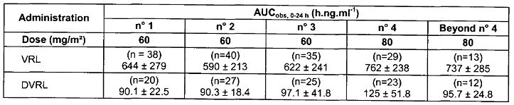
VRL: vinorelbine
DVRL: 4-O-deacetyl vinorelbine (metabolite of VRL)
In the Phase II open label study 96 CA 206, PK blood samples were collected in 13 patients. There was no accumulation of unchanged vinorelbine when repeating dose on a weekly schedule and when increasing dose from 60mg/m² to 80mg/m² on fourth administration, the mean vinorelbine concentrations increased proportionally to dose. DVRL blood concentrations were low, close to limit of quantification of the analytical method. However, an increase in AUC_{0-24h} (area under the concentration curve from time zero to 24 h) was observed after repeated administration, the steady state being reached at the second administration. One patient had a febrile neutropenia which was associated with a high vinorelbine exposure. The other patients with serious adverse events (AEs) related to vinorelbine did not have blood PK sampling.

Pharmacokinetics in other special populations
Not applicable.

Pharmacokinetic interactions
In the Phase I-II open label study CA 101, the mean exposure to vinorelbine increased with the dose of IV vinorelbine and total clearance was comparable between dose levels (Table 2); comparison of AUC_{inf} (area under the plasma concentration-time curve from time zero to infinity) after IV dosing on Day 1 (normalised to 25 mg/m²) was demonstrated to provide equivalent exposure to oral vinorelbine 60 mg/m². There was no statistically significant difference on vinorelbine Cl_{tot} (total body clearance) and t_{1/2} (elimination half life) between dose levels of docetaxel and vinorelbine PK parameters were similar whatever the dose of co administered docetaxel. There was no statistically significant difference of vinorelbine exposure between Day 1 and Day 15 showing that co administration of docetaxel did not affect exposure to vinorelbine (Table 3). The PK parameters of IV vinorelbine in patients in this study were comparable with those in reference populations having received IV vinorelbine alone. For docetaxel, the comparison to literature data showed that in the present study, its PK were not altered by co administration with vinorelbine, especially there was no decrease in docetaxel clearance which may have occurred due to competition with vinorelbine on CYP3A4 metabolism.
Table 2: Mean (± standard deviation) blood pharmacokinetic parameters of vinorelbine after IV dosing on Day 1 (Study CA 101).
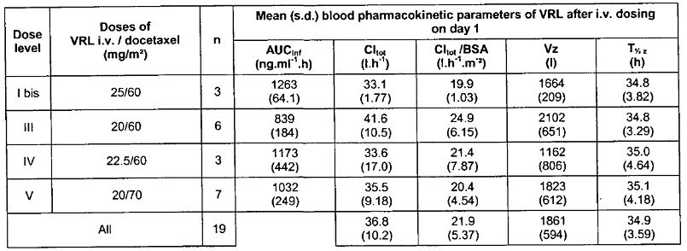
VRL = vinorelbine
bis = twice
Cl_{tot}/BSA = total body clearance/body surface area
Vz = apparent volume of distribution during terminal
t_{1/2} = elimination half life
Table 3: Comparison of vinorelbine AUC_{inf} (mean ± standard deviation) between Day 1 and Day 15 (Study CA 101).

n.s. = not significant
*AUC adjusted to 25 mg/m² dose
The major elimination route of both vinorelbine and docetaxel was hepatic metabolism by cytochrome P450 through 3A4 isoenzyme followed by biliary excretion. Both drugs are substrates of CYP3A4 and competition for the elimination pathway could be expected which might result in increased exposure to the parent compound associated with decrease of its clearance and decrease in metabolite formation. The blood concentrations of DVRL were low either after IV or oral dosing whatever the dose level and DVRL was quantifiable until the last sampling time 24 h after the administration. There was no decrease of the metabolic ratio when increasing the docetaxel dose suggesting that biotransformation of vinorelbine through CYP3A4 was not altered.
Overall, the PK results of this study provided some evidence to suggest that there was no significant drug interaction between vinorelbine and docetaxel although interpretation was limited due to small sample size (only 19 patients on Day 1 and 12 on Day 15); comparison of PK data for vinorelbine alone and docetaxel alone was from literature.
Out of 44 patients enrolled in the Phase II part of the same study, 15 patients underwent blood sampling for PK on Day 1 and only three of them had PK samples on Day 15 of Cycle 1. All patients were evaluable for the calculation of PK parameters. Total body clearance (mean ± standard deviation (s.d.)) of IV vinorelbine was similar to the value calculated in the Phase I part of the study (Cl_{tot} = 36.8 ± 10.2 L.h-1, n = 19 patients). PK parameters of oral vinorelbine were globally within the range of values calculated in the Phase I part of the study on 12 patients. Pharmacokinetic parameters of vinorelbine (IV and oral) and docetaxel were consistent with the ones calculated in the Phase I part of the study where absence of mutual pharmacokinetic interaction between both drugs was demonstrated.
In the Phase I-II Study CA 102, the blood concentration peak of vinorelbine was variable between patients which resulted from low number of blood samples during the absorption phase over the first three hours post dosing. Individual patient plots showed that vinorelbine blood concentrations were within the same range when associated with paclitaxel at either dose of 110 mg/m² or 135 mg/m², although some higher concentrations were observed in three patients at the 110 mg/m² dose of paclitaxel. Overall, no dose level effect, either with vinorelbine or with paclitaxel was observed on vinorelbine PK parameters.
The PK parameters of vinorelbine when combined with paclitaxel did not differ from reference values of vinorelbine administered alone. Exploratory analysis of vinorelbine metabolites showed a decrease of exposure to hydroxyl-1-vinorelbine and hydroxyl-2-vinorelbine between dose levels 60/110 mg/m² and 60/135 mg/m² (vinorelbine/paclitaxel) suggesting possible inhibition of formation of these hydroxylated metabolites following administration of low dose of oral vinorelbine with high dose of paclitaxel; however no effect was observed at the recommended dose level of 80/110mg/m².
Due to low blood concentrations of metabolites, calculation of metabolic ratio for OH-VRL1, desmethyl-VRL, 3, 6-ether-VRL and especially OH-VRL2 was not possible in some patients. Furthermore, OH-VRL1, OH-VRL2, 3, 6-ether-VRL and desmethyl-VRL were only quantified by reference to unchanged vinorelbine and hence values of metabolic ratios should be interpreted with caution. In case of interaction between vinorelbine and paclitaxel, as both drugs are mainly metabolised by CYP3A4, oxidative metabolites like OH-VRL1, OH-VRL2, 3,6-ether-VRL and desmethyl-VRL should have decreased, whereas formation of DVRL, which is not mediated by CYP, should have been unchanged.
Paclitaxel plasma concentrations increased between paclitaxel dose level 110 and 135 mg/m². At 110 mg/m², paclitaxel levels were comparable whatever the vinorelbine dose level. At 135 mg/m², mean paclitaxel plasma concentrations appeared higher after vinorelbine 80 mg/m² than those after 60mg/m². However, in the 60 mg/m² group, 2 patients had a peak concentration at 1.5 hours, whereas all patients in the 80 mg/m² group had T_{max} (time to reach peak plasma concentration following drug administration) at 3 hours.
As no reference data was available for AUC_{0-24h} of paclitaxel, the analysis of any interaction was performed by comparing the paclitaxel AUC_{0-24h}/dose between the different vinorelbine dose level groups (60, 70 or 80 mg/m²). The sponsor’s claim that should an interaction have occurred, the magnitude should have increased with vinorelbine dose; AUC_{0-24h}/dose were compared between dose levels by a two way analysis of variance (vinorelbine dose level and paclitaxel dose level factors). However, the sponsor had initially stated in the study protocol that comparison between paclitaxel PK following co administration compared to those following paclitaxel alone (from reference literature) would be done but this was not provided in the study report. As no reference value was available for AUC_{0-24h} of paclitaxel, the analysis of putative interaction was performed by comparing concentrations of paclitaxel to literature. No significant difference was evidenced.
In the Phase I-II Study CA 103 involving 44 patients, the C_{max} (peak plasma drug concentration) values of vinorelbine were variable due to low number of samples from the absorption phase which did not allow accurate estimate. Mean AUC_{inf} were 760+264 ng/ml.h and 1061+335 ng.ml.h after dosing at 60 and 80 mg/m², respectively. The t_{½} was comparable at both vinorelbine dose levels with mean of 31.9+1.69 h (Table 4).
Table 4: Mean (standard deviation) Bayesian blood pharmacokinetic parameters of vinorelbine (Study CA 103 BO).
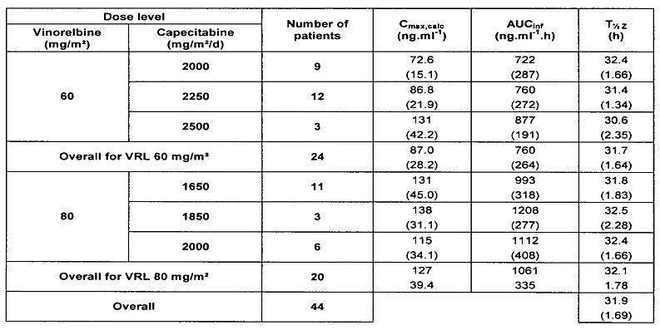
PK parameters of vinorelbine were not changed when combined with capecitabine. There was no dose level effect and PK of vinorelbine when combined with capecitabine did not differ from reference values of vinorelbine alone. Analysis of vinorelbine metabolites showed that there was no alteration of their PK behaviour, and especially with co- administration of capecitabine.
PK of capecitabine was evaluated on Day 1 when combined with vinorelbine and on Day 7 when administered alone. The PK of capecitabine and its metabolites, especially 5’DFCR was not altered following co-admininstration with vinorelbine.
Once orally administered, capecitabine is rapidly absorbed and then undergoes three successive biotransformation steps that ultimately lead to the active compound 5-FU; in the first step, capecitabine is hydrolysed by liver carboxylesterases to the intermediate 5’-deoxy-5-flurocytidine (5’DFCR). Literature suggests that capecitabine metabolism does not involve CYP3A4 and that capecitabine and its metabolites neither induce nor inhibit CYP450 enzymes. Metabolism of vinorelbine mostly involves CYP450 3A4 except DVRL, the only active metabolite likely to be produced by carboxylesterases. Hence, the drug interaction analysis focussed on the parent compounds and its metabolites, especially those formed through carboxylesterases: DVRL and 5’DFCR. Results from this study suggested lack of significant PK interaction between oral vinorelbine and capecitabine.

Evaluator’s overall conclusions on pharmacokinetics
No new specific PK studies was presented in this submission as the proposed oral formulation is the same as that already approved for treatment of NSCLC.
Data from two Phase I-II studies provided some evidence to suggest lack of PK drug interaction following co administration of oral vinorelbine with IV docetaxel or IV paclitaxel. However, interpretation was limited by small sample size for PK analysis and no direct comparison with paclitaxel alone. Results of the Phase I-II Study CA103 in 44 patients with MBC provided evidence to suggest lack of PK interactions between oral vinorelbine and oral capecitabine.

Pharmacodynamics
No new PD data was presented in this submission. However, the recommended dose for oral vinorelbine to be used in combination with other chemotherapy agents such as docetaxel, paclitaxel and capecitabine was evaluated in the Phase I-II Studies CA 101, CA 102 and CA 103, respectively. In these Phase I-II studies, the recommended dose for the Phase II study was the dose level below the MTD in the Phase I part of the study. In Study CA 101, the recommended dose was 20 mg/m² IV vinorelbine and IV docetaxel 60 mg/m² on Day 1 followed by oral vinorelbine 60 mg/m² on day 15, every three weeks. In Study CA 102, the recommended dose for the Phase II part of the study was oral vinorelbine at 80mg/m² on Days 1 and 15 and IV paclitaxel at 110 mg/m² on Day 1, every three weeks. In Study CA 103, neutropenia was the main dose limiting toxicity. When oral vinorelbine was given at 60 mg/m², two recommended doses were established: oral vinorelbine 60 mg/m² on days 1 and 8 plus capecitabine 2250 mg/m²/day from Day 1 to 14 every 3 weeks; or oral vinorelbine 60mg/m² on Days 1, 8 and 15 plus capecitabine 2000 mg/m²/day from Day 1 to 14 every three weeks. In the every four week schedule, the established recommended dose was oral vinorelbine 80 mg/m² on Days 1 and 8 plus capecitabine 2000 mg/m²/day from Day 1 to 14 every four weeks.
Although above studies provided some information on recommended doses based on MTD, use of oral vinorelbine in combination regimens have not been extensively studied and safety of higher oral vinorelbine dose of 80 mg/m² has not been established (this has been stated clearly in the proposed PI).

Dosage selection for the pivotal studies
Study 95 CA 201 evaluated the efficacy and safety of oral vinorelbine at 80 mg/m²/week in the first line treatment of ABC and this study was already evaluated in the earlier submission to TGA, but results have been briefly discussed here.
In Study 95 CA 201, the planned sample size was 50 patients but the study was prematurely discontinued after inclusion of 35 patients due to the occurrence of three toxic deaths. The median age of the study population was 61 years [range: 39 - 75], 40% of the patients had received prior neo/adjuvant chemotherapy and 74% of them had visceral involvement. The median number of administrations was 8 [range: 1 - 45] and median relative dose intensity was 89.9%. Four responses were reported and validated by an extramural panel, yielding a response rate of 11.4% [95% confidence interval (CI): 1 - 22] in the intent-to-treat (ITT) population and 17.4% [95% CI: 2 - 33] in the 23 evaluable patients. In the overall population, median durations of progression free and overall survival were 4.8 and 15.8 months, respectively. The main dose limiting toxicity was neutropenia with 41.2% of patients having experienced Grade 3-4 episodes. Febrile neutropenia was observed in 2 patients (5.7%) and neutropenic infection in three patients (8.6%). For three of the patients (8.6%) who experienced neutropenic complication, the outcome was fatal. Most common non haematological toxicities included nausea (82.9% of patients), diarrhoea (74.3%) and vomiting (60%). In conclusion, the poor efficacy reported in this study could be explained by the premature discontinuation of the study. Analysis of safety data concurrently with those of Study 96 CA 204 (in NSCLC) led to test the currently recommended regimen of oral vinorelbine.
Consequently, the treatment regimen of oral vinorelbine was modified so that a lower dose of 60 mg/m²/week was given for the first three weeks and subsequently increased to 80 mg/m²/week in the absence of severe haematological toxicity (as evidenced by one episode of Grade 4 neutropenia or more than one episode of Grade 3 neutropenia during the initial treatment period). Also, recommendation for dose reduction from 80 to 60 mg/m²/week beyond the first three weeks was introduced in the protocol to better adjust the dose to the haematological tolerance of the patient.
This new regimen was investigated in two independent, non comparative Phase II studies in the first line treatment of ABC (96 CA 201 and 97 CA 206) which enrolled a total of 184 patients. Moreover in May 2004, a randomised Phase II study of oral vinorelbine or IV vinorelbine (Study CA 221) was initiated in patients previously treated with anthracyclines. Due to low accrual rate, this study was closed in October 2006 after enrolment of only 85 patients among the 230 planned by the study protocol.

Efficacy

Clinical studies of oral vinorelbine as a single agent in ABC

Study 96 CA 201

Study design, objectives, locations and dates
The primary objective of the Phase II, open, non comparative, multicentre Study 96 CA 201 was to assess the clinical activity (in terms of overall tumour response rate) of the recommended regimen of oral vinorelbine as single agent in 120 patients who did not receive prior chemotherapy treatment for advanced metastatic breast cancer. Secondary objectives were to evaluate effect on other efficacy measures, safety, quality of life and intra individual variation of oral vinorelbine PK in a subset of 45 patients. Enrolment was stratified by the following three categories:
- prior adjuvant hormonotherapy (HT)
- prior adjuvant chemotherapy (CT)
- no prior adjuvant therapy
The three cohorts were planned to include 25 to 50 patients according to one sample testing procedure of Fleming. The study was conducted at 24 sites in Europe (and South Africa) from Dec 1997 to May 2002.

Inclusion and exclusion criteria
The main inclusion criteria were: histologically confirmed diagnosis of MBC; patients with operable cancer who underwent surgery (mastectomy or tumorectomy) at least two weeks prior to study entry; patients could have received prior hormonal therapy but still had progressive disease; had received prior chemotherapy but had 12 months interval between end of treatment and start of study; radiotherapy >6 weeks prior to study; patients had to be 2 weeks from any kind of surgery (except biopsy); patient had to have at least one uni or bi dimensionally measurable lesion; age 18-75 years; initial haematology parameters of haemoglobin >10g/dl, neutrophils >2x10⁹/L; platelets >100x 10⁹ /L; normal renal function [creatinine <1.5x ULN (Upper Limit of Normal)] and normal hepatic function (serum bilirubin <1.5x ULN, transaminases <2.5x ULN and alkaline phosphatase (<5x ULN, except in presence of liver metastases).
The main exclusion criteria were:
- use of neoadjuvant chemotherapy for locally metastatic breast cancer;
- rapidly progressing visceral disease, prior chemotherapy with vinca alkaloids, non measurable lesions such as single bone metastasis, ascites, or pleural effusion;
- inflammatory breast cancer (stage IVd);
- other current or past malignancy except in situ cervical cancer or basal/ squamous cell skin carcinoma;
- concurrent treatment with other experimental agents;
- uncontrolled hypercalcemia;
- peripheral neuropathy;
- neurological involvement;
- uncontrolled infections;
- unstable diabetes;
- hypertension, previous coronary insufficiency, symptomatic heart disease;
- malabsorption syndrome, significant resection of stomach or small bowel;
- pregnant or lactating women of childbearing age not using adequate contraception; and
- psychiatric, familial, social or geographic conditions which may prevent follow up and compliance.

Study treatments
Treatment was supplied as 20, 30 and 40 mg softgel capsules. Oral vinorelbine was given fasting and dose was calculated based on body surface area (BSA) on the day of treatment. Oral vinorelbine was given at the recommended dose of 60 mg/m²/week for the first three administrations; dose was increased to 80 mg/m²/week for subsequent administrations in the absence of severe neutropenia (Grade 4 neutropenia or >1 Grade 3 neutropenia). After a confirmed partial response (PR) or complete response (CR), dosing was continued every fortnight until progression; after a confirmed no change (NC), treatment was given every week. Treatment period was for eight weeks unless there was disease progression or unacceptable toxicity. The vinorelbine capsule was swallowed by patient in front of the investigator and no problems with treatment compliance were observed.

Efficacy variables and outcomes
The primary efficacy outcome was response rate using World Health Organization (WHO) criteria with the European Organisation for Research and Treatment of Cancer (EORTC) modifications. Each lesion had to be assessed in the same way it was assessed the first time; in case of multiple measurable lesions, all must be evaluated (however, no more than three lesions from one organ system and no more than five selected lesions overall). Non evaluable lesions included ascites, pleural effusions, carcinomatous lymphangitis (skin or lung), lytic or blastic bone lesions.
While all sites of malignant disease were monitored, lesions were categorised as either measurable or evaluable and the clinical response of a measurable lesion had to take precedence over an evaluable lesion. The evaluation of overall response was analysed using WHO criteria.
Secondary efficacy endpoints were duration of response, progression-free survival and overall survival. Quality of life was assessed using the EORTC questionnaire (QLQ-C30), which was administered to patients at baseline and before drug administration at eight weeks. An independent review panel consisting of an independent radiologist and participating investigators was used to determine all responses and stabilisations. All patients were followed up one month after end of treatment, every three months for next two years and then every six months till death.

Randomisation and blinding methods
Not applicable.

Analysis populations
Efficacy analysis was done in the ITT and ‘evaluable’ patient populations. The ITT population included all patients enrolled in the study. The patients evaluable for response were defined as those completing eight weeks of treatment (at least four administrations) with at least one disease assessment with the same imaging procedure as that used at baseline.

Sample size
The sample size calculations assumed that 30% was the minimum desirable response rate in this patient population.
Under these conditions, the total sample size per stratum (N) was 50 evaluable patients and this one sample two test design trial was conducted as follows:
- The first test was performed after 25 evaluable patients for each stratum:
- If <8 responses were observed, the H₀ hypothesis was not rejected and further treatment of patients was not needed.
  - If >14 response were observed, the H₀ hypothesis was rejected and the drug could be considered as effective in the considered pathology.
- The second and last test was performed after 50 evaluable patients for each stratum:
  - If <21 responses were observed, the H₀ hypothesis was not rejected and further investigation of the drug in Phase III trials was not warranted.
  - If >21 responses were observed, the H₀ hypothesis was rejected and the drug could be considered as effective.

Statistical methods
In order to identify which group of patients would benefit from single agent oral therapy with vinorelbine, the patients were stratified into three categories: those who received prior HT; those who received prior chemotherapy followed or not by adjuvant HT and those who received no prior therapy. Since this was not a comparative study, no statistical tests were used.

Participant flow
Of the 120 registered patients who received treatment, only 115 were included in the ITT analysis as five of these patients did not meet inclusion criteria (four of these patients had no measurable lesion and one patient had concomitant invasive cervical cancer). The main reason for study discontinuation was progressive disease in 76 patients (63.3%) and excessive toxicity (17 patients, 14.2%). Twenty-four patients discontinued due to other reasons (patient refusal, protocol deviations, investigator decision or according to study protocol).

Major protocol violations/deviations
Seven patients had major protocol violations and were not evaluable for efficacy with major violations being withdrawal due to AE, death and inter current disease. There were many minor protocol deviations including those related to schedule of assessment, patient characteristics and treatment schedule.

Baseline data
Majority of the patients were aged over 50 years (107 of 120), were postmenopausal (91.7%), had WHO performance status of 0 or 1 (112 of 120) and had ductal histopathology (80.8%) with stage IIIb or IV ABC. The majority of patients had undergone surgery (92%) and received regional radiotherapy (45%); 49.2% had received adjuvant or neoadjuvant chemotherapy. Overall, 73 patients (74%) had received HT but of these 33 patients had also received adjuvant chemotherapy and hence only 40 patients were included in stratum 1 (prior HT alone). Majority of patients had metastatic disease (95%) with involvement of >2 organs besides the primary tumour with lymph nodes, lungs and liver being most common metastatic sites. Dose delays of one to three weeks were recommended due to haematological, hepatic or neurological toxicity. Overall, dose delays of more than three days were recorded for 88 of the 118 patients (74.6%) who received more than one administration and neutropenia was the most common reason for dose delay.

Results for the primary efficacy outcome
Efficacy was assessed in terms of response rate (by investigator) in first 25 patients in stratum 1, 2 and 3 based on one sample, multiple testing procedure of Fleming.² In strata 1 and 2, 8 and 10 responses were reported among the first 25 patients, respectively; as the minimum desirable response rate of 30% was achieved in these strata, recruitment was continued until a total sample size of 37 and 50 patients in strata 1 and 2, respectively. In stratum 3, only 3 responses among 21 patients were reported (< desirable 30% response rate); recruitment into stratum 3 was stopped on 1 February 2000.
Overall, response rate as per the independent panel review was 20.8% (95% CI: 14, 29.2) in the ITT population and 23.2% (95% CI: 15.6, 32.3) in the evaluable patients. Overall, only two patients achieved CR and 23 achieved a PR. The response rate was lower in patients with stage IIIb, IV disease at diagnosis, short disease free interval, visceral involvement, and/ or >3 organs involved.
The response rate in stratum 3 (with no prior adjuvant therapy) was only 14.3% as this group consisted mainly of patients with very poor prognosis [12 patients (57.2%) had stage IIIb/ IV disease, 14 patients (66.7%) had a disease free interval (DFI) <2 years and 13 patients (62%) had at least three organs involved].
The response rate was 22-24% in stratum 1 (prior adjuvant HT) and 22-26% in stratum 2 (prior adjuvant chemotherapy). This may have been due to smaller number of patients with stage IIIb/ IV disease (2.5% and 11.9% in stratum 1 and 2, respectively), short DFI (15% and 27%, respectively), and multiple organ involvement (17.5% and 24.4%, respectively).
The age of the responders ranged from 37 to 73 years; 19 of them had received prior adjuvant HT and 13 prior chemotherapy and the majority of responders (22/25) had a disease interval >2 years. Furthermore, 10 responders had visceral involvement and 11 had at least two organs involved.

Results for other efficacy outcomes
The median duration of response for the 25 responding patients (CR+PR) was 9.1 months (95 % confidence interval (CI): 5.8 to 13.3 months); four patients were censored at cut off date at the time of initiation of a new therapy. The median progression free interval was 4.6 months (95% CI: 4.0 to 5.9 months); ten patients were censored at cut off date (three were lost to follow up and seven were alive without progression). The median overall survival was 19.3 months (95% CI: 16.8 to 25.3months); 36 patients were censored at cut off date (four lost to follow up and 32 were alive). Due to poor compliance with completing the QLQ-C30 questionnaires, quality of life analysis were not done.
In this study, monotherapy with oral vinorelbine as first line treatment of ABC showed a response rate of 20-23%, duration of response of 9.1 months, progression free survival of 4.6 months and overall survival of 19.3 months. The response rate was slightly lesser than that observed in IV vinorelbine Phase II studies and mentioned in the approved PI for IV vinorelbine (30%). Furthermore, the response rate in patients with no previous adjuvant therapy was only 14%.

Study 97 CA 206

Study design, objectives, locations and dates
Study 97 CA 206 was an open label, multi centre, non comparative Phase II study in 64 patients to evaluate efficacy and safety of vinorelbine as single agent in first line chemotherapy of ABC. It was conducted from November 1997 to 20 July 2000 at 21 centres (17 in France, one in Belgium and three in Russia).
The inclusion/exclusion criteria, study treatments and efficacy endpoints were similar to Study 96 CA 201 discussed above.

Participant flow
Of the 64 patients who received treatment, one was not eligible and 58 were evaluable for efficacy. The main reason for study discontinuation was disease progression in 37 patients (57.9%) and excessive toxicity (12.5%); other reasons included patient’s refusal (9.4%), investigator decision (14.1%) and inter current events. Majority of patients (58 of 60) received the planned dose of 80mg/m² beyond the first three administrations. Four patients did not undergo dose escalation due to early withdrawal due to non drug related reasons during first three administrations. One patient experienced Grade 4 neutropenia and did not undergo dose escalation according to study protocol; two other patients did not undergo dose escalation without any specific reason. Thirteen patients had their dose reduced from 80 to 60 mg/m² (for 12 of them it was due to >Grade 2 neutropenia; for one patient the dose was erroneously reduced following inter current event. For 3 of the 13 patients who experienced dose reduction, the dose could be re-escalated from 60 to 80mg/m² in the absence of severe haematotoxicity.

Major protocol violations/deviations
There was only one major protocol violation which was inclusion of a patient with non measurable disease (skin lymphangitis). There were some minor protocol deviations mainly related to eligibility criteria, treatment schedule and assessment schedules.

Baseline data
Most patients were aged over 50 years (51 of 64), had WHO status of 0 to 1 (58 of 64), had ductal histopathology (76.6%) and were postmenopausal (87.5%); over 50% had positive estrogen receptors for the tumour and almost 30% had stage IV disease. Majority of patients underwent surgery (73.4%) associated with post operative radiotherapy (65.6%). HT was given to most of the patients (70.3%) while 31.3% had received prior chemotherapy in neoadjuvant or adjuvant setting. The majority of patients had metastatic disease (82%) with 62.5% having visceral metastases and 68.7% had at least two organs involved; the main tumour sites were lymph nodes (57.8%), primary tumour or recurrence (28.1%), lung (34.1%), liver (34.4%) and bone (35.9%).

Results for the primary efficacy outcome
The overall response rate was 29.7% (95% CI: 18 to 41) in the ITT population (4 CR and 15 PR) and it was 31% (95% CI: 19-43) in the evaluable patients (4 CR and 14 PR). As expected response rates were better in patients with non visceral disease, <3 organs involvement and/ or DFI >2 years. The impact of prior adjuvant therapy was difficult to analyse as the number of patients in each subgroup were small but results suggested a decreased response rate in patients with no previous adjuvant therapy. The age of responders ranged from 44 to 77 years; 9 of them (47.4%) had received prior adjuvant HT and 5 (26.3%) prior adjuvant chemotherapy and majority of responders (73.7%) had a DFI >2 years. Furthermore, ten of the responders (52.6%) had visceral involvement and 63.2% had at least two organs involved.

Results for other efficacy outcomes
The median duration for the 19 responding patients (CR + PR) was 9.3 months (range: 1.9 to 32.4 months) and two patients were censored at the time of initiation of new therapy. The median progression free survival was 4.2 months (95 % CI: 2.5 to 5.5 months) and four patients were censored at the cut off date (three were lost to follow up and one was alive without progression). The median overall survival was 23.9 months (95 % CI: 16.6 to 28.6 months) and 23 patients were censored (13 lost to follow up and 10 were alive at the cut off date).
The effect of weekly administration of vinorelbine on quality of life was evaluated at baseline and every eight weeks during the study. Only the QLQ-C30 results at the first and second evaluation were presented in the study report as there was insufficient data after the third evaluation (only seven patients filled in the QLQ-C30 forms). The functional scores did not show any significant difference between baseline, first and second evaluation. The mean scores of diarrhoea and nausea/ vomiting were higher at the first and second evaluations (consistent with increased incidence of diarrhoea and vomiting). However, mean scores of pain and constipation were decreased at first and second evaluation compared to baseline. Global health status was analysed in only 18 patients who filled in at baseline and at the first two evaluations and vinorelbine treatment did not show any significant deterioration in global quality of life.
Overall, in this study response rates were 29.7% and 31% in ITT and evaluable populations, respectively. Median duration of response was 9.3 months, progression free survival was 4.2 months and overall survival was 23.9 months. These results were comparable to the efficacy results reported in all published Phase II studies of IV vinorelbine. The response rates were lowest in patients who had received no prior adjuvant treatment (21%) compared to patients with prior adjuvant HT (38-41%) or patients with prior adjuvant CT (29-31%).

Study CA 221

Study design, objectives, locations and dates
This was an open label, randomised, multi centre, international Phase II study. Patients were randomised in a 2:1 ratio (oral vinorelbine versus IV vinorelbine). The primary objective of the study was to determine the efficacy of oral vinorelbine in patients with MBC previously treated with anthracyclines, in terms of tumour response. The secondary objectives were:
- to assess the tumour response rate in the IV vinorelbine arm;
- to determine the progression free survival and the overall survival in both arms;
- to evaluate the safety of oral and IV vinorelbine; and
- to assess the quality of life in each treatment arm.
The study was conducted at 28 centres in seven countries (UK, Switzerland, Germany, Belgium, France, Poland and South Africa) from 30 September 2004 to 1 June 2007.
The sponsor states that this was a confirmatory trial that was expected to show that oral vinorelbine is at least as effective as IV vinorelbine in MBC while being more convenient; however, it was not designed as an equivalence or non inferiority trial.

Inclusion and exclusion criteria
The main inclusion criteria were:
- Age ≥ 60 years (by amendment no. 1 dated 27 July 2005, replacing over 65 years);
- Karnofsky performance status (KPS) ≥ 70%;
- Functional score > 18/20 measured by activities of daily living (ADL) and instrumental activities of daily living (IADL);
- Histologically or cytologically confirmed adenocarcinoma of the breast;
- Documented metastatic disease;
- At least one measurable lesion according to the Response Evaluation Criteria in Solid Tumours (RECIST);
- No more than two prior chemotherapy regimens including neo/adjuvant and palliative chemotherapy,
- Prior anthracycline regimen as: prior anthracycline containing regimen as first line chemotherapy for metastatic breast cancer, and/or prior anthracycline containing regimen as neo/adjuvant chemotherapy; adjuvant and neo adjuvant therapy were considered as one line;
- Patients with disease refractory (primary resistant) to anthracyclines (defined as relapse during anthracycline based adjuvant chemotherapy or progression as best response to prior anthracycline regimen for metastatic disease) were not eligible;
- Patients could have received prior taxanes in the neo adjuvant, adjuvant and/or palliative setting;
- Patients could have received prior radiotherapy but not to the sites used to assess response; a minimum of four weeks must have elapsed unless the area involved was < 25% of bone marrow volume in which case the patient could start treatment earlier;
- Patients could have had previous hormonal therapy as adjuvant treatment and/or treatment of metastatic disease provided that the patient had progressive disease at study entry; hormonal treatment had to be discontinued prior to study entry;
- Adequate haematological (ANC (absolute neutrophil count) ≥ 2.0 x 10⁹/L, platelets ≥ 100 x 10⁹/L, haemoglobin (Hb) ≥ 10 g/dL), hepatic (total bilirubin < 1.5 x ULN, AST (aspartate aminotransferase) and ALT (alanine aminotransferase ) ≤ 2.5 x ULN), and renal functions (serum creatinine ≤ 1.5 x ULN);
- Left Ventricular Ejection Fraction (LVEF) (measured by radionuclide angiography [MUGA scan] or bidimensional echography) at least ≥ to the lower normal limit of the institution;
- Absence of any psychological, familial, sociological or geographical conditions potentially hampering compliance with the study protocol;
- Written informed consent obtained prior to the inclusion;
- Concomitant treatment with biphosphonates was allowed whatever the time elapsed prior to study treatment (by amendment no 1. dated 27 July 2005).
The main exclusion criteria were:
- Patient with life threatening conditions (such as symptomatic lung lymphangitis, rapidly progressive visceral lesions);
- Previous or current malignancies except adequately treated in situ carcinoma of the cervix uteri, basal or squamous cell carcinoma of the skin or other cancer curatively treated with surgery and/or radiotherapy and with no evidence of disease for at least five years;
- Patients with uncontrolled infection;
- Patients medically unstable (for example, uncontrolled high blood pressure, uncontrolled arrhythmia, symptomatic congestive heart failure, unstable angina pectoris, myocardial infarction within the three months prior to study entry, chronic obstructive pulmonary disease);
- History of significant neurologic (that is, peripheral neuropathy Grade ≥ 2 using National Cancer Institute – Common Toxicity Criteria [NCI-CTC] or psychiatric disorders including psychotic disorder, dementia or seizures that would have prohibited the understanding and giving of informed consent;
- Malabsorption syndrome or disease significantly affecting gastrointestinal function or major resection of the stomach, proximal small bowel or grade ≥ 2 dysphagia;
- Previous treatment with a vinca alkaloid;
- Patients with prior history of high dose chemotherapy followed by bone marrow or peripheral stem cell support;
- Concurrent treatment with any other anti cancer therapy;
- Treatment with any investigational drug within 30 days prior to registration;
- Primary CNS neoplasm, known brain or leptomeningeal metastases;
- Male patients.

Study treatments
Treatment was supplied as 20 and 30 mg softgel capsules. The study treatment of oral vinorelbine 60 mg/m² was given on Days 1 and 8 every three weeks for the first cycle (Arm A). The dose was increased to 80 mg/m² on Days 1 and 8 every three weeks from Cycle 2 except in patients who experienced Grade 4 neutropenia or Grade 3 neutropenia lasting ≥ 7 days during the first cycle. Systematic antiemetic treatment was administered prior to oral vinorelbine administration with an oral 5-HT3 antagonist. The reference treatment was IV vinorelbine 25 mg/m² on Days 1 and 8 every three weeks for the first cycle (Arm B). The dose was increased to 30 mg/m² on Days 1 and 8 every three weeks from Cycle 2 according to haematological tolerance. Treatment had to be continued until documented disease progression, unacceptable toxicity or patient’s refusal. However, after six cycles, the decision to pursue the treatment for responding patients and those with stable disease was at the discretion of the investigator. The administration of oral or IV vinorelbine had to be done in the investigational centre and supervised by a physician or a nurse of the department. The selection of doses for the present study was based on the results of prior Phase I and Phase II studies with both IV and oral vinorelbine. Absolute bioavailability studies had demonstrated that the oral dose of 60 mg/m² vinorelbine corresponds to an IV dose of 25 mg/m², and the oral dose of 80 mg/m² to an IV dose of 30 mg/m².

Efficacy variables and outcomes
Efficacy was determined by using RECIST as follows:
- Assessment of all lesions at baseline, after the first two cycles and then every two cycles;
- Assessment of the tumour response rate, duration of response, progression free survival and overall survival.
Safety was assessed by physical examination, performance status, reporting of AEs by using NCI-CTC (version 2.0), and laboratory tests including complete blood cell counts before each administration of Day 1 and Day 8, and serum chemistry on Day 1 of every cycle. Quality of life was assessed by using QLQ-C30 and QLQ-BR23 quality of life questionnaires, which were filled in before randomisation and every two treatment cycles and at study treatment discontinuation. Lesions were categorised into one of the two following groups for the purposes of response analysis: measurable and non measurable lesions. All the measurable lesions up to a maximum of five lesions per organ and ten lesions in total were measured at regular intervals defined by the protocol and were considered as “target lesions”. The evaluation of target measurable and non measurable lesions and determination of overall response with RECIST is outlined in Table 5.
Table 5: Determination of the overall response of target and non target lesions using RECIST (Study CA 221).
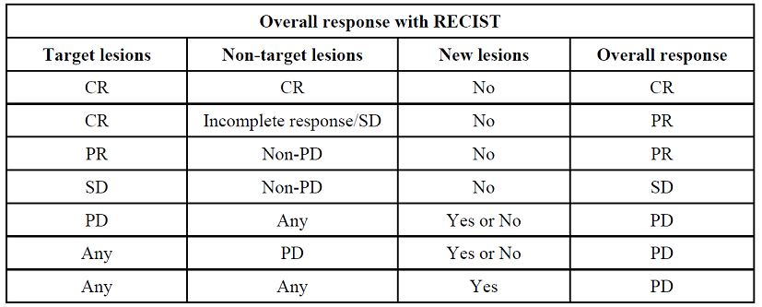
The evaluation of target lesions was performed using the sum of the longest diameter (LD) for all of these lesions. The LD was calculated and reported as the baseline sum LD. The baseline sum LD was used as reference to further characterise the objective tumour response of the measurable dimension of the disease as follows:
- Complete Response (CR): disappearance of all target lesions.
- Partial Response (PR): at least a 30% decrease in the sum of LD of target lesions taking as reference the baseline sum LD.
- Progression (PD): at least a 20% increase in the sum of LD of target lesions taking as references the smallest sum LD recorded since the treatment started or the appearance of one or more new lesions.
- Stable Disease (SD): neither sufficient shrinkage to qualify for PR nor sufficient increase to qualify for PD taking as reference the smallest sum LD since the treatment started.
The evaluation of non target lesions was as follows:
- Complete Response (CR): disappearance of all non-target lesions and normalization of tumour marker level.
- Incomplete Response/Stable disease (SD): persistence of one or more non-target lesion and/or maintenance of tumour marker level above the normal limits.
- Progression (PD): appearance of one or more new lesions and/or unequivocal progression of existing non target lesions.
An Independent Radiological Panel (IRP) was consulted in order to determine all responses (and stabilisation if appropriate). All records of patients [such as computed axial tomography (CAT) scans, magnetic resonance imaging (MRI) scans, X rays] were available for review. If a difference between the panel’s determination of response and that determined from the data provided by the study centre existed, a re-evaluation could be performed between the investigator and the panel. After that, the IRP’s decision prevailed.
The primary efficacy analysis was to assess the tumour response rate in the oral vinorelbine arm, in the ITT population. The secondary analyses included:
- Tumour response rate in the ITT population of IV vinorelbine arm;
- Tumour response rate in the evaluable population in both arms;
- Duration of response;
- Progression free survival (PFS); and
- Overall survival in both arms.

Randomisation and blinding methods
Patients were randomised to receive in a 2:1 ratio (oral versus IV vinorelbine). Randomisation was stratified according to the resistance to anthracyclines (resistant versus non resistant), prior treatment with taxanes (yes versus no), and centre.

Analysis populations
Efficacy analysis was done on the ITT and evaluable patient populations. All randomised and treated patients were included in the ITT population. The evaluable population was a subset of the ITT population. Patients evaluable for tumour response were defined as follows: patients who remained on study for at least two cycles and who were evaluated for tumour; patients who died from malignant disease before having received two cycles were considered as early death; patients who progressed before having received two cycles were considered as early progression.

Sample size
The one sample multiple testing procedure of Fleming² was used for sample size calculation in the oral vinorelbine arm. A total of 210 evaluable patients with MBC previously treated with anthracyclines were to be randomised in the study, 70 patients in the IV vinorelbine arm and 140 in the oral vinorelbine arm. Maximal inefficacy tumour response rate = 15%, minimal efficacy tumour response rate = 25% in the oral vinorelbine arm, α = 5%, β < 15%. Assuming a 10% rate of non evaluable patients, 230 patients had to be included in the trial. The study was initiated in May 2004 but the accrual remained low due to a low rate of recruitment and despite an amendment issued in July 2005 to extend the recruitment period and the criteria of age to patients aged 60 years old and over. Therefore, completion of the study was not expected to occur in an acceptable period of time, inclusions were discontinued from the 31 October 2006 and the study was prematurely stopped. The Fleming procedure could not be applied.

Statistical methods
The study design did not allow formal statistical comparisons between the oral and IV vinorelbine treatment arms. The data were analysed using the SAS system software (Version 8.2 for Windows). Summary tables were provided. Continuous data were summarised with the following items: frequency, median (if n ≥ 3), range and mean, and standard error of the mean if relevant. Categorical data were presented in contingency tables with frequencies and percentages of each modality (including missing data modality). The 95% CI for proportions was computed following the exact method. To describe time dependent parameters, Kaplan-Meier curves and life tables by treatment arm were provided. The study design did not allow for any formal statistical comparisons between both arms (oral versus IV vinorelbine).

Participant flow
The study was initiated in May 2004. Due to a low rate of recruitment and despite an amendment issued in July 2005 to extend the recruitment period and the criteria of age to patients aged 60 years old and over, the accrual remained low and completion of the study was not expected to occur in an acceptable period of time. Therefore, inclusions were discontinued from the 31 October 2006 and the study was prematurely discontinued. A total of 85 patients were recruited and registered into the study to be randomly allocated to either oral or IV vinorelbine. The cut off date for the data analysis was 1 June 2007. Eighty-five patients with MBC previously treated with anthracyclines were randomised in the study, 58 patients in the oral vinorelbine arm, and 27 patients in the IV vinorelbine arm. A single patient who was randomised in the oral vinorelbine arm was withdrawn before having received the study treatment, due to the occurrence of two AEs, both classified serious AEs (grade 1 hypokalaemia and Grade 4 hyponatraemia). Two patients in the oral vinorelbine arm and two patients in the IV vinorelbine arm were not eligible at baseline, and one patient of the oral vinorelbine arm presented with major protocol deviation during study because this patient was treated with both IV vinorelbine and oral vinorelbine. Ten patients were non evaluable for tumour response (primary efficacy endpoint of the study) including five patients in the oral vinorelbine arm and five patients in the IV vinorelbine arm.

Major protocol violations/deviations
A total of four patients, two in the oral vinorelbine arm and two in the IV vinorelbine arm, were non eligible due to major violation of selection criteria. A total of 37 minor protocol deviations at study entry were documented in patients of the oral vinorelbine arm and five minor deviations in the IV vinorelbine arm. The most frequent types of minor protocol deviations were deviations from the planned schedule of biological and/or tumour assessment to be performed before study entry.

Baseline data
Majority of patients were in the 65-75 year old group (oral versus IV: 74% versus 52%) with median age of 68 years. The percentage of patients with normal KPS (100%) was slightly greater in the IV vinorelbine arm (24.6% versus 33.3%). Most of patients had a ductal carcinoma in both treatment arms. In the oral vinorelbine arm, primary tumour site at diagnosis was bilateral for two patients (3.5%) versus none in the IV vinorelbine arm, and nine patients (15.8%) were tumour node metastasis (TNM) IV (metastatic) versus none in the IV vinorelbine arm. In addition, there were eight patients (14.0%) of the oral vinorelbine arm strongly positive for immunohistochemistry (IHC) test (IHC score 3+) versus one patient (3.7%) in the IV vinorelbine arm; however the rate of IHC tests not performed was high and the fluorescence in situ hybridisation (FISH) test was rarely applied to confirm IHC findings. Majority of patients underwent surgery in both oral vinorelbine arm (91.2%) and IV vinorelbine arm (96.3%), and radical mastectomy was the type of surgery used in most cases in both arms (42.1% and 37.0%, respectively). Most of patients also received radiotherapy (curative and/or palliative) in both arms (75.4% and 70.4%, respectively). Prior chemotherapy setting consisted of neo/adjuvant for 36 patients (63.2%) of the oral vinorelbine arm and 18 patients (66.7%) of the IV vinorelbine arm, and metastatic for 33 patients (57.9%) of the oral vinorelbine arm and 15 patients (55.6%) of the IV vinorelbine arm. Prior chemotherapy consisted of anthracycline based regimens for all patients. Twelve patients of the oral vinorelbine arm were resistant to anthracyclines including one patient (1.8%) with primary resistance and 11 patients (19.3%) with secondary resistance compared to six patients (22.2%) in the IV vinorelbine arm, all with secondary resistance to anthracyclines. Fourteen patients (24.6%) of the oral vinorelbine arm received a prior taxane and four patients (14.8%) of the IV vinorelbine arm. Most of patients also received HT in both the oral vinorelbine arm (75.4%) and the IV vinorelbine arm (70.4%). Prior HT setting consisted of neo/adjuvant for 33 patients (57.9%) of the oral vinorelbine arm and 18 patients (66.7%) of the IV vinorelbine arm, and metastatic for 31 patients (54.4%) of the oral vinorelbine arm and 15 patients (55.6%) of the IV vinorelbine arm. Median time interval from diagnosis to study entry was slightly shorter for patients of the oral vinorelbine arm (3.9 years) than for patients of the IV vinorelbine arm (4.3 years). In addition, disease free interval < 2 years was reported in more patients of the oral vinorelbine arm (45.6%) than in those of the IV vinorelbine arm (40.7%). Most of the patients had three or more organs involved at study entry in both study arms, and the vast majority had visceral involvement.

Results for the primary efficacy outcome
In the oral vinorelbine arm, four patients had a partial response after IRP on ITT population yielding a response rate (CR + PR) of 7.0% (95% CI [2.0, 17.0]), and 23 patients (40.4%) had stable disease, which gave a disease control rate (CR + PR + SD) of 47.4% (95% CI [34.0, 61.0]). In the IV vinorelbine arm, one patient (3.7%) had a complete response and five patients (18.5%) had a partial response yielding a response rate (CR + PR) of 22.2% (95% CI [8.6, 42.3]), and eight patients (29.6%) had stable disease, which gave a disease control rate of 51.9% (95% CI [32.0, 71.3]).
In the oral vinorelbine arm, five patients had a partial response according to investigator on ITT population yielding a response rate (CR + PR) of 8.8% (95% CI [2.9, 19.3]), and 30 patients (52.6%) had stable disease, which gave a disease control rate (CR + PR + SD) of 61.4% (95% CI [47.6, 74.0]).
In the IV vinorelbine arm, one patient (3.7%) had a complete response and five patients (18.5%) had a partial response yielding a response rate (CR + PR) of 22.2% (95% CI [8.6, 42.3]), and 11 patients (40.7%) had stable disease, which gave a disease control rate of 63.0% (95% CI [42.4, 80.6]). Among the responses as per investigators’ assessment, a total of seven responses (CR, PR) were confirmed (one CR in the IV vinorelbine arm and six PR, three in each arm) after IRP review. Thus, the overall response was modified for 21 patients, including 14 patients in the oral vinorelbine arm and 7 patients in the IV vinorelbine arm.
In the ‘evaluable patient population’, four patients had a partial response in the oral vinorelbine arm, yielding a response rate (CR + PR) of 7.5% (95% CI [2.1, 18.2]), and 22 patients (41.5%) had stable disease, which gave a disease control rate of 49.1% (95% CI [35.1, 63.2]). In the IV vinorelbine arm, one patient (4.5%) had a complete response and five patients (22.7%) had a partial response yielding a response rate (CR + PR) of 27.3% (95% CI [10.7, 50.2]), and seven patients (31.8%) had stable disease, which gave a disease control rate of 59.1% (95% CI [36.4, 79.3]).

Results for other efficacy outcomes
Median duration of response according to investigator on ITT population was 9.0 [2.9, 11.3] months in the oral vinorelbine arm, whereas it was 4.2 [2.5, 6.2] months in the IV vinorelbine arm. Median time to first response according to IRP evaluation on ITT population was 1.7 [1.1, 3.3] months in the oral vinorelbine arm, and 1.6 [1.3, 2.8] in the IV vinorelbine arm. Median duration of stabilisation according to investigator on ITT population was 3.0 [2.8, 6.0] months in the oral vinorelbine arm, and 6.2 [3.0, 7.6] months in the IV vinorelbine arm.
In the oral vinorelbine arm, 53 patients (93.0%) experienced disease progression which was during the study for 38 patients (66.7%) or during follow up for 15 patients (26.3%). In the IV vinorelbine arm, 24 patients (88.9%) experienced disease progression, during study for 14 patients (51.9%) and during follow up for ten patients (37.0%). Two patients (7.4%) of the IV vinorelbine arm (130303 and 520601) died from disease progression. Median PFS was 2.8 [2.3, 4.3] months in the oral vinorelbine arm and 4.2 [2.6, 6.7] in the IV vinorelbine arm (Table 6). Further sensitivity analyses were performed for PFS. A sensitivity analysis was applied to patients who progressed or died from progression but without tumour assessment in the previous 12 weeks; in this analysis PFS was calculated by using as event the last tumour assessment or the date of last contact showing no progression plus 6 weeks (that is, one follow up visit). Accordingly, median PFS was 2.6 [2.3, 2.9] months in the oral vinorelbine arm and 3.9 [1.5, 5.6] in the IV vinorelbine arm. Another sensitivity analysis took into account further anticancer therapy: patients for whom a new antineoplastic treatment had been initiated before their disease progression were considered as censored on the date of beginning of the new antitumoral treatment. Only the first new antitumoural treatment was recorded. A total of 8 patients (14.0%) in the oral vinorelbine arm and 5 patients (18.5%) in the IV vinorelbine arm received a new antineoplastic treatment. The most frequently used drug were capecitabine (3 patients), HT (3 patients), docetaxel (2 patients) and IV vinorelbine (2 patients).
Table 6: Overall response rate of vinorelbine (VRL) after IRP – ITT population.
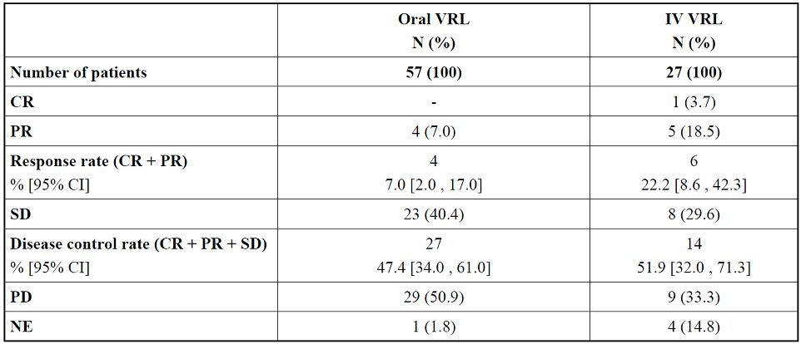
Median overall survival according to investigator for ITT population was 9.4 [7.7, 11.9] months in the oral vinorelbine arm, and 10.2 [8.4, 14.0] months in the IV vinorelbine arm. Median follow ups defined as the time elapsed between the date of randomisation and the cut off date was 18.3 [14.8, 22.2] months in the oral vinorelbine arm, and 16.9 [11.9, 27.7] months in the IV vinorelbine arm. Among the patients who died in the oral vinorelbine arm until the cut off date, 39 patients died from disease progression and 2 patients from other causes. In the IV vinorelbine arm, among the patients who died until the cut off date, 19 patients died from disease progression.

Efficacy results in subgroups
The primary efficacy endpoint was analysed according to anthracycline resistance, prior use of taxanes, and age categories.
Among patients with resistance to anthracyclines (only 11/57 in oral and 6/27 in IV group), the response rate (CR + PR) was (oral versus IV vinorelbine) 9.1% (1/11) versus 16.7% (1/6) and the disease control rate (CR + PR + SD) was 45.5% versus 33.3%. In patients non resistant to anthracyclines (45/57 in oral and 21/27 in IV group), the response rate was (oral versus IV) 6.7% (3/45) versus 16.7% (5/21) and the disease control rate was 50% versus 57%. Among responders, there were two patients with a secondary resistance to anthracyclines, one patient of the oral vinorelbine arm in advanced setting, and one patient of the IV vinorelbine arm in adjuvant and advanced settings (Table 7).
Table 7: Response after IRP according to anthracyclines resistance.
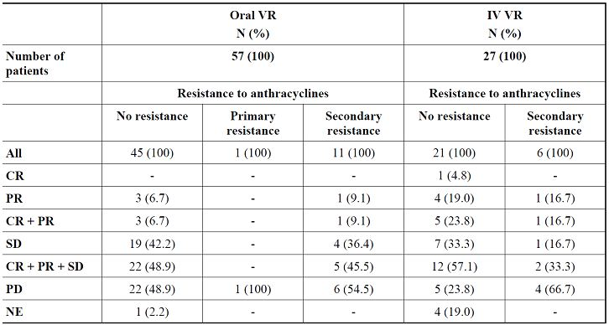
Among patients having received prior taxanes, the response rate (CR + PR) was (oral versus IV) 7.1% (1/14) versus 0% (0/4) and the disease control rate (CR + PR + SD) was 43% versus 25%. In patients with no prior taxanes, the response rate was (oral versus IV) was 7.0% (3/43) versus 26% (6/23) and the disease control rate was 48.9% versus 56.6%. Thus, among responders (CR or PR), there were one patient of the oral vinorelbine arm who have received prior taxanes in adjuvant and advanced setting, and no patient of the IV vinorelbine arm.
In the oral vinorelbine arm, partial responses were observed in patients aged less than 75 years, and the complete response in the IV arm was obtained in a patient of the [65 , 75] year age group (71.4 years). In both vinorelbine arms, the response rate (CR + PR) decreased with age, whereas disease control rate (CR + PR + SD) remained high in patients aged 75 years old or more.
Quality of life (QoL) was evaluated by using EORTC score questionnaires QLQ-C30 and QLQBR- 23. Questionnaires were given to patient without any medical staff influence before patient inclusion at baseline, then every two treatment cycles before Day 1 drug administration of next cycle, and at the end of the study. Patients were considered evaluable for quality of life if they had completed more than two third of the questions of one EORTC questionnaire within 14 days prior to first administration and at least one questionnaire during study period at least 18 days after the beginning of study treatment.
Compliance with EORTC questionnaires is presented at Week 6 and Week 12; only few patients having completed a questionnaire beyond Week 12 and showed compliance between groups. Global health status tended to decrease since baseline in the oral vinorelbine arm (mean score -4.3 [-12.5, 3.8] at 6 weeks and -9.7 [-27.8, 8.3] at 12 weeks) and to remain stable in the IV vinorelbine arm (mean score 1.4 [-11.9, 14.7] at 6 weeks and 3 [-12.3, 18.3] at 12 weeks). However, taking into account the limited numbers of evaluable questionnaires at the assessment time points for both study arms (only 29 evaluable questionnaires at Week 6 and 12 at Week 12 for oral vinorelbine arm, only 12 and 11 evaluable questionnaires respectively for the IV vinorelbine arm) and considering that confidence intervals were wide, these findings must be interpreted with caution.
This was not an active control study intended to show equivalence. The study design did not allow for any statistical comparison between oral and IV vinorelbine. Although, response rate was lower in the oral vinorelbine group, an overlap of activity was observed between oral and intravenous vinorelbine in terms of tumour response rates. The slightly lower rate of tumour responses in the oral arm may have been due to an imbalance in important prognostic factors (stage IV at diagnosis, Her-2 positive patients, disease free interval), which all favoured the IV arm. Nevertheless, it should be noted that in this limited sample size (due to problems encountered in recruiting patients), the disease control rates and median overall survival were similar in the oral and IV vinorelbine treatment arms.

Studies of oral vinorelbine in combination with capecitabine (Studies CA 222, CA103)

Study CA 222

Study design, objectives, locations and dates
This was an open label, randomised, multicentre, international Phase II study. The primary objective was to evaluate simultaneously the disease control rate of the combination of oral vinorelbine with capecitabine, a sequential regimen of oral vinorelbine and capecitabine, and the combination of docetaxel and capecitabine for the treatment of patients with metastatic breast cancer, after prior anthracycline containing (neo) adjuvant regimen. The secondary objectives were:
- to evaluate the safety profile in the three study arms;
- to evaluate the response rate, duration of response, progression free survival, time to treatment failure and overall survival; and
- to assess the quality of life.
The study was conducted at 35 centres in Europe, South Africa and Taiwan from 3 June 2005 to 14 April 2008.

Inclusion and exclusion criteria
The main inclusion criteria were:
- Age 18-75 years;
- Female with histologically or cytologically confirmed adenocarcinoma of the breast;
- Documented metastatic disease;
- HER-2 negative disease (assessed by 0-1 + IHC or 2 + IHC with FISH) on the primary tumour or on metastatic site (unless these tests were not available);
- At least one measurable or non measurable lesion according to RECIST;
- Prior (neo) adjuvant chemotherapy (anthracycline based, unless contraindicated) with at least 12 months of disease free interval. In case of prior taxane chemotherapy in the (neo) adjuvant setting, at least twelve months of disease free interval was required;
- No prior chemotherapy for metastatic disease;
- Patients might have received prior radiotherapy but not to the sites used to assess response. A minimum four week interval had to have elapsed unless the area involved was < 20% of bone marrow volume in which case the patient might start treatment earlier;
- Patient might have had previous hormonal therapy as adjuvant treatment and/or treatment of metastatic disease provided that she had progressive disease at study entry. Hormonal therapy had to be discontinued prior to study entry;
- Life expectancy of at least three months;
- Adequate haematological (ANC ≥ 2.0 x 10⁹/L, platelets ≥ 100 x 10⁹/L, Hb ≥ 10 g/dL), hepatic (total bilirubin < 1.5 x ULN, AST and ALT ≤ 2.5 x ULN), and renal functions (serum creatinine ≤ 1.5 x UNL);
- Absence of any psychological, familial, sociological or geographical conditions potentially hampering compliance with the study protocol;
- Written informed consent obtained prior to the inclusion.
The main exclusion criteria were similar to those described for Study CA 221. The only additional exclusion criteria specific for this study were:
- HER-2 positive disease on the primary tumour or on metastatic site (unless IHC or FISH tests were not available);
- Prior severe and unexpected reaction to fluoropyrimidine therapy (which could be explained by dihydropyrimidine dehydrogenase (DPD) deficiency) or known hypersensitivity to 5-fluorouracil, or capecitabine;
- Patients with prior history of severe hypersensitivity to drugs formulated with polysorbate 80;
- Patients with prior history of high- ose chemotherapy followed by bone marrow or peripheral stem cell support.

Study treatments
Patients were stratified according to minimisation process with a random component on the following factors: investigational centre, prior chemotherapy in the (neo) adjuvant setting (taxane, fluoropyrimidine, other) and age (< or ≥ 60 years).
V+C arm (combination arm): Every 3 weeks, oral vinorelbine 60 mg/m² on Days 1 and 8 for the first cycle and then increased to 80 mg/m² for subsequent cycles, associated with capecitabine 1000 mg/m² twice a day from Day 1 to Day 14 followed by a seven day rest period.
V→C arm (sequential regimen): Oral vinorelbine 60 mg/m²/week (Day 1, 8, 15) for the first cycle, then increased to 80 mg/m²/week for a total of three cycles followed by capecitabine 1000 mg/m² twice a day from Day 1 to Day 14, followed by a seven day rest period for a total of three cycles. A cycle was defined as a three week period. This sequential regimen was pursued by alternating three cycles of each drug.
D+C arm (combination arm): Every 3 weeks, docetaxel 75 mg/m² on Day 1 in combination with capecitabine 1000 mg/m² twice a day from Day 1 to Day 14, followed by a seven day rest period.
Antiemetic treatment with 5-HT3 antagonists was recommended from the first cycle by oral route just before each vinorelbine intake. Pre medication with corticosteroids was recommended before docetaxel administration. The use of bisphosphonates was allowed, provided they were started before and no later than the start of the trial. Vinorelbine was supplied as 20 and 30 mg softgel capsules. Treatment continued until documented disease progression, unacceptable toxicity or patient’s refusal.
Concomitant medications: Patients had to receive supportive care in the form of treatment or prophylaxis as clinically indicated, for example, transfusion of blood products, antibiotics, analgesics, anti diarrhoeals, laxatives, stool softeners, anti emetics. Any blood product and/or concomitant medication administered were recorded in the medical record and case report form (CRF), including dose, start and stop dates. Patients receiving concomitant capecitabine and oral coumarin derivative anticoagulant therapy had to have their anticoagulant response (international normalised ratio [INR] or prothrombin time) monitored closely with great frequency and the anticoagulant dose was to be adjusted accordingly.
Primary prophylaxis with colony stimulating factor (CSF) was not allowed during the study treatment. If it was medically necessary, growth factors might be given as a secondary prophylaxis at recommended doses no earlier than 24 hours after the administration of cytotoxic chemotherapy. The use of granulocyte colony stimulating factor (G-CSF) had to be clearly documented in the medical record and in the CRF. Palliative radiotherapy to more than one peripheral bone lesion, spinal cord compression or imminent fracture, while the patient was on study, was allowed if the irradiation concerned less than 10% of the bone marrow reserve. The administration of palliative radiotherapy on evaluable or measurable lesions meant that these lesions could not be used for further tumour assessment. Strong inhibitors of CYP 3A4 inhibitors such as ketoconazole, ritonavir or itraconazole can inhibit vinorelbine metabolism. In this case, it was recommended to perform blood cell counts twice a week.
Treatment compliance: All patients had to be fully informed by study staff about how to take capecitabine tablets, AEs, and the necessity of contacts with the investigator or personal physician in case of the occurrence of treatment related AEs. Patients were instructed to return capecitabine tablets prior to the start of the next cycle to enable the site study staff to check compliance. Tablets that were not taken had to be returned to the pharmacy. Vinorelbine and docataxel were administrated in the presence of a qualified physician or nurse.

Efficacy variables and outcomes
Efficacy was assessed by using RECIST as follows: assessment of all lesions every 2 cycles; assessment of the disease control rate, response rate, duration of disease control, duration of stable disease, duration of response, progression free survival, time to treatment failure, and overall survival.
Safety was assessed by: physical examination, electrocardiogram (ECG), regular reporting of AEs by using NCI/CTC (Version 2.0), complete blood cell counts performed on a weekly basis, serum chemistry including liver function tests and creatinine clearance performed every cycle. FACT-B quality of life questionnaires were filled in at baseline before randomisation, then immediately before Cycle 2, Cycle 4, Cycle 7 and at the end of study treatment. The patients were followed during the 30 days after the last study treatment administration. Survival information was collected approximately every three months until death. Determination of the overall response in case of presence of target and non target lesions was done as already described for Study CA 221.
An IRP was consulted in order to determine all responses (and stabilisation if appropriate). All records of patients (for example, CAT, MRI, X rays) were available for review. If a difference between the panel’s determination of response and that determined from the data provided by the study centre existed, a re-evaluation could be performed between the investigator and the panel. After that, the IRP’s decision prevailed.
The primary efficacy analysis was to assess the disease control rate in the three arms. Disease control rate is the sum of the complete, partial and stabilisation rate. For patients in stable disease, only those with stabilisation for at least three months (12 weeks) were included in the definition of the disease control rate. The secondary analyses included:
- Response rate (CR+PR);
- Duration of disease control measured from the start of the treatment until the criteria for disease progression was met or started of a new anti tumour treatment without progression;
- Duration of response measured from the time that measurement criteria were met for complete or partial response (whichever status is recorded first) until the documentation of progression or death or start of new anti tumour treatment without progression;
- Duration of stable disease measured from the start of the treatment until the criteria for disease progression was met (taking as reference the smallest measurements recorded since the treatment started or start of a new anti-tumour treatment without progression);
- Progression free survival calculated from the date of randomisation until the date of progression or the date of death (whatever the reason of death);
- Time to treatment failure calculated from the date of randomisation up to the date of failure (progression, relapse, death or withdrawal due to AE, patient’s refusal, lost to follow up or start of new anti cancer therapy without progression);
- Survival time measured from the date of randomisation up to death or last follow up;
- Health related quality of life was assessed using the FACT-B questionnaire.

Analysis populations
All registered and treated patients were included in the ITT population. Patients evaluable for efficacy were defined as follows:
- Eligible patients (no major protocol deviations from inclusion and exclusion criteria);
- Patients treated in the arm assigned by randomisation;
- Patients who remained in the study until the first evaluation (after first two cycles) as required by protocol and whose baseline lesions were all assessed with the same method of assessment throughout the study period;
- Patients who progressed before this first evaluation were considered as early progression;
- Patients who died before the first evaluation due to malignant disease were labelled as “early death”.

Sample size
The required number of patients was determined according to the one sample testing procedure described by Fleming² with the following hypotheses for the three arms under study: maximal inefficacy disease control rate = 50%, minimal efficacy disease control rate = 75%, alpha < 5% and beta < 10%. Under these conditions, the total sample size was 40 evaluable patients in each treatment arm. Assuming about 10% of patients were not evaluable, a total of 45 patients were to be enrolled in each arm, so 135 patients had to be included. This procedure employed the standard single stage test procedure at the last one of two pre specified testings, while both allowing for early termination (should extreme results be seen) and essentially preserving the size and power of the single stage procedure.

Statistical methods
All statistical tables were tabulated by treatment arm as well as the overall population. The cut off date for the final statistical analysis was 31 May 2009; all information collected for cycles or follow up after this date was excluded from analyses. All descriptive statistics were presented in summary tables. Continuous data were summarised with the following items: frequency, median (if ≥ 3), range and mean and standard deviation of the mean (if relevant). Categorical data were presented in contingency tables with frequencies and percentages of each modality (including missing data modality). The 95% CI for proportions was calculated following the exact method. The Kaplan Meier method was applied to describe time dependent parameters.

Participant flow
A total of 44, 47 and 48 patients were allocated to the V+C arm, V→C arm, and the D+C arm regimen, respectively. In the V→C arm, one patient was registered but not treated because the patient had Grade 2 alkaline phosphatase and Grade 2 AST the day before the study regimen. Three patients (one in each treatment arm) were not eligible. Among the 139 patients enrolled, 17 patients were not evaluable for response.
At the cut off date, only two patients were still under treatment (one each in the V+C and V→C arm) while all others discontinued the study. The main reason for discontinuation was progressive disease (49.6%), AE (15.1%), and others (18%; most common ‘other’ reason being investigator decision due to no further benefit). The incidence of discontinuations due to progressive disease was similar in the V+C and V→C groups but was much lesser in the D+C group (61.4%, 66% and 23%, respectively). However, discontinuations due to AE were much higher in the D+C arm (13.6%, 2.1% and 29.2%, respectively).

Major protocol violations/deviations
At study entry, there were three major protocol violations, one in each treatment arm (HER-2 positive disease, no distant metastases, and five months disease free interval), but there were no major violations during the study period.

Baseline data
Baseline demographics were generally well balanced between the three arms. The median patient age was 54.2 years (range, 27.4 to 75.0 years), with 84.1% of patients aged between 35 and 64 years.
The majority of the patient population (71.1%) had a good performance status, that is, Karnofsky index of 90-100%. The disease characteristics were also similar with ductal carcinoma being most common in all three treatment arms though it was slightly more common in the D+C arm and the incidence of lobular carcinoma was slightly higher in the V→C arm. The median interval from first diagnosis to study entry was 3.6 years (range 1.2-20.7) for the whole population. For the majority of the patients (69.6%), disease free interval was > 2 years. Patients were HER-2 negative (77.5%) or HER-2 status unknown (21.7%) as per protocol. Visceral involvement at study entry was slightly more frequent in V→C arm (91.3%) compared to the V+C arm (65.9%) and D+C arm (64.6%). Patients with at least three organs involved in V+C arm were more frequent (54.5%) than in V→C arm (41.3%) or in D+C arm (45.8%). Most of the organs involved were lymph nodes (65.2%), lung (47.1%) and liver (42.0%). Bone involvement was reported in 45.7% of the population and the rate was similar in three arms. Prior anthracyclines based chemotherapy was administered in 99.3% of patients. Only one patient in D+C arm did not receive any prior anthracycline (main reason was contraindication to anthracyclines conduction defect in ECG). Few patients have received cumulative doses of doxorubincin > 360 mg/m² (10.2%) or epirubicin > 600 mg/m² (4.4%). One patient in D+C arm has received both doxorubicin and epirubicin. A similar proportion of patients in three arms have received prior taxanes and prior 5-FU in the (neo) adjuvant setting. The majority of patients underwent loco regional treatment; surgery in 98.6% of patients and radiotherapy in 72.5% of patients with a similar proportion in three arms. HT was given to 69.6% of patients.

Results for the primary efficacy outcome
The disease control rate (CR+PR+NC ≥ 3 months) after an independent review was (V+C/V→C/D+C arms) [95% CI]: 70.5% [54.8-83.2], 37.0% [23.2-52.5] and 70.8% [55.9-83.1] in the ITT population; 73.2% [57.1-85.8], 39.0% [24.2-55.5] and 80.5% [65.1-91.2] in the evaluable population.
The disease control rate (CR+PR+NC ≥ 3 months) according to the investigators was (V+C/V→C/D+C arms) [95% CI]: 72.7% [57.2-85.0], 47.8% [32.9-63.1] and 81.3% [67.4-91.1] in the ITT population; 75.6% [59.7-87.6], 47.6% [32.0-63.6] and 86.4% [72.7-94.8] in the evaluable population.

Results for other efficacy outcomes
The overall response rate (CR+PR) after an independent review was (V+C/V→C/D+C arms) [95% CI]: 31.8% [18.6-47.6], 8.7% [2.4-20.8] and 35.4% [22.2-50.5] in the ITT population; 34.1% [20.1-50.6] 7.3% [1.5-19.9], 39.0% [24.2-55.5] in the evaluable population. The overall response rate (CR+PR) according to the investigator was (V+C/V→C/D+C arms) [95% CI]: 34.1% [20.5-49.9], 10.9% [3.6-23.6] and 33.3% [20.4-48.4] in the ITT population; 36.6% [22.1-53.1], 11.9% [4.0-25.6] and 36.4% [22.4-52.2] in the evaluable population.
The overall response was modified after the panel review for 7 patients in V+C arm, 8 patients in V→C arm and 16 patients in D+C arm. The discrepancies between the independent panel review and investigator’s evaluation of the responses were similar in three treatment groups.
According to the investigator, median time to first response in the ITT population was (V+C/V→C/D+C arms) [95% CI]: 1.6 months [1.4-2.8], 1.4 months [0.9-4.5] and 1.5 months [1.4-2.1]. After an independent review, median time to first response in the ITT population was (V+C/V→C/D+C arms) [95% CI]: 1.6 months [1.3-2.9], 2.4 months [1.3-5.7] and 1.5 months [1.4-2.7]. At the cut off date, 12 patients (three patients in V+C arm, one patient in V→C, eight patients in D+C arm) were censored (11 patients at the time of initiation of a new therapy and one patient was alive without any treatment).
According to the investigator, in the ITT population, the median duration of response was (V+C/V→C/D+C arms) [95% CI]: 6.3 months [4.4-9.8], 7.9 months [4.1-9.9] and 13.6 months [5.3-14.3], median duration of disease control was 7.6 months [5.8-9.5], 9.2 months [6.9-14.4], 9.0 months [7.8-15.4] and median duration of stable disease was 5.8 months [5.3-8.9], 6.9 months [4.1-10.1], 7.2 months [5.5-9.0].
The median duration of progression free survival in the ITT population was (V+C/V→C/D+C arms) [95% CI]: 7.2 months [5.3-8.9], 3.4 months [2.6-5.6], 8.9 months [7.2-12.0]. At the cut off date, 121 patients (87.7%) were in progression according to the investigator, six patients have died (4.3%) and 11 patients (8.0%) were censored.
The median time to treatment failure in the ITT population was (V+C/V→C/D+C arms) [95% CI]: 5.6 months [4.2-6.5], 3.0 months [1.8-4.4], 4.3 months [4.0-5.0]. At the cut off date, 70 patients (50.7%) were in progression according to the investigator during treatment period, 26 patients (18.8%) were discontinued due to AE, 18 patients (13.0%) had a new therapy, 12 patients (8.7%) have refused to continue further treatment, 6 patients (4.3%) were in progression according to the investigator during follow up period, 2 patients died (1.4%), and 4 patients (2.9%) were censored.
The median duration of survival was not matured after a median follow up of 22 months. At the cut off date, 68 patients died and 70 patients (50.7%) were censored (65 patients were alive and 5 patients were lost to follow up).
Further chemotherapy was given to 106 patients (76.8%): 14 patients received anthracyclines without taxanes containing regimen, 22 patients received anthracyclines and taxanes regimens, 42 patients received taxanes based regimen. Further chemotherapy with taxanes was given in 73.5% of patients in V+C arm, 80.5% of patients in V→C arm, and 27.8% in D+C arm. Out of 32 patients who did not receive further chemotherapy, HT was given to 13 patients (4, 2 and 7 patients in the V+C/V→C/D+C arms, respectively); 3 patients underwent a radiotherapy (one patient in each arm), 9 patients died after the last study drug administration (2, 3 and 4 patients, respectively), 5 patients were alive (2 patients in V+C arm, 3 patients in V→C), and 2 patients (one each in V+C arm and in V→C arm) were under treatment at the cut off date.
In V+C arm, 14 partial responses were validated by an independent review in the ITT population. The median age of responders was 52 years and ranged from 40 to 62 years. The majority of the patients (71.4%) had a good performance status, that is, Karnofsky index of 90-100%. All patients had received prior anthracyclines based chemotherapy and four out of them had received prior anthracyclines and taxanes. The majority of the patients underwent a loco regional treatment, which consisted of surgery in all patients and radiotherapy in nine patients (64.3%). Prior adjuvant HT was given to half of the patients. Eleven patients had a disease free interval of two years or longer. Of note, 11 patients had visceral involvement according to an independent review and all of them had at least two organs involved. Median number of cycles received by the responders was 10 cycles, range (3-38 cycles).
In V→C arm, four partial responses were validated by an independent review in the ITT population. The median age was 57 years and ranged from 47 to 60 years. Three patients had a good performance status, that is, Karnofsky index of 90-100%. All patients had received prior anthracyclines based chemotherapy and underwent locoregional treatment (surgery and radiotherapy). Only one patient had received a prior adjuvant HT.
Three patients had a disease free interval of two years or longer. Three patients had visceral involvement according to an independent review and two of them had at least two organs involved. Median number of cycles received by the responders was 11 cycles, range (8-25 cycles). In D+C arm, 16 partial responses and one complete response were validated by an independent review in the ITT population. The median age of responders was 52 years and ranged from 39 to 69 years. The majority of the patients (88.2%) had a good performance status, that is, Karnofsky index of 90-100%. Prior anthracyclines based chemotherapy was administered in 16 patients (94.1%) and only one patient has received prior anthracyclines and taxanes.
The majority of the patients underwent locoregional treatment, which consisted of surgery in all patients and radiotherapy in 13 patients (76.5%). Prior adjuvant HT was given to 14 patients. Thirteen patients had a disease free interval of two years or longer. Of note, 11 patients had visceral involvement according to an independent review and most of them had at least two organs involved. Median number of cycles received by the responders was 8 cycles, range (3-23 cycles).
The efficacy and safety results of this three arm randomised Phase II study did not show any benefit for the alternating regimen (V→C over V+C or D+C combinations). The disease control rate, response rate, progression free survival and time to treatment failure were similar in the V+C and D+C regimens. Major differences were observed in toxicity; the V+C arm induced less neutropenia, infection, hand foot syndrome, and alopecia than the D+C arm. The combination of capecitabine with docetaxel is considered a standard option for the treatment of anthracycline pretreated patients. However, its use is restricted by the burden of toxicity, especially in patients older than 60 years. Hence, this study provided evidence that the V+C combination could be used as an alternative option to D+C in patients with metastatic breast cancer who have failed anthracyclines, while offering the advantages of an all oral treatment.

Study CA 103
Study CA 103 was designed as a Phase I/II study which tested an all oral combination of vinorelbine and capecitabine. In the Phase I part, 44 patients with MBC received as first or second line chemotherapy oral vinorelbine at 60 or 80 mg/m² on Day 1 and 8 (and 15) with escalating doses of capecitabine from 1650 to 2500 mg/m²/day from Day 1 to 14 every three or four weeks. Three schedules were tested: a Day 1-Day 8 regimen of oral vinorelbine, a weekly regimen of oral vinorelbine with a fourteen day course of capecitabine every three weeks, and a Day 1-Day 8 regimen of oral vinorelbine with a fourteen day course of capecitabine every four weeks. The MTD was defined as the dose at which at least 33% of patients experienced a dose limiting toxicity (DLT) during their first cycle. The majority of DLTs was neutropenia which led to postpone the start of Cycle 2; for two patients only, the DLT was febrile neutropenia. With every three week regimen, the recommended doses (RDs) were established as oral vinorelbine 60 mg/m² on Day 1 and 8 plus capecitabine 2250 mg/m²/d from Day 1 to Day 14, and oral vinorelbine 60 mg/m²/week plus capecitabine 2000 mg/m²/d from Day 1 to Day 14. With the every four week regimen, the RD was oral vinorelbine 80mg/m² on Day 1 and 8 plus capecitabine 2000 mg/m²/d from Day 1 to Day 14.
The regimen using oral vinorelbine 60 mg/m²/week and capecitabine 2000 mg/m²/day from Day 1 to 14 every three weeks was selected for Phase II testing because of greater dose intensities of both agents compared with the two other RDs. The sample size for this Phase II study was determined using the one sample multiple testing procedure for Phase II clinical trials as described by Fleming. In the Phase II part of the study, 52 patients received this regimen as chemotherapy of MBC. At the cut off date, 4 patients (7.7%) were still ongoing and 48 patients (92.3%) had discontinued study treatment (progression of disease 40% and AE 19% being most common reasons). Median age of all patients was 59.9 years (range 28.8−77.2). Forty-two patients (80.8%) had visceral involvement and 43 patients (82.6%) had two or more organs involved at study entry. Most of the organs involved were liver (63.5%), lymph nodes (59.6%) and lung (36.5%). Bone involvement was reported in 53.8% of the patients. Fifty-one patients (98.1%) underwent locoregional treatment consisting of surgery and post operative radiotherapy (42.3%). Eleven patients (21.2%) were chemotherapy naïve, while 41 patients (78.8%) received prior neo and/or adjuvant chemotherapy.
Prior chemotherapy consisted mainly of cyclophosphamide, methotrexate and fluorouracil (CMF) and/or anthracyclines based chemotherapy regimens. Only three patients received adjuvant taxane. Hormone therapy was given to 45 patients (86.5%) in the adjuvant and/or metastatic setting.
In the first 25 patients, one patient achieved a complete response and 11 patients a partial response, yielding a response rate of 48%. Since the first step of Fleming test was completed in the first 25 patients, the recruitment was therefore pursued to evaluate efficacy on 40 evaluable patients. After independent panel review, a total of 23 responses were confirmed (2 CRs + 21 PRs) yielding a response rate of 44.2%, [95% CI: 30.5−58.7 %] and 54.8% [95% CI: 38.7−70.2%] in the ITT and evaluable populations, respectively. Fifteen patients (28.8%) had stable disease. Median duration of stabilisation was 6.1 months, ranging from 2 to 10.3 months, according to investigator assessment. After a median follow up duration of 13 months, the median durations of PFS and overall survival have not been reached. Median age of the responders was 60 years, ranging between 28 and 69 years. All had visceral involvement, except one patient with only lymph nodes and bone involvement. Among the responders, 5 were naïve of chemotherapy and 15 received prior neo and/or adjuvant chemotherapy. Median number of cycles received by the responders was 11 cycles, range (2−18). Two patients had their responses confirmed in a follow up visit.
A total of 396 cycles were given until the time of the cut off date for this analysis. Median number of cycles was 7 with a range between 1 to 18 cycles. Median relative dose intensity of oral vinorelbine and capecitabine was 71.1 % and 82.8%, respectively. Cycles were delayed in 21.8% and for more than 7 days in only 4.9% of the cycles. The administrations of oral vinorelbine on days 8 and 15 were cancelled in 15.6% and 26.9% of the cycles respectively. Neutropenia was the main dose limiting toxicity with 46.2% of patients having Grade 3-4 episodes. Only one patient experienced a neutropenic complication consisting of a single episode of febrile neutropenia. Common non haematological toxicities included nausea and diarrhoea, stomatitis and hand foot syndrome, but they were rarely severe.
In this Phase i_II study oral vinorelbine (60mg/m²/w) in combination with capecitabine (2000mg/m2/day from Day 1 to 14 every three weeks) was shown to be effective (with response rate of 44%) and safe and offered the additional advantage of being an all oral combination regimen.

Other supportive studies

Study CA 205
Study CA 205 was an open label, multicentre, non randomised study conducted from 27 October 2000 to 12 March 2002 at twelve active centres in France, UK, Czech Republic, Germany and Poland to assess the efficacy and safety of alternating IV and oral vinorelbine in combination with epirubicin as first line treatment in 49 patients with MBC. On Day 1, IV vinorelbine 25 mg/m² was given as an IV infusion over 6-10 minutes followed immediately by epirubicin 90 mg/m² as a short infusion; this was followed by oral vinorelbine 60 mg/m² on Day 8 (or day 15 if neutrophils < 1500 mm³) every three weeks up to a total of six cycles. Most of the patients completed the study (73.5%); excessive toxicity and disease progression were the reasons for discontinuation of four patients (8.2%) each. The median age of the study population was 55 years [range: 27-75], 69.4% had Karnofsky performance status of >90%, 16 patients (32.7%) had a disease free interval <2 years, 42 (85.7%) had visceral involvement, 21 patients (43%) had two organs involved and 18 (36.7%) had more than two organs involved. Overall, 28 patients (51.7%) had received prior neo/adjuvant chemotherapy of whom 16 received anthracyclines/anthracenedione. The median number of cycles was six [range: 1-7] and the median relative dose intensity (RDI) was 95 % for IV vinorelbine, 85 % for oral vinorelbine and 95 % for epirubicin.
Nine patients achieved a CR or PR yielding a response rate of 40.9% (95% CI: 20.7-63.7) in the ITT and 45% (95% CI: 23.1-58.5) in the evaluable patients. The minimum desirable response rate of 40% was achieved in the first 20 evaluable patients; 49 patients then enrolled. At the cut off date, 25 responses were documented and validated by an independent review panel, yielding a response rate of 51 % [95 % CI: 36-66] in the 49 enrolled patients. In the evaluable patients, 24 patients achieved either a CR (2 patients) or a PR (22 patients) yielding a response rate of 54.5% (95% CI: 38.9-69.6). Age of the responders ranged from 35 to 75 years; 14 of them (56%) had received prior adjuvant HT and 12 (48%) prior adjuvant chemotherapy. The majority of patients had a DFI or > 2 years (64%); 19 responders (76%) had visceral involvement and the majority (72%) and at least two organs involved. The median time to response was 1.9 months (range 1.1-4.7 months) and the median duration of response was 7.7 months. Median durations of progression free and overall survival were 8.1 months [95 % CI: 6.9-9.8] and 19.9 months [95 % CI: 15.3-25.3], respectively. Neutropenia was the main DLT with 65 % of patients having Grade 3-4 episodes. But complications were occasional, four patients (8.2%) having experienced febrile neutropenia and six patients (12.2%) had neutropenic infection. Common non haematological toxicities included nausea, vomiting and stomatitis which were rarely severe. Among patients who received six cycles, quality of life remained stable.
The regimen of alternating IV and oral vinorelbine in combination with epirubicin showed an efficacy and safety profile similar to that of the fully IV regimen. Results from this study suggested that oral vinorelbine could be offered as an alternative to the IV form in combination regimens in order to improve patient comfort and convenience.

Study CA 101
Study CA 101 was designed as a Phase I-II study that investigated a regimen alternating IV and oral vinorelbine in combination with docetaxel in the first line treatment of MBC. In the Phase I part involving 30 patients, the RD was determined as IV vinorelbine 20 mg/m² and docetaxel 60 mg/m² on Day 1 followed by oral vinorelbine 60 mg/m² on Day 15, every 3 weeks. In the Phase II part, 49 first line patients received this recommended regimen (IV vinorelbine 20mg/m² and docetaxel 60 mg/m² were administered at Day 1 and oral vinorelbine was administered at a dose of 60 mg/m² on Day 15, every three weeks). For the majority of patients, the main reason for treatment discontinuation was completion of study treatment as per protocol. Death was the reason for treatment discontinuation in three patients (6.1%). For one of them, the death was considered related to the study drug and was secondary to severe dehydration. Two patients died from unrelated cause (progressive disease and pulmonary embolism). Their median age was 54 years [range: 32.5 - 70], 78% had visceral involvement and 70% of them had received prior neo/adjuvant chemotherapy. The majority of patients (71.4%) could receive the maximum of six cycles set by the study protocol. Median RDI was 76.4% for oral vinorelbine, 99 % for intravenous vinorelbine and 99.6% for docetaxel.
Tumour responses were validated by an independent review panel. In the ITT analysis, one patient achieved a complete response and 23 patients achieved a partial response yielding a response rate of 49% [95% CI: 34.4-63.7] and 40 patients (81.6%) achieved a disease control (CR + PR + NC). In the evaluable population, 55.8% of patients achieved a complete or partial responses [95% CI: 39.9-70.9] and 88.4% a disease control. The median duration of response for the 20 responding patients (CR + PR) according to the investigators was 9.4 months [95% CI: 5.1-12.4] in the ITT population. At the cut off date (30 September 2007), 10 patients were censored (8 patients at the time of initiation of a new therapy and 2 patients were alive without new treatment). The median duration of progression free survival was 5.5 months [95% CI: 4.2-7.2] in the ITT population. At the cut off date, 44 patients (89.8%) were in progression according to the investigator, four patients have died (8.1%) and one patient (2.0%) was censored. The median duration of survival was 33.2 months [95% CI: 21.1-53.0] in the ITT population. At the cut off date, 31 patients have died and 18 patients (36.7%) were censored (17 patients were alive and one patient was lost to follow up). Further chemotherapy was given to 36 patients (73.5%). Nine patients underwent capecitabine containing regimen, 4 patients received monotherapy with taxanes, and 11 patients received anthracyclines based regimen. Out of 13 patients who did not receive further chemotherapy, HT was given to 6 patients, one patient underwent locoregional treatment with radiotherapy, and 6 patients died from disease progression after the end of study treatment. The median age of responders was 53 years and ranged from 36 to 70 years. Sixteen of them (66.7%) had received prior adjuvant chemotherapy and 15 prior adjuvant HT. Seventeen patients had a disease free interval (DFI) of 2 years or longer. Of note, 19 of the responders had visceral involvement and most of them had at least two organs involved. The most frequent related adverse events included anaemia and neutropenia. Grade 4 events were reported for neutropenia (51%), anaemia (2%) and one episode of dehydration (2%) which was lethal. Febrile neutropenia was seen in 4 patients (8.2%) and neutropenic infection in one (2%).
In this study involving 49 patients with MBC, first line treatment with an alternating regimen of oral and IV vinorelbine (IV vinorelbine 20 mg/m² + docetaxel 60 mg/m² on Day 1 and oral vinorelbine 60 mg/m² on Day 15 every three weeks) was safe and effective.

Study CA 102
Study CA 102 was designed as a Phase I-II study which explored oral vinorelbine at doses of 60 to 80 mg/m² given on Days 1 and 8 or on Days 1 and 15 in combination with paclitaxel at doses of 110 or 135 mg/m² administered on Day 1 (by IV infusion over three hours), every three weeks. The RD was determined as oral vinorelbine 80 mg/m² given on Days 1 and 15 combined with paclitaxel 110 mg/m² on Day 1 every three weeks and in Phase II part of the study, a total of 48 first line patients received this recommended regimen. The majority of patients (62%) competed their study treatment according to protocol; other reasons for study discontinuation were progressive disease (22%) and excessive toxicity (10.2%). Their median age was 51 years [range: 31 - 70], 71% had visceral involvement, 60% had DFI longer than 2 years and 60% had received prior neo/adjuvant chemotherapy. Most patients (62.5%) could receive the maximum of six cycles set by the study protocol. Median RDI was 69.5% for oral vinorelbine and 98.1% for paclitaxel. Tumour responses were validated by an independent review panel. Overall, 16 patients achieved a partial response yielding a response rate of 33.3% [95% CI: 20.4-48.4] and 33 patients (68.8%) achieved a disease control (PR + NC) in the ITT analysis. In the evaluable population, 38.1% of patients achieved a partial response [95% CI: 23.6-54.4] and 78.6% a disease control. The median duration of response could not be calculated as 13 of the 16 responders were censored at the time of initiation of a new therapy. The median duration of progression free survival was 5.0 months [95% CI: 4.2-7.4] in the ITT analysis. At the cut off date, 40 patients (83.3%) were in progression according to the investigator, 4 patients had died (8.3%), and 4 patients (8.3%) were censored. The median survival time was 28 months [95% CI: 22.4-not reached] in the ITT population. At the cut off date, 20 patients (41.7%) were alive. Further chemotherapy was given to 43 patients (89.6%). A total of 19 patients received anthracyclines based regimen, 7 patients underwent monotherapy with capecitabine, 5 patients received monotherapy with paclitaxel, and 2 patients received taxanes in combination with anthracyclines. The median age of responders was 51 years and ranged from 34 to 65 years; 11 of them (68.8%) had received prior adjuvant chemotherapy and 8 prior adjuvant HT. Nine patients had a DFI longer than 2 years. Of note, 10 of the responders had visceral involvement and most of them had at least two organs involved. The most frequent related adverse events included neutropenia, alopecia, anaemia, fatigue, nausea and sensory neuropathy. Grade 4 events were reported for neutropenia (50%), anaemia (2.1%) and cardiac ischemia (2.1%). Only a single episode of febrile neutropenia (2.1%) was seen.
Overall, results from this study provide preliminary evidence that the combination of oral vinorelbine and IV paclitaxel may be useful in treatment of metastatic advanced breast cancer.

Analyses performed across trials (pooled analyses and meta analyses)
There was no meta analysis or pooled of studies provided in the submission. Results of various studies could not be pooled due to differences in study design and patient populations.

Evaluator’s conclusions on clinical efficacy
The development of oral vinorelbine has been considered as an extension of the registration dossier of IV vinorelbine and consequently no Phase III studies are included in the present submission. Three uncontrolled trials of oral vinorelbine monotherapy in ABC (Studies 95 CA 201, 96 CA 201 and 97 CA 206) had been provided in the initial registration file, but no comparative study was included. Complying with the regulatory requirement in Australia, two comparative, randomised studies were carried out: CA221 and CA222. In all the submitted studies, all responses and stable diseases were validated by an independent radiologist. These measurements (following RECIST criteria and NCI-CTC Version 2.0 guidelines) are among the generally accepted criteria used to evaluate the efficacy and safety of a treatment for solid tumour. CAT and MRI scans were used as they are the best currently available and most reproducible methods for measuring target lesions.
Studies 95CA201, 96CA201, 97CA206 and CA221 provided data regarding efficacy and safety of oral vinorelbine administered as a single agent in the treatment of ABC. Three of these studies claimed to use oral vinorelbine as first line treatment for ABC (Studies 95CA201, 96CA201 and 97CA206) and Study CA221 used vinorelbine as a single agent in patients who had already received prior treatment with an anthracycline containing regimen as first line chemotherapy of MBC or as neo/adjuvant chemotherapy. Majority of patients had metastatic disease with visceral involvement of at least 2 organs and had a good performance status. The majority of patients had received prior HT and between one third and one half of patients had received prior adjuvant chemotherapy. In Study CA 221, more than one half of patients received first line chemotherapy for MBC; all of them had anthracycline containing regimen and 42% of them received also taxanes.
In Study 95CA201 (submitted and evaluated in earlier submission) that used oral vinorelbine at 80mg/m²/week in 35 patients, response rate was only 11-17% due to significant neutropenia which led to early termination of the study and warranted a change in the dosing regimen for oral vinorelbine. Response rates reported in Studies 96 CA 201 and 97 CA 206 involving 184 patients which used the recommended regimen of 60 then 80 mg/m²/week are summarised in Table 8. The response rate with oral vinorelbine in Study 96CA201 (20-23%) was slightly less than that observed in Study 97CA206 (29-31%); it is interesting to note that the percentage of patients with metastatic disease was lesser in Study 97CA206 (82%) compared to Study 96CA201 (95%). However, the two studies showed consistent results in terms of median duration of response, progression free (4-5 months) and overall survival (19-24 months). The responders in these studies had received prior adjuvant HT and/or chemotherapy and had disease interval of longer than 2 years. Subgroup analysis in both these studies showed that the response rate in patients who had received no prior adjuvant therapy was much lesser (14-21%) compared to those patients who had received prior adjuvant HT and/or CT. In fact monotherapy with oral vinorelbine in patients who had received prior adjuvant CT or HT ranged from 22-49%; however, results in these subgroups should be interpreted with caution due to very small numbers.
Table 8: Response rates in Studies 96 CA 201 and 96 CA 206.
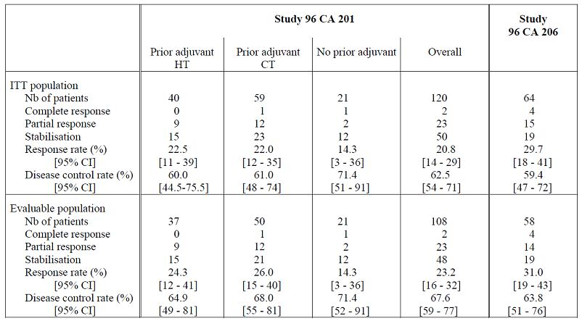
The only monotherapy study which evaluated efficacy/safety for the proposed indication of ABC after standard therapy was Study CA221. In this study, oral vinorelbine monotherapy was evaluated as second line treatment in 85 patients (58 received oral vinorelbine and 27 received IV vinorelbine) who had received first line treatment with anthracyclines. However, interpretation of results from this study was limited by early termination of the study due to difficulty in recruiting patients.
The earlier submission for oral vinorelbine in treatment of ABC was rejected on grounds of inadequate evidence of efficacy. The only additional data provided in this submission for monotherapy is the open label, comparative, randomised, Phase II Study CA221 in 57 patients who had received first line treatment with anthracyclines. There were no studies directly comparing efficacy/ safety of oral versus IV vinorelbine in treatment of ABC. Although Study CA221 randomised patients in the ratio 2:1 (oral:IV vinorelbine), it was not designed for formal statistical comparisons between the oral and IV vinorelbine treatment arms. Response rates were lower in the oral vinorelbine treatment arm compared with the IV arm (7% versus 22%). However, low response rates in the oral arm may have been due to greater proportion of patients with worst prognostic factors (visceral disease, DFI < 2 years) in the oral arm. Despite this, it was reassuring to see that the disease control rates (47% versus 52%) and median overall survival (9.4 versus 10.2 months) was similar in the oral and IV arms. Oral monotherapy with oral vinorelbine would offer a convenient, less invasive treatment option for ABC patients with bad prognosis.
In the clinical evaluation of the application for first line use in breast cancer, a total of 7 open, uncontrolled studies of IV vinorelbine monotherapy were evaluated and response rates with IV administration were usually 35-50%. However, response rates with monotherapy of oral vinorelbine were usually <30% suggesting that oral therapy may be less effective in breast cancer. However, the sponsor is not seeking approval of oral vinorelbine for first line treatment of ABC as IV vinorelbine is also approved for treatment of ABC in Australia only after failure of standard therapy. Subgroup analysis in the monotherapy studies did suggest that response rates were better and similar to those observed with IV vinorelbine in patients who had received prior adjuvant HT and/or CT. Results from the new Study CA221 showed lower response rate with oral vinorelbine compared with IV vinorelbine (7% versus 21%), but the study was not designed to do any statistical comparison between oral and IV vinorelbine, was confounded by worst prognostic factors in the oral treatment arm and despite that, the disease control rates and median overall survival was similar in the oral and IV arms.
The primary objective of the Phase II, open label, randomised, comparative Study CA222 was to simultaneously evaluate the disease control rate of the combination of oral vinorelbine with capecitabine, a sequential regimen of oral vinorelbine and capecitabine, and the combination of docetaxel and capecitabine for the treatment of 139 patients with metastatic breast cancer, after prior anthracycline containing (neo) adjuvant regimen. The overall response rate (CR+PR) in the ITT population after an independent review was (V+C/V→C/D+C arms) [95% CI]: 31.8% [18.6-47.6], 8.7% [2.4-20.8] and 35.4% [22.2-50.5]. The efficacy and safety results of the three arm randomised Phase II Study CA222 showed no benefit of alternating V→C over V+C or D+C combinations. Combinations of V+C or D+C resulted in similar efficacy in terms of disease control rate, response rate, progression-free survival and time to treatment failure. Major differences were observed in toxicity; V+C arm induced less neutropenia, infection, hand-foot syndrome, and alopecia than D+C arm. Results of the Phase I-II Study CA103 in 52 patients also showed that oral vinorelbine in combination with capecitabine was effective and safe and offers the additional advantage of being an all oral combination regimen.
Results from the Phase II Studies CA 205 (with epirubicin) and CA 101 (with docetaxel) suggested that oral vinorelbine could be offered as an alternative to the IV form in combination regimens in order to improve patient comfort and convenience. The two regimens alternating oral and IV vinorelbine in combination with epirubicin or docetaxel gave similar response rates of approximately 50%. Median durations of overall survival tended to be longer for the taxane combinations than for the combination with epirubicin. Furthermore, results from Study CA102 provided some preliminary evidence that the combination of oral vinorelbine and IV paclitaxel may be useful in treatment of metastatic advanced breast cancer (Table 9). Although, the use of oral vinorelbine in combination regimens has not been extensively studied, the above studies provide preliminary evidence to suggest that IV vinorelbine may be replaced with oral vinorelbine therapy. Furthermore, evidence for efficacy of the all oral combination of vinorelbine and capecitabine is quite convincing.
Table 9: Efficacy results in the ITT population of Studies CA 205, CA 101 and CA 102.
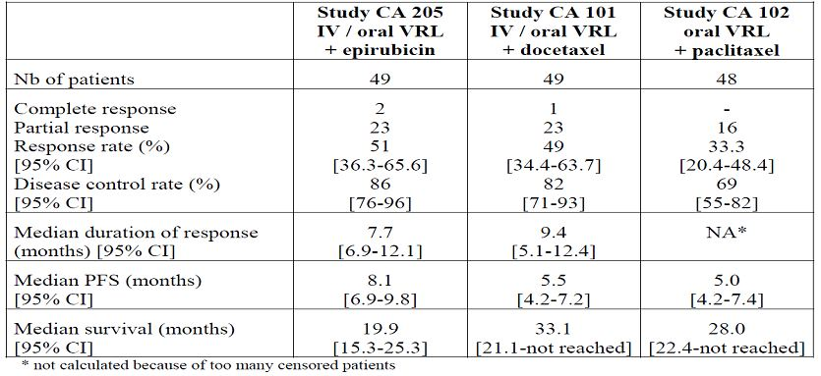

Safety

Studies providing evaluable safety data
Safety results of oral vinorelbine were obtained from the studies evaluating oral vinorelbine as a single agent and from the studies evaluating oral vinorelbine as combination treatment in treatment of advanced breast cancer.
As a single agent, oral vinorelbine was used:
- At 80 mg/m²/week in the first two studies carried out in patients with NSCLC (Study 96 CA 204) and with ABC (Study 95 CA 201). Both trials were discontinued after accrual of 48 and 35 patients, respectively, because of the occurrence of eight toxic deaths. Overall, 83 patients were enrolled in the two studies and 82 patients (48 NSCLC and 35 ABC) received oral vinorelbine at 80 mg/m²/week.
- At the currently recommended regimen of 60 mg/m²/week for the first 3 weeks increased to 80 mg/m²/week for the subsequent administrations in the absence of severe haematological toxicity at 60 mg/m²/week (defined by one episode of Grade 4 neutropenia or more than one episode of Grade 3 neutropenia). This regimen was administered in a total of 184 patients with ABC who were enrolled in 2 independent, non-comparative Phase II studies (96 CA 201 and 97 CA 206). In addition, the recommended regimen was given to 132 patients with NSCLC (studies 97 CA 205 and CA 208).
On May 2004, a randomised Phase II Study CA221 of oral vinorelbine given at 60 mg/m² on Days 1 and 8 of the first three week cycle then increased to 80 mg/m² given on Days 1 and 8 every three weeks (subsequent cycles); or IV vinorelbine given at 25 mg/m² on Days 1 and 8 of the first three week first cycle then increased to 30 mg/m² on Days 1 and 8 every three weeks (subsequent cycles) was initiated. This trial was conducted in MBC patients, aged 60 years and older previously treated with anthracyclines. Due to poor accrual, this study was closed on October 2006 after inclusion of only 85 patients (58 in the oral arm and 27 in the IV arm) among the 225 planned by the study protocol. Therefore safety data of the 57 patients (one patient never treated) who received this less intensive regimen of oral vinorelbine due to their greater age are included in the present analysis.
As combination therapy, oral vinorelbine was used:
- In combination, oral vinorelbine with capecitabine was investigated in a Phase I-II Study (CA 103) and in a randomised Phase II study (Study CA 222). This all oral combination was administered in 52 patients included in the Phase II part of Study 103 and in 44 patients of Study 222. Thus, 96 ABC patients received the all oral combination of vinorelbine and capecitabine.
- In addition, a total of 146 patients received oral vinorelbine in combination with epirubicin (Study CA205), docetaxel (Study CA 101) or paclitaxel (Study CA102).
All the AEs were reported whatever their relationship to study treatment, and graded according to the Cancer and Leukaemia Group B (CALGB) common toxicity criteria for all the clinical studies of oral vinorelbine except Studies CA221, CA103 and CA222 that used the NCI-CTC (Version 2.0). Patients were asked to describe specifically any AE they had noticed regardless of relationship to the study medication. All clinical AEs were to be recorded on the AEs page of the CRF and appropriately graded as to the severity and whenever possible to the relationship to the study medication or the disease. The NCI/CTC Version 2.0 was used for grading the severity of toxic events, except for febrile neutropenia (Pizzo’s definition). All AEs regardless of severity had to be followed up for 30 days after the last dose of drug or until resolution. For all studies, febrile neutropenia was defined as fever > 38°C (Grade > 2) concomitant with Grade 4 neutropenia (< 500 neutrophils/mm³). Neutropenic infection was defined as Grade > 3 infection concomitant with Grade > 3 neutropenia (< 1000 neutrophils/mm³). AEs considered definitely, possibly, or probably related to the study drug according to the investigator were analysed as treatment related.

Laboratory evaluations
Complete blood counts (including a differential and platelet count) were to be assessed every cycle on Days 1 and 15 within 24 hours prior to dosing. In case of delay in drug administration, blood counts had to be repeated on the scheduled day for drug administration. AST, ALT, alkaline phosphatase, blood urea nitrogen (BUN), creatinine, total bilirubin, glucose, and electrolytes (including calcium and total proteins) were assessed every cycle. Blood samples had to be taken within 24 hours of the drug administration.
Physical examination and vital signs were assessed every 3 weeks: a complete physical examination including neurological assessment, performance status, body weight, height, blood pressure and pulse had to be recorded. ECG had to be performed and recorded prior to initial administration. It had to be repeated every cycle and at the end of the treatment if any cardiac event occurred.

Pivotal studies that assessed safety as a primary outcome
None of the oral vinorelbine studies assessed safety as a primary outcome.

Patient exposure

Clinical studies of oral vinorelbine used at 80 mg/m²/week
In the two Phase II studies (NSCLC Study 96 CA 204 and ABC Study 95 CA 201) which investigated oral vinorelbine at 80mg/m²/week, patients had to receive a minimum of four administrations during the first eight weeks unless early disease progression or excessive toxicity. Responders and patients with stable disease continued treatment up to a total of 24 weeks in Study 96 CA 204 and 12 weeks in Study 95 CA 201. Dose delay by one to three weeks was recommended in case of haematological, hepatic or neurological toxicity. For Study 96 CA 204 only, dose reduction from 80 to 60 mg/m²/week was mandated in the event of Grade 4 neutropenia or two consecutive episodes of Grade > 2 neutropenia.
The rates of delayed administrations appear slightly higher for IV vinorelbine. Reasons for dose delay < 3 days were generally restricted to patient’s convenience and logistical issues. Hence, only the percentages of patients who experienced dose delay by more than 3 days were considered. The principal reason for dose reduction and dose delay > 3 days was haematological toxicity: 37 patients (45.1%) who received the 80 mg/m²/week regimen underwent dose delay including 5 patients (6.1%) who experienced dose delay associated with dose reduction.

Clinical studies of oral vinorelbine used at 60/80 mg/m²/week
In the two Phase II studies which investigated the proposed dose of oral vinorelbine (60/80 mg/m²/week) in ABC, the patients had to receive a minimum of four administrations during the first eight weeks unless early disease progression or excessive toxicity. Beyond eight weeks, duration of further treatment was slightly different between the two studies. For Study 96 CA 201, they could be treated for three additional months if their disease was stable while responders were treated until progression. For Study 97 CA 206, patients with stable disease and responders were treated until progression. Dose delay by one to two weeks was recommended in case of haematological, neurological or hepatic toxicities. Moreover, dose reduction from 80 to 60 mg/m²/week was required in the event of severe neutropenia (defined as one episode of Grade 4 neutropenia or two consecutive episodes of Grade 3 neutropenia).
Among the 316 patients, 284 received at least four administrations, 23 being prematurely discontinued for non drug related reason, and only 9 being withdrawn for drug related toxicity.
Out of those 284 patients, 249 (87.7%) underwent dose escalation from 60 to 80 mg/m²/week after the third administration. Only 35 patients remained at 60 mg/m²/week: 16 due to occurrence of severe neutropenia in 15 instances and vomiting in one instance; and 19 due to protocol violation (in absence of any toxicity). The principal reason for dose reduction and dose delay > 3 days was haematological toxicity in 178 patients (56.3%), including 22 patients for whom dose delay was associated with dose reduction from 80 to 60 mg/m² beyond the first three administrations. Twenty of the 22 patients (90.9%) treated at reduced dose could undergo dose re-escalation from 60 to 80 mg/m²/week after a minimum of three administrations given at 60 mg/m²/week. Of note, the rate of delayed administrations tended to be higher for IV vinorelbine.
In the randomised Phase II Study CA 221 that tested oral vinorelbine at 60/80 mg/m² on Days 1 and 8 every three weeks and IV vinorelbine at 25/30 mg/m² using the same schedule, the patients had to receive a minimum of two cycles unless early disease progression or excessive toxicity. Then responders and patients with stable disease were treated until progression or up to 6 cycles at the investigator’s discretion. The same recommendation for dose delay and dose reduction as previously described. The majority of patients underwent dose escalation beyond cycle 1: 84% in the oral arm and 63% in the IV arm. A similar proportion of cycles were delayed in the two study arms, mainly because of neutropenia.

Clinical studies of oral vinorelbine in combination with capecitabine
In Study CA 103, patients received oral vinorelbine at 60 mg/m²/week associated with capecitabine 2000 mg/m²/day from days 1 to 14 every 3 weeks. In study CA 222, patients randomised in the oral vinorelbine plus capecitabine arm received oral vinorelbine at 60 mg/m² on Days 1 and 8 for the oral first three week cycle and then at 80 mg/m² for subsequent cycles associated with capecitabine at 2000 mg/m²/day from Days 1 to 14 every three weeks. In both studies patients were treated until disease progression, excessive toxicity or patient refusal. Patients having received the oral vinorelbine plus capecitabine combination tended to be given a higher number of cycles (median of 7 in Study CA 103 and median of 8 in Study CA 222). Of note, the median dose intensity and the relative dose intensity of capecitabine were greater when combined with oral vinorelbine than when combined with docetaxel.

Other combination studies
In addition, a total of 146 patients received oral vinorelbine in combination with epirubicin (Study CA 205), docetaxel (Study CA 101) or paclitaxel (Study CA 102).
Selection of patients in the four studies which tested the recommended regimen of 60/80mg/m²/week was restricted to first line treatment in the two targeted indications. The studied populations enrolled in the two studies conducted at 80 mg/m²/week and the four studies which used the 60/80 mg/m²/week regimen were comparable in terms of age. The majority of patients were older than 50 years and had a good performance status of 0 or 1. Note that ABC patients who had received prior chemotherapy had been treated in the neo/adjuvant setting only. Selection of patients in Studies 96 CA 204 and 95 CA 201 was restricted to first line treatment of ABC and advanced/metastatic NSCLC. Baseline characteristics of patients treated with oral vinorelbine 80 mg/m²/week and also these of patients treated in the IV arm of Study 96 CA 204. Selection criteria of Study CA 221 were restricted to elderly patients (age > 60 years) previously treated with anthracyclines. As expected from the selection criteria of Study CA 221, the patients tended to be older and all of them had received prior chemotherapy in the neo/adjuvant and/or metastatic setting.
Patients enrolled in Studies CA 103 and CA 222 (combination or oral vinorelbine and oral capecitabine) were treated with a palliative intent. Moreover, to be enrolled in Study CA 222, patients had to have received prior anthracyclines based regimen. The majority of patients were aged between 35 and 64 years and had a Karnofsky performance status between 100 and 90%.

Adverse events

All adverse events (irrespective of relationship to study treatment)

Single agent at proposed 60/80mg/m² dose
Grade 3-4 neutropenia was the main dose limiting toxicity. Its incidence was consistent in ABC and NSCLC patients who received the recommended regimen of 60 then 80 mg/m²/week. Complicated neutropenia was seen in a small proportion of patients treated with oral vinorelbine: 2.8% of patients experienced febrile neutropenia and 3.5% had neutropenic infection (Table 10). The main non haematological AE irrespective of the relationship to study drug were gastrointestinal disorders (mainly nausea, vomiting, diarrhoea and anorexia), pulmonary disorders including cough and dyspnoea, cardiovascular events with hypertension as the most frequent event, constitutional disorders (mainly malaise/fatigue and weight loss) and alopecia (Table 11). Pulmonary disorders could be explained by the underlying disease and hypertension was generally considered as a concomitant disease.
Table 10: Haematological toxicity in Phase II studies of oral vinorelbine (VRL) at 60/80 mg/m²/week.
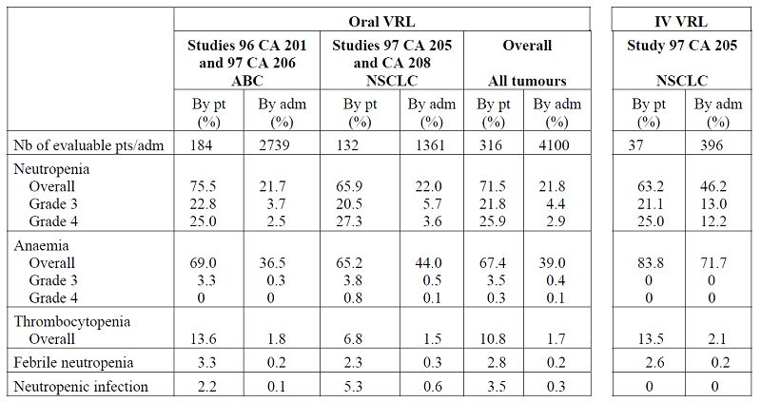
Table 11: Non haematological toxicities (incidence by patient > 5%) regardless of attribution of study treatment in studies of oral vinorelbine (VRL) at 60/80 mg/m²/week.
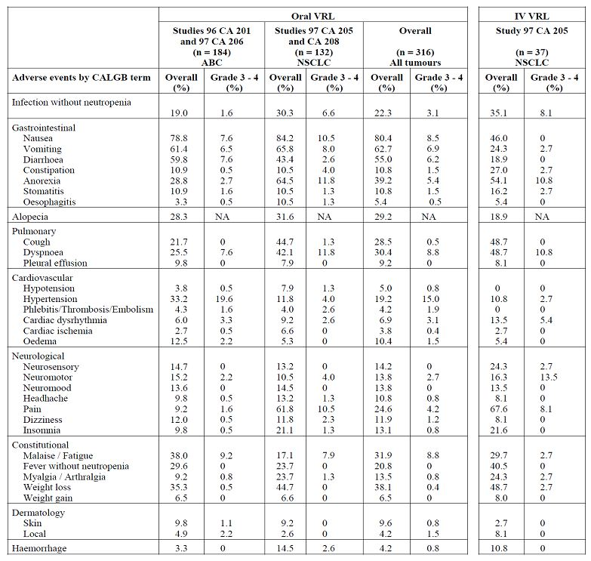

Study CA 221
As previously reported for the 60/80 mg/m² weekly regimen, neutropenia was the main dose limiting toxicity. The incidences of neutropenia fall in the same range for the two study arms. Febrile neutropenia and neutropenic infection were uncommon.
As previously reported for the 60/80 mg/m² weekly regimen, the main non haematological AE were gastrointestinal disorders, constitutional symptoms, infection and alopecia.

Combination with capecitabine
Grade 3-4 neutropenia was the main haematological toxicity; however, its incidence in patients treated with the oral vinorelbine plus capecitabine combination was lower than that of the docetaxel plus capecitabine one in Study CA 222: 47.7% versus 83.4% of patients and 18% versus 40.6% of cycles. The incidence of complicated neutropenia was also higher for docetaxel in combination with capecitabine compared with oral vinorelbine in combination with capecitabine: 6.3% versus 2.3% of patients with febrile neutropenia, 12.5% versus 0% of patients with neutropenic infection (Table 12). The most frequently reported AEs included gastrointestinal disorders such as nausea and diarrhoea, constitutional symptoms such as fatigue, and hand-foot syndrome (Table 13).
Table 12: Haematological toxicity: combination with capecitabine (Studies CA 103 and CA 222).
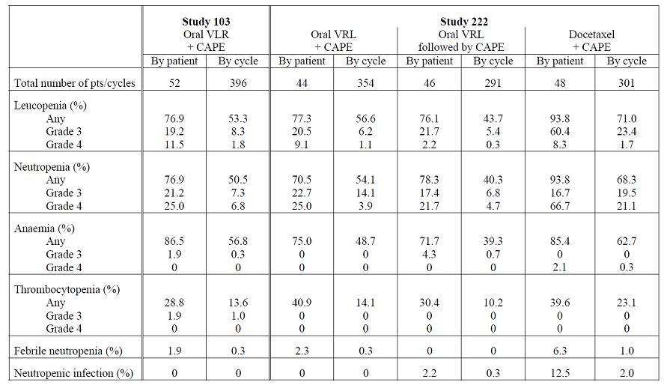
Table 13: Non haematological toxicities (incidence by patient > 5%) regardless of attribution of study treatment: combination with capecitabine (Studies CA 103 and CA 222).
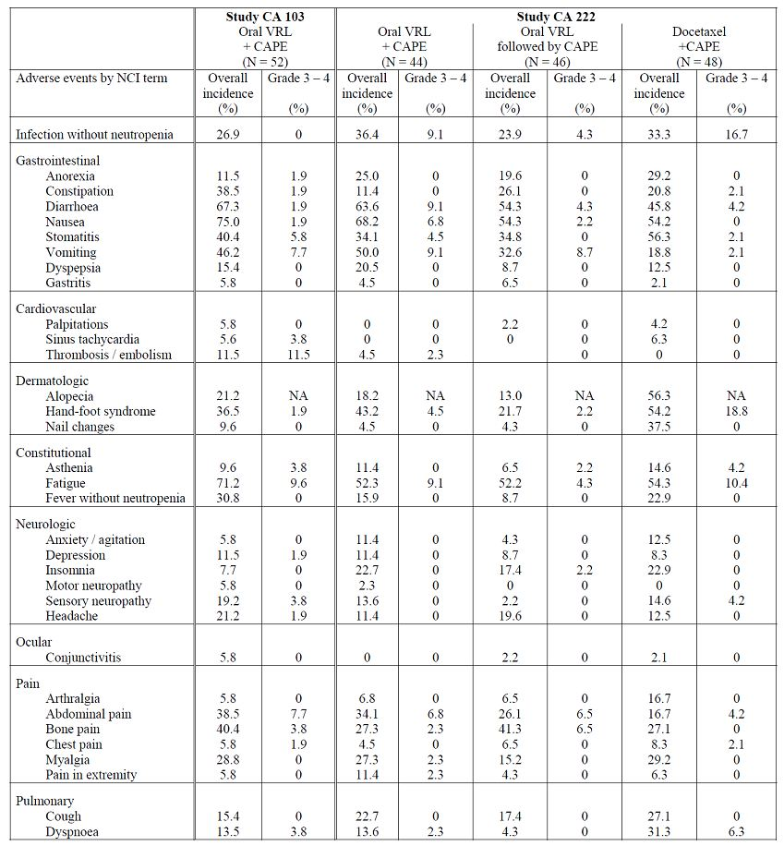

Other studies

Clinical studies of oral vinorelbine used at 80 mg/m²/week
Both the overall incidences and the incidences of Grade 3 and 4 neutropenia fell in the same range for oral vinorelbine and IV vinorelbine. However patients who presented Grade 3 or 4 neutropenia were at higher risk of developing septic complication when treated by oral vinorelbine compared to IV vinorelbine as evidenced by the overall incidences by patient of febrile neutropenia (13.4% versus 4%) and neutropenic infection (10.9% versus 0%). Gastrointestinal toxicities such as nausea (64.6%), vomiting (48.9%) and diarrhoea (59.8%) were frequently encountered in patients treated with oral vinorelbine, but were generally of mild to moderate intensity; their overall incidences appeared to be higher in comparison with IV vinorelbine. It is worth noting that prophylactic antiemetics were not mandated in any study. The principal neurological symptoms included neurosensory disorders (23.2%) and constipation (31.7%). Grade 3 and 4 events were rarely reported. The overall incidences and the incidences of Grade 3-4 events were comparable for oral and IV vinorelbine. Other toxicities such as cardiac, pulmonary, and flu like symptoms were less frequently seen and rarely severe. Their nature and intensity did not seem different for oral and IV vinorelbine. Alopecia was reported in 34.1% of patients treated with oral vinorelbine and 44% of those treated with IV vinorelbine. No Grade 3 events were seen.

Treatment related adverse events (adverse drug reactions)

Single agent at proposed 60/80mg/m² dose
The main drug related adverse events were gastrointestinal disorders including nausea, vomiting, diarrhoea and anorexia, and fatigue. Similar overall and Grade 3-4 incidences were reported in the 184 patients with ABC in the 132 patients with NSCLC and in the overall population who received oral vinorelbine at 60/80 mg/m²/week. Of note, study protocols did not mandate prophylactic use of antiemetics. Neurological disorders were occasional, especially constipation (15.2% of the overall population). Grade 3-4 events were seen in a few patients (Table 14).
Table 14: Non haematological adverse events (incidence by patient > 5%) related to treatment of oral vinorelbine (VRL) at 60/80 mg/m²/week (Studies CA 103 and CA 222).
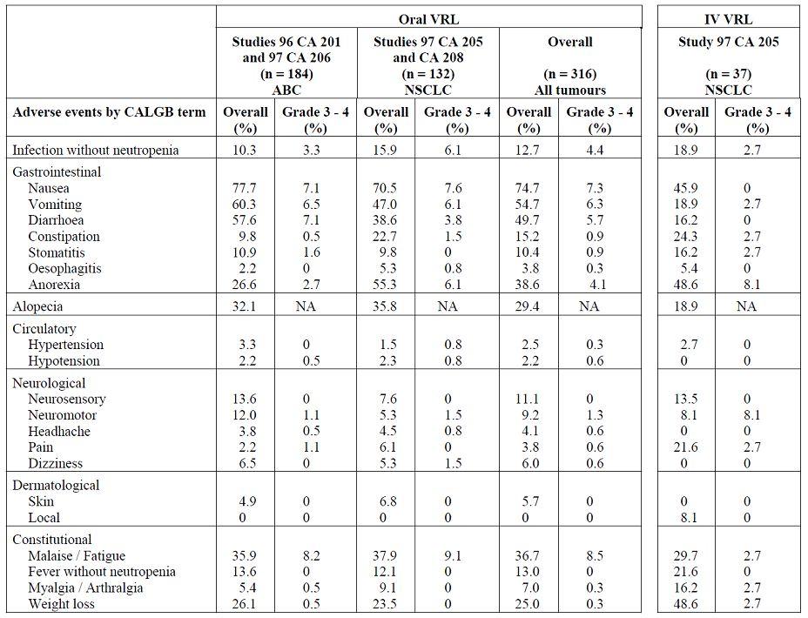

Study CA 221
As previously reported for the 60/80 mg/m² weekly regimen, the main drug related AEs were gastrointestinal disorders and fatigue.

Combination with capecitabine
The main AEs considered as drug related were gastrointestinal disorders with nausea, diarrhoea, vomiting and stomatitis, fatigue, alopecia, and hand-foot syndrome. The incidences of nausea and vomiting tended to be higher for the oral vinorelbine plus capecitabine combination, while that of stomatitis was greater for the docetaxel plus capecitabine combination. Alopecia and hand-foot syndrome were more frequent with docetaxel plus capecitabine than with oral vinorelbine plus capecitabine: 54.2% versus 18.2%, and 54.2% versus 43.2%, respectively. Also nail changes, myalgia and arthralgia were more often reported with the docetaxel plus capecitabine combination.

Other studies

Clinical studies of oral vinorelbine used at 80 mg/m²/week
As previously noticed from the analysis of all the AEs regardless of their relationship to study treatment, the main toxicities were gastrointestinal disorders and neurological symptoms. Pulmonary symptoms and pain were generally attributed to the underlying disease.

Deaths and other serious adverse events

Single agent at proposed 60/80mg/m² dose
Deaths were reported in 22 of the 316 patients having received this regimen. According to the investigator’s opinion on the relationship to study drug, three deaths (1.2% of patients) were related to oral vinorelbine. All of them were reported in patients with advanced/metastatic NSCLC. Seventeen deaths were considered as non drug related and for two deaths, the cause was insufficiently documented and consequently the relationship to study drug cannot be ruled out. Causes of deaths are presented in Table 15 for the 316 patients treated with oral vinorelbine and the 38 patients treated with IV vinorelbine in the context of the randomised Phase II study in advanced/metastatic NSCLC (Study 97 CA 205). Drug related deaths were secondary to pneumonia concomitant with Grade 4 neutropenia, paralytic ileus and massive pulmonary haemorrhage. One NSCLC patient out of the 37 treated with IV vinorelbine (2.7%) died from septicaemia, which was considered drug related.
Table 15: Causes of deaths of oral vinorelbine (VRL) at 60/80 mg/m²/week.
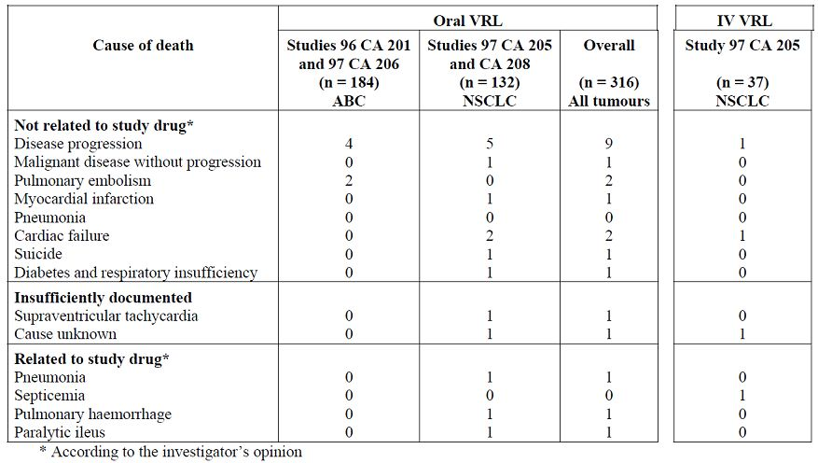
In Study CA 221, one patient from the oral arm died during the treatment period. This death was secondary to cerebral infarction and was not considered drug related by the investigator. Of note, two patients died from disease progression in the IV arm during the treatment period.
Among the 316 patients who received oral vinorelbine at 60/80 mg/m²/week, 102 patients (32.3%) experienced a total of 126 SAEs; 52 patients (16.5%) experienced a total of 60 drug related SAEs. The incidence of SAEs tended to be slightly greater in patients with NSCLC (17.4%) than in ABC patients (15.8%). The most frequently encountered drug related events were of haematological nature, but their incidence remained low: 2.5% of patients had febrile neutropenia, 2.8% had neutropenic infection, and 1.6% presented with severe neutropenia requiring hospitalisation. Other main types of SAEs were gastrointestinal disorders and malaise/fatigue/weakness. SAEs did not differ in nature and incidence between patients treated with the recommended regimen of oral vinorelbine and those treated with the IV form.
In Study CA 221, 22/57 (37.9%) patients in the oral treatment arm experienced a total of 45 SAEs. Ten patients (17.2%) from the oral arm experienced a total of 16 drug related SAEs. Gastrointestinal disorders and haematological events were the most frequent events with no difference in the nature and incidence of SAEs between the oral and IV vinorelbine study arms.

Combination with capecitabine
Two patients enrolled in Study 103 died within 30 days of the last study administration. In Study CA 222, two patients died during this period in the oral vinorelbine plus capecitabine arm, while three occurred in the docetaxel plus capecitabine arm.
In Study 103, 9 patients (17.3%) experienced 11 SAEs regardless of relationship to study treatment. Four SAEs reported in 4 patients (7.7%) were considered as drug related. In Study 222, 12 patients (27.3%) treated with the oral vinorelbine plus capecitabine combination had a total of 18 SAEs whatever their relationship to study drug, while 8 patients (16.7%) treated with the docetaxel plus capecitabine combination had a total of 13 SAEs regardless of relationship to study drug. Among those, five patients (11.4%) in the oral vinorelbine plus capecitabine arm and four patients (8.3%) in the docetaxel plus capecitabine arm experienced at least one drug related SAE. SAEs were mainly of gastrointestinal and infectious nature for the oral vinorelbine plus capecitabine combination.

Other studies

Clinical studies of oral vinorelbine used at 80 mg/m²/week
Deaths were reported in 15 of the 82 patients having received oral vinorelbine at 80 mg/m²/week during the study period. According to the investigator’s opinion on the relationship to study drug, eight deaths (9.8% of patients) were related to oral vinorelbine. Five deaths were considered as non drug related; for the two remaining deaths, the cause of death was unknown, and consequently the relationship to study drug cannot be ruled out. Causes of death are presented in Tables 16 and 17 among the 82 patients treated with oral vinorelbine 80 mg/m²/week and the 25 patients treated with IV vinorelbine 30 mg/m²/week in the context of Study 96 CA 204. All the eight toxic deaths were septic deaths that occurred in the context of severe neutropenia (Grade 4 neutropenia in seven instances and Grade 3 neutropenia for the last patient). All patients except one died after having received a maximum of three administrations of oral vinorelbine. No septic death was reported for IV vinorelbine (Tables 16 and 17). These findings led to modify the treatment regimen so that:
- The first three administrations which were associated with an increased risk of severe haematological toxicity were given at a lower dose of 60 mg/m²/week.
- Subsequent administrations were given at 80 mg/m²/week if the patient did not develop one episode of Grade 4 neutropenia or two episodes of Grade 3 neutropenia when treated at 60 mg/m²/week. The few high risk patients remained at 60 mg/m²/week.
- The dose had to be reduced from 80 to 60 mg/m² in the event of Grade 4 neutropenia or two consecutive episodes of Grade 3 neutropenia.
Table 16: Causes of deaths in studies of oral vinorelbine (VRL) at 80 mg/m²/week [Studies 95 CA 201 (ABC) and 96 CA 204 (NSCLC)].
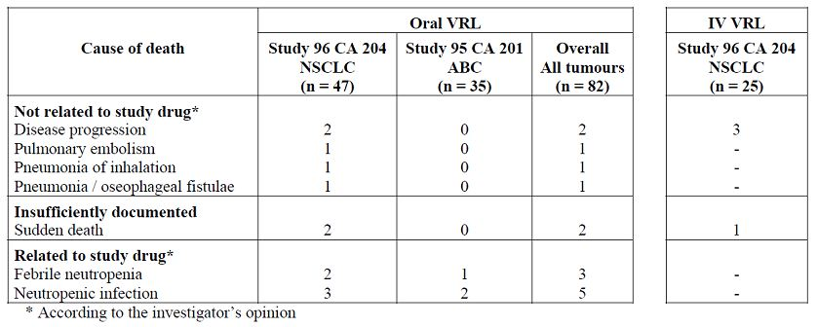
Table 17: Details of toxic deaths occurring at 80 mg/m²/week [Studies 95 CA 201 (ABC) and 96 CA 204 (NSCLC)].
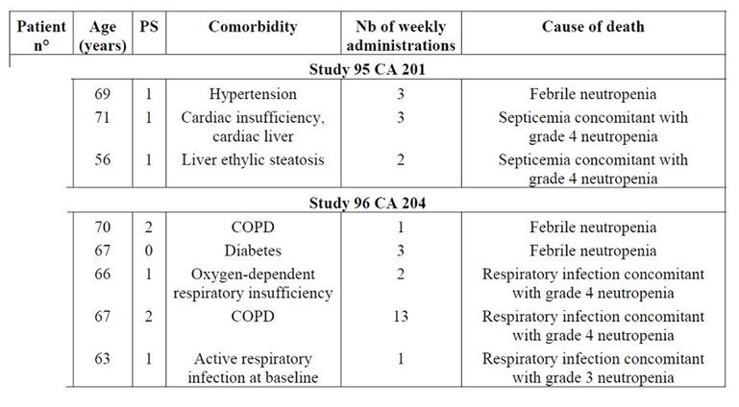
PS = Performance Score (World Health Organisation):
0 – Asymptomatic (Fully active, able to carry on all pre disease activities without restriction)
1 – Symptomatic but completely ambulatory (Restricted in physically strenuous activity but ambulatory and able to carry out work of a light or sedentary nature. For example, light housework, office work)
2 – Symptomatic, <50% in bed during the day (Ambulatory and capable of all self care but unable to carry out any work activities. Up and about more than 50% of waking hours)
3 – Symptomatic, >50% in bed, but not bedbound (Capable of only limited self-care, confined to bed or chair 50% or more of waking hours)
4 – Bedbound (Completely disabled. Cannot carry on any self-care. Totally confined to bed or chair)
5 – Death
Out of the 82 patients who received oral vinorelbine at 80 mg/m²/week, 44 patients (53.6%) experienced a total of 77 SAEs. Among those SAEs, 43 were considered as drug related, 25 as non drug related, and for 9 events the investigator’s opinion on the relationship to study drug was missing. Overall, 32 patients (39%) experienced a total of 46 SAEs considered as drug related that included 43 events related to study drug according to the investigator’s opinion and three insufficiently documented events. Among those, 27 patients had NSCLC and 5 had ABC. Overall, 21 patients (25.6%) experienced serious haematological toxicity. The incidence appears to be higher (16 out of 47 patients: 34%) in patients with NSCLC who are known to be high risk patients for severe infections. By comparison with IV vinorelbine, the incidence of haematologic events was much lower since only two patients out of 25 (8%) treated with the injectable form developed Grade 4 neutropenia with or without fever. A total of five patients experienced at least one episode of Grade > 3 infections that were not concomitant with Grade 3-4 neutropenia. There were two urinary infections, one herpes zoster infection, one febrile pleuritis, and three pneumonia diagnoses. The incidences of infection were similar in the overall population (6.1%) and in ABC patients (5.7%). Other types of SAEs were seen in less than 5% of patients.

Discontinuation due to adverse events

Single agent at proposed 60/80mg/m² dose
A total of 53 patients (16.7%) discontinued oral vinorelbine given at 60/80 mg/m²/week because of the occurrence of an AE. The main reason for treatment discontinuation was the occurrence of gastrointestinal disorders, which were mainly nausea/vomiting in Studies 96 CA 201 and 97 CA 205. This finding is consistent with the reported incidence of those events. In Study 97 CA 206, neutropenia with or without fever and asthenia were the main events leading to patient withdrawal. However, the proportion of patients who were withdrawn because of the occurrence of a drug related AE was low in the three studies; 17 of 120 patients (14.2%) in Study 96 CA 201, 8 of 64 patients (12.5%) in Study 97 CA 206, and 19 of 132 patients (14.4%) in Studies 97 CA 205 and CA 208.

CA 221
A total of 15 patients (26.3%) discontinued treatment due to an AE in the oral arm. Reasons for treatment discontinuation were consistent with those reported for the 60/80 mg/m² weekly regimen. They were also consistent between the oral and the IV arm of Study CA 221.

Combination with capecitabine
In Study CA 103, 10 patients (19.2%) discontinued study treatment because of the occurrence of a drug related AE.
In Study CA 222, 6 patients (13.6%) treated with the oral vinorelbine plus capecitabine combination were withdrawn because of the occurrence of a drug related AE, while 14 patients (29.2%) did so in the docetaxel plus capecitabine combination arm. Reasons for treatment discontinuation in patients having received the oral vinorelbine plus capecitabine combination were mainly of haematological or gastrointestinal nature.

Other studies

Clinical studies of oral vinorelbine used at 80 mg/m²/week
Twenty three patients (28%) discontinued oral vinorelbine given at 80 mg/m²/week because of the occurrence of an AE. Drug related adverse events were responsible for study discontinuation in 17 patients (20.1%). The main toxicities leading to patient’s withdrawal included haematological toxicity in six patients and gastrointestinal disorders in six patients.

Laboratory tests

Liver function
In the four studies with oral vinorelbine at proposed dose of 60/80mg/m², there was a slight increase compared to baseline of bilirubin abnormalities from 1.7 to 7.2%, alkaline phosphatases from 25.8 to 34.9%, AST from 17.9% to 33.3%, and ALT from 15.8 to 41.7%. Grade 3-4 alterations of liver function tests were observed in a small proportion of patients: 1.9% of patients for bilirubin, 0.6% for alkaline phosphatises, and 0.9% for transaminases. These alterations had no clinical consequences.
In Studies 95CA201 and 96CA204 that used oral vinorelbine at 80mg/m², there was a slight increase from baseline in the overall incidence of bilirubin abnormalities from 2.4 to 6.6%, AST from 11.4 to 25.8% and ALT from 16.6 to 33.3%. Only one patient had a transient increase of bilirubin to Grade 4 without clinical consequences.
In the two oral vinorelbine plus oral capecitabine combination studies (Studies CA103 and CA222), there were no clinically relevant changes in liver function tests.
In Study CA221, which was the only study that compared oral and IV vinorelbine treatment, there were no clinically relevant differences between the oral and IV treatment arms in the incidence of liver function test abnormalities.

Kidney function
There were no clinically relevant changes (no Grade 3 or 4 abnormalities) in serum creatinine levels in any of the monotherapy studies of oral vinorelbine at proposed dose of 60/80 mg/m² or in monotherapy studies of oral vinorelbine at 80 mg/m² or in combination studies of oral vinorelbine plus capecitabine. In Study CA221, there were no clinically relevant differences between the oral and IV vinorelbine treatment arms in terms of change in serum creatinine.

Haematology
In Study CA221, neutropenia was observed in 59.6% of patients and 34.8% of cycles in the oral vinorelbine arm, in 77.8% of patients and 59.0% of cycles in the IV vinorelbine arm; incidences of grades 3 and 4 neutropenia tended to be slightly higher in the IV arm.
Throughout the study period in 96CA201, neutropenia was observed in 92 patients (76.7%) and Grade 3 and 4 neutropenia was seen in 27 (22.5%) and 34 (28.3%) patients, respectively. Seven patients (5.8%) had Grade 4 neutropenia at 60 mg/m² during the first three administrations; 25 patients (26.3%) experienced Grade 4 neutropenia at actual dose of 80 mg/m²/week (18 of these underwent dose reduction to 60mg/m², while for seven of these patients protocol was not followed and dose was maintained at 80 mg/m²).
In Study 96CA206, the overall incidence of neutropenia per patient and per administration was lower during first three administrations compared to subsequent administrations whatever the actual dose received.
In Study CA222, the main haematological toxicity was leukopenia reported in 77.3% in V+C arm, neutropenia in 78.3% in VC arm, and leukopenia/neutropenia in 93.8% each in D+C arm. The incidence of Grade 3/4 neutropenia was higher in D+C arm (83.3%) compared to V+C and VC arms (47.7% and 39.1%, respectively) by patient, and 40.6% versus 18.0% and 11.5% by cycle.
Febrile neutropenia was reported in one patient (2.3%) in V+C arm (as an SAE) and three patients (6.3%) in D+C arm. No patient experienced febrile neutropenia in VC arm. Neutropenic infection (infection concomitant with Grade 3-4 neutropenia) was higher in D+C arm (12.5%) compared to VC arm (2.2%). No patient experienced neutropenic infection in V+C arm. The incidence of anaemia was similar in three arms (V+C/VC/ D+C): 75.0%, 71.7% and 85.4% of patients and was severe in two patients in VC arm and one patient in D+C. The incidence of thrombocytopenia was similar in three arms (V+C/VC/ D+C): 40.9%, 30.4% and 39.6% of patients and was never severe.

Electrocardiograph
No clinically relevant changes were observed in the oral vinorelbine studies.

Vital signs
No clinically relevant changes in vital signs were reported in any of the oral vinorelbine studies.

Post marketing experience
Oral vinorelbine has received market authorisation by health authorities in 43 countries, including the United Kingdom and Sweden, until June 2010.
During this post marketing period, no actions were taken by health authorities for safety reasons such as marketing authorisation withdrawal or suspension, restrictions on distribution, clinical trial suspension, dosage modifications, changes in target population or formulation changes.
Post marketing experience was provided from 11 April 2001 to 10 April 2010. This was presented as 4 semi annual periodic safety update reports (PSURs) from 11 April 2001 to 10 April 2003 and 7 annual PSURs from 11 April 2003 to 10 April 2010. The estimation of patients treated with oral vinorelbine during this period was based on the total sales volume in grams of oral vinorelbine distributed by the marketing authorisation holder. This estimated figure is based on the assumption that on average the BSA of a patient exposed to oral vinorelbine is 1.6 m²; a patient is treated first with a dose of 60 mg/m²/week and then with a dose of 80 mg/m²/week. The patient receives ten cycles of oral vinorelbine treatment. So the estimated average total dose per patient is 1000 mg taking into consideration that in a certain percentage of patients the administered dose is reduced due to occurrence of adverse reactions, in particular bone marrow depression, or a treatment course is omitted. The total sales volume of oral vinorelbine amounted to about 111.9 kg and the estimated number of the patients treated with oral vinorelbine amounts to approximately 112,000 patients.
Review of all the PSURs did not provide any evidence of an increase in frequency of any listed adverse drug reaction (ADR) or serious ADR associated with use of Navelbine soft capsules during the period of the PSURs.
Comparison of the oral form of Navelbine with the IV concentrate remains difficult as the safety information for the oral capsules is primarily based on information gained from clinical studies, whereas post marketing experience with the oral form is limited; in fact, only a few spontaneous reports have been associated with use of Navelbine oral capsules. On the other hand, safety information of IV concentrate is based on the huge safety data from post marketing pharmacovigilance since this product has been marketed worldwide for several years.
The systemic safety profile of the two forms of Navelbine is almost identical with no significant difference in severity and incidence of ADRs. This is not surprising considering the fact that the active ingredient in both forms of Navelbine is similar (vinorelbine). However, the one main difference between the oral and IV forms of Navelbine is in terms of local tolerability which is due to the different mode of administration: Navelbine IV concentrate can cause local reactions at site of administration due to the vesicant property of the active substance; due to the same property, Navelbine soft capsule can cause local irritation of the upper gastrointestinal tract (GIT), especially the oesophageal and gastric tracts. However, the formulation as soft capsule aims to minimise this local toxicity.

Safety issues with the potential for major regulatory impact
Not applicable. The same formulation of oral vinorelbine is already approved for first line treatment of NSCLC.

Other safety issues

Safety in special populations
The analysis of safety in special groups and situations was performed in the three Phase II studies (Studies 96 CA 201, 97 CA 206 and 97 CA 205), which used the recommended regimen of oral vinorelbine in monotherapy. Note that Study CA 208 was carried out in NSCLC patients older than 70 years and is specifically analysed in the subsection on the impact of age.

Intrinsic factors (age and baseline WHO performance score)
The impact of age (< and > 65 years) and WHO performance status (0 and 1-2) was analysed with respect to the incidence of Grade 3-4 neutropenia and the occurrence of SAEs used as single agent, oral vinorelbine was associated with a slight increase in the incidence of Grade 3-4 neutropenia from 37.8% to 48.1% in elderly patients from Study 97 CA 206, while in Studies 96 CA 201 and 97 CA 205 no impact of age was found. In Studies 96 CA 201 and 97 CA 206, a slight increase in the rate of patients having experienced a SAE whatever its relationship to the study drug was observed. However the rate of patients having experienced a drug related SAE was very similar: 14.1% in patients less than 65 years versus 16.1% in elderly patients for Study 96 CA 201 and 16.2% versus 18.5%, respectively, for Study 97 CA 206. In Study 97 CA 205, no impact of age on the incidence of SAE was observed.
There was no obvious impact of performance status on the incidence of Grade 3-4 neutropenia.
For the three studies analysed, the overall incidence and the incidence of drug related SAEs seem greater in patients with a performance status of 1 or 2 (Table 18).
Table 18: Influence of WHO performance score on Grade 3-4 neutropenia and SAEs.
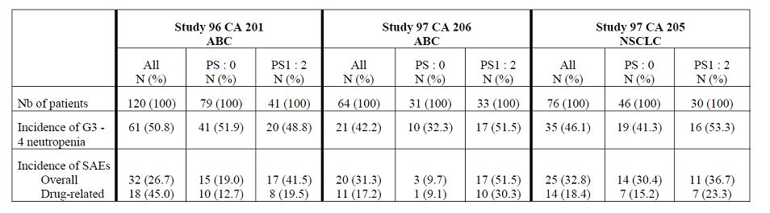
Therefore, the decision to use CT should be carefully weighed in patients with poor performance status.

Extrinsic factors
No relevant safety data were described with extrinsic factors such as use of tobacco, alcohol and food habits.

Safety related to drug-drug interactions and other interactions
Biotransformation of vinorelbine involves CYP3A4 isoform of cytochrome P450 except for the formation of DVRL, the only active metabolite, which likely involves carboxylesterases. DVRL is the main metabolite in blood. Potential drug-drug interactions were investigated in clinical studies where oral navelbine was administered in combination with other cytotoxics commonly used in the treatment of MBC and no significant safety concerns were detected although the number of patients evaluated was small.

Use in pregnancy and lactation
No case of pregnancy was observed. Vinorelbine is contraindicated in pregnancy or lactation.

Overdose
No case of overdose has been reported in any of the studies in MBC presented in this submission. It may produce bone marrow hypoplasia sometimes associated with infection and paralytic ileus. General supportive measures together with blood transfusion and antibiotic therapy should be instituted as deemed necessary by the physician. There is no known antidote for over dosage of IV vinorelbine.

Drug abuse
No information regarding the dependence of vinorelbine has been reported.

Withdrawal and rebound
The clinical studies presented in this Summary were not designed to detect any withdrawal and rebound effects.

Effects on ability to drive or operate machinery or impairment of mental ability
No studies on the ability of patients to drive or to use machines have been performed.

Evaluator’s overall conclusions on clinical safety
Safety data on the proposed regimen for oral vinorelbine (60mg/m² for first three administrations followed by 80mg/m² in absence of haematological toxicity) were available for a total of 316 patients (184 ABC and 132 NSCLC patients); 82 patients (48 NSCLC and 35 ABC) received oral vinorelbine at 80 mg/m²/week. Overall, 96 ABC patients received the all oral combination of vinorelbine and capecitabine, and 146 patients received oral vinorelbine in combination with epirubicin (Study CA 205), docetaxel (Study CA 101) or paclitaxel (Study CA 102).
In patients receiving the proposed dose of oral vinorelbine in monotherapy studies (96CA201, 97CA206 and CA221), Grade 3-4 neutropenia was the main dose limiting toxicity. Complicated neutropenia was seen in a small proportion of patients treated with oral vinorelbine: 2.8% of patients experienced febrile neutropenia and 3.5% had neutropenic infection. The main non haematological AEs were gastrointestinal disorders (mainly nausea, vomiting, diarrhoea and anorexia), pulmonary disorders including cough and dyspnoea, cardiovascular events with hypertension as the most frequent event, constitutional disorders (mainly malaise/fatigue and weight loss), and alopecia.
When oral vinorelbine was used in combination with oral capecitabine, Grade 3-4 neutropenia was the main haematological toxicity. However, its incidence in patients treated with the oral vinorelbine plus capecitabine combination was lower than that of the docetaxel plus capecitabine in Study CA 222: 47.7% versus 83.4% of patients, and 18% versus 40.6% of cycles. The incidence of complicated neutropenia was also higher for docetaxel in combination with capecitabine compared with oral vinorelbine in combination with capecitabine: 6.3% versus 2.3% of patients with febrile neutropenia, and 12.5% versus 0% of patients with neutropenic infection. The most frequently reported AEs included gastrointestinal disorders such as nausea and diarrhoea, constitutional symptoms such as fatigue, and hand-foot syndrome. The incidences of treatment related AE of nausea and vomiting tended to be higher for the oral vinorelbine plus capecitabine combination while that of stomatitis, alopecia (54.2% versus 18.2%) and hand-foot syndrome (54.2% versus 43.2%) was greater for the docetaxel plus capecitabine combination. Nail changes, myalgia and arthralgia were also more often reported with the docetaxel plus capecitabine combination.
Two patients enrolled in Study 103 died within 30 days of the last study administration. In Study CA 222, two patients died during this period in the oral vinorelbine plus capecitabine arm, while three occurred in the docetaxel plus capecitabine arm.
In Study 222, 12 patients (27.3%) treated with the oral vinorelbine plus capecitabine combination had a total of 18 SAEs whatever their relationship to study drug, while eight patients (16.7%) treated with the docetaxel plus capecitabine combination had a total of 13 SAEs regardless of relationship to study drug. Among those, five patients (11.4%) in the oral vinorelbine plus capecitabine arm and four patients (8.3%) in the docetaxel plus capecitabine arm experienced at least one drug related SAE. The most frequently reported drug related SAEs were of haematological nature but their incidence remained low: 2.5% of patients had febrile neutropenia, 2.8% had neutropenic infection, and 1.6% presented with severe neutropenia requiring hospitalisation. Other main types of SAEs were gastrointestinal disorders and malaise/fatigue/weakness. SAEs did not differ in nature and incidence between patients treated with the recommended regimen of oral vinorelbine and those treated with the IV form.
A total of 53 patients (16.7%) discontinued oral vinorelbine given at 60/80 mg/m²/week because of the occurrence of an AE. The main reason for treatment discontinuation was the occurrence of neutropenia with or without fever/infection, nausea and vomiting. In study CA221, 15 patients (26.3%) discontinued treatment because of the occurrence of an AE with similar incidence in the oral and IV arm of study. In Study CA 103, 10 patients (19.2%) discontinued study treatment because of the occurrence of a drug related AE. In Study CA 222, the incidence of withdrawal due to AE was higher in the docetaxel plus capecitabine combination arm (14 patients, 29.2%) compared with the oral vinorelbine plus capecitabine combination (6 patients, 13.6%). Reasons for treatment discontinuation in patients having received the oral vinorelbine plus capecitabine combination were mainly of haematological or gastrointestinal nature.
There were no clinically relevant changes in liver or kidney functions laboratory tests with similar incidences associated with oral and IV vinorelbine. In Study CA221, incidence of neutropenia was 59.6% and 77.8% in the oral and IV arms, respectively, and incidences of grades 3 and 4 neutropenia also tended to be slightly higher in the IV arm. In Study CA222, the incidence of Grade 3/4 neutropenia was higher in D+C arm (83.3%) compared to V+C (47.7%) and VC (39.1%) arms. Febrile neutropenia was reported in one patient (2.3%) in V+C arm (as an SAE) and three patients (6.3%) in D+C arm. No patient experienced febrile neutropenia in VC arm. Neutropenic infection (infection concomitant with Grade 3-4 neutropenia) was higher in D+C arm (12.5%) compared to VC arm (2.2%). No patient experienced neutropenic infection in V+C arm. The incidence of anaemia was similar in three arms (V+C/VC/ D+C): 75.0%, 71.7% and 85.4% of patients and was severe in two patients in VC arm and one patient in D+C. The incidence of thrombocytopenia was similar in three arms (V+C/VC/ D+C): 40.9%, 30.4% and 39.6% of patients and was never severe.
Review of all the PSURs did not provide any evidence of an increase in frequency of any listed adverse drug reaction (ADR) or serious ADR associated with use of Navelbine soft capsules during the period of the PSURs.
Potential drug interactions were investigated in clinical studies where oral navelbine was administered in combination with other cytotoxics commonly used in the treatment of MBC and no significant safety concerns were detected although the number of patients evaluated was small.
Contra indications are those reported with IV vinorelbine. Additional contra-indications are diseases significantly affecting GIT function and previous significant surgical resection of stomach or small bowel. In the absence of clinical data in patients with liver dysfunction, oral vinorelbine is contra indicated in patients with severe hepatic insufficiency.
Since inhibition of the hematopoietic system is the main risk associated with vinorelbine, close haematological monitoring should be undertaken during treatment (determination of haemoglobin level and the leukocyte, neutrophil and platelet counts on the day of each new administration).
The systemic safety profile of the two forms of Navelbine is almost identical with no significant difference in severity and incidence of ADRs. This is not surprising considering the fact that the active ingredient in both forms of Navelbine is similar (vinorelbine). However, the one main difference between the oral and IV forms of Navelbine is in terms of local tolerability which is due to the different mode of administration: Navalbine IV concentrate can cause local reactions at site of administration due to the vesicant property of the active substance due to the same property, Navelbine soft capsule can cause local irritation of the upper GIT especially oesophageal and gastric.

Benefit-risk assessment

Benefits
The use of oral vinorelbine in combination with capecitabine showed comparable efficacy to an approved regimen of docetaxel and capecitabine for treatment of MBC patients after anthracycline failure. In combination with capecitabine, oral vinorelbine was better tolerated than docetaxel. Furthermore, no pharmacokinetic interaction was detected when vinorelbine was given with capecitabine.
Two regimens alternating oral and IV vinorelbine in combination with epirubicin or docetaxel gave similar response rates of approximately 50% and median overall survival of 20 (with epirubicin) to 33 months (with docetaxel). Furthermore, results from Study CA102 provided some preliminary evidence that the combination of oral vinorelbine and IV paclitaxel may be useful in treatment of metastatic advanced breast cancer.
Oral vinorelbine at the proposed dose (60 mg/m²/week for first three weeks, subsequently increased to 8 0mg/m²/week in absence of severe haematological toxicity) showed a predictable and manageable safety profile, mainly neutropenia and gastrointestinal disorders. As previously reported for IV vinorelbine, the most common dose limiting toxicity was neutropenia but it was rarely associated with complications. Non haematological toxicities were those expected from the safety profile of each individual drug.
In Study CA221, incidence of neutropenia was 59.6% and 77.8% in the oral and IV arms, respectively and incidence of Grade 3-4 neutropenia, febrile neutropenia and febrile neutropenia also tended to be higher in the IV arm. Although the incidence of gastrointestinal AE such as nausea, vomiting and diarrhoea were higher in the oral arm, most of them were mild (<4% had Grade 3-4 AE).
In Study CA222, the incidence of Grade 3-4 neutropenia was significantly higher in the docetaxel + capecitabine arm (83%) compared to the all oral combination of vinorelbine + capecitabine (48%) and incidence of neutropenia complications was also lower in the V+C arm.
In the palliative setting of ABC, oral vinorelbine offers the advantages of an oral treatment which include vein sparing, greater comfort and convenience without sacrificing efficacy and safety.

Risks
Evidence for efficacy of oral vinorelbine as a single agent (monotherapy) in treatment of ABC after standard therapy was not conclusive. Three of the four studies that evaluated efficacy of vinorebine monotherapy were open label studies as first line treatment of ABC (which is not the proposed indication) and the only study (Study CA221) in MBC patients after anthracycline failure showed very low response rate of 7% with oral vinorelbine.
In Study CA222, the incidence of gastrointestinal AE (nausea, vomiting) was much higher in the V+C arm compared to the D+C (Grade 3-4 AE were still <10%); however, incidence of discontinuations due to AE were almost doubled in the D+C arm (29.2%) compared to the V+C arm (13.6%).
Since inhibition of the haematopoietic system is the main risk associated with vinorelbine, close haematological monitoring should be undertaken during treatment (determination of haemoglobin level and the leukocyte, neutrophil and platelet counts on the day of each new administration). This has been adequately addressed in the draft Product Information (PI) and Consumer Medicine Information.
Contra indications for oral vinorelbine are similar to those reported with IV vinorelbine. Additional contra indications are diseases significantly affecting GIT function and previous significant surgical resection of stomach or small bowel. In the absence of clinical data in patients with liver dysfunction, oral vinorelbine is contra indicated in patients with severe hepatic insufficiency.
Over dosage produces bone marrow hypoplasia sometimes associated with infection and paralytic ileus. General supportive measures together with blood transfusion and antibiotic therapy should be instituted as deemed necessary by the physician. There is no known antidote.

Benefit-risk balance
Breast cancer is the most common malignancy of females, responsible for 18% of cancer deaths in women. In Australia, breast cancer is the most common cancer among Australian women, accounting for 27% of all cancer diagnoses. Metastatic breast cancer (MBC) is essentially incurable and the median survival from the manifestation of metastases is about three years. Both chemotherapy and hormonal therapy have been used to treat MBC and have produced objective responses associated with palliation of symptoms in most patients but complete responses are uncommon and short lived. Among the cytotoxic agents which have demonstrated activity in MBC, anthracyclines remain the most active and the most frequently used first line regimens for MBC. Classical anthracycline regimens include FAC (5-FU, doxorubicin, cyclophosphamide), FEC (5-FU, epirubicin, cyclophosphamide) or AC (doxorubicin, cyclophosphamide). The shift in the use of anthracyclines to earlier in the course of disease, including the adjuvant setting, has increased the likelihood of patients presenting with MBC that have relapsed after treatment with these agents. For patients in whom anthracyclines have failed, a variety of drugs and regimens have been evaluated. So far, none has unequivocally proved its superiority and thus no single standard therapy exists, with the possible exception of taxanes, particularly docetaxel, in anthracycline refractory disease. Nowadays, taxanes are increasingly given as first line chemotherapy of MBC and in the adjuvant setting, which restricts their use as salvage therapy. The considerable haematotoxicity associated with the standard every three week regimen of taxanes also limits their use in patients with poor bone marrow reserve as a consequence of age and/or prior therapy. Among the possible therapeutic options which are available for salvage therapy of MBC, IV vinorelbine has been shown to be effective and to have an acceptable toxicity profile in heavily pretreated patients.
As a single agent, oral vinorelbine is given at 60 mg/m²/week for the first three administrations and then increased to 80 mg/m²/week for subsequent administrations except in patients who developed Grade 4 neutropenia or two episodes of Grade 3 neutropenia when treated at the lower dose. Doses should be reduced from 80 to 60 mg/m²/week in the event of Grade 4 neutropenia or two consecutive episodes of Grade 3 neutropenia.
It is accepted that the two Phase II studies (96CA201 and 97CA206) evaluating monotherapy with oral vinorelbine used it as first line therapy for ABC, which is not the proposed indication. However, subgroup analysis in both these studies showed that the response rate in patients who had received no prior adjuvant therapy was much lesser (14-21%) compared to those patients who had received prior adjuvant HT and/or CT. In fact, monotherapy with oral vinorelbine in patients who had received prior adjuvant CT or HT ranged from 22-49%, which was similar to results observed with IV vinorelbine. Furthermore, results from the only monotherapy comparative Study CA221 failed to show equivalent response rates in the oral and IV vinorelbine arms, but interpretation was limited due to early termination of study and lack of statistical comparison. Despite the fact that the patients in the oral arm had worst prognostic factors (visceral disease, DFI <2 years), the disease control rates (47% versus 52%) and median overall survival (9.4 versus 10.2 months) was similar in the oral and IV arms. Furthermore, results from this study suggested that the incidence of severe haematological AE was reduced in the oral arm. Hence, this study did provide some evidence to suggest that monotherapy with oral vinorelbine may be useful in patients with ABC as second line treatment.
In combination with capecitabine 2000 mg/m²/day given from days 1 to 14 every 3 weeks, it is recommended to administer oral vinorelbine on days 1 and 8 at 60 mg/m² for the first 3-week cycle and then at 80 mg/m² for the subsequent every 3-week cycles. The combination of capecitabine with docetaxel is considered a standard option for the treatment of anthracycline pretreated patients. However, its use is restricted by the burden of toxicity, especially in patients older than 60 years. Hence, results of the Study CA222 provides evidence that the V+C combination could be used as an alternative option to D+C in patients with metastatic breast cancer who have failed anthracyclines, while offering advantages of reduced toxicity (reduced incidence of severe neutropenia, alopecia, hand-mouth disease) and the convenience of an all oral treatment.
There is convincing evidence that the all oral combination of vinorelbine + capecitabine provides similar efficacy to the standard therapy of docetaxel + capecitabine in patients relapsing or refractory to anthracycline chemotherapy. Furthermore, vinorelbine + capecitabine offers some advantages in terms of reduced incidence of severe neutropenia, alopecia, hand-mouth disease. Although incidence of gastrointestinal AE of nausea and vomiting was greater with oral vinorelbine + capecitabine, these AE were predictable, manageable and not serious. The incidence of discontinuations due to AE was also much higher in the D+C arm compared to the all oral combination of V+C. There was no risk of pharmacokinetic interaction between vinorelbine and capecitabine.
Potential drug interactions were investigated in clinical studies where oral navelbine was administered in combination with other cytotoxics commonly used in the treatment of metastatic breast cancer and no significant safety concerns were detected although the number of patients evaluated was small. In these combination regimens, intravenous vinorelbine may be replaced with oral vinorelbine 60mg/m² although safety of higher 80mg/m² dose has not been established. All these facts are covered adequately in the proposed PI.
The earlier submission for oral vinorelbine in treatment of ABC was rejected on grounds of inadequate evidence of efficacy. The only additional data provided in this submission for monotherapy is Study CA221 in 57 patients who had received first line treatment with anthracyclines which showed a very low response rate of 7% with oral vinorelbine. However, the other comparative, randomised, Phase II Study CA222 along with other supportive combination Phase II studies (CA103, CA205, CA101 and 102) provided convincing evidence of efficacy/safety of oral vinorelbine in treatment of ABC after failure of standard therapy.
Intravenous Navelbine has been marketed in Australia since 1998 for the treatment of ABC after failure of standard therapy, as a single agent and in combination. The systemic safety profile of the oral and IV forms of Navelbine is almost identical with no significant difference in severity and incidence of ADRs. This is not surprising considering the fact that the active ingredient in both forms of Navelbine is similar (vinorelbine). However, the one main difference between the oral and IV forms of Navelbine is in terms of local tolerability which is due to the different mode of administration: Navelbine IV concentrate can cause local reactions at site of administration due to the vesicant property of the active substance; due to the same property, Navelbine soft capsule can cause local irritation of the upper GIT especially oesophageal and gastric, but these gastrointestinal AE were predictable, not serious, and could be managed easily. Furthermore, there were no clinically relevant changes in the liver function tests.
It is important to note that the wording of the proposed Australian indication (treatment of ABC as a single agent or in combination after standard therapy) is different to the one approved in other countries. The proposed Australian indication is misleading and does not clearly specify that Navelbine is indicated in treatment of ABC after failure of standard therapy. It needs to be absolutely clear that oral vinorelbine is not indicated as first line treatment for ABC.
In the palliative setting of ABC in patients who have failed to respond to first line chemotherapy, oral vinorelbine offers the advantages of an oral treatment which include vein sparing, greater comfort and convenience without sacrificing efficacy and safety.
The benefit-risk balance of Navelbine oral capsules is favourable for the proposed indication of “treatment of ABC as a single agent or in combination after standard therapy”, subject to incorporation of the changes recommended in this AusPAR.

Recommendation regarding authorisation
It is recommended that the submission to register Navelbine oral vinorelbine capsules (20, 30, 40 and 80 mg) for the “treatment of advanced breast cancer as a single agent or in combination, after standard therapy.” be approved subject to incorporation of recommended changes to the draft PI as described in next section.
It was proposed that the indications be changed to the following: “Treatment of advanced breast cancer as a single agent or in combination after failure of standard therapy.”

Clinical aspects of the safety specification in the draft RMP
As per the draft guidance, the applicant is of the opinion that a Risk Management Plan is not required for use of the Navelbine soft capsules alone or in combination with other cytotoxic drugs due to extensive safety data available following use of the oral capsules since 2001. This application does not involve a new formulation since Navelbine capsules have been approved in Australia since 2004 for first line treatment of NSCLC as a single agent or in combination. Review of the 11 PSURs submitted in this application did not reveal any new safety concerns. Hence, exemption from a separate RMP for this submission seems appropriate.

V. Pharmacovigilance findings

Risk management plan
A risk management plan was not required for this submission.

VI. Overall conclusion and risk/benefit assessment
The submission was summarised in the following Delegate’s overview and recommendations:

Clinical
The clinical evaluators have recommended approval of the application, with a modified indication.

Pharmacokinetics
The submission included data from three Phase I/II studies which examined potential interactions between vinorelbine and other cytotoxic agents. Study CA 101 examined the co-administration of vinorelbine with docetaxel, and Study CA 102 examined the co-administration of vinorelbine with paclitaxel. Although both studies suggested no interaction, the evaluators considered that interpretation was difficult due to small sample size.
Study CA 103 suggested no interactions between vinorelbine and capecitabine.

Efficacy

Monotherapy
As indicated above, the second line breast cancer indication was rejected in 2005 due to concerns that the oral formulation may be less effective than the IV formulation. This concern was raised from cross trial comparisons, as no head to head comparison of the two formulations had been conducted in the breast cancer setting.
With the current application, the sponsor has submitted the results of a Phase II study comparing the two formulations in patients with breast cancer (Study CA 221). The study enrolled patients with metastatic breast cancer who had received prior anthracycline therapy, either in the adjuvant setting or as treatment for their metastatic disease (only approximately 55% of subjects enrolled had received prior chemotherapy for their metastatic disease). Patients were randomised (2:1) to one of the following two treatment groups:
- Oral vinorelbine 60 mg/m² Days 1 and 8 first cycle
80 mg/m² Days 1 and 8 subsequent cycles
- IV vinorelbine 25 mg/m² Days 1 and 8 first cycle
30 mg/m² Days 1 and 8 subsequent cycles
All cycles were of 21 days duration. Although patients were randomised to these two arms, the study was not designed to allow formal statistical comparisons between the oral and IV formulations. The primary endpoint was overall response rate as determined by an IRP.
The study was planned to enrol a total of 230 patients. Enrolment was terminated due to poor recruitment after only 85 subjects were enrolled. There were some imbalances between groups in terms of baseline demographics and disease characteristics.
The response rate was numerically lower in the oral vinorelbine arm (7.0% versus 22.2%). Results for clinical benefit rate (response rate + stable disease rate) were comparable (47.4% versus 51.9%). Results for PFS and overall survival (OS) were also numerically inferior in the oral vinorelbine arm. Quality of life measures appeared to deteriorate in the oral vinorelbine arm and remain stable in the IV vinorelbine arm.
The sponsor also resubmitted two previously evaluated, single arm, Phase II studies of oral vinorelbine in breast cancer (Studies 96 CA 201 and 97 CA 206). The response rates observed in these studies were 20.8% and 29.7% respectively. Although these results were more impressive than in Study CA 221, these studies were conducted in the first line setting, and therefore higher response rates would be expected.

Combination therapy
The submission included one randomised, open Phase II study which studied the efficacy of the combination of oral vinorelbine + capecitabine (Study CA 222). Subjects enrolled had MBC and had received anthracyclines as part of neoadjuvant or adjuvant chemotherapy, but had not received any chemotherapy for the treatment of their metastatic disease. Subjects were randomised to one of the following three regimens:

Combination vinorelbine + capecitabine (V+C):
- Oral vinorelbine 60 mg/m² Days 1 and 8 of first cycle (21 days); then
80 mg/m² Days 1 and 8 every 21 days (subsequent cycles)
plus
Capecitabine 1000 mg/m² Days 1-14 every 21 days (all cycles)

Sequential vinorelbine + capecitabine (V↔C):
- Oral vinorelbine 60 mg/m² Days 1, 8, 15 of first cycle (21 days); then
80 mg/m² Days 1, 8, 15 every 21 days (2nd & 3rd cycles);
Alternating every three cycles with:
Capecitabine 1000 mg/m² Days 1-14 every 21 days (3 cycles)

Combination docetaxel + capecitabine (D+C):
- Docetaxel 75 mg/m² Day 1 every 21 days (all cycles);
plus
Capecitabine 1000 mg/m² Days 1-14 every 21 days (all cycles)
The D+C combination is currently registered in Australia for the treatment of advanced/metastatic breast cancer after failure of prior anthracycline containing chemotherapy. Hence, although this study does not compare the oral vinorelbine formulation with the IV formulation, it does compare it with a valid comparator regimen. The study was only a Phase II trial and hence was not powered to demonstrate superiority or non inferiority for any of the three treatment arms.
The primary endpoint for the study was disease control rate as assessed by an independent radiological panel. The V+C and D+C regimens produced similar results (70.5% versus 70.8%). Secondary efficacy endpoints were also generally comparable for the two regimens although V+C regimen produced numerically inferior results for duration of response (6.3 versus 13.6 months) and PFS (7.2 versus 8.9 months). The V↔C produced generally inferior results compared to the other two regimens.
It should be noted that the oral vinorelbine dosage regimen used in this study was 80 mg/m² (after the first cycle). The dosage regimen proposed by the sponsor for use in combination therapy is 60 mg/m². Hence this study may overestimate the efficacy of oral vinorelbine when used in combination with other agents.
Four other single arm Phase II studies of combination use were also included in the submission. These studies are not considered relevant as they were conducted in patients receiving first line treatment for metastatic disease. As they were single arm trials they provide no useful information on the efficacy of the oral formulation relative to standard therapies. Some of these studies also used dosage regimens other than that being proposed by the sponsor or involved use of both the IV and oral formulations together.

Safety
The initial application for use in breast cancer was not rejected on safety grounds.
The most informative information on safety in the current submission comes from the two new randomised controlled trials.
In the monotherapy study (CA 221), the oral formulation was compared to the IV formulation. Use of the oral formulation was associated with the following:
- Decreased haematological toxicity, that is, neutropaenia, febrile neutropaenia;
- Increased GIT toxicity, that is, nausea, vomiting, diarrhoea, anorexia, abdominal pain.
There was no difference in the incidence of SAEs or deaths.
In the combination study (CA 222), the combination of oral vinorelbine plus capecitabine was compared with the combination of docetaxel plus capecitabine. In comparison to docetaxel, vinorelbine was associated with the following:
- Decreased haematological toxicity, that is, neutropaenia, febrile neutropenia, neutropaenic infection;
- Increased GIT toxicity, that is, nausea, vomiting, diarrhoea;
- An increased incidence of SAEs;
- An increased incidence of liver function test abnormalities.
There was no difference in deaths (2 versus 3).
The remainder of the new studies included in the submission were small Phase I/II studies which did not compare oral vinorelbine with other standard therapies used in the treatment of breast cancer. They therefore provide little useful additional safety information. There were no new safety issues raised by the evaluators.

Risk management plan
A risk management plan was not required for this submission.

Risk-benefit analysis

Delegate considerations

Efficacy
The second line breast cancer indication was initially rejected because of concerns that the efficacy of the oral formulation in this setting may be lower than that of the IV formulation.
The response rate results of the comparative monotherapy study included in this submission (Study CA 221) reinforce this concern rather than allay it. The new controlled study of combination use (Study CA 222) used a higher dose than that proposed for approval. The other studies included in the submission were small Phase I/II trials which did not involve comparison of oral vinorelbine with other standard treatments in breast cancer patients who had failed standard therapies. The evidence provided in this submission therefore fails to address the original concerns that led to rejection. The Delegate therefore proposed to reject the application.

Indication
If the Committee considers that the data are adequate to allow approval, the Delegate would proposed that the indication should be made consistent with that approved for the IV formulation, as recommended by the clinical evaluators:
“Treatment of advanced breast cancer after failure of standard therapy, as a single agent or in combination after standard therapy.”

Response from sponsor

Development of oral vinorelbine
The development of oral vinorelbine has been considered as an extension of the registration dossier of IV vinorelbine and consequently no Phase III studies have been performed.
IV vinorelbine is indicated in Australia since 8 January 1998, for the treatment of ABC after failure of standard therapy, as a single agent or in combination; and as first line treatment for advanced NSCLC, as a single agent or in combination.
The primary objective of the clinical program of oral vinorelbine was to demonstrate the bioequivalence between the oral and the IV formulations on the basis of pharmacokinetic studies. From these studies, the oral dose of 80 mg/m² was demonstrated to correspond to 30 mg/m² of the IV form and 60 mg/m² to 25 mg/m².
Based on the established bioequivalence between the two formulations, Phase II studies were carried out to support the efficacy and the tolerance of oral vinorelbine in the two indications where IV vinorelbine has been approved.
In NSCLC, a comparative Phase II study of oral vinorelbine or IV vinorelbine was carried out in a total of 115 patients and led to the registration of the oral formulation in this indication in 2005 by the Australian Drug Evaluation Committee (ADEC) (now called Advisory Committee on Prescription Medicines (ACPM)).
In ABC, a total of 184 patients were recruited in two single arm Phase II studies (Studies CA 201 and CA 206). Historical comparison with published studies of IV vinorelbine suggested that the oral formulation may be less effective in the absence of comparative data with a standard therapy used in the treatment of ABC. The breast cancer indication was therefore rejected by ADEC.
Because oral vinorelbine has been approved and is used in medical practice in ABC in Eastern and Western Europe, Pierre Fabre Médicament (PFM) was unable to complete a comparative Phase II study of oral or IV formulations (Study CA 221). Only 85 of the 230 planned patients were recruited.
In parallel, Phase I and Phase I-II studies of oral vinorelbine in combination with other cytotoxics were conducted. The combination of oral vinorelbine and capecitabine being an all oral combination was considered especially interesting. Study 103 was a Phase I-II study which enrolled 44 patients in its Phase I part and 52 patients in its Phase II part.
In an effort to provide comparative data, the sponsor decided to set up a comparative Phase II study of the combination of oral vinorelbine plus capecitabine, versus the sequential administration of oral vinorelbine followed by capecitabine versus the combination of docetaxel plus capecitabine (Study CA 222). A total of 139 patients previously treated with anthracycline were recruited as planned by the study protocol. The combination of docetaxel and capecitabine was selected as the control arm since this regimen has been approved in the setting of ABC after anthracycline failure. Investigators were interested in enrolling patients in such a trial because of the need for new therapeutic options after anthracycline failure due to the increased use of docetaxel in the neoadjuvant/adjuvant setting.

Efficacy results

Oral vinorelbine as a single agent
Response rates of 30% and 21% were reported in the two single arm studies conducted in ABC patients treated in first line (Studies CA 201 and 206). The 104 patients were enrolled in the two studies between November 1997 and May 2002.
Published efficacy results of IV vinorelbine in ABC came from studies conducted in the late 1980s. Response rates ranged between 35% and 45%.
Historical comparisons are always debatable, especially when a comparison is made with a patient population treated approximately one decade before the population enrolled in the oral vinorelbine studies. Considerable progress has been made in the treatment of breast cancer with a remarkable increase in the cure rate. As a consequence, patients with advanced disease eligible for chemotherapy have nowadays worse prognostic features than those eligible in the early 1990s. It is noteworthy that almost all patients in the oral vinorelbine studies (95.8% in Study CA 201 and 81.3% in Study CA 206) had visceral lesions whilst only 34 to 62% of those enrolled in the published studies of IV vinorelbine had visceral involvement.
The comparative Phase II study of oral or IV vinorelbine (Study CA 221) is not interpretable because despite considerable effort (47 initiated centres, 2.5 years accrual period) only 37% of the targeted sample size (85 out of 230 patients) was recruited. Furthermore, this led to an important imbalance in disease characteristics between the two study arms:
- proportion of patients with stage IV disease at diagnosis (15.8% in the oral arm and none in the IV arm),
- proportion of patients with Her-2 positive disease (14% and 3.7%),
- disease free interval less than two years (45.6% and 40.7%).
Such imbalances can explain different response rates (7% and 18.5%) even though disease control rates were similar (47.4% and 51.9%). Importantly, the median durations of overall survival were superimposed (9.4 months and 10.2 months) alleviating potential doubts about the respective efficacy of oral and IV formulations.

Oral vinorelbine in combination with capecitabine
The efficacy of oral vinorelbine was tested in combination with capecitabine in parallel with the combination of docetaxel plus capecitabine which is an approved regimen for the treatment of MBC patients after anthracycline failure. For the efficacy parameters assessed, results were similar for both combination regimens: disease control rate which was the primary endpoint (70.5% for oral vinorelbine plus capecitabine versus 70.8% for docetaxel plus capecitabine in the ITT population according to an IRP), response rate (31.8% versus 35.4% in the ITT population according to IRP) and PFS (7.2 months versus 8.9 months in the ITT population according to investigator’s evaluation). The median duration of response was numerically inferior in the vinorelbine plus capecitabine arm compared to the docetaxel plus capecitabine arm: 6.3 months and 13.6 months but 95% CIs were large ([4.4 - 9.8] and [5.3-14.3], respectively). Conversely, time-to-treatment failure was numerically superior in the oral vinorelbine plus capecitabine arm: 5.6 months and 4.3 months, reflecting the higher rate of treatment discontinuation for toxicity (13.6% and 29.2%) in docetaxel plus capecitabine arm.
Importantly, the efficacy results observed in Study CA 222 are consistent with those published in the pivotal Phase III study of docetaxel plus capecitabine versus docetaxel which has led to the approval of this combination regimen: response rate of 32%, median PFS of 6.1 months and median time-to-treatment failure of four months.
The dosage regimen of oral vinorebine in combination with capecitabine was 60 mg/m² given on Days 1 and 8 of the first three week cycle increased to 80 mg/m² on Days 1 and 8 of subsequent three week cycles in the absence of Grade 4 neutropenia or Grade 3 neutropenia lasting seven days or more during the first cycle. The Day 1-Day 8 regimen used in Study 222 was preferred to the weekly regimen of 60 mg/m² used in the Phase I-II study of oral vinorelbine plus capecitaine (Study CA 103) because it allowed a higher median dose intensity per patient (43.7 mg/m²/week versus 42.7 mg/m²/week) and a higher relative dose intensity (87.5% versus 71.1%). This is explained by the frequent cancellation of Day 15 administration of oral vinorelbine in Study CA 103.
Importantly, the dose increase of oral vinorelbine from 60 to 80 mg/m² after the first cycle was possible in combination with capecitabine because of the non overlapping toxicity profiles of the two drugs. The main dose limiting toxicity of oral vinorelbine is neutropenia while capecitabine has low haematotoxicity.
The feasibility of the proposed dosage regimen is supported by the analysis of the safety data of Study CA 222 which showed:
- a decreased haematological toxicity compared with the standard therapy of docetaxel plus capecitabine: 25.0% versus 66.7% of patients with Grade 4 neutropenia, 2.3% versus 6.3% of patients with febrile neutropenia, and 0% versus 12.5% of patients with neutropenic infection;
- a smaller incidence of hand-foot syndrome, especially Grade 3: 4.5% of patients versus 18.8%;
- a smaller incidence of Grade 3 - 4 peripheral neuropathy: 0% versus 4.2% of patients.
Gastrointestinal disorders were more frequent but manageable with conventional antiemetics in the vinorelbine plus capecitabine arm except stomatitis which was seen more often in the docetaxel plus capecitabine arm.
Abnormalities of liver function tests tended to be reported more frequently in the oral vinrorelbine plus capecitabine arm, but Grade 3 events were rare (none for bilurubin, 9% of patients for alkaline phosphatase, 9% for ALT, 4.5% for AST). No Grade 4 events were observed. Those abnormalities had no clinical consequences.
Taken together, all these elements justify the selection of the dosage regimen of oral vinorelbine used in Study CA 222. It is noteworthy that the response rate reported in the single arm Phase II part of Study 103 which tested the combination of oral vinorelbine at 60 mg/m²/week and capecitabine was 44.3%. It is therefore unlikely that the regimen used in Study CA 222 has overestimated the efficacy of oral vinorelbine.

Conclusion
The sponsor tried its best to conduct a comparative Phase II study of oral vinorelbine in ABC which included an arm treated with a standard therapy (Study CA 222). Similar to the clinical development carried out in NSCLC, the goal of this Phase II study was to support the bioequivalence demonstrated between the oral and the IV formulations.
Similar efficacy results were obtained with the combination of oral vinorelbine and capecitabine and the combination of docetaxel and capecitabine, a standard therapy in ABC patients who have failed anthracycline. Besides the similar efficacy, the regimen used for this combination has an acceptable safety profile which makes it an interesting alternative to the standard regimen of docetaxel plus capecitabine.
Lastly, an all oral combination regimen offers the advantages of oral drugs in the management of cancer patients in palliative setting. In conclusion, oral vinorelbine is considered an additional therapeutic option in patients who failed anthracyclines.

Advisory Committee Considerations
The Advisory Committee on Prescription Medicines (ACPM), having considered the evaluations and the Delegate’s overview, as well as the sponsor’s response to these documents, advised the following:

Efficacy
The ACPM agreed with the Delegate that the evidence of efficacy was limited and did not consistently demonstrate comparable clinical benefit with the intravenous formulation for the proposed population. In addition, the studies did not adequately identify optimal oral dosage regimens. Overall, however, when considering the clinical advantage of oral therapy for a sub-population of patients, efficacy has been sufficiently demonstrated.

Safety
There were no new safety signals of particular concern, with the exception that the oral formulation results in an increased incidence of nausea and this may in turn result in intolerance and cessation of treatment.

Indication
The ACPM advised that the indication for the oral product should match the current registered intravenous product and considered the product to have a positive benefit-risk profile for the indication of:
Treatment of advanced breast cancer after failure of standard therapy, as a single agent or in combination.

PI/CMI
The ACPM advised that in addition to the changes proposed by the Delegate, the PI and Consumer Medicine Information (CMI) amendments that should be considered include:
- A statement in the Dosage and Administration section to reflect the evidence that as monotherapy or in combination with capecitabine, the dosage regimen can be increased up to 80 mg/m², if tolerated.
- The proposed deletion of haemorrhagic cystitis from the PI was acceptable.
The ACPM advised that the implementation by the sponsor of the recommendations outlined above to the satisfaction of the TGA, in addition to the evidence of efficacy and safety provided for Navelbine®/Vinorelbine Pierre Fabre® would support the safe and effective use of this product.

Outcome
Based on a review of quality, safety and efficacy, TGA approved the registration of Navelbine/Vinorelbine Pierre Fabre containing vinorelbine as tartrate for the treatment of advanced breast cancer after failure of standard therapy as a single agent or in combination.
The approved full indications now read as follows:
Non-small cell lung cancer
Navelbine®/Vinorelbine Pierre Fabre® is indicated for the first line treatment of advanced non-small cell lung cancer as a single agent or in combination.
Breast cancer
Navelbine®/Vinorelbine Pierre Fabre® is indicated for the treatment of advanced breast cancer after failure of standard therapy as a single agent or in combination.

Attachment 1. Product Information
The Product Information approved at the time this AusPAR was published is at Attachment 1. For the most recent Product Information please refer to the TGA website at <http://www.tga.gov.au/hp/information-medicines-pi.htm>.

Therapeutic Goods Administration
PO Box 100 Woden ACT 2606 Australia
Email: info@tga.gov.au Phone: 1800 020 653 Fax: 02 6232 8605
http://www.tga.gov.au

Grades of neutropenia: Grade 1: absolute neutrophil count (ANC) ≥1.5 to <2 × 10⁹/L; Grade 2: ANC ≥1.0 to <1.5 × 10⁹/L; Grade 3: ANC ≥0.5 to <1.0 × 10⁹/L; Grade 4: ANC <0.5 × 10⁹/L. See Crawford J, et al. Chemotherapy-induced neutropenia. Risks, consequences and new directions for its management. Cancer 2004; 100: 228-237.
Fleming TR. One sample multiple testing procedure for Phase II clinical trials. Biometrics 1982; 38: 143-151.
Unidimensional measurable lesion defined as >20mm on physical examination and computed axial tomography/magnetic resonance imaging (CAT/MRI) or >10mm on X-ray and ultrasonography (USG).
Superficial lesion or lymph node measuring >20x10mm on physical examination and >10x10mm on USG; lung lesion with surrounding aerated lung tissue measuring >10x10mm on chest x-ray and >20x10mm on CAT/MRI; liver lesion or deep lymph node measuring >20x10mm on CAT scan.
World Health Organisation, WHO Handbook for Reporting Results of Cancer Treatment, WHO Offset publication No. 48, World Health Organisation, Geneva, 1979.
EORTC Breast Cancer Cooperative Group, Manual for Clinical Research in Breast Cancer, Excerpta Medica, Leuven, 1991.
The EORTC questionnaire consists of multi item functioning scale and multi and single item scales for the evaluation of general cancer related symptoms.
The Karnofsky performance status score runs from 100 to 0, where 100 is ‘perfect’ health and 0 is death: 100% – normal, no complaints, no signs of disease 90% – capable of normal activity, few symptoms or signs of disease 80% – normal activity with some difficulty, some symptoms or signs 70% – caring for self, not capable of normal activity or work 60% – requiring some help, can take care of most personal requirements 50% – requires help often, requires frequent medical care 40% – disabled, requires special care and help 30% – severely disabled, hospital admission indicated but no risk of death 20% – very ill, urgently requiring admission, requires supportive measures or treatment 10% – moribund, rapidly progressive fatal disease processes 0% – death. See Karnofsky DA and Burchenal JH. The Clinical Evaluation of Chemotherapeutic Agents in Cancer in MacLeod CM (Ed.) Evaluation of Chemotherapeutic Agents, Columbia University Press, New York, 1949.
Katz S and Akpom CA. A measure of primary sociobiological functions. Int. J. Health Serv. 1976; 6: 493-508.
Lawton MP and Brody EM. Assessment of older people: self-maintaining and instrumental activities of daily living. Gerontologist 1969; 9: 179-186.
Measurable lesions could be accurately measured in at least one dimension (longest diameter to be recorded) as ≥ 20 mm with conventional techniques or as ≥ 10 mm with spiral CAT scan. These lesions were identified as target lesions and were recorded and measured at baseline. Irradiated tumour lesions were not eligible for measurable disease while lesions appearing in a previously irradiated area were considered as measurable lesions.
Non measurable lesions were all the lesions other than measurable lesions, including small lesions (longest diameter < 20 mm with conventional techniques or < 10 mm with spiral CAT scan) and truly non measurable lesions such as bone lesions, leptomeningeal disease, Ascites, pleural/pericardial effusion, inflammatory breast disease, lymphangitis cutis/pulmonis, abdominal masses that are not confirmed and followed by imaging techniques, and cystic lesions. All these lesions were identified as non target lesions. Their measurements were not required and these lesions were followed as present or absent.
The progression free survival (PFS) was defined as the time elapsed from the date of randomisation until the date of progression or death whatever the reason of death. PFS was calculated as per investigator assessment.
The duration of response, which was calculated as per investigator’ s assessment, was measured among the responders (confirmed CR and PR) from the time measurement criteria were met for CR/PR (whichever was first recorded) until the first date that recurrent or progressive disease was objectively documented.
Overall survival was defined as the duration between the date of randomisation and the date of death from any cause. Overall survival of patients lost to follow up without a known record of death, was censored at the date of last contact or at the cut off date whichever occurred first.
Capecitabine was to be administered orally at home within 30 mins after the end of a meal (breakfast, dinner). Tablets had to be swallowed with water (and not fruit juice). Approximately 200 ml of water had to be ingested.
Docetaxel was administered at the dose of 75 mg/m² on Day 1 of each cycle every three weeks as a one hour IV infusion in the combination arm (D+C arm). The use of a peristaltic infusion pump was recommended. The first 5 mins of the infusion had to run very slowly.
Patients assigned to D+C arm treatment received from study entry, corticosteroid premedication in order to prevent the onset of HSR (hypersensitivity reaction) and reduce and/or delay the occurrence of skin toxicity and fluid retention related to docetaxel. Dexamethasone (8 mg per os BID) was given for 3 days, starting one day prior to docetaxel for a total of 6 doses according to the following schedule: the night before chemotherapy (CT), immediately upon waking the morning of CT (D1), one hour before infusion of docetaxel, the night of CT, morning the day after CT, evening the day after CT. If dexamethasone was not marketed in one country or the dosage form was too low, the equivalent medications to dexamethasone 8 mg were methylprednisolone 40 mg per dose (Medrol®) and predisolone 50 mg per dose (Solupred®).
The questionnaire included the FACT-General (FACT-G), plus the Breast Cancer subscale (BCS), which complements the FACT-G with items specific to quality of life in breast cancer: the questionnaire evaluated the impact of study treatment on patient’s Physical Well Being, Social/Family Well Being, Emotional Well Being, Functional Well Being, and on few other concerns frequently addressed by breast cancer patients. The FACT-B questionnaire was completed prior to randomisation, before Cycle 2, Cycle 4 and Cycle 7 and at the end of study.
This assumed that 30% is the minimum desirable response rate for an active combination regimen in this population. Under this condition, the total sample size (N) was 45 evaluable patients and this one sample, two test design trial was conducted as follows: The first test was performed after 25 evaluable patients: - if < 9 responses were observed, the H₀ hypothesis was not rejected and further treatment of patients was not needed; - if ≥ 14 responses were observed, the H₀ hypothesis was rejected and further investigation of the drug in Phase III trials was warranted; - if > 8 and < 14 responses were observed, 20 more patients needed to be evaluated. The second and last test was performed after 45 evaluable patients: - if < 20 responses were observed, the H₀ hypothesis was not rejected and further investigation of the drug in Phase III trials was not warranted; - if ≥ 20 responses were observed, further investigation of the drug in Phase III trials was warranted. Assuming about 10% of non evaluable patients, a total of 50 patients were to be enrolled in this Phase II part of the study.
Jones S, et al. Randomized comparison of vinorelbine and melphalan in anthracycline-refractory advanced breast cancer. J. Clin. Oncol. 1995; 13: 2567-2574.
European Medicines Agency, “Guideline on Risk Management Systems for Medicinal Products for Human Use”, November 2005, Web, accessed 24 April 2012 <http://web.invima.gov.co/portal/documents/BVSalud/IVC/anexo5emeagrmsmp.pdf>.
O’Shaughnessy J, et al. Superior survival with capecitabine plus docetaxel combination therapy in anthracycline-pretreated patients with advanced breast cancer: Phase III trial results. J. Clin. Oncol. 2002; 20: 2812-2823.

