9 October 2020

Australian Public Assessment Report for Venetoclax
  - Proprietary Product Name: Venclexta, Venclexta Starting Pack
  - Sponsor: AbbVie Pty Ltd

About the Therapeutic Goods Administration (TGA)
- The Therapeutic Goods Administration (TGA) is part of the Australian Government Department of Health and is responsible for regulating medicines and medical devices.
- The TGA administers the Therapeutic Goods Act 1989 (the Act), applying a risk management approach designed to ensure therapeutic goods supplied in Australia meet acceptable standards of quality, safety and efficacy (performance) when necessary.
- The work of the TGA is based on applying scientific and clinical expertise to decision-making, to ensure that the benefits to consumers outweigh any risks associated with the use of medicines and medical devices.
- The TGA relies on the public, healthcare professionals and industry to report problems with medicines or medical devices. TGA investigates reports received by it to determine any necessary regulatory action.
- To report a problem with a medicine or medical device, please see the information on the TGA website <https://www.tga.gov.au>.

About AusPARs
- An Australian Public Assessment Report (AusPAR) provides information about the evaluation of a prescription medicine and the considerations that led the TGA to approve or not approve a prescription medicine submission.
- AusPARs are prepared and published by the TGA.
- An AusPAR is prepared for submissions that relate to new chemical entities, generic medicines, major variations and extensions of indications.
- An AusPAR is a static document; it provides information that relates to a submission at a particular point in time.
- A new AusPAR will be developed to reflect changes to indications and/or major variations to a prescription medicine subject to evaluation by the TGA.

Copyright
© Commonwealth of Australia 2020
This work is copyright. You may reproduce the whole or part of this work in unaltered form for your own personal use or, if you are part of an organisation, for internal use within your organisation, but only if you or your organisation do not use the reproduction for any commercial purpose and retain this copyright notice and all disclaimer notices as part of that reproduction. Apart from rights to use as permitted by the Copyright Act 1968 or allowed by this copyright notice, all other rights are reserved and you are not allowed to reproduce the whole or any part of this work in any way (electronic or otherwise) without first being given specific written permission from the Commonwealth to do so. Requests and inquiries concerning reproduction and rights are to be sent to the TGA Copyright Officer, Therapeutic Goods Administration, PO Box 100, Woden ACT 2606 or emailed to <tga.copyright@tga.gov.au>.

Contents
Common abbreviations 4
I. Introduction to product submission 6
Submission details 6
Product background 7
Regulatory status 8
Product Information 10
II. Registration timeline 10
III. Submission overview and risk/benefit assessment 10
Quality 10
Nonclinical 11
Clinical 11
Risk management plan 19
Risk-benefit analysis 19
Outcome 21
Attachment 1. Product Information 22

Common abbreviations
Abbreviation | Meaning
ACM | Advisory Committee on Medicines
AE | Adverse event
AML | Acute myeloid leukaemia
ARTG | Australian Register of Therapeutic Goods
BCL-2 | B-cell lymphoma 2
CD20 | Cluster of differentiation 20
CIRS | Cumulative Illness Rating Scale
Clb | Chlorambucil
CLL | Chronic lymphocytic leukaemia
CNS | Central nervous system
CR | Complete response
CRi | Complete response with incomplete bone marrow recovery
EOT | End of treatment
G | Obinutuzumab
GClb | Obinutuzumab + chlorambucil
IRC | Independent Review Committee
KM | Kaplan Meier
M27 | Major human metabolite of venetoclax
MRD | Minimal residual disease
PFS | Progression free survival
PI | Product Information
R/R | Relapsed or refractory
RMP | Risk management plan
SLL | Small lymphocytic lymphoma
VEN | Venetoclax
VEN + G | Venetoclax and obinutuzumab
WHO | World Health Organization

I. Introduction to product submission

Submission details
Type of submission: | Extension of indications
Product name: | Venclexta and Venclexta Starting Pack
Active ingredient: | Venetoclax
Decision: | Approved
Date of decision: | 29 April 2020
Date of entry onto ARTG: | 5 May 2020
ARTG numbers: | 267441, 267442, 267443, 267444, 267445
Black Triangle Scheme: | Yes  This product will remain in the scheme for 5 years, starting on the date the new indication was registered.
Sponsor’s name and address: | AbbVie Pty Ltd  241 O’Riordan Street  Mascot NSW 2020
Dose form: | Film coated tablet
Strengths | 10 mg, 50 mg, 100 mg
Containers: | Wallet (with blister pack), blister pack and bottle
Pack sizes: | 10 mg wallet: 14 tablets  50 mg wallet: 7 tablets  100 mg bottle: 120 tablets, 180 tablets  100 mg blister pack: 7 tablets, 14 tablets and 112 tablets  Starting pack for CLL: 42 tablets (14 x 10 mg, 7 x 50 mg, 7 x 100 mg, 14 x 100 mg)
Approved therapeutic use: | Chronic Lymphocytic Leukaemia /Small Lymphocytic Lymphoma  Venclexta in combination with obinutuzumab is indicated for the treatment of patients with chronic lymphocytic leukaemia (CLL) or small lymphocytic lymphoma (SLL) who are considered unfit or unsuitable for chemo-immunotherapy.
Route of administration: | Oral
Dosage: | For patients with CLL or SLL:  Start on a low dose and gradually increase as follows:  - Week 1: Take two 10 mg tablets together once every day  - Week 2: Take one 50 mg tablet once every day  - Week 3: Take one 100 mg tablet once every day  - Week 4: Take two 100 mg tablets together once every day  - Week 5: Take four 100 mg tablets all together once every day  After Week 5, continue to take four 100 mg tablets all together once every day.  For further information regarding dosage, refer to the Product Information.
Pregnancy category: | Category C  Drugs which, owing to their pharmacological effects, have caused or may be suspected of causing, harmful effects on the human fetus or neonate without causing malformations. These effects may be reversible. Accompanying texts should be consulted for further details.  The use of any medicine during pregnancy requires careful consideration of both risks and benefits by the treating health professional. This must not be used as the sole basis of decision making in the use of medicines during pregnancy. The TGA does not provide advice on the use of medicines in pregnancy for specific cases. More information is available from obstetric drug information services in your State or Territory.

Product background
This AusPAR describes the application by AbbVie Pty Ltd (the sponsor) to register Venclexta (venetoclax) 10 mg, 50 mg, 100 mg film-coated tablet for the following proposed extension of indications:
Venclexta is indicated for the treatment of patients with chronic lymphocytic leukaemia (CLL) or small lymphocytic lymphoma (SLL).
Chronic lymphocytic lymphoma (CLL) is the most common form of adult leukaemia. It is a relatively rare condition, with approximately 1400 people diagnosed each year in Australia. CLL is largely a disease of the elderly, with around 80% of new CLL cases occurring in people over the age of 60, and is more common in men.
CLL and small lymphocytic lymphoma (SLL) are generally described as different manifestations of the same disease, with the term CLL used when the disease manifests primarily in the bone marrow and blood and the term SLL used when involvement is primarily nodal. Presentation as SLL is less common at approximately 5% of patients. The 2016 World Health Organization (WHO) classification of mature lymphoid neoplasms refers to both manifestations as ‘CLL/SLL’; that is, classed as a single entity.
As current treatments are not curative, and the course is most commonly indolent, management usually commences with watchful waiting. Treatment is introduced when symptoms or complications develop, with the goals of symptom reduction and improved survival whilst maintaining quality of life.
The backbone of treatment for CLL has been chemo-immunotherapy but patient ill health, drug toxicity and/or molecular genetics of the tumour strongly determine the choice of regimen. There is a clinical demand for lower toxicity regimens for older and less fit patients.
There has been a rapid evolution of management for CLL, with novel biological medicines becoming available to allow combinations with synergistic mechanisms of action.
Venetoclax is a small molecule inhibitor of B-cell lymphoma 2 (BCL-2), a molecule which suppresses apoptosis in lymphoid cells and has been shown to have an important role in maintaining CLL. Inhibition of BCL-2 induces apoptosis in sensitive cells and has demonstrated activity against acute myeloid leukaemia (AML) and CLL.
Obinutuzumab is a recombinant human anti-cluster of differentiation 20 (CD20) antibody. Binding of drug to CD20-expressing cells results in activation of an immune response against them and cell lysis. It has a separate but overlapping epitope to rituximab.
Venclexta plus obinutuzumab is a novel combination without chemotherapy for first-line therapy for CLL. At the time the submission described in the AusPAR was under consideration, Venclexta was registered for the following indications in relation to CLL:
Venclexta in combination with rituximab is indicated for the treatment of adult patients with chronic lymphocytic leukaemia (CLL) who have received at least one prior therapy. Venclexta monotherapy is indicated for the treatment of:
- patients with relapsed or refractory CLL with 17p deletion, or
- patients with relapsed or refractory CLL for whom there are no other suitable treatment options.
In this submission, the sponsor proposed to replace the above indications in their entirety, with an indication which does not qualify either the specific combination approved, or the line of therapy in which it is approved (as outlined at the beginning of this section).

Regulatory status
The product received initial registration on the Australian Register of Therapeutic Goods (ARTG) on 5 January 2017 for the following indication:
Venclexta is indicated for the treatment of:
- patients with relapsed or refractory chronic lymphocytic leukaemia (CLL) with 17p deletion, or
- patients with relapsed or refractory CLL for whom there are no other suitable treatment options.
Note to indications. The indications are approved based on overall response rates. Duration of response and improvements in overall survival, progression-free survival or health-related quality of life have not been established.
The TGA approved an extension of indication for Venclexta on 8 October 2018, for the following indication:
Venclexta in combination with rituximab is indicated for the treatment of adult patients with chronic lymphocytic leukaemia (CLL) who have received at least one prior therapy.
In January and February of 2020, provisional approval; was granted for patients newly diagnosed with AML who are ineligible for intensive chemotherapy; for the following indication:
Acute Myeloid Leukaemia
Venclexta, as part of combination therapy, is indicated for the treatment of newly diagnosed adult patients with Acute Myeloid Leukaemia (AML) who are ineligible for intensive chemotherapy.
This medicine has provisional approval in Australia for the treatment of newly diagnosed patients with AML who are ineligible for intensive chemotherapy. The decision to approve this indication has been made on the basis of interim data (overall response rate and duration of response). Continued approval of this indication depends on verification and description of benefit in confirmatory trials
At the time the TGA considered this application, similar applications have been approved in the jurisdictions as detailed below in Table 1.
Table 1: International regulatory status of similar applications
Region | Submission date | Status | Approved indications
United States of America | 6 March 2019 | Approved on 15 May 2019 | For the treatment of adult patients with chronic lymphocytic leukemia (CLL) or small lymphocytic lymphoma (SLL).
European Union | 28 June 2019 | Approved on 30 January 2020 | Venclyxto in combination with obinutuzumab is indicated for the treatment of adult patients with previously untreated chronic lymphocytic leukaemia (CLL) (see section 5.1).

Product Information
The Product Information (PI) approved with the submission which is described in this AusPAR can be found as Attachment 1. For the most recent PI, please refer to the TGA website at <https://www.tga.gov.au/product-information-pi>.

II. Registration timeline
The following table captures the key steps and dates for this application and which are detailed and discussed in this AusPAR.
Table 2: Timeline for Submission PM-2019-01011-1-6
Description | Date
Submission dossier accepted and first round evaluation commenced | 30 April 2019
First round evaluation completed | 30 September 2019
Sponsor provides responses on questions raised in first round evaluation | 6 November 2019
Second round evaluation completed | 2 December 2019
Delegate’s Overall benefit-risk assessment and request for Advisory Committee advice | 18 February 2020
Sponsor’s pre-Advisory Committee response | 13 March 2020
Advisory Committee meeting | 2-3 April 2020
Registration decision (Outcome) | 29 April 2020
Completion of administrative activities and registration on the ARTG | 5 May 2020
Number of working days from submission dossier acceptance to registration decision* | 222
*Statutory timeframe for standard applications is 255 working days

III. Submission overview and risk/benefit assessment
The submission was summarised in the following Delegate’s overview and recommendations.

Quality
There was no requirement for a quality evaluation in a submission of this type.

Nonclinical
No new pharmacology studies were submitted for nonclinical evaluation. New data was submitted regarding carcinogenicity and embryotoxicity.
The following points were summarised in the nonclinical evaluation:
- The acceptability of the proposed extension of indication relies on clinical data only.
- Newly submitted nonclinical studies showed no carcinogenicity for venetoclax and its major human metabolite, M27, and no teratogenicity for M27, in mice.
- The draft PI document should be amended as directed.
The nonclinical evaluator has raised no objection to approval of the application.

Clinical
The clinical dossier provides a Phase III study (active controlled, named Study B025323, also known as Study CLL14); and Phase Ib study (uncontrolled, named Study GP28331); to support the proposed extension of indication to combination with obinutuzumab for first line use in CLL. Pharmacokinetic and pharmacodynamics data from both of these studies are used to investigate the combination of venetoclax + obinutuzumab.

Pharmacology
The pharmacology of venetoclax and obinutuzumab have been investigated in previous TGA submissions.
The sponsor provided a population pharmacokinetics analysis of Study CLL14. This suggested high inter-individual variability for venetoclax and obinutuzumab levels, but no drug-drug interaction. The evaluator has noted that drug-drug interactions between venetoclax and obinutuzumab may not have any effect on adverse events (AEs) even if they were present, as previous studies have indicated that venetoclax blood levels are not associated with the probability of AEs.

Efficacy

Study CLL14
Study CLL14 was a prospective, open-label, randomised Phase III trial that compared the efficacy and safety of venetoclax + obinutuzumab to obinutuzumab + chlorambucil in previously untreated patients. Patients were adults with co-morbidities resulting in a total Cumulative Illness Rating Scale (CIRS) score > 6. Exclusion criteria included known central nervous system (CNS) involvement of CLL, and renal impairment with creatinine clearance < 30 mL/min.
A total of 432 patients were enrolled in Study CLL14 (see Figure 1). Twelve of these patients participated in a safety run-in in which they received venetoclax +obinutuzumab followed by venetoclax. The remaining 420 patients were randomised 1:1 into venetoclax + obinutuzumab (n = 210) and obinutuzumab + chlorambucil (n = 210) arms for the controlled portion of the study. Combination therapy was administered for 6 x 28 days cycles, followed by single agent treatment (venetoclax or obinutuzumab) for a further 6 months.
The primary endpoint of the trial was progression free survival (PFS).
Figure 1: Study CLL14 Patient disposition
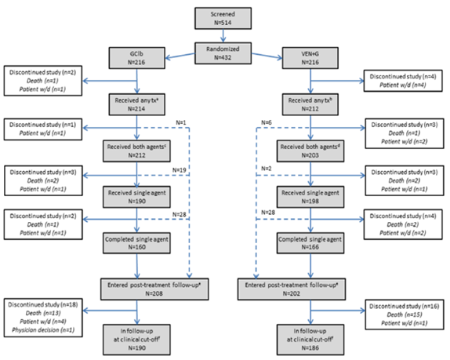
Clb = chlorambucil, G = obintutzumab, VEN = venetoclax, w/d = withdrawal.
ª Obinutuzumab or chlorambucil, although obinutuzumab administered first per protocol.
^{b} Obinutuzumab or venetoclax, although venetoclax not scheduled until Day 22 of Cycle 1.
^{c} Obinutuzumab and chlorambucil.
^{d} Obinutuzumab and venetoclax.
^{e} all patients who received treatment and did not discontinue the study within 30 days of last exposure were considered as having entered post-treatment follow-up.
^{f} Date of clinical cut-off: 17 August 2018.
Dashed lines indicate flow of patients who discontinued one or both components of treatment and subsequently entered post-treatment follow-up.
(Note: 12 patients in the GClb arm and 6 in the VEN + G arm did not have a Treatment Completion Page in the eCRF but from the treatment duration were considered to have completed treatment.)
Baseline characteristics were considered by the evaluator to be consistent with first line presentations for CLL.
Table 3: Study CLL14 Baseline disease characteristics of enrolled patients
 | GClb  N = 216 | VEN + G  N = 216 | All Patients  N = 432
Time from first diagnosis (years)  Median (range) | 2.4 (0-20.4) | 2.6 (0-18) | 2.5 (0-20.4)
≥ 6 years from first diagnosis | 43(20%) | 44 (20.4%) | 87 (20.2%)
Binet stage at screening;  Stage A  Stage B  Stage C | 44  80  92 | 46  77  93 | 90  157  185
ECOG score  0-1  ≥ 2 | 190  25 | 188  28 | 378  53
Any B symptoms (fever, weight loss, night sweats) | 112 (51.9%) | 103 (47.7%) | 215 (49.8%)
TP53 mutation | 19 (8.8%) | 23 (10.6%) | 42 (9.7%)
Mutated IGHV | 83 (38.4%) | 76 (35.2%) | 159 (36.8%)
Non-mutated IGHV | 123 (56.9%) | 121(56.0%) | 244 (56.5%)
Absolute lymphocyte count at baseline (g/L)  Median  (range) | 57.7  (0.8-528) | 55.9  (0.6-103270) | 56.7  (0.6-103270)
Cumulative Illness Rating Scale (CIRS) category  Median (range)  ≤ 6  > 6  Number of organ systems with score ≥ 2 per patient  Median (range) | 8 (1-28)  39 (18.1%)  177 (82%)  3 (0-7) | 9 (0-23)  30 (13.9%)  186 (86%)  3 (0-8) | 8 (0-28)  69 (16.0%)  363 (84%)  3 (0-8)
Creatinine clearance (Cockcroft Gault Formula)  < 70mL/min  ≥ 70mL/min | 118 (55.4%)  95 (44.6%) | 128 (59.5%)  87 (40.5%) | 246 (57.5%)  182 (42.5%)
Reason(s) for initiating treatment  Binet stage C  Severe B symptoms*  Massive lymphadenopathy/splenomegaly*  Short lymphocyte doubling time (< 6 months)*  Other*  * Binet stage A or B only | 92 (42.6%)  72 (58.1%)  49 (39.5%)  29 (23.4%)  20 (16.1%) | 93 (43.1%)  61 (49.6%)  50 (40.7%)  30 (24.4%)  19 (15.4%) | 185 (42.8%)  133 (53.8%)  99 (40.1%)  59 (23.9%)  39 (15.8%)
ECOG = Eastern Cooperative Oncology Group, GClb = obinutuzumab + chlorambucil, IGHV = immunoglobulin heavy chain variable region.

Results
The results of the primary analysis indicated an improvement in PFS for patients treated with venetoclax + obinutuzumab compared to those treated with obinutuzumab + chlorambucil.
Table 4: Study CLL14 Primary endpoint results
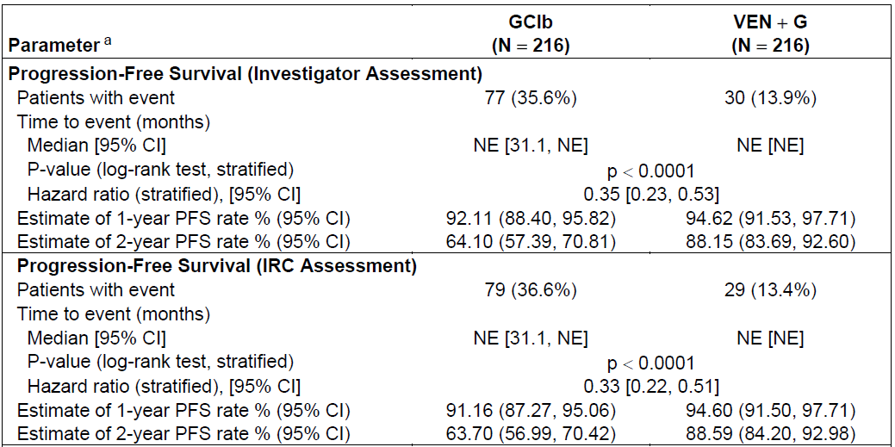
ª The overall type 1 error rate at a pre-specified 2-sided level alpha = 0.05 was controlled for all endpoints in this table.
Figure 2: Study CLL14 Kaplan Meier plot of time to progression free survival event
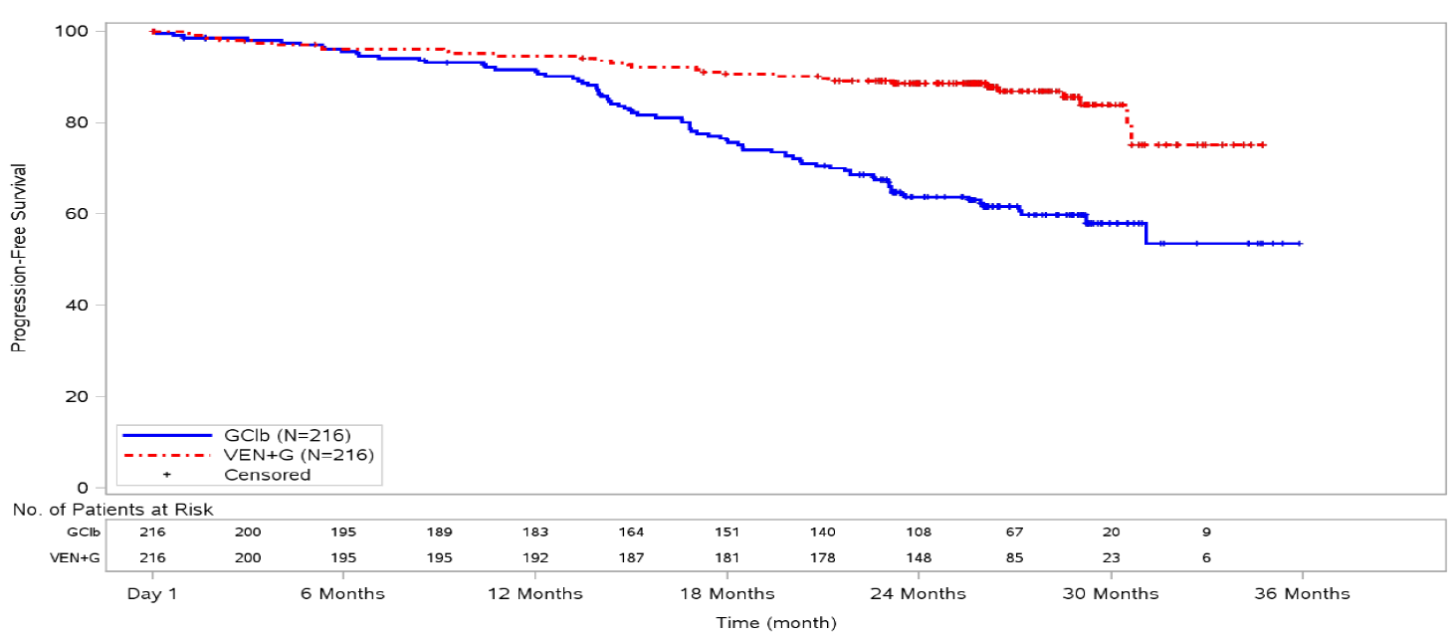
The clinical evaluator has noted that the PFS for the two treatments was the same for the first six-months of therapy, and only began to diverge over the 12 to 15 month period.
The sponsor has noted that ‘The results demonstrate that response to treatment is very effective from the start of the study and continues after stopping therapy in the venetoclax + obinutuzumab arm, rather than representing a slow response to treatment’.
It has noted that the divergence in the curves is better explained by reduced duration of response once chlorambucil was ceased in the comparator arm.
Figure 3: Study CLL14 Time to progression free survival events
IRC = Independent Review Committee.
The Delegate notes that there the difference in the two arms becomes significantly greater in the later part of the study, after chlorambucil is discontinued in the comparator arm, and remains fairly constant in the venetoclax treated arm.
The clinical evaluator has noted significantly higher rates of haematological response to venetoclax + obinutuzumab therapy than obinutuzumab + chlorambucil therapy at the end of treatment.
Table 5: Study CLL14 Rates of peripheral blood and bone marrow response at the end of study treatment
All Patients
 | GClb  (N = 216) | VEN + G  (N = 216)
Peripheral blood MRD negative | 76 (35.2%) | 163 (75.5%)
Bone marrow MRD negative | 37 (17.1%) | 123 (56.9%)
Patients achieving CRi per investigator at EOT
 | GClb  (N = 50) | VEN + G  (N = 107)
Peripheral blood MRD negative in CR/CRi patients | 31 (62%) | 91 (85%)
Bone marrow MRD negative in CR/CRi patients | 23 (46%) | 73 (68.2%)
CR = complete response, CRi = complete response with incomplete bone marrow recovery, EOT = end of treatment, MRD = minimal residual disease.
Supplemental efficacy was provided by Study GP28331, which was a Phase Ib open label uncontrolled study in which escalating doses of venetoclax+obinutuzumab were administered to patients with either relapsed or refractory (R/R) CLL (n = 43) or untreated CLL (n = 32).
The evaluator has noted that this was the only efficacy data provided in ‘fit’ patients who might otherwise be suitable for chemoimmunotherapy. This was provided in a post-hoc analysis of 22 such fit patients. Of these, 16 were assessed by investigators as having a complete response (72.7%) and 6 were assessed as having a partial response (27.3%). All 22 had progression free survival at 12 months.
Of these patients, 7 ceased venetoclax prior to 12 months, 7 at about 52 weeks and 8 for longer than 12 months. The median duration of venetoclax treatment was about 14 months.
The overall survival for the two arms is virtually identical with 12.5% of the population dying over the 48 months of observation.

Safety
Table 6: Exposure to venetoclax in submitted studies
Treatment milestone | Number of patients
Assigned to VEN + G treatment | 216
Received G | 212
Received VEN + G | 203
Completed VEN + G combinationª | 159
Started VEN single agent^{b} | 198
Completed VEN single agent^{c} | 166
ª Combination treatment completion derived from the Treatment Completion Page of the eCRF
^{b} Patients could start VEN single-agent treatment without completing VEN + G combination if they discontinued G only.
^{c} Treatment completion derived from Treatment Completion Page of the eCRF. Note, however, that 6 patients did not have a Treatment Completion Page at end of single-agent treatment but from the treatment duration were considered to have completed treatment.
Figure 4: Study CLL Overall incidence of adverse events and adverse events with an incidence rate of ≥ 10% in any treatment group
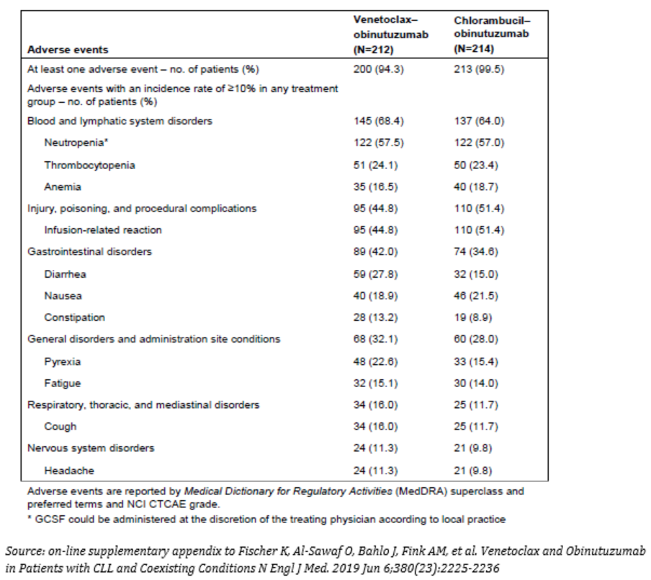
The clinical evaluator has noted that the rate of serious infections was higher in the venetoclax + obinutuzumab arm than the obinutuzumab + chlorambucil arm, being 19.3% versus 16.4% respectively. In the second round of evaluation, the evaluator remained concerned that an increase in susceptibility to serious infection could not be excluded on venetoclax + obinutuzumab therapy. They have noted that the sponsor has proposed inserting the following warning into the PI:
‘Venclexta in combination with obinutuzumab:
There were 56 events of serious infection, including 8 with fatal outcome, in 40/212 patients in patients treated with venetoclax + obinutuzumab compared to 44 serious infection events, including 3 with fatal outcome, in 30/214 patients treated with chlorambucil + obinutuzumab. Of the 52/56 serious events in the patients treated with venetoclax + obinutuzumab for which neutrophil counts at the time of onset of the serious infection were available, 8/52 events occurred in the setting of neutropenia. Some serious infections occurred some time after completion of venetoclax treatment.’
Overall, the adverse event profile observed in the pivotal trial was consistent with the known toxicities of both venetoclax and obinutuzumab.

Risk management plan
There was no requirement for a risk management plan evaluation for a submission of this type, because it is considered that the proposed target population does not differ materially from the previously approved target population from the risk management plan (RMP) perspective.

Risk-benefit analysis

Delegate’s considerations

Efficacy
The Delegate agrees with the sponsor that the PFS data does not suggest a delayed onset of effect. The risk of an event, such as disease progression, occurring in a Kaplan Meier (KM) curve is defined by gradient of its KM plot. The difference between two therapies is defined by the difference in their gradients, not the separation between the two respective KM curves. The gradient for the venetoclax + obinutuzumab arm of the pivotal trial remains fairly constant over the period of observation.
The separation in the KM plots between the venetoclax + obinutuzumab and obinutuzumab + chlorambucil arms appears entirely due to worsening prognosis in obinutuzumab + chlorambucil patients once chlorambucil is ceased. While this does not specifically inform the efficacy of venetoclax + obinutuzumab, it does indicate that obinutuzumab + chlorambucil appears almost equally effective to venetoclax + obinutuzumab. The effect of obinutuzumab + chlorambucil cannot be inferred from its efficacy at the end of the observation period since it is fairly obvious that the risk of progression in the obinutuzumab arm differs significantly over that time, that is, the hazards are not proportional over that time.
The Delegate notes that this similarity does potentially inform the sponsor’s proposal to have an ‘unqualified’ first line therapy indication for venetoclax.

Serious infection
The Delegate notes that amendments have been made to the Australia Venclexta PI since evaluation of this application was completed. It contains the statement, under Special Warnings:
‘Serious infection
Serious infections, including events of sepsis and events with fatal outcome, have been reported in patients treated with Venclexta (see Section 4.8 Adverse Effects). Monitor patients for fever and any symptoms of infection and treat promptly. Interrupt dosing as appropriate.’
The Delegate considers serious infection to be a potential adverse outcome with venetoclax therapy regardless of its combination with obinutuzumab and, as such, the main issue is whether this is exacerbated in combination therapy with obinutuzumab.
The sponsor has proposed to include a warning regarding infection rate in venetoclax and obinutuzumab combination therapy, and the Delegate considers this appropriate.

Indication
The sponsor has proposed to change the CLL indication for Venclexta to:
Venclexta is indicated for the treatment of patients with chronic lymphocytic leukaemia (CLL) or small lymphocytic lymphoma (SLL).
The clinical evaluator has recommended against this and proposed that the indication should be:
Venclexta in combination with obinutuzumab is indicated for the treatment of adult patients with previously untreated chronic lymphocytic leukaemia (CLL) who have co-morbidities (Clinical Trials).
The clinical evaluator has noted that there is uncertainty about the duration of response, survival benefit and role in patients with different risk profiles.
The Delegate notes that the amendment proposed by the clinical evaluator is consistent with the population in the pivotal efficacy trial for venetoclax + obinutuzumab. The Delegate has concluded there is far too little data in ‘fit’ patients to recommend venetoclax + obinutuzumab in patients who may be suitable for chemo-immunotherapy because, in addition to the issues raised by the clinical evaluator:
- There is no data provided in this population other than a post-hoc analysis in a small supportive trial.
- There is no comparison of efficacy in venetoclax + obinutuzumab with optimal management of patients who are suitable for chemoimmunotherapy.
The Delegate has concluded that the indication for first line therapy should specify the venetoclax + obinutuzumab combination because:
- This is the regimen examined in the pivotal efficacy trial.
- The indication proposed by the sponsor would include, or may incorrectly imply, venetoclax monotherapy for first-line CLL therapy.
- The findings of the venetoclax + obinutuzumab arm of the pivotal trial are immature with respect to long-term efficacy and not sufficient to recommend a general venetoclax + an x drug combination for first line CLL management.

Proposed action
The Delegate is currently minded to register an additional indication for Venclexta worded as:
Venclexta in combination with obinutuzumab is indicated for the treatment of adult patients with previously untreated chronic lymphocytic leukaemia (CLL) who have co-morbidities (Clinical Trials).
This proposed action is dependent on provision of an acceptable Australian PI with inclusion of amendments proposed by the clinical and nonclinical evaluators.

Request for Advisory Committee on Medicines advice
The proposed indication is:
Venclexta is indicated for the treatment of patients with chronic lymphocytic leukaemia (CLL) or small lymphocytic lymphoma (SLL).
The advice of the ACM is requested on whether an alternate wording of the indication would be considered more appropriate.

Advisory Committee considerations
The Advisory Committee on Medicines (ACM), having considered the evaluations and the Delegate’s overview, as well as the sponsor’s response to these documents, advised the following.
The ACM did not support the indication proposed by the sponsor due to a lack of evidence to support the proposed indication, and instead recommended the following alternative wording:
Venclexta in combination with obinutuzumab is indicated for the treatment of patients with CLL or SLL who are considered unfit or unsuitable for chemo-immunotherapy.

Outcome
Based on a review of quality, safety and efficacy, the TGA approved the registration of the presentations below:
- Venclexta (venetoclax) 10 mg film coated tablet blister pack
- Venclexta (venetoclax) 50 mg film coated tablet blister pack
- Venclexta (venetoclax) 100 mg film coated tablet blister pack
- Venclexta (venetoclax) 100 mg film coated tablet bottle
- Venclexta Starting Pack (venetoclax) 10 mg, 50 mg, 100 mg film coated tablets blister pack
for the following extension of indications:
Chronic Lymphocytic Leukaemia /Small Lymphocytic Lymphoma
Venclexta in combination with obinutuzumab is indicated for the treatment of patients with chronic lymphocytic leukaemia (CLL) or small lymphocytic lymphoma (SLL) who are considered unfit or unsuitable for chemo-immunotherapy.
As such, the full indications at this time were:
Acute Myeloid Leukaemia
Venclexta, as part of combination therapy, is indicated for the treatment of newly diagnosed adult patients with Acute Myeloid Leukaemia (AML) who are ineligible for intensive chemotherapy.
This medicine has provisional approval in Australia for the treatment of newly diagnosed patients with AML who are ineligible for intensive chemotherapy. The decision to approve this indication has been made on the basis of interim data (overall response rate and duration of response). Continued approval of this indication depends on verification and description of benefit in confirmatory trials.
Chronic Lymphocytic Leukaemia/Small Lymphocytic Lymphoma
Venclexta in combination with obinutuzumab is indicated for the treatment of patients with chronic lymphocytic leukaemia (CLL) or small lymphocytic lymphoma (SLL) who are considered unfit or unsuitable for chemo-immunotherapy.
Venclexta in combination with rituximab is indicated for the treatment of adult patients with chronic lymphocytic leukaemia (CLL) who have received at least one prior therapy. Venclexta monotherapy is indicated for the treatment of:
- patients with relapsed or refractory CLL with 17p deletion, or
- patients with relapsed or refractory CLL for whom there are no other suitable treatment options.

Specific conditions of registration applying to these goods
- Venclexta (venetoclax) is to be included in the Black Triangle Scheme. The PI and CMI for Venclexta must include the black triangle symbol and mandatory accompanying text for five years, which starts from the date the new indication is registered.
- This approval does not impose any requirement for the submission of Periodic Safety Update Reports (PSURs). The sponsor should note that it is a requirement that all existing requirements for the submission of PSURs as a consequence of the initial registration or subsequent changes must be completed.

Attachment 1. Product Information
The PI for Venclexta approved with the submission which is described in this AusPAR is at Attachment 1. For the most recent PI, please refer to the TGA website at <https://www.tga.gov.au/product-information-pi>.

Therapeutic Goods Administration
PO Box 100 Woden ACT 2606 Australia
Email: info@tga.gov.au Phone: 1800 020 653 Fax: 02 6232 8605
https://www.tga.gov.au

The Black Triangle Scheme provides a simple means for practitioners and patients to identify certain types of new prescription medicines, including those being used in new ways and to encourage the reporting of adverse events associated with their use. The Black Triangle does not denote that there are known safety problems, just that the TGA is encouraging adverse event reporting to help us build up the full picture of a medicine's safety profile.
Cancer Australia CLL Statistics. Accessed May 2019 at https://canceraustralia.gov.au/affected-cancer/cancer-types/leukaemia/chronic-lymphocytic-leukaemia-statistics
Swerdlow, S.H. et al. The 2016 revision of the World Health Organization classification of lymphoid neoplasms, Blood, 2016; 127 (20): 2375-2390.
As part of the provisional approval pathway, the provisional registration process will allow certain medicines to be provisionally registered in the Australian Register of Therapeutic Goods (ARTG) for a limited duration. These medicines are registered on the basis of preliminary clinical data, where there is the potential for a substantial benefit to Australian patients. The TGA will re-assess risks related to the absence of evidence through data provided at a later stage, as part of the confirmatory data. Confirmatory data should confirm the relationship between outcomes predicted by the surrogate endpoint, or other preliminary data, and the clinical benefit as demonstrated by direct clinical outcomes. The sponsor may apply to transition to full registration at any time up until the provisional registration lapse date, once they have completed the obligations outlined for the provisional registration period and complete confirmatory data on safety and efficacy are available.
Note: Submissions PM-2018-05208-1-6 and PM-2019-04393-1-6 related to the extension of AML indication application listed above were received for this indication on 31 January 2019 (approved on 28 January 2020 and 5 February respectively); evaluation of these separate submissions were ongoing concurrently when the dossier for Submission PM-2019-01001-1-6 (as discussed in this AusPAR) was accepted and the first round evaluation commenced (30 April 2019). Further details of the submissions can be found in the relevant AusPAR for these submissions at https://www.tga.gov.au/auspar/auspar-venetoclax-0
Study CLL14; title: A Study to Compare the Efficacy and Safety of Obinutuzumab + Venetoclax (GDC-0199) Versus Obinutuzumab + Chlorambucil in Participants With Chronic Lymphocytic Leukemia. NCT identifier: NCT02242942; EudraCT Number: 2014-001810-24; also known as Study BO25323.
Study GP28331; title: A Study of Venetoclax in Combination With Obinutuzumab in Participants With Chronic Lymphocytic Leukemia. NCT Identifier: NCT01685892; EudraCT Number: 2012-002038-34.
The Cumulative Illness Rating Scale (CIRS) is a comorbidity scale that is used to assess physical and psychiatric impairment. Various body systems (for example cardiac, vascular and renal) are rated from 0 (no problem affecting that system) to 4 (extremely severe problem affecting that system) and the scores are tallied.
The Binet stage system is used to classify CLL based on the number of affected lymphoid tissues, presence of anaemia and presence of thrombocytopenia. There are 3 stages: Stage A: Less than 3 areas of lymphoid tissue are enlarged. No anaemia or thrombocytopenia is present. Stage B: 3 or more areas of lymphoid tissue are enlarged. No anaemia or thrombocytopenia is present. Stage C: Anaemia and/or thrombocytopenia are present. Any number of lymphoid tissue areas may be enlarged.
Online supplement to: Fischer K, Al‐Sawaf O, Bahlo J, et al. Venetoclax and obinutuzumab in patients with CLL and coexisting conditions. N Engl J Med, 2019; 380: 2225‐2236.
The ACM provides independent medical and scientific advice to the Minister for Health and the Therapeutic Goods Administration (TGA) on issues relating to the safety, quality and efficacy of medicines supplied in Australia including issues relating to pre-market and post-market functions for medicines. The Committee is established under Regulation 35 of the Therapeutic Goods Regulations 1990. Members are appointed by the Minister. The ACM was established in January 2017 replacing Advisory Committee on Prescription Medicines (ACPM) which was formed in January 2010. ACM encompass pre and post-market advice for medicines, following the consolidation of the previous functions of the Advisory Committee on Prescription Medicines (ACPM), the Advisory Committee on the Safety of Medicines (ACSOM) and the Advisory Committee on Non-Prescription Medicines (ACNM). Membership comprises of professionals with specific scientific, medical or clinical expertise, as well as appropriate consumer health issues relating to medicines.

