Date of CER: 10 April 2012

AusPAR Attachment 2

Extract from the Clinical Evaluation Report for vandetanib
  - Proprietary Product Name: Caprelsa
  - Sponsor: AstraZeneca Pty Ltd
About the Therapeutic Goods Administration (TGA)
- The Therapeutic Goods Administration (TGA) is part of the Australian Government Department of Health and Ageing, and is responsible for regulating medicines and medical devices.
- The TGA administers the Therapeutic Goods Act 1989 (the Act), applying a risk management approach designed to ensure therapeutic goods supplied in Australia meet acceptable standards of quality, safety and efficacy (performance), when necessary.
- The work of the TGA is based on applying scientific and clinical expertise to decision-making, to ensure that the benefits to consumers outweigh any risks associated with the use of medicines and medical devices.
- The TGA relies on the public, healthcare professionals and industry to report problems with medicines or medical devices. TGA investigates reports received by it to determine any necessary regulatory action.
- To report a problem with a medicine or medical device, please see the information on the TGA website <http://www.tga.gov.au>.
About the Extract from the Clinical Evaluation Report
- This document provides a more detailed evaluation of the clinical findings, extracted from the Clinical Evaluation Report (CER) prepared by the TGA. This extract does not include sections from the CER regarding product documentation or post market activities.
- The words [Information redacted], where they appear in this document, indicate that confidential information has been deleted.
- For the most recent Product Information (PI), please refer to the TGA website <http://www.tga.gov.au/hp/information-medicines-pi.htm>.
Copyright
© Commonwealth of Australia 2013
This work is copyright. You may reproduce the whole or part of this work in unaltered form for your own personal use or, if you are part of an organisation, for internal use within your organisation, but only if you or your organisation do not use the reproduction for any commercial purpose and retain this copyright notice and all disclaimer notices as part of that reproduction. Apart from rights to use as permitted by the Copyright Act 1968 or allowed by this copyright notice, all other rights are reserved and you are not allowed to reproduce the whole or any part of this work in any way (electronic or otherwise) without first being given specific written permission from the Commonwealth to do so. Requests and inquiries concerning reproduction and rights are to be sent to the TGA Copyright Officer, Therapeutic Goods Administration, PO Box 100, Woden ACT 2606 or emailed to <tga.copyright@tga.gov.au>.

Contents
List of abbreviations 5
1. Clinical rationale 9
2. Contents of the clinical dossier 9
2.1. Scope of the clinical dossier 9
2.2. Paediatric data 10
2.3. Good clinical practice 10
3. Pharmacokinetics 10
3.1. Studies providing pharmacokinetic data 10
3.2. Physicochemical characteristics of the active substance 11
3.3. Evaluator’s overall conclusions on pharmacokinetics 41
4. Pharmacodynamics 44
4.1. Studies providing pharmacodynamic data 44
4.2. PK/PD data – population-pk analysis (Study 58) 44
4.3. PD effect on cardiac-repolarisation (Study 21) 46
4.4. Effect on vascular permeability (Study 50) 47
4.5. Summary of pharmacodynamics 49
5. Dosage selection for the pivotal studies 49
6. Clinical efficacy 50
6.1. Pivotal efficacy study (Study 58) 50
7. Clinical safety 77
7.1. Studies providing evaluable safety data 77
7.2. Exposure – pooled monotherapy 300 mg 77
7.3. Pivotal study 58 – Safety data 78
7.4. Phase II studies in patients with hereditary MTC 104
7.5. Study 68 (vandetanib 100 mg) 105
7.6. Pooled vandetanib 300 mg monotherapy studies 106
7.7. Evaluator’s overall conclusions on clinical safety 107
8. First round benefit-risk assessment 113
8.1. First round assessment of benefits 113
8.2. First round assessment of risks 114
8.3. First round assessment of benefit-risk balance 116
9. First round recommendation regarding authorisation 116
10. Clinical questions 116
10.1. Efficacy 116
10.2. Safety 116
11. References 117

List of abbreviations
Abbreviation | Meaning
AE | Adverse event
ALT | Alanine aminotransferase
ALP | Alkaline phosphatase
APTT | Activated partial thromboplastin time
ARMS | Amplification refractory mutation system
AST | Aspartate aminotransferase
AUCss | Area under plasma concentration-time curve during any dosing interval at steady state
bFGF | Basic fibroblast growth factor
BOR | Best objective response
BPI | Brief Pain Inventory
CEA | Carcinoembryonic antigen
CER | Clinical Evaluation Report
CI | Confidence interval
CL/F | Total body clearance of drug from plasma after an oral dose
CR | Complete response (RECIST)
CRF | Case report form
CSP | Clinical study protocol
CSR | Clinical study report
Css,max | Maximum steady state plasma concentration
CT | Computerised tomography
CTCAE | Common terminology criteria for adverse events (National Institutes of Health, National Cancer Institute, Version 3.0)
CTN | Calcitonin
DCR | Disease control rate
DOR | Duration of response
ECG | Electrocardiogram
EGFR | Epidermal growth factor receptor
EWB | Emotional well-being
FACT-G | Functional Assessment of Cancer Therapy - General
FMTC | Familial Medullary Thyroid Carcinoma
FWB | Functional well-being
GCP | Good Clinical Practice
GI | Gastrointestinal
HR | Hazard ratio
IC₅₀ | Concentration at which 50% of the activity is inhibited
ICH | International Conference on Harmonisation
IEC | Independent Ethics Committee
ITT | Intention-to-treat
IRB | Institutional Review Board
LD | Longest diameter (of tumour measurement)
MAPK | Mitogen-activated protein kinase
MedDRA | Medical Dictionary for Regulatory Activities
MEN | Multiple Endocrine Neoplasia
MRI | Magnetic resonance imaging
MTC | Medullary thyroid carcinoma
NE | Not evaluable
NYHA | New York Heart Association
OR | Odds ratio
ORR | Objective response rate
OS | Overall survival
PD | Pharmacodynamic(s)
PFS | Progression-free survival
PK | Pharmacokinetic(s)
PP | Per protocol
PR | Partial response
PRO | Patient reported outcome
PT | Preferred term
PWB | Physical well-being
QoL | Quality of life
QT (QTc) | Cardiology: time interval between the start of the Q wave and the end of the T wave, (corrected for heart rate) (note: may be further differentiated as QTcB or QTcF depending on whether it is Bazett’s or Fridericia’s correction)
RECIST | Response Evaluation in Solid Tumours
RET | Rearranged during transfection (proto-oncogene)
SAE | Serious adverse event
SAP | Statistical Analysis Plan
SD | Stable disease
t_{1/2} | Elimination half-life
Tmax | Time to reach maximum plasma concentration following drug administration
TKI | Tyrosine kinase inhibitor
TSH | Thyroid stimulating hormone
TWP | Time to worsening of pain
ULN | Upper limit of reference range
VEGF | Vascular endothelial growth factor
VEGFR | Vascular endothelial growth factor receptor
VEGFR-2 | Vascular endothelial growth factor receptor-2
Vss/F | Volume of distribution at steady state after an oral dose
WHO PS | World Health Organisation performance status
ZD6474 | vandetanib

Clinical rationale
The Clinical Overview included a clinical rationale for the development of vandetanib based on the absence of effective or approved therapies for the treatment of patients with MTC who present with either surgically unresectable locally advanced disease or distant metastases, and the poor prognosis of the condition.
Comment: The sponsor’s clinical rationale for the development of vandetanib for the treatment of MTC is acceptable. Carcinoma of the thyroid is the most common malignancy of the endocrine system (Harrison’s, 16th Edition, 2005). Most cases of thyroid cancer (85%-95%) are well-differentiated tumours (papillary or follicular). Less common types of thyroid cancer include medullary (5%-10%) and anaplastic (5%), both of which carry a worse prognosis (Mackenzie and Mortimer, 2004). MTC arises from the calcitonin producing parafollicular C-cells of the thyroid, and elevated serum calcitonin provides a marker of disease burden.
MTC presents either as a sporadic cancer (75% of cases), or as part of a hereditary syndrome (25%) as Multiple Endocrine Neoplasia (MEN) type 2a, MEN type 2b, or Familial Medullary Thyroid Carcinoma (FMTC). Each of these syndromes is inherited as an autosomal dominant trait, and each is characterised by a distinct clinical genotype and phenotype. The hereditary form of MTC is characterised by complete penetrance as virtually all patients develop MTC, but variable expressivity as only 50% of patients with MEN2a and MEN2b develop phaeochromocytoma and 30% of patients with MEN2a develop parathyroid hyperplasia. Mutations within the coding region of the RET proto-oncogene have been found to be associated with the MEN2a, FMTC and sporadic forms of MTC (Donis-Keller et al., 2003; Mulligan et al., 1993; Hofstra et al., 1994). The RET proto-oncogene encodes a tyrosine kinase receptor that plays a major role in MTC. Significant overexpression of VEGFR2 and EGFR has also been found to be present in metastatic MTC tissues (Rodriguez-Antona et al, 2010). Vandetanib is selective inhibitor of VEGF, EGFR tyrosine kinase and oncogenic RET kinase.
The prognosis of MTC is generally favourable if the disease is treated at an early stage (86% and 78% at 5 years and 10 years, respectively), but patients with distant metastases have 5-year survival of only approximately 36% (Mackenzie and Mortimer, 2005). Patients with the hereditary form of the disease generally have a better prognosis than patients with the sporadic form. However, no differences in survival are seen if patients are matched for age and disease stage, suggesting that patients with sporadic disease may be diagnosed later with more advanced disease (Orlandi et al 2001). Patients with MTC can be cured only by thyroidectomy, performed when the tumour is confined to the thyroid gland, and metastatic disease is the most common cause of death. In patients with distant metastases the tumour is relatively unresponsive to conventional doses of radiation therapy and to chemotherapeutic regimens. Treatment options with cytotoxic chemotherapy or radiotherapy for patients with unresectable or metastatic MTC have been minimally effective (Solomon and Rischin, 2012).

Contents of the clinical dossier

Scope of the clinical dossier
The submission contained the following clinical information:
- 15 clinical pharmacology studies, including 13 that provided pharmacokinetic data and 2 that provided pharmacodynamic data.
- 7 population pharmacokinetic analyses.
- 1 pivotal Phase III efficacy/safety study in patients with MTC.
- 2 Phase II efficacy/safety studies in patients with MTC.
- 15 other Phase II/III efficacy/safety studies in patients with cancers other than MTC.

Paediatric data
The submission did not include paediatric data.

Good clinical practice
All studies undertaken by the sponsor complied with the principles of good clinical practice.

Pharmacokinetics

Studies providing pharmacokinetic data

Overview of the studies
The submission included pharmacokinetic data from 13 clinical pharmacology studies (8 studies in volunteers; 5 studies in patients with malignant disease), and 7 population pharmacokinetic studies in patients with malignant disease.

Statistical methods
The individual PK studies were conventional in design and employed standard non-compartmental statistical methods based on the plasma concentration – time profile to determine the standard range of PK parameters. Vandetanib has a long-half (estimated to be about 19 days in patients with MTC), and plasma sampling was extended to include at least 5 half-lives in the key PK studies. Consequently, extended duration of sampling allowed for the terminal phase of the vandetanib plasma concentration – time curve to be adequately defined. The population-pk analyses used the Nonlinear Mixed Effects modelling program NONMEM (V1.1), and complementary standard software packages for analysis of the data. The statistical methods for the population-pk analyses were fully described and the reporting of the results complied with the relevant TGA adopted guideline (Guidelines on reporting the results of population pharmacokinetic analyses [CHMP/EWP/185990/06]).

Assay methods
All assays used to analyse vandetanib in plasma employed liquid chromatography tandem mass spectrometry (LC-MS/MS). Validated assays were also used to support analyses of vandetanib metabolites and co-administered drugs.
Comment: Relevant PK data from the 8, single-dose studies (12, 14, 16, 22, 24, 25, 26, 30) have been included in the body of the text of the CER, and brief synopses of these studies have been provided. PK data from the 8 single-dose studies (HV, V [hepatic / renal impairment]) have been supplemented by PK data from single and multiple dose studies (studies 01, 04, 43) and descriptive PK interaction data (studies 06, 38) from patients with malignant tumours. Relevant data from the studies in patients with malignant tumours have been included in the body of the text of the CER, and supplementary Tables and/or Figures have been provided.
The pivotal population-pk analysis is derived from data from the pivotal Phase III efficacy and safety study (study 58). This population-pk analysis is reviewed and discussed below. Data from the other 6 population-pk analyses have been examined, but are considered not to add to that from the pivotal population-pk analysis (study 58). Consequently, the PK data from these additional population-pk studies have not been included in the CER.

Biomaterial studies
In vitro studies were performed to determine protein binding, identification of metabolites, identification of enzymes responsible for metabolism, potential for drug-drug interactions through CYP inhibition and induction and whether vandetanib was a substrate/inhibitor of specific transporters. Relevant information from the biomaterial studies has been included in the text of the body of the CER.

Physicochemical characteristics of the active substance
The following information is derived from the relevant Module 2 summaries. The systematic chemical name (IUPAC) of vandetanib is N-(4-bromo-2-fluorophenyl)-6-methoxy-7-[(1-methylpiperidin-4-yl)methoxy]quinazolin-4-amine. The molecular formula is C₂₂H₂₄BrFN₄O₂ and the molecular weight is 475.36 g/mol. The drug is achiral and the structural formula is provided below in Figure 1.
Figure 1: Vandetanib structural formula.
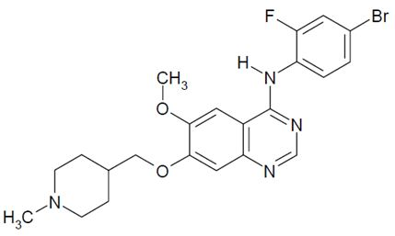
Vandetanib is a powder and the solubility and permeability data indicate that based on Biopharmaceutical Classification System (BCS) criteria it is a Class II compound (i.e., low solubility, high permeability). Dissolution is the rate limiting step to drug absorption for BCS Class II compounds and factors that influence dissolution have the potential to affect the bioavailability of such compounds. The drug exhibits pH dependent aqueous solubility with increased solubility at low pH. The molecule has two pKa values, 5.2 (for the aminoquinazolone moiety) and 9.4 (for the piperidine moiety). The partition coefficient assessed by Log P (n-octanol/water) is 4.7 at pH 11. Two potential morphological forms can be accessed from the final purification process; Form 1 is an anhydrous crystalline material and Form 4 is a monohydrate crystalline material. The purification process has been designed such that only Form 1 can be produced and this has been demonstrated in all batches manufactured throughout development. Vandetanib is not hygroscopic and the melting point is approximately 235°C.

Pharmacokinetics in healthy subjects and in subjects with cancer

Absorption
In healthy volunteers, the absorption of vandetanib following single oral doses (300 to 1200 mg) was relatively slow with the median t_{max} for all doses being 6 hours and the range being from 4 to 10 hours (study 12). The median t_{max} of the commercial vandetanib tablet (300 mg) was 8 hours (range: 6 to 18 hours) following administration of a single dose to 10 healthy volunteers (study 30).
In the population-pk analysis in patients (n=231) with MTC from the pivotal study (study 58), vandetanib pharmacokinetics were reasonably described by a two compartment model with first order absorption and first order distribution and elimination. However, due to the sparsity of the data the first order absorption rate constant could not be reliably estimated and following preliminary analysis it was fixed to the previously estimated value of 0.3 hr⁻¹ obtained from fitting a two-compartment model to data from healthy volunteers.
Individual simulations obtained from the final population-pk model for patients (n=191) with MTC from the pivotal study (study 58) dosed to steady state (day 56) with vandetanib 300 mg daily provided estimates for PK parameters. These estimated mean (SD) PK parameters included an accumulation ratio of 8.05 (3.10) ng/mL, a C_{max} at 4 hours post-dose of 857 (259) ng/mL, a trough concentration of 795 (248) ng/mL, and steady state exposure of 19829 (6066) ng.h/mL. The corresponding results from this study based on all patients (n=230) treated with vandetanib (100 mg, 200 mg, and 300 mg) in the pivotal study were accumulation ratio 7.70 (3.31), C_{max} 810 (293) ng/mL, trough concentration 754 (276) ng/mL, steady state exposure 18782 (6842) ng.h/mL.
In the population-pk analysis of pooled data from 4 studies in patients with cancer (01, 02, 03, 04) and 5 clinical pharmacology studies in healthy volunteers (12, 15, 21, 24, 30), no differences were identified between patients and volunteers for the predicted C_{max}, the estimated T_{max}, the relative percentage of drug absorbed over time or the apparent clearance. In this analysis, most subjects reached 100% of the drug absorbed by 6 to 9 hours after administration. The results suggest that the PKs of vandetanib in volunteers are linear after single doses between 300 mg and 1200 mg with clearance being relatively constant (mean CL/F ranged from 10.5 L/h for 700 mg to 13.0 L/h for 400 mg and 800 mg). The data also suggest that the mean apparent oral clearance in healthy volunteers (n=110) is approximately 11.1 (0.29) L/h and the volume of distribution at steady is approximately 3200 L, and these figures are similar to those from the population-pk analysis in patients with MTC (study 58).

Bioavailability

Absolute bioavailability
The submission did not include an absolute bioavailability study, and the sponsor provided a justification for not providing such a study. The sponsor stated that it had not been possible to produce an IV formulation of vandetanib because of “tolerability considerations”. The sponsor referred to a 14 day toxicity study in dogs in which an IV formulation caused inflammation at the infusion site at all dose levels from 2.5 mg/kg/day to 16.5 mg/kg/day, and a No Adverse Effect Level (NOAEL) was not identified. In a separate study in dogs, one animal experienced severe inflammation associated with IV infusion of vandetanib thought to have been due to extravasation of the solution into the surrounding tissues. The sponsor considered that the administration of an IV solution to healthy volunteers would carry an unacceptable risk of local infusion site inflammation reactions due to the requirement for slow infusions because of concerns relating to QT interval prolongation.
Comment: The sponsor’s justification for not conducting an absolute bioavailability study is considered to be acceptable.

Bioavailability relative to an oral solution or micronised suspension
Study 30: The submission include one study (study 30) in health volunteers investigating the relative oral bioavailability of four oral tablet formulations (300 mg) with an oral solution (300 mg) following single dosing. One of the oral tablet formulations in this study (Tablet A) is the formulation proposed for commercial production. The bioavailability of this tablet was ~ 20% greater than that of the oral solution based on the AUC_{0-inf}, and ~ 8% greater based on the C_{max}.
Design: Study 30 was a single-centre (USA), Phase I, randomised, open-label, incomplete cross-over study designed to assess the PKs of four oral tablet variants of vandetanib and an oral solution of vandetanib in healthy subjects. The study consisted of two parts (Part I and II) separated by a minimum washout period of 60 days. In Part 1, each subject received a single oral dose of the solution (300 mg) with 210 mL of distilled water, and in Part II, each subject was randomly allocated to receive single doses of three of the four tablet (300 mg) variants. Due to the long half-life of vandetanib (~19 days), there was a minimum washout period of 5 weeks between each Part II study day. Based on previous data, this ensured that at least 90% of the AUC was captured and that the impact of any pre-dose concentrations on the subsequent plasma-concentration time profile was negligible.
Treatment: Tablet variant A was selected because it was manufactured using drug substance of standard particle size (D90 = 18 μm), standard formulation and standard processing conditions. Tablet variant B was selected as it was manufactured using the standard formulation and processing conditions, but the drug substance had a larger particle size (D90 = 50 μm). Tablet variant C was manufactured by increasing the amount of added water from 34% w/w for the standard process to 38% w/w, and total wet mixing times were increased from 6 to 7 minutes. These changes to the process resulted in harder granules with increased densities, and would be expected to slow the rate of dissolution. Tablet variant D was manufactured by decreasing the amount of disintegrant and increasing the level of binder.
Subjects: A total of 23 healthy subjects entered the study, 12 subjects completed all 4 study periods, and 11 subjects terminated early. The reasons for early termination were: 5 withdrew consent; 3 withdrew due to AEs; 1 developed study specific discontinuation criteria (positive urine drug screen); 1 was lost to follow-up; and 1 was withdrawn for “other” reasons (initially lost to follow-up but returned to clinic for off-study visit).
Results: The AUC_{0-inf}, C_{max}, and t_{1/2} for the formulations are summarised in Table 1, and the gmean plasma concentration – time profiles (0 to 864 hours) are summarised in Figure 2. Following a single 300 mg dose of the oral solution, C_{max} was achieved at a median of 8.25 hours, ranging from 6.25 to 18 hours. The gmean for AUC_{0-inf} and C_{max} for the oral solution was 28700 ng.h/mL and 169.9 ng/mL, respectively. Administration of the standard tablet 300 mg (variant A) resulted in a greater exposure than that obtained for the oral solution, as regards both AUC_{0-inf} and C_{max}, with gmean of 34530 ng.h/mL and 183.8 ng/mL, respectively. Each of the three other tablet variants resulted in slightly lower exposure than that observed for the standard tablet, with the AUC and C_{max} being approximately 85% to 90% of the standard tablet.
Table 1: Study 30 - Summary of AUC_{0-inf}, C_{max}, and t_{1/2} of vandetanib for each of the formulations (4 tablets and oral solution).
Figure 2: Geometric mean plasma concentration of vandetanib following administration of 300 mg oral solution and four tablet variants (0 to 864 hours).
Comment: This study showed that exposure to vandetanib was greater following administration of a single oral 300 mg dose of the standard tablet (variant A) compared with a single oral 300 mg dose of the solution. The AUC0-inf was about 20% higher and the Cmax was about 8% higher for the standard tablet (variant A) relative to the oral solution. The Tmax values suggest that absorption of vandetanib is slow following administration of both the oral solution and the standard tablet (variant A), with the median Tmax for both formulations being 8 hours (range: 6 to 18 hours). Exposure to vandetanib from tablet variant A is greater than that from tablet variants B, C, and D. Overall, the comparative PK results for the oral solution and the standard tablet (variant A) suggest that the tablet is well formulated.
No formal statistical assessment of the bioequivalence of the formulations was presented in the study. However, the Module 2 data included post-hoc standard statistical bioequivalence analyses of each of the tablet formulations with the oral solution. These analyses showed that the 90% CIs for ratios of the gmeans for AUCτ, AUCinf, and Cmax for each of the comparisons between the tablets and the oral solution were enclosed entirely within the interval 0.8 to 1.25 (i.e., standard bioequivalence limits). In particular, the AUCinf and Cmax ratios (Tablet Variant A: oral solution) were 1.10 (90%CI: 1.03, 1.17) and 1.04 (90% CI: 0.95, 1.14), respectively.

Bioequivalence of clinical trial and market formulations
There were no studies investigating the bioequivalence of the clinical trial and market formulations. However, the sponsor states that the tablets in the Phase III program have identical quantitative composition to the vandetanib tablets intended for commercial supply. Phase III studies were supplied with tablets from two manufacturing sites: the development pilot plant (Macclesfield, UK) and the proposed commercial manufacturing site (IPR Pharmaceuticals Inc, Puerto Rico). These two sites used equivalent vandetanib manufacturing processes to those that will be used to meet commercial demand for the product. Therefore, the sponsor considered that no bioequivalence study was required to bridge between the Phase III and commercial supply products. The sponsor sates that tablets produced at the commercial manufacturing site were introduced directly into the clinical program after being shown to be equivalent to tablets produced by the pilot tablet plant using the clinically relevant dissolution method.
Comment: There were no clinical data on the bioequivalence of formulations used in the Phase I studies and the commercial formulation. The sponsor’s justification for not providing bioequivalence data bridging between the Phase III tablet formulation and the commercial formulation appears to be acceptable. However, comment on the chemical aspects of the similarities between the formulations used in the Phase I, II and III studies and the commercial product should be provided by the Quality evaluator.

Influence of food
Study 24: The submission included one study (study 24) in healthy volunteers investigating the effect of food on the bioavailability of vandetanib following a single oral dose (300 mg).
Design: Study 24 was a single-centre (UK), Phase I, randomised, open-label, 3-period, cross-over study designed to assess the effect of food on the single-dose PKs of vandetanib, and the intra-subject variability in the PKs of vandetanib in healthy subjects. The subjects were randomised to 1 of 2 treatment groups, each of which had 3 study periods with a minimum of 6 weeks between doses of vandetanib. In treatment group 1, one oral dose of vandetanib 300 mg in a fasted state was administered, and two oral doses of vandetanib 300 mg were administered on two separate occasions 30 minutes after consuming a standard high fat breakfast. In treatment group 2, one oral dose of vandetanib 300 mg was administered 30 minutes after consuming a standard high fat breakfast, and oral doses of vandetanib 300 mg in a fasted state were administered on two separate occasions.
Subjects: A total of 16 healthy subjects (15 males, 1 female) were randomised, all 16 subjects received vandetanib at a dose of 300 mg and were included in the primary analysis and 15 subjects completed the study.
Results: The AUC_{0-inf} and C_{max} of vandetanib in the fasted and fed states are summarised below in Table 2. The overall estimate in 15 subjects for the intra-subject variability for the AUC_{0-inf} was 0.006 and the SD was 0.080, and the overall estimate for intra-subject variability for the C_{max} was 0.013 and the SD was 0.112.
Table 2: Study 24 - Analysis of AUC_{0-inf} and C_{max} of vandetanib (ZD6474) under fed and fasted conditions; geometric least square means (Gls means).
a Analysis includes all volunteers who received at least 1 dose of ZD6474. Includes volunteers who received single doses and volunteers who received repeat doses.
b Treatment ratio = ratio of ZD6474 300 mg Fed : ZD6474 300 mg Fasted.
c Volunteer number [information redacted] was withdrawn after receiving 1 fasted ZD6474 dose only.
d Volunteer number [information redacted] did not have a full pharmacokinetic profile for the single fasted dose of ZD6474 and the AUC was not calculable.
Comment: This study showed that food had no significant effects on exposure to vandetanib as assessed by the AUC0-inf and the Cmax. The 90% CIs for both the AUC0-inf and Cmax ratios (fed:fasted) were enclosed completely within the standard bioequivalence limits of 0.80 to 1.25 specified for this study. The median Tmax values were 8 hours (range: 3 to 18 hours) and 6 hours (range: 5 to 18 h) following single dose vandetanib 300 mg in the fed and fasted state, respectively. It is considered that the difference in the Tmax between the fed and fasted states is clinically insignificant. The overall estimates of intra-subject variability in the AUC0-inf and Cmax are small.

Dose proportionality
There were no formal dose proportionality studies. However, descriptive dose proportionality data based on C_{max} and AUC values following single and multiple doses were available in healthy subjects (study 12), and Caucasian, Chinese and Japanese patients with malignant tumours (studies 01, 04, and 43, respectively).
The AUC_{0-inf} and C_{max} values were approximately dose proportional across the range 300 mg to 1200 mg following single doses of vandetanib in healthy volunteers (study 01), and across the range 100 to 400 mg following single doses in Japanese patients (study 43). However, in study 01 in Caucasian patients and study 04 in Chinese patients the AUC₀₋₂₄ and C_{max} values were ~ 4.0 to ~4.6 higher following single 300 mg compared with single 100 mg doses.
Comment: Descriptive data based on Cmax and AUC values suggest that exposure to vandetanib is approximately dose proportional following single dosing for 100 mg and 300 mg doses. However, the submission included no formal dose proportionality studies.

Distribution

Volume of distribution
In the population-pk analysis in patients with MTC (study 58), the apparent volume of distribution was approximately 7450 L (apparent initial and peripheral volume of distributions were 2100 L (SE=104) L and 5350 (SE=536) L, respectively). The estimate of inter-individual variation in the total volume of distribution was 101%.
In the mass balance study (study 25), the concentrations of radioactivity in blood were initially slightly lower than in plasma (plasma:blood ratio 1.1 at 6 hours) then slightly higher than plasma, at later time points (plasma:blood ratio 0.8 at 72 hours).
Comment: The apparent volume of distribution in patients with MTC was large (7450 L) indicating that vandetanib is extensively distributed to the tissues following oral administration. Inter-subject variability in patients with MTC was high (CV = 101%). The proportion of drug related material associated with the plasma fraction, as opposed to the cellular components, decreased with time.

Plasma protein binding
In the in vitro study KPJ010, mean (SE) binding of vandetanib to plasma proteins was 90.4% (0.13%) in males and 89.5% (0.25%) in females, and binding was independent of concentration over the range 0.05 µg/mL to 6 µg/mL. The mean (SE) percentage binding of vandetanib to human serum albumin (40 mg/mL) was 76.2% (0.39%) over the concentration range 0.05 µg/mL to 6 µg/mL, and binding was independent of dose. Binding to human α-1 acid glycoprotein (0.8 mg/mL) decreased from 90.5% to 71.4% over the concentration range 0.05 µg/mL to 6 µg/mL.
Protein binding was determined ex vivo in healthy subjects and subjects with hepatic impairment in study 16, in healthy subjects and subjects with renal impairment in study 22, and in patients with advanced colorectal cancer and liver metastases in study 50.
In studies 16 and 22, blood samples were taken for assessment of protein binding from plasma ultrafiltrate at 4 hours and 24 hours post-dose (singe-dose 800 mg). In study 16, protein binding was similar in healthy subjects, and in subjects with mild, moderate and severe hepatic impairment with the mean fraction unbound being 0.06692, 0.07130, 0.07380, and 0.07624, respectively. In study 22, protein binding was similar in healthy subjects, and in subjects with mild, moderate, and severe renal impairment with the mean fraction unbound being 0.05780, 0.05820, 0.06002 and 0.06454, respectively.
In study 50, ex vivo protein binding was assessed in patients with advanced colorectal cancer and liver metastases. The fraction unbound on Day 2 was similar for both dose levels (100 mg and 300 mg), with a mean of 0.06646 and 0.06418 for 100 mg and 300 mg, respectively. Based on the 300 mg dose level, ex vivo protein binding was unaltered at steady state with the mean fraction unbound being 0.06296 on Day 57 (cf. 0.06418 following a single-dose).
Comment: Ex vivo protein binding studies showed that vandetanib is approximately 93% to 94% bound, and binding is unchanged by hepatic impairment, renal impairment, or advanced colorectal cancer with liver metastases. In vitro studies showed that vandetanib protein binding was independent of concentration over the range 0.05 µg/mL to 6 µg/mL, and that vandetanib binds to serum albumin (independent of concentration) and α-1 acid glycoprotein (dependent on concentration).

Metabolism

Sites of metabolism and mechanisms / enzyme systems involved

Healthy volunteers
In the mass-balance study in 4 healthy male volunteers (study 25), unchanged vandetanib and two metabolites (vandetanib-N-oxide and N-desmethyl-vandetanib) were detected in plasma, urine and faeces following a single oral dose of radiolabelled [¹⁴C]-vandetanib (800 mg). An additional minor metabolite consisting of a glucuronide conjugate of vandetanib was found in both urine and faeces.
N-desmethyl-vandetanib was the major circulating metabolite of vandetanib, but exposure to the metabolite relative to the parent compound was small (7% to 10%) as assessed by common time-point AUC_{0-t} values. In study 26, following a single 300 mg oral dose of vandetanib to healthy subjects, mean exposure to N-desmethyl-vandetanib relative to vandetanib was 7%. In studies 16 and 22, following single 800 mg oral doses of vandetanib to healthy subjects mean exposures to N-desmethyl-vandetanib relative to vandetanib were 10% and 8%, respectively.
Vandetanib-N-oxide was the minor circulating metabolite of vandetanib with exposure to the metabolite relative to the parent compound being small (1.4% to 1.8%) as assessed by common time-point AUC_{0-t} values. In study 26, following a single 300 mg oral dose of vandetanib to healthy subjects mean exposure to the N-oxide metabolite relative to vandetanib was 1.8%. In studies 16 and 22, following single 800 mg oral doses of vandetanib to healthy subjects mean exposures to vandetanib-N-oxide relative to vandetanib were 1.4% and 1.5%, respectively.

Patients
Information on N-desmethyl-vandetanib and vandetanib-N-oxide in patients with NSCLC was obtained from study 57. Blood samples were taken at weeks 1, 12 and 24 from a subpopulation of patients and were used to estimate respective accumulation ratios of the metabolites (comparing concentrations at weeks 12 or 24 versus week 1), and exposure of each metabolite relative to vandetanib. Data for the various analyses were available on 11 to 26 patients for the N-desmethyl metabolite and 5 to 23 patients for the N-oxide metabolite.
At steady state, the mean accumulation ratio of N-desmethyl-vandetanib was estimated to be 2.9-fold (2.3-fold at 12 weeks and 3.5-fold at 24 weeks) and for vandetanib-N-oxide to be 1.8-fold (1.6-fold at 12 weeks and 1.9-fold at 24 weeks). The percentage mean exposure to N-desmethyl vandetanib relative to that to vandetanib was estimated to be 14.1 % (11.1% at 12 weeks and 17.1% at 24 weeks), and for vandetanib-N-oxide to be 1.8% (1.4% at 12 weeks and 2.2% at 24 weeks). Exposures of the metabolites relative to the parent compound at steady state were similar for patients with NSCLC treated with vandetanib 300 mg once daily and for healthy subjects following single dose vandetanib (300 mg).

In vitro studies
In study KMX038, the metabolism of vandetanib to N-desmethyl-vandetanib and vandetanib-N-oxide was investigated using human liver microsomes in the presence and absence of selective CYP inhibitors, and was also explored in microsomes from insect cell lines that heterologously expressed individual CYPs 1A2, 2B6, 2C8, 2C9, 2C19. The study found that formation of N-desmethyl-vandetanib was mediated primarily by CYP3A4. However, CYP isoforms did not mediate the formation of N-oxide-vandetanib.
In study KMX046, the metabolism of vandetanib to N-desmethyl-vandetanib and vandetanib-N-oxide by flavin-containing monoxygenase (FMO) enzymes was investigated in pooled human liver microsomes. The study found that FMO1 and FMO3 were the major isoforms of FMO involved in the formation of vandetanib-N-oxide, while these FMOs were not involved in the formation of N-desmethyl-vandetanib. FMO1 and FMO3 are the dominant isoforms in adult kidney and intestine, and adult liver, respectively. The authors comment that FMO1 is known to be polymorphic to varying degrees across different populations and could account for up to a 2- to 3-fold decrease in FMO1 expression. The authors further note that the expression of human FMO1 and FMO3 is known to be highly variable.
In study KMN091, incubations with a range of expressed enzymes were used to determine which uridine glucuronosyl transferases (UGTs) contributed to the metabolism of [¹⁴C]-vandetanib. No vandetanib glucuronides were identified.

Pharmacological activity of the metabolites
The sponsor examined the pharmacological activities of N-desmethyl-vandetanib and vandetanib-N-oxide in VEGFR-2, VEGFR-1, EGFR and FGFR-1 recombinant kinase assays. The activity of N-desmethyl-vandetanib in these assays was broadly similar to that of vandetanib, while vandetanib-N-oxide was 5-fold less potent against isolated VEGFR-2 tyrosine kinase than vandetanib. The N-oxide metabolite was also less potent than the N-desmethyl metabolite against all kinase enzymes.
The sponsor also examined the inhibitory activities of the N-desmethyl and N-oxide metabolites in a growth factor stimulated human umbilical cord endothelial cell (HUVEC) assay. The N-desmethyl metabolite demonstrated very similar inhibitory activity to parent vandetanib when evaluated against HUVEC proliferation induced by VEGF, EGF and bFGF. However, vandetanib was greater than 50-fold more potent than its N-oxide metabolite in these cellular assays.

Non-renal clearance
In the population-PK analysis in patients with MTC from pivotal Phase III study 58 (300 mg daily), the mean (SE) estimated apparent total oral clearance was 13.2 (0.306) L/h for a patient with median weight 68 kg. The effect of weight on clearance was statistically significant, but unlikely to be clinically significant as the inclusion of all covariates in the model resulted in a decrease in the inter-individual variability in clearance of only 2% (i.e., from 32.9% without covariates to 30.9% with covariates).
Comment: There were no data in the submission on renal clearance. Consequently, it is not possible to identify the non-renal and renal components of total clearance. In general, renal clearance is usually estimated from mass balance studies and/or IV studies of drug disposition. However, no IV studies were submitted due to the potential local toxicity of vandetanib associated with infusions in humans. Furthermore, due to the long plasma half-life of vandetanib and the radiochemical dose used in the human mass balance study (study 25), the low concentrations of radioactivity in samples meant it was not possible to determine quantitative metabolite profiles in plasma or excreta samples. Consequently, it was not possible to quantify the relative contributions of specific clearance pathways to the overall elimination of vandetanib.

Excretion

Routes and mechanisms of excretion
In the human mass balance study (Study 25) the recovery of radioactivity in excreta in 4 healthy male subjects was collected for a total of 21 days. Over this period, the total radioactivity recovered was 69% of the total dosed radioactivity, with approximately 44% being excreted in faeces and approximately 25% recovered in urine. The elimination of radioactivity was very slow with between 1% and 3% of the administered dose being excreted daily from Day 8 to Day 21. This is consistent with both the slow clearance of vandetanib from the plasma (mean population estimate of 13.2 L/h in patients with MTC) and the long plasma half-life (median population estimate of ~ 19.0 days in patients with MTC). The percentage of the dose excreted daily (Day 8 to Day 21) was similar in urine and faeces, indicating that both renal and hepatic excretion contribute to the elimination of vandetanib.

Mass balance studies
Study 25: The submission included 1 mass balance study in healthy male subjects (study 25).
Design: Study 25 was a single-centre (UK), Phase I, open-label, non-randomised, study designed to assess the absorption, metabolism and excretion of a single oral radiolabelled dose of vandetanib administered as an aqueous solution to healthy male subjects. Six subjects were each to receive a single 800 mg dose of [¹⁴C]-vandetanib (60 μCi; 2.22 MBq), and were to remain in-house at the study facility for 21 days following the dose. During in-house residence continuous urine and faeces collection was to be undertaken for 21 days. Subjects were also asked to provide an additional faecal sample 28 days following dosing. Blood samples, for PK and radiochemical analysis, were also to be collected during the 42 days following the dose.
Subjects: Only 4 of the planned 6 subjects were studied because of slow recruitment. However, it was considered that 4 subjects would provide enough information to address the primary study objective.
Results: The plasma pharmacokinetic parameters are summarised in Table 3. Vandetanib concentrations in plasma, total radioactivity in plasma and total radioactivity in whole blood, over time were assessed (Figure 3). At the time of peak plasma concentration (6 hours), vandetanib represented 80% of the circulating radioactivity, but this percentage declined over time falling to 15% at 28 days, indicating the increasing importance of circulating metabolites over time. The plasma:blood ratio of radioactivity showed a small association of radioactivity with the cellular components of the blood which increased over time.
Table 3: Study 25 - Percentage dose recovered in urine and faeces following oral [¹⁴C]-vandetanib.
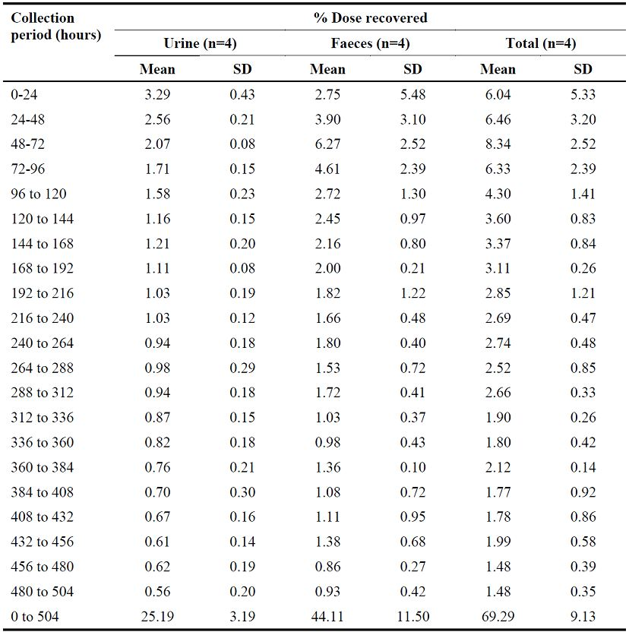
Figure 3: Study 12 – Geometric mean vandetanib plasma concentration following all oral doses of vandetanib 300 mg to 1200 mg.
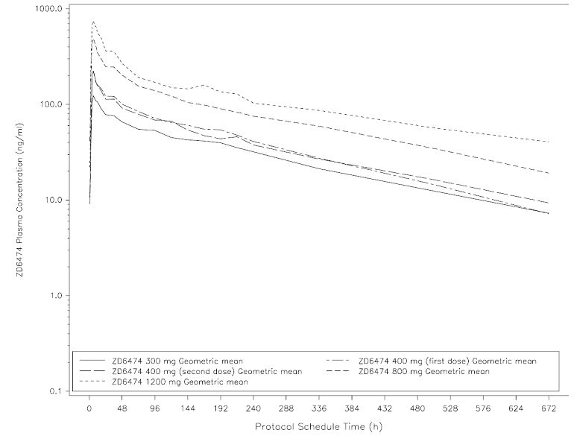
Following the single oral dose of radiolabelled vandetanib, C_{max} (gmean: 499.8 ng/mL) occurred 6 hours post-dose in all subjects after which plasma concentrations declined very slowly, falling to a gmean of 88.4 ng/mL at 168 hours (7 days) post-dose and 20.9 ng/mL at 672 hours (28 days) post-dose. The decline in plasma levels exhibited a biphasic disposition, with evidence of secondary peaks occurring at approximately 48 and 96 hours in 2 of the 4 profiles, possibly indicating enterohepatic recirculation. A well-defined terminal elimination phase was observed in all subjects beyond 336 hours (14 days) post-dose, with a mean half-life of 246.6 hours representing the balance between the extensive distribution (Vss/F gmean: 4103 L) and low clearance (Cl/F gmean: 13.28 L/h). The total exposure to vandetanib, as determined by gmean AUC_{0-inf}, was 60260 ng.h/mL. The gmean AUC_{0-t} (where t = 1008 hours) of 57020 ng.h/mL represented approximately 95% of the AUC_{0-inf}.
The mean (SD) total recovery of radioactivity recovered over the time interval of 0 to 504 hours post-dose was 69.3% (9.1%), with mean (SD) faecal recovery being 44.1% (11.5%) and mean (SD) urinary recovery being 25.2% (3.2%) (Table 6).
Due to the low levels of radioactivity in plasma, urine and faeces, quantitative metabolite analysis was unsuccessful. However, qualitative analysis, carried out by HPLC-MS, identified vandetanib and N-desmethyl-vandetanib in plasma, urine and faeces, while N-oxide-vandetanib was present in plasma and urine and the majority of faecal samples. The glucuronide conjugate of vandetanib was detected in most of the urine and faecal samples analysed, but at lower concentrations than the other components, and was not detected in plasma. The structure of the glucuronide metabolite of vandetanib was confirmed by HPLC-MS-MS, but the position of the attachment of the glucuronide could not be determined.
Comment: In this study, recovered radioactivity was incomplete due to the long plasma half-life of vandetanib and the low radiolabelled dose administered. Consequently, it was not possible to determine quantitative metabolite profiles in plasma or excreta samples. Therefore, it was not possible to quantify the relative contributions of specific clearance pathways to the overall elimination of vandetanib.
The total radioactivity in urine and faeces collected over 21 days from 4 subjects was 69.3% of the administered dosed radioactivity (44.1% collected in the faeces and 25.2% collected in the urine). The total amount of radioactivity recovered in this time period was incomplete, but this was consistent with the observed long plasma half-life of radioactivity. Faecal samples taken on Day 28 contained 0.2% of the dosed radioactivity, confirming that radioactivity was still being eliminated after the end of the 21 day collection period. Faecal radioactivity could represent unabsorbed dose or biliary excretion of absorbed radioactivity. However, an average of only 6.5% of the dose was recovered in faeces in the first 2 days when the majority of unabsorbed radioactivity would be expected suggesting that most of the dose was likely to have been absorbed.
The elimination of radioactivity was very slow, with approximately 1% to 3% of the dose being excreted daily from 192 hours (Day 8) to 504 hours (Day 21). Unchanged vandetanib and 2 known metabolites (vandetanib-N-oxide and N-desmethyl vandetanib) were detected in plasma, urine and faeces. An additional minor metabolite, a glucuronide conjugate of vandetanib, was found in both urine and faeces but not in the plasma.

Renal clearance
The submission included no data on renal clearance in patients with MTC. However, the mass balance studies in humans showed that approximately 25% of the total radioactivity dose was recovered from the urine over 21 days after dosing, and that the percentage of the dose excreted daily (Day 8 to Day 21) was similar in urine and feces. These results suggest that both renal and hepatic clearance are significant in the elimination of vandetanib.
There were limited data in healthy controls on renal clearance from study 12. In this study, gmean CL_{R} following a single oral dose of 300 mg (n=6) was 1.035 L/h (CV = 23.9%), and the mean (SD) percentage of the administered dose excreted unchanged in the urine was 1.9 (0.54) % in the first 72 hours. However, the data relating to percent of unchanged vandetanib should be interpreted cautiously given that the terminal-half life of the drug in this study was 176.2 to 315.96 hours and urine was collected only over the first 72 hours following administration. Further urinary excretion could be expected given the very long half-life of the drug. The CL_{R} remained relatively unchanged (range: 0.89 L/h to 1.60 L/h) for single vandetanib doses ranging from 300 to 1200 mg suggesting that the PKs of vandetanib are linear.

Single and multiple dose PK studies (healthy volunteers and patients)
The submission included single dose PK data on vandetanib in healthy subjects (study 12), and single and multiple PK data on vandetanib in Caucasian, Chinese and Japanese patients with malignant tumours (studies 01, 04, and 43, respectively). These four studies are reviewed below.

Study 12 (healthy subjects)
Design: Study 12 was a single-centre (UK), Phase 1, randomised, double-blind, placebo-controlled, study designed to assess the safety, tolerability and PKs of oral ascending single-doses of vandetanib in healthy male subjects. Vandetanib was formulated in two tablet strengths (100 mg and 300 mg) with matching placebo, and the tablets were to be swallowed whole. Healthy volunteers were to be allocated into 3 cohorts of 8 volunteers and randomised to vandetanib (6 volunteers) or placebo (2 volunteers) in a parallel group design. A maximum of 8 oral dose steps were planned. Volunteers in Cohorts 1 and 2 were to receive a maximum of 3 doses of vandetanib or placebo, and volunteers in Cohort 3 were to receive a maximum of 2 doses of vandetanib or placebo. For any volunteer, a minimum of 5 weeks was to elapse between doses.
Subjects: Enrolment was to be 24 healthy male volunteers randomised into three cohorts. However, as 1 subject was ill on the day of dosing 23 subjects were randomised. Of the 23 volunteers, 5 received placebo and 18 received vandetanib at doses of 300 mg, 400 mg, 800 mg or 1200 mg. Twenty (20) volunteers completed the study.
Dose-escalation: Cohort 1 received 300 mg (vandetanib, 6 volunteers; placebo, 2 volunteers); one 300 mg vandetanib treated volunteer was discontinued (AE of vomiting). Dose escalations were determined after review of the preliminary PK and tolerability data following each dose by the Safety Monitoring Committee (SMC). Haematuria was recorded in 3 volunteers in Cohort 1 and so dose escalation was reduced from planned 600 mg to 400 mg for Cohort 2 (vandetanib, 6 volunteers; placebo, 1 volunteer). One 400 mg vandetanib treated volunteer in Cohort 2 was discontinued (AE of eczema). In the absence of further safety concerns, the dose was escalated to 800 mg for Cohort 3 (vandetanib, 6 volunteers; placebo, 2 volunteers); one 800 mg vandetanib treated volunteer was discontinued (AE of folliculitis). After a minimum 5-week washout period, Cohort 1 received 1200 mg (vandetanib, 5 volunteers; placebo, 2 volunteers). Dose escalation was not continued beyond 1200 mg because, based on the raw QTc interval data from the 1200 mg dose group and PK/PD modelling, it was considered likely that further increases in dose would be associated with QTc interval increases greater than 60 ms. Cohort 2 received a repeat dose of 400 mg (vandetanib, 5 volunteers; placebo, 1 volunteer) to determine intra-subject PK variability. Another repeat dose was not performed due to investigator concerns about the incidence of skin rashes. However, following unblinding, there was no apparent relationship between incidence of skin rash and dose.
Results: The PK results for the dose-escalation cohorts are summarised in Section 18.2, Table 42, page 113. Following single oral doses of vandetanib of 300 mg to 1200 mg, absorption was slow with a median t_{max} of 6 hours for all doses (range: 4 to 10 hours). Plasma concentrations declined slowly in a biphasic manner after reaching C_{max}. Sampling was performed daily for the first 10 days post-dose and 1 or more secondary peaks were observed from 24 hours onwards over this period. Geometric mean (gmean) AUC_{0-inf} and C_{max} both increased in an approximate dose-proportional manner across the dose range 300 mg to 1200 mg. For each dose level, AUC_{0-inf} values had a coefficient of variation (CV) between 8.4% and 25.8%. Intra-subject variability, as assessed by comparison of the first and second 400 mg dose, appeared to be small, with individual AUC_{0-inf} values being within 10% of each other and individual C_{max} values being within 20% of each other.
Oral clearance of vandetanib was slow and appeared to be independent of dose, with gmean oral clearance (CL/F) ranging from 11.75 to 13.62 L/h. Oral volume of distribution was very large with gmean V_{ss} ranging from 3267 to 4649 L across the dose range studied. The terminal half-life was very long with gmean ranging from 176.2 hours to 315.9 hours. Less than 5% of the dose was excreted in the urine as unchanged vandetanib over the first 72 hours post-dose, but the collection time was very short compared with the very long half-life of the drug. The gmean of CL_{R} ranged from 0.89 L/h to 1.60 L/h, with the gmean (CV%) CL_{R} following the single 300 mg (n=6) being 1.035 L/h.
Comment: This was the first study with vandetanib in healthy volunteers. It provided a preliminary assessment of dose-proportionality and showed that the AUC0-inf and the Cmax were approximately dose proportional across the range 300 mg to 1200 mg. The CL/F, Vss, and t1/2 were independent of dose. Overall, the PK results suggest that the PKs of vandetanib are linear across the dose range 300 mg to 1200 mg. The secondary peaks in the plasma concentration – time profile observed from 24 hours post-dose onwards suggest possible entero-hepatic recirculation. The Vss is very large indicating extensive extra-vascular tissue distribution. The terminal half-life was very long (~ 10 days) due to the slow oral clearance (CL/F) of ~ 12 L/h and the large Vss of ~ 3500 L. Less than 5% of the administered dose was excreted in the urine unchanged, and the renal clearance accounted for less than 10% of total plasma clearance. However, the results for the percentage of the dose administered unchanged should be interpreted cautiously as the terminal half-life of the drug ranged from 176.2 hours to 315.9 hours while urine was collected only over the first 72 hours following dosing.

Study 01 (Caucasian patients with malignant tumours)
Design: Study 01 was a multinational (US and Australia), multicentred (6 centres), Phase I, rising multiple dose tolerability trial of vandetanib in patients with malignant tumours. The primary objective was to assess the tolerability and toxicity of rising doses of vandetanib when given orally as a single dose and when given daily until tumor progression. The secondary efficacy objectives included assessment of the single and multiple dose PKs of vandetanib in patients with advanced malignant tumours. This review of the study focuses on the PK results in patients administered vandetanib at 100 mg and 300 mg doses. The PK parameters were estimated following the first dose in Cycle 1 (i.e., single-dose) and following multiple dosing in Cycle 1 (i.e., at steady state).
Treatment: Cycle 0 was a single dose followed by 7 days of observation. Cycle 1 was 28 days in duration. Cycle 2 and every cycle thereafter was 28 days in duration for as long as the patient was receiving a benefit and there was no evidence of tumor progression (unless in the view of the investigator, and on discussion with the sponsor, the patient was benefiting from treatment with vandetanib).
Subjects: The treatment groups for the 100 mg and 300 mg dose groups included 19 patients and 25 patients, respectively. The mean age of the 100 mg dose group was 56.6 years (range: 28-75) years, there were 12 male and 7 female patients, and 16 patients in the group were Caucasian, 1 was oriental, and race was not specified for 2 patients. The mean age of the 300 mg dose group was 57.7 years (range: 37 to 82 years), there were 15 male and 10 female patients, and 19 patients were Caucasian, 2 “other” racial groups, 1 Asian and race was unspecified for 3 patients.
Results: The PK results (AUC_{0-24h}, C_{max}, and T_{max}) following single and multiple doses of vandetanib 100 mg and 300 mg are summarised in Table 4.
Table 4: Study 01 – PK results following single dose and multiple dose vandetanib 100 mg and 300 mg.
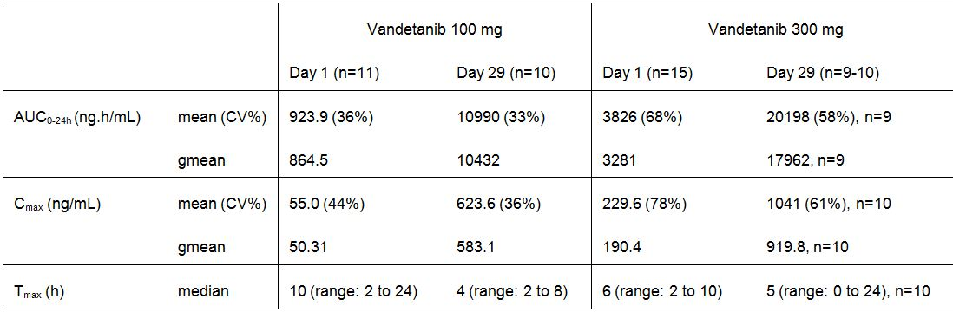
Comment: Absorption of vandetanib was slow following single and multiple doses at both the 100 mg and 300 mg dose levels. The AUC0-24h and Cmax increased with dose following both single and multiple 100 mg and 300 mg doses, but the increases were not dose proportional. Notable accumulation of vandetanib occurred as assessed by the AUC0-24h (~ 12x for the 100 mg dose and ~ 5x for the 300 mg dose). There was marked inter-subject variability for AUC0-24h and Cmax in subjects taking single and multiple 300 mg doses, and moderate inter-subject variability in these parameters in subjects taking the 100 mg dose.

Study 04 (Chinese patients with solid, malignant tumours)
The primary objective of this single-centre (China) Phase I study was to assess the PKs of rising doses of vandetanib when administered daily in Chinese patients with advanced solid, malignant tumours. The PK results following single doses and at steady state for vandetanib at doses of 100 mg once every other day (eod) 100 mg once daily (od) and 300 mg once daily (od) are summarised in Table 5.
Table 5: Study 04 – Chinese patients – PK parameters for vandetanib after a single dose and at steady state for 100 mg every other day (eod), and 100 mg and 300 mg once daily (od).
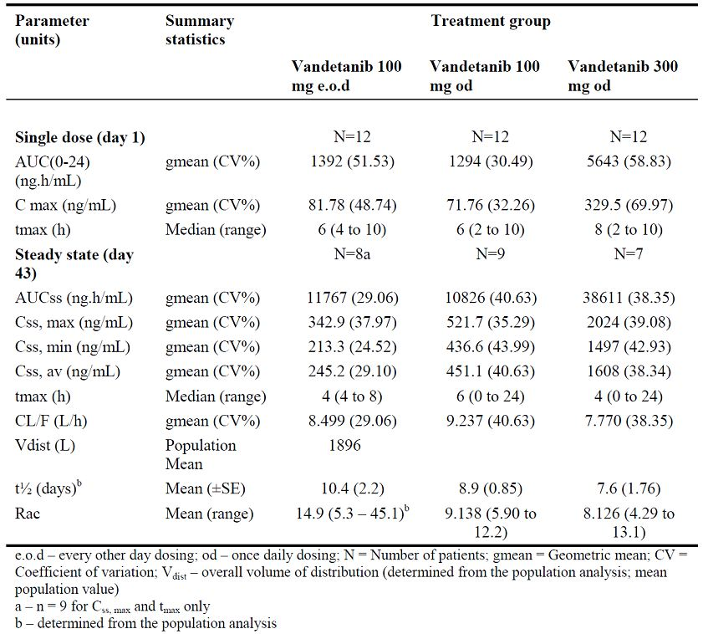
Following single 100 mg or 300 mg doses of vandetanib, absorption was relatively slow with median t_{max} values of 6 to 8 hours with a range from 2 to 10 hours. The gmean C_{max} and AUC₀₋₂₄ following the first 100 mg dose of the 100 mg eod (n=12) and 100 mg od (n=12) groups were similar, at 81.78 and 71.76 ng/mL, and 1392 and 1294 ng.h/mL respectively. The gmean C_{max} following the first dose of 300 mg od (n=12) was 329.5 ng/mL (~ 4-fold and ~ 4.6-fold higher than the respective values for 100 mg eod and 100 mg od), and the AUC₀₋₂₄ was 5643 ng.h/mL (~ 4.1-fold and ~ 4.4-fold higher than the respective values for 100 mg eod and 100 mg od).
Steady state was achieved in individual patients from day 22 onwards with the majority of patients achieving steady state by day 29 or 37 and all patients achieving steady state by day 43 (when steady state PK were assessed). The steady state gmean C_{ss,max} and AUC_{ss} for 300 mg od (n=7) were 3.9-fold and 3.6-fold higher, respectively, relative to 100 mg od (n=9). The apparent oral clearance (CL/F) was slow, with similar gmean CL_{ss}/F values of 8.5, 9.2 and 7.8 L/h for 100 mg eod, (n=8), 100 mg od (n=9) and 300 mg od (n=7), respectively, and with similar inter-patient variability (CV %) of 29.06%, 40.63% and 38.35%, respectively. There was marked accumulation of vandetanib by the time steady exposure was achieved, with mean accumulation ratios of 14.9, 9.1 and 8.1 for 100 mg eod, 100 mg od and 300 mg od, respectively. The mean terminal half-time determined by population-pk analysis was long at 10.4, 8.9, and 7.6 days for 100 mg eod, 100 mg od and 300 mg od, respectively. The mean population estimate of the volume of distribution was high (1896 L).

Study 43 (Japanese subjects with solid, malignant tumours)
The primary objective of this single-centre (Japan) Phase I study was to assess the tolerability and toxicity of rising doses of vandetanib when give as single and repeat doses to Japanese patients with solid, malignant tumours. The secondary objectives included the assessment of the single and multiple dose vandetanib PKs.
The study included PK information on small numbers of patients administered vandetanib 100 mg (n=3), 200 mg (n=6), 300 mg (n=6) and 400 mg (n=3). Following a single oral dose of 100 to 400 mg, absorption was slow with the t_{max} being about 4 to 6 hours. The terminal half-life was estimated to be about 90 to 115 hours and was independent of dose. However, about 40% of the AUC was extrapolated suggesting that the terminal half-life may exceed this estimated value. The C_{max} and AUC₀₋₂₄ were approximately dose proportional across the single dose range 100 to 400 mg. Following multiple dosing, steady state was achieved at 28 days based on mean plasma trough concentrations. Exposure after multiple doses increased about 6 times (range 5.3 to 6.5) relative to a single dose exposure for the 200 to 400 mg doses and about 14 times for the 100 mg dose.

Population-pharmacokinetic analysis in patients with MTC

Population-PK analyses from single studies (MTC)

Study 58
The submission included a population-pk analysis of patients with MTC from the pivotal Phase III study (study 58). This analysis is considered to be the primary source of PK data for patients with MTC.
- Design: Study 58 was a multinational, multicentre, Phase III, randomised, placebo-controlled study designed to assess the efficacy of vandetanib in patients with locally advanced or metastatic medullary thyroid cancer.
- Objective: The objectives of the population-pk analysis were to determine the PK characteristics of vandetanib in patients with MTC, and identify any demographic and/or physiological covariates influencing plasma concentrations.
- Method: The principle software used to generate the data for the analysis was the NONlinear Mixed Effects Modelling program (NONMEM). Using the final model and actual dosing histories, drug concentrations were predicted for various time points corresponding to sampling at 0, 4 and 24 hours on Day 56 (i.e., at steady state).
- Subjects: The original dataset included 231 patients treated with 300 mg vandetanib once daily. Of the 231 patients, 83 (35.9%) had their dose reduced from 300 mg daily at some point during the study. The dose was reduced from 300 mg daily to 200 mg for 81 patients (35.1%) and subsequently reduced from 200 mg to 100 mg for 30 patients (37% of subjects already reduced to 200 mg). Of the 117,294 dosing records in the dataset, 26,197 (22.3%) were associated with a dose less than 300 mg.
- Dataset: The original dataset included 231 patients and consisted of 1624 plasma concentrations. The number of PK samples per patient ranged from 2 to 18 with a median value of 7. During preliminary PK evaluation, 1 patient was identified as a PK outlier and was subsequently excluded from all analyses. Consequently, the dataset used for the analysis included 230 patients. A sparse sample design was used with blood samples for the determination of plasma concentrations of vandetanib taken between 4 and 8 hours post dose during weeks 1, 2, 4, 8, 12, and then every 12 weeks up to and including discontinuation of the study drug. PK samples were obtained up to 515 days after the first vandetanib dose, with 53% of samples collected 56 days (1368 hours) after the first dose and 84% of samples within 200 days. The majority of the PK samples were taken between 4–6 hours after the oral dose with the median number being collected 4.6 hours after the administered dose. A number of samples (83) were available from 24 hours to 1539 hours (64 days) after the administered dose.
- Results (PK Model): The vandetanib PK were reasonably described by a two compartment model with first order absorption and first order distribution and elimination. Due to the sparsity of the data, the first order absorption rate constant could not be reliably estimated and following preliminary analysis it was fixed to the previously estimated value (0.3 hr⁻¹) obtained from fitting a two-compartment model to rich data from healthy volunteers.
- Results (Estimated Pop-PK parameters): Population-PK analysis estimated the mean (SE) apparent clearance to be 13.2 (0.306) L/h, and the mean (SE) apparent initial and peripheral volumes of distribution to be 2100 (104) L and 5350 (536) L, respectively. Estimates of the inter-individual variability were high, approximately 31% for clearance, 52% for the initial volume of distribution and 101% for the total volume of distribution. The effect of weight on clearance and initial volume of distribution was identified as being statistically significant, with both parameters being proportional to body weight normalised for the median weight in this population (68 kg). The statistically significant effects of weight on clearance and initial volume of distribution in the PK model predict decrease in exposure with increasing weight. However, reductions in inter-individual variability in the model with the covariates were only 2.0% to 5% lower for clearance and volume of distribution compared with the model without covariates, suggesting that the effect of weight on these two PK parameters is unlikely to be clinically significant. The median effective half-life was estimated to be 19.0 days. There was no observable difference in the PKs between male and female patients. Differences between racial groups could not be satisfactorily evaluated as nearly all patients were Caucasian (95%).
- Results (PK parameters): Secondary PK parameter were obtained using the fixed absorption rate of 0.3 hr⁻¹ and the estimated clearance and volume parameters derived from the final PK model for subjects (n=191) who received daily doses of 300 mg up to Day 56, and for all subjects (n=231) irrespective of dose modifications up to Day 56. For subjects dosed to steady state (Day 56) with 300 mg daily, the mean (SD) results for the following parameters derived from individual patient simulations were accumulation ratio, 8.05 (3.10); steady state C_{max} 4 hours post-dose 857 (259) ng/mL; clearance, 13.94 (4.06) L/h; steady state trough concentration 795 (248) ng/mL; half-life 19.62 (11.84) days; steady state exposure 19829 (6066) ng.h/mL. The results from patients dosed to steady state with 300 mg daily are summarised in Table 6, and the corresponding results from all patients including dose reductions are summarised in Table 7.
Table 6: Study 58 (population-pk report) - Summary of secondary PK parameters from patients dosed to steady state (Day 56) with 300 mg daily.
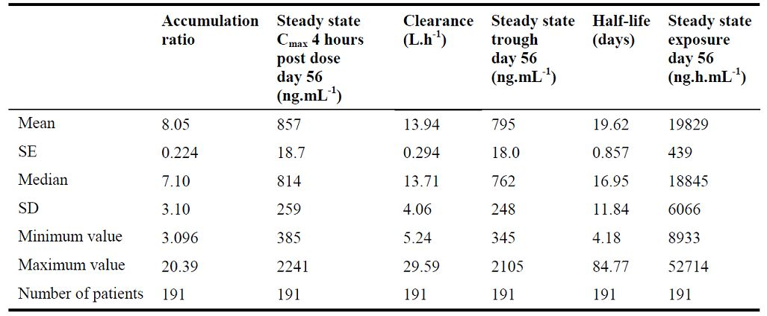
Table 7: Study 58 (population-pk report) - Summary of secondary PK parameters from all patients dosed to steady state (Day 56) with 300 mg daily including dose reductions.
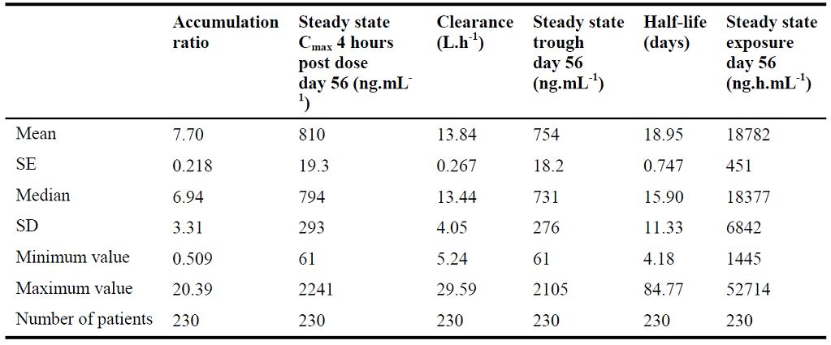

Pharmacokinetics in special populations

Pharmacokinetics in subjects with impaired hepatic function

Study 16
The submission included 1 study investigating the effect of hepatic impairment on the PKs of vandetanib and the N-desmethyl and N-oxide metabolites of the parent compound (study 16).
Design: Study 16 was a single-centre (Germany), Phase I, open-label. parallel-group study of the PKs, safety, and tolerability of vandetanib following single oral doses in subjects with mild, moderate, or severe hepatic impairment, and healthy subjects. The primary objective was to investigate the PKs of vandetanib measured by the C_{max} and AUC_{0-inf}. Subjects remained at the study site from Day -1 to Day 2 and received the single oral dose of 800 mg vandetanib on Day 0. Subjects returned on 13 occasions from Day 3 to Day 42 for safety and PK assessments, and a post-study visit took place on Day 63.
Treatment: Fasting subjects received a single oral dose (800 mg) of vandetanib, provided as 2 x 300 mg tablets and 2 x 100 mg tablets. Subjects were to take all 4 tablets with 200 mL of water, and the tablets were to be swallowed whole and not chewed, crushed, or divided.
Subjects: Forty-five (45) subjects were enrolled and 30 were treated (8 healthy, 8 with mild hepatic impairment, 8 with moderate hepatic impairment, and 6 with severe hepatic impairment). The mean age of the 30 treated subjects (22/8: male/female) was 54 years (range: 36 to 70 years) and all were Caucasian. Twenty-nine (29) treated subjects completed all required study procedures, and 1 subject with severe hepatic impairment died from an AE considered to be related to the underlying disease. Of the 15 subjects enrolled but not treated: 7 did not meet the eligibility criteria; 7 were not required; and 1 voluntarily discontinued. The three hepatic impairment groups were mild (Child-Pugh Group A [5-6 points]), moderate (Child-Pugh Group B [7-9 points]), and severe (Child Pugh Group B [10-15 points]).
Results: The geometric least square (GLS) mean ratios and 90% CIs for the primary variables of AUC_{0-inf} and C_{max} for the comparisons between the normal group and the mild, moderate, and severe hepatic impairment groups are summarised in Table 8.
Table 8: Study 16 – AUC_{0-inf} and C_{max} GLS mean ratios (90% CIs) of vandetanib.
a. Treatment ratio=ratio of subjects with hepatic impairment: healthy subjects (i.e., normal hepatic function).
NB: N=5 for normal group Cmax and AUC; N=8 for Group A AUC and Cmax; N=7 and 8 for Cmax and AUC respectively, for Group B; and N=6 for AUC and Cmax for Group C.
The plots of vandetanib AUC_{0-inf} and C_{max} values versus hepatic impairment defined by Child-Pugh criteria are provided in Figure 4.
Figure 4: Study 16 - Plot of the C_{max} (left-panel) and log AUC_{0-inf} (right panel) of vandetanib versus hepatic impairment (Child-Pugh criteria).
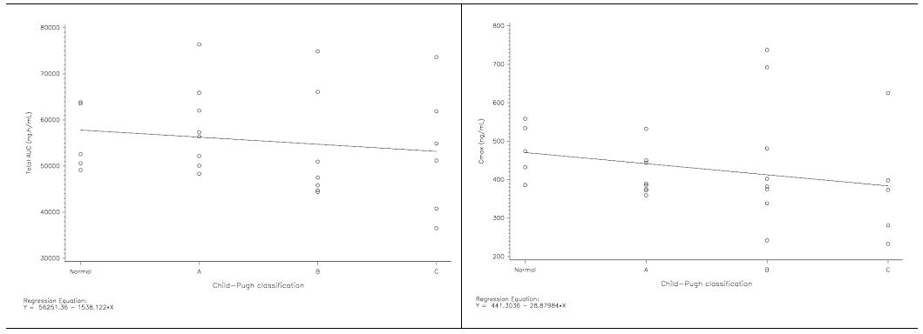
Comment: The 90% CIs for both AUC0-inf and Cmax were not entirely above 1 for any of the treatment groups, and all the upper 90% CIs were below 2. These results indicate that hepatic impairment had no marked effect on the PKs of vandetanib based on the study specified criteria. The study specified that if the 90% CIs for either the Cmax or AUC0-inf ratios (impairment:normal) were entirely above 1, with the upper bound greater than or equal to 2, then the PKs of vandetanib were considered to be possibly influenced by hepatic impairment.
There was no marked difference in CL/F in subjects with mild, moderate or severe hepatic impairment, but there was an increase in Vss/F with gmeans of 4498 L, 5059 L and 6025 L, respectively, compared with healthy subjects (3810 L). This resulted in an increase in the half-life of vandetanib with gmeans of 262.6, 276.6 and 325.7 hours, for subjects with mild, moderate or severe hepatic impairment, respectively, compared with healthy subjects (215.7 hours). Protein binding of vandetanib was similar for healthy subjects, and for subjects with mild, moderate and severe hepatic impairment with the mean fraction unbound being 0.06692, 0.07130, 0.07380, and 0.07624 respectively.
Relative to vandetanib, exposure to the N-desmethyl metabolite was small. In healthy subjects, the mean ratio for the AUC0-inf was 0.1035 (range: 0.0639 to 0.138) for the N-desmethyl metabolite relative to vandetanib. The half-life and AUC0-inf of the N-desmethyl metabolite could not be determined for subjects with severe hepatic impairment, due to plasma N-desmethyl metabolite plasma concentrations being too low to define the terminal phase of the concentration-time curve. However, comparison of the AUC0-t values showed that this parameter decreased with increasing hepatic impairment, with gmeans of 4923, 2945, 2217 and 851.3 ng.h/mL for healthy, mild impairment, moderate impairment and severe impairment cohorts, respectively. Cmax also decreased with increasing hepatic impairment with gmeans of 23.37, 14.77, 9.116 and 6.020 ng/mL for healthy, mild impairment, moderate impairment and severe impairment cohorts, respectively. The exposure to the N-desmethyl metabolite relative to vandetanib in the mild, moderate and severe hepatic impairment cohorts was lower than that observed for healthy subjects, with mean ratios of 0.06287, 0.04465, 0.02630, and 0.1035 respectively.
Relative to vandetanib, exposure to the N-oxide metabolite was small. In healthy subjects, the mean ratio for the AUC0-t was 0.01404 (range: 0.00845 to 0.0195) for the N-oxide metabolite relative to vandetanib. The AUC0-t was similar in subjects with mild and moderate hepatic impairment (gmean AUC0-t of 458.4 and 449.2 ng.h/mL, respectively) compared with the gmean AUC0-t of 470.2 ng.h/mL in health subjects. However, AUC0-t showed an increase in subjects with severe hepatic impairment, with a gmean of 985.4 ng.h/mL. Gmean Cmax was increased in subjects with hepatic impairment with values of 3.467, 4.786, 5.627 and 6.074 ng/mL for healthy, mild impairment, moderate impairment and severe impairment cohorts, respectively. There was no apparent change in the exposure to the N-oxide metabolite relative to vandetanib in subjects with mild and moderate hepatic impairment (mean ratios 0.01559 and 0.01763, respectively) compared with healthy subjects (mean ratio 0.01404), but exposure was increased in subjects with severe hepatic impairment (mean ratio 0.02917).

Pharmacokinetics in subjects with impaired renal function

Study 22
The submission included 1 study investigating the effect of renal impairment on the PKs of vandetanib and the N-desmethyl and N-oxide metabolites of the parent compound (study 22).
Design: Study 22 was a single-centre (Germany), Phase I, open-label, parallel group study of the PKs, safety, and tolerability of vandetanib following single oral doses in subjects with mild, moderate, or severe renal impairment, and healthy subjects. The primary objective was to investigate the PKs of free vandetanib measured by the C_{max} and AUC_{0-inf}. Subjects remained at the study site until 48 hours post-dose, and returned for safety and PK assessments on 14 occasions between Days 3 and 63 inclusive (Day 63 was the post-study visit).
Treatment: Fasting subjects received a single oral dose (800 mg) of vandetanib, provided as 2 x 300 mg tablets and 2 x 100 mg tablets. Subjects were to take all 4 tablets with 200 mL of water and were to be swallowed whole and not chewed, crushed, or divided.
Subjects: Thirty-seven (37) subjects were enrolled, 32 were treated and 5 were not treated (3 were incorrectly enrolled, 1 voluntarily discontinued and 1 did not receive vandetanib due to “other” reason). The 32 patients completing all required study procedures were all Caucasian (22/10 : males/females) and mean ages across the groups ranged between 56 and 63 years. Patient numbers in the four treatment groups were: normal renal function CLcr > 80 mL/min (n=10); mild renal impairment CLcr ≥ 50 to ≤ 80 mL/min (n=6); moderate renal impairment CLcr ≥ 30 to < 50 mL/min (n=10); and severe renal impairment CLcr < 30 mL/min (n=6).
Results: Geometric least square (GLS) mean ratios and 90% CIs for free vandetanib AUC_{0-inf,} C_{max}, and CL/F are summarised in Table 9.
Table 9: Study 22 – AUC_{0-inf}, C_{max} and CL/F GLS mean ratios (90% CIs): free vandetanib.
CLcr values of 10 mL/min, 30 mL/min, 50 mL/min and 125 mL/min were used to represent the severe, moderate, mild and normal groups, respectively. N=10 subjects in the normal group; N=6 in the mild impairment group; N=8 in the moderate impairment group; N=6 in the severe impairment group.
The plots of log AUC_{0-inf} and log C_{max} values for free vandetanib versus calculated creatinine clearance are provided below in Figure 4.
Figure 5: Study 22 - Plot of the log C_{max} (left-panel) and log AUC_{0-inf} (right panel) of free vandetanib versus calculated creatinine clearance.
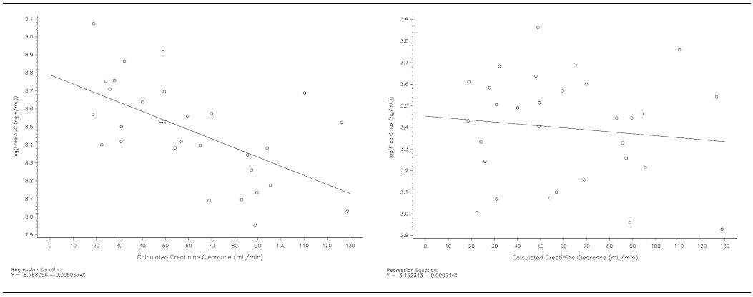
Comment: In this study, vandetanib was administered as a single oral dose of 800 mg. The primary analysis of the PKs of vandetanib in the four treatment groups was based on free vandetanib concentrations rather than total vandetanib concentrations. Plasma protein binding assessed ex vivo in subjects with normal renal function was approximately 94%, and this was unaltered in subjects with renal impairment.
In this study, it was considered that the PKs were influenced by renal impairment if the 90% CI for the ratios (Cmax, AUC) of subjects with severe renal impairment relative to normal renal function were entirely above 1, with the upper bound of the 90% CI being 2.0 or above. It was considered that exposure levels in severe renal subjects should not exceed twice the exposure levels experienced in healthy volunteers, and if the 90% CIs for the Cmax or AUC0-inf ratios were entirely below 2.0 then a doubling of exposure could be ruled out. A doubling in exposure was considered important based on tolerability data for vandetanib from earlier patient studies in which daily doses of 100 to 300 mg were relatively well tolerated while daily doses of 500 to 600 mg were poorly tolerated. Since the PKs of vandetanib are linear between 50 to 600 mg daily, doubling in exposure was considered a relevant increase with the potential to adversely affect patient tolerability.
Based on the GLS mean ratios and 90% CIs for AUC0-inf for the comparison of the normal with the renal impairment groups, a doubling of exposure to free vandetanib could not be ruled out for subjects with severe renal impairment. Furthermore, the results for patients with moderate renal impairment also suggested an approximate doubling of exposure. The log AUC0-inf of free vandetanib increased in a linear manner with decreasing CLcr. There were no clinically relevant increases in free vandetanib Cmax in patients with renal impairment compared with subjects with normal renal function, and there were no marked differences in the tmax across the four treatment groups.
The clearance of free vandetanib was slower in subjects with renal impairment. For subjects with mild, moderate and severe renal impairment, gmean CL/F for free vandetanib was 179.3 L/hr, 141.9 L/hr and 131.9 L/hr, respectively, compared with 207.2 L/hr in subjects with normal renal function. Halving of CL/F could not be ruled out for subjects with severe renal impairment based on the GLS mean ratios for the comparison between the normal and severe impairment groups. For total vandetanib, gmean CL/F was slower in subjects with mild, moderate and severe renal impairment and was 10.31 L/hr, 8.440 L/hr and 8.315 L/hr, respectively, compared with 11.74 L/hr in subjects with normal renal function. There was no notable difference in the volume of distribution of total vandetanib across the four treatment groups. The slower clearance in the severe renal impairment group compared with the normal group resulted in an increase in terminal half-life of about 60% (409.8 and 261.1 hours, respectively).
The appearance and subsequent disposition of the N-desmethyl and N-oxide metabolites was similar to the total plasma concentration-time profile of vandetanib. The mean ratio for total AUC0-inf of N-desmethyl metabolite to total vandetanib was low (0.08252). The total AUC0-inf of the N-desmethyl vandetanib increased with increasing renal impairment and showed a 1.29-fold, 1.37-fold and 2.07-fold increase with mild, moderate and severe renal impairment, respectively, compared with subjects with normal renal function. However, there was no apparent difference in Cmax or tmax for N-desmethyl-vandetanib in patients with renal impairment.
The very low plasma levels of the N-oxide metabolite and technical difficulties with assay validation did not allow the free fraction to be determined, and no results were obtained for the free fraction of the N-oxide metabolite. Relative to vandetanib the exposure to total N-oxide metabolite was very small, with a mean ratio for total AUC0-t of N-oxide metabolite to vandetanib of 0.01466. The total AUC0-t for N-oxide vandetanib increased with increasing renal impairment and showed a 1.58-fold, 2.59-fold and 3.51-fold increase with mild, moderate and severe renal impairment, respectively, compared with normal renal function. There was no apparent difference in N-oxide-vandetanib Cmax in the mild renal impairment group, but the gmean Cmax showed 1.26-fold and 1.38-fold increases in the moderate and severe renal impairment groups, respectively. There was no apparent difference in the N-oxide-vandetanib tmax values in patients with renal impairment.

Pharmacokinetics according to age
In the population-pk analysis in patients with MTC from the pivotal Phase III efficacy and safety study (study 58), age had no statistically significant effects on apparent oral clearance, initial volume of distribution or peripheral volume of distribution. The mean (SD) age of the 231 patients included in the analysis was 50.7 (14.1) years and the range was 18 to 83 years.

Pharmacokinetics according to gender
In the population-pk analysis in patients with MTC from the pivotal Phase III efficacy and safety study (study 58), gender had no statistically significant effects on apparent oral clearance, initial volume of distribution or peripheral volume of distribution. In the 231 patients included in the analysis there were 97 males and 217 females.

Pharmacokinetics according to race
In the population-pk analysis in patients with MTC from the pivotal Phase III efficacy and safety study (study 58) most of the 231 patients were Caucasian (n=217) with the remaining patients being black (n=1), Asian (n=8), or other (n=4). Consequently, no meaningful analysis of racial differences in the population-pKs of vandetanib could be drawn from this study. However, the submission included PK data from Western, Chinese and Japanese patients with solid malignant tumour (studies 01, 04, and 43, respectively). The mean (SD) C_{max} and AUC₀₋₂₄ values following single doses of vandetanib 100 mg and 300 mg in the three racial groups are summarised in Table 10.
Table 10: Mean (SD) PK parameters in three racial groups following vandetanib single-dose 100 mg and 300 mg; studies 01 (Western), 04 (Chinese), and 43 (Japanese).
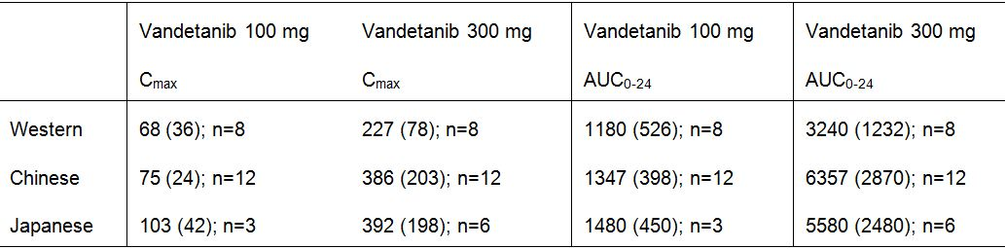
Study 04 included a comparison of the mean (SE) population estimate of apparent oral clearance CL/F for Chinese, Western, and Japanese patients (Table 11). Individual CL/F values in Western, Japanese and Chinese patients are summarised below in Figure 6.
Table 11: Study 04 – Mean ± SE CL/F with 95% confidence intervals.
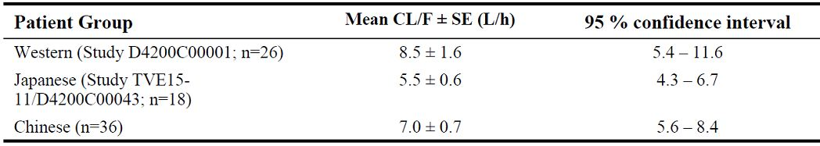
Figure 6: Individual CL/F values in Western, Japanese and Chinese patients.
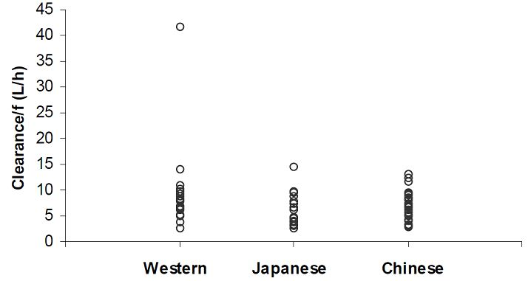
Comment: Exposure to vandetanib following single 100 mg and 300 mg doses, as assessed by the Cmax and AUC0-24, was lower in Western patients than in Chinese or Japanese patients. The mean CL/F values in the three racial groups were consistent with the differences in exposure with clearance being faster in the Western group than in the two Asian groups.

Pharmacokinetic interactions

Pharmacokinetic interactions demonstrated in human studies

Interaction with itraconazole (CYP3A4 inhibitor) – study 15
Design: Study 15 was a single-centre (France), Phase 1, randomised, 2-period, cross-over study designed to asses the effect of itraconazole (CYP3A4 inhibitor) on the PKs of a single oral dose of vandetanib (300 mg) in healthy subjects.
Treatment: Volunteers were to receive single oral doses of vandetanib (300 mg) in a “to be marketed” formulation on Day 4 of each of the study periods, with a 3-month washout period between administrations. During one of the study periods, volunteers were also to receive oral doses of itraconazole (200 mg) daily from Day 1 to Day 24. For each study period, assessments were to be made up to Day 37.
Subjects: The study enrolled 16 healthy male volunteers. In Period 1, 8 volunteers received a single dose of vandetanib and 8 received a single dose of vandetanib plus daily doses of itraconazole. After cross-over, in Period 2, 7 volunteers received a single dose of vandetanib and 7 received a single dose of vandetanib plus daily doses of itraconazole. Fourteen (14) volunteers completed the study, and 2 withdrew consent. The mean age of the 16 enrolled volunteers was 30.2 years (range: 20 to 44 years), and 11 were Caucasian, 2 were black, and 3 were of “other” race.
Results: The results of the statistical analysis of AUC_{0-504h} and C_{max} following a single dose of vandetanib 300 mg (Day 4), alone or in combination with 200 mg/day itraconazole (Days 1 to 24), are summarised in Table 12. The plasma PKs of vandetanib with and without co-administration of itraconazole are summarised in Table 13.
Table 12: Study 15 – Effect of itraconazole on the PKs of vandetanib (ZD6474).
a. Treatment ratio = ratio of glsmean ZD6474 + itraconazole : ZD6474 alone.
b. Volunteer 3 was withdrawn after receiving ZD6474 + itraconazole in Period 1 but the AUC₀₋₅₀₄ was not calculable. This volunteer did not receive ZD6474 alone.
c. Volunteer 15 was withdrawn after receiving ZD6474 alone. This volunteer did not receive ZD6474 + itraconazole.
Table 13: Study 15 - Plasma PKs of vandetanib (ZD6474), with and without itraconazole.
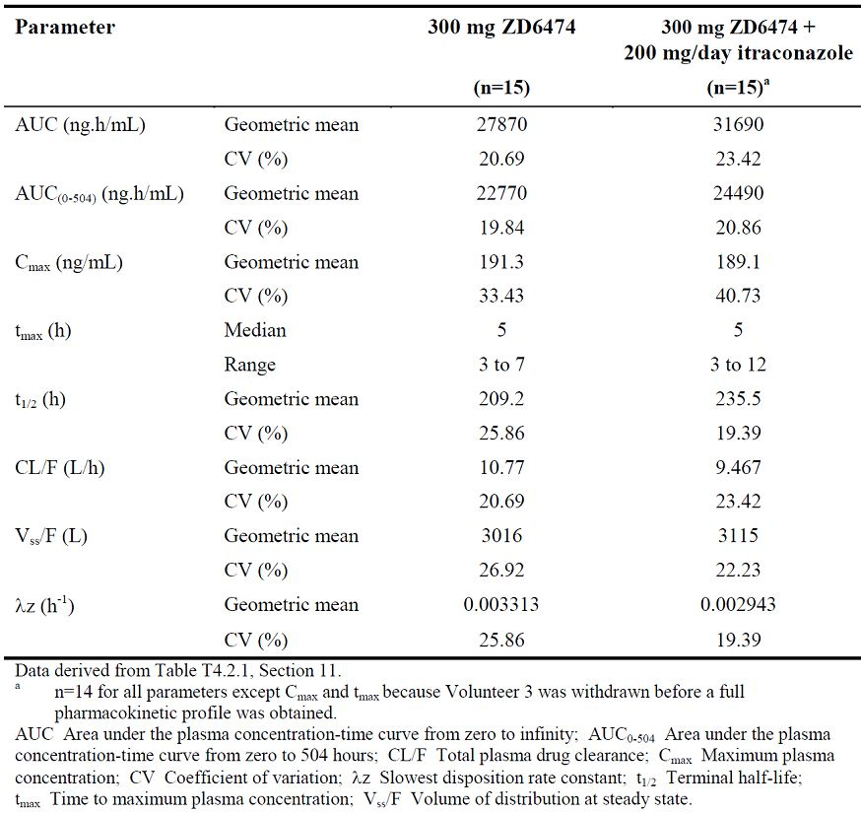
Comment: There was no significant PK interaction between vandetanib and itraconazole. The 90% CI for the AUC0-504h and Cmax ratios for vandetanib + itraconazole relative to vandetanib alone were completely within the specified bioequivalence limits of 0.8 to 1.25. The observed changes in other vandetanib PK parameters following co administration of itraconazole were small and are unlikely to be clinically significant.

Interaction with rifampicin (CYP3A4 inducer) – study 26
Design: Study 26 was a single-centre (France), Phase 1, randomised, 2-period, cross-over study designed to asses the effect of rifampicin (a CYP3A4 inducer) on the PKs of a single oral dose of vandetanib (300 mg) in healthy subjects.
Treatment: The study consisted of 2 treatment regimens: (1) oral doses of rifampicin (600 mg daily) for 31 days, with a single oral dose of vandetanib 300 mg on Day 10; (2) a single oral dose of vandetanib 300 mg on Day 1. Subjects received both treatment regimens with a minimum washout period of 6 weeks between doses of vandetanib.
Subjects: The study enrolled 35 subjects, 18 received treatment and 15 completed the study (2 discontinued due to an AE and 1 withdrew consent). There were 16 subjects in the PK analysis set. The mean age of the 18 enrolled subjects was 31.7 years (range: 21 to 24 years) and 14 were Caucasian, 3 were black and 1 was oriental.
Results: The results of the statistical analyses of AUC_{0-504h} and C_{max} following a single 300 mg oral dose of vandetanib, alone or in combination with daily 600 mg oral doses of rifampicin, are summarised in Table 14. The plasma PKs of vandetanib with and without co-administration of rifampicin are summarised in Table 15.
Table 14: Study 26 - Effect of rifampicin on the AUC_{0-504h} and C_{max} of vandetanib; PK analysis set.
a. Treatment ratio = glsmean (vandetanib in the presence of rifampicin) / glsmean (vandetanib in the absence of rifampicin).
Table 15: Study 26 - Plasma PKs of vandetanib, with and without rifampicin; PK analysis set.
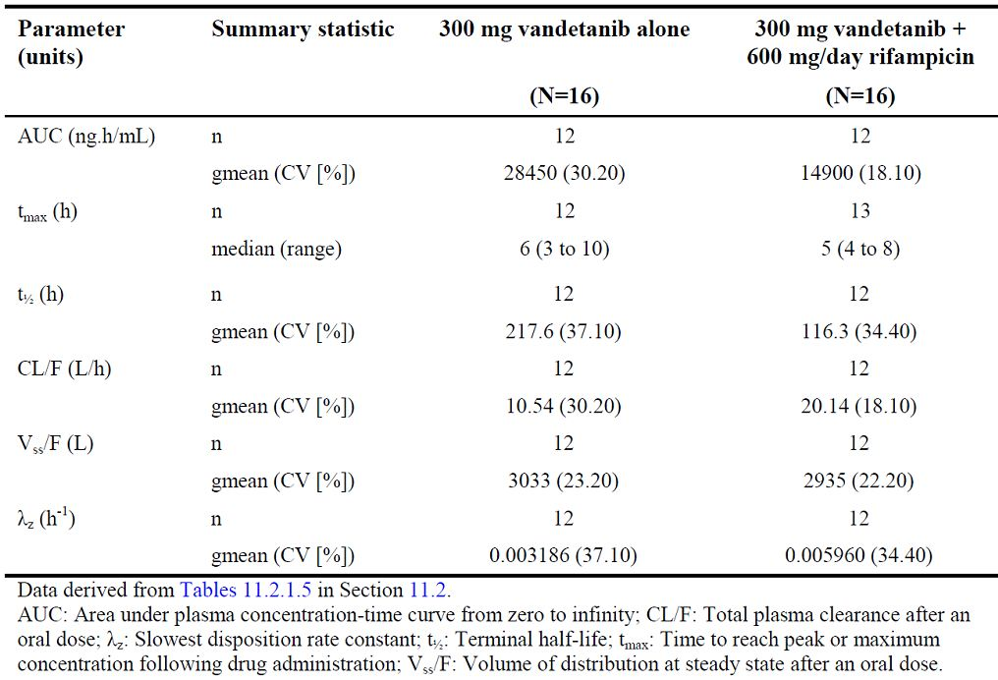
The gmean (SD) vandetanib plasma concentration-time curves alone and in combination with rifampicin are summarised in Figure 7.
Figure 7: Study 26 - Gmean (SD) vandetanib plasma concentration-time curves alone and in combination with rifampicin; PK analysis set.
Comment: Following co-administration of vandetanib and rifampicin the 90% CI for the Cmax ratio (vandetanib + rifampicin/vandetanib alone) was completely within the bioequivalence limits set for this study of 0.8 to 1.25. However, the 90% CI for the AUC0-504h ratio was not enclosed with the interval 0.8 to 1.25, and the mean AUC0-504h for vandetanib was 40% lower when vandetanib was co-administered with rifampicin compared with when vandetanib was administered alone. The results indicate that co-administration with CYP3A4 inducers significantly reduces systemic exposure to vandetanib as assessed by the AUC0-504h.
The gmean apparent oral clearance (CL/F) of vandetanib was about twice as fast following co-administration of vandetanib and rifampicin compared with vandetanib alone (20.14 L/h and 10.54 L/h, respectively), the gmean terminal half-life (t1/2) was shorter (116.3 h and 217.6 h, respectively), and the gmean apparent volumes of distribution (Vss/F) were similar (2935 L and 3033 L, respectively). The vandetanib median Tmax values were similar following co-administration of vandetanib and rifampicin (5 hours [range: 4 to 8 hours]) and administration of vandetanib alone (6 hours [range: 3 to 10 hours]).
Exposure to the N-desmethyl metabolite of vandetanib increased markedly when vandetanib was co-administered with rifampicin as assessed by both the AUC0-504h (266.0% increase) and the Cmax (414.3% increase). The ratio of N-desmethyl metabolite of vandetanib exposure (AUC0-504h) to vandetanib exposure (AUC0-504h) was 0.07086 following vandetanib alone and increased to 0.4294 when vandetanib was co-administered with rifampicin.
Exposure to the N-oxide metabolite of vandetanib decreased when vandetanib was co-administered with rifampicin as assessed by the AUC0-t (76.5% reduction) but increased as assessed by the Cmax (178.9% increase). However, the sponsor states that the AUC0-t of the N-oxide metabolite reported for subjects when receiving vandetanib in combination with rifampicin is not directly comparable to the AUC0-t for subjects when receiving vandetanib alone, as these parameters were not determined using a common value for time. The sponsor states that if AUC0-t is determined using a common value for time using data that it holds on file, a 126.0% increase was observed for vandetanib in combination with rifampicin (gmean: 44.26 ng.h/mL) compared with vandetanib alone (gmean: 19.56 ng.h/mL). The ratios of reported N-oxide metabolite of vandetanib exposure (AUC0-t) to vandetanib exposure (AUC0-t) were similar following vandetanib alone and following co-administration of vandetanib and rifampicin (0.01774 and 0.02041, respectively).

CYP3A4 substrate docetaxel (study 06)
Study 06 was a Phase III efficacy and safety study in patients with NSCLC. The primary objective was to assess the efficacy of vandetanib (100 mg or 300 mg) combined with docetaxel (75 mg/m² IV over 1 hour every 21 days) compared with docetaxel combined with placebo in prolonging progression-free survival (PFS) in patients with locally advanced or metastatic NSCLC after failure of prior platinum-based chemotherapy. The study included an assessment of the PKs of vandetanib following multiple oral doses (100 mg or 300 mg once daily) in the presence and absence of single doses of docetaxel (75 mg/m² IV over 1 hour), and the PKs of docetaxel in the presence and absence of multiple doses of vandetanib.
Vandetanib is cleared by both the renal and hepatic routes, and the major CYP450 enzyme involved in its metabolism is CYP3A4. Docetaxel is cleared principally by the hepatic route, and the major CYP450 enzyme involved in its metabolism is also CYP3A4. The potential for a PK interaction between vandetanib and docetaxel was assessed in 12 patients from the safety run-in phase of the study, 4 patients treated with vandetanib 100 mg + docetaxel and 8 patients treated with vandetanib 300 mg + docetaxel. The PKs were assessed by comparison of the geometric means of the AUC₀₋₂₄ and C_{max} for vandetanib, and the AUC_{0-t} and C_{max} for docetaxel when the drugs were given alone and in combination.
Effect of docetaxel on exposure to vandetanib: The plasma sampling schedule for vandetanib PKs on Day 21 and Day 22 was pre-dose and then post-dose at 1, 3, 5, and 7 hours. The gmean AUC₀₋₂₄ of vandetanib following co-administration of vandetanib and docetaxel was lower compared with vandetanib alone, with gmean ratios of 0.91 (CV = 7%) and 0.85 (CV = 16%) for vandetanib 100 mg and 300 mg dose levels, respectively. The gmean C_{max} of vandetanib following co-administration of vandetanib and docetaxel was lower compared with vandetanib alone, with gmean ratios of 0.88 (CV = 14%) and 0.83 (CV =14%).
Effect of vandetanib on exposure to docetaxel: The plasma sampling schedule for docetaxel PKs on Day 1 and Day was pre-dose, 5 minutes prior to the end of the infusion and then post-doe at 1.25 hours, 1.75 hours, 3 hours and 7 hours. The gmean AUC₀₋₂₄ of docetaxel following co-administration of docetaxel and vandetanib was lower compared with vandetanib alone for the 100 mg dose of vandetanib (gmean ratio 0.90 [CV = 77%]), and marginally higher for the corresponding comparison with the 300 mg dose of vandetanib (gmean ratio 1.05 [CV = 63%). The gmean C_{max} of docetaxel following co-administration of docetaxel and vandetanib was markedly lower compared with vandetanib alone for the 100 mg dose of vandetanib (gmean ratio 0.46 [CV = 68%]), and higher for the corresponding comparison with the 300 mg dose of vandetanib (gmean ratio 1.28 [CV = 52%]).
Comment: The PK data in this study is considered to be exploratory. The gmean AUC0-24h and gmean Cmax values for vandetanib were 9% and 12% lower when vandetanib 100 mg was co-administered with docetaxel compared with vandetanib 100 mg alone, and the corresponding values were 15% and 17% lower for the 300 mg dose of vandetanib. These results indicate that co-administration with docetaxel moderately reduces exposure to vandetanib. However, it is unlikely that the observed reduction is clinically significant given that docetaxel is administered once every 3 weeks and there is little or no docetaxel in the systemic circulation at 24 hours following administration.
The gmean AUC0-24 values for docetaxel were 10% lower and 5 % higher when docetaxel was co-administered with vandetanib 100 mg and 300 mg, respectively, compared with docetaxel alone. These observed changes in exposure are unlikely to be clinically significant. The gmean Cmax values for docetaxel were 54% lower and 28% higher when docetaxel was co-administered with vandetanib 100 mg and 300 mg, respectively, compared with docetaxel alone. These results are unlikely to be clinically significant. There was marked inter-subject variability in docetaxel AUC0-24 and Cmax when docetaxel was given alone or in combination with vandetanib, with CV values ranging from 52% to 77%.

FOLFIRI regimen (study 38)
Study 38 was a Phase I, multi-centred, open-label, ascending-dose study with the primary objectives to establish the safety and tolerability of once-daily oral doses of vandetanib (100 mg or 300 mg) when co-administered with standard 14-day treatment cycles of FOLFIRI to patients with metastatic colorectal adenocarcinoma. The FOLFIRI regimen consisted of Day 1 irinotecan 180 mg/m² given IV over 90 minutes and leucovorin 400 mg/m² given IV over 2 hours simultaneously, immediately followed by 5-fluorouracil 400 mg/mg² bolus given over 2 to 4 minutes, followed by 5-fluorouracil 2400 mg/m² given as a 46 to 48 hour infusion. The secondary objectives included an investigation the PKs of vandetanib, irinotecan and 5-fluorouracil when co-administered to patients with metastatic colorectal adenocarcinoma. There was no formal statistical analysis of the PK interaction between vandetanib and FOLFIRI. There were 17 patients with evaluable PK data (11 and 6 patients on the 100 and 300 mg vandetanib doses, respectively).
Vandetanib is eliminated by both renal and hepatic routes. Formation of the N-desmethyl metabolite is mediated by CYP3A4 and the N-oxide by flavine-containing mono-oxygenase enzymes FMO1 and FMO3. Irinotecan is converted to the active metabolite, SN-38, by carboxylesterase enzymes, and is also metabolised by CYP3A4. Exposure to both irinotecan and SN-38 is reduced in patients receiving CYP3A4 inducers and is increased in patients receiving CYP3A4 inhibitors. The major route of elimination of irinotecan is biliary, with about 60% of the dose recovered in the faeces. Greater than 80% of 5-FU is eliminated by metabolic conversion to dihydrofluorouracil (DHFU) via the pyrimidine catabolic pathway. The major route of elimination of 5-FU is renal with 60 to 90% of the administered dose excreted in the urine.
The results for this study are summarised in Table 16 (PKs for vandetanib alone and in combination with FOLFIRI); Table 17 (PKs for irinotecan alone and in combination with vandetanib); Table 18 (PKs for SN-38 alone and in combination with vandetanib); and Table 19 (PKs for 5-FU alone and in combination with vandetanib).
Table 16: Study 38 – PK variables for vanetanib alone and in combination with FOLFIRI; all patients evaluable for PK.
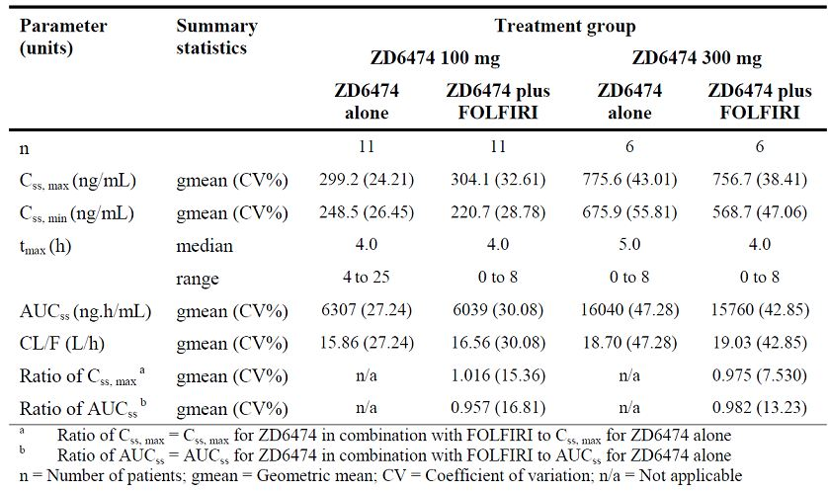
Table 17: Study 38 – PK variables for irinotecan alone and in combination with vandetanib; all patients evaluable for PK.
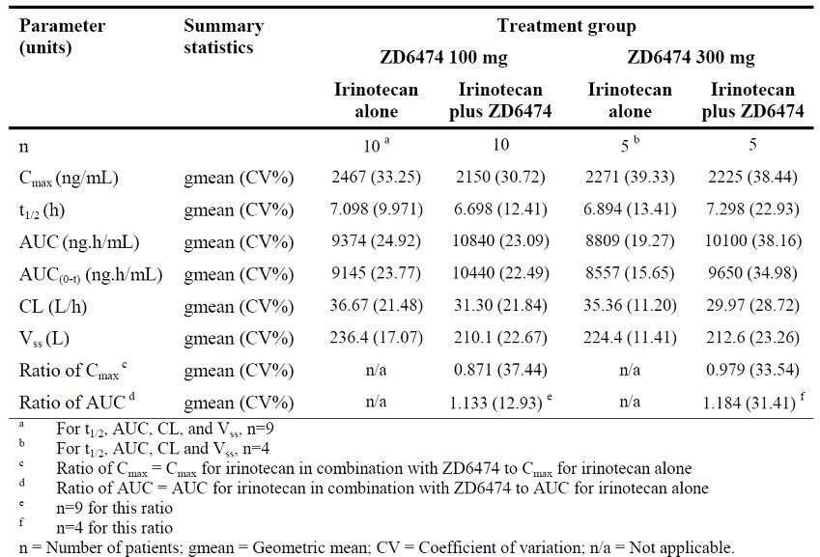
Table 18: Study 38 – PK variables for SN-38 alone, and in combination with vandetanib; all patients evaluable for PK.
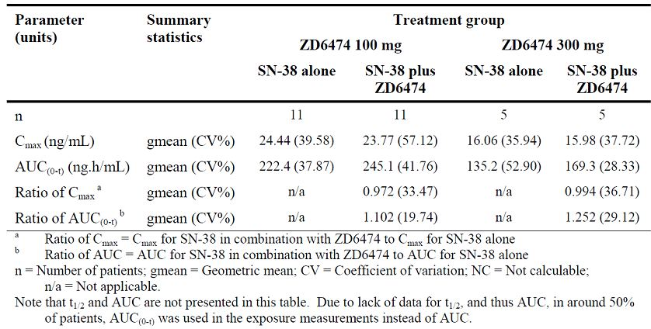
Table 19: Study 38 – PK variables for 5-FU alone, and in combination with vandetanib; all patients evaluable for PK.
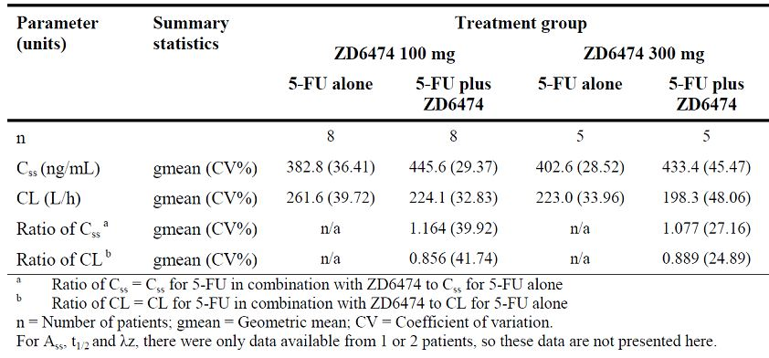
Comment: There were no marked differences in the PKs of vandetanib when vandetanib was administered alone (100 mg or 300 mg) and when it was co-administered with FOLFIRI. The ratios of gmean Css,max for vandetanib 100 mg and 300 mg in combination with FOLFIRI relative to vandetanib alone were 1.016 (CV = 15.4%) and 0.975 (CV = 7.5%), respectively. The corresponding ratios for gmean AUCss were 0.957 (CV = 16.8%) and 0.982 (CV = 13.2%).
The ratios of irinotecan gmean Cmax were 0.87 (CV = 37.4%) and 0.98 (CV = 33.5%) when irinotecan was co-administered with vandetanib 100 mg and 300 mg, respectively, relative to irinotecan alone. The corresponding ratio of the irinotecan gmean AUC were 1.13 (CV = 12.9%) and 1.18 (CV = 31.4%). The ratios of SN-38 gmean Cmax were 0.97 (CV = 37.4%) and 0.99 (CV = 36.7%) when irinotecan was co-administered with vandetanib 100 mg and 300 mg, respectively, relative to irinotecan alone. The corresponding ratios of SN-38 gmean AUC0-t were 1.10 (CV = 19.7%) and 1.25 (CV = 29.1%). The results for irinotecan and SN-38 suggest that vandetanib is not a clinically significant inhibitor or inducer of CYP3A4.

Interactions in vitro

Inhibition of CYPs
- Data from studies KMX020 and KMX054 indicated that vandetanib has the potential to inhibit CYP2D6 and CYP2C8. For CYP2D6 the IC₅₀ and K_{i} values were 25000 and 13000 ng/mL, respectively (study KMX020). For CYP2C8 the potential inhibition was weaker and, whilst not formally determined, the sponsor estimates that the IC₅₀ and K_{i} would be in the order of 100,000 ng/mL and 25,000 ng/mL, respectively. The population-pk analysis of vandetanib in MTC patients administered 300 mg of vandetanib once daily predict mean steady-state vandetanib concentrations of 810 ng/mL. Ex vivo vandetanib protein binding in patients with metastatic colorectal adenocarcinoma was estimated at 93.5%. Estimates of the I/K_{i} ratios (where I is the mean steady-state C_{max}) for total and free mean steady-state C_{max} values of vandetanib for both CYP2D6 and CYP2C8 are less than 0.1 for both vandetanib 100 mg and 300 mg doses. Consequently, the level of inhibition observed in the in vitro studies would not be expected to result in clinically relevant effects on exposure to substrates of CYP2D6 or CYP2C8 administered concomitantly with vandetanib (Bjornsson et al., 2003).
- Study KMX020 showed that vandetanib is unlikely to cause clinically significant inhibition of CYPs 1A2, 2C9, 2C19 or 3A4, and study KXM054 showed that vandetanib did not inhibit CYP2A6 at the highest vandetanib concentration of 100000 ng/mL. The IC₅₀ values for CYP 1A2, 2A6, 2C9, 2C19 or 3A4 could not be determined experimentally from the vandetanib concentration range used in this study. Consequently, the IC₅₀ values for these isoenzymes were inferred to be at least the highest concentration of vandetanib used (i.e., > 100000 ng/mL), which was much higher than the estimated steady state C_{max} of 810 ng/mL in patients with MTC.
- Study KMX095 showed that the N-desmethyl metabolite of vandetanib caused no or minimal reversible or time-dependent inhibition of CYP1A2, CYP2A6, CYP2B6, CYP2C8, CYP2C9, CYP2C19, CYP2D6, CYP2E1 and CYP3A4/5 in human liver microsomes. In addition, vandetanib showed no or minimal time-dependent inhibition of these enzymes.

Induction of CYPs
- Study KMX067 showed that vandetanib caused induction of CYP1A2, CYP2C9 and CYP3A4 in cultures of fresh human hepatocytes. It has been suggested that if a drug candidate produces a greater than 2-fold increase in probe drug enzyme activity, or that change in activity is more than 40% of the change observed with the positive control, it can be considered as an enzyme inducer in vitro and in vivo evaluation is warranted (Preliminary Concept Paper, FDA, 2004; Bjornsson et al, 2003). The criteria of a 2-fold increase in activity were met for all three isoenzymes when vandetanib was included at 2 μM with cells from all hepatocyte donors assayed. Moderate induction of CYP1A2, CYP2C9 and CYP3A4 activities was observed at clinically relevant concentrations which suggested that vandetanib may induce CYP1A2, CYP2C9 and CYP3A4 in vivo.

Human transport proteins MDR1 (Pgp), BCRP and MRP1
- The effects of vandetanib on human multi-drug resistance 1 protein (MDR1), also known as P-glycoprotein (P-gp), the human breast cancer resistance protein (BCRP) and the human multidrug resistance protein 1 (MRP1) were investigated in studies KMN070 and KMNO96.
- Study KMN070 showed that vandetanib is not or is only a low affinity substrate for MDR1 (Pgp), and is not a substrate for BCRP or MRPI, but is a moderate affinity inhibitor of these two transporters. Inhibition of BCRP and MRPI was evident at a vandetanib concentration of 47.5 µg/mL (i.e., ca 59-fold higher than the estimated steady C_{max} of 0.81 µg/mL in patients with MTC following vandetanib 300 mg daily).
- Study KMN096 showed that in the MDCKII-MDR1 and MDCKII-BCRP cell systems, vandetanib was an inhibitor of both MDR1 and BCRP, with an IC₅₀ value of 8.7 µg/mL and 11.9 µg/mL, respectively (i.e., ca 10.7-fold and 14.7-fold higher than the estimated steady C_{max} of 0.81 µg/mL in patients with MTC following vandetanib 300 mg daily). In the MDCKII-MRP1 cell system, there was some indication that vandetanib may have the potential to inhibit MRP1 (Pgp), but the variability in the dataset did not allow any firm conclusions to be made.

Human transporter protein OCT2

Study KMX083, assessed whether vandetanib as a substrate and/or inhibitor of the human organic cation transporter 2 protein (OCT2; also known as SLC22A2). The study showed that vandetanib was not a substrate for OCT2. However, vandetanib inhibited the uptake of the selective OCT2 marker substrate [¹⁴C]-creatinine by HEK-OCT2 cells, with a mean IC₅₀ value of approximately 2.1 µg/mL. This is about 2.5 fold higher than the estimated steady state C_{max} of 0.81 µg/mL in patients with MTC following vandetanib 300 mg daily. The sponsor postulates that inhibition of renal excretion of creatinine by vandetanib offers an explanation for the increase in plasma creatinine in human subjects treated with vandetanib.

Evaluator’s overall conclusions on pharmacokinetics
Data on the PKs of vandetanib are derived primarily from studies in healthy volunteers, and the population-pk analysis in patients with MTC from the pivotal Phase III study (study 58). However, the PKs of vandetanib have not been completely characterised and the deficiencies in the submitted data are summarised below:
- There was no absolute bioavailability study. However, the sponsor satisfactorily justified the absence of an absolute bioavailability study on the basis that an IV infusion solution of vandetanib has the potential to cause local tissue damage at the site of the infusion.
- The submission included a mass balance study in healthy volunteers. However, recovered radioactivity was incomplete due to the long plasma half-life of vandetanib and the low radiolabelled dose administered. Consequently, it was not possible to quantify the metabolite profiles in plasma or excreta samples, or to quantify the relative contributions of specific clearance pathways to the overall elimination of vandetanib.
- In vitro data indicate that vandetanib can induce CYP1A2, CYP2C9, and CYP3A4 enzymes (study KMX067), but there were no formal PK interaction studies between vandetanib and substrates of these CYPs.
- The solubility of vandetanib is pH dependent with solubility being greater in acidic solutions. However, there no PK interaction studies between vandetanib and drugs which can increase intra-gastric pH (i.e., antacids, PPIs, H2-antagonists). Co-administration of drugs which can increase intra-gastric pH and vandetanib have the potential to decrease the solubility and, consequently, the absorption of vandetanib.
The key features of the PKs of vandetanib from the submitted data are summarised below:
- Vandetanib pharmacokinetics were reasonably described by a two compartment model with first order absorption and first order distribution and elimination (population-pk analysis, study 58).
- Key estimated mean (SD) steady state parameters derived from the population-pk analysis (study 58) in all patients (n=230) with MTC dosed to day 56 with vandetanib up to 300 mg daily including dose reductions were: accumulation ratio 7.70 (3.31); C_{max} 4 hours post-dose 810 (293)ng/mL; clearance 13.84 (4.05) L/h; trough concentration 754 (276)ng/mL; half-life 18.95 (11.33) days; and exposure 18782 (6842) ng.h/mL.
- The commercial vandetanib 300 mg tablet was bioequivalent to a vandetanib solution following single oral doses. Post-hoc analysis showed that the gmean C_{max} and AUC_{0-inf} values for the tablet were 4% and 10% higher, respectively, relative to the solution, with the 90% CIs for the relevant ratios being completely enclosed within the standard bioequivalent limits of 0.8 to 1.25.
- Absorption following oral administration of a single 300 mg dose of the commercial tablet formulation was 8 hours (range: 6 to 18 hours) (study 30). In the population-pk analysis of pooled data from 4 studies in patients with cancer (01, 02, 03, 04) and 5 clinical pharmacology studies in healthy volunteers (12, 15, 21, 24, 30), no differences were identified between patients and volunteers for the predicted C_{max}, the estimated T_{max}, the relative percentage of drug absorbed over time or the apparent clearance. In this population-pk analysis, most subjects reached 100% of the drug absorbed by 6 to 9 hours after administration. Steady state exposure was reached after 1 to 2 months of dosing for most patients.
- There were no formal dose proportionality studies. Comparisons of C_{max} and AUC values suggested approximate dose proportionality across the single-dose range 300 mg to 1200 mg in healthy volunteers (study 12), and between single-dose 100 mg and 300 mg in patients with malignant tumours (01, 04, 43). The pharmacokinetics of vandetanib were linear across the dose range 300 mg to 1200 mg. Inter-subject variability in the PKs of vandetanib are marked, but intra-subject variability is small.
- Food had not significant affects on the bioavailability of vandetanib following a single 300 mg oral dose administered to healthy volunteers (study 24). The gLS mean C_{max} following administration of vandetanib with food was 11% lower relative to fasted administration, and there were was no difference between fasting and fed gLS mean AUC_{0-inf}. The ratios (fed:fasted) for the gLS means for the C_{max} and the AUC_{0-inf} were entirely enclosed within the standard bioequivalence limits of 0.8 to 1.25.
- Vandetanib has a large volume of distribution which indicates extensive tissue distribution. In the population-pk analysis in patients with MTC (study 58), the apparent volume of distribution was approximately 7450 L (apparent initial and peripheral volume of distributions 2100 L (SE=104) and 5350 (SE=536) L, respectively). The estimate of inter-individual variation in the total volume of distribution was 101%.
- Ex-vivo studies showed that vandetanib protein binding is approximately 93% to 94%, and is unchanged by hepatic impairment, renal impairment, or advanced colorectal cancer with liver metastases (studies 15, 22, 50). In an in-vitro protein binding study (KPJ010), vandetanib protein binding was independent of concentration over the range 0.05 µg/mL to 6 µg/mL, and showed that vandetanib binds to serum albumin (independent of concentration) and α-1 acid glycoprotein (dependent on concentration).
- In the mass balance study in healthy volunteers (study 25), the total radioactivity recovered over the 21 day collection period was 69% of the total dose of radioactivity, with ~44% being excreted in faeces and ~25% recovered in urine. The elimination of radioactivity was very slow with a total of between 1% and 3% of the dose being excreted daily from Day 8 to Day 21. This is consistent with both the slow apparent oral plasma clearance of vandetanib (estimated mean 13.2 L/h) and the long apparent plasma half-life (estimate mean 19 days) in patients with MTC (population-PK analysis study 58). The percentage of the dose excreted daily (Day 8 to Day 21) was similar in urine and faeces, indicating that both renal and hepatic excretion contribute to the elimination of vandetanib.
- There were no satisfactory data in the submission on renal clearance in patients. Data from the mass balance study (study 25) indicates that ~25% of the administered dose was eliminated in the urine in the 21 day collection period indicating that renal excretion is significant. However, it was not possible to quantify the contributions of unchanged vandetanib and vandetanib metabolites to the total radioactivity excreted in the urine.
- In the mass-balance study (study 25), unchanged vandetanib and 2 known metabolites (vandetanib-N-oxide and N-desmethyl-vandetanib) were detected in plasma, urine and faeces following an oral radiolabelled dose of vandetanib (800 mg). An additional minor metabolite of vandetanib was found in both urine and faeces (glucuronide conjugate). N-desmethyl-vandetanib was the major circulating metabolite, and exposure to the metabolite relative to the parent compound was about 7% to 10% (studies 16, 22, 26). Vandetanib-N-oxide was the minor circulating metabolite, and exposure to the metabolite relative to the parent compound was about 1.4% to 1.8% (studies 16, 22, 26).
- In vitro data showed that the formation of N-desmethyl-vandetanib from vandetanib was mediated primarily by CYP3A4 (study KMX038), and that the formation of N-oxide-vandetanib from vandetanib was mediated by FMO1 and FMO3 (KMX046). N-desmethyl-vandetanib and vandetanib have similar pharmacology activity, while N-oxide-vandetanib has markedly lower pharmacological activity than vandetanib.
- Hepatic impairment (mild, moderate, and severe) had no significant affects on exposure to vandetanib as assessed by AUC values, while C_{max} values were non-clinically significantly lower in patients with hepatic impairment relative to healthy subjects (study 16).
- In moderate and severe renal impairment, a doubling in exposure to vandetanib relative to subjects with normal renal function based on AUC_{0-inf} values could not be ruled out following a single oral 800 mg dose (study 22). The starting dose of vandetanib should be reduced in patients with moderate or severe renal impairment, while no adjustment to the starting dose appears to be required for patients with mild renal impairment.
- In the PK interaction study with itraconazole (a CYP3A4 inhibitor), co-administration with vandetanib (single-dose 300 mg) did not affect exposure to vandetanib relative to vandetanib alone as assessed by the C_{max} and AUC_{0-504h} (study 15). These results suggest that vandetanib can be co-administered with CYP3A4 inhibitors without dose modification.
- In the PK interaction study with rifampicin (a CYP3A4 inducer), co-administration with vandetanib (single-dose 300 mg) reduced exposure to vandetanib by 40% relative to vandetanib alone as assessed by the AUC_{0-504h} (study 26). This result suggests that co-administration of vandetanib with CYP3A4 inducers should be avoided.
- In vitro data indicated that vandetanib can induce CYP1A2, CYP2C9 and CYP3A4 activity (study KMX067). However, in vivo data in patients with malignant disease suggest that vandetanib at steady state (100 mg or 300 mg once daily) does no significantly affect the PKs of docetaxel (study 06) or irinotecan (study 38). Both docetaxel and irinotecan are metabolised by CYP3A4 and the in vivo data suggest that vandetanib does not significantly reduce the metabolism of these two drugs by CYP3A4 induction.
- In vitro data indicated that vandetanib is not or is only a low affinity substrate for the transporter protein MDR1 (Pgp), and is not a substrate for the transporter proteins BCRP and MRCPI (study KMN070). However, in vitro data indicated that vandetanib is an inhibitor of MDR1 and BCRP at IC₅₀ levels greater than 10-fold the estimated steady state C_{max} levels in patients with MTC treated with vandetanib up to 300 mg daily. In vitro data indicated that vandetanib is not a substrate of the OCT2 transporter, but is an inhibitor at IC₅₀ levels about 2.5-fold greater than the estimated steady state C_{max} levels in patients with MTC treated with vandetanib 300 mg daily (KMX083). Consequently, increased plasma creatinine concentrations observed in patients treated with vandetanib might be due to inhibition of OCT2 mediated excretion of creatinine.
- The population-pk analysis in patients with MTC (study 58) showed that age and gender had no significant effects on vandetanib clearance or volume of distribution. The studies in Western, Chinese and Japanese patients showed that exposure was greater in the Asian patients than in the Western patients, probably due to greater oral apparent clearance in the Western patients.

Pharmacodynamics

Studies providing pharmacodynamic data
The submission included PD and PK/PD data from the three studies.
- PK/PD data in the population-pk analysis of patients with MTC from the pivotal Phase III efficacy and safety study (study 58). The data relate to QTc interval prolongation, CTC ≥ grade 3 AEs, and efficacy outcomes.
- PD data from study 21 in healthy volunteers primarily investigating the effect on QTc prolongation of vandetanib (700 mg single oral dose) administered in combination with ondansetron (32 mg IV infusion over 15 minutes).
- PD data from study 50 investigating the effect of vandetanib on vascular permeability assessed by dynamic contrast-enhanced magnetic resonance imaging (DCE-MRI) in patients with advanced colorectal cancer and liver metastases treated with vandetanib 100 mg or 300 mg once daily for 56 days.

PK/PD data – population-pk analysis (Study 58)

Predicted plasma concentration and observed QTc prolongation
The final PK model from the population-pk analysis was used to generate predicted plasma concentrations at times when the QTc was recorded, and these were then used to evaluate the QTc plasma concentration relationship. Predicted QTcB and QTcF prolongation in 230 patients assuming vandetanib steady state C_{max} concentrations of 800 ng/mL are summarised in Table 20.
Table 20: Predicted mean QTcB and QTcF prolongation assuming vandetanib steady state C_{max} plasma concentrations of 800 ng/mL; n=230.
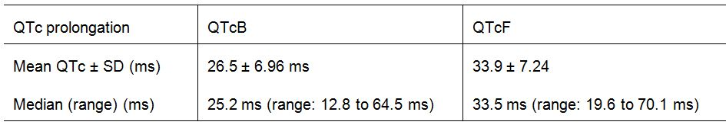
Comment: The QTc prolongation data from PK/PD modelling suggest that vandetanib has the potential to significantly increase the QTc interval from baseline. The Emax models predict mean ± SE Emax and EC50 values of 64.5 ms and 1260 ng/mL for QTcB and 57.1 ms and 613 ± 30.8 ng/mL for QTcF, with inter-individual baseline variability in QTcB of 4.2% and in QTcF of 4.0%, and inter-individual variability for maximum prolongation of 34.5% and 27.2%, respectively. Simulations from the 230 patients at steady state Cmax plasma concentrations observed in patients treated with 300 mg once daily (i.e., about 800 ng/mL) predict mean ± SD prolongations of 25.5 ± 6.96 ms and 33.9 ± 7.24 ms for QTcB and QTcF, respectively, with maximum prolongations of 64.5 ms and 70.1 ms, respectively. Mean QTc as a function of time showed an increase over the first 6 weeks following the first dose reaching a plateau of around 450 ms (QTcB) or 440 ms (QTcF) from 3 to 6 weeks.

Relationship of predicted plasma concentrations to biomarkers

Calcitonin
Calcitonin (CTN) concentrations appeared to decrease over the course of the study, and with increasing predicted vandetanib concentration. The sigmoidal E_{max} model derived from the PK/PD analysis indicated a decrease in CTN concentrations at predicted vandetanib concentrations greater than 500 ng/mL and plateau at vandetanib concentrations greater than 1500 ng/mL. Back-transformation of the model predicted parameters indicated an estimated CTN baseline concentration of 7332 pg/mL and maximum decrease from baseline to a CTN concentration of 361 pg/mL. This is equivalent to an estimated mean population reduction of 95% from the predicted baseline level. Individually the E_{max} model predicted maximal percentage reduction from predicted baselines to range between 74% and 100%. Estimates of inter-individual variability were 15%, 57% and 45% for baseline, E_{max} and EC₅₀, respectively.

Carcinoembryonic antigen concentration
There appears to have been little change in observed carcinoembryonic antigen (CEA) concentrations over the course of the study. The modelled relationship of CEA to the predicted plasma vandetanib concentration showed little change from baseline as assessed by linear, E_{max} and exponential PK/PD models fitted to log CEA concentrations.

Relationship of predicted plasma concentrations to adverse events
A limited number of patients experienced AEs at CTCAE grade ≥ 3 during the course of the study, with 6.5% (15/230) reporting rash, 10.9% (25/230) diarrhoea and 7.0% (16/230) hypertension, while < 1% (2/230) had interstitial lung disease (pneumonitis) and 15.2% (35/230) had QTc related AEs. The data showed no obvious correlation between vandetanib plasma concentration and the CTCAE grade ≥ 3 events listed in the previous sentence.

Relationship of clearance to dosage outcomes
The data showed no apparent correlation between the number of medication-free days and estimated vandetanib clearance, or the number of dose reductions, from either 300 mg to 200 mg daily or from 200 mg to 100 mg daily and estimated vandetanib clearance.

Relationship of predicted plasma concentrations to efficacy outcomes

Progression free survival (PFS) and Overall survival (OS)
Examination of the relevant data showed no correlation between the predicted plasma vandetanib concentration and PFS at the time of progression, and no correlation between PFS or OS and trough plasma concentration at day 56 or total exposure up to day 56.

Response
The majority (87%) of patients responded to the medication, with 96 (41.7%) patients having disease control and 104 (45.2%) patients having partial response as best response. The relationship of the best response was analysed as a function of the predicted steady-state exposure on day 56. A PK/PD cumulative probability model suggested that response correlated to an increase in steady state exposure. The model predicted that a steady-state AUC of at least 7.05 μg.hr/mL is required for the probability of stable disease to be 50% or more as best response, while a steady-state AUC of 20.77 μg.hr/mL or greater is required for the predicted probability of partial response to be 50% or more.
The observed data showed that of the 220 (95.7%) patients with a steady-state AUC greater than 7.05 μg.hr/mL, 23 (10.5%) had no response, 93 (42.3%) had disease control and 104 (47.3%) had partial response as best response. The observed data showed that of the 78 (33.9%) patients with a predicted steady-state AUC greater than 20.77 μg.hr/mL, 10 (12.8%) had no response, 29 (37.2%) had disease control and 39 (50.0%) had partial response as best response.
Both the observed and predicted probabilities of best response suggest that approximately 10% of the patients are non-responders irrespective of the exposure achieved, and that increases in exposure beyond 20 to 30 μg.hr/mL do not result in marked improvements in best response.
Comment: The results suggest that response might correlate with an increased in steady state (Day 56) vandetanib exposure as assessed by the AUC. However, while the PK/PD results for response are of interest they do not outweigh the PK/PD results for PFS and OS showing no correlation between vandetanib plasma concentration and these two efficacy outcomes at Day 56.

PD effect on cardiac-repolarisation (Study 21)
The submission included a PD study (study 21) in healthy volunteers (n=28) whose primary objective was to assess the PD effect on cardiac repolarisation of co-administration of a single oral dose of vandetanib (700 mg) and a single IV dose of ondansetron (32 mg infused over 15 minutes) in healthy volunteers. The secondary objectives were to determine whether an effect on cardiac repolarisation is likely to be additive or synergistic, and to characterise the PKs of vandetanib and ondansetron when administered alone and in combination.
There were methodological problems for the protocol specified analysis relating to the time-points chosen for assessment of the QTc for vandetanib + ondansetron being associated with low plasma ondansetron concentrations. Consequently, a retrospective analysis was undertaken based on time-points where the largest ondansetron effects on changes from baseline in QTc interval were expected to occur (i.e., within the first hour of the 32 mg IV infusion). This analysis showed that the maximum effect of ondansetron on QTcB relative to placebo was an increase from baseline of 12.5 ms (90% CI: 7.1, 17.8) observed 30 minutes after starting the infusion, and the maximum effect of ondansetron combined with vandetanib on QTcB relative to baseline was 22.3 ms.
Ondansetron plus vandetanib had no significant effects on the PKs of vandetanib compared with vandetanib alone. Vandetanib gmean AUC and C_{max} values were similar in both the presence and absence of ondansetron, and there was little difference (about 5% or less) in gmean CL/F. The gmean (SD) vandetanib plasma concentration - time profiles were virtually superimposable for ondansetron plus vandetanib compared with vandetanib alone.
Ondansetron gmean AUC values were similar in the presence and absence of vandetanib, and there was little difference (about 10% or less) in gmean CL/F and t_{1/2}. However, plasma ondansetron gmean C_{max} and C_{inf} (concentration at the end of the infusion) were higher in the presence of vandetanib compared with ondansetron alone (36% and 26%, respectively). In addition, ondansetron gmean V_{ss} was 22% lower in the presence of vandetanib compared with ondansetron alone.
Comment: The QTcB data suggest that effects on maximum QTcB increase of ondansetron and vandetanib in combination are additive compared with ondansetron alone. The PK data showed that ondansetron Cmax and Cmin concentrations increased when ondansetron and vandetanib were administered in combination, while the combination had little effect on the PKs of vandetanib.

Effect on vascular permeability (Study 50)
The submission included a two-centre (Germany), Phase I (clinical pharmacology), randomised (1:1), 2-treatment arm, open-label study (study 50) to assess the effect of once daily dosing with vandetanib on vascular permeability as assessed by dynamic contrast-enhanced magnetic resonance imaging DCE-MRI in patients with advanced colorectal cancer and liver metastases. Vandetanib (100 mg or 300 mg) was to be taken orally, once daily, for 56 days.
The primary objective was to assess the effect of once-daily dosing with vandetanib (100 mg or 300 mg) on tumour perfusion and vascular permeability in patients with advanced colorectal cancer and liver metastases. The primary PD variables were the DCE-MRI transfer constant used to quantify vascular permeability (K^{trans}), and initial area under the contrast enhancement curve (iAUC₆₀). The K^{trans} is the volume transfer constant between blood plasma and extravascular extracellular space (min⁻¹) measuring blood perfusion and permeability. The iAUC₆₀ is the initial area under the DCE-MRI contrast agent concentration time curve after 60 seconds.
Baseline was defined as the average of two baseline DCE-MRI measurements. Following the first dose on Day 1, patients were assessed again using DCE-MRI on Days 2, 8, 29 and 57 in order to assess both acute and longer term effects of vandetanib on K^{trans} and iAUC₆₀. A repeated measures analysis of variance model (ANOVA) model was fitted to log_{e} transformed K_{trans} and iAUC₆₀ data, fitting log_{e} transformed baseline as a covariate and dose and visit as fixed effects, and subjects as random effect. Comparisons at each visit were performed to provide the least squares estimates and corresponding 95% CIs for the comparison of the two dose levels. These point and interval estimates were exponentially back-transformed to provide estimates of the percentage (%) difference. Results were also reported as percentage (%) change from baseline by dose. Intra-subject, inter-subject and overall variabilities were also reported. As a supportive analysis this ANOVA modelling was repeated for data collected at Days 2, 8, 29 and 57.
DCE-MRI data were summarised and analysed on an intent-to-treat (ITT) basis. The analysis population consisted of all subjects who received at least 1 dose of vandetanib. The study planned to investigate the PD variables in patients with histologically confirmed metastatic colorectal adenocarcinoma refractory to standard therapies who had at least one measurable hepatic lesion of 20 mm or more on magnetic resonance imaging (MRI). It was considered that 10 patients per dose group would be adequate to demonstrate a 40% reduction in iAUC₆₀, with an additional 2 patients per dose group to account for a dropout rate of 20%. Therefore, the total sample size for this study was 24 patients.
The first subject was enrolled on 15 August 2006, the date of data cut-off was 22 June 2007 and the CSR was dated 15 January 2008. A total of 25 patients from 2 centres in Germany were enrolled and 24 were randomised at Visit 1 (screening). The screening results were not known until Visit 2 (Day 1), and as a result 2 patients failed eligibility criteria after randomisation and did not receive study drug. A total of 22 patients received study drug (100 mg, n=10; 300 mg, n=12), 18 continued study treatment until progression, 3 discontinued study treatment (2 due to an AE and 1 due to violation of screening criteria) and 1 was continuing 300 mg vandetanib at data cut-off.
All 22 patients were Caucasian. In the 100 mg group, there were 6 male and 4 female patients, the mean age was 60 years (range: 38 to 77 years), the mean weight was 77 kg (range: 42 to 111 kg), and mean height 173.1 cm (range: 152 to 187 cm). In the 300 mg group, there were 5 male and 7 female patients, the mean age was 59.8 years (range: 41 to 73 years), the mean weight was 67 kg (range: 48 to 97 kg), and mean height 168.3 cm (range: 155 to 180 cm). Four (33%) patients in the 300 mg group had 1 prior chemotherapy regimen compared to only 1 patient (10%) at 100 mg. The majority of patients in both treatment arms at 300 mg had 3 or more prior regimens.
Statistical analyses (repeated measure ANOVA) of the Day 2, 8, 29 and 57 iAUC₆₀ and K^{trans} data were performed to investigate whether the magnitude of the decreases from baseline were different at 100 mg and 300 mg vandetanib (Table 21). The observed reductions in the iAUC₆₀ and K^{trans} were both < 5% for both doses of vandetanib, and the difference between the two doses for both parameters were not statistically significant. The estimates of intra-patient coefficients of variation were low, at 11.3% for iAUC₆₀ and 24.0% for K^{trans}.
Table 21: Study 50 - Change from baseline in iAUC₆₀ and K^{trans}; full analysis set.
Comment: DCE-MRI has been shown in a number of Phase I trials referenced by the sponsor to demonstrate changes in tumour perfusion and permeability produced by antiangiogenic and antivascular treatments. The technique utilises a low molecular weight paramagnetic contrast agent that readily diffuses from the blood to the extravascular extracellular space. By acquiring a set of rapid MR images, the time course of the signal intensity change induced by the contrast agent may be followed. The time course may be characterised by the initial area under the curve, iAUC60, or a tracer kinetic model may be fitted to extract the transfer constant, Ktrans. The transendothelial transport of the contrast medium depends on the permeability of the microvessels, their surface area and on blood flow.
The study showed no significant mean reductions from baseline in the primary variables of iAUC60 or Ktrans for either 100 mg or 300 mg as measured by DME-MRI, and there was no evidence of a statistically significant dose effect between the two doses. Consequently, the study provided no evidence that vandetanib (100 mg or 300 mg) significantly reduced vascular permeability in patients with advanced colorectal cancer and liver metastases. The study was powered on a > 40% reduction in iAUC60, and the sponsor comments that this percentage reduction has been suggested as the threshold of activity for iAUC60. The reductions from baseline in the iAUC60 (and Ktrans) were < 5% for both doses of vandetanib.
The sponsor comments that the absence of an effect on tumor iAUC60 or Ktrans does not rule out significant inhibition of VEGFR-2 signalling. However, the sponsor refers to exploratory data to support inhibition of VEGFR-2 and EGFR signalling from studies 2 and 39, but concludes that “these studies are not considered to provide compelling evidence for target inhibition in tumours”.

Summary of pharmacodynamics
- The PK/PD data from study 58 showed that at predicted steady state vandetanib plasma concentrations following 300 mg daily, increases in the mean QTc interval from baseline of approximately 26 ms (QTcB) and 34 ms (QTcF) were observed. The PD data from study 21 showed that vandetanib and ondansetron in combination had an additive effect on QTcB prolongation compared with ondansetron alone. There was no “thorough QT/QTc” study in the submission complying with the TGA adopted guideline CHMP/ICH/20/04. This considered to be a deficiency in the data, given the potential for vandetanib to significantly increase the QT interval.
- The PK/PD data from study 58 showed no correlation between plasma concentration at PFS at the time of progression, and no correlations between PFS or OS and vandetanib trough plasma concentration at day 56, or total exposure up to day 56. In addition, the data showed no correlations between rash, diarrhoea, hypertension and QTc related AEs for CTCAE grade ≥ 3 events and predicted vandetanib plasma concentrations. There was evidence from the PK/PD analysis that calcitonin concentrations decrease with increasing vandetanib plasma concentrations, but no evidence that changes in carcinoembryonic antigen concentration are related to vandetanib plasma concentration.
- The PD data from study 50 showed that vandetanib (100 mg or 300 mg od) did not significantly reduce vascular permeability in patients with advanced colorectal cancer with liver metastases as assessed by DME-MRI.

Dosage selection for the pivotal studies
The submission included no formal dose ranging studies. In the pivotal Phase III efficacy and safety study (study 58), vandetanib 300 mg was selected as the dose with which to begin treatment, with permitted dose reductions to 200 mg and 100 mg in the event of CTCAE grade ≥ 3 events. The rationale for the use of the 300 mg dose in the pivotal study was based primarily on:
- preclinical data which demonstrated that the greatest benefit (in terms of maximizing inhibition against key targets) was seen when vandetanib was used at the maximum tolerated dose (MTD);
- the MTD of 300 mg identified from data in the Phase I ascending-dose study in Western patients (study 01) and the corresponding Phase I study in Japanese patients (study 43); and
- data from study 08, a Phase II study therapeutic exploratory study of vandetanib in hereditary MTC patients showing that the 300 mg dose was associated with an ORR of 20%, and that the regimen which allowed for dose reductions to 200 mg and 100 mg based on the occurrence CTCAE grade ≥ 3 events was safe and well tolerated.

Clinical efficacy

Pivotal efficacy study (Study 58)

Study design, objectives, locations and dates

Title
The pivotal study was titled – “An International, Phase III, Randomised, Double-Blinded, Placebo- Controlled, Multi-Center Study to Assess the Efficacy of ZD6474 versus Placebo in Subjects with Unresectable Locally Advanced or Metastatic Medullary Thyroid Cancer”.

Locations and dates
The study was sponsored by AstraZeneca and was conducted at 63 sites in 23 countries. The countries involved in the study and the stated number of randomised patients (in brackets) were: United States (73), France (45), Italy (38), Poland (32), Germany (28), Netherlands (13), Canada (12), Belgium (9), Australia (8), Russia (8), Portugal (7), Serbia (7), Switzerland (7), Brazil (6), India (6), Republic of Korea (5), Denmark (5), Austria (4), Hungary (4), Romania (4), Spain (4), Czech Republic (4), and Sweden (2). The first patient was enrolled on 23 November 2006, and the last patient on 31 July 2009. The CSR was dated 6 July 2011. The study was performed in compliance with all ethical requirements and with Good Clinical Practice guidelines.

Objectives
The primary objective was to demonstrate an improvement in progression-free survival (PFS) with vandetanib compared with placebo in patients with unresectable, locally advanced or metastatic medullary thyroid cancer (MTC).
The secondary objectives were:
- To demonstrate an improvement in the objective response rate (ORR), disease control rate (DCR), and duration of response (DOR) with vandetanib compared with placebo.
- To demonstrate an improvement in the overall survival (OS) in patients with MTC who have been treated with vandetanib compared with placebo.
- To demonstrate an improvement in biochemical response with vandetanib compared with placebo, as measured by calcitonin (CTN) and carcinoembryonic antigen (CEA).
- To demonstrate a delay in time to worsening of pain (TWP) among patients with MTC after treatment with vandetanib compared with placebo.
- To determine the pharmacokinetics (PK) of vandetanib and investigate any influence of patient demography and pathophysiology on the PK.
- To assess the relationship between PK and time interval between the start of the Q wave and the end of the T wave, (corrected for heart rate) (QTc), safety, efficacy, and biomarkers.
- To determine the safety and tolerability of vandetanib treatment in MTC patients.
- To determine the mutational status of the rearranged during transfection (RET) proto-oncogene in deoxyribonucleic acid (DNA) extracted from tumour samples.

Design
The study was a Phase III (therapeutic confirmatory), multinational, multicentre, randomised, double-blind, placebo-controlled study designed to assess whether vandetanib (300 mg daily) improves PFS compared with placebo in patients with unresectable, locally advanced or metastatic MTC.
Due to a statistically significant benefit in PFS observed during the study for patients in the vandetanib arm compared with placebo, Protocol Amendment 6 (January 2010) allowed investigators to unblind randomised patients. Any patient who was unblinded as a result of the protocol amendment had to either enter the open-label phase of the study or discontinue blinded therapy and be followed for survival. Once unblinding occurred, patients could not stay on blinded therapy.
Tumour response was assessed by radiologic evaluation using modified Response Evaluation Criteria in Solid Tumors (RECIST) version 1.0 (Therasse et al, 2000). Radiographic studies were performed at screening (i.e., within 3 weeks before date of randomisation), then once every 12 weeks in the double-blind period until progression or withdrawal of consent. Tumour response was required to be confirmed by an additional assessment not less than 4 weeks after the date of first response. If progression had not occurred by the time a patient entered open-label treatment, then RECIST assessments continued every 12 weeks until progression or withdrawal of consent. All scans were assessed for progression by central imaging review (“central read”), independent of the sponsor. Data from the central review, which was not conducted in “real time,” were used in the primary analysis in preference to data from the local site review. The method of assessment used at the baseline assessment (CT scan or MRI) was to be used at each subsequent assessment.
All patients with sporadic MTC were required to submit a suitable archived tumour sample prior to randomisation (regardless of previous testing for RET). The results were not known before patients were randomised. Tumour samples were tested for the presence of the RET gene. Optional fresh tumour biopsies were collected from patients who consented to the exploratory part of the study to characterise the effects of vandetanib dosing on RET, EGFR, and VEGFR tumour signaling pathways.
The original Clinical Study Protocol (CSP) was dated 20 December 2005, and there were 6 Amendments to the CSP up to the cut-off date of 31 March 2010.
Comment: The use of a placebo control rather than an active control is considered appropriate. There are no chemotherapeutic agents approved specifically for monotherapy or combination therapy for the treatment of unresectable locally advanced or metastatic MTC.
Modified RECIST 1.0 criteria were used to evaluate response to treatment. The current RECIST is version 1.1. However, RECIST 1.1 was published in January 2009 which was well after the first patient was enrolled into study 58. Therefore, the use of RECIST 1.0 is considered acceptable. The RECIST 1.0 criteria used in the study were modified on the basis of particular radiographic characteristics relating to both hypodense lesions and calcified lesions. Calcified tumor lesions can occur in medullary thyroid cancer. Therefore, the evaluation of RECIST target and non-target lesions with significant calcification were adjusted to eliminate the calcium component from the lesion measurement. If the calcium component lesion diameter (LD) was below 80% of the total LD, no adjustment was required. However, if the relative size of the calcium component LD was ≥ 80%, the total target LD was adjusted according to pre-specified criteria. The modified RECIST criteria also allowed investigators to retrospectively assess whether or not a hypodense or hypointense lesion in the liver seen in the first 2 follow-up assessments at week 12 or week 24 was present at baseline. If the hepatic lesions observed in the first 2 follow-up assessments were retrospectively determined to have been present at baseline then investigators were instructed to record these as non-target lesions at baseline and not treat them as disease progression. The primary analysis of PFS used these 2 modifications of the RECIST criteria, but sensitivity analyses of the PFS were performed that removed the effects of these 2 corrections.

Inclusion and exclusion criteria
The target population was male and female patients aged ≥ 18 years with a previously confirmed histological diagnosis of unresectable, locally advanced or metastatic hereditary or sporadic MTC. Inclusion criteria included 1 or more measurable lesions, WHO Performance status 0 to 2, and life expectancy of ≥ 12 weeks.
The study also required patients to use acceptable contraceptive methods from the time of signed consent until 2 months after the last dose of study drug, not to donate blood during the study or for 12 weeks after the last dose of study drug, to avoid concomitant medications that may have affected the QTc interval or induced CYP3A4 function, and modify the use of somatostatin (or analogues).
Discontinuations could occur at any time during the study at the discretion of the investigators or the instigation of patients. The reasons for discontinuation were to be recorded as were the presence of an AEs at the time of discontinuation. Appropriate follow-up procedures were in place for patients discontinuing the study.

Study treatments
Patients were randomised double-blind to single oral doses of vandetanib 300 mg or placebo daily. Vandetanib or placebo tablets were to be taken whole and were not be broken or crushed and dissolved, and there were no food restrictions. Missed morning doses were allowed to be taken up to 22 hours on the same day. Missed doses which were unable to be taken on the same day were not to be taken and treatment was to continue as scheduled. If vomiting occurred within 30 minutes of taking the study drug, the dose could be repeated.
All toxicities were graded according to the National Cancer Institute (NCI) Common Toxicity Criteria for Adverse Events (CTCAE), Version 3. Depending on severity, toxicities were managed by symptomatic treatment and/or dose interruption and/or dose reductions and/or treatment discontinuation. If Grade 3 or 4 toxicities occurred (other than hypertension or QTc prolongation), then the study drug was withheld until toxicity had resolved to CTCAE grade 1 or baseline, then the dose was permanently reduced to 200 mg on restarting treatment. If toxicity recurred, then the dose was reduced to 100 mg on restarting treatment. If severe cutaneous toxicity recurred after the final dose reduction, then treatment was permanently discontinued. If the study drug was withheld for > 3 weeks, then treatment was permanently discontinued.
Patients with CTCAE grade 3 hypertension were permitted to continue on therapy provided blood pressure was controlled on increased anti-hypertensive medication. If blood pressure was not stabilised with increased anti-hypertensive medication, then dose interruption was required, and treatment could not resume until blood pressure was controlled to baseline level. In patients with CTCAE grade 4 hypertension, the study drug was withheld and was not restarted until blood pressure was controlled to baseline levels. If the study drug was withheld for > 3 weeks, then treatment was permanently discontinued.
Because QTc prolongation had been observed with vandetanib, ECGs were performed to monitor the QTc interval (using Bazett’s correction). QTc values above preset thresholds of 500 ms and 550 ms (or changes from baseline of ≥ 60 ms and ≥ 100 ms) were deemed to require intervention. Dose interruption was required for a single QTc value of ≥ 550 ms or an increase of ≥100 ms from baseline. For a QTc interval ≥ 500 ms, but < 550 ms, or an increase of ≥ 60 ms but < 100 ms from baseline QTc to a QTc value ≥ 480 ms, treatment could continue but a repeat ECG (in triplicate, with the average calculated) had to be obtained within 48 hours. If QTc prolongation was confirmed by the average of these 3 ECGs, dose interruption was required. Treatment was resumed at a lower dose after the QTc recovered to < 480 ms or baseline. QTc values above these thresholds were referred to as protocol defined QT prolongation.
Patients continued to receive blinded treatment as long as there was no evidence of tumour progression, they were benefiting from treatment in the opinion of the investigator, and they did not meet the criteria of discontinuation. Patients were treated with vandetanib or placebo until they reached objective disease progression determined by the investigators. If disease progression occurred, patients were discontinued from blinded study treatment and given the option to be unblinded and enter follow-up for survival outcome, or begin open label treatment with vandetanib 300 mg (or receive a reduced dose, if applicable). All patients were followed to collect survival data, and follow-up was planned to continue until 50% of patients had died.

Efficacy variables and outcomes

Primary efficacy variable – Progression-Free Survival (PFS)
The primary efficacy variable was progression-free survival (PFS). PFS was defined as the time from the date of randomisation until the date of objective disease progression or death (by any cause in the absence of progression), provided death was within 3 months from the last evaluable RECIST assessment. PFS was based on data derived from all available “central read” modified RECIST assessments including scans performed whilst patients were on randomised treatment, scans performed after patients discontinued randomised treatment, and scans performed after patients had received their first dose of open label treatment. Patients who had not progressed or who had not died at the time of the analysis were censored at the time of their last evaluable “central read” RECIST assessment.
Comment: The primary efficacy variable (PFS) is consistent with the relevant TGA approved clinical guidelines relating to the evaluation of anticancer medicinal products (CPMP/EWP/205/95/Rev.3/Corr.). The guidelines specify that Phase III therapeutic confirmatory studies should demonstrate that the investigational product provides a clinical benefit. The guidelines go on to state that acceptable primary endpoints include OS and PFS/DFS, and if PFS/DFS is the selected primary endpoint OS should be reported as a secondary endpoint and vice versa. The use of RECIST criteria to assess disease progression is standard in solid tumour oncology trials and is considered to be appropriate for the assessment of surgically unresectable locally advanced or metastatic MTC. The frequency of RECIST assessments (every 12 weeks) is considered to be acceptable. The use of independent, blinded, central reading of the radiographs mitigates the chance of observer bias.
PFS assessment based on “central read” RECIST criteria included patients who had discontinued randomised treatment and continued vandetanib in the open-label phase. This had the potential to bias the results of the primary analysis against vandetanib in those patients who switched from randomised, blinded placebo to open-label vandetanib.

Secondary efficacy variables

Objective response rate (ORR), disease control rate (DCR), and duration of response (DOR)
The ORR, DCR, and DCR were assessed by RECIST criteria.

Overall survival (OS)
OS was defined as the time from date of randomisation to the date of death.

Calcitonin (CTN) and Carcinoembryonic antigen (CEA)
Biochemical response rate was defined as a percentage of patients with a best biochemical response (CTN or CEA) of CR or PR.

Randomisation and blinding methods
Eligible subjects were randomised in a 2:1 ratio (vandetanib:placebo), with treatment being allocated by centralised computer generated randomisation stratified by centre. Once the eligibility of a subject was confirmed, the Investigator (or nominated assistant) contacted the Centralised Registration/Randomisation Centre by telephone for allocation of randomised therapy.
The actual randomisation ratio (vandetanib:placebo) was greater than 2:1. Randomisation was stratified by site in blocks of 3 and if a site did not use all the randomisation numbers in a given block, it would be expected that the ratio of patients assigned to the vandetanib group relative to those assigned to the placebo group would not be equal to 2. The sponsor commented that these incomplete blocks, by random chance, had a ratio that was greater than 2 more often than they had a ratio that was less than 2 and consequently, the overall ratio was greater than 2.
The active and placebo tablets were identical and presented in the same packaging to ensure blinding of the study drug. The subject’s randomisation code break was available through the Centralised Registration/Randomisation Centre. The treatment code was not be broken except in medical emergencies when the appropriate management of the subject necessitated knowledge of randomised treatment. Treatment codes were not be broken for the planned analyses of data until all decisions on whether data from each individual subject were made and documented.

Analysis populations
The analysis populations/sets were:
- Full Analysis Set (FAS) (intention-to-treat [ITT] population) - all randomised patients.
- Per-protocol (PP) analysis set - all randomised patients excluding those who had at least 1 significant protocol deviation believed by the sponsor to have a potential impact on the efficacy outcomes of the study.
- Safety Analysis Set (SAS) - all randomised patients who received at least 1 dose of randomised treatment of either vandetanib or placebo.
- PK analysis set - all randomised patients with valid plasma concentrations of vandetanib who were identified as being randomised to the vandetanib group.
- Open label analysis set – all randomised patients who received at least one dose of open label treatment.

Sample size
Assuming 2:1 randomisation (vandetanib:placebo), to detect a doubling of PFS at the 2-sided alpha = 0.05 level with 80% power, at least 90 events were required. Assuming a median PFS of 12 months in the control group, a non-linear recruitment period of 22 months, and a minimum follow up of 6.7 months, at least 232 patients were to be recruited for the study (i.e., the total length of the study was estimated to be 28.7 months to observe 90 progression events).
Comment: The study included 331 patients and there were a total of 124 PFS events included in the analysis. Therefore, the study satisfied the assumptions on which it was powered.

Statistical methods

Primary analysis
The PFS data for the primary analysis was derived from all available centrally assessed modified RECIST criteria tumour assessments. These tumour assessments included all available information on modified RECIST scans performed whilst patients were (1) on randomised treatment, (2) after discontinuation of randomised treatment, and (3) after first dose of open-label treatment.
The null hypothesis was that there was no difference in PFS between vandetanib 300 mg and placebo, and the alternative hypothesis was that there was a difference in PFS between the two treatments. The primary analysis of the PFS between the two treatment arms was investigated in the FAS (i.e., the ITT population) using an unajusted log-rank test with treatment as the only factor. Results were presented in terms of an estimate of the hazard ratio (vandetanib:placebo), associated CI, and p-value (2-sided significance level of 5%). Point estimates of the median PFS were provided for each treatment group, and PFS was displayed graphically using Kaplan-Meier (KM) plots. There were numerous sensitivity analyses performed for PFS.
Subgroup analyses were performing using the log-rank test and presented graphically using forest plots. The following subgroups were pre-specified prior to unblinding: RET mutation status; CTN doubling time; CEA doubling time; number of prior therapies; response to most recent prior therapy; MTC status; sex, stage/extent of disease at entry; WHO PS at baseline; race; p-VEGF at baseline; p-VEGFR2 at baseline; and p-bFGF at baseline.
Comment: The primary analysis was comprehensively described and the methods are considered to be appropriate. No interim analyses were planned or conducted for the primary analysis of PFS. In the original protocol it was planned to include a co-primary analysis population of patients with known RET mutation. However, in Protocol Amendment 5 (18 May 2009), this analysis was removed due to the assay being unable to establish RET mutation status in 41% of MTC patients. This protocol amendment occurred when the study was still blinded.

Other analyses
A nominal 2-sided significance level of 5% was used for all other analyses, with the exception of OS where the significance level was adjusted to account for an initial analysis at the time of the PFS analysis. The significance level for the OS was 2-sided alpha = 4.98% with corresponding 95.02% CI, and the final analysis of OS will take place once 50% of the patients have died. OS and TWP were analysed using the log rank test.
ORR, DCR and biochemical response rates were analysed using logistic regression. DOR was summarised using a Kaplan-Meier (KM) plot. ORR, DCR and DOR derived from the “central read” RECIST data were considered primary and the “site read” RECIST assessments were considered supportive. Biochemical response and TWP were derived from data collected whilst the patient was receiving randomised treatment.
Safety and tolerability were assessed based on AEs, laboratory data, ECG data, vital signs, and weight. The Safety Analysis Set included all randomised patients who received at least 1 dose of randomised treatment; safety data were summarised by treatment received.
Comment: All analyses were comprehensively described and are considered to be appropriate. No major changes were made to the planned analyses either before or after unblinding of the study. No statistical adjustments were made for the multiple secondary endpoints. Consequently, all statistical results for the secondary efficacy endpoint analyses should be considered to be nominal.

Participant flow
The first patient was enrolled on 23 November 2006 and the last patient was enrolled on 19 October 2007. The date of data cut-off was 31 July 2009. Patient disposition is summarised in Figure 8.
Figure 8: Study 58 – Patient disposition; full analysis set.
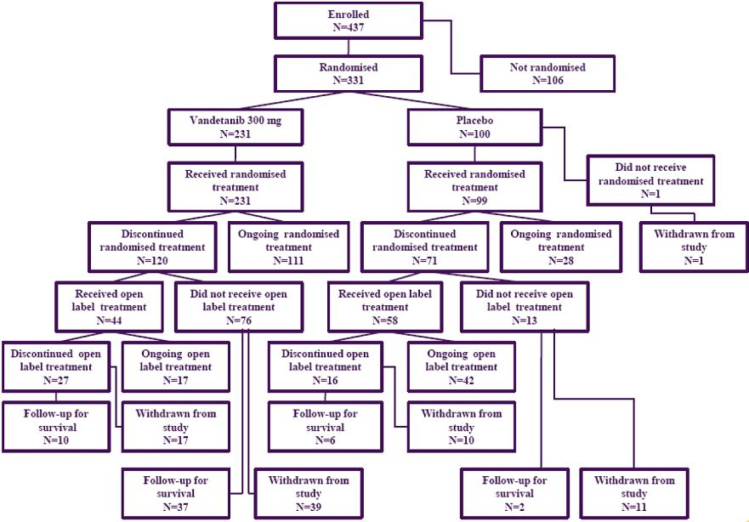
Comment: The number of patients recruited for the study was higher than expected, with 331 patients being randomised to treatment, while the initial target was for a recruitment of 232 patients. With 231 patients assigned to the vandetanib arm and 100 patients to the placebo arm, the ratio of the number of patients randomised to vandetanib:placebo exceeded the 2:1 target. All patients randomised to treatment (vandetanib, n=231; placebo, n=100) received at least 1 dose of study drug, except for 1 patient randomised to placebo who died of died of progressive MTC before receiving randomised treatment.
A total of 111 (48.1%) patients in the vandetanib arm continued to receive randomised treatment at the date of data cut-off, compared with 28 patients (28.0%) in the placebo arm. A total of 120 (51.9%) patients in the vandetanib arm discontinued randomised treatment, compared with 71 (71.0%) patients in the placebo arm. The most common reason for discontinuation was disease progression (71 [30.7%] patients in the vandetanib arm compared with 55 [55.0%] patients in the placebo arm). Patients who discontinued randomised treatment for disease progression were given the option to be unblinded and receive open label vandetanib or to continue in the study without receiving open label vandetanib. AEs resulted in discontinuation of randomised treatment in 28 (12.1%) patients in the vandetanib arm and 3 (3.0%) patients in the placebo arm. In the patients who received no open-label treatment, 21 (9.1%) died in the randomised to vandetanib arm compared with 7 (7.0%) patients in the placebo arm.

Major protocol violations/deviations
Protocol deviations in the FAS leading to exclusion from the PP analysis and deemed by the sponsor to potentially impact on the efficacy results are summarised in Table 22.
Table 22: Study 58 - Summary of protocol deviations leading to exclusion from the per-protocol analysis; FAS.
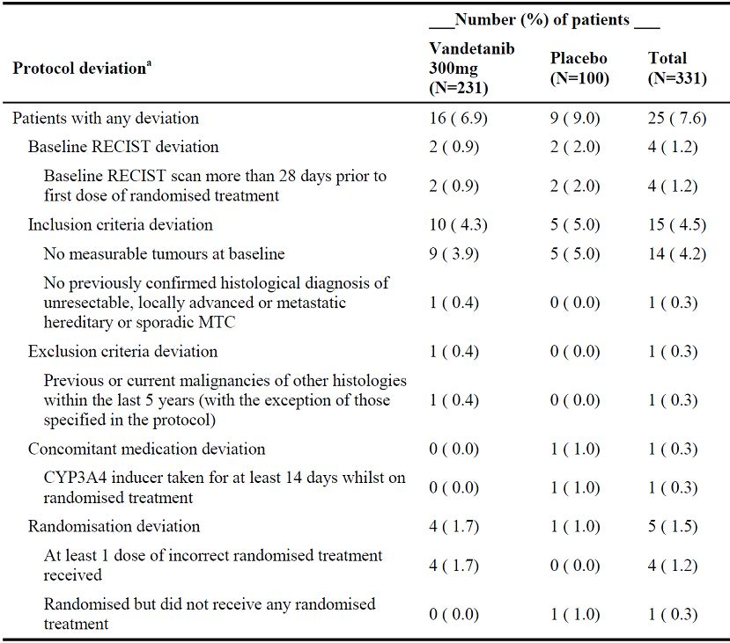
Comment: Significant protocol deviations were reported in 6.9% (n=16) and 9.0% (n=9) of patients in the vandetanib and placebo arms, respectively. The major group of protocol deviations in both treatment arms related to inclusion criteria deviations (10 [4.3%] and 5 [5.0%] patients in the vandetanib and placebo arms, respectively). The only individual protocol deviations occurring in 4 or more patients in either treatment arm were “no measurable tumour at baseline” (9 [3.9%] and 5 [5.0%] patients in the vandetanib and placebo arms, respectively), and “at least 1 dose of incorrect randomised treatment received” (4 [1.7%] and 0 [0%] patients in the vandetanib and placebo arms, respectively). All other individual protocol deviations occurred in ≤ 2 patients in one or both treatment arms. Overall, it is considered that the reported protocol deviations in the FAS population resulting in exclusion from the PP analysis are unlikely to have invalidated the primary efficacy analysis.

Baseline data

Baseline demographic characteristics
Baseline demographic characteristics are summarised in Table 23.
Table 23: Study 58 – Baseline demographics.
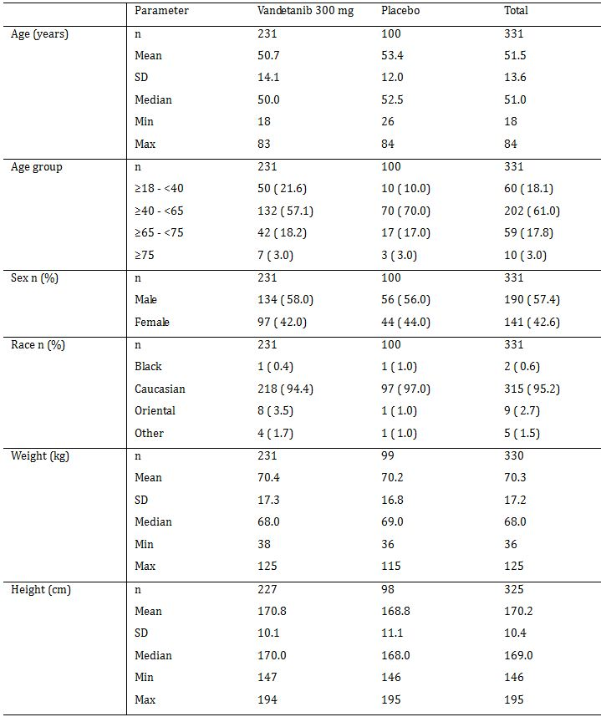
Comment: Overall, the demographic characteristics were reasonably well balanced between the two treatment arms in the FAS population. However, there was an imbalance in the age distribution between the two treatment arms with a greater percentage of patients being aged ≥ 18 to < 40 years in the vandetanib arm (21.6%, n=50) compared with the placebo arm (10.0%, n=10), and a greater percentage of patients aged ≥ 40 to < 60 years in the placebo arm (70.0%, n=70) compared with the vandetanib arm (57.1%, n=132). Other baseline demographic characteristics did not notably differ between the two treatment arms (i.e., mean age; weight and height; sex; race). The mean age of the total population (n=321) was 51.5 years (range: 18 to 84 years), and the majority of patients were aged ≥ 40 to < 65 years (n=202, 61.0%). In the total patient population, there were 190 males (57.4%) and 141 (42.6%) females, and nearly all patients were Caucasian (n=315, 95.2%). The mean weight of the total population was 70.3 kg (range: 36 to 125 kg), and the mean height was 170.2 cm (range: 146 to 195 cm).

Medical and surgical histories
The medical and surgical histories were relatively well balanced between the two treatment arms in the FAS population, with 97.0% of patients in both the vandetanib arm (224/231) and the placebo arm (97/100) having at least one event. Surgical history events occurring in ≥ 10% of patients in at least one of the two treatment arms (vandetanib vs placebo) were: thyroidectomy (89.6% vs 92.0%); lymphadenectomy (74.0% vs 80.0%); and radical neck dissection (10.4% vs 11.0%). Medical history events occurring in ≥ 10% of patients in at least one of the two treatment arms (vandetanib vs placebo) were: diarrhoea (43.3% vs 49.0%); hypothyroidism (21.6% vs 21.0%); hypertension (19% vs 19%); fatigue (15.6% vs 15.0%); hypocalcaemia (13.4% vs 9.0%); post-procedural hypothyroidism (13.4% vs 17.0%); post-procedural complication (3.9% vs 11.0%); back pain (12.6% vs 7.0%); insomnia (11.7% vs 11.0%); anxiety (11.0% vs 11.0%); headache (9.5% vs 11.0%); vocal cord paralysis (9.5% vs 11.0%); and hot flush (5.6% vs 11.0%).

Previous MTC chemotherapy
Previous radiotherapy for MTC had been received by a similar percentage of patients in the vandetanib and placebo arms (79.7%, n=184 and 84.0%, n=84; respectively), and the respective percentages for chemotherapy were 21.6% (n=50) and 18.0% (n=18). Radioimmunotherapy had been received by 4.3% (n=10) of patients in the vandetanib arm and 4.0% (n=4) of patients in the placebo arm. No more than 2% of patients in either treatment arm had received hormonal, immunomodulators, immunosuppressants, or interferons, but 21.8% (n=72) of all patients had received therapy specified as other.
Comment: Overall, 20.5% (n=68) of all patients in the FAS had received prior chemotherapy (21.6% [n=50] and 18.0% [n=18] in the vandetanib and placebo arms, respectively). The best response in total patients previously treated with chemotherapy was stable disease (7.6%, n=19). However, there was an imbalance between the two vandetanib and placebo arms in the percentage of patients reported as achieving stable disease (6.1%, [n=14] and 11.0% [n=11], respectively), and progression (7.8% [n=18] and 1.0% [n=1], respectively).

TNM classification and metastatic sites
The TNM classification and stage of disease at study entry in the FAS population are summarised in Table 24. Local and metastatic disease in the FAS population are summarised in Table 25. The number of locally advanced/metastatic organs involved the FAS population is summarised in Table 26.
Table 24: Study 58 – Summary of TNM classification and stage of disease at entry; FAS.
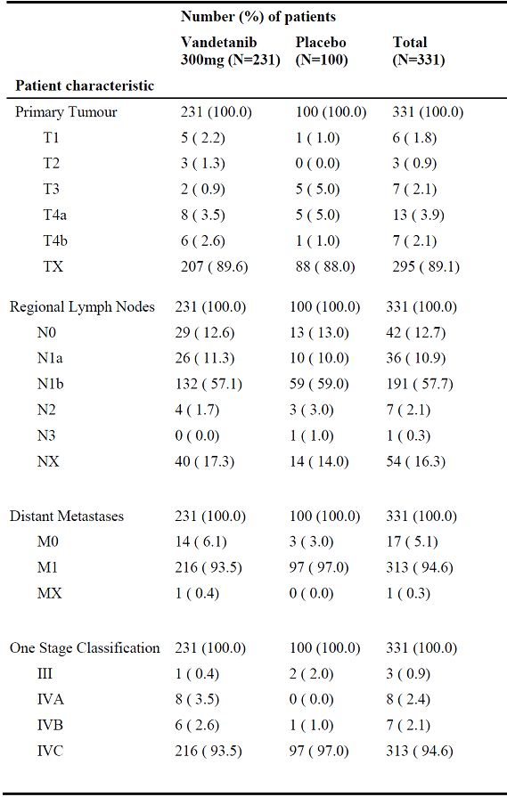
Table 25: Study 58 – Summary of local/metastatic disease; FAS.
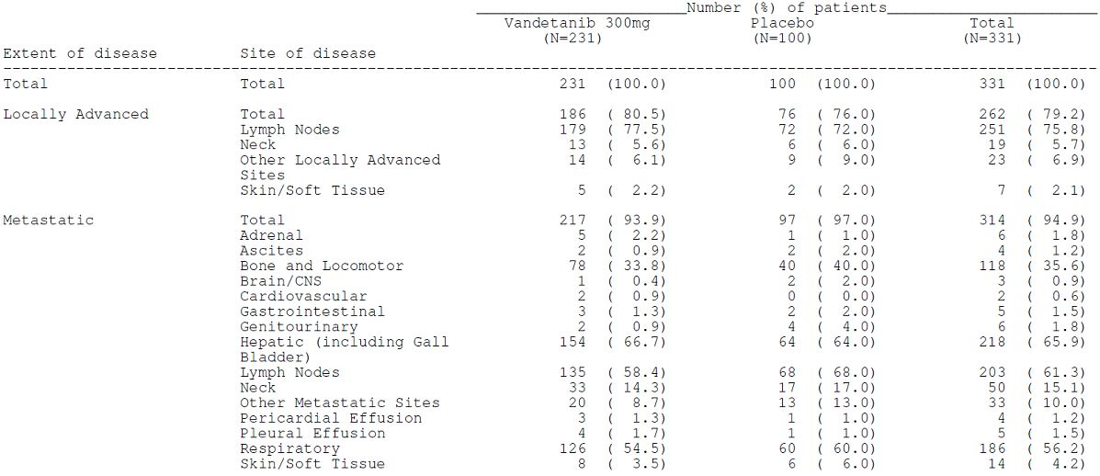
Table 26: Study 58 – Summary of number of organs involved; FAS.
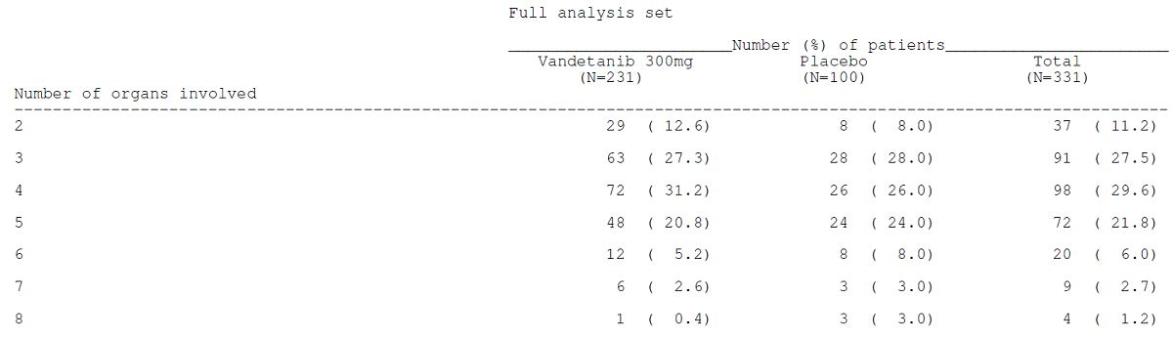
Comment: TNM classification and stage of disease at study entry was well balanced between the two treatment arms. Nearly all patients in both treatment arms were Stage IVC (93.5% [n=216] and 97.0% [n=97] in the vandetanib and placebo arms, respectively). The most common TNM stages in both treatment arms (vandetanib vs placebo) were: TX for primary tumour (89.6% vs 88.0%); N1b for regional lymph nodes (57.1% vs 59.0%); and M1 for distant metastases (93.5% vs 97.0%).
Locally advanced disease was reported in 80.5% (n=186) of patients in the vandetanib arm and 76.0% (n=76) of patients in the placebo arm, and the respective percentages for patients with metastatic disease were 93.9% (n=217) and 97.0% (n=97). The protocol allowed for patients with locally advanced disease or metastatic disease, but patients with metastatic disease predominated in the study. The sponsor postulates that possible reasons for the predominance of patients with metastatic disease include: (i) aggressive surgical techniques so that fewer locally advanced tumors are unresectable; (ii) eligibility criteria for the study requiring a CTN level ≥ 500 pg/mL and clearly measurable tumor, which could favour patients with metastatic disease; and (iii) investigator choice to select predominately patients with metastatic disease for the study.
There was no significant imbalance in the distribution of the metastatic sites between the two treatment groups. In the total population, the most common metastatic sites were hepatic (65.9%, n=218), lymph nodes (61.3%, n=203), respiratory (56.2%, n=186), bone and locomotor (35.6%, n=118), and neck (15.1%, n=50). There was no significant imbalance between the two treatment groups in the number of locally advanced/metastatic organs involved, and the most commonly occurring number of sites in the total population was 4 (29.6%, n=98).

MTC – associated findings
The associated findings in patients with hereditary MTC disease are summarised in Table 27.
Table 27: Study 58 – Hereditary MTC; FAS population, patients with hereditary disease.
Comment: In the 33 patients with hereditary MTC, 48.5% (n=16) had a family history of disease (42.9% [n=12] and 80.0% [n=4], vandetanib and placebo arms, respectively). In both treatment arms, the most commonly related associated syndrome was MEN2a (50.0% [n=14] and 60.0% [n=3], vandetanib and placebo, respectively).

RET mutation status
In the total 331 patients, 287 (86.7%) had sporadic MTC, 33 (10.0%) had hereditary MTC, and 11 (3.3%) had unknown status. RET mutation status was positive in 187 (56.5%) patients (45.0% [n=104] and 43.0% [n=30], vandetanib and placebo arms, respectively), negative in 8 (2.4%) patients (2.6% [n=6] and 2.0% [n=2], vandetanib and placebo arms, respectively), and unknown in 136 (41.1%) patients (39.8% [n=92] and 44.0% [n=44] vandetanib and placebo arms, respectively).
Comment: All patients were required to provide an archived tumour sample prior to randomisation for RET mutation analysis, although no sample was required for patients with hereditary disease who had a documented germline mutation in RET. Tumour biopsy samples were obtained using standard core biopsy techniques or by use of fine needle aspiration. RET mutation status was determined by sequencing the 6 most commonly mutated exons in MTC (10, 11, 13, 14, 15, and 16) and by testing for the M918T mutation using an amplification refractory mutation system (ARMS) analysis. RET positive mutation status was defined as having a mutation either observed from the sequencing or ARMS assay. While all except 2 patients provided an archived tumour sample for RET mutation analysis, the complete mutation analysis comprising the ARMS assay for M918T and the 6-exon sequencing was not successful for all patients (41.1% unsuccessful), suggesting that the quality of the archived samples may have been inadequate for the comprehensive sequencing analyses.

WHO PS (performance status)
The WHO PS is summarised in Table 28.
Table 28: Study 58 - Summary of WHO PS at entry; FAS population.
Comment: WHO PS status at study entry was reasonably well balanced between the two treatment arms with the majority of patients in both treatment arms being WHO PS 1. All patients met the inclusion criteria for WHO PS 0-2, and these patients were considered most likely to be able to tolerate study procedures and treatment.

Concomitant medication after study entry
Nearly all patients in both treatment arms in the safety analysis set (n=330) took concomitant medications during the study (99.7%, n=329, total patients). The most commonly taken concomitant medications in the total treatment group (n=330) in the safety analysis set were thyroid hormones (76.7%), antipropulsives (47.9%), anilides (35.2%), and calcium (33.9%). An extensive range of standard and expected medications were taken concomitantly during the study.
A total of 28 (8.5%) patients received disallowed concomitant medications during the study (24 [10.4%] and 4 [4.0%], vandetanib and placebo, respectively). Of these 28 patients, 22 (6.7%) received a disallowed QTc concomitant medication (19 [8.2%] and 3 [3.0%], vandetanib and placebo, respectively).
Comment: There were some imbalances between the two treatment arms in concomitant medications, but is unlikely that these imbalances significantly influenced the efficacy outcomes.

Results for primary efficacy outcome – PFS
The primary PFS analysis was performed using the log-rank test (unadjusted model with treatment factor only) and was based on all available “central read” RECIST assessments, including assessments performed during open-label vandetanib treatment in patients initially randomised to placebo who chose to switch to open-label vandetanib. The median duration of follow-up at the date of data cut-off on 31 July 2009 was 103 weeks, with the median duration of follow-up being 102 weeks in the vandetanib arm and 106 weeks in the placebo arm. The results for the primary analysis are summarised in Table 29.
Table 29: Study 58 – Summary of primary analysis of the PFS; FAS population.
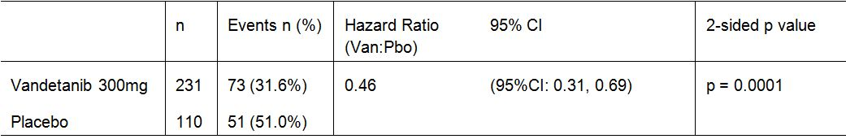
A hazard ratio < 1 favours vandetanib. The analysis was performed using a log rank test with treatment as the only factor. PFS was derived from all available central read RECIST assessments.
The median PFS in the vandetanib arm could not be calculated because an insufficient number of PFS events had occurred in this arm at the time of data cut-off, but the median PFS in the placebo arm was 19.3 months. Because the median PFS in the vandetanib arm could not be calculated, a Weibull model was fitted and used to estimate the median PFS in the two treatment arms. The predicted median PFS for the vandetanib arm was 30.5 months, which is an 11.2 month increase in median duration of PFS compared with the observed median PFS in the placebo arm of 19.3 months.
At the time of the analysis, a total of 124 (37.5%) had progressed (RECIST progression [110, 33.2%] plus death [14 [4.2%]). Progression status at the date of data cut-off is summarised in Table 30.
Table 30: Study 58 – Summary of progression at data cut-off; FAS population.
a. Death, in the absence of RECIST progression, where death occurs within 3 months of the last evaluable RECIST assessment.
b. Death, in the absence of RECIST progression, occurring more than 3 months after the last evaluable
The results for the sensitivity analyses of PFS were consistent with the primary analysis.
PFS results at 6 months, 1 year and 2 years (vandetanib vs placebo) were: 91.4% vs 74.5%; 83.3% vs 62.7%; and 58.8% vs 41.7%. The K-M curves for time to PFS derived from all available “central read” RECIST assessments are summarised in Figure 9.
Figure 9: Study 58 – PFS Kaplan-Meier curves; FAS population.
Comment: The primary analysis showed that there was a statistically significant difference in PFS in favour of vandetanib relative to placebo (HR=0.46 [95% CI, 0.31, 0.69], p=0.0001). The HR represents a 54% reduction in the rate of progression in the vandetanib arm relative to the placebo arm. The median time to PFS in the vandetanib arm could not be derived from the KM curve because an insufficient number of events had occurred in this treatment arm at the date of data cut-off. Therefore, the median time to PFS for the vandetanib arm was estimated using a Weibull survival model. This model predicted a median time to PFS of 30.5 months in the vandetanib arm and 19.2 months in the placebo arm (consistent with 19.3 months derive from the KM curve). The duration of follow-up was similar in both treatment arms (102 and 106 weeks, vandetanib and placebo, respectively).
As described in the SAP an analysis of PFS was to be performed when 90 events had occurred in the FAS. The primary PFS analysis was based on the number of RECIST progression events as assessed by the central independent readers. Because the central reads were not done in "real time," the time at which at least 90 events would have been centrally assessed had to be estimated based on events observed at the study sites. At the time estimated for this to occur (the data cut-off date of 31 July 2009), 124 centrally assessed progression events had occurred (14 deaths and 110 RECIST progressions).
The primary PFS analysis was based on all available “central read” RECIST assessments, including assessments performed during open-label vandetanib treatment, if the patient received open label vandetanib prior to progression. A total of 51 (15.4%) patients (23 [10.0%] in the vandetanib arm and 28 [28.0%] in the placebo arm) received open-label vandetanib before progression was documented. When data from the open-label phase were excluded from the PFS analysis and data imputed for patients without a central assessment of disease progression in the randomised treatment phase, the HR was 0.27 (95% CI: 0.18, 0.41), p<0.001; 64 (27.7%) events in the vandetanib arm and 59 (59.0%) events in the placebo-arm. It is unclear why the sponsor chose to assess the primary efficacy endpoint based on randomised and open-label data. It is noted that the FDA assessed the primary efficacy endpoint using only the data from the randomised period (FDA Statistical Review, available online from the FDA website). This appears to account for the different PFS results in the USA label compared with the proposed Australian PI.
In addition to the sensitivity analysis of PFS based on data from the randomised period, there were number of additional sensitivity analyses of the PFS. The results for the sensitivity analyses of the PF were consistent with the result for the primary analysis of this endpoint. In particular, the PFS sensitivity analysis based on the Cox proportional hazards model including pre-specified baseline covariates produced virtually identical results to the primary analysis based on the unadjusted log-rank analysis allowing for treatment effect alone. The Cox proportional hazards model adjusted for the pre-specified baseline covariates: RET mutation status (positive or negative/unknown); CTN doubling time (≤ 24 months or > 24 months/unknown); CEA doubling time (≤ 24 months or > 24 months/unknown); number of prior systemic anticancer therapies (none or ≥ 1); response to the most recent systemic anticancer therapy (response or no response/unknown), and MTC status (hereditary or sporadic/unknown). A global interaction test was performed to determine if there were any significant treatment-by-covariate interactions in the Cox proportional hazards model. This test was not significant at the 1% level (p=0.177). Therefore, no further interaction testing was performed. A test for non-proportional hazards was performed by fitting a time dependent covariate to the Cox proportional hazards model and was statistically significant at the 5% level (p=0.0132), which suggests that the assumption of proportional hazards may not hold for the analysis.
The PP sensitivity analysis for PFS was consistent with both the primary analysis in the FAS population, and the Cox proportional hazards model accounting for pre-specified baseline covariates. Furthermore, the two PFS sensitivity analysis which, (1) treated first appearance of hypointense or hypodense lesions in the first two follow-up scans as progressive disease, and (2) did not use the correction for calcified lesions, were both consistent with the primary analysis.
In general, the subgroup analyses of PFS supported the primary efficacy analysis with the results demonstrating statistical superiority of vandetanib compared with placebo. However, these results are considered to be exploratory as the study was not powered to show statistical differences between vandetanib and placebo in the subgroups.

Results for secondary efficacy outcomes

Objective Response Rate (ORR)
The ORR was 45.0% (104/321) and 13.0% (13/100) in the vandetanib and placebo treatment arms respectively: odds ratio 5.48 (95% CI: 2.99, 10.79); p<0.0001; FAS. In both treatment arms, there were no patients with a complete response and all patients with an objective response (complete + partial response) had a partial response. Objective tumour response in the FAS is summarised in Table 31.
Table 31: Study 58 – Summary of objective tumour response; FAS.
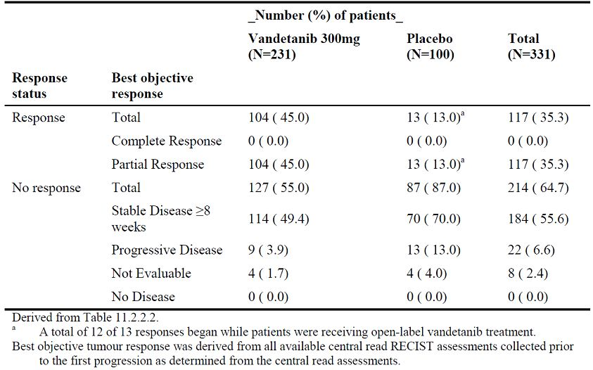
The results for the primary analysis of the ORR were almost identical for a sensitivity analysis using logistic regression allowing for the effects of treatment and also including terms for baseline covariates of RET mutation status, CTN doubling time, CEA doubling time, number of prior therapies, response to most recent prior therapy, and MTC status.
In an exploratory analysis not specified in the SAP, the ORR was calculated excluding open-label assessments. In this analysis, the ORR was 43.7% (101/231) and 1.0% (1/100) in the vandetanib and placebo treatment arms, respectively: odds ratio = 76.91 (95% CI: 16.68, 1366); p<0.0001; FAS.

Disease Control Rate (DCR)
DCR was defined as patients who had a best response of CR or PR, or SD (≥ 24 weeks). The DCRs were 86.6% (200/231) and 71.0% (71/100) in the vandetanib and placebo treatment arms, respectively: odds ratio = 2.64 (95% CI: 1.48, 4.69); p=0.001; FAS. Based on the central review of the RECIST data, the median time to response from randomisation was 5.8 months for patients in the vandetanib arm and 13.7 months for patients in the placebo arm.
The results for the primary analysis of the DCR were almost identical to those for a sensitivity analysis using logistic regression adjusting for treatment and baseline covariates of RET mutation status, CTN doubling time, CEA doubling time, number of prior therapies, response to most recent prior therapy, and MTC status. In this analysis, the DCR was 86.6% (200/231) in the vandetanib arm and 71.0% (71/100) placebo arm: odds ratio = 2.93 (95% CI: 1.57, 5.49); p=0.0007; FAS.
Of the 13 responders in the placebo arm, 12 had responses that commenced during open-label vandetanib treatment. Consequently, a non pre-specified exploratory analysis of the DCR was performed to assess the impact of including these open-label assessments in the analysis. The results showed that when open-label assessments were excluded, there was a statistically significant improvement in DCR at 24 weeks for vandetanib compared with placebo: odds ratio = 3.58 (95% CI 2.09, 6.17), p <0.0001; FAS. The DCR was 84.8% (196/231) and 61.0% (61/100) in the vandetanib and placebo arms, respectively, when open label assessments were excluded.

Overall survival (OS)
The submission included an initial OS analysis, and a second OS analysis will be performed when at least 50% of the patients have died. At the time of the initial OS analysis, 48 (14.5%) randomised patients had died, and at the time of the second analysis it is predicted that at least 166 (50.2%) deaths will have occurred. Therefore, the sponsor estimated that 28.9% (48/166) of the final predicted number of deaths had occurred at the date of data cut-off for the initial OS analysis of 31 July 2009. Consequently, the sponsor calculates the significance level for the first analysis to be 0.02% with corresponding 99.98% confidence intervals. For the second analysis of OS, the sponsor states that the significance level will be 4.98% with corresponding 95.02% confidence intervals.
In the initial OS analysis there were 32 (13.9%, 32/231) and 16 (16.0%, 16/100) events in the vandetanib and placebo treatment arms respectively; HR = 0.89 (95% CI: 0.28, 2.85); p = 0.7121; FAS. Survival status at the time of the data cut-off are summarised in Table 32.
Table 32: Study 58 – Summary of survival status at data cut-off; FAS.
There were two OS sensitivity analyses, (1) a log rank test based on the PP population, and (2) a Cox proportional hazard model based on the FAS with baseline covariate terms for RET mutation status, CTN doubling time, CEA doubling time, number of prior therapies, response to most prior therapies, and MTC status. The results of both of the OS sensitivity analyses were consistent with the primary analysis.
Comment: There was no statistically significant difference between the two treatment arms in OS, but the OS data are considered to be immature. However, the final assessment of the OS is unlikely to be informative due to the significant bias which will be introduced into the analysis by patients switching from randomised placebo to open-label vandetanib.

Calcitonin (CTN) response and carcinoembryonic antigen (CEA) response
CTN response was derived from data collected when patients were receiving randomised treatment. The CTN responses (CR + PR) were 69.3% (160/231) and 3.0% (3/100) in the vandetanib and placebo treatment arms respectively: odds ratio = 72.86 (95% CI: 26.2, 303.2); p<0.0001; FAS. Complete response (CR) was defined as complete normalization of CTN, confirmed by a repeat assessment > 4 weeks later, and partial response (PR) was defined as a decrease of > 50% in CTN from baseline, confirmed by a repeat assessment > 4 weeks later. Of the 160 patients with a response in the vandetanib arm, 157 had a PR and 3 had a CR, while in the placebo treatment arm all 3 patients with a response had a PR.
CEA response was derived from data collected when patients were receiving randomised treatment. The CEA responses (CR + PR) were 51.5% (110/231) and 2.0% (2/100) in the vandetanib and placebo treatment arms, respectively: odds ratio = 52.03 (95% CI: 15.95, 320.3); p<0.0001; FAS. Complete response (CR) was defined as complete normalisation of CEA, confirmed by a repeat assessment > 4 weeks later, and partial response (PR) was defined as decrease of > 50% in CEA from baseline, confirmed by a repeat assessment > 4 weeks. Of the 119 patients with a response in the vandetanib arm, 112 had a PR and 7 had a CR, while in the placebo arm both patients with a response had a PR.

Time to Worsening of Pain (TWP)
TWP was a patient reported outcome (PRO) categorised as a secondary efficacy outcome, and was a composite endpoint derived from opioid analgesic use and the worst pain item of the BPI. Responses for opioid analgesic use and responses for the worst pain item were derived by comparing follow-up assessments to baseline or the previous visit. These responses were then used to derive a worsening of pain parameter, defined as a response of worsening in at least 1 of the 2 components (opioid analgesic use or worst pain item) that was not followed by an overall response of improvement in the next 14 days (determined by combining the response for opioid analgesic use and the response for worst pain). TWP was defined as the time to the date of the assessment of the component that led to the first confirmed worsening from the date of randomisation. If both components had a response of worsening at the same visit, then the earliest assessment date was used in the derivation of TWP.
For worst pain, worsened was defined as a ≥ 2 point increase from baseline, improvement was defined as a ≥ 2 point decrease from baseline worst-pain item score with no increase from baseline of ≥ 10 mg/day of morphine sulphate equivalent, otherwise no change.
For opioid analgesic use, worsened was defined as an increase from baseline of ≥ 10 mg/day of morphine sulphate equivalent, improvement was defined as a decrease from previous visit by > 50% of opioid analgesic use with no increase of ≥ 2 point from baseline worst-pain item score, otherwise no change.
There was a statistically significant improvement in TWP for vandetanib compared with placebo in the FAS as assessed by a log-rank test with treatment as the only factor (HR = 0.61 [95% CI 0.43, 0.87], p=0.0062). In the vandetanib arm, 49.4% (114/231) of patients had worsening pain compared with 57.0% (57/100) in the placebo arm. The median time to deterioration in worsening of pain was 7.85 months in the vandetanib arm, compared with 3.25 months in the placebo arm.
Comment: Patients in the vandetanib arm had a statistically significantly longer median time to worsening of pain of 4.6 months compared with patients in the placebo arm. The analysis of TWP was considered the primary analysis for PRO, and all other analyses of PROs were considered to be exploratory.

Other efficacy studies (Phase II therapeutic exploratory)

Study 8

Design
This was a bi-national, multicentred, Phase II (therapeutic exploratory), open-label, 2-stage study designed to evaluate the efficacy and tolerability of vandetanib in patients with locally advanced or metastatic hereditary MTC. The study was conducted at 7 centres (6 in the US and 1 in France). The first patient was enrolled on 12 November 2004 and the last patient/last visit was on 22 February 2008. The CSR was dated 11 March 2009. The data cut-off date for this study was 22 February 2008.

Primary efficacy objective / outcome variable
The primary objective of the study was to assess the objective response to vandetanib 300 mg in patients with locally advanced or metastatic hereditary MTC. The primary method for determining objective response was the ORR (CR + PR) based on site reviewed CT/MRI scans using RECIST criteria. Following approval of Amendment 005, CT/MRI scans were also reviewed centrally, using modified RECIST criteria.

Secondary efficacy objectives / outcome variables
There were a number of secondary efficacy objectives and outcome variables including “biochemical response” (change from baseline in basal CTN levels), “symptomatic response” (change from baseline in stool consistency and frequency in patients with symptomatic diarrhoea), and “clinical response” (time to progression [TTP] referred to as progression free survival [PFS], disease control rate [DCR], duration of objective response, duration of disease control, change in PS [WHO] from baseline). In addition, the study included a number of exploratory efficacy objectives.

Study population
The inclusion criteria included patients aged at least 18 years of age with previously confirmed histological diagnosis of MEN2a, MEN2b, or FMTC with a characteristic germline mutation in the RET proto-oncogene. In addition patients were required to have WHO PS 0 to 2, and 1 or more measurable lesions at least 1 cm in the longest diameter by spiral CT scan or 2 cm with conventional techniques. All inclusion and exclusion have been examined and are considered to be satisfactory. Similarly, the restriction and discontinuation criteria have been examined and are considered to be satisfactory.

Treatment
Treatment was initiated in all patients with vandetanib 300 mg once daily and continued with this dose unless reduced/modified for toxicity. If trial treatment was deemed effective, treatment was to continue until the patient met any of the criteria for study discontinuation. For all toxicity other than QTc prolongation, the dose of study treatment was to be withheld for up to 3 weeks until the toxicity had resolved to ≤ CTCAE grade 1 or baseline, and then study treatment could be restarted. Dose reduction/re-challenge for each toxicity criterion was managed by pre-specified guidelines. Patients were withdrawn from the study if toxicity did not resolve to ≤ CTCAE grade 1 or baseline within 3 weeks. The withdrawal visit was to be performed as soon as possible after the last dose of vandetanib. Patients were to be followed-up for resolution of toxicity for 30 days, and study-related toxicities and SAEs were to be followed-up until resolution unless these values were not likely to improve because of the underlying disease. Patients were also followed-up for objective disease progression.
Patients who demonstrated a response or stable disease remained in the study as long as they were benefiting from treatment (i.e., an objective, biochemical, or symptomatic CR, PR, or SD), there was no evidence of tumor progression, and they met no other withdrawal criteria. Protocol Amendment 006 allowed patients demonstrating progression by RECIST criteria to continue on trial and receive study medication if the investigator, with approval from the sponsor, believed the patients were deriving clinical benefit from vandetanib therapy.

Assessments
The primary method for determining objective response was based on the site reviewed computed tomography (CT)/magnetic resonance imaging (MRI) scans using RECIST criteria. All CT/MRI scans were also reviewed by a centrally appointed vendor, using modified RECIST criteria, following protocol Amendment 005. The central review data were intended to supplement the primary, site-reviewed method of assessment of response. Radiographic studies were assessed at screening (within 21 days of the first study dose) then at every 12 weeks and at withdrawal, unless assessment had been undertaken taken within the previous 4 weeks. Patients who withdrew for reasons other then objective disease progression or consent withdrawal were continued to be followed every 3 months for objective disease progression. Confirmation of objective response was assessed at no less than 4 weeks from initial response. Patients who had demonstrated progression through RECIST evaluations were allowed to continue on trial and receive study medication if the investigator, with approval of the sponsor, believed the patients were deriving clinical benefit from monotherapy. Assessments were undertaken at 28 day intervals prior to protocol Amendment 007, and 12 week intervals following approval of Amendment 007.

Statistical methods
The primary objective was to assess efficacy based on the objective response rate (CR +PR) following vandetanib 300 mg in patients with hereditary MTC using a 2-stage study design. In stage 1, the first 15 evaluable patients (defined as patients receiving at least 1 dose of vandetanib) were followed up for 3 months. Vandetanib treatment was considered to be promising if 1 or more of the 15 patients experienced a confirmed objective, biochemical, or symptomatic CR or PR. If no patients demonstrated a response, the study would not proceed to the second stage. However, if stage 1 was successful, an additional 15 evaluable patients were to be recruited.
At the end of the study, a successful efficacy outcome would be considered to be an objective response rate of ≥ 20% of patients. Assuming a null hypothesis of an objective tumor response rate of < 20%, and an alternative hypothesis of an objective tumor response rate (CR and PR patients) of ≥ 20%, with 30 evaluable patients and using a one-sided hypothesis test with a significance level of 5%, there would be ≥ 80% power to reject the null hypothesis in favour of the alternative hypothesis if the true objective tumor response rate was ≥ 40%. Efficacy data were summarised and analysed on an intention-to-treat (ITT) basis. The efficacy analysis population consisted of all patients who received at least 1 dose of vandetanib.

Patient disposition
Thirty-five (35) patients were recruited, 30 received initial treatment with vandetanib 300 mg and 5 were “screen failures” (i.e., failed to meet all inclusion criteria or met any exclusion criteria). Of the 30 initially treated patients, 13 discontinued treatment with vandetanib for the following reasons: patient not willing to continue treatment (n=2); AEs (n=7); and disease progression (n=4). Of the 13 patients discontinuing treatment, 11 terminated the study and no further post discontinuation assessments were performed (patient not willing to continue [n=7], death [n=2], and lost to follow-up [n=2]), and 2 completed the study. There were 17 ongoing patients at the time of data cut-off on 22 February 2008. The cut-off date was determined based on when the patients in the study had at least 18 months of treatment.

Baseline demographics and characteristics
There were more females than males in the study (70.0% [n=21] and 30.0% [n=9], respectively), and the majority of patients were Caucasian (96.7% [n=29]). The mean age of the 30 treated patients was 48.7 years (range: 20 to 77 years), with the majority of patients being younger than 65 years (86.7% [n=26]). Metastatic disease was present in 29 (96.7%) patients at baseline. The majority of patients had MEN2a (70.0% [n=21]), with the remainder having FMTC (16.7% [n=5]) or MEN2b (13.3% [n=4]).
All 30 patients (100%) had previously undergone disease related surgery, 36.7% (n=11) had received radiotherapy, and 26.7% (n=8) had received other cancer therapy. The WHO PS score at study entry was 0 (normal activity) for 50.0% (n=15) of patients, PS 1 (restricted activity) for 46.7% (n=14), and PS 2 (in bed ≤50% of the time) for 3.3% (n=1).
Protocol deviations were reported in 56.7% (n=17) of patients, and patients may have had multiple deviations per category but were counted only once per category. Protocol deviations were primarily associated with failure to adhere to scheduled assessments or performance of scheduled laboratory assessments. The most commonly reported protocol deviations were laboratory assessments not done (9 patients), visit not as planned (8 patients), consenting problem (7 patients), other (6 patients), and site problem with study drug administration (4 patients). All other individual protocol deviations occurred in 1 or 2 patients.

Results – Primary efficacy variable
The results for the objective response rate are summarised in Table 33.
Table 33: Study 8 – Objective response with vandetanib 300 mg; ITT analysis set.
a. Initial treatment received.
CR = Complete response; ITT = Intention-to-treat; N = Number of patients in treatment group; PR = Partial response; SD = Stable disease.
Comment: The study specified that a successful efficacy outcome would be considered to be an objective response rate of ≥ 20%. Based on this criteria, the study can be considered to be successful as the ORR was 20.0% (6/30). In the 6 patients with an objective response, all had a PR and no patients reported a CR. In the exploratory outcome of ORR assessed by independent review of the RECIST criteria, the ORR was 16.7% (5/30) in the ITT population (exploratory efficacy outcome).

Results – Secondary efficacy variables
- The estimated median PFS was 27.9 months (95% CI: 19.4, upper limit not calculated due to insufficient follow-up).
- The disease control rate (CR + PR +SD ≥ 24 weeks) was 73.3% (22/30), and the median duration of disease control from first dose until progression or death from any cause was 555.5 days (95% CI: 500.0, 752.0).
- The median duration from onset of objective response until progression or death was 310.5 days (95% CI: 254.0, 402.0), and from first dose until progression or death was 561.5 (95% CI: 322.0, 830.0) days.
- Biochemical CTN response was observed in 80% (24/30) of patients, and biochemical CEA response was observed in 53% (16/30) of patients. No symptomatic response was observed in patients with abnormal stools at baseline.
- At Week 24, 6.7% (2/30) of patients had a shift from WHO PS of 1 at baseline to 0, no change from baseline was reported in 46.7% (14/30) of patients, and worsening was reported in 13.3% (4/30) of patients.

Study 68

Design
Study 68 was a multi-national, multi-centre, Phase II (therapeutic exploratory), open-label, study designed to evaluate the efficacy and tolerability of vandetanib 100 mg in approximately 15 patients with locally advanced or metastatic hereditary MTC. The study was conducted at 9 study sites in Australia, Canada, Italy, Netherlands, Romania, Spain, Switzerland, and the United States. The first patient was enrolled on 29 August 2006 and the last patient completed on 31 January 2008. The CSR was dated 17 July 2008. The data cut-off date for the study was 31 January 2008.

Efficacy objectives and outcomes
The primary, secondary, and exploratory efficacy objectives and outcome variables were similar to those for study 8.

Study population
The inclusion and exclusion criteria were consistent with those for study 8, as were the restriction and discontinuation criteria.

Treatment
Patients with recurrent disease may have received prior local palliative radiation or surgery provided that the treatment was given at least 1 month (28 days) before date of first dose. Patients received an oral dose of vandetanib 100 mg once daily until objective disease progression, and were seen weekly for the first 2 weeks, then again at 4 weeks, 8 weeks, and 12 weeks, then every 12 weeks thereafter. On disease progression, all patients considered by the investigator to be deriving benefit from treatment were permitted to enter post-progression vandetanib 300 mg treatment to determine if further clinical benefit could be observed at a higher dose. Patients were permitted to continue receiving vandetanib 300 mg treatment until objective disease progression occurred at this dose, or another discontinuation criterion was met. Patients who did not enter post-progression vandetanib 300 mg treatment were discontinued from 100 mg treatment, and entered directly into follow-up. Safety data from all patients were assessed on an ongoing basis including discontinuation and follow-up.
Most toxicities were to be managed medically, and dose reduction was only to be necessary for CTCAE grade 3-4 toxicities. The study included information on the management of cardiac, gastrointestinal, cutaneous, and other toxicities, including instruction on modifications or interruption of vandetanib treatment. All ongoing study drug-related toxicities and SAEs were followed until resolution, unless in the investigator’s opinion, the condition was unlikely to be resolved due to the patient’s underlying disease. All new study-related AEs and all SAEs occurring up to 60 days after the last dose of vandetanib were required to be reported to the sponsor and were to be followed-up until resolution whenever possible. All patients who had any CTCAE grade 3 or 4 laboratory values at the time of discontinuation were required to have further tests performed, and the results recorded until the lab values returned to CTCAE grade 1 or baseline, unless these values were not likely to improve because of the underlying disease.

Assessments
Radiologic evaluation using modified RECIST was performed every 12 weeks (± 2 weeks) while the patient was receiving vandetanib 100 mg treatment. Patients who discontinued 100 mg study treatment for reasons other than disease progression continued to be evaluated every 12 weeks (± 2 weeks) until progression was documented, unless they withdrew consent. Patients who entered post-progression vandetanib 300 mg treatment had RECIST assessments performed every 24 weeks (± 2 weeks) in accordance with the assessment schedule. Blood samples for the determination of CTN, CEA, plasma levels of vandetanib (pharmacokinetics) and plasma and serum protein markers were obtained from all patients enrolled in the study.

Statistical methods
The objective tumour response rate was assessed according to RECIST criteria. Evaluable patients had measurable disease (at least 1 tumour measuring at least 2 cm in diameter by conventional imaging techniques or at least 1 cm by spiral CT for non lymph node tumours and 1.5 cm for lymph node tumours) at screening. Best objective response was determined using a computer program based on the modified RECIST criteria. Responders were patients with a best objective response of CR or PR. Best response of CR (or PR) meant that CR (or PR) criteria were satisfied on 1 visit, and that CR (or PR) status was confirmed by repeat imaging at not less than 4 weeks following the date of identified CR (or PR).
Fifteen (15) evaluable patients (defined as patients receiving at least 1 dose of vandetanib) were to be recruited and followed for 3 months. Vandetanib 100 mg treatment was considered to have activity if 1 or more of the 15 patients experienced a confirmed objective, biochemical, or symptomatic CR or PR. Patients with stable disease continued in the study for as long as the investigator judged that the patient was gaining benefit from this treatment.
The sample size of 15 subjects was selected on the basis that if no response was seen in 15 subjects, the probability that the true objective response rate is 20% or greater was less than 0.05. At the end of this trial, if there were 0 responses, then it would represent a failed study.
Efficacy data were summarised and analysed on an intention-to-treat basis. The efficacy analysis population (full analysis set) consisted of all patients who received at least 1 dose of vandetanib. The safety analysis population (safety analysis set) comprised all patients who received at least 1 dose of study treatment. Safety and tolerability were assessed in terms of AEs, laboratory data, vital sign data, and ECG changes, and were collected for all patients.

Patient disposition
Twenty-two (22) patients were enrolled, 19 received vandetanib 100 mg/day, and 3 were not treated with vandetanib (incorrect enrollment [n=2] and voluntary discontinuation [n=1]). There were 11 patients continuing vandetanib 100 mg/day at data cut-off, while 8 patients had discontinued treatment (AE [n=3], disease under investigation worsened [n=4], voluntary discontinuation [n=1]). There was 1 patient continuing follow-up after 100 mg/day treatment at data cut-off. There were 3 patients who withdrew from the study after 100 mg treatment (death [n=1], voluntary discontinuation [n=1]).
There were 4 patients who entered optional 300 mg/day post-progression treatment. There were 4 patients who continued 300 mg/day post-progression treatment (1 withdrew due to the condition under investigation worsening, and 3 were continuing at data cut-off after post progression treatment [1 of whom subsequently withdrew after post-progression treatment due to study completed]).

Patient baseline demographics and characteristics
Of the 19 patients in whom treatment was initiated with vandetanib 100 mg/day, there were more males (68.4% [n=13]) than females (31.6% [n=6]), and the majority of patients were Caucasian (94.7% [n=18]). The mean age of the treated patients was 44.7 years (range: 22 to 79 years), with the majority being younger than 65 years (89.5% [n=17]). The majority of patients had stage IVC disease (94.7% [n=18]) and the mean time since diagnosis was 13 years (range: 5 to 33 years). Nearly all patients had metastatic disease (94.7% [n=18]), with the most common site being hepatic, including gall bladder (84.1% [n=16]). Nearly all patients had MEN2a (89.5% [n=17]) and 1 patient each had FMTC or MEN2a.
Anticancer therapy had been received by 6 (31.6%) patients, 4 (21.0%) radiotherapy and 2 (10.5%) chemotherapy. The WHO PS score was 0 (normal activity) in 16 (84.2%) patients, 1 (restricted activity) in 1 (5.3%) patient, and 2 (in bed ≤ 50% of the time) in 2 (10.5%) patients. RET mutation status was confirmed for 17 (89.5%) patients and unknown for 2 (10.5%) patients.

Results – Primary efficacy variable (ORR)
The results for the objective response rates with vandetanib 100 mg are summarised in Table 34.
Table 34: Study 68 – Objective response with vandetanib 100 mg; FAS.
CR = Complete response; ITT = Intention-to-treat; N = Number of patients in treatment group; PR = Partial response; SD = Stable disease.
Comment: The ORR was 15.8% (3/19), and all 3 patients with a response had a PR rather than a CR. As there were more than 0 responses, the study is not considered to have failed as assessed by the pre-specified study criteria.

Results – Secondary efficacy variables
- Progression was reported in 26.3% (5/19) of patients treated with vandetanib 100 mg (4 [21.1%] RECIST progression; 1 [5.3%] death). There were 14 (73.7%) patients alive with no progression. The estimated median PFS could not be calculated for patients who received vandetanib 100 mg because of insufficient follow-up.
- Disease control rate (DCR) was defined as patients who had a best response of CR or PR, or SD ≥ 24 weeks, and was assessed according to RECIST criteria. The DCR was 68.4% (95% CI: 43.4, 87.4); i.e., disease control in 13 out of 19 patients treated with vandetanib 100 mg. The median duration of disease control was 256 days. The median duration of response from onset of response was 168 days, and the median duration of response from first dose was 252 days.
- Overall, no marked improvement in WHO PS was evident in patients treated with vandetanib 100 mg. No symptomatic responses occurred among the 19 patients in the FAS who were evaluable for symptomatic response in diarrhoea (abnormal stool at baseline).
- There were 3 (15.8%) patients with a CTN biochemical response (PR), and 1 (5.3%) patient with CEA biochemical response (PR) out of the 19 patients treated with vandetanib 100 mg.
- Of the 4 patients who received vandetanib 300 mg during the post-progression period, 1 patient had a documented RECIST progression and completed the study. The remaining 3 patients had no objective RECIST progression observed in the post-progression period and continued receiving vandetanib 300 mg daily at the time of data cut-off. None of the 4 patients had an objective response during the post-progression period, a biochemical CTN response, or a biochemical CEA response.

Analyses performed across trials (pooled analyses and meta-analyses)
There were no efficacy analyses performed across trials.

Evaluator’s conclusions on clinical efficacy
The submission included one, pivotal Phase III (therapeutic confirmatory) study supporting the efficacy of vandetanib 300 mg for the treatment of unresectable locally advanced or metastatic MTC (study 58). The study randomised 231 patients to vandetanib and 100 patients to placebo. The study is considered to provide meaningful clinical evidence for the efficacy of vandetanib compared with placebo as assessed by the primary outcome of PFS, and supported by the secondary outcomes of ORR, DCR, CTN response, CEA response, and TWP. However, there was no statistically significant difference between the two treatment arms in OS, but the survival data were immature at the data cut-off date. The submission also included two, small, Phase II, open-label, single-arm studies which are considered to be exploratory as regards the efficacy of vandetanib rather than pivotal or supportive.
The TGA adopted EU “points to consider” document (CPMP/EWP/2330/99) provides guidance on applications supported only by one single Phase III study. While acknowledging the “general demand” for replication of scientific studies the document recognises that clinical drug development differs from the situation applying to strictly experimental studies. The document notes that “where the confirmatory evidence is provided by only one pivotal study, this study will have to be exceptionally compelling”, and outlines a number of factors which should be taken into account in the regulatory evaluation of such studies. These factors have been applied to the pivotal Phase III study (study 58) and the conclusions are summarised as follow: (1) the study is internally valid; (2) the study is externally valid; (3) the difference in PFS between the vandetanib and placebo treatment arms is clinically relevant; (4) the statistical significance difference in PFS between the vandetanib and placebo treatment arms as assessed by the primary analysis in the FAS is robust and supported by the PFS sensitivity analyses; (5) the sponsor’s quality assurance and internal quality control procedures in conjunction with independent auditing procedures provide reassurance that the data were of good quality; (6) the assessment of the PFS was internally consistent with vandetanib being superior to vandetanib in most of the sub-group analyses; (7) the tested hypothesis was plausible. The only factor which needs to be taken into account on which there were no data relates to centre effects. No data could be identified on whether there was a difference in PFS between the two treatment arms among the study centres. However, this is not considered to be critical in this multi-national study from 63 centres where the number of patients from each centre was too small to allow for meaningful outcome comparisons to be made between the two treatment arms.
In study 58, the primary PFS analysis was performed using the log-rank test (unadjusted) based on all available centrally assessed modified RECIST data, including assessments performed during open-label vandetanib treatment in patients initially randomised to placebo who decided to continue treatment with open-label vandetanib following unblinding. Following protocol Amendment 6, investigators had the option to unblind subjects remaining on randomised therapy, whether or not disease progression had occurred. It was stated in the submission (CSR 58) that the amendment was “made as a consequence of the analysis results, rather than before the data were analysed”. The sponsor will be asked to clarify this rather confusing statement.
The decision to base the primary analysis on modified RECIST data from both the randomised and the open-label phases is considered to be unusual. It appears to have been undertaken because central assessment of RECIST data specified for the primary analysis was not performed in real time. Consequently, in some patients initially randomised to placebo central assessments were undertaken after switching to vandetanib. The patient’s decision to switch from placebo to vandetanib following unblinding was based on disease progression determined by the site read of the modified RECIST data. Sensitivity analysis of the PFS based on central assessment of RECIST data prior to open-label treatment, with imputation of data for those patients in whom a central assessment had not occurred at this time-point, showed that the outcome statistically significantly favoured vandetanib relative to placebo. In addition, a PFS sensitivity analysis based on site assessment of modified RECIST data also showed that the outcome statistically significantly favoured vandetanib relative to placebo.
The key efficacy findings in the pivotal Phase III study (study 58) are:
- The median duration of follow-up at the date of data cut-off was 102 weeks in the vandetanib treatment arm and 106 weeks in the placebo treatment arm. There was a statistically significant difference in favour of vandetanib compared with placebo in PFS based on all available centrally assessed modified RECIST data (HR = 0.46 [95% CI: 0.31, 0.69]; p=0.0001). The HR represents a 54% reduction in the rate of progression in the vandetanib arm relative to the placebo arm. Progression events were reported in 31.6% (73/231) of patients in the vandetanib arm and 51.0% (51/100) of patients in the placebo arm. There were 23 (10.0%) patients in the vandetanib arm who received open-label vandetanib before centrally determined progression and 26 (26%) patients in the placebo arm. These patients were included in the primary analysis of PFS in the FAS (i.e., ITT population) in the treatment arms to which they were initially randomised.
- The median time to PFS in the vandetanib arm could not be derived from the KM analysis because an insufficient number of events had occurred in this treatment arm at the date of data cut-off. Therefore, the median time to PFS for the vandetanib arm was estimated using a Weibull survival model. This model predicted a median time to PFS of 30.5 months in the vandetanib arm and 19.2 months in the placebo arm (consistent with 19.3 months derive from the KM analysis). There were a number of sensitivity analyses of the PFS and all supported the primary PFS analysis.
- There was no statistically significant difference between vandetanib 300 mg and placebo as regards the secondary efficacy outcome of OS in the FAS (HR = 0.89 [95% CI: 0.28, 2.85]; p = 0.7121). In the OS analysis, death occurred in 13.9% (32/231) of patients in the vandetanib arm and 16.0% (16/100) of patients in the placebo arm. The OS data were immature with only 48 (14.5%) deaths at the time of the analysis compared with 166 (50.2%) specified for the final analysis. Furthermore, the long median time of PFS in the placebo arm in this study (19.3 months) suggest that the natural history of the disease in patients in the study is slowly progressive. Consequently, if there are differences in OS between the two treatment groups then it is likely that these will be slow to emerge and might only do so after prolonged treatment. However, future analysis of OS in study 58 is unlikely to be conclusive due to patients randomised to blinded placebo choosing to switch to open-label vandetanib following protocol permitted unblinding.
- The secondary efficacy outcomes of ORR, DCR, CTN response, and CEA response all statistically significantly favoured vandetanib relative to placebo. No statistical adjustment was made for the multiple pairwise comparisons, and the nominal significance level for each of the analyses was alpha = 0.05. However, the results were consistent for the secondary efficacy endpoints, and the statistical analyses based on the odds ratios with 95% CIs are considered to be robust.
- Time to worsening pain (TWP) was the only patient reported outcome (PRO) pre-specified as a secondary efficacy outcome, and all other PRO’s were considered to be exploratory. There was a statistically significant improvement in TWP for vandetanib compared with placebo (HR 0.61 [95% CI 0.43, 0.87], p=0.0062); log-rank test with treatment as the only factor in the FAS. In the vandetanib arm, 49.4% (114/231) of patients had worsening pain compared with 57.0% (57/100) in the placebo arm. The median time to deterioration in worsening of pain was 7.9 months in the vandetanib arm, compared with 3.3 months in the placebo arm.
The efficacy results from the two Phase II studies (exploratory therapeutic) for the primary endpoint of ORR are as follows:
- In study 8, the ORR with vandetanib 300 mg was 20.0% (6/20), and the median duration of the response from onset until progression or death was 310.5 (95% CI: 254.0, 402.2) days.
- In study 68, the ORR with vandetanib 100 mg was 15.8% (3/10), and the median duration of the response from onset until progression of death was 168 (95% CI: 158.0, 245.0) days.
- In the absence of a control arm it is difficult to meaningfully interpret the efficacy outcomes in studies 8 and 68.

Clinical safety

Studies providing evaluable safety data
The submission included key safety data on vandetanib from the following studies:
- study 58 (vandetanib 300 mg) - pivotal Phase III study in patients with locally advanced and metastatic MTC;
- studies 8 (vandetanib 300 mg) and 68 (vandetanib 100 mg) – exploratory Phase II studies in patients with locally advanced and metastatic hereditary MTC; and
- pooled monotherapy data on vandetanib 300 mg from 11 studies (1, 2, 3, 7, 8, 39, 43, 44, 50, 57, and 58) in patients with various malignant tumours (primarily NSCLC).
Evaluation of the safety data in this CER focuses primarily on the pivotal Phase III data in patients with MTC (study 58), supplemented by the data from 2, exploratory Phase II studies in patients with hereditary MTC (studies 8 and 68), and the pooled data from 11 monotherapy Phase I/II/III studies with the 300 mg dose of vandetanib in patients with various malignant tumours (primarily NSCLC). The submission also included safety data from 2 studies in which vandetanib 100 mg was combined with chemotherapy in patients with NSCLC (studies 32 and 36). The safety data from these two vandetanib combination studies are not considered to be directly relevant to the proposed vandetanib monotherapy 300 mg dose for the proposed indication and have not been evaluated.

Exposure – pooled monotherapy 300 mg
Exposure in the 11 pooled monotherapy (vandetanib 300 mg) studies is summarised in Table 35.
Table 35: Monotherapy pool – duration of exposure to vandetanib 300 mg; safety analysis set.
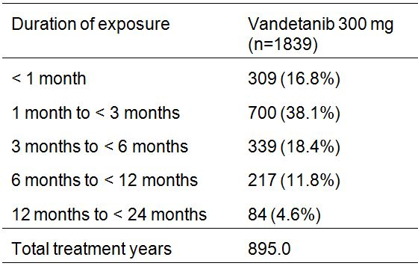
Duration of exposure = (last dose date - first dose date +1). Total treatment years are derived from the sum of the individual patient exposure times. Data from studies 1, 2, 3, 7, 8, 39, 43, 44, 50, 57 and 58. Study 3 includes patients who took vandetanib in either part A or part B. Study 7 includes all patients who took monotherapy vandetanib. This summary table includes data collected from Study 58 for all patients who took vandetanib either on randomised treatment or open label treatment.
Comment: In the 11 pooled monotherapy studies (vandetanib 300 mg), a total of 1839 patients had received 300 mg vandetanib by the data cut-off date of 19 October 2009. In these pooled studies, a total of 274 (14.9%) patients were treated with vandetanib 300 mg monotherapy for at least 1 year and 84 (4.6%) patients were treated with vandetanib 300 mg monotherapy for at least 2 years. Total exposure to vandetanib from the clinical studies in healthy volunteers and patients was approximately 4,000 subjects at the data cut-off date.

Pivotal study 58 – Safety data

Exposure
The Safety Analysis Set (SAS) included all patients who received at least 1 dose of randomised treatment with either vandetanib or placebo. The SAS included 331 patients (231 in the vandetanib group and 99 in the placebo group), and included all randomised patients, apart from 1 patient randomised to placebo who died before receiving the first dose of study treatment. The duration of exposure for patients in the SAS is summarised in Table 36, and the overall extent of exposure in study 58 is summarised in Table 37.
Table 36: Study 58 – Duration of exposure; safety analysis set.
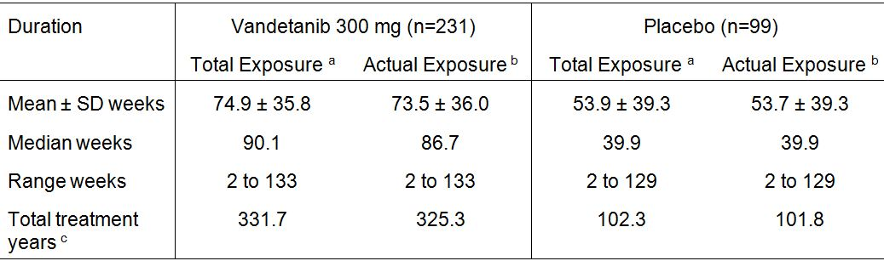
a. Total exposure = (date of last dose of randomised treatment - date of first dose of randomised treatment +1).
b. Actual exposure = total exposure to randomised treatment accounting for dose interruptions whilst on randomised treatment.
c. Total treatment years are derived from the sum of the individual patient exposure times for randomised treatment.
Table 37: Study 58 – Duration of exposure in the randomised phase; safety analysis set.
a. Total treatment years are derived from the sum of the individual patient exposure times for randomised treatment.

Dose reductions and interruptions
Dose reductions and interruptions were permitted during the study, and dose reductions/interruptions occurred in 114 (49.4%) patients randomised to vandetanib 300 mg.
- Of the 231 patients who began randomised treatment with vandetanib 300 mg, 70 (30.3%) remained on the starting dose of 300 mg daily, 51 (22.0%) discontinued because of disease progression, 14 (6.1%) discontinued because of an AE without having a dose reduction, and 13 (5.6%) discontinued for other reasons. The remaining 83 (35.9%) patients who began randomised treatment with vandetanib 300 mg had a dose reduction to 200 or 100 mg.
- Of the 83 (35.9%) patients in the vandetanib arm who required a dose reduction, 81 (35.1%) had their dose reduced to 200 mg daily and 2 (0.9%) had their dose reduced directly to 100 mg daily. Of the 81 patients who received the 200 mg dose, 24 (10.4%) remained on this dose until the date of data cut-off, 15 (6.5 %) stopped randomised treatment because of disease progression, 8 (3.5%) stopped for AEs, and 4 (1.7%) for other reasons.
- A total of 30 (13.0%) patients whose dose was reduced to 200 mg required a subsequent dose reduction. Of these 30 patients, 29 (12.6%) had their dose reduced directly to 100 mg daily, and 1 (0.4%) had their dose reduced to 200 mg every other day before receiving 100 mg daily (not part of the protocol specified dose reduction scheme).
- Of the 32 (13.9%) patients whose dose was reduced to 100 mg, 17 (7.4%) remained on this dose, 5 (2.2%) stopped randomised treatment because of disease progression, 7 (3.0%) stopped for AEs, and 3 (1.7%) stopped for other reasons.
The median time on initial randomised dose was 339 days (range: 9 to 929 days) for vandetanib 300 mg (n=231) and 265 days (range: 14 to 904 days) for placebo. The mean duration of dose interruption was 21.3 days for vandetanib and 11.5 days for placebo. Most dose reductions from 300 mg to 200 mg occurred during the first 10 months of treatment, and patients who had dose reductions to 200 mg remained on the reduced dose for a median of 163 days (range: 3 to 801 days). Patients who had dose reductions to 100 mg remained on the reduced dose for a median of 206.5 days (range: 1 to 723 days), and most reductions also occurred in the first 10 months of treatment.
Comment: In patients initially randomised to vandetanib 300 mg, 114 (49.4%) required dose reductions/interruptions compared with 15 (15.2%) patients randomised to placebo, and the majority of dose reductions/interruptions in the vandetanib arm were due to AEs. The median duration of treatment on the 200 mg dose following reduction from 300 mg was 163 days (range: 3 to 801 days), while the median duration of treatment on 100 mg days was 206.5 days. The data suggest that that dose reductions/interruptions were an effective means of managing adverse events and allowing patients to stay on vandetanib.

Adverse events

Background
Safety data were collected from patients from the randomised period for up to 60 days after discontinuation of study treatment unless starting open label treatment. Safety and tolerability were assessed based on AEs, laboratory data, ECG data, vital signs, and weight. AEs defined in terms of Medical Dictionary for Regulatory Activities (MedDRA) preferred term (PT), and CTCAE grade, were listed individually by patient and summarised by treatment group.
In addition to individual AEs (PT), the study also examined significant pre-specified AEs grouped by pharmacologic class or by data from previous studies with vandetanib. The grouped AEs included: rash; diarrhoea; nausea/vomiting; QTc-related events; ischaemic heart disease; ischaemic cerebrovascular conditions; embolic and thrombotic events, venous; interstitial lung disease (ILD) and similar events; and seizures.

Overview
An overview of AEs occurring while on randomised treatment are summarised in Table 38.
Table 38: Study 58 – Patients with at least 1 AE while on randomised treatment; safety analysis set.
a. Patients with multiple events in the same category are counted only once in that category.
b. As assessed by the Investigator.
c. Any AE deemed by the sponsor to be significant.
Event rate = (number of patients with AEs / total duration of follow-up across all patients in a given group) x 1000.
Comment: The adverse event rate (per 1000 pt years) was about 5-fold higher in the vandetanib arm than in the placebo arm. AEs, causally related AEs, CTCAEs ≥ grade 3, SAEs, and AEs leading to discontinuation all occurred more commonly in the vandetanib arm than in the placebo arm. However, deaths due to AEs occurred with similar frequencies in the two treatment arms.

Common adverse events
Overall, 99.6% of patients in the vandetanib arm experienced 1 or more AE compared with 90.9% in the placebo arm. The most commonly reported “system, organ, class” (SOC) disorders associated with vandetanib (vs placebo) were skin and subcutaneous tissue (90.5% vs 30.3%) followed by gastrointestinal (80.5% vs 56.6%). The 10 most commonly occurring AEs (PT) occurring in the vandetanib arm (vs placebo) were:
- diarrhoea (55.4% vs 26.3%);
- rash (45.0% vs 11.1%);
- nausea (33.8% vs 17.2%);
- hypertension (31.6% vs 5.1%);
- headache (26.0% vs 9.1);
- fatigue (23.8% vs 23.2%);
- decreased appetite (21.2% vs 12.1%);
- acne (19.9% vs 5.1%);
- dry skin (15.2% vs 5.1%); and
- dermatitis acneiform (15.2% vs 2.0%).
AEs reported with a frequency of ≥ 10% in either treatment arm are in Table 39.
Table 39: Study 58 – Summary of patients who had ≥ 1 AE on randomised treatment, AEs reported in ≥ 10% of patients; SAS.
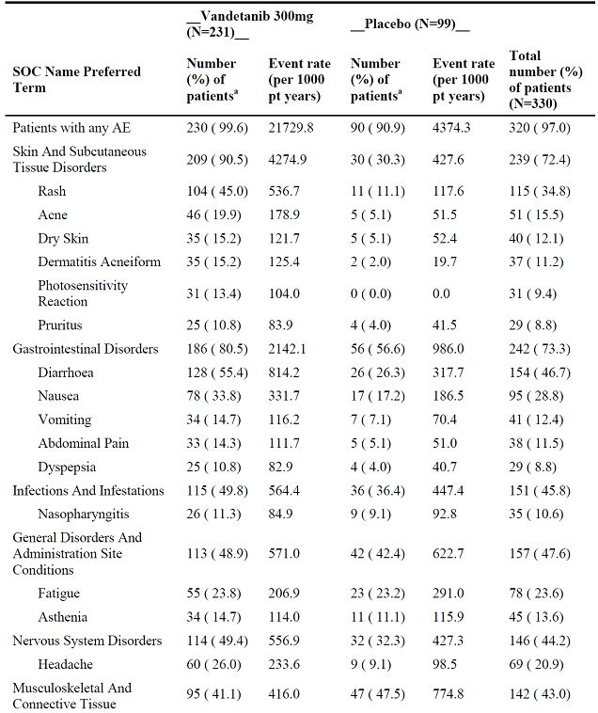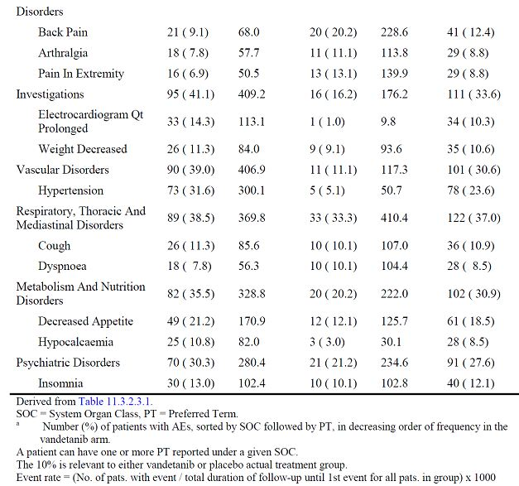

Grouped adverse events

Rash
The collective term “rash” was the most commonly occurring grouped event reported in patients in the vandetanib arm. This grouped event occurred in 89.2% of patients in the vandetanib arm compared with 23.2% of patients in the placebo arm. The majority of patients with “rash” in the vandetanib arm experienced CTCAE grade 1 or 2 events (82.2%), while CTCAE Grade ≥ 3 events were reported in 6.9% of patients in the vandetanib arm, compared with no events in the placebo arm. One (1) patient treated with vandetanib had a CTCAE grade 4 rash. This patient was treated with oral methylprednisolone and the rash resolved, although a concomitant photosensitivity reaction was still present. There were no cases of toxic epidermal necrolysis, erythema multiforme, Stevens-Johnson syndrome, or toxic skin eruption reported in study 58, although these events have occurred in other vandetanib studies. The AEs by grade for “rash” are summarised in Table 40.
Table 40: Study 58 – Rash (grouped events) on randomised treatment; safety analysis set.
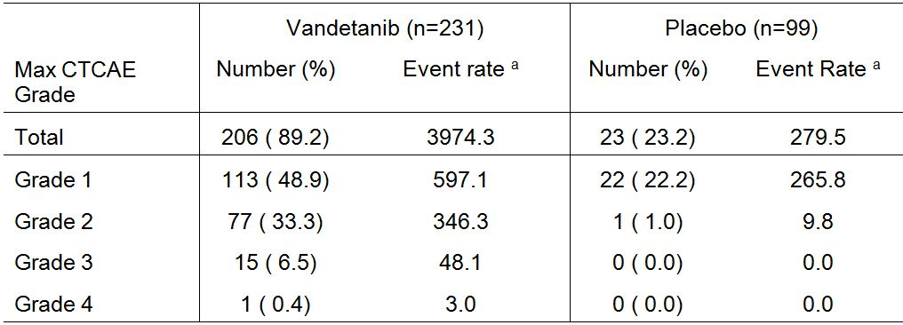
ª Event rate (per 1000 patient years) = (number of patients with event / total duration of follow-up until 1st event for all patients in group) x 1000
Photosensitivity reactions were reported in 31 (13.4%) patients in the vandetanib arm and in no patients in the placebo arm. One (0.4%) patient in the vandetanib arm discontinued due to a photosensitivity reaction. CTCAE Grade 3 or higher photosensitivity reactions were reported in 4 (1.7%) patients in the vandetanib arm.
The majority of patients in the vandetanib arm with skin and subcutaneous tissue disorders did not require either dose reduction or discontinuation of randomised treatment, and were treated with standard medical care. In the vandetanib arm, these disorders resulted in dose reduction in 4.3% (10) of patients and study discontinuation in 1.7% (n=4) of patients. In the placebo arm, none of these disorders resulted in dose reduction or discontinuation. The skin and subcutaneous tissue disorders events resulting in study discontinuation in patients in the vandetanib arm were rash 3 (1.3%), eczema 1 (0.4%), and photosensitivity reaction 1 (0.4%).

Diarrhoea
The MedDRA PTs in the grouped event of “diarrhoea” included diarrhoea, diarrhoea haemorrhagic, diarrhoea infectious, frequent bowel movements, loose stools, and stools watery. Grouped event “diarrhoea” was reported more frequently in patients in the vandetanib arm than in patients in the placebo arm (55.8% vs 27.3%) (Table 41).
Table 41: Study 58 – Diarrhoea (grouped event) on randomised treatment; safety analysis set.
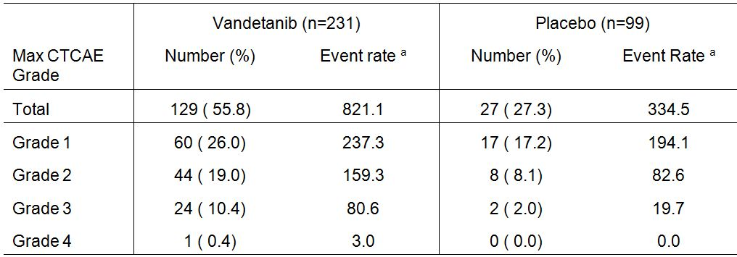
a. Event rate (per 1000 patient years) = (number of patients with event / total duration of follow-up until 1st event for all patients in group) x 1000
Diarrhoea haemorrhagic and frequent bowel movements were each reported in 1 (0.4%) patient in the vandetanib arm. In the vandetanib arm, the majority of patients had grouped events of diarrhoea that were CTCAE grade 1 or 2 (44.6% vs 25.3% [placebo]), and diarrhoea grouped events of CTCAE ≥ grade 3 were reported for 25 (10.8%) patients in the vandetanib arm and 2 (2%) patients in the placebo arm. Dehydration, an event that may be related to diarrhoea, was reported in 6 (2.6%) patients in the vandetanib arm, and no patients in the placebo arm.

Nausea and vomiting
AEs (PTs) included in the grouped event “nausea/vomiting” were nausea, regurgitation, regurgitation of food, retching, and vomiting. Patients in the vandetanib arm had a higher frequency of grouped nausea/vomiting than those in the placebo arm (36.8% vs 20.2%) (Table 42). In vandetanib treated patients, the majority of grouped nausea/vomiting events were CTCAE grade 1 or 2 (35.1% vs 20.2%), placebo), while 4 (1.7%) patients had nausea/vomiting CTCAE grade 3 events compared with no placebo treated patients.
Table 42: Study 58 – Nausea/vomiting (grouped events) on randomised treatment; safety analysis set.
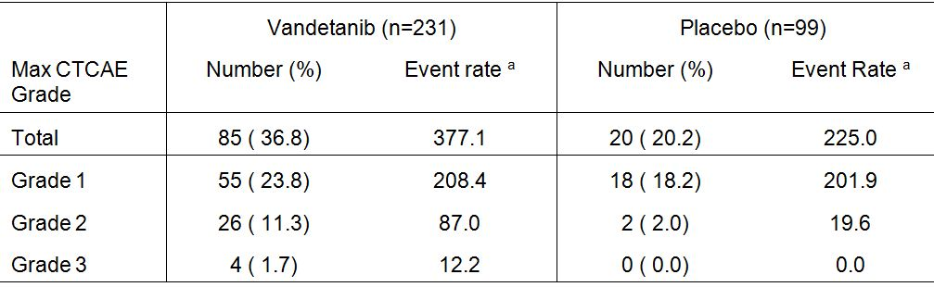
ª Event rate (per 1000 patient years) = (number of patients with event / total duration of follow-up until 1st event for all patients in group) x 1000.

Haemorrhages
The grouped event of “haemorrhages” was reported more frequently in patients in the vandetanib arm compared with the placebo arm (15.6% vs 11.1%). The majority of grouped “haemorrhage” events in both treatment arms were CTCAE grade 1 or 2, and CTCAE grade ≥ 3 events were reported in 2 (0.9%) patients in the vandetanib arm and 3 (3.0%) patients in the placebo arm. The group event of “haemorrhage” is summarised in Table 43.
Table 43: Haemorrhage (grouped events) on randomised treatment; safety analysis set.
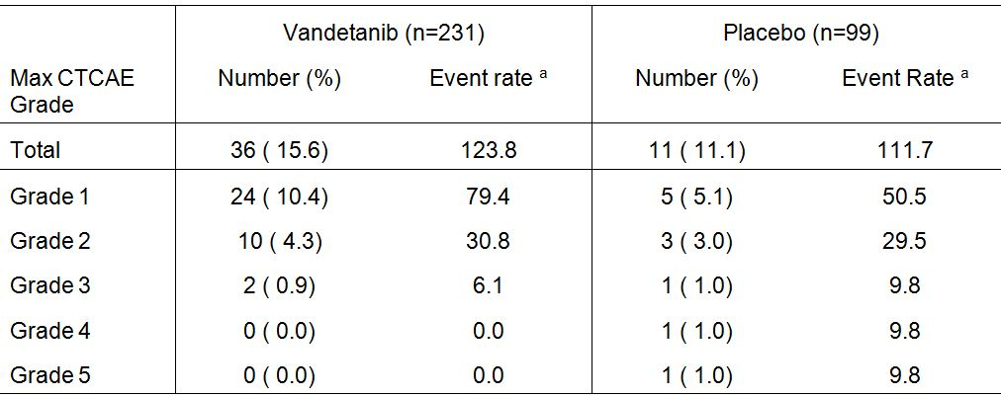
a. Event rate (per 1000 patient years) = (number of patients with event / total duration of follow-up until 1st event for all patients in group) x 1000.
Epistaxis was reported more frequently in vandetanib treated patients (7.8% [n=18]) compared with placebo (5.1% [n=5]), and all events of epistaxis were CTCAE grade 1 or 2. Haemoptysis was reported more frequently in patients in the vandetanib arm compared with the placebo arm (3.0% [n=7] vs 2.0% [n=2]) One (1) patient died of a gastrointestinal haemorrhage (52 year old male in the placebo arm).

QTc related events
QTc grouped events were reported more frequently in vandetanib treated patients (15.6%) than in placebo treated patients (4.0%). In the vandetanib arm, 16 (7.0%) patients had CTCAE grade 1 or 2 events compared with 1 (1.0%) patient in the placebo arm, and 20 (8.7%) patients had CTCAE grade ≥ 3 events compared with 3 (3.0%) patients in the placebo arm. QTc related grouped events are summarised in Table 44.
Table 44: Study 58 – QTc related grouped events on randomised treatment; safety analysis set.
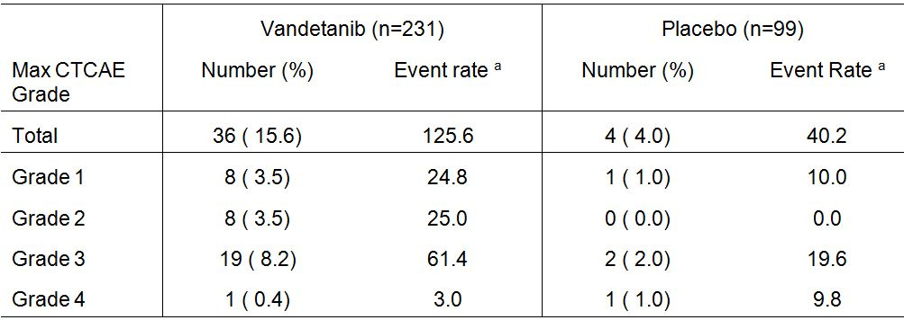
a. Event rate (per 1000 patient years) = (number of patients with event / total duration of follow-up until 1st event for all patients in group) x 1000
In the vandetanib arm, the majority of QTc grouped events were electrocardiogram QT prolonged (reported in 33 [14.3%] patients compared with 1 [1.0%] patient in the placebo arm), and these events were not necessarily protocol defined QT prolongation events.
One (0.4%) patient in the vandetanib arm had a CTCAE grade 2 event of exercise induced ventricular tachycardia, 2 patients in the vandetanib arm had loss of consciousness, and 1 (0.4%) additional patient in the vandetanib arm had syncope. In the placebo arm, 1 (1.0%) patient had syncope.
Two (0.9%) patients in the vandetanib arm discontinued treatment due an AE of QTc prolongation or electrocardiogram QT prolonged, and both of these patients met the criteria for protocol defined QTc prolongation. In addition, 1 patient in the vandetanib arm had an AE of prolonged QTc that was CTCAE grade 4, but the patient did not meet the criteria for protocol defined QTc prolongation.

Venous embolic and thromboembolic events
Venous embolic and thrombotic events were reported in 2 (0.9%) patients in the vandetanib arm and 4 (4.0%) patients in the placebo arm. Both patients in the vandetanib arm experienced CTCAE grade 2 events, while in the placebo arm CTCAE grades 1, 2, 3, and 4 events were each experienced by 1 patient.

Seizures
Only 1 patient in the vandetanib arm experienced a seizure (CTCAE grade 1).

Ischaemic heart disease
Ischaemic heart disease grouped events were reported in 5 (2.2%) patients in the vandetanib arm (4x CTCAE grade 1 events, 1x grade 3 event), and 2 (2.0%) patients in placebo arm (both CTCAE grade 1 events).

Ischaemic cerebrovascular conditions
Ischaemic cerebrovascular grouped events were reported in 3 (1.3%) patients in the vandetanib arm (all Grade 3), and no patients in the placebo arm.

Interstitial lung disease (ILD) and similar conditions
No event of ILD occurred during randomised treatment. One patient randomised to placebo had an SAE of ILD during open-label treatment with vandetanib. The grouped term included pneumonitis, which was reported in 2 (0.9%) patients in the vandetanib arm (both CTCAE grade 3), but in no patients in the placebo arm.

Severity of adverse events
CTCAE grade ≥ 3 events occurring in ≥ 1% of patients in the vandetanib arm (vs placebo) were:
- diarrhoea (10.8% [n=25] vs 2.0% [n=2]);
- ECG QT prolonged (7.8% [n=18] vs 1.0% [n=1]);
- hypertension (7.4% [n=17] vs 0%);
- fatigue (5.6% [n=13] vs 1.0%[ n=1]);
- decreased appetite (3.9% [n=9] vs 0%);
- rash (3.5% [n=8] vs 0%);
- asthenia (2.6% [n=6] vs 1.0% [1]);
- abdominal pain (1.7% [n=4] vs 0%);
- hypocalcaemia (1.3% [n=3] vs 0%);
- hypokalaemia (1.3% [n=3] vs 0%);
- hypertensive crisis (1.7% [n=4] vs 0%);
- photosensitivity reaction (1.7% [n=4] vs 0%);
- depression (1.7% [n=4] vs 0%);
- dysphagia (1.3% [n=3] vs 0%);
- pruritus (1.3% [n=3] vs 0%);
- dyspnoea (1.3% [n=3] vs 3.0% [n=3]);
- renal failure (1.3% [n=3] vs 1.0% [n=1]); and
- nephrolithiasis (1.3% [n=3] vs 0%).
The mean time to CTCAE grade ≥ 3 events were calculated for grouped events, but the only two grouped events with a reasonable number of patients on which to base the calculation were rash and diarrhoea. The mean time to onset of the first incidence of a CTCAE grade ≥ 3 “rash” for vandetanib (n=16) was 103.1 days (range: 10 to 316 days). Mean time to onset of the first incidence of CTCAE grade ≥ 3 “diarrhoea” for vandetanib (n=25) was 151.1 days (range: 9 to 415).

Treatment related adverse events
A total of 222 (96.1%) patients in the vandetanib arm experienced an AE considered by the investigator to be related to treatment, compared with 59 (59.6%) patients in the placebo arm. Treatment-related events occurring in ≥ 10% of patients in the vandetanib arm (vs placebo) were:
- diarrhoea (46.8% [n=98] vs 19.2% [n=19]);
- rash (42.4% [n=98] vs 9.1% [n=9])
- hypertension (24.7% [n=57] vs 2.0% [n=2]);
- nausea (23.4% [n=54] vs 7.1% [n=7]);
- acne (18.6% [n=43] vs 5.1% [n=5]);
- fatigue (18.6% [n=43] vs 14.1% [n=14]);
- decreased appetite (15.2% [n=35] vs 7.1% [n=7]);
- ECG QT prolonged (13.4% [n=31] vs 0%);
- dermatitis acneiform (14.7% [n=34] vs 2% [n=2]);
- photosensitivity reaction (13.0% [n=30] vs 0%);
- dry skin (12.6% [n=29] vs 4.0% [n=4]);
- pruritus (10.4% [n=24] vs 1.0% [n=1]); and
- asthenia (10.4% [n=24] vs 5.1% [n=5]).

Deaths and other serious adverse events

Death
There had been 48 (14.5%) deaths at the time of the data cut-off date of 31 July 2009. Of these 48 deaths, 47 were included in the SAS, and 1 occurred in a patient randomised to placebo who died of progressive MTC before receiving treatment and was therefore not included in the SAS.
Of the 47 deaths in the SAS, 32 (13.9%) occurred in patients in the vandetanib arm and 15 (15.2%) occurred in the placebo arm. There were 8 (2.4%) deaths on randomised treatment, 5 (2.2%) in the vandetanib arm and 3 (3.0%) in the placebo arm; 2 (0.6%) deaths on open-label treatment, 1 (0.4%) in the vandetanib arm and 1 (1.0%) in the placebo arm; 16 (4.8%) deaths in the safety follow-up period, 10 (4.3%) in the vandetanib arm and 6 (6.1%) in the placebo arm; and 21 (6.4%) deaths after safety follow-up, 16 (6.9%) in the vandetanib arm and 5 (5.1%) in the placebo arm.
The majority of deaths in the 2 treatment groups had MTC as their primary or secondary cause (10.4% [n=24] in the vandetanib arm and 14.0% [n=14] in the placebo arm). However, a higher percentage of patients in the vandetanib arm were considered by the investigator to have a cause of death other than MTC (3.5% [n=8] and 1.0% [n=1], respectively). Overall, reported causes of death were consistent with those expected in patients with MTC and there were no marked differences between treatment arms in terms of primary causes of death (see Section 18.2, Table 89, page 153). The most common cause of death in both treatment groups was thyroid cancer (7.8% [n=18] of patients in the vandetanib arm and 11.1% [n=11] in the placebo arm).
During randomised treatment, SAEs with an outcome of death (excluding deaths due to disease progression) were reported in 5 (2.2%) patients in the vandetanib arm and 2 (2.0%) patients in the placebo arm. In the 5 patients in the vandetanib arm with an SAE resulting in death, the events were: respiratory failure in 1 patient; respiratory arrest in 1 patient; acute cardiac failure/arrhythmia in 1 patient; disseminated intravascular coagulation/sepsis in 1 patient; pneumonia/aspiration in 1 patient; and staphylococcal sepsis in 1 patient. In the 2 patients in the placebo arm with an SAE resulting in deaths, the events were: gastrointestinal haemorrhage in 1 patient; and gastroenteritis in 1 patient. In 1 patient, the SAEs resulting in death were considered by the investigator to be related to the study drug (i.e., acute cardiac failure/arrhythmia in a vandetanib treated patient). Of the 7 deaths in the randomised period, 1 of the 5 deaths in the vandetanib arm was considered related to SAEs of acute cardiac failure and arrhythmia.
The key information relating to the deaths in the 7 patients while on randomised treatment are summarised in Table 45.
Table 45: Study 58 - Key information for SAEs with outcome = death whilst on randomised treatment; SAS.
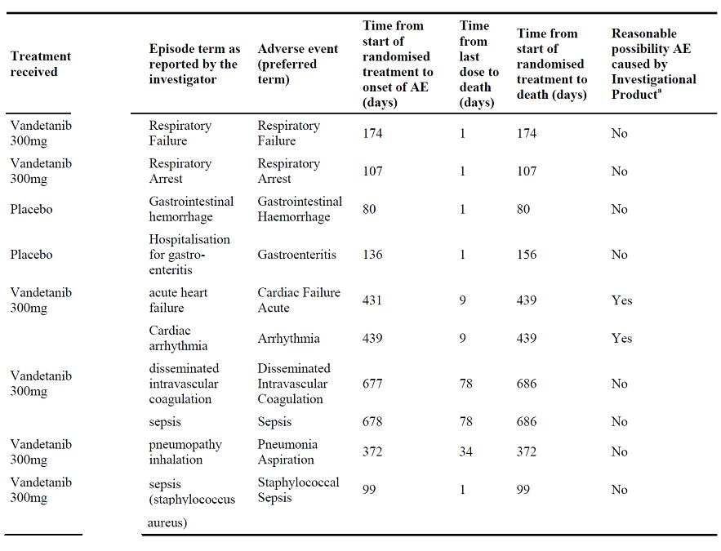
SAEs that occurred at any time during study, excluding any SAEs that occurred during or after open label treatment.

Serious adverse events
SAEs during randomised treatment were reported more frequently in patients in the vandetanib arm than in the placebo arm (30.7% [n=71] vs 13.1% [n=13], respectively). The following SAEs were the most common in the vandetanib arm, but did not occur in the placebo arm: pneumonia (2.2%); diarrhoea (2.2%); decreased appetite (1.7%); hypertensive crisis (1.7%); urinary tract infection (1.3%); abdominal pain (1.3%); hypercalcaemia (1.3%); and depression (1.3%). SAEs occurring in ≥ 1% of patients during randomised treatment are summarised in Table 46.
Table 46: Study 58 - Patients (> 1%) with SAEs while on randomised treatment; SAS.
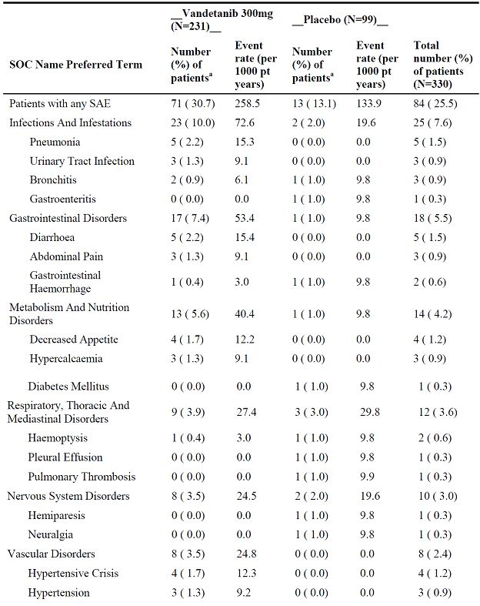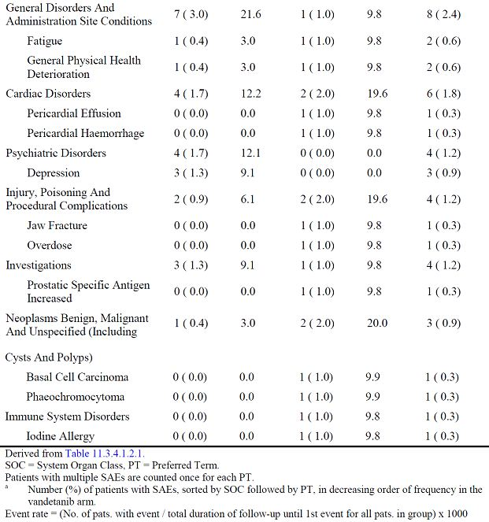

Discontinuations due to adverse events
Discontinuation of randomised treatment due to AEs occurred more frequently in patients in the vandetanib arm than in the placebo arm (12.1% [n=28] vs 3.0% [n=3], respectively). AEs resulting in discontinuation of vandetanib randomised treatment and occurring in ≥ 1.0% of patients (vs placebo) were: asthenia (1.7% [n=4] vs 0%) and rash (1.3% [n=3] vs 0%).

Clinical laboratory tests

Haematology

Overall
The most notable differences in laboratory haematology parameters in the vandetanib arm compared with the placebo arm were increases in haemoglobin levels, increases in activated partial thromboplastin time (APTT) and increases in the international normalised ratio (INR). There results for the haematology parameters for patients with a baseline observation and at least one follow-up observation are summarised in Table 47.
Table 47: Study 58 – Haematological laboratory parameters, randomised period; only patients with a baseline observation and at least one follow-up observation are included.
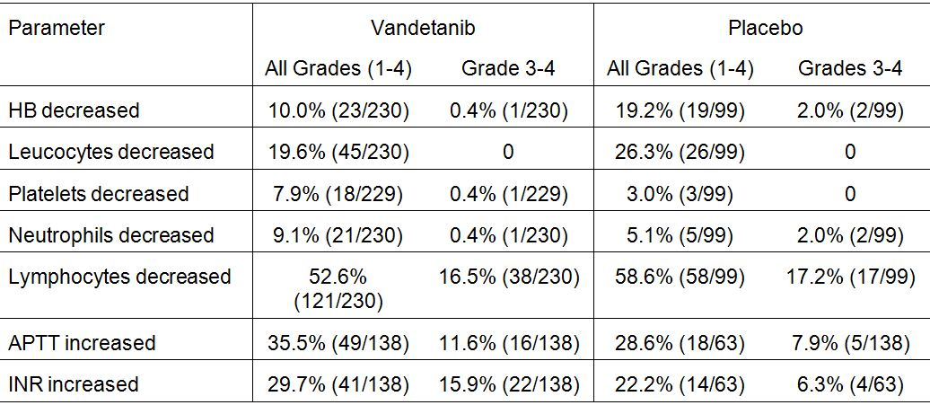

Haemoglobin
Mean haemoglobin levels were consistently higher with vandetanib compared with placebo over the duration of the study in both males and females, and the difference was most marked in females (Figures 10-11). In males, mean haemoglobin levels were approximately 5 to 10 g/L higher in the vandetanib arm than in the placebo arm up to Week 72, after which the differences between the treatment arms diminished. In females, mean haemoglobin levels were ≥10 g/L higher in the vandetanib than in the placebo arm at the majority of time points.
Figure 10: Study 58 – Haemoglobin (g/L) in males over time; SAS.
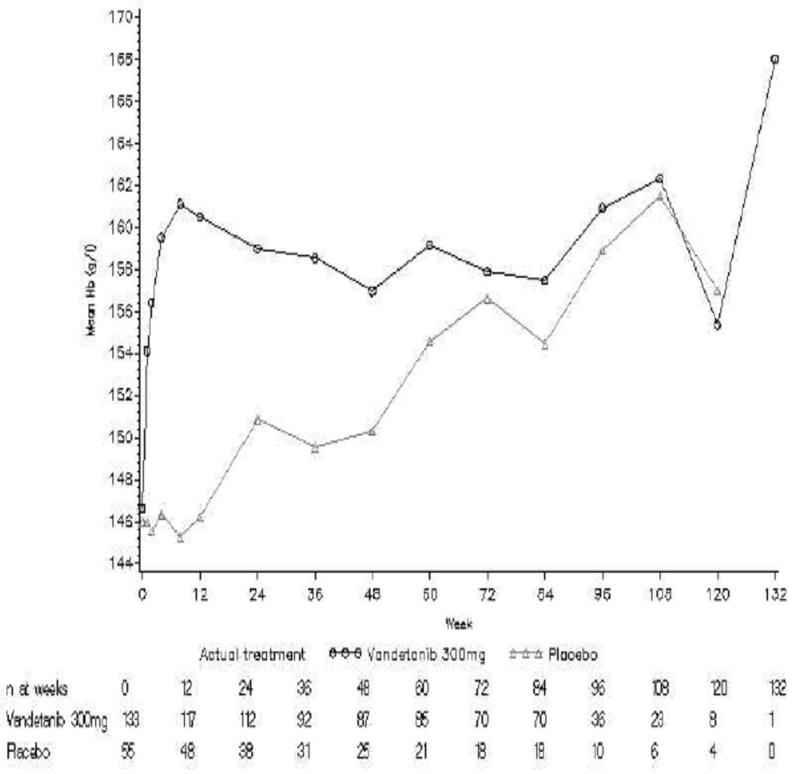
Figure 11: Study 58 – Haemoglobin (g/L) in females over time; SAS.
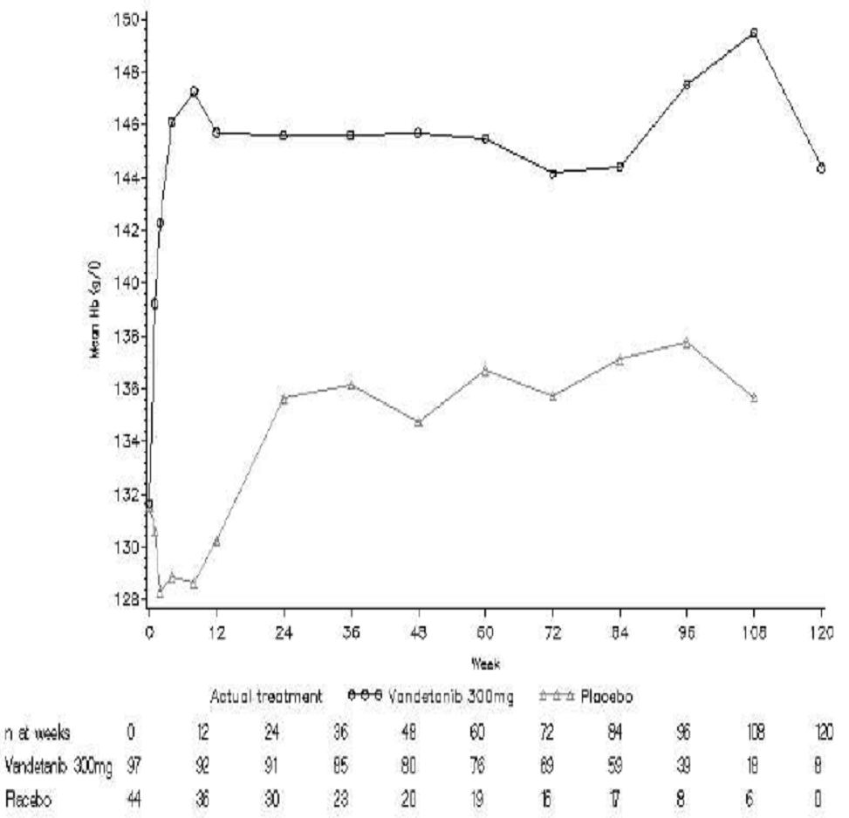
Reductions in haemoglobin levels CTCAE grades 1-4 were reported in 10.0% (23/230) of patients in the vandetanib arm and 19.2% (19/99) of patients in the placebo arm, and CTCAE grade 3 or 4 events were reported in 0.4% (1/230) and 2.0% (2/99) of patients, respectively.
Comment: The PI states that animal data suggests that increased haemoglobin levels observed in patients treated with vandetanib might be due to increased hepatic erythropoietin production. It is recommended that the nonclinical evaluator confirm this statement.

INR
For INR, 15.9% (22/138) of patients in the vandetanib arm and 6.3% (4/63) of patients in the placebo arm with a baseline observation and at least one follow-up observation had CTCAE grade 3 events (i.e., > 2x ULN). Two patients randomised to the vandetanib arm with CTCAE Grade 3 INR events also had haemorrhagic AEs. One of the patients was also being treated with warfarin and experienced epistaxis, tongue haematoma, and haematuria, and the other patient had 1 day of CTCAE Grade 1 haemoptysis. However, the coagulation indices in these two patients were normal around the time of the AE. Overall, 3 patients in both the vandetanib and placebo arms who had an elevated INR also had hemorrhagic related AEs.

Clinical chemistry

Overall
Key laboratory clinical biochemical parameters (Grades 1-4) occurring with an incidence of ≥ 10% in the vandetanib arm and ≥ 5% more frequently than in the placebo arm in the randomised period of the pivotal study were: calcium decreased (57.1% vs 25.3%); ALT increased (51.1% vs 18.2%); AST increased (28.9% vs 12.1%); creatinine increased (16.5% vs 1%); and glucose decreased (22.1% vs 8.1%). The results are summarised in Table 48.
Table 48: Study 58 – Biocehmical parameters, randomised period.
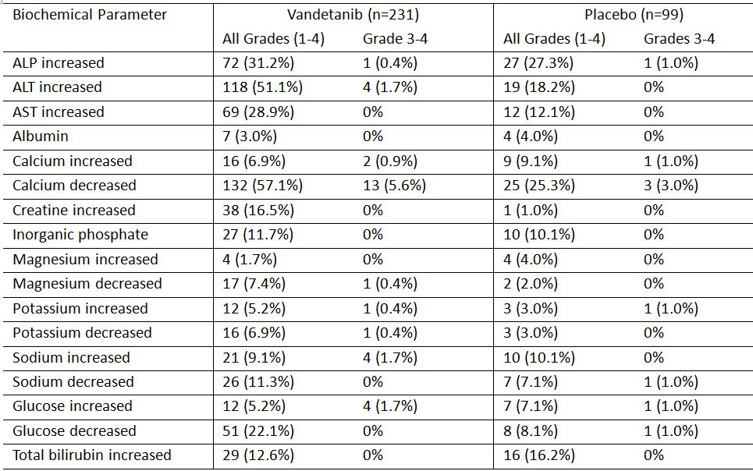
Key laboratory clinical biochemical parameters (Grade 3 or 4) occurring more commonly in the vandetanib arm than in the placebo arm in the randomised period were: ALT increased (1.7% vs 0%); calcium decreased (5.6% vs 3.0%); magnesium decreased (0.4% vs 0%); potassium decreased (0.4% vs 0%); sodium increased (1.7% vs 0%); and glucose increased (1.7% vs 1.0%). The results are summarised in Table 49.
Table 49: Study 58 – Clinical chemistry - summary of patients with laboratory abnormalities CTCAE Grade 3 or 4 whilst on randomised treatment; SAS.
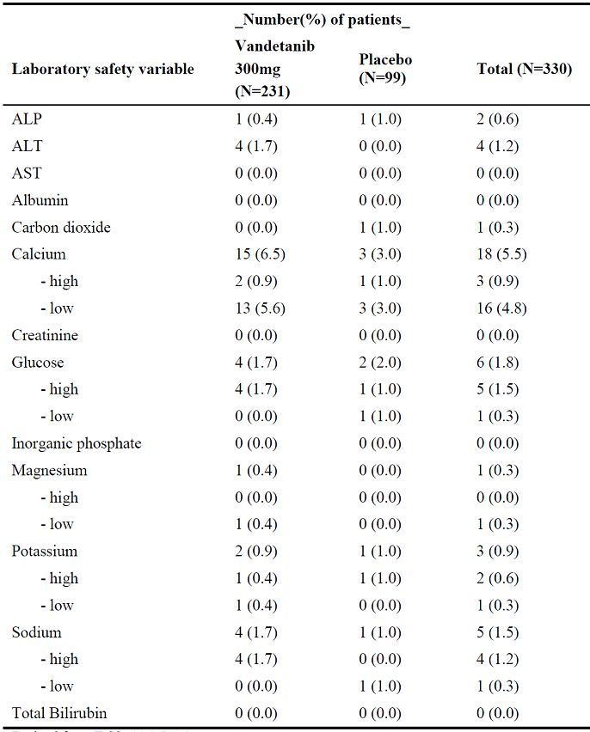

Liver function

ALT
In the vandetanib arm, mean ALT levels increased from baseline (23 U/L) to Week 12 (45 U/L), and then decreased to baseline by Week 120. In contrast, there were no changes in ALT levels in the placebo treatment arm over the course of the study. Mean ALT values during randomised treatment were consistently higher over time through Week 108 in the vandetanib arm compared with the placebo arm. Laboratory ALT increases (CTCAE grades 1-4) were reported in 51.1% of patients in the vandetanib arm and 18.2% of patients in the placebo arm, and the percentages for CTCAE grade 3 or 4 events were 1.7% and 0% respectively.
Of the 28 patients in the vandetanib arm who had an ALT elevation of CTCAE grade ≥ 2, ALT levels returned to normal in 18 patients or improved to grade 1 ALT elevations in 3 patients without any change in vandetanib dose. In 3 patients ALT normalised (2 patients) or improved to grade 1 (1 patient) after dose reduction or interruption. Four (4) patients still had an ALT of grade 2 at data cut-off.
ALT elevations > 3x ULN, > 5x ULN, and > 8x ULN while on randomised treatment were reported in 11 (4.8%), 4 (1.7%) and 1 (0.4%) patients in the vandetanib arm compared with no patients in the placebo arm. There were no patients in either arm with ALT elevations > 3x ULN and bilirubin elevations > 2x ULN while on randomised treatment (i.e., no Hy’s law cases).

AST
In the vandetanib arm, mean AST values increased from baseline (25 U/L) to Week 12 (38 U/L), and then decreased to baseline levels by Week 120. In contrast, there were no changes in AST levels in the placebo treatment arm over the course of the study. Laboratory AST increases (CTCAE grades 1-4) were report in 28.9% of patients in the vandetanib arm and 12.1% of patients in the placebo arm, and no CTCAE grade 3 or 4 events were reported in either treatment arm.

LDH
In the vandetanib arm, mean LDH levels increased from baseline (168 U/L) to Week 12 (204 U/L), and were still above baseline at Week 120 (198 U/L). In contrast, there were no changes in LDH levels in the placebo treatment arm over the course of the study.

Total bilirubin
There were no marked changes in mean total bilirubin levels over the course of the study in either the vandetanib or placebo arms. Laboratory total bilirubin increases (CTCAE grades 1-4) were report in 12.6% of patients in the vandetanib arm and 16.2% of patients in the placebo arm, and no CTCAE grade 3 or 4 events were reported in either treatment arm.

LFTs as AEs
LFT (ALT and AST) elevations were reported as an AE more frequently in the vandetanib arm than the placebo arm. The relevant LFT results (vandetanib vs placebo treated patients) were: AST increased (10 [4.3%] vs 1 [1.0%]); ALT increased (9 [3.9%] vs 1 [1.0%]); transaminases increased (5 [2.2%] vs 0%); blood ALP increased (2 [0.9%] vs 1 (1.0%)]; total bilirubin increased (1 [0.4%] vs 1 [1.0%]); LDH increased (1 [0.4%] vs 0%); and liver function test abnormal (1 [0.4%] vs 0%).

Renal function (creatinine level)
In patients in the vandetanib arm (randomised treatment), the mean creatinine level increased from 73.6 μmol/L at baseline to 91.6 μmol/L at Week 1 and remained relatively stable through Week 108 before decreasing slightly. In contrast, in the randomised treatment period the mean creatinine level remained largely unchanged over the duration of the study in patients in the placebo arm.
Laboratory creatinine increases (CTCAE grades 1-4) were reported in 16.5% of patients in the vandetanib arm and 1.0% of patients in the placebo arm, and no CTCAE grade 3 or 4 events were reported in either treatment arm. There were 6 (2.6%) patients with CTCAE grade 2 elevations in serum creatinine in the vandetanib arm versus none in the placebo arm. Of these 6 patients, 4 normalised or improved with dose interruption, reduction, or discontinuation, 1 patient had recurrent episodes of nephrolithiasis and pyelonephritis, and 1 patient continued to have elevated creatinine at the date of data cut-off.
A total of 9 (3.9%) patients in the vandetanib arm had an AE of blood creatinine increased, while no patient in the placebo arm had this AE. Two (0.9%) of these patients discontinued vandetanib treatment due to AEs of blood creatinine increased.
It is possible that the increased creatinine levels observed with vandetanib might be due (at least in part) to inhibition of the renal OCT-2 transporter.

Thyroid function tests (TSH)
Median TSH values in the vandetanib arm were higher than those in the placebo arm at virtually all time points, with the highest median value for vandetanib occurring at Week 12, after which the median values declined at all time points except one. There were 43 (18.6%) patients with elevated TSH levels in the vandetanib arm compared with 1 (1.0%) patient in the placebo arm. A patient with an elevated TSH value was defined as having a TSH value > 3x ULN on at least two separate follow-up assessments for patients with normal TSH at baseline, or as having a TSH value > 3 x the baseline value on at least two separate follow-up assessments for patients with abnormal TSH at baseline. The median time to TSH elevation in the vandetanib arm was 57 days (range: 14 to 502 days).
Hypothyroidism was reported as an AE in 15 (6.5%) patients in the vandetanib arm and no patients in the placebo arm. All of the AEs of hypothyroidism were CTCAE grade 1 or 2. A total of 114 (49.3%) and 17 (17.2%) of patients on the vandetanib and placebo arms respectively, required an increase in thyroid hormone replacement therapy while on randomised treatment. Hypothyroidism has been reported in patients treated with anti-VEGF therapy for cancer (Kamba and McDonald, 2007).

Other laboratory findings of note

Hypocalcaemia
Hypocalcaemia (CTCAE grades 1-4) was reported in 57.1% of patients in the vandetanib arm and 25.3% of patients in the placebo arm, and the percentages for CTCAE grade 3 or 4 events were 5.6% and 3.0%, respectively. The mean serum calcium level decreased by 0.1 mmol/L and this was only partly explained by a decrease in serum albumin of 0.15 g/L. Calcium supplementation was given to 48% of patients in the vandetanib arm and 43% of patients in the placebo arm, compared with 36% of patients in each arm receiving calcium supplementation at randomisation. Hypocalcaemia was reported as an AE during the randomised phase of the study in 25 (10.8%) patients in the vandetanib arm and 3 (3.0%) patients in the placebo arm, with 2 of the patients in the vandetanib arm and 1 in the placebo arm having CTCAE Grade 3 events, and 2 patients in the vandetanib arm having CTCAE Grade 4 events.

Hypoglycaemia
Hypoglycaemia (CTCAE grades 1-4) was reported in 22.1% of patients in the vandetanib arm and 8.1% of patients in the placebo arm, and CTCAE grade 3 or 4 events were reported in 0% and 1% of patients, respectively.

Hyperglycaemia
Hyperglycaemia was reported in 5.2% of patients in the vandetanib arm and 7.1% of patients in the placebo arm, and CTCAE grade 3 or 4 events were reported in 1.7% and 1% of patients, respectively.

Hypomagnesaemia
Hypomagnesaemia was reported in 7.4% of patients in the vandetanib arm and 2.0% of patients in the placebo arm, and CTCAE grade 3 or 4 events were reported in 1% and 0% of patients, respectively.

Hypokalaemia
Hypokalaemia was reported in 6.9% of patients in the vandetanib arm and 3.0% of patients in the placebo arm, and CTCAE grade 3 or 4 events were reported in 1% and 0% of patients, respectively.

Hypernatraemia
Hypernatraemia was reported in 9.1% of patients in the vandetanib arm and 10.1% of patients in the placebo arm, and CTCAE grade 3 or 4 events were reported in 1.7% and 0% of patients, respectively.

Urinalysis
Newly developed proteinuria or deterioration of existing proteinuria as a dipstick finding during randomised treatment occurred markedly more frequently in the vandetanib arm (90.9% [n=210]) than in the placebo arm (28.3% [n=28]). In addition, the frequency of newly developed haematuria or deterioration of existing haematuria was greater in the vandetanib arm than in the placebo arm (34.2% [n=79] and 22.2% [n=22], respectively). The sponsor comments that proteinuria has frequently been reported following inhibition of VEGF signaling. The sponsor refers to the publication by Kamba and McDonald (2007) reviewing the adverse effects of anti-VEGF therapy for cancer which states that proteinuria is typically asymptomatic, decreases after treatment discontinuation, and rarely leads to serious renal impairment.
The incidence of proteinuria as a reported AE was greater in the vandetanib arm (10.0% [n=23]) than in the placebo arm (2.0% [n=2]). No serious cases of proteinuria were reported. Among the 210 patients in the vandetanib treatment arm who developed proteinuria or had deterioration of existing proteinuria during randomised treatment, 54 (23.4%) patients had concurrent or subsequent AEs of hypertension and 109 of 220 (47.2%) patients had a concurrent or subsequent elevation of blood pressure.
The incidence of haematuria reported as an AE was similar for the 2 treatment arms (1.7% [n=4] for vandetanib and 1.0% [n=1] for placebo). Among the 79 patients who developed haematuria or had deterioration of existing haematuria during treatment with vandetanib, 16 (6.9%) patients had a concurrent or subsequent AE of hypertension and 42 (18.2%) had a concurrent or subsequent elevated blood pressure.

Vital signs, ECG changes, visual assessment

Blood pressure
In patients taking no anti-hypertensive drugs at baseline, 59.7% (138/223) in the vandetanib arm developed elevated blood pressure while on randomised treatment compared with 11.1% (11/92) in the placebo arm. In the vandetanib arm, the increase in DBP peaked at about 12 weeks and the increase in SBP peaked at about 24 weeks. Following these peaks, blood pressure slowly declined but remained well above baseline levels at the end of assessment (Figures 12-13).
Figure 12: Study 58 – Change in Diastolic Blood Pressure from baseline over time.
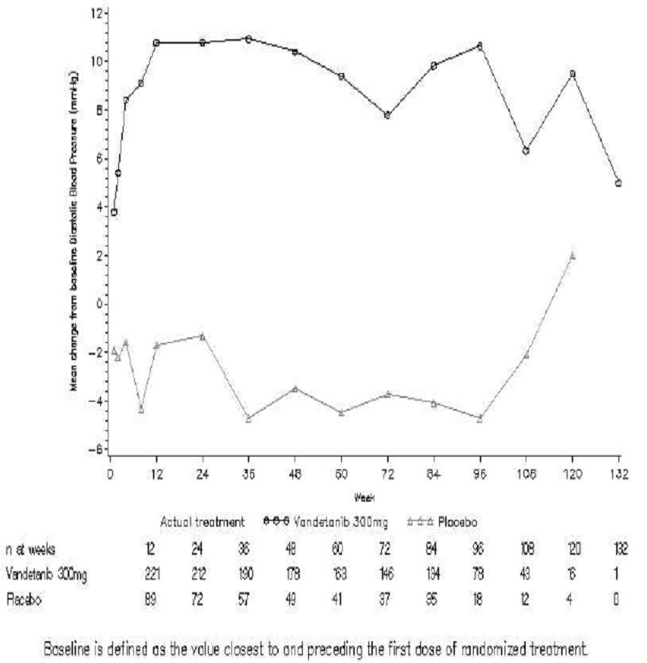
Figure 13: Study 58 – Change in Systolic Blood Pressure from baseline over time.
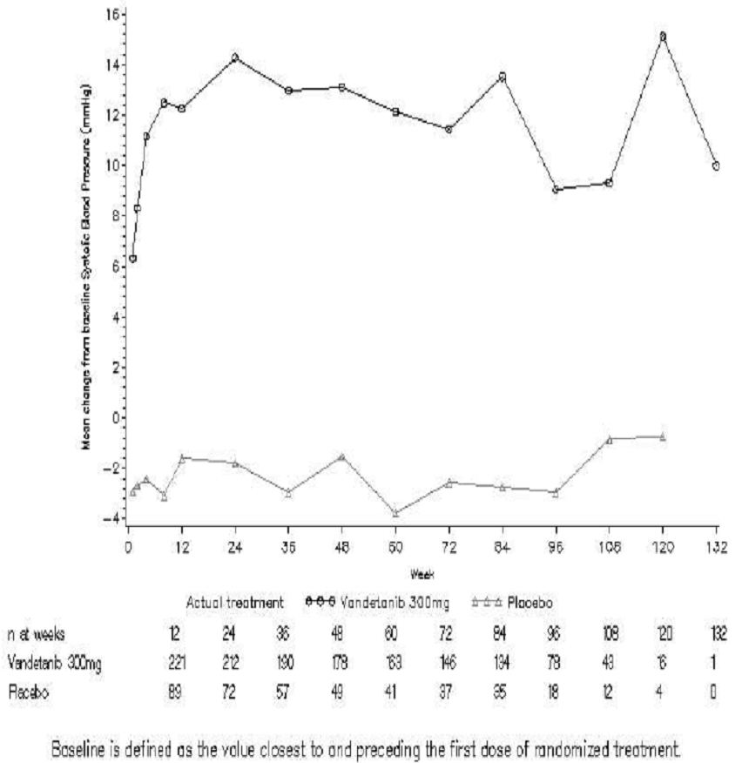
DBP > 95 mmHg was reported in 97 (42.0%) patients in the vandetanib arm and 8 (8.1%) patients in the placebo arms, and the corresponding percentages for SBP > 160 mmHg were 44 (19.0%) and 3 (3.0%) patients.
There was a reduction in pulse rate from baseline in the vandetanib arm of about 6 bpm after the first week’s treatment and the pulse rate remained at about 4 to 6 bpm below baseline throughout the remainder of the study. In contrast, there were no meaningful changes in pulse rate in the placebo arm.

ECG changes
Prolongation of the ECG QT interval was defined as either: (a) QTcB > 550 ms or a change from baseline of >100 ms; or (b) 2 consecutive values of either QTcB > 500 ms or change from baseline of > 60 ms (provided that the change was to a QTcB of at least 480 ms). All ECGs were assessed by an independent cardiologist.
The results showed that protocol defined QTcB prolongation was observed in 8.2% (n=19) of patients in the vandetanib arm and no patients in the placebo arm during randomised treatment. Two (0.9%) patients in the vandetanib arm discontinued treatment due to an AE of QTc prolongation or electrocardiogram QT prolonged. Both of these patients met the criteria for protocol-defined QTc prolongation. In addition, 1 patient in the vandetanib arm had an AE of prolonged QTc that was CTCAE Grade 4, but the patient did not meet the criteria for protocol-defined QTc prolongation.
First prolongations of the electrocardiogram QT interval occurred most often in the first 3 months of treatment, but first prolongations continued to occur after this time. Modelling of PK data suggested that vandetanib concentrations reach a peak by 3 to 6 weeks after randomisation. Therefore, it is possible that occurrences of QT prolongation after this period reflected electrolyte abnormalities or other physiologic changes. The maximum increase in QTcB from baseline was 27.6 ms observed at week 12, and the corresponding change from baseline in the placebo arm at this time point was 1.7 ms. The QTcB over time during randomised treatment is summarised in Figure 14.
Figure 14: Study 58 – QTcB over time in the randomised phase; SAS.
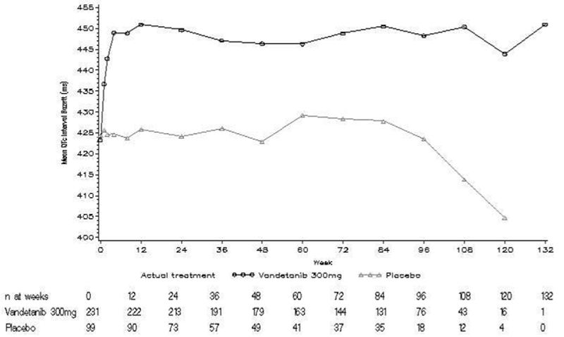
During randomised treatment, 22 (9.5%) patients in the vandetanib arm had QTcB values of > 500 ms compared with 1 (1.0%) patient in the placebo group, and 63 (27.3%) patients in the vandetanib arm had an increase in QTcB from baseline of > 60 ms compared with 1 (1.0%) patient in the placebo arm.
Most (n=15) patients who developed QTc prolongation did so while receiving vandetanib 300 mg during randomised treatment, but QTc prolongation also occurred in patients receiving lower doses (200 mg or 300 mg) or even shortly after the last dose was given (which is not surprising given the long half-life of vandetanib).
Comment: In the pivotal Phase III study the QT interval was corrected using Bazett’s method only and no date were presented using Fridericia’s correction method. It was noted that the mean heart rate in the pivotal study was consistently about 4 to 6 bpm below baseline levels in the vandetanib arm, and that bradycardia/sinus bradycardia was reported as an AE in 8 (2.4%) patients in the vandetanib arm. Bazett’s correction is known to under correct at heart rates lower than 60 bpm and, as heart rates were consistently lower than baseline in the vandetanib arm, Fridericia’s correction for the QT interval might have been a more appropriate method.

Visual assessment
With the approval of protocol Amendment 2 on 30 May 2007, ophthalmologic examinations were included as part of the study procedures to determine whether vandetanib increased the likelihood of patients developing corneal opacities or other eye abnormalities. These examinations were deemed necessary after 4 patients who received vandetanib 300 mg in study 8 reported visual changes and had abnormalities noted on ophthalmologic examination. Ophthalmologic examinations were performed at screening and at 9 months (Visit 9) after patients began receiving randomised treatment. Patients who were discontinued from study drug before Visit 9, or who had already completed Visit 9 before Amendment 2 was approved, were required to have an ophthalmologic examination performed at their discontinuation visit (Visit 75). In addition, any patient who complained of visual symptoms underwent visual assessment at the time the event was noted. Overall, 211 (63.7%) randomised patients underwent an examination during randomised treatment (69.1% [n=159] in the vandetanib arm, 52.5% [n=52] in the placebo arm). Not all randomised patients had an ophthalmologic examination performed at screening, due to enrollment occurring before baseline visual screening became a requirement.
Visual abnormalities identified by ophthalmological assessment were more common in the vandetanib arm than in the placebo arm, with abnormalities in either eye being reported in 83.6% (n=133) of patients in the vandetanib arm and 61.5% (n=32) of patients in the placebo arm. The most notable difference between the two treatment arms was in abnormalities of the epithelium, which were observed in 49.7% (n=79) of patients in the vandetanib arm compared with 3.8% (n=2) patients in the placebo arm. Patients in the vandetanib arm also had higher frequencies than patients in the placebo arm of stromal abnormalities (17.6% vs 3.8%) and abnormalities of the conjunctiva (7.5% vs 3.8%). Patients in the vandetanib arm had a lower frequency of abnormalities of blood vessels (6.9% vs 11.5%) and colour vision (7.5% vs 17.3%) relative to patients in the placebo arm.
Blinded review of the reports from the ophthalmology examinations was performed by a consultant ophthalmologist (USA). This review revealed that 49 of 159 (30.8%) patients in the vandetanib arm who underwent ophthalmologic examinations had vortex keratopathy, compared with no patients in the placebo arm. In addition, another 9 patients in the vandetanib arm could possibly have the same condition and currently remain undiagnosed. The consultant considered the events of vortex keratopathy to be related to vandetanib treatment.
Comment: The sponsor states that “Vortex keratopathy, also called cornea verticillata, is characterised by the appearance of fine, grayish or brown linear opacities in the epithelial layer of the cornea. The linear opacities typically branch repeatedly to form a distinctive whorl-like pattern. Although the opacities often are asymptomatic, patients can have one or more symptoms such as hazy vision, photophobia, haloes around lights, or, in some instances, glare. Vortex keratopathy is typically innocuous and rarely requires discontinuation of drug therapy.”
The consultant ophthalmologist (USA) concluded that the association of study drug to the occurrence of vortex keratopathy can be classified as certain by World Health Organisation (WHO) criteria. The sponsor notes that this conclusion is strengthened by the fact that the actual prevalence of vortex keratopathy is decidedly low in the general population. The sponsor also states that, “[a]t present, even with partial analysis possible, it appears that at least 3 months of dosing is required for the first appearance of vortex keratopathy. No serious corneal AE has yet been associated with study drug. For this reason, the consultant ophthalmologist indicated that there is no need to stop dosing even in instances where vortex keratopathy develops”.

Special groups

Gender
In the vandetanib arm there were 97 female patients (153.6 years patient-years of exposure) and 134 male patients (178.6 patient-years of exposure). In the vandetanib arm, at least 1 AE was reported in 99.3% (133/134) of male patients and 100% (97/97) of female patients.
The adverse event profiles in vandetanib treated male and female patients for events occurring with an incidence of ≥ 5 % in at least one of the two groups are summarised in Table 50.
Table 50: Study 58 – Vandetanib treated patients adverse events (PT) in ≥ 5% of male or female patients; SAS.
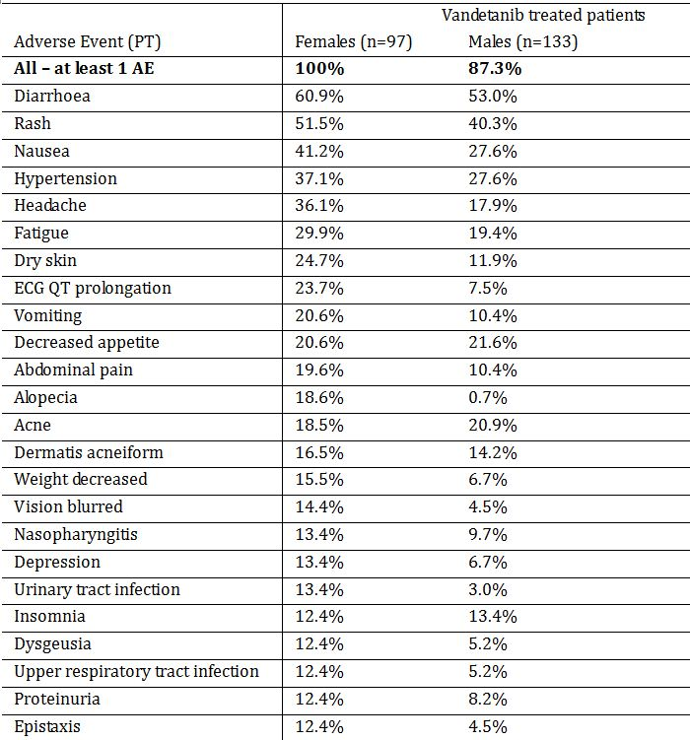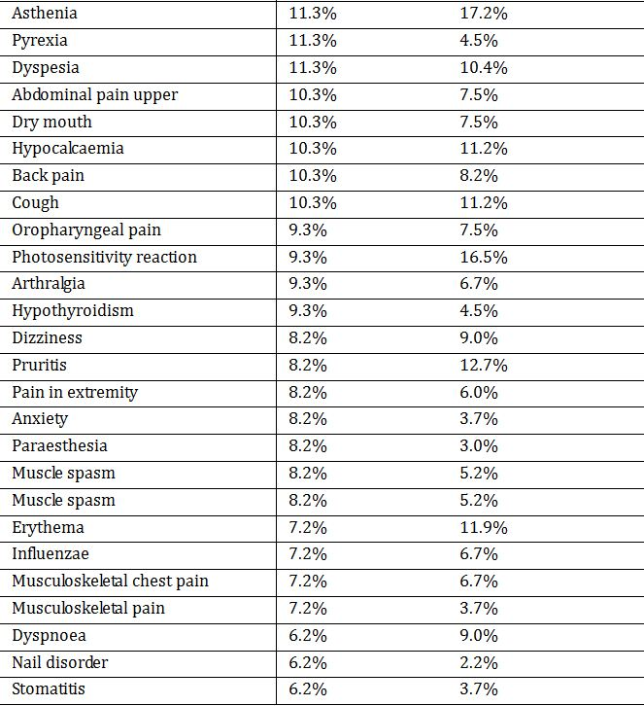
Table 50 (continued): Study 58 – Vandetanib treated patients adverse events (PT) in ≥ 5% of male or female patients; SAS.
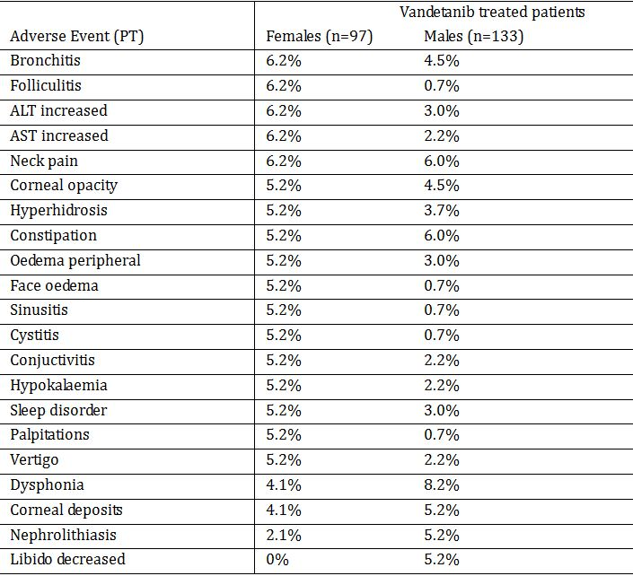
AEs for which the absolute difference between females and males was ≥ 10% and the event occurred more frequently in females than males were headache, alopecia, ECG QT prolongation, nausea, dry skin, rash, fatigue, urinary tract infection, and vomiting. AEs with a difference between females and males of ≥ 5% (females minus males) and occurring in female or male patients with an incidence of ≥ 10% are summarised in Table 51. The only AE with an incidence of ≥ 5% between male and female patients occurring in ≥ 10% of male and female patients and more commonly in males was asthenia.
Table 51: Study 58 – Vandetanib treated patients adverse events (PT) in ≥ 5% of male or female patients; SAS.
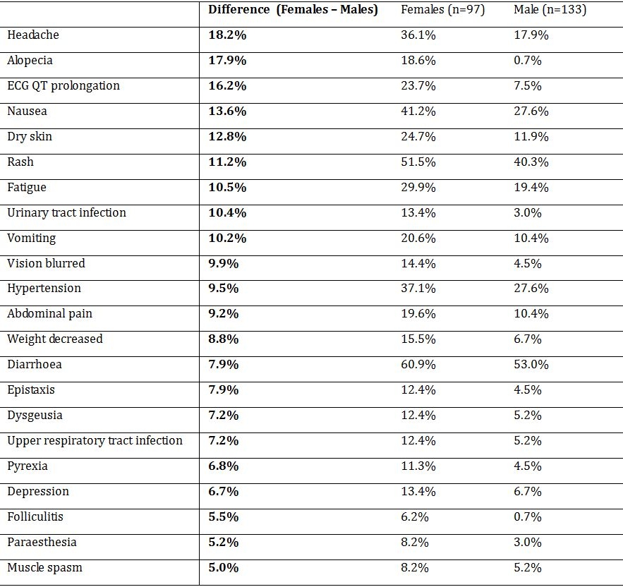
Comment: There was a notable difference in the vandetanib safety profile between female and male patients, with a number of clinically significant AEs occurring more commonly in females than in males.

Age
The sponsor examined the safety profile of vandetanib across the following age ranges: < 40 years of age (n=50, 82.5 patient years of exposure); ≥ 40 to < 65 years of age (n=132, 194.3 patient years of exposure); ≥ 65 to <75 years of age (n=42, 47.7 years of patient exposure; and ≥ 75 years of age (n=7, 7.7 patient-years of exposure). Elderly patients were defined as those aged ≥ 65 years. The number of patients aged ≥ 75 years (n=7) was too small to define the safety profile in this age group. The adverse event profiles in vandetanib treated patient in the < 40, ≥ 40 to <65, and ≥ 65 to < 75 age groups, for those events occurring with an incidence of ≥ 10% in at least one of the age groups, are summarised in Table 52.
Table 52: Study 58 – Vandetanib treated patients adverse events (PT) in ≥ 5% of male or female patients; SAS.
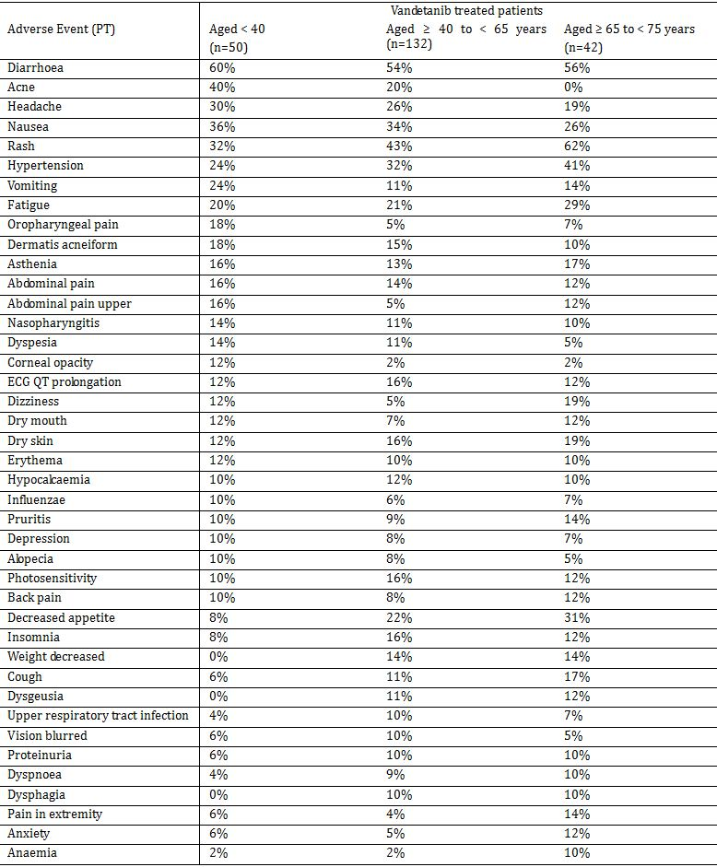
AEs occurring in ≥ 10% patients in at least one of the three age groups, and ≥ 10% more commonly in one of the age groups compared with both of the other two age groups were (< 40, ≥ 40 to < 65, and ≥ 65 to < 75 years) were: acne (40%, 20%, 0%); vomiting (24%, 11%, 14%); oropharyngeal pain (18%, 5%, 7%); corneal opacity (12%, 2%, 2%); decreased appetite (8%, 22%, 31%); weight decreased (0%, 14%, 14%); dysgeusia (0%, 11%, 12%); and dysphagia (0%, 10%, 10%).
Comment: There were some differences in the vandetanib adverse event profiles in the three age groups (most notably in the incidence of acne).

Race
There were too few patients enrolled in racial groups other than Caucasian to define separate vandetanib safety profiles. The racial groups in the vandetanib treatment arm were: Caucasian (94.3% [n=218]), Oriental (3.5% [n=8]), Other (1.7% [n=4]), and Black (0.4% [n=1]).

Safety in the vandetanib open-label phase

Exposure
A total of 102 patients had received open-label treatment with vandetanib by the data cut-off date of 31 July 2009. Patients receiving placebo during randomised treatment began open-label treatment with a vandetanib dose of 300 mg, while patients who received vandetanib during randomised treatment received vandetanib at the last dose level they had received while on randomised treatment.
The mean duration of total exposure in the vandetanib arm 300 mg (n=289) during the randomised and open-label treatment phases was 77.0 weeks (range: 3 to 133 weeks) and the actual exposure was 75.1 weeks (range: 3 to 133 weeks).
Overall, 90 (88.2%) patients received 300 mg in the open-label phase, 9 (8.8%) had their dose reduced to 200 mg and 3 (2.9%) had their dose reduced to 100 mg. AEs of ≥ CTCAE grade 3 leading to dose reduction for vandetanib from 300 to 200 mg per day were recorded for 5 (4.9%) patients in the vandetanib arm, and 2 (2.0%) patients in the vandetanib arm were dose reduced to 200 mg per day because of QTc prolongation.

Adverse events
A total of 94 (92.2%) patients had at least 1 AE; 51 (50.0%) patients had AEs of CTCAE grade ≥ 3; 28 (27.5%) patients had SAEs, including 1 patient who died due to an SAE. The 5 most frequently reported AEs during open label vandetanib treatment were: diarrhoea (33.3% [n=34]); rash (25.5% [n=26]); decreased appetite (18.6% [n=19]); acne (18.6% [n=19]); and photosensitivity reaction (8.8% [n=9]). A total of 8 (7.8%) patients had an AE of QT prolongation.

Deaths and serious adverse events
One death (1.0%) was reported during open-label treatment (SAE of aspiration pneumonia). A total of 28 (27.5%) patients had an SAE during open label treatment with vandetanib. SAEs reported in more than 1 patient were diarrhoea, vomiting, renal failure acute, pneumonia aspiration, and back pain, each of which occurred in 2 (2.0%) patients. The majority of SAEs required either a dose adjustment or dose interruption. One patient had an SAE of myocardial infarction that required discontinuation of vandetanib treatment. This patient also had SAEs of renal failure acute, ILD, and haemoptysis that began on the same day (5 days after the myocardial infarction.).

Discontinuations due to adverse events
Seven (6.9%) patients had AEs leading to discontinuation of open-label treatment. There were 4 nervous system disorders (1 [1.0%] dementia, 1 [1.0%] depressed level of consciousness, 1 [1.0%] dysgeusia, 1 [1.0%] peripheral sensory neuropathy); 1 cardiac disorder (1 [1.0%] myocardial infarction); 1 eye disorder (1 [1.0%] blurred vision); 1 gastrointestinal disorder (1 [1.0%] nausea); 1 infection and infestations (1 [1.0%] meningitis); and 1 musculoskeletal and connective tissue disorders (1 [1.0%] myalgia).

Phase II studies in patients with hereditary MTC

Study 8 (vandetanib 300 mg)
Study 8 included 35 patients with locally advanced or metastatic hereditary MTC. Of these 35 patients, 30 received initial treatment with vandetanib 300 mg and were therefore included in the analysis of safety. The overall mean duration of treatment with vandetanib 300 mg was 525.9 days (range: 19 to 1167 days). Of the 30 patients, 24 (80.0%) had either dose reduction or dose interruption during the study. Overall, 21 (70%) patients had dose reductions due to AEs, 10 had dose reductions without interrupting administration of vandetanib, and 11 had a temporary interruption of vandetanib administration and then had subsequent dose reduction. The median time to first dose reduction was 149 days (95% CI: 82.0, 257.0). The AE profile is summarised in Table 53.
Table 53: Study 8 – Adverse events; safety analysis (n=30).
a. Patients with multiple events in the same category are counted only once in that category. Patients with events in more than 1 category are counted once in each of those categories.
b. Initial treatment received.
c. In the opinion of the investigator.
CTCAE Common Terminology Criteria for Adverse Events; N Number of patients in treatment group.
As of data cutoff on 22 February 2008.
Overall, the highest incidence of AEs (SOC) was observed in general disorders and administration site conditions (96.7%); gastrointestinal disorders (93.3%); skin and subcutaneous tissue disorders (93.3%); and nervous system disorders (83.3%). The most common AEs reported in ≥ 50% of patients by preferred term were diarrhoea (70.0%), rash (66.7%), fatigue (63.3%), and nausea (63.3%). Other significant AEs included headache (46.7%), dizziness (26.7%), and ECG QT prolonged (26.7%). Five groups of AEs were prespecified by event type: rash (83.3%); diarrhoea (70.0%); nausea/vomiting (66.7%); QTc related events (26.7%), and dizziness/seizures (26.7%).
Most AEs were CTCAE Grade 1 or 2. The most common CTCAE Grade 3 AEs included: ECG QT prolonged (20.0%); diarrhoea (10.0%); nausea (10.0%), and hypertension (10.0%). There were 2 CTCAE Grade 4 AEs (azotemia and muscle weakness). For AEs grouped by event type, CTCAE grade 3 AEs included ECG QT prolonged (20.0%), rash (13.3%), nausea/vomiting (13.3%), and diarrhoea (10.0%).
Two patients had died at the time of data cut-off, and both deaths occurred for reasons other than progression of thyroid cancer (i.e., colon cancer and cardiac failure) and neither of the deaths were considered by the investigators to be treatment related. There were no deaths due to disease progression.
SAEs with outcomes other than death occurred in 10 (33.3%) patients and included events relating to the gastrointestinal disorders (haemorrhagic diarrhoea, haemorrhagic intestinal diverticulitis, dysphagia, gastrointestinal obstruction, nausea, acute pancreatitis, and vomiting); infections and infestations (empyema, gastroenteritis, pneumonia, and sinusitis); investigations (ECG QT prolonged); nervous system disorders (convulsion and cranial neuropathy); and renal and urinary disorders (azotemia). All of these SAEs were CTCAE Grade 2 or 3, with the exception of one grade 4 azotemia. Except for the 2 patients with an SAE leading to death, SAEs in all other patients had resolved at the time of data cut-off. No specific SAE occurred in more than 1 patient, and 9 of the 17 SAEs were not considered by the investigator to be related to vandetanib.
AEs resulting in discontinuation of vandetanib occurred in 7 (23.3%) patients. These included cardiac failure, colon cancer, haemorrhagic diarrhoea, gastrointestinal obstruction, nausea, increased blood creatinine, increased blood urea nitrogen (BUN), QTc prolongation, and acne.
There were few haematological or clinical chemistry abnormalities noted during the study. One patient was reported to have an AE of CTCAE Grade 4 azotemia. However, all BUN and creatinine values for this patient were reported to have been within normal limits throughout the study. Liver function laboratory abnormalities were reported as being infrequent and transient.
Clinically significant changes from baseline in pulse rate (>20 bpm) and blood pressure (>30/15 mm Hg systolic/diastolic) were observed in the majority of patients (57% to 80%). A higher incidence of clinically significant increases to > 160 mm Hg systolic (33.3%) and to > 95 mm Hg diastolic (30.0%) blood pressure versus decreases to < 100 mm Hg systolic (23.3%) and to < 60 mm Hg diastolic (26.7%) blood pressure was observed. Hypertension was reported as an AE in a total of 10 (33.3%) patients, and of these AEs, 3 were CTCAE grade 1, 4 were grade 2, and 3 were grade 3. There were no reported AEs of hypotension.
Clinically significant weight gain (≥10% increase from baseline) occurred more frequently than weight loss (≥ 10% decrease from baseline) (30.0% vs 13.3%). However, AE reporting reflected a higher incidence of decreased weight (13.3%) compared to AEs of increased weight (6.7%), and AEs of anorexia and decreased appetite were reported in 13 (43.3%) and 2 (6.7%) patients.
There were 8 (27%) patients who developed protocol defined QTcB prolongation, and all were managed by dose interruption followed by dose reduction once the QTcB improved. Of the 8 patients with a QTcB prolongation, 1 had a QTcB increase of ≥550 ms or change from baseline ≥100 ms, and 7 had two consecutive measurements of either 550 > QTcB ≥ 500 ms, or increase from baseline ≥ 60 to ≥ 460 ms. All QTc prolongations were clinically asymptomatic and had resolved at the time of data cut-off.
AEs of corneal change (all CTCAE grade 1), symptomatic but not interfering with function, were reported in 4 patients, and all 4 patients had dose reductions.

Study 68 (vandetanib 100 mg)
Study 68 included 19 patients with locally advanced or metastatic hereditary MTC for whom no standard therapeutic option was available. In the safety analysis set (n=19), total mean exposure was 261.7 days (range: 1 to 501). Mean dose interruptions of 9.8 days (range: 4 to 18) were reported in 4 patients. Two (2) patients required interruptions for procedures, 1 for surgery to remove a phaeochromocytoma, and 1 to receive radiotherapy for a bone metastases. Both patients were restarted on vandetanib 100 mg daily after the procedures were completed. However, the patient who had received radiotherapy for bone metastases subsequently died of aspiration pneumonia. Two (2) patients had dose interruptions due to an AE, 1 due to QTc prolongation and restarted at a reduced dose of 100 mg on alternate days after 4 days when the prolongation had resolved, 1 due the development of diabetes insipidus and restarted at a reduced dose of 100 mg on alternate days but subsequently discontinued due to aspiration pneumonia.
Of the 19 patients treated with vandetanib 100 mg, 18 (94.7%) experienced at least 1 AE. The most common AEs (SOC) were skin and subcutaneous tissue disorders (73.7%) gastrointestinal disorders (68.4%), and general disorders and administration site conditions (57.9%). The most common AEs (PT) were diarrhoea (47.4%), fatigue (42.1%), and rash (26.3%). There were 6 (31.6%) patients with CTCAE Grade ≥ 3 events, including SAEs of aspiration pneumonia that led to death, phaeochromocytoma, and diabetes insipidus, and an AE of muscular weakness that led to treatment discontinuation.
One death due to aspiration pneumonia (SAE) occurred after 135 days on treatment and was considered by the investigator to be unrelated to study treatment. There were no deaths due to disease progression. Three (3) additional patients had SAEs during the study, including 2 patients with phaeochromocytomas and 1 patient with diabetes insipidus. Three (3) patients had an AE resulting in treatment discontinuation, including aspiration pneumonia, renal insufficiency, and muscle weakness.
Overall, the changes in clinical laboratory values were mild with all but 1 change being CTCAE Grade 1 or 2. One (1) patient who had undergone a bilateral adrenalectomy prior to study entry developed CTCAE grade 3 hyponatraemia observed at the final assessment prior to data cut-off. Elevated pulse was observed in 5 (26.3%) patients and changes from baseline > 20 bpm in 4 (21.1%) patients. Elevated diastolic blood pressure (> 95 mmHg) was observed in 7 (36.8%) patients, and changes from baseline >15 mmHg were observed in 12 (63.2%) patients. Elevated systolic blood pressure (>160 mmHg) was observed in 2 (10.5%) patients. QTc prolongation was observed in 1 patient, and this was successfully managed by interruption and reduction of the patient’s vandetanib dose.

Pooled vandetanib 300 mg monotherapy studies
In the pooled monotherapy vandetanib 300 mg studies (n=1839), 96.0% (n=1766) of vandetanib treated patients had at least 1 AE. AEs occurring in ≥ 10% of patients were diarrhoea (50.6%), rash (36.2%), nausea (26.1%), fatigue (22.8%), hypertension (21.6%) dyspnoea (15.5%), cough (15.6%), vomiting (13.9%), decreased appetite (13.8%), constipation (12.5%), headache (12.4%), asthenia (11.0%), insomnia (11.0%), and dry skin (10.3%).
SAEs with death as an outcome were reported in 65 (3.5%) patients. Causes of death reported in 3 or more patients were pneumonia (12 [0.7%]), dyspnoea (6 [0.3%]), death (6 [0.3%]), pneumonia aspiration (5 [0.3%]), respiratory failure (4 [0.2%]), pulmonary embolism (3 [0.2%]), and cardiac failure (3 [0.2%]).
SAEs were reported in 453 (24.6%) patients. SAEs occurring in ≥ 0.5% of patients were pneumonia (2.9% [n=53]), diarrhoea (1.8% [n=34]), dyspnoea (1.4% [n=25]), dehydration (0.8% [n=15]), vomiting (0.9% [n=16]), hypertension (0.8% [n=14]), convulsion (0.7% [n=12]), rash (0.7% [n=12]), pulmonary embolism (0.6% [n=11]), urinary tract infection (0.6% [n=11]), asthenia (0.6% [n=11]), pyrexia (0.5% [n=10]), abdominal pain (0.5% [n=9]), and myocardial infarction (0.5% [n=9]).
AEs leading to vandetanib discontinuation were reported in 200 (10.9%) patients. AEs occurring in ≥ 0.2% of patients leading to discontinuation were rash (1.2% [n=22]), diarrhoea (0.7% [n=12]), pneumonia (0.7% [n=12]), dyspnoea (0.6% [n=11]), fatigue (0.4% [n=8]), asthenia (0.3% [n=6]), ECG QT prolonged (0.3% [n=6]), nausea (0.3% [n=5]), convulsion (0.3% [n=5]), hypertension (0.3% [n=5]), death (0.2% [n=4]), pulmonary embolism (0.3% [n=5]), myocardial infarction (0.2% [n=4]), cardiac failure (0.2% [n=3]), cerebrovascular accident (0.2% [n=3]), pneumonitis (0.2% [n=3]), haemoptysis (0.2% [n=3]), photosensitivity reaction (0.2% (n=4]), rash erythematous (0.2% [n=3]), erythema multiforme (0.2% [n=3]), dermatitis acneiform (0.2% [n=3]).
Comment: The safety profile in the pooled monotherapy vandetanib 300 mg studies differs in some respects from the safety profile in the pivotal Phase III study. This reflects the different patient populations in the two datasets with the majority of pooled studies being in patients with NSCLC. However, apart from respiratory AEs the safety profiles of the two datasets are similar.

Evaluator’s overall conclusions on clinical safety

General comments
The safety profile of vandetanib is derived primarily from patients in the safety analysis set in the randomised period of the pivotal Phase III study (58). The relevant safety analysis set included 231 patients in the vandetanib arm and 99 patients in the placebo arm. The mean duration of total and actual exposure was notably longer in the vandetanib 300 mg arm than in the placebo arm (total exposure 74.9 and 53.9 weeks; actual exposure 73.5 and 53.7 weeks).
In the pivotal Phase III study (randomised period), there were 194 patients treated with vandetanib for at least 6 months, 162 treated for least 12 months, and 51 treated for at least 24 months. The 6 month exposure (194 patients) is less than that specified in the TGA adopted ICH guideline (CPMP/ICH/375/95) relating to the extent of exposure for non-life threatening conditions (300 to 600 patients), while the 12 month exposure (162 patients) is consistent with the guidelines (at least 100 patients). However, these guidelines are considered not relevant to the proposed indication as unresectable locally advanced or metastatic MTC is considered to be a life-threatening condition. The exposure data from the pooled vandetanib 300 mg monotherapy studies in various malignant conditions included 491 patients treated with vandetanib for at least 6 months, 174 treated for at least 12 months and 84 treated for at least 24 months. Overall, exposure to vandetanib in the randomised period of the pivotal Phase III study is considered adequate, particular as vandetanib has been designated as an orphan drug.
The pivotal Phase III study included an open-label period in which 102 patients were treated with vandetanib in addition to the randomised period in which 231 patients were treated with the drug. The safety profile of vandetanib in the open-label period has been examined and is considered to be consistent with that in the randomised period. In addition, the safety profiles of vandetanib in the two, Phase II studies in 54 patients with hereditary MTC (studies 8 and 68) are considered to be consistent with the safety profile of the drug in the pivotal Phase III study (randomised period).
The safety profile of vandetanib in the pivotal Phase III study (randomised period) differed in some respects from the drug’s safety profile in the pooled monotherapy vandetanib 300 mg studies (n=1839). The differences appear to be primarily due to the different patient populations in the two datasets, with the majority of patients in the pooled monotherapy vandetanib 300 mg studies being treated for NSCLC. Consequently, the safety profiles of vandetanib from the two datasets are not directly comparable. However, examination of the safety data from the pooled monotherapy vandetanib 300 mg studies does not give rise to additional or unexpected concerns.

Optimal dose
The dose reduction data suggest that a lower vandetanib dose than 300 mg once daily might be more appropriate for treatment of patients for the proposed indication. Of the 231 patients randomised to vandetanib in the pivotal Phase III study, 114 (49.4%) required dose reductions and/or interruptions primarily for the management of AEs compared with 15 (15.2%) patients in the placebo arm. The mean duration of dose interruption was 21.3 days in the vandetanib arm (n=109) and 11.5 days in the placebo arm (n=15). The mean total exposure to vandetanib was 74.9 weeks and the median actual exposure was 73.5 weeks (exposure accounting for dose interruptions), suggesting that dose interruptions did not markedly reduce total exposure to vandetanib.
In the vandetanib arm, 83 (35.9%) patients required dose reductions and 81 (35.1%) of these patients had a dose reduction directly to 200 mg daily and 2 (0.9%) patients had a reduction directly to 100 mg. Of the 81 patients initially reduced to 200 mg once daily, 30 required subsequent reductions (29 to 100 mg once daily and 1 to non-protocol specified 200 mg every other day).
Dose reductions due to AEs were required by 54 (23.4%) patients in the vandetanib arm (28 [12.1%] for CTCAE < grade 3 events and 26 [11.3%] for CTCAE ≥ 3 events), and 1 (1.0%) patient in the placebo arm for a CTCAE < grade 3 event. Dose interruptions due to AEs were required by 79 (34.2%) patients in the vandetanib arm (33 [14.3%] for CTCAE grade < 3 events and 46 [19.9%] for CTCAE grade ≥ 3 events), and 11(11.1%) patients in the placebo arm (7 [7.1%] for CTCAE grade < 3 events and 4 [4.0%] for CTCAE grade ≥ 3 events). In the vandetanib arm, dose reductions and interruptions occurred most commonly due to QTc prolongation, rash and diarrhoea.
The design of the pivotal Phase III study did not allow for direct comparison of the safety profile of the 300 mg, 200 mg, and 100 mg doses.

Overall adverse event profile
In the pivotal Phase III study (randomised period), most patients in both the vandetanib and placebo treatment arms experienced at least 1 AE (99.6% and 90.9%, respectively) However, the, incidence of CTCAEs ≥ grade 3 were notably higher in patients in the vandetanib arm (55.4%) than in the placebo arm (24.2%). Furthermore, SAEs also occurred notably more frequently in patients in the vandetanib arm (30.7%) than in the placebo arm (13.1%), but the incidence of death associated with SAEs was similar in the two treatment arms in the randomised period (2.2% and 2.0%, respectively). Discontinuations due to AEs also occurred more frequently in patients in the vandetanib arm (12.1%) than in the placebo arm (3.0%). Treatment related AEs (investigator defined) occurred notably more frequently in patients in the vandetanib arm (96.1%) than in the placebo arm (59.6%).

Most commonly occurring adverse events
In the pivotal Phase III study (randomised period), the most commonly reported SOC disorders in patients in the vandetanib arm (vs placebo) were “skin and subcutaneous tissue disorders” (90.5% vs 30.3%) followed by “gastrointestinal disorders” (80.5% vs 56.6%). The 10 most commonly occurring AEs (PT) occurring in the vandetanib arm (vs placebo) were: diarrhoea (55.4% vs 26.3%); rash (45.0% vs 11.1%); nausea (33.8% vs 17.2%); hypertension (31.6% vs 5.1%); headache (26.0% vs 9.1%); fatigue (23.8% vs 23.2%); decreased appetite (21.2% vs 12.1%); acne (19.9% vs 5.1%); dry skin (15.2% vs 5.1%); and dermatitis acneiform (15.2% vs 2.0%). All of the 10 most commonly occurring AEs reported in the vandetanib arm occurred more frequently in patients in this arm compared with placebo.

Death and other serious adverse events
In the pivotal Phase III study, the SAS included 47 (14.2%) deaths; 32 (13.9%) in the vandetanib arm and 15 (15.2%) in the placebo arm. There was no difference in the percentage of deaths occurring in patients in the vandetanib and placebo arms in the randomised period (2.2% and 2.0%, respectively). In the 5 patients in the vandetanib arm with an SAE resulting in death, the events were: respiratory failure in 1 patient; respiratory arrest in 1 patient; acute cardiac failure/arrhythmia in 1 patient; disseminated intravascular coagulation/sepsis in 1 patient; pneumonia/aspiration in 1 patient; and staphylococcal sepsis in 1 patient. In the 2 patients in the placebo arm with an SAE resulting in death, the events were: gastrointestinal haemorrhage in 1 patient; and gastroenteritis in 1 patient. Overall, of the 7 deaths associated with SAEs in the randomised period there was 1 death that was considered by investigators to be related to the study drug (i.e., acute cardiac failure/arrhythmia in 1 vandetanib treated patient).
In the pivotal Phase III study (randomised period), SAEs occurred notably more frequently in patients in the vandetanib arm (30.7%) than in the placebo arm (13.1%). The following SAEs were the most common in the vandetanib arm, but did not occur in the placebo arm: pneumonia (2.2%); diarrhoea (2.2%); decreased appetite (1.7%); hypertensive crisis (1.7%); urinary tract infection (1.3%); abdominal pain (1.3%); hypercalcaemia (1.3%); and depression (1.3%).

Discontinuations due to adverse events
In the pivotal Phase III study (randomised period), treatment discontinuation due to AEs occurred notably more frequently in the vandetanib arm (12.1% [n=28]) than in the placebo arm (3.0% [n=3]). AEs resulting in discontinuation in the vandetanib arm occurring in ≥ 1.0% of patients (vs placebo) were: asthenia (1.7% [n=4] vs 0%) and rash (1.3% [n=3] vs 0%).

Safety issues of particular interest
Vandetanib is a selective inhibitor of VEGF vascular dependent angiogenesis, with additional activity against both the EGFR and RET dependent tumour growth. Consequently, there are important risks associated with the drug arising from effects on both the VEGF and EGF downstream signalling pathways. These include diarrhoea, hepatic failure, proteinuria, rash and other skin reactions, QT prolongation, hypertension, heart failure, abnormal/delayed wound healing, posterior leukoencephalopathy syndrome, gastro-intestinal perforation, haemorrhage and thrombosis, and hypothyroidism (Kamba and McDonald 2007; Sponsors Global Risk Management Plan, 7 September 2011). Relevant data relating to these risks of special interest associated with vandetanib in the submitted safety data are discussed below.

Rash and other skin reactions
Rash and other skin reactions including acne, dry skin, dermatitis acneiform, photosensitivity reaction, and pruritus occurred very commonly in patients in the vandetanib arm, but dose reductions and treatment discontinuations due to these AEs were uncommon.
“Skin and subcutaneous tissue disorders” (SOC) were reported in 90.5% (n=209) of patients in the vandetanib arm and 30.3% (n=30) in the placebo arm. The most commonly reported AEs (PT) occurring in ≥ 10% of patients in the vandetanib arm (vs placebo) were rash (45.0% vs 11.1%), acne (19.9% vs 5.1%), dry skin (15.2% vs 5.1%), dermatitis acneiform (15.2% vs 2.0), photosensitivity reaction (13.4% vs 0%), and pruritus (10.8% vs 4.0%).
However, most patients in the vandetanib arm with “skin and subcutaneous tissue disorders” (SOC) did not require either dose reduction or treatment discontinuation. In the vandetanib arm, these disorders resulted in dose reduction in 4.3% (10) of patients and treatment discontinuation in 1.7% (n=4) of patients. In the vandetanib arm, dose reductions and treatment discontinuation were reported (respectively) for rash in 3 (1.3%) and 3 (1.7%) patients, dermatitis acneiform in 2 (0.9%) and no patients, photosensitivity reactions in 1 (0.4%) and 1 (0.4%) patients, pruritus in no and 1 (0.4%) patient, and acne in no patients. In the placebo arm, no “skin and subcutaneous tissue disorders” (SOC) resulted in dose reduction or discontinuation.
The grouped event term “rash” occurred notably more commonly in the vandetanib arm than in the placebo arm (89.2% vs 23.2%, respectively). The majority of patients with grouped “rash” in the vandetanib arm and all patients in the placebo arm experienced CTCAE grade 1 or 2 events (82.2% vs 23.2%). CTCAE Grade ≥ 3 events were reported in 6.9% of patients in the vandetanib arm and 1 (0.4%) of these patients had a CTCAE grade 4 event.
In the pooled vandetanib 300 mg monotherapy data (n=1839), there were rare reports of serious skin conditions including erythema multiforme (8 [0.4%] patients), Stevens-Johnson syndrome (6 [0.3%] patients), and toxic skin eruption (1 [0.3%] patient). There were no cases of these serious skin conditions in the pivotal Phase III study.

Diarrhoea, nausea, vomiting and gastro-intestinal perforation
Diarrhoea, nausea and vomiting occurred very commonly in patients treated with vandetanib 300 mg, but dose reductions and discontinuations due to these AEs were uncommon.
The AE (PT) of diarrhoea was reported in 55.4% (n=128) of patients in the vandetanib arm and 26.3% (n=26) of patients in the placebo arm. In the vandetanib arm, 4 (1.7%) patients had a dose reduction due to diarrhoea compared with 1 (1.0%) patient in the placebo arm. Discontinuations due to diarrhoea occurred in 2 (0.9%) patients in the vandetanib arm compared with 1 (1.0%) patient in the placebo term. There was no marked difference in the incidence of diarrhoea (PT) and the incidence of diarrhoea (grouped event).
The AE (PT) of nausea was reported in 33.8% (n=78) of patients in the vandetanib arm and 17.2% (n=17) of patients in the placebo arm. In the vandetanib arm, there was 1 (0.4%) patient who discontinued due to nausea compared with no patients in the placebo arm. No patients in either of the two treatment arms required dose reductions due to nausea.
The AE (PT) of vomiting was reported in 14.7% (n=34) of patients in the vandetanib arm and 7.1% (n=7) of patients in the placebo arm. In the vandetanib arm, 1 patient (0.4%) discontinued treatment due to vomiting compared with no patients in the placebo arm. No patients in either of the two treatment arms required dose reductions due to vomiting.
The grouped event of “nausea/vomiting” was reported in 36.8% (n=85) of patients in the vandetanib arm compared with 20.2% (n=20) of patients in the placebo arm, and CTCAE grade 1 or 2 accounted for 81/85 events in the vandetanib arm and 20/20 events in the placebo arm.
Intestinal perforation (small bowel) was reported as an SAE in 1 (0.4%) patient with diverticulitis in the vandetanib arm, and this event was considered to be causally related to treatment. The event was graded CTCAE ≥ 3 and resulted in treatment discontinuation.

Hypertension
Hypertension occurred very commonly in the vandetanib arm, but dose reductions and discontinuations due to this AE were uncommon.
Hypertension (PT) was reported as an AE in 31.6% (n=73) of patients in the vandetanib arm and 5.1% of patients in the placebo arm, and CTCAE ≥ 3 events were reported in 7.4% (n=17) and 0% of patients, respectively. Dose reductions due to hypertension and hypertensive crisis were reported in 2 (0.9%) and 1 (0.4%) patients respectively in the vandetanib compared with no patients in the placebo arm. Treatment discontinuation due to hypertension occurred in 2 (0.9%) patients in the vandetanib arm and no patients in the placebo arm. Blood pressure monitoring during the study showed that in patients taking no anti-hypertensive drugs at baseline, elevated blood pressure developed in 59.7% (138/223) of patients in the vandetanib arm and 11.1% (11/92) of patients in the placebo arm.

Haemorrhage
Haemorrhage (grouped event) occurred very commonly in both the vandetanib (15.6% [n=36]) and placebo arms (11.1% [n=11]), with the absolute risk difference being 4.5%. The majority of haemorrhages (grouped event) in both treatment arms were CTCAE grade 1 or 2 events, and CTCAE grade ≥ 3 events were reported in 2 (0.9%) patients in the vandetanib arm compared with 3 (3.0%) in the placebo arm. Epistaxis was reported more frequently in vandetanib treated patients (7.8% [n=18]) compared with placebo (5.1% [n=5]), and all events of epistaxis were CTCAE grade 1 or 2. Haemoptysis was reported more frequently in patients in the vandetanib arm compared with the placebo arm (3.0% [n=7] vs 2.0% [n=2]). Intraventricular haemorrhage, intracranial haematoma and cerebral haemorrhage were each reported in 1 (0.4%) patient in the vandetanib arm. One (1) patient in the placebo arm died of a gastrointestinal haemorrhage. Haemorrhage (grouped event) resulted in treatment discontinuation in 1 (1.0%) patient in the placebo arm and no patients in the vandetanib arm.

QTc prolongation
QTcB prolongation based on protocol defined ECG assessments occurred notably more frequently in patients in the vandetanib arm (8.2%) than in the placebo arm (0%). Two (0.9%) patients in the vandetanib arm discontinued treatment due to an AE of QTc prolongation or electrocardiogram QT prolonged, and both of these patients met the criteria for protocol defined QTc prolongation. In addition, 1 patient in the vandetanib arm had an AE of prolonged QTc that was CTCAE Grade 4, although the patient did not meet the criteria for protocol defined QTc prolongation. QT prolongation initially emerged most often in the first 3 months of treatment, but first occurrences were also observed after this time. The maximum increase in QTcB from baseline in patients in the vandetanib arm was 27.6 ms (range: -27.6 to 135.7 ms) observed at week 12, and the corresponding change from baseline in the placebo arm at this time point was 1.7 ms (range: -13.3 to 88.3 ms). During randomised treatment, 22 (9.5%) patients in the vandetanib arm had QTcB values of > 500 ms compared with 1 (1.0%) patient in the placebo group, and 63 (27.3%) patients in the vandetanib arm had an increase in QTcB from baseline of > 60 ms compared with 1 (1.0%) patient in the placebo arm.
QTc related AEs (grouped events) were reported more frequently in vandetanib treated patients (15.6%) than in placebo treated patients (4.0%). In the vandetanib arm, 16 (7.0%) patients had CTCAE grade 1 or 2 events compared with 1 (1.0%) patient in the placebo arm, and 20 (8.7%) patients had CTCAE grade ≥ 3 events compared with 3 (3.0%) patients in the placebo arm.
There were no reports of Torsade de Pointes (TdP) in the pivotal Phase III study. However, 2 cases of TdP (documented by ECG) have occurred in the vandetanib clinical program. The first case occurred in a patient with NSCLC enrolled in study 57 who experienced TdP after 12 weeks of treatment with vandetanib 300 mg daily. The second case occurred in a patient with papillary thyroid cancer in study 79 who experienced TdP after 5 weeks of treatment with vandetanib 300 mg daily. Both patients recovered. Only the TdP case from study 59 was included in the pooled monotherapy studies as the data from study 79 are preliminary and unvalidated. Therefore, in the pooled monotherapy vandetanib 300 mg studies (n=1839) TdP has been reported in 1 (0.1%) patient.

Cardiac failure
The available data suggest that cardiac failure is unlikely to be a significant risk with vandetanib therapy.
“Cardiac disorders” (SOC) were reported in 13.4% (n=31) of patients in the vandetanib arm and 13.1% (n=13) of patients in the placebo arm. The AEs (PT) occurring with an incidence of ≥ 1.0% in the vandetanib arm (vs placebo) were palpitations (2.6% [n=6] vs 2.0% [n=2]), angina pectoris (1.7% [n=4] vs 1.0% [n=1]), bradycardia (1.7% [n=4] vs 0%), and sinus bradycardia (1.7% [n=4] vs 0%). Cardiac failure (PT) was reported in 2 patients in the vandetanib arm compared with no patients in the placebo arm. The 2 patients in the vandetanib arm included 1 (0.4%) patient with CTCAE grade 1 cardiac failure (following a CTCAE grade 3 event of left ventricular failure), and 1 (0.4%) patient with acute cardiac failure / ventricular arrhythmia resulting in death with both events in this patient being considered to be related to the study drug.
Ischaemic heart disease (grouped event) was reported in 5 (2.2%) patients in the vandetanib arm (4x CTCAE grade 1 events, 1x grade 3 event), and 2 (2.0%) patients in the placebo arm (both CTCAE grade 1 events).
In the pooled monotherapy vandetanib 300 mg data (n=1839), cardiac disorders (SOC) were reported in 180 (9.8%) patients and the only two events occurring in ≥ 1% of patients were palpitations (2.4% [n=44]) and atrial fibrillation (1.1% [n=44]).

Proteinuria and renal events
Newly developed dipstick proteinuria or deterioration of existing proteinuria was markedly higher in the vandetanib arm (90.9% [n=210]) than in the placebo arm (28.3% [n=28]). In addition, the frequency of newly developed dipstick haematuria or deterioration of existing haematuria was higher in the vandetanib arm (34.2% [n=79]) than in the placebo arm (22.2% [n=22]). The incidence of proteinuria reported as an AE was greater in the vandetanib arm (10.0% [n=23]) than in the placebo arm (2.0% [n=2]), while the incidence of haematuria reported as an AE was similar in the two treatment arms (1.7% [n=4] and 1.0% [n=1], respectively).
Among the patients in the vandetanib arm who developed dipstick proteinuria or had deterioration of existing proteinuria during randomised treatment, 23.4% (54/210) had concurrent or subsequent AEs of hypertension and 47.2% (109/220) had concurrent or subsequent elevation of blood pressure. Among the patients in the vandetanib arm who developed dipstick haematuria or had deterioration of existing haematuria, 6.9% (16/79) had concurrent or subsequent AEs of hypertension and 18.2% (42/79) had concurrent or subsequent elevated blood pressure.
In patients with a baseline observation and at least one follow-up value, a higher percentage shifted from normal baseline (Grade 0) to elevated creatinine CTCAE grade ≥ 1 in the vandetanib arm (15.4% [35/228]) than in the placebo arm (0%). There were 9 (3.9%) patients in the vandetanib arm with an AE of blood creatinine increased compared with no patients in the placebo arm. There were 2 (0.9%) patients in the vandetanib arm who discontinued treatment due to AEs of blood creatinine increased.
Nephrolithiasis was reported in 4.3% (n=10) patients in the vandetanib arm and 2 (2.0%) patients in the placebo arm. Renal failure was reported in 4 (1.7%) patients in the vandetanib arm and 1 (1.0%) patient in the placebo arm.

Hypothyroidism
Hypothyroidism occurred commonly in patients in the vandetanib arm. Hypothyroidism was reported as an AE in 15 (6.5%) patients in the vandetanib arm and no patients in the placebo arm. All of the AEs of hypothyroidism were CTCAE grade 1 or 2. There were 114 (49.3%) and 17 (17.2%) patients in the vandetanib and placebo arms, respectively, who required an increase in thyroid hormone replacement therapy while on randomised treatment.

Embolic events
Venous embolic and thrombotic events were reported in 2 (0.9%) patients in the vandetanib arm and 4 (4.0%) patients in the placebo arm. Both patients in the vandetanib arm experienced CTCAE grade 2 events, while in the placebo arm CTCAE grades 1, 2, 3, and 4 events were each experienced by 1 patient.

Wound healing
There were no reports of wound dehiscence in the pivotal Phase III study. In the pooled monotherapy vandetanib 300 mg studies, wound complications were reported in 3 (0.2%) patients.

Reversible posterior leukoencephalopathy syndrome (RPLS)
There were no reported of RPLS in the pivotal Phase III study. However, 4 cases of RPLS have occurred in the vandetanib program. One case occurred in study 32 in a patient who received vandetanib 100 mg daily in combination with chemotherapy for NSCLC. Two cases occurred in paediatric patients with primary brain tumours receiving vandetanib with concomitant radiotherapy in investigator sponsored study IRUSZACT0051. One case occurred in a patient receiving vandetanib in combination with gemcitabine + oxaliplatin for transitional cell cancer in an investigator sponsored study IRUSZACT0070. There were no cases of RPLS in patients receiving vandetanib 300 mg monotherapy. However, there were 2 cases reported in patients receiving vandetanib in combination with chemotherapy.

Other relevant adverse events

Visual impairment
Visual abnormalities identified by ophthalmological assessment were more common in the vandetanib arm than the placebo arm, with abnormalities in either eye being reported in 83.6% (n=133) of patients in the vandetanib arm and 61.5% (n=32) of patients in the placebo arm. The most notable difference between treatment arms was in abnormalities of the epithelium, which were observed in 49.7% (n=79) of patients in the vandetanib arm compared with 3.8% (n=2) of patients in the placebo arm. Independent consultant ophthalmoligical review of the data showed that 30.8% (49/159) of patients in the vandetanib arm who underwent ophthalmologic examinations had vortex keratopathy, compared with no patients in the placebo arm. The consultant considered that vortex keratopathy was related to vandetanib treatment.

Hepatic events
ALT elevations > 3x ULN, > 5x ULN, and > 8x ULN while on randomised treatment were reported in 11 (4.8%), 4 (1.7%) and 1 (0.4%) patients in the vandetanib arm compared with no patients in the placebo arm. There were no patients in either arm with ALT elevations > 3x ULN and bilirubin elevations > 2x ULN while on randomised treatment. In the vandetanib arm, mean ALT values increased from baseline (23 U/L) to Week 12 (45 U/L), and then decreased to baseline levels by Week 120. In contrast, there were no changes in ALT levels in the placebo treatment arm over the course of the study. Hepatobiliary AEs were reported in 9 (3.9%) patients in the vandetanib arm and 1 (1.0%) patient in the placebo arm. There was one report of hepatic failure resulting in death in the placebo arm due to metastatic thyroid cancer.

Interstitial lung disease (ILD)
There were no reported cases of ILD (PT) in the randomised phase of the pivotal Phase III study, but there was 1 case in the open-label period following administration of contrast material during cardiac catheterization. In the pivotal Phase III study in the vandetanib arm there were 3 cases of pneumonitis (2 [0.9%] in the randomised period and 1 [2.3%] in the open-label period). All 3 cases were CTCAE ≥ 3 events, and discontinuation due to pneumonitis occurred in 2 patients (1 in the randomised period and 1 in the open-label period). In the pooled monotherapy vandetanib studies, pneumonitis was reported in 0.7% (n=13) patients.

First round benefit-risk assessment

First round assessment of benefits
The pivotal Phase III study showed that vandetanib 300 mg once daily resulted in a statistically significant predicted median increase in progression free survival (PFS) of approximately 11.2 months compared with placebo as assessed by centrally reviewed modified RECIST criteria (30.5 months vs 19.3 months, respectively). The risk of experiencing an event (disease progression or death) at the date of data cut-off was 54% lower in the vandetanib arm relative to the placebo arm (HR = 0.46 [95% CI: 0.31, 0.69], p=0.0001). The results for PFS are considered to be clinically meaningful.
The primary analysis of the PFS was supported by a number of sensitivity analyses. In particular, sensitivity analyses of the PFS excluding events occurring in the open-label period and a Cox proportional hazards model adjusting for pre-specified baseline covariates supported the primary analysis. The primary analysis of the PFS was also supported by the secondary efficacy endpoints of ORR and DCR, both of which statistically favoured vandetanib compared with placebo. In addition, the biomarker responses (CTN and CEA) both favoured vandetanib compared with placebo. There was no statistically significant difference in OS between the vandetanib and placebo treatment arms, but the data are considered to be immature. However, future assessments of OS are unlikely to satisfactorily discriminate between vandetanib and placebo due to the significant bias introduced into the analysis by cross-over of patients from randomised placebo to open-label vandetanib.
There were limited data in the pivotal Phase III study on patient reported outcomes (PROs). Time to worsening of pain (PRO) was pre-specified as a secondary efficacy endpoint, and patients in the vandetanib arm had a statistically significantly longer time to worsening of pain compared with patients in the placebo group (median time 7.9 vs 3.3 months, respectively). All other PROs were considered to be exploratory.

First round assessment of risks
In the pivotal phase III study (randomised period), nearly all patients (99.6%) in the vandetanib arm experienced at least 1 AE. However, most of these AEs were manageable by symptomatic treatment and/or dose reduction and/or dose interruption rather than treatment discontinuation.
The most commonly reported risks associated with vandetanib (vs placebo) were: diarrhoea (55.4% vs 26.3%); rash (45.0% vs 11.1%); nausea (33.8% vs 17.2%); hypertension (31.6% vs 5.1%); headache (26.0% vs 9.1%); fatigue (23.8% vs 23.2%); decreased appetite (21.2% vs 12.1%); acne (19.9% vs 5.1%); dry skin (15.2% vs 5.1%); and dermatitis acneiform (15.2% vs 2.0%). SAEs occurred notably more frequently in patients in the vandetanib arm (30.7%) than in the placebo arm (13.1%). In addition, visual impairment assessed by ophthalmological assessment occurred frequently in both the vandetanib (83.6%) and placebo (61.5%) treatment arms, with 30.8% of patients in vandetanib arm having vortex keratopathy compared with no patients in the placebo arm. Also, the risk of hypothyroidism was more common in the vandetanib arm (6.5%) compared with the placebo arm (0%). Discontinuations due to AEs occurred notably more frequently in the vandetanib arm (12.1% [n=28]) than in the placebo arm (3.0% [n=3]). It was notable that female patients were at a greater risk of adverse events associated with vandetanib treatment than male patients.
The most significant and potentially life threatening risk associated with vandetanib treatment relate to QT prolongation. QTcB prolongation based on protocol defined ECG assessments occurred notably more frequently in patients in the vandetanib arm (8.2%) than in the placebo arm (0%). In the randomised period of this study, the maximum increase in QTcB from baseline in patients in the vandetanib arm was 27.6 ms (range: -27.6 to 135.7 ms) observed at week 12, and the corresponding change from baseline in the placebo arm at this time point was 1.7 ms (range: -13.3 to 88.3 ms). During randomised treatment, 22 (9.5%) patients in the vandetanib arm had QTcB values of > 500 ms compared with 1 (1.0%) patient in the placebo group, and 63 (27.3%) patients in the vandetanib arm had an increase in QTcB from baseline of > 60 ms compared with 1 (1.0%) patient in the placebo arm.
There was one death in the vandetanib arm due to acute cardiac failure / arrhythmia which raises the possibility that this death might have been related to QT prolongation. While no cases of TdP were reported in the pivotal Phase III study, one case was reported in the pooled monotherapy studies (0.1%) and one additional case was reported in study 79 (preliminary unvalidated data). In the pooled monotherapy vandetanib 300 mg studies, sudden death was reported in 1 (0.1%) patient, cardio-respiratory arrest in 3 (0.2%) patients, and cardiac arrest in 2 (0.2%) patients. In the population-pk analysis (study 58), the mean±SD increase in QTcB was 26.5±9.6 ms (range: 12.8 to 64.5 ms) and in QTcF was 33.9±7.24 ms (range: 19.6 to 70.1 ms) in 230 patients assuming steady state vandetanib Cmax concentrations of 800 ng/mL.
Other serious but uncommon risks that have been reported with vandetanib in the clinical trial program include: pneumonitis (2 [0.9%] cases in the randomised period and 1 [2.3%] case in the open-label period of the pivotal Phase III study [study 58]; all 3 cases CTCAE ≥ grade 3 events; discontinuation in 2 of the cases); and rare reports in the pooled monotherapy vandetanib 300 mg studies of erythema multiforme (8 [0.4%] patients), Stevens-Johnson syndrome (6 [0.3%] patients), and toxic skin eruption (1 [0.3%] patient).
Laboratory abnormalities of note occurring in the pivotal Phase III study (randomised period) included: CTCAE Grades 1-4 occurring with an incidence of ≥ 10% in the vandetanib group and ≥ 5% more frequently than in the placebo group – hypocalcaemia (57.1% vs 25.3%), ALT increased (51.1% vs 18.2%), AST increased (28.9% vs 12.1%), creatinine increased (16.5% vs 1%), hypoglycaemia (22.1% vs 8.1%); and CTCAE grade 3 or 4 events occurring more commonly in the vandetanib arm than in the placebo arm: ALT increased (1.7% vs 0%), hypocalcaemia (5.6% vs 3.0%), hypomagnesaemia (0.4% vs 0%), hypokalaemia (0.4% vs 0%), hypernatraemia (1.7% vs 0%), and hyperglycaemia (1.7% vs 1.0%). Elevated TSH levels were also observed more frequently in the vandetanib arm (18.6%) than in the placebo arm (1.0%). Urinalysis (dipstick) showed a greater incidence of proteinuria in the vandetanib arm than in the placebo arm (90.9% vs 28.3%, respectively), and haematuria was also observed more commonly in the vandetanib arm than in the placebo arm (34.2% vs 22.1%, respectively).
In the US, the FDA approved vandetanib for the treatment of MTC with a Risk Evaluation Mitigation Strategy (REMS) aimed at reducing the risk of QT prolongation. Elements of the strategy include medication guides, communication strategies, certification of healthcare professionals permitted to prescribe vandetanib, certification of pharmacies permitted to dispense vandetanib, and a boxed warning on the prescribing information (label) highlighting the association between vandetanib and QT prolongation, TdP and sudden death. Health Canada has also adopted a similar approach to the FDA, and the Canadian sponsor recently distributed a “Dear Health Care Professional” letter drawing attention to the association between vandetanib and QTc interval prolongation and cases of TdP and sudden death, and stating that vandetanib was only available through a Restricted Distribution Program. If the TGA approves vandetanib for the proposed indication, then it might like to consider a similar approach to the Australian supply of vandetanib to that adopted by the US and Canadian regulators. The approach adopted by the USA and Canadian regulators appears to be due to the particularly high incidence of QTcB prolongation observed in the pivotal Phase III study (study 58) in patients treated with vandetanib compared with placebo and the associated potential risks of TdP and sudden death.
In addition to restricting the supply of vandetanib, one of the other approaches adopted by the US and Canadian regulators to mitigating the risks of vandetanib was to limit the indication to the treatment of symptomatic or progressive MTC in patients with unresectable locally advanced or metastatic disease. The restriction of the indication is presumably due the indolent and slowly progressive nature of unresectable locally advanced or metastatic MTC. If the TGA approves vandetanib, then it might like to consider a similar approach to limiting the indication to patients with symptomatic of progressive disease. However, it is considered that that this approach might unnecessarily hinder the prescribing of vandetanib to patients with unresectable locally advanced or metastatic MTC. Consequently, it is recommended that the proposed indication should remain general, particularly as vandetanib will be prescribed for the proposed indication by medical practitioners who are expert in the treatment of cancer.

First round assessment of benefit-risk balance
The benefit-risk balance of vandetanib, given the proposed usage, is favourable. The median predicted increase in time to progression or death of 11.2 months in patients treated with vandetanib is considered to provide an important clinical benefit, given that there are no other approved treatments for unresectable locally advanced or metastatic MTC. The risks of treatment with vandetanib for the proposed usage are significant, but are considered to be manageable by appropriated symptomatic treatment, dose reductions, and dose interruptions. In addition, it is considered that the potentially life-threatening risk of QT prolongation can be managed by judicious patient selection, careful attention to known risk factors and appropriate ECG monitoring.

First round recommendation regarding authorisation
It is recommended that the submission to register vandetanib 300 mg once daily for the treatment of patients with unresectable locally advanced or metastatic MTC be approved.

Clinical questions

Efficacy
- Why was it was decided to include all available “central read” RECIST assessments (randomised and open-label) in the primary analysis of PFS in the pivotal Phase III study (study 58)? Data from the open-label period had the potential to bias the result due to patients randomised to placebo crossing-over to vandetanib.
- In study 58, following protocol Amendment 6 investigators had the option to unblind subjects remaining on randomised therapy, whether or not disease progression had occurred. The rationale given for unblinding was “based on the results of the primary analysis for the study, which showed a significant benefit for subjects receiving vandetanib” (Protocol Amendment 006, Dated 13 January 2010). The results of the primary analysis of PFS provided in the protocol amendment showed a statistically significant improvement in PFS for subjects randomised to vandetanib compared to placebo (Hazard Ratio = 0.45; 95% CI = 0.30, 0.68; p<0.0001). Please explain the difference between the results provided for the primary analysis of PFS in the CSR and in Protocol Amendment 6. Furthermore, please explain the somewhat confusing statement in the CSR that the amendment was “made as a consequence of the analysis results, rather than before the data were analysed” (CSR 58).
- It is stated that study 58 was double-blinded. Were investigator’s aware of calcitonin and CEA measurements for individual patients during the course of the study? If so, then it is unlikely that the study was truly double-blinded given that vandetanib could potentially suppress levels of both of these biomarkers.
- The primary analysis of PFS in the pivotal Phase III study (study 58) was undertaken using a log-rank test unadjusted for baseline covariates. Why was it decided to undertake the primary analysis using a statistical method unadjusted for baseline covariates rather than a statistical method adjusted for baseline covariates?

Safety
- Does the sponsor intend to investigate vandetanib doses lower than 300 mg once daily for the proposed indication? The submitted data included no dose ranging studies. The PK/PD modelling data showed no relationship between vandetanib plasma concentration and PFS or OS. The safety data showed that AEs associated with vandetanib 300 mg can be effectively managed by reducing the dose to 200 mg and/or 100 mg once daily. Of the patients randomised to vandetanib 300 mg (n=231), 35.9% (n=83) required dose reductions primarily due to AEs.
- Why do the patient numbers and percentages from the pooled vandetanib 300 mg monotherapy studies relating to AEs, most commonly occurring AEs, SAEs, deaths, and discontinuations due to AEs described in the Summary of Clinical Safety differ from those in the source tables provided on the CD. The relevant tables are: Table 2.7.4.2.1.1.1; Table 2.7.4.2.1.1.2; Table 2.7.4.2.1.6; Table 2.7.4.2.1.3.1; Table 2.7.4.2.1.3.2; and Table 2.7.4.2.1.4. The data provided in the Summary of Clinical Safety are “hyperlinked” directly to the relevant tables.
- Why was Bazett’s method rather than Fridericia’s method was used to correct the QT interval in the pivotal Phase III study (study 58)? The mean heart rate in the pivotal study was consistently about 4 to 6 bpm below baseline levels in the vandetanib arm, and bradycardia/sinus bradycardia was reported as an AE in 8 (2.4%) patients in the vandetanib arm. Bazett’s correction is known to under correct at heart rates lower than 60 bpm, and heart rates were consistently lower than baseline in the vandetanib arm. Consequently, Fridericia’s method might have been a more appropriate QT interval correction method. Furthermore, the PK/PD data from study 58 showed that vandetanib (300 mg daily) at the predicted steady state C_{max} increased the mean QT interval to a greater extent when corrected by Fridericia’s method compared with Bazett’s method (34 ms and 26 ms, respectively).

References
Donis-Keller H, Dou S, Chi D, et al. Mutations in the RET protooncogene are associated with MEN 2a and FMTC. Hum Mol Genet. 1993;2:851-6.
Harrison’s Principles of Internal Medicine, 16th Edition, 2005, McGraw Hill.
Hofstra RMW, Landsvater RM, Ceccherini I, et al. Mutation in the RET proto-oncogene associated with multiple endocrine neoplasia type 2B and sporadic medullary thyroid carcinoma. Nature. 1994;367:375-376.
Kamba T and McDonald DM. Mechanisms of adverse effects of anti-VEGF therapy for cancer. British Journal of Cancer. 2007;96:1788-1795.
Mackenzie EJ and Mortimer RH. Thyroid nodules and thyroid cancer. Medical Journal of Australia. 2004;180:242-247.
Mulligan LM, Kwok JBJ, Healy CS, et al. Germline mutations of the RET proto-oncogene in multiple endocrine neoplasia type 2A (MEN 2A). Nature. 1993;363:458-60.
Orlandi F, Caraci P, Mussa A, et al. Treatment of medullary thyroid carcinoma: an update. Endocrine-Related Cancer. 2001;8:135-147.
Rodriguez-Antona C, Pallares J, Montero-Conde C, et al. Overexpression and activation of EGFR and VEGFR2 in medullary thyroid carcinomas is related to metastases. Endocrine-Related Cancer. 2010; 17:7-16.
Solomon B and Rischin D. Progress in molecular targeted therapy for thyroid cancer: vandetanib in medullary thyroid cancer. Editorial. Journal of Oncology. 2012;30:119-121.
Wells SA, Robinson BJ, Gagel RG, et al. Vandetanib in patients with locally advanced or metastatic medullary thyroid cancer: a randomised, double-blind, Phase III trial. Journal of Oncology. 2012; 30: 134-141.

