January 2016

Australian Public Assessment Report for valganciclovir
  - Proprietary Product Name: Valcyte
  - Sponsor: Roche Products Pty Ltd

About the Therapeutic Goods Administration (TGA)
- The Therapeutic Goods Administration (TGA) is part of the Australian Government Department of Health and is responsible for regulating medicines and medical devices.
- The TGA administers the Therapeutic Goods Act 1989 (the Act), applying a risk management approach designed to ensure therapeutic goods supplied in Australia meet acceptable standards of quality, safety and efficacy (performance) when necessary.
- The work of the TGA is based on applying scientific and clinical expertise to decision-making, to ensure that the benefits to consumers outweigh any risks associated with the use of medicines and medical devices.
- The TGA relies on the public, healthcare professionals and industry to report problems with medicines or medical devices. TGA investigates reports received by it to determine any necessary regulatory action.
- To report a problem with a medicine or medical device, please see the information on the TGA website <https://www.tga.gov.au>.
About AusPARs
- An Australian Public Assessment Report (AusPAR) provides information about the evaluation of a prescription medicine and the considerations that led the TGA to approve or not approve a prescription medicine submission.
- AusPARs are prepared and published by the TGA.
- An AusPAR is prepared for submissions that relate to new chemical entities, generic medicines, major variations and extensions of indications.
- An AusPAR is a static document; it provides information that relates to a submission at a particular point in time.
- A new AusPAR will be developed to reflect changes to indications and/or major variations to a prescription medicine subject to evaluation by the TGA.
Copyright
© Commonwealth of Australia 2015
This work is copyright. You may reproduce the whole or part of this work in unaltered form for your own personal use or, if you are part of an organisation, for internal use within your organisation, but only if you or your organisation do not use the reproduction for any commercial purpose and retain this copyright notice and all disclaimer notices as part of that reproduction. Apart from rights to use as permitted by the Copyright Act 1968 or allowed by this copyright notice, all other rights are reserved and you are not allowed to reproduce the whole or any part of this work in any way (electronic or otherwise) without first being given specific written permission from the Commonwealth to do so. Requests and inquiries concerning reproduction and rights are to be sent to the TGA Copyright Officer, Therapeutic Goods Administration, PO Box 100, Woden ACT 2606 or emailed to <tga.copyright@tga.gov.au>.

Contents
Common abbreviations 4
I. Introduction to product submission 5
Submission details 5
Product background 5
Regulatory status 7
Product Information 8
II. Quality findings 9
III. Nonclinical findings 9
IV. Clinical findings 9
Introduction 9
Pharmacokinetics 12
Pharmacodynamics 12
Dosage selection for the pivotal studies 12
Efficacy 13
Safety 14
First round benefit-risk assessment 18
First round recommendation regarding authorisation 19
Clinical questions 19
Second round evaluation 19
V. Pharmacovigilance findings 19
VI. Overall conclusion and risk/benefit assessment 19
Quality 19
Nonclinical 19
Clinical 20
Risk management plan 26
Risk-benefit analysis 26
Outcome 34
Attachment 1. Product Information 34
Attachment 2. Extract from the Clinical Evaluation Report 34

Common abbreviations
Abbreviation | Meaning
AE | adverse event
AIDS | acquired immunodeficiency syndrome
AUC | area under the plasma concentration-time curve
BSA | body surface area
C_{max} | maximum drug serum concentration
CMV | cytomegalovirus
CrCl | creatinine clearance
CrClS | creatinine clearance derived from the Schwartz formula
EMA | European Medicines Agency
FCT | film coated tablets
FDA | Food and Drug Administration (FDA)
GCV | ganciclovir
PBPK | physiologically based pharmacokinetics
PD | pharmacodynamic
PI | Product Information
PK | pharmacokinetic
popPK | population pharmacokinetics
POS | powder for oral solution
SAE | serious adverse event
SOT | solid organ transplantation
VGCV | valganciclovir

I. Introduction to product submission

Submission details
Type of submission: | Major variation (dosage)
Decision: | Approved
Date of decision: | 8 September 2015
Date of entry onto ARTG | 14 September 2015

Active ingredient: | Valganciclovir
Product name: | Valcyte
Sponsor’s name and address: | Roche Products Pty Ltd  PO Box 255  Dee Why NSW 2099
Dose forms: | Film coated tablet / powder for oral solution
Strengths: | 450 mg / 50 mg/mL
Approved therapeutic use: | Valcyte is indicated for the treatment of cytomegalovirus (CMV) retinitis in adult patients with acquired immunodeficiency syndrome (AIDS).  Valcyte is indicated for the prophylaxis of CMV disease in adult and paediatric solid organ transplantation (SOT) patients who are at risk.
Route of administration: | Oral
ARTG numbers: | 82903 (450 mg tablet bottle)  154382 (50 mg/mL powder for oral solution bottle)

Product background
This AusPAR describes the application by Roche Products Pty Ltd to extend the use of Valcyte (valganciclovir, VGCV) as prophylaxis against cytomegalovirus (CMV) infection in the paediatric (from birth) solid organ transplantation (SOT) setting.
CMV is a herpes virus transmitted through contact with blood or bodily secretions. In immunocompetent individuals, infection is usually subclinical, with fever, malaise, and fatigue being the most common symptoms. However, the impact of infection can be more significant in immunocompromised individuals, such as SOT patients for whom CMV is the most important infectious cause of morbidity following transplantation. In the absence of prophylaxis in these patients, CMV disease can occur following introduction of the infection from the transplanted organ and when patients receive intensive immunosuppressive regimens for the prevention and treatment of graft rejection. There is no clear data in children to establish the frequency of CMV infection or disease without prophylaxis. However, the CMV risk is considered to be similar to that reported in the adult population. Without preventive CMV therapy, 30-75% of adult transplant recipients develop CMV infection, and 8-30% develop CMV disease.
The safety and efficacy of VGCV has been established in adults. It was approved in the form of film coated tablets (FCT) for the treatment of CMV retinitis in patients with AIDS in the US and EU in 2001. Subsequently, VGCV was approved for the prevention of CMV disease in SOT patients in the EU on 2 May 2003; and in kidney, heart and kidney-pancreas transplant patients at high risk in the US on 12 September 2003. To allow more flexible dosing, a powder for oral solution (POS) formulation was developed, and approved in the EU for the same indications as the FCT in January 2008. The POS and the FCT were both approved in the US in 2009 for the prevention of CMV disease in paediatric kidney and heart transplant patients ≥4 months of age at high risk of developing CMV disease. The paediatric indication was approved for kidney and heart transplant in the US on the basis of the results of 4 paediatric pharmacokinetic (PK) and safety studies (WP16296, WP16303, WV16726, and CASG109). The data obtained from the paediatric studies were used to generate a dosing algorithm in the paediatric population. This algorithm enabled the determination of a paediatric dose that was expected to achieve AUC levels (40-60 μg•h/mL) in paediatrics, which were proven to be efficacious in adults.
Prevention of CMV disease in adults and paediatrics liver transplant recipients is not included in the indications approved by the FDA. The trial supporting the use of VGCV for the prevention of CMV in adult transplants recipients was a single randomised, double blind, double dummy, ganciclovir (GCV) controlled study conducted in kidney, liver, heart, and kidney pancreas transplants recipients. In that study, VGCV tablets or GCV capsules, each with corresponding placebo, were administered from post transplant Day 10 through post transplant Day 100. The incidence of CMV disease was evaluated at Day 180. Overall, the proportion of subjects who developed CMV disease was similar between the two groups (GCV 15.2%, VGCV 12.1%) and met the protocol definition of non-inferiority of VGCV compared to GCV. However, subgroup analyses demonstrated differences in the incidence of CMV disease by transplant type, and, in particular, in the subgroup of liver transplant recipients, the incidence of tissue invasive CMV disease was higher. On the basis of this, VGCV was not approved by FDA for prevention of CMV disease in liver transplant recipients.
The currently approved indications for VGCV in Australia are:
Valcyte is indicated for the treatment of cytomegalovirus (CMV) retinitis in patients with acquired immunodeficiency syndrome (AIDS).
Valcyte is indicated for the prophylaxis of CMV infection and disease following solid organ transplantation in patients at risk of CMV disease.
The proposed new indication statement is as follows:
Valcyte is indicated for the prophylaxis of CMV disease in adult and paediatric solid organ transplantation (SOT) patients who are at risk.
In accordance with the EU Paediatric Investigation Plan, two new studies, Study NV25409 and NP22523, were conducted to support the use of VGCV in the paediatric SOT population (from birth to 18 years). The two new studies were submitted to the EU on 12 December 2013 under the mutual recognition procedure and were approved on 20 June 2014.
Table 1 shows dosage of VGCV.
Table 1: Dosage of VGCV.
Adult dosage
Treatment of CMV retinitis | Induction: 900 mg (two 450 mg tablets) twice a day for 21 days  Maintenance: 900 mg (two 450 mg tablets) once a day
Prevention of CMV disease in heart or kidney pancreas transplant patients | 900 mg (two 450 mg tablets) once a day within 10 days of transplantation until 100 days post transplantation
Prevention of CMV disease in kidney transplant patients | 900 mg (two 450 mg tablets) once a day within 10 days of transplantation until 200 days post transplantation
Paediatric dosage
Prevention of CMV disease in kidney transplant patients 4 months to 16 years of age | Dose once a day within 10 days of transplantation until 200 days post transplantation according to dosage algorithm (note the calculation of creatinine clearance using a modified Schwartz formula in children)
Prevention of CMV disease in heart transplant patients 1 month to 16 years of age | Dose once a day within 10 days of transplantation until 100 days post transplantation according to dosage algorithm (note the calculation of creatinine clearance using a modified Schwartz formula in children)

Regulatory status
The international regulatory status at the time of submission is listed in Table 2.
Table 2: International regulatory status for VGCV at time of submission.
Country | Dates | Indication
EU | Submitted: 12-12-2013 Approved: 20-06-2014 | Valcyte is indicated for the induction and maintenance treatment of cytomegalovirus (CMV) retinitis in adult patients with acquired immunodeficiency syndrome (AIDS).  Valcyte is indicated for the prevention of CMV disease in CMV negative adults and children (aged from birth to 18 years) who have received a solid organ transplant from a CMV positive donor.
US | Submitted: 31-03-2014 Approved: 23-04-2015 | Adult Patients  Treatment of Cytomegalovirus (CMV) Retinitis: Valcyte is indicated for the treatment of CMV retinitis in patients with acquired immunodeficiency syndrome (AIDS) [see Clinical Studies (14.1)].  Prevention of CMV Disease: Valcyte is indicated for the prevention of CMV disease in kidney, heart, and kidney/pancreas transplant patients at high risk (Donor CMV seropositive/Recipient CMV seronegative [D+/R-]) [see Clinical Studies (14.1)].  Paediatric Patients  Prevention of CMV Disease: Valcyte is indicated for the prevention of CMV disease in kidney transplant patients (4 months to 16 years of age) and heart transplant patients (1 month to 16 years of age) at high risk [see Clinical Studies (14.2)].
Canada | Change to indication application not submitted. Paediatric safety information included in Monograph. | Valcyte (valganciclovir hydrochloride) is indicated for adult patients:  - For the treatment of cytomegalovirus (CMV) retinitis in patients with acquired immunodeficiency syndrome (AIDS).  - For the prevention of cytomegalovirus (CMV) disease in solid organ transplant patients who are at risk. This indication is based on a double blind, double dummy, active comparator study in heart, liver, kidney and kidney pancreas transplant patients at high risk for CMV disease (donor CMV seropositive/recipient seronegative [D+/R-] (see WARNINGS and PRECAUTIONS and CLINICAL TRIALS for information on specific solid organ transplant subgroups)).
New Zealand | Change to indication not submitted as no paediatric formulation registered in New Zealand. Paediatric safety information included in Data Sheet. | Valcyte is indicated for the treatment of CMV retinitis in acquired immunodeficiency syndrome (AIDS) patients. Valcyte is indicated for the prevention of CMV disease in solid organ transplant patients at risk.

Product Information
The approved Product Information (PI) current at the time this AusPAR was prepared can be found as Attachment 1. For the most recent PI, please refer to the TGA website at <https://www.tga.gov.au/product-information-pi>.

II. Quality findings
There was no requirement for a quality evaluation in a submission of this type.

III. Nonclinical findings
There was no requirement for a nonclinical evaluation in a submission of this type.

IV. Clinical findings
A summary of the clinical findings is presented in this section. Further details of these clinical findings can be found in Attachment 2.

Introduction
VGCV is an anti viral agent active against CMV. The approved indication is as follows:
VGCV is indicated for the treatment of CMV retinitis in adult patients with AIDS.
This original approval was given on 17 May 2002. Subsequently, an additional indication for FCT was approved on 2 September 2003 for:
the prophylaxis of CMV disease following solid organ transplantation in patients at risk of CMV disease.
The proposed additional indication is as follows:
Valcyte is indicated for the prophylaxis of CMV disease in adult and paediatric solid organ transplantation (SOT) patients who are at risk.

Clinical rationale
CMV is a herpes virus transmitted through contact with blood or bodily secretions. In immunocompetent individuals, infection is usually subclinical, with fever, malaise, and fatigue being the most common symptoms. However, the impact of infection can be more significant in immunocompromised individuals, such as solid organ transplant (SOT) patients for whom CMV is the most important infectious cause of morbidity following transplantation. In the absence of prophylaxis in SOT patients, CMV disease can occur following introduction of the infection from the transplanted organ (donor + =D+) and when patients receive intensive immunosuppressive regimens for the prevention and treatment of graft rejection. There is no clear data in children to establish the frequency of CMV infection or disease without prophylaxis. However, the CMV risk is considered to be similar to that reported in the adult population. Without preventive CMV therapy, 30-75% of adult transplant recipients develop CMV infection, and 8-30% develop CMV disease. There is therefore an unmet need to warrant investigation of VGCV in paediatric patients.
VGCV is an inactive L-valyl ester prodrug of GCV, an anti viral with potent activity against human CMV. After oral administration, VGCV is rapidly absorbed and extensively hydrolyzed to GCV. The majority of the hydrolysis occurs during pre-systemic absorption, with the exposure of the prodrug (VGCV) being only 1-2% of the exposure of the GCV derived from VGCV. VGCV is mainly eliminated by renal excretion (as GCV) through glomerular filtration and active tubular secretion. The safety and efficacy of VGCV has been well established in adults. It was first approved in the form of FCT for the treatment of CMV retinitis in patients with AIDS in the USA on 29 March 2001, and in the EU via the Mutual Recognition Procedure on 20 September 2001, with the Netherlands as the Reference Member State. To allow more flexible dosing, a POS formulation was developed, and approved in the EU for the same indications as the FCT on 17 January 2008. The POS and the FCT were both approved in the USA on 28 August 2009 for the prevention of CMV disease in paediatric kidney and heart transplant patients ≥4 months of age at high risk of developing CMV disease. The paediatric indication for VGCV was approved for kidney and heart transplant in the USA, on the basis of the results of four paediatric PK and safety studies (WP16296, WP16303, WV16726, and CASG109). The data obtained from the paediatric studies were used to generate a dosing algorithm for VGCV in the paediatric population regardless of age or type of organ transplant. This algorithm enabled the determination of a paediatric dose that was expected to achieve area under the plasma concentration-time curve (AUC) levels in paediatrics, which were proven to be efficacious in adults (that is, AUC_{0-24h} in the range of at least 40-60 μg•h/mL).
In accordance with the approved EU Paediatric Investigation Plan (PIP; P/0220/2013), two additional paediatric studies were conducted to support the indication in the paediatric population (from birth to 18 years). Study NV25409 assessed the tolerability and efficacy of VGCV in paediatric kidney transplant patients (aged 4 months to ≤16 years) and Study NP22523 assessed the PK of GCV from VGCV in neonates and infants (aged <4 months) who had undergone heart transplant and were at risk of developing CMV disease. The CASG112 study provides additional safety data, although it is a study exploring the efficacy and safety of VGCV in the treatment of congenital CMV; these infants have not undergone SOT. Study WV16726 was also included in this dossier to provide additional safety information.
The dossier in support of this application is essentially the same as that submitted in the EU (12 December 2013), this was approved on 20 June 2014.

Guidance

Compliance with the pre submission planning form
Roche provides the assurance that this submission is consistent with the pre submission planning form lodged on 28 May 2014.

Issues identified in the pre submission planning letter requiring sponsor action
Roche addresses the specific issues detailed in the planning letter as follows:
- There are two study reports that were submitted to TGA previously, but will not resubmitted with this submission (one is for Protocol NT18435, another is WV16726). Please:
  - Provide these two study reports with this submission because there are proposed changes to the Product Information (PI) statements which are based on these two studies;
  - Provide references mentioned in the annotated PI to support the proposed PI changes.
No Risk Management Plan (RMP) has been provided as the planning letter stated that an RMP was not needed at this stage.

Contents of the clinical dossier
The submission contained the following clinical information:
- 1 clinical pharmacology study (NP22523) that provided PK and safety VGCV powder in paediatric heart transplant recipients from birth to <4 months of age;
- 1 refined physiologically based PK (PBPK) analysis (1052174): in silico study
- 2 efficacy/safety studies pertinent to the claimed indication:
  - CASG112: a Phase III randomised, placebo controlled study of blinded investigation of 6 weeks versus 6 months of oral VGCV therapy with symptomatic congenital CMV infection. This study contributed safety data. The efficacy data is not directly applicable to this application in so much as the population is different, that is, not SOT. Moreover, in CASG112 VGCV is being used therapeutically in infants who already have CMV rather than prophylactically in children undergoing SOT and who are at risk of CMV disease.
  - NV25409: non randomised study exploring tolerability of up to 200 days of VGCV oral solution or tablets in paediatric kidney transplant recipients aged between 4 months to 16 years.
In addition, the following study is included as supporting evidence, this study has already been reviewed by the TGA and contributed to the current indication for VGCV in adults, that is, NT18435: A Randomized, Double-Blind, Placebo Controlled Multi-Center Study of the Efficacy and Safety of up to 100 days of Valganciclovir vs. up to 200 days of Valganciclovir for Prevention of Cytomegalovirus Disease in High-Risk Kidney Allograft Recipients.

Paediatric data
The submission included paediatric pharmacokinetic/efficacy/safety data.

Good clinical practice
The clinical studies in this application complied with Note for Guidance on Good Clinical Practice (CPMP/ICH/135/95), an internationally accepted standard for the design, conduct, recording and reporting of clinical trials. There were no deviations from Good Clinical Practice and ethical requirements.

Pharmacokinetics

Studies providing pharmacokinetic data
Submitted pharmacokinetic studies are shown in Table 3.
Table 3: Submitted pharmacokinetic studies.
PK topic | Subtopic | Study ID | *
PK in special populations | Neonates/infants (children who underwent heart transplant and aged birth to <4 months of age) | NP22523 | §
* Indicates the primary aim of the study.
§ Subjects who would be eligible to receive the drug if approved for the proposed indication.
The one PK study presented did not have any deficiencies that excluded its results from consideration. The major issue with the study in terms of fewer enrolments than planned is discussed.

Evaluator’s conclusions on pharmacokinetics
Overall, the PBPK modelling approach appears to be successful in characterising the factors influencing GCV PK in the studied population and provides adequate predictions of GCV exposures under different dosing conditions. The simulation results are consistent with available data across species and through a variety of human age ranges, which raises confidence in the mechanistic basis of the model. In a situation where it is very difficult to obtain actual PK data to guide dosing, particularly in neonates (under 4 weeks of age) children, PBPK modelling can simulate PK with reasonable confidence after the appropriate adjustment of physiological properties is made. However, it is uncertain whether this current PBPK model is adequate to predict dosing in neonates who are premature and/or of low birth weight. In both these situations, GCV levels achieved through VGCV may be even higher and associated with excess toxicity as both kidney function and gut and renal transporters may be even less well developed. Adjustments of the algorithm to define creatinine clearance may help overcome this, but as renal function is not the only determine of GCV levels, close monitoring of haematological and renal parameters in such infants will be required.

Pharmacodynamics
No pharmacodynamic (PD) studies were submitted in this application to extend the indication for VGCV.

Dosage selection for the pivotal studies
A population PK (popPK) model was originally developed using data from Studies WP16303, WP16296, and WV16726 (provided in variation NL/H/0323/001-002/II/029, approved on 23 June 2011). Data from these three previously submitted (Table 4) paediatric PK studies were used to characterise PK in paediatric SOT patients who were at risk for developing CMV disease. This population PK model was used to develop the following recommended paediatric dosing algorithm for VCGV:
Paediatric Dose (mg) = 7 × body surface area (BSA) × creatinine clearance derived from the Schwartz formula (CrClS)
This algorithm calculates dosing on the basis of both BSA and CrCLS, and was used to provide individualised dosing for GCV exposure within the target exposure range (40-60 μg•h/mL) achieved in adults who received the recommended 900mg daily dose. Adult exposure (AUC_{0-24h}) was targeted since efficacy has been established in this population, and viral sensitivity (efficacy) is expected to be identical regardless of patient population. These exposures can successfully be achieved across the entire paediatric age ranges. It is of note that in Study NP22523 the GCV exposure (AUC_{0-24h}) in neonates (≤4 months of age) using the population PK model and sparse PK sampling was higher (68 μg•h/mL) than the target exposure range (40-60 μg•h/mL), but it was still within the expected limits of variability. Moreover, no safety concerns were identified, and the difference was attributed to pre-term birth, low birth weight for gestational age and premature renal function affecting CrCl. To maintain accurate calculation of VGCV dosing, adjustment of the k value (used to estimate creatinine clearance) may be required for paediatric patients with low body weight for gestational age or where enzymatic methods for measuring serum creatinine are used.
Table 4: Summary of paediatric pharmacokinetic studies.
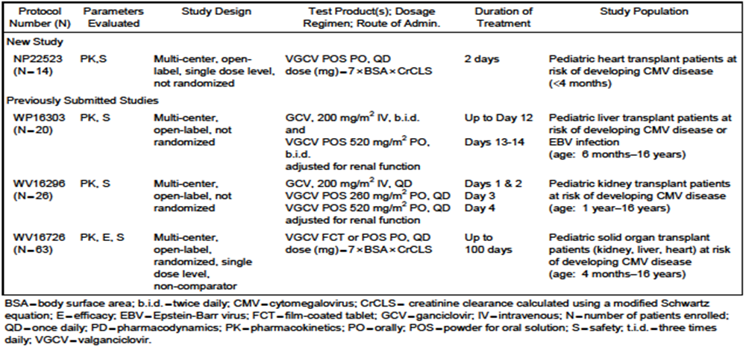

Efficacy

Studies providing efficacy data
There is one new safety and efficacy study conducted in a paediatric SOT population that is directly relevant to the proposed new indication. The second efficacy and safety study was not conducted in a paediatric SOT population, and hence only the safety and PK data (tested in the PBPK model described) arising from this study has been considered as relevant to this application. The reviewer considered the data provided on hearing: a marker of ‘efficacy’ of VGCV in congenital CMV infection as not directly relevant to this Application. Study NT18435 (IMPACT) (A Randomised, Double Blind, Placebo Controlled Multi Center Study of the Efficacy and Safety of up to 100 days of Valganciclovir vs. up to 200 days of Valganciclovir for Prevention of Cytomegalovirus Disease in High-Risk Kidney Allograft Recipients. Report No. 1025780/ March 2009) was included to provide further background information to this application, this was reviewed in 2010.

Evaluator’s conclusions on efficacy
The results of Study NV25409 do provide some support that VGCV prophylaxis for 200 days is efficacious in prevention of CMV disease in paediatric kidney transplant patients. However the major caveat is that there is no comparator arm. The drug is clearly well tolerated over several months of dosing and this is also the case in the CASG112 study where all of those enrolled were 30 days old or less. Although one of the efficacy outcomes states that ‘All patients with measurable CMV will have both UL54 and UL97 genes sequenced to assess for known CMV resistance to GCV’, the evaluator was unable to locate this sequencing data in the application. While there are very few young children enrolled (n = 6, ≤2 years of age) in NV25409, the CASG112 study provides additional safety data on 109 infants less than or equal to 30 days of age with symptomatic congenital CMV infection. The evaluator feels that the lack of PK/PD data in NV25409 was a missed opportunity.

Safety

Studies providing safety data
The following studies provided evaluable safety data: Phase IV Study NV25409 and the Phase III Study CASG112. The safety data arising from the Phase I Study NP22523 is summarised in detail. Within this safety section, the evaluator has classified Studies NV25409 and CASG112 as pivotal.
In the pivotal efficacy studies, the following safety data were collected:
Study NV25409: Managed according to the Schedule of Assessments. Clinical assessments included: surgical history; physical examination; weight; height, BSA calculation, estimated CrClS calculation and vital signs (temperature, blood pressure, heart rate, and ECG abnormalities); Safety/laboratory assessments.
Safety assessments at visits during and VGCV administration & during post prophylaxis follow up: Adverse Events (AEs) (including opportunistic infections) and treatments; Biopsy Information for acute rejection or CMV tissue invasion (if applicable); date, reason and result; weight, height, BSA calculation, estimated CrClS calculation and vital signs (temperature, blood pressure, heart rate, and ECG abnormalities); pregnancy test if applicable.
General AEs were assessed by the investigator/research nurse: direct questioning of parent/guardian and child (as applicable); vital signs; clinical examination; laboratory parameters (haematology & chemistry) and in CASG112; growth parameters and hearing tests were performed. In CASG112, these were performed as follows: During the 6 month treatment period and for 1 month thereafter, study subjects were followed weekly for 4 weeks, then every other week for 8 weeks, then every month for 4 months.
Study NV25409: All clinical AEs encountered during the clinical study reported on the AE form of the CRF. Intensity of AEs will be graded on a four point scale (mild, moderate, severe, life-threatening) and reported in detail on the electronic case report form (eCRF). Serious AE (SAE) reporting as for CASG112, except in NV25409, absolute neutrophil count (ANC) <500 cells/mm³ (Grade IV toxicity) alone is not an SAE.
In CASG112, each investigator was responsible for reporting all AEs and SAEs that were observed or reported from day 1 of study drug administration through 30 days after the last dose of study drug, regardless of relationship to study product. The study coordinator or other research staff, as designated by the Principal Investigator, also could have completed and documented the AEs. If the subject was withdrawn from the study or the study medication was stopped prematurely, AEs were collected for 30 days following the last administered drug dose. The investigator provided his/her assessment of any SAE and AE resulting from study participation. All AEs were graded for intensity using the Division of AIDS Toxicity Tables and assigned a relationship to study product and recorded on the AE CRF. All AEs were followed until satisfactory resolution (with or without sequelae) or until the investigator deemed the event to be irreversible or stable. The relationship to study products and severity of AEs, regardless of cause, was graded by the investigator as outlined:
- Associated: a known temporal relationship and/or, if re-challenge was done, the event abated with de-challenge and reappeared with re-challenge and/or the event was known to occur in association with the study product or with a product in a similar class of study products. No other aetiology explains the event.
- Not Associated: the AE was completely independent of study product administration; and/or evidence exists that the event was to be related to another aetiology.
If an event met the definition of suspected unexpected serious adverse reaction (SUSAR), additional information was collected to identify more specific categories as required by the EMEA for assigning relatedness (that is, definitely associated, probably associated, possibly associated, probably not/remotely associated or not associated). An SAE was defined as an AE meeting one of the following conditions and occurring from day of study drug administration through 30 days following the last dose of study drug (except death), unless the subject had been withdrawn from the study. In the case of premature cessation of study medication, SAEs were collected for 30 days following the last administered drug dose.
The SAE criteria were: Death throughout study participation; life threatening event; an event requiring inpatient hospitalisation or prolongation of existing hospitalisation during the period of protocol defined surveillance; resulted in congenital anomaly or birth defect; Resulted in a persistent or significant disability/incapacity; absolute neutrophil count (ANC) <500 cells/mm³ (Grade IV toxicity); any other important medical event that may not have resulted in death, be life threatening, or require hospitalisation, may be considered a serious adverse experience when, based upon appropriate medical judgment, the event may jeopardise the study subject and may require medical or surgical intervention to prevent one of the outcomes listed above.
- AEs of particular interest, including haematological toxicities, assessed by regular Full Blood Counts.
- Laboratory tests, including renal function, haematology and liver function tests, were performed at the scheduled visits (varied according to the study). Laboratory assessments in NV: Pregnancy test (for females of childbearing capacity only); Haematology (Hb, haematocrit, FBC including WBC and five part differential, platelet count); blood chemistry (total bilirubin, AST, ALT, alkaline phosphatase, total protein, albumin, uric acid, glucose, electrolytes, calcium, phosphate, serum creatinine and blood urea nitrogen [BUN]/urea) and CrClS.
Table 5: Summary of studies contributing to safety evaluation.
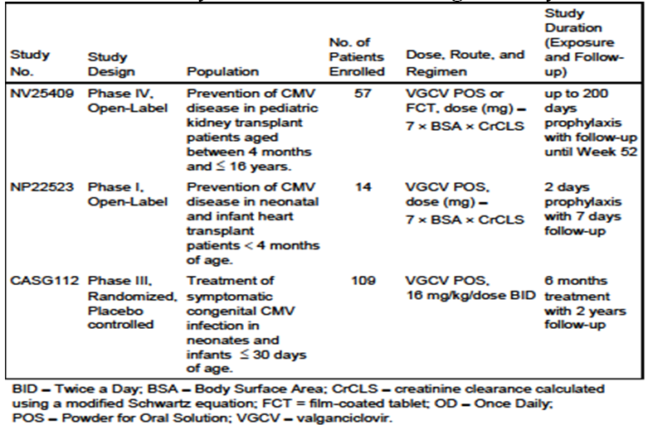

Patient exposure
This is shown in Table 6.
Table 6: Summary of the planned dosing regimen and the number of patients who received the full course of treatment by study.
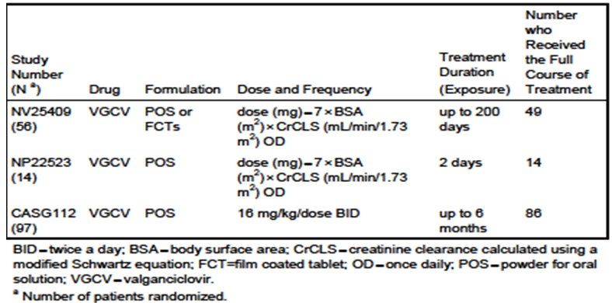

Safety issues with the potential for major regulatory impact
None revealed.

Post marketing data
The Roche Global drug safety database was queried for VGCV post marketing cases reported in paediatric patients <18 years of age (cut-off date: 30 June 2013). The post marketing safety data retrieved in the paediatric population has been compared with post marketing safety data retrieved from the adult population. Cumulatively, a total of 218 cases including 383 AEs (of which 292 were SAEs) have been reported in the paediatric population. Roche sponsored clinical trial cases were excluded from the search, since the purpose of the search was to review post marketing data only. VGCV is not approved in the EU for use in paediatric patients; however, VGCV, is approved in the US for patients ≥4 months of age; therefore, these post marketing data may reflect approved use in the US as well as off label use. Out of the 218 post marketing cases reported in the paediatric population, 83 cases (38%) were reported from spontaneous origin, 62 cases (28%) were reported from non Roche sponsored studies, 33 cases (15%) reported from literature, and the remaining cases were reported from other sources. For both the child (≥2 years to <12 years) and adolescent (≥12 years to <18 years) age groups, spontaneous cases were mostly reported; whereas, study and literature were the most reported sources for the infant (≥1 month to < 2 years) and neonatal (birth to <1 month) age groups, respectively. The majority of the post marketing reports concerning paediatric cases were from the USA, Japan and Germany. A total of 82 paediatric case reports (151 AEs) was in the indication “CMV prophylaxis in SOT patients” and 136 cases (237 AEs) were reported in “other indications”. Of the 383 AEs reported in the paediatric population, 32 AEs (29 were SAEs) were reported in neonates (birth to <1 month), 115 AEs (99 were SAEs) were reported in infants (≥1 month to <2 years), 143 AEs (96 SAEs) were reported in the child age group (≥2 years to <12 years), and 93 AEs (68 SAEs) were reported in adolescents (≥12 years to <18 years). By System Organ Class (SOC), the most frequently reported AEs in the paediatric population were blood and lymphatic disorders (24%), infections and infestations (17.2%), investigations (14.4%), and gastrointestinal (GI) disorders (8.6%). For each age group, AEs were most reported in the blood and lymphatic disorders SOC, with the exception of the child age group where AEs were mostly in the infections and infestations SOC. In the adult population, the most reported SOCs for all reported indications were blood and lymphatic disorders (19.7%), infections and infestations (17.6%), investigations (11.7%), general disorders (8.8%), and GI disorders (8.1%).

Deaths
A total of 6 deaths were reported post marketing in the paediatric population (neonatal [1 case], infant [1 case], child [2 cases], and adolescent [2 cases] age groups). These six cases reported 12 fatal AEs in the following indications: prophylaxis of CMV disease in SOT patients (3 cases), and other indications (3 cases). The 12 fatal AEs were reported under the following SOCs: infections and infestations (3 AEs, 25%), congenital, familial and genetic disorders (3 AEs, 25%), respiratory, thoracic and mediastinal disorders (3 AEs, 25%), renal and urinary disorders (1 AE, 8.3%), general disorders and administration site conditions (1 AE, 8.3%), nervous system disorders (1 AE, 8.3%).

Events under close monitoring
Some events associated with VGCV are currently under close monitoring: hypersensitivity, neoplasms, renal failure, GI disorders, medication errors, overdose, drug-drug interaction, and cytopaenia associated with infection or haemorrhage. Cumulatively, 22 cases (cut-off: 30 June 2013) reported in the paediatric population were assessed as AEs under close monitoring: hypersensitivity (1 case), neoplasms benign, malignant and unspecified (3 cases), renal failure (2 cases), medication errors (7 cases), overdose (1 case), drug-drug interaction (1 case), and cytopaenia associated with infection or haemorrhage (9 cases). Up to the 30 June 2013 cut-off, no cases of GI disorders have been reported in the paediatric population treated with the VGCV POS formulation. Following close monitoring of these 22 cases, no new major findings were found to have a bearing on the established overall safety profile of the product.

Evaluator’s conclusions on safety
In Study NV25409, extended prophylaxis with VGCV for up to 200 days in paediatric kidney transplant patients was well tolerated, with an overall safety profile consistent with that obtained in adult kidney transplant patients. The observed AEs and laboratory data were generally consistent with the known safety profile for VGCV in adults, reinforcing the need to monitor haematological parameters during prophylaxis. In Study NP22523, VGCV POS was well tolerated in paediatric heart transplant patients aged <4 months, with no unexpected safety issues; however, since this study has a small sample size, is of such short duration, and used GCV or VGCV as a standard of care, no conclusions with respect to safety can really be drawn. In Study CASG112, no unexpected safety issues were observed in infants receiving VGCV for the treatment of symptomatic congenital CMV infection. The safety data from studies NV25409, NP22523 and CASG112 support the proposed paediatric indication, and suggest that the tolerability of VGCV in paediatric patients is similar to that in adults. A cumulative review of all post marketing data identified a similar safety profile in the paediatric and adult populations and this is reassuring. Continued surveillance and reporting will be essential especially in very young children exposed which reports late onset events including malignancy and sterility.

First round benefit-risk assessment

First round assessment of benefits
The benefits of VGCV FCT and POS in the proposed usage are:
- Oral administration achieving levels considered effective against CMV; oral administration is a great advantage in the paediatric (and adult) setting;
- Appears safe and well tolerated in all age groups even in the very young (30 days of age or less) including when dosed over extended periods of several months;
- PBPK model derived from several prior paediatric studies appears to predict the correct dose for efficacy;
- No added haematological or renal toxicity in those on concurrent immunosuppressant agents.

First round assessment of risks
The risks of VGCV FCT and POS in the proposed usage are:
- Very little data in those SOT recipients aged 6 weeks or less; the FDA has requested PK and safety data on 4 SOT patients, at the time of this submission only 2 of the planned 4 had been enrolled. However, the reason it has been so difficult to enrol these 4 patients is that most SOT happen after 6 weeks of age, plus the difficulties of enrolling patients in those receiving transplants within the first 6 weeks of life;
- The safety of the drug is not established in those born premature and/or of low birth weight. In this situation the PBPK modelling may not be accurate. In the NP22523 study, it appeared that the <4 months experienced GCV exposures approximately 23% higher than the youngest group studied in previous clinical trials. This observation needs to be confirmed, and further data derived from longer exposure in SOT recipients under the age of 4 months.
- No data in those of Asian ethnicity, which would be potentially important for an Australian setting.

First round assessment of benefit-risk balance
The benefit-risk balance of VGCV FCT and POS, given the proposed usage, is favourable. The rationale for this is that CMV disease in the transplant setting is associated with graft rejection and other serious consequences including death. In the paediatric situation, especially in the very young, it is even more likely that if CMV disease does occur it will be a primary infection with devastating consequences including CMV pneumonia, associated with high mortality. The oral formulations of GCV, that is, the pro-drug VGCV represent an advance in the management of paediatric SOT.

First round recommendation regarding authorisation
The evaluator recommends approval of the submission as it stands.

Clinical questions

Pharmacokinetics
No questions.

Pharmacodynamics
- Why weren’t any PK/PD analyses performed in NV25409? This was a missed opportunity. What are the plans for obtaining more safety and efficacy data in younger children with SOT treated with VGCV?

Efficacy
- What are the plans to obtain efficacy data in other types of SOT in the very young patients, such as liver transplant?

Safety
- What are the plans to obtain more data on children of Asian ethnicity treated with VGCV. There appears to be a paucity of data in this regard. Only 2 patients enrolled in NV25409 were Asian.

Second round evaluation
The sponsor submitted a response where they addressed the questions raised and no further information was required by TGA in relation to these issues.

V. Pharmacovigilance findings
The TGA granted a waiver from the requirement for a Risk Management Plan (RMP) for this application.

VI. Overall conclusion and risk/benefit assessment
The submission was summarised in the following Delegate’s overview and recommendations:

Quality
There was no requirement for a quality evaluation in a submission of this type.

Nonclinical
There was no requirement for a nonclinical evaluation in a submission of this type.

Clinical
The application contains the following clinical information:

Pharmacokinetics studies
- PBPK and popPK analysis
- Phase I PK study (NP22523) that provided PK and safety VGCV POS in paediatric heart transplant recipients from birth to <4 months of age.

Clinical efficacy and safety studies pertinent to paediatric SOT population
- NV25409: non randomised study exploring tolerability of up to 200 days of VGCV oral solution or tablets in paediatric kidney transplant recipients aged between 4 months to 16 years.

Supportive clinical studies
- CASG112: a Phase III study in paediatric patients with congenital CMV infection.
- NT18435: an adult study previously reviewed by the TGA.

Pharmacokinetics

Study NP22523
This is a Phase I PK study conducted in heart transplant patients aged 3 weeks to 125 days (n = 14). The primary objective was to characterise the PK of GCV following administration of VGCV POS in paediatric heart transplant patients aged <4 months.
The study originally planned to enrol at least 16 patients and 14 patients were enrolled up to 18 April 2013. Twelve of the 14 patients were in the 6 weeks to < 4 months age group and only two patients were in the birth to < 6 weeks age group (one was 21 days old at screening and the other was 28 days old at screening) (Table 7).
Table 7: Patients birth to < 6 weeks old, n = 2.
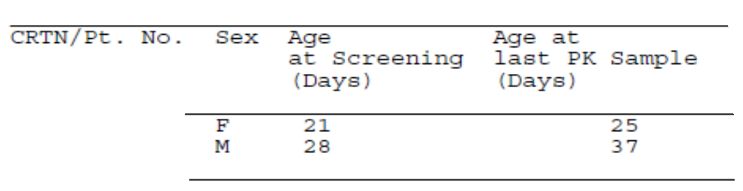
All 14 patients received a single daily dose of valganciclovir according to the paediatric dosing algorithm on 2 consecutive days and completed the study. Follow up after treatment was 7 days.
A popPK model was developed using the PK data from Study NP22523, together with data from previous PK paediatric studies (WP16296, WP16303, and WV16726). The data set contains a total of 985 measured concentrations from these 4 studies to characterise the PK of GCV after oral VGCV in paediatric heart transplant patients aged <4 months. The final PK model is a two compartmental model with first order absorption. The model indicated that CL was influenced by weight and CrCL, while the volume of distribution at steady state (Vapp) for the central compartment (Vcent) and the peripheral compartment (Vperiph) were influenced by body weight only. The mean total body clearance and bioavailability of GCV in the NP22523 population were 1.25 L/h and 64% respectively. Estimated overall average AUC0-24h was 68 μg•h/mL (64.7 μg•h/mL in the < 6 weeks subgroup and 68.8 μg•h/mL in the 6 weeks to 4 months subgroup). The range of the estimated steady state AUC_{0-24h} is 34-124 μg•h/mL. The estimated AUC_{0-24h} range is similar and within the same range (22-152 μg•h/mL) as reported in Study WV16726 for paediatric SOT patients aged 4 months to 16 years receiving VGCV prophylaxis for up to 100 days, as well as those reported in adults for 100 to 200 days (Study PV16000: 8.5-71.6 μg•h/mL and from Study NT18435: 22.4-145.1 μg•h/mL). The AUC_{0-24h} also achieved the target exposures shown to be efficacious in adult SOT patients (AUC_{0-24h} = 40-60 μg•h/mL).
A summary of estimated data from Study NP22523, divided by age group with descriptive statistics of the steady-state AUC_{0-24h} and the C_{max} are presented in Table 8. There did not appear to be a difference between the two age groups, however the patient numbers are small.
Table 8: Summary of model estimated GCV steady steady state AUC and the Cmax.
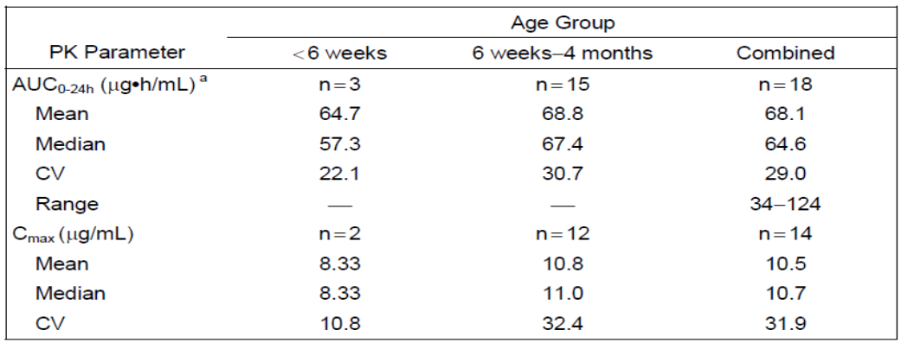
Viral sensitivity to VGCV is anticipated to be unchanged regardless of the patient population. Therefore, it is expected that by achieving exposures similar to those shown to be safe and efficacious in adult SOT patients, efficacy will be achieved. Although efficacy was not measured in this study (NP22523), effective prophylaxis results would be expected based on the estimated GCV exposure range of 34-124 μg•h/mL, which is within the previous exposure ranges observed in adult SOT patients. In addition, the mean GCV AUC_{0-24h} of 68.1 μg • h/mL is close to the target exposure range of GCV AUC_{0-24h} of 40-60 μg • h/mL established in the adult SOT population.

PBPK and popPK analyses
The PBPK model and popPK analyses are discussed in detailed. Model parameters used in simulations for GCV and VGCV PBPK models are presented. In brief, due to the difficulty in enrolling paediatric patients younger than 6 weeks old in NP22523, the sponsor was requested to develop a PBPK model in order to characterise the PK of valganciclovir (VGCV) and ganciclovir (GCV) in SOT patients from birth to 4 months old. The human PBPK model was developed stepwise to describe the PK of GCV following the administration of GCV and VGCV in adult and paediatric populations. An initial human adult PBPK model was based on the PBPK model that described GCV and VGCV PK data across preclinical studies and optimized using clinical adult PK data. The adult model was able to describe the PKs of GCV following administration of VGCV in paediatric patients aged 13-16 years. For patients younger than 13 years old, adjustments to the model were needed, especially for patients aged <1 year. The refined PBPK model simulated mean GCV exposures (AUC_{0-24h}) of the population aged < 4 months using 3 scenarios of dosing algorithm including the one used in Study NP22523. This PBPK model was found to be generally predictive using the paediatric dosing algorithm and was supported by the limited data available from the 10 patients enrolled in Study NP22523 at that time. A population PK model was then developed to perform the PK analysis as defined by NP22523 protocol. The model used the combined clinical data from Study NP22523 and 3 previous paediatric SOT studies (Studies WP16303, WP16296, and WV16726).
The PBPK modelling was performed by Simulations Plus for the sponsor using a custom version of GastroPlus 8.0.0016 software. Active transport of VGCV and GCV was assumed in the gut, liver, and kidney. Based on the pre clinical PBPK model, permeability limited tissue penetration was assumed. As the model was applied sequentially to younger age groups, multiple parameters were optimised or adjusted in order to obtain good predictions. Although good predictions were obtained for infants with heart transplantation under 4 months of age and a single 25 day old neonate, respectively, these predictions relied on un-validated assumptions of disease related and age related alterations in transport expression.
The FDA review team pointed out that in order to obtain adequate predictions in neonate, the additional assumption of very low transporter expression, which was not verified, was required. Due to the uncertainty (particularly for neonates) in the model prediction, the FDA review team determined that the model is not sufficiently verified to support dosing recommendations in neonates. The conclusion from the FDA review is that:
the population PK analysis supports acceptable GCV exposures in the infants enrolled (1-4 months of age) using the valganciclovir dosing regimen. Due to unverified assumptions, the PBPK analysis is not sufficient to support valganciclovir dosing recommendations for infants < 1 month of age.

Efficacy

Study NV25409
This is a Phase IV safety and efficacy study conducted in a paediatric kidney transplant recipients aged 4 months to ≤16 years. It is a multicentre, open label, single arm non comparator study. The primary objective was to describe the tolerability profile of up to 200 days prophylaxis of VGCV oral solution and FCT in paediatric kidney transplant recipients; secondary objectives were to describe the incidence of CMV infection (viraemia) and disease (CMV syndrome or tissue invasive CMV) within the first 52 weeks post transplant, and to describe the incidence and nature of CMV resistance to GCV (mutations in UL97 and/or UL54).
Eligible subjects were male or female kidney transplant recipients aged 4 months to ≤16 years who were at risk of developing CMV disease (including R+ who was at risk of CMV due to other factors) with an adequate haematological and renal function. Subjects who met the criteria began treatment with oral VGCV, as soon after transplant as possible, and treatment continued until a maximum of 200 days post transplant. The VGCV dose was calculated according to the approved dosing algorithm. The main efficacy variables were: incidence of CMV disease; incidence of CMV infection (viraemia); viral load and resistance (UL54 & UL97); biopsy proven acute rejection; patient and graft survival. Efficacy outcomes were based on the Intention-To-Treat Population.
The sample size was based on practical considerations. A sample size of ≈30 was considered adequate to describe the tolerability of oral VGCV in this population, with an acceptable level of precision, based on the width of the 95% CI around AE rates expected in this population. A total of 57 patients enrolled, 56 patients received treatment (ITT population): 6 patients in the ≤ 2 years age group, 18 patients in the > 2 to <12 years age group and 32 patients in the ≥12 years age group; CMV serology status: D+/R+ (45%) or D+/R- (39%) and an Epstein-Barr virus (EBV) status of D+/R+ (68%) or D+/R- (18%).

Results of the primary efficacy outcome
- 4 patients (7.1%) were reported with CMV events locally, including 3 patients (5.4%) with CMV infection (viraemia, detected locally) and 1 patient (1.8%) with CMV syndrome. All CMV events occurred during the post-prophylaxis follow-up period. The single case of CMV syndrome was later invalidated by a lack of quantifiable CMV DNA (>150 copies/mL) in any samples tested at the central laboratory.
- 3 of the 4 with reported CMV events received CMV treatment; one patient with CMV infection did not receive treatment. All but two were resolved by the end of the study period.
- 10 patients (17.9%) had CMV viraemia in the absence of any reported fever or other symptoms of CMV disease, which included 3 of the 4 patients with locally detected CMV events.
- 2 of the 10 with confirmed CMV viraemia (both during the post-prophylaxis follow-up period) were treated with VGCV, and both patients had CMV DNA <LOQ by their week 52 visit.
- 2 additional patients received treatment with VGCV or valacyclovir following the end of study treatment as secondary prophylaxis of CMV disease but did not demonstrate CMV viraemia or antigenaemia locally or in central laboratory tests.
Table 9: Summary of CMV events by age group in Study NV25409.
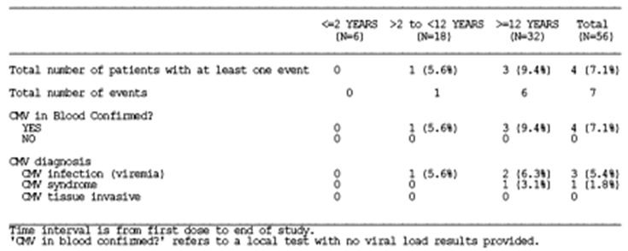

Results of other efficacy outcomes
- Viral load and resistance (UL54 and UL97): during the study period, of the 10 out of 56 (18%) patients with quantifiable viral load, 6 (60.0%) were D+R- patients. CMV infection was confirmed in 2 patients (3.6%) during the treatment period, and the remaining 8 patients (14.3%) with positive samples were in the follow-up period. There were no cases of CMV disease. All patients with measurable CMV will have both UL54 and UL97 genes sequenced to assess for known CMV resistance to GCV (these data were not included in this application).
- Biopsy proven acute rejection: of the 6 patients who experienced biopsy proven acute rejection, one patient experienced CMV infection prior to the rejection episode. In summary, the rate of biopsy proven acute rejection episodes were low and of mild or moderate intensity.
- Patient and graft survival: no patients died: all grafts survived.

CASG 112
This is a multicentre, prospective, blinded investigation, randomised Phase III study. This study was not conducted in paediatric SOT population, and hence only the safety data are considered relevant to this application. The study provided important safety information for the use of VGCV in very young children.
The efficacy and safety of VGCV treatment of 6 weeks versus 6 months was studied in infants aged 2 to 30 days with symptomatic congenital CMV disease. All infants received oral valganciclovir at a dose of 16 mg/kg twice a day (b.i.d) for 6 weeks. After 6 weeks of treatment, the infants were randomised 1:1 to continue treatment with VGCV at the same dose or receive a matched placebo to complete 6 months of treatment. The dose was adjusted for weight gain and renal impairment at each study visit, as well as for neutropaenia and thrombocytopaenia.
A total of 109 subjects were enrolled and 97 randomised. Only 96 were included in the ITT population for efficacy analyses; 82 completed treatment during open label and blinded phase.
Ninety-six patients were randomised to blinded therapy: 13 patients (13.5%) were in the <7 days age group, 31 patients (32.3%) were in the 7-14 days age group, 16 patients (16.7%) were in the 15-21 days age group, and 36 patients (37.5%) were in the 21- <30 days age group. The number of term and pre-term infants was similar (52.1% versus 47.9%, respectively). Most patients were Caucasian (66.7%), not Hispanic/Latino (70.8%), and male (62.5%).
The main efficacy variable was:
- Change in best ear hearing assessment between baseline and 6 months post enrollment.
- Changes in a number of other hearing and development criteria.
- Relationships between whole blood CMV viral load and the change in hearing between baseline and 12 months of age, and neuro-developmental outcomes at 12 and 24 months.
- Relationships between GCV PK parameters and change in CMV viral load and hearing outcome.

Results for the primary efficacy outcome
- Primary endpoint: there was no difference between the two randomisation groups in change in best ear hearing assessments between baseline and 6 months.
- Adjusting for baseline CNS involvement, as dictated in the a priori study analysis plan, and using a stricter cut-off for concluding a statistically significant treatment effect on neurodevelopmental outcomes using Bonferroni adjustment for multiple testing (where p-values <0.0071 are considered statistically significant), subjects treated for 6 months had better language composite and receptive communication outcomes at 24 months compared with subjects treated for 6 weeks.

PK/PD results
- Relationships between GCV PK parameters and change in CMV viral load and hearing outcome measures were explored. GCV clearance (CL/F) was significantly associated with the viral load AUC over the entire study period and from Day 1 to Day 42. Although statistically significant, the correlations were very low and several outliers affected the relationships. In addition, the relationship was counter-intuitive in that as the CL/F increased (so lower drug exposure) the viral load AUC decreased. Similarly, CL/F was significantly associated with improved/protected and deteriorated hearing at months 12 and 24, respectively. As with the viral load AUC correlations, these relationships were also backwards. The higher the CL/F (lower drug exposure) the better the improved/protected group did. Lower CL/F (higher drug exposure) was associated with increased deteriorated hearing. Lower whole blood viral load during Day 1-42 was associated with better hearing outcomes at 12 months (p = 0.0297) and 24 months (p = 0.0436).

Study NT18435 (IMPACT)
This is a randomised, double blind, placebo controlled multicentre study of the efficacy and safety of up to 100 days of VGCV versus up to 200 days of VGCV for prevention of CMV disease in high risk kidney allograft recipients. This study was included to provide further background information and updated information on AEs; this study was submitted and reviewed in 2010.

Safety
In addition to Study NP22523, Study NV25409 and CASG112 have provided evaluable safety data. Table 5 presents the summary of the dosing regimens and the number of patients who received the full course of treatment in each of these 3 studies.

Study NV25409
The extended prophylaxis with VGCV for up to 200 days in paediatric kidney transplant patients was well tolerated in this study, with an overall safety profile consistent with that obtained in adult kidney transplant patients. The observed AEs and laboratory data were generally consistent with the known safety profile for VGCV in adults, reinforcing the need to monitor haematological parameters during prophylaxis. The key safety findings from this study were:
- All patients (100%) experienced at least one AE during the treatment period, and the overall incidence of AEs was similar across 3 age groups. Infection and infestation AEs as well as blood and lymphatic AEs were commonly reported in each age group. The most common AEs reported were upper respiratory tract infection (33.9%), urinary tract infection (33.9%), diarrhoea (32.1%), leukopenia (25.0%), neutropenia (23.2%) and headache (21.4%). Upper respiratory tract infection, urinary tract infection and diarrhoea were reported with a higher incidence in the youngest age group ( ≤ 2 years) and leukopenia and neutropenia were respectively reported with higher incidence in the ≥ 12 years and > 2 to < 12 years age groups. Differences observed might be related to the low number of patients in the ≤ 2 years age group.
- A total of 66.1% patients experienced at least one SAE during the treatment period with a higher incidence in the ≤ 2 years and in the > 2 to < 12 years age groups (83.3% and 72.2%), which might be due to the low number of patients included in these two groups (6 and 18 patients, respectively).
The most common types of SAEs were infections and infestations (23 patients [41.1%]) and blood and lymphatic disorders (9 patients [16.1%]). No blood and lymphatic system disorder SAE was reported in the ≤ 2 years group.
Six patients withdrew from study drug due to an adverse event, five due to blood and lymphatic disorders (neutropenia, anaemia, pancytopenia) all considered related to the study drug, and one patient because of gastrointestinal disorders (diarrhoea, vomiting and abdominal pain) and gastrointestinal protozoal infection considered not related to the study drug. No safety concerns identified in relation to drug-drug interactions.
No new safety signals were detected.

Study NP22523
VGCV was well tolerated in paediatric heart transplant patients aged <4 months, with no unexpected safety issues; however, since this study has a small sample size, is of such short duration, and used GCV or VGCV as a standard of care, no conclusions with respect to safety can really be drawn.

Study CASG112
No unexpected safety issues were observed in infants receiving VGCV for the treatment of symptomatic congenital CMV infection.

Post marketing experience in the paediatric population
The post marketing safety data in the paediatric population has been compared with post marketing safety data in the adult population. Cumulatively, a total of 218 cases including 383 AEs (of which 292 were SAEs) have been reported in the paediatric population. VGCV is not approved in the EU for use in paediatric patients during the reported period; however, VGCV, is approved in the US for patients ≥4 months; therefore, these post marketing data may reflect approved use in the US as well as off-label use. Out of the 218 post-marketing cases, 83 cases were reported from spontaneous origin, 62 cases were reported from non Roche sponsored studies, 33 cases reported from literature, and the remaining cases were from other sources. For both the child and adolescent groups, spontaneous cases were mostly reported; whereas, study and literature were the most reported sources for the infant (≥1 month to < 2 years) and neonatal (birth to <1 month) groups, respectively. The majority of the paediatric cases were reported from the USA, Japan and Germany. Eighty-two paediatric cases (151 AEs) were reported in the indication “CMV prophylaxis in SOT patients” and 136 cases (237 AEs) were reported in “other indications”. Of the 383 AEs reported, 32 AEs were reported in neonates, 115 AEs were in infants, 143 AEs were in the ≥2 years to <12 years age group, and 93 AEs were reported in adolescents (≥12 to <18 years). By SOC, the most frequently reported AEs were blood and lymphatic disorders (24%), infections and infestations (17.2%), investigations (14.4%), and GI disorders (8.6%). There were 6 post marketing cases reported deaths. Some AEs associated with VGCV use are currently under close monitoring, these include hypersensitivity, neoplasms, renal failure, GI disorders, medication errors, overdose, drug-drug interaction, and cytopaenia associated with infection or haemorrhage.
The clinical evaluator considers that the safety data from Studies NV25409, NP22523 and CASG112 support the proposed use in paediatric SOT recipients, and suggest that the tolerability of VGCV in paediatric patients is similar to that in adults. The review of the post-marketing data indicates that the safety profile in the paediatric patients is similar to that in adult population. Continued surveillance and reporting will be essential especially in very young children exposed; this includes late onset events including malignancy and sterility.

Risk management plan
There was no requirement for a RMP in a submission of this type.

Risk-benefit analysis

Delegate’s considerations
The CMV disease in the transplant setting is associated with graft rejection and other serious consequences including death. In the paediatric setting, especially in the very young, it is even more likely that if CMV disease does occur it will be a primary infection with devastating consequences including CMV pneumonia, associated with high mortality. The oral formulation, VGCV oral tablet and solution, represent an advance in the management of paediatric SOT recipients.
In this application, one Phase I PK study (NP22523) and one safety, efficacy study (NV25409) were submitted as pivotal data to support the extension of the approved dosing algorithm to the very young (from birth) SOT recipients.
Study NP22523 was a Phase I PK study conducted in heart transplant recipients aged 3 weeks to 125 days (n = 14). The study demonstrated that oral VGCV can achieve serum levels that are considered effective against CMV, however, as there were no patients < 3 weeks old in this study, no PK data was available for paediatric patients < 3 weeks old. Due to the difficulty in enrolling very young patients in this study, a PBPK model was developed to characterise the PK of VGCV and GCV in SOT patients from birth to 4 months old. As the PBPK model was applied sequentially to younger age groups, multiple parameters were optimised or adjusted in order to obtain good predictions. Although good predictions were obtained for infants with heart transplantation under 4 months of age and a single 25 day old neonate respectively, these predictions relied on un-validated assumptions of disease related and age-related alterations in transport expression. As discussed before, the conclusion from the FDA review team regarding the population PK model and analysis is that
the population PK analysis supports acceptable gancivlovir exposures in the infants enrolled (1-4 months of age) using the valganciclovir dosing regimen. Due to unverified assumptions, the PBPK analysis is not sufficient to support valganciclovir dosing recommendations for infants < 1 month of age.
Study NV25409 is not a comparative study, but the study has provided some level of support that VGCV prophylaxis for 200 days is safe and effective for the prevention of CMV disease in paediatric kidney transplant recipients. VGCV is well tolerated over several months of dosing and this is also the case in Study CASG112 where all of those enrolled were 30 days old or less. While there are very few young children (≤ 2 years of age, n = 6) in Study NV25409, the CASG112 study provides additional safety data on 109 infants (30 days old or less) with symptomatic congenital CMV infection.
With regards to the PK data in paediatric liver transplantation recipients, there was a Study WP16303 which was previously evaluated by TGA. WP16303 was a Phase I/II, open label study of PK, safety and tolerability of valganciclovir oral solution in comparison to IV ganciclovir in paediatric liver transplant patients. The study enrolled 20 patients aged between 6 months and 16 years and the patients were administered the study drugs within the first 14 days post transplantation. The PK result from this study is included in the Australian PI. It should be noted that there is no PK data for paediatric liver transplant patients < 6 months old in this study.
The committee is requested to provide advice on the following specific issue:
- What is the view of the ACPM with regards to the proposed extension of the current dosing algorithm to paediatric SOT recipients aged from birth) on the basis of Study NP22523 in paediatric heart transplant recipients aged from 3 weeks to 4 months old (n = 14) and the PBPK model analysis?
- What is the view of the ACPM with regards to the use of VGCV (valganciclovir) for the prophylaxis of CMV disease in paediatric liver transplant recipients?
The Delegate is seeking the advice from the ACPM prior to make the final decision regarding the sponsor proposed extension of the approved dosing algorithm to very young paediatric SOT recipients aged from birth.

Summary of issues
The studies provided to support the dosing extension to paediatric patients from birth are:
- One PBPK and popPK analysis
- One Phase I PK study (NP22523) conducted in paediatric heart transplant recipients aged from 3 weeks to 4 months
- One safety, efficacy, and PK study (NV25409) conducted in paediatric kidney transplant recipients aged between 4 months to 16 years.
There is no PK data for paediatric heart transplant recipients aged from birth to 3 weeks, no PK data for paediatric kidney or liver transplant recipients aged from birth to 4 months old.
With regards to the popPK model and analysis, the conclusion from the FDA review team is that
the population PK analysis supports acceptable gancivlovir exposures in the infants enrolled (1-4 months of age) using the valganciclovir dosing regimen. Due to unverified assumptions, the PBPK analysis is not sufficient to support valganciclovir dosing recommendations for infants < 1 month of age.
The use of VGCV for the prevention of CMV disease in liver transplant recipients (adults and paediatrics) is not approved by the FDA.

Request for ACPM advice
The Advisory Committee on Prescription Medicines (ACPM) is requested to provide advice on the following specific issue:
- What is the view of the ACPM with regards to the proposed extension of the current dosing algorithm to paediatric SOT recipients aged from birth) on the basis of Study NP22523 in paediatric heart transplant recipients aged from 3 weeks to 4 months old (n = 14) and the PBPK model analysis?
- What is the view of the ACPM with regards to the use of VGCV (valganciclovir) for the prophylaxis of CMV disease in paediatric liver transplant recipients?
The committee is also requested to provide advice on any other issues that it thinks may be relevant to a decision on whether or not to approve this application.

Response from sponsor
The sponsor acknowledges that the delegate is seeking the advice from the ACPM prior to make the final decision regarding the sponsor’s proposed extension of the approved dosing algorithm to very young paediatric SOT recipients aged from birth.
The sponsor confirms the intent of this application is to extend the patient population to include paediatrics from birth for the prophylaxis of CMV disease following SOT in patients at risk of CMV disease.
The paediatric program to extend the indication to the ages less than 4 months was developed and approved following extensive discussions with the FDA and EMA on the generation of further data on the use of VGCV in this population. The data generated in accordance with the agreed paediatric investigation plan (PIP) approved by the European Medicines Agency and the US Written Requests are the basis for this application. The applications to update the respective countries prescribing information have been submitted and approved in both the USA (with modifications) and EU. Further, in both regions, on the basis of this data the paediatric commitments are considered fulfilled.
The data to support this application is as follows: two new studies in paediatric SOT patients (Study NP22523 and Study NV25409), new safety data from infants with symptomatic congenital CMV disease (Study CASG112) and previously submitted paediatric studies (WP16303, WP16296, WV16726 and CASG109).

Comment in response to Delegate’s specific requests
- What is the view of the ACPM with regards to the proposed extension of the current dosing algorithm to paediatric solid organ transplantation (SOT) recipients aged from birth) on the basis of Study NP22523 in paediatric heart transplant recipients aged from 3 weeks to 4 months old (n = 14) and the PBPK model analysis ?
Study NP22523 was conducted in heart transplant patients aged up to 4 months to provide PK information of GCV after administration of VGCV in very small children. Data from Study NP22523 together with additional simulations using an external dataset with 790 demographic data records show that the paediatric dosing algorithm for valganciclovir provides safe and effective GCV exposures in children from birth onwards.
The original intent of Study NP22523 was to include at least 16 patients of which 4 patients should have been younger than 6 weeks. Even though the study was open for recruitment for almost 3 years (17 study sites in 3 countries), it turned out to be very challenging to find eligible patients for inclusion in the study. The average time from a potential patient’s birth to being listed for heart transplant was 45 days in the year 2013, which made it almost impossible to include patients into the trial that are younger than 6 weeks at the time of transplantation.
The study was closed after inclusion of 17 patients, of which 16 provided PK information. Two patients were younger than 6 weeks at screening (21 days and 28 days). The pharmacokinetic parameters were derived using a population pharmacokinetic model and the results confirm that the proposed paediatric dosing algorithm achieves mean exposure levels in line with the AUC target range of 40-60 µg•h/mL.
As the number of patients was small, additional popPK simulations were performed to illustrate the expected GCV exposure range in a broader population of children aged birth to less than 4 months. An external dataset including 790 patient records was built from patient data (for patients < 4 months of age) coming from two Roche sponsored paediatric transplant studies (Studies NP22523 and WV16726) and two investigator initiated studies (Studies CASG109 and CASG112) in paediatric patients with congenital CMV. Table 10 shows the distribution of demographic characteristics that were covered.
Table 10: Summary of demographic distribution for external dataset used for simulation of GCV exposures for children aged birth to less than 4 months (790 patient records).
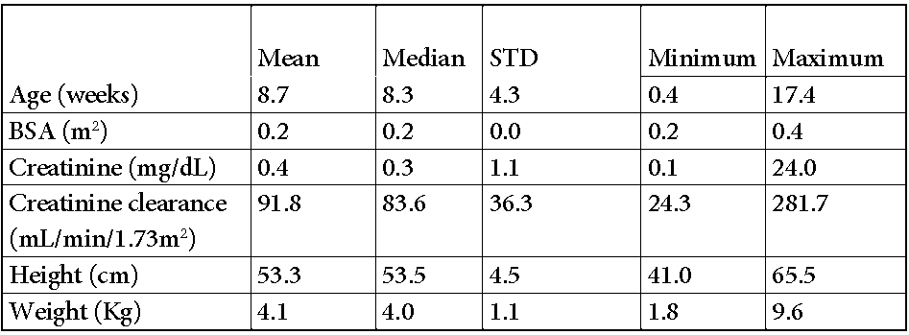
The simulated exposure values for 249 patient records coming from patients below 6 weeks of age and 541 patient records from patients between 6 weeks and 4 months of age confirmed that despite considerable variability in the demographics, the proposed dosing regimen provides similar exposure ranges for these two age groups (Table 11; Figure 1). Furthermore, the median AUC values for both groups are approximately 55 µg•h/mL, which is within the target exposure range of 40-60 µg•h/mL.
Table 11: Summary of simulated GCV steady state AUC_{0-24h} and C_{max} by age for children aged birth to less than 4 months using an external dataset (790 patient records).
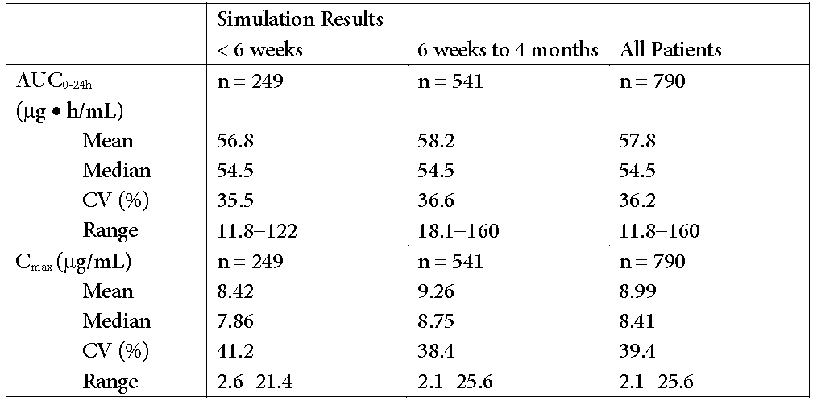
Figure 1: Simulated GCV steady state AUC_{0-24h} by age for children aged birth to less than 4 months using an external dataset (790 patient records).
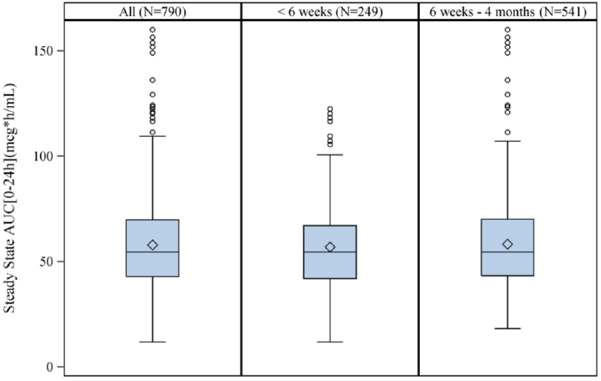
For C_{max}, no difference between children younger than 6 weeks and 6 weeks to 4 months was observed (Table 10 and Figure 2).
Figure 2: Simulated GCV C_{max} by age for children aged birth to less than 4 months using an external dataset (790 patient records).
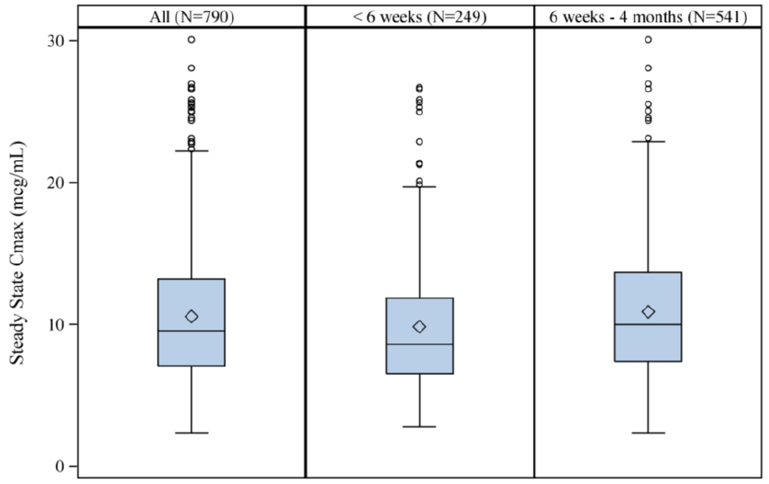
To further strengthen the confidence that the paediatric dosing algorithm is also applicable for very young children a PBPK was developed. This model describing the PK of GCV after administration of GCV and VGCV had previously been developed for adults and was adjusted stepwise to paediatric groups of decreasing age.
Pharmacokinetic data from 24 neonates aged 8 to 33 days old with symptomatic congenital CMV disease were used to evaluate the model in children up to 5 weeks. The accordance of the PBPK model derived on the data from older children with this very young patient group was already reasonable without further adjustments indicating that the physiology driving the PK of GCV in children is not dramatically different in children 5 weeks and younger. Overall, the exposure in neonates was slightly higher than model predicted (about 20%) and the inclusion of a small factor describing the maturation of the expression of kidney transporters during the first weeks after birth improved the model prediction. However, this assumption could not be verified by external data sources as scientific data on the maturation of transporter levels in children are sparse.
In conclusion, based on the data from Study NP22523 and the additional simulations using an external dataset with 790 demographic data records it is expected that the paediatric dosing algorithm for valganciclovir provides safe and effective GCV exposures in children from birth onwards. The PBPK model that compared the understanding of the pharmacokinetics of GCV to the data from 24 neonates indicated a slight difference that could potentially be related to the ontogeny of kidney transporters. This hypothesis could not be verified by further scientific evidence; however, the effect is small and overall there is no evidence for a major physiological difference in neonates changing the PK profile of ganciclovir compared to older children.
In clinical practice, it will be very rare that children will receive an organ transplant before they are 6 weeks old and therefore it may seem irrelevant whether or not valganciclovir is indicated starting from birth or 4 weeks of age. However, for the exceptional situation in which a very young child needs to be treated with valganciclovir it is important to provide guidance on the dose to the treating physician. Our data and scientific assessment indicate that the general paediatric dosing algorithm is also appropriate for neonates and therefore we propose the dosing extension to paediatric patients from birth.
- What is the view of the ACPM with regards to the use of VGCV for the prophylaxis of CMV disease in paediatric liver transplant recipients?
The use of VGCV for the prophylaxis of paediatric liver transplants has been studied during the paediatric development of VGCV. Clinical trial WV16726 that assessed the tolerability of up to 100 days of VGCV prophylaxis in SOT patients demonstrated that the safety profile is similar across organ types, including liver, and also delivered consistent drug exposures across different organ types using the algorithm described.
Extensive post marketing experience has not suggested any additional risks for the liver transplant indication, and therefore a favourable benefit risk for up to 100 days prophylaxis remains in this patient population.

Advisory committee considerations
The ACPM, taking into account the submitted evidence of efficacy, safety and quality, considered Valcyte
- film coated tablet, containing 450 mg of valganciclovir and
- powder for oral solution containing 450 mg of valganciclovir 50 mg/mL
to have an overall positive benefit-risk profile for the indication:
Valcyte is indicated for the prophylaxis of CMV disease in adult and paediatric solid organ transplantation (SOT) patients who are at risk.
In making this recommendation, the ACPM:
- Noted the extreme paucity of trial data in
  - Kidney transplantation patients under 2 years
  - Heart transplantation patients under 6 weeks (2 patients)
  - Liver transplantation patients under 4 months
- Acknowledged the rarity of transplant patients less than 1 month of age.
- Advised that the PI should specify the extent of data in patients under 4 weeks of age.
- Advised that Valcyte should be available for patients undergoing liver transplantation.
- Suggested dosage instructions start for patients from 1 month, with a statement that the paucity of data below that age limit is such that extreme caution should be exercised.

Proposed conditions of registration
The ACPM agreed with the Delegate on the proposed conditions of registration and advised on the inclusion of the following:
- Negotiation of PI and Consumer Medicines Information (CMI) to the satisfaction of the TGA.

Proposed PI/CMI amendments
The ACPM agreed with the Delegate to the proposed amendments to the PI and CMI and specifically advised on the inclusion of the following:
- The CLINICAL TRIALS section should include all paediatric trial data, specifically the numbers in each age group reported.
- The PI should state that there is scant information about dosing in patients under the age of 1 month.
- The PI should include dosing instructions for patients undergoing liver transplantation.

Specific advice
The ACPM advised the following in response to the Delegate’s specific questions on this submission:
- What is the view of the ACPM with regards to the proposed extension of the current dosing algorithm to paediatric SOT recipients aged from birth on the basis of Study NP22523 in paediatric heart transplant recipients aged from 3 weeks to 4 months old (n = 14) and the PBPK model analysis?
The ACPM noted that there were no PK data for paediatric heart transplant patients from birth to 3 weeks of age and no PK data for paediatric kidney or liver transplant recipients aged from birth to 4 months old. The ACPM agreed that the assumptions regarding the physiologically based PK analysis in the under 4 weeks of age group could not be verified. The ACPM also noted there were few such patients to provide data of any kind in the proposed indication.
The ACPM noted that PK in neonates with congenital CMV suggest body weight is the only important factor in the PK of VGCV and that the available evidence in the non-transplant population is supportive of the dose recommendations. The ACPM noted that further evidence was unlikely in this group and that patients would be managed by expert clinicians. However, the ACPM advised that, due to the paucity of data, the PI should not recommend specific dosing for patients less than 4 weeks of age. The ACPM considered that there would be very few patients undergoing SOT who were less than 4 weeks of age. The ACPM noted treatment of these patients would be in the hands of very experienced physicians.
- What is the view of the ACPM with regards to the use of VGCV for the prophylaxis of CMV disease in paediatric liver transplant recipients?
The ACPM noted the results of the subgroup analyses for the trial supporting the use of VGCV for the prevention of CMV in adult transplant recipients indicated that the incidence of tissue invasive CMV was higher in liver transplant recipients treated with VGCV compared to ganciclovir. However, this was based on a post hoc subgroup analysis considered invalid. Nonetheless, the FDA had not approved use of valganciclovir for the prevention of CMV in liver transplant patients (adult and paediatric) on this basis. The ACPM considered that there was no plausible explanation for these results and that it might be due to statistical random variation. Therefore, the ACPM advised that oral valganciclovir should be available for paediatric patients undergoing liver transplantation.
The ACPM advised that implementation by the sponsor of the recommendations outlined above to the satisfaction of the TGA, in addition to the evidence of efficacy and safety provided would support the safe and effective use of these products.

Outcome
Based on a review of quality, safety and efficacy, TGA approved the registration of Valcyte containing valganciclovir for paediatric patients for the prophylaxis of CMV disease following solid organ transplantation (SOT) and the indications for the Valcyte are now:
Valcyte is indicated for the treatment of cytomegalovirus (CMV) retinitis in adult patients with acquired immunodeficiency syndrome (AIDS).
Valcyte is indicated for the prophylaxis of CMV disease in adult and paediatric solid organ transplantation (SOT) patients who are at risk.

Attachment 1. Product Information
The PI approved for Valcyte at the time this AusPAR was published is at Attachment 1. For the most recent PI, please refer to the TGA website at <https://www.tga.gov.au/product-information-pi>.

Attachment 2. Extract from the Clinical Evaluation Report

Therapeutic Goods Administration
PO Box 100 Woden ACT 2606 Australia
Email: info@tga.gov.au Phone: 1800 020 653 Fax: 02 6232 8605
https://www.tga.gov.au

Ho M. Advances in understanding cytomegalovirus infection after transplantation. Transplant Proc. 26 suppl 1: 7-11 (1994); Razonable RR, et al. Allograft rejection predicts the occurrence of late-onset cytomegalovirus disease among CMV-mismatched solid organ transplant patients receiving prophylaxis with oral ganciclovir. J Infect Dis. 184: 1461-4 (2001).
Ho M, Dummer JS. Risk factors and approaches to infections in transplant recipients. In: Principles and Practice of Infectious Diseases 3rd ed. New York: Churchill Livingstone, pp. 2284-91 (1990); Winston DJ, et al. Long-term ganciclovir prophylaxis eliminates serious cytomegalovirus disease in liver transplant recipients receiving OKT3 therapy for rejection. Transplantation 60: 1357-60 (1995).
Legendre C and Pascual M. Improving outcomes for solid-organ transplant recipients at risk from cytomegalovirus infection: late-onset disease and indirect consequences. Clin Infect Dis. 46: 732-40 (2008).
Jung D, et al. Single-dose pharmacokinetics of valganciclovir in HIV- and CMV-seropositive subjects. J Clin Pharmacol. 39: 800-4 (1999).
A copy of this study was provided as ‘additional data’.
Acosta EP, et al. Ganciclovir population pharmacokinetics in neonates following intravenous administration of ganciclovir and oral administration of a liquid valganciclovir formulation. Clinical Pharmacol. Ther. 81: 867-872 (2007).
Acosta EP, et al. Ganciclovir population pharmacokinetics in neonates following intravenous administration of ganciclovir and oral administration of a liquid valganciclovir formulation. Clinical Pharmacol Ther. 81: 867-72 (2007).
Vaudry et al. Valganciclovir dosing according to body surface area and renal function in pediatric solid organ transplant recipients. Am J Transplant. 9: 636-43 (2009).
Kimberlin DW, et al. Effect of ganciclovir therapy on hearing in symptomatic congenital cytomegalovirus disease involving the central nervous system: a randomized, controlled trial. J Pediatr. 143: 16-25 (2003); Acosta EP, et al. Ganciclovir population pharmacokinetics in neonates following intravenous administration of ganciclovir and oral administration of a liquid valganciclovir formulation. Clinical Pharmacol Ther. 81: 867-72 (2007).

