First round CER report: 18 October 2014

AusPAR Attachment 2

Extract from the Clinical Evaluation Report for valganciclovir
  - Proprietary Product Name: Valcyte
  - Sponsor: Roche Products Pty Ltd

About the Therapeutic Goods Administration (TGA)
- The Therapeutic Goods Administration (TGA) is part of the Australian Government Department of Health, and is responsible for regulating medicines and medical devices.
- The TGA administers the Therapeutic Goods Act 1989 (the Act), applying a risk management approach designed to ensure therapeutic goods supplied in Australia meet acceptable standards of quality, safety and efficacy (performance), when necessary.
- The work of the TGA is based on applying scientific and clinical expertise to decision-making, to ensure that the benefits to consumers outweigh any risks associated with the use of medicines and medical devices.
- The TGA relies on the public, healthcare professionals and industry to report problems with medicines or medical devices. TGA investigates reports received by it to determine any necessary regulatory action.
- To report a problem with a medicine or medical device, please see the information on the TGA website <https://www.tga.gov.au>.
About the Extract from the Clinical Evaluation Report
- This document provides a more detailed evaluation of the clinical findings, extracted from the Clinical Evaluation Report (CER) prepared by the TGA. This extract does not include sections from the CER regarding product documentation or post market activities.
- The words [Information redacted], where they appear in this document, indicate that confidential information has been deleted.
- For the most recent Product Information (PI), please refer to the TGA website <https://www.tga.gov.au/product-information-pi>.
Copyright
© Commonwealth of Australia 2015
This work is copyright. You may reproduce the whole or part of this work in unaltered form for your own personal use or, if you are part of an organisation, for internal use within your organisation, but only if you or your organisation do not use the reproduction for any commercial purpose and retain this copyright notice and all disclaimer notices as part of that reproduction. Apart from rights to use as permitted by the Copyright Act 1968 or allowed by this copyright notice, all other rights are reserved and you are not allowed to reproduce the whole or any part of this work in any way (electronic or otherwise) without first being given specific written permission from the Commonwealth to do so. Requests and inquiries concerning reproduction and rights are to be sent to the TGA Copyright Officer, Therapeutic Goods Administration, PO Box 100, Woden ACT 2606 or emailed to <tga.copyright@tga.gov.au>.

Contents
List of abbreviations 5
1. Background 8
1.1. Submission type 8
1.2. Drug class and therapeutic indication 8
1.3. Dosage forms and strengths 8
1.4. Dosage and administration 8
2. Clinical rationale 10
3. Contents of the clinical dossier 11
3.1. Scope of the clinical dossier 11
3.2. Paediatric data 11
3.3. Good clinical practice 11
4. Pharmacokinetics 12
4.1. Studies providing pharmacokinetic data 12
4.2. Evaluator’s overall conclusions on pharmacokinetics 17
5. Pharmacodynamics 18
6. Dosage selection for the pivotal studies 18
7. Clinical efficacy 18
7.1. Protocol NV25409 19
8. Clinical safety 27
8.1. Studies providing evaluable safety data 27
8.2. Pivotal studies that assessed safety as a primary outcome 29
8.3. Patient exposure 29
8.4. Adverse events 30
8.5. Discontinuation due to adverse events 31
8.6. Laboratory tests 32
8.7. Post marketing experience 35
8.8. Safety issues with the potential for major regulatory impact 36
8.9. Other safety issues 36
8.10. Evaluator’s overall conclusions on clinical safety 37
9. First round benefit-risk assessment 37
9.1. First round assessment of benefits 37
9.2. First round assessment of risks 37
9.3. First round assessment of benefit-risk balance 38
10. First round recommendation regarding authorisation 38
11. Clinical questions 38
11.1. Pharmacokinetics 38
11.2. Pharmacodynamics 38
11.3. Efficacy 38
11.4. Safety 38
12. Second round evaluation 38
13. References 38

List of abbreviations
Abbreviation | Meaning
ALT | alanine aminotransferase
AST | aspartate aminotransferase
AE | adverse event
AIDS | Acquired Immunodeficiency Syndrome
ANC | absolute neutrophil count
AUC | area under the plasma concentration−time curve
AUCss24h | AUC over a 24-hour period at steady state
BID | twice a day
BLQ | below the limit of quantification
BSA | body surface area
CDC | Centers of Disease Control and Prevention
CHMP | Committee for Medicinal Products for Human Use
CI | Confidence Interval
CL | Plasma clearance
Cmax | Maximum plasma concentration
Cmin | Minimum plasma concentration
CMV | cytomegalovirus
Cp | Plasma concentration
CrCl | creatinine clearance
CrClS | creatinine clearance derived from the Schwartz formula
DR | Roche valganciclovir dose for infants less than four months old
DRadj | DR calculated with a maximum CrCL value of 75 ml/min/1.73 m2
DS | Seattle Children’s Hospital Formulary dose for infants less than four months old
ELISA | enzyme-linked immunosorbent assay
EMEA | European Medicines Agency
EU | European Union
eCRF | electronic Case Report Form
FBC | full blood count
FCT | film coated tablets
FDA | Food and Drug Administration
GCP | Good Clinical Practice
GCV | ganciclovir
GFR | Glomerular filtration rate
GI | gastrointestinal
GMTs | Geometric Mean Titres
Hb | haemoglobin
ICH | International Conference on Harmonization
IDMC | Independent Data Monitoring Committee
IV | Intravenous
Km | Michaelis-Menten constant
MAA | Marketing Authorization Application
MATE | Multi antimicrobial extrusion protein
MEDRA | Medical Dictionary for Regulatory Activities
ml | milliliters
MRP | Multidrug resistance protein
OAT | Organic anion transporter
OCT | Organic cation transporter
PBPK | Physiologically based pharmacokinetics
PD | Pharmacodynamic
Peff | Effective permeability
PepT1 | Peptide transporter 1
PI | Prescribing Information
PK | Pharmacokinetic
pKa | Acid dissociation constant
PMS | Post Marketing surveillance
POS | powder for oral solution
PStc | Permeability-surface-area product
PStcT | Permeability-surface-area product for a given tissue
QD | once daily
RMP | Risk Management Plan
SAE | Serious Adverse Event
SmPC | Summary of Product Characteristics
SD | Standard deviation
SOC | System Organ Class
SOP | Standard Operation Procedure
SOT | solid organ transplantation
URTI | upper respiratory tract infection
US | United States
UTI | urinary tract infection
VGCV | valganciclovir
Vmax | Maximum rate of reaction
Vss | Volume of distribution
WHO | World Health Organisation

Background

Submission type
This is a Category F submission to extend the use of the anti-cytomegalovirus (CMV) agent, valganciclovir hydrochloride (VALCYTE) (VGCV) as prophylaxis against CMV (in those at risk) to the paediatric solid organ transplantation (SOT) setting.

Drug class and therapeutic indication
Valganciclovir Hydrochloride is an anti-viral agent, active against CMV. The approved indication is as follows: Valcyte is indicated for the treatment of cytomegalovirus (CMV) retinitis in adult patients with acquired immunodeficiency syndrome (AIDS). This original approval was given on 17 May 2002. Subsequently, an additional indication for Valcyte film coated tablets was approved on 2 September 2003 for “the prophylaxis of CMV disease following solid organ transplantation in patients at risk of CMV disease”. The proposed additional indication is as follows: “VALCYTE is indicated for the prophylaxis of CMV disease in adult and paediatric solid organ transplantation (SOT) patients who are at risk.”

Dosage forms and strengths
The following dosage forms and strengths are currently registered: i) Valcyte 450mg film coated tablets; ii) Valcyte powder for oral suspension approved in 2010.

Dosage and administration

Treatment of cytomegalovirus (CMV) retinitis in HIV-infected adults

Induction treatment of CMV retinitis
For patients with active CMV retinitis, the recommended dose is 900 mg valganciclovir BID for 21 days and, whenever possible, taken with food.
Maintenance treatment of CMV retinitis: Following induction treatment, or in patients with inactive CMV retinitis, the recommended dose is 900mg valganciclovir QD and, whenever possible, taken with food. Patients whose retinitis worsens may repeat induction treatment; however, consideration should be given to the possibility of viral drug resistance.

Prevention of CMV disease in solid organ transplantation
Adult patients: For kidney transplant patients, the recommended dose is 900 mg QD, starting within 10 days post-transplantation and continuing until 100 days post-transplantation. Prophylaxis may be continued until 200 days post-transplantation. For patients who have received a solid organ transplant other than kidney, the recommended dose is 900 mg QD, starting within 10 days post-transplantation and continuing until 100 days post-transplantation. Whenever possible, the tablets should be taken with food.

Paediatric population
In paediatric solid organ transplant patients, aged from birth, who are at risk of developing CMV disease, the recommended once daily dose of Valcyte is based on body surface area (BSA) and creatinine clearance (CrCl) derived from Schwartz formula (CrCLS), and calculated using the equation below:
Paediatric Dose (mg) = 7 x BSA x CrCLS (see Mosteller BSA formula and Schwartz Creatinine Clearance formula below). If the calculated Schwartz creatinine clearance > 150 mL/min/1.73m2, then a maximum value of 150 mL/min/1.73m2 should be used in the equation:
where k = 0.45* for patients aged < 2 years, 0.55 for boys aged 2 to <13 years and girls aged 2 to 16 years, and 0.7 for boys aged 13 to 16 years.
The adult dosing is recommended for those older than 16 years of age.
The k values provided are based on the Jaffe method of measuring serum creatinine and may require correction when enzymatic methods are used.
*For appropriate sub-populations a lowering of k value may also be necessary (e.g. in paediatric patients with low birth weight).
For paediatric kidney transplant patients, the recommended once daily mg dose (7 x BSA x CrCLS) should start within 10 days post-transplantation and continue until 200 days post-transplantation.
For paediatric patients who have received a solid organ transplant other than kidney, the recommended QD mg dose (7x BSA x CrCLS) should start within 10 days post-transplantation and continue until 100 days post-transplantation.
All calculated doses should be rounded to the nearest 25 mg increment for the actual deliverable dose. If the calculated dose exceeds 900 mg, a maximum dose of 900 mg should be administered. The oral solution is the preferred formulation since it provides the ability to administer a dose calculated according to the formula above; however, Valcyte film-coated tablets may be used if the calculated doses are within 10% of available tablet doses, and the patient is able to swallow tablets. For example, if the calculated dose is between 405 mg and 495 mg, one 450 mg tablet may be taken. It is recommended to monitor serum creatinine levels regularly and consider changes in height and body weight and adapt the dose as appropriate during the prophylaxis period.

Special dosage instructions

Patients with renal impairment
Serum creatinine levels or creatinine clearance should be monitored carefully. Dosage adjustment is required according to creatinine clearance, as shown in Table 1 below.

Table 1: Valcyte tablets and oral powder for solution dose for renally impaired patients
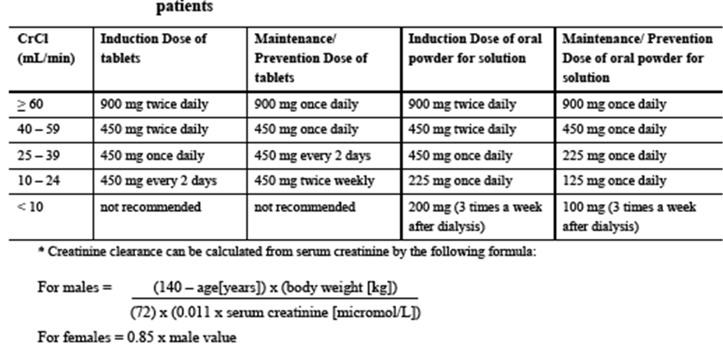
An estimated creatinine clearance (ml/min) can be related to serum creatinine by the following formulae as shown above.

Paediatric patients
Dosing of paediatric solid organ transplant patients is individualised based on a patient’s renal function and size (see above).

Patients with severe leukopaenia, neutropaenia, anaemia, thrombocytopaenia and/or pancytopaenia
Severe leukopaenia, neutropaenia, anaemia, thrombocytopaenia, pancytopaenia, bone marrow depression and aplastic anaemia have been observed in patients treated with VALCYTE (and ganciclovir). Therapy should not be initiated if the absolute neutrophil count is less than 500 cells/µL or the platelet count is less than 25,000/µL or the haemoglobin is less than 8 g/100 mL.

Clinical rationale
CMV is a herpes virus transmitted through contact with blood or bodily secretions. In immunocompetent individuals, infection is usually subclinical, with fever, malaise, and fatigue being the most common symptoms. However, the impact of infection can be more significant in immunocompromised individuals, such as solid organ transplant (SOT) patients for whom CMV is the most important infectious cause of morbidity following transplantation (Ho et al., 1994, Razonable et al., 2001). In the absence of prophylaxis in SOT patients, CMV disease can occur following introduction of the infection from the transplanted organ (donor + =D+) and when patients receive intensive immunosuppressive regimens for the prevention and treatment of graft rejection (Ho et al., 1990, Winston et al., 1995). There is no clear data in children to establish the frequency of CMV infection or disease without prophylaxis. However, the CMV risk is considered to be similar to that reported in the adult population. Without preventive CMV therapy, 30%-75% of adult transplant recipients develop CMV infection, and 8%-30% develop CMV disease (Legendre et al. 2008). There is therefore an unmet need to warrant investigation of Valcyte in paediatric patients.
Valganciclovir (Valcyte) is an inactive L-valyl ester prodrug of ganciclovir (GCV), an anti-viral with potent activity against human CMV. After oral administration, valganciclovir (VGCV) is rapidly absorbed and extensively hydrolyzed to GCV. The majority of the hydrolysis occurs during pre-systemic absorption, with the exposure of the prodrug (VGCV) being only 1%−2% of the exposure of the GCV derived from VGCV (Jung et al., 1999). VGCV is mainly eliminated by renal excretion (as GCV) through glomerular filtration and active tubular secretion. The safety and efficacy of VGCV has been well established in adults. It was first approved in the form of film-coated tablets (FCT) for the treatment of CMV retinitis in patients with AIDS in the USA on 29 March 2001, and in the EU via the Mutual Recognition Procedure on 20 September 2001, with the Netherlands as the Reference Member State. Subsequently, VGCV was approved for the prevention of CMV disease in SOT patients in the EU on 2 May 2003; and in kidney, heart and kidney-pancreas transplant patients at high risk in the USA on 12 September 2003. To allow more flexible dosing, a powder for oral solution (POS) formulation was developed, and approved in the EU for the same indications as the FCT on 17 January 2008. The POS and the FCT were both approved in the USA on 28 August 2009 for the prevention of CMV disease in paediatric kidney and heart transplant patients ≥ 4 months of age at high risk of developing CMV disease. The paediatric indication for VGCV was approved for kidney and heart transplant in the USA, on the basis of the results of four paediatric PK and safety studies (WP16296, WP16303, WV16726, and CASG109). The data obtained from the paediatric studies were used to generate a dosing algorithm for VGCV in the paediatric population regardless of age or type of organ transplant. This algorithm enabled the determination of a paediatric dose that was expected to achieve area under the plasma concentration−time curve (AUC) levels in paediatrics, which were proven to be efficacious in adults (i.e. AUC from 0 to 24 hours [AUC0-24h] in the range of at least 40-60 μg•h/mL).
In accordance with the approved EU Paediatric Investigation Plan (PIP; P/0220/2013), two additional paediatric studies were conducted to support the indication in the paediatric population (from birth to 18 years). Study NV25409 assessed the tolerability and efficacy of VGCV in paediatric kidney transplant patients (aged 4 months to ≤ 16 years) and Study NP22523 assessed the PK of GCV from VGCV in neonates and infants (aged <4 months) who had undergone heart transplant and were at risk of developing CMV disease. The CASG112 study provides additional safety data, although it is a study exploring the efficacy and safety of VGCV in the treatment of congenital CMV; these infants have not undergone SOT. Study WV16726 (PM-2008-2270-3) was also included in this dossier to provide additional safety information.
The dossier in support of this Application is essentially the same as that submitted in the EU (12 December 2013), this was approved on 20 June 2014.

Contents of the clinical dossier

Scope of the clinical dossier
The submission contained the following clinical information:
- 1 clinical pharmacology study (NP22523) that provided PK and safety VGCV powder in paediatric heart transplant recipients from birth to <4 months of age;
- 1 refined population based PK analysis (1052174) – in vitro study
- 2 efficacy/safety studies pertinent to the claimed indication:
  - CASG112: a Phase III randomised, placebo-controlled study of blinded investigation of 6 weeks vs. 6 months of oral VGCV therapy with symptomatic congenital CMV infection. Data from this study contributed to the verification of the PBPK model and also provided safety data. The efficacy data is not directly applicable to this Application in so much as the population is different i.e. not SOT. Moreover, in CASG112 VGCV is being used therapeutically in infants who already have CMV rather than prophylactically in children undergoing solid-organ transplantation and who are at risk of CMV disease.
  - NV25409: non-randomised study exploring tolerability of up to 200 days of VGCV oral solution or tablets in paediatric kidney transplant recipients aged between 4 months to 16 years.
In addition, the following study is included as supporting evidence, this study has already been reviewed by the TGA and contributed to the current indication for VGCV in adults. i.e. NT18435.
- A Randomized, Double-Blind, Placebo Controlled Multi-Center Study of the Efficacy and Safety of up to 100 days of Valganciclovir vs. up to 200 days of Valganciclovir for Prevention of Cytomegalovirus Disease in High-Risk Kidney Allograft Recipients.

Paediatric data
The submission included paediatric PK / efficacy / safety data.

Good clinical practice
The clinical studies in this application complied with CPMP/ICH/135/95 an internationally accepted standard for the design, conduct, recording and reporting of clinical trials. There were no deviations from GCP/ethical requirements.

Pharmacokinetics
One in-vivo study, NP22523, is presented in this dossier. In advance of this, an in vitro Refined PBPK (Physiologically based pharmacokinetic) Model for Prodrug valganciclovir and Parent Drug ganciclovir RO1079070 (Valcyte):1052174 was developed. A brief overview of this in vitro study is summarised below. This PBPK model was tested in the in vivo study, NP22523.

Studies providing pharmacokinetic data
Table 2 shows pharmacokinetic studies.

Table 2. Submitted pharmacokinetic studies.
PK topic | Subtopic | Study ID | *
PK in special populations | Neonates/infants (children who underwent heart transplant and aged birth to <4 months of age) | NP22523 | §
* Indicates the primary aim of the study.
§ Subjects who would be eligible to receive the drug if approved for the proposed indication.
The one PK study presented did not have any deficiencies that excluded its results from consideration. The major issue with the study in terms of fewer enrolments than planned is discussed.

Pharmacokinetics in other special populations

Pharmacokinetics according to age
In vitro Refined PBPK Model for Prodrug Valganciclovir and Parent Drug Ganciclovir RO1079070 (Valcyte): 1052174. This was conducted in order to characterise GCV PK in SOT patients from birth to 4 months old with the purpose of identifying and understanding the key processes driving the age-dependency of PK. Also, through sensitivity analysis the PBPK model can be used to determine key physiological properties driving exposures in this young population and leading to inter-individual variability in PK. The purpose of the work in this report was to refine a human PBPK model for VGCV and GCV in infants and neonates to understand factors influencing PK and to estimate PK exposures for different dosing paradigm. An initial human PBPK model was developed to describe GCV intravenous (IV) and oral (PO) PK and VGCV PO PK in adults and paediatric populations (Reddy, 2012). This human PBPK model was based on the PBPK model that described PK data across preclinical species. Key model assumptions were:
- GCV was actively transported from the blood into the kidney and from the kidney to the kidney tubules, as well as from the liver and gut into the blood;
- GCV clearance was renal by glomerular filtration and active secretion;
- VGCV undergoes active uptake into enterocytes, liver and kidney;
- VGCV metabolism to form GCV occurred in enterocytes as well as in the liver and kidney;
- VGCV clearance was renal by glomerular filtration.
Model parameters, including transporter expression levels, were optimised based on the available adult clinical PK data.
Figure 1: Schematic diagram of the VGCV and GCVPBPK model
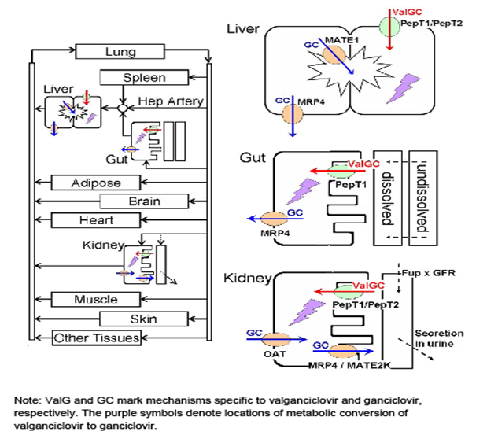
The adult PBPK model was adapted to describe the PK in younger populations. Firstly, the simulation results were compared to PK parameters determined in paediatric kidney transplant recipients administered IV GCV or PO VGCV (study WP16296, 2004). In the 13- to 16-year-old population, the adult model gave good predictions of the Cmax and the AUC after IV administration of GCV and PO administration of VGCV. In younger children (9- to 12-year-olds and 5- to 8-year olds), adjustment to drug distribution (i.e., to the specific permeability-surface-area parameter important for describing permeability limited uptake) was required to match the observed PK endpoints. The adjusted model then gave good predictions for the 1- to 3-year old population. A second study with children of similar ages was used to further validate the model (study WV16726 in paediatric SOT recipients, 2007), and good predictions were obtained for all age groups without any additional model modifications. Success in simulating these paediatric populations increased confidence that the PK in infants could be predicted.
The PBPK model was next modified to describe infant and neonate PK by incorporating several key physiological changes for these populations. Growth-related changes in tissue compartment volumes and composition were all included in the model (Tayman et al, 2011; ICRP 1975; Young et al, 2009). Renal elimination is the primary mechanism of elimination for GCV. The development of renal function with age was taken into account. Premature infants have reduced renal function compared to full-term babies (DeWoskin, 2008), and so this was also incorporated into the model to explore the relationship between premature birth and PK. The PBPK model was used to predict the PK in infant heart transplant recipients 25 to 125 days old (study NP22523), and no modifications to the model were needed. PBPK simulations were then compared to the PK data in neonates with congenital CMV disease (Acosta et al, 2007). However, in the youngest subjects, i.e., neonates about 30 days old or less with congenital CMV, the simulations were not consistent with the data and tended to underestimate exposures. To describe these data, additional physiological differences, i.e., very low expression levels of transporters in the gut and kidney had to be included in the model. Once these changes were incorporated in the model, the PBPK simulations were consistent with the available clinical data from neonates as well as infants. Data on the ontogeny of transporters are limited, but the assumptions made in this model are consistent with available data (Kearns et al, 2003). Several data gaps were identified in the preliminary PBPK model report (Reddy et al, 2012) and so some additional data were incorporated. Bioavailability was somewhat overestimated in the preliminary model, possibly due to an unidentified first-pass mechanism not included in the model. Renal elimination of VGCV through glomerular filtration was included in the model. A minor pathway of GCV elimination by biliary excretion in the bile was incorporated in the refined model because it is a MATE1 and MATE-2K substrate. This mechanism of biliary excretion was confirmed in a bile-duct cannulated rat study, in which biliary excretion was observed at low levels (Nov 2012).

Details of methodology used in the modelling and simulation study.
Conducted by Simulations Plus, Inc., Lancaster, CA. PBPK modelling utilised in GastroPlus version 8.0.0016, a version of the software specially modified for this analysis; can be obtained upon request from the software company (Simulations Plus, Inc., Lancaster CA). Model parameters used in simulations for GCV and VGCV PBPK models are found below in Tables 3-5 and Figure 1.

Table 3: Parameters used in the GCV and VGCV PBPK Models
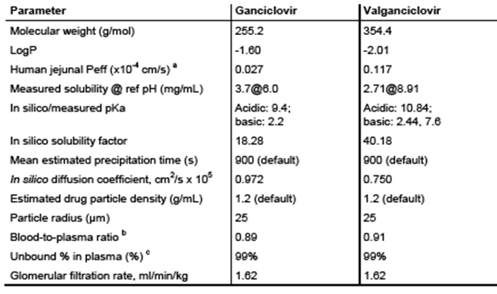
Abbreviations: LogP = Log of the octanol-water partition coefficient; Peff = effective permeability;
pKa = acid dissociation constant
a These values were optimised based on clinical data.
b The in silico blood-to-plasma ratio calculated for humans was used. It was similar to the observed value of about 1 in the mouse and rat (Chaplin MD, 1986; Smith S, et al. AT 3074 March 1984); but the measured value for the dog was lower at 0.6 (Smith S, et al. AT 3074 March 1984).
c The protein binding of GCV was measured in vitro and was less than 2% bound across species. Protein binding for VGCV was not measured, but it was assumed to be similar to that of GCV because it is slightly more hydrophilic.

Table 4: Transporter and Enzyme Model Parameters for GCV and VGCV PBPK Models
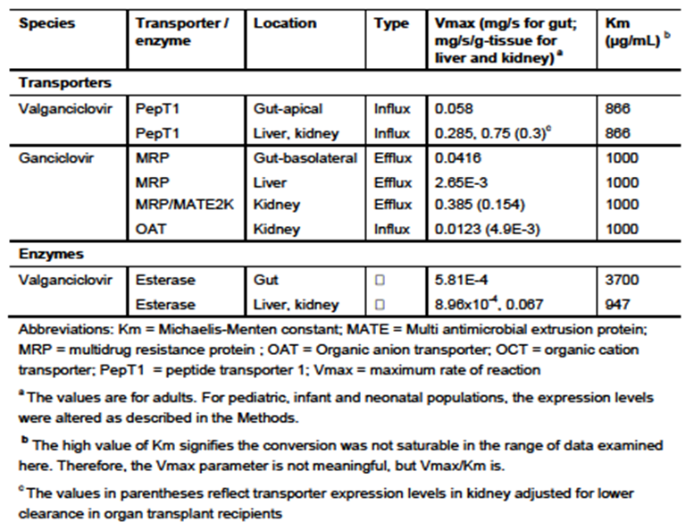

Table 5: PStc Values (ml/s) for Ganciclovir and Valganciclovir PBPK Models.
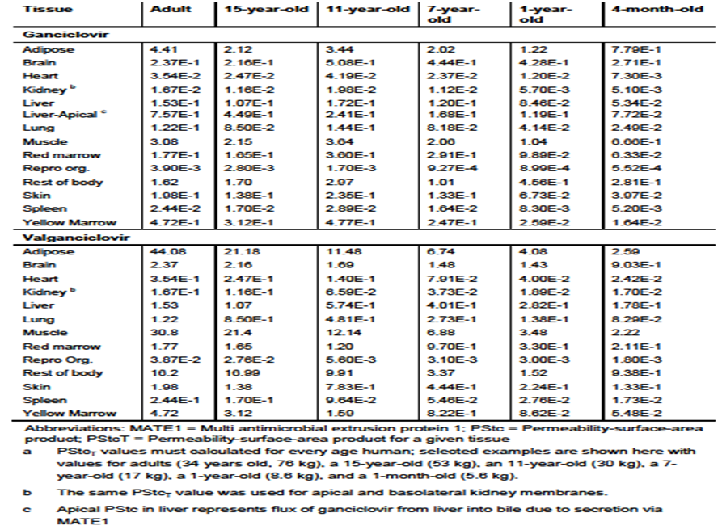
Table 6 shows the selected studies that were used for the PBPK model development and to evaluate it. Table 7 shows the PBPK Predictions of GCV PK in paediatric Kidney Transplant Recipients after IV GCV or PO VGCV.

Table 6: Summary of Selected Studies Used for PBPK Model Development and Evaluation
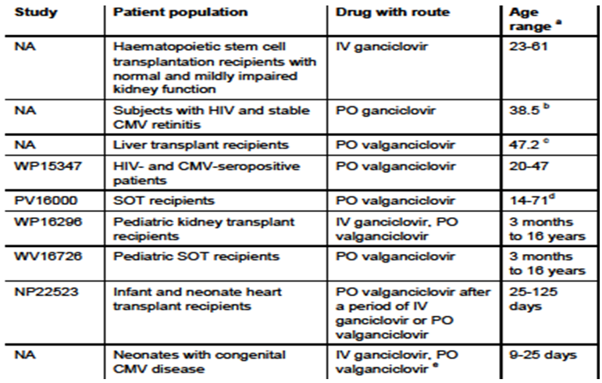
a The age range specifies the range of actual patients included in the study; b This is the median age of subjects administered 1000 mg GCV PO. A range was not provided; c This is the mean. A range was not provided; d This is the age range of subjects administered VGCV. Although the study included some paediatric subjects, the majority were adult, with a median age of 48 years and a mean of 45.7 years; e Two versions of a complex study design were used; details have been reported (Acosta et al, 2007). Subjects were administered both IV GCV and PO VGCVover the period of the study. But only Day 1 data, in which subjects were administered IV GCV or PO VGCV, were used.

Table 7: PBPK Predictions of Ganciclovir PK in Paediatric Kidney Transplant Recipients after IV Ganciclovir or PO Valganciclovir Administrationª
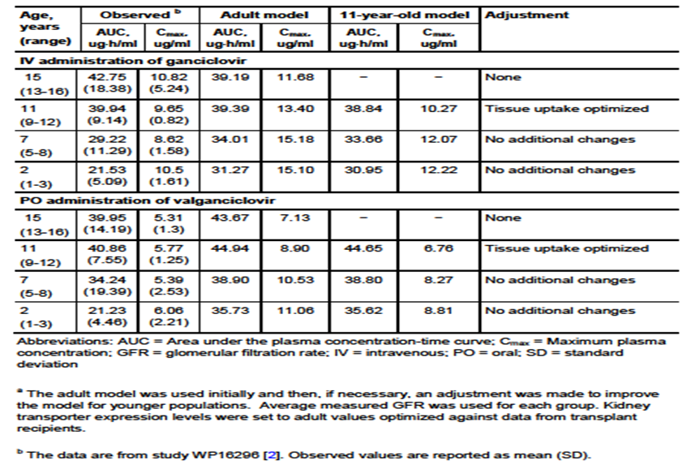
a The adult model was used initially and then, if necessary, an adjustment was made to improve the model for younger populations. Average measured GFR was used for each group. Kidney transporter expression levels were set to adult values optimized against data from transplant recipients.
b The data are from study WP16296. Observed values are reported as mean (SD).
The model predictions obtained were consistent with observed PK data (Table 8).

Table 8: PBPK Predictions of GCV PK after PO Administration of VGCV in Paediatric SOT Recipients
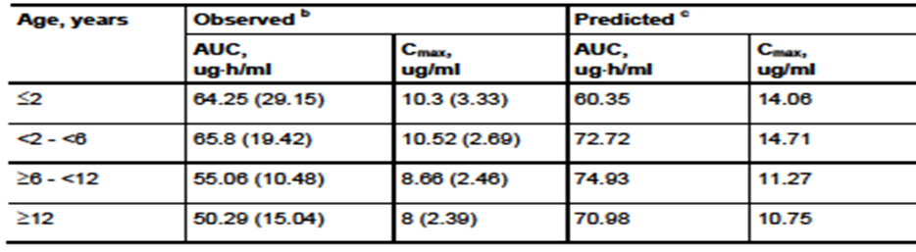
a For these simulations, the most age-appropriate model was used based on what was learned from study WP16296
b The data are from Study WV16726 [3]. Observed values are reported as mean (SD).
c Average measured GFR was used for each group. Kidney transporter expression levels were set to adult values optimized against data from transplant recipients

PK difference between SOT recipient and CMV seropositive patients
A review of GCV PK and PD after VGCV administration found that apparent GCV oral clearance was about 50% lower in transplant recipients than in healthy volunteers and patients infected with HIV/AIDS (Perrottet et al, 2009). Estimated IV clearances for SOT and other patient populations in Table 10 illustrate this reduced difference in CL for the youngest age group.
Assessment of Dosing algorithms: According to one study of 240 SOT recipients at risk of CMV infection who were administered VGCV (n = 160) or GCV (n = 80), the therapeutic exposure range for CMV prophylaxis resulting in suppression of CMV viraemia was 40-50 ug⋅h/mL (Wiltshire et al, 2005). Using the PBPK model to predict exposures with doses derived from the Dr paradigm showed that the Dr algorithm i.e. DR (mg) = 7 x BSA x CrCL(s) results in slightly higher than target exposures for the neonate population. These predictions were consistent with observed data from NP22523. Additionally, the simulations showed that capping CrCL to a value of 75 ml/min/1.73m2 (DRadj) is useful in limiting the dose and, subsequently, the exposures in neonates with minimal risk of underexposing patients. The weight based (Ds =Seattle Children’s Hospital Formulary to calculate the dose = 16 (mg/kg) x weight (kg)) approach results in a trend toward lower exposures compared to DRadj that may lead, in individual cases, to the target exposure range of 40 – 50 μg•h/mL not being reached.

Evaluator’s overall conclusions on pharmacokinetics
Overall, the PBPK modelling approach appears to be successful in characterising the factors influencing GCV PK in the studied population and provides adequate predictions of GCV exposures under different dosing conditions. The simulation results are consistent with available data across species and through a variety of human age ranges, which raises confidence in the mechanistic basis of the model. In a situation where it is very difficult to obtain actual PK data to guide dosing, particularly in neonates (under 4 weeks of age) children, PBPK modelling can simulate PK with reasonable confidence after the appropriate adjustment of physiological properties is made. However, it is uncertain whether this current PBPK model is adequate to predict dosing in neonates who are premature and/or of low birth weight. In both these situations, GCV levels achieved through VGCV may be even higher and associated with excess toxicity as both kidney function and gut and renal transporters may be even less well developed. Adjustments of the algorithm to define creatinine clearance may help overcome this (see below), but as renal function is not the only determine of GCV levels, close monitoring of haematological and renal parameters in such infants will be required.

Pharmacodynamics
No PD studies were submitted in this application to extend the indication for VGCV.

Dosage selection for the pivotal studies
A population PK (popPK) model was originally developed using data from Studies WP16303, WP16296, and WV16726 (provided in variation NL/H/0323/001-002/II/029, approved on 23 June 2011). Data from these three previously submitted (Table 9) paediatric PK studies were used to characterise PK in paediatric SOT patients who were at risk for developing CMV disease. This population PK model was used to develop the following recommended paediatric dosing algorithm for VCGV: Paediatric Dose (mg) = 7×BSA × CrCLS. This algorithm calculates dosing on the basis of both BSA and CrCLS, and was used to provide individualised dosing for GCV exposure within the target exposure range (40 - 60 μg•h/mL) achieved in adults who received the recommended 900mg daily dose. Adult exposure (AUC_{0-24h}) was targeted since efficacy has been established in this population, and viral sensitivity (efficacy) is expected to be identical regardless of patient population. These exposures can successfully be achieved across the entire paediatric age ranges. It is of note that in Study NP22523 the GCV exposure (AUC_{0-24h}) in neonates (≤ 4 months of age) using the population PK model and sparse PK sampling was higher (69 μg•h/mL) than the target exposure range (40-60 μg•h/mL), but it was still within the expected limits of variability. Moreover, no safety concerns were identified, and the difference was attributed to pre-term birth, low birth weight for gestational age and premature renal function affecting CrCl. To maintain accurate calculation of VGCV dosing, adjustment of the k value (used to estimate creatinine clearance) may be required for paediatric patients with low body weight for gestational age or where enzymatic methods for measuring serum creatinine are used.

Table 9. Summary of Paediatric Pharmacokinetic Studies
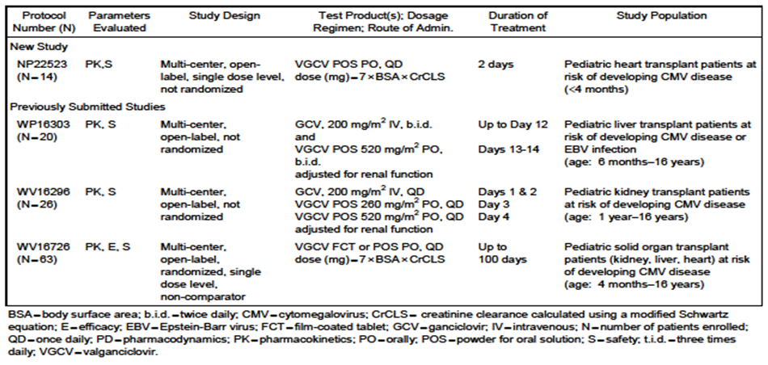

Clinical efficacy
There is one new safety and efficacy study conducted in a paediatric SOT population that is directly relevant to the proposed new indication. The second efficacy and safety study was not conducted in a paediatric SOT population, and hence only the safety and PK data (tested in the PBPK model described) arising from this study has been considered as relevant to this Application. The Reviewer considered the data provided on hearing – a marker of ‘efficacy’ of VGCV in congenital CMV infection as not directly relevant to this Application. Study NT18435 (IMPACT) (A Randomized, Double-Blind, Placebo Controlled Multi-Center Study of the Efficacy and Safety of up to 100 days of Valganciclovir vs. up to 200 days of Valganciclovir for Prevention of Cytomegalovirus Disease in High-Risk Kidney Allograft Recipients. Report No. 1025780/ March 2009) was included to provide further background information to this Application, this was reviewed in 2010 as part of PM-2009-01243-3-2.

Protocol NV25409

Recipients
Male or female kidney transplant recipients aged 4 months to ≤16 years, at risk of developing CMV disease (including R+ who were at risk of CMV due to other factors determined by the treating physician) with an adequate haematological and renal function.

Study design, objectives, locations and dates

Design
Phase IV, multi-centre, open label, non-comparator study.

Sites
16 centres in eight countries: USA (n = 4), Australia (n = 2), France (n = 2), Germany (n = 2), Mexico (n = 2), UK (n = 2) and 1 centre in Brazil and Spain.

Study dates
21 July 2011 to 23 May 2013.

Objectives
- The primary objective was to describe the tolerability profile of up to 200 days prophylaxis of VGCV POS and film-coated tablets in paediatric kidney transplant recipients;
- Secondary objectives were to describe the incidence of CMV infection (viraemia) and disease (CMV syndrome or tissue invasive CMV) within the first 52 weeks post-transplant, and to describe the incidence and nature of CMV resistance to GCV (mutations in UL97 and/or UL54).

Methodology
Patients who met all of the entry criteria began treatment with oral VGCV, as soon after transplant as possible, preferably within 1-2 days, but no later than 10 days post-transplant and treatment continued until a maximum of 200 days post-transplant. The total duration of this study was 52 weeks. IV GCV was not prohibited if required in the immediate post-operative period. The VGCV dose was calculated according to the algorithm stated below. Following initiation of treatment with VGCV and throughout the study, patients underwent a series of safety assessments (AEs, vital signs and laboratory assessments). These occurred on the day of study drug start and Week 4, 8, 12, 16, 20, 24, and 28 (Day 200), then at the follow-up visits off-treatment (Weeks 32, 36, 40, 44, 48 and 52 post-transplant). Safety/tolerability data were collected by the investigator on a regular basis.
At each visit, according to the schedule of assessments, patients and/or their parents/guardians were questioned about AEs and signs or symptoms of possible CMV disease and opportunistic infections. Blood samples were taken for safety laboratory tests (serum chemistries and full blood counts) and CMV viral load at each visit. Patients who developed signs or symptoms of possible CMV disease had a blood sample taken for detection of CMV viraemia as part of their clinical evaluation. This blood sample was analysed locally by PCR or CMV antigenaemia, and was reported as a ‘local’ CMV disease event. In addition, samples were collected at each study visit and sent to a central laboratory for standardised CMV viral load analysis. The diagnosis of CMV disease was based on the definition in the protocol, with signs and symptoms recorded in the eCRF. A blood sample was obtained at the end of prophylaxis (or Day 200) for viral resistance assessment and then additionally at any time point during follow-up if the patient was suspected to have CMV disease, or viral breakthrough.

Inclusion and exclusion criteria
Inclusion criteria
- Parent or guardian of patient was willing and able to give written informed consent; the written assent from the child was also required if he/she was old enough to understand the risks and benefits of the study.
- Patient had received a kidney transplant.
- Males or females aged between 4 months and ≤ 16 years.
- Patient was at risk of developing CMV disease (including R+ who were at risk of CMV due to other factors determined by the treating physician).
- Patient had adequate haematological and renal function defined as: Absolute neutrophil count >1300 cells/μL; platelet count >40,000 cells/μL; Haemoglobin >8.0 g/dL; Estimated Schwartz creatinine clearance (>15 mL/min) to allow for dosing according to algorithm.
- Patient was able to tolerate oral medication (any standard practice tube feeding was acceptable).
- Negative pregnancy test (blood or urine) for females of child bearing potential before initiation of VGCV treatment.
- Patients of reproductive potential agreed to utilize an effective method of contraception throughout the study period and for 90 days after discontinuing study drug (abstinence was a valid method of contraception).
Exclusion criteria
- Patient had exhibited an allergic or other significant adverse reaction to acyclovir, valaciclovir, GCV or VGCV (or excipients) in the past.
- Patient had severe, uncontrolled diarrhea (more than 5 watery stools per day).
- Patient had liver enzyme elevation of more than five times the upper limit of normal for AST or ALT. 4. Patient required use of any protocol prohibited concomitant medications.
- Patient had previously participated in this clinical trial.
- Patient was a lactating female who did not discontinue nursing prior to study entry.
- Patient was simultaneously participating in another clinical trial except as approved by the Sponsor.

Study treatments
VGCV POS and/or film-coated tablets. The bulk batch numbers for POS were B1020, N0002, N0005, N0010 and N0011. The bulk batch numbers for film-coated tablets were B1255, N0038 and N1006. Dose (mg) = 7 x body surface area (BSA [m2]) x creatinine clearance calculated using a modified Schwartz equation (CrCLS [mL/min/1.73 m2]). The final concentration of the oral solution when constituted per bottle was 50 mg/mL. The dose was capped at the full adult dose i.e. if calculated dose >900 mg, then dose = 900 mg, where CrCLS equalled the child’s BSA-normalized CrCLS. If CrCLS was ≥150 mL/min/1.72m2 then 150 mL/min/1.73m2 was used as a maximum.

Efficacy variables and outcomes
The main efficacy variables were: incidence of CMV disease; incidence of CMV infection (viraemia); viral load and resistance (UL54 & UL97); biopsy proven acute rejection; patient and graft survival.

Randomisation and blinding methods
This was an open-label, single arm study.

Analysis populations
The ITT population included all enrolled patients who had taken ≥1 dose of study medication. The Safety Population included all enrolled patients who received ≥1 dose of study medication and had at least one post-baseline assessment of safety. The Per Protocol (PP) Population included all evaluable patients, i.e. those that had received VGCV up to 200 days post-transplant. Efficacy outcomes were based on the ITT Population and safety outcomes were based on the Safety Population. The PP population was also defined and assessed for the demographic data in order to confirm how many patients completed the treatment duration as planned.

Sample size
No formal sample size calculation performed. The sample size for this study was based on practical considerations. This was a single arm non-comparative study to provide data on ≥30 children scheduled to receive up to 200 days of VGCV prophylaxis. A sample size of ≈30 was considered adequate to describe the tolerability of oral VGCV in this population, with an acceptable level of precision, based on the width of the 95% CI around AE rates expected in this patient population.

Statistical methods
Efficacy and safety parameters reported descriptively through listings, summary tables and graphs. Efficacy & safety outcomes summarised for all and separately by age group and CMV serostatus.

Participant flow
57 patients enrolled, 56 treated, 49 completed treatment and follow-up; 6 completed the follow-up; 1 withdrew before follow-up was completed.

Major protocol violations/deviations
Seven were withdrawn from treatment, 6 due to AEs and 1 withdrew their consent. In addition, 1 patient withdrew from the study before receiving any study drug. There were 31 documented protocol violations; none excluded from the analysis populations due to major protocol violations.

Baseline data

Table 10: Summary of Demographic Data by Age Group (ITT Population) in NV25409
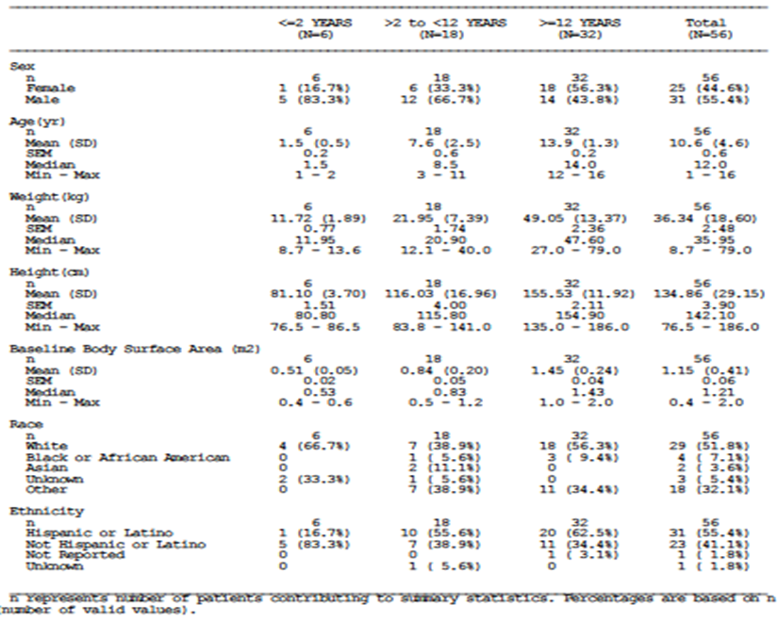
- Fifty-six patients (55% male; 55% Hispanic and 52% White) enrolled in the study and received treatment with VGCV (ITT population): 6 patients (11%) in the ≤ 2 years age group, 18 patients (32%) in the > 2 to < 12 years age group and 32 patients (57%) in the ≥ 12 years age group;
- In 54/56 it was their first kidney transplant; ≈half were living donor transplants;
- CMV serology status: D+/R+ (45%) or D+/R- (39%) and an Epstein-Barr virus (EBV) status of D+/R+ (68%) or D+/R- (18%);
- Immunosuppressants: tacrolimus, mycophenolate mofetil, steroids, basiliximab used in 94.6%, 89.3%, 98.2% and 62.5% of patients, respectively;
- Concomitant anti-viral agents were taken by 46.4% of patients as either prophylaxis or to treat CMV and included GCV (33.9%), VGCV hydrochloride (32.1%), valaciclovir (3.6%) and valaciclovir hydrochloride (1.8%). One patient received valaciclovir for CMV prevention after discontinuing from the study prematurely.

Results for the primary efficacy outcome

Extent of exposure
66.1% received the maximum study drug duration of more than 190 days; 8.9% received treatment for less than the per protocol cut-off of 150 days.
- Four patients (7.1%) were reported with CMV events locally, including 3 patients (5.4%) with CMV infection (viraemia or antigenaemia, detected locally) and 1 patient (1.8%) with CMV syndrome. All CMV events occurred during the post-prophylaxis follow-up period of the study. The single case of CMV syndrome was later invalidated by a lack of quantifiable CMV DNA (> 150 copies/mL) in any samples tested at the central laboratory.
- Three of the 4 with reported CMV events received CMV treatment; one patient with CMV infection did not receive treatment. All but two were resolved by the end of the study period.

Central laboratory CMV DNA viral load results
- Ten patients (17.9%) had CMV viraemia (confirmed with CMV DNA above the lower limit of quantification [LLOQ = 150 copies/mL)] at the central laboratory) in the absence of any reported fever or other symptoms of CMV disease, which included 3 of the 4 patients with locally detected CMV events.
- Two of the 10 with confirmed CMV viraemia (both during the postprophylaxis follow-up period) were treated with VGCV, and both patients had CMV DNA < LOQ by their wk 52 visit.
- Two additional patients received treatment with VGCV or valacyclovir following the end of study treatment as secondary prophylaxis of CMV disease but did not demonstrate CMV viraemia or antigenaemia locally or in central laboratory tests.

Table 11: Summary of CMV events is given by age group in NV25409
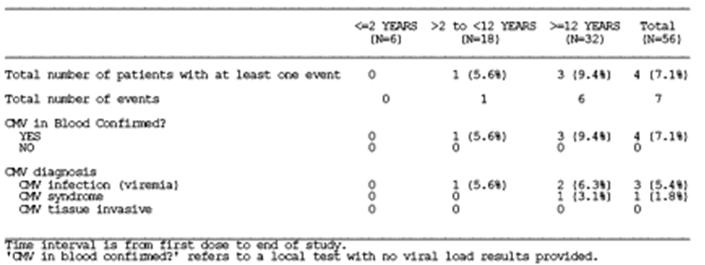

Results for other efficacy outcomes
- Viral load and resistance (UL54 and UL97): Of the 10 out of 56 (18%) during the study period patients with quantifiable viral load, 6 (60.0%) were D+R- patients. CMV infection (local viraemia or antigenaemia or central quantifiable CMV DNA) was confirmed in two patients (3.6%) during the study treatment period, and the remaining eight patients (14.3%) with positive samples were in the follow-up period of the study. There were no cases of CMV disease. All patients with measurable CMV will have both UL54 and UL97 genes sequenced to assess for known CMV resistance to GCV (these data were not included in this Application).
- Biopsy proven acute rejection: Of the six patients who experienced biopsy-proven acute rejection, one patient (233049/90104) experienced CMV infection prior to the rejection episode. In summary, the rate of BPAR episodes were low and of mild or moderate intensity.
- Patient and graft survival: no patients died; all grafts survived.

Safety
All patients experienced ≥1 AE during the treatment period. Infection and Infestation AEs as well as blood and lymphatic AEs were commonly reported in each age group. The most common AEs reported were upper respiratory tract infection (URTI) (33.9%), urinary tract infection (UTI) (33.9%), diarrhoea (32.1%), leukopaenia (25.0%), neutropaenia (23.2%) and headache (21.4%). URTI, UTI and diarrhoea were reported with a higher incidence in the youngest age group ( ≤ 2 years) and leukopaenia and neutropaenia were respectively reported with higher incidence in the ≥ 12 years and > 2 to < 12 years age groups. Note the very small numbers in the ≤ 2 years age group.
An overview of AEs is given in Table 12.

Table 12: summary of AEs in NV25409
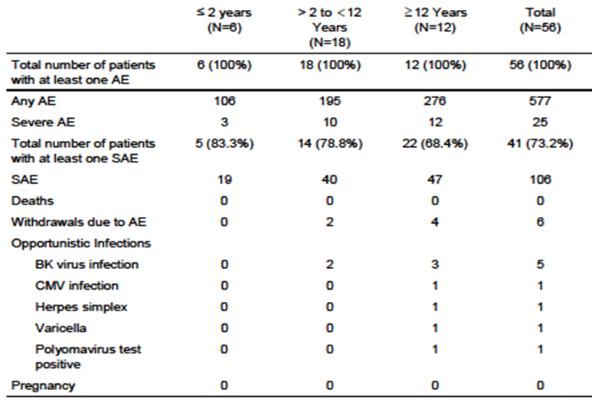
SAE: 66.1% experienced ≥ 1 SAE during the treatment period with a higher incidence in the ≤ 2 years and in the > 2 to < 12 years age groups (83.3% and 72.2%). The most common types of SAEs were infections and infestations (23 patients [41.1%]) and blood and lymphatic disorders (9 patients [16.1%]).
Six patients withdrew from study drug due to an AE, five due to blood and lymphatic disorders (neutropaenia, anaemia, pancytopaenia and bicytopaenia) all considered related to the study drug; one patient because of gastrointestinal disorders and gastrointestinal protozoal infection considered not related to the study drug. No new safety signals were detected.

A Phase III, randomized, placebo-controlled, blinded investigation of six weeks vs. six months of oral valganciclovir therapy in infants with symptomatic congenital cytomegalovirus infection (CASG 112)
The study population in CASG112 are not SOT recipients, and the drug is being used therapeutically for congenital CMV. However the study does provide important safety information for the use of VGCV in very young children. The key aspects of study design are summarised below.

Recipients
Babies with symptomatic congenital CMV disease.

Study design
Design: This study was a multi-centre, prospective, international, Phase III, randomised and blinded investigation of 6 weeks versus 6 months of oral VGCV therapy in babies with symptomatic congenital CMV disease. Following enrolment, all study subjects received 6 weeks of oral VGV (Dose: 16 mg/kg; Concentration: 50 mg/mL; Route: oral; Regimen: BID). Near the end of the 6 week course, subjects were randomised in a 1:1 fashion either to continue on VGCV to complete 6 months of therapy or to begin a matching placebo to complete the 6 months. The dose was adjusted for weight gain and renal impairment at each study visit, as well as for neutropaenia and thrombocytopaenia. Study subjects were stratified according to whether or not there was central nervous system involvement at study entry.
During the 6 month treatment period and for 1 month thereafter, study subjects were followed weekly for four weeks, then every other week for 8 weeks, and finally every month for four months. At each of these visits, safety labs were checked, hearing and growth parameters recorded, and AEs assessed. Hearing outcomes were assessed at baseline, 6, 12 and 24 months. Developmental outcomes were assessed at 12 and 24 months. CMV whole blood viral loads were measured throughout and correlated with both hearing and neurologic outcomes at 12 months of age.

Inclusion and exclusion criteria

Inclusion criteria
- Signed informed consent from parent(s) or legal guardian(s).
- Confirmation of CMV from urine or throat swab specimens by culture, shell vial, or polymerase chain reaction (PCR) tests.
- Symptomatic congenital CMV disease, as manifested by one or more of the following: a. Thrombocytopaenia; b. Petechiae; c. Hepatomegaly; d.Splenomegaly; e. Intrauterine growth restriction; f. Hepatitis; g. CNS involvement of the CMV disease (such as microcephaly, radiographic abnormalities indicative of CMV CNS disease, abnormal cerebrospinal fluid indices for age, chorioretinitis, hearing deficits as detected by formal brainstem evoked response, and/or positive CMV PCR from CSF).
- ≤ 30 days of age at study enrollment.
- Weight at study enrollment ≥1800 grams.
- Gestational age ≥ 32 weeks at birth.

Exclusion criteria
- Imminent demise.
- Patients receiving other antiviral agents or immune globulin.
- GI abnormality which might preclude absorption of an oral medication.
- Documented renal insufficiency, i.e. creatinine clearance <10 mL/min/1.73m2 at time of study enrollment.
- Breastfeeding from mother who is receiving GCV, VGCV, foscarnet, cidofovir, or maribivir.
- Infants known to be born to women who are HIV positive (but HIV testing not required for study entry).
- Current receipt of other investigational drugs.

Efficacy variables and outcomes
The main efficacy variable was:
- Change in best ear hearing assessment between baseline and 6 months post enrollment.
- Changes in a number of other hearing and development criteria;
- Change in whole blood CMV viral load was correlated with change in hearing between baseline and 12 months of age over left and right ears (total ear analyses), as well as with neuro-developmental outcomes at 12 and 24 months. PK assessments of drug compliance were correlated with hearing outcomes as well.
- Safety.

Sample size
The planned enrollment was 104 subjects. Allowing for up to 15% of enrolled subjects being ineligible for randomization at 6 weeks, another 10% failing to complete the 6 month hearing evaluation following randomization, and another 10% with inadequate baseline or 6 month hearing data to adequately assess change over that time, this enrollment sample size was considered sufficient to have a minimum sample size of 37 randomised, evaluable subjects per treatment arm (total sample size of 74 evaluable subjects). The estimation of sample size was based on observations from the GCV treatment trial (Kimberlin et al. 2003).

Statistical methods
To compare demographics, clinical characteristics, outcomes and safety parameters between two groups, Fisher’s exact test was used appropriately for proportions and Wilcoxon-rank sum test was used for continuous outcomes. To examine the treatment effects adjusted for covariates, logistic regression model was used to model binary outcomes while general linear model was used to model continuous outcomes. In addition, logistic model utilizing generalized estimating equations was used to model binary outcomes related to hearing assessment for total ear where both right and left ear hearing assessments were analysed in one model. Spearman rank correlation was utilised to examine the association between viral load and PK parameters.

Participant flow
A total of 109 subjects were enrolled and 97 randomised. ITT group = randomized subjects who had taken ≥ 1 dose of the blinded treatment drug. Only 96 were included in the ITT analysis population for efficacy analyses; 82 completed treatment during open label and blinded phase.

Baseline data
Ninety-six patients were randomised to blinded therapy: 13 patients (13.5%) were in the < 7 days age group, 31 patients (32.3%) were in the 7 − 14 days age group, 16 patients (16.7%) were in the 15 − 21 days age group, and 36 patients (37.5%) were in the 21- < 30 days age group. The number of term and pre-term infants was similar (52.1% versus 47.9%, respectively). Most patients were Caucasian (66.7%), not Hispanic/Latino (70.8%), and male (62.5%).

Results for the primary efficacy outcome
- Primary Endpoint: There was no difference between the two randomisation groups in change in best ear hearing assessments between baseline and 6 months.
- Adjusting for baseline CNS involvement, as dictated in the a priori study analysis plan, and using a stricter cut-off for concluding a statistically significant treatment effect on neurodevelopmental outcomes using Bonferroni adjustment for multiple testing (where p-values<0.0071 are considered statistically significant), subjects treated for 6 months had better language composite and receptive communication outcomes at 24 months compared with subjects treated for 6 weeks.
PK/PD results
- Relationships between GCV PK parameters and change in CMV viral load [represented as the viral load area under the curve (AUC)] and hearing outcome measures were explored. GCV clearance (CL/F) was significantly associated with the viral load AUC over the entire study period and from day 1 to day 42. Although statistically significant, the correlations were very low and several outliers affected the relationships. In addition, the relationship was counter-intuitive in that as the CL/F increased (so lower drug exposure) the viral load AUC decreased. Similarly, CL/F was significantly associated with improved/protected and deteriorated hearing at months 12 and 24, respectively. As with the viral load AUC correlations, these relationships were also backwards. The higher the CL/F (lower drug exposure) the better the improved/protected group did. Lower CL/F (higher drug exposure) was associated with increased deteriorated hearing. Lower whole blood viral load during Day 1 - 42 was associated with better hearing outcomes at 12 months (p = 0.0297) and 24 months (p = 0.0436).

Analyses performed across trials (pooled analyses and meta-analyses)
Not applicable, there was no pooled analysis or meta-analysis.

Evaluator’s conclusions on clinical efficacy for Valcyte
The results of Study NV25409 do provide some support that VGCV prophylaxis for 200 days is efficacious in prevention of CMV disease in paediatric kidney transplant patients. However the major caveat is that there is no comparator arm. The drug is clearly well tolerated over several months of dosing and this is also the case in the CASG112 study where all of those enrolled were 30 days old or less. Although one of the efficacy outcomes states that ‘All patients with measurable CMV will have both UL54 and UL97 genes sequenced to assess for known CMV resistance to GCV’, the Reviewer was unable to locate this sequencing data in the Application. While there are very few young children enrolled (n = 6 ≤ 2 years of age) in NV25409, the CASG112 study provides additional safety data on 109 infants less than or equal to 30 days of age with symptomatic congenital CMV infection. The Reviewer feels that the lack of PK/PD data in NV25409 was a missed opportunity.

Clinical safety

Studies providing evaluable safety data
The following studies provided evaluable safety data: Phase IV Study NV25409 and the Phase III Study CASG112. The safety data arising from the Phase I Study NP22523 is summarised in detail. Within this safety section, the evaluator has classified Studies NV25409 and CASG112 as pivotal.

Pivotal efficacy studies
In the pivotal efficacy studies, the following safety data were collected:

Study NV25409
Managed according to the Schedule of Assessments. Clinical assessments included: surgical history; physical examination; weight; height, BSA calculation, estimated CrClS calculation and vital signs (temperature, blood pressure, heart rate, and ECG abnormalities); Safety/laboratory assessments.

Safety assessments at visits during and VGCV administration & during post prophylaxis follow-up
AEs (including opportunistic infections) and treatments; Biopsy Information for acute rejection or CMV tissue invasion (if applicable); date, reason and result; Weight, height, BSA calculation, estimated CrClS calculation and vital signs (temperature, BP, heart rate, and ECG abnormalities); pregnancy test if applicable.

General AEs
AEs were assessed by the investigator/Research nurse – direct questioning of parent/guardian and child (as applicable); vital signs, clinical examination, laboratory parameters (haematology & chemistry) and in CASG112, growth parameters and hearing tests were performed. In CASG112 these were performed as follows: during the 6 month treatment period and for 1 month thereafter, study subjects were followed weekly for 4 weeks, then every other week for 8 weeks, then every month for 4 months.

Study NV25409
All clinical AEs encountered during the clinical study reported on the AE form of the CRF. Intensity of AEs will be graded on a four-point scale [mild, moderate, severe, life-threatening] and reported in detail on the eCRF. SAE reporting as for CASG112, except in NV25409, absolute neutrophil count (ANC) < 500 cells/mm3 (Grade IV toxicity) alone is not an SAE. In CASG112, each investigator was responsible for reporting all AEs and SAEs that were observed or reported from day 1 of study drug administration through 30 days after the last dose of study drug, regardless of relationship to study product. The study coordinator or other research staff, as designated by the Principal Investigator, also could have completed and documented the AEs. If the subject was withdrawn from the study or the study medication was stopped prematurely, AEs were collected for 30 days following the last administered drug dose. The investigator provided his/her assessment of any SAE and AE resulting from study participation. All AEs were graded for intensity using the Division of AIDS Toxicity Tables and assigned a relationship to study product and recorded on the AE CRF. All AEs were followed until satisfactory resolution (with or without sequelae) or until the investigator deemed the event to be irreversible or stable. The relationship to study products and severity of AEs, regardless of cause, was graded by the investigator as outlined:
- Associated: a known temporal relationship and/or, if re-challenge was done, the event abated with de-challenge and reappeared with re-challenge and/or the event was known to occur in association with the study product or with a product in a similar class of study products. No other aetiology explains the event.
- Not Associated: the AE was completely independent of study product administration; and/or evidence exists that the event was to be related to another aetiology.
If an event met the definition of suspected unexpected serious adverse reaction (SUSAR), additional information was collected to identify more specific categories as required by the EMEA for assigning relatedness (i.e. definitely associated, probably associated, possibly associated, probably not/remotely associated or not associated). An SAE was defined as an AE meeting one of the following conditions and occurring from day of study drug administration through 30 days following the last dose of study drug (except death), unless the subject had been withdrawn from the study. In the case of premature cessation of study medication, SAEs were collected for 30 days following the last administered drug dose.
The SAE criteria were: Death throughout study participation; Life Threatening Event; An event requiring inpatient hospitalisation or prolongation of existing hospitalisation during the period of protocol defined surveillance; Resulted in congenital anomaly or birth defect; Resulted in a persistent or significant disability/incapacity; ANC <500 cells/mm3 (Grade IV toxicity);Any other important medical event that may not have resulted in death, be life threatening, or require hospitalisation, may be considered a serious adverse experience when, based upon appropriate medical judgment, the event may jeopardize the study subject and may require medical or surgical intervention to prevent one of the outcomes listed above.
- AEs of particular interest, including haematological toxicities, assessed by regular FBC.
- Laboratory tests, including renal function, haematology and liver function tests, were performed at the scheduled visits (varied according to the study). Laboratory assessments in NV: Pregnancy test (for females of childbearing capacity only); Haematology (Hb, haematocrit, FBC including WBC and five part differential, platelet count); blood chemistry (total bilirubin, AST, ALT, alkaline phosphatase, total protein, albumin, uric acid, glucose, electrolytes, calcium, phosphate, serum creatinine and blood urea nitrogen [BUN]/urea) and CrClS.

Table 13: Summary of Studies Contributing to Safety Evaluation
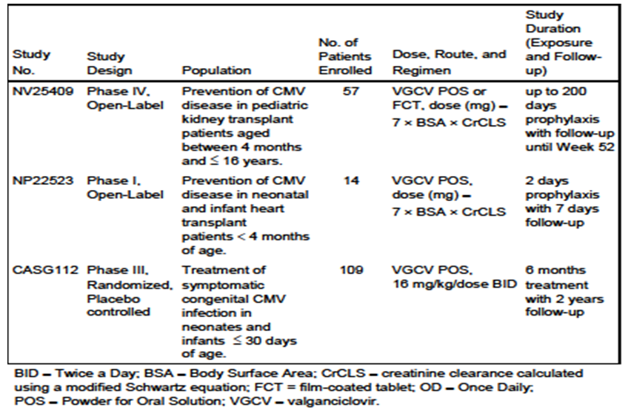

Pivotal studies that assessed safety as a primary outcome
Not applicable.

Patient exposure
Planned dosing regimen and number of patients who received the full course of treatment by study is shown in Table 14.

Table 14: Summary of the Planned Dosing Regimen and the Number of Patients who Received the Full Course of Treatment by Study
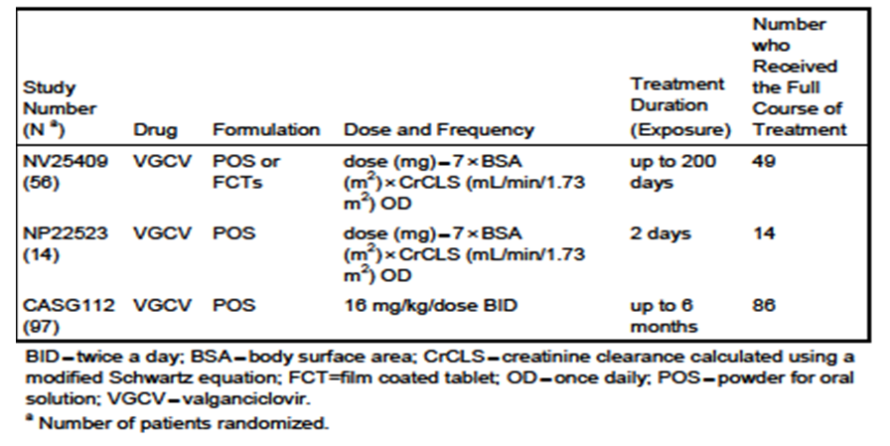

Adverse events

All adverse events (irrespective of relationship to study treatment)

Pivotal studies

Study NV25409
All 56 patients (100%) experienced ≥1 AE; a total of 577 AEs reported (525 AEs reported on-treatment).
- During the on-treatment period, the most frequently reported AEs (expressed as % of patients experienced at least one event) were: URTI (33.9%), UTI (33.9%), diarrhoea (32.1%), leukopaenia (25.0%), neutropaenia (23.2%), and headache (21.4%).
- The most frequent related AEs which occurred on-treatment were leukopaenia (12 patients [21.4%]), neutropaenia (11 patients [19.6%]), and anaemia (4 patients [7.1%]).

Study CASG112
- 675 AEs reported in 96 patients: 246 AEs during the open-label phase, and 432 AEs during the blinded part (213 AEs in VGCV-treated patients; 216 AEs in placebo arm).
- The SOCs with the most AEs were: infections and infestations (163 AEs), GI disorders (124 AEs), blood and lymphatic system disorders (76 AEs), skin and subcutaneous tissue disorders (69 AEs), and investigations (62 AEs).

Treatment-related adverse events (adverse drug reactions)

Pivotal studies

Study NV25409
The proportion of patients with AEs considered by the investigator to be related to study medication was higher in the ≥ 12 years age group (62.5%) than in the > 2 to < 12 years age group (38.9%). No AEs considered study drug-related in the ≤ 2 years age group. Proportion of patients who had AEs considered related to study medication similar from Days 1 - 100 (18 patients [32.1%]), and Days 101 - 228 (16 patients [28.6%]).

Study CASG112
Of the 675 AEs reported, 98 AEs (14.5%) were considered related to the study drug of which 11 AEs were grade 3, and one AE was grade 4. In randomised patients, the most frequently reported related AEs were neutropaenia (42 AEs [12 in active, 30 in placebo]), anaemia (12 AEs [3 in active, 9 in placebo]), liver function test abnormal (9 AEs [3 in active, 6 in placebo]), and diarrhoea (7 AEs [1 in active, 6 in placebo]).

Deaths and other serious adverse events

Pivotal studies
No deaths in Studies NV25409 and CASG112.

SAEs in NV25409
- 106 SAEs reported in 41 patients (66.1%) with the higher incidence in the younger groups: 83.3% (≤ 2 years), 77.8% ( > 2 to < 12 years), and 68.8% (≥ 12 years). During the on-treatment period, 83 SAEs were reported in 37 patients.
- The most frequently reported SAEs on-treatment were: UTI (7 patients (12.5%), Escherichia UTI (5 patients (8.9%) and neutropaenia (5 patients (8.9%). The most frequent related SAEs were: neutropaenia (8.9%), leukopaenia (3.6%), and pancytopaenia (3.6%).
- Six patients were withdrawn from treatment due to an AE. In 5 of the 6 patients, the AEs that led to withdrawal were blood and lymphatic disorders (neutropaenia, anaemia, pancytopaenia, and bicytopaenia [all thought related]). The sixth patient had four AEs that resulted in withdrawal from the study, three were gastrointestinal disorders (diarrhoea, vomiting, and abdominal pain [not related]), and one was an infection and infestation disorder (gastrointestinal protozoal infection [not related]).
- Twenty-two patients (39.3%) had 40 AEs that led to dose modification. Fifteen of the 22 patients had SAEs that led to dose modification. The most frequent AEs leading to dose modification were leukopaenia (9 patients [16.1%]), and neutropaenia (7 patients [12.5%]).

Serious Adverse Events by intensity and relatedness
Most who experienced SAEs on-treatment had moderate (23 patients) and/or severe (20 patients) SAEs. Five patients had mild SAEs. Severe SAEs experienced by patients included infections and infestations (11 patients [19.6%]), blood and lymphatic system disorders (5 patients [8.9%]), renal and urinary disorders (4 patients [7.1%]), gastrointestinal disorders (2 patients [3.6%]) and nervous system disorders (1 patient [1.8%]). A total of 14 SAEs in nine patients (16.1%) were considered related to VGCV by the investigator and all occurred while on-treatment. All the related SAEs occurred in the two older age groups: 4 patients (22.2%) aged >2 to <12 years experienced 5 related SAEs, and 5 patients (15.6%) aged ≥12 years experienced 9 related SAEs. The most common related SAEs were neutropaenia (5 patients [8.9%]), leukopaenia (2 patients [3.6%]) and pancytopaenia (2 patients [3.6%]). All other related SAEs were each reported in 1patient and included bicytopaenia, infection, headache, nausea, vomiting (all isolated events). Ten of the 14 related SAEs were of severe intensity and four were of moderate intensity. The 10 related SAEs considered severe by the investigator included 4 cases of neutropenia and isolated cases of leukopaenia, pancytopaenia, infection, headache, nausea and vomiting.

SAEs in CASG112
A total of 43 SAEs were reported in 30 patients (18 SAEs in 11 VGCV-treated patients, and 25 SAEs in 19 placebo-treated patients). Most commonly: neutropaenia (25.6%), Respiratory Syncitial Virus (14.0%), anaemia (7.0%), bronchiolitis (7.0%). All other SAEs occurred at a frequency of ≤ 4.7%.
- Of the 43 SAEs reported, a total of 14 SAEs in 12 patients (32.6%) were considered related to study drug by the investigator (3 SAEs in 2 VGCV-treated patients, and 11 SAEs in 10 placebo-treated patients). All 14 related SAEs occurred within the blood and lymphatic disorders SOC: neutropenia (11 patients [2 VGCV; 9 placebo]), and anemia (3 patients [1 VGCV; 2 placebo]).
- Six AEs led to withdrawal from study drug (neutropenia [3 AEs], URT [1 AE], feeding complication [1 AE], and rash [1 AE]).
- Six SAEs led to withdrawal from study drug (neutropaenia [4 SAEs], gastroesophageal reflux [1 SAE], and respiratory distress [1 SAE]).

Discontinuation due to adverse events

Pivotal studies

Study NV25409
Six of 56 patients (10.7%) withdrew from study drug due to an AE. In 5 of 6 patients, the AEs that led to withdrawal were blood and lymphatic disorders: 1 patient had two AEs (neutropaenia and anaemia) that led to withdrawal and four patients had isolated AEs (two cases of pancytopaenia and single cases of neutropaenia and bicytopaenia) - all considered study drug-related. The sixth patient had four AEs that resulted in withdrawal from the study, one was an infection and infestation disorder (GI protozoal infection) and three were GI disorders (diarrhoea, vomiting and abdominal pain) and all four AEs were considered to be unrelated to study medication by the investigator. Both cases of pancytopaenia, one case of neutropaenia, the bicytopaenia and the GI protozoal infection were considered serious by the investigator. Seven of the 10 events were of moderate intensity and three severe (pancytopaenia, neutropaenia and anaemia). All AEs that led to withdrawal subsequently resolved.

Adverse events leading to dose modification

Study NV25409
A total of 22 patients (39.3%) had 40 AEs that led to dose modification. Fifteen of the 22 patients had SAEs that led to dose modification. The number of patients who had at least one AE that led to dose modification was similar from Days 1-100 and Days 101-228 (15 [26.8%] vs 13 [23.2%], respectively), but the number of AEs that led to dose modification was higher from Days 1-100 than from Days 101-228 (25 vs. 15, respectively). The pattern was the same for SAEs that led to dose modification. Of 40 AEs leading to dose modification, 18 were blood & lymphatic disorders in 13 patients (23.2%): leukopaenia (9 patients [16.1%]) and neutropaenia (7 patients [12.5%]). The proportion of patients who had these events was higher from Days 1- 100 than on Days 101-228 (6 patients [10.7%] vs. 3 patients [5.4%] for each AE).

Study CASG112
Six AEs led to withdrawal from study drug (neutropaenia [3 AEs], URT [1 AE], feeding complication [1 AE], and rash [1 AE]). Among the six withdrawals due to AEs, five AEs were reported during the open-label phase, and one AE occurred in a placebo patient during the blinded phase. Six SAEs (neutropaenia [4 SAEs], gastroesophageal reflux [1 SAE], and respiratory distress [1 SAE]) led to withdrawal of treatment. Only one SAE (respiratory distress during the open-label phase) led to permanent treatment withdrawal, and eventually study withdrawal as the patient was lost to follow-up. One of these six SAEs (placebo patient) occurred during the blinded treatment phase. All other SAEs occurred during the open-label treatment phase.

Study CASG112L
None of the reported AEs indicated dose was modified.

Laboratory tests

Liver function

Pivotal studies

Study NV25409
One patient in the study [information redacted] was identified with simultaneous moderate elevations of AST >3x ULN and total bilirubin >2xULN on Days 19 and 28 post-transplant. There were no AEs or SAEs associated with these lab abnormalities. The investigator considered these laboratory values as not clinically significant.

Study CASG112
AST and ALT appeared to be higher at Months 4-7; although, the actual AST and ALT values were still within normal ranges (<100 IU/L) for both treatment groups.

Kidney function

Pivotal studies

Study NV25409
During the prophylaxis period, 42 patients (75%) had a maximum serum creatinine value ≤1.5 mg/dL and 11 patients (19.6%) had a maximum serum creatinine value between 1.5 and 2.5 mg/dL. Only three patients had creatinine values which exceeded 2.5 mg/dL. Around 70% of patients had a minimum creatinine clearance value ≥60 mL/min/1.73 m2 and 19.6% a minimum creatinine clearance between 40 and 60mL/min/1.73 m2. Eleven patients (19.6%) during the entire study period had a total of 15 events of increased serum creatinine. The increased serum creatinine occurred on-treatment in 9 of the 11 patients. Of the 15 events, 6 were serious: 3 severe and 3 moderate. The remaining 9 events were non-serious: one was of moderate intensity and eight of mild intensity. All 15 events were considered unrelated and resolved.

Study CASG112
No discernable differences between the two randomisation groups (placebo vs. VGCV) across time with respect to changes in creatinine.

Other clinical chemistry

Pivotal studies
Table 15 shows clinical chemistry.

Table 15: Marked Shifts from Baseline at Week 28 in Key Laboratory Parameters On-Treatment in Study NV25409 (Safety Population)
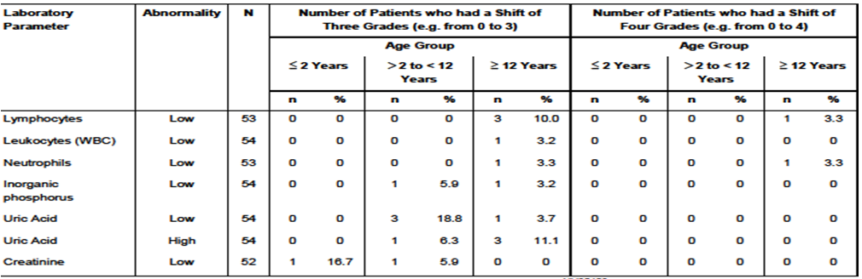

Haematology

Pivotal studies

Study NV25409
As hematologic AEs are a common side effect associated with VGCV prophylaxis, Study NV25409 incorporated monitoring of FBC. Patients with haematologic AEs were managed with dose reductions or interruptions, along with appropriate treatment (e.g. hematopoietic growth factors), as required. Over half of all patients (32 patients, 57.1%) experienced 55 haematological AEs (serious or non-serious) over the course of the study period, of which the most common were leukopaenia, neutropaenia and anaemia. Nine patients (16.1%) reported a11 serious hematological AEs, of which the most common was neutropaenia. Twelve of the 32 patients with haematological AEs required medical intervention (either treatment or a procedure), and 15 patients had a VGCV dose reduction, dose interruption or drug withdrawal as a result of haematological AEs. Treatment for a haematological AEs was predominantly with haematological stimulants or colony stimulating factors. All haematological AEs except four were resolved by the end of the study period.

Table 16: Minimum Post-Baseline ANC Value, Hemoglobin Value and Platelets Value On-Treatment by Age Group in Study NV25409 (Safety Population)
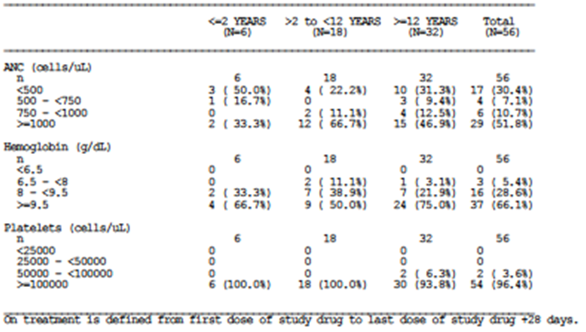

Study CASG112
During the open-label period, the % of grade 3 and 4 neutropenia was 14.7% and 4.6%, respectively. For the blinded treatment period (study Day 42-Month 7), 14.9% and 6.4% of VGCV-treated patients, and 16.3% and 10.2% of placebo-treated patients experienced grade 3 and 4 neutropaenia, respectively. During the open-label period, the % of grade 3 and 4 anaemia was 1.8% and 0.9%, respectively. During the blinded treatment period (study Day 42-Month 7), the % of both grade 3 and 4 anaemia was 1.8%. There was no trend observed with Hb, ANC, or platelet counts. Beyond Day 56, there were statistically significant differences in WBC counts between the two treatment groups, where placebo tended to be higher. However, the WBC values were within normal ranges for both groups; by Month 7 WBC values were similar between the groups.

Electrocardiograph

Pivotal studies

Study NV25409
Nine patients had abnormalities detected in their ECG recordings, of which five patients already had abnormalities at the screening visit, none were clinically significant. No abnormalities reported in the youngest age group. Four patients (22.2%) in the >2 to <12 years age group had a total of 36 ECG abnormalities, and 5 patients (15.6%) in the ≥12 years age group had a total of 14 ECG abnormalities.

Study CASG112
No ECGs were collected in the study.

Vital signs

Pivotal studies

Study NV25409
Vital sign parameters including BP, temperature, and pulse rate were similar throughout the study visits. Several patients in the two older age groups had large changes from baseline in their diastolic blood pressure recordings. This was mainly because they had an elevated recording at baseline, possibly due to anxiety.

Study CASG112
No vital signs collected in the study. However, physical examinations were performed on Days 1, 14, 28, 56, 84, and at Month 6 and Month 7 to assess overall patient health and tolerance of therapy. The examination consisted of cardiac, respiratory, gastrointestinal (hepatomegaly, splenomegaly), and neurologic examinations. Growth parameters (weight, length/height, and head circumference) were also recorded at each visit. At baseline, several patients presented with liver, spleen and neurological abnormalities (45.9%, 40.4%, and 20.2%, respectively), as assessed by hepatomegaly, splenomegaly, and neurologic examinations. Except at Day 14 (liver abnormality) and Month 7 (spleen abnormality), there was no evidence of a difference in abnormalities between patients randomised to active versus placebo. At Day 14, there were significantly more patients with a liver abnormality randomised to active compared to placebo (53.2% vs. 30.6%, p=0.0379). At Month 7, a month after the blinded treatment phase, there were significantly more patients with spleen abnormality in the active group vs. placebo group (13.3% vs. 0%, p=0.0265). For growth parameters, no significant differences were found between the average head circumference, weight and height between the active and placebo groups.

Post marketing experience
The Roche Global drug safety database was queried for VGCV reports post-marketing in paediatric patients < 18 years of age (cut-off date: 30 June 2013). The post-marketing safety data retrieved in the paediatric population has been compared with post-marketing safety data retrieved from the adult population. Cumulatively, a total of 218 cases including 383 AEs (of which 292 were SAEs) have been reported in the paediatric population. Roche sponsored clinical trial cases were excluded from the search, since the purpose of the search was to review post-marketing data only. VGCV is not approved in the EU for use in paediatric patients; however, VGCV, is approved in the US for patients ≥4 months of age; therefore, these post-marketing data may reflect approved use in the US as well as off-label use. Out of the 218 post-marketing reports in the paediatric population, 83 cases (38%) were reported from spontaneous origin, 62 cases (28%) were reported from non-Roche sponsored studies, 33 cases (15%) reported from literature, and the remaining cases were reported from other sources. For both the child (≥ 2 years to < 12 years) and adolescent (≥ 12 years to < 18 years) age groups, spontaneous cases were mostly reported; whereas, study and literature were the most reported sources for the infant ( ≥ 1 month to < 2 years) and neonatal (birth to < 1 month) age groups, respectively. The majority of the post-marketing reports concerning paediatric cases were from the USA, Japan and Germany. Eighty-two reports concerning paediatric cases (151 AEs) in the indication “CMV prophylaxis in SOT patients” and 136 cases (237 AEs) were reported in “other indications”. Of the 383 AEs reported in the paediatric population, 32 AEs (29 were SAEs) were reported in neonates (birth to < 1 month), 115 AEs (99 were SAEs) were reported in infants (≥ 1 month to < 2 years), 143 AEs (96 SAEs) were reported in the child age group ( ≥ 2 years to < 12 years), and 93 AEs (68 SAEs) were reported in adolescents (≥ 12 years to < 18 years). By SOC, the most frequently reported AEs in the paediatric population were blood and lymphatic disorders (24%), infections and infestations (17.2%), investigations (14.4%), and GI disorders (8.6%). For each age group, AEs were most reported in the blood and lymphatic disorders SOC, with the exception of the child age group where AEs were mostly in the infections and infestations SOC. In the adult population, the most reported SOCs for all reported indications were blood and lymphatic disorders (19.7%), infections and infestations (17.6%), investigations (11.7%), general disorders (8.8%), and GI disorders (8.1%).

Deaths
A total of 6 deaths were reported post marketing in the paediatric population (neonatal [1 case], infant [1 case], child [2 cases], and adolescent [2 cases] age groups). These six cases reported 12 fatal AEs in the following indications: prophylaxis of CMV disease in SOT patients (3 cases), and other indications (3 cases). The 12 fatal AEs were reported under the following SOCs: infections and infestations (3 AEs, 25%), congenital, familial and genetic disorders (3 AEs, 25%), respiratory, thoracic and mediastinal disorders (3 AEs, 25%), renal and urinary disorders (1 AE, 8.3%), general disorders and administration site conditions (1 AE, 8.3%), nervous system disorders (1 AE, 8.3%).

Events under close monitoring
Some events associated with VGCV are currently under close monitoring: hypersensitivity, neoplasms, renal failure, GI disorders, medication errors, overdose, drug-drug interaction, and cytopaenia associated with infection or haemorrhage. Cumulatively, 22 cases (cut-off: 30 June 2013) reported in the paediatric population were assessed as AEs under close monitoring: hypersensitivity (1 case), neoplasms benign, malignant and unspecified (3 cases), renal failure (2 cases), medication errors (7 cases), overdose (1 case), drug-drug interaction (1 case), and cytopaenia associated with infection or haemorrhage (9 cases). Up to the 30 June 2013 cut-off, no cases of GI disorders have been reported in the paediatric population treated with the VGCV POS formulation. Following close monitoring of these 22 cases, no new major findings were found to have a bearing on the established overall safety profile of the product.

Safety issues with the potential for major regulatory impact
None revealed.

Liver toxicity
None revealed.

Haematological toxicity
None unexpected revealed.

Serious skin reactions
None revealed.

Cardiovascular safety
None revealed.

Unwanted immunological events
None revealed.

Other safety issues
None.

Safety in special populations
These data were derived from a special population i.e. paediatric. No safety concerns were revealed in the studies submitted as part of this dossier.

Safety related to drug-drug interactions and other interactions
No concerns, all patients in the NV25409 study were on concurrent immunosuppressant agents as you would expect for a group of SOT recipients. There did not appear to be any additional renal or haematological toxicity as a consequence of the co-administration. Dose adjustment of VGCV is required on the basis of changes in creatinine clearance as described throughout this review.

Evaluator’s overall conclusions on clinical safety
In Study NV25409, extended prophylaxis with VGCV for up to 200 days in paediatric kidney transplant patients was well tolerated, with an overall safety profile consistent with that obtained in adult kidney transplant patients. The observed AEs and laboratory data were generally consistent with the known safety profile for VGCV in adults, reinforcing the need to monitor haematological parameters during prophylaxis. In Study NP22523, VGCV POS was well tolerated in paediatric heart transplant patients aged <4 months, with no unexpected safety issues; however, since this study has a small sample size, is of such short duration, and used GCV or VGCV as a standard of care, no conclusions with respect to safety can really be drawn. In Study CASG112, no unexpected safety issues were observed in infants receiving VGCV for the treatment of symptomatic congenital CMV infection. The safety data from studies NV25409, NP22523 and CASG112 support the proposed paediatric indication, and suggest that the tolerability of VGCV in paediatric patients is similar to that in adults. A cumulative review of all post-marketing data identified a similar safety profile in the paediatric and adult populations and this is reassuring. Continued surveillance and reporting will be essential especially in very young children exposed, this includes late onset events including malignancy and sterility.

First round benefit-risk assessment

First round assessment of benefits
The benefits of VALCYTE tablets and powder for oral solution in the proposed usage are:
- Oral administration achieving levels considered effective against CMV; oral administration is a great advantage in the paediatric (and adult) setting;
- Appears safe and well tolerated in all age groups even in the very young (30 days of age or less) including when dosed over extended periods of several months;
- PBPK Model derived from several prior paediatric studies appears to predict the correct dose for efficacy;
- No added haematological or renal toxicity in those on concurrent immunosuppressant agents.

First round assessment of risks
The risks of VALCYTE tablets and VALCYTE powder for oral solution in the proposed usage are:
- Very little data in those SOT recipients aged 6 weeks or less; the FDA has requested PK and safety data on 4 SOT patients, at the time of this submission only 2 of the planned 4 had been enrolled. However, the reason it has been so difficult to enrol these 4 patients is that most SOT happen after 6 weeks of age, plus the difficulties of enrolling patients in those receiving transplants within the first 6 weeks of life.
- The safety of the drug is not established in those born premature and/or of low birth weight. In this situation the PBPK modelling may not be accurate. In the NP22523 study it appeared that the < 4 months experienced GCV exposures approximately 23% higher than the youngest group studied in previous clinical trials. This observation needs to be confirmed, and further data derived from longer exposure in SOT recipients under the age of 4 months.
- No data in those of Asian ethnicity, this would be potentially important for an Australian setting.

First round assessment of benefit-risk balance
The benefit-risk balance of VALCYTE tablets and powder for oral solution, given the proposed usage, is favourable. The rationale for this is that CMV disease in the transplant setting is associated with graft rejection and other serious consequences including death. In the paediatric situation, especially in the very young, it is even more likely that if CMV disease does occur it will be a primary infection with devastating consequences including CMV pneumonia, associated with high mortality. The oral formulations of GCV i.e. the prodrug VGCV represent an advance in the management of paediatric SOT.

First round recommendation regarding authorisation
The evaluator recommends approval of the submission as it stands.

Clinical questions

Pharmacokinetics
No questions.

Pharmacodynamics
- Why weren’t any PK/PD analyses performed in NV25409? This was a missed opportunity. What are the plans for obtaining more safety and efficacy data in younger children with SOT treated with VGCV?

Efficacy
- What are the plans to obtain efficacy data in other types of SOT in the very young patients, such as liver transplant?

Safety
- What are the plans to obtain more data on children of Asian ethnicity treated with VGCV. There appears to be a paucity of data in this regard. Only 2 patients enrolled in NV25409 were Asian.

Second round evaluation
The sponsor submitted a response where they addressed the questions raised and no further information was required by TGA in relation to these issues.

References
- Acosta EP, RC Brundage, JR King, PJ Sanchez, S Sood, V Agrawal, J Homans, RF Jacobs, D Lang, JR Romero, J Griffin, G Cloud, R Whitley, and DW Kimberlin. (2007). Ganciclovir population pharmacokinetics in neonates following intravenous administration of ganciclovir and oral administration of a liquid valganciclovir formulation. Clinical Pharmacol Ther 81:867-72.
- Chaplin MD. Absorption metabolism and excretion of ganciclovir in rats and dogs. AT 3753 October 1986.
- DeWoskin RS and CM Thompson. (2008). Renal clearance parameters for PBPK model analysis of early lifestage differences in the disposition of environmental toxicants. Regul Toxicol Pharm 51: 66-86.
- Ho M, Dummer JS. Risk factors and approaches to infections in transplant recipients. In: Principles and Practice of Infectious Diseases 3rd ed. New York: Churchill Livingstone 1990: 2284-91.
- Ho M. Advances in understanding cytomegalovirus infection after transplantation. Transplant Proc. 1994;26(5) suppl 1:7-11.
- International Commission on Radiological Protection. (1975). ICRP Publication 23: Report on the Task Group on Reference Man. Pergamon Press, Oxford, New York.
- Jung D, et al. Single-dose pharmacokinetics of valganciclovir in HIV- and CMV-seropositive subjects. J Clin Pharmacol 1999;39:800-4.
- Kearns GL, SM Abdel-Rahman, SW Alander, DL Blowey, JS Leeder, and RE Kauffman. (2003). Developmental pharmacology - Drug disposition, action, and therapy in infants and children. New Eng J Med 349: 1157-1167.
- Kimberlin DW, Lin CY, Sanchez PJ, Demmler GJ, Dankner W, Shelton M, et al. Effect of ganciclovir therapy on hearing in symptomatic congenital cytomegalovirus disease involving the central nervous system: a randomized, controlled trial. J Pediatr 2003;143(1):16-25.
- Legendre C and Pascual M. Improving outcomes for solid-organ transplant recipients at risk from cytomegalovirus infection: late-onset disease and indirect consequences. Clin Infect Dis. 2008;46(5):732-40.
- Perrottet N, LA Decosterd, P Meylan, M Pascual, J Biollaz, and T Buclin. (2009). Valganciclovir in adult solid organ transplant recipients pharmacokinetic and pharmacodynamic characteristics and clinical interpretation of plasma concentration measurements. Clin Pharmacokinet 48: 399-418.
- Razonable RR, et al. Allograft rejection predicts the occurrence of late-onset cytomegalovirus disease among CMV-mismatched solid organ transplant patients receiving prophylaxis with oral ganciclovir. J Infect Dis 2001;184:1461-4.
- Reddy M and V Lukacova. RO1079070 (Valcyte): A preliminary PBPK model for prodrug valganciclovir and parent drug ganciclovir. Report number 1051325, July 2012.
- Smith S, McClung S, Nerenberg C, and Chaplin M. Kinetics of DHPG (RS-21592-000) after single dose intravenous administration in mice and dogs. AT 3074 March 1984.
- Tayman C, M Rayyan, and K Allegaert. (2011). Neonatal pharmacology: extensive interindividual variability despite limited size. J Ped Pharmacol Ther 16: 170-84.
- Weick I and Tuffin G. Pharmacokinetic assessment following intravenous administration to bile duct cannulated rats, Report No. 1052142, Nov 2012.
- Wiltshire H, CV Paya, MD Pescovitz, A Humar, E Dominguez, K Washburn, E Blumberg, B Alexander, R Freeman, N Heaton, KP Zuideveld, and the Valganciclovir Solid Organ Transplant Study Group. (2005). Pharmacodynamics of oral ganciclovir and valganciclovir in solid organ transplant recipients. Transplant 79:1477–1483.
- Winston DJ, Imagawa DK, Holt CD, Kaldas F, Shaked A, Busuttil RW. Long-term ganciclovir prophylaxis eliminates serious cytomegalovirus disease in liver transplant recipients receiving OKT3 therapy for rejection. Transplantation 1995;60(11):1357-60.
- WP16296: Pharmacokinetics and tolerability of i.v. ganciclovir and oral valganciclovir syrup formulation in pediatric renal transplant recipients. Research Report 1013449. October 2004.
- WV16726. Safety and pharmacokinetics of valganciclovir syrup formulation in pediatric solid organ transplant recipients. Report No. 1021904. November 2007.
- Young JF, RH Luecke, BA Pearce, T Lee, H Ahn, S Baek, H Moon, DW Dye, TM Davis, and SJ Taylor. (2009). Human Organ/Tissue Growth Algorithms that Include Obese Individuals and Black/White Population Organ Weight Similarities from Autopsy Data. J Toxicol Environ Health-Part A-Curr Issues 72: 527-540.

Therapeutic Goods Administration
PO Box 100 Woden ACT 2606 Australia
Email: info@tga.gov.au Phone: 1800 020 653 Fax: 02 6232 8605
https://www.tga.gov.au

