Date of first round report: 25 August 2016
Date of second round report: 11 November 2016

AusPAR Attachment 2

Extract from the Clinical Evaluation Report for Ustekinumab
  - Proprietary Product Name: Stelara
  - Sponsor: Janssen-Cilag Pty Ltd.

About the Therapeutic Goods Administration (TGA)
- The Therapeutic Goods Administration (TGA) is part of the Australian Government Department of Health, and is responsible for regulating medicines and medical devices.
- The TGA administers the Therapeutic Goods Act 1989 (the Act), applying a risk management approach designed to ensure therapeutic goods supplied in Australia meet acceptable standards of quality, safety and efficacy (performance), when necessary.
- The work of the TGA is based on applying scientific and clinical expertise to decision-making, to ensure that the benefits to consumers outweigh any risks associated with the use of medicines and medical devices.
- The TGA relies on the public, healthcare professionals and industry to report problems with medicines or medical devices. TGA investigates reports received by it to determine any necessary regulatory action.
- To report a problem with a medicine or medical device, please see the information on the TGA website <https://www.tga.gov.au>.
About the Extract from the Clinical Evaluation Report
- This document provides a more detailed evaluation of the clinical findings, extracted from the Clinical Evaluation Report (CER) prepared by the TGA. This extract does not include sections from the CER regarding product documentation or post market activities.
- The words [Information redacted], where they appear in this document, indicate that confidential information has been deleted.
- For the most recent Product Information (PI), please refer to the TGA website <https://www.tga.gov.au/product-information-pi>.
Copyright
© Commonwealth of Australia 2017
This work is copyright. You may reproduce the whole or part of this work in unaltered form for your own personal use or, if you are part of an organisation, for internal use within your organisation, but only if you or your organisation do not use the reproduction for any commercial purpose and retain this copyright notice and all disclaimer notices as part of that reproduction. Apart from rights to use as permitted by the Copyright Act 1968 or allowed by this copyright notice, all other rights are reserved and you are not allowed to reproduce the whole or any part of this work in any way (electronic or otherwise) without first being given specific written permission from the Commonwealth to do so. Requests and inquiries concerning reproduction and rights are to be sent to the TGA Copyright Officer, Therapeutic Goods Administration, PO Box 100, Woden ACT 2606 or emailed to <tga.copyright@tga.gov.au>.

Contents
List of common abbreviations 6
1. Introduction 12
1.1. Dosage forms and strengths 12
1.2. Dosage and administration 13
1.3. Background 14
1.4. Clinical rationale 15
1.5. Formulation 16
1.6. Guidance 18
1.7. Evaluator’s commentary on the background information 18
2. Contents of the clinical dossier 19
2.1. Scope of the clinical dossier 19
2.2. Evaluator’s commentary on the clinical dossier 19
3. Pharmacokinetics 19
3.1. Studies providing pharmacokinetic information 19
3.2. Summary of pharmacokinetics 20
3.3. Pharmacokinetics in the target population 25
3.4. Pharmacokinetics in special populations 25
3.5. Population pharmacokinetics 27
3.6. Pharmacokinetic interactions 28
3.7. Evaluator’s overall conclusions on pharmacokinetics 28
4. Pharmacodynamics 29
4.1. Studies providing pharmacodynamic information 29
4.2. Summary of pharmacodynamics 30
4.3. Pharmacodynamic effects 30
4.4. Time course of pharmacodynamic effects 41
4.5. Relationship between drug concentration and pharmacodynamic effects 41
4.6. Genetic, gender and age related differences in pharmacodynamic response 42
4.7. Pharmacodynamic interactions 42
4.8. Evaluator’s overall conclusions on pharmacodynamics 42
5. Dosage selection for the pivotal studies 44
5.1. Pharmacokinetics and pharmacodynamics: dose finding studies 44
5.2. Phase II dose finding studies 44
5.3. Phase IIb Study C0743T26: CERTIFI (Crohn’s Evaluation of Response to Ustekinumab anti-IL12/23 for Induction) 46
5.4. Phase III pivotal studies investigating more than one dose regimen 54
5.5. Evaluator’s conclusions on dose finding for the pivotal studies 55
6. Clinical efficacy 55
6.1. Studies providing evaluable efficacy data 55
6.2. Pivotal or main efficacy studies 55
6.3. Study treatments 81
6.4. Results for other efficacy outcomes 91
6.5. Analyses performed across trials: pooled and Meta analyses 99
6.6. Evaluator’s conclusions on clinical efficacy 109
7. Clinical safety 115
7.1. Studies providing evaluable safety data 115
7.2. Patient exposure 118
7.3. Adverse events 119
7.4. Evaluation of issues with possible regulatory impact 127
7.5. Other safety issues 134
7.6. Safety related to drug-drug interactions and other interactions 137
7.7. Post marketing experience 138
7.8. Evaluator’s overall conclusions on clinical safety 139
8. First round benefit-risk assessment 140
8.1. First round assessment of benefits 140
8.2. First round assessment of risks 142
8.3. First round assessment of benefit-risk balance 143
8.4. First round recommendation regarding authorisation 145
9. Clinical questions 145
9.1. Pharmacokinetics 145
9.2. Pharmacodynamics 146
9.3. Efficacy 146
9.4. Safety 146
9.5. Additional expert input 146
10. Second round evaluation 146
10.1. Clinical Questions 146
11. Second round benefit-risk assessment 150
11.1. Second round assessment of benefits 150
11.2. Second round assessment of risks 150
11.3. Second round assessment of benefit-risk balance 150
11.4. Second round recommendation regarding authorisation 150
12. References 150

List of common abbreviations
Abbreviation | Meaning
5-ASA | 5-aminosalicylic acid
6-MP | 6-mercaptopurine
ADA | antidrug antibodies
ADR | adverse drug reaction
AE | adverse event
ALT | alanine aminotransferase
AST | aspartate aminotransferase
AUC | area under the serum concentration versus time curve
AUC_{inf} | area under the serum concentration versus time curve from time zero to infinity with extrapolation of the terminal phase.
AUC_{last} | area under the serum concentration versus time curve from time zero to the time corresponding to the last quantifiable concentration.
AxSpA | axial spondyloarthritis
AZA | azathioprine
AZMP | Azathioprine or 6-mercaptopurine
BALB | baseline albumin
BLQ | below the limit of quantification
BMI | body mass index
BSV | between-subject variability
BWGT | baseline body weight
CD | Crohn’s disease
CDAI | Crohn’s Disease Activity Index
CI | confidence interval
CKMB | creatine kinase isoenzyme-MB
CL | total systemic clearance
Cmax | maximum observed serum concentration
CNTO 1275 | Stelara, ustekinumab
CORT | corticosteroid usage
CRF | case report form
CRP | C-reactive protein
CSR | clinical study report
CV% | coefficient of variation
DP | drug product
ECG | electrocardiogram
ECL | electrochemiluminescent
ECLIA | electrochemiluminescent immunoassay
eCRF | electronic case report form
EIA | enzyme immunoassay
ELISA | enzyme-linked immunosorbent assay
EMA | European Medicines Evaluation Agency
E-R | Exposure-response
EU | European Union
F | bioavailability
fCAL | faecal calprotectin
FDA | Food and Drug Administration (US)
FDR | false discovery rate
fLAC | faecal lactoferrin
FTNF | TNF failure
FVP (IV) | final vialed product for intravenous administration
GI | gastrointestinal
GMCSF | granulocyte macrophage-colony stimulating factor
h | hour/s
HSTCL | hepatosplenic T-cell lymphoma
IBCRP | baseline CRP
IBD | inflammatory bowel disease
IBDQ | Inflammatory Bowel Disease Questionnaire
ICAM-1 | intercellular adhesion molecule 1
ICAM-3 | intercellular adhesion molecule 3
IFNγ | Interferon-γ
IFN-γ | interferon-gamma
IIV | inter-individual variability
IL | interleukin
IL-12 | interleukin 12
IL-17A | interleukin-17A
IL-17F | interleukin-17F
IL-23 | interleukin 23
IOV | inter-occasion variability
IP-10 | interferon-gamma inducible protein 10
IRPT | positive for antidrug antibodies
IV | intravenous
Kg | Kilogram
LIV | liquid in vial
LLOQ | lower limit of quantitation
LOR | loss of response
LTE | long-term extension
mAb | monoclonal antibody
MACE | major adverse cardiovascular events
MCP-1 | monocyte chemotactic protein 1
MCS | Mental Component Summary
MedDRA | Medical Dictionary for Regulatory Activities
mg | milligram
MI | myocardial infarction
min | minute/s
MMP | matrix metalloproteinase
MPO | myeloperoxidase
MS | multiple sclerosis
MSD | Meso Scale Discovery
MTX | methotrexate
NMSC | nonmelanoma skin cancer
NR | non-responders
OR | odds ratio
PCS | Physical Component Summary
PD | pharmacodynamic(s)
P-Eq | Prednisolone Equivalent
PFS | prefilled syringe
PK | pharmacokinetic(s)
PPK | population pharmacokinetic
PsA | psoriatic arthritis
PT | Preferred term
q12w | every 12 weeks
q8w | every 8 weeks
R | responders
r² | coefficient of determination
RA | Rheumatoid arthritis
RANTES | Regulated on activation, normal T cell expressed and secreted
RMP | Risk Management Plan
RPLS | reversible posterior leukoencephalopathy
SAA | serum amyloid A
SAE | serious adverse event
SAEM | stochastic approximation of expectation-maximisation
SC | subcutaneous
SCE | Summary of Clinical Efficacy
SCP | Summary of Clinical Pharmacology
SCS | Summary of Clinical Safety
SD | standard deviation
SES-CD | Simplified Endoscopic Activity Score for Crohn’s Disease
SF-36 | 36-item Short Form Health Survey
SIR | standardised incidence ratio
SMOH | history of smoking
SMOK | smoking currently
SmPC | Summary of Product Characteristics
SOC | system-organ class
Stelara | ustekinumab
TB | tuberculosis
Th1 | T-helper cell 1
Th17 | T-helper cell 17
TIMP-1 | tissue inhibitor of matrix metalloproteinase 1
TNF | tumor necrosis factor
UC | ulcerative colitis
US | United States
UTI | urinary tract infection
V₂ | Volume of central compartment
V₃ | Volume of peripheral compartment
VAS | Visual Analog Scale
Vz | volume of distribution based on terminal phase
W | week
WLQ | Work Limitations Questionnaire

Introduction
This is a Category 1 application to extend the Indications to include Crohn’s Disease (Type C) and register a new strength and route of administration (Type F) for:
Stelara ustekinumab 45mg/0.5mL Solution for Injection Vial AUST R 149549
Stelara ustekinumab 90mg/1.0mL Solution for Injection Vial AUST R 149550
Stelara ustekinumab 45mg/0.5mL Solution for Injection Pre-filled Syringe AUST R 165953
Stelara ustekinumab 90mg/1.0mL Solution for Injection Pre-filled Syringe AUST R 165954
Comment: As the treatment regimen requires intravenous (IV) administration during the induction phase, this submission includes data to support the new modified 5 mg/mL formulation with 130 mg ustekinumab in 26 mL (5 mg/mL) in each vial. It is also important to note that of the four SC preparations, only the 45mg/0.5ml vial is marketed; the 90mg/1.0ml vial, 45mg/ 0.5ml pre-filled syringe and 90mg/ 1ml pre-filled syringe are not currently marketed in Australia.
Ustekinumab (Stelara) is classified according to the Anatomical Therapeutic Chemical (ATC) Classification System as an Interleukin Inhibitor (ATC code: L04AC05). Ustekinumab is a human IgG1κ monoclonal antibody (mAb) that binds with high affinity and specificity to the p40 subunit common to both human interleukin (IL)-12 and human IL-23.
Stelara is currently approved for the following indications:
‘Plaque Psoriasis: Stelara is indicated for the treatment of adult patients (18 years or older) with moderate to severe plaque psoriasis who are candidates for phototherapy or systemic therapy.
Psoriatic Arthritis (PsA): Stelara, alone or in combination with methotrexate, is indicated for the treatment of signs and symptoms of active psoriatic arthritis in adult patients (18 years and older) where response to previous non-biological DMARD therapy has been inadequate.’
The sponsor is proposing to register the following additional indication:
‘Crohn’s Disease: Stelara is indicated for the treatment of adult patients with moderately to severely active Crohn’s disease who have had an inadequate response, lost response, were intolerant to conventional therapy or a TNFα antagonist or have medical contraindications to such therapies.’

Dosage forms and strengths

For subcutaneous injection:
Stelara is supplied as a sterile solution in a single-use (Type 1) glass vial. The vial is stoppered with a coated stopper. Stelara is also supplied as a single-use, sterile solution in a Type 1 glass syringe with a fixed 27G, half-inch needle and needle cover. The needle cover is manufactured using a dry natural rubber containing latex (see PRECAUTIONS). The syringe is fitted with a passive safety guard. There are two strengths of Stelara available: 45 mg of ustekinumab in 0.5 mL, or 90 mg of ustekinumab in 1.0 mL. Currently only the 45mg/0.5ml vial is marketed.

For intravenous infusion only
Stelara 130 mg vial is supplied as a sterile solution in a single-use (Type 1) glass vial. The solution is clear, colourless to light yellow with a pH of approximately 6.0. Each mL of Stelara contains 5.0 mg of ustekinumab, 0.8 mg L-histidine, 1.1 mg L-histidine hydrochloride monohydrate, 85 mg sucrose, 0.40 mg polysorbate 80, 0.40 mg L-methionine, and 0.02 mg EDTA disodium salt dihydrate. Stelara does not contain preservatives. The proposed Stelara for intravenous infusion is available in one strength; 130 mg in 26 mL, and packaged as 1 single use vial. This submission includes data to support the new modified 5 mg/mL formulation with 130 mg ustekinumab in 26 mL (5 mg/mL) in each vial intended for commercial use.

Dosage and administration
The currently approved dosage and administration for treatment of plaque psoriasis and Psoriatic arthritis is:
Plaque Psoriasis: For the treatment of plaque psoriasis, Stelara is administered by subcutaneous injection. The recommended dose of Stelara is 45 mg administered at Weeks 0 and 4, then every 12 weeks thereafter. Alternatively, 90 mg administered over Weeks 0 and 4, then every 12 weeks thereafter may be used in patients with a body weight greater than 100 kg. For patients who inadequately respond to dosing every 12 weeks, consideration may be given to treating as often as every 8 weeks. Treatment should be discontinued in patients who have shown no response after 28 weeks of treatment. After interruption of therapy, re-treatment with a dosing regimen of Weeks 0 and 4, then every 12 weeks thereafter has been shown to be safe and effective.
Psoriatic Arthritis: For the treatment of psoriatic arthritis, Stelara is administered by subcutaneous injection. The recommended dose of Stelara is 45 mg administered at Weeks 0 and 4, then every 12 weeks thereafter. Some patients with a body weight greater than 100 kg received a 90 mg dose in clinical trials and observed a clinical benefit. Treatment should be discontinued in patients who have shown no response after 28 weeks of treatment.
The proposed dosage regimen for patients in Crohn’s Disease is a single intravenous (IV) tiered dose of Stelara based on body weight (Table 1), followed by 90 mg subcutaneous dosing 8 weeks later, then every 8 weeks thereafter.
Table 1: Initial IV dosing of Stelaraª
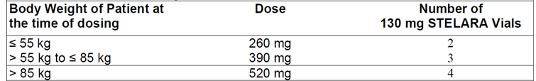
For some patients, a single IV dose based on body weight (Table 1) followed by 90 mg subcutaneous dosing 8 weeks later, then every 12 weeks thereafter may be acceptable.
Patients who inadequately respond to 90 mg subcutaneous dosing every 12 weeks may benefit from an increase in dosing frequency to every 8 weeks.
The following dosing instructions for the new proposed IV formulation were provided in the proposed PI in the submitted dossier:

Intravenous infusion (Crohn’s Disease)
Stelara 130 mg vial is for IV infusion only. Intravenous infusion of Stelara should be administered by qualified health care professionals (For preparation, see Instructions for Dilution).

Instructions for dilution of Stelara 130 mg for IV infusion (Crohn’s disease)
Stelara 130 mg solution must be diluted and prepared for IV infusion by a healthcare professional using aseptic technique.
- Calculate the dose and the number of Stelara vials needed based on patient’s body weight. Each 26 ml vial of Stelara contains 130 mg of ustekinumab.
- Withdraw and then discard a volume of the 0.9% w/v sodium chloride solution from the 250 ml infusion bag equal to the volume of Stelara to be added (discard 26 mL sodium chloride for each vial of Stelara needed, for 2 vials-discard 52 mL, for 3 vials- discard 78 mL, for 4 vials- discard 104 mL).
- Withdraw 26 mL of Stelara from each vial needed and add it to the 250 ml infusion bag. The final volume in the infusion bag should be 250 ml. Gently mix.
- Visually inspect the diluted solution before administration. Do not use if visibly opaque particles, discoloration or foreign particles are observed.
- Administer the diluted solution over a period of at least one hour. Once diluted, the infusion solution may be stored for up to four hours prior to infusion.
- Use only an infusion set with an in-line, sterile, non-pyrogenic, low protein-binding filter (pore size 0.2 micrometer).
- Do not infuse Stelara concomitantly in the same intravenous line with other agents.
- Each vial is for single use only and any unused medicinal product should be disposed of in accordance with local requirements.

Background

Information on the condition being treated
Crohn’s disease is a chronic immune-mediated inflammatory bowel disease (IBD), with annual incidence rates ranging from 6 to 8 per 100,000 in the US and from 0.3 to 12.7 per 100,000 in the Europe; prevalence ranges from 100-200 per 100,000 in the US and ~0.6 to 322 per 100,000 in Europe (Talley, 2011). Incidence and prevalence in Australia is similar or higher than that observed in other industrialised nations (Wilson, 2010). Peak age-specific incidence occurs between ages 15 and 30 years, thereby disproportionally affecting young adults during their prime working years; a second, smaller peak occurs in the sixth and seventh decades of life (Ananthakrishnan, 2015). Crohn’s disease is associated with substantial morbidity and mortality. Clinically, Crohn’s disease is characterised as a relapsing, remitting disease that occurs most commonly at the end of the small intestine (terminal ileum) and the beginning of the colon with clinical manifestations such as abdominal cramps / diarrhoea and systemic features such as cachexia, fever, anaemia, and weight loss; extraintestinal manifestations include pyoderma gangrenosum, uveitis, and arthritis (Glickman, 1998). Complications include bowel fistulas, abscesses and luminal strictures, which often require multiple surgeries and can lead to short gut syndrome (Schalamon, 2003). Studies suggest that 15 years after diagnosis, approximately 70% of patients with Crohn’s disease will have undergone at least 1 major intra-abdominal surgery; by the same time-point, 35% of patients will have required two such operations and 20% will have required at least three. Patients also suffer from reduced quality of life and increased risk for clinical depression.

Current treatment options
The current standard of medical care for Crohn’s disease involves anti-inflammatory therapeutic approaches, which include 5-aminosalicylic acid (5-ASA) compounds, corticosteroids, immuno-modulators including azathioprine (AZA) or its active metabolite 6-mercaptopurine (6-MP) and methotrexate (MTX), and biologic agents including tumour necrosis factor (TNF) antagonist therapies and anti-integrin therapies. Among these commonly prescribed agents, only the biologic agents and the corticosteroid budesonide are approved for the treatment of Crohn’s disease, and even with combinations of the available therapeutic options, many patients do not attain clinical benefit or cannot tolerate the therapy.
Frequently used as acute therapy for Crohn’s disease, corticosteroids are capable of inducing remission but are ultimately ineffective in maintaining it, and their therapeutic benefit is often offset by the side effects of prolonged exposure. Immunomodulators can take as long as 3 months to work, may only be partially effective, and can result in neutropenia, pancytopenia, pancreatitis, nephrotoxicity, or hepatotoxicity in some patients, requiring additional serologic monitoring and frequent blood sample collections. The use of thiopurines (AZA/6-MP) is associated with a possibly increased risk of lymphoma in adults (Kandiel, 2005) and a very rare and rapidly fatal lymphoproliferative disorder, hepatosplenic T-cell lymphoma (HSTCL), has been reported in mostly young adult male patients with IBD (predominantly Crohn’s disease) who were treated with thiopurines with or without TNF antagonists (Kotlyar, 2007; Mackey, 2007, 2009).
TNF antagonist therapies (infliximab, adalimumab and certolizumab pegol [currently not approved in Australia]) have been the first-line biologic agents in Crohn’s disease. Although many patients initially respond to TNF antagonist therapy, many others do not, and secondary failures due to intolerance or loss of initial response are common. Among patients who receive TNF antagonist therapies for Crohn’s disease, 20% to 40% are primary non-responders, and among those with an initial response, ~40% lose their response over time (Ha C, 2014).
For patients who have failed TNF antagonists, only one other class of biologic agent is available for the treatment of moderate to severe Crohn’s disease, the integrin inhibitors, which interfere with lymphocyte trafficking. This class includes natalizumab and, more recently, vedolizumab. Natalizumab is available only via restricted distribution in some regions and is not approved in others, largely due to safety concerns associated with progressive multifocal leukoencephalopathy (PML). Vedolizumab is approved more broadly but is available only as an IV therapy and has shown mixed results in induction studies in Crohn’s disease, especially in TNF-antagonist refractory populations.
With only two classes of biologic agents available for patients who have failed or are intolerant to conventional systemic therapies, there is an unmet need for additional treatment options for a disease that largely affects younger patients during their most formative and productive years. For those who have exhausted existing treatment options or are relatively new to treatment, the lifelong course of the disease and the lack of a single enduring treatment highlight the inevitable need for additional treatment options with durable efficacy, a favourable benefit-risk profile, and minimally invasive dosing and frequency.

Clinical rationale
Clinical, genetic, and animal model data suggest that Crohn’s disease is mediated by IL-12/23-mediated induction of Th1 and Th17 cells (Berrebi, 1998; Monteleone, 1997; Parrello, 2000). In Crohn’s disease, intestinal antigen-presenting cells secrete increased levels of IL-12 and IL-23 (Liu, 2011; Monteleone, 1997). IL-12 induces immune cells toward a T helper 1 (Th1) phenotype (stimulates interferon-gamma [IFN-γ] production) while IL-23 induces a T helper 17 (Th17) pathway (promotes secretion of IL-17A, IL-21, and IL-22). Both cytokines stimulate TNF production, resulting in the intestinal inflammation and epithelial cell injury typical of Crohn’s disease.
Anti-IL-12/23 p40 antibodies administered at early or late time points in rodent models of colitis improved clinical and histopathological changes (Davidson, 1998; Neurath, 2007) and mice with a genetic deletion of the p19 chain of IL-23 are protected in several models of intestinal inflammation (Hue S, 2006; Kullberg, 2006;Yen D, 2006). Significant associations have been found between Crohn’s disease and genetic polymorphisms in the genes encoding the IL-23 receptor (IL23R) and the IL-12/23 p40 protein (IL12B) (Duerr, 2006; Umeno, 2011; Wang, 2009; Moon, 2013). Collectively, the roles of IL-12 and IL-23 in Th1 and Th17 signalling, combined with data from murine models of IBD, elevations in IL-12 and IL-23 in human Crohn’s disease, and genetic linkage data provide a strong rationale for inhibiting these cytokines in Crohn’s disease. Ustekinumab binds with high affinity and specificity to the p40 subunit common to both human IL-12 and human IL-23 and inhibits their binding to the IL-12 receptor β1 chain and subsequent intracellular signalling by both cytokines.

Formulation

Formulation development
For the IV administration of ustekinumab, liquid in vial (LIV) was supplied as a single-use, sterile solution in 2 mL vials with 2 dose strengths (that is, 90 mg in 1 mL nominal volume or 45 mg in 0.5 mL nominal volume). Each 1 mL of ustekinumab solution contained 90 mg ustekinumab.
Note that the Phase III studies were originally designed to include induction doses for IV administration using a dilute formulation specifically designed for IV use comprising 130 mg ustekinumab in 26 mL (5 mg/mL) of each vial. However, a stability issue was identified with the batch of IV drug used in the study after 40 subjects had been randomised. To prevent significant delay, the sponsor substituted the dilute LIV formulation (5 mg/mL) with the approved 90 mg/mL ustekinumab formulation for the protocol-specified IV induction administrations.
The final IV presentation for commercial use will be the 5 mg/mL formulation. The NAP1002 study demonstrated that this diluted commercial formulation was comparable in PK with the 90 mg/mL formulation that had been used in Phase III induction.
Subcutaneous administration of 90 mg ustekinumab every 8 weeks (q8w), or every 12 weeks (q12w) was supplied in a single-use prefilled syringe. Each single-use prefilled syringe contains 90 mg (1 mL fill of liquid) ustekinumab in an aqueous medium of L-histidine, sucrose and polysorbate 80 at pH 6.0. No preservatives are present.

Comparability between the 5 mg/mL and 90 mg/mL IV solutions
To evaluate the impact of protein concentration and formulation changes made during clinical development, a comparability study between the final vialed product for intravenous administration (FVP [IV]) (5 mg/mL) and Stelara FVP (90 mg/mL) drug product (DP) presentations was performed. The formulation change consisted of the addition of 2 excipients, methionine and EDTA to stabilize the FVP (IV). The test articles used and the corresponding formulations for the FVP and FVP (IV) are shown in Table 2.
Table 2: Test Articles Used in the Comparability Assessment
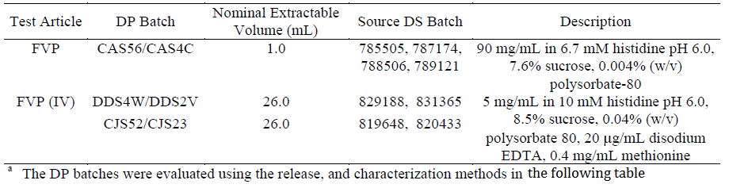
The comparability assessment was comprised of 2 components: (1) an in vitro study using release and characterisation methods to evaluate biochemical, biophysical and biological comparability at or near the time of manufacture (T=0), and (2) an evaluation of stability profiles. In general, the differences in protein concentration of the FVP and FVP (IV) did not impact the methods used as the testing procedures require preparation of samples at the same final concentration. For the in vitro study, release results were compared to release criteria, and characterisation results were evaluated based on quantitative acceptance criteria, method performance, and product knowledge. For the evaluation of stability profiles, a statistical analysis of available stability data was used to compare degradation pathways (trends) and rates (differences in trends).
Based on an evaluation of the characterisation study results, it was concluded that the FVP (IV) batches, which contained 5 mg/mL ustekinumab, were comparable to the FVP batch, which contained 90 mg/mL active drug. Specifically, the primary structure, carbohydrate structure, mass heterogeneity, charge heterogeneity, size heterogeneity, purity, higher order structure, biological activity, particles, and colour of the DP batches were comparable. Differences observed in 1 solution property (turbidity) and strength (protein concentration) were expected as a result of the lower protein concentration designed for the FVP (IV) presentation. In addition, the stability profiles for the FVP and FVP (IV) were comparable at the recommended (2-8˚C), accelerated (25˚C) and stressed (40˚C) storage conditions and differed only in the comparison of the absolute protein concentration and turbidity results, which were expected based on the lower protein concentration used for the FVP (IV).
Stelara is available for intravenous infusion in one strength (130 mg in 26 mL) and packaged as 1 single use vial. Stelara does not contain preservatives.
The IV and SC formulations of ustekinumab used in the overall clinical development program in Crohn’s disease is summarised in Table 3 below.
Table 3: Ustekinumab formulations used in Crohn’s disease studies
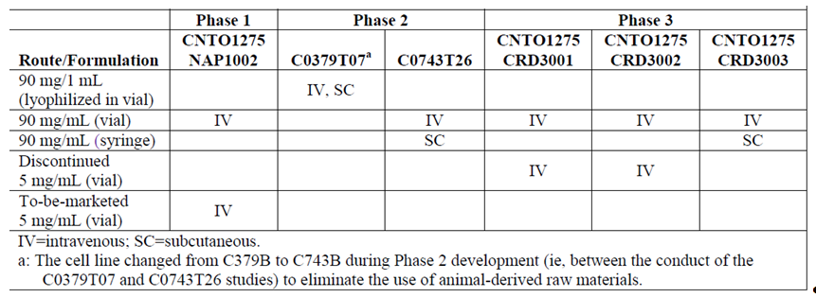
The Phase II studies used a 90 mg/mL lyophilised in vial (C0379T07) and 90 mg/mL LIV (C0743T26) formulations; C0743T26 also used the 90 mg/mL prefilled syringe (PFS).
The Phase III studies used the following formulations:
- A 5 mg/mL formulation with 130 mg per vial for IV induction administration, which was discontinued due to stability issues (discussed below).
- The approved 90 mg/mL ustekinumab LIV formulation.
- A new modified 5 mg/mL formulation with 130 mg ustekinumab in 26 mL (5 mg/mL) in each vial intended for commercial use.
- 90 mg ustekinumab supplied in a single-use PFS for SC administration.
The Phase III studies originally incorporated a 5 mg/mL formulation with 130 mg per vial for IV induction dosing that was intended to be marketed. Due to the stability issue identified with the original LIV drug formulation, the sponsor substituted the approved 90 mg/mL ustekinumab LIV formulation for the IV induction administrations.
The final IV presentation for commercial use will be a new dilute formulation for IV administration comprising 130 mg ustekinumab in 26 mL (5 mg/mL) in each vial. The 5 mg/mL LIV has the same excipient components as 90 mg/mL LIV, with the addition of ethylenediamine-tetraacetic acid (EDTA; 0.02 mg/mL) and L-methionine (0.4 mg/mL). This dilute LIV formulation was shown to have biophysical and biochemical properties comparable with those of the 90 mg/mL LIV formulation.
Study NAP1002 also demonstrated that this dilute to-be-marketed formulation had PK comparable with the 90 mg/mL formulation used in the Phase III induction studies.
Subcutaneous administration of 90 mg ustekinumab q8w or q12w was done using a single-use PFS. Each single-use PFS contains 90 mg (1 mL fill of liquid) ustekinumab in an aqueous medium of L-histidine, sucrose, and polysorbate 80 at pH 6.0

Excipients
The 45 mg and 90 mg pre-filled syringe/vials for SC administration contain the following excipients: L-histidine, L-histidine monohydrochloride monohydrate, polysorbate 80, sucrose, water for injection, whereas, the proposed 130 mg vial for IV administration contains: EDTA disodium salt dehydrate, L-histidine, L-histidine hydrochloride monohydrate, L-methionine, polysorbate 80, sucrose, water for injection.

Guidance
The final submission for Stelara ustekinumab is consistent with the pre-submission planning form lodged with TGA on 23 December 2015 apart from a minor difference which does not affect the scope of the submission.
The overall clinical design and dose selection was based on guidance and advice with regulatory authorities including those in the United States, the European Union and Japan.

Evaluator’s commentary on the background information
The clinical rationale for the proposed use of ustekinumab (an interleukin inhibitor-human IgG1κ monoclonal antibody that binds with high affinity and specificity to the p40 subunit common to both human interleukin (IL)-12 and human IL-23) for treatment of moderately to severely active Crohn’s disease) is valid and acceptable.

Contents of the clinical dossier

Scope of the clinical dossier
The submitted dossier documented a clinical development program of pharmacology, dose-finding, pivotal and other clinical trials relating to the proposed extension of indications. The clinical development program in Crohn’s Disease consisted of two placebo-controlled Phase II studies, three placebo-controlled Phase III studies, and a Phase 1 study:
- Clinical pharmacology: One Phase I PK comparability study in healthy subjects (CNT01275NAP1002).
- Two Dose–finding studies: Phase IIa Study C0379T07 and the Phase IIb Study C0743T26.
- Population PK studies: PopPK modelling was undertaken using PK data obtained from one Phase IIb study (C0743T26) and three Phase III studies, that is, CRD3001, CRD3002 and CRD3003.
- Pivotal efficacy/ safety studies: Two Phase III Studies CRD3001 and CRD3002
- Other efficacy/ safety studies: Efficacy and safety data are also provided for the Phase II studies (C0379T07, 28 weeks; C0743T26, 36 weeks).

Evaluator’s commentary on the clinical dossier
The submission is well-presented although the efficacy, safety and PK-PD results for the important Phase IIb Study C0743T26 were not presented in the initial submission. However, this was promptly provided by the sponsors in the subsequent submission.

Pharmacokinetics

Studies providing pharmacokinetic information
Serum ustekinumab concentrations were determined by a validated electrochemiluminescent immunoassay (ECLIA) method using the Meso Scale Discovery (MSD) platform in samples collected in the C0743T26, CRD3001, CRD3002, CRD3003 and NAP1002 studies. The lowest quantifiable concentration in a sample for the MSD ECLIA method was 0.1688 μg/mL. In C0379T07, serum ustekinumab concentrations were measured by a validated enzyme-linked immunosorbent assay (ELISA). The lowest quantifiable concentration in a sample for the ELISA method was 0.08 μg/mL.
The following table summarises the Pharmacokinetic studies provided.
Table 3: Submitted pharmacokinetic studies
PK topic | Subtopic | Study ID | *
PK in healthy adults | General PK Single dose† | NAP1002 | PKs of 2 IV formulations, 90 mg/mL and 5 mg/mL, following a single dose of 6 mg/kg.
PK in special pop^{n} | Target pop^{n} - subjects with Crohn’s disease§ | C0379T07 | PK/PD following a single IV or multiple SC administrations in subjects with moderately to severely active disease despite treatment with 5-ASA compounds, antibiotics, corticosteroids, and/or immuno-modulators
PK in special pop^{n} | Target pop^{n} - subjects with Crohn’s disease§ | C0743T26 | PK/PD following an IV induction dose and multiple SC maintenance doses in subjects with moderately to severely active disease who had received treatment with 1 or more TNF antagonists and had not responded initially, responded and then lost response, or were TNF-intolerant.
PK in special pop^{n} | Target pop^{n} - subjects with Crohn’s disease§ | CRD3001 | PK/PD following an IV induction dose in subjects with moderately to severely active disease had who previously failed or were intolerant to 1 or more TNF-antagonist therapies.
PK in special pop^{n} | Target pop^{n} - subjects with Crohn’s disease§ | CRD3002 | PK/PD following an IV induction dose in subjects with moderately to severely active disease with evidence of active inflammation who failed conventional therapy.
PK in special pop^{n} | Target pop^{n} - subjects with Crohn’s disease§ | CRD3003 | PK, immunogenicity and PDs following multiple SC doses in continuing subjects following IV induction in CRD3001 or CRD3002
PPK analyses | Target pop^{n} | Population PK Study | To develop a PPK model to characterise the PK of ustekinumab following IV and SC administrations
* Indicates the primary PK aim of the study. † Bioequivalence of different formulations. § Subjects who would be eligible to receive the drug if approved for the proposed indication. pop^{n} population

Summary of pharmacokinetics

Physicochemical characteristics of the active substance
Stelara (ustekinumab) is a human IgG1kappa monoclonal antibody with an approximate molecular weight of 148,600 daltons. Stelara is produced by a recombinant cell line cultured by continuous perfusion and is purified by a series of steps that includes measures to inactivate and remove viruses.
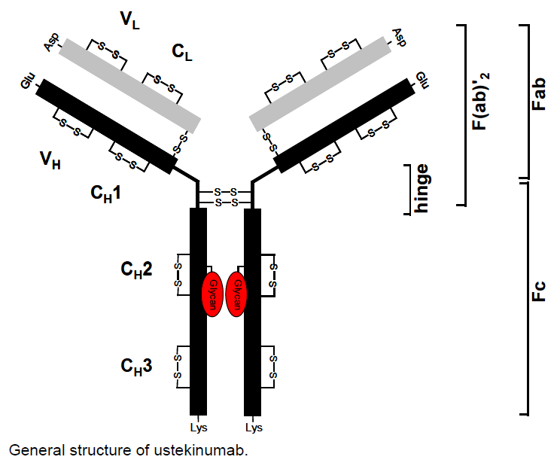

Pharmacokinetics in healthy subjects
Comment: As the PK/PD data provided by the sponsor primarily examines patients suffering from moderately to severely active Crohn’s disease (that is, only a single study examined the PKs in healthy subjects) the following discussion, which would normally focus on healthy subjects, will include information from both healthy subjects and the target patient group.
The current application aims to provide justification for not only an extension of the indication of Stelara to include Crohn’s disease and to provide a new formulation strength of 90 mg/mL, it also provides justification for the administration of Stelara via intravenous (IV) injection. To this end, the sponsor has provided new information regarding the PKs and PDs of Stelara in the form of: a single new Phase 1 study (NAP1002), which was conducted in healthy subjects; a population PK analysis (Population PK Study); and 5 studies (two Phase II and three Phase III studies) which were all undertaken in patients with moderately to severely active Crohn’s disease.

Analytic Methods
In general, analyses of serum ustekinumab concentrations were undertaken using a validated ECLIA method on the MSD® platform (Gaithersburg, MD, USA). The lower limit of quantitation (LLOQ) for the ECLIA method was 0.1688 μg/mL. The PK parameters of ustekinumab were then calculated from serum ustekinumab concentration-time data using non-compartmental methods. However, in one study, serum ustekinumab concentrations were measured using a validated ELISA, which was capable of quantifying a serum ustekinumab concentration with a LLOQ of 0.08 μg/mL.

Absorption

Sites and mechanism of absorption
For the treatment of Crohn’s Disease it is proposed that following the administration of an initial IV dose of Stelara, SC doses of the drug are then given at 8 week intervals. As the initial dose of Stelara is to be administered IV for the treatment of Crohn’s disease the question of absorption for this initial dose is not relevant. The absorption of the SC dose has been previously addressed; however, although it is likely to be delayed relative to the IV dose, SC administration is generally more rapid and predictable than following oral administration.
Following a single IV administration of a 6 mg/kg dose of the proposed formulation strength of 90 mg/mL to 70 healthy subjects, the mean C_{max} and AUC_{inf} of ustekinumab were 199.1 µg/mL and 3218.3 µg.h/mL and the t_{1/2} was 25.1 h. Similarly, following a single IV administration of a 6 mg/kg dose of the proposed formulation strength of 5 mg/mL to 69 healthy subjects, the mean C_{max} and AUC_{inf} were 196.7 µg/mL and 3132.4 µg.h/mL and the t_{1/2} was 24.7 h.

Bioavailability

Absolute bioavailability
As the proposed doses of Stelara are to be given either IV or SC the absolute bioavailability is not relevant. However, the PopPK study predicted that the bioavailability of Stelara following SC dosing relative to IV dosing was 78.3% in subjects with moderately to severely active Crohn’s disease.

Bioavailability relative to an oral solution or micronised suspension
Not applicable.

Bioequivalence of clinical trial and market formulations
Not applicable.

Bioequivalence of different dosage forms and strengths
5 mg/mL verses 90 mg/mL
Study NAP1002 compared the PKs of Stelara following a single 6 mg/kg IV administration of the proposed new formulation strength (5 mg/mL) and the previously registered formulation strength of 90 mg/mL in 140 healthy subjects. The results indicated that the ratios of geometric means of the C_{max} and AUC values for the two formulation strengths were approximately 1 (0.967 for C_{max} and 0.971 for both AUC_{inf} and AUC_{last}); the 90% CIs of all these ratios fell within the standard bioequivalence interval of 0.80 to 1.25.
IV verses S.C.
The Phase II Study C0379T07 examined the PKs of ustekinumab following a single 4.5 mg/kg IV dose or four 90 mg SC doses (1 dose per week) in 104 adults with moderately to severely active Crohn’s disease or fistulising Crohn’s disease. Subjects who received a single 4.5 mg/kg IV dose of ustekinumab had higher serum ustekinumab concentrations in the first 3 weeks following the initial administration than subjects who had received three weeks of weekly SC dosing with 90 mg (Figure 1).
Figure 1: Study C0379T07; Median CNTO 1275 serum concentration (mg/mL) following initial CNTO 1275 administration through Week 54; treated subjects in Population 1.
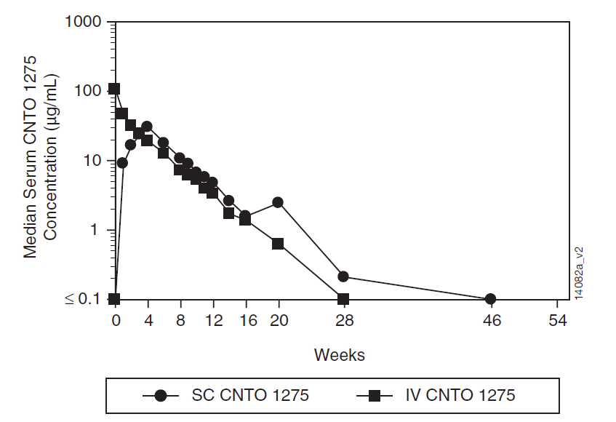
Ustekinumab was eliminated from the circulation in the SC groups of Populations 1 and 2 with a median t_{1/2} of approximately 25 and 23 days, respectively, and was eliminated from the circulation in the IV groups of Populations 1 and 2 with a median t_{1/2} of approximately 23 and 17 days, respectively.

Bioequivalence to relevant registered products
Please see the previous section of this report.

Influence of food
Not applicable.

Dose proportionality
The PKs of ustekinumab were examined following single IV administrations of 1, 3, or 6 mg/kg in 526 patients with moderately to severely active Crohn’s disease who did not responded initially, responded initially but then lost response or were intolerant to other medications in a second Phase II Study C0743T26. The results indicated that following a single IV administration of 1, 3, or 6 mg/kg ustekinumab, serum ustekinumab concentrations were proportional to dose and were detectable in almost all subjects through Week 8. Median peak serum ustekinumab concentrations, 1 h after the infusion at Week 0, were 24.3 μg/mL, 71.6 μg/mL and 144.1 μg/mL for the 1, 3 and 6 mg/kg induction treatment groups, respectively. At the end of induction (Week 8), median serum ustekinumab concentrations were 0.8 μg/mL, 3.1 μg/mL and 7.0 μg/mL for the 1, 3 and 6 mg/kg induction treatment groups, respectively. The lowest ustekinumab dose group (1 mg/kg) had the highest proportion of subjects (10.3%) without detectable concentrations at Week 8.
Two Phase III studies, CRD3001 and CRD3002 examined the PKs of ustekinumab following a single IV dose of 130 mg or a single IV weight-range-based [hereafter referred to as ‘tiered’] ustekinumab dose approximating ustekinumab 6 mg/kg. Therefore subjects weighing <55 kg were administered a 260 mg dose, subjects weighing > 55 kg and ≤ 85 kg received a 390 mg dose and subjects who weighed > 85 kg received a 520 mg dose. Enrolled subjects in both studies had moderately to severely active Crohn’s disease; however, subjects in CRD3001 had previously failed or were intolerant to one or more tumour necrosis factor (TNF-) antagonist therapies, whereas, subjects in CRD3002 had failed conventional therapy (that is, corticosteroids and immuno-modulators). The results of both studies indicated that median serum ustekinumab concentrations were approximately dose proportional and were detectable at all sampling time-points through Week 8. For instance, in Study CRD3001, 8 weeks following a single IV dose of 130 mg, 260 mg, 390 mg or 520 mg ustekinumab the median serum concentration values were 2.1, 3.9, 6.6 and 8.8 µg/mL, respectively and the coefficient of determination (r²) was 0.994, indicating that 99.4% of the total variation in serum concentration could be explained by a linear relationship with IV dose.

Bioavailability during multiple-dosing
Single IV versus multiple SC
Although the results of Study C0379T07 indicated that compared to three weeks of SC dosing with 90 mg once weekly, serum ustekinumab concentrations were higher following a single 4.5 mg/kg IV dose, by the beginning of Week 4, following the 4th SC dose the median serum concentrations of ustekinumab were slightly higher in subjects receiving multiple SC administrations than in subjects receiving the single IV administration (Figure 1).

Effect of administration timing
In Study CRD3003 subjects who had been administered ustekinumab at Week 0 in Studies CRD3001 or CRD3002 and completed the Week 8 CDAI score evaluation, were randomised in a 1:1:1 ratio at Week 0 to receive a SC administration of either placebo or 1 of 2 maintenance regimens of ustekinumab (ustekinumab 90 mg q12w through Week 36 or ustekinumab 90 mg q8w through Week 40). Following maintenance dosing with ustekinumab 90 mg SC q8w or q12w, steady-state was reached at approximately 8 or 12 weeks after subjects began receiving ustekinumab 90 mg SC q8w, or ustekinumab 90 mg SC q12w, respectively. Median steady-state trough serum ustekinumab concentrations over time were 3-fold greater in the ustekinumab q8w group (1.97 μg/mL to 2.24 μg/mL) than in the q12w group (0.61 μg/mL to 0.76 μg/mL). Serum ustekinumab concentrations were sustained through Week 44 in almost all subjects, with a smaller proportion of subjects with undetectable trough concentrations in the 90 mg q8w group (3.2% to 4.9%) compared to those in the 90 mg q12w group (11.1% to 19.1%). The impact of the different IV induction doses on serum ustekinumab concentrations during maintenance appears to have completely diminished by Week 16 of this maintenance study.

Distribution

Volume of distribution
In healthy subjects (Study NAP1002), the volume of distribution values based on terminal phase (Vz) corrected for body weight following a 6 mg/kg IV infusion of ustekinumab 90 mg/mL or 5 mg/mL were 4.7 L and 4.9 L, respectively. The PopPK study identified that a 2-compartment disposition model with first-order absorption following SC administration fitted data from subjects with Crohn’s disease adequately. Based on this model, the predicted volume of the central compartment (V₂) was 2.74 L (95% CI: 2.69 to 2.78 L).

Plasma protein binding and Erythrocyte and Tissue distribution
Little information is provided in the evaluation materials regarding the plasma protein binding of ustekinumab and its distribution to erythrocytes or tissues; however, given the relatively low volume of distribution (≥4.9L) it can be assumed that plasma protein binding is high and little to no ustekinumab is distributed to the tissues.

Metabolism
The sponsor states that the exact metabolic pathway for ustekinumab is unknown.

Excretion
Study C0379T07 indicated that ustekinumab was eliminated following SC administration with a median t_{1/2} of approximately 23 to 25 days and following IV administration with a median t_{1/2} of approximately 17 to 23 days, whereas, the t_{1/2} predicted by PopPK modelling was 18.9 days with 90% CI of (18.5, 19.5) days.

Intra and inter individual variability of pharmacokinetics
PopPK modelling provided predictions of between-subject variability (BSV) in terms of %CV of 29.1% for CL and 14.7% for V2. In terms of inter-occasion variability (IOV), the sponsor states the following: ‘IOV is useful when there is high degree of residual error due to lack of reproducibility of a PK profile from one occasion to the next within an individual subject. This level of random effect was not considered necessary for the PPK reported here. The estimate of residual (within-subject) variability was small enough that such characterisation was not considered warranted.’

Pharmacokinetics in the target population
Please see the preceding sections of this report.

Pharmacokinetics in special populations
Note: Unless stated otherwise, the following analyses were undertaken as part of the covariate analysis for the PopPK study.

Pharmacokinetics in subjects with impaired hepatic function
The PopPK study evaluated alkaline phosphatase as an indicator of hepatic function. Within the data set, values for alkaline phosphatase ranged from 27 to 422 IU/L with a median value of 71 IU/L. Modelling indicated that there was no meaningful impact of alkaline phosphatase on the PK of ustekinumab.

Pharmacokinetics in subjects with impaired renal function
No studies examined the effect of impaired renal function on the PKs of ustekinumab. However, the PopPK study identified that plasma albumin was a covariate of ustekinumab clearance with the model-predicted mean CL of ustekinumab increasing as serum albumin level decreased. Accordingly, the change in ustekinumab CL ranged from -7.3% to +12.0% of the CL estimate when serum albumin levels decreased from the 75th percentile (4.0 g/dL) to the 25th percentile (3.3 g/dL), respectively. Therefore, as proteinuria is associated with some types of renal disease, there is a possibility that ustekinumab CL could be higher in subjects with impaired renal function.

Pharmacokinetics according to age
The effect of age on CL and the volume of the central compartment (V2) were evaluated as part of the covariate analysis. Across the PopPK data set the median age (range) was 37 years (18 to 76). Results indicated that the subject’s age had no meaningful impact on the PKs of ustekinumab.

Pharmacokinetics related to genetic factors
No studies examined the PKs related to genetic factors.

Pharmacokinetics in other special population / with other population characteristic

Effect of Gender
Sex was evaluated as a potential covariate on CL and V2 as part of the popPK analysis. There were 736 (43.5%) male and 958 (56.6%) female subjects contained within the data set. The results indicated that ustekinumab CL and V2 were 17% higher in male subjects than in females. This implies that males would have slightly lower ustekinumab exposure than females; however, this finding may be related to body weight since males tend to have higher body weight. Overall, the impact of gender on the PKs of ustekinumab is not considered clinically meaningful.

Effect of Body weight
Body weight was a statistically significant covariate for both ustekinumab CL and V2. The median body weight of subjects included in the population PK analysis was 68.7 kg, and ranged from 35.0 kg to 184.0 kg. The model-predicted CL and V2 values of ustekinumab increased slightly as body weight increased.
Among subjects with Crohn’s disease, the change in CL due to body weight ranged from -8.2% to +9.0% of the CL estimate when body weight increased from the 25th percentile (57.5 kg) to the 75th percentile (82.2 kg), respectively; while the change in V2 ranged from -6.9% to +7.0% of the V2 estimate when body weight increased from the 25th to the 75th percentile, respectively. Based on these results, body weight would have minimal impact on steady-state serum ustekinumab concentrations. Studies CRD3001 and CRD3002 provided further support for this finding as subjects who received an IV induction dose of 130 mg ustekinumab in these studies, attained comparable serum ustekinumab concentrations regardless of body weight.

Effect of Race
Race was evaluated as a potential covariate on CL as part of the PopPK analysis. The dataset included subjects from a primarily Caucasian background (87.1%), whereas, 3.1% of subjects were Black, 6.3% were Asians and the remaining subjects were from other races or were missing data concerning their racial type. The results indicated that ustekinumab CL was 14% higher in Asian subjects compared to the other race categories. Based on PK bridging studies in healthy subjects where body weights are similar or matched between different races, race has not generally been found to have significant impact on the PK of monoclonal antibodies. Therefore, this finding of the race effect on ustekinumab CL is not considered to be clinically meaningful.

Effect of Immunogenicity
Model-predicted CL was 13.0% higher in subjects positive for antibodies to ustekinumab. However, as only 1.8% of subjects (n = 30), over the course of treatment with ustekinumab through 52 weeks, developed antibodies the potential impact of immunogenicity on increased CL of ustekinumab should be interpreted with caution.

Population pharmacokinetics

PopPK analysis ID
PopPK modelling was undertaken using PK data obtained from one Phase IIb study (C0743T26) and three Phase III studies, that is, CRD3001, CRD3002, and CRD3003. As mentioned previously, the analysis identified that a 2-compartment disposition model with first-order absorption following SC administration adequately fitted the data. A number of covariates were selected for inclusion in the final model, including SEX (Males), RACE (A = Asian), FTNF (TNF failure), IBCRP (baseline CRP) on CL and BALB (baseline albumin) and SEX (Males) on V2 (Figure 2). These were in addition to the covariates included structurally in the base model, which were: BWGT (baseline body weight) on all the disposition parameters (CL, V2, Q and V3) and BALB on CL. Overall, the predicted effects of the covariates on the PKs of ustekinumab were modest in magnitude (that is, ≤ 17%) and were individually unlikely to induce clinically significant effects.
Figure 2: Population PK Study: Effects of Selected Covariates on Predicted CL and V2 using the Final Model.
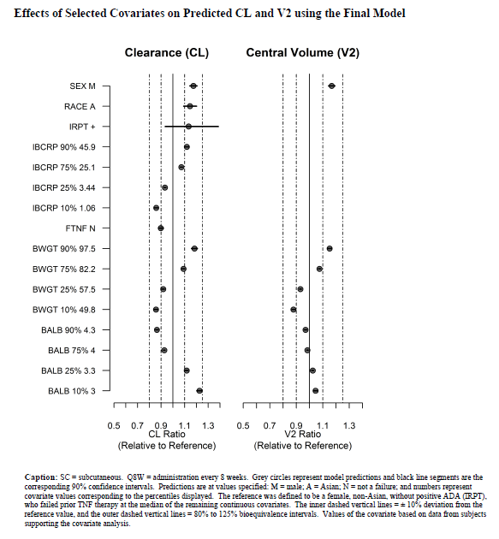

Pharmacokinetic interactions
No studies examined the PK interaction between ustekinumab and other drugs; however, given that drug is an antibody, typical drug-drug interactions are unlikely.

Evaluator’s overall conclusions on pharmacokinetics
- Stelara (ustekinumab) is a human IgG1kappa monoclonal antibody. In patients with Crohn’s disease, following the recommended IV induction dose, median peak serum ustekinumab concentration was 126.1 μg/mL. Starting at Week 8, subcutaneous maintenance dosing of 90 mg ustekinumab was administered every 8 or 12 weeks. Steady state ustekinumab concentration was achieved by the start of the second maintenance dose. Median steady-state trough concentrations ranged from 1.97 μg/mL to 2.24 μg/mL and from 0.61 μg/mL to 0.76 μg/mL for 90 mg ustekinumab every 8 weeks or every 12 weeks respectively. The steady-state trough ustekinumab levels resulting from 90 mg ustekinumab every 8 weeks were associated with higher clinical remission rates as compared to the steady-state trough levels following 90 mg every 12 weeks.
- In healthy subjects, the mean C_{max}, AUC_{inf} and t_{1/2} of ustekinumab following a 6 mg/kg IV dose of the proposed formulation strength of 90 mg/mL were 199.1 µg/mL, 3218.3 µg.day/mL and 25.1 days, respectively. Similarly, following the same IV dose of the formulation strength of 5 mg/mL ustekinumab, C_{max}, AUC_{inf} and t_{1/2} were 196.7 µg/mL, 3132.4 µg.day/mL and 24.7 days, respectively.
- Following a 6 mg/kg IV dose in healthy subjects, the two proposed formulations strengths of ustekinumab (that is, 90 mg/mL and 5 mg/mL) were bioequivalent.
- PopPK analysis predicted that the bioavailability of Stelara following SC dosing relative to IV dosing was 78.3% in subjects with moderately to severely active Crohn’s disease.
- In subjects with moderately to severely active Crohn’s disease or fistulising Crohn’s disease, patients who received a single 4.5 mg/kg IV dose of ustekinumab had higher serum ustekinumab concentrations in the first 3 weeks following initial administration than subjects who had received three weeks of weekly SC dosing with 90 mg. By contrast, following the 4th SC dose the median serum concentrations of ustekinumab were slightly higher in subjects receiving multiple SC administrations than in subjects receiving the single IV administration.
- Following a single IV administration of 1, 3 or 6 mg/kg ustekinumab, serum ustekinumab concentrations were proportional to dose and were detectable in almost all subjects through Week 8. Similarly, in subjects with Crohn’s disease who received a single IV dose of 130 mg, 260 mg, 390 mg or 520 mg, median serum ustekinumab concentrations were approximately dose proportional and were detectable at all sampling time-points through Week 8. For example, 8 weeks after a single IV dose of 130 mg, 260 mg, 390 mg or 520 mg ustekinumab the median serum concentration values were 2.1, 3.9, 6.6 and 8.8 µg/mL, respectively, and the r² was 0.994.
- Following maintenance dosing with ustekinumab 90 mg SC q8w or q12w, steady-state was reached at approximately 8 or 12 weeks after subjects began receiving ustekinumab 90 mg SC q8w, or ustekinumab 90 mg SC q12w, respectively. Median steady-state trough serum ustekinumab concentrations over time were 3-fold greater in the ustekinumab q8w group (1.97 μg/mL to 2.24 μg/mL) than in the q12w group (0.61 μg/mL to 0.76 μg/mL).
- In healthy subjects, the volume of distribution corrected for body weight following a 6 mg/kg IV infusion of ustekinumab 90 mg/mL or 5 mg/mL were 4.7 L and 4.9 L, respectively. In subjects with Crohn’s disease, the predicted volume of the central compartment was 2.74 L. Based on these findings, it appears that plasma protein binding is high in both healthy subjects and patient’s with Crohn’s disease and little to no ustekinumab is distributed to the tissues.
- The exact metabolic pathway for ustekinumab is unknown.
- Ustekinumab was eliminated following SC administration with a median t_{1/2} of approximately 23 to 25 days and following IV administration with a median t_{1/2} of approximately 17 to 23 days.
- PopPK modelling provided predictions of between-subject variability in terms of %CV of 29.1% for CL and 14.7% for V2. Inter-occasion variability was deemed low and was not reported.
- Modelling indicated that there was no meaningful impact of alkaline phosphatase, a marker for hepatic function, on the PK of ustekinumab.
- PopPK analysis indicates that there is a possibility that ustekinumab CL could be higher in subjects with impaired renal function.
- Age, within the range of 18 to 76 years, had no meaningful impact on the PKs of ustekinumab.
- Ustekinumab CL and V2 were 17% higher in male subjects than in females.
- Model-predicted CL and V2 values increased slightly as body weight increased.
- Ustekinumab CL was 14% higher in Asian subjects than in the other race categories.
- The model-predicted CL was 13.0% higher in subjects positive for antibodies to ustekinumab. 1.8% of subjects in the pooled popPK analysis set developed antibodies to ustekinumab.
- PopPK analysis identified that a 2-compartment disposition model with first-order absorption following SC administration adequately fitted the pooled data set.
- Covariates for CL were gender; race; TNF-antagonist failure; baseline CRP; and for V2 were baseline albumin and gender. In addition, the following covariates were included in the base model: baseline body weight on all the disposition parameters (CL, V2, Q and V3) and baseline albumin on CL.
- The PK sections of the proposed PI are satisfactory.

Pharmacodynamics

Studies providing pharmacodynamic information
Analyses of antibodies to ustekinumab were performed in the Phase III studies and NAP1002 using a validated, drug-tolerant ECLIA, in which ustekinumab was used to capture and detect induced immune responses to ustekinumab. Anti-drug antibody positive samples were further characterised for titre and neutralising capability in the Phase III studies. In the Phase II studies (C0397T07 and C0743T26), the presence of antibodies to ustekinumab was determined by a bridging enzyme immunoassay.
Comment: All of the PD studies described in the following PD section have been previously summarised in Table 3 of this document.

Summary of pharmacodynamics

Mechanism of action
Stelara is a human IgG1kappa monoclonal antibody that specifically binds to the shared p40 protein subunit of the human cytokines interleukin (IL)-12 and IL-23. Stelara inhibits the bioactivity of human IL-12 and IL-23 by preventing p40 from binding to the IL-12Rbeta1 receptor protein expressed on the surface of immune cells. Stelara cannot bind to IL-12 or IL-23 that is already bound to IL-12Rbeta1 cell surface receptors. Thus, Stelara is not expected to contribute to complement- or antibody-mediated cytotoxicity of cells with IL-12 and/or IL-23 receptors.

Analytic Methods

Immunogenicity
Blood samples, which had been taken at various time points, were analysed for the existence of antibodies to ustekinumab using a validated, drug-tolerant, ECLIA or a validated bridging EIA. In general, a subject was considered to have developed a positive immune response if antibodies specifically binding to ustekinumab could be demonstrated in serum samples following administration of the study agent. Otherwise, the subject was classified as negative for antibodies to ustekinumab.

PD
The PD effects of ustekinumab were assessed in some studies by measuring relevant biomarkers in serum, whole blood samples and in mucosal biopsies. Serum-based biomarker analyses included the following: measurement of proteins associated with pro-inflammatory and anti-inflammatory effects, the recruitment and proliferation of cells associated with inflammation and repair, and markers associated with tissue injury or repair, as well as markers associated with response to treatment. Whole blood sample analyses included an evaluation of the regulatory effect of ustekinumab on RNA expression profiles. Mucosal biopsy analyses included an evaluation of the regulatory effect of ustekinumab on RNA expression profiles and the histologic assessment of disease and healing. These analyses also examined gene expression associated with the mechanism of Crohn’s disease.

Pharmacodynamic effects

Primary pharmacodynamic effects
In patients with Crohn’s disease, treatment with Stelara resulted in a significant decrease in inflammatory markers including C - reactive protein (CRP) and faecal calprotectin. Reductions in serum IFNγ and IL-17A, which are IL-12 and IL-23 regulated pro-inflammatory cytokines, were achieved and maintained in Stelara treated patients through Week 44 compared to placebo. Expression of genes such as IL-12Rβ1 and IL-23 were reduced in inflamed colon tissue from Crohn’s disease patients, who were responders to Stelara treatment while no significant changes were observed in placebo treated patients at Week 6.

Serum-based Biomarker Analyses

Study C0379T07
The design of Study C0379T07 in regards to Population 1 allowed for a placebo-controlled evaluation of serum biomarker changes in response to either a single IV administration or multiple SC treatments with ustekinumab in subjects with moderately to severely active Crohn’s disease or fistulising Crohn’s disease. In general, the results indicated that compared to placebo, inflammation-related markers in serum were lower at Weeks 1, 4, and 8 following a single administration of IV ustekinumab. Subjects receiving SC ustekinumab also showed changes in biomarker expression, though only at later time-points.

Inflammatory Cytokines
The first of the inflammatory cytokines to be examined was IL-12p40, which is the target antigen for ustekinumab. Compared to subjects receiving placebo, IL-12p40 serum levels increased up until Week 4 of treatment and the elevated levels were maintained up until Week 8 following treatment with either SC or IV ustekinumab (Figure 3). IL-12p40 complexed to ustekinumab, and is, therefore, biologically inactive. By contrast, TNFα levels decreased by approximately 15% one week following IV dosing, whereas, decreases in TNFα were not seen until Week 4 following multiple SC doses of ustekinumab (Figure 4). For IL-6, subjects who received either IV or SC doses of ustekinumab demonstrated substantial decreases in IL-6 at Week 1 (SC: -43.1%; IV: -51.4%) compared with placebo (SC: -6.1%; IV: -15.1%) and these decreases were sustained over an 8-week period (Figure 5).
Figure 3: Median percent change from baseline in IL-12p40 through Week 8 by visit; treated subjects in Population 1 (top panel) and Population 2 (bottom panel). Study C0379T07
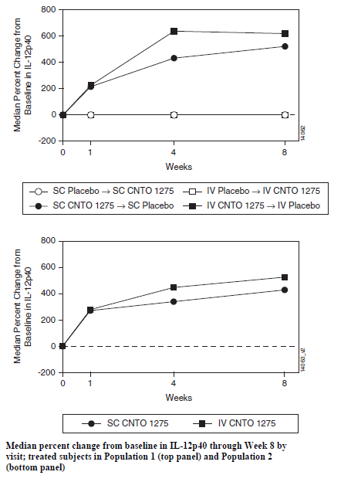
Figure 4: Median percent change from baseline in TNFα through Week 8 by visit; treated subjects in Population 1 (top panel) and Population 2 (bottom panel) who had quantifiable baseline concentrations. Study C0379T07
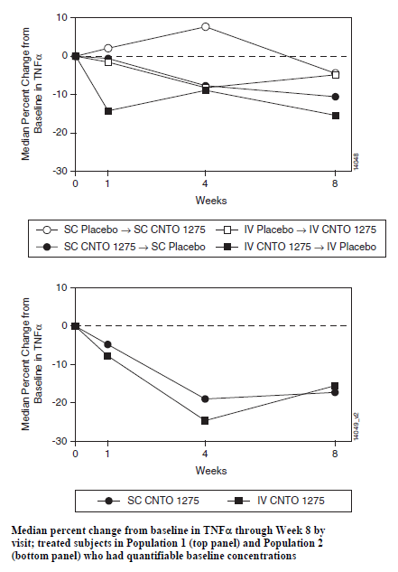
Figure 5: Median percent change from baseline in IL-6 through Week 8 by visit; treated subjects in Population 1 (top panel) and Population 2 (bottom panel) who had quantifiable baseline concentrations. Study C0379T07
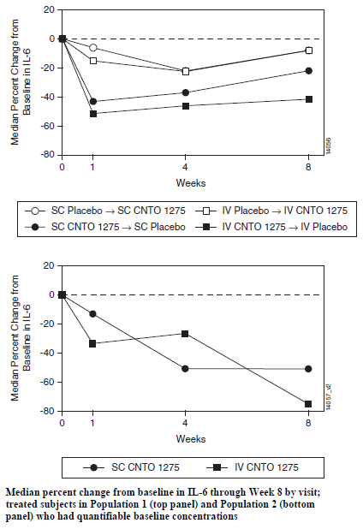

Inflammatory Chemokines
RANTES is chemotactic for T-cells, and plays a role in both promoting and controlling inflammation. Subjects initially administered IV ustekinumab displayed a large median increase (25.8%) in RANTES which was larger than that seen following administration of SC ustekinumab (Figure 6). By Week 4, the median percent change of all the Population 1 treatment groups returned to baseline levels. For IP-10, the median percent change in IP-10 at Week 1 was greater following IV administration of ustekinumab (-10.4%), than following SC dosing with active drug (-1.7%) or placebo (-1.4% to 2.8%) (Figure 7). This decrease in IP-10 for the subjects treated with CNTO 1275 IV relative to placebo was sustained throughout the remainder of the 8-week period. For MCP-1, the median percent decrease in expression at Week 1 following IV ustekinumab was 8.5%, whereas following placebo it ranged from -0.7 to 6.3% (Figure 85). However, this change was not consistently maintained during the following weeks. For ENA-78, IV ustekinumab induced a substantial and steady decrease in median ENA-78 through to week 8 (Figure 9). By contrast, the expression of ENA-78 in the placebo treated groups remained steady through Week 8, whereas, following SC ustekinumab the median percent change in ENA-78 increased slightly over time.
Figure 6: Median percent change from baseline in RANTES through Week 8 by visit; treated subjects in Population 1 (top panel) and Population 2 (bottom panel) who had quantifiable baseline concentrations. Study C0379T07
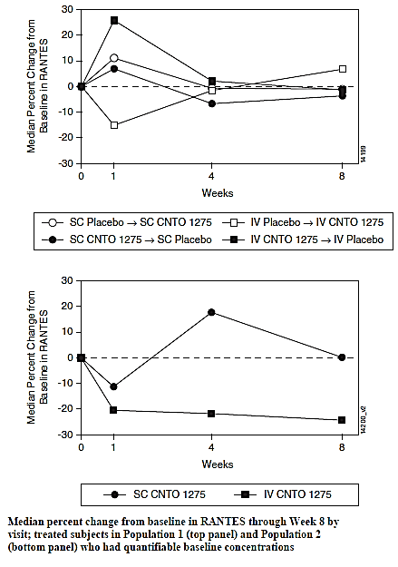
Figure 7: Median percent change from baseline in IP-10 through Week 8 by visit; treated subjects in Population 1 (top panel) and Population 2 (bottom panel) who had quantifiable baseline concentrations. Study C0379T07
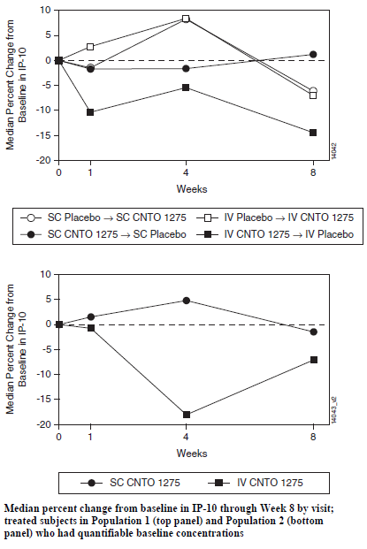
Figure 8: Median percent change from baseline in MCP-1 through Week 8 by visit; treated subjects in Population 1 (top panel) and Population 2 (bottom panel) who had quantifiable baseline concentrations. Study C0379T07
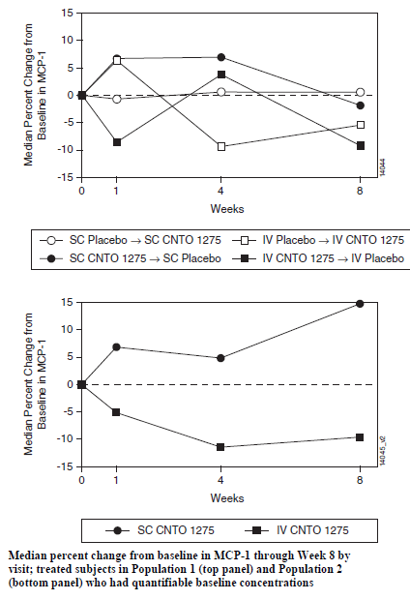
Figure 9: Median percent change from baseline in ENA-78 through Week 8 by visit; treated subjects in Population 1 (top panel) and Population 2 (bottom panel) who had quantifiable baseline concentrations. Study C0379T07
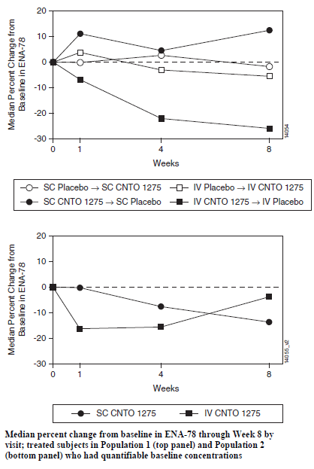

Proteins Associated with Angiogenesis
Both EGF and VEGF are mitogenic for endothelial cells. In addition, VEGF is also angiogenic. Both of these factors were down-regulated following treatment with either IV or SC ustekinumab. For instance, one week following treatment, IV and SC ustekinumab induced a 46.3% and a 30.6% decrease, respectively in EGF expression.

Matrix Metalloproteinase
MMP-3 (matrix metalloproteinase) and MMP-9 are members of a group of zinc-dependent enzymes that are involved in the degradation of extracellular matrix proteins, whereas, TIMP-1 (tissue inhibitor of matrix metalloproteinase 1) serves as a means of control over MMP activity.
One week following IV administration of ustekinumab there was a median percent decrease in all three proteinases ranging from 10.5% to 15.7%. By contrast following SC ustekinumab, MMP-3 expression was unchanged, whereas, MMP-9 decreased 10.6% and TIMP-1 expression increased 12.5%.

Study C0743T26
A second Phase II study, C0743T26, also examined various serum markers following an IV induction dose of 1, 3 or 6 mg/kg ustekinumab followed by SC doses starting at Week 8 in patients with Crohn’s disease. Initial tests established that IL17A was significantly up-regulated in patients with Crohn’s disease compared to healthy controls (p<0.0001) (Figure 10). Then following 22 weeks of ustekinumab treatment, IL17A was significantly down-regulated among patients who demonstrated consistent responses during both induction and maintenance, whereas, there were marginal effects on IL17F expression (Figures 11 and 12). By contrast, no significant modulation was observed among placebo-treated subjects, or ustekinumab non-responders.
Figure 10: Study C0743T26. IL-17A, IL-17F and IL-23 in Crohn’s patients comparing to healthy control.
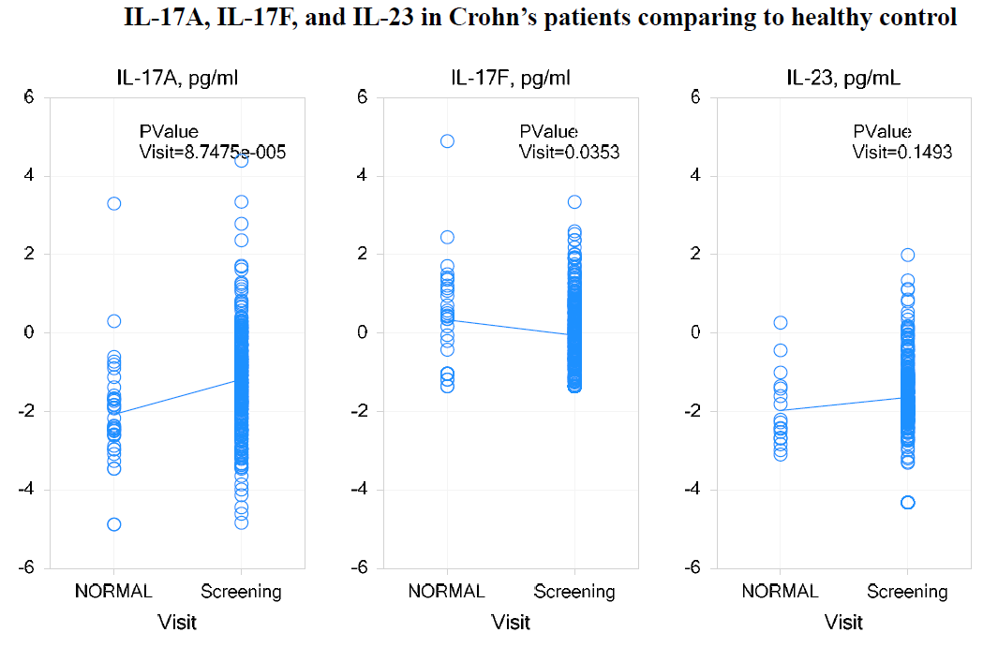
Figure 11: Pilot cohort IL-17A serum levels at week 0 and week 22. Study C0743T26
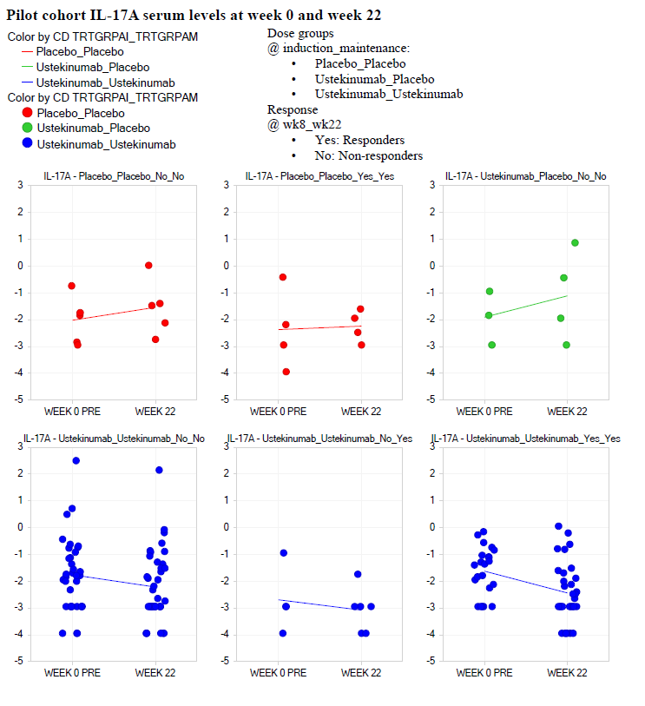
Figure 12: Pilot cohort IL-17F serum levels at week 0 and week 22. Study C0743T26
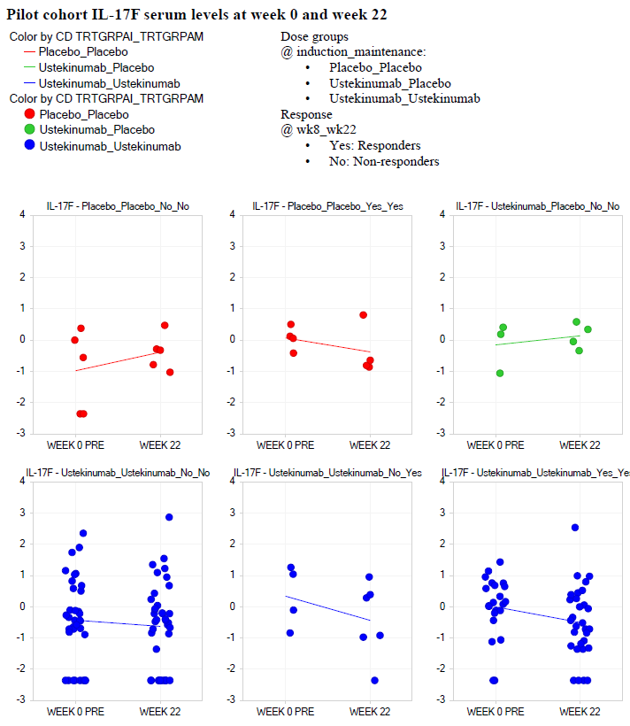
No significant modulation observed among placebo-treated subjects, or ustekinumab non-responders. IL17A was significantly correlated with inflammation markers (CRP, FCAL, and FLAC), but correlation with CDAI was moderate (Table 4). IL17A and/or IL17F in serum differentiate CD sub-types defined by baseline inflammation level (CRP, FCAL, and FLAC), TNF treatment history, presence of Stricture/stenosis, tissue involvement and response to ustekinumab. No differentiation among CD sub-types by disease duration, primary TNF response, or complications of fistula.
Table 4: Correlation of IL-17A and IL-17F with inflammation markers (CRP, fCP, fLF). Study C0743T26
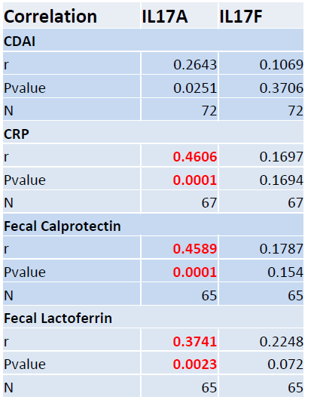
IL17A levels were significantly correlated with the inflammation markers C-reactive protein (CRP), faecal calprotectin (fCAL) and faecal lactoferrin (fLAC), whereas, there was no significant correlation between IL17A or IL17F with Crohn’s disease activity index (CDAI) (Table 4). IL17A and IL17F levels at Week 22 could be used to differentiate between ustekinumab responders (R) and non-responders (NR) at baseline. Significantly different levels of IL-17A were identified in Crohn’s disease subtypes, which can be defined by different levels of the inflammatory markers (CRP, fCP, fLF). By contrast, IL-17F levels were significantly different for the Crohn’s disease phenotypes defined by disease duration, CRP, fCP and the presence of fistula (Table 5).
Table 5: Differentiation of CD subtypes by baseline IL-17A, IL-17F and IL-23. Study C0743T26
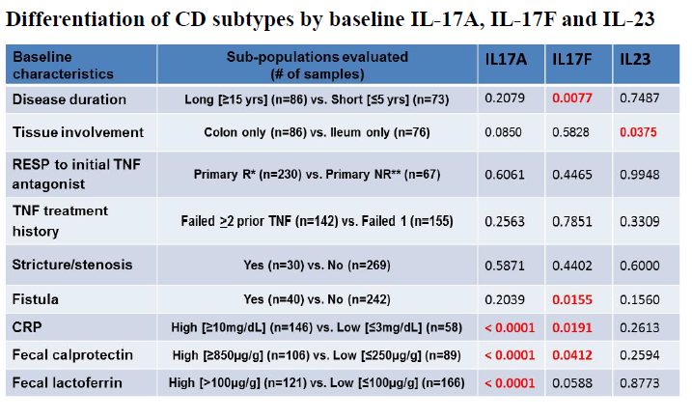

Biomarker Technical Report
The Biomarker Technical Report summarised the serum biomarker results from the three Phase III Studies CRD3001, CRD3002 and CRD3003. Please note in the following discussion of this report a significant change in expression is deemed to occur when the magnitude of the change is ≥1.5-fold.

Differences in serum marker expression between healthy subjects and patients with Crohn’s disease
This report provided further support to the results C0743T26 as compared to healthy subjects, IL17A was also upregulated in the populations with Crohn’s disease in Studies CRD3001 and CRD300). In addition, the populations studied in CRD3001 and CRD3002 had similar serum disease profiles as serum amyloid A (SAA), interferon-γ (IFNγ), IL17A, myeloperoxidase (MPO), creatine kinase isoenzyme-MB (CKMB), IL-8, and TNFα were all differentially expressed in patients with Crohn’s disease compared to healthy subjects. By contrast, levels of IL23, IL12p40, IL17F, IL6, MMP3, and granulocyte macrophage-colony stimulating factor (GMCSF) were similar in patients with Crohn’s disease and healthy subjects. In addition, some differences in the expression profiles between the Crohn’s disease populations in CRD3001 and CRD3002were also identified as haptoglobin, MMP1 and MMP9 were significantly dysregulated in Study CRD3002 but not in CRD3001.

Baseline serum marker levels in responder (R) and non-responder (NR)
Although within each study certain serum markers were elevated at baseline in R as opposed to NR, none of the markers could be used to consistently identify or distinguish between R and NR at baseline across Studies CRD3001 and CRD3002.

Effects of an induction dose of ustekinumab on serum markers in R and NR
Following an induction dose of ustekinumab, marker levels were compared and assessed at 3 and 6 weeks in R (CDAI decrease from screening >100) and NR (CDAI decrease from screening as <100) in Studies CRD3001 and CRD3002.
By the third week following induction dosing a number of inflammatory markers, including SAA, CRP and IL-6, which were elevated at baseline, were significantly reduced in both R and NR, albeit with reduced potency in NR. Whereas, IFNγ was reduced by a similar magnitude in both R and NR and as expected, levels of IL-12p40 increased following treatment in all subjects treated with ustekinumab due to the formation of circulating antibody/ligand complexes. By contrast, no consistent changes in marker levels were identified at both the 3 week and 6 week time points in placebo treated subjects.

Effects of maintenance dosing with ustekinumab on serum markers in R
In Study CRD3003, the effect of ustekinumab maintenance therapy on serum markers was examined in a population of R who had been identified in Studies CRD3001 and CRD3002. These subjects were randomised in a 1:1:1 ratio at Week 0 of CRD3003 study to receive either SC placebo, ustekinumab 90 mg SC q12w (with final dose at Week 36) or ustekinumab 90 mg SC q8w (with final dose at Week40. In contrast, to induction therapy, following maintenance therapy R experienced a significant reduction in IL17A and CKMB increased from the decreased levels seen at baseline compared to healthy controls. In addition, maintenance therapy resulted in significant reduction in MMPs in the CRD3002 population, whereas, MMPs were not elevated in the CRD3001 population.

Immunohistochemical Analyses of Biopsies
The two Phase II studies (C0379T07 and C0743T26) also used immunohistochemical techniques to examine the expression of various markers in biopsies of ileum and/or colonic mucosa taken from a sub-set of patients.
In Study C0379T07 biopsies of colonic mucosa were obtained from 10 subjects in the placebo groups and 9 subjects in the ustekinumab treatment groups in Population 1 and 8 ustekinumab-treated subjects from Population 2. In the biopsies taken from Population 1 there was little change in expression of the apoptosis marker, FAS, from baseline by Week 8 following treatment with placebo (0.8%). By contrast, subjects who received either IV or SC ustekinumab at Week 0, the number of FAS expressing cells increased by 3.1% from baseline to Week 8. Similarly, for the apoptosis marker caspase 3 treatment with placebo at week o resulted in a -0.7% decrease caspase 3 expressing cells by week 8, whereas, treatment with either IV or SC ustekinumab resulted in a 0.2% increase in caspase expressing cells by week 8.
In Study C0743T26 biopsies of colon and ileum from patients with Crohn’s disease displayed transcript dysregulation in both the inflamed and non-involved areas compared to tissues taken from healthy subjects (Table 6). Following ustekinumab treatment, the disease profile of colon and ileum including IL-12 receptor B1, IL-23, IL-6, and SAA showed significant resolution in responders (>25% of genes dysregulated in the disease profile are normalised by Week 6 and maintained or further normalised by Week 22) while no significant changes were observed in non-responders or placebo treated patients (Figures 13 and 14).
Table 6: Transcripts dysregulated in Crohn’s Disease Colon and Ileum as compared to Normal Study C0743T26
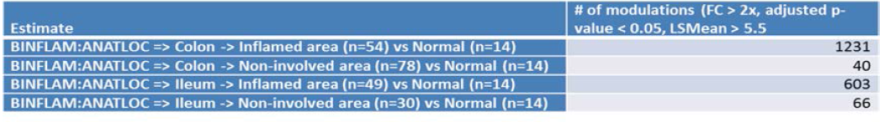
Figure 13: Top canonical pathways in CD colon disease profile or ustekinumab treatment signatures. Study C0743T26
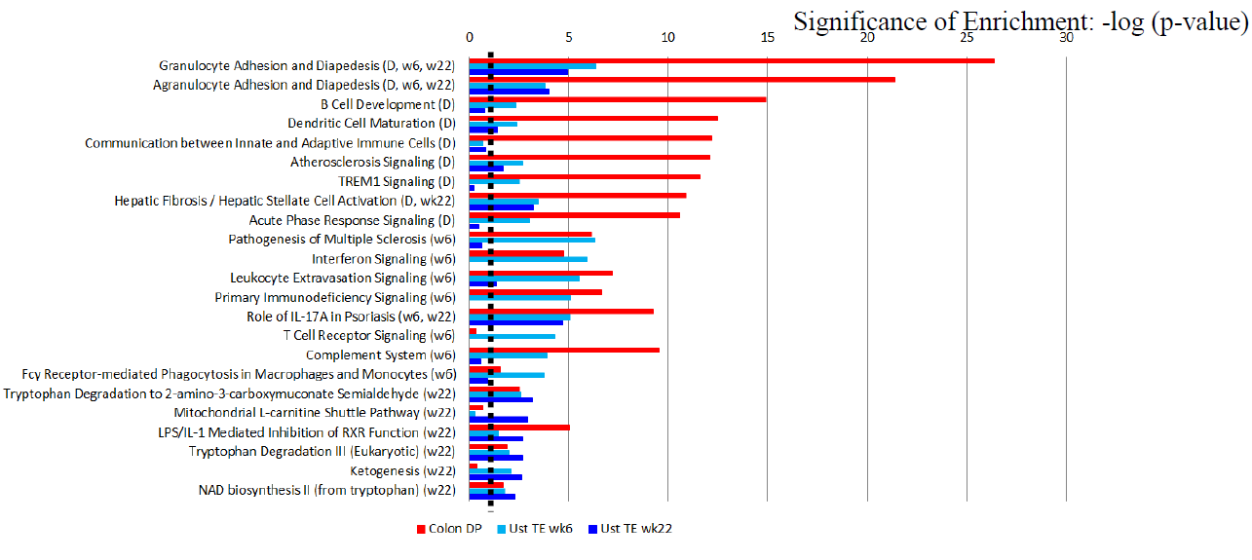
Figure 14: Top canonical pathways in CD Ileal disease profile or ustkinumab treatment signatures. Study C0743T26
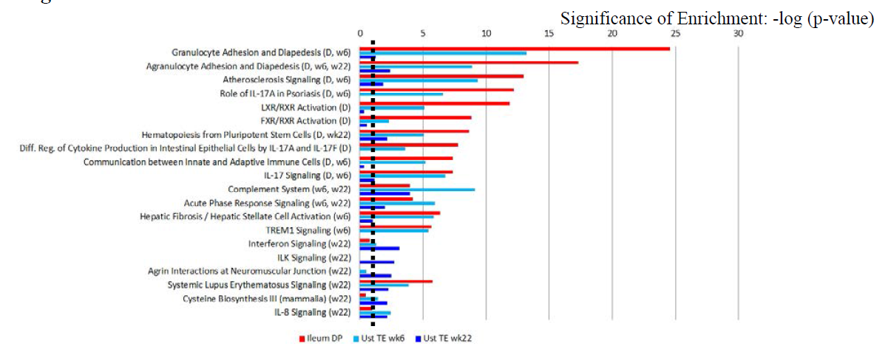

Secondary pharmacodynamic effects

Immunogenicity

Healthy subjects
In Study NAP1002 following a single ustekinumab 6 mg/kg IV infusion, 2 of 139 subjects (1.4%, one in each ustekinumab 6 mg/kg group) were positive for antibodies to ustekinumab with low titres (1:50).

Crohn’s Disease
One Phase II study and the three Phase III studies examined the incidence of antibodies to ustekinumab following treatment in patients with Crohn’s disease. Overall the incidence of antibodies to ustekinumab was very low. For instance, in Study C0379T07 none of the subjects were positive for antibodies to ustekinumab. Similarly in Studies CRD3001, CRD3002 and CRD3003 only 0.2%, 0.2% and 2.3%, respectively, of subjects were positive for antibodies to ustekinumab.

Time course of pharmacodynamic effects
Please see the preceding sections of this report.
Overall, it would appear that the onset of PD effects following treatment with ustekinumab occurs sooner following IV dosing than following SC dosing. In addition, SC dosing for three to four weeks is required to attain similar plasma concentration levels of ustekinumab to that obtained by a single IV dose and in some cases to induce similar PD effects.

Relationship between drug concentration and pharmacodynamic effects
Following induction dosing with ustekinumab in Studies CRD3001 and CRD3002, serum ustekinumab concentrations at Week 8 were positively associated with the proportions of subjects achieving remission at Week 8 (Figure 15).
Figure 15: Proportion of Subjects in Clinical Remission at Wk 8 by serum ustekinumab concentration at Wk 8; randomised subjects in CNT01275CRD3001 and CNTO1275CRD3002
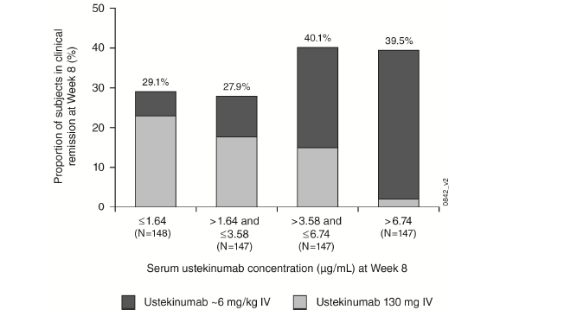
In Study CRD3003, during maintenance therapy with ustekinumab administered either q8w or q12w, a positive association was observed between serum ustekinumab concentration and the clinical efficacy outcomes of clinical response and clinical remission (Figure 16). For instance, in the quartile containing the lowest serum ustekinumab concentrations, the lowest remission rates were observed and a substantial majority of subjects were receiving the q12w regimen and not the q8w regimen (Figure 16).
Figure 16: Proportion of subjects in clinical remission at week 24 and week 44 by trough serum ustekinumab concentration; randomised subjects in CNTO1275CRD3003
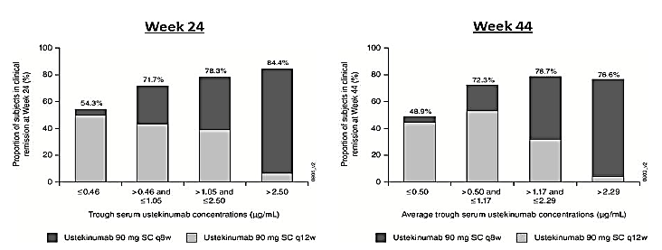
Among subjects receiving maintenance ustekinumab, no apparent impact on clinical efficacy was observed following the development of antibodies to ustekinumab. Because of the limited number of subjects who were positive for antibodies to ustekinumab, these analyses should be interpreted with caution.

Genetic, gender and age related differences in pharmacodynamic response
No studies examined the effects of genetic, gender or age related differences in PD response.

Pharmacodynamic interactions
No studies examined PD interactions of ustekinumab.

Evaluator’s overall conclusions on pharmacodynamics
- Stelara is a human IgG1kappa monoclonal antibody that specifically binds to the shared p40 protein subunit of the human cytokines IL-12 and IL-23, which prevents p40 from binding to the IL-12Rbeta1 receptor protein expressed on the surface of immune cells.
- In general, compared to placebo, inflammation-related markers in serum, including cytokines, chemokines, mitogens and matrix metalloproteinase, were lower at Weeks 1, 4, and 8 following a single administration of IV ustekinumab, whereas, subjects receiving SC ustekinumab also showed changes in biomarker expression, though generally at later time-points.
- In contrast, serum levels of the inflammatory cytokine IL-12p40, which is the target antigen for ustekinumab, increased up until week 4 of treatment and the elevated levels were maintained up until Week 8 following treatment with either SC or IV ustekinumab. This represented IL-12p40 complexed with ustekinumab and was therefore inactive. Serum levels of regulated on activation, normal T cell expressed and secreted (RANTES), which plays a role in both promoting and controlling inflammation, was also increased following IV administration of ustekinumab.
- IL17A was significantly up-regulated in patients with Crohn’s disease compared to healthy controls (p<0.0001); however, 22 weeks following an IV induction dose of ustekinumab and SC doses starting at Week 8, IL17A was significantly down-regulated among patients who demonstrated consistent responses during both induction and maintenance, whereas, there were marginal effects on IL17F expression. By contrast, no significant modulation was observed among placebo-treated subjects, or ustekinumab non-responders.
- IL17A levels were significantly correlated with the inflammation markers CRP, fCAL and fLAC, whereas, there was no significant correlation between IL17A or IL17F with CDAI.
- Significantly different levels of IL-17A were identified in Crohn’s disease subtypes, whereas, IL-17F levels were significantly different for the Crohn’s disease phenotypes.
- The populations with Crohn’s disease in CRD3001 and CRD3002 had similar serum marker profiles and the patterns of expression for SAA, IFNγ, IL17A, MPO, CKMB, IL-8, and TNFα were different to those seen in healthy subjects. By contrast, levels of IL23, IL12p40, IL17F, IL6, MMP3, and GMCSF were similar in both diseased patients and healthy subjects.
- None of the markers measured consistently discriminated between R and NR at baseline across the CRD3001 and CRD3002 study populations with response defined as a decrease in CDAI of at least 100 points from baseline.
- IFNγ was identified as a PD marker and was significantly modulated by ustekinumab in both responders and non-responders following induction treatment.
- SAA, CRP and IL-6 were significantly modulated by ustekinumab in responders and less so or not at all in non-responders following both induction and maintenance therapy.
- IL-12p40 levels increased following treatment with ustekinumab, due to the presence of the circulating antibody/ligand complex. A similar trend was observed for IL-23p19.
- Induction therapy had no effect on the baseline levels of IL17A, TNFα, MPO, CKMB, IL-8, or haptoglobin, whereas, maintenance therapy resulted in a significant reduction in IL17A in R and increases in CKMB relative to decreased levels seen at baseline compared to healthy controls.
- Biopsies of colon and ileum from patients with Crohn’s disease displayed transcript dysregulation in both the inflamed and non-involved areas compared to tissues taken from healthy subjects.
- In biopsies of colonic mucosa there was little change in expression of the apoptosis marker, FAS, following treatment with placebo (0.8%), whereas, in subjects who received either IV or SC ustekinumab at Week 0 the number of FAS expressing cells increased by 3.1% from baseline to Week 8. A similar pattern was identified for caspase 3; however, the magnitude of the difference between placebo and active drug treatment was much smaller (0.9%).
- Following ustekinumab treatment, the disease profile of colon and ileum including IL-12 receptor B1, IL-23, IL-6, and SAA showed significant resolution in responders (>25% of genes dysregulated in the disease profile are normalised by Week 6 and maintained or further normalised by Week 22) while no significant changes were observed in non-responders or placebo treated patients.
- Following treatment with ustekinumab the number of subjects (either healthy or with Crohn’s disease) who were positive for antibodies to ustekinumab was low and ranged from 0.2% to 2.3% of the study population. During maintenance ustekinumab therapy, no apparent impact on clinical efficacy was observed following the development of antibodies to ustekinumab, but interpretation was limited by low incidence of antibody development.
- A positive association was observed between serum ustekinumab concentration and clinical remission following both induction and maintenance dosing with ustekinumab.
- In the lowest serum ustekinumab concentration quartile where the lowest remission rates were observed, a substantial majority of subjects were receiving a q12w regimen and not a q8w regimen.

Dosage selection for the pivotal studies

Pharmacokinetics and pharmacodynamics: dose finding studies
No new data.

Phase II dose finding studies

Phase IIa Study C0379T07
This was a Phase IIa, randomised, blinded, placebo-controlled, proof-of-concept study with primary objective to determine the efficacy of CNTO 1275 (ustekinumab) in reducing the signs and symptoms of Crohn’s disease in subjects with moderately to severely active disease or fistulising Crohn’s disease of at least 6 weeks duration with a CDAI score of ≥ 220 and ≤ 450. In Population 1, subjects must have had active disease despite treatment with 5-ASA compounds, antibiotics, corticosteroids, and/or immuno-modulators. This study also included an open-label evaluation in subjects who failed to respond to infliximab at the maximum approved dose and treatment regimen for Crohn’s disease as defined in the US package insert (Population 2). Details about study design, methodology, inclusion/exclusion criteria, efficacy endpoints an, efficacy and safety results were provided.
Overall, 104 subjects in Population 1 were randomised at baseline to 1 of 4 treatment groups:
- SC placebo at Weeks 0, 1, 2, and 3 and SC CNTO 1275 (90 mg) at Weeks 8, 9, 10, and 11;
- SC CNTO 1275 (90 mg) at Weeks 0, 1, 2, and 3, and SC placebo at Weeks 8, 9, 10, and 11;
- IV placebo at Week 0 and IV CNTO 1275 (4.5 mg/kg) at Week 8;
- IV CNTO 1275 (4.5 mg/kg) at Week 0 and IV placebo at Week 8.
Another 27 subjects in Population 2 were randomised at baseline to receive SC CNTO 1275 (90 mg) at Weeks 0, 1, 2, and 3; or IV CNTO 1275 (4.5 mg/kg) at Week 0 (Table 7).
Table 7: Phase IIa Study C0379Y07. Dosing Scheme for Population 1
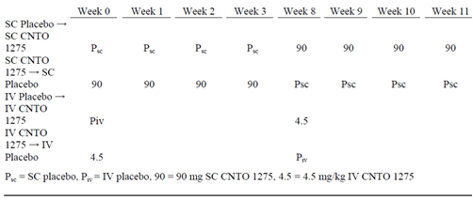
In Population 1 (subjects with active disease despite treatment with 5-ASA compounds, antibiotics, corticosteroids, and/or immuno-modulators), the primary endpoint of clinical response at Week 8 (defined by a ≥ 25% and ≥ 70-point CDAI reduction from baseline) showed a greater separation from placebo following ustekinumab IV (4.5mg/kg) [placebo: 29.6%,(8/27); IV: 50% (13/26)] compared with SC (90mg) dosing [placebo: 50%,(13/26); SC: 48% (12/25)], although the difference from placebo was not statistically significant for either ustekinumab groups.
Similar results were observed for clinical remission at week 8 [placebo: 11.1% (3/27); IV: 26.9% (7/26)] and [placebo: 23.1% (6/26); SC: 24% (6/25)]. For the subset of subjects with prior infliximab experience, a significantly greater proportion of subjects both the SC and IV CNTO 1275 treatment group were in clinical response at Week 8 compared with placebo but the difference was much greater following the IV ustekinumab dosing. Consistent with this finding, the overall benefit observed following administration of CNTO 1275 was more discernible in subjects with more severe disease as evidenced by baseline disease activity (that is, CDAI), prior use of corticosteroids and immuno-modulators, and exposure to prior anti-TNF therapy (Figure 17). Although sample sizes were small, it appeared that response rates for SC CNTO 1275 were dependent on baseline body weight because lighter subjects had a greater response (Figure 17).
Figure 17: Odds ratio (vertical bars) and 95% CI (horizontal bars) for comparing the proportion of subjects in clinical response at week 8 in the combined CNTO1275 groups versus the combined placebo groups by baseline weight and disease characteristics; randomised subjects in Population 1.
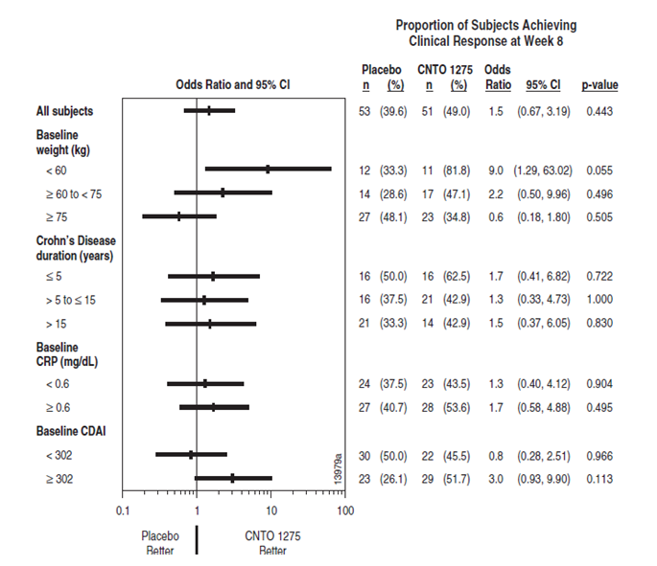
In subjects with moderately to severely active Crohn’s disease, who did not respond to or lost response to infliximab based on US prescribing information (Population 2), treatment with SC or IV CNTO 1275 showed that the proportion of subjects in clinical response at Week 8 following SC (42.9%, 6/14) and IV (53.8%, 7/13) ustekinumab was similar to that seen in Population 1.
Comments: This was the first study to evaluate ustekinumab in treatment of Crohn’s disease in subjects with moderate to severe Crohn’s disease despite treatment with 5-ASA compounds, antibiotics, corticosteroids, and/or immuno-modulators, including anti-TNF agents. When considering the selection of a route of administration for continued clinical development, it is important to note that although the proportion of subjects in clinical response to CNTO 1275 was similar for both the IV and SC routes of administration with no significant difference from placebo, the separation from placebo was numerically greater following IV (4.5mg/kg) compared with SC (90mg) dosing with ustekinumab. No notable differences in safety profiles were observed for the two routes of administration. However, there was a generally more rapid impact on serum biomarkers following IV compared with SC administration which supported the use of IV induction therapy for continued clinical development.

Phase IIb Study C0743T26: CERTIFI (Crohn’s Evaluation of Response to Ustekinumab anti-IL12/23 for Induction)
This was randomised, double-blind, placebo-controlled, parallel-group, dose-ranging, Phase IIb study. The primary objective was to evaluate the efficacy of ustekinumab in inducing clinical response, and to evaluate the safety of ustekinumab in subjects with moderately to severely active Crohn’s disease who had received treatment with 1 or more TNF antagonists and had not responded initially, responded and then lost response, or were intolerant to this therapy at a dose approved for Crohn’s disease. Secondary objectives were: to evaluate the efficacy of ustekinumab in inducing clinical remission, fistula response, and mucosal healing; to obtain data to support selection of a maintenance dose regimen for continued clinical development; to explore the pharmacokinetics and pharmacodynamics of ustekinumab therapy; and to evaluate the efficacy of ustekinumab in achieving delayed clinical response. The study design is summarised in Figure 18. The study was conducted from 21 Oct 2008 to 9 Dec 2010 at 153 sites in North America, Europe and Australia. Details regarding study design, inclusion/exclusion criteria, study treatment, efficacy endpoints, and statistical methods were provided.
Figure 18: Study design for C0743T26: (A) study treatments; (B) key time points. Phase IIb Study C0743T26
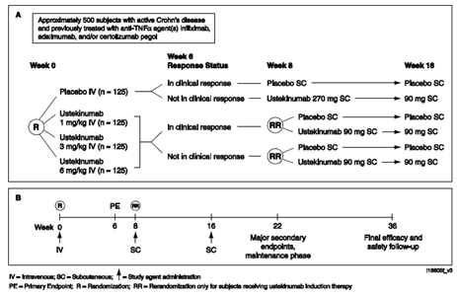
In the induction phase, subjects were randomised to receive placebo or 1 mg/kg, 3 mg/kg, or 6 mg/kg IV ustekinumab at Week 0. In the maintenance phase, subjects who were in clinical response to IV ustekinumab at Week 6 were re-randomised (1:1 ratio) at Week 8 to receive an SC maintenance regimen of placebo or ustekinumab 90 mg at Week 8 and Week 16. Those who were not in clinical response at Week 6 were re-randomised in a 1:1 ratio at Week 8 to receive a SC maintenance regimen of either placebo or ustekinumab 90 mg at Week 8 and Week 16. Subjects who were randomised to placebo induction dosing were not re-randomised at Week 8: those in clinical response to IV placebo induction dosing at Week 6 continued to receive placebo via SC injections at Week 8 and Week 16; those who were not in clinical response to IV placebo induction dosing at Week 6 received ustekinumab 270 mg as three 90 mg SC injections at Week 8 and then a ustekinumab 90 mg SC injection at Week 16.
Comment: Selection of the three IV ustekinumab induction regimens (1, 3, or 6 mg/kg at Week 0) for C0743T26 was guided by a subgroup analysis of the pharmacokinetics of ustekinumab and response rate in Study C0379T07, which demonstrated a relationship between ustekinumab Cmax and response rate in subjects whose Crohn’s disease had not worsened 4 weeks after administration of ustekinumab 4.5 mg/kg IV (that is, subjects’ CDAI at 4 weeks after ustekinumab administration was not increased relative to baseline). The 6 mg/kg dose represented an incremental (33.3%) increase in drug exposure relative to that observed in Study C0379T07, which could potentially lead to greater efficacy. A dose of 3 mg/kg (representing a 33.3% decrease in drug exposure compared with the 4.5 mg/kg dose) was also evaluated to further define the therapeutic window of ustekinumab in Crohn’s disease. The 1 mg/kg IV dose was chosen as the dose for the lowest arm in the induction phase of this study. It approximates the initial SC regimen demonstrated to be efficacious in psoriasis and PK modelling identified 1.12 mg/kg as the appropriate loading dose to rapidly reach maintenance steady state trough levels (at Week 8).
A maintenance regimen of ustekinumab 90 mg SC injections every 8 weeks was selected based on the observation that subjects in response in C0379T07 demonstrated a tendency to lose their clinical response when serum ustekinumab concentrations decreased to less than 1 to 2 μg/mL. Based on PK modelling, an ustekinumab regimen of 90 mg every 8 weeks should provide a steady state serum trough level of 1.69 μg/mL. Subjects randomised to IV placebo induction who were not in clinical response at Week 6 were to receive ustekinumab 270 mg at Week 8. The 270 mg dose was chosen because PK modelling predicted that it would produce a PK profile intermediate between that of the ustekinumab 1 mg/kg and 3 mg/kg IV induction doses used in this study.
Subject disposition: A total of 526 subjects were randomly assigned to receive study agent during the induction phase at 153 sites in North America (277 subjects), Europe (238 subjects), and Australia (11 subjects). In the maintenance phase, 72 IV ustekinumab responders were randomised to SC ustekinumab and 73 IV ustekinumab responders were randomised to SC placebo, 109 IV ustekinumab non-responders were randomised to SC ustekinumab, 110 IV ustekinumab non-responders were randomised to SC placebo, 28 responders to IV placebo received SC placebo, and85 non-responders to IV placebo received 270 mg followed by 90 mg SC ustekinumab.
In the induction phase, a total of 49 subjects (9.3%) discontinued study agent with higher incidence of discontinuations in placebo group (14.4%) compared with the ustekinumab groups (7.6%). Slightly more than half discontinued study agent due to either unsatisfactory therapeutic effect or an AE of Crohn’s disease, each of which occurred in at least twice as many subjects in the placebo group than in any of the ustekinumab groups. During the maintenance phase, a total of 63 subjects (13.2%) discontinued study agent. Among subjects who were randomised as responders to ustekinumab induction, a greater proportion of subjects in the SC placebo group (13.7%) discontinued study agent compared with subjects in the SC ustekinumab group (6.9%) Among subjects who were randomised as non-responders, a greater proportion of subjects in the SC placebo group (20.0%) discontinued study agent compared with subjects in the SC ustekinumab group (15.6%). The most common reasons for discontinuation were unsatisfactory therapeutic effect and AE (the majority of which were an AE of Crohn’s disease).
Of the 526 randomised subjects, 82 had a major protocol deviation at some point during the study (from randomisation through Week 36); the proportions were similar across the 4 treatment groups. Deviations varied in nature but are not considered to have any clinically relevant impact on data integrity. Major protocol deviations for Study C0743T26 were categorised as follows: subjects who entered the trial but did not satisfy entry criteria; subjects who developed withdrawal criteria during the trial but were not withdrawn; subjects who received the wrong medication or incorrect dose; subjects who received disallowed concomitant medication; and other major protocol deviations.
Baseline characteristics: Of the 526 subjects randomised in the induction phase, 309 (58.7%) were women; 490 (93.2%) were Caucasian. The median age was 38.0 years and median weight was 69.0 kg. Baseline demographic characteristics were generally similar across the 4 induction treatment groups, although the number of male subjects in the placebo group was slightly higher compared with the other groups. The median duration of Crohn’s disease was 10.34 years, the median CDAI score was 316.0, and the median IBDQ score was 116.0. Disease characteristics were generally similar across the 4 treatment groups; however, the median CDAI scores in the ustekinumab 3 mg/kg and 6 mg/kg groups were slightly higher (327.0 and 333.0, respectively) compared with those in the ustekinumab 1 mg/kg and placebo groups (306.0 and 302.5, respectively), and median CRP concentrations in the ustekinumab groups were slightly higher (11.80 mg/L, 13.00 mg/L, and 12.60 mg/L in the 1, 3, and 6 mg/kg groups, respectively) compared with that in the placebo group (9.34 mg/L). Additionally, more subjects in the ustekinumab 6 mg/kg group (82) had extraintestinal manifestations than in placebo and ustekinumab 1 and 3 mg/kg groups (68, 68, and 67 subjects, respectively). At baseline, 14.6% of the subjects had 1 or more draining fistulas and 4.4% had a stoma (draining ileostomy or colostomy). Overall, 25.3%, 28.9% and 44.7% of subjects had disease in the ileum, colon and both (ileum and colon), respectively; proximal GI tract disease was present in 10.1% of all subjects. A total of 216 subjects (41.1%) reported a history of Crohn's disease-related small- or large-bowel resection, and 89 subjects (16.9%) had a history of small-bowel stricture. Subject numbers were generally balanced across the 4 induction treatment groups.
Baseline demographics and disease characteristics in the maintenance phase were generally similar between the SC placebo and ustekinumab 90 mg SC groups among both the subjects who were randomised as responders and those who were randomised as non-responders. However, slightly more subjects in the SC placebo treatment group, among both responders and non-responders, had CD involved in the ileum only, while slightly more subjects in the ustekinumab 90 mg SC group had CD involved in the colon only. Responders to IV placebo had a lower mean CRP than all other treatment groups. At baseline, 216 of 525 subjects (41.1%) had cardiovascular risk factors including hyperlipidaemia, hypertension, diabetes mellitus, family history of early coronary artery disease, or current smoking status; 52 subjects (9.9%) had 2 or more cardiovascular risk factors. The most common risk factor was current smoking (135 subjects [25.7%]). Thirty of 523 subjects (5.7%) had current or past atherosclerotic cardiovascular disease (ASCVD); approximately half of those subjects (14/522 [2.7%]) had a history of ischemic heart/coronary artery disease.
In the induction phase, the proportions of subjects receiving each class of Crohn’s disease medication at baseline were similar across the 4 treatment groups. Approximately 50% of subjects were receiving corticosteroids at baseline with similar median dose across treatment groups (overall median dose of 20 mg/day of prednisone or its equivalent). Among all subjects, 24.0% were receiving immuno-modulatory agents (6-mercaptopurine, azathioprine, or methotrexate) and 17.3% were receiving 5-ASA compounds at baseline; 90% of subjects had received immuno-modulators in the past; of those, 85.9% had previously failed or become intolerant to these agent.
To enter Study C0743T26, subjects had to have failed at least 1 TNF antagonist in the past, that is, had an inadequate initial response, had a response following by loss of response, or been intolerant; sites were instructed to record all agents and failure criteria that subjects met. The proportions of subjects in each of these categories were well balanced across treatment groups. Approximately 50% had failed 1 TNF antagonist in the past, 40% had failed 2 TNF antagonists, and 10% had failed 3 TNF antagonists. Among all subjects, 30.4% had an inadequate initial response to 1 or more TNF antagonists, 72.2% had response followed by loss of response to 1 or more TNF antagonists, and 33.5% had intolerance to 1 or more TNF antagonists. Summary of concomitant medications for Crohn’s disease at baseline in the maintenance phase was also similar across treatment groups.
Main efficacy results (induction phase): A greater proportion of subjects in the ustekinumab 1 mg/kg, 3 mg/kg and 6 mg/kg treatment groups was in clinical response at Week 6 (36.6%, 34.1%, and 39.7%, respectively) compared with the placebo treatment group (23.5%), and the comparison between the ustekinumab 6 mg/kg treatment group and the placebo treatment group was statistically significant (p = 0.005).
Comment: Although the nominal p-value for the comparison of the 1 mg/kg ustekinumab treatment group with placebo was < 0.05, the 1 mg/kg ustekinumab treatment group could not be considered to be significantly different from placebo because in the fixed-sequence testing procedure, the comparison of the 3 mg/kg ustekinumab treatment group with placebo was not statistically significant (p = 0.057).
The result of the sensitivity analysis was consistent with the results of the primary analysis. The consistency of the efficacy of ustekinumab (proportion of subjects in clinical response at Week 6) was also evaluated for each ustekinumab induction group versus placebo in the following categories: by demographics and baseline disease characteristics, by concomitant medications at baseline and Crohn’s disease-related drug history and by TNF antagonist therapy history.
Within each of the subgroups, the effect was generally consistent with that seen in all subjects. In particular, a consistent response to ustekinumab was shown in subjects with an inadequate initial response to a TNF antagonist (that is, primary non-responders), those who had a response followed by a loss of response (that is, secondary non-responders), and those who were intolerant to a TNF antagonist for each of the ustekinumab treatment groups compared with the placebo treatment group. A differentially greater response to ustekinumab was observed in subjects who had failed at least 2 TNF antagonists compared with those who had failed only 1 TNF antagonist (odds ratio: 5.4 versus 1.1, respectively, in the 6 mg/kg ustekinumab treatment group.); this differential response was also present in the 1 mg/kg and 3 mg/kg ustekinumab treatment groups.
There were no significant differences between the ustekinumab groups and placebo in clinical remission at Week 6 (defined as CDAI score of <150 points). A greater proportion of subjects who were randomised to the ustekinumab 1 mg/kg, 3 mg/kg, and 6 mg/kg treatment groups (27.5%, 37.1%, and 30.5%, respectively) were in clinical response at Week 4 compared with the placebo group (16.7%).
Comment: Although the nominal p-values for the comparisons of each of the ustekinumab groups with placebo were < 0.05 for this endpoint (clinical response at Week 4), the 3 ustekinumab groups could not be considered to be significantly different from placebo because the prior comparisons in the fixed-sequence testing procedure (for clinical remission at week 6) were not positive.
Main efficacy results (maintenance phase): Among subjects randomised as responders to ustekinumab induction, the proportion of subjects in clinical remission at Week 22 was significantly greater in the ustekinumab 90 mg SC group (41.7%) than in the SC placebo group (27.4%, p = 0.029). Based on the prespecified fixed-sequence testing procedure in the SAP, because the test of the highest ustekinumab dose (6 mg/kg) compared with placebo for the primary analysis was positive, the test for clinical remission at Week 22 in the maintenance phase was allowed to be claimed statistically significant. Clear separation in the proportion of subjects in clinical remission was apparent beginning at Week 16. Approximately 20% of subjects randomised as non-responders attained response at Week 22 in both the SC placebo and SC ustekinumab treatment groups.
Other efficacy results in induction phase: A significantly greater proportion of subjects in the ustekinumab 1 mg/kg, 3 mg/kg, and 6 mg/kg treatment groups were in clinical response at Week 8 (32.1%, 31.8%, and 43.5%, respectively) compared with the placebo treatment group (17.4%) [p = 0.006, p = 0.007, p < 0.001]), with a greater proportion of subjects in the 6 mg/kg ustekinumab group being in clinical response compared with the other ustekinumab treatment groups. Compared with rates of clinical response through the Week 6 primary endpoint, rates of response were higher at Week 8 in the 6 mg/kg group and lower in the 1 and 3 mg/kg groups. A greater proportion of subjects in the ustekinumab 1 mg/kg, 3 mg/kg, and 6 mg/kg treatment groups were in clinical remission at Week 8 (17.6%, 18.2%, and 18.3%, respectively) compared with the placebo treatment group (10.6%). The proportion of subjects in clinical remission at the high dose (6 mg/kg) increased from 12.2% at Week 6 to 18.3% at Week 8. At Week 4, the proportion of subjects in clinical remission was significantly greater in the ustekinumab 3 mg/kg group (18.9%) than in the placebo group (9.1%, p = 0.022); the ustekinumab 1 mg/kg and 6 mg/kg groups were similar to the placebo group (10.7% and 12.2%, respectively).
At Week 4, Week 6, and Week 8, a significantly greater proportion of subjects had a reduction from baseline in the CDAI score of ≥ 70 points in each of the ustekinumab treatment groups compared with the placebo group. There was a significantly greater reduction in CDAI score in each of the ustekinumab groups compared with placebo at Week 4, Week 6 and Week 8. The proportion of subjects who achieved fistula response was numerically higher (although not significant) in the ustekinumab 6 mg/kg group compared with all other groups at all 3 time points, especially at Week 6 (47.1%, 10%, 15.8% and 21.4% in the ustekinumab 6 mg/kg, 3mg/kg, 1mg/kg and placebo groups, respectively). However, interpretation was limited as only 61 of the 526 subjects had fistula at baseline. At baseline, 12 subjects in the placebo group and 47 subjects in the combined ustekinumab groups were assessed as having ulcerations. At Week 6, 8 of 41 evaluable subjects (19.5%) in the combined ustekinumab groups had mucosa healing, compared with 1 of 9 evaluable subjects (11.1%) in the placebo group. Proportions were similar among the 3 ustekinumab groups.
Reductions in mean CRP were apparent for all 3 ustekinumab groups as soon as Week 4. At all visits, there was a significantly greater reduction in CRP concentration in each of the ustekinumab treatment groups compared with the placebo treatment group A significantly greater proportion of subjects in the 6 mg/kg ustekinumab treatment group who had abnormal CRP levels at baseline had normalised CRP levels (<3mg/L) at Week 6, compared with the placebo group (19.8% versus 8.9%, p = 0.026). At Week 8, some dose-response was notable, with more subjects with normalised CRP levels in the 3 mg/kg and 6 mg/kg ustekinumab treatment groups (17.3% and 20.8%, respectively); response in the placebo and 1 mg/kg groups was lower and similar (5.9% and 5.7%, respectively). At both Week 4 and Week 6, there was a significantly greater reduction in faecal lactoferrin concentrations in all ustekinumab treatment groups compared with the placebo group (p < 0.05 for all comparisons). At Week 6, the reduction in faecal calprotectin was significant in the 1 mg/kg and 6 mg/kg groups compared with placebo (p = 0.044 and p = 0.024, respectively). The magnitude of the reduction in faecal lactoferrin and faecal calprotectin concentrations at Week 6 was greater in the 6 mg/kg group than in the 1 and 3 mg/kg groups.
For the 1, 3, and 6 mg/kg IV ustekinumab doses, mean improvement from baseline in IBDQ at Week 6 (19.9, 22.7 and 24.8, respectively) was statistically significant compared with that seen in the placebo group (11.8) (p < 0.05 for all comparisons). At Week 6, IBDQ dimension scores (bowel symptoms, emotional function, systemic symptoms, and social function) were each significantly improved from baseline in the combined IV ustekinumab groups compared with the IV placebo group (p < 0.05 for all comparisons). At Week 6, a greater proportion of subjects randomised to the ustekinumab 1 mg/kg, 3 mg/kg and 6 mg/kg treatment groups (45.0%, 47.7% and 54.7%, respectively) had a ≥ 16-point improvement from baseline in IBDQ scores compared with the placebo group (33.1%); this improvement was significant for subjects in the 3 and 6 mg/kg groups (p = 0.018 and p < 0.001, respectively).
Other efficacy results in maintenance phase: Among subjects randomised as responders to ustekinumab induction, the proportion of subjects in clinical response at Week 22 was significantly greater in the SC ustekinumab treatment group (69.4%) than in the SC placebo group (42.5%, p < 0.001). Clear separation in the proportion of subjects in clinical response was apparent beginning at Week 16. Among responders randomised to SC ustekinumab, no appreciable difference in the proportion of subjects in clinical response was observed at Week 22 based upon induction dose received. Among those randomised to SC placebo, however, the proportion of subjects in clinical response declined earlier among those who received lower induction doses. Among subjects randomised as responders to ustekinumab induction, the proportion of subjects in sustained clinical response at Week 22 (that is, in clinical response at Weeks 12, 16, 20, and 22) was significantly greater in the SC ustekinumab group (55.6%) than in the SC placebo group (32.9%, p = 0.005). In addition to the major secondary endpoint of clinical remission at Week 22 among subjects randomised as responders to ustekinumab induction, clinical remission was assessed among subjects who were in clinical remission at Week 6. In this population, the proportion of subjects in clinical remission at Week 22 was greater in the SC ustekinumab group (78.6%) than in the SC placebo group (53.3%, p = 0.056). Similarly, sustained clinical remission at Week 22 was assessed for subjects randomised as responders to ustekinumab induction who were in clinical remission at Week 6. The proportion of subjects in sustained clinical remission was greater in the SC ustekinumab group (60.7%) than in the SC placebo group (33.3%, p = 0.047).
At Week 22, the mean CDAI score was significantly lower in the SC ustekinumab group (184.0) compared with the SC placebo group (233.6, p = 0.001). The CDAI scores at baseline of the maintenance study (that is, at Week 8) were similar in the 2 groups. The mean CDAI score in the SC ustekinumab group did not increase remarkably from Week 8 through Week 22, while the mean CDAI score in the SC placebo group increased progressively over time from the Week 8 value.
Subjects receiving corticosteroids at Week 0 who were in clinical response at Week 6 were to initiate corticosteroid tapering at the Week 8 visit according to schedules specified in the protocol; other subjects could also undergo tapering at the discretion of the investigator and were encouraged to do so if demonstrating a clinical response at Week 8 or beyond. For subjects who were randomised as responders at Week 6 and were receiving corticosteroids at Week 8, the mean corticosteroid doses at baseline of the maintenance study (that is, at Week 8) were 19.94 P.Eq and 18.78 P.Eq for the SC ustekinumab and SC placebo groups, respectively. At Week 22, the mean corticosteroid dose was lower in the SC ustekinumab group (8.98 P.Eq) compared with the SC placebo group (11.58 P.Eq). Also at Week 22, among subjects randomised as responders to ustekinumab induction, more subjects in the SC ustekinumab group than in the SC placebo group were in remission and not receiving corticosteroids (30.6% versus. 17.8%, p = 0.048). In the subset of subjects who were randomised as responders to ustekinumab induction and were receiving oral corticosteroids at baseline in the maintenance phase (that is, Week 8), more subjects in the SC ustekinumab group than in the SC placebo group were in clinical remission and off corticosteroids at Week 22 (9 of 38 subjects [23.7%] versus. 3 of 30 subjects [10.0%], p = 0.427).
Among subjects randomised as responders to ustekinumab induction, 8 of 11 subjects (72.7%) in the SC ustekinumab group had a fistula response at Week 22 compared with 3 of 10 subjects (30.0%) in the SC placebo group. Given the small number of subjects with data at Week 22, caution should be used in interpreting these results. Among subjects randomised as responders to ustekinumab induction, 12 subjects in the SC ustekinumab group and 10 subjects in the SC placebo group were assessed as having ulcerations at baseline (Week 0). At Week 22, 1 of 10 (10.0%) evaluable subjects in the SC ustekinumab group and 1 of 7 evaluable subjects (14.3%) in the SC placebo group had mucosal healing.
At baseline of the maintenance study (that is, at Week 8), the mean CRP concentrations were 12.35 mg/L and 15.41 mg/L for the SC ustekinumab and SC placebo groups, respectively, for subjects who had been randomised as responders at Week 6. At Week 22, the mean CRP concentration was significantly lower in the SC ustekinumab group (13.46 mg/L) compared with the SC placebo group (25.04 mg/L, p = 0.023). The mean CRP concentration in the SC ustekinumab group did not change markedly from Week 8 through Week 22, while the mean CRP concentration in the SC placebo group increased progressively over time from Week 8 A greater proportion of subjects in the combined SC ustekinumab group (22.6%) had normalised CRP at Week 22 compared with the combined SC placebo group (5.1%). In particular, a greater proportion of subjects who received ustekinumab 6 mg/kg at Week 0 had normalised CRP at Week 22 compared with the other induction dose groups. Among subjects randomised as responders to ustekinumab induction, concentrations of faecal lactoferrin and faecal calprotectin were lower at Week 22 in the SC ustekinumab group compared with the SC placebo treatment group; the comparison for lactoferrin was significant.
At Week 22, mean IBDQ dimension scores in Week 6 ustekinumab responders remained significantly higher for subjects receiving SC ustekinumab compared with SC placebo (p < 0.05 for all comparisons). Among subjects randomised as responders, a significantly greater proportion of subjects in the SC ustekinumab group had a ≥ 16-point improvement from baseline in the IBDQ score at Week 22 compared with the SC placebo group (68.1% versus 44.9%, p = 0.005).
Among subjects randomised as non-responders to ustekinumab induction, the proportions of subjects in clinical response were similar in the SC ustekinumab and SC placebo groups at Week 22. The proportion of subjects in clinical remission at Week 22 was slightly higher in the SC ustekinumab group than in the SC placebo group among non-responders. In subjects who were non-responders to placebo induction and who received 270 mg SC ustekinumab at Week 8 and 90 mg SC ustekinumab at Week 16, data showed clinical response and clinical remission rates that were generally consistent with those observed with IV induction. However, these data are difficult to interpret in the absence of a control.
Among subjects randomised as responders to ustekinumab induction, the rate of remission at Week 22 for subjects in the combined SC ustekinumab group was 41.7%, compared with 27.4% for subjects in the combined SC placebo group. At Week 28 and Week 36, the rates of remission in the combined SC ustekinumab group were 33.3% and 29.2%, respectively, compared with 23.3% and 21.9% for the combined SC placebo group. Also among subjects randomised as responders, the rate of clinical response at Week 22 for the combined SC ustekinumab group was 69.4%, compared with 42.5% for the combined SC placebo group. At Week 28 and Week 36, the rates of clinical response for the combined SC ustekinumab group were 56.9% and 52.8%, respectively, compared with 35.6% and 32.9% in the combined SC placebo group.
Comment: Efficacy assessments were also collected in the maintenance phase at Week 28 and Week 36, but interpretation of these results was limited by fact that the last administration of study agent occurred at Week 16 (therefore subjects had not received study agent for 12 weeks at Week 28 and for 20 weeks at Week 36) and investigators were permitted to adjust concomitant medications for Crohn’s disease as necessary beginning at Week 22, and therefore the efficacy assessments at Weeks 28 and 36 may be confounded by the use of other Crohn’s disease medications.
Overall comments:
Ustekinumab IV induction therapy showed significant benefit in inducing clinical response in a refractory Crohn’s disease population, as shown by a significantly greater proportion of subjects in clinical response at Week 6 (the primary endpoint of the study) in the ustekinumab 6 mg/kg treatment group compared with placebo (39.7% versus 23.5%, respectively; p = 0.005). The proportions of subjects in clinical response at Week 6 in the 1 and 3 mg/kg ustekinumab groups were 36.6% and 34.1%, respectively. Compared with Week 6, the proportions of subjects in clinical response were higher at Week 8 in the 6 mg/kg group and lower in the 1 and 3 mg/kg groups, suggesting a dose response. The effect of ustekinumab on inducing clinical response was generally consistent across the subgroups, including in TNF antagonist primary and secondary non-responders and in those who were intolerant to a TNF antagonist. Among subjects randomised as responders to ustekinumab induction, the proportion of subjects in clinical remission at Week 22 was significantly greater in the ustekinumab 90 mg SC group (41.7%) than in the SC placebo group (27.4%, p = 0.029). Clear separation in the proportion of subjects in clinical remission was apparent beginning at Week 16. Approximately 20% of subjects randomised as non-responders attained response at Week 22 in both the SC placebo and SC ustekinumab treatment groups.
The magnitude of benefit (that is, effect size) observed for clinical response in both the induction and maintenance phases of the study compares favourably with that seen in the pivotal studies of other approved biologics (Colombel, 2007; Hanauer, 2002; Sandborn, 2007; Schreiber, 2007). The proportion of subjects in clinical remission during the induction period showed a trend toward efficacy but did not achieve statistical significance. Achieving clinical remission during the narrow time frame of the induction phase is a particular challenge in this population with a high disease burden. Because of the severity of their disease, subjects with high baseline CDAI scores required large reductions in CDAI scores to achieve remission (CDAI < 150). Interpretation was further confounded by an imbalance in the randomisation at baseline, with higher median CDAI scores in subjects in the 3 mg/kg and 6 mg/kg treatment groups. Despite the challenges in inducing clinical remission by Week 8 in this refractory population, significantly more subjects who received ustekinumab maintenance had achieved clinical remission at Week 22 compared with those who received placebo maintenance.
Additional measures of efficacy (that is, IBDQ, CRP, CDAI, fistula response, faecal lactoferrin and faecal calprotectin) supported these findings. Among subjects randomised as responders to ustekinumab induction, more subjects in the SC ustekinumab group than in the SC placebo group were in remission and not receiving corticosteroids at Week 22, (30.6% versus. 17.8%, p = 0.048). In the subset of subjects who were randomised as responders to ustekinumab induction and were receiving oral corticosteroids at baseline in the maintenance phase (that is, Week 8), more subjects in the SC ustekinumab group than in the SC placebo group were in clinical remission and off corticosteroids at Week 22 (9 of 38 subjects [23.7%] versus 3 of 30 subjects [10.0%], p = 0.427).
Overall, this well-conducted 36-week Phase IIb study in 526 patients with Crohn’s disease who had previously failed TNF antagonist therapy showed that ustekinumab administered at 1, 3, or 6 mg/kg IV at Week 0 and then at 90 mg SC at Week 8 and Week 16 was effective at inducing and maintaining clinical response.

Phase III pivotal studies investigating more than one dose regimen
The Phase III pivotal induction Studies CRD3001 and CRD3002 evaluated two IV induction doses of ustekinumab (130 mg or weight-based 6 mg/kg). The pivotal Phase III maintenance Study CRD3003 evaluated two dosing regiments of SC ustekinumab 90mg (given every 8 weeks or 12 weeks: q8w or q12w). Results of these studies and relevance to the proposed dosing regimens are discussed in detail in section 7 of this report.

Evaluator’s conclusions on dose finding for the pivotal studies
The Phase IIb Study C0743T26 in 526 patients with Crohn’s disease who had previously failed TNF antagonist therapy showed that ustekinumab administered at 1, 3 or 6 mg/kg IV at Week 0 and then at 90 mg SC at Week 8 and Week 16 was effective at inducing and maintaining clinical response. The 6 mg/kg dose appeared to be the most effective dose in inducing clinical response through Week 8. This dose also showed the greatest reduction in CDAI, and the highest proportions of subjects with normalisation of CRP, improvement in IBDQ, and fistula response compared with the other induction doses. The 6 mg/kg dose was also well-tolerated, with a safety profile generally comparable with those of the other treatment groups, including placebo. Hence, the decision was made to continue to evaluate doses approximating the 6 mg/kg induction dose in the Phase III studies, through a tiered dosing approach for the higher dose group that allowed administration of complete vials to subjects to simplify dosing: - Ustekinumab 260 mg (weight ≤55 kg), - Ustekinumab 390 mg (weight >55 kg and ≤85 kg), -Ustekinumab 520 mg (weight >85 kg). This tiered dosing was targeted to achieve drug exposure comparable with that observed in the 6 mg/kg dose group in Study C0743T26.

Clinical efficacy

Studies providing evaluable efficacy data
The proposed indication is for treatment of adult patients with moderately to severely active Crohn’s disease who have had an inadequate response, lost response, were intolerant to conventional therapy or a TNFα antagonist or have medical contraindications to such therapies.
There were three pivotal Phase III studies:
CRD3001: A Phase III, randomised, double-blind, placebo-controlled, parallel-group, multicentre study to evaluate the safety and efficacy of Ustekinumab Induction Therapy in subjects with Moderately to Severely Active Crohn’s Disease Who Have Failed or Are Intolerant to TNF Antagonist Therapy (UNITI-1)
CRD3002: A Phase III, randomised, double-blind, placebo-controlled, parallel-group, multicentre study to evaluate the safety and efficacy of Ustekinumab Induction Therapy in subjects with moderately to Severely Active Crohn’s Disease (UNITI-2)
CRD3003: A Phase III, randomised, double-blind, placebo-controlled, parallel-group, multicentre study to evaluate the safety and efficacy of Ustekinumab Maintenance Therapy in Subjects with Moderately to Severely Active Crohn’s Disease (IM-UNITI).

Pivotal or main efficacy studies

Study CRD3001

Study design, objectives, locations and dates
This was a Phase III, randomised, double-blind, placebo-controlled, parallel-group study that evaluated ustekinumab in subjects with moderate to severe Crohn’s disease. The study was conducted at multiple sites in North America, Europe, the Asia-Pacific region, and South Africa from 23 June 2011 to 3 July 2013.
The primary objective was to evaluate the efficacy and safety of IV induction regimens of ustekinumab in inducing clinical response in subjects with moderately to severely active Crohn’s disease that have failed or are intolerant to one or more TNF antagonist therapies. The secondary objectives were :- to evaluate the efficacy of IV induction regimens of ustekinumab in inducing clinical remission, and in improving disease specific health-related quality of life; -to evaluate the pharmacokinetics and pharmacodynamics of ustekinumab therapy, including changes in CRP, faecal calprotectin, faecal lactoferrin, and other pharmacodynamics biomarkers and to provide, along with induction Study CRD3002, the target study population to be evaluated in the maintenance Study CRD3003. At Week 8, subjects who had been randomised to ustekinumab induction therapy at Week 0 and had been induced into clinical response at Week 8 in this study were eligible to enter the maintenance study, CNTO1275CRD3003, as the primary efficacy population. Subjects who were not in clinical response to ustekinumab induction therapy, as well as all subjects who initially received placebo (both in clinical response and not in clinical response), were also eligible to enter Study CRD3003 at Week 8, but were not included in the primary efficacy population. Subjects who did not enter the maintenance study were to have a safety follow-up visit approximately 20 weeks after the Week 0 study drug administration (Figure 19).
Figure 19: Study Design: Study CRD3001
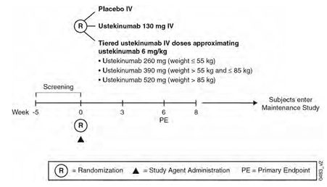

Inclusion and exclusion criteria
The main inclusion criteria were: subjects had to be ≥ 18 years of age and have moderately to severely active Crohn’s disease or fistulising Crohn’s disease of at least 3 months’ duration, with colitis, ileitis, or ileocolitis, confirmed by radiography, histology, and/or endoscopy. Active disease was defined as a CDAI score ≥220 but ≤450. Subjects also had to have received infliximab, adalimumab or certolizumab pegol at a dose approved for the treatment of Crohn’s disease and either did not respond initially, responded initially but then lost response, or were intolerant to the medication. Subjects also had to meet criteria for concomitant medication stability, screening laboratory test results, and TB history and testing results, and had to agree to use adequate birth control measures.
The main exclusion criteria were: had complications of Crohn’s disease that might require surgery or preclude the use of the CDAI to assess response; had or were suspected to have an abscess within specified time periods; had any kind of bowel resection or diversion or any other intra-abdominal surgery within specified time periods before screening; had a draining (that is, functioning) stoma or ostomy; or had a stool culture or other examination that was positive for an enteric pathogen within a specified time period. Subjects could not have received prior treatment with any therapeutic agent targeted at reducing IL-12 or IL-23 (for example, ustekinumab or briakinumab). Non-autologous stem cell therapy (for example, Prochymal), IV corticosteroid, immuno-modulatory agents (other than azathioprine [AZA], 6-mercaptopurine [6-MP], or methotrexate [MTX]), biologic agents, investigational drugs, and treatment with apheresis or total parenteral nutrition (TPN) were prohibited within specific time periods before screening. Subjects were excluded if they had received or experienced any of the following within specified time periods before screening: Bacille Calmette-Guérin (BCG) vaccination or live viral or bacterial vaccination; serious infection or evidence of a herpes zoster infection; known substance abuse; or organ transplantation. Other exclusion criteria were evidence of current active infection or a history of latent or active granulomatous infection (including TB), nontuberculous mycobacterial infection, serious opportunistic infection, recurrent infections, or infection with HIV, hepatitis B, or hepatitis C or malignancy; receipt of allergy immunotherapy for prevention of anaphylactic reactions; diagnosis or history of lymphoproliferative disease; or the presence of severe, progressive, or uncontrolled renal, hepatic, hematologic, endocrine, pulmonary, cardiac, neurologic, cerebral, or psychiatric disease

Study treatments
Subjects were randomly assigned in a 1:1:1 ratio to receive a single IV administration of placebo (n=247) or 1 of 2 induction doses of ustekinumab at Week 0 (ustekinumab 130 mg or weight-range-based [hereafter referred to as ‘tiered’] ustekinumab doses approximating ustekinumab 6 mg/kg [~6 mg/kg]: ustekinumab 260 mg [weight ≤55 kg], 390 mg [weight >55 kg and ≤85 kg], or 520 mg [weight >85 kg]). All subjects were to receive a single IV administration of study agent (placebo or ustekinumab) at Week 0. Intravenous study agent was to be administered to each subject over a period of not less than 1 hour. The infusion was to be completed within 5 hours of preparation.
Comment: Originally, the Phase III studies intended to use a specific formulation (130 mg ustekinumab in 26 mL [5 mg/mL]) developed to facilitate IV administration. However, a stability issue was identified with the batch of IV drug used in the studies. The sponsor temporarily suspended dosing of subjects with the 5 mg/mL IV formulation of ustekinumab in November 2011, at which point 40 subjects had been randomised into the 2 induction studies (28 in CRD3001 and 12 in CRD3002). A total of 26 of these subjects entered CRD3003, of which 9 were randomised as responders. The Phase III IV induction studies were subsequently restarted with the commercially available 90 mg/mL liquid in vial formulation (with 45 mg or 90 mg per vial). Because knowledge of the stability issue could potentially bias the assessments, data from subjects randomised before the studies were temporarily suspended and were not used in the planned efficacy analyses of the Phase III studies.
Subjects were permitted to receive oral 5-ASA compounds, the immuno-modulators AZA, 6-MP, and MTX, oral corticosteroids, and/or antibiotics or the treatment of Crohn’s disease during the study, provided that the subject was on a stable dose for a specified period before baseline.
Enrolled subjects were not to initiate treatment with any of the following concomitant Crohn’s disease-specific medical therapies: oral or rectal 5-ASA compounds; immuno-modulators (AZA, 6-MP, or MTX); oral, parenteral, or rectal corticosteroids; antibiotics or total parenteral nutrition as a treatment for Crohn’s disease. Subjects who initiated such medications or modified their doses/regimens were to complete all efficacy visits and the final safety visit in this study. However, such modifications in Crohn’s disease therapies could exclude the subject from entry into the CRD3003 maintenance study. Enrolled subjects were not permitted to initiate any of the prohibited medications; subjects who initiated such medications at any time during the study were to be excluded from entering the maintenance study, but were to complete all efficacy visits and the final safety visit in this study. Initiation of these medications was to be documented as a deviation from the study protocol.

Efficacy variables and outcomes
Efficacy evaluations were to include the Crohn’s Disease Activity Index (CDAI), serum CRP concentrations, stool samples analyses for faecal lactoferrin and faecal calprotectin markers, the Inflammatory Bowel Disease Questionnaire (IBDQ), and the 36-Item Short-Form Health Survey (SF-36). Fistula closure was to be assessed for subjects with fistulising disease, and reduction or resolution of lesions was to be assessed for subjects with pyoderma gangrenosum. Mucosal healing was to be assessed by ileocolonoscopy at participating sites in subjects who consented to participate in that substudy. Health economics analyses (Resource utilisation, productivity visual analog scale (VAS), Work Limitations Questionnaire (WLQ) Resource utilisation, productivity visual analog scale (VAS), Work Limitations Questionnaire (WLQ).were also to be performed.
The primary endpoint was clinical response at Week 6, defined as a reduction from baseline in the CDAI score of ≥100 points. Subjects with a baseline CDAI score of ≥220 to ≤248 points were to be considered to be in clinical response if a CDAI score of <150 was attained. Subjects who had any of the following events before the Week 6 visit were considered to not be in clinical response at Week 6, regardless of the actual CDAI score:- A Crohn’s disease-related surgery (with the exception of drainage of an abscess or seton placement) that was thought to be a result of lack of efficacy of study agent; -Specified changes in concomitant Crohn’s disease medications, If the CDAI score could not be calculated (that is, <4 components available) at a visit, the CDAI score was considered missing. Subjects with a missing CDAI score at Week 6 were considered to not have achieved clinical response at Week 6.
The major secondary endpoints, in order of importance, were 1) clinical remission at Week 8, defined as a CDAI score <150 points; 2) clinical response at Week 8; 3) 70-point response at Week 6, defined as a reduction from baseline in the CDAI score of ≥70 points; and 4) 70-point response at Week 3.

Randomisation and blinding methods
Subjects were to be randomised in a 1:1:1 ratio to receive a single IV administration of either placebo or 1 of 2 induction doses of ustekinumab at Week 0: Group 1: Placebo (n=247); Group 2: Ustekinumab 130 mg (n=245); Group 3: Tiered ustekinumab doses approximating ustekinumab 6 mg/kg (n=249). Subjects were to be allocated to a treatment group using a permuted block randomisation with study region (Asia, Eastern Europe, or rest of world), CDAI score (<300 or >300), and initial response to TNF antagonist therapy (yes or no) as the stratification variables. For subjects who had received multiple TNF antagonist therapies, their initial response status (yes or no) was to be determined by whether they had initially responded to the first TNF antagonist therapy received. Allocation to treatment group was to be performed using a central randomisation centre by means of an interactive voice response system (IVRS)/interactive web response system (IWRS).
Comment: As the first 28 subjects randomised into the study were to be excluded from the key efficacy analyses, the randomisation was restarted with new blocks for each stratum when the study was restarted.

Analysis populations
Efficacy analyses were to be based on an intent-to-treat principle. Therefore, the efficacy data for each subject were analysed according to the assigned treatment, regardless of the actual treatment received. The PK analyses were based on subjects who received at least 1 dose of IV ustekinumab, and safety analyses were based on subjects who received at least 1 dose of IV study agent. Subjects were analysed according to the actual treatment received.

Sample size
The assumptions for sample size and power calculations were based on data from Study C0743T26, in which the proportion of subjects in clinical response at Week 6 was approximately 40% in the ustekinumab 6 mg/kg group, 35% in the ustekinumab 1 mg/kg and 3 mg/kg groups, and 25% in the placebo group. Assuming a 25% clinical response rate at Week 6 in the placebo group and a 40% rate in the ustekinumab high dose group, 205 subjects per treatment group were predicted to yield an overall power of 90%, at a significance level of 0.05 (2-sided). The power for detecting a significant difference between the ustekinumab high dose group and placebo was also examined for the first major secondary endpoint of clinical remission at Week 8. Assuming a 10% clinical remission rate at Week 8 in the placebo group, and a rate of 20% in the ustekinumab high-dose group, 205 subjects per treatment group were predicted to yield an overall power of 81%, at a significance level of 0.05 (2-sided). To increase the power to detect a significant difference for the clinical remission endpoint, the sample size for the key efficacy analyses was increased to 225 subjects per treatment.

Statistical methods
Descriptive statistics included counts and percentages for categorical data, and median, mean, SD, interquartile range and range for continuous data. Graphical data displays could also be used to summarise the data. Analyses suitable for categorical data (for example, chi-square test or Cochran-Mantel-Haenszel chi-square test, as appropriate) were used to compare the proportion of subjects achieving selected endpoints (for example, clinical remission). In cases of rare events, the Fisher exact test was used for treatment comparisons. Continuous response parameters were compared using an analysis of variance/covariance on the van der Waerden normal scores, unless otherwise specified. All statistical testing was performed at the 2-sided 0.05 significance level. Nominal p-values were presented.
The primary endpoint (proportion of subjects in clinical response at Week 6) was compared between each of the ustekinumab treatment groups and the placebo group using a 2-sided Cochran-Mantel-Haenszel chi-square test, stratified by study region (Asia, Eastern Europe, or rest of world), CDAI score (≤300 or >300), and initial response to TNF antagonist therapy (yes or no), at a significance level of 0.05. A fixed-sequence testing procedure was used to control the overall Type 1 error rate at the 0.05 level of significance. Specifically, the ustekinumab high-dose group (dose approximating 6 mg/kg ustekinumab) was first compared with the placebo group at the 2-sided 0.05 level of significance. If the ustekinumab high-dose group was significantly different from the placebo group, then the ustekinumab low-dose group (130 mg ustekinumab) was compared with the placebo group at the 2-sided 0.05 level of significance. The study was considered positive if the ustekinumab high-dose group was significantly different from the placebo group for the primary endpoint.
The robustness of the primary endpoint analysis was examined by sensitivity analyses of the primary endpoint using the observed case, last observation carried forward, multiple imputations and the worst case missing data methods. Treatment failure rules were to override the missing data rules, meaning that if a subject has both an event of treatment failure (that is, a Crohn’s disease-related surgery thought to be a result of lack of efficacy of study agent or specified changes in concomitant Crohn’s disease medications) before Week 6 and has a missing CDAI score at Week 6 (that is, <4 components of the CDAI available), the subject was considered a non-responder in the sensitivity analysis regardless of whether or not CDAI data are present.
The consistency of the efficacy of the primary endpoint was evaluated in subgroups based on demographic, baseline disease characteristics, Crohn’s disease medication history, concomitant Crohn’s disease medication use at baseline, centre location and initial response to TNF antagonist therapy. The odds ratios of each ustekinumab dose group versus placebo and corresponding 95% confidence intervals were provided for each of the subgroups.
The major secondary endpoints were compared between each of the ustekinumab treatment groups and the placebo group using a 2-sided Cochran-Mantel-Haenszel chi-square test, stratified by study region (Asia, Eastern Europe, or rest of world), CDAI score (≤300 or >300), and initial response to TNF antagonist therapy (yes or no), at a significance level of 0.05. To control the overall Type 1 error rate, the primary endpoint and major secondary endpoints were tested in a hierarchical fashion, that is, the first major secondary endpoint was tested only if the primary endpoint was positive, and the subsequent endpoint(s) were tested only if the preceding endpoint in the hierarchy was positive.

Participant flow
A total of 769 subjects were randomly assigned to receive study agent but the efficacy analysis only included the 741 subjects who were randomised after the study was restarted at 177 sites in Asia (8.0%), Eastern Europe (3.2%), and other countries (88.8%) in North America, Western Europe, Israel, South Africa, Australia, New Zealand, and Brazil. Among the 28 subjects who were randomised before the study was restarted (refer details above), 9 each were randomised to the placebo and ustekinumab 130 mg groups and 10 were randomised to the ustekinumab ~6 mg/kg group. Subject disposition is summarised in Figure 20.
Figure 20: Subject disposition in study CNTO1275CRD3001; randomised subjects excluding those enrolled prior to study re-start.
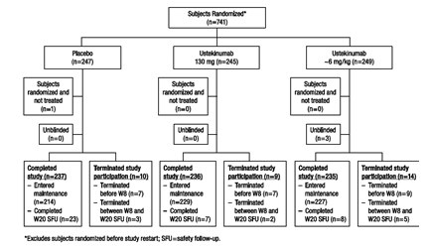
More than 95% of subjects completed their study participation and more than 90% entered the maintenance study. Among the 4.5% of subjects who did not complete the study, 3.1% (n=23) terminated before Week 8 (2.8%, 2.9%, and 3.6% in the placebo, 130 mg ustekinumab, and ~6 mg/kg ustekinumab groups, respectively) and the other 1.3% (n=10) of subjects terminated between Week 8 and the Week 20 safety follow-up visit withdrawal of consent was also the most common reason for termination. Approximately 10% of the patients did not enter the maintenance study with higher incidence in the placebo group (13.4%) compared with the ustekinumab groups (6.5% and 8.8% in the 130 mg and ~6 mg/kg groups, respectively). The most common reasons for not continuing to receive study agent by entering the maintenance study were AE (n=25; predominantly Crohn’s disease), which occurred in a greater proportion of subjects in the placebo group than in the combined ustekinumab groups; lack of efficacy (n=19); and withdrawal of consent (n=12).

Major protocol violations/deviations
Of the 741 randomised subjects, 72 had a major protocol deviation, with slightly fewer subjects in the placebo group (n=19) than in the ustekinumab groups (n=28 and n=25 in the 130 mg and ~6 mg/kg ustekinumab groups, respectively); of those, 65 subjects had deviations before randomisation, with the remainder occurring after randomisation. Majority of the protocol violations were due to subjects who did not meet study entry criteria (8.9%, 66/741) being enrolled, with slightly fewer subjects in the placebo group (n=17) than in the ustekinumab treatment groups (n=25 and n=24). The most common deviations in study entry criteria were Crohn’s disease criteria (n=30 [4.0%]) and medication criteria (n=23 [3.1%]). The most common entry criterion that was not met was exclusion criterion of negative stool testing for enteric pathogens not documented within 4 months of baseline, which accounted for 25 study entry criteria deviations, largely because negative test results were not available at the time of randomisation (Of these, 20 had subsequent negative testing and none developed a serious bacterial enteric infection). The next largest category of protocol deviations was that of prior medications (23 subjects); 8 involved treatment with an anti-TNF therapy <8 weeks before baseline (shortest interval between anti-TNF therapy and study agent administration was 4 weeks and most were between 7.5 and 8 weeks). The target population for the study was subjects with moderate to severely active Crohn’s disease who had failed or demonstrated intolerance to TNF antagonist therapy; 8 subjects had deviations from those criteria. Two had CDAI scores indicating disease that was more severe than permitted and 6 did not have a history of nonresponse to or intolerance of TNF antagonist therapy.

Baseline data
Majority of the patients were women (57%), White (84.1%) with median age of 36 years (range: 27-45years). Baseline demographics were generally similar across treatment groups with exception of slightly higher proportion of male subjects in the placebo group (47.8%) compared with the ustekinumab 130 mg (40.0%) and ~6 mg/kg (40.6%) groups, respectively. In general, disease characteristics were well balanced across the 3 treatment groups, including the baseline CDAI score. The median duration of disease at baseline was 10.14 years, median CDAI score was 317 and the median CRP concentration was 9.88 mg/L. Isolated colonic disease was present in 16.8% of subjects, 13.9% had only ileal involvement, and 68.6% were reported to have involvement in both areas. A total of 43.4% of subjects had current or prior perianal disease and 21.1% reported proximal GI tract involvement (defined as proximal small intestine, stomach, or oesophagus). Half of the subjects (50.8%) had at least 1 extraintestinal manifestation of Crohn’s disease, with the most prevalent being arthritis / arthralgia (47.3%).
Many subjects had a penetrating phenotype, with a history of intra-abdominal abscess in 14%, current or prior sinus tracts or perforation in 8%, and current or prior fistulising disease in 47.5%. Some kind of clinically apparent fistula was present at baseline in 19.3% of subjects. A stricturing phenotype was also common: 44.8% of subjects had a current or prior stricture and 9.7% had some degree of stricture present at baseline. Overall, the extent of extra-intestinal involvement and the proportions and types of Crohn's disease complications were similar across the treatment groups.
Medical history and current diagnoses were generally well-balanced across the treatment groups. The most common comorbid diseases were hypertension (12.3%) and psoriasis (7.4%). At baseline, 294 subjects (39.7%) had at least 1 cardiovascular risk factor, including hyperlipidaemia, hypertension, diabetes mellitus, family history of early coronary artery disease, or current smoking status, and 67 (9.0%) had 2 or more cardiovascular risk factors. At baseline, 72.5% of subjects were receiving 1 or more concomitant medications for Crohn’s disease. A total of 340 subjects (45.9%) were receiving corticosteroids (including budesonide). For the 285 subjects who were receiving oral systemic corticosteroids (that is, excluding budesonide) at baseline, the median dose was 20 mg/day of prednisone or its equivalent in each of the 3 treatment groups. A total of 233 (31.4%) of subjects were receiving immuno-modulators (AZA, 6-MP, or MTX).
The proportions of subjects receiving each class of Crohn’s disease medication at baseline were balanced across the 3 treatment groups. Approximately 96% (708/741) of subjects had previously received corticosteroids; of those, 43.5% had previously failed, 10.2% had become intolerant, and 46.0% had been corticosteroid dependent. Although the proportions of subjects who had received corticosteroids were similar among the treatment groups, among the subset of subjects who had failed corticosteroids, the proportion was slightly higher in the ~6 mg/kg group (51.0%) compared with the placebo and 130 mg groups (41.5% and 37.8%, respectively). This difference was not expected to affect study results. Overall, 91% (677/741) of subjects had previously received immuno-modulators; of those, 66.9% had previously failed and 41.2% had become intolerant to these agents.
Subjects had to have previously failed at least 1 TNF antagonist (that is, infliximab, adalimumab, or certolizumab pegol), either by having an inadequate initial response, by having a response following by loss of response, or by being intolerant. Overall, 29.1% had an inadequate initial response, 69.4% had response followed by loss of response, and 36.4% had intolerance to 1 or more TNF antagonists; 48.0% had failed 1 TNF antagonist in the past and approximately half had failed 2 or 3 TNF antagonists (40.8% and 10.4%, respectively). 78.8% of subjects had failed infliximab, 59.8% had failed adalimumab, and 22.1% had failed certolizumab pegol.

Results for the primary efficacy outcome
The primary endpoint was clinical response at Week 6, defined as a reduction from baseline in the CDAI score of >100 points. Subjects with a baseline CDAI score of >220 to <248 points were considered to be in clinical response if a CDAI score of <150 was attained. Significantly greater proportion of subjects in the ~6 mg/kg ustekinumab and 130 mg ustekinumab groups were in clinical response at Week 6 (33.7% [84/249] and 34.3% [84/245], respectively) compared with the placebo group (21.5% [53/247]; p=0.003 and p=0.002, respectively) (Table 8). Approximately 4% (31/741) of randomised subjects had missing data for the CDAI score at Week 6 (5.3%, 5.2% and 2.0% of subjects in the placebo, ~6 mg/kg, and 130 mg ustekinumab groups, respectively). The primary endpoint analysis was robust to changes in analysis rules regarding missing data and to the exclusion of subjects who were randomised but never treated; these sensitivity analyses for the primary endpoint showed results consistent with those of the primary analysis, as both the ~6 mg/kg and 130 mg ustekinumab groups had significantly greater proportions of subjects in clinical response at Week 6 compared with the placebo group (Table 9).
Table 8: Number of subjects in clinical response at week 6; randomised subjects excluding those enrolled prior to study re-start.
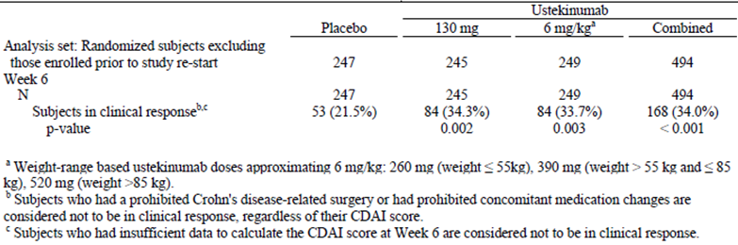
Table 9: Number of subjects in clinical response at week 6 (sensitivity analysis 1: Observed case); randomised subjects excluding those enrolled prior to study re-start and excluding site 1127
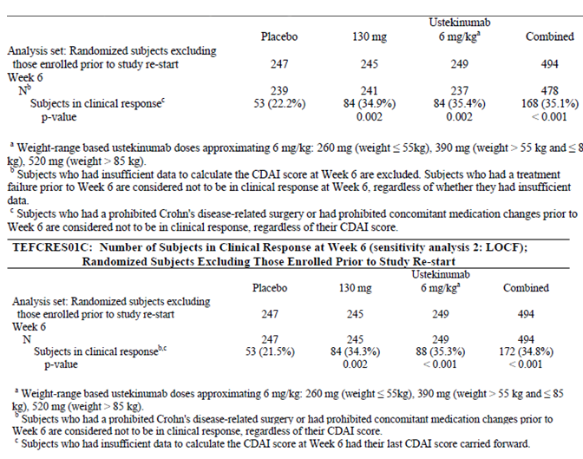
Table 9 continued: Number of subjects in clinical response at week 6 (sensitivity analysis 1: Observed case); randomised subjects excluding those enrolled prior to study re-start and excluding site 1127
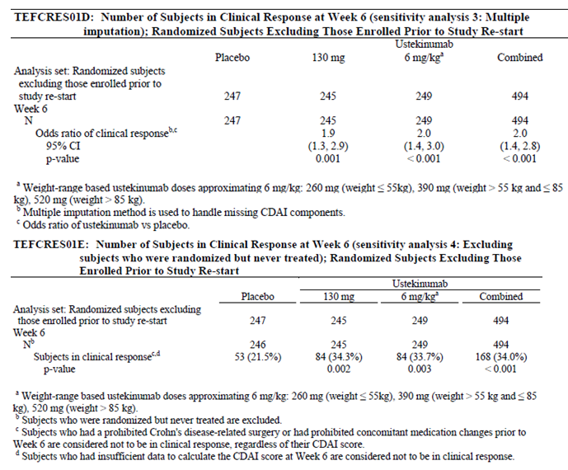

Results for other efficacy outcomes
Secondary endpoints: Clinical remission at Week 8 was defined as a CDAI score of <150 points. A significantly greater proportion of subjects in the ~6 mg/kg ustekinumab and 130 mg ustekinumab groups were in clinical remission at Week 8 [20.9% (52/249) and 15.9% (39/245), respectively) compared with the placebo group [7.3% (18/247); p<0.001 and p=0.003, respectively]. The proportion of subjects in remission at Week 8 was numerically greater in the ~6 mg/kg dose group than in the 130 mg group.
A significantly greater proportion of subjects in the ~6 mg/kg ustekinumab and 130 mg ustekinumab groups (37.8% [94/249] and 33.5% [82/245], respectively) were in clinical response at Week 8 compared with the placebo group (20.2% [50/247]; p<0.001 and p=0.001, respectively).
A significantly greater proportion of subjects in the ustekinumab groups were in 70-point response at Week 6 (43.8%, 46.1% and 30.4% in the~6 mg/kg, ustekinumab, 130 mg ustekinumab and placebo groups (respectively) and at Week 3 (40.6%, 38.4% and 27.1%, respectively.
By the first post-baseline visit at Week 3, a greater proportions of subjects were in clinical remission in both ustekinumab dose groups (12.9% and 10.6% in the ~6 mg/kg and 130 mg groups, respectively) compared with the placebo group (5.7%; p=0.005 and p=0.05, respectively). The proportion of subjects in clinical remission continued to increase from Week 3 through Week 8 in the ~6 mg/kg group; in the 130 mg group, the proportion of subjects in clinical remission increased from Week 3 to Week 6 and was maintained at Week 8. At Weeks 6 and 8, the proportions of subjects in clinical remission were significantly greater in both dose groups compared with placebo. At each visit, the proportion of subjects in remission was numerically greater in the ~6 mg/kg group (12.9%, 18.5% and 20.9% at Weeks 3, 6, and 8, respectively) than in the 130 mg group (10.6%, 16.3% and 15.9%, respectively) with the greatest difference occurring at Week 8, (Figure 21). The trend over time for clinical response in the ustekinumab groups was similar to that observed for clinical remission in the ustekinumab groups (Figure 22) with similar trends observed for 70-point response over time (Figure 23).
Figure 21: Number of subjects in clinical remission through Week 8; randomised subjects excluding those enrolled prior to study re-start.
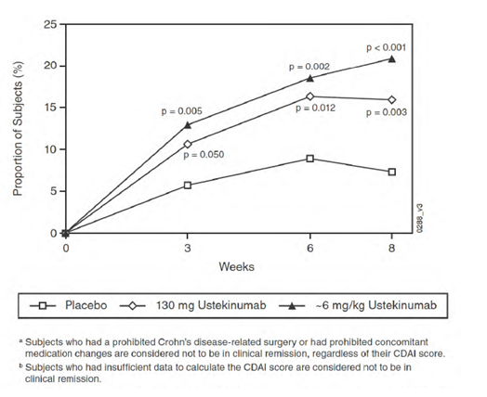
Figure 22: Number of subjects in clinical response through Week 8; randomised subjects excluding those enrolled prior to study re-start.
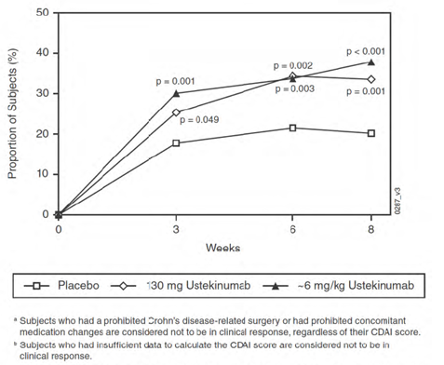
Figure 23: Number of subjects in 70 point response through week 8; randomised subjects excluding those enrolled prior to study re-start.
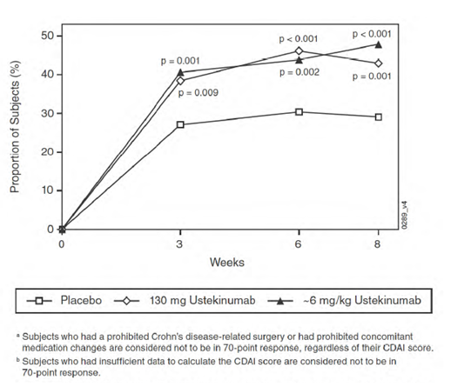
At Week 3, there was a significantly greater reduction in the CDAI score in both ustekinumab treatment groups (median CDAI score changes from baseline of −53.0 and −50.0 in the ~6 mg/kg and 130 mg ustekinumab groups, respectively) compared with the placebo group (−22.0; p<0.001 for both). At Weeks 6 and 8, reductions in the CDAI score remained significantly greater in both ustekinumab treatment groups compared with placebo (p<0.001 for both dose groups at both time points). At visits from Week 3 to Week 8, median reductions in the CDAI score continued to increase in the ~6 mg/kg group; in the 130 mg group, the median reduction in the CDAI score increased from Week 3 to Week 6, but no further reduction in the CDAI score was observed from Week 6 to Week 8 (Figure 24).
Figure 24: Mean change from baseline in CDAI at Weeks 3, 6 and 8; randomised subjects excluding those enrolled prior to study re-start
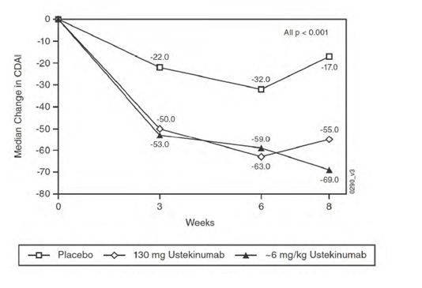
Other efficacy endpoints: At Week 3, the mean reductions in CRP concentrations were significantly greater in each of the ustekinumab groups (−6.89 and −5.70 mg/L, respectively) compared with the placebo group (2.37 mg/L; p<0.001 for both groups). At Weeks 6 and 8, the mean reductions in CRP concentrations remained significantly greater in both ustekinumab treatment groups compared with placebo (p<0.001 for both groups at both time points); however no further reductions in CRP were observed in the ustekinumab groups after Week 3 (Figure 25).
Figure 25: Mean change from baseline in CRP concentration (mg/L) through week 8; randomised subjects excluding those enrolled prior to study re-start.
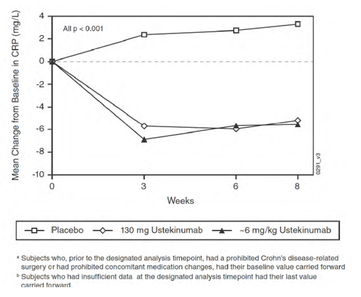
At baseline, 192, 197, and 191 subjects in the placebo, ~6 mg/kg and 130 mg ustekinumab groups, respectively, had abnormal CRP (defined in the protocol as a CRP value >3 mg/L). Among these subjects, a significantly greater proportion of subjects in the ~6 mg/kg and 130 mg ustekinumab groups (17.3% and 13.6%, respectively) had normalised CRP at Week 3 compared with the placebo group (6.3%, p<0.001 and p=0.018, respectively) and this difference was maintained at Weeks 6 and 8.
At Week 6, there was a significantly greater reduction in faecal calprotectin concentration in the ~6 mg/kg and 130 mg ustekinumab groups (median reduction: −41.25 and −38.57mg/kg) compared with the placebo group (0.00, p<0.001 for both groups. Among subjects with a baseline faecal calprotectin value >250 mg/kg, the proportions of subjects with a faecal calprotectin value ≤250 mg/kg at Week 6 were significantly higher in the ~6 mg/kg and 130 mg ustekinumab groups (27.8% and 23.3%, respectively) compared with the placebo group (10.5%, p<0.001 and p=0.001, respectively.
Among the 12.6% (93 of 741) of subjects who had a fistula at baseline, a greater proportion of subjects were in fistula response at Week 8 in the combined ustekinumab group (18.5%, n=10) compared with the placebo group (11.8%, n=4). Two subjects, both in the 130 mg ustekinumab group, had pyoderma gangrenosum and both subjects experienced resolution of the primary lesion and reduction in the number of lesions, although 1 subject with 2 lesions at baseline was reported as again having 2 lesions at Week 8 that were smaller in size than the primary lesions
Patient reported outcomes: At Week 8, the mean (±SD) change from baseline in the IBDQ score was significantly greater in the ~6 mg/kg and 130 mg ustekinumab groups (22.1 [28.59] and 18.1 [28.02], respectively) compared with the placebo group (11.9 [26.51]; p<0.001). The mean change in the IBDQ dimension scores at Week 8 was significantly higher in the ~6 mg/kg ustekinumab group compared with placebo (p<0.001 for all 4 dimensions; in the 130 mg ustekinumab group, the mean change was significantly higher for the social (p=0.003) and systemic (p=0.010) dimensions compared with placebo. A significantly greater proportion of subjects in the ~6 mg/kg and 130 mg ustekinumab groups (54.8% and 46.9%, respectively) had a ≥16-point improvement from baseline in the IBDQ score at Week 8 compared with the placebo group (36.5%, p<0.001 and p=0.019, respectively).
Both PCS and MCS at baseline were below the general US population mean norms of 50, indicating significantly impaired health-related quality of life. At Week 8, the mean (±SD) change from baseline in the PCS score was numerically, but not significantly, greater in the ~6 mg/kg and 130 mg ustekinumab groups (3.57 [±6.750] and 3.21 [±6.434], respectively) compared with the placebo group (2.62 [±6.502]). The mean (±SD) change from baseline in the MCS score at the same time point was significantly greater in the ~6 mg/kg ustekinumab group (4.86 [±9.278]; p=0.006), but only numerically greater for the 130 mg ustekinumab group (3.34 [±9.410]) compared with the placebo group (2.19 [±8.466). The mean changes from baseline in norm-based scores of the SF-36 scales at Week 8 were numerically greater in both ustekinumab groups compared with placebo, particularly in the ~6 mg/kg ustekinumab group for the bodily pain, vitality, social functioning and mental health scales, which were significantly greater than the placebo group. Numerically greater proportions of subjects in both ustekinumab groups had at least a 5-point improvement from baseline in the PCS and MCS scores of the SF-36 at Week 8 compared with the placebo group, particularly the MCS score for the ~6 mg/kg group, which was significantly greater than the placebo group (42.2% versus 30.0%, p=0.007).
Efficacy in subgroups: Efficacy results for primary endpoint of clinical response at Week 6 in subgroups (based on demographics, baseline disease characteristics, concomitant medications at baseline, Crohn’s disease-related drug history and by TNF antagonist therapy history) were consistent with those of the overall study population, with 2 exceptions where the OR was <1 for both ustekinumab doses compared with placebo.
The first was the subgroup with Crohn’s disease limited to the ileum only, which represented a small proportion of the overall study population (approximately 15% of the subjects per group).The second was the subgroup of nonresponse to the initial TNF antagonist therapy (representing approximately 25% of the total subjects per group), where the initial TNF antagonist therapy was defined as the first anti-TNF agent to which they were exposed. It is especially important to note that in subgroup of patients that did not respond to initial TNF antagonist therapy, the clinical response rate was similar in the 130 mg and placebo groups (24.1% versus 25%, OR=0.9, 95% CI: =0.4, 2.2; p=0.833), but it was lower in the 6 mg/kg group compared with placebo (18.6% versus 25%, OR=0.7, 95% CI: 0.3, 1.7; p=0.376), although none of the differences were statistically significant.
Health economic analysis: The impact of ustekinumab on measures of health economics was assessed by measuring subjects’ Crohn’s disease-related hospitalisations and surgeries, days missed from work during the previous 4 weeks due to Crohn’s disease, and the change from baseline in productivity (productivity VAS) and work limitations (WLQ). The numbers of Crohn’s disease-related hospitalisations and surgeries were low across all treatment groups through Week 8 with no notable differences between treatment groups. Fewer subjects in the ustekinumab groups (n=3 and n=5 in the 130 mg and ~6 mg/kg groups, respectively) had Crohn’s disease-related surgeries through Week 8 compared with subjects in the placebo group (n=11). The time lost from work (in days) during the previous 4 weeks due to Crohn’s disease at Week 8 also showed no significant differences between groups. The median change from baseline in daily productivity (productivity VAS) at Week 8 was significantly greater for the ~6 mg/kg and 130 mg ustekinumab groups (−1.2 and −0.9, respectively) compared with placebo (−0.5, p=0.002 and p=0.032, respectively). The change from baseline in work limitations (WLQ) at Week 8 showed a significant difference on the time management score between the ~6 mg/kg ustekinumab group and the placebo group (p=0.032).

Evaluator commentary
This was a well-conducted pivotal study and the enrolled patients reflected a population of subjects with moderate to severe Crohn’s disease who have previously failed or were intolerant to TNF antagonists. More than half of the subjects had failed at least 2 TNF antagonists, and 89.3% had previously failed a full and adequate course of corticosteroids or immuno-modulators. The long prior duration of Crohn’s disease (median 10 years) also illustrates the refractory nature of the population studied. The treatment groups were well balanced with respect to baseline demographic and disease characteristics, including baseline CDAI. The baseline disease characteristics showed that the patient population in this study was representative of a population of subjects with moderate to severe Crohn’s disease that is refractory to available therapies, specifically TNF antagonists.
The study design, efficacy endpoints were appropriate and complied with the CHMP guidelines for evaluation of medicinal products for treatment of Crohn’s disease. The statistical analysis methods were well-described with adequate analysis of robustness of results in sensitivity analysis as well as analysis in subgroups of patients (based on demographic and baseline disease characteristics as well as history of concomitant and prior response to other medications for Crohn’s disease).
The majority of deviations from study entry criteria were generally detected during monitoring and the subjects who were reported to have these deviations were found on follow-up assessment to have results consistent with the protocol-specified eligibility requirements. The population as a whole represented appropriate subjects for the target disease population.
In this patient population of refractory Crohn’s disease, ustekinumab showed significant induction benefit, reaching statistical significance for the primary endpoint and all 4 major secondary endpoints for both the low (130 mg) and high (tiered dosing approximating 6 mg/kg) doses. For the primary endpoint, a significantly greater proportion of subjects in both the ~6 mg/kg (33.7%) and the 130 mg (34.3%) ustekinumab treatment groups were in clinical response at Week 6 compared with placebo (21.5%; p=0.003 and p=0.002, respectively). This positive result was robust to changes across multiple sensitivity analyses. The magnitude of benefit compares favourably with that observed for other approved biologics in similar anti-TNF-resistant populations (Sandborn, 2013; Sandborn, 2007; Sands, 2014). Achieving clinical remission is a central goal of Crohn’s disease therapy and ustekinumab showed significant benefit in inducing clinical remission at Week 8 (the first major secondary endpoint), with remission rates of 20.9% and 15.9% in the ~6 mg/kg and 130 mg groups, respectively, compared with 7.3% in the placebo group (p<0.001 and p=0.003, respectively). The proportions of subjects in clinical remission, clinical response, and 70-point CDAI response were greater for both IV ustekinumab doses than placebo at all visits in this induction study. For the major secondary endpoint of clinical response at Week 8, a significantly greater proportion of subjects in both the ~6 mg/kg ustekinumab and 130 mg ustekinumab treatment groups were in clinical response (37.8% and 33.5%, respectively) compared with the placebo group (20.2%; p<0.001 and p=0.001, respectively). The median reductions in CDAI score in both ustekinumab dose groups were of significantly greater magnitude than placebo at all visits.
It is important to note that the 95% CI for the primary and main secondary endpoints were not provided (only p-values for comparison versus placebo were provided in the CSR). Only the sensitivity analysis 3 (excluding those enrolled prior to study restart) showed the odds ratios and 95% CI values. The sponsors have been requested to provide the 95% CI for the primary and major secondary endpoints (refer Clinical questions below).
The efficacy of ustekinumab in Crohn’s disease was evident at the earliest time point assessed among the study endpoints (Week 3). The major secondary endpoint of 70-point CDAI response at Week 3 was achieved in 40.6% and 38.4% in the ~6 mg/kg and 130 mg groups, compared with 27.1% in the placebo group (p=0.001 and p=0.009, respectively). A similar pattern was observed for clinical response and remission at Week 3. This early clinical improvement was accompanied by reductions in mean CRP at Week 3 (p<0.001 for both doses). The onset of benefit for ustekinumab was similar to that observed for infliximab (in an anti-TNF-naïve population) and adalimumab (previously treated with infliximab) (Sandborn, 2007; Targan, 1997) and appears to be more rapid than that observed for vedolizumab in a similar population (Sands, 2014). At later study time points, the 130 mg and ~6 mg/kg ustekinumab doses appeared to differentiate from each other: in the higher dose group, the proportions of subjects in response or remission continued to rise between Week 6 and Week 8, while these proportions decreased slightly in the lower dose group. Nevertheless, all of the primary and major secondary endpoints were achieved in both dose groups. Although the absolute difference in clinical response rates at Week 6 between the 2 dose groups was small, the difference in rates of remission at Week 8 was slightly larger (20.9% versus.15.9% in the ~6 mg/kg and 130 mg ustekinumab dose groups, respectively), which may be clinically significant in this TNF-refractory population.
In addition to the clinical measures discussed above, ustekinumab improved both general and IBD-specific health-related quality of life outcomes. Most notably, a greater proportion of subjects in each of the ustekinumab groups, particularly the ~6 mg/kg group, demonstrated clinically significant improvement (of at least 16 points) in the IBDQ compared with placebo. Consistent with this, improvements in both the PCS and MCS scores of the SF-36 at Week 8 were numerically greater in each ustekinumab dose group compared with placebo, and a statistically significant improvement in MCS score was observed in the ~6 mg/kg group. Along with clinical improvements, reductions in or normalisation of Crohn’s disease inflammatory markers including CRP, faecal lactoferrin and faecal calprotectin were consistently observed with both ustekinumab doses.
Overall, this study demonstrates that IV induction treatment with ustekinumab (6 mg/kg and 130 mg) significantly improved clinical, inflammatory and health-related quality of life parameters of Crohn’s disease in a treatment-refractory population of subjects with moderate to severe, long-standing disease. However, the proposed 6 mg/kg dose appeared to show numerically greater benefits in terms of clinical response, remission as well as improvement in inflammatory biomarkers and quality of life endpoints.

Study CRD 3002

Study design, objectives, locations and dates
This was a Phase III, randomised, double-blind, placebo-controlled, parallel-group, multicentre study to evaluate the efficacy and safety of Ustekinumab Induction therapy in subjects with moderately to severely active Crohn’s Disease. The primary objective was to evaluate the efficacy and safety of intravenous (IV) induction regimens of ustekinumab in inducing clinical response in subjects with moderately to severely active Crohn’s disease. The secondary objectives are to evaluate the efficacy of IV induction regimens of ustekinumab in inducing clinical remission and improving disease-specific health-related quality of life; to evaluate the pharmacokinetics and pharmacodynamics of ustekinumab therapy, including changes in C-reactive protein (CRP), faecal calprotectin, faecal lactoferrin, and other pharmacodynamic biomarkers; and to provide, along with induction Study CRD3001, the target study population to be evaluated in the maintenance Study CRD3003. Subjects who were not in clinical response to ustekinumab induction therapy, as well as all subjects who initially received placebo (both in clinical response and not in clinical response), were also eligible to enter Study CRD3003 at Week 8, but were not included in the primary efficacy population. Subjects who did not enter the maintenance study were to have a safety follow-up visit approximately 20 weeks after the Week 0 study agent administration. The study was conducted from 23 June 2011 to 28 October, 2014 at 175 sites in North America, South America, Eastern Europe, Western Europe, Asia Pacific, and South Africa.

Inclusion and exclusion criteria
The inclusion and exclusion criteria were similar to those described for Study CRD3001 (refer to details above) with exception that subjects with prior exposure to TNF antagonists were permitted to enter the study only if they have not demonstrated inadequate response or intolerance to such therapy. The target population for the study was subjects with moderate to severe active Crohn’s disease that was confirmed to be active and who had demonstrated an inadequate response to, or failed to tolerate corticosteroids or immuno-modulators (6-MP, AZA, or MTX).

Study treatments
Subjects were randomised in a 1:1:1 ratio at Week 0 to receive a single IV administration of either placebo or 1 of 2 induction doses of ustekinumab for IV administration was supplied as a single-use, sterile solution in glass vials with 2 dose strengths (that is, 90 mg in 1 mL nominal volume or 45 mg in 0.5 mL nominal volume) Placebo for IV administration was supplied as a single-use, sterile solution in a glass vial.

Efficacy variables and outcomes
These were identical to the ones described for Study CRD3001 (see above).

Randomisation and blinding methods
Randomisation and blinding methods were similar to those described for Study CRD3001 (see above) with exception that stratification variables only included study region (Asia, Eastern Europe, or Rest of World) and CDAI score (≤300 or >300).

Analysis populations
This was identical to that described for Study CRD3001.

Sample size
The assumptions for sample size and power calculations were based on data from the Phase IIa study of ustekinumab in subjects with Crohn’s disease (C0379T07). In C0379T07, the proportion of subjects with 100-point response at Week 6 was 50% and 15% in the 4.5 mg/kg ustekinumab IV and placebo groups, respectively. In Study C0379T07, placebo rates were low following IV administration (15%), while they were higher following SC administration (approximately 35%). In addition, the response rates in C0379T07 were estimated from small samples. Therefore, as a conservative measure, a response rate in the range of 30% to 35% was assumed for the placebo group in the current study. Assuming a 33% clinical response rate at Week 6 in the placebo group and 50% in the ustekinumab high dose group, 200 subjects per treatment group would yield an overall power above 90%, at a significance level of 0.05 (2-sided). The power for detecting a significant difference between the ustekinumab high dose group and placebo was also examined for the first major secondary endpoint of clinical remission at Week 8. Assuming a 12% clinical remission rate at Week 8 in the placebo group, and a rate of 25% in the ustekinumab high dose group (based on clinical remission rates in the combined SC and IV groups in C0379T07), 200 subjects per treatment group was predicted to yield an overall power above 90% for the first major secondary endpoint of clinical remission at Week 8, at a significance level of 0.05 (2-sided).

Statistical methods
These were similar to those described for Study CRD3001.

Participant flow
Subjects were randomly assigned in a 1:1:1 ratio to receive a single IV administration of placebo (n=210) or 1 of 2 induction doses of ustekinumab at Week 0: ustekinumab 130 mg (n=209) or tiered ustekinumab doses approximating 6 mg/kg (n=209). All subjects received the treatment to which they were assigned with the exception of 4 subjects. One subject was randomised to the placebo group but never received study agent. Another subject was randomised to the placebo group and received ustekinumab dose approximating the low dose (130 mg) and this subject was analysed in the ustekinumab 130 mg group for PK and safety. In addition, 2 subjects who were randomised to the ustekinumab ~6 mg/kg group actually received doses more closely approximating the low dose (130 mg); those 2 subjects were analysed in the ustekinumab 130 mg group for PK and safety. All 4 of these subjects were analysed by their randomised treatment group for efficacy.
More than 96% of subjects completed study participation and more than 93% entered the maintenance study. Of the 3.7% of subjects who did not complete the study, 2.2% terminated before Week 8 (9 [4.3%]), 3 [1.4%] and 2 [1.0%] in the placebo, 130 mg and ~6 mg/kg groups, respectively) and the other 1.4% of subjects terminated between Week 8 and the Week 20 safety follow-up visit. Withdrawal of consent and loss to follow-up were the most common reasons for early termination (Figure 26). A total of 43 subjects (6.8%) did not enter the maintenance study; a greater proportion of subjects in the placebo group did not enter the maintenance study compared with subjects in the ustekinumab groups (24 [11.4%]), 13 [6.2%] and 6 [2.9%] in the placebo, 130 mg and ~6 mg/kg groups, respectively). The most common reasons for not entering into the maintenance study were subject ineligibility (9 [4.3%], 1 [0.5%] and 2 [1.0%] subjects, respectively) and withdrawal of consent (6 [2.9%] subjects in the placebo group; 5 [2.4%] and 1 [0.5%] subjects in the 130 mg and ~6 mg/kg groups, respectively). Only 5 (2.4%) subjects in the placebo group, and 3 (1.4%) and 2 (1.0%) subjects in the 130 mg and ~6 mg/kg groups, respectively, did not enter the maintenance study due to an AE.
Figure 26: Study CRD 3002. Subject disposition; randomised subjects excluding those enrolled prior to study re-start.
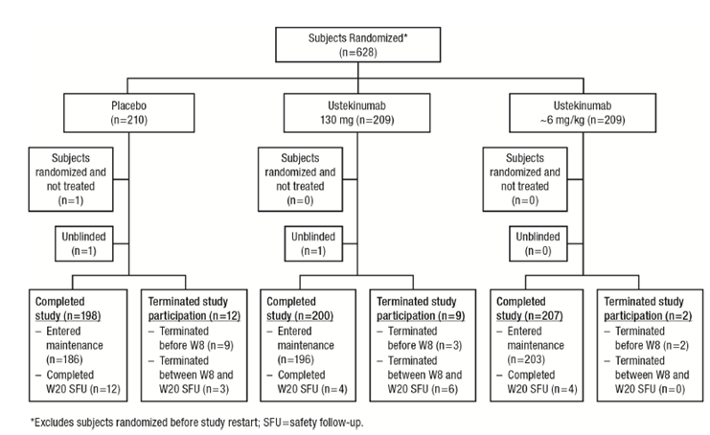

Major protocol violations/deviations
Of the 628 randomised subjects, 79 had a major protocol deviation, with slightly more subjects in the placebo group (n=33) than in the individual ustekinumab groups (n=23 in both ustekinumab groups). The majority of major protocol deviations (74/79) were due to subjects who entered the study but did not meet Crohn’s disease entry criteria and most of these were related to incomplete information at the time of randomisation and subjects were ultimately found to meet the relevant criteria. Most of the Crohn’s disease criteria violations were associated with enteric pathogen screening guidelines (34 subjects), which was the single most common protocol deviation. However, 25 of the 34 subjects had subsequent negative testing and the rest generally had already terminated study participation at the time that these deficiencies were identified. None of these subjects experienced adverse events of bacterial enteric infections. The next largest category of protocol deviations were related to TB screening (20 subjects). A total of 5 (0.8%) subjects did not meet the CRP, calprotectin or endoscopic criteria for active inflammation; 1 (0.16%) subject was found to have been randomised with a CDAI score outside of the specified range; and 5 (0.8%) subjects were found upon site monitoring to have demonstrated inadequate response or intolerance to 1 or more TNF antagonist therapies.
During the conduct of the study, the sponsor was notified of significant deviations from Good Clinical Practice at one study site (Site 1127); of the 2 subjects randomised at the site, 1 subject was believed to have been falsified and all data for this subject was removed from the database. The second subject at this site was confirmed to have consented, received study agent, and participated in the trial, the sponsor was unable to make a final determination of the accuracy and validity of the subject’s data and data were therefore excluded from the efficacy analyses. However, because the subject was confirmed to have received study agent, all available data were included in the safety and PK analyses.

Baseline data
Of the 628 randomised subjects, baseline demographics were generally well balanced across the treatment groups: 52.9% were female and 83.8% were White; the median age was 37.0 years; and the median weight was 70.8 kg. The median Crohn’s disease duration was slightly higher in the placebo group at baseline (8.28 years) compared with the ustekinumab groups (5.61 years and 6.21 years in 130 mg and ~6 mg/kg group, respectively), but in general, the disease characteristics (including the baseline CDAI score) were well balanced across the 3 groups.
Overall, the median duration of disease at baseline was 6.4 years; the median CDAI score was 292.5 (mean=302.8); and the median CRP concentration was 8.05 mg/L. Of the 628 randomised subjects, the majority (91.0%, 92.3%, and 92.8% in the placebo group, ustekinumab 130 mg group and ustekinumab ~6 mg/kg group, respectively) had active inflammation as assessed by the following inflammatory markers at baseline: an abnormal CRP; highly elevated faecal calprotectin; or abnormal faecal lactoferrin.
Isolated colonic disease was present in 19.8% of subjects and 23.3% had only ileal involvement, while 56.6% had involvement in both areas. A total of 28.4% of subjects had current or prior perianal disease and 15.2% reported proximal GI tract involvement (defined as proximal small intestine, stomach, or oesophagus). More than half (55.6%) of subjects had at least one extra-intestinal manifestation of Crohn’s disease, with the most prevalent being arthritis/arthralgia (52.5%). Many subjects had Crohn’s disease complications, with a history of intra-abdominal abscess in 10.2%, current or prior sinus tracts or perforation in 5.6%, and current or prior fistulising disease in 35.0% of subjects. One or more clinically apparent fistulas were present at baseline in 15.6% of subjects.
A stricturing phenotype was also common, with 31.1% of subjects experiencing current or prior stricture and 10.5% of subjects having some degree of stricture present at baseline. Overall, the extent of extra-intestinal involvement and the proportions and types of Crohn's disease complications were similar across the treatment groups. Psoriasis and psoriatic arthritis (diseases commonly associated with IBD) occurred in 8.3% of subjects and 1.6% of subjects, respectively. At baseline, 272 subjects (43.2%) had at least 1 cardiovascular risk factor, including hyperlipidaemia, hypertension, diabetes mellitus, family history of early coronary artery disease, or current smoking status, and 63 (10.0%) had 2 or more cardiovascular risk factors. Overall, medical history and current diagnoses were well-balanced across the treatment groups.
The proportion of subjects receiving each class of Crohn’s disease medication at baseline was similar across the 3 treatment groups. Approximately 39% of subjects were receiving corticosteroids (including budesonide) at baseline. In the 187 (approximately 30%) subjects receiving oral systemic corticosteroids (that is, excluding budesonide) at baseline, the median dose was 15 mg/day of prednisone (or its equivalent) in the placebo and ustekinumab 130 mg groups and 20 mg/day in the ustekinumab ~6 mg/kg group. A total of 96.3% of subjects had previously received corticosteroids with approximately 81% of subjects having previously failed, become intolerant of, or been dependent on, corticosteroids.
At baseline, approximately 35% of subjects were receiving immuno-modulators (6-MP, AZA, or MTX); 75% of subjects had been treated with a full and adequate course of immuno-modulators in the past, and about 68% of subjects had either failed or become intolerant to immuno-modulators. A total of 308 (49.0%) subjects (55.2% in the placebo group, and 45.9% in each ustekinumab group) had failed full and adequate courses or had become intolerant of both corticosteroids and immuno-modulators in the past, and consistent with the study entry criteria, 99.4% of subjects previously had failed either corticosteroids or immuno-modulatory.
Subjects in the study were allowed to have previously received TNF antagonists, but they were not to have demonstrated inadequate response or intolerance to them. A total of 197 (31.4%) subjects (35.7%, 27.3% and 31.1% in the placebo, ustekinumab 130 mg and ~6 mg/kg groups, respectively) had previously received TNF antagonists and 98.5% of these subjects had not demonstrated failure or intolerance to them, per study entry criteria. A total of 431 (68.6%) subjects (64.3%, 72.7% and 68.9%, respectively) had not previously received TNF antagonists and were therefore anti-TNF naïve.

Results for the primary efficacy outcome
A significantly greater proportion of subjects in the ustekinumab ~6 mg/kg and ustekinumab 130 mg groups were in clinical response at Week 6 (55.5% and 51.7%, respectively) compared with the placebo group (28.7%; p<0.001 for both). The treatment effect of ustekinumab was 26.8% in the ~6 mg/kg dose group and 23.0% in the 130 mg group. The primary endpoint analysis was robust to changes in analysis rules regarding missing data and to the exclusion of subjects who were randomised but never treated. Results of the sensitivity analyses for the primary endpoint were consistent with those of the primary analysis, and both the ~6 mg/kg and 130 mg ustekinumab groups had significantly greater proportions of subjects in clinical response at Week 6 compared with the placebo group (Table 10).
Table 10: Number of subjects in clinical response at week 6 (sensitivity analysis 1: Observed case); randomised subjects excluding those enrolled prior to study re-start and excluding site 1127.
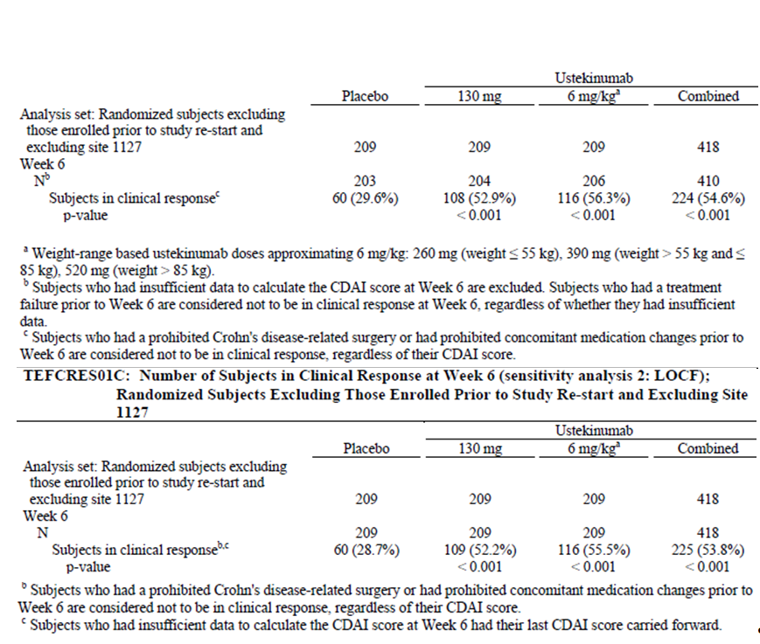

Results for other efficacy outcomes
Secondary endpoints: A significantly greater proportion of subjects in both the ustekinumab ~6 mg/kg and ustekinumab 130 mg groups were in clinical remission at Week 8 (40.2% and 30.6%, respectively) compared with the placebo group (19.6%; p<0.001 and p=0.009, respectively). The proportion of subjects in remission at Week 8 was numerically greater in the ~6 mg/kg dose group than in the 130 mg group and the treatment effect for the ~6 mg/kg dose group was nearly twice that seen in the 130 mg group (20.6% and 11.0%, respectively).
A significantly greater proportion of subjects in both the ustekinumab ~6 mg/kg and ustekinumab 130 mg groups were in clinical response at Week 8 (57.9% and 47.4%, respectively) compared with the placebo group (32.1%; p<0.001 for both). The proportion of subjects in response at Week 8 was also numerically greater in the ~6 mg/kg dose group than in the 130 mg group and the treatment effect was larger for the ~6 mg/kg group (25.8%) than for the 130 mg group (15.3%). A significantly greater proportion of subjects in both the ustekinumab ~6 mg/kg and ustekinumab 130 mg groups were in 70-point response compared with the placebo group at Week 6 (64.6%, 58.9% and 38.8%, respectively; p<0.001 for both) and at week 3 (50.7%, 49.3% and 31.6%, respectively; p<0.001 for both).
As early as Week 3, a significantly greater proportion of subjects in the ~6 mg/kg group were in remission compared with the placebo group (p=0.002). At Weeks 6 and 8, the proportions of subjects in both ustekinumab groups in clinical remission continued to increase and were significantly greater compared with placebo (~6 mg/kg: both p<0.001; 130 mg: both p≤0.009). At each of the time points, the proportion of subjects in remission was numerically greater in the ~6 mg/kg dose group than in the 130 mg group (Figure 27).
At the first post baseline visit at Week 3, significantly greater proportions of subjects were in clinical response in both ustekinumab dose groups (38.8% and 32.5% in the ~6 mg/kg and 130 mg groups, respectively) compared with the placebo group (21.5%). At Week 6, the proportion of subjects in clinical response had increased in both ustekinumab dose groups. At Week 8, the proportion of subjects in clinical response remained stable in the high dose group but decreased slightly in the low dose group (Figure 28).
At Week 3, a significantly greater proportion of subjects were in 70-point response in both ustekinumab dose groups (50.7% and 49.3% in the ~6 mg/kg and 130 mg groups, respectively) compared with the placebo group (31.6%). At Week 6, the proportion of subjects in 70-point response had increased in both ustekinumab dose groups and remained stable at Week 8. As a result, the treatment effect at Week 8 was larger for the ~6 mg/kg group (22.5%) than for the 130 mg group (13.9%) (Figure 29).
At Week 3, there was a significantly greater reduction in the CDAI score in both ustekinumab treatment groups (median CDAI score changes from baseline of −70.0 and −68.0 in the ~6 mg/kg and 130 mg ustekinumab groups, respectively) compared with the placebo group (−37.0). At Week 6, median reductions in the CDAI score had increased in magnitude in both ustekinumab dose groups compared with placebo. At Week 8, median reductions in the CDAI score remained stable in the high dose group but decreased slightly in the low dose group. As a result, the treatment effect was larger at Week 8 for the ~6 mg/kg group (−65.0) than for the 130 mg group (−41.0) (Figure 30).
Figure 27: Number of subjects in clinical response at week 6; randomised subjects excluding those enrolled prior to study re-start and excluding site 1127.
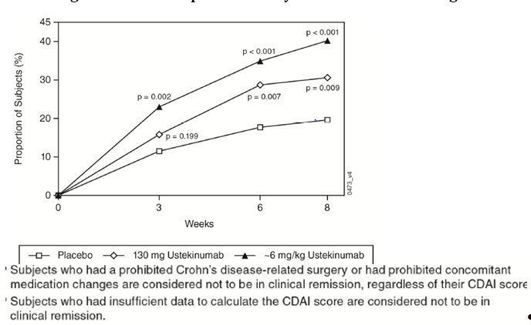
Figure 28: Number of subjects in clinical response through week 8; randomised subjects excluding those enrolled prior to study re-start and excluding site 1127.
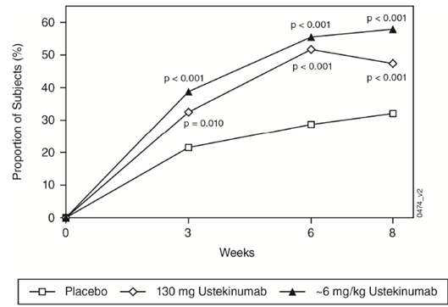
Figure 29: Number of subjects in 70-poing response through week 8; randomised subjects excluding those enrolled prior to study re-start and excluding site 1127.
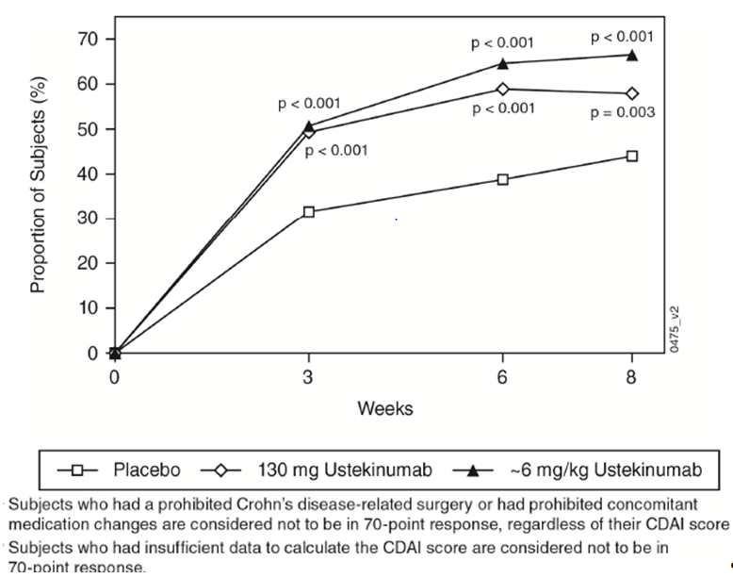
Figure 30: Median change from baseline in CDAI at weeks 3, 6 and 8; randomised subjects excluding those enrolled prior to study re-start and excluding site 1127.
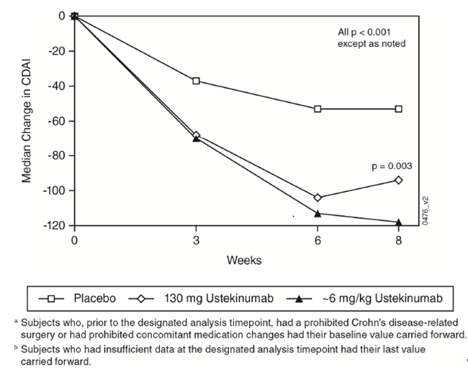
Other efficacy endpoints: The mean reductions in CRP concentrations were significantly greater in both the ~6 mg/kg and 130 mg ustekinumab groups compared with placebo at each time-point (p<0.001 for both groups). The maximum reduction in CRP was achieved by Week 3 for the high dose group and remained stable at Week 6 and Week 8. In the low dose group, the maximum reduction in CRP was achieved by Week 6 (-5.97 mg/L) but decreased at Week 8 (-3.97 mg/L). At baseline, 160, 165, and 157 subjects in the placebo, ~6 mg/kg, and 130 mg ustekinumab groups, respectively, had abnormal CRP (>3 mg/L). Among these subjects, a significantly greater proportion of subjects in the ~6 mg/kg and 130 mg ustekinumab groups (25.5% and 17.8%, respectively) had normalised CRP as early as Week 3 compared with the placebo group (7.5%, p<0.001 and p=0.007,respectively. At Weeks 6 and 8, the proportions of subjects with normalised CRP remained significantly greater in both ustekinumab groups compared with placebo (Week 6: p<0.001 for both groups; Week 8: p<0.001 and p=0.004, respectively).
The proportion of subjects with normalised CRP was greater in the high dose group than in the low dose group at all time-points. At Week 6, there was a significantly greater reduction in faecal lactoferrin concentration in the ~6 mg/kg and 130 mg ustekinumab groups (median reduction -25.93 and −10.35) compared with the placebo group (0.00, p<0.001 for both groups). Among subjects with a baseline faecal lactoferrin value >7.24 μg/g, the proportions of subjects with a normalised (≤7.24 μg/g) faecal lactoferrin value at Week 6 were significantly greater in the ~6 mg/kg and 130 mg ustekinumab groups (14.9% and 13.8%, respectively) compared with the placebo group (7.4%, p=0.027 and p=0.045 for the ~6 mg/kg and 130 mg ustekinumab groups, respectively. Similar results were observed for changes in faecal calcopretin at Week 6 with significantly greater proportion of subjects showing levels <250mg/kg at week 6 in the 6 mg/kg (30.4%) and 130 mg ustekinumab (26.3%) groups compared with placebo (15.7%).
Among the 10.8% (68 of 627) of subjects who had a fistula at baseline, a greater proportion of subjects were in fistula response at Week 8 in the combined ustekinumab group (34.1% [n=14/41]) compared with the placebo group (17.4% [n=4/23]). A total of 4 subjects (1 in the ustekinumab 130 mg group and 3 in the ustekinumab ~6 mg/kg group) had pyoderma gangrenosum. Resolution of the primary lesion occurred in 1 subject in the ustekinumab ~6 mg/kg group.
Patient reported outcomes: At Week 8, the mean change from baseline in the IBDQ score was significantly greater in the ~6 mg/kg and 130 mg ustekinumab groups (35.3 and 29.1, respectively) compared with the placebo group (14.7, p<0.001 for both groups) with significant reductions in all 4 dimensions for both ustekinumab groups. A significantly greater proportion of subjects in the ~6 mg/kg and 130 mg ustekinumab groups (68.1% and 58.7%, respectively) had a ≥16-point improvement from baseline in the IBDQ score at Week 8 compared with the placebo group (41.1%, p<0.001 for both ustekinumab groups. At Week 8, the mean change from baseline in the PCS score was significantly greater in the ~6 mg/kg and 130 mg ustekinumab groups (6.01 and 5.05, respectively) compared with the placebo group (2.59, p<0.001 and p=0.002, respectively) with similar improvements observed in the MCS scores. In addition, significantly greater proportions of subjects in both ustekinumab groups had at least a 5-point improvement from baseline in the PCS and MCS scores of the SF-36 at Week 8 (p≤0.036); the proportions were numerically higher for the 6 mg/kg group compared with the 130 mg group for PCS.
Efficacy in subgroups: Efficacy results for subgroups (based on demographics, baseline disease characteristics, concomitant medications at baseline and Crohn’s disease related drug history) for the primary endpoint of clinical response at Week 6 were consistent with those of the overall study population, with no subgroups having an OR <1 for either of the ustekinumab doses versus placebo. Notably, subgroup analyses demonstrated similar efficacy for ustekinumab in subjects previously treated with TNF antagonists (but who had otherwise not failed or developed intolerance to anti-TNF therapy) and those who were anti-TNF naïve. In general, efficacy results for subgroups examining the major secondary endpoint of clinical remission at Week 8 were consistent with those of the overall study population. There were no subgroups with an OR<1 within the ~6 mg/kg treatment group. Two of the 130 mg dose subgroups had an OR<1 compared with placebo. The first was the subgroup with weight at baseline > first quartile and ≤ second quartile (OR=0.9; 95% CI: 0.4, 2.1), and the second was the subgroup with CDAI >300 and receiving corticosteroids (OR=0.9; 95% CI: 0.3, 2.7). Notably, subgroup analyses demonstrated similar improvement in clinical remission for ustekinumab in subjects previously treated with TNF antagonists (but who had otherwise not failed or developed intolerance to anti-TNF therapy) and those who were anti-TNF naïve.
Health economic analysis: The proportions of subjects with Crohn’s disease-related hospitalisations were low across all treatment groups, and there was no significant difference between treatment groups though Week 8 (placebo [4.3% of subjects]; combined ustekinumab group [2.9% of subjects]). A similar pattern was seen with Crohn’s disease related surgeries and there was also no significant difference between treatment groups (placebo [1.4% of subjects]; combined ustekinumab group [0.7% of subjects]). The time lost from work (in days) during the previous 4 weeks due to Crohn’s disease at Week 8 and the change from baseline in work limitations (WLQ) did not show any significant difference between ustekinumab and placebo groups. The median change (reduction) from baseline in the impact of disease on daily productivity (VAS) at week 8 was significantly greater for the ~6 mg/kg and 130 mg ustekinumab groups (−2.0 and −1.2, respectively) compared with placebo (−0.6, p<0.001 and p=0.036, respectively).

Evaluator commentary
The efficacy of IV induction therapy with ustekinumab in subjects with Crohn’s disease who had failed TNF antagonist therapy was confirmed in the Phase III induction study (CRD3001; UNITI-1) discussed above. The focus of the present study was to determine the risk-benefit profile of IV induction therapy in Crohn’s disease patients who were anti-TNF naïve or who did not have a history of an inadequate response to TNF antagonists. The subjects enrolled in this study were reflective of the population in which first-line biologic use would be appropriate: patients with moderate to severe Crohn’s disease who had previously failed or were intolerant to conventional systemic therapy (that is, corticosteroids or immuno-modulators). Approximately 50% of subjects had previously failed full and adequate courses of both corticosteroids and immuno-modulators and about 70% were naïve to TNF antagonists. The treatment groups were well balanced with respect to baseline demographic and disease characteristics, including the baseline CDAI. One exception was the median disease duration, which was slightly greater in the placebo group at baseline (8.3 years) compared with the ustekinumab groups (6.2 and 5.6 years in the ~6 mg/kg and 130 mg groups, respectively. The effect of this on the interpretation of results is not clear.
The protocol deviations observed were not likely to affect the efficacy conclusion in the target patient population. GCP compliance issues were also addressed during conduct of the study with appropriate corrective action before database lock.
Ustekinumab showed significant induction benefit, reaching statistical significance for the primary endpoint as well as all 4 major secondary endpoints for both the low (130 mg) and high (tiered dosing approximating 6 mg/kg) doses. For the primary endpoint, significantly greater proportions of subjects were in clinical response at Week 6 in both the ~6 mg/kg (55.5%) and the 130 mg (51.7%) ustekinumab treatment groups compared with placebo (28.7%; p<0.001 for both). This positive result was robust to changes across multiple sensitivity analyses. Achieving clinical remission is a central goal of Crohn’s disease therapy. Ustekinumab showed significant benefit in inducing clinical remission at Week 8 (the first major secondary endpoint), with remission rates of 40.2% and 30.6% in the ~6 mg/kg and 130 mg groups, respectively, compared with 19.6% in the placebo group (p<0.001 and p=0.009, respectively). The efficacy of ustekinumab in achieving both the primary endpoint and the first major secondary endpoint of clinical remission at Week 8 was generally consistent across the prespecified subgroups examined.
It is important to note that the 95% CI for the primary and main secondary endpoints were not provided (only p-values for comparison versus placebo were provided in the CSR). Only the sensitivity analysis 3 (excluding those enrolled prior to study restart) showed the odds ratios and 95% CI values. The sponsors have been requested to provide the 95% CI for the primary and major secondary endpoints (refer Clinical questions below).
The efficacy of ustekinumab in Crohn’s disease was evident at the earliest time point assessed (Week 3). The major secondary endpoint of 70-point CDAI response at Week 3 was achieved in 50.7% and 49.3% in the ~6 mg/kg and 130 mg groups, compared with 31.6% in the placebo group (p<0.001 for both). Compared with placebo, greater proportions of subjects were in clinical response at Week 3 in both ustekinumab groups (~6 mg/kg: p<0.001; 130 mg: p=0.010) and a greater proportion of subjects were in clinical remission at Week 3 in the ~6 mg/kg group (p=0.002).
Ustekinumab also improved both general and IBD-specific health-related quality of life Outcomes. Along with improvements in subjective measures, ustekinumab had a significant and rapid effect on objective measures of inflammation. At both ustekinumab doses, significant reductions and normalisations were observed by Week 3 for the Crohn’s disease inflammatory marker of CRP and significant reductions in faecal lactoferrin and faecal calprotectin were observed at Week 6.
Overall, this well-conducted study demonstrated that IV induction treatment with ustekinumab significantly improved clinical, inflammatory and health-related quality of life parameters of Crohn’s disease in a population of subjects with moderate to severe, long-standing disease who were refractory to conventional therapy with corticosteroids and/or immuno-modulators. A greater magnitude of effect was seen in the ustekinumab ~6 mg/kg group compared with the 130 mg group for each of the clinical endpoints (clinical remission, clinical response, 70-point response, and CDAI score), as well as in the objective measures of inflammation (CRP, faecal lactoferrin, and faecal calprotectin concentrations), in the patient-reported outcome of ≥16-point improvement from baseline in IBDQ, and ≥5 point improvement in SF-36 physical component sub score. Although this greater magnitude of effect was observed at all 3 time points, it was particularly evident at Week 8.

Study CRD3003 (IM-UNITI)

Study design, objectives, locations and dates
This was a Phase III, randomised, double-blind, placebo-controlled, parallel group, multicentre study to evaluate the efficacy and safety of ustekinumab maintenance therapy in subjects with moderately to severely active Crohn’s disease. The primary objective of this study was to evaluate clinical remission for the two subcutaneous (SC) maintenance regimens of ustekinumab in subjects with moderately to severely active Crohn’s disease induced into clinical response with ustekinumab in the induction studies, CRD3001 and CRD3002 and to also evaluate their safety. The secondary objectives were:- to evaluate the efficacy of ustekinumab in maintaining clinical response in subjects induced into clinical response; to evaluate the efficacy of ustekinumab in maintaining clinical remission in subjects induced into clinical remission; to evaluate the efficacy of ustekinumab in achieving corticosteroid free remission; to evaluate the PKs, immunogenicity, and PDs of ustekinumab therapy, including changes in CRP, faecal calprotectin, faecal lactoferrin, and other PD biomarkers; and to evaluate the effect of ustekinumab on health-related quality of life (QOL). The study was conducted from 13 Sept 2011 to 10 June, 2015 at 260 sites in North America, Europe, Asia-Pacific region, Israel, South Africa, Australia, New Zealand, and Brazil. The study design is summarised in Figure 31 and discussed in detail below.
Figure 31: Study CRD3003. Study Schema
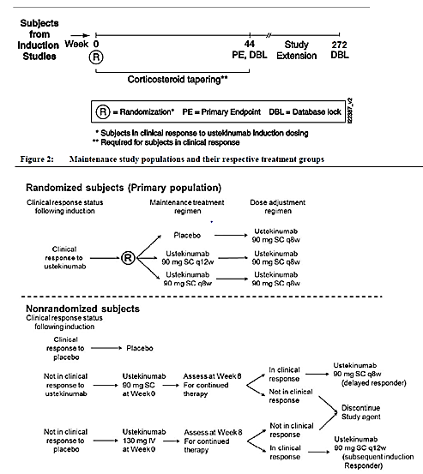

Inclusion and exclusion criteria
Eligible subjects were required to have received study agent at Week 0 in Study CRD3001 or CRD3002 and completed the Week 8 Crohn’s Disease Activity Index (CDAI) score evaluation. Induction Study CRD3001 included subjects with moderately to severely active Crohn’s disease had who previously failed or were intolerant to 1 or more TNF-antagonist therapies. Induction Study CRD3002 included subjects with moderately to severely active Crohn’s disease with evidence of active inflammation who failed conventional therapy (that is, corticosteroids and immuno-modulators).
Subjects were not to be enrolled into the study if they had specific changes to their concomitant medications due to Crohn’s disease (that is, lack of efficacy) since Week 0 of Studies CRD3001 and CRD3002 or initiated protocol prohibited medication since Week 0 of Studies CRD3001 and CRD3002, underwent a Crohn’s disease related surgery since Week 0 of induction Studies CRD3001 or CRD3002 or were diagnosed with any medical condition (or signs or symptoms thereof) which would have precluded enrolment in induction Studies CRD3001 and CRD3002.

Study treatments
Ustekinumab for SC administration was supplied as a sterile liquid for SC injection in a single-use prefilled syringe (PFS). Each single-use PFS contained 90 mg (1 mL fill of liquid) ustekinumab. Ustekinumab for IV administration was supplied as a single-use, sterile solution in glass vials with 2 dose strengths (that is, 90 mg in 1 mL nominal volume or 45 mg in 0.5 mL nominal volume). The placebo for SC injection was supplied as a sterile liquid at a fill volume of 1.0 mL in a single use PFS.
Subjects with moderately to severely active Crohn’s disease induced into clinical response with ustekinumab in induction Studies CRD3001 or CRD3002 were randomised in a 1:1:1 ratio at Week 0 to receive a SC administration of either placebo or 1 of 2 maintenance regimens of ustekinumab (ustekinumab 90 mg every 12 weeks [q12w] through Week 36 or ustekinumab 90 mg every 8 weeks [q8w] through Week 40). This population of subjects is considered the primary population in this study. At Week 44, subjects were evaluated for the primary endpoint of clinical remission.
Randomised subjects who subsequently met loss of response (LOR) criteria at any time between Week 8 and Week 32 of the study were eligible to have a single dose adjustment to ustekinumab 90 mg q8w. Subjects who had a dose adjustment were evaluated 16 weeks after adjustment and were discontinued from study agent if not in clinical response.
Subjects who were not in clinical response to ustekinumab at Week 8 of the induction studies, as well as all subjects who initially received placebo (both in clinical response and not in clinical response), were also eligible to enter the study, but were not included in the primary population. Subjects in clinical response to placebo IV induction continued to receive SC placebo throughout the maintenance study. Subjects not in clinical response to IV placebo induction received ustekinumab 130 mg IV administration at Week 0. Subjects who achieved clinical response at Week 8 initiated ustekinumab 90 mg SC at Week 8 and then q12w thereafter through Week 32; otherwise they were discontinued from further study agent administration. Subjects who were not in clinical response to ustekinumab IV induction received ustekinumab 90 mg SC at Week 0 of this maintenance study. Subjects who achieved clinical response at Week 8 continued to receive ustekinumab 90 mg SC q8w through Week 40; otherwise they were discontinued from further study agent administration.
Duration of treatment in the main study was 44 weeks. The long-term extension will continue through Week 272.
Subjects receiving corticosteroids at Week 0 who were in clinical response were to initiate corticosteroid tapering at Week 0. This tapering was mandatory and was to follow a recommended schedule . Enrolled subjects were not permitted to initiate any of the following prohibited medications: Immunomodulatory agents other than 6-MP/AZA or MTX (including but not limited to 6-TG, cyclosporine, tacrolimus, sirolimus, mycophenolate mofetil); Immunomodulatory biologic agents (including but not limited to TNF antagonists, natalizumab and abatacept); Experimental Crohn’s disease medications. If initiated at any time during the study, subjects were discontinued from study agent.

Efficacy variables and outcomes
The following efficacy variables were assessed: -CDAI assessment, CRP concentrations, faecal lactoferrin and faecal calprotectin concentrations, fistula assessment, pyoderma gangrenosum assessment, ileocolonoscopy (in subjects who consented to the substudy at participating sites); Patient-reported outcomes (IBDQ, SF-36); Health economics [Resource utilisation, productivity Visual Analog Scale (VAS), Work Limitations Questionnaire (WLQ)]. PKs, PDs (biomarkers) and immunogenicity (antibodies to ustekinumab) was also assessed,
The primary efficacy endpoint was Clinical remission at Week 44, defined as a CDAI score of <150 points. The major secondary endpoints, listed in hierarchical order:
- Clinical response at Week 44, defined as a reduction from Week 0 of induction Study CRD3001 or CRD3002 in the CDAI score of ≥100 points.
- Clinical remission at Week 44 among subjects in clinical remission to ustekinumab at Week 0 of maintenance.
- Corticosteroid-free remission at Week 44.
- Clinical remission at Week 44 in the subset of subjects who were refractory or intolerant to TNF antagonist therapy (that is, subjects from induction Study CRD3001.

Randomisation and blinding methods
Subjects who were in clinical response to ustekinumab induction in either Study CRD3001 or CRD3002 were randomly assigned to 1 of 3 treatment groups (placebo, ustekinumab 90 mg SC q12w, and ustekinumab 90 mg SC q8w) based on a computer-generated randomisation schedule prepared before the study under the supervision of the sponsor. Permuted block randomisation with stratification factors of clinical remission at Week 0 (yes or no) and ustekinumab induction dose (130 mg or tiered dosing approximating 6 mg/kg ustekinumab) were used. Other subject populations were not randomised and were assigned treatment as described above.
The study was double-blind. Treatment assignment blinding was maintained for investigative sites, site monitors, and subjects participating in the study until the Week 44 analyses were completed. The sponsor was blinded to treatment assignment until after the Week 44 database lock occurred. All subjects were to receive an SC administration of study agent (either placebo or ustekinumab) every 4 weeks from Week 0 to Week 40 with the exception of Week 4 Placebo administrations (both IV and SC) were given at dosing visits in which an active administration was not planned in order to maintain the blind, particularly with respect to SC regimen dosing interval (for example, a subject in the 90 mg ustekinumab q12w treatment group was to receive SC placebo at visits occurring 4 weeks and 8 weeks after receiving 90 mg ustekinumab).

Analysis populations
Efficacy analyses were based on the primary population (that is, subjects in clinical response to ustekinumab at Week 8 from 1 of the induction Studies CRD3001 and CRD3002 who were randomised at Week 0 into one of the SC maintenance regimens), excluding the subjects who were randomised prior to study restart. Efficacy analyses were based on an intent-to-treat principle and efficacy data for each subject was analysed according to the assigned treatment regardless of the actual treatment received. Selected efficacy endpoints were summarised for other subject populations in this study (that is, subjects in clinical response to placebo IV and subjects not in response to ustekinumab or placebo IV at Week 8 in the induction studies).

Sample size
A fixed sequence testing procedure was used to control the overall type I error rate at the 0.05 level (2-sided) for the comparisons of the two ustekinumab maintenance regimens with placebo.
Therefore, sample size and power were determined by the chi-square test to detect the significance of difference between the 90 mg q8w ustekinumab and placebo groups. The assumptions for sample size and power calculations were based on maintenance data in subjects randomised as responders from the infliximab ACCENT I and adalimumab CHARM studies (Colombel, 2007; Rutgeerts, 2004). In the ACCENT I study, the proportion of subjects in clinical remission at Week 54 was 33% and 14% for infliximab and placebo, respectively. In the CHARM study, the proportion of subjects in clinical remission at Week 56 was 36% and 12% for adalimumab and placebo, respectively. Assuming a 15% clinical remission rate at Week 44 in the placebo group and 35% in the 90 mg q8w ustekinumab group, 100 subjects per treatment group were predicted to yield power above 90%, at a significance level of 0.05 (2-sided).

Statistical methods
The proportion of subjects in clinical remission at Week 44 was compared between each of the ustekinumab treatment groups and the placebo group using a 2-sided Cochran Mantel Haenszel chi-square test, stratified by clinical remission status at Week 0 (yes or no), ustekinumab induction dose (130 mg or tiered dosing approximating ustekinumab 6 mg/kg), and the induction Study CRD3001 or CRD3002 at a significance level of 0.05. The study was considered positive if the 90 mg q8w ustekinumab group was significantly different from placebo.
The major secondary endpoints were compared between each of the ustekinumab treatment groups and the placebo group using a 2-sided Cochran-Mantel-Haenszel chi square test, stratified by clinical remission status at Week 0 (yes or no), ustekinumab induction dose (130 mg or tiered dosing approximating ustekinumab 6 mg/kg), and the induction study (CRD3001 or CRD3002) at a significance level of 0.05. In order to control the overall Type I error rate, the primary endpoint and major secondary endpoints were tested in a hierarchical fashion. The first major secondary endpoint was tested only if the primary endpoint was positive, and the later major secondary endpoints were tested only if the earlier endpoint in the hierarchy was positive. A fixed-sequence testing procedure was also employed to control the Type 1 error rate within each of the 4 major secondary endpoint analyses at the 0.05 (2 sided) significance level. Therefore, the ustekinumab 90 mg SC q12w dose for a major secondary endpoint could not be tested unless the ustekinumab 90 mg SC q8w dose tested positive for that endpoint. In addition, the ustekinumab 90 mg SC q12w dose would not be tested for an endpoint unless the dose tested positive for the previous endpoint in the hierarchy. Global and US-specific multiple testing procedures were prespecified to control the overall Type 1 error rate at the 0.05 level over the primary and major secondary endpoints in this study. All statistical testing was performed at the 2-sided 0.05 significance level. Nominal p-values were presented.

Participant flow
A total of 1,281 subjects who completed the ustekinumab induction studies were enrolled in this study. Table 11 summarises the study participation status as of Week 44 for all enrolled subjects.
Table 11: Summary of study participation status as of week 44; enrolled subjects
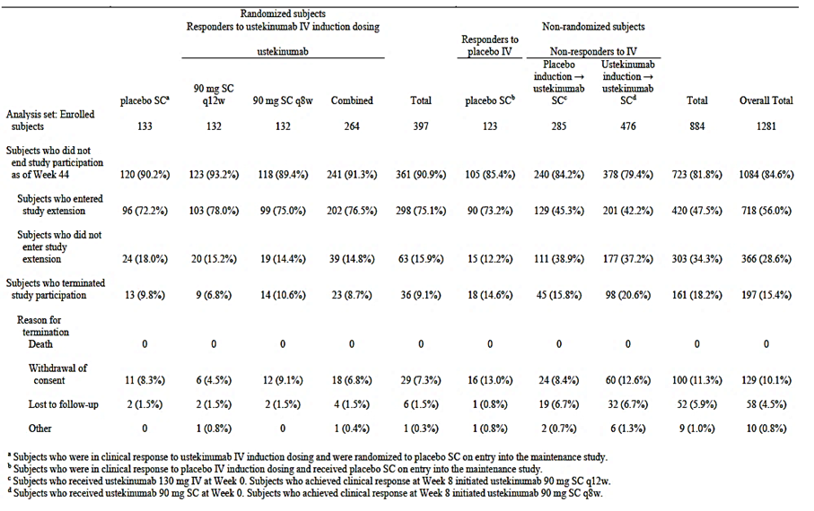
Randomised subjects: This was the primary population (in clinical response to ustekinumab IV induction at Week 8 of an induction study) which included 397 subjects (31.0%) were in: 133 subjects randomised to placebo; 132 subjects randomised to ustekinumab 90 mg q12w; 132 subjects randomised to ustekinumab 90 mg q8w. The proportions of randomised subjects who discontinued study agent were similar across treatment groups (23.3%, 22.0%, and 22.7% in the placebo SC, ustekinumab 90 mg SC q12w, and q8w groups, respectively). The most common reasons for discontinuation of study agent among subjects in the primary population were lack of efficacy or an adverse event. Among randomised subjects, 9.8%, 6.8%, and 10.6% in the placebo, ustekinumab 90 mg q12w, and ustekinumab 90 mg q8w groups, respectively, terminated study participation prior to Week 44. The most common reason for termination was withdrawal of consent.
Subjects in the primary population who subsequently lost clinical response at any scheduled visit were eligible, beginning at Week 8, for a single dose adjustment through Week 32. A total of 27.5% (109 subjects) of the primary population had a dose adjustment as follows:
- Among subjects randomised to placebo, 38.3% (51 subjects) had a dose adjustment to an ustekinumab 90 mg SC q8w dose regimen
- Among subjects randomised to ustekinumab 90 mg SC q12w, 22.0% (29 subjects) had a dose adjustment to an ustekinumab 90 mg SC q8w regimen
- Among subjects randomised to ustekinumab 90 mg SC q8w, 22.0% (29 subjects) continued on the same dose regimen after dose adjustment.
The majority (76.1%) of dose adjustments in the primary population occurred by Week 20. The incidence of discontinuation among randomised subjects who had a dose adjustment was similar across treatment groups with lack of efficacy being most common reason for discontinuation.
Non-randomised subjects: These included 884 subjects (69.0%) who were enrolled but not randomised:
- 123 placebo induction responders who continued to receive placebo.
- 285 placebo induction non-responders who received an ustekinumab 130 mg IV infusion at Week 0. Subjects who achieved clinical response by Week 8 of maintenance continued to receive ustekinumab 90 mg q12w (subsequent induction responders).
- 476 ustekinumab induction non-responders who received ustekinumab 90 mg at Week 0.
- Subjects who achieved clinical response by Week 8 of maintenance continued to receive ustekinumab 90 mg q8w (delayed responders).
A total of 455 (51.5%) nonrandomised subjects discontinued study agent. The most common reason for discontinuation of study agent was lack of efficacy. Among nonrandomised subjects, 14.6%, 15.8%, and 20.6% in the placebo induction responder, placebo induction non-responder and ustekinumab induction non-responder groups, respectively, terminated study participation prior to Week 44. The most common reason for termination was withdrawal of consent.

Major protocol violations/deviations
Overall, there were 28 major protocol deviations through Week 44. Of the 397 randomised subjects, 12 had a major protocol deviation, with 5 in the placebo group and 7 in the combined ustekinumab group. Of 884 nonrandomised subjects, 16 had a major protocol deviation, 2 in the placebo IV induction responder group and 14 in the ustekinumab IV induction non-responders group. Deviations varied in nature but are not considered to have any clinically relevant impact on data integrity or subject safety.

Baseline data
Randomised subjects (primary analysis population)
Baseline demographic and disease characteristics were generally similar across the treatment groups and was representative of a population of subjects with intractable moderate to severe Crohn’s disease that was refractory to available therapies. Majority of subjects were women (56.4%), White (84.9%) with median age of 36 years and median weight of 69kg.
The median duration of disease at baseline was 7.57 years, median CDAI score, 311.0; median CRP concentration, 9.27 mg/L. Majority of subjects had either an abnormal CRP (>3.0 mg/mL), abnormal calprotectin (>250 mg/kg), or abnormal lactoferrin (>24 μg/g) levels at baseline of an induction study (95.4%, 95.3%, and 89.1% for the placebo, ustekinumab 90 mg q12w and q8w groups, respectively. Approximately 60% of subjects were in clinical remission at Week 0 of this study in both the placebo group and ustekinumab groups. At Week 0 of this maintenance study, CDAI, CRP, IBDQ values and clinical remission status were well balanced across the three groups. The medical history and current diagnoses at Week 0 of an induction study among the primary population were generally consistent across treatment groups; 38.3% of subjects had at least 1 cardiovascular risk factor and 7.1% had 2 or more risk factors; 11.8% were hypertensive; 6.0% had a family history of coronary artery disease; 23.9% were current smokers and 6.5% of subjects had a diagnosis of psoriasis.
Overall, 95.5% (n=379/397) of randomised subjects had previously received corticosteroids; of those, 44.3% had previously failed to respond, 10.8% had become intolerant or developed a medical contraindication to these agents, and 47.2% had been corticosteroid dependent. The proportions of subjects who had received corticosteroids were similar among the treatment groups. A total of 83.1% of subjects (n=330/397) had previously received immuno-modulators; of those, 62.7% had previously failed to respond and 45.2% had become intolerant or developed a medical contraindication to these agents. The proportions of subjects who had previously received immuno-modulators and had failed or become intolerant to them were well-balanced across the treatment groups. Of the randomised subjects in this study, 44.8% were TNF antagonist refractory, 15.6% had received TNF antagonists and had not demonstrated failure or intolerance and 39.5% had not received any TNF antagonist therapy prior to study participation.
The use of concomitant Crohn’s disease medications at Week 0 of this study was consistent with the use observed at baseline of an induction study. Additionally, 79.3% of subjects were receiving 1 or more concomitant medications for Crohn’s disease at baseline, and the proportions of subjects receiving each class of Crohn’s disease medication at baseline were similar across the 3 treatment groups. A total of 181 subjects (45.6%) were receiving corticosteroids; the median dose of oral corticosteroids excluding budesonide was 20.0 P.Eq/day and the median dose of budesonide was 9.0 mg/day. Overall, 143 (36.0%) were receiving immuno-modulators (28.5% receiving 6-MP or AZA and 7.6% receiving MTX); 35.8% were receiving aminosalicylates.
Non-randomised subjects: Baseline demographic characteristics were generally similar to those noted for randomised subjects. Baseline disease characteristics were representative of a population of subjects with intractable moderate to severe Crohn’s disease that was refractory to available therapies: median duration of disease at baseline, 9.19 years; median CDAI score, 298.0; median CRP concentration, 8.1 mg/L. The proportions of subjects with a prior history of corticosteroid and immuno-modulator use were also comparable to the proportions seen in the randomised subjects.
Concomitant medication use for Crohn’s disease and the proportions of subjects with a prior history of corticosteroid and immuno-modulator use in the nonrandomised subjects were comparable to the proportions seen in the randomised subjects. Of the 884 nonrandomised subjects in this study, 57.6% were TNF antagonist refractory, 14.3% had received TNF antagonists and had not demonstrated failure or intolerance, and 28.2% had not received any TNF antagonist therapy prior to study participation. Of the 884 nonrandomised subjects in this study, 509 (57.6%) subjects enrolled from induction Study CRD3001 and were TNF antagonist refractory. Of these subjects, 31.2% had an inadequate initial response, 69.9% had response followed by loss of response, and 34.6% had intolerance to 1 or more TNF antagonists; 46.6% had failed 1 TNF antagonist in the past and 41.7% and 11.2% had failed 2 or 3 TNF antagonists, respectively.

Results for the primary efficacy outcome
A significantly greater proportion of subjects in the ustekinumab 90 mg q12w and q8w ustekinumab groups were in clinical remission at Week 44 (48.8% and 53.1%, respectively) compared with the placebo group (35.9%; p=0.040, p=0.005, respectively).
The proportion of subjects in the primary analysis population who met treatment failure criteria prior to Week 44 was greater in the placebo group compared with the ustekinumab 90 mg q12w and q8w groups (45%, 36.4% and 28.9% the placebo, ustekinumab 90 mg q12w and q8w groups, respectively) and the most common reason for meeting treatment failure criteria was loss of clinical response (38.9%, 22.5%, and 21.9%, respectively.
The proportion of subjects with missing data for the CDAI score at Week 44 (that is, <4 of the 8 CDAI components available) was approximately 5% overall (6.1%, 1.6%, and 7.8% in the placebo, ustekinumab 90 mg q12w and q8w dose groups, respectively) and the most common reason for missing data was discontinuation of study agent.
Sensitivity analyses were conducted to test robustness of the primary efficacy analysis. For the ustekinumab q8w regimen, the primary endpoint analysis was robust to changes in missing data rules (that is, significant for all missing data sensitivity analyses except the Worst Case analysis, though the treatment effect for this analysis was in the same direction as the primary analysis) and to the exclusion of subjects who were randomised and not treated.
For the q12w regimen, while the treatment effects for the missing data sensitivity analyses were in the same direction and of generally similar magnitude as the primary analysis, these sensitivity analyses were not significant for the q12w regimen.
In general, efficacy results for subgroups examining the primary endpoint of clinical remission at Week 44 were consistent with those of the overall study population. A single subgroup, weight at maintenance baseline >1st and ≤2nd quartile had an OR<1 in the ustekinumab 90 mg q8w group compared with placebo (OR=0.5, 95% CI: 0.1, 1.5) (Figure 32). Three ustekinumab 90 mg q12w treatment subgroups had an OR<1 compared with placebo (weight >1st quartile and <2nd quartile; baseline CDAI<75 and CRP<3mg/L) (Figure 33). When evaluated by Crohn’s disease-related concomitant medication and prior CD medication subgroups at baseline of an induction study, the treatment effects of ustekinumab 90 mg q8w (Figure 34) and q12w (Figure 35) versus placebo were generally consistent with those of the primary analysis population with the exception of receiving both oral corticosteroids and 6-MP/AZA/MTX which had an OR<1 for both treatment groups compared with placebo (OR=0.5, 95% CI: 0.1, 2.9 for q12w group and OR=0.9, 95% CI: 0.2, 4.1 for q8w group).
As part of the primary analysis population, subjects who were in response and were randomised to placebo were treated with ustekinumab 90 mg q8w upon meeting LOR criteria. Overall, 51 subjects randomised to placebo had a dose adjustment to ustekinumab 90 mg q8w after meeting LOR criteria. At assessments 16 weeks after initiation of maintenance therapy: 39.2% of these subjects were in clinical remission, 70.6% of these subjects had regained clinical response and the median change in CDAI score from time of dose adjustment was -121.0. These data indicate that in the subset of subjects who responded to the ustekinumab IV induction dose but delayed initiation of the SC maintenance therapy, benefit can be regained without the need for an additional IV induction dose. However, it should be noted that the number of subjects in this group was limited (51 subjects total) and the majority of subjects (32 of 51) had a dose adjustment within the first 16 weeks of the maintenance study.
Figure 32: Plots of odds ratio and 95% CI for comparing the proportion of subjects in clinical remission at week 44 in the ustekinumab 90mg SC q8w group vs the placebo group by demographics and clinical disease characteristics.
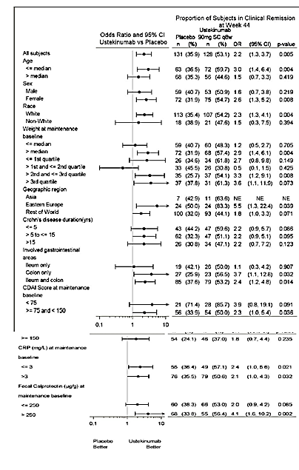
Figure 33: Plots of odds ratio and 95% CI for comparing the proportion of subjects in clinical remission at week 44 in the ustekinumab 90mg q12w group vs the placebo group by demographics and clinical disease characteristics.
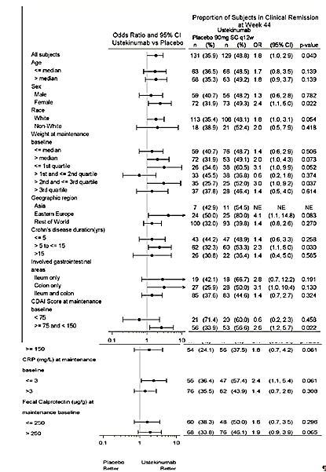
Figure 34: Plots of odds ratio and 95% CI for comparing the proportion of subjects in clinical remission at week 44 in the ustekinumab 90mg SC q8w group vs the placebo group by concomitant CD medications at baseline of the induction study, prior CD medication history (including TNF antagonist therapy) and induction dose.
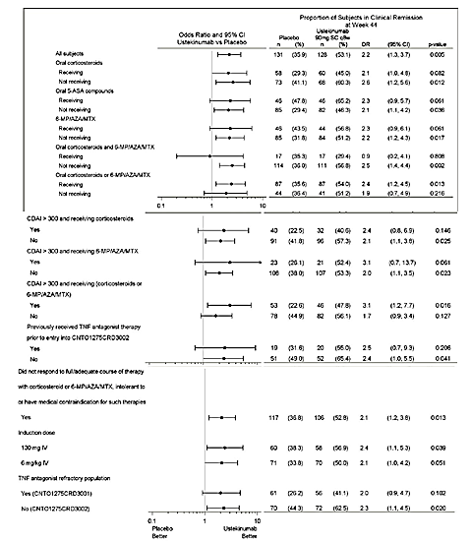
Figure 35: Plots of odds ratio and 95% CI for comparing the proportion of subjects in clinical remission at week 44 in the ustekinumab 90mg SC q12w group vs the placebo group by concomitant CD medications at baseline of the induction study, prior CD medication history (including TNF antagonist therapy) and induction dose
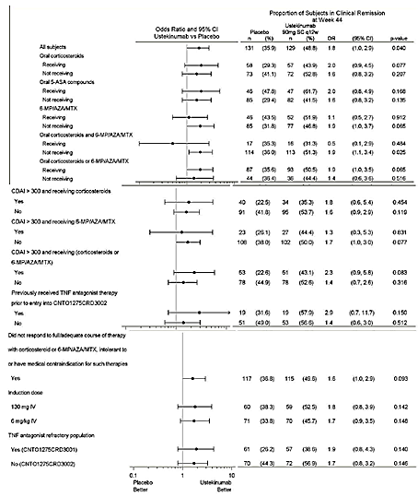

Results for other efficacy outcomes

Major secondary endpoints
A significantly greater proportion of subjects in the ustekinumab 90 mg q12w and q8w groups maintained clinical response at Week 44 (58.1% and 59.4%, respectively) compared with the placebo group (44.3%; p=0.033 and p=0.018, respectively).
Among the approximately 60% of subjects who were in clinical remission at baseline, a significantly greater proportion of subjects in the ustekinumab 90 mg q8w group maintained clinical remission at Week 44 (66.7%) compared with the placebo group (45.6%; p=0.007). The remission rate in the ustekinumab 90 mg q12w group (56.4%) was numerically higher than the placebo group (45.6%), however the difference was not statistically significant (p=0.189).
A greater proportion of subjects in the ustekinumab 90 mg q12w and q8w groups were in corticosteroid-free remission at Week 44 (42.6% and 46.9%, respectively) compared with the placebo group (29.8%). While the nominal p-values for the comparisons of each of the ustekinumab groups with placebo were <0.05 for this endpoint, only the ustekinumab 90 mg q8w regimen can be considered as significantly different from placebo (p=0.004) within the global testing procedure. Under the US-specific testing procedure, neither of the two ustekinumab groups was considered as statistically significant as the difference in remission rate in ustekinumab 90 mg q12w group compared with placebo group did not achieve statistical significance (see previous paragraph).
Among the subset of subjects who were refractory to TNF-antagonist therapy, remission rates at Week 44 were numerically greater in the ustekinumab 90 mg q12w and q8w dose groups (38.6% and 41.1%, respectively) compared with the placebo group (26.2%) although the difference was not statistically significant. While the treatment effects were similar to those in the overall population, it is likely that there was not sufficient power to detect a significant difference from placebo as only 44.8% of the subjects in the primary population of this study were in this subpopulation.

Other efficacy results
Compared with placebo, a significantly greater proportion of subjects in the ustekinumab 90 mg q12w and q8w groups were in sustained clinical remission(40.3%, 46.1% and 26.0%, respectively; p=0.023 and p<0.001 for the q12w and q8w groups, respectively) and sustained clinical response (53.5%, 53.1% and 38.2%, respectively; p=0.019 for both the q12w and q8w comparisons).
Analyses of clinical efficacy over time were generally similar for the ustekinumab q12w and q8w dose groups with separation from placebo as early as Week 20. The proportions of subjects in clinical remission over time were generally similar for the ustekinumab 90 mg q12w and q8w groups, though remission rates were smallest for the ustekinumab q12w dose group at trough serum ustekinumab concentration visits (that is, Weeks 12, 24 and 36), and remission rates were generally more consistent for the ustekinumab q8w groups with the exception of Week 16. The proportion of subjects in the placebo group who were in clinical remission decreased over time, with separation from the ustekinumab groups observed by Week 20 (Figure 35). Similar results were observed for proportion of subjects in clinical response (with separation from placebo after week 28) (Figure 36) and median CDAI scores (Figure 37).
Figure 35: Proportion of subjects in clinical remission at each visit through week 44; randomised subjects excluding those enrolled prior to study re-start.
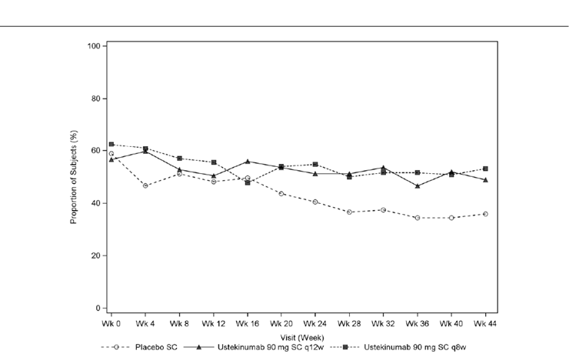
Figure 36: Proportion of subjects in clinical remission at each visit through week 44; randomised subjects excluding those enrolled prior to study re-start.
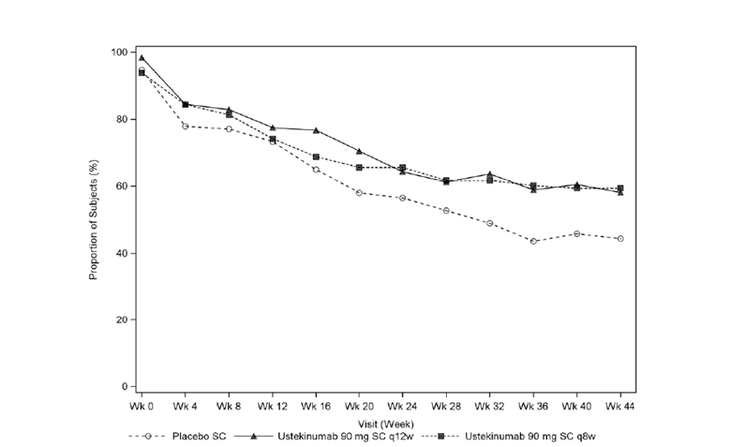
Figure 37: Line plot of median CDAI through week 44; randomised subjects excluding those enrolled prior to study re-start.
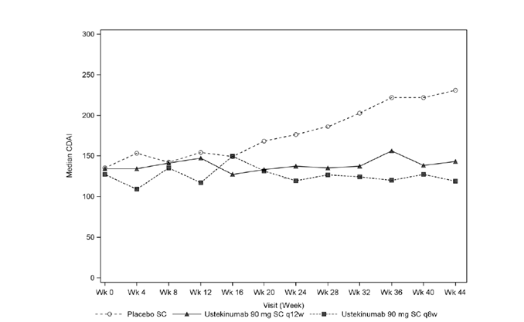
Dose Adjustment: Overall, 29 subjects in the ustekinumab 90 mg q12w group had a dose adjustment to 90 mg q8w after meeting LOR criteria. When assessed 16 weeks after dose adjustment: 41.4% of these subjects were in clinical remission, 55.2% of these subjects had regained clinical response and the median change in CDAI score from time of dose adjustment was -141.0. Overall, 28 subjects in the ustekinumab 90 mg q8w group met LOR criteria for dose adjustment but continued to receive ustekinumab 90 mg q8w (per protocol). When assessed 16 weeks after meeting LOR criteria for dose adjustment: 32.1% of these subjects were in clinical remission, 46.4% of these subjects had regained clinical response and the median change in CDAI score from time of dose adjustment was -78.5.
Having observed benefit within the group of subjects who had a dose adjustment from ustekinumab q12w to q8w, the data were alternatively evaluated through post hoc analyses as a treatment strategy, an analytic approach that preserves the initial randomisation. In this assessment of dose adjustment, subjects starting on q12w or q8w remained in their randomised treatment group whether or not LOR and subsequent dose adjustment occurred. In these analyses, the LOR treatment failure criteria was suspended, and the rest of the analysis rules were kept the same. When examined using this approach, there was no consistent difference in clinical remission or clinical response rates between the q8w and the q12w group. For example, at Week 44, clinical remission was achieved by 60.2% of subjects who remained on q8w (with and without LOR) and 58.1% of subjects in the q12w group (including subjects who dose adjusted from q12w to q8w upon LOR). These results suggest that subjects receiving an ustekinumab 90 mg q12w dose regimen who have experienced a decrease in their response during maintenance, may benefit from an increase in dosing frequency to 90 mg q8w, and that taking the approach of initiating subjects on 90 mg q12w with adjustment to q8w when needed by LOR ultimately results in similar clinical outcomes to simply starting all subjects on 90 mg q8w. This supports further the rationale to have the ability to increase the maintenance dose frequency from q12w to q8w upon LOR in subjects who would begin maintenance therapy with a q12w regimen.
Additional Corticosteroid Endpoints: The proportions of subjects in clinical remission at Week 44 who were not receiving concomitant corticosteroids for at least 90 days prior to Week 44 were significantly greater in the ustekinumab 90 mg q12w (41.1%) and q8w (45.3%) groups compared with the placebo group (29.0%; p=0.046 and p=0.005 for the q12w and q8w comparisons, respectively) with similar results for not receiving concomitant corticosteroids for 30 days prior to week 44 (q12w= 42.6%, q8w=46.9%, placebo=29.8%).
The proportion of all subjects in the primary population (regardless of concomitant corticosteroid use at baseline) who were in clinical response at Week 44 and not receiving corticosteroids at Week 44 were significantly greater in the ustekinumab 90 mg q12w and q8w groups (51.2% and 50.8%, respectively) compared with subjects in the placebo group (36.6%; p=0.024 and p=0.026 for the q12w and q8w comparisons, respectively).
Among subjects who were receiving corticosteroids at baseline (about 46% of the patients) a significantly greater proportion of these subjects in the combined ustekinumab group were able to achieve clinical remission or clinical response at Week 44 and not be receiving corticosteroids at Week 44 compared with the placebo group (30.2% versus 15.5%, p=0.030). In addition, a higher proportion of subjects in the ustekinumab 90 mg q12w and q8w groups were able to eliminate corticosteroid use by Week 44 compared with the placebo group.
Clinical efficacy by induction study: Of the 397 randomised subjects in this study, 44.8% entered from CRD3001 and were TNF antagonist refractory Of the 397 randomised subjects in this study, 55.2% entered from Study CRD3002, of whom 15.6% had received TNF antagonists and had not demonstrated failure or intolerance, and 39.5% had not received any TNF antagonist therapy prior to study participation. At Week 44, the proportions of subjects in clinical remission were numerically greater for both ustekinumab treatment groups compared with placebo regardless of induction study and reached statistical significance for the ustekinumab 90 mg q8w group (p=0.020) in Study CRD3002. The proportions of subjects from Study CRD3002 who were in clinical remission were greater than the proportions of subjects from Study CRD3001 who were in clinical remission at all visits through Week 44. The proportion of TNF antagonist-naïve subjects in remission at Week 44 was significantly greater in the ustekinumab 90 mg q8w group (65.4%) and numerically greater in the q12w group (56.6%) compared with the placebo group (49.0%; p=0.041 for the ustekinumab q8w group). Similar results were observed for clinical response at week 44.
Clinical efficacy by IV induction dose (130 mg or 6 mg/kg IV induction): At baseline of this maintenance study, the proportions of subjects in clinical remission were slightly lower for subjects who received ustekinumab 130 mg IV induction (55.9%) compared with subjects who received 6 mg/kg IV induction (62.1%). However, by Week 16, the proportion of subjects in clinical remission was undifferentiated by induction dose (51.3% and 52.1% for the combined ustekinumab groups in the 130 mg and 6 mg/kg groups, respectively). Similar results were observed for clinical response by induction dose.
One or more clinically apparent fistulas were present at induction baseline in 8.8% of subjects in the primary analysis population. At Week 0 of this study, after having received ustekinumab induction, 23.1% (n=3/13) and 42.9% (n=9/21) in the placebo and combined ustekinumab groups, respectively were in fistula response. The proportions of subjects who achieved fistula response were numerically greater in the combined ustekinumab compared with the placebo group at all-time points. At Week 44, 80.0% (n=12/15) of subjects in the combined ustekinumab groups had a fistula response compared with 45.5% (n=5/11) in the placebo group. Two subjects in the primary analysis population of this study had pyoderma gangrenosum. One subject in the placebo SC group and 1 subject in the ustekinumab 90 mg q12w group both experienced resolution of the primary lesion and reduction in the number of lesions.
Inflammatory markers: The median decrease in CRP concentrations from Week 0 of the induction study observed to Week 0 of this study was significantly maintained through Week 44 by both ustekinumab maintenance dose regimens compared with the placebo group. Over time there was more consistent control of inflammation with the ustekinumab q8w regimen than the q12w regimen (Figure 38). The decreases in the faecal lactoferrin and faecal calprotectin at Week 0 of this maintenance study were maintained at Week 20 and significantly maintained at Week 44 in the both ustekinumab dose groups compared with the placebo group. The proportions of subjects with normalised faecal lactoferrin concentrations remained stable or increased slightly over time in both ustekinumab dose groups and were significantly greater at Week 44 compared with placebo, where the proportion of normalised subjects decreased over time. The proportions of subjects with faecal calprotectin levels ≤250 μg/g or ≤100 μg/g at Week 44 were significantly greater in both ustekinumab groups compared with placebo.
Figure 38: Line plot of median CRP (mg/L) through week 44; randomised subjects, excluding those enrolled prior to study re-start.
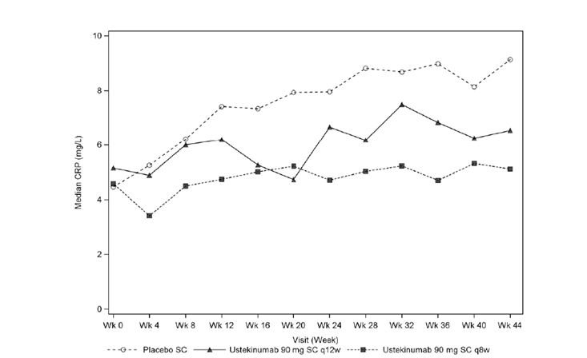
Patient-reported outcomes and health economics: At Week 44, the median change in IBDQ scores from Week 0 of this study was significantly smaller in the ustekinumab 90 mg q12w and q8w dose groups (-2.5 and -2.0, respectively), compared with the placebo group (-14.5; p<0.001 and p=0.003, respectively). The median changes in all 4 of the IBDQ dimension scores at Week 44 were significantly smaller in both ustekinumab groups compared with placebo. At Week 44, the proportions of subjects with at least a 16-point improvement in IBDQ score were 61.3% and 67.9% for the ustekinumab 90 mg q12w and q8w groups, respectively, compared with 50.4% of subjects in the placebo group (p=0.140 and p=0.014, respectively).
The mean change (±SD) from baseline of this maintenance study in the SF-36 Physical Component Summary (PCS) score for the ustekinumab q8w group (-0.93±7.139) was significantly smaller compared with the placebo group (-3.56±9.326, p=0.003), and numerically, but not significantly smaller for the ustekinumab q12w group (-2.30±9.311) compared with the placebo group at Week 44. The mean (±SD) change from baseline of this maintenance study in the Mental Component Summary (MCS) score in the ustekinumab q12w (-1.89±12.679) and ustekinumab q8w groups (-1.67 ± 9.759) was significantly smaller compared with the placebo group (-4.38 ± 11.058) at Week 44. A significantly greater proportion of subjects in the ustekinumab q8w group achieved clinically meaningful (≥5-point) improvement from baseline of an induction study in SF-36 PCS than placebo, and significantly greater proportions of subjects in both ustekinumab q12w and q8w groups achieved clinically meaningful (≥5 points) improvement in SF-36 MCS than placebo at Week 44. At Week 44, the mean changes from Week 0 across the SF-36 dimension scores were generally smaller in the ustekinumab 90 mg q8w groups compared with the placebo group.
Among subjects who were employed at Week 0 of this maintenance study, the time lost from work at Week 20 and Week 44 did not differentiate across the placebo and ustekinumab groups. At Week 44 the median change from baseline in work productivity (VAS) was significantly smaller in both the ustekinumab 90 mg q12w (0.0) and q8w (0.1) groups compared with the placebo group (1.4; p=0.006 and p=0.017 for the q12w and q8w groups, respectively). Healthcare utilisation (that is, hospitalisations and surgeries) through Week 44 of the maintenance study was low and did not differentiate across the treatment groups.

Efficacy results in the non-randomised subjects
For the 467 ustekinumab induction non-responders , 8 weeks after being given an additional SC dose of ustekinumab 90 mg, 50.5% achieved clinical response, 28.9% were in clinical remission and the median change from baseline in CDAI score was -66.0 for these subjects. Of these subjects, 251 continued dosing at Week 8 with ustekinumab 90 mg SC q8w, 68.1% maintained clinical response and 50.2% were in clinical remission at Week 44 (median change from baseline in CDAI score for these subjects was -115.0).
The 279 Placebo induction non-responders received ustekinumab 130 mg IV at Week 0 and at Week 8, 53.0% were in clinical response and 28.7% were in clinical remission (median change from baseline in CDAI score was -90.0 for these subjects). Of these subjects, 159 continued dosing at Week 8 with ustekinumab 90 mg SC q12w. At Week 44, 66.7% of these subsequent induction responders were in clinical response, 49.7% were in clinical remission (median change from baseline in CDAI score was -112.0 for these subjects.
The 120 Placebo induction responders received placebo SC at Week 0 and at week 8, 74.2% were in clinical response and 53.3% were in clinical remission. Of these subjects, 118 continued dosing with placebo and at Week 44, 55.9% were in clinical response and 47.5% were in clinical remission.

Evaluator commentary
The pivotal Phase III Study CRD3003 was designed to evaluate the efficacy and safety of two SC maintenance regimens of ustekinumab (90 mg q8w or 90 mg q12w) in subjects with moderately to severely active Crohn’s disease who had received IV induction therapy in one of two induction studies (CRD3001 and CRD3002). The primary focus of this study is the randomised population of responders to IV ustekinumab induction (that is, the primary population) which provides a basis to assess the efficacy of ustekinumab as maintenance therapy and the most appropriate regimen (q8w and q12w) compared with placebo. The randomised patients in this maintenance study reflects the proposed target patient population of subjects with moderate to severe Crohn’s disease that would be eligible for biologics therapy whether as a first biologic or after failing one or more approved TNF-antagonist. The treatment groups in the primary population were well balanced with respect to clinical disease characteristics including disease location, baseline CDAI, disease duration, and markers of inflammation. Overall, 60.5% of randomised subjects entering the maintenance study were in clinical remission (defined as a CDAI score <150) and the median CDAAI score of 132 demonstrated the response following single IV induction dose of ustekinumab. This proportion of subjects in remission is higher than previously reported in recent Phase III studies evaluating therapies in moderate to severe Crohn’s disease, which notably used an entry criterion for maintenance of 70 point CDAI response rather than the 100 point response used in this clinical program (Colombel, 2007; Sandborn, 2013).
Among subjects withdrawn from ustekinumab (that is, the placebo arm), a gradual recurrence of disease was observed (clinically and laboratory markers of inflammation- CRP, faecal calprotectin, and lactoferrin). By contrast, minimal recurrence of disease was observed among subjects who continued receiving maintenance doses of ustekinumab, such that by Week 44, approximately 15% more subjects receiving ustekinumab maintenance were in remission, response, corticosteroid-free remission, and sustained response and remission as compared with subjects withdrawn from ustekinumab after the induction dose (that is,. the placebo group).
The ustekinumab q8w regimen demonstrated slightly greater efficacy than the q12w regimen across the range of endpoints, especially clinical remission (including remission in TNF-naïve subjects, remission in remitters, sustained remission) as well as health related quality of life (HRQoL) endpoints (16-point improvement in IBDQ and 5-point improvement in SF-36 PCS). While these differences were modest, ranging from approximately 5% to 10%, they are clinically meaningful.
The treatment effect of ustekinumab was generally consistent across all subgroups analysed, and importantly, similar treatment effects were observed regardless of prior treatment history (that is, in both conventional therapy failures, including those naïve to prior TNF antagonists and also in TNF antagonist- refractory subjects). Of note, the treatment effect in TNF antagonist refractory subjects was consistent with that seen in the maintenance phase of the Phase IIb C0743T26 study which was conducted exclusively in TNF-antagonist failure subjects, and demonstrated statistical significance of ustekinumab q8w maintenance compared with placebo at Week 22. Additionally, while q12w and q8w dosing generally appeared to have consistent efficacy across all subpopulations, analyses suggested that weight and/or CRP could be relevant covariates for dosing. Interpretation of these data is limited by the small sample sizes. However, these analyses suggest that weight and CRP may be covariates that impact dosing. Subjects above the median weight as well as those with elevated inflammatory markers (at either induction or maintenance baseline) attained greater benefit with the ustekinumab q8w regimen compared with placebo, versus subjects receiving an ustekinumab q12w regimen compared with placebo. In contrast, subjects with low CRP or faecal calprotectin levels at induction baseline, as well as after completing induction, may do just as well clinically with q12w maintenance, at least through the maintenance study primary endpoint at Week 44.
This study also provided some evidence to support the benefit of dose adjustment. In subjects who were in clinical response to ustekinumab induction and subsequently lost response, meeting study criteria for dose adjustment, the change from 90mg q12w to 90 mg q8w provided additional clinical benefit. Dose adjustment from q12w to q8w dosing re-captured more than 55% of subjects who lost response, achieved clinical remission in 41.1% of subjects, and lowered median CDAI score by 141 points when assessed after 16 weeks compared to subjects who remained on q 8 week dosing. Although only a limited number of subjects were included (for example, only 29 subjects had a q12w→q8w dose adjustment) and this was not a randomised, controlled experiment, it does indicate that some benefit is achieved from moving to the shortened dose interval. As these analyses were based on observational data as opposed to randomised data, additional analyses were conducted incorporating dose adjustment as a treatment strategy. Post-hoc treatment strategy analysis (which suspends LOR criteria preserving initial randomisation) suggests that initiating subjects on 90 mg q12w dosing with adjustment to 90 mg q8w dosing when needed by LOR ultimately results in similar rates of clinical response and remission to subjects who receive 90 mg q8w throughout.
While the primary focus of the study was in subjects who achieved clinical response to ustekinumab IV induction treatment, the study also suggested that subjects who were initially non-responders to a single dose of IV ustekinumab induction may benefit from an additional dose of ustekinumab SC 8 weeks after induction. More than half of these subjects achieved clinical response 8 weeks after initiating maintenance dosing, and of those subjects, 68.1% maintained clinical response and 50.2% achieved clinical remission at Week 44 on the protocol-specified 90mg q8w regimen. This suggests that there are a substantial number of patients who may be delayed responders and highlights the benefit of continued treatment with at least one additional SC ustekinumab administration 8 weeks after initiation of induction, even in subjects without a robust initial clinical response to IV induction.
Overall, this study provided consistent and definitive evidence that the ustekinumab 90 mg SC q12w and q8w dose regimens were both effective at maintaining clinical response and clinical remission in adult subjects with moderate to severe Crohn’s disease who had responded to initial IV induction therapy with ustekinumab.
Some of the limitations of this study were:
- 95% CI for the primary and main secondary endpoints were not provided (only p-values for comparison versus placebo were provided in the CSR). Only the sensitivity analysis 3 (excluding those enrolled prior to study restart) showed the odds ratios and 95% CI values. The sponsors have been requested to provide the 95% CI for the primary and major secondary endpoints (refer Clinical questions below).
- The pivotal maintenance Study CRD3003 had only 44 week duration of treatment and hence does not comply with the minimum duration of 12 months required for assessment of maintenance of efficacy according to CHMP guidelines on the development of new medicinal products for the treatment of Crohn’s disease (2009). Although long-term extension up to 272 weeks is mentioned, it has not been clarified if the extension will be double-blind and randomised. Clarification regarding this has been sought from the sponsors in Section 12 of this report.
- Evidence to support efficacy of ustekinumab maintenance therapy in patient that were refractory to TNF-antagonist treatment was not unequivocal. There was no significant difference in clinical remission rates at week 44 in this subgroup of patients although the results were similar to those observed in the overall population. Interpretation may have been limited to lack of power to detect significant differences in this subgroup of TNF refractory patients. Furthermore, analysis of efficacy by induction study showed significant benefit of ustekinumab maintenance therapy only for subjects enrolled from Study CRD3002 (which did not include TNF-antagonist refractory patients).

Other efficacy studies
None.

Analyses performed across trials: pooled and Meta analyses

Ustekinumab Endoscopy Substudy

Study design, objectives, methods
The primary objectives of the endoscopy substudy were to conduct a systematic and comprehensive evaluation of: (1) efficacy of ustekinumab compared with placebo to induce endoscopic healing of the mucosa, (2) benefit of continued ustekinumab maintenance compared with placebo on the achievement of endoscopic healing of the mucosa among subjects who had a clinical response to ustekinumab induction.
Subjects from participating sites within the Phase III studies (CRD3001, CRD3002 and CRD3003) could consent to participate in the endoscopy substudy and undergo endoscopic assessments at screening (induction baseline), at the end of the induction study (Week 8 of induction) and at the end of the maintenance study (Week 44 of maintenance). Inclusion criteria for all 3 studies required Crohn’s disease activity in the ileum or colon, confirmed at any time in the past by radiography, histology, and/or endoscopy. All inclusion/exclusion criteria for the Phase III studies summarised in Table 12. Ileocolonoscopic assessments were conducted in 5 segments: ileum, right colon, transverse colon, left colon, and rectum. A single reader at a central facility evaluated and scored all video endoscopies in a blinded manner. Subjects with at least 1 segment that could be evaluated were considered to have evaluable endoscopy data. The reader recorded whether the endoscopy was evaluable or not evaluable (due to absence of or poor quality recording, poor bowel preparation, or other reasons).
Table 12: Endoscopy substudy: data from Phase 3 studies CRD3001, CRD3002 and CRD3003.
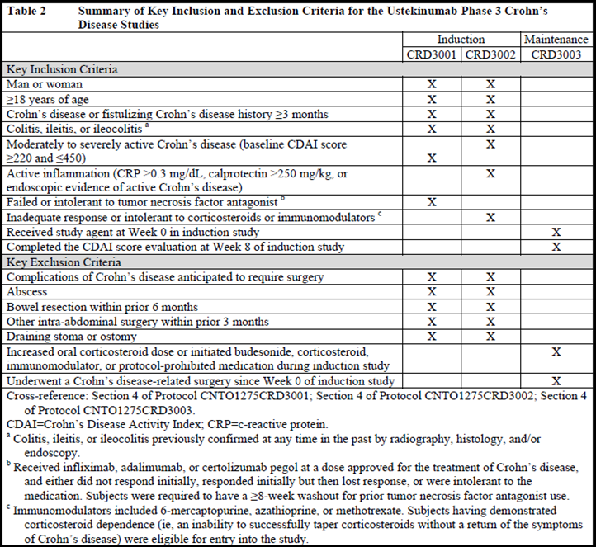

Efficacy variables and endpoints
Two measures were used for the evaluation of endoscopic healing of the mucosa: (1) changes in the Simplified Endoscopic Disease Severity Score for Crohn’s Disease (SES-CD) score and (2) detection of presence/absence of mucosal ulceration.
The SES-CD score is based on the evaluation of 4 endoscopic components (presence/size of ulcers, proportion of mucosal surface covered by ulcers, proportion of mucosal surface affected by any other lesions, and presence/type of narrowing/strictures) across 5 ileocolonic segments. Each endoscopic component is scored from 0 to 3 for each segment, and a total score is derived from the sum of all the component scores (range, 0 to 56). A multi-part study validated the operating properties of the SES-CD, including construct validity, inter-observer agreement, and external validity (Daperno, 2004). This study also demonstrated correlations between SES-CD scores, clinical disease activity, and laboratory measures of inflammation. A majority of studies that have incorporated SES-CD scoring have defined the severity of endoscopic disease activity as follows: total scores of 0-2 for remission, 3-6 for mild inflammation, 7-16 for moderate inflammation, and >16 for severe inflammation (Khanna, 2014; Mooscovitz, 2007). The SES-CD score at baseline was calculated based on all segments scored at baseline. The SES-CD score at post-baseline visits was calculated based only on segments scored at baseline. Segments that were scored only at a post-baseline visit were excluded, because it was not possible to evaluate changes in disease activity in a segment without a baseline evaluation of the same segment. For missing segments at post-baseline visits, the baseline score for each of the missing segments was carried forward.
The presence or absence of mucosal ulceration was evaluated in the same 5 segments assessed by the SES-CD: ileum, right colon, transverse colon, left colon, and rectum. Subjects who had at least 1 ulcer in any segment at induction baseline were included in the analyses for mucosal healing endpoints. The determination of ulceration status at baseline and post-baseline visits was based on the presence or absence of ulceration across all segments evaluated at that visit. Any segments that were not evaluated or missing post-baseline had their ulceration status at baseline carried forward, if available. Segments that were evaluated only at post-baseline visits were included in the determination of the ulceration status at that visit.
Subjects with evaluable endoscopy data (that is, at least 1 ileocolonic segment evaluated) were eligible for inclusion in the evaluation of induction and maintenance endpoints if they had either SES-CD score ≥3 at baseline excluding the contribution from narrowing (for evaluation of SES-CD based endpoints) or ulceration in any segment at baseline (for evaluation of mucosal healing based endpoints). In addition, biopsies were collected to support exploratory histologic evaluation.
The primary endpoint was the change from baseline in SES-CD score at Week 8 of induction (Analysis Set 3001/3002) in subjects with eligible endoscopy data at baseline. The change from baseline in the SES-CD score at Week 8 of induction was summarised and compared between the combined ustekinumab group and the placebo group using an analysis of covariance on the van der Waerden normal scores, with the baseline SES-CD score and study as covariates, at a significance level of 0.05.
The major secondary endpoints, listed in the order in which they were tested based on the prespecified testing procedure were as follows:
- The change from induction baseline in the SES-CD score at Week 44 of maintenance (Analysis Set 3003) in subjects with eligible endoscopy data at induction baseline.
- The proportion of subjects with mucosal healing at Week 44 of maintenance (Analysis Set 3003) in subjects with ulcerations at induction baseline.
- The proportion of subjects with mucosal healing at Week 8 of induction (Analysis Set 3001/3002) in subjects with ulcerations at induction baseline.
The analysis of change from induction baseline in SES-CD score used the same analysis methods as the primary endpoint. For the mucosal healing endpoints, the combined ustekinumab treatment group was compared to the placebo group using a 2-sided chi-square test, at a significance level of 0.05. In case of rare events, Fisher’s exact test was used for treatment comparisons. Other endpoints assessed at Week 8 of induction (Analysis Set 3001/3002, Analysis Set 3001, and Analysis Set 3002) included:
- The proportion of subjects with reduction from baseline in SES-CD score > 3 at Week 8 of induction in subjects with eligible endoscopy data at induction baseline.
- The proportion of subjects in endoscopic response at Week 8 of induction in subjects with eligible endoscopy data at induction baseline.
- The proportion of subjects in endoscopic remission at Week 8 of induction in subjects with eligible endoscopy data at induction baseline.
Other endpoints assessed at Week 44 of maintenance (Analysis Set 3003) included:
- The proportion of subjects with reduction from induction baseline in SES-CD score >3 at Week 44 of maintenance in subjects with eligible endoscopy data at induction baseline.
- The proportion of subjects in endoscopic response at Week 44 of maintenance in subjects with eligible endoscopy data at induction baseline.
- The proportion of subjects in endoscopic remission at Week 44 of maintenance in subjects with eligible endoscopy data at induction baseline.

Analysis populations, sample size, statistical analysis
The primary analysis population for endoscopy endpoints in induction was the integrated induction population from the CRD3001 and CRD3002 induction studies, and data for ustekinumab were pooled across the induction dose groups. The primary analysis population for endoscopy endpoints in maintenance was the randomised maintenance population in the CRD3003 maintenance study (that is, ustekinumab induction responders who were randomised to ustekinumab 90 mg SC every 12 weeks (q12w), ustekinumab 90 mg SC every 8 weeks (q8w), or placebo maintenance); data for ustekinumab were pooled across maintenance dose groups. A prespecified integrated analysis approach was used to evaluate the totality of evidence obtained from the induction and maintenance studies, respectively. For analyses of induction endpoints, endoscopy data from both induction studies (CRD3001 and CRD3002) were integrated, and the ustekinumab induction treatment groups (130 mg and ~6 mg/kg) were combined. This integrated ustekinumab induction treatment group was compared with the placebo induction treatment group. For analyses of maintenance endpoints, the ustekinumab maintenance treatment groups (90 mg SC q12w and 90 mg SC q8w) were combined. This integrated ustekinumab maintenance treatment group was compared to the maintenance placebo group. The integrated approach improved the power to detect treatment differences in both induction and maintenance in the substudy.
Control of Type 1 error was applied independently from the Type 1 error control in the individual induction and maintenance studies. A hierarchical multiple testing procedure was used to strongly control the overall Type 1 error rate over the primary and major secondary endpoints within this substudy. Testing for statistical significance of major secondary endpoints was inferential only if the tests for the primary endpoint and all preceding major secondary endpoints were statistically significant. Additional post-hoc exploratory analyses of endoscopic endpoints and pre-planned exploratory histologic assessments were also conducted. Descriptive statistics included counts and percentages for categorical data, and mean, SD, median, interquartile range, and range for continuous data. All statistical testing was performed at the 2-sided 0.05 significance level. Nominal p-values were presented.
Sensitivity analyses were performed to evaluate the impact of different rules for missing data. Consistency of results was evaluated by subgroup analyses (by induction study [CRD3001 or CRD3002] and by induction dose [130 mg IV or ~6 mg/kg IV]; and by maintenance dose [90 mg SC q12w or 90 mg SC q8w).
Pre-specified analyses of the nonrandomised maintenance population, as well as exploratory post-hoc evaluations using pooled data from the randomised and the nonrandomised maintenance populations, were also conducted to further evaluate the effect of maintenance therapy. A post-hoc analysis was also conducted to evaluate the meaningfulness of improvement in SES-CD by at least 3 points by examining the relationship between this endoscopic endpoint and the clinical, patient-reported, and objective biomarker endpoints.
Exploratory histologic assessments included: (1) biopsy sample collection at induction baseline, week 8 of induction and week 44 of maintenance, (2) analyses of histologic disease activity using the Global Histology Activity Score (GHAS).
The primary hypothesis was that ustekinumab was superior to placebo in achieving greater improvement in the SES-CD score at Week 8 of induction in subjects in Analysis Set 3001/3002 who had an eligible baseline SES-CD score ≥3. The assumptions for power calculations were based on data from the Remicade SONIC study in subjects with moderately to severely active Crohn’s disease (C0168T67). In C0168T67, the change in SES-CD score from baseline at Week 26 was -10 (SD ±9), -9 (SD ±9), and -4 (SD ±6.5) in the infliximab + azathioprine, infliximab + placebo, and azathioprine + placebo groups, respectively. Because the changes in SES-CD score in that study were based on data at Week 26, as a conservative measure, changes in SES-CD score of -5 (SD ±7) and -2 (SD ±7) were assumed for the ustekinumab and placebo groups at Week 8 in the ustekinumab phase 3 induction studies. It was estimated that approximately 210 randomised subjects from the induction studies had eligible endoscopy data at baseline. Assuming a change in SES-CD score of -2 (SD ±7) at Week 8 in the placebo group and -5 (SD ±7) in the ustekinumab group, 70 subjects in the placebo group and 140 subjects in the ustekinumab treatment groups would yield an overall power of approximately 80%, at a significance level of 0.05 (2-sided). Assuming a change in SES-CD score at Week 44 of maintenance of -4 (SD ±6.5) in the placebo group and -10 (SD ±9) in the ustekinumab group, 20 subjects in the placebo group and 40 subjects in the ustekinumab treatment groups would yield an overall power of approximately 80%, at a significance level of 0.05 (2-sided).

Subject disposition
Overall, 334 of 1409 subjects in the induction studies were enrolled in the endoscopy substudy, including 142 subjects in CRD3001 and 192 subjects in CRD3002. Of the 334 enrolled subjects, 289 (86.5%) had evaluable endoscopy data (that is, at least 1 ileocolonic segment evaluated) at baseline, including 104 (83.9%) subjects and 185 (88.1%) subjects in the placebo and ustekinumab groups, respectively. Nearly 90% (252/289) of subjects with evaluable endoscopy data had eligible SES-CD scores or ulceration at baseline. All subjects who met eligibility criteria for baseline ulceration status also met eligibility criteria for baseline SES-CD score, demonstrating the concordance in the 2 approaches used to define a minimum threshold for baseline endoscopic disease activity.
A greater proportion of subjects in the placebo group (93.3%) than in the ustekinumab group (83.8%) met the eligibility criteria. The proportion of evaluable subjects who met eligibility criteria was similar between the induction studies (89.9% in CRD3001 and 85.3% in CRD3002), and a greater proportion of subjects from CRD3002 than CRD3001 (57.5% and 42.5%, respectively) contributed to the overall population of subjects who met the eligibility criteria. Overall, 9.5% of the subjects did not enter the maintenance study, including 12.4% and 7.7% in the placebo and ustekinumab groups, respectively. This included 3.1% and 0.6% of subjects in the placebo and ustekinumab groups, respectively, who terminated induction study participation before Week 8.
Overall, 95 of 397 subjects in the primary randomised population of the maintenance study had enrolled in the endoscopy substudy at induction baseline nearly 90% (83/95) of subjects in the endoscopy substudy randomised maintenance population had evaluable endoscopy data at baseline. Of these subjects, 84.3% met the eligibility criteria for SES-CD score and ulceration at baseline. All subjects who met eligibility criteria for baseline ulceration status also met eligibility criteria for baseline SES-CD score. The proportion of subjects contributing to the endoscopy substudy (that is, evaluable subjects meeting eligibility criteria) were similar between the placebo (82.8%) and ustekinumab (85.2%) groups. Overall, 11.4% of subjects terminated study participation before Week 44 of maintenance. A greater proportion of subjects in the ustekinumab group (15.2%) terminated study participation (primarily due to withdrawal of consent), compared with the placebo group (4.2%).

Baseline characteristics

Randomised Induction population
For the endoscopy substudy induction population, the median age was 39 years and most subjects were White (83.3%) with similar baseline demographics in placebo and ustekinumab induction groups. The median duration of disease at baseline was 8.5 years, the median CDAI score was 311.0, the median CRP concentration was 8.35 mg/L, and the median IBDQ score was 116.5. Isolated ileal disease was present in 19.1% of subjects, 17.9% had only colonic involvement, and 62.9% had involvement in both areas. Disease characteristics of subjects randomised to placebo or ustekinumab induction were generally comparable, except for a lower median CDAI score (301.0 and 318.0, respectively), lower median CRP concentration (7.49 mg/L and 9.28 mg/L, respectively) and a greater proportion of subjects with extra- intestinal manifestations (61.9% and 50.3%, respectively) in the placebo group compared with the ustekinumab group.
Most (73.4%) of the subjects were receiving at least 1 concomitant medication for Crohn’s disease and the most commonly used medications were corticosteroids including budesonide (40.9%), aminosalicylates (31.0%), and immuno-modulatory drugs (30.2%). Among subjects who were receiving corticosteroids (excluding budesonide), the median dose (prednisone equivalent) was 20 mg/day. A small proportion of subjects (7.1%) received antibiotics. The proportions of subjects receiving each class of Crohn’s disease medication were generally comparable between subjects randomised to placebo or ustekinumab induction.
In the endoscopy substudy induction population, nearly all subjects (96.8%) had previously failed to respond to corticosteroids or immuno-modulators. Approximately half of the subjects previously failed both corticosteroids and immuno-modulators. Approximately two thirds of subjects had prior exposure to TNF antagonists, and nearly half (42.5%) had previously failed at least 1 TNF antagonist. Medication history was generally comparable between subjects randomised to placebo or ustekinumab induction except for a few differences. While a greater proportion of subjects in the placebo group compared with the ustekinumab group were TNF antagonist experienced (70.1% and 58.1%, respectively), a similar proportion of subjects in the placebo and ustekinumab groups had a history of TNF antagonist failure (42.3% and 42.6%, respectively).
The mean SES-CD score at baseline was 13.5, and 80% of subjects had moderate or severe endoscopic disease severity. Ulcerations were observed in the ileum only for 27.4% of subjects, in the colon only for 33.3%, and in both the ileum and colon for 39.3%. Overall, endoscopic disease activity was generally comparable between subjects randomised to placebo or ustekinumab induction except for a few differences. The mean SES-CD score at baseline was numerically higher in the ustekinumab group (14.2) compared with the placebo group (12.3), possibly suggesting greater endoscopic disease activity among patients randomised to ustekinumab induction. Consistent with this observation, the prevalence of moderate or severe endoscopic disease severity by SES-CD score was greater in the ustekinumab group than in the placebo group (85.1% versus 72.1%); this was mainly driven by the higher prevalence in patients randomised to ustekinumab compared to placebo in the CRD3002 study (86.5% versus 67.9%). Overall, the demographics and disease characteristics of subjects in the endoscopy substudy induction population were similar to those of the overall induction study population.

Randomised maintenance population
Baseline demographic characteristics were generally balanced between the treatment groups. Apparent numeric differences may be confounded by the small size of each treatment group. There were more male subjects (50.0% and 37.0%, respectively), and fewer white subjects (66.7% and 80.4%, respectively) in the placebo group than in the ustekinumab group. Disease characteristics of subjects randomised to placebo or ustekinumab maintenance were generally comparable.
A few notable differences were observed in relation to baseline disease activity between the 2 treatment groups. A greater proportion of subjects in the placebo group compared with the ustekinumab group had current or past strictures (50.0% and 15.2%, respectively). Median CRP was lower in the placebo group compared with the ustekinumab group at baseline (9.82 versus 12.70 mg/L, respectively). However, these observed differences were based on small sample sizes. Concomitant medication usage also was generally comparable between subjects randomised to placebo or ustekinumab maintenance. Overall, the concomitant medication usage in the endoscopy substudy randomised maintenance population was similar to that of the overall randomised maintenance study population. Endoscopic disease severity at induction baseline was generally comparable between subjects randomised to placebo or ustekinumab maintenance and was comparable to that for the endoscopy substudy induction population. Overall, the demographic and disease characteristics of subjects in the endoscopy substudy randomised maintenance population were similar to those of the overall randomised maintenance population

Primary efficacy results
The primary endpoint, change from baseline in SES-CD score at Week 8 of induction, was significantly greater in the ustekinumab group than in the placebo group (-2.8 versus -0.7, p=0.012). Approximately 3% of subjects in the placebo group and 1% of subjects in the ustekinumab group met the treatment failure criteria in the induction studies while 26% of subjects in the placebo group and 30% of subjects in the ustekinumab group had missing data at Week 8. The most common reasons for missing data at Week 8 were: endoscopy was not performed (14.4% placebo and 19.4% ustekinumab), or missing segments as a result of poor bowel preparation or poor quality of the video recording (8.2% placebo and 8.4% ustekinumab). Results of the sensitivity analyses for both observed data and observed cases were consistent with the main analysis. The results were also consistent across subgroup analyses by induction study and by induction dose. However, it is important to note that the improvement in SES-CD score observed with ustekinumab were not significantly greater than placebo in Study CRD3002 and also the 130 mg ustekinumab IV induction dose.

Major secondary endpoints
The initial improvements observed (that is, reduction in mean SES-CD from induction baseline) at Week 0 of maintenance were similar between subjects who were randomised to placebo or ustekinumab maintenance. At Week 44 of maintenance, a maintenance effect was evident in both the ustekinumab and placebo groups. A slight loss of the initial reductions in SES-CD from induction treatment was observed in both the ustekinumab and placebo maintenance groups. The magnitude of this decrease was numerically lower in the ustekinumab maintenance group (from -3.6 at Week 0 of maintenance to -2.5 at Week 44 of maintenance) than in the placebo maintenance group (from -3.4 to -1.9), but the treatment difference between ustekinumab and placebo maintenance was not statistically significant.
Approximately 33% of subjects in the placebo group and 35% of subjects in the ustekinumab group met the treatment failure criteria in the maintenance study primarily due to a loss of clinical response during maintenance (33.3% placebo and 30.4% ustekinumab). Approximately 29% of subjects in the placebo group and 22% of subjects in the ustekinumab group had missing data at Week 44 of maintenance, primarily due to endoscopy not being performed (20.8% placebo and 10.9% ustekinumab) and termination of study participation before Week 44 of maintenance (4.2% placebo and 8.7% ustekinumab).The sensitivity analyses of observed data and observed case were consistent with the main analysis. The change from baseline in SES-CD decreased at Week 44 of maintenance compared with Week 0 of maintenance in each treatment group. The magnitude of this decrease was numerically lower among subjects randomised to ustekinumab 90 mg SC q8w (from -4.1 at Week 0 of maintenance to -3.1 at Week 44 of maintenance) compared with subjects randomised to ustekinumab 90 mg SC q12w maintenance (from -2.8 to -1.6) or placebo maintenance (from -3.4 to -1.9).
The number and proportion of subjects in the endoscopy substudy randomised maintenance population with ulcerations at induction baseline and mucosal healing at Week 44 of maintenance was summarised: Mucosal healing was defined as the complete absence of mucosal ulcerations at the follow-up visit. The proportion of subjects with mucosal healing was 3-fold greater in the ustekinumab group (13.0%) than in the placebo group (4.2%). At Week 44 of maintenance, mucosal healing rates were 17.2% for subjects randomised to maintenance with ustekinumab 90 mg SC q8w, 5.9% for ustekinumab 90 mg SC q12w, and 4.2% for placebo.
The number and proportion of subjects in the endoscopy substudy induction population with ulcerations at induction baseline and mucosal healing at Week 8 of induction was summarised: A numerically greater proportion of subjects achieved mucosal healing in the ustekinumab group (9.0%) than in the placebo group (4.1%). In the CRD3001 study, no subject in the placebo group and 3.0% of subjects in the ustekinumab group achieved mucosal healing at Week 8 of induction. In the CRD3002 study, 7.1% of subjects in the placebo group and 13.5% of subjects in the ustekinumab group achieved mucosal healing at Week 8 of induction. Mucosal healing was observed for more subjects who received an induction dose of ustekinumab 130 mg (8.3%) or a tiered induction dose approximating ustekinumab 6 mg/kg (9.6%) than for subjects who received placebo (4.1%).These subgroup results were consistent with the integrated results.
Other endpoints at Week 8 of induction also consistently favoured ustekinumab over placebo.
- Subjects were significantly more likely to achieve clinically meaningful endoscopic improvement (that is, a reduction of ≥3 points in SESCD score from baseline) at Week 8 of induction (47.7% versus 29.9%, p=0.005); this endoscopic improvement observed in each induction study (CRD3001: 43.9% versus 17.1%; CRD3002: 50.6% versus 39.3%) and with each ustekinumab induction dose compared with placebo (ustekinumab ~6 mg/kg: 49.4%; ustekinumab 130 mg: 45.8%; placebo: 29.9%).
- Rates of endoscopic response (that is, a reduction of ≥50% from baseline in SESCD score) were numerically greater for the ustekinumab group than the placebo group at Week 8 of induction (20.6% versus 13.4%) but difference only observed in study in CRD3001 (13.6% versus 0.0%), but not in CRD3002 (25.8% versus 23.2%). The high placebo response observed in CRD3002 might have been attributable to the notably lower prevalence of moderate to severe endoscopic disease activity by SESCD at induction baseline in the placebo group (67.9%) compared with the ustekinumab group (86.5%).
- Rates of endoscopic remission (that is, a total SESCD score of ≤2) also were numerically greater in the ustekinumab group than in the placebo group at Week 8 of induction (7.7% versus 4.1%) with increased endoscopic remission observed in each induction study (CRD3001: 3.0% versus 0.0%; CRD3002: 11.2% versus 7.2%) and with each ustekinumab induction dose compared with placebo (ustekinumab ~6 mg/kg: 8.4%; ustekinumab 130 mg: 6.9%; placebo: 4.1%).
- The proportion of subjects with mucosal healing at Week 8 of induction was numerically greater in the ustekinumab group (9.0%) than in the placebo group (4.1%).
- The significant reductions in endoscopic disease activity from ustekinumab induction were corroborated by reductions in the underlying histologic inflammation. At Week 8 of induction, a significant decrease from baseline in Global Histology Activity Score (GHAS) was observed among subjects who received ustekinumab induction, but not among subjects who received placebo induction. Consistent results were demonstrated in subgroup analyses by induction study and by induction dose.
Similar results were observed at Week 44 of maintenance:
- The proportion of subjects who achieved clinically meaningful endoscopic improvement at Week was numerically greater in the ustekinumab group (37.0%) than in the placebo group (25.0%) with greater improvement observed in the ustekinumab 90 mg SC q8w group compared to both ustekinumab 90 mg SC q12w and placebo (41.4%, 29.4% and 25% in q8w, q12w and placebo groups, respectively).
- The rate of endoscopic response at Week 44 of maintenance was numerically greater in the ustekinumab group (17.4%) than in the placebo group (4.2%) with greater rates of endoscopic response in the ustekinumab 90 mg SC q8w group compared to both ustekinumab 90 mg SC q12w and placebo (24.1%, 5.9% and 4.2%, respectively).
- The rate of endoscopic remission at Week 44 of maintenance was numerically greater in the ustekinumab group than in the placebo group (10.9% versus 4.2%).
In the nonrandomised maintenance population, the mean change from induction baseline in SES-CD score in the ustekinumab group was -1.1 at Week 0 of maintenance and -3.1 at Week 44 of maintenance. In the placebo group (placebo induction responders), the mean change from baseline in SES-CD score was -2.5 at Week 0 of maintenance and -2.0 at Week 44 of maintenance. These subjects had responded to placebo induction and continued to receive nonrandomised placebo treatment during maintenance. The absence of changes in SES-CD (no apparent improvement or worsening) with continued placebo maintenance suggests that these subjects represent a distinct group of subjects in whom the benefit of anti-inflammatory drugs remains to be confirmed.

For the pooled randomised and nonrandomised maintenance population
At Week 44 of maintenance, subjects who received ustekinumab 90 mg SC q8w maintenance showed greater benefits in terms of following endpoints compared with SC q12w and placebo:
- greater reduction in SES-CD from induction baseline was observed (-.3.8, -1.5 and -2 in q8w, q12w and placebo groups, respectively).
- proportion of subjects who achieved clinically important endoscopic improvement (48.6%, 29.8% and 27.5%, respectively).
- the proportion of subjects who achieved endoscopic response (33.8%, 17% and 13.7%, respectively).
- the proportion of subjects who achieved endoscopic remission (20.3%, 12.8% and 9.8% respectively).
- the proportion of subjects who achieved mucosal healing (21.6%, 12.8% and 9.8%, respectively).

Relationship between clinical and endoscopic endpoints
Subjects who achieved a ≥3-point reduction from baseline in SES-CD at Week 8 of induction were more likely to achieve each of these clinical endpoints than subjects with a <3-point reduction from baseline in SES-CD.

Exploratory histologic assessments
Of the 334 subjects who enrolled in the endoscopy substudy, 327 (97.9%) had evaluable histologic data at induction baseline. Of the 252 subjects with eligible SES-CD scores at baseline, 251 (99.6%) had evaluable histologic data at baseline. Although the primary population and endoscopy substudy population were not randomised or stratified by histologic disease activity, histologic disease activity as measured by GHAS at baseline was similar between the ustekinumab and placebo groups of the endoscopy substudy population (10.4 and 9.2, respectively).
For all study treatment groups combined, statistically significant, moderate correlations existed between the SES-CD and GHAS at baseline (r=0.63, p<0.001), at Week 8 of induction (r=0.50, p<0.001), and at Week 44 of maintenance (r=0.59, p<0.001). These results suggest a relationship exists between endoscopic and histologic disease activity. A significant reduction from baseline to Week 8 of induction in mean GHAS was observed within the ustekinumab group (from 10.4 to 7.1, p<0.001), but not within the placebo group (from 9.2 to 7.8). Among subjects who had evaluable histology data at both induction baseline and Week 8 of induction, the mean reduction from baseline in GHAS was numerically greater for ustekinumab (-2.35 [n=95]) compared with placebo (-0.97 [n=58]), but there was no difference at Week 44 in the randomised maintenance population (ustekinumab: from 8.5 to 6.8; placebo: from 12.9 to 10.9)
Comment: The Ustekinumab Endoscopy Substudy included 334 of 1409 patients in the induction studies (289 patients with evaluable endoscopy data) and 95 of the 397 patients in the primary randomised population of the maintenance study. The 2 main measures used for evaluating endoscopic healing of the mucosa were change in the Simplified Endoscopic Disease Severity Score for Crohn’s Disease (SES-CD) score and detection of presence/absence of mucosal ulceration. The SES-CD score is a validated measure that has been used for evaluation of other Crohn’s disease treatments.
Integration of the induction studies was justified as the induction studies had identical designs, used the same dose and route of administration and was enrolled at same time; the populations were generally similar in terms of baseline demographics and disease characteristics, except for differences that were expected based upon differences in study eligibility criteria for TNF antagonist failure history. Additionally, the efficacy of ustekinumab induction compared with placebo in improving clinical signs and symptoms was consistently and individually demonstrated in the 2 induction studies. integration of the ustekinumab induction dose groups and integration of the ustekinumab maintenance dose groups was also justified as treatment effects for the key endpoints for clinical signs and symptoms were qualitatively similar across the ustekinumab induction dose groups (130 mg and ~6 mg/kg) in the induction studies (CRD3001 and CRD3002). Treatment effects for the key endpoints for clinical signs and symptoms were also qualitatively similar across the ustekinumab maintenance dose groups (90 mg SC q12w and 90 mg SC q8w) in the Phase III maintenance Study CRD3003.
The primary endpoint, reduction from baseline in SES-CD score at Week 8 of induction showed that ustekinumab induction was more effective in reducing endoscopic disease activity compared with placebo. The results were confirmed in the sensitivity analysis (for both observed data and observed cases). However, it is important to note that the improvement in SES-CD score observed with ustekinumab were not significantly greater than placebo in Study CRD3002 and also the 130 mg ustekinumab IV induction dose. By Week 44 of maintenance treatment, both ustekinumab and placebo groups showed slight loss of initial reduction in SES-CD scores but this was slightly more pronounced in the placebo maintenance group compared to the ustekinumab group. Other efficacy endpoints such as clinically meaningful endoscopic improvement were also significantly greater in the ustekinumab induction groups compared with placebo. However, at Week 8, endoscopic response and endoscopic remission only showed numerical benefits over placebo. There was a trend suggestive of a potential role for ustekinumab maintenance across the endoscopic endpoints evaluated at Week 44 of maintenance in the primary maintenance population (that is, the randomised maintenance population), and a potential dose effect suggestive of greater benefit associated with the ustekinumab 90 mg SC q8w regimen was observed consistently across the subgroup analyses. However, the treatment differences between ustekinumab maintenance and placebo maintenance were not statistically significant. The significant reductions in endoscopic disease activity were corroborated by reductions in the underlying histologic inflammation.
Among currently approved therapies for Crohn’s disease, evidence of endoscopic improvement and healing of the mucosa has been reported for TNF antagonists (Colombel, 2010; Hebuterne, 2013; Rutgeerts, 2006 and 2012), but not for biologics with other mechanisms of action.
Overall, results from the Ustekinumab Endoscopy Substudy provided evidence to support efficacy of ustekinumab for induction of endoscopic healing of the mucosa, based on significant improvements in endoscopic disease activity in the ustekinumab group that were corroborated by improvements in histologic disease activity. However, this endoscopic substudy failed to provide definitive evidence to support efficacy of ustekinumab maintenance treatment on endoscopic healing of the mucosa.

Evaluator’s conclusions on clinical efficacy
Two Phase III pivotal, randomised, double-blind, placebo-controlled induction studies (CRD3001 and CRD3002) evaluated the efficacy and safety of ustekinumab in 1409 patients with moderately to severely active Crohn’s disease. The Phase III pivotal randomised, double-blind, placebo-controlled Study CRD3003 evaluated efficacy of maintenance treatment with SC ustekinumab in 397 patients enrolled from the induction studies (CRD3001 and CRD3002). Overall, this submission includes a total of 52 weeks of efficacy and safety data from the Phase III studies (8 weeks from the induction studies and 44 weeks from the maintenance study). The endoscopic substudy with endoscopy data from 334 of 1409 subjects in the induction studies and 95 of 397 subjects from the maintenance study evaluated endoscopic healing of mucosa by ustekinumab induction and maintenance therapy in the Phase III pivotal studies.
The Phase III induction studies, CRD3001 and CRD3002 used an IV route of administration for ustekinumab and were essentially identical in design, but targeted different, mutually exclusive patient populations, which together reflect the full spectrum of biologic-eligible patients with Crohn’s disease. CRD3001 enrolled subjects with a history of inadequate response to, or intolerance to, TNF antagonists. CRD3002 enrolled subjects with a history of inadequate response to or intolerance of corticosteroids or immuno-modulators; these subjects could have received TNF antagonists, but could not have a history of an inadequate response or intolerance to them. In each induction study, subjects were randomised to receive a single IV dose of placebo or one of two doses of ustekinumab (a fixed 130 mg dose or a tiered [weight based] dose approximating ~6 mg/kg) at Week 0. The CRD3003 Phase III study was designed to evaluate 2 SC maintenance regimens of ustekinumab (90 mg q8w or 90 mg q12w) in subjects with moderately to severely active Crohn’s disease who had received IV induction therapy in one of two induction studies (CRD3001 and CRD3002).
All pivotal Phase III studies were well-conducted; the study design (randomised, double-blind, placebo-controlled) and efficacy endpoints (clinical, laboratory and QOL), complied with the TGA adopted CHMP guidelines on the development of new medicinal products for the treatment of Crohn’s disease. The patient population evaluated in these studies were representative of the target patient population.
Both CRD3001 and CRD3002 achieved the primary (clinical response at week 6) and all 4 major secondary endpoints for both IV induction doses. Both doses also showed consistent efficacy compared with placebo in additional efficacy measures, such as patient quality of life measures (such as IBDQ), significant reductions and normalisations in inflammatory markers, and in a pooled analysis showed endoscopic improvement/healing. However, the magnitude of benefit seen with the lower 130 mg dose was generally less than that seen with the weight-tiered ~6 mg/kg dose. The following results provide evidence to support the proposed 6 mg/kg IV induction dose for ustekinumab:
- Better efficacy, as illustrated by greater separation from IV placebo for ~6 mg/kg, was most notable in the CRD3002 study population with higher rates of clinical remission at Week 8 (40.2%, 30.6% and 19.6% in the 130 mg, ~6 mg/kg and placebo groups, respectively) These numbers represent a clinically meaningful near-doubling of the treatment effect, from 11% with 130 mg to 20.6% with ~6 mg/kg. While remission differences in Study CRD3001 were more modest (5% delta between doses), these differences are still clinically meaningful in this very refractory population of TNF-antagonists (from an 8.6% delta with 130 mg to 13.6% with ~6 mg/kg). Clinical response differences at Week 8 showed a similar pattern, though differences in response rates between the dose groups were less than 5% in Study CRD3001.
- The 6 mg/kg IV induction dose was also associated with early onset of efficacy with differences in treatment effects apparent as early as Week 3, for clinical remission and clinical response between the ~6 mg/kg and 130 mg groups. Only the ~6 mg/kg group demonstrated significant (p<0.05) benefit in remission at Week 3 (in both the CRD3001 and CRD3002 studies). Proportions of subjects in clinical response at Week 3 were also numerically higher in both studies for ~6 mg/kg than those seen with the 130 mg dose.
- The greater improvements in the key study endpoints with 6 mg/kg (compared with the 130 mg) IV induction dose were translated into meaningful improvements in QOL measures: Greater proportions of subjects achieved a ≥16-point (clinically meaningful) improvement in the disease-specific IBDQ instrument at Week 8, with approximately 9% higher larger treatment effects seen for the ~6 mg/kg group in both CRD3001 and CRD3002. Reduction in inflammatory markers also showed slightly better efficacy for the 6 mg/kg IV induction dose (the proportion of subjects attaining a normalisation of CRP at Week 8 (≤ 3 mg/L among those >3 mg/L at baseline) was greater for the ~6 mg/kg group in CRD3001 and CRD3002 compared with the 130 mg group (both approximately 5% higher proportions of subjects).
- While proportions of subjects in clinical response at Week 6 (the primary endpoint) were nearly the same for the 2 doses in CRD3001 and only slightly higher for ~6 mg/kg group in CRD3002, the rates of clinical response increased for the ~6 mg/kg groups between Weeks 6 and 8 in both studies, while the proportion in response decreased slightly from 51.7% to 47.4% in the 130 mg group in CRD3002. This phenomenon was also seen in other endpoints, including change in CDAI, 70 point response, and change in CRP. These trends are notable because differences with a suboptimal dose would be expected to become more apparent over time, as continually decreasing serum ustekinumab concentration would result in many subjects dropping to sub-therapeutic serum ustekinumab levels in the 130 mg dose group. The E-R analyses are supportive that the ~6 mg/kg induction dose would be expected to provide more optimal efficacy for the entire 8 weeks post-induction dose.
- Furthermore, the Phase III induction studies also did not show any consistent difference in safety profile between the 130 mg and ~6 mg/kg IV induction doses, supporting a dosing recommendation driven by the greater efficacy seen with the ~6 mg/kg dose for both the conventional therapy and TNF-antagonist failure populations.
Ustekinumab maintenance therapy was shown to be of significant benefit to ustekinumab induction responders over 44 weeks. Maintenance with 90 mg SC given q8w and q12w demonstrated statistically significant benefit for clinical remission (the primary endpoint) as well as clinical response at Week 44. The study demonstrated that among subjects who respond to ustekinumab induction therapy, continuous maintenance therapy is needed to maintain clinically meaningful improvements in signs and symptoms as well as patient reported outcomes and objective measures of inflammation.
Among subjects withdrawn from ustekinumab after induction (that is, the SC placebo group), a gradual recurrence of disease was observed by every clinical measure as well as by laboratory measures of inflammation (that is, CRP and faecal calprotectin). By contrast, minimal recurrence of disease was observed among subjects who continued receiving maintenance doses of ustekinumab, such that by Week 44, a treatment effect of approximately 15% was seen for subjects who received ustekinumab maintenance for the endpoints of remission, response, corticosteroid-free remission, and sustained response and remission as compared with subjects withdrawn from ustekinumab after the induction dose (that is, the placebo group). Likewise, laboratory measures of inflammation (CRP and faecal calprotectin) demonstrated a significantly lower inflammatory burden among subjects who continued maintenance ustekinumab.
The following results provide evidence to support the 90 mg q8w as the primary maintenance ustekinumab dose:
- While efficacy was observed with both the q12w and q8w regimens compared with placebo, the magnitude of benefit was greater for the q8w dosing regimen for many endpoints including improvements in signs and symptoms and patient reported outcomes. The distinction between q8w and q12w dosing was more apparent in parameters evaluating the more clinically relevant stringent endpoints of remission (for example, remission, especially in TNF antagonist naïve subjects, remission in remitters, steroid-free remission, and sustained remission) with differences ranging from approximately 4% to 10%. For example, higher proportions of subjects achieved clinical remission (53.1%) or were in sustained clinical remission (46.1%) with q8w than with q12w (48.8%, 40.3% respectively) administration. Additionally, all sensitivity analyses except the worst case remained significant for the q8w dosing regimen, indicating robustness for the primary endpoint of clinical remission for q8w versus placebo. These sensitivity analyses were not consistently robust for the q12w regimen, though the results trended in the same direction, with generally similar treatment effects.
- QOL effects greater with q8w dosing: proportions of subjects with at least a 16-point improvement in IBDQ score, a threshold widely considered clinically meaningful, was significantly better than placebo for q8w administration (67.9% versus 50.4%, p=0.014), but only numerically better than placebo at q12w maintenance intervals (61.3% versus 50.4%; p=0.140). Similarly, a significantly greater proportion of subjects in the ustekinumab q8w group compared with placebo achieved clinically meaningful (≥5-point) improvement from baseline of this study in SF-36 PCS at Week 44 (52.1% versus 34.7%, p=0.008) while the q12w regimen was only numerically better than placebo (41.7% versus 34.7%, p=0.269).
Other dosing strategies were also evaluated in the Phase III Study CRD3003. Adjustment from 90 mg q12w to 90 mg q8w specifically in subjects who dose adjusted (after meeting study loss of response criteria) provided additional clinical benefit: clinical response was recaptured in 55.2% of these subjects, clinical remission in 41.4% and median change in CDAI improved by 141.0 points when assessed 16 weeks later. Improvement upon q12w to q8w dose adjustment was numerically better than that observed for subjects remaining on q8w after meeting loss of response criteria for dose adjustment (q8w to q8w). However, interpretation of these results was limited by small number of patients (n=29) who adjusted from q12w to q8w dosing. In an analyses of actual observed data over time (that is, not considering subjects who dose adjust as treatment failures) which allowed for an as-randomised comparison of a q8w only strategy versus q12w to q8w strategy, the key efficacy measures of clinical remission and clinical response were similar for the q12w to q8w dosing regimens.
Subgroup Analyses to Identify Subjects Appropriate for Initiation of Maintenance at q12w: Subjects above the median weight and with elevated inflammatory markers (at either induction or maintenance baseline) attained greater benefit compared with SC placebo for q8w dosing, compared to q12w, while the subgroups with low weight, and particularly those with low markers of inflammation did equally well on q12w. Further post-hoc analyses combining these factors suggested that higher inflammatory burden rather than weight was the more important factor, and that subjects with low weight, and particularly those with low markers of inflammation did equally well and showed no difference between q12w and q8w for all the key endpoints, whereas subjects with elevated inflammatory markers attained greater benefit for q8w dosing compared to q12w.
These analyses suggest that subjects with low inflammatory burden could start on q12w regimen, with the caveat that they be able to dose adjust based on inadequate response to q8w, as this is the best overall regimen. Meanwhile, subjects with a higher inflammatory burden (based upon pre- or post-treatment CRP or potentially faecal calprotectin), should be always started on q8w given the substantially better efficacy seen for these subjects on q8w. Given that not all patients with low inflammatory burden will achieve high levels of efficacy with q12w dosing, the ability to dose adjust as described above, would provide additional assurance that patients have every opportunity to achieve maximal response with ustekinumab therapy.
For the 467 subjects not in clinical response at Week 8 following ustekinumab IV induction dosing, more than half achieved clinical response 8 weeks later (16 weeks after IV induction) after receiving an additional ustekinumab 90 mg SC dose at week 8. Of those subjects who subsequently continued on ustekinumab maintenance (receiving 90 mg q8w), 68.1% maintained clinical response and 50.2% were in clinical remission at Week 44. These results suggest that it may be appropriate to wait until 16 weeks after initiation of IV induction (with an additional SC 90 mg dose at Week 8) to make the ultimate assessment of efficacy and a decision on continuation of treatment. However, interpretation was again limited due to uncontrolled analysis in non-randomised subjects.
Among ustekinumab IV induction responder-primary population subjects randomised to SC placebo, initiation of maintenance with ustekinumab treatment at 90 mg SC q8w re-captured more than 70% of subjects who lost response, achieved clinical remission in 39.2% of subjects, and achieved a median improvement in CDAI of 121.0 points when assessed 16 weeks after dose adjustment. This suggests that some benefit can be regained in many patients after interruption of ustekinumab treatment. However, interpretation was again limited due to uncontrolled analysis in non-randomised subjects.

Comparison with other biologics approved for Crohn’s disease
No direct comparator studies have been performed. Review of published literature from Phase III programs for biologics approved within the last 15 years including, where comparable data are available, vedolizumab, adalimumab, and certolizumab pegol, suggest that the efficacy and safety of ustekinumab therapy compares favourably with these approved agents. Infliximab was the first biologic approved in Crohn’s disease and while it is widely used in Crohn’s disease, comparative data is limited to only anti-TNF-naïve populations. Given the limitations of comparisons with infliximab, efficacy of ustekinumab induction and maintenance therapy is mainly compared with adalimumab, vedolizumab and certolizumab pegol. Data were extracted from published Phase III studies in the relevant patient populations comparing clinical response (100-point) and remission at time of primary endpoint.
In TNF-antagonist refractory population: results for ustekinumab were similar to adalimumab for the induction endpoints of clinical response and remission, it is noteworthy that adalimumab was studied only at the higher induction dose of 160/80 mg and in a narrower treatment-refractory population (that is, primary non-responders were excluded, and only infliximab failures were included, as infliximab was the only TNF antagonist approved at the time). In contrast, CRD3001 evaluated subjects who had failed one or more TNF antagonists (infliximab, adalimumab, or certolizumab pegol) and included both primary and secondary non-responders.
Vedolizumab showed significance for remission at Week 10, but did not reach significance at the earlier time point of Week 6 (the primary endpoint of GEMINI III study). This suggests that vedolizumab may have more modest induction efficacy compared to ustekinumab at early time points and appears to have a slower onset of efficacy. The data for certolizumab pegol are more difficult to interpret, as a placebo-controlled induction trial in a defined population of TNF-antagonist failures was not conducted and the data shown are from a trial where the infliximab-exposed subjects were not required to demonstrate failure. Furthermore, certolizumab is not approved for Crohn’s disease in Australia.
Ustekinumab also compared favourably to adalimumab, vedolizumab, and certolizumab pegol in the population of subjects who had not failed previous biologic therapy including subjects who were TNF-antagonist naïve, suggesting its potential role as a first-line biologic agent (Table 13).
Table 13: Comparison of results in induction studies in Crohn’s disease.
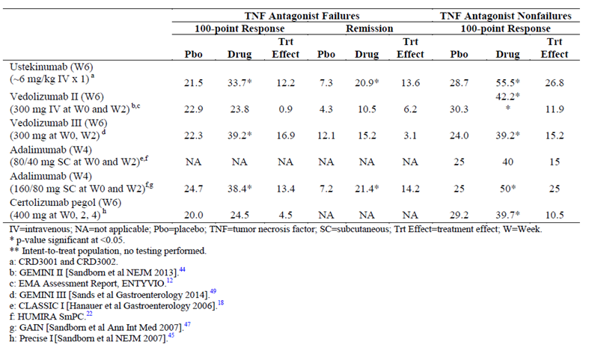
Evaluation of maintenance data shows similar patterns, although interpretation was limited due to differences in the populations studied for the maintenance trials regarding inclusion of previous biologic responses (Table 14). With regard to maintenance therapy in the broad Crohn’s disease population, the absolute remission rates at 1 year of ustekinumab therapy were higher than those reported previously for any biologic though the treatment effects are comparable. However, this maybe confounded by fact that in Study CRD3003, 100-point response was used as the criteria for selecting the population randomised to assess long-term maintenance, while the registration trials for adalimumab and vedolizumab used 70-point response. This difference was reflected in the rates of remission for patients entering the maintenance phase, with 60% of subjects entering the primary population in CRD3003 in remission compared with approximately 30% to 40% with vedolizumab and adalimumab, respectively.
Table 14: Comparison of results in maintenance studies in Crohn’s disease.
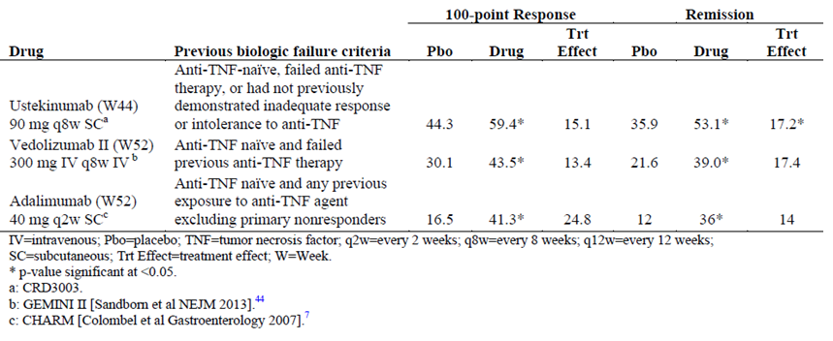
Results from the Ustekinumab Endoscopy Substudy provided evidence to support efficacy of ustekinumab for induction of endoscopic healing of the mucosa, based on significant improvement in endoscopic disease activity in the ustekinumab group that were corroborated by improvements in histologic disease activity. However, this endoscopic substudy failed to provide definitive evidence to support efficacy of ustekinumab maintenance treatment on endoscopic activity. Among currently approved therapies for Crohn’s disease, evidence of endoscopic improvement and healing of the mucosa has been reported for TNF antagonists (Colombel, 2010; Hebuterne, 2013; Rutgeerts, 2006 and 2012), but not for biologics with other mechanisms of action.
Overall, indirect comparisons to biologic therapies approved for moderate to severe Crohn’s disease suggest that ustekinumab has efficacy that is at least comparable and in some instances appears better or has a more rapid onset than currently approved biologics with a favourable safety profile. Although cross-study comparisons with other approved biologic agents can provide insight into the relative efficacy and safety of ustekinumab and its potential place in the treatment of patients with moderate to severe Crohn’s disease although such indirect comparisons are limited by differences in populations, timing and study designs.
Limitations:
- 95% CI for the primary and main secondary endpoints were not provided (only p-values for comparison versus placebo were provided in the CSR). Only the sensitivity analysis 3 (excluding those enrolled prior to study restart) showed the odds ratios and 95% CI values. The sponsor has been requested to provide the 95% CI for the primary and major secondary endpoints (refer Clinical questions below).
- Efficacy data beyond 1 year of treatment are currently not available in Crohn’s disease although the long-term extension of Study CRD3003 through wWeek 272 should provide efficacy data of an additional 4 years..

Clinical safety

Studies providing evaluable safety data

Pivotal studies that assessed safety as the sole primary outcome
None.

Pivotal and/or main efficacy studies
All studies contributing to the evaluation of safety of ustekinumab in Crohn’s disease were summarised. Safety data for the 5 Crohn’s disease studies, focused on the pooled Phase III data, analysed separately for: the induction phase of treatment (Week 0 through Week 8), the maintenance phase of treatment (Week 0 of maintenance up to Week 44) and the combined induction and maintenance phases of treatment (up to 1 year of treatment; 8 weeks exposure in induction studies and 44 weeks exposure in the maintenance study).
Analyses of safety were conducted according to the following categories:
- Standard analysis of adverse events: AEs, SAEs, reasonably-related AEs, discontinuations due to AEs, deaths, infections, serious infections, treated infections, injection-site reactions, evaluation of AEs temporally related to infusions, and clinical laboratory evaluations.
- Targeted AEs: Malignancies, adjudicated serious major adverse cardiac events (MACE), anaphylactic and serum sickness-like reactions, tuberculosis (TB), opportunistic infections and serious neurological disorders.
- Subgroup analyses: Conducted to evaluate whether demographics, disease characteristics, concomitant Crohn's disease medications, or Crohn's disease medication history factors had a differential effect on safety.
- Carry over effect: Conducted to evaluate any potential impact of the IV induction dose on safety in the maintenance phase.
Safety assessment was based on reported AEs, clinical laboratory test results, vital sign measurements, physical examinations, electrocardiogram (ECG) findings, and tuberculosis (TB) testing. Treatment-emergent AEs were coded in accordance with the Medical Dictionary for Regulatory Activities (MedDRA), version 15.0, using the lower-level term (LLT) as the description most closely related to the investigator's terminology, a preferred term describing a group of closely related LLTs, and the system organ class (SOC), which is the broad category including related preferred terms. The frequency of AEs through Week 8 was summarised by treatment group and MedDRA system-organ class and preferred term. All reported AEs with onset during the treatment phase (that is, treatment-emergent AEs and AEs that have worsened since baseline) were included in the analysis.

Other studies

Other efficacy studies
The safety data from the Crohn’s disease studies was compared with relevant available safety data for the approved psoriatic disease indications, through 1 year. Pooled safety data for the assessment of safety across indications (Crohn’s disease, psoriasis and psoriatic arthritis) was also analysed separately for the placebo-controlled period and through approximately 1 year of treatment. The clinical studies in the approved psoriatic disease indications (psoriasis and PsA) which were used to provide supportive evidence of safety are summarised in Table 15.
Table 15: Overview of Phase II and III studies of ustekinumab in psoriasis and psoriatic arthritis included in the pooled dataset.
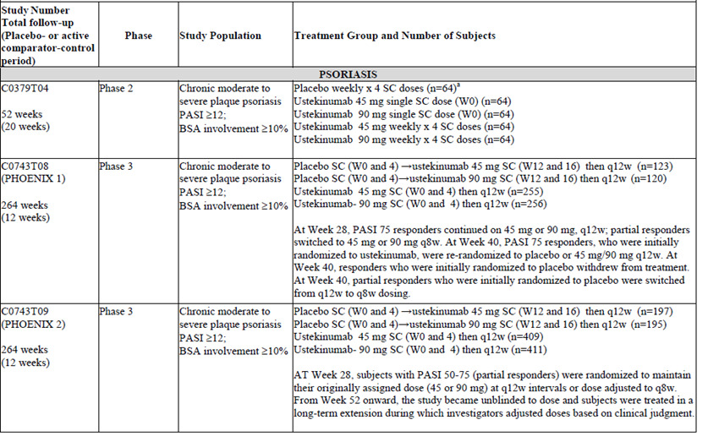
Table 15 continued:
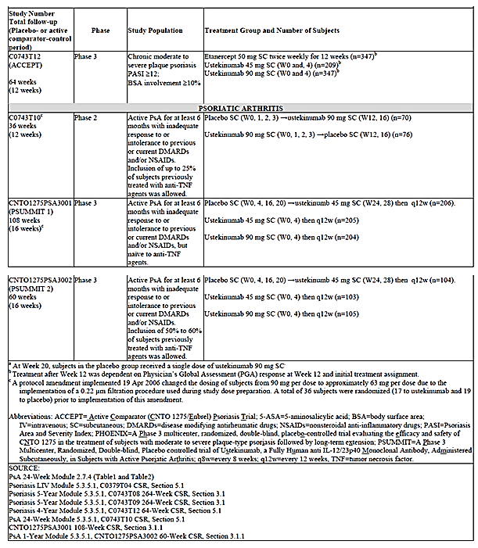
Comment: Safety of ustekinumab has been evaluated in clinical trials in psoriasis and PsA at doses of 45 mg and 90 mg q12w or q8w SC for up to 5 years; the 90mg SC q8w is the proposed dose for Crohn’s disease. Use of safety data from these approved indications to provide supportive information for the evaluation of safety in subjects with Crohn’s disease is justified and the addition of safety data from the psoriasis and PsA studies provides a larger database for the evaluation of: rare events, events with long latencies such as malignancies and other targeted events in a controlled setting such as serious infections.

Studies with evaluable safety data: dose finding and pharmacology
Safety data was also provided by the two Phase II studies (C0379T07 and C0743T26) involving 657 subjects with moderate to severely active Crohn’s disease.

Studies evaluable for safety only
None.

Studies that assessed safety as the sole primary outcome
None.

Patient exposure
The safety database from the 5 Crohn’s disease clinical studies comprises 1749 ustekinumab-treated subjects (a total of 1106 subject-years of follow-up) and includes 849 subjects exposed for at least 6 months, and 464 subjects exposed for at least 1 year. Of these 1749 subjects, 1664 subjects received a single IV induction dose of ustekinumab in the Phase II studies (C0379T07 and C0743T26), Phase III induction studies (CRD3001 and CRD3002) and Phase III maintenance study (CRD3003): 601 received ~6 mg/kg; 754 received 130 mg; and 309 received other doses (Figure 39).
Figure 39: Summary of exposure to IV ustekinumab in phase 2 and phase 3 studies in Crohn’s disease.
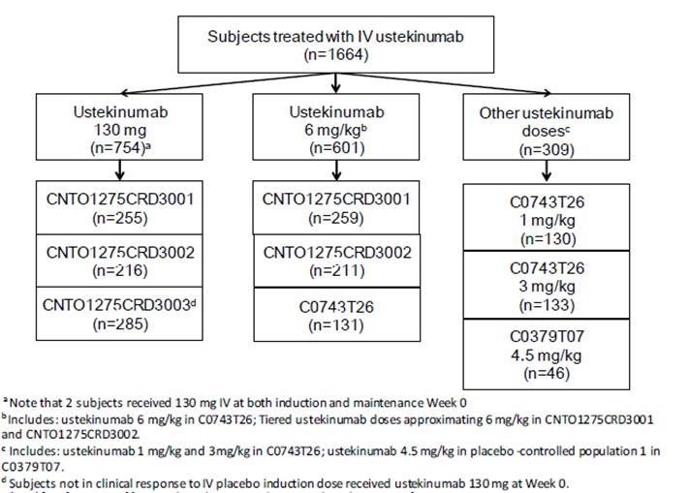
Of the 314 randomised subjects in the Phase III maintenance Study CRD3003, 132 subjects received ustekinumab 90 mg SC q12w and 131 received ustekinumab 90 mg SC q8w prior to meeting loss of response criteria. An additional 51 subjects received ustekinumab 90 mg SC q8w following loss of response to placebo SC. Therefore, 263 randomised subjects received ustekinumab maintenance treatment (90 mg q8w or q12w) in the CRD3003 study. An additional 72 subjects received ustekinumab 90 mg SC q8w as maintenance treatment in the Phase IIb Study C0743T26 following response to ustekinumab IV induction. Overall for Studies CRD3003 and C0743T26 combined, of the subjects randomised as responders, 335 received ustekinumab SC (90 mg q8w or q12w) as maintenance treatment. Of these 335 subjects, 69.0% of subjects randomised as responders were exposed to ustekinumab SC for at least 6 months. For all treated subjects in maintenance Study CRD3003, in addition to the 263 subjects randomised to ustekinumab maintenance treatment following response to ustekinumab IV , 419 non-responders to induction treatment (either placebo or ustekinumab) received ustekinumab maintenance treatment (90 mg q8w or q12w) (that is, did not discontinue at Week 8). Overall, 1205 subjects received ustekinumab 90 mg SC maintenance dosing (every 8 or 12 weeks).
Furthermore, one PK comparability study in healthy normal subjects (CNTO1275NAP1002) was conducted to support the registration of a 5mg/ml formulation intended for IV induction use in Crohn’s disease. Results from this study were not included in any of the pooled analyses of safety data.
The safety database for clinical studies in the approved psoriatic disease indications (psoriasis and PsA) comprised of 4135 ustekinumab-treated subjects and includes 3255 subjects exposed for at least 6 months, and 1669 subjects exposed for at least 1 year. Of these 4135 subjects, 2298 were treated with ustekinumab 90 mg SC either q8w or q12w.
Through 1 year of follow-up across all pooled indications, a total 5884 subjects were treated with ustekinumab (1749 subjects in the combined Crohn’s disease studies, 3117 in the combined psoriasis studies, and 1018 in the combined PsA studies) with a total of 4521 subject-years of follow-up.

Adverse events

All adverse events (irrespective of relationship to study treatment)

Integrated safety analyses
Analysis of pooled data from the Phase III induction studies was considered the primary analysis for the induction phase because it provides randomised, placebo-controlled data for the evaluation of the 2 ustekinumab IV induction doses studied in the Phase III induction studies (130 mg and ~6 mg/kg). Supportive data are provided from the analyses in the pooled Phase II and Phase III studies combined. Analysis of data from randomised subjects from the Phase III maintenance study is considered the primary analysis for the maintenance phase because it is a placebo-controlled, randomised comparison. Supportive data are provided from the analysis of all treated subjects in the maintenance Study CRD3003 and from analyses of pooled data from the Phase II and Phase III studies combined.

Safety of IV ustekinumab in induction phase
The average duration of follow-up and average exposure was similar for subjects in the placebo, ustekinumab 130 mg IV, and ustekinumab ~6 mg/kg IV groups, during the placebo-controlled period (0-8 weeks) in the pooled induction Phase III Studies CRD3001 and CRD3002. The overall proportions of subjects with AEs were comparable between treatment groups with no evidence of a dose effect (60.5%, 58.4% and 60.4% in the placebo, ustekinumab 130 mg IV and ~6 mg/kg IV groups, respectively). The SOCs with the highest proportions of AEs that occurred in subjects in the combined ustekinumab group were Gastrointestinal Disorders (26.4% and 22.3% in the placebo and the combined ustekinumab groups, respectively) and Infections and Infestations (22.1% and 22.0%, respectively). The proportions of subjects in these SOCs were comparable between treatment groups and there was no evidence of a dose effect between the 2 ustekinumab dose groups.
AEs of constipation, influenza, acne, and asthenia, and the established ADR of pruritus were reported more frequently in ustekinumab-treated subjects compared with placebo-treated subjects. The AE of Crohn’s disease was reported more frequently in placebo-treated subjects compared with ustekinumab-treated subjects and this was not unexpected. Although there appeared to be an imbalance between placebo-treated subjects and ustekinumab-treated subjects in the number of subjects with constipation, this imbalance was driven by subjects who received ustekinumab 130 mg IV with no dose effect. The approximate 1% difference in the proportion of subjects with the AEs of asthenia and acne (including the PTs of acne, pustular acne, cystic acne, and dermatitis acneiform) between the ustekinumab ~6 mg/kg IV and placebo groups and an approximately 2.5-fold greater number of events in ustekinumab-treated subjects support the determination of acne and asthenia as new ADRs. Similarly the 1.7% difference in the proportion of subjects with the AE of vomiting and an approximate 1.5 fold greater number of events in the ustekinumab ~6 mg/kg IV group support the determination of vomiting as a new ADR.
When data from the induction phase of Phase II Study C0743T26 and C0379T07 (T07 subgroup) were pooled with data from the Phase III induction studies (CRD3001 and CRD3002), no notable differences were observed compared with the primary analysis, with regards to the types of AEs reported more frequently in ustekinumab-treated subjects (~6 mg/kg ustekinumab) compared with placebo-treated subjects.

Safety of SC ustekinumab in the maintenance phase
During the maintenance phase (up to the point of dose adjustment), the average duration of follow-up in Study CRD3003 was similar for randomised subjects who received placebo, ustekinumab 90 mg SC q12w, or ustekinumab 90 mg SC q8w. The overall proportions of subjects with AEs were comparable between treatment groups with no evidence of a dose effect between the 2 ustekinumab dose groups (83.5%, 80.3% and 81.7% in the placebo, ustekinumab 90 mg SC q12w and 90 mg SC q8w groups, respectively). As seen during the induction phase, the SOCs with the highest proportions of AEs in the combined ustekinumab group during maintenance were Infections and Infestations (48.9% and 46.8% of subjects in the placebo and the combined ustekinumab groups, respectively) and Gastrointestinal Disorders (47.4% and 39.2%, respectively) with no evidence of dose effect between the 2 ustekinumab dose groups.
In general, the proportions of subjects with each type of AE were comparable across treatment groups with the following exceptions which were reported more frequently in ustekinumab-treated subjects: urinary tract infection, sinusitis, cough, anaemia, vulvovaginal mycotic infection, abnormal liver function tests, viral gastroenteritis and the established ADRs of myalgia and injection site erythema.
Although there appeared to be an imbalance between placebo-treated subjects and ustekinumab-treated subjects in the number of subjects with urinary tract infection (UTI) and sinusitis, this imbalance was driven by subjects who received ustekinumab 90 mg SC q12w with no dose effect and both events occurred at relatively low frequencies overall (<5% in the combined ustekinumab group) despite being relatively common infections. In addition, although an imbalance was noted for cough, this AE represents a nonspecific symptom, encompassed by the already established ADRs of upper respiratory infection, viral upper respiratory infection, and nasopharyngitis.
Ustekinumab-treated subjects showed higher incidence of viral gastroenteritis (0.8, 3.8% and 3.1% in the placebo, ustekinumab 90 mg SC q12w and 90 mg SC q8w groups, respectively), but when similar PTs (gastroenteritis and viral gastroenteritis) were combined, the proportions of subjects with these events were comparable across treatment groups. Similarly, when the AEs of anaemia and iron deficiency anaemia were combined, the apparent imbalance in the proportion of subjects with anaemia between treatment groups dissipated. Furthermore, results from haematology laboratory evaluations showed that markedly abnormal changes in haemoglobin values were generally infrequent with comparable rates among the treatment groups without any dose-related or clinically-concerning patterns.
A higher proportion of subjects with AEs of abnormal liver function tests was seen in the ustekinumab 90 mg SC q8w group compared with the q12w group, although the clinical relevance of these results is not clear as reporting of these AEs are based on investigator subjective interpretation of liver function test results and the threshold for determination of abnormal varied between reporters. However, markedly abnormal changes in chemistry laboratory values for ALT and AST were generally infrequent with comparable rates among the treatment groups without any dose-related or clinically-concerning patterns.
The approximate 2% difference in the proportion of subjects with the AE of vulvovaginal mycotic infection between the ustekinumab 90 mg SC q8w and placebo SC groups together with the 4-fold greater number of events in the ustekinumab q8w group support the determination of vulvovaginal mycotic infection as a new ADR.
When data from the Phase II Study C0743T26 were pooled with data from the Phase III maintenance Study CRD3003, the pattern of AEs were consistent with that observed in the primary analysis (that is, data from the Phase III maintenance study alone); number of subjects with AEs per 100 subject years was 163.30 and 128.43 in the placebo and ustekinumab groups, respectively.

Main/pivotal studies that assessed safety as the sole primary outcome
None.

Pivotal and/or main efficacy studies

Study CRD3001
Intravenous ustekinumab administered in a 130 mg or ~6 mg/kg dose was well tolerated, with a safety profile generally comparable with placebo through Week 8. The proportions of subjects with AEs were similar across all treatment groups through Week 8 (64.9%, 64.6% and 65.9%, in the placebo, ustekinumab 130 mg and 6 mg/kg groups, respectively).
The most common treatment-emergent AEs that occurred at a frequency >5% were arthralgia, headache, pyrexia, nausea, nasopharyngitis, abdominal pain, Crohn’s disease and fatigue; the frequency of individual AEs was similar across the treatment groups, with the exception of AEs of Crohn’s disease, which occurred at a higher frequency in the placebo group than in either ustekinumab group. Through Week 8, the proportion of subjects who experienced at least 1 AE of severe intensity was slightly higher in the ustekinumab 6 mg/kg group compared to placebo and the 130 mg groups (6.9%, 6.9% and 10.8%, respectively) mainly driven by slightly higher incidence of infections and skin and subcutaneous AEs (pruritus). The proportions of subjects with infections were similar across all treatment groups through Week 8 (23.7%, 23.2% and 25.7%, respectively); AEs temporally associated with infusions, while infrequent and nonserious, occurred at a slightly higher rate in the ustekinumab groups compared with placebo (2%, 4.5% and 3.6%, respectively). No specific infusion reaction occurred in >1% of subjects in the combined ustekinumab groups. No anaphylaxis or serum-sickness-like reactions to ustekinumab were reported.

Study CRD3002
Intravenous ustekinumab at both 130 mg and ~6 mg/kg was well-tolerated with a safety profile generally comparable with placebo through Week 8 (54.3%, 50% and 55.6% in the placebo, ustekinumab 130 mg and 6 mg/kg groups, respectively).
Table 16 presents the number of subjects with 1 or more treatment-emergent AEs with a frequency of 5% or greater in any treatment group through Week 8. The 4 AEs that met this criterion were: headache, nasopharyngitis, pyrexia, and nausea. Of these, headache and nasopharyngitis occurred in ≥5% of the combined ustekinumab groups. Gastrointestinal disorders (20.2%, 18.8% and 21.3% in the placebo, 130 mg and ~6 mg/kg ustekinumab groups, respectively) and infections and infestations (22.2%, 17.5% and 22.2%, respectively). Through Week 8, the proportion of subjects who experienced at least 1 AE of severe intensity was 6.7% in the placebo group and 5.7% and 5.3% in the 130 mg and ~6 mg/kg ustekinumab groups, respectively.
Table 16: Number of Subjects with 1 or more Treatment-Emergent AEs with Frequency of 5% or greater in any Treatment Group through Week 8 by MedDRA Preferred Term; Treated Subjects Excluding Those Enrolled Prior to Study Re-start. Study CRD 3002
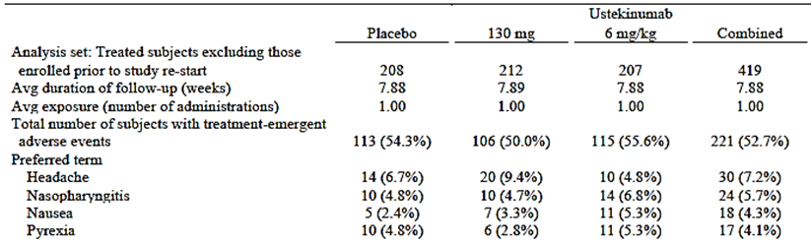

Other studies
The main results of the Phase IIa Study C0379T07 are summarised here. Through Week 8 in Population 1, the placebo-controlled part of the study, a similar frequency of AEs was observed in subjects who received ustekinumab compared with those who received placebo. Following initial ustekinumab administration through Week 28, the proportion of subjects with an AE was similar in Populations 1 and 2. Through Week 28, a similar frequency of AEs was observed in subjects who received ustekinumab subcutaneously compared with subjects who received ustekinumab intravenously in both Populations 1 and 2. In subjects who received a fixed dose of study agent (that is, the SC treatment groups), there was a tendency for subjects with higher baseline body weight to experience fewer AEs (80%, 80% and 63.2% in subjects weighing <60kg, 60 to <75kg and >75kg, respectively).
The main results of Phase IIb Study C0743T26 are summarised here. During the Induction Phase, IV ustekinumab at 1, 3, and, 6 mg/kg was well tolerated, with a safety profile generally comparable with placebo through Week 8. The proportions of subjects experiencing at least one AE were similar across the IV treatment groups and comparable with placebo.
AEs temporally associated with infusions were infrequent and nonserious, and occurred at a similar rate in all treatment groups. During the maintenance phase, among subjects randomised as responders and non-responders, 90 mg SC ustekinumab at Week 8 and Week 16 was also well tolerated, with a safety profile similar to SC placebo. The regimen of 270 mg SC ustekinumab at Week 8 followed by 90 mg at Week 16 was also well tolerated. The proportions of subjects with AEs were similar across all treatment groups in the maintenance phase.

Treatment related adverse events (adverse drug reactions)

Integrated safety analyses
Data on treatment-related AEs were not provided for the integrated safety analyses.

Main/pivotal studies that assessed safety as the sole primary outcome
None.

Pivotal and/or main efficacy studies
In Study CRD3001, the proportions of subjects with reasonably related AEs were similar across the treatment groups (27.3%, 26.0% and 28.1% in the placebo, 130 mg and ~6 mg/kg ustekinumab groups, respectively). In Study CRD3002, through Week 8, the proportion of subjects who experienced at least 1 reasonably related AE was 17.8%, 13.2% and 12.1%, respectively.

Other studies
In Study C0379T07, the proportion of subjects with a reasonably related AE through Week 28 in Population 2 (44.4%) was similar to that observed in Population 1 (37.6%). General administration disorders, gastrointestinal disorders and infections and infestations system-organ classes had the highest proportions of subjects.
In Study C0743T26, in the induction phase, 24.2% of subjects in the placebo group had reasonably related AEs compared with 29.2%, 36.1%, and 28.2% of subjects in the 1 mg/kg, 3 mg/kg, and 6 mg/kg ustekinumab groups. Among subjects randomised as responders to ustekinumab induction, reasonably related AEs were experienced by 37.5% of subjects in the SC ustekinumab group compared with 30.1% of subjects in the SC placebo group during the maintenance phase.

Deaths and other serious adverse events

Integrated safety analyses
There were no deaths in the combined Crohn’s disease studies during the placebo-controlled period. There were also no deaths in maintenance Study CRD3003 through Week 44 (in both randomised subjects and nonrandomised subjects) and no deaths through the end of the study period in Phase II Studies C0379T07 and C0743T26.
Five deaths occurred in the ongoing long-term extension for maintenance Study CRD3003. Brief summaries of these 5 deaths, which occurred between the Week 44 data lock point of the CRD3003 study and 01 September 2015, were provided. The causes of death (3 presumed cardiovascular, 1 renal and 1 suicide) are not atypical of an IBD population.

Serious AEs in induction phase
Overall, the proportions of subjects with SAEs were low and comparable across treatment groups in the placebo-controlled period in the combined Phase III induction studies (CRD3001 and CRD3002) with no evidence of a dose effect (6.0% in the placebo group, 4.9% in the ustekinumab 130 mg IV group, and 5.3% in the ustekinumab ~6 mg/kg IV group). The SOC with the highest proportions of SAEs that occurred in subjects in the combined ustekinumab group were Gastrointestinal Disorders (3.9% in the placebo group and 2.7% in the combined ustekinumab group). These SAEs were predominately events of Crohn’s disease, or related symptoms and complications, and occurred in a low and comparable proportion of subjects across treatment groups with no evidence of a dose effect between the 2 ustekinumab dose groups. Notably, Crohn’s disease, intestinal obstruction, diarrhoea, intestinal abscess, anal abscess, and spontaneous pneumothorax were the only SAEs reported in more than 1 subject in any treatment group. Infections and Infestations was the SOC in which the next highest proportion of ustekinumab-treated subjects experienced SAEs (1.1% in the placebo group and 1.4% in the combined ustekinumab group); events occurred in a low and comparable proportion of subjects across treatment groups with no evidence of a dose effect.

Supportive induction data
When data from the induction phase of Phase II Study C0743T26 were pooled with data from the Phase III induction studies (CRD3001 and CRD3002), no notable differences were observed compared to the primary analysis, with regard to the types of SAEs reported in more than 1 ustekinumab-treated subject (~6 mg/kg ustekinumab) compared with placebo-treated subjects, with the exception of Clostridium difficile infection (2 and 0 subjects, respectively) SAE’s of Crohn’s disease and related symptoms and complications (diarrhoea and anal abscess) were reported more frequently in placebo-treated subjects compared with ustekinumab-treated subjects. When data from Phase II Study C0379T07 (T07 subgroup) were pooled with data from Studies C0743T26, CRD3001, and CRD3002, no notable differences were observed compared to the previous analyses, with regard to the types of SAEs reported in more than 1 ustekinumab-treated subject compared with placebo-treated subjects with the exception of abdominal pain, viral gastroenteritis, and suicidal ideation (each event reported in 2 ustekinumab-treated subjects compared to 0 placebo-treated subjects). However, the low numbers of subjects with these SAEs make interpretation difficult.

Maintenance phase
During the maintenance phase (up to the point of dose adjustment) in Study CRD3003, the proportions of randomised subjects with SAEs were comparable between treatment groups with no evidence of a dose effect (15.0% in the placebo group, 12.1% in the ustekinumab 90 mg SC q12w group, and 9.9% in the ustekinumab 90 mg SC q8w group). As seen during the induction phase, the SOCs with the highest proportions of SAEs in the combined ustekinumab group during maintenance were Gastrointestinal Disorders (placebo versus combined ustekinumab group: 8.3% versus 5.3%) and Infections and Infestations (2.3% versus 3.8%) with no evidence of dose effect.
When data from the Phase II Study C0743T26 were pooled with data from the Phase III maintenance Study CRD3003, the types and patterns of AEs were consistent with that observed in the primary analysis (that is, data from the Phase III maintenance study alone; number of subjects with SAEs per 100 subject –years was 23.75 and 16.36 in the placebo and ustekinumab groups, respectively.

Main/pivotal studies that assessed safety as the sole primary outcome
None.

Pivotal and/or main efficacy studies

Study CRD3001
SAEs were infrequent in all treatment groups through Week 8 (6.1%, 4.9% and 7.2%, respectively). More SAEs of infection were reported in subjects in the ~6 mg/kg ustekinumab group (7/249, 2.8%) than in the 130 mg ustekinumab (3/246, 1.2%) or placebo (3/245, 1.2%) groups (3 subjects both).No subjects developed active TB during the study. One serious opportunistic infection (Listeria meningitis; ~6 mg/kg ustekinumab group) was reported.
No deaths and no MACE were reported. The only SAEs reported in the Cardiac disorders SOC were atrial fibrillation and cardiac failure in a single subject in the ~6 mg/kg ustekinumab group. The investigator considered these cardiac events to be related to the subject’s TB prophylaxis therapy (Rifampin). After the Week 20 safety follow-up visit, 1 malignancy, a case of multiple myeloma, was reported in a subject in the ~6 mg/kg ustekinumab group.

Study CRD3002
SAEs occurred at a low frequency overall and in similar proportions of subjects in all treatment groups through Week 8 (5.8%, 4.7% and 2.9%, respectively). Except for anal abscess, intestinal obstruction, and Crohn’s disease, no individual SAE was reported in more than 1 subject in any treatment group. SAEs of note that occurred in the ustekinumab 130 mg group included events of non cardiac chest pain (1 subject), spontaneous pneumothorax on Study Day 4 (1 subject), impaired wound healing after a bowel resection (1 subject).
There were no notable SAEs in the 6 mg/kg ustekinumab group. Two subjects within the placebo group also had SAEs of note; 1 subject had pancytopenia and another subject experienced rapid atrial fibrillation during an SAE of pneumonia.
Proportions of subjects with infections and serious infections were similar in all treatment groups through Week 8; there were no opportunistic infections in either ustekinumab treatment group and no cases of tuberculosis were reported. AEs temporally related to an infusion were non-serious and occurred in a similar proportion of subjects in all treatment groups. No individual infusion reaction occurred in >1% of subjects in any treatment group. No anaphylaxis or serum-sickness-like reactions to ustekinumab were reported. There were no deaths, MACE, serious opportunistic infections, or cases of TB.

Other studies
In the Phase IIa Study C0379T07, SAEs were infrequent and most of the SAEs were related to Crohn’s disease. Infections were reported in similar proportions of ustekinumab-treated subjects compared with placebo-treated subjects. Two serious infections were reported: disseminated histoplasmosis (also identified as an opportunistic infection) and infectious gastroenteritis. No cases of TB were observed. AEs temporally associated with infusions and injection-site reactions were infrequent. No anaphylactic or serum sickness like reactions were reported. No deaths were reported. One malignancy (other than NMSC) was reported through Week 28 (prostatic adenocarcinoma). Two NMSCs were reported in 1 subject after Week 28. Markedly abnormal laboratory results were infrequent.
In the Phase IIb Study C0743T26, SAEs were infrequent in all treatment groups in the induction phase through Week 8 (8.3%, 4.6%, 6% and 6.9% in the placebo, ustekinumab 1mg/kg, 3mg/kg and 6 mg/kg groups, respectively) and except for Crohn’s disease, no individual SAE was reported in more than 1 subject in any IV ustekinumab dose group. The proportions of subjects with infections were similar across all treatment groups through Week 8; more SAEs of infection were reported in subjects in the 6 mg/kg ustekinumab group (5 subjects) than in the placebo or 1 or 3 mg/kg ustekinumab groups (1 subject, 1 subject, and 0 subjects, respectively).
During the maintenance phase of the study, SAEs occurred at a similar frequency in the SC placebo and SC ustekinumab groups. SAEs within the GI SOC, particularly events of Crohn’s disease, were reported most frequently across the treatment groups. No non-GI SAEs occurred in more than 1 subject in any dose group in the maintenance phase. The proportions of subjects with infections were similar across all treatment groups in the maintenance phase. SAEs of infection were infrequent and similar in frequency across treatment groups. No anaphylactic or serum sickness like reactions to ustekinumab were reported and there were no deaths, malignancies, serious opportunistic infections, cases of TB or MACE in the induction and maintenance phases.

Discontinuations due to adverse events

Integrated safety analyses

Induction phase
During the placebo-controlled period in the combined Phase III induction studies (CRD3001 and CRD3002), the overall incidence of discontinuations due to AEs was low. The proportion of subjects who discontinued due to an AE was higher in the placebo group compared with the ustekinumab IV groups (4.1%, 1.7% and 1.7% in the placebo, ustekinumab 130 mg ~6 mg/kg IV groups, respectively). The SOC with the highest proportions of discontinuations was Gastrointestinal Disorders (3.2%, 0.8% and 0.6%, respectively). Consistent with this, Crohn’s disease was the most frequently occurring AE leading to discontinuation (3.0%, 0.8% and 0.2%, respectively). These observations were not unexpected given the underlying nature of disease within the overall subject population. Other AEs leading to discontinuation generally occurred as single events without any notable patterns with regard to SOC or type of event.
For C0743T26 pooled with CRD3001 and CRD3002 (~6 mg/kg ustekinumab only), 4.0% of subjects in the placebo group and 1.5% in the ustekinumab group discontinued due to an AE For C0379T07 (T07 subgroup) pooled with C0743T26, CRD3001, and CRD3002, 4.3% of subjects in the placebo group and 1.9% in the ustekinumab group discontinued due to an AE. In addition, the types of AEs leading to discontinuation were consistent with that observed in the primary analysis.

Maintenance phase
During the maintenance phase (up to the point of dose adjustment) in Study CRD3003, the overall incidence of AEs leading to discontinuation was low and generally comparable between treatment groups (6.0%, 7.6% and 3.1% in the placebo, ustekinumab 90 mg SC q12w and 90 mg q8w groups, respectively). In common with the induction phase, the SOC with the highest proportions of discontinuations was Gastrointestinal Disorders (4.5% [6 subjects], 3.8% [5 subjects] and 1.5% [2 subjects], respectively). Consistent with this, Crohn’s disease was the most frequently occurring AE leading to discontinuation (2.3% [3 subjects], 2.3% [3 subjects] and 0.8% [1 subject], respectively). These observations were not unexpected given the underlying nature of disease within the overall subject population. Other AEs leading to discontinuation generally occurred as single events without any notable patterns with regard to SOC or type of event.
When data from the Phase II Study C0743T26 were pooled with data from the Phase III maintenance Study CRD3003, the incidence and types of AEs leading to discontinuation were consistent with observations from the Phase III study alone.

Main/pivotal studies that assessed safety as the sole primary outcome
None.

Pivotal and/or main efficacy studies

Study CRD3001
Fourteen (5.7%) subjects in the placebo group discontinued due to an AE compared with 3 (1.2%) in the 130 mg and 7 (2.8%) in the ~6 mg/kg ustekinumab groups.
An AE of Crohn’s disease was the most common event that led to discontinuation in all treatment groups: 11 subjects in the placebo group and 2 and 1 subjects in the 130 mg and ~6 mg/kg ustekinumab groups, respectively.

Study CRD3002
The number of discontinuations due to AEs was low in this study and especially in the ustekinumab 6 mg/kg group (2.4%, 1.9% and 0.5%, respectively). Crohn’s disease was the most common AE that led to discontinuation (2 subjects in the placebo group and 2 subjects in the combined ustekinumab groups [both subjects received 130 mg ustekinumab]). No other AE led to discontinuation in more than 1 subject in any treatment group.

Other studies
In Study C0379T07, discontinuations due to AEs were higher in the placebo group compared with the combined IV and SC CNTO1275 group (9.6% versus 3.8%) and gastrointestinal disorders were main cause of discontinuations.
In Study C0743T26, 5 (3.8%) subjects in the placebo group discontinued due to an AE in the induction phase compared with 2 (1.5%), 5 (3.8%), and 1 (0.8%) subjects in the 1, 3, and 6 mg/kg ustekinumab treatment groups, respectively. Among subjects randomised as responders to ustekinumab induction, 1 (1.4%) subject in the SC ustekinumab group discontinued study agent due to an AE compared with 5 (6.8%) subjects in the SC placebo group. Crohn’s disease was the predominant AE leading to discontinuation in the maintenance phase and no other individual AE resulted in discontinuation in more than 1 subject.

Evaluation of issues with possible regulatory impact
Tests of clinical chemistry consisted of laboratory measurements of alkaline phosphatase, ALT, AST, total and direct bilirubin, sodium, potassium, chloride, BUN/urea, serum creatinine, albumin, total protein, calcium and inorganic phosphate at scheduled study visits in all 5 Crohn’s disease studies.

Liver function and liver toxicity

Integrated safety analyses
Integrated analyses for clinical chemistry parameters were not provided.

Main/pivotal studies that assessed safety as the sole primary outcome
None.

Pivotal and/or main efficacy studies
See below.

Other studies
No significant changes in liver function tests were reported in the Phase II studies.

Renal function and renal toxicity

Integrated safety analyses
Integrated analyses for clinical chemistry parameters were not provided.

Main/pivotal studies that assessed safety as the sole primary outcome
See below.

Pivotal and/or main efficacy studies
See below.

Other studies
No significant changes in renal function tests were reported in the Phase II studies.

Other clinical chemistry

Integrated safety analyses
Integrated analyses for clinical chemistry parameters were not provided.

Main/pivotal studies that assessed safety as the sole primary outcome
Not applicable.

Pivotal and/or main efficacy studies
In Study CRD3001, the only markedly abnormal change in chemistry values that was observed in more than 1 subject on more than 1 occasion in any treatment group was decreased albumin in 2 (0.8%) subjects in the placebo group and no subjects in the ustekinumab groups.
In Study CRD3002, there were no markedly abnormal changes in chemistry laboratory values observed in more than 1 subject on more than 1 occasion in any treatment group through Week 8.
For induction Studies CRD3001 and CRD3002, changes in chemistry values through Week 8 did not appear to be clinically important and no clear patterns of changes over time were seen. In both studies, there were no markedly abnormal changes in chemistry laboratory values observed in more than 1 ustekinumab-treated subject on more than 1 occasion through Week 8.
For maintenance Study CRD3003, changes in chemistry values through Week 44 were generally small and did not appear to be clinically important with similar results in the maintenance phase of the C0743T26 study (Week 8 through Week 22).

Other studies
Changes in clinical chemistry values were generally small and not clinically relevant in the Phase II studies.

Haematology and haematological toxicity

Integrated safety analyses
Integrated analyses for haematology parameters were not provided.

Main/pivotal studies that assessed safety as the sole primary outcome
Not applicable.

Pivotal and/or main efficacy studies
In Study CRD3002, the only markedly abnormal changes in haematology laboratory values occurring in more than 1 subject on more than 1 occasion in any treatment group through Week 8 were decreased lymphocytes; the proportions of subjects experiencing decreased lymphocytes were <6% across all treatment groups.
IN Study CRD3001, markedly abnormal changes in haematology laboratory values were observed in some subjects; the most common markedly abnormal change that occurred on more than 1 occasion in more than 1 subject was decreased absolute lymphocyte count (5.3%, 2.9%, and 4.0% in the placebo, 130 mg, and ~6 mg/kg ustekinumab groups).
For the induction phase of the Crohn's disease studies, markedly abnormal changes in haematology through Week 8 were generally infrequent and generally occurred in comparable proportions of subjects in each treatment group with no clear trends observed. For maintenance Study CRD3003, changes in haematology values through Week 44 were small and did not appear to be clinically important for both randomised and all treated subjects.

Other studies
Changes in haematology parameters were generally small and not clinically relevant in the Phase II studies.

Other laboratory tests
Not applicable.
The Crohn’s disease studies; AEs of pruritus, rash, acne were reported in <2% of the ustekinumab-treated patients.

Pivotal studies that assessed safety as the sole primary outcome
None.

Electrocardiograph findings and cardiovascular safety

Integrated safety analyses
Through the placebo-controlled period, there were no events of serious MACE in the combined Crohn’s disease studies. Through approximately 1 year of treatment, in the combined Crohn’s disease studies, there was 1 event of a subarachnoid haemorrhage due to aneurysm rupture which was adjudicated as a nonfatal stroke in a non-responder to ustekinumab induction who subsequently received ustekinumab 90mg SC q8w as maintenance treatment in Study CRD3003.

Main/pivotal studies that assessed safety as the sole primary outcome
Not applicable.

Pivotal and/or main efficacy studies
See above.

Other studies
See above.

Vital signs and clinical examination findings
In the three pivotal Phase III studies, vital signs were measured for safety purposes; however, these data were not entered in the clinical study database for formal analyses. Vital sign-related AEs were reported and analysed as standard AEs and no safety signals related to vital signs were identified.
Analysis of vital signs and physical findings were not performed during the Phase II studies (C0379T07 and C0743T26); any abnormal findings meeting the definition of an AE or SAE were recorded in the eCRF.

Immunogenicity and immunological events
In the CRD3001 study, neither of the 2 subjects who were positive for antibodies to ustekinumab reported an AE temporally associated with an infusion during their participation in the study. In the CRD3002 study, the 1 subject who was positive for antibodies to ustekinumab through Week 20 did not report an AE temporally associated with an infusion during participation in the study. In the CRD3003 study, none of the 14 randomised subjects who were positive for antibodies to ustekinumab, in any treatment group, experienced an injection-site reaction.
In the Phase II C0379T07, none of the subjects in this study were positive for antibodies to ustekinumab. In the C0743T26 study, none of the 3 subjects who were positive for antibodies experienced an AE temporally associated with an infusion or an injection-site reaction.
Overall, the incidence of antibodies to ustekinumab in the Crohn’s disease studies, and incidence of study agent administration-related events (for example, injection-site reactions and AEs temporally associated with an infusion reaction) were low.
Overall, in the combined Crohn’s disease studies, no subject who was positive for antibodies had a reaction related to study agent administration. However, due to the small number of subjects who were positive for antibodies, caution should be used in interpreting the data regarding the association of antibodies to ustekinumab and study agent administration-related events.

Serious skin reactions

Integrated safety analyses
No serious AEs were reported.

Pivotal and/or main efficacy studies
See above.

Other studies
No serious skin reactions were reported in the Phase II studies.

Other safety parameters
Analysis of ‘AEs by organ system or syndrome’, ‘safety of combined induction and maintenance phase (up to 1 year)’ and ‘Analysis of Carry-Over effects from Induction Phase to Maintenance Phase’ is discussed in this section.

Analysis of ‘AEs by organ system or syndrome’

Infections
The proportions of subjects with infections were comparable across treatment groups in the placebo-controlled period (0-8 weeks) in the combined Phase III induction studies (CRD3001 and CRD3002) with no evidence of a dose effect between the 2 ustekinumab dose groups (23.2%, 19.5%, and 23.6% in the placebo, ustekinumab 130 mg IV and ~6 mg/kg IV groups, respectively). The most frequently occurring infections across all ustekinumab treatment groups were nasopharyngitis, upper respiratory tract infection, gastroenteritis and sinusitis. The proportions of subjects with infections that required oral or parenteral antimicrobial treatment were comparable across treatment groups (12.0%, 8.5% and 11.5%, respectively). The proportions of subjects with serious infections were low and comparable across treatment groups (1.3%, 1.5% and 1.7%, respectively). With the exception of anal abscess (considered a manifestation of underlying Crohn’s disease), no one specific serious infection occurred in more than 1 subject in any treatment group. Serious infections considered unrelated to Crohn’s disease, which occurred in single ustekinumab-treated subjects, were Clostridium difficile infection, Escherichia sepsis, gastroenteritis, viral gastroenteritis, intervertebral discitis, Listeria meningitis and cholangitis. Listeria meningitis was the only serious infection that was considered to be an opportunistic infection. During the induction phase of the combined Crohn’s disease studies, no cases of active TB were reported.
During the maintenance phase (up to the point of dose adjustment) in Study CRD3003, the proportions of randomised subjects with infections were comparable between treatment groups with no evidence of a dose effect between the 2 ustekinumab dose groups (49.6%, 46.2% and 48.1% in the placebo, ustekinumab 90 mg SC q12w and 90 mg SC q8w groups, respectively). The most frequently occurring infections across all treatment groups were nasopharyngitis, upper respiratory tract infection, influenza, and UTI.
In general, the proportions of subjects with each type of infection were comparable across treatment groups, without any clear evidence of a dose effect between the 2 ustekinumab dose groups, with the exception of UTI, viral gastroenteritis, sinusitis and the new ADR of vulvovaginal mycotic infection which were reported more frequently in ustekinumab-treated subjects compared with placebo-treated subjects. The proportions of subjects with infections that required oral or parenteral antimicrobial treatment were also comparable across treatment groups (25.6%, 25.8% and 29%, respectively).
The proportions of subjects with serious infections were low and comparable across treatment groups (2.3%, 5.3% and 2.3%, respectively). With the exception of pneumonia, which occurred in 2 subjects in the placebo group, no one specific serious infection occurred in more than 1 subject in any treatment group. Serious infections considered unrelated to Crohn’s disease, which occurred in ustekinumab-treated subjects (1 subject each) were abdominal infection, appendicitis, bacteraemia, campylobacter gastroenteritis, gastroenteritis, viral gastroenteritis, postoperative wound infection, ophthalmic herpes zoster, and viral infection. Through Week 44 of the combined Crohn’s disease studies, there was 1 event of presumed active primary TB reported in a subject; 24 subjects who received ustekinumab treatment were also receiving treatment for latent TB at randomisation and 1 subject who was randomised to placebo and receiving treatment for latent TB at randomisation, also crossed over to receive ustekinumab during maintenance. None of these subjects subsequently reported active TB during the study.
In the combined Crohn’s disease studies, the total number of opportunistic infections was low (8 cases; 2 serious cases [both on IV ustekinumab] and 6 nonserious cases [4 ustekinumab and 2 placebo]) through the end of the study period for Studies CRD3001, CRD3002, C0379T07, C0743T26, and through Week 44 for CRD3003. Overall, in the Crohn’s disease program, no one opportunistic infection occurred in more than 1 subject with the exception of nonserious cases of oesophageal candidiasis which occurred in 3 ustekinumab-treated subjects and 2 placebo-treated subjects. In addition, in the majority of cases in which an opportunistic infection was reported, subjects were also receiving immunosuppressant agents concomitantly with study agent.

Adverse Events Temporally Associated with Infusions
Overall, the proportions of subjects who experienced AEs within 1 hour following IV infusion were low and generally comparable across treatment groups in the combined Phase II and Phase III Crohn’s disease studies (C0379T07, C0743T26, CRD3001, CRD3002, and CRD3003): 2.9% of placebo-treated subjects and 3.4% of ustekinumab-treated subjects. The most frequently reported AEs within 1 hour following IV infusion in the ustekinumab group were headache, nausea, pyrexia, pruritus, and urticaria and none of these events were reported in >0.6% of subjects with comparable incidence across treatment groups with the exception of pyrexia and the established ADRs of pruritus and urticaria which were reported more frequently in ustekinumab-treated subjects (incidence <0.5%).
Consistent with the results from the combined Phase II and Phase III Crohn’s disease studies, the proportion of subjects who experienced AEs within 1 hour following IV infusion in the combined Phase III induction studies alone (CRD3001 and CRD3002) were low and generally comparable across all treatment groups with no evidence of a dose effect between the 2 ustekinumab doses (2.4% in the placebo group, 3.6% in the ustekinumab 130 mg IV group, and 2.6% in the ustekinumab ~6 mg/kg group). Similarly, the proportions of subjects who experienced AEs within 1 hour following IV infusion in the maintenance Study CRD3003 were low and generally comparable across treatment groups (2.5% in the placebo group and 1.8% in the ustekinumab 130 mg IV group).
In an effort to specifically identify subjects that may have experienced an infusion reaction, the comprehensive list of AEs reported within 1 hour following IV infusion was subsequently evaluated for terms suggestive of an infusion reaction. Using this assessment approach, a total of only 4 subjects (2 placebo-treated subjects and 2 ustekinumab-treated subjects) had experienced a collection of AEs suggestive of a possible infusion reaction. All of the events identified in these subjects were assessed as mild or moderate severity, with the exception of severe dyspnoea reported in a subject that received a placebo infusion. The events were self-limited in all cases and required no intervention other than oral antihistamine. Interruption or termination of the drug infusion only occurred in 2 subjects. Overall, an extremely low number of potential infusion reactions were detected in this analysis during 2790 total infusions of IV ustekinumab treatment.

Injection site reactions
Ustekinumab was administered by SC injection during Study CRD3003 and during the maintenance phase of Study C0743T26. The proportions of all treated subjects who reported injection-site reactions through Week 44 were low overall: 1.7% of subjects reported a placebo injection-site reaction and 3.0% reported an ustekinumab injection-site reaction. No serious injection-site reactions or injection-site reactions of severe intensity were reported. The most frequently reported injection-site reaction among all treated subjects was the established ADR of injection-site erythema which occurred in 1.1% and 1.7% of subjects receiving a placebo or ustekinumab injection, respectively.

Anaphylactic and Serum Sickness like Reactions
The terms anaphylactic reaction, anaphylactic shock, anaphylactoid reaction, anaphylactoid shock, Type I hypersensitivity, and serum sickness or serum sickness-like reaction were utilised to search all reported AEs. There were no possible anaphylactic reactions or possible serum sickness-like reactions in ustekinumab-treated subjects through approximately 1 year of treatment in the Crohn’s disease studies combined (C0379T07 [T07 subgroup), C0743T26, CRD3001, CRD3002, and CRD3003). There was 1 serum sickness-like reaction to infliximab in a subject who had completed treatment with ustekinumab in Study C0743T26 and was in safety follow-up; the event occurred 7 days after treatment with infliximab (209 days after administration of ustekinumab).

Malignancies
There were no malignancies in the combined Crohn’s disease studies through the placebo-controlled period. In the combined Crohn’s disease studies, through approximately 1 year of treatment; the incidence of malignancies per 100 subject-years of follow-up was low and comparable between placebo-treated subjects and ustekinumab-treated subjects (0.58 [95% CI: 0.07, 2.09] in the placebo group, and 0.63 [95% CI: 0.25, 1.31] in the combined ustekinumab group). The numbers of subjects with 1 or more nonmelanoma skin cancer (NMSC) were low and comparable between treatment groups Incidence rates for other malignancies (other than NMSC) were also low (0.00 [95% CI: 0.00, 0.86] in the placebo group, and 0.27 [95% CI: 0.06, 0.79] in the combined ustekinumab group) with overlapping confidence intervals. There were 4 malignancies (other than NMSCs) in 3 subjects.

Safety of combined induction and maintenance phase (up to 1 year)
Key safety events for up to 52 weeks of exposure for the Phase III studies and the combined Phase II and III studies show generally consistent results and no evidence of a dose effect between treatment groups for each high-level safety topic, including the subgroup of subjects who received the recommended dosing regimen for Crohn’s disease (6 mg/kg IV induction followed by 90 mg SC q8w or q12w). These results are also consistent with results already presented for each of the components of induction and maintenance (see above).

Analysis of Carry over Effects from Induction Phase to Maintenance Phase
A supportive analysis was conducted in randomised subjects from Study CRD3003 to determine if the dose received during induction (130 mg or ~6 mg/kg) had any demonstrable effect upon safety during the maintenance phase (termed ‘carry over effect’). To evaluate any potential carry over effect, key safety events that occurred from Week 0 through Week 8 in the CRD3003 maintenance study in the placebo and ustekinumab SC treatment groups were compared based upon the IV induction dose received (130 mg or ~6 mg/kg). In the ustekinumab SC maintenance group, the proportions of subjects with AEs, SAEs, and infections were generally similar regardless of whether they received 130 mg or ~6 mg/kg as their IV induction dose. Consistent with the ustekinumab SC maintenance group, results in the placebo SC maintenance group also suggested a lack of carry over effect. However, interpretation of this data was limited by the low number of events of interest. .

Overdose, drug abuse, withdrawal and rebound
Single IV doses of ustekinumab up to 6 mg/kg have been administered in clinical studies without any direct toxic effect. There have been no known occurrences of infusions of more than 6 mg/kg or of overdose of any kind. There were no known occurrences of overdose during any of the Crohn’s disease clinical studies.
There is no evidence that ustekinumab is associated with the potential for addiction or abuse. The effect of ustekinumab on the ability to drive or operate machinery or the impairment of mental ability is not known.
None of the PsA or Crohn’s disease studies have examined withdrawal or rebound of PsA or Crohn’s disease since no definition for rebound of PsA or Crohn’s disease exists; however, withdrawal and rebound were studied in the psoriasis program and there was no pattern to suggestive of psoriasis rebound.

Other safety issues

Safety in special populations

Crohn’s disease
In the Crohn’s disease studies, no trends were observed with regard to differences between treatment groups in the proportions of subjects with AEs, SAEs, infections, or who discontinued due to an AE, when evaluated by sex, race, age, and weight during induction or maintenance. Overall, no trends were observed with regard to differences in the proportions of subjects with AEs, SAEs, infections, or who discontinued due to an AE, when evaluated by the subject’s disease severity as measured by baseline CDAI score during the induction or maintenance phase.
Comment: Interpretation of data regarding the impact of race upon ustekinumab safety is limited due to the small number of non-White subjects. Similarly, interpretation of data regarding the impact of age upon safety is limited due to the low number of subjects’ ≥65 years of age and the low number of subjects with SAEs.

Use in pregnancy and lactation
No studies of ustekinumab were conducted in pregnant or lactating women. The ustekinumab protocols mandated the use of effective contraception during the studies. Discontinuation of study agent was mandated in the event a subject became pregnant. As of 08 July 2015, 137 reports of pregnancy were identified in studies of ustekinumab in Crohn’s disease, psoriasis, PsA, MS, and healthy volunteers: 67 maternal pregnancies and 70 pregnancies with paternal exposure. The outcomes seen in the ustekinumab pregnancies are comparable with what is expected in the general population.

Safety of ustekinumab across other disease populations
Safety data from the Crohn’s disease studies was compared with the safety data from pooled indications of Crohn’s disease, psoriasis and PsA to determine if the safety experience in Crohn’s disease alters the well characterised ustekinumab safety profile established previously in the approved indications.
The duration of follow-up for subjects across indications varies due to differences in study design; the average duration of follow-up for the placebo-controlled period in the Crohn’s disease studies was approximately 4 to 7 weeks shorter and that through approximately 1 year of treatment was approximately 10 weeks shorter than the durations of follow-up for the approved psoriatic disease indications. Hence, the data were compared as event rate per 100 subject-years of follow-up to allow for more informative comparisons. In addition, the duration of follow-up for placebo treated subjects through approximately 1 year, across all indications, was shorter than observed in ustekinumab treated subjects.
Through 1 year of follow-up across all pooled indications, 5884 subjects were treated with ustekinumab (1749 subjects in the combined Crohn’s disease studies, 3117 in the combined psoriasis studies, and 1018 in the combined PsA studies with a total of 4521 subject-years of follow-up (2566 subject-years in psoriasis, 850 subject-years in PsA, and 1106 subject-years in Crohn’s disease). Of these subjects, 3503 were treated with a 90mg SC dose of ustekinumab either q8w or q12w (1205 subjects in the combined Crohn’s disease studies, 1801 in the combined psoriasis studies, and 497 in the combined PsA studies).
In the combined Phase II and Phase III Crohn’s disease studies (C0379T07, C0743T26, CRD3001, CRD3002, and CRD3003), 849 subjects (48.5%) and 464 subjects (26.5%) were exposed to ustekinumab for at least 6 months and at least 1 year, respectively, with an average duration of treatment of 19.48 weeks. The mean total dose in the combined Crohn’s disease studies was 432.1±243.86 mg. In the combined Phase II and Phase III psoriasis studies (C0379T04, 0743T08, C0743T09, andC0743T12), 2413 subjects (77.4%) and 1142 subjects (36.6%) were exposed to ustekinumab for at least 6 months and at least 1 year, respectively, with an average duration of treatment of 26.49 weeks with a mean total dose of 270.4±122.38 mg. In the combined Phase II and Phase III PsA studies (C0743T10, CNTO1275PSA3001, and CNTO1275PSA3002), 842 subjects (82.7%) and 527 subjects (51.8%) were exposed to ustekinumab for at least 6 months and at least 1 year, respectively, with an average duration of treatment of 27.66 weeks with a mean total dose of 264.5±126.34 mg.
Across all the pooled indications, the majority (91.2%) of subjects were White. Consistent with the reported demographics of patients with Crohn’s disease, subjects in the Crohn’s disease studies weighed less, had a lower median body mass index and were younger compared with subjects in the psoriatic studies. Subjects in the Crohn’s disease studies had lower cardiovascular risk factors compared with subjects in the psoriatic studies. Based on study design, concomitant immunosuppressant agents (such as oral AZA, 6-MP, MTX, and oral corticosteroids) were permitted in the Crohn’s disease and PsA studies only. As expected, given the different approaches to conventional treatment, there were differences in the predominant immuno-modulators used in each indication and also differences in the use of corticosteroids. Overall, for both indications, a similar proportion of subjects received both corticosteroids and immuno-modulators at baseline.
Through the placebo-controlled period, the overall numbers of subjects with AEs per 100 subject-years were comparable between treatment groups within Crohn’s disease (402.06 and 389.66 subjects per 100 subject-years for placebo and ustekinumab, respectively) and across the pooled indications (250.12 and 250.92, respectively). However, the overall number of subjects with AEs per 100 subject-years of exposure reported for Crohn’s subjects was substantially higher than for the other approved indications among both placebo-treated subjects (213.12, 174.86 and 402.06 for psoriasis, PsA and Crohn’s disease, respectively) and ustekinumab-treated subjects (220.59, 168.00 and 389.66, respectively) demonstrating that subjects with Crohn’s disease reported AEs at a higher rate independent of whether they received ustekinumab-treatment or not.
Moreover, the comparable AE rate seen between placebo-treated subjects and ustekinumab-treated subjects within the combined Crohn’s disease studies suggests that the higher occurrence of AEs in subjects with Crohn’s disease was most likely related to the underlying disease rather than ustekinumab treatment. The SOCs with the highest AE subject rate (number of subjects with AEs per 100 subject-years) across the pooled indications were Infections and Infestations and Gastrointestinal Disorders. In both of these SOCs the event rate for Crohn’s disease was substantially higher than it was for the other approved indications, although comparable between the placebo and ustekinumab groups. Predictably, within these SOCs, the events with the greatest disparity in frequency between Crohn’s disease and the other indications were events generally associated with underlying Crohn’s disease such as anal abscess, nausea, abdominal pain, vomiting, Crohn’s disease, dyspepsia, upper abdominal pain and constipation. AEs, that occurred more frequently (based on subject-rate data) in ustekinumab-treated subjects across the pooled indications were acne asthenia and the established ADRs of tooth abscess (dental infections), injection site erythema, injection site pain and pruritus.
Through the placebo-controlled period, there were no deaths in the combined Crohn’s disease and combined PsA studies. There was 1 death in psoriasis subject who received ustekinumab (90 mg regimen) due to dilated cardiomyopathy. The number of subjects with SAEs per 100 subject-years (SAE subject rate) was relatively low and comparable between placebo-treated subjects (16.36) and ustekinumab-treated subjects (13.14). As previously noted for common AEs, the overall SAE subject rate in the combined Crohn’s disease studies was higher than the rate seen across the approved indications (psoriasis and PsA) and pooled indications, both among placebo- and ustekinumab-treated subjects suggesting that the higher rate of SAEs was related to the underlying disease rather than ustekinumab treatment. The number of subjects who discontinued due to an AE during the placebo-controlled period across the pooled indications was low and slightly higher in placebo-treated subjects compared with ustekinumab-treated subjects (3.4% versus 1.6%). A similar pattern was seen in the Crohn’s disease studies where a slightly higher proportion of placebo-treated subjects discontinued due to an AE compared with ustekinumab-treated subjects (4.3% versus 1.9%).The SOC with the highest proportion of discontinuations across pooled indications was Gastrointestinal Disorders, which was mainly driven by placebo-treated subjects with the AE of Crohn’s disease in the combined Crohn’s disease studies.
Through approximately 1 year of treatment across pooled indications, the number of subjects with AEs per 100 subject-years was 102.67 in ustekinumab-treated subjects and 190.07 in placebo-treated subjects and the profile of AEs was similar to that observed during the placebo-controlled period (described above). No additional notable AEs in ustekinumab-treated subjects across the pooled indications were identified.
Through approximately 1 year of treatment, there were no deaths in the combined Crohn’s disease and combined PsA studies. Through 1 year, in the psoriasis studies, there were 5 deaths in ustekinumab-treated subjects. Through approximately 1 year of treatment across pooled indications, the number of subjects with SAEs per 100 subject-years was lower in ustekinumab-treated subjects compared with placebo-treated subjects (10.90 versus 21.51). Consistent with the placebo-controlled period, the SAE subject rate was higher in the combined Crohn’s disease studies compared with the pooled indications; however the SAE subject rate was lower for ustekinumab-treated subjects compared with placebo-treated subjects (25.86 and 34.04 subjects per 100 subject-years, respectively). The number of subjects who discontinued due to an AE through 1 year across the pooled indications was low and comparable between ustekinumab and placebo-treated subjects (3.8% versus 4.1%) with a similar pattern observed in the Crohn’s disease studies (6.2% versus 4.8%).
Through the placebo-controlled period and up to 1 year across the pooled indications, the AE and SAE subject rate was comparable between placebo- and ustekinumab-treated subjects. Although the overall subject rate in the combined Crohn’s disease studies was higher than observed across the pooled indications, the rate was comparable between placebo and ustekinumab treated subjects in the combined Crohn’s disease studies. There were no deaths in the combined Crohn’s disease studies suggesting no impact to the previously established safety profile with psoriasis and PsA with regards to fatal events. Overall, the number of subjects who discontinued due to AEs during the placebo-controlled period and up to 1 year across the pooled indications was low and comparable between placebo- and ustekinumab-treated subjects.
The number of subjects with infections and serious infections per 100 subject-years was generally comparable between placebo and ustekinumab-treated subjects. Although the overall infection subject rate in the combined Crohn’s disease studies was higher than observed across the pooled indications, the rate was comparable between placebo-treated subjects and ustekinumab-treated subjects in the combined Crohn’s disease studies.
During the placebo-controlled period no malignancies were reported in the Crohn’s disease safety database. Through 1 year of follow-up in the Crohn’s disease studies the numbers of subjects with 1 or more NMSC were low. There were 4 malignancies (other than NMSCs) in 3 Crohn’s disease subjects. Across all indications, the incidence per 100 subject-years of follow-up for all malignancies was low and generally comparable between treatment groups and was driven by NMSC. In all diseases pooled, the SIR in the combined ustekinumab group was 0.84 (95% CI, 0.47, 1.38) compared with a SIR in the placebo group of 0.43 (95% CI, 0.01, 2.38). Since malignancies are long-latency events, 5 year data in psoriasis was pooled with 1 year data in PsA and Crohn’s disease providing an overall SIR for the combined ustekinumab group of 1.07 (CI: 0.81, 1.39). Taken together, these analyses do not suggest a clear impact of ustekinumab on malignancy risk in subjects with Crohn’s disease or across the pooled indications.
During the placebo-controlled period in the Crohn’s disease studies, no serious MACE were identified. In the Crohn’s disease studies, through 1 year, there was 1 event of subarachnoid haemorrhage due to aneurysm rupture which was adjudicated to nonfatal stroke. Overall, across indications, there was no consistent evidence that ustekinumab increases cardiovascular risk. Results from the Crohn’s disease studies, up to 1 year, did not change the previous assessment of the impact of ustekinumab on serious MACE.
There were no possible anaphylactic reactions or possible serum sickness-like reactions to ustekinumab through the placebo-controlled period and through approximately 1 year of treatment across all indications.
Across the pooled indications through 1 year the total number of opportunistic infections was low with no single opportunistic infection occurring in more than 1 subject with the exception of nonserious oesophageal candidiasis. No cases of disseminated Salmonella or atypical mycobacterial infections were observed through approximately 1 year of treatment across the pooled indications. Across the pooled indications there was 1 case of presumed active primary TB reported in subject with Crohn’s disease 10 months after the subject’s last dose of ustekinumab.
Across all indications, serious neurological disorders were reported rarely. There were no events of RPLS, definitive cases of PML or demyelinating disorders reported across all indications through approximately 1 year, with the exception of 1 nonserious event of ‘other demyelinating diseases of the central nervous system’ in the Crohn’s disease trials.
Overall, the safety profile for ustekinumab in Crohn’s disease was consistent with the well-characterised ustekinumab safety profile established in the approved indications of psoriasis and PsA.

Safety related to drug-drug interactions and other interactions
No formal study of drug-drug interactions was performed with ustekinumab.
Safety (AEs, SAEs, infections, and discontinuations due to AEs) was analysed according to use of baseline immuno-modulator, corticosteroids and TNF-antagonist therapy at baseline.

Immunomodulators
In the C0379T07, C0743T26, CRD3001, and CRD3002 studies, subjects were permitted to receive AZA, 6-MP and MTX for the treatment of Crohn’s disease during the study, provided that the subject was on a stable dose before baseline and maintained a stable dose throughout the study. Overall, no trends were observed with regard to differences in the proportions of subjects with AEs, SAEs, infections, or who discontinued due to an AE, when evaluated by immuno-modulator use at baseline during the induction phase and maintenance phase. For ustekinumab-treated subjects, the proportion of subjects with infections was comparable between subjects who did receive and did not receive an immunosuppressant at baseline during the induction (18.8% and 23.1%, respectively) and maintenance (41.1% and 42.6%, respectively) phases.

Corticosteroids
In the Crohn’s disease studies, use of oral corticosteroids was permitted according to specific guidelines Overall, no trends were observed with regard to differences in the proportions of subjects with SAEs, infections, or who discontinued due to an AE, when evaluated by corticosteroid use at baseline during the induction and maintenance phase. For ustekinumab treated subjects, the proportion of subjects with infections was comparable between subjects who did receive and did not receive corticosteroids at baseline in the induction (21.0% and 22.3%, respectively) and maintenance (42.9% and 41.6%, respectively) phases.

TNF antagonists
Safety (AEs, SAEs, infections, and discontinuations due to AEs) was analysed according to TNF antagonist history. Study C0379T07 is not included in these analyses as all subjects in this study were naïve to TNF antagonist treatment. In the other 4 Crohn’s disease studies, use of TNF antagonists followed specific guidelines in each study. As such, TNF antagonist history included subjects who failed TNF antagonists, subjects who were TNF antagonist experienced (but who had not failed) and subjects who were TNF antagonist naïve. The proportions of subjects with AEs, SAEs, infections and discontinuations due to 1 or more AEs were slightly lower for subjects who were TNF antagonist naïve relative to subjects who were TNF antagonist experienced in both the placebo and ustekinumab treatment groups in the induction and maintenance phases.
Overall, the proportions of subjects with AEs, SAEs, infections and discontinuations due to an AE, were comparable between treatment groups in each of the 3 subgroups analysed (TNF antagonist failure, TNF antagonist experienced but not failed, and TNF antagonist naïve) suggesting that baseline TNF antagonist status did not have an impact on safety.

Post marketing experience
Ustekinumab has not received marketing approval in any country for proposed indication in treatment of Crohn’s disease.
However, ustekinumab has been approved for psoriasis and psoriatic arthritis. Post marketing information has been accruing since the first approval of ustekinumab on 12 December 2008. As of 31 December 2014, ustekinumab was approved in 84 countries. Global post marketing exposure through 31 December 2014 has been estimated as 379,596 person-years. Annual Periodic Safety Update reports (PSURs) have been generated for this product reflecting the assessment of active ongoing post marketing surveillance of targeted safety events as described in clinical study safety analyses, as well as broad overall safety surveillance.
A large safety database is already available from previous studies of ustekinumab which includes 5 years of long-term safety data in psoriasis subjects; no dose differentiation based on safety data was identified between the 45 mg and 90 mg doses q12w in these studies and no increase in the risk of death, serious infection, MACE, or malignancies over time was observed in either dose group.

Evaluator’s overall conclusions on clinical safety
Overall, IV ustekinumab at doses of 130 mg and ~6 mg/kg was well tolerated in the pooled Phase III induction studies (CRD3001 and CRD3002) with a safety profile generally comparable with placebo through Week 8. In addition, SC ustekinumab at doses of 90 mg q12w and 90 mg q8w was also well tolerated in randomised subjects in the Phase III maintenance Study CRD3003, with a safety profile generally comparable with placebo through Week 44. When safety data from the Phase II studies (C0379T07 and C0743T26) were pooled with data from the Phase III studies, results were generally consistent with observations from the pivotal Phase III studies alone.
The proportions of subjects with AEs, SAEs and discontinuations due to AEs during the induction phase of the pooled Phase III studies (CRD3001 and CRD3002) and in randomised subjects in the Phase III maintenance study (CRD3003) were comparable across treatment groups with no evidence of a dose effect. There were no new types or patterns of AEs identified with the exception of the new adverse drug reactions (ADRs) of acne, asthenia, vomiting and vulvovaginal mycotic infections.
The proportion of subjects with serious infections was low and generally comparable across treatment groups with no evidence of a dose effect during the induction phase of the pooled Phase III studies (CRD3001 and CRD3002) and in randomised subjects in the Phase III maintenance study (CRD3003). Overall, in the 5 Crohn’s disease studies, no single opportunistic infection occurred in more than 1 subject with the exception of cases of nonserious oesophageal candidiasis which occurred in 2 placebo-treated subjects and 3 ustekinumab-treated subjects. Through Week 44 of the combined Crohn’s disease studies, there was 1 event of presumed active primary TB reported in a subject (10 months after their last ustekinumab dose) who was randomised to ustekinumab 130 mg IV as induction treatment and then received placebo maintenance treatment in Study CRD3003.
The proportion of subjects with AEs temporally associated with infusions (defined as AEs reported during or within 1 hour following the IV infusion) was low and generally comparable across treatment groups (2.9% in the placebo-treated subjects and 3.4% in ustekinumab-treated subjects) across the 5 Crohn’s disease studies. None of these events were considered to be serious or severe in subjects treated with ustekinumab.
During the placebo-controlled period no malignancies, serious MACE, deaths, anaphylactic reactions, reversible posterior leukoencephalopathy syndrome (RPLS) or definitive cases of progressive multifocal leukoencephalopathy (PML) were reported in the 5 Crohn’s disease studies through 1 year.
The proportions of subjects experiencing markedly abnormal values in haematology and chemistry laboratory test results were low and were generally comparable among the treatment groups (placebo and all ustekinumab dose groups). The incidence of antibodies to ustekinumab in the Crohn’s disease studies was low and no subject who was positive for antibodies had a reaction related to study agent administration.
Overall, no trends were apparent with regard to differences in the proportions of subjects with AEs, SAEs, infections, or who discontinued due to AEs, when evaluated by demographics, baseline disease characteristics, concomitant Crohn's disease medications (immuno-modulators and/or corticosteroids) or tumor necrosis factor (TNF) antagonist failure history.
There were no meaningful differences between ustekinumab treatment groups and placebo treatment groups in the overall safety profile for both induction treatment (ustekinumab 130 mg IV and 6 mg/kg IV) and maintenance treatment (ustekinumab 90 mg SC q8w and q12w) through 1 year. In addition, no apparent dose effect between ustekinumab treatment groups was seen. Safety data from the Crohn’s disease studies were consistent with those from the approved indications of psoriasis and PsA. With the exception of the new nonserious ADRs of acne, asthenia, vomiting and vulvovaginal mycotic infections, there were no new types or patterns of AEs identified. There is no clear impact of ustekinumab on the safety events of serious infection, malignancy, infusion reactions, and serious MACE.
Through 1 year of follow-up across all pooled indications, a total 5884 subjects were treated with ustekinumab, with a total of 4521 subject-years of follow-up: 1749 subjects in the combined Crohn’s disease studies, 3117 in the combined psoriasis studies, 1018 in the combined PsA studies. Overall, the safety data from the Crohn’s disease studies does not appear to have altered the well-characterised ustekinumab safety profile established in the approved indications of psoriasis and PsA.
Ustekinumab was well tolerated in Crohn’s disease, including subjects who received the proposed induction and maintenance dosages (that is, 6 mg/kg IV followed by 90 mg SC q8w).The comprehensive safety analyses presented in the Crohn’s disease population, in 5 studies with 1,749 ustekinumab-treated subjects with up to 1 year of follow-up, combined with data from the psoriatic indications, support the safety of ustekinumab in the treatment of patients with moderately to severely active Crohn’s disease.

First round benefit-risk assessment

First round assessment of benefits
Indication
Benefits | Strengths and Uncertainties
IV induction therapy with proposed dose of 6 mg/kg showed statistically and clinically significant benefits over placebo in both pivotal induction studies (CRD3001 and CRD3002). | Clinical response at Week 6:  Study CRD3001: 33.7%, 34.3% and 21.5% in ustekinumab IV 6 mg/kg, 130 mg and placebo groups, respectively. Study CRD3002: 55.5%, 51.7% and 28.7%, respectively.  Clinical remission at Week 8: Study CRD3001: 20.9%, 15.9% and 7.3% in ustekinumab IV 6 mg/kg, 130 mg and placebo groups, respectively. Study CRD3002: 40.2%, 30.6% and 19.6%, respectively.  95% CI were not provided in the CSRs of Studies CRD3001 and CRD3002; only p-values were provided.
Rapid improvement in signs and symptoms of moderate to severely active Crohn’s disease following IV induction treatment with ustekinumab. | Statistically significant benefits compared to placebo observed after Week 3 following ustekinumab IV induction treatment.
In patients who responded to IV induction therapy, maintenance of efficacy shown up to 44 weeks following SC ustekinumab 90 mg given every 8 weeks or 12 weeks. | Clinical remission at Week 44 was 35.9%, 48.8% and 53.1% in the placebo, ustekinumab q12w and q8w groups, respectively.  Clinical response at Week 44 was 44.3%, 58.1% and 59.4%, respectively.  Corticosteroid free remission at Week 44 was 29.8%, 42.6% and 46.9%, respectively.
Demonstrated consistent efficacy across the full spectrum of patients with moderately to severely active Crohn’s disease, from those who had failed conventional therapies and were TNF-naïve to those who had failed TNF | Statistically and clinically significant benefits with ustekinumab IV induction and SC maintenance treatment in all 3 pivotal Phase III studies (CRD3001, CRD3002 and CRD3003). Although response and remission rates were slightly lower in Study CRD3001 (patients failed TNF-antagonist treatment) compared to Study CRD3002 (failed conventional therapy), the difference compared with placebo were statistically and clinically significant in both studies.  Benefit of maintenance therapy in patients unresponsive to TNF-antagonist therapy not statistically significant although still numerically better than placebo.
Sustained clinical remission and clinical response observed in ustekinumab treatment groups. | Compared with placebo, patients treated with ustekinumab induction and maintenance treatment showed higher rates of sustained clinical remission (40.3%, 46.1% and 26% in 90mg q12w, 90mg q8w and placebo groups, respectively) and clinical response (53.5%, 53.1% and 38.2%, respectively).
Induction and maintenance treatment with ustekinumab reduces the need for concomitant corticosteroid treatment. | The proportion of patients in clinical remission and not receiving concomitant corticosteroids for at least 90 days (and 30 days) prior to Week 44 was significantly greater in ustekinumab groups compared with placebo.
Improved objective markers of inflammation including both laboratory and tissue-based biomarkers of inflammation | Biomarker analysis in the Phase II and Phase III studies showed significant improvements with ustekinumab treatment.
Provided clinically meaningfully improvement in both disease-specific and general health related quality of life measures such as IBDQ and SF-36 | Improvements in clinical response / remission, laboratory markers associated with relevant improvement in quality of life.
Evidence for endoscopic healing of the mucosa after ustekinumab induction therapy. | Among currently approved treatments for Crohn’s disease, evidence of endoscopic improvement and mucosal healing has only been shown for TNF antagonists, but not for biologics with other mechanisms of action.  However, there was insufficient evidence for endoscopic healing with ustekinumab maintenance therapy.
Evidence of fistula response over a year of therapy | Draining fistulas are clinically important manifestations of Crohn’s disease for which there remains a large unmet medical need for new therapies. At Week 44, 80.0% (n=12/15) of subjects in the combined ustekinumab groups had a fistula response compared with 45.5% (n=5/11) in the placebo group. However interpretation was limited by sample size.

First round assessment of risks
Risks | Strengths and Uncertainties
IV induction therapy associated with risks of anaphylaxis and/or serious infusion reactions. | However, there were no reports of anaphylaxis or serious infusion reactions in the 5 Crohn’s disease studies.
Risks of malignancies and MACE | There were no reports of MACE or malignancies in the placebo-controlled periods of the 5 Crohn’s disease studies.
Risks of serious infections including opportunistic infections | Proportion of subjects with serious infections was low and generally comparable across treatment groups with no evidence of a dose effect during the induction phase of the pooled Phase III studies (CRD3001 and CRD3002) and in randomised subjects in the Phase III maintenance study (CRD3003). In the 5 Crohn’s disease studies, no single opportunistic infection occurred in more than 1 subject with the exception of cases of nonserious oesophageal candidiasis which occurred in 2 placebo-treated subjects and 3 ustekinumab-treated subjects
Review of Crohn’s safety data identified four new ADRs of acne, asthenia, vulvovaginal mycotic infections, and vomiting | These have been included in the proposed PI.
Long-term safety in Crohn’s disease only evaluated up to 1 year | The extension of the pivotal Phase III maintenance Study CRD3003 through to 272 weeks should provide data on long term efficacy and safety of ustekinumab in Crohn’s disease.
No direct comparisons with other biologics approved for treatment of Crohn’s such as infliximab, adalimumab, vedolimumab and certolimumab. | Overall, indirect comparisons to biologic therapies approved for moderate to severe Crohn’s disease suggest that ustekinumab has efficacy that is at least comparable and in some instances appears better or has a more rapid onset than currently approved biologics with a favourable safety profile. Although cross-study comparisons with other approved biologic agents can provide insight into the relative efficacy and safety of ustekinumab and its potential place in the treatment of patients with moderate to severe Crohn’s disease although such indirect comparisons are limited by differences in populations, timing and study designs.
Evidence to support efficacy of ustekinumab maintenance therapy in patients that are refractory to TNF-antagonist treatment was not unequivocal. | There was no significant difference in clinical remission rates at Week 44 in the subgroup of patients refractory to TNF-antagonists although the results were similar to those observed in the overall population. Interpretation may have been limited to lack of power to detect significant differences in this subgroup of TNF refractory patients. Furthermore, analysis of efficacy by induction study showed significant benefit of ustekinumab maintenance therapy only for subjects enrolled from Study CRD3002 (which did not include TNF-antagonist refractory patients).
The proposed CMI was not available for evaluation in the submitted dossier.

First round assessment of benefit-risk balance
Ustekinumab is a fully human monoclonal antibody (mAb) with high specificity for the p40 subunit shared by the human IL-12 and IL-23 cytokines. It has a different mechanism of action to the currently approved biologics for treatment of Crohn’s disease in Australia.
The 3 pivotal Studies CRD3001/CRD3002/CRD3003 were part of a Phase III program to study the safety and efficacy of ustekinumab induction (CRD3001/CRD3002) and maintenance therapy (CRD3003) in subjects with moderately to severely active Crohn’s Disease who have inadequate response to or have failed conventional therapies (CRD3002) and those who have failed or are intolerant to TNF antagonist therapy (CRD3001).
Both Phase III induction Studies CRD3001 and CRD3002 achieved the primary and all 4 major secondary endpoints for both IV induction doses (130 mg and weight-based 6 mg/kg). Both doses also showed consistent efficacy compared with placebo in additional efficacy measures, such as patient quality of life measures (such as IBDQ), significant reductions and normalisations in inflammatory markers. However, the magnitude of benefit seen with the lower 130 mg dose was generally less than that seen with the proposed weight-tiered ~6 mg/kg dose. Better efficacy, as illustrated by greater separation from IV placebo for ~6 mg/kg, was most notable in the CRD3002 study population where, for example, ~6 mg/kg induced 40.2% of subjects into the clinically important remission at Week 8, compared with 30.6% in the 130 mg group (versus 19.6% on IV placebo). This represents a clinically meaningful near-doubling of the treatment effect, from 11% with 130 mg to 20.6% with ~6 mg/kg. While remission differences in CRD3001 were more modest (5% difference between doses), they were still clinically meaningful in this difficult to treat population (refractory to TNF-antagonists) as they represent a >50% increase in the treatment effect in comparison to placebo. Clinical response differences at Week 8 showed a similar pattern, though differences in response rates between the dose groups were less than 5% in CRD3001.
The CRD3003 maintenance study and its randomised withdrawal study design represent the most appropriate dataset to examine persistence of efficacy as well as to consider any possible tolerance or tachyphylaxis that might be observed. Good overall persistence of efficacy with high rate of remission among responders was observed at the Week 44 primary endpoint. Among the responders to IV induction ustekinumab therapy at baseline of the maintenance study, 59.4% were in clinical response and 53.1% in clinical remission at Week 44. When considering remission rates over time in the overall populations, including both those subjects in remission and those only in response at study entry, the rate is consistent over time, having started only slightly higher at baseline (60%). When considering remission over time exclusively in the subset of responding subjects that were in remission upon entry to CRD3003 (that is, remission in remitters), there was a decline over time to 66.7% at Week 44 in the q8w group (with a lower proportion of 56.4% on q12w). This decline was gradual and even slowed over time. The early loss of remission may have been affected by mandatory steroid tapering and the study requirements for corticosteroid withdrawal in the primary population may have been a confounding factor when considering the ability of ustekinumab to maintain persistence of efficacy in the maintenance phase. Despite this, it is also important to note that there were subjects who were successfully tapered from steroids and had good clinical response to ustekinumab. Efficacy data beyond 1 year of treatment are currently not available in Crohn’s disease although the 272 week long-term extension of Study CRD3003 should provide efficacy data of an additional 4 years.
Results from the Ustekinumab Endoscopy Substudy provided evidence to support efficacy of ustekinumab for induction of endoscopic healing of the mucosa, based on significant improvements in endoscopic disease activity in the ustekinumab group that were corroborated by improvements in histologic disease activity. However, this endoscopic substudy failed to provide definitive evidence to support efficacy of ustekinumab maintenance treatment on endoscopic activity. Among currently approved therapies for Crohn’s disease, evidence of endoscopic improvement and healing of the mucosa has been reported for TNF antagonists (Colombel, 2010; Hebuterne, 2013; Rutgeerts, 2006 and 2012), but not for biologics with other mechanisms of action.
The proportion of subjects developing antibodies to ustekinumab, utilising a drug tolerant assay, was low (2.3% and 3.0% in the q8w and q12w groups, respectively). Furthermore, presence of these antibodies did not preclude clinical response, with similar rates of clinical remission in those with antibodies (4/7, 57.1%) compared to those negative for antibodies (59.0%). However, interpretation was limited due to very small number of patients with positive antibodies. Antibody rates were slightly higher in the group of subjects randomised to placebo who were later re-treated after ustekinumab induction (5.3%).
No direct comparator studies have been performed. Indirect comparisons to biologic therapies approved for moderate to severe Crohn’s disease suggest that ustekinumab has efficacy that is at least comparable and in some instances appears better or has a more rapid onset than currently approved biologics with a favourable safety profile. Although, cross-study comparisons with other approved biologic agents can provide insight into the relative efficacy and safety of ustekinumab and its potential place in the treatment of patients with moderate to severe Crohn’s disease, it is important to note that such indirect comparisons are limited by differences in populations, timing and study designs.
Ustekinumab was well tolerated in Crohn’s disease, including subjects who received the proposed induction and maintenance dosages (that is, 6 mg/kg IV followed by 90 mg SC q8w). There were no meaningful differences between ustekinumab treatment groups and placebo treatment groups in the overall safety profile for both induction treatment (ustekinumab 130 mg IV and 6 mg/kg IV) and maintenance treatment (ustekinumab 90 mg SC q8w and q12w) through 1 year. No apparent dose effect between ustekinumab treatment groups was seen. Safety data from the Crohn’s disease studies were consistent with those from the approved indications of psoriasis and PsA. With the exception of the new nonserious ADRs of acne, asthenia, vomiting, and vulvovaginal mycotic infections, there were no new types or patterns of AEs identified. There is no clear impact of ustekinumab on the safety events of serious infection, malignancy, infusion reactions, and serious MACE. The comprehensive safety analyses presented in the Crohn’s disease population, in 5 studies with 1,749 ustekinumab-treated subjects with up to 1 year of follow-up, combined with data from the psoriatic indications, support the safety of ustekinumab in the treatment of patients with moderately to severely active Crohn’s disease.
The ustekinumab development program in Crohn’s disease through 1 year demonstrated that ustekinumab therapy, administered as a single IV induction dose to rapidly gain control of inflammation and symptoms followed by a convenient SC maintenance regimen administered every 8 or 12 weeks, provides a new treatment option with a new mechanism of action for patients living with moderately to severely active Crohn’s disease who have either failed conventional therapies or have failed or are intolerant to TNF antagonists.
Overall, the benefit-risk profile of ustekinumab for the proposed usage in Crohn’s disease is favourable.

First round recommendation regarding authorisation
Approval is recommended for ustekinumab for the proposed indication of ‘Crohn’s Disease: Stelara is indicated for the treatment of adult patients with moderately to severely active Crohn’s disease who have had an inadequate response, lost response, were intolerant to conventional therapy or a TNFα antagonist or have medical contraindications to such therapies.’
However, approval is subject to incorporation of suggested changes to the proposed PI and satisfactory response to Clinical questions raised in this evaluation report.
Overall the summary of safety concerns in the draft RMP is satisfactory.

Clinical questions

Pharmacokinetics
None.

Pharmacodynamics
None.

Efficacy

Question 1
In the pivotal, Phase III induction studies (CRD3001 and CRD3002) and maintenance Study CRD3003, the 95% CI for the primary and main secondary endpoints were not provided (only p-values for comparison versus placebo were provided in the CSR). Only the sensitivity analysis 3 (excluding those enrolled prior to study restart) showed the odds ratios and 95% CI values. Could the 95% CI for the primary and major secondary endpoints be provided?

Question 2
The pivotal maintenance Study CRD3003 only had 44 week duration of treatment and hence does not comply with the minimum duration of 12 months required for assessment of maintenance of efficacy according to CHMP guidelines on the development of new medicinal products for the treatment of Crohn’s disease (2009). Although long-term extension up to 272 weeks is mentioned, it has not been clarified if the extension will be double-blind and randomised. Could the sponsor please provide clarification on this?

Safety
None.

Additional expert input
None.

Second round evaluation
The initial questions raised by evaluators will be followed by summary of sponsor’s response and then the evaluator’s comments on the sponsor’s response.

Clinical Questions

Pharmacokinetics
None.

Pharmacodynamics
None.

Efficacy

Question 1
In the pivotal, Phase III induction studies (CRD3001 and CRD3002) and maintenance Study CRD3003, the 95% CI for the primary and main secondary endpoints were not provided (only p-values for comparison versus placebo were provided in the CSR). Only the sensitivity analysis 3 (excluding those enrolled prior to study restart) showed the odds ratios and 95% CI values. Could the 95% CI for the primary and major secondary endpoints be provided?

Sponsor’s response
Point estimates and confidence intervals (CIs) for the difference between each ustekinumab group and placebo for the primary and major secondary endpoints in Studies CRD3001, CRD3002 and CRD3003 have been provided (Tables 17-19).
Table 17: Summary of Primary and Major Secondary Endpoints; Randomised Subjects in CNTO1275CRD3001 Excluding Those Enrolled Prior to Study Re-start.
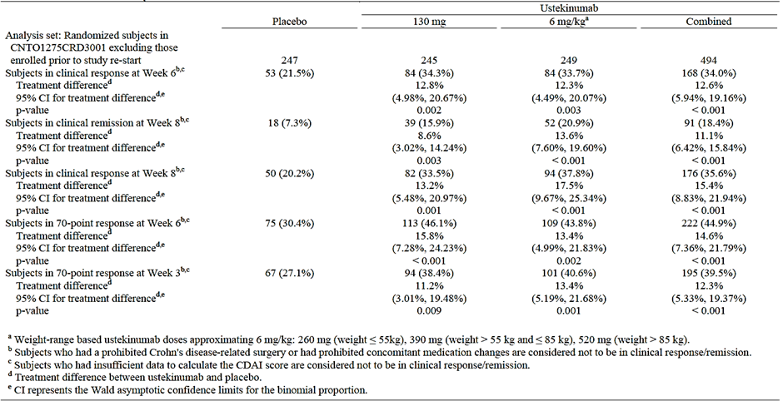
Table 18: Summary of Primary and Major Secondary Endpoints; Randomised Subjects in CNTO1275CRD3002 Excluding Those Enrolled Prior to Study Re-start and Excluding Site 1127.
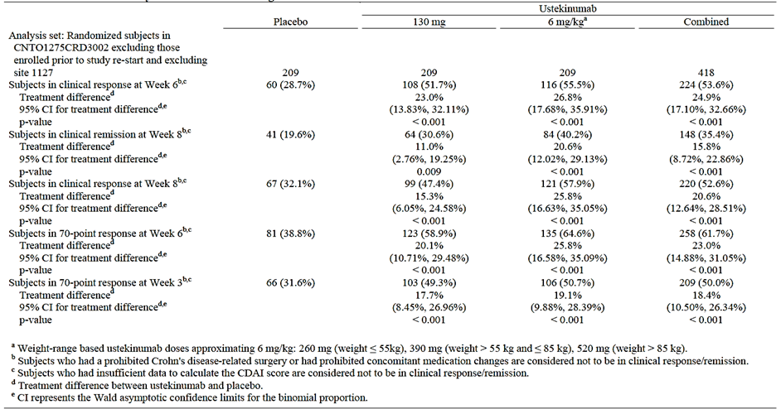
Table 19: Summary of Primary and Major Secondary Endpoints; Randomised Subjects in CNTO1275CRD3003 Excluding Those Enrolled Prior to Study Re-start
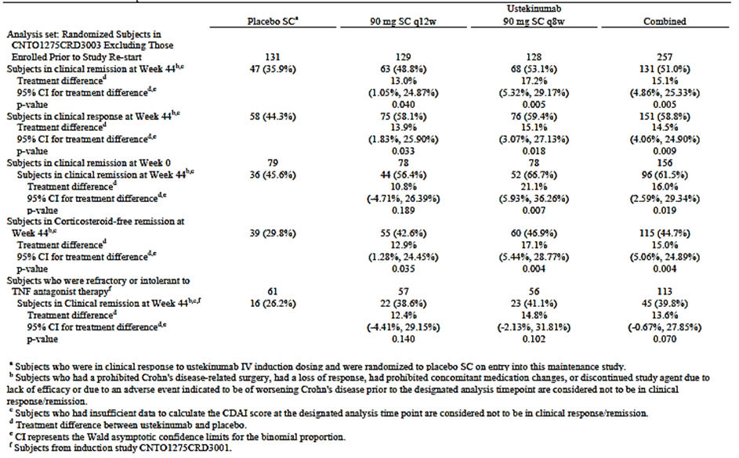

Evaluator’s comments
Review of these tables providing point estimates and confidence intervals (CIs) for the difference between each ustekinumab group and placebo for the primary and major secondary endpoints in Studies CRD3001, CRD3002 and CRD3003 did not change any of the efficacy conclusions.

Question 2
The pivotal maintenance Study CRD3003 only had 44 week duration of treatment and hence does not comply with the minimum duration of 12 months required for assessment of maintenance of efficacy according to CHMP guidelines on the development of new medicinal products for the treatment of Crohn’s disease (2009). Although long-term extension up to 272 weeks is mentioned, it has not been clarified if the extension will be double-blind and randomised. Could the sponsor please provide clarification on this?

Sponsor’s response
Based on feedback from multiple health authorities, including those in the EU, the sponsor considers that the overall exposure for the primary and major secondary endpoints for the induction and maintenance study (8 weeks for induction and 44 weeks for maintenance treatment) yields 52 total weeks of treatment. The overall clinical design for the maintenance study was based on guidance and advice with regulatory authorities including those in the US, the EU, and Japan. These regulatory authorities considered the study design and endpoints for the maintenance study, including their timing at Week 44, to be acceptable. In addition, the primary endpoint, including the timing at Week 44, was considered by the Swedish Health Authority (Medical Products Agency [MPA]) during a national Scientific Advice procedure to be in line with the primary maintenance analysis that was accepted for approved anti-TNF antagonists.
In response to the evaluator’s request for further clarification relating to study blinding and randomisation for the long-term extension (LTE) study, the sponsor provided an overview of the LTE, with focus on the randomisation and blinding aspects. In terms of participation in the LTE, all patients who completed the safety and efficacy evaluation at Week 44 of the main study (including the randomised and non-randomised groups) who, in the opinion of the investigator may benefit from continued treatment had the opportunity to participate in the study extension. The study extension began at Week 44 and will continue until Week 272 with final efficacy evaluations completed at Week 252. Patients were not randomised to treatment in the LTE but rather all patients continued to receive the same treatment regimen that they were receiving at the end of the main study (either placebo or 90 mg subcutaneous (SC) ustekinumab every 8 or 12 weeks), with the first dose in the LTE occurring at Week 44. No dose adjustment was allowed in the LTE. The study blind in CNTO1275CRD3003 was maintained for all patients until the last patient in the main study completed the Week 44 evaluations and the Week 44 analyses were completed. After that time, the investigators and patients were notified of the treatment assignments, and patients receiving placebo were discontinued from the LTE; patients receiving ustekinumab in the LTE continued to receive ustekinumab. Therefore, only a portion of the LTE remained blinded to investigators until the Week 44 analyses were completed. In the LTE, efficacy, quality of life, health economics, pharmacokinetics, immunogenicity, and safety continues to be assessed as detailed in the Time and Events schedule in Table 3 [not included here] of the CNTO1275CRD3003 protocol. The LTE will be primarily used for the evaluation of maintenance of efficacy and for safety evaluation; due to the discontinuation of placebo patients after unblinding, comparisons between the treatment groups in the LTE will not be made.

Evaluator’s comments
The sponsor’s response is satisfactory.

Safety
None.

Second round benefit-risk assessment

Second round assessment of benefits
After consideration of responses to the clinical questions, the benefits of Stelara (ustekinumab) in the proposed usage are unchanged from those identified in the first round evaluation.

Second round assessment of risks
After consideration of responses to the clinical questions, the risks of Stelara (ustekinumab) in the proposed usage are unchanged from those identified in the first round evaluation.

Second round assessment of benefit-risk balance
The benefit-risk balance of Stelara (ustekinumab), given the proposed usage is favourable.

Second round recommendation regarding authorisation
Approval is recommended for ustekinumab for the proposed indication of ‘Crohn’s Disease: Stelara is indicated for the treatment of adult patients with moderately to severely active Crohn’s disease who have had an inadequate response, lost response, were intolerant to conventional therapy or a TNFα antagonist or have medical contraindications to such therapies.’

References
Ananthakrishnan AN. Epidemiology and risk factors for IBD. Nat Rev Gastroenterol Hepatol. 2015;12:205-217.
Berrebi D, Besnard M, Fromont-Hankard G, et al. Interleukin-12 expression is focally enhanced in the gastric mucosa of pediatric patients with Crohn’s disease. Am J Pathol. 1998; 152(3):667-672.
Colombel JF, Sandborn WJ, Reinisch W, et al; SONIC Study Group. Infliximab, azathioprine, or combination therapy for Crohn’s disease. N Engl J Med. 2010;362(15):1383-1395.
Colombel JF, Sandborn WJ, Rutgeerts P, et al. Adalimumab for maintenance of clinical response and remission in patients with Crohn's disease: the CHARM trial. Gastroenterology. 2007;132(1):52-65
Colombel JF, Sandborn WJ, Rutgeerts P, et al. Adalimumab for maintenance of clinical response and remission in patients with Crohn's disease: the CHARM trial. Gastroenterol. 2007;132(1):52-65.
Daperno M, D'Haens G, Van Assche G, et al. Development and validation of a new, simplified endoscopic activity score for Crohn's disease: the SES-CD. Gastrointest Endosc. 2004;60(4):505-512.
Davidson NJ, Hudak SA, Lesley RE, Menon S, Leach MW, Rennick DM. IL-12, but not IFN-gamma, plays a major role in sustaining the chronic phase of colitis in IL-10-deficient mice. J Immunol. 1998; 161:3143–3149
Duerr RH, Taylor KD, Brant SR, et al. A genome-wide association study identifies IL23R as an inflammatory bowel disease gene. Science. 2006; 314(5804):1403-1405.
Glickman RM. Inflammatory bowel disease: ulcerative colitis and Crohn’s disease. In: Faluce AS, Braunwald E, eds. Harrison’s Principles of Internal Medicine, 14th ed. New York, NY: McGraw-Hill; 1998:1633-1645
Ha C, Kornbluth A. Vedolizumab as a treatment for Crohn’s disease and ulcerative colitis. Gastroenterol Hepatol. 2014; 10:793-800.
Hanauer SB, Feagan BG, Lichtenstein GR, et al. Maintenance infliximab for Crohn’s disease: the ACCENT I randomised trial. Lancet. 2002;359(9317):1541-1549.
Hébuterne X, Lémann M, Bouhnik Y, et al. Endoscopic improvement of mucosal lesions in patients with moderate to severe ileocolonic Crohn’s disease following treatment with certolizumab pegol. Gut. 2013;62(2):201-208..
Hue S, Ahern P, Buonocore S, et al. Interleukin-23 drives innate and T cell-mediated intestinal inflammation.J Exp Med. 2006; 203:2473-2483.
Kandiel A, Fraser AG, Korelitz BI, et al. Increased risk of lymphoma among inflammatory bowel disease patients treated with azathioprine and 6-mercaptopurine. Gut. 2005; 54:1121-1125.
Khanna R, Bouguen G, Feagan BG, et al. A systematic review of measurement of endoscopic disease activity and mucosal healing in Crohn's disease: recommendations for clinical trial design. Inflamm Bowel Dis. 2014;20(10):1850-1861.
Kotlyar DS, Osterman MT, Diamond RH, et al. A systematic review of factors contribute to hepatosplenic T-cell lymphoma in patients with inflammatory bowel disease. Clin Gastroenterol Hepatol. 2011; 9(1):36-41.
Kullberg MC, Jankovic D, Feng CG, et al. IL-23 plays a key role in Helicobacter hepaticus-induced T cell dependent colitis. J Exp Med. 2006; 203:2485-2494.
Liu Z, Yadav PK, Xu X, et al. The increased expression of IL-23 in inflammatory bowel disease promotes intraepithelial and lamina propria lymphocyte inflammatory responses and cytotoxicity. J Leukoc Biol. 2011; 89:597-606.
Mackey AC, Green L, Leptak C, Avigan M. Hepatosplenic T cell lymphoma associated with infliximab use in young patients treated for inflammatory bowel disease: update. J Pediatr Gastroenterol Nutr. 2009; 48:386-388.
Mackey AC, Green L, Liang LC, et al. Hepatosplenic T cell lymphoma associated with infliximab use in young patients treated for inflammatory bowel disease. J Pediatr Gastroenterol Nutr. 2007; 44:265-267.
Monteleone G, Biancone L, Marasco R, et al. Interleukin 12 is expressed and actively released by Crohn's disease intestinal lamina propria mononuclear cells. Gastroenterology. 1997; 112(4):1169-1178.
Moon CM, Shin DJ, Son NH, et al. Genetic variants in the IL12B gene are associated with inflammatory bowel diseases in the Korean population .J Gastroenterol Hepatol. 2013; 28:1588-1594.
Moskovitz DN, Daperno M, Van Assche GA, et al. Defining and validating cut-off’s for the Simple Endoscopic Score for Crohn’s Disease. Gastroenterology 2007;132(4Suppl2):S1097.
Neurath MF. IL-23: a master regulator in Crohn disease. Nat Med. 2007; 13(1):26-28.
Parrello T, Monteleone G, Cucchiara S, et al. Up-regulation of the IL-12 receptor beta 2 chain in Crohn's disease. J Immunol. 2000; 165(12):7234-7239
Rutgeerts P, Diamond RH, Bala M, et al. Scheduled maintenance treatment with infliximab is superior to episodic treatment for the healing of mucosal ulceration associated with Crohn’s disease. Gastrointest Endosc. 2006;63(3):433-442.
Rutgeerts P, Feagan BG, Lichtenstein GR, et al. Comparison of scheduled and episodic treatment strategies of infliximab in Crohn’s disease. Gastroenterology. 2004;126(2):402-413.
Rutgeerts P, Van Assche G, Sandborn WJ, et al. Adalimumab induces and maintains mucosal healing in patients with Crohn's disease: data from the EXTEND trial. Gastroenterology. 2012;142(5):1102-1111.e2.
Sandborn WJ, Feagan BG, Rutgeerts P, et al, and the GEMINI 2 Study Group. Vedolizumab as induction and maintenance therapy for Crohn's disease. N Engl J Med. 2013; 369(8):711-21.
Sandborn WJ, Feagan BG, Rutgeerts P, et al, and the GEMINI 2 Study Group. Vedolizumab as induction and maintenance therapy for Crohn's disease. N Engl J Med. 2013; 369(8):711-721
Sandborn WJ, Feagan BG, Stoinov S, et al, for the PRECISE 1 Study Investigators. Certolizumab pegol for the treatment of Crohn’s disease. N Engl J Med. 2007b;357:228-238.
Sandborn WJ, Hanauer SB, Rutgeerts P, et al. Adalimumab for maintenance treatment of Crohn's disease: results of the CLASSIC II trial. Gut. 2007a;56(9):1232-1239.
Sandborn WJ, Rutgeerts P, Enns R, et al. Adalimumab induction therapy for Crohn disease previously treated with infliximab. Ann Intern Med. 2007; 146(12):829-838.
Sandborn WJ, Rutgeerts P, Enns R, et al. Adalimumab induction therapy for Crohn disease previously treated with infliximab. Ann Intern Med. 2007c;146(12):829-838.
Sands BE, Feagan BG, Rutgeerts P, et al. Effects of vedolizumab induction therapy for patients with Crohn's disease in whom tumor necrosis factor antagonist treatment had failed. Gastroenterology. 2014; 147(3):618- 627.
Sands BE. Crohn’s disease. In: Feldman M, Friedman LS, Sleisenger MH, eds. Sleisenger’s and Fordtran’s Gastrointestinal and Liver Disease Vol 2. 7th ed. Philadelphia, PA: Saunders; 2002:2005-2038.
Schalamon J, Mayr J, Höllwarth M. Mortality and economics in short bowel syndrome. Best Pract Res Clin Gastroenterol. 2003; 17(6):931-942.
Schreiber S, Khaliq-Kareemi M, Lawrence IC, et al, for the PRECISE 2 Study investigators. Maintenance therapy with certolizumab pegol for Crohn’s disease. N Engl J Med. 2007;357:239-250.
Talley NJ, Abreu MT, Achkar JP, et al. An evidence-based systematic review on medical therapies for inflammatory bowel disease. Am J Gastroenterol. 2011; 106 Suppl 1:S2-S25.
Targan SR, Hanauer SB, van Deventer SJ, et al, for the Crohn’s Disease cA2 Study Group. A short-term study of chimeric monoclonal antibody cA2 to tumor necrosis factor alpha for Crohn’s disease. N Engl J Med. 1997; 337(15):1029-1035.
Umeno J, Asano K, Matsushita T, et al. Meta-analysis of published studies identified eight additional common susceptibility loci for Crohn's disease and ulcerative colitis. Inflamm Bowel Dis. 2011; 17(12):2407-2415.
Wang K, Zhang H, Kugathasan S, et al. Diverse genome-wide association studies associate the IL12/IL23 pathway with Crohn Disease. Am J Hum Genet. 2009; 84(3):399-405.
Wils P, Bouhnik Y, Michetti P, et al. Subcutaneous ustekinumab provides clinical benefit for two-thirds of patients with Crohn’s disease refractory to anti-tumor necrosis factor agents. Clin Gastroenterol Hepatol. 2015; pii: S1542-3565(15)01317-01318.
Wilson J, et al: High incidence of inflammatory bowel disease in Australia: a prospective population-based Australian incidence study. Inflamm Bowel Dis. 2010 Sep;16(9):1550-6. doi: 10.1002/ibd.21209.
Yen D, Cheung J, Scheerens H, et al. IL-23 is essential for T cell- mediated colitis and promotes inflammation via IL-17 and IL-6. J Clin Invest. 2006; 116:1310-1316

Therapeutic Goods Administration
PO Box 100 Woden ACT 2606 Australia
Email: info@tga.gov.au Phone: 1800 020 653 Fax: 02 6232 8605
https://www.tga.gov.au

A PPK analysis was performed using PK data obtained from one Phase IIb study (C0743T26), and three Phase III studies, that is, CNTO1275CRD3001 [CRD3001], CNTO1275CRD3002 [CRD3002], and CNTO1275CRD3003 [CRD3003]). PPK analysis was performed using PK data obtained from these 4 studies in order to characterise the disposition of ustekinumab following IV and SC administration, and to evaluate the influence of covariates on the PK of ustekinumab in subjects with moderately to severely active Crohn’s disease. The final PPK model was also used to generate ustekinumab exposure predictions to support exposure-response analyses which were described in a separate report.
Eligible subjects had to be ≥ 18 years of age, have moderately to severely active Crohn’s disease (Crohn’s Disease Activity Index [CDAI] score ≥ 220 but ≤ 450) for at least 3 months, with colitis, ileitis, or ileocolitis as confirmed by radiography and/or endoscopy, and have received infliximab, adalimumab, or certolizumab pegol at a dose approved for the treatment of Crohn’s disease and either did not respond initially, responded initially but then lost response, or were intolerant to the medication.
Subjects who had insufficient data to assess their clinical response status at Week 6 had their last CDAI score carried forward; all other rules were the same as the primary analysis rules
A fistula response was defined as a ≥ 50% reduction from baseline in the number of draining fistulas
The following medications are permitted provided doses meeting the requirements below are stable for or have been discontinued at least 3 weeks prior to baseline (Week 0), unless otherwise specified. a. Oral 5-ASA compounds. b. Oral corticosteroids (eg, prednisone, budesonide) at a prednisone-equivalent dose of <40 mg/day or <9 mg/day of budesonide. c. Antibiotics being used as a primary treatment of Crohn’s disease. d. Subjects receiving conventional immuno-modulators (i.e., AZA, 6-MP, or MTX) must have been taking them for ≥ 12 weeks, and on a stable dose for a least 4 weeks prior to baseline.
-Immunomodulatory agents other than 6-MP/AZA or MTX (including but not limited to 6-TG, cyclosporine, tacrolimus, sirolimus, mycophenolate mofetil). -Immunomodulatory biologic agents (including but not limited to TNF antagonists, natalizumab, abatacept). -Experimental Crohn’s disease medications (including but not limited to thalidomide, briakinumab, vedolizumab, traficet, AMG 827).
The CDAI was to be assessed by collecting information on 8 different Crohn’s disease-related variables: extraintestinal manifestations, abdominal mass, weight, haematocrit, total number of liquid stools, abdominal pain/cramping, use of antidiarrheal drug(s) and/or opiates, and general well-being. The last 4 variables were scored by the subject over 7 days on a diary card.
C-reactive protein has demonstrated usefulness as a marker of inflammation in patients with IBD. In Crohn’s disease, elevated CRP concentrations have been associated with severe clinical activity, elevated sedimentation rate, and active disease as detected by colonoscopy.
Faecal lactoferrin and faecal calprotectin have been demonstrated to be sensitive and specific markers in identifying intestinal inflammation and response to treatment in patients with IBD
The IBDQ is a 32-item self-reported questionnaire for subjects with IBD to evaluate patient-reported outcomes across 4 dimensions: bowel symptoms (loose stools, abdominal pain), systemic symptoms (fatigue, altered sleep pattern), social function (work attendance, need to cancel social events), and emotional function (anger, depression, irritability). Scores range from 32 to 224, with higher scores indicating better outcomes. A change of ≥16 points in total IBDQ score is considered clinically meaningful.
The SF-36 consists of 8 multi-item scales: limitations in physical functioning. due to health problems; limitations in usual role activities due to physical health problems; bodily pain; general mental health (psychological distress and well-being); limitations in usual role activities due to personal or emotional problems; limitations in social functioning due to physical or mental health problems; vitality (energy and fatigue); and general health perception. These scales are scored from 0 to 100, with higher scores indicating better health. Another algorithm yields 2 summary scores, the Physical Component Summary (PCS) and the Mental Component Summary (MCS) scores. These summary scores are also scaled, with higher scores indicating better health,
For subjects with open/draining fistulas and fistulising disease, fistula closure was to be assessed. Enterocutaneous fistulas (e.g., perianal and abdominal) were to be considered no longer draining (i.e., closed) when there was an absence of drainage despite gentle compression. Rectovaginal fistulas were to be considered closed based on either physical examination or absence of relevant symptoms (e.g., passage of rectal material or flatus from the vagina).
For subjects with pyoderma gangrenosum, the total number of lesions, size of primary lesion, and resolution were to be assessed.
A video ileocolonoscopic examination was to be performed according to the study reference manual provided to each site, at screening (at least 8 days before or at the Week 0 visit), and at least 8 days before or at the Week 8 visit to determine the presence or absence of mucosal inflammation and ulceration. Video endoscopies were to be assessed by a central facility that was blinded to treatment group and visit.
In C0743T26, the clinical remission rates at Week 8 were 10% for the placebo group and 18% for the 6 mg/kg group. However, more subjects in the 6 mg/kg group had higher baseline CDAI scores and required a greater reduction to attain clinical remission. Because of an imbalance in the baseline CDAI score between the 6 mg/kg group and the placebo group, the treatment effect might be greater than what was observed and so a clinical remission rate of 20% was assumed for the ustekinumab high dose group in this study.
Subgroup analyses were planned when the number of subjects in the subgroups permitted.
Majority were related to documentation of negative QuantiFERON-TB Gold testing at the time of randomization. Of these, most (7/11) were ultimately found to satisfy the TB-related entry criteria. Of the 8 subjects who did not have a negative chest radiograph within 3 months of study agent administration, 7 had a negative chest X-ray no more than 1.5 months prior to this window. A negative chest X-ray was obtained for the remaining subject prior to entry into the maintenance study. There were no adverse events of TB in any of the subjects with protocol deviations related to TB screening
A fistula response was defined as a ≥50% reduction in the number of open and draining fistulas.
Recommended tapering schedule for oral corticosteroids (other than budesonide) • Dose > 15 mg/day prednisone or equivalent: taper daily dose by 5 mg/week until receiving 10 mg/day, then continue tapering at 2.5 mg/week until 0 mg/day. • Dose 11 to 15 mg/day prednisone or equivalent: taper daily dose to 10 mg/day for 1 week, then continue at 2.5 mg/week until 0 mg/day. • Dose ≤ 10 mg/day prednisone or equivalent: taper daily dose by 2.5 mg/week until 0 mg/day. Recommended tapering schedule for oral budesonide Subjects receiving budesonide should have their daily dose tapered by 3 mg every 3 weeks until 0 mg/day.
including but not limited to thalidomide, briakinumab, vedolizumab, traficet, AMG 827
The US-specific testing procedure for strong control of the Type-1 error over the primary and major secondary endpoints employed sequential testing at the 0.05 (2-sided) level for each comparison of a ustekinumab treatment group to placebo. The following list details the order of the testing that was performed at the 0.05 level of significance. Testing continued to the next endpoint in the list, provided the preceding endpoint was significant: - Clinical remission at Week 44 in the ustekinumab 90 mg SC q8w group - Clinical response at Week 44 in the ustekinumab 90 mg SC q8w group - Clinical remission at Week 44 (among subjects in clinical remission at Week 0) in the ustekinumab 90 mg SC q8w group - Clinical remission at Week 44 in the ustekinumab 90 mg SC q12w group - Clinical response at Week 44 in the ustekinumab 90 mg SC q12w group - Clinical remission at Week 44 (among subjects in clinical remission at Week 0) in the ustekinumab 90 mg SC q12w group - Corticosteroid-free remission at Week 44 in the ustekinumab 90 mg SC q8w group - Corticosteroid-free remission at Week 44 in the ustekinumab 90 mg SC q12w group - Clinical remission at Week 44 (among subjects who were refractory or intolerant to TNF antagonist therapy) in the ustekinumab 90 mg SC q8w group - Clinical remission at Week 44 (among subjects who were refractory or intolerant to TNF antagonist therapy) in the ustekinumab 90 mg SC q12w group
To examine the robustness of the primary endpoint analysis, sensitivity analyses of the primary endpoint were conducted using the observed case, last observation carried forward, multiple imputation, and the worst case missing data methods
To evaluate the consistency of the efficacy of the primary endpoint over demographic, induction baseline disease characteristics, Crohn’s disease medication history (including TNF antagonist therapy), Crohn’s disease medication use at induction baseline, and centre location, subgroup analyses were planned when the number of subjects in the subgroups permitted.
i.e., clinical remission at Weeks 36, 40, and 44
subjects not in clinical response following ustekinumab IV induction dosing
The contribution of the narrowing component score was included in the analysis of total SES-CD scores, but it was excluded from the SES-CD eligibility criterion for a number of reasons. Strictures represent chronic manifestations of potentially fixed and irreversible bowel damage in patients with longstanding Crohn’s disease, and are typically seen in patients who are candidates for biologic treatment. Though unlikely, it is possible for a patient with active Crohn’s disease to achieve a baseline SES-CD score ≥3 based on the presence of strictures/stenosis exclusively, without having any ulcerations or other non-ulcerative involvement. These subjects with potentially irreversible strictures in the absence of intestinal inflammation would not represent an appropriate target population to evaluate the effect of ustekinumab treatment on endoscopic healing
Clinical response (reduction from induction baseline in the CDAI score of ≥100 points), Clinical remission (a CDAI score of <150 points), Inflammatory Bowel Disease Questionnaire (IBDQ) response (increase from induction baseline ≥16 points), Normalized CRP (<3 mg/L) among subjects with abnormal CRP (≥3 mg/L) at induction baseline, Normalized faecal calprotectin (≤250 mg/kg) among subjects with abnormal faecal calprotectin (>250 mg/kg) at induction baseline
The GHAS assigns scores for 8 components: epithelial damage, architectural changes, infiltration of mononuclear cells into the lamina propria (all scored 0-2); number of biopsy specimens affected (anticipating 6 biopsies per anatomic area) and number of polymorphonuclear cells in the epithelium (both scored 0-3). Lastly, the presence of erosions/ulcers and presence of granulomas are scored 1 point each for yes and 0 for no.
All safety analyses were descriptive in nature, and no hypothesis testing for predefined safety endpoints was performed. In these safety analyses, data were presented for subjects treated with study agent.
due to the study design, none of the subjects in C0743T26 were exposed to 90 mg q8w for more than 6 months
A reasonably related AE was defined as any event with a relationship to study agent of ‘very likely,’ ‘probable,’ or ‘possible’ on the AE page of the eCRF or if the relationship to study agent was missing.
This subject was randomized to the IV CNTO 1275 → IV Placebo group, was diagnosed with prostatic adenocarcinoma approximately 2 months after receiving CNTO 1275 and had an elevated prostate-specific antigen (PSA) prior to randomisation.
The subject was randomized to ustekinumab 130 mg IV as induction treatment and then received placebo maintenance treatment in study CRD3003; the subject had previously received a Bacilli Calmette Guerin (BCG) vaccination and at screening, had a negative chest radiograph and negative QuantiFERON test. The subject experienced flu like symptoms with fever, chills, sore throat, cough and yellowish sputum approximately 10 months after exposure to a single IV ustekinumab dose. QuantiFERON test results were negative; as were sputum smear and culture for Mycobacterium tuberculosis; chest radiograph and computed tomography scan results were reported as consistent with TB. The subject was empirically treated with triple anti-TB therapy with resolution of symptoms.
A collection of AE terms consistent with the clinical signs or symptoms that would be expected to occur during an allergic (anaphylactic) or non-allergic (anaphylactoid) infusion reaction (e.g., anaphylaxis, fever, chills, rigors, hypotension, hypertension, bronchospasm, laryngospasm, wheezing, dyspnoea, syncope, pre-syncope, urticaria, angioedema, generalized pruritus, flushing, rash, and nausea) was created and utilized to retrospectively review all AEs reported within 1 hour following IV infusion.
An injection-site reaction was defined as any AE at an injection site that was identified as an injection-site reaction by the investigator on the CRF/eCRF.
Multiple myeloma in a subject with a 6 year history of monoclonal gammopathy of unknown significance prior to enrolment in CRD3001, who received ustekinumab 6 mg/kg IV in study CRD3001 - Small intestine adenocarcinoma and incidental carcinoid tumor in 1 subject who received placebo → ustekinumab 130 mg IV → ustekinumab 90 mg SC, in study CRD3003 Prostate cancer in 1 subject who received a single dose of ustekinumab 4.5 mg/kg IV→ placebo in study C0379T07
Psoriasis rebound is defined as a Psoriasis Area and Severity Index of 125% of baseline, of new generalized pustular, eerythrodermic or more inflammatory psoriasis occurring within 3 months of stopping therapy.
In Studies C0379T07, CRD3001 and CRD3002, subjects were permitted to receive oral corticosteroids for the treatment of Crohn’s disease during the study, provided that the subject was on a stable dose before baseline and maintained this stable dose throughout the study. In Study C0743T26, subjects receiving oral corticosteroids at Week 0 in clinical response at Week 6 initiated corticosteroid tapering at the Week 8 visit. Other subjects could also undergo steroid tapering at the discretion of the investigator. In Study CRD3003, subjects were permitted to receive oral corticosteroids for the treatment of Crohn’s disease during the study, provided that the subject was on a stable dose before baseline. Subjects receiving oral corticosteroids at Week 0 who were in clinical response initiated corticosteroid tapering at Week 0. Other subjects could also undergo steroid tapering at the discretion of the investigator.
In Study C0743T26, subjects must have previously received infliximab, adalimumab, or certolizumab pegol at a dose approved for the treatment of Crohn’s disease, and either did not respond initially, responded initially but then lost response, or were intolerant to the medication. In Study CRD3001, subjects must have received infliximab, adalimumab, or certolizumab pegol at a dose approved for the treatment of Crohn’s disease, and did not respond initially, responded initially but lost response, or were intolerant to the medication. In Study CRD3002, subjects with prior exposure to a TNF antagonist were permitted to enter the Study but they could not have failed such therapy. In Study CRD3003, subjects in maintenance Study CRD3003 comprised subjects from induction studies CRD3001 and CRD3002.
At weeks 36, 40 and 44.
Sandborn WJ, Feagan BG, Rutgeerts P, Hanauer S, Colombel JF, Sands BE, et al. Vedolizumab as induction and maintenance therapy for Crohn's disease. N Engl J Med. 2013;369:711-21.

