First round report 2 October 2013
Second round report 7 January 2014

AusPAR Attachment 2

Extract from the Clinical Evaluation Report for Umeclidinium bromide and Vilanterol trifenatate
  - Proprietary Product Name: Anoro Ellipta
  - Sponsor: GlaxoSmithKline Australia Pty Ltd

About the Therapeutic Goods Administration (TGA)
- The Therapeutic Goods Administration (TGA) is part of the Australian Government Department of Health, and is responsible for regulating medicines and medical devices.
- The TGA administers the Therapeutic Goods Act 1989 (the Act), applying a risk management approach designed to ensure therapeutic goods supplied in Australia meet acceptable standards of quality, safety and efficacy (performance), when necessary.
- The work of the TGA is based on applying scientific and clinical expertise to decision-making, to ensure that the benefits to consumers outweigh any risks associated with the use of medicines and medical devices.
- The TGA relies on the public, healthcare professionals and industry to report problems with medicines or medical devices. TGA investigates reports received by it to determine any necessary regulatory action.
- To report a problem with a medicine or medical device, please see the information on the TGA website <https://www.tga.gov.au/>.
About the Extract from the Clinical Evaluation Report
- This document provides a more detailed evaluation of the clinical findings, extracted from the Clinical Evaluation Report (CER) prepared by the TGA. This extract does not include sections from the CER regarding product documentation or post market activities.
- The words (Information redacted), where they appear in this document, indicate that confidential information has been deleted.
- For the most recent Product Information (PI), please refer to the TGA website <https://www.tga.gov.au/product-information-pi>.
Copyright
© Commonwealth of Australia 2015
This work is copyright. You may reproduce the whole or part of this work in unaltered form for your own personal use or, if you are part of an organisation, for internal use within your organisation, but only if you or your organisation do not use the reproduction for any commercial purpose and retain this copyright notice and all disclaimer notices as part of that reproduction. Apart from rights to use as permitted by the Copyright Act 1968 or allowed by this copyright notice, all other rights are reserved and you are not allowed to reproduce the whole or any part of this work in any way (electronic or otherwise) without first being given specific written permission from the Commonwealth to do so. Requests and inquiries concerning reproduction and rights are to be sent to the TGA Copyright Officer, Therapeutic Goods Administration, PO Box 100, Woden ACT 2606 or emailed to <tga.copyright@tga.gov.au>.

Contents
List of abbreviations 5
1. Introduction 9
2. Clinical rationale 9
2.1. Guidance 9
3. Contents of the clinical dossier 10
3.1. Scope of the clinical dossier 10
3.2. Paediatric data 11
3.3. Good clinical practice 11
4. Pharmacokinetics 12
4.1. Studies providing pharmacokinetic (PK) data 12
4.2. Summary of pharmacokinetics 14
4.3. Evaluator’s overall conclusions on pharmacokinetics 25
5. Pharmacodynamics 27
5.1. Studies providing pharmacodynamic (PD) data 27
5.2. Summary of pharmacodynamics 27
5.3. Evaluator’s overall conclusions on pharmacodynamics 32
6. Dosage selection for the pivotal studies 32
7. Clinical efficacy 37
7.1. Pivotal efficacy studies 37
7.2. Other efficacy studies 83
7.3. Evaluator’s conclusions 90
8. Clinical safety 96
8.1. Studies providing evaluable safety data 96
8.2. Pivotal studies that assessed safety as a primary outcome 98
8.3. Patient exposure 98
8.4. Adverse events 99
8.5. Laboratory tests 102
8.6. Post-marketing experience 107
8.7. Safety issues with the potential for major regulatory impact 108
8.8. Other safety issues 108
8.9. Evaluator’s overall conclusions on clinical safety 108
9. First round benefit-risk assessment 109
9.1. First round assessment of benefits 109
9.2. First round assessment of risks 110
9.3. First round assessment of benefit-risk balance 111
10. First round recommendation regarding authorisation 111
11. Clinical questions 111
11.1. Pharmacokinetics 111
11.2. Pharmacodynamics 111
11.3. Efficacy 111
12. Second round evaluation of clinical data submitted in response to questions 112
13. Second round benefit-risk assessment 113
13.1. Second round assessment of benefits 113
13.2. Second round assessment of risks 113
13.3. Second round assessment of benefit-risk balance 113
14. Second round recommendation regarding authorisation 113
15. References 113

List of abbreviations
Abbreviation | Meaning
≥ | At or greater than
≤ | At or less than
< | Less than
> | Greater than
AE | adverse event
Ae | amount of drug excreted unchanged in urine
ALT | Alanine transaminase
ANCOVA | analysis of covariance
ANOVA | analysis of variance
AUC_{(0-∞)} | area under the concentration-time curve from time zero (predose) extrapolated to infinite time
AUC_{(0-t)} | area under the concentration-time curve from time zero (predose) to last time of quantifiable concentration within a subject across all treatments
AUC_{(0-x)} | area under the concentration-time curve from time zero (predose) to x hours post dose
BD | twice daily
bid | Twice daily
BMI | body mass index
CI | confidence interval
CLcr | creatinine clearance
CLr | renal clearance
C_{max} | maximum concentration
COPD | chronic obstructive pulmonary disease
CSR | Clinical Study Report
CV | between-subject coefficient of variation
CYP | cytochrome P450
e.g. | Exempli gratia; for example
E_{max} | maximum effect
EU | European Union
FDA | Food and Drug Administration
Fe | fraction of dose excreted unchanged in urine
FEV₁ | Forced Expiratory Volume in One Second
FF | fluticasone furoate
FP | fluticasone propionate
FVC | forced vital capacity
FVC | Forced Vital Capacity
GCP | Good Clinical Practice
HPLC-MS/MS | high pressure liquid chromatography with tandem mass spectrometric detection
HR | Heart rate
i.e. | Id est; that is
IC50 | half maximal inhibitory concentration
ICS | inhaled corticosteroid
IH | inhaled
IV | intravenous
IVRS | interactive voice response system
L | Litre
LABA | long-acting beta2-adrenergic agonist
LAMA | Long-acting muscarinic receptor antagonist
LLQ | lower limit of quantification
LS | least squares
mcg | microgram
mg | Milligram
MgSt | magnesium stearate
mL | Milliliter
N | number of subjects who received a specific treatment
n | number of subjects with non-missing values (including not calculable where applicable)
n* | number of subjects for whom parameter could not be derived because of not quantifiable concentration
NA | not applicable
NDPI | Novel Dry Powder Inhaler
NQ | not quantifiable
PD | pharmacodynamic
PEFR | peak expiratory flow rate
P-gp | P-glycoprotein
PK | pharmacokinetic(s)
PM | poor metaboliser
PO | oral
qd | Once daily
QTc(F) | QT interval corrected for heart rate using Fridericia's formula
SD | Standard Deviation
SE | Standard Error
sGaw | specific airway conductance
SGRQ | St. George’s Respiratory Questionnaire
SOC | System Organ Class
t½ | Half-life associated with the terminal slope
TDI | Transition Dyspnoea Index
TGA | Therapeutic Goods Administration
tlast | time to last quantifiable plasma concentration
tmax | time of occurrence of C_{max}
ULN | Upper limit normal
UMEC | umeclidinium
US | United States
VI | vilanterol
vs. | versus
µg | microgram

Introduction
This is a submission to register umeclidinium (as bromide) in combination with vilanterol (as trifenatate). The proposed indication is:
Anoro Ellipta is a long term once daily maintenance bronchodilator treatment to relieve symptoms in adult patients with chronic obstructive pulmonary disease (COPD).

Clinical rationale
The sponsor had stated that chronic obstructive pulmonary disease (COPD) is a major cause of poor health, resulting in millions of deaths annually worldwide and contributing significantly to health care costs and morbidity. Current pharmacological treatment of COPD includes 2 classes of inhaled bronchodilators: beta₂-agonists and muscarinic antagonist (that is, anticholinergics). Inhaled long acting beta₂-agonists (LABA) (e.g. salmeterol and indacaterol) and long acting muscarinic antagonists (LAMA) (e.g. tiotropium and aclidinium), are currently recommended for the treatment of symptomatic patients with moderate to very severe COPD and are considered to be more efficacious than short acting bronchodilators. According to the sponsor, there are no prescribing information restrictions on the concomitant use of a LABA and a LAMA in the COPD population, and co-administration of LAMAs and LABAs is considered in clinical practice to be more effective than either drug class alone in managing stable COPD. At the time of this submission no LAMA/LABA combination products were currently licensed for COPD treatment. The sponsor had postulated that by targeting 2 different pharmacologic mechanisms, a LAMA/LABA combination product could potentially optimise bronchodilator therapy of COPD while avoiding the risk of side effects associated with increasing the dose of a single bronchodilator class. The sponsor was therefore of the opinion that the development of a LAMA/LABA combination product could be a beneficial addition to the treatment options in COPD.
Evaluator’s comments: The clinical rationale is sound and logical.

Guidance
The sponsor had confirmed in Module 1.8 that the issues identified in the TGA Planning Letter issued on 14 March 2013 had been addressed in the dossier submission.
According to the sponsor, the development program of Anoro Ellipta complied with the following guidance and regulations:
- European Medicines Agency, Note for Guidance on Fixed Dose Combination Medicinal Products. 19 February 2009
- European Medicines Agency, Points to consider on the clinical investigation of medicinal products in the treatment of chronic obstructive pulmonary disease (COPD). 19 May 1999
- Food and Drug Administration, Guidance for Industry- Chronic Obstructive Pulmonary Disease: Developing Drugs for Treatment. November 2007
- Food and Drug Administration, CFR300.50 regulations on Fixed Dose Combination Prescription Drugs for Human Use. 1999.

Contents of the clinical dossier

Scope of the clinical dossier
The submission contained the following clinical information:
Module 5:
- 39 clinical pharmacology studies, including 27 that provided pharmacokinetic (PK) data and 5 that provided pharmacodynamic (PD) data.
- 3 population PK analyses.
- 7 dose finding studies. These included 4 dose ranging studies on UMEC in COPD patients (3 Phase II studies (AC4113589, AC4113073 and AC4115321) and 1 Phase IIIa study (AC4115408)), and 3 dose ranging studies on VI (1 in COPD patients (B2C111045) and 2 on asthma patients (B2C109575 and HZA113310)).
- 4 pivotal efficacy/safety studies. These 4 pivotal Phase III studies consisted of 2 sets of randomised, double blind, parallel group studies, each with a 24 week treatment duration. One set of studies (DB2113361 and DB2113373) was placebo (PLA) controlled, while the other set (DB2113360 and DB2113374) was active controlled (active control: tiotropium (TIO)). Studies DB2113361 and DB2113373 were identical except for the doses of UMEC/VI and UMEC investigated. Study DB2113361 evaluated UMEC/VI, UMEC and VI doses of 125/25 µg, 125 µg and 25 µg once daily (QD) respectively, while study DB2113373 evaluated doses of 62.5/25 µg, 62.5 µg and 25 µg, QD, respectively. Studies DB2113360 and DB2113374 were also identical except for the study drugs used. Study DB2113360 evaluated QD doses of UMEC/VI 125/25 µg, UMEC/VI 62.5/25 µg, and VI 25 µg, while study DB2113374 evaluated QD doses of UMEC/VI 125/25 µg, UMEC/VI 62.5/25 µg, and UMEC 125 µg.
- 3 other efficacy/safety studies. These included two 12-week exercise tolerance studies (DB2114417 and DB2114418) and one 12 month long term safety study (DB2113359).
- Other reports. These included 1 Phase IIa safety/tolerability study of UMEC/VI (500/25 µg) in COPD patients (DB2113120), and 2 combined/pooled analyses reports. These 2 reports consisted of the meta-analyses of 2 of the pivotal efficacy studies DB2113360 and DB2113374 (report DB2116844), and of 2 of the dose ranging studies AC4113073 and AC4115321 (report AC4116689). In addition, the sponsor had submitted six other studies in COPD patients evaluating a fluticasone furoate (FF) /VI (FF/VI) combined product and VI, 10 studies in asthma patients evaluating FF/VI and VI, 7 ongoing studies, and 2 reports on the development and validation of the Shortness of Breath with Daily Activities (SOBDA) questionnaire.
Module 1:
- Application letter, application form, draft Australian PI and CMI, proposed FDA product label, proposed European Summary of Product Characteristics.
Module 2:
- Clinical Overview, Summary of Clinical Efficacy, Summary of Clinical Safety and literature references.
In this evaluation report:
- The four 24 week Phase III studies (studies DB2113361/DB2113373 and DB2113360/DB2113374) will be evaluated as pivotal efficacy/safety studies.
- With the other 3 Phase III studies (studies DB2114417/DB2114418, and DB2113359) evaluated as supporting efficacy/safety studies.
- The 5 dose finding studies in COPD patients (4 for UMEC and 1 for VI) will be evaluated with regards to the rationale for the selected dosing regimen in the pivotal Phase III studies.
- As this submission is for the indication for use of Anoro Ellipta (UMEC/VI) in COPD patients, the 2 dose finding studies in asthma patients, the 10 studies in asthma patients evaluating FF/VI and VI, and the 6 studies in COPD patients evaluating FF/VI and VI will not be formally evaluated. The study reports submitted will be looked through and will only be commented on in this report if additional safety or other concerns relevant to this submission are triggered.
- As per TGA instructions the 7 ongoing studies submitted in Module 5.3.5.3 are not expected to be part of the dossier, and will not be evaluated in this report.
- The Phase IIa safety/tolerability study of UMEC/VI in COPD patients (DB2113120) will be evaluated in the Safety Section of this report, with regards to whether the safety results were consistent with those of the pivotal studies.
- With regards to the combined/pooled analyses reports submitted, the meta-analysis of the pivotal efficacy studies DB2113360 and DB2113374 will be evaluated in the Efficacy section together with the individual studies, while that of the dose ranging studies AC4113073 and AC4115321 will be evaluated with regards to the rationale for the selected dosing regimen in the pivotal Phase III studies.

Paediatric data
The submission did not include paediatric data. As COPD is not a disease affecting paediatric patients, the use of Anoro Ellipta in the treatment of COPD is not considered relevant in the paediatric population.

Good clinical practice
The clinical studies reviewed in this evaluation were in compliance with CPMP/ICH/135/95 Note for Guidance on Good Clinical Practice.

Pharmacokinetics

Studies providing pharmacokinetic (PK) data
Table 1 below shows the studies relating to each PK topic.

Table 1. Submitted pharmacokinetic studies.
PK topic | Subtopic |  | Study ID
PK in healthy adults | General PK
PK in healthy adults | Single dose | UMEC | AC4112008
PK in healthy adults | Single dose | VI | B2C106180
PK in healthy adults | Single dose | UMEC | AC4115487
PK in healthy adults | Single dose | UMEC | AC4106889
PK in healthy adults | Single dose | UMEC | AC4105209
PK in healthy adults | Single dose | VI/GSK233705 | DB1111509
PK in healthy adults | Single dose | VI | B2C10001
PK in healthy adults | Single dose | VI/GW85698X | HZA105871
PK in healthy adults | Multi-dose | VI | B2CC10878
PK in healthy adults | Absolute Bioavailability | Single dose FF/VI | HZA102934
PK in healthy adults | Food effect |  | No studies conducted
 | Mass Balance Study | UMEC | AC4112014
 | Mass Balance Study | VI | B2C106181
PK in special populations
Target population § | Single dose | UMEC | AC4108123
Target population § | Single dose | VI | B2C110165
Target population § | Multi-dose | UMEC | AC4105211
Target population § | Multi-dose | UMEC | AC4113589
Target population § | Multi-dose | UMEC | AC4115321
Target population § | Multi-dose | UMEC | AC4113073
Target population § | Multi-dose | UMEC | AC4115408
Target population § | Multi-dose | UMEC/VI | DB2113361
Target population § | Multi-dose | UMEC/VI | DB2113373
Target population § | Multi-dose | FF/VI | HZC111348
Target population § | Multi-dose | FF/VI | HZC110946
Target population § | Multi-dose | UMEC/VI | DB2113120
Target population § | Multi-dose | VI | B2C111045
Target population § | Multi-dose | VI | B2C108562
Hepatic impairment |  | UMEC/VI; UMEC | DB2114637
Hepatic impairment |  | FF/VI | H2A111789
Renal impairment |  | UMEC/VI; UMEC | DB2114636
Renal impairment |  | FF/VI | H2A111789
Neonates/infants/children/adolescents |  |  | No studies
Elderly |  |  | No studies
Japanese Subjects |  | UMEC, UMEC/VI | DB2113208
Japanese Subjects |  | UMEC | AC4113377
Japanese Subjects |  | VI | DB1112146
Japanese Subjects |  | VI | DB1112017
Japanese Subjects |  | VI/GW85698X | HZA102940
Genetic/gender-related PK
 | Males vs. females |  | No studies
 | CYP2D6 | UMEC | AC4110106
PK interactions
 | Verapamil |  | DB2113950
 | Ketoconazole |  | B2C112205
 | Ketoconazole |  | H2A105548
Population PK analyses
 |  |  | DB2116975 2011N122282 2011N130718
None of the PK studies had deficiencies that excluded their results from consideration.

Summary of pharmacokinetics
The information in the following summary is derived from conventional PK studies unless otherwise stated.

Pharmacokinetics in healthy subjects

Absorption

UMEC
Plasma UMEC concentrations were all below the limit of quantification in all subjects following oral administration of UMEC 1000 µg (AC4112008). Using radioactivity (AUC_{(0-t)}) values following oral (1000 µg) and intravenous (IV) administration of (¹⁴C)-UMEC solution (AC4112014), estimated oral bioavailability of total radioactivity was low (4.7% to 5.4%). Since oral bioavailability of unchanged UMEC was negligible, these data suggested that the majority of the dose was not absorbed. Low levels of metabolites in the systemic circulation were indicative of first pass metabolism of orally absorbed UMEC. Following oral administration, maximum total radioactivity plasma concentrations were achieved at a median time of 4 hours post dose (AC4112014). The low estimate of UMEC oral bioavailability (< 1%) suggested a minimal oral contribution to the overall inhalation (IH) PK profile in healthy subjects. The absolute bioavailability of UMEC following IH administration was calculated using plasma data following 1000 µg IH which averaged 12.8%. Results were similar for urine data, with absolute bioavailability averaging 13.1% (95% confidence interval (CI): 10.5%, 16.3%) (AC4112008).

VI
Based on urinary recovery of radioactivity, at least 50.4% of the VI solution oral dose was absorbed via the gut, resulting in exposure to drug-related material (B2C106181). Based on the proportion of unchanged VI in human faeces (5% of the recovered dose) oral absorption is likely to be greater than this estimate. Exposure to parent VI represented a small percentage (in the region of < 0.5%) of the total drug-related material in plasma, indicative of extensive first pass metabolism of orally absorbed VI and the presence of one or more circulating VI metabolites. Following oral administration, maximum VI plasma concentrations were achieved at a median time of 30 minutes post dose (B2C106180). The low estimate of VI oral bioavailability (< 2%) was consistent with high first pass metabolism. Consequently, following IH administration, systemic VI exposure is primarily due to absorption of the inhaled portion of the dose delivered to the lung.

Bioavailability
Five studies examining absolute bioavailability were conducted: one study examined the absolute bioavailability of PO and IH UMEC (AC4112008); one study that examined PO UMEC (AC4112014); one study examined the absolute bioavailability of VI when administered as the FF/VI IH powder (HZA102934); one study that examined absolute bioavailability of PO and IH VI (B2C106180), and one study that examined absolute bioavailability of PO VI (B2C106181).

Absolute bioavailability

UMEC
PK parameters for UMEC were compared in 10 healthy male volunteers who received three ascending single IV doses (20, 50, and 65 µg), a single oral dose (1000 µg), and a single inhaled (IH) dose (1000 µg) of UMEC (AC4112008). This study serves as the primary study for defining bioavailability of the inhaled product. Following a single inhaled dose administration, UMEC was rapidly absorbed with the C_{max} values occurring at approximately 5 to 15 minutes post dose. Plasma concentrations declined rapidly following the occurrence of C_{max}. Plasma concentrations of UMEC following single oral dose administration of UMEC were all non quantifiable (NQ) (bioanalytical assay LLQ was 0.02 ng/mL). Absolute bioavailability of UMEC following inhaled administration calculated using plasma data following 1000µg IH which averaged 12.8% (95% CI: 9.0%, 18.2%). Results were similar for urine data, with F averaging 13.1% (95% CI: 10.5%, 16.3%). Absolute bioavailability of UMEC following PO administration using plasma data was reported as negligible (<1%) since all plasma concentrations of UMEC were not quantifiable following PO administration.
Healthy male volunteers received a single dose of an oral solution (1000 µg containing 50 µCi (approximately 2 MBq) of (¹⁴C)-UMEC in a volume of 50 mL) and an IV infusion (65 µg in a volume of 20 mL/IV containing 7.1 µCi (approximately 0.3 MBq) of (¹⁴C)-UMEC) (AC4112014). Mean oral bioavailability estimates of plasma ¹⁴C-radioactivity following oral administration calculated based on AUC_{(0-∞)} were similar to those calculated based on AUC_{(0-t)} and were approximately 5.4% (95% CI: 1.8%, 15.9%) and 4.7% (95% CI: 2.1%, 10.3%), respectively.

VI
A three way cross over study was conducted in healthy subjects to estimate the absolute bioavailability of a single dose of FF (800 µg) and VI (100 µg) when administered as the FF/VI inhalation powder (HZA102934). In order to produce measurable concentrations of VI following IH dosing, a supra-therapeutic dose of 100 µg (4-times higher than the highest clinical dose) was necessary. This serves as the primary study for defining bioavailability of the inhaled product. For IH VI, the estimate of absolute bioavailability was 27.2% (95% CI: 20.4%, 36.2%).
A sequential, dose-ascending study in healthy male subjects evaluated PK of single IV and oral doses of VI (Study B2C106180). Accurate estimates of oral and inhaled bioavailability could not be determined from plasma due to the low number of subjects with measurable post-dose plasma VI concentrations. However, results from 100 µg IH VI and 55 µg IV VI suggested approximately 30% IH bioavailability calculated from the ratio of AUCs to a common time point. Consistent results were obtained from urinary excretion data which indicated approximately 26% IH bioavailability. Following 500 µg PO VI administrations, maximum plasma concentrations were achieved at a median time of 0.5 hours post dose. The approximate estimate of PO bioavailability was < 2%, calculated from the ratio of AUCs to a common time point after PO and IV administrations.
The excretion balance and metabolic disposition of (¹⁴C)-VI administered as a single oral dose was examined in an open label study (B2C106181). Data for parent VI in 5 out of 6 subjects was not quantifiable and from the remaining subject was sparse, it was estimated that VI only represented < 0.5% of the circulating drug-related material in plasma.

Bioequivalence of different dosage forms and strengths
- Comparison of 1 strip to 2 strip Configurations of dry powder inhaler (DPI)
A single-centre, randomized, cross-over study in healthy ipratropium responsive subjects was conducted to characterize the PK and PD effects of single inhalations of 2 doses of UMEC (62.5 and 125 µg) and placebo when administered from 2 configurations (1-strip or 2-strip) of the DPI (AC4115487). The doses selected were those investigated in the Phase III clinical trials.
Analysis of plasma UMEC AUC₍₀₋₁₎ and AUC₍₀₋₂₎ showed on average lower AUC values following 1-strip configuration compared with that following 2-strip configuration for both dose levels: 9% lower (CI: 26% lower, 12% higher) for 62.5 µg and 7% lower (CI: 16% lower, 4% higher) for 125 µg. Results were similarly lower for C_{max} comparisons with 1-strip configuration being on average 14% lower (CI: 32% lower, 7% higher) for 62.5 µg and on average 12% lower (CI: 30% lower, 11% higher) for 125 µg compared with 2-strip configuration. Overall plasma systemic exposures were dose proportional with small differences between the 2 configurations within each dose, which are considered unlikely to be clinically relevant. In addition, urine exposure was dose proportional with small differences between the 2 configurations which are also considered unlikely to be clinically relevant.
There was no evidence of a clinically relevant difference in bronchodilation when comparing the same doses of UMEC administered via either a 1-strip or 2-strip configuration of the UMEC monotherapy products. However, there was statistical evidence of an increase in sGaw and FEV1 for UMEC when compared with placebo. The inability to detect a PD dose response in this study could reflect lower overall bronchodilation as reflected in sGaw in ipratropium responsive healthy volunteers, or that the 2 doses selected were near maximal response.

Bioequivalence to relevant registered products
UMEC/VI is not registered in Australia.

Influence of food
As oral bioavailability of UMEC is negligible (<1%) and VI from the swallowed portion undergoes extensive first pass metabolism a food interaction study was not conducted.

Dose proportionality

UMEC
Over the dose range studied in healthy subjects and in subjects with COPD, UMEC systemic exposure showed dose proportionality. In healthy subjects (DB2114635) administration of UMEC/VI 125/25 µg, UMEC 500 µg, and UMEC/VI 500/100 µg, UMEC systemic exposure was approximately dose proportional, in line with the 4-fold difference in UMEC dosing. At steady state following administration of UMEC 62.5 and 125 µg, both C_{max} and AUC increased in an approximate dose proportional manner in subjects with COPD, (AC4115321; AC4113073). Multiple studies show that systemic exposure at 125 µg was approximately 2-fold higher compared with 62.5 µg, and the relationship became more than dose proportional at doses 4-fold or 8-fold higher than proposed clinical doses. Dose proportionality assessments based on urine excretion in both healthy subjects and subjects with COPD were on average consistent with plasma. Two studies (AC4113073; AC4115321) compared a once-daily with a twice-daily regimen in subjects with COPD. UMEC systemic exposure in terms of AUC and C_{max} was lower with the twice-daily regimen compared with the once-daily regimen for the same total daily dose.

VI
Due to the large percentage of samples with concentrations below the limit of quantitation following the 25 µg VI dose, dose proportionality for AUC was difficult to estimate; however, within studies, C_{max} appeared to increase in an approximate dose proportional manner (HZA102936; DB1112017; HZC110946).

Effect of administration timing
In the majority of studies the drug was administered once daily in the morning. There were no specific studies designed to evaluate evening versus morning dose PK.

Distribution

Volume of distribution

UMEC
Following IV dosing, UMEC was rapidly and extensively distributed with an average t_{last} of 1 hour (AC4112014). The average volume of distribution at steady state was 86.2 L, which is greater than the total body water for a 70 kg man (42 L).

VI
Following intravenous dosing, VI was extensively distributed (HZA102934). The average volume of distribution at steady state was 165 L, which is greater than the total body water for a 70 kg man (42 L).

Plasma protein binding
In vitro plasma protein binding of UMEC in human plasma was moderate with an average value of 88.9% and was similar in plasma from either males or females (07DMW030; QBR113236). Both plasma protein binding and blood cell binding for UMEC were independent of concentration (07DMW030).
In vitro plasma protein binding of VI in human plasma was moderately high with an average value of 93.9% (05DMW138; QBR106268/1). Both plasma protein binding and blood cell binding for VI were independent of concentration (05DMW138).

Erythrocyte distribution
Blood cell association of UMEC was low in humans with a blood-to-plasma ratio ranging from 0.67 at 45 minutes post dose to 0.82 up to 24 hours post dose (AC4112014).
Blood cell association of VI was low with a blood-to-plasma ratio of 0.8 in humans (05DMW138).

Tissue distribution
The high volume of distribution would suggest extensive distribution to the tissues.

Metabolism

Interconversion between enantiomers
Vilanterol is formulated as a R-enantiomer. The beta agonist activity of the S-enantiomer of vilanterol was tested in vivo and found to be 60 times less potent than the R-enantiomer (HR2008/00016). There was no evidence of chiral conversion of vilanterol (R-enantiomer) to its S-enantiomer (GSK907117) in plasma following inhaled administration to the rat and dog or during incubations with control human plasma (WD2008/00181).
Potential inter-conversion of enantiomers was not investigated in the human PK studies.

Sites of metabolism and mechanisms / enzyme systems involved

UMEC
In vitro studies showed that umeclidinium is metabolised principally by the enzyme P450 CYP2D6 and is a substrate for the P-glycoprotein (P-gp) transporter. The metabolism of UMEC was investigated using faecal, urine, plasma, and bile samples collected following intravenous (65 µg) and oral (1000 µg) administration of (¹⁴C)-UMEC (AC4112014). Disposition of UMEC following intravenous administration was by a combination of biliary and renal secretion of unchanged UMEC and metabolism. The major routes of metabolism were via hydroxylation (M33) and O-dealkylation (M14) with metabolites being excreted in both the urine and faeces. There were low amounts of drug related material in plasma with the major component being parent. There were 3 other components: GSK339067 (M14, an O-dealkylated metabolite), GSK1761002 (M33; a hydroxylated metabolite) and a further metabolite which could not be fully characterized but assigned as di-hydroxy metabolite. All metabolites were less than 20% of radioactivity present. Following intravenous administration, UMEC, GSK339067 (M14), GSK1761002 (M33), and putative di-hydroxy metabolite were excreted in faeces and urine. The major drug-related component in a bile extract sample (collected using Entero-Test device over a 2.5-hour period post dose) was unchanged UMEC along with the metabolite, GSK1761002 (M33). Following oral dosing, consistent with low oral absorption, very little drug related material was observed in the plasma or urine, with the vast majority in the faeces being unchanged parent (presumed unabsorbed) UMEC. Unchanged UMEC, GSK339067 (M14), and GSK1761002 (M33, formed by hydroxylation) were also detected in plasma after oral dosing. The major drug-related component in a concentrated pooled human bile extract sample was unchanged UMEC which represented approximately 37% of the radioactivity present in this sample. Unchanged UMEC was also the major peak observed in human faeces following intravenous administration. Direct secretion of unchanged UMEC was, therefore, a major route of elimination of UMEC following intravenous administration. GSK1761002 (M33) was also detected in human bile; GSK339067 (M14) and GSK1761002 (M33) were detected in human faeces. Based on the proposed dose for UMEC (62.5 or 125 µg) by the IH route, the chemical mass of drug-related material in the circulation and excreta will be low.

VI
In vitro studies showed that vilanterol is metabolised principally via CYP3A4 and is a substrate for the P-gp transporter. The metabolism of VI was investigated using faecal, urine, plasma, and bile samples collected following oral administration of (¹⁴C)-VI to healthy male subjects (B2C106181). Following oral administration, VI was absorbed then eliminated mainly by metabolism followed by excretion of metabolites in urine and faeces. The main route of metabolism was by O-dealkylation resulting in a range of metabolites which included GW630200 and GSK932009. The majority of the recovered radioactivity in the excreta was potentially associated with O-dealkylated metabolites. N-dealkylation (M20) and C-dealkylation (GW630200, M26) were minor pathways. Less than 5% of the recovered dose in the faeces was parent which was either unabsorbed secreted directly into the gastrointestinal tract or via bile. The metabolites in plasma were also mainly the products of O- or C-dealkylation the most notable was GW630200, with other components including GSK932009 being present. Data supports the hypothesis that metabolites of VI make a negligible contribution to its pharmacological effect in man.

Metabolites identified in humans

UMEC
The inhibitory potency and direct agonist or antagonist potential of the UMEC human metabolites GSK1761002 (M33) and GSK339067 (M14), was evaluated against muscarinic cholinergic receptors (M1, M2, M3). Although GSK1761002 is pharmacologically active, as a consequence of the low inhaled dose, plasma concentrations of metabolites are low. Therefore, it is unlikely that either metabolite would possess pharmacological activity at pulmonary or extra-pulmonary muscarinic receptors following the proposed commercial inhaled dose of 62.5 or 125 µg /day.

VI
All major VI human metabolites GW630200 (M29) and GSK932009 (M33) were > 2500 times less potent compared with VI. None of the compounds demonstrated any detectable beta₂- antagonist activity when tested against a submaximal concentration of isoprenaline as the agonist in the assay. All metabolites were either inactive in the assay or of such low potency that no beta-related effects would be seen in humans following administration of vilanterol at the proposed commercial dose (25 µg/day). Considering the low concentrations of metabolites present in human plasma, these results indicate that the pharmacological actions will predominantly be driven by vilanterol and not by the metabolites.

Pharmacokinetics of metabolites
In the majority of studies metabolite concentrations were below the limits of quantitation and so PK parameters were not evaluable.

Excretion

Routes and mechanisms of excretion

UMEC
Plasma clearance following IV administration was on average 151 L/hour (AC4112014). Following discontinuation of infusion at 30 minutes unchanged UMEC showed rapid disappearance from systemic circulation (median t_{last} = 1 hour) and an elimination half-life following intravenous administration could not be estimated. The excretion of the drug related material in the faeces following intravenous dosing suggests evidence for biliary secretion. This was further confirmed by detection of ¹⁴C-drug related material following IV radio-labelled dosing in duodenal bile samples (37% of the radioactivity in duodenal bile samples was unchanged UMEC (11DMW019). UMEC plasma elimination half-life following IH dosing for 10 days averaged 19 hours (DB2114635). Following IH UMEC, approximately 1% to 2% and 3% to 4% of the drug following single and repeat dosing, respectively, was excreted unchanged in urine.

VI
The intravenous PK of VI showed high plasma clearance (geometric mean: 108 L/h) with an elimination half-life of on average 2.4 hours (HZA102934). Following single dose IH administration, the plasma elimination phase half-life averaged 2.5 hours (HZA102934). Vilanterol plasma elimination half-life following inhaled dosing for 10 days averaged 11 hours.

Mass balance studies

UMEC
Following oral administration of (¹⁴C)-UMEC to healthy male subjects, total radioactivity was excreted primarily in faeces (92% of the administered radiolabeled dose or 99% of the recovered radioactivity), by 168 hours post dose (AC4112014). Less than 1% of the orally administered dose (1% of recovered radioactivity) was excreted in urine in, suggesting negligible absorption following an oral dose. Following intravenous administration, approximately 58% of the administered radiolabeled dose (or 73% of the recovered radioactivity) was excreted in faeces by 192 hours post dose. Urinary elimination accounted for 22% of the administered radiolabeled dose by 168 hours (27% of recovered radioactivity).

VI
Following oral administration of (¹⁴C)-VI to healthy male subjects (B2C10618) total radioactivity was excreted primarily in urine (50.4% of the administered radiolabeled dose or 70% of the recovered radioactivity). Faecal elimination accounted for 21.2% of the administered radio-labelled dose over the 168 hour post dose period (corresponding to 30% of the recovered radioactivity). Most of the urinary radioactivity (48.4% of the administered radiolabelled dose) was excreted within 24 hours post dose and most of the faecal radioactivity (20.6% of the administered radiolabeled dose) was excreted within 96 hour post dose. Although only 72% of the administered radiolabeled dose was recovered in urine and faeces collected over 7 days post dose, the elimination of VI drug-related material was essentially complete within 120 hours of dosing with less than 0.2% of the administered oral radiolabeled dose being recovered in the 120 to 144 hour and 144- to 168- hour urine and faecal post dose collections.

Renal clearance

UMEC
Renal clearance was on average 6 to 20 L/h suggesting elimination via glomerular filtration and possible renal tubular secretion. Urine half-life of UMEC was on average approximately 9 to 35 hours and is consistent with UMEC half-life observed in plasma.

Intra- and inter-individual variability of pharmacokinetics
Inter-individual variability in calculated PK parameters was expressed as CV% for most studies. Thus in healthy volunteers AUC_{(0-∞)} values ranged from 28 to 108% after doses of 20 to 65 µg IV and 28% after 1000 µg IH of UMEC. Similar variation was observed for other PK parameters in this study (AC4112008) After a single inhaled fluticasone furoate/vilanterol (800/100 µg) or a single IV dose of vilanterol (55 µg) the variance in AUC_{(0-∞)} was 28 and 42% respectively (HZA102934).
After repeated IH doses of 1000 µg UMEC in patients with COPD for 7 days the variance in AUC_{(0-t)} was 42 to 134% (AC4105211). After repeated IH doses of fluticasone furoate/vilanterol Inhalation Powder 400/25µg once daily for 28 days the variance in AUC_{(0-t)} was 21% at day 14 and 24% at day 28 (HZC111348).

Pharmacokinetics in the target population

UMEC
The PK profile of UMEC in subjects with COPD has been established in eight studies (AC4108123; AC4105211; AC4115321; AC4113073; AC4113589; AC4115408; DB2113361; DB2113373). The most relevant estimates of selected PK parameters in subjects with COPD for UMEC, VI, and UMEC/VI were obtained from a population PK meta-analysis (DB2116975) of data from two Phase IIIa studies (DB2113361; DB2113373). Subjects with COPD received UMEC (62.5 or 125 µg), VI (25 µg) or UMEC/VI (62.5/25 µg or 125/25 µg). In addition to the population PK analysis, data on the PK profile of UMEC in subjects with COPD was also collected in AC4105211. The UMEC time concentration profile over 24 hours suggests a 2-compartmental PK model for UMEC at lower doses. Absorption following single- and repeat-doses of inhaled UMEC was rapid, with a median t_{max} of 5 to 15 minutes across all doses (AC4105211).
Analysis of UMEC PK following repeat dose administration with UMEC for 7 days showed 1.5 -to 1.9-fold higher systemic exposure compared with Day 1. The elimination t_{½} could only be calculated in 4 subjects at Day 7 in the 1000 µg group due to the large number of unquantifiable samples. The elimination t_{½} ranged between 8 to 17 hours (AC4105211). This range in elimination t_{½} is consistent with the expected 1.5 to 2 fold accumulation following QD dosing. PK analysis of urine UMEC data showed that renal excretion is a minor disposition pathway for UMEC. Approximately 1% to 2% of the total dose following single dose administration and 2% to 3% of the total dose following repeat dose administration was excreted unchanged in urine (AC4105211). Urine data suggested an approximate 2 fold accumulation of unchanged UMEC following repeat dose administration for 7 days. Other studies (AC4115321; AC4113073; AC4113589; AC4115408; AC4108123) generally support the estimates of PK parameters for UMEC in subjects with COPD.

VI
The PK profile of VI in subjects with COPD has been established in five studies (B2C110165; HZC111348; HZC110946; DB2113361; DB2113373). The VI PK dataset had a total of 1637 subjects who provided 8405 observations for population PK analyses, either alone or in combination with UMEC (DB2116975 combined data from DB2113361 and DB2113373. VI plasma concentration-time data were used for population PK analyses using non-linear mixed effects modelling with NONMEM program. VI data were best described by a 2-compartment PK model with first order absorption. Weight and age were statistically significant predictors (covariates) of apparent inhaled clearance of VI. Model predicted VI apparent clearance (CL/F) was 41 L/hour (approximate to liver blood flow), suggesting hepatic metabolism as one of the primary disposition pathways. Apparent volume of distribution of 268 L for the central compartment (V2/F) suggested extensive distribution. The predicted absorption rate constant (Ka) was also large, indicating rapid absorption. Model predicted geometric means (and 95% CI) were: CL/F = 41 (40, 42) L/h; V2/F = 268 (258, 278) L; Ka = 19 (14, 24) h-1. The final model parameters were used to estimate the typical PK parameters for an individual. No dose adjustment was warranted based on these covariates as their effect on VI PK was marginal. Population PK analysis also showed no difference in PK parameters when VI was administered as mono-therapy compared with when administered in combination with UMEC.
In addition to the population PK analysis data on the PK profile of VI in subjects with COPD was available in Study HZC111348. Median VI PK profiles at Day 1, Day 14, and Day 28 over 4 hours suggest a 2-compartmental PK model for VI at steady state. Following both single- and repeat-dose administration, VI was rapidly absorbed, with median t_{max} values of 7 to 10 minutes post-dose, after which plasma concentrations declined rapidly (HZC111348). Repeat-dose administration with VI for 14 days showed a 1.3- to 1.7-fold higher systemic exposure and repeat-dose administration for 28 days showed a 1.7- to 2.0-fold higher systemic exposure compared with Day 1, as indicated by estimated accumulation ratios for plasma parameters (C_{max} and AUC_{(0-t)}). Lower accumulation ratios between Day 28 and Day 14 suggest achievement of steady state by Day 14.

UMEC/VI
The primary PK in subjects with COPD for UMEC/VI was established from a population PK meta-analysis. Additionally, the PK profile of UMEC and VI in subjects with COPD when administered in combination has been established in Study DB2113120. Study DB2113120 was a study that evaluated the combination of UMEC (500 µg) and VI (25 µg) administered once-daily for 4 weeks in subjects with COPD. Following both single- and repeat-dose administration UMEC was rapidly absorbed, with median t_{max} values of approximately 5 minutes post dose, after which plasma concentrations declined rapidly (DB2113120). Repeat-dose administration for 14 days showed a 1.4-fold higher systemic exposure (based on C_{max}), and administration for 28 days showed a 1.1- to 1.3-fold higher systemic exposure (based on C_{max}, AUC₍₀₋₂₎, and AUC₍₀₋₃₎) compared with Day 1. Following both single- and repeat-dose administration of VI in combination with UMEC, VI was rapidly absorbed, with median t_{max} values occurring at 5 to 15 minutes post-dose. Except for the C_{max} comparison at Day 14 versus Day 1 (1.3-fold), there was no consistent evidence of accumulation of VI based estimated accumulation ratios for VI plasma parameters (C_{max}, AUC_{(0-0.25)}, and AUC_{(0-0.5)}).

Pharmacokinetics in other special populations

Pharmacokinetics in subjects with impaired hepatic function
The hepatic route has been determined as the major route of elimination of UMEC. Therefore, the effect of hepatic impairment on the PK of UMEC and VI was assessed in two studies comparing healthy subjects to subjects with varying degrees of hepatic impairment (DB2114637 and HZA111789).
Single- and repeat-doses of UMEC alone (125 µg) and a single dose of UMEC/VI (125/25 µg) in subjects with moderate hepatic impairment were compared to healthy subjects. Hepatically impaired subjects were classified using the Child-Pugh moderate: Child-Pugh B (7 to 9 points) (DB2114637). Patients with mild or moderate hepatic impairment showed no evidence of an increase in systemic exposure to UMEC and VI (C_{max} and AUC), and no evidence of altered protein binding.
An open-label study of repeat doses of FF/VI (once-daily for 7 days) was conducted in subjects with mild, moderate, or severe hepatic impairment and healthy controls (HZA111789). Hepatically impaired subjects were classified into groups using the Child-Pugh classification;-mild: Child-Pugh A (5 to 6 points); moderate: Child-Pugh B (7 to 9 points); severe: Child-Pugh C (10 to 15 points). There was no indication of an effect of hepatic impairment on VI systemic exposure (dose normalised C_{max} and dose normalised AUC₍₀₋₂₄₎ on Day 7).
The PK of UMEC/VI, UMEC and VI in subjects with moderate hepatic impairment were similar to those in healthy subjects. As UMEC/VI was not studied in subjects with severe hepatic impairment caution will be recommended for use of UMEC/VI in patients with severe hepatic impairment.

Pharmacokinetics in subjects with impaired renal function
The effect of renal impairment on the PK of UMEC and VI was directly assessed in two studies in subjects with severe renal impairment and matched healthy controls (DB2114636 and HZA113970).
A single-blind, single-dose study investigated the PK of UMEC alone (125 µg) and UMEC/VI (125/25 µg) in subjects with severe renal impairment compared with healthy subjects (DB2114636). There was no evidence of a clinically relevant increase in UMEC plasma exposure (AUC₍₀₋₂₎ or C_{max}) for subjects with severe renal impairment compared to healthy controls. There was no difference in the in vitro plasma protein binding of UMEC. On average Ae_{(0–24)} was 88% (90% CI: 81%, 93%) lower in subjects with severe renal impairment compared with healthy subjects for UMEC 125 µg. There was no effect of renal impairment on urine t_{½} (healthy subjects: 9.66 hours (95% CI 4.44, 20.99); subjects with severe renal impairment: 8.03 hours (95% CI: 6.49, 9.94)). Following administration of UMEC/VI 125/25 µg, there was no evidence of an increase in UMEC plasma exposure (AUC₍₀₋₂₎ or C_{max}) for subjects with severe renal impairment compared with healthy controls. Following dosing with UMEC/VI 125/25 µg, there was no evidence of a clinically relevant increase in VI plasma exposure for subjects with severe renal impairment compared with healthy subjects.
Similarly an open-label study examined the PK of repeat-dose once-daily FF/VI 200/25 µg (7 days) in subjects with severe renal impairment (creatinine clearance rate (CLcr) < 30 mL/min) and matched controls (HZA113970). Following 7 days’ repeat-dosing non-inferiority was demonstrated for VI exposure as measured by AUC_{0–24} as the upper 90% CI limit for the adjusted geometric mean ratio was less than 2, which was the protocol specified fold exposure defining a clinically significant increase. Non-inferiority was not demonstrated for C_{max} on Day 7 as the upper 90% CI limit for the adjusted geometric mean ratio was greater than 2. Results for AUC₍₀₋₈₎ and C_{max} on Day 1 indicated increased exposure for subjects with severe renal impairment compared with healthy subjects. However, again, with exclusion of the outlier, there was a change in inference for C_{max} but not AUC₍₀₋₈₎ on Day 1.
In the population PK analysis (DB2116975) conducted across two Phase III clinical efficacy and safety studies (DB2113361; DB2113373), a wide range of baseline (CLcr: 15 mL/min to > 90 mL/min) was available and was therefore evaluated as a covariate in this pooled analysis. Baseline creatinine clearance was identified as a statistically significant covariate on apparent inhaled clearance (CL/F) of UMEC. However, the magnitude of effect of baseline creatinine clearance on UMEC PK was marginal and therefore does not warrant any dose adjustment based on this covariate.

Pharmacokinetics according to age, weight and gender
The effects of age, weight, gender, and race were assessed in the population PK analysis of data across 2 Phase III clinical efficacy and safety studies (DB2116975). Weight and age were statistically significant covariates on apparent inhaled clearance (CL/F) of UMEC and weight was a significant covariate on UMEC apparent volume of distribution (V2/F). Weight and age were statistically significant covariates on VI apparent inhaled clearance (CL/F). The magnitude of effect of these covariates on UMEC and VI PK was small and not clinically relevant. No other covariates such as gender, post albuterol/salbutamol reversibility, post albuterol/salbutamol and ipratropium reversibility, use of inhaled corticosteroids at screening, smoking status, race, and percent predicted baseline FEV1 had a significant effect on UMEC and VI PK parameters.

Pharmacokinetics related to race
No specific studies were conducted to evaluate the effect of race on PK parameters. Several studies were conducted solely in Japanese healthy subjects however these did not include direct comparisons with other racial groups. Population PK datasets for both UMEC (n = 1635) and VI (n = 1637) were evaluated for an effect of race on the PK of UMEC and VI. There were no racial differences in apparent clearance or apparent volume of distribution for UMEC or VI.

Studies in Japanese subjects

UMEC
The PK profile of UMEC in Japanese subjects was evaluated in two studies (DB2113208; AC4113377). Single and repeat IH doses of 250, 500, and 1000 µg UMEC were administered via NDPI to healthy Japanese male subjects (AC4113377). After repeated doses, UMEC was rapidly absorbed with median t_{max} values of 5 minutes post dose at all dose levels, following which plasma concentrations declined rapidly. The analysis of C_{max} suggested a more than dose proportional increase on both at Day 1 and after 7 days of dosing. The results of the analysis for the AUC_{(0-1.5)} parameter on Day 1 suggested a slightly higher than dose proportional increase over the dose range from 250 to 1000 µg. There was no evidence against the assumption of dose proportionality for the AUC_{(0-t)} parameter after 7 days of dosing. For C_{max} and AUC the ratio of adjusted geometric mean for all doses was approximately 1.4 to 2.0. Hence, there was evidence of accumulation after 7 days of dosing for C_{max} and AUC when compared with Day 1. UMEC urine PK was also evaluated in this study. Overall, urine excretion data indicated that a small amount of total inhaled dose of UMEC was excreted unchanged in urine (approximately 5.0% for repeat-dose).

VI
The PK profile of VI in Japanese subjects was evaluated in four studies (DB2113208; HZA102940; DB1112146; DB1112017). A 4-way crossover study assessed the PK of single IH doses of UMEC (500 µg) and VI (50 µg) as monotherapies and administered concurrently by separate NDPI inhalers with lactose and magnesium stearate (MgSt) as excipients in healthy Japanese subjects (DB2113208). Following single dose administration, VI was rapidly absorbed with median t_{max} occurring at 5 minutes, following which plasma concentrations declined rapidly. The large number of plasma samples with concentrations below the limit of quantitation at later time points indicated rapid distribution and elimination of drug from systemic circulation. The t_{½} for all subjects was determined using at least 3 data points (range 3 to 6 points) based on visual inspection and was on average 0.42 hours.

UMEC/VI
The PK profile of UMEC and VI when administered in combination to Japanese subjects was evaluated in Study DB2113208. Following single dose administration of UMEC/VI, UMEC was rapidly absorbed with median t_{max} occurring at 5 minutes, following which plasma concentrations declined rapidly. The t_{½} for all subjects was determined using at least 3 data points (range 3 to 8 points) based on visual inspection and was on average 1.78 hours (95% CI: 1.17, 2.70). Following single-dose administration UMEC/VI, VI was rapidly absorbed with median t_{max} occurring at 5 minutes, following which plasma concentrations declined rapidly. The large number of plasma samples with concentrations below the limit of quantitation at later time points indicated rapid distribution and elimination of drug from systemic circulation. The t_{½} for all subjects was determined using at least 3 data points (range 3 to 6 points) based on visual inspection and was on average 0.71 hours (95% CI: 0.52, 0.97).

Pharmacokinetics related to genetic factors
In vitro metabolism of UMEC is mediated primarily by CYP2D6. No clinically meaningful difference in systemic exposure to UMEC (500 µg) was observed following repeat daily inhaled dosing to normal and CYP2D6 poor metaboliser subjects (AC4110106). Comparison of PK parameters between poor and extensive metabolisers showed statistically significant differences. No dose adjustment is recommended in patients using concomitant CYP2D6 inhibitors or subjects with genetic polymorphisms of CYP2D6 metabolism.

Pharmacokinetic interactions

Pharmacokinetic interactions demonstrated in human studies
The effect of verapamil, a moderate CYP3A4 inhibitor and potent P-gp inhibitor, on the PK of UMEC (administered as UMEC/VI and as UMEC alone) and VI (administered as UMEC/VI) was studied in healthy volunteers (DB2113950). UMEC systemic exposure in terms of AUC_{(0-t)} (the ratio of adjusted geometric means) was approximately 40% higher in the presence of verapamil, which was not considered clinically relevant. There was no effect of concurrent administration of repeat-dose verapamil on steady state UMEC C_{max} following both treatments. Results from urine excretion of UMEC in 24 h (Ae₍₀₋₂₄₎) at steady state were similar to plasma with on average approximately 18% to 25% higher amount of UMEC excreted in presence of concomitant repeat-dose verapamil. The results of the analysis showed no evidence of a difference in VI PK in the presence of verapamil, however as 71% (299 of 422) plasma samples showed no quantifiable VI concentrations this result should be regarded with caution.
Vilanterol is a substrate of CYP3A4. A drug interaction study was conducted in healthy subjects to investigate the PK and PD effects of VI 25 µg as an IH powder with oral ketoconazole, a strong inhibitor of CYP3A4 (B2C112205). Co-administration of repeat dose ketoconazole 400 mg and single inhaled dose VI 25 µg resulted in on average a 1.9-fold increase in VI systemic exposure as measured by AUC_{(0-t)}although the VI C_{max} was unchanged.
The effect of ketoconazole, a strong CYP3A4 inhibitor and a potent P-gp inhibitor, on VI PK was studied in a double-blind, crossover drug interaction study (HZA105548). Subjects received repeat-dose oral ketoconazole (400 mg once-daily) or matching placebo with FF/VI inhalation powder (200/25 µg) co-administered on Days 5 to 11. Vilanterol (single- and repeat-dose) showed higher plasma concentrations following co-administration of IH FF/VI 200/25 µg with ketoconazole than with placebo. Repeat dose co-administration of FF/VI (200/25 µg) with ketoconazole in comparison with FF/VI (200/25 µg) with placebo resulted in greater VI exposure: mean VI AUC_{(0-t)}and C_{max} were increased by 65% (90% CI: 38% to 97%) and 22% (90% CI: 8% to 38%), respectively.
Three studies were conducted which allowed for the evaluation of a potential PK interaction between UMEC and VI (DB2114635; DB2113208; DB2113950) although none were specifically designed for this purpose. When UMEC and VI were administered in combination by the IH route, the PK parameters for each component were similar to those observed when each active substance was administered separately. Similar results were observed in Population PK analyses (DB2116975) at the proposed therapeutic doses.

Clinical implications of in vitro findings
The major routes of metabolism for umeclidinium in vitro in human derived systems are mediated primarily by CYP2D6. Umeclidinium was shown to be a substrate of human P-gp in transfected MDCKII-MDR1 cell lines and in MDR1a/b (P-gp knockout) mice. It is an in vitro substrate for the organic cation uptake transporters OCT1 and OCT2, which are expressed in human liver and kidney. The contribution of the OCTs to the overall systemic clearance is unclear and there is no clear guidance on clinical probes to study inhibition of OCTs in human.
Umeclidinium is an in vitro inhibitor of CYP3A4 and CYP2D6. It does not inhibit P-gp at concentrations up to 100 µM. The C_{max} of Umeclidinium at its maximum proposed commercial dose of 125 µg/day, is at least 200-fold lower than the lowest IC50 for CYP2D6 inhibition as a worst case. Small changes in mRNA expression for CYP1A1 and CYP4A1 were observed following inhaled administration to the rat for up to 4 weeks, at doses up to 2000 µg/kg/day. The changes and were variable between individual animals and not thought to be biologically significant. The inhibition and induction potential of GSK573719 (umeclidinium bromide (UMEC)) at proposed inhaled commercial dose (125 µg/day) is considered negligible.
The major routes of metabolism of Vilanterol in human are mediated primarily by CYP3A4. Vilanterol was also a substrate of human P-gp in transfected MDCKII-MDR1 cell lines and in vivo studies using MDR1a/b (P-gp knockout) mice. Only small increases (< 2-fold change) in systemic exposure were observed in the P-gp knockout mice. Vilanterol is not an in vitro substrate for the organic cation uptake transporters OCT1, OCT3, OCTN1 and OCTN2.
Vilanterol is an in vitro inhibitor of CYP3A4 (lowest mean IC50 of 4 µM following duplicate determinations using two different probes) and a weak in vitro inhibitor of CYP2D6 (IC50 of 12 µM. Vilanterol inhibited P-gp but only at high concentrations (100 µM). The inhibition and induction potential at low inhalation dose (25 µg/day), is considered negligible.

Evaluator’s overall conclusions on pharmacokinetics
PK studies presented appear to have been carefully conducted with appropriate methodological considerations using validated analytical methods. There were no specific studies conducted with respect to the effect of age on PK parameters. The sponsor has relied on a population PK study to gauge any clinically relevant effects. Similarly it is not clear that the sponsor has fulfilled the guidelines with respect to evaluating the bioequivalence requirements of the guidelines with respect to comparing each component medication alone with the values obtained with administering the combination.
Three studies were conducted which allowed for the evaluation of a potential PK interaction between UMEC and VI (DB2114635; DB2113208; DB2113950) although none were specifically designed for this purpose. When UMEC and VI were administered in combination by the IH route, the PK parameters for each component were similar to those observed when each active substance was administered separately. Similar results were observed in Population PK analyses (DB2116975) at the proposed therapeutic doses.
Inhaled UMEC is rapidly absorbed, with median t_{max} of 5 to 15 minutes, followed by rapid disposition from the systemic circulation. Both plasma and urine data demonstrated approximately 2-fold accumulation in UMEC systemic exposure following 7 days of dosing. At the proposed therapeutic doses of 62.5 µg and 125 µg, UMEC exposure was dose proportional. Following repeat dose UMEC/VI 125/25 µg to healthy subjects, plasma elimination half-life of UMEC averaged 19 hours (95% CI: 13 – 29 h), with 3% to 4% of drug excreted unchanged in urine at steady state. Inhaled VI is rapidly absorbed, with t_{max} values of 7 to 10 minutes, followed by rapid disposition from the systemic circulation attributed to both moderate to high clearance and wide distribution in tissue compartments. Plasma data suggested an up to 2-fold accumulation following 28 days of repeat dosing. Following repeat dose UMEC/VI 125/25 µg to healthy subjects, plasma elimination half-life of VI averaged 11 hours (95% CI: 8 – 13 h) with no detectable VI excreted in urine.
Weight and age were statistically significant covariates on apparent clearance (CL/F) of inhaled UMEC and VI; and weight was a significant covariate on UMEC apparent volume of distribution (V2/F). The magnitude of effect of these covariates on UMEC and VI exposure was small and does not warrant dose adjustment. Gender, post salbutamol reversibility, post salbutamol and ipratropium reversibility, use of ICS at screening, smoking status, race, and percent predicted baseline FEV1 did not significantly affect UMEC and VI PK.
Neither UMEC 125 µg nor UMEC/VI 125/25 µg administered to subjects with severe renal impairment resulted in clinically significant increases in either UMEC or VI systemic exposure. Therefore, no dose adjustment is recommended in patients with impaired renal function. Both UMEC 125 µg and UMEC/VI 125/25 µg administered to subjects with moderate hepatic impairment led to UMEC and VI systemic exposures that were on average lower in the subjects with moderate hepatic impairment compared to healthy subjects. Therefore, no dose adjustment is recommended in patients with moderate hepatic impairment. UMEC/VI has not been studied in subjects with severe hepatic impairment.
UMEC is metabolized principally by cytochrome P450 CYP2D6. There was no clinically significant difference in the systemic exposure to UMEC following 7 days of repeat inhaled dosing with UMEC doses up to 1000 µg in a population of CYP2D6 poor metabolisers. No dose adjustment is recommended in patients using concomitant CYP2D6 inhibitors or subjects with genetic polymorphisms of CYP2D6 metabolism. The major routes of metabolism of VI in humans are mediated primarily by cytochrome P450 CYP3A4. Results from clinical drug interaction studies support the position that caution is advised when administering VI in the presence of strong CYP3A4 inhibitors. Both UMEC and VI are substrates of the P-gp transporter. Results from a clinical drug interaction study support the position that no dose adjustment is recommended in patients using concomitant P-gp transporter inhibitors.

Pharmacodynamics

Studies providing pharmacodynamic (PD) data
Table 2 below shows the studies relating to each PD topic.

Table 2. Submitted pharmacodynamic studies.
PD Topic | Subtopic | Study ID
Primary Pharmacology | Effect on sGaw | AC4105209 AC4108123 B2C10001
Primary Pharmacology | Effect on FEV1 | B2C110165 DB2113361 DB2113373
Secondary Pharmacology | Effect on QTc Interval | DB2114635
Secondary Pharmacology | Effect on QTc Interval | H2A102963
Secondary Pharmacology | Blood Glucose | B2C108784
Secondary Pharmacology | Blood Glucose | B2C110165
Secondary Pharmacology | Blood Potassium | DB2113208
Secondary Pharmacology | Blood Potassium | DB2113950
Gender, other genetic and Age related differences in PD Response | Effect of Gender | N/A
PD Interactions | VI and ketaconazole | B2C112205

Summary of pharmacodynamics
The information in the following summary is derived from conventional PD studies in humans unless otherwise stated.

Mechanism of action
Umeclidinium is a long acting muscarinic receptor antagonist with activity across multiple muscarinic cholinergic receptor subtypes. Umeclidinium bromide exerts its bronchodilatory activity by competitively inhibiting the binding of acetylcholine with muscarinic acetylcholine receptors on airway smooth muscle. It demonstrates slow reversibility at the human M3 muscarinic receptor subtype in vitro and a long duration of action in vivo when administered directly to the lungs in pre-clinical models.
Vilanterol trifenatate is a selective long-acting, beta₂-adrenergic receptor agonist. The pharmacologic effects are at least in part attributable to stimulation of intracellular adenylate cyclise. Increased cyclic AMP levels cause relaxation of bronchial smooth muscle and inhibition of release of mediators of immediate hypersensitivity from cells, especially from mast cells.

Pharmacodynamic effects

Primary pharmacodynamic effects
Early phase healthy subject studies and studies in subjects with COPD demonstrated a clear bronchodilatory effect of both UMEC and VI. Bronchodilation was assessed by changes in specific airway conductance and forced expiratory volume. Evidence from these studies confirms bronchodilation as the therapeutic mechanism of action for UMEC/VI.
Effective bronchodilatory activity was demonstrated for UMEC in healthy volunteers (AC4105209). Higher sGaw (mid) values were observed at all time points for UMEC 350 µg and tiotropium compared with placebo. At 12 hours, on average, values showed a 34% improvement over placebo and at 24 hours they showed a 13% and 17% improvement over placebo for UMEC 350 µg and tiotropium, respectively. For the UMEC 100 and 250 µg groups, higher sGaw (mid) values were observed compared with PLA at all time points except 24 hours. At 12 hours, improvements over placebo were 34% and 24% greater for the UMEC 100 and 250 µg groups, respectively. Higher FEV1 values were observed compared with placebo for UMEC 350 µg at all time points except at 15 minutes, and at all time points except for 15 minutes and 1 hour for UMEC 100 mcg.
In subjects with COPD (AC4108123), values of sGaw were, on average, higher for all active treatment groups (UMEC 250, 500, and 1000 µg, and tiotropium 18 µg) compared with placebo over the 24 hour assessment period, with UMEC doses of 500 and 1000 µg consistently showing the greatest differences relative to placebo. All 3 UMEC doses resulted in higher average sGaw values compared with tiotropium 18 µg. Trends in FEV1 were similar to those of sGaw; higher values were seen for all active treatment groups compared with placebo, with UMEC 500 and 1000 µg showing the largest differences in adjusted means relative to placebo.
In healthy subjects, improvements were observed in sGaw at VI doses of 50 µg and higher (B2C10001). Across the wide range of doses investigated, changes relative to PLA at 24 hours post dose ranged from 10% to 31%. In subjects with COPD (B2C110165), all active doses of VI demonstrated efficacy compared with PLA as measured by FEV1. Treatment differences for FEV1 (difference in adjusted mean) 23 to 24 hours post dose were at least 190 mL greater than PLA for all doses of VI.
The bronchodilatory effects of UMEC and VI were confirmed by the significant improvements in lung function following UMEC/VI treatment observed in the Phase IIb and Phase III clinical efficacy studies.

Secondary pharmacodynamic effects

Blood potassium
The effect of UMEC on blood potassium levels was formally assessed as a PD endpoint in two UMEC studies (DB2113208; DB2113950), both studies included VI either as monotherapy or in combination with UMEC. No apparent effects on blood potassium were observed.
The effect of VI on blood potassium was formally assessed as a PD endpoint in one study in healthy subjects (B2C108784) and one in subjects with COPD (B2C110165) as well as various other supportive studies. In the healthy subject study (B2C108784) VI did not affect minimum potassium, and minimum potassium values were at least 3.4 mmol/L for all subjects at all time points. Similarly, in subjects with COPD (B2C110165), VI did not affect minimum potassium, and minimum potassium values were at least 3.5 mmol/L for all subjects across all doses of VI.

Blood glucose
The effect of VI on blood glucose was formally assessed as a PD endpoint in one healthy volunteer study (B2C108784) and one study in subjects with COPD (B2C110165) as well as various other supportive studies. In the healthy subject study (B2C108784), there were no obvious treatment differences compared with placebo on Day 14 for weighted mean (0 - 4 hours) glucose following the administration of VI. The only positive treatment difference from placebo was observed following the administration of VI 100 µg (0.06 mmol/L). Maximum glucose values were less than or equal to 7.4 mmol/L for all subjects at all time points. In subjects with COPD (B2C110165), there were no obvious treatment differences compared with PLA for weighted mean glucose following the administration of VI, although the largest treatment difference in weighted mean (0 - 4 hours) glucose occurred at VI 100 µg.

Through QTc interval study
The effect of IH UMEC and the UMEC/VI combination on QT prolongation was investigated in healthy subjects (DB2114635). Subjects were randomized to receive 4 of 5 possible treatments: Placebo: Single inhalation of placebo NDPI on Days 1 - 10; single dose of placebo moxifloxacin oral tablet on Day 10; Moxifloxacin positive control: Single inhalation of placebo NDPI on Days 1 - 10; single dose of moxifloxacin 400 mg oral tablet on Day 10; UMEC supra-therapeutic dose: Single inhalation of UMEC 500 µg NDPI on Days 1 - 10; single dose of placebo moxifloxacin oral tablet on Day 10; UMEC/VI therapeutic dose: Single inhalation of UMEC/VI 125/25 µg NDPI on Days 1 - 10; single dose of PLA moxifloxacin oral tablet on Day 10; UMEC/VI supra-therapeutic dose: Single inhalation of UMEC/VI 500/100 µg NDPI on Days 1 - 10; single dose of placebo moxifloxacin oral tablet on Day 10. A total of 103 subjects were randomized and 86 subjects completed all 4 randomized treatments. A summary of point estimates and 90% CIs for the adjusted mean difference from placebo in change from baseline QTc(F) for the comparisons of interest was provided. The Fridericia correction provided the best overall correction. Single-dose oral moxifloxacin 400 mg (positive control) demonstrated assay sensitivity with mean increases in time matched QTc(F) compared with placebo greater than 5 msec from 1 to 12 hours after dosing.
Repeat-dose UMEC/VI 125/25 µg for 10 days showed no evidence of an effect on QTc(F) compared with placebo as the adjusted mean treatment difference did not exceed 5 msec, and the upper bound of the 90% CI for the estimated treatment difference did not exceed 10 msec at any time point out to 24 hours after dosing (Figure 1). The estimated treatment difference of UMEC 500 µg from placebo of QTc(F) (msec) was negative at all time points post-last dose on Day 10, and the upper limit of the 90% CI for the estimated treatment difference was less than 10, indicating a lack of an effect of UMEC 500 µg on QTc(F) compared with placebo. At a dose representing 4-times the proposed upper therapeutic UMEC/VI dose (500/100 µg for 10 days), there was evidence of an effect on QTc(F) during the first hour after dosing. The largest mean time-matched difference from placebo was 8.2 msec (90% CI: 6.2, 10.2) at 30 minutes after dosing. This was the only time point where the upper limit of the 90% CI exceeded 10 msec and QTc(F) differences from placebo declined rapidly afterwards. There were no QTc(F) values > 450msec following 10 days of repeat dosing with placebo, UMEC 500 µg, or UMEC/VI 500/100 µg, while 3 subjects experienced QTc(F) values > 450 to 480 msec following single-dose moxifloxacin 400 mg and one subject following repeat dosing with UMEC/VI 125/25 µg. One subject each experienced QTc(F) changes from baseline of > 30 to 60 msec after placebo, UMEC/VI 125/25 µg, and UMEC/VI 500/100 µg compared with 2 subjects after moxifloxacin. No subjects experienced QTc(F) changes > 60msec across all treatment groups. No categorical QTc(F) effects were observed in the UMEC 500 µg group. In addition to DB2114635, a number of other supportive studies assessed the effect of UMEC on the QT interval (DB2113950; DB2113208; AC4106889; AC4105209; AC4108123). Supportive studies assessed the effect of VI on the QT interval (B2C108784; B2C110165; HZA105548; B2C112205; DB2113208; DB1112146; DB1112017; B2C10001; DB1111509; HZA102936). The effect of the UMEC/VI combination on the QT interval was supported by two other studies (DB2113208 and DB2113950).
Figure 1. Study DB2114635. Electrocardiogram effects of umeclidinium/ vilanterol. Differences from placebo (and 90% CIs) in adjusted mean change from baseline in QTcF by time on day 10.
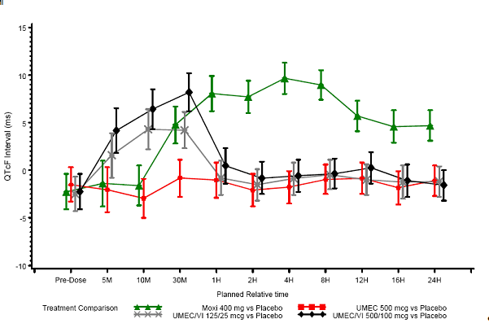
There was no evidence of an effect on QTcF in a repeated dose study conducted to evaluate the effect of the inhaled FF/VI in healthy subjects (HZA102936) at the proposed upper therapeutic FF/VI dose (200/25 µg for 7 days). At a dose representing 4-times the proposed upper therapeutic FF/VI dose (800/100 µg), there was an effect on QTcF during the first hour after dosing. The largest mean time-matched difference from placebo was 9.6 msec at 30 minutes. An integrated, cross-study analysis was undertaken to assess the effect of varying doses of UMEC and UMEC/VI on the QTc interval in volunteers and COPD patients. There did not appear to be a difference in effects of UMEC or UMEC/VI on the QTc interval between COPD and healthy subjects. There were no maximum QTcF (0 - 4 hours) values greater than 500 msec reported. There was no QTc effect of UMEC at any dose versus placebo. A slight effect was observed for UMEC /VI (500/50 µg) in healthy subjects.

Concentration-QT interval analysis
The concentration-QTcF mixed-effects analysis (DB2114635) developed a nonlinear mixed-effect systemic exposure-response model describing the concentration-QTcF effect of UMEC and UMEC/VI in healthy subjects. The model successfully described the relationship between QTcF, UMEC, and VI, with additive drug effects of UMEC and VI. The QTc prolongation effect of VI systemic exposure was adequately described by a saturable relationship. The decreasing QTc effect of UMEC systemic exposure was adequately described by a linear model. Simulations of the model typical parameters were carried out at the geometric mean observed C_{max} for each treatment. For the supra-therapeutic monotherapy UMEC dose (500 µg), the estimated mean UMEC drug effect was -2.38 msec at the geometric mean observed UMEC C_{max}. The combined additive drug effect was estimated to be 5.39 msec and 5.22 msec for the therapeutic (UMEC/VI 125/25 µg) and supra-therapeutic (UMEC/VI 500/100 µg) combinations, respectively. Decreased QTcF following UMEC monotherapy along with increased QTcF observed for the combination therapies in this study suggest the effect is possibly attributable to the VI component of the combination treatment. Additionally, the effect of UMEC/VI on cardiac rhythm in subjects diagnosed with COPD as assessed using 24-hour Holter monitoring: 53 subjects received UMEC/VI 62.5/25 µg for up to 6 months, 55 subjects received UMEC/VI 125/25 µg for up to 6 months, 226 subjects received UMEC/VI 125/25 µg for up to 12 months, and 182 subjects received placebo. No clinically meaningful effects on cardiac rhythm were observed.

Relationship between drug concentration and pharmacodynamic effects
At doses up to 1000 µg no relationship was observed between UMEC plasma concentrations and heart rate, in subjects with COPD. The proposed dose of VI 25 µg does not show any clinically relevant systemic heart rate effects. The combination of UMEC 62.5 µg or 125 µg and VI 25 µg has not shown any clinically relevant systemic heart rate changes. Similarly, the relationship between plasma UMEC and VI concentrations and changes in QTcF was modelled. Predicted mean QTcF changes at all time points were < 5 msec and none of the 95% CIs showed upper 95% CI greater than 10 msec.

Relationship between drug dose and pharmacodynamic effects

UMEC pulmonary dose-response
A physiological E_{max} model adequately described the relationship between dose and trough FEV1 (primary endpoint) when studies AC4113073 and AC4115321 were analysed individually and following pooled analysis (AC4116689). The model parameters of UMEC estimated from analysis of the individual studies and after analysis of the pooled data were comparable. The model from the pooled population dose response analysis was used to support the selection of Phase III doses and dosing regimen. Based on the final model simulation, the probability of achieving a target FEV1 response with different doses and dose frequencies was computed. The once-daily 62.5 µg or 125 µg UMEC appeared to be the optimal doses. Although lower doses of 31.25 µg and 15.6 µg once-daily UMEC were better than placebo, they showed a lower response compared with that of the 62.5 µg once-daily dose based on both observed and model predicted trough FEV1values. Predictions from modelling further indicated lower likelihood of providing meaningful response following doses of 15.6 µg and 31.25 µg UMEC.

VI pulmonary dose-response
VI dose response was modelled using data from Study B2C111045 in subjects with COPD, which supports the selected dose of 25 µg in UMEC/VI combination treatment.

UMEC-VI combination pulmonary dose-response
No dose range studies of the combination UMEC/VI was undertaken. The UMEC doses of 62.5 µg and 125 µg were selected as clinically relevant doses in Phase III as monotherapy and in combination with VI 25 µg. In the Phase III pivotal studies (DB2113361 and DB2113373) each combination (UMEC/VI 125/25 µg and UMEC/VI 62.5/25 µg) provided clinically relevant higher changes in trough FEV1 response when compared with the respective individual components. It was possible in these Phase III studies to evaluate qualitatively the potential mechanism of the PD interaction for the UMEC and VI combination using the observed longitudinal trough FEV1 over a 6-month duration. The trough FEV1 responses obtained for each combination appeared to be sub-additive when compared with the addition of FEV1 responses from the individual components.

Pharmacodynamic interactions
The PD effect of co-administration of repeated doses ketoconazole 400 mg and single inhaled dose VI 25 µg was examined in healthy volunteers (B2C112205). Dosing with ketoconazole did not result in significant increases in systemic PD effects of VI. The 90% CIs for the treatment effects of ketoconazole with VI compared with VI alone were within predefined limits for equivalence for both heart rate (±10 bpm) and blood potassium (±0.22 mmol/L). There were minor treatment effects on some secondary PD endpoints.

Evaluator’s overall conclusions on pharmacodynamics
Early phase healthy subject studies and studies in subjects with COPD demonstrated a clear bronchodilatory effect of both UMEC and VI. Bronchodilation was assessed by changes in specific airway conductance and forced expiratory volume. Evidence from these studies confirms bronchodilation as the therapeutic mechanism of action for UMEC/VI. In healthy subjects, UMEC 100 to 350 µg significantly increased bronchodilation compared with placebo up to 12 h post-dose, and to 24 h post-dose with 350 µg. In COPD patients 250 to 1000 µg provided superior bronchodilation compared to placebo up to 24 h post-dose. For VI doses from 25 to 100 µg significantly increased bronchodilation compared with placebo to 24 h post-dose in both healthy subjects and patients with COPD.
There was no evidence of an effect on QTcF following 10 days of IH dosing with UMEC/VI 125/25 µg or UMEC 500 µg compared with placebo. A dose representing 4-times the proposed upper therapeutic UMEC/VI dose (UMEC/VI 500/100 µg) increased QTcF 8.2 msec at 30 minutes only, which was the largest increase observed. Data from clinical pharmacology studies in healthy subjects and subjects with COPD suggest that small, transient changes in SBP and DBP following both UMEC and VI. Studies in healthy subjects and subjects with COPD suggest no clinically relevant changes in blood potassium or glucose following both UMEC and VI.
A physiological E_{max} model adequately characterized the dose trough FEV1 response for UMEC over the QD dose range of 15.6 to 1000 µg in subjects with COPD, with an estimated dose that would yield 50% of E_{max} (ED50) of 33 µg.
The once-daily proposed UMEC doses of 62.5 µg and 125 µg have shown dose related increases in trough FEV1. There was no marked difference between the once-daily versus twice-daily regimen for UMEC. The VI dose of 25 µg has also shown consistent clinically relevant changes in trough FEV1. The trough FEV1 responses obtained for each dose of the combination (UMEC/VI 62.5/25 µg and 125/25 µg) appeared to be sub additive when compared to the addition of FEV1 responses from the individual components. There was no apparent dose- or concentration- dependent change in cardiovascular (heart rate) effects for UMEC over the dose range 15.6 to 1000 µg.

Dosage selection for the pivotal studies
Dose selection of UMEC for the pivotal studies was based on the results of 2 Phase IIb dose-ranging studies in COPD subjects (AC4113073 and AC4113589). Two other studies, AC4115321 and AC4115408, were conducted after the commencement of the Phase III studies, and their results were used to further support the dose selection of UMEC for the pivotal studies. Dose selection of VI for the pivotal studies was based on the results of a Phase IIb dose-ranging study in COPD subjects (B2C111045). A summary of the study design and dose tested in these studies is presented in Table 3.

Table 3. Studies to support doses and dosing interval of UMEC and VI used in the UMEC/VI Phase III COPD studies.
Study Number | Study Objective | Study Design & Duration | Relevant Treatment Arms (µg)
UMEC Dose selection
AC4113589 | Dose ranging | R, DB, PG, PC  28 Days | UMEC 125 QD  UMEC 250 QD  UMEC 500 QD  PLA QD
AC4113073 | Dose ranging, dosing interval and PK | R, DB, XO, PC Incomplete block 3 periods per subject, 14 days per period | UMEC 62.5 QD UMEC 125 QD UMEC 250 QD UMEC 500 QD UMEC 1000 QD TIO 18 OL QD PLA QD  UMEC 62.5 BD UMEC 125 BD UMEC 250 BD PLA BD
AC4115321 | Dose ranging and dosing interval | R, DB, XO, PC Incomplete block 3 periods per subject, 7 days per period | UMEC 15.6 QD UMEC 31.25 QD UMEC 62.5 QD UMEC 125 QD TIO 18 OL QD PLA QD  UMEC 15.6 BD UMEC 31.25 BD PLA BD
AC4115408 | Efficacy & Safety | R, DB, PG, PC  12 weeks | UMEC 125 QD UMEC 62.5 QD PLA QD
VI dose selection
B2C111045 | Dose ranging | R, DB, PG, PC Stratified ª  28 days | VI 3 QD  VI 6.25 QD  VI 12.5 QD  VI 25 QD  VI 50 QD  PLA QD
Abbreviations DB double-blind, OL open-label, PC placebo-controlled, PG parallel-group, PLA placebo, r randomized, XO cross over.
- Subjects reversibility to salbutamol was used to stratify the randomisation.
Study AC4113073 was a multicentre, randomised, double-blind, double-dummy, placebo-controlled, three-way cross-over, incomplete block study evaluating the dose-response, safety, and efficacy of five once-daily doses of UMEC (62.5, 125, 250, 500, and 1000 µg), three twice-daily doses of UMEC (62.5, 125, and 250 µg), and tiotropium 18 µg once-daily (open-label active control) compared with placebo in subjects with COPD. The primary endpoint was change from baseline in morning trough forced expiratory volume in 1 second (FEV₁) at the end of each treatment period (Day 15). Results showed that all once-daily doses of UMEC had statistically significant improvements in the primary efficacy endpoint of change from baseline in morning trough FEV1 at Day 15 compared with placebo (difference over placebo of 128, 147, 95, 140, and 186 mL for UMEC 62.5, 125, 250, 500, and 1000 µg once-daily, respectively; p ≤ 0.006). However, there was no clear linear dose-response relationship across the once-daily doses tested. Comparisons of the same total daily dose administered once- or twice-daily did not show a clear pattern of greater benefit for either dosing regimen. In addition, evaluation of the serial FEV1 response curves over 28 hours at Day 14 did not show a clear indication that twice-daily dosing of UMEC provided additional benefit in bronchodilator response over once-daily dosing. Analyses of the ratios of evening (12 to 24 hours) to morning (0 to 12 hours) weighted mean FEV1 values were supportive of a once-daily dosing interval, with the exception of the 250 µg once-daily dose (ratio of FEV1 (12 - 24hours) versus FEV1 (0 - 12hours) of 0.751, compared to ratio of 1.125 for 125 µg twice-daily dose). Safety results showed that the incidence of AEs at doses of 62.5 µg once-daily, 125 µg once-daily, 62.5 µg twice-daily, and 125 µg twice-daily (18% to 23%) was similar to that of placebo (16%) and tiotropium (17%), but was higher at the 250, 500, and 1000 µg once-daily and 250 µg twice-daily doses (30% to 41%), mainly due to an increased incidence of cough, dry mouth, and dysgeusia.
Study AC4113589 was a multicentre, randomised, double-blind, parallel-group, placebo-controlled, study evaluating the efficacy and safety of three doses of UMEC (125, 250, and 500 µg once-daily, over 28 days) compared with PLA in subjects with COPD. The primary endpoint was change from baseline in trough FEV1 at Day 29. Results showed that there were statistically significant improvements in the primary efficacy endpoint of trough FEV1 at Day 29 for all doses of UMEC compared with placebo (difference over placebo of 159, 168, and 150 mL for UMEC 125, 250, and 500 µg once-daily, respectively, p < 0.001). However, there was no clear linear dose-response relationship across the once-daily doses tested. Safety results showed that the overall incidence of AEs was higher with the 500 µg dose (34%) compared with lower UMEC doses (24 to 25%) and placebo (23%). This was primarily related to an increased incidence of cough and headache.
According to the sponsor the efficacy and safety results from studies AC4113073 and AC4113589 indicated that the 62.5 and 125 µg once-daily doses of UMEC were the most appropriate doses for further clinical development. The selection of one single dose of UMEC for Phase III clinical development was not apparent due to a lack of clear separation in FEV1 response between the two doses, and hence, both 62.5 µg and 125 µg once-daily doses of UMEC were evaluated (as monotherapy and as a component of UMEC/VI) in the Phase III studies.
Results of studies AC4115321 and AC4115408 were generally supportive of the dose selection of UMEC for the pivotal Phase III studies. Study AC4115321 was a multicentre, randomised, double-blind, placebo-controlled, 3 way cross-over, incomplete block study evaluating the dose response of 4 once-daily dose regimens of UMEC (15.6, 31.25, 62.5 and 125 µg ) over a 7-day treatment period in patients with COPD. The secondary objective was to explore the efficacy and safety of these 4 once-daily dose regimens of UMEC and 2 twice-daily regimens of UMEC (15.6 and 31.25 µg) compared with tiotropium 18 µg once-daily (open label active comparator) and placebo over a 7-day treatment period in patients with COPD. The primary efficacy endpoint was trough FEV1 on Day 8. Results showed that the potency (ED50) estimate of UMEC was 37 µg (geometric mean ED50 of 37 µg; 95% % confidence interval [CI]: 18, 57) after once-daily dosing. The maximum predicted response (Emax) value was 0.185 L (95% CI: 0.154, 0.216) after once-daily dosing. There were statistically significant increases from baseline in trough FEV1 on Day 8 for all once-daily and twice-daily UMEC doses compared with placebo (differences over placebo of 101 to 183 mL; p < 0.001). Comparison of the once-daily and twice-daily dosing regimens showed that mean changes from baseline for trough FEV1 on Day 8 were slightly greater with 31.25 µg twice daily regimen compared with 62.5 µg once-daily regimen (difference over placebo of 139 mL vs. 124 mL), and slightly greater with 15.6 µg twice-daily regimen compared with 31.25 µg once-daily regimen (difference over placebo of 125 mL vs. 101 mL). However, analyses of the 24-hour serial FEV1 dose-response curves at Day 7 did not show a clear indication that twice-daily dosing of UMEC provided greater benefit in bronchodilator response over once-daily dosing. In addition, analyses of the ratios of evening (12 to 24 hours) to morning (0 to 12 hours) weighted mean FEV1 values were supportive of a once-daily dosing interval, with the ratios approximately 1.0 for all once-daily doses. The ratios were also generally comparable between both dosing regimens. Safety results showed that the overall incidence of on treatment AEs was comparable across the once-daily doses of UMEC 15.6, 31.25, and 62.5 µg (5% to10%) compared with placebo (8%), with a higher incidence (18%) reported in the UMEC 125 µg once-daily treatment period.
Study AC4115408 was a multicentre, randomised, double-blind, placebo-controlled, parallel-group, Phase IIIa study evaluating the efficacy and safety of UMEC (62.5 and 125 µg, once daily over 12 weeks) compared with placebo in subjects with COPD. The primary efficacy endpoint was trough FEV1 on Treatment Day 85. Results showed that there were statistically significant improvements in the least squares mean (LSM) change from baseline trough FEV1 for both doses of UMEC compared with placebo at Day 85 (differences over placebo of 127 mL and 152 mL for UMEC 62.5 and 125 µg, respectively; p < 0.001). Safety results showed that the overall incidence of on-treatment AEs was comparable across treatment groups: (35%, 39% and 41% in the placebo, UMEC 62.5 and 125 µg groups, respectively). The most commonly reported AEs were headache (10%, 7% and 14% of subjects in the placebo, UMEC 62.5 and 125 µg groups, respectively) and nasopharyngitis (10%, 12% and 10%, respectively).
A summary of trough FEV1 (primary endpoint) findings from the above 4 UMEC dose-ranging studies was presented in the CSR. The sponsor also did a meta-analysis of studies AC4113073 and AC4115321 (report AC4116689). The primary objective of the meta-analysis was to evaluate the dose response of seven once-daily doses of UMEC (15.6, 31.25, 62.5, 125, 250, 500, and 1000 µg) and five twice-daily doses of UMEC (15.6, 31.25 62.5, 125, and 250 µg) in subjects with COPD. The secondary objective was to evaluate the efficacy of these seven once-daily doses of UMEC, five twice-daily doses of UMEC, and once-daily tiotropium 18 µg compared with placebo in subjects with COPD. The primary efficacy endpoint was trough FEV1 at the end of the treatment period. Results showed that the potency ED50 estimate of UMEC was 33 µg after once-daily dosing. The predicted E_{max} value was 0.187 L. There were statistically significant treatment differences in favour of UMEC over placebo in the mean change from baseline in trough FEV1 at the end of the treatment period for all once- and twice-daily doses of UMEC tested. Dose ordering was observed over the once-daily dosing regimens of UMEC from 15.6 to 125 µg, after which there appeared to be a plateau in response for trough FEV1 at doses of 125 µg once-daily and higher.
Dose selection of VI for the pivotal studies was based on the results of a Phase IIb dose-ranging study in COPD subjects (B2C111045). Study B2C111045 was a multicentre, randomised, placebo-controlled, double-blind, parallel group study evaluating the dose response, efficacy and safety of five dosage regimens of VI (3, 6.25, 12.5, 25 and 50 µg once daily) over a 28-day period in subjects with COPD. The primary efficacy endpoint was the change from baseline in trough FEV1 at the end of the 28-day treatment period (that is, trough FEV1 on Day 29). Efficacy results showed that there were statistically significant (p < 0.001) dose-dependent differences in favour of all VI doses compared with placebo in the mean change from baseline in trough FEV1 on Day 29. Effects on trough FEV1 increased with increasing doses of VI with no plateau in the dose-response with the doses tested in this study, indicating that maximal efficacy might not have been achieved in this study. Treatment differences of ≥ 100 mL in trough FEV1 compared to placebo were observed on Day 29 only in the 12.5, 25, and 50 µg groups, while differences of ≥ 130 mL were observed only in the 25 and 50 µg groups. A Bayesian analysis of the change from baseline in trough FEV1 showed that the probabilities of having a true treatment difference of > 100 mL over placebo were more than 90% with both the 25 and 50 µg doses (99% and 92%, respectively), but lower for the 3, 6.25, and 12.5 µg doses (37%, 47% and 64%, respectively). The probabilities of having a true treatment difference of > 130 mL over placebo were 61% and 90% with the 25 and 50 µg, respectively, compared with 7%, 11% and 22% for the 3, 6.25, and 12.5 µg doses, respectively. The sponsor also considered other study FEV1 endpoints (e.g. weighted mean 24-hour serial FEV1 on Days 1 and 28, mean changes from baseline in trough FEV1 on Days 2, 14, and 28), and results showed that improvements of ≥ 130 mL FEV1 over placebo were consistently observed only with the 25 and 50 µg doses. The sponsor was also of the opinion that although the point estimate for these efficacy parameters favoured the 50 µg dose over the 25 µg dose, it was unclear whether these differences were clinically meaningful. Safety results showed that all doses were well-tolerated. The overall incidence of AEs was comparable across the treatment groups (24% to 36%), with no obvious dose-dependent trend.
Dosing interval or schedule of VI for the pivotal studies was based on the results of a Phase IIb study in asthma patients (HZA113310). Study HZA113310 was a multicentre, double-blind, placebo-controlled, five-period cross-over study evaluating the relative effects in trough FEV1 compared with placebo of VI at doses of 6.25 µg, 12.5 µg and 25 µg once daily, and 6.25 µg twice-daily, each administered for 7 days. The primary efficacy endpoint was the mean trough FEV1 at the end of the 7-day treatment period. Efficacy results with regards to selection of dosing interval showed that treatment difference from PLA in the 0 to 24 hour weighted mean FEV1 was comparable between VI 12.5 µg once-daily (LSM difference from placebo of 168 mL) and 6.25 µg twice-daily (LSM difference from PLA of 166 mL).
Based upon these efficacy and safety data, 25 µg once-daily of VI was selected as the optimal dose to be assessed in the pivotal Phase III studies.
Evaluator’s comments: The rationale for the dose selection in the Phase III studies is appropriate.

Clinical efficacy
Four pivotal Phase III studies were submitted to support clinical efficacy for the proposed indication. These consisted of 2 sets of randomised, double-blind, parallel group studies (studies DB2113361/DB2113373, and studies DB2113360/DB2113374), each with a 24-week treatment duration. Within each set, the studies were identical except for the study drugs or doses tested. In addition, the sponsor had performed a meta-analysis of studies DB2113360 and DB2113374, comparing UMEC/VI and tiotropium for the endpoint of the Transition Dyspnoea Index score.
In this efficacy section of this evaluation report, the respective sets of studies and the meta-analysis (where applicable) will be presented in the same sub-sections, for ease of reference.
The clinical efficacy has been reviewed for the indication of long term, once daily bronchodilator treatment to relieve symptoms in adult patients with COPD.

Pivotal efficacy studies

Studies DB2113361 and DB2113373

Study design, objectives, locations and dates
Both studies DB2113361 and DB2113373 were multi-centre, randomised, double-blind, placebo-controlled, parallel group studies evaluating the efficacy and safety of UMEC/VI IH powder and its individual components, in subjects with COPD. The primary objective of both studies was to assess the efficacy and safety of UMEC/VI, UMEC, and VI IH powder, when administered once-daily via a Novel Dry Powder Inhaler (NDPI) over 24 weeks in subjects with COPD. Study DB2113361 investigated doses of UMEC/VI 125/25 µg, UMEC 125 µg, and VI 25 µg, while study DB2113373 investigated doses of UMEC/VI 62.5/25 µg, UMEC 62.5 µg, and VI 25 µg.
Studies DB2113361 and DB2113373 were multi-centre studies where subjects were enrolled in a total of 153 study sites across 14 countries and 163 study sites across 13 countries, respectively. The study start and end dates, of study DB2113361 were 22 March 2011 and 19 April 2012, respectively, and those of study DB2113373 were 30 March 2011 and 5 April 2012, respectively.
Subjects who met the eligibility criteria at screening (Visit 1) completed a 7- to 14-day Run-in Period followed by a 24-week Treatment Period (Figure 2). Randomisation was conducted on Visit 2 (Day 1). Additional clinic visits were scheduled at Day 2, and after 4, 8, 12, 16, and 24 weeks of treatment, and 1 day after the Week 24 Visit (that is, Treatment Day 169). A follow-up clinic visit (Visit 10) for lung function and adverse event assessments was conducted approximately 7 days after Visit 9 or the Early Withdrawal Visit. The total duration of subject participation, including follow-up, was approximately 27 weeks.
Figure 2. Studies DB2113361 and DB113373 schematics.
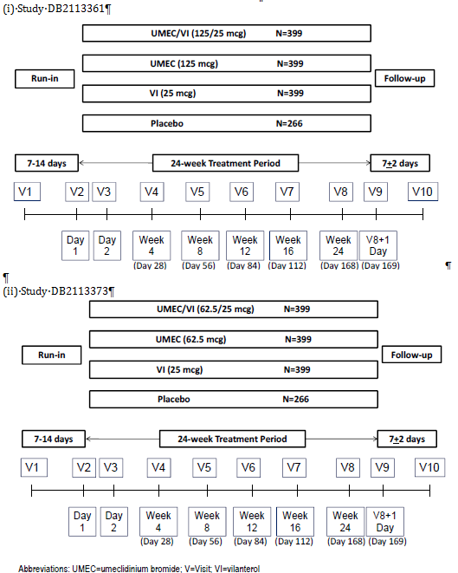

Inclusion and exclusion criteria
Subjects enrolled in these 2 studies were males or females aged ≥ 40 years with a diagnosis of COPD, who had a smoking history of ≥ 10 pack-years, and who had a post-salbutamol FEV1 of ≤ 70% of predicted normal value, and a post-salbutamol FEV1/forced vital capacity (FVC) ratio of < 0.70 at the screening visit. Subjects also had to have a score of ≥ 2 using the Modified Medical Research Council (mMRC) Dyspnoea Scale.
Subjects were excluded if they had a current diagnosis of asthma, α-1 antitrypsin deficiency, or any clinically significant uncontrolled disease, hospitalisation for COPD or pneumonia within 12 weeks prior to Visit 1, or lung volume reduction surgery within the 12 months prior to Visit 1. Subjects were also excluded if they were unable to withhold salbutamol for the 4-hour period required prior to spirometry testing at each study visit, if they were on long-term oxygen therapy, or if they were participating in the acute phase of a pulmonary rehabilitation program within 4 weeks prior to Visit 1.
In addition, in order to be randomised to double-blind study drug, subjects had to have no evidence of a significantly abnormal 12-lead electrocardiogram (ECG) finding at the pre-dose ECG at Visit 2, and had not experienced a COPD exacerbation or a lower respiratory tract infection during the Run-in period or at Visit 2. In addition, subjects using inhaled corticosteroids (ICS) had to have maintained regular use of a consistent dose of ICS during the Run-in Period at a dose ≤ 1000 µg /day fluticasone propionate or equivalent.
A full list of inclusion and exclusion criteria was provided in the CSR.
Evaluator’s comments: The inclusion and exclusion criteria were in line with recommendations on study population in the European Medicines Agency (EMA) guidelines on clinical investigation of medicinal products in the treatment of COPD as well as the US Food and Drug Administration (FDA) Guidance for Industry- Chronic Obstructive Pulmonary Disease: Developing Drugs for Treatment. The diagnostic criteria for COPD (post-bronchodilator FEV1 ≤ 70% of predicted normal value and post-bronchodilator FEV1/FVC ratio of < 0.70) were consistent with those in the above guidelines. Overall, the inclusion and exclusion criteria aimed to recruit adult subjects with stable, symptomatic COPD.

Study treatments
In study DB2113361, the treatment groups were UMEC/VI 125/25 µg, UMEC 125 µg, VI 25 µg, and matching placebo (randomised in a 3:3:3:2 ratio), all to be administered once daily in the morning with an NDPI. In study DB2113373, the treatment groups were UMEC/VI 62.5/25 µg, UMEC 62.5 µg, VI 25 µg, and matching placebo (randomised in a 3:3:3:2 ratio), all to be administered once daily in the morning with an NDPI. The treatment duration in both studies was 24 weeks.
During both studies, salbutamol was provided for use as rescue medication throughout the Run-in and Treatment Periods. Concurrent use of systemic corticosteroids or long-acting bronchodilators, including theophyllines, was not allowed. Concurrent use of ICS at a stable dose of ≤ 1000 µg/day of fluticasone propionate or equivalent was permitted provided the dose of ICS remained consistent throughout the study. Permitted and prohibited concomitant medications in studies DB2113361 and DB2113373 were provided in the CSR.
Evaluator’s comments: The study dose selection is appropriate and has been previously discussed in Section 6 of this evaluation report. The study design involving a placebo control is appropriate and consistent with the recommendation of the FDA Guidance for Industry- Chronic Obstructive Pulmonary Disease: Developing Drugs for Treatment. The provision of a short-acting beta2-agonist (salbutamol) as rescue medication and the permitted concomitant medications are in general keeping with both the FDA and EMA guidelines. The study design evaluating the efficacy and safety of the combination product as well as the individual components is consistent with the EMA guidelines “Note for Guidance on Fixed Dose Combination Medicinal Products”..

Efficacy variables and outcomes
The primary efficacy endpoint was the trough FEV1 at Day 169. This was defined as the mean of the FEV1 values obtained 23 and 24 hours after dosing on Day 168 (that is, at the Week 24 Visit).
The secondary efficacy endpoints were the mean Transition Dyspnoea Index (TDI) focal score, at Day 168, and the weighted mean FEV1 over 0 to 6 hours post-dose at Day 168. A list of the other study efficacy endpoints evaluating FEV1 or FVC included trough FEV1 and weighted mean FEV1 over 0 to 6 hours post-dose at other time points, time to onset (defined as an increase of 100 mL above baseline in FEV1) during 0 to 6 hours post-dose on Day 1, proportion of subjects achieving an increase in FEV1 of ≥ 12% and ≥ 200 mL above baseline at any time during 0 to 6 hours post-dose on Day 1, proportion of subjects achieving an increase of ≥ 100 mL above baseline in trough FEV1, serial FEV1 over 0 to 6 hours (at each time point), peak FEV1, serial and trough FVC, and weighted mean and serial FEV1 over 0 to 24 hours post-dose obtained in a subset of subjects. Other efficacy endpoints evaluating symptomatic benefits included mean TDI focal score at other time points, proportion of responders to TDI (defined as a subject with a TDI score of 1 unit or more), rescue salbutamol use (percentage of rescue free days and puffs/day), mean Shortness of Breath with Daily Activities (SOBDA) score, proportion of responders to the SOBDA (definition of responder to SOBDA is discussed below), and time to first COPD exacerbation. In addition, health outcomes were assessed using the St. George’s Respiratory Questionnaire (SGRQ) and by evaluation of healthcare resource utilisation.
Pulmonary function tests and assessments of endpoints were performed according to the schedule provided.
Evaluator’s comments:
- Overall, the primary and secondary endpoints of these studies are appropriate and consistent with the recommendations in the EMA guidelines on clinical investigation of medicinal products in the treatment of COPD, as well as the FDA Guidance for Industry- Chronic Obstructive Pulmonary Disease: Developing Drugs for Treatment, which recommended endpoints evaluating FEV1, symptom relief, or effect on exacerbations of COPD. The study primary and secondary endpoints allowed evaluations of the post dose bronchodilatory effect of UMEC/VI and its components after 24 weeks of treatment (FEV1 over 0 to 6 hours post dose at Day 168), and at the end of the 24-hour dosing interval after 24 weeks of treatment (trough FEV1 on Day 169), as well as effect on symptom relief (TDI score). Other efficacy endpoints allowed further characterisation of the bronchodilatory effect of UMEC/VI and its components across 24 weeks and over 24-hours post-dose period, and of the effects on symptom relief and health outcomes (use of rescue salbutamol, time to first COPD exacerbations, SOBDA, SGRQ, healthcare resource utilisation). The use of the SGRQ is in line with the recommendations of the EMA guidelines, which cited the use of the Chronic Respiratory Questionnaire or the St George’s Respiratory Questionnaire.
- The study duration of 24 weeks to support the proposed indication of a long term once daily maintenance bronchodilator treatment in COPD is consistent with both the EMA and FDA guidelines. The EMA guidelines on clinical investigation of medicinal products in the treatment of COPD states that “Study duration will depend on the primary endpoints chosen. The effect on lung function parameters and symptoms might be demonstrated in 12 to 24 weeks; demonstration of efficacy through reduction in exacerbations will require studies of longer duration, at least one year”. The FDA Guidance for Industry- Chronic Obstructive Pulmonary Disease: Developing Drugs for Treatment gives similar recommendations that for drugs claiming to improve airflow obstruction, the duration of treatment should be at least 3 months for a bronchodilator drug and at least 6 months for a non-bronchodilator drug.
- With regards to the subset of study population that performed 24-hour serial spirometry during the study, the sponsor had stated that at selected study sites, a subset of approximately 198 planned subjects performed 24-hour serial spirometry during the study, but no further explanation was provided in the clinical study reports (CSR) or protocols as to how the sites or the subset of subjects had been selected. This information would be important in the overall assessment of any potential bias in the study results with regards to this subset. This will be raised as a clinical question in section 11.

Randomisation and blinding methods
Following the completion of the Run-in Period, eligible subjects were randomised in a 3:3:3:2 ratio to one of 4 treatment groups: UMEC/VI 125/25 µg, UMEC 125 µg, VI 25 µg, or matching placebo in study DB2113361, or UMEC/VI 62.5/25 µg, UMEC 62.5 µg, VI 25 µg, or matching placebo in study DB2113373. Subjects were randomised using an Interactive Voice Response System (IVRS). Subjects were assigned to study treatments in accordance with a randomisation schedule, and the randomisation codes were generated by the sponsor using a validated computerised system RandAll version 2.5. Both studies had a double-blind study design. The sponsor generated the randomisation schedule, prepared and coded the study drug in a blinded fashion, and provided all study drugs.

Analysis populations
In both studies, 5 analysis populations were identified. The All Subjects Enrolled (ASE) population comprised of all subjects for whom a record existed on the study database, including screen failures and any subject who was not screened but reported an SAE between the date of informed consent and the planned date of the Screening Visit. This population was used for reporting subject disposition and for listing adverse events (AEs) and incorrect treatment allocation. The Screen and Run-in Failure (SRF) population comprised of all subjects in the ASE population who were recorded as screen failures or run-in failures. This population was used for the tabulation of reasons for screen and run-in failure and for inclusion, exclusion, and randomisation criteria failure. The Intent-to-treat (ITT) population comprised of all subjects who were randomised to treatment and who received at least one dose of randomised study drug during the treatment period. This population was the primary analysis population for all efficacy analyses, and outcomes were reported according to the randomised treatment allocation. The Per Protocol (PP) population comprised of all subjects in the ITT population who were not identified as having full protocol deviations. The PP population was used for confirmatory analyses of the primary and secondary efficacy endpoints. The Twenty Four Hour (TFH) population comprised of a subset of subjects from the ITT population for whom 24-hour data were collected for spirometry and Holter monitoring.
Evaluator’s comments: The definitions of the analysis populations are in keeping with the TGA-adopted ICH E 9 Statistical Principles for Clinical Studies. Although the ITT population excluded subjects who took no study drug, the intent-to-treat principle would be preserved as the study was double-blind, and the initial decision by subjects of whether or not to begin treatment would not be influenced by knowledge of the assigned treatment, and hence the exclusion of these subjects is not deemed to have introduced any potential bias.

Sample size
The sample size estimation aimed to provide sufficient power for the comparison of the primary and secondary endpoints, including the TDI. The sample size calculations used a two-sided 5% significance level and estimates of residual standard deviations (SD) of 3.24 units for TDI, and of 210 mL for trough FEV1. The estimate of SD for TDI was based on Mixed Model Repeated Measures (MMRM) analyses of a previous study in COPD subjects with a fluticasone propionate (FP)/salmeterol combination. The estimate of SD for trough FEV1 was based on MMRM analyses of previous studies in COPD subjects with UMEC, VI, and the FP/salmeterol combination. According to the sponsor, subjects were to be randomised to active treatment arms or placebo in a 3:2 ratio, in order to provide additional safety data for the active treatments.
It was estimated that a study with 273 evaluable subjects in each active arm and 182 evaluable subjects in the placebo arm would have 90% power to detect a 1-unit difference between treatments in TDI. With this number of evaluable subjects per active arm, the study would have > 99% power to detect a 100 mL difference between UMEC/VI and either UMEC or VI, or between an active treatment and placebo, at the two-sided 5% significance level. It would have 90% power to detect a difference of 58 mL between UMEC/VI and either UMEC or VI, or 68 mL between an active treatment and placebo.
In addition, it was estimated that approximately 30% of subjects would withdraw without providing a Day 168 (Week 24) assessment. To account for this 30% withdrawal rate, 399 subjects were needed to be randomised to each active treatment arm and 266 subjects were needed to be randomised to the placebo arm.

Statistical methods
The primary endpoint of trough FEV1 at Day 169 was analysed for the ITT population using a MMRM analysis, including covariates of baseline FEV1, smoking status, day, centre group, treatment, day by baseline interaction, and day by treatment interaction, where day was nominal. The model used all available trough FEV1 values recorded on Days 2, 28, 56, 84, 112, 168, and 169. Missing data were not directly imputed in this primary analysis, but all non-missing data for a subject were used within the analysis to estimate the treatment effect for trough FEV1 on Day 169. Additional sensitivity analyses were conducted for the primary endpoint using different imputation methods: missing at random multiple, copy differences from control, Last Mean Carried Forward (LMCF) assuming decline of 0 mL/year, and LMCF assuming decline of 25 mL/year. The analyses of the secondary endpoints of mean TDI focal score at Day 168 and weighted mean FEV1 over 0 to 6 hours post dose at Day 168 used the same methodology as that for the primary endpoint.
Treatment comparisons performed on the primary and secondary endpoints were UMEC/VI vs. placebo, UMEC vs. placebo, VI vs. placebo, UMEC/VI vs. VI, and UMEC/VI vs. UMEC. In order to account for multiplicity across treatment comparisons and key endpoints, a step-down closed testing procedure was applied, whereby inference for a test in the pre-defined hierarchy was dependent upon statistical significance having been achieved for previous tests in the hierarchy. This hierarchy consisted of the five treatment comparisons described above, performed in that order, on the primary and secondary endpoints.
With regards to statistical testing hierarchy among the primary and secondary endpoints, for the purpose of submission to EMA, statistical testing hierarchy was applied to trough FEV1 at Day 169, followed by TDI score at Day 168, and then weighted mean FEV1 over 0 to 6 hours post dose at Day 168 (that is, statistical inference for TDI score at Day 168 was conditional on having achieved statistical significance on the primary endpoint, and that for weighted mean FEV1 over 0 to 6 hours post-dose at Day 168 was conditional on having achieved statistical significance on the first 2 endpoints). For purpose of evaluation by the FDA, the testing hierarchy was applied to trough FEV1 at Day 169 followed by weighted mean FEV1 over 0 to 6 hours post-dose at Day 168, as the endpoint of TDI score at Day 168 was designated “other efficacy endpoint” and not “secondary efficacy endpoint” for the FDA submission. The sponsor had provided the rationale for this, that the relevant EMA guidelines (relevant to regulatory submissions to the EMA) recommended that the clinical benefit of an investigational COPD medication should be evaluated using both a measure of lung function and a symptom based endpoint such as the TDI, while the FDA guidance document (relevant to regulatory submissions to the FDA) has designated the TDI as “other” efficacy endpoint. Hence, in these 2 studies, the TDI score was considered a key secondary endpoint for submissions to the EMA and other relevant regulatory authorities, but was considered an “other endpoint” for regulatory submission to the FDA and other relevant regulatory authorities.
With regards to the endpoint of the proportion of responders to the SOBDA, two thresholds for response according to SOBDA were considered, based on the range of values considered to contain the minimally important difference: -0.1 and -0.2. For each threshold, a subject was to be considered a SOBDA “responder” if the difference between the mean post-treatment score and the baseline score was the same as or less than the threshold.
Evaluator’s comments: The hierarchical testing of the hypothesis is consistent with the TGA-adopted EMA guidelines on Points to consider on multiplicity in clinical trials. The rationale for designating the TDI score as a key secondary endpoint for submissions to the EMA, and as an “other endpoint” for regulatory submission to the FDA is in line with the respective guidelines. In the EMA document “Points to consider on the clinical investigation of medicinal products in the treatment of chronic obstructive pulmonary disease” (19 May 1999, CPMP/EWP/562/98; the EMA document referenced by the sponsor), there was no mention of the TDI instrument. However, in the EMA “guidelines on clinical investigation of medicinal products in the treatment of chronic obstructive pulmonary disease” (21 June 2012, EMA/CHMP/483572/2012), among the recommended efficacy endpoints listed, the TDI was stated as one of the “examples of clinical ratings extensively used in randomised controlled trials”. In the FDA “Guidance for Industry- Chronic Obstructive Pulmonary Disease: Developing Drugs for Treatment” (November 2007; the FDA document referenced by the sponsor), it was stated that “activity scales such as the Medical Research Council dyspnoea score, the Borg Scale, and the Mahler Baseline Dyspnoea Index/ Transitional Dyspnoea Index can be used as supportive of efficacy. These scales are relatively simple to administer, but they have limitations that make them unsuitable for use as the sole or primary evidence of efficacy and for supporting specific labelling claims. These scales were not specifically developed for use in clinical studies of drugs and their attributes in longitudinal interventional settings may not be fully elucidated”.

Participant flow
In study DB2113361, out of a total of 2114 subjects screened, 1493 subjects were randomised: 275, 407, 404, and 403 in the placebo, UMEC 125 µg, VI 25 µg and UMEC/VI 125/25 µg groups, respectively (see Figure 3 below).
Figure 3. Flow chart of participant flow Study DB2113361.
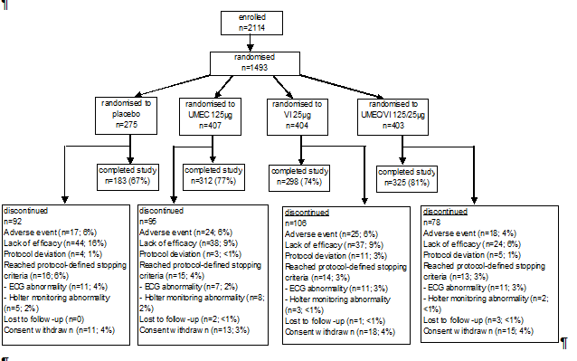
In study DB2113373, out of a total of 2210 subjects screened, 1536 subjects were randomised: 280, 418, 421, and 413 in the PLA, UMEC 62.5 µg, VI 25 µg and UMEC/VI 62.5/25 µg groups, respectively (Figure 4).
Figure 4. Flow chart of participant flow Study DB2113373.
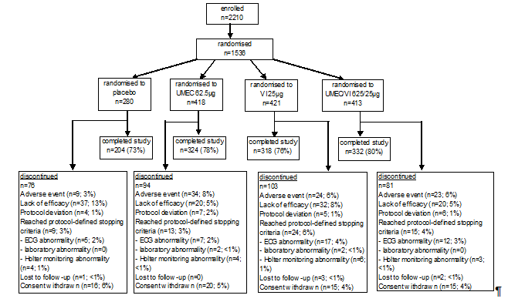
A summary of the main analysis population datasets for studies DB2113360 and DB2113373 is presented in Tables 4 and 5, respectively.

Table 4. Study DB2113361. Summary of subject populations.
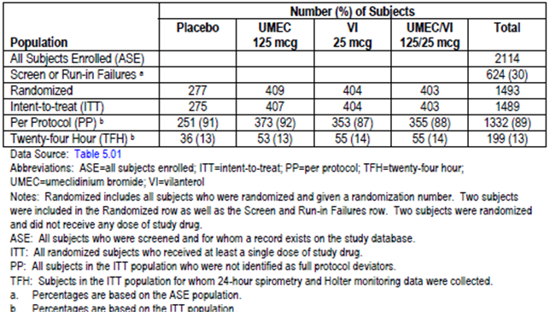

Table 5. Study DB2113373. Summary of subject populations.
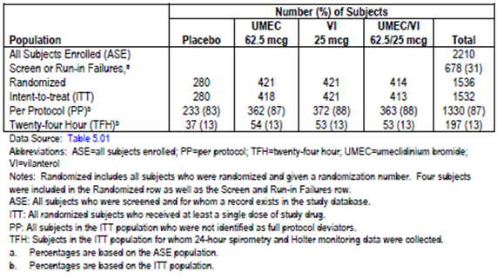

Major protocol violations/deviations
In study DB2113361, a total of 157 (11%) subjects had at least 1 full protocol deviation (9% (24/275), 8% (34/407), 13% (51/404) and 12% (48/403) in the placebo, UMEC 125 µg, VI 25 µg and UMEC/VI 125/25 µg groups, respectively).The most commonly reported full protocol deviation in all 4 treatment groups was " use of prohibited medication(s)" (6% (16/275), 4% (18/407), 9% (36/404) and 7% (27/403), respectively).
In study DB2113373, a total of 202 (13%) subjects had at least 1 full protocol deviation (17% (47/280), 13% (56/418), 12% (49/421) and 12% (50/413) in the placebo, UMEC 62.5 µg, VI 25 µg and UMEC/VI 62.5/25 µg groups, respectively).The most commonly reported full protocol deviation in all 4 treatment groups was " use of prohibited medication(s)" (10% (28/280), 8% (35/418), 6% (26/421) and 8% (34/413), respectively).
Subject compliance with double-blind study drug was assessed at Visits 4 through 8 by reviewing the dose counter on the NDPI. Treatment compliance was high and comparable across the treatment groups in both study DB2113361 (mean compliance of 98.1% to 99.1% across treatment groups) and study DB2113373 (mean compliance of 98.3% to 99.8% across treatment groups).

Baseline data
In study DB2113361, baseline demographic characteristics were comparable among treatment groups. The majority of subjects in each treatment group were male (64% to 66%) and White (87% to 89%). The mean age was 62.2 to 63.4 years. Baseline mean BMI was similar among treatment groups (mean BMI of 26.41 to 27.16), as was the mean smoking history (mean of 42.8 to 45.4 pack years). The baseline disease characteristics were also comparable among treatment groups, as were concomitant pre-treatment and on-treatment COPD medications.
In study DB2113373, the baseline demographic characteristics were comparable among treatment groups. The majority of subjects in each treatment group were male (68% to 74%) and White (84% to 86%). The mean age was 62.2 to 64.0 years. Baseline mean BMI was similar among treatment groups (mean BMI of 26.46 to 27.26), as was the mean smoking history (mean of 44 7 to 47.2 pack years). The baseline disease characteristics were also comparable among treatment groups, as were concomitant pre-treatment and on-treatment COPD medications.
Evaluator’s comments:
- Overall, the baseline demographic and disease characteristics were comparable among treatment groups in each study. The study populations in these studies were reflective of the target patient population, with mean (SD) age of 62.9 (8.47) years and 63.1 (8.86) years in studies DB2113361 and DB2113373, respectively, mean (SD) smoking pack years of 44.0 (23.85) and 46.2 (25.71), respectively, and with 92% and 89% of the respective study populations in GOLD grades II and III of COPD (representing moderate and severe COPD, respectively),.
- The baseline demographic and disease characteristics of the 24-hour subset (TFH population) were not provided, and comparability of these baseline characteristics across the treatment groups in this subset of study population could not be ascertained. This will be raised as a clinical question in Section 11.

Results for the primary efficacy outcome
The primary efficacy endpoint was the trough FEV1 on Day 169. In study DB2113361, there were statistically significantly greater least square mean (LSM) changes from baseline in trough FEV1 at Day 169 compared to placebo for UMEC/VI 125/25 µg (difference of 238 mL over placebo, p < 0.001), UMEC 125 µg (difference of 160 mL over placebo, p < 0.001), and VI 25 µg (difference of 124 mL over placebo, p < 0.001) (Table 6). There were also statistically significantly greater LSM changes from baseline in trough FEV1 on Day 169 with UMEC/VI 125/25 µg compared with both VI 25 µg (difference of 114 mL over VI 25 µg, p < 0.001) and UMEC 125 µg (difference of 79 mL over UMEC 125 µg, p < 0.001).

Table 6. Primary Efficacy Analysis: Trough FEV1(L) at Day 169 (DB2113361 ITT Population).
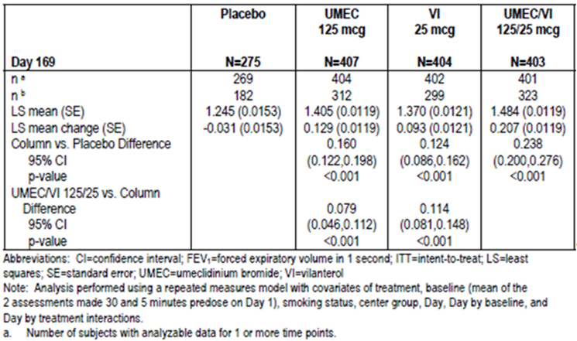
In Study DB2113373, there were also statistically significantly greater LSM changes from baseline in trough FEV1 on Day 169 compared to placebo for UMEC/VI 62.5/25 µg (difference of 167 mL over placebo, p < 0.001), UMEC 62.5 µg (difference of 115 ml over placebo, p < 0.001), and VI 25 µg (difference of 72 mL over placebo, p < 0.001) (Table 7). There were also statistically significantly greater LSM changes from baseline in trough FEV1 on Day 169 with UMEC/VI 62.5/25 µg compared with both VI 25 µg (difference of 95 mL over VI 25 µg, p < 0.001) and UMEC 62.5 µg (difference of 52 mL over UMEC 62.5 µg, p = 0.004).

Table 7. Primary Efficacy Analysis: Trough FEV1 (L) at Day 169 (DB2113373 ITT Population).
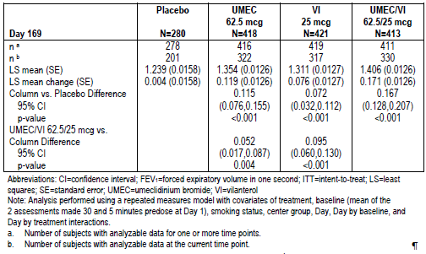

Results for other efficacy outcomes

Other supportive analyses on the primary efficacy endpoint
The results of the Per-Protocol analyses of trough FEV1 on Day 169 were supportive of the primary analyses in both studies DB2113361 and DB2113373 (Table 8). Sensitivity analyses were also conducted for trough FEV1 at Day 169 using different imputation methods (missing at random multiple (MAR), copy differences from control (CDC), Last Mean Carried Forward (LMCF) assuming decline of 0 mL/year, and LMCF assuming decline of 25 mL/year). These sensitivity analyses yielded results consistent with the primary MMRM analyses in both studies DB2113361 (statistically significantly greater LSM trough FEV1 change from baseline on Day 169 compared to placebo for UMEC/VI 125/25 µg, UMEC 125 µg, and VI 25 µg, and statistically significantly greater LSM trough FEV1 change from baseline on Day 169 with UMEC/VI 125/25 µg compared with both VI 25 µg and UMEC 125 µg) and DB2113373 (statistically significantly greater LSM trough FEV1 change from baseline on Day 169 compared to placebo for UMEC/VI 62.5/25 µg, UMEC 62.5 µg, and VI 25 µg, and statistically significantly greater LSM trough FEV1 change from baseline on Day 169 with UMEC/VI 62.5/25 µg compared with both VI 25 µg and UMEC 62.5 µg) (Figure 5).

Table 8. Per Protocol Analysis: Trough FEV1 (L) at Day 169 (i) DB2113360 PP Population (ii) DB2113374 PP Population.
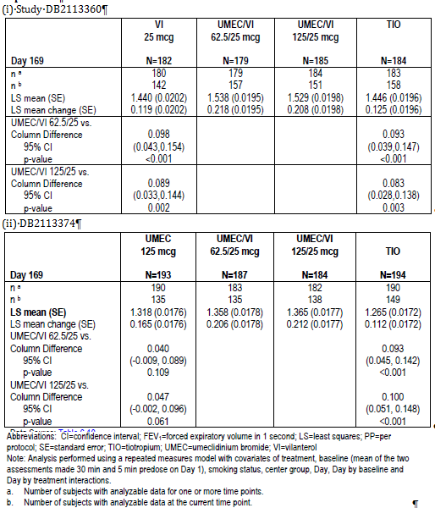
Figure 5. Studies DB2113361 and DB2113373. Least Squares Mean (95% CI) Treatment Differences in Change from Baseline in Trough FEV1 (L) at Day 169 Primary and Sensitivity Analyses (i) DB2113361 (ii) DB2113373.
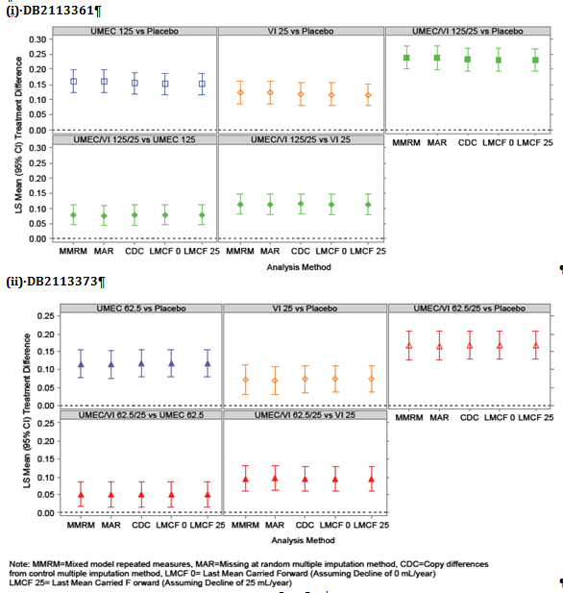

Secondary efficacy endpoints
The secondary efficacy endpoints were mean TDI focal score at Day 168, and weighted mean FEV1 over 0 to 6 hours post dose at Day 168. As previously discussed in Sections 7.1.1.4 and 7.1.1.8, in studies DB2113361 and DB2113373, the TDI focal score at Day 168 had been designated as a key secondary endpoint for submissions to the EMA, and was hence included in the testing hierarchy for primary and secondary efficacy endpoints. In contrast, the TDI score was designated as an “other efficacy endpoint” for submissions to the FDA, and hence was not included in the statistical testing hierarchy. Weighted mean FEV1 over 0 to 6 hours post-dose at Day 168 was designated as a secondary endpoint for evaluation by all regulatory authorities. Therefore, for EMA submission purposes, the statistical testing hierarchy was applied to trough FEV1, followed by TDI score at Day 168, and then weighted mean FEV1 over 0 to 6 hours post-dose at Day 168. For FDA submission purposes, the testing hierarchy was applied to trough FEV1 followed by weighted mean FEV1 over 0 to 6 hours post-dose at Day 168.
In study DB2113361, there was a statistically significant greater LSM TDI focal score (that is, improvement from baseline) at Day 168 compared to PLA for the UMEC/VI 125/25 µg group (difference of 1.0 over placebo, p < 0.001). However, the difference between the UMEC 125 µg treatment group and placebo group was not statistically significant (p = 0.108). Based on application of the statistical testing hierarchy, the results of all further statistical analyses could only be interpreted descriptively for EMA submission purposes. However, for FDA and other relevant submissions where TDI was not designated as a secondary endpoint, inferences could be drawn from the analyses of the secondary endpoint of weighted mean FEV1 over 0 to 6 hours post-dose at Day 168. With regards to the weighted mean FEV1 over 0 to 6 hours post-dose at Day 168, there were statistically significantly greater LSM changes from baseline in 0 to 6 hour weighted mean FEV1 at Day 168 compared to placebo for UMEC/VI 125/25 µg (difference of 287 mL over placebo, p < 0.001), UMEC 125 µg (difference of 178 mL over placebo, p < 0.001), and VI 25 µg (difference of 145 mL over placebo, p < 0.001). There were also statistically significantly greater LSM changes from baseline in 0 to 6 hour weighted mean FEV1 at Day 168 with UMEC/VI 125/25 µg compared with both VI 25 µg (difference of 142 mL over VI 25 µg, p < 0.001) and UMEC 125 µg (difference of 109 mL over UMEC 125 µg, p < 0.001).
In study DB2113373, there was a statistically significant greater LSM TDI focal score at Day 168 compared to placebo for UMEC/VI 62.5/25 µg (difference of 1.2 over placebo, p < 0.001), UMEC 62.5 µg (difference of 1.0 over placebo, p < 0.001) and VI 25 µg (difference of 0.9 over placebo, p < 0.001). However, there was no statistically significant difference between UMEC 62.5/25 µg and VI 25 µg (p = 0.117), and between UMEC 62.5/25 µg and UMEC 62.5 µg (p = 0.244). Based on application of the statistical testing hierarchy, the results of all further statistical analyses could only be interpreted descriptively for EMA submission purposes. However, for FDA and other relevant submissions where TDI was not designated as a secondary endpoint, inferences could be drawn from the analyses of the secondary endpoint of weighted mean FEV1 over 0 to 6 hours post dose at Day 168. With regards to the weighted mean FEV1 over 0 to 6 hours post-dose at Day 168, there were statistically significantly greater LSM changes from baseline in 0 to 6 hour weighted mean FEV1 at Day 168 compared to placebo for UMEC/VI 62.5/25 µg (difference of 242 mL over placebo, p < 0.001), UMEC 62.5 µg (difference of 150 mL over placebo, p < 0.001), and VI 25 µg (difference of 122 mL over placebo, p < 0.001). There were also statistically significantly greater LSM changes from baseline in 0 to 6 hour weighted mean FEV1 at Day 168 with UMEC/VI 62.5/25 µg compared with both VI 25 µg (difference of 120 mL over VI 25 µg, p < 0.001) and UMEC 62.5 µg (difference of 92 mL over UMEC 62.5 µg, p < 0.001).
A summary of the results of the step down or hierarchical testing procedure for the primary and secondary endpoints in studies DB2113361 and DB2113373 is presented in Table 8.

Table 8. Studies (i) DB2113361 ITT population and (ii) DB2113373 ITT population. Results of step down testing procedure and secondary endpoints.
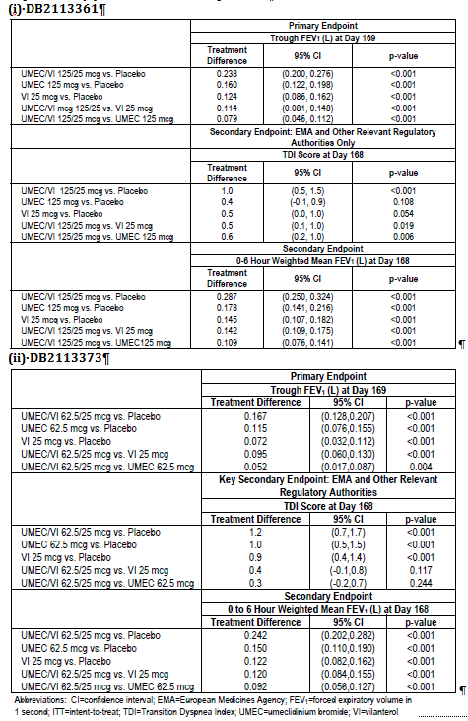

Other efficacy endpoints

Other efficacy endpoints relating to FEV1 and FVC
In study DB2113361, analysis of trough FEV1 at other time points (Days 2, 28, 56, 84, 112 and 168) showed that there were statistically significantly greater LSM changes from baseline in trough FEV1 compared to placebo for UMEC/VI 125/25 µg, UMEC 125 µg, and VI 25 µg at all assessed time points (Figure 6). There were also statistically significantly greater LSM changes from baseline in trough FEV1 with UMEC/VI 125/25 µg compared with both VI 25 µg and UMEC 125 µg at all assessed time points. In study DB2113373, analysis of trough FEV1 at other time points (Days 2, 28, 56, 84, 112 and 168) showed that there were statistically significantly greater LSM changes from baseline in trough FEV1 compared to placebo for UMEC/VI 62.5/25 µg, UMEC 62.5 µg, and VI 25 µg at all assessed time points (Figure 6). There were also statistically significantly greater LSM changes from baseline in trough FEV1 with UMEC/VI 62.5/25 µg compared with both VI 25 µg and UMEC 62.5 µg at all assessed time points, except for the comparison between UMEC/VI 62.5/25 µg and UMEC 62.5 µg at Day 112 (p = 0.076).
Figure 6. Individual studies DB2113361, DB2113373 ITT populations. Least squares mean (95% CI) change from baseline in trough FEV1(L).
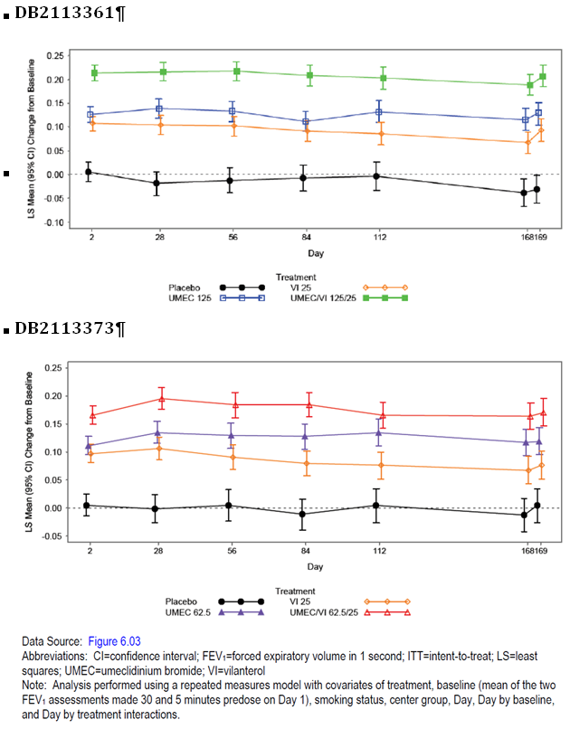
In study DB2113361, analysis of weighted mean FEV1 over 0 to 6 hours post-dose at other time points (Days 1, 28, 84) showed that there were statistically significantly greater LSM changes from baseline in 0 to 6 hour weighted mean FEV1 compared to placebo for UMEC/VI 125/25 µg, UMEC 125 µg, and VI 25 µg at all assessed time points (Figure 7). There were also statistically significantly greater LSM changes from baseline in trough FEV1 with UMEC/VI 125/25 µg compared with both VI 25 µg and UMEC 125 µg at all assessed time points. In study DB2113373, analysis of weighted mean FEV1 over 0 to 6 hours post-dose at other time points (Days 1, 28, 84) showed that there were statistically significantly greater LSM changes from baseline in 0 to 6 hour weighted mean FEV1 compared to placebo for UMEC/VI 62.5/25 µg, UMEC 62.5 µg, and VI 25 µg at all assessed time points (Figure 7). There were also statistically significantly greater LSM changes from baseline in trough FEV1 with UMEC/VI 62.5/25 µg compared with both VI 25 µg and UMEC 62.5 µg at all assessed time points.
Figure 7. Individual Studies DB2113361, DB2113373, ITT Populations. Least Squares Mean (95% CI) Change from Baseline in 0 to 6 hour Weighted Mean FEV1 (L).
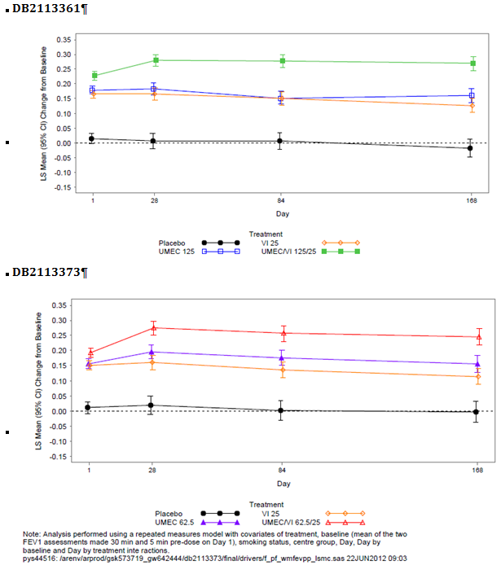
Analysis of time to onset (defined as an increase of 100 mL above baseline in FEV1) during 0 to 6 hours post-dose on Day 1 showed that in study DB2113361, the median time to onset was shorter in the UMEC/VI 125/25 µg and VI 25 µg treatment groups (22 and 27 minutes, respectively) compared with the UMEC 125 µg treatment group (34 minutes). In addition, analyses showed that subjects on UMEC/VI 125/25 µg, UMEC 125 µg, or VI 25 µg had a higher likelihood (5.8, 3.8 and 4.5 x higher likelihood, respectively; p < 0.001) of achieving an increase in FEV1 ≥ 100 mL above baseline at Day 1 compared with placebo. Subjects in the UMEC/VI 125/25 µg treatment group also had a higher likelihood of achieving an increase in FEV1 ≥ 100 mL above baseline at Day 1 compared with those in the VI 25 µg and UMEC 125 µg treatment groups (1.3 and 1.5 x higher likelihood, respectively; p < 0.001). In study DB2113373, the median time to onset was shorter in the UMEC/VI 62.5/25 µg and VI 25 µg treatment groups (27 and 31 minutes, respectively) compared with the UMEC 62.5 µg treatment group (56 minutes). In addition, analyses showed that subjects on UMEC/VI 62.5/25 µg, UMEC 62.5 µg, or VI 25 µg had a higher likelihood (4.7, 3.1 and 3.9 x higher likelihood, respectively; p < 0.001) of achieving an increase in FEV1 ≥ 100 mL above baseline at Day 1 compared with placebo. Subjects in the UMEC/VI 62.5/25 µg treatment group also had a higher likelihood of achieving an increase in FEV1 ≥ 100 mL above baseline at Day 1 compared with those in the VI 25 µg and UMEC 62.5 µg treatment groups (1.2 and 1.5 x higher likelihood, respectively; p ≤ 0.011).
In study DB2113361, the proportion of subjects achieving an increase in FEV1 of ≥ 12% and ≥ 200 mL above baseline at any time during 0 to 6 hours post dose on Day 1 was 71%, 54% and 52% in the UMEC/VI 125/25 µg, UMEC 125 µg, and VI 25 µg groups, respectively, compared with 12% in the placebo group. Subjects on UMEC/VI 125/25 µg, UMEC 125 µg, or VI 25 µg had higher odds (19.5, 9.3 and 8.4 x higher likelihood, respectively; p < 0.001) of achieving an increase in FEV1 of ≥ 12% and ≥ 200 mL above baseline at any time during 0 to 6 hours post-dose on Day 1 compared with placebo. Subjects in the UMEC/VI 125/25 µg treatment group also had a higher likelihood of achieving this endpoint compared with those in the VI 25 µg and UMEC 125 µg treatment groups (2.3 and 2.1 x higher likelihood, respectively; p < 0.001). In study DB2113373, the proportion of subjects achieving an increase in FEV1 of ≥ 12% and ≥ 200 mL above baseline at any time during 0 to 6 hours post-dose on Day 1 was 61%, 50% and 47% in the UMEC/VI 62.5/25 µg, UMEC 62.5 µg, and VI 25 µg groups, respectively, compared with 15% in the placebo group. Subjects on UMEC/VI 62.5/25 µg, UMEC 62.5 µg, or VI 25 µg had higher odds (9.0, 5.9 and 5.1 x higher likelihood, respectively; p < 0.001) of achieving an increase in FEV1 of ≥ 12% and ≥ 200 mL above baseline at any time during 0 to 6 hours post-dose on Day 1 compared with placebo. Subjects in the UMEC/VI 62.5/25 µg treatment group also had a higher likelihood of achieving this endpoint compared with those in the VI 25 µg and UMEC 62.5 µg treatment groups (1.7 and 1.5 x higher likelihood, respectively; p ≤ 0.003).
In study DB2113361, the proportion of subjects achieving an increase of ≥ 100 mL above baseline in trough FEV1 at Day 169 was 56%, 44% and 36% in the UMEC/VI 125/25 µg, UMEC 125 µg, and VI 25 µg groups, respectively, compared with 13% in the placebo group. Subjects on UMEC/VI 125/25 µg, UMEC 125 µg, or VI 25 µg had higher odds (9.1, 5.5 and 3.9 x higher likelihood, respectively; p < 0.001) of achieving an increase of ≥ 100 mL above baseline in trough FEV1 at Day 169 compared with placebo. Subjects in the UMEC/VI 125/25 µg treatment group also had a higher likelihood of achieving this endpoint compared with those in the VI 25 µg and UMEC 125 µg treatment groups (2.3 and 1.7 x higher likelihood, respectively; p < 0.001). In study DB2113373, the proportion of subjects achieving an increase of ≥ 100 mL above baseline in trough FEV1 at Day 169 was 49%, 43% and 35% in the UMEC/VI 62.5/25 µg, UMEC 62.5 µg, and VI 25 µg groups, respectively, compared with 19% in the placebo group. Subjects on UMEC/VI 62.5/25 µg, UMEC 62.5 µg, or VI 25 µg had higher odds (4.1, 3.2 and 2.3 x higher likelihood, respectively; p < 0.001) of achieving an increase of ≥ 100 mL above baseline in trough FEV1 at Day 169 compared with placebo. Subjects in the UMEC/VI 62.5/25 µg treatment group also had a higher likelihood of achieving this endpoint compared with those in the VI 25 µg treatment group (1.8 x higher likelihood; p < 0.001). Comparison between UMEC/VI 62.5/25 µg and UMEC 62.5 µg treatment groups yielded result that was not statistically significant (odds ratio of 1.3, p = 0.055).
In both studies, serial FEV1 at 15 and 30 minutes and 1, 3, 6, 23, and 24 hours after dosing on Days 1 and 168, and at 15 and 30 minutes and 1, 3, and 6 hours after dosing on Days 28 and 84 were evaluated. In study DB2113361 there were statistically significantly greater post-dose improvements in FEV1 from baseline compared to placebo for UMEC/VI 125/25 µg, UMEC 125 µg, and VI 25 µg across all assessed time points (Figures 8 to 11). There were also statistically significantly greater post-dose improvements in FEV1 from baseline with UMEC/VI 125/25 µg compared to VI 25 µg and to UMEC 125 µg across all assessed time points except at 15 minutes on Day 1 for the comparison between UMEC/VI 125/25 µg and UMEC 125 µg. In study DB2113373 there were statistically significantly greater post-dose improvements in FEV1 from baseline compared to PLA for UMEC/VI 62.5/25 µg, UMEC 62.5 µg, and VI 25 µg across all assessed time points (Figures 12 to 15). There were also statistically significantly greater post-dose improvements in FEV1 from baseline with UMEC/VI 62.5/25 µg compared to VI 25 µg and to UMEC 62.5 µg across all assessed time points except at 15 minutes, 30 minutes and 1 hour on Day 1 for the comparison between UMEC/VI 62.5/25 µg and VI 25 µg.
Figure 8. Study DB2113361. Least Squares Mean Change from Baseline in FEV1 (L) over Time at Day 1 (ITT Population).
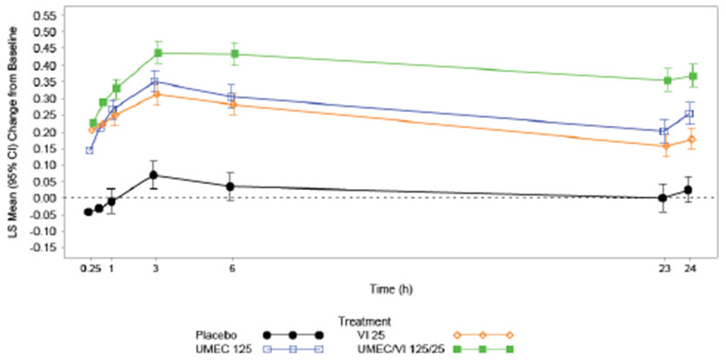
Figure 9. Study DB2113361. Least Squares Mean Change from Baseline in FEV1 (L) over Time at Day 28 (ITT Population).
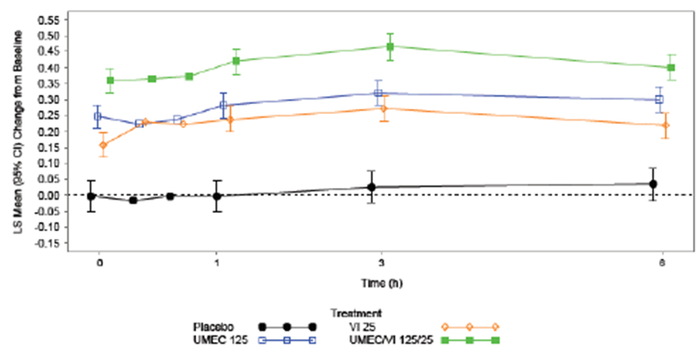
Figure 10. Study DB2113361. Least Squares Mean Change from Baseline in FEV1 (L) over Time at Day 84 (ITT Population).
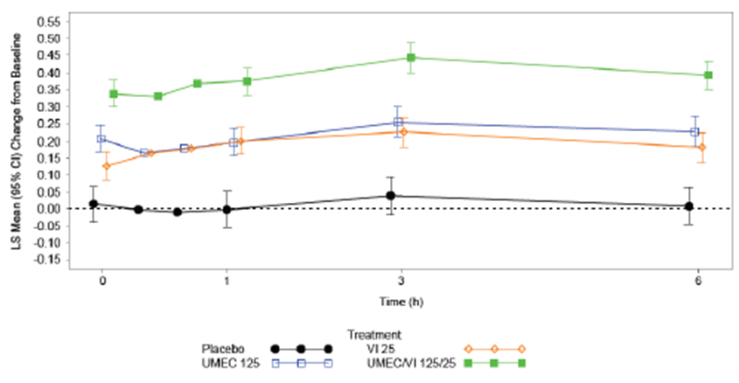
Figure 11. Study DB2113361. Least Squares Mean Change from Baseline in FEV1 (L) over Time at Day 168 (ITT Population).
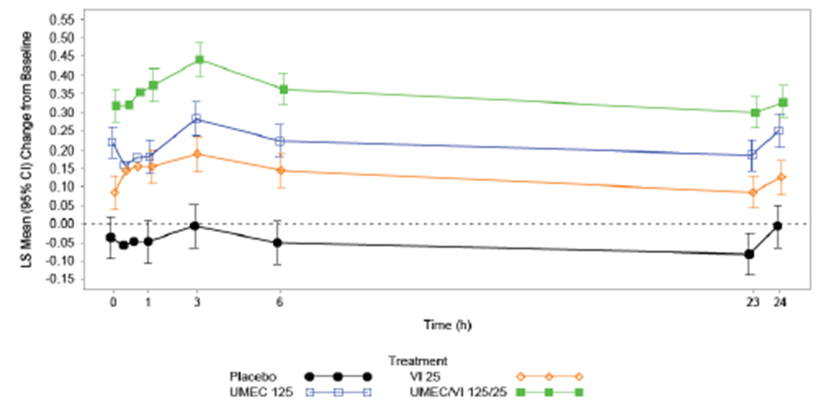
Figure 12. Least Squares Mean Change from Baseline in FEV1 (L) over Time at Day 1 (DB2113373 ITT Population).
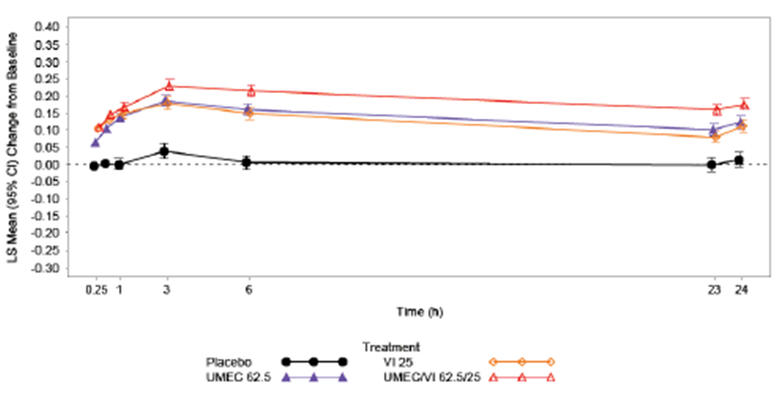
Figure 13. Least Squares Mean Change from Baseline in FEV1 (L) over Time at Day 28, (DB2113373 ITT Population).
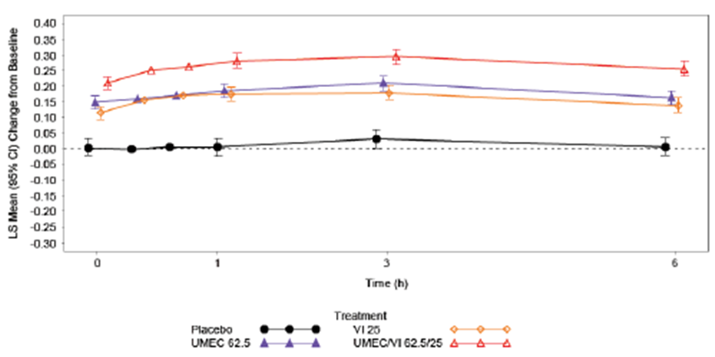
Figure 14. Least Squares Mean Change from Baseline in FEV1 (L) over Time at Day 84 (DB2113373 ITT Population).
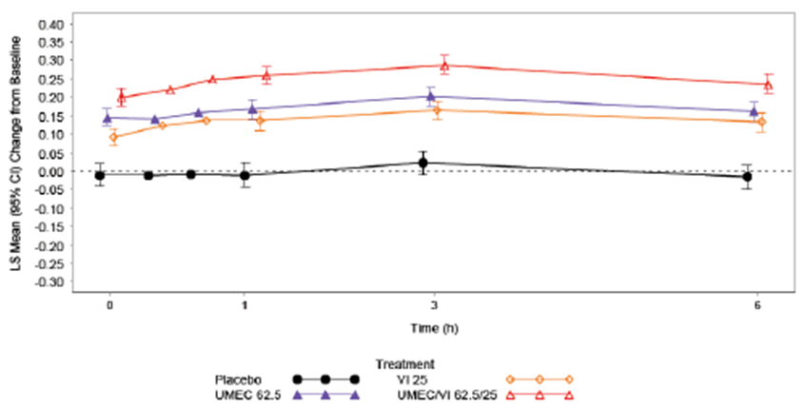
Figure 15. Least Squares Mean Change from Baseline in FEV1 (L) over Time at Day 168 (DB2113373 ITT Population).
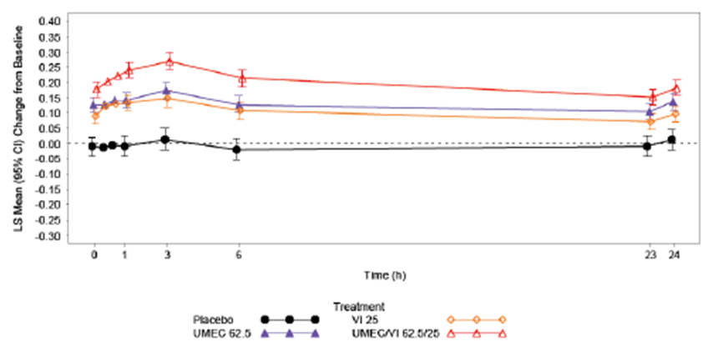
Analysis of peak FEV1 in study DB2113361 showed that there were statistically significantly greater LSM changes from baseline in peak FEV1 compared to placebo for UMEC/VI 125/25 µg, UMEC 125 µg, and VI 25 µg at assessed time points (Days 1, 28, 84, and 168). There were also statistically significantly greater LSM changes from baseline in peak FEV1 for UMEC/VI 125/25 µg compared to VI 25 µg and to UMEC 125 µg at these time points. Analysis of peak FEV1 in study DB2113373 showed that there were statistically significantly greater LSM changes from baseline in peak FEV1 compared to placebo for UMEC/VI 62.5/25 µg, UMEC 62.5 µg, and VI 25 µg at assessed time points (Days 1, 28, 84, and 168). There were also statistically significantly greater LSM changes from baseline in peak FEV1 for UMEC/VI 62.5/25 µg compared to VI 25 µg and to UMEC 62.5 µg at these time points.
Analysis of trough FVC in study DB2113361 showed that there were statistically significantly greater LSM changes from baseline in trough FVC compared to placebo for UMEC/VI 125/25 µg, UMEC 125 µg, and VI 25 µg at assessed time points (Days 2, 28, 56, 84, 112, 168, and 169). There were also statistically significantly greater LSM changes from baseline in trough FVC for UMEC/VI 125/25 µg compared to VI 25 µg and to UMEC 125 µg at these time points. Analysis of trough FVC in study DB2113373 showed that there were statistically significantly greater LSM changes from baseline in trough FVC compared to placebo for UMEC/VI 62.5/25 µg, UMEC 62.5 µg, and VI 25 µg at assessed time points (Days 2, 28, 56, 84, 112, 168, and 169). There were also statistically significantly greater LSM changes from baseline in trough FVC for UMEC/VI 62.5/25 µg compared to VI 25 µg and to UMEC 62.5 µg at these time points except at Day 112 for the comparison between UMEC/VI 62.5/25 µg and UMEC 62.5 µg.
In study DB2113361, analysis of weighted mean FEV1 over 0 to 24 hours post-dose in the Twenty-four Hour (TFH) Population showed that there were statistically significantly greater LSM changes from baseline in 0 to 24 hour weighted mean FEV1 compared to placebo for UMEC/VI 125/25 µg, UMEC 125 µg, and VI 25 µg at assessed time points (Days 1, 84, and168). There were also statistically significantly greater LSM changes from baseline in 0 to 24 hour weighted mean FEV1 for UMEC/VI 125/25 µg compared to VI 25 µg and to UMEC 125 µg at these time points. In study DB2113373, analysis of weighted mean FEV1 over 0 to 24 hours post-dose in the TFH population showed that there were statistically significantly greater LSM changes from baseline in 0 to 24 hour weighted mean FEV1 compared to placebo for UMEC/VI 62.5/25 µg, UMEC 62.5 µg, and VI 25 µg at assessed time points (Days 1, 84, and168) except at Day 168 for the comparison between VI 25 µg and placebo. There were statistically significantly greater LSM changes from baseline in 0 to 24 hour weighted mean FEV1 for UMEC/VI 62.5/25 µg compared to VI 25 µg and to UMEC 62.5 µg only at the time point of Day 84.
Serial FEV1 at Days 1, 84, and 168 in the TFH population was provided in the CER for study DB2113361 and study DB2113373. Analyses of serial FEV1 at Days 1, 84, and 168 in the TFH population in study DB2113361 showed that there were statistically significantly greater post-dose improvements in FEV1 from baseline compared to placebo for UMEC/VI 125/25 µg, UMEC 125 µg, and VI 25 µg at all assessed post-dose time points. Analyses of serial FEV1 at Days 1, 84, and 168 in the TFH population in study DB2113373 showed that there were statistically significantly greater post-dose improvements in FEV1 from baseline compared to placebo for UMEC/VI 62.5/25 µg, and for UMEC 62.5 µg at all assessed post-dose time points, except at 30 minutes post-dose on Day 168 for the comparison between UMEC 62.5 µg and placebo. There were statistically significantly greater post-dose improvements in FEV1 from baseline compared to placebo for VI 25 µg at all assessed post-dose time points, except at 21, 23 and 24 hours on Day 84, and 15 minutes, 30 minutes, and 1, 15, 23 and 24 hours on Day 168.

Other efficacy endpoints relating to symptomatic relief and health outcomes
In study DB2113361, analysis of TDI focal score at other time points (Days 28 and 84) showed that there were statistically significantly greater LSM TDI focal score (i.e. improvement from baseline) compared to placebo for UMEC/VI 125/25 µg, UMEC 125 µg, and VI 25 µg at Days 28 and 84. There were also statistically significantly greater LSM TDI focal score with UMEC/VI 125/25 µg compared with both VI 25 µg and UMEC 125 µg at Days 28 and 84. In study DB2113373, analysis of TDI focal score at other time points (Days 28 and 84) showed that there were statistically significantly greater LSM TDI focal score compared to placebo for UMEC/VI 62.5/25 µg, UMEC 62.5 µg, and VI 25 µg at Days 28 and 84. There was also statistically significantly greater LSM TDI focal score with UMEC/VI 62.5/25 µg compared with VI 25 µg at Day 28. Comparison between UMEC/VI 62.5/25 µg and UMEC 62.5 µg for this endpoint yielded results that were not statistically significant at Days 28 and 84, as was the comparison between UMEC/VI 62.5/25 µg and VI 25 µg at Day 84.
Analysis of the proportion of subjects responders to TDI (defined as a subject with a TDI score of 1 unit or more) showed that in study DB2113361, subjects on UMEC/VI 125/25 µg, UMEC 125 µg, or VI 25 µg had higher odds (2.5 to 3.7, 1.7 to 2.4, and 1.5 to 2.1 x higher likelihood, respectively; p ≤ 0.037) of being a TDI responder compared with placebo at Days 28, 84, and168. Subjects in the UMEC/VI 125/25 µg treatment group also had a higher odds of being a TDI responder compared with those in the VI 25 µg and UMEC 125 µg treatment groups (1.7 to 1.8, and 1.5 to1.6 x higher likelihood, respectively; p ≤ 0.01) at Days 28, 84, and168. In study DB2113373, subjects on UMEC/VI 62.5/25 µg, UMEC 62.5 µg, or VI 25 µg had higher odds (2.0 to 3.1, 1.6 to 2.3, and 1.5 to 2.2 x higher likelihood, respectively; p ≤ 0.013) of being a TDI responder compared with placebo at Days 28, 84, and168. Subjects in the UMEC/VI 62.5/25 µg treatment group also had higher odds of being a TDI responder compared with those in the VI 25 µg and UMEC 62.5 µg treatment groups (1.4 and 1.4 x higher likelihood, respectively; p ≤ 0.039) at Days 28, 84. Subjects in the UMEC/VI 62.5/25 µg treatment group had 1.4 x higher odds (p = 0.038) of being a TDI responder compared with those in the VI 25 µg treatment group at Day 168. The comparison of UMEC/VI 62.5/25 µg with UMEC 62.5 µg at Day 168 for this endpoint yielded result that was not statistically significant (p = 0.143).
Analyses of the mean number of puffs of rescue medication per day over Weeks 1 to 24 showed that in study DB2113361, there were statistically significantly greater reductions from baseline in LSM rescue salbutamol use over Weeks 1 to 24 for the UMEC/VI 125/25 µg, UMEC 125 µg, and VI 25 µg treatment groups compared with placebo (reduced by 1.5, 0.8, and 0.8 puffs per day, respectively, compared to placebo; p < 0.001). There were also statistically significantly greater reductions from baseline in LSM rescue salbutamol use over Weeks 1 to 24 for the UMEC/VI 125/25 µg treatment group compared with both the VI 25 µg and UMEC 125 µg treatment groups. In study DB2113373, there were statistically significantly greater reductions from baseline in LSM rescue salbutamol use over Weeks 1 to 24 for the UMEC/VI 62.5/25 µg and VI 25 µg treatment groups compared with placebo (reduced by 0.8 and 0.9 puffs per day, respectively, compared to placebo; p ≤ 0.001). Comparison of UMEC 62.5 µg with placebo for this endpoint yielded result that was not statistically significant. There was statistically significantly greater reduction from baseline in LSM rescue salbutamol use over Weeks 1 to 24 for the UMEC/VI 62.5/25 µg treatment group compared with the VI 25 µg treatment group. Comparison of UMEC/VI 62.5/25 µg with UMEC 62.5 µg for this endpoint yielded result that was not statistically significant.
Analyses of the percentage of rescue free days showed that in study DB2113361, the mean (SD) change from baseline at Weeks 1 through 24 in the percentage of rescue free days was 17.2% (39.93), 9.3% (34.74) and 11.1% (35.55) in the UMEC/VI 125/25 µg, UMEC 125 µg, and VI 25 µg groups, respectively, compared with 0.4% (31.65) in the placebo group. In study DB2113373, the mean (SD) change from baseline at Weeks 1 through 24 in the percentage of rescue-free days was 11.1% (33.55), 7.5% (35.07) and 13.0% (34.08) in the UMEC/VI 62.5/25 µg, UMEC 62.5 µg, and VI 25 µg groups, respectively, compared with -0.9% (33.26) in the placebo group (Table 9).

Table 9. Summary of Percentage of Rescue-free Days (i) DB2113361 ITT Population (ii) DB2113373 ITT Population
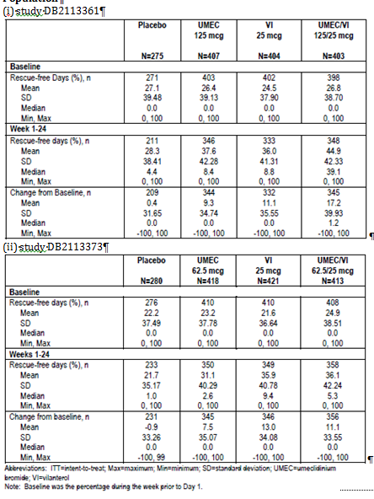
Analyses of the mean SOBDA score showed that in study DB2113361, there was statistically significantly greater LSM mean SOBDA score improvement from baseline with UMEC/VI 125/25 µg compared with placebo at Week 24 (difference over placebo of -0.15; p = 0.002). The comparison with placebo for UMEC 125 µg and VI 25 µg yielded results that were not statistically significant. There was statistically significantly greater LSM mean SOBDA score improvement from baseline with UMEC/VI 125/25 µg compared with VI 25 µg at Week 24, but the comparison between UMEC/VI 125/25 µg and UMEC 125 µg yielded results that were not statistically significant. LSM change from baseline in SOBDA score across time points in study DB2113361.). In study DB2113373, there were statistically significantly greater LSM mean SOBDA score improvement from baseline at Week 24 compared to placebo for UMEC/VI 62.5/25 µg, UMEC 62.5 µg and VI 25 µg (differences over placebo of -0.17, -0.10 and -0.14, respectively; p ≤ 0.043). Comparison of UMEC/VI 62.5/25 µg with VI 25 µg and with UMEC 62.5 µg yielded results that were not statistically significant. LSM change from baseline in SOBDA score across time points in study DB2113373.
Analysis of the proportion of responders to the SOBDA showed that in study DB2113361, using the responder threshold of -0.1, subjects on UMEC/VI 125/25 µg had 1.9 times higher likelihood of being a responder compared with placebo at Week 24 (34% in the UMEC/VI 125/25 µg group were responders versus 22% in the placebo group; p = 0.002). The comparison with placebo for UMEC 125 µg and VI 25 µg yielded results that were not statistically significant, as did the comparisons of UMEC/VI 125/25 µg with VI 25 µg and with UMEC 125 µg. Using the responder threshold of - 0.2, subjects on UMEC/VI 125/25 µg had 2.3 times higher likelihood of being a responder compared with placebo at Week 24 (34% in the UMEC/VI 125/25 µg group were responders versus 16% in the placebo group; p < 0.001). Subjects on UMEC 25 µg had 1.6 times higher likelihood of being a responder compared with placebo at Week 24 (23% vs. 16%; p = 0.033). The comparison between placebo and VI 25 µg yielded results that were not statistically significant. Subjects on UMEC/VI 125/25 µg had 1.5 times higher likelihood of being a responder compared with VI 25 µg at Week 24 (28% vs. 23%; p = 0.032), but the comparison between UMEC/VI 125/25 µg and UMEC 125 µg yielded result that was not statistically significant. In study DB2113373, using the responder threshold of -0.1, compared to placebo, subjects on UMEC/VI 62.5/25 µg, UMEC 62.5 µg and VI 25 µg had 1.8, 1.7 and 1.6 times higher likelihood, respectively, of being a responder at Week 24 (percentage of responders of 32%, 30% and 29% in the UMEC/VI 62.5/25 µg, UMEC 62.5 µg and VI 25 µg groups, respectively, versus 21% in the placebo group; p ≤ 0.02). The comparisons of UMEC/VI 62.5/25 µg with VI 25 µg and with UMEC 62.5 µg yielded results that were not statistically significant. Using the responder threshold of -0.2, compared to placebo, subjects on UMEC/VI 62.5/25 µg, UMEC 62.5 µg and VI 25 µg had 2.1, 1.8 and 1.9 times higher likelihood, respectively, of being a responder at Week 24 (percentage of responders of 28%, 24% and 26% in the UMEC/VI 62.5/25 µg, UMEC 62.5 µg and VI 25 µg groups, respectively, versus 16% in the placebo group; p ≤ 0.007). The comparisons of UMEC/VI 62.5/25 µg with VI 25 µg and with UMEC 62.5 µg yielded results that were not statistically significant.
In study DB2113361, the proportion of subjects with on-treatment COPD exacerbations was lower in the UMEC/VI 125/25 µg, UMEC 125 µg and VI 25 µg groups (6%, 8% and 8%, respectively) compared to in the placebo group (14%). Results of the analysis of time to first on-treatment COPD exacerbation showed that there was a lower risk of a COPD exacerbation with UMEC/VI 125/25 µg, UMEC 125 µg and VI 25 µg compared with placebo (hazard ratios of 0.4 (p < 0.001), 0.5 (p = 0.004) and 0.5 (p = 0.006), respectively). The comparisons of UMEC/VI 125/25 µg with VI 25 µg and with UMEC 125 µg yielded results that were not statistically significant. In study DB2113373, the proportion of subjects with on-treatment COPD exacerbations was lower in the UMEC/VI 62.5/25 µg, UMEC 62.5 µg and VI 25 µg groups (7%, 8% and 9%, respectively) compared to in the placebo group (13%). Results of the analysis of time to first on-treatment COPD exacerbation showed that there was a lower risk of a COPD exacerbation with UMEC/VI 62.5/25 µg and UMEC 62.5 µg compared with placebo (hazard ratios of 0.5 (p = 0.004), and 0.6 (p = 0.035), respectively). The comparisons of VI 25 µg with placebo, and of UMEC/VI 62.5/25 µg with VI 25 µg and with UMEC 62.5 µg yielded results that were not statistically significant.
Analysis of the SGRQ total score showed that in study DB2113361, there were statistically significant reductions from baseline (i.e. improvement) in SGRQ total score at Day 168 with UMEC/VI 125/25 µg compared to placebo, and compared to VI 25 µg and UMEC 125 µg alone (Figure 16). The treatment differences between UMEC 125 µg or VI 25 µg alone and PLA were not statistically significant at Day 168. In study DB2113373, there were statistically significant reductions from baseline (that is, improvement) in SGRQ total score at Day 168 with UMEC/VI 62.5/25 µg, UMEC 62.5 µg and VI 25 µg when compared to placebo. The treatment differences between UMEC 125 µg or VI 25 µg alone and UMEC/VI 62.5/25 µg were not statistically significant at Day 168.
Figure 16. Least Squares Mean Change from Baseline in SGRQ Total Score (i) DB2113361 ITT Population (ii) DB2113373 ITT Population.
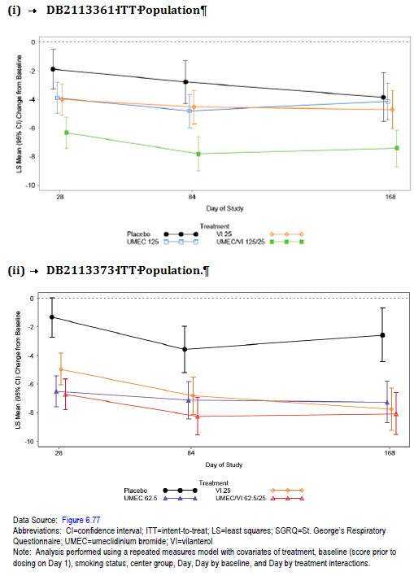
Analysis of the proportion of SGRQ responders (defined as having a SGRQ total score of 4 units below baseline (score on Day 1) or lower) at Day 168 showed that in study DB2113361, subjects on UMEC/VI 125/25 µg had 1.7 times higher likelihood of being a responder compared with placebo (49% in the UMEC/VI 125/25 µg group were responders vs. 37% in the placebo group; p = 0.002). The treatment differences between UMEC 125 µg or VI 25 µg alone and placebo were not statistically significant. In study DB2113373, subjects on UMEC/VI 62.5/25 µg, UMEC 62.5 µg and VI 25 µg had 2.0, 1.6 and 1.9 times higher likelihood of being a responder, respectively, compared with placebo (49%, 44% and 48% in the UMEC/VI 62.5/25 µg, UMEC 62.5 µg and VI 25 µg groups were responders, respectively, vs. 34% in the placebo group; p ≤ 0.003).
Descriptive summary of the changes from baseline in the SGRQ symptoms, activity, and impacts domain scores at Day 168 in studies DB2113361 and DB2113373 is presented in Table 10, showing numerically greater reductions from baseline (i.e. improvement) in these SGRQ component scores with UMEC/VI 125/25 µg compared with placebo, and with UMEC/VI 62.5/25 µg compared with placebo.

Table 10. Summary of SGRQ Symptoms, Activity, and Impact Domain Scores at Day 168 (i) DB2113361 ITT Population (ii) DB2113373 ITT Population.
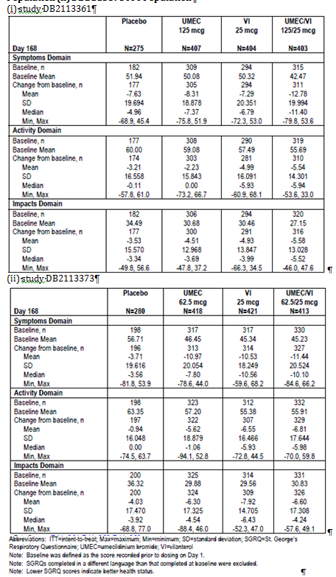
Analysis of healthcare resource utilisation in studies DB2113361 and DB2113373 yielded results that were comparable across all treatment groups. In study DB2113361, 30%, 29% and 35% of subjects in the UMEC/VI 125/25 µg, UMEC 125 µg and VI 25 µg groups, respectively, reported contact with a healthcare provider on any day during the study, compared with 30% in the placebo group. The proportions of subjects who reported unscheduled healthcare utilisation were 4%, 5% and 6% in the UMEC/VI 125/25 µg, UMEC 125 µg and VI 25 µg groups, respectively, compared to 7% in the placebo group. In study DB2113373, 31%, 35% and 32% of subjects in the UMEC/VI 62.5/25 µg, UMEC 62.5 µg and VI 25 µg groups, respectively, reported contact with a healthcare provider on any day during the study, compared with 36% in the placebo group. The proportions of subjects who reported unscheduled healthcare utilisation were 2%, 5% and 5% in the UMEC/VI 62.5/25 µg, UMEC 62.5 µg and VI 25 µg groups, respectively, compared to 5% in the placebo group.

Studies DB2113360 and DB2113374, and meta-analysis (report DB2116844)

Study design, objectives, locations and dates
Both studies DB2113360 and DB2113374 were multi-centre, randomised, double-blind, double-dummy, active-controlled, parallel group studies evaluating the efficacy and safety of 2 doses of UMEC/VI (125/25 µg and 62.5/25 µg once daily; administered via an NDPI) compared with tiotropium (TIO; 18 µg administered once daily administered via HandiHaler), and with either VI 25 µg (once daily via an NDPI; study DB2113360) or with UMEC 125 µg (once daily via an NDPI; study DB2113374) over a treatment period of 24 weeks in subjects with COPD. The primary objective of both studies was to compare the efficacy of UMEC/VI (125/25 µg and 62.5/25 µg once daily) with tiotropium (18 µg once daily) and with either with VI (25 µg once daily; study DB2113360) or UMEC (125 µg once daily, study DB2113374) over 24 weeks in subjects with COPD.
Studies DB2113360 and DB2113374 were multi centre studies where subjects were enrolled in a total of 91 study sites across 9 countries and 95 study sites across 10 countries, respectively. The study start and end dates of study DB2113360 were 21 March 2011 and 24 April 2012, respectively, and those of study DB2113374 were 21 March 2011 and 10 April 2012, respectively.
Subjects who met the eligibility criteria at screening (Visit 1) completed a 7- to 10- day Run-in Period followed by a 24-week Treatment Period (Figure 17). Randomisation was conducted on Visit 2 (Day 1). Additional clinic visits were scheduled at Day 2, and after 28, 56, 84, 112 and 168 days of treatment and 1 day after the Week 24 Visit (Treatment Day 169). A safety follow-up assessment was conducted approximately 7 days after Visit 9 or the Early Withdrawal Visit. The total duration of subject participation, including follow-up, was approximately 26 weeks.
Figure 17. Studies DB2113360 and DB2113374 schematics
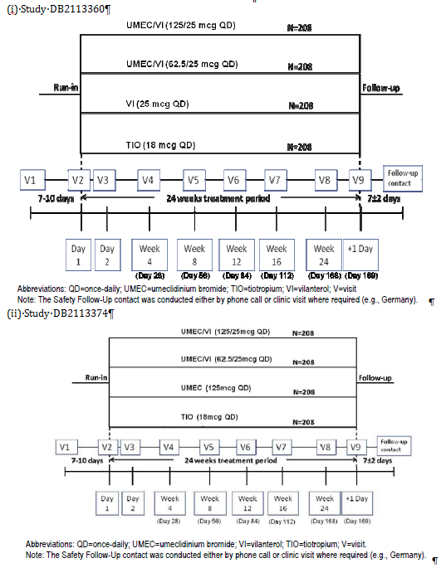

Inclusion and exclusion criteria
Study inclusion and exclusion criteria and randomisation criteria were the same as for studies DB2113361 and DB2113373.

Study treatments
In Study DB2113360, the study treatment groups were UMEC/VI 125/25 µg, UMEC/VI 62.5/25 µg, VI 25 µg, and TIO (randomised in a 1:1:1:1 ratio) all to be administered once daily in the morning using an NDPI (for UMEC/VI and VI) or HandiHaler (for TIO). In Study DB2113373, the study treatment groups were UMEC/VI 125/25 µg, UMEC/VI 62.5/25 µg, UMEC 125 µg, and TIO (randomised in a 1:1:1:1 ratio) all to be administered once daily in the morning using an NDPI (for UMEC/VI, UMEC) or HandiHaler (for TIO). The treatment duration in both studies was 24 weeks. As the studies were of double-dummy design, each subject received 2 inhalers, a pre-loaded NDPI and a HandiHaler dry powder inhaler with capsules, for once-daily administration of 1 active treatment and 1 placebo treatment for 24 weeks.
During both studies, salbutamol was provided for use as rescue medication throughout the Run-in and Treatment Periods. Concurrent use of systemic corticosteroids or long-acting bronchodilators, including theophyllines, was not allowed. Concurrent use of ICS at a stable dose of ≤ 1000 µg/day of fluticasone propionate or equivalent was permitted provided the dose of ICS remained consistent throughout the study. Permitted and prohibited concomitant medications in studies DB2113360 and DB2113374 were the same as those for studies DB2113361 and DB2113373.
Evaluator’s comments: The study dose selection is appropriate and has been previously discussed in this evaluation report (Section 6). The study design involving an active control is appropriate and consistent with the recommendation of the EMA guidelines on clinical investigation of medicinal products in the treatment of COPD. The provision of a short-acting beta₂-agonist as rescue medication and the permitted concomitant medications are in general keeping with both FDA and EMA guidelines. The study design evaluating the efficacy and safety of the combination product as well as the individual components is consistent with the EMA guidelines “Note for Guidance on Fixed Dose Combination Medicinal Products”. The choice of active control of f tiotropium 18 µg QD is appropriate, given that there are currently no LAMA/LABA combination products approved for the treatment of COPD, nor established combined regimens of LAMA and LABA monotherapies. Tiotropium is a LAMA and is registered in Australia as Spiriva, indicated “for the long term maintenance treatment of bronchospasm and dyspnoea associated with COPD”, and “for the prevention of COPD exacerbations”. It is currently accepted as part of standard treatment regimen for COPD. The dose of tiotropium in the study is the recommended therapeutic dose in clinical practice.

Efficacy variables and outcomes
The primary efficacy endpoint was the trough FEV1 on Day 169. This was defined as the mean of the FEV1 values obtained 23 and 24 hours after dosing on Day 168 (that is, at the Week 24 Visit). The secondary efficacy endpoint was the weighted mean FEV1 over 0 to 6 hours post-dose at Day 168.
Other efficacy endpoints were the same as “other efficacy endpoints” in studies DB2113361 and DB2113373, and have been previously described in Section 7.1.1.4, except that there were no 24-hour population subsets in studies DB2113360 and DB2113374, and hence no endpoints relating to this subset. In addition, in studies DB2113360 and DB2113374, other efficacy endpoints included morning peak expiratory flow rate (PEFR), and subject device preference. Health outcomes were assessed using the SGRQ, evaluation of healthcare resource utilisation, the EuroQol-5D (EQ-5D) health outcome assessment, and the COPD Assessment Test (CAT). Pulmonary function tests and assessments of endpoints were performed according to the schedule provided.
The primary objective of the meta-analysis of studies DB2113360 and DB2113374 was to assess the effect on dyspnoea (as measured by TDI focal score) of UMEC/VI 125/25 µg and 62.5/25 µg, UMEC 125 µg, VI 25 µg and TIO 18 µg in subjects with COPD using pooled data from studies DB2113360 and DB2113374. The primary endpoint for this meta-analysis was the TDI focal score at Day 168. Other efficacy endpoints were TDI focal score at Days 28 and 84 and the proportion of responders according to TDI at Days 28, 84 and 168. Responders were defined as subjects who had at least a l-unit TDI focal score.
Evaluator’s comments: Overall, the primary and secondary endpoints of this study are appropriate and consistent with the recommendations in the EMA guidelines on clinical investigation of medicinal products in the treatment of chronic obstructive pulmonary disease, as well as the FDA Guidance for Industry- Chronic Obstructive Pulmonary Disease: Developing Drugs for Treatment, which recommended endpoints evaluating FEV1, symptom relief, or effect on exacerbations of COPD. The study primary and secondary endpoints allowed evaluations of the post-dose bronchodilatory effect of UMEC/VI and its components after 24 weeks of treatment (FEV1 over 0 to 6 hours post-dose at Day 168), and at the end of the 24-hour dosing interval after 24 weeks of treatment (trough FEV1 on Day 169). Other efficacy endpoints allowed further characterisation of the bronchodilatory effect of UMEC/VI and its components across 24 weeks and effects on symptom relief and health outcomes. The study duration of 24 weeks to support the proposed indication of a long term once daily maintenance bronchodilator treatment in COPD is consistent with both the EMA and FDA guidelines. This has been discussed in Section 7.1.1.4.

Randomisation and blinding methods
Following the completion of the Run-in Period, eligible subjects were randomised in a 1:1:1:1 ratio to one of 4 treatment groups: UMEC/VI 125/25 µg, UMEC/VI 62.5/25 µg, VI 25 µg, or TIO 18 µg in study DB2113360, or UMEC/VI 125/25 µg, UMEC/VI 62.5/25 µg, UMEC 125 µg, or TIO 18 µg in study DB2113374. Subjects were randomised using an IVRS. Subjects were assigned to study treatment in accordance with a randomisation schedule, and the randomisation codes were generated by the sponsor using a validated computerised system RandAll version 2.5. Both studies had a double-blind study design. The sponsor generated the randomisation schedule, and prepared and coded the study drug in a blinded fashion.

Analysis populations
In both studies, 4 subject populations had been pre-specified: the All Subjects Enrolled (ASE) population, the Screen and Run-in Failure (SRF) population, the Intent-to-treat (ITT) population, and the Per Protocol (PP) population. The definitions and pre-specified usages of these analysis populations were the same as for studies DB2113361 and DB2113373, and have been previously described in Section 7.1.1.6. In study DB2113360, an additional analysis population, called “the ITT (Excluding Investigator X) population” was defined during the conduct of the study, prior to unblinding. The sponsor had stated that significant deviations from Good Clinical Practice (GCP) for Investigator X were identified by the sponsor, and hence the decision was taken to exclude efficacy and health outcome data from this investigator from all efficacy and health outcomes summaries and analyses. This population comprised of all subjects randomised to treatment who received at least one dose of randomised study drug in the treatment period, except for those from Investigator X. In study DB2113360, this was used as the primary analysis population for all efficacy and health outcomes data analyses.
Evaluator’s comments: The definitions of the analysis populations are in keeping with the TGA-adopted ICH E 9 Statistical Principles for Clinical Studies. Although the ITT population excluded subject who took no study drug, the intent-to-treat principle would be preserved as the study was double-blind, and the initial decision by subjects of whether or not to begin treatment would not be influenced by knowledge of the assigned treatment, and hence the exclusion of these subjects is not deemed to have introduced any potential bias. In study DB2113360, the decision to exclude the data from Investigator X for the efficacy analyses occurred before unblinding, and is not likely to introduce any potential bias to the efficacy results.

Sample size
The sample size estimation aimed to provide sufficient power for the comparison of the primary endpoint, and also for the comparisons of TDI score for UMEC/VI and TIO in the meta-analysis of data from studies DB2113360 and DB2113374. The sample size calculations used a two-sided 5% significance level and an estimate of residual standard deviations (SD) for trough FEV1 of 210 mL. The estimate of SD for trough FEV1 was based on MMRM analyses of previous studies in COPD subjects with UMEC, VI, and the FP/salmeterol combination. It was estimated that a study with 94 evaluable subjects in each arm would have 90% power to detect a 100 mL difference between treatments in trough FEV1.
For the meta-analysis of TDI, the sample size calculations used a two-sided 5% significance level and an estimate of residual SD for TDI of 3.24 units. The estimate of SD for TDI was based on MMRM analyses of a previous study in COPD subjects with the FP/salmeterol combination. It was estimated that a study with 221 evaluable subjects in each combined arm would have 90% power to detect a 1-unit difference between treatments in TDI.In order to achieve this, a sample size of 111 evaluable subjects per arm per study were required.
The sponsor had stated that the planned number of evaluable subjects in each arm was increased to 146, in order to meet ICH guidelines on exposure to new medicinal products (E1A). A study with 146 evaluable subjects per treatment arm would provide 98% power to detect a 100 mL difference in trough FEV1 between treatment groups and 96% power to detect a difference of 1 unit in TDI in the meta-analysis using the assumptions above.
In addition, it was estimated that approximately 30% of subjects would withdraw without providing a Week 24 assessment. To account for this 30% withdrawal rate, 208 subjects were needed to be randomised to each treatment arm.
Evaluator’s comments: The sponsor had stated that the planned number of evaluable subjects in each arm was increased from the calculated 111 to 146 subjects, in order to meet ICH E1A guidelines on exposure to new medicinal products. This referenced guidance document was looked through, but it remains unclear to the evaluator how the exact number of 146 subjects per treatment arm was derived. The arrival at this number was not further elaborated in the CSR, protocols or statistical plans. This will be raised as a clinical question to the sponsor in Section 11.

Statistical methods
The primary endpoint of trough FEV1 on Day 169 was analysed for the ITT population in study DB2113374, and in the ITT population (excluding Investigator X) in study DB2113360, using a MMRM analysis, including covariates of baseline FEV1, smoking status, day, centre group, treatment, day by baseline interaction, and day by treatment interaction, where day was nominal. The model used all available trough FEV1 values recorded on Days 2, 28, 56, 84, 112, 168, and 169.
Missing data were not directly imputed in this primary analysis, but all non-missing data for a subject were used within the analysis to estimate the treatment effect for trough FEV1 on Day 169. Additional sensitivity analyses were conducted for the primary endpoint using different imputation methods: missing at random multiple, copy differences from control, Last Mean Carried Forward (LMCF) assuming decline of 0 mL/year, and LMCF assuming decline of 25 mL/year.
Treatment comparisons performed on the primary and secondary endpoints were UMEC/VI 125/25 µg vs. TIO, UMEC/VI 125/25 µg vs. VI 25 µg, UMEC/VI 62.5/25 µg vs. TIO, and UMEC/VI 62.5/25 µg vs. VI 25 µg in study DB2113360, and UMEC/VI 125/25 µg vs. TIO, UMEC/VI 125/25 µg vs. UMEC 125 µg, UMEC/VI 62.5/25 µg vs. TIO, and UMEC/VI 62.5/25 µg vs. UMEC 125 µg in study DB2113374. In order to account for multiplicity across treatment comparisons and endpoints, a step-down closed testing procedure was applied, whereby inference for a test in the pre-defined hierarchy was dependent upon statistical significance having been achieved for previous tests in the hierarchy. In study DB2113360, the hierarchy consisted of the treatment comparisons for UMEC/VI 125/25 µg vs. TIO, then UMEC/VI 125/25 µg vs. VI 25 µg, performed in this order for the primary (trough FEV1 on Day 169) and then secondary (weighted mean FEV1 over 0 to 6 hours at Week 24) efficacy endpoints, followed by comparisons on the same endpoints in the same order for UMEC/VI 62.5/2 µg vs. TIO, then UMEC/VI 62.5/25 µg vs. VI 25 µg. In study DB2113374, the hierarchy consisted of the treatment comparisons for UMEC/VI 125/25 µg vs. TIO, then UMEC/VI 125/25 µg vs. UMEC 125 µg, performed in this order for the primary and then secondary efficacy endpoints, followed by comparisons on the same endpoints in the same order for UMEC/VI 62.5/2 µg vs. TIO, then UMEC/VI 62.5/25 µg vs. UMEC 125 µg.
In the meta-analysis, the primary comparisons of interest were between each dose of UMEC/VI and TIO on the TDI focal score at Day 168. For each UMEC/VI dose, statistical inference could be drawn only if the comparison of that dose with TIO on the individual study primary endpoint of trough FEV1 on Day 169 was statistically significant in each individual study, as determined by the specific testing hierarchy within each study. Other comparisons of interest for the TDI focal score at Day 168 in the meta-analysis were UMEC/VI 125/25 µg vs. VI 25 µg, UMEC/VI 125/25 µg vs. UMEC 125 µg, UMEC/VI 62.5/25 µg vs. VI 25 µg, and UMEC/VI 62.5/25 µg vs. UMEC 125 µg. The primary and other comparisons were also to be performed on the other endpoints (TDI focal score at Days 28 and 84; proportion of responders according to TDI at Days 28, 84 and 168). No adjustment for multiplicity was to be made for these comparisons.

Participant flow
In study DB2113360, out of a total of 1141 subjects screened, 846 subjects were randomised: 209, 212, 214, and 208 in the VI 25 µg, UMEC/VI 62.5/25 µg, UMEC/VI 125/25 µg and TIO 18 µg groups, respectively (see Figure 18, below).
Figure 18. Study DB2113360 Flow chart of participant flow.
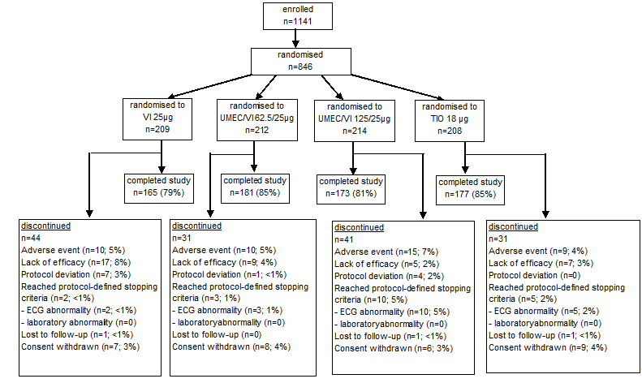
In study DB2113374, out of a total of 1191 subjects screened, 872 subjects were randomised: 222, 217, 215 and 215 in the UMEC 125 µg, UMEC/VI 62.5/25 µg, UMEC/VI 125/25 µg and TIO 18 µg groups, respectively (see Figure 19, below).
Figure 19. Study DB2113374. Flow chart of participant flow.
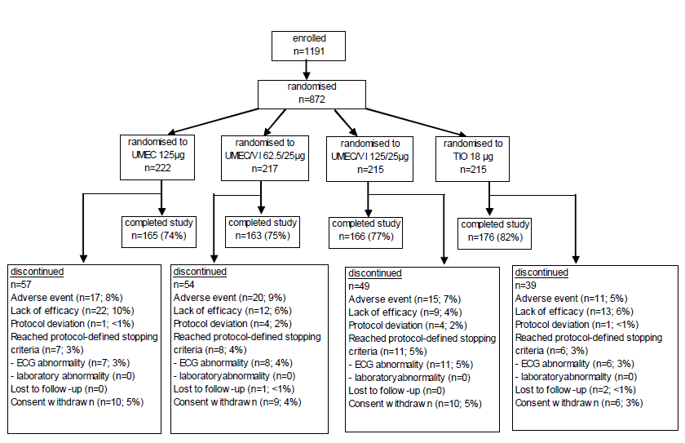

Major protocol violations/deviations
In study DB2113360, in the ITT (excluding Investigator X) Population, a total of 93 (11%) subjects had at least 1 full protocol deviation (11% (23/205), 14% (28/207), 11% (23/208) and 9% (19/203) in the VI 25 µg, UMEC/VI 62.5/25 µg, UMEC/VI 125/25 µg and TIO 18 µg groups, respectively).The overall most commonly reported full protocol deviation was " use of prohibited medication(s)" (6% (13/205), 5% (10/207), 5% (11/208) and 4% (9/203), respectively).
In study DB2113374, in the ITT population, a total of 111 (13%) subjects had at least 1 full protocol deviation (13% (29/222), 14% (30/217), 14% (31/215) and 10% (21/215) in the UMEC 125 µg, UMEC/VI 62.5/25 µg, UMEC/VI 125/25 µg and TIO 18 µg groups, respectively). The overall most commonly reported full protocol deviation was "use of prohibited medication(s)" (9% (21/222), 8% (18/217), 10% (21/215) and 7% (14/215), respectively).
Subject compliance with double-blind study drug was assessed at Visits 4 through 8. Compliance with the NDPI was determined by reviewing the dose counter on the NDPI. Compliance with the study HandiHaler was determined by counting the number of inhalation capsules remaining. Treatment compliance was high and comparable across the treatment groups in both study DB2113360 (mean compliance of 97.8% to 104.5% across treatment groups) and study DB2113374 (mean compliance of 98.0% to 98.9% across treatment groups).

Baseline data
In study DB2113360, the baseline demographic characteristics were comparable among treatment groups. The majority of subjects in each treatment group were male (67% to 71%) and White (84% to 88%). The mean age was 62.6 to 63.2 years. Baseline mean BMI was similar among treatment groups (mean BMI of 26.51 to 27.56), as was the mean smoking history (mean of 41.6 to 44.8 pack years). The baseline disease characteristics were also comparable among treatment groups, as were concomitant pre-treatment and on-treatment COPD medications.
In Study DB2113374, the baseline demographic characteristics were comparable among treatment groups. The majority of subjects in each treatment group were male (67% to 71%) and White (74% to 77%). The mean age was 63.8 to 65.2 years. Baseline mean BMI was similar among treatment groups (mean BMI of 26.43 to 26.72), as was the mean smoking history (mean of 46.9 to 54.0 pack years, respectively). The baseline disease characteristics were also comparable among treatment groups, as were concomitant pre-treatment and on-treatment COPD medications.
Evaluator’s comments: Overall, the baseline demographic and disease characteristics were comparable among treatment groups in each study. The study populations in these studies were reflective of the target patient population, with mean (SD) age of 62.9 (9.00) years and 64.6 (8.44) years in studies DB2113360 and DB2113374, respectively, mean (SD) smoking pack years of 43.0 (25.63) and 49.1 (27.76), respectively, and with 89% and 87% of the respective study populations in GOLD grades II and III of COPD (representing moderate and severe COPD, respectively). The baseline demographic and disease characteristics were also generally comparable between studies. Given this and that the study design of the 2 studies were identical except that UMEC 125 µg was investigated in study DB2113374 instead of the VI 25 µg in study DB2113360, meta-analysis using pooled data from the 2 studies is considered acceptable.

Results for the primary efficacy outcome
The primary efficacy endpoint was the trough FEV1 at Day 169. In study DB2113360, there were statistically significantly greater LSM changes from baseline in trough FEV1 at Day 169 for UMEC/VI 125/25 µg compared with both TIO (difference of 88 mL over TIO, p < 0.001), and VI 25 µg (difference of 88 mL over VI 25 µg, p < 0.001) (Table 11). There were also statistically significantly greater LSM changes from baseline in trough FEV1 at Day 169 for UMEC/VI 62.5/25 µg compared with both TIO (difference of 90 mL over TIO, p < 0.001) and VI 25 µg (difference of 90 mL over VI 25 µg, p < 0.001).

Table 11. Primary Efficacy Analysis: Trough FEV1 (L) at Day 169 (DB2113360 ITT Population Excluding Investigator X).
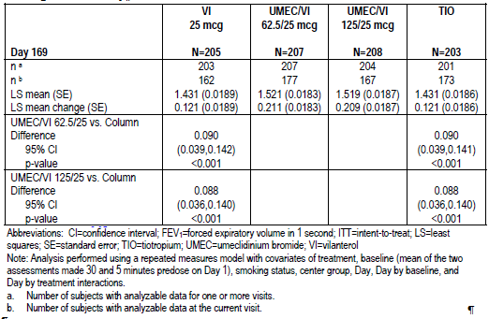
In study DB2113374, there were also statistically significantly greater LSM changes from baseline in trough FEV1 at Day 169 for UMEC/VI 125/25 µg compared with TIO (difference of 74 ml over TIO, p = 0.003) (Table 12). However, the treatment difference for this endpoint between UMEC/VI 125/25 µg and UMEC 125 µg was not statistically significant (p = 0.142). Based on application of the statistical testing hierarchy (described in Section 7.1.2.8), the results of all further statistical analyses could only be interpreted descriptively. A summary of the results of the step-down or hierarchical testing procedure for the primary and secondary endpoints in studies DB2113360 and DB2113374 is presented in Table 13.

Table 12. Primary Efficacy Analysis: Trough FEV1 (L) at Day 169 (DB2113374 ITT Population).
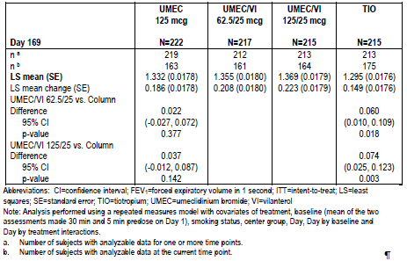

Table 13. Results of Step-down Testing Procedure for the Primary and Secondary Endpoints (i) DB2113360 ITT Population Excluding Investigator X (ii) DB2113374 ITT Population.
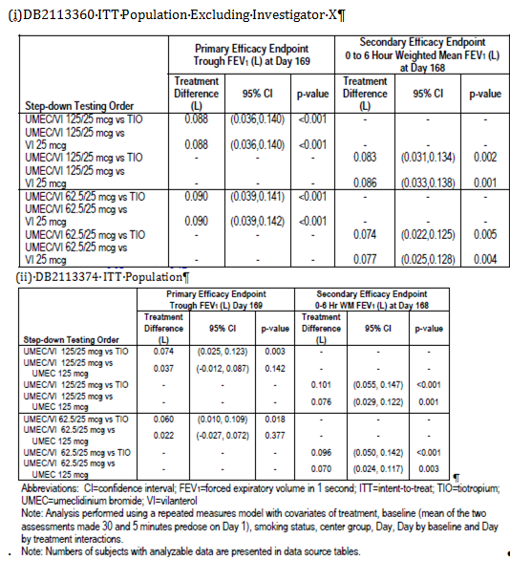

Results for other efficacy outcomes

Other supportive analyses on the primary efficacy endpoint
The results of the Per-Protocol analyses of trough FEV1 at Day 169 were supportive of the primary analyses in both studies DB2113360 and DB2113374. Sensitivity analyses were also conducted for trough FEV1 at Day 169 using different imputation methods (missing at random multiple (MAR), copy differences from control (CDC), Last Mean Carried Forward (LMCF) assuming decline of 0 mL/year, and LMCF assuming decline of 25 mL/year). These sensitivity analyses yielded results consistent with the primary MMRM analyses in both study DB2113360 (statistically significantly greater LSM trough FEV1 change from baseline on Day 169 for UMEC/VI 125/25 µg compared with TIO and with VI 25 µg, and also for UMEC/VI 62.5/25 µg compared with TIO and with VI 25 µg) and study DB2113374 (statistically significantly greater LSM trough FEV1 change from baseline on Day 169 for UMEC/VI 125/25 µg compared with TIO, but not with UMEC 125 µg) (Figure 20).

Figure 20. Least Squares Mean (95% CI) Treatment Differences in Change from Baseline in Trough FEV1 (L) at Day 169 Primary and Sensitivity Analyses (i) DB2113360 (ii) DB2113374.
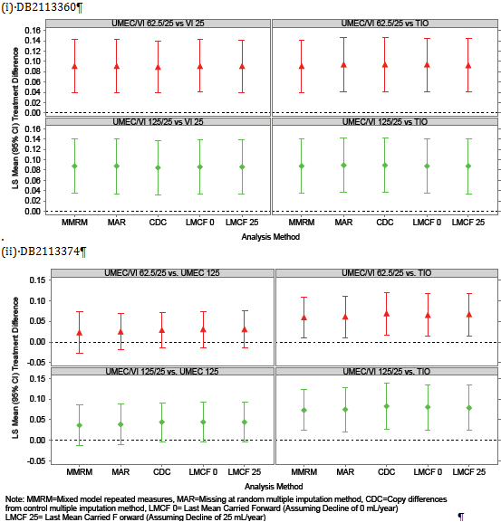
In study DB2113360, additional sensitivity analysis was done for the primary endpoint in the ITT population (that is, including Investigator X), and results were consistent with the primary analysis in the ITT (excluding Investigator X) population, with all treatment comparisons statistically significant.

Secondary efficacy endpoints
The secondary efficacy endpoint was weighted mean FEV1 over 0 to 6 hours post dose at Day 168.
In study DB2113360, there were statistically significantly greater LSM changes from baseline in 0 to 6 hour weighted mean FEV1 at Day 168 for UMEC/VI 125/25 µg compared with TIO (difference of 83 mL over TIO, p = 0.003), and with VI 25 µg (difference of 86 mL over VI 25 µg, p = 0.001). There were also statistically significantly greater LSM changes from baseline in 0 to 6 hour weighted mean FEV1 at Day 168 for UMEC/VI 62.5/25 µg compared with TIO (difference of 74 mL over TIO, p = 0.005) and with VI 25 µg (difference of 77 mL over VI 25 µg, p = 0.004).
In study DB2113374 there were greater LSM changes from baseline in 0 to 6 hour weighted mean FEV1 at Day 168 for UMEC/VI 125/25 µg compared with TIO (difference of 101 mL over TIO, p < 0.001), and with UMEC 125 µg (difference of 76 mL over UMEC 125 µg, p = 0.001). There were also greater LSM changes from baseline in 0 to 6 hour weighted mean FEV1 at Day 168 for UMEC/VI 62.5/25 µg compared with TIO (difference of 96 mL over TIO, p < 0.001) and with UMEC 125 µg (difference of 70 mL over UMEC 125 µg, p = 0.003).

Other efficacy endpoints

Other efficacy endpoints relating to FEV1, FVC and PEFR
In study DB2113360, analysis of trough FEV1 at other time points (Days 2, 28, 56, 84, 112 and 168) showed that there were statistically significantly greater LSM changes from baseline in trough FEV1 for both the UMEC/VI 125/25 µg and UMEC/VI 62.5/25 µg treatment groups compared with both the VI 25 µg and TIO treatment groups at all assessed time points. In study DB2113374, analysis of trough FEV1 at other time points (Days 2, 28, 56, 84, 112 and 168) showed that there were statistically significantly greater LSM changes from baseline in trough FEV1 for both the UMEC/VI 125/25 µg and UMEC/VI 62.5/25 µg treatment groups compared with both the UMEC 125 µg and TIO treatment groups at all assessed time points, except for the comparison between UMEC/VI 125/25 µg and UMEC 125 µg at Days 112 and 168, and the comparison between UMEC/VI 62.5/25 µg and UMEC 125 µg at Days 84, 112 and 168.
In study DB2113360, analysis of weighted mean FEV1 over 0 to 6 hours post dose at other time points (Days 1 and 84) showed that there were statistically significantly greater LSM changes from baseline in 0 to 6 hour weighted mean FEV1 for both the UMEC/VI 125/25 µg and UMEC/VI 62.5/25 µg treatment groups compared with both the VI 25 µg and TIO treatment groups at all assessed time points. In study DB2113374, analysis of weighted mean FEV1 over 0 to 6 hours post-dose at other time points (Days 1, and 84) also showed that there were statistically significantly greater LSM changes from baseline in 0 to 6 hour weighted mean FEV1 for both the UMEC/VI 125/25 µg and UMEC/VI 62.5/25 µg treatment groups compared with both the UMEC 125 µg and TIO treatment groups at all assessed time points.
Analysis of time to onset (defined as an increase of 100 mL above baseline in FEV1) during 0 to 6 hours post-dose on Day 1 showed that in study DB2113360, the median time to onset was shorter in the UMEC/VI 125/25 µg and UMEC/VI 62.5/25 µg treatment groups (21 and 20 minutes, respectively) compared with the TIO (34 minutes) and VI 25 µg (32 minutes) groups. In addition, analyses showed that subjects on UMEC/VI 125/25 µg had a higher likelihood of achieving an increase in FEV1 ≥ 100 mL above baseline at Day 1 compared with TIO 18 µg and with VI 25 µg (1.63 and 1.42 x higher likelihood, respectively; p ≤ 0.001). Subjects in the UMEC/VI 62.5/25 µg treatment group also had a higher likelihood of achieving this endpoint compared with TIO 18 µg and with VI 25 µg (1.79 and 1.56 x higher likelihood, respectively; p < 0.001). In study DB2113374, the median time to onset was shorter in the UMEC/VI 125/25 µg and UMEC/VI 62.5/25 µg treatment groups (19 and 21 minutes, respectively) compared with the TIO (34 minutes) and UMEC 125 µg (36 minutes) groups. In addition, analyses showed that subjects on UMEC/VI 125/25 µg had a higher likelihood of achieving an increase in FEV1 ≥ 100 mL above baseline at Day 1 compared with TIO 18 µg and with UMEC 125 µg (1.56 and 1.46 x higher likelihood, respectively; p < 0.001). Subjects in the UMEC/VI 62.5/25 µg treatment group also had a higher likelihood of achieving this endpoint compared with TIO 18 µg and with UMEC 125 µg (1.60 and 1.50 x higher likelihood, respectively; p < 0.001).
In study DB2113360, the proportion of subjects achieving an increase in FEV1 of ≥ 12% and ≥ 200 mL above baseline at any time during 0 to 6 hours post-dose on Day 1 was 68% and 69% in the UMEC/VI 125/25 µg and UMEC/VI 62.5/25 µg groups, respectively, compared with 47% and 48% in the TIO 18 µg and VI 25 µg groups, respectively. Subjects on UMEC/VI 125/25 µg had higher odds of achieving an increase in FEV1 of ≥ 12% and ≥ 200 mL above baseline at any time during 0 to 6 hours post-dose on Day 1 compared with TIO 18 µg and with VI 25 µg (2.3 and 2.2 x higher likelihood, respectively; p < 0.001). Subjects in the UMEC/VI 62.5/25 µg treatment group also had a higher likelihood of achieving this endpoint compared with TIO 18 µg and with VI 25 µg (2.5 and 2.4 x higher likelihood, respectively; p < 0.001). In study DB2113374, the proportion of subjects achieving an increase in FEV1 of ≥ 12% and ≥ 200 mL above baseline at any time during 0 to 6 hours post-dose on Day 1 was 69% and 63% in the UMEC/VI 125/25 µg and UMEC/VI 62.5/25 µg groups, respectively, compared with 46% and 56% in the TIO 18 µg and UMEC 125 µg groups, respectively. Subjects on UMEC/VI 125/25 µg had higher odds of achieving an increase in FEV1 of ≥ 12% and ≥ 200 mL above baseline at any time during 0 to 6 hours post-dose on Day 1 compared with TIO 18 µg and with UMEC 125 µg (2.7 and 1.8 x higher likelihood, respectively; p ≤ 0.005). Subjects in the UMEC/VI 62.5/25 µg treatment group also had a higher likelihood of achieving this endpoint compared with TIO 18 µg (2.1 x higher likelihood, p < 0.001). The treatment difference between UMEC/VI 62.5/25 µg and UMEC 125 µg was not statistically significant (p = 0.133).
In study DB2113360, the proportion of subjects achieving an increase of ≥ 100 mL above baseline in trough FEV1 at Day 169 was 53% and 58% in the UMEC/VI 125/25 µg and UMEC/VI 62.5/25 µg groups, respectively, compared with 41% and 43% in the TIO 18 µg and VI 25 µg groups, respectively. Subjects on UMEC/VI 125/25 µg had higher odds of achieving an increase of ≥ 100 mL above baseline in trough FEV1 at Day 169 compared with TIO 18 µg (1.6 x higher likelihood, p = 0.023). The treatment difference between UMEC/VI 125/25 µg and VI 25 µg was not statistically significant (p = 0.087). Subjects in the UMEC/VI 62.5/25 µg treatment group also had a higher likelihood of achieving this endpoint compared with TIO 18 µg and with VI 25 µg (2.5 and 2.4 x higher likelihood, respectively; p ≤ 0.002). In study DB2113374, the proportion of subjects achieving an increase of ≥ 100 mL above baseline in trough FEV1 at Day 169 was 57% and 55% in the UMEC/VI 125/25 µg and UMEC/VI 62.5/25 µg groups, respectively, compared with 46% and 47% in the TIO 18 µg and UMEC 125 µg groups, respectively. Subjects on UMEC/VI 125/25 µg had higher odds of achieving an increase of ≥ 100 mL above baseline in trough FEV1 at Day 169 compared with TIO 18 µg and with UMEC 125 µg (1.6 and 1.5 x higher likelihood, respectively; p ≤ 0.033). The treatment differences between UMEC/VI 62.5/25 µg and TIO 18 µg (p = 0.064), and between UMEC/VI 62.5/25 µg and UMEC 125 µg (p = 0.101) were not statistically significant.
In both studies, serial FEV1 at 15 and 30 minutes and 1, 3, 6, 23, and 24 hours after dosing on Days 1 and168 and at 15 and 30 minutes and 1, 3, and 6 hours after dosing on Day 84 were evaluated. In study DB2113360 there were statistically significantly greater post-dose improvements in FEV1 from baseline for both doses of UMEC/VI compared to TIO and to VI 25 µg across all assessed time points, except for the comparisons between UMEC/VI 125/25 µg and VI 25 µg at 15 minutes post-dose on Days 1, 84 and 168, and at 30 minutes post-dose on Day 168, and between UMEC/VI 62.5/25 µg and TIO 18 µg at 6-hour post dose on Day 168. In study DB2113374 there were statistically significantly greater post-dose improvements in FEV1 from baseline for both doses of UMEC/VI compared to TIO and to UMEC 125 µg across all assessed time points, except for the comparisons between both doses of UMEC/VI and UMEC 125 µg at 23- and 24-hour post-dose on Day 168.
Analysis of peak FEV1 in study DB2113360 showed that there were statistically significantly greater LSM changes from baseline in peak FEV1 for both doses of UMEC/VI compared to TIO and to VI 25 µg across all assessed time points (Days 1, 84, and 168). Analysis of peak FEV1 in study DB2113374 also showed that there were statistically significantly greater LSM changes from baseline in peak FEV1 for both doses of UMEC/VI compared to TIO and to UMEC 125 µg across all assessed time points (Days 1, 84, and 168).
Analysis of trough FVC in study DB2113360 showed that there were statistically significantly greater LSM changes from baseline in trough FVC for both doses of UMEC/VI compared to TIO and to VI 25 µg across all assessed time points (Days 2, 28, 56, 84, 112, 168, and 169), except for the comparison between UMEC/VI 62.5/25 µg and TIO at Days 56, 112 and 169. Analysis of trough FVC in study DB2113374 showed that there were statistically significantly greater LSM changes from baseline in trough FVC for both doses of UMEC/VI compared to TIO and to UMEC 125 µg across all assessed time points (Days 2, 28, 56, 84, 112, 168, and 169), except for the comparison between UMEC/VI 62.5/25 µg and UMEC 125 µg at Days 84, 112, 168 and 169, and that between UMEC/VI 125/25 µg and UMEC 125 µg at Days 112, 168 and 169.
Analysis of mean PEFR over Weeks 1 to 24 in study DB2113360 showed that there were statistically significantly greater LSM changes from baseline in mean PEFR over Weeks 1 to 24 for UMEC/VI 125/25 µg compared to TIO and to VI 25 µg, and for UMEC/VI 62.5/25 µg compared to VI 25 µg. The treatment difference between UMEC/VI 62.5/25 µg and TIO was not statistically significant. Analysis of this endpoint in study DB2113374 showed that there were statistically significantly greater LSM changes from baseline in mean PEFR over Weeks 1 to 24 for both doses of UMEC/VI compared to TIO and to UMEC 125 µg.

Other efficacy endpoints relating to symptomatic relief and health outcomes
In study DB2113360, analysis of TDI focal score at Days 28, 84 and 168 showed that the treatment differences between either dose of UMEC/VI and TIO or VI 25 µg were all not statistically significant, except for that between UMEC/VI 125/25 µg and VI 25 µg at Days 28 and 168. In study DB2113374, analysis of TDI focal score showed that there were statistically significantly greater LSM TDI focal score (that is, improvement from baseline) compared to placebo for both doses of UMEC/VI compared to TIO and to UMEC 125 µg at Day 28, but the treatment differences at Day 168 between either dose of UMEC/VI and TIO or UMEC 125 µg were all not statistically significant. There were statistically significantly greater LSM TDI focal score at Day 84 for both doses of UMEC/VI compared to TIO, but the treatment differences between either dose of UMEC/VI and UMEC 125 µg were not statistically significant.
Analysis of the proportion of subjects responders to TDI (defined as a subject with a TDI score of 1 unit or more) at Days 28, 84 and 168 showed that in study DB2113360, treatment differences between either dose of UMEC/VI and TIO or VI 25 µg were all not statistically significant, except for that between UMEC/VI 125/25 µg and VI 25 µg at Day 168. In study DB2113374, subjects on UMEC/VI 125/25 µg had higher odds of being a TDI responder compared with TIO and with UMEC 125 µg at Day 28 (2.0 and 2.2 x higher likelihood, respectively; p ≤ 0.001). Subjects on UMEC/VI 62.5/25 µg also had higher odds of being a TDI responder compared with TIO and with UMEC 125 µg at Day 28 (1.6 and 1.7 x higher likelihood, respectively; p ≤ 0.03). The treatment differences at Day 168 between either dose of UMEC/VI and TIO or UMEC 125 µg were all not statistically significant. At Day 84, subjects on UMEC/VI 125/25 µg and those on UMEC/VI 62.5/25 µg had 1.9 (p = 0.002) and 1.8 (p = 0.004) times higher likelihood, respectively, of being a TDI responder compared with TIO, but the treatment differences at Day 84 between either dose of UMEC/VI and UMEC 125 µg were not statistically significant.
Analyses of the mean number of puffs of rescue medication per day over Weeks 1 to 24 showed that in study DB2113360, there were statistically significantly greater reductions from baseline in LSM rescue salbutamol use over Weeks 1 to 24 for both doses of UMEC/VI (125/25 µg and 62.5/25 µg) compared with TIO (reduced by 0.6 (p = 0.031), and 0.7 (p = 0.022) puffs per day, respectively). The treatment differences between either dose of UMEC/VI and VI 25 µg were not statistically significant. In study DB2113374, there were statistically significantly greater reductions from baseline in LSM rescue salbutamol use over Weeks 1 to 24 for the UMEC/VI 125/25 µg compared with TIO and with UMEC 125 µg (reduced by 1.1 puffs per day for both comparisons; p < 0.001). Treatment differences between UMEC/VI 62.5/25 µg and TIO or UMEC 125 µg were not statistically significant.
Analyses of the percentage of rescue-free days showed that in study DB2113360, the mean (SD) change from baseline at Weeks 1 through 24 in the percentage of rescue-free days was 18.8% (39.24) and 18.6% (34.75) in the UMEC/VI 125/25 µg and UMEC /VI 62.5/25 µg groups, respectively, compared with 11.7% (35.77) and 16.3% (37.15) in the TIO and VI 25 µg groups, respectively. In study DB2113374, the mean (SD) change from baseline at Weeks 1 through 24 in the percentage of rescue-free days was 26.9% (41.32) and 17.6% (40.11) in the UMEC/VI 125/25 µg and UMEC /VI 62.5/25 µg groups, respectively, compared with 13.4% (34.38) and 14.0% (36.62) in the TIO and UMEC 125 µg groups, respectively.
Analyses of the mean change from baseline in SOBDA score at Week 24 showed that in study DB2113360, treatment differences between either dose of UMEC/VI and TIO or VI 25 µg were all not statistically significant. LSM change from baseline in SOBDA score across time points in study DB2113360 were presented in in the CER. In study DB2113374, there were statistically significantly greater LSM mean SOBDA score improvement from baseline at Week 24 for UMEC/VI 125/25 µg compared to TIO and to UMEC 125 µg. Treatment differences between UMEC/VI 62.5/25 µg and TIO or UMEC 125 µg were not statistically significant. LSM change from baseline in SOBDA score across time points in study DB2113374 was presented in the CER.
Analysis of the proportion of responders to the SOBDA at Week 24 showed that in study DB2113360, treatment differences between either dose of UMEC/VI and TIO or VI 25 µg were all not statistically significant for both responder thresholds of -0.1 and -0.2.
In study DB2113374, treatment differences between either dose of UMEC/VI and TIO or VI 25 µg were also all not statistically significant for both responder thresholds of -0.1 and -0.2 except for the comparison between UMEC/VI 125/25 µg and UMEC 125 µg for both responder thresholds of -0.1 and -0.2, which showed that subjects on UMEC/VI 125/25 µg had 1.6 (p = 0.023) and 2.1 (p = 0.002) times higher likelihood of being a responder at Week 24 compared to those on UMEC 125 µg.
In study DB2113360, the proportion of subjects with on treatment COPD exacerbations was comparable among treatment groups (5%, 7%, 5%, and 8% in the UMEC/VI 125/25 µg, UMEC/VI 62.5/25 µg, TIO and VI 25 µg groups, respectively). Results of the analysis of time to first on-treatment COPD exacerbation showed that treatment differences between either dose of UMEC/VI and TIO or VI 25 µg were all not statistically significant. In study DB2113374, the proportion of subjects with on-treatment COPD exacerbations were 7%, 12%, 7% and 12% in the UMEC/VI 125/25 µg, UMEC/VI 62.5/25 µg, TIO and UMEC 125 µg groups, respectively. Results of the analysis of time to first on treatment COPD exacerbation showed that treatment differences between either dose of UMEC/VI and TIO or UMEC 125 µg were all not statistically significant.
A summary of subject preferences for the HandiHaler versus the NDPI in terms of number of steps, time needed to use, and overall preference was provided. In study DB2113360, 59% to 64% of subjects across the treatment groups had an overall preference for the NDPI, compared with 11% to 16% for the HandiHaler device. In study DB2113374, 60% to 65% of subjects across the treatment groups had an overall preference for the NDPI, compared with 14% to 21% for the HandiHaler device.
Analysis of the improvement from baseline in SGRQ total score at Day 168 showed that in study DB2113360, treatment differences between either dose of UMEC/VI and TIO or VI 25 µg were all not statistically significant. In study DB2113374, analysis of this endpoint also showed that treatment differences between either dose of UMEC/VI and TIO or UMEC 125 µg were all not statistically significant.
Analysis of the proportion of SGRQ responders (defined as having a SGRQ total score of 4 units below baseline (score on Day 1) or lower) at Day 168 showed that in study DB2113360, the proportion of SGRQ responders were comparable across treatment groups (53%, 49%, 52% and 52% in the UMEC/VI 125/25 µg, UMEC/VI 62.5/25 µg, TIO and VI 25 µg groups, respectively), and treatment differences between either dose of UMEC/VI and TIO or VI 25 µg were all not statistically significant. In study DB2113374, the proportion of SGRQ responders were also comparable across treatment groups (53%, 49%, 52% and 52% in the UMEC/VI 125/25 µg, UMEC/VI 62.5/25 µg, TIO and UMEC 125 µg groups, respectively), and treatment differences between either dose of UMEC/VI and TIO or UMEC 125 µg were all not statistically significant.
Descriptive summary of the changes from baseline in the SGRQ symptoms, activity, and impacts domain scores at Day 168 in studies DB2113360 and DB2113374 were presented and showed that reductions from baseline (that is, improvement) in these SGRQ component scores were generally comparable across all treatment groups in both studies.
Descriptive summary of change from baseline in the EQ-5D Index Score in studies DB2113360 and DB2113374 were provided. In study DB2113360, there was numerically greater increase from baseline (that is, improvement) in the EQ-5D Index Score with UMEC/VI 125/25 µg and UMEC/VI 62.5/25 µg compared with TIO or VI 25 µg, at Days 28, 84 and 168. In study DB2113374, there was numerically greater increase from baseline (that is, improvement) in the EQ-5D Index Score with UMEC/VI 125/25 µg and UMEC/VI 62.5/25 µg compared with TIO or UMEC 125 µg at Day 28, while the improvements in the EQ-5D Index Score at Days 84 and 168 were comparable across treatment groups.
Descriptive summary of change from baseline in the COPD Assessment Test Score in studies DB2113360 and DB2113374 were provided and showed that reductions from baseline (i.e. improvement) in COPD Assessment Test score were generally comparable across all treatment groups in both studies.
Analysis of healthcare resource utilisation in studies DB2113360 and DB2113374 yielded results that were generally comparable across all treatment groups. In study DB2113360, 36% and 31% of subjects in the UMEC/VI 125/25 µg and UMEC/VI 62.5/25 µg groups, respectively, reported contact with a healthcare provider on any day during the study, compared with 29% and 30% in the TIO 18 µg and VI 25 µg groups, respectively. The proportions of subjects who reported unscheduled healthcare utilisation were 8% and 6% in the UMEC/VI 125/25 µg and UMEC/VI 62.5/25 µg groups, respectively, compared to 8% and 7% in the TIO 18 µg and VI 25 µg groups, respectively. In study DB2113374, 21% and 29% of subjects in the UMEC/VI 125/25 µg and UMEC/VI 62.5/25 µg groups, respectively, reported contact with a healthcare provider on any day during the study, compared with 32% and 35% in the TIO 18 µg and UMEC 125 µg groups, respectively. The proportions of subjects who reported unscheduled healthcare utilisation were 7% and 11% in the UMEC/VI 125/25 µg and UMEC/VI 62.5/25 µg groups, respectively, compared to 6% and 9% in the TIO 18 µg and UMEC 125 µg groups, respectively.

Meta-analysis endpoints
The primary endpoint for this meta-analysis was the TDI focal score at Day 168. Other endpoints were TDI focal score at Days 28 and 84 and the proportion of responders according to TDI at Days 28, 84 and 168. In the meta-analysis, the primary comparisons of interest were between each dose of UMEC/VI and TIO on the TDI focal score at Day 168. For each UMEC/VI dose, inference could be drawn only if the comparison of that dose with TIO on the individual study primary endpoint of trough FEV1 on Day 169 was statistically significant in each individual study, as determined by the specific testing hierarchy within each study. In study DB2113360, the requirements for the testing hierarchy were met for both doses of UMEC/VI. In study DB2113374, the treatment difference for the study primary endpoint of trough FEV1 on Day 169 between UMEC/VI 125/25 µg and UMEC 125 µg was not statistically significant, and hence, by the statistical testing hierarchy rules of the study, statistical inference could not be made for the comparison between UMEC/VI 62.5/25 µg and TIO. Hence, in this meta-analysis, statistical inference for the comparison of TDI focal score for UMEC/VI 125/25 µg vs. TIO could be drawn, but that for UMEC/VI 62.5/25 µg vs. TIO could not be drawn.
In this meta-analysis, the primary comparisons between each dose of UMEC/VI and TIO for TDI focal score at Day 168 were not statistically significant. Other comparisons for the TDI focal score at Day 168 (UMEC/VI 125/25 µg vs. VI 25 µg, UMEC/VI 125/25 µg vs. UMEC 125 µg, UMEC/VI 62.5/25 µg vs. VI 25 µg, and UMEC/VI 62.5/25 µg vs. UMEC 125 µg) all yielded results that were not statistically significant, except for the comparison between UMEC/VI 125/25 µg vs. UMEC 125 µg (a difference of 0.8 in the TDI focal score in favour of UMEC/VI 125/25 µg, p = 0.010).
Analysis of TDI focal score at Days 28 and 84 showed statistically significant results in favour of both doses of UMEC/VI versus TIO (Figure 21). Comparisons between both doses of UMEC/VI and their individual components, for TDI focal score at Day 28, all yielded statistically significant results in favour of UMEC/VI over the individual components, except for the comparison between UMEC/VI 62.5/25 µg and VI 25 µg (p = 0.070). Comparisons between both doses of UMEC/VI and their individual components all yielded results that were not statistically significant, for TDI focal score at Day 84.
Figure 21. Meta-analysis DB2116844. Least Squares Mean TDI Focal Score, meta-analysis of studies DB2113360 (ITT Population Excluding Investigator X) and DB2113374 (ITT Population).
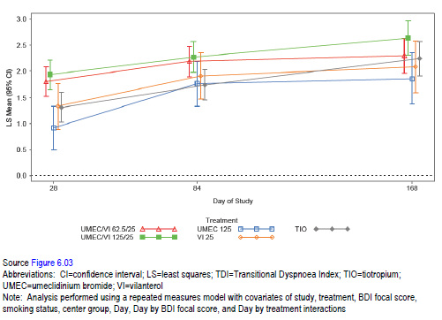
Summary of the proportion of subjects who were responders according to the TDI focal score on Days 28, 84, and 168 were provided. The odds of being a responder versus a non-responder based on TDI score was not statistically significant for either dose of UMEC/VI compared with TIO at Day 168.

Other efficacy studies

Studies DB2114417 and DB2114418
Both studies DB2114417 and DB2114418 were multi-centre, randomised, double-blind, placebo-controlled, combination and component, 2-period, incomplete block design cross-over studies to evaluate the effect of UMEC/VI on exercise endurance time in COPD patients. The primary objective of the study was to evaluate the effect of UMEC/VI (125/25 µg and 62.5/25 µg), administered once-daily, on exercise endurance time (EET; measured using the endurance shuttle walk test (ESWT)) and trough FEV1 over 12 weeks in subjects with COPD. The secondary objective was to evaluate the effect of UMEC/VI, its components, and placebo, administered once-daily, on lung volumes and post-dose lung function over 12 weeks in subjects with COPD. The study designs of both studies were identical, except for the inclusion of cardio respiratory measurements (CRM) taken during shuttle walks in a subset of subjects in study DB2114417.
Study inclusion and exclusion criteria and randomisation criteria were the same as for studies DB2113361/DB2113373 and DB2113360/DB2113374 (discussed in Section 7.1.1.2) except that studies DB2114417 and DB2114418 had an additional inclusion criterion of lung hyperinflation defined by a resting functional residual capacity (FRC) of ≥ 120% of predicted normal, and the inclusion criterion for post-salbutamol FEV1 was a post-salbutamol FEV1 of ≥ 35% and ≤ 70% of predicted normal values (instead of post-salbutamol FEV1 of ≤ 70% of predicted normal value as for studies DB2113361/DB2113373 and DB2113360/DB2113374). According to the sponsor, the additional inclusion criterion for FRC was to select subjects most likely to have exercise limitation, as hyperinflation was a significant factor in determining exercise capacity. A lower limit was applied for post-salbutamol FEV1 (that is, ≥ 35% of predicted normal values) to preclude subjects with very severe disease from performing exercise tests.
Study treatments in each study were UMEC/VI 125/25 µg, UMEC/VI 62.5/25 µg, UMEC 125 µg, UMEC 62.5 µg, VI 25 µg, and placebo, all administered once-daily via an NDPI. Eligible subjects were randomised to receive a sequence consisting of 2 of the treatments (i.e. one in period I and one in period II), each administered for 12 weeks separated by a 14-day Washout Period (Figure 22). Subjects were randomised to 1 of 26 different sequences. According to the sponsor, the sequences were selected to optimise power for the comparisons between UMEC/VI and placebo, and hence the number of subjects on each treatment was unbalanced.
Figure 22. Design Schematic, studies DB2114417 and DB2114418.
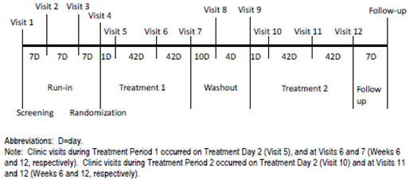
The co-primary efficacy endpoints in both studies were the EET post-dose at Week 12 (defined as the EET obtained 3 hours after dosing at Week 12) and the trough (i.e. pre-bronchodilator and pre-dose) FEV1 at Week 12 (defined as the FEV1 value obtained 24 hours after dosing on Treatment Day 84). The secondary efficacy endpoints were measures of lung volume (inspiratory capacity (IC), functional residual capacity (FRC), and residual volume (RV)) at Week 12 (trough and 3-hour post-dose), and 3-hour post-dose FEV1 at Week 12. Primary treatment comparisons were 3-hour post-dose EET for UMEC/VI 125/25 µg vs. placebo, trough FEV1 for UMEC/VI 125/25 µg vs. placebo, 3-hour post-dose EET for UMEC/VI 62.5/25 µg vs. placebo, and trough FEV1 for UMEC/VI 62.5/25 µg vs. placebo. In order to account for multiplicity across treatment comparisons and co-primary endpoints, a step-down closed testing procedure was applied whereby inference for a test in the predefined hierarchy was dependent upon statistical significance having been achieved for previous tests in the hierarchy. The hierarchy consisted of the 4 treatment comparisons described above, performed in that order.
In study DB2114417, a total of 596 subjects were screened, 349 were randomised and 348 were included in the ITT population (Figure 23). In study DB2114418, a total of 634 subjects were screened, 308 were randomised, and 307 were included in the ITT population (Figure 24). Baseline demographic and disease characteristics in the ITT populations of studies DB2114417 and DB2114418 were provided. In study DB2114417, subjects had a mean (SD) age of 61.6 (8.25) years. The majority of subjects were male (56%; 195/348) and White (97%; 336/348), with a mean (SD) smoking pack years of 48.7 (25.27). The mean post-salbutamol percent predicted FEV1 was 51.3%. In study DB2114418, subjects had a mean (SD) age of 62.6 (7.88) years. The majority of subjects were male (55%; 168/307) and White (97%; 298/307), with a mean (SD) smoking pack years of 47.4 (24.73). The mean post-salbutamol percent predicted FEV1 was 51.3%.
Figure 23. Summary of Subject Disposition Study DB2114417.
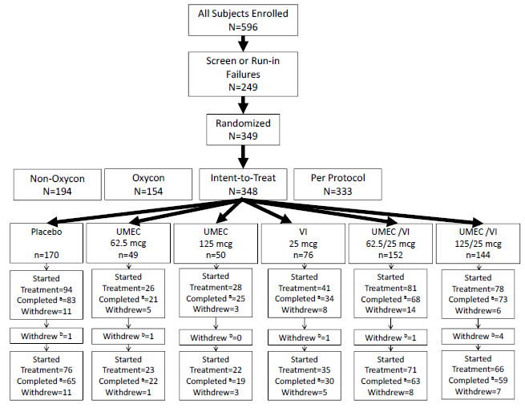
Figure 24. Summary of Subject Disposition Study DB2114418
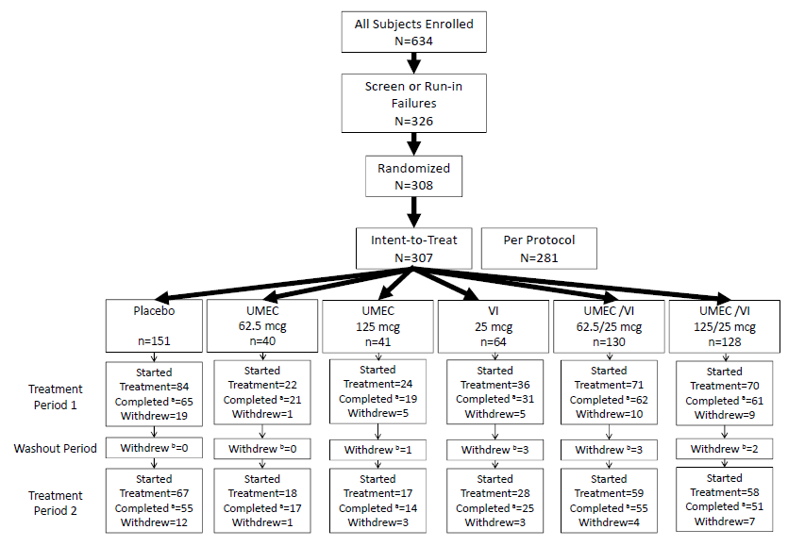
In study DB2114417, analysis of the co-primary endpoint of EET post-dose at Week 12 showed that treatment differences between either doses of UMEC/VI and placebo were not statistically significant. As the comparison of UMEC/VI 125/25 µg against placebo did not achieve statistical significance for this co-primary endpoint of EET at Week 12, based on application of the statistical testing hierarchy, the results of all further statistical analyses could only be interpreted descriptively. Analysis of the co-primary endpoint of trough FEV1 at Week 12 showed that both doses of UMEC/VI had greater LSM changes from baseline in trough FEV1 compared with placebo at Week 12 (UMEC/VI 125/25 µg: difference of 169 mL over placebo, p < 0.001; UMEC/VI 62.5/25 µg: difference of 211 mL over placebo, p < 0.001).
In study DB2114418, analysis of the co-primary endpoint of EET post-dose at Week 12 showed that there were statistically significantly greater LSM changes from baseline in the 3-hour post-dose EET at Week 12 compared with placebo for both doses of UMEC/VI (UMEC/VI 125/25 µg: difference of 65.8 seconds over placebo, p = 0.005; UMEC/VI 62.5/25 µg: difference of 69.4 seconds over placebo, p = 0.003). Analysis of the co-primary endpoint of trough FEV1 at Week 12 showed that both doses of UMEC/VI had statistically significantly greater LSM changes from baseline in trough FEV1 compared with placebo at Week 12 (UMEC/VI 125/25 µg: difference of 261 mL over placebo, p < 0.001; UMEC/VI 62.5/25 µg: difference of 243 mL over placebo, p < 0.001).
The sponsor presented an integrated analysis of both studies for the co-primary endpoints. Results showed that there were statistically significantly greater LSM changes from baseline in the 3-hour post-dose EET at Week 12 compared with placebo for both doses of UMEC/VI (pooled UMEC/VI 125/25 µg: difference of 47.5 seconds over pooled placebo, p = 0.001; pooled UMEC/VI 62.5/25 µg: difference of 43.7 seconds over placebo, p = 0.002). There were also statistically significantly greater LSM changes from baseline in trough FEV1 compared with placebo at Week 12 (pooled UMEC/VI 125/25 µg: difference of 211 mL over pooled placebo, p < 0.001; pooled UMEC/VI 62.5/25 µg: difference of 224 mL over pooled placebo, p < 0.001).
Analyses of the secondary efficacy endpoints showed that in study DB2114417, there were greater LSM changes from baseline in trough and 3-hour post-dose IC, FRC, and RV compared with placebo at Week 12, for both doses of UMEC/VI. There were also greater LSM changes from baseline in 3-hour post-dose FEV1 compared with placebo at Week 12 for both doses of UMEC/VI. In study DB2114418, there were statistically significantly greater LSM changes from baseline in trough and 3-hour post-dose IC, FRC, and RV compared with placebo at Week 12, for both doses of UMEC/VI. There were also statistically significantly greater LSM changes from baseline in 3-hour post-dose FEV1 compared with placebo at Week 12 for both doses of UMEC/VI.

Analyses performed across trials (pooled analyses and meta-analyses)
Subgroup analyses were performed combining data from all 4 pivotal efficacy studies (studies DB2113361, DB2113373, DB2113360 and DB2113374) and were provided. The subgroups were gender (male vs. female), age (≤ 64 vs. 64 to 75 vs. 75 to 84 vs. ≥ 85 years), treatment-naive status (yes vs. no) GOLD classification (I/II vs. III/IV), smoking status (former vs. current), race (African American vs. American Indian or Alaska Native vs. Asian versus White vs. Native Hawaiian or other Pacific Islander vs. Mixed Race), geographical region (US vs. EU vs. others), ICS use at screening (yes vs. no), reversibility to salbutamol (reversible vs. not reversible) and reversibility to salbutamol and ipratropium (reversible vs. not reversible). The number of subjects in each subgroup for this combined analysis is summarised in Table 14. Interactions of treatment with the subgroup parameters were done and results showed that for the primary efficacy endpoint of trough FEV1 at Day 169, interactions with treatment for gender (male vs. female), age (≤ 64 vs. ≥ 65 years), treatment-naive status (yes vs. no), GOLD classification (I/II vs. III/IV), smoking status (former vs. current) and geographical region (EU vs. non-EU) were not statistically significant (p > 0.10). For the primary efficacy endpoint, there were statistically significant interactions of treatment with race (White vs. non-White; p = 0.015), ICS use at screening (yes vs. no; p = 0.002), geographical region (US vs. non-US; p = 0.085), reversibility to salbutamol (reversible vs. not reversible; p < 0.001), and reversibility to salbutamol and ipratropium (reversible vs. not reversible; p < 0.001). For the subgroup category of race (White vs. non-White), ICS use at screening (yes vs. no), and geographical region (US vs. non-US), the differences in magnitude between the subgroups were not considered to be clinically relevant. However, for the subgroup category of reversibility to salbutamol and reversibility to salbutamol and ipratropium, responses to treatment were consistently greater in reversible subjects compared with non-reversible subjects. In addition, the reversible subjects appeared to show a greater difference from placebo for UMEC/VI 125/25 µg than that observed for UMEC/VI 62.5/25 µg, which was not observed in the non-reversible subjects.

Table 14. Summary of Number of Subjects by Subgroup (Integrated Studies DB2113361, DB2113373, DB2113360, and DB2113374 ITT Population)
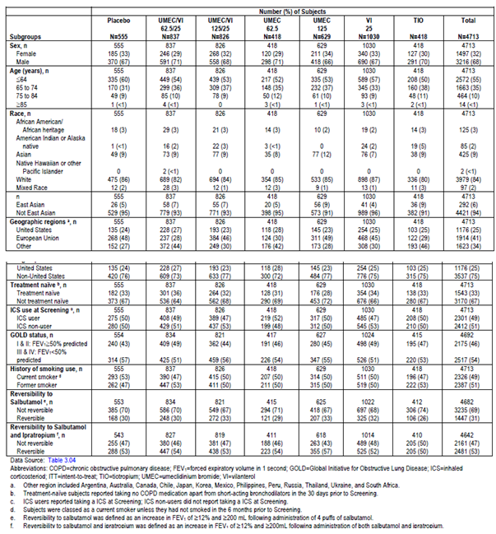
The sponsor performed additional analysis of the integrated data from the 4 pivotal efficacy studies, showing that in the subgroup of subjects reversible to salbutamol at screening (31% of all study subjects; 1447/4682) there were greater improvements in bronchodilatation as measured by trough FEV1 at Day 169 with UMEC/VI 125/25 µg (282 mL improvement over placebo; p < 0.001) compared with UMEC/VI 62.5/25 µg (225 mL over placebo; p < 0.001). This pattern was not observed in the non-reversible subjects (UMEC/VI 125/25 µg: 181 mL improvement over placebo, p < 0.001; UMEC/VI 62.5/25 µg: 188 mL improvement over placebo, p < 0.001) (Table 15). The greater improvements in trough FEV1 over PLA for UMEC/VI 125/25 µg compared to 62.5/25 µg in the subgroup of subjects reversible to salbutamol at screening were observed at Day 2 and maintained for the duration of the study (Figure 25). Greater treatment response with the 125/25 µg than with 62.5/25 µg in the reversible subgroup was also observed for the TDI focal scores, SGRQ scores, and rescue salbutamol use.

Table 15. Trough FEV1 (L) at Day 169 by Reversibility to Salbutamol (Integrated Studies DB2113361, DB2113373, DB2113360, and DB2113374 ITT Population)
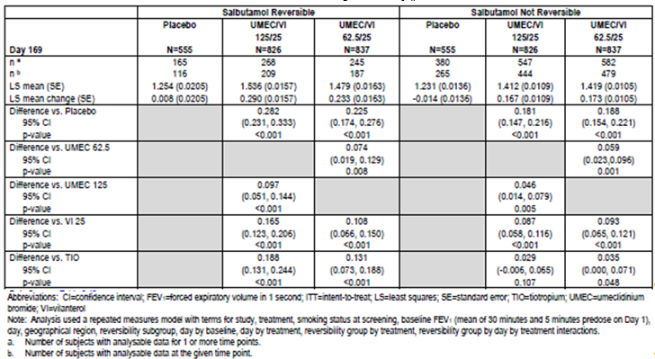
Figure 25. Trough FEV1 (L): Least Squares Mean (95% CI) Treatment Differences from Placebo in Change from Baseline by Reversibility to Salbutamol (Integrated Studies DB2113361, DB2113373, DB2113360, and DB2113374 ITT Population).
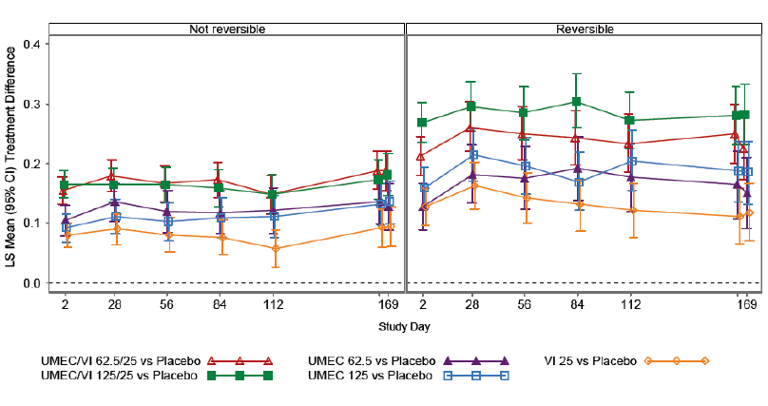
Evaluator’s comments: In the interactions tests with regards to smoking status, the smoking status used was that at screening. It is noted that in the pivotal studies, smoking status was assessed at screening, and also Weeks 12 and 24. The potential interaction between smoking status at Weeks 12 and 24 and efficacy was not explored. However, a look through the results of these 4 studies showed that the proportion of subjects who reported changes in smoking status from screening during the study was low (< 1% in each study). In view of this, the evaluator does not consider it necessary nor feasible for additional analyses on the potential interaction between smoking status at Weeks 12 and 24 and efficacy to be performed.

Evaluator’s conclusions
Evaluator’s conclusions on clinical efficacy for the indication of long term, once daily bronchodilator treatment to relieve symptoms in adult patients with COPD.
The efficacy of Anoro Ellipta (UMEC/VI) was evaluated in 2 sets of randomised, double-blind, parallel group studies, where 1 set of studies was placebo-controlled, while the other set was active-controlled (active control: tiotropium(TIO)). The study designs, study inclusion and exclusion criteria and the primary and secondary endpoints are consistent with the recommendations in the EMA guidelines on clinical investigation of medicinal products in the treatment of chronic obstructive pulmonary disease, as well as the FDA Guidance for Industry- Chronic Obstructive Pulmonary Disease: Developing Drugs for Treatment. Overall, 1493 and 1536 subjects with COPD were randomised in the 2 placebo-controlled studies (DB2113361 and DB2113373, respectively), while 826 and 872 subjects with COPD were randomised in the 2 active-controlled studies (DB2113360 and DB2113374, respectively). Baseline demographic and disease characteristics of the study populations in these studies showed that they were reflective of the target patient population.
In these 4 pivotal studies, the efficacy of UMEC/VI was evaluated through effects on FEV1 as well as effects on symptom relief and health outcomes. Overall, analyses on the effects of UMEC/VI on FEV1 compared to placebo yielded results which were supportive of the efficacy claim of both doses of UMEC/VI (125/25 µg and 62.5/25 µg) as well as of its components (UMEC 125 µg, UMEC 62.5 µg and VI 25 µg) over placebo. Analyses on the effects of UMEC/VI on FEV1 compared to an active comparator, TIO, also yielded results which were generally supportive of the efficacy claim of both doses of UMEC/VI (125/25 µg and 62.5/25 µg) over TIO. Analyses on the effects of UMEC/VI on symptom relief and health outcomes compared to placebo yielded results which were generally supportive of the efficacy claim of both doses of UMEC/VI over placebo. However, comparisons between UMEC/VI and TIO with regards to effects on symptom relief and health outcomes yielded results that largely showed no statistically significant treatment differences between either dose of UMEC/VI and TIO.
With regards to bronchodilatory effects at the end of a 24-hour dosing interval (as measured by trough FEV1) in the two pivotal 24-week placebo-controlled studies (DB2113361 and DB213373), both doses of UMEC/VI showed statistically significant improvements over placebo in trough FEV1 at Day 169 (difference over placebo of 167 mL and 238 mL with UMEC/VI 62.5/25 µg and 125/25 µg, respectively; p < 0.001). Improvements over placebo were also observed in the 12-week exercise studies (DB2114417 and DB2114418; difference over placebo of 211 to 243 mL and 169 to 261 mL with UMEC/VI 62.5/25 µg and 125/25 µg, respectively; p < 0.001), although statistical significance could not be claimed for the comparisons in study DB2114417 under the terms of the testing hierarchy in the study. In the two pivotal 24-week active-controlled studies (DB2113360 and DB213374), both doses of UMEC/VI showed statistically significant improvements over TIO in trough FEV1 at Day 169 (difference over TIO of 60 to 90 mL and 74 to 88 mL with UMEC/VI 62.5/25 µg and 125/25 µg, respectively; p ≤ 0.018), although statistical significance could not be claimed for the comparison between UMEC/VI 62.5/25 µg and TIO in study DB213374 as a result of a prior test in the predefined testing hierarchy not achieving statistical significance in this study. Comparisons between UMEC/VI 62.5/25 µg with its individual components in the pivotal studies showed statistically significant improvements of the combination product over the individual components in trough FEV1 at Day 169 (improvement over UMEC 62.5 µg of 52 mL (p = 0.004; study DB213373); improvement over VI 25 µg of 95 mL (p < 0.001; study DB213373) and of 90 mL (p < 0.001; study DB213360). Comparisons between UMEC/VI 125/25 µg with its individual components in the pivotal studies also showed statistically significant improvements of the combination product over the individual components in trough FEV1 at Day 169, except for that between UMEC/VI 125/25 µg and UMEC 125 µg in study DB213374 (improvement over UMEC 125 µg of 79 mL (p < 0.001; study DB213361) and of 37 mL (p = 0.142; study DB213374); improvement over VI 25 µg of 114 mL (p < 0.001; study DB213361) and of 88 mL (p < 0.001; study DB213360).
Analyses of the bronchodilatory effects in the first 6 hours after dosing, after 24 weeks of treatment (weighted mean FEV1 over 0 - 6 hours post-dose at Day 168) showed that in the two 24-week placebo controlled studies (DB2113361 and DB213373), both doses of UMEC/VI showed improvements over placebo in weighted mean FEV1 over 0 - 6 hours post-dose at Day 168 (difference over placebo of 242 mL and 287 mL with UMEC/VI 62.5/25 µg and 125/25 µg, respectively; p < 0.001). In one of the 24-week active-controlled studies (DB2113360), both doses of UMEC/VI showed statistically significant improvements over TIO in weighted mean FEV1 over 0 - 6 hours post dose at Day 168 (difference over TIO of 74 mL and 83 mL with UMEC/VI 62.5/25 µg and 125/25 µg, respectively; p ≤ 0.005). In the other 24-week active-controlled studies (DB2113374), both doses of UMEC/VI also showed improvements over TIO in weighted mean FEV1 over 0 - 6 hours post dose at Day 168 (difference over TIO of 96 mL and 101 mL with UMEC/VI 62.5/25 µg and 125/25 µg, respectively; p ≤ 0.005), although statistical significance could not be claimed for these comparisons as a result of a prior test in the predefined testing hierarchy not achieving statistical significance in study DB2113374.
With regards to bronchodilatory effects over 24-week treatment period (as measured by serial trough FEV1 and weighted mean FEV1 over 0 - 6 hours across the 24-week treatment period), results in the 4 pivotal studies showed that improvements with both doses of UMEC/VI in trough FEV1 compared to placebo and TIO were observed early (at Day 2) and then maintained across the 24-week treatment period (Figure 26). Improvements with both doses of UMEC/VI in weighted mean FEV1 over 0 - 6 hours compared to placebo and TIO were also observed early and then maintained across the 24-week treatment (Figure 27).
Figure 26. Least Squares Mean (95% CI) Change from Baseline in Trough FEV1 (L) (Integrated Studies DB2113361, DB2113373, DB2113360, DB2113374 ITT Population)
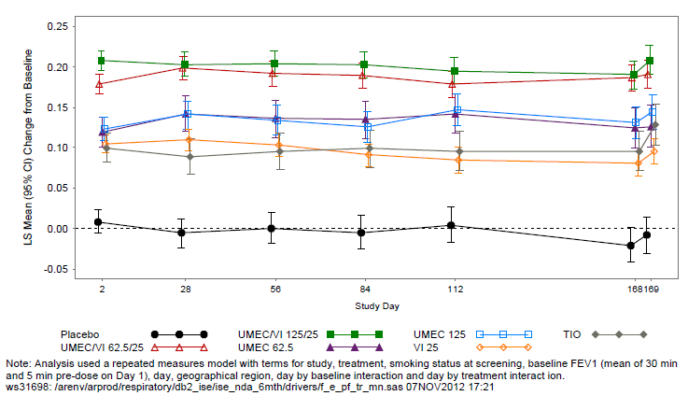
Figure 27. Least Squares Mean (95% CI) Change from Baseline in 0 to 6 hour Weighted Mean FEV1 (L) (Integrated Studies DB2113361, DB2113373, DB2113360, DB2113374 ITT Population).
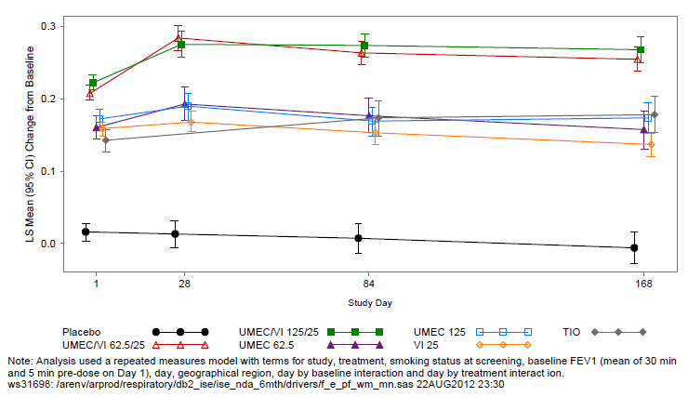
Characterisation of bronchodilatory effects over 24-hour dosing period was done by analyses of data in the Twenty-four Hour (TFH) Population in studies DB2113361 and DB2113373. Results showed that there were statistically significantly greater LSM changes from baseline in 0 to 24 hour weighted mean FEV1 compared to placebo for both UMEC/VI 62.5/25 µg (study DB2113373) and UMEC/VI 125/25 µg (DB2113361) at Days 1, 84 and 168 (UMEC/VI 62.5/25 µg: differences over placebo of 212 mL, 254 mL and 219 mL at Days 1, 84 and 168, respectively (p < 0.001); UMEC/VI 125/25 µg: differences over placebo of 253 mL, 309 mL and 312 mL, respectively (p < 0.001)). Analyses of serial FEV1 at Days 1, 84, and 168 in the TFH population in studies DB2113361 and DB2113373 showed that there were statistically significantly greater post dose improvements in FEV1 from baseline compared to placebo for both doses of UMEC/VI.
With regards to effects on symptom relief and health outcomes, results were generally supportive of improvements over placebo for both doses of UMEC/VI, but not over TIO for either dose of UMEC/VI. In the pivotal 24-week placebo-controlled studies (DB2113361 and DB213373), both doses of UMEC/VI showed statistically significant improvements over placebo in TDI focal scores at Days 28, 84 and 168 (difference over placebo at Day 168 of 1.2 and 1.0 with UMEC/VI 62.5/25 µg and 125/25 µg, respectively; p < 0.001). The proportion of TDI responders (as defined by a ≥ 1 unit value) at Day 168 was greater for UMEC/VI 62.5/25 µg compared with placebo (study DB2113373; 58% vs. 41%) and for UMEC/VI 125/25 µg compared with placebo (study DB2113361; 49% vs. 30%). The ratio of the odds of being a TDI responder vs. a non-responder was greater for both doses of UMEC/VI compared with placebo at all assessed time points (odds ratio of 2.0 to 3.1 (p < 0.001) and 2.5 to 3.7 (p < 0.001) with UMEC/VI 62.5/25 µg and 125/25 µg, respectively. However, in the pivotal 24-week active-controlled studies (DB2113360 and DB213374), the treatment differences between either dose of UMEC/VI and TIO for TDI focal score at Day 168 were not statistically significant in both the individual studies as well as the meta-analysis of the 2 studies. Statistically significant improvements over TIO with both doses of UMEC/VI were seen at Days 28 and 84 only in study DB2113360 and the meta-analysis, but not in study DB2113374. The odds of being a responder vs. a non-responder based on TDI score was also not statistically significant for either dose of UMEC/VI compared with TIO at Day 168 in both the individual studies as well as the meta-analysis of the 2 studies.
Analyses of other endpoints of symptomatic benefit and health outcomes (rescue salbutamol use, SOBDA score and proportion of SOBDA responders, COPD exacerbation, SGRQ score and proportion of SGRQ responders, and evaluation of healthcare resource utilisation) gave similar results, showing improvements with both doses of UMEC/VI over placebo, but not over TIO. In the pivotal 24-week placebo-controlled studies (DB2113361 and DB213373), both doses of UMEC/VI showed statistically significantly greater reductions from baseline in LSM rescue salbutamol use over Weeks 1 to 24 compared to placebo (reduced by 0.8 and 1.5 puffs per day compared to placebo with UMEC/VI 62.5/25 µg (p < 0.001) and UMEC/VI 125/25 µg (p=0.001), respectively), and larger changes from baseline in percentage of rescue-free days over Weeks 1 to 24 compared with placebo for both doses of UMEC/VI (11.1% for UMEC/VI 62.5/25 µg vs. -0.9% for placebo and 17.2% for UMEC/VI 125/25 µg vs. 0.4% for placebo). There was statistically significantly greater LSM SOBDA score improvement from baseline with both doses of UMEC/VI compared with placebo at Week 24 (difference over placebo of -0.17 and -0.15 with UMEC/VI 62.5/25 µg (p < 0.001) and UMEC/VI 125/25 µg (p = 0.002), respectively). The proportion of SOBDA responders at Week 24 was greater for UMEC/VI 62.5/25 µg compared with placebo (using responder threshold of -0.1: 32% vs. 21% (p = 0.002); using responder threshold of -0.2: 28% versus 16% (p < 0.001)) and for UMEC/VI 125/25 µg compared with placebo (using responder threshold of -0.1: 34% vs. 22% (p = 0.002); using responder threshold of -0.2: 34% versus 16% (p < 0.001). Both doses of UMEC/VI also showed a lower risk of COPD exacerbation compared with placebo (hazard ratios of 0.5 (p = 0.004) and 0.4 (p < 0.001) with UMEC/VI 62.5/25 µg and UMEC/VI 125/25 µg, respectively). In terms of health outcomes, there were statistically significant greater LSM decreases from baseline in SGRQ total score at Day 168 compared to placebo for both doses of UMEC/VI (difference over placebo of -5.51 (p < 0.001) and -3.60 (p = 0.001) with UMEC/VI 62.5/25 µg and UMEC/VI 125/25 µg, respectively). The proportion of SGRQ responders (defined as having a SGRQ total score of 4 units below baseline or lower) at Day 168 was greater for UMEC/VI 62.5/25 µg compared with placebo (study DB2113373: 49% versus 34%, p < 0.001) and for UMEC/VI 125/25 µg compared with placebo (study DB2113361; 49% versus. 37%, p = 0.002). However, analysis of healthcare resource utilisation in studies DB2113361 and DB2113373 yielded results that were comparable between the PLA and UMEC/VI treatment groups.
In the pivotal 24 week active-controlled studies (DB2113360 and DB213374), UMEC/VI 125/25 µg showed statistically significantly greater reductions from baseline in LSM rescue salbutamol use over Weeks 1 to 24 compared to TIO (reduced by 0.6 and1.1 puffs per day compared to TIO in studies DB2113360 and DB213374, respectively; p ≤ 0.031). However, statistically significantly greater reductions from baseline in LSM rescue salbutamol use over Weeks 1 to 24 compared to TIO for UMEC/VI 62.5/25 µg was only observed in study DB2113360 (reduced by 0.7 puffs per day compared to TIO; p = 0.022). There were larger changes from baseline in percentage of rescue free days over Weeks 1 to 24 compared with TIO with both doses of UMEC/VI (study DB2113360: 18.6% and 18.8% with UMEC/VI 62.5/25 µg and UMEC/VI 125/25 µg, respectively versus 11.7% with placebo; study DB213374: 17.6% and 26.9%, respectively versus 13.4%). However, analyses of the SOBDA score, proportion of SOBDA responders at Week 24, COPD exacerbations, SGRQ total score at Day 168 and proportion of SGRQ responders at Day 168 yielded results that were not statistically significant for the comparison between either dose of UMEC/VI and TIO.
With regards to effects on exercise tolerance, analyses in one of the 2 exercise studies (DB2114417) showed that there were no statistically significant difference in 3-hour post-dose EET at Week 12 between either doses of UMEC/VI and placebo (EET change from baseline of 58.6, 69.1 and 36.7 seconds with UMEC/VI 62.5/25 µg, UMEC/VI 125/25 µg and placebo, respectively; UMEC/VI 62.5/25 µg vs. placebo: p = 0.234; UMEC/VI 125/25 µg vs. placebo: p = 0.08). However, in the other exercise study (DB2114418), there were statistically significantly greater LSM changes from baseline in the 3-hour post dose EET at Week 12 compared with placebo for both doses of UMEC/VI (UMEC/VI 62.5/25 µg: difference of 69.4 seconds over placebo (69.5 vs. 0.1 seconds), p = 0.003; UMEC/VI 125/25 µg: difference of 65.8 seconds over placebo (65.9 vs. 0.1 seconds), p = 0.005). Detailed analysis shows that the changes in EET from baseline were similar with both doses of UMEC/VI between both studies, but there was a greater placebo response in study DB2114417 (EET change from baseline of 36.7 seconds) than was observed in the DB2114418 study (EET change from baseline of 0.1 seconds). The sponsor had stated that no obvious reason for this difference between the studies was found.
The individual components of UMEC/VI (UMEC 62.5 µg, UMEC 125 µg and VI 25 µg) were all new chemical entities and have not been approved as monotherapies. The bronchodilatory efficacy of the individual components was investigated against placebo in the two pivotal 24-week placebo-controlled studies (DB2113361 and DB213373). Results in these 2 studies showed that there were statistically significant improvements over placebo in trough FEV1 at Day 169 with both doses of UMEC and with VI 25 µg (difference over placebo of 115 mL, 160 mL and 72 to 124 mL with UMEC 62.5 µg, UMEC 125 µg and VI 25 µg, respectively (p < 0.001). There were also improvements over placebo in weighted mean FEV1 over 0 - 6 hours post-dose at Day 168 with both doses of UMEC and with VI 25 µg (difference over placebo of 150 mL, 178 mL and 122 to 145 mL with UMEC 62.5 µg, UMEC 125 µg and VI 25 µg, respectively (p < 0.001)). These results were generally supported by results in the two exercise studies (DB2114417 and DB2114418). In study DB2114418, there were statistically significant improvements over placebo in trough FEV1 at Week 12 with both doses of UMEC and with VI 25 µg (difference over placebo of 144 mL, 255 mL and 112 mL with UMEC 62.5 µg, UMEC 125 µg and VI 25 µg, respectively (p < 0.001)). In study DB2114417, there were also improvements over placebo in trough FEV1 at Week 12 with both doses of UMEC and with VI 25 µg (difference over placebo of 87 mL, 140 mL and 99 mL with UMEC 62.5 µg, UMEC 125 µg and VI 25 µg, respectively (p ≤ 0.003)), although statistical significance could not be claimed for these comparisons as a result of a prior test in the predefined testing hierarchy not achieving statistical significance in study DB2114417. In the two pivotal 24-week active-controlled studies (DB2113360 and DB213374), direct statistical comparisons of UMEC or VI with TIO was not performed, but FEV1 results of UMEC and VI were numerically similar to or greater than those of TIO (change from baseline in trough FEV1 at Day 169: 186 mL (SE:17.8 mL) for UMEC 125 µg vs. 149 mL (SE: 17.6 mL) for TIO; 121 mL (SE:18.9 mL) for VI 25 µg vs. 121 mL (SE: 18.6 mL) for TIO; change from baseline in weighted mean FEV1 over 0 - 6 hours at Day 168: 206 mL (SE:16.7 mL) for UMEC 125 µg vs. 180 mL (SE: 16.5 mL) for TIO; 178 mL (SE:18.9 mL) for VI 25 µg vs. 181 mL (SE: 18.7 mL) for TIO).
Although 2 doses of UMEC/VI were tested in the Phase III studies and both were proposed for registration, the recommended dose in the proposed Product Information was one oral inhalation of UMEC/VI 62.5/25 µg once daily, with additional note that “the use of Anoro Ellipta 125/25 micrograms once daily in some patients has been shown to provide additional clinical benefit with regard to lung function and rescue medication use”. The sponsor provided the rationale that efficacy results in the pivotal studies showed no clear differentiation between the 2 doses. Studies DB2113360 and DB2113374 allowed within study comparisons of the 2 doses and showed that in study DB2113360, there was a treatment difference over TIO in trough FEV1 at Day 169 of 90 mL and 88 mL with UMEC/VI 62.5/25 µg and UMEC/VI 125/25 µg, respectively, and in study DB2113374, there was a treatment difference over TIO in trough FEV1 at Day 169 of 60 mL and 74 mL with UMEC/VI 62.5/25 µg and UMEC/VI 125/25 µg, respectively. In study DB2113360, the treatment difference over TIO in weighted mean FEV1 over 0 - 6 hours post-dose at Day 168 was 74 mL and 83 mL with UMEC/VI 62.5/25 µg and 125/25 µg, respectively, while in study DB2113374, the treatment difference over TIO for this endpoint was 96 mL and 101 mL, respectively. Results in the 2 pivotal placebo-controlled studies (DB2113361 and DB213373) and the 2 exercise studies (DB2114417 and DB2114418) were also generally supportive of this. Hence, the sponsor had concluded that the UMEC/VI dose of 62.5/25 µg would be appropriate for the majority of COPD patients.
Subgroup analyses on integrated data of the 4 pivotal efficacy studies showed that in the subgroup of subjects reversible to salbutamol at screening, there were greater improvements in bronchodilatation as measured by trough FEV1 at Day 169 with UMEC/VI 125/25 µg (282 mL improvement over placebo; p < 0.001) compared with UMEC/VI 62.5/25 µg (225 mL over placebo; p < 0.001), a pattern that was not observed in the non-reversible subjects (UMEC/VI 125/25 µg: 181 mL improvement over placebo, p < 0.001; UMEC/VI 62.5/25 µg: 188 mL improvement over placebo, p < 0.001). Greater treatment response with the 125/25 µg than with 62.5/25 µg in the reversible subgroup was also observed for the TDI focal scores, SGRQ scores, and rescue salbutamol use. Hence, the sponsor had concluded that in some COPD patients who had salbutamol reversibility, UMEC/VI 125/25 µg could potentially offer additional benefit.
Evaluation of the clinical overview in Module 2 of the submission dossier showed that the summary and conclusions were reasonable.

Clinical safety

Studies providing evaluable safety data
The following studies provided evaluable safety data:

Pivotal efficacy studies
In the pivotal efficacy studies (studies DB2113361, DB2113373, DB2113360 and DB2113374), the following safety data were collected:
- General adverse events (AEs) were assessed by the investigator obtaining and recording all AEs at each scheduled visit.AEs of special interest included cardiovascular effects, effects on glucose, effects on potassium, tremor, urinary retention, ocular effects, gallbladder disorders, pneumonia, intestinal obstruction, and anticholinergic syndrome.
- Laboratory tests performed included haematology, and routine non-fasting blood chemistry (alkaline phosphatase (ALP), gamma-glutamyl transpeptidase (GGT), aspartate aminotransferase (AST), alanine aminotransferase (ALT), total, direct and indirect bilirubin, total protein, albumin, serum potassium, sodium, chloride, bicarbonate, creatinine, blood urea nitrogen (BUN), glucose, calcium, phosphorus, uric acid, creatine phosphokinase (CPK)). Laboratory tests were performed according to the schedule provided.
- Other safety endpoints included vital signs (pulse rate and systolic and diastolic blood pressure) and 12-lead electrocardiogram (ECG) performed according to the schedule provided. In addition, in studies DB2113361 and DB2113373, 24-hour Holter monitoring was performed in a subset of subjects (Twenty Four Hour population subset; previously defined in Section 7.1.1.6) over a 24-hour period at screening, and Days 1 and 84 and 168. Across these 2 studies, Holter monitoring was done in 396 subjects: 73, 53, 55, 54, 53 and 108 subjects in the pooled placebo, UMEC/VI 62.5/25 µg, UMEC/VI 125/25 µg, UMEC 62.5 µg, UMEC 125 µg and VI 25 µg groups, respectively.

Pivotal studies that assessed safety as a primary outcome
Not applicable

Dose-response and non pivotal efficacy studies
The dose-response and non-pivotal efficacy studies provided safety data, as follows:
- The two 12-week exercise tolerance studies (DB2114417 and DB2114418) provided data on adverse events, vital signs, routine laboratory evaluations and 12-lead ECG.
- The 12- month long term safety study (DB2113359) provided data on adverse events, AEs of special interest (cardiovascular, effects on glucose, effects on potassium, tremor, urinary retention, ocular effects, gallbladder disorders, pneumonia, intestinal obstruction, and anticholinergic syndrome), vital signs, routine laboratory evaluations,12-lead ECG, and 24-hour Holter ECGs.
- The five dose-finding studies in COPD patients (studies AC4113589, AC4113073, AC4115321, AC4115408 and B2C111045) provided data on adverse events, COPD exacerbations, vital signs, routine laboratory evaluations and 12-lead ECG.
- The Phase IIa safety/tolerability study of UMEC/VI 500/25 µg in COPD patients (DB2113120) assessed safety through its primary endpoint of change from baseline in weighted mean pulse rate over 0 to 6 hours post-dose at Day 28, and the secondary endpoints of weighted mean pulse rate over 0 to 6 hours post-dose on Days 1 and 14, and maximum and minimum pulse rate over 0 to 6 hours post-dose on Days 1, 14, and 28. In addition the study provided data on adverse events, COPD exacerbations, vital signs, routine laboratory evaluations and 12-lead ECG.
The 12-month long-term safety study (DB2113359) and the Phase IIa safety/tolerability study of UMEC/VI 500/25 µg in COPD patients (DB2113120) have not been described in the efficacy section in this report, and the essential elements of the study design of these studies will be summarised here. Study DB2113359 was a Phase IIIa multicentre, randomised, double-blind, placebo-controlled, parallel-group study evaluating the safety and tolerability of UMEC/VI 125/25 µg and UMEC 125 µg compared with placebo, when administered once daily over 52 weeks in subjects with COPD. Subjects were males or females, 40 years of age or older, with a diagnosis of COPD and ≥ 10 pack-years smoking history, and had at screening a post-salbutamol FEV1/FVC ratio of < 0.70, and a post-salbutamol FEV1 of ≥ 35 and ≤ 80% of predicted normal values. Eligible subjects were randomised, in a 2:2:1 ratio, to UMEC/VI 125/25 µg, UMEC 125 µg, and placebo, respectively. Safety endpoints were as previously described above. A total of 893 subjects were screened, 563 were randomised, and 562 received at least 1 dose of study drug and were included in the ITT population (226, 227 and 109 subjects in the UMEC/VI 125/25 µg, UMEC 125 µg, and placebo groups, respectively). Baseline demographic and baseline characteristics were comparable across treatment groups. Overall, subjects had a mean (SD) age of 61.3 (8.92) years. The majority of subjects were male (67%; 374/562) and White (94%; 529/562), with a mean (SD) smoking pack years of 41.7 (24.63). The mean post-salbutamol percent predicted FEV1 was 54.7%.
Study DB2113120 was a Phase IIa multicentre, randomised, double-blind, placebo-controlled, parallel group study evaluating the safety and tolerability of UMEC/VI 500/25 µg administered QD for 4 weeks in subjects with COPD. Subjects were males or females, 40 years of age or older, with a diagnosis of COPD and ≥ 10 pack-years smoking history, and had at screening a post-salbutamol FEV1/FVC ratio of ≤ 0.70, and a post-salbutamol FEV1 of ≤ 80% of predicted normal values. Eligible subjects were randomised in a 4:1 ratio, to receive either UMEC/VI 500/25 µg, or placebo. Safety endpoints were as previously described above. A total of 77 subjects were screened, 52 were randomised and 51 were included in the ITT population (9 and 42 subjects in the placebo and UMEC/VI 500/25 µg groups, respectively). Baseline demographic and baseline characteristics were generally comparable across treatment groups with the exception of gender, which showed a higher proportion of females in the UMEC/VI 500/25 µg group compared with the placebo group (43% versus 22%, respectively). However, the small sample size in the placebo group makes interpretation difficult. Overall, subjects had a mean (SD) age of 59.1 (9.43) years. The majority of subjects were male (61%; 31/51) and White (86%; 44/51), with a mean (SD) smoking pack years of 61.5 (30.29). The mean post-salbutamol percent predicted FEV1 was 48.76%.
Evaluator’s comments: The safety evaluation parameters were appropriate. UMEC is a LAMA and VI is a LABA, and hence the main safety concerns with UMEC/VI will relate to known LAMA and LABA effects. The AEs of special interest addressed the known pharmacologic class effects of LAMA (e.g. cardiovascular effects, ocular disorders (e.g., blurred vision), urinary retention, gastrointestinal and gallbladder disorders, and anticholinergic effects) and of LABA (e.g. cardiovascular effects, metabolic effects (low potassium and elevated glucose) and tremors).
In this evaluation, the safety data of the 4 pivotal Phase III studies were evaluated individually, and were found to be consistent among all 4 studies. In addition, the study inclusion/exclusion criteria of the 4 pivotal Phase III studies were similar and the baseline demographic and disease characteristics were also comparable across these 4 studies. In view of the above, the combined safety data in the 4 pivotal studies will be presented in this report.
The safety data of the 2 non-pivotal exercise tolerance studies were also evaluated individually, and were found to be consistent between both studies. The study design of these 2 non-pivotal Phase III studies was similar and the baseline demographic characteristics were also comparable across these 2 studies. In view of the above, the combined safety data in these 2 non-pivotal studies will be presented in this report.
As previously discussed (in Section 3.1), the five dose-finding studies in COPD patients and the Phase IIa safety/tolerability study of UMEC/VI in COPD patients (DB2113120) will be evaluated with regards to dose selection for the pivotal Phase III studies and whether the safety results were consistent with those of the pivotal studies. The safety data of these 6 Phase II studies were evaluated for the purpose of this submission, and were found to be generally consistent with the safety results of the pivotal studies and no major safety concerns were raised, and hence will not be elaborated in the following sections.

Pivotal studies that assessed safety as a primary outcome
Not applicable.

Patient exposure
For the 4 combined pivotal Phase III studies, the mean (SD) exposure was 136.6 (55.39), 150.1 (44.11), 147.6 (46.97), 146.7 (47.03), 144.5 (48.53), 145.3 (47.85) and 149.5 (45.74) days in the pooled placebo, UMEC/VI 62.5/25 µg, UMEC/VI 125/25 µg, UMEC 62.5 µg, UMEC 125 µg, VI 25 µg and TIO 18 µg groups, respectively (Table 16). Overall, 73%, 84%, 82%, 82%, 79%, 79% and 85% of subjects in these respective groups had an exposure to study drug of > 20 weeks.

Table 16. Summary of Exposure (DB2113361, DB2113373, DB2113360, and DB2113374 ITT Population).
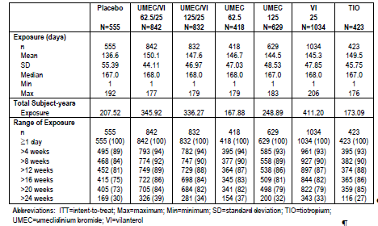
For the 2 combined exercise tolerance studies, the mean (SD) exposure was 77.8 (20.17), 80.5 (16.23), 80.4 (16.50), 81.4 (12.73), 77.7 (21.07) and 78.5 (19.39) days in the pooled placebo, UMEC/VI 62.5/25 µg, UMEC/VI 125/25 µg, UMEC 62.5 µg, UMEC 125 µg, and VI 25 µg groups, respectively. Overall, 62%, 65%, 69%, 67%, 63% and 66% of subjects in these respective groups had an exposure to study drug of > 12 weeks.
In the 12-month long-term safety study (DB2113359), the mean (SD) exposure was 269.4 (127.54), 269.0 (125.52) and 285.3 (114.18) days in the placebo, UMEC 125 µg and UMEC/VI 125/25 µg groups, respectively. Overall, 65%, 64% and 66% of subjects in these respective groups had an exposure to study drug of ≥ 274 days.
Evaluator’s comments: Overall, the study drug exposure is adequate to assess the safety profile of UMEC/VI.

Adverse events

All adverse events (irrespective of relationship to study treatment)

Pivotal studies
An overview of the number and percentage of subjects with AEs in each pooled treatment group is presented in Table 17. The percentages of subjects with any on-treatment AEs were comparable among treatment groups (48% (264/555), 53% (447/842), 53% (438/832), 52% (216/418), 55% (348/629), 50% (518/1034), and 49% (208/423) in the pooled placebo, UMEC/VI 62.5/25 µg, UMEC/VI 125/25 µg, UMEC 62.5 µg, UMEC 125 µg, VI 25 µg and TIO 18 µg groups, respectively).

Table 17. Summary of Adverse Events (DB2113361, DB2113373, DB2113360, DB2113374 ITT Population).
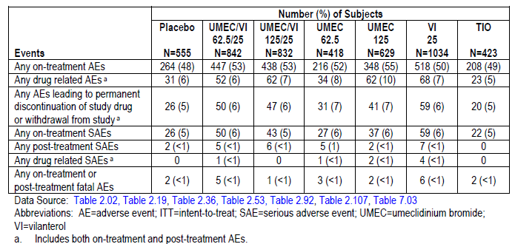
On-treatment AEs that occurred in ≥ 3% of subjects in any treatment group were presented. The most commonly reported on-treatment AEs by preferred term (PT) in the UMEC/VI 62.5/25 µg or UMEC/VI 125/25 µg group were headache (10%, 9%, 9%, 8%, 10%, 8% and 6% in the pooled placebo, UMEC/VI 62.5/25 µg, UMEC/VI 125/25 µg, UMEC 62.5 µg, UMEC 125 µg, VI 25 µg and TIO 18 µg groups, respectively) and nasopharyngitis (9%, 9%, 9%, 7%, 7%, 9% and 8%, respectively). On-treatment AEs reported by more than 1% of subjects in any UMEC/VI treatment group and having an incidence in any UMEC/VI group of greater than 1% over the incidence in the PLA group were cough, pharyngitis, dry mouth, and constipation.

Other studies

Exercise tolerance studies (DB2114417 and DB2114418)
The percentages of subjects with any on-treatment AEs were comparable among treatment groups (33% (105/321), 33% (92/282), 36% (98/272), 20% (18/89), 40% (36/91), and 32% (45/140) in the pooled placebo, UMEC/VI 62.5/25 µg, UMEC/VI 125/25 µg, UMEC 62.5 µg, UMEC 125 µg, and VI 25 µg groups, respectively).
On-treatment AEs that occurred in ≥ 3% of subjects in any treatment group were presented. The most commonly reported on treatment AE by preferred term in the UMEC/VI 62.5/25 µg or UMEC/VI 125/25 µg group was nasopharyngitis (6%, 5%, 4%, 6%, 5% and 3% in the pooled placebo, UMEC/VI 62.5/25 µg, UMEC/VI 125/25 µg, UMEC 62.5 µg, UMEC 125 µg, and VI 25 µg groups, respectively).

Long-term safety study (DB2113359)
The percentages of subjects with any on-treatment AEs were comparable among treatment groups (52% (57/109), 58% (132/227) and 53% (120/226) in the placebo, UMEC 125 µg and UMEC/VI 125/25 µg groups, respectively).
For on-treatment AEs that occurred in ≥ 3% of subjects in any treatment group the most commonly reported on-treatment AE by preferred term in the UMEC 125 µg or UMEC/VI 125/25 µg group was headache (8%, 11% and 9% in the placebo, UMEC 125 µg and UMEC/VI 125/25 µg groups, respectively).

Treatment-related adverse events (adverse drug reactions)

Pivotal studies
The incidences of any treatment-related AEs were comparable among the pooled treatment groups (6% (31/555), 6% (52/842), 7% (62/832), 8% (34/418), 10% (62/629), 7% (68/1034), and 5% (23/423) in the pooled placebo, UMEC/VI 62.5/25 µg, UMEC/VI 125/25 µg, UMEC 62.5 µg, UMEC 125 µg, VI 25 µg and TIO 18 µg groups, respectively). No treatment-related AEs by preferred term was reported in ≥ 3% of subjects in any treatment group. No treatment-related AEs by preferred term was reported in ≥ 1% of subjects in the pooled UMEC/VI 62.5/25 µg group. In the pooled UMEC/VI 125/25 µg group, the most commonly reported treatment-related AEs by preferred term were dry mouth (<1%, <1%, 1%, 0%, <1%, <1% and 1% in the pooled placebo, UMEC/VI 62.5/25 µg, UMEC/VI 125/25 µg, UMEC 62.5 µg, UMEC 125 µg, VI 25 µg and TIO 18 µg groups, respectively) and cough (<1%, <1%, 1%, <1%, 1%, <1% and <1%, respectively).

Other studies

Exercise tolerance studies (DB2114417 and DB2114418)
The incidences of any treatment-related AEs were comparable among the pooled treatment groups (4% (14/321), 4% (12/282), 4% (10/272), 0%, 4% (4/91), and 4% (5/140) in the pooled placebo, UMEC/VI 62.5/25 µg, UMEC/VI 125/25 µg, UMEC 62.5 µg, UMEC 125 µg, and VI 25 µg groups, respectively). No treatment-related AEs by preferred term were reported in ≥ 3% of subjects in any treatment group. No treatment-related AEs by preferred term were reported in ≥ 1% of subjects in the pooled UMEC/VI 62.5/25 µg group. In the pooled UMEC/VI 125/25 µg group, the most commonly reported treatment-related AE by preferred term was cough (0%, 0%, 1%, 0%, 2%, and 0% in the pooled placebo, UMEC/VI 62.5/25 µg, UMEC/VI 125/25 µg, UMEC 62.5 µg, UMEC 125 µg, and VI 25 µg groups, respectively).

Long-term safety study (DB2113359)
The incidences of any treatment-related AEs were comparable among the treatment groups (13% (14/109), 12% (28/227) and 12% (26/226) in the placebo, UMEC 125 µg and UMEC/VI 125/25 µg groups, respectively). The most commonly reported treatment-related AEs by preferred term in the UMEC 125 µg or UMEC/VI 125/25 µg group was ventricular extra systoles (3% each in the PLA, UMEC 125 µg and UMEC/VI 125/25 µg groups, respectively).

Deaths and other serious adverse events

Pivotal studies
The incidences of deaths were comparable among the pooled treatment groups (<1% (2/555), <1% (5/842), <1% (1/832), <1% (3/418), <1% (2/629), <1% (6/1034), and <1% (2/423) in the pooled placebo, UMEC/VI 62.5/25 µg, UMEC/VI 125/25 µg, UMEC 62.5 µg, UMEC 125 µg, VI 25 µg and TIO 18 µg groups, respectively). Overall, the most frequently reported fatal AE was COPD, reported in 2 subjects (<1%), 1 subject (<1%) and 2 subjects (<1%) in the UMEC/VI 62.5/25 µg, UMEC 62.5 µg and VI 25 µg groups, respectively).
The incidence of on-treatment SAEs was comparable among pooled treatment groups (5% (26/555), 6% (50/842), 5% (43/832), 6% (27/418), 6% (37/629), 6% (59/1034), and 5% (22/423) in the pooled placebo, UMEC/VI 62.5/25 µg, UMEC/VI 125/25 µg, UMEC 62.5 µg, UMEC 125 µg, VI 25 µg and TIO 18 µg groups, respectively). The most frequently reported on-treatment SAE by preferred term in the UMEC/VI 62.5/25 µg or UMEC/VI 125/25 µg group was COPD (2%, 2%, 2%, 3%, < 1%, 1% and < 1% in the pooled placebo, UMEC/VI 62.5/25 µg, UMEC/VI 125/25 µg, UMEC 62.5 µg, UMEC 125 µg, VI 25 µg and TIO 18 µg groups, respectively). The only on-treatment SAE reported by 1% or more of subjects in any treatment group was COPD.
The incidence of treatment-related SAEs was low across all treatment groups (0%, < 1% (1/842), 0%, < 1% (1/418), < 1% (2/629), < 1% (4/1034), and 0% in the pooled placebo, UMEC/VI 62.5/25 µg, UMEC/VI 125/25 µg, UMEC 62.5 µg, UMEC 125 µg, VI 25 µg and TIO 18 µg groups, respectively). No on-treatment treatment-related SAE (by preferred term) was reported for more than 1 subject in any treatment group.

Other studies

Exercise tolerance studies (DB2114417 and DB2114418)
Overall, two deaths were reported in studies DB214417 and DB2114418, one in the UMEC 125 µg group (study DB214417; PT of death; the event was not considered to be related to study drug by the investigator) and one in the UMEC/VI 62.5/25 µg group (study DB214418; PT of lung neoplasm malignant and metastases to central nervous system; the event was not considered to be related to study drug by the investigator).
The incidence of on-treatment SAEs was comparable among pooled treatment groups (3% (10/321), 2% (7/282), 3% (9/272), 1% (1/89), 4% (4/91), and 6% (9/140) in the pooled placebo, UMEC/VI 62.5/25 µg, UMEC/VI 125/25 µg, UMEC 62.5 µg, UMEC 125 µg, and VI 25 µg groups, respectively). No on-treatment SAEs by preferred term was reported in ≥ 1% of subjects in the UMEC/VI 62.5/25 µg group. In the UMEC/VI 125/25 µg the most commonly reported on treatment SAEs by preferred term was COPD (< 1%, 0%, 1%, 0%, 0%, and 0% in the pooled placebo, UMEC/VI 62.5/25 µg, UMEC/VI 125/25 µg, UMEC 62.5 µg, UMEC 125 µg, and VI 25 µg groups, respectively). Overall, only one subject had an on-treatment drug-related SAE (VI 25 µg treatment group; PT of leukocytoclastic vasculitis).

Long term safety study (DB2113359)
A total of 5 on-treatment or post-treatment fatal AEs were reported among 5 subjects in study DB2113359: 1 in the placebo group (< 1%) and 4 in the UMEC 125 µg group (2%). None of the fatal AEs were considered related to study drug by the investigator.
The incidence of on-treatment SAEs was comparable among treatment groups (6% (7/109), 7% (17/227) and 6% (14/226) in the placebo, UMEC 125 µg and UMEC/VI 125/25 µg groups, respectively). The only on-treatment SAE by preferred term reported for > 1% of subjects in any treatment group was COPD (3%, 2% and < 1% in the placebo, UMEC 125 µg and UMEC/VI 125/25 µg groups, respectively). Overall, only one subject had an on-treatment drug-related SAE (UMEC 125 µg treatment group; PT of rhythm idioventricular).

Discontinuation due to adverse events

Pivotal studies
The incidence of any AEs resulting in discontinuation of study drug or withdrawal from study was comparable among pooled treatment groups (5% (26/555), 6% (50/842), 6% (47/832), 7% (31/418), 7% (41/629), 6% (59/1034), and 5% (20/423) in the pooled placebo, UMEC/VI 62.5/25 µg, UMEC/VI 125/25 µg, UMEC 62.5 µg, UMEC 125 µg, VI 25 µg and TIO 18 µg groups, respectively). The most frequently reported AEs resulting in discontinuation of study drug or withdrawal from study in the UMEC/VI 62.5/25 µg or UMEC/VI 125/25 µg group was COPD (3%, 2%, 2%, 3%, 1%, 1% and < 1% in the pooled placebo, UMEC/VI 62.5/25 µg, UMEC/VI 125/25 µg, UMEC 62.5 µg, UMEC 125 µg, VI 25 µg and TIO 18 µg groups, respectively).

Other studies

Exercise tolerance studies (DB2114417 and DB2114418).
The incidence of any AEs resulting in discontinuation of study drug or withdrawal from study was comparable among pooled treatment groups (5% (17/321), 4% (10/282), 3% (7/272), 2% (2/89), 3% (3/91), and 5% (7/140) in the pooled placebo, UMEC/VI 62.5/25 µg, UMEC/VI 125/25 µg, UMEC 62.5 µg, UMEC 125 µg, and VI 25 µg groups, respectively). No AEs resulting in discontinuation of study drug or withdrawal from study by preferred term was reported in ≥ 1% of subjects in the UMEC/VI 62.5/25 µg group. In the UMEC/VI 125/25 µg group, the most commonly reported AE resulting in discontinuation of study drug or withdrawal from study by preferred term was COPD (< 1%, 0%, 1%, 0%, 0%, and 0% in the pooled placebo, UMEC/VI 62.5/25 µg, UMEC/VI 125/25 µg, UMEC 62.5 µg, UMEC 125 µg, and VI 25 µg groups, respectively).

Long-term safety study (DB2113359)
The incidence of any AEs resulting in discontinuation of study drug or withdrawal from study was comparable among treatment groups (11% (12/109), 9% (21/227) and 8% (17/226) in the placebo, UMEC 125 µg and UMEC/VI 125/25 µg groups, respectively). No AEs resulting in discontinuation of study drug or withdrawal from study by preferred term was reported in ≥ 1% of subjects in the UMEC/VI 125/25 µg group. In the UMEC 125 µg group, the most commonly reported AEs resulting in discontinuation of study drug or withdrawal from study by preferred term was ventricular extrasystoles (< 1%, 2% and < 1% in the placebo, UMEC 125 µg and UMEC/VI 125/25 µg groups, respectively.

Laboratory tests

Clinical laboratory tests

Pivotal studies
Glucose and potassium results will be discussed under “Adverse events of special interest”. Analyses of other clinical laboratory tests (routine haematology and blood chemistry) did not raise any significant safety concerns. Incidence of adverse events relating to abnormal liver chemistry was low across treatment groups (< 1% in all treatment groups). Overall, three subjects (1 subject each in the UMEC 62.5 µg (study DB2113373), UMEC 125 µg (study DB2113374) and TIO 18 µg (study DB2113374 ) groups) were reported as having liver events that exceeded the a priori liver chemistry stopping criteria and were withdrawn from the study.

Other studies

Exercise tolerance studies (DB2114417 and DB2114418)
Glucose and potassium results will be discussed under “Adverse events of special interest”. Analyses of other clinical laboratory tests (routine haematology and blood chemistry) did not raise any significant safety concerns. Overall, 2 subjects had adverse events relating to abnormal liver chemistry: 1 subject treated with PLA and 1 subject treated with UMEC/VI 62.5/25 µg, reported AEs of hepatic enzyme increased and gamma-glutamyl transferase increased, respectively. No subjects liver events that exceeded the a priori liver chemistry stopping criteria.

Long-term safety study (DB2113359)
Glucose and potassium results will be discussed under “Adverse events of special interest”. Analyses of other clinical laboratory tests (routine haematology and blood chemistry) did not raise any significant safety concerns. Incidence of adverse events relating to abnormal liver chemistry was low across treatment groups (< 1% in all treatment groups). No subjects liver events that exceeded the a priori liver chemistry stopping criteria.

Vital signs

Pivotal studies
Maximum or minimum post baseline mean changes from baseline in vital signs were similar across all treatment groups. Overall, LSM changes from baseline in vital signs were small across all pre- and post-dose time points over the treatment period.

Other studies

Exercise tolerance studies (DB2114417 and DB2114418)
Maximum or minimum post-baseline mean changes from baseline in vital signs were similar across all treatment groups. Overall, LSM changes from baseline in vital signs were small across all pre- and post-dose time points over the treatment period.

Long-term safety study (DB2113359)
Maximum or minimum post-baseline mean changes from baseline in vital signs were similar across all treatment groups. Overall, LSM changes from baseline in vital signs were small across all pre- and post-dose time points over the treatment period.

Electrocardiograph

Pivotal studies
Analyses of the ECGs did not raise any significant safety concerns. Maximum post-baseline mean changes from baseline in ECG parameters were similar across treatment groups. Overall, LSM changes from baseline in QTc(F), PR interval and heart rate were small across all assessed pre-and post-dose time points over the treatment period. Categorical summary of the frequency of change from baseline QTc(F) showed that the majority of subjects across treatment groups (91% to 95%) reported maximum post-baseline QTc(F) values ≤ 450 milliseconds. The majority of maximum post-baseline changes from baseline in QTc(F) (75% to 79%) were within the range of ≥ 0 to < 30 milliseconds across all treatment groups. The proportion of subjects with maximum post-baseline changes from baseline in QTc(F) of ≥ 30 milliseconds was comparable across treatment groups (9% (52/555), 13% (110/842), 11% (93/832), 11% (44/417), 10% (63/629), 10% (102/1034), and 12% (49/423) in the pooled placebo, UMEC/VI 62.5/25 µg, UMEC/VI 125/25 µg, UMEC 62.5 µg, UMEC 125 µg, VI 25 µg and TIO 18 µg groups, respectively). The proportion of subjects with one or more abnormal, clinically significant ECG result at any time post-baseline was similar across treatment groups (18% to 22%). Analyses of the specific ECG abnormalities for subjects with any post-baseline abnormal, clinically significant ECG interpretation showed that incidences were comparable between active treatment groups and placebo group.

Other studies

Exercise tolerance studies (DB2114417 and DB2114418)
Analyses of the ECGs did not raise any significant safety concerns. The proportion of subjects with one or more abnormal, clinically significant ECG result at any time post-baseline was higher in the UMEC 125 µg group (25%), but comparable among the other treatment groups (11% to 19%). The proportion of subjects with one or more abnormal, clinically significant ECG result at baseline was also higher in the UMEC 125 µg group (20%), compared to the other treatment groups (9% to13%).

Long-term safety study (DB2113359)
Analyses of the ECGs did not raise any significant safety concerns. Maximum post-baseline mean changes from baseline in ECG parameters were similar across treatment groups. Overall, LSM changes from baseline in QTc(F), PR interval and heart rate were small across all assessed pre-and post-dose time points over the treatment period. Categorical summary of frequency of change from baseline QTc(F) showed that the majority of subjects across treatment groups (90% to 91%) reported maximum post-baseline QTc(F) values ≤ 450 milliseconds. The majority of maximum post-baseline changes from baseline in QTc(F) (71% to 78%) were within the range of ≥ 0 to < 30 milliseconds across all treatment groups. The proportion of subjects with maximum post-baseline changes from baseline in QTc(F) of ≥ 30 milliseconds was comparable across treatment groups (15% (16/109), 18% (40/227), and 21% (48/226) in the placebo, UMEC 125 µg and UMEC/VI 125/25 µg groups, respectively). The proportion of subjects with one or more abnormal, clinically significant ECG result at any time post-baseline was similar across treatment groups (23% to 26%).

24-hour holter monitoring

Pivotal studies
Holter monitoring was conducted in a subset of subjects (the TFH population) in studies DB2113361 and DB2113373. A baseline Holter monitoring of 24-hour duration was performed at screening. Post-treatment Holter monitoring was performed at Day 1, Month 3, and Month 6. Results showed that mean and maximum Holter heart rates for all active treatment groups (UMEC/VI, UMEC, and VI) were similar to those seen in the placebo group. The proportion of subjects with one or more abnormal, clinically significant Holter ECG interpretation at any time post-baseline was 45% to 56% in the active treatment groups, compared with 60% in the placebo group. Analyses of the specific Holter ECG abnormalities for subjects with any post-baseline abnormal, clinically significant Holter ECG interpretation showed that incidences were generally comparable between active treatment groups and placebo group.

Other studies
In the long-term safety study (DB2113359), Holter monitoring results showed that the proportion of subjects with one or more abnormal, clinically significant Holter ECG interpretation at any time post-baseline was comparable among treatment groups (52% to 55%). Analyses of the specific Holter ECG abnormalities for subjects with any post-baseline abnormal, clinically significant Holter ECG interpretation showed that incidences were comparable among groups.

AEs of special interest
The standardised Medical Dictionary for Regulatory Activities (MedDRA) queries (SMQs) or MedDRA High Level Terms used for the adverse events of special interest (AESIs) is presented in Table 18.

Table 18. Adverse Events of Special Interest Groups, Subgroups, and Selection of Terms.
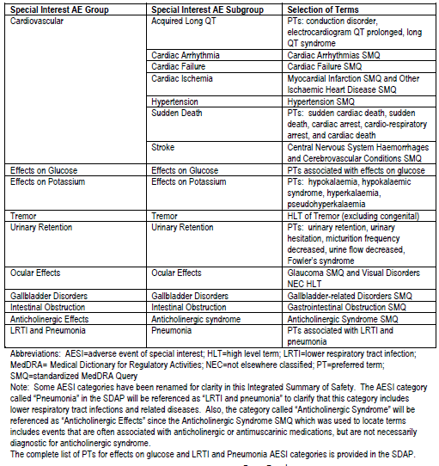

Pivotal studies
The incidence of on-treatment events in the cardiovascular special interest group was generally comparable across the pooled treatment groups (6% to 10%). The incidence of on-treatment cardiovascular AESIs by special interest subgroups was shown. Results showed that there were no obvious dose- or treatment-related trends. Overall, the most commonly reported subgroup of on-treatment cardiovascular AESIs was cardiac arrhythmias (2% to 5% across treatment groups). The incidence of on-treatment cardiovascular AESIs by PT was low (all PTs were reported for ≤ 1% of subjects by treatment group), and no obvious dose- or treatment-related patterns identified.
The incidence of on-treatment potassium AESIs was low (< 1% in all treatment groups) and all of these events were described by the PT “hypokalaemia”. The incidence of on-treatment glucose AESIs was low (< 1% to 2% across treatment groups), as was the incidence of on-treatment glucose AESIs by PT (all PTs were reported for < 1% of subjects by treatment group), with no obvious dose- or treatment-related patterns identified. The incidence of on-treatment tremor AESIs was low (< 1% in all treatment groups) and all of these events were described by the PT “tremor”. The incidence of on-treatment urinary retention AESIs was also low (< 1% in all treatment groups). Three PTs were reported for this AESI group: urinary hesitation, urinary retention, and urine flow decreased (each reported for < 1% of subjects by treatment group), and no obvious dose- or treatment-related patterns were identified. The incidence of on-treatment ocular AESIs was low (≤ 1% in all treatment groups), as was the incidence of on-treatment ocular AESIs by PT (all PTs were reported for <1% of subjects by treatment group), with no obvious dose- or treatment-related patterns identified. The incidence of on-treatment gallbladder AESIs was low (< 1% in all treatment groups). The incidence of on-treatment gallbladder AESIs by PT was low (all PTs were reported for < 1% of subjects by treatment group), and no obvious dose- or treatment-related patterns were identified. The incidence of on-treatment intestinal obstruction AESIs was low (< 1% in all treatment groups). Two PTs were reported for this AESI group: ileus and small intestinal obstruction (each reported for < 1% of subjects by treatment group), and no obvious dose- or treatment-related patterns were identified.
The incidence of on-treatment anticholinergic effects AESIs was 3% to 5% in the UMEC/VI, UMEC and VI treatment groups, compared with 4% each in the TIO and placebo groups. The incidence of on-treatment anticholinergic effects AESIs by PT was ≤ 1% in all treatment groups, except for dry mouth (< 1%, < 1%, 2%, < 1%, < 1%, < 1% and 2% in the pooled placebo, UMEC/VI 62.5/25 µg, UMEC/VI 125/25 µg, UMEC 62.5 µg, UMEC 125 µg, VI 25 µg and TIO 18 µg groups, respectively) and pyrexia (1%, < 1%, 2%, < 1%, 1%, 1% and < 1%, respectively). The incidence of on-treatment LRTI and pneumonia AESIs was 1% to 3% in the UMEC/VI, UMEC and VI treatment groups, compared with 4% and 1% in the TIO and placebo groups, respectively. The incidence of on-treatment LRTI and pneumonia AESIs by PT was low (all PTs were reported for ≤ 1% of subjects by treatment group), and no obvious dose- or treatment-related patterns identified.

Other studies

Exercise tolerance studies (DB2114417 and DB2114418)
The incidence of on-treatment events in the cardiovascular special interest group was generally comparable across the pooled treatment groups (1% to 4%). The incidence of on-treatment cardiovascular AESIs by special interest subgroups was presented. Results showed that there were no obvious dose- or treatment-related trends. Overall, the most commonly reported subgroup of on-treatment cardiovascular AESIs was cardiac arrhythmias (< 1% to 2% across treatment groups) and hypertension (< 1% to 2% across treatment groups). The incidence of on-treatment cardiovascular AESIs by PT was low. All PTs were reported for ≤ 1% of subjects by treatment group, with the exception of hypertension (< 1%, 0%, 2%, 1%, 1% and < 1% in the pooled placebo, UMEC/VI 62.5/25 µg, UMEC/VI 125/25 µg, UMEC 62.5 µg, UMEC 125 µg, and VI 25 µg groups, respectively). There was no obvious dose- or treatment-related pattern.
The incidence of on-treatment potassium AESIs was low, with only one subject each in the UMEC/VI 62.5/25 µg and placebo groups (< 1% each) reporting an event (both described by the PT “hypokalaemia”). The incidence of on-treatment glucose AESIs was low (≤ 1% in all treatment groups), as was the incidence of on-treatment glucose AESIs by PT (all PTs were reported for ≤ 1% of subjects by treatment group), with no obvious dose- or treatment-related patterns identified. The incidence of on-treatment tremor AESIs was low, with only one subject each in the UMEC/VI 62.5/25 µg and placebo groups (< 1% each) reporting an event (both described by the PT “tremor”). The incidence of on-treatment urinary retention AESIs was also low, with only one subject each in the UMEC/VI 62.5/25 µg and VI 25 µg groups (< 1% each) reporting an event (both described by the PT “urinary retention”). The incidence of on-treatment ocular AESIs was low (≤ 1% in all treatment groups), as was the incidence of on-treatment ocular AESIs by PT (all PTs were reported for ≤ 1% of subjects by treatment group), with no obvious dose- or treatment-related patterns identified. The incidence of on-treatment gallbladder AESIs was low, with only one subject (1%) in the UMEC 125 µg reporting an event (PT of “Porcelain gallbladder”). No subjects had any intestinal obstruction AESIs in these studies.
The incidence of on treatment anticholinergic effects AESIs was 0% to 3% in the UMEC/VI, UMEC and VI treatment groups, compared with 2% in the placebo group. The incidence of on-treatment anticholinergic effects AESIs by PT was ≤ 1% in all treatment groups, except for dry mouth (< 1%, < 1%, 0%, 0%, 2% and 0% in the pooled placebo, UMEC/VI 62.5/25 µg, UMEC/VI 125/25 µg, UMEC 62.5 µg, UMEC 125 µg, and VI 25 µg groups, respectively). The incidence of on-treatment LRTI and pneumonia AESIs was low (≤ 1% in all treatment groups), as was the incidence of on treatment LRTI and pneumonia AESIs by PT (all PTs were reported for ≤ 1% of subjects by treatment group), and no with no obvious dose- or treatment-related patterns identified.

Long-term safety study (DB2113359)
The incidence of on-treatment events in the cardiovascular special interest group was generally comparable across the treatment groups (15% to 23%). The incidence of on-treatment cardiovascular AESIs by special interest subgroups was presented, and results showed that there were no obvious dose- or treatment-related trends. Overall, the most commonly reported subgroup of on treatment cardiovascular AESIs was cardiac arrhythmias (12% to 17% across treatment groups) and hypertension (3% to 6% across treatment groups). Analyses of the incidence of on-treatment cardiovascular AESIs by PT showed that there were no obvious dose- or treatment-related patterns. The most commonly reported on-treatment cardiovascular AESIs by PT in the UMEC/VI 125/25 µg or UMEC 125 µg group was ventricular extrasystoles (5% each in the placebo, UMEC/VI 125/25 µg and UMEC 125 µg groups).
The incidence of on-treatment potassium AESIs was low, with only one subject (in the UMEC 125 µg group; < 1%) reporting an event (PT of “hypokalaemia”). The incidence of on-treatment glucose AESIs was 0%, 4% and 1% in the placebo, UMEC/VI 125/25 µg and UMEC 125 µg groups, respectively. The incidence of on-treatment glucose AESIs by PT was low (all PTs were reported for ≤ 1% of subjects by treatment group), and no obvious dose- or treatment-related patterns were identified. No subjects in study DB2113359 had an event in the AESI group of tremors or urinary retention. The incidence of on-treatment ocular AESIs was low (< 1% in all treatment groups), as was the incidence of on-treatment ocular AESIs by PT (all PTs were reported for < 1% of subjects by treatment group), with no obvious dose- or treatment-related patterns identified. The incidence of on-treatment gallbladder AESIs was low, with only 2 subjects (< 1%) in the UMEC 125 µg reporting an event (PT of “Cholelithiasis” and “Cholecystitis chronic”, respectively). No subjects had any intestinal obstruction AESIs.
The incidence of on-treatment anticholinergic effects AESIs was low (2% in each treatment group). The incidence of on-treatment anticholinergic effects AESIs by PT was < 1% in all treatment groups, and no obvious dose- or treatment-related patterns were identified. The incidence of on-treatment LRTI and pneumonia AESIs was 2%, 2% and 5% in the placebo, UMEC/VI 125/25 µg and UMEC 125 µg groups, respectively. The incidence of on-treatment LRTI and pneumonia AESIs by PT was ≤ 1% in all treatment groups, except for pneumonia (0%, 0% and 3% in the placebo, UMEC/VI 125/25 µg and UMEC 125 µg groups, respectively) and bronchitis (2%, < 1% and < 1%, respectively).

Post-marketing experience
Not applicable.

Safety issues with the potential for major regulatory impact

Muscarinic antagonist class effects
Muscarinic antagonist pharmacological class effects include cardiovascular effects, ocular disorders, urinary retention, intestinal obstruction, gallbladder disorders, and anticholinergic effects. Overall, the results did not raise any particular safety concerns.

Beta₂ adrenergic agonist class effects
Beta₂ adrenergic agonist pharmacological class effects include cardiovascular effects, hypokalaemia, elevated glucose and tremors. Overall, the results did not raise any particular safety concerns.

Other safety issues

Safety in special populations
Subgroup analyses in the combined data of the 4 pivotal studies showed that the incidences of on-treatment AE, treatment-related AEs, SAEs, or AEs leading to permanent discontinuation of study drug were generally comparable across the subgroups of gender, age, salbutamol reversibility at screening and ICS use.

Evaluator’s overall conclusions on clinical safety
Overall, the safety results did not raise any major safety concerns for either dose of UMEC/VI or its individual components. The overall incidences of all-causality AEs, treatment-related AEs, SAEs and AEs leading to discontinuation were comparable between both doses of UMEC/VI and placebo or TIO in the pivotal Phase III studies. These results were generally supported by those of the non-pivotal exercise tolerance studies and the long-term safety study. The commonly reported treatment-related AEs were those expected for a LABA and LAMA. Analyses of cardiovascular safety and of AEs related to muscarinic antagonist and beta₂ adrenergic agonist pharmacological class effects did not raise major safety concerns. The incidences of these AEs were generally low and comparable between PLA and active treatment groups, with no obvious dose- or treatment-related trends detected.
With regards to potential drug/drug interactions with known pharmacological smoking cessation agents, such as varenicline, the sponsor had not provided any analyses regarding potential drug-drug interactions between UMEC/VI and varenicline, or incidence of AEs with and without concomitant use of varenicline. As smoking cessation plays an important role in the overall clinical management of patients with COPD, it is expected that in clinical settings, COPD patients being prescribed UMEC/VI would also be engaged in smoking cessation programs, which may include the use of varenicline. It would therefore be clinically relevant to explore any potential safety issues with concomitant use of these 2 medications in the 4 pivotal studies. However, a look through the data of the 4 pivotal studies showed that the incidence of concomitant use of varenicline during the studies was very low (1% in each study). In view of this, additional safety analyses comparing results with and without concomitant use of varenicline in the 4 pivotal studies are not considered to be able to allow meaningful interpretation.
Evaluation of the clinical overview in Module 2 of the submission dossier showed that the summary and conclusions were reasonable.

First round benefit-risk assessment

First round assessment of benefits
The potential benefit of UMEC/VI in the proposed usage is as a once-daily maintenance bronchodilator treatment to relieve symptoms in adult patients with COPD. Overall, efficacy results were supportive of the efficacy claim of both doses of UMEC/VI (125/25 µg and 62.5/25 µg) over placebo in terms of lung function as well as symptom relief.
The efficacy of UMEC/VI was evaluated through effects on lung function (FEV1) as well as effects on symptom relief and health outcomes, compared to placebo and to tiotropium. Analyses on the effects of UMEC/VI on FEV1 compared to placebo in the two pivotal 24-week placebo-controlled studies showed that after 24 weeks of treatment, both doses of UMEC/VI had statistically significant improvements over placebo in trough FEV1 (difference over placebo of 167 mL and 238 mL with UMEC/VI 62.5/25 µg and 125/25 µg, respectively) and in weighted mean FEV1 over 0 - 6 hours post-dose (difference over placebo of 242 mL and 287 mL with UMEC/VI 62.5/25 µg and 125/25 µg, respectively). Over the 24-week treatment period, improvements with both doses of UMEC/VI in trough FEV1 and weighted mean FEV1 over 0 - 6 hours post-dose compared to placebo were observed early and then maintained across the 24-week treatment period.
Analyses on the effects of UMEC/VI on FEV1 compared to tiotropium in the two pivotal 24-week active-controlled studies showed that after 24 weeks of treatment, both doses of UMEC/VI had improvements over placebo in trough FEV1 (difference over tiotropium of 60 to 90 mL and 74 to 88 mL with UMEC/VI 62.5/25 µg and 125/25 µg, respectively) and in weighted mean FEV1 over 0 - 6 hours post-dose (difference over tiotropium of 74 to 96 mL and 83 to 101 mL with UMEC/VI 62.5/25 µg and 125/25 µg, respectively). Over the 24-week treatment period, improvements with both doses of UMEC/VI in trough FEV1 and weighted mean FEV1 over 0 - 6 hours post-dose compared to tiotropium were observed early and then maintained across the 24-week treatment period.
Analyses on the effects of UMEC/VI on symptom relief and health outcomes compared to PLA in the two pivotal 24-week placebo-controlled studies showed that after 24 weeks of treatment, both doses of UMEC/VI had statistically significant improvements over placebo in TDI focal scores (difference over placebo of 1.2 and 1.0 with UMEC/VI 62.5/25 µg and 125/25 µg, respectively), and there were greater proportions of TDI responders (as defined by a ≥ 1 unit value) compared with placebo for UMEC/VI 62.5/25 µg (58% vs. 41% with placebo) and for UMEC/VI 125/25 µg (49% vs. 30% with placebo). There were also statistically significantly greater reductions from baseline in rescue salbutamol use over Weeks 1 to 24 compared to placebo as well as greater changes from baseline in percentage of rescu- free days over Weeks 1 to 24 compared with placebo. Both doses of UMEC/VI also showed statistically significantly lower risk of COPD exacerbation compared with placebo.
With regards to effects on exercise tolerance, analyses in one of the 2 exercise studies (DB2114418) showed statistically significantly greater changes from baseline in the 3-hour post-dose EET at Week 12 compared with placebo for both doses of UMEC/VI (difference over placebo of 69.4 seconds and 65.8 seconds for UMEC/VI 62.5/25 µg and UMEC/VI 125/25 µg, respectively), while results in the other exercise study (DB2114417) showed no statistically significant difference in 3-hour post-dose EET at Week 12 between either doses of UMEC/VI and placebo. However, further analysis shows that this was due to a greater placebo response in study DB2114417 than was observed in the DB2114418 study, and the changes in EET from baseline were similar with both doses of UMEC/VI between both studies.
Efficacy results in the pivotal studies showed no clear differentiation between the 2 doses of UMEC/VI. The two pivotal 24-week active-controlled studies (DB2113360 and DB2113374) allowed within study comparisons of the 2 doses and showed that in study DB2113360, change from baseline in trough FEV1 at Day 169 was 211 mL and 209 mL with UMEC/VI 62.5/25 µg and UMEC/VI 125/25 µg, respectively (treatment difference over TIO of 90 mL and 88 mL, respectively), while in study DB2113374, change from baseline in trough FEV1 at Day 169 was 208 mL and 223 mL with UMEC/VI 62.5/25 µg and UMEC/VI 125/25 µg, respectively (treatment difference over TIO of 60 mL and 74 mL, respectively).
Additional subgroup analyses on integrated data of the 4 pivotal efficacy studies showed that in the subgroup of subjects reversible to salbutamol at screening, there were greater improvements in bronchodilatation with UMEC/VI 125/25 µg (improvement over placebo in trough FEV1 at Day 169 of 282 mL) compared with UMEC/VI 62.5/25 µg (improvement over placebo of 225 mL), a pattern that was not observed in the non-reversible subjects (improvement over placebo of 181 mL and 188 mL with UMEC/VI 125/25 µg and UMEC/VI 62.5/25 µg, respectively). This greater treatment response with UMEC/VI 125/25 µg than with UMEC/VI 62.5/25 µg in the reversible subgroup was also observed for the TDI focal scores, SGRQ scores, and rescue salbutamol use. The sponsor’s conclusions that the UMEC/VI dose of 62.5/25 µg would be appropriate for the majority of COPD patients, and that UMEC/VI 125/25 µg could potentially offer additional benefit in some COPD patients who had salbutamol reversibility, were sound.

First round assessment of risks
The risks of UMEC/VI in the proposed usage are:
- Muscarinic antagonist pharmacological class effects
- Beta₂ adrenergic agonist pharmacological class effects
In particular, as both LAMA and LABA have potential cardiovascular effects, and UMEC/VI consists of a combination of a LAMA and a LABA, adverse effects on the cardiovascular system needs to be assessed.
Overall, analyses of cardiovascular safety and of AEs related to muscarinic antagonist and beta₂ adrenergic agonist pharmacological class effects did not raise major safety concerns. In the pivotal studies, the incidence of on-treatment events in the cardiovascular special interest group was generally comparable across the pooled treatment groups (6% to 10%). The overall most commonly reported subgroup of on- treatment cardiovascular AESIs was cardiac arrhythmias, but the incidence was low and comparable across treatment groups (2% to 5% across treatment groups; 3% and 2% with UMEC/VI 62.5/25 µg and UMEC/VI 125/25 µg, respectively compared with 3% with placebo and 2% with tiotropium). There were no obvious dose- or treatment-related trends. Results in the 2 exercise studies and the long-term safety studies were consistent with those in the pivotal studies. Cardiovascular effects were assessed via Holter monitoring in a subset of subjects in the 2 placebo-controlled pivotal studies and in the long-term safety study. Results did not raise major cardiovascular safety concerns for either dose of UMEC/VI. The proportion of subjects with one or more abnormal, clinically significant Holter ECG interpretation at any time post-baseline was 53% and 45% in the UMEC/VI 62.5/25 µg and UMEC/VI 125/25 µg groups, respectively, vs. 60% in the placebo group, in the 2 pivotal studies, while that in the long-term safety study was 55% in the UMEC/VI 125/25 µg group versus 52% in the placebo group. The incidences of other AEs of special interest relating to muscarinic antagonist and beta2 adrenergic agonist pharmacological class effects were generally low and comparable between placebo and active treatment groups, with no obvious dose- or treatment-related trends detected.

First round assessment of benefit-risk balance
The benefit-risk balance of UMEC/VI, given the proposed usage, is favourable.
Overall, analyses on effects of UMEC/VI on FEV1 compared to placebo yielded results which were generally supportive of the efficacy claim of both doses of UMEC/VI (62.5/25 µg and 125/25 µg) over placebo. Analyses on effects of UMEC/VI on symptom relief compared to placebo also yielded results which were generally supportive of the efficacy claim of both doses of UMEC/VI over placebo. Safety results did not raise any major safety concerns.

First round recommendation regarding authorisation
It is recommended that the application for the registration of UMEC/VI 62.5/25 µg and 125/25 µg as a long term QD maintenance bronchodilator treatment to relieve symptoms in adult patients with COPD be approved.
This is subject to a satisfactory response to the clinical questions raised in Section 11.

Clinical questions

Pharmacokinetics
None.

Pharmacodynamics
None.

Efficacy
- Please provide clarification on how the twenty four hour population subsets in studies DB2113361 and DB2113373 were selected.
Rationale for question: As discussed, it was not clearly explained in the clinical study reports (CSR) or protocols how the twenty-four hour population subset was selected. In the CSR, the sponsor had stated that in each of these studies, at selected study sites, a subset of approximately 198 planned subjects performed 24-hour serial spirometry during the study, but no further explanation was provided in the CSRs or protocols as to how the sites or the subset of subjects had been selected. This information would be important in the overall assessment of any potential bias in the study results with regards to this subset.
- Please provide the baseline demographic and disease characteristics of the twenty four hour population in studies DB2113361, DB2113373.
Rationale for question: As discussed, the baseline demographic and disease characteristics of the 24-hour subset (TFH population) were not provided, and hence comparability of these baseline characteristics across the treatment groups in this subset of study population could not be ascertained.
- Please elaborate on the sample size calculations for studies DB2113360 and DB2113374, with regards to the increased in the planned number of evaluable subjects in each arm from the calculated 111 to 146 subjects.
Rationale for question: As discussed, the sponsor had stated that the planned number of evaluable subjects in each arm was increased from the calculated 111 to 146 subjects, in order to meet ICH E1A guidelines on exposure to new medicinal products. This referenced guidance document was looked through, but it remains unclear to the evaluator how the exact number of 146 subjects per treatment arm was derived. The arrival at this number was not further elaborated in the CSR, protocols or statistical plans.

Second round evaluation of clinical data submitted in response to questions
Overall, the sponsor has adequately addressed all the questions posed in the first round of evaluation. In this section on the evaluation of the sponsor’s responses to the questions posed in the first round of evaluation, each question will be re-stated for ease of reference, followed by the evaluation.
Question 1
Please provide clarification on how the twenty four hour population subsets in studies DB2113361 and DB2113373 were selected.
The sponsor provided explanation that subset-specific investigational sites were used in studies DB2113373 and DB2113361 in order to limit selection bias. A feasibility analysis was conducted to identify sites with the ability to conduct 24 hour serial spirometry assessments. The majority of these subset sites were restricted to enrolling all patients into the 24-hour subset, and this reduced selection bias as there was no option for them to enrol a patient into the non subset group. In study DB2113361, nine of the 14 sites (65%) that enrolled subset patients were subset-specific and in study DB2113373, nine of the 13 sites (69%) were subset-specific. Overall, the majority of patients in the 24-hour subset were enrolled at the subset-specific sites (subset-specific sites enrolled 165 of 199 (83%) of subset subjects in study DB2113361 and 155 of 197 (79%) of subset subjects in study DB21133373), thus minimising the risk of selection bias.
The sponsor’s response to this question has not resulted in any changes to the conclusions of the first round of evaluation.
Question 2
Please provide the baseline demographic and disease characteristics of the twenty four- hour population in studies DB2113361, DB2113373.
The sponsor provided the baseline demographics, COPD history, smoking history, and screening lung function and ICS use of the twenty four-hour populations in studies DB2113361 and DB2113373. The baseline demographic and disease characteristics for the twenty four-hour populations in these studies were generally comparable across treatment groups. The sponsor’s response to this question has not resulted in any changes to the conclusions of the first round of evaluation.
Question 3
Please elaborate on the sample size calculations for studies DB2113360 and DB2113374, with regards to the increase in the planned number of evaluable subjects in each arm from the calculated 111 to 146 subjects.
The sponsor clarified that the increase in sample size was due to the need to maintain the conditional power for the comparisons in the meta-analysis at approximately 90%. For the comparison of each UMEC/VI dose with tiotropium (TIO) for the endpoint of TDI in the meta-analysis, statistical inference was conditional on having achieved statistical significance on the comparison of that dose with TIO on the individual study primary endpoint of trough FEV1 on Day 169 in each individual study, as determined by the specific testing hierarchy within each study. The power for the meta-analysis comparisons was thus affected by the fact that prior comparisons were required to be performed in the individual studies. In order to maintain the conditional power for the comparisons in the meta-analysis at approximately 90%, it was necessary to increase the power for the comparisons in the individual studies and hence increase the sample size in each treatment arm.
Increasing the sample size to 146 subjects per arm provided 98% power to detect a 100 mL difference in trough FEV1 between treatment groups in each study and 96% power to detect a difference of 1 unit in TDI in the combined analysis. This gave conditional power for the comparison of UMEC/VI 125/25 with TIO for TDI of 92% and conditional power for the comparison of UMEC/VI 62.5/25 with TIO for TDI of 89%.

Second round benefit-risk assessment

Second round assessment of benefits
After consideration of the responses to clinical questions, the benefits of UMEC/VI in the proposed usage are unchanged from those identified in Section 9.1.

Second round assessment of risks
After consideration of the responses to clinical questions, the risks of UMEC/VI in the proposed usage are unchanged from those identified in Section 9.2.

Second round assessment of benefit-risk balance
The benefit-risk balance of UMEC/VI, given the proposed usage, is favourable.

Second round recommendation regarding authorisation
It is recommended that the application for the registration of UMEC/VI 62.5/25 µg and 125/25 µg as a long term QD maintenance bronchodilator treatment to relieve symptoms in adult patients with COPD be approved.

References
Australian Lung Foundation. The COPD‐X Plan: Australian and New Zealand Guidelines for the management of Chronic Obstructive Pulmonary Disease. 2010.
European Medicines Agency, Guidelines on clinical investigation of medicinal products in the treatment of chronic obstructive pulmonary disease. 21 June 2012.
European Medicines Agency, Points to consider on the clinical investigation of medicinal products in the treatment of chronic obstructive pulmonary disease (COPD), 19 May 1999.
European Medicines Agency, Points to consider on multiplicity in clinical trials. 19th September 2002.
European Medicines Agency, Guideline on the requirements for clinical documentation for orally inhaled product (OIP) including the requirements for demonstration of therapeutic equivalence between two inhaled products for use in the treatment of asthma and chronic obstructive pulmonary disease (COPD) in adults and for use in the treatment of asthma in children and adolescents. 22 January 2009.
European Medicines Agency, Note for Guidance on Fixed Dose Combination Medicinal Products. 19 February 2009.
FDA, Guidance for Industry- Chronic Obstructive Pulmonary Disease: Developing Drugs for Treatment. November 2007.
FDA, CFR300.50 regulations on Fixed Dose Combination Prescription Drugs for Human Use. 1999.
Global Initiative for Chronic Obstructive Lung Disease (GOLD), Global Strategy for the Diagnosis, Management and Prevention of COPD. 2011. http://www.goldcopd.org/uploads/users/files/GOLD_Report_2011_Feb21.pdf (accessed 20th August 2013).
ICH, Efficacy Guidelines E9: Statistical Principles for Clinical Trials. September 1998.
ICH E1A. The Extent of Population Exposure to Assess Clinical Safety: For Drugs intended for Long Term Treatment of Non-Life Threatening Conditions. March 1995.

Therapeutic Goods Administration
PO Box 100 Woden ACT 2606 Australia
Email: info@tga.gov.au Phone: 1800 020 653 Fax: 02 6232 8605
https://www.tga.gov.au/
Reference/Publication #

Ultibro Breezhaler was registered in Australia on 21 March 2014.
studies DB2114417/DB2114418 will be discussed in Efficacy Section and Safety Section of this report, while study DB2113359, which has no efficacy endpoints, will be discussed only in the Safety Section of this report.
Dose selection for UMEC in the Phase IIb studies were based on results of single ascending dose studies in ipratropium-responsive healthy volunteers (study AC4105209) and ipratropium-responsive subjects with COPD (study AC4108123). Results of study AC4105209 showed that single-dose administration of 10 and 20 µg of UMEC had a negligible effect on FEV1 over 24 hours while 350 µg of UMEC had the greatest effect, with the remaining doses (UMEC 60, 100, 250 µg), and tiotropium falling in between. All doses were well tolerated. Based on this study, doses of UMEC of 10 and 20 µg were identified as unlikely to be effective. Results of study AC4108123 suggested that maximal bronchodilatation over 24 hours was obtained at UMEC dose of 500 µg and that UMEC 250 µg provided less, but still robust, bronchodilatory effect. The bronchodilatory benefit of the 3 doses of UMEC tested (250, 500, and 1000 µg) was generally similar to that of tiotropium over 12 hours and greater at trough.
The sponsor considered a change in trough FEV1 of ≥ 100 mL to be clinically relevant based on literature which showed that this difference could be perceived by patients with COPD. The study had been powered to detect a treatment difference of 130 mL in change from baseline in trough FEV1, as the sponsor considered that this treatment difference would allow demonstration of an effect similar in magnitude to that obtained with tiotropium.
Erratum: the correct values are 92% and 99%, respectively.
the US, Belgium, Denmark, Estonia, France, Germany, Hungary, Japan, the Netherlands, Norway, Philippines, Slovakia, Sweden, and Ukraine.
the US, Bulgaria, Canada, Chile, Czech Republic, Greece, Japan, Mexico, Poland, Russia, South Africa, Spain, and Thailand.
Score 0 = not troubled with breathlessness except with strenuous exercise; Score 1 = troubled by shortness of breath when hurrying on the level or walking up a slight hill; Score 2 = walks slower than people of the same age on the level because of breathlessness or has to stop for breath when walking at own pace on the level; Score 3 = stops for breath after walking about 100 yards or after a few minutes on level; Score 4 = too breathless to leave the house or breathless when dressing or undressing.
Defined as oxygen therapy prescribed for > 12 hours a day. As-needed oxygen use (i.e. ≤ 12 hours per day) was not exclusionary.
Subjects who were in the maintenance phase of a pulmonary rehabilitation program were not excluded.
European Medicines Agency, Guidelines on clinical investigation of medicinal products in the treatment of chronic obstructive pulmonary disease. 21 June 2012. This EMA guideline was adopted by the EU Committee for Medicinal Products for Human Use (CHMP) on 9 July 2012, and was intended to replace the TGA-adopted EMA guidelines “Points to consider on clinical investigation of medicinal products in the treatment of chronic obstructive pulmonary disease” (CPMP/EWP/562/98, 19 May 1999).
FDA, Guidance for Industry- Chronic Obstructive Pulmonary Disease: Developing Drugs for Treatment. November 2007
European Medicines Agency, Note for Guidance on Fixed Dose Combination Medicinal Products. 19 February 2009
The sponsor had stated that the TDI focal score at Day 168 was considered a key secondary endpoint for submission to the European Medicines Agency (EMA) and other relevant regulatory authorities, and was considered an “other endpoint” for regulatory submission to the US Food and Drug Administration (FDA) and other relevant regulatory authorities
At Visit 2, the severity of dyspnoea at baseline was assessed using the Baseline Dyspnoea Index (BDI). At subsequent visits (Visits 4, 6, and 8) change from baseline was assessed using the TDI. The BDI is an interviewer-administered instrument used to measure the severity of dyspnoea in subjects at baseline, while the TDI (also interviewer-administered) measures changes in the subject’s dyspnoea from baseline. The scores in both the BDI and TDI evaluated ratings of dyspnoea for three different categories: functional impairment, magnitude of task, and magnitude of effort. For the BDI assessment of baseline dyspnoea, each of these categories has 5 possible scores ranging from 0 to 4 (with lower scores indicating more impairment), and hence the range of the total BDI focal score is 0 to 12. For the TDI assessment of change from baseline state, each of these categories has 7 possible scores ranging from -3 (major deterioration) to +3 (major improvement). The score for each component is added to give an overall score (called the TDI focal score) ranging from -9 to +9. A difference of 1 unit for the mean TDI focal score is considered to be clinically meaningful.
In both studies, at selected study sites, a subset of approximately 198 planned subjects performed 24-hour serial spirometry during the study (Visits 2, 6 and 8 [i.e. Day 1, Weeks 12 and 24, respectively]) for evaluation of lung function over the dosing period. This subset of subjects also performed 24-hour Holter monitoring.
The SOBDA is a patient-reported outcome instrument developed by the sponsor according to the FDA Guidance for Industry on Patient-Reported Outcome Measures for Use in Medical Product Development to Support Labeling Claims (FDA 2009), to assess dyspnoea or shortness of breath with daily activities, and to measure changes in shortness of breath over time in clinical trials. According to the sponsor, studies conducted by the sponsor showed that SOBDA was a reliable and valid instrument for measuring shortness of breath with daily activity for COPD patients. The SOBDA is made up of 13 items completed by the patient each evening just prior to bedtime. The patient was assigned a weekly mean SOBDA score ranging from 1 to 4 (greater scores indicate more severe breathlessness with daily activities) based on the mean of seven days of data (at least 4 of 7 days must be completed for a weekly mean to be calculated). Each daily score was computed as the mean of the scores on the 13 items (at least 7 out of 13 items must have non-missing response options for a daily mean to be calculated).
A COPD exacerbation was defined as an acute worsening of symptoms of COPD requiring the use of any treatment beyond study drug or rescue salbutamol. This included the use of systemic corticosteroids, antibiotics, and/or emergency treatment or hospitalisation.
The SGRQ consisted of 76 items grouped into 3 domains (symptoms, activity, and impact). The domain score was calculated as the sum of the weighted scores for the non-missing items within each domain, divided by the maximum possible score for those non-missing items and multiplied by 100. The SGRQ total score was calculated as the sum of the weighted scores from all 76 items, divided by the maximum possible score for the SGRQ, multiplied by 100. The SGRQ total score ranged from 0 to 100, with lower scores indicating better health status. A -4 unit difference was considered the minimum clinically important difference for the SGRQ.
Subjects with partial protocol deviations were included in the PP population but had their data excluded from PP analyses from the time of deviation onwards. The exception to this was a partial deviation which occurred prior to the start of treatment, in which case the subject would be excluded from the PP population. Subjects with time-point specific protocol deviations were included in the PP population but had the affected data excluded from PP analyses. Receipt of a study treatment other than the randomised treatment was considered a protocol deviation from the time of receiving incorrect treatment onwards.
This treatment difference was generally accepted as the minimally important difference for this endpoint.
European Medicines Agency, Points to consider on multiplicity in clinical trials. 19th September 2002.
This EMA guideline was adopted by the EU Committee for Medicinal Products for Human Use (CHMP) on 9 July 2012, and was intended to replace the TGA-adopted EMA guidelines “Points to consider on clinical investigation of medicinal products in the treatment of chronic obstructive pulmonary disease”
GOLD classifies COPD into 4 grades of severity: Grade I (mild; FEV1 ≥ 80% predicted), Grade II (moderate; FEV1 ≥ 50% and < 80% predicted), Grade III (severe; FEV1 ≥ 30% and < 50% predicted), and Grade IV (very severe; FEV1 < 30% predicted). FEV1 is based on post bronchodilator FEV1.
Global Initiative for Chronic Obstructive Lung Disease (GOLD), Global Strategy for the Diagnosis, Management and Prevention of COPD. 2011.
Erratum: UMEC 125 µg should read VI 25 µg
ERRATUM “There was statistically significantly greater reduction from baseline in LSM rescue salbutamol use over Weeks 1 to 24 for the UMEC/VI 62.5/25 µg treatment group compared with the VI 25 µg treatment group. Comparison of UMEC/VI 62.5/25 µg with UMEC 62.5 µg for this endpoint yielded result that was not statistically significant.” Should read “There was statistically significantly greater reduction from baseline in LSM rescue salbutamol use over Weeks 1 to 24 for the UMEC/VI 62.5/25 µg treatment group compared with the UMEC 62.5 µg treatment group. Comparison of UMEC/VI 62.5/25 µg with VI 25 µg for this endpoint yielded result that was not statistically significant.”
Erratum:the corrected value is 28%.
Erratum: UMEC 25 µg should read UMEC 125 µg.
Erratum:UMEC 125 µg should read UMEC 62.5 µg.
the US, Germany, Italy, Mexico, Peru, Poland, Romania, Russian Federation, and Ukraine
the US, Argentina, Australia, Canada, Chile, Germany, South Korea, Mexico, Romania, and South Africa
European Medicines Agency, Note for Guidance on Fixed Dose Combination Medicinal Products. 19 February 2009
Australian Product Information for tiotropium. February 2013
The EQ-5D is a standardised, non-disease-specific instrument for use as a measure of health outcome. The EQ-5D score ranges from -1 (worst possible health) to 1 (best possible health).
The CAT is a subject-completed instrument designed to measure overall COPD-related health status for the assessment and long-term follow-up of individual subjects. The instrument consists of eight items, each formatted as a semantic six-point differential scale (from 0 to 5), and was completed by the subject. A higher score represents a worse health status. http://www.catestonline.org/images/pdfs/CATest.pdf
The number identifier of the Investigator has been redacted and replaced by X for confidentiality reasons.
This involved the exclusion of 20 subjects randomised by this investigator: 4, 5, 6 and 5 subjects in the VI 25 µg, UMEC/VI 62.5/25 µg, UMEC/VI 125/25 µg and TIO 18 µg groups, respectively
ICH E1A. The Extent of Population Exposure to Assess Clinical Safety: For Drugs intended for Long Term Treatment of Non-Life Threatening Conditions. March 1995.
due to a reported compliance value of 1400% for 1 subject in the UMEC/VI 125/25 µg group as a result of missing data needed for calculation of compliance
Errata the corrected value is 65%.
Errata: the corrected value is p = 0.002
Errata: the correct values are 2.1 and 1.9 x higher
Errata: the corrected figures are 51%, 54%, 55% and 48%.
Study DB2114417 was conducted across 31 centres in the United States (US), Germany, United Kingdom (UK), Bulgaria, Estonia, and Russia. Study DB2114418 was conducted across 42 centres in the US, Czech Republic, South Africa, Denmark, Canada, Ukraine, and the UK.
This was carried out using the Oxycon mobile system, a mobile measuring unit which enabled the measurement of exercise inspiratory capacity and other CRM. This subset of subjects (the Oxycon population) was composed of subjects from the intent-to-treat (ITT) population for whom Oxycon data were collected for exercise inspiratory capacity (EIC) and other CRM (heart rate [HR], arterial oxygen saturation [SpO₂], oxygen uptake [VO₂], carbon dioxide production [VCO₂], minute ventilation [Ve], respiratory exchange ratio [RER], breathing frequency [Bf], tidal volume [Vt], Ve/VCO₂, Ve/VO₂, fraction of inspired oxygen [FiO₂], and RER/Vt). Only CRM of HR and SpO₂ were evaluated for subjects in the ITT population who were not included in the OX population (i.e. the Non-Oxycon [NOX] population).
Reversibility to salbutamol was defined as an increase in FEV1 of ≥ 12% and ≥ 200 mL following administration of 4 puffs of salbutamol.
Reversibility to salbutamol and ipratropium was defined as an increase in FEV1 of ≥ 12% and ≥ 200mL following administration of both salbutamol and ipratropium.
Statistical significance for the treatment interactions analysis was p ≤ 0.10.
For regulatory agencies that consider the TDI score as a key secondary efficacy endpoint, these improvements in weighted mean FEV1 over 0-6 hours observed in both studies were not considered inferential as a prior comparison in the testing hierarchy did not achieve significance. For regulatory agencies that do not consider the TDI as a key secondary endpoint, these improvements were considered statistically significant.
Errata: the corrected value is p ≤ 0.003
Erratum: the correct figure is 28%.
Erratum: correct text should read with TIO
For regulatory agencies that consider the TDI score as a key secondary efficacy endpoint, these improvements in weighted mean FEV1 over 0 to 6 hours observed in both studies were not considered inferential as a prior comparison in the testing hierarchy did not achieve significance. For regulatory agencies that do not consider the TDI as a key secondary endpoint, these improvements were considered statistically significant.
defined as an increase in FEV1 of ≥ 12% and ≥ 200 mL following administration of 4 puffs of salbutamol
One subject was randomised in error but did not receive study drug and was therefore not included in the ITT population.
one subject was randomised in error but did not receive study drug and was therefore not included in the ITT population.
AEs with onset dates during treatment period up to on the day after the last day of treatment were considered on-treatment. If the AE onset date was missing or partial then the AE was considered on-treatment unless there was evidence to the contrary.
All fatal AEs were included, regardless of the date of death in relationship to the date of the last recorded dose of study drug.
These stopping criteria were: ALT ≥ 3xULN and bilirubin ≥ 2xULN (> 35% direct bilirubin) (or ALT ≥ 3xULN and INR > 1.5, if INR measured); ALT ≥ 8xULN; ALT ≥ 5xULN but < 8xULN persists for ≥ 2 weeks; ALT ≥ 3xULN if associated with the appearance or worsening of symptoms of hepatitis or hypersensitivity such as fatigue, nausea, vomiting, right upper quadrant pain or tenderness, fever, rash, or eosinophilia; ALT ≥ 5xULN but < 8xULN and cannot be monitored weekly for > 2 weeks
Statistical significance could not be claimed for these comparisons in study DB2113374 as a result of a prior test in the predefined testing hierarchy not achieving statistical significance in study DB2113374.
Note: the sponsor subsequently withdrew the part of the application to register the UMEC/VI 125/25 µg strength.

