ANORO® ELLIPTA®
PRODUCT INFORMATION

NAME OF THE MEDICINE umeclidinium (as bromide)/vilanterol (as trifenatate)

Structure of umeclidinium bromide:

Structure of vilanterol trifenatate:

Chemical Name: The chemical name of umeclidinium bromide is 1-Azoniabicyclo[2.2.2]octane, 4- (hydroxydiphenylmethyl)-1-[2-(phenylmethoxy)ethyl]-, bromide (1:1)

The chemical name of vilanterol trifenatate is benzeneacetic acid, α,α-diphenyl-, compd. with (α1R)-α1-[[[6-[2-[(2,6-dichlorophenyl)methoxy]ethoxy] hexyl]amino]methyl]-4-hydroxy-1,3-benzene dimethanol (1:1)

Molecular Formula: Umeclidinium bromide: C₂₉H₃₄BrNO₂

Vilanterol trifenatate: C₂₄H₃₃Cl₂NO₅.C₂₀H₁₆O₂

CAS Number: Umeclidinium bromide: 869113-09-7

Vilanterol trifenatate: 503070-58-4

DESCRIPTION
Umeclidinium bromide is slightly soluble in water and slightly soluble in methanol, ethanol, acetonitrile and propan-1-ol.
Vilanterol trifenatate is practically insoluble or insoluble in water and slightly soluble in methanol, ethanol, acetonitrile and propan-2-ol.
Anoro Ellipta (umeclidinium/vilanterol 62.5/25 micrograms) is a moulded plastic inhaler with a light grey body, a red mouthpiece cover and a dose counter, packed in a foil tray which contains a desiccant packet. The tray is sealed with a peelable foil lid. The inhaler contains two aluminium foil laminate strips of either 30 or 7 regularly distributed blisters, each containing a white powder.
Anoro Ellipta also contains the excipients lactose (which contains milk protein) and magnesium stearate.

PHARMACOLOGY

Mechanism of action
Anoro Ellipta is a combination inhaled long-acting muscarinic receptor antagonist/long-acting beta₂-adrenergic agonist (LAMA/LABA). Following inhalation both compounds act locally on airways to produce bronchodilation by separate mechanisms.
Umeclidinium
Umeclidinium is a long acting muscarinic receptor antagonist (also referred to as an anticholinergic). It is a quinuclidine derivative that is a muscarinic receptor antagonist with activity across multiple muscarinic cholinergic receptor subtypes. Umeclidinium exerts its bronchodilatory activity by competitively inhibiting the binding of acetylcholine with muscarinic acetylcholine receptors on airway smooth muscle. It demonstrates slow reversibility at the human M3 muscarinic receptor subtype in vitro and a long duration of action in vivo when administered directly to the lungs in pre-clinical models.
Vilanterol
Vilanterol is a selective long-acting, beta₂-adrenergic receptor agonist (beta₂-agonist).
The pharmacologic effects of beta₂-agonists, including vilanterol, are at least in part attributable to stimulation of intracellular adenylate cyclase, the enzyme that catalyzes the conversion of adenosine triphosphate (ATP) to cyclic-3’,5’-adenosine monophosphate (cyclic AMP). Increased cyclic AMP levels cause relaxation of bronchial smooth muscle and inhibition of release of mediators of immediate hypersensitivity from cells, especially from mast cells.

Pharmacodynamic effects
Improvement in lung function over placebo was seen at 15 minutes (the first time point assessed after dosing) and was maintained over 24 hours.
In one placebo controlled clinical efficacy study, umeclidinium/vilanterol 62.5/25 micrograms increased FEV₁ after the first dose on Day 1 with an improvement compared with placebo of 112 mL [95% CI=96 mL to 129 mL] at 15 minutes following administration. The change from baseline to peak FEV₁ during 0-6 hours post-dose at Day 1 and Week 24 was 273 mL and 320 mL respectively for umeclidinium/vilanterol 62.5/25 micrograms compared with 106 mL (Day 1) and 96 mL (Week 24) for placebo. There was no evidence for tachyphylaxis to the bronchodilator effect after repeated dosing of umeclidinium/vilanterol over time.

Cardiovascular effects
The effect of umeclidinium/vilanterol on the QT interval was evaluated in a placebo and moxifloxacin controlled QT study involving once daily administration of umeclidinium/vilanterol 125/25 micrograms or 500/100 micrograms for 10 days in 103 healthy volunteers. The maximum mean difference in prolongations of QT interval (corrected using the Fridericia method, QTcF) from placebo after baseline-correction was 4.3 (90% CI=2.2 to 6.4) milliseconds seen 10 minutes after administration with umeclidinium/vilanterol 125/25 micrograms and 8.2 (90% CI=6.2 to 10.2) milliseconds seen 30 minutes after administration with umeclidinium/vilanterol 500/100 micrograms. No clinically relevant effect on prolongation of QT interval (corrected using the Fridericia method) was observed.
In addition, no clinically significant effects of umeclidinium/vilanterol on cardiac rhythm were observed on 24-hour Holter monitoring in 108 patients with COPD treated for up to 6 months (of whom 53 patients received umeclidinium/vilanterol 62.5/25 micrograms and 55 patients received 125/25 micrograms once daily), and in a further 226 patients who received umeclidinium/vilanterol 125/25 micrograms once daily for up to 12 months.

Pharmacokinetics:
When umeclidinium and vilanterol were administered in combination by the inhaled route, the pharmacokinetics of each component was similar to those observed when each active substance was administered separately (see Metabolism; Drug-drug interactions). For pharmacokinetic purposes each component can therefore be considered separately.

Absorption
Umeclidinium
Following inhaled administration of umeclidinium in healthy volunteers, C_{max} occurred at 5 to 15 minutes. The absolute bioavailability of inhaled umeclidinium was on average 13% of the dose, with negligible contribution from oral absorption. Following repeat dosing of inhaled umeclidinium, steady state was achieved within 7 to 10 days with 1.5 to 2-fold accumulation.
Vilanterol
Following inhaled administration of vilanterol in healthy volunteers, C_{max} occurred at 5 to 15 minutes. The absolute bioavailability of inhaled vilanterol was 27%, with negligible contribution from oral absorption. Following repeat dosing of inhaled vilanterol, steady state was achieved within 6 days with up to 2.4-fold accumulation.

Distribution
Umeclidinium
Following intravenous administration to healthy subjects, the mean volume of distribution was 86 litres. In vitro plasma protein binding in human plasma was on average 89%.
Vilanterol
Following intravenous administration to healthy volunteers, the mean volume of distribution at steady state was 165 litres. In vitro plasma protein binding in human plasma was on average 94%.

Metabolism
Umeclidinium
In vitro studies showed that umeclidinium is metabolised principally by the enzyme P450 CYP2D6 and is a substrate for the P-glycoprotein (P-gp) transporter. The primary metabolic routes for umeclidinium are oxidative (hydroxylation, O-dealkylation) followed by conjugation (glucuronidation, etc), resulting in a range of metabolites with either reduced pharmacological activity or for which the pharmacological activity has not been established. Systemic exposure to the metabolites is low.
Vilanterol
In vitro studies showed that vilanterol is metabolised principally via CYP3A4 and is a substrate for the P-gp transporter. The primary metabolic routes are O-dealkylation to a range of metabolites with significantly reduced beta₁- and beta₂- agonist activity. Plasma metabolic profiles following oral administration of vilanterol in a human radiolabel study were consistent with high first-pass metabolism. Systemic exposure to the metabolites is low.

Excretion
Umeclidinium
Plasma clearance following intravenous administration was 151 litres/hour. Following intravenous administration, approximately 58% of the administered radiolabelled dose (or 73% of the recovered radioactivity) was excreted in faeces by 192 hours post-dose. Urinary elimination accounted for 22% of the administered radiolabelled dose by 168 hours (27% of recovered radioactivity). The excretion of the drug-related material in the faeces following intravenous dosing indicated secretion into the bile. Following oral administration to healthy male subjects, total radioactivity was excreted primarily in faeces (92% of the administered radiolabelled dose or 99% of the recovered radioactivity) by 168 hours post-dose. Less than 1% of the orally administered dose (1% of recovered radioactivity) was excreted in urine, suggesting negligible absorption following oral administration. Umeclidinium plasma elimination half-life following inhaled dosing for 10 days averaged 19 hours, with 3% to 4% drug excreted unchanged in urine at steady-state.
Vilanterol
Plasma clearance of vilanterol following intravenous administration was 108 litres/hour. Following oral administration of radiolabelled vilanterol, mass balance showed 70% of the radiolabel in urine and 30% in faeces. Primary elimination of vilanterol was by metabolism followed by excretion of metabolites in urine and faeces. Vilanterol plasma elimination half-life following inhaled dosing for 10 days averaged 11 hours.

Special patient populations

Elderly
A population pharmacokinetic analysis showed that pharmacokinetics of umeclidinium and vilanterol were similar between COPD patients 65 years and older and those younger than 65 years of age.

Renal impairment
Subjects with severe renal impairment showed no evidence of an increase in systemic exposure to either umeclidinium or vilanterol (C_{max} and AUC), and no evidence of altered protein binding by umeclidinium or decreased protein binding by vilanterol between subjects with severe renal impairment and healthy volunteers was observed in vitro.

Hepatic impairment
Subjects with moderate hepatic impairment showed no evidence of an increase in systemic exposure to either umeclidinium or vilanterol (C_{max} and AUC), and no evidence of altered protein binding by umeclidinium or decreased protein binding by vilanterol between subjects with moderate hepatic impairment and healthy volunteers was observed in vitro. Umeclidinium/vilanterol has not been evaluated in subjects with severe hepatic impairment.

Other patient characteristics
A population pharmacokinetic analysis showed that no dose adjustment is required for umeclidinium or vilanterol based on the effect of age, race, gender, inhaled corticosteroid use, or weight. A study in CYP2D6 poor metabolisers showed no evidence of a clinically significant effect of CYP2D6 genetic polymorphism on systemic exposure to umeclidinium.

CLINICAL TRIALS
The safety and efficacy of umeclidinium/vilanterol administered once daily was evaluated in seven Phase III clinical studies in adult patients with a clinical diagnosis of COPD. Four studies were 6-month primary efficacy studies, two of these studies evaluated umeclidinium/vilanterol 62.5/25 micrograms and umeclidinium/vilanterol 125/25 micrograms (DB2113360 and DB2113374), one study evaluated umeclidinium/vilanterol 62.5/25 micrograms (DB2113373) and one study evaluated umeclidinium/vilanterol 125/25 micrograms (DB2113361). In addition, there were two 12-week exercise endurance studies that included both umeclidinium/vilanterol 62.5/25 micrograms and umeclidinium/vilanterol 125/25 micrograms (DB2114417 and DB2114418) and one study (DB2113359) that evaluated the safety of umeclidinium/vilanterol 125/25 micrograms administered over a 12-month treatment period.
Efficacy results for umeclidinium/vilanterol 62.5/25 micrograms are presented below.

Placebo Controlled Studies
In the 6-month placebo-controlled study (DB2113373) umeclidinium/vilanterol 62.5/25 micrograms demonstrated a statistically significant improvement in lung function as defined by change from baseline trough FEV₁ (primary end point) compared with placebo. At Week 24, umeclidinium/vilanterol 62.5/25 micrograms increased trough FEV₁ by 167 mL (95% CI=128 mL to 207 mL, p<0.001) compared with placebo. Umeclidinium/vilanterol 62.5/25 micrograms demonstrated greater improvements from baseline in weighted mean FEV₁ over 0-6 hours post-dose at Week 24 compared with placebo (242 mL [95% CI=202 mL to 282 mL]). Bronchodilatory effects with umeclidinium/vilanterol 62.5/25 micrograms compared with placebo were evident after the first day of treatment and were maintained over the 24 week treatment period.
Umeclidinium/vilanterol 62.5/25 micrograms demonstrated clinically meaningful improvements compared with placebo in breathlessness (evaluated by TDI focal score), health related quality of life (as assessed by Saint George’s Respiratory Questionnaire [SGRQ total score]) and rescue use throughout the study period (see Table 1).

Table 1. Symptom relief from 6 months treatment duration
Variable | Treatment
 | Anoro Ellipta  62.5/25 micrograms OD  (n= 413) | Placebo  (n=280) | Improvement over Placebo  (95% CI)  p-value
TDI Focal Score
Mean (units) | 2.4 | 1.2 | 1.2  (0.7,1.7)  <0.001
Percentage of patients who achieved MCID^{a, b} | 58%  (226/389) | 41%  (106/260) | 2.0^{c}  (1.5,2.8)
SGRQ Total Score
Mean change from baseline (units) | -8.07 | -2.56 | -5.51  (-7.88, -3.13)
Percentage of patients who achieved MCID^{b, d} | 49%  (188/381) | 34% (86/254) | 2.0^{c}  (1.4,2.8)
Use of rescue medication
Mean change from baseline in mean number of puffs/day of rescue medication use | -2.3 | -1.4 | -0.8  (-1.3,-0.3)
Mean percentage of days with no rescue medication use | 36.1% | 21.7% | n/e
Abbreviations: CI= confidence interval; MCID= minimum clinically important difference; n= number receiving treatment;
n/e= not evaluated; OD= once daily; SGRQ= Saint George’s Respiratory Questionnaire TDI= Transition Dyspnoea Index.
a. MCID of at least 1 unit TDI Focal Score
b. Percentage of subjects with data at Week 24
c. Odds ratio, ratio of the odds of achieving the MCID vs. not achieving the MCID on umeclidinium/vilanterol compared to placebo.
d. MCID of at least -4 units change from baseline in SGRQ Score

Treatment with umeclidinium/vilanterol 62.5/25 micrograms resulted in a lower risk of COPD exacerbation compared with placebo (analysis of time to first exacerbation: Hazard Ratio (HR) 0.5, 95% CI 0.3 to 0.8, risk reduction 50%).

Tiotropium Comparator Studies
In the two 6-month active-controlled (tiotropium 18 micrograms administered once daily) studies (DB2113360 and DB2113374) umeclidinium/vilanterol 62.5/25 micrograms demonstrated a statistically significant improvement in the primary end point of trough FEV₁ compared with tiotropium at Week 24 in the first study (improvement over tiotropium by 90 mL [95% CI=39 mL to 141 mL; p<0.001]) and a numerically greater improvement compared with tiotropium in the second study (improvement over tiotropium by 60 mL [95% CI=10 mL to 109 mL]).
In the first study, umeclidinium/vilanterol 62.5/25 micrograms showed a statistically significant greater improvement of 74 mL [95% CI=22 mL to 125 mL; p=0.005] mL in change from baseline in weighted mean FEV₁ over 0-6 hours at Week 24 (secondary endpoint) compared with tiotropium. In the second study, umeclidinium/vilanterol 62.5/25 micrograms showed a clinically meaningful improvement of 96 mL [95% CI=50 mL to 142 mL] in change from baseline in weighted mean FEV₁ over 0-6 hours at Week 24 compared with tiotropium.
Umeclidinium/vilanterol 62.5/25 micrograms and tiotropium both improved measures of dyspnoea (TDI focal score) and health-related quality of life (SGRQ) compared with baseline. A statistically significant improvement in rescue salbutamol use over weeks 1-24 was observed for umeclidinium/vilanterol 62.5/25 micrograms over tiotropium in the first study (-0.7 puffs per day [95% CI=-1.2 to -0.1; p=0.022]).

Supportive 3 month exercise endurance studies
Exercise endurance was evaluated with the endurance shuttle walk test (ESWT) in adult COPD patients with hyperinflation (functional residual capacity [FRC] >120%) in two replicate, 12-week clinical studies.
In the first study (DB2114418), treatment with umeclidinium/vilanterol 62.5/25 micrograms demonstrated statistically significant improvement over placebo in exercise endurance time (EET) obtained 3 hours after dosing at Week 12 of 69.4 seconds [95% CI=24.5 seconds to 114.4 seconds; p=0.003]. Improvement in EET compared with placebo was seen at Day 2 and was sustained at Week 6 and Week 12. In the second study (DB2114417), treatment with umeclidinium/vilanterol 62.5/25 micrograms did not show a statistically significant improvement in EET over placebo (21.9 seconds; p=0.234).
In the first study, umeclidinium/vilanterol 62.5/25 micrograms showed a statistically significant improvement compared to placebo in change from baseline in trough FEV₁ at Week 12 of 243 mL [95% CI=202 mL to 284 mL; p<0.001] and a statistically significant improvement compared to placebo in change from baseline in lung volume measures at trough and at 3 hours post dose at Week 12 (inspiratory capacity: -237 mL and 316 mL respectively, residual volume: -466 mL and -643 mL respectively and functional residual capacity: -351 mL and -522 mL respectively; all p<0.001). In the second study, umeclidinium/vilanterol 62.5/25 micrograms showed a clinically meaningful improvement compared to placebo in change from baseline in trough FEV₁ at Week 12 of 211 mL [95% CI=172 mL to 249 mL] and improvements compared to placebo in change from baseline in lung volume measures at trough and at 3 hours post dose at Week 12 (inspiratory capacity: 198 mL and 238 mL respectively, residual volume: -295 mL and -351 mL respectively and functional residual capacity: -238 mL and -302 mL respectively).

INDICATIONS
Anoro Ellipta is indicated as a long-term once daily maintenance bronchodilator treatment to relieve symptoms in adult patients with chronic obstructive pulmonary disease (COPD).

CONTRAINDICATIONS
Anoro Ellipta is contraindicated in patients with severe milk-protein allergy or who have demonstrated hypersensitivity to either umeclidinium, vilanterol trifenatate or any of the excipients.

PRECAUTIONS
Asthma
Anoro Ellipta should not be used in patients with asthma since it has not been studied in this patient population.
Deterioration of Disease
Anoro Ellipta is intended for the long-term maintenance treatment of COPD. It should not be used for the relief of acute symptoms, i.e. as rescue therapy for the treatment of acute episodes of bronchospasm. Acute symptoms should be treated with an inhaled short-acting bronchodilator. Increasing use of short-acting bronchodilators to relieve symptoms indicates deterioration of control and patients should be reviewed by a physician.
Paradoxical Bronchospasm
As with other inhalation therapies, administration of Anoro Ellipta may produce paradoxical bronchospasm that may be life threatening. Treatment with Anoro Ellipta should be discontinued if paradoxical bronchospasm occurs and alternative therapy instituted if necessary.
Cardiovascular Effects
Cardiovascular effects, such as cardiac arrhythmias e.g. atrial fibrillation and tachycardia, maybe seen after the administration of sympathomimetic agents and muscarinic receptor antagonists, including Anoro Ellipta. Therefore, Anoro Ellipta should be used with caution in patients with severe cardiovascular disease.
Antimuscarinic Activity
Consistent with its antimuscarinic activity, Anoro Ellipta should be used with caution in patients with narrow-angle glaucoma or urinary retention.
Excipients
Patients with rare hereditary problems of galactose intolerance, the Lapp lactase deficiency or glucose-galactose malabsorption should not take this medicinal product.
Effects on Fertility:
There are no data on the effects of umeclidinium/vilanterol on human fertility. Studies in rats showed no effects of umeclidinium or vilanterol trifenatate on male and female fertility when the individual agents were administered at doses producing very large multiples of the systemic exposure in patients.
Use in Pregnancy (Category B3):
There are no adequate and well-controlled trials of umeclidinium/vilanterol or its individual components, umeclidinium and vilanterol, in pregnant women. Teratogenicity has been observed in animals treated with vilanterol.
Embryofoetal development was unaffected by umeclidinium in rats treated at up to 278 micrograms/kilogram/day by inhalation (estimated to yield 50 times the plasma AUC in patients at the maximum recommended human dose of 62.5 micrograms per day) and in rabbits treated at up to 306 micrograms/kilogram/day by inhalation or up to 180 micrograms/kilogram/day subcutaneously (yielding 35 and ~200 times the plasma AUC in patients).
In rabbits, there was evidence of maternal toxicity and embryotoxicity following inhalation exposure to vilanterol 62.7 micrograms/kilogram/day, respectively (yielding at least 6 times the clinical exposure based on AUC). A non-dose related increase in malformations, including the rare open eyelid, was also observed. In a separate study with subcutaneous exposure, increased incidence of open eye and increase in skeletal variations (indicative of developmental delay) occurred at 300 micrograms/kilogram/day (approximately 500 times the clinical exposure based on AUC) with a NOAEL of 30 micrograms/kilogram/day (equivalent to 36 times the clinical exposure based on AUC).
Anoro Ellipta should be used during pregnancy only if the expected benefit to the mother justifies the potential risk to the foetus.
Use in Lactation:
It is unknown whether umeclidinium or vilanterol are excreted in human milk. However, other beta₂-agonists are detected in human milk. A risk to breastfed newborns/infants cannot be excluded.
A decision must be made whether to discontinue breastfeeding or to discontinue Anoro Ellipta therapy taking into account the benefit of breastfeeding for the child and the benefit of therapy for the woman.
Paediatric Use:
Anoro Ellipta should not be used in children.
Use in the Elderly:
There are no special precautions for use in the elderly.
Genotoxicity:
Umeclidinium was not genotoxic in a standard battery of studies, comprising bacterial mutation assays, the mouse lymphoma tk assay and the rat bone marrow micronucleus test.
Vilanterol was negative in assays for bacterial mutagenicity and transformation of Syrian hamster embryo cells in vitro, and for unscheduled DNA synthesis (hepatocytes) and the bone marrow micronucleus test in vivo in rats; the mouse lymphoma tk assay returned equivocal results. The weight of evidence suggests that vilanterol does not pose a genotoxic hazard.
Carcinogenicity:
No carcinogenicity studies have been performed with umeclidinium and vilanterol in combination.
Umeclidinium was not carcinogenic in 2-year inhalation studies in mice or rats at doses yielding systemic exposure levels (plasma AUC) up to ≥ 26 or ≥ 22 times the human clinical exposure to umeclidinium at the recommended dose of 62.5 micrograms per day in the respective species.
Consistent with findings for other beta₂-agonists, in 2-year inhalation studies vilanterol trifenatate caused proliferative effects in the female rat and mouse reproductive tract and in the rat pituitary gland. There was no increase in tumour incidence in rats or mice at doses producing AUC levels 0.5- or 13-fold the human clinical exposure of vilanterol at the maximum recommended dose of 25 micrograms per day in the respective species. These findings are not considered to indicate a carcinogenic hazard to patients.
Effect on Laboratory Tests:
Interactions with laboratory tests have not been established.
Ability to perform tasks that require Judgement, Motor or Cognitive Skills:
There have been no studies to investigate the effect of umeclidinium/vilanterol on the ability to perform tasks that require judgement, motor or cognitive skills.

INTERACTIONS WITH OTHER MEDICINES
Clinically significant drug interactions mediated by umeclidinium and vilanterol at clinical doses are considered unlikely due to the low plasma concentrations achieved after inhaled dosing.
Interaction with beta-blockers
Beta-adrenergic blockers may weaken or antagonise the effect of beta₂-agonists, such as vilanterol trifenatate. Concurrent use of either non-selective or selective beta-adrenergic blockers should be avoided unless there are compelling reasons for their use.
Interaction with CYP3A4 inhibitors
Vilanterol trifenatate is cleared by CYP3A4 mediated extensive first-pass metabolism in the gastrointestinal tract and in the liver.
Co-administration with the strong CYP3A4 inhibitor ketoconazole (400 mg) increased mean vilanterol AUC(0-t) and C_{max}, 65% and 22% respectively. The increase in vilanterol exposure was not associated with an increase in beta-agonist related systemic effects on heart rate, blood potassium or QT interval (corrected using the Fridericia method).
Care is advised when co-administering with strong CYP3A4 inhibitors (e.g. ketoconazole) as there is potential for an increased systemic exposure to vilanterol trifenatate, which could lead to an increase in the potential for adverse reactions (see Pharmacokinetics).
Interaction with P-glycoprotein inhibitors
Both umeclidinium and vilanterol are substrates of P-glycoprotein (P-gp). The effect of the moderate P-gp transporter inhibitor verapamil (240 mg once daily) on the steady-state pharmacokinetics of umeclidinium and vilanterol was assessed in healthy volunteers. No effect of verapamil was observed on umeclidinium or vilanterol C_{max}. An approximately 1.4-fold increase in umeclidinium AUC was observed with no effect on vilanterol AUC. Based on the magnitude of these changes, no clinically relevant drug interaction is expected when umeclidinium bromide/vilanterol is co-administered with P-gp inhibitors.

ADVERSE EFFECTS
Clinical trial data
6-month studies:
Table 1 shows all adverse events that occurred with a frequency of greater than 1% in groups receiving umeclidinium/vilanterol 62.5/25 micrograms in the four 24-week well-controlled studies (DB2113361, DB2113373, DB2113360 and DB2113374) where the rates in either of the groups receiving umeclidinium/vilanterol 62.5/25 micrograms exceeded placebo by greater than 1%.
Table 1 Adverse Events with >1% Incidence and greater than Placebo by 1% with umeclidinium/vilanterol in Subjects with COPD
Adverse Event | Placebo  (n=555) | ANORO ELLIPTA  62.5/25 micrograms  (n=842) | ANORO ELLIPTA  125/25 micrograms  (n=832) | Umeclidinium 62.5 micrograms  (n=418) | Umeclidinium 125 micrograms  (n=629) | Vilanterol 25 micrograms  (n=1,034) | Tiotropium bromide  18 micrograms  (n=423)
Adverse Event | n (%) | n (%) | n (%) | n (%) | n (%) | n (%) | n (%)
Respiratory, Thoracic and Mediastinal Disorders
Cough | 23 (4) | 18 (2) | 44 (5) | 16 (4) | 29 (5) | 37 (4) | 11 (3)
Infections and Infestations
Pharyngitis | 2 (<1) | 16 (2) | 5 (<1) | 6 (1) | 7 (1) | 16 (2) | 5 (1)
Gastrointestinal Disorders
Dry mouth | 2 (<1) | 4 (<1) | 14 (2) | 3 (<1) | 5 (<1) | 6 (<1) | 7 (2)
Constipation | 1 (<1) | 12 (1) | 9 (1) | 1 (<1) | 7 (1) | 6 (<1) | 3 (<1)
Studies DB2113361, DB2113373, DB2113360, and DB2113374
Incidence boundaries are applied prior to rounding percentages for presentation in the table.

12-month study:

In a long-term safety study (DB2113359), 335 subjects were treated for up to 12 months with umeclidinium/vilanterol 125/25 micrograms or placebo. The demographic and baseline characteristics of the long-term safety study were similar to those of the placebo-controlled efficacy studies. Adverse events that occurred with a frequency of greater than 1% in the group receiving umeclidinium/vilanterol 125/25 micrograms and exceeded placebo by greater than 1% reported in this study were: back pain (umeclidinium/vilanterol 4%, placebo 3%), cough (umeclidinium/vilanterol 3%, placebo <1%), urinary tract infection (umeclidinium/vilanterol 2%, placebo 0%), abdominal pain (umeclidinium/vilanterol 2%, placebo 0%), pleuritic pain (umeclidinium/vilanterol 1%, placebo 0%), and diabetes mellitus (umeclidinium/vilanterol 1%, placebo 0%).
The safety profile of umeclidinium/vilanterol 62.5/25 micrograms is based on 2,454 patients with COPD who received doses of umeclidinium/vilanterol 62.5/25 micrograms or greater for up to one year during clinical studies. This includes 1,124 patients who received umeclidinium/vilanterol 62.5/25 micrograms and 1,330 patients who received umeclidinium/vilanterol 125/25 micrograms, both once daily.
Adverse drug reactions (ADRs) are listed below by MedDRA system organ class and by frequency. The following convention has been used for the classification of adverse reactions:
Very common: ≥1/10
Common: ≥1/100 to <1/10
Uncommon: ≥1/1000 to <1/100
Rare: ≥1/10000 to <1/1000
Very rare: <1/10000
MedDRA  System organ class | Adverse reaction(s) | Frequency
Infections and infestations | Urinary tract infection  Sinusitis  Nasopharyngitis  Pharyngitis  Upper respiratory tract infection | Common  Common  Common  Common  Common
Cardiac Disorders | Atrial Fibrillation  Supraventricular tachycardia  Tachycardia | Uncommon  Uncommon  Uncommon
Respiratory, Thoracic and Mediastinal Disorders | Cough  Oropharyngeal pain | Common  Common
Gastrointestinal Disorders | Constipation  Dry mouth | Common  Common

Post-marketing data
There are no relevant data available.

DOSAGE AND ADMINISTRATION
Adults
Anoro Ellipta (umeclidinium/vilanterol 62.5/25 micrograms) should be taken as one inhalation once daily by the orally inhaled route.

Anoro Ellipta should be taken at the same time everyday.

Do not use Anoro Ellipta more than once every 24 hours.

Children
This product should not be used in children.

Special populations
Elderly population
No dosage adjustment is required in patients over 65 years (see Pharmacokinetics – Special Patient Populations).

Renal impairment
No dosage adjustment is required in patients with renal impairment (see Pharmacokinetics – Special Patient Populations).

Hepatic impairment
No dosage adjustment is required in patients with mild or moderate hepatic impairment. Anoro Ellipta has not been studied in patients with severe hepatic impairment (see Pharmacokinetics – Special Patient Populations).

Method of administration
Anoro Ellipta is for oral inhalation use only.

OVERDOSAGE

Symptoms and signs
An overdose of Anoro Ellipta will likely produce signs and symptoms due to the individual components’ actions, consistent with the known inhaled muscarinic antagonist adverse effects (e.g. dry mouth, visual accommodation disturbances and tachycardia) and those seen with overdose of other beta₂-agonists (e.g. tremor, headache and tachycardia).

Treatment
If overdose occurs, the patient should be treated supportively with appropriate monitoring as necessary.
For information on the management of overdose, contact the Poison Information Centre on 131126 (Australia).

PRESENTATION AND STORAGE CONDITIONS

Storage
Store below 30°C.
Following removal from the tray, the product may be stored for a maximum period of 6 weeks.

Nature and Contents of Container
Moulded plastic device containing two foil strips of either 7 or 30 regularly distributed blisters, each containing a white powder formulation of 74.2 micrograms of umeclidinium bromide (equivalent to 62.5 micrograms of umeclidinium) and 25 micrograms of vilanterol (as trifenatate). Each delivered dose (the dose leaving the mouthpiece of the inhaler) contains 55 micrograms umeclidinium (equivalent to 65 micrograms of umeclidinium bromide) and 22 micrograms vilanterol (as trifenatate).
Not all pack sizes may be distributed in Australia.

NAME AND ADDRESS OF THE SPONSOR
GlaxoSmithKline Australia Pty Ltd,
Level 4, 436 Johnston Street,
Abbotsford, Victoria, 3067

POISON SCHEDULE OF THE MEDICINE

Schedule 4 – Prescription Only Medicine

How to Use ANORO® ELLIPTA®
What is the Ellipta inhaler?
ANORO ELLIPTA is inhaled through the mouth using the Ellipta inhaler.
When you first use the Ellipta inhaler you do not need to check that it is working properly, and you do not need to prepare it for use in any special way. Just follow these step-by-step instructions.

The inhaler is packaged in a tray containing a desiccant sachet, to reduce moisture. Throw the sachet away — don’t eat or inhale it.

When you take the inhaler out of the sealed tray, it will be in the ‘closed’ position. Don’t open it until you are ready to inhale a dose of medicine.

The step-by-step instructions shown below for the 30-dose Ellipta inhaler also apply to the 7-dose Ellipta inhaler.

Step 1: Read this before you start

! If you open and close the cover without inhaling the medicine, you will lose the dose.

The lost dose will be securely held inside the inhaler, but it will no longer be available.

It is not possible to accidentally take extra medicine or a double dose in one inhalation.

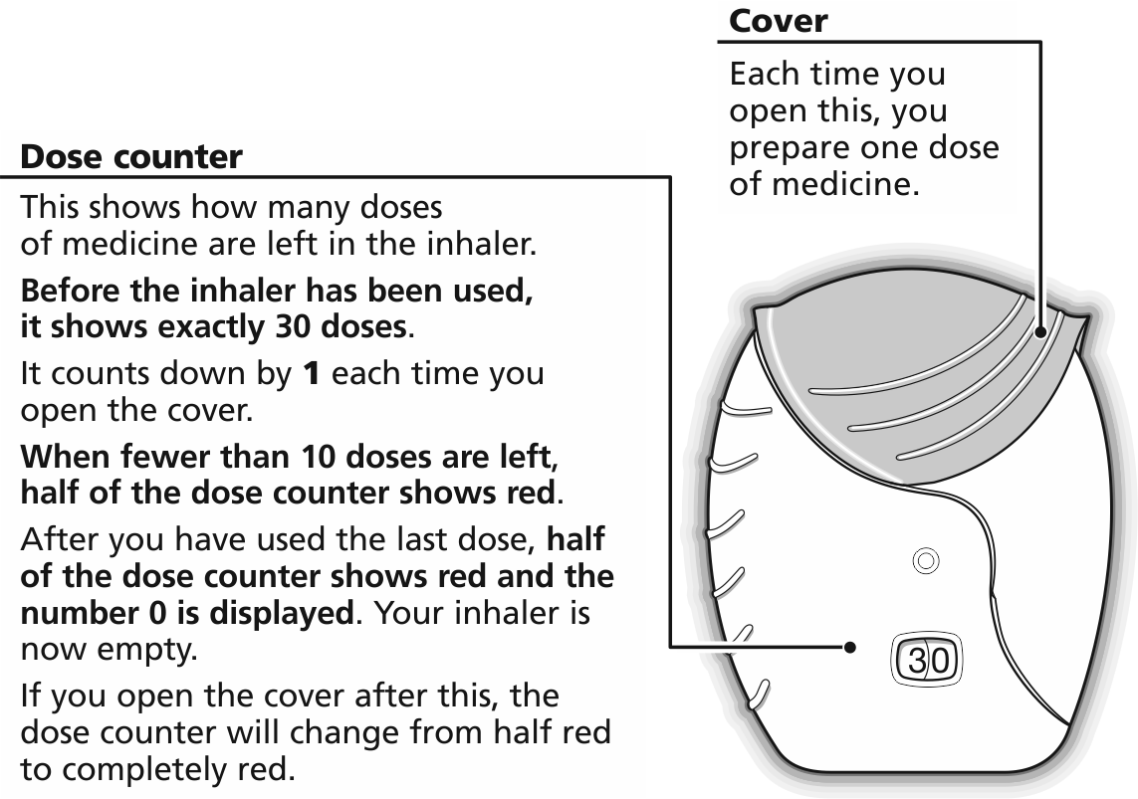

Step 2: Prepare a dose
! Wait to open the cover until you are ready to take your dose. Do not shake the inhaler.

- Slide the cover fully down until you hear a “click”.

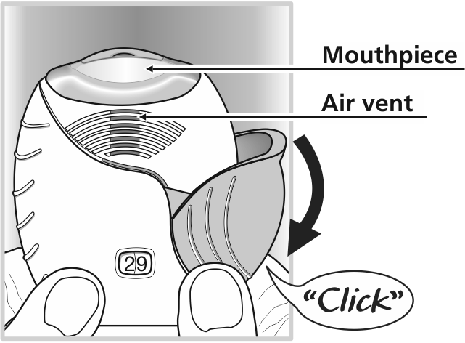

Your medicine is now ready to be inhaled.

The dose counter counts down by 1 to confirm.

! If the dose counter does not count down as you hear the “click”, the inhaler will not deliver medicine. Take it back to your pharmacist for advice.
! Do not shake the inhaler at any time.
Step 3: Inhale your medication
- Whilst holding the inhaler away from your mouth, breathe out as far as is comfortable.
- Don’t breathe out into the inhaler.
- Put the mouthpiece between your lips, and close your lips firmly around it.
Don’t block the air vent with your fingers.
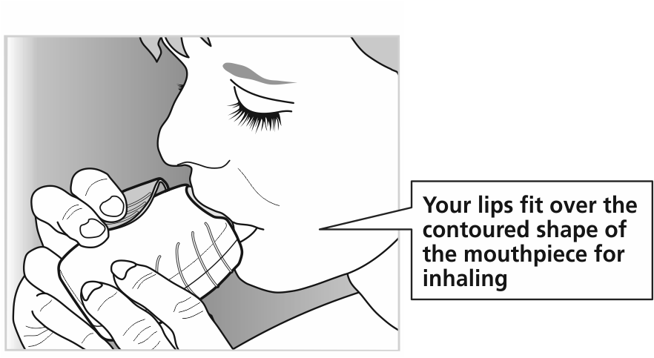
- Take one long, steady, deep breath in. Hold this breath for as long as possible (at least 3-4 seconds).
- Remove the inhaler from your mouth.
- Breathe out slowly and gently away from the mouthpiece.
! You may not be able to taste or feel the medicine, even when you are using the inhaler correctly.

Step 4: Close the inhaler
If you want to clean the mouthpiece, use a dry tissue, before you close the cover.
- Slide the cover upwards as far as it will go, to cover the mouthpiece.

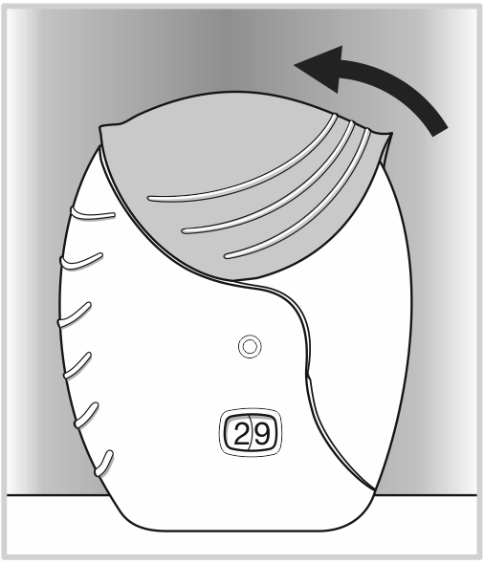

Date of first inclusion in the Australian Register of Therapeutic Goods (the ARTG): 4 July 2014

ANORO and ELLITPA are registered trade marks of the GlaxoSmithKline group of companies.
Version 1.0

