July 2015

Australian Public Assessment Report for Umeclidinium bromide
  - Proprietary Product Name: Incruse Ellipta
  - Sponsor: GlaxoSmithKline Australia Pty Ltd

About the Therapeutic Goods Administration (TGA)
- The Therapeutic Goods Administration (TGA) is part of the Australian Government Department of Health and is responsible for regulating medicines and medical devices.
- The TGA administers the Therapeutic Goods Act 1989 (the Act), applying a risk management approach designed to ensure therapeutic goods supplied in Australia meet acceptable standards of quality, safety and efficacy (performance), when necessary.
- The work of the TGA is based on applying scientific and clinical expertise to decision-making, to ensure that the benefits to consumers outweigh any risks associated with the use of medicines and medical devices.
- The TGA relies on the public, healthcare professionals and industry to report problems with medicines or medical devices. TGA investigates reports received by it to determine any necessary regulatory action.
- To report a problem with a medicine or medical device, please see the information on the TGA website <http://www.tga.gov.au>.
About AusPARs
- An Australian Public Assessment Record (AusPAR) provides information about the evaluation of a prescription medicine and the considerations that led the TGA to approve or not approve a prescription medicine submission.
- AusPARs are prepared and published by the TGA.
- An AusPAR is prepared for submissions that relate to new chemical entities, generic medicines, major variations, and extensions of indications.
- An AusPAR is a static document, in that it will provide information that relates to a submission at a particular point in time.
- A new AusPAR will be developed to reflect changes to indications and/or major variations to a prescription medicine subject to evaluation by the TGA.
Copyright
© Commonwealth of Australia 2015
This work is copyright. You may reproduce the whole or part of this work in unaltered form for your own personal use or, if you are part of an organisation, for internal use within your organisation, but only if you or your organisation do not use the reproduction for any commercial purpose and retain this copyright notice and all disclaimer notices as part of that reproduction. Apart from rights to use as permitted by the Copyright Act 1968 or allowed by this copyright notice, all other rights are reserved and you are not allowed to reproduce the whole or any part of this work in any way (electronic or otherwise) without first being given specific written permission from the Commonwealth to do so. Requests and inquiries concerning reproduction and rights are to be sent to the TGA Copyright Officer, Therapeutic Goods Administration, PO Box 100, Woden ACT 2606 or emailed to <tga.copyright@tga.gov.au>.

Contents
List of the most common abbreviations used in this AusPAR 5
I. Introduction to product submission 9
Submission details 9
Product background 9
Regulatory status 10
Product Information 10
II. Quality findings 10
Drug substance (active ingredient) 10
Drug product 11
Biopharmaceutics 11
Advisory committee considerations 11
Quality summary and conclusions 11
III. Nonclinical findings 12
Introduction 12
Pharmacology 12
Pharmacokinetics 13
Toxicology 14
Nonclinical summary 20
Conclusions and recommendation 21
IV. Clinical findings 22
Introduction 22
Pharmacokinetics 24
Pharmacodynamics 26
Dosage selection for the pivotal studies 28
Efficacy 28
Safety 33
Evaluator’s conclusions on safety 38
First round benefit-risk assessment 40
First round recommendation regarding authorisation 41
Clinical questions 41
Second round evaluation of clinical data submitted in response to questions 41
Second round benefit-risk assessment 43
V. Pharmacovigilance findings 43
Risk management plan 43
VI. Overall conclusion and risk/benefit assessment 60
Introduction 60
Quality 60
Nonclinical 60
Clinical 61
Safety 62
Risk management plan 62
Risk management plan 62
Risk-benefit analysis 63
Outcome 69
Attachment 1. Product Information 70
Attachment 2. Extract from the Clinical Evaluation Report 70

List of the most common abbreviations used in this AusPAR
Abbreviation | Meaning
AE | adverse event
AESI | adverse event of special interest
AUC | area under the concentration time curve
AUC_{(0-x)} | area under the concentration-time curve from time zero (pre dose) to x hours post dose
CHMP | Committee for Medicinal Products for Human Use
CI | confidence interval
C_{max} | maximum concentration
CNS | central nervous system
COPD | chronic obstructive pulmonary disease
CSR | Clinical Study Report
CV | Cardiovascular
CYP | cytochrome P450
CYP2D6 | cytochrome P450 2D6
CYP1A1 | cytochrome P450 1A1
CYP3A4 | cytochrome P450 3A4
ECG | electrocardiogram
eCRF | the electronic case report form
ED50 | estimated dose that would yield 50% of E_{max}
EMA | European Medicines Agency
E_{max} | maximum effect
EU | European Union
FDA | Food and Drug Administration
FDC | fixed dose combination
FEV1 | forced expiratory volume in 1 second
FF | fluticasone furoate
FVC | forced vital capacity
GCP | Good Clinical Practice
GI | gastro intestinal
GLP | Good laboratory practice
GOLD | Global Initiative for Obstructive Lung Disease
GSK | GlaxoSmithKline
h | hour
hERG K+ | human ether-à-go-go-related gene (hERG) potassium (K⁺) channel
IC₅₀ | half maximal inhibitory concentration
ICH | International Conference on Harmonisation of Technical Requirements for Registration of Pharmaceuticals for Human Use
ICS | inhaled corticosteroid
IH | Inhalation(al)
ITT | intent-to-treat
IV | intravenous(ly)
Ki | affinity constant
K_{m} | Michaelis constant
L | litre
LABA | long-acting beta₂-agonist
LAMA | long-acting muscarinic antagonist
LS | least squares
MACE | Major Adverse Cardiac Event
max | maximum
MedDRA | Medical Dictionary for Regulatory Activities
min | minimum
mL | milliliter
msec | millisecond
NOEL | no observable effect level
OCT | organic cation transporter
PBRER | periodic benefit-risk evaluation report
PC | placebo-controlled
PD | pharmacodynamic
PG | parallel group
P-gp | P-glycoprotein
PK | pharmacokinetic(s)
PLA | placebo
PR | PR interval in an ECG (sometimes measured as the PQ interval;)
PSURs | product safety update reports
PT | preferred term
QOL | quality of life
QTcF | QT interval corrected for heart rate using Fridericia’s formula
RR | RR interval in an ECG (the heart rate as measured on an ECG)
SAE | serious adverse event
SC | sub cutaneous
sGaw | specific airway conductance
SGRQ | St. George’s Respiratory Questionnaire
SVT | supraventricular tachycardia
TDI | Transition Dyspnea Index
TIO | tiotropium (bromide)
t_{max} | time of occurrence of C_{max}
UK | United Kingdom
UMEC | umeclidinium bromide (GSK573719)
URTI | upper respiratory tract infection
US | United States
VI | vilanterol trifenatate
WHO | World Health Organization

I. Introduction to product submission

Submission details
Type of submission: | New chemical entity
Decision: | Approved
Date of decision: | 2 July 2014
Active ingredient: | Umeclidinium bromide
Product name: | Incruse Ellipta
Sponsor’s name and address: | GlaxoSmithKline Australia Pty Ltd  PO Box 18095  Melbourne VIC 8003
Dose form: | Powder for inhalation
Strength: | 62.5 µg
Container: | Inhaler - dry powder
Pack sizes: | 7 (physicians sample pack) and 30
Approved therapeutic use: | Incruse Ellipta is indicated as a long-term once daily maintenance bronchodilator treatment to relieve symptoms in adult patients with chronic obstructive pulmonary disease (COPD)
Route of administration: | Inhalation
Dosage: | Incruse Ellipta (umeclidinium bromide 62.5 µg) should be taken as one inhalation once daily by the orally inhaled route.  Incruse Ellipta should be taken at the same time every day.  Do not use Incruse Ellipta more than once every 24 hours.  Further details regarding dosage are provided in the Product Information (PI, attachment 1).
ARTG number: | 211601

Product background
This AusPAR describes the application by the GlaxoSmithKline Australia Pty Ltd (the sponsor) to register a new chemical entity, umeclidinium bromide (as Incruse Ellipta) for the following indication;
Incruse Ellipta is indicated as a long term once daily maintenance bronchodilator treatment to relieve symptoms in adult patients with chronic obstructive pulmonary disease (COPD).
Umeclidinium bromide (from this point on also referred to as umeclidinium, UMEC or GSK573719) is a new chemical entity, a long acting muscarinic antagonist (LAMA) with activity across multiple muscarinic cholinergic receptor subtypes . It exerts its bronchodilatory activity by competitively inhibiting the binding of acetylcholine with muscarinic acetylcholine receptors on airway smooth muscle.
The registration of umeclidinium bromide as a new chemical entity was considered at the same time the TGA considered the registration of the fixed dose combination (FDC) product Anoro Ellipta, umeclidinium bromide and vilanterol trifenatate.
Chronic obstructive airways disease (COPD) is a serious, progressive and disabling condition that limits airflow in the lungs. People with COPD are prone to severe episodes of shortness of breath, with fits of coughing. Current pharmacological treatment of COPD includes muscarinic antagonists (also referred to as anticholinergics). Inhaled LAMAs are currently recommended for the treatment of symptomatic patients with moderate to very severe COPD and are considered to be more efficacious than short acting bronchodilators.

Regulatory status
The product received initial registration on the Australian Register of Therapeutic Goods (ARTG) on 8 July 2014.
At the time the TGA considered this application; a similar application had been approved in the USA (30 April 2014), Canada (17 April 2014) and European Union (EU) (30 April 2014) and was under consideration in 9 other countries (Philippines, Switzerland, Chile, Indonesia, South Africa, Israel, Brazil, Russia and Morocco).

Product Information
The approved Product Information (PI) current at the time this AusPAR was prepared can be found as Attachment 1. For the most recent Product Information please refer to the TGA website at < https://www.tga.gov.au/product-information-pi>.

II. Quality findings

Drug substance (active ingredient)
Umeclidinium bromide (structure shown in Figure 1) is a white anhydrous solid that is synthesised as a single stable polymorph. It is not very soluble in water but fine particles of the drug substance dissolve rapidly in simulated lung fluid.
Figure 1. Structure of Umeclidinium bromide
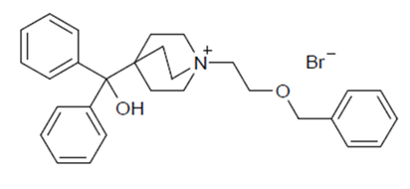
The drug substance quality is controlled by a specification that includes appropriate limits for assay and residual solvents. The specified impurity limits, which all lie outside that specified in the relevant TGA adopted EU guideline , are considered justified on the basis that at the maximum recommended dose (62.5 µg) the impurity levels are well below the standard threshold of toxicological concern. The particle size limits are based on the drug substance batches used in the key clinical and stability trials.

Drug product
The drug product is presented in a plastic inhaler with a light grey body, a light green mouthpiece cover and a dose counter, packed in a foil tray which contains a desiccant packet. The inhaler contains one strip of either 30 or 7 regularly distributed blisters, each containing a white powdered mixture of the drug substance and excipients, magnesium stearate and lactose monohydrate.
The formulation and manufacturing process were developed using a quality by design approach.
The drug product specification includes limits for mean umeclidinium content per blister. Appropriate tests and limits are included to control the uniformity of the delivered dose and the mean delivered dose. The fine particle mass limits are based on tolerance intervals calculated from clinical and stability drug product batches. Impurities and microbial content are appropriately controlled.
The analytical methods used to test the drug product were adequately validated.
Stability data were provided to support a shelf life for the unopened product of 24 months when it is stored below 30°C. Following removal of the secondary packaging and desiccant packet from the inhaler, the product may be stored for a maximum period of 6 weeks (below 30°C).

Biopharmaceutics
Studies were submitted in which the absolute bioavailability and pharmacokinetic profile of umeclidinium were determined. These studies were summarised as part of the chemistry and quality assessment but have not been assessed in detail due to the locally acting nature of the product.
Following inhalation the maximum concentration (C_{max} ) of umeclidinium occurs at 5 to 15 minutes and its absolute bioavailability is 13% (umeclidinium). The mean volume of distribution is 86 L. Umeclidinium is metabolised oxidatively to produce compounds with reduced pharmacological activity.
Following repeat dosing of inhaled umeclidinium, steady state was achieved within 7 to 10 days with 1.5 to 2 fold accumulation. Umeclidinium systemic exposure following inhaled administration of 125 µg was approximately twice the systemic exposure following 62.5 µg. Its half-life following repeated inhalation dosing was 19 hours.

Advisory committee considerations
No significant issues were raised during the chemistry and quality assessment and consequently the product was not referred for consideration by the Pharmaceutical Sub-Committee (PSC) of the Advisory Committee on Prescription Medicines (ACPM).

Quality summary and conclusions
The chemistry, manufacturing and quality aspects of the submission are acceptable and approval is recommended.

III. Nonclinical findings

Introduction
The nonclinical dossier was comprised of data previously submitted in the application to register the FDC product Anoro Ellipta, plus a single new study on pharmacokinetics.
The nonclinical dossier was of high quality. All pivotal safety related studies were conducted under Good Laboratory Practice (GLP) conditions.

Pharmacology

Primary pharmacology
Umeclidinium is a LAMA, anticipated to inhibit acetylcholine induced bronchoconstriction (principally mediated by M₃ receptors on bronchial smooth muscle cells). It was shown to possess high affinity for all five human muscarinic receptor subtypes (affinity constant (K_{i}), 0.05 to 0.16 nM; 0.062 nM at the M₃ subtype) where it acted as a competitive inhibitor. The rate of dissociation of the drug from the M₃ receptor was slow (half-life, 82 minutes). Umeclidinium inhibited contractions induced by carbachol (cholinergic agonist) in isolated human bronchial and guinea pig tracheal strips, acting with a long duration of action (offset half times following washout, > 10 hours).
In vivo, intranasal administration of umeclidinium in mice and intra tracheal instillation in guinea pigs produced dose dependent inhibition of bronchoconstriction induced by cholinergic agonists. Inhibition of ≥ 50% was maintained for up to 72 hours post dose in mice (0.05 µg intranasal) and for more than 48 hours (2.5 µg intra tracheal) or 5 days (25 µg intra tracheal) in guinea pigs.
The two principal human metabolites of umeclidinium showed either negligible activity (M14; GSK339067), or almost 6 times lower activity (M33; GSK1761002), compared to the parent in cell based functional assays examining antagonism of the recombinant human M₃ receptor.

Secondary pharmacodynamics and safety pharmacology
Umeclidinium was screened for secondary activity against a panel of 50 other receptors, ion channels and transporters. The kappa opioid receptor was identified as the highest affinity secondary target, with umeclidinium inhibiting radio ligand binding with a Ki of 69 nM (that is, > 1000 times less potently compared to at the primary pharmacological target). Given that the observed Ki value is > 425 times higher than the plasma C_{max} for umeclidinium in patients at the maximum recommended dose of 62.5 µg/day (that is, 0.0693 ng/mL (= 0.162 nM)), the finding is not considered to be of clinical relevance.
Specialised safety pharmacology studies with umeclidinium covered the core systems (central nervous system (CNS), cardiovascular (CV) and respiratory). No adverse effects on CNS function were observed in rats at inhalational doses ≤ 1994 µg/kg; effects observed in the study were limited to moderately dilated pupils (≥ 322 µg/kg; consistent with antimuscarinic activity). Umeclidinium was shown to be able to inhibit the human ether-à-go-go-related gene (hERG) potassium (K⁺) channel current in transfected mammalian cells, but only very weakly; the 50% inhibitory concentration (IC₅₀) value (9.41 µM) is > 58000 times greater than the plasma C_{max} in patients at the maximum recommended dose of 62.5 µg/day (and an even larger margin exists when considering the free plasma concentration), indicating no clinical significance. In dogs, a 10 µg/kg intravenous (IV) dose caused a small decrease in pulse pressure, an increase in heart rate, an increase in the electrocardiogram (ECG) PR interval, a decrease in the RR interval in an ECG, and second degree atrioventricular block (isolated P waves in the absence of QRS complexes) effects consistent with antimuscarinic activity. There were no CV effects in dogs at 3 µg/kg IV; a dose yielding almost 330 times the plasma C_{max} in patients treated with umeclidinium at 62.5 µg/day.
In a cardiovascular safety study conducted with umeclidinium and vilanterol in combination in dogs, single IV administration of the two drugs (0.3/0.3 µg/kg) caused a small increase in mean, systolic and diastolic blood pressure that was not seen with the individual agents; umeclidinium did not exacerbate the increase in heart rate induced by vilanterol. Increased pulse rates/heart rates were observed in the general repeat dose inhalation toxicity studies conducted with umeclidinium (alone and in combination with vilanterol) in dogs, generally accompanied by the loss of respiratory sinus arrhythmia (the physiological modulation of heart rate in time with breathing). No further ECG changes related to umeclidinium were evident in these studies.
Respiratory parameters were examined in rats during and after inhalation exposure to umeclidinium, with an increase in respiratory rate and a decrease in tidal volume observed at ≥ 215 µg/kg; there was no effect at 36 µg/kg. These changes may relate to the pharmacologically mediated bronchodilation.

Pharmacokinetics
Absorption of umeclidinium after inhalation was shown to be rapid in mice, rats, rabbits and dogs, with peak plasma concentrations generally observed at the first sampling time point (0.17 to 1 hour post dose). Similarly, the plasma C_{max} was achieved within 5 to 15 minutes of inhalation administration in COPD patients. Plasma C_{max} and area under the concentration time curve (AUC) were generally dose proportional with inhalational administration in the laboratory animal species and in humans. Accumulation with repeated dosing was generally not seen or was only limited. No consistent sex differences were observed. Oral bioavailability was found to be negligible in rats, dogs and humans.
Tissue distribution of radioactivity after IV administration of (¹⁴C)-umeclidinium in rats was rapid and wide, with highest concentrations of radioactivity detected in the kidney and liver. Penetration of the blood brain barrier was poor, with peak concentrations of ¹⁴C-umeclidinium derived radioactivity approximately 44 times lower than in blood. Some association of drug related material with melanin was seen. Plasma protein binding by umeclidinium was moderate in all species (75 to 89% in mouse, rat, rabbit and dog; 89% in human) and independent of concentration. Severe renal impairment and hepatic impairment did not alter the extent of plasma protein binding compared to that in healthy human volunteers. Human serum albumin, gamma globulin and α1-acid glycoprotein contributed to binding (67%, 65% and 85% binding, respectively). Blood cell association was low in all species.
Metabolism of umeclidinium chiefly involved O-dealkylation (generating metabolite M14), hydroxylation (M33 and other metabolites) and glucuronidation. Unchanged umeclidinium was by far the dominant circulating species in laboratory animals (mouse, rat and dog) and humans following IV administration in all species, and additionally inhalation administration in humans. Cytochrome P450 (CYP) 2D6 was identified as the P450 isoform chiefly responsible for the metabolism of the drug in in vitro experiments, with additional minor contributions from CYP1A1 and CYP3A4. All major human metabolites were also formed in one or both of the species (rats and dogs) used in the pivotal repeat dose toxicity studies with the exception of a dihydroxylated metabolite (M61), which accounted for approximately 20% of drug related material in plasma in humans after IV administration.
Excretion of radioactivity following dosing with ¹⁴C-umeclidinium was primarily via the faeces after IV (mouse, rat, dog and human) and oral administration (rat, dog and human). Biliary excretion was demonstrated in rats and dogs.
Comparisons of the pharmacokinetic profiles of umeclidinium in the laboratory animal species used in the pivotal repeat dose toxicity studies (rats and dogs) indicate sufficient similarities exist to allow them to serve as appropriate models for the assessment of umeclidinium toxicity in humans. Notably though, these animal species are unable to model potential toxicity related to the unique human metabolite M61. This is not considered a major deficiency, however, in light of the relatively low systemic exposure to this metabolite in patients.

Pharmacokinetic drug interactions
Umeclidinium was shown to be able to inhibit CYP2D6 (IC₅₀, 0.1 µM), CYP3A4 (IC₅₀, 1.0 or 8.0 µM depending on the substrate) and CYP2C19 (IC₅₀, 14 µM), but not CYP1A2 or CYP2C9 (IC₅₀ > 33 µM), in experiments with human liver microsomes. Given these IC₅₀ values are > 600 times higher than the drug’s peak plasma concentration in humans at the maximum recommended dose of 62.5 µg/day, no relevant CYP inhibition is expected in patients.
In an in vivo enzyme induction study in rats (involving 4 weeks treatment by inhalation), mean CYP1A1 messenger ribonucleic acid (mRNA) was increased to approximately 8 times the control level in females with treatment at 1829 µg/kg/day (due to one animal) (no effect in males or at ≤ 243 µg/kg/day) and CYP4A1 mRNA was increased to approximately 2 and approximately 4 times the level of controls in males at 26.1 and 243 µg/kg/day; levels of CYP1A2, 2B1, 2B2, 2E1, 3A2 and 3A23 mRNA were unaffected. Given the magnitude of the changes and the large associated relative exposure levels (animal: human plasma AUC ratios at doses producing changes, 10.5 to621), no clinically significant enzyme induction is expected to be produced by umeclidinium in patients.
Umeclidinium was shown to be a substrate for P-gp in experiments with transfected mammalian cells. Demonstrating the significant role P-gp plays in limiting absorption, the oral bioavailability of ¹⁴C umeclidinium derived radioactivity was markedly higher in P-gp knockout mice compared to wild type ones (14% compared to 1.1%). Umeclidinium (≤ 100 µM) did not act as an inhibitor of P-gp. Experiments with recombinant human cation transporters showed that the drug is a substrate for organic cation transporter (OCT) OCT1 (Km, 4.42 µM) and OCT2 (Km, 0.157 µM), but not for OCT3, OCTN1 or OCTN2.

Toxicology

Single dose toxicity
No conventional single dose toxicity study was conducted for umeclidinium; information on the drug’s acute toxicity was instead obtained from other studies (in accordance with International Conference on Harmonisation of Technical Requirements for Registration of Pharmaceuticals for Human Use (ICH) guideline M3(R2). No mortality or overt signs of toxicity were observed with umeclidinium in rats after a single inhalational dose of up to 2260 µg/kg (in safety pharmacology studies) or with sub cutaneous (SC) administration at 60 µg/kg (local tolerance/toxicokinetic study), nor following two 20 mg/kg IV doses 24 hours apart (in a genotoxicity study); animals were monitored for up to 24 hours (inhalation, SC) or 48 hours (IV) after dosing/the commencement of treatment. In general repeat dose toxicity studies where animals were treated for at least 14 days (that is, where the period of monitoring met the recommended minimum observation period after a single dose recommended in the EU Guideline on single dose toxicity () no test article associated mortality was observed at dose levels of up to 2850 µg/kg/day by inhalation in mice, 1828.5 µg/kg/day by inhalation, 1600 µg/kg/day by the SC route in rats and 2758 µg/kg/day by inhalation in dogs. These data support that umeclidinium has a low order of acute toxicity.

Repeat dose toxicity
Studies with umeclidinium by the inhalation route of up to 3 months duration were conducted in mice, 6 months in rats and 9 months in dogs. Other routes were used in studies in mice (oral up to 3 months) and rats SC up to 2 weeks). The duration of the pivotal studies, the species used (rats and dogs), group sizes and the use of both sexes were consistent with EU guidelines. Umeclidinium was formulated in lactose and magnesium stearate in the pivotal and most of the other inhalation studies, resembling the proposed commercial product.

Relative exposure
Exposure ratios have been calculated based on animal: human plasma AUC_{0-24h} values (for consideration of systemic effects) and animal: human lung deposited dose adjusted for lung weight (for consideration of local toxicity). Lung deposited doses were calculated assuming 10%, 25% and 100% deposition in rodents, dogs and humans, respectively; lung weights of 0.2, 1.5, 110 and 1000 g in mice, rats, dogs and humans, respectively; and body weights of 0.03, 0.25 and 10 kg for mice, rats and dogs, respectively. High local and systemic exposure ratios were obtained in the animal studies. Human AUC values are from the sponsor’s summary of the population PK analyses.
Table 1A: Relative local and systemic exposure achieved in selected inhalational toxicity studies with umeclidinium.
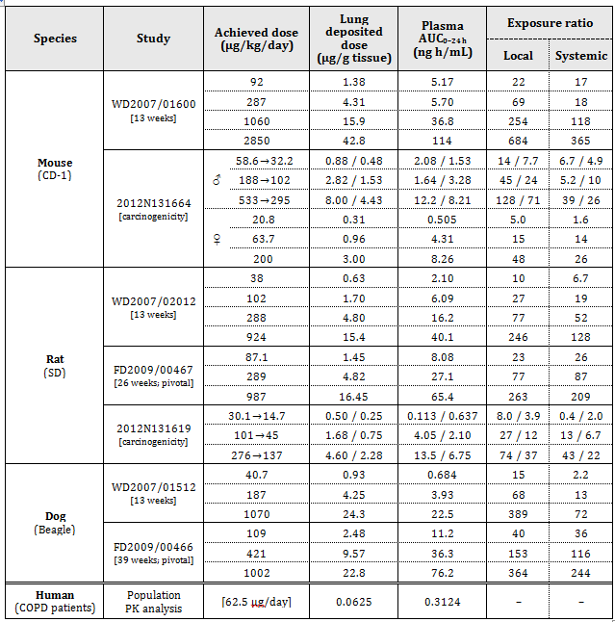
Table 1B: Relative local and systemic exposure achieved in combination toxicity studies.
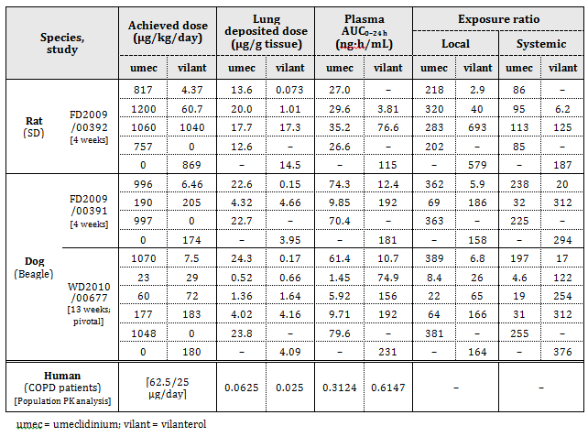

Major toxicities
The major target organs for toxicity in inhalation studies with umeclidinium were respiratory tract tissues and the cardiovascular system. The gastro intestinal (GI) tract was identified as an additional target in oral studies.
Umeclidinium was seen to act as an irritant of the upper respiratory tract in all three laboratory animal species (mouse, rat and dog). Corresponding histopathological findings in affected tissues (nasal turbinates, nasopharynx, larynx and tracheal bifurcation) included epithelial degeneration/regeneration, hyperplasia, squamous metaplasia, inflammatory cell infiltration and erosion/ulceration. These effects may have been exacerbated by drying of the mucosa due to the drug’s antimuscarinic activity. In the pivotal studies, such respiratory tract findings were observed at all dose levels in rats (≥ 87.1 µg/kg/day by inhalation ; relative local exposure, 23) and at ≥ 421 µg/kg/day in dogs (relative local exposure, 153). No histopathological changes were observed in the respiratory tract of dogs treated for 9 months at 109 µg/kg/day; yielding a high multiple of the local clinical dose (relative local exposure, 40).
Oral administration of umeclidinium at high doses in mice (≥ 30 mg/kg/day) was also associated with nasal cavity changes consistent with local irritation (epithelial atrophy/degeneration and fluid/ inflammatory exudates in nasal airways), most likely due to gastro oesophageal reflux. Breathing difficulties, abdominal distension, fundic degeneration of the stomach (≥ 30 mg/kg/day) and elongation of the caecum and epithelial hyperplasia in the colon (at 100 mg/kg/day) were additionally seen; these are considered related to a mix of local irritant and antimuscarinic activity (to cause smooth muscle relaxation). The GI tract was not a target for toxicity with administration by the inhalation route at doses yielding very large multiples of the clinical exposure.
Lung macrophage accumulation was increased in incidence and severity (up to slight) in male rats treated with umeclidinium at 987 µg/kg/day by inhalation for 6 months (relative local exposure, 263). This was not apparent at ≤ 289 µg/kg/day (relative local exposure, 77).
Dogs treated with umeclidinium showed tachycardia and other clinical signs (dry eyes, nose and mouth) consistent with the drug’s antimuscarinic activity. Moderate subacute inflammation in the extramural coronary arteries was seen in the heart of single animals at 421 and 1002 µg/kg/day (relative systemic exposure, 116 to 244) and subacute inflammation was seen in a pulmonary arteriole in another animal at 1002 µg/kg/day (relative systemic exposure, 244) in the pivotal 9 month dog study. Treatment with umeclidinium did not produce cardiovascular lesions in rats. No observable effect levels (NOELs) for cardiovascular lesions by umeclidinium are 109 µg/kg/day in dogs (relative systemic exposure, 36) and 987 µg/kg/day in rats (relative systemic exposure, 209).

Genotoxicity
The potential genotoxicity of umeclidinium was investigated in the standard battery of tests (bacterial mutagenicity, mouse lymphoma thymidine kinase (tk) assay and bone marrow micronucleus test). The conduct of the studies was in accordance with ICH guidelines. Concentrations and doses were appropriate. A suitable set of Salmonella typhimurium and Escherichia coli strains were used in the bacterial mutation assays. The in vivo assay for clastogenicity was conducted in rats and involved IV administration (20 mg/kg/day × 2 days), yielding a very high multiple (approximately 8000 fold) of the plasma C_{max} in patients at the maximum recommended human dose of 62.5 µg/day. All studies returned negative results for the drug.

Carcinogenicity
The carcinogenic potential of umeclidinium by the inhalation route was investigated in 2 year studies in mice and rats. Group sizes were adequate. Appropriate doses were tested, albeit requiring reduction in male mice and rats of both sexes during the course of the studies due to excessive suppression of body weight gain. There was no adverse effect on survival. No carcinogenic effect was seen with the drug in either species. NOELs for carcinogenicity are 295 µg/kg/day in male mice (relative systemic exposure, 26; relative local exposure, 71), 200 µg/kg/day in female mice (relative systemic exposure, 26; relative local exposure, 48) and 137 µg/kg/day in rats (relative systemic exposure, 22; relative local exposure, 37).

Reproductive toxicity
Submitted studies with umeclidinium covered all stages (fertility and early embryonic development, embryofetal development and pre/postnatal development). The studies were appropriately designed with regard to the numbers of animals, the timing/duration of treatment, the range of species and the route of administration (inhalation and/or SC).

Relative exposure
Very high multiples of the clinical plasma AUC was obtained in animals at the upper dose levels in the studies.
Table 2. Relative exposure in reproductive toxicity studies with umeclidinium
Species | Study |  | Route | Dose μg/kg/day | AUC_{0–24 h} ng∙h/mL | ER
Rat (SD) | Fertility | ♂ | SC | 180 | 24.9ª | 80
Rat (SD) | Fertility | ♀ | inhalation | 294 | 16.5^{b} | 53
Rat (SD) | Embryofetal development |  | inhalation | 278 | 15.6^{b} | 50
Rat (SD) | Pre-/postnatal development |  | SC | 60 | 8.07 | 26
Rat (SD) |  |  | SC | 180 | 24.9 | 80
Rabbit (NZW) | Embryofetal development |  | inhalation | 306 | 10.9 | 35
Rabbit (NZW) |  |  | SC | 180 | 61.4 | 197
Human COPD patients | Population PK analysis |  | inhalation | [62.5 μg/day] | 0.3124 | –
Only data for the highest dose levels and NOELs are shown;
a = based on data obtained in Study 2011N118595 (rat pre/postnatal development study);
b = estimated based on extrapolation of data from Study WD2007/02012 (rat 13 week general repeat dose toxicity). ER=exposure ratio.
Fertility and early embryonic development were unaffected by umeclidinium in male (≤ 180 µg/kg/day SC; estimated relative exposure, 80) and female rats (≤ 294 µg/kg/day by inhalation; estimated relative exposure, 53). No adverse effects on embryofetal development were observed with the drug in either rats (≤ 278 µg/kg/day by inhalation; estimated relative exposure, 50) or rabbits (≤ 306 µg/kg/day by inhalation (relative exposure, 35) or ≤ 180 µg/kg/day SC (relative exposure, 197)). Placental transfer of umeclidinium was not investigated.
In a pre/postnatal study, pre weaning body weight was reduced in pups of rats treated with umeclidinium at 180 µg/kg/day SC during gestation and lactation (relative exposure, 80); no other effects on development were noted. The NOEL for effects on pre/postnatal development in the rat was 60 µg/kg/day SC (relative exposure, 26). While there were no specific studies investigating excretion of umeclidinium in milk in animals, the drug was detected in the plasma of 2/54 suckling pups in the pre/postnatal development study, suggesting some possible transfer.

Pregnancy classification
The sponsor has proposed Pregnancy Category B3 for the use of Incruse Ellipta in pregnancy. Under the Australian classification scheme, this category is for drugs where ‘studies in animals have shown evidence of an increased occurrence of fetal damage, the significance of which is considered uncertain in humans.’ Given the absence of adverse effects on embryofetal development seen in adequately conducted studies, the drug is more appropriately placed instead in Category B1 applicable where ‘studies in animals have not shown evidence of an increased occurrence of fetal damage’.

Immunotoxicity
No specialised immunotoxicity study was conducted. This is acceptable given the absence of findings to suggest immunotoxicity in the general repeat dose toxicity studies.

Local tolerance and antigenicity
Consistent with findings showing local irritant activity with inhalation and oral administration in the general repeat dose toxicity studies, umeclidinium was found to be a mild to moderate skin irritant (rabbit in vivo; human in vitro) and a mild to moderate ocular irritant (human in vitro). Umeclidinium was shown to not be a skin sensitiser (mouse local lymph node assay).

Paediatric use
Incruse Ellipta is not proposed for paediatric use and no specific studies in juvenile animals with umeclidinium were submitted.

Impurities
Proposed impurity limits are considered to be acceptable from a toxicological perspective, based on application of the TTC (threshold of toxicological concern) principle.

Nonclinical summary
- The nonclinical dossier was of high quality. All pivotal safety related studies were conducted under GLP conditions.
- Umeclidinium is a competitive muscarinic receptor antagonist with subnanomolar affinity across all five human muscarinic receptor subtypes. The rate of dissociation from the M₃ receptor (the muscarinic subtype mainly mediating bronchoconstriction) was slow. Long lasting antagonism of cholinergic agonist induced contraction was shown for the drug in vitro in isolated human bronchial and guinea-pig tracheal strips, and in vivo in mice (intranasal administration) and guinea pigs (intratracheal administration).
- No clinically significant off target activity was found for umeclidinium in secondary PD studies. Safety pharmacology studies covered the CNS, cardiovascular and respiratory systems, with limited classic anticholinergic effects observed (most notably tachycardia). Inhibition of the hERG K⁺ channel did not occur at clinically relevant concentrations.
- Rapid absorption of umeclidinium after inhalation was shown in laboratory animal species and humans, with oral bioavailability negligible. Tissue distribution of radioactivity following IV administration of ¹⁴C-umeclidinium was rapid and wide in the rat; penetration of the blood brain barrier was poor. Plasma protein binding by umeclidinium was moderate in all species.
- Metabolism of umeclidinium chiefly involved O-dealkylation, hydroxylation and glucuronidation. A major role for CYP2D6 and additional minor roles for CYP1A1 and CYP3A4 were shown. Excretion was predominantly via the faeces in all species. The drug is a substrate for P-gp, OCT1 and OCT2. CYP inhibition (2D6, 3A4, 2C19, 1A2 and 2C9) and induction (1A1, 1A2, 2B1, 2B2, 2E1, 3A2, 3A23 and 4A1) by umeclidinium were not seen at clinically relevant concentrations/exposure levels.
- Umeclidinium displayed a low order of acute toxicity in laboratory animal species.
- The repeat dose toxicity of umeclidinium by the inhalation route was investigated in studies in mice, rats and dogs; the pivotal studies were conducted in rats (6 months) and dogs (9 months). The major target organs for toxicity identified in inhalation studies were the respiratory tract (irritation of nasal turbinates, nasopharynx, larynx and tracheal bifurcation; increased lung macrophage accumulation) and the cardiovascular system (inflammation in extramural coronary arteries and pulmonary arteriole, as well as tachycardia), with such effects seen at very large multiples of the clinical exposure level.
- Umeclidinium was examined for potential genotoxicity in bacterial mutagenicity assays, the mouse lymphoma tk assay and the bone marrow micronucleus test, with universally negative results returned. Two year inhalation studies with umeclidinium in mice and rats revealed no carcinogenic effect.
- Umeclidinium did not affect male or female fertility in rats, and had no adverse effect on embryofetal development in rats or rabbits. Reduced pre-weaning body weight was observed in pups of rats treated with umeclidinium during gestation and lactation but only at a very large multiple of the clinical exposure level.

Conclusions and recommendation
- The nonclinical dossier contained no major deficiencies.
- Primary pharmacology studies with umeclidinium, showing potent and long lasting antimuscarinic activity/inhibition of bronchoconstriction, support the drug’s use for the proposed indication.
- Secondary PD studies revealed no clinical significant activities for umeclidinium. Safety pharmacology studies identified a classic antimuscarinic profile for the drug, with limited clinical relevance predicted.
- The respiratory tract (principally upper and related to local irritation) and the cardiovascular system were identified as the main targets for toxicity by umeclidinium. Given the nature of the findings and with very large exposure margins evident at the NOELs established in the pivotal rat and/or dog studies, limited clinical significance is predicted.
- Umeclidinium is not considered to pose a genotoxic or carcinogenic hazard to patients.
- As no adverse effects on embryofetal development were observed with umeclidinium in adequately conducted studies in rats and rabbits, the drug should be placed in Pregnancy Category B1 (rather than B3 as the sponsor proposes).
- There are no nonclinical objections to the registration of Incruse Ellipta for the proposed indication.
- The nonclinical evaluator also recommended amendments to nonclinical statements in the draft PI document but these are beyond the scope of this AusPAR.

IV. Clinical findings
A summary of the clinical findings is presented in this section. Further details of these clinical findings can be found in Attachment 2.

Introduction

Clinical rationale
COPD is a major cause of poor health, resulting in millions of deaths annually worldwide and contributing significantly to health care costs and morbidity ,. As of 2002, COPD was the fourth leading cause of death and the eleventh leading cause of disability worldwide;. By the year 2020, COPD is expected to be the third leading cause of death and the fifth leading cause of disability¹². COPD is a preventable and treatable disease characterized by airflow limitation that is not fully reversible⁸. The airflow limitation of COPD is primarily due to small airways disease and parenchymal destruction associated with an abnormal inflammatory response of the lungs, mainly caused by cigarette smoking or air pollution. COPD is characterised by symptoms of chronic and progressive breathlessness (or dyspnoea), cough and sputum production which can be a major cause of disability and anxiety associated with the disease. COPD is a progressive disease with worsening lung function over time⁸. Currently no agents are available that modify disease progression. Pharmacological management of chronic, stable COPD is primarily aimed at improving symptoms and quality of life (QOL), optimizing lung function, reducing exacerbations and improving exercise tolerance⁸. Long acting bronchodilators, including long-acting beta₂-agonist (LABAs) and LAMAs, are recommended for the treatment of symptomatic patients with moderate to very severe COPD and are considered more efficacious and safer to use than short acting bronchodilators^{13,8},. The benefits of LAMAs include not only the control of symptoms but improvements in lung function and hyperinflation, exercise performance, COPD exacerbations, and health status,,. Umeclidinium bromide will provide an additional treatment option to marketed LAMAs such as tiotropium (TIO) and aclidinium in the management of COPD.

Guidance
The clinical development program was designed to provide sufficient data for registration of both the fixed dose combination umeclidinium and vilanterol and the mono product umeclidinium. Advice on the development program was sought from regulatory authorities in the United States (US), EU, Japan and Canada. Though the advice received at the agency meetings was specific to umeclidinium/vilanterol and positioning of the combination product, the program included both the combination and monotherapy arms and some of the advice is equally applicable for umeclidinium monotherapy.
ln accordance with the TGA planning letter, the sponsors provided an assurance that the submission complies with the requirements contained with the regulatory and supporting documents for the streamlined submission process. The following documents are also provided (as requested within the planning letter): A Risk Management Plan (RMP) and Australian Specific Annex (ASA) and the full proposed PI in the form approved under section 7D of the Act.

Contents of the clinical dossier
The submission contained the following clinical information:
- 17 clinical pharmacology studies, including 15 that provided PK data and 2 that provided PD data.
- 1 population PK analyses.
- 10 clinical studies conducted as part of the clinical development program provide data for umeclidinium and support the global regulatory filings for monotherapy in subjects with COPD. These include 7 pivotal efficacy/safety studies and 3 Phase IIb dose ranging studies.
The pivotal Phase III studies included:
- One Phase III, 12 week, placebo controlled, efficacy and safety study (AC4115408);
- Two Phase III, 24 week, placebo controlled, efficacy and safety studies (DB2113361 and DB2113373) and one Phase III, 24 week, TIO comparator efficacy and safety study (DB2113374);
- One Phase III, long term (52 week) safety study (DB2113359); and
- Two 12 week cross over exercise studies (DB2114417 and DB2114418).
The 3 dose ranging Phase IIb studies included:
- 4 week umeclidinium dose ranging study (AC4113589);
- 14 day cross over umeclidinium dose ranging/dose interval study (AC4113073); and
- 7 day cross over umeclidinium dose ranging/dose interval study (AC4115321).
Other, for example pooled analyses, meta-analyses, product safety update reports (PSURs), Integrated Summary of Efficacy and Integrated Summary of Safety.
- Clinical Overview, Summary of Clinical Efficacy, Summary of Clinical Safety and literature references.

Paediatric data
The submission did not include paediatric data. Since COPD is a disease of adults and has no paediatric correlate, a waiver is being sought for conducting paediatric studies with umeclidinium for the maintenance treatment of COPD.

Good clinical practice
All studies in this development program were undertaken in accordance with the principles of Good Clinical Practice (GCP). All studies were conducted with the approval of Ethics Committees or Institutional Review Boards. Informed consent was obtained for all subjects and the studies were performed in accordance with the version of the Declaration of Helsinki that applied at the time the studies were conducted. Regulatory approval was obtained from the relevant health authority, where required.
Significant deviations from GCP for investigator X were identified by GlaxoSmithKline (GSK) during the conduct of the clinical development program. These deviations were identified prior to unblinding of Study DB2113359 and after unblinding of Study AC4115321. A total of 28 subjects from this site were treated in these two studies (18 subjects from AC4115321 and 10 subjects from DB2113359). Sensitivity analyses of efficacy data with and without these subjects were conducted for Study AC4115321. Results of the analyses with and without these subjects were generally consistent and are included in the AC4115321 Clinical Study Report (CSR). No sensitivity analyses were performed in the safety study DB2113359.

Pharmacokinetics

Studies providing pharmacokinetic data
Table 3 shows the studies relating to each PK topic.
Table 3. Submitted pharmacokinetic studies.
PK topic | Subtopic |  |  | Study ID
PK in healthy adults | General PK | Single dose UMEC |  | AC4112008
PK in healthy adults | General PK | UMEC |  | AC4115487
PK in healthy adults | General PK | UMEC  UMEC |  | AC4106889  AC4105209
PK in healthy adults | Food effect |  |  | No studies conducted
PK in healthy adults | Mass Balance Study UMEC |  |  | AC4112014
PK in special populations | Target population § |  | Single dose | AC4108123
PK in special populations |  |  | UMEC | AC4113589
PK in special populations |  |  | Multi dose | AC4105211
PK in special populations |  |  | UMEC | AC4113589
PK in special populations |  |  | UMEC | AC4115321
PK in special populations |  |  | UMEC | AC4113073
PK in special populations |  |  | UMEC | AC4115408
PK in special populations |  |  | UMEC/VI | DB2113120
PK in special populations | Hepatic impairment: UMEC/VI; UMEC |  |  | DB2114637
PK in special populations | Renal impairment UMEC/VI; UMEC |  |  | DB2114636
PK in special populations | Neonates/infants/children/adolescents |  |  | No studies
PK in special populations | Elderly |  |  | No studies
PK in special populations | Japanese Subjects UMEC, UMEC/VI |  |  | DB2113208
PK in special populations | Japanese Subjects UMEC |  |  | AC4113377
Genetic/gender-related PK | Males vs. females |  |  | No studies
Genetic/gender-related PK | CYP2D6 UMEC |  |  | AC4110106
Population PK analyses |  |  |  | DB2116975
PK interactions | Verapamil |  |  | DB2113950
None of the PK studies had deficiencies that excluded their results from consideration.

Evaluator’s conclusions on pharmacokinetics

Absorption, distribution, metabolism, and elimination profile:
- Following inhaled administration in healthy subjects, umeclidinium is rapidly absorbed with C_{max} occurring by 5 to 15 minutes. Umeclidinium has low systemic bioavailability (on average 13% of the dose), and negligible contribution from oral absorption. Steady state umeclidinium after repeated inhaled doses was achieved within 7 to 10 days with 1.5 to 2 fold accumulation.
- The mean volume of distribution was 86 L. In vitro plasma protein binding in human plasma was on average 89%. Distribution to the lung has not been evaluated in human studies.
- In vitro umeclidinium is metabolised by CYP2D6 and is a substrate for the P-gp transporter. Systemic exposure to the metabolites is low. Plasma clearance following IV umeclidinium was 151 L/hour. The excretion of the drug related material in the faeces following IV dosing indicated elimination in the bile.
- At the two doses evaluated in Phase III trials (62.5 µg and 125 µg), umeclidinium systemic exposure was dose proportional. Following repeat dose umeclidinium/vilanterol 125/25 µg to healthy subjects, plasma half-life of umeclidinium averaged 19 hours, with 3% to 4% of drug excreted unchanged in urine at steady state.
- Severe renal impairment resulted in no clinically significant increases in umeclidinium systemic exposure. No dose adjustment is recommended in patients with impaired renal function.
- Moderate hepatic impairment (Child-Pugh Class B) led to umeclidinium systemic exposures that were on average lower in the subjects with moderate hepatic impairment compared to healthy subjects. No dose adjustment is recommended in patients with moderate hepatic impairment. Umeclidinium has not been studied in subjects with severe hepatic impairment.
- Umeclidinium is primarily metabolised by CYP2D6. There was no clinically relevant difference in the systemic exposure to umeclidinium following 7 days of repeat inhaled dosing with umeclidinium doses up to 1000 µg in a population of CYP2D6 poor metabolisers. No dose adjustment is recommended in patients using concomitant CYP2D6 inhibitors or subjects with genetic polymorphisms of CYP2D6 metabolism.
- Umeclidinium is a substrate of the P-gp transporter. Results from a clinical drug interaction study support the proposition that no dose adjustment is recommended in patients using concomitant P-gp transporter inhibitors.

Population PK analysis:
- Weight and age were statistically significant covariates on apparent clearance (CL/F) of inhaled umeclidinium, and weight was a significant covariate on umeclidinium apparent volume of distribution. However, the magnitude of effect of these covariates on umeclidinium exposure does not warrant dose adjustment. Other intrinsic factors including gender, post salbutamol reversibility, post salbutamol and ipratropium reversibility, inhaled corticosteroid (ICS) use at screening, smoking, race and percent predicted baseline forced expiratory volume in 1 second (FEV1) did not affect umeclidinium PK.
- Submitted PK data for umeclidinium are adequate, with the exception that the effect of severe hepatic impairment has not been investigated in a clinical study.

Pharmacodynamics

Studies providing pharmacodynamic data
Table 4 shows the studies relating to each PD topic.
Table 4. Submitted pharmacodynamic studies.
PD Topic | Subtopic | Study ID
Primary Pharmacology | Effect on sGaw¹ | AC4105209
Primary Pharmacology | Effect on sGaw¹ | AC4108123
Primary Pharmacology | Effect on FEV1 | AC4116689
Secondary Pharmacology | Effect on QTc Interval | DB2114635
Secondary Pharmacology | Blood Potassium | DB2113208
Gender other genetic and Age-Related Differences in PD Response | Effect of gender | No studies
 | Effect of age | No studies
PD Interactions | verapamil | DB2113950
Population PD and PK-PD analyses | Healthy subjects | No studies
Population PD and PK-PD analyses | Target population | DB2116975
1. sGaw = specific airway conductance
None of the PD studies had deficiencies that excluded their results from consideration.

Evaluator’s conclusions on pharmacodynamics
- Umeclidinium is an inhaled LAMA that acts locally on airways to produce bronchodilation. The compound has activity across multiple muscarinic receptor subtypes. Umeclidinium competitively inhibits binding of acetylcholine with muscarinic receptors on airway smooth muscle. Umeclidinium demonstrates slow reversibility at the human M₃ muscarinic receptor subtype in vitro and long duration of action in vivo when administered directly to the lungs in nonclinical models; the clinical relevance of these nonclinical findings is unknown.
- A physiological maximum effect (E_{max}) model developed using pooled data from Phase IIb clinical trials adequately characterized the dose trough FEV1 response for umeclidinium over the once daily dose range of 15.6 to 1000 µg. An estimated dose that would yield 50% effective dose (ED₅₀) of 33 µg with a predicted E_{max} for trough FEV1 of 187 mL.
- The once daily umeclidinium doses of 62.5 µg and 125 µg have shown dose related increases in trough FEV1.
- There was no marked difference between the once and twice daily regimens of the same total daily dose for umeclidinium.
- There was no evidence of an effect on QT interval corrected for heart rate using Fridericia’s formula (QTcF) following 10 days of inhalation dosing with umeclidinium/vilanterol 125/25 µg or umeclidinium 500 µg compared with placebo.
- A UMEC/VI dose of 500/100 representing 4 to 8 times the evaluated doses in Phase III clinical development (62.5 µg and 125 µg) increased QTcF 8.2 msec (90% confidence interval (CI): 6.2, 10.2 msec) at 30 minutes only, which was the largest increase observed. This effect was attributed to supra therapeutic dose of vilanterol , a LABA which have class effect on QTcF. Data from clinical pharmacology studies in healthy subjects and subjects with COPD suggests small, transient changes in in systolic blood pressure (SBP) and diastolic blood pressure (DBP) following umeclidinium at supra therapeutic doses (umeclidinium 1000 µg).
- The proposed PI adequately reflects the reviewed PD data.

Dosage selection for the pivotal studies
This application includes 3 Phase IIb studies AC4113073, AC4115321, and AC4113589 to support dose selection and dosing interval of umeclidinium in COPD subjects.
Meta-analysis presented in Study AC4116689, of dose response to umeclidinium after repeated dosing in COPD patients was evaluated using data from 2 Phase II studies (AC4113073 and AC4115321). Results of this meta-analysis data indicated that the 62.5 µg and 125 µg once daily doses of umeclidinium were most appropriate for further clinical development based on more favourable tolerability profiles and similar efficacy compared with the higher doses tested. The selection of a single dose for Phase III clinical development of umeclidinium as a component of the umeclidinium and vilanterol combination was not apparent due to a lack of clear separation in FEV1 response between the two doses. Hence, both the 62.5 µg/25 µg and 125/25 µg once daily doses of umeclidinium/vilanterol were evaluated in Phase IIIa studies for umeclidinium/vilanterol and for umeclidinium monotherapy.
An overall assessment of the dose ranging studies of umeclidinium demonstrates that 62.5 µg and 125 µg represented the optimal balance of efficacy and tolerability. Doses below 62.5 µg, though not ineffective, had a lower probability of producing a clinically meaningful effect on FEV1 compared with the 62.5 µg and 125 µg doses. Doses above 125 µg offered a disproportionately small increase in efficacy relative to the step up in dose and were less well tolerated. To allow for further evaluation of the long term safety of umeclidinium as a monotherapy and as a component of umeclidinium/vilanterol both the 62.5 µg and 125 µg were carried forward into Phase IIIa.
Selection of a once daily dosing interval for umeclidinium is supported by evaluations of once and twice daily dosing in the Phase IIb studies AC4115321 and AC4113073. In these studies, once daily doses of umeclidinium were administered in the morning and twice daily doses were administered in the morning and evening, approximately 12 hours apart. To maintain blinding, a double dummy design was used where subjects using once daily treatments took placebo in the evening. In both studies, the FEV1 response profiles with once daily dosing showed consistent improvements in FEV1 relative to placebo over 24 hours and twice daily dosing of umeclidinium at the same nominal dose did not provide greater benefit over once daily dosing in the latter 12 hours of the dosing interval. This is reflected in the ratios for the difference from placebo in 0 to 12 hour FEV1 weighted mean values obtained after evening dosing over those obtained after morning dosing, which showed comparable results for both dosing regimens.
Evaluator’s comments:
Based on an overall benefit to risk assessment, two doses (62.5 µg and 125 µg once daily), selected for further evaluation in Phase IIIa were appropriate.

Efficacy

Studies providing efficacy data
Table 5 shows studies which provided data for efficacy.
Table 5. Studies which provided data for efficacy. All studies performed in COPD populations.
Study number | Phase | Study Objectives | Study design | Duration | Treatment arms (µg) (once daily unless otherwise specified | No of randomised (completed N(n) | Integrated
12 week and 24 week placebo controlled efficacy studies
AC4115408 | IIIa | Efficacy and safety | R, DB, PG, PC | 12 weeks | UMEC 125  UMEC 62.5  PLA | 69 (56)  69 (62)  68 (50) | yes
DB2113361 | IIIa | Safety efficacy and population PK | R, DB, PG, PC | 24 weeks | UMEC 125  VI 25  UMEC/VI 125/25  PLA | 408 (312)  404 (298)  403 (325)  277 (183) | yes
DB2113373 | IIIa | Safety efficacy and population PK | R, DB, PG, PC | 24 weeks | UMEC 62.5  VI 25  UMEC/VI 62.5/25  PLA | 421 (324)  421 (318)  414 (332)  280 (204) | yes
24 week active comparator efficacy study
DB2113374 | IIIa | Safety and efficacy | R, DB, DD, PG, AC | 24 weeks | UMEC 125  UMEC/VI 125/25  UMEC/VI 62.5/25  TIO 18 | 222 (165)  217 (166)  218 (163)  215 (176) | yes
Exercise Studies
DB2114417 | IIIa | Exercise endurance and lung function | R, DB, PC, XO incomplete block | 12 weeks per period  2 periods per subject | UMEC 125  UMEC 62.5  UMEC/VI 125/25  UMEC/VI 62.5/25  VI 25  PLA | 50 (19)  49 (22)  144 (59)  152 (63)  76 (30)  170 (65) | yes
DB2114418 | IIIa | Exercise endurance and lung function | R, DB, PC, XO incomplete block | 12 weeks per period  2 periods per subject | UMEC 125  UMEC 62.5  UMEC/VI 125/25  UMEC/VI 62.5/25  VI 25  PLA | 41 (14)  41 (17)  128 (51)  130 (55)  64 (25)  151 (55) | yes
Long Term Study
DB2113359 | IIIa | Long term study | R, DB, PG, PC | 52 weeks | UMEC 125  UMEC/VI 125/25  PLA | 227 (133)  227 (143)  109 (66) | no
The clinical development program included two doses of umeclidinium (62.5 µg and 125 µg) and umeclidinium/vilanterol (62.5/25 µg and 125/25 µg) and is comprised of 7 Phase IIIa studies that evaluated the efficacy and safety of umeclidinium in which a total of 1592 subjects were treated with umeclidinium monotherapy and 1053 were treated with placebo. Of these 7 studies, 1 is a 12 week and 3 are 24 week efficacy studies, 2 are 12 week exercise endurance studies, and 1 is a 52 week safety study that provides long term data supportive of efficacy (refer Table 5). Six of the studies described in this document evaluated umeclidinium as both monotherapy and in the umeclidinium/vilanterol combination. Details of these studies are presented in the CER Extract (see Attachment 2).

Pivotal efficacy studies
One Phase IIIa 12 week study (AC4115408) and 2 Phase IIIa 24 week studies (DB2113361 and, DB2113373) are considered to be primary studies for demonstrating the efficacy of umeclidinium compared with placebo.

Evaluator’s conclusions on efficacy
The efficacy of umeclidinium in COPD has been evaluated in an extensive clinical development program that was designed in accordance with regulatory guidance for the development of drugs for the treatment of COPD,) and from advice received from Regulatory Authorities in the US and Europe. In order to support international registration activities for umeclidinium, these studies included endpoints for lung function (trough FEV1) and symptomatic measures, transition dyspnoea index (TDI) to meet expectations of regulatory agencies in the US and Europe.
The primary evidence for the proposed dose of umeclidinium 62.5 µg for treatment of COPD is provided by the two Phase IIIa pivotal Studies AC4115408 and DB2113373 involving a total of 1738 patients (approximately 85% had moderate to severe COPD severity) of whom 487 were treated with proposed dose of umeclidinium 62.5 µg (69 and 348 patients were treated with umeclidinium 125 µg and placebo, respectively). The study population in these pivotal Phase III studies was representative of the target patient population.
The 12 week placebo controlled Study AC4115408 demonstrated that treatment with umeclidinium 62.5 µg and 125 µg resulted in statistically significant and clinically relevant improvements in the primary endpoint of trough FEV1 at Day 85 compared with placebo (placebo subtracted least squares (LS) mean change from baseline was 127 mL and 152 mL with umeclidinium 62.5 µg and umeclidinium 125 µg, respectively) which were comparable to treatment differences reported for other long acting bronchodilators such as TIO, aclidinium, indacaterol and salmeterol in COPD.,,,. These findings for umeclidinium were consistent with statistically significant improvements in secondary and other efficacy measures related to lung function that included 0 to 6 hour weighted mean FEV1, serial FEV1 assessments obtained over 24 hours, serial and trough forced vital capacity (FVC), time to onset and proportional analyses of FEV1. Improvements in lung function were numerically larger with the umeclidinium 125 µg dose compared with the 62.5 µg dose, but the study was not designed to compare the 2 doses of umeclidinium. The improvements in lung function were supported by reductions in dyspnoea as demonstrated by clinically relevant improvements (of > 1 unit) of TDI focal scores with umeclidinium 62.5 µg and 125 µg once daily as compared with placebo with more than twice the proportion of subjects treated with umeclidinium 62.5 µg (38%) and 125 µg (38%) once daily achieving a TDI focal score of > 1 unit at Day 84 compared with placebo (15%). Reductions in average daily number of puffs of rescue salbutamol over Weeks 1 through 12 were observed for both doses, although only the reduction with the umeclidinium 62.5 µg once daily dose was statistically significantly different from placebo. Treatment with umeclidinium (62.5 µg and 125 µg) was also shown to favourably impact health related QOL. The improvements in lung function and symptomatic endpoints from Day 1 were maintained for the 12 week duration of this study.
Following 24 weeks of treatment with proposed dose of once daily umeclidinium 62.5 µg in pivotal study DB2113373, there were statistically significant and clinically relevant improvements compared with placebo in the primary efficacy endpoint (of trough FEV1), secondary endpoints (TDI dyspnoea score and 0 to 6 hour weighted mean FEV1), additional lung function parameters, health related QOL measures (St. George’s Respiratory Questionnaire (SGRQ) total scores and SGRQ responders). Umeclidinium 62.5 µg was also associated with reduction in incidence of on treatment COPD exacerbations compared with placebo. Serial spirometry obtained over 24 hours in a subgroup of subjects confirmed treatment with umeclidinium 62.5 µg resulted in improvements in FEV1 over 24 hours compared with placebo. Greater improvements in these measures were observed with umeclidinium/vilanterol treatment compared with umeclidinium and vilanterol alone. Use of rescue salbutamol did not show reduction with umeclidinium 62.5 µg compared with placebo. The median time to onset of action (post dose FEV1 > 100 mL above baseline) was also significantly longer in the umeclidinium 62.5 µg group (56 mins) compared with umeclidinium/vilanterol 62.5 µg/25 µg (27 mins) and vilanterol 25 µg (31 mins) groups.
The 3 placebo controlled efficacy studies (AC4115408, DB2113373, and DB2113361) showed that both doses of umeclidinium (62.5 µg and 125 µg) produced significant improvements in lung function and other symptomatic endpoints and the results from the individual studies were supported by results of the 12 week and 24 week integrated efficacy analysis. Furthermore, results from the TIO controlled Study DB2113374 indicated that umeclidinium 125 µg and TIO provide similar improvements in lung function, symptoms and health related QOL. However, the proposed dose of umeclidinium 62.5 µg was not compared with TIO or any other LAMA in any of the clinical studies.
The 12 week crossover exercise studies (DB2114417 and DB2114418) failed to demonstrate significant improvement in exercise endurance time following treatment with umeclidinium 62.5 µg, compared with placebo although interpretation may have been limited by smaller number of patients in the umeclidinium monotherapy treatment arms compared with the umeclidinium/vilanterol treatment arms.
The long term efficacy of umeclidinium in the treatment of COPD has been demonstrated in three 24 week efficacy studies (DB2113361, DB2113373, and DB2113374) and in the 52 week placebo controlled safety Study DB2113359. A total of 2164 subjects contribute to the evaluation of long term efficacy of umeclidinium; including 1602 subjects in the intent to treat (ITT) population for the three 24 week efficacy studies and 336 subjects in the ITT population of Study DB2113359. However, the proposed dose of umeclidinium 62.5 µg was only evaluated in Study DB2113373. In the 24 Week Integration, treatment with umeclidinium 62.5 µg or umeclidinium 125 µg resulted in sustained improvements over placebo in lung function (as assessed by trough FEV1 and 0 to 6 hour weighted mean FEV1), dyspnoea (measured by TDI focal score), health related QOL (measured by SGRQ total scores) and a lower risk of COPD exacerbation over the 24 week treatment period with no evidence of tolerance. While the pivotal long term safety Study DB2113359 did not have any pre specified efficacy endpoints, trough FEV1, rescue medication use and COPD exacerbations evaluated throughout the 52 week treatment period provides additional data supporting long term efficacy of umeclidinium 125 µg; however, proposed dose of umeclidinium 62.5 µg was not evaluated in this study and so there is no evidence for efficacy or safety of umeclidinium 62.5 µg beyond 6 months.
Subgroup analyses indicate that no modification of the proposed dose of 62.5 µg once daily is required based on age, gender, race, or geographical region. There was evidence to suggest greater improvements in primary and secondary efficacy endpoints in the following subgroups of COPD patients: treatment naïve, non ICS user subgroups, reversibility to salbutamol and salbutamol/ ipratropium; however, these differences did not appear to be clinically relevant and did not justify changes in dosing recommendations.
Both umeclidinium 62.5 µg and 125 µg were shown to be efficacious in the Phase IIIa studies but only umeclidinium 62.5 µg is proposed for registration. Although numerically greater differences from placebo with umeclidinium 125 µg compared to umeclidinium 62.5 µg were noted in some studies in the efficacy endpoints related to lung function and rescue use at several time points, these differences were not observed consistently at each time point measured and tended to be modest. There was no statistical comparison of the umeclidinium 62.5 µg versus umeclidinium 125 µg in any of the studies. However, confidence intervals for these endpoint differences were often overlapping suggesting that there were no substantial clinical benefits with the umeclidinium 125 µg dose over the umeclidinium 62.5 µg dose. In the analyses of subgroups by, for example, gender, age, geographical region, GOLD stage and ICS use, no subgroup appeared to benefit to a greater extent with 125 µg dose compared with the 62.5 µg dose. There was an indication that subjects reversible to salbutamol and reversible to salbutamol followed by ipratropium achieved slightly higher trough FEV1 values with umeclidinium 125 µg than with 62.5 µg but the differences were generally small and not considered clinically relevant and were not shown consistently at every time point (that is, not at Day 84 in the integrations). The data overall indicate that both doses were efficacious with no substantial clinically meaningful differentiation in efficacy between umeclidinium 62.5 µg and umeclidinium 125µg.
Overall, the data presented in this submission demonstrate that umeclidinium 62.5 µg once daily produces statistically significant and clinically relevant improvements in lung function and symptomatic endpoints in an adequate number of patients with moderate to severe COPD. The only limitations are that efficacy of umeclidinium 62.5 µg was not evaluated beyond 6 months of treatment, although a higher dose of 125µg was shown to be well tolerated in the 52 week safety study. The other limitation was that there was no comparison between proposed dose of umeclidinium 62.5 µg and another LAMA such as TIO.

Safety

Studies providing evaluable safety data
Studies providing evaluable safety data are summarised in Table 6.
Table 6. Completed clinical studies in COPD subjects reported in the integrated safety summary.
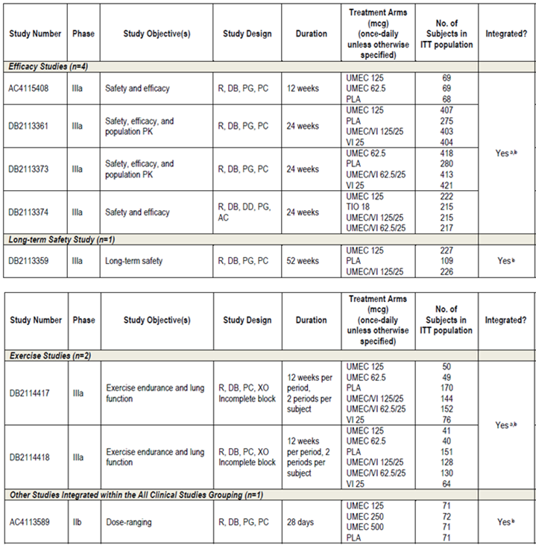
Safety assessments in the Phase II and Phase III development programs included reporting of adverse events (AEs), evaluation of clinical laboratory tests (clinical chemistry and haematology), measurement of vital signs (blood pressure and heart rate), and ECGs (12 lead ECGs and Holter monitoring). Pre specified AEs of special interest (AESIs) were defined as specified areas of safety assessment, which evaluated the pharmacologic class effects of anticholinergics/muscarinic antagonists. AESI groups were cardiovascular, urinary retention, ocular effects, gallbladder disorders, intestinal obstruction, and anticholinergic effects. A Pneumonia and Lower Respiratory Tract Infection group was added due to its prevalence in patients with COPD. In addition, all serious adverse events (SAEs) were adjudicated by an independent, blinded adjudication committee for the 7 studies which contained an umeclidinium monotherapy treatment group in subjects with COPD treated for at least 12 weeks duration. Adjudicated cardiovascular (CV) deaths were included in the assessment of the major adverse cardiac event (MACE) analyses.
The text for AEs was coded using the Medical Dictionary for Regulatory Activities (MedDRA) and coded AEs were reported using the primary System Organ Class (SOC) and Preferred Term (PT).
For the purpose of integrating the safety data from the clinical development program, studies were grouped as indicated in Table 7 below.
Table 7. Groupings for clinical studies.
For each study grouping, only integrated data from umeclidinium monotherapy (62.5 µg and 125 µg) and placebo arms were summarised. For Study DB2113374, data from the TIO and umeclidinium 125 µg groups will be presented separately, nested under the All Clinical Studies grouping.

Pivotal studies that assessed safety as a primary outcome
Study DB2113359 was a pivotal, long term, 52 week study that assessed safety as a primary outcome.

Clinical pharmacology studies
The clinical pharmacology program consisted of 14 studies evaluating umeclidinium by inhalation, oral and/or IV administration. Eight studies contribute key findings to the umeclidinium clinical safety profile: AEs of Special Interest Gallbladder Disorders: (AC4106889, and AC4113377); Ocular Effects: (AC4113377); Safety in Studies of Intrinsic Factors; Hepatic Impairment: (DB2114637); Renal Impairment: (DB2114636); Safety in Studies Investigating Drug/Drug Interaction and genetic polymorphisms CYP2D6: AC4110106, P-gp: (DB2113950); Cardiac Electrophysiology in healthy subjects Thorough QT: (DB2114635).

Patient exposure
A total of 2706 subjects with COPD were treated with at least 1 dose of study medication in the 8 studies comprising the All Clinical Studies Grouping as summarised in Table 8.
Table 8. Summary of subject exposure (all clinical studies ITT population).
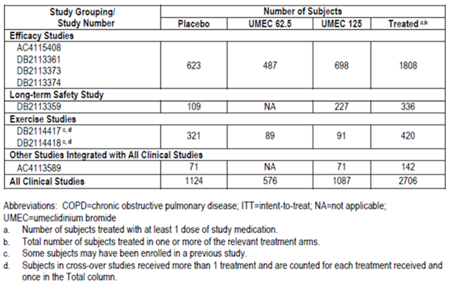
In the ‘Efficacy studies’ safety dataset, the planned duration of treatment was 24 weeks (168 days) for DB2113361, DB2113373 and DB2113374 and 12 weeks (84 days) for AC4115408. Median exposure duration in each treatment group was either 166 or 167 days (mean: 129 to 137 days).
The planned duration of treatment for the Exercise Studies was 12 weeks (84 days). Median exposure duration in each umeclidinium treatment group was 85 days.
The number of subjects in All Clinical Studies ITT population exposed to umeclidinium 62.5 µg and umeclidinium 125 µg was 576 and 1087 respectively, compared with 1124 for placebo. Median exposure of duration was 165, 166 and 88 days in the umeclidinium 62.5 µg, umeclidinium 125 µg and placebo group, respectively.
A total of 1808 subjects were randomised to umeclidinium or placebo and included in the ITT population for the Efficacy Studies and majority of subjects completed the study (79%, 76% and 70% for umeclidinium 62.5 µg, 125 µg and placebo groups respectively). Overall, the most common primary reasons for withdrawal were AEs (7%, 6% and 4%, respectively) and lack of efficacy (5%, 9% and 14%, respectively). Lack of efficacy due to COPD exacerbation was reported for fewer umeclidinium treated patients (5%, 7% and 11%, respectively). In Study DB2113374, the majority of subjects in each treatment group completed the study (74% of subjects on umeclidinium 125 µg compared with 82% on TIO) and the percentage of subjects who withdrew and the reasons for withdrawal from the study were generally similar across the 2 treatment groups. Overall, the most common reason for withdrawal was lack of efficacy (10% for umeclidinium 125 µg compared with 6% for TIO), followed by AEs (8% for umeclidinium 125 µg and 5% for TIO). Withdrawal due to COPD exacerbation was reported for 9% of subjects on umeclidinium 125 µg and 5% of subjects on TIO.
A total of 2706 subjects received umeclidinium 62.5 µg, umeclidinium 125 µg and/or placebo and were included in the ITT population for the All Clinical Studies grouping with the majority of subjects in each treatment group completing the study (81%, 74% and 74% in umeclidinium 62.5 µg, umeclidinium 125 µg and placebo groups, respectively). Overall, the primary reasons for withdrawal were AEs (7%, 6% and 5%) and lack of efficacy (5%, 7% and 11%). Lack of efficacy due to COPD exacerbation was reported for 4%, 5% and 8%, respectively.
Demographic and baseline disease characteristics of subjects receiving umeclidinium or placebo in the Efficacy Studies were generally similar across all treatment groups. Subjects receiving umeclidinium or placebo in the Efficacy Studies also had extensive smoking histories at Screening across all treatment groups (mean of 46 pack-years smoked over a mean of 39 years smoked) and 51% of subjects were classified as current smokers at screening (including subjects who stopped smoking within 6 months prior to Screening). Most subjects (80%) reported medical conditions in addition to their COPD and the most common current medical conditions reported overall were CV risk factors (58%), musculoskeletal and connective tissue disorders (33%) and cardiac disorders (20%). Demographic characteristics of subjects in the All Clinical Studies grouping were generally similar to the demographics of subjects in the Efficacy Studies.

Safety issues with the potential for major regulatory impact

Liver toxicity
There was no apparent treatment or dose related effect of umeclidinium on liver chemistry parameters.

Haematological toxicity
There was no apparent treatment or dose-related effect of umeclidinium on haematology parameters.

Serious skin reactions
None.

Cardiovascular safety
The most important cardiovascular finding observed was atrial arrhythmias (for example, supraventricular tachycardia, atrial fibrillation and supraventricular extra systoles), as assessed by frequency of AEs, ECG and Holter findings. A higher number of ECG abnormalities associated with atrial arrhythmias were reported for both umeclidinium treatment groups compared with placebo, with no reported clinical consequences as a result of the ECG abnormalities. Overall, although a higher number of AEs associated with atrial arrhythmias were reported with umeclidinium treatment compared with placebo, the AEs of atrial arrhythmias were not reported concurrently with other cardiovascular AEs or AEs of clinical significance such as syncope, hypotension or stroke. Four subjects reported SAEs associated with atrial arrhythmias in each of the umeclidinium groups, with no events reported in the placebo group. The SAEs of atrial arrhythmias were not reported concurrently with other SAEs of clinical significance.
Given that patients with COPD are at risk of CV disease, and pharmacological CV effects are associated with the use of LAMAs, an additional analysis of Major Adverse Cardiac Events (MACE) was conducted which included the efficacy studies, the long term safety study and the exercise studies. There was no evidence for an increased MACE risk with either dose of umeclidinium compared with placebo.

Unwanted immunological events
None applicable.

Postmarketing data
Not applicable.

Evaluator’s conclusions on safety
The safety population supporting the clinical development program included 8 completed clinical studies with a umeclidinium monotherapy arm and duration of > 4 weeks. A total of 2,706 subjects with COPD were treated with umeclidinium monotherapy or placebo; of which 1,663 subjects received treatment with umeclidinium 62.5 µg or 125 µg; representing 656 subject years of exposure.
However, 487 patients were exposed to the proposed dose of umeclidinium 62.5 µg once daily with median exposure duration of 167 days in the efficacy studies dataset. In the all clinical studies dataset, 576 patients were exposed to umeclidinium 62.5 µg with median duration of 165 days.
The study population in the clinical development program was representative of the overall COPD population.
The overall incidence of subjects reporting any on treatment AEs in the Efficacy Studies was similar across umeclidinium treatment groups and higher than placebo. The most commonly occurring AEs with > 3% incidence in at least one treatment group were headache, nasopharyngitis, cough, URTI, back pain and hypertension, with similar incidences across all three treatment groups. The most commonly occurring SAE was exacerbation of COPD which is not unexpected in a COPD population.
Overall, 14 fatalities on umeclidinium or placebo were reported in the clinical development program; 3 reported in umeclidinium 62.5 µg treatment group, 7 in umeclidinium 125 µg treatment group, and 4 in the placebo group. The majority of these fatalities were classified by an external independent adjudication committee as cardiovascular, respiratory or oncologic in nature, which is consistent with known co-morbidities of the COPD patient population. A higher number of fatal events occurred in the umeclidinium 125 µg treatment group compared with the umeclidinium 62.5 µg and placebo groups, and this was driven mainly by 4 deaths which were oncologic in nature. There was no pattern to the type of cancer reported in these subjects.
The incidence of SAEs in the Efficacy Studies was slightly higher in the umeclidinium treatment groups compared with placebo and the exposure adjusted frequency of subjects with on treatment SAEs was 153, 149 and 123 subjects with event per 1000 subject years of exposure in the umeclidinium 62.5 µg, 125µg and placebo groups, respectively. However, incidence of treatment related SAEs was <1% in umeclidinium groups and of the 3 drug related SAEs, 2 were in the umeclidinium 125 µg (atrial fibrillation and chest pain) and 1 in the umeclidinium 62.5 µg group (tachycardia). AEs leading to discontinuation or withdrawal were reported at slightly higher incidence in umeclidinium treatment groups (7%, 6% and 4% in the umeclidinium 62.5 µg, 125µg and placebo groups, respectively).
In the efficacy studies, there was a higher incidence of AEs in the cardiac disorders SOC for umeclidinium 125 µg and umeclidinium 62.5 µg compared with placebo; while a similar incidence of AEs in the cardiac disorders SOC was noted between umeclidinium 125 µg and placebo in the long term safety study. The most important cardiovascular finding observed was atrial arrhythmias (for example, supraventricular tachycardia, atrial fibrillation, supraventricular extrasystoles), as assessed by frequency of AEs, ECG and Holter findings. A higher number of ECG abnormalities associated with atrial arrhythmias were reported for both umeclidinium treatment groups compared with placebo, with no reported clinical consequences as a result of the ECG abnormalities. Overall, although a higher number of AEs associated with atrial arrhythmias were reported with umeclidinium treatment compared with placebo, the AEs of atrial arrhythmias were not reported concurrently with other cardiovascular AEs or AEs of clinical significance such as syncope, hypotension or stroke. Four subjects reported SAEs associated with atrial arrhythmias in each of the umeclidinium groups, with no events reported in the placebo group. The SAEs of atrial arrhythmias were not reported concurrently with other SAEs of clinical significance.
Given that patients with COPD are at risk of CV disease and pharmacological CV effects are associated with the use of LAMAs, an additional analysis of MACE was conducted which included the efficacy studies, the long term safety study and the exercise studies. There was no evidence for an increased MACE risk with either dose of umeclidinium compared with placebo. The risk of CV events with anticholinergics has been widely studied, although results remain unclear. In the Understanding the Long-Term Impact of Tiotropium on Lung Function trial (UPLIFT), there was an increased relative risk of tachyarrhythmias and atrial tachycardias reported as AEs for TIO compared with placebo . In addition, in the TIO active comparator studies performed in the umeclidinium and umeclidinium/vilanterol development program, there were also some increases in atrial arrhythmias noted compared to baseline. A recently approved LAMA, aclidinium, has been shown to have a greater incidence of non-sustained supraventricular tachycardia (SVTs) compared with placebo. Therefore, the evidence seems to suggest that atrial arrhythmias may be a class effect of anticholinergics.
Since clinical consequences of these arrhythmias are rare and may not have been detectable in the clinical development program, this potential risk will continue to be managed through relevant class prescribing information, post marketing risk management activities and post approval monitoring studies.
A higher incidence of pneumonia associated AESI events was noted in the umeclidinium 125 µg treatment group (1%) compared with umeclidinium 62.5 µg (< 1%) and placebo (< 1%) in the Efficacy Studies. This was driven by a higher incidence with the PT of pneumonia, most of which were non-serious events. The incidence of serious pneumonia associated events in the efficacy studies was comparable between both umeclidinium treatment groups (<1%) and placebo (<1%). In the long term safety study, a higher incidence of pneumonia associated AESI events was noted in the umeclidinium 125 µg treatment group (3%) compared with placebo (0%). Safety results from other marketed LAMAs have not shown an association between anticholinergics and pneumonia. The recently approved LAMA, aclidinium bromide showed no evidence for an increased risk of pneumonia in COPD patients. Similarly, results from the UPLIFT trial showed a similar incidence for the AE of pneumonia between TIO and placebo groups. Pneumonia is a common background event in the COPD population, and there is no clear association of umeclidinium with events of pneumonia. Pneumonia-associated AESI events observed may reflect the co-morbidities associated with the COPD population at large.
Other AEs identified as being potentially related to anticholinergics (for example, ocular, gallbladder, intestinal obstruction, and urinary retention) were specifically analysed across the clinical development program. There was no evidence for a treatment related response of umeclidinium indicative of anticholinergic effects.
There was no indication from the routine laboratory evaluations in the umeclidinium program of a clinically relevant treatment or dose related effect on haematology or clinical chemistry. No concerns for hepatic toxicity were observed in the studies with umeclidinium. The few episodes of liver abnormalities were generally transient or confounded by concurrent medical conditions or concomitant medications.
Overall, the safety profile of both doses of umeclidinium was similar to placebo and no difference in the safety profile was observed between the two doses of umeclidinium. The most important safety finding with umeclidinium was atrial arrhythmias, as assessed by frequency of AEs and ECG findings, which occurred at a higher incidence in active treatment groups compared with placebo. Clinical experience with umeclidinium did not show any clear associations with significant and serious cardiac events.
The safety of proposed dose of umeclidinium 62.5 µg has not been evaluated beyond 6 months. However, in the long term safety study, there were no newly identified safety concerns with umeclidinium 125 µg over the 52 week duration of the study, with a similar overall safety profile to the efficacy studies.

First round benefit-risk assessment

First round assessment of benefits
The benefits of umeclidinium 62.5 µg in the proposed usage are:
- Improved lung function as assessed by trough FEV1 and weighted mean FEV1 over 0 to 6 hours compared to placebo.
- Improvements in symptoms as demonstrated in clinically relevant TDI measures and reductions in rescue salbutamol use compared with placebo.
- Improved health related QOL as measured by change from baseline in SGRQ score.
- Reduced the risk of COPD exacerbation compared to placebo based on an analysis of time to first exacerbation in the two 24 week studies.
- Maintenance of long term efficacy with no evidence of tolerance over 24 weeks. Maintenance of efficacy in the pivotal long-term, 52 week safety Study DB2113359 was only shown for umeclidinium 125 µg as the proposed dose of umeclidinium 62.5 µg was not evaluated in this study.
- Well tolerated with no major safety concerns. No increased risk of CV events except atrial arrhythmias which appears to be a class effect for anticholinergics.

First round assessment of risks
The risks of umeclidinium 62.5 µg in the proposed usage are:
- Efficacy and safety of umeclidinium 62.5µg has not been evaluated beyond 6 months.
- Efficacy of umeclidinium 62.5 µg was not compared with TIO or any other LAMA although efficacy of umeclidinium 125 µg was shown to be comparable to TIO in Study DB2113374.
- The 12 week crossover exercise studies (DB2114417 and DB2114418) failed to demonstrate significant improvement in exercise endurance time or exertional dyspnoea following treatment with umeclidinium 62.5 µg.
- Slightly higher incidence of cardiac arrhythmias was associated with umeclidinium 62.5 µg; atrial fibrillation, loss of consciousness, bradycardia and supraventricular extrasystoles were reported by < 1% of subjects in both umeclidinium treatment groups compared to none in the placebo group.

First round assessment of benefit-risk balance
Umeclidinium at the dosages studied is an effective treatment for patients with moderate to severe COPD, producing improvements in both lung function and symptoms, key measures considered important in the management of COPD. Umeclidinium was well tolerated with a low incidence of AEs and no unexpected safety observations. Potential pharmacology related effects such as atrial arrhythmias require appropriate cautionary labelling and risk management activities tailored to the regions where umeclidinium will be marketed. Overall, umeclidinium 62.5 µg and 125 µg both have favourable risk-benefit profiles. Additional improvements obtained with umeclidinium 125 µg over 62.5 µg were not considered substantial nor likely to offer additional clinical benefit due to increased risk of AEs especially pneumonia. Therefore the proposed dose of umeclidinium 62.5 µg is appropriate for treatment of patients with COPD.
The benefit-risk balance of umeclidinium 62.5 µg for proposed indication of long term maintenance bronchodilator treatment to relieve symptoms in adult patients with COPD is favourable.

First round recommendation regarding authorisation
It is recommended that the application for the registration of Incruse Ellipta (umeclidinium 62.5 µg) once daily for long term maintenance bronchodilator treatment to relieve symptoms in adult patients with COPD be approved.
The approval is conditional to an appropriate response to clinical questions raised below.

Clinical questions

Efficacy
The Committee for Medicinal Products for Human Use (CHMP) guidelines for ‘Clinical investigation of medicinal products in treatment of patients with COPD’ states that formal stratification of patients according to their smoking status (current smokers, ex-smokers) should be performed prior to randomisation. This was not done in any of the pivotal clinical studies for umeclidinium. Furthermore, tobacco exposure was not monitored during the study and any change in smoking status did not appear to be documented or reported. Use of nicotine replacement therapy or other smoking cessation aids such as varenicline was also not documented.
Could the sponsors please confirm if change in smoking status was monitored for the pivotal Phase III studies and if it had any effect on the efficacy results?

Second round evaluation of clinical data submitted in response to questions

Sponsor’s response to clinical questions efficacy:
Stratification by smoking status was not performed. However, the proportion of current and former smokers across treatment groups at entry in each of the studies was very similar. The proportion of current smokers ranged from 52% to 54% for the placebo group, 50% to 54% for the umeclidinium 62.5 µg group and 44% to 57% for the umeclidinium 125 µg group across the 4 efficacy studies. The proportion of former smokers ranged from 46% to 48% for the placebo group, 46% to 50% for the umeclidinium 62.5 µg group and 43% to 56% for the umeclidinium 125 µg group across the 4 efficacy studies. Smoking status at screening was included as a covariate in all efficacy analyses and sensitivity analyses were performed for the interaction between treatment and smoking status for the primary and secondary endpoints. These sensitivity analyses showed a statistically significant overall interaction between smoking status and trough FEV1 (primary endpoint) in DB2113361 and DB2113374, and between smoking status and weighted mean FEV1 (secondary endpoint) in DB2113374. When this was further investigated, the interaction was not found to be statistically significant at the final visit in both these studies. Therefore smoking status did not have an effect on the primary or secondary endpoints for these 2 studies. For AC4115408, no interaction with smoking status was observed for the primary endpoint of trough FEV1 or the secondary endpoint of weighted mean FEV1. However, there was a statistically significant interaction between smoking status and serial FEV1 (secondary endpoint) at Day 1 but not at Day 84.
To further explore this potential interaction, smoking status at screening was removed from the original model to determine if the original conclusions would be affected. Removing smoking status from the Day 1 analysis did not change the original conclusions. Given the inconsistency of the interactions across the 2 separate by visit analyses (Day 1 and Day 84), it was concluded that no further investigation was warranted beyond the initial investigative analyses. There was no statistically significant interaction between smoking status and trough FEV1 (primary endpoint) or weighted mean FEV1 (secondary endpoint) in DB2113373. Furthermore, there was no evidence of a statistically significant treatment by smoking status interaction for the primary efficacy endpoint of trough FEV1 on Day 84 in the 12 week integration or Day 169 in the 24 week integration for the integration of the efficacy studies.
Changes in smoking status were recorded during each study. Subjects were asked at the Day 84 and Day 168 clinic visits in the 6 month studies (DB2113361, DB2113373, DB2113374) if they had changed their smoking status since the previous clinic visit and the results were recorded in the electronic case report form (eCRF). For the 3 month study AC4115408, changes in smoking status were recorded at end of the treatment period at the Day 84 clinic visit. Few changes in smoking status during the studies were reported. In DB2113361, 2 (< 1%) subjects changed their smoking status from screening. In DB2113373, 7 (< 1%) subjects and in DB2113374, 3 (< 1%) subjects changed their smoking status from screening. In AC4115408, no subjects changed their smoking status from screening. Given that the percentage of subjects changing their smoking status was < 1%, the impact on the efficacy results is likely to be negligible.
Usage of concomitant medications that are considered smoking cessation aids such as varenicline, both at study entry and whilst on treatment were captured in the eCRF and (were documented) in the respective clinical study reports. In DB2113361, 17 (1%) subjects were reported as using varenicline whilst on treatment compared to 11 (< 1%) subjects who were receiving varenicline at study entry; 8 (< 1%) subjects were reported as receiving nicotine/nicotine polacrilex during the treatment period compared with 2 (< 1%) subjects prior to the study. In DB2113373, 20 (1%) subjects were reported as using varenicline tartrate during the treatment period compared to 10 (< 1%) subjects who were reported as using varenicline at study entry; 11 (< 1%) subjects were reported as using nicotine/nicotine polacrilex during treatment compared to 8 (< 1%) subjects who reported using nicotine at study entry. For DB2113374, 11 (< 1%) subjects were reported as taking varenicline/varenicline tartrate during the study compared to 6 (< 1%) subjects who were reported as using varenicline/varenicline tartrate at study entry; 3 (< 1%) subjects were reported as using nicotine during the treatment period compared to 1 (< 1%) subject at study entry. In AC4115408, 1 (< 1%) subject each was reported as using varenicline tartrate at study entry and during the study whilst no subjects were recorded as using nicotine either prior to or during the treatment period. Overall, few patients used varenicline or nicotine replacement therapy during the studies.

Evaluator’s comment on sponsor’s response:
The sponsor’s response is acceptable.

Second round benefit-risk assessment

Second round assessment of benefits
After consideration of the response to clinical questions, the benefits of umeclidinium 62.5µg once daily in the proposed usage are unchanged from those identified in the first round assessment of benefits.

Second round assessment of risks
After consideration of the response to clinical questions, the risks of umeclidinium 62.5µg once daily in the proposed usage are unchanged from those identified in the first round assessment of risks.

Second round assessment of benefit-risk balance
After consideration of the response to clinical questions, the benefit-risk balance of umeclidinium 62.5µg once daily in the proposed usage are unchanged from those identified in in the first round assessment of benefit-risk balance.

Second round recommendation regarding authorisation
It is recommended that Incruse Ellipta (umeclidinium 62.5μg once daily by inhalation) be approved for the maintenance bronchodilator treatment to relieve symptoms in adult patients with Chronic Obstructive Pulmonary Disease (COPD).
The evaluator recommended that the approval be subject to incorporation of suggested changes to the proposed PI, details of these changes are beyond the scope of the AusPAR.

V. Pharmacovigilance findings

Risk management plan
The sponsor submitted a Risk Management Plan EU-RMP Version 2.0 (dated 14/11/2013, DLP 10/12/2012) and Australian Specific Annex Version 2.0 (dated 22/01/2014, DLP not given), which was reviewed by the TGA’s Post-Market Surveillance Branch (PMSB).

Safety specification
The sponsor provided a summary of ongoing safety concerns which are shown at Table 9.
Table 9. Summary of ongoing safety concerns.
Summary of safety concerns
Important identified risks | None identified
Important potential risks | Cardiac disorders
Important missing information | Safety in pregnancy and lactation

Pharmacovigilance plan
The sponsor plans routine pharmacovigilance activities for all ongoing safety concerns and additional pharmacovigilance activities (clinical studies) for the important potential risk ‘cardiac disorders’. The additional proposed activities for the safety concern cardiac disorders are:
- Study HZC115058; assessment of co-morbidities in COPD in European symptomatic subjects from primary care (ACCESS). A non drug interventional observational prospective cohort study of patients managed for their COPD in primary care in multiple European countries.
- A post authorisation safety observational cohort study to quantify the incidence of selected cardiovascular endpoints in COPD patients using inhaled UMEC/VI combination or inhaled UMEC. This study will be conducted in several European countries, including but not limited to sites selected for the ACCESS study above.
- Study WEUSKOP6679. A post authorisation study of new users of inhaled UMEC/VI or new users of inhaled UMEC in the primary care setting: UK Clinical Practice Research Datalink (CPRD) study.

Risk minimisation activities
The sponsor is not proposing any additional risk minimisation activities.
PMSB evaluator comment: This is acceptable.

Reconciliation of issues outlined in the RMP report
A summary of the PMSB’s recommendations from the first round evaluation of the RMP, the sponsor’s responses to issues raised by the PMSB and the PMSB’s evaluation of the sponsor’s responses is below.

PMSB recommendation 1
Safety considerations may be raised by the nonclinical and clinical evaluators through the consolidated TGA request for information and/or the nonclinical and clinical evaluation reports respectively. It is important to ensure that the information provided in response to these includes a consideration of the relevance for the RMP, and any specific information needed to address this issue in the RMP. For any safety considerations so raised, please provide information that is relevant and necessary to address the issue in the RMP.

Sponsor’s response
GSK has considered the responses to the consolidated TGA request for information and the clinical evaluation report. Safety in long term use has been included as missing information in the EU RMP.

PMSB evaluator’s comments
This is considered acceptable.

PMSB recommendation 2
Cerebrovascular events should be added as an important potential risk in key changes to the updated RMP.

Sponsor’s response
Cerebrovascular events have been included in the important potential risk of ‘cardio and cerebrovascular events’ in the updated EU RMP.

PMSB evaluator’s comments
This is considered acceptable.

PMSB recommendation 3
‘Urinary retention (including prostate hypertrophy bladder neck obstruction)’ should be added as an important potential risk.

Sponsor’s response
Urinary retention including bladder outflow obstruction has been included as an important potential risk in the updated EU RMP.

PMSB evaluator’s comments
This is considered acceptable.

PMSB recommendation 4
Ocular effects (including narrow angle glaucoma)’ should be added as an Important potential risk.

Sponsor’s response
Narrow angle glaucoma has been included as an important potential risk in the updated EU RMP.

PMSB evaluator’s comments
This is considered acceptable.

PMSB recommendation 5
GI effects (including GI obstruction), should be added as an important potential risk.

Sponsor’s response
‘Gastrointestinal obstruction was evaluated as an AESI in the clinical development program. This AESI categorisation included a wide range of terms to describe signs and symptoms relating to intestinal obstruction (gastrointestinal obstruction SMQ).
In the efficacy studies, on treatment AEs in the gastrointestinal obstruction AESI group were reported only in the placebo group (< 1%), with no events reported for either dose of umeclidinium; Table 10. Two AEs reported in the placebo group were serious (PTs: ileus; small intestinal obstruction). No subjects in the long term safety study had an on treatment AE reported in the intestinal obstruction AESI group; Table 10. GSK therefore does not consider the inclusion of ‘GI effects (including GI obstruction)’ as an important potential risk in the RMP is warranted.
Table 10. On treatment Intestinal Obstruction AESI.
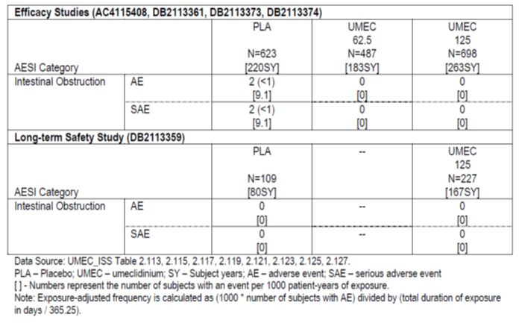

PMSB evaluator’s comments
This is considered acceptable.

PMSB recommendation 6
Paradoxical bronchospasm should be added as an important potential risk.

Sponsor’s response
Paradoxical bronchospasm (which may be life threatening) has been included as an important potential risk in the updated EU RMP.

PMSB evaluator’s comments
This is considered acceptable.

PMSB recommendation 7
Off label use (including use in asthma and use in children), should be added as an important potential risk.

Sponsor’s response
The diagnosis and treatment of COPD are dictated by international guidelines. The use of prescription only umeclidinium for asthma would not be consistent with established guidance by the Global Initiative for Asthma. The benefits of LAMAs in asthma management have not been established. There is a wide range of licensed and established controller treatment options available to physicians for the management of asthma including, glucocorticosteroids, leukotriene modifiers, LABAs in combination with glucocorticosteroids, sustained release theophylline, cromones and anti IgE therapy. GSK therefore does not consider the addition of off label use (including use in asthma and use in children) in the EU RMP as warranted.
GSK will routinely monitor for AEs arising from off label use including use in children, as part of routine pharmacovigilance and will discuss such cases in future periodic benefit-risk evaluation reports (PBRERs).

PMSB evaluator’s comments
This is not considered acceptable. Umeclidinium is not indicated for asthma or children.
The GINA guideline does not specifically mention umeclidinium. Generally, a statement in a guideline that LAMAs should not be used in asthma will not prevent off label use. There will always be a potential for off label use.
Given that the sponsor agreed to report off label use in PBRERs/PSUR and will conduct a drug utilisation study, it is assumed that the sponsor will have no objection to include ‘Off label use’ as an important potential risk.
The recommendation remains.

PMSB recommendation 8
Medication errors (including device errors), should be added as an important potential risk.

Sponsor’s response
There is very limited potential for medication errors with umeclidinium. To minimise the potential for medication errors, approval of this invented name was granted subsequent to extensive review and research to identify any possible conflicts or similarities with existing trade names. Therefore accidental prescribing and incorrect dispensing are unlikely.
Umeclidinium, delivered at a pre-dispensed strength via the Ellipta inhaler may not be tasted or felt by the patient, so they may not realise a dose has been dispensed. However, as indicated in the Australian PI, CMI and User leaflet, the Ellipta inhaler is ready for use and does not require any additional preparation by the patient. The patient will be aware that the dose is ready for inhalation by; i) hearing an audible click once the cover of the inhaler is fully extended; and ii) the dose counter of the inhaler will count down by 1. If the dose counter does not count down with the audible click, the inhaler will not deliver medicine. The Australian PI and CMI provide appropriate guidance that the administration of umeclidinium is for once daily use only, and that if a larger dose of umeclidinium is taken, the patient should contact their doctor or pharmacist for advice. Due to these considerations, the potential for medication errors for a pre dispensed strength of umeclidinium is minimised and inclusion as missing information in the RMP is not warranted.

PMSB evaluator’s comments
The OPR evaluator has no objection to the trade name.
The fact that the sponsor considered risk minimisation measures necessary makes this an ongoing safety concern that warrants specific attention in the pharmacovigilance plan. Medication errors are common in medications that are delivered with devices. The sponsor has not provided any data on the failure rate of the device. In the interest of regulatory consistency, ‘Medication errors (including device errors)’ should be added as an important potential risk.
The recommendation remains.

PMSB recommendation 9
Long term safety (beyond 12 months), should be added as important missing information.

Sponsor’s response
Safety in long term use has been included as missing information in the updated RMP.

PMSB evaluator’s comments
This is considered acceptable.

PMSB recommendation 10
Use in renal impairment, should be added as important missing information, as the number of patients in this subpopulation exposed to umeclidinium is too small to draw relevant conclusions.

Sponsor’s response
Eighteen subjects were enrolled into the study (9 with severe renal impairment and 9 matched healthy subjects) in this single blind, non-randomized pharmacokinetic and safety study of single dose of umeclidinium and umeclidinium/vilanterol combination in healthy subjects and in subjects with severe renal impairment.
Data from previous studies included in the original submission, DB2113950, AC4110106, and HZA113970 were used to obtain estimates of variability to assess the width of the confidence interval for the ratio between groups based on the proposed sample size. For the purpose of selecting an appropriate estimate of variability only single dose data from healthy volunteers and treatment groups umeclidinium 100 µg, umeclidinium/vilanterol 500/25 µg and fluticasone/vilanterol 200/50 were used as these were considered the most relevant from historic umeclidinium and vilanterol studies. HZA113970 included severe renally impaired subjects however the estimates of variability were lower in these subjects than in the healthy subjects hence the healthy were used as a reference. The studies provided estimates of standard deviation based on log_{e} transformed data of AUC_{0-0.25 h} = 0.640 and C_{max} = 0.716 for umeclidinium and AUC = 0.811 and C_{max} = 1.207 for vilanterol. Based on the most conservative standard deviation of 1.207 and a sample size of 9 subjects, this equates to a half width of a 90% confidence interval, on log transformed data, of 0.993. This, when back transformed, will provide a half width of the 90% confidence interval around the estimate ratio of the geometric means of approximately ±171%, which corresponds to a lower and upper confidence limit of 0.37 and 2.70 assuming a true ratio of 1. Table 11 below provides a sample size sensitivity based on 9 subjects, showing the effect of variation in the standard deviation and different true ratios on the magnitude of the 90% confidence interval.
Table 11. A sample size sensitivity based on 9 subjects.
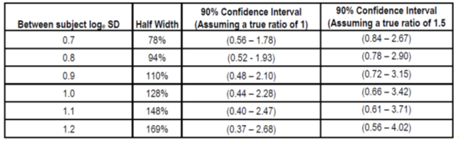
GSK therefore considers that the study population in study DB2114636 was sufficient to draw relevant conclusions, and does not consider the addition of ‘Use in renal impairment’ as missing information in the RMP is warranted.

PMSB evaluator’s comments
The sponsor does not need to include this safety concern as important missing information but not for the reasons given by the sponsor. The PMSB evaluator does not agree with the sponsor’s described study methodology.

PMSB recommendation 11
Use in hepatic impairment, should be added as important missing information, as the number of patients in this subpopulation exposed to umeclidinium is too small to draw relevant conclusions.

Sponsor’s response
Eighteen subjects were enrolled into the study (9 with moderate hepatic impairment and 9 matched healthy subjects) in this open label, non randomised, pharmacokinetic and safety study of single dose umeclidinium/vilanterol and repeat doses of umeclidinium in healthy subjects and in subjects with moderate hepatic impairment.
Data from previous studies, and which were included in the original submission, AC4110106, DB2113950, HZA113970 and HZA111789 were used to obtain estimates of variability to assess the width of the confidence interval for the ratio between groups based on the proposed sample size.
Estimates of between subject standard deviation for log_{e} transformed data observed in the studies mentioned are presented below (Table 12) for the populations and treatments most relevant for this study. There are no historic single or repeat dose studies where the current formulation of the umeclidinium 125 µg dose was studied, therefore the 100 µg and 500 µg dose levels have been considered where available. The AUC parameter presented is the largest AUC standard deviation observed across all AUC parameters. Single and repeat dose estimates are presented for umeclidinium monotherapy, whereas only single dose estimates are presented for umeclidinium and vilanterol in combination to reflect the proposed study design for the current study.
Table 12. Estimates of between subject standard deviation for log_{e} transformed data observed in the selected studies (AC4110106, DB2113950, HZA113970 and HZA111789).
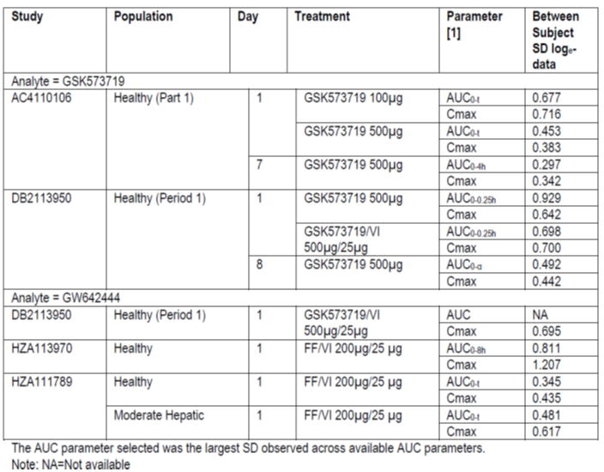
Based on the most conservative standard deviation of 1.207 and a sample size of 9 subjects, this equates to a half width of a 90% confidence interval, on log transformed data of 0.993. This, when back transformed, will provide a half width of the 90% confidence interval around the estimate ratio of the geometric means of approximately ±171%, which corresponds to a lower and upper confidence limit of 0.37 and 2.70 assuming a true ratio of 1.
Table 13 below provides a sample size sensitivity based on 9 subjects, showing the effect of variation in the standard deviation and different true ratios on the magnitude of the 90% confidence interval.
Table 13. A sample size sensitivity based on 9 subjects.
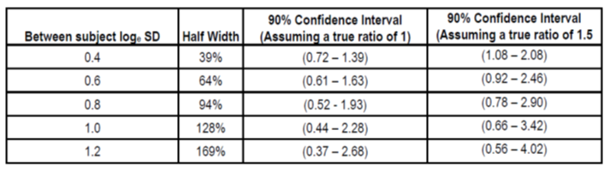
GSK therefore considers that the study population in Study DB2114637 was sufficient to draw relevant conclusions, and does not consider the addition of ‘use in hepatic impairment’ as missing information in the RMP is warranted. However, umeclidinium has not been studied in patients with severe hepatic impairment and therefore ‘Safety in subjects with severe hepatic impairment’ has been included as missing information in the updated EU RMP.

PMSB evaluator’s comments
The sponsor does not need to include this safety concern as important missing information, but not for the reasons given by the sponsor. The PMSB evaluator does not agree with the sponsor’s described study methodology.

PMSB recommendation 12
Patients with a concomitant respiratory disease (including asthma), should be added as important missing information, as they were excluded from clinical trials.

Sponsor’s response
Subjects with a concomitant respiratory disease (including asthma) were excluded from the clinical development program to ensure the study population had a clear diagnosis of COPD, so as not to confound the determination of the efficacy profile of umeclidinium in the COPD population and to avoid confounding the efficacy or safety analysis if the disease/condition exacerbated during the study. There is no evidence to suggest that subjects with concomitant respiratory disease (including asthma) would respond differently to umeclidinium treatment or have any additional risks that were different from those with a diagnosis of COPD alone. GSK therefore does not consider the inclusion of ‘Patients with a concomitant respiratory disease (including asthma)’ as missing information in the EU RMP is warranted.

PMSB evaluator’s comments
The sponsor does not need to include this safety concern as important missing information, if ‘off label use’ is included.

PMSB recommendation 13
Patients with a recent exacerbation of COPD (including pneumonia), should be added as important missing information, as they were excluded from clinical trials.

Sponsor’s response
Subjects who had been hospitalised for COPD or pneumonia within 12 weeks prior to starting study were excluded from the clinical studies, so as not to confound the determination of the safety and efficacy profile of the investigational products, if the disease/condition exacerbated during the study. Additionally, it was important for this population to be clearly subjects with COPD, who could be assessed for changes in lung function and those recovering from respiratory infection may have improvements in lung function that were not as a consequence of treatment with study drug. In the long term safety study, subjects who experienced a COPD exacerbation during the treatment period were allowed to remain in the study and continue to take study drug, if possible.
Patients with COPD are at risk of an exacerbation and/or developing pneumonia. In these patients, it is important for COPD to be adequately controlled and there is no reason to believe that this would represent a different population to that studied in the clinical development program. GSK therefore does not consider the inclusion of ‘patients with a recent exacerbation of COPD (including pneumonia)’ as missing information in the EU RMP is warranted.

PMSB evaluator’s comments
The sponsor does not need to include this safety concern as important missing information but not for the reasons given by the sponsor.

PMSB recommendation 14
Patients with concomitant use of other anticholinergics, should be added as important missing information, as they were excluded from clinical trials.

Sponsor’s response
The main concomitant medications anticipated with the use of umeclidinium are short acting bronchodilators (for example, short acting beta agonists) for symptomatic relief and maintenance on an ‘as needed’ basis, and ICS for more severe disease associated with recurrent exacerbations.
There is potential for an interaction with concomitantly used anticholinergic medications. The Australian PI provides appropriate warning that co administration of umeclidinium with other anticholinergic containing drugs may lead to an increase in anticholinergic adverse effects. GSK has included a comprehensive pharmacovigilance plan in the EU RMP to assess potential risks associated with umeclidinium, including cardio and cerebrovascular disorders, narrow angle glaucoma and bladder outflow obstruction. Any SAEs reported will be continually monitored with routine pharmacovigilance activities, including timely awareness of important individual cases in the safety database, and in period scientific evaluations will be included in future PBRERs. In addition, post authorisation safety studies will further evaluate the risks and incidence of cardio and cerebrovascular events in patients using umeclidinium. In the event of further characterisation of the incidence, nature and outcome of these potential anticholinergic risks, these findings would be managed with an update to the existing wording in the Australian PI.
GSK therefore considers that the proposed pharmacovigilance plan to assess the potential risks outlined in the umeclidinium EU RMP will adequately characterise the nature and outcome of the risks, including those patients that receive concomitant anticholinergics. Therefore, inclusion of ‘Patients with concomitant use of other anticholinergics’ as missing information in the EU RMP is not warranted.

PMSB evaluator’s comments
This is considered acceptable.

PMSB recommendation 15
Patients with concomitant clinically significant cardiovascular disease should be added as important missing information, as they were excluded from clinical trials.

Sponsor’s response
Exclusion of subjects with clinically significant uncontrolled cardiovascular disease was based on the medical judgment of the study investigator and subjects were also excluded if they had an abnormal and clinically significant ECG finding at screening.
However, in the efficacy studies and the long term safety study, the majority of subjects (55% to 68% in each treatment group) reported at least one cardiovascular risk factor, 18% to 35% reported a concurrent cardiac disorder, and 51% to 65% of the subjects were current smokers.
In addition, the clinical development program included subjects with a past medical history of myocardial infarction (5% to 6%) and stroke (3% to 4%). The majority of subjects (51% to 63%) in each treatment group of these studies also reported taking at least one cardiovascular medication, which included antihypertensive and/or cholesterol-lowering agents.
The prevalence of these cardiovascular conditions at screening is comparable to the estimates reported for COPD patients who were managed for their disease; as shown in Table 14.
Table 14. Prevalence of CV risk factors in the COPD population compared with the clinical development program.
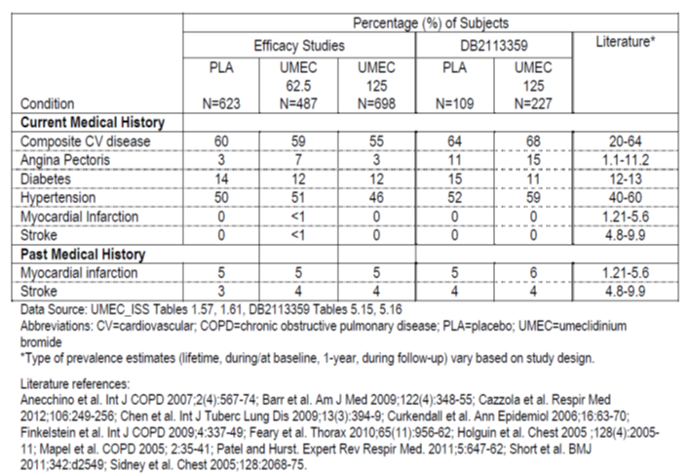
A proportion of subjects in the clinical development program were excluded from study participation based on assessment of pre-specified abnormal and clinically significant ECG findings. However, the clinical studies did include subjects with baseline ECG abnormalities and baseline ECG abnormalities for the long term safety study are provided for illustration of this point; Table 15.
Table 15. Summary of all ECG abnormalities at baseline - long term safety study.
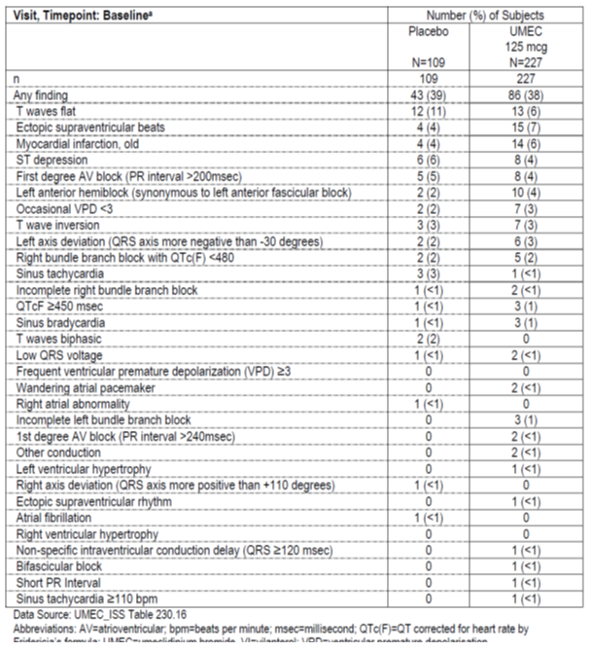

PMSB evaluator’s comments
This is considered acceptable.

PMSB recommendation 16
Patients with concomitant clinically significant urological disease (including benign prostatic hyperplasia (hypertrophy), bladder neck obstruction, and urinary retention), should be added as important missing information, as they were excluded from clinical trials.

Sponsor’s response
‘Exclusion of patients with medical conditions such as prostatic hypertrophy or bladder neck obstruction was based on the medical judgment of the study investigator. In the efficacy studies and the long term safety study, subjects with concurrent urological disease, including benign prostatic hyperplasia and bladder outlet obstruction were included into study participation; Table 16.
Table 16. Current medical history at screening - renal and urinary disorders.
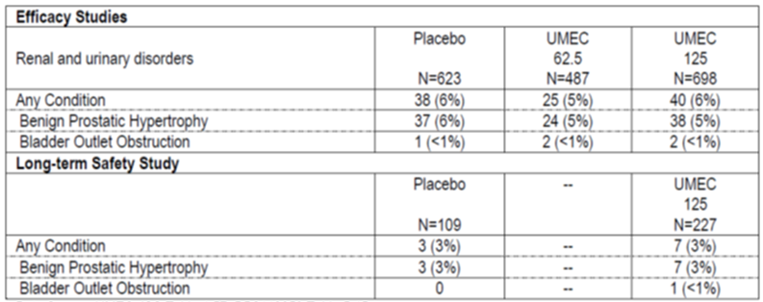
In the clinical development program, anticholinergic effects including urinary retention were evaluated as AESI’s. There were few AEs reported that suggested systemic anticholinergic effects and few urological events relating to urinary retention were reported; Table 17. Two AEs of urinary retention were reported in the umeclidinium 125 µg treatment group in the efficacy studies. In the long term safety study, no AEs relating to urinary retention were reported in the umeclidinium 125 µg treatment group.
Table 17. On-treatment anticholinergic effects AESI – efficacy studies.
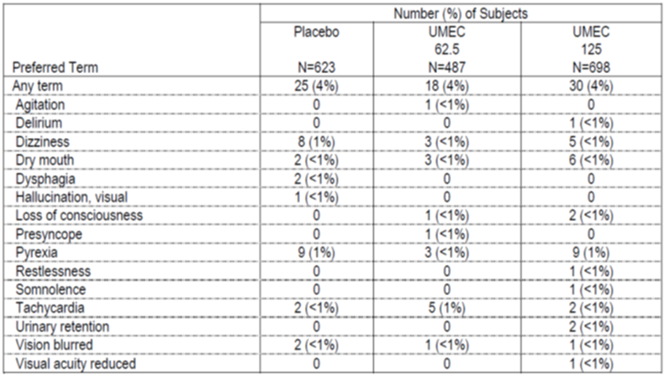
Urinary retention including bladder outflow obstruction has been included as an important potential risk in the updated EU RMP. Any reports of bladder outflow obstruction and urinary retention will be continually monitored with routine pharmacovigilance activities, including timely awareness of important individual cases in the safety database, and in period scientific evaluations will be included in future PBRERs. In the event of further characterisation of the incidence, nature and outcome of the risk, these findings would be managed with an update to the existing wording in the Australian PI.
GSK therefore considers that given the proposed pharmacovigilance activities, the inclusion of ‘Patients with concomitant clinically significant urological disease (including BPH, bladder neck obstruction, and urinary retention)’ as missing information in the EU RMP is not warranted.

PMSB evaluator’s comments
This is considered acceptable.

PMSB recommendation 17
Patients with concomitant narrow angle glaucoma should be added as important missing information, as they were excluded from clinical trials.

Sponsor’s response
Exclusion of patients with medical conditions such as narrow angle glaucoma was based on the medical judgment of the study investigator. In the efficacy studies and the long term safety study, subjects with concurrent eye disorders, including glaucoma were included into study participation; Table 18.
Table 18. Current medical history at screening: Ocular disorders.
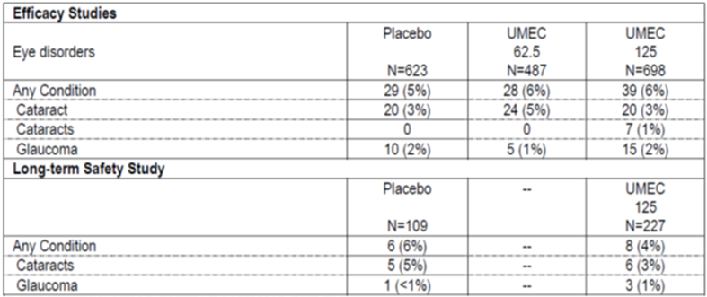
In the clinical development program, ocular effects were evaluated as an AESI. There were few AEs reported with umeclidinium compared with placebo in the ocular effects AESI in the efficacy studies and long term safety study; Table 19. The incidence of glaucoma was very low, with one AE of glaucoma reported in the umeclidinium 125 µg treatment group and one AE of open angle glaucoma in the umeclidinium 62.5 µg treatment group in the efficacy studies. There were no reports of glaucoma in the umeclidinium 125 µg treatment group in the long term safety study; Table 19.
Table 19. On treatment Ocular effects AESI.
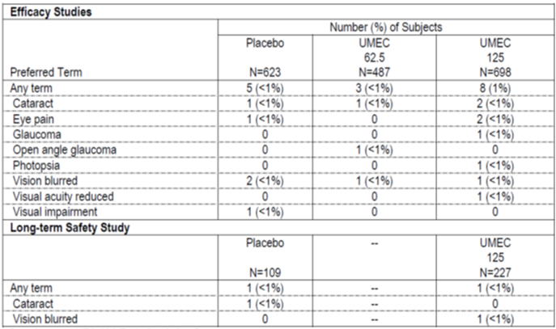
Narrow angle glaucoma has been included as an important potential risk in the updated EU RMP. Any reports of narrow angle glaucoma will be continually monitored with routine pharmacovigilance activities, including timely awareness of important individual cases in the safety database and in-period scientific evaluations will be included in future PBRERs. In the event of further characterisation of the incidence, nature and outcome of the risk, these findings would be managed with an update to the existing wording in the Australian PI. GSK therefore considers that given the proposed pharmacovigilance activities, the inclusion of ‘patients with concomitant narrow angle glaucoma’ as missing information in the EU RMP is not warranted.

PMSB evaluator’s comments
The sponsor does not need to include this safety concern as important missing information but not for the reasons given by the sponsor.
In their response, the sponsor does not specify the type of concomitant glaucoma. It is rather likely that the patients in the efficacy studies and in the long term safety study had open angle glaucoma or another type of glaucoma other than narrow angle glaucoma. The difference is considered rather significant. The sponsor is advised to clarify which type of glaucoma was investigated in these studies.

PMSB recommendation 18
The sponsor is advised to submit the expected dates of availability of the final reports for all additional pharmacovigilance activities, where missing.

Sponsor’s response
The EU RMP has been updated to include the expected dates of the final reports for the additional pharmacovigilance activities.

PMSB evaluator’s comments
This is considered acceptable.

PMSB recommendation 19
The sponsor should conduct a clinical trial to investigate cardiac events and cerebrovascular events or make the results of such a trial available to the TGA.

Sponsor’s response
‘GSK accepts that collection from a larger safety dataset in the ‘real world’ would be beneficial to characterise the overall absolute and relative risks with long term use (> 1 year) of umeclidinium, particularly relating to the potential risk of cardio and cerebrovascular effects and has proposed two post authorisation safety studies in the EU RMPs to collect that information.
The first study is a TIO controlled, post authorisation safety study of 2 years duration, which will provide long term safety information with the use of umeclidinium/vilanterol and umeclidinium. This study will quantify the incidence of cardio and cerebrovascular events of interest after the start of exposure to umeclidinium/vilanterol or umeclidinium in the licensed indication, specifically in the COPD patients managed in primary care within multiple EU countries. Cardio and cerebrovascular endpoints will include: acute myocardial infarction, incident congestive heart failure and stroke. A further evaluation of other cardiovascular AEs of special interest including acquired long QT interval, cardiac arrhythmias, cardiac ischemia, hypertension, and sudden death will be conducted. In addition, all-cause mortality will be collected by the investigators in a period post exposure to umeclidinium/vilanterol, umeclidinium or TIO on patients remaining in the study or, for patients who withdraw from the study. An assessment of the patients’ prior and concurrent cardiovascular history and cardiovascular risk factors will be recorded when subjects are enrolled into the study. Available safety data and COPD exacerbations will also be collected for each subject for 24 months or until withdrawal of consent, leaving the practice or death. This study will also provide an assessment of the patients’ broader safety experience with umeclidinium/vilanterol and umeclidinium, including healthcare utilisation over 24 months. Interim analyses of recruitment status and safety data emerging from the study will be conducted regularly and interim reports provided in the PSURs.
A second observational study aims to collect safety data reflecting the ‘real world’ experience with umeclidinium/vilanterol and umeclidinium in the post approval setting of patients identified based on new prescriptions for umeclidinium/vilanterol, umeclidinium or other long acting bronchodilators from the distributed network of electronic medical records (EMR) databases. This study will aim to characterise; i) new users of inhaled umeclidinium/vilanterol and umeclidinium in the primary care setting; and ii) estimate the incidence and relative risk of cardio and cerebrovascular events of arrhythmias, cardiac ischaemia, acute myocardial infarction and stroke among new users of umeclidinium/vilanterol, umeclidinium and a comparator (selected from new long acting bronchodilator users) among those with no ongoing management for the events of interest at observation start (that is, excluding prevalent cases of chronic diseases of interest separately for each evaluation).

PMSB evaluator’s comments
This is considered acceptable.

PMSB recommendation 20
The sponsor should conduct an additional pharmacovigilance activity, or assign an existing activity, that assesses the safety of umeclidinium beyond 12 months.

Sponsor’s response
Please refer to the preceding response under recommendation 19.

PMSB evaluator’s comments
This is considered acceptable.

PMSB recommendation 21
Relevant additional pharmacovigilance activities should be conducted or existing additional pharmacovigilance activities should be assigned to the ongoing safety concerns identified, for example the planned drug utilisation Study WEUSKOP6679 should be assigned to ‘off label use’.

Sponsor’s response
The EU RMP has been updated to include the additional pharmacovigilance activities and assigned to the appropriate safety concerns.

PMSB evaluator’s comments
This is not considered acceptable, as the sponsor has not included ‘off label use’ as an ongoing safety concern. The recommendation remains.

Summary of outstanding issues
- Off-label use (including use in asthma and use in children)’ should be added as an Important Potential Risk.
- Medication errors (including device errors)’ should be added as an Important Potential Risk.
- The sponsor is advised to clarify which type of glaucoma was investigated in the efficacy and long-term safety studies.
- Relevant additional pharmacovigilance activities should be conducted or existing additional pharmacovigilance activities should be assigned to the Ongoing Safety Concerns identified, for example the planned drug utilisation study WEUSKOP6679 should be assigned to ‘Off-label use’ and should be assigned to ‘Medication errors (including device errors)’.
- In the ‘Precautions’ section, the PI should include a statement that umeclidinium is not indicated in asthma (or a statement to that effect).

Advice from the Advisory Committee on the Safety of Medicines (ACSOM)
ACSOM advice was not sought for this submission.

Key changes to the updated RMP
In their response to the TGA request for information the sponsor provided an updated EU-RMP Version 2.0 (dated 14/11/2013, DLP 10/12/2012) and Australian Specific Annex Version 2.0 (dated 22/01/2014, DLP not given). ). Key changes from the version evaluated in eh first round are summarised below in Table 20.
Table 20. Summary of key changes between RMP versions 1.0 and 2.0.
Summary of key changes between RMP versions 1.0 and 2.0
Safety Specification | Important Potential Risks:  Cardiac Disorders expanded to Cardio- and Cerebrovascular Disorders  Added:  Paradoxical bronchospasm (which may be life threatening)  Narrow angle glaucoma  Bladder outflow obstruction and urinary retention  Important Missing Information:  Added:  Safety in long-term use  Safety in subjects with severe hepatic impairment
Pharmacovigilance activities | Updates to include new Ongoing Safety Concerns  Revised additional pharmacovigilance activities:  A Post-Authorisation Safety Observational Cohort Study to Quantify the Incidence of Selected Cardiovascular and Cerebrovascular Events in COPD patients using inhaled umeclidinium/vilanterol or inhaled umeclidinium.  WEUSKOP6679: Post-authorisation Safety Electronic Medical Records Database Cohort Study of New Users of Inhaled umeclidinium/vilanterol or New Users of Inhaled umeclidinium in the Primary Care setting: UK EMR Distributed Network Study.
Risk minimisation activities | Updates to include new Ongoing Safety Concerns

Suggested conditions of registration
Any changes to the RMP that were agreed to by the sponsor become part of the RMP, whether they are included in the currently available version of the RMP document, or not included, inadvertently or otherwise.
The suggested wording for the conditions of registration (once a satisfactory RMP has been submitted) is:
Implement EU-RMP Version 2.0 (dated 14/11/2013, DLP 10/12/2012) and Australian Specific Annex Version 2.0 (dated 22/01/2014, DLP not given) and any future updates (where TGA approved) as a condition of registration.

VI. Overall conclusion and risk/benefit assessment
The submission was summarised in the following Delegate’s overview and recommendations:

Introduction
The clinical development program was designed to provide sufficient data for registration of both the mono product umeclidinium (UMEC) and the FDC product UMEC/VI. This overview and recommendations only contains information specific to the mono product (UMEC). The overview and recommendations for the FDC product contains information common to both or specific to the FDC product (for further information please refer to the TGA website for the FDC Anoro Ellipta AusPAR at <https://www.tga.gov.au/australian-public-assessment-reports-prescription-medicines-auspars>). The two reports are intended to be considered together.

Quality
The pharmaceutical chemistry evaluator concluded that: the chemistry, manufacturing and quality aspects of the submission are acceptable and approval is recommended.
For further details please also see the Delegate’s overview and recommendations in section VI Overall conclusion and risk benefit assessment in the AusPAR for Anoro Ellipta.

Nonclinical
The nonclinical evaluator concluded that there are no nonclinical objections to registration.
For further details please also see the Delegate’s overview and recommendations in section VI ‘Overall conclusion and risk benefit assessment’ in the AusPAR for Anoro Ellipta.

Clinical

Efficacy
The only Phase III trial that did not include a fixed dose combination (FDC) (with vilanterol) arm was AC4115408. The main difference from the Phase III trials that included a FDC arm is that it was of 12 weeks duration (versus 24 weeks).
Design, of Study AC4115408 is outlined in Table 21 and the results of the study are outlined in Table 22.
Table 21. Study AC4115408 Design. Conducted 2011/2012 in 27 centres in US, Germany, and Japan.
Participants | 40+ years (mean=63 years), approximately 70% men, post bronchodilator FEV1/FVC<0.7, post-bronchodilator FEV1<0.7 predicted, 2+ on modified Medical Research Council Dyspnoea Scale, GOLD stage 2 (46%), GOLD stage 3 (43%), GOLD stage 4 (11%)
Intervention | UMEC 62.5 µg  UMEC 125 µg
Comparator | Placebo
Background therapy | Allowed: ICS (mono product), O₂ therapy< 12 hours/day, mucolytics, rescue SABA  Prohibited: systemic CS, LABAs, ICS/LABA, SAMA, SAMA/SABA, TIO, PDE4 inhibitors, leukotriene inhibitors, theophylline
Endpoints | Primary: trough FEV1 on day 85 (mean FEV1 23 and 24 hours after dosing on the previous day)  ‘Key’ secondary: weighted mean FEV1 (0 to 6 hours), Transitional Dyspnoea Index (this was at request of EMA)  Other secondary: exacerbations, St Georges Respiratory Questionnaire
Duration | 12 weeks
Table 22. Results AC4115408, trough FEV1, Day 85, ITT.
Treatment | n | LS mean (L) | LS mean change (L) | Difference from placebo (95% CI) | p
UMEC 125 | 69 | 1.388 | 0.145 | 0.152 (0.076, 0.229) | <0.001
UMEC 62.5 | 69 | 1.363 | 0.120 | 0.127 (0.052, 0.202) | <0.001
Placebo | 68 | 1.235 | -0.007
Secondary endpoints (for example, rescue free days, total SGRQ score) were supportive.
Results from the umeclidinium mono product from the placebo controlled Phase III trials (with FDC arms) are reproduced in Table 23 below for completeness. (See the Delegate’s overview and recommendations in section VI ‘Overall conclusion and risk benefit assessment’ in the AusPAR for Anoro Ellipta for more details).
Table 23. Results from placebo controlled Phase III trials (with FDC arms) ITT population, 24 weeks.
Trial |  | Placebo-subtracted change in trough FEV₁ (L) (95% CI)
3361 | UMEC 125 µg | 0.160 (0.122, 0.198)
3373 | UMEC 62.5 µg | 0.115 (0.076, 0.155)
The active controlled Phase III trial 3374 included an arm with the mono product umeclidinium 125 µg. The change in trough FEV1 at 24 weeks was 0.186 L. (This could not be placebo adjusted because there was no placebo arm.) The change in trough FEV1 for the TIO 18 µg arm was 0.149 L. (More details are given in the Delegate’s overview and recommendations in section VI ‘Overall conclusion and risk benefit assessment’ in the AusPAR for Anoro Ellipta). For the 52 week safety trial (3359), the placebo adjusted change in FEV1 for umeclidinium 125 µg (mono product) was 0.160 L (at 26 weeks) and 0.178 L (at 52 weeks).

Safety
Please see the Delegate’s overview and recommendations in section VI “Overall conclusion and risk benefit assessment” in the AusPAR for Anoro Ellipta.

Clinical evaluator’s recommendation
The clinical evaluator had no objections to registration.

Risk management plan
Implement EU-RMP Version 2.0 (dated 14/11/2013, DLP 10/12/2012) and Australian Specific Annex Version 2.0 (dated 22/01/2014, DLP not given) and any future TGA-approved updates.

Clinical evaluator’s recommendation
The clinical evaluator had no objections to registration.

Risk management plan
Implement EU-RMP Version 2.0 (dated 14/11/2013, DLP 10/12/2012) and Australian Specific Annex Version 2.0 (dated 22/01/2014, DLP not given) and any future TGA-approved updates.

Risk-benefit analysis

Delegate’s considerations
Umeclidinium 62.5 µg showed a placebo subtracted improvement in trough FEV1 at the end of 3 months of 127 mL. The pre specified minimal clinically important difference, used in the sample size calculation was 130 mL. This treatment difference was selected because it is of similar magnitude to the effect seen with TIO. Secondary endpoints were supportive.
The other efficacy data for umeclidinium mono therapy (62.5 µg) is from Study 3373: at 6 months, the placebo subtracted improvement in trough FEV1 was 115 mL.
Results were robust across various subgroups based on age, sex, disease severity, ICS use and smoking status.
For a discussion on the safety of UMEC, please see the Delegate’s overview and recommendations in section VI ‘Overall conclusion and risk benefit assessment’ in the AusPAR for Anoro Ellipta.

Summary of issues
The two submissions, Incruse and Anoro Ellipta, should be considered together.
The placebo adjusted improvement in trough FEV1 with the mono product umeclidinium is similar to that for TIO (approximately 115 to 130 mL).
Cardiovascular safety remains a concern for LAMAs as a class.

Proposed action
The Delegate had no reason to say, at this time, that the application for Incruse Ellipta should not be approved for registration as a long-term once daily maintenance bronchodilator treatment to relieve symptoms in adult patients with chronic obstructive pulmonary disease (COPD).

Conditions of registration
Implement EU-RMP Version 2.0 (dated 14/11/2013, DLP 10/12/2012) and Australian Specific Annex Version 2.0 (dated 22/01/2014, DLP not given) and any future TGA approved updates.

Request for ACPM advice
The Delegate proposed to seek general advice on this application from the ACPM and to request the committee provide advice on the following specific issues:
- Is the ACPM satisfied that efficacy has been satisfactorily established?
- Does the ACPM have any safety concerns about Incruse Ellipta that would preclude registration?

Response from sponsor

Executive summary
GSK welcomes the TGA Delegate’s recommendation to approve the registration of Incruse (also referred to as umeclidinium) for the treatment of patients with COPD. This view is supported by the Clinical Evaluator who recommended approval for the modified indication:
Incruse Ellipta is indicated as a long-term once daily maintenance bronchodilator treatment to relieve symptoms in adult patients with chronic obstructive pulmonary disease (COPD).
GSK agreed with the modification in a revised PI submitted to TGA on 21 March 2014.
The efficacy of Incruse (also referred to as umeclidinium 62.5 µg) was demonstrated across two Phase III placebo controlled studies in which Incruse demonstrated clinically meaningful improvements in lung function (trough FEV1) compared to placebo. Two additional studies of umeclidinium 125 µg, one placebo controlled and one active controlled, demonstrated clinically meaningful improvements in lung function (trough FEV1) compared to placebo and the active comparator TIO. Incruse has also demonstrated improved symptoms of dyspnoea (measured by TDI scores) and improved health outcomes (measured by SGRQ) compared to placebo providing additional evidence of beneficial effect.
The safety profile for Incruse is based on 1,663 patients with COPD who received doses of 62.5 µg or greater for up to one year during clinical studies. Incruse was well tolerated with a similar incidence of Adverse Events (AEs) across all treatment groups including placebo and no significant safety concerns noted. Overall, Incruse is well tolerated and the safety is as expected for LAMA monotherapy.
In totality, the data from the umeclidinium (and umeclidinium/vilanterol and vilanterol) development programs supports a favourable benefit risk assessment for the registration of Incruse for treatment of patients with COPD.
Incruse received European Marketing Authorisation on 29 April 2014 and was approved by the US FDA on 30 April 2014 and by Health Canada on 18 April 2014 for indications similar to the one proposed for Australia.
Incruse is a testament to GSK’s long standing commitment to the development of respiratory medicines in order to offer physicians a choice of treatment options for their patients and represents an additional treatment option to registered LAMAs in Australia including TIO (once daily), aclidinium (twice daily) and glycopyrronium (once daily).

Background
Long acting bronchodilators, such as LAMAs, are recommended for the treatment of COPD patients who are characterised by significant symptoms, either alone or in combination. Incruse (umeclidinium) was developed as a LAMA monotherapy and as a component of the LAMA/LABA combination Anoro Ellipta (umeclidinium/vilanterol). Data submitted in support of Incruse registration includes studies of umeclidinium (umeclidinium) monotherapy in separate studies and as a monotherapy treatment arm in studies of umeclidinium/vilanterol fixed dose combination. Efficacy and safety data from the umeclidinium arms of the registration studies (for the fixed dose combination Anoro Ellipta) are discussed here as well as an additional 12 week placebo study of umeclidinium monotherapy only.

Specific questions raised by the Delegate for ACPM’s advice

1. Is the ACPM satisfied that efficacy has been satisfactorily established?

Company response
The efficacy of umeclidinium (62.5 µg and 125 µg) was demonstrated across four Phase III clinical studies, three placebo controlled studies (3373, 5408 and3361) and one active controlled study (3374). It should be noted that Studies 3361 and 3374 examined the efficacy of umeclidinium 125 µg only and therefore the efficacy findings of these studies are not discussed in this response.
The data from the pivotal efficacy studies provide substantial evidence for the effectiveness of umeclidinium 62.5 µg as a long term maintenance therapy for the treatment of COPD; a 12 week study (AC4115408) and a 24 week study (DB2113373). Specifically, umeclidinium demonstrated statistically significant and clinically meaningful improvements in primary efficacy endpoints which measured lung function (as defined by change from baseline trough FEV1) compared with placebo (0.13 in the 12 Week study, and 0.12 in the 24 Week study, p < 0.001). The clinical evaluator noted that the improvements in trough FEV1 with umeclidinium over placebo were ‘comparable to treatment differences reported for other long acting bronchodilators such as TIO, aclidinium, indacaterol, and salmeterol in COPD’.
The above primary outcomes are supported by secondary outcomes in which the bronchodilatory effects with umeclidinium compared with placebo were evident after the first day of treatment and were maintained over both the 12 and 24 week treatment periods. Umeclidinium demonstrated greater improvements from baseline in weighted mean FEV1 over 0 to 6 hours post dose compared with placebo (0.17 L in the 12 Week study, and 0.15 L in the 24 Week study, p < 0.001). The 24 week study (Study 3373) also measured and demonstrated a reduced risk of COPD exacerbation for umeclidinium compared to placebo based on an analysis of time to first exacerbation. The positive outcomes of these endpoints demonstrate the clinically meaningfulness of the improvements observed in lung function.
This view is supported by the TGA Delegate and clinical evaluator who both conclude that the efficacy of Incruse has been satisfactorily established. Specifically, the Delegate stated that ‘results were robust against various subgroups based on age, sex, disease severity, ICD use and smoking status’ and the clinical evaluator stated ‘the benefit-risk balance of umeclidinium 62.5 µg for proposed indication of long term maintenance bronchodilator treatment to relieve symptoms in adult patients with OPD is favourable’.

2. Does the ACPM have any safety concerns about Incruse that would preclude registration?

Company response
The total available safety database for Incruse provides overwhelming support for the safety of the proposed daily dose of umeclidinium 62.5 µg in patients with COPD. This database includes ten clinical studies (8 integrated and 2 supportive), six of which evaluated umeclidinium as both monotherapy and as an umeclidinium/vilanterol combination. Overall, the safety profile of both the dose proposed for registration (62.5 µg) and a higher dose (125 µg) was similar to placebo and TIO, making it consistent with the known class effects of LAMAs and comorbidities often present in patients with COPD.
Specifically, the safety profile of Incruse is based on 1,663 patients with COPD who received doses of 62.5 µg or greater for up to one year. This includes 576 patients who received the recommended dose of 62.5 µg micrograms once daily. The clinical evaluator acknowledged that the safety profile of Incruse was similar to placebo and was ‘well tolerated with a low incidence of AEs and no expected safety observations’.
The clinical evaluator highlighted LAMA pharmacological class effects as risks of Incruse for the proposed indication, in particular, cardiovascular effects. The Delegate also noted that cardiovascular safety remains a concern for LAMAs as a class.
GSK acknowledges the clinical evaluator’s and the Delegate’s comments on cardiovascular safety with LAMAs and for this reason closely monitored cardiovascular safety in the Incruse clinical development program through assessment of MACE, cardiovascular AESI groupings, extensive ECG and Holter monitoring and vital signs. Analysis of the Incruse safety results has not identified any significant safety concern related to cardiovascular effects or class effects in general. This is supported by the clinical evaluator who has concluded that Incruse is ‘well tolerated with no major safety concerns.’ In particular, there are ‘no increased risk of CV events except atrial arrhythmias which appears to be a class effect for anticholinergics’. Therefore, GSK does not believe these concerns are warranted at this point in time. However, as cardiovascular effects have been identified as the safety finding of most interest, they have been discussed in further detail below.
Clinical experience with umeclidinium did not show any clear associations with significant and serious cardiovascular events. Of note, the AE and SAE event rate with Incruse, specifically the absolute number of cardiovascular events, was very low. Additionally, the MACE score for Incruse, assessed through an integrated analysis of 8 studies, was similar to or lower than placebo and the percentage of patients with a myocardial infarction was < 1% across all treatment groups. Although there was a small imbalance observed in the exposure adjusted events with 2.7 events per 1,000 patient years of exposure in the placebo group compared to 4.9 events per 1,000 patient years of exposure in the umeclidinium 62.5 µg group and 8.9 events per 1,000 patient years of exposure in the umeclidinium 125 µg group, it is difficult to determine if this represents a true effect on myocardial infarction due to the small number of events (Table 24).
Table 24. Major Adverse Cardiac Events: Broad and Narrow Analyses - Integrated Studies (ITT population).
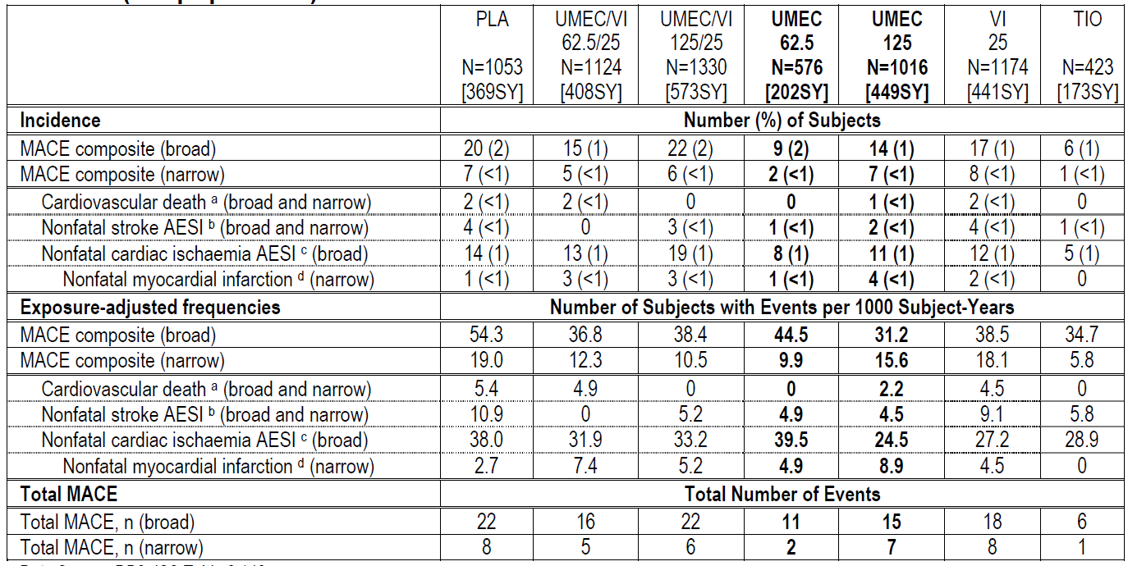
Abbreviations: AESI=adverse event of special interest; ECG=electrocardiogram; MACE=major adverse cardiac event; MedDRA= Medical Dictionary for Regulatory Activities; SMQ=standard MedDRA query; SY=subject-years; PLA=placebo; PT=preferred term; TIO=tiotropium; UMEC=umeclidinium bromide; vilanterol trifenatate=vilanterol.
Note: Integrated studies: DB2113611, DB2113373, DB2113360, DB2113374, DB2114417, DB2114418, DB2113359 and AC4115408 Note: The broad analysis was a priori and the narrow analysis was post-hoc.
a. Cardiovascular deaths were independently adjudicated.
b. The following MedDRA SMQs contributed to the nonfatal stroke AESI category: Central nervous system haemorrhages and cerebrovascular conditions SMQ.
c. The following MedDRA SMQs contributed to the cardiac ischaemia AESI category: Myocardial Infarction SMQ; Other Ischaemic Heart Disease SMQ.
d. The following MedDRA PTs contributed to myocardial infarction: myocardial infarction and acute myocardial infarction.
Cardiac ischemia was further examined in the AESI analysis. The incidence of on treatment events in the cardiac ischemia subgroup was < 1% for umeclidinium 125 µg and placebo and 1% for the umeclidinium 62.5 µg treatment group in the efficacy studies. There was also an imbalance observed in the long term safety study where events in the cardiac ischemic AESI grouping were lower with umeclidinium 125 µg and umeclidinium/vilanterol 125/25 µg than placebo. There was no evidence of a dose response for either umeclidinium or umeclidinium/vilanterol. As the overall number of cardiac ischemia events and the incidence were low and similar to placebo, cardiac ischaemia was not identified as a major safety concern for umeclidinium.
Overall, there were no dose or treatment related patterns identified in the incidence of AEs in the cardiovascular AESI categories acquired long QT, cardiac arrhythmias, cardiac failure, cardiac ischaemia, hypertension, sudden death and stroke. The most commonly reported cardiovascular AESI category was cardiac arrhythmias followed by hypertension, with a low incidence of AEs in the cardiac arrhythmia AESI category. A higher number of subjects reported supraventricular tachyarrhythmias (such as, atrial fibrillation, atrial flutter, sinus tachycardia and supraventricular extrasystoles) in the umeclidinium/vilanterol and umeclidinium treatment groups compared with placebo, which is consistent with the ECG monitoring observations. These findings are consistent with evidence that suggests that atrial arrhythmias may be a class effect of anticholinergics,.
The Delegate noted that differential withdrawal for protocol specified ECG and Holter abnormalities in the 52 week long term safety study (3359) complicates the interpretation of the cardiovascular safety data. GSK recognises that although a higher number of patient withdrawals were observed in the long term safety study due to Holter/ECG abnormalities in the active treatment groups compared with placebo, the majority of the ECG abnormalities leading to withdrawal were unlikely to have led to more severe cardiovascular events. None of the ECG or Holter withdrawals were associated with any concurrent clinically relevant symptoms. Overall, withdrawal rates were similar between the placebo group and active treatments.
The exposure adjusted incidence of cardiovascular AEs, including serious cardiovascular AEs (that is, myocardial infarction) reported with umeclidinium monotherapy in the umeclidinium/vilanterol studies were similar to those reported in the general COPD population, including observational studies with TIO, as well as a pooled analysis of TIO trials including UPLIFT (Table 25). A similar pattern was also noted in the long term 52 week safety study (3359). This suggests that any small imbalances noted in individual events in these categories are likely due to chance and are not a treatment related effect.
Table 25. Exposure-adjusted Incidence of CV Adverse Events in the COPD Population compared with umeclidinium Arms in umeclidinium/vilanterol Phase IIIa studies.
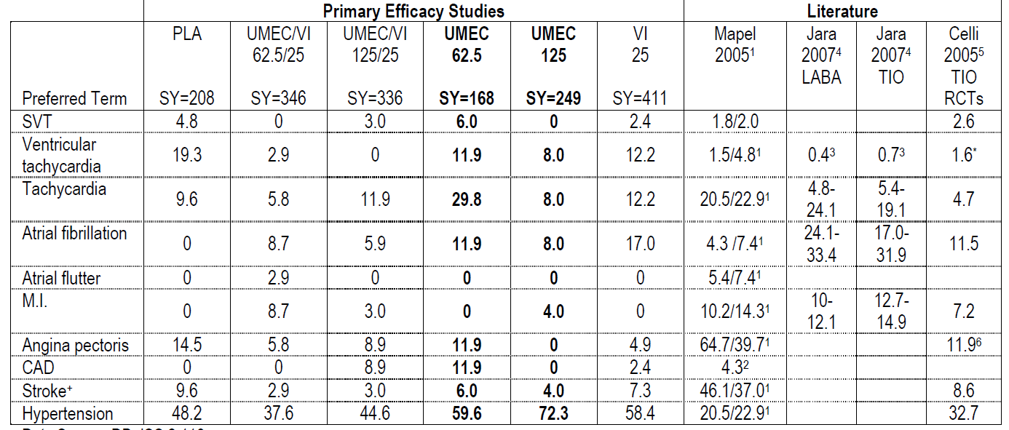
Abbreviations: UMEC – umeclidinium bromide, vilanterol trifenatate – vilanterol, TIO – tiotropium, PLA – placebo; RCT – randomised controlled trial; SVT – supraventricular tachycardia, M.I. – myocardial infarction, CAD – coronary artery disease, VA – veterans association
*Includes ventricular fibrillation + Stroke AESI category
1. Mapel et al. COPD 2005;2:35-41; 2. Schneider et al. Eur J Epi 2010; 25(4):253-60; 3. Jara et al., BMJ Open. 2012 May 22;2(3); 4. Jara et al., Drug Saf. 2007;30(12):1151-60; 5. Celli et al. Chest 2010; 137: 20-30; 6. Kesten et al. Chest 2006; 130: 1695-1703.
Whilst the Incruse safety data are reassuring, cardio and cerebrovascular disorders have been included as an important potential risk in both the Incruse (umeclidinium) and Anoro (umeclidinium/ vilanterol) EU Risk Management Plans (RMP) and a comprehensive pharmacovigilance plan is proposed to further evaluate and characterise cardio and cerebrovascular disorders. As part of the EU RMP, GSK plans to undertake two post authorisation safety studies to collect data from a larger ‘real world’ dataset to determine the overall absolute and relative risks (Study 201038 and Study WWE117397 (formerly WEUSKOP6679)).
In addition, GSK has included text in the ‘Precautions’ section of the PI advising of potential cardiovascular effects and that caution should therefore be used in treating patients with severe cardiovascular disease. Furthermore, GSK has included the adverse drug reactions tachycardia, supraventricular tachycardia and atrial fibrillation in the ‘Adverse Effects’ section of the PI, as these events had an incidence of greater than 1% and were considered potentially be related to Incruse. Any further characterisation of the incidence, nature and outcome of the cardiovascular risk will be managed with updates to the PI as required.

Other issues raised by the delegate

Risk management plan
GSK agrees with the Delegate’s request for the implementation of the European Risk Management Plan (EU RMP) with an Australian Specific Annex (ASA).
The EU RMP previously provided to the TGA (version 2.0, dated 14 November 2013) have now been superseded by the EU-RMP version 5.0, dated 14 February 2014 recently approved by the European Medicines Agency. GSK commits to providing the TGA with the most recent EU RMP, along with a summary of changes between version 2.0 and version 5.0 and an updated ASA during PI negotiations. GSK also commits to liaising with the TGA to implement an RMP that is to the satisfaction of the TGA.

Advisory Committee Considerations
The Advisory Committee on Prescription Medicines (ACPM), having considered the evaluations and the Delegate’s overview, as well as the sponsor’s response to these documents, advised the following:
The submission seeks to register a new chemical entity.
The ACPM, taking into account the submitted evidence of efficacy, safety and quality, agreed with the Delegate and considered Incruse Ellipta dry powder inhalation administered by the Ellipta inhaler device containing 62.5 µg of umeclidinium bromide to have an overall positive benefit-risk profile for the proposed indication;
Incruse Ellipta is indicated as a long-term, once daily, maintenance bronchodilator treatment to relieve symptoms in adult patients with chronic obstructive pulmonary disease (COPD).
In making this recommendation the ACPM;
- Noted the evaluations submitted in the concurrent fixed dose combination application for umeclidinium bromide and vilanterol trifenatate also before the committee.

Proposed conditions of registration
The ACPM agreed with the Delegate on the proposed conditions of registration.

Proposed PI/CMI amendments
The ACPM agreed with the Delegate to the proposed amendments to the Product Information (PI) and Consumer Medicine Information (CMI).

Specific advice
The ACPM advised the following in response to the Delegate’s specific questions on this submission:
- Is the ACPM satisfied that efficacy has been satisfactorily established?
The ACPM considered the evidence supports efficacy.
- Does the ACPM have any safety concerns about Incruse that would preclude registration?
The ACPM advised that there were no significant safety concerns apparent in the submitted data but agreed with the Delegate that the post registration data, particularly cardiovascular event data, will be important.
The ACPM advised that the implementation by the sponsor of the recommendations outlined above to the satisfaction of the TGA, in addition to the evidence of efficacy and safety provided would support the safe and effective use of this product.

Outcome
Based on a review of quality, safety and efficacy, TGA approved the registration of Incruse Ellipta Umeclidinium bromide 62.5 µg powder for inhalation, indicated for:
Incruse Ellipta is indicated as a long-term once daily maintenance bronchodilator treatment to relieve symptoms in adult patients with chronic obstructive pulmonary disease (COPD).

Specific conditions of registration applying to these goods
- The Incruse Ellipta (umeclidinium bromide) EU Risk Management Plan (RMP), Version 2.0, dated 14 November2013 [data lock point (DLP) 10 December 2012] and Australian Specific Annex Version 2.0, dated 22 January 2014, and any subsequent revisions, as agreed with the TGA will be implemented in Australia.
- Any post marketing studies must be submitted to the TGA for evaluation as soon as results are available.
Details of additional specific conditions of registration applying to these goods including batch release conditions are beyond the scope of the AusPAR.

Attachment 1. Product Information
The Product Information approved for main Incruse Ellipta at the time this AusPAR was published is at Attachment 1. For the most recent Product Information please refer to the TGA website at << https://www.tga.gov.au/product-information-pi>.

Attachment 2. Extract from the Clinical Evaluation Report

Therapeutic Goods Administration
PO Box 100 Woden ACT 2606 Australia
Email: info@tga.gov.au Phone: 1800 020 653 Fax: 02 6232 8605
https://www.tga.gov.au

CPMP/ICH/2737/99 ICH Topic Q 3 A (R2) Note for Guidance on Impurities Testing: Impurities in New Drug Substances
Gosens R et al., Muscarinic receptor signalling in the pathophysiology of asthma and COPD. Respir. Res. 2006;7:73.
PR interval is the interval between the P and R waves as measured in an ECG as shown 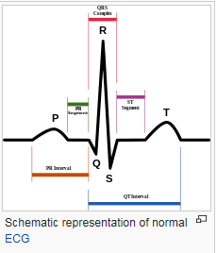
ICH guideline M3(R2) on non-clinical safety studies for the conduct of human clinical trials and marketing authorisation for pharmaceuticals. December 2009. EMA/CPMP/ICH/286/1995.
3BS1a Note for guidance on single dose toxicity.
Category B3 for the use of medicines in pregnancy is defined as: Drugs which have been taken by only a limited number of pregnant women and women of childbearing age, without an increase in the frequency of malformation or other direct or indirect harmful effects on the human fetus having been observed. Studies in animals have shown evidence of an increased occurrence of fetal damage, the significance of which is considered uncertain in humans.
Category B1 for the use of medicines in pregnancy is defined as: Drugs which have been taken by only a limited number of pregnant women and women of childbearing age, without an increase in the frequency of malformation or other direct or indirect harmful effects on the human fetus having been observed. Studies in animals have not shown evidence of an increased occurrence of fetal damage.
Global Initiative for Obstructive Lung Disease (GOLD). Global strategy for the diagnosis, management, and prevention of chronic obstructive lung disease. Global Initiative for Obstructive Lung Disease (GOLD) 2013.
Chapman KR et al. Epidemiology and costs of Chronic Obstructive Pulmonary Disease. Eur Respir J. 2006;27:188-207.
Lopez AD et al. Chronic obstructive pulmonary disease: current burden and future projections. Eur Respir J. 2006;27:397-412.
World Health Organization WHO. World Health Statistics 2008:1-110.
Rennard SI et al. Impact of COPD in North America and Europe in 2000: subjects' perspective of confronting COPD International Survey. Eur Respir J. 2002;20:799-805.
Celli BR, MacNee W. Standards for the diagnosis and treatment of patients with COPD: a summary of the ATS/ERS position paper. Eur Respir J. 2004;23:932-946
Qaseem A et al. Diagnosis and management of stable chronic obstructive pulmonary disease: a clinical practice guideline update from the AmericanCollege of Physicians, American College of Chest Physicians, American Thoracic Society, and European Respiratory Society. Ann Intern Med. 2011;155:179-91.
Casaburi R et al. A long-term evaluation of once-daily inhaled ipratropium in chronic obstructive pulmonary disease. Eur Respir J. 2002;19:217-24.
O'Donnell DE et al. Effects of tiotropium on lung hyperinflation, dyspnoea, and exercise tolerance in COPD. Eur Respir J. 2004;23:832-840.
Niewoehner DE et al. Prevention of exacerbations of chronic obstructive pulmonary disease with tiotropium, a once-daily inhaled anticholinergic bronchodilator: a randomized trial. Ann Intern Med. 2005;143:317-326.
The QT interval is a measure of the time between the start of the Q wave and the end of the T wave in the heart's electrical cycle. The QT interval represents electrical depolarisation and repolarisation of the ventricles. A lengthened QT interval is a marker for the potential of ventricular tachyarrhythmias like torsades de pointes and a risk factor for sudden death.
The 24-week Efficacy Studies (DB2113361, DB2113373, and DB2113374), the supporting Exercise Studies (DB2114417 and DB2114418), and the long-term safety study (DB2113359) included in this document, evaluated both UMEC monotherapy and the combination product UMEC/VI
Committee for Medicinal Products for Human Use (CHMP) Guideline on Clinical Investigation of Medicinal Products in the Treatment of Chronic Obstructive Pulmonary Disease (COPD) [EMA/CHMP/483572/2012]
Food and Drug Administration (FDA) COPD Guidance. Guidance for industry chronic obstructive pulmonary disease: developing drugs for treatment. U.S. Department of Health and Human Services, Food and Drug Administration, Centre for Drug Evaluation and Research (CDER). Nov 2007.
Casaburi R.et al. The spirometric efficacy of once-daily dosing with tiotropium in stable COPD: a 13-week multicentre trial. The US Tiotropium Study Group. Chest. 2000;118:1294-302.
Kerwin EM. et al. Efficacy and tolerability of indacaterol 75 mcg once daily in patients aged 40 years with chronic obstructive pulmonary disease: results from 2 double-blind, placebo-controlled 12-week studies. Clin Ther. 2011;33:1974-84.
Kerwin EM. et al. Efficacy and safety of a 12-week treatment with twice-daily aclidinium bromide in COPD patients (ACCORD COPD I). COPD. 2012;9:90-101.
Mahler DA. et al. Efficacy of salmeterol xinafoate in the treatment of COPD. Chest. 1999;115:957-65.
Salpeter S. Do inhaled anticholinergics increase or decrease the risk of major cardiovascular events? A synthesis of the available evidence. Drugs. 2009;69:2025-2033
Division of Pulmonary-Allergy Drugs Advisory Committee and Office of Surveillance and Epidemiology, US Food and Drug Administration, FDA Briefing Document. 2009.
Center for Drug Evaluation and Research (CDER), Medical Reviews, aclidinium bromide, 25 May 2012
Center for Drug Evaluation and Research (CDER), Medical Reviews, aclidinium bromide, 25 May 2012
Tashkin DP et al. Concomitant treatment with nebulized formoterol and tiotropium in subjects with COPD: A placebo controlled trial. Respir Med. 2008;102: 479–487.
EMA/CHMP/483572/2012 Guideline on clinical investigation of medicinal products in the treatment of chronic obstructive pulmonary disease (COPD).
From the Global Strategy for Asthma Management and Prevention, Global Initiative for Asthma (GINA) 2011. Available from: http://www.ginasthma.org/.
From the Global Strategy for Asthma Management and Prevention, Global Initiative for Asthma (GINA) 2010. Available from: http://www.ginasthma.org/.
Anthonisen, 2002
Center for Drug Evaluation and Research (CDER), 2012
Kesten et al. Chest 2006; 130: 1695-1703

