INCRUSE® ELLIPTA®
PRODUCT INFORMATION

NAME OF THE MEDICINE
Umeclidinium (as bromide)

Structure of umeclidinium bromide:

Chemical Name: The chemical name of umeclidinium bromide is 1-Azoniabicyclo[2.2.2]octane, 4- (hydroxydiphenylmethyl)-1-[2-(phenylmethoxy)ethyl]-, bromide (1:1)

Molecular Formula: Umeclidinium bromide: C₂₉H₃₄BrNO₂

CAS Number: Umeclidinium bromide: 869113-09-7

DESCRIPTION
Umeclidinium bromide is slightly soluble in water and slightly soluble in methanol, ethanol, acetonitrile and propan-1-ol.
Incruse Ellipta is a moulded plastic inhaler with a light grey body, a light green mouthpiece cover and a dose counter, packed in a foil tray which contains a desiccant packet. The tray is sealed with a peelable foil lid. The inhaler contains an aluminium foil laminate strip of either 30 or 7 regularly distributed blisters, each containing a white powder.
Incruse Ellipta also contains the excipients lactose (which contains milk protein) and magnesium stearate.

PHARMACOLOGY

Mechanism of action
Umeclidinium is a long acting muscarinic receptor antagonist (also referred to as an anticholinergic). It is a quinuclidine derivative that is a muscarinic receptor antagonist with activity across multiple muscarinic cholinergic receptor subtypes. Umeclidinium exerts its bronchodilatory activity by competitively inhibiting the binding of acetylcholine with muscarinic acetylcholine receptors on airway smooth muscle. It demonstrates slow reversibility at the human M3 muscarinic receptor subtype in vitro and a long duration of action in vivo when administered directly to the lungs in pre-clinical models.

Pharmacodynamic effects
Improvement in lung function over placebo was seen at 15 minutes (the first time point assessed after dosing) and was maintained over 24 hours. There was no evidence for tachyphylaxis to the bronchodilator effect after repeated dosing of Incruse Ellipta 62.5 micrograms for up to 52 weeks.

In a 24-week, placebo controlled clinical efficacy study Incruse Ellipta 62.5 micrograms increased forced expiratory volume in one second (FEV₁) after the first dose on Day 1 with an improvement of 0.07 L at 15 minutes compared with placebo (p<0.001). The increase from baseline to peak FEV₁ over the first 6 hours post-dose at Day 1 was 0.23 L with umeclidinium 62.5 micrograms compared with 0.11 L for placebo. The increase from baseline to peak FEV₁ over the first 6 hours post-dose at Week 24 was 0.23 L with umeclidinium 62.5 micrograms compared with 0.10 L for placebo.

Cardiovascular effects
The effect of umeclidinium 500 micrograms on the QT interval was evaluated in a placebo and moxifloxacin controlled QT study of 103 healthy volunteers. Following repeat doses of 500 micrograms once daily for 10 days, no clinically relevant effect on prolongation of QT interval (corrected using the Fridericia method) was observed.

Pharmacokinetics
Absorption
Following inhaled administration of umeclidinium in healthy volunteers, C_{max} occurred at 5 to 15 minutes. The absolute bioavailability of inhaled umeclidinium was on average 13% of the dose, with negligible contribution from oral absorption. Following repeat dosing of inhaled umeclidinium, steady state was achieved within 7 to 10 days with 1.5 to 2-fold accumulation. Umeclidinium systemic exposure following inhaled administration was dose proportional.

Distribution
Following intravenous administration to healthy subjects, the mean volume of distribution was 86 litres. In vitro plasma protein binding in human plasma was on average 89%.

Metabolism
In vitro studies showed that umeclidinium is metabolised principally by the enzyme P450 CYP2D6 and is a substrate for the P-glycoprotein (P-gp) transporter. The primary metabolic routes for umeclidinium are oxidative (hydroxylation, O-dealkylation) followed by conjugation (glucuronidation, etc), resulting in a range of metabolites with either reduced pharmacological activity or for which the pharmacological activity has not been established. Systemic exposure to the metabolites is low.

Excretion
Plasma clearance following intravenous administration was 151 litres/hour. Following intravenous administration, approximately 58% of the administered radiolabelled dose (or 73% of the recovered radioactivity) was excreted in faeces by 192 hours post-dose. Urinary elimination accounted for 22% of the administered radiolabelled dose by 168 hours (27% of recovered radioactivity). The excretion of the drug-related material in the faeces following intravenous dosing indicated secretion into the bile. Following oral administration to healthy male subjects, total radioactivity was excreted primarily in faeces (92% of the administered radiolabelled dose or 99% of the recovered radioactivity) by 168 hours post-dose. Less than 1% of the orally administered dose (1% of recovered radioactivity) was excreted in urine, suggesting negligible absorption following oral administration. Umeclidinium plasma elimination half-life following inhaled dosing for 10 days averaged 19 hours, with 3% to 4% drug excreted unchanged in urine at steady-state.

Special patient populations

Elderly
A population pharmacokinetic analysis showed that pharmacokinetics of umeclidinium are similar between COPD patients 65 years and older and those younger than 65 years of age.

Renal impairment
Subjects with severe renal impairment (creatinine clearance <30 mL/min) showed no evidence of an increase in systemic exposure to umeclidinium (C_{max} and AUC), and no evidence of altered protein binding between subjects with severe renal impairment and healthy volunteers.

Hepatic impairment
Subjects with moderate hepatic impairment showed no evidence of an increase in systemic exposure to umeclidinium (C_{max} and AUC), and no evidence of altered protein binding between subjects with moderate hepatic impairment and healthy volunteers. Incruse Ellipta has not been evaluated in subjects with severe hepatic impairment.

Other patient characteristics
A population pharmacokinetic analysis showed that no dose adjustment is required for umeclidinium based on the effect of age, race, gender, inhaled corticosteroid use, or weight. A study in CYP2D6 poor metabolisers showed no evidence of a clinically significant effect of CYP2D6 genetic polymorphism on systemic exposure to umeclidinium.

CLINICAL TRIALS
The efficacy of Incruse Ellipta administered once daily was evaluated in two placebo controlled clinical studies, in adult patients with a clinical diagnosis of COPD; a 12-week study (AC4115408) and a 24 week study (DB2113373).

Placebo Controlled Studies
In the 12-week study, Incruse Ellipta demonstrated statistically significant and clinically meaningful improvements in measures of lung function (as defined by change from baseline trough FEV₁ at Week 12, which was the primary efficacy endpoint compared with placebo (see Table 1). The bronchodilatory effects with Incruse Ellipta compared with placebo were evident after the first day of treatment and were maintained over the 12-week treatment period.

Table 1. Primary efficacy endpoint at Week 12 (Study AC4115408)
 | Trough FEV₁ (L)
 |  |  | Difference from Placebo
 | Baseline (SD) | Change from baseline  (SE) | Treatment  Difference  (95% CI)  p-value
Study AC4115408
Incruse Ellipta  62.5 micrograms OD  (n= 69) | 1.26 (0.57) | 0.12 (0.03) | 0.13  (0.05,0.20)  <0.001
Placebo  (n=68) | 1.21 (0.43) | -0.01 (0.03) | -
Abbreviations: CI= confidence interval; FEV₁= forced expiratory volume in 1 second; L= litres; n= number randomized to treatment; OD= once daily; SD= standard deviation; SE= standard error.

Incruse Ellipta demonstrated a statistically significant greater improvement from baseline in weighted mean FEV₁ over 0-6 hours post-dose at Week 12 compared with placebo (0.17 L (p<0.001)).

The percentage of patients receiving Incruse Ellipta that responded with a minimum clinically important difference (MCID) of ≥1 unit Transition Dyspnoea Index (TDI) focal score at Week 12 was 38% (24/64) compared with 15% (8/53) for placebo. The odds of being a TDI responder vs. a non responder, was statistically significantly greater for Incruse Ellipta compared with placebo at Week 12 (Odds Ratio 3.4 (95% CI 1.3,8.4), p=0.009).

Incruse Ellipta demonstrated statistically significant improvements from placebo in the change from baseline in total score at Week 12 for the St. George’s Respiratory Questionnaire (SGRQ), a disease-specific health status measure (-7.90 units) (p<0.001). The percentage of patients receiving Incruse Ellipta that responded with a reduction of ≥4 units (MCID) in SGRQ total score at Week 12 was 44% (28/63) compared with 26% (14/54) for placebo. The odds of being a SGRQ responder vs. a non responder, was statistically significantly greater for Incruse Ellipta compared with placebo at Week 12 (Odds Ratio 2.44 (95% CI 1.08, 5.50), p=0.032).

In addition, patients treated with Incruse Ellipta required less rescue salbutamol over the 12-week treatment period than those treated with placebo (mean reduction of 0.7 puffs per day and the difference from placebo was statistically significant (p=0.025)).

In the 24-week study, DB2113373, Incruse Ellipta demonstrated statistically significant improvements in lung function (as defined by change from baseline trough FEV₁ at Week 24 , which was the primary efficacy endpoint compared with placebo (see Table 2). The bronchodilatory effects with Incruse Ellipta compared with placebo were evident after the first day of treatment and were maintained over the 24-week treatment period.

Table 2. Primary efficacy endpoint at Week 24 (Study DB2113373)
 | Trough FEV₁ (L)
 |  |  | Difference from Placebo
 | Baseline (SD) | Change from baseline  (SE) | Treatment  Difference  (95% CI)  p-value
Study DB2113373
Incruse Ellipta  62.5 micrograms OD  (n= 418) | 1.20 (0.49) | 0.12 (0.01) | 0.12  (0.08,0.16)  <0.001
Placebo  (n=280) | 1.20 (0.47) | 0.00 (0.02) | -
Abbreviations: CI= confidence interval; FEV₁= forced expiratory volume in 1 second; L= litres; n= number randomized to treatment; OD= once daily; SD= standard deviation; SE= standard error.

Incruse Ellipta demonstrated a statistically significant greater improvement from baseline in weighted mean FEV₁ over 0-6 hours post-dose at Week 24 compared with placebo (0.15L; p<0.001).

A statistically significant improvement from placebo in the TDI focal score at Week 24 was demonstrated for Incruse Ellipta (1.0 units) (p<0.001). The percentage of patients receiving Incruse Ellipta that responded with a minimum clinically important difference (MCID) of ≥1 unit TDI focal score at Week 24 was 53% (207/394) compared with 41% (106/260) for placebo. The odds of being a TDI responder vs. a non responder, was statistically significantly greater for Incruse Ellipta compared with placebo at Week 24 (Odds Ratio 1.6 (95% CI 1.2, 2.3), p=0.002).

A statistically significant improvement from placebo in the change from baseline in total score at Week 24 for the St. George’s Respiratory Questionnaire (SGRQ), a disease-specific health status measure, was also demonstrated for Incruse Ellipta (-4.69 units) (p≤0.001). The percentage of patients receiving Incruse Ellipta that responded with a reduction of ≥4 units (MCID) in SGRQ total score at Week 24 was 44% (172/388) compared with 34% (86/254) for placebo. The odds of being a SGRQ responder vs. a non responder, was statistically significantly greater for Incruse Ellipta compared with placebo at Week 24 (Odds Ratio 1.6 (95% CI 1.2,2.3), p=0.003).

Treatment with Incruse Ellipta lowered the risk of a COPD exacerbation compared with placebo (analysis of time to first exacerbation; Hazard Ratio 0.6, p=0.035, risk reduction 40%).

INDICATIONS
Incruse Ellipta is indicated as a long-term once daily maintenance bronchodilator treatment to relieve symptoms in adult patients with chronic obstructive pulmonary disease (COPD).

CONTRAINDICATIONS
Incruse Ellipta is contraindicated in patients with severe milk-protein allergy or who have demonstrated hypersensitivity to either umeclidinium or any of the excipients.

PRECAUTIONS
Asthma
The use of Incruse Ellipta has not been studied in patients with asthma, and is not recommended in this patient population.
Deterioration of Disease
Incruse Ellipta is intended for the long-term maintenance treatment of COPD. It should not be used for the relief of acute symptoms, i.e. as rescue therapy for the treatment of acute episodes of bronchospasm. Acute symptoms should be treated with an inhaled short-acting bronchodilator. Increasing use of short-acting bronchodilators to relieve symptoms indicates deterioration of control and patients should be reviewed by a physician.
Paradoxical Bronchospasm
As with other inhalation therapies, administration of Incruse Ellipta may produce paradoxical bronchospasm that may be life threatening. Treatment with Incruse Ellipta should be discontinued if paradoxical bronchospasm occurs and alternative therapy instituted if necessary.
Cardiovascular Effects
Cardiovascular effects, such as cardiac arrhythmias e.g. atrial fibrillation and tachycardia, may be seen after the administration of muscarinic receptor antagonists, including Incruse Ellipta. Therefore, Incruse Ellipta should be used with caution in patients with severe cardiovascular disorders, particularly cardiac arrhythmias.
Antimuscarinic Activity
Consistent with its antimuscarinic activity, Incruse Ellipta should be used with caution in patients with narrow-angle glaucoma or urinary retention.
Excipients
Patients with rare hereditary problems of galactose intolerance, the Lapp lactase deficiency or glucose-galactose malabsorption should not take INCRUSE ELLPTA.

Effects on Fertility:
There are no data on the effects of Incruse Ellipta on human fertility. Studies in rats showed no effects of umeclidinium on male or female fertility at doses producing very large multiples of the systemic exposure in patients.

Use in Pregnancy (Category B1):
There is a limited amount of data from the use of Incruse Ellipta in pregnant women. Embryo-foetal development was unaffected by umeclidinium in rats treated at up to 278 micrograms/kg/day by inhalation (estimated to yield 50 times the plasma AUC in patients at the maximum recommended human dose of 62.5 micrograms per day) and in rabbits treated at up to 306 micrograms/kg/day by inhalation or up to 180 micrograms/kg/day subcutaneously (yielding 35 and ~200 times the plasma AUC in patients).
Incruse Ellipta should only be used during pregnancy if the expected benefit to the mother justifies the potential risk to the foetus.

Use in Lactation:
It is unknown whether umeclidinium is excreted in human milk. A risk to breastfed newborns/infants cannot be excluded.
A decision must be made whether to discontinue breastfeeding or to discontinue Incruse Ellipta therapy taking into account the benefit of breastfeeding for the child and the benefit of therapy for the woman.

Paediatric Use:
This product should not be used in children.

Use in the Elderly:
There are no special precautions for use in the elderly.

Genotoxicity:
Umeclidinium was not genotoxic in a standard battery of studies, comprising bacterial mutation assays, the mouse lymphoma tk assay and the rat bone marrow micronucleus test.

Carcinogenicity:
Umeclidinium was not carcinogenic in 2-year inhalation studies in mice or rats at doses yielding systemic exposure levels (plasma AUC) up to 26 or 22 times the human clinical exposure of umeclidinium at the maximum recommended dose of 62.5 micrograms per day in the respective species.

Effect on Laboratory Tests:
Interactions with laboratory tests have not been established.

Ability to Perform Tasks that Require Judgement, Motor or Cognitive Skills
There have been no studies to investigate the effect of Incruse Ellipta on the ability to perform tasks that require judgement, motor or cognitive skills. There have been no adverse effects associated with Incruse Ellipta that would affect the ability to perform tasks that require judgement, motor or cognitive skills.

INTERACTIONS WITH OTHER MEDICINES
Clinically significant drug interactions mediated by umeclidinium at clinical doses are considered unlikely due to the low plasma concentrations achieved after inhaled dosing.

Interaction with P-glycoprotein inhibitors
Umeclidinium is a substrate of P-glycoprotein (P-gp) transporter. The effect of the P-gp transporter inhibitor verapamil (240 mg once daily) on the steady-state pharmacokinetics of umeclidinium was assessed in healthy volunteers. No effect of verapamil was observed on umeclidinium C_{max}. An approximately 1.4-fold increase in umeclidinium AUC was observed.
Based on the magnitude of these changes, no clinically relevant drug interaction is expected when umeclidinium is co-administered with P-gp inhibitors.

Interaction with CYP2D6 inhibitors
Umeclidinium is a substrate of CYP2D6. The effect of a CYP2D6 poor metaboliser genotype on the steady-state pharmacokinetics of umeclidinium was assessed in healthy volunteers (CYP2D6 normal metabolisers and CYP2D6 poor metabolisers). No clinically meaningful difference in systemic exposure to umeclidinium (500 micrograms) was observed following repeat daily inhaled dosing to normal and CYP2D6 poor metaboliser subjects.

ADVERSE EFFECTS
Clinical trial data
Table 1 shows all adverse events that occurred with a frequency of greater than 1% in either of the groups receiving Incruse Ellipta in the four 24-week well-controlled studies where the rates in either of the groups receiving Incruse Ellipta exceeded placebo by greater than 1%.

Table 3 Adverse Events with >1% Incidence and greater than Placebo by 1% with INCRUSE ELLIPTA in Subjects with COPD

 | Number (%) of Subjects
Preferred Term | Placebo  (N=623) | UMEC 62.5 (N=487) | UMEC 125 (N=698)
Respiratory, Thoracic and Mediastinal Disorders
Cough | 24 (4) | 16 (3) | 34 (5)
Infections and Infestations
Upper respiratory tract infection | 21 (3) | 23 (5) | 25 (4)
Viral upper respiratory tract infection | 1 (<1) | 7 (1) | 1 (<1)
Vascular Disorders
Hypertension | 10 (2) | 10 (2) | 19 (3)
Contusion | 1 (<1) | 7 (1) | 4 (<1)
Immune System Disorders
Arthralgia | 9 (1) | 12 (2) | 11 (2)

52 week study
In a long-term safety study, 336 subjects (n=227 umeclidinium 125 micrograms, n=109 placebo) were treated for up to 52 weeks with umeclidinium 125 micrograms or placebo. The demographic and baseline characteristics of the long-term safety study were similar to those of the efficacy studies. In addition to the adverse events listed in Table 3, the adverse events reported in subjects receiving umeclidinium 125 micrograms with a frequency of greater than 1% and exceeding the rate in subjects receiving placebo by greater than 1% in this study were: nasopharyngitis (umeclidinium 125 micrograms 9%, placebo 5%), supraventricular extrasystoles (umeclidinium 125 micrograms 3%, placebo <1%), supraventricular tachycardia (umeclidinium 125 micrograms 3%, placebo <1%), rhythm idioventricular (umeclidinium 125 micrograms 2%, placebo 0%), and urinary tract infection (umeclidinium 125 micrograms 2%, placebo 0%).

The safety profile of Incruse Ellipta was evaluated from 1663 patients with COPD who received doses of 62.5 micrograms or greater for up to one year. This includes 576 patients who received the recommended dose of 62.5 micrograms once daily.
The adverse reactions identified from the four pivotal studies and the long term safety study (which involved 1,412 patients who received Incruse Ellipta) are presented in the table below.
Adverse drug reactions (ADRs) are listed below by MedDRA system organ class and by frequency. The following convention has been used for the classification of adverse reactions:
Very common: ≥1/10
Common: ≥1/100 to <1/10
Uncommon: ≥1/1000 to <1/100
Rare: ≥1/10000 to <1/1000
Very rare: <1/10000
MedDRA  System organ class | Adverse reaction(s) | Frequency
Infections and infestations | Upper Respiratory Tract Infection | Common
Cardiac Disorders | Atrial Fibrillation  Supraventricular tachycardia  Tachycardia | Uncommon  Uncommon  Uncommon
Respiratory, Thoracic and Mediastinal Disorders | Cough | Common

Post-marketing data
There are no relevant data available.

DOSAGE AND ADMINISTRATION

Adults
Incruse Ellipta (umeclidinium 62.5 micrograms) should be taken as one inhalation once daily by the orally inhaled route.
Incruse Ellipta should be taken at the same time everyday.
Do not use Incruse Ellipta more than once every 24 hours.

Special populations
Paediatric populations
This product should not be used in children.

Elderly population
No dosage adjustment is required in patients over 65 years (see Pharmacokinetics – Special Patient Populations).

Renal impairment
No dosage adjustment is required in patients with renal impairment (see Pharmacokinetics – Special Patient Populations).

Hepatic impairment
No dosage adjustment is required in patients with mild or moderate hepatic impairment. Incruse Ellipta has not been studied in patients with severe hepatic impairment (see Pharmacokinetics – Special Patient Populations).

Method of administration
Incruse Ellipta is for oral inhalation use only.

OVERDOSAGE
No data from clinical studies are available regarding overdose with Incruse Ellipta.

Symptoms and signs
An overdose of Incruse Ellipta will likely produce signs and symptoms consistent with the known inhaled muscarinic antagonist adverse effects (e.g. dry mouth, visual accommodation disturbances and tachycardia).

Treatment
If overdose occurs, the patient should be treated supportively with appropriate monitoring as necessary.
For information on the management of overdose, contact the Poison Information Centre on 131126 (Australia).

PRESENTATION AND STORAGE CONDITIONS

Storage
Store below 30°C.

If stored in the refrigerator, allow the inhaler to return to room temperature for at least 1 hour before use.

Following removal from the tray, the product may be stored for a maximum period of 6 weeks.

Nature and Contents of Container
Moulded plastic device containing one foil strip of either 7 or 30 regularly distributed blisters, each containing a white powder. Each delivered dose (the dose leaving the mouthpiece of the inhaler) contains 55 micrograms umeclidinium (equivalent to 65 micrograms of umeclidinium bormide). This corresponds to a pre-dispensed dose of 62.5 micrograms of umeclidinium (equivalent to 74.2 micrograms umeclidinium bromide).

Not all pack sizes may be distributed in Australia.

NAME AND ADDRESS OF THE SPONSOR
GlaxoSmithKline Australia Pty Ltd,
Level 4, 436 Johnston Street,
Abbotsford, Victoria, 3067

POISON SCHEDULE OF THE MEDICINE
Schedule 4 – Prescription Only Medicine

How to Use INCRUSE® ELLIPTA®

What is the Ellipta inhaler?
INCRUSE ELLIPTA is inhaled through the mouth using the Ellipta inhaler.
When you first use the Ellipta inhaler you do not need to check that it is working properly, and you do not need to prepare it for use in any special way. Just follow these step-by-step instructions.
The inhaler is packaged in a tray containing a desiccant sachet, to reduce moisture. Throw the sachet away - don’t eat or inhale it.
When you take the inhaler out of the sealed tray, it will be in the ‘closed’ position. Don’t open it until you are ready to inhale a dose of medicine.
The step-by-step instructions shown below for the 30-dose Ellipta inhaler also apply to the 7-dose Ellipta inhaler.

Step 1: Read this before you start
! If you open and close the cover without inhaling the medicine, you will lose the dose.
The lost dose will be securely held inside the inhaler, but it will no longer be available.

It is not possible to accidentally take extra medicine or a double dose in one inhalation.

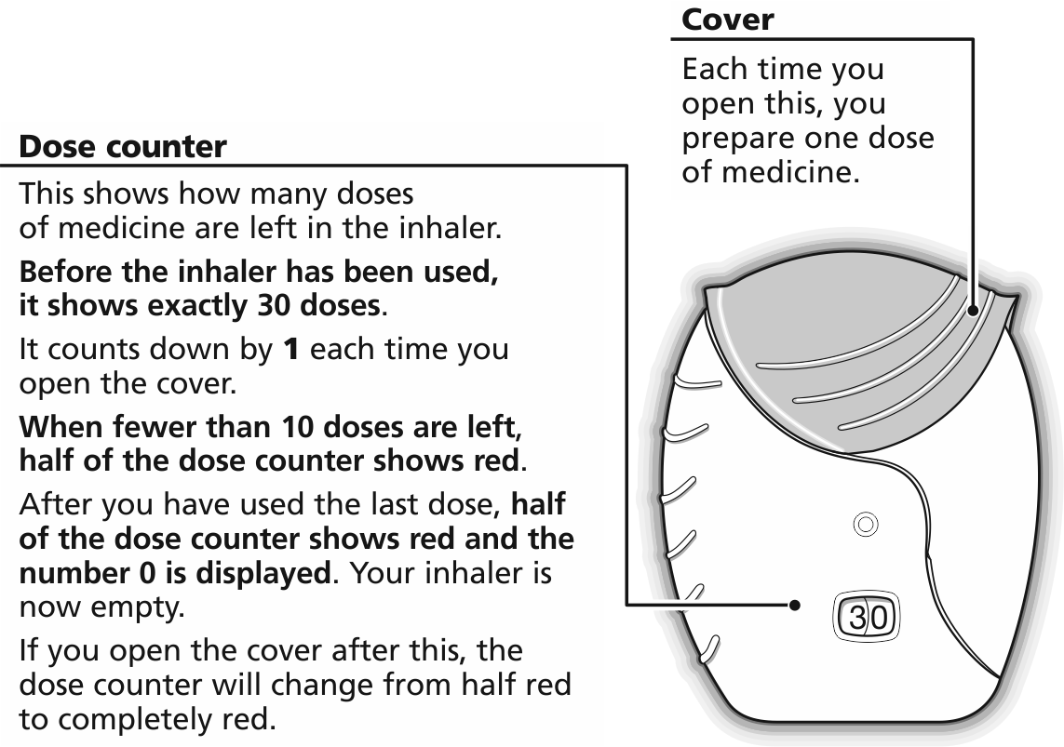

Step 2: Prepare a dose
! Wait to open the cover until you are ready to take your dose. Do not shake the inhaler.
- Slide the cover fully down until you hear a “click”.
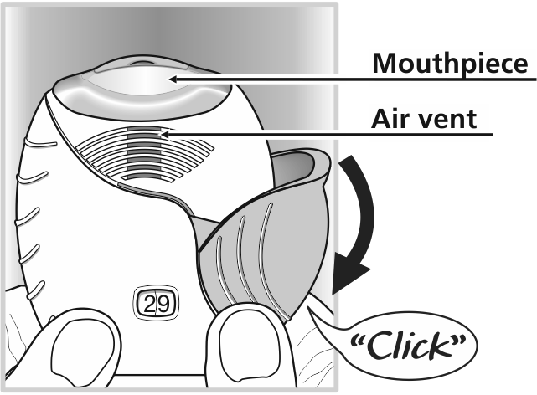
Your medicine is now ready to be inhaled.

The dose counter counts down by 1 to confirm.
! If the dose counter does not count down as you hear the “click”, the inhaler will not deliver medicine. Take it back to your pharmacist for advice.
! Do not shake the inhaler at any time.
Step 3: Inhale your medication
- Whilst holding the inhaler away from your mouth, breathe out as far as is comfortable.
Don’t breathe out into the inhaler.
- Put the mouthpiece between your lips, and close your lips firmly around it.
Don’t block the air vent with your fingers.
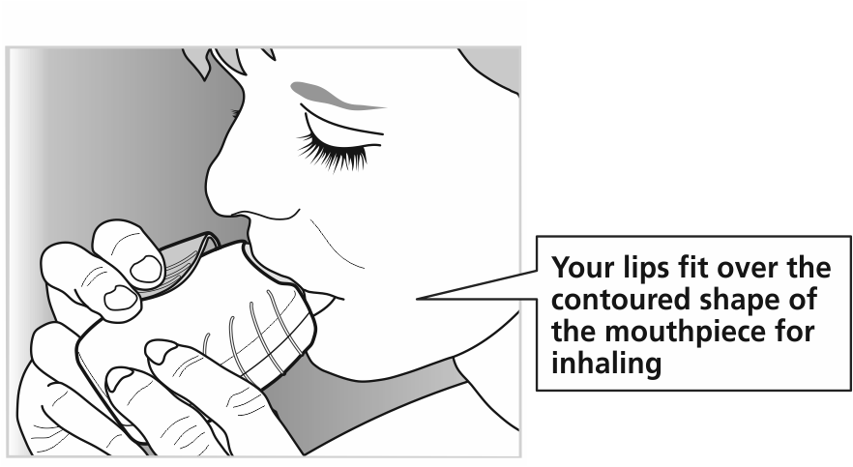
- Take one long, steady, deep breath in. Hold this breath for as long as possible (at least 3-4 seconds).
- Remove the inhaler from your mouth.
- Breathe out slowly and gently away from the mouthpiece.
! You may not be able to taste or feel the medicine, even when you are using the inhaler correctly.

Step 4: Close the inhaler
If you want to clean the mouthpiece, use a dry tissue, before you close the cover.
- Slide the cover upwards as far as it will go, to cover the mouthpiece.

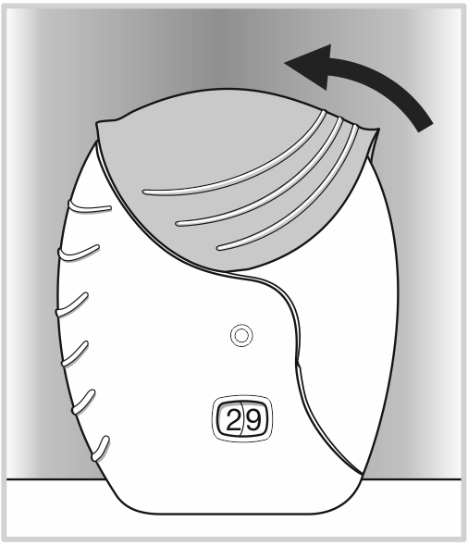

Date of first inclusion in the Australian Register of Therapeutic Goods (the ARTG): 8 July 2014

INCRUSE and ELLIPTA are registered trade marks of the GlaxoSmithKline group of companies.
Version 1.0

