First round report 20 November 2013
Second round report 20 February 2014

AusPAR Attachment 2

Extract from the Clinical Evaluation Report for Umeclidinium bromide
  - Proprietary Product Name: Incruse ellipta
  - Sponsor: GlaxoSmithKline Australia Pty Ltd

About the Therapeutic Goods Administration (TGA)
- The Therapeutic Goods Administration (TGA) is part of the Australian Government Department of Health, and is responsible for regulating medicines and medical devices.
- The TGA administers the Therapeutic Goods Act 1989 (the Act), applying a risk management approach designed to ensure therapeutic goods supplied in Australia meet acceptable standards of quality, safety and efficacy (performance), when necessary.
- The work of the TGA is based on applying scientific and clinical expertise to decision-making, to ensure that the benefits to consumers outweigh any risks associated with the use of medicines and medical devices.
- The TGA relies on the public, healthcare professionals and industry to report problems with medicines or medical devices. TGA investigates reports received by it to determine any necessary regulatory action.
- To report a problem with a medicine or medical device, please see the information on the TGA website <http://www.tga.gov.au>.
About the Extract from the Clinical Evaluation Report
- This document provides a more detailed evaluation of the clinical findings, extracted from the Clinical Evaluation Report (CER) prepared by the TGA. This extract does not include sections from the CER regarding product documentation or post market activities.
- The words (Information redacted), where they appear in this document, indicate that confidential information has been deleted.
- For the most recent Product Information (PI), please refer to the TGA website <https://www.tga.gov.au/hp/information-medicines-pi.htm>.
Copyright
© Commonwealth of Australia 2015
This work is copyright. You may reproduce the whole or part of this work in unaltered form for your own personal use or, if you are part of an organisation, for internal use within your organisation, but only if you or your organisation do not use the reproduction for any commercial purpose and retain this copyright notice and all disclaimer notices as part of that reproduction. Apart from rights to use as permitted by the Copyright Act 1968 or allowed by this copyright notice, all other rights are reserved and you are not allowed to reproduce the whole or any part of this work in any way (electronic or otherwise) without first being given specific written permission from the Commonwealth to do so. Requests and inquiries concerning reproduction and rights are to be sent to the TGA Copyright Officer, Therapeutic Goods Administration, PO Box 100, Woden ACT 2606 or emailed to <tga.copyright@tga.gov.au>.

Contents
List of abbreviations 5
1. Submission type 10
1.1. Drug class and therapeutic indication 10
2. Clinical rationale 11
3. Contents of the clinical dossier 11
3.1. Scope of the clinical dossier 11
3.2. Paediatric data 12
3.3. Good clinical practice 12
4. Pharmacokinetics 12
4.1. Studies providing pharmacokinetic data 12
4.2. Summary of pharmacokinetics 13
4.3. Population PK Study 21
4.4. Evaluator’s overall conclusions on pharmacokinetics 21
5. Pharmacodynamics 22
5.1. Studies providing pharmacodynamic data 22
5.2. Summary of pharmacodynamics 23
5.3. Evaluator’s overall conclusions on pharmacodynamics 28
6. Dosage selection for the pivotal studies 29
7. Clinical efficacy 29
7.1. Pivotal efficacy studies 30
7.2. Other efficacy studies 59
7.3. Analyses performed across trials (pooled analyses and meta analyses) 66
7.4. Evaluator’s conclusions 70
8. Clinical safety 73
8.1. Studies providing evaluable safety data 73
8.2. Pivotal studies that assessed safety as a primary outcome 76
8.3. Patient exposure 83
8.4. Adverse events 85
8.5. Laboratory tests 89
8.6. Post-marketing experience 99
8.7. Safety issues with the potential for major regulatory impact 99
8.8. Other safety issues 100
8.9. Safety in special populations 100
8.10. Evaluator’s overall conclusions on clinical safety 104
9. First round benefit-risk assessment 106
9.1. First round assessment of benefits 106
9.2. First round assessment of risks 106
9.3. First round assessment of benefit-risk balance 107
10. First round recommendation regarding authorisation 107
11. Clinical questions 107
11.1. Pharmacokinetics 107
11.2. Pharmacodynamics 107
11.3. Efficacy 107
11.4. Safety 108
12. Second round evaluation of clinical data submitted in response to questions 108
12.1. Clinical efficacy questions 108
12.2. Clinical safety questions 109
13. Second round benefit-risk assessment 109
13.1. Second round assessment of benefits 109
13.2. Second round assessment of risks 109
13.3. Second round assessment of benefit-risk balance 110
13.4. Second round recommendation regarding authorisation 110
14. References 110

List of abbreviations
Abbreviation | Meaning
AC | active-controlled
ADME | absorption, distribution, metabolism, and elimination
AE | adverse event
Ae | amount of drug excreted unchanged in urine
AESI | adverse event of special interest
ANCOVA | analysis of covariance
ANOVA | analysis of variance
AUC∞ | area under the concentration time curve from time zero (pre dose) extrapolated to infinite time
AUC_{(0-t)} | area under the concentration-time curve from time zero (pre dose) to last time of quantifiable concentration within a subject across all treatments
AUC_{(0-x)} | area under the concentration-time curve from time zero (pre dose) to x hours post dose
BD | twice-daily
BMI | body mass index
bpm | beats per minute
CAT | COPD Assessment Test
CDER | Center for Drug Evaluation and Research
CHMP | Committee for Medicinal Products for Human Use
CI | confidence interval
CLcr | creatinine clearance
CLr | renal clearance
C_{max} | maximum concentration
CNS | central nervous system
COPD | chronic obstructive pulmonary disease
CPRD | Clinical Practice Research Datalink
CRM | Cardio Respiratory measurements
CSR | Clinical Study Report
CV | between-subject coefficient of variation
CV= | Cardiovascular
CYP | cytochrome P450
CYP2D6 | cytochrome P450 2D6
DB | double-blind
DD | double-dummy
DPI | dry powder inhaler
ECG | electrocardiogram
ED50 | estimated dose that would yield 50% of E_{max}
EET | exercise endurance time
EIC | Exercise Inspiratory Capacity
EMA | European Medicines Agency
E_{max} | maximum effect
EQ-5D | EuroQol-5D
EM | Extensive metabolisers
ESWT | Exercise Endurance Shuttle Walk Test
EU | European Union
FDA | Food and Drug Administration
Fe | fraction of dose excreted unchanged in urine
FEV1 | forced expiratory volume in 1 second
FF | fluticasone furoate
FRC | functional residual capacity
FVC | forced vital capacity
GCP | Good Clinical Practice
GOLD | Global Initiative for Obstructive Lung Disease
GSK | GlaxoSmithKline
GSK573719 | umeclidinium bromide (UMEC)
hr | hour(s)
HRQoL | Health-related quality of life
IC | inspiratory capacity
IC₅₀ | half maximal inhibitory concentration
ICH | International Conference on Harmonisation
ICS | inhaled corticosteroid
IH | inhalation
IND | Investigational New Drug Application
ISWT | Incremental Shuttle Walk Test
ITT | intent-to-treat
IV | intravenous(ly)
L | litre
LABA | long-acting beta₂ agonist
LAMA | long-acting muscarinic antagonist
LFT | liver function tests
LLQ | lower limit of quantification
LRTI | lower respiratory tract infection
LS | least squares
MAA | Marketing Authorization Application
MACE | Major Adverse Cardiac Event
max | maximum
µg | microgram
MCID | minimal clinically important difference
MedDRA | Medical Dictionary for Regulatory Activities
MgSt | magnesium stearate
min | minimum
mITT | modified intent-to-treat
mL | millilitre
mmHg | millimetres of mercury
mMRC | modified Medical Research Council
MMRM | Mixed Model Repeated Measures
msec | millisecond
N | number of subjects who received a specific treatment
n | number of subjects with non missing values (including not calculable where applicable)
n* | number of subjects for whom parameter could not be derived because of not quantifiable concentration
NA | not applicable
NDA | New Drug Application
NDPI | Novel Dry Powder Inhaler
NOX | Non-Oxycon
NQ | not quantifiable
OL | open-label
OX | Oxycon
PC | placebo-controlled
PD | pharmacodynamic
PEF | peak expiratory flow
PG | parallel group
P-gp | P-glycoprotein
PK | pharmacokinetic(s)
PLA | placebo
PM | poor metaboliser
PO | oral
PO | oral (per os)
PT | preferred term
QD | once daily
QTc(F) | QT interval corrected for heart rate using Fredericia's formula
R | randomized
RV | residual volume
SAE | serious adverse event
SD | standard deviation
SDAP | Summary Document Analysis Plan
SE | standard error
sGaw | specific airway conductance
SGRQ | St. George’s Respiratory Questionnaire
SOBDA | shortness of breath with daily activities
SpO₂ | Arterial Oxygen Saturation
SVT | supraventricular tachycardia
t½ | terminal phase half-life
TDI | Transition Dyspnoea Index
TIO | tiotropium bromide
tlast | time to last quantifiable plasma concentration
tmax | time of occurrence of C_{max}
Tmax | time to maximum plasma concentration
UK | United Kingdom
UMEC | umeclidinium bromide (GSK573719)
URTI | upper respiratory tract infection
US | United States
VCO₂ | Carbon dioxide production
Ve | minute ventilation
VI | vilanterol (GW642444)
VO₂ | oxygen uptake
Vt | tidal volume
WHO | World Health Organization
WM | weighted mean
XO | cross-over

Submission type
This is a Category 1 application for a new chemical entity umeclidinium bromide 62.5 µg as dry powder inhaler. The proposed indication is:
Incruse Ellipta is indicated as a long term once daily maintenance bronchodilator treatment to relieve symptoms in adult patients with chronic obstructive pulmonary disease (COPD)."

Drug class and therapeutic indication
Umeclidinium is a long acting muscarinic receptor antagonist (also referred to as an anticholinergic). It is a quinuclidine derivative that is a muscarinic receptor antagonist with activity across multiple muscarinic cholinergic receptor subtypes. Umeclidinium bromide exerts its bronchodilatory activity by competitively inhibiting the binding of acetylcholine with muscarinic acetylcholine receptors on airway smooth muscle.

Clinical rationale
COPD is a major cause of poor health, resulting in millions of deaths annually worldwide (GOLD, 2013) and contributing significantly to health care costs and morbidity (Chapman, 2006; Lopez, 2006). As of 2002, COPD was the fourth leading cause of death and the eleventh leading cause of disability worldwide (WHO, 2008; Rennard, 2002). By the year 2020, COPD is expected to be the third leading cause of death and the fifth leading cause of disability (Rennard, 2002). COPD is a preventable and treatable disease characterized by airflow limitation that is not fully reversible (GOLD, 2013). The airflow limitation of COPD is primarily due to small airways disease and parenchymal destruction associated with an abnormal inflammatory response of the lungs, mainly caused by cigarette smoking (Celli, 2004) or air pollution. COPD is characterized by symptoms of chronic and progressive breathlessness (or dyspnoea), cough and sputum production which can be a major cause of disability and anxiety associated with the disease. COPD is a progressive disease with worsening lung function over time (GOLD, 2013). Currently no agents are available that modify disease progression. Pharmacological management of chronic, stable COPD is primarily aimed at improving symptoms and quality of life, optimizing lung function, reducing exacerbations and improving exercise tolerance (GOLD 2013). Long-acting bronchodilators, including LABAs and LAMAs, are recommended for the treatment of symptomatic patients with moderate to very severe COPD and are considered more efficacious and safer to use than short-acting bronchodilators (Celli, 2004; GOLD, 2013; Qaseem, 2011). The benefits of LAMAs include not only the control of symptoms but improvements in lung function and hyperinflation, exercise performance, COPD exacerbations, and health status (Casaburi, 2002; O'Donnell, 2004; Niewoehner, 2005). UMEC will provide an additional treatment option to marketed LAMAs such as tiotropium (TIO) and aclidinium in the management of COPD.

Contents of the clinical dossier

Scope of the clinical dossier
The submission contained the following clinical information:
- 17 clinical pharmacology studies, including 15 that provided pharmacokinetic data and 2 that provided pharmacodynamic data.
- 1 population pharmacokinetic analyses.
- Ten clinical studies conducted as part of the clinical development program provide data for UMEC and support the global regulatory filings for UMEC monotherapy in subjects with COPD. These include 7 pivotal efficacy/ safety studies and 3 Phase IIb dose-ranging studies.
The pivotal Phase III studies included:
- One Phase III, 12-week, placebo-controlled, efficacy and safety study (AC4115408)
- Two Phase III, 24-week, placebo-controlled, efficacy and safety studies (DB2113361 and DB2113373) and one Phase III, 24-week, tiotropium (TIO) comparator efficacy and safety study (DB2113374)
- One Phase III, long-term (52-week) safety study (DB2113359)
- Two 12-week cross-over exercise studies (DB2114417 and DB2114418)
- The 3 dose ranging Phase IIb studies included: 4-week UMEC dose ranging study (AC4113589); 14-day cross-over UMEC dose-ranging/dose-interval study (AC4113073), and a 7-day cross-over UMEC dose-ranging/dose-interval study (AC4115321).
- Other, e.g. pooled analyses, meta-analyses, PSURs, Integrated Summary of Efficacy, Integrated Summary of Safety, etcetera.

Paediatric data
The submission did not include paediatric data. Since COPD is a disease of adults and has no paediatric correlate, a waiver is being sought for conducting paediatric studies with UMEC for the maintenance treatment of COPD.

Good clinical practice
All studies in this development program were undertaken in accordance with standard operating procedures of the GSK Group of Companies, which comply with the principles of Good Clinical Practice (GCP). All studies were conducted with the approval of Ethics Committees or Institutional Review Boards. Informed consent was obtained for all subjects, and the studies were performed in accordance with the version of the Declaration of Helsinki that applied at the time the studies were conducted. Regulatory approval was obtained from the relevant health authority, where required.
Significant deviations from GCP for investigator site 040688 were identified by GSK during the conduct of the clinical development program. These deviations were identified prior to unblinding of Study DB2113359 and after unblinding of Study AC4115321. A total of 28 subjects from this site were treated in these two studies (18 subjects from AC4115321 and 10 subjects from DB2113359). Sensitivity analyses of efficacy data with and without these subjects were conducted for Study AC4115321. Results of the analyses with and without these subjects were generally consistent and are included in the AC4115321 Clinical Study Report (CSR). No sensitivity analyses were performed in the safety study DB2113359.

Pharmacokinetics

Studies providing pharmacokinetic data
Summaries of the pharmacokinetic studies were presented. Table 1 (below) shows the studies relating to each pharmacokinetic topic.

Table 1: Submitted pharmacokinetic studies.
PK topic | Subtopic |  | Study ID
PK in healthy adults | General PK | Single dose UMEC | AC4112008
PK in healthy adults | General PK | UMEC | AC4115487
PK in healthy adults | General PK | UMEC  UMEC | AC4106889  AC4105209
PK in healthy adults | Food effect |  | No studies conducted
PK in healthy adults | Mass Balance Study UMEC |  | AC4112014
PK in special populations | Target population § | Single dose | AC4108123
PK in special populations | Target population § | UMEC | AC4113589
PK in special populations | Target population § | Multi dose | AC4105211
PK in special populations | Target population § | UMEC | AC4113589
PK in special populations | Target population § | UMEC | AC4115321
PK in special populations | Target population § | UMEC | AC4113073
PK in special populations | Target population § | UMEC | AC4115408
PK in special populations | Target population § | UMEC/VI | DB2113120
PK in special populations | Hepatic impairment: UMEC/VI; UMEC |  | DB2114637
PK in special populations | Renal impairment UMEC/VI; UMEC |  | DB2114636
PK in special populations | Neonates/infants/children/adolescents |  | No studies
PK in special populations | Elderly |  | No studies
PK in special populations | Japanese Subjects UMEC, UMEC/VI |  | DB2113208
PK in special populations | Japanese Subjects UMEC |  | AC4113377
Genetic/gender related PK | Males versus females |  | No studies
Genetic/gender related PK | CYP2D6 UMEC |  | AC4110106
Population PK analyses |  |  | DB2116975
PK interactions | Verapamil |  | DB2113950
§ Subjects who would be eligible to receive the drug if approved for the proposed indication.
None of the pharmacokinetic studies had deficiencies that excluded their results from consideration.

Summary of pharmacokinetics
The information in the following summary is derived from conventional pharmacokinetic studies unless otherwise stated.

Pharmacokinetics in healthy subjects

Absorption
Plasma UMEC concentrations were below the limit of quantification in all subjects following oral administration of UMEC 1000 µg (study AC4112008). Following oral (1000 µg) and intravenous (65 µg) administration of (¹⁴C)-UMEC solution (study AC4112014), estimated oral bioavailability of total radioactivity was low (4.7% to 5.4%). Since oral bioavailability of unchanged UMEC was negligible, these data suggested that the majority of the dose was not absorbed. Low levels of metabolites in the systemic circulation were indicative of first pass metabolism of orally absorbed UMEC. Following oral administration, maximum total radioactivity plasma concentrations were achieved at a median time of 4 hours post-dose (AC4112014). The low estimate of UMEC oral bioavailability (<1%) suggested a minimal oral contribution to the overall IH PK profile in healthy subjects. The absolute bioavailability of UMEC following IH administration was calculated using plasma data following 1000µg IH which averaged 12.8%. Results were similar for urine data, with absolute bioavailability averaging 13.1% (95% CI: 10.5%, 16.3%) (AC4112008).

Bioavailability
Two studies examining absolute bioavailability were conducted: study AC4112008 examined the absolute bioavailability of PO and IH UMEC and study AC4112014 following PO UMEC.

Absolute bioavailability
PK parameters for UMEC were compared in 10 healthy male volunteers who received three ascending single IV doses (20, 50, and 65µg), a single oral dose (1000µg), and a single inhaled (IH) dose (1000µg) of UMEC (AC4112008). This study serves as the primary study for defining bioavailability of the inhaled product. Following a single inhaled dose administration, UMEC was rapidly absorbed with the C_{max} values occurring at approximately 5 to 15 minutes post-dose. Plasma concentrations declined rapidly following the occurrence of C_{max}. Plasma concentrations of UMEC following single oral dose administration were all non-quantifiable (NQ) (bioanalytical assay LLQ was 0.02ng/mL). Selected PK parameters are summarized for UMEC. Absolute bioavailability of UMEC following inhaled administration calculated using plasma data following 1000µg IH averaged 12.8% (95% CI: 9.0%, 18.2%). Results were similar for urine data, with F averaging 13.1% (95% CI: 10.5%, 16.3%). Absolute bioavailability of UMEC following PO administration using plasma data was reported as negligible (<1%) since all plasma concentrations of UMEC were not quantifiable following PO administration.
Healthy male volunteers received a single dose of an oral solution (1000µg containing 50µCi (approximately 2 MBq) of (¹⁴C)-UMEC in a volume of 50 mL) and an IV infusion (65µg in a volume of 20 mL/IV containing 7.1µCi (approximately 0.3 MBq) of (¹⁴C)-UMEC) in study AC4112014. Mean oral bioavailability estimates of plasma 14C-radioactivity following oral administration calculated based on AUC_{(0-∞)} were similar to those calculated based on AUC_{(0-t)} and were approximately 5.4% (95% CI: 1.8%, 15.9%) and 4.7% (95% CI: 2.1%, 10.3%), respectively.

Bioavailability relative to an oral solution or micronised suspension
No studies were performed since the drug is an inhaled product with negligible oral bioavailabilty.

Bioequivalence of clinical trial and market formulations
All Phase IIIa studies were conducted with the formulations intended for marketing.
Early phase clinical studies were initiated using a DISKUS/ACCUHALER inhaler with umeclidinium bromide and cellobiose octacetate (COA) added to the formulation. COA was removed from the formulation and magnesium stearate added to produce a final blend composition of umeclidinium/lactose monohydrate/magnesium stearate which was used in all key clinical pharmacology and Phase III studies. No bioequivalence studies were conducted to compare the DISKUS/ACCUHALER and the NPI formulations.
Studies AC4105209, AC4106889 and AC4108123 were conducted using the DISKUS/ACCUHALER formulation. These studies were a single rising dose study in healthy volunteers (AC4105209), a 14-day repeated dose study in healthy volunteers (AC4106889) and a single dose safety and tolerability study in patients with COPD (AC4108123). In this latter study, the DISKUS/ACCUHALER contained lactose and COA. All other PK studies reported were conducted with the intended marketing formulation.
There did not appear to be any differences in the PK parameters determined after DISKUS and NPI formulations following single or repeated doses.

Bioequivalence of different dosage forms and strengths
Comparison of 1-strip to 2-strip Configurations DPI
A single-centre, randomized, cross-over study in healthy ipratropium responsive subjects was conducted to characterize the PK and PD effects of single inhalations of 2 doses of UMEC (62.5 and 125 µg) and placebo when administered from 2 configurations (1-strip or 2-strip) of the DPI (AC4115487). The doses selected were those investigated in the Phase III clinical trials.
Analysis of plasma UMEC AUC₍₀₋₁₎ and AUC₍₀₋₂₎ showed on average lower AUC values following 1-strip configuration compared with that following 2-strip configuration for both dose levels: 9% lower (CI: 26% lower, 12% higher) for 62.5 µg and 7% lower (CI: 16% lower, 4% higher) for 125 µg. Results were similarly lower for C_{max} comparisons with 1-strip configuration being on average 14% lower (CI: 32% lower, 7% higher) for 62.5 µg and on average 12% lower (CI: 30% lower, 11% higher) for 125 µg compared with 2-strip configuration. Overall plasma systemic exposures were dose proportional with small differences between the 2 configurations within each dose, which are considered unlikely to be clinically relevant. In addition, urine exposure was dose proportional with small differences between the 2 configurations which are also considered unlikely to be clinically relevant.
There was no evidence of a clinically relevant difference in bronchodilation when comparing the same doses of UMEC administered via either a 1-strip or 2-strip configuration of the UMEC monotherapy products. However, there was statistical evidence of an increase in sGaw and FEV1 for UMEC when compared with placebo. The inability to detect a PD dose response in this study could reflect lower overall bronchodilation as reflected in sGaw in ipratropium responsive healthy volunteers, or that the 2 doses selected were near maximal response.

Bioequivalence to relevant registered products
Not applicable.

Influence of food
A food interaction study was not conducted as oral bioavailability of UMEC is negligible (< 1%).

Dose proportionality
At the proposed therapeutic doses of 62.5 and 125 µg, UMEC systemic exposure showed dose proportionality in healthy subjects and in subjects with COPD. In healthy subjects (study DB2114635), UMEC systemic exposure was approximately dose proportional following administration of UMEC/VI 125/25 µg, UMEC 500 µg and UMEC/VI 500/100 µg which was in line with the 4-fold difference in UMEC dosing. At steady state following administration of UMEC 62.5 and 125 µg, both C_{max} and AUC increased in an approximate dose proportional manner in subjects with COPD, (study AC4115321; study AC4113073). Multiple studies show that systemic exposure at 125 µg was approximately 2-fold higher compared with 62.5 µg, and the relationship became more than dose proportional at doses 4-fold or 8-fold higher than proposed clinical doses. Dose proportionality assessments based on urine excretion in both healthy subjects and subjects with COPD were on average consistent with plasma. Two studies (AC4113073; AC4115321) also compared a once-daily with a twice-daily regimen in subjects with COPD. UMEC systemic exposure in terms of AUC and C_{max} was lower with the once-daily regimen compared with the twice daily regimen for the same total daily dose.

Bioavailability during multiple dosing
The results from multiple studies of repeated dosing of UMEC in healthy subjects (study AC4106889; study AC4113377) and patients with COPD (study AC4105211; study AC4113589; study AC4113073; study AC4115321; study AC4115408) suggested rapid absorption of UMEC, with median t_{max} values of 5 to 15 minutes post dose, followed by rapid disposition from the systemic circulation attributed to both high clearance and wide distribution in tissue compartments. Elimination t_{½} ranged between 8 to 17 hours and approximately 2 to 3% of the total dose was excreted unchanged in urine. Both plasma and urine data showed accumulation in UMEC systemic exposure and UMEC excretion in urine following 7 days of repeat dosing, which ranged between approximately 1.5- to 1.9-fold for plasma data and was approximately 2-fold for urine data. At the two doses evaluated for clinical use (62.5 µg and 125 µg), UMEC systemic exposure was dose proportional in COPD subjects. None of the subject demographic or baseline characteristics (age, weight, gender, race, inhaled corticosteroid use, baseline FEV1, creatinine clearance, and smoking status) had clinically relevant effects on UMEC systemic exposure to warrant dose adjustment based on these covariates.

Effect of administration timing
In the majority of studies the drug was administered once daily in the morning. There were no specific studies designed to evaluate PKs of UMEC following evening versus morning dosing.

Distribution

Volume of distribution
Following intravenous dosing, UMEC was rapidly and extensively distributed with an average t_{last} of 1 hour (AC4112014). The average volume of distribution at steady state was 86.2 L, which is greater than the total body water for a 70kg man (42L).

Plasma protein binding
In vitro plasma protein binding of UMEC in human plasma was moderate with an average value of 88.9% and was similar in plasma from either males or females (07DMW030; QBR113236). Both plasma protein binding and blood cell binding for UMEC were independent of concentration (07DMW030).

Erythrocyte distribution
Blood cell association of UMEC was low in humans with a blood-to-plasma ratio ranging from 0.67 at 45 minutes post dose to 0.82 up to 24 hours post dose (AC4112014).

Tissue distribution
The high volume of distribution of UMEC would suggest extensive distribution to the tissues. Distribution to the lung in human subjects has not been studied.
In vitro dissolution to characterize the potential for lung transport of UMEC was studied. Data for UMEC 125 µg product strength was evaluated. UMEC shows rapid dissolution in simulated lung fluid, taking approximately 30 minutes to reach 80% dissolution.
Study CH2006/00002/00 (non-clinical) was conducted to estimate the lung retention and systemic exposure of UMEC in the mouse following intranasal administration of a saline solution formulation. Concentrations of UMEC in the lung were higher than those observed in plasma at the same timepoint up to 24h pos tdose.

Metabolism

Interconversion between enantiomers
UMEC does not possess isomeric forms.

Sites of metabolism and mechanisms/enzyme systems involved
In vitro studies showed that UMEC is metabolised principally in the liver by the enzyme P450 2D6 CYP2D6 and is a substrate for the P-glycoprotein (P-gp) transporter. The metabolism of UMEC was investigated using faecal, urine, plasma, and bile samples collected following intravenous (65 µg) and oral (1000 µg) administration of (¹⁴C)-UMEC (study AC4112014). Disposition of UMEC following intravenous administration was by a combination of biliary and renal secretion of unchanged UMEC and metabolism. The major routes of metabolism were via hydroxylation (M33) and O-dealkylation (M14) with metabolites being excreted in both the urine and faeces. There were low amounts of drug related material in plasma with the major component being the parent compound. There were 3 other components: GSK339067 (M14, an O-dealkylated metabolite), GSK1761002 (M33; a hydroxylated metabolite) and a further metabolite which could not be fully characterized but assigned as di-hydroxy metabolite. All metabolites were less than 20% of radioactivity present. Following intravenous administration, UMEC, GSK339067 (M14), GSK1761002 (M33), and putative di-hydroxy metabolite were excreted in faeces and urine. The major drug-related component in a bile extract sample (collected using Entero Test device over a 2.5 hour period post dose) was unchanged UMEC along with the metabolite, GSK1761002 (M33). Following oral dosing, consistent with low oral absorption, very little drug related material was observed in the plasma or urine, with the vast majority in the faeces being unchanged parent (presumed unabsorbed) UMEC. Unchanged UMEC, GSK339067 (M14), and GSK1761002 (M33, formed by hydroxylation) were also detected in plasma after oral dosing. The major drug-related component in a concentrated pooled human bile extract sample was unchanged UMEC which represented approximately 37% of the radioactivity present in this sample. Unchanged UMEC was also the major peak observed in human faeces following intravenous administration. Direct secretion of unchanged UMEC was, therefore, a major route of elimination of UMEC following intravenous administration. GSK1761002 (M33) was also detected in human bile; GSK339067 (M14) and GSK1761002 (M33) were detected in human faeces. Based on the proposed dose for UMEC (62.5 µg) by the IH route, the chemical mass of drug-related material in the circulation and excreta will be low.

Metabolites identified in humans
The inhibitory potency and direct agonist or antagonist potential of the UMEC human metabolites GSK1761002 (M33) and GSK339067 (M14), was evaluated against muscarinic cholinergic receptors (M1, M2, M3). Although GSK1761002 is pharmacologically active, as a consequence of the low inhaled dose, plasma concentrations of metabolites are low. Therefore, it is unlikely that either metabolite would possess pharmacological activity at pulmonary or extra-pulmonary muscarinic receptors following the proposed commercial inhaled dose of 62.5 µg/day.

Pharmacokinetics of metabolites
In the majority of studies metabolite concentrations were below the limits of quantitation and so PK parameters were not evaluable.

Excretion

Routes and mechanisms of excretion
Plasma clearance following IV administration was on average 151 L/h (study AC4112014). Following discontinuation of infusion at 30 minutes unchanged UMEC showed rapid disappearance from systemic circulation (median t_{last} = 1 h) and an elimination half-life following intravenous administration could not be estimated. The excretion of the drug-related material in the faeces following IV dosing suggests evidence for biliary secretion. This was further confirmed by detection of ¹⁴C-drug-related material following IV radio-labelled dosing in duodenal bile samples (37% of the radioactivity in duodenal bile samples was unchanged UMEC (11DMW019). UMEC plasma elimination half-life following IH dosing for 10 days averaged 19 hours (study DB2114635). Following IH UMEC, approximately 1% to 2% and 3% to 4% of the drug following single and repeat dosing, respectively, was excreted unchanged in urine.

Mass balance studies
Following oral administration of (¹⁴C) UMEC to healthy male subjects, total radioactivity was excreted primarily in faeces (92% of the administered radio-labelled dose or 99% of the recovered radioactivity), by 168 hours postdose (study AC4112014). Less than 1% of the orally administered dose (1% of recovered radioactivity) was excreted in urine in, suggesting negligible absorption following an oral dose. Following intravenous administration, approximately 58% of the administered radio-labelled dose (or 73% of the recovered radioactivity) was excreted in faeces by 192 hours post-dose. Urinary elimination accounted for 22% of the administered radio-labelled dose by 168 hours (27% of recovered radioactivity).

Renal clearance
Renal clearance was on average 6 to 20L/h suggesting elimination via glomerular filtration and possible renal tubular secretion. Urine half-life of UMEC was on average approximately 9 to 35 h and is consistent with UMEC half-life observed in plasma.

Intra and inter individual variability of pharmacokinetics
Inter-individual variability in calculated PK parameters was expressed as CV% for most studies. In healthy volunteers, CV% of AUC_{(0-∞)} values ranged from 28 to 108% after doses of 20 to 65 µg IV and 28% after 1000 µg IH of UMEC. Similar variation was observed for other PK parameters in this study (AC4112008). After repeated IH doses of 1000 µg UMEC in patients with COPD for 7 days the variance in AUC _{(0-t)} was 42 to 134% (AC4105211).

Pharmacokinetics in the target population
The PK profile of UMEC in subjects with COPD has been established in nine studies (AC4105211, AC4108123, DB2113120, AC4113589, AC4113073, AC4115321, AC4115408, DB2113361 and DB2113373). The most relevant estimates of selected PK parameters in subjects with COPD for UMEC were obtained from a population PK meta-analysis (DB2116975) of data from two Phase IIIa studies (DB2113361; DB2113373). Subjects with COPD received UMEC (62.5 or 125 µg) or UMEC/VI (62.5/25 µg or 125/25 µg). In addition to the population PK analysis, data on the PK profile of UMEC in subjects with COPD was also collected in study AC4105211. The UMEC time concentration profile over 24 h suggests a 2-compartmental PK model for UMEC at lower doses. Absorption following single- and repeat-doses of inhaled UMEC was rapid, with a median t_{max} of 5 to 15 minutes across all doses (AC4105211).
Analysis of UMEC PK following repeat-dose administration with UMEC for 7 days showed 1.5- to 1.9-fold higher systemic exposure compared with Day 1. The elimination t_{½}could only be calculated in 4 subjects at Day 7 in the 1000 µg group due to the large number of unquantifiable samples. The elimination t_{½} ranged between 8 to 17 hours (AC4105211). This range in elimination t_{½} is consistent with the expected 1.5 to 2-fold accumulation following once daily dosing. PK analysis of urine UMEC data showed that renal excretion is a minor disposition pathway for UMEC. Approximately 1% to 2% of the total dose following single dose administration and 2% to 3% of the total dose following repeat-dose administration was excreted unchanged in urine (AC4105211). Urine data suggested an approximate 2-fold accumulation of unchanged UMEC following repeat-dose administration for 7 days. Other studies (AC4108123, DB2113120, AC4113589, AC4113073, AC4115321, and AC4115408) generally support the estimates of PK parameters for UMEC in subjects with COPD.

Pharmacokinetics in other special populations

Pharmacokinetics in subjects with impaired hepatic function
The hepatic route has been determined as the major route of elimination of UMEC. Therefore, the effect of hepatic impairment on the PK of UMEC was assessed by comparing healthy subjects to subjects with varying degrees of hepatic impairment in study DB2114637. Single- and repeat-doses of UMEC alone (125 µg) and a single dose of UMEC/VI (125/25 µg) in subjects with moderate hepatic impairment were compared to healthy subjects. Hepatic impaired subjects were classified using the Child-Pugh moderate: Child-Pugh B (7 to 9 points) patients with mild or moderate hepatic impairment showed no evidence of an increase in systemic exposure to UMEC (C_{max} and AUC), and no evidence of altered protein binding.

Pharmacokinetics in subjects with impaired renal function
A single-blind, single-dose study investigated the PK of UMEC alone (125 µg) and UMEC/VI (125/25 µg) in subjects with severe renal impairment compared with healthy subjects (DB2114636). There was no evidence of a clinically relevant increase in UMEC plasma exposure (AUC_{(0–2)} or C_{max}) for subjects with severe renal impairment compared to healthy controls. There was no difference in the in vitro plasma protein binding of UMEC. On average Ae_{(0–24)} was 88% (90% CI: 81%, 93%) lower in subjects with severe renal impairment compared with healthy subjects for UMEC 125 µg. There was no effect of renal impairment on urine t_{½} (healthy subjects: 9.66 hours (95% CI 4.44, 20.99); subjects with severe renal impairment: 8.03 hours (95% CI: 6.49, 9.94)). Following administration of UMEC/VI 125/25 µg, there was no evidence of an increase in UMEC plasma exposure (AUC _{(0–2)} or C_{max}) for subjects with severe renal impairment compared with healthy controls.
In the population PK analysis (DB2116975) conducted across two Phase III clinical efficacy and safety studies (DB2113361, DB2113373), a wide range of baseline creatinine clearance (CrCl: 15mL/min to > 90 mL/min) was available and was therefore evaluated as a covariate in this pooled analysis. Baseline creatinine clearance was identified as a statistically significant covariate on apparent inhaled clearance (CL/F) of UMEC. However, the magnitude of effect of baseline CLcr on UMEC PK was marginal and therefore does not warrant any dose adjustment based on this covariate.

Pharmacokinetics according to age
Since COPD is a disorder of adults, no paediatric PK studies were performed.
The effects of age, weight, gender, and race were assessed in the population PK analysis of data across 2 Phase III clinical efficacy and safety studies (DB2116975). Weight and age were statistically significant covariates on apparent inhaled clearance (CL/F) of UMEC and weight was a significant covariate on UMEC apparent volume of distribution (V2/F). The magnitude of effect of these covariates on UMEC PK was small and clinically not relevant.

Pharmacokinetics related to genetic factors
In vitro metabolism of UMEC is mediated primarily by CYP2D6. Differences in systemic exposure to UMEC (500 µg and 1000 µg) following repeated daily inhaled dosing to normal and CYP2D6 poor metaboliser subjects was assessed (AC4110106). The ratio of the adjusted geometric means and corresponding 90% CIs showed no clear evidence of a difference in systemic exposure with these 4 to 8 fold supra-therapeutic doses between the EM (extensive metaboliser) and PM (poor metaboliser) populations. At the 500 µg dose, which is 4-fold greater than 125 µg and 8-fold greater than 62.5 µg, the AUC_{(0-t))} ratio between PM and EM subjects was 1.03 and for C_{max} was 0.80. Similar results were obtained for the urinary excretion data following 500 µg. Following the 1000 µg repeat-dose, both AUC_{(0-t)} and Ae₍₀₋₂₄₎ were higher in PM subjects compared with EM subjects. This increase was not considered relevant since 1000 µg is 8 to 16-fold greater than doses used in the Phase III studies and the proposed therapeutic doses. No dose adjustment is recommended in patients using concomitant CYP2D6 inhibitors or subjects with genetic polymorphisms of CYP2D6 metabolism.

Pharmacokinetic parameters according to ethnicity
No specific studies were conducted to evaluate the effect of ethnicity on PK parameters. Several studies were conducted solely in healthy Japanese subjects but these did not include direct comparisons with other ethnic groups. Population PK datasets for UMEC (n=1635) were evaluated for an effect of race on the PK of UMEC. There were no racial differences in apparent clearance or apparent volume of distribution for UMEC.
The PK profile of UMEC in Japanese subjects was evaluated in two studies (DB2113208 and AC4113377). Single and repeat IH doses of 250, 500, and 1000 µg UMEC were administered via NDPI to healthy Japanese male subjects (AC4113377). After repeated doses, UMEC was rapidly absorbed with median t_{max} values of 5 minutes postdose at all dose levels, following which plasma concentrations declined rapidly. The analysis of C_{max} suggested a more than dose proportional increase on both at Day 1 and after 7 days of dosing. The results of the analysis for the AUC_{(0-1.5)} parameter on Day 1 suggested a slightly higher than dose proportional increase over the dose range from 250 to 1000 µg. There was no evidence against the assumption of dose proportionality for the AUC _{(0-t)} parameter after 7 days of dosing. For C_{max} and AUC the ratio of adjusted geometric mean for all doses was approximately 1.4 to 2.0. Hence, there was evidence of accumulation after 7 days of dosing for C_{max} and AUC when compared with Day 1. UMEC urine PK was also evaluated in this study. Overall, urine excretion data indicated that a small amount of total inhaled dose of UMEC was excreted unchanged in urine (~5.0% for repeat dose).

Pharmacokinetic interactions

Pharmacokinetic interactions demonstrated in human studies
The effect of verapamil (240 mg od), a moderate CYP3A4 inhibitor and potent P-gp inhibitor, on the PK of UMEC (administered as UMEC/VI 500/25 and as UMEC 500mg alone) was studied in healthy volunteers (study DB2113950). UMEC systemic exposure in terms of AUC_{(0-t)} (the ratio of adjusted geometric means) was approximately 40% higher in the presence of verapamil, which was not considered clinically relevant. There was no effect of concurrent administration of repeat-dose verapamil on steady state UMEC C_{max} following both treatments. Results from urine excretion of UMEC in 24h (Ae ₍₀ ₂₄₎) at steady state were similar to plasma with on average approximately 18% to 25% higher amount of UMEC excreted in presence of concomitant repeat-dose verapamil. The magnitude of the changes was not regarded as clinically significant. Dose adjustment in the presence of P-gp and CYP3A4 inhibitors is not considered necessary.
Comment: The proposed dose of UMEC (62.5 mg) was not evaluated in this drug interaction study.
There is a low likelihood of drug interactions due to low plasma concentrations following inhaled doses of UMEC.

Clinical implications of in vitro findings
The major routes of metabolism for UMEC in vitro in human derived systems are mediated primarily by CYP2D6. Umeclidinium was shown to be a substrate of human P-gp in transfected MDCKII-MDR1 cell lines and in mdr1a/b (P-gp knockout) mice. It is an in vitro substrate for the organic cation uptake transporters OCT1 and OCT2, which are expressed in human liver and kidney. The contribution of the OCTs to the overall systemic clearance is unclear and there is no clear guidance on clinical probes to study inhibition of OCTs in human.
UMEC is an in vitro inhibitor of CYP3A4 and CYP2D6. It does not inhibit P-gp at concentrations up to100µM. The C_{max} of UMEC at its maximum proposed commercial dose of 125 µg/day is at least 200-fold lower than the lowest IC₅₀ for CYP2D6 inhibition as a worst case. Small changes in mRNA expression for cytochrome CYP1A1 and CYP4A1 were observed following inhaled administration to the rat for up to 4 weeks, at doses up to 2000 µg/kg/day. The changes were variable between individual animals and not thought to be biologically significant. The inhibition and induction potential of GSK573719 at proposed inhaled commercial dose (125 µg/day) is considered negligible.

Population PK Study
The population PK of UMEC and VI, in combination or alone when administered to COPD patients was characterised using data from two Phase III studies DB2113361 and DB2113373. Non-linear mixed effects model (NONMEM) generated post-hoc estimates for UMEC and VI population PK parameters and associated inter-subject variability. Both studies included male and female subjects aged ≥ 40 years, with clinical history of COPD and a history of at least 10 pack-years of cigarette smoking at Screening (Visit 1). Additionally, subjects were required to have a post albuterol/salbutamol FEV1/FVC ratio of ≤ 0.70, a post albuterol/salbutamol FEV1≤ 70% of predicted normal, and a dyspnoea score ≥ 2 at Visit 1. The UMEC analysis dataset consisted of 8498 observations from 1635 subjects. UMEC PK population comprised of all subjects in the ITT Population from each study for whom a PK sample was obtained and analysed and a result reported for UMEC concentration. This included subjects from the following four treatment arms; mono-therapy arms (UMEC 62.5 µg- study DB2113361 and UMEC 125 µg study DB2113373) and the combination arms (UMEC/VI 62.5/25 µg study DB2113373 and UMEC/VI 125/25 µg- study DB2113361). Additionally, the UMEC PK analysis population was to have dosing and plasma sampling history available. With missing covariate information for a patient, the population median value was used when the total number of subjects with missing values was ≤ 15% for that covariate. If the total number of subjects missing a particular covariate was higher than 15%, that particular covariate was not used in the model. No imputation was performed for any missing categorical covariate value. UMEC PK was best described by a two-compartment model with first order absorption.
The population PK parameters and associated inter individual variability were adequately characterised. There was no apparent PK interaction with co-administration of UMEC with VI. Weight, age and creatinine clearance were statistically significant covariates on apparent inhaled clearance (CL/F) of UMEC and weight was significant covariate on UMEC volume of distribution (V2/F). However, the magnitude of effect of these covariates on UMEC PK was marginal and do not warrant any dose adjustment based on these covariates. No other covariates such as gender, post albuterol/salbutamol reversibility, post albuterol/salbutamol and ipratropium reversibility, use of inhaled corticosteroids at screening, smoking status, race, and percent predicted baseline FEV1 had significant effect on UMEC PK parameters. There was no apparent trend between observed maximum heart rate and model predicted C_{max} (or highest observed concentrations) for UMEC.

Evaluator’s overall conclusions on pharmacokinetics
Absorption, distribution, metabolism, and elimination (ADME) profile:
- Following inhaled administration in healthy subjects, UMEC is rapidly absorbed with maximum concentrations (C_{max}) occurring by 5 to 15 minutes. UMEC has low systemic bioavailability (on average 13% of the dose), and negligible contribution from oral absorption. Steady state UMEC after repeated inhaled doses was achieved within 7 to 10 days with 1.5- to 2-fold accumulation.
- The mean volume of distribution was 86L. In vitro plasma protein binding in human plasma was on average 89%. Distribution to the lung has not been evaluated in human studies.
- In vitro UMEC is metabolized by CYP2D6 and is a substrate for the P-glycoprotein (P-gp) transporter. Systemic exposure to the metabolites is low. Plasma clearance following intravenous UMEC was 151L/hr. The excretion of the drug-related material in the faeces following intravenous dosing indicated elimination in the bile.
- At the two doses evaluated in Phase III trials (62.5 µg and 125 µg), UMEC systemic exposure was dose proportional. Following repeat dose UMEC/VI 125/25 µg to healthy subjects, plasma half-life of UMEC averaged 19 hours, with 3% to 4% of drug excreted unchanged in urine at steady state.
- Severe renal impairment resulted in no clinically significant increases in UMEC systemic exposure. No dose adjustment is recommended in patients with impaired renal function.
- Moderate hepatic impairment (Child-Pugh Class B) led to UMEC systemic exposures that were on average lower in the subjects with moderate hepatic impairment compared to healthy subjects. No dose adjustment is recommended in patients with moderate hepatic impairment. UMEC has not been studied in subjects with severe hepatic impairment.
- UMEC is primarily metabolized by CYP2D6. There was no clinically relevant difference in the systemic exposure to UMEC following 7 days of repeat inhaled dosing with UMEC doses up to 1000 µg in a population of CYP2D6 poor metabolisers. No dose adjustment is recommended in patients using concomitant CYP2D6 inhibitors or subjects with genetic polymorphisms of CYP2D6 metabolism.
- UMEC is a substrate of the P-gp transporter. Results from a clinical drug interaction study support the proposition that no dose adjustment is recommended in patients using concomitant P-gp transporter inhibitors.
- Population PK analysis: Weight and age were statistically significant covariates on apparent clearance (CL/F) of inhaled UMEC, and weight was a significant covariate on UMEC apparent volume of distribution. However, the magnitude of effect of these covariates on UMEC exposure does not warrant dose adjustment. Other intrinsic factors including gender, post salbutamol reversibility, post salbutamol and ipratropium reversibility, ICS use at screening, smoking, race, and percent predicted baseline FEV1 did not affect UMEC PK.
- Submitted PK data for UMEC are adequate, with the exception that the effect of severe hepatic impairment has not been investigated in a clinical study.

Pharmacodynamics

Studies providing pharmacodynamic data
Summaries of the pharmacodynamic studies were provided. Table 2 (below) shows the studies relating to each pharmacodynamic topic.

Table 2: Submitted pharmacodynamic studies.
PD Topic | Subtopic | Study ID
Primary Pharmacology | Effect on sGaw | AC4105209
Primary Pharmacology | Effect on sGaw | AC4108123
Primary Pharmacology | Effect on FEV1 | AC4116689
Secondary Pharmacology | Effect on QTc Interval | DB2114635
Secondary Pharmacology | Blood Potassium | DB2113208
Gender other genetic and Age Related Differences in PD Response | Effect of gender | No studies
 | Effect of age | No studies
PD Interactions | verapamil | DB2113950
Population PD and PK-PD analyses | Healthy subjects | No studies
Population PD and PK-PD analyses | Target population | DB2116975
None of the pharmacodynamic studies had deficiencies that excluded their results from consideration.

Summary of pharmacodynamics
The information in the following summary is derived from conventional pharmacodynamic studies in humans unless otherwise stated.

Mechanism of action
Umeclidinium is a long acting muscarinic receptor antagonist with activity across multiple muscarinic cholinergic receptor subtypes. Umeclidinium bromide exerts its bronchodilatory activity by competitively inhibiting the binding of acetylcholine with muscarinic acetylcholine receptors on airway smooth muscle. It demonstrates slow reversibility at the human M₃ muscarinic receptor subtype in vitro and a long duration of action in vivo when administered directly to the lungs in pre-clinical models.

Pharmacodynamic effects

Primary pharmacodynamic effects: Respiratory Function
Early phase healthy subject studies and studies in subjects with COPD demonstrated a clear bronchodilatory effect of UMEC. Bronchodilation was assessed by changes in specific airway conductance and forced expiratory volume. Evidence from these studies confirms bronchodilation as the therapeutic mechanism of action for UMEC.
Effective bronchodilatory activity was demonstrated for UMEC in healthy volunteers (study AC4105209). Higher sGaw (mid) values were observed at ‘all time’ points for UMEC 350 µg and tiotropium compared with placebo. At 12 hours on average, values showed a 34% improvement over placebo and at 24 hours they showed a 13% and 17% improvement over placebo for UMEC 350 µg and tiotropium (18 µg), respectively. For the UMEC 100 and 250 µg groups, higher sGaw (mid) values were observed compared with placebo at ‘all time’ points except 24 hours. At 12 hours, improvements over placebo were 34% and 24% greater for the UMEC 100 and 250 µg groups, respectively. Higher FEV1 values were observed compared with placebo for UMEC 350 µg at ‘all time’ points except at 15 minutes and at ‘all time’ points except for 15 minutes and 1 hour for UMEC 100 µg.
Comment: Although the range of doses used in the study encompassed the proposed therapeutic dose of UMEC, 62.5 µg was not specifically evaluated.
In subjects with COPD (study AC4108123), values of sGaw were, on average, higher for all active treatment groups (UMEC 250, 500, and 1000 µg, and tiotropium 18 µg) compared with placebo over the 24-hour assessment period, with UMEC doses of 500 and 1000 µg consistently showing the greatest differences relative to placebo. All 3 UMEC doses resulted in higher average sGaw values compared with tiotropium 18 µg. Trends in FEV1 were similar to those of sGaw; higher values were seen for all active treatment groups compared with placebo, with UMEC 500 and 1000 µg showing the largest differences in adjusted means relative to placebo.
Three Phase IIa dose ranging studies with UMEC were conducted in subjects with COPD (AC4113589, AC4113073 and AC4115321). An integrated model-based pooled analysis of the data from studies AC4113073 and AC4115321 was undertaken (AC4116689). The rationale for the pooled analysis was due to the wide dose range of 15.6 µg to 1000 µg once-daily, similarity of both studies with respect to subject population, and crossover design. The primary endpoint was trough FEV1 at the end of the treatment phase. The adjusted mean change from baseline in trough FEV1 at the end of the treatment period demonstrated statistically significant (p ≤ 0.012) differences in favour of UMEC for all once- and twice-daily doses compared with placebo; a “no effect” dose was not identified. A physiological E_{max} model adequately characterized the dose-trough FEV1 response for UMEC over the once-daily dose range of 15.6 to 1000 µg in subjects with COPD, with an estimated ED50 of 33 µg (95% CI: 25 - 41). The results of the dose-response analysis were consistent with those found in the independent analysis of studies AC4113073 and AC4115321. The dose of 125 µg once-daily UMEC equates to approximately 3.8-fold ED50 of 33 µg estimated in this analysis. It showed near maximum trough FEV1 response and is in agreement with the trough FEV1 response observed for the 125 µg once-daily dose in the previous dose ranging studies with doses from 125 to 500 µg once-daily (AC4113589), 62.5 to 1000 µg once-daily UMEC (AC4113073) and 15.6 to 125 µg once daily UMEC (AC4115321). The modelling also suggests that, at the lower end of the dose range, the 15.6 µg dose is predicted to achieve approximately 30% of the maximum trough FEV1 response. Simulation of the final dose response model suggested the once-daily doses of 62.5 µg and 125 µg are the appropriate doses warranting further evaluation in Phase III.
The results of the model-based analysis also indicated no apparent difference in the trough FEV1 response following the once-daily versus twice-daily regimen given the same total daily dose.

Secondary pharmacodynamic effects

Blood potassium
The effect of UMEC on blood potassium levels was formally assessed as a PD endpoint in two UMEC studies (DB2113208 and DB2113950), both studies included VI either as monotherapy or in combination with UMEC.
Weighted mean potassium (0 - 4 h) showed an increase for the comparison of UMEC 500 µg to placebo (DB2113208). The other treatment comparisons showed decreases, with the greatest decrease being in the comparison between the combination (UMEC / VI) and UMEC 500 µg which gave a value of -0.15mmol/L with 95% CI suggesting that the true mean decrease was likely to be between -0.22 and -0.08mmol/L.
Similarly the effect on blood potassium was evaluated in a drug-drug interaction study (DB2113950). The analysis of the mono-therapy cohort showed that the 90% CI of the weighted mean (0–4 h) potassium decrease was likely to be between (-0.11 and -0.00) mmol/L with high confidence 90%. The corresponding 90% CI for the UMEC 500 µg /VI 25 µg group with and without verapamil was -0.17 to -0.02 mmol/L. These changes were not considered to be clinically significant.

Thorough QTc interval study
The effect of IH UMEC and the UMEC/VI combination on QT prolongation was investigated in healthy subjects (study DB2114635). Subjects were randomized to receive 4 of 5 possible treatments: Placebo: Single inhalation of placebo NDPI on Days 1 - 10; single dose of placebo moxifloxacin oral tablet on Day 10; Moxifloxacin positive control: Single inhalation of placebo NDPI on Days 1 - 10; single dose of moxifloxacin 400mg oral tablet on Day 10; UMEC supra-therapeutic dose: Single inhalation of UMEC 500 µg NDPI on Days 1 - 10; single dose of placebo moxifloxacin oral tablet on Day 10; UMEC/VI therapeutic dose: Single inhalation of UMEC/VI 125/25 µg NDPI on Days 1 - 10; single dose of placebo moxifloxacin oral tablet on Day 10; UMEC/VI supra therapeutic dose: Single inhalation of UMEC/VI 500/100 µg NDPI on Days 1 - 10; single dose of placebo moxifloxacin oral tablet on Day 10. A total of 103 subjects were randomized and 86 subjects completed all 4 randomized treatments. A summary of point estimates and 90% CIs for the adjusted mean difference from placebo in change from baseline QTc(F) for the comparisons of interest was provided. The Fridericia correction provided the best overall correction. Single-dose oral moxifloxacin 400mg (positive control) demonstrated assay sensitivity with mean increases in time matched QTc(F) compared with placebo greater than 5 msec from 1 to 12 hours after dosing.
Repeat-dose UMEC/VI 125/25 µg for 10 days showed no evidence of an effect on QTc(F) compared with placebo as the adjusted mean treatment difference did not exceed 5 msec, and the upper bound of the 90% CI for the estimated treatment difference did not exceed 10 msec at ‘any time’ point out to 24 hours after dosing. The estimated treatment difference of UMEC 500 µg from placebo of QTc(F) (msec) was negative at ‘all time’ points post-last dose on Day 10, and the upper limit of the 90% CI for the estimated treatment difference was less than 10, indicating a lack of an effect of UMEC 500 µg on QTc(F) compared with placebo. At a dose representing 4-times the proposed upper therapeutic UMEC/VI dose (500/100 µg for 10 days), there was evidence of an effect on QTc(F) during the first hour after dosing. The largest mean time-matched difference from placebo was 8.2 msec (90% CI: 6.2, 10.2) at 30 minutes after dosing. This was the only time point where the upper limit of the 90% CI exceeded 10 msec and QTc(F) differences from placebo declined rapidly afterwards. There were no QTc(F) values > 450 msec following 10 days of repeat dosing with placebo, UMEC 500 µg, or UMEC/VI 500/100 µg, while 3 subjects experienced QTc(F) values > 450 to 480 msec following single-dose moxifloxacin 400mg and one subject following repeat dosing with UMEC/VI 125/25 µg. One subject each experienced QTc(F) changes from baseline of > 30 to 60 msec after placebo, UMEC/VI 125/25 µg, and UMEC/VI 500/100 µg compared with 2 subjects after moxifloxacin. No subjects experienced QTc(F) changes > 60 msec across all treatment groups. No categorical QTc(F) effects were observed in the UMEC 500 µg group.
In addition to DB2114635, a number of other supportive studies assessed the effect of UMEC on the QT interval (AC4105209, AC4106889, DB2113208, AC4108123 and DB2113950).
A meta-analysis of the effects of UMEC on QTc was conducted by combining the data from single and multiple dose studies in healthy controls and patients with COPD from Phase I and Phase II trials (2011N114061). Data for the meta-analysis was included from studies: AC4105209; AC4106889; AC4110106; AC4113377; DB2113208; DB2113950; AC4108123; AC4105211; AC4113073 and DB2113120. Placebo data from all studies was included. Tiotropium bromide data from studies AC4105209, AC4108123 and AC4113073 were also included. Raw and change from baseline QTc values were reviewed to assess the effect of: each dose of UMEC versus placebo; dose response of UMEC; healthy subjects versus COPD patients; single versus repeat dose; DISKUS inhaler versus NDPI; UMEC monotherapy versus UMEC + GW642444 in combination. The maximum change from baseline QTc (0 - 4 h) data was analysed after correction by both Bazett’s (QTcB) and Fridericia’s (QTcF) formulae. There did not appear to be a difference in effects of UMEC or UMEC /GW642444 on the QTcF interval between COPD patients and healthy subjects. Repeated dosing with UMEC for up to 28 days was not associated with an increase on the QTcF interval compared with single dosing. There was no clear evidence of dose response in the effect of UMEC mono- or combination therapy on maximum QTcF(0 - 4 h) after single or repeat dosing in healthy subjects or COPD patients, however there were some potentially clinically relevant, but inconsistent, mean effects on QTcF across studies. There were no maximum QTcF (0 - 4 h) values greater than 500 msec reported with UMEC or UMEC/GW642444 treatment. Three maximum QTcF (0 - 4 h) values were found to be in the range 480 - 500 msec, all with COPD patients. Graphical analysis of the PK/PD relationship did not show clear evidence for any correlation between UMEC C_{max} and QTc. In general, there did not appear to be a difference between DISKUS and Novel DPI on QTcF.

Time course of pharmacodynamics effects
Initial dose-ranging studies conducted in healthy subjects used sGaw as a sensitive measure of bronchodilation to test for the PD effect. It was expected that changes in sGaw would predict changes in the therapeutic effect as assessed by FEV1. In these studies the time course of the effect of UMEC on respiratory function was investigated. The first-time-in-human study (AC4105209) was a single dose, 5-way crossover trial in which lung function was monitored to 24h after the dose. The placebo and UMEC 10 µg group demonstrated maximum sGaw values at 2 hours of, on average (adjusted geometric mean), 2.1 1/(kPa*s), while 20 µg and 60 µg observed maximum values at 6 hours, with values, on average, of 2.2 to 2.3 1/(kPa*s). UMEC 250 µg also peaked at 2 hours but with an average value of 2.4 1/ (kPa*s); tiotropium and UMEC 100 µg and 350 µg reached maximums of, on average, 2.5 1/ (kPa*s) (at 12 hours for both UMEC doses and at 6 hours for tiotropium).
There was some indication of a dose response pattern occurring at 12 hours, and also at 24 hours, although at the latter time point there was less separation between doses as the geometric means for all treatment groups tend to converge. This could not be statistically confirmed by a formal dose response analysis. Serial timepoint analysis for active treatment comparisons with placebo, yielded statistically significant higher sGaw (mid) values at ‘all time’ points for UMEC 350 µg and tiotropium bromide and also for UMEC 100 µg and 250 µg at ‘all time’ points except 24 hours. FEV1 was measured at pre-dose 15 min, 1, 2, 6, 9, 12, 22 and 24 hours post-dose. The placebo, UMEC 20 µg and UMEC 350 µg group demonstrated maximum adjusted mean FEV1 values at 1 hour of 4.739 L, 4.840 L, and 4.995 L respectively, while UMEC 250 µg and tiotropium 18 µg observed maximum adjusted mean values at 22 hours, of 4.838L and 4.904L respectively. UMEC 10 µg peaked at 24 hours with an adjusted mean value of 4.783L; UMEC 60 µg and 100 µg reached maximum adjusted mean values of 4.882 L and 4.946 L at 6 hours and 12 hours respectively. Serial time point analysis for active treatment comparisons with placebo yielded statistically significant higher FEV1 values at ‘all time’ points for UMEC 350 µg except at 15 min. The UMEC 100 µg group and tiotropium bromide 18 µg showed statistically significant higher FEV1 values at ‘all time’ points, apart from 15 min and 1 hour. There was less difference between 10 µg, 20 µg, 60 µg and 250 µg relative to placebo.
Effective bronchodilatory activity was demonstrated for UMEC. At 12 hours, on average, values showed at least a 34% improvement over placebo and at 24 h they showed at least a 13% and 17% improvement over placebo for UMEC 350 µg and tiotropium 18 µg, respectively. For the UMEC 100 and 250 µg groups, higher sGaw values were observed compared to placebo at ‘all time’ points except 24 hours. At 12 hours, improvements over placebo were 34% and 24% greater for the UMEC 100 and 250 µg groups, respectively. Statistically significantly higher FEV1 values were observed for the UMEC 350 µg group compared with placebo at ‘all time’ points except at 15 minutes. The UMEC 100 µg group demonstrated statistically significantly higher FEV1 values at ‘all time’ points, except at 15 minutes and 1 hour. At 12 hours, for the UMEC 100 µg, UMEC 350 µg, and tiotropium groups, FEV1 values were 0.235L, 0.209L and 0.100L greater than placebo; at 24 hours, FEV1 values in the three active treatment groups were 0.202L, 0.149L and 0.155L greater than placebo.
Two additional studies in healthy subjects (DB2113208 and AC4115487) assessed the effect of UMEC on lung function over time. Both provide supportive evidence for the results obtained in AC4105209. The effect of UMEC 500 µg alone or in combination with VI 50 µg showed a sustained effect on FEV1 compared to placebo up to 24h after a single dose with a peak difference at 6h. Similarly, single doses of UMEC 62.5 and 125 µg showed a trend for increased values compared to placebo across ‘all time’ points up to 24h for sGaw and FEV1. In this study the primary end-point sGaw weighted mean (0 - 24 h) and maximal ratio to baseline (0 - 24 h) was statistically significant compared to placebo. The endpoints FEV1 weighted mean (0 - 24 h) and maximal change from baseline (0 - 24 h) showed statistical evidence of higher values on UMEC when compared to placebo however, the differences were small.
As part of a safety and tolerability study the effect of 14 days repeated doses of UMEC on bronchodilation was evaluated in healthy volunteers (AC4106889). Subjects received 250, 500 or 750 µg UMEC or placebo once daily for 14 days. FEV1 was recorded at screening and pre-dose, 30minutes and 2h after the dose each day of the trial as well as on the day after the trial. Mean FEV1 in the placebo group generally decreased compared with baseline over the 14 day dosing period. The UMEC 250 µg treatment group demonstrated a greater increase in FEV1 compared with baseline than the other treatment groups. The largest increase in FEV1 compared with baseline was observed on Day 13 at 2 h post-dose in the 250 µg treatment group (0.369L (95% CI: 0.123 to 0.614)).
In patients with COPD the effect of single doses of UMEC on sGaw and FEV1 were investigated in a cross-over, ascending dose study and compared to placebo and tiotropium (AC4108123). Subjects were randomized to receive UMEC 250, 500 and 1000 µg, tiotropium 18 µg or placebo. These were high doses of UMEC compared to the doses investigated in phase III clinical development program (62.5 and 125 µg). UMEC 500 and 1000 µg consistently showed the greatest differences relative to placebo for sGaw at the 2-, 6-, and 12-hour time points. At 24 hours, there was a reduction in the adjusted geometric means in all treatment groups; however, there were still clinically significant increases compared with placebo. All UMEC treatment groups showed a ratio relative to placebo of approximately 1.35 1/kPa.s. The ratio of tiotropium 18 µg to placebo showed a less marked effect than UMEC relative to placebo at the 24-hour time point. All three UMEC treatment groups had higher average sGaw values compared with tiotropium 18 µg. At 12 hours, values were 16%, 34%, and 33% higher than tiotropium 18 µg for UMEC 250, 500, and 1000 µg, respectively. At 24 hours, the effect was less marked; sGaw values were 17%, 14%, and 17% higher than tiotropium 18 µg for UMEC 250, 500, and 1000 µg, respectively. Treatment differences and 95% CIs for FEV1 results over time were presented. Values of FEV1 were higher for all treatment groups compared with placebo and represent clinically important improvements in lung function. UMEC 500 and 1000 µg showed the largest differences in adjusted means relative to placebo. These 2 treatment groups tracked each other closely, with the FEV1 effect peaking at 6 hours with differences in adjusted means of 0.414 L for UMEC 500 µg and 0.401 L for UMEC 1000 µg. There were greater increases observed following the administration of all active treatments relative to baseline than for the placebo group relative to baseline, although this was not analysed statistically.

Relationship between drug concentration and pharmacodynamic effects
At doses up to 1000 µg no relationship was observed between UMEC plasma concentrations and heart rate, in subjects with COPD. Similarly, the relationship between plasma UMEC concentrations and changes in QTcF was modelled. Predicted mean QTcF changes at ‘all time’ points were < 5 msec and none of the 95% CIs showed upper 95% CI greater than 10 msec.
A population maximum effect (E_{max}) dose response model was developed using integrated pooled data from two Phase IIb clinical trials and adequately characterized the dose-trough FEV1 response for UMEC over the once-daily dose range of 15.6 to 1000 µg (study AC4116689). The parameters of the final dose response model were adequately estimated with good precision (with relative standard errors generally less than 30%) and supported UMEC as a potent bronchodilator (ED50 = 33 µg (95% CI: 25, 41)) with a predicted maximum effect (E_{max}) for trough FEV1 of 187mL (95% CI: 170, 210). This translates into UMEC 33 µg providing 50% of the maximum trough FEV1 effect compared with 30% for the 15.6 µg dose, 46% for the 31.25 µg dose, 63% for the 62.5 µg dose and 77% for the 125 µg UMEC dose. Age and Baseline FEV1 were significant covariates accounting for variability in the E_{max} and placebo response, respectively. There was a decrease in E_{max} with age, and a higher baseline FEV1 value was associated with a higher placebo response. The effect of age on maximum response (E_{max}) was not considered clinically relevant. Simulated dose response profiles based on the model were used to evaluate the probability of achieving a certain target response at a selected dose, or to evaluate the expected response (5th to 95th percentiles) at a given dose. Based on these simulations the minimum total daily dose of 125 µg (either as single dose or divided twice daily), has the highest probability to exceed a target of 100 mL change from baseline trough FEV1. For example, the probabilities of 62.5 and 125 µg once-daily to exceed a target trough FEV1 response of 100 mL are 96% and 100%, respectively, while only 44% and 50%, respectively, for the 15.6 and 31.25 µg once-daily doses. This indicates a suboptimal response at doses below 62.5 µg once daily. Based on the simulation results the expected trough FEV1 response to 125 µg (either as a single dose or divided twice daily), and the 90% probability of response were similar, indicating no advantage of a twice-daily dosing interval over a once daily dosing for UMEC.
The concentration QTcF mixed-effects analysis (study DB2114635) developed a nonlinear mixed effect systemic exposure response model describing the concentration QTcF effect of UMEC and UMEC/VI in healthy subjects. The model successfully described the relationship between QTcF, UMEC and VI, with additive drug effects of UMEC and VI. The QTc prolongation effect of VI systemic exposure was adequately described by a saturable relationship. The decreasing QTc effect of UMEC systemic exposure was adequately described by a linear model. Simulations of the model typical parameters were carried out at the geometric mean observed C_{max} for each treatment. For the supra-therapeutic monotherapy UMEC dose (500 µg), the estimated mean UMEC drug effect was -2.38 msec at the geometric mean observed UMEC C_{max}. The combined additive drug effect was estimated to be 5.39 msec and 5.22 msec for the therapeutic (UMEC/VI 125/25 µg) and supra-therapeutic (UMEC/VI 500/100 µg) combinations, respectively. Decreased QTcF following UMEC monotherapy along with increased QTcF observed for the combination therapies in this study suggest the effect is possibly attributable to the VI component of the combination treatment. Additionally, the effect of UMEC/VI on cardiac rhythm in subjects diagnosed with COPD was assessed using 24-hour Holter monitoring: 53 subjects received UMEC/VI 62.5/25 µg for up to 6 months, 55 subjects received UMEC/VI 125/25 µg for up to 6 months, 226 subjects received UMEC/VI 125/25 µg for up to 12 months, and 182 subjects received placebo. No clinically meaningful effects on cardiac rhythm were observed.

Pharmacodynamic interactions
A single study was performed to evaluate the interaction of verapamil and UMEC with blood potassium as the PD endpoint (DB2113950). The effect of verapamil was to reduce the weighted mean (0 – 4 h) potassium by -0.06mmol/L in the UMEC alone group and -0.10 mmol/L in the UMEC/VI combined group. These changes were not considered to be clinically significant.

Evaluator’s overall conclusions on pharmacodynamics
- UMEC is an inhaled LAMA that acts locally on airways to produce bronchodilation. The compound has activity across multiple muscarinic receptor subtypes. UMEC competitively inhibits binding of acetylcholine with muscarinic receptors on airway smooth muscle. UMEC demonstrates slow reversibility at the human M3 muscarinic receptor subtype in vitro and long duration of action in vivo when administered directly to the lungs in pre-clinical models; the clinical relevance of these pre-clinical findings is unknown.
- A physiological maximum effect (E_{max}) model developed using pooled data from Phase IIb clinical trials adequately characterized the dose-trough FEV1 response for UMEC over the once-daily dose range of 15.6 to 1000 µg. An estimated dose that would yield 50% of E_{max} (ED50) of 33 µg with a predicted maximum effect (E_{max}) for trough FEV1 of 187 mL.
- The once daily UMEC doses of 62.5 µg and 125 µg have shown dose related increases in trough FEV1.
- There was no marked difference between the once and twice daily regimen of the same total daily dose for UMEC.
- There was no evidence of an effect on QTcF following 10 days of IH dosing with UMEC/VI 125/25 µg or UMEC 500 µg compared with placebo.
- A dose representing 4 to 8 times the evaluated doses in Phase III clinical development (62.5 µg and 125 µg) increased QTcF 8.2 msec (90% CI: 6.2, 10.2 msec) at 30 minutes only, which was the largest increase observed. This effect was attributed to supra-therapeutic dose of VI, a LABA which have class effect on QTcF. Data from clinical pharmacology studies in healthy subjects and subjects with COPD suggests small, transient changes in SBP and DBP following UMEC at supra-therapeutic doses (UMEC 1000 µg).
- The proposed PI adequately reflects the reviewed PD data.

Dosage selection for the pivotal studies
This application includes 3 Phase IIb studies (AC4113073, AC4115321 and AC4113589) to support dose selection and dosing interval of UMEC in COPD subjects.
Meta-analysis (AC4116689) of dose response to UMEC after repeated dosing in COPD patients was evaluated using data from 2 phase II studies (AC4113073 and AC AC4115321). Results of this meta-analysis data indicated that the 62.5 and 125 µg once daily doses of UMEC were most appropriate for further clinical development based on more favourable tolerability profiles and similar efficacy compared with the higher doses tested. The selection of a single dose for Phase III clinical development of UMEC as a component of the UMEC/VI combination was not apparent due to a lack of clear separation in FEV1 response between the two doses. Hence, both the 62.5/25 µg and 125/25 µg once daily doses of UMEC/VI were evaluated in Phase IIIa studies for UMEC/VI.
An overall assessment of the dose-ranging studies of UMEC demonstrates that 62.5 and 125 µg represented the optimal balance of efficacy and tolerability. Doses below 62.5 µg, though not ineffective, had a lower probability of producing a clinically meaningful effect on FEV1 compared with the 62.5 and 125 µg doses. Doses above 125 µg offered a disproportionately small increase in efficacy relative to the step up in dose and were less well tolerated. To allow for further evaluation of the long term safety of UMEC as a monotherapy and as a component of UMEC/VI both the 62.5 and 125 µg were carried forward into Phase IIIa.
Selection of a once daily dosing interval for UMEC is supported by evaluations of once and twice daily dosing in the Phase IIb studies AC4115321 and AC4113073. In these studies, once-daily doses of UMEC were administered in the morning and twice-daily doses were administered in the morning and evening, approximately 12 hours apart. To maintain blinding, a double-dummy design was used where subjects using once-daily treatments took placebo in the evening. In both studies, the FEV1 response profiles with once daily dosing showed consistent improvements in FEV1 relative to placebo over 24 hours and twice daily dosing of UMEC at the same nominal dose did not provide greater benefit over once daily dosing in the latter 12 hours of the dosing interval. This is reflected in the ratios for the difference from placebo in 0 to 12 hour FEV1 weighted mean values obtained after PM dosing over those obtained after AM dosing, which showed comparable results for both dosing regimens.
Comment: Based on an overall benefit to risk assessment, two doses (62.5 and 125 µg once daily) selected for further evaluation in Phase IIIa were appropriate.

Clinical efficacy
The clinical development program included two doses of UMEC (62.5 µg and 125 µg) and UMEC/VI (62.5/25 µg and 125/25 µg) and is comprised of 7 phase IIIa studies that evaluated the efficacy and safety of UMEC in which a total of 2564 subjects were treated with UMEC monotherapy or placebo. Of these 7 studies, 1 is a 12 week and 3 are 24 week Efficacy Studies, 2 are 12 week Exercise Endurance Studies, and 1 is a 52 week safety study that provides long-term data supportive of efficacy (refer Table 3 below). Six of the studies described in this document evaluated UMEC as both monotherapy and in the UMEC/VI combination.

Table 3. Studies used for Clinical Efficacy.
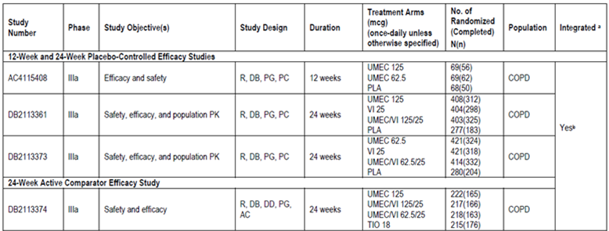

Table 3. (continued) Studies used for Clinical Efficacy.
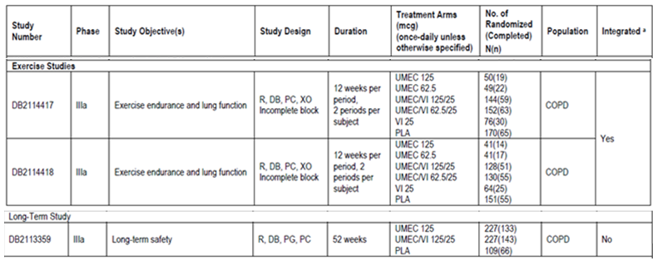

Pivotal efficacy studies
One Phase IIIa 12 week study (AC4115408) and 2 Phase IIIa 24 week studies (DB2113361 and, DB2113373) are considered to be primary studies for demonstrating the efficacy of UMEC compared with placebo.

Study AC4115408

Study design, objectives, locations and dates
This was a Phase IIIa, multicentre, randomized, double-blind, placebo-controlled, parallel-group study. The primary objective of the study was to compare the efficacy and evaluate the safety of UMEC (62.5 µg or 125 µg daily) with placebo when administered once-daily via a NDPI over 12 weeks for treatment of patients with COPD. Secondary objectives were to evaluate the effects of UMEC (62.5 µg or 125 µg daily) compared with placebo on quality of life and PK evaluation over 12 weeks in subjects with COPD. The study was conducted from 8 Nov 2011 to 16 Nov 2012 at 27 centres in the United States (US), Germany, and Japan.

Inclusion and exclusion criteria
The main inclusion criteria were: Male or female patients aged ≥ 40 years with established clinical history of COPD in accordance with the definition by the American Thoracic Society (ATS)/ European Respiratory Society (Celli, 2004); Current or former cigarette smokers with a history of cigarette smoking of ≥ 10 pack years; A post-salbutamol FEV1/FVC ratio of < 0.70 and a post-salbutamol FEV1 of ≤ 70% of predicted normal values calculated at Visit 1 using National Health and Nutrition Examination Survey (NHANES) III reference equations; score of ≥ 2 on the Modified Medical Research Council Dyspnea Scale at Visit 1.
The main exclusion criteria were:
Pregnant/ lactating females. Current diagnosis of asthma. Known respiratory disorders other than COPD including but not limited to α-1 antitrypsin deficiency, active tuberculosis, active bronchiectasis, sarcoidosis, lung fibrosis, pulmonary hypertension, and interstitial lung disease (subjects with allergic rhinitis were not excluded. Historical or current evidence of clinically significant cardiovascular, neurological, psychiatric, renal, hepatic, immunological, endocrine (including uncontrolled diabetes or thyroid disease), or haematological abnormalities that were uncontrolled and/or a previous history of cancer in remission for < 5 years prior to Visit 1 (localized carcinoma of the skin that had been resected for cure was not exclusionary).
A chest x-ray or CT scan that revealed evidence of clinically significant abnormalities not believed to be due to the presence of COPD; history of allergy or hypersensitivity to any anticholinergic/muscarinic receptor antagonist, beta2-agonist, lactose/milk protein, or magnesium stearate, or a medical condition such as narrow-angle glaucoma, prostatic hypertrophy, or bladder neck obstruction that, in the opinion of the investigator, contraindicated study participation or use of an inhaled anticholinergic. Hospitalization for COPD or pneumonia within 12 weeks prior to Visit 1 and subjects with lung volume reduction surgery within the 12 months prior to Visit 1 (Screening). Abnormal and significant electrocardiogram (ECG) findings, clinical chemistry or haematology tests at Visit 1. Subjects unable to withhold salbutamol for the 4-hour period required prior to spirometry testing at each study visit; Use of long-term oxygen therapy (LTOT) described as oxygen therapy prescribed for greater than 12 h a day. Use of the prior medications according to the defined time intervals prior to Visit 1 as detailed in Table 4; As-needed oxygen use (i.e., ≤ 12 hours per day) was not exclusionary. The regular use (prescribed for use every day, not for as-needed use) of short-acting bronchodilators (e.g., salbutamol (albuterol)) via nebulized therapy. Participation in the acute phase of a pulmonary rehabilitation program within 4 weeks prior to Visit 1 (subjects who were in the maintenance phase of a pulmonary rehabilitation program were not excluded). Known history of suspected alcohol or drug abuse within 2 years prior to Visit 1; previous use of UMEC or UMEC/VI combination.

Table 4: Study AC4115408. Disallowed medications prior to screening. Use of the following medications according to the following defined intervals prior to Visit 1.

Study treatments
Eligible subjects were randomized to UMEC 62.5 µg or 125 µg or placebo treatment groups in a 1:1:1 ratio such that, of the planned 198 total number randomized subjects, approximately 66 subjects would be randomized to each treatment group. All treatments were administered once-daily in the morning by inhalation using a NDPI. There were a total of 8 study clinic visits conducted on an outpatient basis. Subjects who met the eligibility criteria at Screening (Visit 1) completed a 5- to 9-day Run-in Period followed by a 12-week Treatment Period. Clinic visits were at Screening (Visit 1), Randomization Day 1 (Visit 2), Day 2 (Visit 3), Day 14 (Visit 4), and after 4, 8, and 12 weeks (Visits 5 through 7) of treatment, and 1 day after Week 12 (Visit 8 also referred to as Treatment Day 85). A follow-up contact for adverse event (AE) assessment was conducted by telephone approximately 7 days after Visit 8 or the Early Withdrawal Visit. The total duration of subject participation, including follow-up, was approximately 14 weeks. The following relevant medications were permitted during this study: inhaled salbutamol for use as rescue medication throughout the Run-in and Treatment Periods, but must have been withheld for at least 4 h prior to spirometry testing; Inhaled corticosteroids at a dose < 1000 µg/day of FP or equivalent were permitted provided the dose of ICS remained consistent throughout the study; Mucolytics such as acetylcysteine; Medications for rhinitis (e.g., intranasal corticosteroids, antihistamines, cromolyn, nedocromil, nasal decongestants); Flu shots; Pneumonia vaccine; Antibiotics for short-term treatment of acute infections; As-needed oxygen use (i.e., ≤ 12 hours per day); Systemic beta-blockers and beta-blocker eye drops were allowed for those subjects who had been on a stable regimen for at least 30 days prior to screening and judged capable to continue this regimen until discharged from the study; Initiation of systemic beta-blocker medications was prohibited; Pulmonary rehabilitation program in Maintenance Phase; Smoking cessation treatment, including a stable regimen of nicotine replacement; Use of positive airway pressure for sleep apnoea; Localized corticosteroid injections (for example, intra-articular and epidural); Oral muscarinic antagonists for the treatment of overactive bladder were permitted but should have been used with caution as they may exacerbate medical conditions that are contraindicated for anticholinergics (e.g., narrow angle glaucoma and bladder outflow obstruction).
Subject compliance with double-blind study drug was assessed at Visits 3 through 7 by reviewing the dose counter on the NDPI. Subjects should have been ≥ 80% to ≤120% compliant on taking study drug between each pair of consecutive on-treatment clinic visits. Subjects who fell outside this range were to be re-educated on treatment compliance by their site and this re-education was to be documented.

Efficacy variables and outcomes
Spirometry measurements were obtained using spirometry equipment that met or exceeded the minimal performance recommendations of the ATS (Miller, 2005). All sites used standardized spirometry equipment and subjects wore nose clips while performing spirometry manoeuvres. For FEV1 and FVC determinations, at least 3 acceptable spirometry efforts (with no more than 8) were obtained.
The primary efficacy endpoint was trough FEV1 on Treatment Day 85 (defined as the mean of FEV1 values obtained 23 and 24 hours after the dose administered on Day 84/Week 12 Visit).
Secondary endpoints included: Weighted mean FEV1 over 0 to 6 hours after dosing on Day 1, Weeks 4 (Day 28) and 12 (Day 84); Serial FEV1 at 1, 3, 6, 23, and 24 h after dosing at Day 1 and Week 12 (Day 84).
Other endpoints included: TDI focal score at Weeks 4 (Day 28), 8 (Day 56), and 12 (Day 84); Proportion of responders to TDI (responder to TDI was defined as a subject who reported a TDI score of 1 unit or more); Pre-dose trough FEV1 at Day 2, Weeks 2 (Day 14), 4 (Day 28), 8 (Day 56) and 12 (Day 84); Serial FEV1 1, 3, and 6 hours post-dose at Week 4 (Day 28) Pre-dose trough FVC at Day 2, Weeks 2 (Day 14), 4 (Day 28), 8 (Day 56) and 12 (Day 84) and Day 85; Weighted mean FVC over 0 to 6 hours after dosing at Day 1 and Weeks 4 (Day 28) and 12 (Day 84); Serial FVC at 1, 3, 6, 23, and 24 hours after dosing at Day 1 and Week 12 (Day 84); Serial FVC at 1, 3, and 6 hours post-dose at Week 4 (Day 28); Rescue salbutamol use (percentage of rescue-free days and puffs/ day); Time to onset (defined as an increase of 100 mL above baseline in FEV1) during 0 to 6 hours post-dose on Day 1; Proportion of subjects achieving an increase in FEV1 of ≥ 12% and ≥ 200mL above baseline at ‘any time’ during 0 to 6 hours post-dose on Treatment Day 1; Proportion of subjects achieving an increase of ≥ 100 mL above baseline in trough FEV1.

Randomisation and blinding methods
Subjects were randomized using RAMOS, an Interactive Voice Response System (IVRS). Following the completion of the Run-in Period, eligible subjects were randomized in a 1:1:1 (2 active: 1 placebo; planned n = 66 per treatment) ratio to one of the following blinded treatment regimens: UMEC 125 µg once-daily; UMEC 62.5 µg once-daily; Placebo once-daily. Subjects were instructed to take one inhalation each morning from the NDPI. The duration of treatment for each subject was 12 weeks. Study drug taken during the 12-week Treatment Period was double-blind. Neither the subject nor the study physician knew which study drug the subject was receiving.
Comment: The CHMP guidelines for ‘clinical investigation of medicinal products in treatment of patients with COPD’ states that formal stratification of patients according to their smoking status (current smokers, ex-smokers) should be performed prior to randomisation. This was not done in any of the pivotal clinical studies for UMEC. Use of nicotine replacement therapy or other smoking cessation aids such as varenicline was also not documented.

Analysis populations
The ITT population constituted the primary population for all data analyses and displays. The Per Protocol (PP) population was comprised of all subjects in the ITT population who were not identified as full protocol violators. This population was used for confirmatory analyses of the primary efficacy endpoint only, irrespective of how many subjects were in the PP population. The Pharmacokinetic (PK) population was comprised of all subjects in the ITT population who were randomized to treatment with UMEC and for whom a PK sample was obtained and analysed.

Sample size
Sample size calculations were based on the primary endpoint of trough FEV1 at Day 85 and assumed 90% power, a two-sided 5% significance level, an estimate of residual standard deviation (SD) of 210 mL (based on recent repeat-dose parallel-group studies in COPD conducted by GSK), and a treatment difference from placebo of 130 mL. This treatment difference was selected as it is of similar magnitude to the effect seen with TIO. Under these assumptions, 56 evaluable subjects on each treatment (168 in total) were required.

Statistical methods
The following treatment comparisons were performed on trough FEV1 on Treatment Day 85: UMEC 125 µg versus placebo; UMEC 62.5 µg versus placebo. In order to account for multiplicity across treatment comparisons for the primary endpoint, a step down closed testing procedure was applied, whereby inference for the comparison of UMEC 62.5 µg with placebo was dependent on statistical significance having been achieved for the comparison of UMEC 125 µg with placebo.
A two-sided 5% risk associated with incorrectly rejecting the null hypothesis (significance level) was considered acceptable for this study. Since a step-down closed testing procedure was used, no further multiplicity adjustments were applied. Whilst the study is powered on FEV1 at trough, secondary and other efficacy and safety measures were evaluated in order to help differentiate the UMEC doses. Thus, pair-wise treatment comparisons of each UMEC dose and placebo were performed for all the secondary and other efficacy endpoints, as well as selected safety endpoints (vital signs and ECGs), for the ITT population. The primary endpoint of trough FEV1 on Day 85 was analysed for the ITT population using a Mixed Model Repeated Measures (MMRM) analysis (Siddiqui, 2009), including covariates of baseline FEV1, smoking status at screening, Day, centre group, treatment, Day by baseline interaction, and Day by treatment interaction, where Day was nominal. The model used all available trough FEV1 values recorded on Days 2, 14, 28, 56, 84, and 85. The impact of missing data was explored for the ITT population only and Sensitivity analyses were conducted using the following multiple imputation methods: (1) Missing at Random (MAR) Approach, (2) Copy Differences from Control (CDC) Approach and (3) Last Mean Carried Forward (LMCF) Approach.
Consistency of treatment effect across covariates fitted in the primary and secondary efficacy endpoint analyses models were examined by fitting separate models to examine treatment by baseline, treatment by centre group, and treatment by smoking status at Screening interactions. Separate analysis models were also fitted to examine treatment by ICS use, treatment by reversibility to salbutamol, and treatment by percent predicted FEV1 interactions. No formal statistical analysis of subgroups of the study population was performed.

Participant flow
A total of 246 subjects were enrolled across 27 centres (in Germany, Japan and USA). Of these, 206 were randomised to treatment (68, 69 and 69 to placebo, UMEC 62.5 and 125 µg, respectively). Most subjects (82%) completed the study. More subjects withdrew in the placebo group compared with the UMEC groups. The most common reason for withdrawal was lack of efficacy (7%, 6% and 12% in the UMEC 62.5 µg, 125 µg and placebo groups respectively) primarily due to COPD exacerbations (7%, 3%, and 9%, respectively) (Table 5).

Table 5. Study AC 4115408. Overall subject disposition (ITT population)

Major protocol violations/deviations
The study blind was not broken for any subject during the study. The incidence of protocol deviation was higher in the placebo group (18%) compared to the UMEC groups (6%). Subjects with full protocol deviations were completely excluded from the PP population. Subjects with partial protocol deviations and time point specific deviations were considered part of the PP population but their data were excluded from the PP population analysis from the time of their deviation onwards.

Baseline data
The majority of the patients were male (62%), White (88%), current smokers (54%) with COPD duration of 1 to 10 years who reported no COPD exacerbations requiring oral/systemic corticosteroids and/or antibiotics (77%) and did not require hospitalization for a COPD exacerbation in the 12 months prior to screening (96%); the mean age of patients was 63.1 years. The baseline demographics and disease characteristics were similar in the placebo and UMEC treatment groups. The majority of subjects were GOLD Stage II and III (84%) and a higher percentage of subjects showed responsiveness to salbutamol and ipratropium (46%) compared with reversibility to salbutamol (24%). The proportion of subjects considered reversible to salbutamol was also higher for the placebo group compared with the UMEC groups; however, following administration of salbutamol and ipratropium, the proportion of subjects considered responsive was similar across treatment groups. The baseline bronchodilator function and dyspnoea scores were similar across treatment groups. The percentage of subjects with a family history of cardiovascular risk factors (family history of premature coronary artery disease in women < 65 years or men < 55 years in first degree relatives only) was low (12%) and similar across treatment groups. The majority of subjects (78%) reported use of a COPD medication not administered for an exacerbation taken pre-treatment (within 30 days prior to Screening and/or during the Run-in Period): 75%, 84% and 75% in the placebo, UMEC 62.5 and 125 µg groups, respectively with the most common COPD medications being short (50 - 58%) and long-acting (39 - 46%) beta agonists, LAMAs (22 - 35%) and ICS (23 - 26%). The majority of subjects,74% to 82% across treatments, reported taking a non-COPD medication pre-treatment and/or during the treatment period. Antihypertensive medications and cholesterol-lowering agents used most commonly. Mean treatment compliance was high across all treatment groups (≥ 98.7%) and all subjects, except for one in the placebo group, were at least 80% compliant.

Results for the primary efficacy outcome
Compared with placebo, both UMEC 125 µg and 62.5 µg showed statistically significant (p < 0.001) increase in trough FEV1 after 12 weeks of treatment (LS mean change from baseline was 0.120, 0.145 and -0.007L in UMEC 62.5 µg, 125 µg and placebo groups, respectively) and these results were confirmed in the PP analysis (Table 6).

Table 6: Study AC4115408.Primary Efficacy Analysis: Trough FEV1 (L) at Day 85 (i)ITT population and (ii) PP Population.
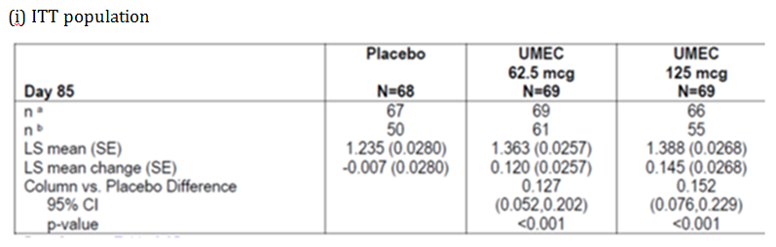

Table 6 (continued): Study AC4115408.Primary Efficacy Analysis: Trough FEV1 (L) at Day 85 (i)ITT population and (ii) PP Population.
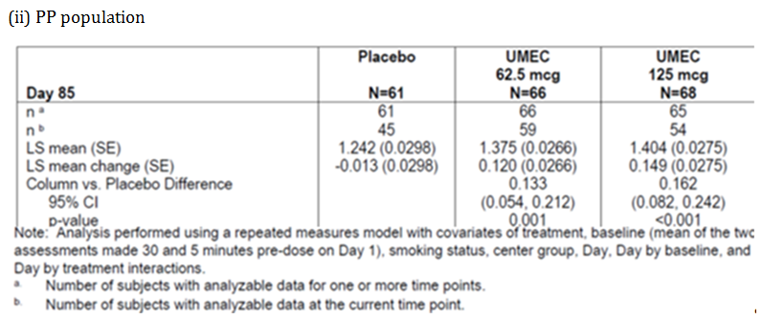
Comment: LS mean differences from placebo for the primary efficacy endpoint of change from baseline in trough FEV1 at day 85 were 0.127 (95% CI, 0.052, 0.202) and 0.152 L (95% CI, 0.076, 0.229) for UMEC 62.5 and 125 µg treatment groups, respectively, and were comparable to treatment differences reported for other long-acting bronchodilators such as TIO, aclidinium, indacaterol, and salmeterol in COPD (Casaburi, 2000; Casaburi, 2002; Kerwin, 2011; Kerwin, 2012; Mahler, 1999).

Results for other efficacy outcomes

Secondary efficacy results
Statistically significant improvements in LS mean 0 to 6 hour weighted mean FEV1 were demonstrated for both the UMEC 62.5 and 125 µg treatment groups compared with placebo at Day 1, Day 28, and Day 84 (Table 7). Statistically significant improvements in LS mean serial FEV1 were demonstrated for both the UMEC 62.5 and 125 µg treatment groups compared with placebo at each time point over 24 hours on Day 1 and Day 84 (p < 0.003) (Figure 1).

Table 7: Study AC4115408 ITT Population. Secondary efficacy analysis: 0 to 6 hour weighted mean FEV1(L).
Figure 1: Study AC4115408 ITT Population. Least squares mean change from baseline in FEV1(L) over time at Day 1 and Day 84.

Other efficacy results
The LS mean TDI focal score was greater for the UMEC 62.5 (p=0.05) and statistically significantly greater for the UMEC 125 (p < 0.05) µg treatment groups compared with placebo at Day 84. The difference from placebo in the TDI score at Day 84 met the threshold for a clinically meaningful improvement in dyspnoea (i.e., ≥ 1 unit) for both UMEC treatment groups. A greater proportion of subjects in the UMEC 62.5 and 125 µg treatment groups were classified as responders (had clinically meaningful improvements of ≥ 1 unit in TDI focal score) compared with placebo at Days 28, 56, and 84. Subjects treated with UMEC (both the 62.5 and 125 µg doses) had 2 to 3 times higher odds of being a TDI responder versus a non-responder compared with placebo treatment at each time point.
Statistically significant improvements in LS mean change from baseline trough FEV1 at Days 2, 14, 28, 56, and 84 were demonstrated for both UMEC 62.5 and 125 µg doses compared with placebo (Figure 2). Statistically significant (p < 0.001) improvements in LS mean change from baseline for serial FEV1 measurements obtained over 6 hours were demonstrated at all time points on Day 28 for both UMEC 62.5 and125 µg treatment groups compared with placebo.
Figure 2: Study AC4115408 ITT population. Least Squares mean change from baseline trough FEV1(L).
Statistically significant (p ≤ 0.002) increases from baseline in LS mean trough FVC were demonstrated for both UMEC 62.5 and 125 µg treatment groups compared with placebo at Day 85 and Days 2, 14, 28, 56, and 84 (p < 0.010). Statistically significant increases from baseline in adjusted 0 to 6 hour weighted mean FVC were demonstrated for both the UMEC 62.5 and 125 µg treatment groups compared with placebo at each time point.
At baseline, the mean daily use of rescue salbutamol ranged from 2.7 to 3.6 puffs/day across treatment groups. Over 12 weeks of treatment, a greater reduction in rescue salbutamol use compared with baseline was reported in the UMEC treatment groups compared with placebo (decrease of 0.7, 0.6 and 0.2 puffs/day for UMEC 62.5, 125 µg and placebo, respectively). Over 12 weeks of treatment, the percentage of rescue-free days was increased from baseline by 9.0% and 8.3% in the UMEC 62.5 and 125 µg treatment groups, respectively, compared with a decrease of 4.2% from baseline in the placebo group.
Subjects in the UMEC treatment groups had statistically significantly (p < 0.001) higher likelihood of reaching post-dose FEV1 ≥ 100 mL above baseline compared with placebo. In the UMEC treatment groups, the majority of subjects had a post-dose FEV1 ≥ 100mL above baseline at the earliest scheduled post-dose time point (i.e., 1 hour on Day 1; 59% and 64% for subjects treated with both doses of UMEC 62.5 and 125 µg, respectively). Subjects treated with UMEC had statistically significantly (p < 0.001) higher odds of achieving an increase in FEV1 of ≥ 12% and ≥ 200mL above baseline compared with placebo treatment at Day 1 (43%, 54% and 10% for UMEC 62.5, 125 µg and placebo, respectively). The proportion of patients achieving an increase in trough FEV1 of ≥ 100mL above baseline at Day 85 was statistically significantly greater with both UMEC 62.5 and 125 µg compared with placebo (42%, 50% and 18% for UMEC 62.5, 125 µg and placebo, respectively, p ≤ 0.003).
Compared with placebo, both the UMEC 62.5 and 125 µg treatment groups showed statistically significant and clinically relevant improvements in total SGRQ score (demonstrating an improvement in health-related quality of life) at Day 84. The treatment differences compared with placebo at Day 84 were particularly notable (-7.90 (95% CI, -12.20, -3.60) and -10.87 (95% CI, -15.25, -6.49)) for the UMEC 62.5 and 125 µg groups, respectively) which was due, in part, to a worsening in the SGRQ score in the placebo group (LS mean change from baseline of 4.75 units at Day 84) while both doses of UMEC showed improvements in the total score from baseline (LS mean change -3.14 and -6.12 for the UMEC 62.5 and 125 µg groups, respectively). A greater proportion of patients in the UMEC groups were likely to be responders according to their SGRQ total score at day 84 (44%, 52% and 26%, respectively). A greater proportion of subjects treated with UMEC showed improvement on the SGRQ total score at all time points compared with subjects treated with placebo. Improvements from baseline in individual SGRQ domain scores were observed for both doses throughout the study, with the largest improvements seen for the symptoms domain scores. Improvements in SGRQ total and domains scores were generally numerically larger for the UMEC 125 µg dose compared with the 62.5 µg dose. A proportional analysis showed a larger percentage of subjects achieved an improvement in SGRQ total score of 4 units or greater with both the UMEC 62.5 (44%) and 125 µg (52%) treatments compared with placebo (26%) on Day 84.
Comment: Overall, results from this study showed that the proposed dose of 62.5 µg UMEC once daily produced statistically significant (compared with placebo) and clinically relevant improvements in lung function and symptomatic endpoints from day 1 which were maintained for the 12-week duration of this study.

Study DB2113361

Study design, objectives, locations and dates
This was a 24-week, Phase IIIa, multicentre, randomized, double-blind, placebo-controlled, parallel-group study. The primary objective of the study was to evaluate the efficacy and safety of UMEC/VI Inhalation Powder, UMEC Inhalation Powder, and VI Inhalation Powder when administered once-daily via a Novel Dry Powder Inhaler (NDPI) over 24 weeks in subjects with COPD. A secondary objective of the study was to characterize the PK of UMEC and VI administered in combination and individually using population PK methodology, to explore effects of covariates, to evaluate PK-pharmacodynamic (PD) relationships, if any, between UMEC or VI systemic exposure and systemic PD endpoints following administration of the UMEC/VI combination and the individual treatments to subjects with COPD. The study was conducted from 22 Mar, 2011 to 19 April 2012 at 153 centres in the US, Germany, Hungary, Netherlands, Estonia, Japan, Norway, Philippines, Denmark , Slovakia, Sweden, France, Ukraine, and Belgium.

Inclusion and exclusion criteria
These were similar to those described for study AC4115408 above.

Study treatments
Eligible subjects were randomized to UMEC/VI 125/25 µg, UMEC 125 µg, VI 25 µg, and placebo treatment groups in a 3:3:3:2 ratio such that, of the planned 1463, approximately 399 subjects were randomized to each active treatment group and 266 subjects were randomized to placebo. All treatments were administered once-daily in the morning by inhalation using a NDPI.

Efficacy variables and outcomes
These were similar to those described for study AC4115408 above with exception of fact that this study had 24-week treatment period compared to 12 weeks in study AC4115408 described above.

Randomisation and blinding methods
Following the completion of the Run-in Period, eligible subjects were to be randomized in a 3:3:3:2 (3 active: 2 placebo) ratio (n=399 to each active treatment and n=266 to placebo) to one of the following 4 possible treatments: UMEC/VI 125/25 µg once-daily; UMEC 125 µg once-daily; VI 25 µg once-daily; Placebo once-daily. Study drugs taken during the 24-week Treatment Period were administered in a double-blind fashion. Neither the subject nor the study physician knew which study drug the subject was receiving.

Analysis populations
The ITT population constituted the primary population for all data analyses and displays. The PP population was used for confirmatory analyses of the primary and secondary efficacy endpoints only. The Twenty Four Hour (TFH) population was comprised of a subset of subjects from the ITT population for whom 24-hour data were collected for spirometry and Holter monitoring.

Statistical methods
The following treatment comparisons were performed on trough FEV1 on Day 169: UMEC/VI versus placebo; UMEC versus placebo; VI versus placebo; UMEC/VI versus VI; UMEC/VI versus UMEC. In order to account for multiplicity across treatment comparisons and endpoints, a step-down closed testing procedure was applied, whereby inference for a test in the pre-defined hierarchy was dependent upon statistical significance having been achieved for previous tests in the hierarchy. The hierarchy consisted of the five treatment comparisons described above, performed in that order, on the primary and secondary endpoints.

Sample size
The sample size was calculated in order to provide sufficient power for the comparison of the primary and secondary endpoints, including TDI. The sample size calculations used a two-sided 5% significance level and an estimate of residual standard deviation (SD) for TDI of 3.24 units. The estimate of SD is based on MMRM analyses of a previous study in COPD subjects with the FP/salmeterol combination. In order to provide additional safety data for the active treatments, subjects were randomized to active treatment arms or placebo in a 3:2 ratio. A study with 273 evaluable subjects in each active arm and 182 evaluable subjects in the placebo arm would have 90% power to detect a 1-unit difference between treatments in TDI. With this number of evaluable subjects per active arm, the study would have > 99% power to detect a 100 mL difference in trough FEV1 between UMEC/VI and either UMEC or VI, or between an active treatment and placebo, at the two sided 5% significance level. It would have 90% power to detect a difference of 58 mL between UMEC/VI and either UMEC or VI, or 68 mL between an active treatment and placebo. These calculations used an estimate of residual SD for trough FEV1 of 210 mL. The estimate of SD was based on MMRM analyses of previous studies in COPD subjects with UMEC, VI, and the FP/salmeterol combination. Statistical inference for TDI was conditional on having achieved statistical significance on the primary endpoint, trough FEV1. Powering trough FEV1 at > 99% would maintain 90% power (conditional on trough FEV1 analysis) for the analysis of TDI for this submission. Assuming a 30% withdrawal rate, 399 subjects were to be randomized to each active treatment arm and 266 subjects were to be randomized to placebo.

Participant flow
Of the 2114 enrolled subjects, 1493 were randomized and 1489 subjects included in the ITT Population. The majority of subjects completed the study (74% to 81% across the active treatment groups versus 67% for placebo). The incidence of withdrawals due to AEs (4 - 6%) was similar across treatment groups while those due to lack of efficacy (mainly COPD exacerbations) was slightly higher in the placebo group (16%) compared to the active treatment groups (6 - 9%).

Major protocol violations/deviations
The majority of full protocol deviations were due to use of prohibited medications (4% to 9% across treatment groups) or compliance < 80% or > 120% (3% to 4%). Overall, 157 subjects of the ITT population were excluded from the PP analysis population with similar percentage across the treatment groups.

Baseline data
Majority of the patients were male (65%), White (88%), current smokers (52%) with moderate to severe COPD (92% had GOLD stage II or III) and had diagnosis of COPD for 1 to 10 years. The baseline demographics and disease characteristics were generally similar across treatment groups. In the 12 months prior to Screening, the majority of subjects across treatment groups reported no COPD exacerbations requiring oral/systemic corticosteroids and/oral antibiotics (72% to 78%) and no COPD exacerbations requiring hospitalization (90% to 92%). A higher percentage of subjects showed reversibility after administration of salbutamol followed by ipratropium (54%) compared with reversibility to salbutamol alone (31%). The proportion of subjects who reported the use of ICS was similar across treatment groups (44 – 50%). The percentage of subjects with a family history of CV risk factors was low (12%) and ranged from 9% to 15% across treatment groups. The majority of subjects (81% to 85% across treatment groups) reported use of a COPD medication not administered for an exacerbation taken pre-treatment and approximately half of the subjects reported use of a concomitant on-treatment COPD medication not administered for an exacerbation with ICS use most common. No subjects reported taking a medication for a COPD exacerbation pre-treatment. Few subjects (3% of subjects in the placebo group, 5% of subjects in the UMEC 125 µg group, 4% of subjects in the VI 25 µg group, and 3% of subjects in the UMEC/VI 125/25 µg group) reported taking a medication for a COPD exacerbation during the Treatment Period or post-treatment (12% of subjects in the placebo group, 7% of subjects in the UMEC 125 µg group, 7% of subjects in the VI 25 µg group, and 6% of subjects in the UMEC/VI 125/25 µg group). A majority of subjects reported taking a non-COPD medication pre-treatment (71% to 73% across treatments) or during the treatment period (81 - 82%) with antihypertensive medications and cholesterol-lowering agents being most common. Mean treatment compliance was high across all treatment groups (≥ 98.1%).

Results for the primary efficacy outcome
Analysis of trough FEV1 at Day 169 demonstrated that statistical significance was obtained for all comparisons in the testing hierarchy. For TDI score at Day 168, statistical significance was obtained for comparisons of UMEC/VI 125/25 µg versus placebo, but not for UMEC 125 µg versus placebo. Hence, results of all further statistical analyses should be interpreted only descriptively.
The UMEC/VI 125/25 µg, UMEC 125 µg, and VI 25 µg treatment groups demonstrated statistically significant (p < 0.001) greater improvement from baseline compared to placebo in trough FEV1 at day 169 (LS mean change from baseline was 0.129, 0.093, 0.207 and -0.031Lin UMEC 125, VI 25, UMEC/VI 125/25 µg and placebo groups, respectively). The UMEC/VI 125/25 µg treatment group also demonstrated statistically significant greater improvement from baseline in trough FEV1 at Day 169 compared with both the VI 25 µg and UMEC 125 µg treatment groups; these primary efficacy results were confirmed in the PP analysis. These improvements in trough FEV1 were observed at all visits (on days 2, 28, 56, 84, 112 and 168) in addition to day 169 (Figure 3).
Figure 3. Study DB2113361 Least squares mean change from baseline in trough FEV1 (L) at Day 169 (i) ITT population and (ii) PP population.
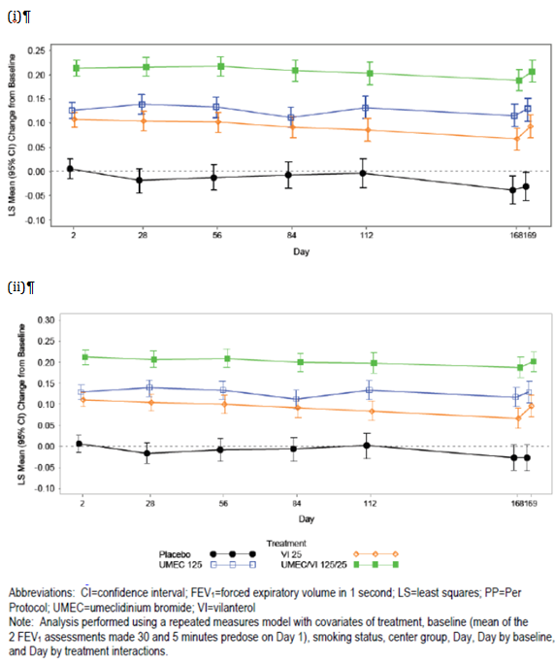

Results for other efficacy outcomes

Secondary endpoint
Clinically meaningful mean improvements in TDI scores from baseline (i.e., > 1; demonstrating an improvement in dyspnoea) were observed in the UMEC/VI 125/25, UMEC 125 and VI 25 µg treatment groups at Day 168; however compared to placebo, a statistically significant greater LS mean TDI focal score was demonstrated only for the UMEC/VI 125/25 µg group (not for the UMEC 125 µg group) at Day 168 (Figure 4). The results of the PP analysis of TDI focal score are supportive of the ITT population analysis. Subjects in the UMEC/VI 125/25 µg, UMEC 125 µg, and VI 25 µg treatment groups had higher odds of being a TDI responder compared with placebo at Days 28, 84, and 168. Subjects in the UMEC/VI 125/25 µg treatment group also had higher odds of being a TDI responder compared with the VI 25 µg and UMEC 125 µg treatment groups at all visits.
Figure 4. Study DB2113361. Least squares mean TDI focal score ITT Population
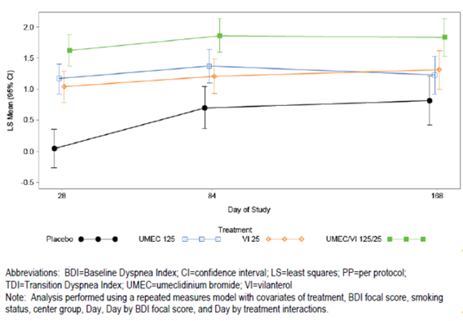
Greater LS mean changes from baseline in 0 to 6 hour weighted mean FEV1 were demonstrated for the UMEC/VI 125/25 µg, UMEC 125 µg, and VI 25 µg treatment groups compared with placebo at Day 168 and at all other visits; the UMEC/VI 125/25 µg treatment group also showed improvements compared with both the VI 25 µg and UMEC 125 µg treatment groups at Day 168 and at all other visits. These results were confirmed in the PP analysis.

Other efficacy results:
Greater LS mean changes from baseline in FEV1 over 0 to 6 hours post-dose were demonstrated for UMEC/VI 125/25 µg, UMEC 125 µg, and VI 25 µg compared with placebo, as well as for UMEC/VI 125/25 µg compared with VI 25 µg and UMEC 125 µg, starting at 15 minutes post-dose on Day 1 and were sustained at every subsequent time point through 24 hours post-dose on Day 168. Median time to onset was lower in the UMEC/VI 125/25 µg and VI 25 µg treatment groups (22 and 27 minutes, respectively) compared with the UMEC 125 µg treatment group (34 minutes). Subjects in the UMEC/VI 125/25 µg, UMEC 125 µg, and VI 25 µg treatment groups had a higher likelihood of achieving an increase in FEV1 ≥ 100 mL above baseline at Day 1 compared with placebo. Subjects in the UMEC/VI 125/25 µg treatment group also had a higher likelihood of achieving an increase in FEV1 ≥ 100 mL above baseline at Day 1 compared with both the VI 25 µg and UMEC 125 µg treatment groups. Similar results were observed for proportion of patients achieving an increase in FEV1 of ≥ 12% and ≥ 200 mL above baseline compared with placebo. Greater LS mean changes from baseline in peak FEV1 at Days 1, 28, 84 and 168 and trough FVC at Days 2, 28, 56, 84, 112, 168 and 169 were demonstrated for the UMEC/VI 125/25, UMEC 125 and VI 25 µg treatment groups compared with placebo as well as for UMEC/VI 125/25 µg compared with VI 25 µg and UMEC 125 µg at all visits. Greater LS mean changes from baseline in trough FVC were demonstrated for the UMEC/VI 125/25 µg, UMEC 125 µg, and VI 25 µg treatment groups compared with placebo at Days 2, 28, 56, 84, 112, 168, and 169 as well as for UMEC/VI 125/25 µg compared with VI 25 µg and UMEC 125 µg at all visits Similar results were observed for serial FVC over 24-hour time points on day 1 and these changes were maintained at day 168. Analyses of 0 to 24 hour weighted mean FEV1 and serial FEV1 performed using the TFH population showed similar results.
Greater reductions from baseline in LS mean rescue salbutamol use over Weeks 1 to 24 were demonstrated for the UMEC/VI 125/25 µg, UMEC 125 µg, and VI 25 µg treatment groups compared with placebo as well as for UMEC/VI 125/25 µg compared with VI 25 µg and UMEC 125 µg. The percentage of rescue-free days was also higher in the active treatment groups compared with placebo.
On -treatment COPD exacerbations were reported more frequently in the placebo treatment group (14%) compared with the UMEC 125 µg, VI 25 µg, and UMEC/VI 125/25 µg treatment groups (6% to 8%); Thirteen subjects reported a post-treatment COPD exacerbation (2, 2, 5 and 4 patients in the placebo, UMEC 125, VI25 and UMEC/VI 125/25 groups, respectively).
Consistently greater proportions of subjects in the UMEC/VI 125/25 µg, UMEC 125 µg, and VI 25 µg treatment groups showed improvement on the SGRQ total score at all visits compared with subjects treated with placebo. Changes from baseline in the SGRQ total and symptoms, activity, and impacts domain scores did not show any difference between the UMEC 125 µg and placebo group at day 168 (only the UMEC/VI group showed greater improvements than placebo). Approximately 29% to 35% of subjects across the treatment groups reported contact with a healthcare provider on any day during the study. The proportions of subjects who reported unscheduled healthcare utilization were low (4% to 7% across treatment groups).
Comment: Following 24 weeks of monotherapy with once daily dose UMEC 125 µg, statistically significant improvements were observed compared with placebo for trough FEV1, serial FEV1 changes and additional lung function parameters as well as reduced need for rescue salbutamol use. However, the key secondary endpoint of TDI dyspnoea score at day 168 was not statistically significantly reduced with UMEC 125 compared to placebo. In general, treatment with UMEC/VI 125/25 µg resulted in larger improvements across the supportive efficacy measures compared with UMEC 125 µg and VI 25 µg alone, with a greater level of differentiation observed for the lung function measures. However, the proposed dose of UMEC 62.5 µg was not evaluated in this pivotal study.

Study DB2113373

Study design, objectives, locations and dates
This was a 24-week, Phase IIIa, multicentre, randomized, double-blind, placebo-controlled, parallel-group study. The primary objective of the study was to evaluate the efficacy and safety of UMEC/VI 62.5/25 µg, UMEC 62.5 µg and VI 25 µg when administered once-daily via a NDPI over 24 weeks in subjects with COPD. A secondary objective of the study was to characterize the PK of UMEC and VI administered in combination and individually using population PK methodology, to explore effects of covariates, to evaluate PK-PD relationships, if any, between UMEC or VI systemic exposure and systemic PD endpoints following administration of the UMEC/VI combination and the individual treatments to subjects with COPD. The study was conducted from 30 Mar, 2011 to 5 April 2012 at 163 centres in the in the United States (US), Bulgaria, Canada, Chile, Czech Republic, Greece, Japan, Mexico, Poland, Russia, South Africa, Spain, and Thailand.

Inclusion and exclusion criteria
These were similar to those described for study DB2113361 above.

Study treatments
Eligible subjects were randomized to UMEC/VI 62.5/25 µg, UMEC 62.5 µg, VI 25 µg, and placebo treatment groups in a 3:3:3:2 ratio such that, of the planned 1463 subjects, approximately 399 subjects were randomized to each active treatment group and 266 subjects were randomized to placebo. All treatments were administered once-daily in the morning by inhalation using a NDPI. At selected study sites, a subset of approximately 198 planned subjects underwent 24-hour serial spirometry and 24- Holter monitoring during the study.

Efficacy variables and outcomes
These were similar to those described for study DB2113361 above.

Randomisation and blinding methods
These were similar to those described for study DB2113361 above.

Analysis populations, statistical methods and sample size
These were similar to those described for study DB2113361 above.

Participant flow
Of 2210 subjects who were screened, 1536 were randomized, and 1532 were included in the ITT population. Four subjects were randomized in error but did not receive study drug and were therefore not included in the ITT population. The majority of subjects completed the study (76% to 80% across the active treatment groups versus 73% for placebo) and AEs and lack of efficacy (COPD exacerbations) were the most common causes of withdrawal.

Major protocol violations/deviations
The majority of full protocol deviations were due to use of prohibited medications (6% to 10% across treatment groups) or compliance < 80% or > 120% (4% to 6%). Overall, 87% of the ITT population was included in the PP population (83 - 88% across treatment groups).

Baseline data
Majority of the patients were male (71%), White (85%), current smokers (50%) with moderate to severe COPD (89% had GOLD stage II or III) and had diagnosis of COPD for 1 to 10 years. The baseline demographics and disease characteristics were generally similar across treatment groups. In the 12 months prior to Screening, the majority of subjects across treatment groups reported no COPD exacerbations requiring oral/systemic corticosteroids and/or antibiotics (70% to 76%) and no COPD exacerbations requiring hospitalization (87% to 91%). A higher percentage of subjects showed reversibility after administration of salbutamol followed by ipratropium (55%) compared with reversibility to salbutamol alone (33%). The proportion of subjects who reported the use of ICS (49 - 52%) was similar across treatment groups. The percentage of subjects with a family history of CV risk factors was low and ranged from 15% to 17% across treatment groups. The majority of subjects (80% to 84% across treatment groups) reported use of a COPD medication not administered for an exacerbation taken pre-treatment and approximately half of the subjects reported use of a concomitant on-treatment COPD medication not administered for an exacerbation with ICS use most common. No subjects reported taking a medication for a COPD exacerbation pre-treatment. Few subjects reported taking a medication for a COPD exacerbation during the treatment period (3% to 4% across the active treatment groups versus 5% for placebo) or post-treatment (5% to 8% across the active treatment groups versus 9% for placebo). A majority of subjects reported taking a non-COPD medication pre-treatment (71% to 77% across treatments) or during the treatment period (78 - 84%) with antihypertensive medications and cholesterol-lowering agents being most common for the cardiovascular system. Mean treatment compliance was high across all treatment groups (≥ 98.3%).

Results for the primary efficacy outcome
Analysis of trough FEV1 at Day 169 demonstrated that statistical significance was obtained for all comparisons in the testing hierarchy. For TDI score at Day 168, statistical significance was obtained for comparisons of UMEC/VI 62.5/25 µg, UMEC 62.5 µg, and VI 25 µg with placebo but not for UMEC/VI 62.5/25 compared with VI 25 µg or UMEC 62.5 µg. Therefore, for EMA purposes the results of all further statistical analyses should be interpreted only descriptively. However, for FDA and other relevant submissions where TDI was not designated as a secondary endpoint, inferences can be drawn from the analyses of the secondary endpoint of weighted mean FEV1 over 0 to 6 hours post dose at Day 168 and other visits as well as from the analyses of other efficacy endpoints.
The UMEC/VI 62.5/25 µg, UMEC 62.5 µg, and VI 25 µg treatment groups demonstrated statistically significant (p < 0.001) greater improvements from baseline in trough FEV1 at day 169 compared with placebo (LS mean change from baseline was 0.119, 0.076, 0.171 and 0.004L in UMEC 62.5, VI 25, UMEC/VI 62.5/25 µg and placebo groups, respectively). The UMEC/VI 62.5/25 µg treatment group also demonstrated statistically significant greater LS mean change from baseline in trough FEV1 at Day 169 compared with both the VI 25 µg and UMEC 62.5 µg treatment groups. These improvements in trough FEV1 were observed at all visits (on days 2, 28, 56, 84, 112 and 168) in addition to day 169; these primary efficacy results were confirmed in the PP analysis (Figure 5).
Figure 5. Study DB113373. Least mean squares change from baseline in trough FEV1(L) in ITT and PP populations.
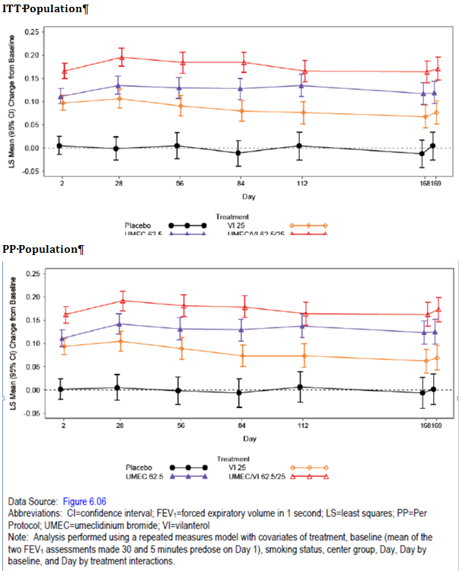

Results for other efficacy outcomes

Secondary endpoint:
Statistically significant (p < 0.001) and clinically meaningful improvements in TDI scores from baseline (> 1unit) were observed for the active treatment groups compared with placebo at day 168 (mean change from baseline was 2.2, 2.1, 2.4 and 1.2 units in UMEC 62.5, VI 25 and UMEC/VI 62.5/25 µg and placebo groups, respectively). TDI focal scores were larger for UMEC/VI 62.5/25 µg compared with UMEC 62.5 µg, and VI 25 µg, but the difference was not statistically significant. Subjects in the UMEC/VI 62.5/25, UMEC 62.5 and VI 25 µg treatment groups had higher odds of being a TDI responder compared with placebo at Days 28, 84, and 168 with slightly higher incidence of responders in the UMEC/VI 62.5/25 µg treatment group compared with the VI 25 µg and UMEC 62.5 µg treatment groups at all visits (at day 168 response rate was 41%, 53%, 51% and 58% in placebo, UMEC 62.5, VI 25 and UMEC/VI 62.5/25 µg groups, respectively).
There were improvements in the secondary lung function endpoint of 0 to 6 hour weighted mean FEV1 for comparisons of the active treatments with placebo and for comparisons of UMEC/VI 62.5/25 µg with UMEC 62.5 µg and VI 25 µg alone; these significant improvements were observed at all visits and also confirmed in the PP analysis (Figure 6 and Figure 7).
Figure 6. Study DB2113373 ITT population. Least squares mean change from baseline on 0 to 6 h weighted mean FEV1 (L).
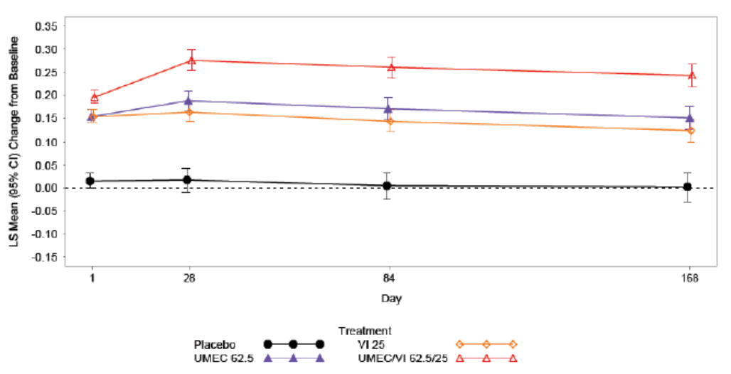
Figure 7. Study DB2113373 PP population. Least squares mean change from baseline on 0 to 6 h weighted mean FEV1 (L).
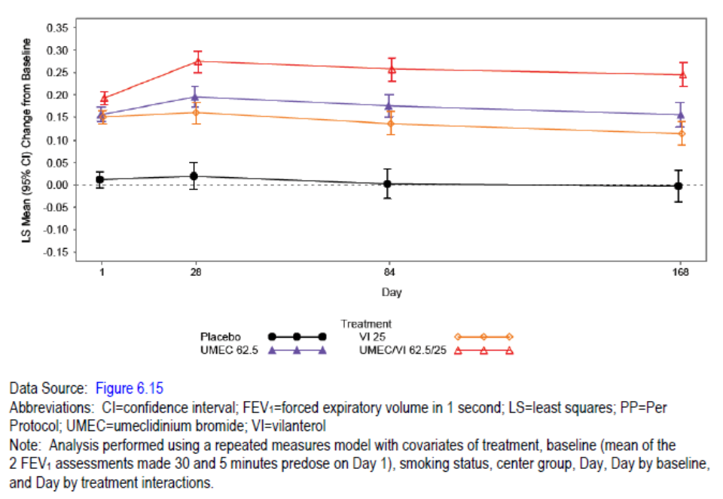

Other efficacy results:
Median time to onset (Post dose FEV1 ≥ 100 mL above Baseline) on Day 1 was lower in the UMEC/VI 62.5/25 µg and VI 25 µg treatment groups (27 minutes and 31 minutes, respectively) compared with the UMEC 62.5 µg treatment group (56 minutes). Subjects in the UMEC/VI 62.5/25 µg, UMEC 62.5 µg, and VI 25 µg treatment groups had higher odds of achieving an increase in FEV1 of ≥ 12% and ≥ 200 mL above baseline compared with placebo. Subjects in the UMEC/VI 62.5/25 µg treatment group also had higher odds of achieving an increase in FEV1 of ≥ 12% and ≥ 200 mL above baseline compared with both the VI 25 µg and UMEC 62.5 µg treatment groups. The proportion of subjects achieving an increase of ≥ 100 mL above baseline in trough FEV1 at day 169 was significantly greater in the active treatment groups compared with placebo; however, UMEC/VI was better than only VI 25 and not UMEC 62.5.
Treatment with UMEC/VI 62.5/25 µg, UMEC 62.5mg, and VI 25 µg resulted in improvements in additional endpoints related to lung function that included serial and trough FVC and proportional analyses of FEV1 compared with placebo. Greater improvements in these measures were observed with UMEC/VI treatment compared with UMEC and VI alone.
Results of the analysis of 0 to 24 hour weighted mean FEV1 at Days 1, 84, and 168 for the TFH population confirmed treatment with UMEC/VI 62.5/25 µg resulted in greater improvements in FEV1 throughout the once-daily dosing interval compared with UMEC 62.5 µg and VI 25 µg alone. Treatment with UMEC 62.5 µg and VI 25 µg alone resulted in improvements in FEV1 over 24 hours compared with placebo.
Rescue salbutamol use was reduced by 0.8, 0.3, and 0.9 puffs per day compared with placebo over Weeks 1 through 24 for the UMEC/VI 62.5/25 µg, UMEC 62.5mg, and VI 25 µg treatment groups, respectively, from mean baseline; similarly, the percentage of rescue-free days was higher in the active treatment groups compared with placebo.
Analysis of change in mean SOBDA scores and percentage of responders was numerically higher in the active treatment groups compared with placebo, but the differences were not statistically significant.
On-treatment COPD exacerbations were reported more frequently in the placebo treatment group (13%) compared with the active treatment groups (7% to 9%). Seven subjects reported post-treatment COPD exacerbations (1, 2, 3 and 1 in placebo, UMEC 62.5, VI 25 and UMEC/VI 62.5/25 µg groups, respectively).
All active treatments were associated with clinically meaningful reductions (i.e., -4 units or larger) from baseline in SGRQ total score at Days 28, 84 and 168. At all assessment visits, treatment with UMEC/VI 62.5/25 µg, UMEC 62.5µg, and VI 25 µg resulted in reductions in SGRQ total score compared with placebo. The treatment differences between the UMEC/VI 62.5/25 µg treatment group and the UMEC 62.5 µg and VI 25 µg treatment groups were generally not significant. The proportion of SGRQ responders was greater in the active treatment groups compared with placebo at day 168 (34%, 44%, 48% and 49% in placebo, UMEC 62.5, VI 25 and UMEC/VI 62.5/25 µg groups, respectively). The SGRQ symptoms and activity domains scores were numerically greater in the active treatment groups compared with placebo (no difference in the impact domain scores).
Comment: Following 24 weeks of treatment with proposed dose of once-daily UMEC 62.5 µg, there were statistically significant and clinically relevant improvements compared with placebo in the primary efficacy endpoint (of trough FEV1 at day 169), secondary endpoints (change in TDI dyspnoea score and 0 - 6 hour weighted mean FEV1 at day 168), additional lung function parameters, health-related QOL measures (SGRQ total scores and SGRQ responders). UMEC 62.5 µg was also associated with reduction in incidence of on-treatment COPD exacerbations compared with placebo. Serial spirometry obtained over 24 hours in a subgroup of subjects confirmed that treatment with UMEC 62.5 µg alone resulted in improvements in FEV1 over 24 hours compared with placebo. Greater improvements in these measures were observed with UMEC/VI treatment compared with UMEC and VI alone.
Use of rescue salbutamol did not show statistically significant reduction with UMEC 62.5 µg compared with placebo. The median time to onset of action (post dose FEV1 ≥ 100 ml above baseline) was also longer in the UMEC 62.5 µg group (56 mins) compared with UMEC/VI 62.5/25 µg (27 mins) and VI 25 µg (31 mins) groups.

Study DB2113374

Study design, objectives, locations and dates
This was a 24-week, Phase IIIa, multicentre, randomized, double-blind, double-dummy, parallel-group study. The primary objective of this study was to compare the efficacy of two doses of UMEC/VI (125/25 µg and 62.5/25 µg once-daily) when administered via a NDPI compared with UMEC 125 µg administered once-daily via a NDPI and compared with TIO 18 µg once-daily when administered via HandiHaler over a treatment period of 24 weeks in subjects with COPD. The secondary objectives of this study were to compare effects of two doses of UMEC/VI (125/25 µg and 62.5/25 µg once-daily) with UMEC (125 µg once-daily) and with TIO (18 µg once-daily) on safety and quality of life assessments over 24 weeks in subjects with COPD. The study was conducted from 21 Mar, 2011 to 10 April 2012 at 95 centres in the US, Argentina, Australia, Canada, Chile, Germany, South Korea, Mexico, Romania, and South Africa.

Inclusion and exclusion criteria
These were similar to those described for study DB2113373 above.

Study treatments
Eligible subjects were randomized 1:1:1:1 to UMEC/VI 125/25 µg, UMEC/VI 62.5/25 µg, UMEC 125 µg, or TIO for 24 weeks. All treatments were administered once-daily in the morning by inhalation using a NDPI (UMEC/VI, UMEC and placebo) and HandiHaler (TIO/placebo).

Efficacy variables and outcomes
These were similar to those described for study DB2113373 above.

Randomisation and blinding methods
Eligible subjects were randomized 1:1:1:1 to UMEC/VI 125/25 µg, UMEC/VI 62.5/25 µg, UMEC 125 µg, or TIO for 24 weeks. Study drugs taken during the 24-week Treatment Period were administered in a double-blind, double-dummy method using placebo for TIO, UMEC and UMEC/VI. Neither the subject nor the study physician knew which study drug the subject was receiving. Subjects were randomized using RAMOS, an interactive voice response system (IVRS).

Analysis populations
The ITT population constituted the primary population for all data analyses and displays. The PP population was used for confirmatory analyses of the primary and secondary efficacy endpoints only.

Statistical methods
The following treatment comparisons were performed for trough FEV1 on Day 169: UMEC/VI 125/25 µg versus TIO and UMEC/VI 125/25 µg versus. UMEC 125 µg. To account for multiplicity across treatment comparisons and endpoints, a step-down closed testing procedure was applied whereby inference for a test in the pre-defined hierarchy was dependent upon statistical significance having been achieved for previous tests in the hierarchy. The hierarchy consisted of the treatment comparisons above, performed for the primary and secondary (weighted mean FEV1 over 0 to 6 hours post dose at Week 24) efficacy endpoints, followed by the same treatment comparisons on the same endpoints for the lower UMEC/VI dose.

Sample size
The sample size was calculated in order to provide sufficient power for the comparisons of trough FEV1 within this study, and also for the comparisons of TDI for UMEC/VI and TIO in the planned meta-analysis of data from this study and Study DB2113360. The sample size calculations used a two-sided 5% significance level and an estimate of residual standard deviation (SD) for trough FEV1 of 210 mL. A study with 94 evaluable subjects per arm has 90% power to detect a 100 mL difference between treatments in trough FEV1. For the meta-analysis of TDI, the sample size calculations used a two-sided 5% significance level and an estimate of residual SD for TDI of 3.24 units. An analysis including 221 evaluable subjects per arm has 90% power to detect a minimally important difference of 1 unit between treatments in TDI. In order to achieve this, a sample size of 111 evaluable subjects per arm per study was required. In order to meet ICH guidelines on exposure to new medicinal products (E1A) for UMEC/VI, the planned number of evaluable subjects in each arm was increased to 146. Allowing for a 30% withdrawal rate, 208 subjects were to be randomized to each treatment arm.

Participant flow
Of the 1191 enrolled subjects, 872 subjects were randomized in the study, and 869 subjects were randomized and received at least 1 dose of study drug (ITT population). Overall, 77% of the patients completed the study; the incidence of withdrawals was slightly lesser in the TIO group (18%) compared with the UMEC/VI and UMEC groups (23 - 26%).

Major protocol violations/deviations
The majority of full protocol deviations were due to use of prohibited medications (7% to 10% across treatment groups) or compliance < 80% or > 120% in either inhaler (3% to 6% across treatment groups; overall, 87% of the ITT patients were included in the PP analysis.

Baseline data
Majority of the patients were male (68%), White (76%), former smokers (55%) with moderate to severe COPD (88% had GOLD stage II or III and 12% had stage IV) and had diagnosis of COPD for 1 to 10 years. The baseline demographics and disease characteristics were generally similar across treatment groups. In the 12 months prior to Screening, the majority of subjects across treatment groups reported no COPD exacerbations requiring oral/systemic corticosteroids and/or antibiotics (65% to 72%) and no COPD exacerbations requiring hospitalization (93% to 96%). The proportion of subjects who reported the use of ICS was similar across treatment groups (47 - 56%). The percentage of subjects with a family history of CV risk factors was low (17% to 22%). The majority of subjects (83% to 87% across treatment groups) reported use of a COPD medication not administered for an exacerbation taken pre-treatment and 54% reported use of a concomitant on-treatment COPD medication not administered for an exacerbation with ICS use most common. Few subjects reported taking a medication for a COPD exacerbation pre-treatment (ranging from <1% to 3% per treatment group). Similarly, few subjects (5% of subjects each in the UMEC 125 µg, UMEC/VI 62.5/25 µg, and UMEC/VI 125/25 µg groups, and 2% of subjects in the TIO group) reported taking a medication for a COPD exacerbation during the Treatment Period or post-treatment (10% in the UMEC 125 µg group, 11% in the UMEC 62.5/25 µg group, and 7% each in the UMEC/VI 125/25 µg and TIO groups). Majority of subjects reported taking a non-COPD medication during treatment period (86 - 89% across treatments) with antihypertensive medications and cholesterol-lowering agents being most common for the cardiovascular system. Mean treatment compliance was high across all treatment groups (≥ 98.0%).

Results for the primary efficacy outcome
As a result of the comparison of UMEC/VI 125/25 µg versus UMEC 125 µg not achieving statistical significance at the 5% level for the primary endpoint of trough FEV1 at Day 169, the restrictions of the step-down testing procedure were not met and therefore the results of all further statistical analyses are not strictly inferential. Only the results of the primary efficacy endpoint comparing the UMEC/VI 125/25 µg versus TIO are considered statistically significant and inferential based on the results of this step-down testing procedure (Table 8).

Table 8. Study DB2113374 ITT population. Results of step down testing procedure for the primary and secondary endpoints.
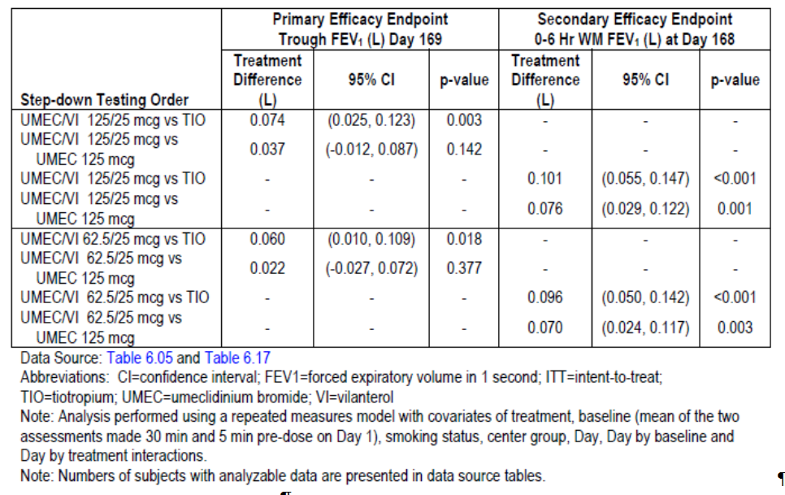
The LS mean change from baseline trough FEV1 was 0.223, 0.208, 0.186 and 0.149L for the UMEC/VI 125/25, UMEC/VI 62.5/25 µg, UMEC 125 µg and the TIO 18 µg groups, respectively. The UMEC/VI 125/25 µg treatment group showed statistically significantly greater improvement in LS mean change from baseline trough FEV1 compared with TIO at Day 169 (0.074 L); the UMEC/VI 62.5/25 µg treatment group showed a greater improvement in LS mean change from baseline trough FEV1 compared with the TIO treatment group at day 169. However, the difference between UMEC/VI 125/25 µg and UMEC 125 µg did not achieve statistical significance. The PP analysis confirmed the primary ITT results). Statistical analysis of trough FEV1 at Days 2, 28, 56, 84, 112, and 168 confirmed significant improvements over TIO from day 2 which were maintained till week 24 (Figure 8).
Figure 8. Study DB2113374. Least mean change from baseline trough FEV1(L) (i) ITT population and (ii) PP population.
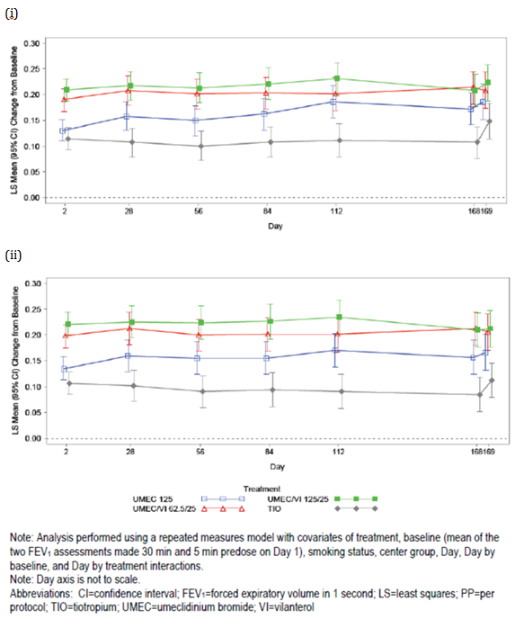

Results for other efficacy outcomes

Secondary endpoint:
The UMEC/VI 62.5/25 µg and UMEC/VI 125/25 µg treatment groups showed greater improvements in LS mean change from baseline in 0 to 6 hour weighted mean FEV1 compared with both TIO and UMEC 125 µg at Day 168. The improvements were observed at day 2, 84 and 168 and also confirmed in the PP analysis (Figure 9). The change from baseline in TDI focal scores failed to show statistically significant difference between UMEC/VI groups and TIO or UMEC125 µg groups; similar results were observed for the proportion of responders (with clinically relevant improvement of 1 unit on the TDI score).
Figure 9. Study DB2113374. Least mean change from baseline in 0 to 6 hour weighted mean FEV1(L) ITT population.
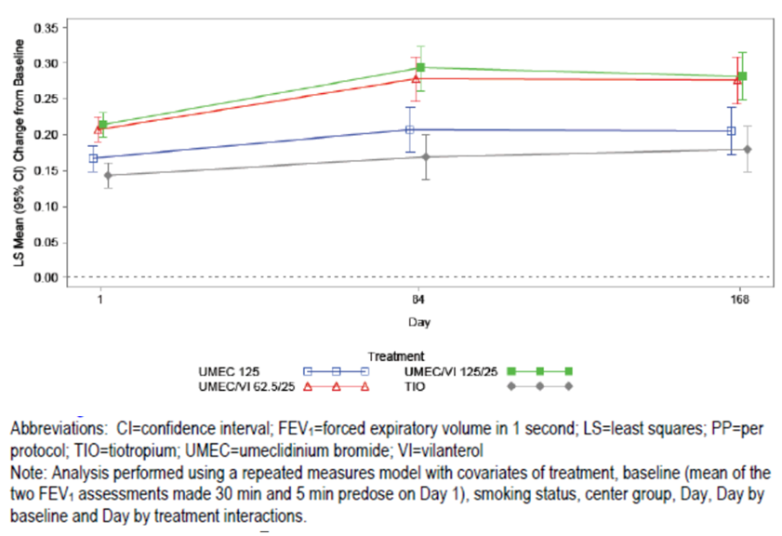

Other efficacy results:
Median time to onset was lower in the UMEC/VI 62.5/25 µg and UMEC/VI 125/25 µg treatment groups compared with the UMEC 125 µg and TIO treatment groups (21, 19, 36 and 34min in the UMEC/VI 62.5/25, UMEC/VI 125/25, UMEC 125 and TIO 18 µg groups, respectively, p < 0.001). The proportion of subjects achieving increase in FEV1 of ≥ 12% and ≥ 200mL above baseline at ‘any time’ during 0 to 6 hours post-dose on Day 1 was greater in the UMEC/VI groups compared to TIO (but not greater than UMEC 125 µg). The proportion of subjects achieving an increase of ≥ 100 mL above baseline in trough FEV1 for day 169 was greater in the UMEC/VI 62.5/25 µg and UMEC/VI 125/25 µg treatment groups compared with the UMEC 125 µg and TIO treatment groups.
The UMEC/VI 62.5/25 µg and UMEC/VI 125/25 µg treatment groups showed a greater improvement in LS mean change from baseline in peak FEV1 compared with TIO and UMEC 125 µg treatment groups at Days 1, 84, and 168 (Table 9).

Table 9. Study DB2113374. Statistical analysis PEAK FEV1 ITT population.
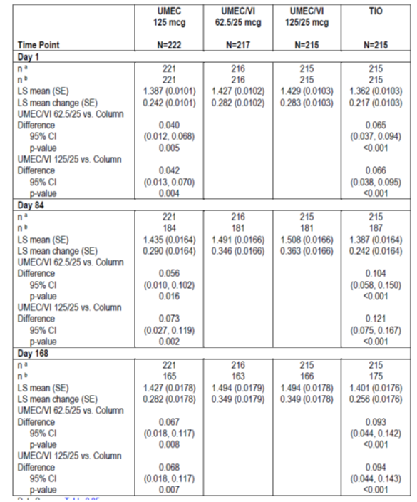
Compared with the TIO and UMEC 125 µg treatment groups, the UMEC/VI 62.5/25 µg and UMEC/VI 125/25 µg treatment groups showed a greater improvement in serial and trough FVC and in LS mean change from baseline in mean PEF over Weeks 1 through 24.
All treatment groups showed reduction in LS mean change from baseline of mean daily number of puffs of rescue salbutamol over Week 1 through Week 24; treatment differences were numerically greater for the UMEC/VI 125/25 µg treatment group compared with both TIO (p < 0.05) and UMEC 125 µg (p < 0.05); the percentage of rescue-free days during the 24-week treatment period was higher in the UMEC/VI 125/25 group (27%) compared to the other 3 treatment groups (13% to 18%).
Compared with the TIO and UMEC 125 µg treatment groups, the UMEC/VI 62.5/25 µg and UMEC/VI 125/25 µg treatment groups showed a greater improvement from baseline in the mean SOBDA score at week 24; analyses of the proportion of responders at Week 24 according to the SOBDA Responder thresholds of -0.1 and -0.2 showed that both UMEC/VI groups were greater than UMEC 125 µg (but not > TIO 18 µg).
The number of subjects with COPD exacerbations during treatment period was numerically higher in the UMEC 125 µg and UMEC/VI 62.5/25 µg groups (12% each) compared with the UMEC/VI 125/25 and TIO 18 µg groups (7% each).
Overall, 65% of the patients preferred the NDPI device (15% preferred the Handihaler device and 20% had no preference). Both doses of UMEC/VI, UMEC 125 and TIO showed clinically relevant improvements from baseline in health-related quality of life/health outcomes of SGRQ (LS mean change from baseline in SGRQ total score for all treatments exceeded the MID of 4 units at all visits where SGRQ was assessed during the treatment period) , EQ-5D health outcome assessment (mean change from baseline of > 0.074 was observed in all treatment groups at Day 168), CAT (COPD Assessment Test; mean improvements in CAT scores from baseline of > 1.3 decrease were observed in all treatment groups at Day 168). However, there were no significant differences between the 4 treatment groups.
Comment: Despite the limitations of the statistical comparisons within the testing hierarchy, the totality of the lung function data reflects an increased benefit with both doses of UMEC/VI compared with TIO. The treatment comparison of UMEC/VI 125/25 to UMEC 125 failed to show statistically significant differences for the primary endpoint of trough FEV1 at Day 169 which suggests that the contribution of VI to the UMEC/VI 125/25 combination was not demonstrated in this study. While the study was not powered for direct statistical comparisons between the two UMEC/VI groups, generally UMEC/VI 125/25 was numerically better than the 62.5/25 dose in trough FEV1 and 0 to 6 hour weighted mean FEV1. However, there was no statistical comparison between UMEC 125 versus TIO.
Treatment with UMEC/VI 62.5/25 did not show significant improvements in lung function measures compared with treatment with UMEC 125. This treatment comparison involved 2 different doses of UMEC and therefore the UMEC 125 may have overshadowed the contribution of VI to the lower dose of UMEC. Interpretation is limited due to lack of UMEC 62.5 µg monotherapy treatment arm in this study.

Other efficacy studies

Exercise study DB2114417

Study design, objectives
This was a Phase IIIa, multicentre, randomized, double-blind, placebo-controlled, combination and component, 2-period (12 weeks per period), incomplete block design cross-over study. The primary objective of the study was to evaluate the effect of UMEC/VI, administered once-daily, on exercise endurance time (EET) measured using the exercise endurance shuttle walk test (ESWT) and trough forced expiratory volume in 1 second (FEV1) over 12 weeks in subjects with COPD. The secondary objective was to evaluate the effect of UMEC/VI, its components, and placebo administered once-daily on lung volumes and post-dose lung function over 12 weeks. The study was conducted from 16 Mar 2011 to 14 June 2012 at 31 centres in the United States (US), Germany, UK, Bulgaria, Estonia, and Russia.

Inclusion/exclusion criteria and study treatments
The inclusion and exclusion criteria were similar to those described for the pivotal studies, except the fact that subjects in the exercise study had lung hyperinflation defined by a resting functional residual capacity (FRC) of > 120% of the predicted normal. This requirement was included to select subjects most likely to have exercise limitations due to dynamic hyperinflation as a result of exercise testing. Additionally, a lower limit was applied for post-salbutamol FEV1 (≥ 35% of predicted normal values) to preclude subjects with very severe disease from performing exercise tests. Eligible subjects were randomized to receive a sequence consisting of 2 of the following treatments administered once-daily via a NDPI for 12 weeks: - UMEC/VI 125/25 µg , UMEC/VI 62.5/25 µg , UMEC 125 µg, UMEC 62.5 µg, VI 25 µg and placebo. Subjects were randomized to 1 of 26 different sequences. The sequences were selected to optimize power for the comparisons between UMEC/VI and placebo. Therefore, the number of subjects on each treatment was unbalanced. Subjects who continued to meet the eligibility criteria were randomized to receive a sequence consisting of 2 study treatments, each administered for 12 weeks separated by a washout period of 2 weeks. All subjects received supplemental salbutamol (via metered-dose-inhaler (MDI) and/or nebules) to be used on an as-needed basis (rescue medication) throughout the study.

Efficacy endpoints
The co-primary efficacy endpoints were: Exercise endurance time (EET) post-dose at Week 12 (defined as the EET obtained 3 hours after dosing at Week 12); and trough FEV1 (pre-bronchodilator and pre dose) at Week 12 (defined as the FEV1 value obtained 24 hours after dosing on Treatment Day 84).
The Incremental Shuttle Walk Test (ISWT) was performed in an enclosed corridor on a flat, 10-meter long course (Singh, 1992). The course was identified by 2 cones, each positioned 0.5 meters from either end to allow subjects to walk in an oval and thereby avoid the need for abrupt changes in direction. Heart rate and SpO₂ were monitored using a pulse oximeter (NOX population) or Oxycon mobile system (OX population). Subjects walked at a predetermined rhythm, as dictated by an audio signal played from a compact disc (CD). Walking speed was initially set at 0.50 meters/second and was increased by 0.17 meters/second every minute until the subject reached maximal capacity. The final measures were distance, expressed in meters, and peak walking speed, expressed in kilometres per hour. The ESWT was performed on the same course as the ISWT. To avoid confounding the interpretation of the walking performance results (and in contrast to the encouragement given during the ISWT), no encouragement was given to subjects throughout the test. Although no encouragement was given, instructions to the subject to correctly perform the test were important. The most important measure was the time the subject carried out the walk (EET expressed in seconds). The physical limitation that required the subject to stop walking was recorded as either dyspnoea, leg fatigue, or other physical limitations such as headache, dizziness and palpitations.

Secondary efficacy endpoints
Secondary efficacy endpoints were: Measures of lung volume (IC, FRC, and residual volume (RV)) at Week 12 (trough and 3-hour post dose); Clinic visit 3-hour post dose FEV1 at Week 12.
Other lung volume endpoints were: FVC and the total lung capacity (TLC), the slow vital capacity (SVC), the IC/TLC and RV/TLC ratios, and the percent predicted normal FRC and TLC.

Other efficacy endpoints
Other efficacy endpoint were: Rescue salbutamol use (percentage of rescue-free days and number of puffs/day); Ease of use of the NDPI; Within the NOX subset, HR and SpO₂ were evaluated. The following exercise evaluations were assessed in the OX subset: EIC; CRM: HR and SpO₂; Other CRM: oxygen uptake (VO₂), carbon dioxide production (VCO₂), minute ventilation (Ve), respiratory exchange ratio (RER), breathing frequency (Bf), tidal volume (Vt), Ve/VCO₂, Ve/VO₂, fraction of inspired oxygen (FiO₂), and RER/Vt Health outcomes were assessed using the Exercise Dyspnoea Scale (EDS; modified Borg scale).

Sample size and statistical methods
The sample size calculations used an estimate of residual SD for the EET of 114 seconds. The sample size calculations for trough FEV1 used an estimate of residual SD of 168 ml based upon a Phase IIb study for UMEC in COPD subjects (AC4113073). A study with 208 evaluable subjects would have 94% power to detect a 70 seconds difference in EET and 92% power to detect a 100mL difference in trough FEV1 between either of UMEC/VI doses and placebo at the 2-sided 5% significance level. To allow for a 30% withdrawal rate, 312 subjects were to be randomized.
The co-primary endpoint of 3-hour post-dose EET at Week 12 was analysed for the ITT population using a MMRM analysis including covariates of period walking speed, mean walking speed, period, treatment, visit, smoking status, centre group, visit by period walking speed interaction, visit by mean walking speed interaction, and visit by treatment interaction, where visit was nominal. The co-primary endpoint of trough FEV1 at Week 12 was analysed for the ITT population using a MMRM analysis, including covariates of period baseline, mean baseline, period, treatment, visit, smoking status, centre group, visit by period baseline interaction, visit by mean baseline interaction, and visit by treatment interaction, The model used all available 3-hour post dose EET and trough FEV1 values recorded on Day 2, Week 6, and Week 12. The following treatment comparisons were designated primary;
- 3-hour post dose EET for UMEC/VI 125/25 µg versus placebo;
- Trough FEV1 for UMEC/VI 125/25 µg versus placebo;
- 3-hour post dose EET for UMEC/VI 62.5/25 µg versus placebo; and
- Trough FEV1 for UMEC/VI 62.5/25 µg versus placebo.
In order to account for multiplicity across treatment comparisons and co-primary endpoints, a step-down closed testing procedure was applied whereby inference for a test in the predefined hierarchy is dependent upon statistical significance having been achieved for previous tests in the hierarchy. The hierarchy consists of the 4 treatment comparisons described above, performed in that order. There were comparisons of the combination treatments versus the individual components of the same dose. These comparisons were considered supportive and no multiplicity adjustments were applied. No direct comparisons between UMEC and VI or between different doses of UMEC or different doses of the combination were made.

Analysis populations, participant flow, major protocol violations
The ITT population was composed of all subjects randomized to treatment who received at least 1 dose of randomized study drug in either treatment period. The Per Protocol (PP) population was composed of all subjects in the ITT population who were not identified as full protocol deviators. The Oxycon (OX) population was composed of a subset of subjects from the ITT population for whom Oxycon data were collected for EIC and CRM in addition to all other specified study endpoints. The Non-Oxycon (NOX) population was composed of all subjects in the ITT population who were not in the OX population. The EIC was not measured for this population and the only CRM measures evaluated were HR and SpO₂ using a pulse oximeter (in addition to all other specified study endpoints).
Of 596 enrolled subjects, 349 were randomized, 348 were included in the ITT population, and 258 completed the study. The most common reasons for withdrawal during the 2 treatment periods were similar with AEs and lack of efficacy most common. The majority of full protocol deviations were due to use of prohibited medications (0% to 4% across treatments). Overall, 96% of ITT patients were included in the PP analysis; the OX subset included 154 (44%) of the ITT patients.

Baseline data
Majority of the patients were male (56%), White (97%), current smokers (63%) and had duration of COPD for 1 to 10 years (69%; 24% had duration ≥ 10 years). The mean age was 62 years and patients had extensive smoking histories, with a mean of 39.0 years smoked and 48.7 pack-years. No subjects reported changes in smoking status during the study. In the 12 months prior to Visit 1, the majority of subjects (82%) reported no COPD exacerbations requiring oral/systemic corticosteroids and/or antibiotics. All patients had stage II (53%) or stage III (47%) GOLD stage COPD. A family history of CV risk factors was reported by 25% of subjects. During the Run-in or the Washout Period prior to starting that treatment, 24% to 32% of subjects reported use of a COPD medication not given for a COPD exacerbation. During treatment periods, 22% to 32% of subjects reported use of a concomitant on treatment COPD medication not administered for an exacerbation with ICS being most common medication. Mean treatment compliance was high for all treatments (≥ 98.9%).

Primary efficacy results
Treatment with once-daily doses of UMEC/VI 125/25 and UMEC/VI 62.5/25 µg did not result in a statistically or clinically significant improvement in the co-primary efficacy endpoint of EET compared with placebo at Week 12. The restrictions of the step-down testing procedure were not met and the results of all further statistical analyses are described but are not strictly inferential. None of the active treatments showed a statistically significant improvement in EET compared with placebo with similar results observed in the PP analysis.
The findings for the co-primary efficacy endpoint of trough FEV1 showed numerical improvements for both doses of UMEC/VI when compared with placebo with similar results in the PP analysis (Figure 10). Although the difference was statistically significant, interpretation was limited due to restrictions of the step-down testing procedure and lack of significant improvement in EET.
Figure 10: Study DB2114417. Least mean change from baseline in trough FEV1(L) in ITT (A) and PP (B) populations.
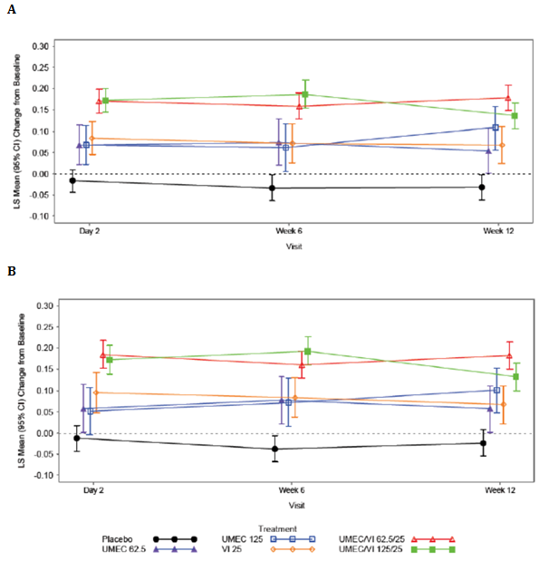

Other efficacy results
Both doses of UMEC/VI demonstrated numerical improvements compared with placebo in the secondary endpoints of trough and post-dose lung function and lung volume measures including pre- and post-dose IC, FRC and RV, FVC and post-dose FEV1 at 12 weeks.
All active treatments showed slight reduction in use of rescue medication (by 0.2 to 0.7 puffs per day reduction versus placebo) and increase in % of rescue medication-free days, but the differences were not statistically significant or clinically relevant. All active treatments except VI 25 µg showed slight non-significant reduction in EDS score (at iso-time) compared with placebo.
Comment: This study had 2 co-primary endpoints (EET and trough FEV1 at week 12) and all the active treatments (UMEC 62.5, UMEC 125, UMEC/VI 62.5/25, UMEC/VI 125/25 µg, VI 25 µg) only showed improvements in trough FEV1 with no improvement in EET. Trough lung volume measures including IC, FRC, and RV at 12 weeks for the combination UMEC/VI 62.5/25 and UMEC/VI 125/25 µg all showed improvements over placebo (IC: 198 mL and 170 mL; FRC: -238 mL and -369 mL; RV: -295 mL and -463 mL). Whilst FEV1 improvement following the administration of a bronchodilator is a good indicator of changes in airflow obstruction, these changes do not adequately profile the full impact of interventions on the COPD patient’s health status. Addition of a bronchodilator should reduce hyperinflation as measured by the lung volumes and allow increased exercise capacity and improved quality of life (Celli, 2003). However, these improvements in lung function did not translate into any significant improvement in the co primary endpoint of EET in this study involving patients with moderate to severe COPD.

Study DB2114418
This study was conducted from 16 March 2011 to 16 July 2012 at 42 centres in the US, Czech Republic, South Africa, Denmark, Canada, Ukraine, and the United Kingdom (UK). The study design, objectives, inclusion/ exclusion criteria, study treatments, efficacy endpoints and statistical methods were similar to those described for study DB2114417 above.

Participant flow, major protocol violations:
Of the 634 enrolled subjects, 308 subjects were randomized and 307 subjects included in the ITT population. The most common reasons for withdrawal during the 2 treatment periods were similar with AEs and lack of efficacy most common. The majority of full protocol deviations were due to failed inclusion/ exclusion or randomization criteria considered to have affected the primary outcome (0 to 3% across treatments), post-salbutamol FEV1 < 35% or > 70% of predicted normal values at Screening (0 to 5%) and use of prohibited medication (0 to 3%). Overall, 92% of the ITT subjects were included in the PP analysis.

Baseline data:
Majority of the patients were male (55%), White (97%), current smokers (61%) and had duration of COPD for 1 to 10 years (66%; 24% had duration ≥ 10 years). The mean age was 63 years and patients had extensive smoking histories, with a mean of 39.9 years smoked and 47.4 pack-years. Few subjects (only 2 patients) reported changes in smoking status during the study. In the 12 months prior to Visit 1, the majority of subjects (72%) reported no COPD exacerbations requiring oral/systemic corticosteroids and/or antibiotics. All patients had stage II (52%) or stage III (47%) GOLD stage COPD; however, there were 2 patients with Stage I and 1 with Stage IV. A family history of CV risk factors was reported by 17% of subjects. During the Run-in or the Washout Period prior to starting that treatment, 41% to 49% of subjects across active treatments reported use of a COPD medication not given for a COPD exacerbation (compared with 47% for placebo). During treatment periods, 37% to 51% of subjects across active treatments, reported use of a concomitant on treatment COPD medication not administered for an exacerbation (compared with 45% for placebo) with ICS being most common medication. Mean treatment compliance was high for all treatments (≥ 98%).

Primary efficacy results:
Statistically significantly greater least squares (LS) mean changes from baseline in 3-hour post-dose EET were demonstrated for UMEC/VI 125/25, 62.5/25 and UMEC 125 µg compared with placebo at Week 12; UMEC 62.5 µg and VI 25 µg failed to show significant improvements in EET over placebo. These significant improvements were observed early and maintained for the 12-week treatment duration; furthermore, these results were confirmed in the PP analysis with the exception of a smaller difference from placebo in the UMEC/VI 125/25 µg at ‘all time’ points.
The UMEC/VI 62.5/25 and 125/25 µg treatments demonstrated statistically significantly greater LS mean changes from baseline in the co-primary endpoint of trough FEV1 at Week 12 compared with placebo. These significant improvements were observed early and maintained for the 12-week treatment duration; furthermore, these results were confirmed in the PP analysis (Figure 11).
Figure 11. Study DB2114418. Least squares mean change from baseline in trough FEV1(L) in ITT (A) and PP (B) populations.
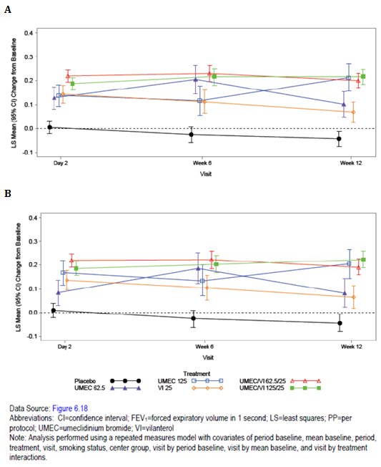

Other efficacy results
All 5 active treatments showed statistically significant improvements compared with placebo in the secondary endpoints of trough and post-dose lung function and lung volume measures including pre- and post-dose IC , FRC, RV, FVC and post-dose FEV1 at 12 weeks.
All active treatments showed slight reduction in use of rescue medication (by 0.1 to 1.2 puffs per day reduction versus placebo) and increase in % of rescue medication-free days. Both UMEC/VI doses and UMEC 125 µg demonstrated statistically significant improvements over placebo in exertional dyspnoea at iso-time.
Comment: In this 12-week, crossover study, treatment with proposed once-daily dose of UMEC 62.5 µg did not produce statistically significant improvement in EET or exertional dyspnoea compared with placebo in hyper inflated COPD patients. Combination therapy with UMEC/VI 125/25 and 62.5/25 µg produced statistically significant improvements in EET, trough FEV1 and all other additional lung function and symptomatic endpoints. However, interpretation of statistical comparisons of UMEC 62.5 µg versus placebo may have been limited by smaller sample size in the monotherapy treatment arms compared to the combination treatment arms.

Analyses performed across trials (pooled analyses and meta analyses)

Pooled analyses
Results of the 12-Week and 24-Week integrated analyses of the Efficacy Studies are summarised below and were generally consistent with the findings of the individual study results.

Effect on FEV1
Both doses of UMEC demonstrated statistically significant (p < 0.001) improvements in LS mean changes from baseline in trough FEV1 at Day 84 compared with placebo in the 12 week integration. Statistically significant (p < 0.001) improvements over placebo in LS mean change from baseline in trough FEV1 at Day 169 were demonstrated for UMEC 62.5 µg in study DB2113373 and UMEC 125 µg in study DB2113361. In study DB2113374, the LS mean change (SE) from baseline in trough FEV1 at Day 169 was 0.186 (0.0178) L for UMEC 125 µg and 0.149 (0.0176) L for TIO. For the 24-week integrated analysis, both doses of UMEC demonstrated statistically significant (p < 0.001) improvements in LS mean changes from baseline in trough FEV1 at Day 169 compared with placebo (placebo subtracted mean change from baseline was 0.133 and 0.154L with UMEC 62.5 and 125 µg, respectively). For the 12- and 24-Week Integration there were statistically significant (p < 0.001) improvements in LS mean changes from baseline in trough FEV1 for both doses of UMEC compared with placebo at all visits (Figure 12).
Figure 12: Least squares mean (95% CI) change from baseline in trough FEV1(L). 12 week integration ITT (A) and PP (B) populations.
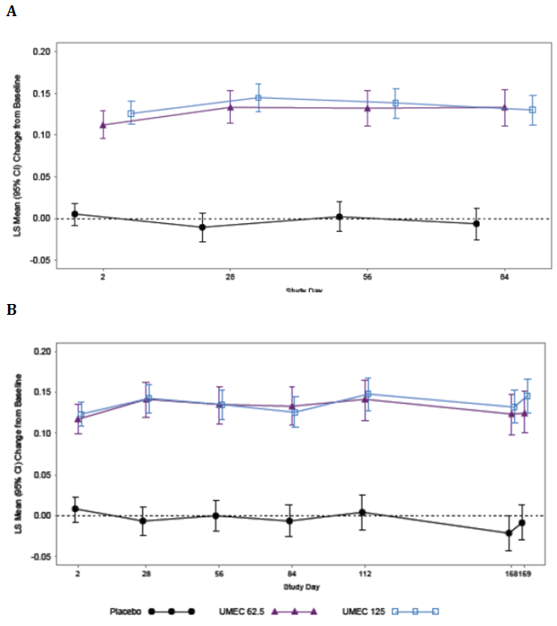
Compared with placebo, both UMEC doses demonstrated a statistically significant (p < 0.001) difference in LS mean change from baseline in weighted mean FEV1 on Day 84 in the 12-week integrated analysis and day 168 in the 24-week integrated analysis. For the 12-Week Integration there were statistically significant improvements in LS mean changes from baseline in 0 to 6 hour weighted mean FEV1 for both doses of UMEC compared with placebo at all visits (p < 0.001) with similar results observed in the 24-week integration analysis.
A subset of 199 and 197 subjects from selected study sites in each of the 24-week placebo controlled studies DB2113361 and DB2113373 performed comprehensive 24-hour serial spirometry at Days 1, 84, and 168, for evaluation of lung function over the dosing period (TFH population). The sample size for the subset was selected to provide a descriptive evaluation of the 24-hour serial FEV1 profiles. From the TFH population in each study, 36 subjects received placebo and 53 subjects received UMEC 125 µg in DB2113361 and 37 subjects received placebo and 54 subjects received UMEC 62.5 µg in DB2113373. For the integrated analysis, both doses of UMEC demonstrated statistically significant (p<0.001) post-dose improvements in LS mean changes from baseline in serial FEV1 compared with placebo at ‘all time’ points assessed on all days studied in the 12-week and 24-week integrated analysis.
For the integrated analysis, both doses of UMEC demonstrated statistically significant (all p < 0.001) improvement in LS mean changes from baseline in peak FEV1 at ‘all time’ points assessed (Days 1, 28, 84, and 168) compared with placebo.

Effect on TDI
Statistically significant (p < 0.001) improvements over placebo in LS mean TDI focal score were demonstrated for UMEC 62.5 µg and 125 µg at day 84 and day 168. Clinically meaningful LS mean TDI focal scores (≥ 1 unit) were observed for both UMEC treatment groups at Days 28 and 56, in the 12-week integrated analysis with similar results in the 24-week integrated analysis. For the12-Week Integration, the proportion of responders according to TDI focal score on Day 84 was greater for both doses of UMEC compared with placebo (UMEC 62.5 µg: 243/457 (53%); UMEC 125 µg: 300/638 (47%) and placebo: 185/546 (34%)). The odds of being a TDI responder versus a non-responder were statistically significantly greater compared with placebo for both UMEC doses with similar results for the 24-week integrated analysis (UMEC 62.5 µg: 207/394 (53%); UMEC 125 µg: 255/579 (44%); placebo: 176/494 (36%)).

Use of rescue medication
Compared with placebo, the mean number of puffs of rescue medication per day was statistically significantly reduced for both UMEC doses (p ≤ 0.033) in the 12-week integrated analysis; however the 24-week integrated analysis only showed statistically significant difference for UMEC 125 µg (p < 0.001) but not for 62.5 µg (p = 0.180) compared with placebo. Compared with placebo, the integrated data demonstrate that treatment with UMEC 62.5 µg and 125 µg results in a higher percentage of rescue-free days over Weeks 1 to 12 and also over weeks 1 to 24.

Health related quality of life
There were statistically significant improvements in LS mean change from baseline in SGRQ total scores at Day 84 and day 168 for both UMEC doses compared with placebo. For the 12-Week Integration the proportion of SGRQ responders at Day 84 was greater for both UMEC doses compared with placebo. The odds of being a SGRQ responder versus a non-responder were statistically significantly greater for both UMEC doses compared with placebo at Day 84 with similar results observed at day 168 in the 24-week integrated analysis. In the 12-Week and 24-week Integration, the results for the mean changes from baseline in SGRQ individual domains were generally consistent with those observed in the SGRQ total score; all active treatments showed a greater reduction in each domain score compared with placebo.

COPD exacerbations
An integration of the data was not undertaken at 12 weeks, as the time to first COPD exacerbation was not an efficacy endpoint for the 12-week AC4115408 study due to the shorter duration and the relatively small number of subjects in this study. In the 24-week Efficacy Studies, a COPD exacerbation was defined as acute worsening of symptoms of COPD requiring the use of any treatment beyond study drug or rescue salbutamol. This included the use of systemic corticosteroids, antibiotics, and/or emergency treatment or hospitalization. These studies were not specifically designed to evaluate the effect of treatments on COPD exacerbations and subjects were required to be withdrawn if an exacerbation occurred. For the 24-Week Integration, analysis of time to first COPD exacerbation showed that both doses of UMEC statistically significantly lowered the risk of a COPD exacerbation compared with placebo (UMEC 62.5 µg, HR 0.6, p = 0.013; UMEC 125 µg HR 0.5, p = 0.001).

Efficacy in subgroups
In the 12-Week Integration, the number of subjects in each subgroup showed similar distribution across treatment groups.
Interactions of treatment with gender (male/female) and age (≤ 64 versus ≥ 65 years) and geographical region (US versus non-US) were not statistically significant for any of the primary and secondary efficacy endpoints of trough FEV1 at Day 84, 0 to 6 hour weighted mean FEV1 at Day 84, and TDI score at Day 84. Interactions of treatment with race (White versus non White) were statistically significant for the primary efficacy endpoint of trough FEV1 at Day 84 and for 0 to 6-hour weighted mean FEV1 at Day 84. Both doses of UMEC were generally better than placebo for both endpoints in all race subgroups and differences in magnitude of treatment response between race subgroups were not considered clinically relevant. The interaction of treatment with race for TDI score at Day 84 was not statistically significant.
Interactions of treatment with the following factors were investigated for the primary efficacy endpoints only and were not statistically significant at Day 84: treatment naïve status, ICS use, and smoking status (former or current). The response to UMEC in GOLD stage II subjects was greater than that in GOLD stage III/IV subjects, but both UMEC doses were consistently better than placebo in both GOLD groups and differences in the magnitude of treatment response between GOLD groups were not considered clinically relevant.
There was no evidence of a statistically significant treatment by treatment-naïve status or ICS use interaction for the primary efficacy endpoint of trough FEV1 on Day 84.
The interactions of treatment with reversibility to salbutamol and reversibility to salbutamol/ ipratropium were statistically significant for trough FEV1 and 0 to 6 hour weighted mean FEV1 at Day 84. The response to UMEC in reversible subjects was greater than that in non-reversible subjects for both endpoints, but both UMEC doses were consistently better than placebo in both reversibility groups and the differences in the magnitude of treatment response between reversibility groups were not considered clinically relevant. (Figure 13).
Figure 13. Least squares mean treatment differences (95% CI) in change from baseline in trough FEV1 (L) at Day 84 by reversibility to salbutamol subgroup (12 week integration ITT population.
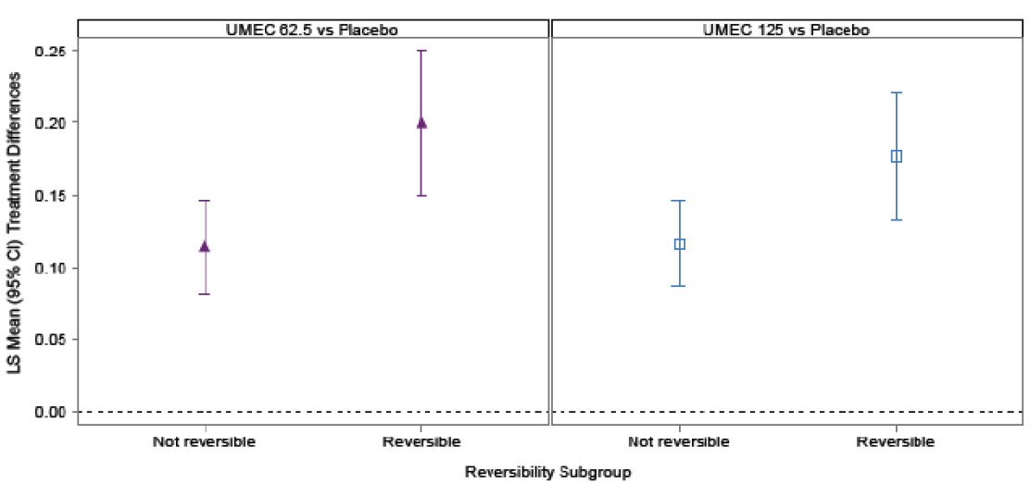
In the 24-Week Integration, the number of subjects in each subgroup showed similar distribution across treatment groups.
Interactions with treatment for gender (male/female) and age (≤ 64 versus ≥ 65 years) geographical region (US versus non-US) were not statistically significant for any of the primary and secondary efficacy endpoints of trough FEV1 at Day 169, 0 to 6 hour weighted mean FEV1 at Day 168, and TDI score at Day 168. The interactions of treatment with race (White versus non-White) were statistically significant for the primary efficacy endpoint of trough FEV1 at Day 169 and for 0 to 6 hour weighted mean FEV1 at Day 168. Both UMEC doses were generally better than placebo in all race subgroups for both endpoints and differences in treatment response between race subgroups were not considered clinically relevant. Interactions of treatment with race for TDI score at Day 168 were not statistically significant.
Interactions of treatment with the following factors were investigated for the primary efficacy endpoints only and were not statistically significant at Day 169: GOLD classification (I/II and III/IV) or smoking status (former or current). There was evidence for a treatment by treatment naïve status interaction and a treatment by ICS use interaction. Both UMEC doses were consistently better than placebo for each category within each subgroup; differences in magnitude of response between categories (greater response in non-ICS users and treatment-naïve subgroups) were not considered clinically relevant.
The interactions of treatment with reversibility to salbutamol and reversibility to salbutamol/ ipratropium were statistically significant for trough FEV1 at Day 169 and for 0 to 6 hour weighted mean FEV1 at Day 168. The response to UMEC in reversible subjects was greater than that in non-reversible subjects for both endpoints, but both UMEC doses were consistently better than placebo in both reversibility groups and the differences in the magnitude of treatment response between reversibility groups were not considered clinically relevant.

Evaluator’s conclusions
Evaluator’s conclusions on clinical efficacy for long term once daily maintenance bronchodilator treatment to relieve symptoms in adult patients with COPD:
- The efficacy of UMEC in COPD has been evaluated in an extensive clinical development program that was designed in accordance with regulatory guidance for the development of drugs for the treatment of COPD (EMA, 1999; FDA, 2007) and from advice received from Regulatory Authorities in the United States (US) and Europe. In order to support international registration activities for UMEC, these studies included endpoints for lung function (trough FEV1) and symptomatic measures (TDI) to meet expectations of regulatory agencies in the US and Europe, respectively.
- The primary evidence for the proposed dose of UMEC 62.5 µg for treatment of COPD is provided by the two Phase IIIa pivotal studies AC4115408 and DB2113373 involving a total of 1738 patients (approximately 85% had moderate to severe COPD severity) of whom 487 were treated with proposed dose of UMEC 62.5 µg (69 and 348 patients were treated with UMEC 125 µg and placebo, respectively). The study population in these pivotal Phase III studies was representative of the target patient population.
- The 12-week placebo-controlled study AC4115408 demonstrated that treatment with UMEC 62.5 µg and 125 µg resulted in statistically significant and clinically relevant improvements in the primary endpoint of trough FEV1 at Day 85 compared with placebo (placebo-subtracted mean change from baseline was 127 and 152 ml with UMEC 62.5 and UMEC 125 µg, respectively) which were comparable to treatment differences reported for other long-acting bronchodilators such as TIO, aclidinium, indacaterol, and salmeterol in COPD (Casaburi, 2000; Casaburi, 2002; Kerwin, 2011; Kerwin, 2012; Mahler, 1999). These findings for UMEC were consistent with statistically significant improvements in secondary and other efficacy measures related to lung function that included 0 to 6 hour weighted mean FEV1, serial FEV1 assessments obtained over 24 hours, serial and trough FVC, time to onset, and proportional analyses of FEV1. Improvements in lung function were numerically larger with the UMEC 125 µg dose compared with the 62.5 µg dose, but the study was not designed to compare the 2 doses of UMEC. The improvements in lung function were supported by reductions in dyspnoea as demonstrated by statistically significant and clinically relevant improvements (of ≥ 1 unit) of TDI focal scores with UMEC 62.5 and 125 µg once-daily as compared with placebo with at least twice the proportion of subjects treated with UMEC 62.5 (38%) and 125 µg (38%) once-daily achieving a TDI focal score of ≥ 1unit at Day 84 compared with placebo (15%). Reductions in average daily number of puffs/day of rescue salbutamol over Weeks 1 through 12 were observed for both doses, although only the reduction with the UMEC 62.5 µg once-daily dose was statistically significantly different from placebo. Treatment with UMEC (62.5 and 125 µg) was also shown to favourably impact health related quality of life. The improvements in lung function and symptomatic endpoints from day 1 which were maintained for the 12-week duration of this study.
- Following 24 weeks of treatment with proposed dose of once-daily UMEC 62.5 µg in pivotal study DB2113373, there were statistically significant and clinically relevant improvements compared with placebo in the primary efficacy endpoint (of trough FEV1), secondary endpoints (change in TDI dyspnoea score and 0 - 6 weighted mean FEV1), additional lung function parameters, health related QOL measures (SGRQ total scores and SGRQ responders). UMEC 62.5 µg was also associated with reduction in incidence of on-treatment COPD exacerbations compared with placebo. Serial spirometry obtained over 24 hours in a subgroup of subjects confirmed treatment with UMEC 62.5 µg alone resulted in improvements in FEV1 over 24 hours compared with placebo. Greater improvements in these measures were observed with UMEC/VI treatment compared with UMEC and VI alone. Use of rescue salbutamol did not show reduction with UMEC 62.5 µg compared with placebo. The median time to onset of action (post dose FEV1 ≥ 100 ml above baseline) was also significantly longer in the UMEC 62.5 µg group (56 mins) compared with UMEC/VI 62.5/25 µg (27 minutes) and VI25 µg (31 minutes) groups.
- The 3 placebo-controlled efficacy studies (AC4115408, DB2113373, and DB2113361) showed that both doses of UMEC (62.5 µg and 125 µg) produced significant improvements in lung function and other symptomatic endpoints and the results from the individual studies were supported by results of the 12-week and 24-week integrated efficacy analysis. Furthermore, results from the TIO-controlled study DB2113374 indicated that UMEC 125 µg and TIO provide similar improvements in lung function, symptoms, and health related quality of life. However, the proposed dose of UMEC 62.5 µg was not compared with TIO or any other LAMA in any of the clinical studies.
- The 12-week crossover exercise studies (DB2114417 and DB2114418) failed to demonstrate significant improvement in EET following treatment with UMEC 62.5 µg although interpretation may have been limited by smaller number of patients in the UMEC monotherapy treatment arms compared with the UMEC/VI treatment arms.
- The long-term efficacy of UMEC in the treatment of COPD has been demonstrated in three 24-week Efficacy Studies (DB2113361, DB2113373, and DB2113374) and in the 52-week placebo-controlled safety study DB2113359. A total of 2164 subjects contribute to the evaluation of long-term efficacy of UMEC; including 1602 subjects in the ITT population for the three 24-Week Efficacy Studies and 336 subjects in the ITT population of DB2113359. However, the proposed dose of UMEC 62.5 µg was only evaluated in studies DB2113361 and DB2113373. In the 24-Week Integration, treatment with UMEC 62.5 µg and UMEC 125 µg resulted in sustained improvements over placebo in lung function (as assessed by trough FEV1 and 0 to 6 hour weighted mean FEV1), dyspnoea (measured by TDI focal score), health-related quality of life (measured by SGRQ total scores) and a lower risk of COPD exacerbation over the 24-week treatment period with no evidence of tolerance. While the pivotal long-term safety study DB2113359 did not have any pre-specified efficacy endpoints, trough FEV1, rescue medication use and COPD exacerbations evaluated throughout the 52-week treatment period provides additional data supporting long-term efficacy of UMEC 125 µg; however, proposed dose of UMEC 62.5 µg was not evaluated in this study and so there is no evidence for efficacy or safety of UMEC 62.5 µg beyond 6 months.
- Subgroup analyses indicate that no modification of the proposed dose of 62.5 µg once-daily is required based on age, gender, race, or geographical region. There was evidence to suggest greater improvements in primary and secondary efficacy endpoints in the following subgroups of COPD patients- treatment-naïve, non-ICS user subgroups, reversibility to salbutamol and salbutamol/ ipratropium; however, these differences did not appear to be clinically relevant and did not justify changes in dosing recommendations.
- Both UMEC 62.5 µg and 125 µg were shown to be efficacious in the Phase IIIa studies, but only UMEC 62.5 µg is proposed for registration. Although numerically greater differences from placebo with UMEC 125 µg compared to UMEC 62.5 µg were noted in some studies in the efficacy endpoints related to lung function and rescue use at several time points, these differences were not observed consistently at each time point measured and tended to be modest. There was no statistical comparison of the UMEC 62.5 µg versus UMEC 125 µg in any of the studies. However, confidence intervals for these endpoint differences were often overlapping suggesting that there were no substantial clinical benefits with the UMEC 125 µg dose over the UMEC 62.5 µg dose. In the analyses of subgroups by, for example, gender, age, geographical region, GOLD stage, and ICS use, no subgroup appeared to benefit to a greater extent with 125 µg dose compared with the 62.5 µg dose. There was an indication that subjects reversible to salbutamol and reversible to salbutamol followed by ipratropium achieved slightly higher trough FEV1 values with UMEC 125 µg than with 62.5 µg, but the differences were generally small and not considered clinically relevant and were not shown consistently at every time point (i.e. not at Day 84 in the integrations). The data overall indicate that both doses were efficacious with no substantial clinically meaningful differentiation in efficacy between UMEC 62.5 µg and UMEC 125 µg.
- Overall, the data presented in this submission demonstrate that UMEC 62.5 µg once daily produces statistically significant and clinically relevant improvements in lung function and symptomatic endpoints in an adequate number of patients with moderate to severe COPD. The only limitations are that efficacy of UMEC 62.5 µg was not evaluated beyond 6 months of treatment, although a higher dose of 125 µg was shown to be well tolerated in the 52 week safety study. The other limitation was that there was no comparison between proposed dose of UMEC 62.5 µg and another LAMA such as TIO.
- The efficacy section of the proposed PI was not satisfactory with respect to some issues which have been discussed further in section 11 of this report.

Clinical safety

Studies providing evaluable safety data
The following studies provided evaluable safety data: 1 Phase III, 12-week UMEC efficacy and safety study (AC4115408); 3 Phase IIIa, 24-week efficacy and safety studies (DB2113361, DB2113373 and DB2113374); 1 Phase IIIa, long-term (52-week) safety study (DB2113359); 2 Phase IIIa, 12-week exercise studies (DB2114417 and DB2114418); 1 Phase IIb, 4-week UMEC dose-ranging study (AC4113589); 2 supportive studies: Phase IIb 14-day and 7-day UMEC dose-ranging studies (AC4113073 and AC4115321, respectively) (Table 10).

Table 10: Completed clinical studies in COPD subjects reported in the integrated safety summary.
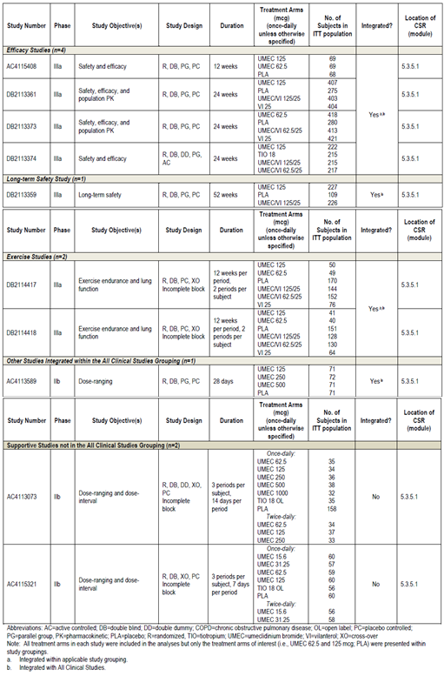
Safety assessments in the Phase II and Phase III development programs included reporting of AEs, evaluation of clinical laboratory tests (clinical chemistry and haematology), measurement of vital signs (blood pressure and heart rate), and ECG s (12-lead ECGs and Holter monitoring). Pre-specified adverse events of special interest (AESI) were defined as specified areas of safety assessment, which evaluated the pharmacologic class effects of anticholinergics/ muscarinic antagonists. AESI groups were cardiovascular, urinary retention, ocular effects, gallbladder disorders, intestinal obstruction, and anticholinergic effects. Pneumonia and lower respiratory tract infection (LRTI) were included due to its prevalence in patients with COPD. In addition, all Serious Adverse Events (SAEs) were adjudicated by an independent, blinded adjudication committee for 7 studies which contained an UMEC monotherapy treatment group in subjects with COPD treated for at least 12 weeks duration. Adjudicated CV deaths were included in the assessment of the major adverse cardiac event (MACE) analyses.
The text for AEs was coded using the Medical Dictionary for Regulatory Activities (MedDRA), and coded AEs were reported using the primary System Organ Class (SOC) and Preferred Term (PT).
For the purpose of integrating the safety data from the clinical development program, studies were grouped as indicated in Table 11 below.

Table 11. Groupings for clinical studies.
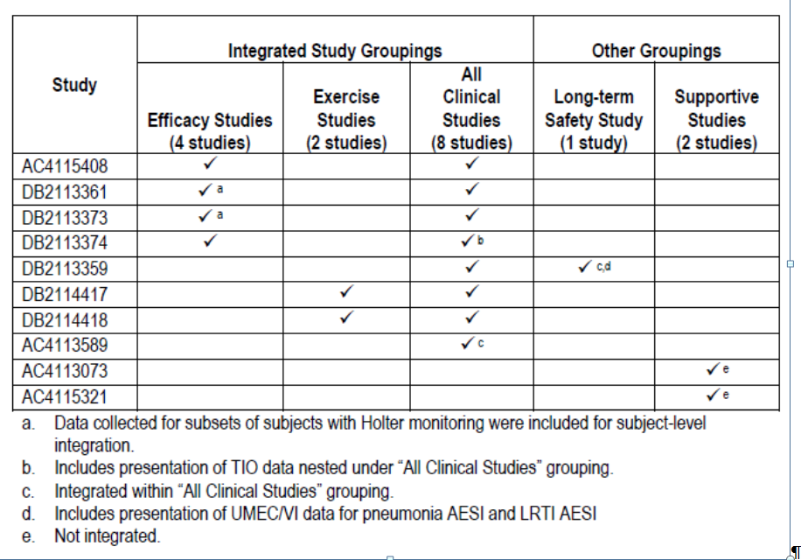
For each study grouping, only integrated data from UMEC monotherapy (62.5 and 125 µg) and placebo arms were summarised. For study DB2113374, data from the TIO and UMEC 125 µg groups will be presented separately, nested under the All Clinical Studies grouping.

Pivotal studies that assessed safety as a primary outcome
DB2113359 was a pivotal, long-term, 52-week study that assessed safety as a primary outcome. This study is not integrated in the Efficacy Studies grouping because of the difference in patient population and time-points of measurements.

Clinical pharmacology studies
The clinical pharmacology program consisted of 14 studies evaluating UMEC by IH, oral (PO), and/or intravenous (IV) administration. The safety data from these studies are summarized above; eight studies contribute key findings to the UMEC clinical safety profile: AEs of Special Interest Gallbladder Disorders: AC4106889, AC4113377; Ocular Effects: AC4113377; Safety in Studies of Intrinsic Factors; Hepatic Impairment: DB2114637; Renal Impairment: DB2114636; Safety in Studies Investigating Drug-Drug Interaction and genetic polymorphisms CYP2D6: AC4110106, P-glycoprotein: DB2113950; Cardiac Electrophysiology in healthy subjects Thorough QT: DB2114635.

Pivotal studies that assessed safety as a primary outcome

Study DB2113359

Study design, objectives, locations and dates
This was a Phase IIIa multicentre, randomized, double-blind, placebo-controlled, parallel-group study to evaluate the safety of UMEC 125 µg alone and in combination with VI 25 µg and placebo, all delivered via the NDPI for 52 weeks in subjects with COPD. The objective of this study was to evaluate the safety and tolerability of UMEC/VI inhalation powder 125/25 µg and UMEC Inhalation Powder 125 µg compared with placebo administered once-daily. The study was conducted from 27 Jan 2011 to 23 July 2012 at 53 centres in the United States (US), Chile, Romania, Russian Federation, Slovakia, and South Africa.

Inclusion and exclusion criteria
Males and females 40 years of age or older with a diagnosis of COPD and ≥ 10 pack years smoking history were enrolled. At Screening, eligible subjects had a post salbutamol FEV1/FVC ratio of < 0.70, a post salbutamol FEV1 of ≥ 35 and ≤ 80% of predicted normal values. Subjects with a current diagnosis of asthma, α1-antitrypsin deficiency, any clinically significant uncontrolled disease, a significant ECG or clinical laboratory finding, or a LRTI or recent COPD exacerbation were excluded. Concurrent use of systemic corticosteroids, long-acting bronchodilators, including theophyllines, was not allowed. Previous use of UMEC and/or VI was not allowed. Concurrent use of ICS at a stable dose was allowed.

Study treatments
Eligible subjects were randomized, using a 2:2:1 ratio, to UMEC/VI 125/25 µg, UMEC 125 µg, and placebo, respectively. All treatments were administered once-daily in the morning by inhalation using a NDPI. Subjects who met the eligibility criteria at Screening (Visit 1) completed a Run-in Period of approximately 7 to 10 days followed by a 52-week Treatment Period. Subjects who experienced a COPD exacerbation or LRTI during the Run-in Period or at Visit 2 were allowed to re-screen (Visit 1A) and repeat the Run-in Period. There was a total of 7 study visits. Clinic visits were at Screening (Visit 1), Randomization (Visit 2), and at 1 month, 3 months, 6 months, 9 months, and 12 months after starting blinded study drug (Visits 3 through Visit 7). A follow-up phone contact was conducted approximately 1 week after Visit 7 or the Early Withdrawal Visit, if applicable. The total duration of subject participation was approximately 54 weeks.
Concurrent use of inhaled corticosteroids (ICS) was permitted during the study with certain provisions. Subjects were provided with salbutamol via a metered-dose inhaler (MDI) for as-needed symptomatic relief during the Run-in and Treatment Periods. However, subjects were permitted to use salbutamol nebules and/or ipratropium bromide via MDI and/or nebules during the Run-in and Treatment Periods as rescue medication as long as the nebulized therapy did not violate pre-specified exclusion criteria. Additionally, COPD exacerbations could have been treated with short courses of systemic corticosteroids and/or antibiotics. Subjects who experienced a COPD exacerbation during the Treatment Period were permitted to continue in the study with certain provisions.
The planned duration of the double-blind treatment period was 52 weeks. The total numbers of subjects exposed to UMEC 125 µg was 227 compared with 109 for placebo. The median duration of exposure was the same in each treatment group, at 357 days. Exposure to study drug for at least 274 days was reported for 146 subjects in the UMEC 125 µg group.

Safety variables and outcomes
Spirometry assessments were conducted at Visit 1/1A (pre- and post-salbutamol) and predose (trough) at Visits 2 to 7 to obtain FEV1 and FVC. Vital signs and ECGs were collected prior to salbutamol dosing for spirometry at Visit 1 and predose and 10 minutes and 45 minutes post dose at Visits 2 to 7. An ECG was also performed at any Early Withdrawal Visit.
Safety endpoints included: Incidence of AEs; AEs of special interest (Table 12); Clinical chemistry and haematology parameters; Vital signs, 12-lead ECGs, and 2- hour Holter ECGs; Incidence of COPD exacerbations; Time to first COPD exacerbation; Supplemental use of salbutamol and/or ipratropium bromide; Percentage of rescue-free days; Trough FEV1 and FVC. There were no efficacy endpoints for this study. COPD exacerbations, rescue salbutamol and/or ipratropium use, trough FEV1, and trough FVC were measured as safety parameters in this long-term safety study.

Table 12: Study DB2113359. Adverse events of special interest.
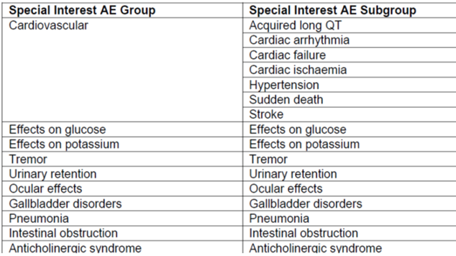

Randomisation and blinding methods
Eligible subjects were randomized, using a 2:2:1 ratio, to UMEC/VI 125/25 µg, UMEC 125 µg, and placebo, respectively. Subjects were randomized using RAMOS (Randomization and Medication Ordering System), an Interactive Voice Response System (IVRS). Study drug was double-blind. Neither the subjects nor the study site personnel knew the treatment assignments.

Analysis populations
The ITT population constituted the primary population for all data analyses and displays.

Sample size
The sample size was determined based on meeting International Conference on Harmonisation (ICH) guidelines (E1A) and based on practical considerations. Two hundred subjects were planned to be randomized to UMEC/VI 125/25 µg, 200 subjects were planned to be randomized to UMEC 125 µg, and 100 subjects were planned to be randomized to placebo, of which it was expected that at least 120 subjects in each active treatment group and 60 subjects in the placebo group would have exposure data for the full 52 weeks, assuming a maximum withdrawal rate of 40% during the 52-week treatment period.

Statistical methods
Safety endpoints were summarized using counts and percentages for categorical data and summary statistics for continuous data. Formal statistical analyses were performed on pulse rate, SBP & DBP, QT interval corrected for HR with Fridericia’s formula (QTc(F)), PR interval and heart rate at each post-treatment time point at which they were recorded, using an analysis of covariance (ANCOVA) with explanatory variables of treatment group, baseline, smoking status, and centre group. The mean number of puffs of rescue per day during each 4 weeks of treatment and over the 52-week Treatment Period was analysed using an ANCOVA with explanatory variables of treatment group, baseline, smoking status, and centre group. Trough FEV1 and FVC at Months 1, 3, 6, 9, and 12 were analysed separately using a mixed model repeated measures analysis with covariates of baseline, month, smoking status at screening, centre group, treatment, month by baseline interaction, and month by treatment interaction, where month is the nominal month of each visit. The model used all available values recorded at Months 1, 3, 6, 9, and 12. The following treatment comparisons were performed: UMEC/VI versus placebo; UMEC versus placebo.

Participant flow
Of the 893 enrolled subjects, 563 were randomised to treatment and 562 were included in the ITT population (placebo =109; UMEC 125 µg = 227; UMEC/VI 125/25 µg = 226). The majority of subjects in each treatment group completed the study (59%, 63% and 61% in UMEC 125, UMEC/VI 125/25 and placebo groups, respectively). A higher incidence of withdrawals due to protocol-defined stopping criteria was reported in the UMEC 125 and UMEC 125/25 treatment groups compared with placebo (16%, 16% and 7%, respectively), particularly for ECG (5%, 6% and 0%) and Holter abnormalities (11%, 12% and 7%). More subjects were withdrawn because of lack of efficacy in the placebo group (8%) compared with the UMEC 125 (1%) or UMEC/VI 125/25 (< 1%) treatment groups (Table 13).

Table 13: Study DB2113359 ITT population. Overall subject disposition.
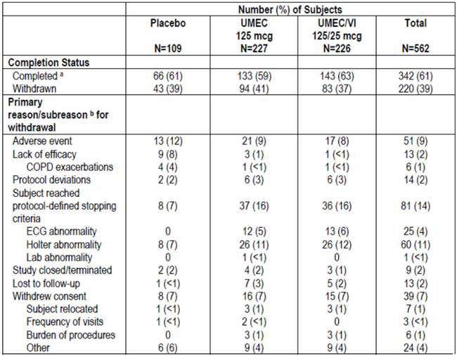

Major protocol violations/deviations
The majority of protocol deviations were due to compliance < 75% (13%, 8% and 11% in UMEC 125, UMEC/VI 125/25 and placebo groups, respectively) or use of prohibited medications (11%, 9% and 8%, respectively).

Baseline data
Demographic characteristics of subjects receiving UMEC 125 µg or placebo were generally similar across treatment groups. The majority of subjects were White (94 - 95%), male (64 - 67%), current smokers (63%); the mean age was 60 - 62 years and BMI was 28kg/m² indicating that subjects in both groups tended to be slightly overweight. COPD history was similar across the treatment groups. At Screening; 13%, 39%, 26%, and 23% of subjects had COPD diagnosed < 1 year, > 1 to < 5 years, ≥ 5 to < 10 years, and ≥ 10 years, respectively, prior to study entry. Nearly all subjects (> 99%) were GOLD Stage II or III. The proportions of subjects who showed reversibility after administration of salbutamol (32%, 35% and 33% in UMEC 125, UMEC/VI 125/25 and placebo groups, respectively) and who reported the use of ICS at Screening (32%, 35% and 37%) were broadly similar across treatment groups. The most commonly reported medical condition classes were CV risk factors (67%), cardiac disorders (34%), and musculoskeletal and connective tissue disorders (32%). The percentages of subjects reporting current medical conditions in the CV risk factors (64% to 68%) and cardiac disorders (33% to 35%) classes were similar across treatment groups. The majority of subjects (65% to 73% across treatment groups) reported use of a COPD medication not administered for an exacerbation taken pre-treatment (within 30 days prior to Screening and/or during the Run-in Period) with ICS used most commonly. COPD concomitant medications not administered for an exacerbation taken post-treatment were reported by 37% to 42% of subjects across treatment groups. Use of a concomitant on-treatment COPD medication given for an exacerbation was slightly higher in the placebo group (14%, 12% and 21% in UMEC 125, UMEC/VI 125/25 and placebo groups, respectively) and antibiotics were most commonly used. Majority of subjects, 69% to 77% across treatment groups, reported taking a non-COPD medication pre-treatment (antihypertensives and cholesterol-lowering agents most common). Mean treatment compliance was high across all treatment groups (≥ 98.6%).

Results

Adverse events
In the long-term safety study, at least one on-treatment AE was reported by slightly higher proportion of subjects in the UMEC 125 µg treatment group compared with placebo and UMEC/VI 125/25 groups (58%, 53% and 52% in UMEC 125, UMEC/VI 125/25 and placebo groups, respectively). Headache was the most commonly reported AE across all 3 treatment groups (11%, 9% and 8%). Among the AEs reported by at least 3% of subjects in any treatment group, headache, nasopharyngitis, cough, supraventricular tachycardia, supraventricular extra systoles, sinus tachycardia, and pneumonia each had an incidence in the UMEC 125 treatment group ≥ 2% higher than the incidence in the placebo group. The incidences of events reported by at least 3% of subjects in any treatment group among subjects in the UMEC/VI 125/25 treatment group were similar to or less than those reported for placebo with the exception of cough, which was reported in a slightly higher percentage of subjects in the UMEC/VI 125/25 treatment group (3%) compared with placebo (< 1%). Pneumonia was reported in the UMEC 125 treatment group (3%) but not in the UMEC 125/25 or placebo groups (Table 14 and 15).

Table 14. Study DB2113359 ITT Population. Summary of on treatment adverse events by system organ class.
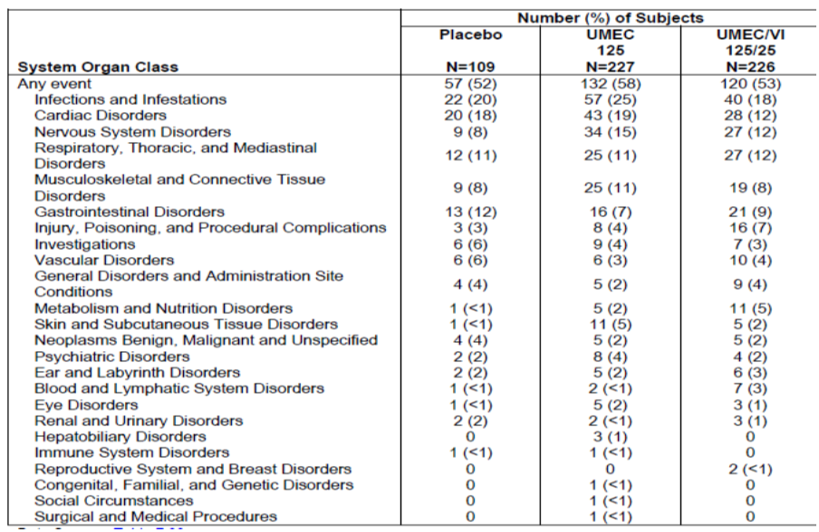

Table 15. Study DB2113359 ITT Population. Summary of on treatment adverse events reported by 3% or more of subjects within any treatment group.
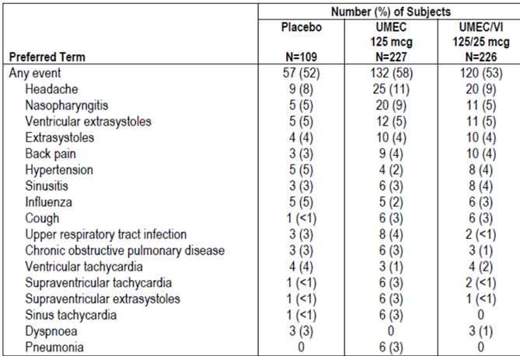
The incidence of drug-related AEs was similar across the treatment groups (12%, 12% and 13%, respectively). The incidences of individual drug-related AEs were similar for the UMEC 125 and placebo treatment groups except for SVT which was reported by 2% of subjects in the UMEC 125 treatment group and < 1% of subjects in the placebo group. The incidences of individual-drug related AEs has a similar or lower incidence for UMEC/VI 125/25 compared with placebo except for headache which was reported by 2% of subjects in the UMEC/VI 125/25 group and < 1% of subjects in the placebo group.

Deaths and SAEs:
Five deaths occurred during the study, 2 were classified as on-treatment (2 subjects (< 1%) in the UMEC 125 group (metastases to the spine and pneumonia)) and 3 were classified as post-treatment (2 subjects (< 1%) in the UMEC 125 group (cardiac failure acute and metastases to the liver) and 1 subject (< 1%) in the placebo group (coronary artery insufficiency)). None of the deaths were considered related to study drug by the reporting investigator. There were no deaths in the UMEC/VI 125/25 group.
The incidence of on-treatment SAEs was similar across treatment groups (7%, 6% and 6%. in UMEC 125, UMEC/VI 125/25 and placebo groups, respectively). The only SAEs reported by ≥ 1% of subjects in any treatment group were COPD (2%, < 1% and 3%, respectively) and pneumonia (1%, 0% and 0%). One subject in the UMEC 125 treatment group reported an SAE (rhythm idioventricular) that was assessed by the investigator as drug-related. The incidence of post-treatment SAEs was ≤ 1% in the UMEC 125 and placebo groups (0% in the UMEC/VI 125/25 treatment group).

Withdrawals due to AEs
The incidence of on-treatment AEs leading to permanent discontinuation of study drug or withdrawal was 9%, 8% and 11% in UMEC 125, UMEC/VI 125/25 and placebo groups, respectively. The UMEC 125 treatment group had a slightly higher incidence of AEs leading to withdrawal of ventricular extra systoles (2%), SVT (1%), and sinus tachycardia (1%) compared with placebo (all < 1%). The incidences of individual AEs leading to permanent discontinuation of study drug or withdrawal in the UMEC 125/25 treatment group were the same as or less than that reported for placebo.

AEs of special interest
No individual on-treatment AE in the AE of special interest groups was reported in more than 5% of subjects in any treatment group. The incidence of on-treatment AEs in the cardiovascular AE of special interest group was similar for UMEC 125 (22%) and placebo (23%) and lower for UMEC/VI 125/25 (15%). Individual events in this group of rhythm idioventricular (2%), sinus tachycardia (3%), supraventricular extra systoles (3%), and SVT (3%) were reported at a slightly higher incidence in the UMEC 125 treatment group compared with placebo (≥ 2% increase in incidence in the UMEC 125 treatment group compared with placebo). The incidence of these events was similar or lower for UMEC/VI 125/25 compared with placebo.
The incidence of effects of glucose AEs of special interest was slightly higher in the UMEC 125 group (< 1% (PT= hyperglycaemia) compared with placebo (0%). A higher incidence of events (4%) was reported in the UMEC/VI 125/25 group. The PTs reported in the UMEC 125/25 group were blood glucose abnormal (< 1%, diabetes mellitus (1%), hyperglycaemia (< 1%), obesity (< 1%) and weight decreased (< 1%)).
A higher incidence of events was reported in the pneumonia AE of special interest group for the UMEC 125 group (5%) compared with placebo (2%). Bronchitis (< 1%), lower respiratory tract infection (1%), pneumonia (3%), pneumonitis (< 1%), and bronchitis viral (< 1%) were reported in the UMEC 125 treatment group. Bronchitis (2%) and tracheitis (< 1%) were reported in the placebo group. The overall incidence in the UMEC/VI 125/25 (2%) was the same as the placebo group. Each of the events in the UMEC 125/25 treatment group were reported in < 1% of subjects (bronchitis, lobar pneumonia, LRTI, sinobronchitis, and bronchitis viral).

Clinical laboratory values
Mean absolute values were generally similar across treatment groups at Screening, baseline, and Months 3, 6, 9, and 12 for all clinical chemistry and haematology parameters. There was little mean change from baseline for any clinical chemistry or haematology parameter in any treatment group. There was no indication of a treatment-related effect on clinical chemistry parameters based on the proportion of subjects with values outside the normal range at any post-baseline assessment. The proportion of subjects reporting changes from a normal baseline value to a value higher or lower than the normal range at any post-baseline assessment was similar across treatment groups for clinical chemistry and haematology parameters with the exception of creatinine kinase (CK). Although there were some increases in the proportions of subjects in the UMEC 125 and UMEC/VI 125/25 treatment groups compared with placebo for shifts in CK to high at ‘any time’ post-baseline (UMEC 125: 11%; UMEC/VI 125/25: 12%; placebo: 6%), no AEs of CK elevations were reported in the study. No subjects were withdrawn due to meeting the liver chemistry stopping criteria.

Vital signs, ECG findings
Overall, mean changes from baseline for SBP, DBP and pulse rate were similar across treatment groups over the treatment period with no clinically relevant differences between treatment groups.
Comparisons of the UMEC 125 and UMEC/VI 125/25 treatment groups with placebo occasionally demonstrated 95% CIs that excluded zero for QTc(F), PR interval, or HR; however, LS mean changes from baseline were generally small across treatment groups at all visits and there was no evidence of a treatment-related effect. Few subjects reported QTc(F) values > 450 to ≤ 480 msec and the proportions were similar across treatment groups (9%,10% and 8% in UMEC 125, UMEC/VI 125/25 and placebo groups, respectively). QTc(F) values > 480 msec were not reported for any UMEC 125 or UMEC/VI 125/25 subjects. The majority of changes from baseline in QTc(F) were > 0 to < 30 msec (71 - 78% across treatment groups).
The proportion of subjects with one or more abnormal, clinically significant ECG interpretation at ‘any time’ post-baseline was similar across treatment groups (26%, 24% and 23%). The ECG abnormality reported in the largest proportion of subjects at baseline was ST depression (4%, 4%; and 6%). The ‘any time’ post-baseline abnormalities which were reported at an increased incidence (≥ 2% higher) in the UMEC 125 treatment group compared with placebo were frequent ventricular depolarization (VPD) ≥ 3, ectopic supraventricular beats, and first degree AV block (PR interval > 200 msec). The ‘any time’ post-baseline abnormalities which were reported at an increased incidence (≥ 2% higher) in the UMEC/VI 125/25 treatment group compared with placebo were frequent ventricular depolarization (VPD) ≥ 3, ectopic supraventricular beats, and right bundle branch block with QTc(F) < 530. Overall, 4% of subjects were reported as withdrawn from the study due to protocol-defined ECG stopping criteria (0 subjects in the placebo group, 5% of subjects in the UMEC 125 group, and 6% of subjects in the UMEC/VI 125/25 group).

Holter ECG findings
Overall, 11% of subjects were reported as withdrawn from the study due to protocol-defined Holter stopping criteria (11%, 12% and 7% in UMEC 125, UMEC/VI 125/25 and placebo groups, respectively). The Holter ECG abnormalities reported in the largest proportions of subjects at Screening were bigeminy (17%, 19% and 17%), and ventricular couplets (15%, 14% and 17%). Ectopic supraventricular beats was reported at Screening for 2% and 1% of subjects in the UMEC 125 and UMEC/VI 125/25 treatment groups, respectively, compared with no subjects in the placebo group. At ‘any time’ post-randomization, bigeminy (30%, 36% and 28%) and ventricular couplets (27%, 30% and 36%) were reported for the largest proportion of subjects with Holter ECGs reported as clinically significant across all treatment groups. The ‘any time’ post-randomization abnormalities reported at an increased incidence (by ≥ 2%) in the UMEC 125 treatment group compared with placebo were bigeminy, premature ventricular complex > 1000/24hr, ectopic supraventricular beats, sustained supraventricular tachycardia (> 100 beats/minute, > 30 beats), right bundle branch block, idioventricular rhythm (≤ 100 bpm, defined by wide QRS complex), ectopic supraventricular rhythm, T wave inversion, first degree AV block, and sinus pause ≥ 2 seconds. The ‘any time’ post-randomization abnormalities reported at an increased incidence (by ≥ 2%) in the UMEC 125/25 treatment group compared with placebo were bigeminy, premature ventricular complex > 1000/24hr, right bundle branch block, and premature ventriculation complex > 4000 in 24 hr period.

COPD exacerbations
The proportion of subjects reporting at least one on-treatment COPD exacerbation was higher in the placebo group (24%) compared with the UMEC 125 (15%) or UMEC/VI 125/25 (13%) treatment groups. Four subjects reported a post-treatment COPD exacerbation (2 (2%) in the placebo group and 1 (< 1%) each in the UMEC 125 and UMEC/VI 125/25 treatment groups. Analysis of time to first COPD exacerbation indicated that treatment with UMEC 125 resulted in a lower risk of COPD exacerbation compared with placebo (hazard ratio (HR) 0.6; CI: 0.3, 1.0, risk reduction 40%). Treatment with UMEC 125/25 also resulted in a lower risk of COPD exacerbation compared with placebo (HR 0.4, CI: 0.3, 0.8, risk reduction 60%).

Rescue salbutamol and/or ipratropium use
Greater differences from baseline in the mean number of puffs of rescue medication per day over Weeks 1 to 52 were reported for subjects in both the UMEC 125 (-4.0 puffs/day; 95% CI: -0.9,0.1) and UMEC/VI 125/25 (-1.0 puffs/day; 95% CI: (-1.4,-0.5) treatment groups compared with placebo. The percentages of rescue-free days at baseline were 27.3, 25.8, and 24.6 for UMEC 125, UMEC/VI 125/25, and placebo, respectively. The mean change from baseline in the percentage of rescue-free days over Weeks 1 to 52 was largest for the UMEC/VI 125/25 treatment group (13.1%, 23.2% and 11.1%, respectively).
Trough FEV1 and FVC at Months 6 and 12: The UMEC 125 and UMEC/VI 125/25 treatment groups demonstrated greater LS mean changes from baseline in trough FEV1 compared with placebo at 6 months (UMEC 125: 0.160 L, 95% CI: 0.083, 0.236; UMEC/VI 125/25: 0.197 L, 95% CI: 0.121, 0.272) and 12 months (UMEC 125: 0.178 L; 95% CI: 0.098, 0.258; UMEC/VI 125/25: 0.231 L; 95% CI: 0.153, 0.310). Trough FVC results supported the trough FEV1 results.

Other results
A total of 9 subjects reported potential investigational product inhaler malfunctions during the course of this study. There were no pregnancies during the study.
Comment: Treatment with UMEC/VI 125/25 and UMEC 125 was safe and well tolerated over a 12-month treatment period with no notable, clinically meaningful treatment-related changes in vital signs and clinical laboratory parameters as compared with placebo. Like other muscarinic antagonists, UMEC 125 was associated with a higher incidence of atrial arrhythmias including ectopic supraventricular beats and short runs of supraventricular tachycardia than placebo, but these events were not associated with AE reports of clinically relevant symptoms. These atrial arrhythmias were observed at similar incidence for the UMEC 125/25 and placebo groups. This long term pivotal safety study did not evaluate the proposed dose of UMEC 62.5 µg.

Patient exposure
A total of 2706 subjects with COPD were treated with at least 1 dose of study medication in the 8 studies comprising the All Clinical Studies Grouping. A total of 1663 subjects received UMEC (62.5 µg or 125 µg), representing approximately 656 subject years of exposure; 1124 subjects received placebo.
In the ‘Efficacy studies’ safety dataset, the planned duration of treatment was 24 weeks (168 days) for DB2113361, DB2113373 and DB2113374 and 12 weeks (84 days) for AC4115408. The total numbers of subjects exposed to UMEC 62.5 µg and UMEC 125 µg were 487 and 698 respectively, compared with 623 for placebo. Median exposure duration in each treatment group was either 166 or 167 days (mean: 129 to 137 days).
The planned duration of treatment for the Exercise Studies was 12 weeks (84 days). Overall, 89, 91 and 321 subjects were exposed to UMEC 62.5 µg, UMEC 125 µg and placebo, respectively. Median exposure duration in each UMEC treatment group was 85 days.
The number of subjects in All Clinical Studies ITT population exposed to UMEC 62.5 µg and UMEC 125 µg was 576 and 1087 respectively, compared with 1124 for placebo. Median exposure of duration was 165, 166 and 88 days in the UMEC 62.5 µg (UMEC 125 µg) and placebo, respectively.
A total of 1808 subjects were randomized to UMEC or placebo and included in the ITT population for the Efficacy Studies and majority of subjects completed the study (79%, 76% and 70% for UMEC 62.5 µg, 125 µg and placebo groups respectively). Overall, the most common primary reasons for withdrawal were AEs (7%, 6% and 4%, respectively) and lack of efficacy (5%, 9% and 14%, respectively). Lack of efficacy due to COPD exacerbation was reported for fewer UMEC-treated patients (5%, 7% and 11%, respectively). In study DB2113374, the majority of subjects in each treatment group completed the study (74% of subjects on UMEC 125 µg compared with 82% on TIO), and the percentage of subjects who withdrew and the reasons for withdrawal from the study were generally similar across the 2 treatment groups. Overall, the most common reason for withdrawal was lack of efficacy (10% for UMEC 125 µg compared with 6% for TIO), followed by AEs (8% for UMEC 125 µg and 5% for TIO. Withdrawal due to COPD exacerbation was reported for 9% of subjects on UMEC 125 µg and 5% of subjects on TIO.
A total of 2706 subjects received UMEC 62.5g, UMEC 125µg and/or placebo and were included in the ITT population for the All Clinical Studies grouping with the majority of subjects in each treatment group completing the study (81%, 74% and 74% in UMEC 62.5µg, UMEC 125µg and placebo groups, respectively). Overall, the primary reasons for withdrawal were AEs (7%, 6% and 5%) and lack of efficacy (5%, 7% and 11%). Lack of efficacy due to COPD exacerbation was reported for 4%, 5% and 8%, respectively.
Demographic and baseline disease characteristics of subjects receiving UMEC or placebo in the Efficacy Studies were generally similar across all treatment groups. The majority of subjects were White (85%) and male (67%); the mean age was 63.2 years (median of 63 years). The mean BMI of 26.6 kg/m² indicated that subjects tended to be slightly overweight. Overall, 8%, 37%, 31%, and 24% of subjects had COPD diagnosed < 1 year, ≥ 1 to < 5 years, ≥ 5 to < 10 years and ≥ 10 years, respectively, prior to study entry; the majority of subjects across UMEC treatment groups and placebo reported no COPD exacerbations requiring oral or systemic corticosteroids and/or antibiotics (72%, 75% and 74%) and no COPD exacerbations requiring hospitalization (89%, 94% and 91%). Subjects receiving UMEC or placebo in the Efficacy Studies also had extensive smoking histories at Screening across all treatment groups (mean of 46 pack-years smoked over a mean of 39 years smoked) and 51% of subjects were classified as current smokers at screening (including subjects who stopped smoking within 6 months prior to Screening). Most subjects (80%) reported medical conditions in addition to their COPD and the most common current medical conditions reported overall were CV risk factors (58%), musculoskeletal and connective tissue disorders (33%), and cardiac disorders (20%). Demographic characteristics of subjects in the All Clinical Studies grouping were generally similar to the demographics of subjects in the Efficacy Studies.

Adverse events

All adverse events (irrespective of relationship to study treatment)

Pivotal studies
In the Efficacy Studies, the incidence of any on-treatment AEs reported for the UMEC 62.5 µg and UMEC 125 µg treatment groups was 50% and 54% respectively, compared with 46% for placebo. There were no noteworthy differences in the incidence of AEs (by PT) reported by ≥ 3% of subjects between the UMEC and placebo treatment groups (Table 16). The most frequently reported AEs were headache and nasopharyngitis, with incidences across both treatment groups and placebo ranging from 8% to 10% and 7% to 9%, respectively. The incidence of cough was comparable across treatment groups (3% to 5%). Dot-plots for the on-treatment AEs reported by ≥ 3% of subjects on any treatment group in the Efficacy Studies showed a hazard ratio > 1 for hypertension associated with UMEC 62.5 µg and 125 µg. Cough, upper respiratory tract infection (URTI), hypertension, arthralgia, contusion and viral URTI were the only on-treatment AEs reported by > 1% of subjects in any UMEC group and having an incidence in any UMEC group > 1% over the placebo incidence (Table 17). Among the AEs reported in the UMEC treatment groups with an incidence of <1% but at an incidence greater than that in the placebo group, atrial fibrillation and tachycardia were considered to be clinically important.

Table 16. Summary of the most frequent on treatment adverse events reported by 3% or more of subjects within any treatment group (efficacy studies integration ITT population).
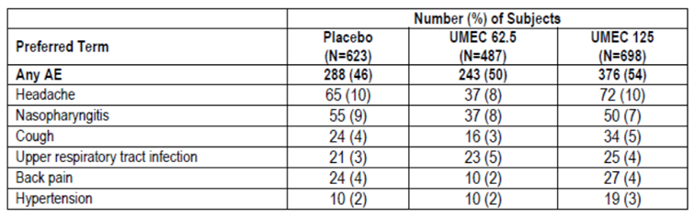

Table 17. Summary of on treatment adverse events reported by more than 1% of subjects on any UMEC group and having > 1% incidence over placebo incidence (efficacy studies integration ITT population).
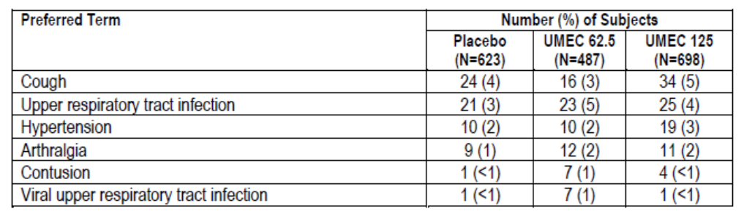

Other studies
In the Exercise Studies, the incidence of on-treatment AEs was higher on UMEC 125 µg treatment (40%) compared with UMEC 62.5 µg (20%) and placebo (33%) treatment. The incidence of on treatment AEs (by PT) reported by ≥ 3% of subjects were similar for UMEC 125 µg and placebo and lower for UMEC 62.5 µg, with the exception of nasopharyngitis. The most frequently reported AEs were nasopharyngitis and headache, with incidences across the UMEC treatments and placebo ranging from 5% to 6% and 1% to 5%.
For the All Clinical Studies grouping, the AE profile was consistent with the Efficacy Studies with the exception of < 3% of subjects reporting the AE of hypertension on any treatment. No noteworthy differences in the incidence of AEs (by PT) that were reported by ≥ 3% of subjects in any treatment group were observed between the UMEC treatment groups and placebo. The most frequently reported AEs were headache (7 to 10%) and nasopharyngitis (7%). The exposure-adjusted frequency of subjects with any on-treatment AEs also showed no noteworthy differences between the UMEC treatment groups and placebo. In study DB2113374, the most common AEs were headache (UMEC 125 µg versus TIO: 11% versus 7%), nasophyarngitis (3% versus 8%) and cough (6% versus 3%).

Treatment related adverse events (adverse drug reactions)

Pivotal studies
In the Efficacy Studies, the incidence of at least one on-treatment drug-related AE was reported for 7% of subjects in the UMEC 62.5 µg treatment group and 9% of subjects in the UMEC 125 µg treatment group compared with 5% in placebo. The PT of cough was the most frequently reported on-treatment drug-related AE with an incidence of 1% in UMEC 125 µg and < 1% in UMEC 62.5 µg and placebo. The incidence of the on-treatment drug-related AE of dry mouth was low (< 1%) across the treatment groups and < 1% for placebo. No individual on-treatment drug-related AE (by PT) was reported in ≥ 3% of subjects in any treatment group.

Other studies
In the exercise studies, the incidences of drug-related AEs were the same (4%) for UMEC 125 µg and placebo, with no drug-related events reported for UMEC 62.5 µg. No individual on treatment drug related AE (by PT) was reported in ≥ 3% of subjects for any treatment.
In the All Clinical Studies group, the incidence of at least one on-treatment, drug-related AE was reported for 6% of subjects in UMEC 62.5 µg and 9% of subjects in UMEC 125 µg compared with 6% in placebo. No individual on-treatment drug-related AE (by PT) was reported in ≥ 3% of subjects in any treatment group. Cough was the most frequently reported on-treatment drug related AE; reporting an incidence of 1% in the UMEC 125 µg treatment group compared with < 1% in the UMEC 62.5 µg and placebo groups. Drug-related dry mouth was reported for < 1% of subjects in UMEC 125 µg and placebo and no events were reported in the UMEC 62.5 µg group.

Deaths and other serious adverse events

Pivotal studies
A total of 11 on-treatment or post-treatment fatal AE terms were reported among 7 subjects receiving UMEC or placebo in the Efficacy Studies grouping. The incidence of any fatal AE was < 1% across the UMEC treatment groups and placebo. Several fatal cases were associated with more than one fatal AE term. No deaths were considered related to study drug. The exposure-adjusted frequency was 16 subjects and 8 subjects with an event per 1000 subject-years in the UMEC 62.5 µg and 125 µg groups respectively, compared to 9 subjects with an event per 1000 subject-years for placebo. A post-hoc summary of fatal AEs was performed by combining the two UMEC treatment groups. The incidence of any fatal AE was < 1% in the combined UMEC and placebo groups corresponding to an exposure-adjusted frequency of 9 and 11 subjects with an event per 1000 subject-years of exposure for placebo and the combined UMEC group, respectively.
All serious adverse report narratives, including deaths and hospitalizations, were adjudicated by an external independent, blinded adjudication committee for Phase IIIa studies in subjects with COPD treated with UMEC or placebo for at least 12 weeks. The adjudication was carried out on the case/report as a whole; thus, the case was adjudicated on the primary event (i.e., the event of the greatest medical significance, such as death, or hospitalization, or other reason for seriousness), not every event comprising a particular case. For all fatal SAEs, the adjudication committee members were asked to indicate the primary cause of death and further select a subcategory corresponding to the primary cause. In addition, the committee members were asked if the death was associated with the patients’ known COPD. A total of 8 on-treatment or post-treatment fatal AEs were adjudicated in the Efficacy Studies, which included one post-treatment fatal AE of lymph node pain in the placebo group of DB2113373 reported after study closure.
The incidence of any on-treatment SAE was slightly higher in the UMEC groups (6%) compared with placebo (4%), The only SAE reported by 1% or more of subjects in any treatment group was COPD, reported for 1% of subjects on UMEC 125 µg and 2% of subjects in the UMEC 62.5 µg and placebo groups. The exposure-adjusted frequency of subjects with on-treatment SAEs was 153 subjects and 149 subjects with an event per 1000 subject-years of exposure in the in the UMEC 62.5 µg and UMEC 125 µg groups, respectively, compared with 123 subjects with an event per 1000 subject-years of exposure in the placebo group. The incidence of on-treatment drug-related SAEs was < 1% in each UMEC treatment group compared with 0% for the placebo group. A total of 3 on-treatment drug-related SAEs were reported. Two SAEs (1 event of atrial fibrillation in the UMEC 125 µg group and 1 event of tachycardia in the UMEC 62.5 µg group) were reported within the cardiac disorders SOC. One event of chest pain was reported in the UMEC 125 µg group within the general disorders and administrative site conditions SOC. For all non-fatal SAEs, the adjudication included classification of the primary SAE according to the categories and subcategories provided in Table 18). The incidence of CV SAEs was slightly higher in the UMEC 125 µg group (2%) compared with UMEC 62.5 µg and placebo (<1% each). Incidence of COPD exacerbation with evidence of pneumonia was <1% in all 3 treatment groups while that of COPD without evidence of pneumonia was slightly higher in the UMEC 62.5 µg group (2%, <1% and 1% in the UMEC 62.5, 125 µg and placebo groups, respectively). Incidence of all other SAEs was low and similar across treatment groups (Table 19).

Table 18. Categories for assignment of primary non-fatal serious adverse event reports.
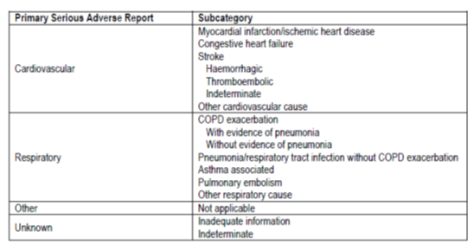

Table 19. Adjudicated non-fatal serious adverse reports (efficacy studies integration ITT population).
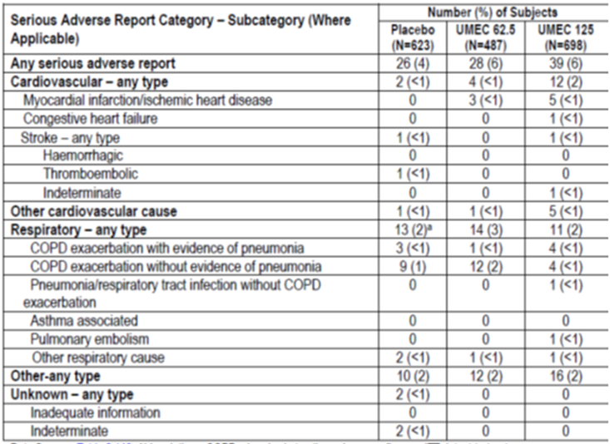

Other studies
A total of 14 deaths were reported on UMEC or placebo in the All Clinical Studies grouping. One death was reported after study closure (63 days after the last dose) for a subject in the placebo group of DB2113373. In addition, 2 deaths were reported in the TIO group from study DB2113374 (no deaths in the UMEC 125 µg group). None of the fatal AEs were reported by the investigator to be related to treatment. The exposure-adjusted frequency of subjects with fatal AEs was 15, 15 and 8 subjects per 1000 years of exposure in the UMEC 62.5 µg, UMEC 125 µg and placebo groups, respectively.
For the All Clinical Studies group, the incidence of at least one on-treatment SAE was reported for 5%, 6% and 4% in the UMEC 62.5 µg, UMEC 125 µg and placebo groups, respectively. The only SAE reported by at least 1% of subjects in any treatment group was COPD (2%, 1% and 1% in UMEC 62.5, UMEC 125 µg and placebo groups, respectively). The exposure-adjusted frequency of subjects with on-treatment SAEs was 143, 134 and 118 subjects with an event per 1000 subject-years of exposure, respectively. A total of 5 on treatment drug-related SAEs were reported among 4 subjects receiving UMEC in the All Clinical Studies grouping (< 1% for the UMEC groups compared with 0% for the placebo group). Of the 5 SAEs reported, 4 events were reported in the cardiac disorders SOC: 1 event each of atrial fibrillation, rhythm idioventricular and ventricular extra systoles was reported in the UMEC 125 µg group and 1 event of tachycardia in the UMEC 62.5 µg group.
In the Exercise studies, only 1 death was reported and the incidences of on-treatment SAEs were lowest on UMEC 62.5 µg treatment (1%) and similar for UMEC 125 µg (4%) and placebo (3%). No post-treatment SAEs were reported for subjects on UMEC treatments compared with 2 subjects (< 1%) on placebo. No drug-related SAEs were reported for subjects on UMEC treatments or placebo. One fatal AE (1%), which was classified as on-treatment, was reported in the UMEC 125 µg group. The SAEs with the highest incidences were bronchitis and COPD, each reported by two subjects (< 1%) on placebo and no subjects on UMEC. No other SAEs were reported for more than one subject on UMEC or placebo. The exposure-adjusted frequency of subjects with on-treatment SAEs was 50, 207 and 146 subjects with an event per 1000 subject-years in the UMEC 62.5 µg, UMEC 125 µg and placebo groups respectively. In the Exercise Studies, the “other” causes (i.e., not of a cardiovascular or respiratory nature) category had the highest incidence of non-fatal serious adverse reports: 3% on UMEC 125 µg, 2% on placebo and no reports categorized as “other” on UMEC 62.5 µg. Non-fatal serious adverse reports were assigned to respiratory causes in 1% of subjects on UMEC 62.5 µg and placebo. There were no serious adverse reports categorized as cardiovascular in nature for either of the UMEC treatments, compared with <1% for placebo.
No deaths occurred in the Other Supportive Studies or in the Clinical Pharmacology Studies.

Discontinuations due to adverse events

Pivotal studies
AEs leading to permanent discontinuation or withdrawal were reported at a slightly higher incidence for UMEC 62.5 µg (7%) and UMEC 125 µg (6%) compared with placebo (4%).The only AE leading to permanent discontinuation or withdrawal of ≥ 1% of subjects in any treatment group was COPD (2%, 1% and 2% in UMEC 62.5, UMEC 125 µg and placebo groups, respectively).

Other studies
In the Exercise studies, the incidences of AEs leading to withdrawal were slightly lower for subjects on UMEC treatment compared with placebo (2%, 3% and 5% in UMEC 62.5, UMEC 125 µg and placebo groups, respectively). AEs leading to permanent discontinuation or withdrawal of ≥ 1% of subjects were pulmonary embolism, pneumonia and deep vein thrombosis (each in 1 subject, 1%) on UMEC 62.5 µg; death, dyspnoea and malignant lung neoplasm (each in 1 subject, 1%) on UMEC 125 µg, and dyspnoea in 5 subjects (2%) on placebo.
For the All Clinical Studies group, the incidence of at least one on-treatment AE leading to permanent discontinuation of study drug or withdrawal from a study was similar across treatment groups (6%, 6% and 5% in UMEC 62.5, UMEC 125 µg and placebo groups, respectively). The only on-treatment AE leading to permanent discontinuation or withdrawal of ≥ 1% of subjects in any treatment group was COPD (2%, < 1% and 2%, respectively). In DB2113374, AEs leading to permanent discontinuation of study drug or withdrawal from the study were reported by 5% of subjects in the TIO group compared with 8% of subjects in the UMEC 125 µg group (pneumonia most common; TIO=1%, UMEC 125=2%).

Laboratory tests

Liver function

Pivotal studies
One subject in the UMEC 62.5 µg group and 1 subject in the UMEC 125 µg group of studies DB2113373 and DB2113374, respectively, were reported by the investigator as having liver events that exceeded the a priori stopping criteria; both subjects were withdrawn from the studies and both events were considered not related to study treatment. Few AEs relating to liver chemistry were reported and all had incidences < 1%. There were no apparent treatment- or dose-related effects on liver chemistry.

Other studies
No AEs of abnormal liver chemistry were reported in the two exercise studies. For the All Clinical Studies grouping overall, the AEs related to liver chemistry abnormalities were distributed across all treatment groups including placebo and had incidences < 1%. All AEs were reported for ≤ 3 subjects in each treatment group. In study DB2113374, 2 subjects, 1 subject in the UMEC 125 µg group (discussed above) and 1 subject in the TIO group, were reported by the investigator as having liver events that exceeded the a priori stopping criteria.

Kidney function

Pivotal studies
There were no significant changes in renal function laboratory parameters in the Efficacy studies dataset.

Other studies
The other clinical studies also did not show any trends suggesting statistically significant or clinically relevant changes in renal function laboratory parameters.

Other clinical chemistry

Pivotal studies
In the ‘Efficacy studies’, majority of subjects (≥ 82%) had values within the normal range or had no change from baseline with respect to the normal range at each time point post-baseline. Analytes for subjects with the highest incidence of shifts to high or low relative to the normal range at ‘any time’ point post-baseline were bicarbonate (to low), creatinine (to low), and glucose (to high); however, the percentages of subjects with abnormal values were low (≤ 14%) in any treatment group) and similar across all treatment groups. There were no apparent treatment-related differences in the percentage of subjects with shifts between baseline and ‘any time’ post-baseline relative to the normal range for clinical chemistry. Overall, the pattern of shifts for clinical chemistry values for UMEC was similar to placebo.

Other studies
In the Exercise studies, notable analytes for subjects with the highest incidence of shifts to high or low relative to the normal range at ‘any time’ point post baseline (≤ 10% for any treatment) were chloride, glucose and creatinine kinase (all to high) and bicarbonate (to low).
Clinical laboratory data were not integrated for the 8 studies (All Clinical studies safety dataset). In study DB2113374, there were no apparent differences across UMEC 125 µg and TIO treatment groups in the percentage of subjects with shifts between baseline and ‘any time’ post-baseline assessment relative to the normal range for clinical chemistry parameters. The other supportive studies did not show any trends of clinical concern in clinical chemistry, and urinalysis for any of the doses of UMEC tested.

Haematology

Pivotal studies
In the Efficacy Studies, majority of subjects (≥ 85%) had values within the normal range or had no change from baseline with respect to the normal range at each time point post-baseline. Analytes for subjects with the highest incidence of shifts to high or low relative to the normal range at ‘any time’ point post-baseline were eosinophils; GI/L (to low), lymphocytes (to low), and segmented neutrophils (to high); however, the percentages of subjects with abnormal values were generally low (≤ 12%) and similar across all treatment groups. There were no apparent treatment-related differences in the percentage of subjects with shifts between baseline and ‘any time’ post-baseline relative to the normal range for haematology. Overall, the pattern of shifts for haematology values for UMEC was similar to placebo.

Other studies
In the Exercise studies, notable analytes for subjects with the highest incidence of shifts to high or low relative to the normal range at ‘any time’ point post-baseline were segmented neutrophils and total neutrophils (both to high; however, the percentages of subjects with abnormal values were low (≤ 8%) and the pattern of shifts for haematology values for UMEC was similar to placebo treatment.
Clinical laboratory data for haematology were not integrated for the 8 studies (All Clinical studies safety dataset). In study DB2113374, there were no apparent differences across UMEC 125 µg and TIO treatment groups in the percentage of subjects with shifts between baseline and ‘any time’ post-baseline assessment relative to the normal range for haematology parameters. The other supportive studies did not show any trends of clinical concern in haematology for any of the doses of UMEC tested.

Electrocardiograph

Pivotal studies
In the Efficacy studies dataset, maximum post-baseline mean changes from baseline in ECG parameters were similar across treatment groups including placebo. Comparisons of the UMEC treatment groups with placebo failed to show p values of < 0.05 for differences in QTc(F) values at 10 and 45 minutes post-dose; the LS mean changes were small (≤ -3.8 milliseconds), not considered clinically relevant, and were similar across treatment groups at ‘all time’ points. Most subjects (≥ 93%) reported maximum post-baseline QTc(F) values < 450 milliseconds. No subjects reported a maximum post-baseline QTc(F) value > 500 msecs. The majority of changes from baseline to maximum post-baseline (76% to 78%) were within the range of ≥ 0 to < 30 milliseconds across all treatment groups including placebo. Similar results were observed for analysis of the PR interval. Comparisons of the UMEC treatment groups with placebo were occasionally shown to have p-values of < 0.05 for differences in heart rates at pre dose and 10 and 45 minutes post-dose; however, LS mean changes from baseline were small (≤ -7.0 bpm), not considered clinically relevant, and were similar across treatment groups at ‘all time’ points.
Most subjects had normal ECG results at baseline (UMEC 62.5 µg: 56%; UMEC 125 µg: 58%; and placebo: 57%). Abnormal, clinically significant ECG results at baseline were reported by 10%, 12% and 15% of subjects on UMEC 62.5 µg, UMEC 125 µg and placebo, respectively. The proportion of subjects with 1 or more abnormal, clinically significant ECG result at ‘any time’ post-baseline was similar across the UMEC treatment groups (18% for both UMEC treatment groups) compared with 22% for placebo. There was no noteworthy difference in overall reports of abnormal, clinically significant ECG interpretations between the UMEC treatment groups and placebo.
Atrial arrhythmias occurred at a low incidence in the Efficacy Studies (< 1% across all treatment groups including placebo at ‘any time’ post-baseline). Of the 6 subjects with the ECG abnormality of atrial fibrillation with rapid ventricular response at ‘any time’ post-baseline, 2 subjects (both in the UMEC 62.5 µg group) had atrial fibrillation at baseline. Of the other 4 subjects with the ECG abnormality of atrial fibrillation with rapid ventricular response at ‘any time’ post-baseline in the UMEC 125 µg group, 3 subjects had a normal ECG at baseline and 1 subject had an abnormality of left anterior hemi block which was considered to be not clinically significant.
The finding of supraventricular tachycardia from ECG abnormalities for subjects with any abnormal, clinically significant ECG interpretation was also < 1% across both UMEC treatment groups and 0% for placebo at ‘any time’ post-baseline. Of the 4 subjects with the ECG abnormality of supraventricular tachycardia at ‘any time’ post-baseline, 3 subjects did not have this abnormality at baseline; one subject in the UMEC 125 µg group had the abnormality at baseline and post-baseline on the same day and was withdrawn.
At ‘any time’ post-baseline, the finding of increase in heart rate ≥ 40 bpm relative to baseline from ECG abnormalities for subjects with any abnormal, clinically significant ECG interpretation was < 1% across all treatment groups; the finding was noted in 5 subjects in the UMEC 125 µg group compared with 2 subjects in the UMEC 62.5 µg group and 1 subject in the placebo group.
The incidence of ectopic supraventricular rhythm was similar across all treatments at ‘any time’ post-baseline; 2% in the UMEC 62.5 µg and placebo groups compared with 3% in the UMEC 125 µg treatment group. Of the subjects with post baseline reports of ectopic supraventricular rhythm, 3 out of 10 in the UMEC 62.5 µg group and 7 out of 18 in the UMEC 125 µg group had ectopic supraventricular rhythm on baseline ECG compared to 6 out of 12 in the placebo group.
Holter monitoring was conducted in a subset of subjects (Holter (TFH) population) in DB2113361 and DB2113373. Holter monitoring was not performed in AC4115408 and DB2113374. Mean and maximum Holter heart rates for the UMEC treatment groups were similar to those seen in the placebo group. The proportion of subjects with one or more abnormal, clinically significant Holter ECG interpretations at ‘any time’ post-randomization was similar across treatment groups. The change from Screening was reported as an unfavourable clinically significant change in 37% of subjects in the UMEC 62.5 µg treatment group and 42% of subjects in the UMEC 125 µg treatment group compared with 39% for placebo. Atrial arrhythmias occurred at a low incidence in the 24-week placebo-controlled studies. There were no reports of an atrial fibrillation abnormality for subjects with any abnormal clinically significant Holter ECG interpretation at ‘any time’ post-randomization. An abnormality of atrial fibrillation with rapid ventricular response (rate > 100 bpm) was identified at ‘any time’ post-randomization in 1 subject in the UMEC 62.5 µg treatment group; this abnormality was not present at baseline. No abnormality of atrial fibrillation with rapid ventricular response (rate > 100 bpm) was noted in the UMEC 125 µg and placebo groups. At any time post-randomization, sustained supraventricular tachycardia (> 100 beats/min, > 30 beats) was reported at a higher incidence in the UMEC 62.5 µg treatment group (4%; 2 subjects compared with the placebo group (1%; 1 subject). No abnormality of sustained supraventricular tachycardia (> 100 beats/min, > 30 beats) was reported at Screening for these subjects and no events were reported in the UMEC 125 µg group. The abnormality of ectopic supraventricular beats occurred at a lower incidence in the UMEC groups (both 2%; n = 1) compared with placebo (4%; n = 3) at screening; however, a different pattern was observed at ‘any time’ post-randomization with the abnormality of ectopic supraventricular beats occurring at a higher incidence in both UMEC 62.5 µg (7%; n = 4) and UMEC 125 µg (6%; n = 3) treatment groups compared with placebo (1%; n = 1). Of the 8 subjects with the abnormality at ‘any time’ post-randomization, 4 subjects (2 each in UMEC groups) also had the abnormality at screening. The abnormality of ectopic supraventricular rhythm was noted in 1 subject in each UMEC group (both with an incidence of 2%) at ‘any time’ post-randomization, compared with none in placebo. No events of ectopic supraventricular rhythm were noted at screening. Right bundle branch block was also reported at a higher incidence (4%; n = 2) in both UMEC groups compared with placebo (1%; n = 1). Of the 5 subjects in both UMEC groups and placebo with right bundle branch block occurring at least one time point post randomization, 4 subjects had the abnormality at screening. Idioventricular rhythm (≤ 100 beats/min, defined by wide QRS complex) had a higher incidence in the UMEC 62.5 µg group (6%; n = 3) compared with the placebo group (1%; n = 1) and UMEC 125 µg group (0%). No abnormality of idioventricular rhythm was noted at screening. There were no noteworthy differences across treatment groups with regard to ventricular ectopics or supraventricular ectopics.

Other studies
In the Exercise studies, maximum post-baseline mean changes from baseline in ECG parameters were similar across all treatments including placebo. All LS mean changes in QTc(F)from baseline were small (≤ -3.8 milliseconds), not considered clinically relevant, and were similar across all treatments at ‘all time’ points; The majority of changes from baseline (68% to 75%) were within the range of ≥ 0 to < 30 milliseconds across all treatments. Similar minimal changes were observed for PR –interval and heart rate analysis. Most subjects had normal ECG results at baseline in the UMEC 62.5 µg (60%) and the placebo (57%) treatment groups with the incidence of abnormal, clinically significant ECG results at baseline reporting for 10%, 20% and 9% in UMEC 62.5, 125 µg and placebo groups, respectively. The proportion of subjects with one or more abnormal, clinically significant ECG result at ‘any time’ post-baseline was higher compared with that at baseline for all treatments including placebo (17% for UMEC 62.5 µg and 25% for UMEC 125 µg versus 12% for placebo). The pattern of increased abnormal clinically significant ECGs for UMEC 125 µg was observed at baseline and post-baseline (Table 20). The most notable ECG abnormalities reported at ‘any time’ post-baseline on any treatment were higher incidences of ST depression on the UMEC 125 µg treatment (13%) compared with UMEC 62.5 µg (4%) and placebo (5%); frequent ventricular premature depolarization ≥ 3 on the UMEC 62.5 µg treatment (7%) compared with UMEC 125 µg (1%) and placebo (3%); right bundle branch block with QTc(F) < 530 in the UMEC 62.5 µg treatment (6%) compared with UMEC 125 µg (3%) and placebo (2%), and T waves flat on the UMEC 125 µg treatment (7%) compared with UMEC 62.5 µg (0%) and placebo (2%).

Table 20. Summary of ECG result interpretations (exercise studies integration ITT population).
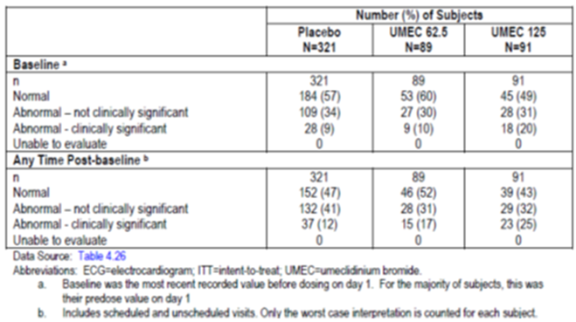
Data from the 12-lead ECGs were not integrated for the 8 clinical studies. In study DB2113374, most subjects had normal ECG results at baseline (UMEC 125 µg: 55% and TIO: 56%). Abnormal, clinically significant ECG results at baseline were reported at 14% for UMEC 125 µg compared with 11% for TIO. The proportion of subjects with 1 or more abnormal, clinically significant ECG result at ‘any time’ post-baseline was similar across the UMEC 125 µg and TIO treatment groups (19% for both treatment groups).
The effect of an eight-fold, supra-therapeutic dose of UMEC (500 µg QD) on QT prolongation was investigated in a controlled, randomised, 10-day repeat dose, incomplete block crossover study DB2114635 in healthy volunteers. Single dose oral moxifloxacin 400 mg (positive control) demonstrated assay sensitivity with mean increases in time matched QTcF compared with placebo greater than 5 msec at 1, 2, 4, 8 and 12 hours after dosing. Upper 90% confidence limit exceeded 10 msec at 4 and 8 hours. The estimated treatment difference from placebo of QTcF (msec) was negative at ‘all time’ points post last dose on Day10, and the upper limit of the 90% CI for the estimated treatment difference was less than 10 msec, indicating a lack of UMEC 500 µg effect on QTcF compared with placebo which is eight times the proposed dose of UMEC. No categorical QTcF effects were observed for UMEC 500 µg. The maximum time matched change in heart rate for UMEC 500 µg compared with placebo was 2.1 bpm at 8-hours post dose.

Vital signs

Pivotal studies
In the Efficacy studies dataset, the maximum or minimum post-baseline mean changes in vital signs were small and similar across both UMEC treatment groups compared with placebo. Comparisons of the UMEC treatment groups with placebo were occasionally shown to have p-values of < 0.05 for differences in vital signs measurements pre-dose and at 10 and 45 minutes post-dose; however, LS mean changes from baseline were small (< 4 mmHg for SBP, < 3 mmHg for DBP, and ≤ 7 bpm for pulse rate), not considered clinically relevant, and were similar across treatment groups at ‘all time’ points.

Other studies
In the Exercise studies, LS mean changes from baseline in vital signs were small and not clinically relevant (< 4 mmHg for SBP, < 2 mmHg for DBP, and < 4 bpm for pulse rate) across all pre- and post-dose time points over the treatment period.
Vital signs data were not integrated for the eight clinical studies. In study DB2113374, changes from baseline were similar for the UMEC 125 µg and TIO 18 µg groups.

AEs of special interest (AESI)
In some of the nonclinical studies, gallbladder disorders, irritant effects in the respiratory tract, ocular effects, and cardiovascular effects were observed with UMEC. The human responses to LAMAs has been extensively studied and, based on this experience and on the data derived from animal studies, the potential for AEs in clinical studies was monitored appropriately.

Cardiovascular AESI
Pharmacologic class effects of LAMAs include CV effects such as atrial arrhythmias and tachycardia. Therefore, in the clinical development program, CV safety was monitored via AE reporting with categorization and analysis of AESI including acquired long QT, cardiac arrhythmias, cardiac failure, cardiac ischemia, hypertension, sudden death, and stroke subgroups. In addition, ECGs and vital signs were measured in all patients and Holter monitoring was performed in a predefined subset.
In the Efficacy Studies, the incidence of on-treatment events in the CV special interest group was similar across treatment groups (9%, 8% and 7% in UMEC 62.5 µg, 125 µg and placebo groups, respectively; 236, 213 and 187 subjects with an event per 1000-subject years, respectively). In the Exercise studies, the incidence of on-treatment cardiovascular AESI was low (2%, 1% and 2%, respectively). In the Long-term Safety Study the incidence of on-treatment cardiovascular AESI was 22% and 23% in the UMEC 125 µg and placebo groups, respectively. The incidence of on-treatment cardiovascular AESI was slightly higher in the All Clinical Studies grouping for UMEC 125 µg compared with UMEC 62.5 µg and placebo (8%, 10% and 7% in UMEC 62.5 µg, 125 µg and placebo groups, respectively; 222, 236 and 209 subjects with an event per 1000-subject years, respectively). In all study groupings, the incidence of post-treatment cardiovascular AESI was < 1% for the UMEC treatments.
Cardiac arrhythmias were the most commonly reported subgroup of on-treatment cardiovascular AESI, followed by hypertension, cardiac failure and cardiac ischemia. In the Efficacy studies, the incidence of most of the individual CV AEs was similar across treatment with trend for slightly higher incidence of cardiac arrhythmias in the UMEC 62.5 µg groups compared with the UMEC 125 µg and placebo groups (Table 21). In the cardiac arrhythmia subgroup, the PTs of atrial fibrillation, loss of consciousness, bradycardia and supraventricular extra systoles were reported by < 1% of subjects in both UMEC treatment groups and in no subjects in the placebo group. The incidence of cardiac failure and ischaemia was low (< 1%) in the UMEC treatment groups compared to none in the placebo group; incidence of hypertension was similar (2%, 3% and 2% in UMEC 62.5 µg, 125 µg and placebo groups, respectively).

Table 21. On treatment cardiovascular AESI incidence and exposure adjusted frequency by special interest subgroup (efficacy studies integration ITT population).
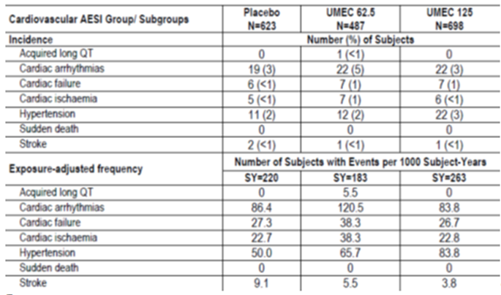
A higher incidence of on-treatment SAEs in the cardiovascular AESI group was noted in the UMEC groups (1%) compared with placebo (<1%). On-treatment SAEs by PT were reported for < 1% of subjects in any treatment group within each subgroup. In the cardiac arrhythmias subgroup, on-treatment SAEs were reported in ≤ 2 subjects in one or both UMEC treatment groups compared with no events reported in the placebo group. Similarly, in the cardiac ischemia subgroup, with the exception of the SAE of angina pectoris (reported in 1 subject in the placebo group and no events in the UMEC groups), all other SAEs were reported in one or both UMEC groups and no events reported in the placebo group (Table 22).

Table 22. On treatment serious cardiovascular ASEI by special interest subgroup and preferred term (efficacy studies integration ITT population).
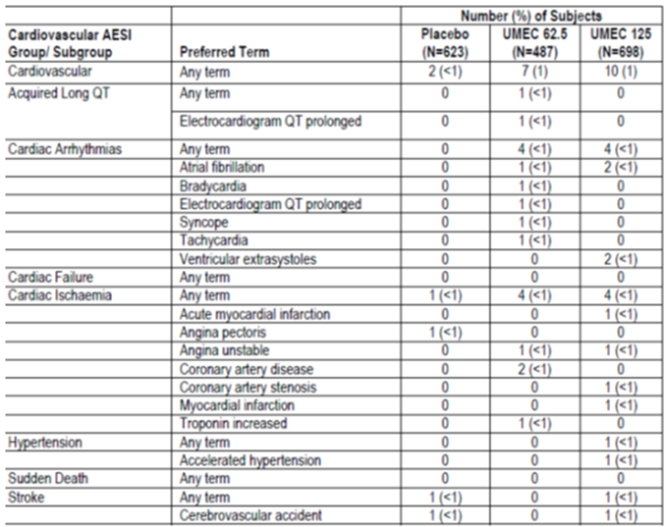
In the Long-term safety study, the incidence of cardiac arrhythmia events in the CV special interest group was comparable between the UMEC 125 µg group (17%) and the placebo group (16%). The incidence of cardiac failure was higher in the UMEC 125 µg group (2%) than in the placebo group (< 1%). In contrast to the Efficacy Studies, the incidence of hypertension events was lower in the UMEC 125 µg group (3%) than in placebo (6%). Two subjects in the Long-term Safety Study had fatal AEs in the cardiovascular special interest group: one subject (< 1%) on UMEC 125 µg experienced cardiac failure acute and 1 subject (< 1%) on placebo experienced coronary artery insufficiency. On-treatment SAEs in the CV special interest group were reported by 2% of subjects in the UMEC 125 µg and placebo groups.
In the Exercise Studies, few subjects had any on-treatment cardiovascular AESI and most common AEs were cardiac ischaemia and hypertension. On-treatment SAEs in the cardiovascular special interest group were reported for 3 subjects (< 1%) on placebo and no subjects on the UMEC treatments. None of these events was fatal.
In the All Clinical studies, cardiac failure as a special interest subgroup was reported in 1% of subjects in both UMEC treatment groups and < 1% of subjects in the placebo group. The most common cardiovascular AESIs were cardiac arrhythmias (4%, 6% and 3% in UMEC 62.5 µg, 125 µg and placebo groups, respectively; 109, 134 and 99 subjects with an event per 1000-subject years, respectively), hypertension (2%, 3% and 2%, respectively) and cardiac failure (1%, 1% and < 1%, respectively). Overall, while differing incidences and exposure-adjusted frequencies of subjects with events were observed for some CV special interest subgroups across treatment groups, no dose- or treatment-related patterns were identified. Among on-treatment cardiovascular AESI in the All Clinical Studies Grouping, all PTs were reported for ≤ 1% of subjects in each treatment group with the exception of hypertension, which was reported for 2% of subjects (all treatment groups) and ventricular extra systoles, reported for 2% of subjects receiving UMEC 125 µg and < 1% of subjects receiving UMEC 62.5 µg or placebo. The overall incidence of serious cardiovascular AESI was < 1% in the placebo group and 1% in both UMEC group. A higher incidence of cardiac arrhythmias was seen in the UMEC groups (< 1%) compared with placebo (0%), no dose- or treatment-related patterns were identified across treatment groups with respect to CV special interest SAEs by PT using incidence or exposure-adjusted frequencies.

MACE (major adverse cardiac events)
The broad criteria for MACE events were defined a priori as follows: -Cardiac Ischemia Special Interest AE Subgroup (Myocardial Infarction SMQ and Other Ischaemic Heart Disease SMQ) excluding fatalities; -Stroke Special Interest AE Subgroup (Central Nervous System, Haemorrhages and Cerebrovascular Conditions SMQ) excluding fatalities; -Adjudicated cardiovascular deaths.
To investigate events relating specifically to myocardial infarction rather than other cardiac ischaemic events, the narrow MACE definition included only the PTs of ‘myocardial ischaemia’ and ‘acute myocardial infarction’ in place of the Cardiac Ischaemia Special Interest AE subgroup.
MACE events for both narrow and broad definitions were summarized for Phase IIIa studies in subjects with COPD treated with UMEC for at least 12 weeks (Studies AC4115408, DB2113361, DB2113373, DB2113374, DB2114417, DB2114418 and DB2113359, combined). In the broad- and narrow-definition MACE analysis, the incidence of MACE events was low and similar across treatment groups including placebo (≤ 2%). The percentage of subjects with non-fatal MI was similar across treatment groups including placebo (< 1%). The exposure-adjusted frequency of subjects with non-fatal MI was slightly higher in UMEC groups (5, 9 and 3 subjects with events per 1000 subject-years of exposure in UMEC 62.5 µg, 125 µg and placebo groups, respectively). The percentage of subjects with non-fatal cardiac ischemia was the same across treatment groups (all 1%; 40, 25, and 38 subjects with events per 1000 subject-years of exposure for UMEC 62.5 µg, UMEC 125 µg and placebo respectively). The exposure-adjusted frequency for non-fatal stroke was lower in the UMEC treatments (5, 5 and 11 subjects with events per 1000 subject years of exposure, respectively). Overall, the data demonstrate that the incidence of MACE events was low for both broad and narrow-definitions in both UMEC.

Ocular AESI
In the Efficacy Studies, Exercise Studies and All Clinical Study Groupings, the incidence of on-treatment ocular effects AESI was < 1% in the UMEC 62.5 µg and placebo groups and 1% in the UMEC 125 µg group. In the Long-term Safety Study, the incidence of on-treatment ocular effects AESI was < 1% in both the UMEC 125 µg and placebo groups. Similar exposure-adjusted frequencies were observed in the Efficacy Studies and Exercise Studies for UMEC 125 µg and placebo, with lower frequencies observed for UMEC 62.5 µg.
In the Efficacy studies, among on-treatment AEs in the ocular effects special interest group, all PTs were reported for < 1% of subjects in each treatment group. No clinically relevant dose- or treatment-related patterns were identified and none of the ocular AESI were serious or fatal. Similar results were observed in the All Clinical studies dataset. In study DB2113374, among on-treatment ocular AESIs, all PTs of glaucoma and ocular hyperaemia were reported for < 1% of subjects in the UMEC 125 µg and TIO treatment groups.

Gallbladder disorders and intestinal obstruction AESI
In all study groupings, the incidence of on-treatment events in the gallbladder disorders special interest group was ≤ 1% in any treatment group including placebo. No clinically relevant dose- or treatment-related patterns were identified in either incidence or exposure-adjusted frequencies. In the Efficacy studies, 2 subjects (< 1%) on UMEC 62.5 µg reported on-treatment SAEs (2 events of chronic cholecystitis and 1 event of cholelithiasis) in the gallbladder disorders special interest group. One subject in the Efficacy Studies on UMEC 62.5 µg had a fatal event of cholecystitis in the gallbladder disorders AESI. The All Clinical studies group showed similar results with no dose- or treatment-related patterns. In the Efficacy Studies, two SAEs of intestinal obstruction (< 1%) were reported for subjects receiving placebo; no AEs in the intestinal obstruction AESI were reported for UMEC 62.5 µg or UMEC 125 µg treatment groups. There were no reports of intestinal obstruction in the Exercise, Long-term or All clinical studies groups.

Anticholinergic AEs
In the Efficacy Studies, the incidence of on-treatment anticholinergic effects AESI was 4% for each UMEC treatment group and placebo. In the Long-term Safety Study, both the placebo and UMEC 125 µg treatment groups had AESI incidence rates of 2%. In the Exercise Studies, the incidence of o- treatment anticholinergic effects AESI was low (3% in UMEC 125 µg compared with 2% in placebo and 0% in UMEC 62.5 µg); the pattern of exposure-adjusted frequency was similar. In the All Clinical Studies Grouping, the incidence was 3% in both the UMEC 62.5 µg and placebo groups and 4% in the UMEC 125 µg group. The exposure-adjusted frequencies were lower in the UMEC 125 µg group compared with placebo and UMEC 62.5 µg.
In the Efficacy studies, the incidence of on-treatment events in the anticholinergic effects special interest group by PT was ≤ 1% in all treatment groups including placebo. Two non-fatal SAEs were reported in the anticholinergic effects special interest group: tachycardia in one subject (< 1%) in the UMEC 62.5 µg group and delirium in one subject (< 1%) in the UMEC 125 µg group. No on-treatment or post-treatment fatal AEs in this AESI group were reported. In the Exercise studies, all on-treatment anticholinergic AESIs PTs were reported by ≤ 2% of subjects by treatment with no events reported in the UMEC 62.5 µg treatment group. Dry mouth was reported at an incidence of 2% in the UMEC 125 µg group and < 1% in the placebo group; none of these AESIs were serious or fatal. In All Clinical studies, the incidence of events in the anticholinergic effects special interest group by PT was ≤1% in all treatment groups including placebo. Dizziness was the most frequent PT in this AESI group with an incidence of 1% in the placebo group and < 1% in the UMEC treatment groups. Two subjects (< 1%) from the All Clinical Studies Grouping reported on-treatment SAEs in the anticholinergic effects special interest group; 1 event of delirium in the UMEC 125 µg group and 1 event of tachycardia in the UMEC 62.5 µg group. In study DB2113374, all PTs in anticholinergic AESIs were reported for < 1% of subjects in the UMEC 125 µg and TIO treatment groups with the exception of dizziness (reported for 2% of subjects on UMEC 125 µg compared with < 1% of subjects on TIO, and dry mouth, reported for 2% of subjects on TIO and no subjects on UMEC 125 µg.

Urinary retention AESI
In the Efficacy Studies and the All Clinical Studies grouping, 2 subjects (< 1%) in the UMEC 125 µg group reported 3 AEs (one AE of urinary hesitation and 2 AEs of urinary retention) in the urinary retention AESI category. No events were reported in the UMEC 62.5 µg or placebo groups. No events in this AESI group were reported for subjects in the Long-term Safety Study or the Exercise Studies. No on-treatment or post-treatment deaths or other on-treatment SAEs in the urinary retention AESI group were reported for subjects in the Efficacy Studies.

Pneumonia and lower respiratory tract infection (LRTI) AESI
Overall, AEs in the pneumonia and LRTI AESI group were reported for 3% of subjects on UMEC 125 µg compared with 1% of subjects on UMEC 62.5 µg and placebo, with exposure-adjusted frequencies of events following a similar pattern.
In the Efficacy Studies, a higher incidence of pneumonia and LRTI was reported for the UMEC 125 µg treatment group compared with UMEC 62.5 µg and placebo groups (1%, < 1% and < 1% in UMEC 125, 62.5 µg and placebo groups, respectively; 38, 16 and 18 subjects with an event per 1000 subject-years of exposure, respectively). The incidence of any on-treatment events in the ‘pneumonia’ subgroup was 1%, < 1% and < 1% for UMEC 125 µg, UMEC 62.5 µg and placebo, respectively. The exposure-adjusted frequency showed a similar pattern; 31, 6 and 18 subjects with events per 1000 subject-years, respectively. As ICS use is a risk factor for pneumonia, ICS use was analysed as a subgroup of interest. For ICS-users, the incidence of the PT of pneumonia was higher in UMEC 125 µg (2%; n = 5) compared with placebo (<1%; n = 2); no events were reported in the UMEC 62.5 µg group. However in the non-ICS users subgroup, the incidence of pneumonia was similar (< 1% across both and placebo treatment groups). A higher incidence of LRTI AESI events was noted for UMEC 125 µg (2%) compared with placebo (< 1%) and UMEC 62.5 µg (< 1%). The exposure-adjusted data demonstrated a similar pattern. The majority of events reported in this AESI group were bronchitis and LRTI. On-treatment SAEs in the Efficacy Studies in the Pneumonia subgroup and LRTI subgroup were reported by < 1% of subjects in any treatment group with no apparent dose- or treatment-related pattern in incidence or exposure-adjusted frequency of subjects with SAEs by PT; only 1 placebo-treated patient had a fatal SAE of pneumonia.
In the All Clinical Studies Grouping, a higher incidence of events in the Pneumonia and LRTI special interest subgroups was noted for the UMEC 125 µg group (3%) compared with the UMEC 62.5 µg and placebo groups (1% in both). The incidence of pneumonia was 2%, <1% and <1% for UMEC 125 µg, 62.5 µg and placebo groups, respectively with similar results for LRTI AEs. The incidence of SAEs for pneumonia and LRTI was low and similar (< 1%) across treatment groups. The highest incidence and exposure-adjusted frequency of Pneumonia AESI subgroup was with UMEC 125 µg (2%; 37 subjects with an event per 1000 subject-years of exposure), compared with < 1% for UMEC 62.5 µg (20 subjects with an event per 1000 subject-years of exposure) and placebo (11 subjects with an event per 1000 subject-years of exposure). Similar results were observed for LRTI with higher incidence in the UMEC 125 µg group (2%) compared with the UMEC 62.5 µg and placebo groups (< 1%).
In the long term study, in the Pneumonia and LRTI AESI group, overall AEs were reported for 5% of subjects on UMEC 125 µg and 2% of subjects on placebo; the overall incidence of serious pneumonia and LRTI AESI was reported for 1% of subjects in UMEC 125 µg and 0% in placebo. The incidence of Pneumonia associated AESI was 3% in the UMEC 125 µg group (42 subjects with an event per 1000 subject-years of exposure), compared with 0% in the placebo group.
In the Exercise studies, pneumonia and LRTI events were reported by 1% of subjects on UMEC 62.5 µg, 0% on UMEC 125 µg and < 1% of subjects on placebo. The incidence of Pneumonia-associated AESI was 1% in the UMEC 62.5 µg group and 0% in both the UMEC 125 µg and placebo groups.

Post-marketing experience
Not applicable as UMEC has not been approved in any country to date.

Safety issues with the potential for major regulatory impact

Liver toxicity
There were no treatment or dose-related effect of UMEC on liver chemistry parameters.

Haematological toxicity
There were no treatment or dose-related effect of UMEC on haematology parameters.

Serious skin reactions
None.

Cardiovascular safety
The most important cardiovascular finding observed was atrial arrhythmias (for example supraventricular tachycardia, atrial fibrillation, supraventricular extra systoles), as assessed by frequency of AEs, ECG and Holter findings. A higher number of ECG abnormalities associated with atrial arrhythmias were reported for both UMEC treatment groups compared with placebo, with no reported clinical consequences as a result of the ECG abnormalities. Overall, although a higher number of AEs associated with atrial arrhythmias were reported with UMEC treatment compared with placebo, the AEs of atrial arrhythmias were not reported concurrently with other cardiovascular AEs or AEs of clinical significance such as syncope, hypotension or stroke. Four subjects reported SAEs associated with atrial arrhythmias in each of the UMEC groups, with no events reported in the placebo group. The SAEs of atrial arrhythmias were not reported concurrently with other SAEs of clinical significance.
Given that patients with COPD are at risk of CV disease, and pharmacological CV effects are associated with the use of LAMAs, an additional analysis of MACE was conducted which included the Efficacy Studies, the Long-term Safety Study and the Exercise Studies. There was no evidence for an increased MACE risk with either dose of UMEC compared with placebo.

Unwanted immunological events
None applicable.

Other safety issues

Safety in special populations

Safety in patients with renal/hepatic impairment
In DB2114636, inhaled UMEC 125 µg and UMEC/VI 125/25 µg were well tolerated in healthy subjects and in subjects with severe renal impairment (creatinine clearance < 30 mL/min). None of the subjects had an AE during the UMEC 125 µg treatment period. One healthy subject experienced AEs of headache and intermittent vomiting during the UMEC/VI 125/25 µg treatment period and there were no AEs in subjects with renal impairment. There were no SAEs or AEs leading to withdrawal from the study and there were no clinically significant changes in laboratory parameters, vital signs or ECG.
DB2114637 was an open-label, non-randomized study that assessed the PKs and safety of single dose UMEC/VI and repeat daily administration for 7 days of UMEC in subjects with moderate hepatic impairment and matched healthy control subjects (Child-Pugh score 7 to 9). Repeat-dose inhaled UMEC 125 µg and single dose inhaled UMEC/VI 125/25 µg were well tolerated in subjects with moderate hepatic impairment and matched healthy controls. No AEs were reported during the study and there were no clinically significant safety laboratory, vital signs or ECG abnormalities in either healthy subjects or subjects with moderate hepatic impairment.
Comment: UMEC was not evaluated in subjects with severe hepatic impairment and this fact has been clearly stated in the proposed PI.

Effects of age, gender, race, region, salbutamol reversibility and ICS use on safety of UMEC.
In the Efficacy studies, the distribution of subjects by gender, age, and race was similar across treatment groups. The majority of subjects in the Efficacy Studies overall ITT population were male (67%); 55% were ≤ 64 years of age, 35% were 65 to 74 years of age, and 10% were 75 to 84 years of age. Six subjects (< 1%) were at least 85 years of age. The majority of subjects were White (85%). Ten percent were Asian and 5% were of other race categories and about one-third (30%) of subjects were reversible to salbutamol.

Gender
Compared with the ITT population, a higher incidence of any on-treatment AEs were reported for females and a lower incidence was reported for males across all treatment groups including the placebo group. The top 4 AEs among the most commonly reported with an incidence greater than placebo were the following (in descending order of incidence): in the ITT population: cough, URTI, back pain and hypertension; in females: back pain, URTI, hypertension and arthralgia; in males: headache, nasopharyngitis, URTI and cough.

Age
There were no significant differences in the pattern of incidence of on-treatment AEs, drug-related AEs, SAEs, or AEs leading to permanent discontinuation of study drug or withdrawal across treatments for subjects ≤64 years of age, 65 to 74 years of age, or 75 to 84 years of age compared with the overall ITT population. The total number of subjects ≥ 85 years of age was small (n = 6), with only 2 subjects in this category (1 in each UMEC group) reporting an AE, precluding meaningful data interpretation in this subgroup of patients. The top 4 AEs among the most commonly reported with an incidence greater than placebo were the following (in descending order of incidence): in the ITT population: cough, URTI, back pain and hypertension; in subjects ≤ 64 years of age: cough, URTI, hypertension and toothache; in subjects 65 to 74 years of age: headache, nasopharyngitis, cough and arthralgia; in subjects ≥ 75 to 84 years of age: cough, URTI, back pain and pharyngitis.
The incidence of AEs of special concern for the elderly, including CNS (confusion/extrapyramidal) AEs, events related to falling, cardiovascular events, cerebrovascular events and infections were categorized based on age. There were no significant differences in the pattern of incidence of on-treatment AEs related to CNS, falling, cardiovascular, cerebrovascular, or infections across treatments for subjects ≤ 64 years of age, 65 to 74 years of age, or 75 to 84 years of age compared with the overall ITT population.
A higher incidence of cardiovascular AEs was noted in the older subjects (75- 84 years) in the UMEC treatment groups compared with the placebo group and compared with the other age groups. A review of the cardiovascular AEs showed no pattern of events reported for these patients within and across treatment groups. With the exception of ventricular extra systoles (reported in 2 subjects on UMEC 62.5 µg and 1 subject on UMEC 125 µg) and hypertension (reported in 1 subject on UMEC 62.5 and 2 subjects on UMEC 125 µg), no other CV events were reported by more than 1 subject in the UMEC groups.
A review of AEs related to falling (i.e., syncope, pre syncope, hypotension, or orthostatic hypotension) was performed to determine if any of these events were associated with abnormal, clinically significant ECG interpretations (including Holter interpretations). One subject had an abnormal, clinically significant ECG abnormality at the time of an event of pre syncope. Two additional subjects in the UMEC 62.5 µg treatment group in DB2113373 also reported an AE of syncope; however, neither subject had a concurrent clinically significant ECG abnormality reported.

Race
There were no significant differences in the pattern of overall incidence of any on treatment AE, drug-related AE, SAE, or AE leading to permanent discontinuation of study drug or withdrawal from the study across treatment groups for the White or Asian subgroups compared with the overall ITT population. The number of subjects in other race subgroups was small and therefore precludes meaningful analysis. The top 4 AEs among the most commonly reported with an incidence greater than placebo were the following (in descending order of incidence): in the ITT population: cough, URTI, back pain and hypertension; in the White subgroup: headache, cough, back pain and URTI; in the Asian subgroup: nasopharyngitis, hypertension, oropharyngeal pain. Only these 3 event categories were reported in the Asian subgroup.
A higher incidence of AEs was reported in the East Asian subgroup (65%) in the placebo group compared with the total population (46%). However, there were no significant differences in the pattern of incidence of any drug-related AE, SAE, or AE leading to permanent discontinuation of study drug or withdrawal from the study across treatment groups for the East Asian subgroup compared with the ITT population. The top 4 AEs among the most commonly reported with an incidence greater than placebo were the following (in descending order of incidence): in the ITT population: cough, URTI, back pain and hypertension; in the East Asian subgroup: nasopharyngitis, pharyngitis, ankle fracture and COPD.

Geographic region
There were no significant differences for either the US or non-US region in the pattern of incidence of any on-treatment AE, drug-related AE, SAE, or AE leading to permanent discontinuation of study drug or withdrawal from the study across treatments compared with the ITT population. The top 4 AEs among the most commonly reported with an incidence greater than placebo were: in the ITT population: cough, URTI, back pain, and hypertension; in US region: cough, URTI, back pain and COPD; in Non-US regions: cough, URTI, hypertension and toothache.

Salbutamol reversibility:
There were no significant differences based on salbutamol reversibility for the overall pattern of incidence of any AE, on-treatment SAE, AE leading to permanent discontinuation of study drug or withdrawal from the study or fatal AE across treatment groups compared with the ITT population. The top 4 AEs among the most commonly reported with an incidence greater than placebo were the following (in descending order of incidence): in the ITT population: cough, URTI, back pain, and hypertension; Not salbutamol-reversible: URTI, cough and hypertension; in Salbutamol-reversible: headache, cough, URTI and back pain.

ICS use
There were no significant differences based on ICS use for the overall pattern of incidence of any on-treatment AEs, SAEs, or AEs leading to permanent discontinuation of study drug or withdrawal from the study across treatment groups compared with the ITT population. The top 4 AEs among the most commonly reported with an incidence greater than placebo were: in the ITT population: cough, URTI, back pain, and hypertension; in ICS user: headache, nasopharyngitis, back pain and URTI; in ICS non-user: cough, URTI, hypertension and arthralgia.

Safety related to drug/drug interactions and other interactions
UMEC is eliminated in urine and faeces unchanged or as metabolites. The major cytochrome P450 involved in the metabolism of UMEC is CYP2D6. While UMEC is a substrate of P-glycoprotein (P-gp), it is not an inhibitor. Since P-gp is a relatively high capacity transporter, a clinical interaction between UMEC and P-gp is unlikely due to the lower systemic bioavailability following inhalation. UMEC was generally well tolerated when co-administered with verapamil, a PgP inhibitor. There were no clinically significant findings with respect to the AE profile, safety laboratory results, vital signs assessments, or 12-lead ECG measures in this study. UMEC was also well-tolerated in both healthy and CYP2D6 poor-metaboliser populations (AC4110106). No dose adjustment is warranted for UMEC with use of P-gp inhibitors or inhibitors of CYP2D6.

Safety in ongoing clinical studies
Brief overviews of study designs and blinded reports of SAEs and deaths for the 6 clinical studies that were ongoing at the data cut-off date for the safety information in this submission were provided. These include studies with UMEC alone or in combination with fluticasone furoate (FF, an inhaled corticosteroid) in subjects with asthma and studies with UMEC alone or in combination with VI in subjects with COPD.
No deaths were reported in these ongoing studies till cut-off date of 10 December 2012.
SAEs reported till cut-off date is summarised below for each of the 6 ongoing studies:
- ALA116402 Phase II, 3-period crossover study with UMEC in subjects with asthma: only 1 SAE of asthma exacerbation was reported in this study.
- CRT116277 Phase III, 4-week UMEC/VI exercise study including a UMEC monotherapy arm in subjects with COPD. Enrolment of subjects had just started in Dec 2012 and there were no reports of SAEs.
- AC4115361 Phase III, 52-week open-label study with UMEC in Japanese subjects with COPD. There were 5 SAEs (2 of COPD exacerbation, 1 cerebral infarct, 1 gastric Cancer and 1 colon adenoma).
- DB2116133Phase III, 12-week, 3-way crossover study with UMEC/VI, UMEC and VI in subjects with COPD. There was only 1 SAE of heart attack.
- ILA115938 Phase III, 2-week crossover study with UMEC/FF, FF and FF/VI in subjects with asthma. There were 3 SAEs (asthma exacerbation, acute cholecystitis and spontaneous abortion).
- ILA116524 Phase I, single-dose crossover study with UMEC, FF and UMEC/FF in healthy subjects. Enrolment had just started in December 2012 and no SAEs were reported.
Based on review of the case narratives for each of the SAEs, the SAEs did not appear to be related to study drug.

Use in pregnancy/lactation
During the clinical development program, female subjects of child bearing potential were required to have a urine pregnancy test conducted at Screening, during the study, and/or the Early Withdrawal Visit. Subjects who became pregnant during the study were to discontinue study drug and were withdrawn from the study. No pregnancies occurred in any subject during a completed or ongoing study in the COPD clinical development program (safety data cut-off 10 December 2012). In the ongoing asthma studies from the FF/UMEC asthma clinical development program (safety data cut-off 10 December 2012), 4 pregnancies have occurred. Two pregnancies occurred prior to administration of any study medication. Two pregnancies occurred while on blinded study medication; one pregnancy was ongoing and the other pregnancy had an outcome of abortion spontaneous while on blinded FF/UMEC, FF or FF/VI.
There are no adequate and well-controlled human trials that have investigated the effects of UMEC during labour and delivery. It is unknown whether UMEC is excreted in human milk. A risk to breastfed newborns/infants cannot be excluded.

Overdose, drug abuse, withdrawal/ rebound, reflect on ability to drive or operate machinery or impairment of mental ability
Treatment of over dosage consists of discontinuation of UMEC together with institution of appropriate symptomatic and/or supportive therapy. No case of overdose has been reported with UMEC. High doses of UMEC may lead to anticholinergic signs and symptoms. However, there were no systemic anticholinergic adverse effects following a single inhaled dose of up to 1000 µg of UMEC in subjects with COPD for 14 days.
There is no evidence for and no anticipation of patient abuse of UMEC.
In the clinical development program, subjects may have resumed their original maintenance therapy following participation in the studies. Unless other appropriate COPD medications are prescribed upon discontinuation of treatment, the expected effect of withdrawal of study drug is an increase in signs and symptoms of COPD. The clinical trials in the Phase IIIa development program in COPD subjects were designed with a post-treatment follow-up period to evaluate AEs following discontinuation of study drug. For All Clinical Studies, post-treatment AEs (that is, AEs occurring with an onset starting 2 days or more after the last recorded dose of study drug) were reported by < 3% of subjects in any treatment group.
There have been no specific studies to investigate the effect of UMEC on the ability to perform tasks that require judgement, motor, or cognitive skills (e.g., the ability to drive and operate machinery). There is no evidence for or expectation that the use of UMEC would affect the ability to drive or operate machinery or otherwise impair mental ability. There was no indication of an increase in the AE PTs of dizziness, pre syncope, syncope, somnolence, fatigue or malaise with UMEC treatment compared with treatment with placebo. With the exception of dizziness, where the incidence was < 1% in the UMEC groups and 1% in placebo, all of the other events were reported in < 1% of subjects across all treatment groups, including placebo, in the All Clinical Studies integration. Data from the Efficacy Studies support these findings. In contrast, for the Long-term Safety Study, the incidence of dizziness was 1% in the UMEC 125 µg group, compared to < 1% in placebo.

Evaluator’s overall conclusions on clinical safety
The safety population supporting the clinical development program included 8 completed clinical studies with a UMEC monotherapy arm and duration of ≥ 4 weeks. A total of 2,706 subjects with COPD were treated with UMEC monotherapy or placebo; of which 1,663 subjects received treatment with UMEC 62.5 µg or 125 µg; representing 656 subject-years of exposure.
However, 487 patients were exposed to the proposed dose of UMEC 62.5 µg once daily with median exposure duration of 167 days in the Efficacy studies dataset. In the All Clinical Studies dataset, 576 patients were exposed to UMEC 62.5 µg with median duration of 165 days.
The study population in the clinical development program was representative of the overall COPD population.
The overall incidence of subjects reporting any on treatment AEs in the Efficacy Studies was similar across UMEC treatment groups and higher than placebo. The most commonly occurring AEs with > 3% incidence in at least one treatment group were headache, nasopharyngitis, cough, URTI, back pain and hypertension, with similar incidences across all three treatment groups. The most commonly occurring SAE was exacerbation of COPD which is not unexpected in a COPD population.
Overall, 14 fatalities on UMEC or placebo were reported in the clinical development program; 3 reported in UMEC 62.5 µg treatment group, 7 in UMEC 125 µg treatment group, and 4 in the placebo group. The majority of these fatalities were classified by an external independent adjudication committee as cardiovascular, respiratory or oncologic in nature, which is consistent with known co-morbidities of the COPD patient population. A higher number of fatal events occurred in the UMEC 125 µg treatment group compared with the UMEC 62.5 µg and placebo groups, and this was driven mainly by 4 deaths which were oncologic in nature. There was no pattern to the type of cancer reported in these subjects.
The incidence of SAEs was slightly higher in the UMEC treatment groups compared with placebo and the exposure adjusted frequency of subjects with on-treatment SAEs was 153, 149 and 123 subjects with event per 1000 subject-years of exposure in the UMEC 62.5, 125 µg and placebo groups, respectively. However, incidence of treatment-related SAEs was < 1% in UMEC groups and of the 3 drug-related SAEs, 2 were in the UMEC 125 µg (atrial fibrillation and chest pain) and 1 in the UMEC 62.5 µg group (tachycardia). AEs leading to discontinuation or withdrawal were reported at slightly higher incidence in UMEC treatment groups (7%, 6% and 4% in the UMEC 62.5, 125 µg and placebo groups, respectively).
In the Efficacy Studies, there was a higher incidence of AEs in the Cardiac Disorders SOC for UMEC 125 µg and UMEC 62.5 µg compared with placebo; while a similar incidence of AEs in the Cardiac Disorders SOC was noted between UMEC 125 µg and placebo in the Long-term Safety Study. The most important cardiovascular finding observed was atrial arrhythmias (for example; supraventricular tachycardia, atrial fibrillation, supraventricular extra systoles), as assessed by frequency of AEs, ECG and Holter findings. A higher number of ECG abnormalities associated with atrial arrhythmias were reported for both UMEC treatment groups compared with placebo, with no reported clinical consequences as a result of the ECG abnormalities. Overall, although a higher number of AEs associated with atrial arrhythmias were reported with UMEC treatment compared with placebo, the AEs of atrial arrhythmias were not reported concurrently with other cardiovascular AEs or AEs of clinical significance such as syncope, hypotension or stroke. Four subjects reported SAEs associated with atrial arrhythmias in each of the UMEC groups, with no events reported in the placebo group. The SAEs of atrial arrhythmias were not reported concurrently with other SAEs of clinical significance.
Given that patients with COPD are at risk of CV disease, and pharmacological CV effects are associated with the use of LAMAs, an additional analysis of MACE was conducted which included the Efficacy Studies, the Long-term Safety Study and the Exercise Studies. There was no evidence for an increased MACE risk with either dose of UMEC compared with placebo. The risk of CV events with anticholinergics has been widely studied, although results remain unclear (Salpeter, 2009). In the Understanding the Long-Term Impact of Tiotropium on Lung Function Trial (UPLIFT), there was an increased relative risk of tachyarrhythmias and atrial tachycardias reported as AEs for TIO compared with placebo (FDA Briefing Document, 2009). In addition, in the TIO active comparator studies performed in the UMEC and UMEC/VI development program, there were also some increases in atrial arrhythmias noted compared to baseline. A recently approved LAMA, aclidinium, has been shown to have a greater incidence of non-sustained SVTs compared with placebo (Centre for Drug Evaluation and Research, 2012). Therefore, the evidence seems to suggest that atrial arrhythmias may be a class effect of anticholinergics.
Since clinical consequences of these arrhythmias are rare and may not have been detectable in the clinical development program, this potential risk will continue to be managed through relevant class prescribing information, post-marketing risk management activities and post-approval monitoring studies.
A higher incidence of pneumonia-associated AESI events was noted in the UMEC 125 µg treatment group (1%) compared with UMEC 62.5 µg (< 1%) and placebo (< 1%) in the Efficacy Studies. This was driven by a higher incidence with the PT of pneumonia, most of which were non-serious events. The incidence of serious pneumonia-associated events in the Efficacy Studies was comparable between both UMEC treatment groups (< 1%) and placebo (< 1%). In the Long-term Safety Study, a higher incidence of pneumonia-associated AESI events was noted in the UMEC 125 µg treatment group (3%) compared with placebo (0%). Safety results from other marketed LAMAs have not shown an association between anticholinergics and pneumonia. The recently approved LAMA, aclidinium bromide showed no evidence for an increased risk of pneumonia in COPD patients, (European Medicines Agency). Similarly, results from the UPLIFT trial showed a similar incidence for the AE of pneumonia between TIO and placebo groups (Tashkin, 2008). Pneumonia is a common background event in the COPD population, and there is no clear association of UMEC with events of pneumonia. Pneumonia-associated AESI events observed may reflect the co-morbidities associated with the COPD population at large.
Other AEs identified as being potentially related to anticholinergics (e.g., ocular, gallbladder, intestinal obstruction, and urinary retention) were specifically analysed across the clinical development program. There was no evidence for a treatment related response of UMEC indicative of anticholinergic effects.
There was no indication from the routine laboratory evaluations in the UMEC program of a clinically relevant treatment- or dose-related effect on haematology or clinical chemistry. No concerns for hepatic toxicity were observed in the studies with UMEC. The few episodes of liver abnormalities were generally transient or confounded by concurrent medical conditions or concomitant medications.
Overall, the safety profile of both doses of UMEC was similar to placebo and no difference in the safety profile was observed between the two doses of UMEC. The most important safety finding with UMEC was atrial arrhythmias, as assessed by frequency of AEs and ECG findings, which occurred at a higher incidence in active treatment groups compared with placebo. Clinical experience with UMEC did not show any clear associations with significant and serious cardiac events.
The safety of proposed dose of UMEC 62.5 µg has not been evaluated beyond 6 months. However, in the long-term Safety Study, there were no newly identified safety concerns with UMEC 125 µg over the 52-week duration of the study, with a similar overall safety profile to the Efficacy Studies.

First round benefit-risk assessment

First round assessment of benefits
The benefits of UMEC 62.5 µg in the proposed usage are:
- Improved lung function as assessed by trough FEV1 and weighted mean FEV1 over 0 to 6 hrs compared to placebo.
- Improvements in symptoms as demonstrated in clinically relevant TDI measures and reductions in rescue salbutamol use compared with placebo.
- Improved health related quality of life as measured by change from baseline in SGRQ score.
- Reduced the risk of COPD exacerbation compared to placebo based on an analysis of time to first exacerbation in the two 24-week studies.
- Maintenance of long term efficacy with no evidence of tolerance over 24 weeks. Maintenance of efficacy in the pivotal long-term, 52-week safety study DB2113359 was only shown for UMEC 125 µg as proposed dose of UMEC 62.5 µg was not evaluated in this study.
- Well tolerated with no major safety concerns. No increased risk of CV events except atrial arrhythmias which appears to be a class effect for anticholinergics.

First round assessment of risks
The risks of UMEC 62.5 µg in the proposed usage are:
- Efficacy and safety of UMEC 62.5 µg has not been evaluated beyond 6 months.
- Efficacy of UMEC 62.5 µg was not compared with TIO or any other LAMA although efficacy of UMEC 125 µg was shown to be comparable to TIO in study DB2113374.
- The 12-week crossover exercise studies (DB2114417 and DB2114418) failed to demonstrate significant improvement in exercise endurance time or exertional dyspnoea following treatment with UMEC 62.5 µg.
- Slightly higher incidence of cardiac arrhythmias was associated with UMEC 62.5 µg; atrial fibrillation, loss of consciousness, bradycardia and supraventricular extrasystoles were reported by < 1% of subjects in both UMEC treatment groups compared to none in the placebo group.

First round assessment of benefit-risk balance
UMEC at the dosages studied is an effective treatment for patients with moderate to severe COPD, producing improvements in both lung function and symptoms, key measures considered important in the management of COPD. UMEC was well tolerated with a low incidence of AEs and no unexpected safety observations. Potential pharmacology-related effects such as atrial arrhythmias require appropriate cautionary labelling and risk management activities tailored to the regions where UMEC will be marketed. Overall, UMEC 62.5 µg and 125 µg both have favourable risk-benefit profiles. Additional improvements obtained with UMEC 125 µg over 62.5 µg were not considered substantial nor likely to offer additional clinical benefit due to increased risk of AEs especially pneumonia. Therefore the proposed dose of UMEC 62.5 µg is appropriate for treatment of patients with COPD.
The benefit-risk balance of umeclidinium bromide 62.5 µg for proposed indication of long-term maintenance bronchodilator treatment to relieve symptoms in adult patients with COPD is favourable.

First round recommendation regarding authorisation
It is recommended that the application to register Incruse Ellipta (UMEC 62.5 µg) once daily for long-term maintenance bronchodilator treatment to relieve symptoms in adult patients with COPD be approved. The approval is conditional to an appropriate response to questions in section 12 and incorporation of suggested changes to the proposed PI for Incruse Ellipta.

Clinical questions

Pharmacokinetics
No questions.

Pharmacodynamics
No questions.

Efficacy
The CHMP guidelines for ‘clinical investigation of medicinal products in treatment of patients with COPD’ states that formal stratification of patients according to their smoking status (current smokers, ex-smokers) should be performed prior to randomisation. This was not done in any of the pivotal clinical studies for UMEC. Furthermore, tobacco exposure was not monitored during the study and any change in smoking status did not appear to be documented or reported. Use of nicotine replacement therapy or other smoking cessation aids such as varenicline was also not documented. Could the sponsors please confirm if change in smoking status was monitored for the pivotal Phase III studies and if it had any effect on the efficacy results?

Safety
No questions.

Second round evaluation of clinical data submitted in response to questions

Clinical efficacy questions
The CHMP guidelines for ‘clinical investigation of medicinal products in treatment of patients with COPD’ states that formal stratification of patients according to their smoking status (current smokers, ex-smokers) should be performed prior to randomisation. This was not done in any of the pivotal clinical studies for UMEC. Furthermore, tobacco exposure was not monitored during the study and any change in smoking status did not appear to be documented or reported. Use of nicotine replacement therapy or other smoking cessation aids such as varenicline was also not documented. Could the sponsors please confirm if change in smoking status was monitored for the pivotal Phase III studies and if it had any effect on the efficacy results?

Sponsor’s response
Stratification by smoking status was not performed. However, the proportion of current and former smokers across treatment groups at entry in each of the studies was very similar. The proportion of current smokers ranged from 52% to 54% for the Placebo group, 50% to 54% for the UMEC 62.5 µg group and 44% to 57% for the UMEC 125 µg group across the 4 efficacy studies. The proportion of former smokers ranged from 46% to 48% for the Placebo group, 46% to 50% for the UMEC 62.5 µg group and 43% to 56% for the UMEC 125 µg group across the 4 efficacy studies. Smoking status at screening was included as a covariate in all efficacy analyses and sensitivity analyses were performed for the interaction between treatment and smoking status for the primary and secondary endpoints. These sensitivity analyses showed a statistically significant overall interaction between smoking status and trough FEV1 (primary endpoint) in DB2113361 and DB2113374, and between smoking status and weighted mean FEV1 (secondary endpoint) in DB2113374. When this was further investigated, the interaction was not found to be statistically significant at the final visit in both these studies. Therefore smoking status did not have an effect on the primary or secondary endpoints for these 2 studies. For AC4115408, no interaction with smoking status was observed for the primary endpoint of trough FEV1, or the secondary endpoint of weighted mean FEV1. However, there was a statistically significant interaction between smoking status and serial FEV1 (secondary endpoint) at Day 1 but not at Day 84. To further explore this potential interaction, smoking status at screening was removed from the original model to determine if the original conclusions would be affected. Removing smoking status from the Day 1 analysis did not change the original conclusions. Given the inconsistency of the interactions across the 2 separate by-visit analyses (Day 1 and Day 84), it was concluded that no further investigation was warranted beyond the initial investigative analyses. There was no statistically significant interaction between smoking status and trough FEV1 (primary endpoint) or weighted mean FEV1 (secondary endpoint) in DB2113373. Furthermore, there was no evidence of a statistically significant treatment by smoking status interaction for the primary efficacy endpoint of trough FEV1 on Day 84 in the 12-Week Integration or Day 169 in the 24-Week Integration for the integration of the efficacy studies.
Changes in smoking status were recorded during each study. Subjects were asked at the Day 84 and Day 168 clinic visits in the 6-month studies (DB2113361, DB2113373, DB2113374) if they had changed their smoking status since the previous clinic visit and the results were recorded in the eCRF. For the 3-month study AC4115408, changes in smoking status were recorded at end of the treatment period at the Day 84 clinic visit. Few changes in smoking status during the studies were reported. In DB2113361, 2 (< 1%) subjects changed their smoking status from screening. In DB2113373, 7 (< 1%) subjects and in DB2113374, 3 (< 1%) subjects changed their smoking status from screening. In AC4115408, no subjects changed their smoking status from screening. Given that the percentage of subjects changing their smoking status was <1%, the impact on the efficacy results is likely to be have been negligible.
Usage of concomitant medications that are considered smoking cessation aids such as varenicline, both at study entry and whilst on treatment were captured in the eCRF and can be found in the respective clinical study reports. In DB2113361, 17 (1%) subjects were reported as using varenicline whilst on treatment compared to 11 (< 1%) subjects who were receiving varenicline at study entry; 8 (< 1%) subjects were reported as receiving nicotine/nicotine polacrilex during the treatment period compared with 2 (< 1%) subjects prior to the study. In DB2113373, 20 (1%) subjects were reported as using varenicline tartrate during the treatment period compared to 10 (<1%) subjects who were reported as using varenicline at study entry; 11 (< 1%) subjects were reported as using nicotine/nicotine polacrilex during treatment compared to 8 (< 1%) subjects who reported using nicotine at study entry. For DB2113374, 11 (< 1%) subjects were reported as taking varenicline/varenicline tartrate during the study compared to 6 (< 1%) subjects who were reported as using varenicline/varenicline tartrate at study entry; 3 (< 1%) subjects were reported as using nicotine during the treatment period compared to 1 (< 1%) subject at study entry. In AC4115408, 1 (< 1%) subject each was reported as using varenicline tartrate at study entry and during the study whilst no subjects were recorded as using nicotine either prior to or during the treatment period. Overall, few patients used varenicline or nicotine replacement therapy during the studies.

Evaluator’s comments on sponsor’s response
The sponsor’s response is acceptable.

Clinical safety questions
None.

Second round benefit-risk assessment

Second round assessment of benefits
After consideration of the response to clinical questions, the benefits of umeclidinium bromide 62.5 µg once daily in the proposed usage are unchanged from those identified in the first round assessment of benefits.

Second round assessment of risks
After consideration of the response to clinical questions, the risks of umeclidinium bromide 62.5 µg once daily in the proposed usage are unchanged from those identified in the first round assessment of risks.

Second round assessment of benefit-risk balance
After consideration of the response to clinical questions, the benefit-risk balance of umeclidinium bromide 62.5 µg once daily in the proposed usage are unchanged from those identified in the first round assessment of benefit-risk balance.

Second round recommendation regarding authorisation
It is recommended that Incruse Ellipta (umeclidinium bromide 62.5µg once daily by inhalation) be approved for the maintenance bronchodilator treatment to relieve symptoms in adult patients with COPD. However, the approval is subject to incorporation of suggested changes to the proposed PI.

References
Casaburi R, Briggs DD Jr, Donohue JF, Serby CW, Menjoge SS, Witek TJ Jr. The spirometric efficacy of once daily dosing with tiotropium in stable COPD: a 13-week multicentre trial. The US Tiotropium Study Group. Chest. 2000;118:1294-302.
Casaburi R, Mahler DA, Jones PW, et al. A long-term evaluation of once-daily inhaled ipratropium in chronic obstructive pulmonary disease. Eur Respir J. 2002;19:217-24.
Celli B, ZuWallack R, Wang S, Kesten S. Improvement in resting inspiratory capacity and hyperinflation with tiotropium in COPD patients with increased static lung volumes Chest. 2003;124:1743-1748.
Celli BR, MacNee W. Standards for the diagnosis and treatment of patients with COPD: a summary of the ATS/ERS position paper. Eur Respir J. 2004;23:932-946.
Centre for Drug Evaluation and Research (CDER), Medical Reviews, aclidinium bromide, 25 May 2012.
Chapman KR, Mannino DM, Soriano JB, et al. Epidemiology and costs of Chronic Obstructive Pulmonary Disease. Eur Respir J. 2006;27:188-207.
European Medicines Agency CHMP assessment report for aclidinium bromide. 2012. http://www.ema.europa.eu/docs/en_GB/document_library/EPAR_Public_assessment_report/human/002706/WC500132734.pdf.
Food and Drug Administration (FDA) COPD Guidance. Guidance for industry chronic obstructive pulmonary disease: developing drugs for treatment. U.S. Department of Health and Human Services, Food and Drug Administration, Center for Drug Evaluation and Research (CDER). Nov 2007. http://www.fda.gov/downloads/Drugs/GuidanceComplianceRegulatoryInformation/Guidances/ucm071575.pdf Accesssed 12 Dec 2012.
GOLD. Global Initiative for Chronic Obstructive Lung Disease. Global strategy for the diagnosis, management and prevention of chronic obstructive pulmonary disease. Revised 2011:1-90.
Global Initiative for Obstructive Lung Disease (GOLD). Global strategy for the diagnosis, management, and prevention of chronic obstructive lung disease. Global Initiative for Obstructive Lung Disease (GOLD) 2013. Available from www.goldcopd.org.
Kerwin EM, D'Urzo AD, Gelb AF, et al. Efficacy and safety of a 12-week treatment with twice-daily aclidinium bromide in COPD patients (ACCORD COPD I). COPD. 2012;9:90-101.
Kerwin EM, Gotfried MH, Lawrence D, Lassen C, Kramer B. Efficacy and tolerability of indacaterol 75 µg once daily in patients aged 40 years with chronic obstructive pulmonary disease: results from 2 double-blind, placebo-controlled 12-week studies. Clin Ther. 2011;33:1974-84.
Lopez AD, Shibuya K, Rao C, et al. Chronic obstructive pulmonary disease: current burden and future projections. Eur Respir J. 2006;27:397-412.
Mahler DA, Donohue JF, Barbee RA, et al. Efficacy of salmeterol xinafoate in the treatment of COPD. Chest. 1999;115:957-65.
Miller MR, Hankinson J, Brusasco V, Burgos R, Casaburi R. Standardisation for spirometry. Eur Respir J. 2005;26:319-38.
Niewoehner DE, Rice K, Cote C, Paulson D, Cooper JA, Korducki L, Cassino C, Kesten S. Prevention of exacerbations of chronic obstructive pulmonary disease with tiotropium, a once-daily inhaled anticholinergic bronchodilator: a randomized trial. Ann Intern Med. 2005;143:317-326.
O'Donnell DE, Fluge T, Gerken F, Hamilton A, Webb K, Aguilania B, Make B, Magnussen H. Effects of tiotropium on lung hyperinflation, dyspnoea, and exercise tolerance in COPD. Eur Respir J. 2004;23:832-840.
Qaseem A, Wilt TJ, Weinberger SE, et al. Diagnosis and management of stable chronic obstructive pulmonary disease: a clinical practice guideline update from the AmericanCollege of Physicians, American College of Chest Physicians, American Thoracic Society, and European Respiratory Society. Ann Intern Med. 2011;155(3):179-91.
Rennard SI, DeCramer M; Calverley PM et al. Impact of COPD in North America and Europe in 2000: subjects' perspective of confronting COPD International Survey. Eur Respir J. 2002;20:799-805.
Salpeter S. Do inhaled anticholinergics increase or decrease the risk of major cardiovascular events? A synthesis of the available evidence. Drugs. 2009;69:2025-2033.
Siddiqui O, Hung HMJ, O’Neill, R. MMRM versus LOCF: A comprehensive comparison based on simulation study and 25 NDA datasets. J.Biopharm Stat. 2009; 19:227-46.
Singh SJ, Morgan MD, Scott S, Walters D, Hardman AE. Development of a shuttle walking test of disability in patients with chronic airways obstruction. Thorax. 1992;47:1019-1024.
Tashkin DP, Celli B, Senn S, Burkhart D, Kesten S, Menjoge S, Decramer M; UPLIFT Study Investigators. A 4-year trial of tiotropium in chronic obstructive pulmonary disease. N Engl J Med. 2008 Oct 9;359(15):1543-54.
World Health Organization WHO. World Health Statistics 2008:1-110.

Therapeutic Goods Administration
PO Box 100 Woden ACT 2606 Australia
Email: info@tga.gov.au Phone: 1800 020 653 Fax: 02 6232 8605
http://www.tga.gov.au

Clarification 1592 subjects were treated with UMEC monotherapy and 1053 were treated with placebo.
The 24 week Efficacy Studies (DB2113361, DB2113373, and DB2113374), the supporting Exercise Studies (DB2114417 and DB2114418), and the long term safety study (DB2113359) included in this document, evaluated both UMEC monotherapy and the combination product UMEC/VI.
Former smokers were defined as those who had stopped smoking for at least 6 months prior to Visit 1.
number of pack years = (number of cigarettes per day / 20) x number of years smoked (for example, 20 cigarettes per day for 10 years, or 10 cigarettes per day for 20 years both equal 10 pack years.
Significant was defined as any disease that, in the opinion of the investigator, would put the safety of the subject at risk through participation, or which would have affected the efficacy or safety analysis if the disease/condition exacerbated during the study.
Any ICS product alone (for example, FP) could not be initiated or discontinued within 30 days prior to Visit 1; If the subject was on an ICS/long acting beta2 agonist (LABA) product for at least 30 days prior to Visit 1, the subject may have switched to an ICS product alone as long as the new ICS product did not exceed 1000 µg/day of FP or equivalent, and the dose remained consistent throughout the study. The switch to ICS alone from an ICS/LABA product must have occurred at least 48 h prior to starting the study. Discontinuation of the ICS/LABA product completely in the absence of starting an ICS alone must have occurred at least 30 days prior to starting the study.
Acceptable spirometry efforts had a satisfactory start of test and end of test (that is, a plateau in the volume time curve) and were free from artefacts due to cough, early termination, poor effort, obstructed mouthpiece, equipment malfunction, or other reasons [Miller, 2005]. The largest FEV1 and FVC from the 3 acceptable efforts were recorded, even if they did not come from the same effort.
This is a telephone based system used by the investigator or designee. Once a randomization number was assigned to a subject, it could not be reassigned to any other subject in the study.
Clarification; smoking status was monitored but did not change during the time of the study.
The Intent to treat (ITT) population was comprised of all subjects randomized to treatment who received at least one dose of randomized study drug in the Treatment Period.
Subjects with only time point deviations were not removed from the PP population but the data at the time point at which the deviation occurred were excluded from the PP population analysis.
A subject was considered a ‘responder’ according to TDI at each visit if the improvement in the TDI focal score was at least 1 unit at that visit.
The LS mean decreases from baseline and the treatment differences from placebo were clinically meaningful (exceeding MCID of -4 units) for the UMEC 62.5 and 125 µg treatment groups.
SGRQ responders showed a difference from the baseline score to the visit score of - 4 units or lower.
Medications for a COPD exacerbation taken post treatment may have included treatment taken by subjects after withdrawal due to an on treatment COPD exacerbation.
Clarification: for accuracy the text should read: ‘…the UMEC/VI 125/25 µg treatment group also showed improvements from baseline compared with both the VI 25 µg and UMEC 125 µg treatment groups at Day 168…’
Non-prescription analgesics were the most common type of medication taken during the treatment period.
Statistical significance cannot be inferred for weighted mean FEV1 due to failing of previous TDI comparison in the hierarchy.
Clarification: text should read ‘these improvements’ as statistical significance cannot be inferred for weighted mean FEV1 due to failing a previous TDI comparison in the hierarchy.
Clarification , the text for accuracy should read; ‘The proportion of subjects achieving an increase of ≥ 100 mL above baseline in trough FEV1 at day 169 was greater in the active treatment groups compared with placebo’ as statistical significance cannot be inferred for this endpoint due to failing a previous TDI comparison in the hierarchy.
Clarification. For accuracy the sentence should read ‘Rescue salbutamol use was reduced by 0.8, 0.3, and 0.9 puffs per day compared with placebo over Weeks 1 through 24 for the UMEC/VI 62.5/25 µg, UMEC 62.5mg, and VI 25 µg treatment groups, respectively; similarly, the percentage of rescue-free days was higher in the active treatment groups compared with placebo”
The SOBDA instrument is a patient reported outcome (PRO) measure developed to be administered as a daily eDiary to assess the impact of pharmacologic therapy on shortness of breath with daily activities in subjects with COPD. The SOBDA instrument development program design was based on the FDA PRO Draft Guidance [FDA Draft Guidance for Industry, 2006] and has been progressed in accordance with the final guidance issued in December 2009 [FDA Guidance for Industry, 2009].
Clarification the sentence for accuracy should read ‘Analysis of change in mean SOBDA scores and percentage of responders was numerically favoured in the active treatment groups compared with placebo, but the differences were not statistically significant.’
Clarification: at Day 168.
Clarification: statistical significance could only be inferred for trough FEV1 and TDI.
The estimate of SD was based on MMRM analysis of a previous study in COPD subjects with the fluticasone propionate/salmeterol combination
Clarification: for accuracy the text should read ‘Statistical analysis of trough FEV1 at Days 2, 28, 56, 84, 112, and 168 confirmed improvements over TIO from day 2 for both doses of UMEC/VI which were maintained until week 24.’
Erratum: day 1.
Clarification the sentence should read; ‘The TDI focal scores at Day 168 failed to show statistically significant difference between UMEC/VI group and TIO or UMEC125 µg groups; similar results were observed for the proportion of TDI responders (with clinically relevant improvement of 1 unit on the TDI score).’
Time to onset was defined as the first time during the 0 to 6 hour post dose period at Day 1 at which a scheduled post dose FEV1 was ≥100 mL above baseline.
Errata: The text in parentheses is incorrect. Absolute numbers of responders are 56%, 63% 69% and 46% for UMEC 125, UMEC/VI 62.5/25, UMEC/VI 125/25, and TIO, respectively. The text in parentheses should read (but UMEC 125 µg was not greater than TIO)
Clarification. Responder thresholds of -0.1 and -0.2 showed that both UMEC/VI groups had a higher odds of being a responder versus a non responder than UMEC 125 µg (but not > TIO 18 µg).
The EDS was assessed using a 10 point modified Borg scale that was assessed at 2 minute intervals during the ESWT. The subject indicated the level on the scale correlating with their dyspnea, and the coordinator confirmed this level verbally to the subject during the ESWT.
This value was based on data from a previous ESWT study indicating that a reasonable estimate of SD for EET in a parallel group study was 160 seconds. For the purposes of converting this between subject SD from a parallel group study to an estimate of a within subject SD for a cross over study, the SD was divided by a factor of square root of 2; this assumes a correlation of 0.5 between measurements on the same subject.
A subset of 154 subjects used an Oxycon mobile system which enabled the investigation of various cardiorespiratory parameters during exercise and evaluate EIC.
Clarification: for accuracy the sentence should read ‘Although there was a numerical difference, statistical interpretation was limited due to restrictions of the step-down testing procedure and lack of significant improvement in EET.’
Errata; Most patients had stage II (52%) or stage III (47%) GOLD stage COPD (two ptients had Stage I).
With the exception of trough IC for UMEC 62.5µg (p=0.061), FRC (p> 0.05 for UMEC and VI doses; p< 0.001 only for UMEC/VI doses), RV, FVC and post dose FEV1.
Erratum: correct values are 0.7 to 1.2 puffs.
12 Week Integration: the 12 week study (AC4115408) and the first 12 weeks from the three 24 week studies (DB2113361, DB2113373, and DB2113374).
24 Week Integration: the three 24 week studies (DB2113361, DB2113373, and DB2113374).
Clarification text should read; For the integrated analysis of serial FEV1 in the ITT population, both doses of UMEC demonstrated statistically significant (p<0.001) post-dose improvements in LS mean changes from baseline in serial FEV1 compared with placebo at ‘all time’ points assessed on all days studied in the 12-week and 24-week integrated analysis
Statistically significant differences in LS mean TDI focal scores were demonstrated for both doses of UMEC compared with placebo at Days 28 and 56. The differences from placebo were clinically meaningful for both UMEC doses on Day 28 but not Day 56. Only subjects in AC4115408 contributed data at the 56 day timepoint.
Clarification; statistical significance can only be inferred for trough FEV1 and TDI.
Study AC4113073 was composed of three 14-day treatment periods and AC4115321 was composed of three 7-day treatment periods.
Errata: at Visit 1/1A.
Erratum. Correct value is 65%.
UMEC125, UMEC/VI 125/25 and placebo respectively.
The categories for non-fatal serious adverse reports differed from those for fatal serious adverse reports in that cancer was included only as a category for fatal serious adverse reports; also “sudden death” was not included as a subcategory under the cardiovascular category in the nonfatal serious adverse report adjudication.
1 placebo subject had an AE of hepatic enzyme increased.
The subject died as a result of post operative complications (peritonitis and bleeding) rather than from the condition of cholescystitis.
The subject in the UMEC 62.5 µg treatment group in DB2113373 reported “pre syncope” on Day 1. No other AEs were reported, and the event was considered resolved within 1 day (collection did not allow for time periods less than 1 day). It was noted that this subject had a normal ECG at Screening and predose but exhibited sinus tachycardia 10 min post dose. The subject did not have a repeat ECG recorded on Day 1. A repeat ECG at Day 11 also showed sinus tachycardia; the reason for early withdrawal of the subject was lack of efficacy – exacerbation. The subject had a prior history of hyperlipidaemia and hypertension, and was concurrently taking rosuvastatin calcium and bisoprolol fumarate (indication was noted as arrhythmia).
Salbutamol reversibility was assessed at Screening and was defined as an increase in FEV1 of ≥12% and ≥200mL following administration of salbutamol.

