May 2014

Australian Public Assessment Report for turoctocog alfa (rch)
  - Proprietary Product Name: NovoEight
  - Sponsor: Novo Nordisk Pharmaceuticals Pty Ltd
About the Therapeutic Goods Administration (TGA)
- The Therapeutic Goods Administration (TGA) is part of the Australian Government Department of Health, and is responsible for regulating medicines and medical devices.
- The TGA administers the Therapeutic Goods Act 1989 (the Act), applying a risk management approach designed to ensure therapeutic goods supplied in Australia meet acceptable standards of quality, safety and efficacy (performance), when necessary.
- The work of the TGA is based on applying scientific and clinical expertise to decision-making, to ensure that the benefits to consumers outweigh any risks associated with the use of medicines and medical devices.
- The TGA relies on the public, healthcare professionals and industry to report problems with medicines or medical devices. TGA investigates reports received by it to determine any necessary regulatory action.
- To report a problem with a medicine or medical device, please see the information on the TGA website <http://www.tga.gov.au>.
About AusPARs
- An Australian Public Assessment Record (AusPAR) provides information about the evaluation of a prescription medicine and the considerations that led the TGA to approve or not approve a prescription medicine submission.
- AusPARs are prepared and published by the TGA.
- An AusPAR is prepared for submissions that relate to new chemical entities, generic medicines, major variations, and extensions of indications.
- An AusPAR is a static document, in that it will provide information that relates to a submission at a particular point in time.
- A new AusPAR will be developed to reflect changes to indications and/or major variations to a prescription medicine subject to evaluation by the TGA.
Copyright
© Commonwealth of Australia 2014
This work is copyright. You may reproduce the whole or part of this work in unaltered form for your own personal use or, if you are part of an organisation, for internal use within your organisation, but only if you or your organisation do not use the reproduction for any commercial purpose and retain this copyright notice and all disclaimer notices as part of that reproduction. Apart from rights to use as permitted by the Copyright Act 1968 or allowed by this copyright notice, all other rights are reserved and you are not allowed to reproduce the whole or any part of this work in any way (electronic or otherwise) without first being given specific written permission from the Commonwealth to do so. Requests and inquiries concerning reproduction and rights are to be sent to the TGA Copyright Officer, Therapeutic Goods Administration, PO Box 100, Woden ACT 2606 or emailed to <tga.copyright@tga.gov.au>.

Contents
List of abbreviations 4
I. Introduction to product submission 7
Submission details 7
Product background 7
Regulatory status 9
Product Information 9
II. Quality findings 9
Drug substance (active ingredient) 9
Drug product 11
Biopharmaceutics 12
Quality summary and conclusions 12
III. Nonclinical findings 12
Introduction 12
Pharmacology 13
Pharmacokinetics 14
Toxicology 15
Nonclinical summary and conclusions 19
IV. Clinical findings 20
Introduction 20
Pharmacokinetics 20
Pharmacodynamics 23
Efficacy 23
Safety 28
Clinical summary and conclusions: first round 30
List of questions 33
Clinical summary and conclusions: second round 34
V. Pharmacovigilance findings 41
Risk management plan 41
VI. Overall conclusion and risk/benefit assessment 51
Quality 52
Nonclinical 52
Clinical 53
Risk management plan 70
Risk-benefit analysis 70
Outcome 78
Attachment 1. Product Information 78
Attachment 2. Extract from the Clinical Evaluation Report 78

List of abbreviations
Abbreviation | Meaning
ABDR | Australian Blood Disorders Register
AE | adverse event
ALT | alanine aminotransferase
APC | activated protein C
APTT | activated partial thromboplastin time
AST | aspartate transaminase
AUC | area under the plasma concentration-time curve
C_{max} | maximum plasma drug concentration
CHMP | Committee for Medicinal Products for Human Use
CHO | Chinese Hamster Ovary
CI | confidence interval
CMI | Consumer Medicine Information
CNS | central nervous system
CVAD | central venous access device
ED₅₀ | half maximal effective concentration
ECG | electrocardiogram
ELISA | enzyme linked immunosorbent assay
EMA | European Medicines Agency
FAS | full analysis set
FDA | US Food and Drug Administration
FVIIIa | activated FVIII
HC | heavy chain
HCP | healthcare professional
HCV | hepatitis C virus
HIV | human immunodeficiency virus
HTC | Haemophilia Treatment Centre
ICH | International Conference on Harmonisation
ICTR | integrated clinical trial report
IgG | immunoglobulin G
ITI | Immune Tolerance Induction
IU | international units
IV | intravenous
Kd | dissociation constant
LC | light chain
LFT | liver function test
MRT | mean residence time
NOAEL | no observed adverse effect level
ODD | Orphan Drug Designation
PD | pharmacodynamic(s)
PI | Product Information
PK | pharmacokinetic(s)
PP | per protocol
PRO | patient reported outcome
PUP | previously untreated patient
SAE | serious adverse event
SOC | System Organ Class
t_{1/2} | half life
URTI | upper respiratory tract infection
Vss | volume of distribution at steady state
vWF | von Willebrand factor
WHO | World Health Organisation

I. Introduction to product submission

Submission details
Type of submission | New Chemical Entity
Decision: | Approved
Date of decision: | 8 January 2014

Active ingredient: | Turoctocog alfa (rch)
Product name: | NovoEight
Sponsor’s name and address: | Novo Nordisk Pharmaceuticals Pty Ltd  PO Box 7586  Baulkham Hills Business Centre NSW 2153
Dose form: | Powder for injection with solvent
Strengths: | 250 IU, 500 IU, 1000 IU, 1500 IU, 2000 IU, 3000 IU
Container: | Vials, Glass Type I Clear
Approved therapeutic use: | NovoEight is indicated for the treatment and prophylaxis of bleeding episodes in patients with haemophilia A, including control and prevention of bleeding in surgical settings.
Route of administration: | Intravenous
Dosage: | The dosage and duration of the substitution therapy depend on the severity of the factor VIII deficiency, on the location and extent of the bleeding, and the patient’s clinical condition. The dose of factor VIII is expressed in international units (IU), which are related to the current World Health Organisation (WHO) standard for factor VIII products. Factor VIII activity in plasma is expressed either as a percentage (relative to normal level human plasma) or in IU (relative to an international standard for factor VIII in plasma). One IU of factor VIII activity is equivalent to that quantity of factor VIII in one mL normal human plasma.
ARTG numbers: | 204371 (250 IU), 205390 (500 IU), 205395 (1000 IU), 205396 (1500 IU), 205397 (2000 IU), 205398 (3000 IU)

Product background
This AusPAR describes a submission by the sponsor, Novo Nordisk Pharmaceuticals Pty Ltd, to register a new chemical (biological) entity, turoctocog alfa (rch), with the trade name NovoEight. This is a recombinant form of the human coagulant factor VIII (rFVIII).
The proposed indication is:
NovoEight is indicated for the treatment and prophylaxis of bleeding episodes in patients with haemophilia A, including control and prevention of bleeding in surgical settings.
Haemophilia A, also known as classical haemophilia, is the most common subtype of haemophilia and is caused by a deficiency or abnormality of human blood clotting factor eight (FVIII). It is largely an X linked inherited disorder affecting males, although in about 30% of cases there is no familial history of the disorder and the condition is the result of a spontaneous gene mutation. Following injury to the blood vessel wall, the coagulation cascade is activated. Endogenous FVIII is an important co-factor in the activation of FX in the human coagulation cascade, leading to thrombin generation and the formation of a stable haemostatic clot. Haemophilia A is characterised by a deficiency in FVIII, and classified according to the endogenous levels of FVIII: severe (<1%), moderate (1-5%) and mild (>5%). The reduced endogenous FVIII and resultant inability to form a stable clot leads to both spontaneous and trauma related haemorrhages, which may occur anywhere. The most common sites are joints (80%), muscles, and from the gastrointestinal tract. Spontaneous haemarthroses are a characteristic of severe disease. Late complications of haemophilia A are joint destruction due to haemoarthroses, transmission of blood borne infection, and the development of inhibitor antibodies.
In Australia, the standard treatment for patients with haemophilia A is substitution therapy including intravenous administration of high purity, plasma derived FVIII concentrates or recombinant FVIII. Replacement therapy can be provided either as prophylaxis to prevent bleeding episodes, as surgical prophylaxis, or as on-demand treatment of bleeding episodes. Prophylactic therapy instituted early in life (prior to the onset of frequent bleeds) is recommended as optimal therapy for patients with severe haemophilia A by national guidelines in Australia, New Zealand, and other international jurisdictions.
Three generations of recombinant human FVIII have been developed: all are purified from the cell culture medium of transfected hamster derived cell lines and require no further viral attenuation. First generation products have additional human serum albumin for stabilisation, which constitutes the sole possible source for contamination with human blood borne viruses, although a theoretical risk for other non human, mammalian viruses or other infective species remains. Second generation recombinant FVIII are derived from truncated gene products and the resultant smaller molecules are more stable and do not require added albumin which may provide a higher level of confidence against any future microbiologic contamination. Octocog alfa (Kogenate FS) is a second generation recombinant FVIII registered for use in Australia. A third generation rFVIII has no added human or animal proteins in the manufacturing process or final preparation. Two third generation products, moroctocog (Xyntha) and octocog alfa (Advate) are registered in Australia for the indication proposed in this application.
Turoctocog alfa is a purified third generation rFVIII produced by recombinant DNA technology in Chinese Hamster Ovary (CHO) cells without the use of serum or other animal derived components. Thrombin activation of turoctocog alfa generates the activated turoctocog alfa (FVIIIa) molecule, similar to FVIIIa derived from plasma FVIII, which participates in amplifying the coagulation cascade via the intrinsic pathway and restores the ability to generate an effective haemostatic response.
Turoctocog alfa (NovoEight) has not been considered previously by the Advisory Committee on Prescription Medicines (ACPM).
NovoEight was granted Orphan Drug Designation (ODD) in Australia by the TGA on 4 September 2012 for the indication:
Treatment and prophylaxis of bleeding episodes in patients with haemophilia A.
While the proposed indication has been extended to include control and prevention of bleeding in surgical settings, this does not incorporate treatment of additional patients and therefore does not affect the ODD.

Regulatory status
The international regulatory status for NovoEight at the time of the Australian submission to the TGA is shown in Table 1.
Table 1: International regulatory status for NovoEight at the time of Australian submission.
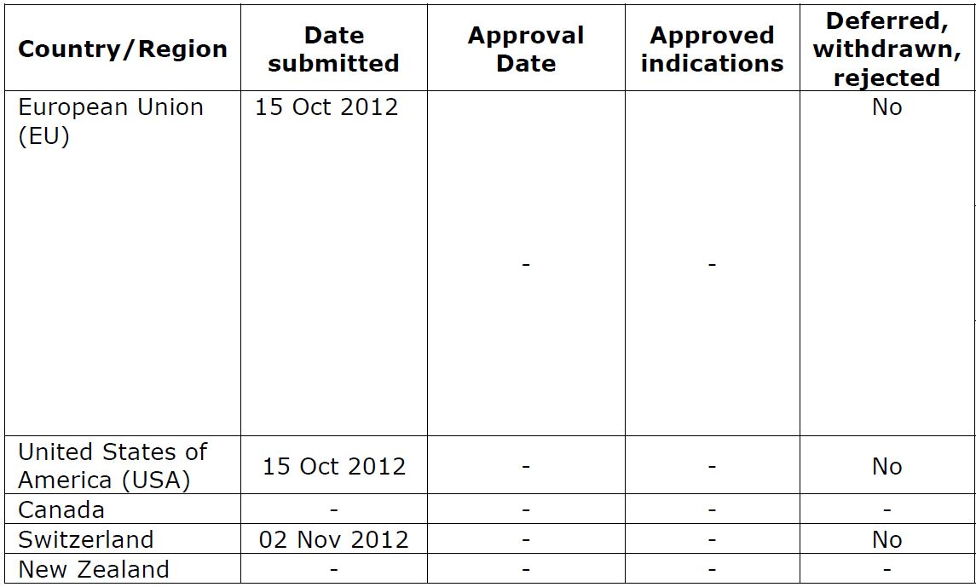
US approval was granted on 15 October 2013 with the following indications:
Novoeight, Antihemophilic Factor (Recombinant), is indicated for use in adults and children with hemophilia A (congenital factor VIII deficiency or classic hemophilia) for:
- Control and prevention of bleeding episodes
- Peri operative management
- Routine prophylaxis to prevent or reduce the frequency of bleeding episodes
Novoeight is not indicated for the treatment of von Willebrand disease
EU approval was granted on 13 November 2013 with the following indications:
Treatment and prophylaxis of bleeding in patients with haemophilia A (congenital factor VIII deficiency). NovoEight can be used for all age groups.

Product Information
The approved Product Information (PI) current at the time this AusPAR was prepared can be found as Attachment 1.

II. Quality findings

Drug substance (active ingredient)
Turoctocog alfa is a human recombinant Factor VIII with a molecular mass of 166 kDa, calculated excluding post translational modifications. The turoctocog alfa molecule is a polypeptide containing a heavy chain (HC) of 87 kDa (Figure 1) and a light chain (LC) of 79 kDa (Figures 2-3) held together by non covalent interactions. These chains in wild type Factor VIII are connected by a B-domain, while turoctocog alfa is a truncated rFVIII containing 21 amino acids of the wild type B-domain (Figure 4). Once activated by thrombin cleavage, the resulting rFVIIIa has the same structure as wild type FVIIIa.
Figure 1. Amino acid sequence of turoctocog alfa heavy chain.
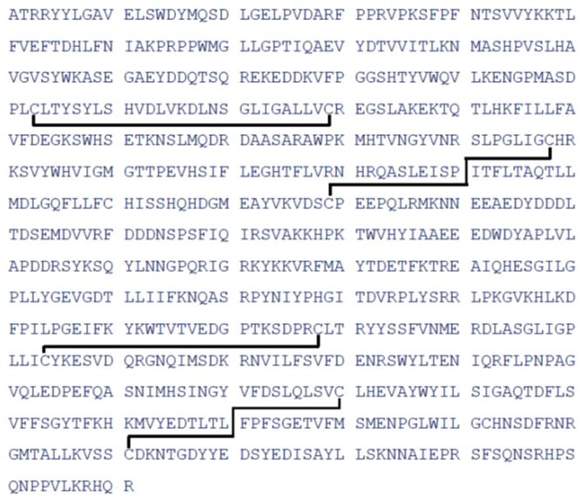
Note: disulfide bridges indicated.
Figure 2. Amino acid sequence of turoctocog alfa light chain.
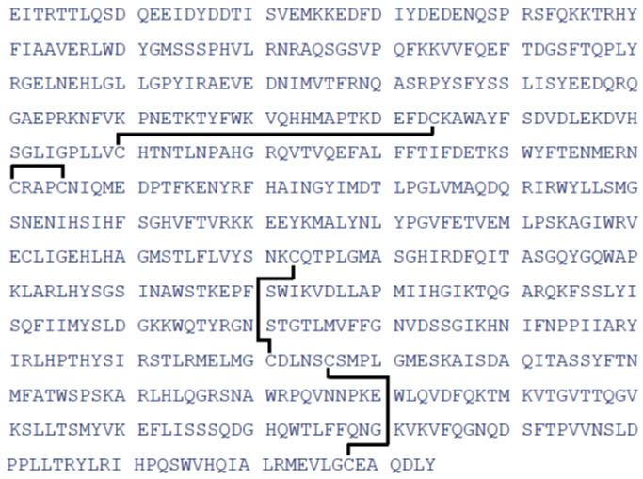
Note: disulfide bridges indicated.
Figure 3. Structure of turoctocog alfa light chain.
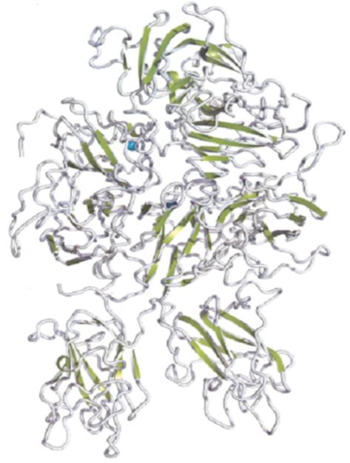
Figure 4. Overall structure of full length FVIII (top) and turoctocog alfa (bottom).
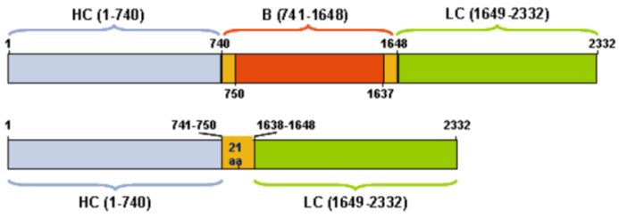
Turoctocog alfa is produced in CHO cells. The post translational modifications of turoctocog alfa include disulfide bridges, tyrosine sulphations and glycosylations. Six potential tyrosine sulphation sites are present in turoctocog alfa. The glycosylation sites are N-linked or O-linked and can be fully or partially occupied. Two N-linked glycosylations are present in the light chain and two N-linked glycosylations are present in the heavy chain and the majority of the bi-antennary structures are sialylated. Two O-linked glycosylation sites are present in the light chain and one O-linked glycosylation site is present in the B-domain. The two O-linked glycosylation sites in the light chain are found to be unoccupied in the major part of the turoctocog alfa molecules.

Drug product
Turoctocog alfa drug product is supplied as a sterile, lyophilised preparation in six different presentations: 250 IU/vial, 500 IU/vial, 1000 IU/vial, 1500 IU/vial, 2000 IU/vial, and 3000 IU/vial. Turoctocog alfa drug product is for single use and intended for injection after reconstitution in 4.3 mL 0.9% sodium chloride solution. There is 4 mL withdrawn for IV use. The 0.9% sodium chloride solution in a syringe is included in the package.
The vial for all six product presentations of turoctocog alfa drug product is a 5 mL vial made of type I glass, high hydrolytic resistance, in compliance with European Pharmacopoeia (Ph Eur), United States Pharmacopoeia (USP), and Japanese Pharmacopoeia (JP).
The lyophilisation rubber stopper for the turoctocog alfa drug product is made of a grey chlorobutyl rubber. The rubber meets the requirements of Ph Eur (Rubber closures for aqueous preparations for parenteral use, type I) and USP (Elastomeric Closures for Injections). The stopper is sealed with a snap off cap made of aluminium and plastic. A vial adapter is provided for turoctocog alfa drug product for transfer of fluids into and out of the vial. The vial adapter is sterile and disposable and is made of plastic. The secondary packaging process of turoctocog alfa drug product includes attachment of a scale to the pre filled syringe in which the 0.9% sodium chloride solution is provided. The syringe will be used for reconstitution and administration of the drug product.

Biopharmaceutics
Biopharmaceutic data are not required for this product because the route of administration is IV.

Quality summary and conclusions
There are no objections on quality grounds to the registration of NovoEight (turoctocog alfa (rch)).

III. Nonclinical findings

Introduction
The sponsor has applied for registration of NovoEight (turoctocog alfa; human coagulation factor VIII) for use in the clinical management of factor VIII deficiency (haemophilia A or classic haemophilia). NovoEight is not indicated for the treatment of von Willebrand disease.
The dosage and duration of the substitution therapy depend on the severity of the factor VIII deficiency, on the location and extent of the bleeding, and the patient’s clinical condition. During bleeding episodes and surgery, the dose is to be calculated so the FVIII plasma levels do not fall below prescribed FVIII levels (% or IU/dL), depending on the degree of haemorrhage or type of surgery. The calculation of the required dosage of factor VIII is based on the empirical finding that 1 IU factor VIII per kg body weight raises the plasma factor VIII activity by 2 IU/dl. The required dose is calculated using the following formula:
Required units (IU) = body weight (kg) x desired factor VIII rise (% or IU/dl) x 0.5 (IU/kg per IU/dl)
Table 2 is a guide for dose calculation in bleeding episodes and surgery.
Table 2: Dose calculation in bleeding episodes and surgery.
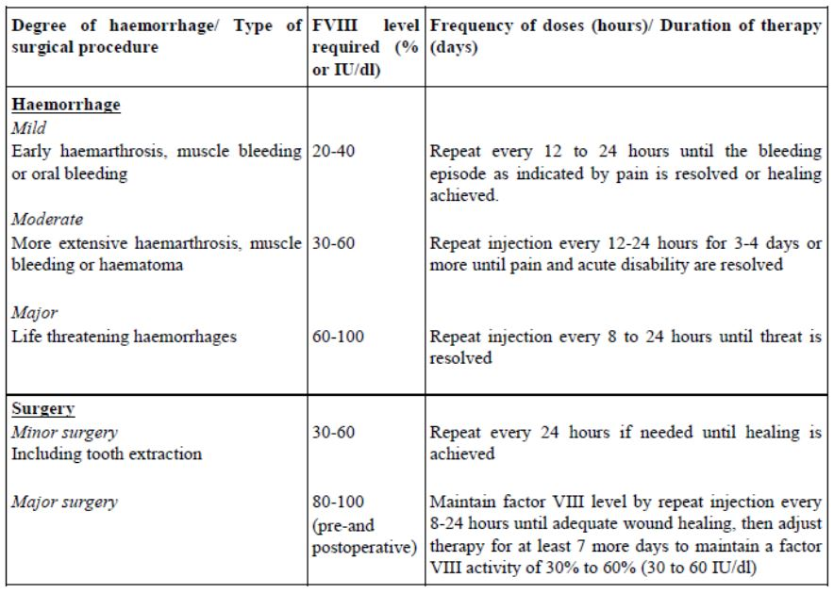
The recommended dose for treatment of bleedings and in surgery is up to 200 IU/kg body weight/day according to the Summary of Clinical Pharmacology.
For long term prophylaxis against bleeding in patients with severe haemophilia A, the usual recommended doses are 20-40 IU of factor VIII per kg body weight every second day or 20-50 IU of factor VIII per kg body weight 3 times weekly. In patients under the age of 12, doses of 25-50 IU of factor VIII per kg body weight every second day or 25-60 IU of factor VIII per kg body weight 3 times weekly are recommended.

Pharmacology

Primary pharmacology
The pharmacological properties of turoctocog alfa were investigated in vitro and in vivo.
The effects of turoctocog alfa on thrombin generation, rate of thrombin activation, and interaction with von Willebrand factor (vWF) were studied in vitro. These effects, as well as the affinity of turoctocog alfa to anti FVIII monoclonal antibodies, were compared with those of other recombinant FVIII products Advate and ReFacto, and the human plasma derived FVIII and von Willebrand factor Haemate.
In vitro, turoctocog alfa dose dependently enhanced thrombin generation in rat platelet rich plasma, cynomolgus monkey plasma, and a plasma based assay using normal platelets added to FVIII deficient human plasma at concentrations ranging between 0.1 and 8 IU/mL. No functional differences were found between turoctocog alfa and the comparator Advate in the affinity for FIXa, the rate of activation by thrombin, and the rate of activated protein C (APC) catalysed inactivation. Using thromboelastography, turoctocog alfa was shown to improve clot formation and clot stability in whole blood from haemophilia A patients, with comparable potency to Advate.
Using surface plasmon resonance and enzyme linked immunosorbent assay (ELISA) analysis, turoctocog alfa was shown to bind vWF with similar binding properties as recombinant FVIII products Advate and ReFacto, with a dissociation constant (Kd) of between 0.2 and 0.4 nM.
It was shown by Western blot analysis that the heavy chain and light chain peptides in turoctocog alfa are similar to the peptides observed in three commercially available FVIII products (Advate, ReFacto, and the plasma derived FVIII product Haemate). Using surface plasmon resonance, no kinetic differences were found between turoctocog alfa, Advate, and ReFacto in binding to different anti FVIII monoclonal antibodies, suggesting there are no discernable differences in the tertiary structures between turoctocog alfa and commercially available FVIII products.
In a study comparing turoctocog alfa, other FVIII products, and FVIII with heavy chain truncation (rFVIII1-720), it was demonstrated that the presence of residual rFVIII1-720 in turoctocog alfa does not decrease the speed of activation by thrombin (rFVIII1-720 by itself is activated more slowly by thrombin).
In conclusion, turoctocog alfa was demonstrated to be fully functional in a variety of in vitro assays measuring FVIII activity without functional differences with Advate.
Haemophilia A mice and dogs were considered as suitable species for toxicological assessment of turoctocog alfa. Turoctocog alfa reduced bleeding times in a mouse model of haemophilia A (F8 knockout mice) in tail bleed (ED₅₀ of 24-32 IU/kg) and knee injury (at 200 IU/kg) assays. In haemophilia A dogs, turoctocog alfa (100 IU/kg) corrected the impaired clotting in whole blood. The primary pharmacodynamic (PD) effects of turoctocog alfa in these studies were similar to those of Advate.

Secondary pharmacodynamics and safety pharmacology
No dedicated safety pharmacology studies were submitted. Safety pharmacology parameters were evaluated during repeat dose toxicity studies of 2 weeks duration.
Safety pharmacology was incorporated in the single dose toxicity study (electrocardiography and blood pressure) and the repeated dose toxicity study in male cynomolgus monkeys (blood pressure, electrocardiography, respiratory rate, neurological/CNS [central nervous system] endpoints and urinalysis). No effects were observed in respiratory rate or depth, behavioural, autonomic or neurological measurements, heart rate, blood pressure or electrocardiogram (ECG) parameters in cynomolgus monkeys. The no observed adverse effect level (NOAEL) was the highest dose tested, 5000 IU/kg.
Thrombus formation, cardiovascular, neurological or respiratory effects are not expected to be a safety concern for the clinical use of turoctocog alfa in patients treated at the maximum anticipated human prophylactic dose of 50 IU/kg.

Pharmacokinetics
A chromogenic assay (modified commercial method) was developed to measure plasma activity of FVIII in SD rats and cynomolgus monkeys. The FVIII measurements does not distinguish between turoctocog alfa and endogenous FVIII. Dog plasma was analysed by chromogenic and clot activity assays. Detection of anti turoctocog alfa antibodies in Sprague Dawley rat and cynomolgus monkey plasma was carried out using a radio immunoassay.
The pharmacokinetics and toxicokinetics of turoctocog alfa were investigated in F8 knockout mice, Sprague Dawley rats, haemophilia A affected dogs, and cynomolgus monkeys after a single and after repeated intravenous administration. The pharmacokinetics of turoctocog alfa was found to be comparable to that of other recombinant FVIII products, ReFacto and Advate, in mouse and dog models of haemophilia A (FVIII ko). In FVIII knockout mice, exposure increased dose proportionally up to 280 IU/kg. At 280 IU/kg, exposure was similar between turoctocog alfa, Advate and ReFacto. The terminal half life for turoctocog alfa, ReFacto and Advate in these knockout mice was 7-8 h. In haemophilia A affected dogs, the area under the plasma concentration-time curve (AUC) and clearance for turoctocog alfa and for Advate were similar within each individual dog (only 2 dogs were used and both products were injected into each dog). The terminal half life for turoctocog alfa and Advate was in the range of 7 to 11 h.
In rats, exposure (AUC) to turoctocog alfa in animals that received between 50 and 1250 IU/kg was not much different from the baseline FVIII levels in control animals because of high endogenous FVIII activity in this species. However, the maximum plasma FVIII concentration (C_{max}) (0.25 h, first sampling time) was higher than that seen in the control group and this increased with increased doses. It appears that rFVIII is rapidly cleared in rats which results in plasma FVIII activities declining to control levels 2-6 h after dosing. Terminal half life was around 4.5 h, when estimated from two composite profiles. After repeated dosing, plasma FVIII levels dropped below control group values. This was considered likely due to the development of anti FVIII antibodies in almost all the animals treated. In these animals, terminal half life was around 4.5 h.
In a toxicity study in monkeys, a less than dose proportional increase in exposure was observed. A decrease in exposure was observed after repeated dosing, likely due to formation of neutralising antibodies. Exposure to turoctocog alfa in monkeys decreased (and was highly variable) towards end of the treatment period.
¹²⁵I-turoctocog alfa in C57Bl mice showed relatively high levels of radioactivity in the organs with high blood flow, whereas distribution was very limited into brain, spinal cord, skeletal muscle and testis. Since turoctocog alfa is a recombinant human protein, the lack of studies of protein binding, metabolic pathways and possible interaction with the cytochrome P450 system is acceptable. The drug is expected to be metabolised into individual constituent amino acids.

Conclusion
The results of the studies in haemophilia mice and dogs demonstrated that the pharmacokinetic (PK) profile of turoctocog alfa following IV infusion is in general similar to that of recombinant FVIII products Advate and ReFacto. A decrease in exposure was seen after repeated dosing in rats and monkeys, which is likely due to the development of anti FVIII antibodies, and which diminishes the weight that can be placed in the results obtained in repeat dose toxicity studies. Tissue distribution was limited to highly perfused organs, which is expected for a protein product.

Toxicology

Acute toxicity
A single dose toxicity study in cynomolgus monkeys showed no signs of toxicity at the highest single intravenous dose tested (NOAEL of 5000 IU/kg). The single dose “safety margin” at the NOAEL is ~39, based on AUC in monkeys obtained after the first dose in the 2 week repeat dose study compared with human AUC at the recommended prophylactic single dose (50 IU/kg).

Repeat dose toxicity
The cynomolgus monkey was a pharmacological responsive species, which was demonstrated by in vitro thrombin generation in platelet poor plasma from cynomolgus monkeys and a comparable range of activated partial thromboplastin time (APTT). Thus, the monkey, together with the rat, was used for toxicity studies.
Studies that were 2 weeks in duration were conducted in Sprague Dawley rats and cynomolgus monkeys. Daily IV dosing (the clinical route) of 0-1250 IU/kg was used in the rat and 0-5000 IU/kg in the monkey. Daily dosing is more frequent than the recommended prophylactic clinical dosing frequency (once every 2 or 3 days).
In the rat, turoctocog alfa was generally well tolerated at IV doses of up to 1250 IU/kg/day, with no evidence of local or systemic toxicity (at necropsy on Days 16 and 23, there were no treatment related macroscopic or microscopic findings, or local or systemic effects). Almost all treated rats developed anti turoctocog alfa antibodies. The presence of these antibodies precluded accurate estimates of pharmacokinetic parameters, as steadily reduced exposure to turoctocog alfa as assessed by the measurable levels of FVIII activity in the plasma was noticed from Day 8 to the end of dosing. Prolongation in the APTT after repeated dosing for 2 weeks and after the recovery period in rats receiving 1250 IU/kg suggested the development of acquired haemophilia due to the development of neutralising antibodies to the administered FVIII.
In the monkey, turoctocog alfa was well tolerated at doses of up to 5000 IU/kg/day IV. Most treated monkeys developed anti turoctocog alfa antibodies, and most of them were neutralising antibodies. Antibodies developed approximately from Day 10 of dosing, suggested by APTT prolongation compared with Day 6 values. The development of neutralising antibodies from Day 10-14 was associated with dose proportional (at doses between 50 and 5000 IU/kg) APTT prolongation, also suggesting the development of acquired haemophilia due to the development of neutralising antibodies. Other effects associated with high doses of turoctocog alfa were also related to abnormalities in coagulation, such as cases of haemorrhages in the skin and seminal vesicles, as well as bruising and swelling. There were no other findings relating to treatment.
Immunogenicity of turoctocog in the animal species compromised the usefulness of the studies as tissue exposure to turoctocog alfa was reduced with repeated dosing. However, short term treatment with animal:human exposure ratios up to 7 in rats and 39 in monkeys for approximately one week (before the development of neutralising antibodies) did not reveal drug related toxicity.

Conclusion
The findings in the repeat dose studies are indirect effects due to immunogenicity of the human protein in rats and monkeys. It is unclear if the use of a haemophilia model (such as haemophilia dogs or mice) would have produced more useful results, as it is likely that the rapid production of neutralising antibodies would have occurred in these animals as well. No drug related toxicity findings were observed, apart from effects in coagulation likely due to the development of neutralising antibodies against the drug.

Relative exposure
Since the proposed recommended dosing regime for long term prophylaxis against bleeding is 3 times weekly administration of 20-50 IU/kg or every second day of 20-40 IU/kg, the human values at 50 IU/kg used to calculate the relative exposure were normalised to weekly exposure by multiplying the AUC value by 3. Since the repeat-dose toxicity studies in animals used a daily administration regime, the animal values were normalised to weekly exposure by multiplying the AUC value by 7.
The recommended dose for the treatment of bleedings is up to 200 IU/kg body weight, and therefore the exposure ratios in the treatment of bleeding are one quarter of the ratios displayed in the following table.
Table 3: Relative exposure in repeat dose toxicity studies.
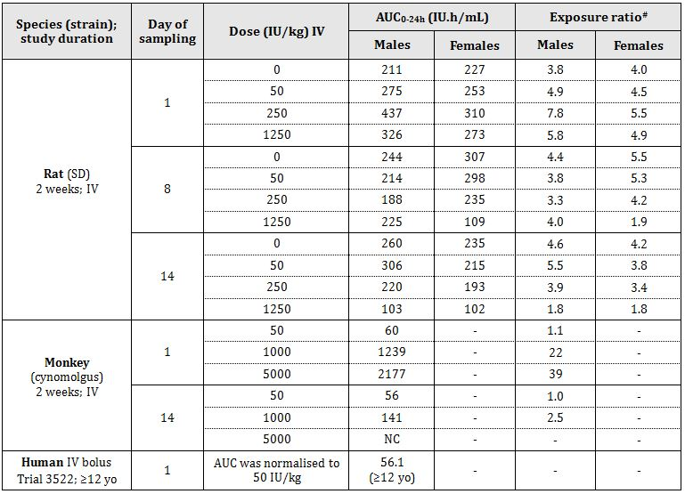
All pharmacokinetic parameters were calculated from values measured using the chromogenic assay
# = animal:human plasma AUC_{0-24h}; - = not applicable; NC = not calculable

Genotoxicity
No genotoxicity studies were included in the submission. This omission is acceptable in accordance with the TGA adopted EU guideline and justified on the basis that as a large protein the drug is not expected to interact directly with DNA or other chromosomal material. No causes for concern of a genotoxic nature have been identified for recombinant FVIII products (Advate and ReFacto) in vitro or after clinical use.

Carcinogenicity
The absence of carcinogenicity studies on turoctocog alfa is acceptable because:
- the International Conference on Harmonisation (ICH) guidelines state that standard carcinogenicity assays of biotechnology derived pharmaceuticals are generally inappropriate;
- the immunogenicity of recombinant factor VIII in experimental species would not allow for a carcinogenicity study of adequate duration; and
- recombinant factor VIII has been used for years in haemophilia A patients, and there are no mechanistic data to suggest a mutagenic or proliferative potential for turoctocog alfa.
The lack of carcinogenicity studies is stated in the PI.

Reproductive toxicity
The absence of reproductive and developmental toxicity studies is appropriate given that the product is only intended for physiological replacement of normal factor VIII activity and that haemophilia A is a sex linked disease that effectively only occurs in males. No effects on the reproductive organs were seen in histopathology assessment of reproductive organs in the repeat dose toxicity study using sexually mature male and female rats. Recombinant factor VIII has been used in patients with haemophilia A for years and there has been no evidence of adverse effects on fertility or embryofoetal development.

Pregnancy classification
Animal reproduction studies have not been conducted with turoctocog alfa. Coagulation factors derived from human plasma are exempt from pregnancy categorisation. However, recombinant FVIII are classified as pregnancy Category B2 drugs. The proposed B2 category is acceptable.

Local tolerance
Each pack of NovoEight 250-3000 IU powder contains 4.3 mL sterile water for injection. Reconstitution of 250 IU and 3000 IU with 4.3 mL results in concentrations of 58 and ~700 IU/mL, respectively.
The local tolerance of turoctocog alfa was investigated in rabbits and results compared to vehicle injections in the contralateral ear of the same animals. Injection related effects (bruising, erythema, and swelling) were not different between control and turoctocog alfa treated ears after IV (clinical application route), peri-venous, and intra arterial administration at total administered doses of 20 IU/kg (500 IU/mL).
Injection site reactions were examined in the repeat dose toxicity studies at concentrations of up to 500 IU/mL (rats) and 2500 IU/mL (monkeys). Histopathological changes at the injection sites (relating to haemorrhages) were observed in these studies but were not significantly different from those seen at control sites. Their occurrence is not unexpected in animals (and possibly humans) in which coagulation is impaired.

Development of neutralising antibodies
Studies in which turoctocog alfa was administered IV to rats and monkeys demonstrated that neutralising antibodies are developed after treatment for 8-10 days. These antibodies reduced the exposure to turoctocog alfa and to endogenous FVIII, and caused the development of acquired haemophilia as assessed by the increased prolongation in the APTT.
Antibody development did not give rise to any observable immunological reactions other than those affecting the coagulation system. The development of neutralising antibodies towards a foreign protein in the monkey or rat is not considered predictive of other forms of immunogenic reactions in humans. However, the formation of neutralising antibodies to factor VIII is a known complication in the management of individuals with haemophilia A. This is stated in the PI document.
These findings justified the short term (2 weeks) duration of the repeat dose toxicity studies, as studies of longer duration than 2 weeks would not provide relevant information on the safety evaluation of turoctocog alfa.

Impurities
The proposed limits for impurities are considered adequately qualified.

Paediatric use
No studies in juvenile animals were performed. The general repeat dose toxicity studies did not identify any system which is could be of specific concern for juvenile patients. Since the only findings in the toxicity studies were related to the development of cross reacting neutralising antibodies (and this is expected in animals receiving foreign proteins), nonclinical studies in juvenile animals were not expected to provide additional information regarding the safety of turoctocog alfa in a paediatric population.

Nonclinical summary and conclusions
- Novo Nordisk Pharmaceuticals Pty Ltd has applied for registration of NovoEight (turoctocog alfa; human coagulation factor VIII) for use in the clinical management of factor VIII deficiency (haemophilia A or classic haemophilia). NovoEight is not indicated for the treatment of von Willebrand disease. Turoctocog alfa is produced by recombinant DNA technology in CHO cells and is a third generation FVIII product prepared without serum or other animal derived material.
- In vitro, turoctocog alfa dose dependently enhanced thrombin generation in rat platelet rich plasma, cynomolgus monkey plasma, and a human plasma based assay using normal platelets added to FVIII deficient plasma, at concentrations ranging between 0.1 and 8 IU/mL. Turoctocog alfa binds vWF with similar binding properties as other recombinant FVIII products.
- Turoctocog alfa reduced bleeding times in a mouse model of haemophilia A (F8 knockout mice) using a tail bleed and a knee injury model. In haemophilia A affected dogs, turoctocog alfa corrected the impaired clotting in whole blood.
- No dedicated safety pharmacology studies were submitted. In the single dose toxicity study and the repeated dose toxicity study in male cynomolgus monkeys, no effects were observed in respiratory rate or depth, behavioural, autonomic or neurological measurements, heart rate, blood pressure or ECG parameters.
- ¹²⁵I-turoctocog alfa in C57Bl mice showed relatively high levels of radioactivity in the organs with high blood flow, whereas distribution was very limited into brain, spinal cord, skeletal muscle and testis. The ultimate fate of the drug is expected to be its metabolism to individual constituent amino acids.
- A single dose toxicity study in cynomolgus monkeys showed no signs of toxicity at the highest single intravenous dose tested (5000 IU/kg).
- In repeat dose toxicity studies, turoctocog alfa was administered to monkeys (up to 5000 IU/kg/day) and rats (up to 1250 IU/kg/day) by IV bolus for 2 weeks. Neutralising antibodies to turoctocog alfa developed in a dose and time dependent manner, leading to progressive prolonged APTT (presumably due to the development of inhibitors to endogenous factor VIII, and predisposition to multi tissue haemorrhage. Apart from immunogenicity related “haemophilia syndrome”, turoctocog alfa was well tolerated at all dose levels. The level of exposure in the monkey at 5000 IU/kg was high (39 fold that in humans at 50 IU/kg). The highest exposure observed in the rats at ≥1250 IU/kg was approximately 7 fold that in humans. Exposure in both rats and monkeys decreased and were highly variable after repeated dosing due to the development of neutralising antibodies, limiting the usefulness of animal studies for the assessment of rFVIII toxicity from repeated dosing in humans. In particular, in rats exposure to turoctocog alfa in animals was only slightly higher than in controls even after the first dose, probably due to rapid clearance in this species and high endogenous rat FVIII activity interfering with the assay. The formation of neutralising antibodies to factor VIII is a known complication in the management of individuals with haemophilia A, and this is stated in the PI document.
- Genotoxicity and carcinogenicity studies have not been conducted, which is acceptable for a biological product. No reproductive toxicity data were provided, and this is acceptable due to the nature of the components of turoctocog alfa. Studies in juvenile animals were not provided but these would not be expected to provide further information regarding the safety of turoctocog alfa in paediatric patients.
- The local tolerance of turoctocog alfa was not different between control and turoctocog alfa treated rabbits after IV (clinical application route), perivenous, and intra arterial administration, at concentrations similar to those expected clinically.
- There are no nonclinical objections to registration of NovoEight.

IV. Clinical findings
A summary of the clinical findings is presented in this section. Further details of these clinical findings can be found in Attachment 2.

Introduction
The submission contained the following clinical information:
- 3 clinical pharmacology trials, including PK and PD data;
- 2 pivotal efficacy/safety trials, including PK data;
- 1 efficacy/safety extension trial including ongoing patients from the two pivotal trials; and
- reports of bioanalytical and analytical methods for human studies;
- literature references.

Pharmacokinetics

Overview of pharmacokinetics trials
PK data for turoctocog alfa in male patients with severe haemophilia A (FVIII ≤ 1%) were derived from five completed clinical trials (three Phase I; two Phase III). These trials are outlined in Table 4. The submission included no PK data in healthy volunteers.
Table 4: Relative exposure in repeat dose toxicity studies.
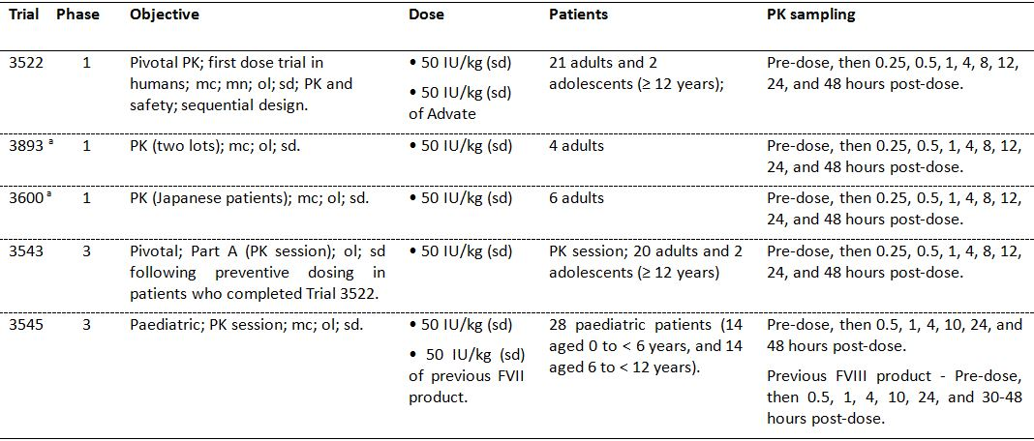
mc = multicentre; mn = multinational; ol = open-label; sd = single-dose
a. Trials 3600 and 3893: single dose PK assessment was preceded by preventive dosing for 3-6 months according to the dosing regimen in Trial 3543 (washout period of ≥ 4 days prior to the PK session)
As of the data cut off date of 21 November 2011, a total of 61 patients with haemophilia A had participated in trials that included full PK assessment of turoctocog alfa, and 28 of these patients were children aged < 12 years. Of the 61 patients, 22 had PK profiles from both Trial 3522 and Trial 3543.
All trials included previously treated male patients aged from 1 to 54 years with severe haemophilia A (FVIII activity level ≤ 1%), and no history of FVIII inhibitors. Patients were required to be non bleeding at the time of PK assessment. Previously treated adolescents aged ≥ 12 years and adults with a documented history of ≥ 150 exposure days to any FVIII product were included in Trials 3522, 3543, 3893 and 3600, and previously treated children aged < 12 years of age with a documented history of ≥ 50 days exposure to any FVIII product were included in Trial 3545.
The pivotal PK trial was considered to be Trial 3522, the first “in-human” Phase I dose trial. In this trial, the single dose PK profile of turoctocog alfa was investigated and compared with the single dose pharmacokinetic profile of octocog alfa (Advate) in adults and adolescent (aged ≥ 12 years). Patients from Trial 3522 continued treatment in the pivotal (adult) Phase III efficacy and safety trial (Trial 3543) during which second PK assessments were carried out after 3-6 months of preventive dosing with turoctocog alfa and were compared with first pharmacokinetic assessments from Trial 3522.
The PK of turoctocog alfa following single dose administration were investigated in paediatric patients aged < 12 years in the pivotal (paediatric) Phase III efficacy and safety trial (Trial 3545). In this trial, the pharmacokinetics of the patient’s previous FVIII product was investigated prior to first administration of turoctocog alfa.
The PK of turoctocog alfa were assessed in a small number of Japanese patients in Phase I Trial 3600), and the PK of two lots of turoctocog alfa were compared in a small number of patients in Trial 3893. In an ongoing Phase IIIb extension trial (Trial 3568), the PK of turoctocog alfa will be assessed prior to use of continuous infusion during surgery in paediatric, adolescent and adult patients. However, as of 21 November 2011, no patients undergoing surgery with continuous infusion had been included in the trial.
The clinical trials including patients with PK data were multinational and included patients from Germany, Israel, Italy, Japan, Lithuania, Macedonia, Malaysia, Poland, Russian Federation, Switzerland, Turkey, the UK and the US. The majority of the patients with PK data were “White”, while one PK trial was conducted in adult Japanese patients.

Evaluator’s overall conclusions on pharmacokinetics
- The PK of turoctocog alfa for the treatment of haemophilia A are considered to have been adequately characterised. The product is a therapeutic protein and once activated by thrombin cleavage the resulting rFVIII has the same structure as endogenous activated FVIII.
- Single dose (50 IU/kg) PK data were available from a total of 61 previously treated male patients aged from 1 to 54 years with severe haemophilia A (FVIII activity ≤ 1%). Of these 61 patients, 22 had PK data from both Trial 3522 (Phase I) and Trial 3543 (Phase III), and 28 were children aged < 12 years from Trial 3545 (Phase I). There were no repeat dose PK data, although Trial 3543 (Phase III) included single dose data on patients from the pivotal Phase I PK trial (Trial 3522) following 2 to 3 months of preventive dosing with turoctocog alfa.
- The composition of the reconstituted turoctocog alfa drug product used in all clinical trials was identical to the product to be marketed. No specific bioavailability or bioequivalence trials were performed. However, in the pivotal Phase I PK trial (Trial 3522) the bioequivalence of turoctocog alfa and Advate was investigated in 20 patients, although the trial was not specifically designed to test bioequivalence. The trial showed that the two rFVIII products administered at a dose of 50 IU/kg were bioequivalent as regards AUC, incremental recovery, half life (t_{1/2}), total clearance (CL), and weight normalised CL when the parameters were measured using the clotting assay, but were not bioequivalent when the parameters were measured using the chromogenic assay. However, the observed differences between the two rFVIII products in the PK parameters measured by the chromogenic assay are unlikely to be clinically significant.
- In the clinical trials, mean FVIII activity after administration of turoctocog alfa was generally higher when measured using the chromogenic assay compared with the clotting assay. In the pivotal Phase I PK trial (Trial 3522), factor FVIII activity following single dose turoctocog alfa (50 IU/kg) was greater in patients (n = 20) when measured using the chromogenic assay than the clotting assay: mean incremental recovery was 40% higher (0.028 versus 0.020 [IU/mL]/[IU/kg]); mean AUC was 32% higher (18.70 versus 14.22 IU*h/mL); and C_{max} was 44% higher (1.54 versus 1.07 IU/mL).
- The PK of turoctocog alfa were similar in patients (n = 15) after the first single dose of turoctocog alfa (Trial 3522) and after a single dose following 3-6 months of preventive treatment with the drug (Trial 3543). The 90% confidence intervals (CIs) for the ratios of the PK parameters at the two time points were within the interval 0.80 to 1.25 for all endpoints, apart from the terminal half life measured by the chromogenic assay. In particular, there were no noteworthy changes in incremental recovery between the two time points. The results suggest that there is unlikely to be loss of efficacy over time.
- The sponsor undertook a trial (Trial 3893) in adult patients (n = 4) comparing the PK of turoctocog alfa from two production lots in order to meet a request from the European Union regulatory authorities to evaluate the PK properties of the drug in at least three production lots. There were no marked differences in the PK profiles of the two lots. However, due to the low number of observations (two PK profiles for each lot), no statistically meaningful conclusions can be drawn with respect to the pharmacokinetic similarity between the two lots.
- The mean (SD) apparent volume of distribution at steady state (Vss) in adults and adolescent patients (n = 20) was small as measured by both the clotting assay (53.43 [10.88] mL/kg) and the chromogenic assay (44.31 [28.17] mL/kg). The low Vss suggests that following IV administration, turoctocog alfa remains primarily in the intravascular compartment with limited distribution to the extravascular compartments.
- The mean t_{1/2} in adults and adolescent patients (n = 20) was approximately 10 to 11 hours, indicating that following IV administration turoctocog alfa is likely to be eliminated from the plasma in approximately 50 to 55 h. The mean (SD) total CL of turoctocog alfa was 274.9 (87.8) mL/h measured by the clotting assay and 209.7 (67.2) mL/h measured by the chromogenic assay. There were no studies investigating the metabolism of turoctocog alfa or its renal clearance. However, as the drug is a protein with a molecular mass of ~166 kDA, it can be predicted that it will eliminated by tissue mechanisms, such as receptor mediated endocytosis followed by catabolism, rather than by hepatic metabolism or renal excretion.
- In Trial 3545, the pharmacokinetics of turoctocog alfa was investigated in children (n = 28) with haemophilia A aged < 12 years of age. The trial showed that the pharmacokinetics of the drug were similar in children aged 0 to < 6 years and 6 to < 12 years. However, in children aged < 12 years the AUC was lower, the CL was higher, and the t_{1/2} was shorter compared with adults and adolescents aged ≥ 12 years. The observed differences in the PK of turoctocog alfa in children and adults in the submitted data have also been reported for other FVIII products. In children, the PK of turoctocog alfa were similar to the PK of a range of other FVIII products taken prior to turoctocog alfa. There were no data on the PK turoctocog alfa patients aged less than 1 year or more than 54 years.
- There were differences between the pharmacokinetics of turoctocog alfa in Japanese patients (Trial 3600) and in “White” patients (Trial 3522). These differences were primarily due to higher FVIII activity levels in Japanese patients, mainly occurring within the first 4 h post dosing. However, there was a notable imbalance in patient numbers between the two racial groups (6 Japanese versus 23 “White”) suggesting that the observed differences should be interpreted cautiously. There were no pharmacokinetic data for racial groups other than “White” or Japanese.
- There were no data on the PK of turoctocog alfa in patients with renal or hepatic impairment. There were no data on PK interactions between turoctocog alfa and other drugs. There were no data on the PK of turoctocog alfa in female patients with haemophilia A. However, it is considered that the absence of PK data in these special populations should not preclude registration of turoctocog alfa.

Pharmacodynamics
PK assessments were based on the FVIII activity assay. This parameter is known to correlate to clinical efficacy of FVIII products. Therefore, FVIII activities are considered to be PD in nature as they reflect the biologic response to turoctocog alfa. No other specific PD endpoints were assessed.

Efficacy

Overview of the clinical efficacy studies
The application to register turoctocog alfa for the proposed indication was supported by three Phase III, multi national, multi centred, uncontrolled, open label, single arm efficacy and safety studies in previously FVIII treated male patients with severe haemophilia A (FVIII activity ≥ 1%) without inhibitors. The three studies are outlined below in Table 5. As of the data cut off date of 21 November 2011, a total of 214 patients had been exposed to turoctocog alfa. Each of the three clinical efficacy and safety studies has been fully evaluated in this clinical evaluation report. Each of the three studies was sponsored by the sponsor.
Table 5: Overview of the three Phase III clinical efficacy and safety trials.
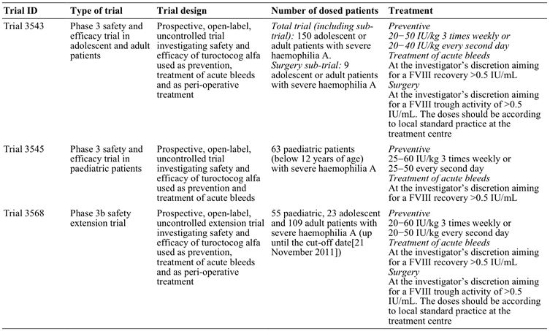
Comment: There were no studies in females with severe haemophilia A. However, Haemophilia A is rare in women. Data in the Australian Bleeding Disorders Registry Annual Report 2010-2011 indicates that the prevalence of severe haemophilia in men at 30 June 2011 was 56 times that of women (5.6 patients/100,000 males versus 0.1 patients/100,000 females). These figures indicate that women comprised ~1.8% of the total population of patients with severe haemophilia A in Australia at 30 June 2011. The sponsor argues that as haemophilia is extremely rare, “it is impossible to include woman in the development programme in order to obtain usable data”. The sponsor’s rationale for not including women patients in the clinical trial program is acceptable. Furthermore, it is considered unlikely that the efficacy and safety of turoctocog alfa will significantly differ between male and female patients with haemophilia A.

Evaluator's conclusions on clinical efficacy
- It is considered that the submission has satisfactorily established the efficacy of turoctocog alfa for the prevention and treatment of bleeding episodes in children and adults with haemophilia A, without inhibitors, who have been previously treated with FVIII products. There were limited efficacy data on the use of turoctocog alfa in the surgical setting, but the submitted data are considered to satisfactorily establish the efficacy of the drug for this indication.
- The submission to register turoctocog alfa for the proposed indications was supported by three, good quality, Phase III, multi national, multi centred, open label, single arm efficacy and safety studies in previously treated male patients with severe haemophilia A (FVIII activity ≥ 1%), without inhibitors (Trials 3543, 3545, and 3568). The submission included 214 patients who had been exposed to turoctocog alfa up to the data cut off date of 21 November 2011. Of these 214 patients, 213 were included in the efficacy analysis, with 1 adult patient not continuing from the pivotal Phase I PK trial (Trial 3522) into the pivotal Phase III trial (Trial 3543). Of the 213 treated patients, 126 were adults aged ≥ 18 years, 24 were adolescents aged ≥ 12 years to < 18 years, 32 were children aged 6 to < 12 years, and 31 were children aged 0 to < 6 years.
- In each of the Phase III trials, efficacy endpoints relating to prevention of bleeding and on-demand treatment of acute bleeding episodes were defined as secondary endpoints, with the primary endpoint in each of the trials being the incidence rate of FVIII inhibitors (that is, a safety endpoint). However, the TGA adopted European Union note for guidance on the clinical investigation of rFVIII products indicates that clinical efficacy should be assessed from clinical response as reported by patients in safety trials, and the efficacy endpoints in the submitted trials were consistent with those defined in the guidance document.
- There was no comparator arm in the three Phase I clinical efficacy and safety trials. While a placebo arm would have been unethical, it would have been useful to have included a commercially available rFVIII product as an active comparator arm. However, in adults and adolescents (≥ 12 years to < 18 years) single dose turoctocog alfa 50 IU/kg and single dose Advate 50 IU/kg were found to be bioequivalent as assessed by the clotting assay (Trial 3543), while in children (0 to 12 years of age) the pharmacokinetics of single dose turoctocog alfa were similar to the PK of a range of other FVIII products taken prior to turoctocog alfa (Trial 3545). Based on the single dose PK data in adults, adolescents and children it is reasonable to infer that the efficacy of turoctocog alfa is likely to similar to that of other FVIII products. Furthermore, the TGA adopted EU note for guidance document on the clinical investigation of rFVIII products does not specify that an active comparator is required for assessment of clinical efficacy endpoints.
- In the pivotal adult trial (Trial 3543), all patients were treated with preventive turoctocog alfa with the majority (83.3%; 125/150) receiving the 20 to 50 IU/kg three times a week regimen and the minority (16.7%; 23/150) receiving the 20 to 40 IU/kg every second day regimen. Of the 150 patients exposed to turoctocog alfa, 148 were exposed for at least 50 days and 142 were exposed for at least 75 days. The estimated mean annualised bleeding rate in the 150 treated patients was 6.50 (95% CI: 5.30, 7.97) bleeds/patient/year, with the mean annualised bleeding rate being higher in adults aged ≥ 18 years (n = 126) than in adolescents aged ≥ 12 to < 18 years (n = 24) (6.68 versus 5.55 bleeds/patient/year, respectively). The mean preventive dose of turoctocog in the total population was 24.6 IU/kg, ranging from 12.8 to 97.4 IU/kg, and the mean consumption of turoctocog alfa for the prevention of bleeds was 3860.1 IU/kg per patient per year, ranging from 2577.8 to 7452.2 IU/kg per patient per year. The estimated mean annualised bleeding rate in the total population in this trial was similar to the corresponding rate reported for Advate from published data in a similar population (6.5 versus 6.3 bleeds/patient/year, respectively).
- In the pivotal adult trial (Trial 3543), there were 499 bleeds in the total population (n = 150), of which 66.5% (332/499 bleeds) were spontaneous and 24.8% (124/499 bleeds) were traumatic, with information being missing on 8.6% (43/499 bleeds). The mean duration of a bleed was 16.4 h, ranging from 15 minutes to 304 h. The mean time from start of a bleed until the first administration of turoctocog alfa was 2.83 h, ranging from 0 to 56 h, and the mean time from the first administration of turoctocog alfa until the bleed stopped was 13.6 h, ranging from 0 to 300 h.
- In the pivotal adult trial (Trial 3543), the haemostatic response in the total population following turoctocog alfa to treat an acute bleed was rated as excellent for 28.1% of bleeds, good for 52.7% of bleeds, moderate for 12.4% of bleeds and none for 2.4% of bleeds, with haemostatic data being missing for 4.4% of bleeds. In the total population, the success rate (excellent/good haemostatic response) for treatment of acute bleeds with turoctocog alfa was 84.5% (excluding missing data), which compares with a success rate of 86.0% for Advate reported in the published data. In the total population, the mean turoctocog alfa dose for the treatment of an acute bleed was 30.4 IU/kg, ranging from 9.8 to 61.1 IU/kg, and the mean consumption of the drug to stop a bleed was 46.6 IU/kg, ranging from 15.0 to 1150.0 IU/kg. Of the 499 bleeds, 71.5% were stopped with one infusion and 17.8% were stopped with two infusions. The mean number of infusions to stop a bleed from start to finish was 1.5 infusions/bleed.
- In the pivotal paediatric trial (Trial 3454), all patients were treated with preventive turoctocog alfa with the majority (74.6%; 47/63) receiving the three times a week regimen (25 to 60 IU/kg, 3x/week) and the minority (25.4%; 16/63) receiving the once every second day regimen (25 to 50 IU/kg, 2nd daily). Of the 63 patients exposed to turoctocog alfa, 59 were exposed for at least 50 days. The estimated mean annualised bleeding rate in the total paediatric population (n = 63) was 5.33 (95% CI: 3.90, 7.28) bleeds/patient/year, with the rate being lower in children aged 0 to < 6 years (n = 31) compared with children aged 6 to < 12 years (n = 32) (4.73 versus 5.86 bleeds/patient/year, respectively). The estimated annualised bleeding rate in the total paediatric population was lower than in the total adult/adolescent population (5.33 versus 6.50 bleeds/day, respectively). The mean preventive dose of turoctocog alfa in the paediatric population was 36.8 IU/kg, ranging from 3.2 to 73.9 IU/kg, and the mean consumption of the drug for prevention of bleeding was 5641.4 IU/kg per patient per year, ranging from 2653.5 to 9357.9 IU/kg per patient per year.
- In the pivotal paediatric trial (Trial 3454), 126 bleeds were reported in 41 patients (65.1%). Of the 126 bleeds, 66.7% (84/126) were traumatic, 31.7% (40/126) were spontaneous, and 1.6% (2/126) were unclassified. The proportion of traumatic bleeds was greater in younger children aged 0 to <6 years than in older children 6 to < 12 years (83.0%; 44/53 versus 54.8%, 40/73; respectively). The mean duration of a bleed was 8.88 h, ranging from 10 minutes to 53.5 hours. Of the 126 bleeds, 81.0% were stopped with one infusion and 14.3% were stopped with two infusions. The mean number of infusions required to stop a bleed from start to finish was 1.3 infusions/bleed.
- In the pivotal paediatric trial (Trial 3454), the haemostatic response following turoctocog alfa for the treatment of an acute bleed was rated as excellent for 54.9%, good for 38.1%, moderate for 4.0%, and none for 1.6%, with haemostatic data being missing for 2.4% of bleeds. The haemostatic response was similar in children aged 0 to < 6 years and 6 to < 12 years. The success rate (excellent/good haemostatic response) for treatment of acute bleeds with turoctocog alfa was 94.3% (excluding missing data), which was higher than in the pivotal adult trial (84.5%). The mean turoctocog alfa dose for the treatment of an acute bleed was 40.4 IU/kg, ranging from 25.5 to 193.8 IU/kg, and the mean consumption of the drug to stop a bleed was 54.2 IU/kg, ranging from 25.7 to 264.0 IU/kg. The mean number of turoctocog alfa infusions required to stop a bleed was 1.3 infusions/patient.
- In the extension trial (Trial 3568), the annualised bleeding rates in the total population (n = 157: 31 children < 12 years and 126 adults/adolescents) was lower than in the total population (n = 150) in the pivotal adult trial (Trial 3543) and in the total population (n = 63) in the pivotal paediatric trial (Trial 3524) (3.54 versus 6.50 versus 5.33 bleeds/patient/year, respectively). The decrease in the estimated annualised rate bleeding rate associated with increased duration of exposure to turoctocog alfa was also observed in the pooled patient population from Trials 3568, 3543, and 3545 where the estimated annualised bleeding rate plotted against month on preventive treatment showed a drop from Month 6 to 7, corresponding to the time at which patients transferred from the pivotal adult trial (Trial 3543) to the extension trial (Trial 3568). The reason for the drop in the estimated annualised bleeding rate is unknown. However, the pooled data for the success rate based on the haemostatic response (excellent/good) remained relatively constant over time.
- In the pooled analysis, 68 patients received preventive treatment with turoctocog alfa for at least 12 months, with cumulative exposure of 114.8 years (that is, mean of 1.69 years per patient). The 68 patients experienced 492 bleeds resulting in a mean estimated annualised bleeding rate of 4.29 (95% CI: 3.28, 5. 60) bleeds/patient/year. These 68 patients experienced 318 bleeds in the first 12 months of treatment (cumulative exposure 68 years) resulting in an estimated mean annualised bleeding rate of 4.68 (95% CI: 3.52, 6.21). The results indicate that the bleeding rate in the 68 patients was similar following > 12 months and ≤ 12 months preventive treatment with turoctocog alfa, suggesting that there is no decrease in efficacy over time. In addition, the mean estimated annualised bleeding rate of 4.29 bleeds/patient/year for the 68 patients exposed for a mean of 1.69 years/patient is comparable to the annualised bleeding rate of 4.89 bleeds/patient/year for the total population of 213 patients exposed for a mean of 0.96 years/patient.
- The pooled analysis included a comparison between pre trial and post trial bleeding rates. At baseline, a total of 85 (40.1%) patients had at least 12 months of prophylactic exposure to FVIII products prior to trial entry, ranging from 12 to 480 months. The mean number of bleeds, as reported by the investigator, within the last year prior to trial entry for these patients was 6.1 bleeds/patient/year. During the trial period the annualised bleeding rate for these patients was lower at 3.86 bleeds/patient/year. At baseline, a total of 73 (34.4%) patients had received on-demand FVIII treatment prior to trial entry. The mean number of bleeds per month within the last year prior to trial entry for these patients was 3.9 bleeds/patient/month corresponding to 47 bleeds/patient/year, as reported by the investigator. The mean annualised bleeding rate for these patients was 5.53 bleeds/patient/year after preventive treatment with turoctocog alfa. In addition, 44 (20.8%) patients were reported to have been on both preventive and on-demand treatment regimens prior to trial entry, and 10 (4.7%) of patients were reported to have been on preventive treatment for less than 12 months. These 54 patients were not included in the comparison between the pre trial and during the trial bleeding rates.
- There were limited data on the use of turoctocog alfa in surgery. The pooled data from the two surgical sub trials (Trials 3543 and 3468) included information on 11 patients (10 major and 1 minor surgeries) with a mean age of 27.3 years, ranging from 14 to 54 years. The haemostatic response was reported as excellent in 72.8% (8/11) of patients and good in 27.3% (3/11) of patients both during surgery and after haemostasis had been achieved.

Safety

Studies providing evaluable safety data
The submission included an evaluation of safety in patients undergoing preventive and on-demand treatment based on data from five completed trials (Trials 3522, 3893, 3600, 3543, 3545), and from one ongoing trial (Trial 3568). The data from the ongoing trial (Trial 3568) included information on non serious adverse events (AEs) up to the cut off date of 21 November 2011, and information on serious adverse events (SAEs), development of inhibitors and hypersensitivity reactions up to the later cut off date of 1 May 2012. The submission also included a separate evaluation of safety in patients undergoing surgery from the two surgical sub trials (Trials 3543 and 3568). In this clinical evaluation report, the evaluation of safety focuses on separate analyses of the pooled safety data in patients undergoing preventive and on-demand and of the pooled safety data in patients undergoing surgery.

Evaluator's overall conclusion on clinical safety
It is considered that the safety of turoctocog alfa for the proposed usage has been satisfactorily established in children and adults. However, there were no comparative safety data with either placebo or active control, which limits the interpretation of the data. The submission included pooled safety data on 214 previously treated patients with severe haemophilia A (FVIII activity ≤ 1%), without inhibitors, who had received turoctocog alfa for the prevention and treatment of bleeds, and 11 patients who had received the drug in a surgical setting.

Prevention and treatment of bleeds
- The 214 patients who received turoctocog alfa for the prevention and treatment of bleeds had a total 32,929 exposure days to the drug, ranging from 1 to 442 days, with a mean of 153.9 exposure days per patients.
- AEs (irrespective or relationship to treatment) were reported in 72.0% (n = 154) of the total patient population (503 events; 2.45 events/patient years of exposure). The event rates were similar across the four age cohorts ranging from a low of 2.30 events/patient years of exposure in adults aged ≥ 18 years to a high of 3.53 events/patient years of exposure in children aged 0 to < 6 years. The overall rate of AEs decreased with time on turoctocog alfa treatment.
- The most commonly occurring AEs (preferred term) reported in ≥ 2% of the total population were: nasopharyngitis (10.3%); headache (10.3%); incorrect dose administered (8.9%); arthralgia (6.1%); pyrexia (6.1%); Upper respiratory tract infection (URTI) (5.1%); toothache (5.1%); contusion (4.7%); cough (4.7%); oropharyngeal pain (4.2%); nasal congestion (3.3%); pharyngitis (2.8%); joint injury (2.8%); sinusitis (2.3%); vomiting (2.3%); and pain in extremity (2.3%). AEs reported in ≥ 2% of all patients and more frequently in children aged 0 to < 6 years compared with the three other age groups included URTI, pyrexia, vomiting, cough, allergic rhinitis, ear pain, and dizziness. Overall, the AE safety profile does not give rise to concern in children, adolescents, or adults.
- There were a total of 26 treatment related AEs reported in 17 (7.9%) patients. The most frequently reported treatment related AEs in 2 or more patients were: incorrect dose administered (4 events in 4 patients); increased levels of hepatic enzymes (4 events in 3 patients); injection site erythema (3 events in 3 patients); and pyrexia (2 events in 2 patients). Of the 26 treatment related AEs, 2 were reported in children aged 0 to < 6 years (0.13 events/patient years of exposure), 0 were reported in children aged 6 to < 12 years, 0 were reported in adolescents ages ≥ 12 to < 18 years, and 24 were reported in adults aged ≥ 18 years (0.16 events/patient years of exposure).
- There was one death reported in the clinical trials up to 1 May 2012. The death was related to a traumatic subdural haematoma following an alleged assault. There were a total of 21 SAEs reported in 17 (7.9%) patients up to 21 November 2011, and the only events occurring in 2 or more patients were road traffic accident (2, 0.9%) and melena (2, 0.9%). Of the 21 SAEs, 4 were considered to be treatment related (hypertension, tachycardia, and insomnia all reported in 1 patient; hepatic enzyme increased in 1 patient). Of the 21 SAEs, 3 were reported in children aged 0 to < 6 years (0.20 events/patient years of exposure), 2 were reported in children aged 6 to < 12 years (0.11 events/patient years of exposure), 3 were reported in adolescents aged ≥ 12 to < 18 years (0.12 events/patient years of exposure), and 13 were reported in adults aged ≥ 18 years (0.09 events/patient years of exposure). A further 4 SAEs were reported in the period from 21 November 2011 to 1 May 2012, including the fatal subdural haematoma, and none were considered to be treatment related.
- Withdrawal from treatment due to AEs was reported in 2 (0.9%) adult patients, 1 due to fatigue lasting for about 24 hours after every infusion and considered to be possibly related to treatment, and 1 due to a psychotic disorder occurring after 386 exposure days considered to be unlikely to be related to treatment. No patients were withdrawn due to a lack of efficacy.
- No patients had developed FVIII inhibitors (≥ 0.6 Bethesda units [BU]) as of 1 May 2011. A total of 19 patients were positive for anti CHO antibodies at some point during the trials: 2 changed from negative to positive during the trial; 6 changed from positive to negative during the trial; 6 were positive throughout the trial; 2 were negative at baseline and end of trial but with transient positive samples between; and 3 were positive at baseline and end of trial but with transient negative samples between. There were 7 patients who were anti murine IgG positive at baseline, and 5 subsequently became negative and 2 remained positive throughout the trial. No patients changed from anti murine IgG negative to positive during the trials. No drug related allergic type hypersensitivity reactions were reported as medical events of special interest as of 1 May 2011. However, examination of the listed AEs indicates that drug hypersensitivity was reported in 1 patient (System Organ Class [SOC] “immune system disorders”). No thromboembolic events occurred during the trials.
- As of 21 November 2011, 34 medication errors were recorded, and most were related to incorrect dosing. There were three overdosing errors, but no symptoms associated with overdosing were reported in the trials. All medication errors were rated as mild, and none were judged to have any impact on the safety of the patients or on the outcome of the treatment.
- The only noteworthy clinical laboratory abnormalities in the trials related to 18 AEs (reported in 10 patients) characterised by increases in liver function test parameters (mainly increases in transaminase levels). However, the majority of patients (80%, 8/10) with liver function test (LFT) abnormalities were hepatitis C positive, which most likely explains the findings. Most of the LFT abnormalities (14/18 = 78%) were considered by the investigator as unlikely to be related to turoctocog alfa. There were no noteworthy changes in vital signs or ECG findings.
- There were no safety data in patients with previously untreated haemophilia A, female patients, patients younger than 1 year and older than 60 years, patients with hepatic impairment, patients with renal impairment, or in racial groups other than “Whites” or Japanese. The safety data on patients with FVIII inhibitors were too limited to allow meaningful conclusions to be drawn. There were no safety data on the effect of HIV status or hepatitis C status on turoctocog alfa treatment. There were no safety data relating to the concomitant use of medications or drug-drug interactions with turoctocog alfa. There is no post marketing experience.

Safety in the surgical setting
- The safety data in patients undergoing surgery is limited to 11 patients (10 adults and 1 adolescent) from the two surgical sub trials (Trials 3543 and 3568). In the two surgical sub trials, 11 patients had a total of 201 exposure days to turoctocog alfa with a mean (SD) of 18.3 (12.55) exposure days per patient ranging from 7 to 41 days.
- There were 5 AEs reported in 5 patients during surgery, and all were considered by the investigator to be unlikely to be related to turoctocog alfa. The 5 events were: paraesthesia (patient aged 36 years, mild severity, recovered); haemorrhage (patient aged 36 years, moderate severity, recovered); allergy to chemicals (patient aged 18 years, mild severity, not recovered); arthralgia (aged 24 years, mild severity, recovered); and vomiting (aged 55, mild severity, recovered). There were no deaths or SAEs reported in patients in the surgical sub trials, and no patients were withdrawn due to AEs.

Clinical summary and conclusions: first round

First round benefit-risk assessment

First round assessment of benefits
There are no data comparing the benefits of turoctocog alfa with other FVIII products for the prevention and treatment of bleeding or in the surgical setting in previously treated patients with severe haemophilia A (FVIII activity ≤ 1%), without inhibitors. However, it can be reasonably inferred from the single dose PK and bioequivalence data in adults and adolescents that turoctocog alfa and Advate are likely to have similar benefits for the treatment of patients with haemophilia A. In addition, it can be reasonably inferred from the PK data in children with haemophilia A that turoctocog alfa is likely to have similar benefits to other FVIII products when used for the treatment of haemophilia A in this patient group.
In the pivotal adult trial (n = 150), the estimated mean annualised bleeding rate was 6.50 (95% CI: 5.30, 7.97) bleeds/patient/year, with the rate being higher in adults aged ≥ 18 years (n = 126) than in adolescents aged ≥ 12 to < 18 years (n = 24) (6.68 versus 5.55 bleeds/patient/year, respectively). The estimated mean annualised bleeding rate in the pivotal adult trial was similar to the corresponding rate reported for Advate from published data in a similar patient population (6.5 versus 6.3 bleeds/patient/year, respectively).
In the pivotal adult trial, the success rate (excellent/good haemostatic response) for treatment of acute bleeds with turoctocog alfa in the total population (n = 150) was 84.5% (excluding missing data), which compares with a success rate of 86.0% for Advate from published data. Of the 499 reported bleeds in the pivotal adult trial, 71.5% were stopped with one turoctocog alfa infusion and 17.8% were stopped with two infusions. The mean number of turoctocog alfa infusions to stop a bleed was 1.5 infusions/bleed.
In the pivotal paediatric trial (n = 63), the estimated mean annualised bleeding rate was 5.33 (95% CI: 3.90, 7.28) bleeds/patient/year, with the rate being lower in children aged 0 to < 6 years (n = 31) compared with children aged 6 to < 12 years (n = 32) (4.73 versus 5.86 bleeds/patient/year, respectively). The estimated mean annualised bleeding rate in the total paediatric population was lower than in the total adult/adolescent population (5.33 versus 6.50 bleeds/patient/year, respectively).
In the pivotal paediatric trial, the success rate (excellent/good haemostatic response) for treatment of acute bleeds with turoctocog alfa was 94.3% (excluding missing data), which was higher than the corresponding success rate in the total population in the pivotal adult trial (84.5%). Of the 126 reported bleeds, 81.0% were stopped with one turoctocog alfa infusion and 14.3% were stopped with two infusions. The mean number of turoctocog alfa infusions to stop a bleed was 1.5 infusions/bleed.
The data from the extension trial (n=157) indicates that the benefits of treatment with turoctocog alfa are maintained with continuous treatment, based on the estimated annualised bleeding rates and the success rates. In addition, in the pooled efficacy analysis, 68 patients received preventive treatment with turoctocog alfa for at least 12 months and experienced 492 bleeds resulting in an estimated mean annualised bleeding rate of 4.29 (95% CI: 3.28, 5. 60) bleeds/patient/year (compared to 318 bleeds in these 68 patients in ≤ 12 months of treatment resulting in an estimated mean annualised bleeding rate of 4.68 [95% CI: 3.52, 6.21] bleeds/patient/year).
There were limited data on the use of turoctocog alfa in surgery. The pooled data from the two surgical sub trials included information on 11 patients (10 major and 1 minor surgeries) with a mean age of 27.3 years, ranging from 14 to 54 years. The haemostatic response was reported as excellent in 72.8% (8/11) patients and good in 27.3% (3/11) of patients both during surgery and after haemostasis had been achieved.

First round assessment of risks
There are no data comparing the risks of turoctocog alfa with other FVIII products for the prevention and treatment of bleeding or in the surgical setting in previously treated patients with severe haemophilia A (FVIII activity ≤ 1%), without inhibitors. However, the submitted data do not give rise to significant safety concerns or unexpected safety signals relating to the use of turoctocog alfa for the proposed indications. In particular, no patients had developed FVIII inhibitors (≥ 0.6 BU) as of 1 May 2011, and no patients experienced thromboembolic events or drug related allergic type hypersensitivity reactions during the trials defined as medical events of special interest.
The risk of experiencing an adverse event (irrespective of relationship to treatment) occurred very commonly in association with turoctocog alfa for the prevention and treatment of bleeding. In the pooled safety population, 72.0% (154/214) of patients experienced at least one AE. There were 503 events resulting in an event rate of 2.45 events/patient years of exposure in the total safety population. The risk of experiencing an adverse event was similar in the four age cohorts, with the event rate ranging from a low of 2.30 events/patient years of exposure in adults aged ≥ 18 years to a high of 3.53 events/patient years of exposure in children aged 0 to < 6 years. The risk of experiencing an adverse event decreased with the length of time on turoctocog alfa treatment. The most commonly occurring AEs (preferred term) reported in ≥ 5% of the total population were: nasopharyngitis (10.3%); headache (10.3%); incorrect dose administered (8.9%); arthralgia (6.1%); pyrexia (6.1%); URTI (5.1%); and toothache (5.1%).
AEs considered by the investigator to be possibly or probably related to treatment were reported uncommonly (26 treatment related events in 17 [7.9%] of patients). Treatment-related AEs reported in 2 or more patients were: incorrect dose administered (4 events in 4 patients); increased levels of hepatic enzymes (4 events in 3 patients); injection site erythema (3 events in 3 patients); and pyrexia (2 events in 2 patients). Of the 26 treatment related AEs, 2 were reported in children aged 0 to < 6 years (0.13 events/patient years of exposure) and 24 were reported in adults aged ≥ 18 years (0.16 events/patient years of exposure), with no events being reported in older children or adolescents.
The risk of experiencing a SAE was uncommon. In the total safety population, 21 SAEs were reported in 17 (7.9%) patients up to 21 November 2011, and the only events reported in 2 or more patients were road traffic accident (2, 0.9%) and melena (2, 0.9%). Of the 21 SAEs, 4 were considered to be treatment related (hypertension, tachycardia, and insomnia all reported in 1 patient; hepatic enzymes increased in 1 patient). Of the 21 SAEs, 3 were reported in children aged 0 to < 6 years (0.20 events/patient years of exposure), 2 in children aged 6 to < 12 years (0.11 events/patient years of exposure), 3 in adolescents aged ≥ 12 to < 18 years (0.12 events/patient years of exposure), and 13 in adults aged ≥ 18 years (0.09 events/patient years of exposure). A further 4, non treatment related SAEs were reported in the period from 21 November 2011 to 1 May 2012, including 1 fatal subdural haematoma due to an alleged assault. The risk of death due to treatment with turoctocog alfa is negligible.
The only noteworthy clinical laboratory abnormalities in the trials related to 18 AEs (reported in 10 patients) characterised by abnormal increases in liver function test parameters (mainly increases in transaminase levels). However, the majority of patients (80%, 8/10) with LFT abnormalities were hepatitis C positive, which most likely explains the findings. Most of the LFT abnormalities (14/18 = 78%) were considered by the investigator as being unlikely to be related to turoctocog alfa. There were no noteworthy changes in vital signs or ECG findings.
A total of 19 patients were positive for anti CHO antibodies at some point during the trials: 2 changed from negative to positive during the trial; 6 changed from positive to negative during the trial; 6 were positive throughout the trial; 2 were negative at baseline and end of trial but with transient positive samples between; and 3 were positive at baseline and end of trial but with transient negative samples between. There were 7 patients who were anti murine IgG positive at baseline, and 5 subsequently became negative and 2 of remained positive throughout the trial. No patients changed from anti murine IgG negative to positive during the trials.
There is limited information on the risks of treatment with turoctocog alfa in the surgical setting. However, the available data suggest that the risks associated with turoctocog alfa in the surgical setting appear to be common, but unrelated to treatment (that is, 5, non treatment related AEs reported in 45.5% [5/11] of patients). In the surgical patients, there were no treatment related AEs, no SAEs (including deaths), and no withdrawals due to AEs.
There was no information on the risks of treatment with turoctocog alfa in patients with previously untreated haemophilia A, female patients, patients younger than 1 year, patients older than 60 years, patients with hepatic impairment, patients with renal impairment, or in patients from racial groups other than “White” or Japanese. The safety data on patients with FVIII inhibitors were too limited to allow meaningful conclusions to be drawn about the risks of treatment in this patient group. There was no information on the risks of turoctocog alfa treatment based on HIV or hepatitis C status. There was no information on the risks of turoctocog alfa when administered in combination with other drugs.

First round assessment of benefit-risk balance
The benefit-risk balance of turoctocog alfa, given the proposed usage, is favourable.

First round recommendation regarding authorisation
It is recommended that turoctocog alfa be approved for the treatment and prophylaxis of bleeding episodes in patients with haemophilia A, including control and prevention of bleeding in surgical settings.

List of questions

Pharmacokinetics
1. What were the baseline demographic characteristics of the 30 paediatric patients included in the PK population of Trial 3545?
2. Please provide a breakdown of the individual FVIII products included in the pooled FVIII product data set used for the PK comparison between “previous FVIII product” and turoctocog alfa in the PK part of Trial 3545.
3. The Summary of Clinical Pharmacology included a post hoc analysis of the PK parameters for turoctocog alfa and “previous [PK] product” from Trial 3545 measured by both the chromogenic and the clot assay. Crosschecking with the original Clinical Trial Report for Trial 3545 indicates that the summary data for “previous [FVIII] product” are based on 26 patients, but the summary data for turoctocog alfa could not be identified. As the post hoc analysis is a “compare analysis set” it is assumed that the data for turoctocog in this analysis is based on the same 26 patients with “previous [FVIII] product” data. Please confirm that the post hoc analysis includes 26 patients in the “compare analysis set” with both “previous [FVIII] product” and turoctocog alfa PK data.

Pharmacodynamics
No questions.

Efficacy
4. In the Clinical Trial Report for Trial 3543, it is stated that: “A total of 35% of the patients had been on prophylactic regimens prior to trial entry and 39% had been on on-demand treatment regimens, while the remaining 26% had been on both prophylaxis and on-demand treatment; calculated from EOT Table 14.1.73”. Please explain how the provided percentages have been calculated from EOT Table 14.1.73.
5. In Trial 3543, the mean baseline FVIII activity was 2.95% (range: 0 to 98%). Please comment on the potential effect this might have had on the trial outcomes given that the mean baseline FVIII activity level was greater than 1%.
6. What was the mean baseline FVIII activity (in percentage terms) in the pivotal paediatric trial (Trial 3545)? Please comment on the potential effect that baseline FVIII activity might have had on the outcomes of the pivotal paediatric trial.
7. The definition of re-bleeding could be identified in Trial 3545 (pivotal paediatric trial), but not in Trial 3543 (pivotal adult trial). What was the definition of re-bleeding used in Trial 3543?

Safety
8. In the Summary of Clinical Safety (2.7.4), it was stated that no drug related allergic type hypersensitivity reactions were reported as medical events of special interest as of 1 May 2011. However, examination of the listed AEs in the total safety population indicates that drug hypersensitivity was reported in 1 patient and hypersensitivity was reported in 1 patient (SOC “immune system disorders”); see Summary of Clinical Efficacy, Appendix 1, Table 7. Please comment on the apparent discrepancy between drug related allergic type reactions reported as medical events of special interest and the listed AEs of drug hypersensitivity and hypersensitivity reported in the Summary of Clinical Efficacy.

Clinical summary and conclusions: second round

Second round evaluation of clinical data submitted by the sponsor in response to the section 31 questions

Question 1
Please advise what were the baseline demographic characteristics of the 30 paediatric patients included in the PK population of Trial 3545.

Sponsor’s section 31 response
A total of 30 patients were enrolled in the PK part of Trial 3545. Two patients were withdrawn between Visits 2 and 3. The reason for withdrawal was stated as “other” in both cases. Since these two patients did not receive turoctocog alfa, they were not included in the full analysis set. The baseline demographics for the paediatric PK population are included in Table 6.
Table 6: Baseline characteristics for the paediatric PK population – Trial 3545.
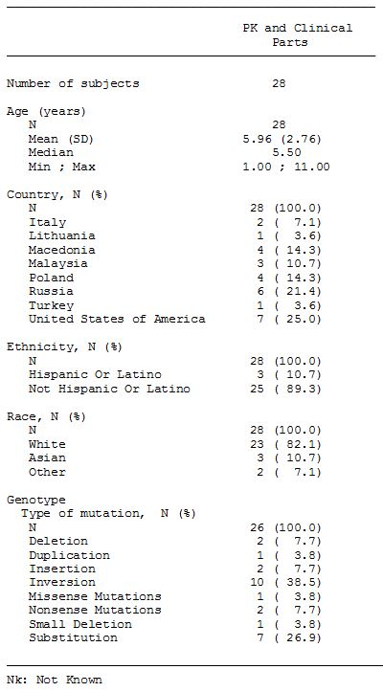

Evaluator’s comment
The sponsor’s response is satisfactory.

Question 2
Please provide a breakdown of the individual FVIII products included in the pooled FVIII product dataset used for the PK comparison between “previous FVIII product” and turoctocog alfa in the PK part of Trial 3545.

Sponsor’s section 31 response
A total of 30 patients were enrolled in the pharmacokinetic part of Trial 3545. Two patients were withdrawn between Visits 2 and 3. Since these two patients did not receive turoctocog alfa, they were not included in the full analysis set. (The response included reference to two additional patients for whom the sponsor excluded PK data from the previous FVIII product. Justification for excluding the data from these two patients was provided and is considered to be acceptable.) Therefore, a total of 26 patients were included in the pharmacokinetic evaluation of previous product.
Mean FVIII activity profiles for the paediatric patients’ previous products (plasma derived and recombinant) are presented in the Figures 5-6 for the chromogenic assay and the clotting assay, respectively.
Figure 5. Chromogenic Assays - FVIII Mean profile activity of previous products based on chromogenic assay (linear scale): Trial 3545 - full analysis set, dose adjusted.
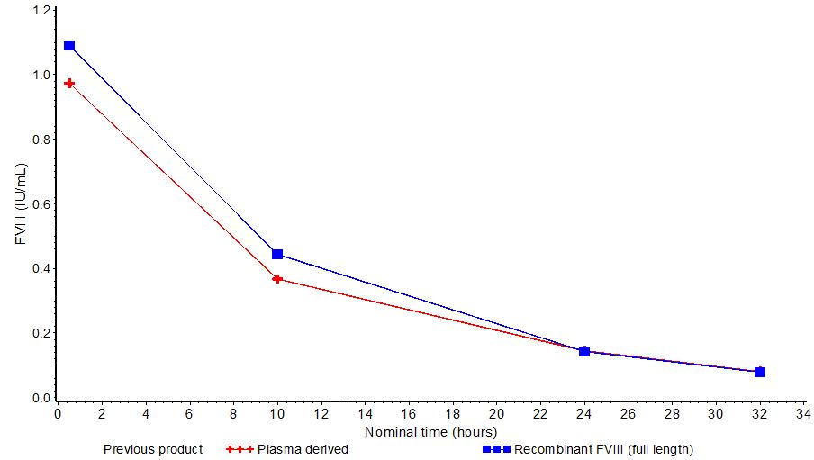
Figure 6. Clot Assay - FVIII Mean profile activity of previous products based on clot assay (linear scale): Trial 3545 - full analysis set, dose adjusted.
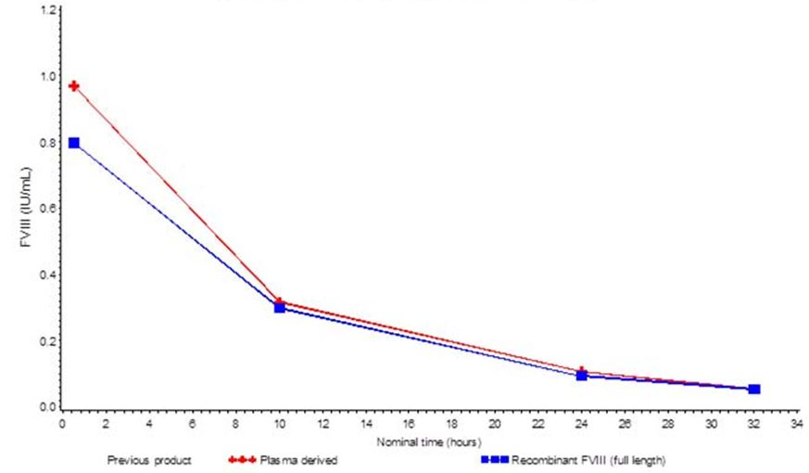

Evaluator’s comment
The sponsor’s response is satisfactory. The FVIII mean activity profiles (chromogenic and clot assays) are similar for the previous plasma derived and recombinant FVIII (full length) products. The mean FVIII activity profiles for the two product groups indicate that it was reasonable to pool the PK data from the “previous products”.

Question 3
The Summary of Clinical Pharmacology included a post hoc analysis of the PK parameters for turoctocog alfa and “previous [PK] product” from Trial 3545 measured by both the chromogenic and the clot assay. Crosschecking with the original Clinical Trial Report for Trial 3545 indicates that the summary data for “previous [FVIII] product” are based on 26 patients, but the summary data for turoctocog alfa could not be identified. As the post hoc analysis is a “compare analysis set” it is assumed that the data for turoctocog in this analysis is based on the same 26 patients with “previous [FVIII] product” data. Please confirm that the post-hoc analysis includes 26 patients in the “compare analysis set” with both “previous [FVIII] product” and turoctocog alfa PK data.

Sponsor’s section 31 response
Yes, that is correct. Only the 26 patients with useable profiles for both previous product and turoctocog alfa are included in this comparison.

Evaluator’s comment
The sponsor’s response is satisfactory.

Question 4
In the Clinical Trial Report for Trial 3543, it is stated that: “A total of 35% of the patients had been on prophylactic regimens prior to trial entry and 39% had been on on-demand treatment regimens, while the remaining 26% had been on both prophylaxis and on-demand treatment; calculated from EOT Table 14.1.73”. Please explain how the provided percentages have been calculated from EOT Table 14.1.73.

Sponsor’s section 31 response
A total of 39 patients (26%) had been on both prophylaxis and on-demand treatment prior to the trial. In the previously submitted Module 5.3.5.2, Trial 3543, EOT Table 14.1.73, these patients were included in both categories (prophylaxis and on-demand). For clarification, please find included the complete overview of the patients’ previous treatment regimens in Table 7.
Table 7: Patients’ previous product – Trial 3543.
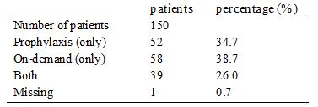

Evaluator’s comment
The sponsor’s response is satisfactory.

Question 5
In Trial 3543, the mean baseline FVIII activity was 2.95% (range: 0 to 98%). Please comment on the potential effect this might have had on the trial outcomes given that the mean baseline FVIII activity level was greater than 1%.

Sponsor’s section 31 response
All enrolled patients had a diagnosis of severe (FVIII ≤1%) haemophilia A documented in medical records. Inclusion in the trial was based on the medical records and not the baseline FVIII activity measured at the screening visit. The wide range in FVIII activity at screening most likely reflects that some patients did not withhold treatment with their previous FVIII product for at least 48 hours prior to the screening visit. Therefore, FVIII activity levels assessed at screening did not necessarily reflect the actual endogenous FVIII levels. The level of the FVIII activities at screening are not considered to influence the outcomes of the trial.

Evaluator’s comment
The sponsor’s response is satisfactory.

Question 6
What was the mean baseline FVIII activity (in percentage terms) in the pivotal paediatric trial (Trial 3545)? Please comment on the potential effect that baseline FVIII activity might have had on the outcomes of the pivotal paediatric trial.

Sponsor’s section 31 response
Due to the limited use of the collected baseline FVIII activity level measured at screening in Trial 3543, baseline FVIII activity was not recorded in Trial 3545. Inclusion of patients was based on documented diagnosis of severe haemophilia A with FVIII levels of < 1% and the contribution of baseline FVIII activity is therefore considered to be very small.

Evaluator’s comment
The sponsor’s response is satisfactory.

Question 7
The definition of re-bleeding could be identified in Trial 3545 (pivotal paediatric trial), but not in Trial 3543 (pivotal adult trial). Please advise what the definition of re-bleeding used was in Trial 3543?

Sponsor’s section 31 response
Classification of re-bleeds was done by the trial statistician based on collected trial data at the time of statistical analysis. The definition of re-bleeding used was identical for the two trials:
Re-bleed is defined as when after an initial period of improvement, there is a worsening of the bleeding site conditions, either on treatment or within 72 h after stopping treatment. It is considered as a new bleeding episode if worsened >72 h after stopping of treatment.

Evaluator’s comment
The sponsor’s response is satisfactory.

Question 8
In the Summary of Clinical Safety (2.7.4), it was stated that no drug related allergic type hypersensitivity reactions were reported as medical events of special interest as of 1 May 2011. However, examination of the listed AEs in the total safety population indicates that drug hypersensitivity was reported in 1 patient and hypersensitivity was reported in 1 patient (SOC “immune system disorders”); see Summary of Clinical Efficacy, Appendix 1, Table 7. Please comment on the apparent discrepancy between drug related allergic type reactions reported as medical events of special interest and the listed AEs of drug hypersensitivity and hypersensitivity reported in the Summary of Clinical Efficacy.

Sponsor’s section 31 response
Allergic type hypersensitivity reactions, including anaphylaxis/anaphylactoid reactions, is a potential risk with the administration of turoctocog alfa and to ensure adequate adverse event follow up information from the clinical trial sites these events were specifically defined as medical events of special interest. No events of hypersensitivity against turoctocog alfa were reported in any trial.
The two events of hypersensitivity referred to in the previously submitted Summary of Clinical Safety, Appendix 1, Table 7 were not reported with a causality related to turoctocog alfa treatment. Details of the two events are included below:
- In Trial 3568, one event of drug hypersensitivity against trimethoprim/polymyxin drops was reported for one patient. This event was mild, non-serious and unlikely related to turoctocog alfa.
- In Trial 3545, one patient reported an event of hypersensitivity caused by an insect bite. The event was evaluated as mild and considered unlikely related to turoctocog alfa.

Evaluator’s comment
The sponsor’s response is satisfactory.

Second round benefit-risk assessment

Second round assessment of benefits
After consideration of the responses to the clinical questions, the benefits of turoctocog alfa (NovoEight) for the proposed indications remain favourable. For ease of reference, the benefits are outlined below and, apart from some minor editorial changes, the wording remains unchanged from that provided in the first round recommendation.
There are no data comparing the benefits of turoctocog alfa with other FVIII products for the prevention and treatment of bleeding or in the surgical setting in previously treated patients with severe haemophilia A (FVIII activity ≤ 1%), without inhibitors. However, it can be reasonably inferred from the single dose PK and bioequivalence data in adults and adolescents that turoctocog alfa and Advate are likely to have similar benefits for the treatment of patients with haemophilia A. In addition, it can be reasonably inferred from the PK data in children with haemophilia A that turoctocog alfa is likely to have similar benefits to other FVIII products when used for the treatment of haemophilia A in this patient group.
In the pivotal adult trial (n = 150), the estimated mean annualised bleeding rate was 6.50 (95% CI: 5.30, 7.97) bleeds/patient/year, with the rate being higher in adults aged ≥ 18 years (n = 126) than in adolescents aged ≥ 12 to < 18 years (n = 24) (6.68 versus 5.55 bleeds/patient/year, respectively). The estimated mean annualised bleeding rate in the pivotal adult trial was similar to the corresponding rate reported for Advate from published data in a similar patient population (6.5 versus 6.3 bleeds/patient/year, respectively).
In the pivotal adult trial, the success rate (excellent/good haemostatic response) for treatment of acute bleeds with turoctocog alfa in the total population (n = 150) was 84.5% (excluding missing data), which compares with a success rate of 86.0% for Advate from published data. Of the 499 reported bleeds in the pivotal adult trial, 71.5% were stopped with one turoctocog alfa infusion and 17.8% were stopped with two infusions. The mean number of turoctocog alfa infusions needed to stop a bleed was 1.5 infusions/bleed.
In the pivotal paediatric trial (n = 63), the estimated mean annualised bleeding rate was 5.33 (95% CI: 3.90, 7.28) bleeds/patient/year, with the rate being lower in children aged 0 to < 6 years (n = 31) compared with children aged 6 to < 12 years (n = 32) (4.73 versus 5.86 bleeds/patient/year, respectively). The estimated mean annualised bleeding rate in the total paediatric population was lower than in the total adult/adolescent population (5.33 versus 6.50 bleeds/day, respectively).
In the pivotal paediatric trial, the success rate (excellent/good haemostatic response) for treatment of acute bleeds with turoctocog alfa was 94.3% (excluding missing data), which was higher than the corresponding success rate in the total population in the pivotal adult trial (84.5%). Of the 126 reported bleeds, 81.0% were stopped with one turoctocog alfa infusion and 14.3% were stopped with two infusions. The mean number of turoctocog alfa infusions to stop a bleed was 1.5 infusions/bleed.
The data from the extension trial (n = 157) indicates that the benefits of treatment with turoctocog alfa are maintained with continuous treatment, based on the estimated annualised bleeding rates and the success rates. In the pooled analysis, 68 patients received preventive treatment with turoctocog alfa for at least 12 months and experienced 492 bleeds resulting in an estimated mean annualised bleeding rate of 4.29 (95% CI: 3.28, 5. 60) bleeds/patient/year (compared to 318 bleeds in these 68 patients in ≤ 12 months of treatment resulting in an estimated mean annualised bleeding rate of 4.68 [95% CI: 3.52, 6.21]).
There were limited data on the use of turoctocog alfa in surgery. The pooled data from the two surgical sub trials included information on 11 patients (10 major and 1 minor surgeries) with a mean age of 27.3 years, ranging from 14 to 54 years. The haemostatic response was reported as excellent in 72.8% (8/11) patients and good in 27.3% (3/11) of patients both during surgery and after haemostasis had been achieved.

Second round assessment of risks
After consideration of the responses to the clinical questions, the risks of turoctocog alfa (NovoEight) for the proposed indications remain favourable. For ease of reference, the risks are outlined below and, apart from some minor editorial changes, the wording remains unchanged from that provided in the first round recommendation.
There are no data comparing the risks of turoctocog alfa with other FVIII products for the prevention and treatment of bleeding or in the surgical setting in previously treated patients with severe haemophilia A (FVIII activity ≤ 1%), without inhibitors. However, the submitted data do not give rise to significant safety concerns or unexpected safety signals relating to the use of turoctocog alfa for the proposed indications. In particular, no patients had developed FVIII inhibitors (≥ 0.6 BU) as of 1 May 2011, and no patients experienced thromboembolic events or drug related allergic type hypersensitivity reactions during the trials.
The risk of experiencing an adverse event (irrespective of relationship to treatment) occurred very commonly in association with turoctocog alfa for the prevention and treatment of bleeding. In the pooled safety population, 72.0% (154/214) of patients experienced at least one AE. There were 503 events resulting in an event rate of 2.45 events/patient years of exposure in the total safety population. The risk of experiencing an adverse event was similar in the four age cohorts, with the event rate ranging from a low of 2.30 events/patient years of exposure in adults aged ≥ 18 years to a high of 3.53 events/patient years of exposure in children aged 0 to < 6 years. The risk of experiencing an adverse event decreased with the length of time on turoctocog alfa treatment. The most commonly occurring AEs (preferred term) reported in ≥ 5% of the total population were: nasopharyngitis (10.3%); headache (10.3%); incorrect dose administered (8.9%); arthralgia (6.1%); pyrexia (6.1%); URTI (5.1%); and toothache (5.1%).
AEs considered by the investigator to be possibly or probably related to treatment were reported uncommonly (26 treatment related events in 17 [7.9%] of patients). Treatment related AEs reported in 2 or more patients were: incorrect dose administered (4 events in 4 patients); increased levels of hepatic enzymes (4 events in 3 patients); injection site erythema (3 events in 3 patients); and pyrexia (2 events in 2 patients). Of the 26 treatment related AEs, 2 were reported in children aged 0 to < 6 years (0.13 events/patient years of exposure) and 24 were reported in adults aged ≥ 18 years (0.16 events/patient years of exposure), with no events being reported in older children or adolescents.
The risk of experiencing a serious adverse event was uncommon. In the total safety population, 21 SAEs were reported in 17 (7.9%) patients up to 21 November 2011, and the only events reported in 2 or more patients were road traffic accident (2, 0.9%) and melena (2, 0.9%). Of the 21 SAEs, 4 were considered to be treatment related (hypertension, tachycardia, and insomnia all reported in 1 patient; hepatic enzymes increased in 1 patient). Of the 21 SAEs, 3 were reported in children aged 0 to < 6 years (0.20 events/patient years of exposure), 2 in children aged 6 to < 12 years (0.11 events/patient years of exposure), 3 in adolescents aged ≥ 12 to < 18 years (0.12 events/patient years of exposure), and 13 in adults aged ≥ 18 years (0.09 events/patient years of exposure). A further 4, non treatment related SAEs were reported in the period from 21 November 2011 to 1 May 2012, including 1 fatal subdural haematoma due to an alleged assault. The risk of death due to treatment with turoctocog alfa was negligible in the submitted trials.
The only noteworthy clinical laboratory abnormalities in the trials related to 18 AEs (reported in 10 patients) characterised by abnormal increases in liver function test parameters (mainly increases in transaminase levels). However, the majority of patients (80%, 8/10) with LFT abnormalities were hepatitis C positive, which most likely explains the findings. Most of the LFT abnormalities (14/18 = 78%) were considered by the investigator as unlikely to be related to turoctocog alfa. There were no noteworthy changes in vital signs or ECG findings.
A total of 19 patients were positive for anti CHO antibodies at some point during the trials: 2 changed from negative to positive during the trial; 6 changed from positive to negative during the trial; 6 were positive throughout the trial; 2 were negative at baseline and end of trial but with transient positive samples between; and 3 were positive at baseline and end of trial but with transient negative samples between. Seven (7) patients were anti murine IgG positive at baseline, 5 of these patients subsequently became negative and 2 remained positive throughout the trial. No patients changed from anti murine IgG negative to positive during the trials.
The risks associated with turoctocog alfa in the surgical setting appear to be relatively minor with 5 non treatment related AEs being reported in 11 (45.5%) patients. There were no treatment related AEs, no SAEs, and no withdrawals due to AEs. However, there is limited information on the risks of treatment with turoctocog alfa in the surgical setting.
There was no information on the risks of treatment with turoctocog alfa in patients with previously untreated haemophilia A, female patients, patients younger than 1 year, patients older than 60 years, patients with hepatic impairment, patients with renal impairment, or in patients from racial groups other than “White” or Japanese. The safety data on patients with FVIII inhibitors were too limited to allow meaningful conclusions to be drawn about the risks of treatment in this patient group. There was no information on the risks of turoctocog alfa treatment based on HIV or hepatitis C status. There was no information on the risks of turoctocog alfa when administered in combination with other drugs.

Second round assessment of benefit-risk balance
After consideration of the responses to the clinical questions, the benefit-risk balance of turoctocog alfa (NovoEight) for the proposed indications remains favourable.

Second round recommendation regarding authorisation
After consideration of the response to the clinical questions, the first round recommendation regarding authorisation stands. It is recommended that turoctocog alfa (NovoEight) be approved for the treatment and prophylaxis of bleeding episodes in patients with haemophilia A, including control and prevention of bleeding in surgical settings.

V. Pharmacovigilance findings

Risk management plan
The sponsor submitted a RMP which was reviewed by the TGA’s Office of Product Review (OPR).

Safety specification
The sponsor provided a summary of ongoing safety concerns which are shown at Table 8.
Table 8: Ongoing safety concerns for NovoEight.
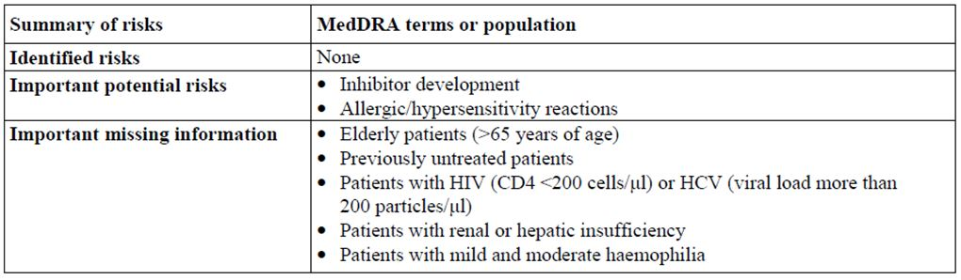

OPR reviewer comment
Notwithstanding the evaluation of the nonclinical and clinical aspects of the Safety Specification, it is recommended that the sponsor amends this table as follows.
- Off-label use for Immune Tolerance Induction (ITI) in children is expected to occur. It is recommended that off-label use for ITI be included as important missing information in the table of ongoing safety concerns. Pharmacovigilance and risk minimisation activities should be assigned to this missing information as appropriate.
- During the clinical development program there was no exposure of patients belonging to the following patient populations:
  - Females, pregnant women, lactating women;
  - Cardiac impaired patients;
  - Sub-populations with genetic polymorphism.
It is recommended that these special patient groups be included in the table of ongoing safety concerns as important missing information. Pharmacovigilance and risk minimisation activities should be assigned to this missing information as appropriate.
- The sponsor states:
During the clinical programme, 23 events (2 within narrow scope and 21 within broad scope) that may indicate allergic reaction have been reported in patients with congenital deficiency.
Based on this statement, this risk is considered to be an identified risk. Consequently, this risk should be included in the table of ongoing safety concerns as identified risk.
- It is recommended that embolic/thrombolic events, secondary to a central venous access device (CVAD), used to administer this product, should be included as identified risk in the table of ongoing safety concerns. Pharmacovigilance and risk minimisation activities should be assigned to this identified risk as appropriate. Thrombosis related complications occurred in 10.8% of patients with CVADs reported in six studies, the risk increased with time of CVAD use. This has relevance to the use of this product because, it will be used at least 3 times/week, and will be administered over a period of 2-5 minutes as described in the CMI. Consequently, it is expected that many patients will administer the product using a CVAD rather than a butterfly needle/injection needle.
- As this product may be injected IV by patients at home, there is the possibility of pain and bleeding at the injection side, due to suboptimal injection techniques. It is recommended that pain and bleeding at the injection side be considered as a potential risk and added to the table of ongoing safety concerns. Pharmacovigilance and risk minimisation activities should be assigned to this potential risk as appropriate. This is of particular importance in the light that these patients are coagulation deficient and consequently these symptoms may be severe.

Pharmacovigilance plan

Proposed pharmacovigilance activities
The proposed pharmacovigilance activities in Europe include, routine pharmacovigilance (including follow-up questionnaires for inhibitor formation and allergic/hypersensitivity reactions) as well as additional pharmacovigilance including, a post-authorisation safety study (PASS, NN7008-3553). The primary objective of NN7008-3553 is to assess the incidence rate of FVIII inhibitors (≥0.6 BU) during long term prevention and treatment of bleeds with turoctocog alfa. Safety concerns for special patient populations are also monitored in this study, including:
- Patients with HIV (CD4 <200 cells/μl) or HCV (viral load more than 200 particles/μl);
- Patients with renal or hepatic insufficiency;
- Patients with mild and moderate haemophilia;
- Elderly patients (>65 years of age).
Please refer to Table 9 for more details.
Table 9: Safety concern and planned pharmacovigilance actions.
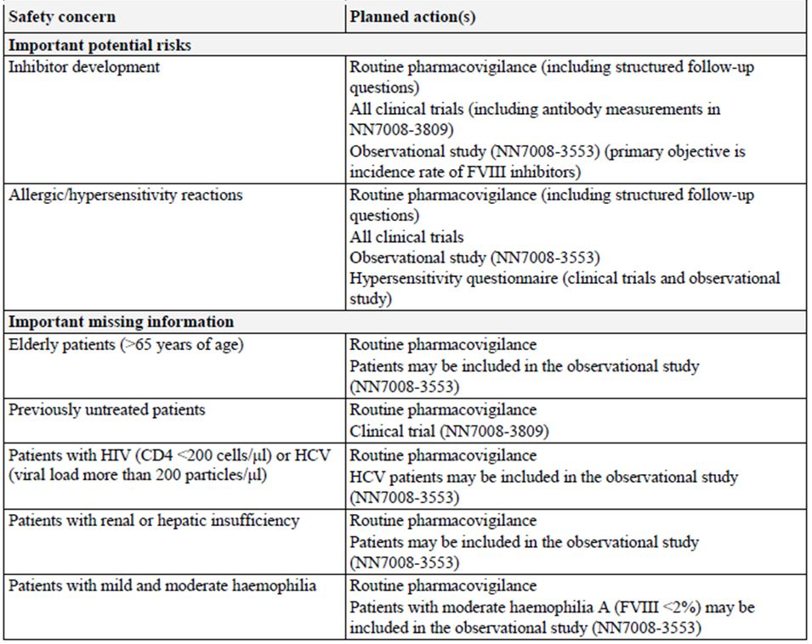
Approximately 70 turoctocog alfa naïve male patients will be enrolled in study N7008-3553 to allow for at least 50 patients to complete the study. Total study duration is estimated to be 4 years with a planned recruitment period of 24 months. The aim is to have the first patient first visit in Q1 2014. Submission of final data expected for June 2018.
A further planned study is PK study: “NN7008-4015: To compare the pharmacokinetics of four lots of turoctocog alfa after IV administration in patients with haemophilia A.” This is a multicentre, open label trial investigating the PK of four lots of turoctocog alfa in patients with haemophilia A.
At the time of this application, clinical trial NN7008-3809 is ongoing in countries outside Australia: “NN7008-3809, Safety and efficacy of turoctocog alfa in prevention and treatment of bleeds in paediatric previously untreated patients with haemophilia A.” Submission of final data expected for January 2017.
Also ongoing at the time of this application: “NN7008-3568: Assessment of safety and efficacy of turoctocog alfa for prevention and treatment of bleeds and during surgical procedures in patients with haemophilia A.” This is a multicentre, multinational, open label, non randomised, single treatment arm safety and efficacy extension trial in patients with haemophilia A investigating turoctocog alfa when used in a preventative or on-demand treatment regimen. The trial includes a sub trial designed to evaluate safety and efficacy of turoctocog alfa during surgery.
It is noted that at the cut off date for this application (21 November 2011), only two patients had been enrolled in the sub trial assessing the safety and efficacy of the product during surgery. In the surgery sub trial of trial N7008-3543, nine patients were included. Hence, in total eleven patients were included in surgery sub trials. As described above, the indication in this application includes: control and prevention of bleeding in surgical settings. This indication was not granted ODD. The evaluator raises the question whether there is enough evidence to support the indication of control and prevention of bleeding in surgical settings.
The sponsor states:
Where clinical results from these studies lead to an update of the global Core Company Data Sheet, and as is standard practice for all Novo Nordisk products, relevant text changes will subsequently be implemented into the Australian Product Information by way of safety related notification and/or Category 1 application.

OPR reviewer’s comments in regard to the pharmacovigilance plan and the appropriateness of milestones
The reporting milestone for the planned observational Study NN7008-3553 is considered mostly acceptable, but the following comment should be noted. Patients in Australia will not be included in the PASS NN7008-3553. In Europe special patient populations, including:
- Patients with HIV (CD4 <200 cells/μl) or HCV (viral load >200 particles/μl);
- Patients with renal or hepatic insufficiency;
- Patients with mild and moderate haemophilia;
- Elderly patients (>65 years of age) are monitored in the NN7008-3553.
It is recommended that the sponsor clarifies how these patient populations will be monitored in Australia. This is of importance in the light that an integrated clinical trial report (ICTR) of this trial will be submitted after June 2018 (please refer to the table below).
It is recommended that the sponsor submits final or interim study reports, resulting from the PASS and ongoing clinical trials, to the TGA at the same time as reports are submitted to other regulatory agencies.
In the summary of the Australian RMP, it appears that the sponsor does not propose to implement follow-up questionnaires for events relating to inhibitor formation and allergic/hypersensitivity reactions. These reactions are expected to occur and are common to very common class effects. The use of such follow up forms is considered to be appropriate for Australia and therefore, it is recommended that the sponsor implements these forms in Australia. The sponsor should provide the structured follow-up questionnaires for inhibitor formation and allergic/hypersensitivity reactions for review prior to approval.

Risk minimisation activities

Sponsor’s conclusion in regard to the need for risk minimisation activities
The following considerations have been provided by the sponsor concerning the need for risk minimisation activities.
Based on analysis of all safety data available at the present stage of development of turoctocog alfa, the sponsor concludes that there is no need for a risk minimisation plan. In addition, data from the completed turoctocog alfa trials do not motivate any special measures with regard to risk communication.
Consideration has been given to the fact that both the haemophilia A patient population and the treating physicians are highly specialised groups. Consideration has also been given to the fact that there are no identified risks at this stage and all the risks described are potential risks. The predicted incidence of each risk in the population, the consequence of the risk and the possible effect of interventions on the benefit-risk balance have been considered as part of the evaluation.
Haemophilia A is a rare disease that is diagnosed and treated in highly specialised treatment centres.
Physicians treating haemophilia A are a small and highly specialised group, experienced with haemophilia and related fields such as bleeding and thromboembolic disorders. They have extensive experience in the treatment of haemophilia A and B and other bleeding disorders with coagulation factor replacement therapies, both plasma derived and recombinant products. These replacement therapies have risks similar to those associated with turoctocog alfa and treatment with turoctocog alfa should not require additional or exceptional procedures in order to minimise risks.
The patient group is small, well informed and educated due to the rarity of their condition, the nature of treatment regimens and the nature of the treating physician group. This group is well informed by physicians of product handling, risks associated with replacement therapies and product use.

OPR reviewer comment
The RMP evaluator considers the justification by the sponsor not to implement any additional risk minimisation activities acceptable, except for the following two points.
- Off-label use for ITI therapy is expected to occur. The sponsor states:
There is a potential for off-label use of turoctocog alfa for ITI, which is the standard treatment for patients with haemophilia and high-responding inhibitors. ITI is used in an attempt to eradicate high responding inhibitors by exposing patients to frequent high doses of FVIII. This is intended to achieve antigen acceptance and to restore normal replacement FVIII kinetics. ITI is the treatment of choice for FVIII inhibitors with high levels of responding inhibitors (>5 BU/ml). The regimen is ideally initiated early after inhibitor detection, which means in most cases in children below school age. In the EU, 50-70% of new inhibitors detected in persons below 10 years of age are treated with ITI. ITI is rare in the developing countries because it is a very expensive treatment.
As with other rFVIII products, turoctocog alfa is likely to be used for ITI despite a lack of labelled indication. Most common clinical practice is to use the factor product that was used at the time of inhibitor development for the ITI regimen. No marketed rFVIII products have an indication for ITI.
It is recommended, that the sponsor adds a statement in the PI, indicating that there is no experience for the off-label indication of ITI with this product and therefore, the safety and efficacy for this indication is not established.
- The RMP evaluator considers it acceptable to include the CMI and not the PI in the product package, only if the sponsor takes further action, to ensure that all physicians administering the product have been supplied with the PI.

Summary of recommendations
The OPR provides these recommendations in the context that the submitted RMP is supportive to the application; the implementation of a RMP satisfactory to the TGA is imposed as a condition of registration; the submitted EU-RMP is applicable without modification in Australia unless so qualified; and the draft product information and consumer medicine information documents should not be revised until the Delegate’s Overview has been received.
Safety considerations may be raised by the nonclinical and clinical evaluators through the consolidated section 31 request and/or the nonclinical and clinical evaluation reports, respectively. It is important to ensure that the information provided in response to these includes a consideration of the relevance for the RMP, and any specific information needed to address this issue in the RMP. For any safety considerations so raised, the sponsor should provide information that is relevant and necessary to address the issue in the RMP.
- It is recommended that EU-RMP, version 1, dated 5 October 2012, data lock point 13 December 2011 and the Australian Specific Annex, version 1, dated 27 December 2012, and any future updates are implemented as a condition of registration.
- The Delegate may wish to consider whether it is appropriate for the sponsor to propose an indication which differs from the ODD status granted by the TGA.
- It is recommended that the sponsor adds/amends the following five points in the table of ongoing safety concerns in the RMP:
  - Off-label use for ITI should be included as missing information and pharmacovigilance and risk minimisation activities should be assigned;
  - The patient populations of females, pregnant women, lactating women, cardiac impaired patients and subpopulations with genetic polymorphism should be included in the table of ongoing safety concerns as missing information. Pharmacovigilance and risk minimisation activities should be assigned as appropriate;
  - The risk of allergic reaction should be included in the table of ongoing safety concerns as identified risk;
  - It is recommended that embolic/thrombolic events, secondary to a CVAD, used to administer this product, should be included as identified risk in the table of ongoing safety concerns;
  - It is recommended that pain and bleeding at the injection side be considered as a potential risk and added to the table of ongoing safety concerns. Pharmacovigilance and risk minimisation activities should be assigned to this potential risk as appropriate.
- It is recommended that the sponsor clarifies how the following patient populations will be monitored in Australia:
  - Patients with HIV (CD4 <200 cells/μl) or HCV (viral load more than 200 particles/μl);
  - Patients with renal or hepatic insufficiency;
  - Patients with mild and moderate haemophilia;
  - Elderly patients (>65 years of age).
This is of particular importance since data from clinical trials monitoring these patient populations will be reported after June 2018.
- It is recommended that the sponsor submits final or interim study reports, resulting from the PASS and ongoing clinical trials, to the TGA at the same time as reports are submitted to other regulatory agencies.
- It is recommended that the sponsor implements structured follow up questionnaires for inhibitor formation and allergic/hypersensitivity reactions in Australia and provides these forms for review prior to approval.
- It is recommended that the sponsor takes further action, to ensure that all physicians administering the product have been supplied with the PI, if the CMI and not the PI will be provided in the product package.

Reconciliation of issues outlined in the RMP report
Reconciliation of issues outlined in the RMP report is as follows.

Recommendation in RMP evaluation report:
It is recommended that EU-RMP, version 1, dated 5 October 2012, data lock point 13 December 2011 and the Australian Specific Annex, version 1, dated 27 December 2012, and any future updates are implemented as a condition of registration.

Sponsor’s response (or summary of the response):
Novo Nordisk agrees to submit the latest version and any future updates of the EU-RMP and the Australian Specific Annex.
The latest updated versions (EU-RMP version 2.0, dated 17 May 2013 and Australian Specific Annex version 2, dated 19 July 2013) are included in this response sequence.

OPR evaluator’s comment:
This is considered acceptable.

Recommendation in RMP evaluation report:
The Delegate may wish to consider whether it is appropriate for the sponsor to propose an indication which differs from the ODD status granted by the TGA.

Sponsor’s response (or summary of the response):
The indication for which the ODD was granted by TGA was “Treatment and prophylaxis of bleeding episodes in patients with haemophilia A.”
The sponsor contends that the wording of this indication includes those haemophilia A patients who will potentially require treatment in a surgical setting. The intention of the revised indication wording described in the current application (“Treatment and prophylaxis of bleeding episodes in patients with haemophilia A, including control and prevention of bleeding in surgical settings”) is not to expand the potential patient population from that approved in the ODD application, but rather to add clarifying information to the PI to assist future prescribers.

OPR evaluator’s comment:
It is recommended to the Delegate to consider if the justification is acceptable.

Recommendation in RMP evaluation report:
It is recommended that the sponsor adds/amends the following five points in the table of ongoing safety concerns in the RMP:
- Off-label use for ITI should be included as missing information and pharmacovigilance and risk minimisation activities should be assigned.
- The patient populations of females, pregnant women, lactating women, cardiac impaired patients and sub-populations with genetic polymorphism should be included in the table of ongoing safety concerns as missing information. Pharmacovigilance and risk minimisation activities should be assigned as appropriate.
- The risk of allergic reaction should be included in the table of ongoing safety concerns as identified risk.
- It is recommended that embolic/thrombolic events, secondary to a CVAD, used to administer this product, should be included as identified risk in the table of ongoing safety concerns.
- It is recommended that pain and bleeding at the injection side be considered as a potential risk and added to the table of ongoing safety concerns. Pharmacovigilance and risk minimisation activities should be assigned to this potential risk as appropriate.

Sponsor’s response (or summary of the response):
- Although turoctocog alfa has not been investigated for ITI, it is not expected that there will be any specific safety issues associated with the use of turoctocog alfa for ITI.
However, Trial 3809 which is ongoing is designed to evaluate safety of turoctocog alfa in previously untreated patients with haemophilia A. The trial might also provide information on ITI with turoctocog alfa since patients with inhibitor formation will be offered ITI with turoctocog alfa.
As for other FVIII products, turoctocog alfa is likely to be used for ITI despite the lack of labelled indication. Most common practice is to use the factor product that was used at the time of inhibitor development for the ITI regimen. No marketed rFVIII products have an indication for ITI.
ITI therapy is included as missing information in the EU-RMP version 2.0.
- Females with haemophilia A are extremely rare and could not be included in the development programme in order to obtain statistically usable data. Therefore, nonclinical reproduction toxicology studies have not been performed. This is also the case for other marketed rFVIII products.
The safety profile of turoctocog alfa is not expected to be different in female patients compared to male patients. Therefore, based on a therapeutic need, the use of turoctocog alfa may be considered for female patients showing symptoms of haemophilia A.
Females, including pregnant and lactating women are included as missing information in the EU-RMP, version 2.0.
Safety of turoctocog alfa in females, including pregnant and breastfeeding women, will be monitored by routine pharmacovigilance.
With regards to cardiac impaired patients, no specific safety concerns have been identified or are expected in this population. Cardiac impaired patients will be included in the Australian Specific Annex version 2, dated 19 July 2013 as missing information, and will be monitored by routine pharmacovigilance.
No differences in metabolism of turoctocog alfa are expected in patients with genetic polymorphism of hepatic cytochromes. Type of FVIII gene mutation affects the risk of inhibitor development and genotyping data are being collected in the ongoing Study 3809 in order to characterise patients with regards to inhibitor development risk. Genetic polymorphism will be included in the Australian Specific Annex version 2, dated 19 July 2013 as missing information, and will be monitored by routine pharmacovigilance.
- Allergic type hypersensitivity reactions, including anaphylaxis/anaphylactoid reactions, is a potential risk with the administration of turoctocog alfa and these events were specifically defined as medical events of special interest during the clinical development programme. No AEs with allergic aetiology related to turoctocog alfa have been reported in the clinical development programme. Based on this, allergic/hypersensitivity reactions will not be proposed included in the RMP as an identified risk, but will remain as a potential risk.
- Embolic/thrombolic events occurring secondary to CVAD will not be included in the RMP since it is considered device related and not related to turoctocog alfa. No adverse events describing thromboembolic events related to CVAD have been reported in the clinical development programme with turoctocog alfa.
Mild pain and minor bleeding at the injection site are to be expected with all injected products. However, pain and bleeding at the injection site have not been reported for turoctocog alfa and will therefore not be added to the RMP as a potential risk. In total, five injection site reactions have been reported in the clinical development programme, but none of them were injection site pain or injection site bleeding.

OPR evaluator’s comment:
This is considered acceptable.

Recommendation in RMP evaluation report:
It is recommended that the sponsor clarifies how the following patient populations will be monitored in Australia:
- Patients with HIV (CD4 <200 cells/μl) or HCV (viral load more than 200 particles/μl);
- Patients with renal or hepatic insufficiency;
- Patients with mild and moderate haemophilia;
- Elderly patients (>65 years of age).
This is of particular importance since data from clinical trials monitoring these patient populations will be reported after June 2018.

Sponsor’s response (or summary of the response):
These groups are described as missing information in the RMP. Any data collected in these groups will be monitored by routine pharmacovigilance activities. Potentially, information from these groups may also be collected in the PASS study.

OPR evaluator’s comment:
This is considered acceptable.

Recommendation in RMP evaluation report:
It is recommended that the sponsor submits final or interim study reports, resulting from the PASS and ongoing clinical trials, to the TGA at the same time as reports are submitted to other regulatory agencies.

Sponsor’s response (or summary of the response):
Novo Nordisk agrees to submit final and possible interim study reports, resulting from the PASS and ongoing clinical trials to the TGA at the same time as it is submitted to the European Medicines Agency (EMA) and US Food and Drug Administration (FDA).

OPR evaluator’s comment:
This is considered acceptable.

Recommendation in RMP evaluation report:
It is recommended that the sponsor implements structured follow up questionnaires for inhibitor formation and allergic/hypersensitivity reactions in Australia and provides these forms for review prior to approval.

Sponsor’s response (or summary of the response):
Follow up questionnaires are included as annex 7a and 7b of the EU-RMP, version 2.0.

OPR evaluator’s comment:
This is considered acceptable.

Recommendation in RMP evaluation report:
It is recommended that the sponsor takes further action to ensure that all physicians administering the product have been supplied with the PI if the CMI and not the PI will be provided in the product package.

Sponsor’s response (or summary of the response):
The 2011-2012 Australian Blood Disorders Register (ABDR) annual report confirms the distribution of haemophilia A patients across Australian states and territories under the care of the known Haemophilia Treatment Centres (HTCs). Any initial launch communications for turoctocog alfa will be targeted to these HTCs, and are expected to be comprehensive. Due to the small number of specialist haematologists, haematology nurses and blood bank staff involved in the care of people with haemophilia A, Novo Nordisk predicts with confidence that all relevant healthcare professionals (HCPs) will be provided with copies of the turoctocog alfa PI.
At time of launch and thereafter, as per the Medicines Australia Code of Conduct all promotional materials and advertising will be accompanied with either a hard copy of the full PI and/or include a ‘minimum PI’ within the body of the materials, as well as clear directions on how to obtain an additional copies via phone, email, and/or internet. Novo Nordisk will also include details of how to obtain a copy of the PI with any training materials and educational presentations for HCPs.
A copy of the PI will also be placed on the Novo Nordisk and TGA websites for download, and the MIMS Index will be updated to include the turoctocog alfa PI.

OPR evaluator’s comment:
On the background that the sponsor requests to only include the CMI and not the PI in the product package, the following is noted.
It appears that comprehensive correspondence, which includes the PI or a minimum PI, will be directed to specialised treatment centres. Consequently, specialised medical practitioners operating outside these centres may not be comprehensively informed about the product specifications, and may not be aware how to obtain the PI for their information.
To ensure that any treating physician will be informed of where to view/download the full PI, it is recommended that the sponsor includes reference, in the CMI, to internet links where the PI can be viewed/downloaded from the company, TGA and MIMS website.

Outstanding issues

Issues in relation to the RMP
- It is recommended to the Delegate to consider if the sponsor’s justification for the following is acceptable:
The sponsor proposes to use a different wording for the indication than the wording stated in the approval letter for the ODD status.
- Regarding risk minimisation activities in Australia:
To ensure that any treating physician will be informed of where to view/download the full PI, it is recommended that the sponsor includes reference, in the CMI, to internet links where the PI can be viewed/downloaded from the company, TGA and MIMS website.

Advice from the Advisory Committee on the Safety of Medicines (ACSOM)
ACSOM advice was not sought for this submission.

Comments on the safety specification of the RMP

Clinical evaluation report
The sponsor included the latest updated versions of the EU-RMP version 2.0, dated 17 May 2013 and the Australian Specific Annex version 2, dated 19 July 2013. The Safety Specification in the updated EU-RMP (version 2.0) is considered to be satisfactory.

Nonclinical evaluation report
Results and conclusions drawn from the nonclinical program for turoctocog alfa detailed in the sponsor’s draft RMP (Section 1.1) are in general concordance with those of the nonclinical evaluator.

Key changes to the updated RMP
In their response to the TGA S31 Requests the sponsor provided an updated RMP (version 2.0, dated 17 May 2013; Australian Specific Annex (version 2.0, dated 19 July 2013). Key changes from the version evaluated at Round 1 are summarised below:
- ITI therapy has been included as missing information in the EU-RMP,
- Females, including pregnant and lactating women have been included as missing information in the EU-RMP,
- Follow up questionnaires for anaphylactic/hypersensitivity reactions have been included as annex 7a and 7b of the EU-RMP,
- Cardiac impaired patients have been included in the Australian Specific Annex version 2, dated 19 July 2013 as missing information, and will be monitored by routine pharmacovigilance,
- Genetic polymorphism will be included in the Australian Specific Annex version 2, dated 19 July 2013 as missing information, and will be monitored by routine pharmacovigilance.

OPR evaluator’s comments
The above described changes to RMP version 2.0 are considered acceptable.

Suggested wording for conditions of registration

RMP
Implement EU-RMP (version 2.0, dated 17 May 2013) with Australian Specific Annex (version 2.0, dated 19 July 2013) and any future updates as a condition of registration.

PSUR
OMA to provide wording.

VI. Overall conclusion and risk/benefit assessment
The submission was summarised in the following Delegate’s overview and recommendations:

Quality
Turoctocog alfa is a purified third generation rFVIII produced by recombinant DNA technology in CHO cells without the use of serum or other animal derived components. It has an approximate mass of 166 kDa (calculated excluding post translational modifications) The molecule consists is a 1445 amino acid polypeptide containing a heavy chain of 87 kDa, with a 21 amino acid residue truncated B domain, and a light chain of 79 kDa. The two chains are held together by non covalent interactions. Two variants of the heavy chain are present in the purified product, namely with and without the B domain linker attached. This linker is removed by thrombin activation of turoctocog alfa rendering the activated turoctocog alfa (FVIIIa) molecule similar to FVIIIa derived from plasma FVIII with a complete B domain. The activated FVIII molecule is a heterotrimer composed of A1/A2 domains (HC) and A3/C1/C2 domains (LC).
Turoctocog alfa is supplied as a sterile lyophilised powder that is dissolved in 0.9% sodium chloride solution before administration as a single use IV injection. Turoctocog alfa has been developed in six different product presentations containing 250 IU/vial, 500 IU/vial, 1000 IU/vial, 1500 IU/vial, 2000 IU/vial and 3000 IU/vial. The composition of the drug product is the same for the six product presentations except for the content of the active ingredient. The sponsor states that the development of the turoctocog alfa product formulation (choice and quantity of excipients) has mainly been based on knowledge of stabilisation of lyophilised rFVIII as described in the literature, and knowledge of other Novo Nordisk recombinant coagulation factors (that is, NovoSeven). Subsequently, long term and accelerated stability studies have verified the stability and compatibility of the formulation. Two strengths of turoctocog alfa, 250 IU and 2000 IU, have been used in clinical trials. The composition of the products used in the clinical trials is the same composition as the product intended for the market (250 to 3000 IU).
The sponsor reported a low level of histidine related impurity after storage of the product for more than 30 months (or 12 months at 30C) but neither the pharmaceutical chemist nor the nonclinical evaluator felt this was likely to pose a health risk to patients.
The pharmaceutical chemistry evaluator had no objections on quality grounds to the registration of NovoEight (turoctocog alfa).

Nonclinical
In vitro, turoctocog alfa binds vWF with similar binding properties as other recombinant FVIII products, and was fully functional in a range of FVIII assays, without any functional differences from Advate (one of the two third generation rFVIII registered in Australia).
Turoctocog alfa reduced bleeding times in a mouse model of haemophilia A (F8 knockout mice) using a tail bleed and a knee injury model. In haemophilia A affected dogs, turoctocog alfa corrected the impaired clotting in whole blood.
No dedicated safety pharmacology studies were submitted. The drug is expected to be metabolised into individual constituent amino acids.
Neither a single dose toxicity study in cynomolgus monkeys nor repeat dose toxicity studies administered to monkeys (equivalent to 39 fold that in humans at 50 IU/kg) and rats (equivalent to 7 times that in humans at 50 IU/kg) by IV bolus for 2 weeks, showed signs of toxicity. Genotoxicity and carcinogenicity studies have not been conducted, which is acceptable for a biological product. No reproductive toxicity data were provided, and this is acceptable due to the nature of the components of turoctocog alfa and rarity of haemophilia A in females. Studies in juvenile animals were not provided but these would not be expected to provide further information regarding the safety of turoctocog alfa in paediatric patients.
The local tolerance of turoctocog alfa was not different between control and turoctocog alfa treated rabbits after IV (clinical application route), perivenous, and intra-arterial administration, at concentrations similar to those expected clinically.
The formation of neutralising antibodies to factor VIII is a known complication in individuals with haemophilia A, and this is stated in the PI document. The Delegate is in agreement with the recommended amendment to the PI by the nonclinical evaluator.
There are no objections from the nonclinical evaluator to registration of NovoEight.

Clinical
The clinical evaluator has reviewed the submitted data, which included:
- 3 clinical pharmacology trials, including PK and PD data;
- 2 pivotal efficacy/safety trials, including PK data;
- 1 efficacy/safety extension trial including ongoing patients from the two pivotal trials;
- reports of bioanalytical and analytical methods for human studies;
- literature references.
The submitted data was evaluated using TGA adopted EMA guidelines as follows:
- Guideline on the Clinical Investigation of the Pharmacokinetics of Therapeutic Proteins;
- Guidance on the Clinical Investigation of Recombinant Factor VIII and IX Products;
- Guidance on the Investigation of Bioequivalence.

Clinical evaluator’s recommendation
The clinical evaluator has recommended that approval be granted for turoctocog alfa for the indication sought.

Paediatric data
The sponsor declared that there is a paediatric development program in place. The submission included paediatric PK, PD, efficacy and safety data. The submission included a pivotal efficacy and safety trial in children aged 1-12 years (Trial 3543), and an ongoing clinical efficacy and safety extension trial (Trial 3568) that included children from the pivotal paediatric trial. The sponsor also referred to an ongoing Phase IIIb clinical efficacy and safety trial in children (not submitted).

Pharmacokinetics/Pharmacodynamics
As FVIII activity is known to correlate with the clinical efficacy of FVIII products, this is measured rather than drug levels. FVIII activity was determined using two assays, APTT and chromogenic assay measuring factor Xa levels (indirect assay as factor X conversion to Xa is dependent upon Factor VIII as a cofactor). As such, the following are both PK and PD studies.
PK data for turoctocog alfa in male patients with severe haemophilia A (FVIII ≤ 1%) were derived from five completed clinical trials (three Phase I; two Phase III) (Table 10). No PK data in healthy volunteers was submitted.
Table 10: Overview of studies providing pharmacokinetic data in patients with severe haemophilia A.
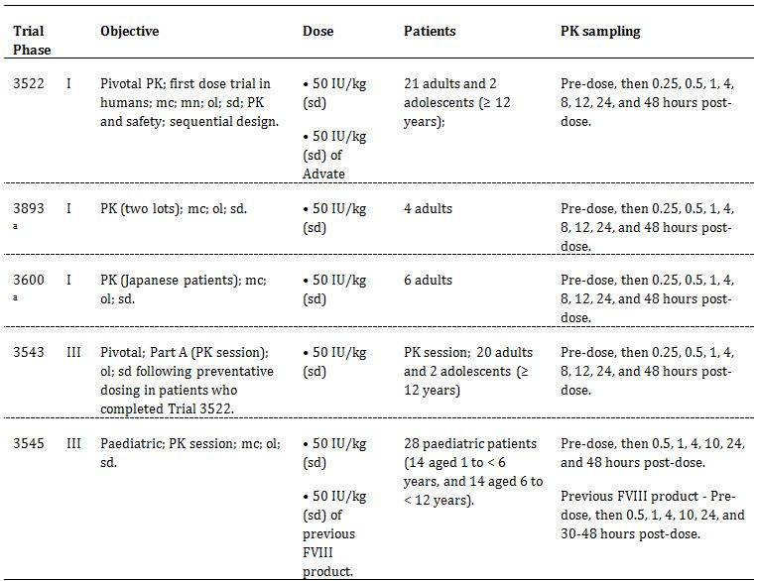
mc = multicentre; mn = multinational; ol = open-label; sd = single-dose
a. Trials 3600 and 3893: single dose PK assessment was preceded by preventative dosing for 3-6 months according to the dosing regimen in Trial 3543 (wash out period of ≥ 4 days prior to the PK session).
In total, 61 patients, aged 1-54, with severe haemophilia A, no history of FVIII inhibitors and who were non-bleeding at the time, participated in trials that included full PK assessment of turoctocog alfa, including 28 children aged 1-12 years. Of the 61 patients, 22 had PK profiles from both Trial 3522 and Trial 3543. Patients groups were predominantly Caucasian with one study (Phase I Study 3600) carried out in Japanese subjects. The PK of a single dose of turoctocog alfa 50 IU/kg were evaluated at the time points specified in Table 10. Previously treated adolescents aged ≥ 12 years and adults with a documented history of ≥ 150 exposure days to any FVIII product were included in Trials 3522, 3543, 3893 and 3600, and previously treated children aged 1-12 years of age with a documented history of ≥ 50 days exposure to any FVIII product were included in Trial 3545.
The pivotal Phase I PK/PD was trial 3522 where the single dose PK profile of turoctocog alfa and octocog alfa (Advate) were measured. This trial was a subset of the Phase III efficacy and safety trial 3543, as all 23 subjects continued treatment, with second PK assessments carried out after 3-6 months of preventative dosing with turoctocog alfa.
The PK of turoctocog alfa following single dose administration were investigated in paediatric patients aged 1-12 years in the pivotal (paediatric) Phase III efficacy and safety trial (Trial 3545). In this trial, the PK of the patient’s previous FVIII product was investigated prior to first administration of turoctocog alfa.
The PK properties were:
- Primary PK/PD parameters: incremental recovery of FVIII (FVIII activity recorded 30 minutes after the end of an infusion relative to the administered dose [IU/mL]/[IU/kg]), AUC_{0-∞}, CL, total and weight normalised and t_{1/2}.
- Secondary PK/PD parameters: Vss, C_{max}, mean residence time (MRT).
The mean activity in the chromogenic assay was 1.3 fold higher than the clotting assay regardless of age or trial.

Trial 3522
In Trial 3522, the turoctocog alfa and Advate PK parameters were compared using a multiplicative linear mixed effects model, with treatment as a fixed effect and patient as a random effect. The treatment ratio for the two products was estimated from the model and presented together with the 90% CI.
A total of 23 patients had PK data for Advate, and 20 of those had data for turoctocog alfa (3 were excluded as outliers as per previously established and acceptable criteria). After correcting for variability in the dose strengths (there was some variability for both products between the stated and measured dose strengths in the vials) the median administered dose of Advate was 54.0 IU/kg (mean: 53.1 IU/kg [range: 50.2, 57.3 IU/kg]), and the median administered dose of turoctocog alfa was 45.2 IU/kg (mean: 45.8 IU/kg [range: 42.4, 50.0 IU/kg]).
From the chromogenic assay, the results were, with standard deviation in brackets: Cmax 1.54 (0.29), t_{1/2} 10.04 (3.59) h, weight normalised clearance 2.87 (0.8) ml/kg/h, Vss 44.31(28.17) ml/kg. The volume of distribution was small consistent with the confinement largely to the intravascular space, and the t_{1/2} is consistent with that of endogenous FVIII (8-12 h).
The excretion of turoctocog is presumed to be via proteolysis, and elimination via receptor mediated endocytosis. Therefore, no data was presented for renal nor hepatic clearance, in line with the relevant TGA adopted EMA guideline.

Trial 3543
In this trial, the PK profile after the first injection of turoctocog alfa (Trial 3522) was compared with the PK profile obtained after 3 to 6 months of preventative dosing with turoctocog alfa (Trial 3543). The preventative regimen was 20-40 IU/kg every second day or 20-50 IU/kg three times weekly, and patients received 36 to 65 doses prior to the PK session. A single dose of turoctocog alfa (50 IU/kg) was administered in the PK session of each trial, and those in Trial 3543 had a washout period of ≥ 4 days prior to the session.
In the “compare analysis set” of 15 evaluable patients, the single dose PK parameters were similar after the first dose (Trial 3522) and following 3-6 months of preventative treatment with turoctococg alfa (Trial 3543). The only endpoint where the 90% CI was outside the bioequivalence interval (0.8 to 1.25) was t_{1/2} measured by the chromogenic assay. This was 9.47 (2.38) at the first dose compared with 8.65 (2.09) after 3-6 months of therapy.

Bioavailability and bioequivalence
In Trial 3893, in accordance with recommendations from the EMA, the PK variation between individual turoctocog alfa production lots was investigated after single IV administration (50 ± 5 IU/kg). With only 4 adult patients, 2 allocated to each of the two turoctocog alfa lots, although there were no marked differences in the PK profiles, no statistically meaningful conclusions can be drawn.

Bioequivalence to relevant registered products
While not designed to compare the single dose (50 IU/kg) PK profiles of turoctocog alfa and Advate, Trial 3522 included an assessment of the bioequivalence of the two products. For the clotting assay, the 90% CI for all parameters (incremental recovery, t_{1/2}, AUC and CL) was within the requisite bioequivalence interval of 0.8 to 1.25; for the chromogenic assay, the results for Factor VIII activity were higher for the turoctocog than the Advate, but none of the bioequivalence endpoints was reached. The sponsor’s explanation is considered satisfactory.

Pharmacokinetics in children with haemophilia A

Trial 3545
The PK of a single dose of turoctocog alfa in children (n = 28) aged 1-12 years with haemophilia A was investigated in Trial 3545. The mean age of the younger children aged 1-6 years (n = 14) was 3.7 years (range: 1-5 years) and the mean age of the older children aged 6 to < 12 years (n = 14) was 8.2 years (range: 6-11 years).
In this trial, a PK assessment of the child’s previous FVIII product was investigated prior to first administration of turoctocog alfa in the “compare analysis set”. Each patient received one dose of their previous FVIII product (50 IU/kg) and one dose of turoctocog alfa (50 IU/kg). Bioequivalence was established, with the exception of incremental recovery of FVIII activity which was slightly lower for the previous FVIII product than for turoctocog alfa. However, the results for the previous FVIII product represented a pool of different FVIII products and the PK profile for previous FVIII product was based on fewer sampling time points compared with the PK profile of turoctocog alfa.
The differences in the PK parameters of turoctocog alfa between children (Trial 3545) and adults (Trial 3543) with haemophilia A are summarised below (Table 11).
Table 11: The relative level of the PK/PD parameters for children compared with adolescents/adults as measured by the clotting assay.
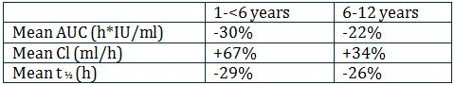
The sponsor notes similar findings have also been described for other FVIII products. Hence in the trials, there was a shorter washout period for children under 12 compared with adolescents or adults.

Pharmacokinetics in Japanese patients with haemophilia A

Trial 3600
The PK/PD of turoctocog alfa following a single dose (50 IU/kg) in Japanese patients with haemophilia A (n = 6) was investigated in this trial and the outcomes compared with the predominantly Caucasian patient in Trial 3522. Japanese patients (Trial 3600) had higher FVIII activity levels, mainly occurring within the first 4 h post dosing. Based on clotting and chromogenic assays respectively, the mean incremental recovery was 20% and 18% higher, the mean AUC was 63% and 57% higher and the mean terminal t_{1/2} was 16% and 54% longer. There is no clear explanation for these differences, but the numbers were very small (6 patients compared with 23) and need to be interpreted with caution.
No data was submitted for female or elderly (>60 years) patients, nor those with renal or hepatic impairment. No drug interaction studies were submitted as there have been no reports of interactions with other FVIII products. However, the Delegate agrees with the clinical evaluator, that absence of these data does not preclude registration.

Dosage selection for pivotal studies/summary of PK data
The submission included no clinical dose ranging studies. The clinical PK data indicate that single doses of turoctocog alfa and Advate are bioequivalent in adults, and turoctocog alfa and FVIII products (pooled) have comparable PK profiles in children. Thus, the proposed dosages for turoctocog alfa for the pivotal adult and paediatric clinical efficacy and safety trials are considered acceptable. The lower AUC, higher CL and shorter t_{1/2} in children compared with adults for turoctocog alfa support the differing preventative regimens for paediatric patients. The limited data for Japanese subjects indicates there may be PK differences in this population but this needs further investigation.

Efficacy
There were three pivotal efficacy and safety studies in previously FVIII treated male patients with severe haemophilia A (FVIII activity ≤ 1%) without inhibitors (Table 12). As of the data cut-off date of 21 November 2011, a total of 214 patients had been exposed to turoctocog alfa.
Table 12: Overview of the three Phase III clinical efficacy and safety trials.
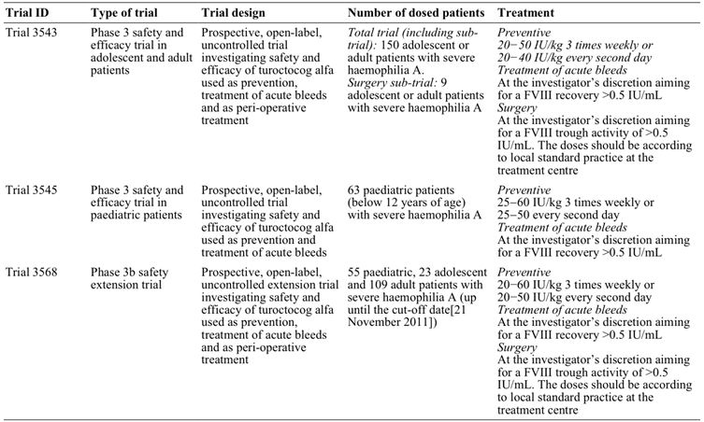

Trial 3543
In this Phase III trial, 150 patients were treated for approximately 20 to 28 weeks per patient depending on the frequency of preventative dosing. The protocol and exclusion criteria are necessarily complicated to allow for the unpredictable nature of bleeding episodes and the use of additional therapies in the event of any bleeding being uncontrolled on the trial medication and are summarised. The trial had three parts:
- Part A included only patients (20 adults, 2 adolescents) who had completed the pivotal PK Trial 3522, that is, they underwent a second PK assessment 3 to 6 months after preventative treatment with turoctocog alfa. Apart from the second PK assessment, the treatment and assessment of patients in Part A were identical to the patients in Part B.
- Part B included 128 patients (including 22 adolescents) who had not previously participated in the pivotal PK Trial 3522.
- Part C (surgery sub trial) included 9 patients (1 adolescent) from Part A or Part B who had received at least one dose of turoctocog alfa and needed a major or minor surgical procedure during the course of the trial estimated to require at least 7 days of daily FVIII treatment, including the day of surgery.
The study treatments in Parts A and B are summarised below in Table 13-14.
Table 13: Trial 3543 - Overview of study treatments in Part A and Part B.
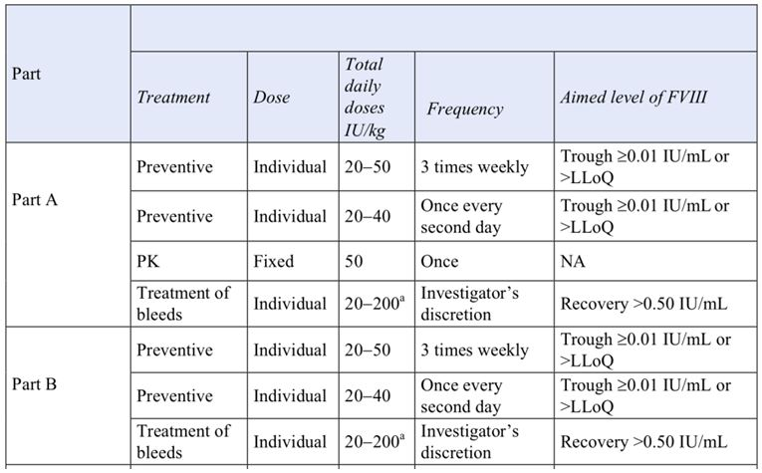
a = Trial product could be administered more than once a day. LLoQ = Lower limit of quantification; NA = Not applicable.
Table 14: Trial 3543 - Overview of study treatment in Part C.
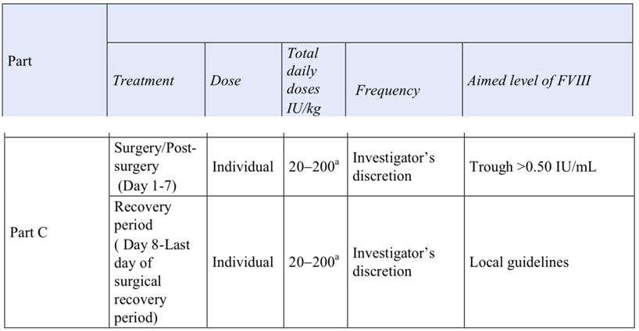
a = Trial product could be administered more than once a day. LLoQ = Lower limit of quantification; NA = Not applicable.
The preventative treatment doses were individualised according to the trough FVIII activity and bleeding episodes (see Table 4), and the dose level, date and time of administration recorded in the patient’s diary.
For the treatment of bleeds, the bleed had to be treated as soon as identified. The dose was chosen to achieve an expected post injection FVIII activity level of at least 0.50 IU/mL. If a haemostatic response was not achieved after 48 h using maximum doses (up to 200 IU/kg per day) of turoctocog alfa, another FVIII product could be selected; this would result in withdrawal of the patient from the trial. For minor or moderate bleeds managed outside of hospital, the patient made the clinical assessment as follows:
Date/time of onset, cause, site (for example, joint, subcutaneous), haemostatic treatment used, any other therapy (for example, compression), bleed category (mild, moderate or severe) and an evaluation of the haemostasis (none, good, moderate or excellent).
For those undergoing surgery, the trial period was divided into two time periods.
Dose adjustments in patients undergoing surgery were:
- a pre surgery loading dose of turoctocog alfa determined by the standard practice at the study site immediately prior to surgery;
- in the surgery period turoctocog alfa was administered and monitored intensively;
- in the post surgical period turoctocog alfa was dosed according to standard practice at the site from Day 8 to the last day of the surgical recovery period (if relevant).
Treatment requiring bleeds were to be reported as “bleeding episodes” and related haemostatic treatment as “haemostatic concomitant medication”. All bleeds were to be treated with turoctocog alfa.
The primary endpoint was to assess the incidence rate of FVIII inhibitors (≥0.6 BU).
The four secondary endpoints for Parts A and B were to:
- evaluate the clinical efficacy of turoctocog alfa for bleeding prevention;
- evaluate the clinical efficacy of turoctocog alfa for bleeding prevention;
- evaluate the safety of turoctocog alfa for prevention and treatment of bleeds;
- assess changes in patient reported outcomes.
Given the differing components of the trial, secondary endpoints for Part C were:
- To evaluate the efficacy of turoctocog alfa during surgical procedures;
- To evaluate the haemostatic response to turoctocog alfa in the post surgery period;
- To evaluate the safety of turoctocog alfa for prevention and treatment of bleeding during surgical procedures and in the post surgery period;
- To assess changes in patient reported outcomes (PROs) from pre surgery to last day of the surgical recovery period.
Part A also included an additional PK endpoint already described.
The decision to have efficacy outcomes as secondary endpoints was influenced by FDA feedback to the sponsor regarding the protocol and it was changed to safety by Protocol Amendment 14 (dated 15 October 2009). However, in an advice letter, the CHMP stated that it did not agree to have clinical efficacy as a secondary endpoint as recommended by the FDA, and further stated that it will consider the clinical efficacy data as a primary endpoint when assessing the results of the trial. The latter approach has been adopted in this overview as demonstrating efficacy is requisite to establishing whether turoctocog alfa should be registered for use in Australia.

Analysis and statistical methods
All main descriptions and analyses of safety, efficacy, and PK data were based on the full analysis set (FAS) for all pivotal trials. The FAS included all patients who received turoctocog alfa with data after dosing. No formal per protocol (PP) analysis was planned. The safety analysis set was identical to the FAS.
The sample size was not based on the secondary efficacy endpoints, but on the primary safety endpoint (that is, the incidence rate of FVIII inhibitors [≥0.6 BU]) following trial design advice received from the FDA. To be able to conclude adequate safety with regard to inhibitor formation the upper one sided 97.5% confidence limit for the incidence rate of FVIII inhibitor needed to be below 6.8%. In order to allow for a 10% withdrawal rate before the 50 exposure days, the trial was planned to have 140 patients dosed with turoctocog alfa. If the true inhibitor rate was 2% (in line with that been seen for other FVIII products), then the chance of seeing 3 or fewer inhibitors out of 140 dosed patients was 69%. Therefore, the trial aimed to dose ~140 patients and to have 127 patients with a minimum of 50 exposure days.
No formal testing of statistical hypotheses was performed for the secondary efficacy endpoints, and evaluation of data was based on descriptive statistics. An interim analysis of the safety and efficacy of turoctocog alfa took place after the first 20 patients had 50 exposures in order to initiate the paediatric trial (Trial 3545).
Trial 3543 included 150 males, predominantly of “White” ethnicity (80.7%) with 13.3% Asian, and a median age of 25, (range 12-60) with a medical history of documented severe haemophilia A based on endogenous FVIII activity levels ≤1% (Table 15). Adolescents were defined as being 12-18 years of age. Four patients withdrew (3 adults, 1 adolescent), each for an unrelated reason.
Table 15: Patients’ previous product usage– Trial 3543.
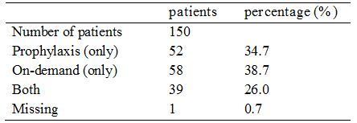
The mean baseline FVIII level was 1% (range 0-98%), which the sponsor attributed to patients not stopping their previous FVIII replacement >48 h prior, and stated that as the trial was ongoing this would not influence the outcome.
At baseline, the most significant laboratory abnormality was that 41 patients (27.3%) had alanine aminotransferase (ALT) and/or aspartate transaminase (AST) levels above the upper limit of the reference range. This is likely to be due to the rate of hepatitis C positivity (39%). One patient was seropositive for hepatitis B and 8% were seropositive for HIV.

Efficacy outcomes
For assessing efficacy, the most useful data were the annualised bleeding rates (which allow comparison with other similar agents) and the use of turoctocog to achieve haemostasis in surgery. It is very difficult in the absence of a comparator arm using an approved FVIII replacement, to interpret the descriptive statistics about dosing levels, such as the mean and median data, which were presented for the total study population, and then according to age, that is, adolescent versus adult consumption. Given the small number and uneven distribution of patients in both groups, together with variability in bleeding rates, preventative regimens, numbers undergoing surgery (9/150, including 1 adolescent in FAS), measurements of the total consumption of turoctocog alfa for the prevention, treatment of bleeding, and surgery for the entire trial are difficult to interpret.
For preventative regimens, the results were presented for good versus less compliance, as this was reasonably felt to be a potential influence on the effective use of turoctocog alfa. However, as the numbers with less compliance were low (10/150 subjects, that is, 6.7%, all from the adult group), it is difficult to make meaningful conclusions.

Prevention of bleeds (secondary endpoint)
The median and mean preventative dose (IU/kg) were highly variable and were difficult to interpret for the reasons outlined above, for example, one adult’s mean preventative dose in IU/kg was 97.4 (median 20.8, range 12.8-97.4). The sponsor has been requested to provide an explanation for the dose requirement of 97.4IU/kg.

Annualised bleeding rates
The annualised bleeding rates were estimated using a Poisson model allowing for over dispersion and presented with 95% CI. The annualised bleeding rates were similar between adults and adolescents treated preventatively at 6.68 (95%CI 5.35-8.34) versus 5.55 (95%CI 3.35-9.19) bleeds/patient/year, respectively. Spontaneous bleeds were more common than traumatic (4.32 [3.34-5.59] versus 1.62 [1.22-2.15] bleeds/patient/year), and this trend was maintained in both populations; however, while still less common than spontaneous bleeds, traumatic bleeds occurred relatively more frequently in the adolescent compared with adult population. Fewer bleeds were seen where there was good compliance compared with patients with less compliance (6.18 [4.99-7.66] versus 10.55 [5.71-19.52] bleeds/patient/year, respectively), but there was a marked imbalance in patient numbers between the two groups as previously stated.
When the time from last preventative dose was narrowed to >72 h and then to >48 h, there was a decrease in the mean bleeding rate from 6.5 to 6.25, and from 6.5 to 5.43 bleeds/patient/year, respectively.
The estimated mean annualised bleeding rate patients in the total population varied considerably among countries with the lowest rate in Japan (1.34 bleeds/patient/year) and the highest rate in the Russian Federation (23.22 bleeds/patient/year). Taken together with the differing PK data in Japanese populations, this may either be due to compliance or the variable PK previously noted in Japanese subjects.
The clinical trial report (CTR) refers to published data showing that the estimated mean annualised bleeding rate for another third generation rFVIII, Advate (n = 107) was comparable to that of turoctocog alfa (n = 150) in a similar patient population using the same estimation method (6.3 versus 6.5 bleeds/patient/year, respectively).

Treatment of bleeds
71.5% and 89.4% of all bleeds were stopped with one or two infusions respectively, with re-bleeds were reported in 7.8% (n = 39) of patients. The majority of bleeds required only one infusion from start of the bleed until preventative treatment was resumed (62.7%, 313), with two infusions being required for 20.4% (n = 102) of bleeds.
The haemostatic response after treatment of a bleed with turoctocog alfa was evaluated on a 4 point scale and the results are summarised below in Table 16. The sponsor is requested to provide clinical information explaining the outcomes and any interventions required for the 12 individuals who had ‘none’ as their recorded haemostatic response. The success rates (haemostatic response excellent or good) excluding missing data were 84.5% (80.8% with missing data). This is comparable with the 86% haemostatic success rate reported for Advate.
Table 16: Trial 3543 - Haemostatic response (number [%]) to treatment of bleeds; FAS.
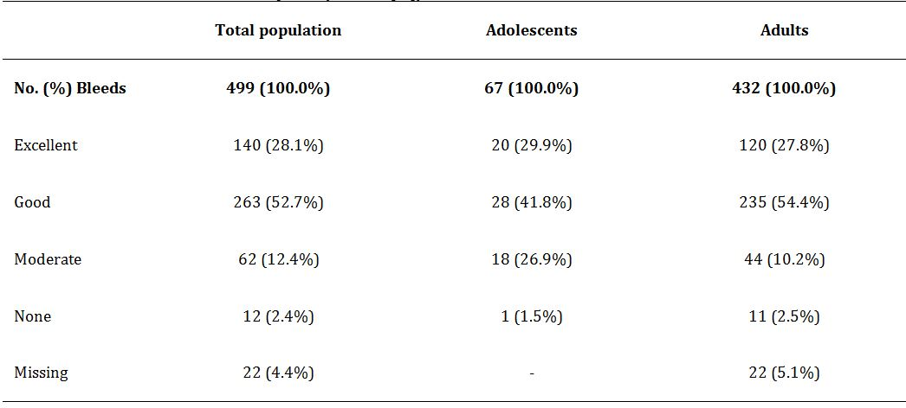

Surgery
Nine patients, including one adolescent, underwent surgery, with 8 operations classed as major and one minor. This should be amended to 7 major and 2 minor operations as circumcision is not regarded as a major procedure. Intraoperative haemostasis was classed as excellent in 7 cases (77.8%) and good in 2 cases (22.2%), and ongoing haemostatic response rated as excellent in 6 cases, and good in 3. There were no treatment failures, that is, no other FVIII products other than turoctocog alfa were required, although one patient undergoing major surgery received 3 units of packed red blood cells.

Patient reported outcomes
There was no significant difference in self reporting of quality of life measurements during the study, with most concerns related to the underlying condition. The data for the surgical procedure did not tally with the number who participated reported as being 7, with 8 responses in each category; additionally, the data are incomplete and the CTR indicates detailed analyses of all patient reported outcome data are to follow.

Trial 3545
Trial 3545 was a trial in previously treated paediatric patients aged 1-12 years with severe haemophilia A (based on medical history of FVIII levels ≤1%) without inhibitors, and >50 days exposure to FVIII products. Baseline FVIII activity was not measured as an entry point. The trial was planned to include at least 50 patients in two age cohorts: 25 children aged 0 to < 6 years, 25 children aged 6 to < 12 years.
The primary objective was to evaluate the safety of turoctocog alfa in previously treated paediatric patients aged 0-12 years of age with haemophilia A.
The secondary objectives were to evaluate:
- PK of turoctocog alfa;
- efficacy of turoctocog alfa;
- to assess and compare patient reported outcomes from baseline to end of trial.
The overview of treatment is summarised in Table 17.
Table 17: Trial 3545 - Overview of treatment.
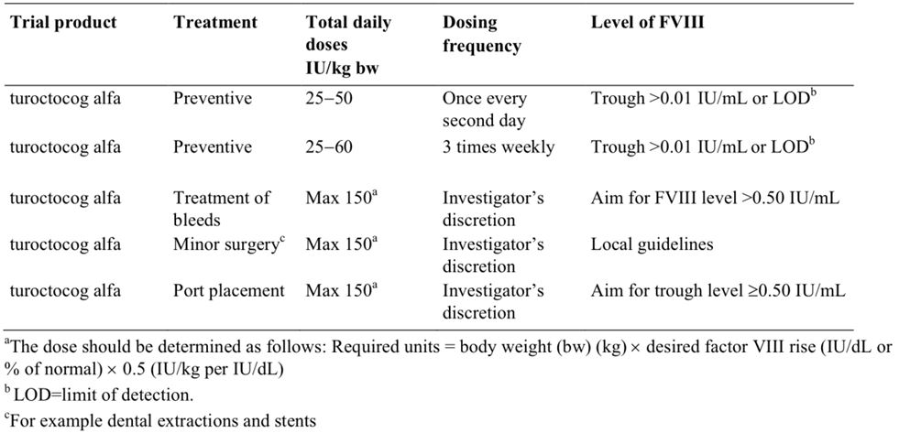
The key inclusion criteria for the trial were male patients with severe haemophilia A (FVIII activity ≤ 1%) aged < 12 years with a weight of ≥ 11 kg with no FVIII inhibitors at screening. Treatment with cryoprecipitate or FVIII concentrates other than turoctocog alfa was not permitted, apart from the specified times during the PK sessions, and if haemostasis could not be obtained with turoctocog alfa.

Efficacy variables and outcomes
The efficacy outcomes were the same as for the pivotal trial (Trial 3543), except the use of turoctocog alfa during surgery was not an endpoint in the pivotal paediatric trial (Trial 3545).
A total of 69 patients were screened, 65 were enrolled, and 60 completed the trial. Of the 60 patients completing the trial, 29 were children aged from 1 to < 6 years and 31 were children aged from 6 to < 12 years. Of the 63 dosed patients, 28 (14 in each age cohort) were dosed in the PK part of the trial while the remaining 35 (17 younger and 18 older children) were dosed in the clinical part of the trial. The majority of the patients were “White” (84%) and the second largest racial group was “Asian” (10%). There were no exclusions based on clinical examination and none tested positive for anti HIV antibodies nor anti HCV antibodies. Prior to trial entry, 76.2% (n = 48) of all patients had been on prophylactic regimens, 28.6% (n = 18) of all patients had been on on-demand treatment, and some patients had been on both prophylaxis and on-demand treatment. The majority (60.4%; n = 29) of patients on prophylaxis used rFVIII products, while only 16.7% (n = 3) of the patients being treated on-demand used rFVIII products.
All patients received preventative treatment, and 74.6% (47/63) were treated three times weekly while 25.4% (16/63) were treated once every second day. Nine (9) patients changed from dosing every second day to dosing three times weekly, while 4 patients changed from three times weekly to every second day.

Estimated annualised bleeding rates
The annualised bleeding rates were estimated using a Poisson model allowing for over dispersion and presented with 95% CIs. The estimated annualised bleeding rates were as follows: all patients: 5.33 (3.9-7.28); small children (aged 1 to < 6 years): 4.73 (3.06-7.3) and older children (aged 6 to < 12 years): 5.86 (3.76-9.13).
Approximately one third of all patients (34.9%; 22/63) did not have a bleed during the trial. Due to the large variation in the estimated annualised bleeding rate among patients, the sponsor considered that it was relevant to look at the median rates. The total median bleeding rate was 3.02 bleeds/patient/year, with 2.95 bleeds/patient/year in children aged 1 to < 6 years and 3.57 bleeds/patient/year in children aged 6 to < 12 years.
Of 126 bleeding events occurring in the total population, 66.7% trauma related, 31.7% were spontaneous and in 1.6% (2/126) the cause was not reported in the diary. Traumatic bleeds occurred more frequently in the younger cohort (83%, 44/53 versus 54.8%, 40/73). Most bleeds were mild/moderate (91.3%), with 6.3% rated as severe, and for 2.4% (3/126), no classification was reported.
The vast majority of bleeds required either only one infusion (81.0%) or two infusions (14.3%) to stop the bleeding. The maximum number of infusions to required was 8 (0.8% of bleeds; 1/126). From the start of the bleed until prevention was resumed, 1 infusion was required for 74.6% of bleeds and two infusions were required for 13.5% of bleeds.

Haemostatic response
The haemostatic response after treatment of a bleed with turoctocog alfa was evaluated on a 4 point scale and the results are summarised in Table 18. The success rates (haemostatic response excellent or good) when assessed conservatively by including the missing values in the denominator were 92.1%, 96.2%, and 89.0% for the total, 1 to < 6, and 6 to < 12 years of age cohorts, respectively. Information regarding the clinical outcomes for the two subjects who have ‘none’ recorded as their haemostatic response has been sought from the sponsor.
Table 18: Trial 3545 - Haemostatic response (number [%]) to treatment of bleeds; FAS.
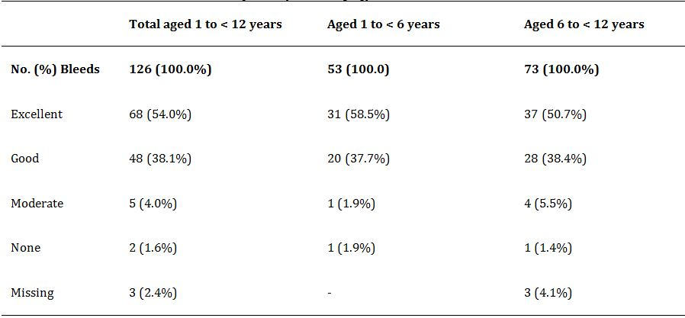
Overall, the haemostatic response was successful in the total population irrespective of the subgroups in which it was examined (for example, location of bleed, cause of bleed, time of bleed). Good compliance with preventative treatment was associated with a better haemostatic response than less compliance (96.4% versus 60.0%). However, most of the bleeds (88.1%, 111/126) occurred in patients with good compliance. The definitions of good compliance and less compliance were consistent with those in the adult trial (Trial 3543).

Surgery
While not a formal endpoint, the haemostatic endpoint was rated as excellent in the 2 minor surgeries described: a dental extraction, and a removal of a central venous access port. The patient who had a dental extraction received tranexamic acid 500 mg two times daily for 3 days, but the other child had turoctocog alfa alone.

Patient report outcomes (other efficacy endpoints)
PROs were measured at Visit 1 and Visit 8. The HAEMO-QOL questionnaire was available for two age groups (4-7 years and 8-12 years of age) in a patient version and in a parent version. The main change appears to be related to changing from on-demand to a preventative regimen, and thus not clearly related to turoctocog alfa itself. No other noteworthy changes were observed from the baseline visit to the end of trial visit in the total HAEMO-QOL scores. The CTR indicates detailed analyses of all patient reported outcome data will be provided as a separate report.

Trial 3568 (extension trial)
The main inclusion criteria for this extension preventative trial were completion of trials 3543 (Phase III trial in adults and adolescents), 3545 (Phase III trial in children), 3600 (Japanese trial) or 3893 (PK trial). The objectives of the main part of trial were to assess the safety (primary objective) and efficacy (secondary objective) of turoctocog alfa for the prevention and treatment of bleeds. The objectives were reversed in the surgical sub trial with efficacy of turoctocog alfa being the primary endpoint and safety a secondary endpoint in assessing turocyocog alfa use during and post surgery.

Efficacy variables and endpoints (secondary)

Main trial: Preventative treatment (secondary efficacy endpoint)
- annualised bleeding rate related to the preventative period;
- haemostatic response to turoctocog alfa for treatment of bleeds (none, moderate, good or excellent).

On-demand treatment (secondary efficacy endpoint)
- Haemostatic response to turoctocog alfa for treatment of bleeds.

Surgery sub trial: Primary efficacy endpoint
- Haemostatic effect of turoctocog alfa.

Secondary efficacy endpoints:
- assessment of actual consumption of turoctocog alfa (IU/kg) in the time period Day 1 to Day 7, and in the time period Day 8 to return to pre surgery regimen;
- comparison of actual and anticipated blood loss;
- haemoglobin level prior to surgery, during surgery, and after surgery;
- blood product transfusion.
All 187 patients in the trial were on a preventative regimen: 109 (58.3%) were adults aged ≥ 18 years, 28 (15.0%) were children aged 6 to < 12 years, 27 (14.4%) were children aged 1 to < 6 years, and 23 (12.3%) were adolescents aged 12 to < 18 years. Of the 187 patients, 93% (n = 147) had negative HIV antibody results at baseline, 5.7% (n = 9) were HIV positive and 1.3% (n = 2) had inconclusive HIV antibody results. All children and adolescents were HIV negative. All patients were negative for hepatitis B surface antigen.
All patients were on a preventative regimen with 82.9% opting for the thrice weekly schedule, although there was some changing back and forth through the trial period. The average dose used varied over time but within the protocol range.

Annualised bleeding rate
Data were not available for all subjects as they had not completed the requisite second visit. Of the 157 who had sufficient data, 86 had suffered a total of 366 bleeds. The average preventative dose ranged from 4.3-86 IU/kg with the latter figure much higher than the range recommended. The estimated mean annualised bleeding rates (bleeds/patient/year) decreased from 3.54 to 3.1 if bleeds occurring more than 72 h after the last preventative dose were excluded, and from 3.54 to 2.53 if bleeds occurring more than 48 h after the last dose were excluded.

Acute bleeds and haemostatic response
The majority of the bleeds were spontaneous rather than traumatic, with 86.1% classed as mild/moderate and 13.9% severe. Of these, 78.7% stopped with a single turoctocog alfa infusion and 90.7% stopped after two. The classification of the 9.3% of bleeds that did not respond after two infusions is not clear nor what treatment was necessary, nor what steps were necessary to achieve haemostasis.
Overall, the haemostatic response was rated as excellent for 170 (46%) bleeds, good for 149 (41%) bleeds, moderate for 44 (12%) of bleeds, and none for 3 (1%) bleeds.

Surgical sub trial
Only two surgical events were reported at the time of cut off. Turoctococg alfa was the only FVIII product used, the intraoperative haemostatic response were rated as excellent for one and good for the other, and excellent for both post operatively. One patient required a red cell transfusion which most likely to be due to the severity of the trauma (femoral fracture).

Pooled efficacy analysis
The Summary of Clinical Efficacy included a post hoc analysis of the pooled efficacy data from 213 patients with severe haemophilia A. Of the 991 bleeds in 158 patients, the haemostatic response was rated excellent/good in 84.6%. This success rate remained relatively constant irrespective of the number of months that a patient had been on preventative turoctocog alfa treatment.
At baseline, 34.4% of patients had been receiving only on-demand FVIII treatment. The mean annualised bleeding rates dropped from an estimated 47 bleeds/patient/year (reported by the investigator and calculated as number of bleeds in month prior to trial entry x 12) to 5.53 bleeds/patient/year after preventative treatment with turoctocog alfa. In the 40.1% patients already on a preventative regimen for at least 12 months, the mean annualised bleeding rate (calculated as above), decreased from 6.1 to 3.86 bleeds/patient/year.
While these improvements confirm the efficacy of turoctocog alfa, they also demonstrate the inherent benefits of a preventative regimen, and of clinical trial participation with education and regular scheduled visits.
Although a secondary endpoint, patient reported outcomes from baseline to end of trial but these data were not presented.

Safety
The 214 patients who received turoctocog alfa for the prevention and treatment of bleeds had a total 32,929 exposure days to the drug, ranging from 1 to 442 days, with a mean of 153.9 exposure days per patients. Eleven of these subjects received turoctocog alfa in a surgical setting (Table 19).
Table 19: Number of patients exposed to turoctocog alfa for prevention and treatment of bleeds.
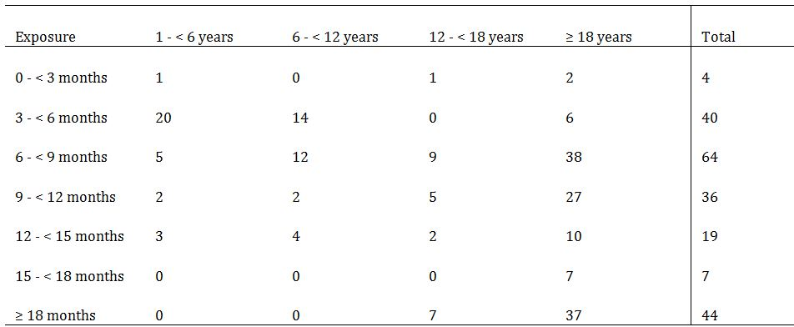
The safety data used standard definitions of AEs, SAEs, and severity of AEs. AEs of special interest were also assessed and these included formation of FVIII inhibitors, allergic type hypersensitivity reactions and thromboembolic events. Disease related bleeds were not to be reported as AEs, unless considered by the investigator to be related to the trial product. In cases of fatal outcome, disease related bleeds were to be reported as SAEs.

Treatment related adverse events
A total of 7.9% of patients, mostly adults (94%), experienced an AE considered by the investigator to be possibly or probably related to treatment with turoctocog alfa. The most frequently reported treatment related AEs were injection site erythema (2.3%), increased levels of hepatic enzymes (1.4%), and pyrexia (0.9%).

Deaths
As of the 1 May 2012 cut off, 1 death had occurred during the trials. This death occurred in a patient in Trial 3568 and was related to an acute subdural haemorrhage with midline shift and cerebral oedema following an alleged assault, and not regarded as a failure of the turcotocog alfa administered pre and post operatively.

Other serious adverse events
In the total population, a total of 21 SAEs were recorded in 17 (7.9%) patients but only 2 were reported as treatment related: hypertension and sinus tachycardia in 1 patient, and a hepatic enzyme rise in 1 patient.
No SAEs were reported during surgery.

Adverse events leading to withdrawal
In the pooled population, 1 (0.45%) patient (aged 54) was withdrawn due to mild fatigue occurring 1 day after every exposure to turoctocog alfa and considered to be possibly related to treatment. The patient was reported to have recovered at follow up. The other patient was withdrawn due to the development of a psychotic disorder, not believed to be treatment related.

Adverse events of special interest

Immunogenicity
As of 1 May 2012, no patients had developed FVIII inhibitors (≥ 0.6 BU) nor any signs of early inhibitor development (for example, lowered incremental recovery of FVIII activity), and the PK results of 15 patients in Trial 3543 were comparable to the results obtained after the first dose of turoctocog alfa in Trial 3522. However, lowered FVIII activity rates have been reported in studies that included previously treated patients, and therefore, this result may well represent selection bias; inhibitors generally develop in the early stages of treatment, thus previously treated patients without inhibitors represent a lower risk group. In a trial of Advate in previously untreated patients, 19/55 developed anti FVIII antibodies, but no comparable studies have been done in turoctocog alfa.
In the pivotal paediatric trial (Trial 3545), 1 patient had a positive FVIII inhibitor test (1.3 BU) at Visit 4, but as a second sample was negative, the criterion for development of FVIII inhibitors was not met. The positive FVIII inhibitor test (1.3 BU) at Visit 4 was reported as an adverse event and as a medical event of special interest.

Anti host cell protein antibodies
Turoctocog alfa is synthesised in a well characterised CHO mammalian cell line and purified using murine IgG. A total of 19 patients from Trials 3522, 3543 and 3545 were positive for anti CHO antibodies, of whom 6 were positive from baseline and throughout the trial. Of the remaining 13, at some point during the trials: 2 changed from negative to positive during the trial; 6 changed from positive to negative during the trial; 2 were negative at baseline and end of trial but with transient positive samples between; and 3 were positive at baseline and end of trial but with transient negative samples between. No patients changed from anti murine IgG negative to positive during the trials, but of the 7 patients who were anti murine IgG positive at baseline, 5 subsequently became negative and 2 remained positive throughout.

Allergic type hypersensitivity reactions
Across all the trials, mild injection site reactions were noted in 5 patients, all of which resolved. No drug hypersensitivity reactions attributable to turoctocog alfa were identified.
The only noteworthy clinical laboratory abnormalities in the trials related to 18 AEs (reported in 10 patients) characterised by increases in liver function test parameters (mainly increases in transaminase levels). However, the majority of patients (80%, 8/10) with LFT abnormalities were hepatitis C positive, which most likely explains the findings. Most of the LFT abnormalities (14/18 = 78%) were considered by the investigator as unlikely to be related to turoctocog alfa. There were no thromboembolic events, no noteworthy changes in other laboratory parameters, vital signs nor ECG findings.

Special populations
Patients who were previously untreated, those with FVIII antibodies, or mild or moderate haemophilia A were excluded. The ages included in the trials ranged from 1-60, with no significant differences in the safety profile according to age. Consistent with its rarity, no females were included in the studies, and consequently there is no information available regarding safety in pregnancy or breastfeeding which is acceptable. There were 9 Japanese patients were involved in Study 3600, with 4 AEs ‘possibly or probably related’ to turoctocog alfa, but no deaths, SAEs or AEs leading to withdrawal or other significant AEs.

Summary and discussion of efficacy and safety

Efficacy discussion
The Delegate is in agreement with the clinical evaluator that the submission has satisfactorily established the efficacy of turoctocog alfa for the prevention and treatment of bleeding episodes in children and adults with severe haemophilia A, without inhibitors, who have been previously treated with FVIII products.
The trial entry specified a medical history of severe haemophilia A, locally determined based on endogenous FVIII activity. However, the median baseline level was 1% (range 0-98%), that is, half the trial patients had FVIII levels not consistent with severe haemophilia A at screening. While accepting the sponsor’s explanation this mostly likely reflects not withholding their previous FVIII replacement therapy, it would have been preferable to have confirmation of severe haemophilia A as a trial requirement; this could otherwise potentially include those with mild or moderate haemophilia A, thereby improving the apparent efficacy of turoctocog alfa in an open label study. Central laboratory confirmation studies should be undertaken in future studies, especially in previously untreated patient studies.
The open label design is justifiable, as it is unethical to have a placebo control arm due to the risk of serious bleeding. However, it would have been better to have had a design where subjects were randomised to treatment with turoctocog alfa or a comparator arm (other FVIII replacement) although numbers would likely have been small in each arm especially if variable treatments were permitted in the comparator arm, given the rarity of the disease. There is support for the design from the pivotal PK/PD trial 3522 which demonstrated bioequivalence to Advate.
The estimated mean annualised bleeding rate for turoctocog alfa was similar to the corresponding rate reported for Advate from published data in a similar patient population (6.5 versus 6.3 bleeds/patient/year, respectively). While prophylactic turoctocog alfa appeared to reduce the bleeding rates, there were some very high doses required, for example, 97.4 IU/kg compared with a median dose of 20.8 IU/kg. The sponsor’s explanation for such variability has been requested, and whether this could represent a case of “less than therapeutic effect (without inhibitor development)” reported for Xyntha (moroctocog alfa) and documented in that product’s PI.
In the pivotal adult trial, the success rate (excellent/good haemostatic response) in managing acute bleeds with turoctocog alfa was 84.5%, and comparable with the reported rate of 86% for Advate in the literature. Furthermore, 89.3% of bleeds were stopped with one or two turoctocog alfa infusions.
In the pivotal paediatric trial (3545) of children aged 1-12, turoctocog alfa prohylaxis, especially when given every second day, is an effective treatment for reducing the risk of bleeding in children. The improved outcomes, especially given some were using a preventative regimen for the first time, resulted in greater parent reported satisfaction with use of turoctocog alfa. In the setting of treatment of acute bleeds, 94.3% (excluding missing data) achieved effective haemostasis with either one or two infusions of turoctocog alfa.
There were limited efficacy data on the use of turoctocog alfa in the surgical setting, but the submitted data are sufficient to establish the efficacy of the drug for this indication. In all eleven patients (including one adolescent), the results indicated that turoctocog alfa was effective, achieving haemostasis, intraoperatively and postoperatively without the use of additional FVIII products. These numbers and results are comparable with Advate (octocog alfa) where ten subjects took part in a surgical study, with all achieving excellent or good haemostatic effect. No children under 1 year of age took part but there is no clear reason not to extrapolate the potential benefits to this age group, and the sponsor has a surgical trial open for recruitment.
A secondary endpoint for each of the three trials was to assess and compare patient reported outcomes from baseline to end of trial but these data were not presented.

Safety discussion
The submitted data do not give rise to significant safety concerns or unexpected safety signals relating to the use of turoctocog alfa. The Delegate is in agreement with the clinical evaluator that the safety of turoctocog alfa for the proposed usage has been sufficiently established in previously treated children and adults, aged 1-60, to warrant recommendation for registration in this group. However, there were some significant deficiencies, the most important of which is that there were no safety data in previously untreated patients (PUPs) with haemophilia A (who are at up to 30% risk of developing FVIII inhibitors, based on studies of other products). Although it is not in the TGA adopted EMA guideline, safety and efficacy studies in PUPs have been done for Advate, another third generation rFVIII products registered in Australia, setting a precedent for establishing safety in this type of product for this indication. It is now in the updated EMA guideline on the clinical investigation of recombinant and human plasma derived factor VIII products (1 February 2012, yet to be adopted in Australia) that such studies are a requirement for approval of the indication in that population. The Delegate considers it reasonable that performing such a study to be submitted upon completion to the TGA to update the PI, be a condition of registration. The advice of the ACPM is sought on this matter.
There are no data about the use of turoctocog alfa in those patients without inhibitors. The safety data on the 3 patients with FVIII inhibitors were too limited to allow meaningful conclusions to be drawn. While this is acknowledged in the PI, as with the PUPs, safety and efficacy data are lacking for this population. Pharmacovigilance will assist to some extent in establishing the outcomes, but the data collection and adverse event reporting is less likely to be as systematic and detailed as for a clinical trial. The advice of the ACPM is sought as to whether routine pharmacovigilance will suffice or whether a clinical trial in this group is required, possibly as a condition of registration.
The safety data in patients undergoing surgery is limited to 11 patients (10 adults and 1 adolescent) from the two surgical sub trials (Trials 3543 and 3568). The classification of the type of surgery should be changed to two minor and nine major procedures, as circumcision is not a major procedure. Nonetheless, effective haemostasis was achieved with turoctocog alfa alone and there were no deaths or SAEs reported in patients in the surgical sub trials, and no patients were withdrawn due to AEs. This is comparable to the numbers and results reported for Advate.
There were some other data deficiencies due to limitations of the studies, but which would not restrict the use of turoctocog alfa, and can reasonable be addressed as part of routine pharmacovigiliance: there were no female patients, patients younger than 1 year and older than 60 years, patients with hepatic impairment, patients with renal impairment, or significant numbers of any racial groups other than “Whites” or Japanese. There were no safety data relating to the concomitant use of medications or drug-drug interactions with turoctocog alfa. There is no post marketing experience. Each of these deficiencies underscores the need for routine pharmacovigilance as per the RMP.

Risk management plan
The OPR has recommended that EU-RMP, version 1, dated 5 October 2012, data lock point 13 December 2011 and the Australian Specific Annex, version 1, dated 27 December 2012, and any future updates are implemented as a condition of registration.
The Delegate considers that the sponsor’s response to the TGA section 31 questions have adequately addressed all of the issues identified in the RMP evaluation report. In particular, the RMP evaluator requested the Delegate’s consideration of two issues regarding the ODD and inclusion of information in the CMI. The Delegate is satisfied with the sponsor’s response to both these.
A number of recommendations for the RMP have been provided by the RMP evaluator and the sponsor should address these matters in the pre ACPM Response and follow up where appropriate with the OPR.
There are two conditions of registration (see ‘Conditions of Registration’ below).

Risk-benefit analysis

Delegate considerations
Overall, the Delegate is satisfied that the efficacy and safety of turoctocog alfa has been sufficiently established in the population examined: pre treated patients with severe haemophilia A, without FVIII inhibitors. While the studies had significant limitations in that there were small numbers, an open label, single arm design, nonetheless, the Delegate is in agreement with the clinical evaluator in considering that the PK/PD studies, safety and efficacy data presented in adults and adolescents indicate that turoctocog alfa is a safe and efficacious rFVIII product. Similarly, the PK/PD, safety and efficacy data for the children aged 1-12 in the paediatric study, indicate that turoctocog alfa is a safe rFVIII replacement therapy in children.
No data were presented for children below 1 year of age, or adults over 60 years of age. Given there were no safety and efficacy differences were identified across the age range examined, it would appear reasonable to extrapolate that those with haemophilia A outside the age range would also benefit. Therefore, the Delegate considers it acceptable not to place an age restriction on the indication, but safety and efficacy outcomes should be monitored as part of routine pharmacovigilance in these age groups.
Few patients underwent surgery (11 patients including 1 adolescent, but no children <12 years were formally studies), but effective haemostasis was achieved without switching to another FVIII product. An additional surgical sub study is underway examining the use of turoctocog alfa and this should be reported as soon as the study is complete, and the PI updated accordingly.
There is no experience in using turoctocog alfa in those with no prior treatment with FVIII products, nor those with or who develop FVIII inhibitors therefore safety and efficacy have not been established in these populations. This is particularly important because of the risk of developing neutralising antibodies is greatest in the early stages of treatment of previously untreated patients with FVIII products.
It is not clear in any of the trials where the haemostatic response was rated as ‘none’ in treating a bleed as to what was required to establish control of the bleeding, and the sponsor has been requested to clarify this.
It is important to note that most of the patients in this trial had been using plasma derived FVIII replacement products prior to enrolment, with its potential for transmission of viruses; this is not considered a risk with rFVIII products such as turoctocog alfa.

Proposed regulatory action and indication
The Delegate has no reason to say, at this time, that the application for Novoeight (turoctocog alfa) should not be approved for registration for the proposed indication.
However, in the absence of safety and efficacy data for those previously untreated patients, or those who have or develop FVIII inhibitors, consideration may be given to performing such studies as a condition of registration. The advice of the ACPM is sought on these matters.

Conditions of registration
The following are proposed as conditions of registration:
- Implementation of EU-RMP, version 1, dated 5 October 2012, data lock point 13 December 2011 and the Australian Specific Annex, version 1, dated 27 December 2012;
- Provision of education materials for review by the OPR prior to the launch of turoctocog alfa in Australia;
- That studies be conducted examining the safety and efficacy of turoctocog alfa in previously untreated patients with severe haemophilia A, and in those with or who develop FVIII inhibitors be performed, and submitted to the TGA upon completion.

Data deficiencies
- Small numbers, open label, single arm with no comparator;
- No data on < 1, > 60 year olds;
- No data where significant renal, hepatic impairment, low CD4 counts in HIV positive;
- No central confirmation of severe haemophilia A before enrolment;
- More information about racial differences;
- No patients without prior FVIII treatment enrolled;
- No data for patients with known inhibitors;
- No patients with mild or moderate haemophilia A.
A secondary endpoint for each of the three trials was to assess and compare patient reported outcomes from baseline to end of trial but this data is not presented.

Questions for the sponsor
- In Trials 3543, 3545 and 3568, the sponsor is requested to provide the following information to explain the outcomes for the 12, 2 and 3 individuals respectively, who had ‘none’ as their recorded haemostatic response:
  - any explanation as to why turoctocog alfa therapy was unsuccessful
  - what action was required to achieve haemostasis including any other FVIII products
  - did this result in withdrawal of these patients from the trial?
- In Trial 3543, why did an individual require 97.4 IU/kg as a preventative dose when the median dose was 20.8 IU/kg? Were there neutralising antibodies in this case or could represent a case of “less than therapeutic effect (without inhibitor development)” reported for Advate and documented in that product’s PI? Is there another explanation?
- Similarly, in Trial 3568, the range of use for preventative doses includes 86IU/kg. Is this the same patient from trial 3543 (in which case the response to question 2 will suffice), or is this another patient requiring much higher than the recommended preventative dose? If so, what is the explanation for requiring this much higher dose?

Summary of issues
Turoctocog alfa is a third generation recombinant FVIII replacement therapy. Efficacy and safety appear to have been satisfactorily established for use in prevention, treatment of bleeds in previously treated patients aged 1-60, with severe haemophilia A, without FVIII inhibitors. The indication proposed potentially includes previously untreated patients, those with FVIII inhibitors, mild or moderate haemophilia A and an open age range in the preventative, treatment and surgical settings. Can these findings be extrapolated to include these populations? Are additional studies required, possibly as a condition of registration?

Advice sought
The committee is requested to provide advice on the following specific issues:
- Has efficacy and safety been adequately established?
- Whether approval be given for the proposed indication, with conducting safety and efficacy studies in previously untreated patients as a condition of registration
- Whether approval be given for the proposed indication, and whether performing additional safety and efficacy studies are required in patients who have or develop FVIII inhibitors be a condition of registration, or whether routine pharmacovigilance will suffice
The committee is (also) requested to provide advice on any other issues that it thinks may be relevant to a decision on whether or not to approve this application.

Pre ACPM preliminary assessment
The Delegate has no reason to say, at this time, that the application for NovoEight (turoctocog alfa) should not be approved for registration.

Response from sponsor

1. Changes to the indications and/or dosage and administration information from the original application
Novo Nordisk generally agrees on the evaluation and no changes to the indications and/or dosage and administration information from the original application are sought.

2. Data about the use of turoctocog alfa in patients with inhibitors

Delegate’s overview: ‘There are no data about the use of turoctocog alfa in those patients [with] inhibitors. The safety data on the 3 patients with FVlll inhibitors were too limited to allow meaningful conclusions to be drawn. While this is acknowledged in the PI, as with the PUPs, safety and efficacy data are lacking for this population. Pharmacovigilance will assist to some extent in establishing the outcomes, but the data collection and adverse event reporting is less likely to be as systematic and detailed as for a clinical trial. The advice of the ACPM is sought as to whether routine pharmacovigilance will suffice or whether a clinical trial in this group is required, possibly as a condition of registration.’

Sponsor’s response
Prophylactic treatment and treatment of bleeds with FVIII product becomes ineffective in patients with high titre inhibitors. For this reason, efficacy and safety studies using conventional treatment regimens with FVIII products cannot be conducted in these patients. Patients with high levels of inhibitor may receive FVIII only as ITI treatment, which involves frequent administration of FVIII product at very high doses. Patients with low levels of inhibitor may respond to prevention and treatment of bleeds with FVIII at higher dose level. It is not recommended to switch a patient with inhibitors to a different FVIII product for ITI or high dose treatment. Consequently, inclusion of subjects with inhibitors in clinical studies is neither feasible nor ethical, and the sponsor is not aware of any studies with other FVIII products enrolling subjects with inhibitors.
Subjects who are at risk for developing inhibitors (such as those with history thereof) are normally excluded from pre registration trials with FVIII products. The three subjects with an historical positive inhibitor test in turoctocog alfa trials were included unintentionally, and these subjects had negative inhibitor status at inclusion and during their time in the trial.
The TGA OPR reviewer concluded that the EU Risk Management Plan v2, 17 May 2013, and Australian specific annex v2, 19 July 2013, will be adequate to support the Australian registration of NovoEight. A key pharmacovigilance element of the EU-RMP is an ongoing paediatric clinical trial in 60 PUPs (NN7008-3809). Based on published data for other rFVIII products, the inhibitor incidence in this trial population is expected to be ~30%. The protocol for this trial allows the subjects to remain in the trial and continue receiving turoctocog alfa, for example, ITI treatment. Although the PUP trial has not been designed to investigate effectiveness of specific ITI regimens, it is expected to provide data on safety of turoctocog alfa in subjects with inhibitors as well as on inhibitor treatment outcomes. Furthermore, and as committed to in the EU-RMP v.2, the sponsor is planning a post marketing observational study (NN7008-3553) in 50 subjects. Inclusion of subjects with a history of inhibitors will be allowed in this trial, although they will be required to have a negative inhibitor test result at inclusion in accordance with the EMA FVIII guideline recommendations.
The sponsor commits to providing the data from the NN7008-3809 and NN7008-3553 clinical studies to the TGA upon completion. Given these initiatives and commitments, the sponsor concludes that a separate, specific study in subjects with inhibitors is not needed.

3. Education materials
Delegate’s Overview (proposed condition of registration): ‘Education materials should be provided for review by the Office of Product Review prior to the launch of turoctocog alfa in Australia.’

Sponsor’s response
The sponsor notes that the OPR reviewer did not conclude that future education materials should be provided for review by the OPR prior to the launch of turoctocog alfa in Australia.
When evaluating the need for educational material, it is considered that both the haemophilia A patient population and the treating physician population are highly specialised groups. Furthermore, the use of turoctocog alfa is not expected to differ materially from that of currently approved FVIII products which are well known by both patients and physicians. In addition, there are no risks specific to the use of turoctocog alfa. The Instructions for Use (IFU) included in the package leaflet (CMI) describe in detail how to handle, reconstitute and inject turoctocog alfa, and pictures are included for clarification. The package insert also advises that all patients be carefully instructed in the use by their treating physician.
Based on above and the analysis of all safety and efficacy data available, the sponsor does not expect there to be significant clinical need for the development of NovoEight specific educational materials apart from reproductions of the PI and/or CMI. The sponsor therefore concludes that it would not be appropriate to require OPR review of educational materials to be included as a formal condition of registration of NovoEight.

4. Questions for the sponsor
Delegate’s Overview Question 1: In Trials 3543, 3545 and 3568, the sponsor is requested to provide the following information to explain the outcomes for the 12, 2 and 3 individuals, respectively, who had ‘none’ as their recorded haemostatic response:
- any explanation as to why turoctocog alfa therapy was unsuccessful?
- what action was required to achieve haemostasis including any other FVIII products?
- did this result in withdrawal of these patients from the trial?

Sponsor’s response
Details of the 17 treatment requiring bleeding episodes for which the haemostatic response was rated as ‘none’ are presented in Table 20. Most of these bleeds were treated with 1-2 injections, normally indicating a good haemostatic response. One reason for the discrepancy between rated efficacy (using the 4 point scale) and number of injections could be that patients sometimes interpret, for example, musculoskeletal pain as a bleed. In such cases the response might be evaluated as poor (as this is not a bleed) and the treatment will be only one or a few injections, before it is realised that the pain was not due to a bleed.
Table 20: Details of bleeds with haemostatic response rated as none – Trial 3543 – Full Analysis Set.
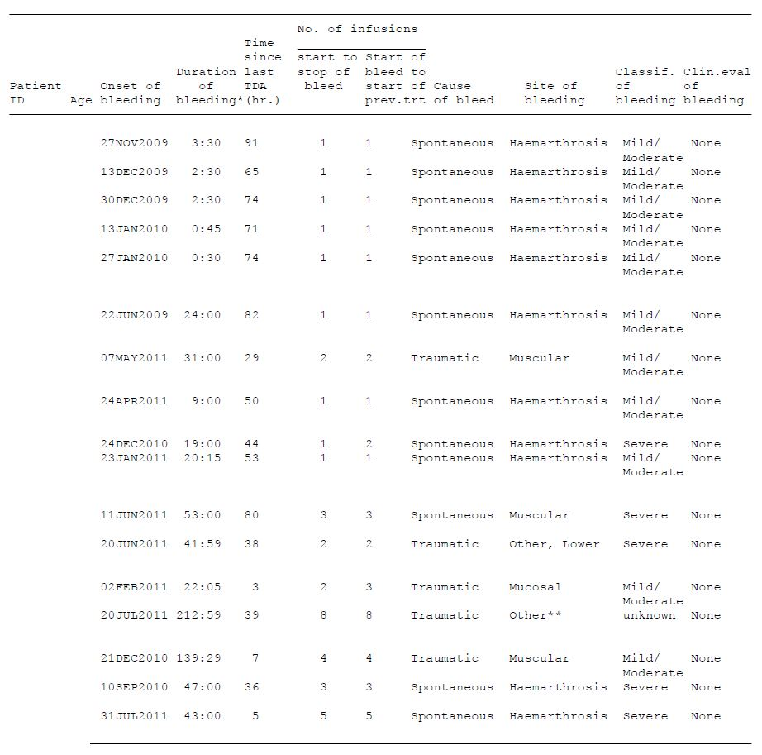
TDA: trial drug administration, hr: hours
*Duration of bleeds in hours. ** left hand bleed, middle and ring finger knot in palm of hand
The poor ratings of some of the severe events (three subjects) might be due to the fact that these bleeds, as expected for severe bleeds, took more than 24 h to resolve. In addition, one subject was withdrawn from Trial 3568 on 20 Oct 2011 due to non compliance.
Furthermore, the records for two of the subjects indicated that these subjects were not consistent in providing evaluations. One of these subjects accounted for five of the bleeding episodes for which the haemostatic response was rated as none. This subject had a total of 19 bleeds in Trial 3543. The ratings of these were: good (1), none (5) and missing (13). The other paediatric subject had a total of four bleeding episodes in Trial 3545. The ratings of these were: none (1) and missing (3), indicating that this subject’s caregiver was not consistent in providing evaluations. This subject was withdrawn from Trial 3545 on 7 Nov 2011 with the reason ‘other’ (subject’s family decided they did not want to continue in the study).
Except from these two subjects, no other subjects were withdrawn from the trials. One subject received treatment with aminocaproic acid for his mucosal bleed. None of the other subjects received any other haemostatic treatment for their bleeds.
Delegate’s Overview Question 2: In Trial 3543, why did an individual require 97.4IU/kg as a preventative dose when the median dose was 20.8IU/kg? Were there neutralising antibodies in this case or could represent a case of "less than therapeutic effect (without inhibitor development)" reported for Advate and documented in that product's PI? Is there another explanation?

Sponsor’s response
This question concerns one patient who by mistake was administered an incorrect dose at the study site. According to the protocol, the turoctocog alfa dose should have been between 20-40 IU/kg. The dose was calculated correctly, however the staff assumed that one box of turoctocog alfa (4 vials) was equal to 2000 IU (instead of 2000 IU/vial). Therefore, they administered a total of 12 mL of reconstituted product, which is equivalent to 1000 IU/kg. The issue was discussed with the Investigator and site staff, and the mistake is described in a protocol deviation. Excluding this dose, all other preventative doses recorded for this patient were within the planned dosing range. There is no indication that this case represents a case of lack of therapeutic effect.
Delegate’s Overview Question 3: Similarly, in Trial 3568, the range of use for preventative doses includes 86 IU/kg. Is this the same patient from Trial 3543 (in which case the response to question 2 will suffice), or is this another patient requiring much higher than the recommended preventative dose? If so, what is the explanation for requiring this much higher dose?

Sponsor’s response
This question concerns one subject who was dosed with 86 IU/mL on 23 August 2011 at 11:00 am. The dose was reported as a preventative dose. However, this subject had a spontaneous, muscular bleed with start time 21 August at 10:30 am and stop time 23 August at 10:30 am (30 minutes before his high preventive dose). This bleed was treated on 22 August at 11:00 am with an on-demand dose of 86 IU/kg. Since the dose level for his high preventative dose was the same as his on-demand dose taken a day before, and since the bleed just stopped 30 minutes before, the higher than normal preventative dose of 86 IU/mL was most likely taken to prevent a re-bleed.
Excluding this dose and a single dose of 70 IU/kg (taken 27 April 2010 at 12:30 pm) in relation to another bleeding episode, all other preventative doses recorded for this subject were within the planned dosing range. There is therefore no indication that this case represents a case of lack of therapeutic effect.

5. Sponsor comments to the second round review of the RMP
The OPR reviewer requested that the CMI document include links to internet sources of the future approved Product Information document. The draft CMI has been updated accordingly.
The sponsor politely points out that the company has previously committed to implementing the EU Risk Management Plan v2, 17 May 2013, and Australian specific annex v2, 19 July 2013, rather than the respective v.1 documents described in the Delegate’s Overview under ‘Conditions of Registration.’

Advisory committee considerations
The submission seeks to register a new chemical entity.
The ACPM, taking into account the submitted evidence of efficacy, safety and quality, agreed with the delegate and considered NovoEight powder for injection containing 250 IU; 500 IU; 1000 IU; 1500 IU; 2000 IU; 3000 IU of turoctocog alfa (rch) to have an overall positive benefit-risk profile for the indication:
for the treatment and prevention of bleeding episodes in patients with haemophilia A, including control and prevention of bleeding in surgical settings

Specific advice
The ACPM also provided the following specifically requested advice:
- Has efficacy and safety been adequately established?
Three clinical pharmacology trials, two pivotal efficacy/safety trials and one efficacy/safety extension trial including ongoing patients from the two pivotal trials are available. One of the pivotal trials was conducted in children aged 1-12 years (28 patients). Patients had been treated previously with other FVIII products but those with FVIII inhibitors were excluded. There were sub studies involving surgery prophylaxis (9 patients) and treatment of acute bleeding.
Haemostatic effect was good regardless of subgroup. Annualised bleeding rates were similar to Advate. As with all other FVIII replacement therapy, prophylactic preventive treatment was more effective than treatment as necessary.
The safety profile was sufficiently favourable that extending the indication to patients below one year and above 60 years, who were not included in the trials, is justified.
- Whether approval be given for the proposed indication, with conducting safety and efficacy studies in previously untreated patients as a condition of registration?
The trials did not include previously untreated patients. These data are important to support further populations. More data on this subgroup should be collected and studies should be encouraged and results reported to the TGA on completion. However, this could be a recommendation rather than a condition of registration. These deficiencies should be clearly stated in the PI.
- Whether approval be given for the proposed indication, and whether performing additional safety and efficacy studies are required in patients who have or develop FVIII inhibitors be a condition of registration, or whether routine pharmacovigilance will suffice?
Data on patients with FVIII inhibitors or who develop inhibitors are also required as these were excluded from the trials. Such studies should be encouraged and results reported to the TGA on completion. However, it is possible that this could be included in pharmacovigilance processes. These deficiencies should be clearly stated in the PI.

Proposed conditions of registration
The ACPM advised that the conditions of registration should be limited to the following:
- Subject to satisfactory implementation of the RMP most recently negotiated by the TGA;
- Negotiation of PI and CMI to the satisfaction of the TGA;
- Provision of education materials for review by the OPR prior to the launch of turoctocog alfa in Australia.

Proposed Product Information (PI)/Consumer Medicine Information (CMI) amendments:
The ACPM agreed with the delegate to the proposed amendments to the PI and CMI and specifically advised on the inclusion of the following:
- The data deficiencies on patients who have not previously been treated, those who have developed inhibitors on previous treatments and those who develop inhibitors during treatment with turoctocog alfa should be clearly stated in the PI and relevant sections of the CMI.
The ACPM advised that the implementation by the sponsor of the recommendations outlined above to the satisfaction of the TGA, in addition to the evidence of efficacy and safety provided would support the safe and effective use of these products.

Outcome
Based on a review of quality, safety and efficacy, TGA approved the registration of NovoEight powder and pre-filled solvent syringe for solution for injection containing turoctocog alfa 250 IU, 500 IU, 1000 IU, 1500 IU, 2000 IU and 3000 IU, indicated for:
NovoEight is indicated for the treatment and prophylaxis of bleeding episodes in patients with haemophilia A, including control and prevention of bleeding in surgical settings.

Specific conditions of registration applying to these therapeutic goods
- The turoctocog alfa EU-RMP, version 1, dated 5 October 2012, data lock point 13 December 2011 and the Australian Specific Annex, version 1, dated 27 December 2012 included with submission, and any future updates as agreed with the TGA will be implemented in Australia.

Attachment 1. Product Information
The Product Information approved at the time this AusPAR was published is at Attachment 1. For the most recent Product Information please refer to the TGA website at <http://www.tga.gov.au/hp/information-medicines-pi.htm>.

Attachment 2. Extract from the Clinical Evaluation Report

European Medicines Agency, “ICH guideline S6 (R1) – preclinical safety evaluation of biotechnology-derived pharmaceuticals Step 5 (EMA/CHMP/ICH/731268/1998)”, June 2011.
European Medicines Agency, “Committee for Medicinal Products for Human Use (CHMP): Guideline on the Clinical Investigation of Recombinant Factor VIII and IX Products (CPMP/BPWG/1561/99 rev.1)”, 19 July 2007.
European Medicines Agency, “Committee for Medicinal Products for Human Use (CHMP): Guideline on the Clinical Investigation of Recombinant Factor VIII and IX Products (CPMP/BPWG/1561/99 rev.1)”, 19 July 2007.
Tarantino MD, et al. (2004) Clinical evaluation of an advanced category antihaemophilic factor prepared using a plasma/albumin-free method: pharmacokinetics, efficacy, and safety in previously treated patients with haemophilia A. Haemophilia 10: 428-437.
Tarantino MD, et al. (2004) Clinical evaluation of an advanced category antihaemophilic factor prepared using a plasma/albumin-free method: pharmacokinetics, efficacy, and safety in previously treated patients with haemophilia A. Haemophilia 10: 428-437.
Coppola A, et al. (2012) Thrombotic adverse events to coagulation factor concentrates for treatment of patients with haemophilia and von Willebrand disease: a systematic review of prospective studies. Haemophilia 18: e173-e187.
European Medicines Agency, “Committee for Medicinal Products for Human Use: Guideline on the Clinical Investigation of the Pharmacokinetics of Therapeutic Proteins (CHMP/EWP/89249/2004)”, 24 January 2007.
European Medicines Agency, “Committee for Medicinal Products for Human Use: Guideline on the Clinical Investigation of Recombinant Factor VIII and IX Products (CPMP/BPWG/1561/99)”, 19 July 2007.
European Medicines Agency, “Committee for Medicinal Products for Human Use: Guideline on the Investigation of Bioequivalence (CPMP/EWP/QWP/1401/98)”, 20 January 2010.

