March 2021

Australian Public Assessment Report for Tucatinib
  - Proprietary Product Name: Tukysa
  - Sponsor: AA-Med Pty Ltd

About the Therapeutic Goods Administration (TGA)
- The Therapeutic Goods Administration (TGA) is part of the Australian Government Department of Health and is responsible for regulating medicines and medical devices.
- The TGA administers the Therapeutic Goods Act 1989 (the Act), applying a risk management approach designed to ensure therapeutic goods supplied in Australia meet acceptable standards of quality, safety and efficacy (performance) when necessary.
- The work of the TGA is based on applying scientific and clinical expertise to decision-making, to ensure that the benefits to consumers outweigh any risks associated with the use of medicines and medical devices.
- The TGA relies on the public, healthcare professionals and industry to report problems with medicines or medical devices. TGA investigates reports received by it to determine any necessary regulatory action.
- To report a problem with a medicine or medical device, please see the information on the TGA website <https://www.tga.gov.au>.

About AusPARs
- An Australian Public Assessment Report (AusPAR) provides information about the evaluation of a prescription medicine and the considerations that led the TGA to approve or not approve a prescription medicine submission.
- AusPARs are prepared and published by the TGA.
- An AusPAR is prepared for submissions that relate to new chemical entities, generic medicines, major variations and extensions of indications.
- An AusPAR is a static document; it provides information that relates to a submission at a particular point in time.
- A new AusPAR will be developed to reflect changes to indications and/or major variations to a prescription medicine subject to evaluation by the TGA.

Copyright
© Commonwealth of Australia 2021
This work is copyright. You may reproduce the whole or part of this work in unaltered form for your own personal use or, if you are part of an organisation, for internal use within your organisation, but only if you or your organisation do not use the reproduction for any commercial purpose and retain this copyright notice and all disclaimer notices as part of that reproduction. Apart from rights to use as permitted by the Copyright Act 1968 or allowed by this copyright notice, all other rights are reserved and you are not allowed to reproduce the whole or any part of this work in any way (electronic or otherwise) without first being given specific written permission from the Commonwealth to do so. Requests and inquiries concerning reproduction and rights are to be sent to the TGA Copyright Officer, Therapeutic Goods Administration, PO Box 100, Woden ACT 2606 or emailed to <tga.copyright@tga.gov.au>.

Contents
List of abbreviations 4
I. Introduction to product submission 7
Submission details 7
Product background 8
Regulatory status 10
Product Information 11
II. Registration timeline 11
III. Submission overview and risk/benefit assessment 12
Quality 12
Nonclinical 12
Clinical 13
Risk management plan 36
Risk-benefit analysis 38
Outcome 44
Attachment 1. Product Information 45

List of abbreviations
Abbreviation | Meaning
ACM | Advisory Committee on Medicines
AE | Adverse event
AESI | Adverse event of special interest
ALT | Alanine aminotransferase
ARTG | Australian Register of Therapeutic Goods
ASA | Australian specific Annex
AST | Aspartate transaminase
AUC | Area under the plasma concentration time curve
AUC_{inf} | Area under the plasma concentration time curve from time zero to infinity
AUC_{tau} | Area under plasma concentration-time curve over dosing interval
BD | Twice daily (Latin: bis in die)
BICR | Blinded independent central review
CAP | Powder in capsule
CBR | Clinical benefit rate
CI | Confidence interval
C_{max} | Maximum plasma concentration
CMI | Consumer Medicines Information
CNS | Central nervous system
C_{trough} | Trough concentration
CV | Coefficient of variation
CYP | Cytochrome P450
DDI | Drug-drug interaction
DGIEP | Division of Gastroenterology and Inborn Errors Products (Food and Drug Administration, United States)
DILI | Drug induced liver injury
DLP | Data lock point
DOR | Duration of response
ECOG PS | Eastern Cooperative Oncology Group performance status
EGFR | Epidermal growth factor receptor
EQ-5D-5L | 5 level EuroQol - 5 Dimension
ER | Oestrogen receptor
EU | European Union
FDA | Food and Drug Administration (United States)
GMR | Geometric mean ratios
GVP | Good Pharmacovigilance Practice(s)
HC | Health Canada
HER2 | Human epidermal growth factor receptor 2
HI | Hepatic impairment
HR | Hazard ratio
HS | Healthy subjects
HSA | Health Sciences Authority (Singapore)
IC₅₀ | Half maximal inhibitory concentration
ITT | Intent to treat
K_{i} | Inhibitory constant
MATE1 | Multidrug and toxin extrusion protein 1
MATE2-K | Multidrug and toxin extrusion protein 2 K
MedDRA | Medical Dictionary for Regulatory Activities
MRI | Magnetic resonance imaging
OCE | Oncology Center of Excellence (Food and Drug Administration, United States)
OCT2 | Organic cation transporter 2
ORR | Overall response rate
OS | Overall survival
PFS | Progression free survival
PFS_{BrainMets} | Progression free survival in patients with brain metastases at Baseline
P-gp | P-glycoprotein
PI | Product Information
PIC | Powder in capsule
PK | Pharmacokinetic(s)
PO | Oral dosing (Latin: per os)
PPE | Palmar-plantar erythrodysaesthesia
PR | Progesterone receptor
PSUR | Periodic safety update report
RECIST | Response Evaluation Criteria in Solid Tumours
RMP | Risk management plan
SAE | Serious adverse event
SD | Standard deviation
TAB | Tablet
T-DM1 | Trastuzumab emtansine
TEAE | Treatment emergent adverse event
TKI | Tyrosine kinase inhibitor
T_{max} | Time to maximum plasma concentration
UGT | Uridine 5'-diphospho-glucuronosyltransferase
ULN | Upper limit of normal
US(A) | United States (of America)
V_{ss}/F | Apparent volume of distribution at steady state

I. Introduction to product submission

Submission details
Type of submission: | New chemical entity
Product name: | Tukysa
Active ingredient: | Tucatinib
Decision: | Approved
Date of decision: | 10 August 2020
Date of entry onto ARTG: | 13 August 2020
ARTG numbers: | 328525, 328526
Black Triangle Scheme: | Yes. This product will remain in the scheme for 5 years, starting on the date the product is first supplied in Australia
Sponsor’s name and address: | AA-Med Pty Ltd  Level 8, 1 Chandos St  St Leonards, NSW, 2065
Dose form: | Film coated tablet
Strengths: | 50 mg, 150 mg
Container: | Blister pack
Pack sizes: | 88 tablets (50 mg), 84 tablets (150 mg)
Approved therapeutic use: | Tukysa is indicated in combination with trastuzumab and capecitabine for treatment of patients with advanced unresectable or metastatic HER2-positive breast cancer, including patients with brain metastases, who have received one or more prior anti-HER2-based regimens in the metastatic setting.
Route of administration: | Oral
Dosage: | Tukysa treatment should be initiated and supervised by a physician experienced in the administration of anti-cancer medicinal products.  The recommended dose of Tukysa is 300 mg taken orally twice daily in combination with trastuzumab and capecitabine until disease progression or unacceptable toxicity.  For further information refer to the Product Information.
Pregnancy category: | D  Drugs which have caused, are suspected to have caused or may be expected to cause, an increased incidence of human fetal malformations or irreversible damage. These drugs may also have adverse pharmacological effects. Accompanying texts should be consulted for further details.  The use of any medicine during pregnancy requires careful consideration of both risks and benefits by the treating health professional. This must not be used as the sole basis of decision making in the use of medicines during pregnancy. The TGA does not provide advice on the use of medicines in pregnancy for specific cases. More information is available from obstetric drug information services in your State or Territory.

Product background
This AusPAR describes the application by AA-Med Pty Ltd (the sponsor) to register Tukysa (tucatinib) 50 mg, and 150 mg film coated tablets for the following proposed indication:
Tukysa is indicated in combination with trastuzumab and capecitabine for treatment of patients with locally advanced unresectable or metastatic HER2-positive breast cancer, including patients with brain metastases, who have received at least 3 prior HER2-directed agents separately or in combination, in the neoadjuvant, adjuvant, or metastatic setting.
Breast cancer that harbours amplification or overexpression of the human epidermal growth factor receptor 2 (HER2), that is HER2-positive/HER+, makes up around 15 to 20% of breast cancers and is associated with earlier age at diagnosis and aggressive phenotype. Most patients receive an anti-HER2 regimen including trastuzumab in the neoadjuvant/adjuvant setting. For patients with metastatic disease, or locally advanced disease that remains unresectable despite neoadjuvant HER2-directed/chemotherapy treatment, a surgical cure is not possible and palliative systemic therapy is indicated.
Patients with metastatic disease usually receive trastuzumab, pertuzumab and a taxane as first-line systemic therapy. Patients who progress on or within 6 months of a neoadjuvant/adjuvant trastuzumab-containing regimen may instead receive trastuzumab emtansine (T-DM1) in the first line metastatic setting, which is otherwise used in the second-line metastatic setting. After progression on T-DM1, there was no standard therapy, and the prognosis of these patients remains poor.
At the time the submission described in this AusPAR was under consideration, options for treatment included:
- Continuation of HER2 targeted therapy with trastuzumab or lapatinib in combination with cytotoxic chemotherapy, such as capecitabine.
- Lapatinib is used (and funded) in Australia in combination with capecitabine following progression on or intolerance precluding continuation of trastuzumab/pertuzumab/taxane or T-DM1. Note that use of lapatinib within 12 months of starting study treatment was an exclusion criterion from the pivotal trial for the submission described in this AusPAR.
- Neratinib in combination with capecitabine is registered by the United Stated (US) Food and Drug Administration (FDA), but this indication for neratinib is not registered in Australia.
- Trastuzumab deruxtecan holds an Accelerated Approval status in the US, but not Australia to date.
Metastases to the brain occur in approximately 20 to 50% of patients with HER2-positive breast cancer, and is associated with a very poor prognosis; with a median survival of approximately 2 years.
Tucatinib is a small molecule, orally administered tyrosine kinase inhibitor (TKI) of HER2. Until the pivotal study for the current submission, the HER2CLIMB trial, no treatment had shown a clinically meaningful and statistically significant overall survival (OS) benefit in the post-T-DM1 setting. And while lapatinib demonstrated some modest activity against brain metastases in the Phase II single arm LANDSCAPE trial, there were no therapies registered specifically for patients with brain metastases (studies have not traditionally been designed with this as a major endpoint).
This evaluation was facilitated through Project Orbis, an initiative of the US FDA Oncology Center of Excellence (OCE). Under this project, the FDA, Health Canada (HC), Health Sciences Authority (HSA, Singapore), Swissmedic (Switzerland) and the TGA collaboratively reviewed the application. This innovative evaluation process provided a framework for process alignment and management of evaluation issues in real-time across jurisdictions.
Each regulator agency maintained its regulatory process to make independent decisions about the approval (market authorisation).

Regulatory status
This product is considered a new chemical entity for Australian regulatory purposes.
At the time the TGA considered this application, a similar application had been approved in the US, Singapore, Canada, and Switzerland, and was under consideration in the European Union (EU), see Table 1.
Table 1: International regulatory status as of July 2020
Region | Submission date | Status | Approved indications
US | 20 December 2019 | Approved on 17 April 2020 | Tukysa (tucatinib) is indicated in combination with trastuzumab and capecitabine for treatment of adult patients with advanced unresectable or metastatic HER2-positive breast cancer, including patients with brain metastases, who have received one or more prior anti-HER2-based regimens in the metastatic setting.
Singapore | 20 January 2020 | Approved on 19 May 2020 | Tukysa is indicated in combination with trastuzumab and capecitabine for treatment of patients with locally advanced unresectable or metastatic HER2-positive breast cancer, including patients with brain metastases, who have received one or more prior anti-HER2-based regimens in the metastatic setting.
Canada | 20 January 2020 | Approved on 5 June 2020 | Tukysa (tucatinib) is indicated in combination with trastuzumab and capecitabine for treatment of patients with locally advanced unresectable or metastatic HER2-positive breast cancer, including patients with brain metastases, who have received prior treatment with trastuzumab, pertuzumab, and trastuzumab emtansine, separately or in combination.  Clinical trial data supporting the effectiveness of Tukysa in combination with trastuzumab and capecitabine are limited to patients who had received at least one prior HER2-directed therapy in the metastatic setting.
Switzerland | 6 January 2020 | Approved on 7 May 2020 | Tukysa is indicated in combination with trastuzumab and capecitabine for the treatment of patients with metastatic HER2-positive breast cancer who previously received 2 or more prior anti HER2 regimens in any setting, including trastuzumab, pertuzumab and T–DM1 (see ‘Clinical Efficacy’).
EU | 9 January 2020 | Under consideration | Under consideration

Product Information
The Product Information (PI) approved with the submission which is described in this AusPAR can be found as Attachment 1. For the most recent PI, please refer to the TGA website at <https://www.tga.gov.au/product-information-pi>.

II. Registration timeline
The following table captures the key steps and dates for this application and which are detailed and discussed in this AusPAR.
Table 2: Timeline for Submission PM-2020-00066-1-4
Description | Date
Submission dossier accepted and first round evaluation commenced | 2 March 2020
Evaluation completed | 29 June 2020
Delegate’s Overall benefit-risk assessment | 27 July 2020
Sponsor’s pre-Advisory Committee response | Not applicable
Advisory Committee meeting | Not applicable
Registration decision (Outcome) | 10 August 2020
Completion of administrative activities and registration on the ARTG | 13 August 2020
Number of working days from submission dossier acceptance to registration decision* | 113
*Target timeframe for priority applications is 150 working days from acceptance for evaluation to the decision.

III. Submission overview and risk/benefit assessment
The submission was summarised in the following Delegate’s overview and recommendations.
This section is a TGA summary of wording used in TGA’s evaluation reports, which discussed numerous aspects of overseas evaluation reports and included some information that was commercial-in-confidence.
The dossier content is substantially the same as the dossier submitted to the other regulatory authorities. The Delegate made reference to the FDA’s publically available Multi-Discipline Review document.

Quality
The major physicochemical properties of tucatinib are:
- Chemical name: (N4-(4-([1,2,4]triazolo[1,5-a]pyridin-7-yloxy)-3-methylphenyl)N6-(4,4-dimethyl-4,5-dihydrooxazol-2-yl)quinazoline-4,6-diamine.
- Molecular formula: C₂₆H₂₄N₈O_{2.}
- Molecular weight (unsolvated free base): 480.52 g/mol.
The chemical structure of tucatinib is shown in Figure 1, below.
Figure 1: Chemical structure of tucatinib
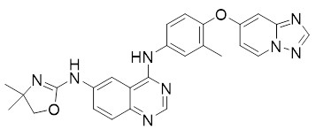
The proposed Australian presentation is foil blister packs, containing either 84 x 150 mg tablets or 88 x 50 mg tablets.
The application and the supporting data relating to the composition, development, manufacture, quality control, stability and bioavailability of the product have been assessed and checked for compliance, as applicable, with Australian legislation and requirements for new medicines and in accordance with pharmacopoeial standards and the technical guidelines adopted by the TGA.
The quality evaluator had no outstanding concerns, and had no objections to the approval of tucatinib.

Nonclinical
The nonclinical evaluator had no objections to the approval of tucatinib for the proposed indication provided the safety of the combination was adequately addressed by clinical data as toxicological interactions between tucatinib and trastuzumab and capecitabine were not investigated in animal studies.
Nonclinical review findings were congruent with the clinical finding that hepatic and gastrointestinal adverse effects predominate the tucatinib safety profile, and predicted some pharmacokinetic (PK) drug interactions, including those based on cytochrome P450 (CYP)2C8 and CYP3A.
Animal data raised concerns regarding tachycardia, lymphoid depletion and effects on reproductive organs, however, these were not evident in the pivotal HER2CLIMB trial.
Given the role of HER2 in implantation and embryofetal development and the teratogenicity observed in toxicology studies, tucatinib should not be used during pregnancy. Pregnancy Category D is considered appropriate for this drug.

Clinical
The efficacy and safety of tucatinib in combination with trastuzumab and capecitabine in the treatment of HER2+ advanced breast cancer after three prior anti-HER2 therapies is based on the pivotal HER2CLIMB trial. Supporting data came from patients with HER2+ metastatic breast cancer treated with tucatinib in single-arm Studies ONT-380-005 and ARRAY-380-101 (safety only). Further supporting data for safety in healthy subjects was submitted from eight early phase studies of tucatinib. The clinical studies included in the dossier are summarised in Table 3.
Table 3: Overview of the clinical studies submitted and how they contributed to the collaborative health authorities’ clinical evaluation
# | Design | Subjects treated with tucatinib | Data contributed to health agencies’ evaluation
Clinical efficacy and safety
HER2CLIMB trial (Study ONT-380-206) | Randomised, double blind, placebo controlled, active comparator | 404 patients (of 410 randomised to tucatinib) | Pivotal: efficacy and safety of tucatinib + trastuzumab + capecitabine in HER2+ advanced breast cancer after trastuzumab, pertuzumab and T-DM1 in any setting
Study ONT-380-005 | Open label, non-controlled study of combinations | 60 patients | Supporting: efficacy and safety of tucatinib plus either trastuzumab and/or capecitabine (triplet, n = 27) in HER2+ metastatic breast cancer after trastuzumab and T-DM1 in metastatic setting
Study ARRAY-380-101 | Open label, non-controlled: dose escalation and expansion | 50 patients | Supporting: safety of tucatinib monotherapy in advanced solid tumours
Study ONT-380-004 | Open label, non-controlled: dose escalation and expansion | 57 patients | Not applicable  (tucatinib combination with T-DM1 in HER2+ metastatic breast cancer after trastuzumab and taxane in metastatic setting)
Clinical pharmacology
ARRAY-380-102 | Open label, single dose | 14 healthy subjects | Effect of various formulations, relative bioavailability
ARRAY-380-103 | Open label, single dose (crossover), open label | 12 healthy subjects | Effect of food, effect of proton pump inhibitors
ONT-380-008 | Open label, single dose | 8 healthy subjects | Absorption, distribution, metabolism and excretion
ONT-380-009 | Open label, single dose (parallel group) | 37 healthy (except hepatic impairment) subjects | Hepatic impairment
ONT-380-011 | Randomised, partially double-blind (placebo and positive controlled), 9 doses | 53 healthy subjects | QT study
ONT-380-012 | Open label, fixed sequence, five part | 114 healthy subjects | Drug-drug interactions: itraconazole, rifampin, gemfibrozil, repaglinide/tolbutamide/midazolam and digoxin
SGNTUC-015 | Open label, fixed sequence, 27 doses | 36 healthy subjects | Effect of race (Caucasian and Japanese)
SGNTUC-020 | Open label, fixed sequence, drug-drug interaction (DDI), 14 doses | 18 healthy subjects | Effect of tucatinib on metformin pharmacokinetics (PK)

Pharmacology

Dose finding
A summary of the clinical dose findings is shown in Table 4.
A powder in capsule (PIC) formulation preceded the tablet that is intended for marketing, and PK data were obtained with both. Exposure with the tablet at 300 mg twice daily (BD) was comparable to exposure with the PIC formulation at 600 mg BD.
The tablet formulation was used in the pivotal HER2CLIMB trial.
Table 4: Summary of clinical dose findings
Parameter | Details
Proposed dose regimen | 300 mg BD (tablet)
Maximum dose tested | 350 mg BD (tablet) / 800 mg BD (PIC)
Maximum tolerated clinical dose | 300 mg BD (tablet) / 600 mg BD (PIC)
Principal adverse events | Most common: diarrhoea, nausea, fatigue  Dose limiting: elevated liver transaminases

Pharmacokinetics
A summary of the PK findings is shown in Table 5.
Table 5: Pharmacokinetics summary for tucatinib
Parameter | Details
Exposure at the therapeutic dose | Geometric mean exposure with the tablet formulation at a 300 mg dose:  - Single dose:  - Area under the plasma concentration time curve from time zero to infinity (AUC_{inf}) (coefficient of variation (CV)): 2480 h*ng/mL (38.5%)  - Maximum plasma concentration (C_{max}) (CV): 410 ng/mL (42.3%)  - At steady state with BD dosing (modelled):  - Area under plasma concentration-time curve over dosing interval (AUC_{tau}): 5234 h*ng/mL  - C_{max}: 630 ng/mL
Range of linear PK | 25 to 800 mg (PIC) / 50 to 300 mg (tablet)
Accumulation at steady-state | Area under the plasma concentration time curve (AUC) = 1.72 fold; C_{max} = 1.52 fold (300 mg BD tablet)
Absorption | Absolute bioavailability not known (intravenous tucatinib not studied).  Median (range) time to maximum plasma concentration (T_{max}) = 2 (1 to 4) hours (300 mg tablet)
Distribution | Apparent volume of distribution at steady state (V_{ss}/F): 730 L (300 mg tablet)  97.1% bound in human plasma
Metabolism | Metabolised by: CYP2C8 (approximately 75%), CYP3A (approximately10%), aldehyde oxidase.  Enzymes tucatinib inhibits (inhibitory constant (K_{i}) in μM): CYP3A (0.8; 0.5 with metabolism-dependent inactivation), CYP2C8 (0.2), CYP2C9 (4.6), uridine 5'-diphospho-glucuronosyltransferase (UGT)1A1 (1.8)  Transported by: P-glycoprotein (P-gp), breast cancer resistance protein  Transporters tucatinib inhibits (for example, substrate) (half maximal inhibitory concentration (IC₅₀) in μM): organic cation transporter 2 (OCT2) (metformin) (14.7), multidrug and toxin extrusion protein 1 (MATE1)(metformin) (0.3), multidrug and toxin extrusion protein 2 K (MATE2-K) (metformin) (0.1), P-gp (10 to 30)  There is no major active metabolite in humans. The predominant metabolite (ONT-993) is 2 to 3 times less potent than parent tucatinib as a cytotoxic agent, and the potency-adjusted exposure of ONT-993 is < 10% of total pharmacological activity.
Excretion | Following administration of nominal 300 mg [¹⁴C]-tucatinib single oral solution, 85.8% (mean) of dosed radioactivity recovered in faeces and 4.09% (mean) of dosed radioactivity recovered in urine.  Terminal elimination half-life = 14.9 hours (300 mg tablet)  Effective elimination half-life = 9.55 hours (300 mg tablet BD)  Oral clearance = 57.3 L/h (300 mg tablet)
Intrinsic factors | No clinically significant effect of age, sex or race.  Renal impairment: no dedicated study (< 5% of excretion).  Hepatic impairment: Study ONT-380-009 (tucatinib exposure to single 300 mg dose in patients with hepatic impairment compared to healthy matched controls). Results are summarised in Figure 2.  The geometric mean ratios (GMR) of exposure in patients with hepatic impairment versus healthy subjects were:  - Mild (Child-Pugh A): AUC_{inf} GMR: 0.99; C_{max} GMR: 1.04  - Moderate (Child-Pugh B): AUC_{inf} GMR: 1.15; C_{max} GMR: 0.89  - Severe (Child-Pugh C): AUC_{inf} GMR: 1.61; C_{max} GMR: 1.17  There was high inter-subject variability in the moderate impairment cohort, but the range of exposure in this cohort was comparable to that seen at the maximum tolerated dose of 600 mg BD (PIC formulation) in early dose-finding study (Study ARR-101).  See Figure 3 for the AUC_{inf} distribution in dose-finding, food effect and dedicated hepatic impairment studies. The data in Figure 3 support a recommendation for no starting dose adjustment for the moderate hepatic impairment population, and a reduced starting dose for patients with severe hepatic impairment to 200 mg.
Extrinsic: DDI | See Table 6, below.
Extrinsic: food | In the presence of a high-fat meal, geometric mean tucatinib C_{max} was unchanged and AUC_{inf} increased approximately 49%.
Population PK | Age, creatinine clearance, and race were not identified as covariates. Body weight and albumin were identified as covariates, but impact on tucatinib PK was not clinically meaningful.
Figure 2, shown below, gives the results of Study ONT-380-009 (AUC_{inf} (h*ng/mL)) according to hepatic impairment.
Figure 2: Results of Study ONT-380-009, hepatic impairment
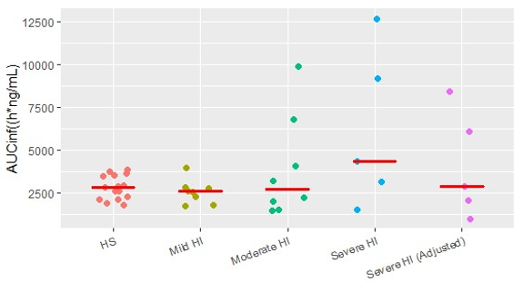
The right-hand group on the plot represents exposures simulated by the FDA for a reduced 200 mg (tablet) dose in patients with severe hepatic impairment.
Figure 3: Area under the plasma concentration time curve from time zero to infinity distribution in dose-finding, food effect and dedicated hepatic impairment studies
CAP = powder in capsule, HI = hepatic impairment, HS = healthy subjects, TAB = tablet.
Table 6: Extrinsic parameters, drug-drug interactions
Drug-drug interactions
Impact of other drugs on tucatinib
Approximate change in geometric mean PK parameters (300 mg tablet):
drug | mechanism | tucatinib C_{max} | tucatinib AUC_{inf}
itraconazole | CYP3A inhibition | increased 1.3 fold | increased 1.3 fold
rifampin | CYP3A/CYP2C8 induction | decreased 37% | decreased 48%
gemfibrozil | CYP2C8 inhibition | increased 1.6 fold | increased 3.0 fold
omeprazole | proton pump inhibition | decreased 13% | decreased 13%
Impact of tucatinib on other drugs
Approximate change in geometric mean PK parameters of the other drug:
drug | mechanism | other drug C_{max} | other drug AUC_{inf}
midazolam | CYP3A inhibition | increased 3.0 fold | increased 5.7 fold
repaglinide | CYP2C8 inhibition | increased 1.7 fold | increased 1.7 fold
tolbutamide | CYP2C9 inhibition | no effect | no effect
digoxin | P-gp inhibition | increased 2.4 fold | increased 1.5 fold
metformin | MATE 1/2-K inhibition | increased 1.1 fold | increased 1.4 fold

Pharmacodynamics
A summary of the pharmacodynamic findings is shown in Table 7.
Table 7: Pharmacodynamics summary for tucatinib
Parameter | Details
Exposure-response analysis | Exploratory analyses were conducted comparing progression free survival (PFS) between subgroups of patients based on tucatinib exposure (trough concentration (C_{trough})). Both by binary (above versus below the median) and by quartile-based comparison, there was a slight trend toward increased PFS with increased exposure.
QT | A thorough, dedicated QT study showed tucatinib does not cause significant change in QT.
Creatinine elevation | Creatinine increase (mean 30%) occurred within the first cycle of tucatinib, remained elevated but stable throughout treatment and was reversible upon discontinuation. This is attributable to inhibition of renal tubular creatinine secretion and does not affect glomerular function.

Pharmacology-related conclusions
- The starting dose for patients with severe hepatic impairment should be 200 mg.
- Tucatinib + capecitabine + trastuzumab is not appropriate for patients with severe renal failure as capecitabine use is contraindicated in such patients.
- Drug-drug interactions (DDI):
  - Effects of other drugs on tucatinib:
    - Avoid concomitant use of strong CYP2C8 inhibitors. If not possible to avoid, reduce the tucatinib dose to 100 mg.
    - In case of concomitant use of moderate CYP2C8 inhibitors, increase monitoring for adverse reactions.
    - Avoid concomitant use of strong CYP3A4 inducers or moderate CYP2C8 inducers.
  - Effects of tucatinib on other drugs:
    - Avoid concomitant use of sensitive CYP3A substrates. If not possible to avoid, consider reducing substrate dose (if narrow therapeutic index) and/or increase monitoring for adverse reactions.
    - Consider reducing dose of P-glycoprotein (P-gp) substrates with narrow therapeutic index (for example, digoxin)
- Exploratory exposure-response analysis suggested slight trend towards better PFS with increased C_{trough}.

Efficacy

HER2CLIMB trial (pivotal study)
The HER2CLIMB trial is an ongoing, randomised, double blind, placebo-controlled study. The study design is summarised in Table 8.
Table 8: Description of the design of the pivotal study (HER2CLIMB trial)
Component | Description
Administrative | First subject randomised: 23 February 2016  Last subject randomised: 3 May 2019  Data cut-off date for primary analysis: 4 September 2019  Clinical study report date: 7 November 2019  A total of 155 sites across 15 countries: US, Canada, Denmark, Belgium, United Kingdom, France, Spain, Portugal, Germany, Switzerland, Czech Republic, Austria, Italy, Israel, and Australia.
Summary schema | - Study design shown in Figure 4, below.  - Crossover was not permitted.  - Dose selection was based on doses studied in Study ONT-380-005. For tucatinib this was the recommended Phase II dose from Study ONT-380-005. The selected trastuzumab and capecitabine dose regimens are consistent with those used in Australian clinical practice.  - Anti-diarrhoeal prophylaxis was not specified in the protocol, so was at investigator discretion.  - No reductions of trastuzumab were permitted.  - Discontinuation entailed discontinuation of all study treatment, unless only capecitabine or only trastuzumab was discontinued.  - Dosing was with food for capecitabine and otherwise unrestricted.  - Concurrent use of strong CYP2C8 or CYP3A4 inhibitors or inducers was not allowed. If the use of sensitive CYP3A substrates was unavoidable, dose reduction of CYP3A substrates with narrow therapeutic indices and/or increased monitoring was recommended.  - Imaging: at Baseline, every 6 weeks for the first 24 weeks, every 9 weeks thereafter, and at end of treatment to 30 days after last study treatment dose.
Eligibility | Key inclusion criteria  - Histologically confirmed breast cancer that is HER2-positive by in situ hybridisation, fluorescence in situ hybridisation or immunohistochemistry (centrally confirmed following American Society of Clinical Oncology guidelines)  - Previous treatment with trastuzumab, pertuzumab, and T-DM1 in the neoadjuvant, adjuvant or metastatic setting  - Progression of locally advanced unresectable or metastatic breast cancer after last systemic therapy (as confirmed by investigator), or was intolerant of last systemic therapy  - Consenting adults ≥ 18 years of age  - Measurable or unmeasurable disease per Response Evaluation Criteria in Solid Tumours (RECIST) V1.1  - Eastern Cooperative Oncology Group performance status (ECOG PS) 0 or 1 | Key exclusion criteria  Previously treated with:  - Lapatinib within 12 months of starting study treatment (except in cases where lapatinib was given for ≤ 21 days and was discontinued for reasons other than disease progression or severe toxicity)  - Neratinib, afatinib, or other investigational HER2/ epidermal growth factor receptor (EGFR) or HER2 TKI at any time  - Capecitabine (or other fluoropyrimidine (for example, 5-fluorouracil)) for metastatic disease (except in cases where capecitabine was given for ≤ 21 days and was discontinued for reasons other than disease progression or severe toxicity)
Eligibility | Contrast brain MRI at baseline for additional central nervous system (CNS)-specific inclusion/exclusion
Eligibility | CNS inclusion  Any of:  - No brain metastases  - Untreated brain lesions not needing immediate local therapy, < 2 cm diameter (unless medical monitor approved)  - Previously treated brain metastases  - If found and treated on initial study screening, both:  - First dose of study treatment had to be at least 21 days after whole brain radiation, at least 7 days after stereotactic radiosurgery, and at least 28 days after surgical resection.  - Other sites of disease assessable by RECIST v1.1 had to be present | CNS exclusion  Any of:  - Untreated brain lesions > 2 cm diameter (unless medical monitor approved)  - Ongoing use of systemic corticosteroids for control of symptoms at equivalent of > 2 mg dexamethasone  - Any brain lesion requiring immediate local therapy  - Known or suspected leptomeningeal disease (per investigator)  - Have poorly controlled (> 1/week) generalised or complex partial seizures, or manifest neurologic progression due to brain metastases notwithstanding CNS directed therapy
Endpoints | - Primary:  - PFS by blinded independent central review (BICR) per RECIST v1.1 in the first 480 randomised patients (intent to treat (ITT)-PFS)  - Subgroup analyses were pre-specified but not alpha-controlled  - Key secondary (alpha-controlled):  - OS in all randomised patients (ITT-OS)  - PFS_{BrainMets}: PFS by BICR per RECIST v1.1 in all randomised patients with brain metastases at baseline (ITT-PFS_{BrainMets}, a subgroup of ITT-OS)  - Other secondary: objective response rate (ORR) by BICR per RECIST v1.1 in all randomised patients who had measurable disease (subgroup of ITT-OS, but not a stratification factor: included as ‘key’ in the clinical study report but not considered ‘key’ in the Multi-Discipline Review for this reason),10 investigator-assessed PFS and ORR, BICR and investigator-assessed duration of response (DOR) and clinical benefit rate (CBR)  - Safety, PK, health economics and patient reported outcomes (5 level EuroQol- 5 Dimension (EQ-5D-5L), healthcare utilisation)
Statistical analysis plan | Sample size: n = approximately 600 randomised  Primary endpoint: 288 events to detect hazard ratio (HR) = 0.67 with 90% power, alpha = 0.05 (2 sided)  Key secondary endpoints:  - OS: 361 events to detect HR = 0.70 with 80% power, alpha = 0.02 (2 sided)  - PFS_{BrainMets}: 220 events to detect HR = 0.67 with 74% power, alpha = 0.03 (2 sided)  Methods: HR estimated by Cox regression, p value using re-randomisation procedure (due to dynamic randomisation), stratified Cochran–Mantel–Haenszel test  Interim analyses: none for PFS, one for PFS_{BrainMets}, up to two for OS  - Multiplicity: PFS at 0.05 (2-sided) to PFS_{BrainMets} at 0.03 (2 sided) and OS at 0.02 (2 sided) with adjustments for interim analyses and re-allocation to ORR at 0.05 (2 sided)
Figure 4: Study design of HER2CLIMB trial
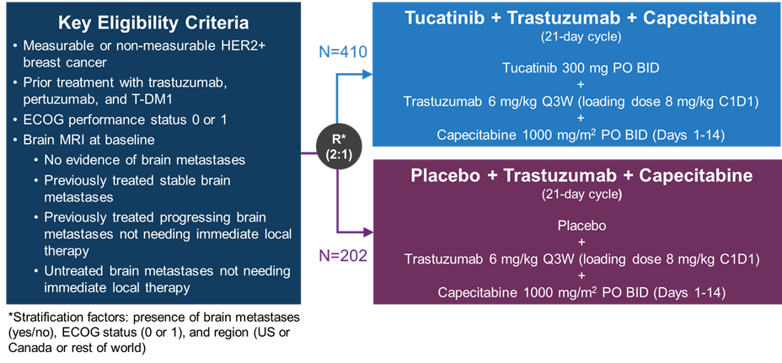
MRI = magnetic resonance imaging, PO = oral.

Protocol amendments
Sample size was increased from 480 to 600 under protocol version 8 to increase power for key secondary endpoints, but the primary analysis of PFS by BICR was kept to the first 480 patients to reduce potential bias due to early progression events.
Other key protocol amendments are described in the Multi-Discipline Review.10

Populations and baseline characteristics
The distribution of demographics (see Table 9) and disease characteristics at Baseline (see Table 10) between arms was consistent with successful randomisation in the three analysis populations in which the primary and key secondary endpoints were analysed.
Table 9: Baseline demographics in the HER2CLIMB trial (intent to treat overall survival population)
 |  | Tucatinib + trastuzumab + capecitabine (n = 410)  n (%) | Placebo + trastuzumab + capecitabine (n = 202)  n (%)
Age | Median (range) | 55 (22 to 80) | 54 (25 to 82)
Age group | < 65 years  ≥ 65 years | 328 (80)  82 (20) | 168 (83)  34 (16)
Sex | Female | 407 (99) | 200 (99)
Race | White  Black  Asian  Unknown/other | 287 (70)  41 (10)  18 (4)  64 (15) | 157 (77)  14 (6)  5 (2)  26 (12)
ECOG PS score | 0  1 | 204 (49)  206 (50) | 94 (46)  108 (53)
Region | US  Canada  Rest of World | 220 (53)  26 (6)  164 (40) | 111 (55)  12 (5)  79 (39)
Table 10: Baseline disease characteristics in the HER2CLIMB trial (intent to treat overall survival population)
 |  |  | Tucatinib + trastuzumab + capecitabine  (n = 410) | Placebo + trastuzumab + capecitabine  (n = 202)
Hormone receptor | Positive, n(%)  Negative, n(%)  Unknown, n(%) |  | 243 (59)  161 (39)  6 (2) | 127 (63)  75 (37)  0
Brain metastases | Total, n(%)  Treated and stable, n(%)^  Treated and progressing, n(%)^  Untreated, n(%)^ |  | 198 (48)  80 (40)  74 (37)  44 (22) | 93 (46)  37 (39)  34 (36)  22 (23)
Brain metastases | Equivocal brain lesions, n(%)^ |  | 24 (12) | 15 (16)
Visceral metastases* | Yes, n (%) |  | 282 (69) | 151 (75)
Prior lines of systemic therapy | Median (range) |  | 4 (2 to 14) | 4 (2 to 17)
Prior lines of systemic therapy in the metastatic setting | Median (range) |  | 3 (1 to 14) | 3 (1 to 13)
Prior lines of systemic therapy in the metastatic setting | n(%) of patients who had | 1 | 21 (5) | 15 (7)
Prior lines of systemic therapy in the metastatic setting | n(%) of patients who had | 2 | 170 (42) | 73 (36)
Prior lines of systemic therapy in the metastatic setting | n(%) of patients who had | 3 | 103 (25) | 64 (32)
Prior lines of systemic therapy in the metastatic setting | n(%) of patients who had | 4 | 55 (13) | 24 (12)
Prior lines of systemic therapy in the metastatic setting | n(%) of patients who had | 5 | 31 (8) | 10 (5)
Prior lines of systemic therapy in the metastatic setting | n(%) of patients who had | 6 or more | 29 (7) | 16 (8)
Prior trastuzumab | Neoadjuvant only, n(%) |  | 25 (6) | 14 (7)
 | Metastatic only, n(%) |  | 233 (57) | 129 (64)
 | Both neoadjuvant and metastatic, n(%) |  | 152 (37) | 59 (29)
Prior pertuzumab | (Neo) adjuvant only, n(%) |  | 38 (9) | 16 (8)
 | Metastatic only, n(%) |  | 354 (86) | 174 (86)
 | Both neoadjuvant and metastatic, n(%) |  | 17 (4) | 11 (5)
Prior T-DM1 | (Neo) adjuvant only, n(%) |  | 3 (0.7) | 4 (2.0)
Prior T-DM1 | Metastatic only, n(%) |  | 406 (99) | 198 (98)
Prior T-DM1 | Both neoadjuvant and metastatic, n(%) |  | 1 (0.2) | 0 (0)
^denominator is number of patients with brain metastases, not ITT population
*non-visceral disease includes tumours located in the neck, breast, chest wall, bone, lymph nodes, skin, and subcutaneous tissue. Brain metastases are considered non-visceral disease. All other locations, including pleura and peritoneum, are classified as visceral disease.
Australian clinical expert advice (see ‘Independent expert advice’ section, below) confirmed that this study population was generally comparable to patients seen in Australian clinical practice (including the relatively infrequent use of pertuzumab outside the metastatic setting), supporting the external validity of the trial findings.

Results
The primary and key secondary endpoints, the overall response rate (ORR) and duration of response (DOR) are summarised in this AusPAR. Details for other endpoints can be found in the Multi-Discipline Review.10

Primary endpoint
Primary endpoint: Progression free survival per BICR in the first 480 randomised patients (intent to treat PFS population).
The primary analysis showed a statistically significant improvement favouring the tucatinib arm. Sensitivity analyses showed consistent findings.
Table 11: Progression free survival by blinded independent central review in the first 480 patients randomised in the HER2CLIMB trial (intent to treat progression free survival population)
 | Tucatinib + trastuzumab + capecitabine N = 320 | Placebo + trastuzumab + capecitabine N = 160
Events, n (%) | 178 (55.6) | 97 (60.6)
Median PFS | 7.8 (7.5, 9.6) | 5.6 (4.2, 7.1)
Stratified HR | 0.54 (0.42, 0.71)
p-value* | < 0.00001
*Based on stratified log-rank test and re-randomisation procedure.
Figure 5: Kaplan-Meier curve for progression free survival in the HER2CLIMB trial (intent to treat progression free survival population)
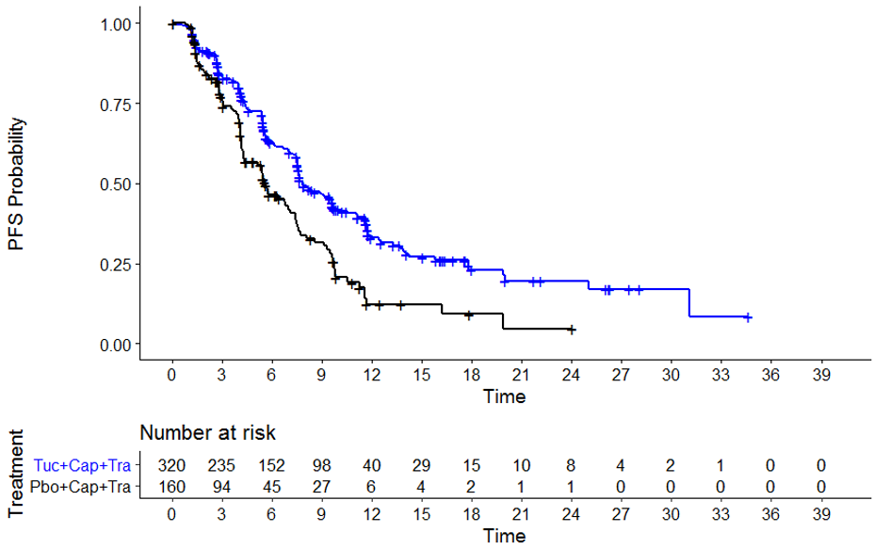
Tuc + Cap + Tra = tucatinib + trastuzumab + capecitabine, Pbo + Cap + Tra = placebo + trastuzumab + capecitabine.
Table 12: Selected subgroup analyses for progression free survival in the HER2CLIMB trial (intent to treat progression free survival population)
 | Tucatinib + trastuzumab + capecitabine  N = 320 |  | Placebo + trastuzumab + capecitabine  N = 160
 | #Events out of N (%) | Median | #Events out of N (%) | Median | Stratified HR  (95% confidence interval (CI))
HR status
Oestrogen receptor (ER) and/or progesterone receptor (PR) positive | 106 out of 190 (55.8) | 7.6 | 66 out of 99 (66.7) | 5.6 | 0.58 (0.42, 0.80)
ER and PR negative or other | 72 out of 130 (55.4) | 8.1 | 31 out of 61 (50.8) | 4.2 | 0.54 (0.34, 0.86)
Baseline brain metastases
Yes | 94 out of 148 (63.5) | 7.6 | 44 out of 71 (62.0) | 5.1 | 0.46 (0.31, 0.67)
No | 84 out of 172 (48.8) | 9.5 | 52 out of 88 (59.1) | 7.4 | 0.62 (0.44, 0.89)
ECOG performance status
0 | 86 out of 159 (54.1) | 9.1 | 48 out of 76 (63.2) | 6.9 | 0.56 (0.39, 0.80)
1 | 92 out of 161 (57.1) | 7.6 | 49 out of 84 (58.3) | 5.4 | 0.55 (0.38, 0.79)

Key secondary endpoints
Key secondary endpoint: Overall survival (OS) in all randomised patients (intent to treat, overall survival population; n = 612).
Of the planned number of events for final analysis (n = 361), 60% had occurred by this interim analysis: alpha boundary 0.0074 (2 sided).
Table 13: Overall survival in the HER2CLIMB trial (intent to treat, overall survival population)
 | Tucatinib + Cap + Tras N = 410 | Placebo + Cap + Tras N = 202
Events, n (%) | 130 (31.7) | 85 (42.1)
Median OS | 21.9 (18.3, 31.0) | 17.4 (13.6, 19.9)
Stratified HR | 0.66 (0.50, 0.87)
p-value* | 0.0048
*Based on stratified log-rank test and re-randomisation procedure
Key secondary endpoint: PFS per BICR in patients with brain metastases (ITT-PFS_{BrainMets}, n = 291).
Of the planned number of events for final analysis (n = 220), 71% had occurred by this interim analysis: alpha boundary 0.0080 (2-sided).
Table 14: Progression free survival in patients with brain metastases at Baseline in the HER2CLIMB trial (intent to treat, progression free survival in patients with brain metastases population)
 | Tucatinib + trastuzumab + capecitabine  N = 198 | Placebo + trastuzumab + capecitabine  N = 93
Events, n (%) | 106 (53.5) | 51 (54.8)
Median PFS | 7.6 (6.2, 9.5) | 5.4 (4.1, 5.7)
Stratified HR | 0.48 (0.34, 0.69)
p-value* | < 0.00001
*Based on stratified log-rank test and re-randomisation procedure.
Figure 6: Kaplan-Meier curve for progression free survival in patients with brain metastases in the HER2CLIMB trial (intent to treat, progression free survival in patients with brain metastases population)
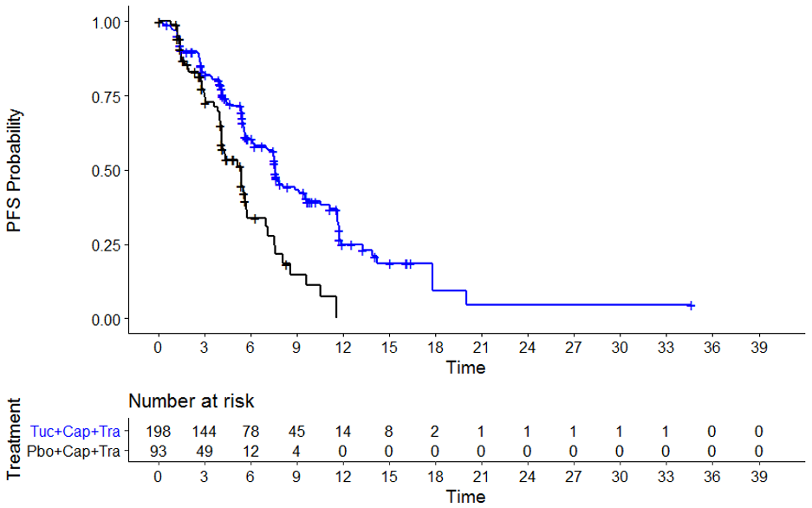
Tuc + Cap + Tra = tucatinib + trastuzumab + capecitabine, Pbo + Cap + Tra = placebo + trastuzumab + capecitabine.

Objective response rate and duration of response
The ORR in all randomised patients who had measurable disease at Baseline (per BICR) was a pre-specified subgroup analysis, but is not a randomised comparison, as measurable disease at Baseline was not a stratification factor.
Of all patients who were randomised, 83.5% had measurable disease at Baseline per BICR (82.9% of the tucatinib arm and 84.7% of the placebo arm). Baseline characteristics between arms in this measurable disease subset of the ITT population were not notably imbalanced.
Table 15: Objective response rate and duration of response in the HER2CLIMB trial by blinded independent central review assessment (measurable disease subset of intent to treat, overall survival population)
 | Tucatinib + trastuzumab + capecitabine  N = 340 | Placebo + trastuzumab + capecitabine  N = 171
ORR
Confirmed ORR (95% CI) | 40.6% (35.3, 46.0) | 22.8% (16.7, 29.8)
Complete response, n (% (95%CI)) | 3 (0.9% (0.2, 2.6)) | 2 (1.2% (0.1, 4.2))
Partial response, n (% (95%CI)) | 135 (39.7% [34.5, 45.1]) | 37 (21.6% (15.7, 28.6))
Stratified Cochran–Mantel–Haenszel test p value | 0.00008
DOR
Median, months (95% CI) | 8.3 (6.2, 9.7) | 6.3 (5.8, 8.9)

Efficacy-related conclusions
A statistically significant and clinically meaningful improvement in PFS by BICR (primary endpoint) was demonstrated, as well as in key secondary endpoints of OS and PFS in patients with brain metastases.
All patients had been exposed to at least one line (and a median of three, maximum of 14 lines) of therapy in the metastatic setting.
As stated in the Multi-Discipline Review,10 endpoints beyond the primary and key secondary endpoints are considered exploratory. They should not be included in the Australian PI.

Safety

Safety analysis plan and populations
This AusPAR focuses on data from the main safety analysis from the HER2CLIMB trial, with a cut-off date of 4 September 2019. The Safety Analysis Set included all randomised patients who received at least one dose of study treatment (tucatinib/placebo, trastuzumab or capecitabine). Adverse events (AEs) were defined as treatment-emergent if occurring between first dose of study treatment to within 30 days after final dose.
A more detailed safety analysis is presented in the Multi-Discipline Review,10 and incorporates data from two preceding Phase I studies (Studies ARRAY-380-101 and ONT-380-005) as well as a 90 day safety update dataset.

Exposure
A total of 861 subjects had received at least 1 dose of tucatinib; 571 subjects with cancer (see Table 16) and 290 subjects without cancer in earlier phase studies.
In the pivotal HER2CLIMB trial, the Safety Analysis Set consisted of 404 patients in the tucatinib arm and 197 in the placebo arm who received at least one dose of tucatinib or matching placebo. Durations of exposure to capecitabine, to trastuzumab and to tucatinib or matching placebo were all around 30% longer in the investigational arm than the comparator arm.
Table 16: Summary of exposure to tucatinib in cancer patients across the clinical development program
Study ID | ARRAY-380-101 | ONT-380-004 | ONT-380-005 | HER2CLIMB
Tucatinib dose (PO BD) | 25 to 800 mg | 300 to 350 mg | 300 to 350 mg | 300 mg
Diagnosis | Solid tumours | MBC | MBC | MBC
Subjects exposed | 50 | 57 | 60 | 404
Duration of exposure (months) | < 1 to 21.8 | < 1 to 40.0 | < 1 to 32.9 | < 0.1 to 35.1
PO BD = twice a day, orally; MBC = metastatic breast cancer.

Overview of adverse events
AEs in the Safety Analysis Set of the HER2CLIMB trial are summarised in Table 17.
The most common adverse reactions (≥ 30%) in patients who received tucatinib were diarrhoea, palmar-plantar erythrodysaesthesia (PPE) syndrome, nausea, fatigue, hepatotoxicity, vomiting and stomatitis. The most common Grade ≥ 3 adverse reactions (≥ 5%) were PPE syndrome, diarrhoea, hepatotoxicity and fatigue.
An exploratory exposure-response analysis for safety based on AUC and C_{max} with data from studies in subjects with cancer (Studies ARRAY-380-101, ONT-380-004, and ONT-380-005) did not find evidence of an association between tucatinib exposure and high grade or serious treatment emergent adverse events (TEAEs).
Table 17: Selected summary safety parameters in the HER2CLIMB trial (data cut-off date 4 September 2019)
 | Tucatinib + trastuzumab + capecitabine  N = 404 | Placebo + trastuzumab + capecitabine  N = 197
Exposure
Mean (standard deviation (SD)) duration of exposure, months (SD)
to tucatinib | 7.6 (6.3) | 5.6 (4.3)
to capecitabine | 7.3 (6.0) | 5.4 (4.1)
to trastuzumab | 7.9 (6.4) | 5.7 (4.3)
Relative dose of tucatinib/placebo
mean (SD) | 88.5% (13.6) | 91.4% (12.3)
median | 93.6% | 97.0%
Deaths (within 30 days of last dose of study treatment)
Due to disease progression | 7 (1.7%) | 7 (3.6%)
Due to adverse events, total | 8 (2.0%) | 6 (3.0%)
Treatment-emergent adverse events (TEAEs)
Patients with at least 1 TEAE | 99% (all but 3) | 97%
Patients with at least 1 serious TEAE (serious adverse event (SAE)) | 25.7% | 26.9%
Most common SAEs (≥ 2% in the tucatinib arm):
diarrhoea | 4.0% | 3.6%
vomiting | 2.5% | 2.5%
nausea | 2.0% | 1.5%
abdominal pain ¹ | 2.0% | 0%
seizure ² | 2.0% | 1.5%
Patients with at least 1 ≥ Grade 3 TEAE | 55% | 49%
Most common ≥ Grade 3 AEs (≥ 10% in the tucatinib arm):
PPE syndrome | 53 (13.1) | 18 (9.1)
diarrhoea | 52 (12.9) | 17 (8.6)
¹ Grouped Medical Dictionary for Regulatory Activities (MedDRA) Preferred Terms: abdominal pain, abdominal pain upper, abdominal pain lower, abdominal discomfort, abdominal tenderness. ² Grouped MedDRA Preferred Terms: seizure, generalised tonic-clonic seizure, epilepsy.

Deaths
In the HER2CLIMB trial, there were 14 fatal TEAEs in the safety population within 30 days of the last dose of study treatment; 8 (2.0%) in the tucatinib arm and 6 (3.0%) in the placebo arm.
The narratives for these events are described in the Multi-Discipline Review,10 beginning on page 168, and are briefly listed in Table 18, below. Of particular note were two deaths (cases 3 and 4 in Table 18) that occurred subsequently to severe diarrhoea in patients in the tucatinib arm, which were considered possibly related to treatment by the regulatory agencies.
Table 18: Treatment emergent adverse events that led to deaths in the HER2CLIMB trial within 30 days of last dose of a study treatment (reported Preferred Term in bold)
Tucatinib arm | Placebo arm
1. Cardiac failure: presented with new onset atrial fibrilation with rapid ventricular response, decreased left ventricular ejection fraction, death due to cardiogenic shock | i. Respiratory failure secondary to disease progression
2. Small bowel obstruction: nausea, vomiting and diarrhoea, deterioration to respiratory failure and sepsis | ii. Cardiac arrest in setting of disease progression, history of diabetes and diverticulitis
3. Grade 4 diarrhoea (confirmed non dihydropyrimidine dehydrogenase deficient) and hypotension, acute kidney injury with oliguria, atrial fibrilation with rapid response. Treated empirically for sepsis though source never isolated. Death attributed to multiple organ dysfunction syndrome. | iii. Developed disease progression and discontinued treatment. Developed fever and shortness of breath, and died 14 days after discontinuing, of systemic inflammatory response syndrome.
4. Presented with nausea, vomiting and large volume diarrhoea non clostridial in setting of positive influenza A swab, Mycoplasma pneumoniae immunoglobulin M antibody in blood, and positive Streptococcus pneumoniae antigen in urine. Death attributed to diarrhoea and dehydration. | iv. Myocardial infarction, in setting of lungs, liver, and brain metastases with malignant pleural effusions
5. Cardiac arrest in setting of fever, chills and shortness of breath in a patient with bilateral malignant pleural effusion | v. Neutropenic sepsis with Klebsiella urinary tract infection, diarrhoea and acalculous cholecystitis on computed tomography.
6. Clostridium difficile colitis and neutropenic septic shock | vi. Metastatic disease involving the brain. Developed encephalopathy with new brain lesions atypical for metastases and subsequent stroke, clostridium difficile colitis, cardiac arrest during blood transfusion for anaemia. Died due to multiple organ dysfunction syndrome.
7. Sudden death at home; baseline liver and brain metastases
8. Sudden death during sleep, 16 days after starting anticoagulation for Grade 3 peripheral oedema of arms presumed due to thrombosis

Discontinuations, dose interruptions and reductions
There were more study drug (tucatinib or matching placebo) discontinuations, dose interruptions and reductions due to AEs in the tucatinib arm than the placebo arm. Diarrhoea and hepatotoxicity-related events were the predominant reason for the difference (see Table 19). PPE syndrome was the most common reason for capecitabine dose adjustment or discontinuation. Although it was an adverse event of special interest (AESI, see next section), rates of trastuzumab interruption due to ejection fraction decrease were similar between arms (1 to 1.5%), and led to trastuzumab discontinuation for one patient, in the tucatinib arm.
Table 19: The most frequent or notable treatment-emergent adverse events leading to discontinuations, dose interruptions or reductions in the HER2CLIMB trial
 | Tucatinib arm  N = 404  n (%) | Placebo arm  N = 197  n (%) | Tucatinib arm  N = 404  % | Placebo arm  N = 197  % | Tucatinib arm  N = 404  % | Placebo arm  N = 197  %
 | Discontinuations |  | Dose interruptions |  | Dose reductions
Tucatinib/placebo
Total | 23 (5.7) | 6 (3.0) | 52 | 39 | 18 | 9
due to hepatotoxicity ¹ | 6 (1.5) | 2 (1.0) | 18 | 9 | 8 | 2.5
due to diarrhoea | 4 (1.0) | 1 (0.5) | 13 | 8 | 5.7 | 4.6
Source: FDA Multi-Discipline Review.10
1: Grouped Preferred Terms: hyperbilirubinaemia, blood bilirubin increased, alanine aminotransferase increased, transaminases increased, hepatotoxicity, aspartate aminotransferase increased, liver function test increased, liver injury, hepatocellular injury, bilirubin conjugated increased.

Adverse events of special interest and otherwise of note
AESIs were defined by the sponsor based on toxicity concerns throughout the tucatinib development program and the regulatory review was in agreement with the sponsor’s selection of terms. The incidence of AESIs across arms in the HER2CLIMB trial is summarised in Table 20.
Table 20: Adverse events of special interest in the HER2CLIMB trial, data cut-off date 4 September 2019
 | Tucatinib + trastuzumab + capecitabine  N = 404 |  | Placebo + trastuzumab + capecitabine  N = 197
 | All grades (%) | Grade 3 to 4 (%) | All grades (%) | Grade 3 to 4 (%)
Hepatoxicity ¹ | 42 | 9 | 24 | 3.6
increased total bilirubin | 25 | 1.2 | 14 | 3
Aspartate transaminase (AST) increase | 22 | 4.7 | 12 | 0.5
Alanine aminotransferase (ALT) increase | 21 | 6 | 7 | 0.5
Diarrhoea | 81 | 13 | 53 | 9
Left ventricular dysfunction | 2.2 | 0.7 | 2.5 | 0.5
Cerebral oedema | 0 | 0 | 2 | -
Increased serum creatinine | 14 | 0 | 1.5 | 0
Source: FDA Multi-Discipline Review.10
1: Grouped MedDRA Preferred Terms: hyperbilirubinaemia, blood bilirubin increased, bilirubin conjugated increased, alanine aminotransferase increased, transaminases increased, hepatotoxicity, aspartate aminotransferase increased, liver function test increased, liver injury, and hepatocellular injury.

Hepatotoxicity
A detailed review of potential for hepatotoxicity was conducted by the FDA, with consultation of experts in the Division of Gastroenterology and Inborn Errors Products (DGIEP).
The rate of all-grade and high-grade hepatotoxicity events was higher in the tucatinib arm than the placebo arm (see Table 20, above). Dose interruptions and reductions due to hepatotoxicity also occurred in higher percentages of the tucatinib than placebo arm (18 versus 9% and 8 versus 2.5%, respectively), but rates of discontinuations were similar (1.5 versus 1%, respectively).
In addition to reported events, laboratory abnormalities were reviewed for potential Hy’s Law cases. Nine cases met initial criteria (ALT and/or AST increase > 3 x the upper limit of normal (ULN) with concurrent total bilirubin increase > 2 x ULN).
Case descriptions for each of the potential Hy’s Law cases and the three patients in the tucatinib arm who discontinued due to hepatotoxicity can be found starting on page 195 of the Multi-Discipline Review.10
The conclusions drawn by the FDA specialist review were:10
‘…evaluation of tucatinib- associated DILI; in HER2CLIMB is challenging for several reasons. All patients who received tucatinib were also receiving capecitabine which is associated with an increase in total bilirubin and can also be associated with transaminase elevation. In many of the cases reviewed, tucatinib and capecitabine were held at the same time, so attribution of hepatotoxicity to one drug or the other is difficult. Additionally, many patients had metastatic disease to the liver, elsewhere in the abdominal cavity, and/or bone which further complicated adjudication of hepatotoxicity.
Tucatinib is a possible cause of DILI, and based on the data available, is associated with a mild to modest rise in transaminases. This rise decreases with drug withdrawal, and patients were able to tolerate a reduced dose. The information available, including the case summary detailed by the applicant, does not point to a Hy’s law signal associated with tucatinib, but based on the confounders listed and the relatively small tucatinib safety database, the possibility cannot be entirely excluded.
There were no cases of hepatotoxicity leading to liver failure or death in HER2CLIMB.’

Diarrhoea
Capecitabine and trastuzumab are both associated with diarrhoea as an adverse event. However, the incidence of all-grade and higher grade diarrhoea events was higher in the tucatinib arm compared to placebo, although the rate of permanent discontinuations was similar. The median time to diarrhoea onset was shorter in the tucatinib arm (12 days versus 22 days), but extent and rate of resolution were similar.
As described under ‘Deaths’ section, above, there were two deaths associated with Grade 4 events of diarrhoea (one due to dehydration and the other due to multi-organ dysfunction syndrome). In both cases, diarrhoea was ongoing at the time of death and there was concurrent suspected infection.

Left ventricular dysfunction
HER2-directed therapies have the potential to cause cardiotoxicity. Left ventricular systolic dysfunction leading to dose modification or discontinuation was considered an AESI in the HER2CLIMB trial, based on mechanism of action and increased risk of cardiac dysfunction in this population due to previous treatment with known cardiotoxic therapies. However, the rates of events and discontinuations in HER2CLIMB were similar between arms.

Cerebral oedema
An index case of cerebral oedema occurred in an early phase study of tucatinib (Study ONT-380-005). The patient had known brain metastases and cerebral oedema was discovered in an area surrounding a known metastasis in the thalamus. Imaging findings were consistent with cytotoxic oedema in myelinated fibres identified as associated with capecitabine in published literature.
In the HER2CLIMB trial, two cases of cerebral oedema occurred, both in the placebo arm. This event does not appear to be associated with tucatinib from the available data.

Increased serum creatinine
Low grade events of creatinine increase occurred in 14% of tucatinib-treated and 1.5% of placebo-treated patients in the HER2CLIMB trial.
Based on the following data, serum creatinine increase appears to be attributable to tucatinib inhibition of OCT2 and MATE1-related tubular secretion, rather than impaired renal function:
- On average, serum creatinine increased around 30% in the first cycle of tucatinib treatment. The elevations then stabilised and persisted throughout treatment, and resolved upon treatment discontinuation.
- The majority of TEAEs of creatinine increase in the tucatinib arm of HER2CLIMB were Grade 1, and no subjects discontinued treatment due to such events.
- Acute kidney injury and renal failure TEAEs were infrequent with similar incidence between treatment arms. Blood urea nitrogen values remained stable throughout tucatinib treatment.
- In Study SGNTUC-020, using metformin as a probe, tucatinib was demonstrated to be a weak inhibitor of MATE1/MATE2-K renal extrusion transporters. Other dedicated markers of renal function (for example, iohexol clearance) were unaffected during treatment.

Palmar-plantar erythrodysaesthesia syndrome
PPE or hand-and-foot syndrome is known to be associated with capecitabine therapy and was not an AESI. However, when adjusted for exposure, the incidence of all grade and higher-grade (≥ 3) PPE syndrome was higher in the tucatinib arm versus the control arm (248 versus 206 and 21 versus 19 per 100 person-years, respectively). Therefore, it is not possible to rule out that tucatinib may cause PPE or increase the propensity for capecitabine to do so.

Safety-related conclusions
The safety profile of tucatinib as an add-on to therapy with capecitabine and trastuzumab in this second-line or later metastatic HER2-positive breast cancer population is notable for gastrointestinal and hepatic toxicities over and above those attributable to capecitabine or trastuzumab. AEs were common, but generally manageable with standard approaches. Two patients in the safety analysis population who received tucatinib died from the sequelae of severe diarrhoea and dehydration. Diarrhoea and hepatotoxicity should be in the Warnings/Precautions section in the PI.

Risk management plan
The sponsor has submitted EU-risk management plan (RMP) version 0.1 (date 20 December 2019; data lock point (DLP) 4 September 2019) and Australian specific Annex (ASA) version 0.1 (date January 2020) in support of this application. With the responses to rolling questions sent on 12 May 2020, the sponsor provided an updated ASA version 0.2 (date May 2020).
The summary of safety concerns and their associated risk monitoring and mitigation strategies are summarised in Table 21.
Table 21: Summary of safety concerns
Summary of safety concerns |  | Pharmacovigilance |  | Risk minimisation
 |  | Routine | Additional | Routine | Additional
Important identified risks | None | – | – | – | –
Important potential risks | None | – | – | – | –
Missing information | Subjects previously treated with cumulative dose of doxorubicin > 360 mg/m² or who have had a previous treatment with another anthracycline with cumulative dose approximately equivalent to > 360 mg/m² doxorubicin | * | – | – | –
Missing information | Carriers of hepatitis B and/or hepatitis C, or who have auto-immune hepatitis, sclerotizing cholangitis, or other known chronic liver disease | † | – |  | –
*Targeted follow up – Standard AE Questionnaire. †Targeted follow up – Hepatic Event Questionnaire
The RMP evaluation has been completed and recommendations for conditions of registration wording given (see ‘Proposed risk management conditions of registration’ section, below). There were no outstanding issues from an RMP perspective.
Tucatinib is a new chemical entity and should be included in the Black Triangle Scheme as a condition of registration.
The RMP evaluator noted that dose adjustment advice regarding diarrhoea has been included in the approved US label; this should also be included in the Australian PI.

Proposed risk management conditions of registration
Any changes to which the sponsor has agreed should be included in a revised RMP and ASA. However, irrespective of whether or not they are included in the currently available version of the RMP document, the agreed changes become part of the risk management system.
The suggested wording is:
The Tukysa EU-RMP (version 0.1, dated 20 December 2019; DLP 4 September 2019), with ASA (version 0.2, dated May 2020), included with submission PM-2020-00066-1-4, and any subsequent revisions, as agreed with the TGA will be implemented in Australia.
An obligatory component of risk management plans is routine pharmacovigilance. Routine pharmacovigilance includes the submission of periodic safety update reports (PSURs).
Unless agreed separately between the supplier who is the recipient of the approval and the TGA, the first report must be submitted to TGA no later than 15 calendar months after the date of the approval letter. The subsequent reports must be submitted no less frequently than annually from the date of the first submitted report until the period covered by such reports is not less than three years from the date of the approval letter. The annual submission may be made up of two PSURs each covering six months. If the sponsor wishes, the six monthly reports may be submitted separately as they become available.
If the product is approved in the EU during the three years period, reports can be provided in line with the published list of EU reference dates no less frequently than annually from the date of the first submitted report until the period covered by such reports is not less than three years from the date of the approval letter.
The reports are to at least meet the requirements for PSURs as described in the European Medicines Agency’s Guideline on Good Pharmacovigilance Practices (GVP) Module VII-periodic safety update report (Rev 1), Part VII.B Structures and processes. Note that submission of a PSUR does not constitute an application to vary the registration. Each report must have been prepared within ninety calendar days of the data lock point for that report.
As Tukysa is a new chemical entity it should be included in the Black Triangle Scheme as a condition of registration. The following wording is recommended for the condition of registration:
Tukysa (Tucatinib) is to be included in the Black Triangle Scheme. The PI and Consumer Medicines Information (CMI) for Tukysa must include the black triangle symbol and mandatory accompanying text for five years, which starts from the date that the sponsor notifies the TGA of supply of the product.

Risk-benefit analysis

Delegate’s considerations

Benefits and uncertainties
The evidence in support of efficacy of the proposed indication consists of data from a well-designed, randomised, double-blind, placebo-controlled trial (the HER2CLIMB trial). The addition of tucatinib to treatment with trastuzumab plus capecitabine showed statistically significant and clinically meaningful efficacy (see Table 22).
Table 22: Overview of HER2CLIMB results
 | Tucatinib +  capecitabine plus trastuzumab | Placebo +  capecitabine plus trastuzumab
PFS (n = 480) (primary)
median, months (95% CI) | 7.8 (7.5, 9.6) | 5.6 (4.2, 7.1)
difference | 2.2 months
stratified HR | 0.54 (0.42, 0.71)
OS (n = 612)
median, months (95% CI) | 21.9 (18.3, 31.0) | 17.4 (13.6, 19.9)
difference | 4.5 months
stratified HR | 0.66 (0.50, 0.87)
PFS in patients with brain metastases (n = 291)
median, months (95% CI) | 7.6 (6.2, 9.5) | 5.4 (4.1, 5.7)
difference | 2.2 months
stratified HR | 0.48 (0.34, 0.69)
All patients enrolled in the HER2CLIMB trial were required to have been previously treated with trastuzumab, pertuzumab, and T-DM1 in the (neo)adjuvant and/or metastatic setting, and all patients had been exposed to at least one line (and a median of three, maximum of 14 lines) of therapy in the metastatic setting.
Patients with active brain disease have been largely excluded from breast cancer trials in the past and the evidence base for therapies in this setting is limited. In the HER2CLIMB trial, patients with brain metastases of all categories (treated and stable; treated and progressing; untreated) made up 48% of the study population. The statistically and clinically robust results for this group - in context of the assumption of exclusion from most trials to date - support specification of this population in the indication despite the grammatical redundancy. Further discussion of the indication wording is located in the ‘Indication wording’ section, below.

Harms and uncertainties
Treatment with tucatinib in the HER2CLIMB trial was associated with more toxicity than placebo, notably gastrointestinal and hepatic toxicities, over and above those attributable to capecitabine or trastuzumab. Diarrhoea and hepatotoxicity are to be included in the PI as Warnings/Precautions.
Two patients treated with tucatinib died from the sequelae of severe diarrhoea and dehydration. In both cases, diarrhoea was ongoing at the time of death and there was concurrent suspected infection.
A specific review of hepatotoxicity was undertaken by the FDA, in conjunction with experts from the Division of Gastroenterology and Inborn Errors Products (DGIEP), coming to the following conclusion:10
‘Tucatinib is a possible cause of DILI, and based on the data available, is associated with a mild to modest rise in transaminases. This rise decreases with drug withdrawal, and patients were able to tolerate a reduced dose. The information available, including the case summary detailed by the applicant, does not point to a Hy’s law signal associated with tucatinib, but based on the confounders listed and the relatively small tucatinib safety database, the possibility cannot be entirely excluded.
There were no cases of hepatotoxicity leading to liver failure or death in HER2CLIMB.’
Overall, there was a higher rate of adverse event-related deaths in the placebo arm (3.0%) than the tucatinib arm (2.0%).
The most common adverse reactions (≥ 30%) in patients who received tucatinib were diarrhoea, palmar-plantar erythrodysaesthesia (PPE) syndrome, nausea, fatigue, hepatotoxicity, vomiting and stomatitis. The most common Grade ≥ 3 adverse reactions (≥ 5%) were PPE syndrome, diarrhoea, hepatotoxicity and fatigue.
Discontinuations, dose interruptions and reductions were all more frequent with tucatinib than placebo, particularly due to hepatotoxicity or diarrhoea.
Treatment with tucatinib plus capecitabine and trastuzumab is not appropriate for patients with severe renal failure as capecitabine use is contraindicated in such patients. For patients with severe hepatic impairment, the starting dose should be 200 mg.
Clinically relevant drug-drug interactions related to CYP2C8, CYP3A4, and P-gp are described in the product information, including dose action recommendations.

Benefit-risk balance
This submission provides robust data from a randomised, double-blind, placebo-controlled trial that demonstrates an improvement in progression-free survival and overall survival when tucatinib is added to trastuzumab and capecitabine in the treatment of patients with previously-treated, HER-2 positive advanced breast cancer. For patients with brain metastases, a statistically significant and clinically significant improvement in PFS was also demonstrated, of the same magnitude seen in the overall population.
The inclusion of tucatinib to this combination results in additional toxicity, but in the setting of this serious, life-threatening disease, the safety profile of the combination is acceptable. Adverse events were generally manageable with standard supportive therapies, dose interruption and reduction, and there was a low adverse reaction-related discontinuation rate (6%).
The benefit-risk balance for the proposed usage is therefore considered favourable.

Indication wording
Table 1 summarises the indication wording approved by other regulators. The indication wording proposed for the Australian PI is:
Tukysa (tucatinib) is indicated in combination with trastuzumab and capecitabine for treatment of patients with locally advanced unresectable or metastatic HER2-positive breast cancer, including patients with brain metastases, who have received one or more prior anti-HER2-based regimens in the metastatic setting.
This wording is based on the following rationale:
- Statistically robust and clinically significant efficacy was specifically demonstrated in patients with brain metastases, who have poor prognosis and limited treatment options, and have usually been excluded from breast cancer clinical trials.
- An indication that specified particular prior therapies may preclude usages that are clinically valid, such as:
  - Patients with HER2+/ER+ disease who elect to have trastuzumab plus endocrine therapy for the treatment of more indolent disease, or based on comorbidities and/or personal preference.
  - Patients preferring home administration of treatment who elect to have trastuzumab plus chemotherapy or endocrine therapy, with maintenance subcutaneous trastuzumab administered in the community setting (for example, hospital in the home).
  - Patients with contraindications to/intolerances of one of the specified drugs.
  - Prior to T-DM1 in a patient who received trastuzumab plus pertuzumab plus a taxane as first line treatment for de novo metastatic disease, then developed brain-only progression.
  - Patients who received newer anti-HER2 drugs, and so wouldn’t be eligible for tucatinib + trastuzumab + capecitabine until relatively later lines of therapy than the study population.
- An indication that required ‘at least three prior HER-2 directed therapies’ in any setting would also preclude some of the above usages.
- The wording used by FDA and Singapore adequately represents the enrolled population: patients had received at least one prior line of systemic anti-HER2 therapy in the metastatic setting (with a mean and median of three).
- A post-hoc, exploratory subgroup analysis in patients who had received one prior systemic anti-HER2-based regimen in the metastatic setting was requested by the TGA (see ‘Questions for the sponsor’ section, below) and, noting the very small group sizes, does not generate hypotheses of a lack of efficacy in such patients:
  - ITT-PFS HR for tucatinib (n = 17) versus placebo (n = 12): HR = 0.454 (95% CI 0.178, 1.156)
  - ITT-OS HR for tucatinib (n = 21) versus placebo (n = 15): HR = 0.783 (95% CI 0.289, 2.125)
  - ITT-PFS_{BrainMets} for tucatinib (n = 7) versus placebo (n = 9): HR = 0.969 (95% CI 0.275, 3.422)
- The prescriber group who would be expected to initiate this drug (that is, registered oncologists) are experts in the application of evolving evidence and clinical practice guidelines to prescribing decisions. For this prescriber group, a less rigid indication can be expected to provide appropriate clinical flexibility without significantly increasing the risk of inappropriate prescribing. It is very unlikely, for example, that an oncologist would recommend use of the tucatinib combination prior to T-DM1 without good clinical rationale for doing so, or be unaware of the evidence base behind the selection.

Proposed action
The Delegate proposes to approve the registration of the product for the indication:
Tukysa (tucatinib) is indicated in combination with trastuzumab and capecitabine for treatment of patients with locally advanced unresectable or metastatic HER2-positive breast cancer, including patients with brain metastases, who have received one or more prior anti-HER2-based regimens in the metastatic setting.

Independent expert advice
The Delegate received the following independent expert advice.
Australian independent clinical expertise was consulted by TGA for impartial advice on the Australia-specific clinical context. The expert advice was in agreement with the following:
- Australian patients with HER2-positive advanced breast cancer can generally be expected to be similar to US patients with HER2-positive metastatic breast cancer.
- It is appropriate to reflect the inclusion of patients with brain metastases in the pivotal trial in the Australian indication wording.
- It is appropriate to select indication wording that does not require use after specific agents, but to specify that at least one other anti-HER2 therapy should have been tried in the metastatic setting, as this sufficiently reflects the actually enrolled trial population as well as an acceptable level of reliance on clinician expert knowledge and decision-making.
The independent Australian clinical experts did not identify any further questions, clarifications, or areas of uncertainty further to those considered in this document.

Questions for the sponsor
The sponsor provided the following response to questions from the Delegate.
In the expert Australian clinician advice received, note was made that exploratory data for subgroups by number of prior lines of therapy and basic descriptive statistics for the subgroups would be reassuring if available. Would it be possible for the sponsor to provide the following?
- The number of patients who were in each of the following categories of number of prior systemic therapies received in the metastatic setting: 1, 2, 3, 4, 5, 6 or more.
The number of patients in the ITT-OS population who received 1 to 6 or more prior lines of systemic therapy in the metastatic setting is summarised in Table 23. The proportion of patients in each of the categories was balanced between the two treatment arms. Patients on both treatment arms received a median of three prior lines of therapy in the metastatic setting with a range of 1 to 14 prior lines.
Table 23: Summary of prior systemic therapies in the metastatic setting (intent to treat – overall survival population)
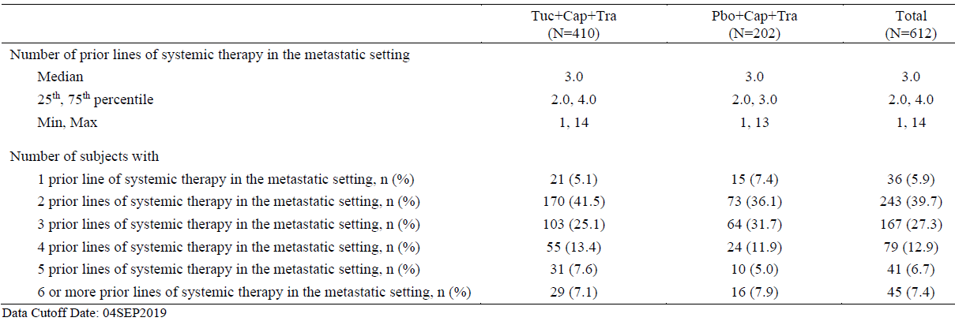
- for each of the following subgroups:
- Patients who had received 1 prior systemic therapy in the metastatic setting
- Patients who had received 2 prior systemic therapies in the metastatic setting
provide an exploratory subgroup analysis of the primary and key second endpoints, that is:
- PFS per BICR in the first 480 randomised patients
- OS in all randomised patients
- PFS per BICR in patients with brain metastases
The requested exploratory subgroup analyses of the primary and key secondary endpoints in patients who received one and two prior systemic lines of therapy in the metastatic setting are provided in Table 24 and Table 25, respectively.
The results from these analyses demonstrate PFS, OS, and PFSBrainMets benefits consistent with the overall study outcome from the primary analyses, further supporting the efficacy of tucatinib in combination with trastuzumab and capecitabine in patients who received either one or two prior systemic lines of therapy. A limitation for these post hoc analyses is the small number of patients in certain subgroups.
Table 24: Efficacy results in the HER2CLIMB trial (subjects who had 1 previous line of therapy in the metastatic setting)
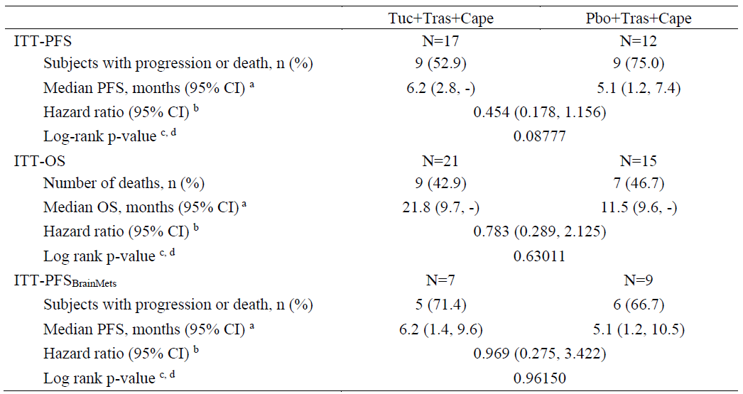
a: Calculated using the complementary log-log transformation method. b: Hazard ratio comparing Tuc + Cap + Tra to Pbo + Cap + Tra calculated from the unstratified Cox proportional hazards model. A hazard ratio < 1.0 favours the Tuc + Cap + Tra arm. c: Two-sided p-value calculated from unstratified log-rank test. d: The p value is nominal p value calculated from post hoc exploratory analysis. Data cut-off date: 4 September 2019.
Table 25: Efficacy results in the HER2CLIMB trial (subjects who had 2 previous lines of therapy in the metastatic setting)
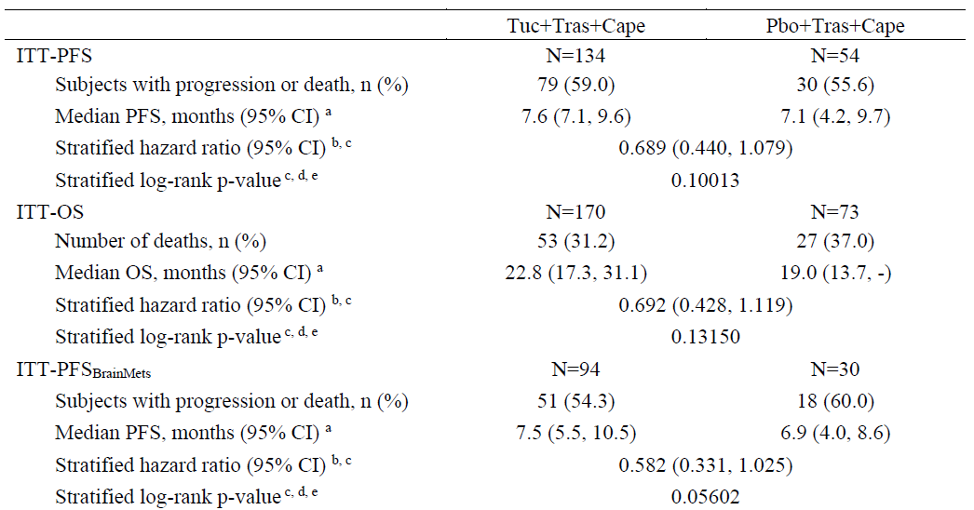
a: Calculated using the complementary log-log transformation method. b: Hazard ratio comparing Tuc + Cap + Tra to Pbo + Cap + Tra calculated from the stratified Cox proportional hazards model. A hazard ratio < 1.0 favours the Tuc + Cap + Tra arm. c: Computed using stratification factors (Presence or history of brain metastases: Yes/No, ECOG performance status: 0/1 and Region of world: North America /Rest of World) at randomisation. d: Two-sided p-value calculated from unstratified log-rank test. e: The p-value is nominal p-value calculated from post hoc exploratory analysis. Data cut-off date: 4 September 2019.

Advisory Committee considerations
The Delegate did not refer this application to the Advisory Committee on Medicines (ACM) for advice.

Outcome
Based on a review of quality, safety and efficacy, the TGA approved the registration of Tukysa (tucatinib) 50 mg, 150 mg film coated tablets, indicated for:
Tukysa is indicated in combination with trastuzumab and capecitabine for treatment of patients with advanced unresectable or metastatic HER2-positive breast cancer, including patients with brain metastases, who have received one or more prior anti-HER2-based regimens in the metastatic setting.

Specific conditions of registration applying to these goods
- Tukysa (tucatinib) is to be included in the Black Triangle Scheme. The PI and CMI for Tukysa must include the black triangle symbol and mandatory accompanying text for five years, which starts from the date that the sponsor notifies the TGA of supply of the product.
- The Tukysa EU-RMP (version 0.1, dated 20 December 2019; DLP 4 September 2019), with ASA version 0.2, dated May 2020), included with submission PM-2020-00066-1-4, and any subsequent revisions, as agreed with the TGA will be implemented in Australia.
An obligatory component of risk management plans is routine pharmacovigilance. Routine pharmacovigilance includes the submission of PSURs.
Unless agreed separately between the supplier who is the recipient of the approval and the TGA, the first report must be submitted to TGA no later than 15 calendar months after the date of the approval letter. The subsequent reports must be submitted no less frequently than annually from the date of the first submitted report until the period covered by such reports is not less than three years from the date of the approval letter.
The annual submission may be made up of two PSURs each covering six months. If the sponsor wishes, the six monthly reports may be submitted separately as they become available.
If the product is approved in the EU during the three years period, reports can be provided in line with the published list of EU reference dates no less frequently than annually from the date of the first submitted report until the period covered by such reports is not less than three years from the date of the approval letter.
The reports are to at least meet the requirements for PSURs as described in the European Medicines Agency’s Guideline on Good Pharmacovigilance Practices (GVP) Module VII-periodic safety update report (Rev 1), Part VII.B Structures and processes. Note that submission of a PSUR does not constitute an application to vary the registration. Each report must have been prepared within ninety calendar days of the data lock point for that report.

Attachment 1. Product Information
The PI for Tukysa approved with the submission which is described in this AusPAR is at Attachment 1. For the most recent PI, please refer to the TGA website at <https://www.tga.gov.au/product-information-pi>.

Therapeutic Goods Administration
PO Box 100 Woden ACT 2606 Australia
Email: info@tga.gov.au Phone: 1800 020 653 Fax: 02 6232 8605
https://www.tga.gov.au

The Black Triangle Scheme provides a simple means for practitioners and patients to identify certain types of new prescription medicines, including those being used in new ways and to encourage the reporting of adverse events associated with their use. The Black Triangle does not denote that there are known safety problems, just that the TGA is encouraging adverse event reporting to help us build up the full picture of a medicine's safety profile.
Loibl, S. & Gianni, L. HER2-positive breast cancer. Lancet. 2017; 389(10087): 2415-2429.
Murphy, B.L., et al. Adolescents and young adults with breast cancer have more aggressive disease and treatment than patients in their forties. Ann Surg Oncol, 2019; 26(12): 3920-3930.
US FDA Accelerated Approval regulations: These regulations allowed drugs for serious conditions that filled an unmet medical need to be approved based on a surrogate endpoint.
Clayton A.J., et al. Incidence of cerebral metastases in patients treated with trastuzumab for metastatic breast cancer. Br J Cancer, 2004; 91(4): 639-43.
Lin, N.U. Breast cancer brain metastases: new directions in systemic therapy. Ecancermedicalscience 2013; 7: 307.
Brufsky, A.M., et al. Central nervous system metastases in patients with HER2-positive metastatic breast cancer: incidence, treatment, and survival in patients from registHER. Clin Cancer Res. 2011; 17(14): 4834-4843.
Bachelot, T. et al. Lapatinib plus capecitabine in patients with previously untreated brain metastases from HER2-positive metastatic breast cancer (LANDSCAPE): a single-group phase 2 study, Lancet Oncol, 2012; 14(1): 64-71.
Project Orbis seeks to increase collaboration among international regulators, which may in turn allow patients with cancer to receive earlier access to products in other countries where there may be significant delays in regulatory submissions, regardless of whether the product has received approval. Pivotal clinical trials in oncology are commonly conducted internationally and these global trials are increasingly important for investigating the safety and effectiveness of cancer drugs for approval across jurisdictions. Future drug development may benefit by establishing a greater uniformity of new global standards of treatment, leading to the optimal design of these important trials. For further information visit: https://www.fda.gov/about-fda/oncology-center-excellence/project-orbis.
FDA, Multi-Discipline Review, Tukysa (tucatinib) 50 mg or 150 mg tablets, Application 213411Orig1s000, April 2020. Available from the FDA website.
Cytochrome P450 (CYP) enzymes: CYPs are the major enzymes involved in drug metabolism, accounting for large part of the total metabolism. Most drugs undergo deactivation by CYPs, either directly or by facilitated excretion from the body. Also, many substances are bioactivated by CYPs to form their active compounds. Many drugs may increase or decrease the activity of various CYP isozymes either by inducing the biosynthesis of an isozyme (enzyme induction) or by directly inhibiting the activity of the CYP (enzyme inhibition). This is a major source of adverse drug interactions, since changes in CYP enzyme activity may affect the metabolism and clearance of various drugs. Such drug interactions are especially important to take into account when using drugs of vital importance to the patient, drugs with important side-effects and drugs with small therapeutic windows, but any drug may be subject to an altered plasma concentration due to altered drug metabolism.
Australian Pregnancy Category D: drugs which have caused, are suspected to have caused or may be expected to cause, an increased incidence of human fetal malformations or irreversible damage. These drugs may also have adverse pharmacological effects. Accompanying texts should be consulted for further details.
The Child-Pugh score is used to assess the prognosis of chronic liver disease. The score employs five clinical measures of liver disease. Each measure is scored 1 to 3, with 3 indicating most severe derangement. Class A: 5 to 6 points, least severe liver disease, one to five year survival rate of 95%. Class B: 7 to 9 points, moderately severe liver disease, one to five year survival of 75%. Class C: 10 to 15 points, most severe liver disease, 1 to 5 year survival rate 50%.
The QT interval is the time from the start of the QRS wave complex to the end of the corresponding T wave. It approximates to the time taken for ventricular depolarisation and repolarisation, that is to say, the period of ventricular systole from ventricular isovolumetric contraction to isovolumetric relaxation. A thorough QT study helps characterise the potential of a drug to cause prolongation of the QT interval, and associated arrhythmias.
DILI = drug induced liver injury.
Routine risk minimisation activities may be limited to ensuring that suitable warnings are included in the product information or by careful use of labelling and packaging. Routine pharmacovigilance practices involve the following activities: - All suspected adverse reactions that are reported to the personnel of the company are collected and collated in an accessible manner; - Reporting to regulatory authorities; - Continuous monitoring of the safety profiles of approved products including signal detection and updating of labelling; - Submission of PSURs; - Meeting other local regulatory agency requirements.
The ACM provides independent medical and scientific advice to the Minister for Health and the Therapeutic Goods Administration (TGA) on issues relating to the safety, quality and efficacy of medicines supplied in Australia including issues relating to pre-market and post-market functions for medicines. The Committee is established under Regulation 35 of the Therapeutic Goods Regulations 1990. Members are appointed by the Minister. The ACM was established in January 2017 replacing Advisory Committee on Prescription Medicines (ACPM) which was formed in January 2010. ACM encompass pre and post-market advice for medicines, following the consolidation of the previous functions of the Advisory Committee on Prescription Medicines (ACPM), the Advisory Committee on the Safety of Medicines (ACSOM) and the Advisory Committee on Non-Prescription Medicines (ACNM). Membership comprises of professionals with specific scientific, medical or clinical expertise, as well as appropriate consumer health issues relating to medicines.

