August 2015

Australian Public Assessment Report for Triptorelin Acetate
  - Proprietary Product Name: Decapeptyl
  - Sponsor: Ferring Pharmaceuticals Pty Ltd

About the Therapeutic Goods Administration (TGA)
- The Therapeutic Goods Administration (TGA) is part of the Australian Government Department of Health and is responsible for regulating medicines and medical devices.
- The TGA administers the Therapeutic Goods Act 1989 (the Act), applying a risk management approach designed to ensure therapeutic goods supplied in Australia meet acceptable standards of quality, safety and efficacy (performance), when necessary.
- The work of the TGA is based on applying scientific and clinical expertise to decision-making, to ensure that the benefits to consumers outweigh any risks associated with the use of medicines and medical devices.
- The TGA relies on the public, healthcare professionals and industry to report problems with medicines or medical devices. TGA investigates reports received by it to determine any necessary regulatory action.
- To report a problem with a medicine or medical device, please see the information on the TGA website <www.tga.gov.au>.
About AusPARs
- An Australian Public Assessment Report (AusPAR) provides information about the evaluation of a prescription medicine and the considerations that led the TGA to approve or not approve a prescription medicine submission.
- AusPARs are prepared and published by the TGA.
- An AusPAR is prepared for submissions that relate to new chemical entities, generic medicines, major variations, and extensions of indications.
- An AusPAR is a static document, in that it will provide information that relates to a submission at a particular point in time.
- A new AusPAR will be developed to reflect changes to indications and/or major variations to a prescription medicine subject to evaluation by the TGA.
Copyright
© Commonwealth of Australia 2015
This work is copyright. You may reproduce the whole or part of this work in unaltered form for your own personal use or, if you are part of an organisation, for internal use within your organisation, but only if you or your organisation do not use the reproduction for any commercial purpose and retain this copyright notice and all disclaimer notices as part of that reproduction. Apart from rights to use as permitted by the Copyright Act 1968 or allowed by this copyright notice, all other rights are reserved and you are not allowed to reproduce the whole or any part of this work in any way (electronic or otherwise) without first being given specific written permission from the Commonwealth to do so. Requests and inquiries concerning reproduction and rights are to be sent to the TGA Copyright Officer, Therapeutic Goods Administration, PO Box 100, Woden ACT 2606 or emailed to <tga.copyright@tga.gov.au>.

Contents
List of abbreviations 5
I. Introduction to product submission 6
Submission details 6
Product background 6
Regulatory status 7
Product Information 8
II. Quality findings 8
Introduction 8
Drug substance (active ingredient) 8
Drug product 9
Advisory committee considerations 10
Quality summary and conclusions 10
III. Nonclinical findings 10
Introduction 10
Pharmacology 11
Pharmacokinetics 11
Toxicology 12
Nonclinical summary and conclusions 16
IV. Clinical findings 17
Pharmacokinetics 22
Pharmacodynamics 25
Dosage selection for the pivotal studies 26
Efficacy 27
Safety 27
First Round Benefit-Risk Assessment 30
First Round Recommendation Regarding Authorisation 30
Clinical Questions 30
V. Pharmacovigilance findings 31
Risk management plan 31
VI. Overall conclusion and risk/benefit assessment 34
Quality 34
Nonclinical 34
Clinical 34
Risk management plan 39
Risk-benefit analysis 39
Outcome 46
Attachment 1. Product Information 46
Attachment 2. Extract from the Clinical Evaluation Report 46

List of abbreviations
Abbreviation | Meaning
ACPM | Advisory Committee on Prescription Medicines
ADR | adverse drug reaction
AE | adverse event
ART | assisted reproductive technologies
ASA | Australian Specific Annex
CMI | Consumer Medicines Information
FSH | follicle stimulating hormone
GCP | Good Clinical Practice
GLP | Good Laboratory Practice
GnRH | gonadotrophin releasing hormone
HMG | human menopausal gonadotrophin
ICH | International Conference on Harmonisation of Technical Requirements for Registration of Pharmaceuticals for Human Use
ICSI | intracytoplasmic sperm injection
IM | intramuscular(ly)
IV | intravenous(ly)
LH | luteinising hormone
LHRH | luteinising hormone-releasing hormone
PSUR | Periodic Safety Update Report
RMP | risk management plan
SAE | serious adverse event
SC | subcutaneous(ly)

I. Introduction to product submission

Submission details
Type of submission: | New chemical entity
Decision: | Approved
Date of decision: | 26 February 2015

Active ingredient(s): | Triptorelin acetate
Product name(s): | Decapeptyl
Sponsor’s name and address: | Ferring Pharmaceuticals Pty Ltd  1/20 Bridge Street  Pymble NSW 2073
Dose form(s): | Solution for injection
Strength(s): | 100 μg/1 mL
Container(s): | Clear Type 1 glass prefilled syringes
Pack size(s): | 7 or 28
Approved therapeutic use: | Decapeptyl 100 μg/1 mL is indicated for down-regulation and prevention of premature luteinising hormone (LH) surges in women undergoing controlled ovarian hyperstimulation for assisted reproductive technologies (ART).  In clinical trials, Decapeptyl 100 μg/1 mL has been used in cycles where urinary and recombinant human follicle stimulating hormone (FSH) as well as human menopausal gonadotrophin (HMG) were used for stimulation.
Route(s) of administration: | Subcutaneous
Dosage: | One injection (0.1 mg; 100 μg) under the skin of the lower abdomen once daily.
ARTG number (s): | 219857

Product background
This AusPAR describes the application by Ferring Pharmaceuticals Pty Ltd to register a new salt of triptorelin (triptorelin acetate; trade name Decapeptyl), a new dose form (injection solution, that is, not modified release) and a new indication. Triptorelin, as the embonate salt and marketed as Diphereline, was first included on the Australian Register of Therapeutic Goods (ARTG) in August 2006. It is registered as a powder and solvent for suspension for intramuscular injection, prolonged release granules indicated for the treatment of hormone dependent locally advanced or metastatic prostate cancer. The TGA considers the application to constitute a new chemical entity by reason of the new salt.
Decapeptyl is a gonadotrophin releasing hormone (GnRH) agonist, an analogue of the native GnRH. The chemical structure resembles that of the decapeptide GnRH: in triptorelin, the glycine in position 6 is replaced by D-tryptophan. The substitution of glycine results in a peptide that is more stable to enzymatic degradation compared to natural GnRH. Therefore, triptorelin has a longer half life than natural GnRH.
The approved indication for Diphereline is indicated for the treatment of hormone dependent locally advanced or metastatic prostate cancer.
The proposed new indication, specific to the new dose form and salt:
Downregulation and prevention of premature luteinizing hormone (LH) surges in women undergoing controlled ovarian hyperstimulation for assisted reproductive technologies (ART). In clinical trials Decapeptyl 0.1 mg/1 mL has been used in cycles where urinary and recombinant human follicle stimulating hormone (FSH) as well as human menopausal gonadotrophin (HMG) were used for stimulation.
Decapeptyl, containing triptorelin acetate 0.1 mg (100 μg) per 1 mL, is formulated as an aqueous injectable isotonic sodium chloride solution with added acetic acid to adjust pH and provide for a stable product.

Regulatory status
The international birth date for Decapeptyl is July 1990, the date of first approval of the Decapeptyl Depot 3.75 mg formulation in Germany.
The sponsor has stated that Decapeptyl is the preferred GnRH agonist for ART in several European countries such as France, Germany, Spain, and Italy. However, this is not the daily SC 0.1 mg formulation. That is, in many countries it is the 3.75 mg depot formulation that is marketed.
- The SC 0.1 mg daily formulation is approved in 73 countries and for the ART indication in 32 countries.
- The SC 0.5 mg daily formulation is approved in 18 countries and for the ART indication in 13 countries.
- The depot formulation is approved in 84 countries and for the ART indication in 34 countries.
More specifically, Decapeptyl 0.1mg SC is registered for IVF/ART in: Canada, Israel, Czech Republic, Mongolia, the Russian Federation, the Ukraine, Taiwan, Austria, Azerbaijan, Bahrain, Bangladesh, Bulgaria, Singapore, China, Egypt, Finland, France, Germany, Greece, India, Hong Kong , Hungary, Iran, Iraq, Jordan, Kazakhstan, South Korea, Kuwait, Libya, Macedonia, Moldova, Pakistan, Paraguay, Qatar, Saudi Arabia, Slovakia, Sudan, Sweden, Switzerland, Syria, The Netherlands, Trinidad, Turkey, UAE, Uruguay, the Yemen.
As mentioned above, in some countries, registration of the 0.1 mg SC formulation has occurred with any subsequent product launch/marketing, including large EU member states (Germany, France, Sweden and The Netherlands).
The Australian dossier is similar to that submitted in Canada, where the product was registered in 2012. The sponsor has provided the Canadian evaluation report.
The product has not been assessed by the European Medicines Agency (EMA) and is not registered in the US.

Product Information
The approved Product Information (PI) current at the time this AusPAR was prepared can be found as Attachment 1. For the most recent PI, please refer to the TGA website at <www.tga.gov.au/product-information-pi>.

II. Quality findings

Introduction
The product (Figure 1) is a solution of the acetate salt of triptorelin in an isotonic buffered aqueous solution at a concentration of 100 µg/1 mL of the acetate salt (95.6 µg/1 mL of the free triptorelin). Although as a new chemical entity the product should not be labelled in terms of the salt (triptorelin acetate), but in terms of the free active entity (triptorelin), the sponsor argued that would mean labelling as an unusual, non round number (95.6 µg/1 mL) and (perhaps more importantly) that the labelling in Australia would not be consistent with the labelling in the rest of the world which has labelled in terms of 0.1 mg/1 mL of triptorelin acetate since 1988. It was thought that this later fact may cause confusion to healthcare professionals, and therefore labelling in terms of triptorelin acetate was accepted in this case.
Figure 1: Chemical structure of triptorelin acetate.
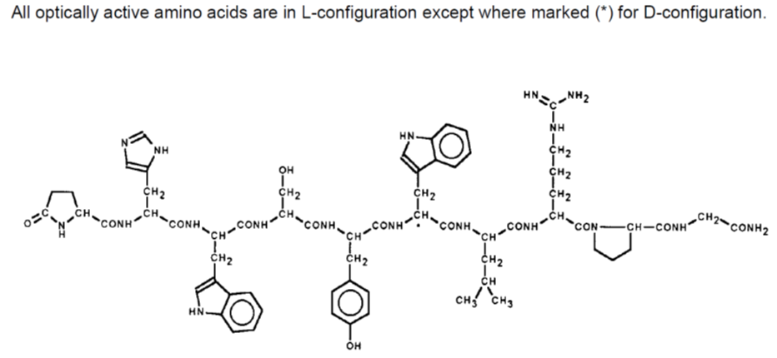
C₆₄H₈₂N₁₈O₁₃.C₂H₄O₂
Molecular Weight = 1371.6 (free base = 1311.5)
aqueous solubility = freely soluble (100 mg/mL to 1000 mg/mL)
optical rotation = -66° to -72°
Triptorelin (acetate) is a synthetic decapeptide and an analogue of the natural hypothalamus hormone, GnRH. Triptorelin has a longer duration of action than the natural GnRH and has a biphasic effect at the pituitary level. It is also closely related to other synthetic peptides, buserelin, goserelin and leuprorelin.
According to the PI, the maximum daily dose is 1 syringe (95.6 µg of free triptorelin) per day for 4 to 7 weeks.

Drug substance (active ingredient)
The triptorelin acetate is manufactured by the drug substance (DS) manufacturer in Switzerland. There are no compendial monographs for triptorelin acetate, but the DS manufacturer has acceptable specifications for their material including a well validated test method for related substances. Some comments on these specifications are given below.
- Note the amino acid analysis test is an identity test in all the monographs of small peptide molecules included in the British Pharmacopoeia (BP) and is therefore considered a critical test for this type of drug substance.
- Note the International Conference on Harmonisation of Technical Requirements for Registration of Pharmaceuticals for Human Use (ICH) thresholds do not apply to synthetic peptides, but the identification threshold of 0.5% for individual related substances is mentioned din the European Pharmacopoeia (EP) general monograph ‘Substances for Pharmaceutical Use’.
According to the code of Good Manufacturing Practice (cGMP), the finished product manufacture (in this case Ferring GmbH) must have specifications for the drug substance, though they may perform reduced testing of the drug substance, once they have qualified the results of the drug substance manufacturer. This qualification of the DS manufacturer as a supplier has not been performed by Ferring GmbH. The cGMP further states that after qualification reduce testing should be at least identity testing to ensure that the drug substance manufacture has not mislabelled a different material as triptorelin acetate. In relation to the specifications adopted by Ferring GmbH, the following is noted.
- The specifications include two complementary identity tests: HPLC and specific optical rotation.
  - Though different from the identity tests performed by the DS manufacturer, it was accepted that these tests will ensure identity.
- The related substances test method and limits of Ferring GmbH differ from those of DS manufacturer.
  - Thus, Ferring GmbH has stated that they will in the future (after the generation of appropriate method transfer validation data) adopt and fully validate the test method for related substances of DS manufacturer, but in the meantime adopt the limit which was accepted by the TGA (Pharmaceutical Chemistry Summary [PSC] for the Advisory Committee for Prescription Medicines [ACPM]).
  - To conclude, if appropriate data to support the transfer of the related substances test method to Ferring GmbH is not provided to the TGA by the decision date of the submission, it should be made a condition of registration that batches of product cannot be supplied in Australia until a Category 3 submission to change the related substances method is provided and approved.

Drug product
The product contains no unusual excipients for this dosage form and is a simple isotonic buffered solution in water: sodium chloride is used for tonicity and glacial acetic acid to buffer the solution with the triptorelin acetate.
The finished product is manufactured at Ferring GmbH in Kiel, Germany. The finished product manufacturer manufactures a sterile bulk solution which is filled into pre sterilised syringes. Becton Dickinson France SAS manufacture and sterilise the syringes.
There are no compendial monographs for the product, but the specifications for the product ensure the BP/EP general requirements for injections are met. The expiry limits for the chemistry and physical tests are acceptable and justified, and, where required the release limits are tighter than the expiry limits to allow for change on storage.
Although the real time stability data was provided for a period of at least 3 years, due to the issue of the LOQ of triptorelin acid noted above, the data was found to support a shelf life of only 12 months when stored between 2-8°C (Refrigerate. Do not freeze) with the additional conditions of ‘protect from light’ and ‘store in original container’ written on the labels and in the PI as ‘Store in the original package, to protect from light’.
The PI and labels have been finalised with respect to chemistry and quality control.

Advisory committee considerations
As there were no issues relating to bioavailability, details of this submission have not been presented to the PSC.

Quality summary and conclusions
Approval of the registration of the proposed product cannot be recommended on quality/safety grounds:
- The specifications of the drug substance adopted by the finished product manufacturer Ferring GmbH do not include the key test (and limits) for amino acid analysis.
If this issue could be resolved, approval could be recommended.
Further, if appropriate data to support the transfer of the related substances test method to Ferring GmbH is not provided to the TGA by the decision date of the submission, it should be made a condition of registration that batches of product cannot be supplied in Australia until a Category 3 submission to change the related substances method is provided and approved.

III. Nonclinical findings

Introduction
Ferring Pharmaceuticals Pty Ltd has applied to register Decapeptyl, containing triptorelin acetate as the active ingredient, to be used for down-regulation and prevention of premature LH surges in women undergoing controlled ovarian hyperstimulation for ART and administered SC daily. Triptorelin embonate is currently registered for the treatment of hormone dependent locally advance or metastatic prostate cancer as Diphereline (Ispen Pty Ltd; since 2006). That product is a slow release powder formulation, injected IM once every 1, 3 or 6 months. A new salt of an existing chemical substance with different safety or efficacy properties is considered to be a new chemical entity under the Therapeutic Goods Regulations (1990). The nonclinical dossier contained no studies directly comparing the acetate and embonate salts of triptorelin to establish the safety/efficacy profile is unchanged.
The nonclinical dossier was of disappointing quality. None of the toxicity studies included toxicokinetic data, and none of the repeat dose toxicity studies was Good Laboratory Practice (GLP) compliant. Study reports were frequently poorly presented.

Pharmacology

Primary pharmacology
Triptorelin is a well established GnRH agonist. It is an analogue of naturally occurring GnRH (= luteinising hormone-releasing hormone, LHRH), with d-tryptophan substituted for l-glycine at position 6.
The sponsor provided a number of peer reviewed publications on the pharmacology of triptorelin. Briefly, binding by triptorelin to LHRH receptor sites in rat anterior pituitary in vitro was reported, with the LH releasing activity of the drug being 100 times more potent than native LHRH. In vivo, and consistent with other members of the class, triptorelin initially stimulated release of LH (shown in rats and monkeys), while ongoing treatment resulted in a decreased plasma levels of LH (rats, dogs and monkeys). This inhibitory phase was long lasting and mediated by LHRH receptor desensitisation. An initial increase (rats), then decrease with ongoing treatment (dogs), was also shown for plasma FSH. The majority of the in vivo studies were conducted in male animals only. Greater focus on the pharmacological effects of triptorelin in female animals would have been of benefit given the proposed indication, but this is not a significant deficiency given pharmacological effects in females are also explored in the repeat dose toxicity studies.

Secondary pharmacodynamics and safety pharmacology
No secondary pharmacodynamic or specific safety pharmacology studies were performed. This is considered to be acceptable given existing experience with the active moiety and the pharmacological class. No direct effect of triptorelin on the central nervous system (CNS), cardiovascular, respiratory, renal or gastrointestinal systems was apparent from the limited examination in the general repeat dose toxicity studies.

Pharmacokinetics
Only very limited pharmacokinetic data were provided, obtained in rats, dogs and humans. No data were provided for the other laboratory animal species used in submitted toxicity studies (mouse, rabbit, Cynomolgus monkey and Capuchin monkey). In addition, much of the data related to a prolonged release form of triptorelin [poly(dl-lactide-co-glycolide) microcapsules] administered intramuscular (IM) rather than the more relevant aqueous solution for SC injection (as for Decapeptyl).
Absorption after SC administration was rapid in dogs and humans, with peak plasma concentrations observed at 1 h and 0.6 h in the respective species. Bioavailability by this route was virtually complete in both species. The plasma half life of triptorelin was approximately 2 h in dogs, estimated to be less than 6 h in rats (based on very sparse data), and 3-8 h in humans following SC administration. Accumulation in plasma with repeat dosing was not evident in animals. Bioavailability through the IM route (microcapsule formulation) was found to be approximately 40% in dogs; comparable bioavailability was observed in humans. No bioavailability data (SC or IM routes) were provided for rats.
No data on plasma protein binding or tissue distribution for triptorelin were submitted. Comparable plasma protein binding to that of natural LHRH (22% in humans) is expected based on the compounds’ structural similarity. Accumulation in the pituitary gland is indicated by virtue of triptorelin being a strong GnRH agonist. Experiments in mice and rats with tritium labelled LHRH showed transient accumulation in the pituitary (anterior and posterior), as well as uptake in the liver, kidney, and pineal gland.
No metabolism studies were submitted. Its structural resemblance to natural LHRH suggests degradation in the same manner by peptidases, but with the d-amino acid substitution in triptorelin conferring less susceptibility to proteolysis. This latter point is supported by the much longer plasma half life of triptorelin observed in vivo in humans compared to natural LHRH (that is, 3-8 h compared to 4-5 min. Urinary excretion as unchanged drug accounted for 19% of an SC dose in dogs (over 24 h). A similar pattern is evident in humans, with 17% of an IV dose reported to be excreted unchanged in urine in women (also over 24 h). Excretion of triptorelin was not examined in rats.

Toxicology

Acute toxicity
Single dose toxicity studies were conducted in mice and rats (non GLP). Administration was by the IP route, which is considered acceptable. Treatment related mortality was observed at 200 mg/kg in mice and 100 mg/kg in rats, occurring within 2 h of dosing. Clinical signs included agitation and clonic convulsions in mice, and inactivity in both species. No specific target organ toxicity was identified (by macroscopic examination at necropsy). Maximum observed non-lethal doses were 100 mg/kg in mice and 10 mg/kg in rats; these are more than 900 times higher than the maximum recommended human dose on a mg/m² body surface area basis.

Repeat dose toxicity
Repeat dose toxicity studies of 6 months duration were conducted with triptorelin acetate in rats, dogs and Capuchin monkeys; a 45 day study in rats was also submitted. The 6 month rat and monkeys studies used daily SC injection (that is, the clinical route and dosing frequency), while the shorter rat study and the 6 month dog study involved monthly IM injection of the slow release microcapsule formulation. The 6 month studies featured an adequate number of animals, were conducted in an appropriate set of species, and were of appropriate duration in accordance with the relevant ICH guidelines. However, as noted earlier, none of these included toxicokinetic analyses, nor were they GLP compliant.

Relative exposure
In the absence of suitable pharmacokinetic/toxicokinetic data, animal:human exposure ratios have been calculated based on dose adjusted for body surface area. For studies involving IM administration, the ratio has been further modified to account for lower bioavailability by this route compared to SC administration; specifically, reduced 2.5 fold for all animal species, based on the 40% relative bioavailability evident in dogs. High multiples of the human exposure are estimated to have been obtained at the upper dose levels in the general repeat dose toxicity studies in rats and monkeys, while more modest relative exposure was reached in the mouse and rat carcinogenicity studies and in the dog toxicity study (Table 1).
Table 1: Relative exposure in repeat dose toxicity and carcinogenicity studies.
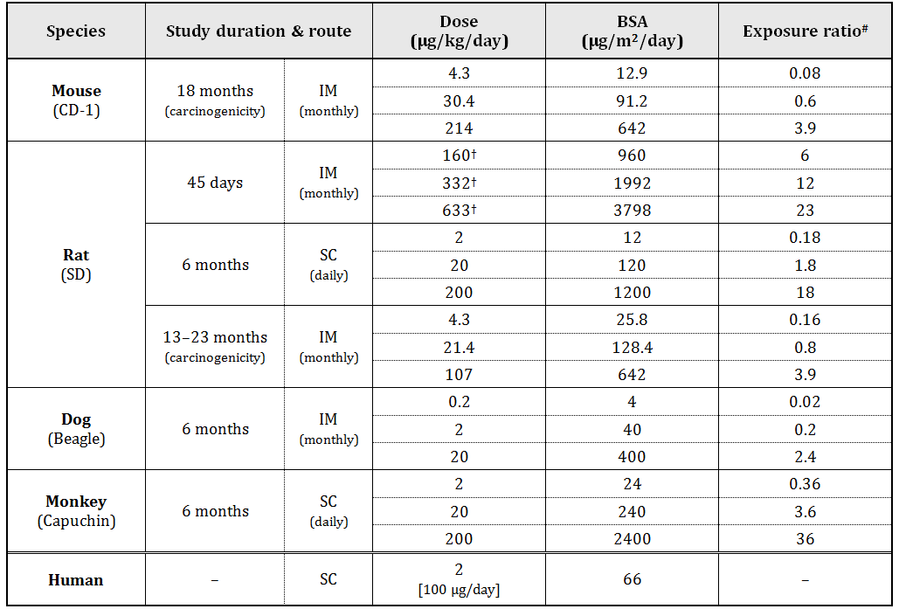
# = calculated as animal:human dose adjusted for body surface area (and 40% relative bioavailability for IM administration); μg/kg to μg/m² conversion factors of 3, 6, 20, 12 and 33 have been used for mice, rats, dogs, monkeys and humans (assuming 50 kg body weight as a conservative measure), respectively; † = only data for females are shown

Major toxicities
Consistent with the drug’s pharmacology, effects on the gonads were seen in both sexes at all dose levels in all studies. In female rats, such effects comprised vacuolisation of corpus luteal cells (≥160 μg/kg/day IM), increased corpora lutea and ovarian hypertrophy at lower doses (2 or 20 μg/kg/day SC) and absence of corpora lutea and ovarian atrophy at higher ones (200 μg/kg/day SC), as well as reduced primordial and primary follicles (≥2 μg/kg/day SC) and sclerosis (≥20 μg/kg/day SC). Similarly, female dogs showed increased corpora lutea at the low dose level (0.2 μg/kg/day IM) and atrophy of ovaries and oviducts at higher doses (≥2 μg/kg/day IM). Female monkeys exhibited decreased primordial follicles at all dose levels (≥2 μg/kg/day SC) and ovarian sclerosis with no corpora lutea at the high dose level (200 μg/kg/day SC). Ovarian atrophy was observed at all doses in the mouse and rat carcinogenicity studies (≥4.3 μg/kg/day IM). Changes in the uterus (atrophy of the endometrium and/or myometrium) were also seen in mice (≥4.3 μg/kg/day SC), rats (≥20 μg/kg/day SC and ≥4.3 μg/kg/day IM) and dogs (≥2 μg/kg/day SC). The 6 month rat and monkey studies included subsequent 2 month recovery periods, during which time these effects appeared to subside.
Effects on the male reproductive system are considered only briefly here given the proposed indication and included seminiferous tubular atrophy, Leydig (interstitial) cell hyperplasia and complete suppression of spermatogenesis. Decreased testosterone was observed in treated male dogs and monkeys at all dose levels (not measured in the rodent studies).
No non sex organs were clearly identified as targets for triptorelin in the repeat dose toxicity studies. Renal tubular dilatation was seen at all dose levels in the 6 month rat study (≥2 μg/kg/day; both sexes) and from the mid dose level in monkeys (≥20 μg/kg/day SC; females only). The finding was not confirmed in the rat carcinogenicity study, and not seen in male monkeys (estimated relative exposure, ≤36). Diffuse fatty change was observed in the liver of male and female rats treated at the high dose level in the 6 month study (200 μg/kg/day SC), but not in monkeys at the same dose despite their higher expected exposure. The clinical relevance of these findings is unclear, but appears low.

Genotoxicity
Although routine genotoxicity studies are not required for peptides under ICH guidelines, the genotoxic potential of triptorelin was examined in the standard battery of tests (comprising assays for bacterial mutagenicity and chromosomal aberrations in vitro [CHO cells] and in vivo [mouse; intraperitoneal administration]) as well as a test for mutagenicity in mammalian cells (mouse L5178Y lymphoma). All studies were GLP compliant, adequately conducted, and returned negative results.

Carcinogenicity
Carcinogenicity studies were conducted in mice (18 months) and rats (up to 23 months) using triptorelin embonate, as long acting release microcapsules, administered IM once monthly. The studies involved adequate numbers of animals and were of adequate duration, and were GLP compliant. The use of the different salt, dose form, route and dosing frequency is considered to be acceptable, but the absence of bridging toxicokinetic data is clearly not ideal.
No carcinogenic effect was observed in male and female mice treated with triptorelin embonate at doses that equated up to 214 μg/kg/day [6000 μg/kg/month] (estimated relative exposure, ≤3.9). No adequate justification was provided for the selection of the high dose level – treatment had no effect on survival, produced minimal clinical signs and had no adverse effect on body weight gain. It is noted, though, that almost all high-dose mice showed atrophy of the testes/ovaries.
In rats, treatment with triptorelin embonate increased incidences of both adenomas and carcinomas of the pituitary (pars distalis) at all dose levels (≥4.3 μg/kg/day [≥120 μg/kg/month] IM; estimated relative exposure, ≥0.16). This was associated with significantly increased mortality, necessitating early termination of remaining animals (as soon as 13 months in males and 19 months in females). The finding of pituitary neoplasia is consistent with that for other members of the pharmacological class (leuprorelin, nafarelin, goserelin) in rats. Available data indicate that rats are particularly sensitive to pituitary tumours with GnRH agonists. The clinical relevance of the observed neoplastic effect appears to be low, but cannot be completely dismissed. The short clinical treatment duration (expected to be generally 4-7 weeks) offers further support for the finding being of likely low relevance to patients. No treatment related microscopic changes in the pituitary were noted in the 6 month dog and monkey studies.

Reproductive and developmental toxicity
An adequate embryofoetal development study was conducted with triptorelin in rabbits. Other studies – examining fertility and early embryonic development (rats and rabbits), and embryofoetal and later development (monkeys and rats) – were submitted, but used non standard designs, were not adequately performed and/or not adequately reported and generally offer only limited supporting information.
Non GLP studies in female rats and rabbits showed no adverse effects on fertility or early embryonic development following recovery of normal oestrus cycles. Rats were treated at up to ≤200 μg/kg/day SC for 60 days and in rabbits to 20 μg/kg/day SC for 2 weeks. No study involving treatment during the actual mating phase (as recommended in published guidelines) was conducted. Impairment of male and female fertility is evident from histological changes observed in the general repeat dose toxicity studies.
GLP compliant embryofoetal development studies with triptorelin acetate showed no adverse effects on embryofoetal development in rats and rabbits up to the highest doses tested (10 μg/kg/day SC and 50 μg/kg/day in the respective species). These doses are estimated to yield exposure ratios (based on body surface area doses in the absence of toxicokinetic data) of 0.9 for rats and 9 for rabbits. No maternal toxicity was observed in either species. A higher dose was feasible and should have been tested in rats given the low relative exposure achieved (subclinical). Pre implantation loss was increased at all doses levels in these studies (≥0.4 μg/kg/day SC in rats; ≥0.5 μg/kg/day SC in rabbits), associated with an increase in corpora lutea, but there was no overall effect on the mean number of implantations or live litter size.
No treatment related effects on embryofoetal development were claimed to have been observed in a study in Cynomolgus monkeys in which animals were dosed IM with the long acting release form of triptorelin acetate on days 10 and 40 of gestation (yielding ~14 μg/kg/day over 60 days and covering the critical period of organogenesis; estimated relative exposure, 2.5). The absence of any concurrent or historical control data precludes an independent evaluation of this study to verify this claim.
A GLP compliant study examining effects of triptorelin exposure in early pregnancy was conducted in rats. Triptorelin acetate was administered SC at 10 μg/kg/day on day 1-6 (that is, to implantation) or days 7-12 of gestation (that is, covering the first half of organogenesis). Relative exposure is estimated to be 0.9. Consistent with findings from the embryofoetal development studies, both treatments increased the number of corpora lutea (representing ovarian stimulation after fertilisation), with pre-implantation loss increased but no effect on the mean number of implantations. Treatment over gestation days 1-6 was associated with a marked reduction in mean foetal weight (by almost 50%) and retardation of foetal development (evident at incomplete ossification of skull and other bones). Both treatments prolonged gestation (to 24.2-24.9 days compared to 22.0 days for controls). This apparently compensated for the retardation of foetal development in the group treated over days 1-6 of gestation, with normal pup weight at birth and no effects on postnatal development (including reproductive performance) observed. Dosing on days 7-12 of gestation had no adverse effect on embryofoetal development (assessed on day 20 of gestation), but had a marked effect on parturition, with delivery prolonged and dystocia observed; almost all of the pups were stillborn. Supplementary dosing of the dams with oestradiol and progesterone during the treatment period failed to prevent these actions of triptorelin.
No specific pre/postnatal development study was submitted; adverse effects on parturition and perinatal survival are noted in the study described above. No data on placental transfer or excretion in milk were submitted.

Pregnancy classification
The sponsor has proposed Pregnancy Category D. This matches the existing category for other members of the class, and is considered acceptable. The product is proposed to be contraindicated in pregnancy and lactation.

Local tolerance
No specific local tolerance studies were conducted with Decapeptyl. SC administration of the clinical strength/formulation appeared to be well tolerated in the general repeat dose toxicity study in rats. Local reactions seen in specialised studies with the microcapsule formulation in rabbits (SC, IM and intravenous [IV] routes) were chiefly attributable to the presence of the microcapsules rather than triptorelin acetate itself.

Impurities
The proposed specifications for triptorelin related impurities in the drug substance/product are considered to be acceptable from a toxicological perspective.

Paediatric use
Triptorelin acetate is not proposed for paediatric use and no specific studies in juvenile animals were submitted. Effects on growth would be expected based on the drug’s pharmacology.

Comments on the nonclinical safety specification of the risk management plan
Results and conclusions drawn from the nonclinical program for triptorelin detailed in the sponsor’s draft Risk Management Plan (RMP) are in general concordance with those of the nonclinical evaluator.

Nonclinical summary and conclusions

Summary
- The nonclinical information was of disappointing quality. None of the toxicity studies included toxicokinetic data, and none of the repeat dose toxicity studies was GLP compliant. Nonclinical study reports were frequently poorly presented.
- Published literature on primary pharmacology indicated potent LH releasing activity for triptorelin in vitro. In vivo, the drug initially stimulated release of LH in animals, followed by a sustained decrease in plasma LH with ongoing treatment, mediated by LHRH receptor desensitisation in the pituitary.
- Only limited pharmacokinetic data were provided. Absorption after SC administration was shown to be rapid in dogs and humans, with virtually complete bioavailability (compared to ~40% bioavailability by the IM route with a microcapsule formulation). Accumulation in plasma with repeat dosing was not evident in animals. No specific studies on distribution or metabolism were submitted. Urinary excretion of unchanged drug was shown in dogs and humans.
- Single dose toxicity studies in mice and rats by the IP route showed a low order of acute toxicity with respect to the clinical dose.
- Repeat dose toxicity studies of 6 months duration in rats, dogs and Capuchin monkeys revealed reversible, biphasic, effects on the ovaries (and on testes in males), consistent with the drug’s pharmacology. No non sex organs were clearly identified as targets for triptorelin in the repeat dose toxicity studies.
- Triptorelin was not genotoxic in tests for bacterial and mammalian mutagenicity and for clastogenicity in vitro and in vivo, and not carcinogenic in mice. In rats, treatment with triptorelin increased pituitary adenomas and carcinomas at all dose levels tested (including at subclinical exposure levels).
- Conventional embryofoetal development studies did not show teratogenicity or other adverse effects in rats or rabbits. However, retardation of foetal development (incomplete ossification), markedly decreased foetal weight, impaired parturition and frequent stillbirths were observed in rats treated with triptorelin acetate early in pregnancy in another study.
- Triptorelin acetate appeared to be well tolerated locally in animals.

Conclusions and recommendation
- The nonclinical dossier was poor but contained no critical deficiencies that would preclude registration.
- Primary pharmacology studies, showing suppression of LH, support use for the proposed indication.
- Repeat dose toxicity studies only showed clear effects on sex tissues (for example, ovarian atrophy) that are consistent with the drug’s pharmacology and reversible.
- The finding of pituitary neoplasia in rats is considered to reflect a response to chronic hormonal disruption. It is consistent with findings for other members of the pharmacological class. Available data indicate that rats are particularly sensitive to such effects. The clinical relevance is considered likely to be low, but cannot be completely dismissed. There was no analogous finding in mice. The compound is not genotoxic.
- Based on its pharmacological activity and the adverse effects observed in reproductive toxicity studies, placement in Pregnancy Category D (as the sponsor proposes) is appropriate.
- There are no nonclinical objections to the registration of Decapeptyl for the proposed indication.
- The draft PI should be amended as directed.

IV. Clinical findings

Clinical rationale
In 1986 Professor Handelsman wrote:
Pharmacological therapy must be based on a therapeutic aim coupled with an understanding of relevant normal physiology. As reviewed elsewhere in this issue, pituitary gonadotropes exposed to GnRH pulses outside the physiological range of 0.5-1 pulses/h fail to sustain gonadotropin output. Consequently, clinical applications of GnRH are designed to stimulate gonadal function when endogenous GnRH pulsatility is deficient (hypogonadism, delayed puberty) by mimicking physiological patterns using exogenous GnRH pulse frequencies of 0.5-1 pulses/h … Conversely, GnRH analog (superactive agonists or pure antagonists) treatment is intended to suppress gonadal function via pituitary desensitization as a result of sustained pituitary overexposure to GnRH effects by continuous or quasi-continuous administration … Thus treatment regimens with GnRH or the analogs will have different optimal modes of application based on the pharmacokinetics of the compound and pharmacodynamics of the target physiological systems.
This suggests that depot formulations should be no worse than daily injections as long as continuous exposure to the GnRH agonist occurs. There is an acute agonistic effect at the pituitary GnRH receptor followed, on repeated dosing, within several days by downregulation due to pituitary GnRH receptor desensitisation, with a consequent marked reduction in gonadal production.
The use of GnRH agonists potentially enables planned in vitro fertilisation (IVF) treatment and oocyte retrieval and the prevention of LH surges would avoid wasted cycles that might have been lost to early ovulation. However, the use of GnRH agonists requires longer treatment courses with FSH than non use.
As stated by the applicant in the letter of application:
The rationale behind the clinical application of Decapeptyl 0.1 mg SC injection in IVF/ICSI (intracytoplasmic sperm injection) treatment is based on the existing evidence that the use of GnRH agonists can prevent the premature LH surge associated with ovarian stimulation with gonadotrophins in ART cycles, thus reducing the cycle cancellation rate, increasing the pregnancy rates and facilitating cycle control.
ART is commonly practised in Australia. As stated by the sponsor in the Australian supplement to the draft RMP:
Use of assisted reproductive treatment: There were 61,158 ART treatment cycles reported from Australian clinics in 2011. The number of ART treatment cycles in 2011 increased by 8.3% from 2010. The number of ART treatment cycles represented 12.9 cycles per 1,000 women of reproductive age (15-44 years) in Australia (Australian Bureau of Statistics, 2013). More than 95% of cycles in 2011 were autologous cycles (where a woman intended to use, or used her own oocytes or embryos), and 33.7% of all cycles used frozen/thawed embryos. On average, 1.9 cycles per woman were undertaken in Australia.
The average age of women undergoing autologous cycles was 36, and ranged from 14 to 54. In contrast, the average age of women undergoing ART treatment using donor oocytes or embryos was approximately five years older (40.8, ranging from 20 to 54). The proportion of autologous cycles undertaken by women aged 40 or older continued to increase, with 26.5% in 2011 compared with 22.8% in 2007.

Guidance
There are no specific guidance documents for ART but numerous general guidelines apply, and include internal TGA guidelines published on the TGA website. In the opinion of the evaluator, adherence to these guidelines has not been well shown in this submission. For example, there are no specific Phase III studies, the large studies that have been resubmitted addressed a different research question, and any analyses involving triptorelin are post hoc.
The evaluator has not seen any documents relating to a pre submission meeting or exchanges with the TGA.

Contents of the clinical dossier
The submission included two Phase I studies (involving absolute bioavailability and pharmacokinetics after IV injection) which the evaluator refers to as Studies 1 and 9. An additional pharmacokinetic study is mentioned in the submission as an “expert report”, but the evaluator will discuss this as Study 10.
There are five Phase II studies that produced pharmacodynamic data, dose ranging data and most provided pharmacokinetic data as well.
There were no Phase III studies in the data package. That is, there is no large scale prospective, multicentric and randomised, double blind placebo or active controlled study. There are no population pharmacodynamic/pharmacokinetic data.
Two previously evaluated studies (referred to by the evaluator as Studies 7 and 8) that were submitted in connection with previous applications to register Menopur HP were included in the data package because the pituitary downregulation phase included the use of Decapeptyl as an option amongst several GnRH agonists (including a depot presentation of triptorelin and nafarelin).
For an overview of the submission, refer to Table 2.

Table 2: Outline of clinical studies.
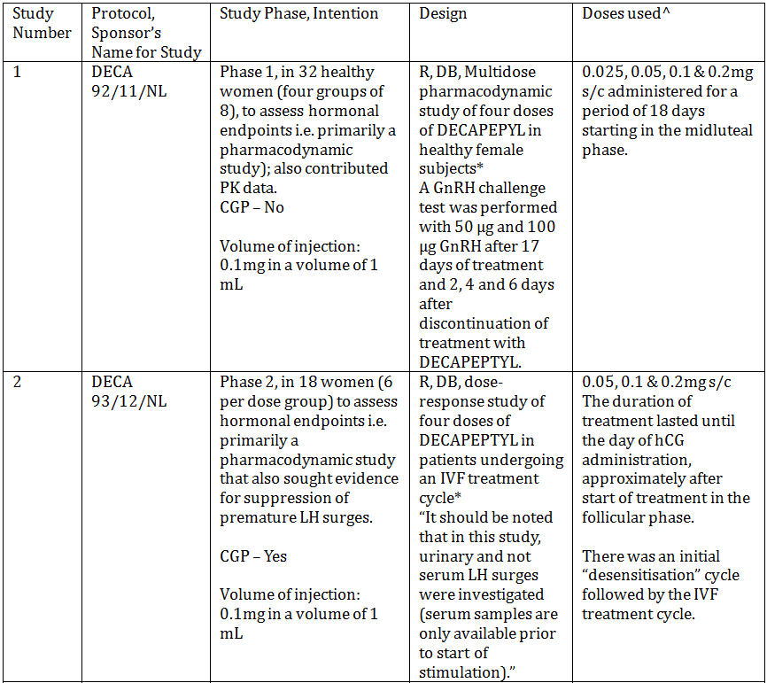
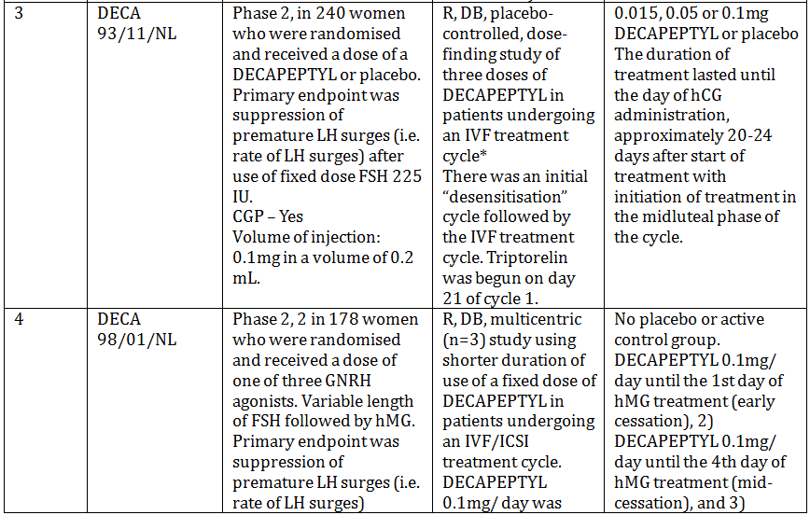
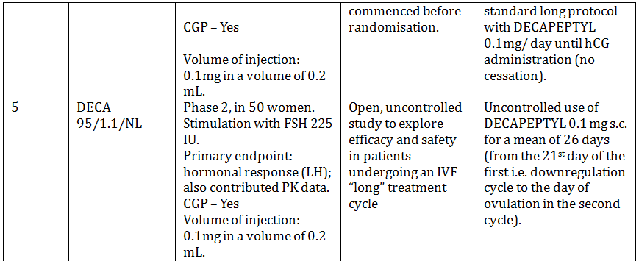
Table 2 (continued): Outline of clinical studies.
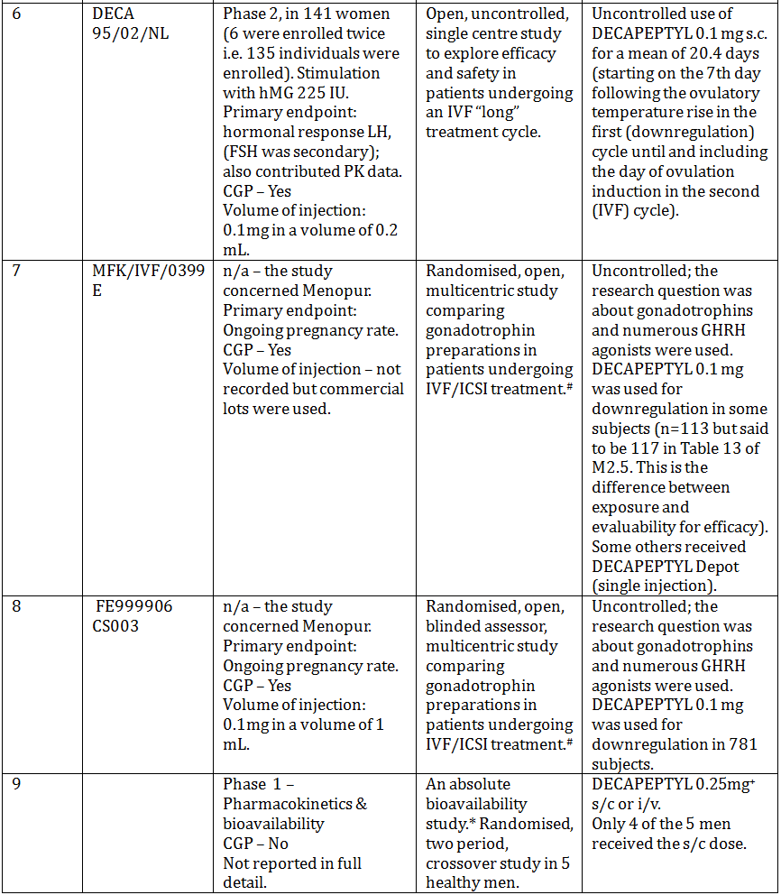
* denotes single centre study.
# denotes previously evaluated study (as part of an application to register a menotrophin product, MENOPUR, Ferring).
^ Only one dosage form/strength is provided for this indication, but clinical studies have been conducted with the dose of Decapeptyl 0.1 mg in volumes of 0.2 mL and 1 mL. The active substance manufacturer and the drug product manufacturer have remained the same since 1992 and 1995, respectively.
Studies 1-6 all took place in The Netherlands, the first three at the same centre.
⁺ The dose in males was w.r.t. use in cancer of the prostate.
The submission contained the following clinical information:
- seven clinical pharmacology studies , including five that provided pharmacokinetic data and five that provided pharmacodynamic data.
- two of the abovementioned pharmacology studies were also dose finding studies.
- five of the abovementioned pharmacology studies also contributed some efficacy and safety data.
- two Phase III studies on Menopur HP (Studies 7 and 8) that also contain some information on Decapeptyl.
- no population pharmacokinetic analyses.
- no pivotal efficacy/safety studies.
- Periodic Safety Update Reports (PSURs), literature, overviews of Studies 7 and 8, tabular listings of all studies, assay validation reports, an “Expert opinion on pharmacokinetics of triptorelin following IV bolus injection and on the bioavailability from Decapeptyl depot in patients with endometriosis or uterine myoma, 1992”.
Most of the study reports included data listings (Study 2 did not) but appendices to the main study report were incomplete in several cases but the information was usually present in other documents such as in the statistical reports.

Paediatric data
The submission did not include paediatric data.

Good clinical practice
The declaration states that the studies complied with the Good Clinical Practice (GCP) guidelines that were applicable at the time of conduct of the studies. The evaluator has also checked the clinical documents for each study. Study 9 was not GCP compliant.

Pharmacokinetics

Studies providing pharmacokinetic data
Table 3 shows the studies relating to each pharmacokinetic topic and the location of each study summary.
Table 3: Submitted pharmacokinetic studies.
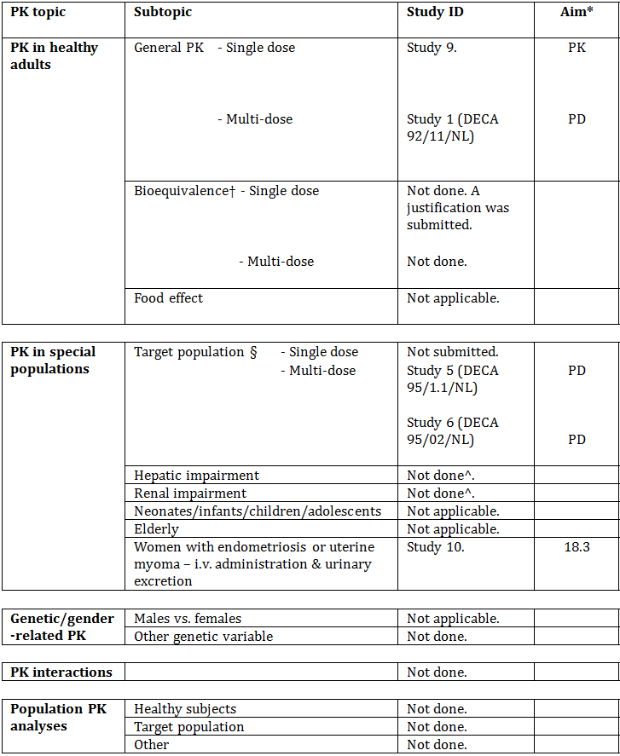
* Indicates the primary aim of the study.
† Bioequivalence of different formulations.
§ Subjects who would be eligible to receive the drug if approved for the proposed indication.
^ Data were generated in two small studies that were part of the submission to register Diphereline.
The only specific pharmacokinetic study was Study 9. Several other studies generated PK data.
All of the pharmacokinetic studies had deficiencies that impacted on the value of their results.
Table 4 lists pharmacokinetic results that have significant study deficiencies. All of the studies that contributed pharmacokinetic data have weaknesses.
Table 4: Pharmacokinetic results from suboptimal studies.
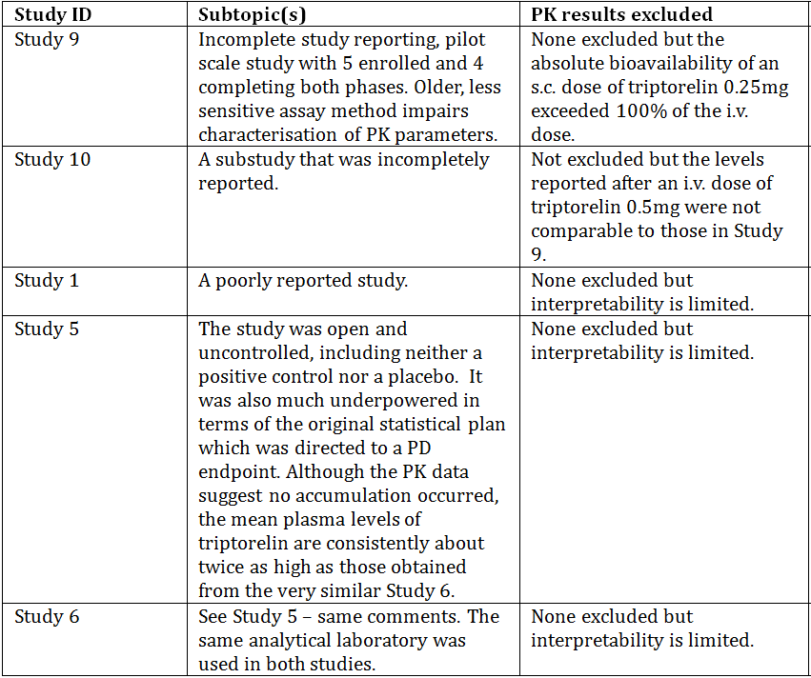
The applicant has tabulated the studies that contributed pharmacokinetic data – the tabulation (Table 5) is reproduced below. The Studies are, in order, Studies 9, 10, 1, 5 and 6.
Table 5: Overview of studies with pharmacokinetic information.
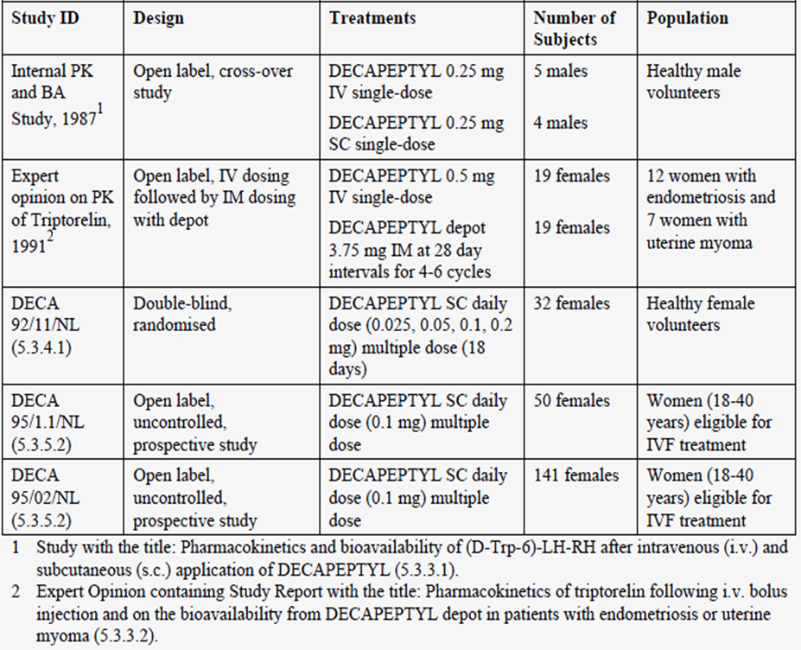
Notes: 1. The dose in males was w.r.t. use in cancer of the prostate. 2. Study 10 was not included in the tabulation.
Five studies contribute with data on the pharmacokinetic profile and mean levels of triptorelin after single or multiple dosing of Decapeptyl.

Evaluator’s conclusions on pharmacokinetics
Little new information on the pharmacokinetics has been added by this submission compared to the information presented in the submission for Diphereline. Triptorelin acetate is proposed for daily dosing but the elimination half life and clearance data suggest that the duration of action is independent of serum triptorelin levels.

Pharmacodynamics

Studies providing pharmacodynamic data
Table 6 shows the studies relating to each pharmacodynamic topic and the location of each study summary.
Table 6: Submitted pharmacodynamic studies.
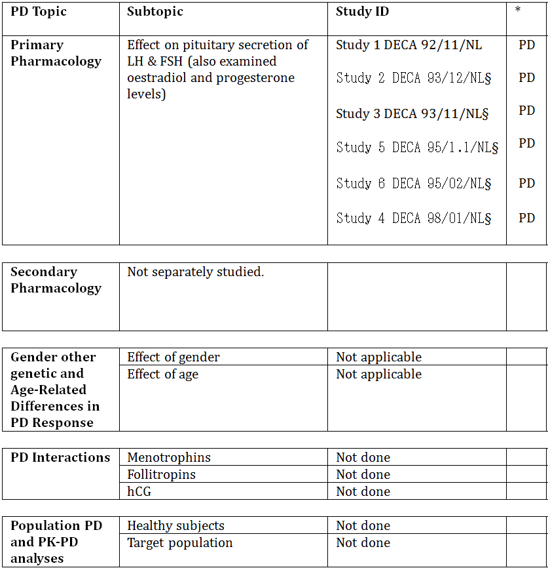
* Indicates the primary aim of the study.
§ Subjects who would be eligible to receive the drug if approved for the proposed indication.
‡ And adolescents if applicable.
Triptorelin, as a GnRH agonist, inhibits gonadotrophin secretion when given repeatedly or continuously (for example, via a depot dose form) and in therapeutic doses. Six of the submitted Phase I and Phase II studies examined LH and FSH levels as well as secondary effects on oestradiol and progesterone. No safety pharmacology studies were undertaken.
No pharmacodynamic results that were excluded from consideration due to study deficiencies. However, the deficiencies are significant and described in the study summaries.
As is seen from the applicant’s summary (Table 7), DECA Studies 5 (DECA 95/1.1/NL) and 6 (DECA 95/02/NL) provided the most sampling times excepting Study 2 (93/11/NL) which sampled LH in the urine.
Table 7: Overview of studies providing data on the pharmacodynamic effects of Decapeptyl on the pituitary vovarian axis.
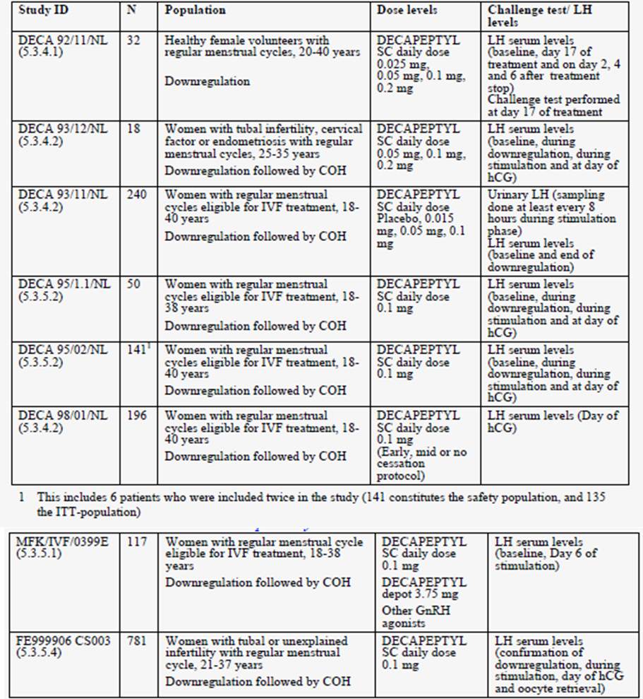

Evaluator’s conclusions on pharmacodynamics
This submission provided pharmacodynamic data chiefly in relation to the “long” protocol in which triptorelin is commenced in the midluteal phase of the downregulation cycle in ART. No LH surges were observed when it was used this way in the Phase II studies. Several Phase II studies included dose ranging information and it is not clear that the proposed dose is more effective that 0.05 mg/day. As is seen from the submitted data, time to onset of downregulation is within one week and the time to offset is about 4 days.

Dosage selection for the pivotal studies
The applicant used triptorelin 0.1 mg SC daily in pivotal studies for Menopur HP. No Phase III pivotal studies were done to test triptorelin against placebo or active comparators in the proposed indication. Unanswered questions from the Phase II programme include:
- What is the correct daily dose? The evaluator suggests that it might be 0.05 mg. However, no specific Phase III studies even at the proposed dose have been done.
- What is the correct duration? The answer is unclear from the Phase II programme which included only one study on this subject but the “long” protocol is favoured in treatment guidelines.

Efficacy

Evaluator’s conclusions on efficacy
The evidence presented suggests that:
- Triptorelin can effectively prevent premature LH surges in ART. The optimal dose is not known but triptorelin 0.1 mg SC daily is effective.
- The “long” protocol has the greatest amount of data in this submission and it appears to be successful if requiring more injections of triptorelin and gonadotrophins.
However, there are inadequate data to confirm either of these suggestions as dose ranging was inadequate and no Phase III study to compare triptorelin to a placebo, a GnRH agonist or a GnRH antagonist was submitted. This is a reasonable expectation in 2014. Ganirelix and nafarelin are both registered in Australia and either would have been an appropriate active comparator in a randomised, controlled trial of non inferiority design.

Safety

Patient exposure
The sponsor mentions:
In the clinical programme for the proposed indication, five different dosages were evaluated and safety data are available for all. A total of 2167 women were included in this safety database to which Decapeptyl 0.1 mg daily was administered to 1337 women participating in 8 completed studies.
However, the evaluator has reservations about the usefulness of these facts. The Phase II studies reported very few adverse events (AEs). The best safety data come from Study 7 and perhaps Study 8. These studies used the dose and “long” protocol that is proposed for marketing.
Updated safety tabulations were included. The sponsor stated:
The number of patients included in each study and the number of patients for whom safety data are available are shown in Table 24. It also tabulates exclusively those patients exposed to Decapeptyl 0.1 mg.
In the table, Study MFK/IVF/0399E I is Study 7 and Study FE9999CS003 is Study 8. All other studies are Phase II studies that are described in detail. The evaluator has reservations about pooling results from these studies but it is correct to regard the Phase II studies in a different light from Studies 7 and 8.
It is striking that routine laboratory tests were not a usual feature of the screening and follow up phases of the studies (Tables 8 and 9).
Table 8: Overview of safety assessments in all completed clinical studies.
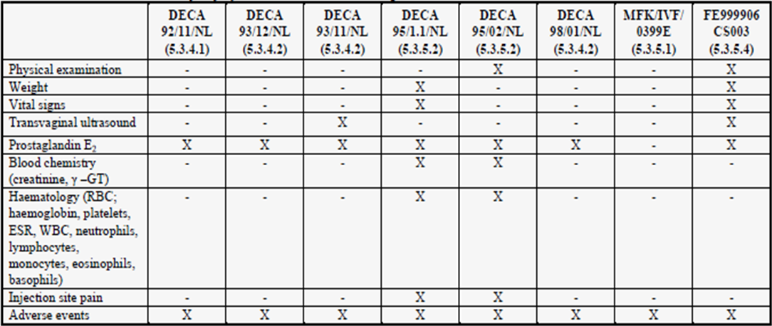
Table 9: Overview of safety population from each study.
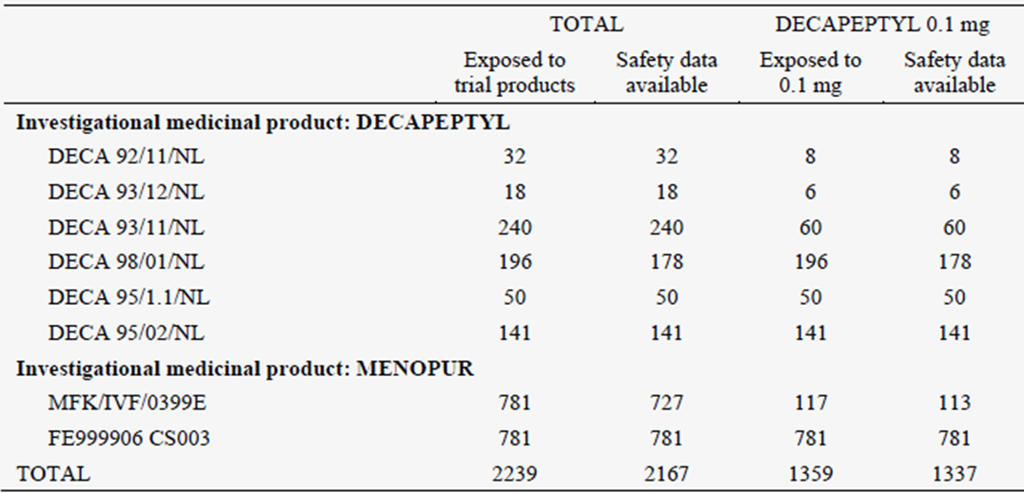
Safety data are available for 1337 (98%) women exposed to Decapeptyl 0.1 mg. The 22 patients for whom there is no safety information refer to 18 patients in Study 4 DECA 98/01/NL who started downregulation but did not proceed to randomisation to one of the cessation schemes and 4 patients in Study 7 who started downregulation but did not initiate ovarian stimulation.
Of note, most women will not be exposed for more than two treatment cycles, so time dependent adverse effects beyond those seen in Studies 7 and 8 are not expected.

Safety issues with the potential for major regulatory impact
None noted.

Postmarketing data
According to the latest PSUR, six serious listed cases have been reported following use of Decapeptyl daily in females of reproductive age, two of them of hypersensitive reactions and four concerning ovarian hyperstimulation syndrome. Five of the cases were reported on a spontaneous basis and one from a clinical trial. Among the spontaneously reported cases, four occurred during infertility therapy, and one during treatment of endometriosis.
Serious unlisted AEs included:
- Tachycardia, bundle branch block in a subject who was also treated with maprotilin for depression;
- Down syndrome infant born to a subject; generalised oedema and pulmonary oedema in a subject who also had been prescribed Valette;
- Therapeutic inefficacy in a subject treated with Decapeptyl 0.1 mg/day SC from 12 August 2000 to 30 August 2000 for infertility;
- Myalgia, paraesthesia and asthenia in a subject was treated with 0.5 mg Decapeptyl (SC once a day) from 21 February until 24 February 2003, followed by 0.1 mg Decapeptyl (same administration and dose interval) from 25 February until 18 March 2003 for in vitro fertilisation treatment, hemiparesis, cerebellar syndrome, weight decreased a subject who received SC Decapeptyl 0.1 mg daily for 1 week and IM follitropin alfa 450 IU daily for infertility (exact treatment dates not reported). During the treatment, the patient developed transitory equilibrium disorder with hemiparesis on the left side; ectopic pregnancy in a subject treated with Decapeptyl daily 0.1 mg, from 31 October 1995 till 20 November 1995 for infertility; and
- Chest pain (not otherwise described) in a subject, experienced chest pain approximately one year after having taken one dose of Decapeptyl 3.75 mg one month depot formulation and approximately ten months following treatment with Decapeptyl daily 0.1 mg for the indication uterine fibroid.
A total of 17 non serious events were reported in females of reproductive age, all of them on a spontaneous basis (Table 10). Nine cases were assessed as non listed and eight as a listed. Decapeptyl daily 0.1 mg and 0.5 mg were used in 11 and five patients, respectively, while in one case the exact strength was not known.
Table 10: Non serious adverse drug reactions.
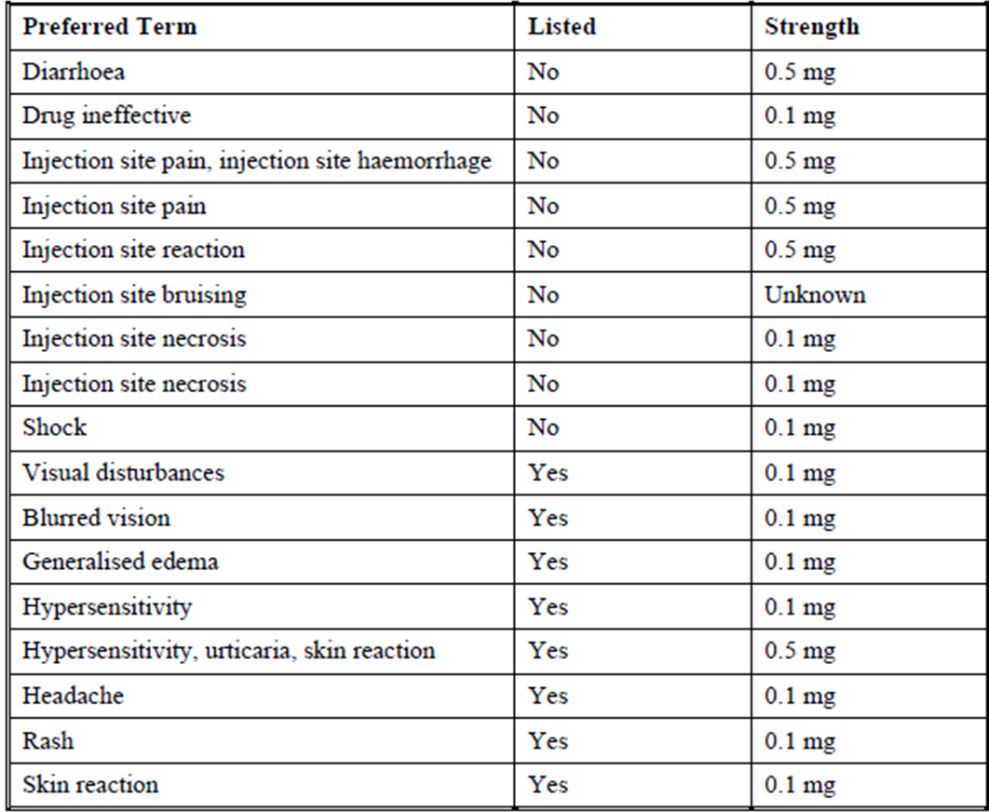

Evaluator’s conclusions on safety
The best evidence for the safety profile comes from the rather small study, Study 7. Although both studies were open label, Study 8 was less sensitive in detecting adverse events. Study 7 seems to be the only reasonable source of information for the PI in regard to common AEs.
Common AEs that are likely to represent true adverse reactions include injection site reactions and oestrogen deficiency symptoms. Uncommon adverse reactions include hypersensitivity.

First round benefit-risk assessment

First round assessment of benefits
The benefits of Decapeptyl brand of triptorelin acetate injection containing (base equivalent) 0.1 mg/1 mL injection solution in the proposed usage are:
- The reasonable prospect of abolishing LH surges in women undergoing IVF/ART procedures.
The efficacy relative to other registered agents is not known. The absolute efficacy is not known because no large scale placebo controlled studies have been done. If Study 3 were generalisable (it is not), the number needed to treat would be about 4 or 5.

First round assessment of risks
The risks of Decapeptyl brand of triptorelin acetate injection containing (base equivalent) 0.1 mg/1 mL injection solution in the proposed usage are quantifiable with difficulty as the evaluator believes that only Study 7 is credible. However, serious adverse events (SAEs) do appear to be uncommon.

First round assessment of benefit-risk balance
The benefit-risk balance of Decapeptyl brand of triptorelin acetate injection containing (base equivalent) 0.1 mg/1 mL injection solution, given the proposed usage, is unfavourable.

First round recommendation regarding authorisation
Registration should be declined due to inadequate safety data, inadequate dose finding and the lack of even one suitable Phase III study.

Clinical questions

Additional expert input
Not requested except into routine chemistry evaluation and assay validation of the bioavailability studies, sterility evaluator’s comments on the adequacy of the labels and Consumer Medicines Information (CMI) to instruct consumers who are asked to self inject.

Clinical questions
The evaluator has no questions of the applicant.

V. Pharmacovigilance findings

Risk management plan
The sponsor submitted a triptorelin acetate RMP (version 1.0 dated 21 January 2014, data lock point 30 June 2013) and Australian Specific Annex (ASA) (version 1.0 dated 21 January 2014, data lock point 30 June 2013), which was reviewed by the TGA’s Office of Product Review (OPR).

Safety specification
The sponsor provided a summary of ongoing safety concerns which are shown at Table 11.
Table 11: Ongoing safety concerns.
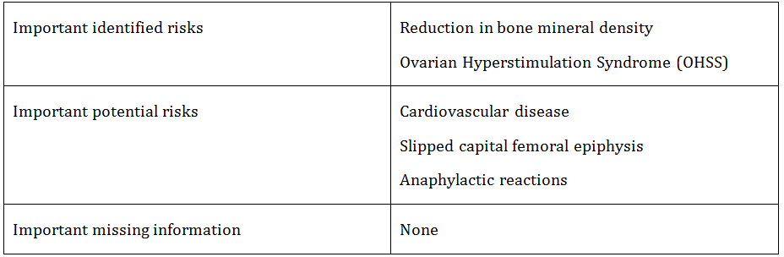

Pharmacovigilance plan
Routine pharmacovigilance activities are proposed by the sponsor to monitor the safety concerns associated with triptorelin acetate. According to the RMP and ASA, there are no planned additional pharmacovigilance activities.

Risk minimisation activities
The sponsor proposes routine risk minimisation (that is, product labelling statements) to mitigate all safety concerns associated with triptorelin acetate. No additional safety concerns are proposed.

Reconciliation of issues outlined in the RMP report

Recommendation #1 in RMP evaluation report
Safety considerations may be raised by the nonclinical and clinical evaluators through the consolidated Section 31 request and/or the nonclinical and clinical evaluation reports respectively. It is important to ensure that the information provided in response to these includes consideration of the relevance for the RMP, and any specific information needed to address this issue in the RMP. For any safety considerations so raised, the sponsor should provide information that is relevant and necessary to address the issue in the RMP.

Sponsor response
The recommendations provided in the RMP evaluation report, as well as the associated safety comments that were raised in the nonclinical and clinical evaluation reports, were addressed in the RMP ASA.

OPR evaluator’s comment
The sponsor’s response is noted.

Recommendation #2 in RMP evaluation report
The sponsor is requested to confirm in the Section 31 response that the RMP provided is the EU-RMP approved in Europe. If it is not the same, the EU-RMP should be provided as well as the differences between the EU-RMP and the RMP for Australia.

Sponsor response
The RMP provided with the submission is the EU-RMP covering all therapeutic indications and formulations of triptorelin acetate.
However, the triptorelin EU-RMP has not been submitted to any EU member countries so far, as it has never been requested. This RMP will be submitted with the next PSUR updates to EU member countries, in 2015.
An ASA has been submitted with this application, which describes the proposed Australian specific changes and key differences between the EU-RMP and the ASA.

OPR evaluator’s comment
The sponsor’s response is noted.

Recommendation #3 in RMP evaluation report
Although OHSS appears to be a known risk with ART, the question of whether additional pharmacovigilance activities are warranted will rely upon the clinical evaluation of the safety data relating to this risk.

Sponsor response
OHSS is a well known risk with ART treatment. However, the causal role of triptorelin is not well established.
OHSS is considered not to be related to GnRH antagonists or agonist treatment but to the gonadotrophins used for controlled ovarian stimulation treatment.
OHSS is an important identified risk in the RMP and a periodic evaluation of reported OHSS events will be presented in the next PSUR reports. Ferring considers that current warnings and precautions regarding OHSS are sufficient measurement for risk minimisation.
If any changes in OHSS events frequency and severity are be reported, Ferring will evaluate the cases and duly inform the authorities.

OPR evaluator’s comment
The sponsor’s response is acceptable from a RMP standpoint.

Summary of recommendations
It is considered that the sponsor’s response to the TGA Section 31 Request has adequately addressed most of the issues identified in the RMP evaluation report. Some outstanding issues remain.

Outstanding issues

Product insert
The “Patient instructions for use” leaflet is not entirely satisfactory from a risk minimisation perspective and should be amended as follows:
- The opening statements in the leaflet should be amended as follows (addition underlined):
If your clinic has asked you to self-administer Decapeptyl, you should follow these step-by-step instructions for subcutaneous injection. Do not self-inject Decapeptyl until you are sure how to do it. Your doctor or nurse will demonstrate how you should inject your medication at home.
- In the ‘You will need’ section as well as antiseptic swabs, a sharps container should be listed.
- In the ‘Injecting your medicine’ section instructions to re-cap the needle are not consistent with good clinical practice and may potentiate needle stick injury – this is particularly important when a third party is performing the injection.
- In the ‘Injecting your medicine’ section instructions should include disposal into a sharps container immediately after the injection.
- In the ‘Disposing your medicine’ section the word ‘preferably’ should be removed so the sentence reads:
If you are self-injecting, you should discard the used needles and syringes, preferably, into a sharps disposal unit.

PI/CMI
- In the ‘Dosage and Administration’ section advice to re-cap the needle is not consistent with good clinical practice and could potentiate needle stick injury. The needle should be disposed of in a sharps container immediately following injection.
- Several PI/CMI amendments were recommended in the RMP evaluation report. The sponsor has made some of these amendments. PI/CMI amendments made in response to the RMP evaluation report are referred to the Delegate for final consideration.

Advice from the Advisory Committee on the Safety of Medicines (ACSOM)
- ACSOM advice was not sought for this submission.

Comments on the safety specification of the RMP

Clinical evaluation report
The clinical evaluator has provided the following comments in the first round clinical evaluation report:
The Safety Specification in the draft RMP is not entirely satisfactory and should be revised, having regard to the comments below:
The evaluator is of the view that the clinical trial data had uneven sensitivity in regard to capture and recording of AEs. Study 7 (MFK/IVF/0399E) is probably the most useful source of information on common AEs.
The RMP evaluator endorses the clinical evaluator’s recommendations.

Nonclinical evaluation report
The nonclinical evaluator has provided the following comments in the first round non-clinical evaluation report:
Results and conclusions drawn from the nonclinical program for triptorelin detailed in the sponsor’s draft RMP are in general concordance with those of the nonclinical evaluator.

Key changes to the updated RMP
The ASA provided in the original submission has been superseded by ASA (version 2.0, data lock point 31 December 2013). Changes have been made to this document in response to the RMP evaluation report.

OPR Evaluator’s comments
The evaluator has no objection to the update provided and notwithstanding the outstanding issues outlined above, recommends to the Delegate that the updated version is implemented.

Suggested wording for conditions of registration

RMP
The triptorelin acetate EU-RMP (version 1.0 dated 21 January 2014, data lock point 30 June 2013) with ASA (version 2.0, data lock point 31 December 2013), to be revised to the satisfaction of the TGA, must be implemented.

PSUR
OMA is to provide wording.

VI. Overall conclusion and risk/benefit assessment
The submission was summarised in the following Delegate’s overview and recommendations:

Quality
The pharmaceutical chemistry evaluator advised that approval of the registration of the proposed product cannot be recommended on quality/safety grounds. The specifications of the drug substance adopted by the finished product manufacturer Ferring GmbH do not include the key test (and limits) for amino acid analysis. If this issue could be resolved approval could be recommended.
Further, if appropriate data to support the transfer of the related substances test method to Ferring GmbH is not provided to the TGA by the decision date of the submission, it should be made a condition of registration that batches of product cannot be supplied in Australia until a Category 3 submission to change the related substances method is provided and approved.

Nonclinical
The nonclinical evaluator had no clinical objections to registration. Some editorial changes to the PI were proposed.

Clinical
There were no Phase III studies submitted (with endpoints such as pregnancy rate or livebirth rate) in which patients were randomised to triptorelin versus another GnRH agonist or GnRH antagonist. The sponsor is relying on Phase II (pharmacodynamic) data, which shows that triptorelin causes down regulation of the pituitary and prevents premature LH surges; plus, non randomised data from two Phase III trials and overseas postmarketing data.
More specifically, the two Phase III trials, included in the dossier, were designed to test HMG menotrophin (MENOPUR) versus recombinant human FSH (GONAL-F). That is, randomisation was MENOPUR versus GONAL-F; not triptorelin versus comparator.
The clinical evaluator has recommended rejection based on the lack of randomised Phase III data, inadequate dose finding, and inadequate safety data.
The evidence submitted by the sponsor is outlined in the two subsections below.
The sponsor’s responses to the evaluator’s concerns are outlined below.

Efficacy
The sponsor’s studies were conducted in Israel and various European countries (Belgium, Czech Republic, Denmark, Finland, France, Germany, the Netherlands, Poland, Slovenia, Spain, Sweden, Switzerland, United Kingdom).
The design and results from the sponsor’s eight main studies are given in Table 12.
Table 12: Design and results from the sponsor’s eight main studies.
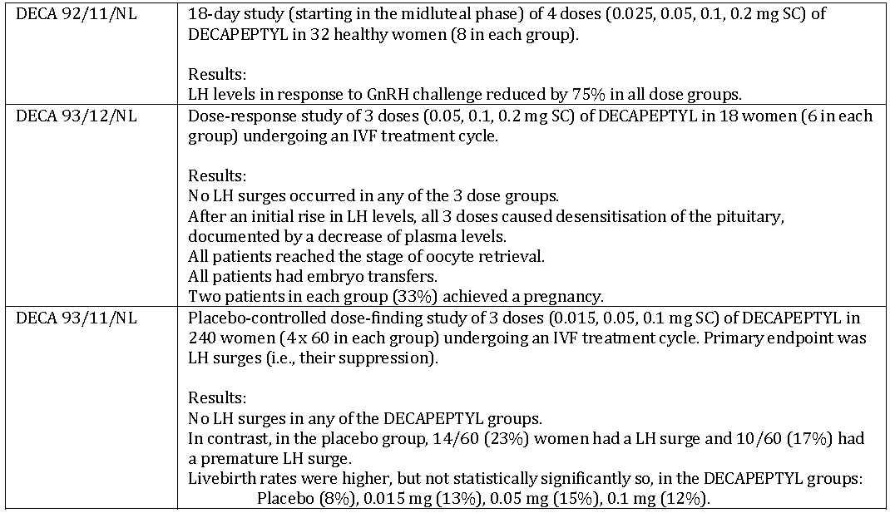

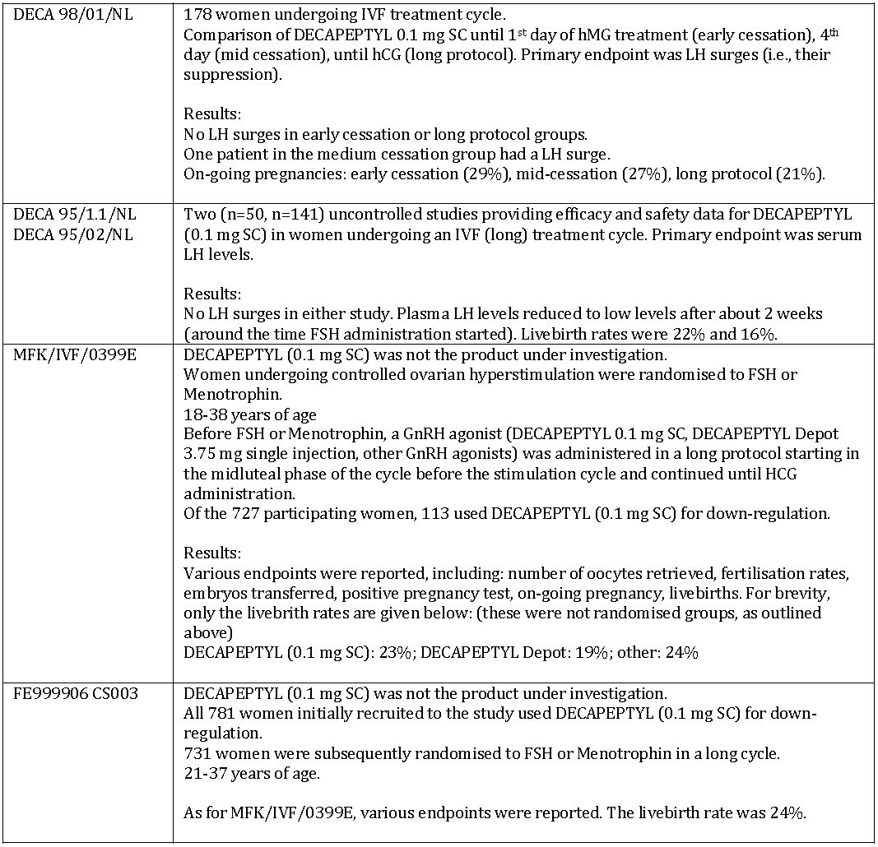

Safety

Clinical trials in sponsor’s dossier
A total of 1359 women received Decapeptyl 0.1 mg SC daily; of whom 1351 were undergoing IVF. There have been 0 deaths.

Serious adverse events
- 6 pharmacokinetic/pharmacodynamic studies: 5. Ectopic pregnancy, pelvic inflammation, gynaecological pain, spondylitis, ovarian hyperstimulation syndrome.
- clinical trials of FSH versus MENOPUR: 38.ovarian hyperstimulation syndrome (12), missed abortion (6), ectopic pregnancy (6), spontaneous abortion (2), pelvic pain (2), convulsion (2), ulcerative colitis (1), severe vomiting (1), pelvic pain (1), vaginal haemorrhage (1), sepsis (1), post procedure pain (1).

Other AEs

Before ovarian stimulation with gonadotrophins
From MFK/IVF/0399E: headache (27%), injection site inflammation (12%), abdominal pain (9%), dysmenorrhea (6%), nausea (5%), injection site pain (4%), dizziness (4%), URTI (4%), hot flushes (4%). The overall incidence of adverse events was similar in the three GnRH agonist groups (Decapeptyl 0.1 mg SC, Decapeptyl depot, other).
From FE99906CS003: (all patients received Decapeptyl 0.1 mg SC) incidence of reported adverse events was lower, with headache (4%) and dysmenorrhea (3%) being the most common.

During ovarian stimulation with gonadotrophins
From MFK/IVF/0399E: headache (26%), abdominal pain (15%), injection site inflammation (10%), dysmenorrhea (6%), nausea (10%), injection site pain (7%), dizziness (5%). The overall incidence of adverse events was similar in the three GnRH agonist groups (Decapeptyl 0.1 mg SC, Decapeptyl depot, other).
From FE99906CS003: (all patients received Decapeptyl 0.1 mg SC) incidence of reported adverse events was lower, with headache (4%) and dysmenorrhea (3%) being the most common.
In Study FE999906CS003 (5.3.5.4), 50% of the patients reported adverse events after start of ovarian stimulation with the most common being vaginal haemorrhage (24%), spontaneous abortion (7%), pelvic pain (6%), headache (5%), post procedural pain (4%), OHHS (3%), nausea (3%), abdominal distension (2%) and abortion missed (2%).

Ovarian hyperstimulation syndrome
MFK/IVF/0399E: Decapeptyl 0.1 mg SC (0%), Decapeptyl 3.75 mg depot (5%), other (15%).
FE99906CS003: (all patients received Decapeptyl 0.1 mg SC) (3%).

Post marketing experience
Based on information provided in the sponsor’s response of 25 September 2014, as at 31 December 2013, exposure to Decapeptyl was 562,322 patient-years; of which, the daily formulations were 88,798 patient-years. It was unclear as to the percentages of patients exposed to 0.1 mg daily versus 0.5 mg daily.
For the daily formulation (0.1 or 0.5 mg) used for the ART indication, 91 adverse drug reactions were reported. Most frequently reported adverse reactions were “drug ineffective” and ovarian hyperstimulation syndrome. Other adverse drug reactions (ADRs) reported were headache, hypersensitivity reaction, nausea, injection site pain.
Ovarian hyperstimulation is the most important reported adverse drug reaction. A total of 27 cases have been reported: 15 for daily formulations and 12 for depot formulation. Two cases resulted in death (one in The Netherlands, one in Russia).

Sponsor’s response
The clinical evaluator has recommended rejection because of inadequate dose finding, the lack of randomised Phase III data, and inadequate safety data.
The sponsor’s responses are summarised below.

Sponsor’s response to concerns about inadequate dose finding
Clinical development for the ART indication was performed in the early 1990s according to standards at the time. Dose response and placebo controlled dose finding studies were conducted. The sponsor stated that there had already been several years of off label use for the ART indication at a daily SC dose of 0.1 mg, based on experience with pituitary down regulation for other indications. The sponsor acknowledged that the Phase II dose finding studies were unable to define the optimal daily dose for ART. The daily SC dose of 0.1 mg was selected based on safe use in other indications.
The sponsor drew attention to a trial reported in the EPAR for registration of ganitrelix (0.25 mg) in the EU. That trial used Decapeptyl (0.1 mg) as the active comparator. The conclusion was that Decapeptyl (0.1 mg) provided similar efficacy and safety as the GnRH antagonist ganirelix. For example, livebirth rate: ganirelix 0.25 mg [31%], Decapeptyl 0.1 mg [34%]; serious adverse effects ganirelix 0.25 mg [3.1%], Decapeptyl 0.1 mg [2.7%]; any adverse effect: ganirelix 0.25 mg [23%], Decapeptyl 0.1 mg [22%]; ovarian hyperstimulation syndrome: ganirelix 0.25 mg [4 cases], Decapeptyl 0.1 mg [1 case]. The sponsor concluded that, although the optimal dose of Decapeptyl is not defined, the dose of 0.1 mg SC provides similar efficacy and safety as the approved dose of ganerelix in the EU.

Sponsor’s response to concerns about lack of Phase III randomised data for efficacy
The sponsor has argued that serum LH levels and premature LH surges, as measured in the Phase II studies, are clinically relevant endpoints to determine the efficacy of triptorelin 0.1 mg. The sponsor has further argued that they are optimal endpoints.
Although not designed to assess the efficacy of Decapeptyl 0.1 mg, outcomes (for example, live birth rates of 20%-25%) from the two large Phase III trials (MFK/IVF/0399E, FE99906CS003) were broadly consistent with those reported from ART registers (for about the same time period: 1999-2006) for women of a similar age (<38 years).

Sponsor’s response to concerns about inadequate safety data
The Phase II trials did not reveal any unexpected safety concerns.
No unexpected safety signals emerged from the large Phase III studies: MFK/IVF/0399E, FE99906CS003.
Postmarketing data: Triptorelin is available OS in different injectable formulations (daily and depot) and has been used for numerous different indications, including prostate cancer and ART. The main spontaneously reported ADRs were “drug ineffective”, “injections site reactions (all non serious for the daily SC formulation), and “ovarian hyperstimulation syndrome”.
The most important ADR is ovarian hyperstimulation syndrome. The sponsor states that this is not related to triptorelin, but is a well known pharmacological effect of ovarian stimulation with gonadotrophin preparations.
In the setting of triptorelin use for androgen deprivation in advanced prostate cancer, use is long term and often in elderly with co-morbidities. No serious unexpected safety signals have been uncovered.

Risk management plan
Routine pharmacovigilance is proposed.

Risk-benefit analysis

Delegate’s considerations

(a) Dose
No properly designed dose finding studies or placebo controlled trials have been performed for Decapeptyl, but this is also the case for the other GnRH agonists used in ART. That is, GnRH agonists have been used for ART despite the lack of classical dose response information on clinically relevant endpoints. The doses currently used in ART have been adopted from other indications. Extensive (nonrandomised) clinical experience supports the efficacy and safety of the currently used doses of GnRH agonists in ART.
Advice from the Advisory Committee on Prescription Medicines (ACPM) is requested on whether the proposed dose of Decapeptyl is acceptable.

(b) Efficacy
The requirement is for the sponsor to satisfactorily establish efficacy (and safety and quality). The gold standard for establishing efficacy is a well conducted Phase III trial on a relevant final endpoint (for example, live births). The sponsor has not submitted such a trial.
However, the sponsor has submitted various randomised (Phase II) trials with endpoints of LH suppression and prevention of LH surges. These are arguably patient relevant endpoints.
Also submitted was non randomised data on various endpoints, including the patient relevant final endpoint of livebirth.
The ACPM’s advice is requested on whether the Phase II trials and the nonrandomised data submitted by the sponsor are sufficient to satisfactorily establish efficacy.

(c) Safety
The introduction of GnRH agonists has increased the amount of gonadotrophins required to achieve maturity of ovarian follicles. A larger number of ovarian follicles are recruited with an increased theoretical risk of ovarian hyperstimulation syndrome. However, the available data suggest that there is no particular increased occurrence of ovarian hyperstimulation syndrome with Decapeptyl versus other GnRH agonists or GnRH antagonists. Other safety concerns (for example, injection site reactions, headache, nausea) appear to be manageable.
The ACPM’s advice is requested on whether the Phase II trials, non randomised data, and postmarketing data, submitted by the sponsor, are sufficient to satisfactorily establish safety.

Proposed action
- Implement the latest RMP as approved by Office of Product Review (OPR), TGA.
- If appropriate data to support the transfer of the related substances test method to Ferring GmbH is not provided to the TGA by the decision date of the submission, it should be made a condition of registration that batches of product cannot be supplied in Australia until a Category 3 submission to change the related substances method is provided and approved.

Request for ACPM advice
- Is proposed dose of Decapeptyl is acceptable?
- Are the Phase II trials and the non randomised data submitted by the sponsor sufficient to satisfactorily establish efficacy?
- Are the Phase II trials, non randomised data, and post marketing data, submitted by the sponsor sufficient to satisfactorily establish safety?

Response from sponsor
Presented here is Ferring’s response to the TGA Delegate’s Request for ACPM’s Advice (DRA) on our application to register Decapeptyl (triptorelin acetate) 0.1 mg/1 mL solution for SC injection for down regulation and prevention of premature LH surges in women undergoing controlled ovarian hyperstimulation (COS) for ART.

Introduction
Ferring welcomes the TGA Delegate’s pre ACPM preliminary assessment in which the Delegate states they have no reason to say, at this time, that Decapeptyl should not be approved for registration (DRA cover page).
The Delegate has provided a comprehensive summary of the overseas regulatory history. Ferring, however, has noticed some discrepancies in the information cited by the Delegate in this section. These will be identified and corrected in this pre ACPM response.
In Ferring’s response to the pharmaceutical chemistry evaluation, a large number of questions raised by the pharmaceutical chemistry evaluator were addressed successfully. However, the Delegate has brought to our attention that two pharmaceutical chemistry issues remain (DRA Sections 2 and 7), and that these will need to be resolved before Decapeptyl can be approved and supplied in Australia. Ferring’s position on these two matters will be given in this pre ACPM response.
Ferring notes that the nonclinical evaluator has no clinical objections to registration. All changes to the Decapeptyl PI recommended by the nonclinical evaluator have now been included in the draft PI (appendix of this pre ACPM response).
As noted by the Delegate (DRA Section 4), the clinical evaluator has recommended that the application be rejected based on:
- the lack of supporting randomised Phase III data
- inadequate dose finding data, and
- inadequate safety data.
In the DRA, the Delegate has provided an accurate summary of Ferring’s response to the clinical evaluator’s three concerns. Then in the DRA, in providing a brief discussion on each of these points, the Delegate suggests that, based on Ferring’s response, the submitted data may be sufficient to support the efficacy and safety of Decapeptyl at a daily dose of 0.1 mg in the intended ART indication. The Delegate has sought the advice of the ACPM on this position, specifically on the acceptability of the proposed Decapeptyl dose (that is, 0.1 mg SC daily), and whether the submitted Phase II and non randomised Phase III data are sufficient to satisfactorily establish both the efficacy and safety of the product. In this pre ACPM response, Ferring will, where appropriate, expand its response to the Clinical Evaluator’s three concerns, focusing on key points not covered by the Delegate.
The Delegate has suggested changes to the AE section of the Decapeptyl PI, and has sought clarification on an aspect of the post marketing experience section of the PI. These and other PI matters are dealt with in detail in this pre ACPM response (appendix).
As well, the Delegate has listed as a condition of registration the need for Ferring to implement the latest RMP as approved by the Office of Product Review. Ferring agrees to implement the latest approved RMP, as required.

Clarification of overseas regulatory history
In discussing the overseas regulatory history of Decapeptyl, the Delegate has acknowledged Ferring’s claim that the product has become the preferred GnRH agonist for use in ART in several large European countries, such as France, Germany, Spain and Italy. However, the Delegate then suggested that, in these countries, the 0.1 mg form of Decapeptyl had not been launched and that the claim might apply to the 3.75 mg depot form instead. Similarly, the Delegate has also noted that:
in some countries, registration of the 0.1 mg SC formulation has occurred without [Ferring’s correction underlined] any subsequent product launch/marketing, including large EU member states (Germany, France, Sweden and The Netherlands).
Ferring provided an updated international regulatory history of Decapeptyl 0.1 mg in its response, dated 25 September 2014, to the Consolidated Section 31 Request for Information. Of the main European countries mentioned by the Delegate, we can confirm that the 0.1 mg SC form is both registered and launched for ART use in Germany, Italy, Sweden, Spain and the Netherlands. (The product was only launched in Spain in the last few months, and the formulation marketed in the Netherlands is an old, unique 0.1 mg in 0.2 mL solution, not the 1 mL solution that is the subject of the present application.)
The Delegate has also noted that:
The SC 0.1 mg daily formulation [of Decapeptyl] is approved in 73 countries & for the ART indication in 32 countries.
These values were obtained by the Delegate from a Post-Marketing Safety document provided in Ferring’s response of 25 September 2014. We wish to advise that, regrettably, these values are not current and correct. The most current and accurate worldwide regulatory history appears in the appendix to this pre ACPM response and in an appendix of our response of 25 September 2014. Based on these documents, we can confirm that Decapeptyl 0.1 mg/1 mL solution for SC injection is approved in the ART indication in 82 countries, and the product has been launched for this indication in 67 countries.

Unresolved pharmaceutical chemistry matters
The Delegate has brought to our attention that two issues arising from the pharmaceutical chemistry evaluation remain unresolved (DRA Section 2).
The first relates to a recommendation that the amino acid test and accompanying specification for the drug substance be retained by the finished product manufacturer, Ferring GmbH. Ferring understands that the pharmaceutical chemistry evaluator has stated that approval cannot be recommended unless this test is in place as a non identity test. Accordingly, Ferring gives an assurance that the amino acid test and specifications will be adopted by Ferring GmbH as a non identity test.
The second unresolved pharmaceutical chemistry issue relates to the provision of data to support the transfer of a related substance test from the DS manufacturer to the finished product manufacturer (Ferring GmbH). The Delegate has requested that, if these data cannot be provided by the decision date, then it should be a condition of registration that batches of the product cannot be supplied in Australia until a Category 3 submission to change the related substances method is provided and approved by TGA. Ferring will accept this condition of registration should approval of Decapeptyl 0.1 mg be granted and the required data are not provided before approval.

Ferring’s response to clinical evaluator’s three concerns

Response to concerns about the lack of supporting randomised Phase-3 data
In this section, we wish to reiterate the reasons why Ferring considers that the submitted clinical data are sufficient to support the efficacy and safety of Decapeptyl 0.1 mg in ART. Before doing so, it is worth recounting the difficulties in identifying a suitable active comparator for a Phase III registration study at the time the product was developed in ART. This section will conclude with a discussion on a Phase III registration trial for the GnRH antagonist ganirelix in which Decapeptyl 0.1 mg was used as an active reference.

No suitable active reference product for a Phase III trial was available
As noted by the Delegate, the clinical development of Decapeptyl in the ART indication was performed in the early 1990s according to the standards at that time, and this involved both dose response and placebo controlled dose finding studies. When Decapeptyl 0.1 mg was first developed and registered overseas for the prevention of premature LH surge indication, no suitable GnRH agonist reference treatment was available for an active comparative trial, simply because no other agent had been fully developed and registered in this indication at that stage. Similar constraints were encountered with other GnRH agonists developed at the time. For example, nafarelin nasal spray (Synarel) was registered in Australia in 1995 for use in ART, yet the pivotal clinical trial which underpinned its registration used an undisclosed, unregistered buserelin nasal spray comparator product/regimen that was in use at the centre at which the trial was conducted.

Adequacy of submitted clinical data in supporting registration of Decapeptyl 0.1 mg
As illustrated above, no suitable active reference product was available when Decapeptyl 0.1 mg was developed and first registered for use in ART. The Australian application therefore relies primarily on:
- the results of the Phase II data;
- experience gained from using open label Decapeptyl 0.1 mg as the down regulation agent in two very large ART trials of other agents; and
- the wealth of post marketing safety experience available for the product.
The first two of these aspects of the application are summarised in the following paragraphs, whereas the third aspect will be discussed below.
The Decapeptyl 0.1 mg clinical dossier includes data on 2,239 female subjects who have been exposed to trial products in the eight studies conducted. This includes 32 healthy women exposed to 18 days of treatment at daily doses up 0.2 mg triptorelin in a clinical pharmacology study. The remaining 2,207 women were patients undergoing ART. A total of 1,359 women were exposed to Decapeptyl 0.1 mg SC daily, of which 1,351 were patients undergoing ART.
The main pharmacological effect of Decapeptyl 0.1 mg is pituitary down regulation and sustained LH suppression during COS, to ensure that endogenous LH does not interfere with the IVF or ICSI treatment. As such, serum LH levels and the incidence of premature LH rises, as measured during the Phase II studies, are optimal and clinically relevant endpoints to determine the efficacy of Decapeptyl 0.1 mg. The results of the Phase II studies demonstrated unambiguously that use of Decapeptyl 0.1 mg induces pituitary down regulation and is effective in preventing a premature LH surge during COS as part of ART. This is entirely consistent with widespread clinical experience over many years with this established product. Moreover, it is universal practice in ART to establish that pituitary down regulation has occurred before proceeding with ovarian stimulation in an IVF/ICSI cycle, and therefore the level of effectiveness of a product like Decapeptyl 0.1 mg would be apparent to clinicians who use it routinely in clinical practice.
The results of the Phase II trials are also reassuring from an overall safety perspective. From these trials, there was no apparent relation between the dose of triptorelin, or the duration of its use, and the incidence of AEs, SAEs, or discontinuation due to AEs. All daily doses of Decapeptyl tested, up to 0.2 mg, were well tolerated. There is no evidence from these trials to suggest that the adverse event profile for Decapeptyl 0.1 mg is less favourable than those observed for other similar GnRH agonist products.
Having established in Phase II studies that Decapeptyl 0.1 mg is effective in its intended purposes, namely pituitary down regulation and the prevention of premature LH rises, it then remains to rule out any possible unforeseen effects on ART outcomes and safety. The use of open label Decapeptyl 0.1 mg as the pituitary down-regulation agent in the Phase III studies MFK/IVF/0399E and FE999906 CS003 provided an opportunity to evaluate its clinical performance in the context of large clinical trials powered to assess ART outcomes such as pregnancy and live birth rates, as well as to allow a large number of women to be exposed to Decapeptyl 0.1 mg in a controlled clinical trial environment. In total, 117 and 781 patients were treated with open label Decapeptyl 0.1 mg in studies MFK/IVF/0399E and FE999906 CS003, respectively. The latter study, commonly known under the acronym MERIT, is one of the largest long GnRH agonist protocol IVF trials ever performed to current GCP standards, and in this study Decapeptyl 0.1 mg SC daily was used exclusively as the down regulation regimen. While the net contribution of Decapeptyl to the overall efficacy and safety in these two large trials cannot be determined, the overall clinical outcomes of the trials were in line with those reported by European Society of Human Reproduction and Embryology (ESHRE) from European ART registers for the year 2004, suggesting that the choice of down regulation agent did not in any way compromise the overall efficacy outcome. Similarly, no unexpected safety signals emerged from studies MFK/IVF/0399E and FE999906 CS003, again suggesting that, while Decapeptyl was not the agent under investigation in the studies, its use in the trial did not appear to adversely influence overall safety in any way.

Decapeptyl 0.1 mg was an active reference in a ganirelix Phase III registration trial
The Decapeptyl development programme in ART pre dated the availability of the GnRH antagonists ganirelix and cetrorelix, which were registered for the prevention of premature LH surges in Australia around 2000. Interestingly, for the development of these newer GnRH analogues, registered and unapproved GnRH agonist regimens were chosen as active comparators. Indeed, Decapeptyl 0.1 mg SC injection was the active comparator regimen used in one of the ganirelix pivotal Phase III registration studies. The main results of this trial have been detailed by the Delegate, and showed that Decapeptyl 0.1 mg was at least as effective and safe as ganirelix at the current approved dose.
In this trial, Decapeptyl 0.1 mg daily was chosen because it was regarded as an appropriate, well established and registered reference regimen. Given that it performed very favourably against ganirelix in this comparative Phase III study, it would have been unjustified for Ferring to attempt to repeat a trial against an approved GnRH antagonist in order to supplement the Australian Decapeptyl registration dossier.

Response to concerns about inadequate dose finding data
As noted by the Delegate, when triptorelin acetate was formally developed in the 1990s for the prevention of premature LH surges during COS, there had already been several years of off label clinical experience with its use in this indication at a daily SC dose of 0.1 mg. This relatively low dose regimen had largely been derived from use of the compound for pituitary down regulation in other clinical indications.
Ferring accepts that subsequent Phase II dose ranging studies in IVF patients were unable to define clearly the optimal daily dose. However, as argued in the previous section of this pre ACPM response, the 0.1 mg daily dose for Decapeptyl was shown to be both effective and safe in the Phase II trials, and it was therefore pragmatically chosen as the dose for registration. Together with the available pharmacovigilance and published data, the results of the Phase II trials were sufficient to support registration in many European countries at the time. In this context, it is worth restating the Delegate’s comment that other GnRH agonists used in ART also have lacked properly designed dose finding studies.

Response to concerns about inadequate safety data
As described earlier in this response, the submitted Phase II data did not reveal any unexpected safety concerns for Decapeptyl 0.1 mg, nor were there any unexpected safety signals from the large Phase III IVF studies MFK/IVF/0399E and FE999906 CS003, which used open label Decapeptyl for pituitary down regulation. Moreover, in discussing the safety of Decapeptyl 0.1 mg based on the available evidence, the Delegate suggests that the risk of ovarian hyperstimulation syndrome with Decapeptyl 0.1 mg is not greater than for other GnRH agonists, and that:
Other safety concerns, such as injection site reactions, headache and nausea, appear manageable.
Unlike for most new products undergoing registration, a reassuring aspect of the safety of Decapeptyl 0.1 mg, and for triptorelin in general, is the availability of considerable post marketing experience with the product and compound. Triptorelin acetate is available overseas in different injectable formulations (daily and depot) and has been used for numerous different indications, including prostate cancer and in the ART indication. As noted by the Delegate, the cumulative patient exposure to all triptorelin acetate formulations up to 31 December 2013 is estimated to be 562,322 patient-years, of which the daily formulations account for 88,789 patient-years of exposure. Of the two daily SC formulations, namely the 0.1 and 0.5 mg strengths, more than 99% of usage has been with the 0.1 mg strength.
Crucially, there has been no important change over time in the characteristics of the listed adverse drug reactions reported with regards to severity, outcome or target population. The post marketing findings attributable to triptorelin have remained consistent with those expected of an injectable GnRH agonist.
Furthermore, additional long standing, widespread post marketing experience comes from the use of triptorelin, both as the acetate and embonate salts, for androgen deprivation in advanced forms of prostate cancer. In contrast to ART use, long term treatment and use in the elderly are common in this setting. As in the ART setting, such experience has failed to uncover serious unexpected safety signals related to the use of triptorelin.

Conclusion
There is long standing clinical experience with Decapeptyl 0.1 mg for pituitary down regulation in the ART setting internationally. It is a well characterised and established product that has been used for this indication in many overseas countries for over 20 years. In the mid 1990s, the long GnRH agonist protocol became the gold standard for pituitary down regulation in IVF cycles, and through this experience some GnRH agonists, including Decapeptyl 0.1 mg, became reference products that were subsequently used in the development of other GnRH analogues such as the GnRH antagonists.
The submitted Phase II data has demonstrated that the safety profile of Decapeptyl is consistent with that of similar GnRH agonist products, and that the selected 0.1 mg dose effectively induces pituitary down regulation and prevents LH surges during COS. Importantly, the effectiveness of the product in achieving the desired therapeutic effect will be monitored in each COS cycle, as part of routine clinical practice.
Moreover, the large randomised controlled clinical trial FE999906 CS003 used open label Decapeptyl 0.1 mg as the sole pituitary down regulation agent. This trial provided pregnancy, live birth and safety outcomes that were entirely consistent with corresponding outcomes from ART practices around Europe at the time, suggesting that the inclusion of Decapeptyl 0.1 mg in the treatment protocol did not adversely influence overall efficacy or safety in the trial.
Finally, post marketing surveillance data collected over many years confirm that triptorelin has a favourable risk/benefit ratio in patients treated for the proposed indication, as well as for other indications, and that the safety profile of triptorelin has remained consistent and predictable over the years. In other words, the major risks and the most frequent adverse events associated with the use of Decapeptyl 0.1 mg are well known.
Ferring therefore maintains that the submitted clinical dataset is sufficient to support the registration of Decapeptyl at a 0.1 mg SC daily dosage, and that this product would be a valuable addition to the therapeutic options available to Australian ART clinicians.

Advisory committee considerations
The ACPM, taking into account the submitted evidence of efficacy, safety and quality, agreed with the Delegate and considered Decapeptyl solution for SC injection containing 100 µg/1 mL of triptorelin acetate to have an overall positive benefit-risk profile for the proposed indication:
Decapeptyl is indicated for down-regulation and prevention of premature luteinising hormone surges in women undergoing controlled ovarian hyperstimulation for assisted reproductive technologies.

Proposed conditions of registration
The ACPM agreed with the Delegate on the proposed conditions of registration.

Specific advice
The ACPM advised the following in response to the Delegate’s specific questions on this submission:
- Is proposed dose of Decapeptyl is acceptable?
The ACPM found the arguments put forward by the sponsor in its pre ACPM response persuasive and advised that, despite lack of dose finding data the proposed dose is suitable.
- Are the Phase II trials and the non randomised data submitted by the sponsor sufficient to satisfactorily establish efficacy?
The ACPM was of the view that, although trial data are inadequate, the postmarket experience in other major jurisdictions is sufficient.
- Are the Phase II trials, non randomised data, and postmarketing data, submitted by the sponsor sufficient to satisfactorily establish safety?
The ACPM noted the Phase II trials did not reveal any unexpected safety concerns and no unexpected safety signals emerged from the large Phase III studies: MFK/IVF/0399E and FE99906CS003.
The postmarketing data in other jurisdictions were reassuring. Triptorelin is available in other jurisdictions in different injectable formulations (daily and depot) and has been used for numerous different indications. The ACPM was of the view that, overall and given the duration of use, evidence in support of safety was adequate.

Outcome
Based on a review of quality, safety and efficacy, TGA approved the registration of Decapeptyl triptorelin acetate 100 µg/1 mL solution for injection in 1 mL prefilled syringe with integrated needle indicated for:
Decapeptyl 100 μg/1 mL is indicated for down-regulation and prevention of premature luteinising hormone (LH) surges in women undergoing controlled ovarian hyperstimulation for assisted reproductive technologies (ART).
In clinical trials, Decapeptyl 100 μg/1 mL has been used in cycles where urinary and recombinant human follicle stimulating hormone (FSH) as well as human menopausal gonadotrophin (HMG) were used for stimulation

Specific conditions of registration applying to these goods
- The triptorelin acetate European RMP, version 1.0 dated 21 January 2014 (data lock point 30 June 2013) with ASA, version 2.0, (data lock point 31 December 2013), and any subsequent revisions, as agreed with the TGA will be implemented in Australia.
- Batches of product cannot be supplied in Australia until a Category 3 submission to change the related substances test method used to test the drug substance applied by the finished product manufacturer is provided to and approved by the TGA.

Attachment 1. Product Information
The PI approved for Decapeptyl at the time this AusPAR was published is at Attachment 1. For the most recent PI, please refer to the TGA website at <www.tga.gov.au/product-information-pi>.

Attachment 2. Extract from the Clinical Evaluation Report
Therapeutic Goods Administration
PO Box 100 Woden ACT 2606 Australia
Email: info@tga.gov.au Phone: 1800 020 653 Fax: 02 6232 8605
https://www.tga.gov.au

Sandow J, Clayton RN. (1983) The disposition, metabolism, kinetics and receptor binding properties of LHRH and its analogues. In: Briggs M and Corbin A, editors. Progress in hormone biochemistry and pharmacology, Vol. 2. Montreal: Eden Press; pp. 63-106.
European Medicines Agency, “ICH Topic S 5 (R2), Detection of Toxicity to Reproduction for Medicinal Products & Toxicity to Male Fertility: Step 5, Note for Guidance on the Detection of Toxicity to Reproduction for Medicinal Products & Toxicity to Male Fertility (CPMP/ICH/386/95)”, March 1994.
Based on a mg/kg to mg/m² conversion factor of 12 for rabbits.
Pregnancy Category D: “Drugs which have caused, are suspected to have caused or may be expected to cause, an increased incidence of human foetal malformations or irreversible damage. These drugs may also have adverse pharmacological effects. Accompanying texts should be consulted for further details.”
Handelsman DJ, Swerdloff RS. (1986) Pharmacokinetics of gonadotropin-releasing hormone and its analogs. Endocr. Review 7: 95-105.
European Medicines Agency, “Guideline on the Investigation of Bioequivalence (CPMP/EWP/QWP/1401/98 Rev. 1), 20 January 2010.

