Date of CER: 30 May 2014

AusPAR Attachment 2

Extract from the Clinical Evaluation Report for Triptorelin Acetate
  - Proprietary Product Name: Decapeptyl
  - Sponsor: Ferring Pharmaceuticals Pty Ltd

About the Therapeutic Goods Administration (TGA)
- The Therapeutic Goods Administration (TGA) is part of the Australian Government Department of Health, and is responsible for regulating medicines and medical devices.
- The TGA administers the Therapeutic Goods Act 1989 (the Act), applying a risk management approach designed to ensure therapeutic goods supplied in Australia meet acceptable standards of quality, safety and efficacy (performance), when necessary.
- The work of the TGA is based on applying scientific and clinical expertise to decision-making, to ensure that the benefits to consumers outweigh any risks associated with the use of medicines and medical devices.
- The TGA relies on the public, healthcare professionals and industry to report problems with medicines or medical devices. The TGA investigates reports received by it to determine any necessary regulatory action.
- To report a problem with a medicine or medical device, please see the information on the TGA website <www.tga.gov.au>.
About the Extract from the Clinical Evaluation Report
- This document provides a more detailed evaluation of the clinical findings, extracted from the Clinical Evaluation Report (CER) prepared by the TGA. This extract does not include sections from the CER regarding product documentation or post market activities.
- The words [information redacted], where they appear in this document, indicate that confidential information has been deleted.
- For the most recent Product Information (PI), please refer to the TGA website <www.tga.gov.au/product-information-pi>.
Copyright
© Commonwealth of Australia 2015
This work is copyright. You may reproduce the whole or part of this work in unaltered form for your own personal use or, if you are part of an organisation, for internal use within your organisation, but only if you or your organisation do not use the reproduction for any commercial purpose and retain this copyright notice and all disclaimer notices as part of that reproduction. Apart from rights to use as permitted by the Copyright Act 1968 or allowed by this copyright notice, all other rights are reserved and you are not allowed to reproduce the whole or any part of this work in any way (electronic or otherwise) without first being given specific written permission from the Commonwealth to do so. Requests and inquiries concerning reproduction and rights are to be sent to the TGA Copyright Officer, Therapeutic Goods Administration, PO Box 100, Woden ACT 2606 or emailed to <tga.copyright@tga.gov.au>.

Contents
List of abbreviations 5
1. Clinical rationale 8
2. Contents of the clinical dossier 9
2.1. Scope of the clinical dossier 9
2.2. Paediatric data 12
2.3. Good clinical practice 12
3. Pharmacokinetics 12
3.1. Studies providing pharmacokinetic data 12
3.2. Summary of pharmacokinetics 15
3.3. Evaluator’s overall conclusions on pharmacokinetics 20
4. Pharmacodynamics 20
4.1. Studies providing pharmacodynamic data 20
4.2. Summary of pharmacodynamics 21
4.3. Evaluator’s conclusions on pharmacodynamics 23
5. Dosage selection for the pivotal studies 23
6. Clinical efficacy 24
6.1. Pivotal efficacy studies 24
6.2. Other efficacy studies 24
6.3. Analyses performed across trials (pooled & meta analyses) 37
6.4. Evaluator’s conclusions on efficacy 37
7. Clinical safety 37
7.1. Studies providing evaluable safety data 37
7.2. Pivotal studies that assessed safety as a primary outcome 47
7.3. Patient exposure 47
7.4. Adverse events 48
7.5. Laboratory tests 52
7.6. Post-marketing experience 53
7.7. Safety issues with the potential for major regulatory impact 54
7.8. Other safety issues 54
7.9. Evaluator’s conclusions on safety 55
8. First round benefit-risk assessment 55
8.1. First round assessment of benefits 55
8.2. First round assessment of risks 55
8.3. First round assessment of benefit-risk balance 55
9. First round recommendation regarding authorisation 55
10. Clinical questions 56
10.1. Additional expert input 56
10.2. Clinical questions 56

List of abbreviations
Abbreviation | Meaning
ADR | Adverse Drug Reaction
AE | adverse event
ANOVA | analysis of variance
ART | assisted reproductive technologies
ATC | anatomical therapeutic classification
AUC | area under the plasma concentration – time curve
BA | bioavailability
BMI | body mass index (kg/m2)
CCDS | Company Core Data Sheet
CL | clearance
Cmax | maximum plasma concentration
COH | controlled ovarian hyperstimulation
D-Trp | D-tryptophan
E2 | 17β-estradiol
FSH | follicle stimulating hormone
GCP | Good Clinical Practice
GnRH | gonadotrophin releasing hormone
hCG | human chorionic gonadotrophin
hMG | human menopausal gonadotrophin
HP | highly purified
ICSI | intracytoplasmic sperm injection
IEC | institutional ethics committee
IM | intramuscular(ly)
IOF | incipient ovarian failure
ITT | intention to treat
IU | International Units
IV | intravenous(ly)
IVF | in vitro fertilisation
LH | luteinizing hormone
LOQ | limit of quantification
MedDRA | Medical Dictionary for Regulatory Activities
ND | not done
NNT | number needed to treat
NR | not recorded
OHSS | ovarian hyperstimulation syndrome
P4 | progesterone
PCOD | polycystic ovarian disease
PCOS | polycystic ovarian syndrome
PD | pharmacodynamics
PK | pharmacokinetics
PP | per protocol
PSUR | Periodic Safety Update Report
RCT | randomised controlled trial
rFSH | recombinant FSH
RIA | radioimmunoassay
SAE | serious adverse event
SC | subcutaneous(ly)
SD | standard deviation
SmPC | Summary of Product Characteristics
SOC | System Organ Class
t_{½} | elimination half-life
Tmax | time at which maximum plasma concentration occurs

Clinical rationale
In 1986 Professor Handelsman wrote:
Pharmacological therapy must be based on a therapeutic aim coupled with an understanding of relevant normal physiology. As reviewed elsewhere in this issue, pituitary gonadotropes exposed to GnRH pulses outside the physiological range of 0.5-1 pulses/h fail to sustain gonadotropin output. Consequently, clinical applications of GnRH are designed to stimulate gonadal function when endogenous GnRH pulsatility is deficient (hypogonadism, delayed puberty) by mimicking physiological patterns using exogenous GnRH pulse frequencies of 0.5-1 pulses/h … Conversely, GnRH analog (superactive agonists or pure antagonists) treatment is intended to suppress gonadal function via pituitary desensitization as a result of sustained pituitary overexposure to GnRH effects by continuous or quasi-continuous administration … Thus treatment regimens with GnRH or the analogs will have different optimal modes of application based on the pharmacokinetics of the compound and pharmacodynamics of the target physiological systems.
This suggests that depot formulations should be no worse than daily injections as long as continuous exposure to the GnRH agonist occurs. There is an acute agonistic effect at the pituitary GnRH receptor followed, on repeated dosing, within several days by downregulation due to pituitary GnRH receptor desensitisation, with a consequent marked reduction in gonadal production.
The use of GnRH agonists potentially enables planned in vitro fertilisation (IVF) treatment and oocyte retrieval and the prevention of LH surges would avoid wasted cycles that might have been lost to early ovulation. However, the use of GnRH agonists requires longer treatment courses with FSH than non use.
As stated by the applicant in the letter of application:
The rationale behind the clinical application of Decapeptyl 0.1 mg SC injection in IVF/ICSI (intracytoplasmic sperm injection) treatment is based on the existing evidence that the use of GnRH agonists can prevent the premature LH surge associated with ovarian stimulation with gonadotrophins in ART cycles, thus reducing the cycle cancellation rate, increasing the pregnancy rates and facilitating cycle control.
ART is commonly practised in Australia. As stated by the sponsor in the Australian supplement to the draft RMP:
Use of assisted reproductive treatment: There were 61,158 ART treatment cycles reported from Australian clinics in 2011. The number of ART treatment cycles in 2011 increased by 8.3% from 2010. The number of ART treatment cycles represented 12.9 cycles per 1,000 women of reproductive age (15-44 years) in Australia (Australian Bureau of Statistics, 2013). More than 95% of cycles in 2011 were autologous cycles (where a woman intended to use, or used her own oocytes or embryos), and 33.7% of all cycles used frozen/thawed embryos. On average, 1.9 cycles per woman were undertaken in Australia.
The average age of women undergoing autologous cycles was 36, and ranged from 14 to 54. In contrast, the average age of women undergoing ART treatment using donor oocytes or embryos was approximately five years older (40.8, ranging from 20 to 54). The proportion of autologous cycles undertaken by women aged 40 or older continued to increase, with 26.5% in 2011 compared with 22.8% in 2007.

Contents of the clinical dossier

Scope of the clinical dossier
The submission included two Phase I studies (involving absolute bioavailability and pharmacokinetics after IV injection) which the evaluator refers to as Studies 1 and 9. An additional pharmacokinetic study is mentioned in the submission as an “expert report”, but the evaluator will discuss this as Study 10.
There are five Phase II studies that produced pharmacodynamic data, dose ranging data and most provided pharmacokinetic data as well.
There were no Phase III studies in the data package. That is, there is no large scale prospective, multicentric and randomised, double blind placebo or active controlled study. There are no population pharmacodynamic/pharmacokinetic data.
Two previously evaluated studies (referred to by the evaluator as Studies 7 and 8) that were submitted in connection with previous applications to register Menopur HP were included in the data package because the pituitary downregulation phase included the use of Decapeptyl as an option amongst several GnRH agonists (including a depot presentation of triptorelin and nafarelin).
For an overview of the submission, refer to Table 1.
Table 1: Outline of clinical studies.
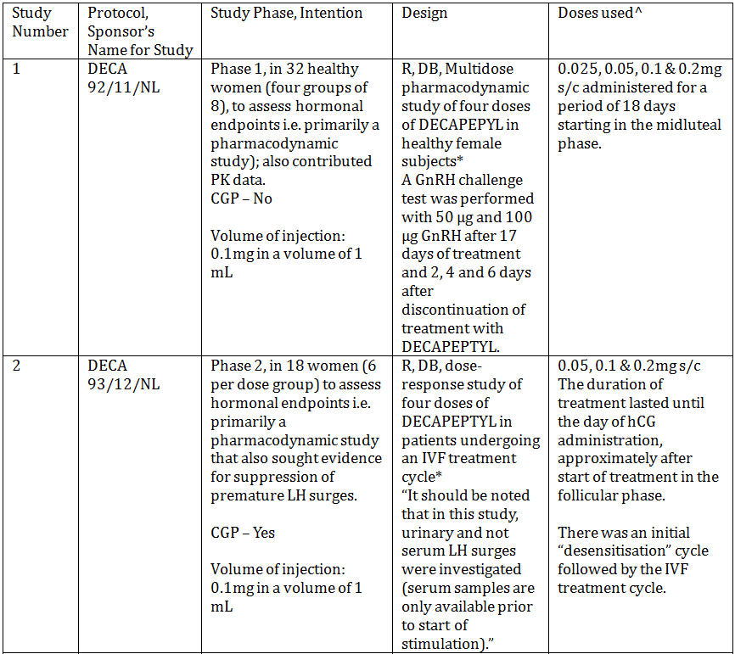
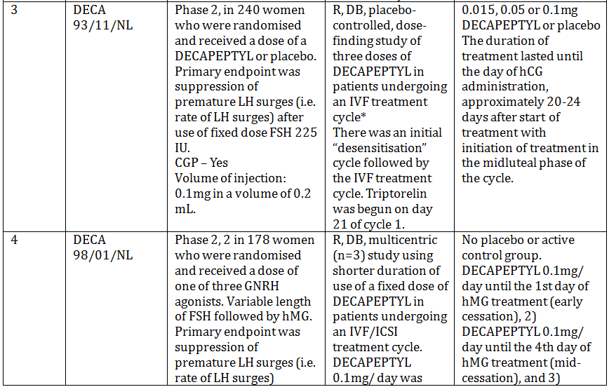
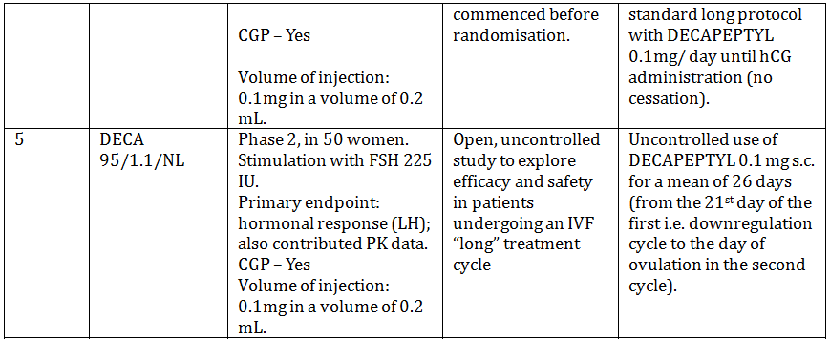
Table 1 (continued): Outline of clinical studies.
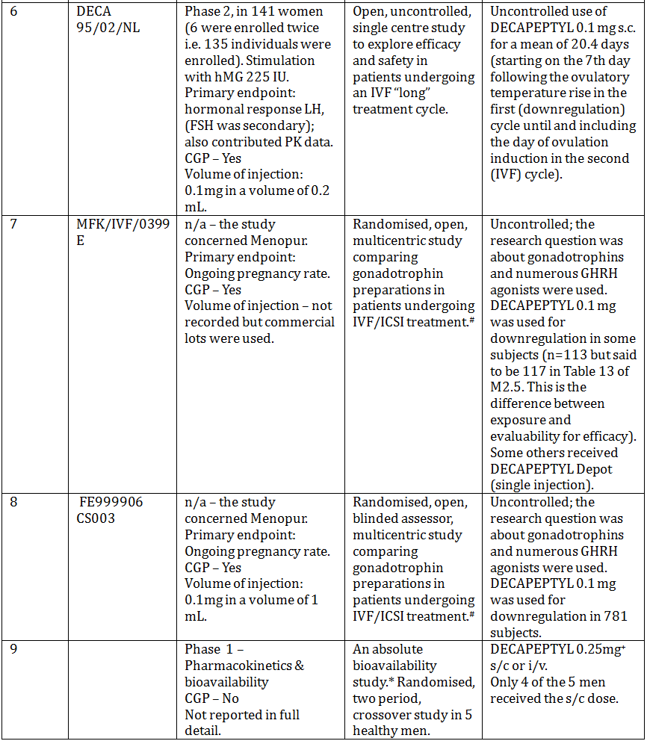
* denotes single centre study.
# denotes previously evaluated study (as part of an application to register a menotrophin product, MENOPUR, Ferring).
^ Only one dosage form/strength is provided for this indication, but clinical studies have been conducted with the dose of Decapeptyl 0.1 mg in volumes of 0.2 mL and 1 mL. The active substance manufacturer and the drug product manufacturer have remained the same since 1992 and 1995, respectively.
Studies 1-6 all took place in The Netherlands, the first three at the same centre.
⁺ The dose in males was w.r.t. use in cancer of the prostate.
The submission contained the following clinical information:
- seven clinical pharmacology studies , including five that provided pharmacokinetic data and five that provided pharmacodynamic data.
- two of the abovementioned pharmacology studies were also dose finding studies.
- five of the abovementioned pharmacology studies also contributed some efficacy and safety data.
- two Phase III studies on Menopur HP (Studies 7 and 8) that also contain some information on Decapeptyl.
- no population pharmacokinetic analyses.
- no pivotal efficacy/safety studies.
- Periodic Safety Update Reports (PSURs), literature, overviews of Studies 7 and 8, tabular listings of all studies, assay validation reports, an “Expert opinion on pharmacokinetics of triptorelin following IV bolus injection and on the bioavailability from Decapeptyl depot in patients with endometriosis or uterine myoma, 1992”.
Most of the study reports included data listings (Study 2 did not) but appendices to the main study report were incomplete in several cases but the information was usually present in other documents such as in the statistical reports.

Paediatric data
The submission did not include paediatric data.

Good clinical practice
The declaration states that the studies complied with the Good Clinical Practice (GCP) guidelines that were applicable at the time of conduct of the studies. The evaluator has also checked the clinical documents for each study. Study 9 was not GCP compliant.

Pharmacokinetics

Studies providing pharmacokinetic data
Table 2 shows the studies relating to each pharmacokinetic topic and the location of each study summary.
Table 2: Submitted pharmacokinetic studies.
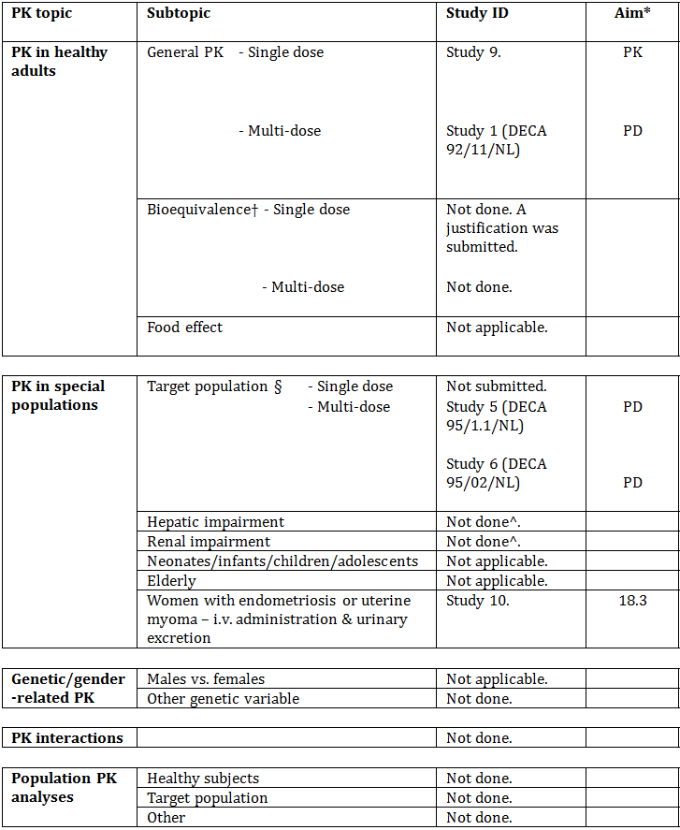
The only specific pharmacokinetic study was Study 9. Several other studies generated PK data.
* Indicates the primary aim of the study.
† Bioequivalence of different formulations.
§ Subjects who would be eligible to receive the drug if approved for the proposed indication.
^ Data were generated in two small studies that were part of the submission to register Diphereline.
All of the pharmacokinetic studies had deficiencies that impacted on the value of their results.
Table 3 lists pharmacokinetic results that have significant study deficiencies. All of the studies that contributed pharmacokinetic data have weaknesses.
Table 3: Pharmacokinetic results from suboptimal studies.
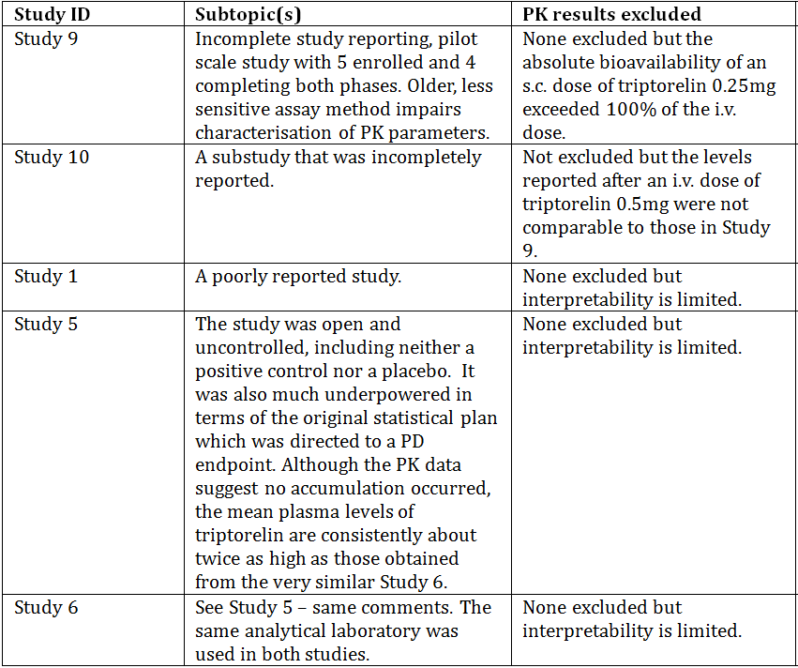
The applicant has tabulated the studies that contributed pharmacokinetic data – the tabulation (Table 4) is reproduced below. The Studies are, in order, Studies 9, 10, 1, 5 and 6.
Table 4: Overview of studies with pharmacokinetic information.
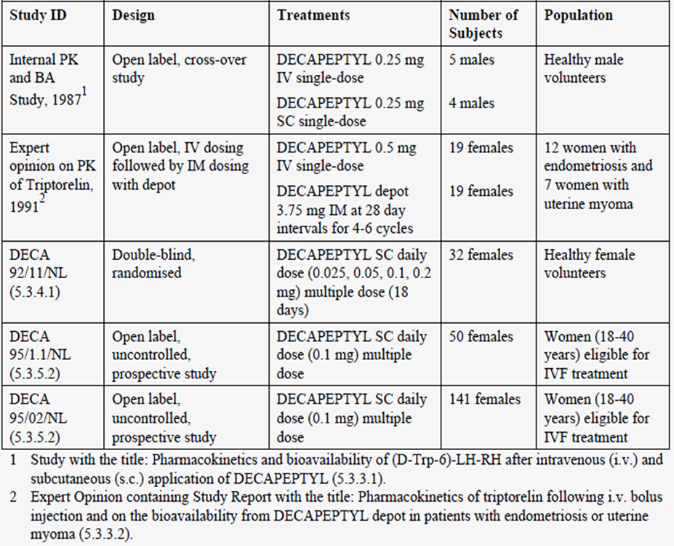
Notes: 1. The dose in males was w.r.t. use in cancer of the prostate. 2. Study 10 was not included in the tabulation.
Five studies contribute with data on the pharmacokinetic profile and mean levels of triptorelin after single or multiple dosing of Decapeptyl.

Summary of pharmacokinetics
The information in the following summary is derived from conventional pharmacokinetic studies unless otherwise stated.

Physicochemical characteristics of the active substance
The following information is derived from the Sponsor’s summaries.
Triptorelin acetate is a synthetic analogue of GnRH. Empirical formula C₆₄H₈₂N₁₈O₁₃ · C₂H₄O₂ (Triptorelin Acetate); molecular weight 1371.6.
The CAS registry number of triptorelin acetate is 160296-12-8. Triptorelin acetate is a white powder, and as might be expected it is freely soluble in acetic acid; soluble in water, 0.1 M hydrochloric acid, 0.1 M sodium hydroxide, practically insoluble in acetone and chloroform.

Pharmacokinetics in healthy subjects

Absorption

Sites and mechanisms of absorption
The dose form is an aqueous injection for s.c. administration. It is absorbed from the site of injection.

Bioavailability

Absolute bioavailability
Limited data were submitted. The draft PI states, “The pharmacokinetic data suggest that after subcutaneous administration of DECAPEPTYL the systemic bioavailability of triptorelin is close to 100%.” The basis of this statement is Study 9 and perhaps Study 10. These are both reported in detail.
Study 9 was based on 5 healthy volunteers. The study results are reproduced below.
Table 5: AUC and clearance following IV and SC injections of 0.25 mg Decapeptyl.
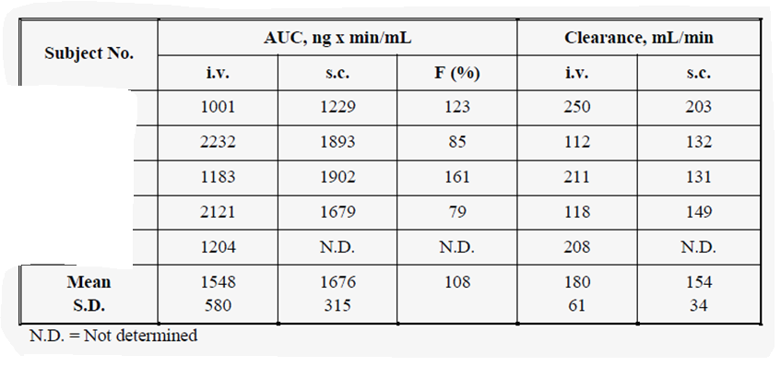
The study has some marked limitations: data are only available for four men with both routes of administration and the radioimmunoassay was less sensitive than the subsequently used method, perhaps explaining the wide variance in F. The clearance in this study was slower than in a published study but faster than in a later in house sub-study (Study 10).
A comparative table of Study 9 (“Internal”) and 10 (“Expert Opinion”) is reproduced below.
Table 6: Pharmacokinetic parameters following a single dose of Decapeptyl IV or SC.
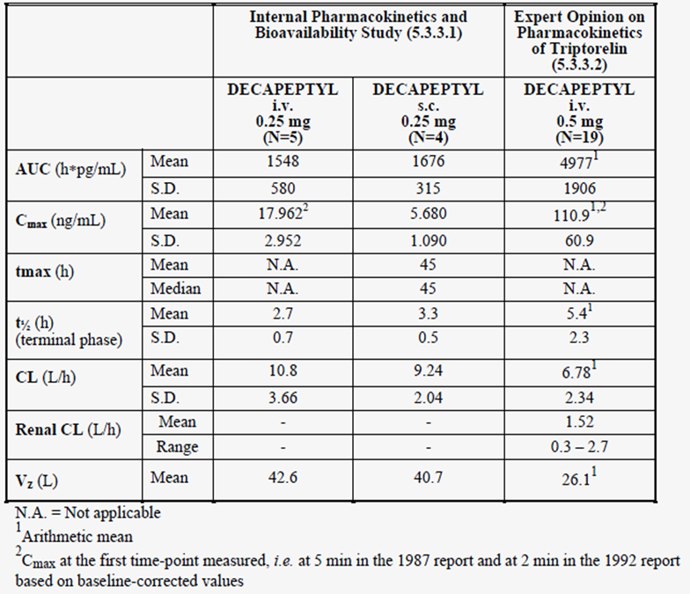
A noticeable feature of the results is the lack of dose proportionality across the two studies for the two i.v. doses. The explanation might relate to the assays used.
The evaluator is uncertain that the claim of close to 100% absorption after s.c. injection of 0.25mg relative to the same dose given i.v. is well supported. No study was done at the proposed dose of 0.1mg s.c.
Most studies in this submission and the submission for Diphereline used 2 or 3 compartment models.

Bioavailability relative to an oral solution or micronised suspension
Not applicable.

Bioequivalence of clinical trial and market formulations
Not established. However, most all studies – including the larger ones - used the “for marketing” formulation. Give the weakness outlined in regard to absolute bioavailability, a study might have been desirable. However, most clinical experience is with the “for marketing” formulation.

Bioequivalence of different dosage forms and strengths
Not applicable – there is only one strength and one dose.

Bioequivalence to relevant registered products
Not relevant. This dose form of triptorelin is specific to this application.

Influence of food
Not relevant.

Dose proportionality
Limited data were submitted. For example, see the tabulated results under Absolute bioavailability above. However, one dose is proposed for registration.
Study 1 triptorelin in dosages 0.025 mg, 0.05 mg, 0.1 mg or 0.2 mg was self-administered subcutaneously daily for 18 days to 32 healthy women. The study was very poorly reported but purports to show dose proportionality of serum triptorelin levels. No accumulation was noted.
Figure shows dose day 17 triptorelin levels. Day 17 was the last dose day, despite the quoted reference above to eighteen days.
Figure 1: Triptorelin (mean ± SD) levels during and after triptorelin treatment in four different dose groups.
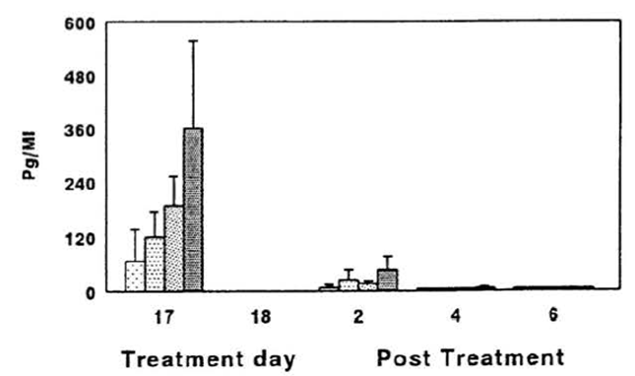
There is no good quality study in regard to this.

Bioavailability during multiple-dosing
Not studied. However, the pharmacokinetic data from the Phase 2 Studies do not suggest the potential for accumulation.

Effect of administration timing
Not studied.

Distribution

Volume of distribution
In this submission, Studies 9 & 10 contributed information – the results were different in the two studies but, as might be expected, the volume of distribution is relatively small, consistent with the physicochemical properties of the molecule, but perhaps somewhat underestimated. The evaluator regards the studies as of poor quality.

Plasma protein binding
No new data were presented.

Erythrocyte distribution
No new data were presented.

Tissue distribution
No new data were presented.

Metabolism

Interconversion between enantiomers
Not applicable.

Sites of metabolism and mechanisms / enzyme systems involved
No new data were presented. The PI of Diphereline states, “Triptorelin is eliminated by both the liver and the kidneys. Following intravenous administration of intermediate-release triptorelin acetate 0.5 mg to 6 young healthy adult males (mean Cl_{creat} 150 mL/min), 42% of the dose was excreted in the urine as intact triptorelin. The mean triptorelin clearance was 212 mL/min.”

Non-renal clearance
No new data were presented.

Metabolites identified in humans

Active metabolites
Not applicable.

Other metabolites
No new data were presented.

Pharmacokinetics of metabolites
No new data were presented.

Consequences of genetic polymorphism
No new data were presented.

Excretion

Routes and mechanisms of excretion
The submission included Study 1 which is reported in detail. This study reported the fraction of a dose that is renally excreted.

Mass balance studies
Not presented.

Renal clearance
Limited data were presented. Study 10 is reported in detail. There are numerous deficiencies in the study. However, in eight women with endometriosis or uterine myoma, urinary excretion was estimated. After i.v. administration of 0.5 mg Decapeptyl , on average 16 .7 % (range 3.4 to 34.6%) of the dose was detected in the urine within 24 hours.

Intra and inter individual variability of pharmacokinetics
This has not been formally examined in the submission but the study results as reported in detail suggest significant inter-individual variability, perhaps unexpectedly. Some longer duration studies undertook repeated triptorelin estimations but the sampling times in relation to dosing were variable, so the evaluator is unable to comment on intra-individual variability.

Pharmacokinetics in the target population
Studies 5 & 6 were conducted in the target population.
These studies used a similar protocol; triptorelin was used according to the “long treatment” regimen. In both studies 6, triptorelin levels were measured by Ferring Malmö. The sampling times were not strict, specified only in terms of visit days. Mean +/- s.d. triptorelin levels were reported.
Plasma triptorelin levels were measured on four occasions at approximately one week intervals starting one week after the initiation of DECAPEPTYL 0.1 mg treatment. The mean triptorelin levels from both studies are shown in the applicant’s Table 7.
Table 7: Triptorelin (pg/ml) levels after administration of Decapeptyl 0.1 mg SC.
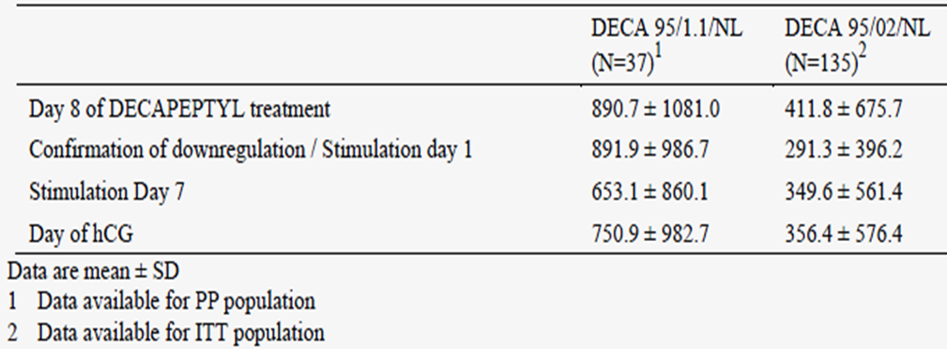
The results are obviously different across the two studies despite similarities.
One might say that no evidence of accumulation on repeated dosing.

Pharmacokinetics in other special populations

Pharmacokinetics in subjects with impaired hepatic function
No new data were submitted.

Pharmacokinetics in subjects with impaired renal function
No new data were submitted.

Pharmacokinetics according to age
Not applicable for this indication.

Pharmacokinetics related to genetic factors
No data were submitted.

Pharmacokinetics in other special populations / according to other population characteristics
No data were submitted. Studies 7 & 8 were conducted in many countries but largely in women of white race.

Pharmacokinetic interactions

Pharmacokinetic interactions demonstrated in human studies
No data were submitted.

Clinical implications of in vitro findings
No data were submitted.

Evaluator’s overall conclusions on pharmacokinetics
Little new information on the pharmacokinetics has been added by this submission compared to the information presented in the submission for Diphereline. Triptorelin acetate is proposed for daily dosing but the elimination half-life and clearance data suggest that the duration of action is independent of serum triptorelin levels.

Pharmacodynamics

Studies providing pharmacodynamic data
Table 8 shows the studies relating to each pharmacodynamic topic and the location of each study summary.
Table 8: Submitted pharmacodynamic studies.
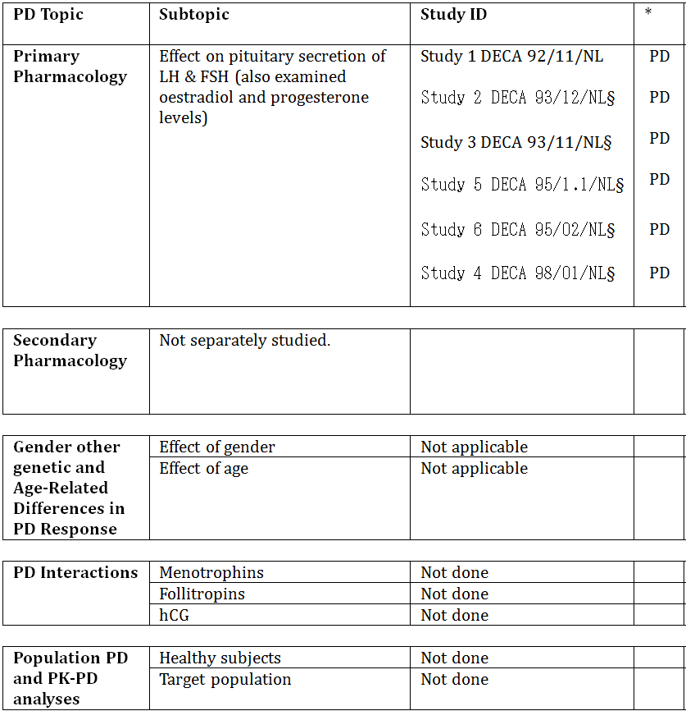
* Indicates the primary aim of the study.
§ Subjects who would be eligible to receive the drug if approved for the proposed indication.
‡ And adolescents if applicable.
Triptorelin, as a GnRH agonist, inhibits gonadotrophin secretion when given repeatedly or continuously (for example, via a depot dose form) and in therapeutic doses. Six of the submitted Phase I and Phase II studies examined LH and FSH levels as well as secondary effects on oestradiol and progesterone. No safety pharmacology studies were undertaken.
No pharmacodynamic results that were excluded from consideration due to study deficiencies. However, the deficiencies are significant and described in the study summaries.
As is seen from the applicant’s summary, DECA Studies 5 (DECA 95/1.1/NL) and 6 (DECA 95/02/NL) provided the most sampling times excepting Study 2 (93/11/NL) which sampled LH in the urine.
Table 9: Overview of studies providing data on the pharmacodynamic effects of Decapeptyl on the pituitary vovarian axis.
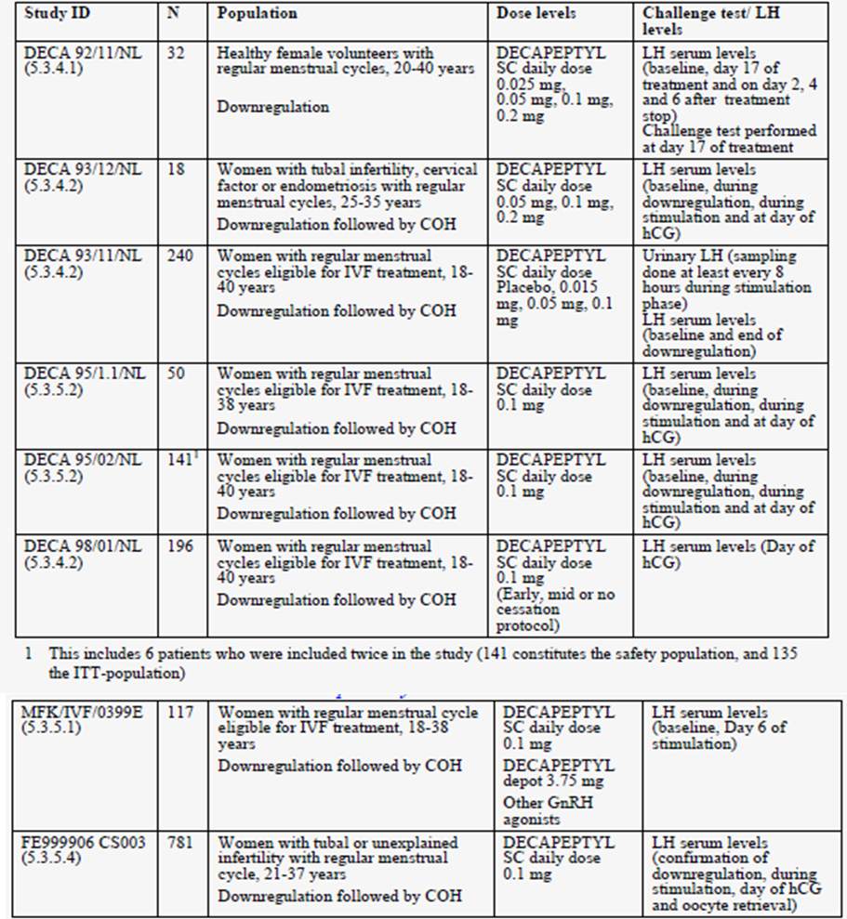

Summary of pharmacodynamics
The information in the following summary is derived from conventional pharmacodynamic studies in humans unless otherwise stated.

Mechanism of action
Mechanistic data depend on nonclinical data. Triptorelin, as a gonadotrophin releasing hormone (GnRH) agonist, inhibits gonadotrophin secretion when given repeatedly or continuously (e.g. via a depot dose form) and in therapeutic doses.

Pharmacodynamic effects

Primary pharmacodynamic effects
The inhibition of LH secretion has been studied in the Phase 2 studies and sought in Studies 7 & 8.

Secondary pharmacodynamic effects
Not applicable. The secondary effects on the gonads are part of the intended therapeutic effect.

Time course of pharmacodynamic effects
No study adequately characterised the initial agonistic effects upon the pituitary.
See next section for information on time to offset of action.

Relationship between drug concentration and pharmacodynamic effects
This has not been formally studied. Study 1 provided some data in relation to dose relationships and time to offset of action.
Table 10: Baseline, Day 17 data of treatment and post treatment mean values of LH and FSH (DECA 92/11/NL).
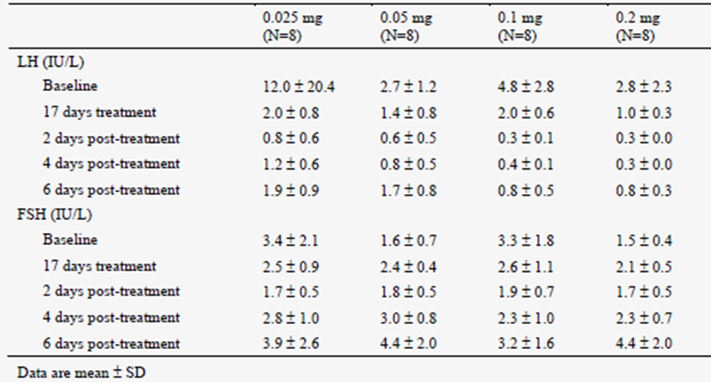
Note: day 17 was the last day of dosing with triptorelin. The figures shown have been expressed to one decimal place.
The report noted a lack of dose response in these results. Oestradiol levels were not related to dose but were somewhat correlated with LH levels. The effect of triptorelin persisted until six days post-treatment, more so in the two higher dose groups. “In response of LH levels to the LHRH challenge test no difference was detected between 0.05 mg and 0.1 mg dosage.”
Evaluator’s comments: The evaluator is struck by the mismatch of mean baseline LH and FSH levels in the low dose group. The evaluator does not agree with the suggestions that dose dependent effects on LH levels have been shown. The lack of a placebo arm is seen as a major disadvantage. The study did not define a minimally effective dose. No gonadotrophins were used in this study.
Study 3 DECA 93/11/NL was conducted in the treatment population. It used a range of doses but did not report triptorelin levels. This is the largest Phase 2 study in terms of patient numbers. The design was acceptable. The gonadotrophins that were used in this study were urinary derived products, FSH (Metrodin, Serono) and hCG (Profasi, Serono). They were used respectively from Cycle 2 Day 3 onwards and as a single injection of 10,000 IU when the minimum criteria were met.
Table 11: Mean values of LH, FSH, and E₂ at the midluteal phase and at confirmation of downregulation (DECA 92/11/NL).
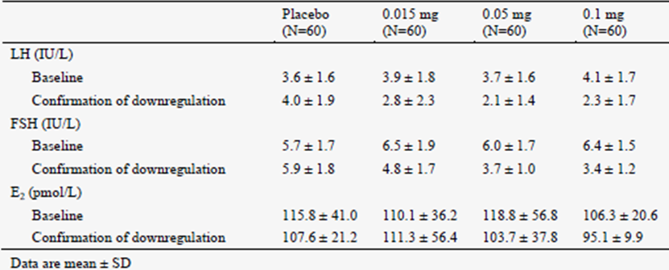
All active doses of triptorelin were effective at preventing premature LH surges; the study does not justify selection of the proposed dose of triptorelin i.e. 0.1 mg/day. In the evaluator’s opinion, the study suggests that 0.05mg or perhaps even slightly less is an appropriate dose.
Studies 5 & 6 have been mentioned w.r.t. pharmacokinetics. Because triptorelin levels were measured and because pharmacodynamic endpoints were also measured, one might have expected useful information to have emerged but – as noted above – the two studies reported very different mean triptorelin levels at the proposed dose. Comparing the two studies suggests indirectly that triptorelin is as effective in preventing LH surges at a dose of 0.1mg whether recombinant or urinary FSH is used.

Genetic-, gender- and age-related differences in pharmacodynamic response
Not explored but not relevant to the intended treatment population – women in their reproductive years.

Pharmacodynamic interactions
These have not been systematically studied but the need for longer courses of FSH has been observed at higher doses and duration of triptorelin (Study 4 DECA 98/01/NL). The quality of evidence to support this observation is low.

Evaluator’s conclusions on pharmacodynamics
This submission provided pharmacodynamic data chiefly in relation to the “long” protocol in which triptorelin is commenced in the midluteal phase of the downregulation cycle in ART. No LH surges were observed when it was used this way in the Phase II studies. Several Phase II studies included dose ranging information and it is not clear that the proposed dose is more effective that 0.05 mg/day. As is seen from the submitted data, time to onset of downregulation is within one week and the time to offset is about 4 days.

Dosage selection for the pivotal studies
The applicant used triptorelin 0.1 mg SC daily in pivotal studies for Menopur HP. No Phase III pivotal studies were done to test triptorelin against placebo or active comparators in the proposed indication. Unanswered questions from the Phase II programme include:
- What is the correct daily dose? The evaluator suggests that it might be 0.05 mg. However, no specific Phase III studies even at the proposed dose have been done.
- What is the correct duration? The answer is unclear from the Phase II programme which included only one study on this subject but the “long” protocol is favoured in treatment guidelines.

Clinical efficacy
Indication: “Downregulation and prevention of premature luteinizing hormone (LH) surges in women undergoing controlled ovarian hyperstimulation for assisted reproductive technologies (ART). In clinical trials Decapeptyl 0.1 mg/1 mL has been used in cycles where urinary and recombinant human follicle stimulating hormone (FSH) as well as human menopausal gonadotrophin (HMG) were used for stimulation”

Pivotal efficacy studies
Two previously evaluated studies, submitted in connection with previous applications to register Menopur HP, were re-submitted because both studies also used triptorelin in the downregulation phase before commencing the cycle that involved the use of gonadotrophins. In approaching these studies, the evaluator has taken note of the original evaluation reports and reproduces them under the study title line before undertaking specific reviews in the context of this application. Inevitably, these two studies can be seen as no more than “supportive” of the proposed indication because the intention of the studies was not to test the efficacy and safety of triptorelin in ART.

Other efficacy studies

Study 7 - MFK/IVF/0399E (5.3.5.1)
Extracts from Clinical Evaluation Report of Submission Number 98.4988.5:
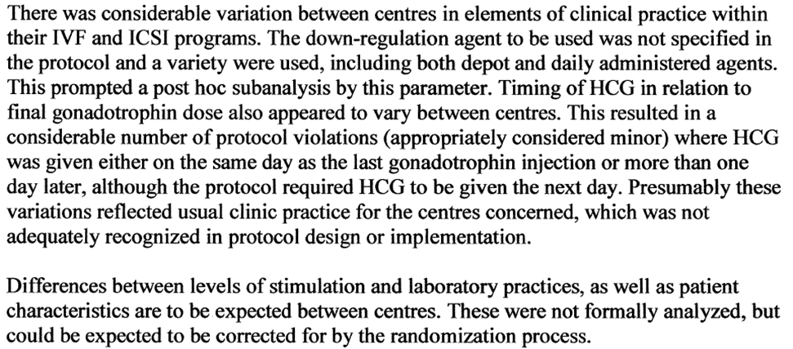
Efficacy:
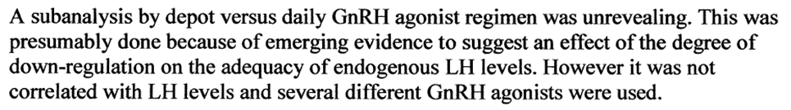
Table 12: Efficacy outcome parameters Study MFK/IVF/0399E.
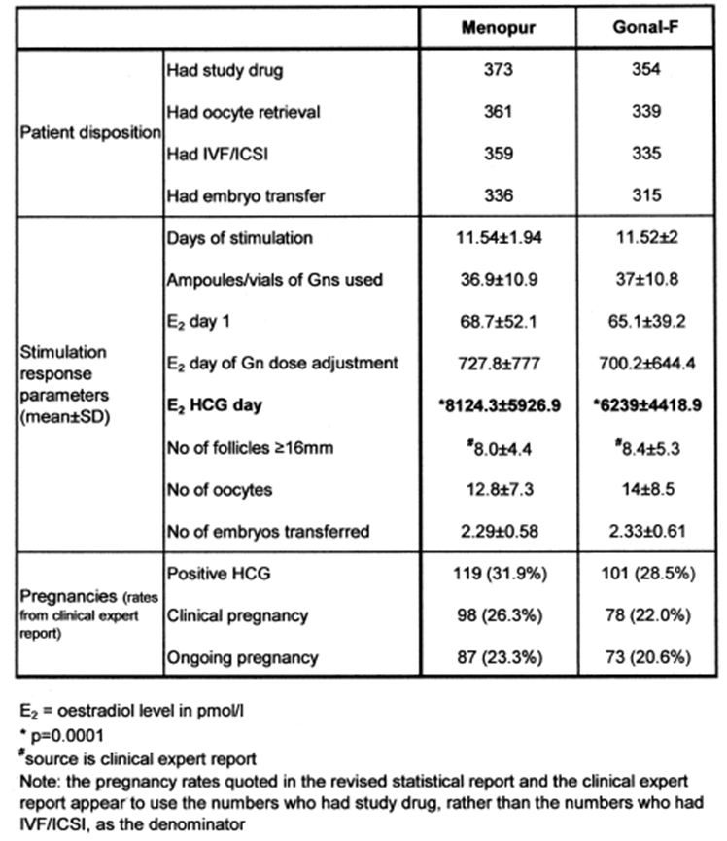
[There were no comments in regard to adverse events related to GnRH agonists used.]
Additional Information Specific to this application:
The evaluator augments this original report with supplementary information pertaining to this application including the claims made by the applicant in regard to DECAPEPTYL.
Studies 7 & 8 used one central laboratory and the same assay (electrochemiluminescence immunoassay, LH Elecsys, Roche) was used, to secure overall consistency in the analysis.
Study 7 was entitled, “An open-label, randomised, parallel group, comparative, phase III trial to study the efficacy and safety of HP Menotrophin versus recombinant FSH administered subcutaneously to female patients in an IVF/ICSI programme”.
Clinical Investigators: Gynaecologists specialised in reproductive medicine in 22 study centres in 6 countries. The study was conducted at 22 reproductive medicine centres in Belgium (1), Germany (6), Israel (6), The Netherlands (2), Switzerland (1) & UK (6).

Study design, objectives, locations and dates
In addition to the above information, the period of the study was 21 May 1999 to 06 November 2000. The study was randomised but open, using a prospective parallel group design.
The primary objective of this trial was to show that HP Menotrophin, administered subcutaneously, was at least as efficient (sic) – in terms of ongoing pregnancy rates – and safe as recombinant FSH in the treatment of females undergoing IVF/ICSI.

Inclusion and exclusion criteria
From the Protocol:
Selected patients were previously untreated. or pre-treated (less than three previous consecutive unsuccessful IVF/ICSI cycles, i.e. not resulting in an ongoing pregnancy) female patients eligible for IVF/ICSI-treatment.
Patients meeting all the inclusion criteria and none of the exclusion criteria were allowed to participate in the trial.
Taking a drop-out rate of 10 % into consideration, the total number of patients to be recruited had to be 720.

Inclusion criteria
The patients had to meet the following inclusion criteria:
- Signed informed consent
- Female patients with infertility period> 1 year, except for proven bilateral tubal occlusion and/or male factor
- Eligible for IVF/ICSI
- A minimum of one menstrual cycle without treatment with fertility modifiers prior to the downregulation cycle
- Pre-menopausal patients aged 18-38 years with regular ovulatory menstrual cycles of 24-36 days and normal hormone levels documented
- Ultrasound prior (within the last 12 months) to or at pre-study examination showing presence of both ovaries, without ev1dence of clinically relevant abnormalities (e.g. PCOS). normal uterus and adnexae.
- Clinically normal baseline parameters for haematology, blood chemistry, urinalysis (dipsticks) within the last 12 months
- Baseline endocrine determinations, all values within the normal limits for the clinical laboratory, within the last 12 months

Exclusion criteria
For assuring that the patients were eligible for participating in the study, the following exclusion criteria were applied and the patient was not allowed to be entered into the trial if any of the following exclusion criteria existed.
- Presence of any clinically relevant systemic disease (e .g. insulin-dependent diabetes mellitus), endocrinological disorders or ovarian cysts which preclude TVF/ICSI procedures
- Contraindications for the use of gonadotrophins or GnRH agonists
- A history of hypersensitivity to any of the constituents of the trial medication or related compounds
- More than three previous consecutive unsuccessful IVF/ICSI cycles (i .e. not resulting in an ongoing pregnancy
- BMI<18.0 and>29.0 kg/m²
- Patient regularly smokes more than 10 cigarettes per day
- A history of alcohol abuse (more than 30 units per week on a regular basis; 1 unit = one glass of wine, one measure of spirits or ½ a pint ~ ¼ litre of beer)
- Current drug abuse (e.g. cannabis abuse)
- Currently breast feeding, pregnant or contraindication to pregnancy
- Diagnosed as a "poor responder" in gonadotrophin-stimulated procedures ("poor response" is defined as the development of less than 3 follicles and/or an overall stimulation period with gonadotrophin of more than 20 days and/or the requirement of more than 6 vials/ampoules of gonadotrophins per day until hCG criteria are met)
- History of severe ovarian hyperstimulation syndrome (OHSS) type III in former hormonal ART-treatment
- Participation in any study of any investigational drug within the last 30 days
- Unable to keep appointments for required trial procedures
- Any other condition or history the investigator considers might increase the risk to the individual or decrease the likelihood of obtaining satisfactory data”.

Study treatments
GnRH Regimens Used: The protocol might not have been strict about this but in practice, amongst those who were evaluable for ongoing pregnancy, the exposure numbers are: triptorelin 0.1mg once daily s.c. n = 113 women; triptorelin monthly depot 3.75mg n = 466 women and other immediate release injections (goserelin, buserelin included) n= 148 women. That is, triptorelin 0.1mg injection comprised a smaller group than the depot dose form.
HP Menotrophin and follitrophin-1 were given as a course of daily subcutaneous injections according to the following dose regimen.
Patients received a fixed dose of 225 IU (3 vials/ampoules) gonadotrophin for 5 days
Depending on the ovarian response (checked by ultrasound and/or oestradiol levels according to the investigator's routine) the dosage was adjusted up or down (</= 450 IU/day </=6 vials/ampoules) until the hCG criteria were met (>/= 3 follicles each with diameter >/= 16 mm and/or oestradiol levels >/= 1000 pmol/follicle >/=16 mm) for a maximum of 20 days, or the investigator withdrew the patient due to poor response.
The maximum duration of gonadotrophin treatment was 20 days.

Efficacy variables and outcomes
The main efficacy variables were:
Efficacy:
Primary endpoint:
Difference (HP Menotrophin - recombinant FSH) in ongoing pregnancy rate> -10%.
Secondary endpoints:
Number of follicles, oocytes retrieved, oocytes fertilised, embryos transferred, biochemical and clinical pregnancies, days of stimulation with gonadotrophins, and vials/ampoules used. Oestradiol levels on the first day of gonadotrophin administration, the day of gonadotrophin dosage adjustment and day of hCG administration (or within a maximum of 48 hours prior to hCG administration). For secondary endpoints no criteria were set.

Randomisation and blinding methods
This was an open-label trial. Patients were randomised for the gonadotrophin they received. Stratification was performed for IVF and ICSI treatment.
Randomisation was achieved by allocation of the next available patient number from the sequence as each patient entered the trial (meets all the eligibility criteria). Copies of the randomisation list were held by the sponsor and the personnel responsible for drug dispensing at each trial centre.

Analysis populations
From the Protocol: Two efficacy analysis populations are defined:
- The Intention-To-Treat (ITT) population: the full analysis set where all patients who were randomised and received study drug are included.
- The Per Protocol (PP) population: patients who are included in the ITI population and do not commit any protocol violations likely to bias the assessment of the primary endpoint.
The primary analysis will be based on the PP population.
The safety results of this trial will be based on all enrolled patients who have received trial medication (follitropin-α or highly purified menotrophin).
Sample size: This study can be distinguished from the Phase 2 studies submitted with this application because it exceeded the sample size requirements for the primary research question.
Number of Patients: (planned & analysed) planned: 660 evaluable patients; analysed: 357 for HP Menotrophin (PP population); 336 for recombinant FSH (PP population).

Statistical methods
In order to achieve at least 80% power in the study, 330 evaluable patients per treatment group are needed, yielding in total 660 evaluable patients.
However, the evaluator points out that the new safety analyses are post hoc.

Participant flow
Study flow is as follows.
Figure 2: Study flow.
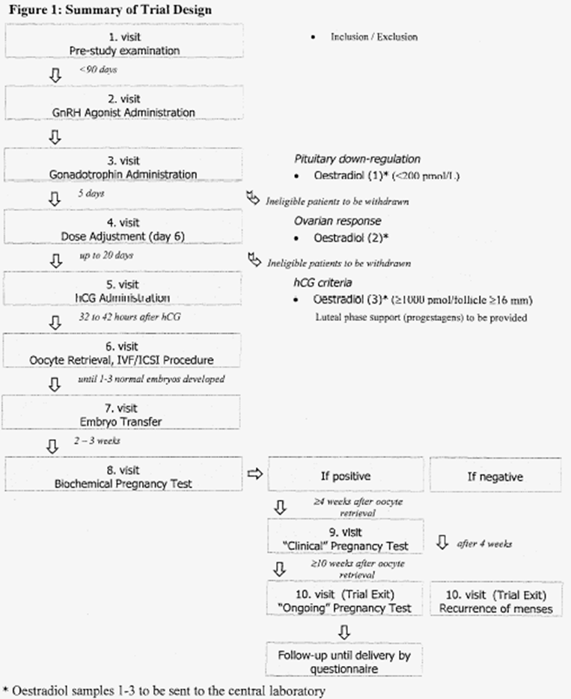
Table 13: Number of patients in the study.
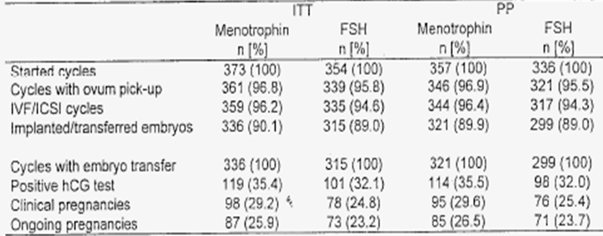
Of the 781 subjects included in MFK/IVF/0399E (5.3.5.1), 54 (7%) withdrew before introduction of study medication (i.e. before starting the stimulation period) and another 76 (10%) after study treatment was initiated, the most common reasons (covering 59 of the 76 subjects) being no oocytes fertilised, risk of OHSS type III, and detection of ovarian cyst.

Major protocol violations/deviations
The evaluator has assumed that the new safety analyses are based on the PP population.

Results for other efficacy outcomes
As noted in the original clinical evaluation report, an analysis was made of depot versus other GnRH agonists “but it was unrevealing”. Further information was generated for this submission and it is reproduced below.
Study 7 does enable post hoc comparisons. The treatment outcome associated with different types of GnRH agonists can be derived from the MFK/IVF/0399E (5.3.5.1) study [Study 7]. The ongoing pregnancy rates are shown in Table 14.
Table 14: Ongoing pregnancy rate by GnRH agonist (MFK/IVF/0399E).
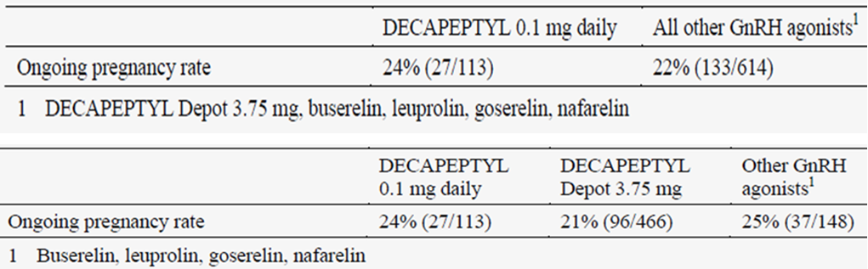
Among the 113 patients who were downregulated with DECAPEPTYL 0.1 mg, the ongoing pregnancy rate was 24% (27/113). Although the MFK/IVF/0399E (5.3.5.1) study was not designed for this investigation, the findings suggest that the ongoing pregnancy rate associated with DECAPEPTYL 0.1 mg SC daily is not different from that observed with other GnRH agonists.
Further evaluation of the data from this study according to type of DECAPEPTYL dose and preparation indicated that there are no major differences in ongoing pregnancy rate between daily and depot administration of DECAPEPTYL. The ongoing pregnancy rate was 21% for patients downregulated with the DECAPEPTYL Depot 3.75 mg and 25% for those who had used other GnRH agonists (daily or depot). This is in line with a systematic review of the available literature indicating that there is no evidence that higher doses such as depot formulations of GnRH agonists significantly reduce pregnancy rates compared to daily administration of GnRH agonists.
As in all studies that used the long midluteal starting protocol, there was no occurrence of premature surge in LH, the primary efficacy parameter in numerous Phase 2 studies, during DECAPEPTYL treatment.

Cross-Study Comparisons:
As remarked by the Clinical expert in his overview:
Caution should be implemented when comparing data across trials, as laboratories and assays differ (except for [Study 7] MFK/IVF/0399E (5.3.5.1) and [Study 8] FE999906 CS003 (5.3.5.4)). A decrease in LH levels is seen over time during treatment with DECAPEPTYL 0.1 mg with the lowest level on the day of hCG administration. At the end of stimulation, mean LH levels ranged from 0.9 to 1.7 IU/L across studies, independent of whether hMG or FSH preparations had been used for ovarian stimulation.
Nonetheless, here is the applicant’s tabulation of mean serum levels of LH (IU/L) in studies with Decapeptyle SC 0.1 mg:
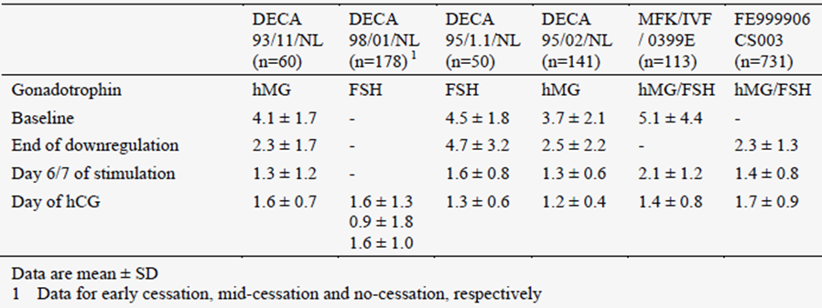
Comment: The four studies with prefix DECA are Phase2 studies that are discussed elsewhere. Looking within each study, mean LH levels were lowered from baseline and stayed so, suggesting a treatment effect. Studies 8 & 9 should have comparable results in terms of laboratory values. However, one critical value is missing from either baseline or “end of downregulation” in each study.

Supportive Efficacy Study 2 - Study 8 [Study FE999906 CS003]
Extract from Clinical Evaluation Report of Submission Number 2009-1335-5:
Study 8 = “Study CS003 is a large randomised, open-label, assessor-blind, parallel group, multicentre superiority study comparing highly purified menotrophin (Menopur) with the recombinant FSH (rFSH) preparation Gonal-F. Gonal-F is an existing product registered in Australia for indications similar to those submitted in this application. The study, conducted in 2004 in 37 European and Israeli centres, bears the acronym MERIT (menotrophin vs recombinant FSH in vitro fertilisation trial), and has been the subject of several publications including one describing the clinical outcome (7). The primary objective of the study was to establish superiority of Menopur compared to Gonal-F with respect to ongoing pregnancy rate in women undergoing IVF following down-regulation with a GnRH agonist in a long controlled ovarian hyperstimulation (COH) protocol. Secondary objectives were to compare the two treatments with respect to a variety of parameters including biochemical and clinical indicators of ovulatory response, and other clinical parameters of efficacy and safety.
The subjects were females, mostly Caucasian, aged 21-37 with subfertility of a type qualifying for IVF treatment and evident for at least 12 months except in the case of proven bilateral tubal disorder. 821 subjects were screened and 731 randomised, 363 to treatment with Menopur and 368 to Gonal-F.
The pituitary down-regulation protocol employed triptorelin acetate administered on a continuous daily basis, 0.1 mg/day SC, starting 5-7 days prior to the next due menstrual period and continuing until the end of gonadotrophin (test or reference product) administration.
The COH protocol specified a starting dose of 225 IU for the first five days after which the dose was adjusted according to the subject’s ovarian follicular response, with dosage adjustments to be changed by 75 IU at intervals of not less than 4 days. The 75 IU presentation was used throughout for both test and reference treatments; note that all doses are multiples of 75 IU. hCG (recombinant chorionic gonadotropin alfa, 250 µg SC, brand Ovitrelle) was given to induce follicular maturation once 3 or more follicles of >17 mm diameter were evident on trans-vaginal ultrasound; oocyte retrieval took place 36+2hr later. Embryo assessment procedures and the remainder of the clinical protocol were consistent with usual ART practice. 1 or 2 embryos of defined quality were transferred on day 3 after oocyte retrieval and progesterone as vaginal gel 90 mg/day was given for luteal support from the day of transfer until confirmation of clinical pregnancy 5-6 weeks after transfer, or a negative hCG pregnancy test 13-15 days after transfer. Follow-up continued until confirmation or otherwise of ongoing pregnancy 10-11 weeks after transfer.
The study protocol specifies collection of information on pregnancy outcome in relation to delivery and neonatal health. This is included in the study report. The protocol also includes the option for the subjects to have subsequent transfer of frozen embryos; this data remained under collection at the time of report and was to be reported subsequently.

Statistical considerations
These are described in the study report. The full statistical plan is in appendix A9 which was not in the package and is "available on request". The primary objective was to show that Menopur was superior to rFSH (Gonal-F) with respect to ongoing pregnancy rate. Testing was based on the likelihood ratio test in a logistic regression analysis, expressed as odds ratios with 95% CI and corresponding p values. The study was powered to detect an odds ratio of 1.67 for Menopur versus Gonal-F, requiring an ongoing pregnancy rate of 32% for Menopur and 22% for Gonal-F with 304 subjects in each group.
Provision was made for non-inferiority testing in the event that superiority was not detected, based on a predefined noninferiority limit of 0.65 for the odds ratio of Menopur versus Gonal-F. The provision to switch from superiority to noninferiority is, as stated in the report, compliant with the requirements of the relevant CPMP guidance document, "Points to Consider" CPMP/EWP/482/99 which is included as a reference. The discussion of the study report does not provide justification for the noninferiority limit of 0.65 which could be regarded as rather generous. It is difficult to criticise this without access to the full statistical plan, which should be submitted for review as requested. Nevertheless, with the proviso that appropriate noninferiority margins should always be established prospectively, this is not seen as an issue with regard to the trial outcome as the data would have satisfied a much more rigorous margin.

Results
The results for ongoing pregnancy rate and related outcomes are shown. Details of the statistical analysis for the principal efficacy parameter in the ITT population are shown in the following table:
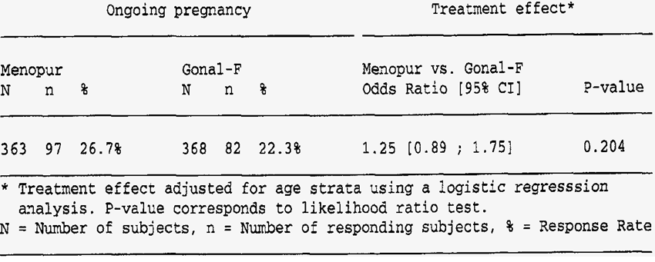
There is a trend towards an improved ongoing pregnancy rate in the Menopur versus rFSH subjects (27% vs 22%), but this does not achieve statistical significance to show superiority as outlined above. Criteria for noninferiority were readily met, as the lower bound of the 95% CI (0.89) is well above the prespecified noninferiority limit of 0.65.
A similar analysis for the per protocol (PP) population showed very similar results. Comparison of outcomes in younger (aged <35 years) - who represent the majority - again showed a trend in favour of Menopur which came closer to achieving statistical significance (p= 0.82)
The number of embryos transferred was the same for both groups (1.7+0.5).
In subjects treated with Menopur, FSH concentrations were statistically significantly higher at all time points. There was no difference in LH concentrations between the treatment groups, consistent with the failure to demonstrate LH by immunoassay in subjects receiving Menopur in pharmacokinetic study CS05. Oestradiol levels were higher in the reference treatment group on day 6 but higher in the Menopur group at the end of stimulation and at the time of oocyte retrieval. Levels of androgenic hormones were higher in the Menopur treated group. Intrafollicular levels of FSH, LH, hCG and oestradiol were statistically significantly higher in Menopur treated subjects. Levels of other hormones including inhibin A and B, IGF-I, VEGF and hydrocortisone showed a variable pattern of no apparent significance.
Subjects treated with Menopur, by comparison with those on the reference treatment, required a higher overall dose (2508 versus 2385 IU), a higher daily dose (238 versus 233 IU) and a longer duration of treatment (10.4 to 10.1 days). Somewhat surprisingly, these changes which are in the 2-5% range, achieve statistical significance but the quantum of difference has no real impact and would be particularly unimportant if on further evaluation the possible improvements in pregnancy outcome turned out to be a real finding.”
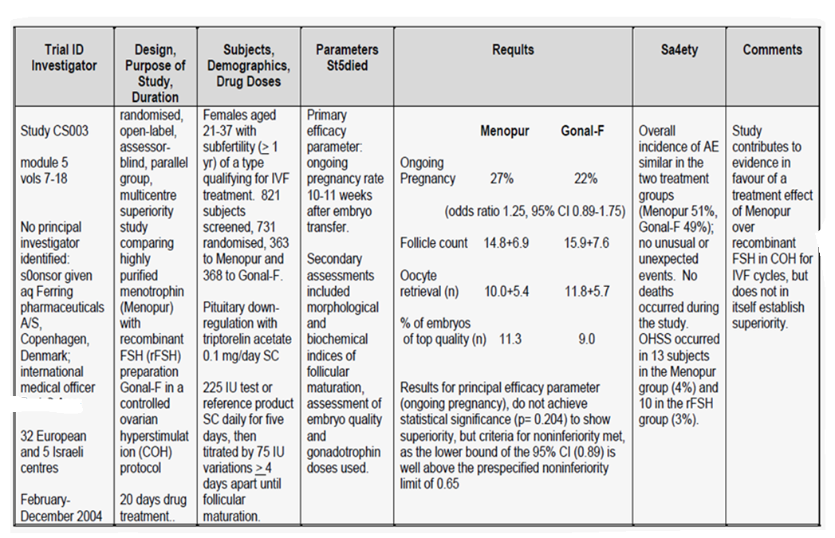
Additional information specific to this application:
Triptorelin 0.1mg s.c. daily was the only GnRH agonist used in this study.
A total of 821 subjects underwent screening, of whom 781 subjects started downregulation with triptorelin (DECAPEPTYL) 0.1 mg daily. Among the 781 subjects who started treatment with DECAPEPTYL, downregulation was not confirmed for 48 subjects (6%) (46 screening failures and 2 randomised despite not meeting the downregulation criteria).

Efficacy variables and outcomes
As in all studies that used the long midluteal starting protocol, there was no occurrence of premature surge in LH, the primary efficacy parameter, during DECAPEPTYL treatment.
At the end of downregulation, the large majority of trial subjects had low LH levels, bearing in mind that these results are only comparable with those obtained from Study 7 which used the same laboratory.
Table 15: Endocrine parameters at stimulation day 1: ITT analysis set.
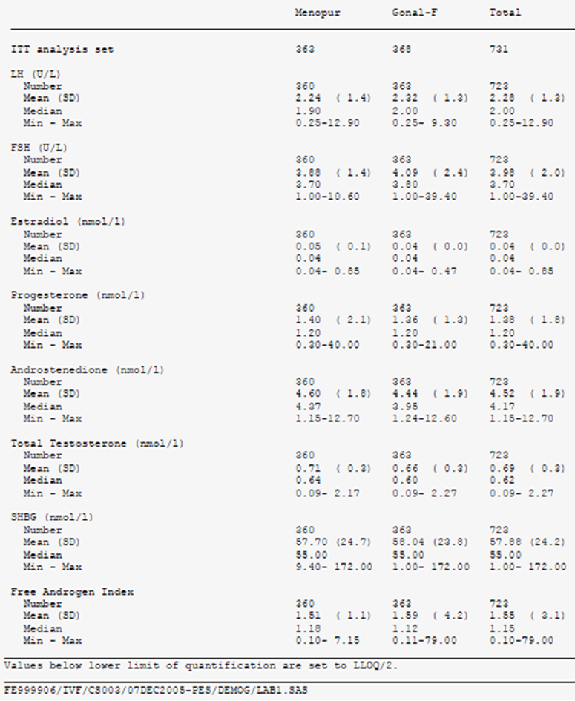
Downregulation was considered to have occurred in 100% of trial subjects, as reported in Table 16.
Table 16: GnRH agonist administration and confirmation of downregulation: ITT analysis set.
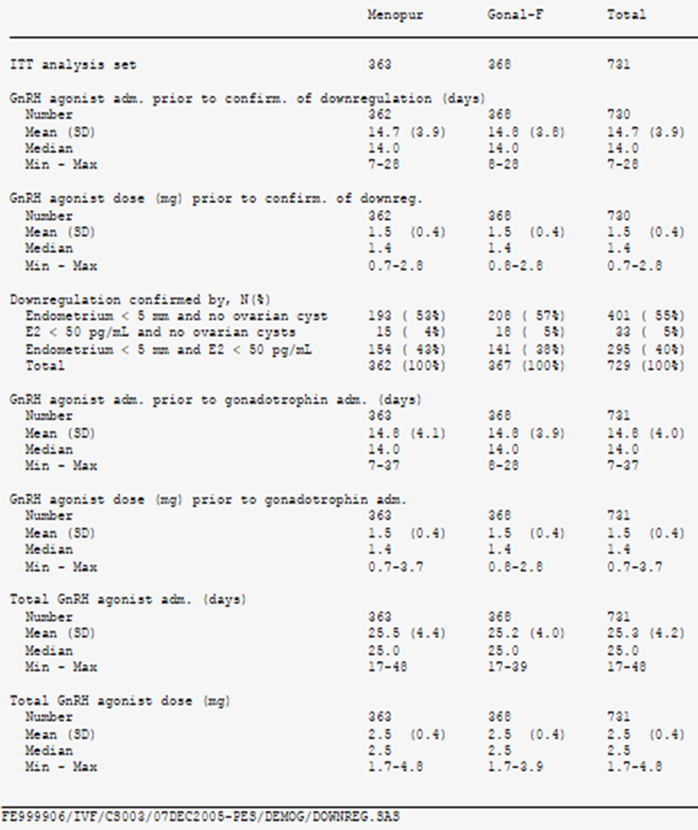
However, this claim of adequate down-regulation is contradicted in the efficacy summary:
In [Study 8] study FE999906 CS003 (5.3.5.4) even at the dose of 0.1 mg daily according to midluteal starting long protocol, a total of 48 (6%) of the 781 subjects who received DECAPEPTYL did not meet one of the specified criteria for adequate down-regulation. This may suggest that a minimum dose and/or duration of treatment with DECAPEPTYL is necessary to be sure of suppression of LH surges.
The evaluator is inclined to accept the evidence in the original report.
A post hoc analysis of the interaction of duration of treatment with triptorelin and the outcome of pregnancy rate:
Table 17: Ongoing pregnancy rate by duration of Decapeptyl 0.1 mg SC treatment before start of ovarian stimulation in Study FE999906 CS003.
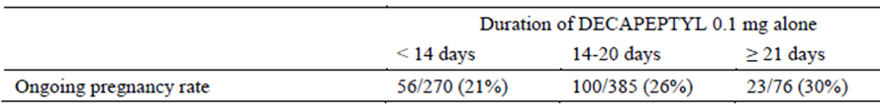
The trend would need a larger, more specific study to be tested. It is of interest that one Phase 2 study compared duration of triptorelin use with one LH surge in the mid-length protocol.
See also “Cross Study Comparisons” in the discussion of Study 7.

Analyses performed across trials (pooled & meta analyses)
No pooled efficacy analyses were undertaken; it would not have been appropriate to do them.

Evaluator’s conclusions on efficacy
The evidence presented suggests that:
- Triptorelin can effectively prevent premature LH surges in ART. The optimal dose is not known but triptorelin 0.1 mg SC daily is effective.
- The “long” protocol has the greatest amount of data in this submission and it appears to be successful if requiring more injections of triptorelin and gonadotrophins.
However, there are inadequate data to confirm either of these suggestions as dose ranging was inadequate and no Phase III study to compare triptorelin to a placebo, a GnRH agonist or a GnRH antagonist was submitted. This is a reasonable expectation in 2014. Ganirelix and nafarelin are both registered in Australia and either would have been an appropriate active comparator in a randomised, controlled trial of non inferiority design.

Clinical safety

Studies providing evaluable safety data
The following studies provided evaluable safety data:
Pivotal efficacy studies
Not applicable – none was submitted.
Pivotal studies that assessed safety as a primary outcome
Not applicable – none was submitted.
Dose-response and non-pivotal efficacy studies
The dose-response/pharmacodynamic Phase 2 studies provided safety data, but are not regarded as reliable for regulatory purposes due to the low rate of adverse event reporting. This is demonstrated in the tabulation from the Safety summary.
Table 18: Overall summary of TEAEs: IVF/ICSI patients receiving 0.1 mg Decapeptyl daily in studies DECA 93/12/NL, DECA 93/11/NL, DECA 95/1.1/NL, DECA 95/02/NL and DECA 98/01/NL.
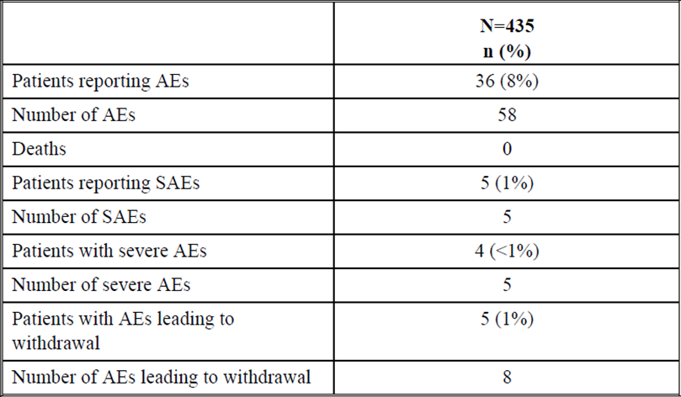
The lack of reports of expected common adverse events (local injection site reactions, oestrogen deficiency symptoms, common intercurrent illnesses) is striking.
Table 19: TEAEs reported by at least 1% of the IVF/ICSI patients receiving 0.1 mg Decapeptyl daily in studies DECA 93/12/NL, DECA 93/11/NL, DECA 95/1.1/NL, DECA 95/02/NL and DECA 98/01/NL.
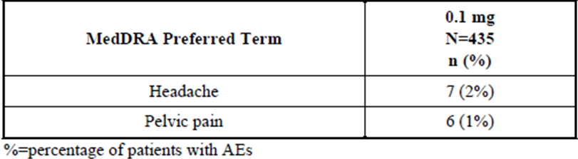
The non-pivotal efficacy studies provided safety data, as follows:
Study 7 - MFK/IVF/0399E (5.3.5.1) provided data on safety of various GnRH agonists that were used during the study. As in Study 8, the applicant was able to extract the safety data from the downregulation phases of these studies.
First, the original evaluation report findings.
Extracts from Clinical Evaluation Report of 2009-1335-5
[No specific comments were made on the interaction of GnRH agonist and safety. This is not surprising, as triptorelin was used in both study arms.]
“9. Safety/Adverse effects
All treatment programs involving the administration of gonadotrophins for female infertility carry the expectation that there will be an incidence of adverse effects attributable to the supraphysiological doses of hormones used. In particular, an incidence of ovarian hyperstimulation syndrome (OHSS) can be anticipated despite the reduction in the frequency of its occurrence with modern treatment protocols. The focus of safety assessment in this evaluation will therefore be not so much the observation of whether OHSS and related adverse effects (AE) occur, but rather the frequency of these AE in the test versus reference populations of the included data and the need to demonstrate that the proposed new treatment (Menopur) does not carry an increased risk in this regard.”
Table 20: Listing of severe AEs in Study MKF/IVF/0399E.
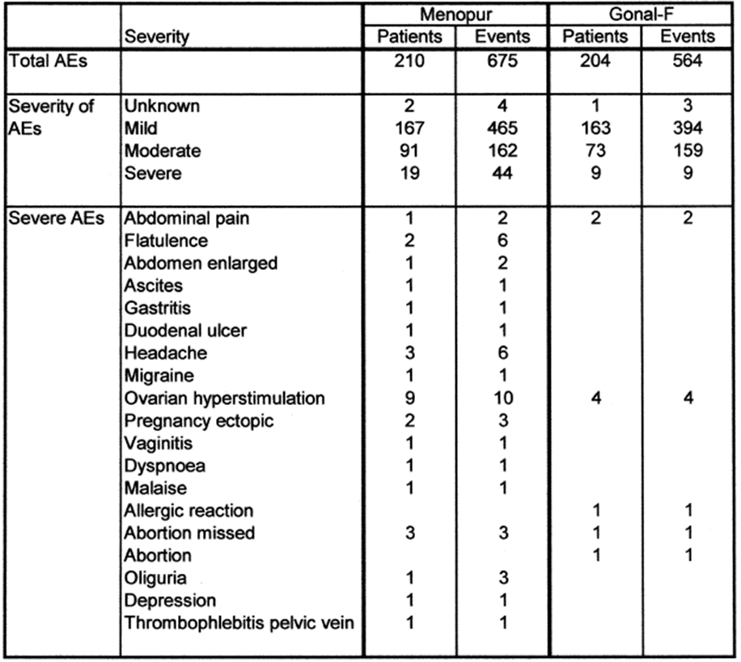
Table 21: Severe AEs in Study MKF/IVF/0399E.
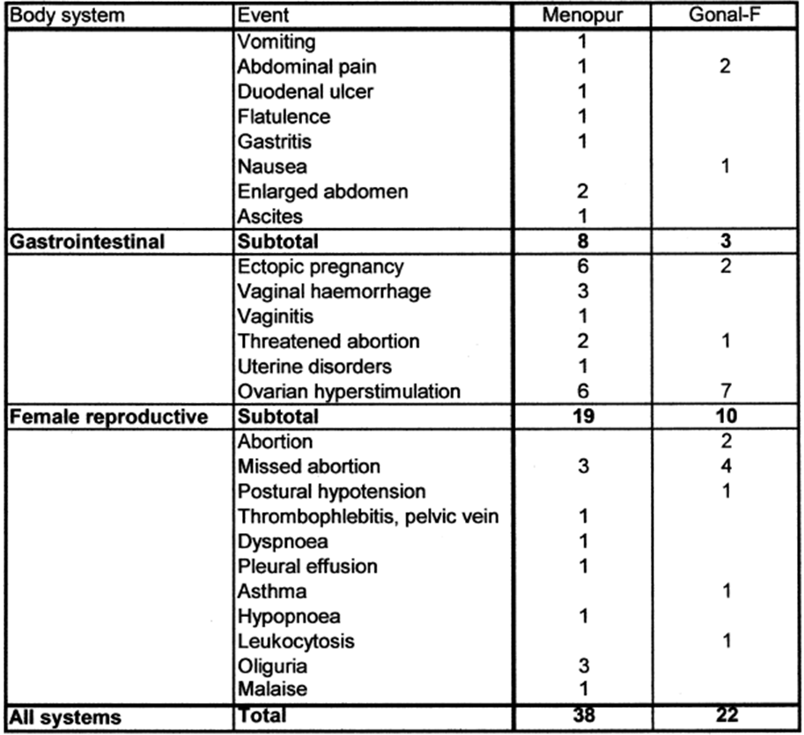
The Study’s protocol had provided for safety outcomes to be reported:
“Frequency and severity of reported Adverse Events, abortion and miscarriage rates, OHSS type II and type III.”
There were no discontinuations due to adverse events during the downregulation period in the study [Study 7].
The clinical expert reported on analyses by cycle “For studies with MENOPUR as the investigational medicinal product, adverse events with onset prior to stimulation were reported in 57% of the patients treated with DECAPEPTYL 0.1 mg in [Study 7]. The most frequently reported adverse events were headache (27%), injection site inflammation (12%), abdominal pain (9%), dysmenorrhea (6%), nausea (5%), injection site pain (4%), dizziness (4%), upper respiratory tract infection (4%), flushing / hot flushes (4% / 2%), vomiting (3%), fatigue (3%) and back pain (3%).”
“Adverse events following the start of gonadotrophin treatment occurred in 61% of the patients exposed to DECAPEPTYL 0.1 mg in [Study 7]. The most frequently reported adverse events were headache (27%), abdominal pain (15%), nausea (10%), injection site inflammation (10%), injection site pain (7%), dizziness (5%), upper respiratory tract infection (4%), fatigue (4%), injection site bruising (3%), injection site reaction (3%), influenza-like symptoms (3%), pharyngitis (3%), back pain (3%) and post-operative pain (3%).” described as “local allergic symptoms at the injection site of DECAPEPTYL”.
The Safety analysis has a legible tabulation of the pattern of adverse Events:
Table 22: Overall summary of TEAEs with Study MKF/IVF/0399E (IVF/ICSI patients).
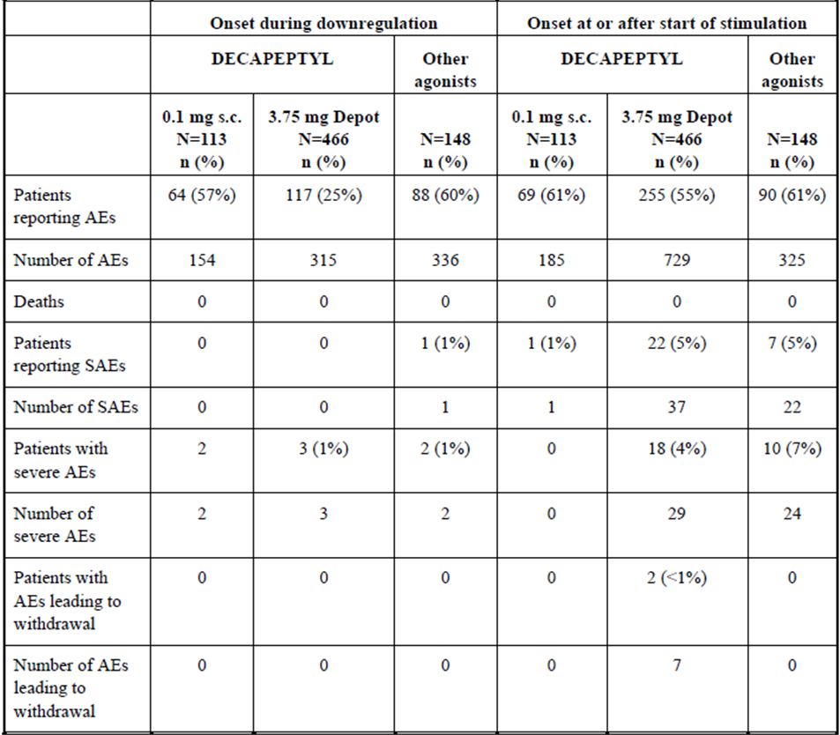
Evaluator’s Comment: This is the only study that appears to have reasonable rates of adverse event reporting. The comparison with Study 8, a much larger study as far as the use of triptorelin 0.1mg s.c. daily was concerned, is striking. If this application is approved, then only Study 7 should be used to suggest which events are likely to be common or very common.
Relative Safety within Study 7
The clinical expert reported on analyses by GnRH agonist used:
“A comparison of the adverse event profile with other GnRH agonists can be derived from the MFK/IVF/0399E (5.3.5.1) study, although it was not designed for this purpose. The overall incidence of adverse events prior to stimulation in [Study 7] was similar in the subgroups treated with DECAPEPTYL 0.1 mg (57%) and other GnRH agonists (60%). On the other hand, the incidence of adverse effects on DECAPEPTYL 0.1 mg daily prior to start of stimulation was approximately two times higher than that for DECAPEPTYL Depot 3.75 mg (25%). This is partly due to frequent injections in the daily treatment with higher risk of encountering at least one occasion of injection site adverse events and higher frequency of headaches. The overall incidence of adverse events with onset following stimulation was similar in the three subgroups of patients: 61% with DECAPEPTYL 0.1 mg daily, 55% with DECAPEPTYL Depot 3.75 mg, and 61% with other GnRH agonists.”
Evaluator’s Comment: The benefits to the patient of a single depot injection go beyond local tolerability to include reduction of the need to self-inject.
OHSS
No cases of OHSS were found in Study 7 in connection with the use of Decapeptyl 0.1 mg daily.
Table 23: OHSS.
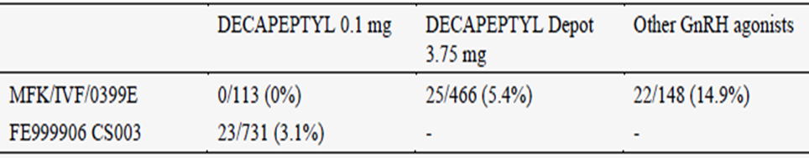
There is no obvious biological reason for this, so the evaluator assumes that it is due to chance. The comparison with Study 8 (FE999906CS003) is affected by a generally lower reporting rate in that study.
Study 8 - FE999906 CS003 provided data on safety similar to Study 7 except that triptorelin was the only GnRH agonist used.
The original study report included hundreds of analyses, presented in tabular form and data listings, but specific analyses on adverse events into pre- and post-gonadotrophin exposure were a feature.
Safety
Extract from clinical evaluation report of submission number 2009-1335-5:
“The results of the safety analysis of this study are discussed. The overall incidence of adverse events (AE) was similar in the two treatment groups (51%, 49%). There were no unusual or unexpected events, and no deaths occurred during the study. Ovarian Hyperstimulation syndrome (OHSS) occurred in 13 subjects in the Menopur group (4%) and 10 in the rFSH group (3%). Of these, 8 cases in each group were in the moderate/severe category. There was no difference evident between the groups in the timing of onset of these cases.”
“9. Safety/Adverse effects
All treatment programs involving the administration of gonadotrophins for female infertility carry the expectation that there will be an incidence of adverse effects attributable to the supraphysiological doses of hormones used. In particular, an incidence of ovarian hyperstimulation syndrome (OHSS) can be anticipated despite the reduction in the frequency of its occurrence with modern treatment protocols. The focus of safety assessment in this evaluation will therefore be not so much the observation of whether OHSS and related adverse effects (AE) occur, but rather the frequency of these AE in the test versus reference populations of the included data and the need to demonstrate that the proposed new treatment (Menopur) does not carry an increased risk in this regard.”
Evaluator’s comment: the study supports the adequacy of triptorelin to achieve downregulation before the use of gonadotrophins in ART. The study is not adequate to define quantitatively the spectrum of very common and common adverse events as it is so obviously insensitive. The failure to include the report of hypersensitivity in the main body of the report is also of concern.”
New Information with this submission:
The clinical expert report includes some false reasoning about safety:
Pharmacological class-related events could also occur during treatment with DECAPEPTYL 0.1 mg, but there is no evidence to suggest that the incidence of these events for DECAPEPTYL 0.1 mg should exceed that reported for other similar GnRH agonists.
That is, it is not possible to argue from a lack of evidence. Study 7 provides the only opportunity to make these comparisons.
There was one discontinuation due to adverse event in the downregulation period in Study 8.
Adverse Events: Study 8
In Study 8 adverse events with onset prior to gonadotrophin treatment were reported by 12% of the patients, with headache (4%) and dysmenorrhea (3%) being the most frequent. It is apparent that the frequency of adverse events during the downregulation prior to stimulation is substantially higher in [Study 7] than in [Study 8]. A possible reason for the difference may be that patients were randomised at an earlier stage (randomisation prior to start of downregulation) in [Study 7] compared to [Study 8]) (randomisation after downregulation confirmed), and thus adverse events during this phase could have been more actively inquired by the investigator.” [M2.5 p. 50/71] “In [Study 8], 50% of the patients reported adverse events after start of ovarian stimulation with the most common being vaginal haemorrhage (24%), spontaneous abortion (7%), pelvic pain (6%), headache (5%), post-procedural pain (4%), OHSS (3%), nausea (3%), abdominal distension (2%) and abortion missed (2%). These adverse events have to be considered within the context of ART procedures and concomitant administration of gonadotrophins.
Evaluator’s Comment: There is no obvious explanation of the differential reporting rates of AEs but it is outstandingly obvious that the rate of reporting from Studies 1-6 is low and is not credible.
This informative tabulation of the pattern of Adverse Events was included.
Table 24: Overall summary of TEAEs with Decapeptyl 0.1 mg in Study FE999906 CS003 (IVF/ICSI patients).
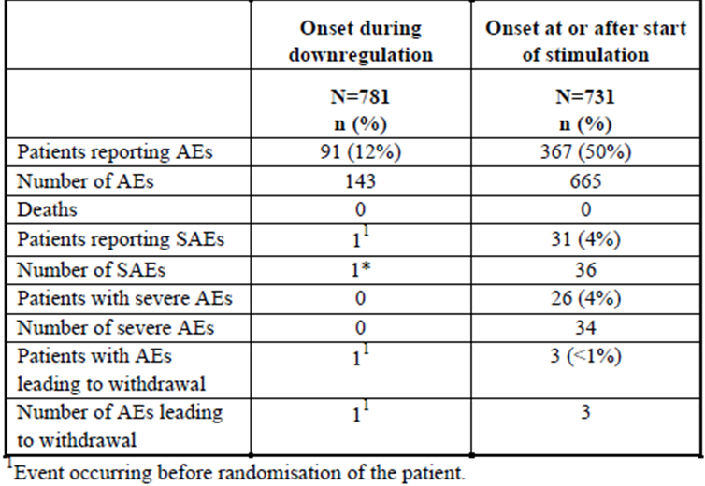
Common adverse events are listed. The adverse events cover the period from randomisation to the end of study thus including downregulation with triptorelin, the duration of gonadotrophin treatment and the last study visit.
Table 25: Frequent TEAEs (>1%).
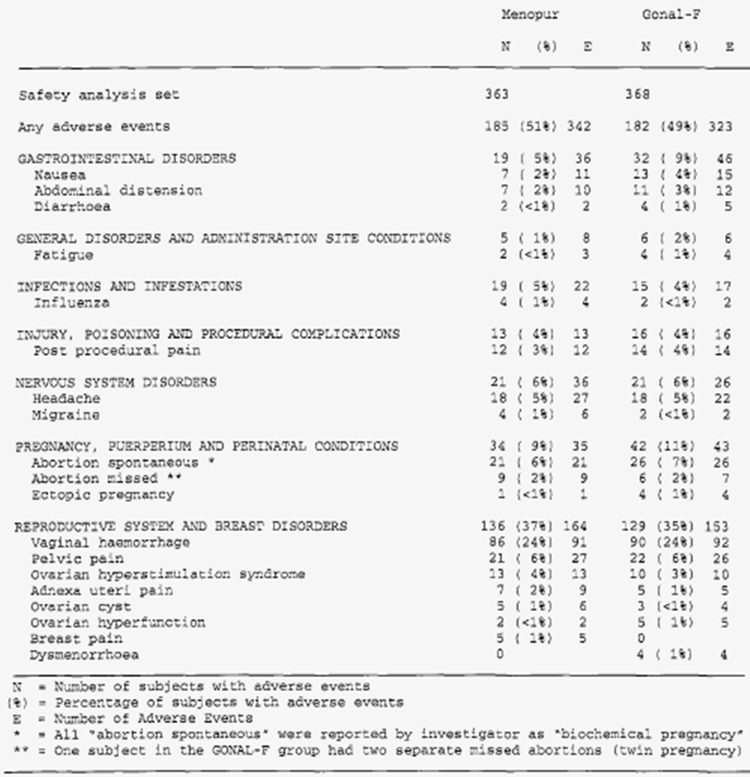
Comment: It is notable, in the above table, that injection site reactions throughout the whole study are subsumed within the term “General Disorders and Administration site Conditions”. Taking the numbers of reports of fatigue from the “general” category, administration site reactions occurred in at most three patients of 363 who received Menopur HP and at most two patients of 368 who received Gonal-F.
This is reasoning supported by the report, an extract of which is reproduced below.
Table 26: Pre treatment AEs (after start of GnRH agonist).
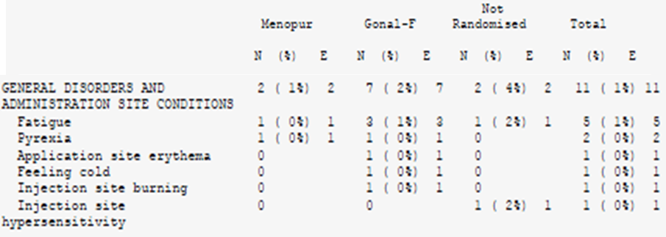
The following is a tabulation of Adverse Events reported in the downregulation phase, confirming the low incidence of injection site reactions.
Table 27: Pre treatment AEs (after start of GnRH agonist).
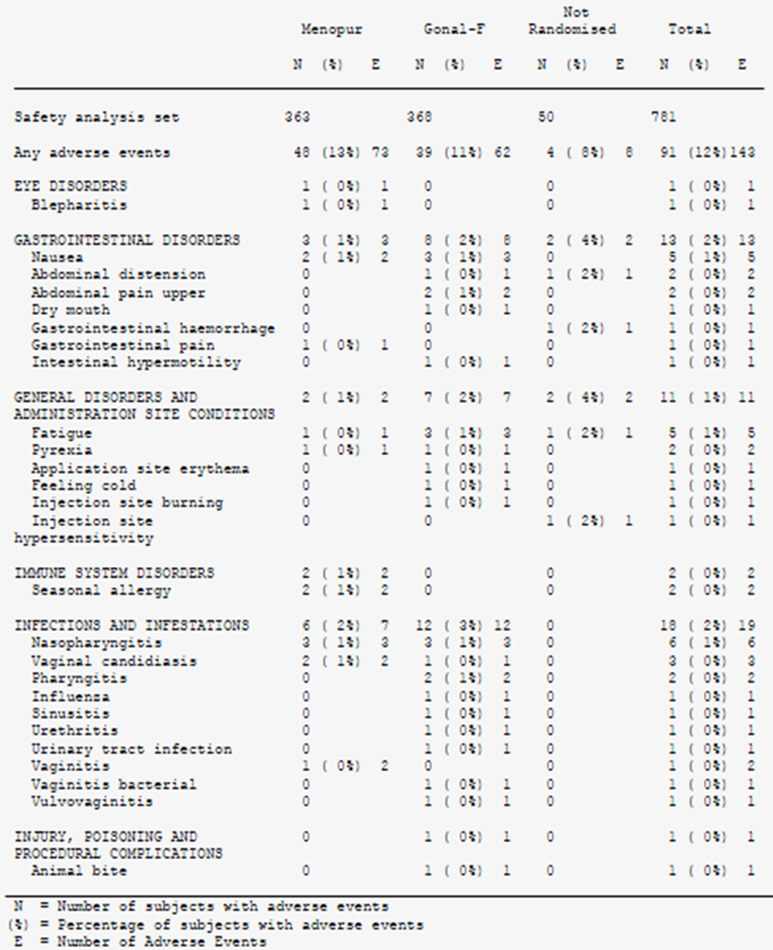
The only reasonable conclusion is that the trial was quite insensitive at capturing injection site disorders (e.g. pain/stinging, bleeding, haematoma). There was one case of hypersensitivity associated with injection of triptorelin in the downregulation phase. The evaluator was not able to find the case narrative in the study report.
It is also of note that oestrogen deficiency symptoms are not common.
See Study 7 above for case numbers of OHSS in Study 8.
Conclusion: Study 8 is less useful than Study 7 to define common adverse events in quantitative terms. Nonetheless, it is an order of magnitude more sensitive than the Phase 2 studies.

Pivotal studies that assessed safety as a primary outcome
Not applicable

Patient exposure
The applicant mentions:
In the clinical programme for the proposed indication, five different dosages were evaluated and safety data are available for all. A total of 2167 women were included in this safety database, of whom DECAPEPTYL 0.1 mg daily was administered to 1337 women participating in 8 completed studies.
However, the evaluator has reservations about the usefulness of these facts. The Phase 2 studies reported very few adverse events. The best safety data come from Study 7 & perhaps Study 8. These studies used the dose and “long” protocol that is proposed for marketing.
Exposure:
The number of patients included in each study and the number of patients for whom safety data are available are shown. It also tabulates exclusively those patients exposed to DECAPEPTYL 0.1 mg.
In the Table, Study MFK/IVF/0399E I is Study 7 and Study FE9999CS003 is Study 8. All other studies are Phase 2 Studies that are described in detail. The evaluator has reservations about pooling results from these studies but it is correct to regard the Phase 2 Studies in a different light from Studies 7 & 8.
It is striking that routine laboratory tests were not a usual feature of the screening and follow-up phases of the studies:
Table 28: Overview of safety assessments in all completed clinical studies.
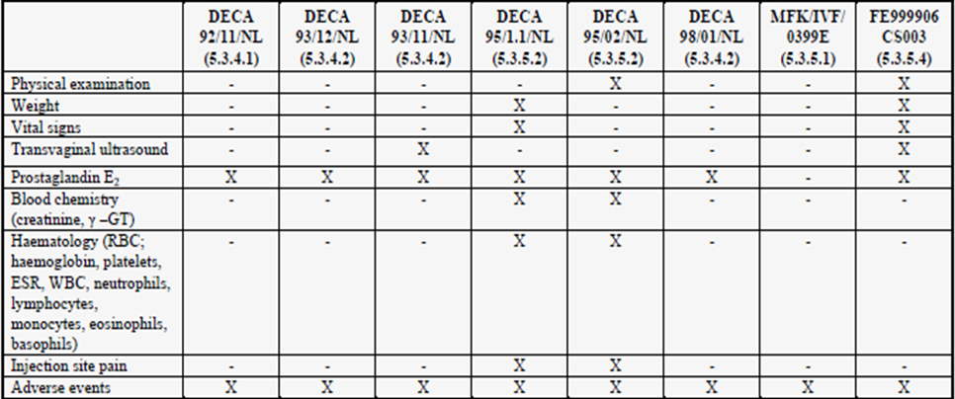
Table 29: Overview of safety population from each study.
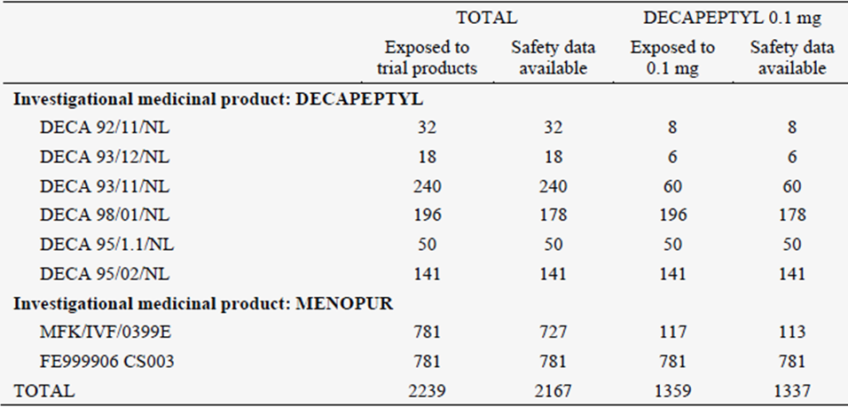
Safety data are available for 1337 (98%) women exposed to DECAPEPTYL 0.1 mg. The 22 patients for whom there is no safety information refer to 18 patients in [Study 4] DECA 98/01/NL (5.3.4.2) who started downregulation but did not proceed to randomisation to one of the cessation schemes and 4 patients in [Study 7] MFK/IVF/0399E (5.3.5.1) who started downregulation but did not initiate ovarian stimulation.
Of note, most women will not be exposed for more than two treatment cycles, so time dependent adverse effects beyond those seen in Studies 7 & 8 are not expected.

Adverse events

All adverse events (irrespective of relationship to study treatment)

Pivotal studies
Not Applicable.

Other studies
As described:
A higher frequency of adverse events were noted in the two MENOPUR studies [Studies 7 & 8), possibly explained by the fact that they were conducted more recently than the studies in the DECAPEPTYL development program.
This is less than plausible. Sensitivity improved with better practices and data gathering and data management. One is left to doubt the adequacy of the more specific data from the non-Menopur studies, i.e. Studies2-6 as well as to question why there were proportionately fewer AEs in Study 8 than in Study 7.
For the two studies in which DECAPEPTYL 0.1 mg was used as concomitant medication and the investigational medicinal product was MENOPUR, there were no discontinuations due to adverse events during the downregulation period in the MFK/IVF/0399E (5.3.5.1) study [Study 7], while there was one discontinuation due to adverse event in the downregulation period in FE999906 CS003 (5.3.5.4) [Study 8] described as local allergic symptoms at the injection site of DECAPEPTYL.

Treatment-related adverse events (adverse drug reactions)

Pivotal studies
Not applicable.

Other studies
Study 7 provided the opportunity to compare adverse events across three treatment arms and it reported proportionately more adverse events than all of the other studies. The evaluator considers its results to be more likely to reflect adequate sensitivity of data capture and good data management.
The following table is from the safety summary – it is useful that the reports are separated into downregulation and stimulation (with gonadotrophins phases).
Table 30: Overall summary of TEAEs within Study MFK/IVF/0399E.
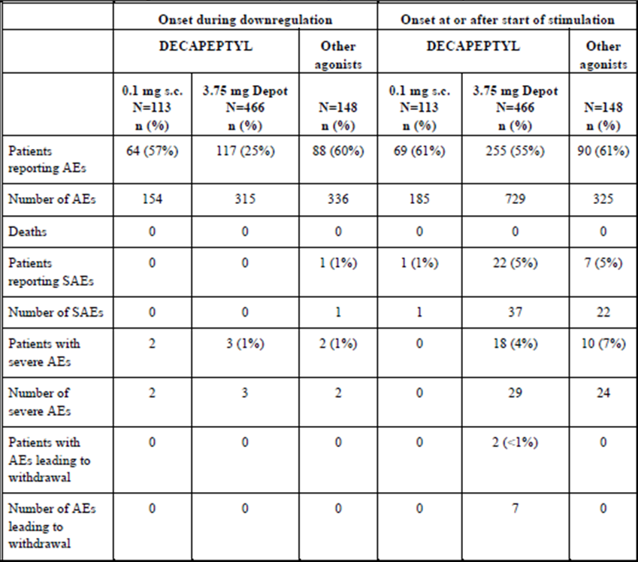
It is striking that Study 8 reported proportionately fewer adverse events.
Table 31: Overall summary of TEAEs with Decapeptyl 0.1 mg in Study FE999906 CS003 (IVF/ICSI patients).
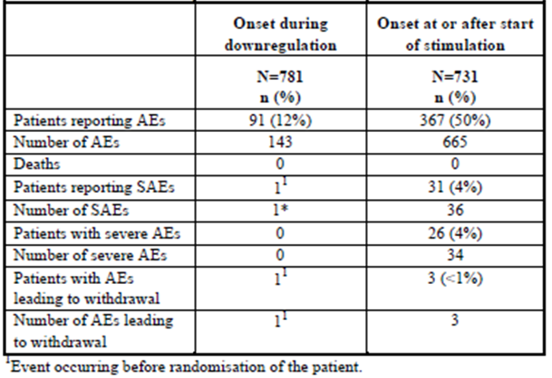
Common adverse events are from Studies 7 & 8 are tabulated below.
Table 32: TEAEs reported by at least 1% of the IVF/ICSI patients receiving Decapeptyl 0.1 mg in Studies MFK/IVF/0399E and FE999906 CS003.
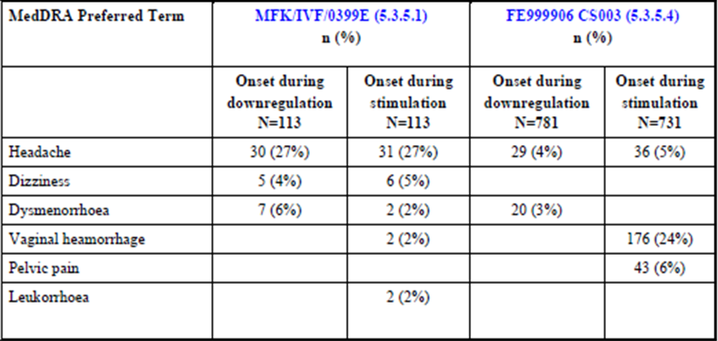
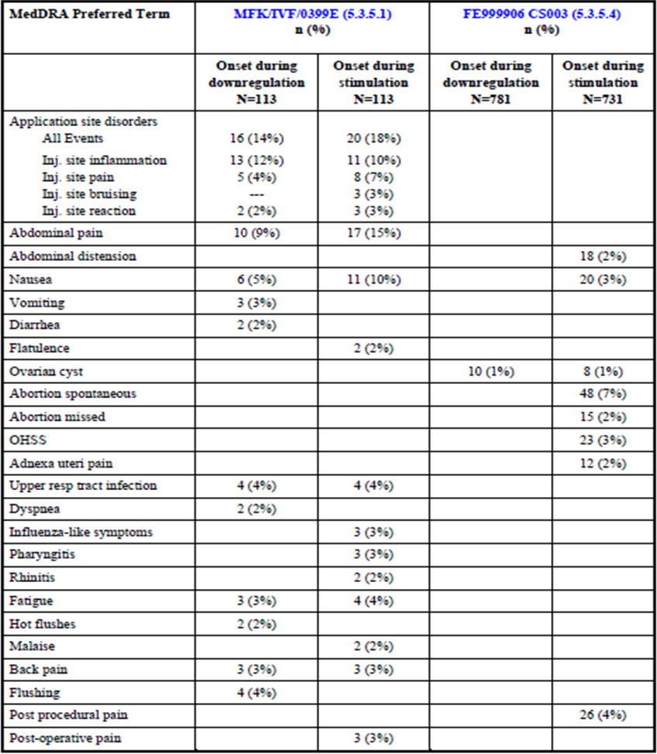
No unexpected adverse events occurred.

Deaths and other serious adverse events

Pivotal studies
Not applicable.

Other studies
No deaths occurred in any of the submitted studies.

Discontinuation due to adverse events

Pivotal studies
Not applicable.

Other studies
In the Pharmacology studies, few adverse events were reported. One withdrawal ensued.
Table 33: Serious AEs with Decapeptyl 0.1 mg – all completed clinical studies.
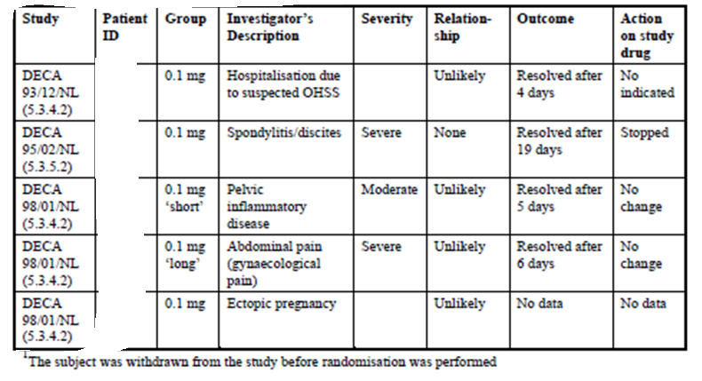
As noted, one withdrawal occurred from Study 8 and none in Study 7.
It can therefore be said that withdrawals due to adverse events were uncommon. Suspected Grade I OHSS is likely to be related to the gonadotrophins.

Laboratory tests

Liver function

Pivotal studies
Not applicable.

Other studies
Not done apart from gamma-GT in two studies. There was nothing of note.

Kidney function

Pivotal studies
Not applicable.

Other studies
Not done.

Other clinical chemistry

Pivotal studies
Not applicable.

Other studies
Most studies did not include these investigations.

Haematology

Pivotal studies
Not applicable.

Other studies
Most studies did not include these investigations. A few cases of incipient anaemia were noted.

Electrocardiograph

Pivotal studies
Not applicable.

Other studies
Not done.

Vital signs

Pivotal studies
Not applicable.

Other studies
Not reported in most studies.

Post-marketing experience
According to the latest PSUR, six serious listed cases have been reported following use of Decapeptyl daily in females of reproductive age, two of them of hypersensitive reactions and four concerning ovarian hyperstimulation syndrome. Five of the cases were reported on a spontaneous basis and one from a clinical trial. Among the spontaneously reported cases, four occurred during infertility therapy, and one during treatment of endometriosis.
Serious unlisted AEs included:
- Tachycardia, bundle branch block in a subject who was also treated with maprotilin for depression;
- Down syndrome infant born to a subject; generalised oedema and pulmonary oedema in a subject who also had been prescribed Valette;
- Therapeutic inefficacy in a subject treated with Decapeptyl 0.1 mg/day SC from 12 August 2000 to 30 August 2000 for infertility;
- Myalgia, paraesthesia and asthenia in a subject was treated with 0.5 mg Decapeptyl (SC once a day) from 21 February until 24 February 2003, followed by 0.1 mg Decapeptyl (same administration and dose interval) from 25 February until 18 March 2003 for in vitro fertilisation treatment, hemiparesis, cerebellar syndrome, weight decreased a subject who received SC Decapeptyl 0.1 mg daily for 1 week and IM follitropin alfa 450 IU daily for infertility (exact treatment dates not reported). During the treatment, the patient developed transitory equilibrium disorder with hemiparesis on the left side; ectopic pregnancy in a subject treated with Decapeptyl daily 0.1 mg, from 31 October 1995 till 20 November 1995 for infertility; and
- Chest pain (not otherwise described) in a subject, experienced chest pain approximately one year after having taken one dose of Decapeptyl 3.75 mg one month depot formulation and approximately ten months following treatment with Decapeptyl daily 0.1 mg for the indication uterine fibroid.
A total of 17 non serious events were reported in females of reproductive age, all of them on a spontaneous basis (Table 34). Nine cases were assessed as non listed and eight as a listed. Decapeptyl daily 0.1 mg and 0.5 mg were used in 11 and five patients, respectively, while in one case the exact strength was not known.
Table 34: Non serious adverse drug reactions.
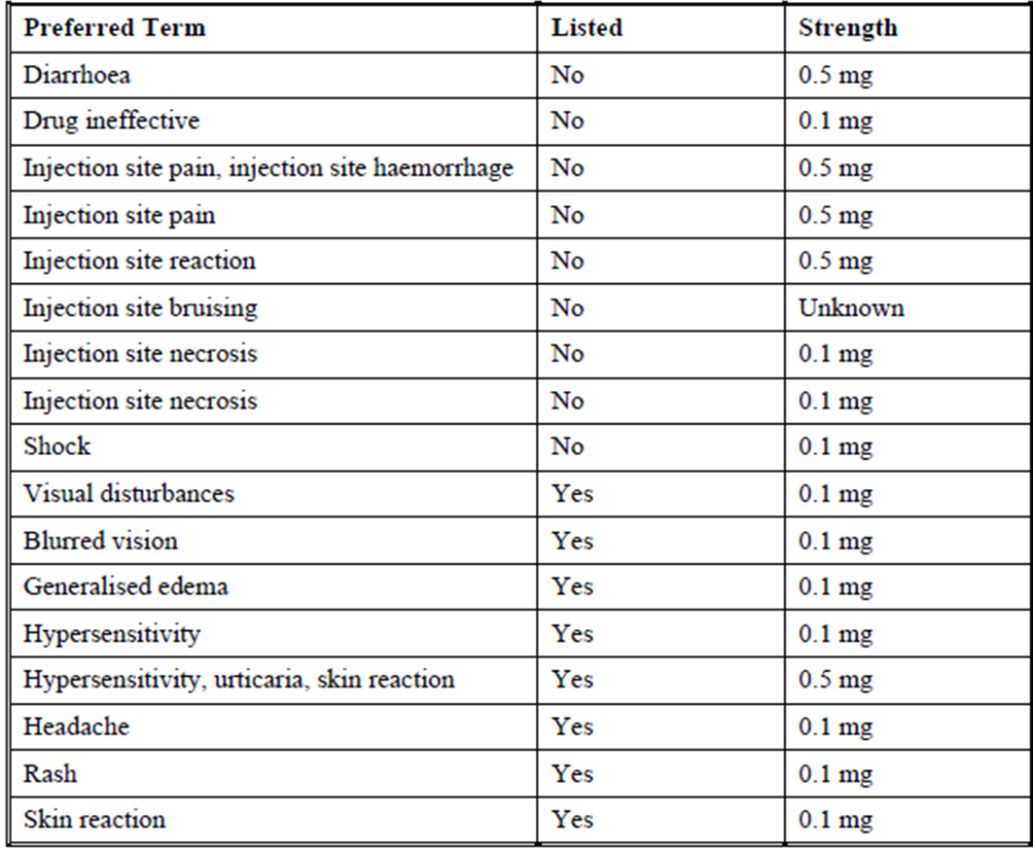

Safety issues with the potential for major regulatory impact
None noted.

Unwanted immunological events
There was one case of hypersensitivity (including urticaria) after a dose of triptorelin 0.5mg i.e. in one of the Pharmacology studies. There was another case in Study 8, after a dose of 0.1mg. The cases were briefly discussed in the overview but the evaluator could not locate the case narratives.

Other safety issues

OHSS
OHHS is an event of interest. It is not attributable to the pituitary downregulation that is induced by triptorelin but there might be interactions with the dose or duration of triptorelin.
The incidence of OHSS in the two open MENOPUR studies (7 & 8 respectively) is displayed.
Table 35: OHSS.
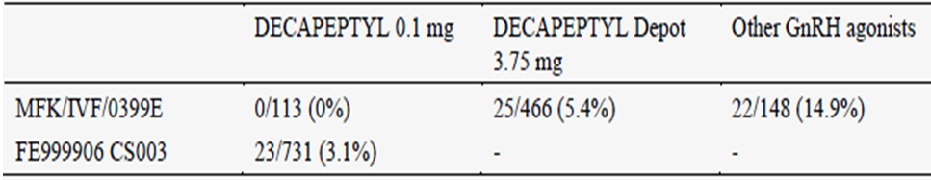
The rate is rather low in Study 8 and the absence of reports with the proposed regimen in Study 7 is inexplicable, particularly as the incidence was 14.9% in other short acting GnRH agonists.

Evaluator’s conclusions on safety
The best evidence for the safety profile comes from the rather small study, Study 7. Although both studies were open label, Study 8 was less sensitive in detecting adverse events. Study 7 seems to be the only reasonable source of information for the PI in regard to common AEs.
Common AEs that are likely to represent true adverse reactions include injection site reactions and oestrogen deficiency symptoms. Uncommon adverse reactions include hypersensitivity.

First round benefit-risk assessment

First round assessment of benefits
The benefits of Decapeptyl brand of triptorelin acetate injection containing (base equivalent) 0.1 mg/1 mL injection solution in the proposed usage are:
- The reasonable prospect of abolishing LH surges in women undergoing IVF/ART procedures.
The efficacy relative to other registered agents is not known. The absolute efficacy is not known because no large scale placebo controlled studies have been done. If Study 3 were generalisable (it is not), the number needed to treat would be about 4 or 5.

First round assessment of risks
The risks of Decapeptyl brand of triptorelin acetate injection containing (base equivalent) 0.1 mg/1 mL injection solution in the proposed usage are:
- Quantifiable with difficulty as the evaluator believes that only Study 7 is credible. However, serious adverse events (SAEs) do appear to be uncommon.

First round assessment of benefit-risk balance
The benefit-risk balance of Decapeptyl brand of triptorelin acetate injection containing (base equivalent) 0.1 mg/1 mL injection solution, given the proposed usage, is unfavourable.

First round recommendation regarding authorisation
Registration should be declined due to inadequate safety data, inadequate dose finding and the lack of even one suitable Phase III study.

Clinical questions

Additional expert input
Not requested except into routine chemistry evaluation and assay validation of the bioavailability studies, sterility evaluator’s comments on the adequacy of the labels and Consumer Medicines Information (CMI) to instruct consumers who are asked to self inject.

Clinical questions
The evaluator has no questions of the applicant.
Therapeutic Goods Administration
PO Box 100 Woden ACT 2606 Australia
Email: info@tga.gov.au Phone: 1800 020 653 Fax: 02 6232 8605
https://www.tga.gov.au

Handelsman DJ, Swerdloff RS. (1986) Pharmacokinetics of gonadotropin-releasing hormone and its analogs. Endocr. Review 7: 95-105.
Personal patient data has been redacted from this table.
Personal patient data has been redacted from this table.

