April 2021

Australian Public Assessment Report for Trientine dihydrochloride
  - Proprietary Product Name: Trientine Waymade
  - Sponsor: Waymade Australia Pty Ltd

About the Therapeutic Goods Administration (TGA)
- The Therapeutic Goods Administration (TGA) is part of the Australian Government Department of Health and is responsible for regulating medicines and medical devices.
- The TGA administers the Therapeutic Goods Act 1989 (the Act), applying a risk management approach designed to ensure therapeutic goods supplied in Australia meet acceptable standards of quality, safety and efficacy (performance) when necessary.
- The work of the TGA is based on applying scientific and clinical expertise to decision-making, to ensure that the benefits to consumers outweigh any risks associated with the use of medicines and medical devices.
- The TGA relies on the public, healthcare professionals and industry to report problems with medicines or medical devices. TGA investigates reports received by it to determine any necessary regulatory action.
- To report a problem with a medicine or medical device, please see the information on the TGA website <https://www.tga.gov.au>.

About AusPARs
- An Australian Public Assessment Report (AusPAR) provides information about the evaluation of a prescription medicine and the considerations that led the TGA to approve or not approve a prescription medicine submission.
- AusPARs are prepared and published by the TGA.
- An AusPAR is prepared for submissions that relate to new chemical entities, generic medicines, major variations and extensions of indications.
- An AusPAR is a static document; it provides information that relates to a submission at a particular point in time.
- A new AusPAR will be developed to reflect changes to indications and/or major variations to a prescription medicine subject to evaluation by the TGA.

Copyright
© Commonwealth of Australia 2021
This work is copyright. You may reproduce the whole or part of this work in unaltered form for your own personal use or, if you are part of an organisation, for internal use within your organisation, but only if you or your organisation do not use the reproduction for any commercial purpose and retain this copyright notice and all disclaimer notices as part of that reproduction. Apart from rights to use as permitted by the Copyright Act 1968 or allowed by this copyright notice, all other rights are reserved and you are not allowed to reproduce the whole or any part of this work in any way (electronic or otherwise) without first being given specific written permission from the Commonwealth to do so. Requests and inquiries concerning reproduction and rights are to be sent to the TGA Copyright Officer, Therapeutic Goods Administration, PO Box 100, Woden ACT 2606 or emailed to <tga.copyright@tga.gov.au>.

Contents
List of abbreviations 4
I. Introduction to product submission 6
Submission details 6
Product background 7
Regulatory status 8
Product Information 9
II. Registration timeline 9
III. Submission overview and risk/benefit assessment 10
Quality 11
Nonclinical 11
Clinical 12
Risk management plan 25
Risk-benefit analysis 26
Outcome 29
Attachment 1. Product Information 30

List of abbreviations
Abbreviation | Meaning
AASLD | American Association for the Study of Liver Disease
ACM | Advisory Committee on Medicines
AE | Adverse event
ALT | Alanine aminotransferase
AST | Aspartate aminotransferase
ARTG | Australian Register of Therapeutic Goods
ATP7B | Copper-transporting P-type ATPase 7
BID | Twice daily (Latin: bis in die)
CHMP | Committee for Medicinal Products for Human Use (European Union)
CMI | Consumer Medicines Information
DAT | Diacetyl trientine
DLP | Data lock point
EASL | European Association for the Study of the Liver
EMA | European Medicines Agency (European Union)
EPAR | European public assessment report
EPS | Elastosis perfrons serpiginosa
ESPGHN | European Society for Paediatric Gastroenterology, Hepatology and Nutrition
GVP | Good Pharmacovigilance Practices
ITT | Intention to treat
IU | International units
KF | Kayser-Fleischer
MAT | Monoacetyl trientine
n.s. | Non-significant
PD | Pharmacodynamic(s)
PI | Product Information
PK | Pharmacokinetic(s)
PSUR | Periodic safety update report
RMP | Risk management plan
SAS | Special Access Scheme
SAE | Serious adverse event
SD | Standard deviation
SSAT | Spermidine/spermine N1-acetyltransferase
TDS | Three times a day (Latin: ter die sumendus)
TEAE | Treatment emergent adverse event
TGA | Therapeutic Goods Administration
T_{max} | Time at maximum concentration
UK | United Kingdom
USA | United States of America
USP | United States Pharmacopeia
UWDRS | Unified Wilson’s Disease Rating Scale
WD | Wilson’s disease

I. Introduction to product submission

Submission details
Type of submission: | New chemical entity
Product name: | Trientine Waymade
Active ingredient: | Trientine dihydrochloride
Decision: | Approved
Date of decision: | 7 January 2021
Date of entry onto ARTG: | 11 January 2021
ARTG number: | 327984
Black Triangle Scheme: | Yes  This product will remain in the scheme for five years, starting on the date the product is first supplied in Australia.
Sponsor’s name and address: | Waymade Australia Pty Ltd  KPMG Tower 3 International Towers, 300 Barangaroo Avenue  Sydney, NSW 2000
Dose form: | Capsule
Strength: | 250 mg
Container: | Bottle
Pack size: | 100 capsules
Approved therapeutic use: | Trientine Waymade is indicated in the treatment of patients with Wilson’s disease who are intolerant of penicillamine.
Route of administration: | Oral
Dosage: | The starting dose would usually correspond to the lowest recommended dose and the dose should subsequently be adapted according to the patient’s clinical response (see Section 4.4 Special warnings and precautions for use in the Product Information).  The daily dose of Trientine Waymade should be increased only when the clinical response is not adequate, or the concentration of free serum copper is persistently above 3.1 µmol/L. Optimal long term maintenance dosage should be determined at 6 to 12 month intervals.  Adults  The recommended initial dose of Trientine Waymade is 750 to 1250 mg/day (equivalent to 500 to 833 mg/day trientine base) for adults given in divided doses two, three or four times daily. This may be increased to a maximum of 2000 mg/day (1333 mg/day trientine base) for adults.  Paediatric patients  For paediatric patients under the age of 12, Trientine Waymade is dose according to bodyweight.  The recommended initial dose of Trientine Waymade is 20 mg/kg/day (equivalent to 13 mg/kg/day trientine base) rounded off to the nearest 250 mg, given in two or three divided doses. This may be increased to a maximum of 1500 mg/day (equivalent to 1000 mg/day trientine base) for paediatric patients age 12 or under.  For further information regarding dosage, refer to the Product Information.
Pregnancy category: | D  Drugs which have caused, are suspected to have caused or may be expected to cause, an increased incidence of human fetal malformations or irreversible damage. These drugs may also have adverse pharmacological effects. Accompanying texts should be consulted for further details.  The use of any medicine during pregnancy requires careful consideration of both risks and benefits by the treating health professional. This must not be used as the sole basis of decision making in the use of medicines during pregnancy. The TGA does not provide advice on the use of medicines in pregnancy for specific cases. More information is available from obstetric drug information services in your State or Territory.

Product background
This AusPAR describes the application by Waymade Australia Pty Ltd (the sponsor) to register Trientine Waymade (trientine dihydrochloride) 250 mg, capsule for the following proposed indication:
Trientine Waymade is indicated for the treatment of patients with Wilson's disease who are intolerant of penicillamine.
Wilson’s disease (WD), also known as hepatolenticular degeneration, is an inherited autosomal recessive disorder in which defective biliary excretion of copper leads to accumulation of copper deposits, predominantly in the liver and brain, but also in the kidneys and in the cornea where the typical appearance is known as Kayser-Fleischer (KF) rings. WD is due to mutations of the copper-transporting P-type ATPase 7 (ATP7B) gene on chromosome 13, which encodes the ATP7B protein (also known as the Wilson disease protein) residing in the trans-Golgi network of hepatocytes. ATP7B is responsible for transporting copper from intracellular chaperone proteins into the secretory pathway, both for excretion into bile and for incorporation into apocaeruloplasmin for the synthesis of functional caeruloplasmin. The condition affects about one in 30,000 people and most commonly presents between the ages of five and 35 years, although it may be diagnosed at any age. WD may present as mild hepatic dysfunction with abnormal serum liver enzymes to fulminant hepatic failure; with one or more of a broad spectrum of neurological symptoms including tremor, ataxia, dysarthria, or psychiatric symptoms including mood disturbances; or as a mixed presentation. A proportion of patients are identified while asymptomatic following screening after the diagnosis of WD in a relative.
WD requires lifelong treatment to remove excess copper deposits in the tissues and to prevent reaccumulation. Chelating agents, including penicillamine (D-penicillamine) and trientine, have been used for many years to remove excess copper. Penicillamine has been used for the treatment of WD since 1956, and has been included on the Australian Register of Therapeutic Goods (ARTG) since 1994. Penicillamine has generally been preferred as the primary chelating agent, but its use can be limited by adverse effects in about 30% of patients. Trientine was first registered in the United States of America (USA) and United Kingdom (UK) in 1985, but has been in clinical use since 1969 as an alternative to penicillamine. There are no controlled trials comparing these chelating agents, so their use is based mainly on observational data and clinical experience. Other treatment options for WD include zinc and tetrathiomolybdate.
Trientine dihydrochloride is a chelating compound used to remove excess copper from the body. Trientine appears to act at two points, firstly chelating copper in the gut and increasing faecal excretion of copper, and secondly, chelating copper from the blood stream and tissues where it may be loosely bound and increasing urinary excretion.

Regulatory status
This product is considered a new chemical entity for Australian regulatory purposes.
At the time the Therapeutic Goods Administration (TGA) considered this application, a similar application had been approved in the USA (approved on 16 January 2019), and similar applications were under consideration in Canada (submitted on 8 July 2019), Switzerland (submitted on 7 August 2020) and New Zealand (submitted on 6 March 2020).
Table 1: International regulatory status
Region | Submission date | Status | Approved indications
USA | 15 December 2017 | Approved on 16 January 2019 | Trientine Hydrochloride Capsule is indicated in the treatment of patients with Wilson’s disease who are intolerant of penicillamine. Clinical experience with Trientine Hydrochloride Capsule is limited and alternate dosing regimens have not been well-characterized; all endpoints in determining an individual patient’s dose have not been well defined. Trientine Hydrochloride Capsule and penicillamine cannot be considered interchangeable. Trientine Hydrochloride Capsule should be used when continued treatment with penicillamine is no longer possible because of intolerable or life endangering side effects.  Unlike penicillamine, Trientine Hydrochloride Capsule is not recommended in cystinuria or rheumatoid arthritis. The absence of a sulfhydryl moiety renders it incapable of binding cystine and, therefore, it is of no use in cystinuria. In 15 patients with rheumatoid arthritis, Trientine Hydrochloride Capsule was reported not to be effective in improving any clinical or biochemical parameter after 12 weeks of treatment.  Trientine Hydrochloride Capsule is not indicated for treatment of biliary cirrhosis.
Canada | 8 July 2019 | Under consideration | Under consideration
Switzerland | 7 August 2020 | Under consideration | Under consideration
New Zealand | 6 March 2020 | Under consideration | Under consideration

Product Information
The Product Information (PI) approved with the submission which is described in this AusPAR can be found as Attachment 1. For the most recent PI, please refer to the TGA website at <https://www.tga.gov.au/product-information-pi>.

II. Registration timeline
The following table captures the key steps and dates for this application and which are detailed and discussed in this AusPAR.
Table 2: Timeline for Submission PM-2019-05976-1-3
Description | Date
Designation (Orphan) | 7 August 2019
Submission dossier accepted and first round evaluation commenced | 30 January 2020
First round evaluation completed | 30 June 2020
Sponsor provides responses on questions raised in first round evaluation | 31 August 2020
Second round evaluation completed | 19 October 2020
Delegate’s Overall benefit-risk assessment and request for Advisory Committee advice | 2 November 2020
Sponsor’s pre-Advisory Committee response | 13 November 2020
Advisory Committee meeting | 3 to 4 December 2020
Registration decision (Outcome) | 7 January 2021
Completion of administrative activities and registration on the ARTG | 11 January 2021
Number of working days from submission dossier acceptance to registration decision* | 188
*Statutory timeframe for standard applications is 255 working days

III. Submission overview and risk/benefit assessment
The submission was summarised in the following Delegate’s overview and recommendations.
Relevant guidelines or guidance documents referred to by the Delegate are listed below:
- eTG complete. Melbourne: Therapeutic Guidelines Ltd; 2019. Wilson disease (updated March 2017; cited 8 November 2019).
- European Association for the Study of the Liver (EASL), Clinical Practice Guidelines: Wilson's disease, J Hepatology, 2012; 56: 671-685.
- European Medicines Agency (EMA), Committee for Medicinal Products for Human Use (CHMP), European Assessment Report, Cufence (trientine dihydrochloride), EMA/330602/2019, 29 May 2019. Available from the EMA website.
- EMA, Guideline on Good Pharmacovigilance Practices (GVP) Module VII-Periodic Safety Update Report (Rev 1), EMA/816292/2011 Rev 1, 9 December 2013, available from the EMA website.
- Roberts, E.A. and Schilsky, M.L. American Association for the Study of Liver Diseases (AASLD) Practice guidelines. Diagnosis and treatment of Wilson disease: an update. A practice guideline on Wilson disease, Hepatology, 2008; 47(6): 2089-2111.
- Socha, P et al. Wilson’s Disease in children: a Children: a Position Paper by the Hepatology Committee of the European Society for Paediatric Gastroenterology, Hepatology and Nutrition (ESPGHN), J of Pediatr Gastr and Nutr, 2018; 66 (2): 334-344.

Quality
The product is labelled in terms of the quantity of the dihydrochloride salt (250 mg) rather than the free base (trientine 167 mg). The product was developed as a generic of Syprine (250 mg capsules, Bausch Health Companies Inc), which has been registered in the USA since 1985. Trientine Waymade capsules are registered in the USA as Trientine Hydrochloride Capsules USP 250 mg (marketed by Navinta LLC). Study 17-VIN-0021 confirmed bioequivalence to Syprine. The chemical structure of trientine dihydrochloride is shown in Figure 1 below.
Figure 1: Chemical structure of trientine dihydrochloride
The quality evaluator accepts the proposed expression of strength (250 mg trientine dihydrochloride) with appropriate descriptions of the free base in the PI: ‘Each capsule contains 250 mg trientine dihydrochloride (equivalent to 166.7 mg trientine base).’
The revised bottle label is acceptable.
The revised PI (dated 5 January 2021) is acceptable.
The drug substance specifications are acceptable.
The manufacturing sites have Good Manufacturing Practice clearance.
Approval is recommended from a quality perspective.

Nonclinical
The nonclinical dossier was based on published literature. The oral bioavailability of trientine was low, and was negatively affected by food in rats. Distribution of trientine was observed to the liver and kidney. Trientine only minimally crossed the blood-brain barrier. Both spermidine/spermine N1-acetyltransferase (SSAT) 2 and SSAT1 were found to acetylate trientine. Urinary excretion was the main route of excretion for absorbed trientine related material in rats. The set of in vitro pharmacokinetic (PK) drug interaction studies was limited, but this should not preclude registration.
Primary pharmacology studies showed copper chelation activity in all animal species tested, supporting the use of this medicine for the proposed indication. No preclinical studies in juvenile animals were submitted, so support for use in paediatric patients is reliant on clinical data. Lower efficacy in reducing brain levels of copper was seen in animals, consistent with the poor ability of the drug to cross the blood brain barrier. The monoacetylated metabolite, monoacetyl trientine (MAT), may contribute to the efficacy of trientine.
Repeat dose toxicity studies in mice, rats and dogs showed histopathological changes in the lungs (interstitial inflammation and bronchoalveolar pneumonia) in all species. These pulmonary effects were assessed as likely due to the pharmacological action of trientine, although similar lung findings in the control group in the long term dog study raise uncertainty regarding the relationship to treatment in this species. Effects on copper and electrolytes were consistent with the pharmacological effect of trientine.
Trientine was genotoxic in some in vitro studies, but negative in an adequately conducted mammalian gene mutation assay and consistently negative in in vivo mouse micronucleus studies. The absence of a carcinogenicity study for oral trientine is considered acceptable based on the negative results in in vivo genotoxicity studies, the negative findings of tumours or other proliferative lesions at the application site in a mouse dermal carcinogenicity study, the absence of concerning findings in the repeat dose studies, and the long history of clinical use.
The set of reproductive and development studies was limited, but this should not preclude registration. Embryofetal development studies suggest some teratogenic potential of trientine. The evaluator recommends Pregnancy Category D.
The revised PI is acceptable from a nonclinical perspective.

Clinical
The clinical dossier consisted of the following studies:
- Sixteen published studies that provided PK and pharmacodynamic (PD) outcomes.
- Five published efficacy studies, two abstracts for conference presentations, and the European public assessment report (EPAR) for an alternative trientine dihydrochloride formulation to support claims for efficacy.
- Twenty-four published studies (not including individual case studies unless as above) included to support claims for safety.

Pharmacology
The literature search identified 16 published studies which inform the PK and/or PD of trientine. Summaries of the main PK and PD findings are provided below.

Pharmacokinetics
Following oral administration, absorption of trientine is low and variable. Absolute bioavailability was not reported. The PK of trientine is similar between healthy individuals and patients with WD. The time of maximum concentration (T_{max}) occurs between 0.5 and 4 hours post dose in healthy volunteers and patients. Trientine displays linear PK. The terminal half life in plasma is approximately 13.5 hours. There is high inter-individual variability in the PK of trientine.
PK studies in the healthy population were predominantly performed under fasting conditions. The studies lacked robust data on the effect of food on the PK of trientine, but some studies commented that co-administration with food may result in binding with trace metals in the diet and reduced bioavailability of trientine. Trientine is recommended to be taken at least one hour before meals or two hours after meals to allow for maximal absorption and reduce the likelihood of binding with trace metals in the diet.
Trientine is rapidly metabolised to MAT and diacetyl trientine (DAT). The extent of the contribution of MAT and DAT to the overall effect of trientine on copper levels is uncertain. Trientine and its metabolites are excreted in the urine. Unabsorbed trientine is eliminated through faecal excretion.
The proposed product is the same formulation as the test product in the bioequivalence Study 17-VIN-0021. This study confirmed bioequivalence with the USA reference product, Syprine (see Table 3 and Table 4).
Table 3: Study 17-VIN-0021 Bioequivalence of test versus reference product
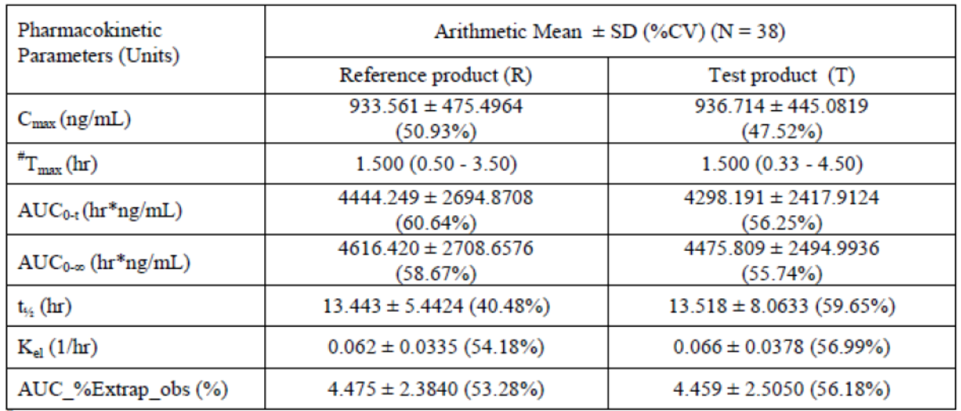
Reference product (R) = Syprine (trientine hydrochloride) 250 mg capsules, Bausch Health Companies Inc, USA.
Test product (T) = Trientine hydrochloride 250 mg capsules, Navinta LLC, USA.
SD = standard deviation; %CV = coefficient of variation; C_{max} = maximum concentration; T_{max} = time of maximum concentration; AUC_{0-t} = area under the concentration-time curve from time zero to last measurable concentration; AUC_{0-∞} = area under the concentration-time curve from time zero extrapolated to infinity; t_{1/2} = half life; K_{el} = first-order rate constant for elimination of drug from the central compartment of the pharmacokinetic model; AUC_%Extrap_obs = area under the plasma concentration-time curve extrapolated from time t to infinity as a percentage of total AUC. # For T_{max}, median (min – max)
Table 4: Study 17-VIN-0021 Bioequivalence of test versus reference product
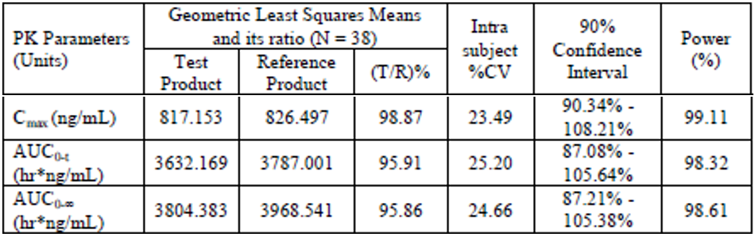
Reference product (R) = Syprine (trientine hydrochloride) 250 mg capsules, Bausch Health Companies Inc, USA.
Test product (T) = Trientine hydrochloride 250 mg capsules, Navinta LLC, USA.
%CV = coefficient of variation; C_{max} = maximum concentration; AUC_{0-t} = area under the concentration-time curve from time zero to last measurable concentration; AUC_{0-∞} = area under the concentration-time curve from time zero extrapolated to infinity.
No data on PK interactions were presented.

Pharmacodynamics
The primary PD effect of trientine is to increase renal excretion of copper as the stable trientine-copper complex. Some studies reported decreased absorption of ingested copper with trientine.
There is intra- and inter-individual variability in responsiveness to trientine, but the relationship between trientine dose and urinary copper excretion is generally linear. The cupruretic response to trientine is affected by the degree of copper overload, with smaller responses seen in patients whose copper overload has been controlled.

Dosage
The proposed dosage guidance for Trientine Waymade is based on the dosage guidance for Syprine.
There were no formal dose finding studies in the literature. The dosages reported in the studies ranged from 100 mg twice daily (BID) to 1800 mg BID. Cho et al. (2009) evaluated the PK, PD, tolerability and safety of trientine after repeated twice daily doses of 200, 600, 1200 and 1800 mg for 14 days in adults. The authors concluded that the steady state doses were safe and well tolerated, but the PK/PD and safety profile support a 600 mg BID regimen (1200 mg/day) as more adverse events (AE) were reported with the higher 3600 mg/day dose.
Trientine has been in clinical use for many years. There is high inter-individual variability in the PK of trientine, and the dose is typically titrated according to clinical response. The Australian Therapeutic Guidelines (eTG December 2019) lists trientine as a treatment for WD but does not make specific dose recommendations.
The AASLD 2008 practice guideline for WD by Roberts and Schilsky (2008)⁶ advises:
‘Typical dosages are 750 to 1500 mg/day in two or three divided doses, with 750 or 1000 mg used for maintenance therapy. In children, the weight based dose is not established, but the dose generally used is 20 mg/kg/day rounded off to the nearest 250 mg, given in two or three divided doses. Trientine should be administered one hour before or two hours after meals.’
The EASL 2012 Clinical Practice Guidelines for WD;⁷ advises ‘Typical dosages of trientine are 900 to 2700 mg/day in two or three divided doses, with 900 to 1500 mg/day used for maintenance therapy. In children, the weight-based dose is not established, but the dose generally used is 20 mg/kg/day rounded off to the nearest 250 mg, given in two or three divided doses.’
A position paper by the ESPGHN Committee (Socha et al 2018) advises ‘The recommended dose of trientine in children is 20 mg/kg/day in two to three divided doses.’

Efficacy
The literature search identified six published studies which informed efficacy in the proposed indication (Table 5). In addition, the submission referenced the Australian Therapeutic Guidelines and clinical practice guidelines published by European and USA hepatology associations (Table 6).
The retrospective cohort study by Weiss et al. (2013) was identified as the pivotal study to support efficacy. The other studies were retrospective or prospective uncontrolled case series. Weiss et al. (2018); and Weiss et al. (2019); were published conference abstracts relating to Study UNV-TRI-002, the pivotal study supporting the marketing authorisation of Cufence (trientine dihydrochloride) in Europe in 2019.
Table 5: Overview of efficacy studies
Literature reference | Level of evidence and study design | Diagnosis of patients and patient population | Objective of the study | Clinical endpoints
Weiss et. al. (2013) | Level III-3 Retrospective case series | WD with Leipzig score ≥ 4  19.51 years (1.23 to 55.06 years)  n = 141 trientine n = 326 DPA | To evaluate the efficacy of trientine versus DPA therapy in terms of hepatic and neurologic outcomes and compare safety based on adverse events leading to discontinuation of treatment | Investigator rated change in hepatic and neurologic outcomes (that is, clinical symptoms and tests) at 6, 12, 24, 36, and 48 months after initiation of the current treatment regimen  Adverse events and time to discontinuation of therapy
Weiss et al. (2018)  Weiss et al. (2019) | Level IV Retrospective case series | WD with Ferenci Score > 3  35.6 +/- 17.74 years  (n = 77; 16 children) | To assess efficacy, safety, and tolerability outcomes of trientine chelator based treatment after withdrawal of DPA | Investigator rated changes in neurological and hepatic outcomes  Copper storage and metabolism  Time to discontinuation of treatment due to AE and/or inadequate response
Weiss et al. (2018)  Weiss et al. (2019) | Level IV Prospective case series | WD with Ferenci Score > 3  42.3 +/- 14.52 years  (n = 52) | To assess the efficacy, safety, and quality of life outcomes of trientine chelator based treatment after withdrawal of DPA | Investigator rated changes in neurological and hepatic outcomes; changes in the UWDRS neurological subscale  Copper metabolism  Quality of life assessments
Walshe et al. (1982) | Level IV Case series | WD with severe intolerance to penicillamine  Age not specified  (n = 20) | To summarise experience over 13 years in patients with WD | Changes in copper metabolism and clearance; and clinical symptoms
Dahlman et al. (1995) | Level IV Case series | WD  Adults  (n = 19) | To examine the long term effects of trientine | Changes in clinical symptoms and KF rings
Arnon et al. (2007) | Level IV Retrospective cohort | WD  Children/adolescents  8 to 17 years  (n = 10) | To evaluate the efficacy of and adherence to trientine and/or zinc therapy in children with WD | Clinical status, normalisation of serum ALT and AST levels, and reduction of 24 hours urinary copper levels  Adherence to treatment
Ala et al. (2015) | Level IV Prospective pilot study | WD  22 to 71 years  (n = 8) | To prospectively evaluate once daily trientine as a therapy for WD | Biochemical and haematology tests, copper and zinc studies, hepatic fibrosis markers  Physical examinations  Adherence and adverse effects
WD = Wilson’s disease; DPA = D-penicillamine; AE = adverse events; UWDRS = Unified Wilson’s Disease Rating Scale; KF = Kayser–Fleischer; ALT = alanine aminotransferase; AST = aspartate aminotransferase.
Table 6: Clinical practice guidelines
Treatment guidelines
AASLD (2008) | Roberts, E.A. and Schilsky, M.L. American Association for the Study of Liver Diseases (AASLD) Practice Guidelines. Diagnosis and Treatment of Wilson Disease: an Update. A Practice Guideline on Wilson Disease, Hepatology, 2008; 47(6): 2089-2111.
EASL (2012) | European Association for the Study of the Liver (EASL), Clinical Practice Guidelines: Wilson's Disease, J Hepatology, 2012; 56: 671-685.
ESPGHN (2018) | Socha, P et al. Wilson’s Disease in children: a Children: a Position Paper by the Hepatology Committee of the European Society for Paediatric Gastroenterology, Hepatology and Nutrition (ESPGHN), J of Pediatr Gastr and Nutr, 2018; 66 (2): 334-344.
Therapeutic Guidelines (2017) | eTG complete. Melbourne: Therapeutic Guidelines Ltd; 2019. Wilson disease (updated March 2017; cited 8 November 2019).
AASLD = American Association for the Study of Liver Disease; EASL = European Association for the Study of the Liver; ESPGHN = European Society for Paediatric Gastroenterology, Hepatology and Nutrition.

Weiss et al. (2013)
This was a retrospective cohort study of 380 patients with WD treated at six tertiary care centres in Germany and Austria, and 25 patients from the Eurowilson registry. The purpose of the study was to evaluate the efficacy and safety of trientine and penicillamine therapy, in terms of hepatic and neurological outcomes and AEs leading to discontinuation.
Medical records of the 405 patients were reviewed. Data were collected for a mean of 13.3 years after therapy began. Patients were categorised according to symptoms present at diagnosis: asymptomatic, hepatic, neurologic, or hepatic and neurologic. 207 (51.1%) patients presented with hepatic symptoms only, 92 (22.7%) presented with neurologic symptoms only, 52 (12.8%) presented with hepatic and neurologic symptoms, and 54 (13.3%) were asymptomatic at diagnosis. 21 patients (5.2%) presented with fulminant WD with hepatic failure at diagnosis.
Patients with a stable course were assessed in the tertiary centres approximately once a year. Patients were reviewed more frequently (3, 6, and 12 months) after initiating or changing therapy. No systematic criteria were applied in the initial choice of chelating agent.
Hepatic and neurologic outcomes were assessed from patient records at 6, 12, 24, 36 and 48 months after initiation of the treatment. Hepatic outcome measures were based on clinical symptoms, course of liver enzymes, and liver function tests. Neurologic outcomes were evaluated by the physician. Hepatic and neurologic outcomes were scored as unchanged, improved to normal, improved but not normal, deteriorated, or asymptomatic over duration.
The analysis identified 467 chelator based treatments with a duration of more than six months: 326 involved penicillamine monotherapy (295 as first line, 31 as second line) and 141 involved trientine monotherapy (38 as first line and 103 as second line). No specific dosage information was presented. Zinc treatments were not analysed, and patients who received only zinc salts over the whole treatment period were excluded from the analysis.
Figure 2: Weiss et al. (2013) overview
Baseline characteristics, recorded at the time of initiation of, or change in, chelator based treatment, were generally similar across the treatment groups but penicillamine was used more commonly as first line treatment.
Hepatic and neurologic improvement and worsening were reported for penicillamine and trientine, stratified by first line and second line use (shown in Table 7, below).
For trientine in the second line setting (proposed for registration):
- 31 of 45 (68.9%) patients with hepatic symptoms showed hepatic improvement;
- 10 (22.2%) patients with hepatic symptoms showed stable hepatic disease;
- 4 (8.9%) patients with hepatic symptoms showed hepatic worsening;
- no hepatic worsening was observed in asymptomatic patients;
- 26 of 51 (50.9%) patients with neurologic symptoms showed neurologic improvement;
- 17 (33.3%) patients with neurologic symptoms showed stable neurologic disease;
- 8 (15.7%) patients with neurologic symptoms showed neurologic worsening;
- no neurologic worsening was observed in asymptomatic patients.
Hepatic improvement was lower in the second line setting compared to the first line setting for both penicillamine and trientine. The authors attributed this finding to advanced liver disease and irreversible structural liver damage.
Neurologic deterioration occurred more frequently with trientine than penicillamine in both the first line and second line settings.
Table 7: Weiss et al. (2013) Rate of hepatic or neurological improvement and worsening in all or only symptomatic patients stratified by first and second line treatment
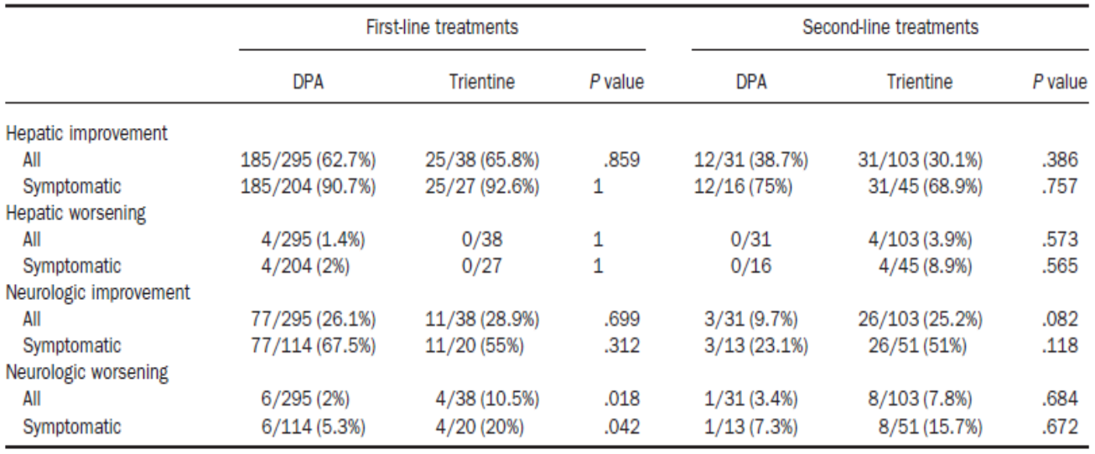
P-value were established using the two-tailed Fisher test.
DPA = D-penacillamine

Walshe et al. (1982)
This was a retrospective review of records for 20 penicillamine intolerant patients treated with trientine dihydrochloride for a minimum of one year over the preceding 13 years. The aim was to describe the clinical response to trientine in patients with WD intolerant to penicillamine. The study reported trientine doses between 400 mg three times a day (TDS) and 800 mg TDS before meals.
The analysis grouped patients according to the stage at which they developed penicillamine intolerance: patients in whom penicillamine intolerance developed within days or weeks of commencing treatment (Group A, n = 8); patients who had received less than one year of continuous penicillamine before developing intolerance (Group B, n = 3); and patients who had responded well to penicillamine before developing intolerance at a later stage (Group C, n = 9).
Clinical responses for patients in Group A are shown in Table 8. All patients in Group A experienced improvement in symptoms after treatment with trientine (duration of treatment ranging from 14 to 120 months). The three patients in Group B were reported to have considerable neurological deficit which improved after commencing trientine, although two had some residual deficit. The patients in Group C had been adequately ‘de-coppered’ at the time of changeover. They remained symptomatically well controlled after changing to trientine, the penicillamine related toxicities resolved, and no new toxicities were observed other than iron deficiency.
Table 8: Walshe et al. (1982) Clinical and pharmacodynamic response to trientine after early intolerance to penicillamine (Group A)
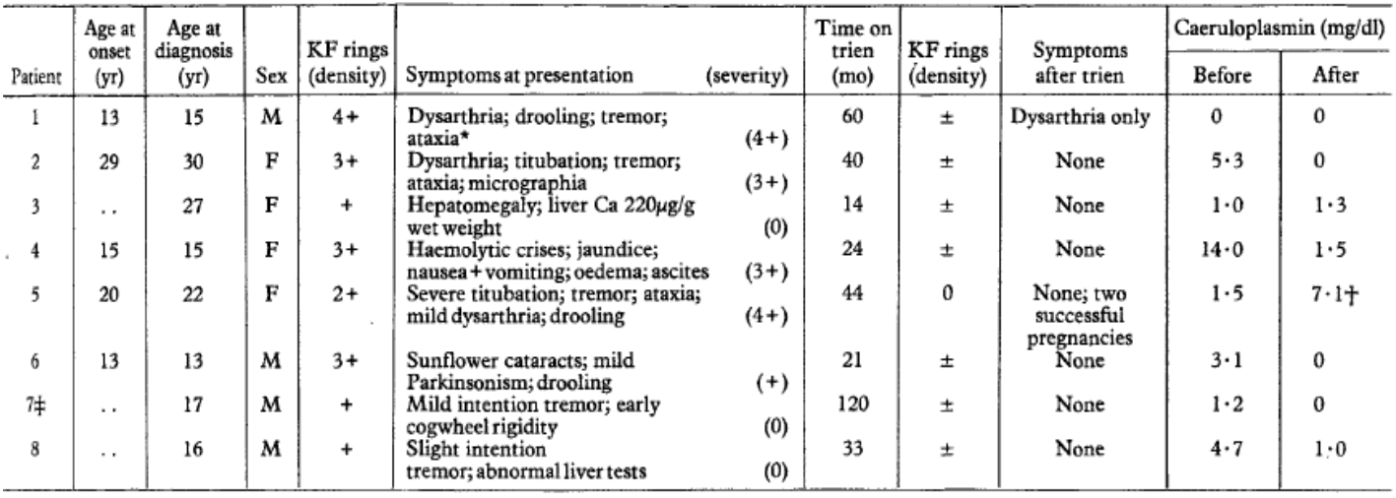
* Had splenectomy at age 11 years
† 22 weeks pregnancy when estimated
‡ Previously reported
yr = year; M = male; F = female; Ca = circa (approximately); mo = months; KF = Kayser–Fleischer.

Arnon et al. (2007)
This was a retrospective review of the clinical records of children with WD treated in the paediatric liver or liver transplant unit of the Mount Sinai Medical Center between 1998 and 2006. The objective was to evaluate the efficacy of, and adherence to, trientine therapy (250 to 500 mg BID, approximate 20 mg/kg/day) and/or zinc therapy (25 to 50 mg BID, approximate 1 to 2 mg/kg/day). This study assessed trientine as first line therapy, not following intolerance to penicillamine. Zinc was added once adequate chelation had been achieved. Efficacy was assessed by measuring serum alanine aminotransferase (ALT) and aspartate aminotransferase (AST), and 24 hour urine copper.
Of the 22 patients, seven presented with acute liver failure requiring liver transplantation at admission, and 15 commenced trientine. Mean ALT levels decreased from 183 international units (IU) at presentation (n = 10) to 80 IU at 12 months (n = 10) and 66 IU at 18 months (n = 7). Mean 24 hour urinary copper levels increased from 156 µg at presentation to 494 µg at one to two months, then decreased to 72 µg after 12 months of treatment.

Dahlman et al. (1995)
This was a case series of 19 patients with WD, 17 of whom were treated initially with penicillamine and subsequently switched to trientine due to adverse effects, lack of improvement or worsening of neurological symptoms, and two of whom were treated with trientine from diagnosis. Trientine doses ranged from 1000 mg to 1800 mg per day, and duration of treatment ranged from 4 months to 17.5 years. Efficacy was evaluated based on clinical symptoms and KF rings (see Table 9, below). The authors reported that all patients responded well to trientine with the exception of one patient who was treated initially with trientine and developed neurological deterioration. Thirteen remained on trientine at final review, and the mean duration of trientine treatment was 8.5 years.
Table 9: Dahlman et al. (1995) Change in Wilson’s disease signs and symptoms with trientine
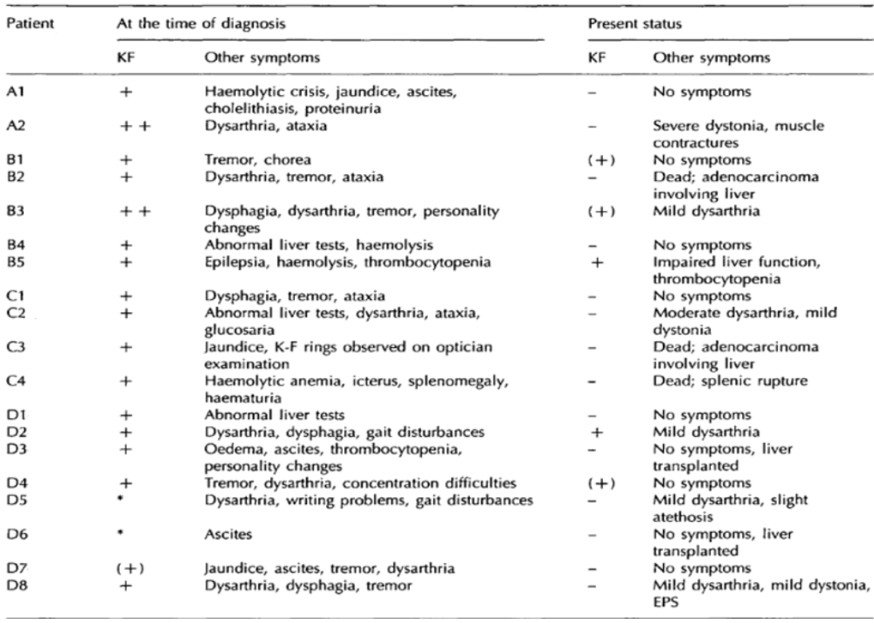
Symptoms referred to as mild or moderate in ‘present status’ were more severe at the time of diagnosis
* No data available.
KF = Kayser–Fleischer; EPS = elastosis perfrons serpiginosa
- absent; (+) narrow + moderate; ++ wide

Weiss et al. (2018), Weiss et al. (2019), European Public Assessment Report for Cufence (2019)
The submission included published conference extracts (Weiss et al. (2018)¹⁰ and Weiss et al. (2019)¹¹) relating to Study UNV-TRI-002. This study, which comprised a retrospective study followed by a prospective study, supported the marketing authorisation of Cufence (trientine dihydrochloride) by Univar Solutions B.V. in Europe by the European Medicines Agency on 25 July 2019. The EPAR for Cufence; was included in the clinical dossier.
The multicentre retrospective study was performed to assess long-term outcomes of treatment with trientine in WD patients withdrawn from therapy with penicillamine. Patients were treated for a minimum of six months with trientine (300 mg capsules commercially available from Univar) at doses of 1200 to 2400 mg/day (800 to 1600 mg trientine base) in two to four divided doses in adults, or 600 to 1500 mg/day (400 to 1000 mg trientine base) in children. 81 patients were enrolled and 77 were included in the intention to treat (ITT) population (four patients were excluded from the ITT population as they received non-Univar trientine at initiation). Efficacy was assessed based on the clinical course of neurological and hepatic disease (unchanged; improved but not normal; improved to normal; asymptomatic over duration of therapy; worsened) at defined intervals up to 48 months of treatment and then at last visit.
Weiss et al. (2018)¹⁰ summarised the efficacy outcomes of the retrospective study as:
‘Of the 77 patients included in the ITT population, 16 (20.8%) patients were under the age of 18 years. Reasons for discontinuation of D-Penicilamine were adverse events (58 (75.3%) patients) or lack of clinical improvement (12 (15.6%) patients).
On average, patients were treated with trientine for 73.3 (± 74.76) months. The mean total dose per day during treatment was 1005.7 (± 425.32) mg. Treatment with trientine improved hepatic symptoms in 49.4% of patients, with 35.1% asymptomatic, 10.4% unchanged and 5.2% worsened, whereas neurological symptoms remained unchanged in 36.4% of patients, with 46.8% asymptomatic, 14.3% improved and 2.6% worsened.’
Weiss et al. (2019)¹¹ reported outcomes from the prospective study of 52 patients with WD, which followed on from the retrospective study. The mean (standard deviation (SD)) age was 42.3 (14.52) years and the mean (SD) dose during treatment was 1377.6 (368.78) mg per day. Investigator rated outcome of hepatic and neurologic symptoms was assessed at 6 and 12 months. Weiss et al. (2019)¹¹ reported that 50 of 51 patients (98.0%) treated with trientine were responders, while only one patient (2.0%) showed a mild worsening of disease. The overall mean (SD) values for Unified Wilson’s Disease Rating Scale (UWDRS)-neurologic subscale assessment-was 11.3 (24.31) at Baseline, 9.7 (23.85) at Month 6 and 8.8 (22.86) at Month 12. The authors concluded that treatment with trientine was effective in maintaining stable hepatic and neurologic disease in patients with WD.

Ala et al. (2015)
This was a prospective pilot study to evaluate once daily trientine in patients with WD. Eight patients aged 22 to 71 years with stable WD for at least one year on current therapy (zinc acetate, two; penicillamine, one; trientine, five) were prospectively enrolled into a one year trial of trientine at a single daily fixed dose of 15 mg/kg. Patients had clinical and laboratory assessments at monthly intervals for three months before commencing the study, then monthly for three months after commencing the study, then at six, nine and 12 months.
All patients remained clinically well throughout the study, no new neurological signs were detected, and biochemical parameters remained broadly similar. The authors concluded that once daily trientine should be explored further, and that larger trials and longer term follow-up are necessary to establish the efficacy and safety of a once daily regimen.

Safety
The literature search identified 37 published studies reporting safety outcomes for trientine. Seventeen studies reported safety in adults, seven studies reported safety in children, and 16 studies did not specify the age of patients. Over 741 patients were exposed to trientine across the safety studies. The studies which identified age included 233 adults and 43 children aged three years or older. The duration of the exposure ranged from a single dose up to 30 years (n = 2) in adults and from a single dose up to 18.6 years in children. The trientine dosage in the studies ranged from 250 mg/day to 3600 mg/day. Reporting of safety data in the published studies was variable and the submission did not include an integrated summary of safety.

Weiss et al. (2013)
This retrospective cohort study included 326 patients treated with penicillamine (295 as first line, 31 as second line) and 141 patients treated with trientine (38 as first line and 103 as second line). The median follow up period was 13.3 years. The safety analysis was restricted to AEs that led to discontinuation of therapy.
Discontinuation due to AEs was more frequent with penicillamine (94 of 326, 28.8%) than trientine (10 of 141, 7.1%; p = 0.039). In trientine treated patients, AEs that led to discontinuation were arthralgia (4), gastric complaints (2), pruritus (1), myalgia (1), nephropathy (1), leukopaenia (1), increased antinuclear antibodies (1), erythema (1), lupus erythematosus (1), hirsutism (1) and other (4). There were no deaths related to AE.

Weiss et al. (2018)
This published conference extract reported safety from the retrospective part of Study UNV-TRI-002, which was submitted as part of the application for marketing authorisation for Cufence in the EU. This study is described in detail in the EPAR for Cufence.
Mean daily doses were 1005.7 mg for adults and 629.7 mg for paediatric patients. The highest daily dose received in this study was 2100 mg. Twelve of 77 patients (15.6%) discontinued trientine. Treatment emergent adverse events (TEAE) were reported in 46 (62.3%) patients (Table 10). The profile of AEs in paediatric patients was similar to adult patients (Table 11). There were no deaths due to AE. Serious adverse events (SAE) assessed as related to trientine were reported in two patients, and included anaemia (which led to discontinuation of trientine) and intestinal obstruction in one patient, and Hepatic enzyme increased (leading to dose reduction from 1800 mg to 1200 mg/day) in one patient.
Table 10: Study UNV-TRI-002 Treatment emergent adverse events (by System Organ Class and Preferred Term) in at least four patients (intention to treat population)
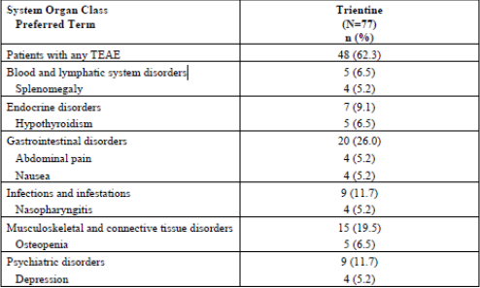
TEAE = Treatment emergent adverse event.
Source: EMA, EPAR, Cufence (trientine dihydrochloride), EMA/330602/2019, 29 May 2019, p 78, Table 18. Available from the EMA website.
Table 11: Study UNV-TRI-002 Summary of adverse events by System Organ Class and age group (intention to treat population)
TEAE = Treatment emergent adverse event.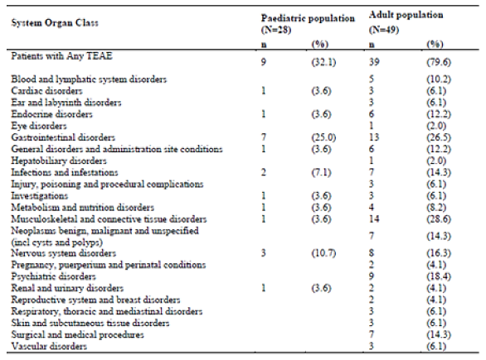
Source: EMA, EPAR, Cufence (trientine dihydrochloride), EMA/330602/2019, 29 May 2019, p 80, Table 20. Available from the EMA website.
Pfeiffenberger et al. (2018) was a retrospective, multicentre study that, reviewed 282 pregnancies in 136 WD patients. Pregnancy outcomes are shown in Table 12. Live birth rates were higher in treated patients than untreated patients. 202 of the 209 live births were healthy, with birth defects reported in seven (3%). Four birth defects were reported in the penicillamine cohort and one birth defect (glucose 6-phosphate dehydrogenase deficiency) was reported in the trientine cohort. Limitations of this study include the retrospective design, non-randomised treatment allocation, and trientine frequently being used as second line to penicillamine because of intolerance.
Table 12: Pfeiffenberger et al. (2018) Pregnancy outcomes with respect to the Wilson’s disease medical therapy during pregnancy
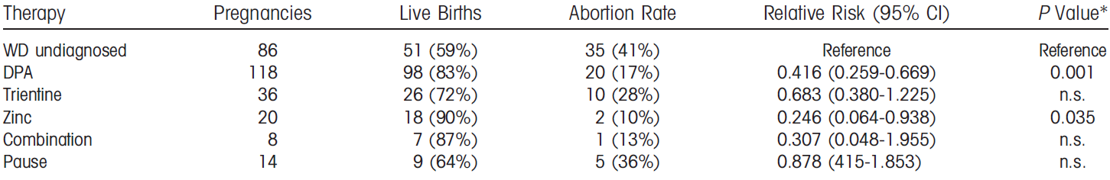Relative risks for abortion for each therapy are shown in comparison to pregnancies in undiagnosed patients.
*P value adjusted according Bonferroni.
WD = Wilson’s disease; n.s.: non-significant; DPA = D-penacillamine; CI = confidence interval.
Weiss et al. (2011) was a retrospective study which assessed outcomes of 207 pregnancies in 100 WD patients in European tertiary centres. Medical regimens included penicillamine, trientine, zinc salts, or a combination of a chelator and zinc. Overall abortion rate was 48/207 (23.2%) in the study group. Abortion rate under trientine treatment (8/20; 40%; p = 0.04) was higher than under penicillamine (14/96; 14.7%) or zinc (2/19; 10.5%). Birth defects were observed in two newborns, one associated with penicillamine therapy (partial oesophageal atresia), and one associated with zinc therapy (glucose-6-phosphate dehydrogenase deficiency).

Risk management plan
The sponsor has submitted Australian risk management plan (RMP) version 0.1 (18 December 2019; data lock point (DLP) 11 December 2019) in support of this application. At the second round, an updated version was submitted (version 0.2, dated 18 December 2019; DLP 11 December 2019). At the third round, an updated version was submitted (version 0.3; DLP 11 December 2019).
The summary of safety concerns and their associated risk monitoring and mitigation strategies are summarised in Table 13.
Table 13: Summary of safety concerns
Summary of safety concerns |  | Pharmacovigilance |  | Risk Minimisation
 |  | Routine† | Additional | Routine | Additional
Important identified risks | Risk of neurological deterioration during early stages of treatment |  | – |  | –
Important potential risks | Gastrointestinal disturbances |  | – |  | –
Important potential risks | Iron-deficiency including anaemia |  | – |  | –
Important potential risks | Zinc-deficiency |  | – |  | –
Important potential risks | Isolated elevation of liver enzymes |  | – |  | –
Important potential risks | Increased pregnancy loss | * | – |  | –
Missing information | Drug exposure during pregnancy | * | – |  | –
Missing information | Use of drugs in lactation and in neonates |  | – |  | –
*Specific adverse reaction follow-up questionnaire
† Routine activities beyond adverse reactions reporting and signal detection, such as periodic safety update reports
The summary of safety concerns is acceptable and addresses recommendations made by the clinical evaluator.
The sponsor has proposed routine pharmacovigilance activities for all safety concerns. A follow-up form will address drug exposure during pregnancy, including pregnancy loss. The proposed pharmacovigilance plan is acceptable.
The sponsor has proposed routine risk minimisation activities for all safety concerns. This is acceptable.
Recommended amendments to the PI are referred to the Delegate.

Risk-benefit analysis

Delegate’s considerations

Efficacy
Efficacy data in this submission were derived from a systematic review of published literature. Weiss et al. (2013)⁹ was identified as the main efficacy study in this submission. It was a retrospective cohort study of 380 patients with WD treated at six tertiary care centres in Germany and Austria, and 25 additional patients from the Eurowilson registry. For trientine in the second line setting (proposed for registration), 31 of 45 (68.9%) patients with hepatic symptoms showed hepatic improvement, and 26 of 51 (51%) patients with neurologic symptoms showed neurologic improvement. 4 of 45 (8.9%) patients with hepatic symptoms showed hepatic worsening, and 8 of 51 (15.7%) patients with neurologic symptoms showed neurologic worsening. Asymptomatic patients treated with trientine did not show hepatic worsening or neurologic worsening.
There are limitations in the strength of the evidence provided by retrospective studies, because the study design is subject to biases and uncertainties due to missing information. Weiss et al. (2013)⁹ did not report dosages, dose titration, and the formulation of trientine used by patients, and neurologic outcomes were not assessed by a standardised or quantitative neurologic scale. No systematic criteria were applied in the initial choice of chelating agent. Treatment decisions were made according to accepted standards at the time and may have been influenced by confounders. Despite the recognised limitations of a retrospective cohort study, Weiss et al. (2013)⁹ reported outcomes for 405 patients treated for this rare disease over a mean duration of 13.3 years. The reported outcomes support a clinical benefit with trientine in patients who are intolerant of penicillamine.
Other published studies provide data informing dosage and use in paediatric patients, supporting the efficacy of trientine in the proposed indication.

Safety
The safety dataset based on published literature is limited, as most of the studies were retrospective reviews reliant on safety information recorded in clinical notes. Many of the studies were small, and safety reporting varied across the studies. Overall, trientine was generally well tolerated. In Weiss et al. (2013)⁹, discontinuations due to AE were lower with trientine than penicillamine. The safety profile of trientine in paediatric patients is similar to adults.
There are limitations in the safety dataset derived from published literature, but there is a long history of clinical experience with trientine, including 35 years of marketing authorisation in USA and UK. The clinical consequences of untreated or inadequately treated disease are severe, and include hepatic failure, neurologic impairment and death.
Overall, the published literature and the long history of clinical experience support the safety of trientine in the treatment of patients with WD who are intolerant of penicillamine.

Labelling
Trientine Waymade is labelled in terms of the quantity of the dihydrochloride salt (250 mg) rather than the free base. This product was developed as a generic of Syprine which has been registered in the USA since 1985. There is a long history of clinical use of Syprine 250 mg capsules internationally, including Australian patients accessing 250 mg capsules through the Special Access Scheme (SAS). Given the familiarity of this product to patients and prescribers, the Delegate is satisfied with the proposed labelling of Trientine Waymade.
Switching between different trientine products may present a risk for patients, as different formulations may have a different trientine content and different bioavailability. This has been addressed in the PI, which contains a precaution regarding switching between different formulations of trientine. The strength of the product is described in terms of the dihydrochloride salt and the free base in Section 2 Qualitative and quantitative composition and Section 4.2 Dose and method of administration.

Deficiencies and limitations of the data
Efficacy and safety data are mainly from retrospective studies, which can be subject to bias and missing information.
The clinical dossier lacks direct linkage between the proposed product and the published literature. Many of the literature references did not specify the trientine product or formulation used in the study. In response to potential differences in efficacy and safety across different formulations of trientine, the sponsor advised:
- trientine dihydrochloride is freely soluble in water, independent of pH changes.
- capsule formulations of trientine dihydrochloride are simple formulations containing the drug substance and lubricants to assist with the flow characteristics of the powder during the encapsulation process.
- Trientine Waymade contains a single lubricant, stearic acid.
- Trientine Waymade is bioequivalent to the USA reference product, Syprine, which has been marketed in USA since 1985 and has a well established efficacy and safety profile in a comparable population to Australia.
- there is substantial inter-individual variability in absorption and exposure.
- patients are monitored for response to treatment, and the dose of trientine is adjusted accordingly.
- trientine is well tolerated and has a wide therapeutic margin.
The sponsor has included a warning in the PI advising caution when switching between different formulations of trientine, as they may have a different trientine content (freebase) and different bioavailability, and dose adjustment may be required.

Conclusion
There are limitations in the efficacy and safety data provided from published literature, but there is a long history of clinical experience with trientine, including 35 years of marketing authorisation internationally. The use of trientine as a chelating agent in patients with WD is recommended in clinical practice guidelines internationally, including the Australian Therapeutic Guidelines.
WD is a rare disease which is managed by specialists with expertise in treating this condition. Treatment options are limited in patients who are intolerant of penicillamine. The clinical consequences of untreated or inadequately treated disease are severe, and include hepatic failure, neurologic impairment and death.
In this context, the clinical studies presented in this literature based submission support the efficacy and safety of Trientine Waymade for the treatment of patients with WD who are intolerant of penicillamine.

Proposed action
The Delegate had no reason to say, at the time, that the application for Trientine Waymade should not be approved for registration.

Advisory committee considerations
The Advisory Committee on Medicines (ACM), having considered the evaluations and the Delegate’s overview, as well as the sponsor’s response to these documents, advised the following.

Specific advice to the delegate
- What is the committee’s clinical perspective on trientine dihydrochloride in the proposed indication?
The ACM agreed that there are limitations in the safety dataset derived from published literature, but there is a long history of clinical experience with trientine, including 35 years of marketing authorisation in USA and UK. The ACM advised that the clinical consequences of untreated or inadequately treated disease are severe, and include hepatic failure, neurologic impairment and death.
- What is the committee’s clinical perspective on the labelling and dosing guidance for Trientine Waymade?
The ACM advised that Trientine Waymade is labelled in terms of the quantity of the dihydrochloride salt (250 mg) rather than the free base. The ACM was of the opinion that this product was developed as a generic of Syprine, registered in the USA since 1985 with a long history of clinical use internationally and locally via SAS. The ACM agreed that given the familiarity of this product to patients and prescribers the proposed labelling and dosing guidance is satisfactory. The ACM did note that switching between different trientine products may present a risk for patients, as different formulations may have a different trientine content and different bioavailability, however the ACM noted this has been addressed in the PI.

Conclusion
The ACM considered this product to have an overall positive benefit-risk profile for the indication:
Trientine Waymade is indicated for the treatment of patients with Wilson's disease who are intolerant of penicillamine.

Outcome
Based on a review of quality, safety and efficacy, the TGA approved the registration of Trientine Waymade (trientine dihydrochloride) 250 mg, capsule, bottle, indicated for:
Trientine Waymade is indicated in the treatment of patients with Wilson’s disease who are intolerant of penicillamine.

Specific conditions of registration applying to these goods
- Trientine Waymade (trientine dihydrochloride) is to be included in the Black Triangle Scheme.¹ The PI and Consumer Medicines Information (CMI) for Trientine Waymade must include the black triangle symbol and mandatory accompanying text for five years, which starts from the date that the sponsor notifies the TGA of supply of the product.
- The trientine dihydrochloride Australian RMP (version 0.3, DLP 11 December 2019) included with submission PM-2019-05976-1-3, and any subsequent revisions, as agreed with the TGA will be implemented in Australia.
- An obligatory component of risk management plans is routine pharmacovigilance. Routine pharmacovigilance includes the submission of periodic safety update reports (PSURs).
Unless agreed separately between the supplier who is the recipient of the approval and the TGA, the first report must be submitted to TGA no later than 15 calendar months after the date of this approval letter. The subsequent reports must be submitted no less frequently than annually from the date of the first submitted report until the period covered by such reports is not less than three years from the date of this approval letter. The annual submission may be made up of two PSURs each covering six months. If the sponsor wishes, the six monthly reports may be submitted separately as they become available.
If the product is approved in the EU during the three years period, reports can be provided in line with the published list of EU reference dates no less frequently than annually from the date of the first submitted report until the period covered by such reports is not less than three years from the date of this approval letter.
The reports are to at least meet the requirements for PSURs as described in the European Medicines Agency’s Guideline on GVP Module VII-periodic safety update report (Rev 1), Part VII.B Structures and processes. Note that submission of a PSUR does not constitute an application to vary the registration. Each report must have been prepared within ninety calendar days of the DLP for that report.

Attachment 1. Product Information
The PI for Trientine Waymade approved with the submission which is described in this AusPAR is at Attachment 1. For the most recent PI, please refer to the TGA website at <https://www.tga.gov.au/product-information-pi>.

Therapeutic Goods Administration
PO Box 100 Woden ACT 2606 Australia
Email: info@tga.gov.au Phone: 1800 020 653 Fax: 02 6232 8605
https://www.tga.gov.au

The Black Triangle Scheme provides a simple means for practitioners and patients to identify certain types of new prescription medicines, including those being used in new ways and to encourage the reporting of adverse events associated with their use. The Black Triangle does not denote that there are known safety problems, just that the TGA is encouraging adverse event reporting to help us build up the full picture of a medicine's safety profile.
Orphan drugs are often developed to treat small and very specific patient populations who suffer from rare diseases and conditions. In order to facilitate orphan drug access to the Australian marketplace and help offset orphan drug development costs the TGA waives application and evaluation fees for prescription medicine registration applications if a related orphan designation is in force. A medicine may be eligible for orphan drug designation if all orphan criteria set by the TGA are met. The orphan designation application precedes the registration application and the designation is specific to the sponsor, orphan indication for which designation was granted and dosage form of the medicine.
USP = United States Pharmacopeia
Pregnancy Category D: Drugs which have caused, are suspected to have caused or may be expected to cause, an increased incidence of human fetal malformations or irreversible damage. These drugs may also have adverse pharmacological effects. Accompanying texts should be consulted for further details.
Cho, H. Y. et al. Pharmacokinetic and Pharmacodynamic Modeling of a Copper-selective Chelator (TETA) in Healthy Adults, J Clin Pharmacol, 2009; 49(8): 916-928.
Roberts E and Schilsky M. American Association for the Study of Liver Diseases (AASLD) Practice Guidelines. Diagnosis and Treatment of Wilson Disease: an Update. A Practice Guideline on Wilson Disease, Hepatology. 2008; 47(6): 2089-2111.
European Association for the Study of the Liver (EASL) Clinical Practice Guidelines: Wilson's Disease, J Hepatology, 2012; 56: 671-685.
Socha. P. et al. Wilson's Disease in Children: a Position Paper by the Hepatology Committee of the European Society for Paediatric Gastroenterology, Hepatology and Nutrition (ESPGHN), J of Pediatr Gastr and Nutr, 2018; 66(2): 334-344.
Weiss, K. H. et al. Efficacy and Safety of oral Chelators in Treatment of Patients with Wilson Disease, Clin Gastroenterol Hepatol, 2013; 11: 1028-1035.
Weiss, K. H. et al. Long Term Outcomes of Treatment with Trientine in Wilson Disease: Final Results from a Multicentre Study in patients Withdrawn from D-penicillamine Therapy, J Hepato, 2018; 68: S106-S107.
Weiss, K. H.et al. Safety and Efficacy of Trientine Treatment in Wilson Disease in Patients Withdrawn from D-Penicillamine: Final Results from a Prospective Study, J Hepatol, 2019; 70: e383-e624.
Walshe, J. M. Treatment of Wilson’s Disease with Trientine (Triethylene Tetramine) Dihydrochloride, Lancet, 1982; March 20, 643-647.
Arnon, R. et al. Wilson Disease in Children: Serum Aminotransferases and Urinary Copper on Triethylene Tetramine Dihydrochloride (Trientine) Treatment, J Ped Gastroent Nutr, 2007; 44: 596-602.
Dahlman, T. et al. Long-term Treatment of Wilson’s Disease with Triethylene Tetramine Dihydrochloride (Trientine), Q J Med, 1995; 88: 609-616.
EMA, CHMP, European Assessment Report, Cufence (trientine dihydrochloride), EMA/330602/2019, 29 May 2019. Available from the EMA website.
Ala, A. et al. Prospective Pilot Study of a Single Daily Dosage of Trientine for the Treatment of Wilson Disease, Dig Dis Sci, 2015; 60:1433-1439.
Pfeiffenberger, J.et al. Pregnancy in Wilson's Disease: Management and Outcome, Hepatology, 2018; 67(4): 1261-1269.
Weiss, K. H. et al. Zinc Monotherapy is Not as Effective as Chelating Agents in Treatment of Wilson Disease, Gastroenterol, 2011; 140: 1189-1198.
Routine risk minimisation activities may be limited to ensuring that suitable warnings are included in the product information or by careful use of labelling and packaging. Routine pharmacovigilance practices involve the following activities: - All suspected adverse reactions that are reported to the personnel of the company are collected and collated in an accessible manner; - Reporting to regulatory authorities; - Continuous monitoring of the safety profiles of approved products including signal detection and updating of labelling; - Submission of PSURs; - Meeting other local regulatory agency requirements.
Special Access Scheme TGA 28 November 2018; FOI 846-1819, SAS Trientine dihydrochloride. Available at: https://www.tga.gov.au/documents-released-under-section-11c-freedom-information-act-1982-jul-2018-jun-2019
The ACM provides independent medical and scientific advice to the Minister for Health and the Therapeutic Goods Administration (TGA) on issues relating to the safety, quality and efficacy of medicines supplied in Australia including issues relating to pre-market and post-market functions for medicines. The Committee is established under Regulation 35 of the Therapeutic Goods Regulations 1990. Members are appointed by the Minister. The ACM was established in January 2017 replacing Advisory Committee on Prescription Medicines (ACPM) which was formed in January 2010. ACM encompass pre and post-market advice for medicines, following the consolidation of the previous functions of the Advisory Committee on Prescription Medicines (ACPM), the Advisory Committee on the Safety of Medicines (ACSOM) and the Advisory Committee on Non-Prescription Medicines (ACNM). Membership comprises of professionals with specific scientific, medical or clinical expertise, as well as appropriate consumer health issues relating to medicines.

