Date of CER: February 2013

AusPAR Attachment 2

Extract from the Clinical Evaluation Report for trastuzumab emtansine
  - Proprietary Product Name: Kadcyla
  - Sponsor: Roche Products Pty Ltd
About the Therapeutic Goods Administration (TGA)
- The Therapeutic Goods Administration (TGA) is part of the Australian Government Department of Health, and is responsible for regulating medicines and medical devices.
- The TGA administers the Therapeutic Goods Act 1989 (the Act), applying a risk management approach designed to ensure therapeutic goods supplied in Australia meet acceptable standards of quality, safety and efficacy (performance), when necessary.
- The work of the TGA is based on applying scientific and clinical expertise to decision-making, to ensure that the benefits to consumers outweigh any risks associated with the use of medicines and medical devices.
- The TGA relies on the public, healthcare professionals and industry to report problems with medicines or medical devices. TGA investigates reports received by it to determine any necessary regulatory action.
- To report a problem with a medicine or medical device, please see the information on the TGA website <http://www.tga.gov.au>.
About the Extract from the Clinical Evaluation Report
- This document provides a more detailed evaluation of the clinical findings, extracted from the Clinical Evaluation Report (CER) prepared by the TGA. This extract does not include sections from the CER regarding product documentation or post market activities.
- The words [Information redacted] indicate confidential information has been deleted.
- For the most recent Product Information (PI), please refer to the TGA website <http://www.tga.gov.au/hp/information-medicines-pi.htm>.
Copyright
© Commonwealth of Australia 2014
This work is copyright. You may reproduce the whole or part of this work in unaltered form for your own personal use or, if you are part of an organisation, for internal use within your organisation, but only if you or your organisation do not use the reproduction for any commercial purpose and retain this copyright notice and all disclaimer notices as part of that reproduction. Apart from rights to use as permitted by the Copyright Act 1968 or allowed by this copyright notice, all other rights are reserved and you are not allowed to reproduce the whole or any part of this work in any way (electronic or otherwise) without first being given specific written permission from the Commonwealth to do so. Requests and inquiries concerning reproduction and rights are to be sent to the TGA Copyright Officer, Therapeutic Goods Administration, PO Box 100, Woden ACT 2606 or emailed to <tga.copyright@tga.gov.au>.

Contents
1. Clinical rationale 4
2. Contents of the clinical dossier 4
2.1. Scope of the clinical dossier 4
2.2. Paediatric data 4
2.3. Good clinical practice 4
3. Pharmacokinetics / Pharmacodynamics 5
3.1. Overview of population pharmacokinetic analysis 5
3.2. Pharmacokinetics of Trastuzumab Emtansine across studies 6
3.3. Exposure/response and exposure/safety relationships 6
3.4. Drug interaction assessment 15
3.5. The effect of Trastuzumab Emtansine on QTc interval 15
3.6. Immunogenicity 17
3.7. Special populations 18
3.8. Comment 21
4. Dosage selection for the pivotal studies 22
5. Clinical efficacy 22
5.1. Comment 32
6. Clinical safety 32
6.1. Adverse events leading to dose reduction/dose delay 39
6.2. Comment 46
7. First round benefit-risk assessment 46
7.1. First round assessment of benefit 46
7.2. First round assessment of risks 47
7.3. First round assessment of benefit/risk balance 47
8. First round recommendation regarding authorisation 47
9. Clinical questions 47

Clinical rationale
While approximately 20% of patients with metastatic breast cancer are shown to have HER2 positivity, ultimate progression of disease despite potential initial response is almost inevitable. Combination of Trastuzumab with a taxane has improved levels of benefit but again with ultimate relapse. Accordingly, Trastuzumab Emtansine, a novel antibody drug conjugate was designed specifically for the treatment of HER2+ cancer. It incorporates the mechanisms and characteristics of Trastuzumab, ie. targeted therapy, while introducing the potent effects of the Maytansine derivative DM1 of mitotic arrest and apoptotic cell death. The targeted delivery of DM1 is expected to improve the therapeutic window compared with the unconjugated molecule. Trastuzumab Emtansine shows greater anti-proliferative activity than Trastuzumab in Trastuzumab-sensitive models and is highly active in Trastuzumab-insensitive cell lines and mouse models.
Single agent Trastuzumab Emtansine demonstrated activity in phase I and II clinical studies in patients who had received multiple HER2 directed single agent or combination therapies for metastatic breast cancer and patients who had not received prior therapy for advanced breast cancer. Accordingly, the phase III pivotal study 4370 g together with four phase II supportive trials were undertaken to determine the potential activity of Kadcyla in patients with unresectable or locally advanced or metastatic breast cancer who had received prior treatment with Trastuzimab and a taxane.

Contents of the clinical dossier

Scope of the clinical dossier
The clinical submission contains full study reports from six clinical trials related to pharmacokinetics and pharmacodynamics. These include the Phase I study TDM3569g, three Phase II studies TDM4258g, TDM4374g, B021976, a QTc Phase II study TDM4688 and the Phase III pivotal study TDM4370. Full study reports and appropriate summaries are provided.
Efficacy and safety data from the clinical submission is provided by full reports of the Phase III pivotal trial 4370g together with supporting efficacy and safety data from three Phase II studies for patients with HER2+ metastatic breast cancer, that is, study TDM4450g, study TDM4374g and study TDM4258g. Further supportive safety data is also provided by one single arm Phase II study 4688g and one Phase I study 3569g as well as long term follow up safety data from 43 patients treated with Kadcyla in earlier Phase I and Phase II studies. These patients continued treatment in the extension study 4529g. Full reports together with appropriate summaries are provided.

Paediatric data
No paediatric data is provided in this submission.

Good clinical practice
All aspects of good clinical practice were observed in these studies.

Pharmacokinetics / Pharmacodynamics
The clinical pharmacology data for this evaluation comes from six clinical studies. All patients involved had locally advanced or metastatic breast cancer. No studies were conducted in healthy volunteers.

Overview of population pharmacokinetic analysis
A comprehensive population PK analysis was conducted by using all the available Kadcyla concentration data obtained across the six clinical Phase I, II III studies. The objectives of the population PK analysis were:
- To describe the PK of Trastuzumab Emtansine using all available information.
- Estimate typical PK parameter values and associated inter-individual variability.
- Compare Trastuzumab Emtansine PK between the pivotal Phase III population and the other Phase I/II populations.
- Determine the effects of demographic and patho-physiological co-variates on the PK variabilities.
- Support the selection of the body weight based dosing regimen without further correction for other factors.
The key observations for the population PK analyses were:
- Kadcyla PK at the clinical dose range can be adequately described by a linear two compartment model with first order elimination from the central compartment.
Based on the population PK analysis the estimated CL, Vc and T1/2 for Kadcyla was 0.676L/day, 3.127L and 3.94 days, respectively. Accumulation of Kadcyla is not expected following dose administration of 3.6mg/kg every three weeks. Trastuzumab Emtansine conjugate and DM1 reached steady state conditions within one treatment cycle.
- Factors associated with statistically significant PK variability included body weight, sum of longest dimension of target lesions, serum concentration, AST, serum albumin and baseline Trastuzumab concentrations. However these co-variates were not considered to be clinically meaningful. On the basis of the known mechanisms of Trastuzumab Emtansine clearance and disposition as well as population PK co-variate analyses any further dose adjustments based on co-variates are unlikely to result in a clinically meaningful reduction in PK variabilities. The body weight base dose of 3.6mg/kg every three weeks without further correction for other factors is considered appropriate.
- No evidence was found to suggest that baseline markers of liver function had any clinically meaningful effect on Trastuzumab Emtansine exposure, impaired hepatic function is unlikely to affect systemic exposure to Trastuzumab Emtansine.
- Based on the population PK analysis to assess the impact of creatinine clearance on Kadcyla pharmacokinetics, renal function appeared to have no effect on these. The assessment was based on a limited number of patients with mild to moderate renal impairment. No conclusions can be drawn for patients with severe renal impairment as there has only been one patient with severe renal impairment treated with Trastuzumab Emtansine. However Trastuzumab Emtansine clearance for this patient was within the range of the clearance values observed in the other three patient groups, namely patients with mild renal impairment, moderate renal impairment and normal renal function.
- Co-variates related to disease severity and treatment history including increased baseline sum of longest dimension of target lesions, higher baseline concentrations and higher AST concentration, low albumin levels and lower baseline Trastuzumab concentrations resulted in a small increase in Trastuzumab Emtansine clearance at <10%. The magnitude of the impact of these variables on Trastuzumab Emtansine steady state exposure was relatively small (<10% on AUC, <1% on C_{max} and <41% on C_{trough}) and therefore unlikely to be of clinical relevance.
- Trastuzumab Emtansine pharmacokinetics are similar across several sub-populations including geriatric population vs young population, ie. 65-75 years and >75 years vs <75 years, and in patients from Asia vs non-Asia regions.

Pharmacokinetics of Trastuzumab Emtansine across studies
The pharmacokinetics of Trastuzumab Emtansine were evaluated in the six clinical studies previously indicated. The PK parameters of Trastuzumab Emtansine administered 3.6mg/kg every three weeks in each of these studies show:
- The studies demonstrate a predictable PK profile for Trastuzumab Emtansine conjugate at 3.6mg/kg every three weeks characterised by mean clearance values ranging from 7-13mL/day/kg at volume of distribution limited for plasma volume and a terminal half-life of approximately four days.
- As expected from the terminal half-life of the conjugate, repeated dosing of Trastuzumab Emtansine on a three-weekly regimen did not result in any noticeable accumulation of the conjugate. This observation was consistent across all clinical studies.
- Following Trastuzumab Emtansine administration both total Trastuzumab and DM1 were detected in human serum and plasma respectively. Maximum systemic plasma DM1 concentrations across clinical studies averaged approximately 6ng/ml with administration of Trastuzumab Emtansine at 3.6mg/kg. The low systemic clearance concentration of DM1 may be explained by their stable linker and/or fast clearance of DM1 following deconjugation from T-DM1. There was no evidence of DM1 accumulation in plasma following repeated dosing of Trastuzumab Emtansine. Across studies, maximum DM1 levels did not exceed 59.7ng/ml for individual patients following repeated administration.
- Total Trastuzumab had a slower clearance at 3-6ml/day/kg and longer terminal half-life at 9-11 days compared with the conjugate with a clearance of 7-13ml/day/kg and terminal half-life of 3-5 days. In contrast, Trastuzimab has a clearance of 0.241L/day and terminal half-life of approximately four weeks.
- There was no time dependent change in the PK of the conjugate or DM1 when comparing PK parameters at cycle one to subsequent cycles. Results suggested that Trastuzumab Emtansine treatment induced tumour burden change, ie. whether an increase or decrease does not affect Trastuzumab Emtansine conjugate or DM1 pharmacokinetics.

Exposure/response and exposure/safety relationships
Across the three Phase II studies 4258g and 4374g and 4450g and the Phase III study 4370g, only one Trastuzumab Emtansine regimen 3.6mg/kg every three weeks was used. At this dose, consistent clinical activity had been observed because the same standard dose was used and it was not possible to conduct a formal dose/response analysis. However, an exposure/efficacy analysis was performed in the pivotal study and demonstrated the variability in Trastuzumab Emtansine exposure observed among patients who received 3.6mg/kg every three weeks but noticed minor impact on progression free survival (PFS), overall survival (OS), and overall response rate (ORR) as indicated in Figures 1, 2 and 3, respectively.
Figure 1: Kaplan-Meier plot of progression free survival (PFS) stratified by Trastuzumab Emtansine exposure (TDM4370g/BO21977).
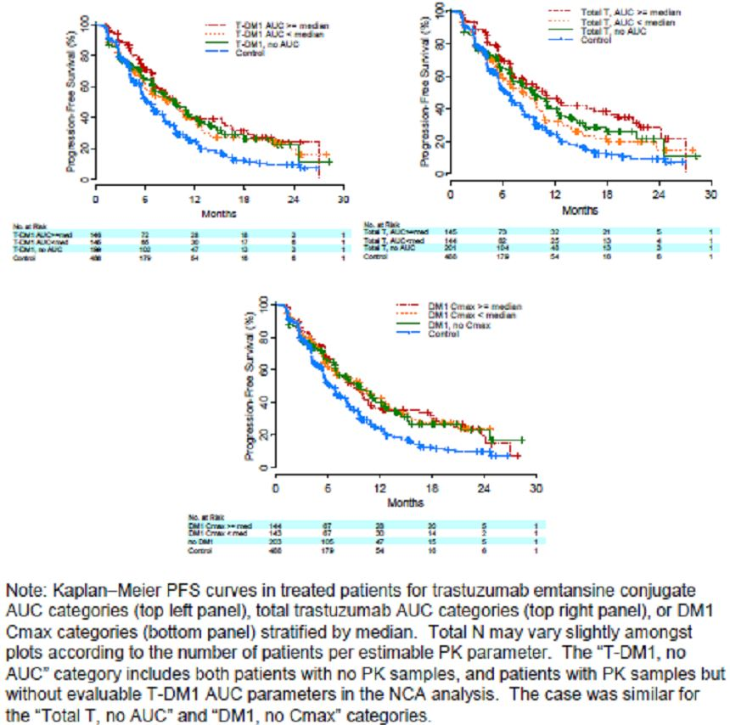

Figure 2: Kaplan-Meier plot of overall survival (OS) stratified by Trastuzumab Emtansine exposure (TDM4370g/BO21977).
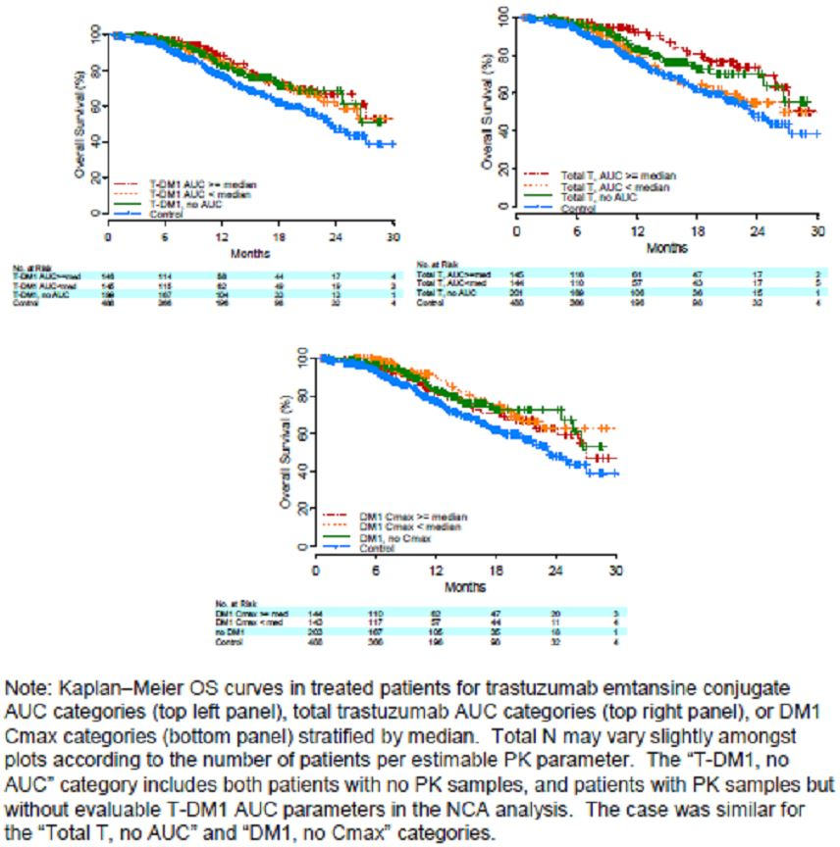

Figure 3: Trastuzumab Emtansine PK exposure versus responder status (TDM4370g/BO21977).
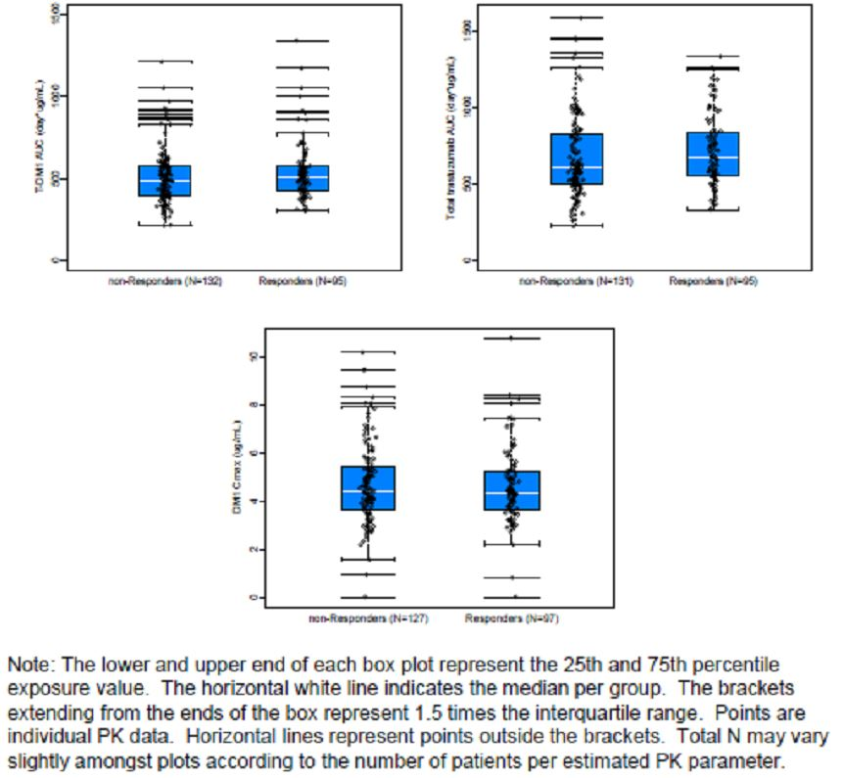
In relation to the exposure safety relationship, the primary analysis included 617 Trastuzumab Emtansine patients with PK data who received Trastuzumab Emtansine at 3.6mg every three weeks from the five Phase II/III studies. Exposure endpoints included Trastuzimab Emtansine conjugate AUC, C_{max}, total Trastuzumab AUC, or DM1 C_{max}. Safety endpoints selected for this analysis were thrombocytopenia and hepatotoxicity. Also assessed were longitudinal platelet counts and laboratory transaminase function tests for the same patient population. Multi-variate logistic regression analysis was used.
Exposure/safety analysis showed that variability in PK parameters (Trastuzimab Emtansine conjugate AUC, C_{max} and DM1 C_{max}) did not impact the risk of having thrombocytopenia adverse events or hepatotoxicity adverse events as indicated in Figures 4-7. Further no obvious change was observed between Trastuzumab Emtansine conjugate exposure and laboratory parameters associated with thrombocytopenia (platelet counts) or hepatotoxicity (ALT, AST and total bilirubin) and indicated in 8-11.
Figure 4: Exposure-response for grade 3 or 4 thrombocytopenia (five studies)
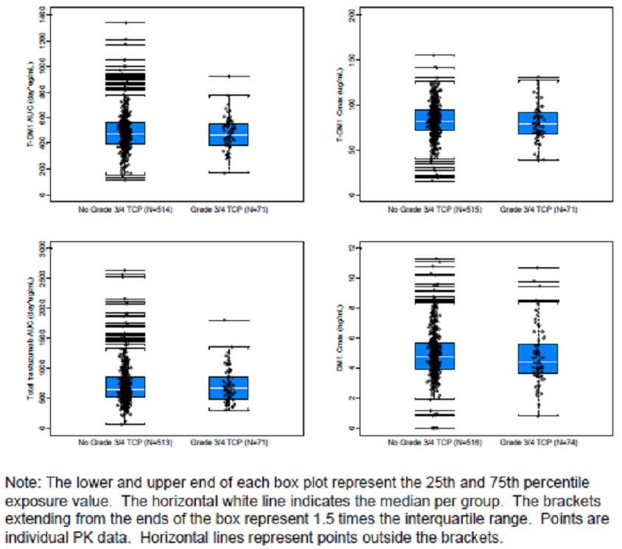
Figure 5: Probability of grade 3 or 4 thrombocytopenia versus exposure (five studies)
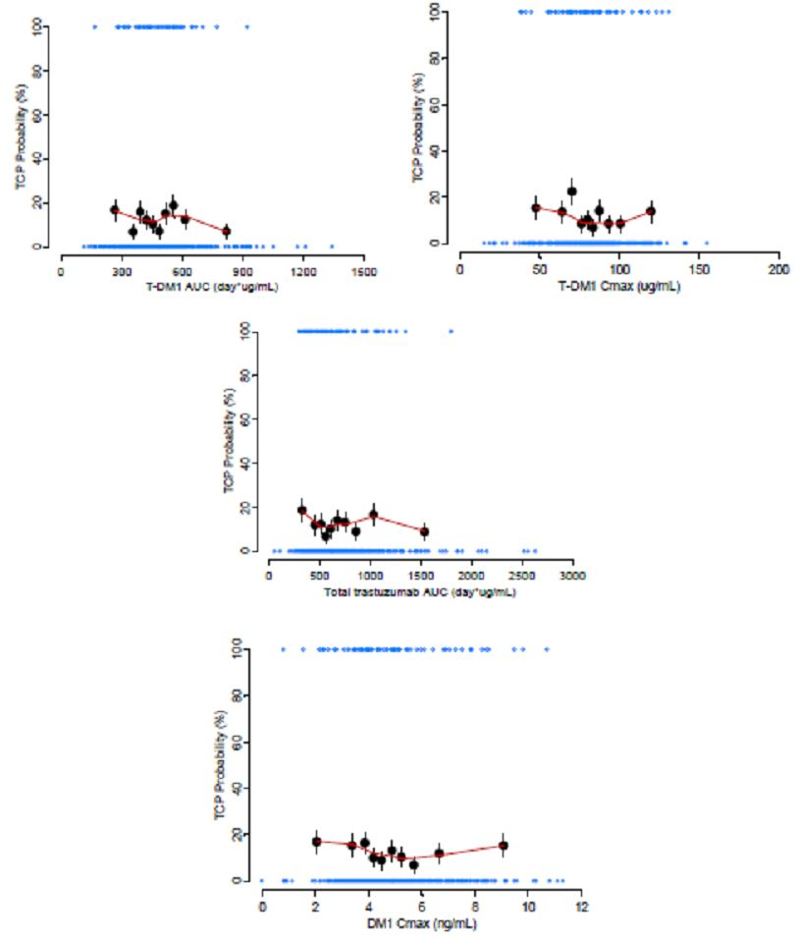
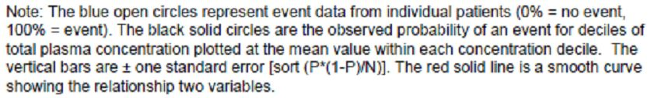
Figure 6: Exposure versus grade 3 or 4 hepatotoxicity occurrence (five studies)
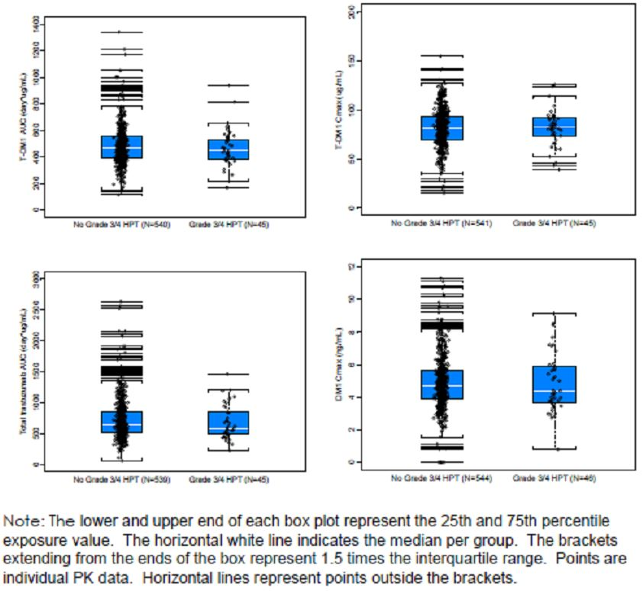
Figure 7: Probability of grade 3 or 4 hepatotoxicity versus exposure (five studies)
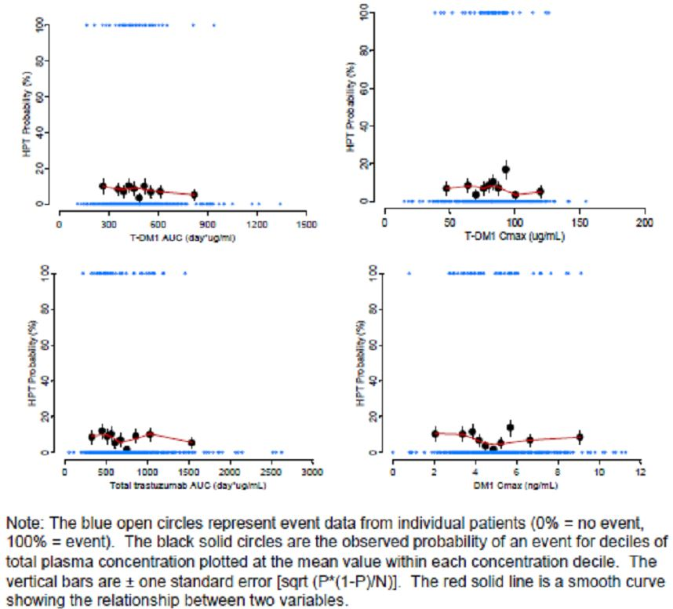
Figure 8: ALT, AST, total bilirubin, and platelet counts versus cycle by Trastuzumab Emtansine AUC quartile (five studies)
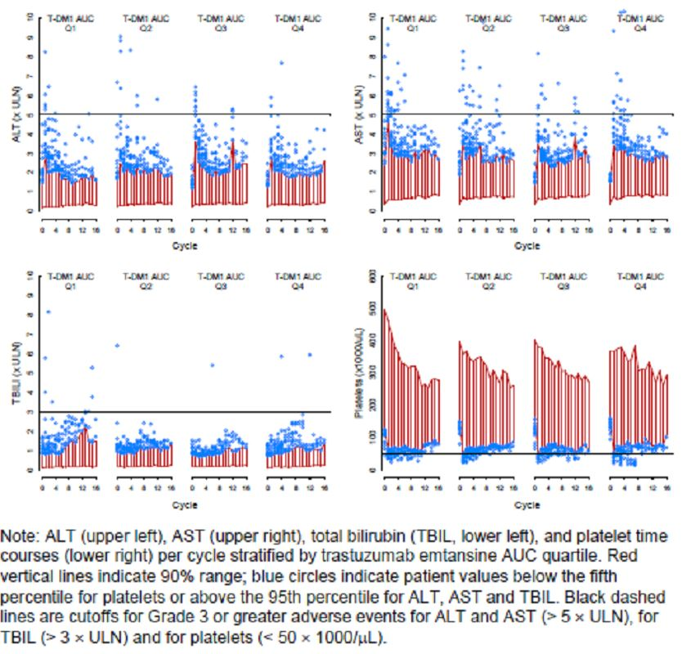
Figure 9: ALT, AST, total bilirubin, and platelet counts versus cycle by Trastuzumab Emtansine Cmax quartile (five studies)
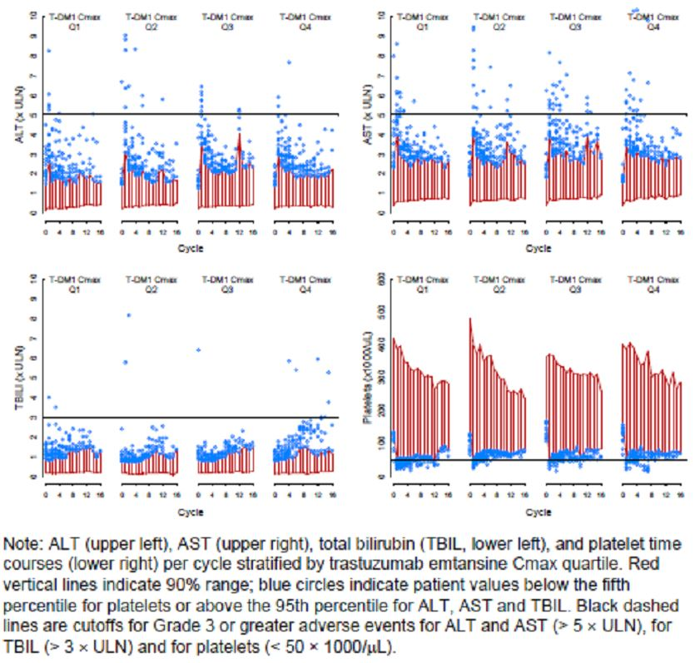
Figure 10: ALT, AST, total bilirubin, and platelet counts versus cycle by total Trastuzumab AUC quartile (five studies)
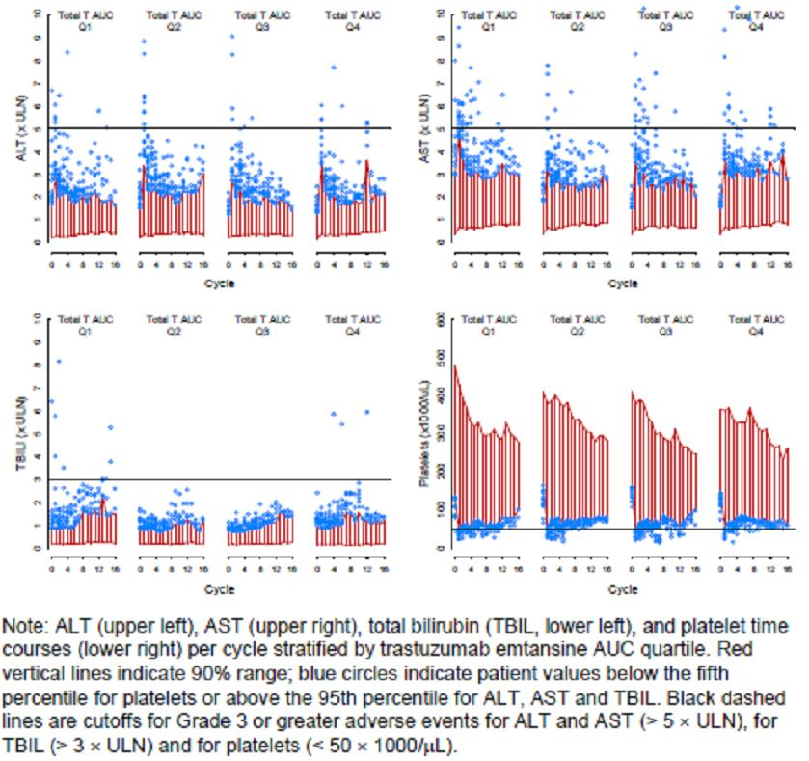
Figure 11: ALT, AST, total bilirubin, and platelet counts versus cycle by DM1 C_{max} quartile (five studies)
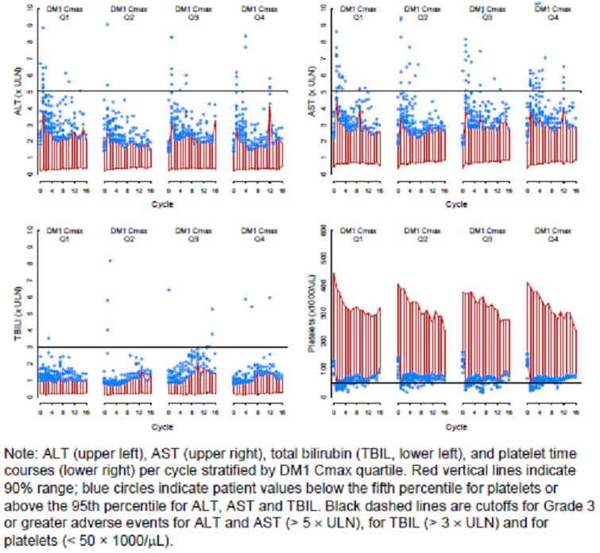

Drug interaction assessment
- Trastuzumab Emtansine is expected to undergo catabolism by means of proteolysis and cellular lysosomes with no significant involvement of CYP enzymes. As such, Trastuzumab Emtansine PK are unlikely to be affected by concomitant medications that are CYP inhibitors and inducers.
- In vitro metabolisms studies in human liver microzones suggested that DM1 a catabolite of Trastuzumab Emtansine is metabolised by CYP3A4 and to a lesser extent by CYP3A5. DM1 did not induce and/or inhibit CYP mediated metabolism at concentrations of up to 600ng/ml. Current available data showed that clinical DM1 levels do not exceed 59.7ng/ml with low DM1 exposure to patients. Consequently, DM1 is unlikely to affect the PK of concomitant medications.
- Additional data from the Phase III clinical trial 4370g demonstrated that concomitant administration of CYP3A inhibitors, CYP3A inducers or P-gp inhibitor with Trastuzumab Emtansine does not result in any noticeable change in PK Trastuzumab in either the conjugate, total Trastuzumab or DM1.
- Preliminary PK analyses showed the co-administration of Docetaxel, Paclitaxel and Pertuzumab do not appear to affect the PK of Trastuzumab Emtansine conjugate or DM1. Further the PK of Docetaxel, Paclitaxel and Pertuzumab are similar with or without co-administration of Trastuzumab Emtansine.

The effect of Trastuzumab Emtansine on QTc interval
A dedicated single arm QTc study M4688g was conducted on the target patient population at the intended marketed dose regimen. The primary objective of the study was to evaluate the effect of Trastuzumab Emtansine on the duration of the QTc interval. QTc interval was measured as change from baseline to selected time point following Trastuzumab Emtansine administration, calculating using QTcF. Secondary objectives of the study included the evaluation of the effect on Trastuzumab Emtansine on cardiac induction and the characterisation of the relationship between PK profile of Trastuzumab Emtansine and observed QTc related effect. Additional endpoints included characterisation of the safety, tolerability, efficacy and the PK properties of Trastuzumab Emtansine as a single agent including immunogenicity.
Single agent Trastuzumab Emtansine 3.6mg/kg was administered every three weeks and ECG data and time match PK samples were collected on cycle 1, day 1, cycle 1, day 8 and cycle 3, day 1. Serum and plasma samples were collected to characterise the PK of Trastuzumab Emtansine, total Trastuzumab and DM1.
A total of 51 patients were enrolled and treated in the study.
Overall, the statistical analysis of ECG data and concentration/QTc analysis indicate that Trastuzumab Emtansine does not have a clinically relevant effect on QTcF interval and other ECG parameters in patients with HER2+ breast cancer. The results of the primary QTcF analysis met guidelines for definition of a negative QT/QTc study thus reasonably assuring that the observed concentration ranges of Trastuzumab Emtansine, DM1 and total Trastuzumab the mean effect of Trastuzumab Emtansine on the QT/QTc interval is not >5mlsecs. Because Trastuzumab Emtansine and DM1 achieved steady state levels by cycle 1 and total Trastuzumab achieved steady state levels by cycle 3, the likelihood of progressively longer QTcF with repeated Trastuzumab Emtansine is low. This data is illustrated in Tables 1-2 and Figure 12.
Table 1: Categorical analyses of baseline-adjusted average of the triplicate QTC interval results by nominal ECG collection time (ECG-evaluable patients, TDM4688g).
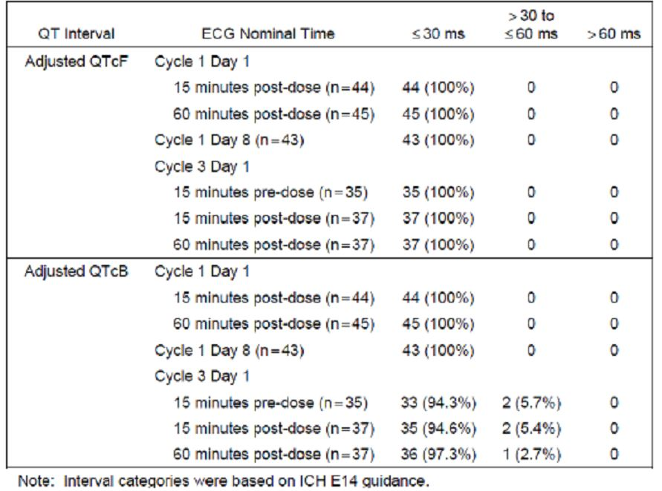
Table 2: Study TDM4688g: final model parameter estimates for concentration-QTc analysis
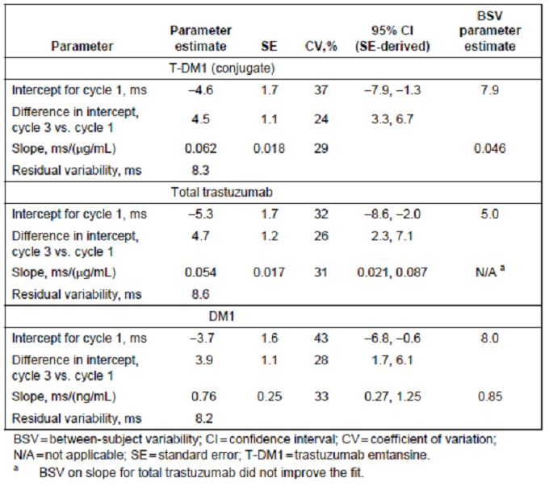
Figure 12: Study TDM4688g: mean baseline-adjusted average Fridericia’s corrected QT interval (ΔQTcF) versus Trastuzumab Emtansine
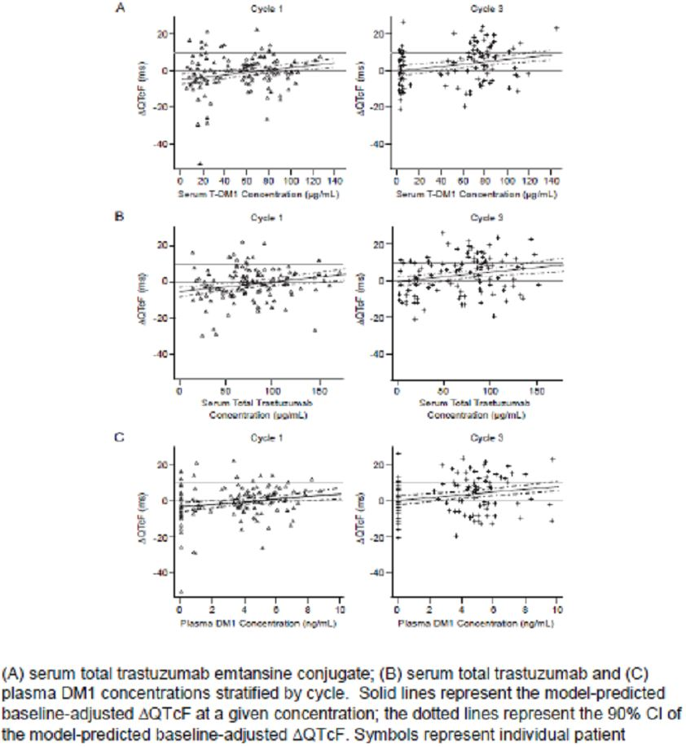

Immunogenicity
Development of anti-therapeutic antibodies to Trastuzumab Emtansine has been assessed in all clinical studies including this submission.
Overall, a total of 5.3% or 44/836 evaluable patients had a post-dose positive ATA response irrespective of their baseline status. Of the 44 patients with a positive ATA response, 13 also had an ATA positive baseline sample and this could be attributed to innate properties of the molecule, and prior exposure to Trastuzumab. All responses are confirmed by competitive binding in immunodepletion with Trastuzumab Emtansine and Trastuzumab. There were no obvious changes in the PK profiles of patients who tested ATA positive to Trastuzumab Emtansine when compare with data from patients who tested ATA negative. In the pivotal study, no significant changes in the safety profile were observed in patients with ATA positive responses. A lower median PFS in the 20 ATA positive patients was observed compared with the intent to treat population (5.6 vs 9.6 months) while objective response rates were comparable. It is to be noted that assessment of the impact of ATA is limited by the low number of ATA positive patients.

Special populations

Elderly
The effect of age on the pharmacokinetics of Trastuzumab Emtansine was evaluated in the population PK analysis. Specifically, of the 671 patients included from the five studies, 78 patients or 11.6% were between 65-75 years and 16 patients or 2.39% were >75 years. There were no patients in the aged category of >85 years enrolled in any of the five studies. No statistically significant effect of age on the PK of Trastuzumab Emtansine was observed.

Hepatic impairment
Patients with significantly impaired liver function were excluded from Trastuzumab Emtansine studies. No evidence was found to suggest that baseline markers of liver function (eg. AST, ALT, total bilirubin, albumin, international normalised ratio, total protein, and alkaline phosphatase) had any clinically meaningful effect on Trastuzumab Emtansine exposure. Impaired hepatic function was therefore unlikely to affect systemic exposure through Trastuzumab Emtansine and dose adjustments in patients with liver function impairment are not likely to result in a meaningful reduction in PK variability. However, a dedicated study in cancer patients with mild to moderate hepatic impairment is currently ongoing.

Renal impairment
Trastuzumab Emtansine PK was evaluated in patients categorised by renal function into normal, mild, moderate or severe according to their estimated creatinine clearance at baseline. Trastuzumab Emtansine CL and Vc were similar across the four groups though only a limited assessment was possible in patients with moderate impairment and data were only available for one patient with severe impairment. It was therefore clear that renal function is unlikely to affect the systemic exposure of Trastuzumab Emtansine.

Race and geographical region
The effects or race and region on the PK of Trastuzumab Emtansine were evaluated from patients enrolled in the five studies. Race (ie. white, Asian and others) and region (ie. Asia vs non-Asia) was tested as a potential categorical co-variate in the population PK model. The results showed that race and region had no impact on Trastuzumab Emtansine pharmacokinetics. Trastuzumab Emtansine pharmacokinetics was similar in Asian vs non-Asian patients and the patients from regions from Asia vs non-Asia.

Stage 1 study TDM3569g
Only one Phase I study was provided in this submission: an open label dose escalation study to assess the safety, tolerability and PK of Trastuzumab Emtansine administered by IV infusion to patients with HER2+ metastatic breast cancer who previously received Trastuzimab prior to enrolment in study. Kadcyla was administered on both an every week 1.2-2.9mg/kg and every three weeks 0.3-4.8mg/kg dosing schedule to determine the recommended Phase II dose regimen on the basis of the assessment of MTD and observed PK.
PK data for serum Trastuzumab Emtansine conjugate concentrations for the first dose of the three week regimen and after the first dose of the weekly regimen are summarised in Tables 3-4. Concentration/time profiles for the conjugate, serum total Trastuzumab and plasma DM1 after the first dose of a three week regimen and the first dose on the weekly regimen are indicated in Figures 14-15. These data show with the three weekly regimen the conjugate concentrations increased rapidly after dosing to reach maximum concentration at the end of infusion and thereafter decreased in the mean terminal half-life ranging from 1.3-4.1 days across the dose levels tested. There was no significant accumulation observed with the three week dosing. Similarly systemic exposure measured by Cmax and AUC increased with increasing dose. Non-linearity in the conjugate pharmacokinetics was observed at doses <1.2mg/kg. Doses of at least 2.4mg/kg clearance were slower with a mean clearance of 7.1-4.7ml/day/kg. Assessment of dose linearity was limited by the small number of patients evaluated. Volume of distribution of Trastuzumab Emtansine approximated the physiologic serum volume and did not appear to change with dose.
Table 3: Study TDM3569g: serum Trastuzumab Emtansine conjugate PK parameters after the first dose of Trastuzumab Emtansine q3w.
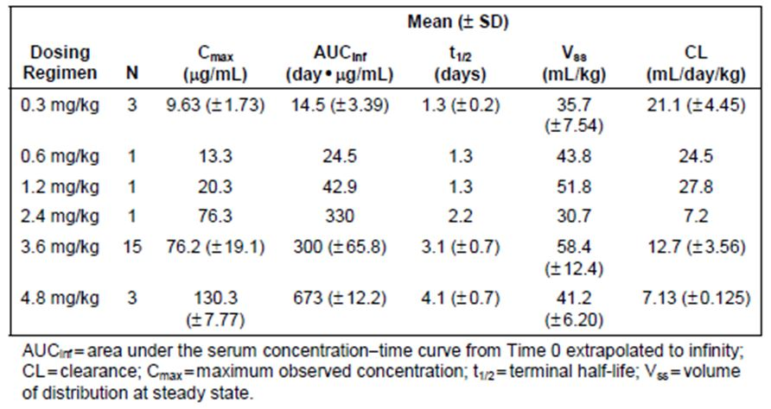
Table 4: Study TDM3569g: serum Trastuzumab Emtansine conjugate PK parameters after the first dose of Trastuzumab Emtansine qw
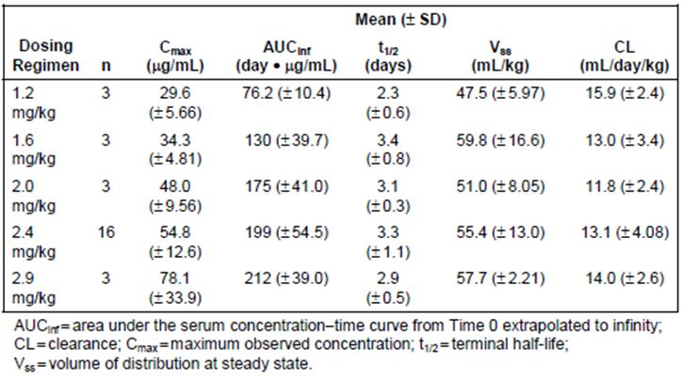
Figure 14: Study TDM3569g: Trastuzumab Emtansine conjugate conjugate concentration-time profiles at cycle 1 for the Trastuzumab Emtansine q3w cohort
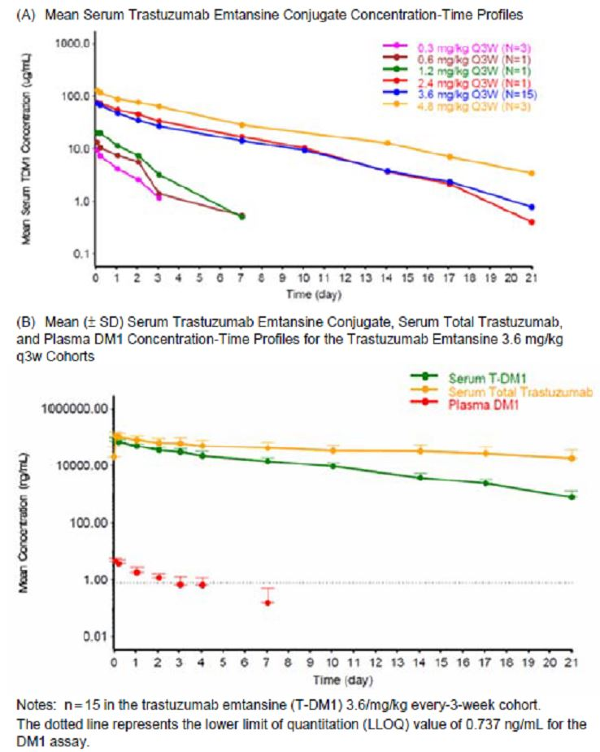
Figure 15: Study TDM3569g: mean (± SD) serum Trastuzumab Emtansine conjugate, serum total Trastuzumab, and plasma DM1 concentration-time profiles for the Trastuzumab Emtansine 2.4mg/kg weekly cohort
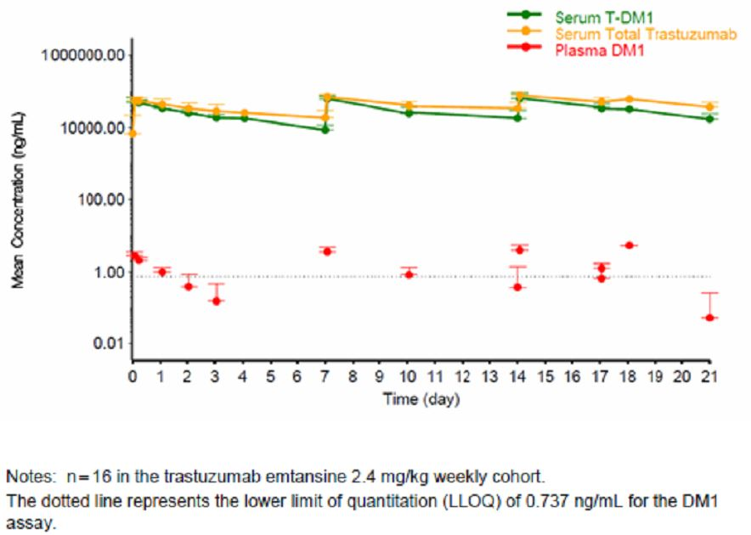
It was also noted that serum concentrations of total Trastuzumab reached maximum concentrations after the end of infusion and declined thereafter with T1/2 of ~9 days following Trastuzumab Emtansine 3.6mg/kg. Across the administered doses, total Trastuzumab exhibited a longer terminal half-life and higher AUC compared with the conjugate.
Plasma DM1 concentrations were measureable immediately following Trastuzumab Emtansine infusion and declined thereafter to below the lower limit of quantification. By day 7, DM1 concentrations were below the limit of detection in the majority of patients, and there was no accumulation observed.
With the weekly regimen similar to the three week regimen, there was a rapid rise in the drug complex concentrations after dosing, reaching maximum concentrations at the end of infusion and a mean T1/2 from 2.3-3.4 days. Systemic exposure is measured using Cmax AUC increased proportion of dose. Mean clearance values were similar across the dose levels evaluated ranging from 11.8-15.9mls/day/kg. The volume of distribution at steady state of the conjugate also approximated the physiologic serum volume with mean values ranging from 47.5-59.8ml/kg. Collectively, the PK of weekly Trastuzumab Emtansine at dose levels ranging from 1.2-2.9mg/kg appeared to be linear.
Similarly, measurement of total Trastuzumab concentrations with the weekly dose and the plasma DM1 concentrations followed those figures determined for the Q3 weekly regimen.
The MTD for the Q weekly and Q3 weekly regimens were established at 2.4mg/kg and 3.6mg/kg, respectively. The three weekly regimen was selected for Phase II and Phase III studies on the basis of its robust activity with respect to ORR observed in this study and based on patient convenience. This was noted with the three week regimen in 5/24 treated patients who had objective partial response of whom four were within the 3.6mg/kg cohort. In the weekly regimen, 13/28 patients had an objective partial response with 6 occurring in the 2.4mg/kg cohort, 2 in the 2mg/kg cohort, 2 in the 1.6mg/kg cohort, and 3 in the 1.2mg/kg cohort.

Phase I study J022591 (Japan)
In this Japanese study, 12 patients with HER2+ advanced recurrent metastatic breast cancer were evaluated for determination of MTD utilising a three weekly regimen ranging in doses from 1.8mg/kg every three weeks to 3.6mg/kg every three weeks.
There were 10 patients evaluable for study and determined that the PK of serum levels of the complex and serum total Trastuzumab were linear within the dose range of 1.8-3.6mg/kg. Assessment of responses was also evaluable for the 10 patients with a partial response in one patient being noted. As tolerability for the conjugate was good across the dose ranges, it was concluded that the use of the conjugate was suitable for trialling in Japanese patients.

Comment
These pharmacologic data have provided a comprehensive profile of trastuzumab emtansine conjugate with linear pharmacokinetics with predictable pharmacokinetic profile and no evidence of repeated dosing led to noticeable accumulation of the conjugate consistent with the observed half life of ~4 days. As concentrations of DM1 detected in the plasma were relatively low after the various infusions, this indicates that the linkage of trastuzumab to DM1 was stable. Various baseline tumour characteristics and baseline renal and hepatic function do not appear to influence pharmacokinetic parameters. There is no evidence that age, race, geographic region or renal function influenced the pharmacokinetics of the conjugate and further assessment is being undertaken in relation to hepatic function.

Dosage selection for the pivotal studies
Initial evaluation of various dosing regimens in in-vitro models revealed efficacious dose of the conjugate ranged from 3-15mg/kg and in one xenograft model 3mg/kg of the conjugate showed significant and sustained regression or tumour growth delay. In the Phase I dose escalation study 3569g, the MTD was established for the three weekly regimen of 3.6mg/kg and 2.4mg/kg for the weekly dose. Based on small sample sizes, the degree of tumour activity for the two regimens appeared to be relatively similar with a more convenient dosage regimen being the three weekly schedule. Initial data from Phase II studies 4258g, 4374g and 4688g also confirmed robust clinical activity for 3.6mg/kg three weekly dosing. Accordingly, this dosing schedule was selected from the pivotal study 4370g.

Clinical efficacy
Efficacy data in this evaluation of Trastuzumab Emtansine (T-DM1) therapy in patients with HER2+ unresectable locally advanced breast cancer or metastatic breast cancer is provided by the pivotal phase III study 4370g, and three supportive studies including a two-arm randomised phase II study 4450g and two single-arm Phase II studies 4374g and 4258g. All patients had histologically or cytologically confirmed invasive breast cancer, unresected locally advanced or metastatic. All patients were also HER2+. The HER2 status was assessed by local laboratories for the three supportive studies but a central confirmation of HER2+ disease was undertaken for the pivotal trial.
In relation to prior treatment, for the pivotal study and studies 4374g and 4258g included patients who had received prior HER2 directed therapy in the locally advanced or metastatic setting. For the pivotal study, this included at least a taxane and Trastuzumab alone or in combination with other agents.
All patients were assessed for adequate organ function prior to enrolment into any of the studies in patients with a history of intolerance to Trastuzumab, severe uncontrolled systemic disease or active infection of HIV, Hepatitis B virus or Hepatitis C virus were excluded.
In relation to study design, for the pivotal study 4370g which was a randomised multicentre international two-arm open label clinical trial designed to compare the safety and efficacy of the conjugate with that of Lapatinib plus Capecitabine in patients with HER2+ unresectable locally advanced or metastatic disease.
A total of 991 patients were randomised in a 1:1 ratio into one of two treatment arms with stratification according to geographical region, number of prior chemotherapeutic regimens and disease site.
The chemotherapy regimen in the pivotal study was on the Trastuzumab Emtansine arm 3.6mg/kg IV on day 1 of a three week cycle whereas for the control arm Lapatinib 1250mg/day orally with continuous daily dosing on a three week cycle and Capecitabine 1000mg/m² orally twice daily on days 1-14 of a three week cycle. Treatment was continued until disease progression or unmanageable toxicity. Tumour assessments were conducted approximately every six weeks and an independent review committee (IRC) evaluated all radiographic and tumour response data generated from all patients to a data cut-off for the final assessment of PFS. This was planned after approximately 508 IRC assessed PFS events had occurred with an interim analysis of OS performed at that time. The clinical cut-off date for the primary analysis for PFS occurred on the 14th January 2012.
Study 4374g, a phase II single arm open label study to evaluate the efficacy and safety of the conjugate in patients with HER2+ MBC Trastuzumab Emtansine, was administered intravenously with a dose of 3.6mg/kg every three weeks. Patients remained on study until documented progressive disease and unacceptable toxicity. Similar design was applied to supportive study 4258g.
The supportive study 4450g was a Phase II randomised multicentre international two-arm open label clinical trial. This study was designed to explore the efficacy and safety of the conjugate relative to the combination of Trastuzumab and Docetaxel in patients with HER2+ unresectable locally advanced and metastatic disease who had not received prior chemotherapy for metastatic disease.
Patients were randomised on a 1:1 ratio to either Trastuzumab Emtansine 3.6mg/kg IV on day 1 of the three week cycle or arm B which is Trastuzumab 8mg/kg IV plus Docetaxel 75-100mg/m² IV on day 1 of a three week cycle.
Patients on the Trastuzumab Emtansine arm who either could not tolerate or developed progressive disease on this therapy could subsequently receive Trastuzumab as a single agent. For those patients in treatment arm B who became intolerant to either Docetaxel or Trastuzumab, these patients could then subsequently receive single agent Trastuzumab or Docetaxel until progressive disease, clinical deterioration or intolerance.
In relation to efficacy assessments, all four studies involved tumour measurements according to RECIST criteria. These were undertaken every six weeks until progressive disease. Various scans were performed as clinically indicated.
In relation to study statistics for the pivotal study 4370g, this study had two primary endpoints: PFS and OS. Fixed sequence hypothesis testing procedures implemented with the hypothesis test for PFS were conducted as a two-side alpha of 5% and only if PFS was significantly different to OS to be tested at a two-sided alpha of 5%. The primary efficacy analysis was planned when enrolment was complete and ~508 IRC assessed PFS events had occurred.
For study 4374g and 4250g, a response rate of at least 25% was considered clinically meaningful with a sample size of 100 patients considered to be required for adequate evaluation.
The goal of study 4450g was to estimate the effect of size and incidence of adverse events rather than to test the specific hypothesis. The goal was to enrol 120 patients with a primary PFS analysis to be undertaken up to 72 PFS events in the two arms under study. It not was anticipated that the study would have adequate power to detect a clinically meaningful difference between the two treatment arms.
In relation to assessment of OS for the pivotal study with co-primary endpoints, an interim analysis of OS was undertaken at the time of final PFS analysis, with the one year and two year survival rates and associated confidence intervals estimated using the Kaplan-Meier approach.
On reviewing the results of the studies, the patient populations for studies 4374g and 4258g were similar, while those for studies 4370g and 4450g were conducted in different patient populations. Accordingly, efficacy data for studies 4370g and 4258g are pooled, while the other two studies are presented separately.
Nearly all patients randomised to studies received treatment, and for the two randomised studies a higher percentage of patients in the control arm discontinued the study compared with the Trastuzumab Emtansine arm.
The median age of patients were similar across the studies and between treatment arms for the two randomised studies. Patients in the pivotal study and study 4450g have similar distributions of baseline ECOG performance status. Fewer patients had a baseline ECOG performance status of zero. This reflected a more advanced stage of disease for these patients.
In relation to baseline disease characteristics, the pivotal study enrolled a heterogeneous population with respect to the number of prior chemotherapy regimens that the patients had received in the locally advanced or metastatic setting. Therefore, as might be expected, patients on studies 4258g and 4374g included patients at baseline disease characteristics more indicative of patients who were further along in their metastatic disease course compared with those patients from the pivotal study 4370g. This is presented as a higher proportion of extensive disease involvement. This is contrasted with patients from study 4450g who had not received any prior treatment for their advanced or metastatic disease, and therefore a shorter time course of disease prior to enrolment onto study. Otherwise, baseline disease characteristics for the four studies were relatively similar.
In relation to prior cancer treatment, the pivotal study 4370g included a broad patient population regarding prior treatment for metastatic disease. This included 12% of patients who received no prior therapy for metastatic disease but received either neo or adjuvant therapy containing Trastuzumab. There was a similarity in terms of prior hormonal therapy across the four studies, and in study 4450g prior exposure to a taxane and anthracyclines was lower as these patients were receiving their first line treatment for metastatic disease.
In all four studies, the same dose of Trastuzumab Emtansine was administered in patients who received study treatment every three weeks until progressive disease or unacceptable toxicity.
Reviewing efficacy results, for the pivotal study IRC assessed PFS was the co-primary efficacy endpoint and a secondary efficacy endpoint for studies 4374g and 4258g. Investigator assessed PFS was a secondary endpoint in studies 4370g, 4374g and 4258g and the primary endpoint in study 4450g.
For the pivotal study, a statistically significant and clinically meaningful increase in PFS was shown for Trastuzumab Emtansine treatment compared with Lapatinib plus Capecitabine. Also as noted, in the first line metastatic patients in the randomised study 4450g treatment with Trastuzumab Emtansine was a statistically significant increase in the investigator assessed PFS compared to the standard HER2 directed combination therapy of Trastuzumab plus Docetaxel as indicated. Results for the pooled single arm studies in heavily pre-treated patients were supportive of these findings.
The pivotal study treatment with Trastuzumab Emtansine showed a statistically significant reduction in the risk of disease progression or death compared with Lapatinib plus Capecitabine. There was a 35% reduction in the risk of PD or death with an HR 0.650 and P<0.0001 and a 50% increase in median PFS in the Trastuzumab Emtansine arm with a median PFS 6.4 months (Lapatinib plus Capecitabine arm) vs 9.6 months (Trastuzumab Emtansine arm). Results of investigator assessed PFS analyses were consistent with the IRC results.
Consistent with the primary PFS analysis, a multi-variate Cox regression analysis also showed significant treatment benefit for Trastuzumab Emtansine with a HR 0.65 and P<0.0001. The three significant prognostic factors for PFS in the final model were number of disease sites, baseline ECOG score, and baseline disease measurability.
Results of nearly all pre-specified sub-groups evaluated showed a clear benefit for Trastuzumab Emtansine. The treatment effect in patients aged 65-74 years, patients with non-visceral disease, and those with only non-measurable disease at baseline also favoured Trastuzumab Emtansine, albeit with less effect.
It is of note that in study 4450g, the median duration of PFS was longer than study 4370g. This reflected the patient population having less pre-treatment and less advanced disease. In this randomised population, the primary efficacy endpoint of investigator assessed PFS demonstrated a significant improvement in PFS among patients in the Trastuzumab Emtansine arm compared with those in the Trastuzumab plus Docetaxel arm with a P value of P=0.0353. This suggests that even in first line metastatic patients without prior chemotherapy treatment, substantial benefit is derived from Trastuzumab Emtansine. This stratified HR for the complex relative to the control arm was 0.594.
In relation to the pivotal study, the Kaplan-Meier curve showed a clear separation between the treatment arms at ~4 months, which was maintained thereafter, as shown in Figure 16.
Figure 16: Study TDM4370g/BO21977: Kaplan-Meier curve of IRC-assessed PFS
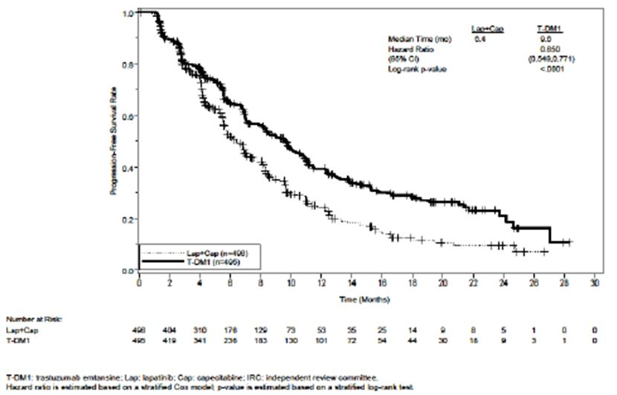
In study 4450g, the PFS rates at six months were estimated to be 76.4% in the Trastuzumab Emtansine arm and 80.4% in the Trastuzumab plus Docetaxel arm. At 12 months, the PFS rates were estimated to be 55.9 and 30.9% in the Trastuzumab Emtansine and Trastuzumab plus Docetaxel arms, respectively, as shown in Figure 17.
Figure 17: TDM4450g/BO21976: Kaplan-Meier estimates of PFS (all randomised patients)
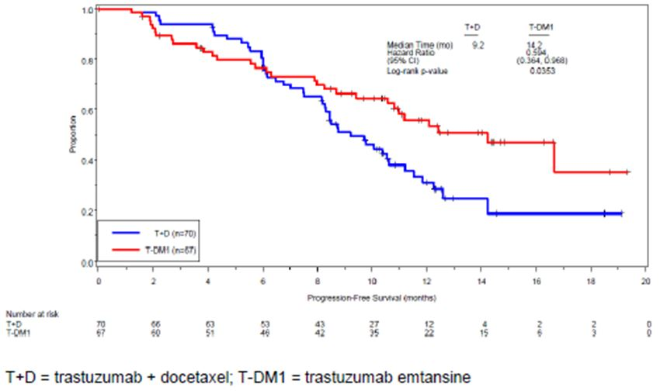
In study 4370g, several predefined sensitivity analyses were conducted. The results of these analyses were similar to those of the primary analysis showing the consistent treatment effect observed and supporting the robustness of the primary endpoint.
In the pooled studies 4374g and 4258g, the results of the sensitivity analyses for IRC PFS were consistent with those of the main analysis.
In study 4450g, consistent effects were seen in two post-hoc exploratory sensitivity analyses. In an analysis of PFS, on the basis of the first documented PD prior to crossover or death from any cause at any time, the stratified HR for Trastuzumab Emtansine relative to Trastuzumab plus Docetaxel was 0.612. In the second post-hoc exploratory sensitivity analysis on PFS, including all deaths of any cause in which patients who had non-protocol anti-cancer therapy prior to the first documented PD were censored at the time of their last tumour assessment before the initiation of a non-protocol anti-cancer therapy; stratified HR for Trastuzumab Emtansine relative to Trastuzumab plus Docetaxel was 0.662.
The treatment effect of Trastuzumab Emtansine observed in these two sensitivity analyses were consistent with that observed in the analysis of the protocol specific primary PFS endpoint of this study as indicated in Table 5.
Table 5: TDM4450g/BO21976: sensitivity analyses of PFS per investigator assessment
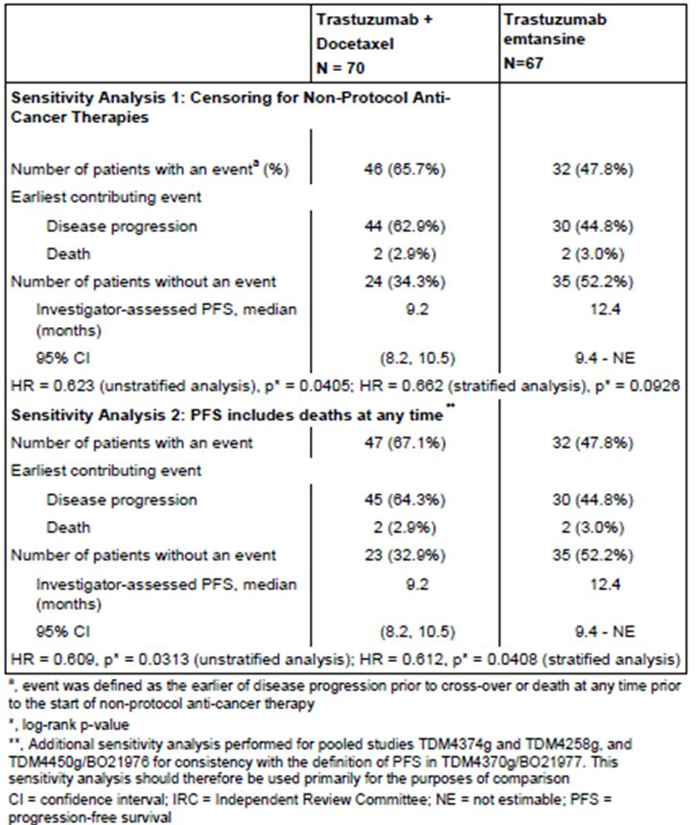
Review of OS data for the pivotal study 4370g demonstrated an apparent benefit favouring Trastuzumab Emtansine. However, only one-third of the death events had occurred at the time of the primary PFS analysis, and the HR for OS did not meet the pre-specified stopping boundary at that time.
Further analysis of the pivotal study 4370g and OS at the time of the data cut-off date for the primary analysis of PFS and interim analysis of OS was conducted. At that time, 35.3% of target events had been reported, ie. 223/632 targeted deaths, with 129 or 26% in the Lapatinib plus Capecitabine arm vs 94 or 19% in the Trastuzumab Emtansine arm, respectively. The median duration of follow up for survival was 12.4 months in the Lapatinib plus Capecitabine arm and 12.9 months in the Trastuzumab Emtansine arm. Results of the interim OS analysis favoured the Trastuzumab Emtansine with an HR 0.621, P=0.0005 corresponding to a 37.9% reduction in the risk of death. However, the HR do not cross the pre-specified stopping boundary for the interim analysis of P=0.0003 or observed HR = 0.617.
At the time of the interim analysis, the Kaplan-Meier estimate for median OS was 23.3 months in the Lapatinib plus Capecitabine arm, and the median was not reached in the Trastuzumab Emtansine arm as indicated in Figure 18. Treatment benefit from Trastuzumab Emtansine in terms of OS was seen in the majority of pre-specified sub-groups evaluated and with highly consistent results of the sub-group analysis for PFS.
Figure 18: Pivotal study TDM4370g/BO21977: Kaplan-Meier curve of OS.
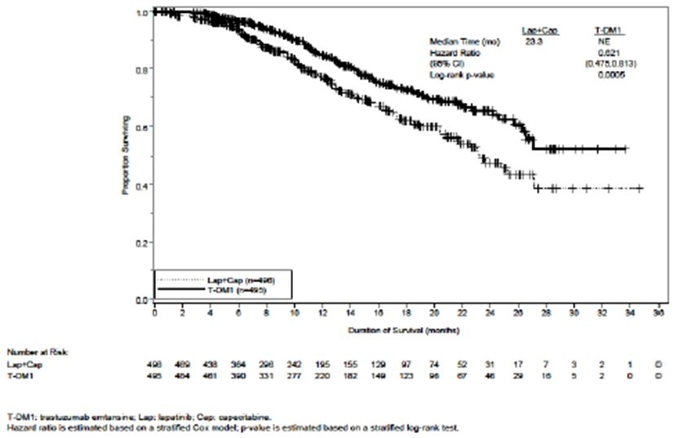
The only other study with any OS data was study 4450g when analysis of OS was performed based on a clinical data cut-off date of 31 August 2011. At this time there were equivalent number of deaths in each arm, ie. 13 and survival rates in the two arms were similar at 6, 12 and 18 months. These data to some extent are confounded by the small number of deaths involved together with the fact that there was crossover from the Trastuzumab plus Docetaxel arm to Trastuzumab Emtansine after documented PD.
ORR was the primary endpoint in the single arm studies 4374g and 4258g and a secondary endpoint in the pivotal study 4370g. These data for both IRC assessed and investigator assessed ORR are indicated in Table 6. In the pivotal study 4370g, there was higher ORR observed for the Trastuzumab Emtansine arm compared with the Lapatinib plus Capecitabine arm. The response rate in the pooled studies also tended to support that observed for the Trastuzumab Emtansine arm of the pivotal study. It is noted that the extent of prior therapy for patients in the pivotal study 4370g were generally less than that for the pooled single arm studies having some influence on the response rates observed. It is noted that study 4450g data assessed ORR was higher in the Trastuzumab Emtansine arm at 64% compared to the Trastuzumab plus Docetaxel arm at 58%. This suggested that with newly diagnosed metastatic breast cancer patients, the Trastuzumab Emtansine provided better efficacy than the combination of Trastuzumab and Docetaxel.
Table 6: ORR across studies.
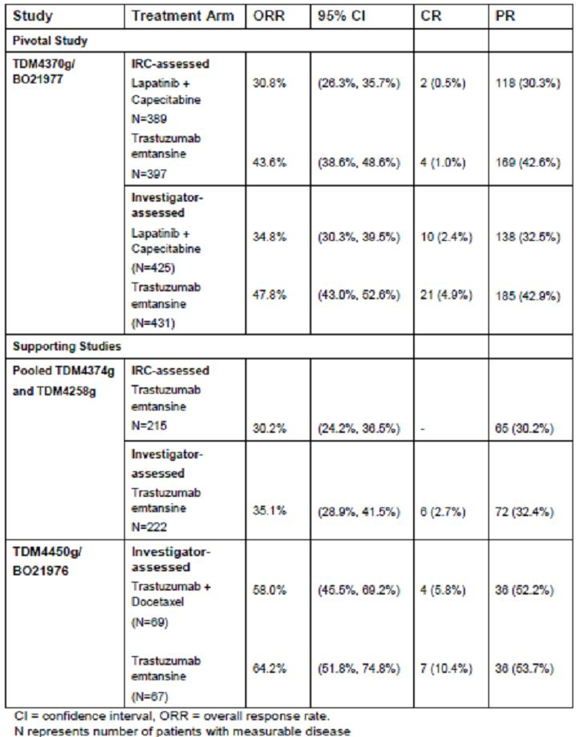
In relation to duration of objective response, the data available in relation to the various studies is indicated in Table 7. It is noted that for the pivotal study objective responses were maintained for approximately six months longer in the Trastuzumab Emtansine arm. Kaplan-Meier curves for the pivotal study are given in Figure 19. Similarly, in study 4450g the Kaplan-Meier curves for duration of response showed a clear and persistent separation between the two treatment arms starting at five months after randomisation and indicated in Figure 20.
Table 7: Duration of ORR across studies.
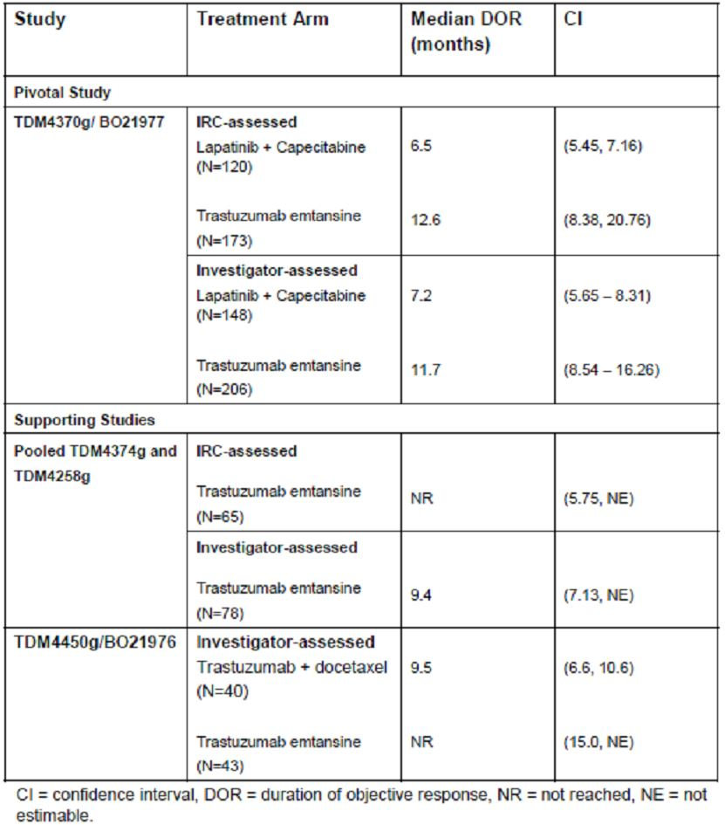
Figure 19: TDM4370g/BO21977: Kaplan-Meier curve for IRC assessed duration of objective response
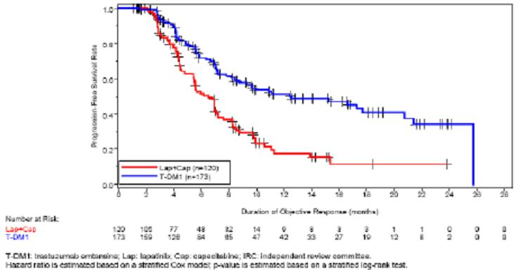
Figure 20: TDM4450g/BO21976: Duration of objective response per investigator assessment (randomised patients with measurable disease at baseline who had an objective response)
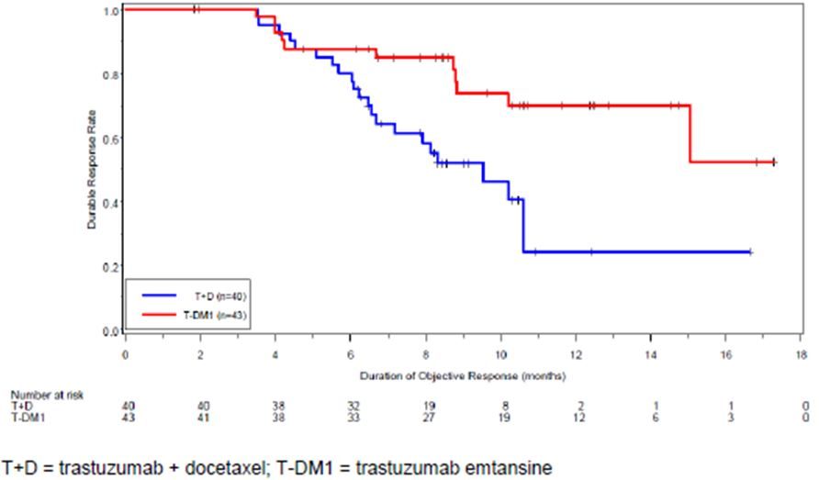
Time to symptom progression was assessed with FACT-BTOI-PFB, which included physical, functional and breast cancer sub-scales of FACT-B. A change of five points in the FACT-BTO-PFB is considered clinically meaningful. These data were collected for studies 4370g, 4374g and 4450g. For the pivotal study these data demonstrated that treatment with the complex results in a delay in clinically meaningful symptom progression compared with Lapatinib plus Capecitabine. As indicated in Figure 21, the worsening of the FACT-BTOI-PFB scores were delayed in the Trastuzumab Emtansine arm compared to the Lapatinib plus Capecitabine arm at 7.1 months vs 4.6 months with an HR 0.796 and P=0.0121. Results of the unstratified analysis and two sensitivity analyses were consistent with this.
Figure 21: TDM4370g/BO21977: Kaplan-Meier plot of time to symptom progression.
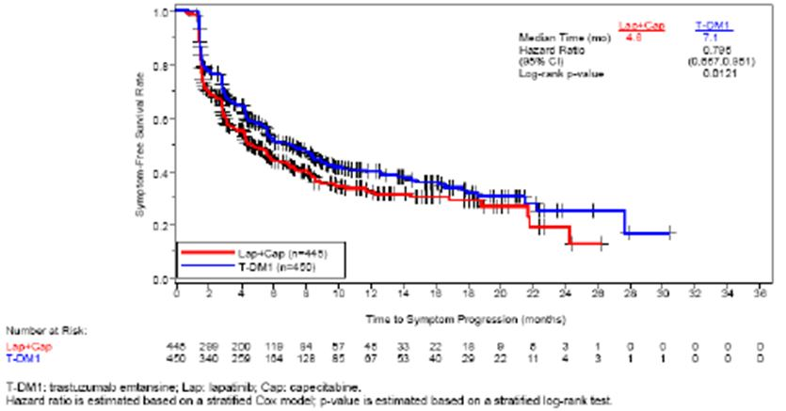
In study 4374g, the median time to symptom progression was 5.5 months and in these heavily pre-treated patients this was noted to be longer than the control arm of study 4370g. For study 4450g there was also a delay in time to symptom progression for patients in the Trastuzumab Emtansine arm with a median time to symptom progression of 7.5 months for the complex vs 3.5 months for the Trastuzumab plus Docetaxel (HR 0.585 and P=0.0215).
Sub-group analyses were undertaken in relation to both PFS and OS with results being of value for the pivotal study. In the pivotal study there was a clear and consistent treatment benefit for Trastuzumab Emtansine in the majority of pre-specified sub-groups although it was less noticeable for sub-groups of patients with ages 65-74 years, those with non-visceral disease, and those with non-measureable disease. The data in relation to PFS for the pivotal study is indicated in Figure 22.
Figure 22: TDM4370g/BO21977: subgroup analyses of PFS per IRC assessment
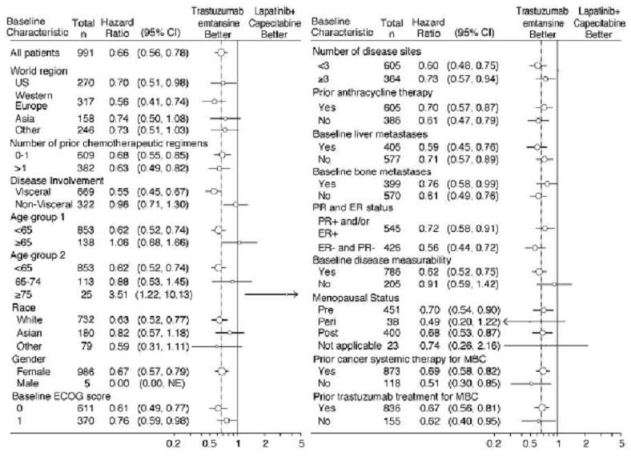
Group analyses of OS also showed consistent benefit for treatment with the complex in the majority of pre-specified sub-groups evaluated with the exception of those who >65 years, had non-visceral disease and those with menopausal status not applicable. This is indicated in Figure 23.
Figure 23: TDM4370g/BO21977: subgroup analyses of OS by baseline risk factors
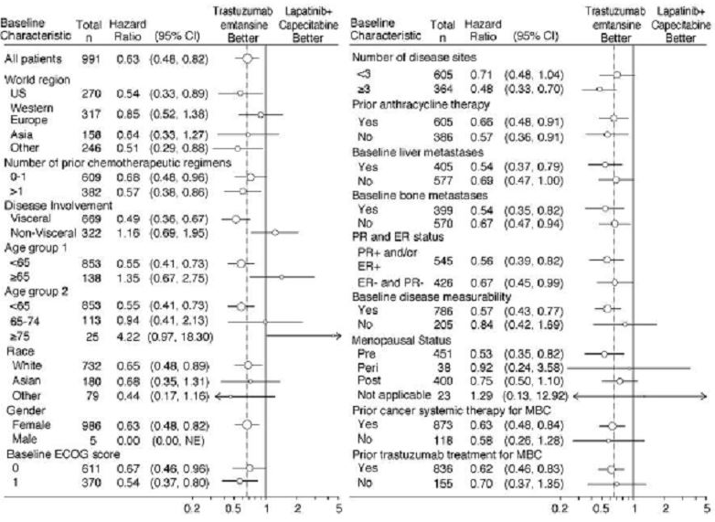

Comment
Efficacy data from the pivotal study has clearly shown evidence of a statistically significant and clinically meaningful benefit for trastuzumab emtansine compared to lapatinib plus capecitabine in this patient population. The statistically significant improvement in PFS was associated with a 35% reduction in the risk of progressive disease. It is also noted that interim OS data has a trend favouring trastuzumab emtansine. Secondary efficacy parameters and subgroup analyses all supported these results. The data from the pooled studies was more limited but nevertheless again demonstrated worthwhile efficacy for trastuzumab emtansine in both previously untreated advanced stage patients and those with heavy previous treatment.

Clinical safety
Safety data provided in this submission comes principally from the pivotal study 4370g with supporting information from five other studies for Phase I and II single arm studies, ie. 3569g, 4374g, 4258g and 4688g, together with the randomised Phase II study 4450g. These data involve 882 patients exposed to Trastuzumab Emtansine at 3.6mg/kg every three weeks. In addition, follow-up safety data included in the safety summary for 43 patients from parent studies 3569g, 4258g, 4374g, 4688g and 4450g, who continued to receive treatment in the extension study 4529g based on a clinical cut-off date of the 14 January 2012. These data are integrated into the parent studies to avoid double counting of patients. A total of four Trastuzumab Emtansine analysis groups were established for this safety analysis, including the data from the pivotal study 4370g, data from study 4450g, the pooled group of single arm studies, and the total Trastuzumab Emtansine exposed patient population. Patients without significant cardiac history and LVEF of at least 50% determined by ECHO or multiple gated acquisition scan (MUGA) were eligible for study participation. An independent cardiac review committee (CRC) reviewed all suspected cases of symptomatic left ventricular dysfunction (LVSD), cardiac death, probable cardiac death, and significantly reduced left ventricular ejection fraction (LVEF).
Clinical laboratory tests including haematology, biochemistry and urinalyses were conducted prior to each cycle of therapy.
Safety data collection for the various other studies followed conventional reporting guidelines for clinical trials. All adverse events and serious adverse events, regardless of attribution, are collected until 30 days following the last administration of study treatment. After this period, investigators only report serious adverse events that are felt to be related to prior study treatment.
For coding, verbatim descriptions of adverse events were mapped to Medication Dictionary for Regulatory Activities (MedDRA version 14.1).
As of the 14 January 2012, 882 patients had received at least one dose of Trastuzumab Emtansine as a single agent in completed studies.
Various demographic and baseline characteristics for the studies have been presented previously.
Review of the adverse events experienced for the four pooled groups is indicated in Table 8. In relation to the pivotal study, most patients in both treatment arms had at least one adverse event with the overall incidence of adverse events balanced between the two treatment arms. These are summarised by system organ class in Table 9. The main imbalances in the incidences of adverse events between the two treatment arms are indicated in Table 10. These are generally in accordance with differing mechanisms of actions of the two treatments and their known safety profiles. The majority of patients in both treatment arms developed at least one adverse event considered by the investigator to have a reasonable and suspected causal relationship to trial treatment (87.1% of patients in the complex arm vs 95.9% in the Lapatinib plus Capecitabine arm). The proportion of patients who experienced at least grade III adverse events were considered related to treatment by the investigator was lower in the complex arm (30.6%) compared to the control arm at (48.8%). The most common treatment related adverse events more frequent in the complex arm compared to the control were thrombocytopenia 27.3% vs 2%, fatigue 27.8% vs 23.2%, AST increase 20.4% vs 7.6%, and ALT increase 16.1% vs 7.2%. Those that occurred more frequently in the Lapatinib plus Capecitabine arm included neutropenia 5.5% vs 6.6%, diarrhoea 14.9% vs 75.6%, nausea 33.7% vs 39.1%, vomiting 13.3% vs 22.7%, mucosal inflammation 6.3% vs 18.2%, and hand/foot syndrome 0.2% vs 57.2%.
Table 8: Overview of safety profile (Safety Population)
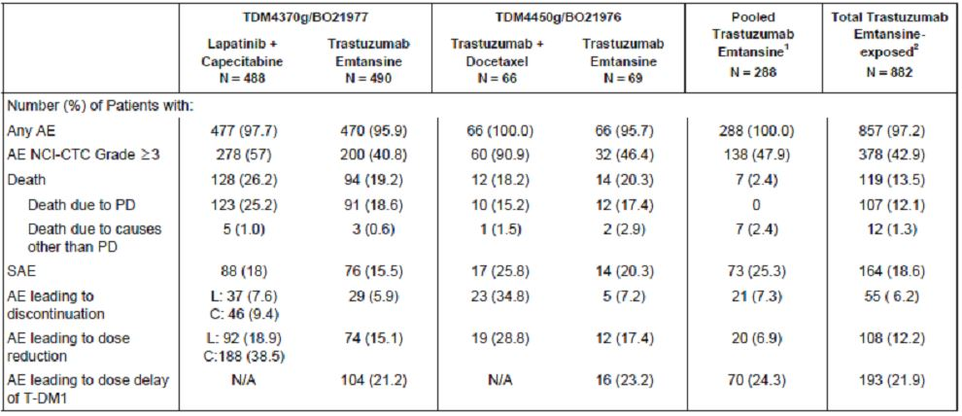
Table 9: Summary of adverse events by system organ class: pivotal study TDM4370g/BO21977 (treated patients)
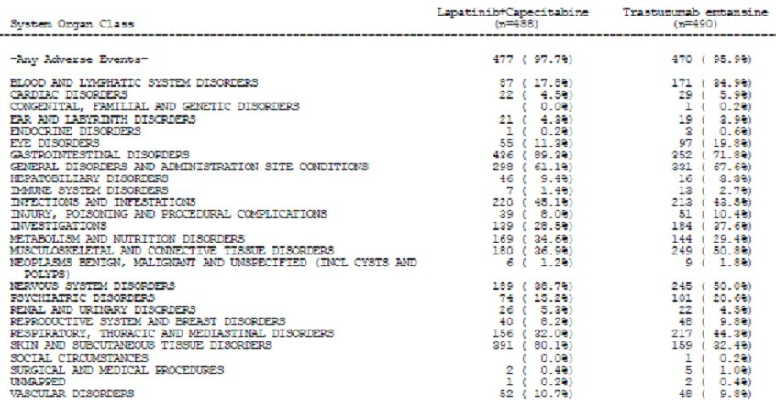
Table 10: Summary of adverse events with difference in incidence rate ≥ 5%: between the Trastuzumab Emtansine arm and the Lapatinib + Capecitabine arms: pivotal study TDM4370g/BO21977 (safety population)
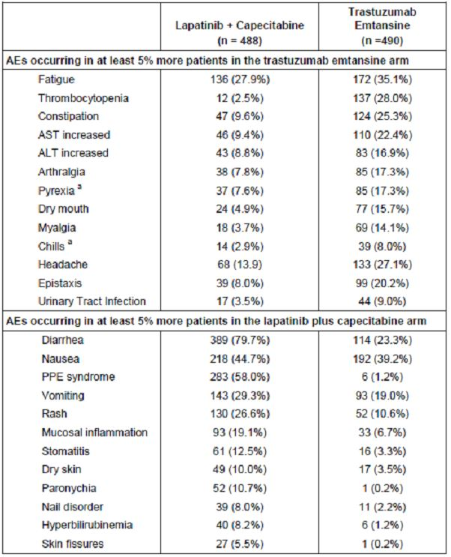
In study 4450g, the most frequently reported adverse events in the Trastuzumab Emtansine arm were nausea and fatigue at 49.3% with increased AST, headache, pyrexia, epistaxis, back pain, increased ALT, thrombocytopenia, and cough being >25% incidence. The main imbalance of an adverse incidence between the two treatment arms are given in Table 11.
Table 11: Summary of adverse events with a ≥ 10% difference in incidence between treatment groups: study TDM4450g/BO21976 (safety evaluable population)
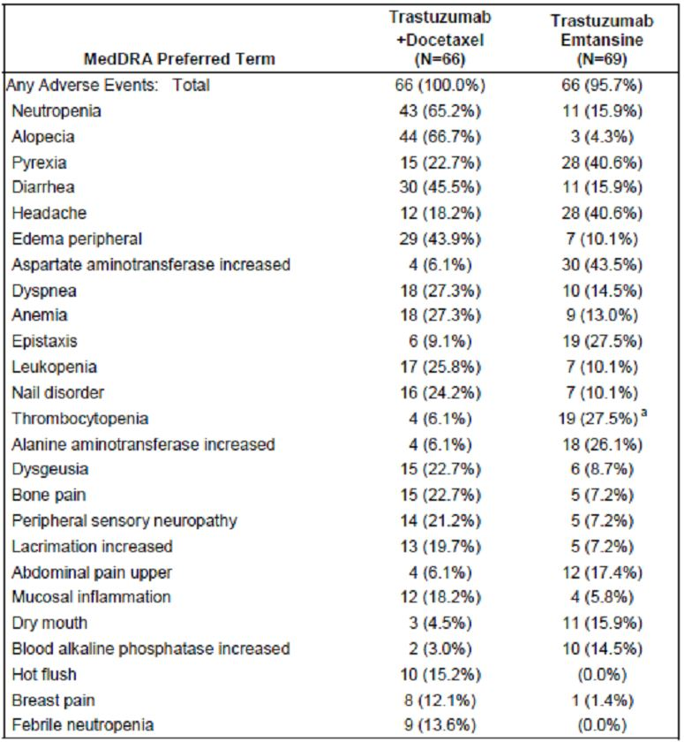
Review of adverse events of at least grade III in intensity revealed that for the pivotal study fewer patients who received the complex reported such events compared with the control arm and is indicated in Table 12. The most common of these for the complex arm were predominantly related to thrombocytopenia at 12.9% and followed by increased AST, hypokalaemia, anaemia, neutropenia, and fatigue.
Table 12: Summary of grade 3, 4 and 5 adverse events with ≥2% incidence in either arm: pivotal study TDM4370g/BO21977 (safety population)
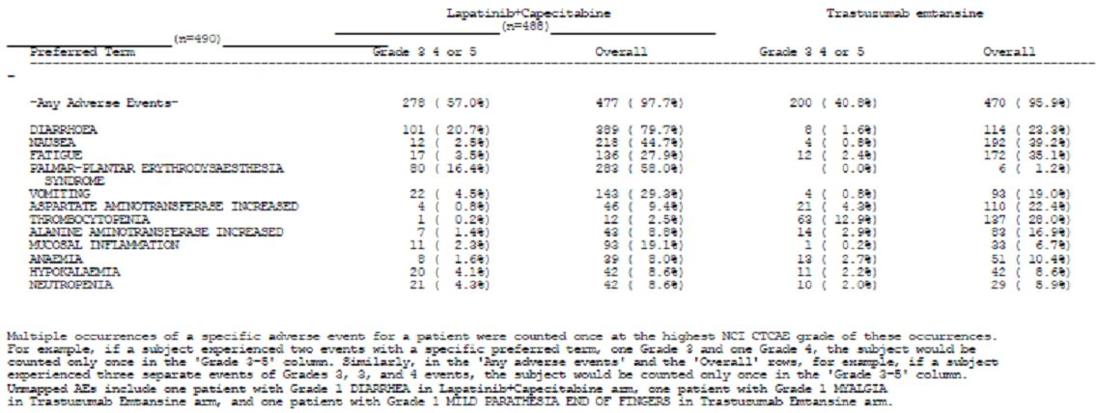
For the total Trastuzumab Emtansine exposed patient population, the most common reported at least grade III adverse events included thrombocytopenia in 10.2%, increased AST 4.1%, fatigue 3.2%, hypokalaemia 2.9%, ALT increase 2.8%, and anaemia 2.5%. Nine patients experienced grade V fatal adverse events.
In study 4450g fewer patients in the complex arm reported at least grade III adverse events compared to the Trastuzumab plus Docetaxel arm as indicated in Table 13. In this study, there were two grade V adverse events: one listed as a sudden death in the complex arm, and one death due to cardiac pulmonary failure in the Trastuzumab plus Docetaxel arm. None of these were attributable to study treatment by the investigator.
Table 13: Summary of adverse events by severity and grade ≥3 adverse events with ≥5% difference in incidence between treatment groups: study TDM4450g/BO21976 (safety evaluable patients)
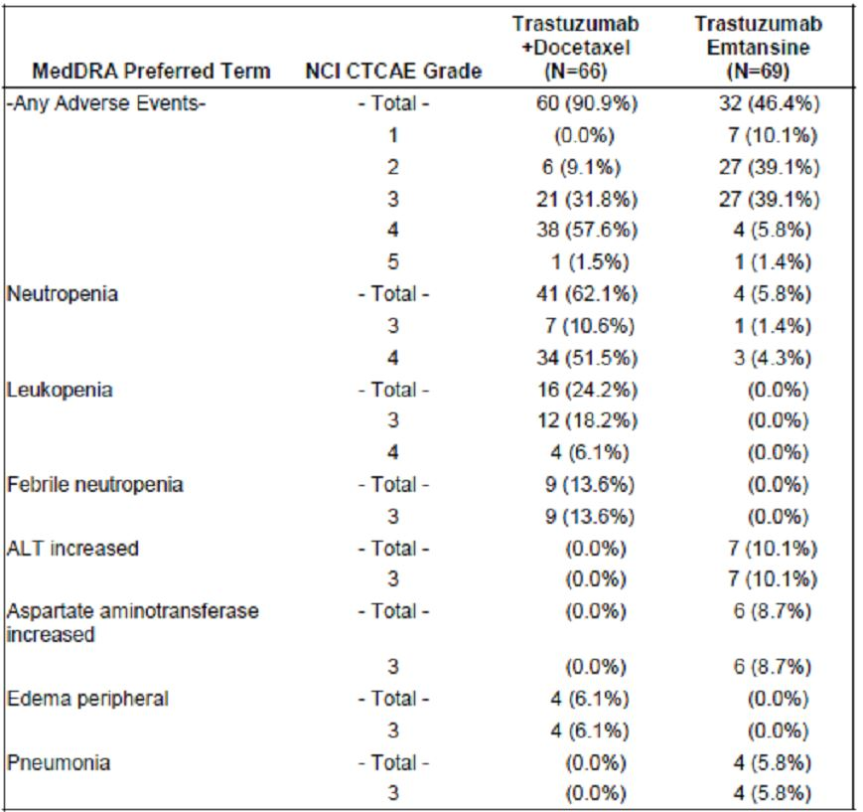
In relation to deaths, in the pivotal study 223 deaths reported at the cut-off date of which 94 or 19.2% on the Trastuzumab Emtansine arm and 129 or 26.4% on the Lapatinib plus Capecitabine arm. The most frequent cause of death was progressive disease and was less in the complex arm than the control arm at 18.6% vs 25.2%. Deaths due to causes other than progressive disease were relatively infrequent with three patients in the complex arm and five in the Lapatinib plus Capecitabine arm as indicated in Table 14.
Table 14: Adverse events leading to death on study treatment: pivotal study TDM4370g/BO21977 (safety evaluable patients)
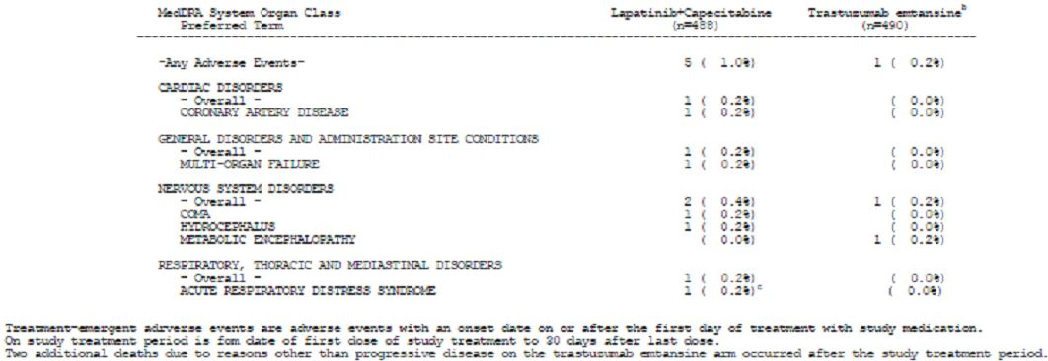
Among the total Trastuzumab Emtansine exposed patient population, there were 119 reported deaths or 13.5%. The majority of these were progressive disease in 107 patients, with deaths due to other causes in 12 patients; of these eight were considered as possibly related to treatment and included hepatic failure, abnormal hepatic function, bacterial sepsis, pneumonia, metabolic encephalopathy, respiratory failure, and interstitial lung disease.
In study 4450g, there were 14 deaths or 20.3% in the Trastuzumab Emtansine arm. No definite relationship to Trastuzumab Emtansine therapy was determined for those not due to progressive disease.
In relation to other serious adverse events, 76 patients or 15.5% who received the complex in the pivotal study developed SAEs compared to 88 for the control arm. Fewer grade III serious adverse events were reported for the complex arm with a similar percentage of patients in both treatment arms reporting grade IV serious adverse events. The most common serious adverse events reported in the complex arm were diarrhoea, vomiting and pyrexia.
For the total Trastuzumab Emtansine exposed patient population, 164 or 18.6% developed serious adverse events. This is highest in the pooled group single arm studies at 25.3% and probably reflects the heavy pre-treatment these patients had undergone.
In study 4450g, serious adverse events were reported for 20.3% in the Trastuzumab Emtansine arm vs 25.8% for the Trastuzumab plus Docetaxel arm (Table 15). The most common serious adverse events in the Trastuzumab Emtansine and the Trastuzumab plus Docetaxel arms were pneumonia and febrile neutropenia, respectively.
Table 15: Serious adverse by severity and serious adverse events with a ≥5% difference in incidence between treatment arms: study TDM4450g/BO21976 (safety evaluable patients)
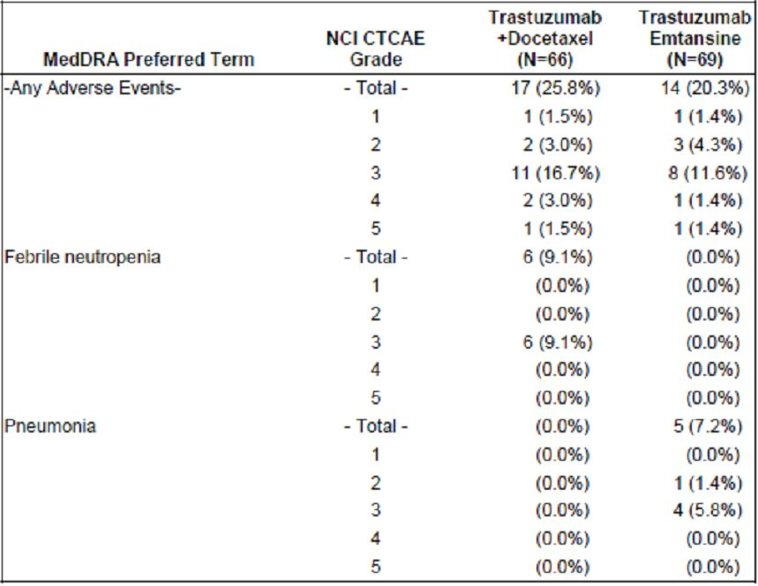
In relation to adverse events leading to treatment discontinuation in the pivotal study, 29 patients or 5.9% discontinued the complex due to an adverse event compared to 37 patients or 7.6% discontinued Lapatinib and 46 patients or 9.4% who discontinued Capecitabine due to adverse events. The most common adverse events leading to Trastuzumab Emtansine and discontinuation were thrombocytopenia and the elevation of liver enzymes.
As of the cut-off date, 55 patients or 6.2% in the total Trastuzumab Emtansine exposed patient population and 21 patients or 7.3% in the pooled group of single arm studies discontinued Trastuzumab Emtansine due to an adverse event. The most common of these were again thrombocytopenia and elevated liver enzymes.
In study 4450g, five patients in the Trastuzumab Emtansine arm discontinued due to adverse events.

Adverse events leading to dose reduction/dose delay
In the pivotal study, fewer patients in the Trastuzumab Emtansine arm had adverse events that led to dose reductions compared to patients on the Lapatinib plus Capecitabine arm (Table 16). The adverse events most frequently leading to dose reduction of the complex included thrombocytopenia, increased AST and ALT and peripheral neuropathy. Similarly, fewer patients on the Trastuzumab Emtansine arm had adverse events that led to dose delays (Table 17). The most frequent adverse events were neutropenia, thrombocytopenia, leukopenia, fatigue, and increased AST and ALT. It is of note that the proportion of patients who experienced dose delays due to increased bilirubin or AST and ALT were similar between the Trastuzumab Emtansine arm and the Lapatinib plus Capecitabine arm.
Table 16: Summary of adverse events leading to dose reduction in ≥1% of patients: pivotal study TDM4370g/BO21977 (safety population)
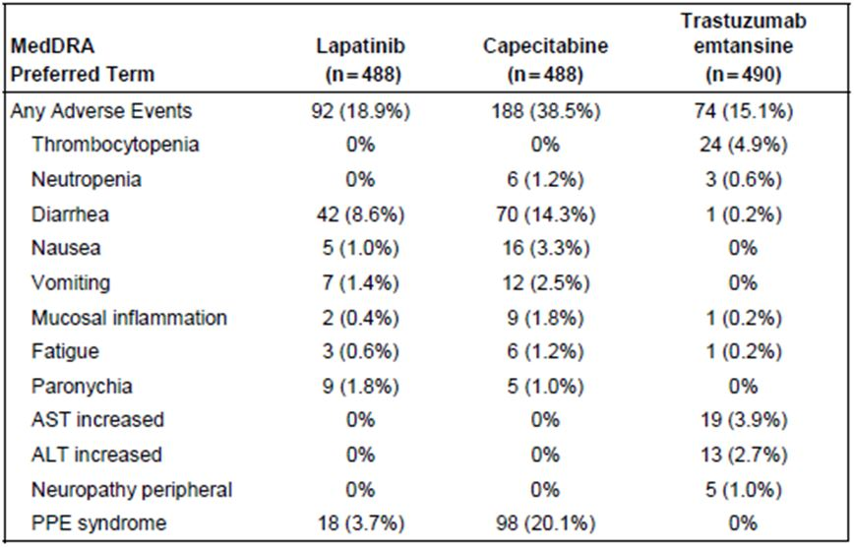
Table 17: Summary of adverse events leading to dose delay in ≥1% of patients: pivotal study TDM4370g/BO21977 (safety population)
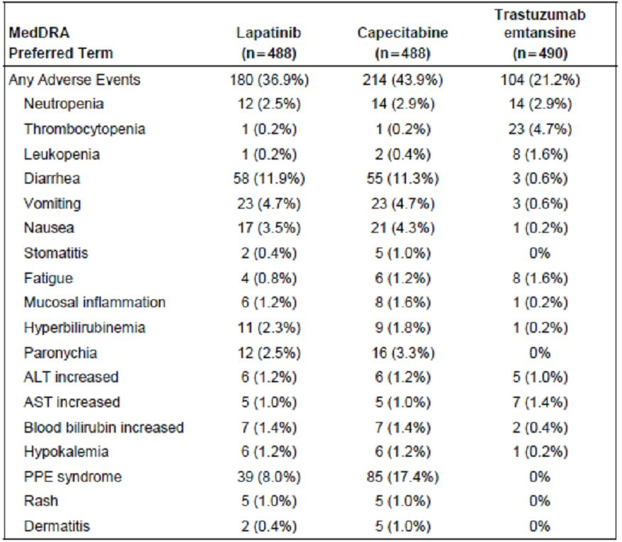
For the total Trastuzumab Emtansine exposed patient population, a total of 108 patients or 12.2% had dose reductions, the most frequent events were thrombocytopenia, increased AST, and increased ALT. It was noted that 6.7% of patients had dose reductions due to at least grade III adverse events.
A total of 193 patients or 21.9% in the total Trastuzumab Emtansine exposed patient population had dose delays; the most frequent causes were thrombocytopenia, neutropenia, increased AST, fatigue, anaemia, and increased ALT. 8.6% of these dose delays were due to at least grade III adverse events.
In study 4450g, 12 patients or 17.4% in the Trastuzumab Emtansine arm had adverse events leading to dose reduction. A total of 16 patients or 23.2% in the Trastuzumab Emtansine arm had adverse events that led to dose delay.

Hepatotoxicity
In the pivotal study, the incidence of hepatic events was higher in the Trastuzumab Emtansine arm at 31% than the Lapatinib plus Capecitabine arm at 25.2%. The majority of adverse events were grade I or II, although 8.8% of patients on the complex had at least grade III adverse events compared to 4.7% in the Lapatinib plus Capecitabine arm. For study 4450g, 46.4% of patients in the Trastuzumab Emtansine arm reported hepatotoxicity and 13.6% in the Trastuzumab plus Docetaxel arm. 15.9% of these were at least grade III adverse events in the complex arm compared to 1.5% in the Trastuzumab plus Docetaxel arm. In the total Trastuzumab Emtansine exposed population of 882 patients, 31.7% developed hepatotoxicity events of which 8.7% were at least grade III. It is noted that the majority of these grade III hepatic events usually occurred in the early treatment cycles and generally showed subsequent improvement even while continuing on study treatment.
A dedicated report of hepatotoxicity has been provided. This report contains data from the clinical data base and the global safety data base including the safety summary for ongoing studies. An external expert liver committee reviewed all relevant data.
An overview of selected events in the hepatotoxicity category by NCI grade assessment for all the various patient groups is indicated in Table 18.
Table 18: Overview of selected hepatic events (safety population)
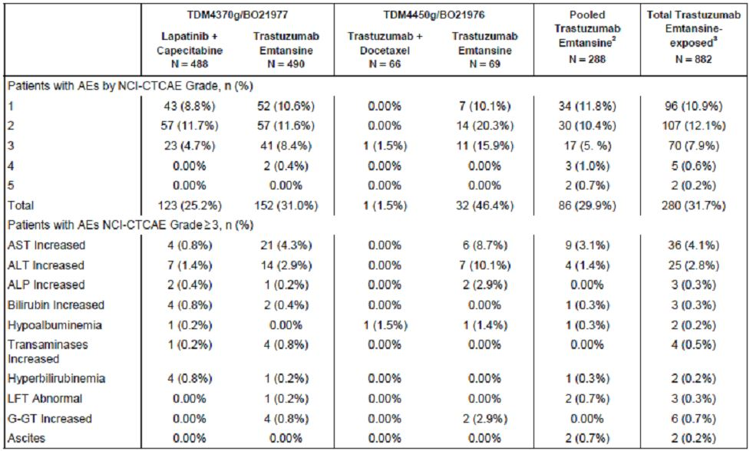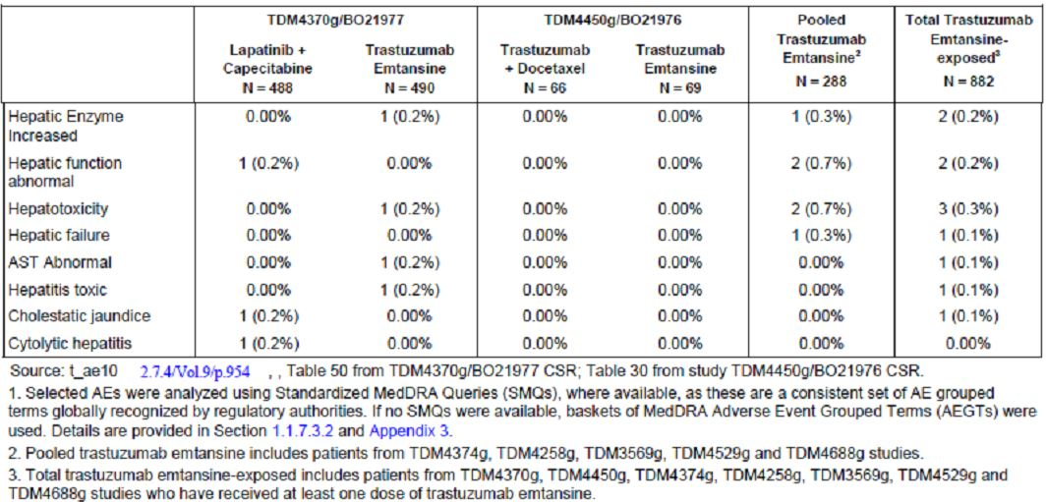
In the pivotal study, the most frequently reported hepatic events in the complex arm were increased AST and increased ALT. There were no grade IV increased AST or ALT cases reported. These increases were generally transient and returned to baseline by the next scheduled treatment dose. Increased bilirubin levels were noted in 2.9% of patients on the complex arm compared to 6.1% in the Lapatinib plus Capecitabine arm.
A summary of patients with increases in AST alone, ALT alone, and both enzymes relative to increased bilirubin for the pooled group of single arm studies and the total Trastuzumab Emtansine exposed patient population is indicated in Table 19. Only 10 or 3.5% and 21 or 2.4% of patients had concurrent elevations of these three liver function tests.
Table 19: Number of patients with increases in AST alone, ALT alone, and/or both increases in AST and ALT, relative to increases in bilirubin (pooled single arm studies and total Trastuzumab Emtansine exposed safety populations)
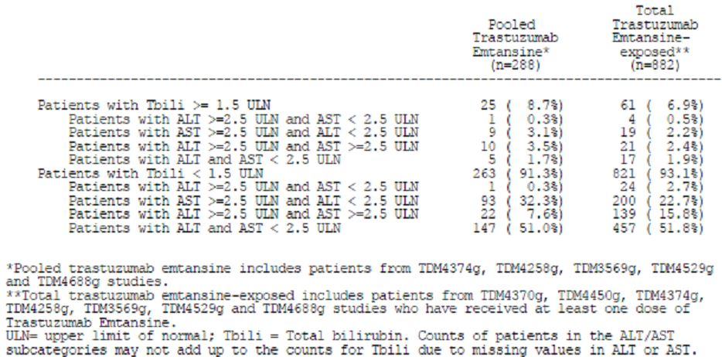
There were a total of six cases of serious hepatic dysfunction for Trastuzumab Emtansine patients of which two were fatal.
In relation to the pivotal study, review of elevation of liver enzymes over time revealed that by 30 weeks of Trastuzumab Emtansine exposure approximately 17%, 4.5% and 1% of the complex group exposed patients developed ALT increases of at least three times the upper limit of normal, five times the upper limit of normal and eight times the upper limit of normal respectively. These tended to stabilise after 30 weeks. Similar changes were noted for the total Trastuzumab Emtansine exposed patient population in study 4450g.

Thrombocytopenia
In the pivotal study, the incidence of all grade adverse events and at least grade III adverse events in the thrombocytopenia category were more common in the Trastuzumab Emtansine arm (30.4%) compared to the Lapatinib plus Capecitabine arm (2.9%). The majority of these were grade I or II, although the incidence of at least grade III adverse events was 13.9% for the Trastuzumab Emtansine arm vs 0.2% for the Lapatinib plus Capecitabine arm. Most of these were transient in nature recovering to ranges to allow the patient to remain on study and to continue to receive study treatment at the same or more reduced dose. Clinical events were also more common in the Trastuzumab Emtansine arm: these were most often epistaxis, gingival bleeding, vaginal haemorrhage, and petechiae. The majority of these were grade I or II. More patients in the Trastuzimab Emtansine arm had a decrease in platelet counts from baseline (71 patients or 15.1% from grade zero to at least grade III) compared to Lapatinib plus Capecitabine at (3 patients or 0.6%). These were generally transient falls with recovery by the next scheduled dose.
There was a similar frequency of thrombocytopenia in the Trastuzumab Emtansine arms for the total exposed patient population of ~30% and slightly higher in the study 4450g. The overall incidence of severe haemorrhagic events (grade III or IV across all grades of platelet count decreases in the total patient population) was low at 1.7%.

Infusion/related and hypersensitivity reactions
An overview of selected adverse events in this category occurring on day 1 and 2 of each treatment cycle is provided in Table 20. In the pivotal study, the incidence of these reactions was low: 19 patients or 3.9%, all of which were grade I or II. For the pooled group of single arm studies, the incidence was 10.4% and for the total Trastuzumab Emtansine exposed patient population 6.7%, and again the vast majority of these were grade I and II. There was only one grade III event.
Table 20: Overview of selected adverse events of infusion reaction and hypersensitivity in all Trastuzumab Emtansine treated groups (safety population)
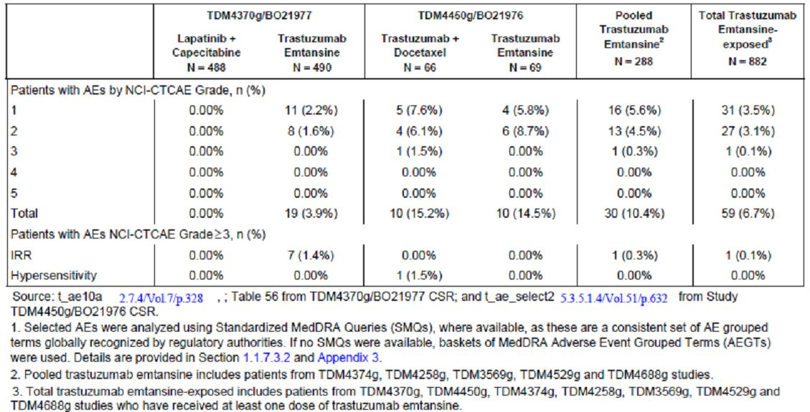

Pneumonitis
In the pivotal study, there were a few reports of pneumonitis involving six patients or 1.2% in the Trastuzumab Emtansine arm; all reports were of grade I or II. In study 4450g, the incidence of pneumonitis events in the Trastuzumab Emtansine arm involved two patients and for the total of Trastuzumab Emtansine exposed population 1% of patients developed pneumonitis events, although two of these experienced at least a grade III event.

Cardiotoxicity
For the pivotal study, the incidence of cardiac dysfunction was low in both treatment groups: 0.8% for the Trastuzumab Emtansine arm vs 2.3% for the Lapatinib plus Capecitabine arm. The four events reported in the Trastuzumab Emtansine arm were all asymptomatic, ie. grades I or II declines in LVEF. Development of left ventricular dysfunction was reported for five patients in the Trastuzumab Emtansine arm and six on the Lapatinib plus Capecitabine arm, with one who had a grade III event having to discontinue treatment. In study 4450g, no clinically relevant cardiac events were reported. One patient in each treatment arm had an LVEF of <40% post baseline according to local assessment. In the total Trastuzumab Emtansine population, 1.5% of patients had cardiac toxicity events of which two were a grade III event.

Hypokalaemia
In the pivotal study, the overall incidence of hypokalaemia for both arms was 9.2%, with grade III adverse events of hypokalaemia in 2.7% of patients receiving Trastuzumab Emtansine vs 4.5% for the Lapatinib plus Capecitabine arm. In study 4450g, hypokalaemia was reported in 17.4% of patients receiving Trastuzumab Emtansine compared to 9.1% in the Trastuzumab plus Docetaxel arm. In the total Trastuzumab Emtansine exposed population, 15.4% of patients had hypokalaemia, of which 29 patients or 3.3% were at least a grade III event.

Vision disorders
In the pivotal study, vision disorder events were more frequent in the Trastuzumab Emtansine arm at 6.3% vs 1.6% of the control arm. In study 4450g, the incidence of the vision disorders were similar. For the total Trastuzumab Emtansine exposed population, 8.2% of patients developed vision disorders, of which only one patient had at least a grade III event.

Peripheral neuropathy
In the pivotal study, the incidence of peripheral neuropathy was more common in the Trastuzumab Emtansine arm with 23.3% compared to the control arm of 8.2%, with grade III events 2.9% in the Trastuzumab Emtansine arm vs 0.4% in the control arm. The most common events were sensory peripheral neuropathy and muscular weakness. It is noted that the incidence of peripheral neuropathy in the pivotal study was generally similar to that for the total Trastuzumab Emtansine exposed patient population, and again the majority of adverse events in this population were grade I or II. It is noted that the incidence of peripheral neuropathy events were slightly higher in the pooled group of single arm studies which may be related to prior exposure to a taxane and longer treatment duration in the single arm phase II studies.

Renal disorders
In the pivotal study, the majority of the incidences of renal disorders are similar in both arms, with the majority of events being grade I or II. The incidences of grade III events were also similar in both treatment arms. It is noted that the incidence of renal disorder events were slightly higher in the single arm studies, and again this may be related to prior treatment.

Clinical laboratory evaluations
More patients in the Trastuzumab Emtansine arm of the pivotal study had a decreased Hb level shifting from grade zero to at least grade III, and involving 2% or seven patients. Fewer patients in the Trastuzumab Emtansine arm had decreased neutrophil levels at 3.3% from grade zero to at least grade III compared to the Lapatinib plus Capecitabine arm of 7%. Among the total Trastuzumab Emtansine exposed patient population, fewer than 10% of patients had shifts in platelet counts from grade zero to at least grade III. Approximately 5% of patients had shifts in Hb and neutrophil counts from grade zero to at least grade III. There were no shifts from grade zero to at least grade III in serum creatinine for any patients.

Vital signs
No salient vital sign abnormalities were observed in any of the studies. Similarly no major change in ECOG performance status was reported.

The effects of QT interval
Study 4688g was a Phase II open-label single-arm multicentre study designed to evaluate the effect of Trastuzumab Emtansine at 3.6mg/kg every three weeks on the duration of QTc interval in patients with HER2+ locally advanced metastatic breast cancer. A review of results revealed that in cycle 1, day 1, 15 minutes post-infusion to baseline adjusted average QTcF interval increased by 1.2msecs on average. Plus 60 minutes post-infusion decreased by 1.0msecs on average and by day 8, cycle 1 the baseline adjusted average had decreased by 4msecs. By cycle 3, day 1, the average QTcF interval had reverted back to baseline average. Following the third infusion the baseline adjusted QTcF interval at both 15 minutes and 60 minutes post-infusion time points increased by an average of 4.7msecs. No patient exceeded 30msecs at any time point within the protocol. It was concluded these demonstrated single agent Trastuzumab Emtansine given every three weeks had no meaningful effect on the treatment QT interval in these patients.

Special groups
An evaluation of safety by baseline demographics factors (including age, race, geographic region, disease status including prior treatment, and disease involvement) revealed there were consistently fewer at least grade III adverse events in the Trastuzumab Emtansine arm than the Lapatinib plus Capecitabine arm. This was the case for all sub-groups except the Asian patient sub-group which had a greater proportion of at least grade III adverse events. This was primarily driven by the higher incidence of thrombocytopenia, but there was no evidence of an increased risk of bleeding adverse events.
In relation to age assessment in the pivotal study, elderly patients had a less clear PFS benefit than those under 65 primarily driven by the results from the 75 years and older sub-groups. There was however a trend for an overall better safety profile with fewer serious adverse events and at least grade III adverse events in patients under 65 years compared with those over 65. However, across all age sub-groups the incidence of serious adverse events, at least grade III adverse events and adverse events leading to discontinuation, are considerably lower on the Trastuzumab Emtansine arm than on the Lapatinib plus Capecitabine arm. Although there were more deaths in the older age groups, there were no fatal adverse events in patients 65 years or older. Overall, it would appear that on balance the safety profile of Trastuzumab Emtansine compared with Lapatinib plus Capecitabine in these patients is at least as favourable for the older patients as in the total safety population.
In the various other sub-groups where PFS benefit was not as apparent, a favourable safety profile when compared with Capecitabine and Lapatinib was seen and the benefit risk ratio remains positive for treatment with Trastuzumab Emtansine across all groups.

Comment
These data have shown that, in general, trastuzumab emtansine was well tolerated with safety profile comparable to conventional chemotherapy regimen. It is noted that in the pivotal study trastuzumab emtansine treated patients had fewer at least grade III adverse events (AEs), serious adverse events (SAEs), and AEs leading to treatment discontinuation than those treated with lapatinib plus capecitabine. Those most frequently abnormal and at least grade III level for trastuzumab emtansine treatment included thrombocytopenia, increased liver enzymes, hypokalaemia and neutropenia. There were a small number of serious hepatic dysfunction events indicating a requirement for careful laboratory monitoring of these patients.

First round benefit-risk assessment

First round assessment of benefit
Data from the four studies presented in this submission to support efficacy for trastuzumab emtansine have all shown clear evidence of benefit for the patient populations treated. For the pivotal trial 4370g, there was a significantly prolonged PFS benefit (IRC assessed) compared with those patients receiving the control arm of lapatinib plus capecitabine, with a median PFS of 9.6 months versus 6.4 months (P<0.0001). All sensitivity analyses supported this result. It is also noted that there was a trend in favour of trastuzumab emtansine in relation to OS compared to the control arm with an Hazard Ratio (HR) = 0.621, P=0.0005, and a one year survival rate of 84% versus 77%, and a two year survival rate of 65.4% versus 47.5%. These results are impressive also because of the nature of the patient population evaluated, namely those who had received considerable prior therapy including trastuzumab and a taxane. Also those patients who had relapsed within six months of receiving adjuvant trastuzumab demonstrated worthwhile benefits. It is to be noted that these benefits in relation to the randomised trial were also pertinent, that is, the control arm was the only approved therapy presently available for patients with HER2+ locally advanced breast cancer and metastatic breast cancer who have failed on trastuzumab and a taxane.
These data were supported by the Phase II Study 4450g in which patients with previously untreated HER2+ metastatic breast cancer showed a statistically significant improvement in PFS when compared to the regimen of trastuzumab plus docetaxel. Again, the various sensitivity and subgroup analyses for these patients supported a significant primary efficacy endpoint of PFS. Two single agent Studies 4258g and 4374g in which heavily pre-treated patients having received prior trastuzumab and a taxane also had an IRC assessed ORR of 30.2% and a median PFS of 6.2 months.
All of this data is substantial in terms of the level of efficacy for this patient population.

First round assessment of risks
The data provided in this safety evaluation (N = 886 patients, including 495 patients in the pivotal trial) demonstrated that trastuzumab emtansine was generally well tolerated with a safety profile comparable with conventional chemotherapy regimens. It is noted that in the pivotal study, trastuzumab emtansine treated patients had fewer grade III and higher AEs, SAEs, and AEs leading to treatment discontinuation than those treated with lapatinib plus capecitabine. The most frequent adverse effect of greater frequency in the trastuzumab emtansine arm was thrombocytopenia of at least grade III severity and followed by increased liver enzymes (alanine transaminase [ALT] and aspartate transaminase [AST]), anaemia, fatigue, hypokalaemia, and neutropenia. The data from the supportive studies supported this adverse effect profile and its overall levels of severity.
Careful monitoring of patients receiving trastuzumab emtansine including appropriate regular laboratory evaluation would be important particularly in reference to the potential disturbance of hepatic function. Nevertheless, it is anticipated that any adverse effects likely to arise will be well managed with careful observation and early intervention as required.

First round assessment of benefit/risk balance
Taking into account the clearly efficacious results associated with the pivotal study, and supportive trials showing significant benefit for PFS compared to standard chemotherapy, together with a safety profile that appears manageable with appropriate careful monitoring and early intervention as required, the benefit-risk balance favours approval of trastuzumab emtansine for the proposed indication.

First round recommendation regarding authorisation
This evaluator considers that the data is adequate to support approval for the indication trastuzumab emtansine as a single agent as indicated for the treatment of patients with HER2+ unresectable, locally advanced or metastatic breast cancer who have received prior treatment with trastuzumab and ataxane.

Clinical questions
Follow up analyses of OS data for the pivotal Study 4370g would be of interest.

Sponsor comment: “There is no mention of the results of the second OS interim analysis from the pivotal study TDM4370g (clinical cut-off date 31 July 2012). The results of this OS analysis were clinically meaningful and statistically significant. A data memo outlining the results was provided in the original application and the completed Addendum 1 to the TDM4370g CSR was submitted to TGA with our response to questions. The sponsor considers that these results are important for inclusion in the evaluation report.”

