Date of first round report: 1 July 2014
Date of second round report: 19 September 2014

AusPAR Attachment 2

Extract from the Clinical Evaluation Report for Trastuzumab
  - Proprietary Product Name: Herceptin
  - Sponsor: Roche Products Pty Ltd

About the Therapeutic Goods Administration (TGA)
- The Therapeutic Goods Administration (TGA) is part of the Australian Government Department of Health, and is responsible for regulating medicines and medical devices.
- The TGA administers the Therapeutic Goods Act 1989 (the Act), applying a risk management approach designed to ensure therapeutic goods supplied in Australia meet acceptable standards of quality, safety and efficacy (performance), when necessary.
- The work of the TGA is based on applying scientific and clinical expertise to decision-making, to ensure that the benefits to consumers outweigh any risks associated with the use of medicines and medical devices.
- The TGA relies on the public, healthcare professionals and industry to report problems with medicines or medical devices. TGA investigates reports received by it to determine any necessary regulatory action.
- To report a problem with a medicine or medical device, please see the information on the TGA website <https://www.tga.gov.au>.
About the Extract from the Clinical Evaluation Report
- This document provides a more detailed evaluation of the clinical findings, extracted from the Clinical Evaluation Report (CER) prepared by the TGA. This extract does not include sections from the CER regarding product documentation or post market activities.
- The words [Information redacted], where they appear in this document, indicate that confidential information has been deleted.
- For the most recent Product Information (PI), please refer to the TGA website <https://www.tga.gov.au/product-information-pi>.
Copyright
© Commonwealth of Australia 2015
This work is copyright. You may reproduce the whole or part of this work in unaltered form for your own personal use or, if you are part of an organisation, for internal use within your organisation, but only if you or your organisation do not use the reproduction for any commercial purpose and retain this copyright notice and all disclaimer notices as part of that reproduction. Apart from rights to use as permitted by the Copyright Act 1968 or allowed by this copyright notice, all other rights are reserved and you are not allowed to reproduce the whole or any part of this work in any way (electronic or otherwise) without first being given specific written permission from the Commonwealth to do so. Requests and inquiries concerning reproduction and rights are to be sent to the TGA Copyright Officer, Therapeutic Goods Administration, PO Box 100, Woden ACT 2606 or emailed to <tga.copyright@tga.gov.au>.

Contents
List of commonly used abbreviations 5
1. Background 6
1.1. Drug class and therapeutic indication 6
1.2. Dosage forms and strengths 6
1.3. Dosage and administration 6
1.4. Other proposed changes to the PI 6
2. Clinical rationale 6
2.1. Orphan drug designation 7
2.2. Related submissions 7
2.3. Guidance 7
3. Contents of the clinical dossier 7
3.1. For the SC administration component: 7
3.2. For the PI update component: 8
3.3. Paediatric data 8
3.4. Good clinical practice 8
4. Pharmacokinetics 8
4.1. Studies providing pharmacokinetic data 8
4.2. Summary of pharmacokinetics 8
4.3. Evaluator’s overall conclusions on pharmacokinetics 9
5. Pharmacodynamics 9
6. Dosage selection for the pivotal studies 9
7. Clinical efficacy 11
7.1. Subcutaneous Administration 11
7.2. Evaluator’s conclusions on clinical efficacy with SC administration 28
7.3. Product information update 33
7.3.2. Evaluator’s conclusions on clinical efficacy - PI update 36
8. Clinical safety 36
8.1. Subcutaneous Administration 36
8.2. Patient exposure 38
8.2.1. Adverse events 39
8.3. Laboratory tests 55
8.4. PI update (HERA study) 56
8.5. Post-marketing experience 62
8.6. Safety issues with the potential for major regulatory impact 62
8.7. Evaluator’s overall conclusions on clinical safety 63
9. First round benefit-risk assessment 64
9.1. Subcutaneous administration 64
9.2. PI update (HERA Study) 64
10. First round recommendation regarding authorisation 65
10.1. Subcutaneous administration 65
10.2. PI update (HERA Study) 65
11. Clinical questions 65
11.1. Pharmacokinetics 65
11.2. Efficacy 65
11.3. Safety 65
12. Second round evaluation of clinical data submitted in response to questions 66
12.1. Response to questions 66
12.2. Neoplasms in the HERA study 68
13. Second round benefit-risk assessment 68
14. Second round recommendation regarding authorisation 68
15. References 69

List of commonly used abbreviations
Abbreviation | Meaning
AE | Adverse Event
ALT | Alanine Transaminase
ARR | Administration-related reaction
AST | Aspartate Transaminase
AUC | Area under the curve
CL | Clearance
Cmax | Maximum concentration
CR | Complete Response
C_{trough} | Trough concentration [the concentration at the end of the dosage interval]
DFS | Disease-free survival
ECG | Electrocardiograph
EFS | Event-free survival
EPP | Efficacy Per-Protocol population
EMA | European Medicines Agency
FDA | Food and Drug Administration
GCP | Good Clinical Practice
HER2 | human epidermal growth factor receptor 2
ICH | International Conference on Harmonisation
ITT | Intention to Treat
IV | Intravenous
LDH | Lactate Dehydrogenase
ORR | Overall Response rate
OS | Overall Survival
pCR | Pathological Complete Response
PI | Product Information
PK | Pharmacokinetics
RECIST | Response evaluation criteria in solid tumours
rHuPH20 | recombinant human hyaluronidase
SAE | Serious Adverse Event
SC | Subcutaneous
Tmax | Time of maximum concentration
tpCR | Total Pathological Complete Response
TTR | Time to Response

Background
This is an abbreviated submission to:
- Register a new route of administration (subcutaneous injection) for the treatment of HER2-positive breast cancer, including a new dosage regimen and formulation; and
- Update the product information (PI) with new data from the HERA study, a pivotal study that formed the basis of the TGA’s approval of trastuzumab for the adjuvant treatment of early HER2 positive breast cancer.

Drug class and therapeutic indication
Trastuzumab is a monoclonal antibody that is directed against the extracellular domain of the human epidermal growth factor receptor 2 protein (HER2).
The product is approved for use in HER2-positive breast cancer (in various settings) and in HER2-positive gastric cancer. In this application the sponsor is seeking approval for use of subcutaneous (SC) administration for the breast cancer indications only. No new indications are proposed.

Dosage forms and strengths
The following dosage forms and strengths are currently registered for IV use:
- A vial containing 150 mg trastuzumab powder for injection (Aust R 73229)
- A 60 mg trastuzumab powder for injection (Aust R 171014).
The submission proposes registration of the following dosage form and strength for SC use:
- A vial containing a solution of 600 mg of trastuzumab in 5 mL.

Dosage and administration
For SC administration, the sponsor is proposing:
- no loading dose
- a fixed dose (600 mg) for all patients rather than a weight-adjusted dose.

Other proposed changes to the PI
Apart from minor editorial changes, all proposed changes to the clinical aspects of the PI are based on data submitted in support of SC administration, or updated data from the HERA study.

Clinical rationale
HER2 (or ErbB2) is a receptor that is expressed in a variety of normal epithelial cell types. It is one of a family of four receptors (the ErbB family) that activate a network of intracellular signalling pathways that affect cell proliferation and survival ⁽¹⁾. HER2-positivity (that is, overexpression of the HER2 protein or amplification of the HER2 gene) is found in approximately 25-30% of breast cancers ⁽²⁾. HER2-positive breast cancer is associated with reduced disease-free survival and overall survival compared to HER2-negative disease ⁽³⁾.
Previously evaluated studies have demonstrated efficacy for trastuzumab in the treatment of HER2-positive breast cancer in both the early and advanced disease settings. All these studies utilised IV administration of the drug.
The rationale for the SC route of administration proposed in this submission was summarised in the Clinical Overview as follows:
‘The currently approved formulation of trastuzumab IV requires a loading dose, which is given over 90 minutes; if well tolerated, subsequent infusions may be given over 30 minutes. Instead, trastuzumab SC can be administered over 2-5 min; this shorter administration time could possibly lead to improved convenience for patients, which is particularly important when patients are treated for prolonged periods of time. Other potential benefits of SC administration include providing an alternative route of administration for patients with poor venous access as well as lower resource utilization (eg, nursing time needed for IV administration and patient monitoring, other treatment center costs, patient travel etc).’

Orphan drug designation
Herceptin has not been designated as an orphan drug by the TGA.

Related submissions
There have been no previous applications for SC trastuzumab. IV trastuzumab was initially approved by the TGA for the treatment of metastatic HER2+ve breast cancer in 2000. In subsequent applications it was approved for use as adjuvant treatment of localised HER2+ve breast cancer (2006), in combination with aromatase inhibitors for metastatic HER2+ve breast cancer (2008), for HER2+ve gastric cancer (2010) and adjuvant treatment of locally advanced HER2+ve breast cancer (2012).
A related product, trastuzumab emtansine (Kadcyla), was approved by the TGA in 2013 for the treatment of metastatic HER2+ve breast cancer in subjects who have previously received trastuzumab. Other registered agents that act through inhibition of the HER2 receptor include pertuzumab and lapatinib.
The sponsor of the current submission has also lodged an application with the TGA for a subcutaneous formulation of another monoclonal antibody (rituximab/MabThera). The proposed formulation also contains rHuPH20. At the time of submission this application had not been decided.

Guidance
The following EMA guidelines, which have been adopted by the TGA, are considered relevant to the current submission:
- Guideline on the evaluation of anticancer medicinal products ⁽⁴⁾
- Guideline on the investigation of pharmacokinetics of therapeutic proteins ^{(5).}
Compliance with these guidelines is considered in the relevant sections of this report.

Contents of the clinical dossier

For the SC administration component:
- 1 Phase I pharmacokinetic study (BP22023) conducted in healthy volunteers and breast cancer patients
- 1 pivotal Phase III study (BO22227) which compared IV and SC administration with respect to efficacy, safety and pharmacokinetics
- 2 population pharmacokinetic analyses (Report Nos: 1045694 and 12-0215v2)
- 1 pooled analysis (dated 2011) of infusion reactions occurring in clinical trials (Report No: 1048158)
- Literature references.

For the PI update component:
- A full clinical study report for the HERA trial
- Literature references.

Paediatric data
The submission did not include paediatric data. As HER2+ve breast cancer is a disease of adults, this is acceptable.

Good clinical practice
The study reports for the clinical trials submitted with this application included assurances that they were conducted in accordance with the principles of the Declaration of Helsinki and the principles of the International Conference on Harmonization (ICH) Guideline for Good Clinical Practice.

Pharmacokinetics

Studies providing pharmacokinetic data
The PK data included in the submission related to the new SC route of administration and consisted of the following:
- An initial Phase I study (BP22023), which examined the PK of single IV and SC weight-adjusted doses of trastuzumab in healthy male volunteers and in female patients with a history of early HER2+ve breast cancer
- A population PK analysis (Report No: 1045694) that used the data from BP22023 and aimed to identify a suitable fixed-dose regimen for SC use in the pivotal Phase III study
- The pivotal Phase III efficacy and safety study comparing IV and SC administration (BO22227) in which PK data were collected from all subjects
- Another population PK analysis (Report No: 12-0215v2) of the PK data collected in the Phase III study.
None of the studies were excluded from consideration due to study deficiencies.

Summary of pharmacokinetics

Absorption

Absolute Bioavailability
In the Phase I study (BP22023) estimates of absolute bioavailability following administration of a single SC dose were:
- 83.9%, 91.3% and 93.2% for male healthy volunteers 6, 8 and 10 mg/kg SC doses respectively.
- 87.1% and 98.6% for female patients receiving 10 and 12 mg/kg SC doses respectively.
In a population PK analysis of data collected in the Phase III study (Report No: 12-0215v2) bioavailability of the SC formulation was estimated to be 77.1%.

Absorption of rHuPH20
In the Phase I study, plasma rHuPH20 levels were below the limit of quantification at all the time points, suggesting minimal systemic absorption.

Dose proportionality
In the Phase I study (BP22023), AUC and C_{max} were dose-proportional over the 6–10 mg/kg SC dose range in healthy males and the 8-12 mg/kg SC dose range in female patients.

Systemic exposure
PK data from the pivotal Phase III study indicate that the proposed SC regimen (600 mg every 3 weeks) results in higher C_{trough} values than the approved IV regimen (6 mg/kg every 3 weeks) - a 33% increase after 7 cycles and a 51% increase after 12 cycles. However, total systemic exposure (as assessed by AUC) is only modestly increased with SC administration (7% increase during Cycle 7 and 18% increase during Cycle 12). Increases in AUC are more pronounced in subjects with low body weight.
SC administration resulted in lower C_{max} and delayed T_{max} compared with IV administration.

Pharmacokinetics in special populations

Patient factors affecting pharmacokinetics
Body weight was found to affect the PK of trastuzumab. The proposed SC regimen is not weight-adjusted. However, the population PK analysis of data collected in the Phase III study (Report No: 12-0215v2) indicated that, with the selected SC dose, weight would not have a clinically significant effect on efficacy. SGPT was also found to have a statistically significant effect on trastuzumab PK. The effect was not clinically significant.
Other covariates tested in population PK model did not have a statistically significant effect on trastuzumab PK.

Evaluator’s overall conclusions on pharmacokinetics
The proposed SC regimen results in increased systemic exposure to trastuzumab compared to the approved 3-weekly IV regimen. The efficacy of the SC regimen would therefore be expected to be at least comparable to that of the IV regimen. The increased systemic exposure may have implications for safety.

Pharmacodynamics
No new pharmacodynamic data were included in the submission.

Dosage selection for the pivotal studies
The proposed fixed dose SC regimen (600 mg every 3 weeks, with no loading dose) was chosen based on the findings of the population PK analysis (Report No. 1045694) of data from the Phase I study (see results in figures and tables below).
Figure 1: The distribution of median C_{trough} values (at Cycles 1 and 8) obtained from the simulations
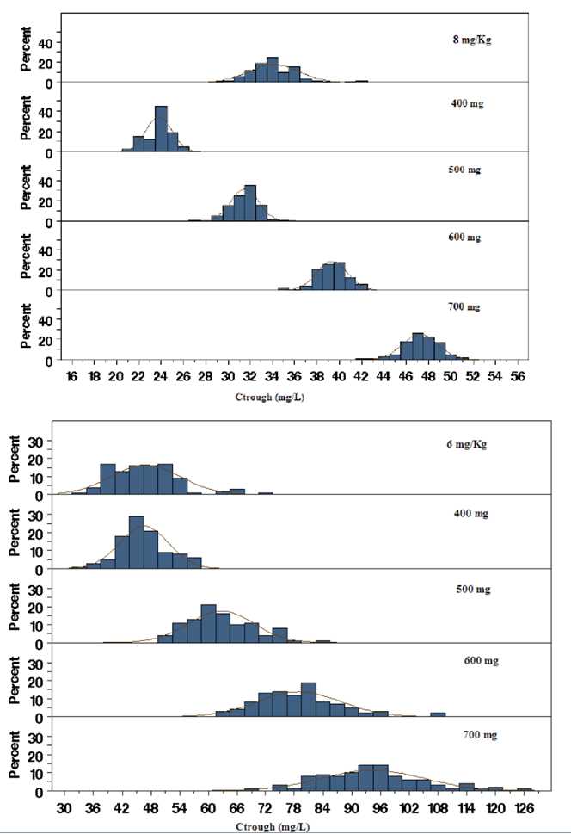
The predicted C_{trough} values for the 600 mg dose at Cycle 8 were found to meet the criteria for selection of the SC dose, as shown in the following table:

Table 1: Predicted C_{trough} values for the 600 mg dose at Cycle 8
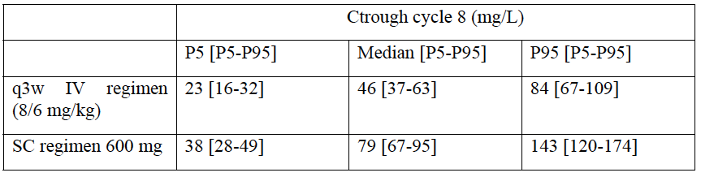
P5 = 5th percentile, P95 = 95th percentile.
Further simulations were performed to compare time course profiles after repeated doses of the chosen 600 q3w SC dose and the two approved IV regimens (that is, 2 mg/kg q1w and 6 mg/kg q3w). The predicted PK parameters at Cycle 8 are shown in the following table and figure.

Table 2: Predicted PK parameters at Cycle 8
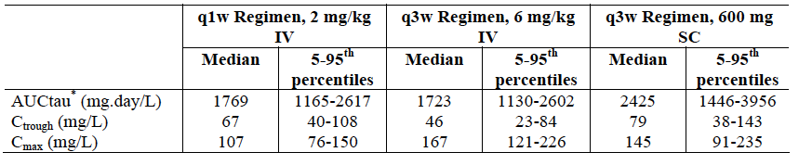
Figure 2: Predicted PK parameters at Cycle 8
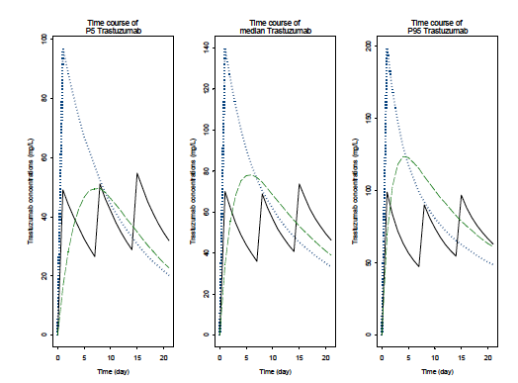
Legend: The full thick line represents the time course of trastuzumab for a IV qw regimen of 4 mg/Kg followed by 2 mg/Kg. The dotted line represents the time course of trastuzumab for a IV q3w regimen of 8 mg/Kg followed by 6 mg/Kg. The dashed line represents the time course of trastuzumab for a SC q3w regimen of 600 mg.

Clinical efficacy

Subcutaneous Administration

Study BO22227 (HannaH study)
Study BO22227 is also known as the HannaH study (enHANced treatment with NeoAdjuvant Herceptin).

Study design, objectives, locations and dates
The study is a Phase III, randomised, open-label trial with two parallel groups (IV versus SC). It was conducted in the neoadjuvant setting (with treatment continued post-operatively) in patients with HER2+ve localised or locally advanced breast cancer. All patients received eight 21-day cycles of neoadjuvant chemotherapy (4 cycles of docetaxel followed by 4 cycles of 5-fluorouracil + epirubicin + cyclohosphamide [FEC]). In addition, patients were randomised (1:1) to receive eight 21-day neoadjuvant cycles of either IV or SC trastuzumab, concurrent with the chemotherapy. Patients then underwent surgery. Post-surgery, subjects continued to receive trastuzumab as monotherapy (either IV or SC as originally randomised) for a further ten 21-day cycles. Total intended duration of trastuzumab treatment was therefore 18 cycles (approximately 12 months). Adjuvant endocrine therapy was permitted in both arms after surgery. A study schema is shown in Figure 3.
Figure 3: Study BO22227 – Study schema
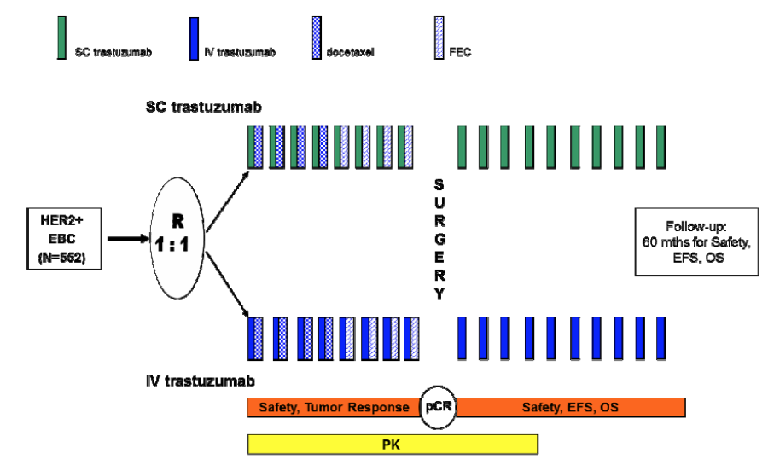
The primary objectives were to compare the following parameters between trastuzumab IV and trastuzumab SC in the neoadjuvant setting:
- Serum trough concentrations (C_{trough}) observed pre-surgery
- Efficacy (pathological complete response).
The secondary objectives were to
- Compare the following parameters between trastuzumab IV and trastuzumab SC:
- Observed C_{trough} concentrations post-surgery
- Predicted C_{trough} concentrations pre-surgery and post-surgery
- Pharmacokinetic profile.
- Evaluate the following parameters in the trastuzumab IV and trastuzumab SC arm:
- Total pathological complete response (tpCR)
- Overall response rate (ORR)
- Time-to-response (TTR)
- Event-free-survival (EFS)
- Overall survival (OS)
- Safety and tolerability
- Immunogenicity.
The trial was conducted in 81 centres in 24 countries (Russia 10, Germany 8, Brazil 6, France, Peru and Spain 5 each, Thailand, Taiwan and South Africa 4 each, Poland, Colombia, Korea, Italy, Turkey and Hungary 3 each, Sweden, Slovakia, Czech Republic 2 each, Canada, China, Estonia, Guatemala, Mexico, Panama 1 each).
The first patient was randomised in October 2009 and the last patient in December 2010. The trial is ongoing and the date of data cut-off for the submitted study report was 9 July 2012. The report itself was dated September 2013. The study has been published ⁽⁶⁾.

Inclusion and exclusion criteria
Inclusion criteria and exclusion criteria are shown in Table 3 below.

Table 3A: Study BO22227 – Inclusion criteria
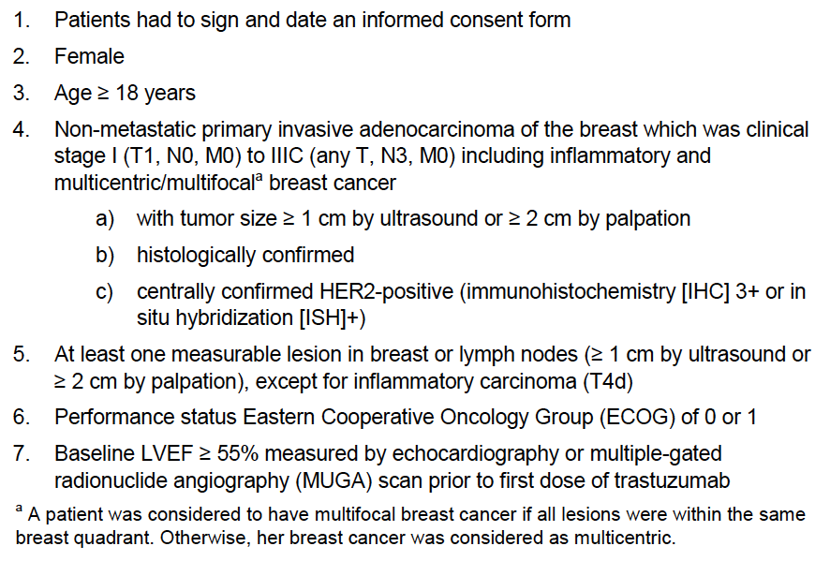

Table 3B: Study BO22227 - Exclusion criteria
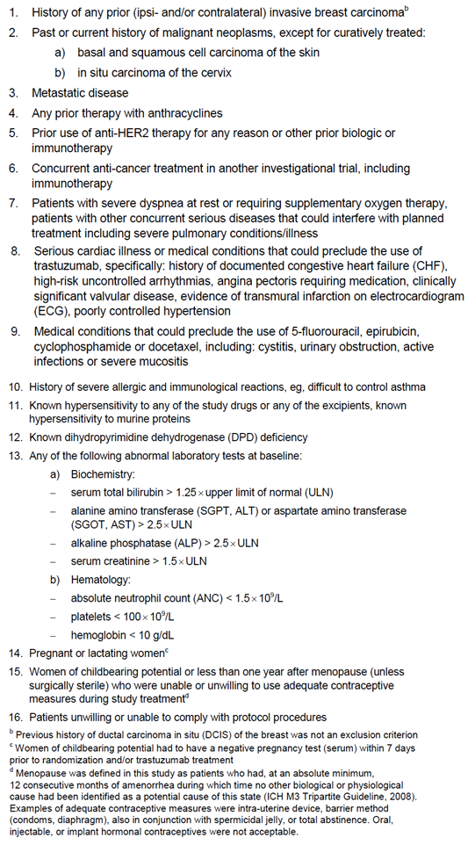
Comment: The study included subjects with clinical stage I (with tumour size ≥ 1 cm) to stage IIIC disease. The population therefore approximately corresponds to those populations covered by the ‘localised’ and ‘locally advanced’ indications currently approved by the TGA. The current staging system for breast cancer is shown in Appendix 1. A central laboratory determined HER2-positivity.

Study treatments
All subjects received 8 cycles of neoadjuvant chemotherapy as follows:
Cycles 1-4:
- Docetaxel 75 mg/m² IV on day 1 of a 21-day cycle, given over 60 minutes. An oral corticosteroid (e.g. dexamethasone 16 mg per day) was given for 3 days as premedication.
Cycles 5-8:
- 5-Fluorouracil 500 mg/m² IV on day 1 of a 21-day cycle, given as an IV bolus over 3-5 minutes or as an infusion over 30 minutes
- Epirubicin 75 mg/m² IV on day 1 of a 21-day cycle, given as an IV bolus over 3-5 minutes or as an infusion over 30 minutes
- Cyclophosphamide 500 mg/m² IV on day 1 of a 21-day cycle, given as an IV bolus over 3-5 minutes. Individual doses were capped at 1200 mg.
In combination with the neoadjuvant chemotherapy, subjects were randomised to receive eight 21-day cycles of neoadjuvant trastuzumab (either IV or SC). Following surgery, patients received a further ten 21-day cycles of adjuvant trastuzumab (either IV or SC as originally randomised), giving a total duration of trastuzumab of 18 cycles (~ 12 months). There was no interruption to the regular 21-day dosing of trastuzumab between the neoadjuvant and adjuvant phases. The trastuzumab regimens that were compared were as follows:
- Trastuzumab 600 mg SC on day 1 of the 21-day cycle, given over 5 minutes into the thigh;
- Trastuzumab IV on day 1 of the 21-day cycle. An initial loading dose of 8 mg/kg IV was used in cycle 1. For subsequent cycles, a maintenance dose of 6 mg/kg IV was used. The first infusion was given over 90 minutes and if this was well tolerated, subsequent doses could be given over 30 minutes.
In both arms, trastuzumab was administered prior to the chemotherapy on Day 1 of each cycle during the neoadjuvant phase. Patients who developed infusion or injection-related symptoms could be pre-medicated with paracetamol and antihistamines for subsequent cycles. Reductions in dose of trastuzumab because of toxicity were not permitted in either arm. However, dosing could be delayed. Dose reduction and delay were permitted for the chemotherapy agents.
The regimen of trastuzumab with a taxane followed by FEC was chosen as it was recommended as standard in the neoadjuvant setting for patients with HER2-positive early breast cancer in the National Comprehensive Cancer Network (NCCN) treatment guidelines.
Patients were permitted to receive adjuvant tamoxifen, aromatase inhibitors or LHRH agonists, as appropriate. Adjuvant use of bisphosphonates for the prevention of bone metastases was not permitted. Other systemic anti-cancer agents or investigational agents were not permitted.

Efficacy variables and outcomes
The main efficacy variables were:
- Tumour response rates
- Overall survival and event-free survival.
The primary efficacy outcome was the pathological complete response (pCR). A pCR was defined as the absence of invasive neoplastic cells in the primary tumour in the breast after surgery.
Secondary efficacy outcomes were:
- Total pathological complete response (tpCR), defined as the absence of invasive neoplastic cells in the primary tumour remnants and in the axillary lymph nodes
- Overall response rate (ORR), defined as the proportion of subjects who achieved a best clinical response of complete response (CR) or partial response (PR) according to modified Response Evaluation Criteria in Solid Tumours (RECIST Version 1.0 ^{[7]}) criteria (see Table 4)
- Time to response (TTR) defined as the time from the first study drug administration to the date of first CR or PR, which was the date the response was first documented by objective evidence. Only responders (CR or PR) were considered for this endpoint
- Event-free survival (EFS), defined as the time from the date of randomization to the date where an event occurred. An event was defined as disease recurrence or progression (local, regional, distant or contra-lateral) or death due to any cause
- Overall survival (OS), defined as the time from the date of randomization to the date of death, regardless of the cause of death.

Table 4: Study BO22227 - Response criteria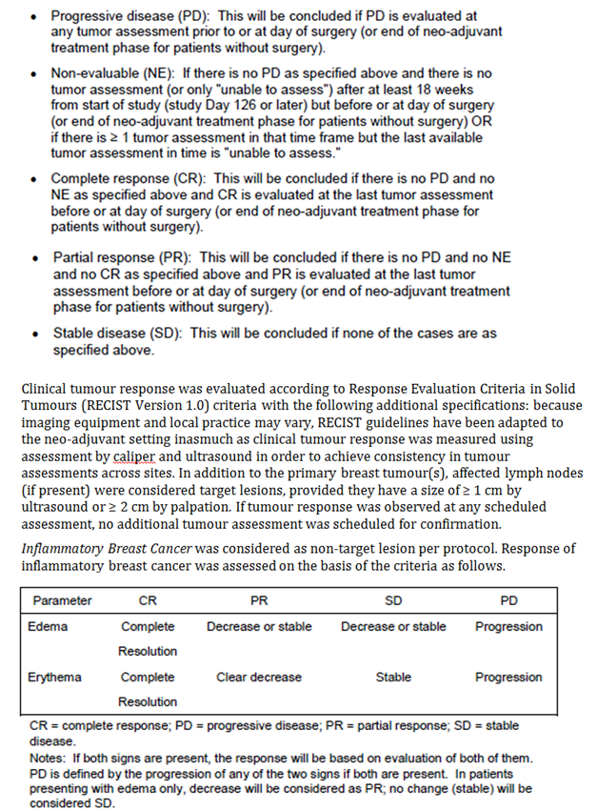
Clinical assessment of the tumour and lymph nodes (using calipers and ultrasound) was conducted at baseline, at Cycles 3, 5 and 7 and at surgery. Pathological assessment of the tumour and lymph nodes was conducted after surgery.

Randomisation and blinding methods
A centralised randomisation centre randomised patients (1:1) via an interactive voice response system. Randomisation was stratified by breast cancer type (inflammatory versus locally advanced versus operable) and oestrogen receptor status (positive versus negative versus unknown). There was no blinding to treatment allocation.
Comment: It appears that the pathologist undertaking the assessment of pCR was not blinded to study treatment. Blinded assessment would have been preferable. According to the study protocol, pCR was to be assessed by the local pathologist following surgery and would not be independently reviewed. However, the published version of the study states that: ‘Review of pathological tumour assessment results was done by a masked medical reviewer’. The sponsor should be asked to clarify this issue.

Analysis populations
The intent-to-treat (ITT) population included all patients who had at least one efficacy assessment after first study drug administration.
The efficacy per-protocol (EPP) population was a subset of the ITT population. It excluded subjects with the following characteristics:
- Less than 8 cycles of trastuzumab/chemotherapy treatment
- Patient not treated as randomized
- Pre-treatment surgical procedure other than biopsy impacting on primary lesion size
- Pre-surgery radiotherapy
- Pre-surgery hormonal therapy
- No surgery after neoadjuvant treatment completion
- More than 4 cycles of either docetaxel or FEC chemotherapy received
- Bilateral breast cancer
- Four cycles of docetaxel or epirubicin treatment completed but intensity deviation > 20% from planned
- Major violation of inclusion/exclusion criteria.
The EPP was the main analysis set for the analysis of the primary efficacy outcome of pCR.
The safety analysis population (SP) included all patients who received at least one dose of study medication (chemotherapy or trastuzumab).

Sample size
The trial was designed as a non-inferiority study. Based on previous studies in the neoadjuvant setting, it was assumed that pCR rates of at least 40% would be achieved in both arms. Using a one-sided 97.5% confidence limit for the difference in response rates between arms, and a non-inferiority margin of 12.5%, it was estimated that 552 patients would be necessary to conclude non-inferiority with a power of 80%. The estimation included an anticipated 10% dropout rate.

Statistical methods
The null hypothesis was that the pCR rate with SC administration would be lower than that achieved with IV administration. This would be rejected if the lower limit of the one-sided 97.5% confidence interval for the difference in pCR rate (SC rate minus IV rate) computed using the continuity correction of Hauck and Anderson, was above -12.5% (absolute percentage points). pCR rates and 95% confidence limits were also calculated according to Pearson-Clopper for individual treatment groups.
Similar methods were used for the analysis of the secondary endpoints of tpCR and ORR. Descriptive statistics were used for TTR. For EFS and OS event rates from randomization were to be displayed using estimates from Kaplan-Meier survival curves. The two treatment arms were to be compared with an un-stratified two-sided log-rank test.
The primary analysis took place after all randomized patients in the study had undergone surgery and 116 patients in each study arm had completed treatment with trastuzumab. The study report included in this submission was based on a later analysis, in which all subjects had completed treatment with trastuzumab, or had withdrawn earlier.

Participant flow
A total of 833 patients were screened and 596 patients were randomised, 299 to the IV arm and 297 to the SC arm. The disposition of randomised subjects is summarised in Figure 4. Reasons for withdrawal from the study are shown in Table 5 and the analysis populations in Table 6.
Figure 4: Study BO22227 - Patient disposition
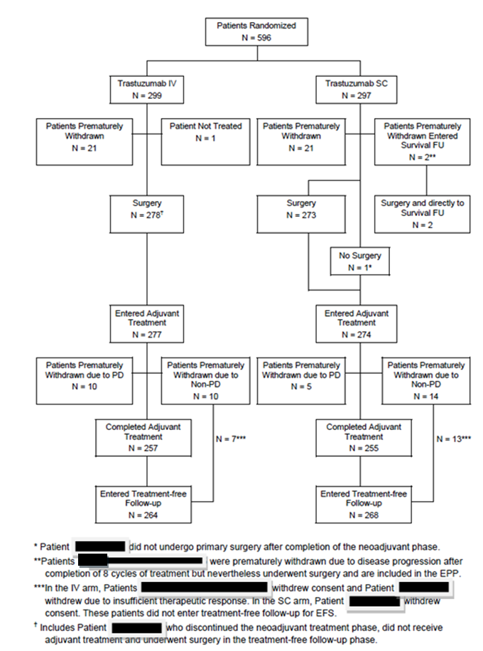
NB: Patient identification numbers have been blacked out in the figure legend.
[Type a quote from the document or the summary of an interesting point. You can position the text box anywhere in the document. Use the Drawing Tools tab to change the formatting of the pull quote text box.]
[Type a quote from the document or the summary of an interesting point. You can position the text box anywhere in the document. Use the Drawing Tools tab to change the formatting of the pull quote text box.]
[Type a quote from the document or the summary of an interesting point. You can position the text box anywhere in the document. Use the Drawing Tools tab to change the formatting of the pull quote text box.]
[Type a quote from the document or the summary of an interesting point. You can position the text box anywhere in the document. Use the Drawing Tools tab to change the formatting of the pull quote text box.]
[Type a quote from the document or the summary of an interesting point. You can position the text box anywhere in the document. Use the Drawing Tools tab to change the formatting of the pull quote text box.]
[Type a quote from the document or the summary of an interesting point. You can position the text box anywhere in the document. Use the Drawing Tools tab to change the formatting of the pull quote text box.]

Table 5: Study BO22227 - Reasons for study withdrawal
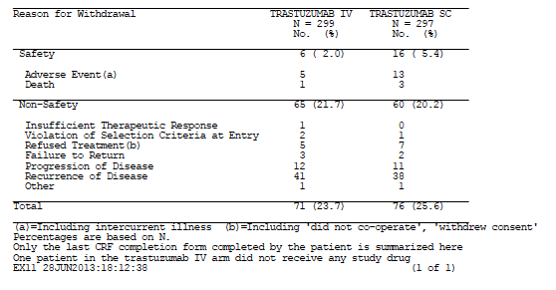

Table 6: Study BO22227 - Analysis populations
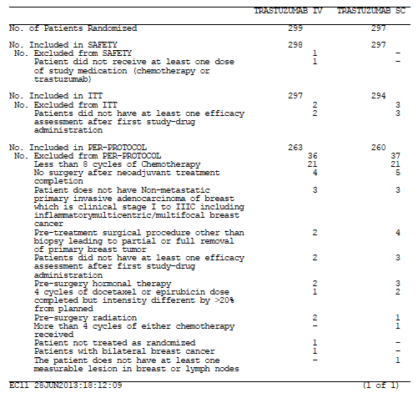
Comment: Withdrawals due to adverse events were more common in the SC arm (13 versus 5). Otherwise subject disposition was similar in the two arms.
Median duration of follow-up at the time of data cut-off was 19.7 months in the IV arm and 20.4 months in the SC arm.

Major protocol violations/deviations
There were 22 subjects who had a major protocol violation that did not warrant exclusion form the EPP – 15 in the IV arm and 7 in the SC arm. In the IV arm the most common major violation was administration of the loading dose in less than 60 minutes (n=7). Other major violations were evenly distributed in the two arms and included:
- Abnormal blood tests at baseline (IV=4 versus SC=3)
- Administration of excessive dose of a cytotoxic agent (2 versus 2)
- No follow-up LVEF exams within 4 weeks of a significant LVEF drop in a patient (2 versus1).
Comment: The major protocol violations would not have affected the efficacy outcomes of the study.

Baseline data
Baseline demographic data are summarised in Table 7 and baseline disease characteristics in
Table 8.
Comment: The two treatment groups were well balanced with respect to baseline characteristics. The study report also included tabulations of previous and concurrent diseases. These were generally balanced between the two groups.

Table 7: Study BO22227 - Baseline demographics (EPP)
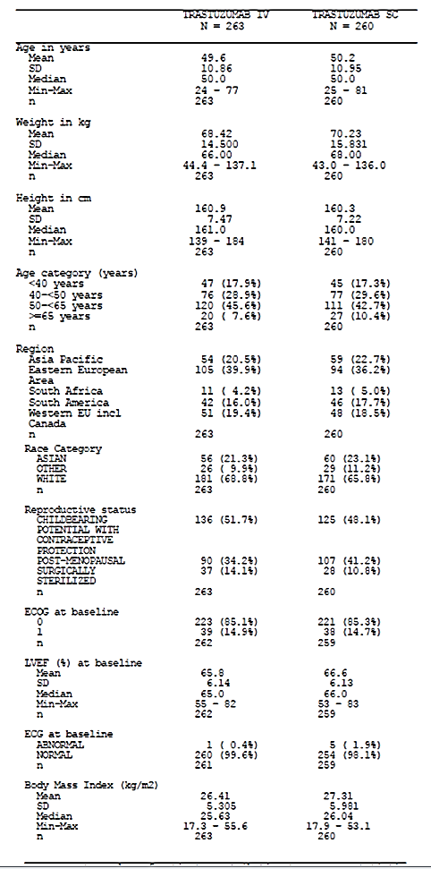

Table 8: Study BO22227 - Baseline disease characteristics (EPP)
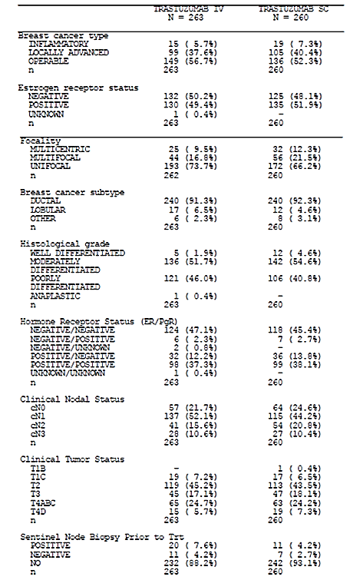
The type of surgery that patients underwent following completion of neoadjuvant therapy is shown in Table 9. In the IV arm 208/263 subjects (79%) underwent radiotherapy, compared to 215/260 (82.7%) in the SC arm. Use of adjuvant hormonal therapy was reasonably well balanced across the two arms.

Table 9: Study BO22227 - Type of surgery (EPP)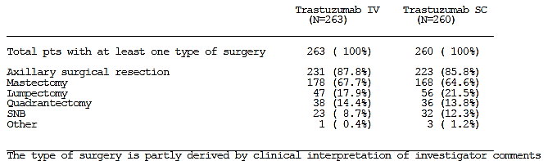

Results for the primary efficacy outcome
The results for the primary endpoint of PCR in the EPP are shown in Table 10. The pCR rate was 40.7% in the IV arm and 45.4% in the SC arm, with the difference being +4.7% in favour of the SC arm. The lower 97.5% confidence interval for the difference was -4.0% which was above the predetermined limit of -12.5%. Non-inferiority was therefore concluded.

Table 10: Study BO22227 – Results for pCR (primary endpoint) - EPP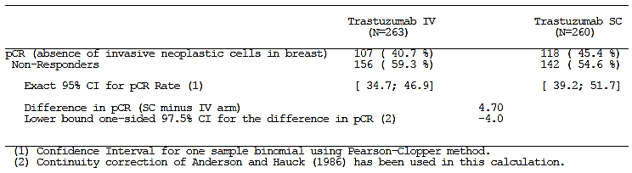
The results in the ITT population were similar (IV = 37.4% versus SC = 42.2%; difference = 4.8%; lower 97.5% CI = -3.3%).

Results for secondary efficacy outcomes
tpCR. The results for tpCR are shown in Table 11. The tpCR rate was again numerically higher in the SC arm (39.2% versus 34.2%; difference = 5.01%; 2-sided 95%CI = -3.5 to 13.5).

Table 11: Study BO22227 – Results for tpCR (EPP)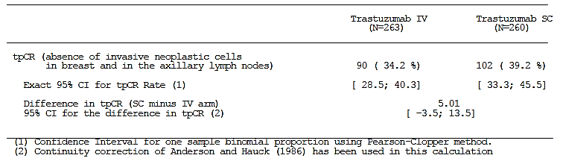
ORR. Results for overall response rate prior to surgery are shown in Table 12. Response rates were 87.2% for SC administration and 88.8% for IV administration. The difference in ORR was not statistically significant. The CR rates (21.7% versus 21.2%) and PR rates (65.5% versus 67.7%) were comparable in the two arms.

Table 12: Study BO22227 – Results for ORR (EPP)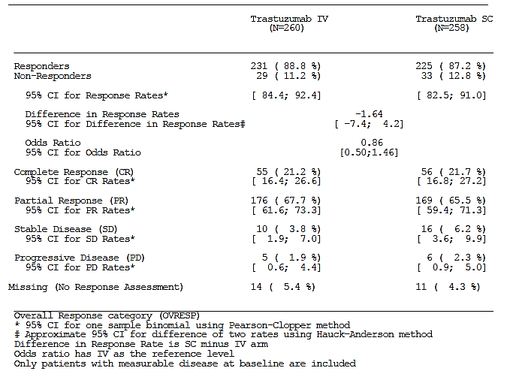
TTR. Time to response was similar in both arms (median = 6.14 weeks in both – Table 13).

Table 13: Study BO22227 – Results for TTR 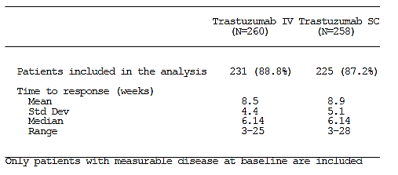
EFS. Results for event-free survival are summarised in Table 14 and Figure 5. The data were not mature, with only 84/523 subjects in the EPP population (16%) having developed an event. The estimated proportion of subjects who remained event-free at 12 months was 95% in both arms.

Table 14: Study BO22227 - Event-free survival (EPP)
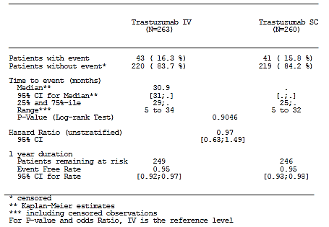
Figure 5: Study BO22227 - Event-free survival (EPP)
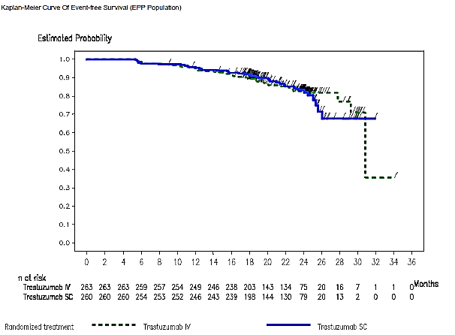
OS. Results for overall survival are summarised in Table 15. The data were not mature with only with only 19/523 subjects in the EPP population (3.6%) having died.

Table 15: Study BO22227 - Overall survival (EPP)
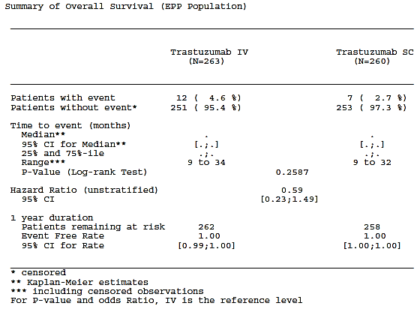
Further analyses of EFS and OS are planned when all subjects have completed two years and five years of follow-up (after completion of trastuzumab treatment).

Exploratory analyses
A multiple logistic regression analysis on pCR adjusting for stratification factors and selected baseline characteristics was conducted. In this analysis the odds ratio (OR) for achieving a pCR (SC versus IV) was 1.3 (95%CI: 0.91 – 1.88). In the unadjusted analysis, the OR had been 1.21 (95%CI: 0.86 – 1.71). The confidence intervals for both these analyses included zero, suggesting comparable efficacy. Among the other factors tested, only oestrogen receptor (ER) status at baseline (negative versus positive) was associated with a significant effect on achievement of a pCR. Patients with ER-negative tumours had a higher probability of achieving a pCR (OR: 2.67; 95%CI: 1.84 – 3.86; p<0.0001). Published data have previously demonstrated that neoadjuvant treatment is more likely to produce a pCR in patients with ER-negative tumours than in patients with ER-positive tumours ⁽⁸⁾.
Exploratory subgroup analyses were conducted to compare pCR rates obtained with SC and IV administration according to baseline demographics and baseline tumour characteristics. The difference in pCR rates was close to zero (suggesting comparable efficacy) in most subgroups. In elderly subjects and in subjects with inflammatory breast cancer, the point estimates suggested superior efficacy with IV administration, however these subgroups had small numbers, and the estimates had wide confidence intervals.
The following additional exploratory analyses were also presented in the study report:
- An analysis of whether subjects who achieved a pCR had higher Ctrough values (at pre-dose Cycle 8) than non-responders. No such association was identified.
- Analyses of the effects of baseline bodyweight and Ctrough (at pre-dose Cycle 8) on pCR rate. An analysis of pCR rate by quartiles of baseline bodyweight did not suggest reduced efficacy with SC administration in heavier patients. An analysis by Ctrough quartiles suggested that in subjects with low Ctrough levels, pCR rate might be reduced in the SC arm (30% versus 44%). However, in a multiple logistic regression analysis for pCR, which included Ctrough, body weight and treatment arm as covariates, no significant effects were observed.

Evaluator’s conclusions on clinical efficacy with SC administration
The data on pCR from the pivotal study suggest that the proposed SC regimen will produce a degree of efficacy that is non-inferior to that obtained with the currently approved IV 6-mg/kg q3 weeks regimen. The pivotal study also compared the PK profiles of IV and SC administration and found that the SC route produced higher levels of systemic exposure to trastuzumab (see Tables 16-19 and associated italicised text below).

Table 16A: Summary statistics for observed serum Ctrough (µg/mL) values at pre-dose Cycle 8 (PKPP1)
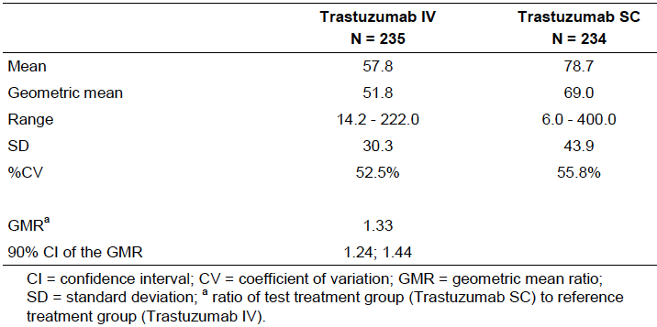

Table 16B: Summary statistics for the predicted^{b} Ctrough (µg/mL) values at pre-dose Cycle 8 (PKPP1)
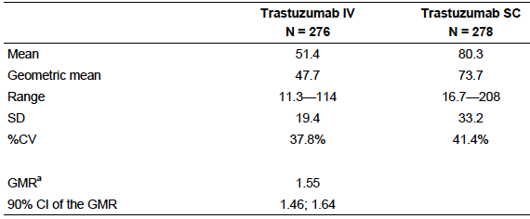

Table 16C: Summary of statistics for predicted^{b} Ctrough (µg/mL) values at pre-dose Cycle 13 (PKPP1)
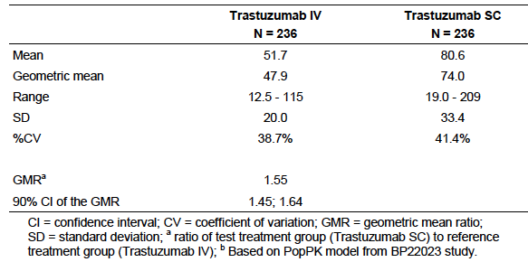

Table 16D: Observed C_{trough} values at pre-dose Cycle 13
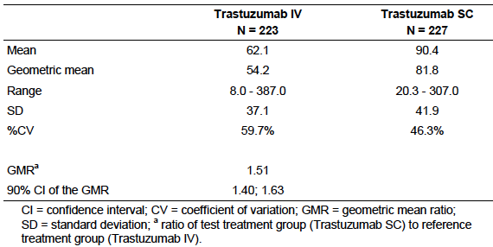
The report provided data on the proportion of patients in both arms who achieved an observed C_{trough} of > 20 μg/mL, as preclinical xenograft models had previously identified that this target serum concentration is required for efficacy in a number of tumour types. At pre-dose cycle 8 the proportions were 98.7% (IV) and 97% (SC). At pre-dose cycle 13 the proportions were 96.9% (IV) and 100% (SC).
C_{trough} values (mean ± SD) at day 21 of cycle 1 were 34.5 (± 23.0) μg/mL in the IV arm and 32.7 (± 18.5) μg/mL in the SC arm. The absence of a loading dose in the SC arm did not therefore affect initial trough levels to any notable extent.

Table 17: Cycle 7, Cmax, Tmax and AUC values
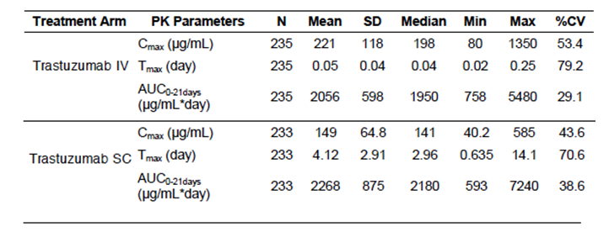
The GMR (SC/IV) for AUC_{0-21 days} during Cycle 7 was 1.07 (90% CI: 1.01; 1.12).

Table 18: Cycle 12, Cmax, Tmax and AUC values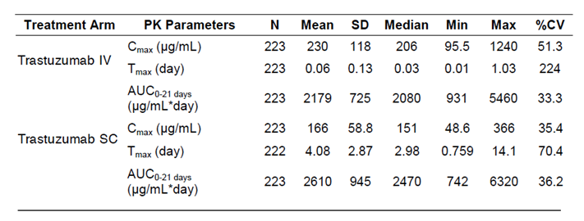
The GMR (SC/IV) for AUC_{0-21 days} during Cycle 12 was 1.18 (90% CI: 1.12; 1.25).
The report presented analyses of the effect of bodyweight on C_{trough} and AUC_{0-21 days}. Results for observed AUC_{0-21 days} during cycle 7 are shown in the following table. Subjects in the lowest quartile of body weight (<59 kg) had notably higher AUC values after SC administration than after IV administration. A similar pattern was seen for C_{trough}.

Table 19: Summary of observed AUC0-21days (µg/mL.day) values following the dose at Cycle 7 (up to Predose Cycle 8) by body weight quartiles for both trastuzumab IV and SC arms (PKPP1)
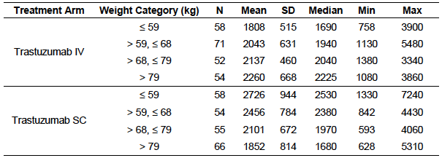
Evaluator’s comments: The study design, conduct and analysis were satisfactory. The PK data demonstrate that the proposed SC regimen results in higher C_{trough} values than IV administration (a 33% increase at pre-dose cycle 8 and a 51% increase at pre-dose cycle 13). However, total systemic exposure (as assessed by AUC) is only modestly increased with SC administration (7% increase during cycle 7 and 18% increase during cycle 12). Increases in AUC are more pronounced in subjects with low body weight. As expected SC administration results in lower C_{max} and delayed T_{max} compared with IV administration.
If the PK findings are accepted then it is improbable that SC administration would be associated with inferior efficacy. However, the following issues are considered relevant:
- Use of pCR as a primary endpoint
According to the EMA guideline on anticancer agents adopted by the TGA ⁽⁴⁾, acceptable primary endpoints for Phase III oncology trials are survival-type endpoints such as overall survival, progression-free survival and disease-free survival. Response rate measures such as ORR and pCR are generally not acceptable.
pCR has been proposed as a possible surrogate endpoint (in place of survival-type endpoints) to enable the early approval of new drugs for the treatment of breast cancer. The FDA has released a draft guideline on the subject ⁽⁹⁾. A pooled analysis of neoadjuvant clinical trials ⁽⁸⁾ demonstrated that patients who achieved a pCR had longer event-free survival and overall survival than those who were left with residual tumour. This association was stronger in patients with more aggressive forms of disease (e.g. hormone receptor negative disease) than in patients with less aggressive forms (e.g. hormone receptor positive disease). However, the analysis could not demonstrate a relationship between the magnitude of a treatment’s effect on pCR rate and the magnitude of its effect on EFS and OS. It cannot therefore be assumed that non-inferiority in terms of pCR will translate into non-inferiority in terms of EFS and OS.
The current debate regarding the use of pCR concerns its use as a surrogate endpoint for new drugs in the situation where data on hard clinical endpoints such as EFS and OS are not yet available. For trastuzumab, a beneficial effect of the drug on these endpoints has already been demonstrated (for the IV form). The use of pCR as a surrogate endpoint to demonstrate comparable efficacy between the IV and SC forms therefore seems a reasonable approach. The alternative would be to require demonstration of non-inferiority between the two routes of administration using a hard clinical endpoint such as EFS. This would require a very large trial, which would take several years to complete.
Despite the wording of the EMA guideline it is noted that the EMA itself has approved the current application. Overall, it is considered that the use of pCR as the primary efficacy endpoint is acceptable.
- Lack of blinding
Local pathologists assessed the primary endpoint of pCR. It appears that these pathologists were not blinded to treatment allocation and that there was no independent review of their findings. This may have introduced some bias into the trial findings.
- Efficacy in metastatic disease
The sponsor is seeking approval for the new SC regimen in the treatment of metastatic disease. The population included in the pivotal study consisted of subjects with localised or locally advanced disease. Patients with metastatic disease were excluded. The study also compared the proposed SC regimen with the 6-mg/kg q3 weeks IV regimen. In Australia the only regimen approved for use in metastatic disease is the 2-mg/kg q1 week regimen (see Table 20). This was the dosage regimen used in the pivotal efficacy studies in this setting. An application for approval of the 6-mg/kg q3 weeks IV regimen in metastatic disease was not approved by the TGA.

Table 20: Approved indications and approved and proposed dosage regimens.
Shaded areas indicate changes that are the subject of the current application.
Approved Indication | RoA | Loading  dose | Subsequent  doses | Duration
Localised Breast Cancer  Treatment of HER2-positive localised breast cancer following surgery, and in association with chemotherapy and, if applicable, radiotherapy. | IV | 8 mg/kg | 6 mg/kg every 3 weeks | 1 year
 | IV | 4 mg/kg | 2 mg/kg every 1 week | 1 year
 | SC | - | 600 mg every 3 weeks | 1 year
Locally Advanced Breast Cancer  Treatment of HER2-positive locally advanced breast cancer in combination with neoadjuvant chemotherapy followed by adjuvant HERCEPTIN. | IV | 8 mg/kg | 6 mg/kg every 3 weeks | 1 year
 | SC | - | 600 mg every 3 weeks | 1 year
Metastatic Breast Cancer  Treatment of patients with metastatic breast cancer who have tumours that overexpress HER2:  As monotherapy for the treatment of those patients who have received one or more chemotherapy regimens for their metastatic disease;  In combination with taxanes for the treatment of those patients who have not received chemotherapy for their metastatic disease; or  In combination with an aromatase inhibitor for the treatment of post-menopausal patients with hormone-receptor positive metastatic breast cancer. | IV | 4 mg/kg | 2 mg/kg every 1 week | Until disease progression
 | SC | - | 600 mg every 3 weeks | Until disease progression
Advanced Gastric Cancer  In combination with cisplatin and either capecitabine or 5-FU for the treatment of patients with HER2 positive advanced adenocarcinoma of the stomach or gastrooesophageal junction who have not received prior anti-cancer treatment for their metastatic disease. | IV | 8 mg/kg | 6 mg/kg every 3 weeks | Until disease progression
RoA-Route of administration.
Simulations using a population PK model suggested that trastuzumab systemic exposure with the 600 mg q3 week SC regimen would be at least comparable to that obtained with the 2-mg/kg q1 week regimen (see Dosage selection for the pivotal studies above). Trastuzumab for metastatic disease is funded in Australia through Medicare, using an arrangement separate to the Pharmaceutical Benefits Scheme. Under this arrangement both the 2-mg/kg q1 week regimen and the 6-mg/kg q3 weeks regimen are funded ⁽¹⁰⁾, even though the latter is not approved by the TGA. It is therefore likely that the 6-mg/kg q3 weeks regimen is being used. For these reasons this reviewer considers it reasonable to extrapolate the efficacy findings of the pivotal study to the metastatic disease setting.
Overall, when the efficacy results are considered together with the pharmacokinetic results, it is concluded that efficacy of the proposed SC regimen has been adequately established.

Product information update

HERA study
The methodology and early results of the Herceptin Adjuvant (HERA) study have been previously evaluated by the TGA. It was one of four randomised Phase III controlled trials that formed the basis for TGA approval of adjuvant use of trastuzumab (that is, use following surgery) in early breast cancer patients.
The study was a randomised, open-label trial with three parallel groups. The study included subjects with HER2+ve early breast cancer (either node-negative or node-positive) who had completed surgery and at least four cycles of chemotherapy (in either the neoadjuvant or adjuvant setting) with or without radiotherapy. A variety of chemotherapy regimens could be used. Subjects were randomised to one of the following three arms:
- Trastuzumab (8mg/kg loading dose followed by 6mg/kg q 3 weeks) for 1 year
- Trastuzumab (8mg/kg loading dose followed by 6mg/kg q 3 weeks) for 2 years
- Observation.
The primary end-point was disease-free survival (DFS), which was defined as the time from randomisation to the first occurrence of any of the following: recurrence of breast cancer at any site, the development of a new breast cancer, the development of a second, non-breast malignancy (other than non-melanoma skin cancer or in-situ carcinoma of the cervix) or death from any cause. Overall survival was a secondary endpoint. Other secondary endpoints were recurrence-free survival (time from randomisation to the first local, regional or distant tumour recurrence) and distant disease-free survival (time from randomization to the first distant tumour recurrence, second primary cancer or contralateral breast cancer).
The initial objective of the study was to compare each of the two trastuzumab arms with the observation arm. Initial TGA approval was based on a sponsor study report that analysed data after a median follow-up of 12 months. These data also formed the basis of the first published report of the study in 2005 ⁽¹¹⁾. This initial analysis demonstrated a significant DFS benefit for subjects in the 1-year trastuzumab arm compared with the observation arm (data from the 2-year arm were not presented). Following these findings, the protocol was amended such that an additional objective was to conduct a direct comparison of the two trastuzumab arms (that is, 1-year versus 2-year). Also following the initial analysis, subjects in the observation arm were permitted to cross over to the 1-year arm.
Further follow-up analyses were published in 2007⁽¹²⁾ (median follow-up 23.5 months), 2011⁽¹³⁾ (median follow-up 48.4 months) and 2013⁽¹⁴⁾ (median follow-up 8 years). The results of these analyses (for the 1-year arm versus the observation arm) are summarised in Table 21. The current TGA-approved product information includes data from the 12- and 23.5-month follow-ups.

Table 21: HERA Study. Published efficacy data: 1 year trastuzumab group versus observation group
 |  | DFS events |  | Deaths
Data cut-off | Median F/U | Observa-tion | Trastuzumab 1 yr  HR; 95% CI  p value | Observa-tion | Trastuzumab 1 yr  HR; 95% CI  p value | Ref
April 2005 | 12 m | 13.0% | 7.5%  0.54  (0.43 – .67)  p<0.0001 | 2.2% | 1.7%  0.76  (0.47 – 1.23)  p=0.26 | 11
March 2006 | 23.5 m | 19% | 13%  0.64  (0.54 – 0.76)  p<0.0001 | 5% | 3%  0.66  (0.47 – 0.91)  p=0.0.015 | 12
June 2008 | 48.4 m | 27.0% | 21.7%  0.76  (0.66 – 0.87)  p<0.0001 | 12.5% | 10.7%  0.85  (0.70 – 1.04)  p=0.11 | 13
April 2012 | 8 years | 33.6% | 27.7%  0.76  (0.67 – 0.86)  p<0.0001 | 20.6% | 16.3%%  0.76  (0.65 – 0.88)  p=0.0005 | 14
The current submission included a full study report for the trial (dated March 2013) with a data cut-off date of 12 April 2012. The report presented analyses of the efficacy and safety of 1 or 2 years of trastuzumab treatment compared to observation, and a comparison of 1 year versus 2 years of trastuzumab treatment.
A total of 5102 subjects were randomised at 478 centres in 39 countries – 1,698 to the observation arm, 1,703 to the 1-year arm and 1,701 to the 2-year arm. One patient in each arm was excluded from analysis due to failure to sign the informed consent form. After the release of the results of the initial analysis, 888 patients in the observation arm (52.3%) crossed over to the 1-year arm. At the date of data cut-off, median duration of follow-up was approximately 8 years in all three groups.
The comparisons of the trastuzumab groups versus the observation group were conducted in the full analysis set (FAS; n=5099). Comparison between the 1- and 2-year groups was conducted in the population of patients who had not been lost to follow-up and were still alive and disease-free at 12 months (n=1552 in the 1-year group and 1553 in the 2-year group).
The three groups were well balanced at baseline for demographic and disease characteristics. Similarly patients remaining in the two trastuzumab groups at 12 months were well balanced with respect to baseline characteristics.
Results for the trastuzumab versus observation efficacy comparisons are summarised in Table 22.

Table 22: HERA study Efficacy results: Trastuzumab arms versus observation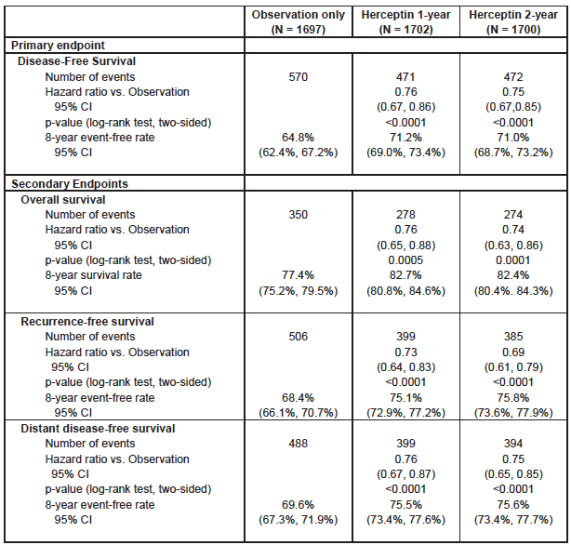
Despite the high rate of crossover of patients from observation to trastuzumab, a significant DFS benefit was maintained after 8 years. In the 1-year arm there was a 24% reduction in the risk of a DFS event (HR 0.76; 95%CI: 0.67 – 0.86; p<0.0001). The percentage of patients remaining alive and disease-free after 8 years was increased by approximately 6% (71.2% versus 64.8%). There was a benefit of similar magnitude for overall survival. Results in the two-year arm were similar.
Comment: As shown in Table 21, previous analyses of the HERA study had not consistently demonstrated a beneficial effect of trastuzumab on overall survival. In this most recent analysis the effect on overall survival was highly significant (p=0.0005). The DFS results at 8 years were consistent those obtained at 4 years.
Results for the comparison of the 1-year and 2-year arms are summarised in Table 23. Two years of treatment with trastuzumab provided no additional benefit over 1 year of treatment.

Table 23: HERA study. Efficacy results – 1-year arm versus 2-year arm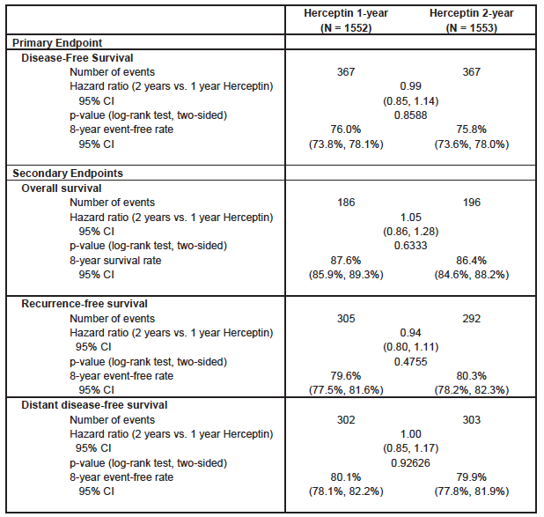

Evaluator’s conclusions on clinical efficacy - PI update
The 8-year follow-up of the study confirms that one-year of adjuvant treatment with trastuzumab in patients with early breast cancer (after completion of surgery and chemotherapy, with or without radiotherapy) results in significant benefit in terms of disease-free survival and overall survival. These benefits have been maintained despite 52% of subjects in the observation arm having also received trastuzumab. The latest results have also shown that prolonging treatment with trastuzumab to a total of 2 years does not result in improved efficacy.
The sponsor proposes to update the efficacy data in the ‘Clinical Trials’ section of the PI by replacing the results obtained after 2 years of follow-up with those obtained at 8 years, and by including the results of the comparison of the two trastuzumab arms at 8 years. These changes are generally acceptable. Comments on the proposed wording are included in the section First round comments on clinical aspects of the draft PI below.

Clinical safety

Subcutaneous Administration

Studies providing evaluable safety data
The following studies provided evaluable safety data.

Pivotal efficacy study - BO22227
In the pivotal efficacy study, the following safety data were collected:
- Information on general adverse events (AEs) was collected throughout the study. Up to 28 days after the last administration of trastuzumab, all AEs were reported irrespective of the type of disorder and relationship of the AE to the drug. Between 28 days after last study drug and the end of the study, only related AEs and cardiac AEs were to be reported.
- Intensity of AEs was graded according to the National Cancer Institute Common Terminology Criteria for Adverse Events (NCI-CTC-AE) version 3.0. Severity of heart failure was graded using the New York Heart Association (NYHA) classification.
- MedDRA version 16.0 was used to assign preferred AE terms to the reported AEs.
- Heart failure and administration-related reactions (ARRs) was identified as an AE of particular interest.
- Laboratory tests, including haematology (haemoglobin, total WBC, absolute neutrophil count (ANC)/neutrophils, platelet count) and biochemistry (creatinine, urea (BUN), SGPT (ALT), SGOT (AST), total bilirubin, alkaline phosphatase, albumin, sodium, potassium and calcium) were performed at baseline, at Cycles 1-9, 13 and 18, at the final visit and then at 3, 6, 12, 18 and 24 months during follow-up.
- Laboratory tests for anti-trastuzumab antibodies (both arms) and anti- rHuPH20 antibodies (SC arm only) were performed at baseline, at Cycles 2, 5 and 13, at 3 and 6 months during follow-up and then at 6 monthly intervals until 60 months.
- Assessment of LVEF (by Echo or MUGA scan) and ECG were performed during screening, at cycles 5, 9, 13 and 18, at 6-monthly intervals for the first 2 years of follow-up and then at 12-monthly intervals.

Phase I study – BP22023
In this study subjects generally only received a single dose of IV or SC trastuzumab. The safety findings of the study are summarised below.

Safety findings:
Four subjects received 2 doses of trastuzumab (1 IV dose and 1 SC dose). The other 62 subjects received only a single dose. There were no deaths, serious AEs or AEs leading to withdrawal. In Part 1, the percentage of patients who developed AEs was comparable with IV and SC administration (83.3 – 100% versus 83.3-100%). However, the total number of AEs was higher in the IV cohorts (26, 24 AEs) than in the SC cohorts (12, 11, 13 AEs).
There were noGrade 3/4 events among the SC groups in Part 1. In Part 2, there were no Grade 4 events, but 4 subjects (10%) developed Grade 3 events (viral infection, gastroenteritis, headache, influenza). All these events occurred 30 or more days after trastuzumab administration and were considered unrelated or remotely related to the drug.
The incidence of injection site reactions was 25.0% with IV administration (Cohorts 1 and 2). With SC administration it was 83.3% at 6 mg/kg (Cohort 3), 38.5% at 8 mg/kg (Cohorts 5 and A), 66.7% at 10 mg/kg (Cohort 4) and 30.0% at 12 mg/kg (Cohort B). In all there were 28 injection site AEs reported. The most common were injection site erythema (7), and discolouration (5). All such reactions were mild in intensity except for two events of moderate injection site pain in Cohort B.

Patient exposure
A total of 661 subjects received at least one dose of trastuzumab in the two submitted studies. A total of 355 subjects received at least one SC dose.

Table 24:- Exposure to trastuzumab SC and IV in clinical studies.
Study | Subjects | SC | IV | Total
BO22023  - Part 1  - Part 2 | Healthy volunteers  Patients  Patients | 18  -  40 | 6  6  - | 24  6*  40*
BO22227 | Patients | 297 | 298 | 595
Totals |  | 355 | 310 | 661*
* Four subjects in BP22023 received a single IV dose and a single SC dose. There were therefore 66 unique subjects in this study.
The main safety data come from the Phase III study and the following review of adverse events etc. will focus on the findings of that trial.
The extent of trastuzumab exposure in the Phase III study is summarised in Table 25. The percentage of planned dose received and the number of cycles received were equivalent in the two arms. The extent of exposure to each of the planned chemotherapy agents (docetaxel, 5-fluorouracil, epirubicin and cyclophosphamide) was also comparable in the two study arms.

Table 25: Study BO22227 – Extent of trastuzumab exposure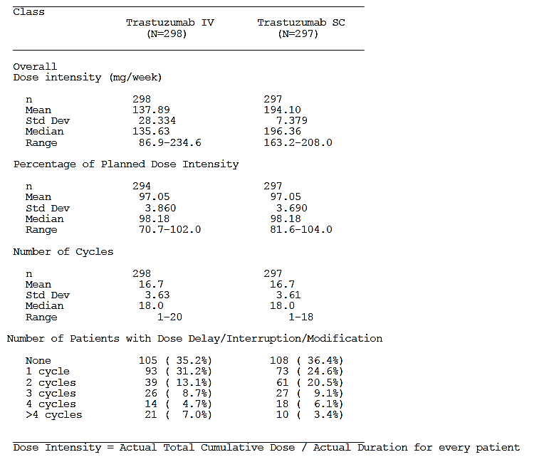

Adverse events
An overview of the safety profiles of trastuzumab SC and IV, in terms of the incidence of AEs etc., is shown in Table 26.

Table 26: Study BO22227 - Overview of safety profile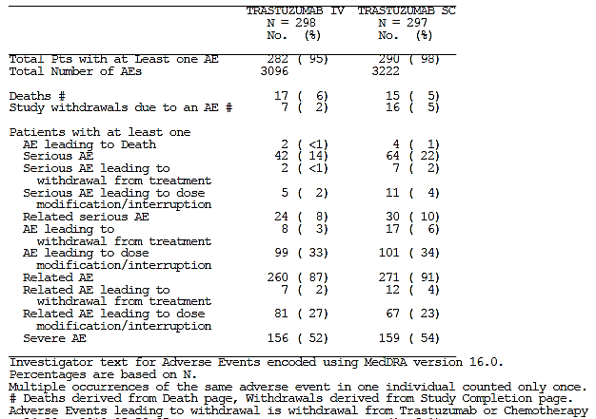

All adverse events (irrespective of relationship to study treatment)
The proportion of patients who developed at least one AE was comparable in the two arms – 95% in the IV arm and 98% in the SC arm. The most common AEs (incidence ≥ 5%) are listed in Table 27.

Table 27: Study BO22227 - Common AEs (incidence ≥ 5%)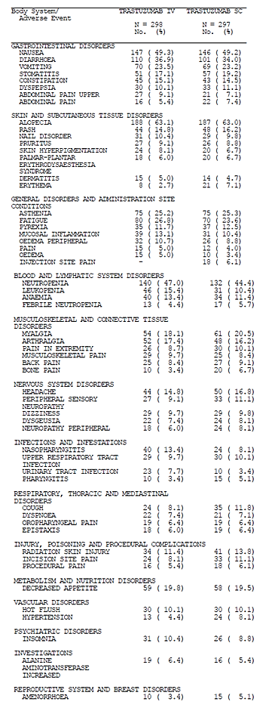

Comment: There were no striking differences in the pattern of AEs between the two arms. Injection site pain was more common in the SC arm (6.1% versus 0%), as was erythema (7.1% versus 2.7%). Many of the AEs may have been due to the cytotoxic chemotherapy that all patients received during the neoadjuvant phase. During the adjuvant phase, when all subjects were treated with trastuzumab monotherapy, the incidence of AEs was 67% in the IV arm and 69% in the SC arm. Again there were no notable differences between arms in the pattern of AEs, apart from injection site events in the SC arm.

Treatment-related adverse events (adverse drug reactions)
Investigators assessed AEs as being either related or unrelated to treatment (which included chemotherapy agents and trastuzumab). The proportion of patients who developed at least one treatment-related AE was slightly higher in the SC arm – 87% (IV) versus 91% (SC). In the adjuvant phase the incidence of treatment-related AEs was 23% (IV) and 25% (SC). Summary tabulations of treatment-related AE terms were not provided in the study report.

Grade ≥ 3 AEs
The proportion of patients who developed at least one Grade 3 or higher AE was comparable in the two arms – 52% in the IV arm and 54% in the SC arm. The most common Grade ≥ 3 AEs (incidence ≥ 1%) are listed in Table 28Table 28:

Table 28: Study BO22227 – Grade ≥ 3 AEs (incidence ≥ 1%)
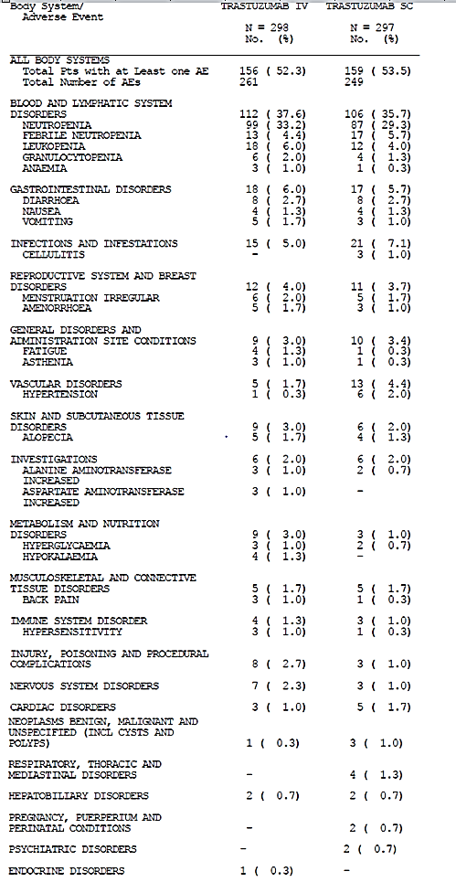
Comment: The pattern of Grade ≥ 3 AEs was similar in the two arms.

Deaths and other serious adverse events

Deaths
A total of 33 deaths had occurred in the total trial population by the cut-off date for the study report - 18 (6.0%) in the IV arm versus 15 (5.1%) in the SC arm. Most of these were due to disease recurrence/progression (Table 29). There were six deaths due to an AE, 4 in the SC group and 2 in the IV group.

Table 29: Study BO22227 – Deaths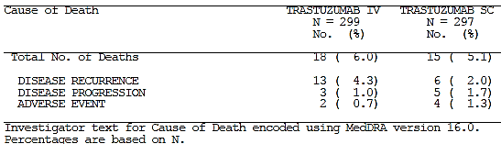
Two of these deaths occurred in the follow-up phase, well after the last dose of trastuzumab:
- A 62-year old woman who had received 12 months of IV trastuzumab, was diagnosed with myeloid leukaemia 8 months after her last dose and died one week later
- A 77-year old subject who had received 12 months of SC trastuzumab, developed endometrial cancer 5 months after her last dose and died 4 months later.
Neither of these deaths was considered related to treatment by the investigators.
The remaining four deaths occurred during the neoadjuvant phase, when subjects were receiving concurrent cytotoxic chemotherapy:
- A 66-year old woman, with pre-existing pulmonary fibrosis, who had received 2 cycles of IV trastuzumab, developed pneumonia (documented on chest X-Ray). She was not neutropaenic. One week later she developed acute respiratory failure and died. The death was not considered related to study treatment, but related to her pulmonary fibrosis.
- A 60-year old subject who had received a single cycle of SC trastuzumab 9 days previously, developed epigastric pain, left sided chest pain, left arm pain and dyspnoea. She died in her sleep that night. No autopsy was performed. The cause of death was given as probable myocardial infarction. She had a prior history hypertension and was obese but had no other risk factors for ischaemic heart disease. Echocardiography at screening had shown an LVEF of 63%. The investigator considered the event was possibly related to study treatment.
- A 71-year old female who had received 8 cycles of SC trastuzumab, died suddenly at home during the night, 20 days after her last dose. No autopsy was performed. Her past history included hypertension and diabetes. Echocardiography six weeks prior to death showed an LVEF of 71%. The death was not considered related to study treatment.
- A 77-year old woman who had received 4 cycles of treatment with SC trastuzumab developed febrile neutropaenia with thrombocytopaenia 11 days after her last dose. She died from septic shock one day later. The event was considered related to study treatment.
Comment: There was a slight excess of deaths in the SC arm during the neoadjuvant phase (3 versus 1). The case of septic shock was probably due to the cytotoxic chemotherapy. The other two deaths in the SC group were possibly cardiac in nature. Neither patient had evidence of cardiac failure prior to death.

Serious AEs
A serious adverse event (SAE) was defined as one that fulfilled one of the following criteria: was fatal, was life-threatening, required in-patient hospitalization or prolongation of existing hospitalization, resulted in persistent or significant disability/incapacity, was a congenital anomaly/birth defect or was medically significant or required intervention to prevent one or other of these outcomes.
The proportion of patients who developed at least one SAE was higher in the SC arm – 14% (IV) versus 22% (SC). SAEs are listed in Table 30. The incidence of SAEs was increased in the SC arm during both the neoadjuvant phase (14.1% versus 10.1%) and the adjuvant phase (8.1% versus 3.4%).
The incidence of SAEs that were considered related to study treatment was comparable - 8% (IV) versus 10% (SC).

Table 30: Study BO22227 – Serious AEs
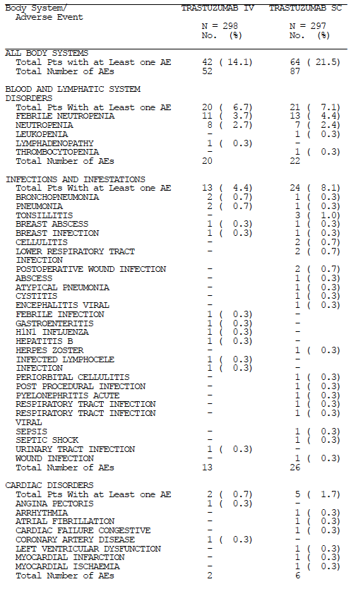

Table 30 (continued) - Study BO22227 – Serious AEs
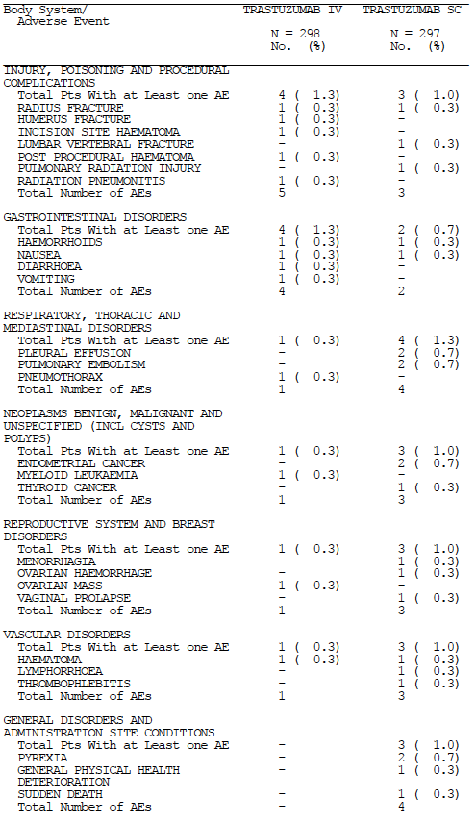
Comment: As shown in Table 30, ‘infections and infestations’ was the only category of SAE in which there was a notable difference in incidence between the two treatment arms - 8.1% (SC) versus 4.4% (IV). However, when individual AE terms are examined, there does not appear to be a specific type of infection that is notably more common with SC administration. There were no serious infections at the SC site of administration. The incidence of neutropaenia and febrile neutropaenia were comparable in the two arms.
The sponsor’s current risk management plan includes infections as a potential safety concern for trastuzumab with the following statement: ‘An increased incidence of infections, primarily mild upper respiratory infections of minor clinical significance or catheter infections, has been observed primarily in patients treated with trastuzumab plus paclitaxel or docetaxel compared with patients receiving paclitaxel or docetaxel alone’.
Besides infections, the remaining excess of SAEs in the SC arm occurred across a variety of body systems, with no individual SAE term being notably more frequent in the SC arm.
The authors of the published version of the study ⁽⁶⁾ noted that although there was no increase in the incidence of Grade 3 AEs in the SC arm, these Grade 3 AEs were more likely to be reported as SAEs for patients in the SC arm. They speculated that: ‘investigators might have adopted a more conservative attitude towards patients receiving subcutaneous trastuzumab in this open-label trial, resulting in differences in clinical management (that is,, a higher rate of hospital admission)’.
Exploratory analyses of the rates of SAEs (and Grade ≥ 3 AEs) by quartiles of body weight at baseline as well as by quartiles of AUC values were performed. Table 31 shows SAE rates according to body weight and AUC quartiles.

Table 31: Study BO22227 – SAEs according to bodyweight and AUC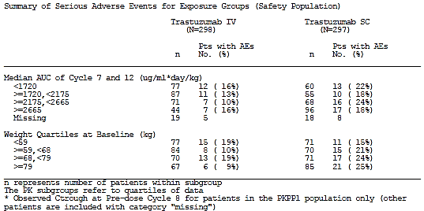
There was no pattern suggestive of increasing SAE rates with increasing AUC or decreasing body weight. The results for Grade ≥ 3 AEs were similar. Further analyses of patients with low bodyweights showed that the SAE rate in these subjects was actually lower than the SAE rate in the population as a whole (Table 32). These data suggest that the higher SAE rate in the SC arm is unlikely to be due to the fixed dose SC regimen producing higher AUC values in low body weight subjects.

Table 32: Study BO22227 – SAEs/Grade ≥ 3 AEs in subjects with low bodyweight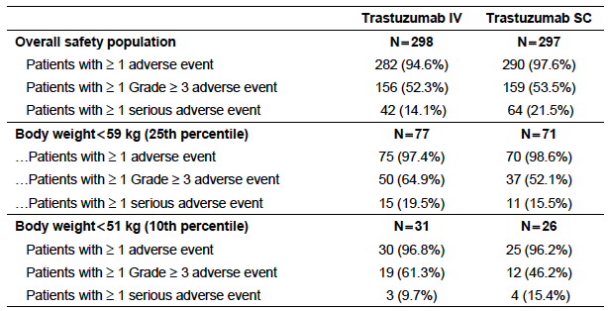
Multiple logistic regression analyses were conducted comparing the occurrence of SAEs (and Grade ≥ 3 AEs) between treatment arms. AUC (median AUC value of Cycle 7 and 12) and body weight were included as covariates. None of the covariates showed a statistically significant effect on the frequency of SAEs or Grade ≥ 3 AEs.

Discontinuation due to adverse events
The proportion of patients who developed at least one AE leading to study withdrawal was higher in the SC arm – 2.7% (IV) versus 5.7% (SC). These AEs are listed in Table 33. Further information on these subjects is given in Tables 34 and 35.

Table 33: Study BO22227 – AEs leading to withdrawal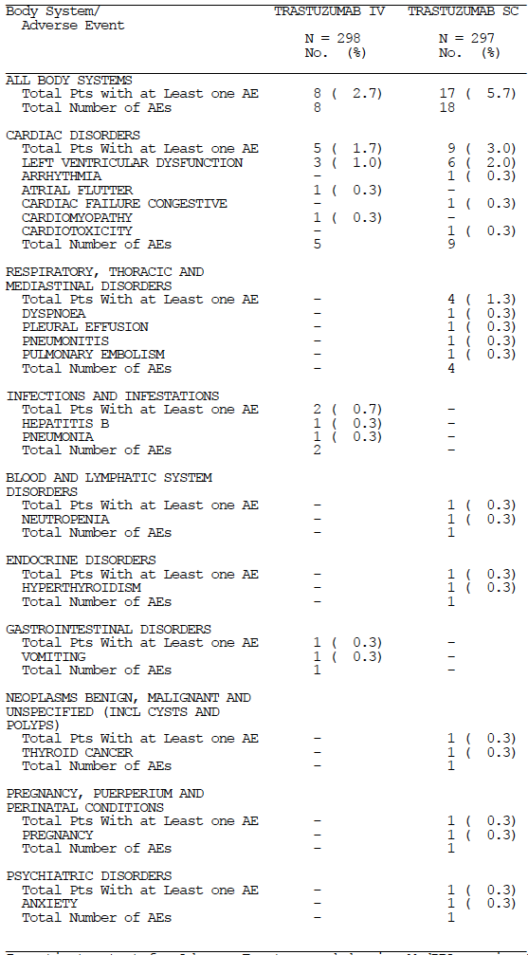

Table 34: Study BO22227 – AEs leading to withdrawal in SC arm
Age | Race | AE term |  |  | Day of onset |  | ? Related |  | Comments
LVD events
47 | White |  | LVD | 371 |  | Yes
47 | White |  | LVD | 337 |  | Yes
44 | White |  | Cardiotoxicity | 260 |  | Yes
56 | Black |  | LVD | 306 |  | Yes
43 | Black |  | CCF | 140 |  | Yes
43 | White |  | LVD | 246 |  | Yes
52 | White |  | LVD | 284 |  | Yes
69 | Asian |  | LVD | 212 |  | Yes
51 | White |  | Pleural effusion | 191 |  | No |  | Raised BNP. Commenced on diuretics. Possible LVD.
Respiratory events
53 | White |  | Arrhythmia |  | 77 | Yes |  | AF. Noted to also have NYHA Class II CCF.
40 | Mestizo |  | Dyspnoea & hyperthyroidism |  | 308 | No |  | Subject withdrawn from study ‘for safety reasons’
48 | White |  | Pneumonitis |  | 340 | Yes
68 | White |  | Pulmonary embolus |  | 94 | Yes ⁽¹⁾
Other events
51 | White |  | Thyroid cancer |  | 274 | No
31 | White |  | Pregnancy |  | 20 | No
67 | White |  | Anxiety |  | 120 | No |  | Trastuzumab continued.
38 | Asian |  | Neutropaenia |  | 82 | Yes ⁽¹⁾ |  | Trastuzumab continued.
LVD = Left ventricular dysfunction; CCF= Congestive cardiac failure; AF= atrial fibrillation. (1) – Considered to be related to chemotherapy, not trastuzumab. NB. Patient identification numbers have been deleted from this table.

Table 35: Study BO22227 – AEs leading to withdrawal in IV arm
Age | Race | AE term | Day of onset | ? Related | Comments
52 | White | Cardio-myopathy | 294 | Yes
53 | Asian | LVD | 182 | Yes
59 | Mestizo | LVD | 254 | Yes
33 | Asian | LVD | 272 | Yes
55 | White | Pneumonia | 51 | No
56 | Asian | Hepatitis B | 166 | Yes ⁽¹⁾ | Known Hep B carrier at baseline. Trastuzumab continued.
40 | White | Vomiting | 127 | Yes ⁽¹⁾ | Trastuzumab continued.
64 | White | Atrial flutter | 321 | Yes | LVEF values were normal at time of event.
LVD = Left ventricular dysfunction. (1) – Considered to be related to chemotherapy, not trastuzumab. NB. Patient identification numbers have been deleted from this table.
Comment: In the SC arm there were 8 subjects who withdrew due to left ventricular dysfunction (LVD). These subjects typically had decreases in LVEF that were considered related to trastuzumab. A further two subjects had events suggestive of LVD. One of these presented with bilateral pleural effusions. There was limited information provided in the case narrative for this subject, but she was noted to have elevated brain natriuretic peptide (BNP) levels (912 pg/mL; normal range = 0-125) and she was commenced on hydrochlorothiazide and triamterene for dyspnoea, suggesting that the cause of her effusions may have been cardiac failure. The other subject was listed as discontinuing due to an arrhythmia (atrial fibrillation) but in the case narrative she was also noted to have NYHA Class II heart failure. The overall incidence of discontinuation due to LVD in the SC arm was therefore 3.4% (10/298). In the IV arm it was 0.8% (4/297). Cardiac safety is discussed further below.
There were more discontinuations due to respiratory events in the SC arm (3 versus 1). One subject developed Grade II dyspnoea (at the same time as being diagnosed with hyperthyroidism). No details of any investigations of the dyspnoea were provided. The dyspnoea was not treated and it subsequently resolved. One subject developed a pulmonary embolus, which was thought by the investigator to be related to cytotoxic chemotherapy, but not to trastuzumab. Another subject developed pneumonitis. Pulmonary toxicity (for example, interstitial lung disease) has been previously reported with trastuzumab. In the IV arm, one subject discontinued due to pneumonia.
There was no obvious pattern to the other events that resulted in withdrawal.

Adverse events of special interest

Cardiac toxicity
The proportion of patients who developed at least one cardiac AE was comparable in the two arms – 13.1% (IV) versus 13.5% (SC). These AEs are listed in Table 36. Events indicative of cardiac failure (left ventricular dysfunction, cardiac failure, etc.) occurred with comparable frequencies.

Table 36: Study BO22227 – Cardiac AEs
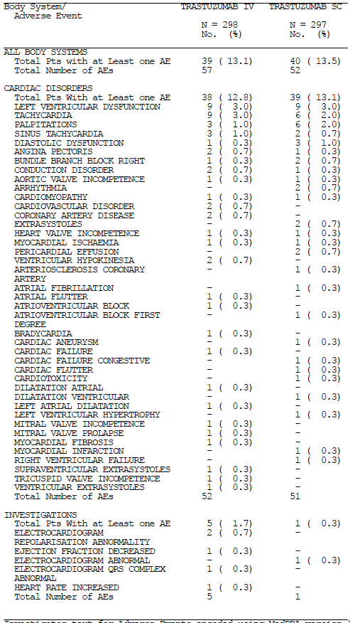
Grade ≥ 3 cardiac AEs had a comparable frequency (1.0% for IV versus 1.7% for SC), as did cardiac SAEs (0.7% for IV versus 1.7% for SC – see Table 30).
Abnormalities of LVEF occurred with a similar frequency in the two arms (Table 37). In patients who were withdrawn due to cardiac toxicity, abnormal LVEF values generally improved to normal after discontinuation of trastuzumab and in some, treatment with anti-failure therapy (Table 38).

Table 37: Study BO22227 – LVEF measurements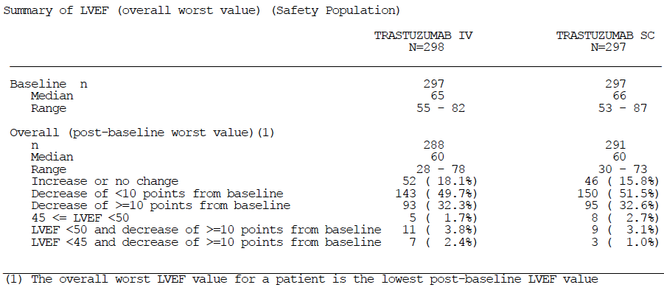

Table 38: Study BO22227 – Long term outcomes for LVD events - LVEF (%)
Age | Race | AE term | Screening | Nadir | Final | ? AE Resolved ⁽¹⁾
Subcutaneous arm
47 | White | LVD | 56 | 49 | 59 | Yes
47 | White | LVD | 61 | 48 | 56 | Yes
44 | White | Cardiotoxicity | 61 | 48 | 56 | Yes
56 | Black | LVD | 57 | 40 | 61 | Yes
43 | Black | CCF | 56 | 25 | 49.9 | Yes
43 | White | LVD | 65 | 48 | 71 | Yes
52 | White | LVD | 67 | 49 | 61 | Yes
69 | Asian | LVD | 70 | 30 | 50 | Yes
51 | White | Pleural effusion | nr | nr | nr | Yes
53 | White | Arrhythmia | 57 | - ⁽²⁾ | nr | Yes
Intravenous arm
52 | White | Cardiomyopathy | 63 | 28 | 56 | Yes
53 | Asian | LVD | 55 | 42 | 54 | Yes
59 | Mestizo | LVD | 66 | 36 | 56 | No
33 | Asian | LVD | 58 | 40 | 68 | No
(1) Resolved according to the investigator. (2) Subject [information redcated] was noted to have NYHA Class II heart failure, but at the time the LVEF was measured as 61%. Patient identification numbers have been deleted from this table.
Comment: Even though there were more withdrawals due to cardiac events in the SC arm, overall cardiac toxicity appeared comparable in the two arms.

Administration-related reactions (ARRs)
ARRs were analysed using a Standardised MEDRA Query (SMQ) for anaphylaxis, modified by the inclusion of the following additional MEDRA preferred terms: hypersensitivity, drug hypersensitivity, infusion-related reaction, and injection site reaction. The results are shown in Table 39. The incidence of ARRs was higher in the SC arm – 37.2% (IV) versus 47.8% (SC). In terms of body systems, the excess of events was most prominent in the skin (22.5% versus 30.3%) and respiratory tract (13.8% versus 17.5%).

Table 39: Study BO22227 – Administration-related reactions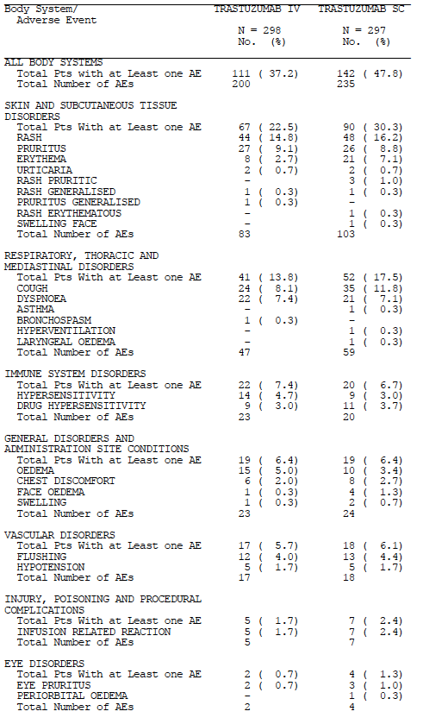
Grade 3 ARRs occurred in 6 subjects in the IV arm (2.0%) and 5 subjects in the SC arm (1.7%). There were no Grade 4 or 5 ARRs. Two events of hypersensitivity in the IV arm were classified as serious. There were no serious ARRs in the SC arm.

Injection site reactions
Injection site reactions associated with SC administration were analysed and are summarised in Table 40. 11.1% of subjects experienced a total of 45 events, after a total of 4,957 injections. There were 5 Grade 2 events (4 of pain, 1 phlebitis). All the remaining events were Grade 1 in severity. None of the events were classified as serious.
Comment: The SC formulation does not appear to be associated with any significant local toxicity.

Table 40: Study BO22227 – Injection site reactions
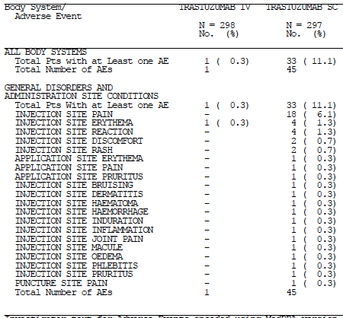

Laboratory tests

Liver function
LFT abnormalities occurred with a similar frequency in the two arms.

Kidney function
Elevations of creatinine occurred with a similar frequency in the two arms. Summary tabulations of urea results were not provided in the study report.

Other clinical chemistry
There were no notable differences between the study arms in the incidence of abnormalities of other biochemical parameters (sodium, potassium, calcium, albumin).

Haematology
Abnormalities in haematology parameters occurred with a similar frequency in the two arms. In particular there was no increased incidence of neutropaenia in the SC arm that might explain the observed increase in serious infections.

Anti-drug antibodies

Anti-trastuzumab antibodies
Samples were tested for the presence of antibodies using a validated electrochemiluminescence immunoassay (ECLIA). The presence of neutralising antibodies was tested for using a cell-based bioassay, which measured the ability of the antibodies to block trastuzumab suppression of proliferation in a HER2-overexpressing human breast cancer cell line (BT-474).
A total of 591 subjects had a least one post-baseline test result (296 IV and 295 SC). At least one positive post-baseline test occurred in 7.1% of subjects in the IV arm (21/296) and 14.6% of subjects in the SC arm (43/295). Of these subjects, 5 in the IV arm and 6 in the SC arm had also had positive results at baseline.
Neutralising antibodies were detected post-baseline in 1 subject in the IV arm and 2 subjects in the SC arm.
An exploratory analysis showed that antibody-positive subjects did not have notably lower trastuzumab C_{trough} values at pre-dose Cycle 8, or pre-dose Cycle 13, compared to antibody-negative subjects, in either the SC or the IV arm. Similarly, there were no apparent differences in rates of pCR or ARRs.

Anti-rHuPH20 antibodies
A validated ECLIA assay was used to test for the presence of anti-rHuPH20 antibodies. Neutralising antibodies were detected using a validated turbidometric method for detecting hyaluronidase activity.
295 subjects in the SC arm had post-baseline test results. Antibodies were detected in 16.3% of subjects (48/295). Of these subjects, 21 had also had a positive test at baseline. No neutralising antibodies were detected.
An exploratory analysis showed that rHuPH20 antibody-positive subjects did not have notably lower trastuzumab C_{trough} values at pre-dose Cycle 8, or pre-dose Cycle 13, compared to antibody-negative subjects. Similarly, there were no apparent differences in rates of pCR or ARRs.
Comment: As noted in the relevant EMA guideline ⁽⁵⁾, SC administration of therapeutic proteins is more immunogenic than IV administration, and the testing results from the pivotal study confirm this for trastuzumab. The exploratory analyses do not suggest that the increased rate of anti-trastuzumab antibodies with SC administration is associated with any effects on PK, efficacy or ARRs. However, as noted by the sponsor, these findings should be interpreted with caution due to the small number of antibody-positive patients included in the analyses.

Urinalysis
There were no notable differences between study arms in the detection of protein or blood on dipstick urinalysis.

Electrocardiograph
New abnormalities on ECG occurred in 30 subjects in the SC arm and 23 subjects in the IV arm. The changes were varied and there was no recognisable pattern to the abnormalities in either arm.

Vital signs
Changes from baseline in mean and median values for body temperature, weight, and diastolic and systolic blood pressure and pulse rate were comparable in the two arms and not clinically significant.

PI update (HERA study)
In the HERA study, all AEs were only monitored for the first 2 years. After this time, only cardiac or cardiovascular events, second primary malignancies, pregnancies and events considered related to study drug were recorded. Monitoring of LVEF continued at 6- and then 12-monthly intervals after completion of trastuzumab.
All the 5099 patients in the FAS were also included in the safety analysis population. The Safety Analysis population was evaluated according to the actual treatment received prior to disease recurrence. Twenty patients randomized to the trastuzumab 1-year arm and 25 patients randomized to the trastuzumab 2-year arm received no trastuzumab prior to recurrence and were thus included in the observation only arm.
An overview of AEs etc. experienced in the three arms of the study is shown in Table 41. Compared to the 1-year arm, the 2-year arm experienced a higher incidence of AEs leading to withdrawal (12% versus 7%), Grade 3 or higher AEs (20% versus 16%) and serious AEs (19% versus 15%).

Table 41: HERA study - Overview of AEs etc.
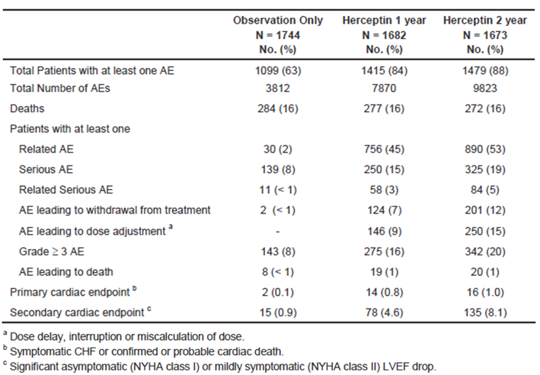
The incidence of AEs was increased in the trastuzumab groups (84% for 1-year, 88% for 2-years) compared to the observation group (63%). Common AEs (those with an incidence of at least 2%) are shown in Table 42. For most AE terms, incidence was higher in the trastuzumab groups than in the observation group. AEs suggestive of infusion reactions (arthralgia, fatigue, headache, pyrexia, chills etc.) were notably more frequent with trastuzumab treatment. The incidence of congestive cardiac failure (CCF) was also notably increased. A similar pattern was observed for AEs considered to be treatment related.

Table 42: HERA study – Common AEs (incidence of at least 2%)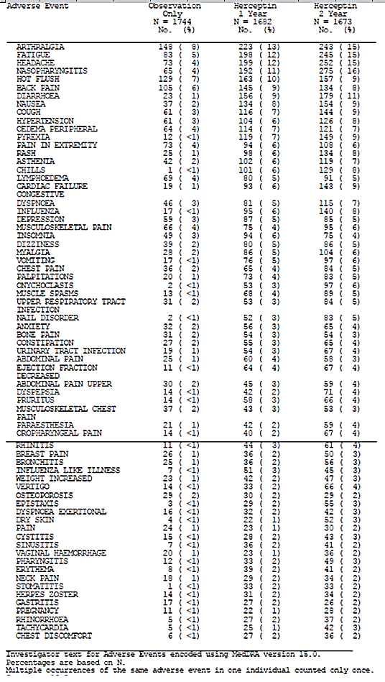

For Grade 3 and 4 AEs, the only individual AE term for which there was a notable difference between treatment arms was CCF (1-year: 15 events; 2-year: 18 events; observation: 1 event).
Deaths occurring during the treatment phase of the trial are summarised in Table 43. Most were due to progressive disease. There was an excess of fatal AEs in the trastuzumab arms (19 and 20) compared to the observation arm (8). Most of the excess was due to neoplastic disorders (9 and 6 versus 1 – see Table 44) and CCF (1 and 4 versus 1).

Table 43: HERA study – Deaths (during the treatment phase)
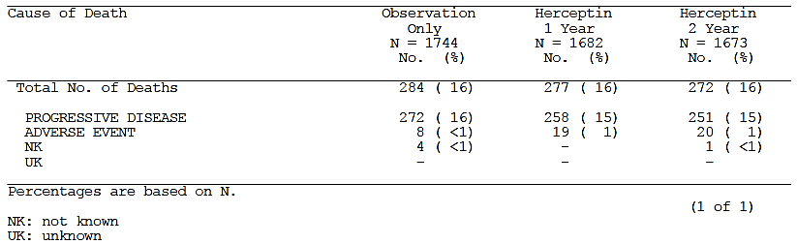

Table 44: HERA study – AEs leading to Death – Neoplastic disorders
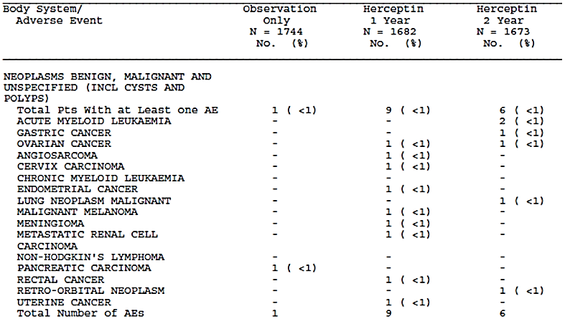
Serious AEs were more frequent in the trastuzumab arms. The system organ classes in which the SAEs occurred are summarised in Table 45.

Table 45: HERA study - SAEs by system organ class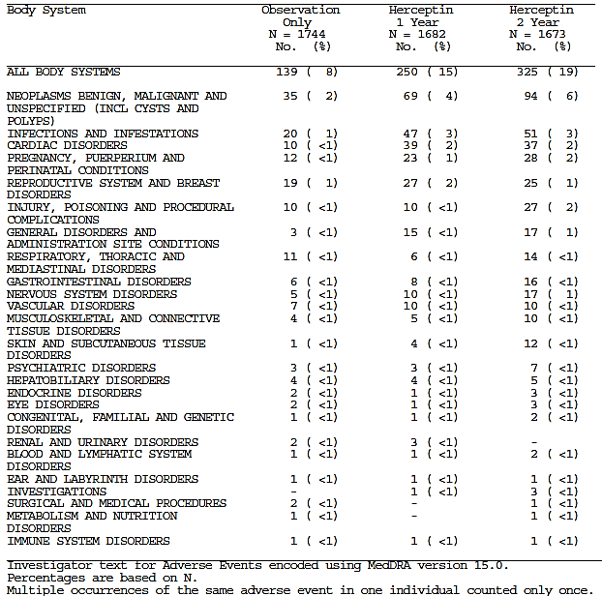
Comment: There was an excess of neoplastic SAEs in the trastuzumab arms, with notable increases in the incidence of contralateral breast cancer, melanoma and thyroid cancer, as shown in Table 46:

Table 46: Neoplastic SAEs
 | Observation | 1-year | 2-year
Serious AEs
All neoplasms | 35 | 69 | 94
- contralateral breast cancer | 9 | 23 | 23
- malignant melanoma | 0 | 8 | 6
- thyroid cancer | 1 | 1 | 7
AEs with Fatal Outcome
All neoplasms | 1 | 9 | 6

Trastuzumab has not previously been associated with an increased risk of malignancy. The sponsor should be asked to comment on any potential explanations for these observations.
Serious infections were also increased with trastuzumab, but the excess was mainly made up of device-related infections and skin infections, which may have been related to cannulation. The excess cardiac SAEs with trastuzumab were mainly CCF events. For ‘general disorders and administration site conditions’ the SAE terms of pyrexia and chills were more common in the trastuzumab arms. In the other body systems, there were no notable differences in the incidence of individual SAE terms.
Withdrawals due AEs were more common in the 2-year arm than the 1-year arm (12% versus 7%). An increased incidence of CCF leading to withdrawal (7% versus 4%) accounted for most of the difference.

Cardiac safety
Two cardiac safety endpoints were defined for the study. The primary cardiac safety endpoint included either:
- Symptomatic congestive heart failure of NYHA class III or IV, confirmed by a cardiologist with a drop in LVEF of at least 10 EF points from baseline and to below 50%; or
- Cardiac death defined as either:
  - Definite cardiac death: due to CHF, myocardial infarction or documented primary arrhythmia;
  - Probable cardiac death: sudden unexpected death within 24 hours of a definite or probable cardiac event (syncope, cardiac arrest, chest pain, infarction, arrhythmia, etc.) without documented aetiology
Results for the primary cardiac safety endpoint are shown in Table 47. Events were notably more common in the trastuzumab arms. Recovery of LVEF to > 50% occurred in approximately 70% of subjects in both trastuzumab arms.

Table 47: HERA study - Primary cardiac safety endpoint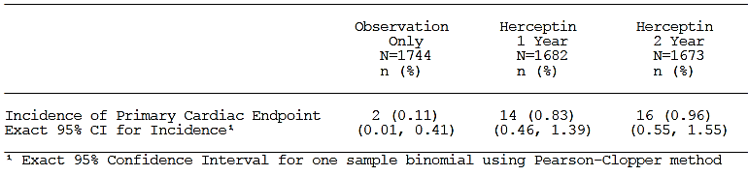
The secondary cardiac safety endpoint was defined as a significant asymptomatic (NYHA class I) or mildly symptomatic (NYHA class II) LVEF drop, unless the following assessment of LVEF indicated a return to levels which did not meet the definition of a significant LVEF drop. A significant LVEF drop was defined as an absolute decrease of 10 ejection fraction (EF) points or more from baseline and to below 50%.
Results for the secondary cardiac safety endpoint are shown in Table 48. Events were more common in the trastuzumab arms compared to the observation arm. They were also more common in the 2-year arm than the 1-year arm. Recovery of LVEF to > 50% occurred in approximately 80% of subjects in the 1-year arm and 85% of subjects in the 2-year arm.

Table 48: HERA study - Secondary cardiac safety endpoint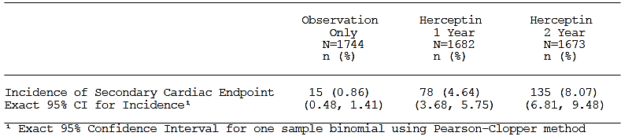
Abnormalities on LVEF testing were also more common in the trastuzumab arms (Table 49).

Table 49: HERA study – Abnormalities on LVEF testing
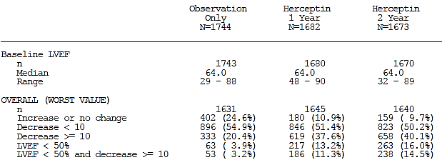

Laboratory testing
The incidences of Grade 3 or 4 shifts in laboratory testing were summarised. There were no remarkable differences between treatment arms.

Post-marketing experience
No post-marketing data were included in the submission.

Safety issues with the potential for major regulatory impact

Liver toxicity
Trastuzumab has not previously been associated with significant hepatic toxicity. The new data in this submission did not suggest any such toxicity.

Haematological toxicity
Trastuzumab has not previously been associated with major haematological toxicity. The studies included in this submission did not raise any new concerns in this area.

Serious skin reactions
In the HERA study dermatological SAEs occurred more frequently in the trastuzumab arms (4 and 12 events) than in the observation arm (1 event only). Skin toxicity would be expected with trastuzumab as a manifestation of hypersensitivity events. In the pivotal study for SC administration there was only one serious dermatological AE – a case of erythema multiforme in the SC arm, which was considered unrelated to trastuzumab.
There were no reports of Stevens-Johnson syndrome or toxic epidermal necrolysis.

Cardiovascular safety
Trastuzumab is known to be associated with an increased incidence of cardiac failure. This was confirmed in the updated HERA report. Cardiac toxicity appeared comparable in the two arms of the pivotal study for SC administration.

Unwanted immunological events
Hypersensitivity reactions and infusion-related reactions are known to occur with trastuzumab. The incidence of such events was higher with SC administration. Similarly, the incidence of anti-trastuzumab antibody development was higher in the SC arm.

Evaluator’s overall conclusions on clinical safety

Subcutaneous administration
The PK data included in this submission demonstrate that the proposed SC dosage regimen will be associated with some increase in systemic exposure to trastuzumab, compared with IV administration. A potential concern therefore, would be that the new regimen might be associated with increased toxicity.
The main safety concern arising out of the submitted data is that SC administration appeared to be associated with a 50% increase in the incidence of serious adverse events (22% SC versus 14% IV). If this were a real difference, it would be clinically important. There are a number of inconsistencies in the safety results that may cast doubt upon any conclusion that the increased SAE rate was due to increased systemic exposure:
- There was no apparent increase in the rate of Grade 3 or higher AEs in the SC arm (54% SC versus 52% IV);
- Exploratory analyses did not demonstrate a relationship between the incidence of SAEs and patients with higher AUC values;
- The increase in SAEs was greatest in the ‘Infections and Infestations’ category. There was no obvious pattern to the types of serious infections observed in the SC arm, and it appears that an increased risk of serious infections has not previously been identified for trastuzumab.
There was also an imbalance in the proportion of subjects who discontinued treatment due to an AE (5.7% SC versus 2.7% IV). This was predominantly due to an excess of patients discontinuing due to cardiac AEs. However, when all the available data from the study on cardiac toxicity are considered, SC administration does not appear to be associated with an increased risk.
SC administration is associated with local injection site reactions in approximately 11% of subjects. Such reactions were infrequent (45 events after 4,957 injections) and mild or moderate in intensity.
SC administration is also associated with an increased risk of developing anti-trastuzumab antibodies (14.6% SC versus 7.1% IV). However, preliminary data suggest that these antibodies are not associated with changes in PK, loss of efficacy or increased risk of administration-related reactions (e.g. hypersensitivity).

PI update (HERA study)
The toxicity of trastuzumab in the 8-year follow-up analysis of the HERA study is generally consistent with that previously described for the drug. The risk of cardiac failure and infusion reactions is increased with trastuzumab treatment. The two-year trastuzumab regimen is associated with greater toxicity than the 1-year regimen. The new data suggest that trastuzumab treatment may be associated with an increased risk of malignancy. The sponsor should be asked to comment on this issue.
The sponsor proposes to update the PI by including information on the negative safety aspects of the 2-year regimen and by updating data on cardiac toxicity. These changes are generally acceptable.

First round benefit-risk assessment

Subcutaneous administration

First round assessment of benefits
The benefits of SC administration of trastuzumab are:
- At least non-inferior efficacy to that obtained with IV administration;
- Patient convenience, in terms of shorter administration times;
- Avoidance of IV cannulation, at least in subjects receiving trastuzumab monotherapy.

First round assessment of risks
The risks of SC administration of trastuzumab are:
- A possible 50% increase in the incidence of serious AEs compared to IV administration;
- Infrequent injection site reactions which are mild or moderate in severity;
- An increased risk of the development anti-trastuzumab antibodies. The available evidence suggests that antibody development is not associated with clinically significant consequences.

First round assessment of benefit-risk balance
It can be reasonably concluded that SC administration will be as efficacious as IV administration. However, the apparent increase in the incidence of SAEs compared to IV administration raises concerns regarding safety.
The efficacy benefits of trastuzumab treatment in patients with HER2+ve breast cancer are substantial. For example, in the adjuvant setting, trastuzumab treatment is associated with significant improvements in disease-free and overall survival. Even if the increased SAE rate with SC use were a real phenomenon, the benefits of its use would still outweigh its risks. However the benefit-risk balance of SC administration would be less favourable than that of IV administration.
The benefits of convenience and avoidance of IV cannulation may be important is some patients. On balance, it is considered that the application for SC administration could be approved. However, it is recommended that the product information for the SC formulation should include an adequate statement in the ‘Precautions’ section alerting prescribers to the possible increased risk of serious AEs.

PI update (HERA Study)

First round assessment of benefits
The 8-year analysis of the HERA study confirmed that use of the drug in the adjuvant setting is associated with significant improvements in disease-free survival and overall survival.

First round assessment of risks
The 8-year analysis indicates that the toxicity profile of trastuzumab is generally consistent with that previously documented.

First round assessment of benefit-risk balance
The benefit-risk balance of trastuzumab in the adjuvant setting remains favourable.

First round recommendation regarding authorisation

Subcutaneous administration
It is recommended that the application for the subcutaneous route of administration be approved, subject to changes in the product information outlined below.

PI update (HERA Study)
It is recommended that the proposed changes to the product information be approved, subject to the changes outlined below.

Clinical questions

Pharmacokinetics
- In Study BP22023, four female subjects who participated in Cohort 2 of Part 1 (6 mg/kg IV) also participated in Cohort A of Part 2 (8 mg/kg SC). Please provide an analysis of PK parameters observed in these four subjects, including an estimate of absolute bioavailability.

Efficacy
- In Study BO22227, it appears that the pathologist undertaking the assessment of pCR was not blinded to study treatment. Blinded assessment would have been preferable. According to the study protocol, pCR was to be assessed by the local pathologist following surgery and would not be independently reviewed. However, the published version of the study states that: ‘Review of pathological tumour assessment results was done by a masked medical reviewer’. Please clarify whether any central blinded assessment of pCR was undertaken in the study. If no central blinded assessment was undertaken, please provide a justification for such a study design.
- A further analysis of Study BO22227 was planned when all subjects had completed 2 years of treatment-free follow-up. Please advise when this analysis will be available.
- In Study BO22227, a high proportion of subjects had clinical lymph node involvement at baseline. What proportion of subjects in each arm had histological confirmation of lymph node involvement prior to neoadjuvant treatment (for example, by sentinel lymph node biopsy or fine needle aspiration)? In this subgroup of patients, what was the total pathological complete response (tpCR) rate in each arm?

Safety
- In the HERA study there was an excess of neoplastic serious AEs in the trastuzumab arms, with notable increases in the incidence of contralateral breast cancer, melanoma and thyroid cancer, as shown in Table 50 below.

Table 50: Incidence of contralateral breast cancer, melanoma and thyroid cancer
 | Observation | 1-year  trastuzumab | 2-year  trastuzumab
All neoplasms | 35 | 69 | 94
- contralateral breast cancer | 9 | 23 | 23
- malignant melanoma | 0 | 8 | 6
- thyroid cancer | 1 | 1 | 7
Trastuzumab is not known to be associated with an increased risk of neoplasms/malignancies. Is the sponsor able to provide an explanation for these observations?

Second round evaluation of clinical data submitted in response to questions

Response to questions

Absolute bioavailability
The sponsor provided the individual PK data and estimates of absolute bioavailability for the four subjects in study BP22023 who received both SC and IV trastuzumab. These data are shown in Table 51. Estimates of absolute bioavailability in the four subjects ranged from 44.7% to 90.3%.

Table 51: Estimates of absolute bioavailability.
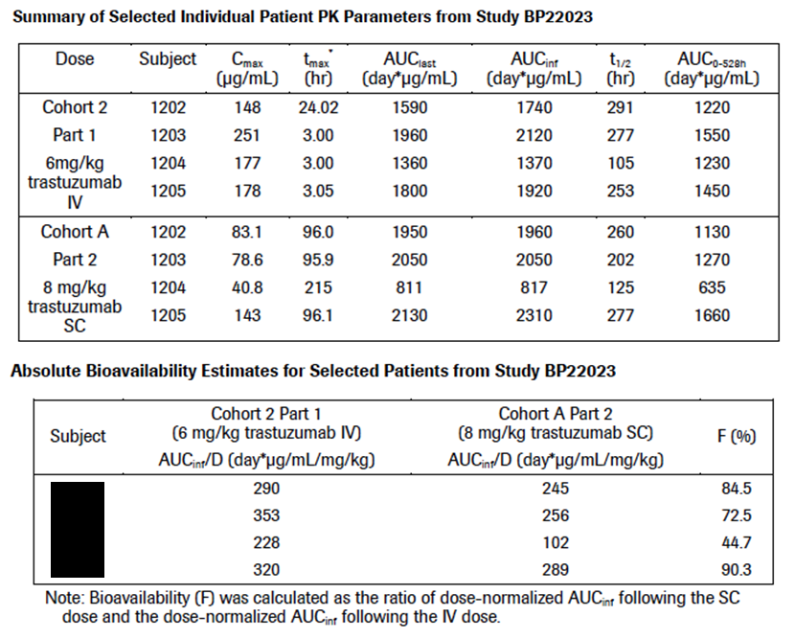

Blinding of pCR assessment
The sponsor confirmed that blinding of local pathologists to treatment allocation was not a component of the study protocol. In justifying the absence of blinding the sponsor made the following points:
- In other large neoadjuvant breast cancer trials (that used pCR as an endpoint), unblinded local pathologists assessed pCR. Examples cited were the Geparquattro, GeparQuinto, NOAH, NEOSPHERE, and Neo-ALTTO trials.
- There was a standard definition for pCR included in the protocol, along with guidelines for assessing pathological response. The sponsor argues that these measures would have ensured objectivity in pCR assessment.
- There were also standard procedures in place for communication between investigators and pathologists to ensure accurate and comprehensive collection of information from pathologists.
- The sponsor retrospectively surveyed all investigators to determine whether existing procedures in operation at their institution would have resulted in pathologists being blinded to treatment allocation. Presumably blinding would have resulted from pathologists not being provided with information on treatment allocation at the time of tumour pathology assessment. The investigators were asked the following question: ‘Was your local pathologist blinded to treatment arm information on HannaH?’ Results of this survey are shown in the following table (Table 52):

Table 52: Survey results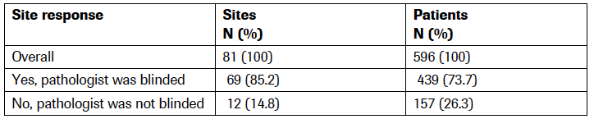
Comment: The published versions of the GeparQuinto and Neo-ALTTO studies state that pathologists/outcome assessors were masked to treatment allocation. In the NOAH study, pCR was only a secondary endpoint.
The retrospective survey provides some reassurance regarding the objectivity of pathologist assessments of pCR in the trial. However, protocol-mandated masking of all pathological response assessments would have been relatively simple measure that would have improved credibility of the study efficacy findings.

Two-year follow-up for Study BO22227
The sponsor advised that the study report for BO22227 after two years of treatment-free follow up would be available in October 2014.

tpCR rate in subjects with confirmed lymph node involvement at baseline
The results of the requested analysis are shown in Table 53. Only a small number of subjects (n=20 for IV and n=11 for SC) had histologically confirmed lymph node involvement at baseline. All were confirmed by sentinel node biopsy, as results of any fine needle aspiration were not recorded in the study database.
The tpCR rates among these subjects were 45.0% for IV and 27.3% for SC.

Table 53: tpCR rate in subjects with confirmed lymph node involvement at baseline
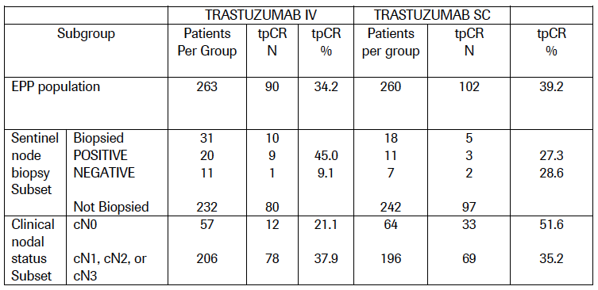
Comment: The numbers of subjects were small, and, based on these results, no reliable conclusions can be drawn regarding comparative efficacy of IV versus SC administration.

Neoplasms in the HERA study
The sponsor provided the following explanation:
‘...for safety analyses, study patients randomized to observation who decided to crossover to receive trastuzumab treatment after disclosure of the interim analysis results in 2005, are evaluated for safety in the observation arm only up to the time of their first treatment with trastuzumab (crossover point). .... Given that more than 50% of patients randomized to observation crossed over to receive trastuzumab treatment, the duration of safety follow-up in the observation arm is significantly shorter compared to each of the trastuzumab treatment arms.’
Median duration of follow-up was 31.05 months for the observation arm and 96.10 months for both the trastuzumab 1- and 2-year arms. The higher incidence of neoplasms was therefore probably due to the longer period of observation in the trastuzumab arms.

Second round benefit-risk assessment
The benefit-risk balance for SC administration is unchanged following evaluation of the sponsor’s additional information. The benefit-risk balance of trastuzumab in the adjuvant setting remains favourable, based on the updated report of the HERA study.

Second round recommendation regarding authorisation
It is recommended that the application for SC administration be approved. It is also recommended that the proposed changes to the PI, based on the updated HERA study report, be approved.

References
- Yarden Y and Sliwkowski M. Untangling the ErbB signalling network. Nat Rev Mol Cell Biol. 2001; 2: 127-37.
- Tsang RY and Finn RS. Beyond trastuzumab: novel therapeutic strategies in HER2-positive metastatic breast cancer. British Journal of Cancer. 2012; 106: 6 –13
- Slamon DJ, Clark GM, Wong SG et al. Human breast cancer: correlation of relapse and survival with amplification of the HER-2/neu oncogene. Science. 1987; 235: 177–82.
- Guideline On The Evaluation Of Anticancer Medicinal Products In Man (CPMP/EWP/205/95/Rev.3.Corr); 2005.
- Guideline On The Clinical Investigation of The Pharmacokinetics Of Therapeutic Proteins (CHMP/EWP/89249/2004); 2007.
- Ismael G, Hegg R, Muehlbauer S et al. Subcutaneous versus intravenous administration of (neo)adjuvant trastuzumab in patients with HER2-positive, clinical stage I-III breast cancer (HannaH study): a phase 3, open-label, multicentre, randomised trial. Lancet Oncol. 2012 Sep; 13(9): 869-78.
- Therasse P et al. New Guidelines to Evaluate the Response to Treatment in Solid Tumours. J Natl Cancer Inst. 2000, 92 (3): 205-216.
- Cortazar P, Zhang L, Untch M et al. Pathological complete response and long-term clinical benefit in breast cancer: the CTNeoBC pooled analysis. Lancet. 2014 Feb 13. pii: S0140-6736(13)62422-8. doi: 10.1016/S0140-6736(13)62422-8. [Epub ahead of print]
- Food and Drug Administration. Guidance for Industry - Pathologic Complete Response in Neoadjuvant Treatment of High-Risk Early-Stage Breast Cancer: Use as an Endpoint to Support Accelerated Approval. 2012.
- Medicare Australia. Late stage metastatic breast cancer – Trastuzumab (Herceptin).
- Piccart-Gebhart MJ, Procter M, Leyland-Jones B, et al. Trastuzumab after adjuvant chemotherapy in HER2-positive breast cancer. N Engl J Med 2005; 353: 1659–72.
- Smith I, Procter M, Gelber RD, et al. 2-year follow-up of trastuzumab after adjuvant chemotherapy in HER2-positive breast cancer: a randomised controlled trial. Lancet 2007; 369: 29–36.
- Gianni L, Dafni U, Gelber RD, et al. Treatment with trastuzumab for 1 year after adjuvant chemotherapy in patients with HER2-positive early breast cancer: a 4-year follow-up of a randomised controlled trial. Lancet Oncol 2011; 12: 236–44.
- Goldhirsch A, Gelber RD, Piccart-Gebhart MJ et al. 2 years versus 1 year of adjuvant trastuzumab for HER2-positive breast cancer (HERA): an open-label, randomised controlled trial. Lancet. 2013; 382 (9897): 1021-8
- Joensuu H, Kellokumpu-Lehtinen PL, Bono P et al. Adjuvant Docetaxel or Vinorelbine with or without Trastuzumab for Breast Cancer. N Engl J Med 2006; 354: 809-820.
- Joensuu H, Bono P, Kataja V et al. Fluorouracil, epirubicin, and cyclophosphamide with either docetaxel or vinorelbine, with or without trastuzumab, as adjuvant treatments of breast cancer: final results of the FinHer Trial. J Clin Oncol. 2009; 27(34): 5685-92.
- Pivot X, Romieu G, Debled M et al. 6 months versus 12 months of adjuvant trastuzumab for patients with HER2-positive early breast cancer (PHARE): a randomised phase 3 trial. Lancet Oncol. 2013; 14(8): 741-8.
- Wynne C, Harvey V, Schwabe C et al. Comparison of subcutaneous and intravenous administration of trastuzumab: a Phase I/Ib trial in healthy male volunteers and patients with HER2-positive breast cancer. J Clin Pharmacol 2012; published online Feb 22. DOI:10.1177/0091270012436560.

Therapeutic Goods Administration
PO Box 100 Woden ACT 2606 Australia
Email: info@tga.gov.au Phone: 1800 020 653 Fax: 02 6232 8605
https://www.tga.gov.au

NCI grading of AEs 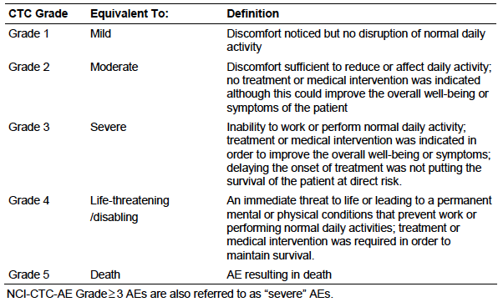
NYHA classification of heart failure 