Date of CER: April 2013

AusPAR Attachment 2

Extract from the Clinical Evaluation Report for Trametinib (as dimethyl sulfoxide)
  - Proprietary Product Name: Mekinist
  - Sponsor: GlaxoSmithKline Australia Pty Ltd

About the Therapeutic Goods Administration (TGA)
- The Therapeutic Goods Administration (TGA) is part of the Australian Government Department of Health, and is responsible for regulating medicines and medical devices.
- The TGA administers the Therapeutic Goods Act 1989 (the Act), applying a risk management approach designed to ensure therapeutic goods supplied in Australia meet acceptable standards of quality, safety and efficacy (performance), when necessary.
- The work of the TGA is based on applying scientific and clinical expertise to decision-making, to ensure that the benefits to consumers outweigh any risks associated with the use of medicines and medical devices.
- The TGA relies on the public, healthcare professionals and industry to report problems with medicines or medical devices. TGA investigates reports received by it to determine any necessary regulatory action.
- To report a problem with a medicine or medical device, please see the information on the TGA website <http://www.tga.gov.au>.
About the Extract from the Clinical Evaluation Report
- This document provides a more detailed evaluation of the clinical findings, extracted from the Clinical Evaluation Report (CER) prepared by the TGA. This extract does not include sections from the CER regarding product documentation or post market activities.
- The words [Information redacted], where they appear in this document, indicate that confidential information has been deleted.
- For the most recent Product Information (PI), please refer to the TGA website <http://www.tga.gov.au/hp/information-medicines-pi.htm>.
Copyright
© Commonwealth of Australia 2014
This work is copyright. You may reproduce the whole or part of this work in unaltered form for your own personal use or, if you are part of an organisation, for internal use within your organisation, but only if you or your organisation do not use the reproduction for any commercial purpose and retain this copyright notice and all disclaimer notices as part of that reproduction. Apart from rights to use as permitted by the Copyright Act 1968 or allowed by this copyright notice, all other rights are reserved and you are not allowed to reproduce the whole or any part of this work in any way (electronic or otherwise) without first being given specific written permission from the Commonwealth to do so. Requests and inquiries concerning reproduction and rights are to be sent to the TGA Copyright Officer, Therapeutic Goods Administration, PO Box 100, Woden ACT 2606 or emailed to <tga.copyright@tga.gov.au>.

Contents
List of abbreviations 4
1. Clinical rationale 6
2. Contents of the clinical dossier 6
2.1. Scope of the clinical dossier 6
2.2. Paediatric data 7
2.3. Good clinical practice 7
3. Part A – Study of mono-therapy trametinib 7
3.1. Pharmacokinetics / Pharmacodynamics 11
3.2. Dosage selection for the pivotal studies 16
3.3. Clinical efficacy 16
3.4. Clinical safety 32
3.5. First round benefit-risk assessment 64
4. Part B – Combination study of trametinib and dabrafenib 65
4.1. Pharmacokinetics 65
4.2. Dose selection 69
4.3. Clinical efficacy 69
4.4. Efficacy results 76
4.5. Safety 85
4.6. First round benefit risk-assessment 103
5. First round recommendation regarding authorisation 104
6. Clinical questions 104
6.1. Pharmacokinetics 105
6.2. Pharmacodynamics 105
6.3. Efficacy 105
6.4. Safety 105

List of abbreviations
Abbreviation | Meaning
AE | Adverse event
AUC | Area under the curve
bd | Twice daily
BRAF | Proto-oncogene B-Raf
BW | Body weight
CI | Confidence interval
CL | Clearance
CL-F | Oral clearance
C_{max} | Maximum concentration
CRC | Colo-rectal cancer
CSR | Clinical study report
DDI | Drug-drug interaction
DRM | Drug related material
ECG | Electrocardiogram
ECOG | Eastern Cooperative Oncology Group
EGFR | Epithelial growth factor receptor
FTIH | First time in humans
GLS | Geometric least squares
HPMC | Hydroxypropyl methylcellulose
IRC | Independent Review Committee
ITT | Intent to treat
IV | Intravenous
KA | Keratoacanthomas
LD | Loading dose
LDH | Lactate dehydrogenase
LVEF | Left ventricular ejection fraction
MAP | Mitogen-Activated Protein
MC | Multi-centre
MEK | Mitogen-activated Extracellular signal related Kinase
MTD | Maximum tolerated dose
NSCLC | Non-small cell lung cancer
ORR | Overall response rate
OS | Overall survival
PD | Pharmacodynamics
PK | Pharmacokinetic
PopPK | Population pharmacokinetics
QD | Once daily
Q/F | Distributional clearance
QTc | QT interval corrected for rate
QTcB | Corrected QT on electrocardiogram by Bazett’s method
QTcF | Frederica-corrected QTc
QTcP | QT interval corrected by estimated population factor
RECIST | Response Evaluation Criteria in Solid Tumours
RR | Response rate
RVO | Retinal vein occlusion
SCC | Squamous cell carcinoma
SAE | Serious adverse event
SD | Single dose
T½ | Half life
ULN | Upper limit of normal
Vc-F | Oral volume of distribution
V_{d} | Volume of distribution
Vp-F | Apparent peripheral volume of distribution

Clinical rationale
Therapeutic options for unresectable and metastatic melanoma are limited. Chemotherapy including agents such as imidazole, carboxamide and carboplatin have limited efficacy with only 10 to 15% of patients achieving any degree of tumour regression. More recently vemurafenib a selective Proto-oncogene B-Raf (BRAF) inhibitor has demonstrated a worthwhile clinical benefit and another agent ipilimumab a mono-clonal antibody that blocks the cytotoxic T-lymphocyte antigen CTLA-4 has demonstrated significant improvement in overall survival (OS) of patients with metastatic melanoma. Nevertheless the need for further agents of worthwhile activity is clear and recognising that 60% of cutaneous melanomas have specific mutations of the BRAF oncogene which activates Mitogen-activated Extracellular signal regulated Kinase (MEK) in a down-stream Mitogen-Ativated Protein (MAP) kinase signalling cascade, by interfering with this pathway at the level of the MEK kinases represents an alternative and potentially clinically active treatment option for unresectable metastatic BRAF mutant melanoma with a different safety profile.

Contents of the clinical dossier

Scope of the clinical dossier
The dossier contains study reports with appropriate tabular summaries for the clinical pharmacology studies:
- MEK111054 - an open label multi-dose escalation study to investigate the safety, pharmacokinetics (PK) and pharmacodynamics (PD) of the MEK inhibitor trametinib in solid tumours or lymphoma;
- MEK113709 - an open label 2-period randomised cross-over study to evaluate the effect of food on the single dose PK of the MEK inhibitor trametinib in subjects with solid tumours;
- MEK113708 - an open label mass balance study to investigate the absorption, distribution, metabolism and elimination of a single oral dose of MEK inhibitor 14C trametinib in male subjects with solid tumours;
- MEK115064 - to determine the absolute bioavailability of trametinib following a single oral dose co-administered with an intravenous regular labelled micro-dose of trametinib in subjects with solid tumours;
- MEK113583 - an open label multi-centre Phase II study to investigate the objective response rate (RR), safety and PK of trametinib in BRAF mutation-positive melanoma subjects previously treated either with or without a BRAF inhibitor;
- MEK114267 - the Phase III pivotal study which is a randomised open label study comparing trametinib to chemotherapy in subjects with advanced metastatic BRAF V600 E-K mutation-positive melanoma;
- BRF113220 - an open label dose escalation Phase I/II study to investigate the safety, PK, PD and clinical activity of the BRAF inhibitor dabrafenib in combination with trametinib in subjects with BRAF mutant metastatic melanoma;
- MEK112111 - another PK study not relevant to this submission is a Phase IB combination study of BRAF inhibitor trametinib with gemcitabine in subjects with solid tumours.
Full study reports together with relevant summaries for the three efficacy/safety studies:
- MEK114267 is the pivotal trial together with the two supportive studies –
  - MEK113583 a Phase II trial and
  - MEK111054 a Phase I dose escalation study.
The relevant study evaluating the dabrafenib/trametinib combination is Study BRF113220 a randomised Phase I/II open label study containing four parts including a full report regarding efficacy and safety.

Paediatric data
This submission does not include paediatric data.

Good clinical practice
All aspects of good clinical practice have been observed in the study submitted.
For the remainder of this submission the evaluation will be presented in two parts:
- Part A - efficacy and safety and benefit – risk assessments for the mono-therapy trametinib
- Part B - efficacy and safety and benefit – risk assessments for the combination of dabrafenib/trametinib.

Part A – Study of mono-therapy trametinib
A total of six PK – PD studies in relation to trametinib mono-therapy have been provided in this submission and include Study MEK111054, Study MEK113709, Study MEK113708, Study MEK115064, Study MEK113583 and Study MEK114267 the pivotal Phase III study. These are indicated in Table 1. A comparison of results across the studies allows for further definition of the various PK parameters.

Table 1: Tabular listing of all clinical pharmacology studies
Protocol No. Type of Study | Study Objectives | Study Design | Key Inclusion Criteria of Subjects | No. Of Subjects Gender (M/F) Mean Age (Range) | Treatment Details (Drug dose/form/route/ frequency/duration) | Study Status; location of study report
MEK111054  (RM2008/00524/00) | Determine the MTD of trametinib  Characterise the PK of single and repeat dose trametinib  Evaluate the PD response in tumours  Explore relationship between PK and PD/clinical endpoints  Explore clinical tumour response | Phase I, OL, DR, MC, FTIH study in 3 parts:  Part 1: FTIH, single and repeat dose escalation  Part 2: Cohort expansion  Part 3: PD Dose Range | Part 1: Subjects with solid tumours or lymphoma  Part 2: Subjects with melanoma, pancreatic, CRC, NSCLC, or other tumour with BRAF mutation. CRC had to be KRAS or BRAF mutation positive.  Part 3: Subjects were to have a biopsiable tumour | 206 subjects  112 M / 94 F  58 years  (19-92 years) | Part 1: Trametinib/Dose  21/7 Regimen: 0.125, 0:25, 0:5, 1, 2.0 mg QD dosing for 21 days, followed by 7 days without drug.  LD Regimen: LDs on 1 or 2 consecutive days followed by one-daily dosing (LD/LD/one-daily regimen of 6.0/6.0/2.0, 8.0/8.0/2.5, 10.0/10.0/3 mg, and LD/QD regimen of 6.0/2.0 mg)  QD Regimen: 2.5, 3.0 or 4.0 mg continuous QD dosing  QD/QD Regimen: QD doses ≤2.5 mg from Days 1to 15. Followed by QD dosing at 2.0 mg or 2.5 mg  Tablet/Oral/QD/continuous | Completed  M 5.3.5.2
MEK 113708  (Mass Balance)  (2011N124060_00) | Determine total recovery and relative excretion of radiocarbon in urine and faeces.  Compare total radiocarbon (DRM) in blood and plasma relative to parent plasma concentration.  Identify trametinib metabolites. Determine plasma trametinib PK parameters.  Evaluate the safety and tolerability of trametinib. | Phase I, OL, SD | Subjects with solid tumours | 2 subjects  2 M /0 F  Age 54 and 66 years | Trametinib/2.0 mg containing approximately 79 µCi of radiocarbon / solution (2 mg/5 mL) Oral/Single Dose/Single Dose | Completed  M5.3.3.2
BRF113220 (Combination with dabrefenib DDI)  (2012N136672_00) | Part A (DDI): Determine the PK of single-dose dabrafenib and metabolites alone and with repeat-dose trametinib.  Confirm steady state exposure to trametinib  Part B: Characterise the steady state PK of dabrafenib and trametinib. | Phase I/II  Part A: NR, OL fixed sequence DDI study  Part B: NR, OL, DR, MC, single-arm, study of dabrafenib /trametinib combination | Subjects with BRAF V600 mutation-positive melanoma and other solid tumours | Part A:  8 subjects  6 M / 2 F  52.8 years  (30 - 77 years)  Part B:  66 subjects  35 M / 31 F  52.5 years  (25 – 78 years) | Part A:  Trametinib/2.0 mg / Tablet / Oral / QD / Day 2 to Day 15  Dabrafenib/75 mg/gelatine capsule/ Oral/SD/Day 1 and Day 15  Part B:  Trametinib/1.0, 1.5 and 2.0 mg / Tablet / Oral / QD / Continuous  Dabrafenib/75 and 150 mg BID (150 and 300 mg daily) / gelatine capsule / Oral / BID / Continuous | Ongoing (interim CSR)  M5.3.5.4
MEK112111 (combination with gemcitabine)  (2011N124805_00) | Safety, tolerability and recommended Phase II dose and regimen of trametinib and gemcitabine  Characterise steady state PK of trametinib and gemcitabine | Phase IB, OL, NR, MC, DR study of trametinib in combination with gemcitabine | Subjects with solid tumours | 31 subjects  13 M / 18 F  57.9 years  (25 – 76 years) | Trametinib/1.0, 2.0 and 2.5 mg/Tablet/Oral/QD/Continuous  Gemcitabine/1000 mg/m²/Solution/IV/Days 1, 8 and 15 every 28 days cycle/30 minute IV infusion | Completed  M5.3.5.4
MEK113583  (Phase I)  (2011N125978_00) | Phase II efficacy and safety study  PK Objective: Assess steady state exposure to trametinib and characterise the population PK including important determinants of variability. | Phase II, OL, MC, Safety, Efficacy | Subjects with BRAF V600 mutation positive melanoma | 97 subjects  68 M / 29 F  54.7 years  (23 – 79 years) | Trametinib/2.0 mg/Tablet/Oral/QD/  Continuous | Completed  M5.3.5.2
MEK114267  (Phase III)  (2011N125978_00) | Phase III, efficacy and safety study  PK Objective: Characterise the population PK of trametinib and identify important determinants of variability.  Characterise the exposure-response relationship between trametinib and tumour size measurements or other clinical safety endpoints, if warranted. | Phase III, R, 2-arm, OL, MC.  Safety, efficacy study of trametinib compared with chemotherapy (either dacarbazine or paclitaxel). | Subjects with BRAF V600 E/K mutation positive melanoma | Total:  322 subjects  173 M / 149 F  53.8 years  (21 – 85 years)  Trametinib:  214 subjects  120 M / 94 F  54.3 years  (23 – 85 years)  Chemotherapy:  108 subjects  53 M / 55 F  52.8 years  (21 – 77 years) | Trametinib/2.0 mg/Tablet/Oral/QD/  Continuous  Or  Chemotherapy:  Dacarbazine (DTIC)/100 mg/m²/IV Solution/every 3 weeks | Completed  M5.3.5.1
Abbreviations: BID, twice daily; CRC, colo-rectal cancer; CSR, clinical study report; DDI, drug-drug interaction; DRM, drug related material; FTIH, first time in humans; IV, intravenous; LD, loading dose; MC, multi-centre; MTD, maximum tolerated dose; NSCLC, non-small cell lung cancer; PD, pharmacodynamic; PK, pharmacokinetic; SD, single dose.

Pharmacokinetics / Pharmacodynamics

Absorption
The biopharmaceutical properties of trametinib have been outlined from the three studies undertaken and in summary the absolute oral bioavailability of trametinib 2 mg tablet is moderate to high (72.3%). Trametinib is absorbed after oral tablet dosing with peak plasma concentrations observed 1.5 hours after single dose (SD) under fasted conditions. SD administration of trametinib with a high fat high calorie meal resulted in a 70% decrease in maximum concentration (C_{max}) and a 10% decrease in area under the curve (AUC_{0-∞)} compared to fasted conditions.
Table 2 summarises the PK parameters observed after repeat dosing of 2 mg trametinib in Study MEK111054 and in combination with dabrafenib (Study BRF113220). Given the long half time (T ½) and the low peak trough ratio, trametinib exposure has been summarised in the Phase II and III studies using pre-dose concentrations, which represent overall exposure. Based on data from Studies MEK111054 and BRF113220 there is a linear relationship between individual AUC₀₋₂₄ and clearance (CL) following administration of trametinib as indicated in Figure 1. This is consistent across doses of 0.125 mg to 4 mg and on Days 15 and 21.
Table 2: Summary of PK parameters following repeat-dose administration of 2.0 mg trametinib across studies
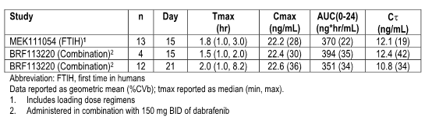
Figure 1: Repeat-dose individual AUC₀₋₂₄ and pre-dose concentration from Study MEK111054 (left) and BRF113220 (right)
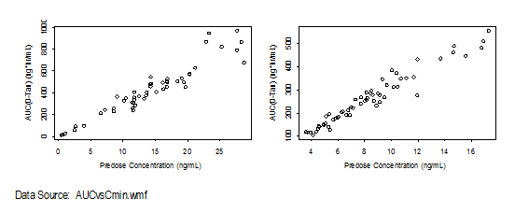
A comparison of pre-dose trametinib concentrations observed in the different studies following repeat dosing of 2 mg once daily (QD) is indicated in Table 3. Data is generally consistent across studies.
Table 3: Summary of pre-dose trametinib concentrations across studies following administration of trametinib 2.0 mg once-daily
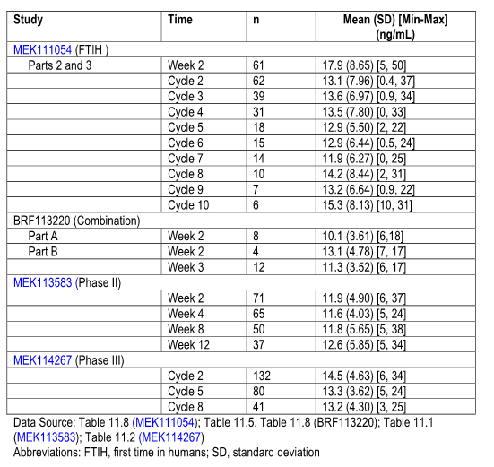

Distribution
In vitro trametinib is highly bound to plasma proteins with the fraction bound 97.4% and set at 0.5 µ/mL. Blood cell association is concentration dependent. At trametinib concentrations of 1, 10 and 15 ng/mL the blood plasma concentration ratio was 3.2, 3.4 and 1.1 respectively. The blood plasma concentration was higher using blood from disease state males (1.328). In the clinical Study MEK113708 the blood plasma ratio increased between 0.5 and 3 hours after a single dose of C14 trametinib and reached a plateau thereafter with ratios of approximately three consistent with in vitro results. Trametinib was not found to be an in vitro substrate of the transporter proteins human P-gp nor human BCRP. Following in vitro micro-dose administration trametinib has a volume of distribution (V_{d}) of 1060 litres.

Metabolism
In vitro studies have shown that trametinib is metabolised predominately via deacetylation (non-CYP450 mediated) to form M5 or with mono-oxygenation to form M7 or in combination with glucuronidation biotransformation pathways to form M6 and M9.
After administration of a single oral dose of C14 trametinib to two subjects in Study MEK113708 plasma samples obtained from two to 48 hours post-dose were analysed for metabolic profiling. Trametinib M5 and M7 were detected in plasma and accounted for 26 to 72%, less than 11% and less than 15% of drug related material (DRM) respectively. M6 was also detected. Based on an AUC_{0-T} where T is 240 hours, post-dose trametinib accounted for 20% and 50% of total radio-activity in the two subjects thus suggesting the metabolites represent a large component of the circulating radio-activity in plasma. This was also replicated in Study MEK111054. Trametinib accounted for at least 75% circulating radio-activity in plasma after repeat dosing compared to about 50% after single dose.
One of the metabolites M5 was found to be pharmacologically active. Based on results of pre-clinical pharmacology studies the activity of M5 was similar to that of parent trametinib. However given the lower exposure relative to parent after repeat dosing, which is, 10% versus at least 75%, M5 is unlikely to be significantly contributing to clinical activity.

Excretion/elimination
Total recovery is low after a 10 day collection period at less than 50% of the dose. Faecal excretion is the major route of elimination involving at least 80% of excreted dose after oral administration with parent, M5 and M7 identified in faeces. Urine is the minor excretion pathway with less than 9% of excreted dose with urinary DRM consisting of parent, M5, M7 and M9. This data is consistent with the results of the population PK (PopPK) analysis represented below with no relationship between renal function and trametinib oral clearance (CL-F).
Trametinib is a low extraction ratio drug with low CL at 3.21L/h approximately 1% of liver blood flow. Elimination is driven by capacity/efficiency of metabolising enzymes and not blood flow. After oral dosing, CL-F was 5.4 L/h based on non-compartmental analysis.
Trametinib terminal T½ is 5.3 days based on single dosing under fasted conditions. The estimates of plasma T½ determined across studies have been dependent on the duration of sampling period with longer estimates of T½ of 13 days with a 10 day sampling period in Studies MEK113708 and MEK115064 compared to 5.3 days with a 7 day sampling period for Study MEK113709. Based on the T½ of 5.3 days, steady state is predicted to be achieved in 21 to 27 days (4 to 5 half lives).

Exposure QTc relationship in Study MEK111054
An exposure response analysis conducted using data from Study MEK111054 to determine the relationship to an independently manually read QT interval corrected for rate (QTc) interval and plasma concentration of trametinib using a non-linear mixed effect model. The electrocardiogram (ECG) data obtained was matched to trametinib concentration and used in these analyses. Data was available for 50 subjects with a total of 498 matched QTc value.
There was a significant slope effect of RR on Fredericia-corrected QTc (QTcF) suggesting that this correction was not optimal. The QT was corrected using an estimated population factor of 0.429 to account for the relationship with RR. The slope of this relationship was not statistically significant. The slope of the relationship between QTcP and trametinib exposure was not statistically significant. Bootstrap estimates and predictions are shown in Table 4.
Table 4: Median (5th, 9th) bootstrap slope estimate and predicted change in QTcP and QTcF at the mean and highest Cmax value of trametinib observed at 2.0 mg once-daily and at the highest value observed (Study MEK111054)
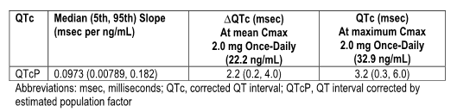

Population pharmacokinetics
A PopPK model was developed with data combined from Studies MEK111054 and the Phase II and Phase III studies in subjects with BRAFV600 mutation-positive melanoma, that is, Studies MEK113583 and MEK114267. Objectives of the PopPK analysis were to develop a PopPK model and to characterise the disposition of trametinib following daily oral administration in cancer subjects, to assess sources of variability of PK parameters of trametinib and to characterise the impact of clinically relevant covariates on trametinib exposure.
Plasma concentration data from 493 subjects with cancer were included in the analysis being 59% male. The majority of patients were white (97%). Age ranged from 19 to 90 years and BW from 41.2 to 125 kilograms. A total of 3120 plasma concentrations were included. 75.7% of patients had melanoma. It is noted that 13% of patients had mild hepatic impairment and 45.2% and 7.1% mild and moderate renal impairment respectively.
The PK of trametinib following single and repeated oral administration were adequately described by a two compartment model with dual sequential first order absorption. The effects of cohort CL-F and Vc-F are indicated in Figure 2. The effects of BW and sex were significant predictors of CL-F and weight was a significant predictor of Vc-F. Age, mild and moderate renal impairment and mild hepatic impairment did not have a significant effect on CL-F and age, weight and sex were not found to be significant predictors of Vc-F although some parameters were estimated with less precision and wider CIs.
Figure 2: Effect of covariates on trametinib oral clearance (CL-F) and Oral Volume of Distribution (Vc-F) from the full population PK model
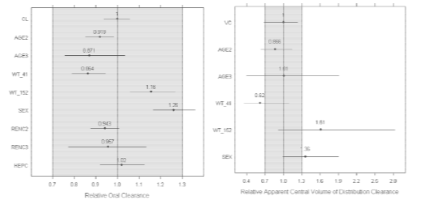
PopPK estimates are indicated in Table 5. Trametinib CL-F is low and dependent on sex and BW. The typical CL-F of trametinib in male subjects is 26% higher than observed in female subjects (6.19 versus 4.91 L/h). The effect of BW with the minimum and maximum BW observed is within 15% of the typical CL-F values. Female or male subjects with a minimum/maximum BW have a predicted AUC and C_{max} within 15% and 30% of the typical value observed with a median BW of 79 kilograms was unlikely to be clinically significant. Although smaller females tend to have higher exposure than heavier male subjects no dosage adjustment is warranted in this population.
Table 5: Population pharmacokinetic parameters of trametinib
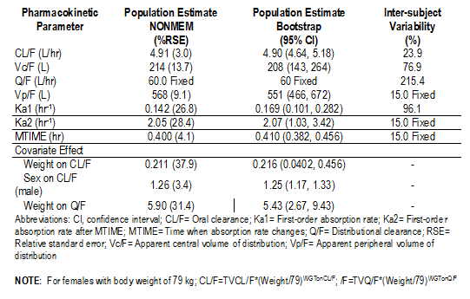
The typical values of DcF and apparent peripheral volume of distribution (Vp-F) of trametinib were to 141 and 568 litres for a total volume of 782 litres. Weight was also identified as an important component describing the variability of distributional clearance (Q/F). Male and female subjects displayed T½ values of 92.5 hours and 115.2 hours.
It is important to note that while no formal studies on the effects of renal impairment have yet been conducted in view of the very small proportion of the drug excreted in urine and an absolute bioavailability of 72.3% it is unlikely that renal impairment will have any clinical significant effect on PK parameters. No studies to date have been undertaken in relation to hepatic impairment and in the PopPK analysis 13% of patients had mild hepatic impairment and exposure to trametinib was not significantly different in these patients. In relation to age the PopPK analysis revealed small changes only in CL-F based on various age groups and was not considered clinically relevant.
In relation to interaction effects of trametinib in vitro and in-vivo data would suggest that trametinib is unlikely to affect the PK of other drugs. In vitro studies support that trametinib is unlikely to be a CYP2C8 inhibitor and has no evidence of CYP3A induction in-vivo. Further trametinib is neither an in vitro substrate for Pgp or BCRP therefore it is unlikely to pose a risk for interaction upon co-administration with Pgp or BCRP inhibitors.

Study MEK111054
Study MEK111054 was an open label Phase I first time in humans (FTIH) multi-centre study conducted in three parts to identify the maximum tolerated dose (MTD) and to evaluate the recommended Phase II dose and regimen for trametinib mono-therapy. Part 1 was the dose escalation phase to identify the MTD using the safety, PK and PD assessment in subjects with solid tumours or lymphoma. Different regimens were evaluated including a dosing for 21 days followed by seven days no treatment: an LD regimen with one or two LDs followed by continuous QD dosing and QD regimen with continuous QD dosing. PK was assessed after a SD on Day 1 and after repeat dosing on Day 15. In most patients sampling on Day 1 was limited to 24 hours. Additional samples were collected pre-dose on Days 2, 3 – 5, 8 and 22 during Cycle 1 and pre-dose in later cycles. Part 2 of the study was a cohort expansion phase exploring the safety of trametinib in patients with solid tumours including melanoma with the dose of trametinib 2 and 2.5 mg QD evaluated. Part 3 was the PD dose range study which characterised the range of biologically effective doses by assessing PD markers in tumour tissue.
A total of 206 subjects were enrolled including 55, 112 and 39 subjects in Parts 1, 2 and 3 respectively. Single doses of 0.125 to 10 mg including an LD and repeat doses of 0.125 to 4 mg QD were explored. The MTD was identified as 3 mg QD and the recommended Phase II dose was 2 mg QD. This is based on the fact that the 2 mg QD dose had a more favourable safety profile than 2.5 mg QD and 3 mg QD in terms of the overall incidence of adverse effects (AEs) of at least Grade 3 level; the incidence of rash or skin related toxicities which were at least Grade 2; the rate of ocular events and the incidence of AEs which led to dose reductions.

Dosage selection for the pivotal studies
Dose selection for the Phase II and III mono-therapy studies was based on the results from Study MEK111054 in which the daily dose of trametinib ranging from 0.125 to 4 mg were administered to subjects with solid tumours. As discussed earlier a dose of 2 mg administered QD was selected based on tolerability, exposure-response relationship with PD markers in tumour biopsies and clinical activity.
It is also noteworthy that MAP kinase pathway inhibition appeared to be dose dependent as demonstrated by modulation and tumour PD markers. The greatest inhibition was observed at 2 mg QD the highest dose level tested. The mean trametinib concentrate observed following repeat dose administration of 2 mg QD exceeds the pre-clinical target concentration of 10.4 ng/mL over the 24 hour dosing interval thereby providing sustained inhibition of the MEK pathway.
It is also worth noting that although not specifically significant 2.5 mg trametinib was not clearly more efficacious than 2 mg. In terms of clinical activity among BRAF V600 mutation-positive melanoma subjects, administration of trametinib doses of 2.5 mg or higher was not more efficacious than 2 mg with a complete and partial RR of 36% (five of 14) of patients at 2.5 mg QD compared to 44% (seven of 16) of patients at 2 mg QD.

Clinical efficacy
The principle evidence supporting efficacy data for trametinib in the treatment of advanced stage metastatic melanoma comes from the pivotal Phase III Trial MEK114267 with supportive data available from the Phase II Study MEK113583 and additional data also available from 30 patients in the Phase I Study MEK111054. These studies are summarised in Table 6.
Table 6: Overview of studies evaluating the efficacy of trametinib in metastatic melanoma

Study designs

The pivotal Study MEK114267
This was a randomised two arm open label international multi-centre Phase III study evaluating the efficacy and safety of single agent trametinib compared with chemotherapy, either dacarbazine (DTIC) or paclitaxel, at the discretion of the investigator, provided the subject had not received that type of chemotherapy before randomisation. On the basis of information from the Phase II Study MEK113583 the patient population was adjusted to those patients with BRAF V600E mutation-positive melanoma without a history of prior brain metastases. These represented the patient population most likely to benefit. Secondary end points also included assessment of patients with BRAF V600K mutation-positive melanoma. Subsequent analysis revealed the activity for trametinib was comparable in both BRAF V600 mutation-positive melanoma subtypes, that is, V600E or V600K. Accordingly data presented includes both patient populations.
The primary objective of this study was to establish the superiority of trametinib over chemotherapy with respect to progression free survival (PFS) in patients with BRAF V600E mutation-positive advanced metastatic melanoma without a history of prior brain metastases. Secondary objectives included PFS of pre-specified sub-groups: evaluation of overall survival (OS), overall response rate (ORR) and duration of response.
Inclusion criteria included a histologically confirmed Stage III unresectable or metastatic cutaneous melanoma which is BRAF V600E and BRAF V600K mutation-positive by a central laboratory assessment; no treatment or up to one prior treatment of chemotherapy regimen for metastatic melanoma; and measurable disease according to Response Evaluation Criteria in Solid Tumors (RECIST) criteria.
Key exclusion criteria included any prior use of BRAF-MEK inhibitors or ipilimumab in the advanced/metastatic setting; any previous major surgery or extensive radiotherapy or chemotherapy within the last 21 days; brain metastasis except for those that had been previously treated with surgery or radiotherapy and if brain lesions are still present but have been confirmed stable for longer than 90 days.
Patients were randomised in a 2 to 1 manner to receive either trametinib 2 mg QD or chemotherapy DTIC 1000 mg/m² every three weeks or Paclitaxel 175 mg/m² every three weeks as indicated in Figure 3. Treatments continued until disease progression, death or withdrawal for any reason. Patients on chemotherapy with confirmation of disease progression by an Independent Review Committee (IRC) were able to cross over to trametinib.
Figure 3: MEK114267 Study design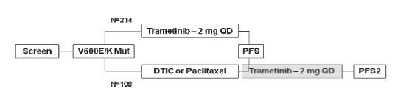
A total of 297 patients were planned for enrollment to provide at least a 99% power to detect for 33% improvement in PFS for patients treated with trametinib compared to chemotherapy.
Kaplan-Meier methods and log rank test analyses were utilised for statistical evaluations. Various sensitivity analyses and sub-group analyses in relation to PFS and ORR were undertaken.

Study MEK113583
This study was an open label Phase II multi-centre (MC) study designed to evaluate the ORR following daily oral dosing of trametinib at 2 mg QD. Other measures of efficacy included duration of response, PFS and OS. Enrolled patients included BRAF V600E or V600K mutation-positive, a histologically or cytological confirmed diagnosis of metastatic cutaneous melanoma. Two separate cohorts of patients when enrolled were defined by prior therapy with Cohort A being those who had prior treatment with BRAF inhibitor dabrafenib either with or without other prior therapy. Cohort B had at least one prior chemotherapy or immunotherapy without prior treatment with BRAF inhibitor. Other inclusion criteria included measurable disease by RECIST criteria: an Eastern Cooperative Oncology Group (ECOG) performance status of 0 to 1. Key exclusion criteria were brain metastases unless previously treated with surgery or radiotherapy and stable for at least eight weeks.
The treatment with trametinib at 2 mg per day was continued until disease progression, death or withdrawal for any reason. The ORR was calculated from an investigator assessment of tumour disease progression and response defined by RECIST criteria. Assessments were performed at screening and then every eight weeks.
Sub-group analyses of ORR were undertaken according to patients with prior brain metastases; patients without prior brain metastases; patients with BRAF V600E mutation-positive melanoma; patients with BRAF V600E mutation positive melanoma and no prior brain metastases.

Study MEK111054
This was an open label Phase I FTIH MC study conducted in three parts to identify the MTD and to evaluate response and safety data for the cohort expansion group. Key inclusion criteria were a histologically and cytologically confirmed diagnosis of solid tumour malignancy or lymphoma that was not responsive to standard therapies; an ECOG performance status of 0 to 1. The dosage regimen utilised for the evaluation of efficacy with the 2 mg QD regimen as well as a modified one study regimen involving a dose of 2 to 2.5 mg from Days 1 to 15 followed by a continuous daily dosing at either 2 or 2.5 mg. Tumour response efficacy was a secondary end point of this study and was measured in all patients who had received at least one dose of trametinib.

Study populations
In the pivotal Study MEK114267 a total of 322 patients including 214 randomised to trametinib and 108 randomised to chemotherapy were enrolled in 86 sites in 19 countries. The first patient was enrolled on 23 November 2010 and the data cut off date was 26 October 2011. Efficacy data in this section is based on the intent to treat (ITT) population.
In the supportive Study MEK113583 a total of 97 patients, 40 in Cohort A and 57 in Cohort B were enrolled at 10 sites in two countries (US and Australia). The first patient was enrolled on 27 November 2009 and the data cut-off date was 25 July 2011. Efficacy data in this analysis is based on Cohort B as this represents the population of interest for the proposed marketing application and also it is noted that in Cohort A no responses occurred with therapy.
In the Phase I Study MEK111054 a total of 206 patients were enrolled at 10 sites in the US. The first patient was enrolled on31 July 2008 and the data cut off date was 7 June 2011. Of these, 81 patients had melanoma and efficacy data pertinent to the subject population of interest for the submission involved 30 patients with BRAF mutation-positive melanoma with no prior BRAF inhibitor therapy.

Subject disposition
At the data cut-off date for the pivotal Study MEK114267 the majority of patients in both arms had discontinued treatment with more patients discontinuing treatment in the chemotherapy arm compared to the trametinib arm as indicated in Table 7. Disease progression was the main reason for discontinuing treatment in both arms and the proportion of patients discontinued because of AEs was slightly higher in the trametinib arm at 10% compared with the chemotherapy arm of 6%. As of the date of cut-off more patients in the trametinib arm were continuing in follow up (79%) compared with the chemotherapy arm of 60%.
Table 7: Study treatment status (MEK114267 and MEK113583)
At the cut-off date for Study MEK113583 the majority of patients had discontinued treatment as indicated in Table 7. Again disease progression was the most common reason for discontinuing treatment and the median follow up time at this cut-off date was 10.4 months.
For the Study MEK111054 at the cut-off date for the relevant patients, 28 of 30 patients or 93% had discontinued treatment and withdrawn from the study with disease progression being responsible in 80% of patients.
The patient population utilised in the efficacy analyses is indicated in Table 8.
Table 8: Study populations
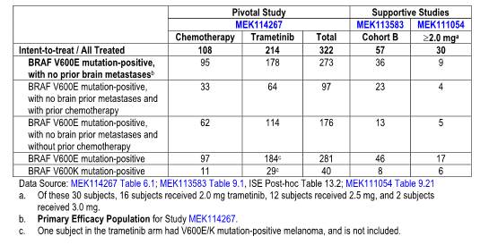

Demographic and disease characteristics
Overall patients enrolled in the three studies were representative of patients with BRAF V600 mutation positive advanced metastatic melanoma.
For the pivotal study demographic characteristics were well balanced between the two treatment arms with the exception of sex as indicated in Table 9.
Table 9: Demography and disease characteristics at baseline
More patients in the trametinib arm had stage M1C melanoma at screening and the median time from diagnosis of metastatic disease to enrolment in the study was longer in the trametinib arm compared with the chemotherapy arm. Most patients had visceral disease and had not had prior chemotherapy or immunotherapy. Demographic and disease characteristics in patients with the V600E mutation-positive melanoma with no prior brain metastases and the V600K populations were also well balanced between the treatment arms and similar to that observed in the ITT population. Other disease characteristics are also indicated in Table 10.
Table 10: Disease characteristics at baseline
For Study MEK113583 a slightly higher percent of patients had stage M1C disease and baseline lactate dehydrogenase (LDH) was at the upper limit of normal (ULN) compared to the pivotal study while more patients in Study MEK111054 had baseline ECOG Performance Status 1, and at least three disease sites and received prior chemotherapy for metastatic disease as indicated in Table 10. A notably higher proportion of patients in these two supportive studies had a history of prior brain metastases compared with the pivotal study. The percentage of patients in Study MEK111054 with known BRAF V600E mutation-positive melanoma was lower than in the other two studies.

Prior anti-cancer therapy
In the pivotal study 301 patients or 93% had received at least one prior anti-cancer therapy, 113 or 35% had received prior chemotherapy and is indicated in Table 11. The type of prior anti-cancer therapy received was similar between the two treatment arms.
Table 11: Summary of prior anti-cancer therapy
It is noted that for the two supportive studies more patients received prior anti-cancer treatment than those in the pivotal study particularly chemotherapy.

Post treatment anti-cancer therapy
This was applicable only to the pivotal study and in the ITT population a greater percentage of patients in the trametinib arm (21%) received at least one form of anti-cancer therapy after study drug discontinuation compared with those in the chemotherapy arm (9%).It is noted that crossover therapy for the 51 (47%) patientswho crossed over to the trametinib arm is not included in the post-progression therapy summary and this may have contributed to the lower percentage of patients receiving follow up therapy in the chemotherapy arm. It is noted that in the V600E mutation-positive melanoma with no prior brain metastases patients the most common follow up anti-cancer therapies were similar to that for the ITT population.

Efficacy results
Overview of efficacy results for the three studies is indicated in Table 12.
Table 12: Overview of efficacy results in the pivotal and supportive studies

Progression free survival
In the pivotal study a statistically significant improvement in PFS by investigator assessment was observed in the trametinib arm compared with the chemotherapy arm as indicated in Table 13 and Figure 4. The median investigator assessed PFS in the ITT population was 4.8 months for the trametinib arm and 1.5 months in the chemotherapy arm with a corresponding hazard ratio (HR) of 0.45 (p < 0.0001) representing a 55% reduction in risk of tumour progression in the trametinib arm compared with the chemotherapy arm.
Table 13: Investigator-assessed Kaplan-Meier estimates of PFS in the pivotal and supportive studies
Figure 4: Investigator-assessed Kaplan-Meier PFS curves (ITT population MEK114267)
Investigator-assessed PFS improvement in the ITT population was compared to the results of the independent reviewer assessed PFS in the ITT population with an HR of 0.42 (p < 0.0001) and with investigator-assessed PFS in patients with V600E mutation positive melanoma with no prior brain metastases with an HR of 0.41 (p < 0.0001).
It is noted that the PFS estimates for the two supportive Studies MEK113583 and MEK111054 are consistent with those of the pivotal study as indicated in Table 13.

Progression free survival sub-group analyses
For the pivotal study, PFS analyses were carried out for a number of sub-groups in the ITT population including those patients with BRAF V600E mutation positive melanoma with no prior brain metastases without and with prior chemotherapy; by BRAF mutation status (V600E and V600K); by sex and age; by baseline ECOG performance status; by disease stage and by baseline LDH. This is illustrated in Figure 5. The magnitude of the improvement varied across sub-groups, the HR’s ranging from 0.38 to 0.58, but was generally greater in the trametinib arm compared with the chemotherapy arm for each sub-group with statistically significant results for all sub-groups except for those with BRAF V600K mutation-positive melanoma and in patients 65 years or older.
Figure 5: Hazard ratios and 95% CIs for investigator assessed PFS for other subgroup analyses (MEK114267)
The PFS estimates for the trametinib arm and the primary ITT population in the key sub-groups for the pivotal study were consistent with PFS estimates observed for the sub-groups in the supportive Study MEK113583 as indicated in Table 14.
Table 14: Investigator-assessed Kaplan-Meier estimates of PFS in key subgroups, in the pivotal and supportive studies
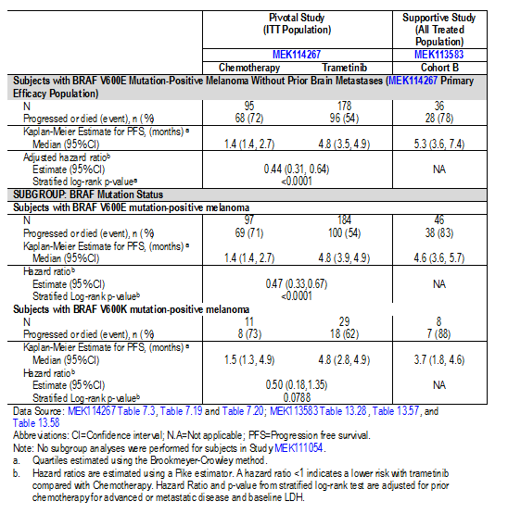

Progression free survival sensitivity analyses for study MEK114267
There was a high degree of concordance between independent review and investigator assessed PFS as demonstrated by Kaplan-Meier plots and indicated in Figure 6.
Figure 6: PFS concordance, investigator versus independent review (ITT population)
A Cox regression analysis was undertaken for various pre-treatment characteristics including mutation status, prior history of brain metastases, prior treatment, baseline ECOG performance status, baseline LDH, stage at screening, visceral disease at screening, number of sites of disease at baseline, gender and age which identified LDH and stage at screening as statistically significant prognostic factors for PFS in the presence of treatment as indicated in Table 15. The model estimated a statistically significant improvement in PFS for the trametinib arm compared with the chemotherapy arm with corresponding HR of 0.44 (p < 0.0001). These significant benefits for pre-treatment factors and treatments itself were similar in the patients with BRAF V600E mutation-positive melanoma with no prior brain metastases.
Table 15: Cox proportional hazards regression model for investigator-assessed progression free survival (ITT population; MEK114267)
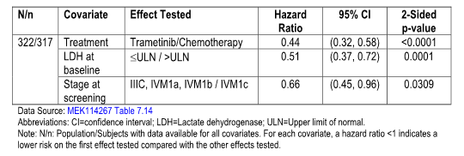

Overall survival
For the patients in the pivotal study 35 patients (16%) and 29 patients (27%) in the trametinib and chemotherapy arms have died by the time of cut off as indicated in Table 16 and Figure 7.
Table 16: Investigator-assessed Kaplan-Meier estimates of OS and OS rate in the pivotal and supportive studies
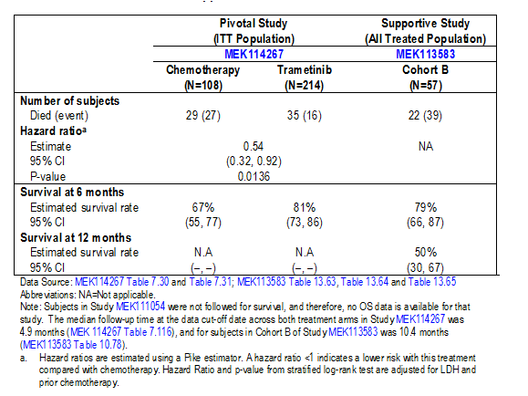
Figure 7: Kaplan-Meier overall survival curves (ITT population; MEK114267)
The HR for the two treatment arms is 0.54 (p=0.0136) representing a 47% reduction in the risk of dying due to disease under the study in the trametinib arm compared with the chemotherapy arm. This was even including those 51 patients who crossed over from the chemotherapy arm to the trametinib arm following disease progression on chemotherapy. Similar results for patients with BRAF V600E positive melanoma with no prior brain metastases were noted in which 16% and 27% of the patients in the trametinib and chemotherapy arms died at the time of data cut off with an HR of 0.53 (p=0.0181). The median OS had not been reached by the time of cut- off. In the ITT population the estimated six month OS for the trametinib arm was 81% compared with the chemotherapy arm at 67%.
It is noted that this is consistent with the six month OS rate of 79% reported in the supportive Study MEK113583.

Overall response rate
In the pivotal population the investigator assessed ORR was higher in the trametinib arm at 22% compared with the chemotherapy arm at 8% (p = 0.01) as indicated in Table 17.
Table 17: Investigator-assessed confirmed overall response rate in pivotal and supportive studies
The investigator assessed ORR improvement in the ITT population was consistent with the results of the independent reviewer assessed ORR for this population with a difference in response between the trametinib arm and the chemotherapy arm being 15% (p=0.0029). Also with the investigator-assessed ORR in patients with BRAF V600E mutation-positive melanoma with no brain metastases the difference in ORR was 17% favouring trametinib (p=0.003).
The supportive Study MEK113583 also had a comparable ORR at 25% while for the smaller number of patients in Study MEK111054 was 33%.
With sub-group analyses the ORR difference between the treatment arms favouring trametinib was statistically significant for three sub-groups namely the sub-group of patients with BRAF V600E mutation positive melanoma with no brain metastases who had received prior chemotherapy, in patients with BRAF V600E mutation-positive melanoma, and in patients less than 65 years. This is illustrated in Table 18. It is of note that for patients with the BRAF V600K mutation positive melanoma the ORR was somewhat lower at 10% for trametinib and actually lower than the chemotherapy arm at 18%.
Table 18: Investigator assessed overall response rate in key subgroups, in the pivotal and supportive studies
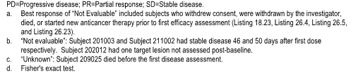
In the supportive Study MEK113583 the ORR for the 36 patients assessed was 25%, consistent with that for the ITT population in the pivotal study.
In relation to duration of response in the pivotal study for the ITT population the median investigator assessed duration of confirmed response was 5.5 months in the trametinib arm and had not been reached for the chemotherapy arm as indicated in Table 19. The supportive studies also had consistent results compared to the pivotal study.
Table 19: Summary of duration of confirmed response in pivotal and supportive studies
Comment: The data from the pivotal study and supportive studies certainly show evidence of a clinically significant benefit in relation to PFS for patients with BRAF mutation-positive metastatic melanoma compared to patients who received chemotherapy. This was in evidence across all sub-groups though it is noted that the level of benefit for patients with BRAF V600K mutation-positive melanoma was not as great as that observed for the BRAF V600E mutation-positive patients and although the PFS favoured the patients receiving trametinib it did not reach clinical significance. Secondary efficacy end points including OS and ORR also favoured the trametinib treated patients and were statistically significant for the ITT population and for the BRAF V600E mutation-positive melanoma patients, but it is again noted that the ORR for patients with BRAF V600K mutation positive melanoma had an inferior ORR compared to the chemotherapy arm. The supportive studies supported the degree of response observed in the pivotal trial for the ITT population. As the pivotal study was quite a large well conducted trial there is definite evidence of benefit for trametinib in patients with BRAF mutation-positive melanoma but some further assessments are required in relation to the BRAF V600K mutation positive patients to be confident that the benefits for these patients are comparable to those with BRAF V600E mutation-positive disease.

Clinical safety
The safety data provided in this evaluation is derived from three studies, namely the pivotal Study MEK114267 together with supportive data from Studies MEK113583 and MEK111054 with the safety population totalling 329 patients from these three studies all of whom received at least one dose of trametinib and in the instance of Study MEK111054 had a starting dose of 2 mg trametinib/day.
AEs for the three studies were described according to standard criteria and graded according to the Common Terminology Criteria (CTC).

Subject disposition
As of 23 June 2012, the data cut off date, 23 patients in the integrated trametinib safety population were ongoing and this is indicated in Table 20. The principle reason for treatment discontinuation was disease progression.
Table 20: Summary of study treatment status (safety population)

Overall extent of exposure
Three patients randomised to trametinib in the pivotal study were excluded from the integrated safety population because they did not receive at least one dose of study medication. Nine patients randomised to chemotherapy were also excluded for the same reason. Summary of the duration of exposure to trametinib and chemotherapy for the patient populations is indicated in Table 21.
Table 21: Summary of duration of exposure to trametinib or chemotherapy (safety population)
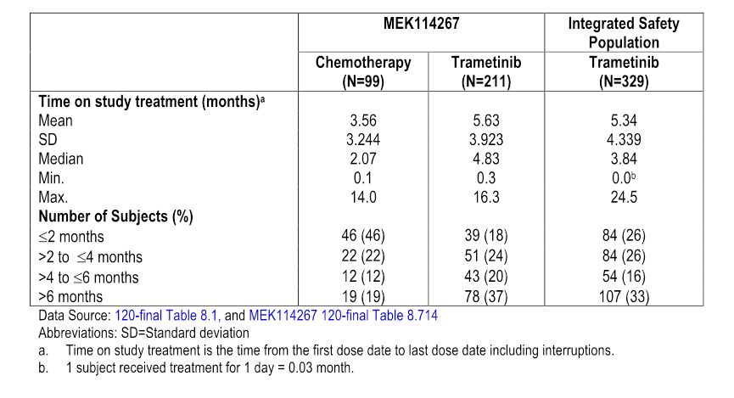
In the pivotal study the median duration of trametinib treatment exposure was more than twice as long compared with the median duration of chemotherapy exposure at 4.8 months versus 2 months respectively. The mean daily dose of trametinib received in the pivotal study was 1.81mg/m² as indicated in Table 22.
Table 22: Summary of exposure to trametinib or chemotherapy (safety population)

Dose modifications
During treatment with trametinib in the integrated studies 29% of patients had dose reductions and 44% had dose interruptions most of which were due to AEs as indicated in Table 23. Patients in the trametinib arm of the pivotal study had more dose reductions or delays/interruptions compared with the chemotherapy arm.
Table 23: Summary of dose reductions and delays/interruptions of trametinib and chemotherapy in MEK114267 and the integrated study population

Adverse events
Greater than 99% of all patients treated with trametinib in the integrated studies had at least one AE as indicated in Table 24. This compares to 93% of patients who had at least one AE in the chemotherapy arm of the pivotal study.
Table 24: Adverse events overview in MEK114267 and the integrated trametinib safety population
The most common AEs in patients treated with trametinib included rash, diarrhoea, fatigue, peripheral oedema, nausea, dermatitis acneiform and vomiting as indicated in Table 25. It is noted there were no reports of cutaneous squamous cell carcinoma or hyperproliferative skin lesions and/or secondary malignancy in this patient population.
Table 25: Adverse events reported by ≥ 10% of subjects in either treatment arm in MEK114267 or the integrated trametinib safety population
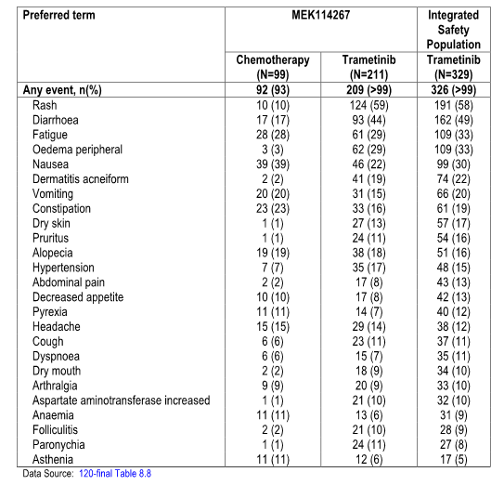
As indicated in Table 26, 48% of the toxicities were Grade I or II but 49% were Grade III and IV with the most common Grade III AE being hypertension and rash. Five patients had Grade V AEs including one with a gastrointestinal (GI) fistula, hepatic failure and renal failure; myocardial infarction; and renal failure.
Table 26: Adverse events reported by ≥ 10% of all subjects by preferred term and maximum toxicity grade plus adverse events reported by > 1% of subjects with Grade 3 or Grade 4 events in the integrated trametinib safety population.
The figures were similar for the pivotal study compared to the integrated population as indicated in Table 27.
Table 27: Adverse events reported by ≥ 10% of all subjects by preferred term and maximum toxicity grade plus AEs reported by > 1% of subjects with Grade 3 or Grade 4 events in either treatment arm or MEK114267 or in the integrated safety population.
As indicated in Table 28 almost all of the patients treated with trametinib in the integrated studies had a drug related AE with the most common of these being rash, diarrhoea, fatigue, dermatitis acneiform, peripheral oedema, nausea, dry skin, pruritis, alopecia and vomiting.
Table 28: Summary of common drug-related adverse events reported by ≥ 10% of subjects in either treatment arm of MEK114267 or the integrated trametinib safety population
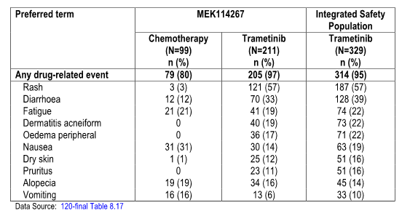
As indicated in Table 29 rash was the most common drug related AE and also occurred in 8% of patients as a Grade III reaction. It is noted that hypertension had an incidence of 4% of patients and fatigue an incidence of 3%.
Table 29: Summary of drug-related adverse events reported by ≥ 10% of subjects in either treatment arm of MEK114267 or the integrated trametinib safety population by Grade 3 and 4 toxicity and by any grades

Deaths
As indicated in Table 30, 157 patients or 48% treated with trametinib died with the most common reason being progressive disease. Only one patient had a death considered potentially related to trametinib therapy with the death being renal failure.
Table 30: Summary of deaths for MEK114267 and the integrated trametinib safety population
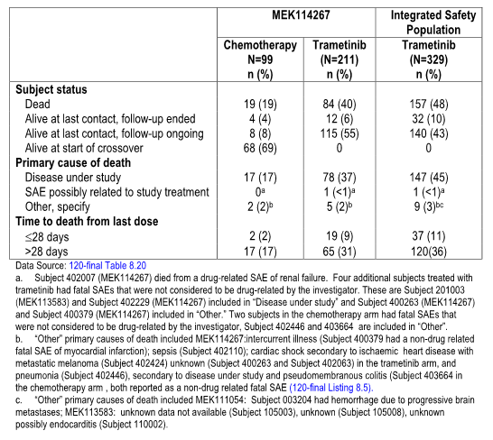

Serious adverse events
As indicated in Table 31, serious AEs (SAEs) occurred in 22% of patients in the integrated drug trametinib safety population with cellulitis being the most common AE followed by pulmonary embolism, anaemia, dyspnoea, pneumonitis, vomiting, dehydration and erysipelas.
Table 31: Summary of serious adverse events reported by ≥ 2 subjects in either treatment arm of MEK114267 or in the integrated trametinib safety population
Those SAEs considered by the investigator to be related to the investigational drug occurred in 33 patients in the integrated treatment safety population and 26 in the pivotal study with the relevant causes indicated in Table 32.
Table 32: Summary of drug-related serious adverse events by > 1 subject in either treatment arm of MEK114267 or in the integrated trametinib safety population

Adverse events leading to permanent discontinuation of study drug
Overall, 10% of patients in the integrated trametinib safety population and 12% in the pivotal study had AEs leading to permanent discontinuation of the study drug as indicated in Table 33. The most common of these was pneumonitis which occurred in four patients and alanine aminotransferase (ALT) elevation in three patients.
Table 33: Summary of adverse events leading to discontinuation of study treatment in > 1 subject in MEK114267 or in the integrated trametinib safety population
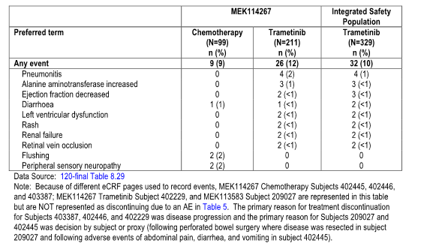

Adverse events leading to dose reduction or temporary interruption of therapy
The proportion of patients who reported AEs that led to dose reductions or dose delay/interruptions are indicated in Tables 34 and 35.
Table 34: Summary of adverse events leading to dose reductions in ≥ 1% of subjects in either treatment arm of MEK 114267 or in the integrated trametinib safety population
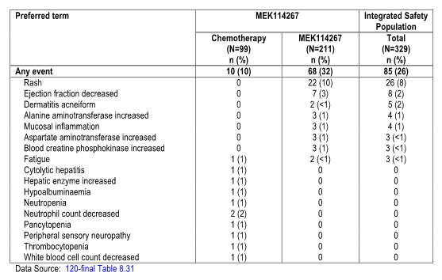
Table 35: Summary of adverse events leading to dose interruptions/delays in ≥ 1% in either treatment arm of MEK114267 or in the integrated trametinib safety population
The most common of those leading to dose reduction were rash, decreased ejection fraction and dermatitis acneiform. The most common AEs leading to dose interruptions were rash, diarrhoea, decreased ejection fraction, peripheral oedema, increased ALT, left ventricular dysfunction, fatigue, pyrexia, cellulitis, dehydration, nausea and vomiting.

Adverse events of special interest
Several AEs of particular interest were more carefully assessed in this evaluation on the basis of their potential association with the mode of action of MEK inhibitors and some earlier case reports. These included skin related toxicity, diarrhoea, ocular events, cardiac related events, hepatic events and pneumonitis. The relevant terms for these categories are indicated in Table 36.
Table 36: Definitions for adverse events of special interest
An overview of these AEs and their incidence is indicated in Table 37.
Table 37: Overview of adverse events of special interest in MEK114267 and integrated trametinib safety population
 | MEK114267 |  | Integrated Safety Population
Composite AE Term | Chemotherapy  (N=99)  N (%) | Trametinib  (N=211)  n (%) | Trametinib I  (N=329)  N (%)
Skin-related toxicities | 14 (14) | 186(88) | 287(87)
Diarrhoea | 17 (17) | 93 (44) | 162 (49)
Ocular Events | 4 (4) | 21 (10) | 42 (13)
Cardiac-related | 0 | 16 (8) | 31 (9)
Hypertension | 7 (7) | 35 (17) | 48 (15)
Hepatic Events | 5 (5) | 24 (11) | 39 (12)
Pneumonitis | 0 | 5 (2) | 6 (2)
Pulmonary Embolism | 1 (1) | 6 (3) | 12 (4)
Oedema | 5 (5) | 84 (40) | 140 (43)
Data source: 120-final Table 8.32, Table 8.67, Table 8.7
- Pulmonary embolism and oedema are described in the cardiac-related events Section 2.5.5, but are not AEs of special interest.

Skin related toxicities
It is noted that skin related toxicities have been previously reported for other small molecule MEK inhibitors and are considered to be rather similar to those noted with epithelial growth factor receptor (EGFR) inhibitors. A breakdown of these skin reactions observed in the integrated trametinib safety population and the pivotal study are indicated in Tables 38 and 39.
Table 38: Summary of skin-related toxicities by grade in all subjects in the integrated trametinib safety population
Table 39: Skin-related toxicities by Grades 3 and 4 and any grade in MEK114267 and the integrated trametinib safety population
It is noted that the overall incidence of frequency and severity of these skin reactions were comparable between the integrated population and the pivotal study. The overall incidence was high with the most common being rash; 8% were Grade III and one patient had Grade IV skin rash which ultimately resolved on cessation of therapy. The overall incidence of Grade III skin reactions was 12%. Almost all of these, that is, 98% were skin related events considered by the investigator to be drug related as indicated in Table 40. Skin related toxicities generally occur within the first 28 days of treatment with a median duration of 72 days.
Table 40: Summary of subjects with skin-related toxicities and event characteristics in MEK114267 and integrated trametinib safety population

Diarrhoea
GI AEs had previously been noted in various toxicology studies in dogs and rats and had also been a common AE studies with other small molecule MEK inhibitors. In the integrated trametinib safety population, diarrhoea occurred in 49% of patients as indicated in Table 41.
3% of these were Grade III in severity and there were no Grade IV events. The majority of the occurrences of the first event of diarrhoea were within the first 14 days although some 47% of these had prolonged duration of greater than 10 days. Dose interruptions due to diarrhoea occurred in 9% of patients although dose reductions were uncommon in 1%.
Table 41: Summary of subjects with diarrhoea and event characteristics in MEK114267 and integrated trametinib safety population

Ocular events
Ocular AEs and specifically events of retinal vein occlusion (RVO) and central serous retinopathy had been reported in clinical trials of small molecule MEK inhibitors. In the integrated trametinib safety population 42 patients or 13% had ocular events as indicated in Table 42.
Table 42: Ocular events by maximum grade and any grade in MEK114267 and integrated Trametinib safety population
The most common of these were blurred vision and dry eyes. It is noted however that three patients experienced chorioretinopathy, two of which were Grade III in severity. The majority or 69% of the events were considered to be drug related as indicated in Table 43.
Table 43: Summary of subjects with ocular events and characteristics in MEK114267 and integrated trametinib safety population
It is noteworthy that review by the sponsors of their entire clinical program revealed that as of the cut off date of 26 September 2012, 14 cases of central serous retinopathy had been reported. It is considered that these are more likely than not related to trametinib therapy. All of these cases progressively resolved within three months after the onset and not all cases actually ceased therapy. For those who temporarily ceased treatment reintroduction of trametinib was successful in the majority of cases.

Cardiac related events
No significant pre-clinical cardiac toxicity with trametinib was noted from chronic toxicity studies in rats or dogs but cardiac toxicity has been reported for a number of drugs that inhibit Tyrosine Kinase activity. The most common of these being decreased LVF. Table 44 indicates the frequency, distribution and severity of cardiac-related AEs for the integrated population and the pivotal study.
Table 44: Cardiac-related events by toxicity Grades 3,4 and any grade in MEK114267 mand integrated trametinib safety population
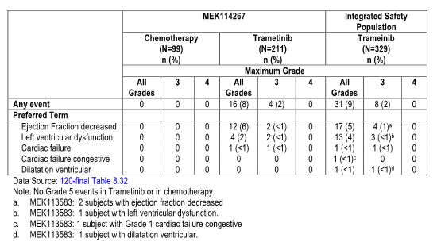
These were reported in 9% of patients with the most common being decreased ejection fraction and eight of these patients had Grade III events. Most of these were considered to be drug related as indicated in Table 45. Dose interruptions were required for these events in 58% of patients and dose reductions in 35% of patients. Five patients required study drug withdrawal.
Table 45: Summary of subjects with cardiac-related events and event characteristics in MEK114267 and integrated trametinib safety population

Hypertension
This AE has been reported previously for small molecule MEK inhibitors. In the integrated study, hypertension was observed in 15% of patients as indicated in Table 46, and 9% of these were Grade III.
Table 46: Hypertension adverse events by toxicity Grades 3, 4 and any grade in MEK114267 and integrated trametinib safety population
There were no SAEs or AEs of hypertension that led to permanent discontinuation of the study drug as indicated in Table 47. Two patients required dose reductions due to hypertension and three patients had dose interruptions. The onset of hypertension generally occurred after 14 days with a mean duration of 66.8 days.
Table 47: Summary of subjects with hypertension events and event characteristics in MEK114267 and integrated trametinib safety population

Oedema
Peripheral oedema has been reported in previous clinical trials of small molecule MEK inhibitors and occurred in 43% of patients in the integrated safety population. Eight of these events were Grade III in severity as indicated in Table 48. Most of these were considered to be drug related; only 6% of patients required dose interruption and 1% dose reduction in relation to this AE.
Table 48: Summary of oedema and event characteristics in MEK114267 and integrated trametinib safety population
 | MEK114267 |  | Integrated Safety Population
 | Chemotherapy  (N=99) | Trametinib  (M=211) | Trametinib  (N=329)
Number of subjects with oedema, n (%)  Number of events | 5 (5)  6 | 84 (40)  122 | 140(43)  214
Event characteristicsª, n (%) | n=5 | n=84 | n=140
Serious  Drug-related | 0  0 | 3 (4)^{b}  49 (58) | 3 (2)^{b}  88 (63)
Number of occurrences, n (%) | n=5 | n=84 | n=140
One  Two  Three or more | 4 (80)  1 (20)  0 | 52 (62)  27 (32)  5 (6) | 85 (61)  40 (29)  15 (11)
Outcomeª n (%) | n=5 | n=84 | n=140
Recovered/resolved  Recovering/resolving  Not recovered/not resolved  Recovered/resolved with sequelae | 2 (40)  0  2 (40)  1 (20) | 34 (40)  9 (11)  48 (57)  7 (8) | 59 (42)  17 (12)  86 (61)  7 (5)
Maximum grade, n (%) | n=5 | n=84 | n=140
Grade 1  Grade 2  Grade 3  Grade 4 | 4 (80)  1 (20)  0  0 | 61 (73)  19 (23)  4 (5)  0 | 97 (69)  35 (25)  8 (6)  0
Action(s) takenª, n (%) | n=5 | n=84 | n=140
Investigational product withdrawn  Dose reduced  Dose not changed  Dose interrupted/delayed  Not applicable | 0  0  5 (100)  0  0 | 2 (2)  1 (1)  79 (94)  6 (7)  1 (1) | 2 (1)  2 (1)  132 (94)  9 (6)  4 (3)
Time of onset of first occurrence, days | n=5 | n=84 | n=140
1-14  15-28  >28  Mean (SD)  Median (minimum – maximum) | 3 (6)  1 (20)  1 (20)  16.0 (16.49)  10 (2 – 42) | 17 (20)  14 (17)  53 (63)  62.1 (59.17)  44.5 (3 – 299) | 29 (21)  27 (19)  84 (60)  58.4 (60.85)  43.0 (3 – 387)
Duration of first occurrenceª days | n=3 | n=30 | n=48
1-5  6-10  >10  Mean (SD)  Median (minimum – maximum) | 0  2 (67)  1 (33)  8.7 (3.79)  7 (6 – 13) | 3 (10)  3 (10)  24 (80)  60.4 (53.97)  42.5 (1 – 176) | 4 (8)  3 (6)  41 (85)  67.2 (63.79)  42.5 (1 – 255)
Data source: 120-final Table 8.67, Table 8.68
- Subject may be included in more than one category
- Subject 404458 (MEK114267) had an event of oedema that was reported as an SAE. Following the data cut-off date, the investigator removed the event form the case report form stating that the event was due to disease progression.
- Only adverse events with resolution dates are included in the duration calculation.

Hepatic events
Hepatotoxicity was observed in the toxicology studies in dogs and mild to moderate increase in ALT and AST have been described with small molecule MEK inhibitors. Hepatic AEs occurred in 39 patients in the integrated trametinib safety population and similar proportion in the pivotal study as indicated in Table 49. The majority of these were Grade I and II in severity particularly associated with elevations of AST and ALT.
Table 49: Hepatic adverse events of special interest by maximum grade – MEK114267 and integrated trametinib safety population
However nine patients had Grade III and two patients Grade IV hepatic events. This is indicated in Table 50. These were considered to be AEs related to trametinib therapy.
Table 50: Summary of subjects with hepatic events and event characteristics in MEK114267 and integrated trametinib safety population

Pneumonitis
Five patients in the integrated trametinib safety population developed pneumonitis; all these were serious and considered by the investigator to be possibly related to treatment. In all cases the AE improved or resolved upon interruption of trametinib treatment and initiation of symptomatic therapy.

Clinical laboratory evaluations
40% of patients had anaemia during treatment with trametinib of which 4% were Grade III. Other changes were less frequent although neutropenia occurred in 14% but in no case was Grade III and 19% of patients had thrombocytopenia with one case being Grade IV. This is illustrated in Table 51.
In relation to clinical chemistry assessments increases from baseline with Grades I or II elevations of ALP, ALT and AST were noted more frequently in the trametinib treated patients in the chemotherapy arm of the pivotal study as indicated in Table 52. Changes of a Grade I and II level for albumin and glucose were also more frequent in the trametinib arm. A few patients however had Grade III or IV AEs related to clinical chemistry assessments.
Table 51: Summary of worst case grade changes from baseline in haematology parameters in MEK114267 and the integrated trametinib safety population.
Table 52: Summary of increases from baseline with Grades I or II elevations of ALP, ALT and AST in MEK114267 and the integrated trametinib safety population

Careful evaluation was undertaken in relation to potential ECG changes and it was noted that eight patients developed QTcB changes from baseline that were greater than 60 milliseconds. Also in the pivotal study the incidence of increase to Grade III or IV in QTcB was low and similar between the trametinib and chemotherapy arms as indicated in Table 53.
Table 53: Summary of worst case increases in QTcB from baseline in MEK114267 and the integrated trametinib safety population
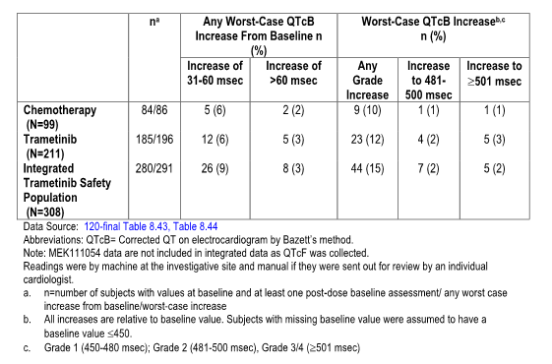

Safety in special groups
In relation to age the proportion of patients less than 65 years who had AEs that led to permanent discontinuation of study drug, dose reduction or interruption was lower than the other age groups and patients greater than 75 years had a higher proportion of all types of AEs and this is indicated in Table 54. There were no differences in AEs related to gender.
Table 54: Adverse events overview by age for subjects in the integrated trametinib safety population
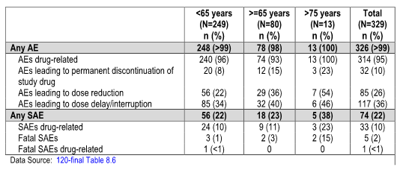
Comment: A sizeable spectrum of AEs have been reported from these studies for trametinib with the most common being skin rash, diarrhoea, fatigue, peripheral oedema, nausea and vomiting. Nevertheless while more than 40% of these AEs were at least of Grade III severity, few patients required drug withdrawal and were managed with appropriate dose interruption or dose reduction. It is noted that 92% of patients were able to continue trametinib until disease progression. Certain AEs require careful monitoring particularly potential for LVEF reduction and left ventricular dysfunction, visual impairment and rash. Less common, but also important potential AEs requiring appropriate monitoring included pneumonitis, hepatic events and hypertension. In general terms despite this incidence of AEs, as already stated, some 92% of patients were able to complete their trametinib therapy.

First round benefit-risk assessment

First round assessment of benefits
The data from the three relevant clinical trials provided in the submission in relation to efficacy namely, the pivotal Study MEK114267, the Phase II Study MEK113583 and the Phase I/II Study MEK111054 have demonstrated a definite degree of efficacy for trametinib in patients with advanced/metastatic BRAF V600 mutation-positive melanoma. In the pivotal study the PFS benefit is highly significant with a median PFS for trametinib patients of 4.8 months compared to the chemotherapy arm of 1.4 months, representing a 55% improvement. This data was confirmed by both investigator assessments and independent review. Various sub-group analyses confirmed this benefit. Similarly, secondary efficacy parameters including OS, ORR and duration of benefit are all statistically significant in favour of trametinib. The supportive studies demonstrated RRs comparable to the pivotal study and again supportive of benefit for trametinib.
It is of particular note however that the patients with the V600K mutation-positive melanoma of which 54 patients were enrolled over the three studies, and 40 in the pivotal study of whom 29 patients received trametinib that the ORR for these patients receiving trametinib was lower at 10% compared to chemotherapy at 18%. Further although the median PFS for patients with V600K mutation-positive melanoma was in the order of 4.8 months compared to 1.5 months for those receiving chemotherapy, this did not reach statistical significance (p=0.0788). It is also noted that in the supportive Study MEK113583 that there were no objective responses among the eight patients with BRAF V600K mutation-positive melanoma who received trametinib. While it is recognised that there are relatively small numbers of patients involved in this sub-population it remains uncertain that the level of efficacy for trametinib in patients with V600K mutation-positive melanoma is comparable to that for patients with V600E mutation-positive melanoma.
Accordingly, it is appropriate to feel confident the benefits of trametinib are apparent for patients with V600E mutation-positive melanoma but remains less clear for those with V600K mutation positive melanoma.

First round assessment of risks
The three studies provided in this submission for assessment of safety involving trametinib at a dose of 2 mg QD demonstrated a definite spectrum of AEs with the most common being rash, diarrhoea, hypertension, peripheral oedema and fatigue. While these were often Grade I and II in severity nevertheless approximately 42% of patients did have Grade III toxicity, although there was a much lower proportion of Grade IV toxicities at 7% and only one death which was attributed to trametinib therapy, namely renal failure. There was however clear indication of other more serious AEs related to skin-related toxicities, visual disorders, cardiac related events, hepatic events and pneumonitis all of which will require very careful monitoring.
Despite the spectrum of AEs, trametinib represents an agent with toxicities which are generally comparable to standard chemotherapy and BRAF inhibitors such as vemurafenib. These AEs have generally been adequately managed with appropriate monitoring, prophylaxis and early intervention.

First round assessment of benefit – risk balance
Overall it is considered that the benefit/risk balance for trametinib in the treatment of V600 mutation positive advanced/metastatic melanoma favours benefit in terms of worthwhile clinical efficacy as determined by improvements in PFS, OS and ORR. This particularly applies to the V600E mutation positive patient population but remains somewhat less certain with regard to the V600K mutation positive melanoma population. Accordingly consideration may need to be given to the recommendation regarding authorisation which will be discussed further below.

Part B – Combination study of trametinib and dabrafenib
Trametinib is an allosteric inhibitor of MEK in the MAP kinase pathway. Studies discussed above have demonstrated clinically significant activity for this agent in the treatment of advanced/metastatic V600 mutation positive melanoma. Dabrafenib is a small molecule ATP competitive inhibitor of BRAF and studies have demonstrated clinical efficacy in the treatment of advanced/metastatic V600 mutation positive melanoma. As these two agents have a different mechanism of action it is considered that the combination of the agents may well represent a further advancement in the treatment of this difficult malignancy. Accordingly, the Phase I/II study BRF113220 was undertaken to assess the potential efficacy and safety of this drug combination. The study was undertaken in four parts:
- Part A involving eight patients evaluating pharmacokinetics;
- Part B involving 80 patients who enrolled in an escalating dose cohort of dabrafenib and trametinib in a three plus three design;
- Part C involving 162 patients was a randomised open label three arm study of dabrafenib/trametinib combination therapy with comparison to dabrafenib monotherapy in patients with metastatic BRAFV600 mutation-positive melanoma who were BRAF inhibitor naïve; and
- Part D involved assessment of a newer form of dabrafenib capsule (hydroxypropyl methylcellulose (HPMC) capsules) compared to the initial gelatine capsules which were used in the first three parts of the study.
The four parts of the study were considered in relation to pharmacokinetics, efficacy and safety.

Pharmacokinetics
Part A of the study was designed as an open label study evaluating the effect of repeat dose of trametinib on the PK single dose dabrafenib. It is noted that trametinib has shown the highest inhibitory potential against CYP2C8 in vitro with the concentration resulting in 50% of maximum inhibition of 0.34 µmols but the risk of drug to drug interaction was considered low. In vitro studies have demonstrated that the oxidative metabolism of dabrafenib was mediated by CYP2C8 and could potentially be affected by CYP2C8 inhibitors. Accordingly, subjects received a single 75 mg dose of dabrafenib as gelatine capsules on Day 1 with trametinib 2 mg QD being administered from Day 2 through to Day 15. PK samples for determination of plasma dabrafenib were taken for up to 24 hours after the dabrafenib single dose on Days 1 and 15.
Part B was designed as an open label dose escalation repeat dose study to identify the range of tolerated dose of the dabrafenib/trametinib combination in patients with BRAF mutation-positive melanoma. The initial dose of the combination was half the recommended dose of each agent. Doses of trametinib at 1, 1.5 and 2 mg QD were administered in combination with dabrafenib at 75 or 150 mg BID as gelatine capsules using a dose escalation procedure. PK samples for determination of plasma concentration of trametinib, dabrafenib and dabrafenib metabolites were obtained for up to eight hours on Day 15 and Day 21. A dose proportionality of trametinib was evaluated using a power model.
Part D of the study involved evaluation of the PK of dabrafenib administered as HPMC capsules as monotherapy and combination after single and repeat doses. Patients were randomised to one of four treatment groups, that is, dabrafenib 75 or 150 mg BID monotherapy or in combination with trametinib 2 mg QD. Serial PK blood samples were drawn after the first dose on Day 1 and after repeat dose on Day 21.
When administered in combination with trametinib, dabrafenib PK characteristics are similar to that when administered alone with a median T_{max} of 1.5 to 2 hours; T½ of 3.6 hours. Consistent with monotherapy, data exposure decreases to repeat BID dosing. Dabrafenib PK parameters determined across the different cohorts in the study for the combination doses of the two agents are indicated in Table 55.
Table 55: Summary of debrafenib PK parameters after single and repeat dose administration of dabrafenib 150 BID in combination with trametinib 2 mg once daily (Study BRF113220; Parts A, B and D)
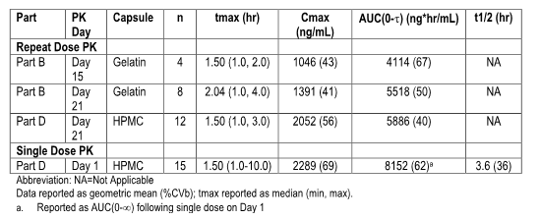
When administered in combination with dabrafenib, trametinib PK characteristics are similar to that when administered alone with a median T_{max} of 1.5 to 2 hours and it accumulates with repeat daily dosing. Trametinib PK parameters determined across the different cohorts in the study at the dabrafenib/trametinib combination dose are indicated in Table 56.
Table 56: Summary of trametinib PK parameters following single and repeat dose administration of trametinib 2 mg once daily in combination with dabrafenib 150 mg BID (Study BRF113220; Parts A, B and D)
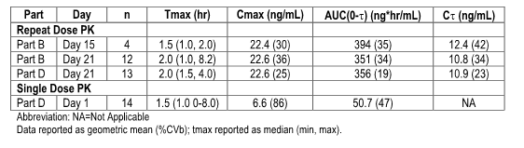

Population pharmacokinetics
Population analyses were conducted to describe the PopPK of dabrafenib and trametinib when administered in combination from all parts of Study BRF113220 involving 349 subjects for dabrafenib and 295 subjects for trametinib who were pooled with prior monotherapy data that is, 606 subjects for dabrafenib and 493 subjects for trametinib and used in the analyses. The effect of combination therapy on PK parameters such as CL-F or oral bioavailability (F) for dabrafenib or trametinib was evaluated using a non-linear mixed effect approach.
The final PK parameters for dabrafenib are indicated in Table 57.
Table 57: Parameter estimates of the final dabrafenib population pharmacokinetic model
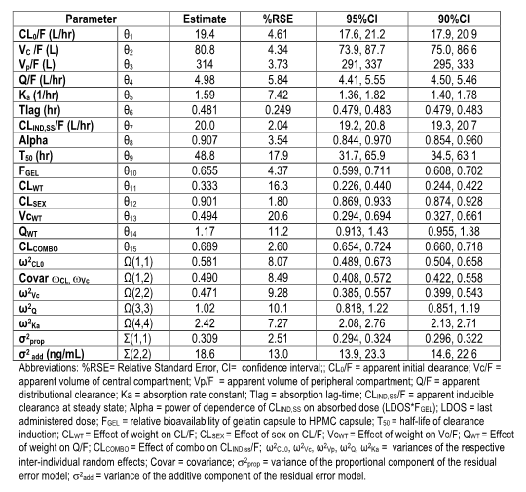
For dabrafenib the effect of co-component trametinib resulted in a decrease in the inducible clearance of dabrafenib with a ratio of 0.689. The inducible clearance represents about half of total CL-F. Administration of the combination had minimal impact on C_{max,} that is, 6% or ratio 1.06 and AUC _{0-T} that is, 19% or ratio 1.19 compared to monotherapy using the HPMC capsules.
Consistent with previous PopPK analyses, exposure with HPMC capsules was 46% and 33% higher for C_{max} and AUC _{0-T} respectively and relative to gelatine capsules for the dabrafenib/ trametinib combination. Various covariates were also analysed including BW and sex in relation to the various PK parameters and the magnitude of effect of these factors was unlikely to be clinically relevant. The effects of organ impairment was tested with mild hepatic or mild or moderate renal impairment having no clinically relevant effects on CL-F at less than 14% of dabrafenib consistent with the results with monotherapy.
The final PK parameters of trametinib are indicated in Table 58.
Table 58: Parameter estimates of the final trametinib population pharmacokinetic model
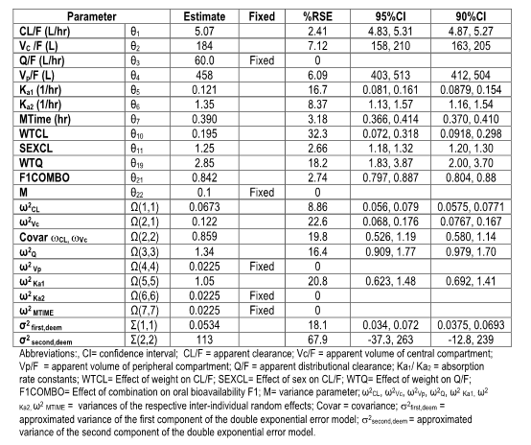
The effect of co-component administration of dabrafenib resulted in a decrease in trametinib oral bioavailability with a ratio of 0.842. Trametinib CL-F was estimated at 5.07 L/hr and was dependent on gender and weight. The typical CL-F of trametinib in male subjects was 25% higher than that observed in female subjects. The effect of BW at the minimum and maximum weight observed was in 16% of typical CL-F value. Nevertheless these differences do not seem to warrant consideration for dosage adjustment. The effects of organ impairment were tested with mild hepatic or mild or moderate renal impairment having no clinically relevant effects of trametinib CL-F consistent with results with monotherapy.

The effect of dabrafenib capsule shell (gelatine versus HPMC capsules)
It is noted that the randomised Phase II portion of the combination study, that is Part C, was conducted primarily with gelatine capsules while the commercial formulation will be the HPMC capsule shells. It is noted the administration of dabrafenib as HPMC capsules results in a higher C_{max} in AUC _{0-∞} following single dose with a geometric least squares (GLS) mean ratio of 2.02 and 1.80 respectively. Exposure to dabrafenib decreases at the peak dosing as dabrafenib induces its own metabolism. The difference between HPMC and gelatine capsules after repeat dosing was evaluated in the PopPK analysis with HPMC to gelatine ratio of 1.66 for C_{max} and 1.42 for AUC_{0-T}. Earlier studies of capsule shell evaluated in the dabrafenib monotherapy submission suggests that the efficacy and safety profile of dabrafenib remains consistent regardless of the HPMC or gelatine capsule as indicated in Table 59.

Dose selection
Dabrafenib 150 mg BID and trametinib 2 mg QD are recommended monotherapy dosing regimens for the treatment of patients with unresectable metastatic melanoma with BRAFV600 mutation. The relationship between exposure and response has been evaluated as indicated above. Dabrafenib and trametinib administered as full monotherapy doses in Part B of the study were well tolerated as will be discussed below and have been subsequently used in Part C of the study.

Clinical efficacy
The Phase I/II Study BRF113220 represents the evidence submitted for consideration of efficacy in relation to the dabrafenib/ trametinib combination. Part C represents the pivotal component in which data from a randomised Phase II three arm open label study evaluated the safety and efficacy of a dabrafenib/trametinib combination therapy with comparison to dabrafenib monotherapy. This phase of the study enrolled 162 BRAF inhibitor naïve patients who were randomised according to 54 patients of dabrafenib 150 mg bd plus trametinib 2 mg, 54 patients to dabrafenib 150 mg bd plus trametinib 1 mg and 54 patients to dabrafenib monotherapy at 150 mg bd alone.
Supportive data also came from Part B of the study which is a dose escalation and safety/efficacy expansion phase and Part D in which the HPMC capsules were evaluated and this is outlined in Table 59.
Table 59: Overview of studies evaluating the efficacy of combination dabrafenib and trametinib in unresectable and/or metastatic BRAF V600 mutation-positive melanoma
Additional data was also provided from the Part C patients who crossed over from dabrafenib monotherapy to combination therapy.
Part B of the study enrolled patients in escalating dose cohorts of dabrafenib and trametinib in a 3 plus 3 design. The highest three cohorts, which are 150-1, 150-1.5 and 150-2 were expanded to a maximum of 25 subjects. Upon completion of dose escalation two additional efficacy expansion cohorts were opened with the relevant one being patients with BRAFV600 mutation positive melanoma who had experienced disease progression following prior treatment with a small molecule BRAF inhibitor.
Part C was a Phase II randomised three arm open label evaluation of safety and efficacy of combination therapy with dabrafenib 150 mg bd and two different doses of trametinib 1 mg QD and 2 mg QD compared with dabrafenib monotherapy in patients with advanced BRAFV600 mutation-positive melanoma who are BRAF V600 naïve. Randomisation was to three arms according to that described above. Patients who had documented disease progression according to RECIST criteria on the dabrafenib monotherapy arm had the opportunity to cross over to the dabrafenib 150-2 combination therapy.
Three primary efficacy end points were specified, namely, PFS, ORR and duration of response with OS identified as a secondary end point. Disease assessments were conducted every eight weeks. Patients who continued were followed till death.
It is to be noted that Part C was initially designed as a non-randomised expansion cohort based on dose identified in Part B with planned enrolment of approximately 20 patients per dose cohort. The protocol was amended prior to the initiation of Part C to a randomisation of dabrafenib monotherapy arm. An initial 20 patients per arm were planned but this was subsequently increased to 50 patients per arm. A blind and independent central review committee was also introduced. Several sensitivity analyses were also pre-specified.
It is to be noted that Part D of the study involving the HPMC capsule formulation was undertaken because of the prior use of gelatine capsules for Part B and Part C of the study as appropriate to evaluate the PK and safety profiles of the combination utilising the HPMC capsule. The PK data has already been presented above. The safety data will be presented subsequently.

Results
Part C of the study enrolled a total of 162 patients with 54 patients randomised to each arm as indicated in Table 60.
Table 60: Subject disposition and reasons for study withdrawal (BRF113220 Part C, ITT population)
At the time of the data cut-off, 31 May 2012, most subjects in each of the treatment groups (59 to 74%) were still ongoing in the study. A total of 51 patients across the three treatment groups died prior to the time of the date of cut-off.
Further, at the date of cut-off, 42% of patients randomised at the 150/2 combination therapy and 43% of patients randomised at the 150/1 combination therapy were still receiving the study treatment compared to 66% of patients randomised for dabrafenib monotherapy as indicated in Table 61.
Table 61: Study treatment status (BRF113220 Part C, all treated population)

Demographic and baseline disease characteristics
The demographics for the Part C ITT population were generally well balanced among the three treatment groups as indicated in Table 62.
Table 62: Demographics and baseline disease characteristics (BRF113220 Part C, ITT population)
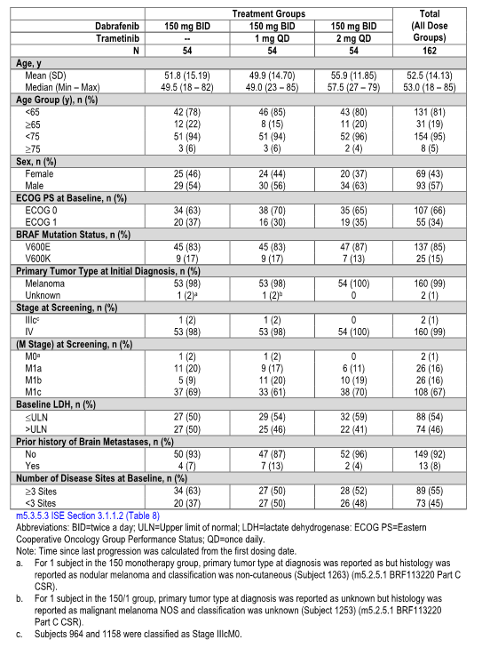
Baseline disease characteristics and prognostic factors were also similar. It is noted that 85% of patients had the V600E mutation. Further, half of all patients had three or more sites of disease although few patients had a history of brain metastases.
As indicated in Table 63 most patients in all three treatment groups had not received previous anti-cancer treatment in the advanced or metastatic setting.
Table 63: Prior anti-cancer therapy in the advanced or metastatic setting (BRF113220 Part C, ITT population)
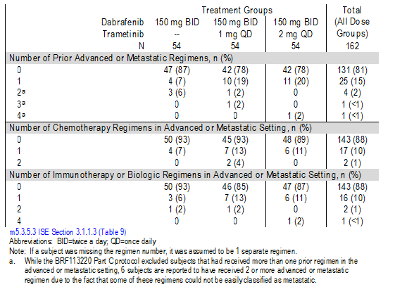

Patient disposition
As indicated in Table 64, BRAF inhibitor naïve melanoma patients treated at the starting dose of the combination of 150/2 included 54 patients in Part C, 24 patients in Part B and 39 patients in Part D.
Table 64: Subject disposition for subjects treated with 150/2 combination therapy (BRF113220 Parts B, C and D populations)
Most patients in Parts C and D were ongoing as of the date of cut-off, 31 May 2012, for Part C and 25 September for Part D. Also a half of Part B patients were ongoing as of 25 May 2012. Medium follow up times were 14 months for Part C, 15.4 months for Part B and 7.7 months for Part D. Nevertheless, more than one half of the patients treated with the combination of 150/2 therapy in Part C and B had discontinued treatment as of the cut-off dates and half of those in Part D had discontinued as indicated in Table 65.
Table 65: Study treatment status for subjects treated with combination 150/2 therapy (BRF113220 Parts B, C and D populations)

Demographic and baseline disease characteristics
Median age was similar for the three populations treated with 150/2 combination therapy as indicated in Table 66.
Table 66: Demographics and baseline disease characteristics for subjects treated with 150/2 combination therapy (BRF113220 Parts B, C and D populations)
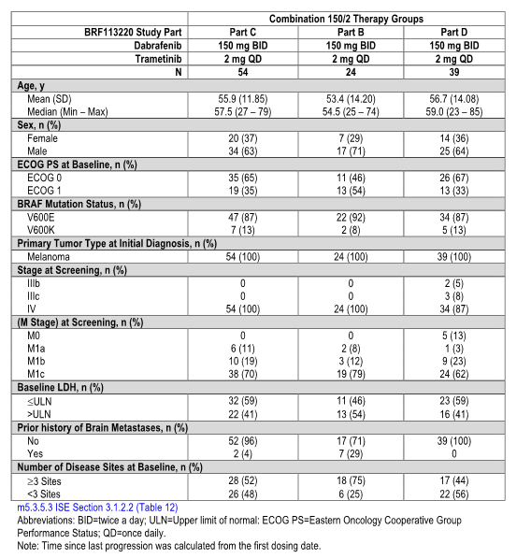
It is noted that the Part B patients had disease characteristics at baseline that indicated more advanced disease and a poorer prognosis based on greater than three disease sites, a high incidence of elevated LDH and prior history of brain metastases.
In relation to prior anti-cancer therapy most patients treated with the 150/2 combination therapy had received at least one prior anti-cancer therapy although the majority of patients in Part C and D had not received prior systemic anti-cancer regimens for advanced metastatic disease as indicated Table 67.
Table 67: Summary of prior anti-cancer therapy for subjects treated with 150/2 combination therapy (BRF113220 Parts B, C and D)

Efficacy results

Progression free survival
In the Part C ITT population, statistically significant improvements in investigator-assessed PFS were observed in the 150/2 and 150/1 combination therapy groups compared with the dabrafenib monotherapy group as indicated in Table 68.
Table 68: Investigator-assessed Kaplan-Meier estimates PFS (BRF113220 Part C, ITT population)
With a median follow up time of 14 months, the 150/2 combination therapy had statistically significant improvement in PFS with an HR of 0.39 (p < 0.0001) representing a 61% reduction in the risk of tumour progression or death for patients treated with the combination 150/2 compared with the dabrafenib monotherapy. The median PFS was 9.4 months for the combination and 5.8 months for monotherapy with an estimate of PFS rate at 12 months being 41% for the combination compared to 9% for the dabrafenib monotherapy.
Treatment with the 150/1 combination therapy also resulted in a statistically significant improvement in investigator-assessed PFS compared to the dabrafenib monotherapy although this was less than the 150/2 arm (p=0.0057). It is noted that the median PFS for the 150/1 combination was similar to the 150/2 combination at 9.2 months and 9.4 months respectively. For the 12 month PFS rate the 150/2 combination is at 41% compared with the 150/1 combination at 26%.
The IRC assessment also showed a statistically significant improvement in PFS for the 150/2 combination compared to monotherapy with an HR of 0.54 (p=0.012) as indicated in Table 69.
Table 69: BICR-assessed Kaplan-Meier estimates of PFS (BRF113220 Part C, ITT population)
This represented a 46% reduction in the risk of tumour progression or death and the median PFS was 9.2 months for patients on the combination versus 7.3 months for the monotherapy. It is noted however that for the 150/1 combination therapy group a statistically significant difference was not observed with the independent review with an HR of 0.73 (p=0.1721) and the median PFS of 8.3 months.

Part B and Part D PFS data
In Part B for those patients treated with 150/2 combination therapy the investigator-assessed median PFS was 10.8 months compared to 9.4 months for Part C subjects as indicated in Table 70.
Table 70: Investigator-assessed Kaplan-Meier estimates of PFS with 150/2 combination therapy (BRF113220 Parts B, C and D populations)
The PFS data for Part D were not mature at the time of date of cut-off with a median follow up of 7.7 months. Although for the first quartile assessment the PFS was comparable to that for Part C patients.

Overall response rate

Investigator-assessed Part C
In the Part C ITT population a statistically significant increase confirmed ORR was observed for the 150/2 combination therapy compared to the monotherapy with an ORR of 76% compared to 54% (p=0.0264) and indicated in Table 70. There was however no significant difference between the 150/1 combination therapy group and the dabrafenib monotherapy group.
Table 71: Investigator-assessed best confirmed response (BRF133220 Part C, ITT population)

Independent review committee analyses
For the Part C patients the IRC analyses for the 150/2 combination demonstrated a higher ORR compared to dabrafenib monotherapy but this was not statistically significant as indicated in Table 72.
Table 72: BICR-assessed best confirmed response (BRF113220 Part C, ITT population)
This was as ORRs assessed by the IRC were lower than that for the investigator. The ORR by the IRC was 61% for the combination compared to 46% for the monotherapy. The 150/1 combination had no evidence of advantage over the monotherapy in relation to ORR.
Patients treated with the 150/2 combination therapy in Parts B and D demonstrated investigator-assessed confirmed RRs of 63% and 67% respectively.

Duration of response
In the Part C ITT population the investigator-assessed median duration of confirmed response for the 150/2 combination therapy was nearly double that for the monotherapy, at 10.5 months versus 5.6 months and is indicated in Table 73.
Table 73: Investigator-assessed duration of confirmed respone (BRF113220 Part C, ITT population)
It is noted that at the time of analysis, 46% of responding patients in the combination therapy group were ongoing compared to 14% in the monotherapy arm. For the IRC analysis median duration of response was the same for the combination and monotherapy groups at 7.6 months indicated in Table 74.
Table 74: BICR-assessed duration of confirmed response (BRF113220 Part C, ITT population)
In Part B subjects treated with the combination 150/2 therapy had a median duration of confirmed response similar to that for Part C patients as indicated in Table 75. Again, approximately 50% of patients were ongoing in this study.
Table 75: Investigator-assessed duration of confirmed response in subjects treated with 150/2 combination therapy (BRF113220 Parts B, C and D populations)

Overall survival
With a median follow up time of 14 months and a total of 51 deaths for the Part C patients in the study the OS data is not yet mature and median OS has not been reached for any treatment group. There does appear to be some trend with an HR of 0.67 (p=0.2591) as indicated in Table 76.
Table 76: Overall survival and 12-month estimated survival rates (BRF113220 Part C, ITT populations)
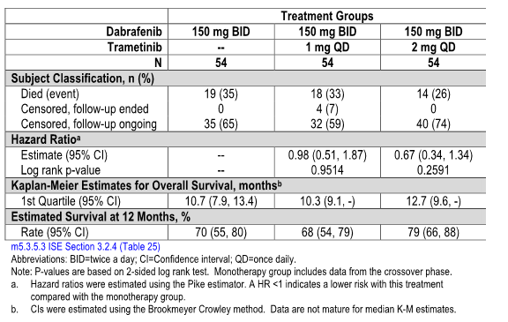
The Kaplan-Meier estimates of OS at 12 months was 79% for the combination 150/2 compared with 68% for the 150/1 combination and 70% for the monotherapy.
For those patients who had received prior BRAF inhibitor therapy and were treated with combination 150/2 therapy in Parts B and C the sequential administration of monotherapy followed by combination therapy showed limited clinical activity as indicated in Table 77.
Table 77: Progression-free survival and overall response rate for BRAFi-treated populations (Part B combination 150/2 and Part C crossover group) and BRAFi-naive population (Part C combination 150/2 group)
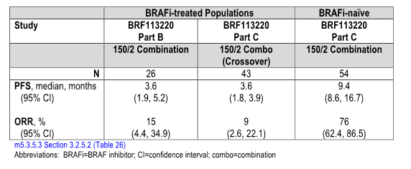
It is also noted that in the 43 patients who crossed over from dabrafenib monotherapy to the combination 150/2 the median PFS in the cross over phase was 3.6 months with a best confirmed ORR of 9%.
In Part B of the study, 26 patients who had previously been treated with a BRAF inhibitor and subsequently with the combination 150/2 showed similar results to the Part C cross-over patients with a median PFS of 3.6 months and a RR of 15%.

BRAF mutation sub-populations
It has previously been demonstrated with dabrafenib monotherapy that there are lower RR for patients with BRAF V600K mutations compared to those with the BRAF V600E mutation. It is of interest that in this Part C combination therapy evaluation there appeared to be similar benefit for both mutation sub-types. For the V600E patients the median PFS was 10 months for the 150/2 combination therapy compared with 6.5 months for the dabrafenib monotherapy while for the V600K patients in Part C the median PFS was 9.3 months for the 150/2 combination therapy compared with 4.3 months for the dabrafenib monotherapy ( P=0.0014). It is to be noted however that the number of patients in this V600K group was small, that is, seven. In Part B the median PFS of V600E patients in the combination group 150/2 was 10.8 months.
In relation to ORR for the Part C V600E patients the confirmed ORR was 77% for the combination 150/2 therapy group compared to 58% for the monotherapy group while for the V600k patients the ORR was 71% for the combination 150/2 compared to 33% in the dabrafenib monotherapy group.
In Parts B and D the confirmed ORRs of the V600E patients in the combination 150/2 group were 59% and 68% respectively. Although the number of patients with V600K mutation in Parts B and D were small, namely two and five, the ORRs were consistent with the Part C patients.
Evaluation of sub-populations in relation to pre-treatment characteristics demonstrated the magnitude of PFS improvement for the 150/2 combination therapy group relative to monotherapy was consistent with the ITT population across all sub-groups with an HR ranging from 0.19 to 0.63.
Comment: The data from Part C of the study shows statistically significant improvement in PFS for the 150/2 combination compared to the dabrafenib monotherapy with a 61% reduction in risk of tumour progression or death and a median PFS of 9.4 months compared to 5.8 months for monotherapy. It is noted the IRC also demonstrated similar degrees of significant benefit. However the investigator evaluation suggested a statistically significant benefit also for the 150/1 combination that was not confirmed by the IRC. There was also a statistically significant improvement in ORR in Part C patients with the 150/2 combination with an ORR of 76% compared to 54% for the dabrafenib monotherapy group. Again no such benefit was seen for the 150/1 combination. Data for duration of response also confirmed this benefit. Nevertheless the OS data remains immature.
While this data shows promise in that the median PFS for the combination represents an advance on that seen for dabrafenib monotherapy in the randomised study as well as improvement compared to the trametinib monotherapy from the studies discussed above there remain a number of concerns regarding the studies.
The number of patients involved in the trials still remains relatively small with only 54 patients receiving the combination and a similar number in the monotherapy group. Further the design of the study involved a number of amendments to ultimately provide a randomised evaluation. Appropriately the study is classified as a Phase II trial and in this instance the comparative data between the combination and monotherapy remains inconclusive. The follow up durations for the study are also relatively short and nearly 50% of patients still remain on treatment and more than 50% in follow up. Accordingly the level of benefit for the combination remains uncertain.

Safety
Safety evaluation for this submission comes from the Study BRF113220 which involved those patients receiving treatment with the combination of dabrafenib 150 mg and trametinib 2 mg and involved 202 patients with BRAF mutation-positive melanoma from Part B, C and D of Study BRF113220. These data were compared with the trametinib monotherapy material described in the earlier part of this evaluation involving the three studies MEK114267, MEK113583 and MEK111054, and 329 patients. Comparison was also made with the dabrafenib monotherapy safety update population involving 586 patients with melanoma treated with 150 mg BID of dabrafenib across five studies as indicated in Table 78. Accordingly the various safety populations involved in the evaluation are indicated in Table 79.
Table 78: Data cut-off dates for dabrafenib studies in 90-day safety update
Table 79: ISS safety populations and designations
AEs were reported by investigators on assessments every six weeks and documented according to standard criteria as well as NCI grading.
It is noted that the dabrafenib capsule shells changed from a gelatine to a HPMC capsule during clinical development and the potential impact of the increased exposure observed with the HPMC capsules compared to gelatine capsules in the safety profile of dabrafenib as monotherapy did not provide any evidence that the increased exposure observed with the HPMC capsule shell has a major impact on the dabrafenib safety profile. Aspects of this data will be presented in this section.

Overall exposure
The median time on study treatment with dabrafenib was longer for the Part C 150/2 group compared with the Part C dabrafenib monotherapy group and this is indicated in Table 80.
Table 80: Overall exposure
The median times on study treatment for the trametinib population and the dabrafenib population were about one half that for the Part C combined group but similar to the Part C dabrafenib monotherapy group. Accordingly the duration of exposure to both trametinib and dabrafenib in the combination is longer than for the single agents and indicates that the Part C 150/2 group represents the most appropriate group to assess the safety of the combination treatment. In the Part C 150/2 group the median daily dose of dabrafenib was 281.75 mg similar to the Part C dabrafenib monotherapy group at 295.91 mg and close to the targeted daily dose of 300 mg for both treatment groups. The median daily dose of trametinib 1.92 mg in the Part C 150/2 group is also close to the targeted daily doses of 2 mg.
As indicated in Table 81 all patients in the Part C 150/2 group had at least one AE and at least one drug-related AE. Most of these led to dose interruption and one half had AEs resulting in dose reduction. These data were greater than for the monotherapy treatment. The higher frequency of dose reductions and interruptions in the combination therapy group suggests a lower tolerability for combination therapy compared with each individual monotherapy.
Table 81: Overview of adverse events
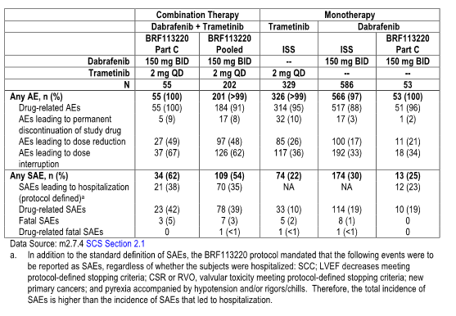

Common adverse events
Pyrexia, chills, fatigue, nausea and vomiting were the most common AEs involving more than 40% of patients in the Part C 150/2 group and is indicated in Table 82.
Table 82: AEs experiences by 10% or more of subjects in part C 150/2 group
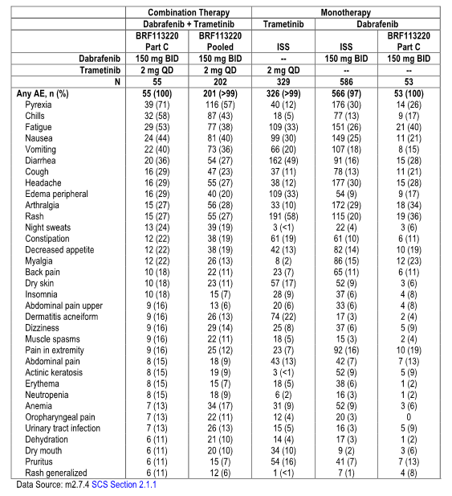
This profile was qualitatively similar to the monotherapy treatment, although occurring at a higher frequency. The incidence and severity of pyrexia and pyrexia related events were the most significant safety concern in relation to the combination therapy.
It is noted that in comparison to the trametinib safety population the incidence of rash and diarrhoea were lower in the Part C 150/2 group while the incidence of fatigue, nausea and vomiting were higher in the Part C 150/2 group. It is noted that in comparison to the dabrafenib safety population the incidence of hyperkeratosis, alopecia and skin papilloma were lower in the Part C 150/2 group while the incidence of pyrexia, fatigue and nausea were higher.
In relation to Grade III/IV events for the combination, pyrexia, neutropenia and back pain were the most common Grade III events involving 5% of patients, and neutropenia at 5% was the most common Grade IV event. These events were more frequent for the combination compared to either single agent.
Of the most common Grade III AEs for the trametinib safety population including Grade III hypertension this occurred at a lower frequency for the combination, that is, 9% versus 2% and Grade III rash at 7%, was not observed in the combination group. Of the most common Grade III AEs in the dabrafenib safety population, Grade III squamous cell carcinoma at 7% occurred in 4% of patients in the combination group. Grade III hypophosphatemia at 4% was not observed in the Part C 150/2 group or in the Part C dabrafenib monotherapy group. This is indicated in Table 83 (page 97 of 112).

Adverse events by causality
Pyrexia, fatigue, chills, vomiting, nausea and diarrhoea were the most common drug-related AEs by investigator-assessment involving at least 30% of patients in the Part C 150/2 group. Other events occurring in at least 20% of patients in this group were arthralgia, night sweats, rash, myalgia and peripheral oedema. There was a higher frequency of these events compared to individual drugs with exceptions of rash, diarrhoea and peripheral oedema. This data is indicated in Table 84.
Table 84: Drug-related adverse events experienced by ≥ 10% of subjects in any group (all treated or safety population)
As indicated in Table 85 (page 98 of 112) for the combination group disease progression was the cause of death in 11 of 14 patients or 80% who died. Three patients or 5% in the Part C 150/2 population and seven patients or 3% in the pooled 150/2 population died due to fatal AEs. Five patients or 2% in the trametinib population and eight patients in the dabrafenib safety population died due to fatal SAEs. All of these were not considered related to study drug with the exception of one event of ventricular arrhythmia which is considered related to both study drugs in a patient with a history of hypertension. This is indicated Table 86 (Page 99 of 112).

Table 83: Adverse events experienced by ≥10% of subjects in part C 150/2 with Grade 3 or Grade 4 events (all treated or safety population)
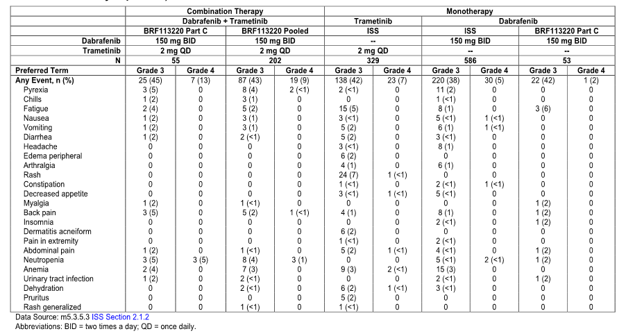
Table 85: Summary of deaths (all treated or safety population)
Table 86: Fatal serious adverse events (all treated or safety population)

Serious adverse events
In the Part C 150/2 treatment group SAEs were reported by 62% of patients, with pyrexia and chills being the most common and this is indicated in Table 87.
Table 87: Serious adverse events experienced by ≥ 2% of subjects in the Part C 150/2 group (all treated or safety population)
Approximately 11% of these patients required hospitalisation for SAEs of pyrexia.

Adverse events leading to dose reductions, interruptions or permanent discontinuation
In the Part C 150/2 treatment group 49% of patients experienced an AE requiring dose reduction of either or both drugs. This is indicated in Table 88. It is of some note that in this combination 50% of patients required dose reduction of dabrafenib although subsequent re-escalation of the dose occurred in 88%. Dose reductions of trametinib due to AEs were less frequent involving 12% of the patients of whom 21% subsequently re-escalated their dose.
Table 88: Adverse events leading to dose reduction of either study drug experienced by ≥ 2% of subjects in any group (all treated or safety population)
In the Part C 150/2 treatment group 67% of patients experienced AEs leading to dose interruptions of either or both study drugs and this is indicated in Table 89. Pyrexia at 42% and chills at 22% were the most common AEs leading to dose interruption.
Table 89: Adverse events leading to dose interruption of either study drug experienced by ≥ 2% of subjects in the Part C 150/2 group and two or more subjects in any other group (all treated or safety population)
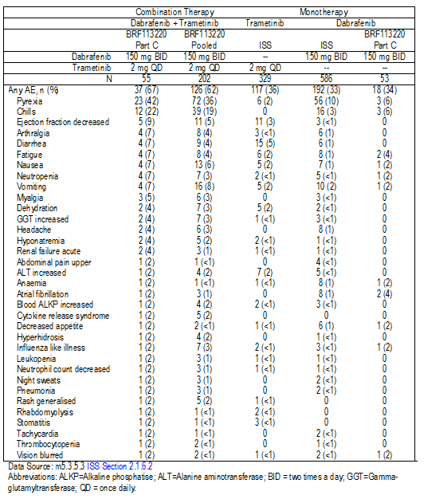
The frequency of AEs leading to dose interruption of either or both study drugs was higher in the Part C 150/2 group than the trametinib population and the dabrafenib population principally due to the higher frequency of pyrexia and chills in the combination.
In the Part C 150/2 treatment Group 5 patients or 9% discontinued study drug permanently due to an AE of which two of these discontinued due to pyrexia and is indicated in Table 90. It is noted that the frequency of AEs leading to permanent discontinuation of study drug was similar between the Part C 150/2 group at 9% and the trametinib safety population at 10% but higher than the dabrafenib safety population at 3%.
Table 90: Adverse events leading to permanent discontinuation of study drug experienced by ≥ 1% of subjects in any group (all treated or safety population)
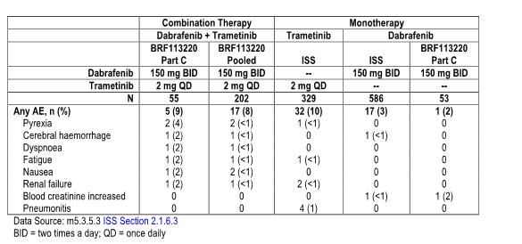

Adverse events of special interest
In general the overall profiles of AEs of special interest observed with the Part C 150/2 combination group and the pooled 150/2 population were consistent with the known profiles of each separate drug. The most noticeable differences were an increase in pyrexia and a decrease in skin-related toxicities with combination therapy relative to monotherapy and are illustrated in Table 91.
Table 91: Overview of AEs of special interest
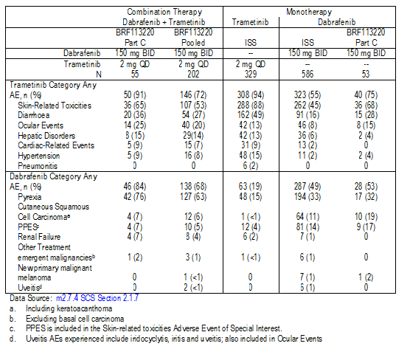
Overall the addition of dabrafenib to trametinib does not appear to increase the frequency or severity of cardiac-related AEs, hypertension, hepatic disorders, and diarrhoea and pneumonitis which previously were observed with trametinib monotherapy. Cardiac-related AEs occurred in 9% of patients in the Part C 150/2 group the same as for the trametinib safety population and the events were all decreased left ventricular ejection fraction (LVEF) of Grade I or II. The proportion of subjects reporting hypertension as an AE was 9% in the Part C 150/2 treatment group compared with 15% in the trametinib safety population. There were no SAEs, interruptions or reductions in the study drugs or discontinuation from study drug due to the AE of hypertension. Hepatic AEs occurred in 15% of the Part C 150/2 group compared to 13% of the trametinib safety population. Most of the events were elevations of ALT or AST. The proportion of patients in the Part C 150/2 group who experienced diarrhoea was 36% compared with 49% in the trametinib safety population. Pneumonitis was reported in 2% of patients in the trametinib safety population but not reported as an AE in any of the patients who received combination treatment in Study BRF113220.
The addition of trametinib to dabrafenib does not appear to increase the frequency or severity of hand/foot syndrome or treatment emergent malignancies previously described with dabrafenib monotherapy. The incidence of hand/foot syndrome was 14% in the dabrafenib safety population of which 1% were Grade III. Hand/foot syndrome was reported in 7% of patients in the Part C 150/2 group and all events were Grade I or II. In Study BRF113220 no confirmed events of new primary melanoma were reported in patients receiving combination therapy. Based on the limited data, no increase in the overall frequency of treatment emergent malignancies in the population of melanoma subjects receiving dabrafenib and trametinib treatment in Study BRF113220 as compared to the dabrafenib safety population was detected.
In the Part C 150/2 group 25% of patients experienced ocular events compared to 8% in the dabrafenib safety population and 13% in the trametinib safety population. Blurred vision, dry eye and visual impairment were the most common AEs in the 150/2 group. However no changes in the incidence rates of central serous retinopathy or RVO were observed due to combination treatment. The incidence of ocular events of uveitis, iritis or iridocyclitis reported for the combination treatment was 2% compared to 1% in the dabrafenib safety population. The severity of these inflammatory ocular events was slightly increased for combination treatment and the median time to resolution was longer.
In the Part C 150/2 group, four patients or 7% experienced renal failure. This was higher than the incidence of renal failure in both the dabrafenib safety population at less than 1% and the trametinib safety population at 2%. Most patients who presented with acute renal failure did so as a secondary event in the setting of pyrexia with dehydration appeared to be a contributing factor in concert with other risk factors such as haemolytic uremic syndrome, antibiotic toxicity or hypercalcaemia. No patient experienced renal failure that was fatal but one patient discontinued treatment due to renal failure.
It is noted that some AEs associated with trametinib were actually decreased with the combination including skin-related toxicity occurring in 65% of patients on the combination compared to 88% for the trametinib safety population. The most regular of these occurring in greater than 10% of patients were rash, dermatitis, acneiform, erythema and generalised rash.

Pyrexia
Pyrexia and pyrexia related events are commonly noted AEs associated with BRAF inhibitors and have occurred in 33% of patients on dabrafenib monotherapy. It is noted that the incidence and severity of this has been significantly increased in combination with trametinib and in the Part C 150/2 group, 76% of patients experienced pyrexia related AEs. Most of these could be managed with standard anti-pyretics although recurrent fever may require steroid therapy and or dose interruption or dose reduction. There did not appear to be a clear relation to trametinib dose. This was generally an early event and with approximately 80% of patients experiencing their first occurrence within the first 16 weeks of combination therapy. One third of patients experienced three or more occurrences of the pyrexia. The incidence of Grade III or IV events were similar to that observed with dabrafenib monotherapy however there was an increased incidence of SAEs, including hospitalisations with combination therapy relative to dabrafenib monotherapy.
Both dose interruptions and dose reductions were common, occurring in approximately 50% of the patients in the combination group. Permanent discontinuation of study medication was required in 5% of patients. It is noted that the majority of patients, that is, greater than 80% with dose reduced dabrafenib due to AEs were able to be dose re-escalated.
Complications of the pyrexia included hypotension, dehydration, severe rigors/chills or renal failure. This occurred with an incidence of 2.7% compared to a 1% identified incidence for dabrafenib monotherapy.

Cutaneous squamous cell carcinoma
Occurrence of hyperproliferative skin lesions including keratoacanthomas (KA) and cutaneous squamous cell carcinoma (SCC) are considered as a class effect of BRAF inhibitors and have been observed in up to 24% of patients treated with vemurafenib. In the Part C 150/2 treatment group KA or cutaneous SCC were reported in 7% of patients and the majority of these cases the event was Grade III. This is indicated in Table 92.
Table 92: Summary of KA and cutaneous SCC by toxicity Grades 3 or 4 or any grade
The incidence of KA and SCC was higher in the dabrafenib safety population at 11% and the Part C dabrafenib monotherapy group at 19%. The median time to onset of the first occurrence of KA or SCC in the Part C 150/2 group was 152 days. This was longer than the eight to 12 weeks reported for other BRAF inhibitor monotherapy.
These data therefore suggest the occurrence of SCC may be reduced or delayed by the dabrafenib/trametinib combination treatment.
Analysis of factors such as age and gender did not reveal any differences within age groups or between genders.

Dabrafenib capsule shell type
As previously noted, the dabrafenib capsule shell was changed from gelatine to the HPMC capsule during clinical development. During Study BRF113220 patients receiving dabrafenib for the Part B and C components of study received the gelatine capsules where as those in the Part D component received the HPMC capsules allowing for some evaluation of safety data between the two groups. It is noted that the median time on treatment for patients on Part C was 10.9 months while the median times on treatment for patients in Part B and D were 11.5 and 6.2 months respectively.
When compared with the AEs reported in the two treatment groups treated with gelatine capsules in Part B and C versus the HPMC capsules in Part D there was no evidence of a higher frequency of AEs leading to treatment interruption, dose reduction or dose discontinuation of therapy and is indicated in Table 93.
Table 93: AEs overview by dabrafenib capsule shell type (BRF113220 safety population)
Similarly the frequency of SAEs remains the same across the three treatment groups and fatal SEAs were only reported in the two treatment groups in which the patients received gelatine capsules.
Most of the common AEs reported a higher frequency in at least one of the two gelatine treatment groups compared to the HPMC group as indicated in Table 94. The rate of pyrexia AEs appears to be lower in the Part D treatment group although this may reflect initial time on treatment.
Table 94: AEs reported by > 20% of subjects in any study part
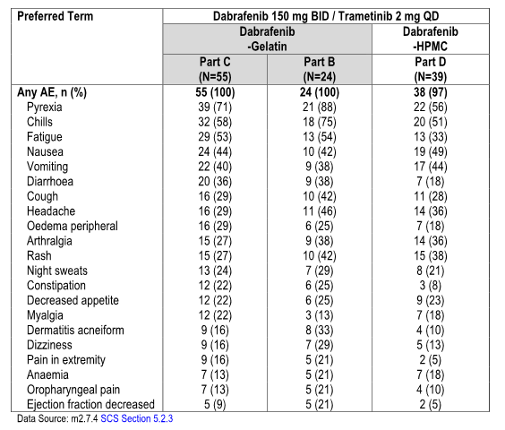
Comment: These combination data reflect essentially a similar safety profile to the monotherapies making up the combination, namely dabrafenib/trametinib. Nevertheless certain toxicities occurred with a higher frequency most particularly pyrexia and to a lesser extent fatigue and nausea occurred at a higher frequency relative to dabrafenib and there was a higher incidence of fatigue, nausea and vomiting relative to trametinib monotherapy. There was however an apparent lower incidence of certain skin-related toxicities particularly KA and SCC.
The most severe toxicity encountered was pyrexia requiring intensive intervention, both dose interruption and dose reduction were required in approximately 50% of patients and 5% of patients had to permanently discontinue therapy.
Accordingly although it is reasonable to indicate that in general terms monitoring, prophylaxis and early management of this AE profile for the combination would allow for its routine clinical use there needs to be an understanding that the toxicity profile for this combination is not insignificant.
With regards to the two capsule formulations for dabrafenib the available safety data indicated the increased exposure observed with the HPMC capsule shell has no significant impact on the combination safety profile compared to the gelatine capsules. Nevertheless it should be noted that this safety data were generated in three small treatment groups and were indirectly compared with differences in length of drug exposure.

First round benefit risk-assessment

First round assessment of benefit
Rationale for the development of the combination therapy and Study BRF113220 came from the fact that there was evidence that the active agents BRAF inhibitors particularly vemurafenib and dabrafenib and the MEK inhibitor trametinib while demonstrating worthwhile RRs and improvements in PFS were limited by the ultimate development of drug resistance and progression of disease generally within five to seven months of starting treatment. It is considered the combination of the two drugs with different mechanisms of action may result in improvement in outcomes.
Accordingly Study BRF113220 was designed involving four parts with Part A being essentially a PK evaluation in eight patients, Part B a dose escalation phase involving a total of 80 patients including 39 treated at the MTD 150mg dabrafenib twice daily and 2 mg trametinib daily. Part C was the randomised open label three arm study of the combination in 162 patients in which 54 patients were randomised to each of three arms including the combination 150/2 and the combination 150/1 and dabrafenib monotherapy at 150 mg BID. Part D involved evaluation of the HPMC capsule in a comparison of PK and safety to the older gelatine capsules. The principal area for determination of efficacy relates to Part C in which there is a significant improvement in PFS for the combination versus dabrafenib with an HR of 0.39 (p<0.0001) with an estimated median PFS for the combination 150/2 at 9.4 months compared to 5.8 months for the monotherapy and estimated PFS at 12 months of 41% for the 150/2 combination compared to 9% for the monotherapy. Independent review of these data confirmed the improvement and PFS. It is noted however that while the investigator assessment suggested significant improvement for the 150/1 combination with a significant advantage for PFS over monotherapy this was not determined by the independent review analysis. Overall, RRs also showed a significant improvement for the 150/2 combination at 76% including a 9% complete remission rate compared to a 54% ORR for the monotherapy with a 4% complete RR (P=0.0264). A significant benefit in ORR was not observed for the 150/1 combination.
It is worth noting that these impressive results particularly relate to the V600E mutation-positive population as although there were also advantages for the V600K mutation-positive population the numbers involved were small involving only seven patients.
These data therefore have certainly suggested a further benefit for the dabrafenib/trametinib combination over either monotherapy alone or other BRAF inhibitors and the antibody iplumibab. There are however several concerns with regards to this study namely the overall small number of patients in each arm of the study; the fact that the study was Phase II in type rather than Phase III and that much of the study design involved various adjustments prior to initiation of the study. There remained a significant proportion of patients still on treatment; 47% and 50% of the patients remain on study. The duration of follow up remains relatively short preventing any assessment at this time of OS.

First round assessment of risks
The safety profile provided in this evaluation essentially comes from that associated with Part C of Study BRF113220. The safety profile appears to be generally consistent with that to be expected in relation to the individual drugs involved in the combination although several of these toxicities were of a somewhat greater incidence than the monotherapy. This resulted in a higher incidence of dose reduction and dose interruption compared to monotherapy. Pyrexia related events were the largest contributor to this with 76% of patients experiencing pyrexia related events and 33% Grade III in severity. This resulted in an increased incidence of SAEs, hospitalisations, dose interruptions and 5% of patients requiring permanent discontinuation of study medication.
Despite this somewhat greater incidence of AEs it is recognised with appropriate monitoring, prophylaxis and early intervention this could generally be managed adequately.
It is noteworthy that the incidence and severity of other more significant AEs associated with the monotherapy including cardiac-related AEs, hypertension, hepatic disorders, diarrhoea and pneumonitis were not greater than for the individual drugs.
It is also noted that the safety data indicated the increased exposure observed with the dabrafenib HPMC capsule shell has no significant impact on the combination safety profile compared to the dabrafenib gelatine capsules so that doses utilised with the gelatine capsule can be reasonably transferred to HPMC dabrafenib capsule dosage.

First round assessment of benefit/risk balance
While the apparent benefits observed in the Study BRF113220 are impressive when compared with the monotherapy and suggest a further advance in therapies of potential value for advanced stage/metastatic KRAS mutation-positive melanoma there are sufficient deficiencies in the data as indicated above to maintain uncertainty as to this level of benefit.
It is noted that there are two major ongoing Phase III studies including Study MEK115306 which is a double blind randomised Phase III study comparing the dabrafenib/trametinib combination therapy at the 150 mg/2 mg dosage to dabrafenib administered with a trametinib placebo. Study MEK116513 is an open label randomised Phase III study comparing dabrafenib/trametinib combination therapy at the 150 mg/2 mg dosage with vemurafenib at 960 mg BID. These two studies should provide major supportive evidence in relation to the efficacy and safety of the combination. It is worth noting that the risk profile for the combination whilst somewhat greater than for the individual agents with appropriate monitoring, prophylaxis and early intervention should remain manageable providing the levels of efficacy presently indicated are confirmed.

First round recommendation regarding authorisation
The proposed indication in this submission is for marketing approval of Mekinist as a monotherapy and in combination with dabrafenib for the treatment of patients with BRAF V600 mutation positive unresectable or metastatic Stage IV melanoma.
Mekinist as monotherapy has not demonstrated clinical activity in patients who have progressed on a prior BRAF inhibitor therapy.
This investigator maintains concerns with regard to the proposed indication in relation to monotherapy. While the data appears strong in relation to patients with BRAF V600E mutation-positive melanoma and therefore supportive of approval, the data in relation to BRAF V600K mutation-positive melanoma remains somewhat weak without evidence of response advantage or significant PFS advantage for the trametinib monotherapy when compared to chemotherapy.
In relation to the proposed combination as part of the indication as discussed above there are several areas of ongoing concern with regard to the submitted material and its adequacy to be confident of the apparent considerable improvement in further benefit for the dabrafenib/trametinib combination.
While this reviewer considers it very likely that these aspects will be resolved and remains supportive of trametinib for all patients with BRAF V600 mutation-positive unresectable metastatic melanoma and also the combination for the same proposed indication, it would seem prudent to await the results of the outstanding Phase III trials before authorisation.

Clinical questions
- Further data is requested in regard to evidence of the level of benefit of trametinib in the treatment of patients with V600K mutation-positive advanced stage metastatic melanoma.
- Further follow up for Study BRF113220 is requested.
- Data from the outcomes of the two ongoing randomised studies, 115306 and 116513, are requested.

Pharmacokinetics
NA

Pharmacodynamics
NA

Efficacy
NA

Safety
NA

Therapeutic Goods Administration
PO Box 100 Woden ACT 2606 Australia
Email: info@tga.gov.au Phone: 1800 020 653 Fax: 02 6232 8605
http://www.tga.gov.au

In cardiology the QT interval is a measure of the time between the start of the Q wave and the end of the T wave in the heart’s electrical cycle.
The Eastern Cooperative Oncology Group (ECOG) score (published by Oken et al. in 1982), runs from 0 to 5, with 0 denoting perfect health and 5 death.

