May 2021

Australian Public Assessment Report for Trabectedin
  - Proprietary Product Name: Yondelis
  - Sponsor: Specialised Therapeutics Pharma Pty Ltd

About the Therapeutic Goods Administration (TGA)
- The Therapeutic Goods Administration (TGA) is part of the Australian Government Department of Health and is responsible for regulating medicines and medical devices.
- The TGA administers the Therapeutic Goods Act 1989 (the Act), applying a risk management approach designed to ensure therapeutic goods supplied in Australia meet acceptable standards of quality, safety and efficacy (performance) when necessary.
- The work of the TGA is based on applying scientific and clinical expertise to decision-making, to ensure that the benefits to consumers outweigh any risks associated with the use of medicines and medical devices.
- The TGA relies on the public, healthcare professionals and industry to report problems with medicines or medical devices. TGA investigates reports received by it to determine any necessary regulatory action.
- To report a problem with a medicine or medical device, please see the information on the TGA website <https://www.tga.gov.au>.

About AusPARs
- An Australian Public Assessment Report (AusPAR) provides information about the evaluation of a prescription medicine and the considerations that led the TGA to approve or not approve a prescription medicine submission.
- AusPARs are prepared and published by the TGA.
- An AusPAR is prepared for submissions that relate to new chemical entities, generic medicines, major variations and extensions of indications.
- An AusPAR is a static document; it provides information that relates to a submission at a particular point in time.
- A new AusPAR will be developed to reflect changes to indications and/or major variations to a prescription medicine subject to evaluation by the TGA.

Copyright
© Commonwealth of Australia 2021
This work is copyright. You may reproduce the whole or part of this work in unaltered form for your own personal use or, if you are part of an organisation, for internal use within your organisation, but only if you or your organisation do not use the reproduction for any commercial purpose and retain this copyright notice and all disclaimer notices as part of that reproduction. Apart from rights to use as permitted by the Copyright Act 1968 or allowed by this copyright notice, all other rights are reserved and you are not allowed to reproduce the whole or any part of this work in any way (electronic or otherwise) without first being given specific written permission from the Commonwealth to do so. Requests and inquiries concerning reproduction and rights are to be sent to the TGA Copyright Officer, Therapeutic Goods Administration, PO Box 100, Woden ACT 2606 or emailed to <tga.copyright@tga.gov.au>.

Contents
List of abbreviations 4
I. Introduction to product submission 6
Submission details 6
Product background 7
Regulatory status 9
Product Information 10
II. Registration timeline 10
III. Submission overview and risk/benefit assessment 11
Quality 11
Nonclinical 12
Clinical 12
Risk management plan 21
Risk-benefit analysis 23
Outcome 24
Attachment 1. Product Information 25

List of abbreviations
Abbreviation | Meaning
ACM | Advisory Committee on Medicines
AE | Adverse event
AIHW | Australian Institute of Health and Welfare
AJCC | American Joint Committee on Cancer
ALT | Alanine aminotransferase
AML | Acute myeloid leukaemia
ARTG | Australian Register of Therapeutic Goods
ASA | Australian specific annex
AST | Aspartate aminotransferase
AUC | Area under the time versus concentration curve
AusPAR | Australian Public Assessment Report
BIRC | Blinded independent review committee
CI | Confidence interval
CMI | Consumer Medicine Information
CPK | Creatine phosphokinase
CR | Complete response
CYP | Cytochrome P450 enzyme
DLP | Data lock point
DNA | Deoxyribonucleic acid
DOR | Duration of response
ECOG | Eastern Cooperative Oncology Group
EMA | European Medicines Agency (European Union)
ESMO | European Society of Medical Oncology
EU | European Union
FDA | Food and Drug Administration (United States)
GI | Gastrointestinal
GIST | Gastrointestinal stromal tumour
GVP | Good pharmacovigilance practices
HR | Hazard ratio
IV | Intravenous(ly)
LMS | Leiomyosarcoma
LPS | Liposarcoma
MDS | Myelodysplasia
NCCN | National Comprehensive Cancer Network (United States)
ORR | Objective response rate
OS | Overall survival
PD | Pharmacodynamic(s)
PFS | Progression free survival
PI | Product Information
PK | Pharmacokinetic(s)
PR | Partial response
PS | Performance status
PSUR | Periodic safety update report
RECIST | Response Evaluation Criteria In Solid Tumours
RMP | Risk management plan
STS | Soft tissue sarcoma
TGA | Therapeutic Goods Administration
US(A) | United States (of America)

I. Introduction to product submission

Submission details
Type of submission: | New chemical entity
Product name: | Yondelis
Active ingredient: | Trabectedin
Decision: | Approved
Date of decision: | 21 April 2021
Date of entry onto ARTG: | 22 April 2021
ARTG numbers: | 332000, 332001
Black Triangle Scheme: | Yes  This product will remain in the scheme for 5 years, starting on the date the product is first supplied in Australia.
Sponsor’s name and address: | Specialised Therapeutics Pharma Pty Ltd  Level 2, 17 Cotham Road,  Kew, VIC, 3101
Dose form: | Powder for solution for infusion
Strengths: | 0.25 mg and 1 mg
Container: | Vial
Pack size: | One
Approved therapeutic use: | Yondelis is indicated for the treatment of patients with unresectable or metastatic liposarcoma or leiomyosarcoma who received a prior anthracycline-containing regimen
Route of administration: | Intravenous infusion
Dosage: | Yondelis must be administered under the supervision of a physician experienced in the use of chemotherapy. Its use should be confined to qualified oncologists or other health professionals specialised in the administration of cytotoxic agents.  The recommended dose is 1.5 mg/m² body surface area, administered as an intravenous infusion over 24 hours with a three week interval between cycles.  All patients must receive corticosteroids for example, 20 mg of dexamethasone intravenously 30 minutes prior to Yondelis, not only as anti-emetic prophylaxis, but also because it appears to provide hepatoprotective effects. Additional anti-emetics may be administered as needed.  For further information regarding dosage, refer to the Product Information.
Pregnancy category: | D  Drugs which have caused, are suspected to have caused or may be expected to cause, an increased incidence of human fetal malformations or irreversible damage. These drugs may also have adverse pharmacological effects. Accompanying texts should be consulted for further details.  The use of any medicine during pregnancy requires careful consideration of both risks and benefits by the treating health professional. This must not be used as the sole basis of decision making in the use of medicines during pregnancy. The TGA does not provide advice on the use of medicines in pregnancy for specific cases. More information is available from obstetric drug information services in your State or Territory.

Product background
This AusPAR describes the application by Specialised Therapeutics Pharma Pty Ltd (the sponsor) to register Yondelis (trabectedin) 0.25 mg and 1 mg, powder for solution for infusion for the following proposed indication:
Yondelis is indicated for the treatment of patients with unresectable or metastatic liposarcoma or leiomyosarcoma who received a prior anthracycline-containing regimen.
Leiomyosarcoma and liposarcoma are subtypes of soft tissue sarcoma; a heterogeneous group of malignant tumours arising in tissues derived from the embryonic mesoderm.
There are over fifty different histological subtypes, each with their own clinical behaviour and response to systemic therapy.
Soft tissue sarcoma (STS) can develop anywhere in the body, but most common primary sites are the extremities (43%), the trunk (10%), visceral (19%), retroperitoneum (15%) and head and neck (9%). The tumours usually present as a painless slowly enlarging mass.,
Soft tissue sarcoma are rare, comprising about 1% of all malignancies in adults and between 7% to 15% of paediatric cancers.3,, According to the Australian Institute of Health and Welfare (AIHW), the incidence of STS in Australia in 2014 was 1,527 cases, with 855 in males and 672 in females.
The most commonly used system for grading and staging of STS is that produced by the American Joint Committee on Cancer (AJCC). There are separate AJCC staging systems for STS of the head neck, visceral STS and gastrointestinal stromal tumours (GIST). Peripheral STS most commonly metastasise to the lungs while those arising in the abdomen commonly spread to the liver and peritoneum. Locally advanced STS has a five year survival rate of approximately 57%. The prognosis for metastatic disease is poor with a five year survival rate of only 16%;⁶ and a median survival of 14 to 17 months.
Adverse prognostic factors in subjects with STS include large tumour size, high grade, advanced stage, older age, poor performance status, liver involvement and histological subtype.3,
Leiomyosarcoma (LMS) is the most common subtype of STS, accounting for approximately 20 to 25% of all newly diagnosed cases. Common sites for LMS include the abdomen, retroperitoneum, larger blood vessels, and the uterus. It is less common in the extremities compared with other STS subtypes, accounting for 10% to 15% of limb sarcomas.
Liposarcoma (LPS) accounts for approximately 10 to 15% of cases of STS. Typical sites of origin include the extremities and retroperitoneum.
The incidence of both LMS and LPS increases with age. Both are uncommon in children with liposarcoma accounting for 3%, and leiomyosarcoma 2%, of soft tissue sarcoma in patients younger than 20 years.4
Although there are a large number of subtypes of STS, recommended treatment is similar for many of them. A number of current clinical practice guidelines provide evidence based recommendations regarding appropriate treatment of STS in adults. These include guidelines produced by:
- the National Comprehensive Cancer Network (NCCN) in the United States of America (USA);4
- the Cancer Council of Australia in collaboration with the Australia and New Zealand Sarcoma Association; and
- the European Society of Medical Oncology (ESMO).
The mainstay of treatment for STS is surgery. Radiotherapy improves local control in subjects with resectable disease and can be used alone in subjects in whom surgery is considered inappropriate.2,3 Systemic chemotherapy is used in subjects with unresectable disease.
In Australia, agents registered for the treatment of STS include various grandfathered agents such as doxorubicin, epirubicin, ifosfamide and dacarbazine. These agents all have a broad STS indication, not restricted by line of therapy or histological subtype. The tyrosine kinase inhibitor pazopanib; is registered for use as second or later line therapy of STS, excluding GIST and liposarcomas. Eribulin;is registered for the treatment of patients with unresectable liposarcoma who have received prior chemotherapy for advanced or metastatic disease.

Regulatory status
This product is considered a new chemical entity for Australian regulatory purposes.
At the time the TGA considered this application, similar applications had been approved in the USA on 23 October 2015, in the European Union (EU) on 17 September 2007, in Canada on 5 August 2010, Singapore on 19 June 2009 and Switzerland on 4 February 2009.
Table 1: International regulatory status
Region | Status | Approved indications
USA | Approved on 23 October 2015 | Yondelis is an alkylating drug indicated for the treatment of patients with unresectable or metastatic liposarcoma or leiomyosarcoma who received a prior anthracycline-containing regimen.
EU via European Medicine Agency (EMA) | Approved on 17 September 2007 | Yondelis is indicated for the treatment of adult patients with advanced soft tissue sarcoma, after failure of anthracyclines and ifosfamide, or who are unsuited to receive these agents.
Canada | Approved on 5 August 2010 | Yondelis (trabectedin) is indicated for the treatment of patients with metastatic liposarcoma or leiomyosarcoma after failure of prior anthracycline and ifosfamide chemotherapy.
Singapore | Approved on 19 June 2009 | Yondelis is indicated for the treatment of patients with advanced or metastatic liposarcoma or leiomyosarcoma, after failure of anthracyclines and ifosfamide, or who are unsuited to receive these agents.
Switzerland | Approved on 4 February 2009 | Advanced or metastatic soft tissue sarcoma

Product Information
The Product Information (PI) approved with the submission which is described in this AusPAR can be found as Attachment 1. For the most recent PI, please refer to the TGA website at <https://www.tga.gov.au/product-information-pi>.

II. Registration timeline
The following table captures the key steps and dates for this application and which are detailed and discussed in this AusPAR.
Table 2: Timeline for Submission PM-2020-01313-1-4
Description | Date
Designation (Orphan) | 21 January 2020
Submission dossier accepted and first round evaluation commenced | 30 April 2020
First round evaluation completed | 30 September 2020
Sponsor provides responses on questions raised in first round evaluation | 30 November 2020
Second round evaluation completed | 12 January 2021
Delegate’s Overall benefit-risk assessment | 12 April 2021
Sponsor’s pre-Advisory Committee response | Not applicable
Advisory Committee meeting | Not applicable
Registration decision (Outcome) | 21 April 2021
Completion of administrative activities and registration on the ARTG | 22 April 2021
Number of working days from submission dossier acceptance to registration decision* | 193
*Statutory timeframe for standard applications is 255 working days

III. Submission overview and risk/benefit assessment
The submission was summarised in the following Delegate’s overview and recommendations.

Quality
The application and the supporting data relating to the composition, development, manufacture, quality control and stability of the product have been assessed and checked for compliance, as applicable, with Australian legislation and requirements for new medicines and in accordance with pharmacopoeial standards and the technical guidelines adopted by the TGA. The quality evaluator has recommended approval to marketing to trabectedin.
Trabectedin is composed of three tetrahydroisoquinoline moieties, eight rings including one ten-membered heterocycle lactone bridge ring containing a cysteine residue and seven chiral centres. The synthetic trabectedin used in the proposed product is a single enantiomer (see Figure 1). The structure is well characterised.
Figure 1: Chemical structure of trabectedin
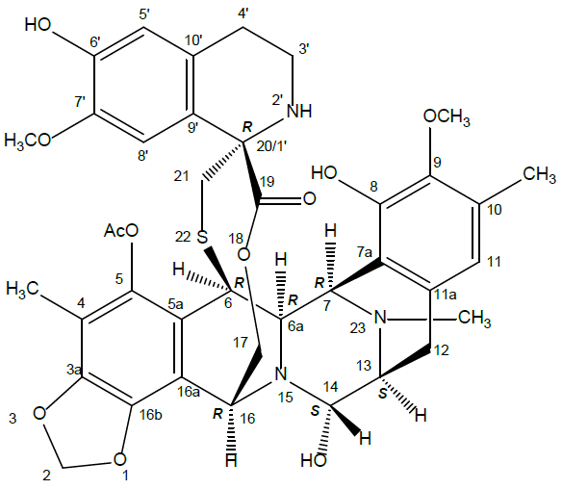

Nonclinical
Trabectedin was shown to be active against STS cells including liposarcoma and leiomyosarcoma in vitro and various sarcoma xenografts in vivo, although this was not comprehensively investigated and concentrations or doses required for appreciable activity were relatively high.
Doses that could be used in the toxicity studies were limited by excessive toxicity and mortalities, and drug exposures based on the area under the time versusconcentration curve (AUC) in plasma were generally below that expected during therapy with the recommended dose. This is, however, often the case with cytotoxic anti-neoplastic drugs and should not preclude approval of registration. Although individual repeated dose studies in cynomolgus monkeys were not ideal, taken together they were adequate to indicate potential toxicity in this species. Results combined with those in rats, revealed major toxicities occurred in the liver, bone marrow, gastrointestinal (GI) tract and infusion site.
Except for the GI tract, the above toxicities are specifically mentioned in the proposed Product Information (PI) and the extent to which these are acceptable given the proposed indications will depend on evaluation of the clinical data and their inclusion in a proposed risk management plan.
Renal toxicity was prominent in cynomolgus monkeys but not rats, and was considered by the investigators to be secondary to infusion site reactions which were often marked and involved surrounding tissues. While this is a probable cause, it would be difficult to exclude a potential for direct nephrotoxicity. This should receive attention by the clinical evaluator. This also applies to retinal oedema, which was noted at ophthalmic examination in one cynomolgus monkey study following six to eight cycles of treatment. While this finding appeared to be incidental or secondary to other toxicity, the ophthalmologist noted that it may possibly represent a sign of retinal toxicity, although there were no corresponding histological findings. While both these observations are included in the proposed risk management plan, a review of clinical and post-marketing data reported no relevant clinical findings for retinal toxicity.
Overall, there are no nonclinical objections to this application for registration, provided adverse effects in patients are manageable.

Clinical
The clinical dossier consisted of the following:
- one pivotal study (Study ET743-SAR-3007), Phase III, open label, randomised, controlled trial comparing trabectedin with dacarbazine in subjects with LMS or LPS
- twelve Phase II studies in subjects with STS
- one Phase III studies in subjects with other oncology indications
- nineteen Phase II studies in subjects with other oncology indications
- fifteen pharmacokinetics (PK) studies and one pharmacodynamics (PD) study
- one pooled PK analysis in children
- eleven Phase I dose finding studies
- three population PK studies
- two population PK/PD studies
- various reports on post-marketing safety data
- an integrated summary of safety data which provided tabulations of safety data from Phase II and Phase III studies
- literature references.

Pharmacology
Trabectedin is an alkylating drug that binds guanine residues in the minor groove of deoxyribonucleic acid (DNA), forming adducts and resulting in a bending of the DNA helix towards the major groove. Adduct formation triggers a cascade of events that can affect the subsequent activity of DNA binding proteins, including some transcription factors, and DNA repair pathways, resulting in perturbation of the cell cycle and eventual cell death.

Pharmacokinetics
The pharmacokinetics of trabectedin is characterised by a rapid decline phase at the end of the infusion and slower exponential phases. Population pharmacokinetic analyses suggest that the pharmacokinetics of trabectedin is dose proportional (over the dose range of 0.024 to 1.8 mg/m²) and exposure is time independent. No accumulation of trabectedin in plasma is observed upon repeated administrations every three weeks.

Distribution
Binding of trabectedin to human plasma proteins was approximately 97%, independent of trabectedin concentrations ranging from 10 ng/mL to 100 ng/mL. Steady state volume of distribution of trabectedin exceeds 5000 L.

Elimination
The estimated mean (% coefficient of variation) clearance of trabectedin is 31.5 L/hr (50%) and the terminal elimination half-life is approximately 175 hours.

Metabolism
CYP3A is the predominant cytochrome P450 (CYP) enzyme; responsible for the hepatic metabolism of trabectedin. Trabectedin was extensively metabolised with negligible unchanged drug in urine and faeces following administration of trabectedin to humans.

Excretion
In patients with solid tumours, following a three hour or a 24 hour intravenous infusion of [¹⁴C]-labelled trabectedin, 64% of the total administered radioactive dose was recovered in 24 days, with 58% in faeces and 6% in urine.

Efficacy
The main evidence for efficacy comes from the Phase III Study ET743-SAR-3007. Study ET743-SAR-3007 is a randomised (2:1), open label, active controlled trial comparing the safety and efficacy of trabectedin to dacarbazine in patients with unresectable or metastatic L-type sarcoma who had received prior anthracycline containing systemic therapy. Supportive evidence for efficacy in LMS and LPS comes from Study ET743- STS- 201, a Phase II dose finding study.
In Study ET743-SAR-3007, patients were randomised to trabectedin 1.5 mg/m² as a 24 hour intravenous (IV) infusion once every 3 weeks or dacarbazine 1000 mg/m² as an IV infusion (20 to 120 minutes) once every 3 weeks. All patients in the trabectedin arm received dexamethasone 20 mg IV bolus prior to each dose to mitigate the risks of Grade 3 and 4 toxicities, including hepatotoxicity. Patients in the dacarbazine arm were not offered trabectedin at the time of disease progression.
Randomisation was stratified by:
- L-sarcoma subtype (liposarcoma (LPS) versus Leiomyosarcoma (LMS));
- Eastern Cooperative Oncology Group (ECOG) Performance status (PS; 0 versus 1);
- number of prior chemotherapy regimens (1 versus ≥ 2).
The major efficacy outcomes were investigator-assessed progression free survival (PFS) according to the response evaluation criteria in solid tumours (RECIST) 1.1, overall survival (OS), objective response rate (ORR), and duration of response (DOR).
Investigators assessed tumour response by radiographic imaging of the chest, abdomen, and pelvis every six weeks for the first 36 weeks on study and every nine weeks thereafter until disease progression, subsequent anticancer therapy, or patient death occurred.
The study was designed to have more than 90% power to detect a hazard ratio (HR) of 0.667 with a two-sided alpha of 0.05, assuming a median PFS of 2.5 months for the dacarbazine arm and 3.75 months for the trabectedin arm.
The original primary endpoint for Study E743-SAR-3007 was OS. However, following the US Food and Drug Administration (FDA) approval of pazopanib based on an improvement in PFS and prior to the data cut off data for the PFS analysis in Study E743-SAR-3007, the US-sponsor made a proposal to the US FDA, to which the FDA agreed, to consider the results of mature PFS and results of the ORR as a basis for possible accelerated approval for trabectedin. The US-sponsoralso agreed to conduct a blinded-independent review (blinded independent review committee (BIRC)) of PFS and ORR in retrospective audit in an agreed upon subset (high accruing sites) as a supportive analysis and to evaluate for potential ascertainment bias as the first stage of the Dodd two-stage plan (See Figure 2 and Table 3).
Figure 2: Study E743-SAR-3007 Consort diagram
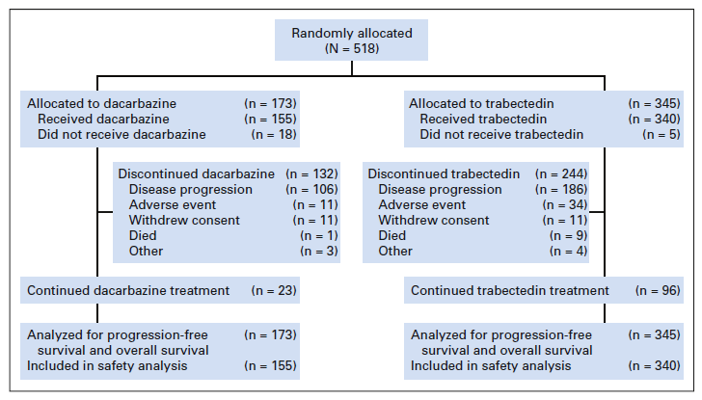
Table 3: Study E743-SAR-3007 Baseline demographic and disease characteristics
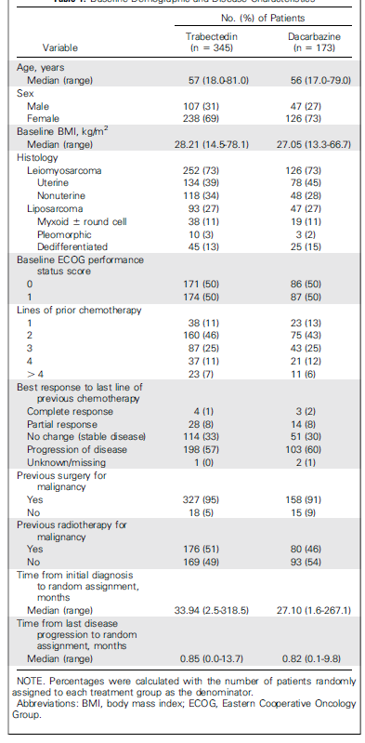
A total of 518 patients were randomised, 345 to the trabectedin arm and 173 patients to the dacarbazine arm. The median patient age was 56 years (range: 17 to 81 years old); 30% were male; 76% were White, 12% Black, and 4% Asian; 73% had leiomyosarcomas and 27% liposarcomas; 49% had an ECOG PS of 0; and 89% received ≥ 2 prior chemotherapy regimens. The most common (≥ 20%) pre-study chemotherapeutic agents administered were doxorubicin (90%), gemcitabine (81%), docetaxel (74%), and ifosfamide (59%). Approximately 10% of patients had received pazopanib (see Table 3)
Study ET743-SAR-3007 demonstrated a statistically significant improvement in PFS (HR = 0.55 (95% confidence interval (CI): 0.44 to 0.70); p < 0.001). Median PFS was increased from 1.5 months with dacarbazine to 4.2 months with trabectedin. An exploratory analysis of independent radiology committee determined PFS, in a subgroup consisting of approximately 60% of the total population, provided similar results to the investigator determined PFS. Efficacy results from Study ET743-SAR-3007 are presented in Table 4 below.
Table 4: Study ET743-SAR-3007 Efficacy results
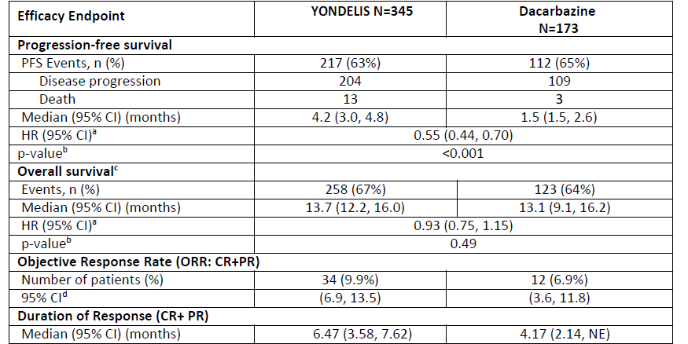
ª cox proportional hazards model with treatment group as the only covariate
^{b} Unstratified log rank test
^{c} Based on 384 patients randomised to Yondelis arm and 193 patients randomised to dacarbazine
^{d} Fisher’s exact CI
CR = complete response; PR = partial response; CI = confidence interval, HR = hazard ratio, NE = not estimable.
The final analysis of OS failed to demonstrate a difference between treatment arms (HR, 0.93; 95% CI, 0.75–1.15; unstratified log rank test, p = 0.49). The estimated median OS was 13.7 months (95% CI, 12.2 to 16.0) for the trabectedin arm and 13.1 months (95% CI, 9.1 to 16.2) for the dacarbazine arm (see Table 4). In addition, there was no significant improvement in ORR (trabectedin 9.9% versus. dacarbazine 6.9%). Median duration of response (DOR, complete response (CR) plus partial response (PR)) was 6.5 months versus 4.2 months (see Table 4).

Summary of efficacy
Evidence to support the efficacy of trabectedin in the treatment of LMS and LPS comes mainly from the Phase III pivotal Study ET743-SAR-3007. This study demonstrated a statistically significant efficacy benefit in terms of PFS (HR = 0.55 (95% CI: 0.44 to 0.70); p < 0.001). Median PFS was increased from 1.5 months with dacarbazine to 4.2 months with trabectedin (see Figure 3).
The final analysis of OS failed to demonstrate a difference between treatment arms (HR, 0.93; 95% CI, 0.75 to 1.15; unstratified log rank test, p = 0.49). The estimated median OS was 13.7 months (95% CI, 12.2 to 16.0) for the trabectedin arm and 13.1 months (95% CI, 9.1 to 16.2) for the dacarbazine arm (see Table 4).
In addition, there was no improvement in ORR (trabectedin 9.9% versus dacarbazine 6.9%, see Table 4).
The TGA has previously approved pazopanib for the second line treatment of STS (other than liposarcoma and GIST). The pivotal study demonstrated an improvement in PFS compared to placebo (HR = 0.35 (95%CI: 0.26, 0.48); p < 0.001). Median PFS was increased from 1.6 months with placebo to 4.6 months with pazopanib. There were no significant differences in terms of OS. The PFS benefit obtained with pazopanib in this study was of a comparable magnitude to that obtained with trabectedin in the pivotal study in this submission (see Table 4).
In recent years the TGA has also registered eribulin for the second line treatment of liposarcoma (see Table 5). The pivotal study in that submission demonstrated a significant benefit in terms of OS compared to dacarbazine.
Overall, the improvement in PFS observed with trabectedin is considered clinically meaningful, and the evidence to support the efficacy trabectedin for the proposed indication is acceptable (See Figure 3).
Figure 3: Study ET743-SAR-3007 Kaplan-Meier curves of progression free survival
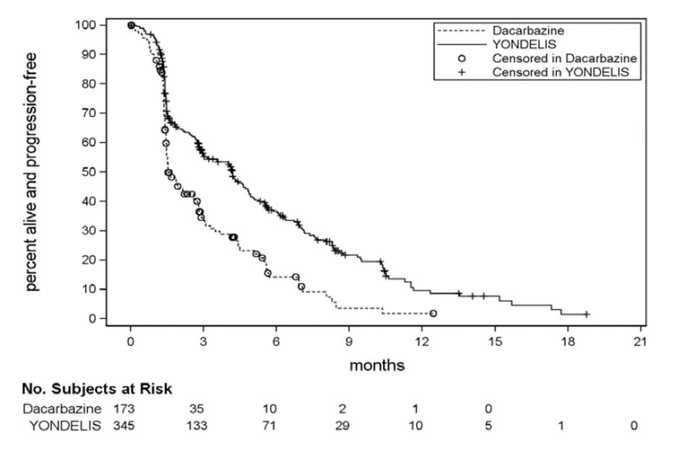
Table 5: Study ET743-SAR-3007 Selected subsequent anticancer therapy
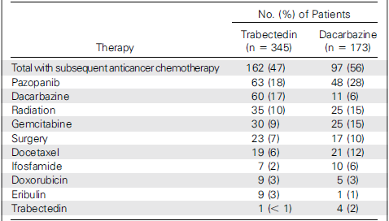
Note: Subsequent anticancer therapies that were used for at least 5% of patients in either treatment group were included. In addition, doxorubicin, eribulin, and trabectedin were also included on the basis of their previously demonstrated activities.

Safety
Data on the safety of trabectedin as monotherapy was available for 378 subjects in the pivotal study, an additional 525 subjects in other STS studies, an additional 1,341 subjects in studies in other indications and a total of 1,803 subjects in the expanded access program study. The total clinical trial safety database is therefore includes in excess of 4,000 subjects. Most of these subjects were treated with the proposed dose of 1.5 mg/m² given over 24 hours on Day 1 of a 21 days cycle. In addition, the drug has been marketed in foreign jurisdictions since 2007. The available database is considered adequate for determining the safety of trabectedin, especially as LMS and LPS are rare diseases.
Compared to dacarbazine, trabectedin has significant toxicity. In the pivotal study it was associated with an increased incidence of Grade 3 to 4 adverse events (AE) (81.2% versus 57.0%) and serious AEs (41.0% versus 30.2%). It was also associated with an increased incidence of drug related fatal AEs (2.4% versus 0%). However, there was lower incidence of deaths due to progressive disease in the trabectedin group (60.1% versus 66.3%) and the efficacy data suggested a non-significant trend towards improved overall survival with trabectedin. The incidence of AEs leading to discontinuation of study drug was only modestly increased (26.7% versus 22.1% for all AEs, 16.7% versus 7.6% for drug related AEs) suggesting that trabectedin toxicity is manageable in most patients with dose delays, dose reductions and supportive therapy.
Specific toxicities associated with trabectedin are:
- Haematological toxicity including neutropaenia, thrombocytopaenia and anaemia: Neutropaenia was the most common of these toxicities with Grade 3 to 4 toxicity occurring in 42.7% of subjects versus 25.6% with dacarbazine. Neutropaenia may be complicated by infection, including sepsis and septic shock. In the pivotal study 1.1% of trabectedin subjects died from sepsis/septic shock versus 0% with dacarbazine. All these subjects had Grade 4 neutropaenia.
- Grade 3 to 4 anaemia and thrombocytopaenia occurred in 18.9% and 20.9% of trabectedin treated subjects respectively.
- Hepatotoxicity:
  - Increases in serum alanine aminotransferase (ALT) and aspartate aminotransferase (AST) were very common, with new Grade 3 to 4 abnormalities occurring in 31.5% and 16.7% of subjects respectively in the pivotal study. Increases in serum bilirubin were less common with new Grade 3 to 4 abnormalities being reported in 1.9% of subjects.
  - Across the clinical trial program there were multiple subjects who met the criteria for a Hy’s law case, indicating that trabectedin is likely to be associated with severe drug-induced liver injury. A post-marketing review of the sponsor’s safety database concluded that the term ‘hepatic failure’ should be listed as an adverse reaction in the prescribing information.
- Muscle toxicity: In the pivotal study, new Grade 3 or 4 increases in creatine phosphokinase (CPK) occurred in 0.6% of subjects in the dacarbazine arm and 6.4% of subjects in the trabectedin arm. Rhabdomyolysis was reported as a serious AE in 1.1% of trabectedin-treated subjects versus 0% in the dacarbazine arm and was reported as a fatal AE in 2 subjects (0.5%).
- Gastrointestinal toxicity: Nausea, vomiting and anorexia were very commonly reported AEs in trabectedin treated subjects.
- Fatigue was commonly reported with trabectedin than with dacarbazine (69.3% versus 52.3%).
- Cardiac toxicity with an increased incidence of heart failure (2.9% versus 0.6%) and decreased ejection fraction (3.4% versus 2.3%) compared to dacarbazine.
- Respiratory symptoms (mainly dyspnoea and cough) were reported more commonly with trabectedin than with dacarbazine.
- Local infusion reactions secondary to extravasation (based on post-marketing data).
- Hypersensitivity reactions (based on post-marketing data).
- Capillary leak syndrome (based on post-marketing data).
In the pivotal study, trabectedin treatment was associated with a higher incidence of increased serum creatinine. The sponsor has not included renal toxicity as an adverse drug reaction in the proposed PI or in the risk management plan (RMP). The creatinine elevations may be a reflection of the increased incidence of nausea, vomiting and dehydration observed with trabectedin. The incidence of renal failure as an adverse event was only increased slightly in the trabectedin arm (4.5% versus 3.5%). According to the summary of clinical safety report, most cases of renal failure ‘were known to have occurred in the presence of confounding factors, developing in the clinical context of a rhabdomyolysis/sepsis, disease progression, dehydration/gastrointestinal bleeding, or congestive cardiac failure/hypotension’.
Catheter-related complications were more common with trabectedin in the pivotal study. This may have been due to more frequent use of a central line in this group.
Unresectable advanced or metastatic LPS and LMS are life threatening conditions associated with poor survival as shown by a median overall survival of only approximately 13 to 14 months in the pivotal study in this submission. In this setting, the above toxicities produced by trabectedin would be considered acceptable

Risk management plan
Specialised Therapeutics Pharma Pty Ltd has submitted EU-RMP version 8 (date 31 March 2017; data lock point (DLP) 17 September 2016) and Australian specific annex (ASA) version 0.1 (March 2020) in support of this application.
The summary of safety concerns and their associated risk monitoring and mitigation strategies are summarised in Table 6.
Table 6: Summary of safety concerns and their associated risk monitoring and mitigation strategies for Yondelis
Summary of safety concerns |  | Pharmacovigilance |  | Risk Minimisation
 |  | Routine | Additional | Routine | Additional
Important identified risks | Capillary leak syndrome | * | – |  | –
Important identified risks | Neutropenia and neutropenia with infections including septic shock |  | – |  | –
Important identified risks | Thrombocytopenia and thrombocytopenia with bleeding |  | – |  | –
Important identified risks | Anaemia |  | – |  | –
Important identified risks | Hepatotoxicity including hepatic failure | * | – |  | –
Important identified risks | CPK elevations and/or rhabdomyolysis |  | – |  | –
Important identified risks | Multi-organ failure |  | – |  | –
Important identified risks | Severe hypersensitivity reactions including fatal outcome |  | – |  | –
Important identified risks | Emesis |  | – |  | –
Important identified risks | Injection site reactions | * | – |  | –
Important identified risks | Respiratory disorders | * | – |  | –
Important potential risks | Acute Myeloid Leukaemia / myelodysplasia (AML/ MDS) | * | – | – | –
Important potential risks | Cardiac dysfunction |  | – |  | –
Important potential risks | Drug-drug interactions of CYP3A4 inhibitors |  | – |  | –
Important potential risks | Reprotoxicity and development toxicities |  | – |  | –
Important potential risks | Pancreatitis, lipase and/or amylase increased | * | – | – | –
Missing information | Off-label use in paediatric population |  | – |  | –
Missing information | Use in patients with renal impairment and direct renal toxicity |  | – |  | –
Missing information | Genetic polymorphism |  | – | – | –
Missing information | Use in patients of different racial/ethnic origin |  | – |  | –
Missing information | Drug-drug interactions with P-gp inhibitors |  | – |  | –
* Targeted follow-up questionnaire
The summary of safety concerns is considered acceptable from an RMP perspective.
The sponsor has proposed routine pharmacovigilance for all safety concerns, which includes targeted follow-up questionnaires for the safety concerns identified above. No additional pharmacovigilance activities have been proposed by the sponsor. This is acceptable.
The sponsor has proposed routine risk minimisation activities for most safety concerns. No additional risk minimisation activities have been proposed however routine risk minimisation activities are considered acceptable to manage the safety concerns. The risk minimisation plan is considered acceptable.

Wording for conditions of registration
Any changes to which the sponsor has agreed should be included in a revised RMP and ASA. However, irrespective of whether or not they are included in the currently available version of the RMP document, the agreed changes become part of the risk management system.
The suggested wording is:
The Yondelis EU-Risk Management Plan (RMP) (version 8, dated 31 March 2017, data lock point 17 September 2016), with Australian specific annex (version 0.1, dated March 2020), included with submission PM-2020-01313-1-4, and any subsequent revisions, as agreed with the TGA will be implemented in Australia.
The following wording is recommended for the PSUR requirement:
An obligatory component of risk management plans is routine pharmacovigilance. Routine pharmacovigilance includes the submission of periodic safety update reports (PSURs).
Reports are to be provided in line with the current published list of EU reference dates and frequency of submission of PSURs until the period covered by such reports is not less than three years from the date of this approval letter.
The reports are to at least meet the requirements for PSURs as described in the European Medicines Agency’s Guideline on good pharmacovigilance practices (GVP) Module VII-periodic safety update report (Rev 1), Part VII.B Structures and processes. Note that submission of a PSUR does not constitute an application to vary the registration. . Each report must have been prepared within ninety calendar days of the data lock point for that report.
As Yondelis is a new chemical entity it should be included in the Black Triangle Scheme as a condition of registration. The following wording is recommended for the condition of registration:
Yondelis (trabectedin) is to be included in the Black Triangle Scheme. The PI and consumer medicine information (CMI) for Yondelis must include the black triangle symbol and mandatory accompanying text for five years, which starts from the date that the sponsor notifies the TGA of supply of the product.

Risk-benefit analysis

Delegate’s considerations
The clinical data included in the submission demonstrates that trabectedin has efficacy in the treatment of leiomyosarcoma (LMS) and liposarcoma (LPS). The improvement in progression-free survival (PFS) compared to dacarbazine was statistically and clinically significant.
The improved efficacy compared to dacarbazine comes at a cost of an increase in toxicity. However, this toxicity appears manageable in most patients.
Advanced/metastatic LMS and LPS are life threatening conditions, with median survival in the pivotal study being only 13 to 14 months.
There are currently limited treatment options for subjects in whom first-line chemotherapy has failed. In this context, it is considered that the overall benefit-risk balance of trabectedin is favourable.

Proposed action
The Delegate proposes to approve trabectedin (Yondelis) for the treatment of patients with unresectable or metastatic liposarcoma or leiomyosarcoma who have received a prior anthracycline-containing regimen.

Advisory Committee considerations
The Delegate did not refer this application to the Advisory Committee on Medicines (ACM) for advice.

Outcome
Based on a review of quality, safety and efficacy, the TGA approved the registration of Yondelis (trabectedin) 0.25 mg and 1 mg, powder for solution for infusion, vial, indicated for:
Yondelis is indicated for the treatment of patients with unresectable or metastatic liposarcoma or leiomyosarcoma who received a prior anthracycline-containing regimen.

Specific conditions of registration applying to these goods
- Yondelis (trabectedin) is to be included in the Black Triangle Scheme.¹ The Product Information and Consumer Medicine Information for Yondelis must include the black triangle symbol and mandatory accompanying text for five years, which starts from the date that the sponsor notifies the TGA of supply of the product.
- The Yondelis EU-RMP (version 8, dated 31 March 2017, DLP 17 September 2016), with ASA (version 0.1, dated March 2020), included with submission PM-2020-01313-1-4, and any subsequent revisions, as agreed with the TGA will be implemented in Australia.
An obligatory component of risk management plans is routine pharmacovigilance. Routine pharmacovigilance includes the submission of periodic safety update reports (PSURs).
Reports are to be provided in line with the current published list of EU reference dates and frequency of submission of PSURs until the period covered by such reports is not less than three years from the date of the approval letter.
The reports are to at least meet the requirements for PSURs as described in the European Medicines Agency’s Guideline on good pharmacovigilance practices (GVP) Module VII-periodic safety update report (Rev 1), Part VII.B Structures and processes. Note that submission of a PSUR does not constitute an application to vary the registration. Each report must have been prepared within ninety calendar days of the data lock point for that report.
- For all injectable products the Product Information must be included with the product as a package insert.

Attachment 1. Product Information
The PI for Yondelis approved with the submission which is described in this AusPAR is at Attachment 1. For the most recent PI, please refer to the TGA website at <https://www.tga.gov.au/product-information-pi>.

Therapeutic Goods Administration
PO Box 100 Woden ACT 2606 Australia
Email: info@tga.gov.au Phone: 1800 020 653 Fax: 02 6232 8605
https://www.tga.gov.au

The Black Triangle Scheme provides a simple means for practitioners and patients to identify certain types of new prescription medicines, including those being used in new ways and to encourage the reporting of adverse events associated with their use. The Black Triangle does not denote that there are known safety problems, just that the TGA is encouraging adverse event reporting to help us build up the full picture of a medicine's safety profile.
Clark MA, et al. Soft-tissue sarcomas in adults. N Engl J Med. 2005; 353 (7): 701-11.
Shiba S, et al. Diagnosis and management of soft tissue sarcoma BMJ 2010; 341: c7170.
National Comprehensive Cancer Network (NCCN). NCCN Clinical Practice Guidelines in Oncology. Soft Tissue Sarcoma. Version 2.2020; 2020. Accessible via www.nccn.org.
Australian Institute of Health and Welfare (AIHW) Sarcoma statistics in Australia. Access via www. canceraustralia.gov.au
American Cancer Society. Survival Rates for Soft Tissue Sarcoma (2020). Accessible via www.cancer.org.
Frezza AM, et al. Systemic treatment in advanced soft tissue sarcoma: what is standard, what is new. BMC Med. 2017; 15 (1): 109.
Van Glabbeke M, et al. Prognostic factors for the outcome of chemotherapy in advanced soft tissue sarcoma: an analysis of 2,185 patients treated with anthracycline-containing first-line regimens--a European Organization for Research and Treatment of Cancer Soft Tissue and Bone Sarcoma Group Study. J Clin Oncol;17 (1): 150-7.
Toro JR. et al. Incidence patterns of soft tissue sarcomas, regardless of primary site, in the surveillance, epidemiology and end results program, 1978-2001: An analysis of 26,758 cases. Int J Cancer. 2006; 119 (12): 2922-2930
George S, et al. Soft Tissue and Uterine Leiomyosarcoma. J Clin Oncol. 2017; 36: 144-150
Lee ATJ, et al. Clinical and Molecular Spectrum of Liposarcoma. J Clin Oncol. 2018; 36 (2): 151-159.
Cancer Council Australia Sarcoma Guidelines Working Party. Clinical practice guidelines for the management of adult onset sarcoma. Sydney: Cancer Council Australia. 2014. Accessible via www.wiki.cancer.org.au
European Society for Medical Oncology and European Reference Network for rare adult solid cancers. Soft tissue and visceral sarcomas: ESMO–EURACAN Clinical Practice Guidelines for diagnosis, treatment and follow-up. Annals of Oncology. 2018; 29 (Supplement 4): iv51–iv67.
Pazopanib is registered on ARTG on the 30 June 2010, ARTG number: 161281, 161282.
Eribulin is registered on ARTG on the 4 September 2012, ARTG number: 187136.
Orphan drugs are often developed to treat small and very specific patient populations who suffer from rare diseases and conditions. In order to facilitate orphan drug access to the Australian marketplace and help offset orphan drug development costs the TGA waives application and evaluation fees for prescription medicine registration applications if a related orphan designation is in force. A medicine may be eligible for orphan drug designation if all orphan criteria set by the TGA are met. The orphan designation application precedes the registration application and the designation is specific to the sponsor, orphan indication for which designation was granted and dosage form of the medicine.
Cytochrome P450 (CYP) enzymes: CYPs are the major enzymes involved in drug metabolism, accounting for large part of the total metabolism. Most drugs undergo deactivation by CYPs, either directly or by facilitated excretion from the body. Also, many substances are bioactivated by CYPs to form their active compounds. Many drugs may increase or decrease the activity of various CYP isozymes either by inducing the biosynthesis of an isozyme (enzyme induction) or by directly inhibiting the activity of the CYP (enzyme inhibition). This is a major source of adverse drug interactions, since changes in CYP enzyme activity may affect the metabolism and clearance of various drugs. Such drug interactions are especially important to take into account when using drugs of vital importance to the patient, drugs with important side-effects and drugs with small therapeutic windows, but any drug may be subject to an altered plasma concentration due to altered drug metabolism.
ECOG Performance Status: The Eastern Cooperative Oncology Group (ECOG) has developed criteria used by doctors and researchers to assess how a patient's disease is progressing, assess how the disease affects the daily living abilities of the patient, and determine appropriate treatment and prognosis. The following are used: 0 - Fully active, able to carry on all pre-disease performance without restriction 1- Restricted in physically strenuous activity but ambulatory and able to carry out work of a light or sedentary nature, e.g., light house work, office work 2 - Ambulatory and capable of all selfcare but unable to carry out any work activities. Up and about more than 50% of waking hours 3 - Capable of only limited selfcare, confined to bed or chair more than 50% of waking hours 4 - Completely disabled. Cannot carry on any selfcare. Totally confined to bed or chair 5 – Dead
The Response Evaluation Criteria In Solid Tumours (RECIST) is a voluntary international standard with unified and easily applicable criteria to define when a patient's tumour has improved ('respond'), stayed the same ('stabilise'), or worsened ('progress') during treatment. The criteria were published in February 2000 by an international collaboration including the European Organisation for Research and Treatment of Cancer (EORTC), National Cancer Institute (NCI) of the United States, and the National Cancer Institute of Canada Clinical Trials Group. Today, the majority of clinical trials evaluating cancer treatments for objective response in solid tumours use RECIST. These criteria were developed and published in February 2000, and subsequently updated in 2009.
Hy’s Law: Evidence of hepatocellular injury with a rise in alanine aminotransferase (ALT) and/or aspartate aminotransferase (AST) > 3 x the upper limit of normal (ULN) and total bilirubin > 2 x ULN, and no other reason to explain rise in aminotransferases and total bilirubin. Hy's law is a rule of thumb that a patient is at high risk of a fatal drug-induced liver injury if given a medication that causes hepatocellular injury with jaundice.
Routine risk minimisation activities may be limited to ensuring that suitable warnings are included in the product information or by careful use of labelling and packaging. Routine pharmacovigilance practices involve the following activities: - All suspected adverse reactions that are reported to the personnel of the company are collected and collated in an accessible manner; - Reporting to regulatory authorities; - Continuous monitoring of the safety profiles of approved products including signal detection and updating of labelling; - Submission of PSURs; - Meeting other local regulatory agency requirements.
The ACM provides independent medical and scientific advice to the Minister for Health and the Therapeutic Goods Administration (TGA) on issues relating to the safety, quality and efficacy of medicines supplied in Australia including issues relating to pre-market and post-market functions for medicines. The Committee is established under Regulation 35 of the Therapeutic Goods Regulations 1990. Members are appointed by the Minister. The ACM was established in January 2017 replacing Advisory Committee on Prescription Medicines (ACPM) which was formed in January 2010. ACM encompass pre and post-market advice for medicines, following the consolidation of the previous functions of the Advisory Committee on Prescription Medicines (ACPM), the Advisory Committee on the Safety of Medicines (ACSOM) and the Advisory Committee on Non-Prescription Medicines (ACNM). Membership comprises of professionals with specific scientific, medical or clinical expertise, as well as appropriate consumer health issues relating to medicines.

