December 2021

Australian Public Assessment Report for Tozinameran (mRNA Covid-19 vaccine)
  - Proprietary Product Name: Comirnaty
  - Sponsor: Pfizer Australia Pty Ltd

About the Therapeutic Goods Administration (TGA)
- The Therapeutic Goods Administration (TGA) is part of the Australian Government Department of Health and is responsible for regulating medicines and medical devices.
- The TGA administers the Therapeutic Goods Act 1989 (the Act), applying a risk management approach designed to ensure therapeutic goods supplied in Australia meet acceptable standards of quality, safety and efficacy (performance) when necessary.
- The work of the TGA is based on applying scientific and clinical expertise to decision-making, to ensure that the benefits to consumers outweigh any risks associated with the use of medicines and medical devices.
- The TGA relies on the public, healthcare professionals and industry to report problems with medicines or medical devices. TGA investigates reports received by it to determine any necessary regulatory action.
- To report a problem with a medicine or medical device, please see the information on the TGA website <https://www.tga.gov.au>.

About AusPARs
- An Australian Public Assessment Report (AusPAR) provides information about the evaluation of a prescription medicine and the considerations that led the TGA to approve or not approve a prescription medicine submission.
- AusPARs are prepared and published by the TGA.
- An AusPAR is prepared for submissions that relate to new chemical entities, generic medicines, major variations and extensions of indications.
- An AusPAR is a static document; it provides information that relates to a submission at a particular point in time.
- A new AusPAR will be developed to reflect changes to indications and/or major variations to a prescription medicine subject to evaluation by the TGA.

Copyright
© Commonwealth of Australia 2021
This work is copyright. You may reproduce the whole or part of this work in unaltered form for your own personal use or, if you are part of an organisation, for internal use within your organisation, but only if you or your organisation do not use the reproduction for any commercial purpose and retain this copyright notice and all disclaimer notices as part of that reproduction. Apart from rights to use as permitted by the Copyright Act 1968 or allowed by this copyright notice, all other rights are reserved and you are not allowed to reproduce the whole or any part of this work in any way (electronic or otherwise) without first being given specific written permission from the Commonwealth to do so. Requests and inquiries concerning reproduction and rights are to be sent to the TGA Copyright Officer, Therapeutic Goods Administration, PO Box 100, Woden ACT 2606 or emailed to <tga.copyright@tga.gov.au>.

Contents
List of abbreviations 4
I. Introduction to product submission 6
Submission details 6
Product background 9
Regulatory status 14
Product Information 15
II. Registration timeline 15
III. Submission overview and risk/benefit assessment 16
Quality 16
Nonclinical 17
Clinical 17
Risk management plan 57
Risk-benefit analysis 59
Outcome 68
Attachment 1. Product Information 70

List of abbreviations
Abbreviation | Meaning
ACV | Advisory Committee on Vaccines
ARTG | Australian Register of Therapeutic Goods
ASA | Australian-specific annex
BNT162b2 | Former name for Comirnaty (tozinameran) COVID-19 vaccine
CDC | Centers for Disease Control (United States of America)
CI | Confidence interval
CMI | Consumer Medicines Information
COVID-19 | Coronavirus disease 2019
EMA | European Medicines Agency (European Union)
FDA | Food and Drug Administration (United States of America)
GMFR | Geometric mean fold rise
GMR | Geometric mean ratio
GMT | Geometric mean titre
ICU | Intensive care unit
IRC | Internal review committee
IRR | Incidence rate ratio
LLOQ | Lower limit of quantitation
MIS-C | Multisystem inflammatory syndrome in children
mITT | Modified intention to treat
mRNA | Messenger RNA
NAAT | Nucleic acid amplification test
NT50 | 50% neutralising titre/assay
PI | Product Information
PIMS-TS | Paediatric inflammatory multisystem syndrome temporally associated with SARS-CoV-2
PSUR | Periodic safety update report
RMP | Risk management plan
SARS-CoV-2 | Severe acute respiratory syndrome coronavirus 2
SMQ | Standardised MedDRA Query
SOC | System Organ Class
Tris | Tromethamine
US(A) | United States (of America)
WHO | World Health Organization

I. Introduction to product submission

Submission details
Type of submission: | Extension of indications; change to formulation (excipients)
Product name: | Comirnaty
Active ingredient: | Tozinameran
Decision: | Approved
Date of decision: | 3 December 2021
Date of entry onto ARTG: | 6 December 2021
ARTG numbers: | 377110; 377111
Black Triangle Scheme: | Yes  As a provisionally registered product, this medicine will remain in the Black Triangle Scheme for the duration of its provisional registration
Sponsor’s name and address: | Pfizer Australia Pty Ltd  Level 17, 151 Clarence Street  Sydney, NSW, 2000
Dose form: | Concentrate for injection
Strengths: | 10 µg/0.2 mL  30 µg/0.3 mL
Container: | Multidose vial
Pack sizes: | 195
Approved therapeutic use: | Comirnaty (tozinameran) COVID-19 Vaccine has provisional approval for the indication below:  Active immunisation to prevent coronavirus disease 2019 (COVID-19) caused by SARS-CoV-2, in individuals 5 years of age and older.  The use of this vaccine should be in accordance with official recommendations.  The decision has been made on the basis of short term efficacy and safety data. Continued approval depends on the evidence of longer term efficacy and safety from ongoing clinical trials and post-market assessment.  Note, this submission is extension of indications based on widening the patient population from individuals aged 12 years and older to include individuals from 5 years and older. Earlier submissions for the 12 to 15 years of age group; and in individuals aged 16 years and older are covered in their respective AusPARs.,
Route of administration: | Intramuscular injection
Dosage: | Individuals 12 years of age and older  Comirnaty Ready To Use Multidose (For Age 12 Years and Above, Do Not Dilute) is administered intramuscularly as a primary course of 2 doses (30 micrograms/0.3 mL) at least 21 days apart. .A booster dose (third dose) of Comirnaty Ready To Use Multidose (For Age 12 Years and Above, Do Not Dilute) may be administered intramuscularly at least 6 months after the completion of a COVID-19 vaccine primary series in individuals 18 years of age and older. The decision when and for whom to implement a booster dose (third dose) of Comirnaty Ready To Use Multidose (For Age 12 Years and Above, Do Not Dilute) should be made based on available vaccine safety and effectiveness data (see Sections 4.4 Special warnings and precautions for use and 5.1 Pharmacodynamic properties of the Product Information), in accordance with official recommendations.  Doses of Comirnaty (tozinameran) COVID-19 Vaccine (Tris/Sucrose Presentation; 30 micrograms/dose) and Comirnaty (tozinameran) COVID-19 Vaccine (PBS/Sucrose Presentation; 30 micrograms/dose) are considered interchangeable. There are limited data on the interchangeability of Comirnaty with other COVID-19 vaccines to complete the primary vaccination course or the booster dose (third dose). Individuals who have received 1 dose of Comirnaty should preferably receive a second dose of Comirnaty to complete the primary vaccination course and for any additional doses.  Individuals 5 to under 12 years of age  Comirnaty Dilute To Use Multidose (for age 5 years to under 12 years of age) is administered intramuscularly as a primary course of 2 doses (10 micrograms/0.2 mL each) at least 21 days apart.  Severely immunocompromised aged 12 years and older  In accordance with official recommendations, a third dose may be given at least 28 days after the second dose to individuals who are severely immunocompromised (see Section 4.4 Special warnings and precautions for use of the Product Information).  Elderly population  No dosage adjustment is required in elderly individuals aged 65 years or older.  Method of administration  Comirnaty should be administered intramuscularly. The preferred site of administration is the deltoid muscle of the upper arm. Do not inject Comirnaty intravascularly, subcutaneously or intradermally. Comirnaty should not be mixed in the same syringe with any other vaccines or medicinal products. For precautions to be taken before administering Comirnaty, see Section 4.4 Special warnings and precautions for use of the Product Information. Comirnaty Ready To Use Multidose (For Age 12 Years and Above, Do Not Dilute) for individuals 12 years of age and older Vials of Comirnaty Ready To Use Multidose (For Age 12 Years and Above, Do Not Dilute) have a grey cap, contain six doses of 0.3 mL of vaccine and do not require dilution. In order to extract six doses from a single vial, low dead-volume syringes and/or needles should be used. The low dead-volume syringe and needle combination should have a dead volume of no more than 35 microlitres. If standard syringes and needles are used, there may not be sufficient volume to extract a sixth dose from a single vial.  Irrespective of the type of syringe and needle:  - Each dose must contain 0.3 mL of vaccine.  - If the amount of vaccine remaining in the vial cannot provide a full dose of 0.3 mL, discard the vial and any excess volume.  - Do not pool excess vaccine from multiple vials.  - For instructions on the handling, thawing and dose preparation of the vaccine before administration see Section: Handling instructions of the Product Information.  For further information regarding dosage, refer to the Product Information.
Pregnancy category: | B1  Drugs which have been taken by only a limited number of pregnant women and women of childbearing age, without an increase in the frequency of malformation or other direct or indirect harmful effects on the human fetus having been observed. Studies in animals have not shown evidence of an increased occurrence of fetal damage  The use of any medicine during pregnancy requires careful consideration of both risks and benefits by the treating health professional. This must not be used as the sole basis of decision making in the use of medicines during pregnancy. The TGA does not provide advice on the use of medicines in pregnancy for specific cases. More information is available from obstetric drug information services in your State or Territory.

Product background
This AusPAR describes the application by Pfizer Australia Pty Ltd (the sponsor) to register Comirnaty (tozinameran) COVID-19 (mRNA) vaccine 30 μg/0.3 mL multidose vial; and 10 μg/0.2 mL multidose vial, for the following proposed extension of indications:
Active immunisation to prevent coronavirus disease 2019 (COVID-19) caused by SARS-CoV-2, in individuals 5 years of age and older.
The use of this vaccine should be in accordance with official recommendations.
This application seeks to replace the current indication by extending the indicated population from individuals 12 years of age and older, to individuals 5 years of age and older.
With this submission, the sponsor has applied for registration of an additional strength (10 μg/0.2 mL multidose vial) presentation, aimed specifically at 5 to under 12 years of age population.
In addition, the sponsor has applied for a change in the Comirnaty (tozinameran) COVID-19 vaccine formulation, from a phosphate-buffered saline/sucrose buffered formulation, to a tris-buffered saline/sucrose buffered formulation. The change concerns the non-active excipients; the active ingredient (tozinameran) is not changed in any way.

Coronavirus 2019 (COVID-19)
Coronavirus 2019 (COVID-19) is an infectious disease caused by the novel coronavirus, SARS-CoV-2 (severe acute respiratory syndrome coronavirus 2), that first appeared in late 2019. Following its emergence, SARS-CoV-2 has spread rapidly and globally, causing high numbers of COVID-19 cases worldwide. The World Health Organization (WHO) declared that the outbreak constituted a public health emergency of international concern on 30 January 2020 and declared the outbreak to be a pandemic on 11 March 2020.
As of 9 December 2021, there have been over 267 million confirmed COVID-19 cases globally, and over 5.27 million deaths, with over 190 countries/regions affected. In Australia, as of 9 December 2021, there have been over 223,000 confirmed COVID-19 cases and over 2000 deaths due to the disease.

COVID-19 in children
COVID-19 is predominantly a respiratory illness, which can affect other organs. Children are just as likely as adults to be infected with SARS-CoV-2. Most children are asymptomatic and when symptoms occur, they are usually mild. The common laboratory findings in hospitalised patient include leukopenia, lymphopaenia, and increased levels of inflammatory markers. Chest X-ray findings are variable and computed tomography scans of the chest may show ground glass opacities similar to adults or non-specific findings. There is limited data in children on the use of antivirals, monoclonal antibodies, and convalescent plasma.
A new entity associated with COVID-19 called multisystem inflammatory syndrome in children (MIS-C) has emerged. Clinical, laboratory, and epidemiological criteria are the basis for this diagnosis. Management options include intensive care unit (ICU) admission, steroids, intravenous gamma globulin, aspirin, anakinra, and anticoagulants.
In the absence of highly effective prophylactic or therapeutic medicines, active immunisation through vaccination represents the best means of preventing hospitalisation and deaths at an individual level and controlling the pandemic at a societal level.

COVID-19 morbidity and mortality in children under 12 Years of age
An Australian government report of data with COVID-19 disease onset from 1 January 2021 through to 10 October 2021 includes the rates of severe disease by age group and is reproduced as Table 1 below.
The report notes that not all cases of hospitalisation are related to disease severity ‘as cases may be hospitalised for reasons other than clinical COVID-19 related care’ (for example, this includes ‘social admissions’ of children when parents are hospitalised with COVID-19).
Table 1 covers data up until 10 October 2021.
Table 1: COVID-19 cases in Australia by age group and highest level of illness severity (1 January 2021 to 10 October 2021)
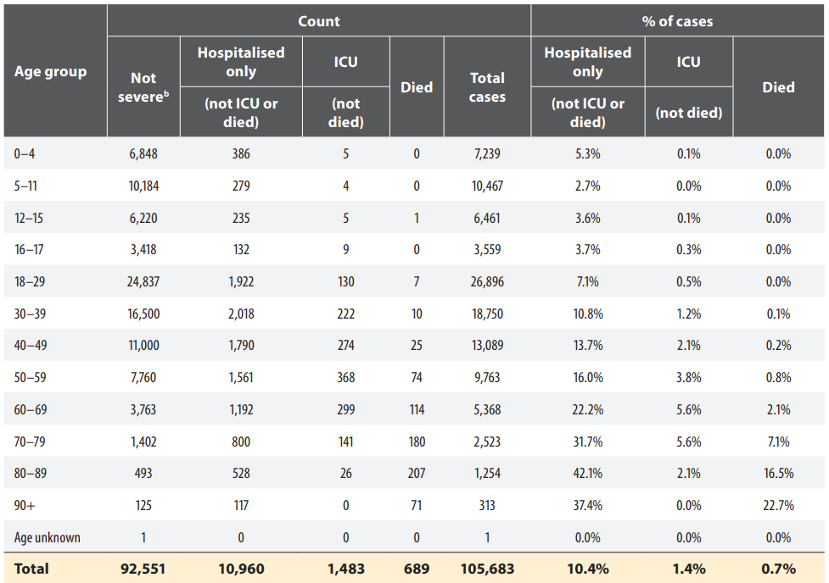
a: National Interoperable Notifiable Disease Surveillance System (NINDSS) project, extract from 26 October 2021. Includes cases notified from 1 January 2021, with an illness onset up to 10 October 2021; cases with an illness onset in the last two weeks (11 to 24 October 2021) were excluded to account for the delay between onset and development of severe illness.
b: ‘Not severe’ includes all cases that were not hospitalised, admitted to ICU or died.
Source: Table 6, Commun Dis Intell (2018) 2021;45. Published online 8 November 2021. Available at: https://doi.org/10.33321/cdi.2021.45.61
The proportions and rates of potential markers of disease severity comparing children aged between 5 and 11 years with those aged 12 years or more (for whom Comirnaty is currently provisionally registered in Australia) up to 11 October 2021, are highlighted in Table 2, below.
Table 2: Comparison of potential markers of disease severity between children aged 5 to 11 years versus those aged 12 years or more
Marker of disease severity | Aged 5 to11 years | Aged 12 years or more
Hospitalised only  (not ICU, nor deaths) | 279/10467 (2.7%) | 10295/87976 (11.7%)
ICU admissions | 4/10467 (0.04%) | 1474/87976 (1.7%)
Deaths | 0/10467 (0.00%) | 689/87976 (0.78%)

Comirnaty (tozinameran) COVID-19 vaccine

Current presentation
The Comirnaty (tozinameran) COVID-19 vaccine, is a single-stranded, 5’-capped messenger RNA (mRNA) produced using a cell-free in vitro transcription from the corresponding DNA templates, encoding the viral spike (or ‘S’) protein of SARS-CoV-2. The RNA is encapsulated in lipid nanoparticles, which enables entry into host cells, expression of the S protein, and elicitation of both antibody and cellular immune responses.
The current provisionally registered formulation of Comirnaty (that is, phosphate-buffered saline/sucrose) is presented in multidose vials of 0.45 mL (containing 225 µg of mRNA at a concentration of 500 µg/mL) that are stored frozen, and then thawed prior to use. After thawing, it is diluted with 1.8 mL of normal saline to a total volume of 2.25 mL (final concentration 100 µg/mL). This provides for 6 doses of 0.3 mL, each containing 30 µg of mRNA (recommended dose for those of 12 years of age or older).

Proposed presentation
The proposed new trometamol hydrochloride-buffered (also referred to as tris hydroxymethyl aminomethane, or simply TRIS)/sucrose formulation will have two different dosage presentations:
- The 30 µg mRNA dosage presentation (for use in individuals 12 years of age or older) is pre-filled to 2.25 mL fill volume with ‘suspension for injection’ (containing 225 µg mRNA at a concentration of 100 µg/mL) and will not require further dilution prior to use. This provides for 6 doses of 0.3 mL, each containing 30 µg mRNA. It is intended that up to 0.45 mL will remain in the vial after use.
- The 10 µg mRNA dosage presentation (proposed for children 5 to less than 12 years of age) is pre-filled to 1.3 mL fill volume with ‘concentrated suspension for injection’ (containing 130 µg mRNA at a concentration of 100 µg/mL) and requires dilution with 1.3 mL of normal saline to a total volume of 2.6 mL. This provides for 10 doses of 0.2 mL, each containing 10 µg mRNA. It is intended that up to 0.6 mL will remain in the vial after use.

Other current therapeutic options

Vaccines
Australia has four vaccines on the Australian Register of Therapeutic Goods (ARTG) with provisional approval for the prevention of COVID-19:
- Comirnaty (tozinameran) (mRNA) COVID-19 vaccine; also known widely as the ‘Pfizer vaccine’, is discussed under in its current presentation in the previous section. Comirnaty was granted provisional registration for individuals over 16 years on 25 January 2021., The regimen is 2 doses, with each dose taken 3 weeks apart. An extension of indications to the expand the age group to individuals aged 12 to 15 years was approved on 21 July 2021.
- Spikevax (elasomeran) (mRNA) COVID-19 vaccine 0.2 mg/mL suspension for injection vial; also widely known as the Moderna vaccine, was granted provisional approval for use in adults and was registered on 9 August 2021., The regimen is 2 doses, with each dose taken 28 days apart. Spikevax received provisional approval to extend the indications to expand the age group to individuals aged 12 to 15 years of age on 4 September 2021.
- COVID-19 vaccine Janssen (Ad26.COV2.S), suspension for injection vial, was first registered on 25 June 2021.,
- Vaxzevria (ChAdOx1-S) COVID-19 vaccine, solution for injection multidose vial, (also known as the AstraZeneca vaccine) was first registered on 16 February 2021. The regimen is 2 doses with each dose given at least 28 days apart,
Comirnaty, Vaxzevria and Spikevax vaccine are being rolled out as part of the Australian Government Department of Health COVID-19 vaccination strategy.

Management and treatment options

Monoclonal antibodies
Currently, three monoclonal antibodies with indications for the treatment of COVID-19 have been granted provisional registration in Australia:
- Xevudy (sotrovimab) 500 mg/8 mL concentrated injection solution for infusion, vial, was registered on the ARTG on 20 August 2021.,
- Ronapreve (casirivimab/imdevimab), casirivimab 120 mg/mL and imdevimab 120 mg/mL solutions for infusion or injection in 1332 mg multi dose vial, was registered on the ARTG on 18 October 2021.,
- Ronapreve (casirivimab/imdevimab), casirivimab 120mg/mL and imdevimab 120 mg/mL solutions for infusion or injection in 300 mg single dose vial, was registered on the ARTG on 18 October 2021.,

Other medicines
The following medicine, is a broad-spectrum antiviral medication and is indicated for the treatment of COVID-19 in adults and adolescents (aged 12 years and older weighing at least 40 kg) with pneumonia, requiring supplemental oxygen, and has been granted provisional registration in Australia:
- Veklury (remdesivir) 100 mg powder for injection vial.,

Regulatory status
The Comirnaty (tozinameran) COVID-19 vaccine, previously referred to, and registered as Comirnaty (BNT162b2 (mRNA)) COVID-19 vaccine;¹ received initial provisional registration; on the Australian Register of Therapeutic Goods (ARTG) on 25 January 2021 for the following indication:
Comirnaty (BNT162b2 (mRNA)) COVID-19 vaccine has provisional approval for the indication below:
Active immunisation to prevent coronavirus disease 2019 (COVID-19) caused by SARS-CoV-2, in individuals 16 years of age and older.
The use of this vaccine should be in accordance with official recommendations.
The decision has been made on the basis of short term efficacy and safety data. Continued approval depends on the evidence of longer term efficacy and safety from ongoing clinical trials and post- market assessment.
On 24 June 2021, provisional determination was granted to cover an extension of indications to include individuals of 12 to 15 years of age.
On 22 July 2021, provisional registration was successfully granted, and Comirnaty was listed on the ARTG for the following indication:
Comirnaty (BNT162b2 (mRNA)) COVID-19 Vaccine has provisional approval for the indication below:
Active immunisation to prevent coronavirus disease 2019 (COVID- 19) caused by SARS-CoV-2, in individuals 12 years of age and older.
The use of this vaccine should be in accordance with official recommendations.
The decision has been made on the basis of short term efficacy and safety data. Continued approval depends on the evidence of longer term efficacy and safety from ongoing clinical trials and post- market assessment.
On 12 October 2021, provisional determination was granted for an extension of indications to include the 5 to 11 years of age group.
At the time the TGA considered this application, Comirnaty (tozinameran (mRNA)) COVID-19 vaccine had been approved widely; however specific to this extension of indications (indicated population age), a similar application had been approved by the United States (US) Food and Drug Administration (FDA) under an Emergency Use Authorization for individuals aged between 5 to 11 years of age as of 29 October 2021.

Product Information
The Product Information (PI) approved with the submission which is described in this AusPAR can be found as Attachment 1. For the most recent PI, please refer to the TGA website at <https://www.tga.gov.au/product-information-pi>.

II. Registration timeline
The following table captures the key steps and dates for this application and which are detailed and discussed in this AusPAR.
Data were provided as a rolling submission. Under normal circumstances, the TGA's assessment (for both provisional and general registration) begins once all information to support registration is available. As part of the Department of Health's response to the pandemic, the TGA has agreed to accept rolling data for COVID-19 vaccines, to enable early evaluation of data as it comes to hand.
Table 2: Timeline for Submission PM-2021-05012-1-2
Description | Date
Designation (Provisional) | 12 October 2021
Submission dossier accepted | 1 November 2021
Evaluation completed | 1 December 2021
Delegate’s Overall benefit-risk assessment and request for Advisory Committee advice | 19 November 2021
Sponsor’s pre-Advisory Committee response | 23 November 2021
Advisory Committee meeting | 1 December 2021
Registration decision (Outcome) | 3 December 2021
Completion of administrative activities and registration on the ARTG | 6 December 2021
Number of working days from submission dossier acceptance to registration decision* | 25
*Statutory timeframe for standard applications is 255 working days

III. Submission overview and risk/benefit assessment
The submission was summarised in the following Delegate’s overview and recommendations.
TGA guidance at pre-submission meetings is nonbinding and without prejudice.
The Delegate referred to the following TGA-adopted guidance in support of evaluating this submission:
- ACCESS Consortium: Access consortium statement on COVID-19 vaccines evidence;,
- European Medicines Agency (EMA/EMEA): Guidelines on clinical evaluation of new vaccines (EMEA/CHMP/VWP/164653/2005);
The Delegate also referred to the following additional guidance:
- EMA: EMA considerations on COVID-19 vaccine approval (EMA/592928/2020);
- United States Food and Drug Administration (US FDA): Development and licensure of vaccines to prevent COVID-19: guidance for industry (FDA-2020-D-1137);
- US FDA: Emergency use authorization for vaccines to prevent COVID-19: guidance for industry (FDA-2020-D-1137);
- US FDA: COVID-19: Developing drugs and biological products for treatment or prevention: guidance for industry (FDA-2020-D-1370);
- World Health Organization (WHO): Design of vaccine efficacy trials to be used during public health emergencies, points of consideration and key principles (not dated).

Quality
The sponsor has applied for provisional approval to extend the indications for Comirnaty to include children aged from 5 to under 12 years of age, with provisional designation granted by the TGA on 12 October 2021. The proposed indication is as follows:
Active immunisation to prevent coronavirus disease 2019 (COVID-19) caused by SARS-CoV-2, in individuals 5 years of age and older. The use of this vaccine should be in accordance with official recommendations.
Additionally, the application is accompanied by quality updates to register a new drug product formulation in 2 strengths and 2 fill volumes using a tromethamine (tris) buffer instead of phosphate-buffered saline. The proposed new dosage form will support the vaccination of different age groups:
- Individuals 12 years of age and older: Formulated as dispersion for injection. Each vial has a 2.25 mL fill volume and contains 6 doses of 30 μg of tozinameran (30 μg RNA/dose) in a 0.3 mL injection volume administered without dilution.
- Children 5 to 11 years: Formulated as concentrate for dispersion for injection. Each vial has a 1.3 mL fill volume and requires dilution with 1.3 mL 0.9% sodium chloride prior to administration. Once diluted, the vial contains 10 doses of 10 μg of tozinameran (10 μg RNA/dose) in 0.2 mL injection volume.

Drug substance
The drug substance (active ingredient: tozinameran) used to manufacture the tris/sucrose drug product will be the same as that used for the current phosphate-buffered saline /sucrose drug product.

Drug product
The tris/sucrose drug product is supplied as a preservative-free, sterile, multi-dose dispersion of RNA-containing lipid nanoparticles in aqueous cryoprotectant buffer for intramuscular administration and is formulated at 0.1 mg/mL RNA in a tris / sucrose buffer at pH 7.4.
The drug product is supplied in a 2 mL glass vial sealed with a bromobutyl rubber stopper and an aluminium seal with flip-off plastic cap.

Shelf life and storage conditions
The following shelf life and storage conditions were placed on this vaccine:
- six months shelf life when stored at the long-term storage condition of -90°C to -60°C; and
- an additional storage condition of 5 ±3°C for up to 3 months (within the 6-month shelf life).

Conclusion
All quality and pharmaceutical chemistry conditions have been adequately satisfied.
There are no outstanding reasons to prevent approval from a quality and pharmaceutical chemistry perspective.

Nonclinical
There was no requirement for a nonclinical evaluation in a submission of this type.
Comirnaty (tozinameran) COVID-19 vaccine has been satisfactorily evaluated from a nonclinical perspective in the previous submissions for this drug.

Clinical
For the evaluation of the proposed extension of indications (extension to vaccinate individuals from the age of 5 years up, specifically the 5 to 11 years of age group) the sponsor supplied the Phase I and II/III Study C4591007.
Study C4591007 is ongoing paediatric study in healthy children from 6 months to under 12 years of age.
It is a randomised, placebo-controlled, Phase I, and II/III study, designed to evaluate Comirnaty (tozinameran) vaccination in an age de-escalation Phase I dose finding part, and a Phase II/III selected dose part. The protocol defined age groups are: 5 to under 12 years; 2 to under 5 years of age; and 6 months to under 2 years of age.
The current submission is only relevant for the children 5 to 11 years of age.

Study C4591007 (Phase I part)
This is a dose finding study starting with the lowest dose in the oldest age group and then de-escalating by age group to identify a dose level that was safe, tolerable and immunogenic in each age group for advancement to the Phase II/III study. The Phase I study utilised the existing Comirnaty formulation of phosphate buffered saline/sucrose buffered products.
Two dose schedule of up to 3 different dose levels (that is, 10, 20 or 30 µg) of Comirnaty mRNA vaccine given 21 days apart as a primary series.
Following dose levels being were tested in each age group:
- 5 to 11 years: 10, 20 and 30 µg
- 2 to 4 years: 3 and 10 µg
- 6 months to 1 year: 3 µg.
Sixteen participants per dose level for each of the 3 age groups and 3 dose levels were recruited (total n = 144).
All 16 participants assigned to the 30 µg group in the Phase I study were excluded from the all-available and evaluable immunogenicity populations, given that the dose level was discontinued due to increased reactogenicity after Dose 2. An additional 2 participants (one each from the 10 and 20 µg groups) were also excluded.
Figure 1: Study C4591007 schema for Phase I dose-finding and Phase II/III selected-dose studies
Abbreviations: IRC = internal review committee.
a: In each age group, if the low dose level was considered not acceptable based on safety assessment after Dose 1, the mid dose level or high dose level would not commence. In this case, an optional lower dose level may have commenced.
b: The IRC reviewed safety data (e-diaries and adverse events) acquired up to 7 days after Dose 1 in the low dose level group, and dosing could commence at the low-dose level in the next age group based upon confirmation of an acceptable safety assessment at this review.
c: IRC choice of dose level for each age group. Dependent on safety, tolerability, and immunogenicity data from 7 days after Dose 2 in each age group.

Phase I study objectives
Table 3: Phase I objectives, estimands and endpoints (efficacy and immunogenicity)
Objectives | Estimands | Endpoints
Secondary: To describe the immune responses elicited by prophylactic vaccine at each dose level in each age group | Secondary: In participants complying with the key protocol criteria in each age group: GMTs at 7 days after Dose 2 | Secondary: SARS-CoV-2 neutralising titres
Exploratory: To describe COVID-19 and severe COVID-19 cases with and without serological or virological evidence of past SARS-CoV-2 infection |  | Confirmed COVID-19 cases  Confirmed severe COVID-19 cases
Exploratory: To describe MIS-C cases with and without evidence of past SARS-CoV-2 infection |  | Confirmed cases as per CDC criteria
CDC = Centers for Disease Control and Prevention; GMT = geometric mean titre; MIS-C = multisystem inflammatory syndrome in children; CSR = clinical study report
a: Results included in the interim CSR only for participants 5 to < 12 years of age.
b: Results not included interim CSR.
c: Results through data cut off date are included in interim CSR.

Procedures
Serum samples for immunogenicity testing were obtained on before Dose 1, before Dose 2 and about one week after Dose 2.
Phase I data are presented to the 7 days post-Dose 2 time point, for participants without serological or virological evidence of SARS-CoV-2 infection up to that time

Disposition of participants
A total of 48 (98.0%) participants assigned to the 10 μg, 20 μg, and 30 μg dose level groups (N = 16 each) received 2 doses of Comirnaty vaccine and completed the 1-month post-Dose 2 visit. One additional participant assigned to the 20 μg dose level group did not receive the vaccine. No participants were withdrawn from the Phase I part of the study.
Due to observed reactogenicity in the initial 4 out of 16 participants of the assigned 30 μg dose level group after receiving both doses, an internal review committee (IRC) decision was made for the remaining 12 of the 16 participants in the dose level group to receive the same dose that was to be selected for Phase II/III (10 μg) at Dose 2, and the 30 μg dose level was discontinued in the study. Phase I immunogenicity results in the clinical study report are not presented for the 30 μg dose level group.
All participants assigned to the 30 μg dose level are included in safety analyses, but safety results are reported separately for those who received different dose levels at Dose 2 (that is, those who received 30 μg at Doses 1 and 2, and those who received 30 μg at Dose 1 and 10 μg at Dose 2).

Immunogenicity analysis
Phase I immune responses were evaluated based on SARS-CoV-2 50% neutralising titres and summarised as GMTs using the same methodologies as the Phase II/III analysis.
Phase I immunogenicity data for participants 5 to < 12 years of age are presented for the groups that received both Comirnaty COVID-19 vaccine doses of 10 and 20 μg as assigned (the 30 μg dose level was discontinued).
The Comirnaty COVID-19 vaccine elicited robust SARS-CoV-2 50% neutralising titres by 7 days after Dose 2 at both tested dose levels when administered to healthy children 5 to < 12 years of age. The Day 7 post-Dose 2 geometric mean titres (GMT) were similar across the 10 μg and 20 μg dose level groups.

Neutralising titres
At 7 days after Dose 2, both tested dose levels (10 μg and 20 μg) elicited high levels of neutralising antibodies.
At Day 7 post-Dose 2, the GMTs were similar across the tested dose levels: 4162.6 (95% confidence interval (CI): 2584.7, 6704.0) in the 10 μg group and 4583.4 (95% CI: 2802.9, 7494.8) in the 20 μg group.
Results for the all-available immunogenicity population were similar to those observed for the evaluable immunogenicity population.
The reverse cumulative distribution curve of SARS-CoV-2 50% neutralising titres after vaccination (at both dose levels) without evidence of infection showed that, all participants responded by the first week after Dose 2.
Figure 2: Phase I geometric mean titres and 95% confidence intervals for SARS-CoV-2 neutralisation assay
7D-PD2 = 7 days after Dose 2; GMT = geometric mean titre; NAAT = nucleic acid amplification test; N-binging = SARS-CoV-2 nuceloprotein binding; NT50 = 50% neutralising titre.
Dots present individual antibody levels, number within each bar represents geometric mean.
Table 4: Summary of geometric mean titres in participants without evidence of infection (evaluable immunogenicity population)
GMT = geometric mean titre; LLOQ = lower limit of quantitation; NAAT = nucleic acid amplification test; N-binding = SARS-CoV-2 nucleoprotein-binding; NT50 = 50% neutralising titre; SARS-CoV-2 = severe acute respiratory syndrome coronavirus 2.
Note: Participants who had no serological or virological evidence (prior to the Visit 3 blood sample collection) of past SARS-CoV-2 infections (that is, N-binding antibody (serum) negative at Visits 1, 2 and, SARS-CoV-2 not detected by NAAT (nasal swab) at Visits 1 and 2; and negative NAAT (nasal swab) result at any unscheduled visit prior to the Visit 3 blood sample collection) and had no medical history of COVID-19 were included in the analysis.
a: protocol-specified timing for blood sample collection; b: n = number of participants with valid and determinate assay results for the specified assay at the given dose/sampling time point; c: GMTs and 2-sided 95% CIs were calculated by exponentiating the mean logarithm of the titres and the corresponding CIs (based on the Student t distribution). Assay results below the LLOQ were set to 0.5 x LLOQ.
Table 5: Summary of geometric mean titres, (all- available immunogenicity population)
GMT = geometric mean titre; LLOQ = lower limit of quantitation; NAAT = nucleic acid amplification test; N-binding = SARS-CoV-2 nucleoprotein-binding; NT50 = 50% neutralising titre; SARS-CoV-2 = severe acute respiratory syndrome coronavirus 2.
a: protocol-specified timing for blood sample collection; b: n = number of participants with valid and determinate assay results for the specified assay at the given dose/sampling time point; c: GMTs and 2-sided 95% CIs were calculated by exponentiating the mean logarithm of the titres and the corresponding CIs (based on the Student t distribution). Assay results below the LLOQ were set to 0.5 x LLOQ.
Figure 3: Reverse cumulative distribution curves, SARS-CoV-2 neutralisation assay (NT50) participants without evidence of infection (evaluable immunogenicity population
7D-PD2 = 7 days after Dose 2; LLOQ = lower limit of quantitation; NAAT = nucleic acid amplification test; Nbinding = SARS-CoV-2 nucleoprotein-binding; NT50 = 50% neutralising titre; RCDC = reverse cumulative distribution curve.
Note: LLOQ value us represented using a vertical line. Assay results below the LLOQ were set to 0.5 x LLOQ in the analysis

Safety analysis
Safety was the sole primary outcome for Phase I of this study and was assessed by dose level up to one month after Dose 2 and/or to the data cut off date of 16 July 2021.
Table 6: Safety Objective, estimands and endpoints
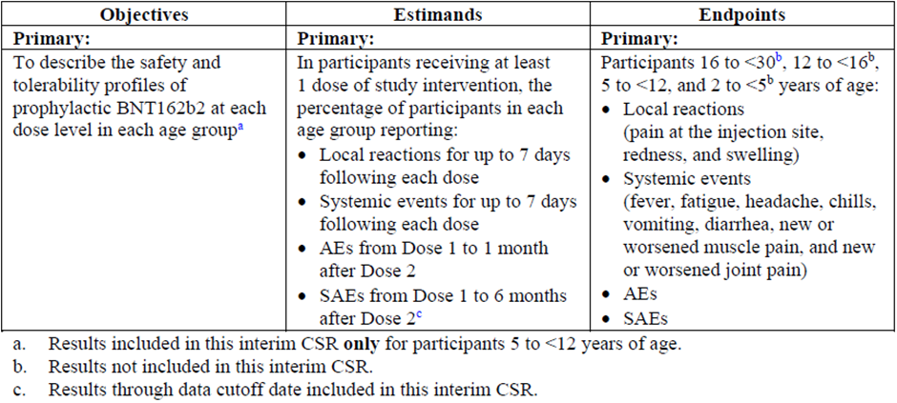
AE = adverse event; CSR = clinical study report; SAE = serious adverse event

Baseline data
In the Phase I study, e-diary data were submitted for between 85.4% and 100.0% of participants on each of the 7 post-vaccination days following Dose 1 and between 81.3% and 97.9% post-Dose 2.

Results for the primary safety outcome
These results are through to 1 month post-Dose 2 and to the Phase I data cut off date 16 July 2021, representing follow-up of approximately 3 months post-Dose 2.

Local reactogenicity
Both the 10 and 20 µg doses were well tolerated with similar frequencies of reactions; however, the intensity of pain at the injection site was higher for the 20 µg dose post-Dose 1 and post-Dose 2.
Frequencies and intensities were higher for the 4 participants given the 30 µg dosing for both doses compared to the lower doses, with 1 of the 4 experiencing severe redness post-Dose 2.
The median onset day for most local reactions was within 1 to 2 days after Dose 1 or Dose 2 and the majority of events resolved within 1 or 2 days of onset.
Figure 4: Participants reporting local reactions, by maximum severity, within 7 days after each dose (safety population)
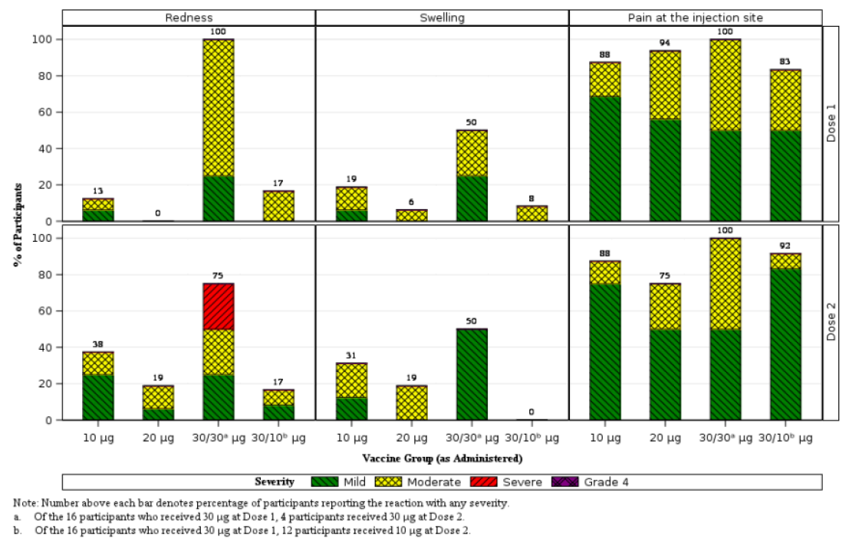
Note: number above each bar denotes percentage of participants reporting the reaction with any severity.
a: of the 16 participants who received 30 µg at Dose 1, 4 participants received 30 µg at Dose 2.
b: of the 16 participants who received 30 µg at Dose 1, 12 participants received 10 µg at Dose 2.

Systemic reactogenicity
There were generally higher frequencies and/or intensities in the 20 µg group compared to the 10 µg group, with frequencies and intensities slightly higher for fever, fatigue, headache and chills post-Dose 2 in the 10 µg group; a similar pattern was seen following 20 µg, with the exception of fatigue.
The only severe reactions seen in the lower dose groups were 1 case each of fever in the 10 and 20 µg groups, post-Dose 2 and both resolved by Day 3. There were no Grade 4 reactions seen.
The 30 µg for both Doses 1 and 2 group had higher frequencies and intensities of reactions than the lower dose groups following both doses but the smaller numbers mean these results should be interpreted cautiously (for example, muscle pain was experienced by 100% of the 4 participants given 30 µg for both doses (post-Dose 1) but 0% of the 12 participants given 30 µg for Dose 1 and 10 µg for Dose 2, even though the first dose was the same in all).
The frequency of anti-pyretic or pain medication use was higher in the 20 µg group than the 10 µg group post-Dose 2 and higher in participants given a 30 µg dose, either for Dose 1 or Dose 2.
The median onset day for most systemic events was 1 to 2 days after Dose 1 or Dose 2 and the majority of events resolved within 1 day of onset.
Figure 5: Participants reporting systemic events, by maximum severity, within 7 days after each dose (safety population)
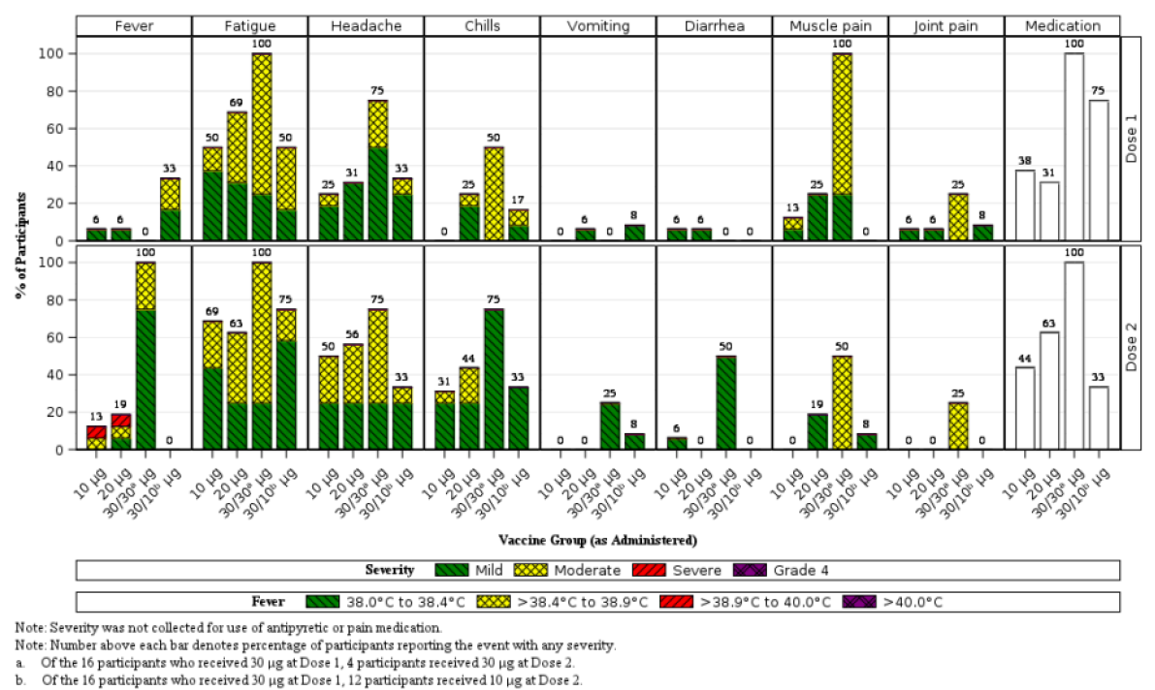
Note: Severity was not collected for use of antipyretic or pain medication.
Note: number above each bar denotes percentage of participants reporting the reaction with any severity.
a: of the 16 participants who received 30 µg at Dose 1, 4 participants received 30 µg at Dose 2.
b: of the 16 participants who received 30 µg at Dose 1, 12 participants received 10 µg at Dose 2.

Adverse events
Frequencies, severities and relatedness for adverse events is shown for each dose level in Table 7. One severe adverse event occurred in a participant in the 20 µg group which involved pyrexia of 39.7°C after Dose 2 on day 1 post-vaccination, lasting 3 days.
Immediate adverse events post-Dose 1 include one case of injection site discomfort and one case of syncope in the 10 µg group, and injection site pain in 2 cases in the 30 µg for Dose 1 and 10 µg for Dose 2 group. Post-Dose 2, there was 1 participant in the 10 µg group who reported immediate injection site pain.
Table 7: Number (%) of participants reporting at least 1 adverse event from Dose 1 through 1 month after Dose 2 (safety population)
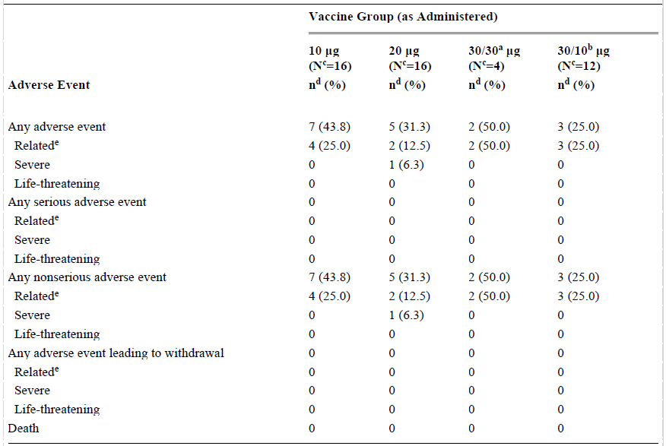
a: of the 16 participants who received 30 µg at Dose 1, 4 participants received 30 µg at Dose 2.
b: of the 16 participants who received 30 µg at Dose 1, 12 participants received 10 µg at Dose 2.
c: N = number of participants in the specified group; this value is the denominator for the percentage calculations.
d: n = number of participants reporting at least 1 occurrence of the specified event category/ For ‘any adverse event’ n = the number of participants reporting at least 1 occurrence of any adverse event.
e: assessed by the investigator as related to investigational vaccine.

Serious adverse events, deaths and adverse events leading to withdrawal
None reported as of the data cut off date.

Adverse events of special interest
There were no cases of anaphylaxis, appendicitis, Bell’s palsy, myocarditis, pericarditis, or MIS-C. There were no cases of participants with abnormal physical findings.
From the clinical study report:
‘One (1) participant who received 2 doses of BNT162b2 [Comirnaty vaccine] 30 μg as assigned had an AE [adverse event] of Grade 2 arthralgia (right hip pain) that was judged by the investigator as related to study intervention. This participant was a White male 5 years of age with no relevant medical history or concomitant vaccinations. The event was reported with an onset of 7 days after Dose 1, and was reported as involving no limitation in movement of the extremity, no accompanying fever, no injection site abnormality, and no other symptoms; the event resolved the same day after administration of ibuprofen.’

Lymphadenopathy
Two participants between 5 to < 12 years of age had cases of lymphadenopathy up to the data cut off date but neither were in the 10 µg group (that is, the dose selected for Phase II/III study).

Dose defining
Based upon review of safety and immunogenicity in the Phase I study, the final BNT162b2 (tozinameran) dose levels selected were 10 µg for the 5 to 11 years of age group, and 3 µg for the two younger age groups.

Study C4591007 (Phase II/III parts)

Study design, objectives, locations and dates
Based on the dose of 10 µg selected in the Phase I part of Study C4591007, subjects were randomised 2:1 to receive the Comirnaty vaccine or placebo at 84 study sites in Finland (n = 11), Poland (n = 8), Spain (n = 10) and the USA (n = 55). The intent was to assess safety and tolerability, immunogenicity and efficacy.
Immunogenicity is to be assessed through immunobridging with a group of randomly selected subjects of 16 to 25 years of age from Study C4591001, and clinical efficacy following accrual of a suitable number of COVID-19 cases in the 5 to 11 years of age group.
A supportive vaccine efficacy analysis is planned once 22 confirmed cases of COVID-19 have accrued among subjects with no prior serological or virological evidence of SARS-CoV-2 infection prior to 7 days after receipt of Dose 2 provided success criteria for immunobridging are also met.
Additional objectives are designed to explore lower dose levels and other vaccine immunogenicity evaluations subsets of subjects.
Of note, the sponsor recruited an additional 2250 children (1500 receiving Comirnaty, and 750 placebo) commencing August 2021 in a safety expansion subset to obtain a larger safety database to support licensure for this age group; however, their data were not included in the present electronic submission and an interim report for 2.4 week median follow up was provided later. In addition to those 2250 subjects, the sponsor intends to recruit a further 750 subjects to collect samples for troponin I evaluation (as a marker of myocarditis), with enrolment scheduled to commence in October 2021.

Inclusion and exclusion criteria

Inclusion criteria
Inclusion criteria were:
- male and female subjects 6 months to 12 years age at time of randomisation; and
- considered healthy, as determined by medical history, physical examination and judgement of investigator.
Note: enrolment was permitted for subjects with medical conditions such as: stable type 1 diabetes mellitus or hypothyroidism; stable and controlled HIV, hepatitis C or B (HCV or HBV) viral infection; and past serological or microbiologic evidence of prior (but not active) SARS-CoV-2 infection.

Exclusion criteria
Main exclusion criteria were:
- clinically important prior medical (including immunosuppressive or autoimmune conditions) or psychiatric illness or laboratory abnormalities; and/or
- past diagnosis of MIS-C.

Study treatments
Comirnaty (tozinameran) 10 µg in 0.2 mL dose given twice, 21 days apart as a primary series. Matching saline placebo, 0.2 mL. However, no details were provided in the clinical study report about the formulation type (phosphate buffered saline/sucrose buffered; or tris/sucrose buffered) used for the clinical trials.
Following information was provided in subsequent email correspondence with the sponsor:
- Both the Phase I and Phase II/III studies utilised the existing formulation of phosphate buffered saline/sucrose buffered products.
- The vial size for the 10 µg dose in the Phase II/III study was 0.2 mL (as above), which was then further diluted so that doses of 10 µg in 0.2 mL could be utilised. The 0.2 mL vial ‘was made specifically for the Study C4591007 and is not being manufactured for supply’.
- The new formulation tris buffered saline/sucrose buffered product was not used at all in Study C4591007.

Efficacy and immunogenicity variables and outcomes
Table 9: Phase II/III Objectives, estimands and endpoints (efficacy and immunogenicity)
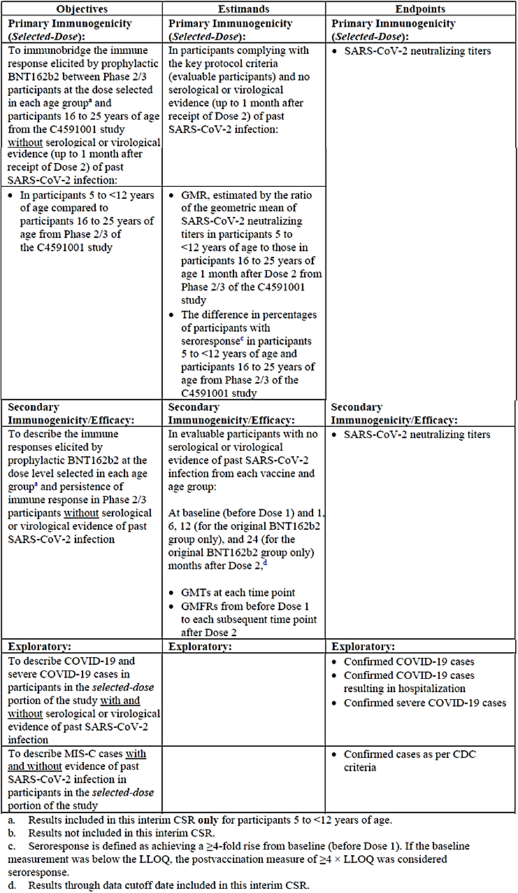
Note: BNT162b2 refers to Comirnaty (tozinameran)

Study procedures
Serum samples for immunogenicity testing were obtained as follows:
- Visit 1: before Dose 1 (from about 450 subjects (300 Comirnaty vaccine, 150 placebo))
- about 1 month after Dose 2
- about 6 months after Dose 2
- about 12 and 24 months after Dose 2 (from a subset of about 70 subjects).
Phase II/III results are reported in the interim clinical study report for SARS-CoV-2 neutralising titres through the 1-month post-Dose 2 time point. Data from later time points will be reported in the future.

Sample size
Phase II/III was designed to include a total of approximately 6750 subjects for all age groups, with the 5 to <12 Years age group including a total of approximately 4500 subjects (3000 active, 1500 placebo). This includes an initial N of approximately 2250 subjects (1500 vaccine, 750 placebo), from whom data are included in the interim clinical study report.
An additional 2250 subjects in the 5 to < 12 years of age group are to be enrolled and randomised in a 2:1 ratio (1500 active, 750 placebo) to enlarge the size of the paediatric safety database to support future licensure.’ This is the safety expansion subset.
An additional 750 subjects in the 5 to < 12 years of age group are to be enrolled to conduct troponin I evaluations. Safety data from these additional subjects will be reported when available.
It was calculated that around 225 evaluable subjects in each age group along with around 225 corresponding randomly selected subjects aged 16 to 25 years from Study C4591001 would provide a power of 90.4% and 92.6% to declare immunobridging success based on geometric mean ratios (GMR) and seroresponse difference respectively.
Accounting for a 25% non-evaluable rate with a 2:1 randomisation ratio, this would require approximately 450 subjects for each age group (that is, 300 Comirnaty vaccine, and 150 placebo) with 1 month post-Dose 2 serum samples available.

Statistical methods

Immunogenicity analysis
Immunobridging analyses were performed to demonstrate non-inferiority between immune responses (GMTs) at 1 month post-Dose 2 relative to the random sample from the 16 to 25 years of age cohort (see above). ‘Samples were tested contemporaneously in the same assay.’
Geometric mean ratios (GMR) with 95% CIs were calculated sequentially. The GMR equalled the difference in means of the 5 to 11 years of age group minus the 16 to 25 years of age group on the natural log scale prior to exponentiating. The criterion for immunobridging success (that is, non-inferiority): if the lower bound of the 2-side 95% CI for the GMR was > 0.67 and the point estimate for the GMR was ≥ 0.8 (or ≥ 1.0 as requested by the FDA).
Seroresponse was defined as a ≥ 4-fold rise in GMTs from Baseline (that is, just prior to Dose 1). If the baseline GMT was below the lower limit of quantitation, then a post-vaccination response of ≥ 4-fold was considered seroresponse. The difference in percentage points of seroresponse of subjects 5 to 11 years of age minus that of subjects 6 to 25 years of age was calculated. Immunobridging success was declared if the lower bound of the 95% CI for the difference in seroresponse rates was greater than -10%, provided that the immunobridging success based on GMRs had been achieved.
Geometric mean titres (GMT) and their 95% CIs were presented as the mean of the assay results after log transformation, followed by exponentiation to the original scale. Excepting for seroresponse, titres < lower limit of quantitation were set to 0.5 x the lower limit for all other analyses.
Geometric mean fold rises (GMFR) and their 95% CIs were calculated as the mean of the difference of logarithmically transformed assay results (later time point minus earlier time point) and exponentiating the mean.
Phase II/III subgroup analyses based on demographics (sex, race, and ethnicity) and SARS-CoV-2 baseline status (positive or negative) were performed on primary safety and immunogenicity endpoints as supplemental analyses.

Participant flow

All randomised subjects
The disposition of all randomised subjects (n = 2285) is shown below. Dose 2 was given to ≥ 98.7% of subjects. Only 2 (0.1%) vaccine recipients discontinued from the vaccination period (but continued in the study) and a total of 5 (0.3%) were withdrawn, 4 by their parents. None of the withdrawals were related to an adverse event. Of the 1528 subjects randomised to receive Comirnaty vaccine 10 µg, 11 (0.7%) were not vaccinated, 1517 (99.3%) received Dose 1 and 1514 (99.1%) received Dose 2. The vaccine was accidentally administered to 1 (0.1%) of the 757 placebo recipients at Dose 1 and again at Dose 2. The protocol-specified window for Dose 2 was 19-23 days following Dose 1 and this was achieved for 94.4% of vaccine 10 µg recipients and 94.5% of placebo recipients. When given outside the window, Dose 2 was most frequently delayed
Table 10: Phase II/III Disposition of all randomised subjects
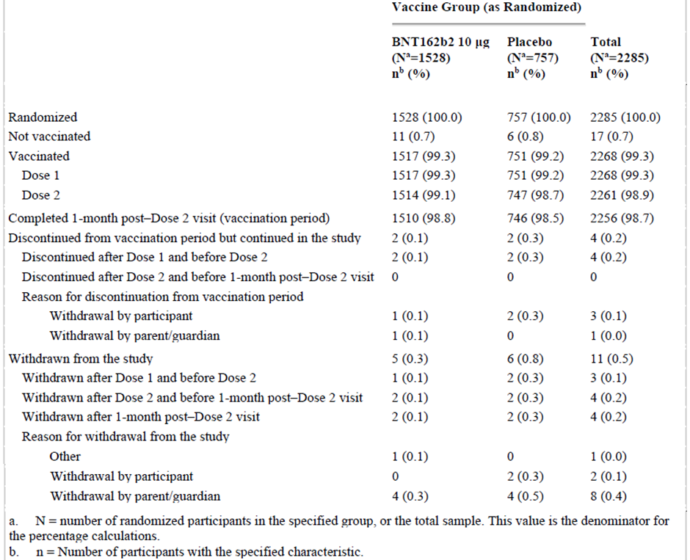

Immunobridging subset
The disposition of subjects in this subset was reflective of the population overall and is shown (along with the inclusion of the historical controls of the 16 to 25 years of age cohort from Study C4591001). Completion of the visit at 1 month after Dose 2 occurred in ≥ 97.7% of each group.
Table 11: Phase II/III Disposition of all randomised subjects through 1 month after Dose 2, immunobridging subset; 5 to < 12 years age and Study C4591001 Phase II/III, 16 through 25 years of age
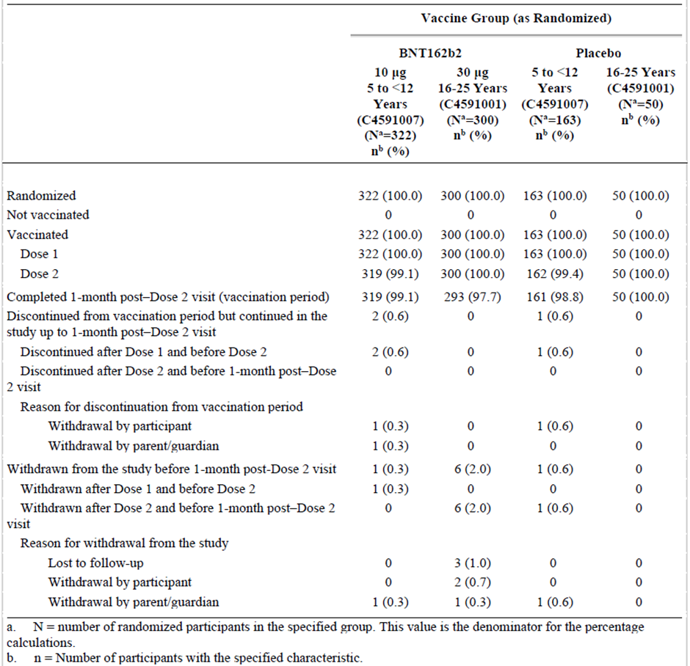

Major protocol deviations
Important protocol deviations were reported in 48 subjects (3.1%) in the Comirnaty vaccine group and 4 subjects (0.5%) in the placebo group. Nearly all protocol deviations in the Comirnaty vaccine group (47 (3.1%)) were related to investigational product, most (38 (2.5%)) due to being unsuitable for use (as the Comirnaty vaccine requires thawing/dilution prior to administration, whereas saline placebo does not).
Table 12: c
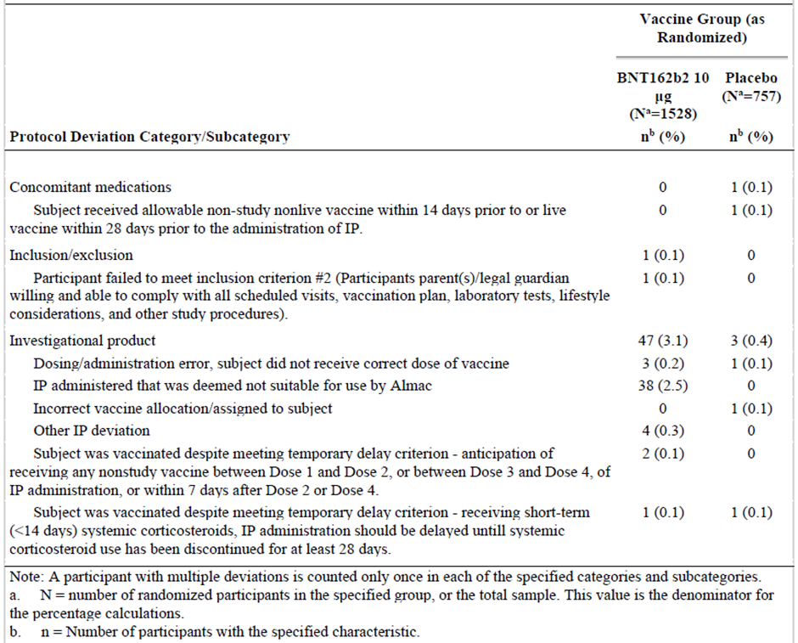

Immunogenicity
The evaluable immunogenicity population for children 5 to < 12 years of age included 294 subjects in the Comirnaty vaccine group and 147 subjects in the placebo group, and for Study C4591001, subjects 16 to 25 years of age included 273 subjects in the Comirnaty group and 47 subjects in the placebo group. The evaluable immunogenicity population without prior evidence of SARS-CoV-2 infection up to 1 month after Dose 2 for the group of children 5 to <12 Years age comprised of 264 subjects in the Comirnaty vaccine group and 130 subjects in the placebo group, and for 16 to 25 years of age, 253 subjects in the Comirnaty vaccine group and 45 subjects in the placebo group.

Baseline data: Immunogenicity populations
In the 5 to 11 years group, demographics in the evaluable immunogenicity population without infection up to 1 month after Dose 2 were very similar to those described for the safety population. Baseline seropositivity was seen in 7.1% of the Comirnaty vaccine group and 8.8% of the placebo group.
In the 16 to 25 years group drawn from Study C4591001, demographics in the evaluable immunogenicity population without infection up to 1 month after Dose 2 included the following:
- 76.7% White, 10.7% Black or African American, 6.3% Asian, 37.5% Hispanic/Latino
- median age: 21.0 years
- baseline SARS-CoV-2 seropositivity (4.8% for Comirnaty group and 2.1% placebo)
- an obesity imbalance between the two groups: 15.8% in the Comirnaty vaccine group and 31.1% in placebo.
Comorbidities in the BNT162b2 (Comirnaty (tozinameran)) group that may increase the risk of severe COVID-19 (including obesity) were present in 20.6%. These included asthma (7.8%), neurologic disorders (1.3%) and congenital heart disease (1.0%). One participant had acute lymphocytic leukaemia.
Table 13: Study C4591007 Exposure to Comirnaty vaccine by special populations (blinded placebo-controlled follow-up period)
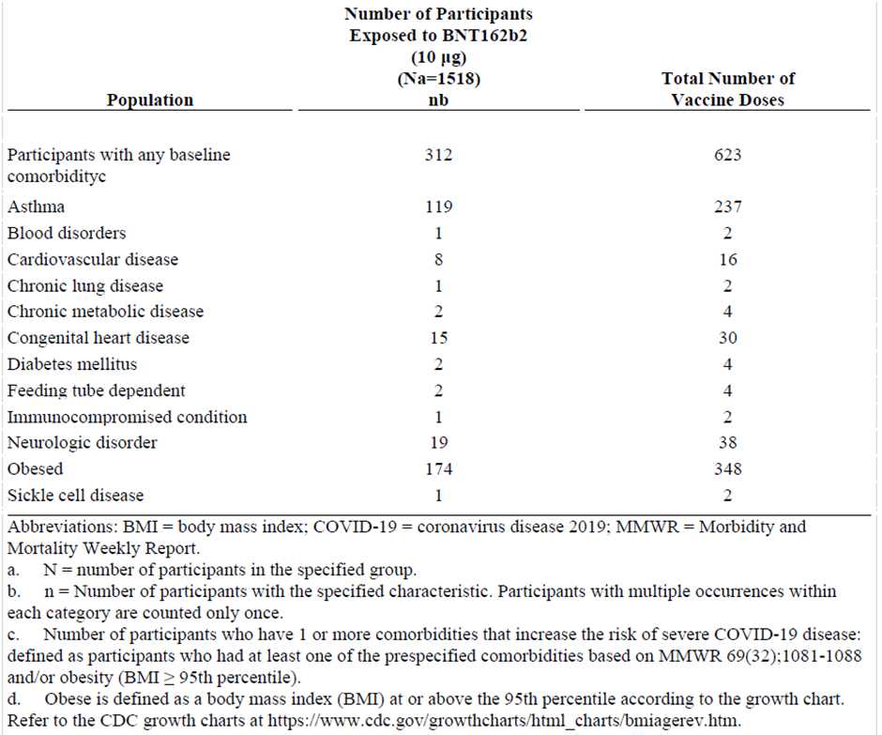
Note: BNT162b2 = Comirnaty (tozinameran) COVID-19 vaccine

Immunogenicity results

Primary immunogenicity outcomes
The GMR of 5 to11 years of age subjects’ GMTs relative to those of 16 to 25 years age subjects was 1.04 (95% CI: 0.93, 1.18). This met the immunobridging objective for success, with the lower bound of the 95% CI being > 0.67 and the point estimate ≥ 0.8 (it was also ≥ 1.0 as preferred by the US FDA). While being non-inferior, the result was not superior (lower bound of 95% CI < 1.0).
Table 13: Study C4591007 Summary of geometric mean ratios; subjects without evidence of infection up to 1 month after Dose 2, immunobridging subset; Phase II/III study, 5 to < 12 years age and Study C4591001 Phase II/III, 16 through 25 years of age (evaluable immunogenicity population)
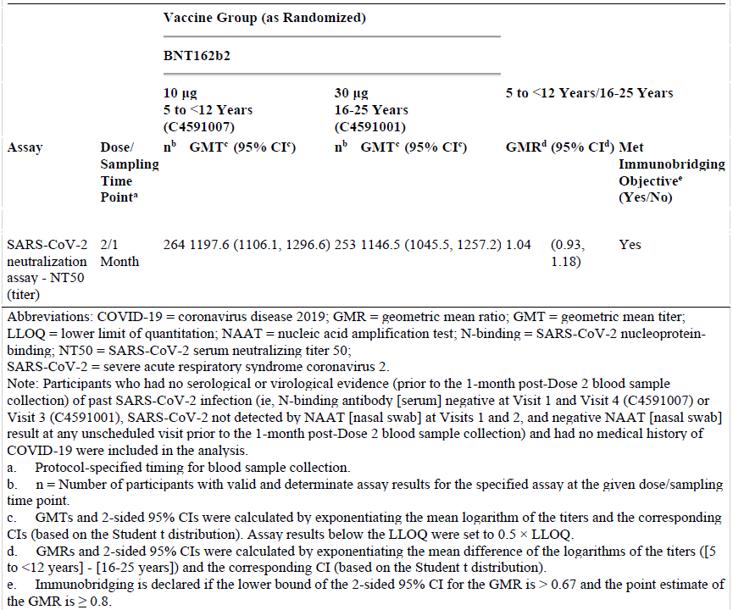

Difference in seroresponse rates
Difference in seroresponse rates in children of 5 to 11 years and young adults of 16 to 25 years age was 0.0% (95% CI: -2.0%, 2.0%). As the pre-specified criteria for immunobridging based on GMR were met (a prerequisite) and the lower bound of the 95% CI for the difference in seroresponse rates was greater than -10.0%, the criteria for non-inferiority were met.
Table 14: Difference in percentages of subjects with seroresponse, subjects without evidence of infection up to one month after Dose 2, immunobridging subsed; Phase II/III comparison of 5 to < 12 Years of age to Study C4591001 Phase II/III 16 through 25 years of age (evaluable immunogenicity population)
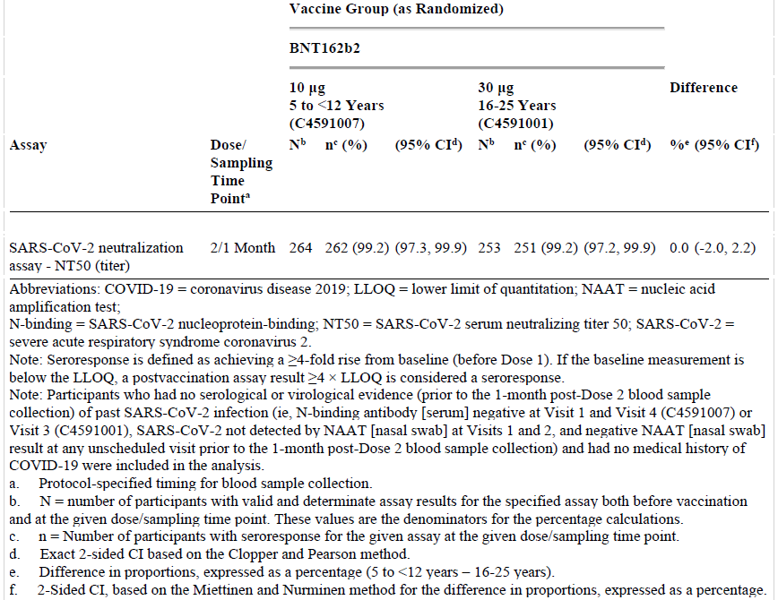

Secondary immunogenicity outcomes
A series of secondary immunogenicity outcomes were analysed in the Phase II/III study.

Geometric mean neutralising titres
GMT responses were very similar in the 5-11 years age groups and 16-25 years age groups and are shown graphically in the following 2 figures.
GMTs in the evaluable and all-available immunogenicity populations with or without evidence of infection up to 1 month post-Dose 2 were similar to those from the primary analysis population.
Figure 6: Geometric mean titres and 95% confidence intervals: SARS-CoV-2 neutralisation assay (NT50); participants without evidence of infection up to 1 month after Dose 2, immunobridging subset; Phase II/III, 5 to < 12 years of age and Study C4591001 Phase II/III, 16 through 25 years
Figure 7: Reverse cumulative distribution curves, SARS-CoV-2 neutralisation assay (NT50); subjects without evidence of infection up to 1 month after Dose 2; immunobridging subset, Phase II/III 5 to <12 Years age and Study C4591001 Phase II/III 16 through 25 years
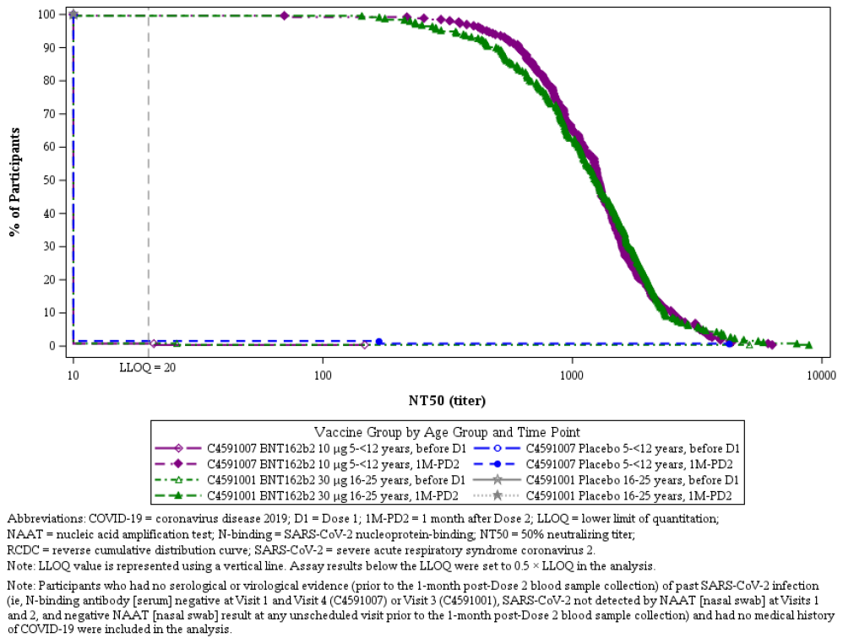

Subgroup analyses
GMTs were evaluated by demographic (for example, sex, race/ethnicity) and baseline SARS-CoV-2 subgroups.
The demographic subgroup analyses didn’t reveal any meaningful differences to the overall results (noting small numbers in some subgroups).
In the baseline seropositive subgroup analysis, subjects of 5 to 11 years of age had a 54.7 fold rise relative to Baseline results at 1 month post-Dose 2 (n = 21, GMT at second timepoint = 3270 (95% CI: 2032.1, 5261.8)). This was higher than the result in baseline seronegative subjects (1211.3 (95% CI: 1121.1, 1308.7)). It was also higher than the GMT seen in baseline seropositive subjects 16 to 25 years of age at 1 month post-Dose 2 (n = 13, GMT at second timepoint = 2253.8 (95% CI: 1497.7, 3391.5), who had a 24.7-fold rise from Baseline).

Geometric mean fold rises
Geometric mean fold rises (GMFR) were similar in the 5 to 11 years of age and 16 to 25 years of age groups, when comparing rises from Baseline to 1 month post-Dose 2 (118.2 versus 111.4 respectively). In placebo recipients, there was no rise as expected (1.0 versus 1.1 respectively).
Geometric mean fold rises in the non-primary analysis populations were similar to those above. Subgroup analyses did not reveal any meaningful new results.
Table 14: Summary of geometric mean fold rises from before vaccination to each subsequent time point (NT50) in participants without evidence of infection up to 1 month after Dose 2 (Immunobridging subset comparison, evaluable immunogenicity population)

Seroresponse rates, subgroup analyses
As discussed above under ‘Difference in seroresponse rates’, a very high rate was achieved that was the same in both age groups (that is, 99.2%). Similar rates were seen in the non-primary immunogenicity populations and across subgroups.

Results for supportive immunogenicity analysis (Delta variant)
A supplemental analysis of neutralising responses to the SARS-CoV-2 Delta variant was conducted in 38 randomly selected subjects 5 to 11 years age from the immunogenicity subset of the Phase II/III study (n = 34 in the Comirnaty vaccine group, and n = 4 in the placebo group).
The assay utilised was a previously reported but unvalidated 50% plaque-reduction utilisation test, distinct from the validated SARS-CoV-2 neutralisation assay used to determine titres for immunobridging. Responses were determined to wild-type (reference) strain and delta variant.

Delta neutralisation subset
Delta neutralisation subset of 38 subjects, were randomly selected from the evaluable immunogenicity population who had no evidence of infection up to 1 month post-Dose 2. They had received Doses 1 and 2 as initially randomised, had at least 1 valid and determinate immunogenicity result within 28 to 42 days after Dose 2, and did not have any important protocol deviations impacting evaluability.

Geometric mean titres
SARS-CoV-2 plaque reduction neutralisation test GMTs substantially increased for both the reference and Delta strains after two doses of 10 μg vaccine. The GMT at 1 month after Dose 2 against the reference strain was 365.3 (95% CI: 279.0, 478.4), which was approximately 36.5-times the GMT pre-vaccination.
The GMT at 1 month after Dose 2 against the Delta variant strain was 294.9 (95% CI: 214.6, 405.3), which was approximately 29.5-times the GMT pre-vaccination.
The pre-Dose 1 GMT in both the Comirnaty-vaccinated and placebo-vaccinated groups was 10.0 (95% CI: 10.0, 10.0).
The GMFR against reference strain was 36.5 (95% CI: 27.9, 47.8) and against Delta variant strain was 29.5 (95% CI: 21.5, 40.5).
The GMR of responses against the Delta variant versus the reference strain was 0.81 (95% CI: 0.65, 1.00).
Figure 8: Neutralisation of both reference strain and Delta variant of concern are comparable (randomly selected subset)
Subjects aged 5 to < 12 years of age from Phase II/III Study C4591007
Source: Pfizer’s US FDA presentation

Study C4591007, Phase II/III (clinical efficacy outcomes)
Clinical efficacy outcomes are considered among the secondary objectives (calculation of vaccine efficacy) and exploratory objectives (description of cases).
Efficacy analyses for the 5 to < 12 years age group were pre-specified to be conducted when at least 22 confirmed COVID-19 cases had accrued in subjects without serological or virological evidence of past SARS-CoV-2 infection prior to 7 days post-Dose 2, and only if immunobridging success criteria had first been met.
A preliminary report of efficacy data was presented through a data cut off date of 8 October 2021 after 19 confirmed cases of COVID-19 had accrued. This was based on the prespecified secondary efficacy objectives and endpoints, as shown in Table 16.
Case definitions; the first or ‘per-protocol’ case definition was of a symptomatic illness triggering an illness visit (at least one of the following symptoms) plus a positive SARS-CoV-2 NAAT (nucleic acid amplification test) either during, or within 4 days before or after the symptomatic period:
- Fever, new or increased cough, new or increased shortness of breath, chills, new or increased muscle pain new loss of taste or smell, sore throat, diarrhoea (as defined by ≥ 3 loose stools/day) and vomiting
A second more inclusive (that is, potentially more sensitive, but less specific) definition was applied according to CDC criteria and could include one or more of the following additional symptoms:
- Fatigue, headache, nasal congestion or runny nose, nausea or abdominal pain or lethargy.
Table 16: Study C459007 Phase II/III Objectives, estimands and endpoints (clinical efficacy)
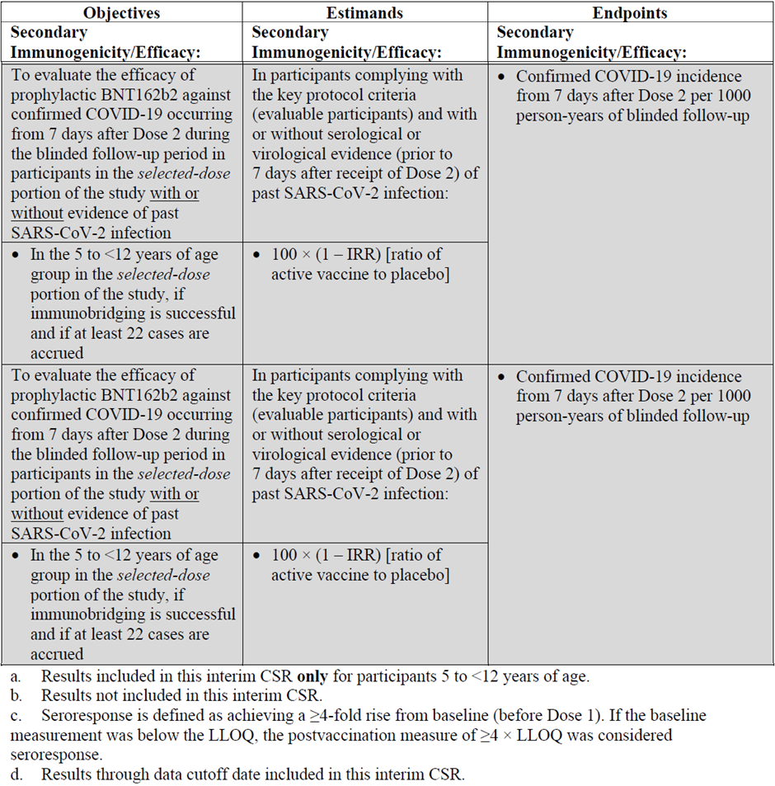

Analysis populations
The data are analysed in ‘evaluable efficacy populations’ and ‘all-available mITT (modified intention to treat) efficacy populations’. Cases are inclusive of any symptomatic confirmed COVID-19, hospitalised COVID-19, severe COVID-19 and MIS-C (using the CDC definition).
At a later date, it is planned to capture cases of confirmed seroconversion or polymerase chain reaction positivity to SARS-CoV-2 in the absence of diagnosed COVID-19.
Table 17: Study 4591007 Definitions of analysis populations
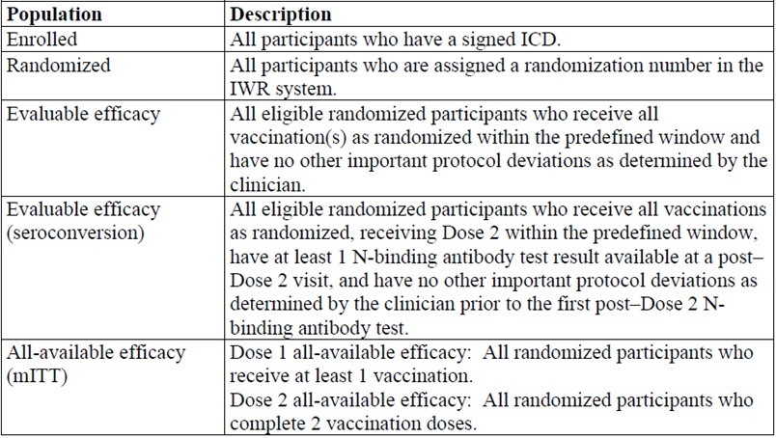

Sample size
For vaccine efficacy, the sample size estimation was based on the whole study population of around 4500 subjects 6 months to 11 years of age, randomised 2:1 to receive vaccine (Comirnaty) or placebo, assuming 25% being non-evaluable and a 1.3% annual attack rate. Across that whole population, it was estimated that 22 cases would accrue within 6 months post-vaccination and that this would provide 70% power to determine vaccine efficacy success (defined as the lower bound of the 95% CI for vaccine efficacy > 20%), assuming a case split of 8 Comirnaty (vaccine) and 14 placebo cases.

Statistical methods
Vaccine efficacy is to be estimated by 100 x (1 – IRR) where IRR is the incidence rate ratio, the calculated ratio of confirmed COVID-19 per 1000 person-years of follow-up in the Comirnaty vaccine group to the corresponding rate in the placebo group at the specified time point (that is, for the main analysis, from at least 7 days post-Dose 2). The 2-sided 95% CI for vaccine efficacy is to be provided using the Clopper-Pearson method adjusting for surveillance time. Vaccine efficacy is only to be calculated once success for the immunobridging criteria has been demonstrated. A lower bound for the 95% CI of > 20% is taken to indicate success for vaccine efficacy.

Results for efficacy outcomes (exploratory analysis), first (per-protocol) definition
A preliminary efficacy analysis was performed on 19 cases that had accrued through 8 October 2021 (3 in the Comirnaty vaccine group and 16 in the placebo group). This demonstrated a vaccine efficacy (at least 7 days after Dose 2) of 90.7% (95% CI: 67.7%, 98.3%) in the evaluable efficacy population without prior evidence of SARS-CoV-2 infection before or during the vaccination regimen. None of the 3 cases in the Comirnaty vaccine group had comorbidities, whereas these were present in 3/16 (18.8%) of the placebo group, which is similar to the rate in the overall evaluable efficacy population of 20.1%.
There were no additional cases of COVID-19 in the evaluable efficacy population with or without prior evidence of SARS-CoV-2 infection in either Comirnaty (vaccine) or placebo recipients. vaccine efficacy in that group was also 90.7% (95% CI: 67.4%, 98.3%).
Table 18: Study C4591007 (Phase II/III) vaccine efficacy; first COVID-19 occurrence from 7 days after Dose 2, subjects 5 to < 12 years of age without evidence of infection prior to 7 days after Dose 2 (evaluable efficacy population)
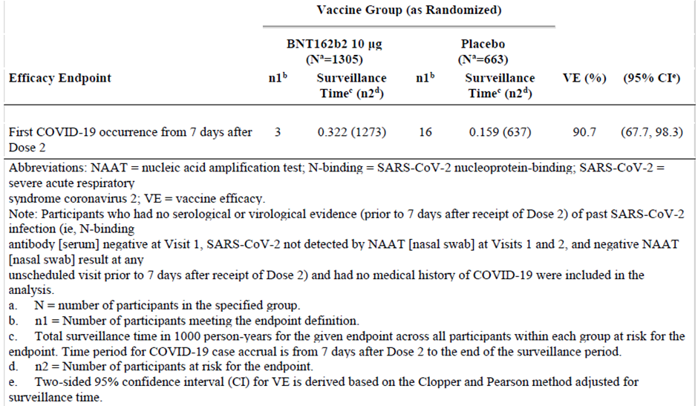

Results for efficacy outcomes (exploratory analysis), second (CDC criteria) definition
There were 2 additional cases of COVID-19, one each in the Comirnaty (vaccine) group (total number = 4) and placebo group (total number = 17). These both occurred in subjects without serological evidence of prior SARS-CoV-2 infection. Vaccine efficacy in evaluable subjects 5 to 11 years of age without prior evidence of SARS-CoV-2 infection was 88.4% (95% CI: 64.5%, 97.2%).

Supportive analyses (all-available efficacy population)
The observed vaccine efficacy of comirnaty 10 µg against any confirmed COVID-19 from Dose 1 through the data cut off date of 8 October 2021 in the Dose 1 all-available (modified intention to treat) population (that is, in all randomised subjects who received Dose 1) was 91.4% (95% CI: 70.4%, 98.4%).
The Kaplan-Meier curve of case accrual shows a steady acquisition of the cases in the placebo group (beginning approximately 3 weeks post-Dose 1) and sporadic occurrence in the vaccine group.
Figure 9: Study C4591007 Phase II/III cumulative incidence curves for the first COVID-19 occurrence after Dose 1 in subjects 5 to < 12 years of age (all-available efficacy population)
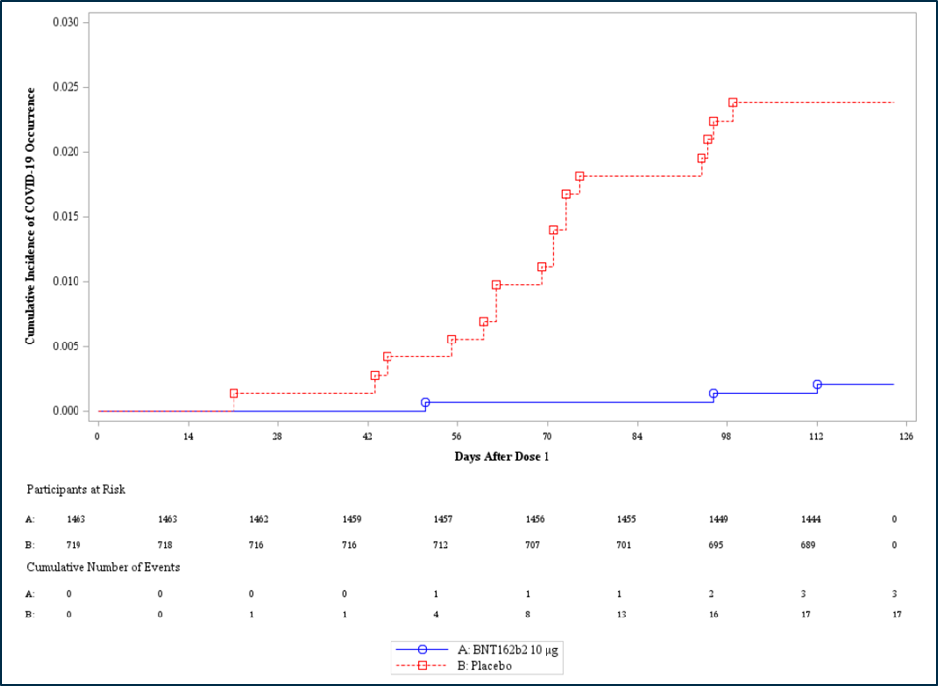
There were no cases of severe COVID-19 (per-protocol definition or per the more inclusive CDC definition) and no cases of multisystem inflammatory syndrome of children (MIS-C) reported through the data cut-off date.

Vaccine efficacy subgroup analyses
Vaccine efficacy was evaluated for subgroups according to sex, race, ethnicity, country and at-risk status (that is, obesity or with ≥ 1 specified comorbidity) based on per-protocol case criteria. All subgroups had observed vaccine efficacy > 85%, noting that numbers were small and the CIs (95%) were wide.

Safety

Study C4591007 (Phase II/III parts)
Objectives, estimands and endpoints relevant to the 5 to 11 years of age subgroup (from Study C4591007, Phase II/III parts) are presented in the following table.
Table 18: Study C4591007 Phase II/III Safety objectives, estimands and endpoints
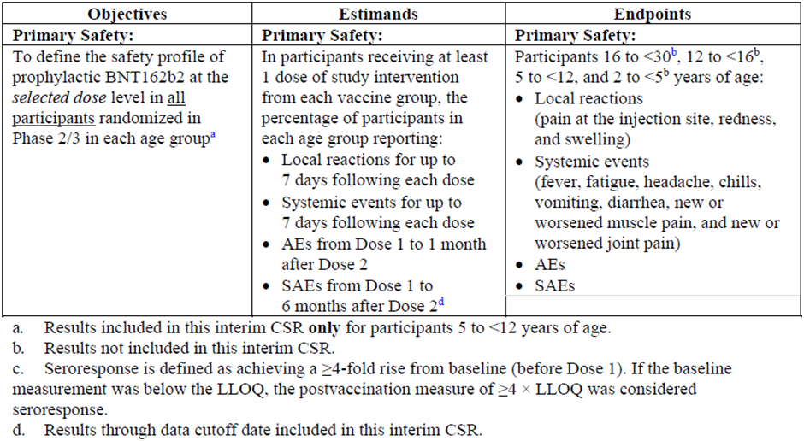
AE = adverse event; CSR = case study report; LLOQ = lower limit of quantitation; SAE = serious adverse event

Study procedures
The following are descriptions of how and when data related adverse events were collected and described in this study:
- All/any adverse events were collected from the time of signing the consent until 1 month after Dose 2, and also for 48 hours after venesections and nasal swab collections.
- Immediate adverse events were monitored up to 30 minutes post-dose.
- Serious adverse events were to be collected from the time of signing the consent until approximately 6 months after Dose 2.
- Adverse events of special interest included myocarditis and pericarditis plus a list of targeted medical events of specific interest; that are highlighted during clinical safety data review and signal detection, and reviewed on an ongoing basis. This includes adverse events related to COVID-19 and vaccines in general, and the CDC list of AESIs for COVID-19. Additional adverse events of special interest to the sponsor and medical regulators were also considered.

Safety population
Of the 1535 subjects randomised to receive Comirnaty vaccine (10 µg), 17 did not receive study vaccine, leaving 1518 in the safety population. In addition, there were 750 placebo recipients, giving a total safety population of 2268, 99.3% of those randomised. None of the safety population were diagnosed HIV positive.
The majority (≥ 95%) of subjects had ≥ 2 to < 3 months follow-up post-Dose 2, with the remainder having < 2 months.
Table 19: Study C4591007 Phase II/III Follow-up time after Dose 2 in subjects 5 to < 12 years of age (safety population)
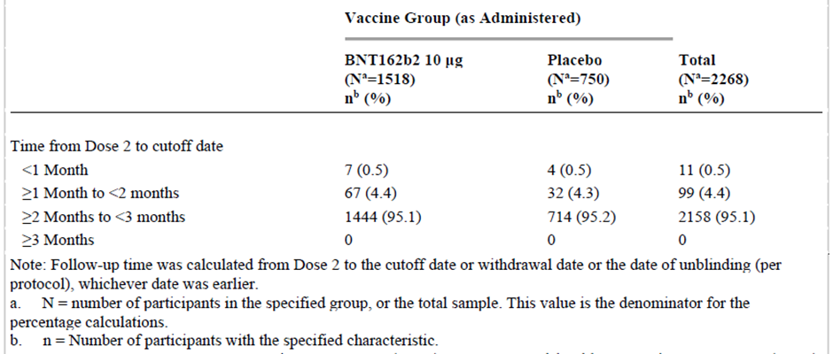
These results are through the Study C4591007 (Phase II/III parts) data cut off date 6 September 2021, representing follow-up of 2 months post-Dose 2.

Local reactogenicity
The frequency and intensity of local reactions was higher in the vaccine group (see Figure 10, below). Pain was the most common reaction, with similar frequencies and intensities post-Dose 1 and Dose 2. Redness and swelling were less frequent and occurred at higher frequency post-Dose 2.
After any dose of Comirnaty, severe reactions were rare, being seen for pain in 9/1517 (0.6%) of cases (4 post-Dose 1 and 5 post-Dose 2), redness in 3/1517 (0.2%; all post-Dose 2) and swelling in 1/1517 (0.1%; post-Dose 1). No Grade 4 reactions were observed.
Across groups, median onset for all local reactions after receiving Comirnaty was 1 to 2 days after Dose 1 or Dose 2, and all events resolved within a median duration of 1 to 2 days.
Children aged 5 to 11 years had comparable rates of pain at the injection site but slightly higher frequencies of redness and swelling at the injection site than were recorded in older individuals (aged 12 to 15 years of age) and the associated cohort of older adolescents and adults 16 to 25 years of age from Study C4591001).
Figure 10: Study C4591007 (Phase II/III) Subjects aged 5 to < 12 years reporting local reactions, by maximum severity, within 7 days after each dose (safety population)
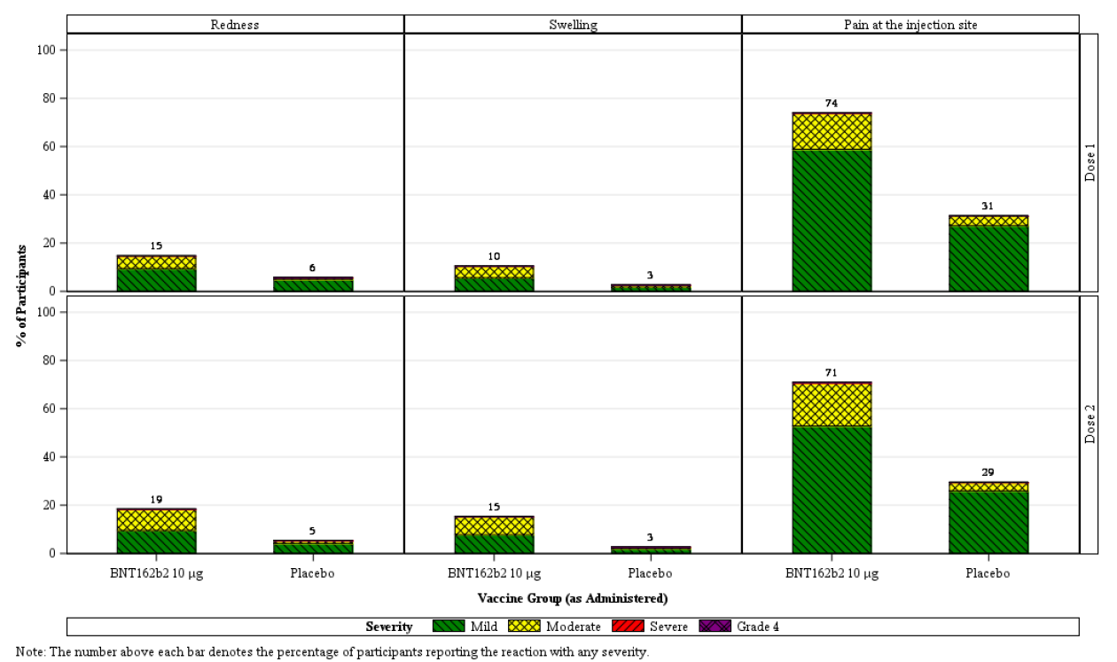

Systemic reactogenicity
Dose 1 was well tolerated, with similar frequencies to placebo that were actually lower in some instances (for example, for headache and joint pain). Frequencies were generally higher for Comirnaty than placebo post-Dose 2.
In Comirnaty recipients, frequencies and intensities of systemic events were generally lower post-Dose 1 than post-Dose 2.
Fever (recorded temperature of ≥ 38°C) occurred in 2.5% after Dose 1 and 6.5% after Dose 2.
Figure 11: Study C4591007 Phase II/III Subjects aged 5 to < 12 years reporting systemic events, by maximum severity, within 7 days after each dose (safety population)
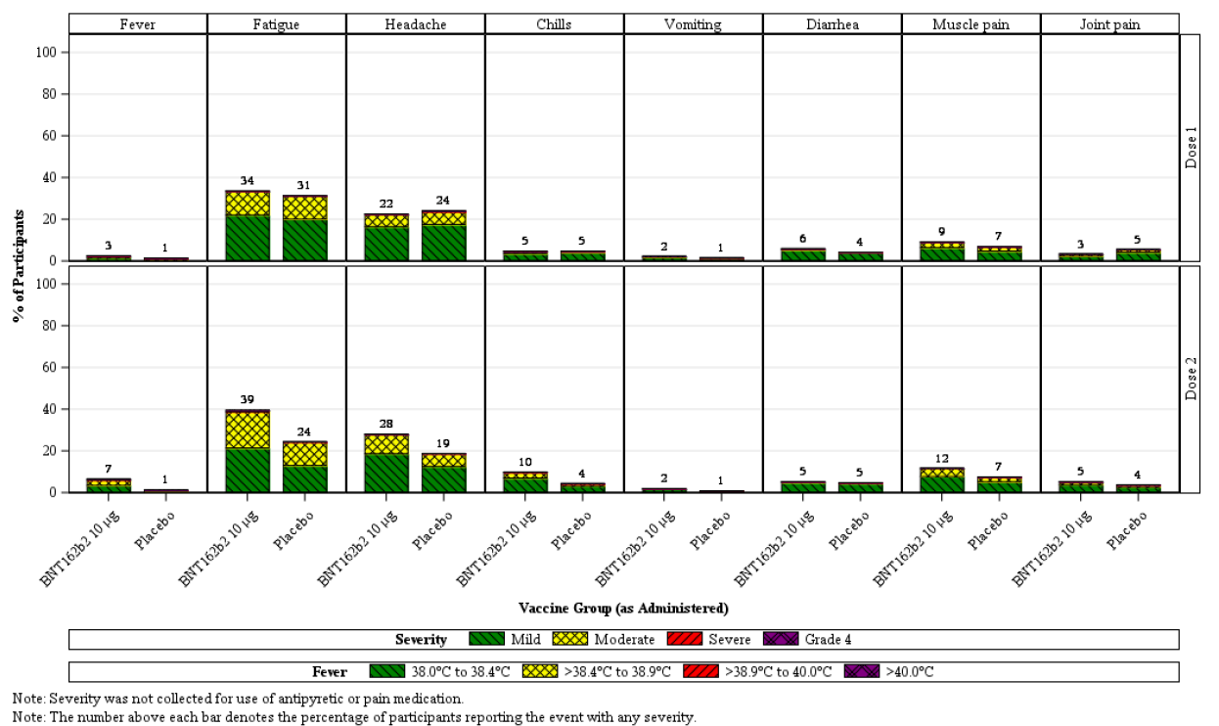
Severe systemic events were rare, occurring in ≤ 0.2% subjects following Dose 1 and Dose 2, only one subject had a fever > 40°C; this occurred on day 2 post-Dose 2 and lasted one day.
Across groups, median onset or all systemic events after receiving Comirnaty was 1 to 4 days after Dose 1 or Dose 2 (most had a median of 2 days post-dose), and all events resolved with a median duration of 1 day.
Overall, the pattern of systemic events reported in children 5 to < 12 years of age after each dose, was generally comparable to, or less than, that observed in prior analyses of Phase II/III participants ≥ 12 Years age in Study C4591001.

Adverse events from Dose 1 to one month after Dose 2
Frequencies of adverse events were comparable in Comirnaty (vaccine) and placebo recipients (10.9% versus 9.2% respectively). An overview of adverse events (including relatedness to vaccination and seriousness) is presented in Table 20.
In Comirnaty (vaccine) recipients, there were 2 severe adverse events reported (versus one in the placebo group) but there were no serious adverse events and none led to study withdrawal.
Table 20: Study C4591007 Phase II/III Number (%) of subjects aged 5 to < 2 years of age reporting at least one adverse event from Dose 1 to one month after Dose 2 (safety population)
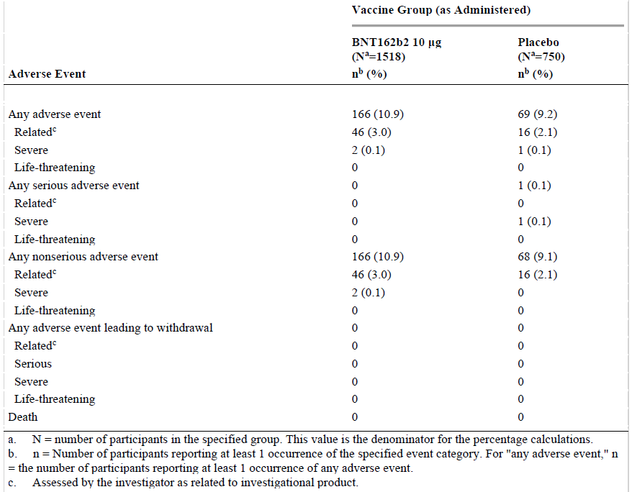
Note: BNT162b2 refers to Comirnaty (tozinameran) vaccine
Adverse events by System Organ Class (SOC) are reflected as reactogenicity SOCs, as follows (for Comirnaty (vaccine) versus placebo):
- SOC General disorders and administration site conditions: 1.6% versus 1.7%
- SOC Gastrointestinal disorders: 1.6% versus 1.7%
- SOC Nervous system disorders: 0.7% versus 0.5%
- SOC Musculoskeletal and connective tissue disorders: 0.5% versus 0.7%.
The frequency of related adverse events was similar to participants aged 12 to 15 years in Study C4591001 and less than those 16 to 25 years The types and frequencies of adverse events reported in children aged 5 to 11 years, was comparable to those for adolescents aged 12 to 15 years.
- Blood and lymphatic system disorders (inclusive of lymphadenopathy and lymph node pain): 0.9% versus 0.1% respectively. This compares to frequencies of 0.8% in previously reported adolescents and 0.2% in those aged 16 to 25 years.
- Skin and subcutaneous disorders (inclusive of rashes, urticaria, eczema and pruritus): 1.4% versus 0.8%. This compares to frequencies of 0.5% in adolescents and 0.9% in those aged 16 to 25 years.
- Cardiac disorders: One participant in the Comirnaty (vaccine) group had a Grade 1 event of ‘angina pectoris’ that was considered by the Investigator as study-related. This represented mild, transient chest pain lasting one minute that was reported 2 days post-Dose 2, then resolved without sequalae.
There were no Preferred Terms that would be considered as per-protocol Tier 2 events (that is, 1.0% or more) in any vaccine group; the closest was lymphadenopathy at 0.9% in the Comirnaty (vaccine) group.
The profile of adverse events by System Organ Classes and Preferred Terms in general (and for those related to lymphadenopathy in particular) showed no obvious meaningful clinical variation across demographic or serostatus subgroups.

Related adverse events from Dose 1 to 1 month after Dose 2
These occurred at a slightly higher frequency in the Comirnaty (vaccine) group (3.0%) than in the placebo group (2.1%). Most related adverse events represented reactogenicity events.
The following was of note to the Delegate:
- Lymphadenopathy was reported in 0.7% of the vaccine (Comirnaty) group and 0.0% of the placebo group. All cases were considered mild. There was an additional one case (0.1%) of lymph node pain in the Comirnaty (vaccine) group, with none in the placebo group.
- Frequencies of Preferred Terms within the System Organ Class of skin and subcutaneous disorders (inclusive of urticaria, rash, erythema and pruritus) occurred at similar frequencies of relatedness (0.4% versus 0.5% respectively).
- A non-serious Grade 3 event of ‘tic’ was reported in a participant in the Comirnaty (vaccine) group post-Dose 2 and initially assessed as related; however, was later assessed as unrelated following neurology consultation.

Immediate adverse events
Post-Dose 1 there were 3 (0.2%) immediate adverse events in the Comirnaty (vaccine) group, all involving injection site pain, compared to 3 (0.4%) in the placebo group.
Table 21: Study C4591007 Phase II/III Number (%) of subjects aged 5 to < 12 years reporting at least one immediate adverse event after Dose 1, by System Organ Class and Preferred Term (safety population)
Note: BNT162b2 refers to Comirnaty (tozinameran) vaccine
Post-Dose 2 there were 4 (0.3%) immediate adverse events in the Comirnaty (vaccine) group (one each of nausea, injection site pain, injection site erythema and erythema), compared to 2 (0.3%) in the placebo group.
No allergic adverse events were reported after either dose of Comirnaty (vaccine) within 30 minutes after vaccination.
Table 23: Study C4591007 Phase II/III Number (%) of subjects aged 5 to < 12 years reporting at least one immediate adverse event after dose 2, by System Organ Class and Preferred Term (safety population)
Note: BNT162b2 refers to Comirnaty (tozinameran) vaccine

Severe or life-threatening adverse events from Dose 1 to 1 month after Dose 2
There were 2 (0.1%) in the Comirnaty (vaccine) group: the case of ‘tic’ discussed above under ‘Related adverse events’ and another Grade 3 case of rash (a bilateral pleomorphic light eruption on arms) that was considered by the Investigator as unrelated, with a plausible alternative explanation as a rash to sunscreen. There were no Grade 4 adverse events in this time period.

Adverse events through the data cut off date
An analysis of adverse events through the data cut off date 6 September 2021) looked at approximately 2 months of data post-Dose 2 as opposed to the one month summarised above.
The frequency of adverse events in the Comirnaty (vaccine) group was 11.6% through the data cut off date vs 10.9% for one month post-Dose 2; in the placebo group these were 9.6% versus 9.2% respectively. There were few additional adverse events in this extended period and no additional adverse of clinical interest were identified.

Serious adverse events, deaths and adverse events leading to withdrawal through data cut off date
There were 3 serious adverse reported by 2 participants, one each in the Comirnaty (vaccine) and placebo groups. The Comirnaty (vaccine) recipient had a fall and fractured elbow 45 days after Dose 2 that was assessed by the investigator as not related to the study intervention. The placebo recipient had pancreatitis and abdominal pain that occurred 4 days post-Dose 2 (unrelated).
There were no deaths and no adverse events leading to study withdrawal.

Adverse events of special interest
There were no cases reported of anaphylaxis, myocarditis, pericarditis, Bell’s palsy (or facial paralysis/paresis) or appendicitis. There were no cases of anaphylaxis, anaphylactoid reaction or hypersensitivity in the Comirnaty (vaccine) group (one placebo recipient had a hypersensitivity event).

Standardised MedDRA Queries (SMQ) of angioedema and hypersensitivity
A safety review was conducted using the Medical Dictionary for Regulatory Activities (MedDRA) Standardised MedDRA Queries (SMQ) of angioedema and hypersensitivity through, one month post-Dose 2.
Much of the imbalance was evidenced by differences in dermatitis/eczema like reactions (5 cases in the Comirnaty (vaccine) group versus zero in the placebo group), all of which were deemed unrelated. Rash was also imbalanced (8 in the Comirnaty (vaccine) group versus one in the placebo group), 4 of which were deemed related: all were Grade 1, typically with an onset ≥ 7 days post-vaccination, and only one with an injection site rash at the injection site at onset 3 days post-Dose 2. There was no clear pattern relating to distribution of the related rashes and there were confounding factors in 2 (that is, prior erythema secondary to Tegaderm (transparent medical dressing) and a bee sting in the same distribution before or after)

Lymphadenopathy
As of the data cut off date, there were 13 (0.9%) cases of lymphadenopathy in the Comirnaty (vaccine) group and one (0.1%) in the placebo group (Table 23). All reported cases of lymphadenopathy were mild.
In the Comirnaty (vaccine) group, the mean time to onset of lymphadenopathy post-Dose 1 was 6.2 days (median 3 days) and post-Dose 2 was 2.6 days (median 2 days). The mean duration was 4.7 days (median 3.5 days, range 1 to 14 days).
Overall, the pattern of lymphadenopathy cases reported in children 5 to < 12 years age was generally similar to that observed in prior analyses of Phase II/III participants ≥ 12 years age in Study C4591001’ (0.8% in adolescents and 0.2% in 16-25 years) and most cases were mild to moderate in severity.
Table 23: Study C4591007 (Phase II/III) Subjects aged 5 to < 12 years reporting an adverse event of lymphadenopathy; blinded placebo-controlled follow-up period (safety population)
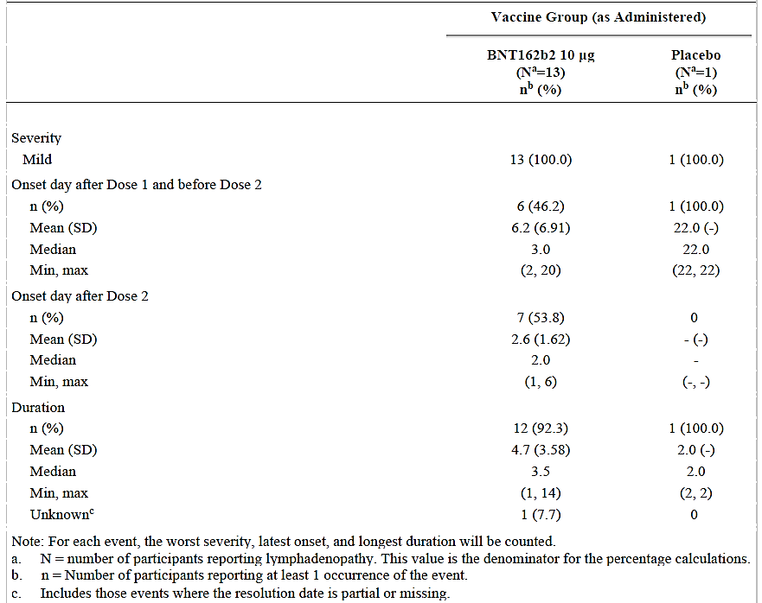
Note: BNT162n2 refers to Comirnaty (tozinameran) vaccine

Other events of clinical interest (not observed)
Referencing the CDC list of adverse events of special interest, there were no cases of thrombocytopenic events, thromboembolic or intravascular coagulation events, autoimmune or demyelination events, meningitis, encephalitis, neuritis, Kawasaki disease, MIS-C, or acute respiratory distress syndrome.
There were no severe COVID-19 cases (for example, potentially VAERD, or vaccine-associated enhanced respiratory disease) recorded. There were no severe or serious related rash.
There were no imbalances in abnormal physical findings (baseline rates were 1.8% and 1.9% in the Comirnaty (vaccine) and placebo groups respectively; from 19 to 23 days post-Dose 1 these were 0.9% an 0.8% respectively).

Other related events of clinical interest
Arthralgia: This was reported in one participant in the (Comirnaty) vaccine group, a 7 year old male with an adverse of Grade 1 arthralgia (right elbow joint pain) occurring on the day of Dose 2 (given in left deltoid) and resolving the next day. It was considered by the investigator as related.
Paraesthesia: This was reported in one participant in the Comirnaty vaccine) group, a 9 year old female with an adverse event of Grade 2 paraesthesia (bilateral lower and upper extremity tingling) with onset at 1 day post-Dose 2 and reported as recovered/resolved 3 days later. It was considered by the investigator as related.
Tic: An adverse event of Grade 3 tic was reported in a 9 years old male with onset at 7 days post-Dose 2, which recovered/resolved at the data cut off. It was considered by the Investigator as related; however, following a normal magnetic resonance imaging (MRI) scan, a paediatric neurologist was consulted and the adverse event wasn’t deemed study-related.
Chest pain: An adverse event of Grade 1 angina pectoris with onset at 2 days post-Dose 2 was reported in a 9 years old female in the Comirnaty (vaccine) group, it was characterised as mild and transient, lasting 1 minute in duration. It resolved without sequalae. Further investigation was not pursued. Mild to moderate reactogenicity events were also reported concurrently, involving pain at injection site, fatigue and headache. There was no troponin or electrocardiogram result available. The reaction was considered by the investigator as related.

Study C4591007 Safety expansion subset (Cohort 2)
Following the initial enrolment, the sponsor commenced enrolling for expansion safety group of approximately 2250 additional participants. Participants were randomised 2:1 to receive Comirnaty (vaccine) 10 μg or placebo. Results are presented up to the data cut off of 8 October 2021, which represents at least 1 week of follow-up after Dose 2 for nearly all (98.5%) participants and at least 2 weeks of follow-up after Dose 2 for most (> 70%) participants.

Overview of adverse events
Data for solicited adverse events were not presented for the safety expansion subset.
The frequency of adverse events observed in the safety expansion subset was 7.2% in the Comirnaty (vaccine) group and 6.3% in the placebo group, slightly lower than seen with longer follow-up in the initial enrolment cohort.
Table 24: Study C4591007 Safety expansion; number (%) of subjects between 5 and < 12 years of age reporting at least one adverse event from Dose 1 through cut off date (8 October 2021; Safety expansion group, safety population)
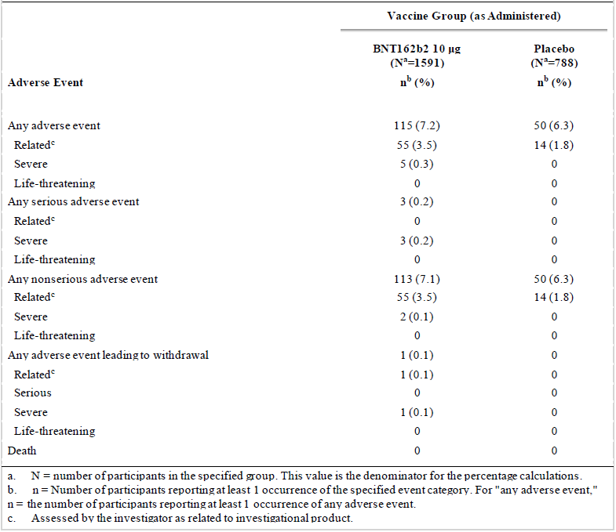
Note: BNT162b2 refers to Comirnaty (tozinameran) vaccine

Analysis of adverse events
Adverse events reflective of reactogenicity events were slightly more common in the Comirnaty (vaccine) group than placebo group as shown for the following System Organ Classes (SOC) in a Comirnaty (vaccine) versus placebo comparison:
- SOC General disorders and administration site conditions: 2.3% versus 1.8%
- SOC Gastrointestinal disorders: 0.8% versus 0.8%
- SOC Nervous system disorders: 0.6% versus 0.4%
- SOC Musculoskeletal and connective tissue disorders: 0.4% versus 0.4%.
Of note, for other SOCs and Preferred Terms:
- Cardiac disorders were not reported by any participants in either group.
- One child in the Comirnaty (vaccine) group had a related event of ‘irritability’ in the SOC ‘psychiatric disorders’.
- Events in the SOC ‘blood and lymphatic system disorders’ were reported in 0.4% of participants in each group (this SOC is inclusive of lymphadenopathy)
- Events in the ‘skin and subcutaneous disorders’ SOC ‘were reported in 1.0% of participants in the Comirnaty (vaccine) group and 0.5% of participants in the placebo group. Events reported more frequently in the Comirnaty (vaccine) group included rashes, urticaria, angioedema, dermatitis, pruritis, night sweats.’
- There were 3 (0.2%) participants in the Comirnaty (vaccine) group with events from the ‘immune system disorders’ SOC that included one event reported as Type IV hypersensitivity reaction (summarised below under ‘Adverse events of clinical interest’) and other non-drug allergies, but none in the placebo group.

Related adverse events
These occurred in 3.5% of the Comirnaty (vaccine) group and 1.8% of the placebo group (see Table 24) and most were reactogenicity events in the SOC of ‘general disorders and administration site conditions’ (2.0% and 0.9% respectively).
One participant had 2 adverse events of pyrexia and neutropenia (‘worsening from baseline’) both considered as related and leading to withdrawal; this is described in more detail below.
There was one non-serious case of haematochezia (moderate severity) in the Comirnaty (vaccine) group occurring 4 days post-Dose 2. The participant had heme occult positive stool, was seen in the emergency department, had no additional tests done and resolved the same day without sequalae.
‘Two participants (0.1%) in the BNT162b2 [Comirnaty/vaccine] group and 1 participant (0.1%) in the placebo group had events of non-cardiac chest pain considered by the investigator as related to study intervention. All events were mild and reported as resolved within 1 to 2 days of onset.’

Immediate adverse events
Immediate adverse events occurring within 30 minutes of Dose 1 or Dose 2 occurred at a frequency of ≤ 0.2% in both groups. Most were reactogenicity events like injection site pain. There were no allergic events reported.

Severe and life-threatening events
Severe (that is, Grade 3) adverse events occurred in 5 (0.3%) of Comirnaty vaccine recipients and none in the placebo group. These 5 adverse events included:
- the case of pyrexia and neutropenia (‘worsening from baseline’) discussed below;
- one unrelated food allergy post-Dose 1 (‘worsening of allergic reaction to Nutella’); and
- three unrelated serious adverse events in the Comirnaty vaccine group (discussed below).

Deaths
There were no deaths in either the vaccine-group, nor the placebo group.

Serious adverse events
There were 3 serious adverse events, all in the Comirnaty vaccine group and all assessed by the investigator as unrelated to study intervention. These events were, one case each of infective arthritis; ingestion of a foreign body (coin); and epiphyseal fracture.

Adverse events leading to withdrawal
There was one adverse event leading to withdrawal, which occurred in the Comirnaty vaccine group. A 5 year-old female participant experienced severe pyrexia (temperature of 40.1°C) with onset 2 days post-Dose 1, which the study investigator considered related to study intervention. It resolved one day after onset.
This participant had an associated adverse event of severe neutropenia (‘worsening from baseline’, from a neutrophil count of 0.48 x 109/L to 0.02 x 109/L) with onset 3 days post-Dose 1, also considered related, which had resolved by the data cut off date. There was a past history of benign transient neutropenia of unknown aetiology in this participant, diagnosed in March 2021.
Subsequently, the participant developed bleeding gums approximately 12 days post-Dose 1. At Visit 2 (on Day 23), the participant had improved, and the neutrophil count had risen to 0.07 x 109/L. A decision was made to discontinue the participant from vaccination and she did not receive Dose 2; however, remains in the study for safety follow-up.

Adverse events of clinical interest
There were no cases of myocarditis, pericarditis, anaphylaxis, Bell’s palsy, convulsions, encephalitis, meningitis, neuritis, peripheral neuropathy, demyelination, thrombocytopenia, thromboembolism, intravascular coagulation events, autoimmunity, acute respiratory distress syndrome, pregnancy, Kawasaki disease or MIS-C through the data cut off date of 8 October 2021.

Hypersensitivity-related adverse events
Other adverse events of clinical interest related to potential hypersensitivity are summarised below:
- A previously healthy participant in the Comirnaty (vaccine) group had a related adverse event of Type IV hypersensitivity reaction diagnosed by a dermatologist that involved a rash on the forehead, earlobe and right forearm 3 days post-Dose 1. There were no other recognised triggers. This was managed with corticosteroid and anti-histamine creams and resolved within 18 days of onset, without sequalae. The participant received Dose 2 without issue.
- A participant in the Comirnaty (vaccine) group with a prior allergy history (hypersensitivity with mild rash to a vaccine, contact dermatitis and seasonal allergies) experienced moderate angioedema involving ‘perioral and periorbital angioedema due to allergic reaction’ and concurrent urticaria reported as ‘hives of the face and back caused due to allergic reaction’, both with onset of 2 days after Dose 2, and was reported as resolved 2 days after onset.’ No other triggers were recognised although the participant had a prior history of past allergy (hypersensitivity with mild rash) to human papilloma virus (HPV) vaccine in the year 2020.
- A previously health participant in the Comirnaty (vaccine) group experienced mild urticaria (‘itchy’, ‘bilateral on hands and forearms’) with onset at 6 days post-Dose 1 and resolved within 2 days. This followed an adverse event of mild injection site erythema at 3 days post-Dose 1. No other triggers were recognised. The participant received Dose 2 without issue.
Overall, 9 participants were identified with hypersensitivity events in the Comirnaty (vaccine) group, including those described above. One other case of urticaria occurring in the Comirnaty (vaccine) group was assessed as unrelated (no further details were provided by the sponsor). There were also unrelated cases of allergic conjunctivitis, and contact dermatitis (due to contact with poison ivy (Genus: Toxicodendron)).
Rashes were reported in 6 participants in the Comirnaty (vaccine) group. Those considered related to Comirnaty (vaccine) were all mild or moderate in severity and included one participant each with rash maculo-papular; rash macular; rash popular; and rash.
Rash was also reported in 4 participants in the placebo group, one each with injection site rash; rash; rash macular; and rash maculo-papular, all of which were mild or moderate in severity, typically occurring within 1 to 3 days post-Dose 1, with one participant reporting a rash again post-Dose 2.
The sponsor concluded that:
‘Overall, the pattern of events in the hypersensitivity analysis within the skin and subcutaneous tissue disorders SOC (including rashes) reported in children 5 to < 12 [of] years age in the safety expansion subset of Study C4591007 was consistent with that observed in prior analyses of Phase II/III participants in the initially enrolled 5 to < 12 years [of] age group in Study C4591007, and higher than observed in prior analyses of Phase II/III participants ≥ 12 years [of] age in Study C4591001.’

Henoch Schoenlein purpura
One previously health participant in the Comirnaty (vaccine) group experienced Henoch Schoenlein purpura as a non-serious unrelated event occurring 21 days post-Dose 1 and reported as ongoing at the data cut off date. No potential triggers were recognised. Treatment was given with steroids and pain medication. The participant had experienced earlier adverse events of mild headache with onset 10 days post-Dose 1 that resolved within 2 days, and mild joint swelling of the right ankle with onset at 16 days post-Dose 1 that resolved in 3 days. Visit 2 was delayed due to treatment of the Henoch Schoenlein purpura and Dose 2 had not been administered by the data cut off date.

Lymphadenopathy
Lymphadenopathy occurred in 6 (0.4%) participants in the Comirnaty (vaccine) group and 3 (0.4%) in the placebo group. In the Comirnaty (vaccine) group, the mean and median times to onset was 11 days post-Dose 1, and one day post-Dose 2 (that is, the same day as vaccination). The mean and median durations was 3 days and all reported cases were mild.

Other adverse events of clinical interest
Additional adverse events of clinical interest were identified based on sponsor safety data review, as summarised below:
- Two cases of arthralgia, one each in the Comirnaty (vaccine) group (attributed to a soccer injury) and the placebo groups; both were considered unrelated.
- One case of severe infective arthritis in a Comirnaty (vaccine) recipient, this was one of the serious adverse events (discussed above) that were considered unrelated.
- Chest pain, non-cardiac chest pain, or chest discomfort was reported in 3 (0.2%) Comirnaty (vaccine) recipients and 4 (0.5%) placebo recipients. There was no identified cardiac involvement. In the 2 related events occurring in the Comirnaty (vaccine) group:
  - A 5 year-old male had mild non-cardiac chest pain within 2 days post-Dose 2 that resolved on the same day. There were no other adverse events or recognised triggers.
  - A 6 year-old male had mild non-cardiac chest pain with onset 10 days post-Dose 1 that resolved 2 days after onset. There were no other adverse events or recognised triggers.
  - One case of moderate syncope occurred in a 7 year-old male recipient of Comirnaty (vaccine) that was thought to be a vasovagal response to nose-blowing with onset 20 days post-Dose 1 and resolving on the same day. There was a past-history of seasonal allergy and frenectomy. There were no other adverse events nor any recognised triggers. It was considered unrelated to vaccination.

Risk management plan
The sponsor has applied to extend the indications of Comirnaty (tozinameran) COVID-19 vaccine, formerly known as Comirnaty (BNT162b2 (mRNA)) COVID-19 vaccine) through the Provisional Approval Pathway.
Furthermore, this submission seeks approval to introduce a new strength and a new formulation.
Comirnaty is currently approved for active immunisation to prevent COVID-19 caused by SARS-CoV-2, in individuals 12 years of age and for the use as a booster dose for individuals 18 years and older.
The current submission seeks to extend the indications to include children aged 5 to < 12 years, and to introduce a new drug product formulation in two strengths using a tris (tromethamine) buffer instead of phosphate-buffered saline.
The most recently evaluated EU-RMP was Round 1, version 3.0; dated 13 October 2021; with the following datalock points (DLP):
- 5 to under 12 years of age :6 September 2021 (Pfizer Clinical Database); and 18 June 2021 (Pfizer Safety Database)
- 12 to 15 years of age: 13 March 2021 (Pfizer Clinical Database); and 18 June 2021 (Pfizer Safety Database
- 16 years of age and older: 23 October 2020 (BioNTech Clinical Database); 13 March 2021 (Pfizer Clinical Database); and 18 June 2021 (Pfizer Safety Database)
The most recently evaluated Australian-specific annex was Round 1, version 0.4; dated 11 November 2021.
The summary of safety concerns and their associated risk monitoring and mitigation strategies are summarised in Table 25.
Table 25: Summary of safety concerns
Summary of safety concerns |  | Pharmacovigilance |  | Risk Minimisation
 |  | Routine | Additional | Routine | Additional
Important identified risks | Anaphylaxis | ✓† | ✓* | ✓ | –
Important identified risks | Myocarditis and pericarditis | ✓ | ✓* | ✓ | –
Important potential risks | Vaccine-associated enhanced disease (VAED) including Vaccine-associated enhanced respiratory disease (VAERD) | ✓† | ✓* | – | –
Missing information | Use in pregnancy and while breast feeding | ✓ | ✓* | ✓ | –
Missing information | Use in immunocompromised patients | ✓ | ✓* | ✓ | –
Missing information | Use in frail patients with co-morbidities (e.g. chronic obstructive pulmonary disease (COPD), diabetes, chronic neurological disease, cardiovascular disorders) | ✓ | ✓* | ✓ | –
Missing information | Use in patients with autoimmune or inflammatory disorders | ✓ | ✓* | – | –
Missing information | Interaction with other vaccines | ✓ | ✓* | ✓ | –
Missing information | Long term safety data | ✓ | ✓* | – | –
† Data capture Aid; * Clinical trials
This summary of safety concerns is the same as the summary that was evaluated for the previous submission PM-2021-04582-1-2 (extension of indications: for use in individuals aged 12 to 15 years of age), except for the addition of ‘Myocarditis and pericarditis’ as an important identified risk into the current safety summary. The changes proposed by this submission do not warrant changes to the summary of safety concerns from an RMP perspective.
The sponsor proposes routine pharmacovigilance activities, as well as the additional pharmacovigilance activities of clinical trials and follow up questionnaires.
The sponsor proposes routine pharmacovigilance activities, as well as the additional risk minimisation activities of education/training provided by the Department of Health COVID-19 vaccine rollout programs.
The Black Triangle Scheme applies for the provisional registration of this vaccine.
As a provisionally registered product, this medicine will remain in the Black Triangle Scheme for the duration of its provisional registration.

Risk-benefit analysis

Delegate’s considerations
The sponsor is proposing extension of indication for Comirnaty tozinameran (mRNA) COVID-19 vaccine to expand the vaccination age range to children of between 5 and 11 years of age.
The sponsor is also proposing to use new formulation (using a tris buffer; replacing the current phosphate-buffered saline) for the Comirnaty vaccine in the proposed age group. However, the pivotal study (Study C4591007) was conducted using the old formulation (that is, using the phosphate-buffered saline formulation).
The sponsor has proposed that the new formulation will subsequently replace the currently available formulation in Australia for all age groups. This has resulted in extensive changes in the Product Information, including storage and dilution requirements. This can lead to significant confusion, especially if the current vaccine stock (phosphate-buffered saline formulation) is also being used simultaneously.
Please see the Body of the Overview (that is, the clinical section of this AusPAR) for the summary of the data submitted for 5 to 11 years of age group. The limitations of the submitted data is presented at the Discussion section of this overview.
The Delegate is of the view that there is a favourable benefit-risk balance for the use of this vaccine in the 5 to 11 years of age population and the submitted data has satisfied the regulatory requirement for the extension of provisional registration to individuals to this age group.
The pivotal Phase I and Phase II/III Study C4591007 provides the data for vaccine’s dose finding, efficacy, immunogenicity and safety in the 5 to 11 years of age population (this is part of the 6 month to 11 years of age drug development plan).
The vaccine produced overall local and systemic reactogenicity similar to the other age groups. However, the sample size for the 5 to 11 years of age group is much smaller in comparison to the adult trial (Study C4591001).
Rare cases of myocarditis and pericarditis after mRNA vaccines have been reported in the adolescent and young adult population, mainly during post market surveillance (highest frequency has been in males aged between 12 and 29 years, and following the second dose). This has been discussed with previous (adolescent) submission. No cases of myocarditis/pericarditis are reported in Study C4591007; however, the safety sample size is very small and the post approval safety reports will be crucial to monitor this.
Limitations of the current data include:
- Safety follow up is currently limited to median 2.4 months post Dose 2 in cohort 1 and 2.4 weeks for the safety expansion cohort.
- Safety sample size is small.
- The duration of immune response and vaccine protection is not currently known in the proposed age group.
- Vaccine efficacy against asymptomatic infection and viral transmission are not known for the proposed age group.
- The data in immunocompromised individuals are lacking.
- Efficacy against the currently circulating variants of concern is not known yet.
Pharmacovigilance activities and post-market studies have been proposed to address these limitations (see the RMP evaluation for details, above).
The sponsor has also proposed two other variations within the same application:
- Major variation, to make changes in strength and dosage: to present 2 new strengths with different fill volumes, to support vaccination of different age groups with dosages of either 30 µg (for individuals ≥ 12 years of age) or 10 µg (for individuals between 5 and 11 years of age).
- A change in formulation: to change from a phosphate-buffered saline/sucrose buffered formulation to a tris/sucrose buffered formulation that can be used in all approved age groups.

Overview
Based on the data provided by the sponsor in the current submission, to support the Comirnaty (tozinameran) COVID-19 vaccine for use in the 5 to 11 years of age group, a robust immunogenicity response was shown in the target age group, without evidence of prior SARS-CoV-2 infection. Immunogenicity response was consistent across relevant subgroups.
Efficacy assessment was a secondary objective and a preliminary efficacy analysis demonstrated a vaccine efficacy of 90.7% (95% CI: 67.7%, 98.3%) in the evaluable efficacy population without prior evidence of SARS-CoV-2 infection. Efficacy among the 5 to 11 years of age group, from the interim analysis appears comparable to the older age groups.
Overall, Comirnaty appears safe in children aged 5 to11 years, with no major safety related issues reported during the study.

Public health need
Australia has had relatively fewer COVID-19 cases in comparison to many other countries; however, intermittent surges of cases are still occurring. These COVID-19 outbreaks cause significant disruption to the normal life.
Most children who get COVID-19 have mild symptoms or no symptoms at all. Children with some underlying medical conditions might be at higher risk severe illness, but very few children with COVID-19 get sick enough to need hospitalisation. Fatal outcome in children is very rare.
The rates of illness, hospitalisations and death for COVID-19 are lower for children than for older age groups, although children can still catch and transmit the virus. There is emerging evidence that younger children are more likely to transmit COVID-19 than compared with older children.
As rates of vaccination increase among adolescents and adults, the proportion of COVID-19 cases involving children is likely to rise.
Concerns have been expressed since the beginning of the COVID‐19 pandemic that the numbers of hospitalisations, critical care admissions, and deaths of children with comorbid conditions were high, but the situation is unclear., Of particular concern is the paediatric inflammatory multisystem syndrome temporally associated with SARS-CoV-2 (PIMS‐TS), or multisystem inflammatory syndrome (MIS-C); a complication reported in settings with high rates of community transmission. One of the first large multicentre studies to report this condition described 78 children in the United Kingdom with considerable short-term critical care needs; 2 of these 78 children died.

Short-term immunogenicity, efficacy and safety data for provisional registration
The sponsor has submitted the short-term results from the pivotal Phase I and Phase II/III Study C4591007, to support the extension of indication to Comirnaty (tozinameran) COVID-19 vaccine for use in children in the 5 to 11 years of age group. The submitted pivotal study has an overall good study design, including representative study population (in the geographical study location context) and acceptable statistical considerations.

Immunogenicity
The immunogenicity analysis demonstrated that the immune response to Comirnaty (tozinameran) vaccine in children between 5 to 11 years age was non-inferior to that of young adults aged between 16 to 25 years of age. It is to be acknowledged that the neutralising antibody responses were chosen here as an immune biomarker for inferring effectiveness through immunobridging, but a specific level of neutralising antibodies has not yet been established to correlate with protection, and other aspects of the immune response, such as cellular immunity, were not analysed. No data were presented on cellular immunity; however, this is not considered critical in the presence of available secondary efficacy data.
A non-inferiority analysis evaluating SARS-CoV-2 50% neutralising titres and seroresponse rates 7 days after Dose 2 was conducted in the evaluable immunogenicity population subsets of children aged 5 to 11 years (n = 264) in Study C4591007 and in participants aged 16 through 25 (n = 253) in the adult Study C4591001. Subjects had no immunologic or virologic evidence of prior SARS-CoV-2 infection at Baseline. The GMR of subjects aged between 5 and 11 years relative to those of between 16 and 25 years age was 1.04 (95% CI: 0.93, 1.18). This met the immunobridging success criteria, with the lower bound of the 95% CI being > 0.67 and the point estimate ≥ 0.8. While being non-inferior, the result was not superior (lower bound of 95% CI < 1.0).
The duration of immune persistence is not known, due to the short follow up period.

Efficacy
Efficacy assessment was a secondary objective for Study C4591007 and was case-driven (a total of 22 cases). The sponsor has submitted interim efficacy assessment report, based on 19 cases (data cut off of 8 October 2021). A preliminary efficacy analysis performed on 19 cases (3 in the Comirnaty group and 16 in the placebo group), demonstrated a vaccine efficacy from at least 7 days after Dose 2 of 90.7% (95% CI: 67.7%, 98.3%) in the evaluable efficacy population without prior evidence of SARS-CoV-2 infection before or during the vaccination regimen.
Protection against asymptomatic infection, or impact on viral transmission offered by the vaccine in children is not known.

Safety (cohort 1)
As expected, the vaccine group reported higher incidence of reactogenicity, as compared to placebo. The majority of these reactogenic adverse reactions were mild to moderate in severity with a median onset of 1 to 2 days and resolved in 1 to 2 days. The most common solicited adverse reactions after Dose 1 and Dose 2 were injection site pain (74.1% Dose 1, versus 71.0% Dose 2), fatigue (33.6% versus 39.4%), headache (22.4% vs 28.0%), myalgia (9.1% versus 11.7%), chills (4.6% versus 9.8%). joint pain (3.3% versus 5.2%) and fever (2.5% versus 6.5%). Median onset for all systemic reactions was 1 to 4 days after Dose 1 or Dose 2 (most had a median of 2 days post-dose) and all events resolved with a median duration of one day. Overall, the systemic events reported in children aged between 5 to < 12 years of age after each dose was generally comparable to, or less than, that observed in the Phase II/III participants ≥ 12 years of age in Study C4591001.
There appeared to be an excess of rashes and lymphadenopathy in the Comirnaty group compared to placebo recipients. The observed events were of mild to moderate severity. The types of rashes were quite variable rather than of a consistent clinical presentation.
No cases of myocarditis or pericarditis were observed, but the participants’ numbers and duration of follow-up was relatively small and post-marketing surveillance will be of critical importance.
There were no related serious adverse events, deaths, nor immediate adverse events involving allergy or anaphylaxis.

Safety expansion subset (cohort 2)
Following the initial enrolment, the sponsor commenced enrolling an expansion group of an additional around 2250 participants (n = 1591 for Comirnaty (vaccine)). Data for solicited adverse events were not presented for the safety expansion subset.
The frequency of adverse events observed in the safety expansion subset (cohort 2) was 7.2% in the Comirnaty (vaccine) group.
Overall, 9 participants were identified with hypersensitivity events in the Comirnaty (vaccine) group. Lymphadenopathy occurred in 6 (0.4%) participants.
There was one adverse event leading to withdrawal in the safety expansion subset, a female with severe pyrexia with an associate adverse event of severe neutropenia exacerbating previously diagnosed benign transient neutropenia.
The submitted safety data are short term at this stage (median follow up of approximately 2.4 months for cohort 1 and around 2.4 weeks for cohort 2); however, the data have fulfilled the requirement as set out in the ‘Access Consortium statement on COVID-19 vaccines evidence’ (published on the TGA website on 4 December 2020). The statement specified the minimum requirement that trial participants must be followed for a median of at least 2 months after receiving their final vaccine dose. It is acknowledged that most adverse reactions to vaccines occur within 4-6 weeks from vaccination. The European Medicines Agency (EMA) has stated that conditional marketing authorisation for a COVID-19 vaccine could be based on review of at least 6 weeks post-vaccination safety data.
Post-market reports of myocarditis/pericarditis in the younger population have raised some safety concerns for the 5 to 11 years of age group as well. However, no cases of myocarditis reported in Phase I or Phase II/III of the Study C4591007. Post-approval monthly safety report (5 to 11 years of age) from the USA, is not available at this stage. The study did include 15 children with congenital heart disease and 8 children with cardiovascular diseases, but further details are not available for these children. The sponsor has planned to include another 750 children of 5 to < 12 years of age in a third safety population for troponin I evaluation (that is, as a marker of myocarditis), with enrolment scheduled to have begun in October 2021.
The vaccine immunogenicity, safety and efficacy in the Aboriginal and Torres Strait Islander population was not studied. This could be of significance in view of the recent pharmacovigilance reports of myocarditis in younger adults, as the Aboriginal and Torres Strait Islander population has a relatively higher background rate of rheumatic heart disease.

Data limitations
- Data on vaccine efficacy to prevent asymptomatic infection are lacking.
- No data on co-administration of Comirnaty with other vaccines in the 5 to 11 years of age group (such as seasonal flu vaccines).
- There are no data available on the interchangeability of Comirnaty with other COVID-19 vaccines to complete the vaccination series.
- The sponsor has provided neutralisation assay data for Delta strain. However, there are no data provided by the sponsor regarding vaccine efficacy against new Variants of concern (VOC). It would be of interest to know the sequences of virus isolated for the 19 patients in the trial group and to compare the isolated strains with the currently circulating strains.
- Duration of protection of Comirnaty is uncertain due to limited follow-up duration (drop in antibody titres observed in the adolescent and adult trials, by Month 6, post-Dose 2).
- Lack of immunogenicity and safety data in immunocompromised patients or children with background autoimmune disease.
- Short-term safety data may not provide information on rare adverse events, risk of vaccine-associated enhanced disease (VAED) or vaccine-associated enhanced respiratory disease (VAERD) as the antibodies wane over time, and there may be adverse events that have a long latency period including adverse events of special interest. Rare adverse events in those between 5 to 11 years of age, like febrile seizures may not be detected in small safety groups.

Proposed action
Considering the unmet public health need and noting the high short term efficacy with acceptable safety demonstrated in the submitted study (Phase I and Phase II/III), the Delegate is of the view that provisional approval of Comirnaty (tozinameran) is appropriate for the use of this vaccine in children between 5 and 11 years of age, to prevent COVID-19 disease caused by SARS-CoV-2 virus. The pivotal study is ongoing for a total of 24 months. The longer-term efficacy and safety data are to be submitted to the TGA for evaluation before a full registration can be considered.
The Delegate proposes the provisional approval of this vaccine for following therapeutic indication:
Comirnaty is indicated for active immunisation to prevent COVID-19 caused by SARS-CoV-2 in individuals 5 years of age and older.
The use of this vaccine should be in accordance with official recommendations.
The decision has been made on the basis of short term efficacy and safety data. Continued approval depends on the evidence of longer term efficacy and safety from the ongoing and post-market assessment.
The Advisory Committee on Vaccines’ (ACV) advice is requested for a number of questions including advice and any comments on the wording of the indication. This Overview is submitted for the ACV advice. The final decision will be made following the ACV discussion.

Proposed conditions of registration
Terms and conditions were imposed upon the authorisation with respect to quality, clinical, labelling, and RMP requirements:

Clinical conditions
The following reports/data will have to be submitted before a definitive authorization can be considered:
- Submit safety analysis at 6 months post-Dose 2 from Phase I, and Phase II/III of Study C4591007, when the analysis is available.
- Submit the final clinical study report for Study C4591007 when ready. Please also submit the final report for this study with 24 months follow up duration when it became available. Please also submit final reports for safety expansion set (cohort 2) and the safety cohort for troponin I evaluation (as a marker of myocarditis).
- Submit the immunogenicity data at 6 months for Study C4591007
- If/when available, please provide (for the 5 to 11 years age group):
  - Further data relating to vaccine efficacy against asymptomatic disease, efficacy against SARS-CoV-2 transmission, vaccine efficacy in immunocompromised subjects, efficacy in subjects with autoimmune conditions, efficacy against variants of concern, and information relating to any planned post-market safety and effectiveness studies should be provided to the TGA to update the Product information.
- Please also provide Real world post market global/local efficacy data, when available.
- Please provide the monthly post market safety summaries when available as soon as possible.

RMP conditions
The Comirnaty EU-Risk Management Plan (RMP) (version 3.0, dated 13 October 2021, data lock point 6 September 2021(Pfizer Clinical Database), 18 June 2021 (Pfizer Safety Database), with Australian-specific annex (version 0.4, dated 11 November 2021), included with submission PM-2021-05012-1-2, and any subsequent revisions, as agreed with the TGA will be implemented in Australia.
An obligatory component of risk management plans is routine pharmacovigilance. Routine pharmacovigilance includes the submission of periodic safety update reports (PSURs).
Unless agreed separately between the supplier who is the recipient of the approval and the TGA, the first report must be submitted to TGA no later than 15 calendar months after the date of this approval letter. The subsequent reports must be submitted no less frequently than annually from the date of the first submitted report until the period covered by such reports is not less than three years from the date of this approval letter, or the entire period of provisional registration, whichever is longer.
The reports are to at least meet the requirements for Periodic Safety Update Reports (PSUR) as described in the European Medicines Agency’s Guideline on good pharmacovigilance practices (GVP) Module VII-periodic safety update report (Rev 1), Part VII.B Structures and processes. Note that submission of a PSUR does not constitute an application to vary the registration. Each report must have been prepared within ninety calendar days of the data lock point for that report.
Additional to the routine submission of the routine PSURs, expedited monthly safety summary reports (including safety data for patients in Australia) are to be provided until otherwise specified by the TGA.
Comirnaty is to be included in the Black Triangle Scheme. The PI and CMI for Comirnaty must include the black triangle symbol and mandatory accompanying text for the products entire period of provisional registration.

Quality conditions
All quality conditions are satisfied.

Question for the sponsor
The sponsor provided the following response to a question from the Delegate.
Question: If available, please provide sequences of virus isolated for the 19 SARS-CoV-2 positive subjects in the trial group.
Sponsor’s response: The sequences of virus for these subjects are not currently available.

Advisory Committee considerations
The Advisory Committee on Vaccines (ACV), having considered the evaluations and the Delegate’s overview, as well as the sponsor’s response to these documents, advised the following.

Specific advice to the Delegate
- Based on the evidence at this point in time, does the ACV consider that there is a favourable benefit-risk balance for the use of this vaccine in the 5 to 11 years of age population and the submitted data has satisfied the regulatory requirement for the extension of provisional registration to approve the Comirnaty (tozinameran) COVID-19 Vaccine in this age group? Especially in view of the absence of a confirmed immunogenicity correlate of protection and only short term safety data?
The ACV agreed there is favourable benefit-risk balance in the 5 to 11 year old age group. The ACV noted that there are likely to be both direct and indirect benefits to this age group and the broader community associated with vaccination of this age group.
The ACV advised that the available evidence, that demonstrated immunogenicity and efficacy against infection, supports use in the population aged 5 to 11 years. The ACV commented there is an observed association between high levels of neutralising antibodies and efficacy although an immunological correlate of protection is yet to be well defined.
Immunogenicity against the Delta strain was considered by the ACV, and although slightly diminished compared to the original strain, there still appeared to be significant neutralisation antibody activity within this small subset of 34 participants. Vaccine-induced immunity against new variants, such as the recently reported Omicron variant, is not yet known.
- Can the ACV comment on overall Safety in this age group? Please also advise on safety in children, especially in view of the pharmacovigilance reports of myocarditis and pericarditis in adolescents and young adults.
The ACV considered both the clinical trial data and preliminary post-market safety experience in the 5 to 11 year age group. The ACV commented that there are no safety signals of note in the USA as yet, however these data are predominantly based on available information following the first dose.
While the ACV advised the overall long-term safety data in children are relatively limited, they were of the view that there are sufficient data to make a positive recommendation, noting the considerable safety data in older age groups. The ACV agreed that the reactogenicity profile is acceptable.
The ACV noted that there were low rates of any serious adverse events, a small number of withdrawals due to adverse events, and no deaths in the clinical trial.
The ACV noted that no cases of myocarditis were reported in the clinical trial, although the safety population was not powered to detect cases at the rates reported in older age groups. The ACV advised that the risk of myocarditis in this age group is reasonably expected to be lower than in older age groups due to the lower dose. The ACV noted that the rate of vaccine-associated myocarditis in 12 to 15 year olds appears to be lower than that in 16 to 17 year olds. It was also noted that the background rate of myocarditis of any cause is lower in the 5 to 11 years of age group than in older children.
The ACV agreed that is important to monitor this potential rare but clinically important adverse event in the wider population. The ACV expressed significant interest in the anticipated provision by the sponsor of the troponin data from clinical trial participants, as this will assist with increasing the understanding of the safety profile of this vaccine.
The ACV discussed the incidence of lymphadenopathy, which was reported at 0.7% in the vaccine group and not reported in the placebo group. The ACV noted that all cases were mild. The ACV agreed that is important to monitor this potential adverse event in the wider population.
The ACV was reassured that further safety data is currently being collected as part of the safety expansion study consisting of 2379 participants. Additionally, data are accumulating from a variety of post-marketing surveillance systems.
- Can the ACV comment on the proposed pharmacovigilance activities? Are any additional risk mitigation strategies required? Especially in view of the risk of febrile seizure in youngest of the proposed age group (5 to 6 years of age).
The ACV reiterated the importance of post-market monitoring for all adverse events, particularly severe adverse events such as myocarditis and pericarditis. The ACV agreed that augmented capabilities for timely investigation, data collation and reporting is important as the program is rolled out to a broader population. This should include long term follow up of clinical outcomes for those who experience serious adverse events following immunisation.
The ACV did not express concern about the risk of febrile seizures in the proposed age group. The ACV noted the risk of febrile seizures is low in the proposed age range, however the risk of fever in select children with underlying medical conditions warrants monitoring. The ACV also noted that there were only rare reported febrile seizure events in US surveillance to date. Specific guidance should be provided to parents to ensure they are aware of potential adverse events following vaccination, what signs and symptoms to look for, and how to respond.
- Does ACV envisage any practical /clinical issues with use of new Tris/Sucrose buffer formulation in the 5 to 11 year old population?
Of note, both Phase I and Phase II/III clinical trials were conducted using old phosphate based saline buffer formulation and the sponsor is proposing exclusive use of new Tris/sucrose buffer formulation for the 5 to 11 years of age group. No clinical data is provided, comparing the two formulations.
The ACV noted the previous phosphate based saline buffered formulation (purple top) and the new Tris/sucrose buffer formulation for adults and children 12 years and older (grey top) and 5 to 11 year paediatric group (orange top).
The ACV did not express any significant concerns with the lack of clinical data being provided to compare the two formulations. The ACV noted the positive benefits of the Tris/sucrose buffer formulation in relation to the extended fridge shelf life. The ACV noted that Tris buffers are widely used in other vaccines and this change in the buffer is not expected to have any safety implications; this may require specific communication to consumers.
The ACV noted that confusion could occur as a result of multiple formulations of the same product being available concurrently and strongly emphasised the importance of having robust guidance, labelling, training, communication and a range of other strategies to clearly convey these changes to both providers and consumers.
The ACV highlighted that such risk mitigation strategies will be important to ensure safe program delivery.

Conclusion
The ACV considered Comirnaty to have an overall positive benefit-risk profile, and therefore supports provisional approval for the following:
Comirnaty (tozinameran) COVID-19 Vaccine has provisional approval for the indication below:
Active immunisation to prevent coronavirus disease 2019 (COVID-19) caused by SARS-CoV-2, in individuals 5 years of age and older.
The use of this vaccine should be in accordance with official recommendations.
The decision has been made on the basis of short term efficacy and safety data. Continued approval depends on the evidence of longer term efficacy and safety from ongoing clinical trials and post-market assessment.

Outcome
Based on a review of quality, safety and efficacy, the TGA approved the registration of Comirnaty (tozinameran [mRNA]) COVID-19 vaccine 30 micrograms/0.3 mL suspension for injection vial as a major variation to add a new dose form (suspension for injection, vial) and change of formulation (change of excipients) indicated the following:
- Comirnaty (tozinameran [mRNA]) COVID-19 vaccine 30 micrograms/0.3 mL suspension for injection vial (the additional Comirnaty 12 years + Medicine) – being a major variation to the existing Comirnaty 12+ Medicine to add a new dosage form (suspension for injection vial) and change the formulation (to change excipients); and
- Comirnaty (tozinameran [mRNA]) COVID-19 vaccine 10 micrograms/0.2 mL concentrated suspension for injection vial (the Comirnaty 5-11 years Medicine) –being an extension of indications of the Existing COMIRNATY 12+ Medicine to include a new indication for use in individuals aged 5-11 years, combined with a variation to the strength for use in this population (to 10 micrograms/0.2 mL), and a change to the formulation (to change excipients).
Note, this submission is also an extension of indications based on widening the patient population from individuals aged 12 years and older to include individuals from 5 years and older. Earlier submissions for the 12 to 15 years of age group; and in individuals aged 16 years and older are covered in their respective AusPARs.,
Based on a review of quality, safety and efficacy, the TGA approved the registration of Comirnaty (tozinameran [mRNA]) COVID-19 vaccine 10 micrograms/0.2mL concentrated suspension for injection vial (the Comirnaty (tozinameran [mRNA]) COVID-19 vaccine for the 5 to 11 years old age group), being an extension of indications of the existing Comirnaty (tozinameran [mRNA]) COVID-19 vaccine 12+ Medicine to include a new indication for use in individuals aged 5 to 11 years, combined with a variation to the strength for use in this population (to 10 micrograms/0.2 mL), and a change to the formulation (to change excipients).
As such, the full indications at this time were:
Active immunisation to prevent coronavirus disease 2019 (COVID-19) caused by SARS-CoV-2, in individuals 12 years of age and older.
This presentation will not be used to treat anyone under 12 years of age.
The use of this vaccine should be in accordance with official recommendations.
The decision has been made on the basis of short term efficacy and safety data. Continued approval depends on the evidence of longer term efficacy and safety from ongoing clinical trials and post-market assessment.
Active immunisation to prevent coronavirus disease 2019 (COVID-19) caused by SARS-CoV-2, in individuals 5 years of age and older.
The use of this vaccine should be in accordance with official recommendations.
The decision has been made on the basis of short term efficacy and safety data. Continued approval depends on the evidence of longer term efficacy and safety from ongoing clinical trials and post-market assessment.

Specific conditions of registration applying to these goods

Clinical
For the Comirnaty 5 to 11 years medicine, the following reports/data must be submitted before a definitive authorization can be considered:
- Submit safety analysis at 6 months post Dose 2 from Phase I, and II/III study when the analysis is available.
- Submit the final clinical study report for Study C4591007 when ready. Please also submit the final report for this study with 24 months follow up duration when it became available. Please also submit final reports for safety expansion set (Cohort 2) and the safety cohort for troponin I evaluation (as a marker of myocarditis).
- Submit the immunogenicity data at 6 months for Study C4591007
- If/When available, please provide (5 to 11 years age group): Further data relating to vaccine efficacy against asymptomatic disease, efficacy against SARS-CoV-2 transmission, vaccine efficacy in immunocompromised subjects, efficacy in subjects with autoimmune conditions, efficacy against variants of concern, and information relating to any planned post-market safety and effectiveness studies should be provided to the TGA to update the Product information.
- Please also provide Real world post market global/local efficacy data, when available.
- Please provide the monthly post market safety summaries when available (as soon as possible).
For the additional Comirnaty 12 years and older medicine (new dose form and new formulation), any previously mandated clinical conditions of registration for the Existing Comirnaty 12 years + medicine are applicable to the Comirnaty 12 years + Medicine (new dose form and new formulation).

Quality
Requested: The leachables study, for the container, to be provided for evaluation once completed.

Batch Release Testing and Compliance
It is a condition of registration that all independent manufacturing batches of Comirnaty (tozinameran) COVID-19 Vaccine to be supplied in Australia are not released for supply by or on behalf of the Sponsor until the manufacturer’s release data have been assessed by, and you have received notification acknowledging authorisation to release from, the Laboratories Branch, TGA.
In complying with the above, the sponsor must supply the following for each independent batch of the product imported or proposed to be imported into Australia:
- a completed Request for Release Form, available from vaccines@health.gov.au; and
- complete summary protocols for manufacture and QC, including all steps in production in the agreed format; and
- if the manufacturing batch has been released in Europe or United Kingdom a copy of the EU Official Control Authority Batch Release (OCABR) certificate (or equivalent from the UK) must also be provided; and
- any reagents, reference material and standards required to undertake testing as requested by Laboratories Branch, TGA.
The shipments of reagents to TGA are the responsibility of the Australian sponsor/agent who will be required to facilitate the import and customs clearance process.
A commitment is required by the sponsor not to supply any batches that have a temperature deviation during shipment.

Certified product details
An electronic copy of the Certified Product Details (CPD) as described in Guidance 7: Certified Product Details of the Australian Regulatory Guidelines for Prescription Medicines (ARGPM) https://www.tga.gov.au/guidance-7-certified-product-detailsshould be provided upon registration of the therapeutic good. In addition, an updated CPD, for the above products incorporating the approved changes is to be provided within one month of the date of approval letter. A template for preparation of CPD for biological prescription medicines and Vaccines can be obtained from the TGA website https://www.tga.gov.au/form/certified-product-details-cpd-biological-prescription-medicines]. The CPD should be sent as a single bookmarked PDF document tovVaccines@health.gov.au as soon as possible after.

Risk management plan
The Comirnaty EU-Risk Management Plan (RMP) (version 3.0, dated 13 October 2021, data lock point 6 September 2021- Pfizer Clinical Database, 18 June 2021 - Pfizer Safety Database), with Australian Specific Annex (version 0.4, dated 11 November 2021), included with submission PM-2021-05012-1-2, and any subsequent revisions, as agreed with the TGA will be implemented in Australia.
An obligatory component of risk management plans is routine pharmacovigilance. Routine pharmacovigilance includes the submission of periodic safety update reports (PSURs).
Unless agreed separately between the supplier who is the recipient of the approval and the TGA, the first report must be submitted to TGA no later than 15 calendar months after the date of this approval letter. The subsequent reports must be submitted no less frequently than annually from the date of the first submitted report until the period covered by such reports is not less than three years from the date of this approval letter, or the entire period of provisional registration, whichever is longer.
The reports are to at least meet the requirements for PSURs as described in the European Medicines Agency’s Guideline on good pharmacovigilance practices (GVP) Module VII-periodic safety update report (Rev 1), Part VII.B Structures and processes. Note that submission of a PSUR does not constitute an application to vary the registration. Each report must have been prepared within ninety calendar days of the data lock point for that report.
Additional to the routine submission of the routine PSURs, expedited safety summary reports (including safety data for patients in Australia) are to be provided in line with the frequency that these reports are submitted to the EMA, until otherwise specified by the TGA.
The medicines are to be included in the Black Triangle Scheme. The PI and CMI for must include the black triangle symbol and mandatory accompanying text for the products entire period of provisional registration.

Attachment 1. Product Information
The PI for Comirnaty approved with the submission which is described in this AusPAR is at Attachment 1. For the most recent PI, please refer to the TGA website at <https://www.tga.gov.au/product-information-pi>.

Therapeutic Goods Administration
PO Box 100 Woden ACT 2606 Australia
Email: info@tga.gov.au Phone: 1800 020 653 Fax: 02 6232 8605
https://www.tga.gov.au

Tozinameran, the active ingredient in the Comirnaty COVID-19 Vaccine was previously registered in Australia and overseas by the provisional drug name BNT162b2. Both the International non-proprietary name (INN) and the Australian Approved Name (AAN) is accepted as being tozinameran, and it is therefore referred to as Comirnaty (tozinameran) COVID-19 Vaccine throughout this AusPAR. This is in contrast to the use of BNT162b2 as the name of the active ingredient in earlier AusPARs. The change is in name only; the composition of the active ingredient is unchanged in any way.
The Black Triangle Scheme provides a simple means for practitioners and patients to identify certain types of new prescription medicines, including those being used in new ways and to encourage the reporting of adverse events associated with their use. The Black Triangle does not denote that there are known safety problems, just that the TGA is encouraging adverse event reporting to help us build up the full picture of a medicine's safety profile.
Australian Public Assessment Report (AusPAR) for BNT162b2 (mRNA) Comirnaty Pfizer Australia Pty Ltd PM-2020-05461-1-2. Approved: 25 January 2021; published online: 25 January 2021. Available at: AusPAR: BNT162b2 (mRNA) - Comirnaty | Therapeutic Goods Administration (TGA)
Australian Public Assessment Report (AusPAR) for BNT162b2 (mRNA) Comirnaty Pfizer Australia Pty Ltd PM-2021-02187-1-2. Approved: 22 July 2021; published online: 23 July 2021. Available at: AusPAR: BNT162b2 (mRNA) | Therapeutic Goods Administration (TGA)
Zhu, N. et al. A Novel Coronavirus from Patients with Pneumonia in China, 2019, N. Engl. J. Med, 2020; 382(8): 727-733.
World Health Organization (WHO; 2020) WHO Director-General Speeches: WHO Director-General's Opening Remarks at the Media Briefing on COVID-19 (11 March 2020). Available from the WHO website.
World Health Organization (WHO), Coronavirus Disease (COVID-19) Dashboard. Available from the WHO website.
Australian Government, Department of Health (last updated 28 October 2021) Coronavirus (COVID-19) Case Numbers and Statistics. Available at: https://www.health.gov.au/news/health-alerts/novel-coronavirus-2019-ncov-health-alert/coronavirus-covid-19-case-numbers-and-statistics.
McIntosh, K. Coronavirus Disease 2019 (COVID-19): Clinical Features, In: UpToDate, Waltham, MA. Available from the UpToDate website.
Comirnaty was first registered on the ARTG on 25 January 2021 (ARTG number: 346290).
AusPAR for Comirnaty (BNT162b2 (mRNA)) new biological entity, published on 25 January 2021. Available at: https://www.tga.gov.au/auspar/auspar-bnt162b2-mrna-comirnaty.
AusPAR for Comirnaty (BNT162b2 (mRNA)) extension of indications, published on 23 July 2021. Available at: https://www.tga.gov.au/auspar/auspar-bnt162b2-mrna.
Spikevax was first registered on the ARTG on 9 August 2021 (ARTG number: 370599).
AusPAR for Spikevax (elasomeran) new biological entity, adult indication, published on 9 August 2021. Available at: https://www.tga.gov.au/auspar/auspar-elasomeran.
AusPAR for Spikevax (elasomeran) new biological entity, paediatric indication, published on 4 September 2021. Available at: https://www.tga.gov.au/auspar/auspar-elasomeran-0.
COVID-19 Vaccine Janssen was first registered on the ARTG on 25 June 2021 (ARTG number: 350150).
AusPAR for COVID-19 Vaccine Janssen (Ad26.COV2.S) new biological entity, published on 25 June 2021. Available at: https://www.tga.gov.au/auspar/auspar-ad26cov2s.
COVID-19 Vaccine AstraZeneca was first registered on the ARTG on 16 February 2021 (ARTG number: 349072).
AusPAR for COVID-19 Vaccine AstraZeneca (ChAdOx1-S) new biological entity, published on 16 February 2021. Available at: https://www.tga.gov.au/auspar/auspar-chadox1-s.
Department of Health, Initiatives and Programs: Approved COVID-19 vaccines. Australian Government, Department of Health, Canberra. Available at: https://www.health.gov.au/initiatives-and-programs/covid-19-vaccines/approved-vaccines.
Xuvudy (sotrovimab) was first registered on the ARTG on 20 August 2021, (ARTG number: 364110).
AusPAR for Xevudy (sotrovimab) is available at https://www.tga.gov.au/auspar/auspar-sotrovimab
Ronapreve (casivirimab/imdevimab) was first registered on the ARTG on 18 October 2021 (ARTG number: 374310)
AusPAR for Ronapreve (casirivimab/imdevimab) is available at: https://www.tga.gov.au/auspar/auspar-casirivimabimdevimab
Ronapreve (casivirimab/imdevimab) was first registered on the ARTG on 18 October 2021 (ARTG number: 373839).
Velkury (remdesivir) received registration on the ARTG on 10 July 2020 (ARTG number: 338419).
AusPAR Velkury remdesivir is available at: https://www.tga.gov.au/auspar/auspar-remdesivir
The provisional approval pathway allows sponsors to apply for provisional registration on the ARTG. It provides access to certain promising new medicines where the public health benefit of immediate or early availability of the medicine outweighs the risk inherent in the fact that additional data are still required. Specific eligibility criteria for the provisional approval pathway are set out in regulations 10K and 10L of the Therapeutic Goods Regulations 1990 (the Regulations). This pathway is for certain medicines that are to treat or prevent life threatening or seriously debilitating conditions. The medicine is considered eligible if there are preliminary clinical data demonstrating that the medicine is likely to provide a major therapeutic advance and the applicant (who made the application under subsection 22C (1) of the Act) can provide sufficient evidence of a plan to submit comprehensive clinical data on the safety and efficacy of the medicine before the end of the 6 year period following provisional registration.
An Emergency Use Authorization (EUA) in the United States of America is an authorisation granted to the Food and Drug Administration (FDA) under sections of the US Federal Food, Drug, and Cosmetic Act, to allow the use of a drug prior to approval.
The ACCESS Consortium are a like-minded group of medicine regulators, incorporating Australia, Canada, Singapore, Switzerland and the United Kingdom.
Published online 4 December 2020. Statement available at: https://www.tga.gov.au/access-consortium-statement-covid-19-vaccines-evidence
Adopted (TGA) 6 January 01 2009. First published: 18 October 2006; last updated: 18 October 2006.
First published: 19 November 2020.
Guidance for Industry document; issued by US FDA Center for Biologics Evaluation and Research (CBER); issued: 30 June 2020.
Guidance for Industry document; issued by US FDA Center for Biologics Evaluation and Research (CBER); issued: 25 May 2020.
Guidance for Industry document; issued by US FDA Center for Biologics Evaluation and Research (CBER) and Center for Drug Evaluation and Research (CDER); issued: May 2020; last updated: 22 February 2021.
Targeted medical events/medical events of special interest (MESI), are adverse events that are considered to be potentially (but not necessarily) associated with either a particular drug or a group (class) of similar drugs; or potentially associated with a specific patient population.
Hazelnut and cocoa based sugar and palm oil based spread
Routine risk minimisation activities may be limited to ensuring that suitable warnings are included in the product information or by careful use of labelling and packaging. Routine pharmacovigilance practices involve the following activities: - All suspected adverse reactions that are reported to the personnel of the company are collected and collated in an accessible manner; - Reporting to regulatory authorities; - Continuous monitoring of the safety profiles of approved products including signal detection and updating of labelling; - Submission of PSURs; - Meeting other local regulatory agency requirements.
As a provisionally registered product, this medicine will remain in the Black Triangle Scheme for the duration of its provisional registration. The Black Triangle Scheme provides a simple means for practitioners and patients to identify certain types of new prescription medicines, including those being used in new ways and to encourage the reporting of adverse events associated with their use. The Black Triangle does not denote that there are known safety problems, just that the TGA is encouraging adverse event reporting to help us build up the full picture of a medicine's safety profile.
Tris, or tris(hydroxymethyl)aminomethane, is also known during medical use as tromethamine or THAM.
https://jamanetwork.com/journals/jamapediatrics/fullarticle/2783022?guestAccessKey=52a9e0cf-bc64-4ec0-a945-49fd1373950f&utm_source=For_The_Media&utm_medium=referral&utm_campaign=ftm_links&utm_content=tfl&utm_term=081621
https://www.vu.edu.au/mitchell-institute/early-learning/covid-19-early-childhood-education-care
Shekerdemian LS, Mahmood NR, Wolfe KK, et al; International COVID‐19 PICU Collaborative. Characteristics and outcomes of children with coronavirus disease 2019 (COVID‐19) infection admitted to US and Canadian pediatric intensive care units. JAMA Pediatr 2020; 40: e137–e145.
Alfraij A, Bin Alamir AA, Al‐Otaibi AM, et al. Characteristics and outcomes of coronavirus disease 2019 (COVID‐19) in critically ill pediatric patients admitted to the intensive care unit: a multicenter retrospective cohort study. J Infect Public Health 2020; 14: 193–200.
Jiang L, Tang K, Levin M, et al. COVID‐19 and multisystem inflammatory syndrome in children and adolescents. Lancet Infect Dis 2020; 20: e276–e288.
Davies P, Evans C, Kanthimathinathan HK, et al. Intensive care admissions of children with paediatric inflammatory multisystem syndrome temporally associated with SARS‐CoV‐2 (PIMS‐TS) in the UK: a multicentre observational study. Lancet Child Adolesc Health 2020; 4: 669–677.
Access Consortium statement on COVID-19 vaccines evidence | Therapeutic Goods Administration (TGA). Available at: https://www.tga.gov.au/access-consortium-statement-covid-19-vaccines-evidence
European Medicines Agency: Considerations on COVID-19 vaccine approval; available at: https://www.ema.europa.eu/en/documents/other/ema-considerations-covid-19-vaccine-approval_en.pdf
The ACV provides independent medical and scientific advice to the Minister for Health and the TGA on issues relating to the safety, quality and efficacy of medicines supplied in Australia including issues relating to pre market and post-market functions for medicines. Further information can be found here: https://www.tga.gov.au/committee/advisory-committee-vaccines-acv.
Australian Public Assessment Report (AusPAR) for BNT162b2 (mRNA) Comirnaty Pfizer Australia Pty Ltd PM-2020-05461-1-2. Approved: 25 January 2021; published online: 25 January 2021. Available at: AusPAR: BNT162b2 (mRNA) - Comirnaty | Therapeutic Goods Administration (TGA)
Australian Public Assessment Report (AusPAR) for BNT162b2 (mRNA) Comirnaty Pfizer Australia Pty Ltd PM-2021-02187-1-2. Approved: 22 July 2021; published online: 23 July 2021. Available at: AusPAR: BNT162b2 (mRNA) | Therapeutic Goods Administration (TGA)

