April 2022

Australian Public Assessment Report for Tozinameran
  - Proprietary Product Name: Comirnaty
Sponsor: Pfizer Australia Pty Ltd

About the Therapeutic Goods Administration (TGA)
- The Therapeutic Goods Administration (TGA) is part of the Australian Government Department of Health and is responsible for regulating medicines and medical devices.
- The TGA administers the Therapeutic Goods Act 1989 (the Act), applying a risk management approach designed to ensure therapeutic goods supplied in Australia meet acceptable standards of quality, safety and efficacy (performance) when necessary.
- The work of the TGA is based on applying scientific and clinical expertise to decision-making, to ensure that the benefits to consumers outweigh any risks associated with the use of medicines and medical devices.
- The TGA relies on the public, healthcare professionals and industry to report problems with medicines or medical devices. TGA investigates reports received by it to determine any necessary regulatory action.
- To report a problem with a medicine or medical device, please see the information on the TGA website <https://www.tga.gov.au>.

About AusPARs
- An Australian Public Assessment Report (AusPAR) provides information about the evaluation of a prescription medicine and the considerations that led the TGA to approve or not approve a prescription medicine submission.
- AusPARs are prepared and published by the TGA.
- An AusPAR is prepared for submissions that relate to new chemical entities, generic medicines, major variations and extensions of indications.
- An AusPAR is a static document; it provides information that relates to a submission at a particular point in time.
- A new AusPAR will be developed to reflect changes to indications and/or major variations to a prescription medicine subject to evaluation by the TGA.

Copyright
© Commonwealth of Australia 2022
This work is copyright. You may reproduce the whole or part of this work in unaltered form for your own personal use or, if you are part of an organisation, for internal use within your organisation, but only if you or your organisation do not use the reproduction for any commercial purpose and retain this copyright notice and all disclaimer notices as part of that reproduction. Apart from rights to use as permitted by the Copyright Act 1968 or allowed by this copyright notice, all other rights are reserved and you are not allowed to reproduce the whole or any part of this work in any way (electronic or otherwise) without first being given specific written permission from the Commonwealth to do so. Requests and inquiries concerning reproduction and rights are to be sent to the TGA Copyright Officer, Therapeutic Goods Administration, PO Box 100, Woden ACT 2606 or emailed to <tga.copyright@tga.gov.au>.

Contents
List of abbreviations 4
I. Introduction to product submission 5
Submission details 5
Product background 7
Regulatory status 8
Product Information 9
II. Registration timeline 10
III. Submission overview and risk/benefit assessment 10
Quality 10
Nonclinical 11
Clinical 11
Risk management plan 18
Risk-benefit analysis 19
Outcome 22
Attachment 1. Product Information 25

List of abbreviations
Abbreviation | Meaning
ACV | Advisory Committee on Vaccines
AE | Adverse event
ARTG | Australian Register of Therapeutic Goods
ASA | Australian specific annex
AusPAR | Australian Public Assessment Report
CDC | Centers for Disease Control and Prevention (United States of America)
CMI | Consumer Medicines Information
DLP | Data lock point
EMA | European Medicines Agency (European Union)
EU | European Union
EUA | Emergency Use Authorization (United States of America)
FDA | Food and Drug Administration (United States of America)
IM | Intramuscular
LNP | Lipid nanoparticle
mRNA | Messenger ribonucleic acid
PI | Product Information
RMP | Risk management plan
SAE | Serious adverse event
SARS-CoV-2 | Severe acute respiratory syndrome coronavirus 2
TGA | Therapeutic Goods Administration
US(A) | United States of America
VE | Vaccine efficacy

I. Introduction to product submission

Submission details
Type of submission: | Major variation (change of dose regimen)
Product name: | Comirnaty
Active ingredient: | Tozinameran (formerly BNT162b2 (mRNA))
Decision: | Approved for provisional registration
Date of decision: | 7 April 2022
Date of entry onto ARTG: | 8 April 2022
ARTG numbers: | 346290, 377110
Black Triangle Scheme: | Yes  As a provisionally registered product, this medicine will remain in the Black Triangle Scheme for the duration of its provisional registration.
Sponsor’s name and address: | Pfizer Australia Pty Ltd  Level 17  151 Clarence Street  Sydney NSW 2000
Dose forms: | Concentrated suspension for injection; and  Suspension for injection
Strength: | 30 µg/0.3 mL
Container: | Multi dose vial
Pack size: | 195 vials
Approved therapeutic use: | Active immunisation to prevent coronavirus disease 2019 (COVID-19) caused by SARS-CoV-2, in individuals 12 years of age and older.  The use of this vaccine should be in accordance with official recommendations.  The decision has been made on the basis of short term efficacy and safety data. Continued approval depends on the evidence of longer term efficacy and safety from ongoing clinical trials and post-market assessment.
Route of administration: | Intramuscular
Dosage: | Individuals 12 years of age and older  Comirnaty is administered intramuscularly after dilution as a primary course of two doses at least 21 days apart. See dosing instructions below.  Booster dose in individuals 12 years of age and older  A booster dose of Comirnaty may be administered intramuscularly at least 6 months after the completion of a COVID-19 vaccine primary series in individuals 12 years of age and older.  The decision when and for whom to implement a booster dose of Comirnaty should be made based on available vaccine safety and effectiveness data (see sections 4.4 Special warnings and precautions for use and 5.1 Pharmacodynamic properties), in accordance with official recommendations.  Interchangeability  There are limited data on the interchangeability of Comirnaty with other COVID-19 vaccines to complete the primary vaccination course or the booster dose. Individuals who have received 1 dose of Comirnaty should preferably receive a second dose of Comirnaty to complete the primary vaccination course and for any additional doses.  Severely immunocompromised aged 12 years and older  In accordance with official recommendations, a third dose may be given, as part of the primary series, at least 28 days after the second dose to individuals who are severely immunocompromised (see section 4.4 Special warnings and precautions for use).  Elderly population  No dosage adjustment is required in elderly individuals ≥ 65 years of age.
Pregnancy category: | B1  Drugs which have been taken by only a limited number of pregnant women and women of childbearing age, without an increase in the frequency of malformation or other direct or indirect harmful effects on the human fetus having been observed.  Studies in animals have not shown evidence of an increased occurrence of fetal damage.  The use of any medicine during pregnancy requires careful consideration of both risks and benefits by the treating health professional. This must not be used as the sole basis of decision making in the use of medicines during pregnancy. The TGA does not provide advice on the use of medicines in pregnancy for specific cases. More information is available from obstetric drug information services in your State or Territory.

Product background
This AusPAR describes the application by Pfizer Australia Pty Ltd (the sponsor) to register a change in the dosage regimen for Comirnaty (tozinameran; formerly BNT162b2 (mRNA)); 30 µg/0.3 mL of BNT162b2 (mRNA) (embedded in lipid nanoparticles) injection for the 12 to 15 year age group: It is proposed that a booster dose of Comirnaty may be administered intramuscularly (IM) at least 6 months after the second dose in individuals 12 years of age and older. The sponsor has also proposed amendments to the current Product Information (PI) including Study C4591001, a 6 month post-Dose 2 analysis for 12 to 15 years age group.
Coronavirus disease 2019 (COVID-19) is an infectious disease caused by the novel coronavirus, severe acute respiratory syndrome coronavirus 2 (SARS-CoV-2), that was first identified in late 2019. It is predominantly a respiratory illness that can affect other organs. People infected with COVID-19 can present with a wide range of symptoms, from mild symptoms to severe illness. Following exposure to the virus, symptoms may appear within 2 to 14 days, and may include any or a combination of the following: fever or chills, cough, fatigue, shortness of breath, headache, muscle or body aches, sore throat, new loss of taste or smell, congestion or runny nose, nausea or vomiting, and diarrhoea.5 Infections caused by SARS-CoV-2, and the resulting disease, COVID-19, have spread globally. On 11 March 2020, the World Health Organization (WHO) declared the COVID-19 outbreak to be a pandemic.
As of 25 March 2022, there have been more than 475 million confirmed cases of COVID-19, and over 6 million deaths globally since the pandemic began.
Immunisation with a safe and effective COVID-19 vaccine is a critical component of the public health strategy to reduce COVID-19-related illnesses, hospitalisations, and deaths, and to help restore societal functioning.
Comirnaty comprises a nucleoside-modified messenger ribonucleic acid (mRNA) encoding the viral spike glycoprotein (S) of SARS-CoV-2. The modified mRNA is encapsulated in lipid nanoparticles (LNPs), enabling entry into host cells, expression of the S protein, and elicitation of both antibody and cellular immune responses. In this way, the body is trained to fight the virus, building up memory of the pathogen so as to rapidly fight it if exposed to the virus again in the future.

Regulatory status
The provisional determination for the Pfizer-BioNTech COVID-19 vaccine Comirnaty was granted by the TGA on 14 October 2020.
The product received initial registration on the Australian Register of Therapeutic Goods (ARTG) on 25 January 2021 (AUST R 346290) with provisional registration for the following indication:
Comirnaty is indicated for active immunisation to prevent COVID-19 caused by SARS-CoV-2 virus, in individuals 5 years of age and older.
The provisional approval pathway allows sponsors to apply for provisional registration on the ARTG.
On 26 October 2021 a ‘booster’ dose (a third dose of vaccine) administered approximately 6 months following the primary series (the first 2 doses) to individuals 18 years of age and older was approved by TGA.
In January 2022 a booster dose of Comirnaty was approved in individuals 16 years of age and older.

International regulatory status
At the time the TGA considered this application, a similar application had been approved in the United States of America (USA) and in the European Union (EU).
On 03 January 2022, the United States (US) Food and Drug Administration (FDA) extended the Emergency Use Authorization (EUA) for the Pfizer BioNTech COVID-19 vaccine (Comirnaty) allowing administration of a single booster dose to individuals 12 through 15 years of age who have completed a primary series with the Pfizer-BioNTech COVID-19 vaccine. The FDA review was based on data not generated by Pfizer or BioNTech.
The current submission was prepared for submission to the European Medicines Agency (EMA) to support lowering the age for the booster dose of Comirnaty in individuals from 18 years of age, to 12 years of age and older. On 24 February 2022 the EMA announced it had recommended authorisation of booster doses of Comirnaty from 12 years of age.
Table 1, shown below, summarises these applications and provides the approved indications where approved by other regulatory agencies.
Table 1: International regulatory status
Region | Submission | Status
USA | Lower the age limit for the booster dose to 12 years (based on real world evidence collected by the Ministry of Health of Israel) | Approved: 3 January 2022 (EUA)
USA | Addition of 6 months post-Dose 2 follow-up safety and efficacy information for adolescents 12 to 15 years of age (based on updated interim results of Study C4591001) | Under consideration
European Union  (centralised procedure) | Lower the age limit for the booster dose to 12 years (based on real world evidence collected by the Ministry of Health of Israel) | Approved:  (EMA CHMP Opinion: 24 February 2022; European Commission Decision: 28 February 2022)
European Union  (centralised procedure) | Addition of 6 months post-Dose 2 follow-up safety and efficacy information for adolescents 12 to 15 years of age (based on updated interim results of Study C4591001) | Approved:  (EMA CHMP Opinion: 27 January 2022; European Commission Decision: 4 February 2022)
New Zealand | Lower the age limit for the booster dose to 12 years (based on real world evidence collected by the Ministry of Health of Israel) | Under regulatory authority review
New Zealand | Addition of 6 months post-Dose 2 follow-up safety and efficacy information for adolescents 12 to 15 years of age (based on updated interim results of Study C4591001) | Under regulatory authority review
United Kingdom | Lower the age limit for the booster dose to 12 years (based on real world evidence collected by the Ministry of Health of Israel) | Under regulatory authority review
United Kingdom | Addition of 6 months post-Dose 2 follow-up safety and efficacy information for adolescents 12 to 15 years of age (based on updated interim results of Study C4591001) | Under regulatory authority review
Switzerland | Addition of 6 months post-Dose 2 follow-up safety and efficacy information for adolescents 12 to 15 years of age (based on updated interim results of Study C4591001) | Under regulatory authority review
Abbreviations: CHMP = Committee for Medicinal Products for Human Use; EMA = European Medicines Agency; EUA = Emergency Use Authorization; USA = United States of America

Product Information
The Product Information (PI) approved with the submission which is described in this AusPAR can be found as Attachment 1. For the most recent PI, please refer to the TGA website at <https://www.tga.gov.au/product-information-pi>.

II. Registration timeline
The following table captures the key steps and dates for this application, and which are detailed and discussed in this AusPAR.
Data were provided as a rolling submission. Under normal circumstances, the TGA's assessment (for both provisional and general registration) begins once all information to support registration is available. As part of the Department of Health's response to the pandemic, the TGA has agreed to accept rolling data for COVID-19 vaccines and treatments, to enable early evaluation of data as it comes to hand.
Description | Date
Submission dossier accepted and first round evaluation commenced | 4 March 2022
Evaluation completed | 10 March 2022
Delegate’s Overall benefit-risk assessment and request for Advisory Committee advice | 10 March 2022
Sponsor’s pre-Advisory Committee response | 15 March 2022
Advisory Committee meeting | 22 March 2022
Registration decision (Outcome) | 7 April 2022
Completion of administrative activities and registration on the ARTG | 8 April 2022
Number of working days from submission dossier acceptance to registration decision* | 24
*Statutory timeframe for standard applications is 255 working days

III. Submission overview and risk/benefit assessment
The submission was summarised in the following Delegate’s overview and recommendations.

Quality
The vaccine is supplied as a white to off white sterile frozen liquid, packaged in a multi dose clear glass vial with a rubber stopper, stored in -60 to -90°C. The vials are packed in cartons containing 195 multi dose vials, intended for use over a short time window (calculated from its first use) due to its preservative free composition.
- Comirnaty Ready To Use Multidose (For Age 12 Years and Above, Do Not Dilute): This is a multidose vial with a grey cap. One vial (2.25 mL) contains 6 doses of 0.3 mL. One dose (0.3 mL) contains 30 micrograms of COVID-mRNA Vaccine (embedded in lipid nanoparticles) (Aust R 377110).
- Comirnaty Dilute To Use Multidose (For Age 12 years and above): This is a multidose vial with purple cap. It must be diluted before use. One vial (0.45 mL) contains 6 doses of 0.3 mL after dilution. One dose (0.3 mL) contains 30 micrograms of COVID-mRNA Vaccine (embedded in lipid nanoparticles) (Aust R 346290).
There was no requirement for a quality evaluation in a submission of this type.
A full quality evaluation was conducted at the time this product received initial registration.

Nonclinical
There was no requirement for a nonclinical evaluation in a submission of this type.
A full nonclinical evaluation was conducted at the time this product received initial registration.

Clinical
This submission combines two separate elements of (1) adolescent booster; and (2) adolescent 6 month data update. These are discussed below.

Adolescent booster submission

Clinical data
The sponsor’s clinical overview referred to safety data from the Israel Ministry of Health. This was referenced to a Corona Vaccine Safety Follow-up Report updated as of 15 December 2021.
The number of doses administered by age as reported by the Israel Ministry of Health is shown in Figure 1 below.
Figure 1: Breakdown of vaccine doses administered in Israel by age
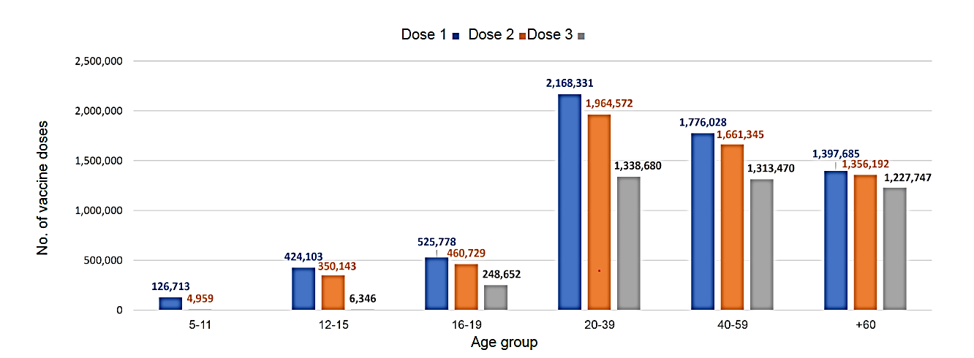
Adapted from Israel Ministry of Health. Corona Vaccine Safety Follow-up: 15 December 2021 https://www.gov.il/BlobFolder/reports/vaccine-efficacy-safety-followup-committee/he/files_publications_corona_vaccine-safty-15122021.pdf. Accessed: 29 December 2021.
In the 12 to 15 year age group, all administered doses were manufactured by the sponsor. Adverse event rates were presented for general events, local events, allergic events and other significant events by dose. The information is based on reports from vaccinating or attending medical staff.
Based on reports to the Israel Ministry of Health, the rate of events by age group is shown in Figure 2.
Figure 2: Rate of events reported by age group for Comirnaty (mRNA) COVID-19 vaccine
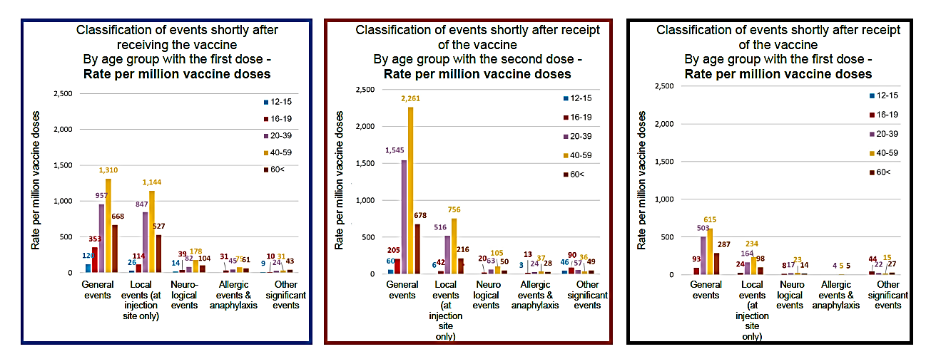
From Israel Ministry of Health. Corona Vaccine Safety Follow-up. 15 December 2021 https://www.gov.il/BlobFolder/reports/vaccine-efficacy-safety-followup-committee/he/files_publications_corona_vaccine-safty-15122021.pdf.Accessed 29 December 2021.
The Israel Ministry of Health safety follow up report also provided the following update on other serious adverse events under surveillance (Figure 3).
Figure 3: Other serious adverse events under surveillance for COVID-19 (mRNA) vaccines (Comirnaty (tozinameran) and Spikevax (elasomeran, Moderna)
From Israel Ministry of Health. Corona Vaccine Safety Follow-up. 15 December 2021 https://www.gov.il/BlobFolder/reports/vaccine-efficacy-safety-followup-committee/he/files_publications_corona_vaccine-safty-15122021.pdf.Accessed 29 December 2021.
Serious adverse events rates by diagnosis were reported for people aged 16 to 59. Adverse events shortly after receipt of a vaccine for ages 12 to 15 years by dose, reported by the Israel Ministry of Health are shown below in Figure 4.
Figure 4: Reported adverse events in the 12 to 15 years of age group
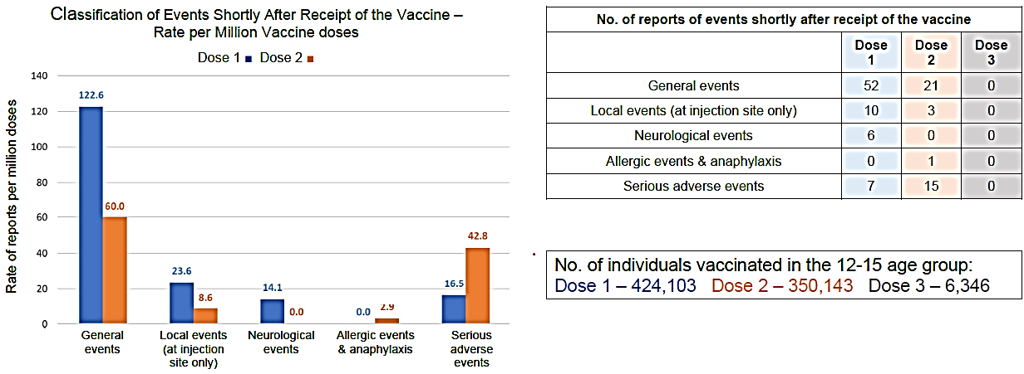
The rate of reports of mild adverse events shortly after the vaccination is lower than observed in the clinical trials. This is probably due to under reporting by the public of mild adverse events that do not require medical monitoring and do not affect life routine. From Israel Ministry of Health. Corona Vaccine Safety Follow-up. 15 December 2021 https://www.gov.il/BlobFolder/reports/vaccine-efficacy-safety-followup-committee/he/files_publications_corona_vaccine-safty-15122021.pdf.Accessed 29 December 2021.
The number of cases of myocarditis in ages 12 to 15 years reported by the Israel Ministry of Health is described in Figure 5.
Figure 5: Number of myocarditis cases in the 12 to 15 years of age group
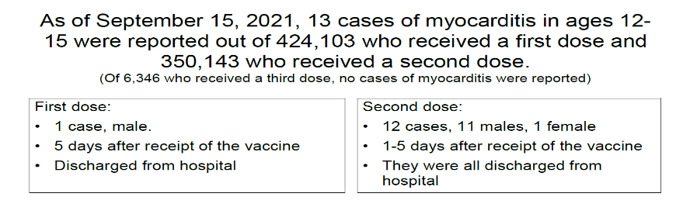
From Israel Ministry of Health. Corona Vaccine Safety Follow-up. 15 December 2021 https://www.gov.il/BlobFolder/reports/vaccine-efficacy-safety-followup-committee/he/files_publications_corona_vaccine-safty-15122021.pdf. Accessed: 29 December 2021.
The clinical symptomatology in cases shortly after vaccine administration reported by the Israel Ministry of Health is detailed in Figure 6 below.
Figure 6: Clinical symptomatology of 13 cases with myocarditis shortly after vaccine administration
From Israel Ministry of Health. Corona Vaccine Safety Follow-up. 15 December 2021 https://www.gov.il/BlobFolder/reports/vaccine-efficacy-safety-followup-committee/he/files_publications_corona_vaccine-safty-15122021.pdf.Accessed 29 December 2021.
The rate of myocarditis across all age groups reported by the Israel Ministry of Health is shown in Table 1 below.
Table 1: Myocarditis cases in all age groups (Comirnaty (mRNA) COVID-19 vaccine)
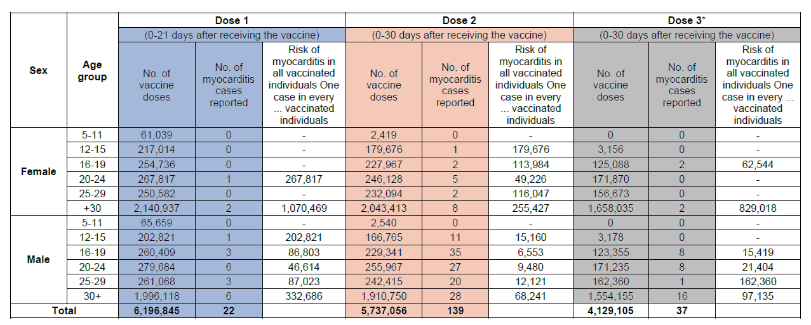
Table 2 shows a comparison of the rates of myocarditis shortly after receipt of the vaccine and the rates of severe morbidity from COVID-19 reported by the Israel Ministry of Health.
Table 2: Rates of myocarditis shortly after receipt of the Comirnaty (mRNA) COVID-19 vaccine compared to the rates of severe morbidity with COVID-19
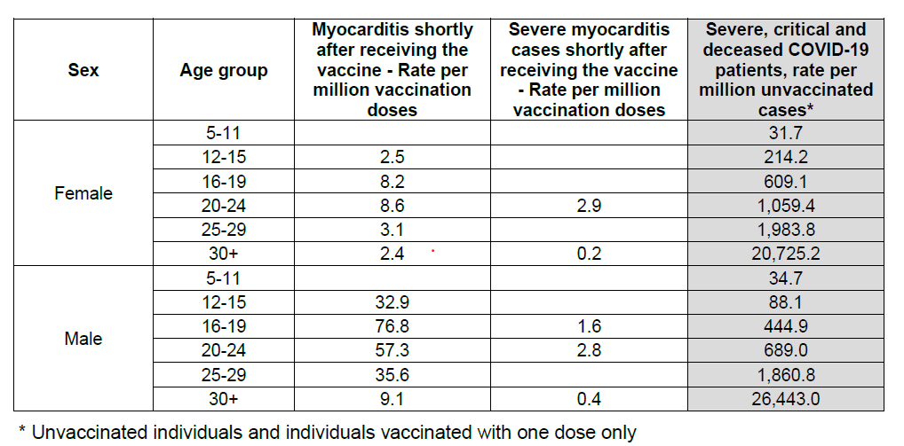

TGA evaluation comment
The sponsor’s clinical overview includes a statement:
‘Safety data from the Israel Ministry of Health showing that after administering a single booster dose to more than 6,000 12- to 15-year-olds, no new safety concerns were identified through 15 December 2021’.
The presented data are consistent with this statement.
Myocarditis and pericarditis have been raised as a safety signal, primarily in younger males, and remains a concern for a booster dose as well as for primary vaccination. These data do not allow any conclusion on an increased or decreased risk in adolescents.

Booster effectiveness
Published data in adults showing that a single booster dose can greatly improve effectiveness against a range of SARS-CoV-2 outcomes compared to after only two doses administered at least five months ago. The following three publications were referenced to support this statement in the sponsor’s clinical overview, and benefit and risk conclusions:
- Arbel R et al. BNT162b2 Vaccine Booster and Mortality Due to Covid-19.
N Engl J Med 2021;385:2413-2420.
- Bar‑On YM, et al. Protection against Covid-19 by BNT162b2 Booster across Age Groups.
N Engl J Med 2021;385:2421-2430.
- Barda N et al. Effectiveness of a third dose of the BNT162b2 mRNA COVID-19 vaccine for preventing severe outcomes in Israel: an observational study.
Lancet 2021; 398(10316); 2093-20100.

TGA evaluation comment
These publications do not report data for those younger than 18 years.
Efficacy was also demonstrated in an interim report of clinical Study C4591031 from age 16 and older, which has previously been considered by the TGA’s Advisory Committee on Vaccines (ACV). The Delegate considers it is reasonable to extrapolate the efficacy of the Comirnaty 30 μg booster to include adolescents aged 12 to 15 years based on the demonstrated efficacy from ages 16 years and older.
The sponsor has identified that Clinical Study C4591031 was designed to evaluate Comirnaty (BNT162b2) boosting strategies in healthy individuals previously vaccinated with Comirnaty (BNT162b2). Substudy B and Substudy C include evaluation of booster dosing in individuals ≥ 12 years of age:
- Substudy B is a randomised, placebo-controlled, observer-blind, crossover substudy to evaluate the safety and tolerability of a booster (third) dose of BNT162b2. Participants ≥12 years of age to ≤ 30 years of age who have completed a 2 dose primary series of BNT162b2 at least 6 months prior to randomisation will be enrolled.
- Substudy C is a randomised, observer-blinded substudy to evaluate the safety, tolerability, and immunogenicity of a booster (third) dose of BNT162b2 at 10 μg and at 30 μg. Participants ≥ 12 years of age who have completed a 2 dose primary series of BNT162b2 at least 6 months prior to randomisation will be enrolled.
The sponsor has targeted the second quarter of 2022 for the availability of data from the substudies of Study C4591031 that will evaluate the booster dose in individuals ≥ 12 years of age. However, following approval in the USA of a booster dose from the age of 12 years under EUA on 3 January 2022, there may be challenges in achieving this timeline.

Protection against Omicron variant B.1.1.529
The recent emergence of the Omicron variant (B.1.1.529) has put further emphasis on the importance of boosting campaigns, as preliminary data suggest that three doses of Comirnaty (BNT162b2) are needed to achieve protection against Omicron induced disease. A single reference was provided by the sponsor to support this statement in the sponsor’s clinical overview, and benefit and risks conclusions:
- Andrews N, Stowe J, Kirsebom F, et al. Effectiveness of COVID-19 vaccines against the Omicron (B.1.1.529) variant of concern medRxiv2021 (updated December 14, 2021). Available at: https://doi.org/10.1101/2021.12.14.21267615.
The Morbidity and Mortality Weekly Report (MMWR) for the first week of March 2022; reports a recent Centers for Disease Control and Prevention (CDC) review: Safety Monitoring of COVID-19 Vaccine Booster Doses among Persons Aged 12-17 Years – United States (dated: 9 December 2021 to 20 February 2022).

TGA evaluation comment
This publication further supports safety in relation to serious adverse events of a Comirnaty booster dose in approximately 2.8 million US adolescents 12 to 17 years old.

Adolescent booster recommendation
The TGA Delegate considers postmarketing safety data from the Israel Ministry of Health shows that after administering a single booster dose of the Comirnaty COVID-19 vaccine to more than 6000 12 to 15 year old no new safety concerns were reported. The exposure reported from Israel is insufficient for assessment of risk of myocarditis.
The recent published experience from the USA supports no new safety concerns in approximately 2.8 million adolescents.
Three publications from Israel have reported a large improvement of vaccine efficacy for 3 doses compared to 2 doses in adults. The Delegate considers it is reasonable to extrapolate efficacy of Comirnaty 30 μg booster in adolescents aged 12 to 15 years based on the demonstrated efficacy from those aged 16 years and older.

Adolescent six month update
Study C4591001 is an ongoing Phase I/II/III randomised, multinational, placebo-controlled, observer-blind, dose finding, vaccine candidate selection, and efficacy study in healthy individuals. Phase II/III study data from a cohort of participants of 12 to 15 years of age (termed ‘adolescents’) have previously been evaluated by the TGA.
An interim report was provided in this submission to support statements in the PI on safety and efficacy. This interim report for adolescent participants of 12 to 15 years of age summarises updated descriptive efficacy analyses from 7 days after Dose 2 during blinded placebo controlled follow-up and the following safety data, as ordered (based on a data cut-off date of 2 September 2021):
- Blinded placebo-controlled follow-up period from Dose 1 to the date of unblinding for Comirnaty (BNT162b2) and placebo participants, including new adverse events (AEs) that were reported after the EUA snapshot date (based on events on or after the data cut-off date of 13 March 2021).
- Open-label observational follow-up period of original Comirnaty (BNT162b2) recipients from the date of unblinding to the data cut-off date.
- Cumulative safety from Dose 1 to at least 6 months after Dose 2, inclusive of blinded data and open-label data for original BNT162b2 recipients, including new AEs that were reported after the EUA snapshot date.
- Open-label observational follow-up period for original placebo recipients who then received Comirnaty (BNT162b2) from the first dose of Comirnaty (BNT162b2) to the data cut-off date.

Updated efficacy results
- In the updated descriptive efficacy analysis (data cut-off date 2 September 2021), among participants in the evaluable efficacy population without evidence of SARS-CoV-2 infection before and during the vaccination regimen, the estimated vaccine efficacy (VE) against confirmed COVID-19 occurring at least 7 days after Dose 2 was 100% (2-sided 95% confidence interval (CI): 86.8%, 100%), with 0 cases in the Comirnaty (BNT162b2) group and 28 cases in the placebo group. Among participants with or without evidence of SARS-CoV-2 infection before and during the vaccination regimen, the estimated VE against confirmed COVID-19 occurring at least 7 days after Dose 2 was 100% (2-sided 95% CI: 87.5%, 100%), with 0 and 30 cases in the BNT162b2 and placebo groups, respectively.
- Among participants without and with or without evidence of SARS-CoV-2 infection before and during the vaccination regimen (evaluable efficacy population), VE against COVID-19 occurring at least 7 days after Dose 2 was evaluated for demographic and risk subgroups, and the estimated VE was 100.0% for all subgroups.
- From the analysis of all cases of confirmed COVID-19 based on the all-available (modified intention-to-treat) population (regardless of evidence of infection before or during the vaccination regimen), the estimated VE against all cases occurring at any time after Dose 1 was 94.0% (2-sided 95% CI: 81.3%, 98.8%), with 3 cases in the Comirnaty (BNT162b2) group (all occurring within <11 days after Dose 1 and in participants who had baseline SARS-CoV-2 negative status) and 48 cases in the placebo group.
- No severe COVID-19 cases (per protocol (PP) definition or CDC criteria) were reported in participants 12 to 15 years of age as of the data cut-off date (2 September 2021).
- Most variants sequenced were neither variants of interest (VOI) nor variants of concern (VOC) except for the B.1.1.7 (Alpha variant) found in 23.3% of placebo participants. All of the cases in the efficacy analyses occurred between 2 November 2020 to 19 May 2021.

Safety results
The safety population of adolescent participants included 1131 participants in the Comirnaty (BNT162b2) vaccine group and 1129 participants in the placebo group. During the blinded placebo-controlled follow-up period, median follow-up time for adolescent participants was 4.4 months. There were 634 (56.1%) and 629 (55.7%) of participants in the Comirnaty (BNT162b2) and placebo groups, respectively, who had follow-up time between ≥ 4 months to < 6 months after Dose 2. From Dose 2 to the cut-off date, 740 (65.4%) of participants in the Comirnaty (BNT162b2) group had a total follow-up time between ≥ 8 to < 10 months, which was composed of blinded and unblinded exposure.
The long-term AE profile among adolescents reflects age appropriate events consistent with the general population, with low incidences of severe and/or related events.
Lymphadenopathy has been identified as related to Comirnaty (BNT162b2) in study participants ≥ 16 years of age and is also identified as related to Comirnaty (BNT162b2) in adolescents. The incidence of severe adverse events (SAEs) in adolescents was low and similar between the vaccine and placebo groups. Most SAEs, including all SAEs in the Psychiatric disorders System Organ Class (SOC), were assessed by the investigator as not related to study intervention. One (1) participant reported an SAE of myocarditis on Day 3 after second dose of Comirnaty (BNT162b2). Only one participant was withdrawn from the study because of an AE. No deaths occurred in the adolescent group.
Review of AEs, SAEs, and events of clinical interest suggested no clear patterns or additional safety signals or concerns among adolescents.
The overall safety conclusions were that the tolerability and safety profile of Comirnaty (BNT162b2) 30 μg in participants 12 through 15 years of age at up to 6 months after Dose 2 was acceptable throughout the follow-up period (to the data cut-off date) and consistent with results previously reported.

Risk management plan
The sponsor provided EU- risk management plan (RMP) version 4.1 (dated 2 February 2022) with the current submission. The sponsor stated that the changes made to the EU-RMP are not considered to have impact on the Australian Specific Annex (ASA) version 0.4, which was submitted and accepted by the TGA for the 5 to < 12 year old indication. The sponsor considers that the ASA version 0.4 is aligned with the EU-RMP version 4.1.
EU-RMP version 4.1 is the latest available and there is no EU-RMP version including the booster dose for adolescents (12 to 15 years of age group) yet. The sponsor committed to provide an updated version of EU-RMP when it becomes available.
The summary of safety concerns is the same as the summary that was evaluated and considered acceptable for the previous TGA submission. The changes proposed by the current submission are not expected to change the summary of safety concerns from an RMP perspective.
The pharmacovigilance plan was deemed acceptable during the previous evaluations and continues to be acceptable for the current submission.
Only routine risk minimisation measures are currently in place. The Consumer Medicine Information (CMI) has been updated to include the changes proposed by this submission (age of booster recipients changed to 12 years and above). Routine risk minimisation measures as part of RMP were deemed acceptable during the previous evaluations. From an RMP perspective, routine risk minimisation measures are acceptable to address the changes proposed by the current submission.
The summary of safety concerns and their associated risk monitoring and mitigation strategies are summarised in Table 2.
Table 2: Summary of safety concerns
Summary of safety concerns |  | Pharmacovigilance |  | Risk Minimisation
 |  | Routine | Additional | Routine | Additional
Important identified risks | Anaphylaxis | † | * |  | –
Important identified risks | Myocarditis and pericarditis |  | * |  | –
Important potential risks | Vaccine-associated enhanced disease (VAED) including Vaccine-associated enhanced respiratory disease (VAERD) | † | * | – | –
Missing information | Use in pregnancy and while breast feeding |  | * |  | –
Missing information | Use in immunocompromised patients |  | * |  | –
Missing information | Use in frail patients with co-morbidities (e.g. chronic obstructive pulmonary disease (COPD), diabetes, chronic neurological disease, cardiovascular disorders) |  | * |  | –
Missing information | Use in patients with autoimmune or inflammatory disorders |  | * | – | –
Missing information | Interaction with other vaccines |  | * |  | –
Missing information | Long term safety data |  | * | – | –
†Data capture Aid (Adverse drug reaction follow-up forms) *Clinical trial

Risk-benefit analysis

Delegate’s considerations

Summary of data
The lower age of booster was supported by the sponsor’s Clinical overview and based on:
- Safety data from the Israel Ministry of Health showing that after administering a single booster dose to more than 6000 12 to 15 year olds, no new safety concerns were identified through 15 December 2021.
- Published data in adults showing that a single booster dose can greatly improve effectiveness against a range of SARS-CoV-2 outcomes compared to after only two doses administered at least five months ago, and
- Emerging evidence suggesting that three doses of vaccine may be especially necessary for preventing Omicron variant-related disease.
Other PI changes are supported by the sponsor’s clinical overview and the interim Study C4591001 clinical study report including 6 months post Dose 2 in adolescents.

Deficiencies
- This booster recommendation is based on extrapolation of effectiveness data in adults 16 to 55 years of age to the younger cohort of adolescent 12 to 15 years of age.
- Safety is supported by real world surveillance of adverse events from Israel and USA. The exposure reported from Israel is insufficient for assessment of risk of myocarditis.
The Delegate recommended changes under PI Section 4.4 Special Warnings, Paediatric use.

Proposed action
The Delegate proposed to approve the registration of the product Comirnaty with a statement that a booster dose of Comirnaty may be administered IM at least 6 months after the second dose in individuals 12 years of age and older.

Advisory Committee considerations
The Advisory Committee on Vaccines (ACV), having considered the evaluations and the Delegate’s overview, as well as the sponsor’s response to these documents, advised the following.

Specific advice to the Delegate
- Does ACV agree that a booster dose of Comirnaty may be administered in individuals 12 years of age and older, based on extrapolation from data in adults 18 to 55 years of age?
The ACV expressed reservations about the lack of data, a likely very small benefit against severe disease, and limited safety data from the USA and Israel.
The risk of myocarditis is hard to quantify, given the sponsor’s reliance on observational Israeli data from only six thousand children. Based on US CDC data, the rate of myocarditis appeared to be lower after the booster dose compared to after second dose.
However, the benefit-risk is likely to be positive for some groups within the 12-15 year age group, for example, children at high risk of severe COVID-19 due to underlying medical conditions.
The ACV advised that the statement in the approved indication, that use of this vaccine should be in accordance with official recommendations, applies to the use of booster doses as well as the primary series doses. Official recommendations, such as from ATAGI, may reflect changing public health contexts and individual clinical situations (e.g., may favour use only in 12-15 year olds at high-risk of severe disease).
The ACV considered that the availability of booster doses may be important in the event of emergence of more transmissible or severe SARS-CoV-2 variants of concern.
The ACV agreed that a booster dose of Comirnaty may be administered in individuals 12 years of age and older, based on extrapolation from data in adults 18 to 55 years of age?
- Does ACV agree with the product information changes proposed by the sponsor?
The ACV agreed with the product information changes proposed by the sponsor.
Additional changes should be considered:
- articulate that there are key gaps in the available data and there is no immunogenicity data in this age group
- Section 4.4/General recommendations/Myocarditis and pericarditis: mention potential for myocarditis after booster dose
- Section 4.4/Paediatric use: mention potential for myocarditis
- Section 5.1/Clinical trials/ Efficacy and immunogenicity in adolescents 12 to 15 years of age – after 2 doses: specify the dominant SARS-CoV-2 variant at the time of the efficacy study.
- The Committee is also requested to provide advice on any other issues that it thinks may be relevant to this decision.
The ACV advised that rigorous post-marketing monitoring is required, such as the monthly safety summary reports. This is consistent with the provisional registration status of the vaccine.
The ACV advised that updated data from the Israel and US CDC should be obtained and considered, given the minimal data provided by the sponsor.
The ACV noted that communication of any TGA decision needed to make clear that registration for use as a booster does not imply a booster dose is necessary or desirable for use across the Australian population aged 12-15 years.

Conclusion
The ACV supported the approval of changes to the Product Information of Comirnaty to include a booster (third) dose for persons 12 years and older, based on extrapolation from older age groups. This does not imply a booster dose is necessary or desirable for use across the Australian population aged 12-15 years.
The use and timing of Comirnaty booster in 12-15 year olds should be in accordance with official recommendations.

Outcome
Based on a review of quality, safety and efficacy, the TGA approved the registration of Comirnaty (tozinameran) 30 µg/0.3 mL, suspension for injection, multi-dose vial, change in dose regimen to:
Individuals 12 years of age and older
Comirnaty is administered intramuscularly after dilution as a primary course of two doses at least 21 days apart. See dosing instructions below.
Booster dose in individuals 12 years of age and older
A booster dose of Comirnaty may be administered intramuscularly at least 6 months after the completion of a COVID-19 vaccine primary series in individuals 12 years of age and older.
The decision when and for whom to implement a booster dose of Comirnaty should be made based on available vaccine safety and effectiveness data (see sections 4.4 Special warnings and precautions for use and 5.1 Pharmacodynamic properties), in accordance with official recommendations.
Interchangeability
There are limited data on the interchangeability of Comirnaty with other COVID-19 vaccines to complete the primary vaccination course or the booster dose. Individuals who have received 1 dose of Comirnaty should preferably receive a second dose of Comirnaty to complete the primary vaccination course and for any additional doses.
Severely immunocompromised aged 12 years and older
In accordance with official recommendations, a third dose may be given, as part of the primary series, at least 28 days after the second dose to individuals who are severely immunocompromised (see section 4.4 Special warnings and precautions for use).
Elderly population
No dosage adjustment is required in elderly individuals ≥ 65 years of age.

Specific conditions of registration applying to these goods
[Risk management plan]
- Comirnaty is to be included in the Black Triangle Scheme. The PI and CMI for Comirnaty must include the black triangle symbol and mandatory accompanying text for the products entire period of provisional registration.
- The Comirnaty EU-Risk Management Plan (RMP) (version 4.1, dated 2 February 2022, data lock point 30 September 2021, for 5 to < 12 years of age: Module SIII - 6 September 2021; Module SVII.3 - 6 September 2021- Pfizer clinical database, 18 June 2021 - Pfizer safety database), with Australian specific annex (version 0.4, dated 11 November 2021), and any subsequent revisions, as agreed with the TGA will be implemented in Australia.
An obligatory component of risk management plans is routine pharmacovigilance. Routine pharmacovigilance includes the submission of periodic safety update reports (PSURs).
Unless agreed separately between the supplier who is the recipient of the approval and the TGA, the first report must be submitted to TGA no later than 15 calendar months after the date of the approval letter. The subsequent reports must be submitted no less frequently than annually from the date of the first submitted report until the period covered by such reports is not less than three years from the date of the approval letter, or the entire period of provisional registration, whichever is longer.
The reports are to at least meet the requirements for PSURs as described in the European Medicines Agency’s Guideline on good pharmacovigilance practices (GVP) Module VII-periodic safety update report (Rev 1), Part VII.B Structures and processes. Note that submission of a PSUR does not constitute an application to vary the registration. Each report must have been prepared within ninety calendar days of the data lock point for that report.
Additional to the routine submission of the routine PSURs, expedited monthly safety summary reports (including safety data for patients in Australia) are to be provided in line with the frequency that these reports are submitted to the EMA, until otherwise specified by the TGA.
Clinical
- Data relating to booster dose
  - Submit the clinical study report of NCT04955626 study to Evaluate the Safety and Efficacy of a Booster Dose of BNT162b2 Against COVID-19 in Participants ≥16 Years of Age.
- Data relating to individuals 12-15 years old
  - Submit study report of Study C4591001, including data up to 24 months after Dose 2 in adolescents 12 to 15 years of age, when the data becomes available. Data relating to individuals 16 years and older
  - Submit safety data in relation to follow-up at 6 months post-Dose 2 for all original Comirnaty recipients and at 6 months post-Dose 4 for original placebo recipients subsequently vaccinated with Comirnaty ([that is], 6 months following their second dose), when the analysis is available.
When available, further data relating to vaccine efficacy against asymptomatic disease, vaccine efficacy in immunocompromised subjects, paediatric subjects, pregnant women, lactating mothers, and the information relating to post-market safety and effectiveness studies should be provided to the TGA, as separate submissions, to update the Product Information.
Quality
- Medicine Labels
  - a) The Medicines must not be supplied with labels other than the labels that have been determined to be acceptable as part of the provisional registration of the Medicines under section 25, or, as relevant, any amended/additional labels subsequently approved under section 9D of the Act.
  - b) The sponsor will develop Australian-specific labels for the products, that conform with all relevant Australian labelling requirements, and will take all reasonable steps to implement such labelling before the end of the provisional registration period referred to in subsection 29(3) of the Act (being the period of 2 years starting on the day specified in the ARTG certificate of registration) (noting that, consistent with paragraph 28(5)(aaa) of the Act, changes to such matters as labels that have been agreed to as part of an evaluation under section 25 of the Act may only occur following submission under section 9D of a 'variation' application and approval by the TGA).
  - c) The sponsor will provide information to the TGA on the proposed strategies and planned timelines for Australian dedicated supplies, as soon as possible, and no later than 24 January 2023.
- Batch Release Testing and Compliance
It is a condition of registration that all independent manufacturing batches of Comirnaty (BNT162b2 [mRNA]) COVID-19 Vaccine to be supplied in Australia are not released for supply by or on behalf of the sponsor until samples and the manufacturer’s release data have been assessed by, and you have received notification acknowledging authorisation to release from, the Laboratories Branch, TGA.
In complying with the above, the Sponsor must supply the following for each independent batch of the products imported or proposed to be imported into Australia:
  - a completed Request for Release Form, available from vaccines@health.gov.au; and
  - complete summary protocols for manufacture and QC, including all steps in production in the agreed format; and
  - if the manufacturing batch has been released in Europe or United Kingdom a copy of the EU Official Control Authority Batch Release (OCABR) certificate (or equivalent from the UK) must also be provided; and
  - any reagents, reference material and standards required to undertake testing as requested by Laboratories Branch, TGA.
The shipments (including reagents) to TGA are the responsibility of the Australian sponsor/agent who will be required to facilitate the import and customs clearance process.
- Certified Product Details
An electronic copy of the Certified Product Details (CPD) as described in Guidance 7: Certified Product Details of the Australian Regulatory Guidelines for Prescription Medicines (ARGPM) https://www.tga.gov.au/guidance-7-certified-product-details should be provided upon registration of the therapeutic good. In addition, an updated CPD, for the above products incorporating the approved changes is to be provided within one month of the date of approval letter. A template for preparation of CPD for biological prescription medicines and Vaccines can be obtained from the TGA website https://www.tga.gov.au/form/certified-product-details-cpd-biological-prescriptionmedicines.
The CPD should be sent as a single bookmarked PDF document to vaccines@health.gov.au as soon as possible after registration/approval of the product or any subsequent changes as indicated above.
Post approval commitments
The sponsor has submitted the list of manufacturing sites along with the responsibilities in the production of the Comirnaty (BNT162b2 [mRNA]) COVID-19 Vaccine Drug Substance (DS) and Drug Product (DP) and specified functions.
The Sponsor must maintain the validity of all manufacturer GMP Clearances for the duration of product supply to Australia and comply with any conditions of GMP Clearance.
- Commercial scale batches
The sponsor must perform testing of future process-validation batches of the commercial scale finished product according to the comparability testing protocol/plan and provide results for assessment by the TGA when available.

Attachment 1. Product Information
The PI for Comirnaty approved with the submission which is described in this AusPAR is at Attachment 1. For the most recent PI, please refer to the TGA website at <https://www.tga.gov.au/product-information-pi>.

Therapeutic Goods Administration
PO Box 100 Woden ACT 2606 Australia
Email: info@tga.gov.au Phone: 1800 020 653 Fax: 02 6232 8605
https://www.tga.gov.au

Formerly known as BNT162b2 (mRNA)T162b2 [mRNA].
The Black Triangle Scheme provides a simple means for practitioners and patients to identify certain types of new prescription medicines, including those being used in new ways and to encourage the reporting of adverse events associated with their use. The Black Triangle does not denote that there are known safety problems, just that the TGA is encouraging adverse event reporting to help us build up the full picture of a medicine's safety profile.
Zhu, N. et al. A Novel Coronavirus from Patients with Pneumonia in China, 2019. The New England journal of medicine. 2020; 382(8): 727-733.
McIntosh, K. Coronavirus disease 2019 (COVID-19): Clinical features, In: UpToDate, Waltham, MA (Accessed on 12 January 2021). Available from the UpToDate website.
National Center for Immunization and Respiratory Diseases (NCIRD), Division of Viral Diseases, Centers for Disease Control and Prevention (CDC; 2020). Symptoms of Coronavirus. Last updated 22 December 2020. Available from the CDC website.
World Health Organization (2020) WHO Director-General speeches: WHO Director-General's opening remarks at the media briefing on COVID-19 - 11 March 2020. Available from the WHO website.
World Health Organization, Coronavirus disease (COVID-19) dashboard. Accessed 24 January 2021. Available from the WHO website at https://covid19.who.int/
Further information regarding mRNA technology in vaccines can be found at https://www.phgfoundation.org/documents/rna-vaccines-an-introduction-briefing-note.pdf
As part of the provisional approval pathway, the provisional registration process will allow certain medicines to be provisionally registered in the Australian Register of Therapeutic Goods (ARTG) for a limited duration. These medicines are registered on the basis of preliminary clinical data, where there is the potential for a substantial benefit to Australian patients. The TGA will re-assess risks related to the absence of evidence through data provided at a later stage, as part of the confirmatory data. Confirmatory data should confirm the relationship between outcomes predicted by the surrogate endpoint, or other preliminary data, and the clinical benefit as demonstrated by direct clinical outcomes. The sponsor may apply to transition to full registration at any time up until the provisional registration lapse date, once they have completed the obligations outlined for the provisional registration period and complete confirmatory data on safety and efficacy are available.
Israel Ministry of Health. Corona Vaccine Safety Follow-up. 15 December 2021. Available at: https://www.gov.il/BlobFolder/reports/vaccine-efficacy-safety-followup- committee/he/files_publications_corona_vaccine-safty-15122021.pdf. Accessed 29 December 2021.
MMWR Weekly March 4, 2022 71(9);347–351. On 1 March 2022, this report was posted online as an MMWR Early Release. Hause AM; Baggs J; Marquez; Winston P et al, Safety Monitoring of COVID-19 Vaccine Booster Doses Among Persons Aged 12–17 Years — United States, 9 December 9, 2021–20 February 2022.
Interim Report – Adolescent 6 Month Update: A Phase 1/2/3, Placebo- Controlled, Randomized, Observer-Blind, Dose-Finding Study to Evaluate the Safety, Tolerability, Immunogenicity, and Efficacy of SARS-COV-2 RNA Vaccine Candidates Against COVID-19 in Healthy Individuals Date of Current Version 12 December 2021
Data Lock Point 5 to <12 years - 06 Sep 2021 (Pfizer clinical database); 18 June 2021 (Pfizer safety database), 12- 15 years – 30 Sep 2021 (Pfizer Safety Database, for both CT and non-CT datasets), Booster in severely immunocompromised aged 12 -15 years (30 September 2021 (Pfizer Safety Database, non-CT dataset), 16 years and older (30 September 2021 (Pfizer Safety Database, for both CT and non-CT datasets), Booster in 16 years and older a, including immunocompromised (30 September 2021 (Pfizer Safety Database, for both CT and non-CT datasets)
Routine risk minimisation activities may be limited to ensuring that suitable warnings are included in the product information or by careful use of labelling and packaging. Routine pharmacovigilance practices involve the following activities: - All suspected adverse reactions that are reported to the personnel of the company are collected and collated in an accessible manner; - Reporting to regulatory authorities; - Continuous monitoring of the safety profiles of approved products including signal detection and updating of labelling; - Submission of Periodic Safety Update Reports (PSURs); - Meeting other local regulatory agency requirements.
The Advisory Committee on Vaccines (ACV) provides independent medical and scientific advice to the Minister for Health and the Therapeutic Goods Administration (TGA) on issues relating to the safety, quality and efficacy of vaccines supplied in Australia including issues relating to pre-market assessment, post-market monitoring and safe use in national immunisation programs. The Committee is established under Regulation 39F of the Therapeutic Goods Regulations 1990 and the members are appointed by the Minister for Health. The ACV was established in January 2017, following consolidation of previous functions of the Advisory Committee on the Safety of Vaccines (ACSOV) and the pre-market functions for vaccines of the Advisory Committee on Prescription Medicines (ACPM). Membership comprises professionals with expertise in specific scientific, medical or clinical fields, or consumer health issues.

